Risk assessment template developed under the "Study on Invasive Alien Species – Development of risk assessments to tackle priority species and enhance prevention"
Contract No 07.0202/2019/812602/ETU/ENV.D.2

Name of organism: Platydemus manokwari de Beauchamp, 1963

Author(s) of the assessment:
Archie K. Murchie, Agri-Food & Biosciences Institute, Belfast, BT9 5PX
Björn Beckmann, Centre for Ecology & Hydrology, Penicuik, EH26 0QB

Risk Assessment Area: The risk assessment area is the territory of the European Union27 and the United Kingdom, excluding the EU-outermost regions.

Peer review 1: Dr Richard Shaw, CABI, Egham, UK
Peer review 2: Prof. Jean-Lou Justine, Muséum National d'Histoire Naturelle, Paris, France

Date of completion: 15 October 2020
Date of revision: 30 September 2022

Contents
SECTION A – Organism Information and Screening 3
SECTION B – Detailed assessment 17
1 PROBABILITY OF INTRODUCTION AND ENTRY 17
2 PROBABILITY OF ESTABLISHMENT 32
3 PROBABILITY OF SPREAD 39
4 MAGNITUDE OF IMPACT 52
Biodiversity and ecosystem impacts 52
Ecosystem Services impacts 55
Economic impacts 58
Social and human health impacts 61
Other impacts 62
RISK SUMMARIES 66
REFERENCES 68
Distribution Summary 73
ANNEX I Scoring of Likelihoods of Events 75
ANNEX II Scoring of Magnitude of Impacts 76
ANNEX III Scoring of Confidence Levels 77
ANNEX IV CBD pathway categorisation scheme 78
ANNEX V Ecosystem services classification (CICES V5.1, simplified) and examples 79
ANNEX VI EU Biogeographic Regions and MSFD Subregions 83
ANNEX VII Delegated Regulation (EU) 2018/968 of 30 April 2018 84
ANNEX VIII Species Distribution Model 85

SECTION A – Organism Information and Screening
A1. Identify the organism. Is it clearly a single taxonomic entity and can it be adequately distinguished from other entities of the same rank?
including the following elements:
- the taxonomic family, order and class to which the species belongs;
- the scientific name and author of the species, as well as a list of the most common synonym names;
- names used in commerce (if any)
- a list of the most common subspecies, lower taxa, varieties, breeds or hybrids
As a general rule, one risk assessment should be developed for a single species. However, there may be cases where it may be justified to develop one risk assessment covering more than one species (e.g. species belonging to the same genus with comparable or identical features and impact). It shall be clearly stated if the risk assessment covers more than one species, or if it excludes or only includes certain subspecies, lower taxa, hybrids, varieties or breeds (and if so, which subspecies, lower taxa, hybrids, varieties or breeds). Any such choice must be properly justified.

Response:
Platydemus manokwari de Beauchamp, 1963
Phylum Platyhelminthes, Class Rhabditophora (previously Turbellaria), Order Tricladida, Family Geoplanidae, Subfamily Rhynchodeminae
Justine et al. (2014) confirm the dating of de Beauchamp's species description as 1963 but which is sometimes given as 1962. Molecular systematics continues to resolve planarian taxonomy (Sluys, 2019; Zhang et al., 2019), so the higher-level classification above may change.
Synonyms: Platydemus joliveti Beauchamp, 1972 (Winsor, 1990)
The organism is a single taxonomic entity. There are no known varieties, breeds or hybrids, although two haplotypes have been identified: the Australian haplotype, which is found in Australia and the Solomon Islands, and the world haplotype (Justine et al., 2015), which has been introduced to many countries. At the moment there is no evidence for any major biological differences between haplotypes, therefore this risk assessment will consider both together.
Common names: New Guinea flatworm, Manokwari flatworm, snail-eating flatworm (EN), Plathelminthe de Nouvelle-Guinée (FR), uus-guinea röövlamelane (EE)

A2. Provide information on the existence of other species that look very similar [that may be detected in the risk assessment area, either in the environment, in confinement or associated with a pathway of introduction]
Include both native and non-native species that could be confused with the species being assessed, including the following elements:
- other alien species with similar invasive characteristics, to be avoided as substitute species (in this case preparing a risk assessment for more than one species together may be considered);
- other alien species without similar invasive characteristics, potential substitute species;
- native species, potential misidentification and mis-targeting

Response:
Platydemus manokwari may be confused with other terrestrial flatworms. There are native European flatworms and several invasive species. Of note within the risk assessment area are the invasives, Bipalium kewense, Arthurdendyus triangulatus (see Murchie, 2017) and Obama nungara. In addition to these species, new records of flatworm species, either under-recorded natives (e.g. Microplana spp. or Rhynchodemus spp., etc.) or introduced, are being added regularly within the EU (Álvarez-Presas et al., 2014; Mazza et al., 2016; Sluys, 2016). In general, the European terrestrial flatworm fauna is poorly recorded.
Platydemus manokwari is a moderately large flatworm (typically 40-65 mm; although size is highly variable) with a pointed head, distinguishing it from the shovel-headed Bipalium spp. The dorsal surface is dark brown with a thin light-brown / light grey medial stripe, and a thin light-brown sub-marginal edge. The ventral surface is pale grey. Confusion is most likely with other terrestrial flatworms with similar colouration and ventral lines (e.g. O. nungara, Caenoplana spp., Kontikia spp.). Generally, the native flatworm species are smaller than the alien flatworms but as size is variable in flatworms this is not a reliable feature.

A3. Does a relevant earlier risk assessment exist? Give details of any previous risk assessment, including the final scores and its validity in relation to the risk assessment area.

Response:
Thunnissen et al. (2022) risk screened 22 alien flatworm species for The Netherlands using the Harmonia⁺ risk assessment protocol (D’hondt et al., 2015). They scored P. manokwari as medium (0.5) for invasion and medium for impact (0.5), resulting in an overall low risk score (0.5 x 0.5 = 0.25) for The Netherlands. Although not a quantitative risk assessment for P. manokwari, the comprehensive CABI datasheet by Sugiura (2008b) addresses many of the key issues relevant for the risk assessment area.

A4. Where is the organism native?
including the following elements:
- an indication of the continent or part of a continent, climatic zone and habitat where the species is naturally occurring
- if applicable, indicate whether the species could naturally spread into the risk assessment area

Response:
Platydemus manokwari is native to the island of New Guinea (Papua and West Papua, Indonesia and Papua New Guinea) (Winsor, 1990). It was first described by specimens collected in 1962 from the Agricultural Research Station Manokwari, West Papua, Indonesia (De Beauchamp, 1962; Kawakatsu et al., 1992). There are three published records of this species in its native habitat (Manokwari, Mount Wilhelm and Kainantu), although there may be other verified records through online database recording.
Sitting on the Bird's Head (Vogelkop) Peninsula, the Manokwari region is tropical, classified as Af (tropical rainforest climate) by the Köppen-Geiger system, with an average annual temperature of 25.9 °C and annual rainfall of 2515 mm (Climate-data.org, 2020). The likely natural habitat of P. manokwari in the Bird’s Head Peninsula consists of two ecoregions. First, floristically-diverse lowland tropical rain forests (Vogelkop-Aru Lowland Rain Forests) consisting of canopy trees (e.g. Pometia pinnata, Octomeles sumatrana, Ficus spp., Alstonia scholaris, Terminalia spp.) with a dense shrub and herb understorey (Morrison, 2020b). Second, the peninsular mountains above 1000 m consist of tropical montane evergreen forest (Vogelkop montane rain forests), which are dominated by Castanopsis in the lower elevations, and Antarctic beech (Nothofagus) at higher altitudes (Morrison, 2020a).
Platydemus manokwari was also recorded at Pindaunde station, Mt. Wilhelm, Papua New Guinea, at an altitude of 3625 m. The habitat here was sub-alpine forests, dominated by Amaracarpus and Pittosporum (Winsor, 1990). Justine et al. (2014) gave an assessment of P. manokwari as a predominantly upland species but with a wide habitat range from alpine through to tropical climates.
Platydemus manokwari is a soil-dwelling organism that naturally disperses by creeping on the substrate surface. It could not naturally spread into the risk assessment area.

A5. What is the global non-native distribution of the organism outside the risk assessment area?

Response:
Platydemus manokwari has established in 15 different territories (Justine et al., 2014). These are mainly throughout the Pacific, i.e. Australia, Guam, the Philippines, Japan, Palau, Hawaii, Hong Kong, French Polynesia, Samoa, Singapore, Thailand, Tonga, Vanuatu and Fiji. However, the flatworm has also established in the Maldives in the Indian Ocean and the south-eastern USA / Caribbean region (Florida, Texas, Puerto Rico and Guadeloupe) (Justine et al., 2015; Justine and Winsor, 2020). Justine et al. (2015) has the most up to date published distribution map.

A6. In which biogeographic region(s) or marine subregion(s) in the risk assessment area has the species been recorded and where is it established? The information needs be given separately for recorded (including casual or transient occurrences) and established occurrences. “Established” means the process of an alien species successfully producing viable offspring with the likelihood of continued survival.
A6a. Recorded: List regions
A6b. Established: List regions
Freshwater / terrestrial biogeographic regions:
- Alpine, Atlantic, Black Sea, Boreal, Continental, Mediterranean, Pannonian, Steppic
Marine regions:
- Baltic Sea, North-east Atlantic Ocean, Mediterranean Sea, Black Sea
Marine subregions:
- Greater North Sea, incl. the Kattegat and the English Channel, Celtic Seas, Bay of Biscay and the Iberian Coast, Western Mediterranean Sea, Adriatic Sea, Ionian Sea, Central Mediterranean Sea, Aegean-Levantine Sea.
Comment on the sources of information on which the response is based and discuss any uncertainty in the response.
For delimitation of EU biogeographical regions please refer to https://www.eea.europa.eu/data-and-maps/figures/biogeographical-regions-in-europe-2 (see also Annex VI).
For delimitation of EU marine regions and subregions consider the Marine Strategy Framework Directive areas; please refer to https://www.eea.europa.eu/data-and-maps/data/msfd-regions-and-subregions/technical-document/pdf (see also Annex VI).

Response (6a):
Platydemus manokwari has been recorded from a hothouse in botanic gardens (Jardin des Plantes) Caen, Normandy, France. This is the only record from Europe (Justine et al., 2014; Justine et al., 2015). As the flatworm was found in an artificial habitat, no assumptions can be derived from the region’s biogeographical classification.
Response (6b):
Platydemus manokwari has not established in the wild in the European Union. However, it is likely that P. manokwari is still present in the hothouse in Caen (Jean-Lou Justine, pers. comm. 2019).

A7. In which biogeographic region(s) or marine subregion(s) in the risk assessment area could the species establish in the future under current climate and under foreseeable climate change? The information needs be given separately for current climate and under foreseeable climate change conditions. =
A7a. Current climate: List regions
A7b. Future climate: List regions
With regard to EU biogeographic and marine (sub)regions, see above.
With regard to climate change, provide information on
- the applied timeframe (e.g. 2050/2070)
- the applied scenario (e.g. RCP 4.5)
- what aspects of climate change are most likely to affect the risk assessment (e.g. increase in average winter temperature, increase in drought periods)
The assessment does not have to include a full range of simulations on the basis of different climate change scenarios, as long as an assessment with a clear explanation of the assumptions is provided. However, if new, original models are executed for this risk assessment, the following RCP pathways shall be applied: RCP 2.6 (likely range of 0.4-1.6°C global warming increase by 2065) and RCP 4.5 (likely range of 0.9-2.0°C global warming increase by 2065). Otherwise, the choice of the assessed scenario has to be explained.

Response (7a):
Platydemus manokwari has mostly been recovered from tropical and subtropical Pacific islands bounded by latitudes of c. 30° N and c. 30° S (Sugiura, 2009). It has been suggested that P. manokwari’s range is within the limits of 15-30ºC and in regions with high humidity (Gerlach, 2019), with 10°C postulated as the lower threshold temperature for the establishment (Sugiura, 2009). Areas of high humidity within the Atlantic and Mediterranean coastal regions would be the most likely areas for establishment (Figure 1). This includes eastern Portugal, north-east Spain and lower Brittany / Bay of Biscay regions in France along with the western Adriatic/ Dalmatian coast and western regions of Italy, and therefore mainly the Atlantic and Mediterranean biogeographic regions. There are areas of the Black Sea biogeographic region that would be suitable for establishment but they are further east and outside the risk assessment area. Similarly, the island climate of the Azores would also be suitable for establishment (Figure 2).
The specimens found in France were in a hothouse in Caen. Despite this, the authors of the paper suggested that P. manokwari may well survive externally in Normandy (Justine et al., 2014). This was based on comparisons with Pindaunde station, Mount Wilhelm in New Guinea. This is a natural site for P. manokwari and at 3625 m altitude represents a sub-alpine forest habitat (mean daily temperature 11.6° C, mean minimum 4°C, mean maximum of 16.7° C, minimum of -0.8° C, precipitation 3450 mm per year). However, sitting relatively close to the equator (5°, 46’S) seasonal fluctuations in temperature are much less extreme than in Europe. There is therefore some uncertainty about the climatic limitations of P. manokwari.
Response (7b):
Under climate change scenarios RCP 2.6 (likely range of 0.4-1.6°C global warming increase) (Figures 1 and 3) and RCP 4.5 (likely range of 0.9-2.0°C global warming increase) (Figures 1 and 4), the likelihood of P. manokwari establishment increases within Europe. The potential distribution of the flatworm remains relatively stable compared to the present scenario and does not diminish. Species distribution modelling suggests that P. manokwari could extend its range northwards to establish in southwest England and Ireland, as well as increasing its range in France, therefore establishing more extensively in the Atlantic, Black Sea and Mediterranean biogeographical regions.
The aspects of climate change most likely to affect the risk assessment are a rise in average annual temperature, whilst maintaining soil humidity. These are likely to increase the likelihood of P. manokwari establishing. Greater periods of drought would be detrimental to this species.

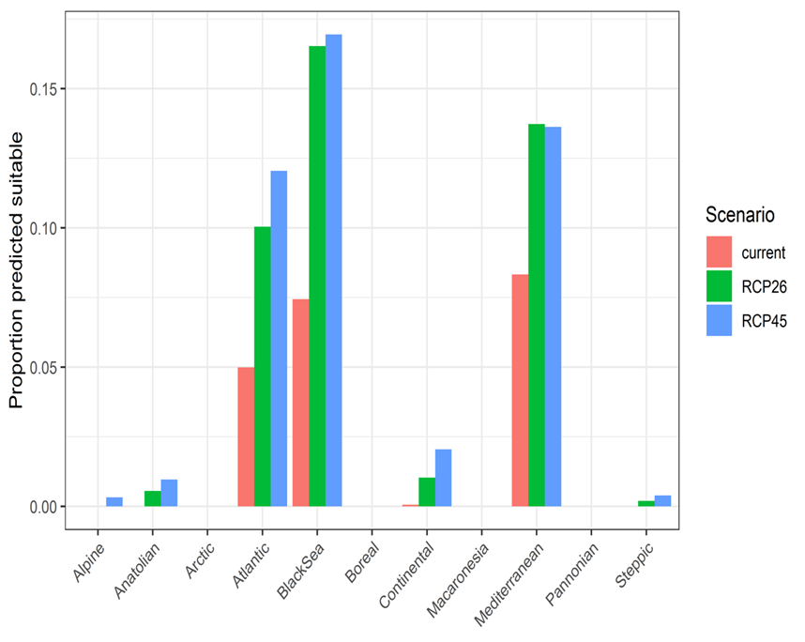
Figure 1. Variation in projected suitability for Platydemus manokwari establishment among Biogeographical regions of Europe (Bundesamt für Naturschutz (BfN), 2003). The bar plots show the proportion of grid cells in each region classified as suitable in the current climate and projected climate for the 2070s under two RCP emissions scenarios. The location of each region is also shown. The Anatolian, Arctic and Macaronesian biogeographical regions are not part of the study area, but are included for completeness. For details, please see attached species distribution model (Annex VIII).

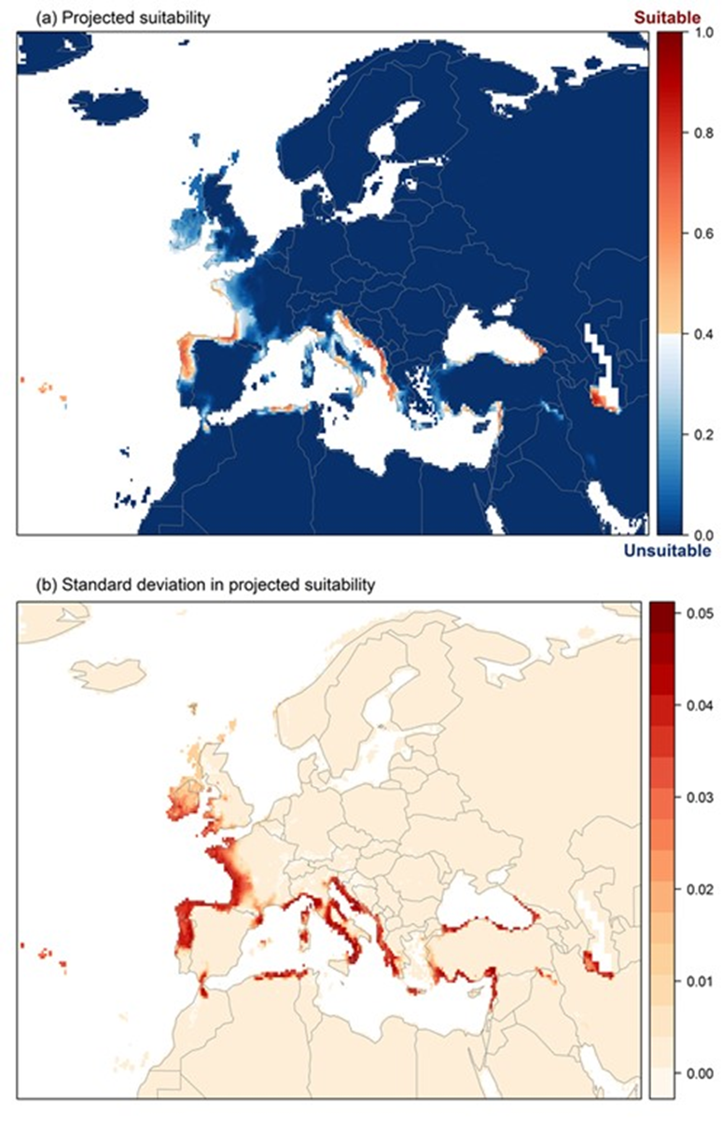
Figure 2. (a) Projected current suitability for Platydemus manokwari establishment in Europe and the Mediterranean region. (b) Uncertainty in the ensemble projections, expressed as the among-algorithm standard deviation in predicted suitability, averaged across 10 datasets. For details, please see attached species distribution model (Annex VIII).

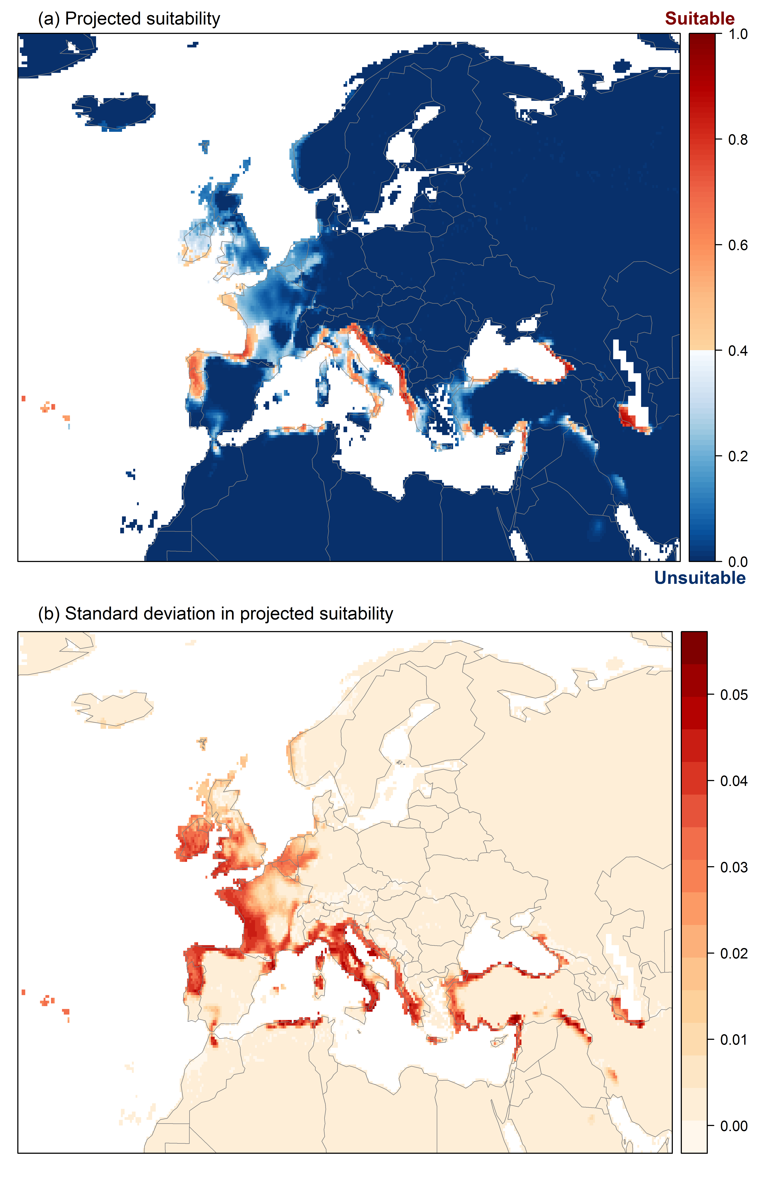
Figure 3. (a) Projected suitability for Platydemus manokwari establishment in Europe and the Mediterranean region in the 2070s under climate change scenario RCP 2.6, equivalent to Figure 2. (b) Uncertainty in the ensemble projections, expressed as the among-algorithm standard deviation in predicted suitability, averaged across 10 datasets. For details, please see attached species distribution model (Annex VIII).

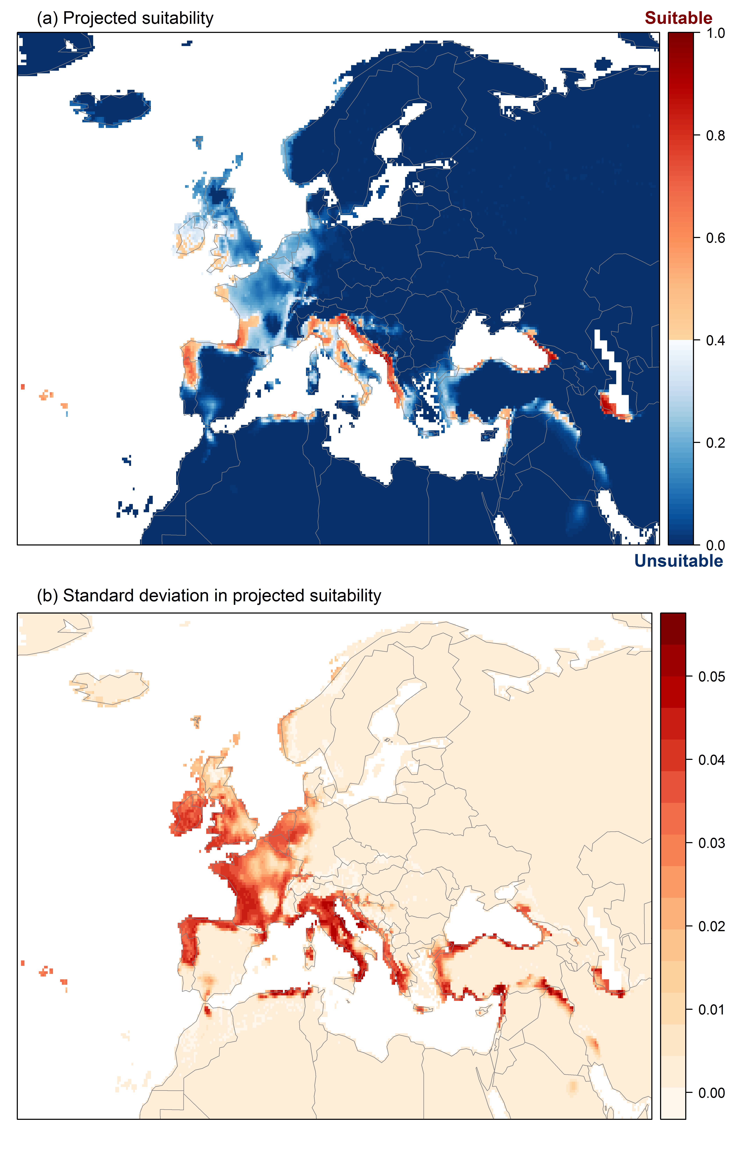
Figure 4. (a) Projected suitability for Platydemus manokwari establishment in Europe and the Mediterranean region in the 2070s under climate change scenario RCP 4.5, equivalent to Figure 2. (b) Uncertainty in the ensemble projections, expressed as the among-algorithm standard deviation in predicted suitability, averaged across 10 datasets. For details, please see attached species distribution model (Annex VIII).
A8. In which EU Member States has the species been recorded and in which EU Member States has it established? List them with an indication of the timeline of observations. The information needs be given separately for recorded and established occurrences.
A8a. Recorded: List Member States
A8b. Established: List Member States
Austria, Belgium, Bulgaria, Croatia, Cyprus, Czech Republic, Denmark, Estonia, Finland, France, Germany, Greece, Hungary, Ireland, Italy, Latvia, Lithuania, Luxembourg, Malta, Netherlands, Poland, Portugal, Romania, Slovakia, Slovenia, Spain, Sweden
The description of the invasion history of the species shall include information on countries invaded and an indication of the timeline of the first observations, establishment and spread.

Response (8a):
There is a single record of P. manokwari in a hothouse in France in 2013 (Justine et al., 2014). This is the first and only record for Europe.
Response (8b):
Platydemus manokwari has not established in the wild in the risk assessment area, although it is likely that the population in the hothouse in France is still extant (Jean-Lou Justine, pers. comm. 2019).

A9. In which EU Member States could the species establish in the future under current climate and under foreseeable climate change? The information needs be given separately for current climate and under foreseeable climate change conditions.
A9a. Current climate: List Member States
A9b. Future climate: List Member States
With regard to EU Member States, see above.
With regard to climate change, provide information on
- the applied timeframe (e.g. 2050/2070)
- the applied scenario (e.g. RCP 4.5)
- what aspects of climate change are most likely to affect the risk assessment (e.g. increase in average winter temperature, increase in drought periods)
The assessment does not have to include a full range of simulations on the basis of different climate change scenarios, as long as an assessment with a clear explanation of the assumptions is provided. However, if new, original models are executed for this risk assessment, the following RCP pathways shall be applied: RCP 2.6 (likely range of 0.4-1.6°C global warming increase by 2065) and RCP 4.5 (likely range of 0.9-2.0°C global warming increase by 2065). Otherwise, the choice of the assessed scenario has to be explained.

Response (9a):
Aside from the French hothouse record, the most northerly record of P. manokwari is from Yokohama, Japan (Eldredge, 1994; Justine et al., 2014). However, this is not an establishment but refers to a transfer of 200 specimens from the Philippines to Yokohama for laboratory experiments, after which they were preserved. There was no release of P. manokwari into the wild (Sugiura, 2008b). Sugiura (2009) gives the subtropical island Chichijima (27°, 04’ N) (Ogasawara Islands, Japan) as the highest latitude of occurrence. This means that the known geographical range of P. manokwari is tropical / subtropical. However, within these regions P. manokwari is found at elevated altitudes in Papua New Guinea, e.g. at 3625 m elevation at Pindaunde station, Mt. Wilhelm and 1558 m elevation at Kainantu (Winsor, 1990; Justine et al., 2014). The temperature in these upland highland forests is cooler than the coastal regions, leading Justine et al. (2014) to suggest that P. manokwari was an upland species with a habitat range from alpine through to tropical.
The western Atlantic regions of Portugal, Spain and France, and the coastal Mediterranean regions of Croatia, Slovenia, Greece and Italy would be most at risk from establishment of P. manokwari (Figures 2 and 5); however, the issue of cold-hardiness (freezing tolerance), humidity and soil moisture remains to be clarified, there are little data on this topic.
Response (9b):
Under climate change scenarios (RCP 2.6 and RCP 4.5), in addition to the above countries, Ireland and the UK (south-western England) would also be susceptible to establishment by P.manokwari (Figures 3 and 4).
The climatic suitability for P. manokwari was most strongly determined by annual precipitation and minimum temperature of the coldest month. Increased annual temperatures will benefit this species provided soil moisture is maintained. Droughts are generally detrimental to moist-bodied animals like terrestrial flatworms which are susceptible to desiccation, although P. manokwari can survive the dry season in north Queensland by aestivating in the soil (Winsor, 1990).

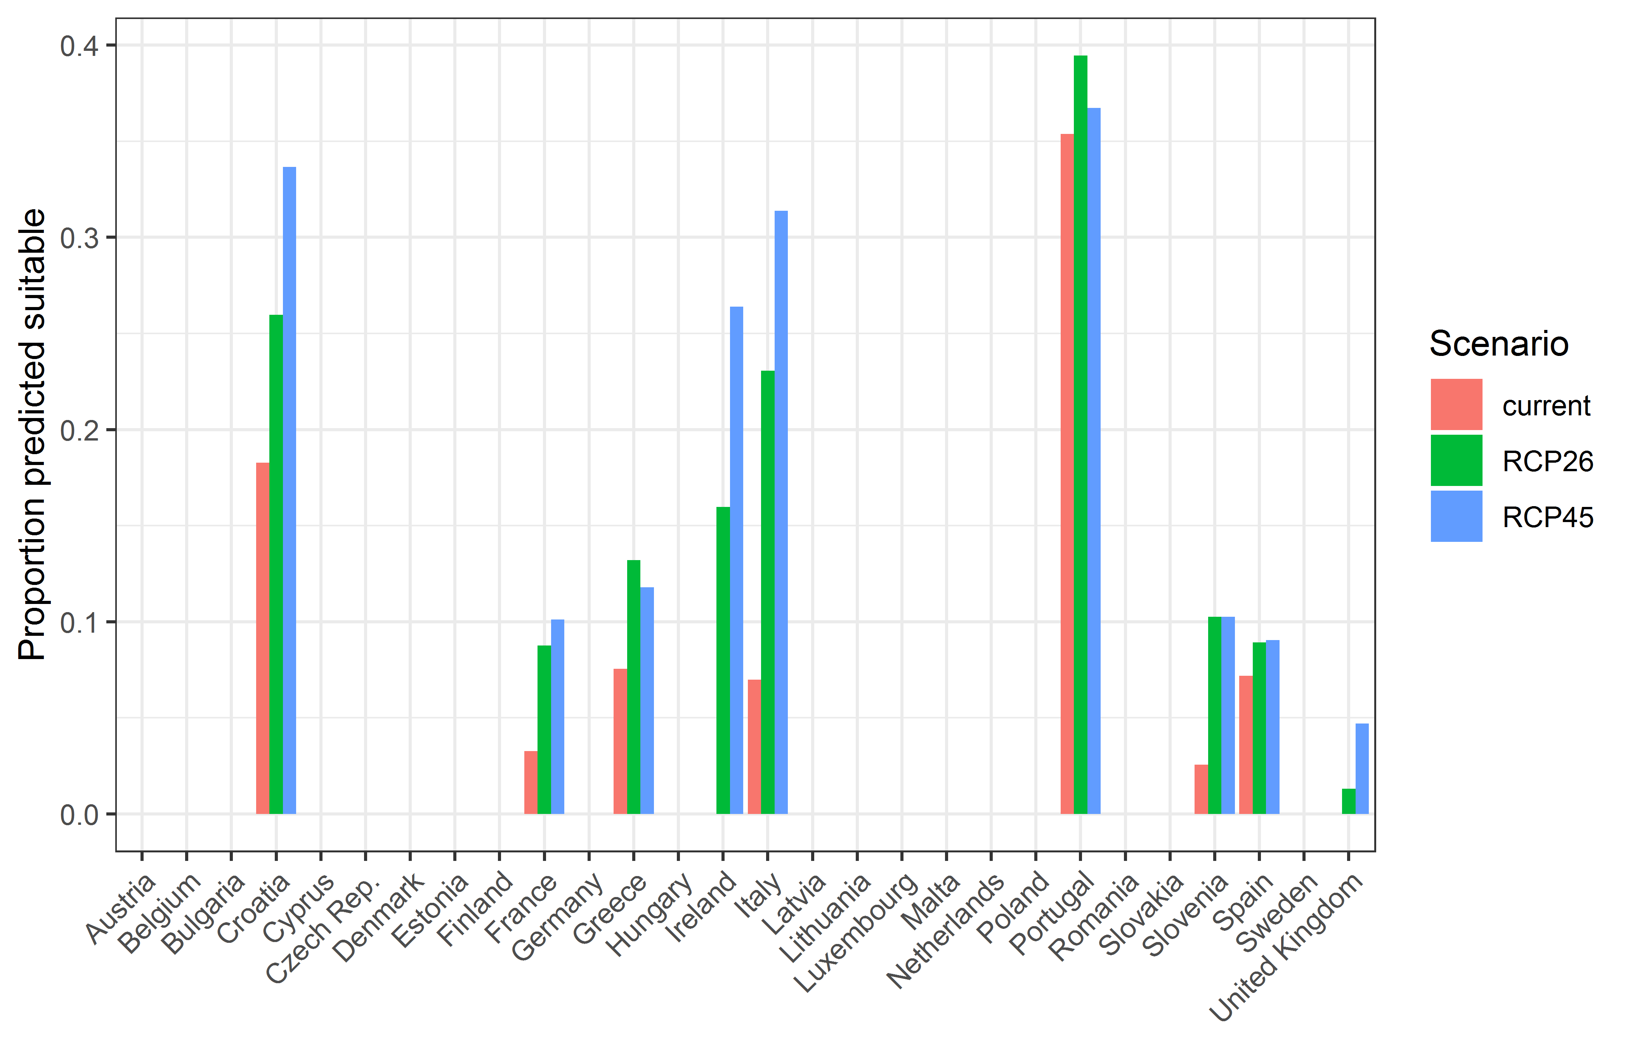
Figure 5. Variation in projected suitability for Platydemus manokwari establishment among European Union countries and the UK. The bar plots show the proportion of grid cells in each country classified as suitable in the current climate and projected climate for the 2070s under two RCP emissions scenarios. For details, please see attached species distribution model.

A10. Is the organism known to be invasive (i.e. to threaten or adversely impact upon biodiversity and related ecosystem services) anywhere outside the risk assessment area?

Response:
The flatworm is listed as one of the ‘World's Worst Invader Alien Species’ (Lowe et al., 2000) due to its role in the decline of endemic terrestrial snails, especially Partula and Mandarina spp., on various Pacific islands (Cowie, 2010; Chiba and Cowie, 2016). There are specific examples of a severe decline in indigenous snail populations to extinction from the Ogasawara Islands (Japan) (Ohbayashi et al., 2007; Sugiura and Yamaura, 2009) and Guam (Hopper and Smith, 1992).

A11. In which biogeographic region(s) or marine subregion(s) in the risk assessment area has the species shown signs of invasiveness? Indicate the area endangered by the organism as detailed as possible.
Freshwater / terrestrial biogeographic regions:
- Alpine, Atlantic, Black Sea, Boreal, Continental, Mediterranean, Pannonian, Steppic
Marine regions:
- Baltic Sea, North-east Atlantic Ocean, Mediterranean Sea, Black Sea
Marine subregions:
Greater North Sea, incl. the Kattegat and the English Channel, Celtic Seas, Bay of Biscay and the Iberian Coast, Western Mediterranean Sea, Adriatic Sea, Ionian Sea, Central Mediterranean Sea, Aegean-Levantine Sea

Response:
Platydemus manokwari has not invaded the risk assessment area. The single record of this flatworm from Europe is from a hothouse in France and it has not established in the wild.

A12. In which EU Member States has the species shown signs of invasiveness? Indicate the area endangered by the organism as detailed as possible.
Austria, Belgium, Bulgaria, Croatia, Cyprus, Czech Republic, Denmark, Estonia, Finland, France, Germany, Greece, Hungary, Ireland, Italy, Latvia, Lithuania, Luxembourg, Malta, Netherlands, Poland, Portugal, Romania, Slovakia, Slovenia, Spain, Sweden

Response:
At the present time, P. manokwari has not established in the wild in the risk assessment area.

A13. Describe any known socio-economic benefits of the organism.
including the following elements:
- Description of known uses for the species, including a list and description of known uses in the risk assessment area and third countries, if relevant.
- Description of social and economic benefits deriving from those uses, including a description of the environmental, social and economic relevance of each of those uses and an indication of associated beneficiaries, quantitatively and/or qualitatively depending on what information is available.
If the information available is not sufficient to provide a description of those benefits for the entire risk assessment area, qualitative data or different case studies from across the risk assessment area or third countries shall be used, if available.

Response:
Platydemus manokwari has been used as a biological control agent against the giant African land snail Lissachatina fulica. From the 1840s onwards, L. fulica was introduced deliberately as a food source, and accidentally with plants, to more than 50 regions (Civeyrel and Simberloff, 1996), including Spain and Italy, although in Europe the distribution is very restricted or transient (EPPO, 2019, 2020). With L. fulica having high fecundity, a polyphagous diet and few natural enemies, the snail rapidly became a pest. Platydemus manokwari was deliberately introduced to L. fulica affected areas in the Pacific Islands, Maldives and Philippines as a biological control agent. Although an effective biological control agent (Muniappan et al., 1986), P. manokwari was released without proper host-specificity testing and predates upon indigenous snail fauna.
In some respects, P. manokwari has had a positive economic benefit through reduction in giant African land snail populations (Civeyrel and Simberloff, 1996; Sugiura, 2008b). In Guam, savings of US$ 600,000 were estimated for prevented crop losses and reduced snail control costs (Muniappan, 1983).

SECTION B – Detailed assessment
Important instructions:
- In the case of lack of information the assessors are requested to use a standardized answer: “No information has been found.”
- With regard to the scoring of the likelihood of events or the magnitude of impacts see Annexes I and II.
- With regard to the confidence levels, see Annex III.
- Highlight the selected response score and confidence level in bold but keep the other scores in normal text (so that the selected score is evident in the final document).

1 PROBABILITY OF INTRODUCTION AND ENTRY
Important instructions:
- Introduction is the movement of the species into the risk assessment area (it may be either in captive conditions and/or in the environment, depending on the relevant pathways).
- Entry is the release/escape/arrival in the environment, i.e. occurrence in the wild
- Introduction and entry may coincide for species entering through pathways such as “corridor” or “unaided”, but it also may differ. If different, please consider all relevant pathways, both for the introduction into the risk assessment area and the entry in the environment.
- The classification of pathways developed by the Convention of Biological Diversity (CBD) should be used (see Annex IV). For detailed explanations of the CBD pathway classification scheme consult the IUCN/CEH guidance document and the provided key to pathways.
- For organisms which are already present (recorded or established) in the risk assessment area, the likelihood of introduction and entry should be scored as “very likely” by default.
- Repeated (independent) introductions and entries at separate locations in the risk assessment area should be considered here (see Qu. 1.7).

Qu. 1.1. List relevant pathways through which the organism could be introduced into the risk assessment area and/or enter into the environment. Where possible give details about the specific origins and end points of the pathways as well as a description of any associated commodities.
For each pathway answer questions 1.2 to 1.7 (copy and paste additional rows at the end of this section as necessary). Please attribute unique identifiers to each question if you consider more than one pathway, e.g. 1.2a, 1.3a, etc. and then 1.2b, 1.3b etc. for the next pathway.
In this context a pathway is the route or mechanism of introduction and/or entry of the species.
The description of commodities with which the introduction of the species is generally associated shall include a list and description of commodities with an indication of associated risks (e.g. the volume of trade; the likelihood of a commodity being contaminated or acting as vector).
If there are no active pathways or potential future pathways this should be stated explicitly here, and there is no need to answer the questions 1.2-1.9.

Terrestrial flatworms are most commonly introduced via accidental importation in potted plants (Sluys, 2016). This is also considered a major pathway for the introduction of P. manokwari (Waterhouse and Norris, 1987; Sugiura, 2008a, 2009). The single record of P. manokwari from the EU is from a hothouse in the botanic gardens Caen, Normandy. It is virtually certain that this was associated with imported plants. The other confirmed pathway for introduction of P. manokwari is as a biological control agent for giant African land snails Lissachatina fulica. Deliberate introductions have been documented for Bugsuk Island, Philippines (Muniappan et al., 1986) and the Maldives (Muniappan, 1987). Lissachatina fulica was found in Miami-Dade County Florida in 2011, having previously been eradicated from the state (Roda et al., 2016) and it is unclear whether the subsequent findings of P. manokwari in Miami in 2012 (Justine et al., 2015) were associated with either co-invasion, greater surveillance or biological control. It is also possible that P. manokwari could be introduced alongside L. fulica as a contaminant of the pet trade in giant African land snails (e.g. in terrarium materials or in shells of predated snails), although for this to be successful there would have to be some release of material to the wild.
The pathways considered in this risk assessment for P. manokwari are contaminant nursery stock (unintentional), botanical garden (unintentional) and biological control (intentional). The first two are very similar and represent unintentional introduction via trade and movement of living plants. There is an additional possible pathway (also unintentional) with trade of bananas. Platydemus manokwari has been recently detected in Guadeloupe (Justine and Winsor, 2020). Commerce between Guadeloupe and Metropolitan France includes the transport of bananas. Platydemus manokwari can climb on bushes and trees up to 1m in height (Sugiura and Yamaura, 2009). Therefore there is a very small, but plausible, possibility of transport of living worms attached to banana bunches. Banana bunches typically are transported to banana ripening stations in Europe and then to shops and thus the possibility of the worm escaping into the wild is theoretically very limited. However, damaged banana bunches might be sent to the garbage or could end in compost heaps. In Pacific regions it is also likely that P. manokwari was inadvertently introduced as a contaminant of agricultural and forestry products and soil. However, there is no documented evidence of any interceptions, so most published comments are speculative. Due to the distances involved between affected regions and the risk assessment area, the likelihood of flatworm desiccation in transit and the plant health restrictions in place, these pathways were considered low risk for introduction into Europe and are more fully discussed under spread.

Pathway name: Contaminant nursery stock
Qu. 1.2a. Is introduction and/or entry along this pathway intentional (e.g. the organism is imported for trade) or unintentional (e.g. the organism is a contaminant of imported goods)?

RESPONSE | intentional  unintentional | CONFIDENCE | low  medium  high

Response:
Trade in exotic plants is increasing and instant landscaping requiring potted trees and shrubs poses a particular risk. However, trade in exotic plants from the particular areas invaded with P. manokwari may be for specialised indoor plants rather than external plantings. Terrestrial flatworms have been intercepted in the UK on plant material, particularly tree ferns (Dicksonia spp.), from Australia and New Zealand (Matthews, 2005; Cannon and Baker, 2007). Data from other EU countries on interceptions of terrestrial flatworms on imported products at ports are sparse.

Qu. 1.3a. How likely is it that large numbers of the organism will be introduced and/or enter into the environment through this pathway from the point(s) of origin over the course of one year?
including the following elements:

- discuss how likely the organism is to get onto the pathway in the first place. Also comment on the volume of movement along this pathway.
- an indication of the propagule pressure (e.g. estimated volume or number of individuals / propagules, or frequency of passage through pathway), including the likelihood of reinvasion after eradication
- if relevant, comment on the likelihood of introduction and/or entry based on propagule pressure (i.e. for some species low propagule pressure (1-2 individuals) could result in subsequent establishment whereas for others high propagule pressure (many thousands of individuals) may not.

RESPONSE | very unlikely  unlikely  moderately likely  likely  very likely | CONFIDENCE | Low  medium  high

Response:
Platydemus manokwari’s natural habitat is leaf litter, sheltering during the daytime underneath debris (logs, stones), on the soil surface, although the flatworm will hunt higher up on plants (Hopper and Smith, 1992; Sugiura, 2008b; Sugiura and Yamaura, 2009). Similar to other invasive terrestrial flatworms, P. manokwari will also shelter under and within potted plants and other horticultural products as their smooth surfaces provide an ideal resting habitat (Sugiura, 2008a, 2009). Potted plants from locations where P. manokwari is present, both native and invasive, would have a significant risk of transporting the flatworm.
Platydemus manokwari has been actively distributed around the Pacific since the 1960s. Despite this, there is only a single confirmed detection of the flatworm in the EU in France in 2013. This must therefore be considered as a rare event, although density of recorders and availability of local experts must be taken into consideration as new and unusual invertebrates may be ignored unless they can be identified With greater awareness of the problems caused by invasive flatworms and more stringent EU plant health legislation, e.g. use of phytosanitary certificates and plant passporting (https://ec.europa.eu/food/plant/plant_health_biosecurity/non_eu_trade_en), the likelihood of entry of invasive flatworms should be lessened. However, this is set against increasing international trade in plants (Migliorini et al., 2015), with the value of imported plants for planting increasing by 60% over the past fifteen years (Eschen et al., 2015). The key factor here is the level of importation of potted plants from affected regions. The largest risk to the risk assessment area would be from regions like China (via Hong Kong), Indonesia, Thailand and Florida in the US, which are producers of potted plants (van Uffelen and de Groot, 2005; EPPO, 2012). For example, in the period 2013-2017, the annual volume of EU imports from the US of live plants (CN ‘Combined Nomenclature’ code 0602) varied between 3,000 and 5,200 tonnes with the US the fifth largest exporter to the EU of these products in volume. The Pacific Islands have minimal trade in living plants with the EU. Although the risk is classed as ‘unlikely’, this may change in the future with increased range expansion of P. manokwari in invaded regions coupled with changes in trading patterns, and therefore confidence is categorised as ‘medium’.
There are no data on P. manokwari interceptions during plant trade, so an estimate of the propagule pressure is difficult. Experience with other invasive flatworms would suggest that the number of individuals would be low and sporadic, with one or two individual flatworms in a contaminated shipment. Flatworm egg cocoons may also be present and they could give rise to several individuals.

Qu. 1.4a. How likely is the organism to survive, reproduce, or increase during transport and storage along the pathway (excluding management practices that would kill the organism)?

RESPONSE | very unlikely  unlikely  moderately likely  likely  very likely | CONFIDENCE | low  medium  high

Response:
Within a potted plant or enclosed in a plant’s root ball, P. manokwari would be in a protected environment. The conditions necessary to keep the plant healthy, would presumably match those of the source location and therefore be amenable to P. manokwari. Cold storage may have an impact on P. manokwari survival as it is largely a tropical species. There are no specific data looking at this but temperatures below 18°C for 14 d resulted in increased mortality in the laboratory (Gerlach, 2019). The likelihood of survival will vary with shipment journey time and storage conditions, which will be dependent on the plant product transported.

Qu. 1.5a. How likely is the organism to survive existing management practices before and during transport and storage along the pathway?

RESPONSE | very unlikely  unlikely  moderately likely  likely  very likely | CONFIDENCE | Low  medium  high

Response:
Aside from plant health inspection, there are no existing management practices implemented specifically against invasive flatworms. Hot water treatment has been considered for flatworm management for imported potted plants (Murchie and Moore, 1998; Justine et al., 2014). Exposure to temperatures above 43°C resulted in 100% mortality of P. manokwari after 5 minutes (Sugiura, 2008a). However, this practice has not been widely implemented.
As the flatworms are sheltering within the soil or in the plant container, other pest management practices along the pathway are unlikely to affect them. For example, treatment with insecticides to control foliar pests is unlikely to penetrate the root ball or if systemic affect the flatworms as they are not feeding on the plant. Use of pesticide baits may be an option but there has been no studies on this.
Platydemus manokwari can survive for over a year without feeding (Kaneda et al., 1990) so whereas a long period of transit may starve another pest species, such a journey will not affect P. manokwari.

Qu. 1.6a. How likely is the organism to be introduced into the risk assessment area or entry into the environment undetected?

RESPONSE | very unlikely  unlikely  moderately likely  likely  very likely | CONFIDENCE | Low  medium  high

Response:
As P. manokwari is embedded in the growing medium or root ball, detection is difficult without destruction of the potted plant. Adult flatworms are comparatively large and distinctive, so once uncovered would be visible easily with the naked eye. Egg capsules (cocoons) are 2-5 mm in diameter (Winsor, 1990) and would be much harder to detect.
As P. manokwari is cryptic, soil-dwelling and nocturnal, it is most likely detected in the environment under refuges, such as plant pots or other items in close contact with the soil, when these are moved. Whilst the flatworms are likely to be noticed by gardeners in these cases, it is worthwhile bearing in mind the comments of Justine et al. (2018) with respect to Bipalium spp., Diversibipalium spp. in France, where the authors expressed their amazement that these highly noticeable flatworms had escaped attention for 20 years.

Qu. 1.7a. How isolated or widespread are possible points of introduction and/or entry into the environment in the risk assessment area?

RESPONSE | isolated  widespread  ubiquitous | CONFIDENCE | Low  medium  high

Response:
Importation of potted plants into the EU is mainly to the Netherlands but occurs throughout Europe. The pathway would encompass ports to wholesale suppliers to local dissemination via garden centres, landscapers and supermarkets. There is substantial internal trade in the EU. Increasing online trade may make dissemination points more dispersed as wholesalers may freight directly to the public.
As the flatworms would be enclosed in potted plants, opportunities for entry into the environment would also be widespread. In warm areas of Europe, ornamental plants that could house P. manokwari may be placed directly outdoors allowing direct dissemination of the flatworm into the local environment. In northern areas of Europe such plants may be housed indoors, with less opportunity for transfer. However, during the summer months tropical plants may be housed in conservatories or glasshouses from which the flatworm could escape into the wild.

Qu. 1.8a. Estimate the overall likelihood of introduction into the risk assessment area and/or entry into the environment based on this pathway?

RESPONSE | very unlikely  unlikely  moderately likely  likely  very likely | CONFIDENCE | Low  medium  high

Response:
The flatworm has also been introduced throughout the Pacific region and to Florida and Puerto Rico, US, with at least some of these introductions associated with movement of plants (Sugiura, 2008a; Justine et al., 2015). The risk of introduction into the EU depends on the extent of trade with regions maintaining populations of P. manokwari. These are most likely to be Australia, Singapore and Japan, which have long-established populations of P. manokwari and export ornamental plants to the EU (AIPH, 2019). As the flatworm spreads in the USA, Thailand and potentially from Hong Kong Island to mainland China, the threat from these countries will increase.

Pathway name: Botanical garden
Qu. 1.2b. Is introduction and/or entry along this pathway intentional (e.g. the organism is imported for trade) or unintentional (e.g. the organism is a contaminant of imported goods)?

RESPONSE | intentional  unintentional | CONFIDENCE | Low  medium  high

Response:
At some point in the past, P. manokwari has been introduced on ornamental or exotic plants to the botanic gardens in Caen, Normandy France (Justine et al., 2014), so this pathway into the EU is viable. However, the flatworm has not escaped from the hothouse to establish in the wild in France.

Qu. 1.3b. How likely is it that large numbers of the organism will be introduced and/or enter into the environment through this pathway from the point(s) of origin over the course of one year?
including the following elements:

- discuss how likely the organism is to get onto the pathway in the first place. Also comment on the volume of movement along this pathway.
- an indication of the propagule pressure (e.g. estimated volume or number of individuals / propagules, or frequency of passage through pathway), including the likelihood of reinvasion after eradication
- if relevant, comment on the likelihood of introduction and/or entry based on propagule pressure (i.e. for some species low propagule pressure (1-2 individuals) could result in subsequent establishment whereas for others high propagule pressure (many thousands of individuals) may not.

RESPONSE | very unlikely  unlikely  moderately likely  likely  very likely | CONFIDENCE | Low  medium  high

Response:
In addition to the case of P. manokwari in France, the introduction of invasive flatworms via importation of exotic plants to botanic gardens has also happened with Arthurdendyus triangulatus (Cannon et al., 1999; Boag and Neilson, 2014) and Bipalium kewense (Winsor, 1983). However, most of these introductions happened in the past when biosecurity and quarantine protocols were less stringent.
The mechanism of contamination of botanical specimen plants and propagule pressure is similar to that of nursery plants (above 1.3a). The main difference is that botanic gardens may seek more exotic plants collected from the wild, which may increase the likelihood of contamination with flatworms compared to reared plants. On the other hand, the quantities imported will be smaller and awareness of biosecurity risk and mitigation procedures are likely to be greater in botanic gardens. In addition, in temperate countries at least, exotic plants collected from the tropics will probably be kept in hothouses as per the case of P. manokwari in Normandy. Such arrangements are likely to limit the flatworm’s entry into the wider environment. Estimates of the propagule pressure along this pathway are problematic due to the diverse nature of pathway. Botanic gardens are represented by Botanic Gardens Conservation International (BGCI; www.bgci.org) which was established in 1987 and represents more than 600 institutes in over 100 countries. BGCI have a database of living plant, seed and tissue collections maintained by botanic gardens. Targeted analyses of additions to the BGCI database could give an indication of the extent of importation and movement of plants from P. manokwari-invaded regions.

Qu. 1.4b. How likely is the organism to survive, reproduce, or increase during transport and storage along the pathway (excluding management practices that would kill the organism)?

RESPONSE | very unlikely  unlikely  moderately likely  likely  very likely | CONFIDENCE | low  medium  high

Response:
As with the nursery plant pathway (above, 1.4a), P. manokwari is likely to survive well in transported exotic plants, assuming that the conditions necessary for the plants’ survival matches that of the flatworms. Winsor et al. (2004) attributes the worldwide dispersal of terrestrial flatworms to the development in Victorian England of portable terrariums, known as Wardian cases after their inventor, for the transportation of living plants. At the present time, it is uncertain in which plant shipment P. manokwari was transported to the botanic gardens in Caen, France, which is the first and only record of this flatworm in Europe. Without more details of the conditions of transport of contaminated material, it is difficult to go beyond generalisations, hence confidence is regarded as ‘low’.

Qu. 1.5b. How likely is the organism to survive existing management practices before and during transport and storage along the pathway?

RESPONSE | very unlikely  unlikely  moderately likely  likely  very likely | CONFIDENCE | Low  medium  high

Response:
The response to this question is very similar to that for nursery plants (above, 1.5a). There are no specific management measures widely implemented against P. manokwari. It would be thought that high value or rare exotic plants on transit to botanic gardens would be subject to intense inspection and scrutiny for pests and diseases. However, flatworms sheltering in root balls can be difficult to detect without damaging the plant.

Qu. 1.6b. How likely is the organism to be introduced into the risk assessment area or entry into the environment undetected?

RESPONSE | very unlikely  unlikely  moderately likely  likely  very likely | CONFIDENCE | Low  medium  high

Response:
Platydemus manokwari shelter in soil surrounding root balls and are unlikely to be detected without destructive sampling (please see response above, 1.6a). For high value exotic plants it may be possible to wash the roots and re-pot, which would expose the flatworms. However, small individuals or egg capsules may still go undetected.
As botanic gardens have dedicated botanists, gardeners and are open to the public, it could be argued that detection in the wider environment may be more likely than for nursery stock, albeit as stated earlier (Qu. 1.3a), unless local experts are available to identify and provide advice on non-indigenous flatworms, staff and gardeners may ignore findings and move on to other priorities Furthermore, many exotic plants are transferred to hothouses, often historic in nature, and once the plants are established they are not disturbed further.

Qu. 1.7b. How isolated or widespread are possible points of introduction and/or entry into the environment in the risk assessment area?

RESPONSE | Isolated  widespread  ubiquitous | CONFIDENCE | Low  medium  high

Response:
Most cities in Europe have botanic gardens. Typically, these would comprise both protected areas (glasshouses, hothouses) and landscaped gardens. In the single example of P. manokwari introduction in Europe, the flatworm was introduced to the botanic garden on plants unknown. However, it remained restricted to a hothouse and did not enter the wider environment.

Qu. 1.8b. Estimate the overall likelihood of introduction into the risk assessment area and/or entry into the environment based on this pathway?

RESPONSE | very unlikely  unlikely  moderately likely  likely  very likely | CONFIDENCE | Low  medium  high

Response:
There are many botanic gardens in Europe often dating from the 19th century. Most have civic, educational, conservation or academic functions. Yet, botanic gardens have been criticised as sources of invasive species and encouraged to adopt and implement codes of practice to prevent the spread of unwanted species (Hulme, 2011). Botanic Gardens Conservation International, the body representing botanic gardens, specifically acknowledges the threats posed by invasive species and the role of botanic gardens in their dissemination but also detection (Hayden, 2020).
Terrestrial flatworms have certainly been introduced into new regions via botanic gardens, and the case of P. manokwari in a botanic garden hothouse in France demonstrates that this remains a viable pathway. As with nursery plants, the extent of the risk depends on the quantities and types of plants transported from regions with P. manokwari to Europe by botanic gardens. Due to the diversity of the plants and locations, coupled with movements amongst botanic gardens, it is difficult to determine this.
Platydemus manokwari found in the botanic gardens in France remained restricted to the hothouse and was not found in the wider environment. Whether the hothouse had barriers that prevented entry to the environment (e.g. skirted and sealed doors) or this was a climatic limitation of the flatworm is not known, although the species distribution model would support the latter. In other parts of France, Bipalium kewense and Diversibipalium multilineatum have been found in both hothouses and the wild (Justine et al., 2018).

Pathway name: Biological control
Qu. 1.2c. Is introduction and/or entry along this pathway intentional (e.g. the organism is imported for trade) or unintentional (e.g. the organism is a contaminant of imported goods)?

RESPONSE | intentional  unintentional | CONFIDENCE | Low  medium  high

Response:
Platydemus manokwari has been deliberately released as a biological control agent for giant African land snails, Lissachatina fulica. This has occurred through both official and unofficial means (Civeyrel and Simberloff, 1996; Sugiura, 2008b).

Qu. 1.3c. How likely is it that large numbers of the organism will be introduced and/or enter into the environment through this pathway from the point(s) of origin over the course of one year?
including the following elements:

- discuss how likely the organism is to get onto the pathway in the first place. Also comment on the volume of movement along this pathway.
- an indication of the propagule pressure (e.g. estimated volume or number of individuals / propagules, or frequency of passage through pathway), including the likelihood of reinvasion after eradication
- if relevant, comment on the likelihood of introduction and/or entry based on propagule pressure (i.e. for some species low propagule pressure (1-2 individuals) could result in subsequent establishment whereas for others high propagule pressure (many thousands of individuals) may not.

RESPONSE | very unlikely  unlikely  moderately likely  likely  very likely | CONFIDENCE | low  medium  high

Response:
In the past, P. manokwari has been deliberately introduced as a biological control agent for giant African land snail (L. fulica). Whilst L. fulica has become invasive in many parts of the world (Vogler and Beltramino, 2013), there are only two infestations in Europe; in Italy where it is transient and subject to eradication (EPPO, 2019) and Spain where there is a localised population (EPPO, 2020). As these occurrences of L. fulica are not economically damaging and given the potential negative effects on biodiversity, it would seem unlikely that the authorities or private individuals would deliberately introduce a generalist predator.

Qu. 1.4c. How likely is the organism to survive, reproduce, or increase during transport and storage along the pathway (excluding management practices that would kill the organism)?

RESPONSE | very unlikely  unlikely  moderately likely  likely  very likely | CONFIDENCE | low  medium  high

Response:
If a deliberate introduction, arrangements would be made to ensure that the conditions of transit and entry into the wild did not kill P. manokwari.

Qu. 1.5c. How likely is the organism to survive existing management practices before and during transport and storage along the pathway?

RESPONSE | Not applicable  very unlikely  unlikely  moderately likely  likely  very likely | CONFIDENCE | Not applicable  low  medium  high

Response:
The scenario considered here is deliberate introduction of P. manokwari as a biological control agent. If this was done legally then there would be no management practices applied, hence the response above of ‘non-applicable’. However, deliberate introductions are very unlikely to be sanctioned by National Plant Protection Organisations in Europe. The only safeguard against illicit introductions are raising awareness of the risks posed by P. manokwari, plant health inspections and legislation to prevent release of invasive species.

Qu. 1.6c. How likely is the organism to be introduced into the risk assessment area or entry into the environment undetected?

RESPONSE | very unlikely  unlikely  moderately likely  likely  very likely | CONFIDENCE | low  medium  high

Response:
An officially sanctioned biological control programme would have some form of monitoring inherent, so it is very unlikely that P. manokwari could be introduced to the risk assessment area undetected. However, P. manokwari can be easily concealed in soil and plant material, therefore illicit release would be very difficult to detect by the authorities.

Qu. 1.7c. How isolated or widespread are possible points of introduction and/or entry into the environment in the risk assessment area?

RESPONSE | isolated  widespread  ubiquitous | CONFIDENCE | low  medium  high

Response:
A legal release of P. manokwari in Europe at the present time would be very unlikely and not justified for biological control purposes. However, if it were to be done for some as yet unknown reason, then the authorities would seek to maximise the likelihood of establishment. Platydemus manokwari may be able to survive on indigenous snail populations within the risk assessment area. As it is a soil/root ball borne species, it could therefore be introduced and released in many suitable habitats throughout the risk assessment area.

Qu. 1.8c. Estimate the overall likelihood of introduction into the risk assessment area and/or entry into the environment based on this pathway?

RESPONSE | very unlikely  unlikely  moderately likely  likely  very likely | CONFIDENCE | low  medium  high

Response:
Platydemus manokwari has been deliberately introduced as a biological control agent against pest snail species in other areas of the world. However, for the EU region there is little rational incentive for an organisation or individual to deliberately release P. manokwari, as a biological control agent for snails. It is almost certain that any official application for a release permit would be turned down in any Member State and if a release did take place subsequently then the costs and legal risks of so doing, would substantially outweigh any perceived benefits.

Qu. 1.9. Estimate the overall likelihood of introduction into the risk assessment area or entry into the environment based on all pathways and specify if different in relevant biogeographical regions in current conditions.
Provide a thorough assessment of the risk of introduction in relevant biogeographical regions in current conditions: providing insight in to the risk of introduction into the risk assessment area.

RESPONSE | very unlikely  unlikely  moderately likely  likely  very likely | CONFIDENCE | low  medium  high

Response:
The most likely pathway for introduction of P. manokwari is with living plants, either through the nursery trade or for botanic gardens. Deliberate introduction of the flatworm as a biological control agent has happened elsewhere in the world but within Europe, there is little incentive for anyone to do this. EU trade in plants with flatworm invaded regions in the Pacific is small but this risk will increase with the flatworm’s invasion of Thailand, Florida and Texas, which are much larger producers of ornamental plants. The 2013 finding of P. manokwari in a hothouse in a botanic garden in France demonstrates that this is a viable pathway. Justine et al. (2014) comments that P. manokwari was present in the hothouse for only months prior to discovery and this is therefore not a historical introduction that has gone undetected.

Qu. 1.10. Estimate the overall likelihood of introduction into the risk assessment area or entry into the environment based on all pathways in foreseeable climate change conditions?
Thorough assessment of the risk of introduction in relevant biogeographical regions in foreseeable climate change conditions: explaining how foreseeable climate change conditions will influence this risk.

With regard to climate change, provide information on
- the applied timeframe (e.g. 2050/2070)
- the applied scenario (e.g. RCP 4.5)
- what aspects of climate change are most likely to affect the likelihood of introduction (e.g. change in trade or user preferences)
The thorough assessment does not have to include a full range of simulations on the basis of different climate change scenarios, as long as an assessment of likely introduction within a medium timeframe scenario (e.g. 30-50 years) with a clear explanation of the assumptions is provided. However, if new, original models are executed for this risk assessment, the following RCP pathways shall be applied: RCP 2.6 (likely range of 0.4-1.6°C global warming increase by 2065) and RCP 4.5 (likely range of 0.9-2.0°C global warming increase by 2065). Otherwise, the choice of the assessed scenario has to be explained.

RESPONSE | very unlikely  unlikely  moderately likely  likely  very likely | CONFIDENCE | low  medium  high

Response:
As the climate warms, there are two issues that will make the risk of introduction and entry of P. manokwari greater. The first is that the flatworm is likely to extend its invasive range outside the risk assessment area. The current predicted areas for establishment of P. manokwari include substantial regions of Asia, south-eastern USA, central and South America, and central Africa (Figure 6). With greater colonisation of these regions, the risk of inadvertent transport with ornamental or exotic plants to the EU increases. This factor will likely apply equally to the biogeographical regions suitable for establishment (e.g. mainly the Atlantic and Mediterranean regions of the risk assessment area), although as this movement is dependent on human agency, the risk will be dependent on human population density. Second, as the EU climate warms, the range of garden plants likely to be grown outdoors will alter. This may include exotic plants from flatworm-infected regions and therefore increase the risk of entry of P. manokwari into the surrounding environment. The risk here will be greater in the Atlantic biogeographical region as it extends further north.

Figure 6. (a) Projected global suitability for Platydemus manokwari establishment in the current climate. For visualisation, the projection has been aggregated to a 0.5 x 0.5 degree resolution, by taking the maximum suitability of constituent higher resolution grid cells. Values > 0.4 may be suitable for the species. (b) Uncertainty in the ensemble projections, expressed as the among-algorithm standard deviation in predicted suitability, averaged across 10 datasets.

2 PROBABILITY OF ESTABLISHMENT
Important instructions:
- For organisms which are already established in parts of the risk assessment area or have previously been eradicated, the likelihood of establishment should be scored as “very likely” by default.
- Discuss the risk also for those parts of the risk assessment area, where the species is not yet established.

Qu. 2.1. How likely is it that the organism will be able to establish in the risk assessment area based on similarity of climatic and abiotic conditions in its distribution elsewhere in the world?

RESPONSE | very unlikely  unlikely  moderately likely  likely  very likely | CONFIDENCE | low  medium  high

Response:
Platydemus manokwari is native to - and has established in tropical and sub-tropical regions. Using the Köppen-Geiger climate classification, these would correspond to tropical (Af, Am, Aw) and humid subtropical climates (Cfa, Cwa). However, there are few tropical or sub-tropical climates within the EU region (Beck et al., 2018), with the exception of the Macaronesian islands, which are outside the risk assessment area. Laboratory work suggests that the temperature threshold for establishment of P. manokwari is above 10°C coupled with high humidity (Sugiura, 2009). The temperatures in the Mediterranean region may be sufficient for survival but soil moisture and humidity may not. However, Justine et al. (2014) point out that P. manokwari is found on Mount Wilhem, Papua New Guinea, at an altitude of 3625 m with the mean daily temperature of 11.6°C, mean minimum of 4°C. However, precipitation is high at 3450 mm per year, which would be comparable to the wettest parts of Europe, such as the west of Scotland (Met Office, 2016) and being close to the equator, there would be little seasonal variation in temperature. The regions of Europe with warm temperatures and high rainfall are the northwest coast of the Balkans / Dalmatian coast (European Environment Agency, 2012). In addition, there is the possibility of specific micro-habitats that may harbour P. manokwari within regions that otherwise would be unsuitable for establishment. As a soil-dwelling organism, P. manokwari may move deeper in the soil to avoid hot or dry weather conditions, so considering this, areas such as riparian margins or those with dense plant cover could provide suitable micro-climates.
The species distribution model (Annex VIII) utilised climate data from native and invaded regions, coupled with the following climatical variables based on what is known about P. manokwari’s physiology: minimum temperature of the coldest month, mean temperature of the warmest quarter, annual precipitation, precipitation seasonality. The regions of the risk assessment area predicted suitable for establishment are the Atlantic coastal regions of Portugal, Spain and France, with western Italy and the Dalmatian coast (Figure 2). Given the flatworm’s predilection for establishing on islands (Gerlach, 2019; Justine and Winsor, 2020), the Azores may be particularly at risk. Whether or not, P.manokwari’s establishment on many islands represents environmental suitability or is an artefact of dispersal is not known. However, the large number of islands colonised by this species both in the Pacific and now the Caribbean do suggest a preference for maritime climates.

Qu. 2.2. How widespread are habitats or species necessary for the survival, development and multiplication of the organism in the risk assessment area? Consider if the organism specifically requires another species to complete its life cycle.

RESPONSE | very isolated  isolated  moderately widespread  widespread  ubiquitous | CONFIDENCE | low  medium  high

Response:
Platydemus manokwari predates mainly snails although it has also been recorded feeding on other invertebrates (Ohbayashi et al., 2005; Iwai et al., 2010; Sugiura, 2010; Justine et al., 2014). It does not rely on another specific species to complete its life cycle.
Platydemus manokwari, like other alien flatworms, is found in disturbed human-modified habits such as gardens and waste ground (Winsor, 1990; Sugiura, 2008b), where there are refuges on the soil surface for sheltering during the day. Therefore, aside from climatic limitations, such suitable habitats would be widespread in the risk assessment area. Little is known about the effects of soil type on P. manokwari, other than a requirement for a humid microhabitat.

Qu. 2.3. How likely is it that establishment will occur despite competition from existing species in the risk assessment area?

RESPONSE | very unlikely  unlikely  moderately likely  likely  very likely | CONFIDENCE | low  medium  high

Response:
Platydemus manokwari has successfully invaded many suitable regions in the Pacific and the Caribbean / south-eastern USA, despite the presence of competitor snail predators. Most notably, this includes invasive species such as the rosy wolf snail Euglandina rosea, native to Florida but introduced to Pacific islands in the 1950s as a biological control agent for L. fulica (Chiba and Cowie, 2016). There are also predatory terrestrial snails in Europe. For example, the decollate snail (Rumina decollata) is native to the Mediterranean but has been introduced into North America as a biological control agent of the brown garden snail (Cantareus aspersus) (Barker and Efford, 2004). The predatory snail genus Poiretia belongs to the same family (Oleacinidae) as E. rosea and feed on a wide range of pulmonate snails in the Mediterranean region (Helwerda, 2015). Given the impact of P. manokwari on E. rosea there is little reason to suggest that competition from native European snail predators will limit the flatworm’s establishment and furthermore they are likely to be prey species for the flatworm. Furthermore, as P. manokwari is not a wholly obligatory snail and slug predator but will feed on carrion and other invertebrates, direct competition with other mollusc predators can be mitigated by the presence of these alternative prey.
Platydemus manokwari has not established in the wild in the risk assessment area but at least 21 others flatworm species have established, including the potentially damaging species Arthurdendyus triangulatus and Obama nungara (Justine et al., 2018; Lago-Barcia et al., 2019; Justine et al., 2020). It has been postulated that invasive flatworms in Europe may be exploiting an underdeveloped predatory niche, which comes from the abundance of prey species combined with the paucity of the native flatworm fauna in Europe compared to Asia, South America and Australasia (Boag and Yeates, 2001; Boag et al., 2010). It is not known whether this is associated with species distribution post glaciation.

Qu. 2.4. How likely is it that establishment will occur despite predators, parasites or pathogens already present in the risk assessment area?

RESPONSE | N/A  very unlikely  unlikely  moderately likely  likely  very likely | CONFIDENCE | Low  medium  high

Response:
As with other terrestrial flatworm species, comparatively little is known about the predators, parasites or pathogens of P. manokwari (Sugiura, 2008b). Within the risk assessment area, predatory beetles, birds and shrews have been found feeding on terrestrial flatworms but as they are not specialist predators and flatworms are distasteful (Cannon et al., 1999; Justine et al., 2014), it is unlikely they would prevent establishment. At least 21 other non-native terrestrial flatworm species have established in Europe, so based on this record native predators, parasites or pathogens are unlikely to hinder the establishment of P. manokwari.

Qu. 2.5. How likely is the organism to establish despite existing management practices in the risk assessment area? Explain if existing management practices could facilitate establishment.

RESPONSE | very unlikely  unlikely  moderately likely  likely  very likely | CONFIDENCE | low  medium  high

Response:
The only management practices related to P. manokwari within the risk assessment area are those directed at another flatworm species A. triangulatus. Specific EPPO guidelines on A. triangulatus were produced for importation (EPPO, 2001a) and nursey inspection, exclusion and treatment (EPPO, 2001b). These would affect the establishment of P. manokwari, where successfully implemented. However, the extent of implementation across the risk assessment area is unknown but probably minimal.
There are other management practices applied against other pests that may have an untargeted impact on P. manokwari. However, there is no evidence of pesticide effects on P. manokwari and terrestrial flatworms are difficult to target as they are normally sheltered under refuges or in the soil. Cultivation of the soil is likely to affect P. manokwari as they are soft-bodied organisms and susceptible to physical damage. Although worryingly Kaneda et al. (1990) found that fragmented P. manokwari could regenerate and survive to adulthood.
Platydemus manokwari is associated with disturbed and man-modified habitats, so agricultural practices and forestry that disturb habitats and create refuges on the soil surface may benefit flatworms. These would include practices such as logging, baled silage and use of plastic membrane weed suppressants.

Qu. 2.6. How likely is it that biological properties of the organism would allow it to survive eradication campaigns in the risk assessment area?

RESPONSE | very unlikely  unlikely  moderately likely  likely  very likely | CONFIDENCE | low  medium  high

Response:
Platydemus manokwari is a cryptic soil dwelling species. If it is capable of surviving under current or future climatic conditions, then once established in the wild it would be very difficult to eradicate from anything other than a small localised area. Eradication has not been attempted in infested areas in other parts of the world and there are no protocols or proven methods for doing so.

Qu. 2.7. How likely are the biological characteristics of the organism to facilitate its establishment in the risk assessment area?
including the following elements:
- a list and description of the reproduction mechanisms of the species in relation to the environmental conditions in the risk assessment area
- an indication of the propagule pressure of the species (e.g. number of gametes, seeds, eggs or propagules, number of reproductive cycles per year) of each of those reproduction mechanisms in relation to the environmental conditions in the risk assessment area.
- If relevant, comment on the likelihood of establishment based on propagule pressure (i.e. for some species low propagule pressure (1-2 individuals) could result in establishment whereas for others high propagule pressure (many thousands of individuals) may not.
- If relevant, comment on the adaptability of the organism to facilitate its establishment and if low genetic diversity in the founder population would have an influence on establishment.

RESPONSE | very unlikely  unlikely  moderately likely  likely  very likely | CONFIDENCE | low  medium  high

Response:
Platydemus manokwari is hermaphrodite and reproduces sexually (Sugiura, 2008b). Whilst P. manokwari can regenerate following injury, fission does not appear to be a means of reproduction (Kaneda et al., 1990). Egg capsules (cocoons) contain an average of 5.2 young (Kaneda et al., 1990), with the range 3 to 9 (Winsor, 1990). The optimum temperature for rearing is 24°C. At this temperature, cocoons can be produced by an individual flatworm 23 d after it has hatched and then at 7-10 d intervals thereafter. Kaneda et al. (1992) suggested that the development threshold for cocoons was 11.7°C and for juveniles 10°C. Under optimum conditions, P. manokwari is highly fecund, but reproduction is temperature dependent. As P. manokwari is fairly long-lived at up to 2 y (Kaneda et al., 1990) and hermaphrodite, with the ability to store sperm, low propagule pressure could result in establishment, if climatic conditions were favourable.
Platydemus manokwari can also survive starvation for over a year, whereupon they can start to feed and reproduce (Kaneda et al., 1990). This characteristic of their biology would facilitate establishment, as they can survive prolonged periods in the absence of prey. In north Queensland P. manokwari appeared with the onset of heavy rain and the monsoon season. It is assumed that they can survive the dry season by aestivating deep in the soil (Winsor, 1990). The sclerotinised egg capsule of P. manokwari may prevent moisture loss and enhance drought survival (Winsor, 1990).
The potential impact of limited genetic diversity on the ability of P. manokwari to establish in unknown. Inbreeding depression has been observed in freshwater flatworms (Benazzi and Forli, 2009). However, in an exclusively self-fertilising flatworm, no effect was found on fitness (Benazzi, 1991).
In summary, its reproductive strategy and extreme survival mechanisms are likely to facilitate its establishment.

Qu. 2.8. If the organism does not establish, then how likely is it that casual populations will continue to occur?
Consider, for example, a species which cannot reproduce in the risk assessment area, because of unsuitable climatic conditions or host plants, but is present because of recurring introduction, entry and release events. This may also apply for long-living organisms.

RESPONSE | very unlikely  unlikely  moderately likely  likely  very likely | CONFIDENCE | low  medium  high

Response:
The single record of P. manokwari from the risk assessment area is in a hothouse in France. The extent to which P. manokwari can survive externally in large areas of the risk assessment area is questionable. However, continued trade in exotic plants from the tropical and sub-tropical regions inhabited by P. manokwari, will continue to pose a risk of introduction. If such an introduction is to a protected environment (e.g. a hothouse), a flatworm population will survive and likely establish within these limited confines. In the wild, if conditions are not suitable for establishment, then it is unlikely that a transient population would survive. They would either establish or die-off.

Qu. 2.9. Estimate the overall likelihood of establishment in the risk assessment area under current climatic conditions. In addition, details of the likelihood of establishment in relevant biogeographical regions under current climatic conditions should be provided.
Thorough assessment of the risk of establishment in relevant biogeographical regions in current conditions: providing insight in the risk of establishment in (new areas in) the risk assessment area.

RESPONSE | very unlikely  unlikely  moderately likely  likely  very likely | CONFIDENCE | low  medium  high

Response:
The greatest limitation to establishment of P. manokwari is climate. Food and habitat availability are unlikely to be limiting. This is a predominantly tropical and subtropical species, which would suggest that its establishment in Europe would be restricted. The optimum temperature for rearing P. manokwari is 24°C and high humidity (Kaneda et al., 1990). Gerlach (2019) reported increased mortality below 18°C, and Sugiura (2009) found that only 23% survived 10°C for 14 days, leading them to suggest that 10°C was the lower threshold temperature for the establishment of P. manokwari. Alternatively, Justine et al. (2014) considered that P. manokwari could survive externally in temperate countries based on the climatical conditions within its native range. In particular, P. manokwari was found at Pindaunde station on Mt Wilhem, Papua New Guinea, at an altitude of 3625 m, where the mean daily temperature is 11.6°C. They said P. manokwari “appears to be an upland species that naturally range from alpine through to sub-alpine, cool temperate and warm temperate zones to tropical climates.”
Species distribution modelling (Annex VIII) predicted that areas of the Atlantic and Mediterranean biogeographical regions would be most suitable for establishment of P. manokwari. Areas of the Black Sea biogeographical region are also suitable but these lie outside the risk assessment area. If it were to arrive in a suitable region in the risk assessment area it is likely that P manokwari would establish at least locally. The confidence is classed a ‘medium’ because there is some debate in the literature about P. manokwari’s climatic limitations. For example, P. manokwari has to date only established externally in tropical/subtropical regions bounded by latitudes of c. 30° N and c. 30° S (Sugiura, 2009). Yet, the conditions at altitude within its native habitat suggest that its range could be greater, allowing establishment in temperate regions (Justine et al., 2014); however the confidence associated with this particular assumption (i.e. establishment in temperate regions) would be ‘low’

Qu. 2.10. Estimate the overall likelihood of establishment in the risk assessment area under foreseeable climate change conditions. In addition, details of the likelihood of establishment in relevant biogeographical regions under foreseeable climate change conditions should be provided.
Thorough assessment of the risk of establishment in relevant biogeographical regions in foreseeable climate change conditions: explaining how foreseeable climate change conditions will influence this risk.
With regard to climate change, provide information on
- the applied timeframe (e.g. 2050/2070)
- the applied scenario (e.g. RCP 4.5)
- what aspects of climate change are most likely to affect the likelihood of establishment (e.g. increase in average winter temperature, increase in drought periods)
The thorough assessment does not have to include a full range of simulations on the basis of different climate change scenarios, as long as an assessment of likely establishment within a medium timeframe scenario (e.g. 30-50 years) with a clear explanation of the assumptions is provided. However, if new, original models are executed for this risk assessment, the following RCP pathways shall be applied: RCP 2.6 (likely range of 0.4-1.6°C global warming increase by 2065) and RCP 4.5 (likely range of 0.9-2.0°C global warming increase by 2065). Otherwise, the choice of the assessed scenario has to be explained.

RESPONSE | very unlikely  unlikely  moderately likely  likely  very likely | CONFIDENCE | low  medium  high

Response:
With warmer temperatures and increased rainfall, climate change is very likely to make European regions more amenable for P. manokwari establishment. As demonstrated by the species distribution modelling (Figures 2-4, Annex VIII), both climate change predictions, RCP 2.6 and RCP 4.5, increase the likelihood of P. manokwari establishing in the risk assessment area. The suitability of regions for P. manokwari is increased and the range extended northwards but with no contraction of the predicted range in southern regions. The score remains likely but confidence in the score is elevated to high.

3 PROBABILITY OF SPREAD
Important instructions:
- Spread is defined as the expansion of the geographical distribution of an alien species within the risk assessment area.
- Repeated releases at separate locations do not represent continuous spread and should be considered in the probability of introduction and entry section (Qu. 1.7).

Qu. 3.1. How important is the expected spread of this organism within the risk assessment area by natural means? (List and comment on each of the mechanisms for natural spread.)
including the following elements:
- a list and description of the natural spread mechanisms of the species in relation to the environmental conditions in the risk assessment area.
- an indication of the rate of spread discussed in relation to the species biology and the environmental conditions in the risk assessment area.
The description of spread patterns here refers to the CBD pathway category “Unaided (Natural Spread)”. It should include elements of the species life history and behavioural traits able to explain its ability to spread, including: reproduction or growth strategy, dispersal capacity, longevity, dietary requirements, environmental and climatic requirements, specialist or generalist characteristics.

RESPONSE | minimal  minor  moderate  major  massive | CONFIDENCE | low  medium  high

Response:
Terrestrial flatworms move by creeping on the soil surface. In general, human-aided dispersal is long distance with natural dispersal local. Flatworms will gradually move out from the initial foci to colonise surrounding areas. The rate of natural spread of P. manokwari was 20-30 m per year in a garden in Townsville, Australia (Winsor, 1990) and 180 m per year after deliberate release in the Maldives (Muniappan, 1987). Natural spread within the risk assessment area will be dependent on climatic conditions. It may be that P. manokwari is restricted to particular microhabitats and unable to move naturally between these.
Platydemus manokwari’s life stages (egg capsule, juvenile and adult) are all soil-bound and there is no specific dispersal phase. Terrestrial flatworms cannot survive long periods of submersion in water but it is possible that they could be dispersed by floodwater, although this has not been confirmed in the field. The flatworm is susceptible to low humidity and will likely aestivate during dry periods (Winsor, 1990), so will be less active then and therefore less likely to disperse. Although mainly feeding on snails, P. manokwari is a generalist invertebrate predator, therefore there is no evidence of dispersal to follow prey populations, although the flatworms will move locally to hunt individuals.

Qu. 3.2a. List and describe relevant pathways of spread other than "unaided". For each pathway answer questions 3.3 to 3.9 (copy and paste additional rows at the end of this section as necessary). Please attribute unique identifiers to each question if you consider more than one pathway, e.g. 3.3a, 3.4a, etc. and then 3.3b, 3.4b etc. for the next pathway.
including the following elements:
- a list and description of pathways of spread with an indication of their importance and associated risks (e.g. the likelihood of spread in the risk assessment area, based on these pathways; likelihood of survival, or reproduction, or increase during transport and storage; ability and likelihood of transfer from the pathway to a suitable habitat or host) in relation to the environmental conditions in the risk assessment area.
- an indication of the rate of spread for each pathway discussed in relation to the species biology and the environmental conditions in the risk assessment area.
- All relevant pathways of spread (except “Unaided (Natural Spread)”, which is assessed in Qu. 4.1) should be considered. The classification of pathways developed by the Convention of Biological Diversity shall be used (see Annex IV).

Invasive terrestrial flatworms are cryptic soil-dwelling organisms that are mostly spread through human activities. As with ‘introduction into the risk assessment area’, the most likely pathway for spread of P. manokwari, at least initially, involves potted plants. Potted plants can be bought by the public and disseminated from garden centres, botanic gardens, nurseries, DIY stores and supermarkets or by personal transfer between gardeners. For ease of use and due to the lack of definitive data, these have all been classed under the one heading of ‘Contaminant nursery material’ (unintentional). The second pathway to consider is ‘Transportation of habitat material’ (unintentional). This refers to the movement of soil and compost, which may house P. manokwari. The final pathway is as a ‘Stowaway on machinery or equipment’. There is some overlap here with the movement of soil, as flatworms may be carried in soil adhering to machinery or equipment. For other flatworm species a range of miscellaneous pathways for spread have been documented, including been caught on pet and livestock fur, stuck to plastic silage bale wrapping and broadcast with farmyard manure (Moore et al., 1998; Boag et al., 1999; Boag and Yeates, 2001).
For all pathways, contamination with P. manokwari is likely to be sporadic and random. The potential propagule pressure along these pathways is likely to be individually low; however, a single fertilised flatworm or egg capsule could give rise to a population.

Pathway name: Contaminant nursery material (including those in botanic gardens)
Qu. 3.3a. Is spread along this pathway intentional (e.g. the organism is deliberately transported from one place to another) or unintentional (e.g. the organism is a contaminant of translocated goods within the risk assessment area)?

RESPONSE | intentional  unintentional | CONFIDENCE | Low  medium  high

Response:
There is evidence that other alien flatworms have been inadvertently disseminated in potted plants from infected garden centres and botanic gardens to the public or other botanic gardens. This is non- intentional transfer and if known it can adversely affect the reputation of the business or botanic garden concerned (Boag and Neilson, 2014).

Qu. 3.4a. How likely is it that a number of individuals sufficient to originate a viable population will spread along this pathway from the point(s) of origin over the course of one year?
including the following elements:
- an indication of the propagule pressure (e.g. estimated volume or number of specimens, or frequency of passage through pathway), including the likelihood of reinvasion after eradication
- if appropriate, indicate the rate of spread along this pathway
- if appropriate, include an explanation of the relevance of the number of individuals for spread with regard to the biology of species (e.g. some species may not necessarily rely on large numbers of individuals).

RESPONSE | very unlikely  unlikely  moderately likely  likely  very likely | CONFIDENCE | low  medium  high

Response:
Secondary spread via the movement of live plants via the nursery trade or domestic transfer is considered the most likely means for spread of P. manokwari within an affected region (Justine et al., 2014). Usually such spread is anecdotal and undocumented but Waterhouse and Norris (1987) give the example of P. manokwari being transported in a houseplant from Cardwell to Weipa, in Queensland Australia (Winsor, 1990; Sugiura, 2008b).
Trade in plants within countries offers numerous opportunities for spread of flatworms; however, trade in exotic plants from tropical or subtropical climes may be more limited. For P. manokwari, transfer between botanic gardens or specialist horticulturalists poses the greatest risk.

Qu. 3.5a. How likely is the organism to survive, reproduce, or increase during transport and storage along the pathway (excluding management practices that would kill the organism)?

RESPONSE | very unlikely  unlikely  moderately likely  likely  very likely | CONFIDENCE | low  medium  high

Response:
If P. manokwari is transferred with potted plants containing soil, then providing these plants are not exposed to temperature extremes or planting material allowed to dry out, it is likely that flatworms will survive.

Qu. 3.6a. How likely is the organism to survive existing management practices during spread?

RESPONSE | very unlikely  unlikely  moderately likely  likely  very likely | CONFIDENCE | low  medium  high

Response:
Hot water treatment could be an effective phytosanitary measure for management of flatworms if implemented at an infected garden centre or nursery (Murchie and Moore, 1998; Sugiura, 2008a; Justine et al., 2014). However, this practice has not been widely utilised for control of other invasive flatworms such as A. triangulatus, which have a lower lethal temperature threshold than P. manokwari. The reasons for this are the extra costs involved and the risk of adversely affecting the plants. Such an approach would be limited to specialist suppliers.
Pesticides are unlikely to affect P. manokwari; whereas cultivation practices are likely to be detrimental. Use of membrane-based weed control may facilitate spread.

Qu. 3.7a. How likely is the organism to spread in the risk assessment area undetected?

RESPONSE | very unlikely  unlikely  moderately likely  likely  very likely | CONFIDENCE | low  medium  high

Response:
Platydemus manokwari is a cryptic, nocturnal soil-dwelling species. It can shelter within plant pots, root balls and within plant material making it very difficult to detect unless the plants are uprooted and the growing medium and root balls examined directly. Evidence from other flatworm species (e.g. A. triangulatus) indicates that there has been considerable undetected spread. It would seems safe to assume that if P. manokwari entered this pathway, it would similarly be largely undetected.

Qu. 3.8a. How likely is the organism to be able to transfer from the pathway to a suitable habitat or host during spread?

RESPONSE | very unlikely  unlikely  moderately likely  likely  very likely | CONFIDENCE | low  medium  high

Response:
Platydemus manokwari is a habitat generalist (Sugiura, 2008b) and a polyphagous predator (Sugiura, 2010). If climatic conditions are favourable it is very likely that P. manokwari would transfer from plant root balls or plant pots to establish in domestic gardens, botanic gardens, parks and landscaped areas. This is essentially direct transfer to the environment.

Qu. 3.9a. Estimate the overall potential rate of spread based on this pathway in relation to the environmental conditions in the risk assessment area (please provide quantitative data where possible).

RESPONSE | very slowly  slowly  moderately  rapidly  very rapidly | CONFIDENCE | Low  medium  high

Response:
If P. manokwari established in garden centres or nurseries in the risk assessment area then there is great capacity for secondary spread through this means. However, it is probable that P. manokwari will have a restricted distribution within the risk assessment area due to climatic limitations. The extent of spread is difficult to predict as although most garden centres will operate locally, some may trade on the internet, whilst customers may purchase plants on holiday or travelling. Such spread is therefore likely to be mostly localised but with some random long-distance transfers.
As transfer of plants is human-mediated and likely to be via cars and vans, environmental conditions are unlikely to have an impact on this means of transfer per se. However, it is questionable whether P. manokwari will be able to establish extensively in the risk assessment climates.

Pathway name: Transportation of habitat material
Qu. 3.3b. Is spread along this pathway intentional (e.g. the organism is deliberately transported from one place to another) or unintentional (e.g. the organism is a contaminant of translocated goods within the risk assessment area)?

RESPONSE | intentional  unintentional | CONFIDENCE | Low  medium  high

Response:
Terrestrial flatworms may be spread with contaminated soil or material left on the soil surface that they have sheltered beneath. Such transport is inadvertent and mostly undetected.

Qu. 3.4b. How likely is it that a number of individuals sufficient to originate a viable population will spread along this pathway from the point(s) of origin over the course of one year?
including the following elements:
- an indication of the propagule pressure (e.g. estimated volume or number of specimens, or frequency of passage through pathway), including the likelihood of reinvasion after eradication
- if appropriate, indicate the rate of spread along this pathway
- if appropriate, include an explanation of the relevance of the number of individuals for spread with regard to the biology of species (e.g. some species may not necessarily rely on large numbers of individuals).

RESPONSE | very unlikely  unlikely  moderately likely  likely  very likely | CONFIDENCE | Low  medium  high

Response:
Movement of topsoil and compost have spread terrestrial flatworms, such as A. triangulatus (Christensen and Mather, 1998; Moore et al., 1998; Cannon et al., 1999; Justine et al., 2014). Given that P. manokwari shelters under soil refuges in the same way as A. triangulatus, it is reasonable to assume that this flatworm species could be spread in a similar manner. As with potted plants, much will depend on the ability of P. manokwari to survive in the wild within the risk assessment area. Such spread is largely random and unpredictable. There is no specific data for P. manokwari. The volume of topsoil and compost movement is such that the starter populations will be larger than with individual potted plants making the chance of successful establishment higher.

Qu. 3.5b. How likely is the organism to survive, reproduce, or increase during transport and storage along the pathway (excluding management practices that would kill the organism)?

RESPONSE | very unlikely  unlikely  moderately likely  likely  very likely | CONFIDENCE | Low  medium  high

Response:
Soil can provide a microhabitat that retains moisture and buffers temperature fluctuations. Depending on the environmental conditions, P. manokwari would likely survive transport in soil especially if the volume is large.

Qu. 3.6b. How likely is the organism to survive existing management practices during spread?

RESPONSE | very unlikely  unlikely  moderately likely  likely  very likely | CONFIDENCE | Low  medium  high

Response:
Management practices vary depending on the substrate moved. There are currently no management practices that would prevent transport of P. manokwari if carried in large quantities of soil or compost. Subsequent cultivation of the soil would be detrimental to P. manokwari as the flatworm could be physically damaged (bearing in mind comments about regeneration).

Qu. 3.7b. How likely is the organism to spread in the risk assessment area undetected?

RESPONSE | very unlikely  unlikely  moderately likely  likely  very likely | CONFIDENCE | Low  medium  high

Response:
Detecting P. manokwari, a cryptic and a brown-coloured flatworm, or their cocoons (5 mm in diameter) in large quantities of soil or compost would be very difficult. Most often terrestrial flatworms are found in the location afterwards, and retrospective association made with a recent delivery of materials.

Qu. 3.8b. How likely is the organism to be able to transfer from the pathway to a suitable habitat or host during spread?

RESPONSE | very unlikely  unlikely  moderately likely  likely  very likely | CONFIDENCE | Low  medium  high

Response:
Topsoil or compost used in garden and landscaping would directly transfer P. manokwari into a suitable habitat assuming that there were no climatic limitations.

Qu. 3.9b. Estimate the overall potential rate of spread based on this pathway in relation to the environmental conditions in the risk assessment area (please provide quantitative data where possible).

RESPONSE | very slowly  slowly  moderately  rapidly  very rapidly | CONFIDENCE | Low  medium  high

Response:
As with movements of ornamental and garden plants, most topsoil and compost will be used in the local vicinity. Due to the diverse nature of this pathway, it is difficult to quantify the potential for spread of P. manokwari. As with potted plants, much will depend on the ability of P. manokwari to survive externally under risk assessment area climatic conditions.

Pathway name: Stowaway on machinery/equipment
Qu. 3.3c. Is spread along this pathway intentional (e.g. the organism is deliberately transported from one place to another) or unintentional (e.g. the organism is a contaminant of translocated goods within the risk assessment area)?

RESPONSE | intentional  unintentional | CONFIDENCE | Low  medium  high

Response:
Terrestrial flatworms can be carried in soil remnants left on machinery or equipment. In addition, flatworms are covered in mucus and may adhere directly to machinery and equipment. Transfer along this pathway is unintentional.

Qu. 3.4c. How likely is it that a number of individuals sufficient to originate a viable population will spread along this pathway from the point(s) of origin over the course of one year?
including the following elements:
- an indication of the propagule pressure (e.g. estimated volume or number of specimens, or frequency of passage through pathway), including the likelihood of reinvasion after eradication
- if appropriate, indicate the rate of spread along this pathway
- if appropriate, include an explanation of the relevance of the number of individuals for spread with regard to the biology of species (e.g. some species may not necessarily rely on large numbers of individuals).

RESPONSE | very unlikely  unlikely  moderately likely  likely  very likely | CONFIDENCE | Low  medium  high

Response:
Platydemus manokwari can be transported inadvertently in soil on boots or machinery (Okochi et al., 2004; Sugiura et al., 2006). It is also possible that flatworms will stick directly to soil-working machinery or equipment, particularly if it is left to stand in one place for a prolonged period prior to relocation thus allowing flatworms time to settle underneath. This is random and sporadic spread. There are no data available to estimate the propagule pressure. The rate of spread along this pathway will be determined by the movement of machines or equipment. As these are likely to horticultural or agricultural, most movement will be local. The likelihood of transport in this manner and the confidence level is dependent on distance. The longer the distance travelled the less likely flatworms will survive as they will be subject to mechanical damage and desiccation (please see below, Qu 3.5c).

Qu. 3.5c. How likely is the organism to survive, reproduce, or increase during transport and storage along the pathway (excluding management practices that would kill the organism)?

RESPONSE | very unlikely  unlikely  moderately likely  likely  very likely | CONFIDENCE | low  medium  high

Response:
Platydemus manokwari are unlikely to survive well when transported stuck to machinery or equipment. They will be prone to desiccation, exposed to temperature extremes and physical damage. Flatworms are only likely to survive short-range transport along this pathway. It is possible that egg cocoons would be less subject to desiccation and therefore survive longer. They may also be more cryptic, smaller and therefore less-detectable than the adult flatworms.

Qu. 3.6c. How likely is the organism to survive existing management practices during spread?

RESPONSE | very unlikely  unlikely  moderately likely  likely  very likely | CONFIDENCE | low  medium  high

Response:
Sometimes agricultural equipment and machinery may be sprayed with disinfectant between sites for biosecurity purposes. The effects of disinfectants on P. manokwari are not known but the washing process may dislodge them. Working machinery is likely to be detrimental to P. manokwari survival as moving parts will increase the risk of physical damage.

Qu. 3.7c. How likely is the organism to spread in the risk assessment area undetected?

RESPONSE | very unlikely  unlikely  moderately likely  likely  very likely | CONFIDENCE | low  medium  high

Response:
Other terrestrial flatworm species have been seen in transit on equipment or machinery but this is mostly happenchance. In Scotland and Northern Ireland, A. triangulatus has been seen on hay and silage bales and the equipment used to move these (Moore et al., 1998; Boag et al., 1999). As this is a diverse pathway, much will depend on the size and structure of the machinery or equipment.

Qu. 3.8c. How likely is the organism to be able to transfer from the pathway to a suitable habitat or host during spread?

RESPONSE | very unlikely  unlikely  moderately likely  likely  very likely | CONFIDENCE | low  medium  high

Response:
Soil-working machinery or equipment could transfer P. manokwari directly to a new soil habitat. However, terrestrial flatworms are susceptible to physical damage so would not survive intensive cultivation practices. For example, the likelihood of P. manokwari establishing in a European arable habitat is low due to cultivation of the soil combined with a lack of snail prey (also due to soil cultivation). Movement of more static equipment to garden and semi-natural sites therefore poses most risk for this pathway.

Qu. 3.9c. Estimate the overall potential rate of spread based on this pathway in relation to the environmental conditions in the risk assessment area (please provide quantitative data where possible).

RESPONSE | very slowly  slowly  moderately  rapidly  very rapidly | CONFIDENCE | low  medium  high

Response:
Agricultural and horticultural machinery and equipment are predominantly used locally, although sometimes they can be moved long distances between sites. There are no quantitative data on the rate of spread of P. manokwari or other terrestrial flatworms along this pathway. As with the other pathways above, it is likely to be random and sporadic.

Qu. 3.10. Within the risk assessment area, how difficult would it be to contain the organism in relation to these pathways of spread?

RESPONSE | very easy  easy  with some difficulty  difficult  very difficult | CONFIDENCE | low  medium  high

Response:
Platydemus manokwari is a cryptic soil-dwelling flatworm that can be spread by potted plants, soil and agricultural/horticultural equipment. The potential individual pathways within this context are numerous and very difficult to manage. Other than direct and potentially destructive inspection, P. manokwari would be difficult to detect and there are no universal control measures that could be applied to bulk quantities of either plants, soil or compost.

Qu. 3.11. Estimate the overall potential rate of spread in relevant biogeographical regions under current conditions for this organism in the risk assessment area (indicate any key issues and provide quantitative data where possible).
Thorough assessment of the risk of spread in relevant biogeographical regions in current conditions, providing insight in the risk of spread into (new areas in) the risk assessment area.

RESPONSE | very slowly  slowly  moderately  rapidly  very rapidly | CONFIDENCE | low  medium  high

Response:
Initially, P. manokwari will most likely be spread via infested botanic gardens, garden centres or nurseries. These will have become infested by P. manokwari through receiving exotic plants that have come from native or invaded regions from outside the risk assessment area. Either these exotic plants or other potted plants kept in the same locality would be the initial mechanism for spread within the risk assessment area. If P. manokwari can survive in the wild in some regions, movement within the horticultural trade or between amateur gardeners would be difficult to detect and manage. However, it is likely that P. manokwari would be restricted within the risk assessment area to regions with warm and wet climatic conditions, and therefore spread would be restricted. If P. manokwari established, local spread would occur through transport of soil or equipment and materials in contact with the soil surface. Platydemus manokmari would also gradually colonise surrounding areas through natural dispersal.

Qu. 3.12. Estimate the overall potential rate of spread in relevant biogeographical regions in foreseeable climate change conditions (provide quantitative data where possible).
Thorough assessment of the risk of spread in relevant biogeographical regions in foreseeable climate change conditions: explaining how foreseeable climate change conditions will influence this risk, specifically if rates of spread are likely slowed down or accelerated.

RESPONSE | very slowly  slowly  moderately  rapidly  very rapidly | CONFIDENCE | low  medium  high

Response:
Platydemus manokwari is mostly found in tropical and subtropical regions, albeit at altitude within these areas (Justine et al., 2014). The optimum temperature for rearing P. manokwari is 24°C (Kaneda et al., 1990) and the flatworm is dependent on high humidity and soil moisture. Increased temperature and rainfall brought upon climate change will increase the rate of natural spread of P. manokwari. For the human-dependent pathways, it is more difficult to suggest an effect of climate change. Changes in consumer preference for ornamental plants and the possibility of growing more exotic species may lead to greater south-to-north European plant trade, which would facilitate spread of P. manokwari. The Atlantic biogeographical region would be most affected by this scenario as it extends further north.

4 MAGNITUDE OF IMPACT
Important instructions:
- Questions 4.1-4.5 relate to biodiversity and ecosystem impacts, 4.6-4.8 to impacts on ecosystem services, 4.9-4.13 to economic impact, 4.14-4.15 to social and human health impact, and 4.16-4.18 to other impacts. These impacts can be interlinked, for example, a disease may cause impacts on biodiversity and/or ecosystem functioning that leads to impacts on ecosystem services and finally economic impacts. In such cases the assessor should try to note the different impacts where most appropriate, cross-referencing between questions when needed.
- Each set of questions starts with the impact elsewhere in the world, then considers impacts in the risk assessment area (=EU27+UK excluding outermost regions) separating known impacts to date (i.e. past and current impacts) from potential future impacts (including foreseeable climate change).
- Only negative impacts are considered in this section (socio-economic benefits are considered in Qu. A.7).
- In absence of specific studies or other direct evidences this should be clearly stated by using the standard answer “No information has been found on the issue”. This is necessary to avoid confusion between “no information found” and “no impact found”.

Biodiversity and ecosystem impacts
Qu. 4.1. How important is the impact of the organism on biodiversity at all levels of organisation caused by the organism in its non-native range excluding the risk assessment area?
including the following elements:
- Biodiversity means the variability among living organisms from all sources, including terrestrial, marine and other aquatic ecosystems and the ecological complexes of which they are part; this includes diversity within species, between species and of ecosystems
- impacted chemical, physical or structural characteristics and functioning of ecosystems

RESPONSE | minimal  minor  moderate  major  massive | CONFIDENCE | low  medium  high

Response:
Platydemus manokwari is a predator of snails and other slow-moving invertebrates. The flatworm is listed as one of the ‘100 World's Worst Invader Alien Species’ due to its role in the decline of terrestrial and arboreal snails on various Pacific islands, where it has been introduced (Lowe et al., 2000). There are about 4000 species of Pacific island land snails (Cowie, 2010), with many endemic. Although not necessarily all flatworm-derived, the levels of extinction of island land snails is startling. Cowie (2010) suggests that 50% of the land snail fauna of the Pacific islands has disappeared in recent times. Predation by P. manokwari is considered a significant risk factor for species extinction (Hopper and Smith, 1992; Cowie and Robinson, 2003; Ohbayashi et al., 2007; Sugiura and Yamaura, 2009; Chiba and Roy, 2011; Chiba and Cowie, 2016). However, the situation is often complicated because of the introduction of other snail predators, as well as habitat degradation and other factors. In addition, there have been few field studies to quantify the impact of P. manokwari on native fauna with most predation studies laboratory-based (Cowie, 2010). Isolating examples of P. manokwari predation impact on individual species is therefore not straightforward. Nevertheless, a substantial body of evidence indicates that the flatworm is highly damaging. In Guam, Hopper and Smith (1992) gave the examples of the Partulidae at risk from P. manokwari as Samoana fragilis, Partula gibba, Partula radiolata and Partula salifana (possibly extinct). The US Fish and Wildlife Service subsequently listed S. fragilis, P. gibba and P. radiolata, along with Partula lonfordi on the Endangered Species Act due to P. manokwari predation on the Mariana Islands (US Fish and Wildlife Service, 2015). On Chichijima (Ogasawara (Bonin) Islands, Japan) 16 out of 25 native snails (mostly Mandarina spp.) went extinct on the island within 25 years because of predation by P. manokwari (Chiba and Cowie, 2016). The extinction of all wild populations of 48 species of Partulidae (genera Partula and Samoana) of the Society Islands (French Polynesia) is attributed to predation by E. rosea and P. manokwari (Gerlach, 2017). Platydemus manokwari also predates E. rosea and in some regions has displaced this predatory snail (Kerr, 2013).
In the Ogasawara Islands, Sugiura et al. (2006) experimentally demonstrated the impact of P. manokwari predation on snails using two non-native Bradybaenidae (Acusta despecta and Bradybaena similaris), as the native island species were threatened or extinct. They found that 90% of bait snails on the forest floor were attacked by P. manokwari within 11 d. In a similar experiment 40% of bait snails (Acusta despecta) on trees were eaten by P. manokwari within 7 d (Sugiura and Yamaura, 2009).

Qu. 4.2. How important is the current known impact of the organism on biodiversity at all levels of organisation (e.g. decline in native species, changes in native species communities, hybridisation) in the risk assessment area (include any past impact in your response)?
Discuss impacts that are currently occurring or are likely occurring or have occurred in the past in the risk assessment area. Where there is no direct evidence of impact in the risk assessment area (for example no studies have been conducted), evidence from outside of the risk assessment area can be used to infer impacts within the risk assessment area.

RESPONSE | minimal  minor  moderate  major  massive | CONFIDENCE | low  medium  high

Response:
Platydemus manokwari has not established in the wild in the risk assessment area. The only record is from a hothouse in France (Justine et al., 2014).

Qu. 4.3. How important is the potential future impact of the organism on biodiversity at all levels of organisation likely to be in the risk assessment area?
See comment above. The potential future impact shall be assessed only for the risk assessment area.

RESPONSE | minimal  minor  moderate  major  massive | CONFIDENCE | low  medium  high

Response:
Platydemus manokwari is a predator of snail species, but will also feed on other invertebrates and carrion (Waterhouse and Norris, 1987; Ohbayashi et al., 2005; Iwai et al., 2010; Sugiura, 2010; Justine et al., 2014; Gerlach, 2019; Justine and Winsor, 2020). If P. manokwari established within the risk assessment area then it will predate upon native snails. In the laboratory, P. manokwari has fed on the snail and slug families, Achatinellidae, Achatinidae, Bradybaenidae, Camaenidae, Clausiliidae, Discidae, Ellobiidae, Helicidae, Helicarionidae, Partulidae, Limacidae, Zonitidae (Kaneda et al., 1990; Ohbayashi et al., 2005; Justine et al., 2014; Gerlach, 2019). With such a wide prey range, including gastropod families found in Europe, and lacking natural predators, P. manokwari would have a major impact on biodiversity, if it can establish in the climate.
Platydemus manokwari is a paratenic host of parasitic nematodes, Angiostrongylus spp. (rat lungworms) (please see Qu. 4.14). Native rodent species have important roles in food chains and some species are threatened already due to other factors. If these parasitic nematodes could establish and use native species for their life cycles, it could have an impact on rodent populations with knock-on effects on rodent-feeding animals.

Qu. 4.4. How important is decline in conservation value with regard to European and national nature conservation legislation caused by the organism currently in the risk assessment area?
including the following elements:
- native species impacted, including red list species, endemic species and species listed in the Birds and Habitats directives
- protected sites impacted, in particular Natura 2000
- habitats impacted, in particular habitats listed in the Habitats Directive, or red list habitats
- the ecological status of water bodies according to the Water Framework Directive and environmental status of the marine environment according to the Marine Strategy Framework Directive

RESPONSE | minimal  minor  moderate  major  massive | CONFIDENCE | low  medium  high

Response:
Platydemus manokwari has not established in the wild in the risk assessment area.

Qu. 4.5. How important is decline in conservation value with regard to European and national nature conservation legislation caused by the organism likely to be in the future in the risk assessment area?
- See guidance to Qu. 4.4.

RESPONSE | minimal  minor  moderate  major  massive | CONFIDENCE | low  medium  high

Response:
In the European region, 22% of the 2,469 native species of gastropods (snails and slugs) are considered threatened (critically endangered, endangered or vulnerable), with 97 species critically endangered (European Commission, 2020). The main centres of diversity and endemism are in the Mediterranean region, including the Balkans / Dalmatian coast, and the Macaronesian Islands, i.e. the Canary Islands, the Azores and Madeira (Cuttelod et al., 2011; Neubert et al., 2019). There are 27 terrestrial snails or slugs listed in the Habitat Directive 92/43 EEC under Annex II and /or under Annex IV. If P. manokwari established in the risk assessment area, it would pose a significant risk to endangered snail species. Given the flatworm’s extensive prey range elsewhere, it is highly likely that it will predate European species.
Species distribution modelling predicted that P. manokwari could establish in the Balkans/ Dalmatian coast (Figure 2). This coincides with a region of high snail endemism (Cuttelod et al., 2011) and would be the European region predicted to be of most risk from P. manokwari. This would include Croatia, Slovenia and parts of Greece. Conversely, other areas at risk of P. manokwari establishment such as the Atlantic biogeographical regions of Portugal, Spain and France have comparatively low species endemism.
Although outside the risk assessment area, most snail species at risk in Europe occur on the Atlantic islands (the Azores, the Canary Islands and Madeira) (Cuttelod et al., 2011). Platydemus manokwari predation on islands in the Pacific has been blamed for the extinction of endemic species (Hopper and Smith, 1992; Cowie and Robinson, 2003; Ohbayashi et al., 2007; Sugiura and Yamaura, 2009). Endemic snails on the Azores would be particularly at risk from P. manokwari.
Unpredictable effects of P. manokwari establishment could be a decline in native rodent species, and their associated predators, if P. manokwari acts as a pathway and reservoir of non-native rat lungworm nematodes (Angiostrongylus spp.) and other parasites.
The impact on habitats and sites is difficult to determine at this stage, as the specific prey species affected by P. manokwari are unknown.

Ecosystem Services impacts
Qu. 4.6. How important is the impact of the organism on provisioning, regulating, and cultural services in its non-native range excluding the risk assessment area?
- For a list of services use the CICES classification V5.1 provided in Annex V.
- Impacts on ecosystem services build on the observed impacts on biodiversity (habitat, species, genetic, functional) but focus exclusively on reflecting these changes in relation to their links with socio-economic well-being.
- Quantitative data should be provided whenever available and references duly reported.

RESPONSE | minimal  minor  moderate  major  massive | CONFIDENCE | Low  medium  high

Response:
Platydemus manokwari is a predator of snails and has the potential to reduce populations to extinction. In some localities infested by P. manokwari there were no snail species detected, although they had been recorded there previously and in similar uninfested area (Ohbayashi et al., 2005). Therefore, P. manokwari has the predatory capability to affect many snail species within the ecosystem. The ecosystem services provide by snails are listed below, along with the impact of P. manokwari in the invaded area.
Food reared animals and wild animals (provisioning, biomass)
The giant African land snail (L. fulica) was introduced as a food source to many parts of the Indo-Pacific. Lissachatina fulica are easy to rear in these regions and snail meat is considered a valuable protein source provided it is cooked properly to kill parasites and pathogens (Schneider et al., 1999; Adegoke et al., 2010). However, on many islands it became a crop pest. Platydemus manokwari was an effective biological control agent against L. fulica (Muniappan et al., 1986). Whilst this is primarily an example of biological control, the viability of L. fulica as a food source has been diminished where P. manokwari was introduced.
Pest and disease control (regulation of physical, chemical, biological conditions)
The rosy wolfsnail (E. rosea) was introduced as a biological control for L. fulica across the Indo-Pacific and has caused the extinction of native snail species on some islands (Clarke et al., 1984; Murray et al., 1988). Platydemus manokwari feeds upon E. rosea and has been implicated in the decline of their populations (Ohbayashi et al., 2005). The relative merits of an introduced herbivorous pest and two introduced biological control agents, one of which feeds on the other, are difficult to untangle. Civeyrel and Simberloff (1996) in their paper titled ‘A tale of two snails: is the cure worse than the disease?’ considered all the introductions disastrous. Nevertheless, this is an example of how P. manokwari may affect a biological control process.
Decomposition (soil quality regulation)
Snails are an important component of the decomposition process by feeding on decaying plant material and other organic matter. As P. manokwari reduces snail numbers, it will undoubtedly affect local decomposition processes. However, no specific information has been found on the issue. Another invasive flatworm, A. triangulatus, by feeding on earthworms, was found to disrupt decomposition processes leading to increased thatch build-up on the soil surface (Murchie and Mac An tSaoir, 2006). Although principally considered as a generalist predator of snails and slugs, P. manokwari has also been recorded as feeding on the carcasses of earthworms (Ohbayashi et al., 2005). Whether P. manokwari will feed on live European earthworm species is not known. If it did so, then there would be further implications for soil quality regulation.

Intellectual and representative interactions with natural environment
The major issue caused by P. manokwari predation has been the loss of unique endemic species. Partulid snails on Polynesian islands have become extinct due to predation caused by predatory snails and P. manokwari (Hopper and Smith, 1992). As well as the philosophical and spiritual concerns with species loss, these species are valuable scientific tools for studying evolutionary genetics and island biogeography (Clarke et al., 1984; Cowie, 1992). For these reasons, Cowie and Cook (2001) considered that the “partulid tree snails are the flagships of terrestrial invertebrate conservation in the Pacific.”

Qu. 4.7. How important is the impact of the organism on provisioning, regulating, and cultural services currently in the different biogeographic regions or marine sub-regions where the species has established in the risk assessment area (include any past impact in your response)?
- See guidance to Qu. 4.6.

RESPONSE | N/A  minimal  minor  moderate  major  massive | CONFIDENCE | low  medium  high

Response:
Platydemus manokwari has not established in the wild in the risk assessment area but remains limited to a single hothouse in France.

Qu. 4.8. How important is the impact of the organism on provisioning, regulating, and cultural services likely to be in the different biogeographic regions or marine sub-regions where the species can establish in the risk assessment area in the future?
- See guidance to Qu. 4.6.

RESPONSE | minimal  minor  moderate  major  massive | CONFIDENCE | low  medium  high

Response:
Platydemus manokwari is a polyphagous predator of snails, which has had major negative impacts on snail populations where it has invaded. Given that 22% of land gastropod species within the EU are threatened and that high levels of endemism occur on the Atlantic island and in the central Mediterranean region, it is likely that P. manokwari could have a major impact on the ecosystem services provided by European snail species in the future.
Food reared animals and wild animals (provisioning, biomass)
Within some parts of Europe, snails (Cornu aspersum and Helix pomatia) are farmed and collected from the wild as food (Conte, 2015; Waldhorn, 2020).
Snails are important components of the food chain in many ecosystems in Europe. This is in contrast to Partulidae in the Pacific, which had few natural predators (Cowie, 1992). European snails are eaten by birds, mammals, reptiles, amphibians and other invertebrates. Some species rely on slugs and snails as the main component of their diet, for example: song thrushes (Turdus philomelos), glow-worm beetles (Lampyridae), marsh flies (Sciomyzidae), hedgehogs (Erinaceus europaeus), and others.
Decomposition (soil quality regulation)
Many land snails and slugs are detritivores and feed on decomposing organic material helping to break these down and release nutrients for recycling within the soil. Their value in this process can be direct assimilation but more importantly fragmentation of material allowing more rapid microbial decomposition. Assessing the contribution of detritivores to decomposition in the field can be difficult as it depends on many factors. However, as an example, in a mixed deciduous forest, slugs consumed 8.4% of the leaf litter input and 6.5% of the total plant litter (Jennings and Barkham, 1979).
The selective feeding of snails on seedlings can influence the habitat’s flora.

Economic impacts
Qu. 4.9. How great is the overall economic cost caused by the organism within its current area of distribution (excluding the risk assessment area), including both costs of / loss due to damage and the cost of current management.
- Where economic costs of / loss due to the organism have been quantified for a species anywhere in the world these should be reported here. The assessment of the potential costs of / loss due to damage shall describe those costs quantitatively and/or qualitatively depending on what information is available. Cost of / loss due to damage within different economic sectors can be a direct or indirect consequence of the earlier-noted impacts on ecosystem services. In such case, please provide an indication of the interlinkage. As far as possible, it would be useful to separate costs of / loss due to the organism from costs of current management.

RESPONSE | No information  minimal  minor  moderate  major  massive | CONFIDENCE | low  medium  high

Response:
There are no economic costs calculated for the environmental damage caused by P. manokwari or for any control measures outside the risk assessment area. No information has been found on this issue. In general, there would be limited economic value directly associated with endemic snail populations damaged by P. manokwari. On the Mariana Islands, partulid snail shells have been used for jewellery, and sold to tourists, although this practice ceased in the 1960s before the widespread decline of snails on the islands (Kerr, 2013). It is possible that snail shells would have some value for collectors (Murray et al., 1988), although ironically their value may increase with extinction. There is no evidence of any attempts at eradication or management of P. manokwari.

Qu. 4.10. How great is the economic cost of / loss due to damage (excluding costs of management) of the organism currently in the risk assessment area (include any past costs in your response)?
- Where economic costs of / loss due to the organism have been quantified for a species anywhere in the EU these should be reported here. Assessment of the potential costs of damage on human health, safety, and the economy, including the cost of non-action. A full economic assessment at EU scale might not be possible, but qualitative data or different case studies from across the EU (or third countries if relevant) may provide useful information to inform decision making. In absence of specific studies or other direct evidences this should be clearly stated by using the standard answer “No information has been found on the issue”. This is necessary to avoid confusion between “no information found” and “no impact found”. Cost of / loss due to damage within different economic sectors can be a direct or indirect consequence of the earlier-noted impacts on ecosystem services. In such case, please provide an indication of the interlinkage.

RESPONSE | minimal  minor  moderate  major  massive | CONFIDENCE | low  medium  high

Response:
Platydemus manokwari has not established in the wild in the risk assessment area but remains limited to a single hothouse in France.

Qu. 4.11. How great is the economic cost of / loss due to damage (excluding costs of management) of the organism likely to be in the future in the risk assessment area?
- See guidance to Qu. 4.10.

RESPONSE | minimal  minor  moderate  major  massive | CONFIDENCE | low  medium  high

Response:
There are two potential categories of economic damage due to P. manokwari: impact on snail production for food and wider costs associated with reduced ecosystem services such as decomposition. Snails are eaten throughout Europe, although predominantly in Spain, France, Italy and Greece. The main species consumed in France is the Roman snail Helix pomatia, cooked in their shells with herbs and butter as escargot. Helix pomatia is mainly collected from the wild and exported to France from Romania and other eastern Europe countries (Gheoca, 2013; Bord Bia, 2018). The garden snail, Cornu aspersum, is also commonly used as food but can be more easily reared in snail farming or heliciculture. As there are two main sources of snail meat (wild-collected and farmed) the value of the European snail sector is difficult to value (Waldhorn, 2020). The annual consumption of snails in Europe is estimated at 100,000 tonnes (Conte, 2015), although Fooddive (2018) citing the IndexBox report ‘World: Snails (Except Sea Snails) - Market Report. Analysis and Forecast to 2025’ give a global snail market of 43,000 tonnes, equating to $154M.
If P. manokwari established in Europe, it would affect snail production. This is most likely to impact on wild-collected snails first, as farmed snails can be more easily protected. However, the invasive flatworm Bipalium adventitium has impacted upon earthworm farming in the US (Sluys, 2016), so it is also possible that non-intensive snail farms will also be affected. Another invasive flatworm, Arthurdendyus triangulatus, is considered to affect agricultural production by reducing grass yield via predation on earthworms (Murchie, 2017). However, although snails and slugs may perform a role in nutrient recycling within agriculture, their contribution to crop yield is likely to be much smaller than earthworms.

Qu. 4.12. How great are the economic costs / losses associated with managing this organism currently in the risk assessment area (include any past costs in your response)?
- In absence of specific studies or other direct evidences this should be clearly stated by using the standard answer “No information has been found on the issue”. This is necessary to avoid confusion between “no information found” and “no impact found”.

RESPONSE | minimal  minor  moderate  major  massive | CONFIDENCE | low  medium  high

Response:
Platydemus manokwari has not established in the wild in the risk assessment area but rather there is a single case in an enclosed hothouse in France. Management practices are therefore limited to this location and are not thought to be costly. Management practices for other invasive flatworms in Europe, e.g. A. triangulatus are mainly physical control measure applied by horticultural producers, garden centres and nurseries (MAFF, 1996; EPPO, 2001b). The extent of implementation of these and the associated costs are unknown.

Qu. 4.13. How great are the economic costs / losses associated with managing this organism likely to be in the future in the risk assessment area?
- See guidance to Qu. 4.12.

RESPONSE | minimal  minor  moderate  major  massive | CONFIDENCE | low  medium  high

Response:
If P. manokwari established in the wild in Europe, it would be very difficult to control. It is not clear if any management of P. manokwari has been attempted in the regions already invaded. Management costs would be associated with limiting spread, such as those currently concerned with A. triangulatus, e.g. hot water treatment for containerised plants (Sugiura, 2008a; Justine et al., 2014), as well as trapping and monitoring at nurseries and garden centres. Chemical control is unlikely to be a widespread viable option, due to the lack of pesticides available, difficulties with approval and concerns with other environmental effects. Trapping and physical removal of P. manokwari may be practised locally but is labour-intensive and unlikely to successful in the long-term (cf. Blackshaw et al., 1996). There are no known biological control agents. Therefore, to be successful, existing management practices would need to be implemented widely and novel options for control developed, with major costs.
Putting a monetary value on widescale implementation of controls measures for terrestrial flatworms or development of novel management methods is problematic without clear examples elsewhere but would likely run into hundreds of thousands / or millions of Euros per annum for each Member State. This would comprise increased training and inspection duties for portal inspectors, implementation of local control measures at infested premises (physical trapping of flatworms, soil removal, hot-water treatment) and increased awareness campaigns for horticulturalists and member of the public. Furthermore, decisions would have to be made regarding the level of management required. If complete eradication is required for a region or commercial premises, then costs will be greater than if a certain population level of flatworms can be tolerated. All of these are unknowns.

Social and human health impacts
Qu. 4.14. How important is social, human health or other impact (not directly included in any earlier categories) caused by the organism for the risk assessment area and for third countries, if relevant (e.g. with similar eco-climatic conditions).
The description of the known impact and the assessment of potential future impact on human health, safety and the economy, shall, if relevant, include information on
- illnesses, allergies or other affections to humans that may derive directly or indirectly from a species;
- damages provoked directly or indirectly by a species with consequences for the safety of people, property or infrastructure;
- direct or indirect disruption of, or other consequences for, an economic or social activity due to the presence of a species.
Social and human health impacts can be a direct or indirect consequence of the earlier-noted impacts on ecosystem services. In such case, please provide an indication of the interlinkage.

RESPONSE | minimal  minor  moderate  major  massive | CONFIDENCE | low  medium  high

Response:
Platydemus manokwari is a paratenic host of parasitic nematodes, Angiostrongylus spp. (rat lungworms). In Okinawa Prefecture Japan, c.14% of flatworms were infected with Angiostrongylus cantonensis (Asato et al., 2004) and in Thailand 12.4% were infected with Angiostrongylus malaysiensis. Angiostrongylus nematodes are parasites of rodents, particularly rats, with snails and slugs as the intermediate host. The movement of giant African land snails around the Pacific has been implicated in the dispersal of A. cantonensis, although movement of rats may be more important (Cowie, 2013). Flatworms are presumably infected when hunting and consuming infected snails. Human infection with Angiostrongylus spp. can cause angiostrongyliasis, where the nematodes migrate into the nervous system including the brain. As they are unable to survive in the human host, nematodes die and the subsequent inflammatory reaction causes eosinophilic meningitis, a potentially very damaging or fatal condition. It is considered that human infections could occur if flatworms with infective-stage nematode larvae were sheltering on or in vegetable material, which was then eaten raw (Asato et al., 2004).
Terrestrial flatworms feed by secreting neuropeptides to subdue prey and digestive enzymes to break-down prey tissue. Exposure to these through handling of flatworms may cause skin irritation (Blackshaw and Stewart, 1992). However, this is mostly felt as mild dermabrasion

Qu. 4.15. How important is social, human health or other impact (not directly included in any earlier categories) caused by the organism in the future for the risk assessment area.
- In absence of specific studies or other direct evidences this should be clearly stated by using the standard answer “No information has been found on the issue”. This is necessary to avoid confusion between “no information found” and “no impact found”.

RESPONSE | minimal  minor  moderate  major  massive | CONFIDENCE | low  medium  high

Response:
Angiostrongyliasis is recorded worldwide in tropical and subtropical regions (Barratt et al., 2016). Transmission of A. cantonensis is temperature dependent, with 15°C considered the minimum temperature threshold for development in the mollusc intermediate host (Lv et al., 2006). There would therefore be an increased risk of nematode transmission to humans from P. manokwari under climate change scenarios.

Other impacts
Qu. 4.16. How important is the organism in facilitating other damaging organisms (e.g. diseases) as food source, a host, a symbiont or a vector etc.?

RESPONSE | N/A  minimal  minor  moderate  major  massive | CONFIDENCE | low  medium  high

Response:
No information has been found on the issue.

Qu. 4.17. How important might other impacts not already covered by previous questions be resulting from introduction of the organism?

RESPONSE | N/A  minimal  minor  moderate  major  massive | CONFIDENCE | low  medium  high

Response:
No information has been found on the issue.

Qu. 4.18. How important are the expected impacts of the organism despite any natural control by other organisms, such as predators, parasites or pathogens that may already be present in the risk assessment area?

RESPONSE | minimal  minor  moderate  major  massive | CONFIDENCE | low  medium  high

Response:
Platydemus manokwari has not established in the wild in the risk assessment area. Whilst it may be predated upon by native predators including birds, shrews and predatory insects, there are no specific predators likely to provide population control. Similarly, there are no known parasites or pathogens capable of limiting P. manokwari populations.

Qu. 4.19. Estimate the overall impact in the risk assessment area under current climate conditions. In addition, details of overall impact in relevant biogeographical regions should be provided.
Thorough assessment of the overall impact on biodiversity and ecosystem services, with impacts on economy as well as social and human health as aggravating factors, in current conditions.

RESPONSE | minimal  minor  moderate  major  massive | CONFIDENCE | low  medium  high

Response:
Platydemus manokwari is a predator of land snails, although it can also feed on other invertebrates and carrion. It has been associated with the decline and extinction of endemic snail species on Pacific islands. The flatworm has established on these Pacific islands and other areas throughout the world distant from its native range. If P. manokwari established in Europe, it could potentially lead to the extinction of endemic snail species here. Although outside the risk assessment are, the rich endemic snail fauna of the Azores is most at risk as species distribution modelling suggests that the climate would be suitable for flatworm establishment and the flatworm’s impact on snail fauna on other island ecosystems has been very damaging (Hopper and Smith, 1992). Other terrestrial flatworms, Bipalium kewense and Rhynchodemus sylvaticus, have already been introduced to the Azores (Winsor et al., 2004; Sluys, 2016). Recently in 2019, Obama nungara was found in a natural environment on São Miguel in the Azores (Lago-Barcia et al., 2020). This is a worrying development as this is a recent discovery of a large predatory and invasive flatworm species. That invasive flatworms have reached these islands indicates that invasion pathways are active. The Balkans / Dalmatian coast is another area of high species richness and endemicity (Cuttelod et al., 2011), where snail species would be vulnerable to P. manokwari predation. A decline in snail biodiversity and populations would have knock-on effects for snail-feeding wildlife and may have other unforeseen effects on decomposition processes and plant life.
The potential economic effects are difficult to evaluate. Platydemus manokwari predation has the potential to affect supplies of wild-collected H. pomatia but is less likely to disrupt snail-farming, where snails are reared indoors.
The capability of P. manokwari to act as a paratenic host of rat lungworms (Angiostrongylus spp.) presents a human health risk. As P. manokwari is a predator, it is more likely to have a high parasite burden due to feeding on many snails. This may increase both the prevalence of the Angiostrongylus spp. in flatworm populations and also within individuals. However, Angiostrongylus spp. are mostly from tropical and subtropical regions and may not be able to complete their lifecycle in the European climate, but this may alter under climate change scenarios (York et al., 2014).
Given the distribution of snail biodiversity and snail consumption in Europe, the impact of P. manokwari will be most damaging in the Mediterranean biogeographical region.

Qu. 4.20. Estimate the overall impact in the risk assessment area in foreseeable climate change conditions. In addition, details of overall impact in relevant biogeographical regions should be provided.
Thorough assessment of the overall impact on biodiversity and ecosystem services, with impacts on economy as well as social and human health as aggravating factors, under future conditions.

RESPONSE | minimal  minor  moderate  major  massive | CONFIDENCE | low  medium  high

Response:
Climate change scenarios increased the likelihood of establishment by P. manokwari and extended its possible range northwards. There was no subsequent contraction of the predicted range in southern regions. Climate change will therefore make the risk assessment area more suitable for P. manokwari establishment and spread. The impacts on biodiversity, ecosystem services and human health are likely to be more severe. However, they will mostly occur in the same regions.

RISK SUMMARIES
 | RESPONSE | CONFIDENCE | COMMENT
Summarise Introduction and Entry* | very unlikely  unlikely  moderately likely  likely  very likely | low  medium  high | Terrestrial flatworms, including P. manokwari, are inadvertently spread via the live plant trade, especially potted plants. The finding of P. manokwari in a hothouse in France confirms that this pathway is valid for Europe.
Summarise Establishment* | very unlikely  unlikely  moderately likely  likely  very likely | low  medium  high | There is uncertainty about the environmental limitations of P. manokwari. It has mostly invaded tropical/subtropical islands and optimum temperatures for survival and growth are high (c. 24°C). However, in its native range it is found in cooler environments at altitude. Species distribution modelling gave the Balkans/Dalmatian coast, western Italy and the Atlantic coastal regions of Portugal, Spain and France, as most suitable for establishment. Therefore, were it to arrive in those regions then establishment is likely.
Summarise Spread* | very slowly  slowly  moderately  rapidly  very rapidly | low  medium  high | Platydemus manokwari is spread by human-assisted transport followed by natural dispersal. Flatworms can be spread easily in potted plants, plants for planting and soil on agricultural machinery. Such movement is likely to be local. Natural movement is slow.
Summarise Impact* | minimal  minor  moderate  major  massive | low  medium  high | Invasion by P. manokwari could lead to the extinction of endemic snail species in Europe, with the Balkans and Azores at greatest risk. Presence of P. manokwari will likely reduce and alter snail biodiversity, leading to knock-on effects on snail-feeding wildlife and soil decomposition processes. Ecosytem service impacts include cultural, provisioning and maintenance, but the value of terrestrial gastropods is generally poorly known. Platydemus manokwari is a paratenic host of rat lungworm which is a human health issue.
Conclusion of the risk assessment  (overall risk) | low  moderate  high | low  medium  high | Europe has been invaded by many other terrestrial flatworms, some of which have had deleterious consequences. As P. manokwari extends its range worldwide, the likelihood of it being introduced into the risk assessment area increases. Whilst there is uncertainty about the climatic limitations of P. manokwari, the species distribution model predicts the hot, humid areas of Europe suitable for establishment. If established, P. manokwari will spread and impact on indigenous snail species. The most severe effect will be extinction of endemic species. This is most likely in the Balkans / Dalmatian coast region of the risk assessment area.
*in current climate conditions and in foreseeable future climate conditions

REFERENCES
Adegoke A., Bukola C., Comfort U., Olayinka A., Amos O. (2010) Snails as meat source: Epidemiological and nutritional perspectives. Journal of Microbiology and Antimicrobials, 2, 001-005.
AIPH (2019) International Statistics : Flowers and Plants. Chilton, Oxford: International Association of Horticultural Producers.
Álvarez-Presas M., Mateos E., Tudó À., Jones H., Riutort M. (2014) Diversity of introduced terrestrial flatworms in the Iberian Peninsula: a cautionary tale. PeerJ, 2, e430.
Asato R., Taira K., Nakamura M., Kudaka J., Itokazu K., Kawanaka M. (2004) Changing epidemiology of Angiostrongyliasis cantonensis in Okinawa prefecture, Japan. Japanese Journal of Infectious Diseases, 57, 184-186.
Barker G. M., Efford M. G. (2004) Predatory gastropods as natural enemies of terrestrial gastropods and other invertebrates. In: Natural Enemies of Terrestrial Molluscs, pp. 279-340 Ed G. M. Barker. Wallingford: CABI.
Barratt J., Chan D., Sandaradura I., Malik R., Spielman D., Lee R., Marriott D., Harkness J., Ellis J., Stark D. (2016) Angiostrongylus cantonensis: a review of its distribution, molecular biology and clinical significance as a human pathogen. Parasitology, 143, 1087-1118.
Beck H. E., Zimmermann N. E., McVicar T. R., Vergopolan N., Berg A., Wood E. F. (2018) Present and future Koppen-Geiger climate classification maps at 1-km resolution. Scientific Data, 5, 180214.
Benazzi M. (1991) Indefinite self-fertilization in the freshwater planarian Cura pinguis. Rendiconti Lincei, 2, 287-289.
Benazzi M., Forli E. G. (2009) Effects of inbreeding on planarian fertility. Italian Journal of Zoology, 63, 105-106.
Blackshaw R. P., Moore J. P., Alston R. (1996) Removal trapping to control Artioposthia triangulata. Annals of Applied Biology, 129, 355-360.
Blackshaw R. P., Stewart V. I. (1992) Artioposthia triangulata (Dendy,1894), a predatory terrestrial planarian and its potential impact on lumbricid earthworms. Agricultural Zoology Reviews, 5, 201-219.
Boag B., Jones H. D., Neilson R., Santoro G. (1999) Spatial distribution and relationship between the New Zealand flatworm Arthurdendyus triangulata and earthworms in a grass field in Scotland. Pedobiologia, 43, 340-344.
Boag B., Neilson R. (2014) The spread and movement of the New Zealand flatworm (Arthurdendyus triangulatus) in Scotland. Proceedings of Crop Protection in Northern Britain 2014, 55-59.
Boag B., Neilson R., Jones H. D. (2010) Quantifying the risk to biodiversity by alien terrestrial planarians. Aspects of Applied Biology, 104, 55-61.
Boag B., Yeates G. W. (2001) The potential impact of the New Zealand flatworm, a predator of earthworms, in western Europe. Ecological Applications, 11, 1276-1286.
Bord Bia (2018) Overview of the market for snails in Europe [Online]. Available: https://www.bordbia.ie/industry/news/food-alerts/overview-of-the-market-for-snails-in-europe/ [Accessed May 2020].
Cannon R. J. C., Baker R. H. A. (2007) Invasive, non-native plant pests. Outlooks on Pest Management, 18, 130-134.
Cannon R. J. C., Baker R. H. A., Taylor M. C., Moore J. P. (1999) A review of the status of the New Zealand flatworm in the UK. Annals of Applied Biology, 135, 597-614.
Chiba S., Cowie R. H. (2016) Evolution and extinction of land snails on oceanic islands. Annual Review of Ecology, Evolution, and Systematics, 47, 123-141.
Chiba S., Roy K. (2011) Selectivity of terrestrial gastropod extinctions on an oceanic archipelago and insights into the anthropogenic extinction process. Proceedings of the National Academy of Sciences, 108, 9496-9501.
Christensen O. M., Mather J. G. (1998) The 'New Zealand flatworm', Artioposthia triangulata, in Europe: the Faroese situation. Pedobiologia, 42, 532-540.
Civeyrel L., Simberloff D. (1996) A tale of two snails: is the cure worse than the disease? Biodiversity & Conservation, 5, 1231-1252.
Clarke B., Murray J., Johnson M. S. (1984) The extinction of endemic species by a program of biological control. Pacific Science, 38, 97-104.
Climate-data.org (2020) Manokwari Climate [Online]. Available: https://en.climate-data.org/asia/indonesia/punjab/manokwari-764298/ [Accessed 9 May 2020].
Conte R. (2015) Heliciculture: Purpose and economic perspectives in the European community. IST Journal. Spring.
Cowie R. H. (1992) Evolution and extinction of Partulidae, endemic Pacific island land snails. Philosophical Transactions of the Royal Society of London. Series B: Biological Sciences, 335, 167-191.
Cowie R. H. (2013) Biology, systematics, life cycle, and distribution of Angiostrongylus cantonensis, the cause of rat lungworm disease. Hawai'i Journal of Medicine & Public Health, 72, 6-9.
Cowie R. H., Cook R. P. (2001) Extinction or survival: partulid tree snails in American Samoa. Biodiversity & Conservation, 10, 143-159.
Cowie R. H., Robinson A. (2003) The decline of native Pacific island faunas: changes in status of the land snails of Samoa through the 20th century. Biological Conservation, 110, 55-65.
Cowie R. H. C. (2010) Platydemus manokwari (flatworm) [Online]. Available: http://www.issg.org/database/species/ecology.asp?si=133&fr=1&sts=sss&lang=EN [Accessed May 2020].
Cuttelod A., Seddon M., Neubert E. (2011) European Red List of Non-marine Molluscs. Luxembourg: Publications Office of the European Union.
D’hondt B., Vanderhoeven S., Roelandt S., Mayer F., Versteirt V., Adriaens T., Ducheyne E., San Martin G., Grégoire J.-C., Stiers I., Quoilin S., Cigar J., Heughebaert A., Branquart E. (2015) Harmonia + and Pandora +: risk screening tools for potentially invasive plants, animals and their pathogens. Biological Invasions, 17, 1869-1883.
De Beauchamp P. (1962) Platydemus manokwari n. sp., planaire terrestre de la Nouvelle-Guinée Hollandiae. Bulettin de la Société Zoologique de France, 87, 609-615.
Eldredge L. G. (1994) Introductions and transfers of the triclad flatworm Platydemus manokwari. In: Tentacle (Newsletter of the IUCN/SSC Mollusc Specialist Group), p. 8.
EPPO (2001a) Import requirements concerning Arthurdendyus triangulatus. EPPO Bulletin, 31, 5-6.
EPPO (2001b) Nursery inspection, exclusion and treatment for Arthurdendyus triangulatus. EPPO Bulletin, 31, 7-10.
EPPO (2012) EPPO study on the risk of imports of plants for planting. In: Technical Document No. 1061. Paris: EPPO.
EPPO (2019) First report of Achatina fulica in Italy [Online]. Available: https://gd.eppo.int/reporting/article-6469 [Accessed May 2020].
EPPO (2020) EPPO Global Database [Online]. Available: https://gd.eppo.int [Accessed May 2020].
Eschen R., Grégoire J.-C., Hengeveld G. M., de Hoop B. M., Rigaux L., Potting R. P. J. (2015) Trade patterns of the tree nursery industry in Europe and changes following findings of citrus longhorn beetle, Anoplophora chinensis Forster. Neobiota, 26, 1-20.
European Commission (2020) Terrestrial molluscs: IUCN Red List Status [Online]. Available: https://ec.europa.eu/environment/nature/conservation/species/redlist/molluscs/terrestrial_molluscs_status.htm [Accessed May 2020].
European Environment Agency (2012) Average annual precipitation [Online]. Available: https://www.eea.europa.eu/data-and-maps/figures/average-annual-precipitation [Accessed May 2020].
Fooddive (2018) Global Snail Market - Key Findings And Insights [Online]. Available: https://www.fooddive.com/press-release/20180528-global-snail-market-key-findings-and-insights/ [Accessed May 2020].
Gerlach J. (2017) Partula survival in 2017, a survey of the Society Islands [Online]. Available: https://islandbiodiversity.com/Partula2017report.pdf [Accessed June 2020].
Gerlach J. (2019) Predation by invasive Platydemus manokwari flatworms: a laboratory study. Biological Letters, 54, 47-60.
Gheoca V. (2013) Edible land snail Helix pomatia’s exploitation in Central Romania legislation, evolution, perspectives. In: Advances in Environment, Ecosystems and Sustainable Tourism. 11th Conference on Environment, Ecosystem, and Development (EED ‘13), 2013 Eds V. Marascu-Klein, F. N. Panaitescu & M. Panaitescu Brasov, Romania. WSEAS Press., pp. 144-149.
Hayden K. (2020) Botanic gardens and plant pathogens: a risk-based approach at the Royal Botanic Garden Edinburgh. Sibbaldia: the International Journal of Botanic Garden Horticulture, 18, 127-139.
Helwerda R. A. (2015) Predatory Poiretia (Stylommatophora, Oleacinidae) snails: histology and observations. Vita Malacologica, 13, 35-48.
Hopper D. R., Smith B. D. (1992) Status of tree snails (Gastropoda: Partulidae) on Guam, with a resurvey of sites studied by HE Campton in 1920. Pacific Science, 46, 77-85.
Hulme P. E. (2011) Addressing the threat to biodiversity from botanic gardens. Trends in Ecology & Evolution, 26, 168-174.
Iwai N., Sugiura S., Chiba S. (2010) Predation impacts of the invasive flatworm Platydemus manokwari on eggs and hatchlings of land snails. Journal of Molluscan Studies, 76, 275-278.
Jennings T. J., Barkham J. P. (1979) Litter decomposition by slugs in mixed deciduous woodland. Ecography, 2, 21-29.
Justine J.-L., Winsor L. (2020) First record of presence of the invasive land flatworm Platydemus manokwari (Platyhelminthes, Geoplanidae) in Guadeloupe. Preprints, doi:10.20944/preprints202005.0023.v1.
Justine J.-L., Winsor L., Gey D., Gros P., Thévenot J. (2014) The invasive New Guinea flatworm Platydemus manokwari in France, the first record for Europe: time for action is now. PeerJ, 2, e297.
Justine J. L., Winsor L., Barriere P., Fanai C., Gey D., Han A. W., La Quay-Velazquez G., Lee B. P., Lefevre J. M., Meyer J. Y., Philippart D., Robinson D. G., Thevenot J., Tsatsia F. (2015) The invasive land planarian Platydemus manokwari (Platyhelminthes, Geoplanidae): records from six new localities, including the first in the USA. PeerJ, 3, e1037.
Justine J. L., Winsor L., Gey D., Gros P., Thevenot J. (2018) Giant worms chez moi! Hammerhead flatworms (Platyhelminthes, Geoplanidae, Bipalium spp., Diversibipalium spp.) in metropolitan France and overseas French territories. PeerJ, 6, e4672.
Justine J. L., Winsor L., Gey D., Gros P., Thevenot J. (2020) Obama chez moi! The invasion of metropolitan France by the land planarian Obama nungara (Platyhelminthes, Geoplanidae). PeerJ, 8, e8385.
Kaneda M., Kitagawa K., Ichinohe F. (1990) Laboratory rearing method and biology of Platydemus manokwari de Beauchamp (Tricladida: Terricola: Rhynchodemidae). Applied Entomology and Zoology, 25, 524-528.
Kaneda M., Kitagawa K., Nagai H., Ichinohe F. (1992) The effects of temperature and prey species on the development and fecundity of Platydemus manokwari De Beauchamp (Tricladida: Terricola: Rhynchodemidae). Research Bulletin of the Plant Protection Service, Japan, 28, 7-11.
Kawakatsu M., Ogren R. E., Muniappan R. Redescription of Platydemus manokwari de Beauchamp, 1962 (Turbellaria: Tricladida: Terricola), from Guam and the Philippines. In: Proceedings of the Japanese Society of Systematic Zoology, 1992. The Japanese Society of Systematic Zoology, pp. 11-25.
Kerr A. M. (2013) The partulid tree snails (Partulidae: Stylommatophora) of the Mariana Islands, Micronesia. In: Technical Report. University of Guam Marine Laboratory.
Lago-Barcia D., Fernández-Álvarez F. Á., Brusa F., Rojo I., Damborenea C., Negrete L., Grande C., Noreña C. (2019) Reconstructing routes of invasion of Obama nungara (Platyhelminthes: Tricladida) in the Iberian Peninsula. Biological Invasions, 21, 289-302.
Lago-Barcia D., González-López J. R., Fernández-Álvarez F. Á. (2020) The invasive land flatworm Obama nungara (Platyhelminthes: Geoplanidae) reaches a natural environment in the oceanic island of São Miguel. Zootaxa, 4830, 197-200.
Lowe S., Browne M., Boudjelas S., De Poorter M. (2000) 100 of the world’s worst invasive alien species: a selection from the global invasive species database. Auckland, New Zealand: World Conservation Union (IUCN).
Lv S., Zhou X. N., Zhang Y., Liu H. X., Zhu D., Yin W. G., Steinmann P., Wang X. H., Jia T. W. (2006) The effect of temperature on the development of Angiostrongylus cantonensis (Chen 1935) in Pomacea canaliculata (Lamarck 1822). Parasitology Research, 99, 583-587.
MAFF (1996) Code of Practice to Prevent the Spread of Non-Indigenous Flatworms. London: Ministry of Agriculture, Fisheries and Food.
Matthews L. (2005) Imported tree ferns as a potential source of invasive alien antipodean invertebrates. In: Loving the Aliens??!!? Ecology, History, Culture and Management of Exotic Plants and Animals: Issues for Nature Conservation. Abstracts of an international conference at Sheffield Hallam University, UK: Wildtrack Publishing, Sheffield, UK.
Mazza G., Menchetti M., Sluys R., Sola E., Riutort M., Tricarico E., Justine J.-L., Cavigioli L., Mori E. (2016) First report of the land planarian Diversibipalium multilineatum (Makino & Shirasawa, 1983) (Platyhelminthes, Tricladida, Continenticola) in Europe. Zootaxa, 4067, 577-580.
Met Office (2016) Western Scotland: climate [Online]. Available: https://www.metoffice.gov.uk/binaries/content/assets/metofficegovuk/pdf/weather/learn-about/uk-past-events/regional-climates/western-scotland_-climate---met-office.pdf [Accessed May 2020].
Migliorini D., Ghelardini L., Tondini E., Luchi N., Santini A. (2015) The potential of symptomless potted plants for carrying invasive soilborne plant pathogens. Diversity and Distributions, 21, 1218-1229.
Moore J. P., Dynes C., Murchie A. K. (1998) Status and public perception of the 'New Zealand flatworm', Artioposthia triangulata (Dendy), in Northern Ireland. Pedobiologia, 42, 563-571.
Morrison J. (2020a) Northwestern portion of the island of New Guinea [Online]. Available: https://www.worldwildlife.org/ecoregions/aa0127 [Accessed June 2020].
Morrison J. (2020b) Western portion of the island of New Guinea [Online]. Available: https://www.worldwildlife.org/ecoregions/aa0128 [Accessed June 2020].
Muniappan R. (1983) Giant African snail enemy in Guam. Biocontrol News & lnformation, 4, 196.
Muniappan R. (1987) Biological control of the giant African snail, Achatina fulica Bowdich, in the Maldives. FAO Plant Protection Bulletin, 35, 127-133.
Muniappan R., Duhamel G., Santiago R., Acay D. (1986) Giant African snail control in Bugsuk Island, Philippines, by Platydemus manokwari. Oleagineux, 41, 183-188.
Murchie A. K. (2017) Annex 10: Risk Assessment for Arthurdendyus triangulatus (Dendy, 1894) (Jones & Gerard, 1999). In: List of Invasive Alien Species of Union Concern, p. 73. European Commission.
Murchie A. K., Mac An tSaoir S. (2006) High densities of ‘New Zealand flatworms’, Arthurdenyus triangulatus (Dendy), in experimental orchard plots in Northern Ireland and implications for thatch formation. Tearmann: Irish journal of agri-environmental research, 5, 23- 28.
Murchie A. K., Moore J. P. (1998) Hot-water treatment to prevent transference of the 'New Zealand flatworm', Artioposthia triangulata. Pedobiologia, 42, 572.
Murray J., Murray E., Johnson M. S., Clarke B. (1988) The extinction of Partula on Moorea. Pacific Science, 42, 150-153.
Neubert E., Seddon M. B., Allen D. J., Arrébola J., Backeljau T., Balashov I., Bank R., Cameron R., de Frias Martins A. M., De Mattia W., Dedov I., Duda M., Falkner G., Falkner M., Fehér Z., Gargominy O., Georgiev D., Giusti F., Gómez Moliner B. J., Groh K., Ibáñez M., Kappes H., Manganelli G., Martínez-Ortí A., Nardi G., Neiber M. T., Páll-Gergely B., Parmakelis A., Prié V., Reischütz A., Reischütz P. L., Rowson B., Rüetschi J., Slapnik R., Son M., Štamol V., Teixeira D., Triantis K., Vardinoyannis K., von Proschwitz T., Walther F. (2019) European Red List of Terrestrial Molluscs. Cambridge, UK and Brussels, Belgium: IUCN.
Ohbayashi T., Okochi I., Sato H., Ono T. (2005) Food habit of Platydemus manokwari De Beauchamp, 1962 (Tricladida: Terrricola: Rhynchodemidae), known as a predatory flatworm of land snails in the Ogasawara (Bonin) Islands, Japan. Applied Entomology and Zoology, 40, 609-614.
Ohbayashi T., Okochi I., Sato H., Ono T., Chiba S. (2007) Rapid decline of endemic snails in the Ogasawara Islands, Western Pacific Ocean. Applied Entomology and Zoology, 42, 479-485.
Okochi I., Sato H., Ohbayashi T. (2004) The cause of mollusk decline on the Ogasawara Islands. Biodiversity & Conservation, 13, 1465-1475.
Roda A., Nachman G., Weihman S., Yong Cong M., Zimmerman F. (2016) Reproductive ecology of the giant African snail in South Florida: Implications for eradication programs. PLoS ONE, 11, e0165408.
Schneider K., ter Meulen U., Marwoto R. M., Djojosoebagîo S. (1999) Current situation of edible snails in Indonesia. Tropicultura, 16, 59-59.
Sluys R. (2016) Invasion of the flatworms. American Scientist, 104, 288-295.
Sluys R. (2019) The evolutionary terrestrialization of planarian flatworms (Platyhelminthes, Tricladida, Geoplanidae): a review and research programme. Zoosystematics and Evolution, 95, 543-556.
Sugiura S. (2008a) Hot water tolerance of soil animals: utility of hot water immersion in preventing invasions of alien soil animals. Applied Entomology and Zoology, 43, 207-212.
Sugiura S. (2008b) Platydemus manokwari [Online]. CABI. Available: www.cabi.org/isc/datasheet/42340 [Accessed May 2014].
Sugiura S. (2009) Seasonal fluctuation of invasive flatworm predation pressure on land snails: Implications for the range expansion and impacts of invasive species. Biological Conservation, 142, 3013-3019.
Sugiura S. (2010) Prey preference and gregarious attacks by the invasive flatworm Platydemus manokwari. Biological Invasions, 12, 1499-1507.
Sugiura S., Okochi I., Tamada H. (2006) High predation pressure by an introduced flatworm on land snails on the oceanic Ogasawara Islands. Biotropica, 38, 700-703.
Sugiura S., Yamaura Y. (2009) Potential impacts of the invasive flatworm Platydemus manokwari on arboreal snails. Biological Invasions, 11, 737-742.
Thunnissen N., de Waart S., Collas F., Jongejans E., Hendriks J., van der Velde G., Leuven R. (2022) Risk screening and management of alien terrestrial planarians in The Netherlands. Management of Biological Invasions, 13, 81-100.
US Fish and Wildlife Service (2015) Endangered and Threatened Wildlife and Plants; Endangered Status for 16 Species and Threatened Status for 7 Species in Micronesia. In: Federal Register 80 (190), pp. 59424-59497.
van Uffelen R. L. M., de Groot N. S. P. (2005) Floriculture world wide; production, trade and consumption patterns show market opportunities and challenges. The Hague, The Netherlands: Wageningen University and Research Centre.
Vogler R. E., Beltramino A. A. (2013) Achatina fulica (giant African land snail) [Online]. CABI. Available: https://www.cabi.org/isc/datasheet/2640 [Accessed May 2020].
Waldhorn D. R. (2020) Snails used for human consumption. The case of meat and slime [Online]. Available: https://forum.effectivealtruism.org/posts/C8247akhZpyMXkRb3/snails-used-for-human-consumption-the-case-of-meat-and-slime [Accessed May 2020].
Waterhouse D. F., Norris K. R. (1987) Achatina fulica Bowdich. In: Biological control Pacific prospects, pp. 265-273 Eds D. F. Waterhouse & K. R. Norris. Melbourne: Inkata Press.
Winsor L. (1983) A revision of the cosmopolitan land planarian Bipalium kewense Moseley, 1878 (Turbellaria, Tricladida - Terricola). Zoological Journal of the Linnean Society, 79, 61-100.
Winsor L. (1990) Taxonomic studies on free-living flatworms (Turbellaria: Platyhelminthes) of the Australian zoogeographic region. PhD, James Cook University.
Winsor L., Johns P. M., Barker G. M. (2004) Terrestrial planarians (Platyhelminthes: Tricladida: Terricola) predaceous on terrestrial gastropods. In: Natural Enemies of Terrestrial Molluscs, pp. 227-278 Ed G. M. Barker. London: CAB International.
York E. M., Butler C. J., Lord W. D. (2014) Global decline in suitable habitat for Angiostrongylus ( = Parastrongylus) cantonensis: the role of climate change. PLoS ONE, 9, e103831.
Zhang H., Hu T., Shi C., Chen G. (2019) Molecular systematics, population genetics and phylogeography on planarians (Platyhelminths: Turbellaria): A brief review of molecular markers. Zoological Systematics, 44, 177-184.

Distribution Summary
Please answer as follows:
Yes if recorded, established or invasive
– if not recorded, established or invasive
? Unknown; data deficient

The columns refer to the answers to Questions A5 to A12 under Section A.
For data on marine species at the Member State level, delete Member States that have no marine borders. In all other cases, provide answers for all columns.

Member States

 | Recorded | Established (currently) | Possible establishment (under current climate) | Possible establishment (under foreseeable climate) | Invasive (currently)
Austria | - | - | - | - | -
Belgium | - | - | - | - | -
Bulgaria | - | - | - | - | -
Croatia | - | - | Yes | Yes | -
Cyprus | - | - | - | - | -
Czech Republic | - | - | - | - | -
Denmark | - | - | - | - | -
Estonia | - | - | - | - | -
Finland | - | - | - | - | -
France | Yes | - | Yes | Yes | -
Germany | - | - | - | - | -
Greece | - | - | Yes | Yes | -
Hungary | - | - | - | - | -
Ireland | - | - | - | Yes | -
Italy | - | - | Yes | Yes | -
Latvia | - | - | - | - | -
Lithuania | - | - | - | - | -
Luxembourg | - | - | - | - | -
Malta | - | - | - | - | -
Netherlands | - | - | - | - | -
Poland | - | - | - | - | -
Portugal | - | - | Yes | Yes | -
Romania | - | - | - | - | -
Slovakia | - | - | - | - | -
Slovenia | - | - | Yes | Yes | -
Spain | - | - | Yes | Yes | -
Sweden | - | - | - | - | -

Biogeographical regions of the risk assessment area

 | Recorded | Established (currently) | Possible establishment (under current climate) | Possible establishment (under foreseeable climate) | Invasive (currently)
Alpine | - | - | - | Yes | -
Atlantic | Yes | - | Yes | Yes | -
Black Sea | - | - | Yes | Yes | -
Boreal | - | - | - | - | -
Continental | - | - | Yes | Yes | -
Mediterranean | - | - | Yes | Yes | -
Pannonian | - | - | - | - | -
Steppic | - | - | - | Yes | -

ANNEX I Scoring of Likelihoods of Events
(taken from UK Non-native Organism Risk Assessment Scheme User Manual, Version 3.3, 28.02.2005)

Score | Description | Frequency
Very unlikely | This sort of event is theoretically possible, but is never known to have occurred and is not expected to occur | 1 in 10,000 years
Unlikely | This sort of event has occurred somewhere at least once in the last millenium | 1 in 1,000 years
Possible | This sort of event has occurred somewhere at least once in the last century | 1 in 100 years
Likely | This sort of event has happened on several occasions elsewhere, or on at least once in the last decade | 1 in 10 years
Very likely | This sort of event happens continually and would be expected to occur | Once a year

ANNEX II Scoring of Magnitude of Impacts
(modified from UK Non-native Organism Risk Assessment Scheme User Manual, Version 3.3, 28.02.2005)

Score | Biodiversity and ecosystem impact | Ecosystem Services impact | Economic impact (Monetary loss and response costs per year) | Social and human health impact, and other impacts
 | Question 5.1-5 | Question 5.6-8 | Question 5.9-13 | Question 5.14-18
Minimal | Local, short-term population loss, no significant ecosystem effect | No services affected | Up to 10,000 Euro | No social disruption. Local, mild, short-term reversible effects to individuals.
Minor | Some ecosystem impact, reversible changes, localised | Local and temporary, reversible effects to one or few services | 10,000-100,000 Euro | Significant concern expressed at local level. Mild short-term reversible effects to identifiable groups, localised.
Moderate | Measureable long-term damage to populations and ecosystem, but reversible; little spread, no extinction | Measureable, temporary, local and reversible effects on one or several services | 100,000-1,000,000 Euro | Temporary changes to normal activities at local level. Minor irreversible effects and/or larger numbers covered by reversible effects, localised.
Major | Long-term irreversible ecosystem change, spreading beyond local area | Local and irreversible or widespread and reversible effects on one / several services | 1,000,000-10,000,000 Euro | Some permanent change of activity locally, concern expressed over wider area. Significant irreversible effects locally or reversible effects over large area.
Massive | Widespread, long-term population loss or extinction, affecting several species with serious ecosystem effects | Widespread and irreversible effects on one / several services | Above 10,000,000 Euro | Long-term social change, significant loss of employment, migration from affected area. Widespread, severe, long-term, irreversible health effects.

ANNEX III Scoring of Confidence Levels
(modified from Bacher et al. 2017)

Each answer provided in the risk assessment must include an assessment of the level of confidence attached to that answer, reflecting the possibility that information needed for the answer is not available or is insufficient or available but conflicting.

The responses in the risk assessment should clearly support the choice of the confidence level.

Confidence level | Description
Low | There is no direct observational evidence to support the assessment, e.g. only inferred data have been used as supporting evidence and/or Impacts are recorded at a spatial scale which is unlikely to be relevant to the assessment area and/or Evidence is poor and difficult to interpret, e.g. because it is strongly ambiguous and/or The information sources are considered to be of low quality or contain information that is unreliable.
Medium | There is some direct observational evidence to support the assessment, but some information is inferred and/or Impacts are recorded at a small spatial scale, but rescaling of the data to relevant scales of the assessment area is considered reliable, or to embrace little uncertainty and/or The interpretation of the data is to some extent ambiguous or contradictory.
High | There is direct relevant observational evidence to support the assessment (including causality) and Impacts are recorded at a comparable scale and/or There are reliable/good quality data sources on impacts of the taxa and The interpretation of data/information is straightforward and/or Data/information are not controversial or contradictory.

ANNEX IV CBD pathway categorisation scheme
Overview of CBD pathway categorisation scheme showing how the 44 pathways relate to the six main pathway categories. All of the pathways can be broadly classified into 1) those that involve intentional transport (blue), 2) those in which the taxa are unintentionally transported (green) and 3) those where taxa moved between regions without direct transportation by humans and/or via artificial corridors (orange and yellow). Note that the pathways in the category “Escape from confinement” can be considered intentional for the introduction into the risk assessment area and unintentional for the entry into the environment. 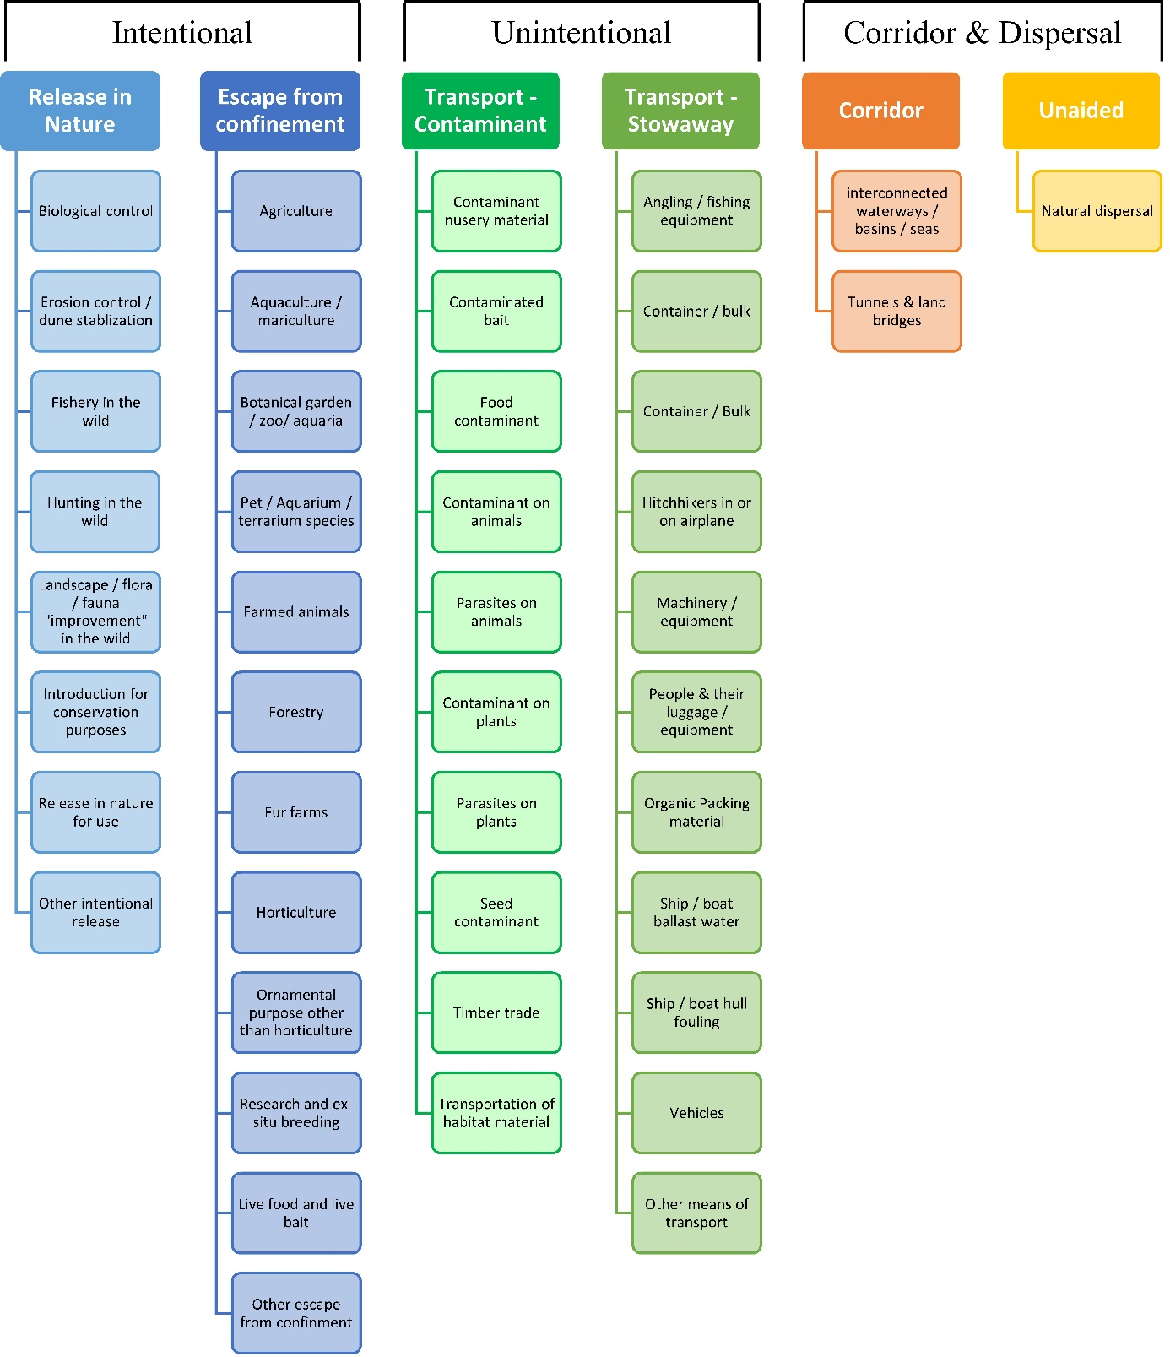

ANNEX V Ecosystem services classification (CICES V5.1, simplified) and examples
For the purposes of this risk assessment, please feel free to use what seems as the most appropriate category / level / combination of impact (Section – Division – Group), reflecting information available.

Section | Division | Group | Examples (i.e. relevant CICES “classes”)
Provisioning | Biomass | Cultivated terrestrial plants | Cultivated terrestrial plants (including fungi, algae) grown for nutritional purposes;  Fibres and other materials from cultivated plants, fungi, algae and bacteria for direct use or processing (excluding genetic materials);  Cultivated plants (including fungi, algae) grown as a source of energy  Example: negative impacts of non-native organisms to crops, orchards, timber etc.
 |  | Cultivated aquatic plants | Plants cultivated by in- situ aquaculture grown for nutritional purposes;  Fibres and other materials from in-situ aquaculture for direct use or processing (excluding genetic materials);  Plants cultivated by in- situ aquaculture grown as an energy source.  Example: negative impacts of non-native organisms to aquatic plants cultivated for nutrition, gardening etc. purposes.
 |  | Reared animals | Animals reared for nutritional purposes;  Fibres and other materials from reared animals for direct use or processing (excluding genetic materials);  Animals reared to provide energy (including mechanical)  Example: negative impacts of non-native organisms to livestock
 |  | Reared aquatic animals | Animals reared by in-situ aquaculture for nutritional purposes;  Fibres and other materials from animals grown by in-situ aquaculture for direct use or processing (excluding genetic materials);  Animals reared by in-situ aquaculture as an energy source  Example: negative impacts of non-native organisms to fish farming
 |  | Wild plants (terrestrial and aquatic) | Wild plants (terrestrial and aquatic, including fungi, algae) used for nutrition;  Fibres and other materials from wild plants for direct use or processing (excluding genetic materials);  Wild plants (terrestrial and aquatic, including fungi, algae) used as a source of energy  Example: reduction in the availability of wild plants (e.g. wild berries, ornamentals) due to non-native organisms (competition, spread of disease etc.)
 |  | Wild animals (terrestrial and aquatic) | Wild animals (terrestrial and aquatic) used for nutritional purposes;  Fibres and other materials from wild animals for direct use or processing (excluding genetic materials);  Wild animals (terrestrial and aquatic) used as a source of energy  Example: reduction in the availability of wild animals (e.g. fish stocks, game) due to non-native organisms (competition, predations, spread of disease etc.)
 | Genetic material from all biota | Genetic material from plants, algae or fungi | Seeds, spores and other plant materials collected for maintaining or establishing a population;  Higher and lower plants (whole organisms) used to breed new strains or varieties;  Individual genes extracted from higher and lower plants for the design and construction of new biological entities  Example: negative impacts of non-native organisms due to interbreeding
 |  | Genetic material from animals | Animal material collected for the purposes of maintaining or establishing a population;  Wild animals (whole organisms) used to breed new strains or varieties;  Individual genes extracted from organisms for the design and construction of new biological entities  Example: negative impacts of non-native organisms due to interbreeding
 | Water | Surface water used for nutrition, materials or energy | Surface water for drinking;  Surface water used as a material (non-drinking purposes);  Freshwater surface water, coastal and marine water used as an energy source  Example: loss of access to surface water due to spread of non-native organisms
 |  | Ground water for used for nutrition, materials or energy | Ground (and subsurface) water for drinking;  Ground water (and subsurface) used as a material (non-drinking purposes);  Ground water (and subsurface) used as an energy source  Example: reduced availability of ground water due to spread of non-native organisms and associated increase of ground water consumption by vegetation.
Regulation & Maintenance | Transformation of biochemical or physical inputs to ecosystems | Mediation of wastes or toxic substances of anthropogenic origin by living processes | Bio-remediation by micro-organisms, algae, plants, and animals; Filtration/sequestration/storage/accumulation by micro-organisms, algae, plants, and animals  Example: changes caused by non-native organisms to ecosystem functioning and ability to filtrate etc. waste or toxics
 |  | Mediation of nuisances of anthropogenic origin | Smell reduction; noise attenuation; visual screening (e.g. by means of green infrastructure)  Example: changes caused by non-native organisms to ecosystem structure, leading to reduced ability to mediate nuisances.
 | Regulation of physical, chemical, biological conditions | Baseline flows and extreme event regulation | Control of erosion rates;  Buffering and attenuation of mass movement;  Hydrological cycle and water flow regulation (Including flood control, and coastal protection);  Wind protection;  Fire protection  Example: changes caused by non-native organisms to ecosystem functioning or structure leading to, for example, destabilisation of soil, increased risk or intensity of wild fires etc.
 |  | Lifecycle maintenance, habitat and gene pool protection | Pollination (or 'gamete' dispersal in a marine context);  Seed dispersal;  Maintaining nursery populations and habitats (Including gene pool protection)  Example: changes caused by non-native organisms to the abundance and/or distribution of wild pollinators; changes to the availability / quality of nursery habitats for fisheries
 |  | Pest and disease control | Pest control;  Disease control  Example: changes caused by non-native organisms to the abundance and/or distribution of pests
 |  | Soil quality regulation | Weathering processes and their effect on soil quality;  Decomposition and fixing processes and their effect on soil quality  Example: changes caused by non-native organisms to vegetation structure and/or soil fauna leading to reduced soil quality
 |  | Water conditions | Regulation of the chemical condition of freshwaters by living processes;  Regulation of the chemical condition of salt waters by living processes  Example: changes caused by non-native organisms to buffer strips along water courses that remove nutrients in runoff and/or fish communities that regulate the resilience and resistance of water bodies to eutrophication
 |  | Atmospheric composition and conditions | Regulation of chemical composition of atmosphere and oceans;  Regulation of temperature and humidity, including ventilation and transpiration  Example: changes caused by non-native organisms to ecosystems’ ability to sequester carbon and/or evaporative cooling (e.g. by urban trees)
Cultural | Direct, in-situ and outdoor interactions with living systems that depend on presence in the environmental setting | Physical and experiential interactions with natural environment | Characteristics of living systems that that enable activities promoting health, recuperation or enjoyment through active or immersive interactions;  Characteristics of living systems that enable activities promoting health, recuperation or enjoyment through passive or observational interactions  Example: changes caused by non-native organisms to the qualities of ecosystems (structure, species composition etc.) that make it attractive for recreation, wild life watching etc.
 |  | Intellectual and representative interactions with natural environment | Characteristics of living systems that enable scientific investigation or the creation of traditional ecological knowledge;  Characteristics of living systems that enable education and training;  Characteristics of living systems that are resonant in terms of culture or heritage;  Characteristics of living systems that enable aesthetic experiences  Example: changes caused by non-native organisms to the qualities of ecosystems (structure, species composition etc.) that have cultural importance
 | Indirect, remote, often indoor interactions with living systems that do not require presence in the environmental setting | Spiritual, symbolic and other interactions with natural environment | Elements of living systems that have symbolic meaning;  Elements of living systems that have sacred or religious meaning;  Elements of living systems used for entertainment or representation  Example: changes caused by non-native organisms to the qualities of ecosystems (structure, species composition etc.) that have sacred or religious meaning
 |  | Other biotic characteristics that have a non-use value | Characteristics or features of living systems that have an existence value;  Characteristics or features of living systems that have an option or bequest value  Example: changes caused by non-native organisms to ecosystems designated as wilderness areas, habitats of endangered species etc.

ANNEX VI EU Biogeographic Regions and MSFD Subregions
See https://www.eea.europa.eu/data-and-maps/figures/biogeographical-regions-in-europe-2 ,
http://ec.europa.eu/environment/nature/natura2000/biogeog_regions/

and

https://www.eea.europa.eu/data-and-maps/data/msfd-regions-and-subregions-1/technical-document/pdf
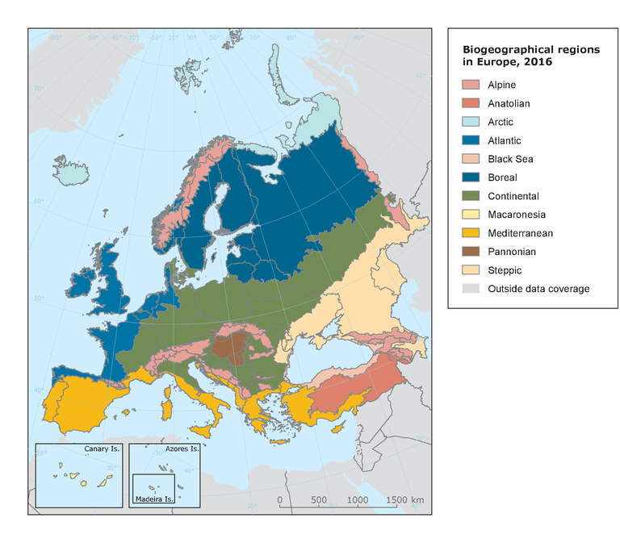

ANNEX VII Delegated Regulation (EU) 2018/968 of 30 April 2018
see https://eur-lex.europa.eu/legal-content/en/TXT/?uri=CELEX%3A32018R0968

ANNEX VIII Species Distribution Model
Projection of environmental suitability for Platydemus manokwari establishment in Europe

Björn Beckmann, Archie Murchie and Dan Chapman
30 May 2020

Aim
To project the suitability for potential establishment of Platydemus manokwari in Europe, under current and predicted future climatic conditions.

Data for modelling
Species occurrence data were obtained from iNaturalist (321 records), the Global Biodiversity Information Facility (GBIF) (114 records), the Biodiversity Information Serving Our Nation database (BISON) (23 records), the Integrated Digitized Biocollections (iDigBio) (3 records), and a small number of additional records from the risk assessment team. The Pindaunde station record at 3625 m elevation on Mount Wilhelm referenced earlier in the risk assessment was included as a natural site. We scrutinised occurrence records from regions where the species is not known to be established and removed any dubious records (e.g. fossils) or where the georeferencing was too imprecise (e.g. records referenced to a country or island centroid) or outside of the coverage of the predictor layers. The remaining records were gridded at a 0.25 x 0.25 degree resolution for modelling, yielding 134 grid cells with occurrences (Figure 1a). As a proxy for recording effort, the density of Platyhelminthes records held by GBIF was also compiled on the same grid (Figure 1b).

Figure 1. (a) Occurrence records obtained for Platydemus manokwari and used in the modelling, showing native and invaded distributions. (b) The recording density of Platyhelminthes on GBIF, which was used as a proxy for recording effort.

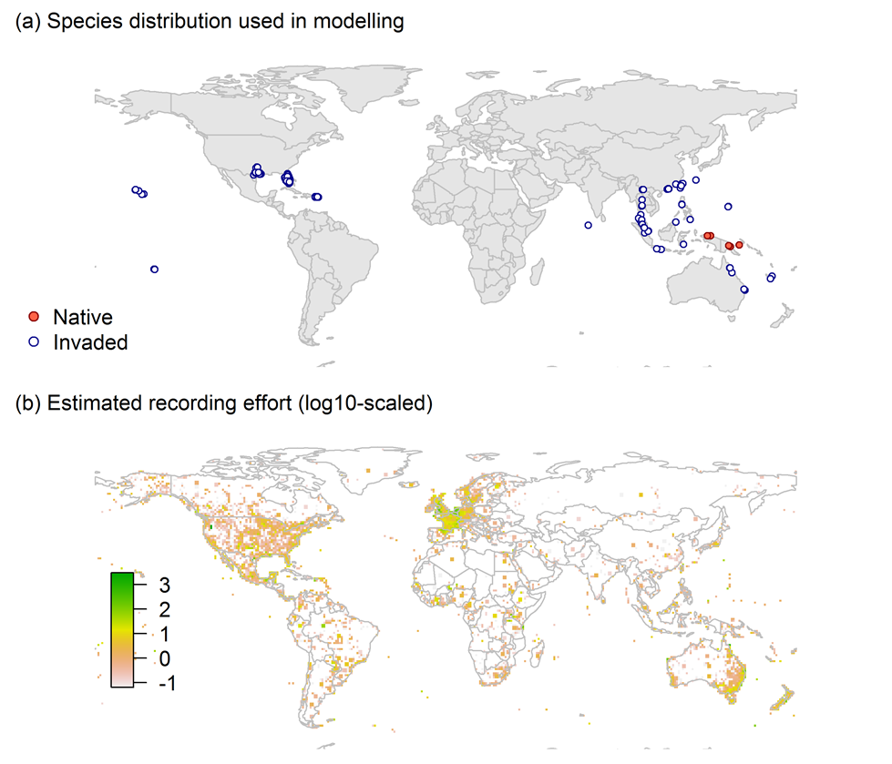
Climate data were selected from the ‘Bioclim’ variables contained within the WorldClim database (Hijmans et al., 2005), originally at 5 arcminute resolution (0.083 x 0.083 degrees of longitude/latitude) and aggregated to a 0.25 x 0.25 degree grid for use in the model.
Based on the biology of Platydemus manokwari, the following climate variables were used in the modelling:
- Minimum temperature of the coldest month (Bio6)
- Mean temperature of the warmest quarter (Bio10)
- Annual precipitation (Bio12)
- Precipitation seasonality (Bio15)

- Climatic moisture index (CMI): ratio of mean annual precipitation to potential evapotranspiration, log+1 transformed. For its calculation, monthly potential evapotranspirations were estimated from the WorldClim monthly temperature data and solar radiation using the simple method of Zomer et al. (2008) which is based on the Hargreaves evapotranspiration equation (Hargreaves, 1994).
To estimate the effect of climate change on the potential distribution, equivalent modelled future climate conditions for the 2070s under the Representative Concentration Pathways (RCP) 2.6 and 4.5 were also obtained. These represent low and medium emissions scenarios, respectively. The above variables were obtained as averages of outputs of eight Global Climate Models (BCC-CSM1-1, CCSM4, GISS-E2-R, HadGEM2-AO, IPSL-CM5A-LR, MIROC-ESM, MRI-CGCM3, NorESM1-M), downscaled and calibrated against the WorldClim baseline (see http://www.worldclim.org/cmip5_5m ).

Species distribution model
A presence-background (presence-only) ensemble modelling strategy was employed using the BIOMOD2 R package version 3.4.6 (Thuiller et al., 2020, Thuiller et al., 2009). These models contrast the environment at the species’ occurrence locations against a random sample of the global background environmental conditions (often termed ‘pseudo-absences’) in order to characterise and project suitability for occurrence. This approach has been developed for distributions that are in equilibrium with the environment. Because invasive species’ distributions are not at equilibrium and subject to dispersal constraints at a global scale, we took care to minimise the inclusion of locations suitable for the species but where it has not been able to disperse to (Chapman et al. 2019). Therefore the background sampling region included:
- The area accessible by native Platydemus manokwari populations, in which the species is likely to have had sufficient time to disperse to all locations. Based on presumed maximum dispersal distances, the accessible region was defined as a 400km buffer around the native range occurrences; AND
- A 30km buffer around the non-native occurrences, encompassing regions likely to have had high propagule pressure for introduction by humans and/or dispersal of the species; AND
- Regions where we have an a priori expectation of high unsuitability for the species so that absence is assumed irrespective of dispersal constraints (see Figure 2). The following rules were applied to define a region expected to be highly unsuitable for Platydemus manokwari at the spatial scale of the model:
  - Minimum temperature of the coldest month (Bio6) < 0
  - Mean temperature of the warmest quarter (Bio10) < 10
  - Climatic moisture index (CMI) < log1p(0.5)

Altogether, only 1.5% of occurrence grid cells were located in the unsuitable background region.
Within the unsuitable background region, 10 samples of 5000 randomly sampled grid cells were obtained. In the accessible background (comprising the accessible areas around native and non-native occurrences as detailed above), the same number of pseudo-absence samples were drawn as there were presence records (134), weighting the sampling by a proxy for recording effort (Figure 2).

Figure 2. The background from which pseudo-absence samples were taken in the modelling of Platydemus manokwari. Samples were taken from a 400km buffer around the native range and a 30km buffer around non-native occurrences (together forming the accessible background), and from areas expected to be highly unsuitable for the species (the unsuitable background region). Samples from the accessible background were weighted by a proxy for recording effort (Figure 1(b)).

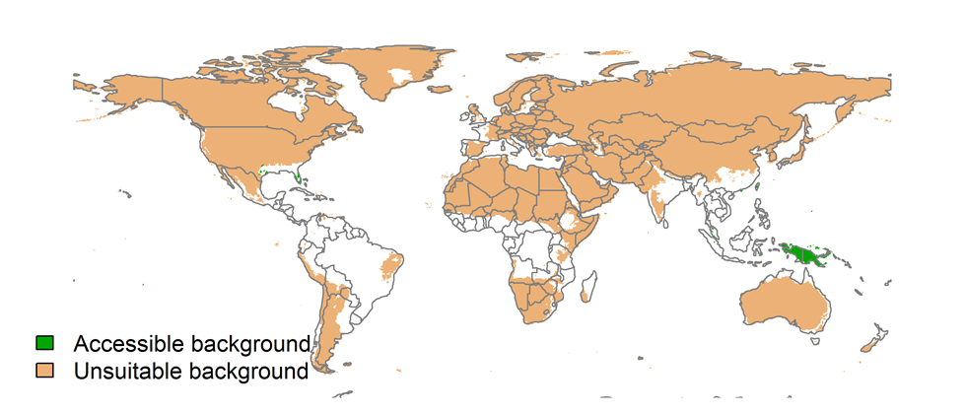
Each dataset (i.e. combination of the presences and the individual background samples) was randomly split into 80% for model training and 20% for model evaluation. With each training dataset, five statistical algorithms were fitted with the default BIOMOD2 settings and rescaled using logistic regression, except where specified below:
- Generalised linear model (GLM)
- Generalised boosting model (GBM)
- Generalised additive model (GAM) with a maximum of four degrees of freedom per smoothing spline
- Random forest (RF)
- Maxent

Since the total background sample was larger than the number of occurrences, prevalence fitting weights were applied to give equal overall importance to the occurrences and the background. Normalised variable importance was assessed and variable response functions were produced using BIOMOD2’s default procedure.
Model predictive performance was assessed by the following three measures:
- AUC, the area under the receiver operating characteristic curve (Fielding & Bell 1997). Predictions of presence-absence models can be compared with a subset of records set aside for model evaluation (here 20%) by constructing a confusion matrix with the number of true positive, false positive, false negative and true negative cases. For models generating non-dichotomous scores (as here) a threshold can be applied to transform the scores into a dichotomous set of presence-absence predictions. Two measures that can be derived from the confusion matrix are sensitivity (the proportion of observed presences that are predicted as such, quantifying omission errors), and specificity (the proportion of observed absences that are predicted as such, quantifying commission errors). A receiver operating characteristic (ROC) curve can be constructed by using all possible thresholds to classify the scores into confusion matrices, obtaining sensitivity and specificity for each matrix, and plotting sensitivity against the corresponding proportion of false positives (equal to 1 - specificity). The use of all possible thresholds avoids the need for a selection of a single threshold, which is often arbitrary, and allows appreciation of the trade-off between sensitivity and specificity. The area under the ROC curve (AUC) is often used as a single threshold-independent measure for model performance (Manel, Williams & Ormerod 2001). AUC is the probability that a randomly selected presence has a higher model-predicted suitability than a randomly selected absence (Allouche et al. 2006).
- Cohen’s Kappa (Cohen 1960). This measure corrects the overall accuracy of model predictions (ratio of the sum of true presences plus true absences to the total number of records) by the accuracy expected to occur by chance. The kappa statistic ranges from -1 to +1, where +1 indicates perfect agreement and values of zero or less indicate a performance no better than random. Advantages of kappa are its simplicity, the fact that both commission and omission errors are accounted for in one parameter, and its relative tolerance to zero values in the confusion matrix (Manel, Williams & Ormerod 2001). However, Kappa has been criticised for being sensitive to prevalence (the proportion of sites in which the species was recorded as present) and may therefore be inappropriate for comparisons of model accuracy between species or regions (McPherson, Jetz & Rogers 2004, Allouche et al. 2006).
- TSS, the true skill statistic (Allouche et al. 2006). TSS is defined as sensitivity + specificity - 1, and corrects for Kappa’s dependency on prevalence. TSS compares the number of correct forecasts, minus those attributable to random guessing, to that of a hypothetical set of perfect forecasts. Like kappa, TSS takes into account both omission and commission errors, and success as a result of random guessing, and ranges from -1 to +1, where +1 indicates perfect agreement and values of zero or less indicate a performance no better than random (Allouche et al. 2006).
An ensemble model was created by first rejecting poorly performing algorithms with relatively extreme low AUC values and then averaging the predictions of the remaining algorithms, weighted by their AUC. To identify poorly performing algorithms, AUC values were converted into modified z-scores based on their difference to the median and the median absolute deviation across all algorithms (Iglewicz & Hoaglin, 1993). Algorithms with z < -2 were rejected. In this way, ensemble projections were made for each dataset and then averaged to give an overall suitability, as well as its standard deviation. The projections were then classified into suitable and unsuitable regions using the ‘minROCdist’ method, which minimizes the distance between the ROC plot and the upper left corner of the plot (point (0,1)).
We also produced limiting factor maps for Europe following Elith et al. (2010). For this, projections were made separately with each individual variable fixed at a near-optimal value. These were chosen as the median values at the occurrence grid cells. Then, the most strongly limiting factors were identified as the one resulting in the highest increase in suitability in each grid cell.

Results
The ensemble model suggested that suitability for Platydemus manokwari was most strongly determined by Annual precipitation (Bio12), accounting for 42.8% of variation explained, followed by Minimum temperature of the coldest month (Bio6) (34.1%), Climatic moisture index (CMI) (9.5%), Mean temperature of the warmest quarter (Bio10) (8.8%) and Precipitation seasonality (Bio15) (4.8%) (Table 1, Figure 3).

Table 1. Summary of the cross-validation predictive performance (AUC, Kappa, TSS) and variable importance of the fitted model algorithms and the ensemble (AUC-weighted average of the best performing algorithms). Results are the average from models fitted to 10 different background samples of the data.
 |  |  |  |  | Variable importance (%)
Algorithm | AUC | Kappa | TSS | Used in the ensemble | Annual precipitation (Bio12) | Minimum temperature of the coldest month (Bio6) | Climatic moisture index (CMI) | Mean temperature of the warmest quarter (Bio10) | Precipitation seasonality (Bio15)
GLM | 0.987 | 0.643 | 0.964 | yes | 42 | 30 | 6 | 11 | 11
GAM | 0.987 | 0.649 | 0.965 | yes | 32 | 34 | 14 | 15 | 5
GBM | 0.981 | 0.660 | 0.954 | yes | 53 | 41 | 4 | 2 | 0
RF | 0.979 | 0.659 | 0.956 | no | 40 | 32 | 15 | 11 | 2
Maxent | 0.984 | 0.658 | 0.942 | yes | 44 | 32 | 14 | 7 | 2
Ensemble | 0.986 | 0.655 | 0.967 |  | 43 | 34 | 10 | 9 | 5

Figure 3. Partial response plots from the fitted models. Thin coloured lines show responses from the algorithms in the ensemble, while the thick black line is their ensemble. In each plot, other model variables are held at their median value in the training data. Some of the divergence among algorithms is because of their different treatment of interactions among variables.
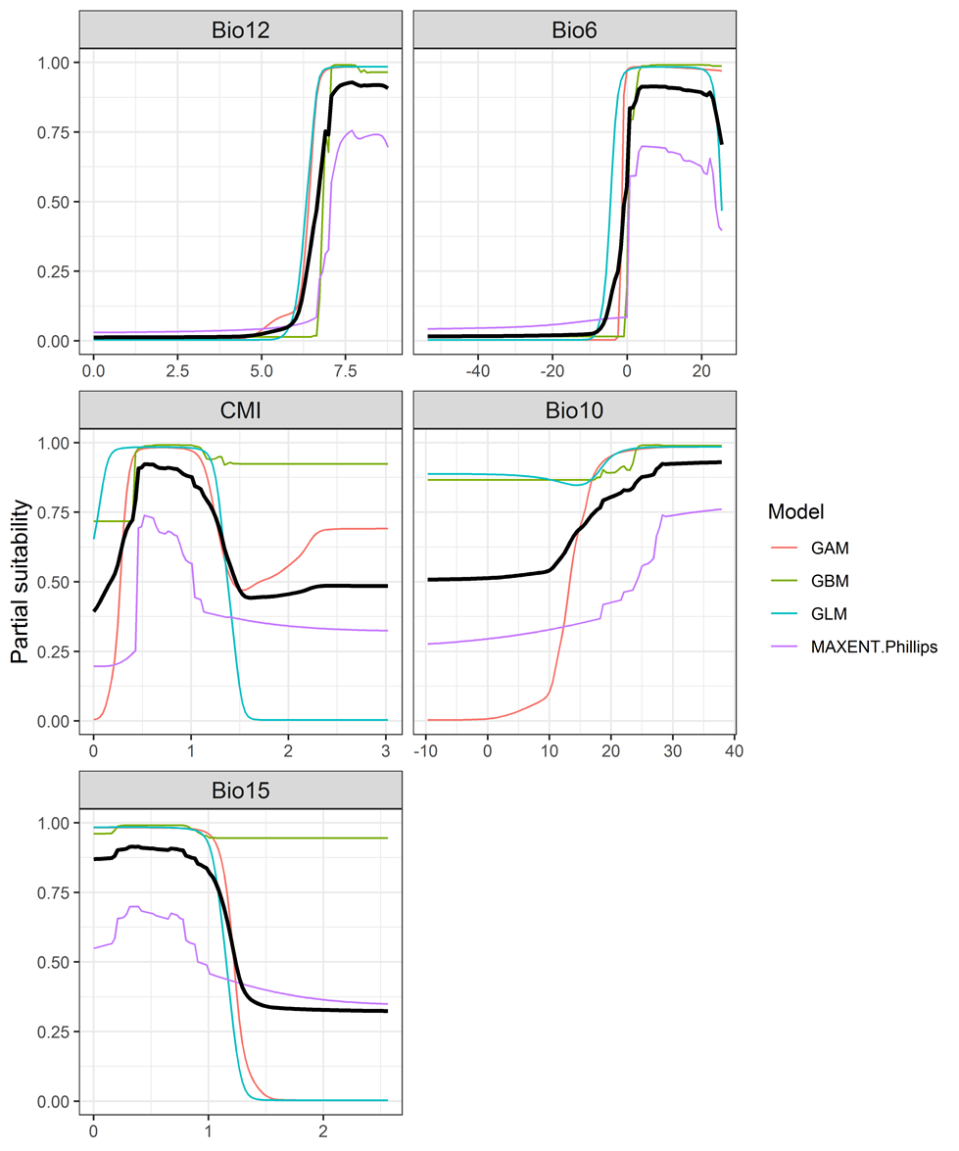

Figure 4. (a) Projected global suitability for Platydemus manokwari establishment in the current climate. For visualisation, the projection has been aggregated to a 0.5 x 0.5 degree resolution, by taking the maximum suitability of constituent higher resolution grid cells. Values > 0.4 may be suitable for the species. (b) Uncertainty in the ensemble projections, expressed as the among-algorithm standard deviation in predicted suitability, averaged across the 10 datasets.

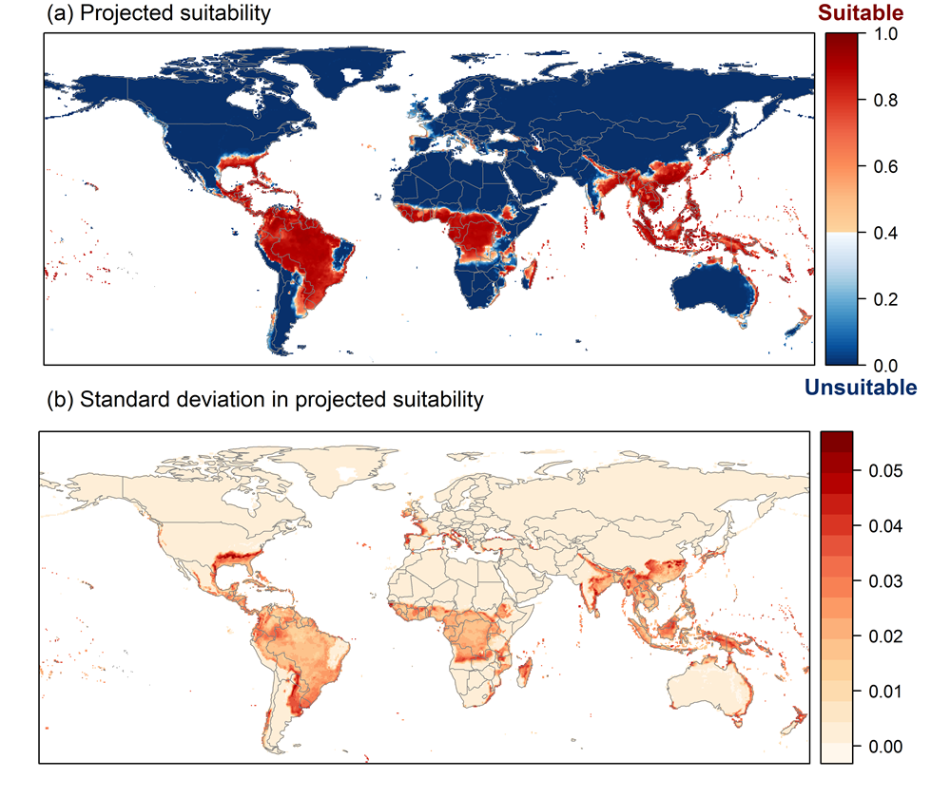

Figure 5. (a) Projected current suitability for Platydemus manokwari establishment in Europe and the Mediterranean region. (b) Uncertainty in the ensemble projections, expressed as the among-algorithm standard deviation in predicted suitability, averaged across the 10 datasets.
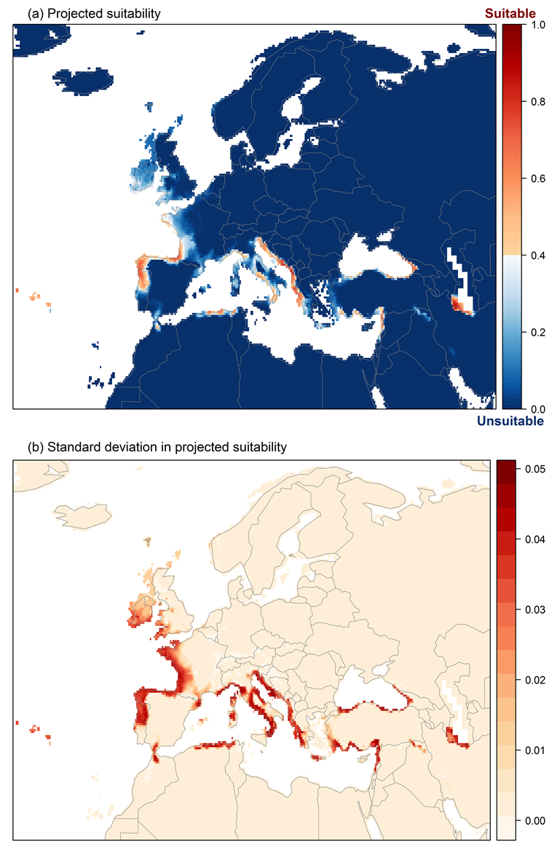

Figure 6. The most strongly limiting factors for Platydemus manokwari establishment estimated by the model in Europe and the Mediterranean region in current climatic conditions.
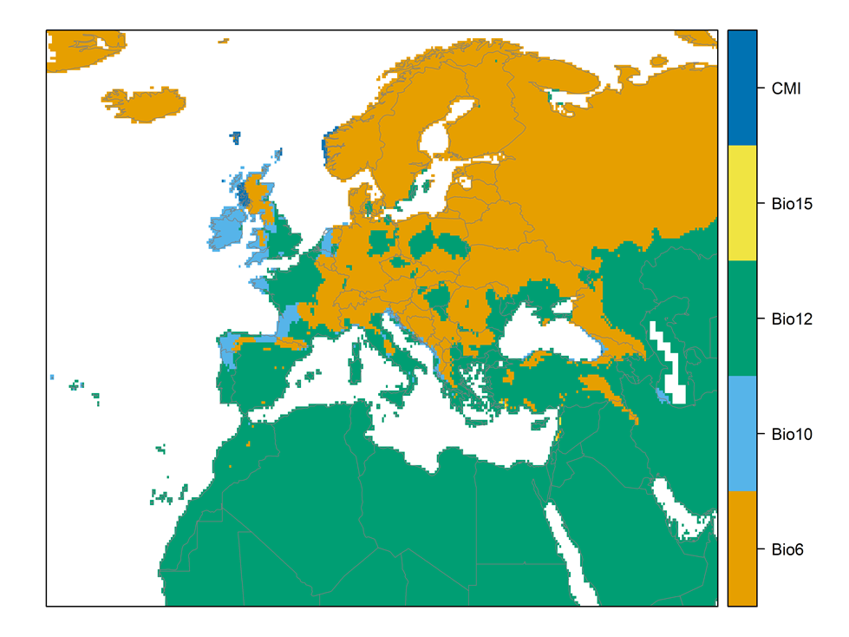

Figure 7. (a) Projected suitability for Platydemus manokwari establishment in Europe and the Mediterranean region in the 2070s under climate change scenario RCP2.6, equivalent to Figure 5. (b) Uncertainty in the ensemble projections, expressed as the among-algorithm standard deviation in predicted suitability, averaged across the 10 datasets.

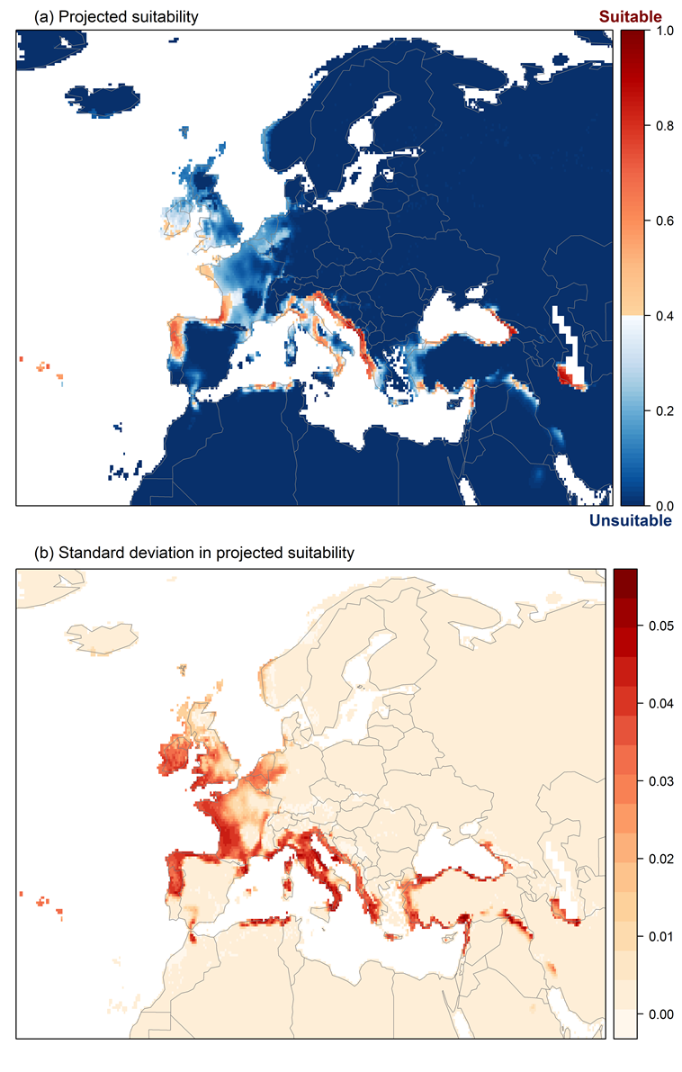

Figure 8. (a) Projected suitability for Platydemus manokwari establishment in Europe and the Mediterranean region in the 2070s under climate change scenario RCP4.5, equivalent to Figure 5. (b) Uncertainty in the ensemble projections, expressed as the among-algorithm standard deviation in predicted suitability, averaged across the 10 datasets.
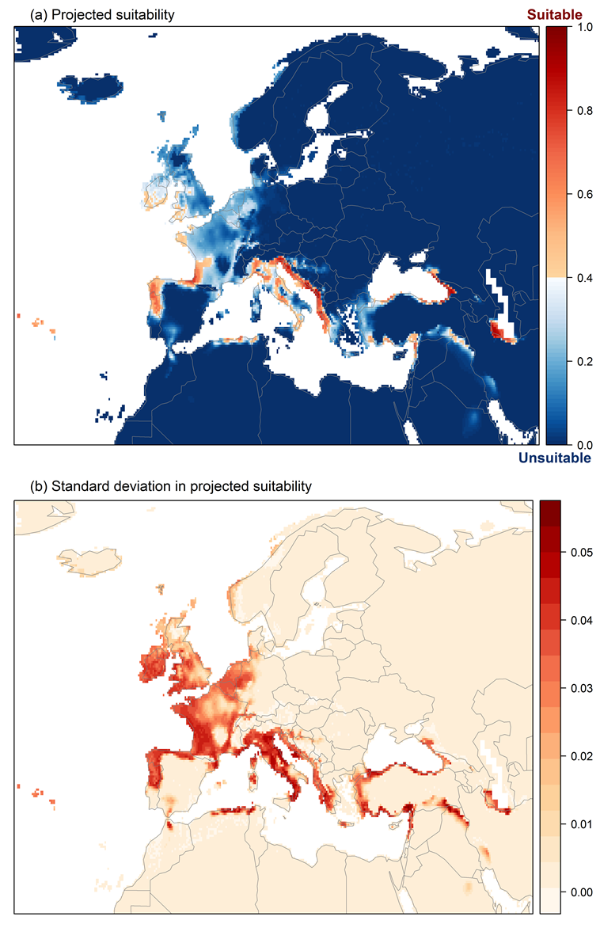

Figure 9. Variation in projected suitability for Platydemus manokwari establishment among Biogeographical regions of Europe (Bundesamt für Naturschutz (BfN), 2003). The bar plots show the proportion of grid cells in each region classified as suitable in the current climate and projected climate for the 2070s under two RCP emissions scenarios. The location of each region is also shown. The Arctic and Macaronesian biogeographical regions are not part of the study area, but are included for completeness.

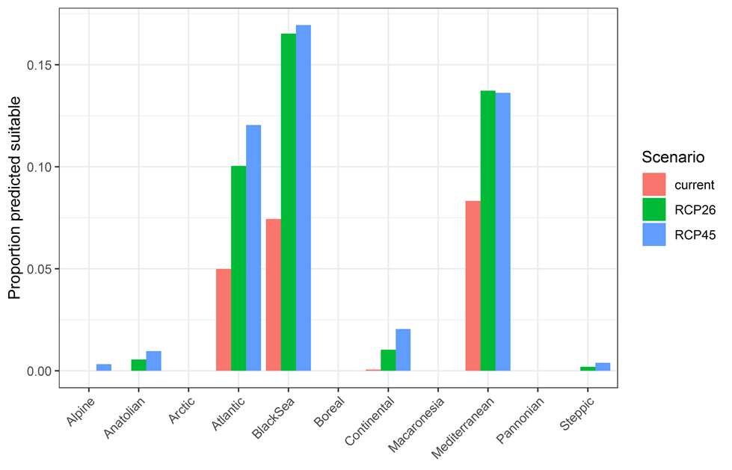
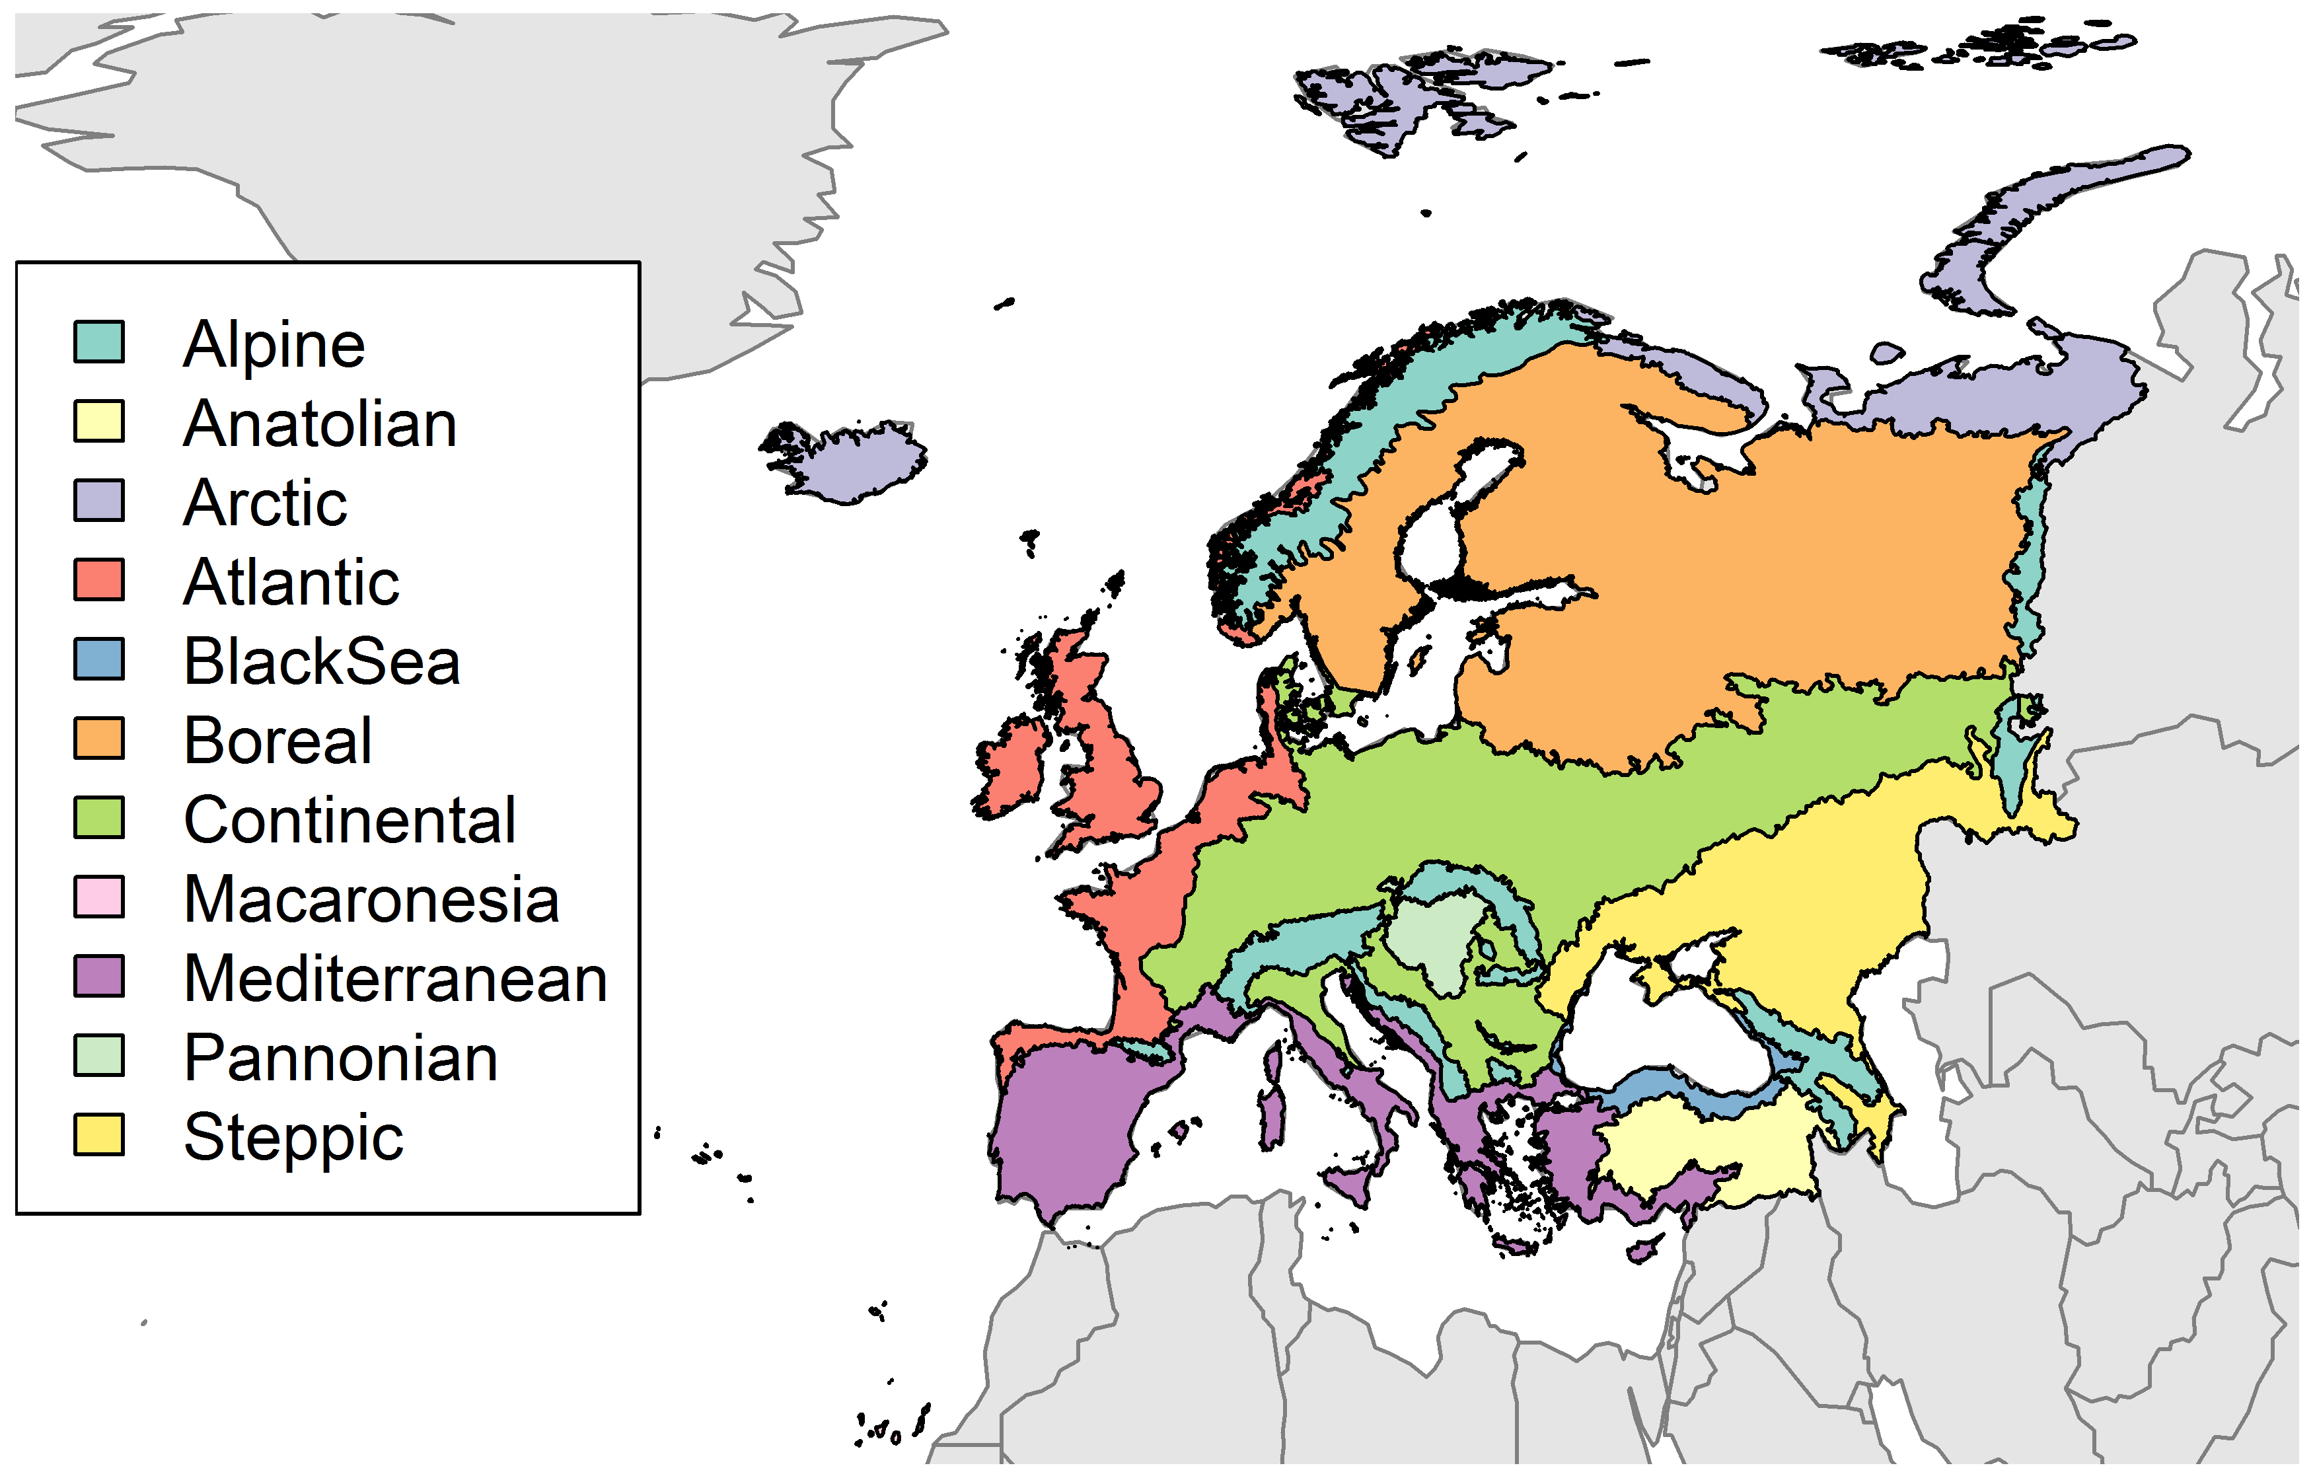

Table 2. Variation in projected suitability for Platydemus manokwari establishment among Biogeographical regions of Europe (numerical values of Figure 9 above). The numbers are the proportion of grid cells in each region classified as suitable in the current climate and projected climate for the 2070s under two RCP emissions scenarios. The Arctic and Macaronesian biogeographical regions are not part of the study area, but are included for completeness.
Region | Current climate | RCP26 | RCP45
Alpine | 0.00 | 0.00 | 0.00
Anatolian | 0.00 | 0.01 | 0.01
Arctic | 0.00 | 0.00 | 0.00
Atlantic | 0.05 | 0.10 | 0.12
BlackSea | 0.07 | 0.17 | 0.17
Boreal | 0.00 | 0.00 | 0.00
Continental | 0.00 | 0.01 | 0.02
Macaronesia | 0.00 | 0.00 | 0.00
Mediterranean | 0.08 | 0.14 | 0.14
Pannonian | 0.00 | 0.00 | 0.00
Steppic | 0.00 | 0.00 | 0.00

Figure 10. Variation in projected suitability for Platydemus manokwari establishment among European Union countries and the UK. The bar plots show the proportion of grid cells in each country classified as suitable in the current climate and projected climate for the 2070s under two RCP emissions scenarios.

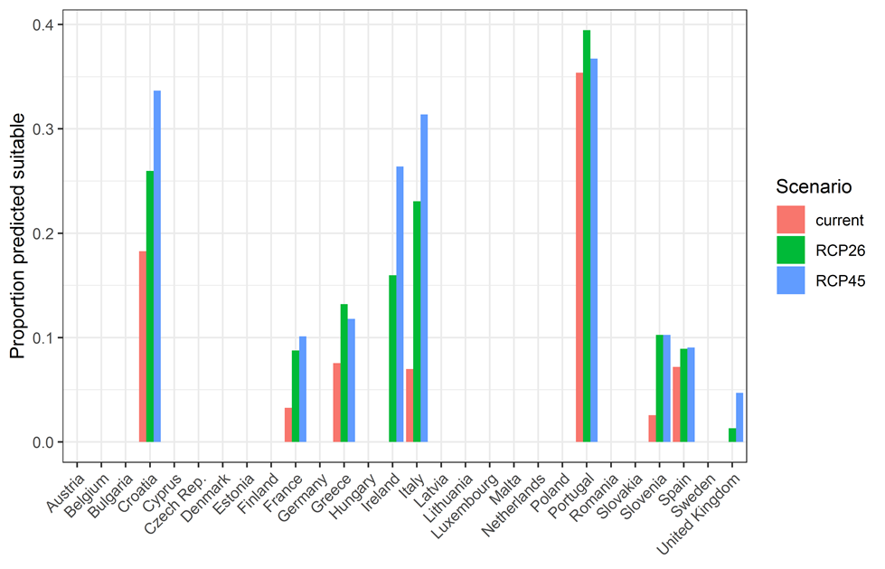

Table 3. Variation in projected suitability for Platydemus manokwari establishment among European Union countries and the UK (numerical values of Figure 10 above). The numbers are the proportion of grid cells in each country classified as suitable in the current climate and projected climate for the 2070s under two RCP emissions scenarios.
Country | Current climate | RCP26 | RCP45
Austria | 0.00 | 0.00 | 0.00
Belgium | 0.00 | 0.00 | 0.00
Bulgaria | 0.00 | 0.00 | 0.00
Croatia | 0.18 | 0.26 | 0.34
Cyprus | 0.00 | 0.00 | 0.00
Czech Rep. | 0.00 | 0.00 | 0.00
Denmark | 0.00 | 0.00 | 0.00
Estonia | 0.00 | 0.00 | 0.00
Finland | 0.00 | 0.00 | 0.00
France | 0.03 | 0.09 | 0.10
Germany | 0.00 | 0.00 | 0.00
Greece | 0.08 | 0.13 | 0.12
Hungary | 0.00 | 0.00 | 0.00
Ireland | 0.00 | 0.16 | 0.26
Italy | 0.07 | 0.23 | 0.31
Latvia | 0.00 | 0.00 | 0.00
Lithuania | 0.00 | 0.00 | 0.00
Luxembourg | 0.00 | 0.00 | 0.00
Malta | 0.00 | 0.00 | 0.00
Netherlands | 0.00 | 0.00 | 0.00
Poland | 0.00 | 0.00 | 0.00
Portugal | 0.35 | 0.39 | 0.37
Romania | 0.00 | 0.00 | 0.00
Slovakia | 0.00 | 0.00 | 0.00
Slovenia | 0.03 | 0.10 | 0.10
Spain | 0.07 | 0.09 | 0.09
Sweden | 0.00 | 0.00 | 0.00
United Kingdom | 0.00 | 0.01 | 0.05

Caveats to the modelling
To remove spatial recording biases, the selection of the background sample from the accessible background was weighted by the density of Platyhelminthes records on the Global Biodiversity Information Facility (GBIF). While this is preferable to not accounting for recording bias at all, it may not provide the perfect measure of recording bias.
There was substantial variation among modelling algorithms in the partial response plots (Figure 3). In part this will reflect their different treatment of interactions among variables. Since partial plots are made with other variables held at their median, there may be values of a particular variable at which this does not provide a realistic combination of variables to predict from.
Other variables potentially affecting the distribution of the species, such as types of land cover were not included in the model.

References
- Allouche O, Tsoar A, Kadmon R (2006) Assessing the accuracy of species distribution models: prevalence, kappa and the true skill statistic (TSS), Journal of Applied Ecology, 43, 1223-1232.
- Bundesamt für Naturschutz (Bfn) (2003) Map of natural vegetation of Europe. Web site: http://www.bfn.de/. National data included.
- Chapman D, Pescott OL, Roy HE, Tanner R (2019) Improving species distribution models for invasive non-native species with biologically informed pseudo-absence selection. Journal of Biogeography, https://doi.org/10.1111/jbi.13555.
- Cohen J (1960) A coefficient of agreement of nominal scales. Educational and Psychological Measurement, 20, 37-46.
- Elith J, Kearney M, Phillips S (2010) The art of modelling range-shifting species. Methods in Ecology and Evolution, 1, 330-342.
- Fielding AH, Bell JF (1997) A review of methods for the assessment of prediction errors in conservation presence/absence models. Environmental Conservation, 24, 38-49.
- Hargreaves GH (1994) Defining and Using Reference Evapotranspiration. Journal of Irrigation and Drainage Engineering, 120.
- Hijmans RJ, Cameron SE, Parra JL, Jones PG, Jarvis A (2005) Very high resolution interpolated climate surfaces for global land areas. International Journal of Climatology, 25, 1965-1978.
- Iglewicz B, Hoaglin DC (1993) How to detect and handle outliers, Asq Press.
- Manel S, Williams HC, Ormerod SJ (2001) Evaluating presence-absence models in ecology: the need to account for prevalence. Journal of Applied Ecology, 38, 921-931.
- McPherson JM, Jetz W, Rogers DJ (2004) The effects of species’ range sizes on the accuracy of distribution models: ecological phenomenon or statistical artefact? Journal of Applied Ecology, 41, 811-823.
- Thuiller W, Lafourcade B, Engler R, Araújo MB (2009) BIOMOD-a platform for ensemble forecasting of species distributions. Ecography, 32, 369-373.
- Thuiller W, Georges D, Engler R and Breiner F (2020). biomod2: Ensemble Platform for Species Distribution Modeling. R package version 3.4.6. https://CRAN.R-project.org/package=biomod2
- Zomer RJ, Trabucco A, Bossio DA, Verchot LV (2008) Climate change mitigation: A spatial analysis of global land suitability for clean development mechanism afforestation and reforestation. Agriculture, Ecosystems & Environment, 126, 67-80.

This template is based on the Great Britain non-native species risk assessment scheme (GBNNRA). A number of amendments have been introduced to ensure compliance with Regulation (EU) 1143/2014 on IAS and relevant legislation, including the Delegated Regulation (EU) 2018/968 of 30 April 2018, supplementing Regulation (EU) No 1143/2014 of the European Parliament and of the Council with regard to risk assessments in relation to invasive alien species (see https://eur-lex.europa.eu/legal-content/en/TXT/?uri=CELEX%3A32018R0968 ).
Convention on Biological Diversity, Decision VI/23
https://circabc.europa.eu/sd/a/738e82a8-f0a6-47c6-8f3b-aeddb535b83b/TSSR-2016-010%20CBD%20categories%20on%20pathways%20Final.pdf
https://circabc.europa.eu/sd/a/0aeba7f1-c8c2-45a1-9ba3-bcb91a9f039d/TSSR-2016-010%20CBD%20pathways%20key%20full%20only.pdf
Not to be confused with “no impact”.
Note: in the CICES classification provisioning of water is considered as an abiotic service whereas the rest of ecosystem services listed here are considered biotic.

