Risk assessment template developed under the "Study on Invasive Alien Species – Development of risk assessments to tackle priority species and enhance prevention"
Contract No 07.0202/2020/834529/ETU/ENV.D.2

Name of organism: Mulinia lateralis (Say, 1822)

Author(s) of the assessment:
Christine A. Wood, The Marine Biological Association, Plymouth, UK
Marika Galanidi, Dr, Ustun Energy Engineering Ltd, Izmir, Turkey
Björn Beckmann, Dr, Centre for Ecology & Hydrology, Edinburgh, UK

Risk Assessment Area: The risk assessment area is the territory of the European Union 27 and the United Kingdom, excluding the EU-outermost regions.

Peer review 1: Argyro Zenetos, Hellenic Centre for Marine Reseach, Anavyssos, Greece
Peer review 2: Francis Kerckhof, Royal Belgian Institute of Natural Sciences (RBINS), Oostende, Belgium

Date of completion: 15/10/2021
Date of revision: 30 September 2022

Contents
SECTION A – Organism Information and Screening 3
SECTION B – Detailed assessment 15
1 PROBABILITY OF INTRODUCTION AND ENTRY 15
2 PROBABILITY OF ESTABLISHMENT 28
3 PROBABILITY OF SPREAD 38
4 MAGNITUDE OF IMPACT 59
RISK SUMMARIES 76
REFERENCES 79
Distribution Summary 92
ANNEX I Scoring of Likelihoods of Events 94
ANNEX II Scoring of Magnitude of Impacts 95
ANNEX III Scoring of Confidence Levels 96
ANNEX IV CBD pathway categorisation scheme 97
ANNEX V Ecosystem services classification (CICES V5.1, simplified) and examples 98
ANNEX VI EU Biogeographic Regions and MSFD Subregions 102
ANNEX VII Delegated Regulation (EU) 2018/968 of 30 April 2018 103
ANNEX VIII Mulinia lateralis physiological requirements and thresholds 104
ANNEX IX Species Distribution Model 106

SECTION A – Organism Information and Screening
A1. Identify the organism. Is it clearly a single taxonomic entity and can it be adequately distinguished from other entities of the same rank?
including the following elements:
- the taxonomic family, order and class to which the species belongs;
- the scientific name and author of the species, as well as a list of the most common synonym names;
- names used in commerce (if any)
- a list of the most common subspecies, lower taxa, varieties, breeds or hybrids
As a general rule, one risk assessment should be developed for a single species. However, there may be cases where it may be justified to develop one risk assessment covering more than one species (e.g. species belonging to the same genus with comparable or identical features and impact). It shall be clearly stated if the risk assessment covers more than one species, or if it excludes or only includes certain subspecies, lower taxa, hybrids, varieties or breeds (and if so, which subspecies, lower taxa, hybrids, varieties or breeds). Any such choice must be properly justified.

Response: This risk assessment covers one species: Mulinia lateralis (Say, 1822)
Phylum: Mollusca, Class: Bivalvia, Order: Venerida, Family: Mactridae

Synonyms: Mactra lateralis Say, 1822
Mactra rostrata Philippi, 1849

Common names: Dwarf surf clam (EN), Mactre naine (FR), Amerikaanse strandschelp (NE), Amerikanische Trogmuschel, Zwergbrandungsmuschel (DE), Coot clam (US), Little surf clam (US).

Figure 1: Key morphological identification characteristics of Mulinia lateralis: (A) the outside of the valves with the radial ridge and (B) the anterior cardinal tooth, which is parallel to the edge of the shell, and the non-serrated lateral teeth. Length of specimen in the picture 16 mm. Photos published in Klunder et al. (2019), an Open Access article © Klunder et al., licensed under CC BY 4.0.

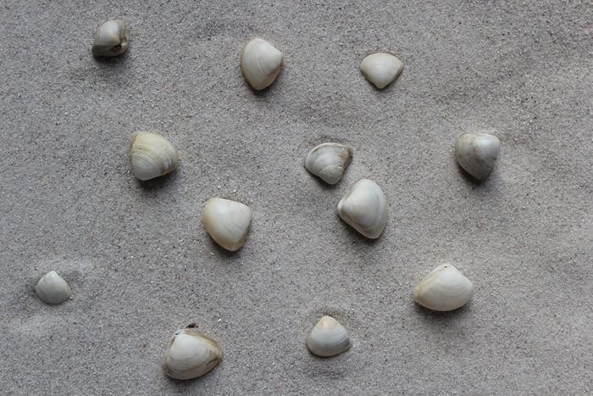
Figure 2: Photo by Vlaams Instituut voor de Zee (VLIZ), .

A2. Provide information on the existence of other species that look very similar [that may be detected in the risk assessment area, either in the environment, in confinement or associated with a pathway of introduction]
Include both native and non-native species that could be confused with the species being assessed, including the following elements:
- other alien species with similar invasive characteristics, to be avoided as substitute species (in this case preparing a risk assessment for more than one species together may be considered);
- other alien species without similar invasive characteristics, potential substitute species;
- native species, potential misidentification and mis-targeting

Response: Mulinia lateralis is a small bivalve in the family Mactridae. The shells are triangular, distinctly convex, thin, and smooth with very fine concentric lines. The exterior of the shell is white to cream with a thin yellowish-orange periostracum, while the interior is bright white. It has a radial ridge along the posterior end of the valves, and a distinctly broad cardinal area between the beaks in larger specimens. It does not have an externally visible ligament. Maximum adult size is approximately 15 to 21 mm in both in the native and the invaded range (Montagna et al., 1993; Craeymeersch et al., 2019), while newly metamorphosed juvenile shell lengths are 200 up to 700 µm (Luckenbach, 1984).
Similar species: Mulinia lateralis is most likely to be confused with native juvenile Spisula subtruncata, juvenile Mactra stultorum or non-native juvenile Rangia cuneata (Verween et al., 2006; Kerckhof, 2019; Craeymeersch et al., 2019). Mactra stultorum has an oval shell, no radial ridge, a thin visible external ligament, and no fine concentric growth lines. Spisula subtruncata has no radial ridge, a thin visible external ligament, and a brown periostracum. Rangia cuneata has distinctly inequilateral shells, an umbo that curves markedly towards the anterior, and a pale brown periostracum, in adults the shell is thick and heavy. Craeymeersch et al. (2019) provides more detail of the main morphological differences between these species, and a key to all species of the subfamily Mactrinae of the NE Atlantic, including the non-native Rangia cuneata.
Other possible native confusion species could be Spisula solida (F. Kerckhof, pers. comm., 17th August 2021), S. elliptica (M. Willing, Conchological Society of Great Britain and Ireland, pers. comm. 25th February 2021), although this species lives further offshore, and juvenile Mercenaria mercenaria (Lippson & Lippson, 2006).
DNA based identification is also possible (Craeymeersch et al., 2019; Klunder et al., 2019), and the complete mitochondrial genome is available (Liu et al., 2020).

A3. Does a relevant earlier risk assessment exist? Give details of any previous risk assessment, including the final scores and its validity in relation to the risk assessment area.

Response: No formal risk assessment has been carried out.
In the UK, Mulinia lateralis was included in the latest Horizon Scanning exercise for invasive alien species carried out in 2019 (Roy et al., 2019). It was rated in the top four marine species when combining likelihood of arrival, establishment, and impact on biodiversity. It is included in the MSFD UK priority surveillance list (MSFD UK, 2021). A risk assessment for Great Britain is in development (C. A. Wood, in prep.).

A4. Where is the organism native?
including the following elements:
- an indication of the continent or part of a continent, climatic zone and habitat where the species is naturally occurring
- if applicable, indicate whether the species could naturally spread into the risk assessment area

Response: Mulinia lateralis is native to the Western Atlantic, encompassing the Temperate North West Atlantic to the Tropical Western Atlantic (Spalding et al., 2007). Its range extends continuously from the Gulf of St Lawrence, Canada; along the eastern coast of the United States (US); and Mexico as far as the Yucatan peninsula, at the southeastern edge of the Gulf of Mexico (Verrill, 1879; Calabrese, 1970; Turgeon et al., 2009; GBIF, 2021; OBIS, 2021).
It is widely reported from bays along the Atlantic coast of the US, in a wide range of salinities, from 5 to 80 psu; where it appears to be a mainly estuarine species (Craeymeersch et al., 2019 and references therein). In the Gulf of Mexico, M. lateralis is reported from coastal lagoons, which can experience hypersaline conditions during droughts (González-Solis et al., 2018) and offshore banks (Turgeon et al., 2009).
This species prefers soft sediments, such as mud and sand, within the low intertidal and shallow subtidal zones (Snelgrove et al., 1993; Klunder et al., 2019). Although it is also found on offshore banks and shoals (Aller, 1912; Turgeon et al., 2009); Turgeon et al. (2009) report it occurring at depths of up to 134 m in the Gulf of Mexico.
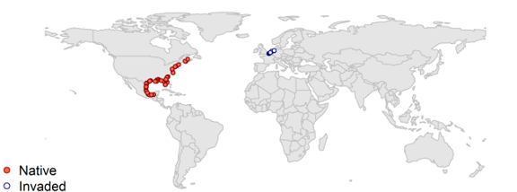
Figure 3: Occurrence records of M. lateralis in the native (red) and invaded (blue) range. Data points retrieved from the literature, biodiversity databases and screened as explained in Qu. A4-A6 and the modelling Annex (Annex IX). Map created by Bjorn Beckmann.

A5. What is the global non-native distribution of the organism outside the risk assessment area?

Response: None. Mulinia lateralis has only been reported as non-native from within the risk assessment area. GBIF (2021) shows a record from the west coast of the US, but the geographical coordinates do not match with the location described as being in Campeche, in the Gulf of Mexico.

A6. In which biogeographic region(s) or marine subregion(s) in the risk assessment area has the species been recorded and where is it established? The information needs be given separately for recorded (including casual or transient occurrences) and established occurrences. “Established” means the process of an alien species successfully producing viable offspring with the likelihood of continued survival.
A6a. Recorded: List regions
A6b. Established: List regions
Freshwater / terrestrial biogeographic regions:
- Alpine, Atlantic, Black Sea, Boreal, Continental, Mediterranean, Pannonian, Steppic
Marine regions:
- Baltic Sea, North-east Atlantic Ocean, Mediterranean Sea, Black Sea
Marine subregions:
- Greater North Sea, incl. the Kattegat and the English Channel, Celtic Seas, Bay of Biscay and the Iberian Coast, Western Mediterranean Sea, Adriatic Sea, Ionian Sea, Central Mediterranean Sea, Aegean-Levantine Sea.
Comment on the sources of information on which the response is based and discuss any uncertainty in the response.
For delimitation of EU biogeographical regions please refer to https://www.eea.europa.eu/data-and-maps/figures/biogeographical-regions-in-europe-2 (see also Annex VI).
For delimitation of EU marine regions and subregions consider the Marine Strategy Framework Directive areas; please refer to https://www.eea.europa.eu/data-and-maps/data/msfd-regions-and-subregions/technical-document/pdf (see also Annex VI).

Response (6a): Greater North Sea, incl. the Kattegat and the English Channel.
Mulinia lateralis was first discovered in this subregion in 2017 (Klunder et al., 2019). It has been recorded from the southeastern part of the subregion, from The Netherlands, Germany and Belgium (Craeymeersch et al., 2019; Klunder et al., 2019; Kerckhof, 2019). The identity of specimens from The Netherlands and Germany have been confirmed by DNA analysis (Craeymeersch et al., 2019; Klunder et al., 2019). For more details on the locations within each country, see response to Qu. A8a.
Response (6b): Greater North Sea, incl. the Kattegat and the English Channel.
Mulinia lateralis is considered established in The Netherlands (Craeymeersch et al., 2019; Klunder et al., 2019), Germany and Belgium, see response to Qu. A8b for more details. It has been found at multiple locations within The Netherlands, sometimes at high densities, and it has been recorded every year from 2017 to 2021. As M. lateralis has a maximum life-span of only two years this indicates that reproduction is occurring (Calabrese, 1969b). In 2017, dense populations of up to almost 6000 ind. m² were recorded from the Voordelta (southwestern Dutch coastal waters) and again in 2018 at densities of 1000 ind. m² (Craeymeersch et al., 2019). In 2017, M. lateralis was reported from sites in the Eems-Dollard estuary spanning the Dutch and German parts of the Wadden Sea (Klunder et al., 2019). It was recorded there again in 2018 (Craeymeersch et al., 2019; Klunder et al., 2019), and 2019 (GBIF, 2021). In 2018, it was found in the western part of the Dutch Wadden Sea (Craeymeersch et al., 2019; GBIF, 2021). In 2018, M. lateralis was recorded at high density (820 ind. m²) in the Westerschelde (Craeymeersch et al., 2019). Subsequently, in 2019, it was recorded there at 18/44 sites sampled, at an average of five ind. m² (Walles et al., 2020). M. lateralis has been reported from multiple sites, all along the Belgian coast.

A7. In which biogeographic region(s) or marine subregion(s) in the risk assessment area could the species establish in the future under current climate and under foreseeable climate change? The information needs be given separately for current climate and under foreseeable climate change conditions.
A7a. Current climate: List regions
A7b. Future climate: List regions
With regard to EU biogeographic and marine (sub)regions, see above.
With regard to climate change, provide information on
- the applied timeframe (e.g. 2050/2070)
- the applied scenario (e.g. RCP 4.5)
- what aspects of climate change are most likely to affect the risk assessment (e.g. increase in average winter temperature, increase in drought periods)
The assessment does not have to include a full range of simulations on the basis of different climate change scenarios, as long as an assessment with a clear explanation of the assumptions is provided. However, if new, original models are executed for this risk assessment, the following RCP pathways shall be applied: RCP 2.6 (likely range of 0.4-1.6°C global warming increase by 2065) and RCP 4.5 (likely range of 0.9-2.0°C global warming increase by 2065). Otherwise, the choice of the assessed scenario has to be explained.

Response (7a): The response is based on combining physiological tolerances and the results from the distribution modeling (see Qu. 2.1, Qu. 2.9 and Annexes VIII & IX for details). For purposes of mapping and assessing the risk of establishment, the following tolerance limits where defined:
- Average surface temperature of the warmest month > 15 °C
- Average surface temperature of the warmest month < 32.5 °C
- Minimum surface salinity > 12.5 psu
The salinity threshold was based in salinity requirements for larval development, which was shown to be normal between 12.5 to 35 psu (Calabrese, 1969a).
Baltic Sea: moderately likely, low confidence (western part)
Greater North Sea: very likely, high confidence
Celtic Seas: moderately likely, medium confidence
Bay of Biscay and the Iberian coast: likely, medium confidence
Mediterranean Sea: likely, medium confidence
Black Sea: moderately likely, medium confidence

Mulinia lateralis is expected to exhibit boom and bust dynamics in Atlantic Europe, where conditions will limit spawning and recruitment to the summer months. An abundance of suitable habitats (estuaries, extensive intertidal and subtidal seabed areas) will make widespread establishment likely. In the Mediterranean Sea, should the species be introduced there, wide establishment is more likely to take place in the western part of the basin which receives higher freshwater discharges, while the more arid eastern Mediterranean contains a lower number of highly suitable habitats, which are mostly concentrated in the northern Aegean. Nevertheless, because climatic conditions there are favourable for larval development throughout most of the year, it is more likely that populations will become more stable and dominant members of the macrobenthos. The Baltic Sea only offers salinity conditions suitable for establishment in its westernmost part. Establishment is also considered possible in the Black Sea, although low winter temperatures are likely to limit reproduction to the warmer months of the year.
Response (7b): The response is based on combining physiological tolerances and the results from the distribution modeling (see Qu. 2.1, Qu. 2.9 and Annexes VIII & IX for details). Aspects of climate change most likely to affect future distribution were considered as an increase in minimum and maximum Sea Surface Temperatures (SST). The methodology for the developed models is described in Annex IX and considers scenarios RCP 2.6 and RCP 4.5 by 2070. See also Qu. 2.10.
Baltic Sea: moderately likely, low confidence (western part)
Greater North Sea: very likely, high confidence
Celtic Seas: likely, medium confidence
Bay of Biscay and the Iberian coast: likely, medium confidence
Mediterranean Sea: likely, medium confidence
Black Sea: moderately likely, medium confidence

The species distribution model (SDM) predicted a small reduction in projected suitability for M. lateralis for the Mediterranean Sea and a corresponding increase for the North-East Atlantic marine subregions under future climate change and, consequently, a small northward shift of the overall suitable area for the species. An increase in sea surface temperature will offer suitable conditions for spawning and larval development for prolonged periods throughout the whole of Atlantic Europe and is predicted to extend its potential range further north along the coast of northern England, Scotland and Ireland. Suitable conditions in the Mediterranean are likely to become even more restricted spatially and temporally, rendering establishment in this marine subregion more localized, especially in the east and south.
Note: Even though the SDM takes into account salinity variability in the form of distance from river mouths, a future scenario for river discharge was not taken into account and would take very elaborate data processing to bring into the model. It is anticipated that extreme weather phenomena, like droughts and storms/flooding, will be more frequent and intense under future climate conditions and this will increase the uncertainty of predictions as well as the population fluctuations of M. lateralis. Even though salinity fluctuations are known to initiate recruitment events in M. lateralis (Montagna & Kalke, 1995), this will also depend on the magnitude and the duration of these events, with prolonged extreme salinity conditions eventually preventing normal larval development and causing population crashes. In this sense, it is more likely than not that prolonged extreme events will result in less suitable habitat and hinder establishment rather than promote it.

A8. In which EU Member States has the species been recorded and in which EU Member States has it established? List them with an indication of the timeline of observations. The information needs be given separately for recorded and established occurrences.
A8a. Recorded: List Member States
A8b. Established: List Member States
Austria, Belgium, Bulgaria, Croatia, Cyprus, Czech Republic, Denmark, Estonia, Finland, France, Germany, Greece, Hungary, Ireland, Italy, Latvia, Lithuania, Luxembourg, Malta, Netherlands, Poland, Portugal, Romania, Slovakia, Slovenia, Spain, Sweden.
The description of the invasion history of the species shall include information on countries invaded and an indication of the timeline of the first observations, establishment and spread.

Response (8a):
Belgium: Mulinia lateralis was first identified in January 2019 from washed up shells from a beach between Oostende and De Haan (Kerckhof, 2019). In February 2019, sixty-four live specimens were found offshore of De Haan (Waarnemingen, 2021), with subsequent reports of live clams from Heist, De Haan and Zeebrugge. There is a large population present in the port of Zeebrugge (F. Kerckhof, pers. comm. 17th August 2021).
Germany: This species was first reported from the German area of the Eems-Dollard estuary within the Wadden sea in 2017 and again in 2018 (Klunder et al., 2019). It has not been recorded from elsewhere in Germany.
The Netherlands: In 2017, M. lateralis was first discovered in August 2017 in the Eems-Dollard estuary within the Dutch Wadden Sea (Klunder et al., 2019). Also in 2017, it was reported in the Voordelta (Dutch coastal waters) (Craeymeersch et al., 2019). Additionally in 2018, it was found in the western part of the Dutch Wadden Sea (Craeymeersch et al., 2019; GBIF, 2021) and in the Westerschelde (Craeymeersch et al., 2019).
Response (8b):
Belgium: All the records of live Mulinia lateralis from Belgium are from citizen science records, however many have been verified and are accompanied by high quality images. Although only recorded from Belgium over the last two years, it has been reported from multiple sites, all along the Belgian coast. It was first identified in Belgium in January 2019 from washed up shells from a beach between Oostende and De Haan (Kerckhof, 2019). In February 2019, sixty-four live specimens were found offshore of De Haan (Waarnemingen, 2021), with subsequent reports of live clams from Heist, De Haan and Zeebrugge. In 2020, there are records from multiple sites along the whole of the Belgian coast from Knokke to De Panne (on the border with France) (Waarnemingen, 2021).
Germany: M. lateralis was first reported from two sites, referred to as Ems-Krummhörn, in the German part of the Eems-Dollard estuary within the Wadden sea in 2017, and from one of the same sites again in 2018 (Klunder et al., 2019). It has not been recorded from elsewhere in Germany. However, its continued presence throughout the Dutch part of the Eems-Dollard estuary has been recorded from 2017 to 2019 (Craeymeersch et al., 2019; Klunder et al., 2019; GBIF, 2021), longer than the species’ maximum life-span of two years (Calabrese, 1969b), so it can be presumed that it is also established in the German part.
The Netherlands: M. lateralis is considered established in The Netherlands (Craeymeersch et al., 2019; Klunder et al., 2019). It has been found at multiple locations, in high densities at some localities, and recorded every year from 2017 to 2021. As M. lateralis has a maximum life-span of only two years this indicates that reproduction is occurring (Calabrese, 1969b). In 2017, dense populations of up to almost 6000 ind. m² were recorded from the Voordelta (Dutch coastal waters) (Craeymeersch et al., 2019). It was found there again in 2018 at densities of 1000 ind. m² (Craeymeersch et al., 2019). In 2017, it was reported from sites in the Eems-Dollard estuary in the Dutch part of the Wadden Sea (Klunder et al., 2019). It was recorded from multiple sites again in 2018 (Craeymeersch et al., 2019; Klunder et al., 2019), and 2019 (GBIF, 2021). In 2018, it was found in the western part of the Dutch Wadden Sea (Craeymeersch et al., 2019, GBIF, 2021). In 2018 it was recorded at high density (820 ind. m²) in the Westerschelde (Craeymeersch et al., 2019). Subsequently, in 2019, in was recorded at 18/44 sites sampled in the estuary, at an average density of five ind. m² (Walles et al., 2020). In 2020 it was recorded at multiple sites along the Dutch coastal zone and estuaries as well as the Dutch part of the Wadden Sea (Troost et al., 2021).

A9. In which EU Member States could the species establish in the future under current climate and under foreseeable climate change? The information needs be given separately for current climate and under foreseeable climate change conditions.
A9a. Current climate: List Member States
A9b. Future climate: List Member States
With regard to EU Member States, see above.
With regard to climate change, provide information on
- the applied timeframe (e.g. 2050/2070)
- the applied scenario (e.g. RCP 4.5)
- what aspects of climate change are most likely to affect the risk assessment (e.g. increase in average winter temperature, increase in drought periods)
The assessment does not have to include a full range of simulations on the basis of different climate change scenarios, as long as an assessment with a clear explanation of the assumptions is provided. However, if new, original models are executed for this risk assessment, the following RCP pathways shall be applied: RCP 2.6 (likely range of 0.4-1.6°C global warming increase by 2065) and RCP 4.5 (likely range of 0.9-2.0°C global warming increase by 2065). Otherwise, the choice of the assessed scenario has to be explained.

Response (9a): The Species Distribution Model outlined in Annex IX provides a projection of environmental suitability for Mulinia lateralis establishment in Europe. According to the model the species could establish in Belgium, Bulgaria, Croatia, Denmark, France, Germany, Greece, Italy, Netherlands, Slovenia, and Spain, and also in the non-member state the United Kingdom.
Along the Portuguese coast seasonal upwellings result in relatively low summer temperatures (Vidal et al., 2017) and cause a reduction in the overall GDD (Growing Degree Days, see Annex IX for details), which emerges as the limiting factor for establishment in the model. This effect however is less pronounced towards the south of the country, where late summer temperatures are well above the minimum needed for establishment (Silva et al., 2009). Furthermore, we expect that at a finer scale the lagoons and estuaries will be warmer and shallower than indicated by the model, and thus Portugal would also be suitable for establishment. Concerning potential establishment in Sweden, see the discussion about limitng factors in the Kattegat in Qu. 7a. In Malta and Cyprus, the limiting factor appears to be the general lack of suitable habitat in the form of gently sloping soft sediments with fresh water influence.
Response (9b): Belgium, Bulgaria, Croatia, Denmark, France, Germany, Greece, Italy, Netherlands, Portugal, Romania, Slovenia, Spain, and Sweden, and also in the non-member state the United Kingdom.
The response to 9b is based on the RCP 4.5 scenario for the period 2050/2070. The aspect of climate change most likely to affect the organism’s ability to establish is an increase in winter sea surface temperatures. Higher winter temperatures in Atlantic Europe will favour larvae for longer periods and at higher latitudes (see Annexes VIII & IX for details on modelling and future climate conditions in the RA area).

A10. Is the organism known to be invasive (i.e. to threaten or adversely impact upon biodiversity and related ecosystem services) anywhere outside the risk assessment area?

Response: No. Mulinia lateralis has not been reported as present anywhere other than within its native range, or the risk assessment area.

A11. In which biogeographic region(s) or marine subregion(s) in the risk assessment area has the species shown signs of invasiveness? Indicate the area endangered by the organism as detailed as possible.
Freshwater / terrestrial biogeographic regions:
- Alpine, Atlantic, Black Sea, Boreal, Continental, Mediterranean, Pannonian, Steppic
Marine regions:
- Baltic Sea, North-east Atlantic Ocean, Mediterranean Sea, Black Sea
Marine subregions:
Greater North Sea, incl. the Kattegat and the English Channel, Celtic Seas, Bay of Biscay and the Iberian Coast, Western Mediterranean Sea, Adriatic Sea, Ionian Sea, Central Mediterranean Sea, Aegean-Levantine Sea

Response: Greater North Sea, incl. the Kattegat and the English Channel.
Mulinia lateralis was only first recorded as an introduced species in The Netherlands and Germany in 2017 (Craeymeersch et al., 2019; Klunder et al., 2019), although Klunder et al. (2019) suggest that it probably arrived in 2016. With such a recent arrival, it is not yet possible to determine if it will be invasive in the long term. However, Craeymeersch et al. (2019) considered it potentially invasive due to its ability to rapidly colonize defaunated areas, its high fecundity, short generation time, planktonic larvae, and its tolerance for anoxia and temperature extremes. In the Voordelta, dense settlements of up to 6000 ind. m² have been recorded. In its native range it can become dominant when conditions are optimal, achieving average densities as high as 21,000 ind. m² (Santos & Simon, 1980; Chalermwat et al., 1991). Klunder et al. (2019) state that M. lateralis seems to have become a successful invader in the Dutch Wadden Sea, with fast spread to all suitable areas there to be expected, given the current rate of spread since its first detection. This species has now, within just four years of its arrival, spread to over 450 km of coast from the Eems-Dollard estuary on the German/Dutch border, to De Panne on the Belgian/French border. In the Westerschelde, in 2019, in was recorded at 18/44 sites sampled (Walles et al., 2020). Potential environmental impacts of this species are discussed by Craeymeersch et al. (2019), including competition for space with native benthic species, and food with other filter-feeding organisms. Other potential impacts include the introduction and/or spread of parasites e.g. Perkinsus spp.
In its native range, M. lateralis frequently undergoes population crashes due to a variety of causes including starvation, predation, hypoxia, very low salinities events, or physical displacement from trawls or storm disturbance (Santos & Simon, 1980; Shumway & Newell, 1984; Powell et al., 1986; Cleveland, et al., 2002; de Buron et al., 2013). Such mass die-offs of bivalves are known to influence abiotic factors that negatively affect other organisms in the ecosystem (Cherry et al., 2005; Cooper et al., 2005), however no such phenomena have been observed or studied in the RA area to date.

A12. In which EU Member States has the species shown signs of invasiveness? Indicate the area endangered by the organism as detailed as possible.
Austria, Belgium, Bulgaria, Croatia, Cyprus, Czech Republic, Denmark, Estonia, Finland, France, Germany, Greece, Hungary, Ireland, Italy, Latvia, Lithuania, Luxembourg, Malta, Netherlands, Poland, Portugal, Romania, Slovakia, Slovenia, Spain, Sweden.

Response: The Netherlands.
Mulinia lateralis was only first recorded as an introduced species in The Netherlands in 2017 (Craeymeersch et al., 2019; Klunder et al., 2019), although Klunder et al. (2019) suggest that it probably arrived in 2016. With such a recent arrival, it is not yet possible to determine if it will be invasive in the long term. However, Craeymeersch et al. (2019) considered it potentially invasive due to its ability to rapidly colonize defaunated areas, its high fecundity, short generation time, planktonic larvae, and its tolerance for anoxia and temperature extremes. In the Voordelta, dense settlements of up to 6000 ind. m² have been recorded. In its native range it can become dominant when conditions are optimal, achieving average densities as high as 21,000 ind. m² ⁽Santos & Simon, 1980; Chalermwat et al., 1991). This species has now, within just four years of its arrival, spread to many areas of the Netherlands including the Voordelta, the Eems-Dollard estuary, the western part of the Dutch Wadden Sea, and the Westerschelde. Klunder et al. (2019) states that M. lateralis seems to have become a successful invader in the Dutch Wadden Sea, with fast spread to all suitable areas there to be expected, given the current rate of spread since its first detection. In the Westerschelde, in 2019, in was recorded at 18/44 sites sampled (Walles et al., 2020). See Qu. A11 and Magnitude of Impact section for potential impacts.

A13. Describe any known socio-economic benefits of the organism.
including the following elements:
- Description of known uses for the species, including a list and description of known uses in the risk assessment area and third countries, if relevant.
- Description of social and economic benefits deriving from those uses, including a description of the environmental, social and economic relevance of each of those uses and an indication of associated beneficiaries, quantitatively and/or qualitatively depending on what information is available.
If the information available is not sufficient to provide a description of those benefits for the entire risk assessment area, qualitative data or different case studies from across the risk assessment area or third countries shall be used, if available.

Response: Due to its small size, short generation time, and ease of culture and maintenance, Mulinia lateralis is considered potentially important as a model species for bivalve development, genetic and transgenic studies (Calabrese, 1969b; Liu et al., 2020; Yang et al., 2021). It has been used extensively in marine pollution bioassays (His et al., 1999; Cripe, 2006). Within its native range, M. lateralis is considered important for recreational hunting and fishing as it provides a food source for birds and fish (Kennedy & Mihursky, 1971; Mendenhall, 2015).

SECTION B – Detailed assessment
Important instructions:
- In the case of lack of information the assessors are requested to use a standardized answer: “No information has been found.” In this case, no score and confidence should be given and the standardized “score” is N/A (not applicable).
- With regard to the scoring of the likelihood of events or the magnitude of impacts see Annexes I and II.
- With regard to the confidence levels, see Annex III.
- Highlight the selected response score and confidence level in bold but keep the other scores in normal text (so that the selected score is evident in the final document).

1 PROBABILITY OF INTRODUCTION AND ENTRY
Important instructions:
- Introduction is the movement of the species into the risk assessment area (it may be either in captive conditions and/or in the environment, depending on the relevant pathways).
- Entry is the release/escape/arrival in the environment, i.e. occurrence in the wild
- Introduction and entry may coincide for species entering through pathways such as “corridor” or “unaided”, but it also may differ. If different, please consider all relevant pathways, both for the introduction into the risk assessment area and the entry in the environment.
- The classification of pathways developed by the Convention of Biological Diversity (CBD) should be used (see Annex IV). For detailed explanations of the CBD pathway classification scheme consult the IUCN/CEH guidance document and the provided key to pathways.
- For organisms which are already present (recorded or established) in the risk assessment area, the likelihood of introduction and entry should be scored as “very likely” by default.
- Repeated (independent) introductions and entries at separate locations in the risk assessment area should be considered here (see Qu. 1.7).

Qu. 1.1. List relevant pathways through which the organism could be introduced into the risk assessment area and/or enter into the environment. Where possible give details about the specific origins and end points of the pathways as well as a description of any associated commodities.
For each pathway answer questions 1.2 to 1.8 (copy and paste additional rows at the end of this section as necessary). Please attribute unique identifiers to each question if you consider more than one pathway, e.g. 1.2a, 1.3a, etc. and then 1.2b, 1.3b etc. for the next pathway.
In this context a pathway is the route or mechanism of introduction and/or entry of the species.
The description of commodities with which the introduction of the species is generally associated shall include a list and description of commodities with an indication of associated risks (e.g. the volume of trade; the likelihood of a commodity being contaminated or acting as vector).
If there are no active pathways or potential future pathways this should be stated explicitly here, and there is no need to answer the questions 1.2-1.9.

Pathway names: No pathway(s) have been proven for Mulinia lateralis. This species has not previously been introduced anywhere outside the RA area, and has only recently arrived in NW Europe, possibly as the result of a single introduction (Klunder et al., 2019). M. lateralis is free-living and does not attach to substrates; therefore hull fouling, floating debris and shellfish imports are unlikely pathways of introduction, particularly as this species is not part of the fouling community as it lives shallowly buried in soft sediments, so would not adhere to or crawl or burrow into other attached fouling organisms. Unaided natural dispersal is not feasible, as the larvae do not remain in the plankton for sufficient time to drift across the Atlantic. M. lateralis is used as a model organism for various experimental studies (see Qu. A13). Thus, escape from confinement (research and ex-situ breeding) is a potential pathway of introduction. However, it was considered an unlikely pathway for entry to the RA area, as the relevant studies are carried out either in the US (where the species is native) or in China, where it was recently (2017) introduced for this purpose (Yang et al., 2021). Similar studies in European laboratories mostly use suitable native species e.g. Mytilus spp. or native oyster species (His et al., 1999).
TRANSPORT-STOWAWAY (ship/boat ballast water and sediments)
Kerckhof (2019) suggests that M. lateralis was introduced into NW Europe with ballast water, like the bivalve Ensis leei, also a species originally from the N. American east coast. In addition, ballast water has been suggested as the pathway for two other recently introduced bivalves, the closely related Rangia cuneata and the tellinid Theora lubrica (Verween et al., 2006; Faasse et al, 2019).
TRANSPORT-STOWAWAY (other means of transport: marine aggregates & dredging)
The global dredging sector is very important in Europe, particularly in Belgium and The Netherlands. M. Faasse proposed the accidental transfer of dredged materials as a possible pathway (pers. comm., 25th February 2021). This could occur from Canada or Mexico within the native range (but not the US, see Qu. 1.3b.).
Pathway name:
- TRANSPORT-STOWAWAY (ship/boat ballast water and sediments)
Qu. 1.2a. Is introduction and/or entry along this pathway intentional (e.g. the organism is imported for trade) or unintentional (e.g. the organism is a contaminant of imported goods)?

RESPONSE | intentional  unintentional | CONFIDENCE | low  medium  high

Response: There is no doubt the uptake of larvae or adults in ballast water is accidental. See categorization of pathways in Annex IV.

Qu. 1.3a. How likely is it that large numbers of the organism will be introduced and/or enter into the environment through this pathway from the point(s) of origin over the course of one year?
including the following elements:

- discuss how likely the organism is to get onto the pathway in the first place. Also comment on the volume of movement along this pathway.
- an indication of the propagule pressure (e.g. estimated volume or number of individuals / propagules, or frequency of passage through pathway), including the likelihood of reinvasion after eradication
- if relevant, comment on the likelihood of introduction and/or entry based on propagule pressure (i.e. for some species low propagule pressure (1-2 individuals) could result in subsequent establishment whereas for others high propagule pressure (many thousands of individuals) may not.

RESPONSE | very unlikely  unlikely  moderately likely  likely  very likely | CONFIDENCE | low  medium  high

Response: The planktotrophic (free swimming) larvae of Mulinia lateralis larvae can be taken in with ballast water. In addition, small juveniles and adults that live only slightly below the surface could also be taken up with any sediments disturbed and accidently loaded with the water (Gollasch & David, 2019). Entry into the environment will occur during the de-ballasting process.
The propagule pressure will depend on the larval densities in the donor location, the time of the year (i.e. if uptake of ballast water coincides with the peak spawning period), as well as the densities of the adult population. There are large populations of M. lateralis in many estuaries along the east coast of N. America, where it can reach average densities of up to 21,000 ind. m² (Santos & Simon, 1980; Walker & Tenore, 1984). The reproductive period of M. lateralis varies from just a few months in the Gulf of St. Lawrence to all year round in the Gulf of Mexico (Montagna et al., 1993). Each female produces 3-4 million eggs (for details on reproductive traits please see Qu. 2.7). Calabrese (1970) recorded peak larval densities of 2,500-3,500 ind. m³ from Long Island Sound.
Although no information could be found of M. lateralis being detected in ballast water, Gollasch et al. (2002) reported 42 bivalve taxa in ballast water in Europe, including the closely related Mactra corallina. Ballast water has been specifically implicated in the introduction of several bivalve species e.g. Ensis leei, Rangia cuneata and Theora lubrica (Von Cosel et al., 1982; Verween et al., 2006; Faasse et al., 2019). The lowest estimates of the volumes of ballast water taken up, transferred and discharged into world oceans each year are around 10 billion tonnes (Interwies & Khuchua, 2017), whereas just one cubic metre of ballast water may contain from 21 up to 50,000 zooplankton specimens (Locke et al., 1991, 1993; Gollasch, 1997) and a heavy bulk carrier can carry more than 130,000 tonnes of ballast water (GloBallast, 2021). In addition, it is estimated that over 100 million tons of ballast tank sediments are being transported annually by ships (Endresen et al., 2003). It is thus evident from the above information that the potential for sufficiently high numbers of M. lateralis larvae or adults to travel along this pathway is high.
The transatlantic shipping routes from the east coast of N. America to Northern Europe and the Mediterranean represent a major east-west trade lane, being particularly important for containerized trade, with annual US exports to Europe of 3M TEU (twenty-foot equivalent units). New York, Houston, Savannah, Virginia and Charleston are the main exporting ports (Kaluza et al., 2010; UNCTAD, 2019; JOC, 2020).

Qu. 1.4a. How likely is the organism to survive, reproduce, or increase during transport and storage along the pathway (excluding management practices that would kill the organism)?

RESPONSE | very unlikely  unlikely  moderately likely  likely  very likely | CONFIDENCE | low  medium  high

Response: The organism has already entered Europe, putatively via ballast water. Larvae of Mulinia lateralis can survive salinities of 7-38 psu and temperatures of 7-33 °C (Calabrese, 1969a). They can remain in the free-swimming planktotrophic phase for up to 22 days (Mann et al., 1991). They are filter-feeders and can feed on a wide variety of phytoplankton and natural seston (particularly bacteria) (Shumway & Newell, 1984; Chalermwat et al., 1991). Thus, there is considerable probability of survival in ballast waters.
Shipping time from the east coast of N. America to the RA area can take 6-30 days (Ports.com, 2021), so the larvae could still be free-swimming when the water is discharged. It is also possible larvae could metamorphose within the ballast water tanks, settle in the ballast sediments, and develop into adults, alongside any adults that had been taken in during the uptake of ballast water.
Adult clams can survive temperatures of -2 °C to 35 °C (Calabrese, 1969a; Kennedy & Mihursky, 1971), anoxic conditions, and salinities of 5-80 psu (Parker, 1975), so should be perfectly able to survive and grow in the ballast tank sediments. M. lateralis has a very short generation time (reaching sexual maturity in 1-2 months (Guo & Allen, 1994)) therefore it is likely that, particularly on slower voyages, a significant proportion of any adult clams will be sexually mature.
M. lateralis spawns when water temperatures reach above 16 °C (Calabrese, 1969a). The ballast water temperature is likely to be above this for most of the year for journeys from ports south of Washington DC, to the Mediterranean and Atlantic coasts. Thus, any adults present could release large numbers of larvae into the ballast water.

Qu. 1.5a. How likely is the organism to survive existing management practices before and during transport and storage along the pathway?

RESPONSE | very unlikely  unlikely  moderately likely  likely  very likely | CONFIDENCE | low  medium  high

Response: The International Maritime Organization (IMO) Ballast Water Management Convention (BWMC) entered into force in September 2017. It requires ships in international traffic to apply ballast water management measures, in particular:
- ballast water exchange in open seas, away from coastal areas (D-1 standard for an interim period)
- fulfil a certain discharge standard (D-2 standard according to the ship specific application schedule phased in up to 8 September 2024). D-2 standard requires the installation of a certified ballast water treatment device, which enables sterilization to avoid transfers of ballast water mediated species.
Ballast Water Exchange (BWE) is currently practiced and requires ships to exchange a minimum of 95% ballast water volume whenever possible at least 200 nautical miles (nm) from the nearest land and in water depths of at least 200 metres. When this is not possible, the BWE shall be conducted at least 50 nm from the nearest land and in waters at least 200 metres in depth (David et al., 2007; and BWMC Guideline 6). Even though BWE can reduce the concentration of live organisms in ballast by 80–95% (Ruiz & Reid 2007; Darling et al., 2018), its application has severe limitations, primarily dependant on shipping patterns of a port (e.g., shipping routes, length of voyages) and local specifics i.e., distance from nearest shore, water depth (David et al., 2007). This is particularly the case for EU Seas where it is often not possible to meet these conditions. In addition, organisms may still remain in the volume of ballast not exchanged and in ballast sediment, or BWE may not be possible due to weather conditions or other safety restrictions. The survival of zooplanktonic organisms (including M. lateralis larvae) is thus not unlikely when only BWE measures are implemented.
As a result, ballast water treatment has been deemed necessary, such that ships shall discharge (in relation to the organism size range of interest for M. lateralis): less than 10 viable organisms per cubic metre greater than or equal to 50 micrometres in minimum dimension (IMO D-2 standard). Ballast water treatment options include mechanical (filtration, separation), physical (heat treatment, ozone, UV light) and chemical methods (biocides). Efficiencies of various technologies utilised for ballast water treatment are reviewed in Tsolaki & Diamadopoulos (2009), and can vary with treatment method but the application of many combined methods (e.g., Filtration+UV or Hydroclone+chemical disinfectant) can decrease live zooplankton to undetectable levels, practically diminishing propagule pressure. Under the D-2 standard, all ships shall be required to regularly remove and dispose of sediments from spaces designed to carry ballast water in accordance with the ship’s Ballast Water Management Plan. Sediments will be disposed of at designated sediment reception facilities in ports (GloBallast, 2017).
As such, the survival of M. lateralis larvae in ballast water, and adults in sediments, with full implementation of the D-2 standard (i.e. after 2024) is considered unlikely. Until then (i.e. currently), planktonic propagules of the species are likely to survive in ballast water and adults in the sediments.

Qu. 1.6a. How likely is the organism to be introduced into the risk assessment area or entry into the environment undetected?

RESPONSE | very unlikely  unlikely  moderately likely  likely  very likely | CONFIDENCE | low  medium  high

Response: Mulinia lateralis has already entered Europe undetected, putatively via ballast water (Kerckhof, 2019). The introduction into The Netherlands probably occurred in 2016 or earlier (Klunder et al., 2019) but was not detected until September 2017, during monitoring surveys associated with the Rotterdam harbour extension (Craeymeersch et al., 2019). The probability of observing the initial introduction event, particularly at the larval stage is minimal without targeted monitoring surveys at introduction hotspots (Andersen et al., 2014). The gross morphology of adult M. lateralis is similar to some common native species, as described in A.2. The adults are small (10-20 mm in length), while newly metamorphosed juvenile shell lengths range from 200 to 700 µm (Wang & Guo, 2008). Thus, M. lateralis could easily be overlooked during casual surveys, or if it settles in inaccessible port areas.
After September 2017, with the BWMC coming into effect and gradually being implemented, detection of larval stages in ballast water during Port State Control inspections may be possible. According to Resolution MEPC.252(67), if initial inspections of ballast water samples indicate non-compliance with the D-2 standard, detailed inspections will be carried out. eDNA methodologies are rapidly becoming one of the fastest and most cost-efficient tools for the detection of NIS in introduction water samples (Darling et al., 2017; Borrell et al., 2017; Koziol et al., 2019). However, full implementation of the BWMC is not anticipated until 2024. Until then, the risk that M. lateralis will enter the RA area undetected in ballast waters and sediments remains likely.

Qu. 1.7a. How isolated or widespread are possible points of introduction and/or entry into the environment in the risk assessment area?

RESPONSE | isolated  widespread  ubiquitous | CONFIDENCE | low  medium  high
Response: Mulinia lateralis favours low-energy sheltered coastal waters, estuaries and lagoons. It prefers soft sediments, such as mud and sand, within the low intertidal and shallow subtidal zones (Snelgrove et al., 1993; Klunder et al., 2019). It is quick to colonise disturbed areas, such as sites recently dredged or defaunated for other reasons (Santos & Simon, 1980; Pollack et al., 2018).
In Atlantic Europe, the main ports of entry are located within a relatively confined region, i.e. both coasts of the English Channel, but principally the Le Havre-Hamburg range along the north coast of continental Europe. Ports in northern and western Europe are often situated in or near estuaries that exhibit major fluctuations in salinity that M. lateralis can take full advantage of, see Qu. 1.4a for more details.
Conversely in the Mediterranean Sea, potential recipient ports are relatively evenly spaced but slightly more concentrated along the central and western Mediterranean, with a small number in Malta, southern Italy and Spain acting as the main transshipment hubs (Rodrigue, 2020). However most Mediterranean ports are located in coastal areas, not lagoons, thus the main risk areas are more isolated. However, this species can survive on the open coast in Belgium, and in its native range, thus it is feasible that possible points of introduction could be widespread; hence we have proposed a conservatively moderate score of isolated, with low confidence.
Repeated introductions from the native range may continue to occur until full implementation of the D-2 standard has taken place.

Qu. 1.8a. Estimate the overall likelihood of introduction into the risk assessment area and/or entry into the environment based on this pathway?

RESPONSE | very unlikely  unlikely  moderately likely  likely  very likely | CONFIDENCE | low  medium  high

Response: Regarding existing populations of the organism in the RA area, although not proven, ballast water and sediment transport is considered the most likely pathway of introduction (Kerckhof, 2019). Management measures implemented so far (i.e. BWE) have not proven adequate to prevent the introduction of this and other marine invasive species in EU marine waters. With the recent ratification of the BWMC (September 2017), compliance with the D-2 standard is expected to greatly reduce the likelihood of new introductions of Mulinia lateralis into Europe with ballast water and sediments. However, this is not expected before 2024 and there may be difficulties in fully implementing it. For example, there are already some early reports of operational problems with the currently installed Ballast Water Management Systems, presumably due to poor installation and inadequate testing in the field (source: https://www.seatrade-maritime.com/news/asia/operating-problems-with-60-80-of-ballast-water-treatment-systems-intertanko/).
A concrete protocol for the verification of ballast water compliance monitoring devices has been proposed by IOC-UNESCO, ICES and ISO to IMO (IOC-UNESCO, ICES, ISO, 2019). This protocol builds on the method presented in documents PPR 6/4 and MEPC 74/4/11 (Denmark) (First et al., 2018) and suggests a practices for verifying ballast water compliance monitoring devices using laboratory and shipboard tests. The intention is that the protocol can be the basis for the development of a standard for such devices, which may be used during commissioning testing, data gathering during the experience-building phase, compliance testing by Port State Control, or self-monitoring.
Pathway name:
- TRANSPORT-STOWAWAY (other means of transport: marine aggregates & dredging)

Qu. 1.2b. Is introduction and/or entry along this pathway intentional (e.g. the organism is imported for trade) or unintentional (e.g. the organism is a contaminant of imported goods)?

RESPONSE | intentional  unintentional | CONFIDENCE | low  medium  high

Response: Mulinia lateralis has no commercial value; the international dredging activities referred to in this pathway do not include dredging of commercial shellfish beds, and do not intentionally collect this species (but see Qu. 3.3c). See categorization of pathways in Annex IV and guidance notes in the beginning of this section.

Qu. 1.3b. How likely is it that large numbers of the organism will be introduced and/or enter into the environment through this pathway from the point(s) of origin over the course of one year?
including the following elements:

- discuss how likely the organism is to get onto the pathway in the first place. Also comment on the volume of movement along this pathway.
- an indication of the propagule pressure (e.g. estimated volume or number of individuals / propagules, or frequency of passage through pathway), including the likelihood of reinvasion after eradication
- if relevant, comment on the likelihood of introduction and/or entry based on propagule pressure (i.e. for some species low propagule pressure (1-2 individuals) could result in subsequent establishment whereas for others high propagule pressure (many thousands of individuals) may not.

RESPONSE | very unlikely  unlikely  moderately likely  likely  very likely | CONFIDENCE | low  medium  high

Response: The global dredging sector is very important in Europe, particularly in Belgium and The Netherlands. European dredging companies have a 90% market share of dredging in worldwide open markets (EuDA, 2013; Van Oord, 2020), and four of the largest dredging companies in the world are Belgian (Jan De Nul, DEME) or Dutch (Boskalis, Van Oord) (Rabobank, 2013). Dutch and Belgian companies have been involved in dredging in Mexico and Canada, at the southern and northern extremes of the native range of Mulinia lateralis (Maritime Journal, 2010; Van Oord, 2019; Wikipedia, 2021). However, dredging in the US, which extends over a large part of the native range, is restricted to vessels built, owned and flagged in America (as a result of the ‘Jones Act’) (Frittelli, 2019), and there was no evidence found of US dredging companies operating in Europe. Thus, dredging as a pathway from the native range is possible but somewhat restricted.
Dredging is a major activity in the current invaded range, within the RA area. There is significant dredging and disposal activity all along the Dutch, German and Belgian coasts. For example, the Port of Rotterdam requires intensive maintenance dredging that yields 12-15 million m³ of dredged material annually (Kirichek et al., 2018). Intensive dredging is also taking place in the port of Zeebrugge and the dredgers often move from one operation zone to another, e.g. from Belgium to the Baltic Sea (F. Kerckhof, pers. comm., 17th August 2021). Dredged materials are distributed along the Dutch and Belgian coasts to help prevent coastal erosion and aid land reclamation (ICES, 2018). There are large populations of M. lateralis in the sheltered waters such as estuaries, lagoons, harbours and coastal areas in the Gulf of Mexico and, to a lesser extent, in the Gulf of St Lawrence, Canada (see Qu. 1.3a for more detail regarding propagule pressure). Any dredging of these sediments will inevitably collect a high percentage of any M. lateralis adults present. The adults are small (10-20 mm in length), while newly metamorphosed juvenile shell lengths range from just 200 to 700 µm (Wang & Guo, 2008), thus can easily be taken up by all forms of dredging. The bulk of the dredged material will be disposed of in the country of origin at designated sites. However, some residual sediment will inevitably be retained in the vessel and on any equipment used. Additionally, larvae of the species may be contained in hopper water. This is water used to fill the hopper (i.e. the storage compartment) of the dredger to increase vessel stability when it is not loaded with sediment. The frequency of events in which European vessels operate in the native range, and then return to Europe without prior extensive cleaning, is unknown, but likely to be very low. Any residual sediment may be washed out in the home port, or may become mixed with waste from the next project (see Qu. 3.6b for more detail). Hopper water with entrained larvae may also be released at the home port or subsequent destinations.

Qu. 1.4b. How likely is the organism to survive, reproduce, or increase during transport and storage along the pathway (excluding management practices that would kill the organism)?

RESPONSE | very unlikely  unlikely  moderately likely  likely  very likely | CONFIDENCE | low  medium  high

Response: During the period of retention on the vessel, the adults will remain in the sediments they were collected with, so should be able to survive, and possibly even reproduce. While in transit, adults can survive anoxic conditions, salinities of 5-80 psu (Parker, 1975), and temperatures from -2 °C to 35 °C (Calabrese, 1969a; Kennedy & Mihursky, 1971). Larvae in hopper water can also survive in a wide range of temperatures and salinities, even though growth may not be optimal (see Qu 2.1, 2.7). Mulinia lateralis can also burrow up to the surface if buried (Maurer et al., 1981), and actively thrives in dredged areas (Flint & Younk, 1983). Shipping time from the east coast of N. America to Europe is estimated to take 6-30 days (Freightos, 2021). If food resources fall below the energy requirements of M. lateralis, its inability to catabolize protein reserves can cause mass mortalities (Shumway & Newell, 1984).

Qu. 1.5b. How likely is the organism to survive existing management practices before and during transport and storage along the pathway?

RESPONSE | very unlikely  unlikely  moderately likely  likely  very likely | CONFIDENCE | low  medium  high

Response: No EC regulations regarding the cleaning of vessels and equipment or the exchange of hopper water before returning from overseas could be found. It does not appear to be common practice to clean equipment and exchange hopper water between dredging localities, as contractors considered this to be additional work when new requirements were introduced in Wales, UK (ABPmer, 2019; G. Wynne, B. Wray & S. Vye (Natural Resources Wales), pers. comm. 21st April 2021).

Qu. 1.6b. How likely is the organism to be introduced into the risk assessment area or entry into the environment undetected?

RESPONSE | very unlikely  unlikely  moderately likely  likely  very likely | CONFIDENCE | low  medium  high

Response: If the vessel and equipment are cleaned on arrival in Europe, Mulinia lateralis will be deposited in the port of entry. If the vessel is not cleaned the residual sediments will be mixed with the next dredge load, and would be dumped with a significant amount of sediment, in the designated disposal site. Similarly, larvae in hopper water can also be released at these locations. See Qu. 1.6a for more detail on difficulty of detection.

Qu. 1.7b. How isolated or widespread are possible points of introduction and/or entry into the environment in the risk assessment area?

RESPONSE | isolated  widespread  ubiquitous | CONFIDENCE | low  medium  high

Response: See Qu. 1.7a. Companies based in The Netherlands and Belgium carry out the majority of overseas dredging, so there is a higher risk of these countries being sites of introduction. However, although it is probable that dredging vessels working overseas would return to their homeport on project completion, it is possible that sometimes they will travel directly to the site of their next contract, which could be anywhere in Europe.

Qu. 1.8b. Estimate the overall likelihood of introduction into the risk assessment area and/or entry into the environment based on this pathway?

RESPONSE | very unlikely  unlikely  moderately likely  likely  very likely | CONFIDENCE | low  medium  high

Response: Accidental transport with dredge spoils has been proposed as a possible means of introduction, as dredging companies based in the countries within the RA area where Mulinia lateralis was first observed are known to carry out major dredging operations in the species’ native range. M. lateralis larvae and adults/juveniles could potentially survive in hopper water and residual sediments respectively, and be released in home ports or at subsequent dredging destinations. The major unknown factor in this pathway is the frequency with which dredging vessels move between sites in the native range and the RA area.

Qu. 1.9. Estimate the overall likelihood of introduction into the risk assessment area or entry into the environment based on all pathways and specify if different in relevant biogeographical regions in current conditions.
Provide a thorough assessment of the risk of introduction in relevant biogeographical regions in current conditions: providing insight in to the risk of introduction into the risk assessment area.

RESPONSE | very unlikely  unlikely  moderately likely  likely  very likely | CONFIDENCE | low  medium  high

Response: Mulinia lateralis has already been introduced into the RA area, but possibly only once. Ballast water and sediments is considered the most plausible pathway for this introduction, due to the volume of traffic, and its importance as a vector in the transfer of bivalve molluscs with similar life histories. This theory is supported by its presence in the region of a major shipping hub. However, there is no direct evidence to support ballast water and sediments as the original pathway, and it is possible that this single introduction resulted from a much rarer event such as the accidental transfer of residual dredging waste. The transatlantic shipping routes from the east coast of N. America to Northern Europe and the Mediterranean represent a major east-west trade lane. Despite its current non-native range being limited to the Greater North Sea, further introductions are also likely in the Mediterranean parts of the RA area, where prevailing temperatures favour the survival of planktotrophic larvae likely to be carried by ballast waters (see Risk of Establishment section).
Baltic Sea: moderately likely, low confidence (western part)
Greater North Sea: very likely, high confidence
Celtic Seas: moderately likely, medium confidence
Bay of Biscay and the Iberian coast: moderately likely, medium confidence
Mediterranean Sea: likely, medium confidence
Black Sea: moderately likely, medium confidence

Qu. 1.10. Estimate the overall likelihood of introduction into the risk assessment area or entry into the environment based on all pathways in foreseeable climate change conditions?
Thorough assessment of the risk of introduction in relevant biogeographical regions in foreseeable climate change conditions: explaining how foreseeable climate change conditions will influence this risk.

With regard to climate change, provide information on
- the applied timeframe (e.g. 2050/2070)
- the applied scenario (e.g. RCP 4.5)
- what aspects of climate change are most likely to affect the likelihood of introduction (e.g. change in trade or user preferences)
The thorough assessment does not have to include a full range of simulations on the basis of different climate change scenarios, as long as an assessment of likely introduction within a medium timeframe scenario (e.g. 30-50 years) with a clear explanation of the assumptions is provided. However, if new, original models are executed for this risk assessment, the following RCP pathways shall be applied: RCP 2.6 (likely range of 0.4-1.6°C global warming increase by 2065) and RCP 4.5 (likely range of 0.9-2.0°C global warming increase by 2065). Otherwise, the choice of the assessed scenario has to be explained.

RESPONSE | very unlikely  unlikely  moderately likely  likely  very likely | CONFIDENCE | low  medium  high

Response: Climate change is most likely to affect future introductions as a result of an increase in minimum and maximum Sea Surface Temperatures (SST). The methodology for the developed models is described in Annex IX and considers scenarios RCP 2.6 and RCP 4.5 by 2070.
Ballast water: The rise in maximum SST will increase the likelihood of further introductions into the RA area. In the northern part of the native range there would likely be an extension to the reproductive period, and possibly larger populations on average, providing greater opportunities for larval uptake with ballast water, e.g. in Long Island Sound, an important shipping hub for exports to Europe.
It is anticipated that extreme weather phenomena, such as droughts and storms/flooding, will be more frequent and intense under future climate conditions. Within the native range, this will likely lead to greater fluctuations in salinity, and more frequent defaunation events, facilitating the establishment of opportunistic high-density populations of Mulinia lateralis, and leading to a corresponding rise in larval density. More frequent storms leading to greater disturbance of inshore waters, may also increase the likelihood of juvenile and small adults being present in the water-column and thus available for uptake in ballast water. Higher frequency and severity of storms can also increase the amount of time vessels have to spend in port, increasing the likelihood of entrainment (Galil et al., 2019).
The likelihood of introductions into the Greater North Sea and Celtic Seas subregions, will increase as conditions will be favourable over a longer period of the year for survival of larvae discharged with ballast water. It is not anticipated that there will any change in the volume of transatlantic shipping as a result of climate change.
International Dredging: The more intense proliferation of native M. lateralis populations, discussed above for ballast water, could also result in a higher risk of M. lateralis adults and larvae being present in any residual sediments and water, remaining in European dredging vessels and on equipment, when they return from dredging works in N. America. Dredging activity in the native range may increase in response to rising sea levels, leading to an increase in demand for coastal protection. In addition, an increase in extreme weather events (e.g. flooding with associated terrigenous inputs), may increase the need for dredging to maintain water channels and protect property. As the European dredging sector have a 90% market share of dredging worldwide, it is likely that there will be an increase in the frequency of European dredging vessels operating in the native range.
Baltic Sea: moderately likely, low confidence (western part)
Greater North Sea: very likely, high confidence
Celtic Seas: likely, medium confidence
Bay of Biscay and the Iberian coast: likely, medium confidence
Mediterranean Sea: likely, medium confidence
Black Sea: moderately likely, medium confidence

2 PROBABILITY OF ESTABLISHMENT
Important instructions:
- For organisms which are already established in parts of the risk assessment area or have previously been eradicated, the likelihood of establishment should be scored as “very likely” by default.
- Discuss the risk also for those parts of the risk assessment area, where the species is not yet established.

Qu. 2.1. How likely is it that the organism will be able to establish in the risk assessment area based on similarity of climatic and abiotic conditions in its distribution elsewhere in the world?

RESPONSE | very unlikely  unlikely  moderately likely  likely  very likely | CONFIDENCE | low  medium  high

Response: The species is already established in the RA area, specifically in the Wadden Sea, coastal waters and estuaries in Belgium, the Netherlands and Germany (see Qu. A6).
Mulinia lateralis is a eurythermal and euryhaline species with a latitudinal distribution extending from the Bay of St. Lawrence, Canada to the Gulf of Mexico, Yucatan, Mexico (Turgeon et al., 2009; see also Qu. A3 for details). This distribution corresponds to low winter temperatures of approximately -1 °C to 24 °C (average temperature of the coldest month, retrieved from BIO-ORACLE 2 (Assis et al., 2018)) and high summer temperatures ranging from 17 °C to 30.5 °C (average temperature of the warmest month, retrieved from BIO-ORACLE 2), conditions which are met throughout most of the RA area (see Annex VIII). Under experimental conditions, this temperature range is further extended to -2 °C and 35 °C for adult survival (Kennedy & Mihursky, 1971) and to 33 °C for larval survival (Calabrese, 1969a). Spawning occurs at different times of the year at different latitudes, e.g., in Canada from mid-July to early September (Sullivan, 1948), in Maryland from May to November with a peak in September (Hanks, 1968), in Texas from January to April, while year-round spawning has also been reported (Montagna et al., 1993). In the Long Island Sound, larvae appear in the water in early July at temperatures ranging between 16 °C and 20 °C but are more abundant at 19-21 °C (Calabrese, 1970). Field observations agree rather well with laboratory results, which indicate that the temperature threshold for larval growth that ensures metamorphosis before the larvae die in the water column lies somewhere between 15 °C and 17.5 °C (Calabrese, 1969a). Thus, temperature does not seem to be a major limiting factor for establishment at a large scale, except perhaps around northern UK waters, where maximum summer temperatures drop below 15 °C. Nevertheless, because M. lateralis is primarily an inshore, estuarine species (Walker & Tenore, 1984), coarse grain temperature maps may not accurately reflect local conditions. For example, temperature measurements in marinas and harbours along the UK coast demonstrate water temperatures typically between 16 °C and 22 °C in July – October, all the way up to northern England (Bishop et al., 2015; C. Wood, unpublished data). Furthermore, even though physiological tolerance thresholds for survival are not exceeded in the Kattegat, the Species Distribution Model indicates that thermal requirements are not met for sufficiently long periods of time to ensure the development of stable populations (i.e. Growing Degree Days is the limiting factor). Nevertheless, the appearance of ephemeral or casual populations in the Kattegat under current conditions cannot be excluded (see also Qu. A7a).
The species can also withstand a wide range of salinities, reportedly between 5-80 psu (Parker, 1975 in Montagna et al., 1993). M. lateralis can persist equally in low salinity estuarine environments as in hypersaline conditions in lagoons, associated with prolonged drought periods (e.g., in Baffin Bay, Texas, where the species is dominating the infaunal community at salinities up to 60 psu). It is generally observed though that major recruitment events are triggered by big salinity changes caused by freshwater inflow, rather than absolute salinity levels (Montagna & Kalke, 1995; Van Diggelen & Montagna, 2016). On the other hand, its presence along the Dutch and Belgian coasts, as well as the shallow sublittoral in its native range (Cleveland et al., 2002) indicates it can also establish in fully marine areas. Regarding larval development, in laboratory experiments it was shown to be normal between 12.5 to 35 psu, although survival was observed within a much larger range of 7-38 psu (Calabrese 1969a).

Qu. 2.2. How widespread are habitats or species necessary for the survival, development and multiplication of the organism in the risk assessment area? Consider if the organism specifically requires another species to complete its life cycle.

RESPONSE | very isolated  isolated  moderately widespread  widespread  ubiquitous | CONFIDENCE | low  medium  high

Response: Mulinia lateralis is an infaunal (i.e. living in soft sediments), opportunistic species that proliferates in shallow, sheltered areas with mixed fine sediments (Walker & Tenore, 1984). It is widespread in coastal bays and often dominates the infaunal assemblages in estuaries and lagoons (Montagna et al., 1993; Reguero & Raz-Guzman, 2018). Even though in its native range it is considered primarily a near-shore, subtidal species, in the RA area it has been repeatedly observed in the intertidal zone and appears capable of establishing there too (Craeymeersch et al., 2019; Klunder et al., 2019). Such habitats are relatively widespread in the RA area; in particular, estuaries and intertidal areas are especially widespread in the North-East Atlantic region while lagoons are more common in the Mediterranean region (Figure 4). Klunder et al. (2019) constructed a habitat suitability map for M. lateralis in the Wadden Sea, based on sediment characteristics at a fine scale. This predicted that a considerable part of the Dutch Wadden Sea could provide suitable habitat.

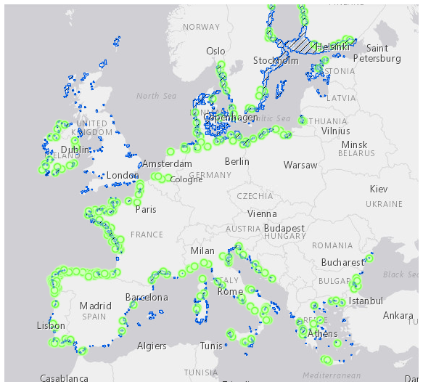
Figure 4: Coastal lagoons (blue polygons) and Estuaries (green circles) in the Natura 2000 network of Europe (source: Natura 2000 Network Viewer).

Qu. 2.3. How likely is it that establishment will occur despite competition from existing species in the risk assessment area?

RESPONSE | very unlikely  unlikely  moderately likely  likely  very likely | CONFIDENCE | low  medium  high

Response: Mulinia lateralis is a typical r-selected species with high fecundity, short generation times and fast maturation (Williams et al., 1986; see also Qu. 2.7). As such, it is a characteristic early colonizer in macrobenthic community succession after periodic or stochastic catastrophic events (e.g., Santos & Simon, 1980; Flint & Younk, 1983) and, according to ecological theory, is not meant to be a good competitor (Rosenberg 1972; 1973; Grassle & Grassle, 1974; McCall, 1977; Rhoads et al., 1978). This is also demonstrated in field studies, where its numerical presence is much reduced in locations with high bivalve diversity (McKeon et al., 2015) or with the strong presence of bioturbating deposit feeders (Levinton & Bambach, 1970). However, because it can withstand a large range of salinities, it recovers very fast from physical disturbance events and rapidly colonises defaunated habitats, it can persist and dominate in frequently “disturbed” environments, such as estuaries and other transitional systems. Moreover, because it can attain significant densities, has a high filtration rate and is adapted to quickly exploit high concentrations of food resources (Shumway et al., 1983; Crayemeersch et al., 2019), it has the capacity to become an effective competitor for space and food, especially if settlement occurs earlier than for native bivalves with a similar trophic ecology and habitat preference. In the Wadden Sea, with extensive tidal flats and a salinity range of approximately 12-31 psu (Duran-Matute et al., 2014), the species is already established, having been recorded for the first time in 2017 (Klunder et al., 2019). In the Voordelta, in The Netherlands, M. lateralis was found together with Spisula subtruncata both at high densities at the same site, and likewise in the Westerschelde, it was found with Cerastoderma edule both at high densities (Craeymeersch et al., 2019). Thus, competition with functionally similar species (i.e. infaunal suspension feeders) has not prevented establishment.

Qu. 2.4. How likely is it that establishment will occur despite predators, parasites or pathogens already present in the risk assessment area?

RESPONSE | very unlikely  unlikely  moderately likely  likely  very likely | CONFIDENCE | low  medium  high

Response: In its native range, Mulinia lateralis constitutes an important food source for a variety of organisms both in estuaries and in coastal waters. Predation by various finfish species (drums, croakers, spots) (Blundon & Kennedy, 1982; Pollack et al., 2018), blue crab Callinectes sapidus (Williams et al., 1986), rays (Ajemian & Powers, 2012), starfish Asterias forbesi (MacKenzie, 1981) and Luidia clathrata (McClintock & Lawrence, 1985), diving ducks, e.g., scaup and ruddy ducks (Perry & Uhler, 1982; Stroud et al., 2019), is well documented along the coasts of North America and the Gulf of Mexico. In Chesapeake Bay, it has been suggested that the seasonal fluctuations of the dwarf clams, with very low abundances in the summer, are due to increased predation by crabs and fish but the clams persist in the face of predation by continuous recruitment (Blundon & Kennedy, 1982). Something similar is likely to happen in the RA area, where the species is already established, with predation by native species of crabs, fish, starfish, shore birds and diving ducks not having prevented establishment so far.
M. lateralis is reported as the intermediate host for larvae of two parasitic cestode species, Duplicibothrium minutum and Rhodobothrium paucitesticulare, however no associated pathology to the examined specimens was observed (de Buron et al., 2013). The species is also a host for the protozoan parasite Perkinsus chesapeaki (Reece et al., 2008), which infects a wide variety of clam species (Burreson et al., 2005) and is pathogenic to its clam host Mya arenaria (Dungan et al., 2002; McLaughlin & Faisal, 1998). No pathogeny has been described though for M. lateralis specifically, such that the potential effect of Perkinsus infections on the risk of establishment cannot be reliably assessed. The other two Perkinsus species that have been reported in European waters, P. olseni and P. mediterraneus (Carrasco et al., 2014), can indeed infect clam species but have not been observed in M. lateralis.
Brown tide event: In a Texas estuary, a prolonged brown tide event caused the demise of the M. lateralis population for two years, although it was not established whether this was due to reproductive failure or direct toxic effects (Montagna et al., 1993). The population rebounded after 2 years in the native range; however, recovery may not be possible after such an event in the invaded range with a newly established or isolated population. Given the continuous distribution of M. lateralis currently in the Wadden Sea, recovery from a similar mass mortality event seems more likely than not.

Qu. 2.5. How likely is the organism to establish despite existing management practices in the risk assessment area? Explain if existing management practices could facilitate establishment.

RESPONSE | very unlikely  unlikely  moderately likely  likely  very likely | CONFIDENCE | low  medium  high

Response: While Ballast Water Exchange (BWE) and Ballast Water Treatment (BWT) can reduce propagule pressure and, consequently, the rate of establishment (see Qu. 1.5a for details), these management practices are not always possible or yet in effect. On the other hand, bivalve transportations for aquaculture purposes (which constitute a pathway of spread) offer suitable habitats to Mulinia lateralis in the form of the aquaculture plots themselves and, thus, facilitate establishment. Moreover, seed relaying offers favourable substrates and conditions for settlement and growth, enhancing establishment potential. Dredging activities also enhance the potential for establishment, both at the dredged sites, which are known to be rapidly colonised by the species (Flint & Younk, 1983; Clarke & Miller-Way, 1992) but also at disposal sites with dredge spoils containing M. lateralis, or at new dredging locations with contaminated equipment (see Probability of Spread section for details). In a similar way, dredging to remove nuisance species close to shellfish culture plots, sometimes practiced for predatory starfish or the invasive mollusc Crepidula fornicata, which heavily infests oyster and mussel beds (Bohn, 2014), may also provide cleared space and promote settlement and establishment of M. lateralis.

Qu. 2.6. How likely is it that biological properties of the organism would allow it to survive eradication campaigns in the risk assessment area?

RESPONSE | very unlikely  unlikely  moderately likely  likely  very likely | CONFIDENCE | low  medium  high

Response: No attempts to eradicate this organism are known. Due to its small size a considerable proportion of the population would be expected to pass through typical commercial towed gear used for removal. Moreover, its burrowing lifestyle, high fecundity, prolonged/continuous recruitment and resistance to disturbance make it a very unlikely candidate for successful eradication as the above characteristics allow the species to maintain low-density “reservoir” populations even under adverse environmental conditions and/or heavy predation (Williams et al., 1986) and recover fast after mass mortality events.

Qu. 2.7. How likely are the biological characteristics of the organism to facilitate its establishment in the risk assessment area?
including the following elements:
- a list and description of the reproduction mechanisms of the species in relation to the environmental conditions in the risk assessment area
- an indication of the propagule pressure of the species (e.g. number of gametes, seeds, eggs or propagules, number of reproductive cycles per year) of each of those reproduction mechanisms in relation to the environmental conditions in the risk assessment area.
- If relevant, comment on the likelihood of establishment based on propagule pressure (i.e. for some species low propagule pressure (1-2 individuals) could result in establishment whereas for others high propagule pressure (many thousands of individuals) may not.
- If relevant, comment on the adaptability of the organism to facilitate its establishment and if low genetic diversity in the founder population would have an influence on establishment.

RESPONSE | very unlikely  unlikely  moderately likely  likely  very likely | CONFIDENCE | low  medium  high

Response: Mulinia lateralis is a gonochoric (i.e. with separate sexes), broadcast spawner with external fertilisation. It has a short life span, up to 2 years, and reaches sexual maturity at a length of 3 mm and at an age of 60 days (Calabrese, 1969b). The species has free-swimming planktotrophic larvae with pelagic larval duration (PLD) of 7 to 22 days (Mann et al., 1991). It thus has a short generation time of about 3 months (Guo & Allen, 1994) and can spawn more than once a year, depending on ambient temperatures, with a mean fecundity of 3-4 million eggs per female per spawning event (Calabrese, 1969b). Spawning occurs at different times of the year at different latitudes, e.g. in Canada from mid-July to early September (Sullivan, 1948), in Maryland from May to November with a peak in September (Hanks, 1968), in Texas from January to April, while year-round spawning has also been reported (Montagna et al., 1993).
Abiotic parameter thresholds for larval development are outlined in Qu. 2.1. In brief, normal larval development and larval growth in the laboratory are achieved at temperatures not lower than 15 °C and as high as 32.5 °C, which was the highest temperature tested (Calabrese, 1969a), and at salinities between 12.5 and 37.5 psu. However, satisfactory embryonic development occurred at a more restricted salinity range of 20-32.5 psu (Calabrese, 1969a). Nevertheless, it is generally accepted that it is salinity fluctuations and not absolute salinity values per se that trigger recruitment (Van Diggelen & Montagna, 2016), such that exact salinity thresholds for reproduction are not easy to set. Such conditions are met throughout most of the RA area, at least for the short duration needed for larval development. The only exception is the Baltic Sea, where salinity drops to <10 psu beyond the western Baltic, and northern UK waters, where maximum summer temperatures are close to or below the lower limit for larval development and growth. Abiotic conditions in the Mediterranean Sea are particularly favourable for prolonged or even continuous spawning, with minimum water temperatures >16 °C in the eastern and southern parts of the basin, whereas in Atlantic Europe spawning and recruitment are likely to be more discreet events, limited to the warmer summer months.

Qu. 2.8. If the organism does not establish, then how likely is it that casual populations will continue to occur?
Consider, for example, a species which cannot reproduce in the risk assessment area, because of unsuitable climatic conditions or host plants, but is present because of recurring introduction, entry and release events. This may also apply for long-living organisms.

RESPONSE | very unlikely  unlikely  moderately likely  likely  very likely | CONFIDENCE | low  medium  high

Response: Conditions for successful reproduction are encountered throughout most of the RA area. However, long-term establishment most likely requires specific water body types, such as estuaries, lagoons and sheltered inshore waters. Accordingly, the occurrence of casual populations would depend on repeated introductions of either larvae in ballast water or benthic stages in dredged material (and to a lesser extent in ballast sediments), being released at suitable locations. Concerning ballast water, for transatlantic voyages, ballast water exchange is expected to have occurred at sufficient distances away from European coasts such that the risk of introduction is not very high and will be even lower after full implementation of the BWMC. With regards to the transport of aggregates from native donor areas however, the risk of additional introductions remains, as long as operations of European companies continue along areas where Mulinia lateralis is native (see relevant pathway in the Probability of Introduction section – Qu. 1.3b, 1.8b). It is worth noting here that an area particularly vulnerable to the occurrence of casual populations is the Baltic Sea, which encompasses a salinity gradient ranging from highly suitable to unsuitable for larval development. Thus, competent larvae entering the Baltic through the high salinity Kattegat can still survive in the western Baltic and eventually settle, even as far as the Baltic proper. Adult clams can survive the salinity in this region but the next generation of larvae would not develop properly. Another area where ephemeral/casual populations may appear is the coast around Ireland, which presents a marginal environment for the species’ larval survival in terms of maximum summer temperature (15-16 °C). Adult clams entering via anthropogenic pathways can survive and may even reproduce locally in a warmer than average year, but long-term establishment doesn’t appear likely.

Qu. 2.9. Estimate the overall likelihood of establishment in the risk assessment area under current climatic conditions. In addition, details of the likelihood of establishment in relevant biogeographical regions under current climatic conditions should be provided.
Thorough assessment of the risk of establishment in relevant biogeographical regions in current conditions: providing insight in the risk of establishment in (new areas in) the risk assessment area.

RESPONSE | very unlikely  unlikely  moderately likely  likely  very likely | CONFIDENCE | low  medium  high

Response: The species is already established in the southwestern North Sea and further establishment throughout most of the RA area is considered very likely. The population dynamics and persistence of Mulinia lateralis populations in its native range are governed by different combinations of reproductive seasonality, abiotic mortality, and predation at different latitudes, as well as local disturbance regimes (Williams et al., 1986). Thus, at lower latitudes, where temperature conditions for spawning and larval development are favourable throughout most of the year, continuous recruitment offsets population losses due to predation and stochastic mass mortality events. On the other hand, at higher latitudes (from Long Island Sound to Canada), where recruitment events are discreet and confined to only a few months per year, populations of the species are described as ephemeral and sporadic, maintained at low density reservoir levels for most of the year.
Similarly, M. lateralis is expected to exhibit boom and bust dynamics in Atlantic Europe, where conditions will limit spawning and recruitment to the summer months. Competition and predation by native species have not hindered establishment thus far and are expected to regulate populations of the species in ways similar to what is observed in the native range. In the Mediterranean Sea, should the species be introduced there, it is more likely that populations will become more stable and dominant members of the macrobenthos, especially in the highly variable lagoonal and estuarine systems of the region. The Baltic Sea only offers salinity conditions suitable for establishment in its western part. Establishment is also considered possible in the Black Sea, although areas of freshwater input are fewer in the RA part of this subregion, and low winter temperatures are likely to limit reproduction to the warmer months of the year.
Baltic Sea: moderately likely, low confidence (western part)
Greater North Sea: very likely, high confidence
Celtic Seas: moderately likely, medium confidence
Bay of Biscay and the Iberian coast: likely, medium confidence
Mediterranean Sea: likely, medium confidence
Black Sea: likely, medium confidence

Qu. 2.10. Estimate the overall likelihood of establishment in the risk assessment area under foreseeable climate change conditions. In addition, details of the likelihood of establishment in relevant biogeographical regions under foreseeable climate change conditions should be provided.
Thorough assessment of the risk of establishment in relevant biogeographical regions in foreseeable climate change conditions: explaining how foreseeable climate change conditions will influence this risk.
With regard to climate change, provide information on
- the applied timeframe (e.g. 2050/2070)
- the applied scenario (e.g. RCP 4.5)
- what aspects of climate change are most likely to affect the likelihood of establishment (e.g. increase in average winter temperature, increase in drought periods)
The thorough assessment does not have to include a full range of simulations on the basis of different climate change scenarios, as long as an assessment of likely establishment within a medium timeframe scenario (e.g. 30-50 years) with a clear explanation of the assumptions is provided. However, if new, original models are executed for this risk assessment, the following RCP pathways shall be applied: RCP 2.6 (likely range of 0.4-1.6°C global warming increase by 2065) and RCP 4.5 (likely range of 0.9-2.0°C global warming increase by 2065). Otherwise, the choice of the assessed scenario has to be explained.

RESPONSE | very unlikely  unlikely  moderately likely  likely  very likely | CONFIDENCE | low  medium  high

Response: The response is based on combining physiological tolerances and the results from the distribution modeling (see Qu. 2.1, Qu. 2.9 and Annexes VIII & IX for details). Aspects of climate change most likely to affect future distribution were considered as an increase in minimum and maximum Sea Surface Temperatures (SST). The methodology for the developed models is described in Annex IX and considers scenarios RCP 2.6 and RCP 4.5 by 2070.
Baltic Sea: moderately likely, low confidence (western part)
Greater North Sea: very likely, high confidence
Celtic Seas: likely, medium confidence
Bay of Biscay and the Iberian coast: likely, medium confidence
Mediterranean Sea: likely, medium confidence
Black Sea: moderately likely, medium confidence

The SDM predicted a small reduction in projected suitability for Mulinia lateralis for the Mediterranean Sea and a corresponding increase for North-East Atlantic marine subregions under future climate change and, consequently, a small northward shift of the overall suitable area for the species. An increase in sea surface temperature will offer suitable conditions for spawning and larval development for prolonged periods throughout the whole Atlantic Europe and is predicted to extend its potential range further north along the coast of northern England, Scotland and Ireland. Suitable conditions in the Mediterranean are likely to become even more restricted spatially and temporally, rendering establishment in this marine subregion more localized, especially in the east and south.
Note: Even though the SDM takes into account salinity variability in the form of distance from river mouths, a future scenario for river discharge was not taken into account and would take very elaborate data processing to bring into the model. It is anticipated that extreme weather phenomena, like droughts and storms/flooding, will be more frequent and intense under future climate conditions and this will increase the uncertainty of predictions as well as the population fluctuations of M. lateralis.

3 PROBABILITY OF SPREAD
Important instructions:
- Spread is defined as the expansion of the geographical distribution of an alien species within the risk assessment area.
- Repeated releases at separate locations do not represent continuous spread and should be considered in the probability of introduction and entry section (Qu. 1.7).

Qu. 3.1. How important is the expected spread of this organism within the risk assessment area by natural means? (List and comment on each of the mechanisms for natural spread.)
including the following elements:
- a list and description of the natural spread mechanisms of the species in relation to the environmental conditions in the risk assessment area.
- an indication of the rate of spread discussed in relation to the species biology and the environmental conditions in the risk assessment area.
The description of spread patterns here refers to the CBD pathway category “Unaided (Natural Spread)”. It should include elements of the species life history and behavioural traits able to explain its ability to spread, including: reproduction or growth strategy, dispersal capacity, longevity, dietary requirements, environmental and climatic requirements, specialist or generalist characteristics.

RESPONSE | minimal  minor  moderate  major  massive | CONFIDENCE | low  medium  high

Response:
Natural larval dispersal: Mulinia lateralis can generate a high propagule pressure as it can form dense populations, has a high fecundity, and in some regions of the RA area could reproduce all year round. In its native range in estuaries along the east coast of N. America, it can reach average densities of up to 21,000 ind. m² (Santos & Simon 1980; Walker & Tenore, 1984), and in The Netherlands, up to almost 6,000 ind. m² were recorded from the Voordelta (Craeymeersch et al., 2019). Each female produces 3-4 million eggs per spawning event (for more details on reproductive traits please see Qu. 2.7). In Long Island Sound, Calabrese (1970) recorded peak larval densities of 2,500-3,500 ind. m³.
In its native range, the reproductive period of M. lateralis varies from just a few months in the Gulf of St. Lawrence to all year round in the Gulf of Mexico (Montagna et al., 1993), depending on the length of time when seawater temperature is above 16 °C (Calabrese, 1969a). If this species becomes established in the Mediterranean Sea, the thermal requirements for successful larval development are met throughout most of the year, this would lead to significant potential for natural dispersal. In Atlantic Europe, lower seawater temperatures will limit the period with conditions suitable for reproduction (see Annex VIII), as well as extending the duration of larval development.
M. lateralis larvae remain in the free-swimming planktotrophic phase for 7-22 days (Mann et al., 1991), during which time they could travel hundreds of kilometres. However, Shanks & Brink (2005) reported that in N. Carolina, during a period of upwelling and downwelling, M. lateralis larvae actively remained within 5 km of shore despite cross-shelf currents and the exchange of nearshore waters with offshore waters, i.e. they did not behave as passive particles. This phenomenon has been demonstrated for other species with a similar native distribution (e.g. Feng et al., 2017). For M. lateralis in particular, a rather limited (spatially) molecular study with populations from Long Island, Virginia and S. Carolina has found that all three populations are rather homogeneous for 19 genetic loci, supporting larval dispersal along the Atlantic coast (Wenne, 1992). However, Mann et al. (1991) observed that larvae of this species use their preference for salinity discontinuities or higher salinity water to assist retention in partially mixed estuaries (Mann et al., 1991). Thus, larvae may generally remain entrained in estuaries where they have established. This species is currently limited to the southern part of the North Sea, its invaded range encompassing the full lengths of the Dutch and Belgian coasts, and the German part of the Wadden Sea.
The prevailing currents would tend to carry the larvae from the Wadden Sea eastwards towards Denmark, Norway and the Baltic Sea (De Hauwere, 2016). However, the populations along the Belgian coast appear to be spreading westward. Anthropogenic factors are likely implicated in this spread pattern; this westward spreading of introduced species along the North Sea coasts being rather common e.g. Petricolaria pholadiformis and Ensis leei (F. Kerckhof, pers. comm., 17th August 2021). However local circulation patterns aided by seasonal wind forcing can vary considerably and can also carry larvae westwards, depending on the timing of spawning (Barnay et al., 2003; Lefebvre et al., 2003; Dauvin et al., 2007). If M. lateralis continues to spread westward into the English Channel, this may well provide a source of larvae that could be carried to the south coast of the UK, as demonstrated by Lefebvre et al. (2003) for the brittle star Ophiothrix fragilis, which has a similar larval duration of 26 days.
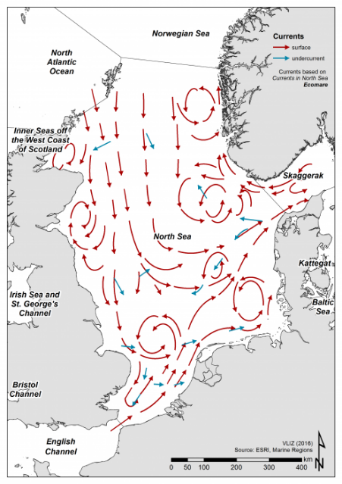
Figure 5: Map of North Sea residual currents (De Hauwere, 2016).
M. lateralis is not currently present in the Mediterranean Sea, and it is very unlikely it could disperse there naturally from its current invaded range in the North Sea. However, if it arrived by a human-assisted pathway, it could potentially spread by natural dispersal throughout the Mediterranean. Surface circulation of the Mediterranean consists basically of a separate counter-clockwise movement of the water in each of the two basins. Because of the complexity of the northern coastline and of the numerous islands, many small eddies and other local currents form essential parts of the general circulation (Millot & Taupier-Letage, 2005). Natural dispersal of planktonic larvae can vary at the subregional level as well as seasonally but has been estimated with modelling simulations in the range of 10²-10³ km for organisms with PLDs similar to M. lateralis (Bray et al., 2017; Andrello et al., 2013). Larvae of M. lateralis can easily survive the current environmental conditions throughout most of the RA area, see Qu. 2.1 for details. Its preferred salinity range is 18-30 psu (Lippson & Lippson, 1984), and it is especially adapted to mixohaline sites where salinity levels fluctuate. Although, its presence along the Dutch and Belgian coasts indicates it can also establish in fully marine areas. Suitable habitats for M. lateralis larvae to settle, consisting of soft sediments on intertidal shores or in the shallow sublittoral, can be found throughout much of the RA area, where there are many estuaries, lagoons and sheltered coastal waters (Craeymeersch et al., 2019; Klunder et al., 2019; Yang et al., 2021).
Natural dispersal of adults: Mulinia lateralis juveniles and adults are small, light due to their thin shells, and they live very close to the surface (Chalermwat et al., 1991). Disturbances to the sediment through strong wave action, or bottom trawling, may lead to excavation of large numbers of clams. These can then be transported by bedload transport, tidal currents, or longshore currents, before deposition elsewhere (Cleveland et al., 2002; Prezant et al., 2010). On St Catherine’s Island, Georgia, US, Cleveland et al. (2002) reported a mass exhumation of M. lateralis, from a subtidal population, possibly caused by strong wave action or shrimp trawling. The clams were likely transported by the strong tidal currents before deposition in an area covering over 7000 m² of intertidal shore. Rees et al. (1977) also noted storm-induced strandings of several bivalve species along the coast of North Wales. They stated that wave activity could be a factor in the maintenance of soft bottom benthic associations in near-shore waters. This method of transport has also been described for: Cerastoderma edule (Richardson et al., 1993); Mya arenaria (Emerson & Grant, 1991); Mercenaria mercenaria, and several other bivalve species (Prezant et al., 2010). Dispersal is probably over relatively short distances of a few kilometres (Prezant et al., 2010).
A rapid rate of natural spread is predicted, resulting from longer distance larval dispersal along the coast, with some restriction due to larval retention in estuaries, and the short distances involved in adult clam dispersal.

Qu. 3.2a. List and describe relevant pathways of spread other than "unaided". For each pathway answer questions 3.3 to 3.9 (copy and paste additional rows at the end of this section as necessary). Please attribute unique identifiers to each question if you consider more than one pathway, e.g. 3.3a, 3.4a, etc. and then 3.3b, 3.4b etc. for the next pathway.
including the following elements:
- a list and description of pathways of spread with an indication of their importance and associated risks (e.g. the likelihood of spread in the risk assessment area, based on these pathways; likelihood of survival, or reproduction, or increase during transport and storage; ability and likelihood of transfer from the pathway to a suitable habitat or host) in relation to the environmental conditions in the risk assessment area.
- an indication of the rate of spread for each pathway discussed in relation to the species biology and the environmental conditions in the risk assessment area.
- All relevant pathways of spread (except “Unaided (Natural Spread)”, which is assessed in Qu. 3.1) should be considered. The classification of pathways developed by the Convention of Biological Diversity shall be used (see Annex IV).

Pathway name: Four potential pathways/ vectors were identified and are listed in order of importance:
- TRANSPORT-STOWAWAY (ship/boat ballast water and sediments)
Kerckhof (2019) suggests that Mulinia lateralis was introduced into NW Europe with ballast water, like the bivalve Ensis leei, also a species originally from the N. American east coast. In addition, ballast water has been suggested as the pathway for two other recently introduced bivalves, Rangia cuneata and Theora lubrica (Verween et al., 2006; Faasse et al., 2019).
With respect to the RA area, movement of vessels between ports within its boundaries is less restricted and ballast water regulations do not apply to short journeys within states. This means that the potential of ballast waters and sediments transport to act as a vector of spread of M. lateralis within the risk assessment area is significant.
- TRANSPORT-STOWAWAY (other means of transport: marine aggregates & dredging)
Dredging is carried out throughout the EU for a number of reasons including: keeping waterways and ports navigable; creation of new ports; coastal protection; land reclamation; and the extraction of sediments as sand and gravel for use by the construction industry (EuDA, 2013; Rabobank, 2013). The dredged sediments from ports and channels may be re-used “beneficially“ for coastal protection, land reclamation or offshore construction, or are disposed of in designated disposal sites in the open sea.
The introduction of a closely related bivalve, Rangia cuneata, into the Vistula Lagoon in the Baltic Sea, and its spread in the UK and the US have been attributed to dredging activities. (Gallagher & Wells, 1969; Rudinskaya & Gusev, 2012; Willing, 2017).
- TRANSPORT-CONTAMINANT (contaminant of animals: mariculture)
In shellfish farming, dredging is used extensively in the relaying of shellfish for ongrowing or purification (Capelle et al., 2017; DG SANTE, 2018). M. lateralis has similar habitat requirements to many cultivated bivalves, so is likely to settle and grow in areas where shellfish are being farmed (McKeon et al., 2015; Craeymeersch et al., 2019). Thus, relaying of shellfish from areas where M. lateralis is present is likely to result in transfer of M. lateralis larvae or adults, as contaminants of the water or sediment associated with the shellfish.
- TRANSPORT-STOWAWAY (other means of transport: boat bilge water)
The bilge water of small vessels, such as fishing boats, yachts and motor boats, not subject to the BWMC, can contain bivalve larvae and juveniles (Darbyson et al., 2009; Fletcher et al., 2017). These vessels typically move between marinas and harbours, or sheltered inland waters such as estuaries, that are likely to provide a habitat suited to the establishment of M. lateralis. The European Boating Industry (2020) estimates that over 6 million boats are kept in European waters, while 10,000 marinas provide one million berths both inland and in coastal areas.

- TRANSPORT-STOWAWAY (ship/boat ballast water)
Qu. 3.3a. Is spread along this pathway intentional (e.g. the organism is deliberately transported from one place to another) or unintentional (e.g. the organism is a contaminant of translocated goods within the risk assessment area)?

RESPONSE | intentional  unintentional | CONFIDENCE | low  medium  high

Response: It can be stated with high certainty that this pathway is unintentional. There is no doubt that uptake of larvae in ballast water is accidental. See categorization of pathways in Annex IV and guidance notes in the beginning of this section.

Qu. 3.4a. How likely is it that a number of individuals sufficient to originate a viable population will spread along this pathway from the point(s) of origin over the course of one year?
including the following elements:
- an indication of the propagule pressure (e.g. estimated volume or number of specimens, or frequency of passage through pathway), including the likelihood of reinvasion after eradication
- if appropriate, indicate the rate of spread along this pathway
- if appropriate, include an explanation of the relevance of the number of individuals for spread with regard to the biology of species (e.g. some species may not necessarily rely on large numbers of individuals).

RESPONSE | very unlikely  unlikely  moderately likely  likely  very likely | CONFIDENCE | low  medium  high

Response: For reproductive output, ship ballast water and sediment volumes, and potential larval concentrations, see Qu. 1.3a. With respect to spread of the organism within the RA area, transshipment operations constitute the main maritime traffic that will act as the vector for spread. Important transshipment hubs are situated along the southern Mediterranean (serving the rest of the Mediterranean and the Black Sea) and the Le Havre-Hamburg range, serving the UK, the Baltic and Scandinavia (Notteboom & de Langen, 2015). Regional vessel movements are more likely, than those from outside the RA area, to pass over suitable habitat where any larvae or adults released in transit may be able to survive. In particular, small vessels may take routes close to the coast and shelter in estuaries or bays overnight or in bad weather, habitats favoured by Mulinia lateralis, see Qu. 1.7a for more details.
Noteworthy, are also larger passenger/ car ferries which operate in most regions, and which have a high traffic volume. Due to the routes taken, measures described in the ballast water convention cannot easily be followed (exchange at depth and distance from shore) so the risk of depositing propagules at suitable locations is higher. These vessels are currently often unchecked, untreated and unregulated, with member states permitted under the BWMC to allow exemptions to apparently low risk inter-regional shipping routes (Olenin et al., 2016). Mulinia lateralis is favoured by water temperatures encountered in many parts of the RA area but has a moderate pelagic larval duration and most likely discreet recruitment periods in Atlantic Europe. Nevertheless, in the Westerschelde the species has been found at locations close to the port of Antwerp (Craeymeersch et al., 2019) and along the Belgian coastline its most dense population is found in the port of Zeebrugge (Nolf, 2022) where sea going vessels exchange ballast water, hinting at the importance of this pathway, thus it is considered likely that sufficient numbers can be transferred with ballast water along this pathway.

Qu. 3.5a. How likely is the organism to survive, reproduce, or increase during transport and storage along the pathway (excluding management practices that would kill the organism)?

RESPONSE | very unlikely  unlikely  moderately likely  likely  very likely | CONFIDENCE | low  medium  high

Response: As in Qu.1.4.a. Additionally, the shorter duration of sea shipping routes between EU ports, and the ferry routes between many European locations, further increases the likelihood of survival within ballast waters, compared with the transatlantic routes from N. America.

Qu. 3.6a. How likely is the organism to survive existing management practices during spread?

RESPONSE | very unlikely  unlikely  moderately likely  likely  very likely | CONFIDENCE | low  medium  high

Response: See Q1.5a. BWE for EU short sea-shipping routes is usually restricted to the second criterion of at least 50 nm from the nearest land, and in waters at least 200 metres in depth in the Mediterranean Sea, and even this is often not feasible in northern European Seas (David et al., 2007). Thus, ballast water exchange is not likely to be effective in preventing the spread of Mulinia lateralis (and other organisms potentially transferred in ballast water) within European Seas. Regarding the IMO D2 standard, compliance can practically diminish propagule pressure of zooplankton, but full implementation of the BWMC is not expected to happen before 2024. However, even then some of the regulations and requirements under the BWMC may be relaxed for shorter, low-risk shipping routes under regional exemption options.

Qu. 3.7a. How likely is the organism to spread in the risk assessment area undetected?

RESPONSE | very unlikely  unlikely  moderately likely  likely  very likely | CONFIDENCE | low  medium  high

Response: As in Qu. 1.6a.

Qu. 3.8a. How likely is the organism to be able to transfer from the pathway to a suitable habitat or host during spread?

RESPONSE | very unlikely  unlikely  moderately likely  likely  very likely | CONFIDENCE | low  medium  high

Response: Mulinia lateralis is typically found in the sheltered, soft sediment habitats common around ports and harbours, which are widely distributed in the RA area. If ballast water exchange occurs in open seas rather than in coastal areas, transfer of planktonic larvae and adults to suitable substrate will be hampered. If, however, untreated ballast water is released in ports, estuaries or other coastal areas, then establishment will be dependent on availability of suitable habitat. Considering: a) the breadth of habitat that characterizes the species; b) the wide distribution of such habitats in the RA area; and c) the initial invasion of the species in The Netherlands, close to Rotterdam (Craeymeersch et al., 2019; Klunder et al., 2019), the third busiest port in the world; there is a high likelihood that M. lateralis can transfer to a suitable habitat after release with ballast water.

Qu. 3.9a. Estimate the overall potential rate of spread based on this pathway in relation to the environmental conditions in the risk assessment area. (please provide quantitative data where possible).

RESPONSE | very slowly  slowly  moderately  rapidly  very rapidly | CONFIDENCE | low  medium  high

Response: Given: a) the amount of maritime traffic between ports and harbours within the RA area (thousands of journeys per year); b) the ballast volume of commercial vessels (10⁴-10⁵ tonnes) (GloBallast, 2021); c) the potentially high densities of both adult Mulinia lateralis on the seabed as well as larvae in surface waters; and d) its wide environmental tolerances (see Qu. 1.4a for details); the potential rate of spread of the species via ballast water is high. Ballast water is considered to be one of the main vectors for spread of the closely related mactrid bivalve Rangia cuneata that has recently invaded and rapidly spread throughout northern European waters (Faillettaz et al., 2020). In addition, ballast water is the most likely vector for long dispersal jumps to other subregions. However, there is currently only inderect evidence of spread within the RA area from ballast water discharge (i.e. no long dispersal jumps to distant locations in/close to port areas but nevertheless the species is present close to the ports of Antwerp and Zeebrugge within its almost continuous distribution along the southern North Sea coast). While potential recipient sites in the Mediterranean are possibly isolated (see Qu. 1.7a), regional vessel movements are more likely, than those from outside the RA area, to pass over suitable habitat where any larvae or adults released in transit may be able to survive. For these reasons we have proposed a rapid rate of spread with ballast water but with low confidence, acknowledging the novelty of the invasion and the difficulty in predicting long dispersal jumps. Due to the limited duration of favourable environmental conditions (seawater temperature) for reproduction in the more northerly parts of the NE Atlantic Ocean, the likelihood that dense populations will develop there is lower.

- TRANSPORT-STOWAWAY (other means of transport: marine aggregates & dredging)
Qu. 3.3b. Is spread along this pathway intentional (e.g. the organism is deliberately transported from one place to another) or unintentional (e.g. the organism is a contaminant of translocated goods within the risk assessment area)?

RESPONSE | intentional  unintentional | CONFIDENCE | low  medium  high

Response: Mulinia lateralis has no commercial value. The dredging activities referred to in this pathway do not include dredging of commercial shellfish beds, and do not intentionally collect this species (but see Qu. 3.3c). See categorization of pathways in Annex IV and guidance notes in the beginning of this section.

Qu. 3.4b. How likely is it that a number of individuals sufficient to originate a viable population will spread along this pathway from the point(s) of origin over the course of one year?
including the following elements:
- an indication of the propagule pressure (e.g. estimated volume or number of specimens, or frequency of passage through pathway), including the likelihood of reinvasion after eradication
- if appropriate, indicate the rate of spread along this pathway
- if appropriate, include an explanation of the relevance of the number of individuals for spread with regard to the biology of species (e.g. some species may not necessarily rely on large numbers of individuals).

RESPONSE | very unlikely  unlikely  moderately likely  likely  very likely | CONFIDENCE | low  medium  high

Response: Dredging is carried out for a number of reasons, including: maintenance to keep waterways and ports navigable, creation of new ports, coastal protection, land reclamation, and the extraction of sediments as sand and gravel, which are used by the construction industry (EuDA, 2013; Rabobank, 2013). The dredged material from ports and channels is usually disposed of in designated areas in the open sea. However, there is a move towards ‘beneficial dredging’ where, whenever possible, dredging waste is re-used for land reclamation, coastal protection, or offshore construction, reducing the need for newly excavated aggregates (ICES, 2016). Thus, dredged materials can be dispersed widely.
Dredging is a major activity in Europe, particularly within The Netherlands, the UK, Denmark and Belgium. For example, over 51 million m³ of marine aggregate was extracted in 2017, approximately 40% as aggregate for construction, 40% for beach replenishment and 19% for land reclamation (ICES, 2018). Maintenance dredging takes place at virtually all harbours, and many marinas throughout the EU. Within the current invaded range of the RA area, there is significant dredging and disposal activity all along the Dutch, German and Belgian coasts. For example, the Port of Rotterdam requires intensive maintenance dredging that yields 12-15 million m³ of dredged material annually (Kirichek et al., 2018). Intensive dredging is also taking place in the port of Zeebrugge and the dredgers often move from one operation zone to another, e.g. from Belgium to the Baltic Sea (F. Kerckhof, pers. comm., 17th August 2021). Large quantities of dredged materials are distributed along the Dutch and Belgian coasts to help prevent coastal erosion and aid land reclamation. Mulinia lateralis lives, shallowly buried, in the surface soft sediments of sheltered waters such as estuaries, lagoons, harbours and coastal areas. Dredging activity is high in such areas as they are prone to silt accumulation. Any dredging of these sediments will inevitably collect a high percentage of any M. lateralis adults present, but also larvae in ballasting hopper water. The adults are small (10-20 mm in length), while newly metamorphosed juvenile shell lengths range from 200 to 700 µm (Wang & Guo, 2008), thus can easily be taken up by all forms of dredging. For details of the M. lateralis propagule pressure generated, see Qu. 1.3a.
M. Faasse proposed the accidental transfer of dredged materials as a possible pathway of spread (pers. comm., 25th February 2021). The introduction of a closely related bivalve, Rangia cuneata, into the Vistula Lagoon in the Baltic Sea, and its spread in the UK and the US have been attributed to dredging activities. (Gallagher & Wells, 1969; Rudinskaya & Gusev, 2012; Willing, 2017).

Qu. 3.5b. How likely is the organism to survive, reproduce, or increase during transport and storage along the pathway (excluding management practices that would kill the organism)?

RESPONSE | very unlikely  unlikely  moderately likely  likely  very likely | CONFIDENCE | low  medium  high

Response: During the period of retention on the vessel, the adults will remain in the sediments they were collected with, so should be able to survive, and possibly even reproduce. While in transit, adults can survive anoxic conditions, salinities of 5-80 psu (Parker, 1975), and temperatures from -2 to 35 °C (Calabrese, 1969a; Kennedy & Mihursky, 1971). Mulinia lateralis can also burrow up to the surface if buried (Maurer et al., 1981) and actively thrives in dredged areas (Flint & Younk, 1983). Larvae in hopper water are also likely to survive (Qu 1.4b).

Qu. 3.6b. How likely is the organism to survive existing management practices during spread?

RESPONSE | very unlikely  unlikely  moderately likely  likely  very likely | CONFIDENCE | low  medium  high

Response: The disposal of dredged materials is regulated throughout the EU (summarised by Mink et al., 2006). OSPAR guidelines specify best environmental practice for managing dredged material (OSPAR, 2014). Member states use these guidelines to manage dredging and dumping and to minimise effects on the marine environment. The main management tools are marine licence and control systems. These require assessments of the environmental impact of planned disposal activities in relation to a specific dumpsite, sediment characteristics and contamination load. Dredging activities are also regulated under the Marine Strategy Framework Directive (MSFD) 2008/56/EC, the Water Framework Directive (WFD) 2000/60/EC and the EC Habitats Directive (92/43/EC). However, the licencing procedures in member states tend to focus mainly on the sediment characteristics and the prevention of the disposal of waste containing contaminants such as heavy metals and pathogens, not non-native species. In addition, many maintenance-dredging activities are exempt or have a reduced licencing requirement (Gov.UK, 2021). No EC regulations on the cleaning of dredging vessels and equipment between projects were found. Thus, residual waste intended for disposal at one site could become mixed with a subsequent load and be disposed of accidentally at another location. As the major dredging corporations are based in the North Sea, see Qu. 1.3b, where this species is now established, there is a risk of spread to other areas within the EU where these corporations operate. For example, there are currently major dredging projects throughout the Mediterranean and Black Sea (Dredging Today, 2021, Van Oord, 2020).
Regulations may vary from country to country. For example in Wales, UK, the completion of a Biosecurity Risk Assessment when applying for a marine licence for dredging and/or disposal, is now required for all activities. Marine licencing conditions imposed include the washing of seabed equipment and filter screens at the end of a campaign, the requirement for the circulation and exchange of hopper water away from shore, and the removal of hopper sediment prior to entering a different region of the UK (ABPmer, 2019; G. Wynne, B. Wray & S. Vye (Natural Resources Wales,) pers. comm. 21st April 2021). However, these management practices are not yet statutory, and do not apply to the rest of the UK. In general, restrictions on disposal based on the risk associated with the source areas would be an effective management method, as long as extensive and up-to-date data on the distribution of the high-risk non-native species are available.

Qu. 3.7b. How likely is the organism to spread in the risk assessment area undetected?

RESPONSE | very unlikely  unlikely  moderately likely  likely  very likely | CONFIDENCE | low  medium  high

Response: Any Mulinia lateralis accidently collected would be dumped with a significant amount of sediment, in the designated disposal site. It is unlikely any regular checks will be made at the disposal sites, particularly where the dredge waste is being re-used for land reclamation, offshore construction, or coastal protection. The transportation and release of larvae in hopper water is even less likely to be monitored or detected.
Adult M. lateralis are small (10-20 mm in length), and the gross morphology is similar to some common native species, as described in A.2, so may easily be overlooked. Newly metamorphosed juvenile shell lengths range from 200 to 700 µm (Wang & Guo, 2008), so transfers at the larval or juvenile stage, within the associated sediment or water, are very likely to go undetected.

Qu. 3.8b. How likely is the organism to be able to transfer from the pathway to a suitable habitat or host during spread?

RESPONSE | very unlikely  unlikely  moderately likely  likely  very likely | CONFIDENCE | low  medium  high

Response: Mulinia lateralis will be deposited along with the sediment or hopper water it was collected with, so the immediate habitat will be very suitable. If the waste is being used for coastal protection or land reclamation, the deposition will probably be made close to shore in a sheltered area. Licensed dredged waste disposal sites may be further offshore, but again the seabed is likely to consist of soft sediments from previous disposals. M. lateralis can also burrow up to the surface if buried during the deposition (Maurer et al., 1981).

Qu. 3.9b. Estimate the overall potential rate of spread based on this pathway in relation to the environmental conditions in the risk assessment area. (please provide quantitative data where possible).

RESPONSE | very slowly  slowly  moderately  rapidly  very rapidly | CONFIDENCE | low  medium  high

Response: Given the high frequency and volumes involved in maintenance and capital dredging activities, the likely high survival rate during transit, and deposition commonly being into suitable habitat, there is a high risk of spread. This is especially the case in the Greater North Sea area where the waste is normally re-used ‘beneficially’ for coastal protection or land reclamation, e.g. in The Netherlands, Denmark and Belgium (ICES, 2016). Under these circumstances, disposal sites may be greater distances away from the initial collection site, than would be the case for designated waste disposal sites. Although the disposal site is likely to be within the same member state, or a close neighbouring member state. Long dispersal events with dredge spoils are probably likely to be more sporadic compared with spread via ballast water/sediment due to the higher volume and frequency of commercial ship journeys.

- TRANSPORT-CONTAMINANT (contaminant of animals: mariculture)
Qu. 3.3c. Is spread along this pathway intentional (e.g. the organism is deliberately transported from one place to another) or unintentional (e.g. the organism is a contaminant of translocated goods within the risk assessment area)?

RESPONSE | intentional  unintentional | CONFIDENCE | low  medium  high

Response: Mulinia lateralis is not grown commercially for food, thus its introduction into commercial shellfish beds is unintentional. In addition, as it will compete with the cultivated shellfish for space and food, so would be considered a nuisance species.

Qu. 3.4c. How likely is it that a number of individuals sufficient to originate a viable population will spread along this pathway from the point(s) of origin over the course of one year?
including the following elements:
- an indication of the propagule pressure (e.g. estimated volume or number of specimens, or frequency of passage through pathway), including the likelihood of reinvasion after eradication
- if appropriate, indicate the rate of spread along this pathway
- if appropriate, include an explanation of the relevance of the number of individuals for spread with regard to the biology of species (e.g. some species may not necessarily rely on large numbers of individuals).

RESPONSE | very unlikely  unlikely  moderately likely  likely  very likely | CONFIDENCE | low  medium  high

Response: Cultivated shellfish are frequently moved between sites locally, regionally and internationally, for the purposes of: restocking; to enhance production; relaying for fattening purposes; relaying for cleansing; or to keep fresh and alive before consumption (McKindsey et al., 2007; Brenner et al., 2014; Muehlbauer et al., 2014). It is known than many non-native species can hitchhike with these movements, including the Manila clam, Ruditapes philippinarum (McKindsey et al., 2007, and references therein).
Production of bivalve molluscs in the EU averages 500,000 tonnes annually (350,000 tonnes of mussels, 100,000 tonnes of oysters and 50,000 tonnes of clams), France and Spain are the most important countries in terms of production volume and value (DG SANTE, 2018). Spain, Ireland, France, Italy and the UK are the most important regarding trade of live bivalve molluscs for farming and relaying. France is particularly important in terms of the number of movements of live bivalve molluscs for relaying before putting on the market, and the natural production of seed spat of Pacific oysters and mussels that is subject to movements either within France or to other member states. For example, bivalve transfers are being conducted between the Bay of Biscay and the Mediterranean Sea cultivation sites by France but also by Spain (Muehlbauer et al., 2014). There are also a large number of movements from Spain, particularly from Galicia to Italy, for relaying and purification (Robert et al., 2013; DG SANTE, 2018). Mussel bottom culture is typically practiced on shallow mudflats in areas where there are extensive naturally occurring mussel seed beds. In the Netherlands, Germany, UK, and Ireland, seed fished from natural beds is the main source for bottom culture (Kamermans & Smaal, 2002).
Mulinia lateralis is likely to establish and thrive in habitats typically used for benthic shellfish cultivation, e.g. in Chesapeake Bay in its native range, it is found in association with several commercial species (Reece et al., 2008), and in the Wadden Sea, it was found to be abundant amongst the edible clam, Spisula subtruncata (Craeymeersch et al., 2019). Mytilus edulis, the Blue mussel, is produced in the Western part of the Dutch Wadden Sea and in the Oosterschelde estuary, both areas where Mulinia has already invaded (Robert et al., 2013; Craeymeersch et al., 2019; Faasse et al., 2019). However, mussels and oysters farmed, fished and transported along the German, Dutch and Belgium coasts, are generally not transported to other coasts in NW Europe, where M. lateralis has not been recorded yet, which lowers the immediate potential for direct transfer of the species outside its current range in the RA area via this pathway for the time being. In the likely event though that the species spreads further via other means, such as natural dispersal, ballast water or dredging operations, secondary spread with shellfish transfers is likely to be significant. For details of the M. lateralis propagule pressure generated, see Qu. 1.3a.
The relaying of spat for on-growing, or adult bivalves for fattening or cleansing, is carried out by dredging the donor site (using a variety of methods), then relaying the bivalves at the new location (Diaz et al., 2012; Gaspar et al., 2013; Robert et al., 2013; Capelle et al., 2014). Although M. lateralis does not attach to other shellfish, juveniles and adults present as contaminants in the sediment would be collected as by-catch during the dredging process, also larvae may be captured in water taken up during the dredging. It should be noted here that different fishing gears targeting different species have a different likelihood of capturing and retaining M. lateralis; thus, a shellfish dredge used for oysters and/or mussels is designed to “skim” over the surface of the sediment, reducing the chance that Mulinia lateralis is inadvertently captured. On the other hand, hydraulic dredges used to fish clams and cockles that live buried within the sediment, are designed to penetrate deeper and consequently have a higher chance of catching M. lateralis specimens. The cockle fishery (Cerastoderma edule) in the Wadden Sea is conducted via manual harvesting (Baer et al., 2022) and the small amounts of the deep-burrowing razor clams (Ensis directus) harvested in the Dutch North Sea are not fished up to be moved to a different location, making this particular fishery a less likely transport vector.
Taking the above into consideration, the likelihood that M. lateralis will be transferred via shellfish culture from its current European distribution range to yet uncolonized sites within the RA area is currently assessed as moderate, noting however that this potential may increase if the species reaches other shellfish grounds via different pathways.

Qu. 3.5c. How likely is the organism to survive, reproduce, or increase during transport and storage along the pathway (excluding management practices that would kill the organism)?

RESPONSE | very unlikely  unlikely  moderately likely  likely  very likely | CONFIDENCE | low  medium  high

Response: In order to successfully transfer the target commercial bivalve species, the dredging, on-board conditions, and transit time will all be optimized to ensure the target species survives and remains healthy. This process will also enable the survival of Mulinia lateralis, a species with wide environmental tolerances, see Qu. 1.4a for more details. Reproduction during transit is unlikely as the period between dredging and relaying of the target species is short, particularly for spat, as the shellfish need to be kept alive and healthy; although some larvae may metamorphose.

Qu. 3.6c. How likely is the organism to survive existing management practices during spread?

RESPONSE | very unlikely  unlikely  moderately likely  likely  very likely | CONFIDENCE | low  medium  high

Response: At the EU level, COUNCIL REGULATION (EC) No 708/2007 concerning use of alien and locally absent species in aquaculture defines the procedures to be followed that minimize the risk of introducing non-target alien species accompanying commercial shellfish spat and stocks. It requires a permit procedure, involving risk assessment for the non-target species and a quarantine period for the translocated stock. Importantly, in relation to spread within the RA area, the regulation does not apply to movements of locally absent species within the member states (i.e. in this case cultivated native species of bivalves) “except for cases where, on the basis of scientific advice, there are grounds for foreseeing environmental threats due to the translocation, Art. 2 para. 2.” Additionally, movements of the bivalves Magallana gigas and Ruditapes philippinarum, listed in Annex IV of the Council Regulation, which could be contaminated with M. lateralis, are permitted without any risk assessment or quarantine. However, local/national legislation exists that can limit the translocation possibilities of species like M. gigas, e.g. see WG-AS & Gittenberger (2018) for the trilateral Wadden Sea area. With regard to mussel relaying in Wales, UK a walkover survey of the source site is required checking for before a licence is granted (G. Wynne, B. Wray & S. Vye (Natural Resources Wales,) pers. comm. 21st April 2021). Moreover, if the import region is a Natura 2000 area, regulations can be much stricter as they aim to protect the conservation objectives of the protected area first.
Where the commercial shellfish are cleaned before transfer, removing any sediment, this will significantly reduce the level of contamination by Mulinia lateralis larvae and juveniles, as these would not be attached to the shellfish. Sorting by size may also limit contamination of adult commercial stocks as M. lateralis only grows to 10-20 mm.
In general, restrictions on transfers based on the risk associated with the source areas is an effective management method, as long as extensive and up-to-date data on the distribution of the high-risk non-native species are available. However, delays in identifying new non-native species, and their distribution in the RA area, can mean that spread, particularly within member states, is not prevented. For example, in The Netherlands, mussel seed is fished from seed beds which generally occur in the Wadden Sea, it is then transported to culture plots in the Wadden Sea and the Oosterschelde (Robert et al., 2013), although movement is not permitted in the other direction. This offers a possible explanation of the finding of M. lateralis in the Oosterschelde. Visual inspections of the dredged shellfish are unlikely to detect M. lateralis, unless it is present in large numbers, due to its small size, and larvae would not be visible. Moves within the commercial shellfish sector towards hatchery culture of spat, and rope culture for mussels, will reduce the need for dredging (Robert et al., 2013; Smaal et al., 2019).

Qu. 3.7c. How likely is the organism to spread in the risk assessment area undetected?

RESPONSE | very unlikely  unlikely  moderately likely  likely  very likely | CONFIDENCE | low  medium  high

Response: Perfunctory visual inspections during bivalve aquaculture operations are likely to miss adult Mulinia lateralis as they are small (10-20 mm in length), and the gross morphology is similar to some common native species, as described in A.2. Newly metamorphosed juvenile shell lengths range from 200 to 700 µm (Wang & Guo, 2008), so transfers at the larval or juvenile stage, within the associated sediment or water, are very likely to go undetected.

Qu. 3.8c. How likely is the organism to be able to transfer from the pathway to a suitable habitat or host during spread?

RESPONSE | very unlikely  unlikely  moderately likely  likely  very likely | CONFIDENCE | low  medium  high

Response: If bivalve seed/stock contaminated with Mulinia lateralis is relayed on cultivation plots without any prior management measures, the likelihood of transfer to other suitable habitats is very high (the cultivation plots themselves are suitable habitats, see Qu. 3.4c). These plots are often situated in coastal areas in close proximity to additional suitable natural habitat to which individuals may spread.

Qu. 3.9c. Estimate the overall potential rate of spread based on this pathway in relation to the environmental conditions in the risk assessment area. (please provide quantitative data where possible).

RESPONSE | very slowly  slowly  moderately  rapidly  very rapidly | CONFIDENCE | low  medium  high

Response: Taking into consideration the particular characteristics of the shellfish culture/fishery in the areas where M. lateralis is currently present, shellfish movements are a moderately likely mechanism of spread towards uncolonized sites in the RA area, albeit more important at the local level, where spat is dredged and then relayed at nearby sites for on-growing. Considering the degree of regulation of the industry and the fact that in many cases transfers are predominantly conducted within member states, spread to distant locations through this pathway may be less important than spread through other pathways such as ballast water and sediments.

d) TRANSPORT-STOWAWAY (other means of transport: boat bilge water)
Qu. 3.3d. Is spread along this pathway intentional (e.g. the organism is deliberately transported from one place to another) or unintentional (e.g. the organism is a contaminant of translocated goods within the risk assessment area)?

RESPONSE | intentional  unintentional | CONFIDENCE | low  medium  high

Response: Bilge water is not taken up intentionally; it results from rough seas, leaks in the hull, rain, washing of equipment on deck, or other interior spillage. Thus, there is no doubt the presence of any Mulinia lateralis in bilge water is accidental. See categorization of pathways in Annex IV.

Qu. 3.4d. How likely is it that a number of individuals sufficient to originate a viable population will spread along this pathway from the point(s) of origin over the course of one year?
including the following elements:
- an indication of the propagule pressure (e.g. estimated volume or number of specimens, or frequency of passage through pathway), including the likelihood of reinvasion after eradication
- if appropriate, indicate the rate of spread along this pathway
- if appropriate, include an explanation of the relevance of the number of individuals for spread with regard to the biology of species (e.g. some species may not necessarily rely on large numbers of individuals).

RESPONSE | very unlikely  unlikely  moderately likely  likely  very likely | CONFIDENCE | low  medium  high

Response: It depends on:
a) The number of yachts and vessels arriving in a hub;
b) Volume of bilge water;
c) Theoretical distance, time to first discharge (assuming constant and linear travel);
d) Propagule pressure; and
e) Survival of the species.
An indication of the number of recreational vessels in the RA area is given by the European Boating Industry (2020), which estimates that over 6 million boats are kept in European waters while 10,000 marinas provide one million berths, both inland and in coastal areas. Fletcher et al. (2017) recorded bilge water volumes of between 0.9 and 29 l from 15 motorboats sampled, and 0.2-200 l from 15 yachts, including a large catamaran, in New Zealand. Fletcher et al. (2020) noted that yachts in particular, have a high likelihood of bilge water being on board when leaving port (i.e. high-risk source regions for Mulinia lateralis larvae). Extrapolating from CPS Authority et al. (2017), approximately 30% of these vessels travel distances >100 km from their home port. Assuming travel speeds of 5 knots (Fletcher et al., 2017) considerable distances can be travelled within the RA area within a matter of days, which significantly increases the likelihood that sufficient viable propagules of M. lateralis can spread along this pathway from already established populations in the RA area. For propagule pressure, see Qu. 1.3a.

Qu. 3.5d. How likely is the organism to survive, reproduce, or increase during transport and storage along the pathway (excluding management practices that would kill the organism)?

RESPONSE | very unlikely  unlikely  moderately likely  likely  very likely | CONFIDENCE | low  medium  high

Response: Analysis of samples collected from yachts and motorboats in Canada and New Zealand, found bivalve larvae and juveniles in the bilge water (Darbyson et al., 2009; Fletcher et al., 2017). Considering: the pelagic larval duration of Mulinia lateralis (7 to 22 days); the relatively short travel times of small vessels within the RA area; the tolerance of the organism to salinities down to 5 psu; and its tolerance of oil pollution (a common contaminant of bilge water (Grassle & Grassle, 1974); the likelihood of survival along this pathway is assessed as high. As adults are unlikely to be taken in with the small water incursions that accumulate as bilge water, it is unlikely that M. lateralis will reproduce during transport.

Qu. 3.6d. How likely is the organism to survive existing management practices during spread?

RESPONSE | very unlikely  unlikely  moderately likely  likely  very likely | CONFIDENCE | low  medium  high

Response: Legislation regarding discharge of bilge water only relates to large commercial vessels and is included under the BWMC, see Qu. 3.6a. For smaller vessels, there is currently no EC legislation in place specifically covering bilge water. However, since 2008 some member states are requiring the installation of holding tanks in recreational vessels for waste water, although this is mainly to control ‘black water’ or ‘grey water’ from the toilets or washing facilities, and does not generally cover bilge water (Noonsite, 2019). Most recreational vessels now have bilge water pumps that operate automatically so the boat owner cannot control the location of discharge (Fletcher et al., 2017).

Qu. 3.7d. How likely is the organism to spread in the risk assessment area undetected?

RESPONSE | very unlikely  unlikely  moderately likely  likely  very likely | CONFIDENCE | low  medium  high

Response: See response Qu. 1.6a. In order to reach Good Environmental Status (GES) targets with reference to Descriptor D2, most EU states are already designing or implementing national/regional NIS-targeted monitoring programmes. Monitoring should focus on introduction hotspots (e.g. ports, marinas, aquaculture plots) and this will increase the detectability of Mulinia lateralis entering the RA area through bilge water, particularly if molecular methods are employed (Hayes et al., 2004).

Qu. 3.8d. How likely is the organism to be able to transfer from the pathway to a suitable habitat or host during spread?

RESPONSE | very unlikely  unlikely  moderately likely  likely  very likely | CONFIDENCE | low  medium  high

Response: Recreational vessels spend substantial periods of time stationary; berthed in marinas and ports, or on moorings in estuaries (Ashton et al., 2006). At other times, they generally remain in sheltered inland waters. Thus, if viable propagules are discharged with untreated bilge water they are likely to transfer to a suitable habitat consisting of soft sediments on intertidal shores or in the shallow sublittoral, see Qu. 1.7a for more detail on habitat.

Qu. 3.9d. Estimate the overall potential rate of spread based on this pathway in relation to the environmental conditions in the risk assessment area. (please provide quantitative data where possible).

RESPONSE | very slowly  slowly  moderately  rapidly  very rapidly | CONFIDENCE | low  medium  high

Response: Small vessels travelling within the RA area can easily spread this organism while in transit, through automatic bilge water discharge, or at the next destination. However, compared to the transport of ballast water by larger vessels, the volumes of water transported are much smaller, the distances covered are generally much shorter, and the voyages less frequent. So the contribution of this pathway to the overall potential rate of spread is assessed as relatively lower than ballast water (see Qu. 3.9a).

Qu. 3.10. Within the risk assessment area, how difficult would it be to contain the organism in relation to these pathways of spread?

RESPONSE | very easy  easy  with some difficulty  difficult  very difficult | CONFIDENCE | low  medium  high

Response: Naturally dispersing organisms are very difficult to contain, especially species such as Mulinia lateralis with high fecundity, relatively long pelagic larval duration, and the capability to develop extremely dense populations in a very short time (See Qu. 2.7 for the biological characteristics of the species). Currently this species is restricted to the Greater North Sea region, and there is no evidence of repeated introductions into the RA area. Thus, it may be feasible to delay the rapid spread of the species, especially long dispersal jumps, if restrictions based on the risk associated with the source areas are rapidly adopted by the industry. The current legal instruments and levels of implementation of voluntary measures are not sufficient to ensure containment of the organism, when transferred by ballast water (but this can change with full implementation of the D-2 Standard), dredging, bivalve movements, or bilge water.

Qu. 3.11. Estimate the overall potential rate of spread in relevant biogeographical regions under current conditions for this organism in the risk assessment area (indicate any key issues and provide quantitative data where possible).
Thorough assessment of the risk of spread in relevant biogeographical regions in current conditions, providing insight in the risk of spread into (new areas in) the risk assessment area.

RESPONSE | very slowly  slowly  moderately  rapidly  very rapidly | CONFIDENCE | low  medium  high

Response: Unaided dispersal and multiple pathways of human-aided spread create a considerable potential for spread. This is illustrated by the known spread of the species along approximately 450 km of coastline during the 4 years since its arrival.
Ballast water and sediment transport is the most likely vector to facilitate rapid spread via long distance transport of the species within European waters, until the BWMC is fully implemented. Even if there is only indirect evidence of Mulinia lateralis being transported in ballast water, the densities attained close to port locations are among the highest in the invaded range (in the order of 1000 ind/m², see Craeymeersch et al., 2019 and Nolf, 2022), supporting the importance of this pathway for its rapid spread (see also Qu 3.9a).
The movements of dredging waste may already have contributed to the current spread of Mulinia lateralis in the Greater North Sea region. Bivalve transfers are another likely mechanism of spread in the RA area, especially within member states but potentially also between marine regions/subregions. Particular attention is needed in the future when transferring oyster and mussel consignments between Atlantic Europe and the Mediterranean, should the species spread via other pathways to the Bay of Biscay, since bivalve transfers are being conducted between these two marine regions by e.g., France and Spain (Muehlbauer et al., 2014; DG SANTE, 2018). On the other hand, mussels and oysters farmed, fished and transported along the German, Dutch and Belgium coasts, are generally not transported to other coasts in NW Europe, where M. lateralis has not been recorded yet, such that this pathway is not as important currently for the spread of the species. Finally, bilge waters, a vector that has been overlooked until recently, appears to be able to transport viable propagules of the species in the relatively short duration of intra-European journeys.
Due to the difficulty of predicting the potential for long dispersal jumps via ballast water or the other pathways, the confidence of this assessment is low.

Qu. 3.12. Estimate the overall potential rate of spread in relevant biogeographical regions in foreseeable climate change conditions (provide quantitative data where possible).
Thorough assessment of the risk of spread in relevant biogeographical regions in foreseeable climate change conditions: explaining how foreseeable climate change conditions will influence this risk, specifically if rates of spread are likely slowed down or accelerated.

RESPONSE | very slowly  slowly  moderately  rapidly  very rapidly | CONFIDENCE | low  medium  high

Response: The rate of spread is not expected to change significantly under foreseeable climate change conditions. An overall rise in sea surface temperatures will increase the potential for adult populations and larval production in the Greater North Sea and Celtic Seas subregions, with a corresponding increase in the likelihood of spread via all pathways. Whereas in the Mediterranean Sea, an increase in SST may result in fewer source populations (see Qu. 2.10 for more detail), and thus reduce the likelihood of spread. Higher frequency and severity of storms can increase the amount of time vessels have to spend in port, increasing the likelihood of entrainment in ballast water (Galil et al., 2019).
Dredging activity may increase in response to rising sea levels, leading to an increase in demand for coastal protection. In addition, an increase in extreme weather events (e.g. flooding with associated terrigenous inputs), may increase the need for dredging to maintain water channels and protect property. Heat waves can cause mass mortality of aquaculture bivalves, leading to increased shellfish transfers to replenish the stocks (Rodrigues et al., 2015). More shellfish movements may be associated with a higher risk of introduction if the stocks/seed originate from areas with a high risk of contamination with Mulinia lateralis and the necessary precautions are not taken.

4 MAGNITUDE OF IMPACT
Important instructions:
- Questions 4.1-4.5 relate to biodiversity and ecosystem impacts, 4.6-4.8 to impacts on ecosystem services, 4.9-4.13 to economic impact, 4.14-4.15 to social and human health impact, and 4.16-4.18 to other impacts. These impacts can be interlinked, for example, a disease may cause impacts on biodiversity and/or ecosystem functioning that leads to impacts on ecosystem services and finally economic impacts. In such cases the assessor should try to note the different impacts where most appropriate, cross-referencing between questions when needed.
- Each set of questions starts with the impact elsewhere in the world, then considers impacts in the risk assessment area (=EU excluding outermost regions) separating known impacts to date (i.e. past and current impacts) from potential future impacts (including foreseeable climate change).
- Only negative impacts are considered in this section (socio-economic benefits are considered in Qu. A.7)
- In absence of specific studies or other direct evidences this should be clearly stated by using the standard answer “No information has been found on the issue”. This is necessary to avoid confusion between “no information found” and “no impact found”. In this case, no score and confidence should be given and the standardized “score” is N/A (not applicable).

Biodiversity and ecosystem impacts
Qu. 4.1. How important is the impact of the organism on biodiversity at all levels of organisation caused by the organism in its non-native range excluding the risk assessment area?
including the following elements:
- Biodiversity means the variability among living organisms from all sources, including terrestrial, marine and other aquatic ecosystems and the ecological complexes of which they are part; this includes diversity within species, between species and of ecosystems
- impacted chemical, physical or structural characteristics and functioning of ecosystems

RESPONSE | NA | CONFIDENCE

Response: There is no evidence to suggest that this species is non-native anywhere else in the world outside the RA area.

Qu. 4.2. How important is the current known impact of the organism on biodiversity at all levels of organisation (e.g. decline in native species, changes in native species communities, hybridisation) in the risk assessment area (include any past impact in your response)?
Discuss impacts that are currently occurring or are likely occurring or have occurred in the past in the risk assessment area. Where there is no direct evidence of impact in the risk assessment area (for example no studies have been conducted), evidence from outside of the risk assessment area can be used to infer impacts within the risk assessment area.

RESPONSE | minimal  minor  moderate  major  massive | CONFIDENCE | low  medium  high

Response: Mulinia lateralis has only been present within the RA area since 2016, and its current distribution is limited to the southern North Sea (see Qu. A6). No studies of impact have been reported from the RA area, so it is not yet possible to reliably assess its current impact on biodiversity. However, this species’ rapid population growth within the RA, its population dynamics within the native range, and the known impacts on biodiversity from other invasive bivalve species, indicate that M. lateralis is likely already having some impact.
Competition: In 2017, dense populations of up to almost 6,000 ind. m² were recorded from the Voordelta (southwestern Dutch coastal waters), and again in 2018 at densities of 1,000 ind. m² (Craeymeersch et al., 2019). In 2018, M. lateralis was recorded at high density (820 ind. m²) in the Westerschelde (Craeymeersch et al., 2019). Subsequently, in 2019, it was recorded there at 18/44 sites sampled, at an average of five ind. m² (Walles et al., 2020). In its native range in estuaries along the east coast of N. America, it can reach average densities of up to 21,000 ind. m² (Santos and Simon 1980; Walker & Tenore, 1984). It is possible that such dense settlements are competing with native bivalves for space and food, but see Qu. 4.3.
Impacts of similar species (i.e. shallowly buried, infaunal suspension feeders with an r-strategy) in the Greater North Sea region:
Ensis leei: In Belgium, declines in abundance of other bivalves such as Mactra stultorum, Cerastoderma edule, Spisula subtruncata, Ensis magnus and tellinids have been observed since the introduction of E. leei (Gollasch et al., 2015).
Rangia cuneata: sympatric with M. lateralis in their native range (temperate west Atlantic, Gulf of Mexico), this mactrid bivalve has recently invaded and rapidly spread throughout northern European waters (Faillettaz et al., 2020). It has managed to establish numerical dominance in many of the invaded locations (estuaries, tidal reaches, brackish waters) with its numbers exceeding those of native species such as Macoma balthica and Cerastoderma glaucum in the Gulf of Gdansk (Janas et al., 2014).

Qu. 4.3. How important is the potential future impact of the organism on biodiversity at all levels of organisation likely to be in the risk assessment area?
See comment above. The potential future impact shall be assessed only for the risk assessment area. A potential increase in the distribution range due to climate change does not per se justify a higher impact score.

RESPONSE | minimal  minor  moderate  major  massive | CONFIDENCE | low  medium  high

Response:
Competition: Most bivalve species largely utilize the same food source and are therefore competitors for food. Whether food competition leads to an introduced species out-competing indigenous species is dependent on many factors such as filtration capacity, selection and absorption efficiency, and energy demand (Shumway & Newell 1984). Mulinia lateralis is adapted to quickly exploit high concentrations of phytoplankton and natural seston (particularly bacteria) but has a relatively high-energy demand and an apparent inability to catabolize protein during prolonged periods of starvation, which may be the cause of observed mass mortalities in its native range (Shumway and Newell, 1984; Chalermwat et al., 1991).
Within its native range, M. lateralis is considered an opportunistic species that tends to rapidly colonise disturbed areas at high population densities, but can just as quickly disappear (see Qu. A.11 and Qu. 2.3). According to McKeon et al. (2015), from studies in its native range, M. lateralis reaches its greatest densities when released from competition with other bivalves. However, in the Voordelta, in The Netherlands, M. lateralis was found together with Spisula subtruncata (a native species considered to be threatened (Cardoso et al., 2007)), both at high densities at the same site, and likewise in the Westerschelde, where M. lateralis was found with Cerastoderma edule both at high densities (Craeymeersch et al., 2019). Both native species are summer spawners, with the main spatfall occurring from June to September (Smaal et al., 1997; Cardoso et al., 2007). Thus, there is considerable overlap likely with M. lateralis during spat settlement (presuming its reproductive period in the North Sea is similar to that in the northern part of its native range (Calabrese, 1970)). Therefore, M. lateralis may well compete successfully both for space and food with native bivalves. Whether this will lead to native species’ declines cannot be predicted with any certainty due to the novelty of the invasion, however increased settlement seems likely as the species establishes dense populations and expands its range. In addition, its colonisation of recently defaunated areas may prevent native opportunistic species from establishing at those sites.
Shellfish disease: In its native range, M. lateralis is a host for the protozoan parasite Perkinsus chesapeaki, recently recorded from the Mediterranean and Atlantic coasts of France and Spain, which can infect clams and cockles. According to Carrasco et al. (2014), no clear evidence of relevant host reaction was observed in Cerastoderma edule tissues, although P. chesapeaki seemed to cause damage to the structure of gill lamellae, see Qu. 2.4. If P. chesapeaki is present in the M. lateralis populations in the RA area, this disease could infect and lead to a decline in native clam or cockle populations.
Hybridisation: M. lateralis can hybridise with other clams e.g. Spisula solidissima (Lindell et al., 2006), whether it will hybridise naturally with clams native to the RA area, such as other Spisula species, is not known.
Trophic interactions: Many native species could potentially utilise M. lateralis as a food resource. M. lateralis lives very close to the sediment surface and has a thin shell, so is easily available to a wide variety of predators (see Qu. 2.4). Craeymeersch et al. (2019) anticipate many native species in the North Sea will be able to feed on Mulinia. Whether M. lateralis would provide equivalent energy and nutrient levels as current native prey species would require detailed investigation. In its native range, M. lateralis is an important food source for wildfowl during the winter (Calabrese, 1970) and it was found to be an adequate replacement nutritionally for Ischadium recurvum, the Hooked Mussel (Wells-Berlin et al., 2015). Baffin Bay, a hypersaline estuary in the Gulf of Mexico, supports an important recreational and commercial fishery for black drum Pogonias cromis, this benthic predator is highly reliant on M. lateralis as a food source, the biomass of which varies with the rapid changes in salinity that occur there (Pollack et al., 2018; Rubio et al., 2018). The sudden crashes in M. lateralis populations could lead to starvation of predators such as crabs and fish that have come to rely on it (Walker & Tenore, 1984). For example, wintering scaup (Aythya affinis) populations in Lake Pontchartrain, Louisiana, declined precipitously a year after a hurricane caused mass mortalities of their preferred bivalve prey, i.e. the clams Rangia cuneata and M. lateralis (Stroud et al., 2019).
Mass mortality events: Mass die-offs of bivalves can affect the ecosystem in 3 ways:
a) Food web structure, nutrient cycling and transfer of energy to higher trophic levels - The interaction between infaunal filter feeders, such as M. lateralis, and resuspended microphytobenthos and detritus can be particularly important in estuaries (e.g. Jones et al., 2016). The sudden loss of large amounts of bivalve biomass can disrupt the transfer of carbon and energy in the system.
b) Water quality - Mass die-offs of bivalves are known to influence abiotic factors that negatively affect other organisms in the ecosystem through organic matter decomposition with associated reduced dissolved oxygen and elevated ammonia concentrations, sometimes to toxic levels (e.g. Cherry et al., 2005; Cooper et al., 2005), although such impacts are less likely to be severe or long-lived in well-flushed environments.
c) Habitat alteration - In its native range, very dense settlements of M. lateralis that then die off can leave large amounts of dead shells in areas of predominantly soft sediments; these can also be transported to local shores (Levinton, 1970; Powell et al., 1986). Changes in habitat complexity and seabed structural properties can in turn greatly affect the communities living within soft sedimentary environments (Bodis et al., 2014). Although this may be considered a positive impact as shell deposits can increase species’ richness through provision of shelter and substrate for other species (Gutiérrez et al., 2003). However, Nicastro et al. (2009) found that even large depositions of shells of the non-native gastropod, Maoricolpus roseus, into a soft-sediment habitat within a dynamic coastal lagoon, did not affect the community structure.
Regional differences: In the Mediterranean Sea, should the species be introduced there, the impacts will probably be greater as it is likely that M. lateralis populations will become more dominant members of the macrobenthos throughout the year, especially in the highly variable lagoonal and estuarine systems (with low diversity) of the region, see Qu. 2.9. Interaction with the dominant bivalve Abra ovata is possible. As a result, strong trophic interactions are more likely to develop but also population crashes of dense settlements are more likely to produce negative effects.

Qu. 4.4. How important is decline in conservation value with regard to European and national nature conservation legislation caused by the organism currently in the risk assessment area?
including the following elements:
- native species impacted, including red list species, endemic species and species listed in the Birds and Habitats directives
- protected sites impacted, in particular Natura 2000
- habitats impacted, in particular habitats listed in the Habitats Directive, or red list habitats
- the ecological status of water bodies according to the Water Framework Directive and environmental status of the marine environment according to the Marine Strategy Framework Directive

RESPONSE | minimal  minor  moderate  major  massive | CONFIDENCE | low  medium  high

Response:
The Netherlands: The Wadden Sea is the largest unbroken system of intertidal sand and mud flats in the world; it stretches from The Netherlands to Denmark, and is recognised as a UNESCO World Heritage Site. It is known for its habitat variability and unique (benthic) biodiversity. The invasion of non-native species can alter the synergetic community currently present in this ecosystem, which provides vital support to migratory birds as a staging, moulting and wintering area. The availability of food and a low level of disturbance are essential factors that contribute to the key role of the property in supporting the survival of migratory species (UNESCO, 2021). The Voordelta, Oosterschelde, Westerschelde and North Sea coastal zone are all designated as Natura 2000 sites under the Habitat Directive and the European Birds Directive. Mulinia lateralis is present in all of these areas (see Qu. A8).
Belgium: Most of the Belgian coast is designated either under the European Birds Directive and/or the Habitat Directive, the largest area is the Vlaamse Banken between Ostend and the French border. M. lateralis has been found scattered along the whole Belgian coast.
Germany: The Wadden Sea – see The Netherlands above.
The habitat types where M. lateralis has established in these member states are Estuaries (X01), Marine littoral sediment (A2), and Marine sublittoral sediment (A5). The broadscale habitat features suitable for establishment of M. lateralis are littoral sand and muddy sand, mud, and mixed sediments; and sublittoral, sand, mud, and mixed sediments; corresponding to the EUNIS level 3 codes: A2.2, A2.3, A2.4, A5.2, A5.3, A5.4.
Changes through competition to infaunal bivalve populations, such as Cerastoderma edule, Mactra stultorum or Spisula subtruncata, have the potential to affect the overwintering success of protected diving seabirds such as the common eider (Somateria mollissima) and common scoter (Melanitta nigra), which depend upon these prey resources for their survival (Bräger et al., 1995). With respect to the environmental status of the sites it has invaded, its impact could be related to the MSFD descriptors D1 (biodiversity), D2 (NIS), D3 (fishing), and D4 (food webs). Yet, the degree impact on GES, based on the MSFD descriptors by M. lateralis has not been quantitatively assessed. The only evident measured impact is presently the indicator D2 (criterion D2C1: number of new NIS per 6 years).

Qu. 4.5. How important is decline in conservation value with regard to European and national nature conservation legislation caused by the organism likely to be in the future in the risk assessment area?
- See guidance to Qu. 4.3. and 4.4.

RESPONSE | minimal  minor  moderate  major  massive | CONFIDENCE | low  medium  high

Response: The conservation status of many estuarine and lagoonal Natura 2000 sites, MPAs and SSSIs could be degraded. Any decline in conservation value is likely to be greater in the Mediterranean Sea, should the species be introduced there, as it is more likely that, due to the potential for prolonged recruitment, year-round reproductive populations will develop, especially in the highly variable lagoonal and estuarine systems of the region, see Qu. 2.9. In addition to the habitats noted in Qu. 4.4, the biodiversity of saline (X02) and brackish lagoon habitats (X03) within the Mediterranean, along the Atlantic coast, and in the Black Sea could be impacted. Considering that lagoonal habitats are important as nursery areas for many fish populations (Pérez-Ruzafa et al., 2011; Newton et al., 2018), as well as feeding grounds for waterfowl, changes in trophic interactions and the overall food web could have short to medium term effects on their conservation value, which is already degraded/unfavourable in large parts of the RA area (EEA – Habitats Directive reporting under Article 17).
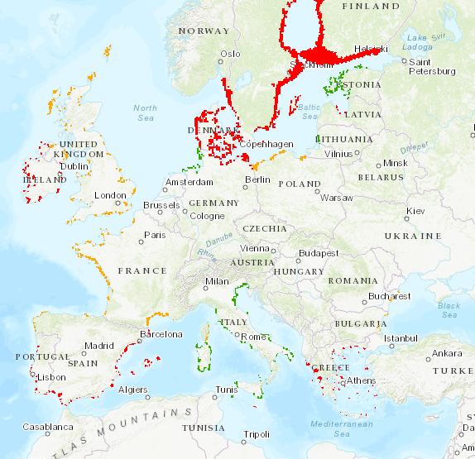
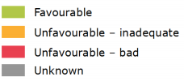

Figure 6: Conservation status of coastal lagoons (Habitat 1150) for the period 2013-2018 for EU28. (Source: European Environment Agency, available at https://nature-art17.eionet.europa.eu/article17/)
With respect to the environmental status of any conservation sites if invaded, the impact of M. lateralis could be related to the MSFD descriptors D1 (biodiversity), D2 (NIS), D3 (fishing), and D4 (food webs).

Ecosystem Services impacts
Qu. 4.6. How important is the impact of the organism on provisioning, regulating, and cultural services in its non-native range excluding the risk assessment area?
- For a list of services use the CICES classification V5.1 provided in Annex V.
- Impacts on ecosystem services build on the observed impacts on biodiversity (habitat, species, genetic, functional) but focus exclusively on reflecting these changes in relation to their links with socio-economic well-being.
- Quantitative data should be provided whenever available and references duly reported.

RESPONSE | NA | CONFIDENCE

Response: There is no evidence to suggest that the species is non-native anywhere else in the world outside the RA area.

Qu. 4.7. How important is the impact of the organism on provisioning, regulating, and cultural services currently in the different biogeographic regions or marine subregions where the species has established in the risk assessment area (include any past impact in your response)?
- See guidance to Qu. 4.6.

RESPONSE | minimal  minor  moderate  major  massive | CONFIDENCE | low  medium  high

Response: Mulinia lateralis has only been present within the RA area since 2016, and its current distribution is limited to the southern North Sea (see Qu. A6). No studies of impact have been reported from the RA area, so it is not yet possible to reliably assess its current impact on ecosystem services. However, this species’ rapid population growth within the RA, its population dynamics within the native range, and the known impacts on ecosystem services from other invasive bivalve species, indicate that M. lateralis is likely already having some impact.
Potential causes of as yet unidentified impacts:
Provisioning: Biomass - Although competition for food and space with cultivated bivalves is a potential source of loss, it is unclear if M. lateralis is a strong competitor to commercial species (see Qu. 2.3). The Wadden Sea and Oosterschelde are important areas for shellfish culture.
Regulation and Maintenance: In the North Sea, where this species is established, it is vulnerable to mass die-offs resulting from storms, low salinity events, or seawater temperatures being too low to sustain annual reproduction. Such events could affect water quality (see Qu. A11, Qu. 2.9 and Qu. 4.3.)

Qu. 4.8. How important is the impact of the organism on provisioning, regulating, and cultural services likely to be in the different biogeographic regions or marine subregions where the species can establish in the risk assessment area in the future?
- See guidance to Qu. 4.6.

RESPONSE | minimal  minor  moderate  major  massive | CONFIDENCE | low  medium  high

Response: Potential causes of impacts:
Provisioning: Biomass - Although competition for food and space with cultivated bivalves is a potential source of loss, it is unclear if Mulinia lateralis is a strong competitor to commercial species (see Qu. 2.3). These effects are likely to be greater in subregions where abiotic conditions are most suitable for year-round reproductive populations to establish, i.e. the Mediterranean, and the Bay of Biscay and the Iberian coast subregions (see Qu. 2.9).
Regulation and maintenance:
Water - In the North Sea, where this species is established, it is vulnerable to mass die-offs resulting from storms, low salinity events, or seawater temperatures being too low to sustain annual reproduction. Such events could affect water quality (see Qu. A11, Qu. 2.9 and Qu. 4.3). These impacts are likely to be greater in subregions where abiotic conditions are not optimal, i.e. the Greater North Sea, Celtic Seas, Baltic Sea and Black Sea (see Qu. 2.9).
Lifecycle maintenance - Maintaining nursery populations and habitats. By altering trophic interactions in lagoons, it has the potential to affect the nursery function of these habitats, especially if it undergoes population fluctuations tied to seasonal and/or stochastic events.
Pest and disease control - M. lateralis may facilitate the spread of the pathogenic parasite P. chesapeaki to commercial clam species (see Qu. 4.11), or cestode parasites to elasmobranchs (see Qu. 4.16). This will have most effect in the Mediterranean and the Bay of Biscay and Iberian coast subregions where commercial clam growing is greatest (see Qu. 4.11).
Cultural:
Physical and experiential - It may affect the amenity and recreational value of infested areas by reducing recreational harvests of other shellfish such as clams and cockles, if M. lateralis replaces these species on intertidal shores.

Economic impacts
Qu. 4.9. How great is the overall economic cost caused by the organism within its current area of distribution (excluding the risk assessment area), including both costs of / loss due to damage and the cost of current management.
- Where economic costs of / loss due to the organism have been quantified for a species anywhere in the world these should be reported here. The assessment of the potential costs of / loss due to damage shall describe those costs quantitatively and/or qualitatively depending on what information is available. Cost of / loss due to damage within different economic sectors can be a direct or indirect consequence of the earlier-noted impacts on ecosystem services. In such case, please provide an indication of the interlinkage. As far as possible, it would be useful to separate costs of / loss due to the organism from costs of current management.

RESPONSE | minimal  minor  moderate  major  massive | CONFIDENCE | low  medium  high

Outside of its native range, Mulinia lateralis is not known to be present, other than within the RA area.
Impacts as a result of trophic interactions in the native range: The Baffin Bay complex (Texas) supports a large commercial Black Drum fishery (Grubbs et al., 2013; Olsen, 2016) which was compromised in a 2012 emaciation event due to reduced M. lateralis availability (its preferred prey), linked to extreme salinity conditions in the bay in 2012 (Pollack et al., 2018). (See also Qu. 4.3). Baffin Bay saw roughly a 33% drop in production by weight in 2012. Considering that the coastwide fishery of Black Drum was estimated as worth approximately $1.5 million per year at the time and the Baffin Bay fishery contributes roughly 50% to the overall landings (Grubbs et al., 2013), the economic impact is estimated as moderate.
Other potential causes of unidentified losses in the native range: Although competition for food and space with cultivated bivalves is a potential source of loss, it is unclear if M. lateralis is a strong competitor to commercial species, see Qu. 2.3. M. lateralis is a host to the parasitic pathogen Perkinsus chesapeaki, which also infects the commercial clam Mya arenaria and is likely to affect its growth, reproduction and possibly mortality (Dungan et al., 2002).

Qu. 4.10. How great is the economic cost of / loss due to damage (excluding costs of management) of the organism currently in the risk assessment area (include any past costs in your response)?
- Where economic costs of / loss due to the organism have been quantified for a species anywhere in the EU these should be reported here. Assessment of the potential costs of damage on human health, safety, and the economy, including the cost of non-action. A full economic assessment at EU scale might not be possible, but qualitative data or different case studies from across the EU (or third countries if relevant) may provide useful information to inform decision making. In absence of specific studies or other direct evidences this should be clearly stated by using the standard answer “No information has been found on the issue”. This is necessary to avoid confusion between “no information found” and “no impact found”. In this case, no score and confidence should be given and the standardized “score” is N/A (not applicable). Cost of / loss due to damage within different economic sectors can be a direct or indirect consequence of the earlier-noted impacts on ecosystem services. In such case, please provide an indication of the interlinkage.

RESPONSE | N/A | CONFIDENCE

Response: No information has been found on the issue. Mulinia lateralis has only been present within the RA area since 2016, and its current distribution is limited to the southern North Sea (see Qu. A6). No studies of impact have yet been reported from the RA area, and no economic costs have yet been identified or estimated, so it is not possible to reliably assess its current economic impact.

Qu. 4.11. How great is the economic cost of / loss due to damage (excluding costs of management) of the organism likely to be in the future in the risk assessment area?
- See guidance to Qu. 4.10.

RESPONSE | minimal  minor  moderate  major  massive | CONFIDENCE | low  medium  high

Response:
Competition: This species is not itself of direct commercial importance (Calabrese, 1970). It may compete with commercially grown bivalves for food and space in natural habitats, potentially reducing the crop harvest, but it is unclear if it is a strong competitor (see Qu. 2.3).
Shellfish disease: Perkinsosis is a disease affecting numerous mollusc species worldwide, causing significant mortalities and economic losses. The main causative species of disease in oysters is Perkinsus marinus, and in clams is P. olseni, currently these are the only species classed as notifiable in Europe. However, Mulinia lateralis is a host for P. chesapeaki, recently recorded from the Mediterranean and Atlantic coasts of France and Spain, that can infect commercial clams and cockles including Ruditapes decussatus, R. philippinarum and Cerastoderma edule, and possibly affect production (Dungan et al., 2002; Reece et al., 2008; Arzul et al., 2012; Carrasco et al., 2014; Ruano et al., 2015).
According to Carrasco et al. (2014), no clear evidence of relevant host reaction was observed in C. edule tissues, although P. chesapeaki seemed to cause damage to the structure of gill lamellae. Carrasco et al. (2014) conclude that the impact of P. chesapeaki on C. edule, as well as in other cohabiting bivalves such as clams, with high commercial value in the region, needs to be urgently addressed. Park et al. (2010) found that the fecal discharge (faeces and pseudofaeces) and decomposition of infected clam tissue could be the two major routes of transmission for Perkinsus parasites. Thus, dense populations of M. lateralis, either alive or after a mass die-off, could significantly mediate the spread of these parasites. Despite a relatively low production in Europe, clams are a high value seafood product, economically important in many European countries, particularly in Spain, Italy and Portugal. Annual production of clams averages 50,000 tonnes (DG SANTE, 2018), with the main producer of clams being Italy. Clams in aquaculture alone (36,000 tonnes in 2019) are worth 240 million Euros (FAO, Fisheries Statistics, 2021). Any potential impacts of M. lateralis would be indirect, to the extent that transport of adult, parasite-infested individuals would facilitate the spread of Perkinsus species to commercial clams. Considering the high value of the clam industry in Europe, moderate economic losses are a plausible scenario, although this estimate comes with high uncertainty.

Qu. 4.12. How great are the economic costs / losses associated with managing this organism currently in the risk assessment area (include any past costs in your response)?
- In absence of specific studies or other direct evidences this should be clearly stated by using the standard answer “No information has been found on the issue”. This is necessary to avoid confusion between “no information found” and “no impact found”. In this case, no score and confidence should be given and the standardized “score” is N/A (not applicable).

RESPONSE | minimal  minor  moderate  major  massive | CONFIDENCE | low  medium  high

Response: No specific management plans are in place for this particular organism in Europe. For marine invasive species introduced by ballast water there are considerable management measures at various stages of implementation (see also Management Annex). These costs are not specific for Mulinia lateralis and therefore not included in the score. Within the Wadden Sea, management measures are in place regarding shellfish transportation (WG-AS & Gittenberger, 2018) again these are not specific to this species.

Qu. 4.13. How great are the economic costs / losses associated with managing this organism likely to be in the future in the risk assessment area?
- See guidance to Qu. 4.12.

RESPONSE | minimal  minor  moderate  major  massive | CONFIDENCE | low  medium  high

Response: Mulinia lateralis is already established in the Greater North Sea, and eradication would likely not be an economically viable option due to the open nature of the marine environment and life history traits of the species. However, measures to prevent its spread to other regions of the RA area, particularly the Mediterranean may be considered, given the likelihood of greater impact on biodiversity and clam fisheries in that region. Costs related to shipping (ballasts/fouling) will be borne by the shipping companies. Significant costs can be associated with the ratification of relevant legislation, e.g. the Ballast Water Management Convention, in ensuring its compliance, related to planning, monitoring, enforcement and capacity building. However, these costs are not specific to M. lateralis and will prevent/reduce the introduction of a wide range of species carried by ballast water.
If management is taken forward then likely costs would include:
Dredging: Introduction of regulations regarding the cleaning of dredging vessels and equipment, such as water exchange and sediment removal from hoppers, between projects; and regulations regarding the ‘beneficial’ use of dredging spoil. There would be significant costs associated with the ratification of any such legislation, and in ensuring compliance, related to planning, monitoring and enforcement. Operational costs would be borne by the dredging companies. However, these costs are not specific to M. lateralis and will prevent/reduce the introduction and spread of a wide range of species. To prevent spread to new sites within the RA area, dredging sites would need to be tested for M. lateralis (and other NIS). Currently, under Marine Licensing regulations these sites are initially checked for chemical contaminants and pathogens, but not NIS.
Shellfish movements and disease: Introduction of further controls over shellfish relaying and movements of other commercial shellfish between natural habitats to include testing for a range of NIS. Current regulations relate to pathogens and diseases. These costs would not be specific to M. lateralis and will prevent/reduce the spread of a wide range of species. A ban on imports or restrictions in the movement of shellfish seed/stock from areas where M. lateralis is present could have potentially significant economic implications for shellfish producers. Monitoring of clam and cockle populations for P. chesapeaki infections - This is not currently a notifiable species, although other Perkinsus species are. Detection of infested M. lateralis specimens among commercial clam beds may warrant the early harvesting of clams, with associated costs and economic losses (Andrews & Ray, 1988).
Conservation status: As this species would be very difficult to eradicate or contain once it is present in a designated conservation area, and direct impact on biodiversity is considered to be ‘minor’ (see Qu. 4.3) any monitoring carried out would not result in management costs directly attributable to this species. However, M. lateralis should be included in MSFD D2 monitoring programmes within the RA area, with particular awareness of its trophic interactions with species of conservation importance.
With regards to the cost of monitoring, an indicative estimate comes from Denmark, where the cost of a proposed hotspot monitoring programme for all marine NIS (covering 13 ports and three areas with discharges of cooling water) was estimated at approximately €125,000 for the period 2015-2017 (Andersen et al., 2014). In the UK, a broad initial estimate of monitoring costs for MSFD D2 alone (considering that existing or new surveys for other descriptors will also contribute to the monitoring of NIS) suggests that they would be less than €974,000 over 10 years (DEFRA, 2012) with an additional €103,000 euros for drafting legislation and guidance.

Social and human health impacts
Qu. 4.14. How important is social, human health or other impact (not directly included in any earlier categories) caused by the organism for the risk assessment area and for third countries, if relevant (e.g. with similar eco-climatic conditions).
The description of the known impact and the assessment of potential future impact on human health, safety and the economy, shall, if relevant, include information on
- illnesses, allergies or other affections to humans that may derive directly or indirectly from a species;
- damages provoked directly or indirectly by a species with consequences for the safety of people, property or infrastructure;
- direct or indirect disruption of, or other consequences for, an economic or social activity due to the presence of a species.
Social and human health impacts can be a direct or indirect consequence of the earlier-noted impacts on ecosystem services. In such case, please provide an indication of the interlinkage.

RESPONSE | N/A | CONFIDENCE

Response: No information has been found on the issue.

Qu. 4.15. How important is social, human health or other impact (not directly included in any earlier categories) caused by the organism in the future for the risk assessment area.
- In absence of specific studies or other direct evidences this should be clearly stated by using the standard answer “No information has been found on the issue”. This is necessary to avoid confusion between “no information found” and “no impact found”. In this case, no score and confidence should be given and the standardized “score” is N/A (not applicable).

RESPONSE | minimal  minor  moderate  major  massive | CONFIDENCE | low  medium  high

Response: There may be an impact on the recreational harvesting of bivalves such as clams and cockles, if Mulinia lateralis replaces these species on intertidal shores. Other recreational activities, such as fishing and bird-watching may be affected if M. lateralis becomes a dominant prey resource and predator populations follow its fluctuations.

Other impacts
Qu. 4.16. How important is the organism in facilitating other damaging organisms (e.g. diseases) as food source, a host, a symbiont or a vector etc.?

RESPONSE | minimal  minor  moderate  major  massive | CONFIDENCE | low  medium  high

Response: Mulinia lateralis is a host for the parasitic pathogen Perkinsus chesapeaki that can infect other clam and cockle species See Qu. 4.11. M. lateralis is also reported as the intermediate host for larvae of two elasmobranch parasitic cestode species, Duplicibothrium minutum and Rhodobothrium paucitesticulare, see Qu. 2.4. In the native range of M. lateralis, the Cownose ray, is the host for both species. No information could be found as to whether either species could potentially infect any elasmobranchs within the RA area.

Qu. 4.17. How important might other impacts not already covered by previous questions be resulting from introduction of the organism?

RESPONSE | NA | CONFIDENCE

Response: No additional impacts could be identified.

Qu. 4.18. How important are the expected impacts of the organism despite any natural control by other organisms, such as predators, parasites or pathogens that may already be present in the risk assessment area?

RESPONSE | minimal  minor  moderate  major  massive | CONFIDENCE | low  medium  high

Response:
Predation: Within its native range, a wide variety of species prey on Mulinia lateralis. Something similar is likely to happen in the RA area, with predation by native species of crabs, fish, starfish, shore birds and diving ducks. In the port of Zeebrugge many Oystercatchers have been observed preying on the abundant M. lateralis living on an intertidal mudflat (F. Kerckhof, pers. comm., 17th August 2021). In the colder parts of its native range predation by crabs and fish is probably the major factor controlling adult population size, at least during warmer months, and numbers increase drastically in the absence of predators (Virnstein, 1977). Wildfowl feeding may become an important regulator (Wells-Berlin et al., 2015), see Qu. 2.4 for more detail. Such trophic interactions however are likely to mediate impacts, rather than temper them, if specific predator-prey relationships develop (as in Qu. 4.3).
Parasites/pathogens: The parasitic pathogen Perkinsus chesapeaki or tapeworm infections may effect some control over abundance, although no pathology has been reported from the native range, see Qu 2.4 for more detail.

Qu. 4.19. Estimate the overall impact in the risk assessment area under current climate conditions. In addition, details of overall impact in relevant biogeographical regions should be provided.
Thorough assessment of the overall impact on biodiversity and ecosystem services, with impacts on economy as well as social and human health as aggravating factors, in current conditions.

RESPONSE | minimal  minor  moderate  major  massive | CONFIDENCE | low  medium  high

Response: As Mulinia lateralis has not previously invaded anywhere else in the world outside the RA area, and as it has only been recorded in the RA area since 2017, there is very little evidence available regarding its likely overall impact. The bulk of the information regarding the likely behavior and potential impacts of M. lateralis in the RA area, presented in this assessment, have been inferred from its life-history traits and population dynamics throughout its native range along the east coast of N. America. What little early indicators of impact there are regarding its recent invasion of the RA area, come from the Greater North Sea subregion, an area corresponding climatically to the northern limit of this species’ native range, and thus may not be indicative of impacts in other subregions.
No impacts have yet been reported from the RA area. However, M. lateralis appears to have the potential to cause minor to moderate environmental impacts within the RA area, with the greatest impacts being predicted for the Mediterranean, if invaded, as populations are more likely to become dominant members of the macrobenthos throughout the year. The habitats primarily affected are estuaries and lagoons, which are both of high conservation value.
Biodiversity: Initial indications are that population densities could be sufficient to impact on native bivalve biodiversity, through competition for space and food; and affect trophic interactions by potentially altering predator/prey relationships e.g. with crabs, fish and shorebirds (Craeymeersch et al., 2019; Klunder et al., 2019). It is likely that mass die-offs, typical of this species, will occur which could have multiple effects on: food web structure; nutrient cycling; the transfer of energy to higher trophic levels; water quality; and habitat structure through the deposition of dead shells. These impacts are likely to be greater in subregions where abiotic conditions are not optimal, i.e. the Greater North Sea, Celtic Seas, Baltic Sea and Black Sea. Other potential impacts on biodiversity include facilitating the spread of the protozoan parasite Perkinsus chesapeaki to clams and cockles or cestode parasites to elasmobranchs.
Ecosystem services: Competition for food and space with, and the possible spread of P. chesapeaki to, cultivated bivalves are potential sources of economic loss. By altering trophic interactions in lagoons, M. lateralis has the potential to affect the nursery function of these habitats, especially if it undergoes population fluctuations tied to seasonal and/or stochastic events.
Economy: Competition for food and space with, and the possible spread of P. chesapeaki to cultivated bivalves are potential sources of economic loss.
Social and human health: Recreational harvests of other shellfish such as clams and cockles could also be reduced, if M. lateralis replaces these species on intertidal shores.

Baltic Sea: minor, low confidence (western part)
Greater North Sea: minor, low confidence
Celtic Seas: minor, low confidence
Bay of Biscay and the Iberian coast: moderate, low confidence
Mediterranean Sea: moderate, low confidence
Black Sea: minor, low confidence

Qu. 4.20. Estimate the overall impact in the risk assessment area in foreseeable climate change conditions. In addition, details of overall impact in relevant biogeographical regions should be provided.
Thorough assessment of the overall impact on biodiversity and ecosystem services, with impacts on economy as well as social and human health as aggravating factors, under future conditions.
- See also guidance to Qu. 4.3.

RESPONSE | minimal  minor  moderate  major  massive | CONFIDENCE | low  medium  high

Response: See Qu. 4.19.
An increase in sea surface temperature will offer suitable conditions for spawning and larval development for longer periods throughout the Greater North Sea and Celtic Seas; this could reduce the likelihood of mass die-offs in those subregions, but increase the effects of competition on native bivalve biodiversity. In addition, it is anticipated that extreme weather phenomena, like droughts and storms/flooding, will be more frequent and intense under future climate conditions, this may lead to higher salinity variations and mechanical substrate disturbance, factors that facilitate colonisation by Mulinia lateralis.
Baltic Sea: minor, low confidence (western part)
Greater North Sea: moderate, low confidence
Celtic Seas: moderate, low confidence
Bay of Biscay and the Iberian coast: moderate, low confidence
Mediterranean Sea: moderate, low confidence
Black Sea: minor, low confidence

RISK SUMMARIES
 | RESPONSE | CONFIDENCE | COMMENT
Summarise Introduction and Entry* | very unlikely  unlikely  moderately likely  likely  very likely | low  medium  high | Mulinia lateralis has already been introduced into the RA area, but possibly only once. Ballast water and sediments is considered the most plausible pathway due to the volume of traffic, its importance as a vector in the transfer of bivalve molluscs with similar life histories, and its presence in the region of a major shipping hub. However, it is possible that this single introduction resulted from a much rarer event such as the accidental transfer of residual dredging waste or hopper water.
Summarise Establishment* | very unlikely  unlikely  moderately likely  likely  very likely | low  medium  high | The species is already established in the southeastern North Sea and further establishment throughout most of the RA area is considered very likely.  M. lateralis is expected to exhibit boom and bust dynamics in Atlantic Europe, where conditions will limit spawning and recruitment to the summer months. Establishment is considered likely up as far as northern England and Ireland. In the Mediterranean Sea, should the species be introduced there, it is more likely that due to the potential for prolonged recruitment, year-round, dense populations will develop, especially in the highly variable lagoonal and estuarine systems of the region. The Baltic Sea only offers salinity conditions suitable for establishment in its western part. Localised establishment is also considered possible in the Black Sea, although conditions there are sub-optimal.  Under future climate change a small northward shift and slight increase of the overall suitable area for the species is expected.
Summarise Spread* | very slowly  slowly  moderately  rapidly  very rapidly | low  medium  high | There is considerable potential for spread through unaided larval dispersal on ocean currents, and multiple pathways of human-aided spread (ballast water and sediments, dredging activities, shellfish transfers, and boat bilge water).  Ballast water and sediment transport may facilitate long distance transport of larvae and adults within European waters, as already indicated by strong populations in ports along the Dutch and Belgian coast.  Dredging activities, bivalve transfers, and movements of small boats containing bilge waters, usually involve shorter distances, generally remaining within member states.  However, international dredging contracts and bivalve transfers do also take place between marine regions/subregions, e.g. with the transfer of oyster consignments between Atlantic Europe and the Mediterranean.  Under future climate conditions, an overall rise in SST will increase the potential for adult populations and larval production in the Greater North Sea and Celtic Seas, with a corresponding increase in the likelihood of spread via all pathways. Whereas in the Mediterranean Sea, an increase in SST may result in fewer source populations in the south and east of the region, and thus reduce the likelihood of spread. There may also be an increased demand for dredging and shellfish movements.
Summarise Impact* | minimal  minor  moderate  major  massive | low  medium  high | Mulinia lateralis appears to have the potential to cause minor to moderate environmental impacts within the RA area, with the greatest impacts being predicted for the Mediterranean. The habitats primarily affected are estuaries and lagoons, which are both of high conservation value.  M. lateralis may impact native bivalve biodiversity, through competition for space and food, and affect trophic interactions by potentially altering predator/prey relationships. Mass die-offs, typical of this species, could affect food web structure, nutrient cycling, the transfer of energy to higher trophic levels, water quality, and habitat structure. It may also facilitate spread of the protozoan parasite Perkinsus chesapeaki to clams and cockles or cestode parasites to elasmobranch species. M. lateralis also has the potential to affect the nursery function of lagoonal habitats.  There may be economic losses in the cultivation of bivalves through competition for space and food, and the possible spread of P. chesapeaki. Recreational harvests of other shellfish such as clams and cockles could also be reduced.
Conclusion of the risk assessment  (overall risk) | low  moderate  high | low  medium  high | Mulinia lateralis is an opportunistic, infaunal bivalve already introduced in the North Sea, either by ballast water/ sediments or by dredger vessels operating in its native range. Further spread via natural dispersal is expected to proceed relatively quickly, and the human-mediated pathways are likely to cause secondary introductions into the other RA subregions.  While dense populations may be ephemeral in Atlantic Europe, the species is expected to persist more in lagoons and estuaries of the northern and western Mediterranean.  Minor to moderate impacts may be anticipated, through competition and altered trophic interactions with native species, primarily in estuaries and lagoons. The ecosystem services and conservation value of these habitats are likely to be moderately affected, especially after mass die-offs of M. lateralis, while the bivalve aquaculture sector may be at risk by increased spread of Perkinsus parasites.
*in current climate conditions and in foreseeable future climate conditions

REFERENCES
ABPmer (2019). Biosecurity Planning in a nutshell: Fulfilling the new marine licence requirement for the marine aggregates sector. Available at: https://www.abpmer.co.uk/blog/biosecurity-planning-in-a-nutshell/
Ajemian, M. J., & Powers, S. P. (2012). Habitat-specific feeding by cownose rays (Rhinoptera bonasus) of the northern Gulf of Mexico. Environmental Biology of Fishes, 95(1), 79-97.
Aller, H. D. (1912). Notes on the distribution of the more common bivalves of Beaufort, NC (Published by permission of the US Commissioner of Fish and Fisheries). Journal of the Elisha Mitchell Scientific Society, 28(2), 76-87.
Andersen, J. H., Pedersen, S. A., Thaulow, J., Stuer-Lauridsen, F., & Cochrane, S. (2014). Monitoring of non-indigenous species in Danish marine waters. Background and proposals for a monitoring strategy and a monitoring network. Danish Nature Agency.
Andrello, M., Mouillot, D., Beuvier, J., Albouy, C., Thuiller, W., et al. (2013). Low connectivity between Mediterranean Marine Protected Areas: A biophysical modeling approach for the Dusky Grouper Epinephelus marginatus. PLoS ONE, 8(7): e68564.
Andrews, J. D. & Ray, S. M., (1988). Management strategies to control the disease caused by Perkinsus marinus. American Fisheries Society Special Publication, 18, 257-264.
Arzul, I., Chollet, B., Michel, J., Robert Mill, H., Garcia, C., Joly, J. P., ... & Miossec, L. (2012). One Perkinsus species may hide another: characterization of Perkinsus species present in clam production areas of France. Parasitology, 139(13), 1757-1771.
Ashton, G. V., Boos, K., Shucksmith, R., & Cook, E. J. (2006). Risk assessment of hull fouling as a vector for marine non-natives in Scotland. Aquatic Invasions, 1(4), 214-218.
Assis, J., Tyberghein, L., Bosh, S., Verbruggen, H., Serrão, E. A., & De Clerck, O. (2018). Bio-ORACLE v2.0: Extending marine data layers for bioclimatic modelling. Global Ecology and Biogeography, 27(3), 277-284.
Baer J., Smaal A., van der Reijden K. & Nehls G. (2017) Fisheries. In: Wadden Sea Quality Status Report 2017. Eds.: Kloepper S. et al., Common Wadden Sea Secretariat, Wilhelmshaven, Germany. Last updated 21.12.2017. Downloaded 30.09.2022
Barnay, A., Ellien, C., Gentil, .F. & Thiébaut, E. (2003). A model study on variations in larval supply: are populations of the polychaete Owenia fusiformis in the English Channel open or closed? Helgoland Marine Research, 56, 229–237.
Bishop, J. D. D., Wood, C. A., Yunnie, A. L. E., Griffiths, C.A. (2015). Unheralded arrivals: non-native sessile invertebrates in marinas on the English coast. Aquatic Invasions, 10(3), 249–264.
Blundon, J. A., & Kennedy, V. S. (1982). Refuges for infaunal bivalves from blue crab Callinectes sapidus predation in Chesapeake Bay USA. Journal of Experimental Marine Biology and Ecology, 65, 67-82.
Bódis, E., Tóth, B., Szekeres, J., Borza, P., & Sousa, R. (2014). Empty native and invasive bivalve shells as benthic habitat modifiers in a large river. Limnologica, 49, 1–9.
Bohn, K. 2014. The distribution and potential northwards spread of the invasive slipper limpet Crepidula fornicata in Wales, UK. NRW Evidence Report No: 40, 43pp, Natural Resources Wales, Bangor.
Borrell, Y. J., Miralles, L., Do Huu, H., Mohammed-Geba, K., & Garcia-Vazquez, E. (2017). DNA in a bottle-Rapid metabarcoding survey for early alerts of invasive species in ports. PloS one, 12(9), e0183347.
Bräger, S., Meißner, J., & Thiel, M. (1995). Temporal and spatial abundance of wintering Common Eider Somateria mollissima, Long-tailed Duck Clangula hyemalis, and Common Scoter Melanitta nigra in shallow water areas of the southwestern Baltic Sea. Ornis Fennica, 72(1), 19-28.
Bray, L., Kassis, D., & Hall-Spencer, J. M. (2017). Assessing larval connectivity for marine spatial planning in the Adriatic. Marine Environmental Research, 125, 73-81.
Brenner, M., Fraser, D., Van Nieuwenhove, K., O'Beirn, F., Buck, B. H., Mazurié, J., ... & Kamermans, P. (2014). Bivalve aquaculture transfers in Atlantic Europe. Part B: environmental impacts of transfer activities. Ocean & Coastal Management, 89, 139-146.
Burreson, E. M., Reece, K., & Dungan, C. F. (2005). Molecular, morphological, and experimental evidence support the synonymy of Perkinsus chesapeaki and Perkinsus andrewsi. Journal of Eukaryotic Microbiology, 52, 258–270.
Calabrese, A. (1969a). Individual and combined effects of salinity and temperature on embryos and larvae of the coot clam, Mulinia lateralis (Say). The Biological Bulletin, 137(3), 417-428.
Calabrese, A. (1969b). Mulinia lateralis, molluscan fruit fly. In Proceedings of the National Shellfish Association (Vol. 59, pp. 65-66).
Calabrese, A. (1970). Reproductive cycle of the coot clam, Mulinia lateralis (Say), in Long Island Sound. Veliger, 12(3), 265-269.
Capelle, J. J., Wijsman, J. W. M., Schellekens, T., van Stralen, M. R., Herman, P. M. J., & Smaal, A. C. (2014). Spatial organisation and biomass development after relaying of mussel seed. Journal of Sea Research, 85, 395-403.
Capelle, J. J., Van Stralen, M. R., Wijsman, J. W., Herman, P. M., & Smaal, A. C. (2017). Population dynamics of subtidal blue mussels Mytilus edulis and the impact of cultivation. Aquaculture Environment Interactions, 9, 155-168.
Cardoso, J. F., Witte, J. I., & van der Veer, H. W. (2007). Growth and reproduction of the bivalve Spisula subtruncata (da Costa) in Dutch coastal waters. Journal of Sea Research, 57(4), 316-324.
Carrasco, N., Rojas, M., Aceituno, P., Andree, K. B., Lacuesta, B., & Furones, M. D. (2014). Perkinsus chesapeaki observed in a new host, the European common edible cockle Cerastoderma edule, in the Spanish Mediterranean coast. Journal of invertebrate pathology, 117, 56-60.
Chalermwat, K., Jacobsen, T. R., & Lutz, R. A. (1991). Assimilation of bacteria by the dwarf surf clam Mulinia lateralis (Bivalvia: Mactridae). Marine ecology progress series. Oldendorf, 71(1), 27-35.
Cherry, D. S., Scheller, J. L., Cooper, N. L., & Bidwell, J. R. (2005). Potential effects of Asian clam (Corbicula fluminea) die-offs on native freshwater mussels (Unionidae) I: water-column ammonia levels and ammonia toxicity. Journal of the North American Benthological Society, 24(2), 369-380.
Clarke, D., & Miller-Way, T. (1992). An environmental assessment of the effects of open water disposal of maintenance dredged material on benthic resources in Mobile Bay, Alabama. Final report. Waterways Experiment Station, Corps of Engineers, Vicksburg, Mississippi, pp. 1-175.
Cleveland, C. M., Prezant, R. S., Rollins, H. B., Toll, R., & Wylie, J. (2002). Mass exhumation and deposition of Mulinia lateralis (Bivalvia: Mactridae) on an intertidal beach, St. Catherines Island, Georgia, USA. Veliger, 45(1), 65-70.
Cooper, N. L., Bidwell, J. R., & Cherry, D. S. (2005). Potential effects of Asian clam (Corbicula fluminea) die-offs on native freshwater mussels (Unionidae) II: porewater ammonia. Journal of the North American Benthological Society, 24(2), 381-394.
CPS Authority, Gittenberger, A., Wesdorp, K. H., & Rensing, M. (2017). Biofouling as a transport vector of non-native marine species in the Dutch Delta, along the North Sea coast and in the Wadden Sea.
Craeymeersch, J. A., Faasse, M. A., Gheerardyn, H., Troost, K., Nijland, R., Engelberts, A., ... & Van Zwol, J. (2019). First records of the dwarf surf clam Mulinia lateralis (Say, 1822) in Europe. Marine Biodiversity Records, 12(1), 1-11.
Cripe, G. M. (2006). Contaminated sediment testing with the bivalve Mulinia lateralis: Culture refinement for organism availability. Environmental Toxicology and Chemistry: An International Journal, 25(5), 1332-1336.
Darbyson, E., Locke, A., Hanson, J. M., & Willison, J. M. (2009). Marine boating habits and the potential for spread of invasive species in the Gulf of St. Lawrence. Aquatic Invasions, 4(1), 87-94.
Darling, J. A., Galil, B. S., Carvalho, G. R., Rius, M., Viard, F., & Piraino, S. (2017). Recommendations for developing and applying genetic tools to assess and manage biological invasions in marine ecosystems. Marine Policy, 85, 54-64.
Darling, J. A., Martinson, J., Gong, Y., Okum, S., Pilgrim, E., Lohan, K. M. P., ... & Ruiz, G. M. (2018). Ballast water exchange and invasion risk posed by intracoastal vessel traffic: an evaluation using high throughput sequencing. Environmental science & technology, 52(17), 9926-9936.
Dauvin, J. C., Ruellet, T., Thiebaut, E., Gentil, F., Desroy, N., Janson, A. L., Duhamel, S., Jourde, J., & Simon, S. (2007). The presence of Melinna palmata (Annelida: Polychaeta) and Ensis directus (Mollusca: Bivalvia) related to sedimentary changes in the Bay of Seine (English Channel, France). Cahiers de Biologie Marine, 48(4), 391–401.
David, M., Gollasch, S., Hewitt, C., & Jakomin, L. (2007). Ballast water management for European seas - Is there a need for a decision suppors System? Ocean. 2007 - Eur., 1–6.
de Buron, I., Roth, P. B., Bergquist, D. C., & Knott, D. M. (2013). Mulinia lateralis (Mollusca: Bivalvia) die-off in South Carolina: Discovery of a vector for two elasmobranch cestode species. The Journal of parasitology, 99(1), 51-55.
DEFRA. (2012). Marine Strategy Framework Directive – targets and indicators for Good Environmental Status Final Impact Assessment.
De Hauwere, N. (2016). Currents in the North Sea. This work is licensed under a Creative Commons Attribution-Noncommercial-Share Alike 4.0 License. Available from: https://www.marineregions.org/gazetteer.php?p=details&id=24177
DG SANTE (2018). Overview report- Animal health controls for bivalve mollusc aquaculture. Directorate-General for Health and Food Safety (European Commission DG. (SANTE) 2018-6568.
Díaz, A. G. (2012). Clam production and cultivation In Galicia (NW Spain): The role of hatcheries. In Clam fisheries and aquaculture (pp. 291-327). Nova Science Publishers, Inc..
Dredging Today (2021). DEME Group is currently executing several port development dredging projects in the Mediterranean. News article. Available from: https://www.dredgingtoday.com/2021/01/13/photo-tshd-uilenspiegel-in-the-mediterranean/
Dungan, C. F., Hamilton, R. M., Hudson, K. L., McCollough, C. B., & Reece, K. S. (2002). Two epizootic diseases in Chesapeake Bay commercial clams, Mya arenaria and Tagelus plebeius. Diseases of Aquatic Organisms, 50(1), 67-78.
Duran-Matute, M., Gerkema, T., de Boer, G. J., Nauw, J. J., & Gräwe, U. (2014). Residual circulation and freshwater transport in the Dutch Wadden Sea: a numerical modelling study. Ocean Science,
10, 611–632.
Emerson, C. W., & Grant, J. (1991). The control of soft-shell clam (Mya arenaria) recruitment on intertidal sandflats by bedload sediment transport. Limnology and Oceanography, 36(7), 1288–1300.
Endresen, Ø., Sørgård, E., Behrens, H.L., & Andersen, A.B. (2003). How much ballast. Ballast Water News 14: 6-7.
EuDA (2013). The European dredging industry: A maritime success story. Available at: https://european-dredging.eu/pdf/EuDA_Brochure_2013_final_web.pdf
European Boating Industry (2020). Available from: https://www.europeanboatingindustry.eu/about-the-industry/facts-and-figures
Faasse, M. A., Gheerardyn, H., Morys, C., van Haaren, T., Ysebaert, T., & Nijland, R. (2019). The non-indigenous window shell Theora lubrica Gould, 1861 (Bivalvia: Cardiida: Semelidae) in the delta area of the Netherlands. Basteria: Tijdschrift van de Nederlandse Malacologische Vereniging, (1-3).
Faillettaz, R., Roger, C., Mathieu, M., Robin, J. P., & Costil, K. (2020). Establishment and population features of the non-native Atlantic rangia, Rangia cuneata (Mollusca: Bivalvia), in northwestern France. Aquatic Invasions, 15(3), 367–381.
FAO (2021). FAO Yearbook. Fishery and Aquaculture Statistics 2019/FAO annuaire. Statistiques des pêches et de l'aquaculture 2019/FAO anuario. Estadísticas de pesca y acuicultura 2019. Rome/Roma.
Feng, X., Williams, E. P., & Place, A. R. (2017). High genetic diversity and implications for determining population structure in the blue crab Callinectes sapidus. Journal of Shellfish Research, 36 (1), 1–12.
First, M. R., Drake, .L. A., Molina, V., Moser, C. S., Robbins-Wamsley, S. H., Riley, S. C., Buckley, E. N., Cangelosi, A. A., Carney, K. J., Johengen, T. H., Purcell, H., Reavie, E.D., Smith. G.J., Tamburri, M.N. (2018). A test of the framework designed to evaluate compliance monitoring devices for ballast water discharge. Management of Biological Invasions, 9, 505-513.
Fletcher, L. M., Atalah, J., & Hopkins, G. A. (2020). Biosecurity risk associated with bilge water from small vessels: an evaluation of systems and operator behaviours. Marine and Freshwater Research, 72, 718-731.
Fletcher, L. M., Zaiko, A., Atalah, J., Richter, I., Dufour, C. M., Pochon, X., ... & Hopkins, G. A. (2017). Bilge water as a vector for the spread of marine pests: a morphological, metabarcoding and experimental assessment. Biological Invasions, 19(10), 2851-2867.
Flint, R. W., & Younk, J. A. (1983). Estuarine benthos: long-term community structure variations, Corpus Christi Bay, Texas. Estuaries, 6(2), 126-141.
Freightos (2021). Shipping from the United States to the UK: air, sea & container freight. Available from: https://www.freightos.com/shipping-routes/shipping-from-the-united-states-to-the-uk/
Frittelli, J. (2019). Shipping under the Jones Act: Legislative and regulatory background. Congressional Research Service Report. Available from: https://fas.org/sgp/crs/misc/R45725.pdf
Galil, B. S., McKenzie, C., Bailey, S., Campbell, M., Davidson, I., Drake, L., Hewitt, C., Occhipinti-Ambrogi, A., Piola, P. (2019). ICES Viewpoint background document: Evaluating and mitigating introduction of marine non-native species via vessel biofouling. ICES Ad Hoc Report 2019. https://doi.org/10.17895/ices.pub.4680.
Gallagher, J. L., & Wells, H. W. (1969). Northern range extension and winter mortality of Rangia cuneata. Nautilus, 83(1), 22-25.
Gaspar, M. B., Barracha, I., Carvalho, S., & Vasconcelos, P. (2013). Clam fisheries worldwide: main species, harvesting methods and fishing impacts. In Clam fisheries and aquaculture (pp. 291-327). Nova Science Publishers, Inc..
GBIF (2021). Mulinia lateralis (Say, 1822) in GBIF Secretariat (2019). GBIF Backbone Taxonomy. Checklist dataset https://doi.org/10.15468/39omei Accessed via GBIF.org on 28/02/2021.
GloBallast (2017). Guidance on best management practices for sediment reception facilities under the Ballast Water Management Convention. GEF-UNDP-IMO GloBallast Partnerships Programme and Florida Institute of Technology. GloBallast, Monograph No. 23.
GloBallast (2021). Globallast website. Available at:
http://archive.iwlearn.net/globallast.imo.org/ballast-water-as-a-vector/index.html
Gollasch, S. (1997). Removal of barriers to the effective implementation of ballast water control and management measures in developing countries.
Gollasch, S., & David, M. (2019). Ballast water: Problems and management. In World Seas: an environmental evaluation (pp. 237-250). Academic Press.
Gollasch, S., MacDonald, E., Belson, S., Botnen, H., Christensen, J. T., Hamer, J. P., ... & Wittling, T. (2002). Life in ballast tanks. In Invasive aquatic species of Europe. Distribution, impacts and management (pp. 217-231). Springer, Dordrecht.
Gollasch, S., Kerckhof, F., Craeymeersch, J., Goulletquer, P., Jensen, K., Jelmert, A., & Minchin, D. (2015). Alien Species Alert: Ensis directus Current status of invasions by the marine bivalve Ensis directus. ICES Cooperative Research Report, (323).
González-Solis, A., Torruco, D., & Torruco-González, Á. D. (2018). Comparative analysis of mollusks in the Los Petenes Biosphere Reserve and coastal lagoons in southeastern Mexico. Boletín de Investigaciones Marinas y Costeras-INVEMAR, 47(1), 25-44.
Gov.UK (2021) UK Dredging: This guidance outlines the circumstances under which a marine licence may be required from the Marine Management Organisation. Available at: https://www.gov.uk/guidance/dredging .
Grassle, J. F., & Grassle, J. P. (1974). Opportunistic life histories and genetic systems in marine benthic polychaetes. Journal of Marine Research, 32(2), 253-284.
Grubbs, F., Morris, A., Nunez, A., Olsen, Z., & Tolan, J. (2013). Emaciated Black Drum event: Baffin Bay and the Upper Laguna Madre. Texas Parks and Wildlife Department Report-Coastal Fisheries Division, Corpus Christi, TX.
Gutiérrez, J. L., Jones, C. G., Strayer, D. L., & Iribarne, O. O. (2003). Mollusks as ecosystem engineers: the role of shell production in aquatic habitats. Oikos, 101(1), 79-90.
Guo, X., & Allen Jr, S. K. (1994). Sex determination and polyploid gigantism in the dwarf surf clam (Mulinia lateralis Say). Genetics, 138(4), 1199-1206.
Hanks, R. W. (1968). Benthic community formation in a “new” marine environment. Chesapeake Science, 9(3), 163-172.
Hayes, K., Sutton, C., Gunasekera, R., Sliwa, C., Migus, S., McEnnulty, F., Dunstan, P., Green, M., Patil, J. (2004). Empirical validation: Small vessel translocation of key threatening species. Stage I - Asterias amurensis. CSIRO Marine Research, Hobart, 58 pp.
His, E., Beiras, R., & Seaman, M. N. L. (1999). The assessment of marine pollution-bioassays with bivalve embryos and larvae. Advances in marine biology, 37, 1-178.
ICES (2016). Effects of extraction of marine sediments on the marine environment 2005-2011. ICES Cooperative Research Report No. 330. 206 pp. https://doi.org/10.17895/ices.pub.5498
ICES (2018). Interim report of the working group on: The effects of extraction of marine sediments on the marine ecosystem. (WGEXT), 16–19 April 2018, Copenhagen, Denmark. ICES CM 2018/HAPISG:05. 49 pp. https://doi.org/10.17895/ices.pub.5498
Interwies, E., & Khuchua, N. (2017). Economic Assessment of ballast water management: A synthesis of the national assessments conducted by the lead partnering countries of the GEF-UNDP-IMO GloBallast partnerships programme. GloBallast Monograph No. 24. Technical Ed. Ameer Abdulla.
IOC-UNESCO, ICES, ISO (2019). Proposed protocol for the verification of ballast water compliance monitoring devices, PPR 7/21, submitted to the International Maritime Organization Sub-Committee on Pollution Prevention and Response, 7th session.
Janas, U., Kendzierska, H., Dąbrowska, A .H., & Dziubińska, A. (2014). Non-indigenous bivalve – the Atlantic rangia Rangia cuneata – in the Wisła Śmiała River (coastal waters of the Gulf of Gdańsk, the
southern Baltic Sea). Oceanological and Hydrobiological Studies, 43(4), 427 – 430.
JOC (2020). JOC Top 10 US ports by US exports to Europe. Journal of Commerce. Available from: https://www.joc.com/maritime-news/container-lines/top-trans-atlantic-carriers-grow-eastbound-share-despite-demand-destruction_20200803.html
Jones, H. F. E., Pilditch, C. A., Hamilton, D. P., Bryan, K. R., Jones, H. F. E., Pilditch, C. A., Hamilton, D. P., & Karin, R. (2016). Impacts of a bivalve mass mortality event on an estuarine food web and bivalve grazing pressure. New Zealand Journal of Marine and Freshwater Research, 51(3), 370-392.
Kaluza, P., Kölzsch, A., Gastner, M. T., & Blasius, B. (2010). The complex network of global cargo ship movements. Journal of the Royal Society Interface, 7(48), 1093-1103.
Kamermans, P., & Smaal, A. C. (2002). Mussel culture and cockle fisheries in The Netherlands: finding a balance between economy and ecology. Journal of Shellfish Research, 21(2), 509-517.
Kennedy, V. S., & Mihursky, J. A. (1971). Upper temperature tolerances of some estuarine bivalves. Chesapeake Science, 12(4), 193-204.
Kerckhof, F. (2019). Mulinia lateralis (Say, 1822) de Kleine Amerikaanse strandschelp nu ook in België. De Strandvlo 39(1): 4-9
Kirichek, A., Rutgers, R., Wensween, M., & Van Hassent, A. (2018). Sediment management in the Port of Rotterdam. In Book of Abstracts (Vol. 10).
Klunder, L., Lavaleye, M., Schaars, L. K., Dekker, R., Holthuijsen, S., & van Der Veer, H. W. (2019). Distribution of the dwarf surf clam Mulinia lateralis (Say, 1822) in the Wadden Sea after first introduction. BioInvasions Record, 8(4).
Koziol, A., Stat, M., Simpson, T., Jarman, S., DiBattista, J. D. et al. (2019). Environmental DNA metabarcoding studies are critically affected by substrate selection. Molecular ecology resources, 19 (2), 366-376.
Lefebvre, A., Ellien, C., Davoult, D., Thiébaut, E., & Salomon, J. C. (2003). Pelagic dispersal of the brittle-star Ophiothrix fragilis larvae in a megatidal area (English Channel, France) examined using an advection/diffusion model. Estuarine, Coastal and Shelf Science, 57(3), 421-433.
Levinton, J. S. (1970). The paleoecological significance of opportunistic species. Lethaia, 3(1), 69-78.
Levinton, J. S., & Bambach, R. K. (1970). Some ecological aspects of bivalve mortality patterns. American Journal of Science, 268, 97-112.
Lindell, S., Walton, B., Simmons, J., & Roberts, S. (2006). Hybridization between two genera of clams, Spisula solidissima and Mulinia lateralis, and early growth trials. Journal of Shellfish Research, 25(2), 750.
Lippson, A. J., & Lippson, R. L. (1984). Life in Chesapeake Bay. John Hopkins University Press, Baltimore, USA, 229 pp [Accessed via Google Books on 09/03/2021].
Lippson, A. J., & Lippson, R. L. (2006). Life in the Chesapeake Bay. JHU Press.
Liu, J., Zeng, Q., Wang, H., Teng, M., Guo, X., Bao, Z., & Wang, S. (2020). The complete mitochondrial genome and phylogenetic analysis of the dwarf surf clam Mulinia lateralis. Mitochondrial DNA Part B, 5(1), 140-141.
Locke, A., Reid, D. M., Sprules, W. G., Carlton, J. T., & van Leeuwen, H. C. (1991). Effectiveness of mid-ocean exchange in controlling freshwater and coastal zooplankton in ballast water. Canadian Journal of Fisheries and Aquatic Sciences, 1822, 1-93.
Locke, A. Reid, D. M. van Leeuwen, H. C. Sprules, W. G. & Carlton, J. T. (1993). Ballast water exchange as a means of controlling dispersal of freshwater organisms by ships. Canadian Journal of Fisheries and Aquatic Sciences, 50 (10), 2086-2093.
Luckenbach, M. W. (1984). Settlement and early post-settlement survival in the recruitment of Mulinia lateralis (Bivalvia). Marine Ecology Progress Series, 17, 45-250.
MacKenzie, C. L. Jr. (1981). Biotic potential and environmental resistance I the American oyster (Crassostrea virginica) in Long Island Sound. Aquaculture, 2, 229-268.
Mann, R., Campos, B. M., & Luckenbach, M. W. (1991). Swimming rate and responses of larvae of three mactrid bivalves to salinity discontinuities. Marine Ecology Progress Series, 68, 257-269.
Maritime Journal (2010). Deme/Boskalis joint venture wins work in Mexico. Available at: https://www.maritimejournal.com/news101/marine-civils/port,-harbour-and-marine-construction/demeboskalis-joint-venture-wins-work-in-mexico
Maurer, D., Keck, R. T., Tinsman, J. C., & Leathem, W. A. (1981). Vertical migration and mortality of benthos in dredged material—Part I: Mollusca. Marine environmental research, 4(4), 299-319.
McCall, P. L. (1977). Community patterns and adaptive strategies of the infaunal benthos of Long Island Sound. Journal of Marine Research, 35, 221-266.
McClintock, J.B., & Lawrence, J. M. (1985). Characteristics of foraging in the soft-bottom benthic starfish Luidia clathrata (Echinodermata, Asteroidea)-prey selectivity, switching behavior, functional-responses and movement patterns. Oecologia, 66, 291–8.
McKeon, C. S., Tunberg, B. G., Johnston, C. A., & Barshis, D. J. (2015). Ecological drivers and habitat associations of estuarine bivalves. PeerJ, 3, e1348.
McKindsey, C. W., Landry, T., O'Beirn, F. X., & Davies, I. M. (2007). Bivalve aquaculture and exotic species: a review of ecological considerations and management issues. Journal of Shellfish Research, 26(2), 281-294.
McLaughlin, S. M., & Faisal, M. (1998). Histopathological alterations associated with Perkinsus spp. infection in the soft shell clam Mya arenaria. Parasite, 5, 263-271.
Mendenhall, K. S. (2015). Diet of black drum (Pogonias cromis) based on stable isotope and stomach content analyses (MSc Thesis). Texas A&M University, Corpus Christi.
Millot, C., & Taupier-Letage, I. (2005). Circulation in the Mediterranean Sea. In The Mediterranean Sea (pp. 29-66). Springer, Berlin, Heidelberg.
Mink, F. R., Dirks, W. O., Van Raalte, G. E., De Vlieger, H. U., & Russell, M. A. (2006). Impact of European Union environmental law on dredging. Terra et Aqua, 104, 3. Available at: https://european-dredging.eu/pdf/EULawOnDredging.pdf
Montagna, P. A., Stockwell, D. A., & Kalke, R. D. (1993). Dwarf surf clam Mulinia lateralis (Say, 1822) populations and feeding during the Texas brown tide event. Journal of Shellfish Research, 12(2), 433-442.
Montagna, P. A., & Kalke, R. D. (1995). Ecology of infaunal mollusca in South Texas estuaries. American Malacological Bulletin, 11, 163–75.
MSFD UK, (2021). MSFD UK Priority Monitoring Species List 2020 – 2021. Available from: http://www.nonnativespecies.org/index.cfm?pageid=597
Muehlbauer, F., Fraser, D., Brenner, M., Van Nieuwenhove, K., Buck, B. H., Strand, O., ... & Kamermans, P. (2014). Bivalve aquaculture transfers in Atlantic Europe. Part A: Transfer activities and legal framework. Ocean & coastal management, 89, 127-138.
Newton, A., Brito, A. C., Icely, J. D., Derolez, V., Clare, I., Angus, S., et al. (2018). Assessing, quantifying and valuing the ecosystem services of coastal lagoons. Journal for Nature Conservation, 44, 50-65.
Nicastro, A., Bishop, M. J., Kelaher, B. P., & Benedetti-Cecchi, L. (2009). Export of non-native gastropod shells to a coastal lagoon: alteration of habitat structure has negligible effects on infauna. Journal of experimental marine biology and ecology, 374(1), 31-36.
Nolf, F. (2022). Mulinia lateralis (Say, 1822) (Mollusca: Bivalvia: Mactridae): comparison between native and introduced populations, and differences with Spisula subtruncata (da Costa, 1788). Neptunea, 15 (4), 8-11.

Noonsite. (2019) European black and grey water regulations. Available at:
https://www.noonsite.com/report/european-black-and-grey-water-regulations/
Notteboom, T. E., de Langen, P.W. (2015). Container port competition in Europe. In: Handbook of ocean container transport logistics. Lee CY, Meng Q (eds). Springer, Cham. pp. 75-95.
OBIS (2021). Ocean Biodiversity Information System. Intergovernmental Oceanographic Commission of UNESCO. www.obis.org.
Olenin, S., Ojaveer, H., Minchin, D., & Boelens, R. (2016). Assessing exemptions under the ballast water management convention: preclude the Trojan horse. Marine pollution bulletin, 103(1-2), 84-92.
Olsen, Z. T. (2016). Emaciated Black Drum (Pogonias cromis) In the Upper Laguna Madre, Texas: Tracking the recovery of the population over two years. Texas Journal of Science, 68, 79–90.
OSPAR. (2014). Ballast water exchange areas in the North Sea. In OSPAR Convention for the Protection of the Marine Environment of the North-East Atlantic Meeting of the OSPAR Commission Cascais (Portugal): 23-27 June 2014. Report OSPAR 14/3/3-E.
Park, K.-I., H.-S. Yang, H.-S. Kang, M. Cho, K.-J. Park and K.-S. Choi. 2010. Isolation and identification of Perkinsus olseni from feces and marine sediment using immunological and molecular techniques. Journal of Invertebrate Pathology, 105, 261-269.
Parker, R. H. (1975). The study of benthic communities: a model and a review. Elsevier Oceanography Series. Elsevier Sci. Publ. Co., New York. NY. 279 pp. [Accessed via Google Books on 04/03/2021].
Pérez-Ruzafa, A., Marcos, C., & Pérez-Ruzafa, I. M. (2011). Mediterranean coastal lagoons in an ecosystem and aquatic resources management context. Physics and Chemistry of the Earth, 36, 160–166.
Perry, M. C., & Uhler, F. M. (1982). Food habits of diving ducks in the Carolinas. Proceedings of the Annual Conference of the Southeastern Association of Fish and Wildlife Agencies, 36, 492-504.
Pollack, J., Palmer, T., & Breaux, N. (2018). An ecosystem-based approach to assess Baffin Bay’s Black Drum in different hydrological conditions. Final Report to: Coastal Bend Bays & Estuaries Program, 34 pp.
Ports.com (2021). Sea routes and distance calculator. Available from: http://ports.com/sea-route/
Powell, E. N., Stanton Jr, R. J., Davies, D., & Logan, A. (1986). Effect of a large larval settlement and catastrophic mortality on the ecologic record of the community in the death assemblage. Estuarine, Coastal and Shelf Science, 23(4), 513-525.
Prezant, R. S., Rollins, H. B., & Toll, R. B. (2010). Post-settlement dispersal and dynamic repopulation of estuarine habitats by adult Mercenaria mercenaria, St. Catherines Island. Geoarchaeology of St. Catherines and the Georgia Bight. American Museum of Natural History Anthropology Paper, 237-245.
Rabobank (2013). Report on the future profitability of dredging 2013 – 2018. Available from: https://dredging.org/media/ceda/org/documents/resources/othersonline/rabobank-outlook_dredging_september_2013.pdf.
Reece, K. S., Dungan, C. F., & Burreson, E. M. (2008). Molecular epizootiology of Perkinsus marinus and P. chesapeaki infections among wild oysters and clams in Chesapeake Bay, USA. Diseases of Aquatic Organisms, 82(3), 237-248.
Rees, E. I. S., Nicholaidou, A., Laskaridou, P. (1977). The effects of storms on the dynamics of shallow water benthic associations. pp. 465-474 in B. F. Keegan, P. O. Ceidigh & P. J. S. Boaden (eds.). Biology of Benthic Organisms. Pergamon Press: New York.
Reguero, M., & Raz-Guzmán, A. (2018). Molluscs (Mollusca: Gastropoda, Bivalvia, Polyplacophora) of Laguna Madre, Tamaulipas, Mexico: Spatial and temporal distribution. Gulf of Mexico Science, 1, 32–55.
Rhoads, D. C., McCall, P. L. & Yingst, J. Y. (1978). Disturbance and production on the estuarine seafloor. American Scientist, 66, 477-486.
Richardson, C. A., Ibarrola, I., & Ingham, R. J. (1993). Emergence pattern and spatial distribution of the common cockle Cerastoderma edule. Marine Ecology Progress Series, 99, 71-81.
Robert, R., Sanchez, J. L., Pérez-Parallé, L., Ponis, E., Kamermans, P., & O'Mahoney, M. (2013). A glimpse on the mollusc industry in Europe. Aquaculture Europe, 38(1), 5-11.
Rodrigue, J-P. (2020). The geography of transport systems, Fifth Edition. New York: Routledge, 456 pages.
Rodrigues, L. C., Bergh, J. C. V. D., Massa, F., Theodorou, J. A., Ziveri, P., & Gazeau, F. (2015). Sensitivity of Mediterranean bivalve mollusc aquaculture to climate change, ocean acidification, and other environmental pressures: findings from a producer survey. Journal of Shellfish Research, 34(3), 1161-1176.
Rosenberg, R. (1972). Benthic faunal recovery in a Swedish fjord following the closure of a sulphite pulp mill. Oikos, 23, 92-108.
Rosenberg, R. (1973). Succession in benthic rnacrofauna in a Swedish fjord subsequent to the closure of a sulphite pulp mill. Oikos, 24, 244-258.
Roy, H. E., Peyton, J., Rork, S. (2019). Horizon-scanning for invasive alien species with the potential to threaten biodiversity and ecosystems, human health and economies in Britain. Available from: http://www.nonnativespecies.org/index.cfm?pageid=611
Ruano, F., Batista, F. M., & Arcangeli, G. (2015). Perkinsosis in the clams Ruditapes decussatus and R. philippinarum in the Northeastern Atlantic and Mediterranean Sea: a review. Journal of invertebrate pathology, 131, 58-67.
Rubio, K. S., Ajemian, M., Stunz, G. W., Palmer, T. A., Lebreton, B., & Beseres Pollack, J. (2018). Dietary composition of black drum Pogonias cromis in a hypersaline estuary reflects water quality and prey availability. Journal of fish biology, 93(2), 250-262.
Rudinskaya, L. V., & Gusev, A. A. (2012). Invasion of the North American wedge clam Rangia cuneata (GB Sowerby I, 1831) (Bivalvia: Mactridae) in the Vistula Lagoon of the Baltic Sea. Russian Journal of Biological Invasions, 3(3), 220-229.
Ruiz, G. M., & Reid, D. F. (2007). Current state of understanding about the effectiveness of ballast water exchange (BWE) in reducing aquatic nonindigenous species (ANS) introductions to the Great Lakes Basin and Chesapeake Bay, USA: synthesis and analysis of existing information. NOAA Technical Memorandum GLERL-142.
Santos, S. L., & Simon, J. L. (1980). Response of soft-bottom benthos to annual catastrophic disturbance in a South Florida estuary. Marine Ecology Progress Series 3, 347-355.
Shanks, A. L., & Brink, L. (2005). Upwelling, downwelling, and cross-shelf transport of bivalve larvae: test of a hypothesis. Marine Ecology Progress Series, 302, 1-12.
Shumway, S. E., & Newell, R. C. (1984). Energy resource allocation in Mulinia lateralis (Say), an opportunistic bivalve from shallow water sediments. Ophelia, 23(2), 101-118.
Shumway, S. E., Scott, T. M., & Shick, J. M. (1983). The effects of anoxia and hydrogen sulphide on survival, activity and metabolic rate in the coot clam, Mulinia lateralis (Say). Journal of Experimental Marine Biology and Ecology, 71, 135-146.
Silva, A., Palma, S., Oliveira, P. B., & Moita, M. T. (2009). Composition and interannual variability of phytoplankton in a coastal upwelling region (Lisbon Bay, Portugal). Journal of Sea Research, 62(4), 238-249.
Smaal, A. C., Ferreira, J. G., Grant, J., Petersen, J. K., & Strand, Ø. (2019). Goods and services of marine bivalves (p. 591). Springer Nature.
Smaal, A. C., Vonck, A. P. M. A., & Bakker, M. (1997). Seasonal variation in physiological energetics of Mytilus edulis and Cerastoderma edule of different size classes. Journal of the Marine Biological Association of the United Kingdom, 77(3), 817-838.
Snelgrove, P. V., Butman, C. A., & Grassle, J. P. (1993). Hydrodynamic enhancement of larval settlement in the bivalve Mulinia lateralis (Say) and the polychaete Capitella sp. I in microdepositional environments. Journal of Experimental Marine Biology and Ecology, 168(1), 71-109.
Spalding, M. D., Fox, H. E., Allen, G. R., Davidson, N., Ferdaña, Z. A., Finlayson, M. A. X., ... & Robertson, J. (2007). Marine ecoregions of the world: a bioregionalization of coastal and shelf areas. BioScience, 57(7), 573-583.
Stroud, C. M., Caputo, C. E., Poirrier, M. A., Reynolds, L. A., & Ringelman, K. M. (2019). Bluebills and bayou bivalves: Hurricane‐driven trophic cascades affect wintering abundance of Lesser Scaup in Louisiana. Ecosphere, 10(8):e02829.
Sullivan, C. M. (1948). Bivalve larvae of Malpeque Bay, P.E.I. Bulletin of the Fisheries Research Board of Canada, 77, 1-36.
Troost, K., van Asch, M., Brummelhuis, E., van den Ende, D., van Es, Y., Perdon, K. J., ... & van Zwol, J. (2021). Schelpdierbestanden in de Nederlandse kustzone, Waddenzee en zoute deltawateren in 2020 (No. 21.001). Stichting Wageningen Research, Centrum voor Visserijonderzoek (CVO).
Tsolaki, E., Diamadopoulos, E. (2009). Technologies for ballast water treatment: A review. Journal of Chemical technology and Biotechnology, 85, 19-32.
Turgeon, D. D., Lyons, W. G., Mikkelsen, P., Rosenberg, G., Moretzsohn, F., Felder, D. L., & Camp, D. K. (2009). Bivalvia (Mollusca) of the Gulf of Mexico. Gulf of Mexico origin, waters, and biota, 1, 711-744.
UNCTAD (2019). United Nations conference on trade and development. Review of Maritime Transport 2019. Available from: https://unctad.org/webflyer/review-maritime-transport-2019
UNESCO (2021). UNESCO World Heritage List – Wadden Sea. Available from:
https://whc.unesco.org/en/list/1314/
Van Diggelen, A. D., & Montagna, P. A. (2016). Is Salinity variability a benthic disturbance in estuaries?. Estuaries and Coasts, 39, 967–980.
Van Oord (2019). https://www.vanoord.com/en/updates/van-oord-awarded-large-mexican-land-reclamation-project/
Van Oord (2020). Van Oord Annual report 2020 - Dredging. Available at: https://annualreport.vanoord.com/annual-report/world-of-van-oord/dredging
Verrill, A. E. (1879). Preliminary check-list of the marine invertebrata of the Atlantic coast, from Cape Cod to the Gulf of St. Lawrence. Tuttle, Morehouse & Taylor, printers.
Verween, A., Kerckhof, F., Vincx, M., & Degraer, S. (2006). First European record of the invasive brackish water clam Rangia cuneata (GB Sowerby I, 1831) (Mollusca: Bivalvia). Aquatic Invasions, 1(4), 198-203.
Vidal, T., Calado, A. J., Moita, M. T., & Cunha, M. R. (2017). Phytoplankton dynamics in relation to seasonal variability and upwelling and relaxation patterns at the mouth of Ria de Aveiro (West Iberian Margin) over a four-year period. PloS one, 12(5), e0177237.
Virnstein, R. W. (1977). The importance of predation by crabs and fishes on benthic infauna in Chesapeake Bay. Ecology, 58(6), 1199-1217.
Von Cosel, R., Dörjes, J., & Mühlenhardt-Siegel, U. (1982). The American Jackknife Clam Ensis directus (Conrad) in the German Bight: I. Zoogeography and taxonomy in comparison with the native jackknife and razor clams. Senckenbergiana Maritima: wissenschaftliche Mitteilungen der Senckenbergischen naturforschenden Gesellschaft, 14(3-4), 147-173.
Waarnemingen (2021). Nature platform in the Netherlands and Belgium. Data source: Waarnemingen.be, Stichting Observation International and local partners. Available from: https://waarnemingen.be/ [Accessed on 20/02/2021].
Walker, R. L., & Tenore, K. R. (1984). Growth and production of the dwarf surf clam Mulinia lateralis (Say 1822) in a Georgia estuary. Gulf and Caribbean Research, 7(4), 357-363.
Walles, B., Brummelhuis, E., & Ysebaert, T. (2020). T0 monitoring bodemdieren en slibgehalte bij het schor van Bath (No. C050/20). Wageningen Marine Research.
Wang, Y., & Guo, X. (2008). Chromosomal mapping of the major ribosomal RNA genes in the dwarf surfclam (Mulinia lateralis Say). Journal of Shellfish Research, 27(2), 307-311.
Wells-Berlin, A. M., Perry, M. C., Kohn, R. A., Paynter Jr, K. T., & Ottinger, M. A. (2015). Composition, shell strength, and metabolizable energy of Mulinia lateralis and Ischadium recurvum as food for wintering Surf Scoters (Melanitta perspicillata). PloS one, 10(5), e0119839.
Wenne, R. (1992). Enzyme electrophoretic variation of the coot clam (Mulinia lateralis, Bivalvia) along the Atlantic coast of the USA. Genetica Polonica, 33, 131-139.
WG-AS & Gittenberger, A. (2018). Trilateral Wadden Sea Alien Species Management and Action Plan. Eds. Busch, J. A., Lüerssen, G., de Jong, F. Common Wadden Sea Secretariat (CWSS), Wilhelmshaven, Germany.
Wikipedia (2021). Dredging, Environmental and Marine Engineering NV (DEME). Available at: https://en.wikipedia.org/wiki/DEME
Williams, J. B., Copeland, B. J., & Monroe, R. J. (1986). Population-dynamics of an R-selected
bivalve, Mulinia lateralis (Say) in a North-Carolina estuary. Contributions in Marine Science, 29, 73–89.
Willing, M. J. (2017). Gulf Wedge Clam (Rangia cuneata). Rapid Risk Assessment Summary Sheet. Available from: http://www.nonnativespecies.org/index.cfm?pageid=143
Yang, Z., Huang, X., Wang, H., Pan, H., Wang, X., Teng, M., ... & Bao, Z. (2021). Effects of microalgae diets and stocking density on larval growth, survival and metamorphosis of dwarf surf clam, Mulinia lateralis. Aquaculture, 536, 736440.

Distribution Summary
Please answer as follows:
Yes if recorded, established or invasive
– if not recorded, established or invasive
? Unknown; data deficient

The columns refer to the answers to Questions A5 to A12 under Section A.
For data on marine species at the Member State level, delete Member States that have no marine borders. In all other cases, provide answers for all columns.

EU-Member States, and United Kingdom

 | Recorded | Established (currently) | Possible establishment (under current climate) | Possible establishment (under foreseeable climate) | Invasive (currently)
Belgium | Yes | Yes | Yes | Yes
Bulgaria | - | - | Yes | Yes
Croatia | - | - | Yes | Yes
Cyprus | - | - | - | -
Denmark | - | - | Yes | Yes
Estonia | - | - | - | -
Finland | - | - | - | -
France | - | - | Yes | Yes
Germany | Yes | Yes | Yes | Yes
Greece | - | - | Yes | Yes
Ireland | - | - | No (casual) | No (casual)
Italy | - | - | Yes | Yes
Latvia | - | - | - | -
Lithuania | - | - | - | -
Malta | - | - | - | -
Netherlands | Yes | Yes | Yes | Yes
Poland | - | - | - | -
Portugal | - | - | Yes | Yes
Romania | - | - | - | Yes
Slovenia | - | - | Yes | Yes
Spain | - | - | Yes | Yes
Sweden | - | - | - | Yes
United Kingdom | - | - | Yes | Yes

Marine regions and subregions of the risk assessment area

 | Recorded | Established (currently) | Possible establishment (under current climate) | Possible establishment (under foreseeable climate) | Invasive (currently)
Baltic Sea |  |  | Yes (limited) | Yes (limited)
Black Sea |  |  | Yes | Yes
North-east Atlantic Ocean | Yes | Yes | Yes | Yes
Bay of Biscay and the Iberian Coast |  |  | Yes | Yes
Celtic Sea |  |  | Yes | Yes
Greater North Sea | Yes | Yes | Yes | Yes
Mediterranean Sea |  |  | Yes | Yes
Adriatic Sea |  |  | Yes | Yes
Aegean-Levantine Sea |  |  | Yes | Yes
Ionian Sea and the Central Mediterranean Sea |  |  | Yes (limited) | Yes (limited)
Western Mediterranean Sea |  |  | Yes | Yes

ANNEX I Scoring of Likelihoods of Events
(taken from UK Non-native Organism Risk Assessment Scheme User Manual, Version 3.3, 28.02.2005)

Score | Description | Frequency
Very unlikely | This sort of event is theoretically possible, but is never known to have occurred and is not expected to occur | 1 in 10,000 years
Unlikely | This sort of event has occurred somewhere at least once in the last millennium | 1 in 1,000 years
Moderately likely | This sort of event has occurred somewhere at least once in the last century | 1 in 100 years
Likely | This sort of event has happened on several occasions elsewhere, or on at least once in the last decade | 1 in 10 years
Very likely | This sort of event happens continually and would be expected to occur | Once a year

ANNEX II Scoring of Magnitude of Impacts
(modified from UK Non-native Organism Risk Assessment Scheme User Manual, Version 3.3, 28.02.2005)

Score | Biodiversity and ecosystem impact | Ecosystem Services impact | Economic impact (Monetary loss and response costs per year) | Social and human health impact, and other impacts
 | Question 5.1-5 | Question 5.6-8 | Question 5.9-13 | Question 5.14-18
Minimal | Local, short-term population loss, no significant ecosystem effect | No services affected | Up to 10,000 Euro | No social disruption. Local, mild, short-term reversible effects to individuals.
Minor | Some ecosystem impact, reversible changes, localised | Local and temporary, reversible effects to one or few services | 10,000-100,000 Euro | Significant concern expressed at local level. Mild short-term reversible effects to identifiable groups, localised.
Moderate | Measurable long-term damage to populations and ecosystem, but reversible; little spread, no extinction | Measurable, temporary, local and reversible effects on one or several services | 100,000-1,000,000 Euro | Temporary changes to normal activities at local level. Minor irreversible effects and/or larger numbers covered by reversible effects, localised.
Major | Long-term irreversible ecosystem change, spreading beyond local area | Local and irreversible or widespread and reversible effects on one / several services | 1,000,000-10,000,000 Euro | Some permanent change of activity locally, concern expressed over wider area. Significant irreversible effects locally or reversible effects over large area.
Massive | Widespread, long-term population loss or extinction, affecting several species with serious ecosystem effects | Widespread and irreversible effects on one / several services | Above 10,000,000 Euro | Long-term social change, significant loss of employment, migration from affected area. Widespread, severe, long-term, irreversible health effects.

ANNEX III Scoring of Confidence Levels
(modified from Bacher et al., 2017)

Each answer provided in the risk assessment must include an assessment of the level of confidence attached to that answer, reflecting the possibility that information needed for the answer is not available or is insufficient or available but conflicting.

The responses in the risk assessment should clearly support the choice of the confidence level.

Confidence level | Description
Low | There is no direct observational evidence to support the assessment, e.g. only inferred data have been used as supporting evidence and/or Impacts are recorded at a spatial scale which is unlikely to be relevant to the assessment area and/or Evidence is poor and difficult to interpret, e.g. because it is strongly ambiguous and/or The information sources are considered to be of low quality or contain information that is unreliable.
Medium | There is some direct observational evidence to support the assessment, but some information is inferred and/or Impacts are recorded at a small spatial scale, but rescaling of the data to relevant scales of the assessment area is considered reliable, or to embrace little uncertainty and/or The interpretation of the data is to some extent ambiguous or contradictory.
High | There is direct relevant observational evidence to support the assessment (including causality) and Impacts are recorded at a comparable scale and/or There are reliable/good quality data sources on impacts of the taxa and The interpretation of data/information is straightforward and/or Data/information are not controversial or contradictory.

ANNEX IV CBD pathway categorisation scheme
Overview of CBD pathway categorisation scheme showing how the 44 pathways relate to the six main pathway categories. All of the pathways can be broadly classified into 1) those that involve intentional transport (blue), 2) those in which the taxa are unintentionally transported (green) and 3) those where taxa moved between regions without direct transportation by humans and/or via artificial corridors (orange and yellow). Note that the pathways in the category “Escape from confinement” can be considered intentional for the introduction into the risk assessment area and unintentional for the entry into the environment. 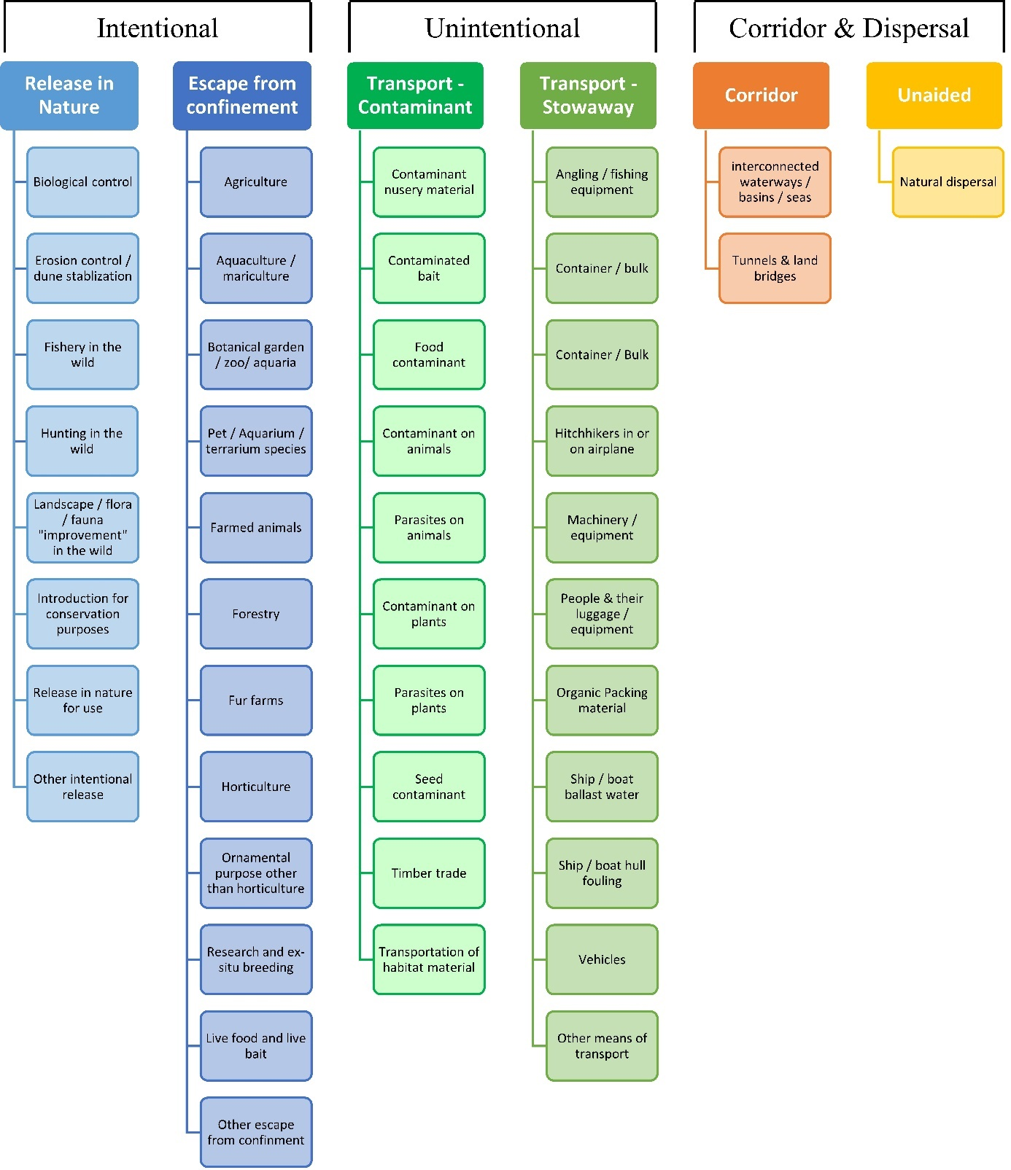

ANNEX V Ecosystem services classification (CICES V5.1, simplified) and examples
For the purposes of this risk assessment, please feel free to use what seems as the most appropriate category / level / combination of impact (Section – Division – Group), reflecting information available.

Section | Division | Group | Examples (i.e. relevant CICES “classes”)
Provisioning | Biomass | Cultivated terrestrial plants | Cultivated terrestrial plants (including fungi, algae) grown for nutritional purposes;  Fibres and other materials from cultivated plants, fungi, algae and bacteria for direct use or processing (excluding genetic materials);  Cultivated plants (including fungi, algae) grown as a source of energy  Example: negative impacts of non-native organisms to crops, orchards, timber etc.
 |  | Cultivated aquatic plants | Plants cultivated by in- situ aquaculture grown for nutritional purposes;  Fibres and other materials from in-situ aquaculture for direct use or processing (excluding genetic materials);  Plants cultivated by in- situ aquaculture grown as an energy source.  Example: negative impacts of non-native organisms to aquatic plants cultivated for nutrition, gardening etc. purposes.
 |  | Reared animals | Animals reared for nutritional purposes;  Fibres and other materials from reared animals for direct use or processing (excluding genetic materials);  Animals reared to provide energy (including mechanical)  Example: negative impacts of non-native organisms to livestock
 |  | Reared aquatic animals | Animals reared by in-situ aquaculture for nutritional purposes;  Fibres and other materials from animals grown by in-situ aquaculture for direct use or processing (excluding genetic materials);  Animals reared by in-situ aquaculture as an energy source  Example: negative impacts of non-native organisms to fish farming
 |  | Wild plants (terrestrial and aquatic) | Wild plants (terrestrial and aquatic, including fungi, algae) used for nutrition;  Fibres and other materials from wild plants for direct use or processing (excluding genetic materials);  Wild plants (terrestrial and aquatic, including fungi, algae) used as a source of energy  Example: reduction in the availability of wild plants (e.g. wild berries, ornamentals) due to non-native organisms (competition, spread of disease etc.)
 |  | Wild animals (terrestrial and aquatic) | Wild animals (terrestrial and aquatic) used for nutritional purposes;  Fibres and other materials from wild animals for direct use or processing (excluding genetic materials);  Wild animals (terrestrial and aquatic) used as a source of energy  Example: reduction in the availability of wild animals (e.g. fish stocks, game) due to non-native organisms (competition, predations, spread of disease etc.)
 | Genetic material from all biota | Genetic material from plants, algae or fungi | Seeds, spores and other plant materials collected for maintaining or establishing a population;  Higher and lower plants (whole organisms) used to breed new strains or varieties;  Individual genes extracted from higher and lower plants for the design and construction of new biological entities  Example: negative impacts of non-native organisms due to interbreeding
 |  | Genetic material from animals | Animal material collected for the purposes of maintaining or establishing a population;  Wild animals (whole organisms) used to breed new strains or varieties;  Individual genes extracted from organisms for the design and construction of new biological entities  Example: negative impacts of non-native organisms due to interbreeding
 | Water | Surface water used for nutrition, materials or energy | Surface water for drinking;  Surface water used as a material (non-drinking purposes);  Freshwater surface water, coastal and marine water used as an energy source  Example: loss of access to surface water due to spread of non-native organisms
 |  | Ground water for used for nutrition, materials or energy | Ground (and subsurface) water for drinking;  Ground water (and subsurface) used as a material (non-drinking purposes);  Ground water (and subsurface) used as an energy source  Example: reduced availability of ground water due to spread of non-native organisms and associated increase of ground water consumption by vegetation.
Regulation & Maintenance | Transformation of biochemical or physical inputs to ecosystems | Mediation of wastes or toxic substances of anthropogenic origin by living processes | Bio-remediation by micro-organisms, algae, plants, and animals; Filtration/sequestration/storage/accumulation by micro-organisms, algae, plants, and animals  Example: changes caused by non-native organisms to ecosystem functioning and ability to filtrate etc. waste or toxics
 |  | Mediation of nuisances of anthropogenic origin | Smell reduction; noise attenuation; visual screening (e.g. by means of green infrastructure)  Example: changes caused by non-native organisms to ecosystem structure, leading to reduced ability to mediate nuisances.
 | Regulation of physical, chemical, biological conditions | Baseline flows and extreme event regulation | Control of erosion rates;  Buffering and attenuation of mass movement;  Hydrological cycle and water flow regulation (Including flood control, and coastal protection);  Wind protection;  Fire protection  Example: changes caused by non-native organisms to ecosystem functioning or structure leading to, for example, destabilisation of soil, increased risk or intensity of wild fires etc.
 |  | Lifecycle maintenance, habitat and gene pool protection | Pollination (or 'gamete' dispersal in a marine context);  Seed dispersal;  Maintaining nursery populations and habitats (Including gene pool protection)  Example: changes caused by non-native organisms to the abundance and/or distribution of wild pollinators; changes to the availability / quality of nursery habitats for fisheries
 |  | Pest and disease control | Pest control;  Disease control  Example: changes caused by non-native organisms to the abundance and/or distribution of pests
 |  | Soil quality regulation | Weathering processes and their effect on soil quality;  Decomposition and fixing processes and their effect on soil quality  Example: changes caused by non-native organisms to vegetation structure and/or soil fauna leading to reduced soil quality
 |  | Water conditions | Regulation of the chemical condition of freshwaters by living processes;  Regulation of the chemical condition of salt waters by living processes  Example: changes caused by non-native organisms to buffer strips along water courses that remove nutrients in runoff and/or fish communities that regulate the resilience and resistance of water bodies to eutrophication
 |  | Atmospheric composition and conditions | Regulation of chemical composition of atmosphere and oceans;  Regulation of temperature and humidity, including ventilation and transpiration  Example: changes caused by non-native organisms to ecosystems’ ability to sequester carbon and/or evaporative cooling (e.g. by urban trees)
Cultural | Direct, in-situ and outdoor interactions with living systems that depend on presence in the environmental setting | Physical and experiential interactions with natural environment | Characteristics of living systems that that enable activities promoting health, recuperation or enjoyment through active or immersive interactions;  Characteristics of living systems that enable activities promoting health, recuperation or enjoyment through passive or observational interactions  Example: changes caused by non-native organisms to the qualities of ecosystems (structure, species composition etc.) that make it attractive for recreation, wild life watching etc.
 |  | Intellectual and representative interactions with natural environment | Characteristics of living systems that enable scientific investigation or the creation of traditional ecological knowledge;  Characteristics of living systems that enable education and training;  Characteristics of living systems that are resonant in terms of culture or heritage;  Characteristics of living systems that enable aesthetic experiences  Example: changes caused by non-native organisms to the qualities of ecosystems (structure, species composition etc.) that have cultural importance
 | Indirect, remote, often indoor interactions with living systems that do not require presence in the environmental setting | Spiritual, symbolic and other interactions with natural environment | Elements of living systems that have symbolic meaning;  Elements of living systems that have sacred or religious meaning;  Elements of living systems used for entertainment or representation  Example: changes caused by non-native organisms to the qualities of ecosystems (structure, species composition etc.) that have sacred or religious meaning
 |  | Other biotic characteristics that have a non-use value | Characteristics or features of living systems that have an existence value;  Characteristics or features of living systems that have an option or bequest value  Example: changes caused by non-native organisms to ecosystems designated as wilderness areas, habitats of endangered species etc.

ANNEX VI EU Biogeographic Regions and MSFD Subregions
See https://www.eea.europa.eu/data-and-maps/figures/biogeographical-regions-in-europe-2 ,
http://ec.europa.eu/environment/nature/natura2000/biogeog_regions/

and

https://www.eea.europa.eu/data-and-maps/data/msfd-regions-and-subregions-1/technical-document/pdf
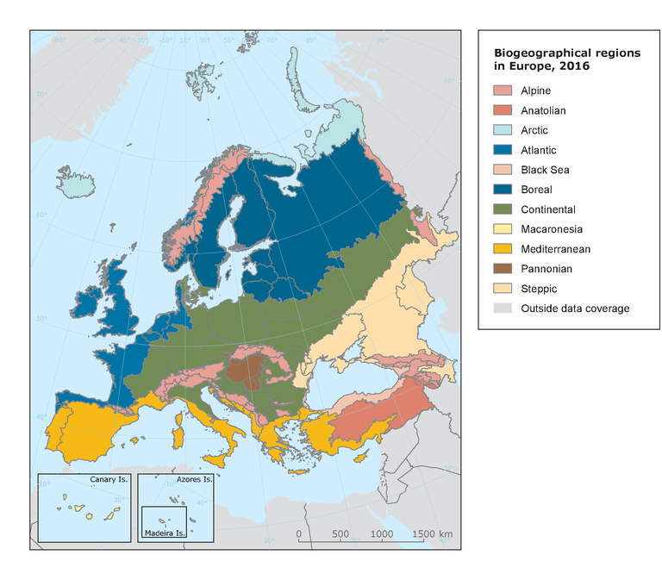

ANNEX VII Delegated Regulation (EU) 2018/968 of 30 April 2018
see https://eur-lex.europa.eu/legal-content/en/TXT/?uri=CELEX%3A32018R0968

ANNEX VIII Mulinia lateralis physiological requirements and thresholds
(text and analysis specifically developed for the purposes of this risk assessment)

Mulinia lateralis is a eurythermal and euryhaline species with a latitudinal distribution extending from the Bay of St. Lawrence, Canada, to the Gulf of Mexico, Yucatan, Mexico (Turgeon et al., 2009; see also Qu. A3 for details). This distribution corresponds to low winter temperatures of approximately -1 °C to 24 °C (mean temperature of the coldest month, retrieved from BIO-ORACLE 2 (Assis et al., 2018)) and high summer temperatures ranging from 17 °C to 30.5 °C (mean temperature of the warmest month, retrieved from BIO-ORACLE 2), conditions which are met throughout most of the RA area. Spawning occurs at different times of the year at different latitudes, e.g. in Canada from mid-July to early September (Sullivan, 1948), in Maryland from May to November with a peak in September (Hanks, 1968), in Texas from January to April, while year-round spawning has also been reported (Montagna et al., 1993). In the Long Island Sound, larvae appear in the water in early July at temperatures ranging between 16 °C and 20 °C but are more abundant at 19-21 °C (Calabrese, 1970). Field observations agree rather well with laboratory results, which indicate that the temperature threshold for larval growth that ensures metamorphosis before the larvae die in the water column lies somewhere between 15 °C and 17.5 °C (Calabrese, 1969a). Thus, temperature doesn’t seem to be a major limiting factor for establishment at a large scale, except perhaps around northern UK waters, where maximum summer temperatures drop below 15°C. Nevertheless, because M. lateralis is primarily an inshore, estuarine species (Walker & Tenore, 1984), coarse grain temperature maps may not accurately reflect local conditions. For example, temperature measurements in marinas and harbours along the UK coast demonstrate water temperatures from 16-22ºC in July – October, every year, all the way up to northern England (Bishop et al., 2015; C. Wood, unpublished data).
Regarding upper temperature limits for larval development, in the laboratory normal development and growth were achieved at temperatures as high as 32.5 ºC (Calabrese, 1969b). Considering potential discrepancies between large-scale modelled data and local measurements, especially in shallow waters, this generally agrees well with the condition the species is faced with in the wild.
For modeling purposes, conditions unsuitable for establishment were defined as:
Mean temperature of the warmest month (LtMax) <15 °C
Mean temperature of the warmest month >32.5 °C
The same temperature limits were used for the calculation of growing degree days (GDD) in the Modeling Annex.
The species can also withstand a wide range of salinities, reportedly between 5-80 psu (Parker, 1975 in Montagna et al., 1993). This extremely wide range does not necessarily mean that M. lateralis from all geographical areas are able to withstand such extreme salinities, nor does it mean that all stages of reproduction are accomplished at the extremes of the salinity range.
M. lateralis can persist equally in low salinity estuarine environments as in hypersaline conditions in lagoons, associated with prolonged drought periods (e.g. in Baffin Bay, Texas, where the species is dominating the infaunal community at salinities between 40-60 psu). It is generally observed though that major recruitment events are triggered by big salinity changes caused by freshwater inflow, rather than absolute salinity levels (Montagna & Kalke, 1995; Van Diggelen & Montagna, 2016). On the other hand, its presence along the Dutch and Belgian coasts, as well as in the shallow sublittoral in its native range (Cleveland et al., 2002) indicates it can also establish in fully marine areas. Regarding larval development, in laboratory experiments it was shown to be normal between 12.5 and 37.5 psu. Larval survival was observed within a larger range of 7-38 psu (Calabrese, 1969), however satisfactory embryonic development occured at a more restricted salinity range of 20-32.5 psu (Calabrese, 1969a). Thus, as long as spawning and embryonic development take place at appropriate salinities, larvae can disperse and will survive and grow in different water bodies.
It is apparent from the above that, when it comes to salinity, it is difficult to set a hard limit for larval development, especially considering that large scale salinity maps are modeling products themselves and do not capture small scale salinity variations near the coast. For the purpose of defining the unsuitable background for modeling, a limit of 12.5 psu was tentatively set for mean surface salinity. However, in an effort to capture the influence of salinity variability we employ an additional parameter, namely distance to the nearest river mouth (see Annex IX, the Species Distribution Model).
The above-mentioned potential limitations to establishment are displayed in Figure 1. This map intends to serve as a first indication of rough geographical limits set by low summer temperatures (blue contour lines of 15°C and 16°C temperature of the warmest month LtMax), and broad salinity ranges (mSSS), as well as indicating areas where continuous recruitment is likely (red contour line of 15°C and 16°C temperature of the coldest month LtMin).

Figure 1.
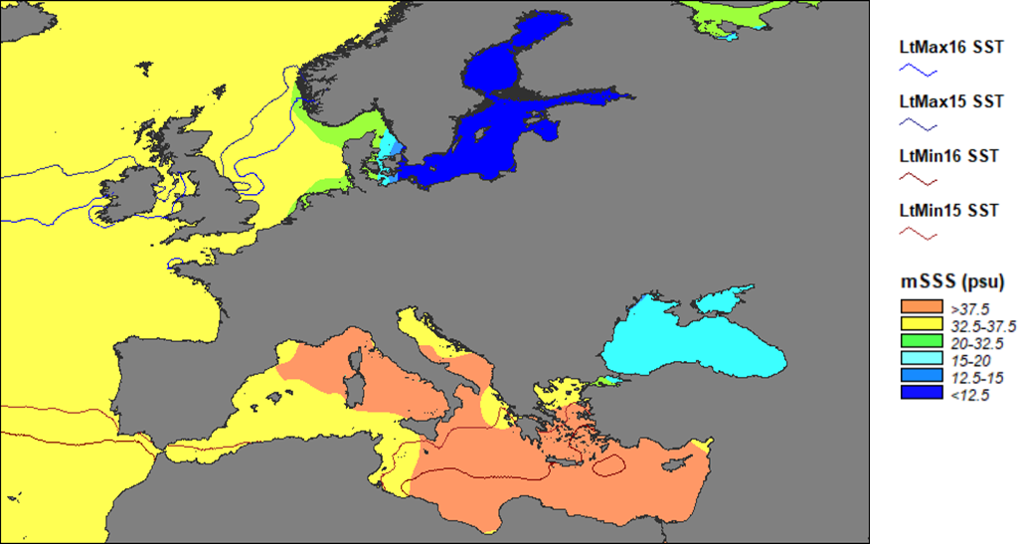

ANNEX IX Species Distribution Model
Projection of environmental suitability for Mulinia lateralis establishment in Europe
Björn Beckmann, Marika Galanidi, Christine Wood and Dan Chapman
22 June 2021

Aim
To project the suitability for potential establishment of Mulinia lateralis in Europe, under current and predicted future climatic conditions.

Data for modelling
Species occurrence data were obtained from the Global Biodiversity Information Facility (GBIF) (195 records), iNaturalist (161 records), the Biodiversity Information Serving Our Nation database (BISON) (121 records), and additional records from the risk assessment team. We scrutinised occurrence records and removed any dubious ones and records where the georeferencing was too imprecise or outside of the coverage of the predictor layers. The records were gridded at a 0.25 x 0.25 degree resolution for modelling, yielding 77 grid cells with occurrences (Figure 1a). As a proxy for recording effort, the density of Bivalvia records held by GBIF was also compiled on the same grid (Figure 1b).

Figure 1. (a) Occurrence records obtained for Mulinia lateralis and used in the modelling, showing native and invaded distributions. (b) The recording density of Bivalvia on GBIF, which was used as a proxy for recording effort.
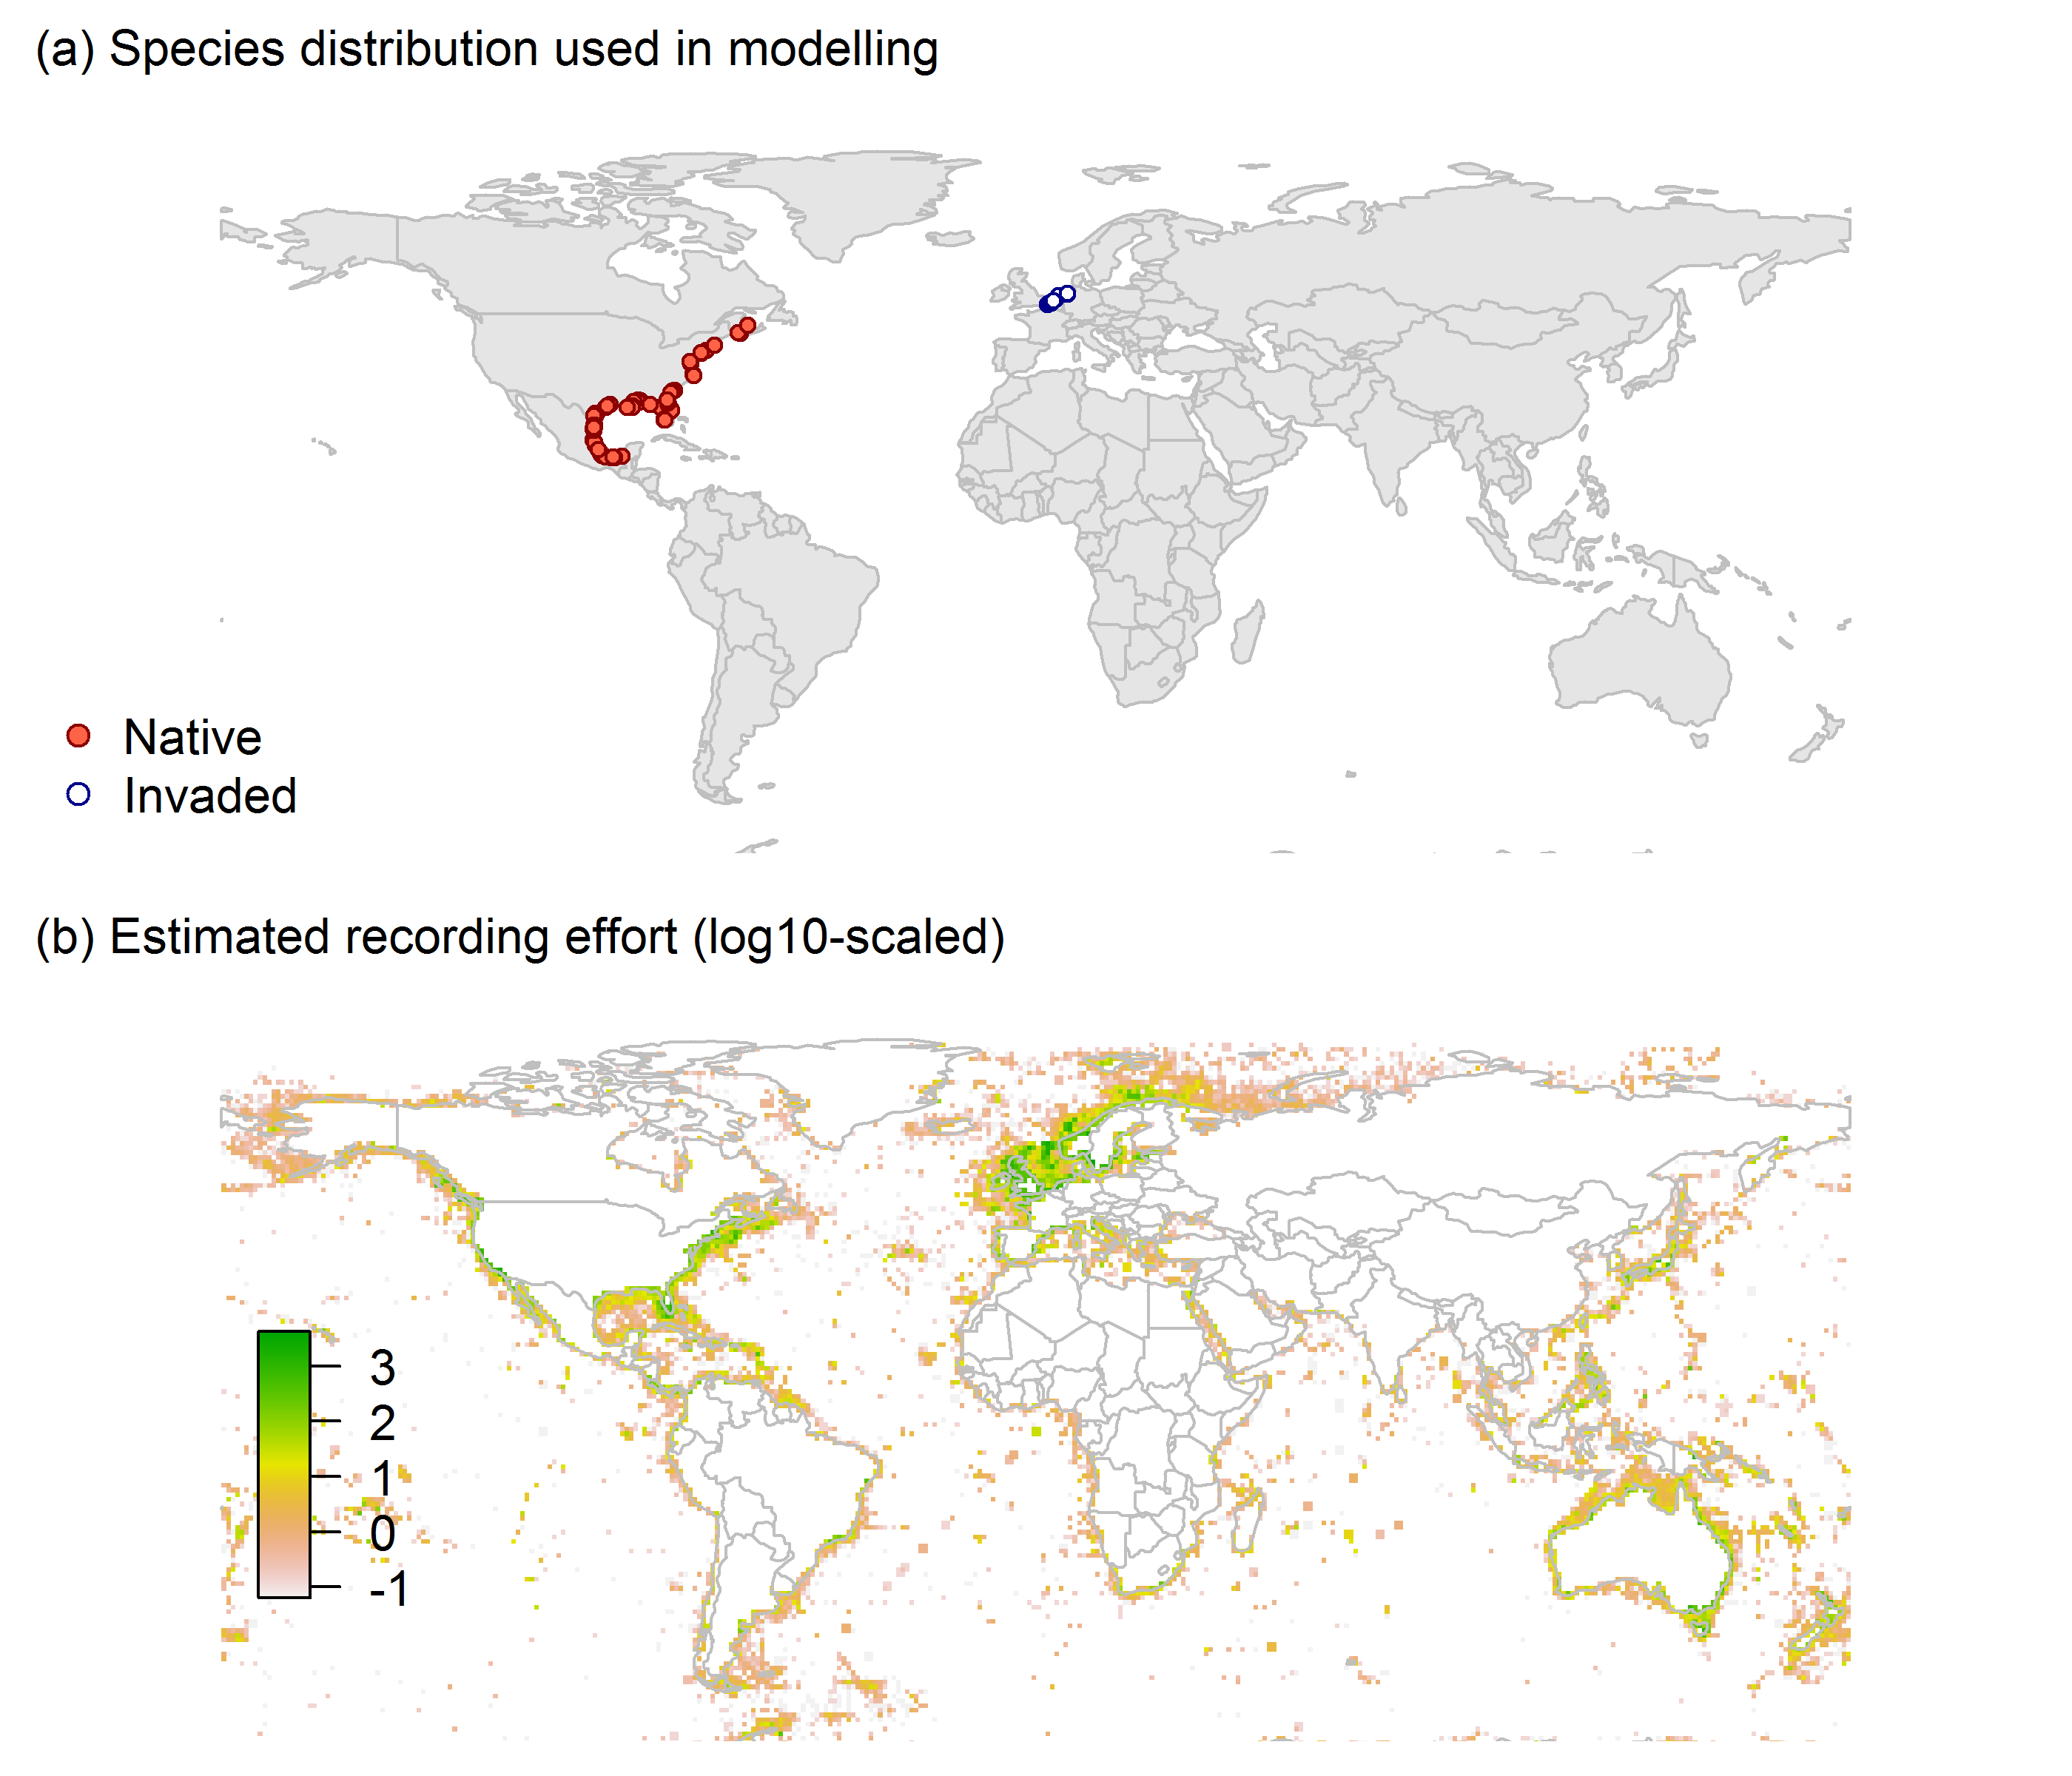

Predictors describing the marine environment were selected from the ‘Bio-ORACLE2’ set of GIS rasters providing geophysical, biotic and environmental data for surface and benthic marine realms (Tyberghein et al., 2012; Assis et al., 2018), supplemented by variables calculated from MARSPEC monthly sea surface temperature data (Sbrocco & Barber, 2013). Both were originally at 5 arcminute resolution (0.083 x 0.083 degrees of longitude/latitude) and aggregated to a 0.25 x 0.25 degree grid for use in the model.
Based on the biology of Mulinia lateralis, the following variables were used in the modelling:
- Maximum long-term temperature (templtmax_ss)
- Minimum long-term temperature (templtmin_ss)
- Mean salinity (salinitymean_ss)
- Mean bathymetry (bathymean)
- Growing Degree Days between 15 and 32.5°C (gdd_15_32.5)
- Sea distance to nearest river mouth with average discharge >10 m³/s (sea_dist_10cms), log+1 transformed to increase normality.
All parameters (except depth) are measured at the sea surface.
Growing Degree Days (GDD) have been widely used as a measure of the “biologically useful” sum of warmth between threshold temperatures where processes of interest occur (McMaster & Wilhelm, 1997). For Mulinia lateralis, larval development occurs between approximately 15 and 32.5°C (see Risk Assessment for details). GDD are usually calculated from daily temperature data, but since these are not available for the marine environment at a global scale, GDD were calculated from MARSPEC monthly mean temperature data. First, all grid cells with temperatures less than 15°C or more than 32.5°C were excluded for each month. Then, any positive difference from the lower temperature threshold was multiplied by the number of days in the month. For example, a grid cell with a temperature of 17°C in January had a value of 17°C - 15°C = 2°C x 31 days = 62 GDD for January. Finally, GDD values for all months were summed to produce an annual total for each grid cell (Figure 2).

Figure 2. Annual Growing Degree Days (GDD) between 15°C and 32.5°C for the current climate, calculated from MARSPEC monthly mean sea surface temperatures.
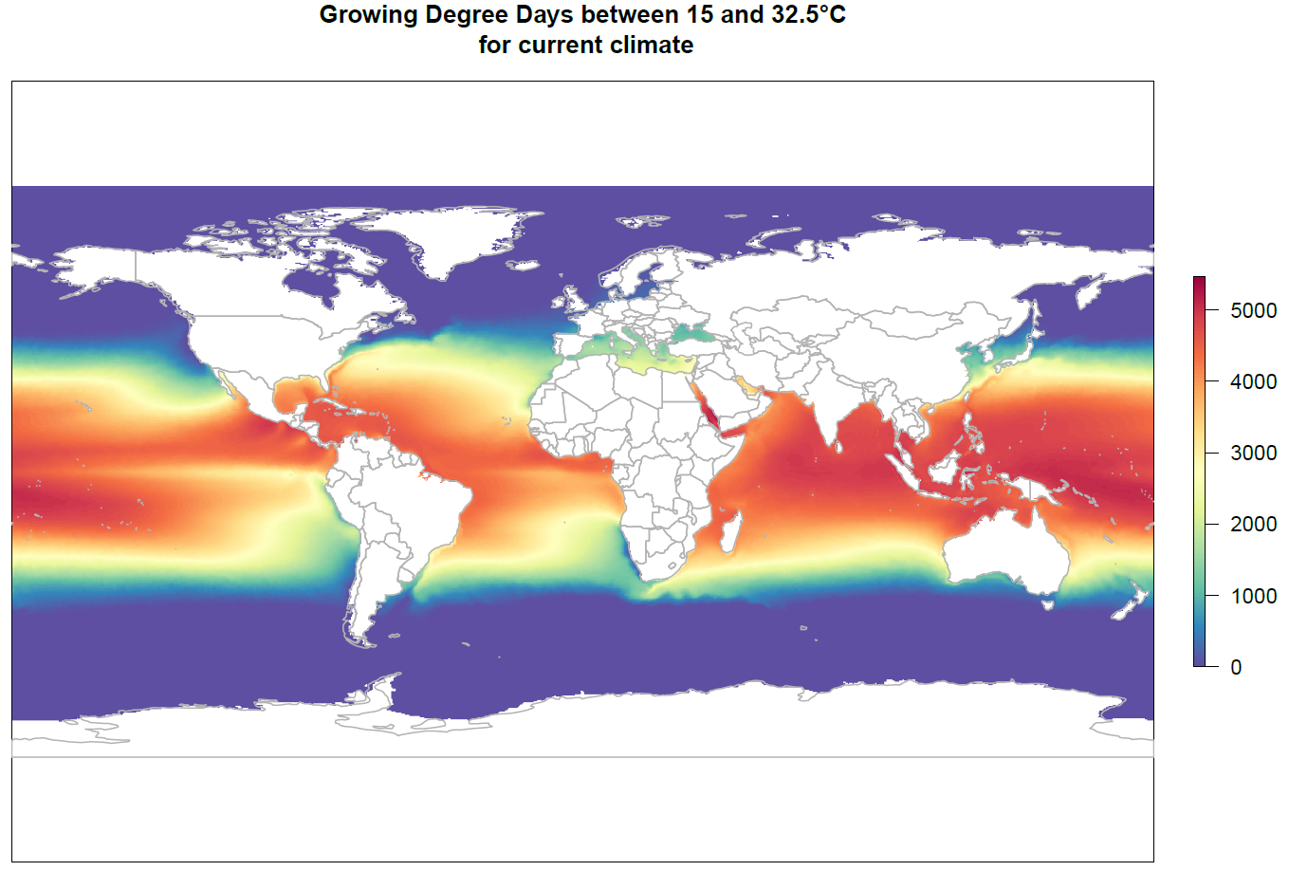

The distance to the nearest large river mouth (with average discharge >10 m³/s) was used as a proxy for presence of brackish water (in addition to the Bio-ORACLE2 salinity layer mentioned above). The location of rivers and their average discharge was taken from the “HydroRIVERS” dataset, version 1.0 (Lehner et al., 2008). Point locations of river mouths were “rasterized” to the model grid, summing discharge per 0.25 x 0.25 degree grid cell in case there were several river mouths per cell. Endorheic rivers (not flowing into the oceans) were excluded. For each model grid cell, distance-by-sea (in meters) to the nearest cell with average discharge > 10 m³/sec was then calculated using “gridDistance” in the R package “raster”, version 3.4.5 (Hijmans, 2020). Figure 3 shows the Mediterranean and Black Sea areas of the final layer (with distances in km).
Figure 3. Proximity to the nearest river mouth with average discharge > 10 m³/sec. Layer created as a proxy for salinity variation.
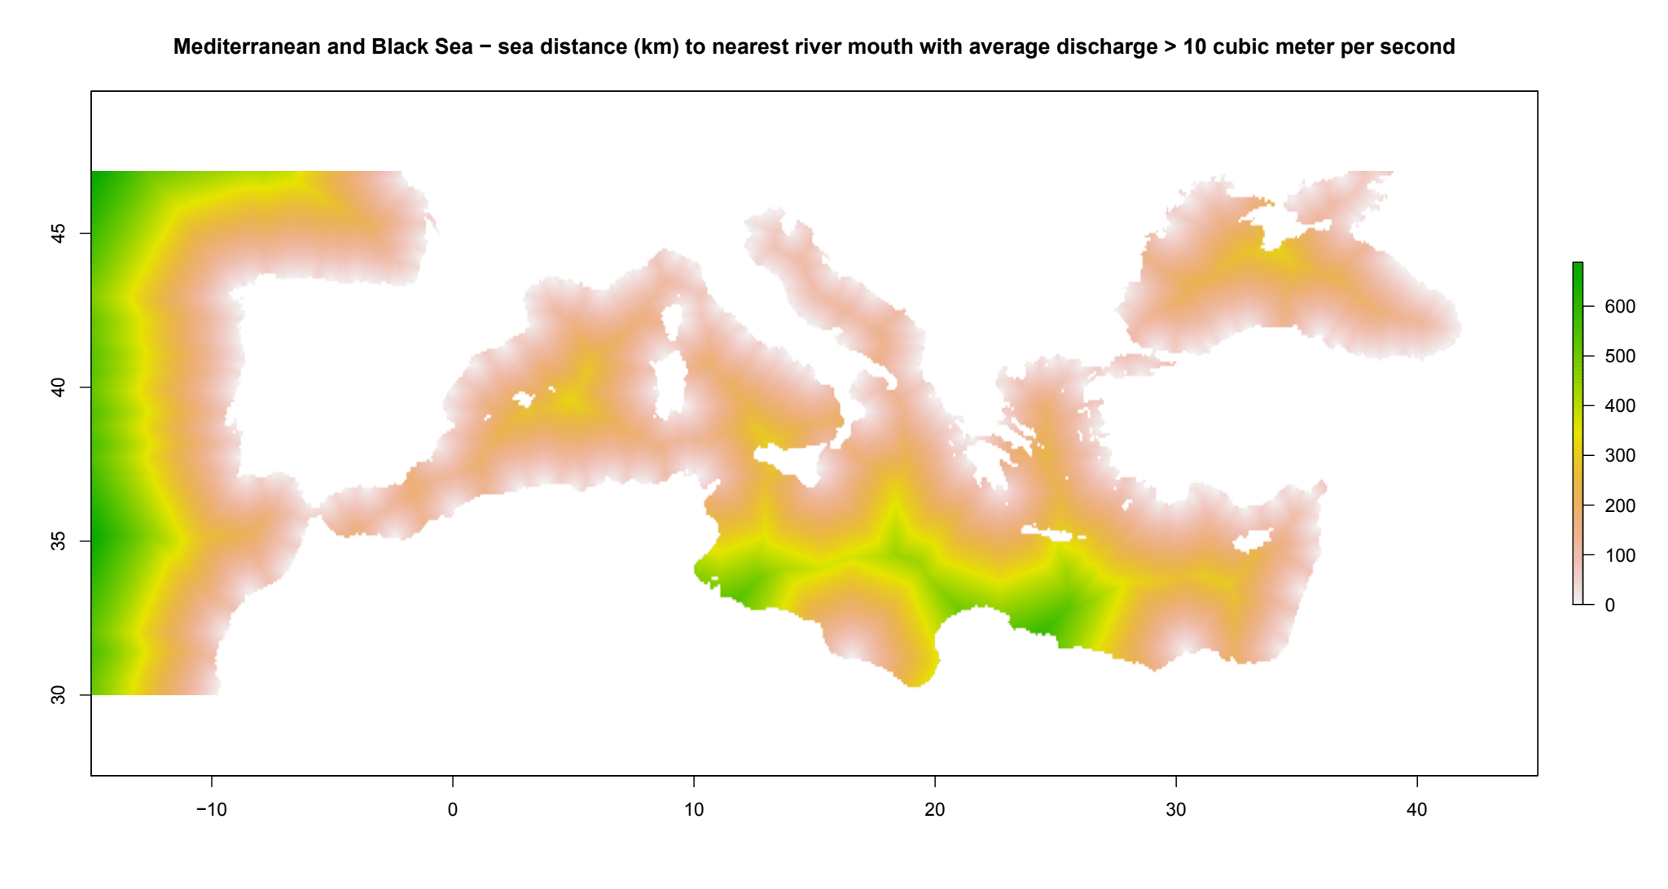

To estimate the effect of climate change on the potential distribution of Mulinia lateralis, equivalent modelled future conditions for the 2070s under the Representative Concentration Pathways (RCP) 2.6 and 4.5 were also obtained. These represent low and medium emissions scenarios, respectively. Projections for the 2070s were calculated as averages of projections for the 2040s and 2090s (which are the time periods available on Bio-ORACLE).

Species distribution model
A presence-background (presence-only) ensemble modelling strategy was employed using the BIOMOD2 R package version 3.4.6 (Thuiller et al., 2009; Thuiller et al., 2020). These models contrast the environment at the species’ occurrence locations against a random sample of the global background environmental conditions (often termed ‘pseudo-absences’) in order to characterise and project suitability for occurrence. This approach has been developed for distributions that are in equilibrium with the environment. Because invasive species’ distributions are not at equilibrium and subject to dispersal constraints at a global scale, we took care to minimise the inclusion of locations suitable for the species but where it has not been able to disperse to (Chapman et al., 2019). Therefore the background sampling region included:
- The area accessible by native Mulinia lateralis populations, in which the species is likely to have had sufficient time to disperse to all locations. Based on presumed maximum dispersal distances, the accessible region was defined as a 400 km buffer around the native range occurrences (the Pacific Ocean was excluded from this area because Mulinia lateralis occurs only on the Atlantic coasts of North America and historically could not readily disperse to the Pacific side); AND
- A 100 km buffer around the non-native occurrences, encompassing regions likely to have had high propagule pressure for introduction by humans and/or dispersal of the species; AND
- Regions where we have an a priori expectation of high unsuitability for the species so that absence is assumed irrespective of dispersal constraints (see Figure 4). The following rules were applied to define a region expected to be highly unsuitable for Mulinia lateralis at the spatial scale of the model:
  - Minimum long-term temperature (templtmin_ss) > 25 °C
  - Maximum long-term temperature (templtmax_ss) < 15 °C
  - Mean salinity (salinitymean_ss) < 12.5 psu

Altogether, 2.6% of occurrence grid cells were located in the unsuitable background region.
Within the unsuitable background region, 10 samples of 5000 randomly sampled grid cells were obtained. In the accessible background (comprising the accessible areas around native and non-native occurrences as detailed above), the same number of pseudo-absence samples were drawn as there were presence records (77), weighting the sampling by a proxy for recording effort (Figure 1(b)).Figure 4. The background from which pseudo-absence samples were taken in the modelling of Mulinia lateralis. Samples were taken from a 400 km buffer around the native range and a 100 km buffer around non-native occurrences (together forming the accessible background), and from areas expected to be highly unsuitable for the species (the unsuitable background region). Samples from the accessible background were weighted by a proxy for recording effort (Figure 1(b)).
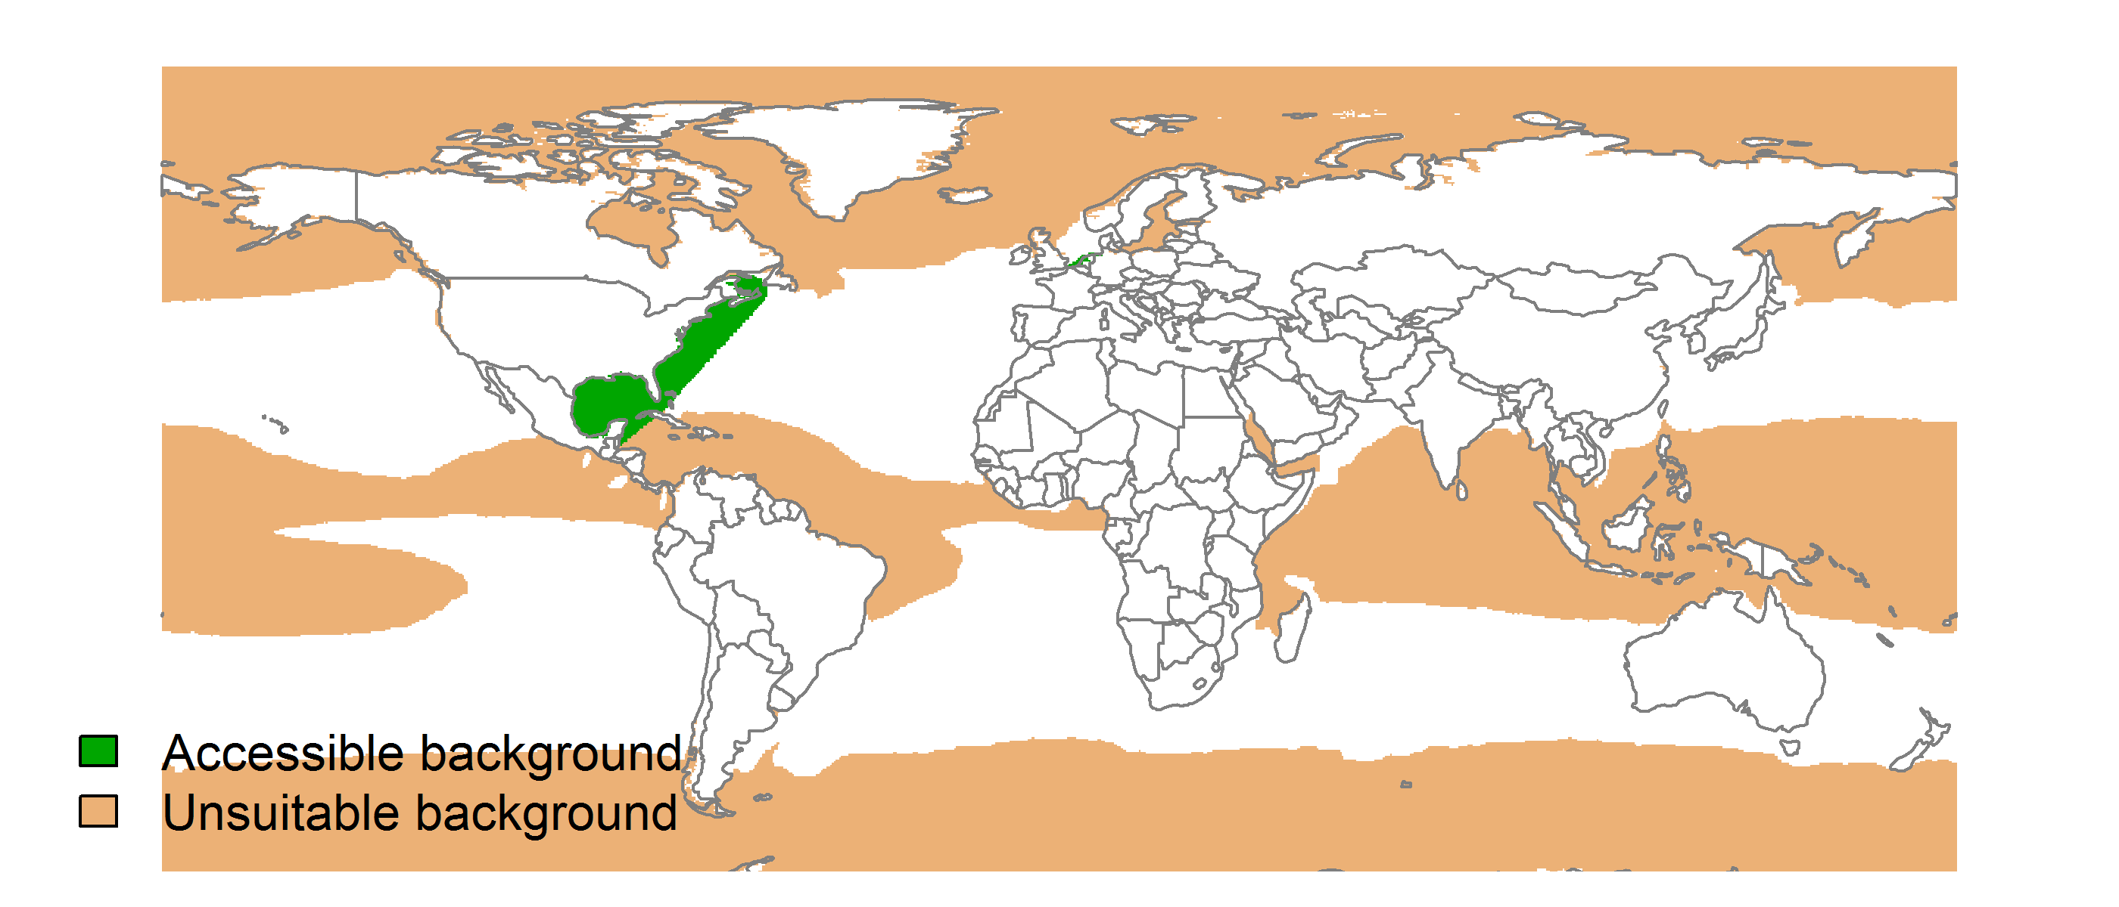

Each dataset (i.e. combination of the presences and the individual background samples) was randomly split into 80% for model training and 20% for model evaluation. With each training dataset, five statistical algorithms were fitted with the default BIOMOD2 settings and rescaled using logistic regression, except where specified below:
- Generalised linear model (GLM)
- Generalised boosting model (GBM)
- Generalised additive model (GAM) with a maximum of four degrees of freedom per smoothing spline
- Artificial neural network (ANN)
- Multivariate adaptive regression splines (MARS)
- Random forest (RF)
- Maxent

Since the total background sample was larger than the number of occurrences, prevalence fitting weights were applied to give equal overall importance to the occurrences and the background. Normalised variable importance was assessed and variable response functions were produced using BIOMOD2’s default procedure.
Model predictive performance was assessed by the following three measures:
- AUC, the area under the receiver operating characteristic curve (Fielding & Bell, 1997). Predictions of presence-absence models can be compared with a subset of records set aside for model evaluation (here 20%) by constructing a confusion matrix with the number of true positive, false positive, false negative and true negative cases. For models generating non-dichotomous scores (as here) a threshold can be applied to transform the scores into a dichotomous set of presence-absence predictions. Two measures that can be derived from the confusion matrix are sensitivity (the proportion of observed presences that are predicted as such, quantifying omission errors), and specificity (the proportion of observed absences that are predicted as such, quantifying commission errors). A receiver operating characteristic (ROC) curve can be constructed by using all possible thresholds to classify the scores into confusion matrices, obtaining sensitivity and specificity for each matrix, and plotting sensitivity against the corresponding proportion of false positives (equal to 1 - specificity). The use of all possible thresholds avoids the need for a selection of a single threshold, which is often arbitrary, and allows appreciation of the trade-off between sensitivity and specificity. The area under the ROC curve (AUC) is often used as a single threshold-independent measure for model performance (Manel et al., 2001). AUC is the probability that a randomly selected presence has a higher model-predicted suitability than a randomly selected absence (Allouche et al., 2006).
- Cohen’s Kappa (Cohen, 1960). This measure corrects the overall accuracy of model predictions (ratio of the sum of true presences plus true absences to the total number of records) by the accuracy expected to occur by chance. The Kappa statistic ranges from -1 to +1, where +1 indicates perfect agreement and values of zero or less indicate a performance no better than random. Advantages of Kappa are its simplicity, the fact that both commission and omission errors are accounted for in one parameter, and its relative tolerance to zero values in the confusion matrix (Manel et al., 2001). However, Kappa has been criticised for being sensitive to prevalence (the proportion of sites in which the species was recorded as present) and may therefore be inappropriate for comparisons of model accuracy between species or regions (McPherson et al., 2004; Allouche et al., 2006).
- TSS, the true skill statistic (Allouche et al., 2006). TSS is defined as sensitivity + specificity - 1, and corrects for Kappa’s dependency on prevalence. TSS compares the number of correct forecasts, minus those attributable to random guessing, to that of a hypothetical set of perfect forecasts. Like Kappa, TSS takes into account both omission and commission errors, and success as a result of random guessing, and ranges from -1 to +1, where +1 indicates perfect agreement and values of zero or less indicate a performance no better than random (Allouche et al., 2006).
An ensemble model was created by first rejecting poorly performing algorithms with relatively extreme low AUC values and then averaging the predictions of the remaining algorithms, weighted by their AUC. To identify poorly performing algorithms, AUC values were converted into modified z-scores based on their difference to the median and the median absolute deviation across all algorithms (Iglewicz & Hoaglin, 1993). Algorithms with z < -2 were rejected. In this way, ensemble projections were made for each dataset and then averaged to give an overall suitability, as well as its standard deviation.
Projections were classified into suitable and unsuitable regions using a “lowest presence threshold” (Pearson et al., 2007), setting the cut-off as the lowest value at which 98% of all presence records are classified correctly under the current climate (here 0.77). In order to express the sensitivity of classifications to the choice of this threshold, thresholds at which 95% and 99% of records are classified correctly (here 0.89 and 0.72 respectively) were used in the calculation of error bars in Figures 11 and 12 below in addition to taking account of uncertainty in the projections themselves.
We also produced limiting factor maps for Europe following Elith et al. (2010). For this, projections were made separately with each individual variable fixed at a near-optimal value. These were chosen as the median values at the occurrence grid cells. Then, the most strongly limiting factors were identified as the one resulting in the highest increase in suitability in each grid cell.

Results
The ensemble model suggested that suitability for Mulinia lateralis was most strongly determined by Mean bathymetry (bathymean), accounting for 23.9% of variation explained, followed by Maximum long-term temperature (templtmax_ss) (23.7%), Minimum long-term temperature (templtmin_ss) (22.4%), Growing Degree Days between 15 and 32.5°C (gdd_15_32.5) (17.1%), Sea distance to nearest river mouth with average discharge >10 m³/s (sea_dist_10cms) (10.8%) and Mean salinity (salinitymean_ss) (2%) (Table 1, Figure 5).Table 1. Summary of the cross-validation predictive performance (ROC, Kappa, TSS) and variable importance of the fitted model algorithms and the ensemble (AUC-weighted average of the best performing algorithms). Results are the average from models fitted to 10 different background samples of the data.
 |  |  |  |  | Variable importance (%)
Algorithm | AUC | Kappa | TSS | Used in the ensemble | Mean bathymetry (bathymean) | Maximum long-term temperature (templtmax_ss) | Minimum long-term temperature (templtmin_ss) | Growing Degree Days between 15 and 32.5°C (gdd_15_32.5) | Sea distance to nearest river mouth with average discharge >10 m³/s (sea_dist_10cms) | Mean salinity (salinitymean_ss)
GLM | 0.986 | 0.749 | 0.960 | yes | 23 | 14 | 17 | 27 | 18 | 2
GAM | 0.996 | 0.748 | 0.987 | yes | 12 | 20 | 24 | 26 | 15 | 3
GBM | 0.993 | 0.759 | 0.968 | yes | 45 | 30 | 22 | 1 | 2 | 0
ANN | 0.976 | 0.674 | 0.936 | yes | 27 | 26 | 15 | 18 | 13 | 3
MARS | 0.966 | 0.734 | 0.930 | no | 18 | 11 | 27 | 22 | 19 | 3
RF | 0.996 | 0.772 | 0.975 | yes | 14 | 29 | 34 | 14 | 7 | 2
Maxent | 0.894 | 0.719 | 0.784 | no | 7 | 10 | 32 | 25 | 18 | 10
Ensemble | 0.996 | 0.774 | 0.986 |  | 24 | 24 | 22 | 17 | 11 | 2

Page Break
Figure 5. Partial response plots from the fitted models. Thin coloured lines show responses from the algorithms in the ensemble, while the thick black line is their ensemble. In each plot, other model variables are held at their median value in the training data. Some of the divergence among algorithms is because of their different treatment of interactions among variables.
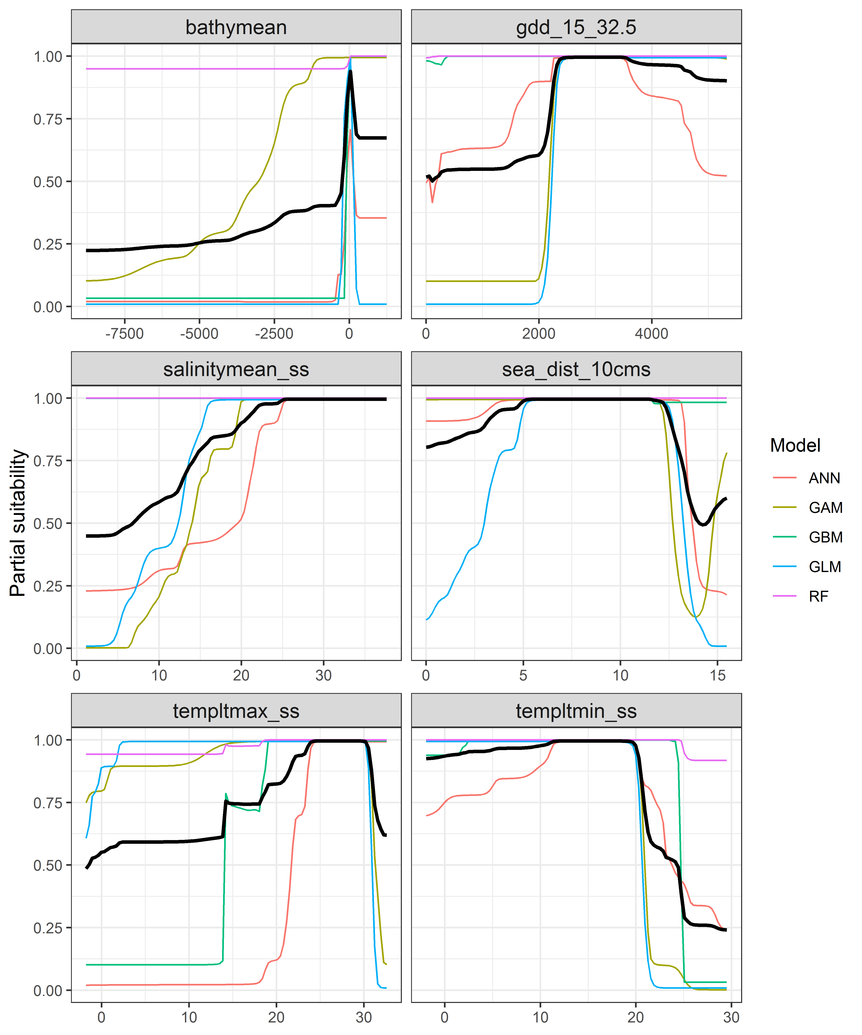

Page Break
Figure 6. (a) Projected global suitability for Mulinia lateralis establishment in the current climate. For visualisation, the projection has been aggregated to a 0.5 x 0.5 degree resolution, by taking the maximum suitability of constituent higher resolution grid cells. Values > 0.77 are suitable for the species, with 98% of global presence records above this threshold. Values below 0.77 indicate lower relative suitability. (b) Uncertainty in the ensemble projections, expressed as the among-algorithm standard deviation in predicted suitability, averaged across the 10 datasets.

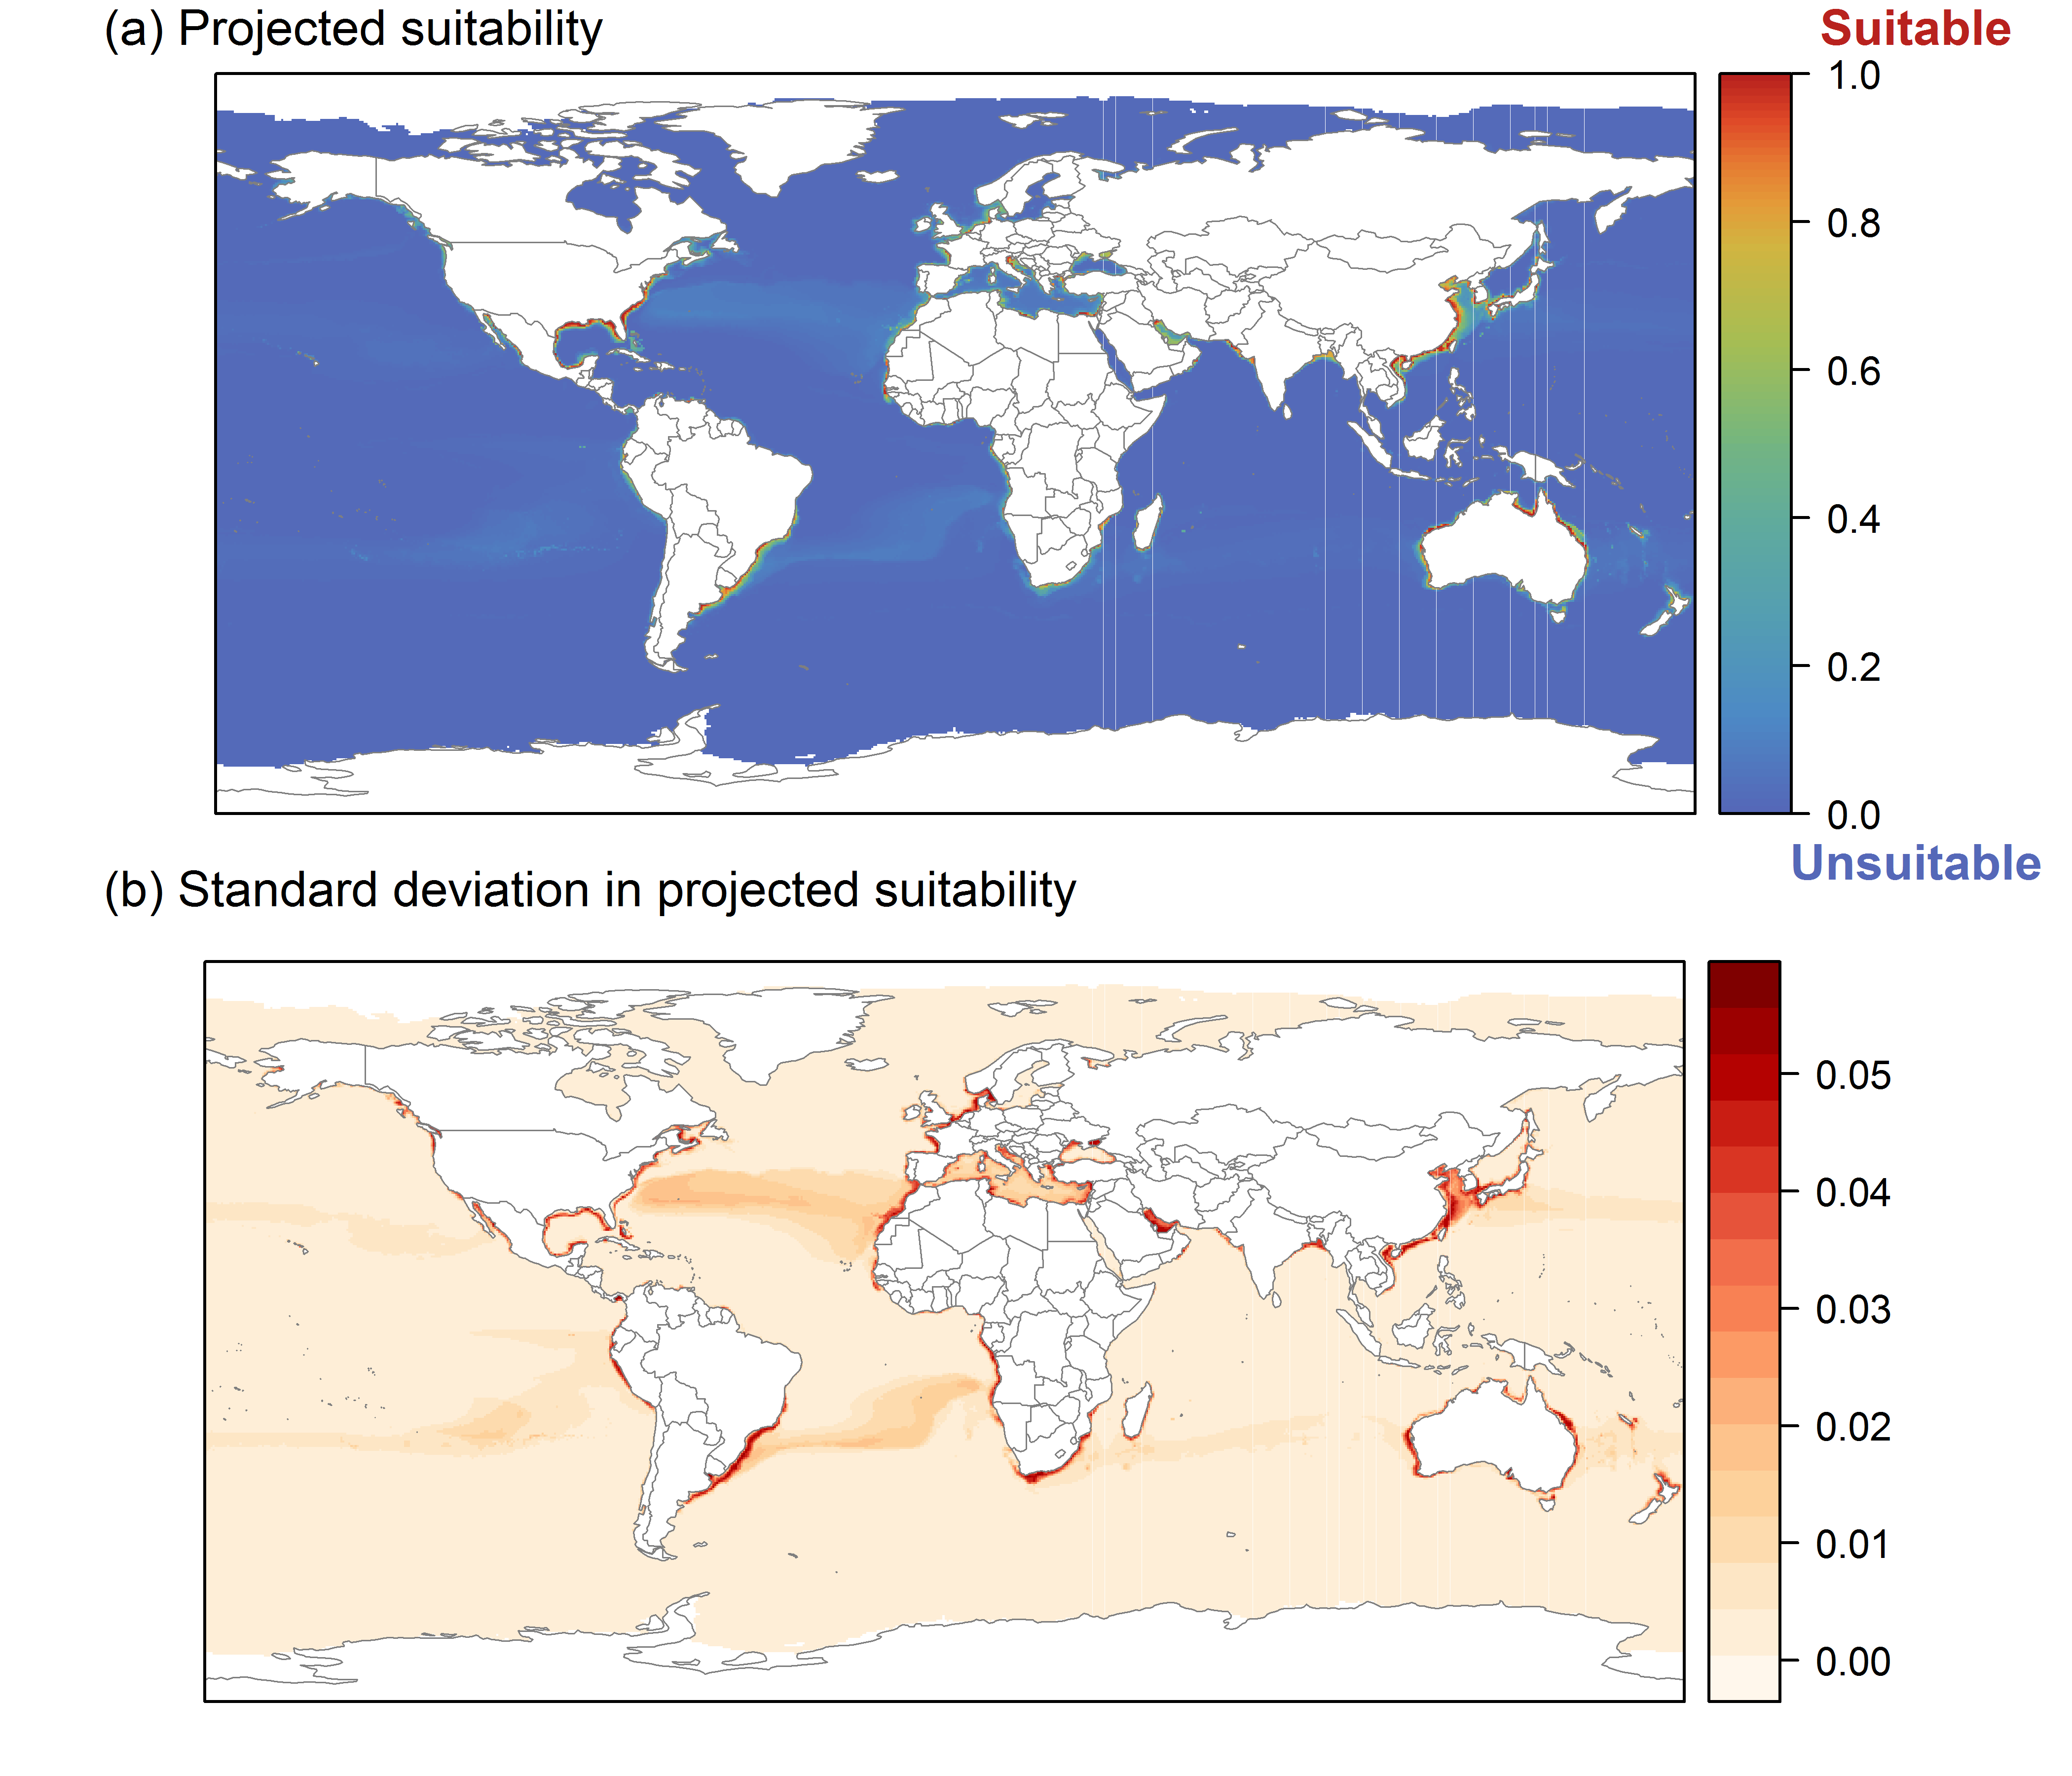

Page Break
Figure 7. (a) Projected current suitability for Mulinia lateralis establishment in Europe and the Mediterranean region. Values > 0.77 are suitable for the species, with 98% of global presence records above this threshold. Values below 0.77 indicate lower relative suitability. (b) Uncertainty in the ensemble projections, expressed as the among-algorithm standard deviation in predicted suitability, averaged across the 10 datasets.
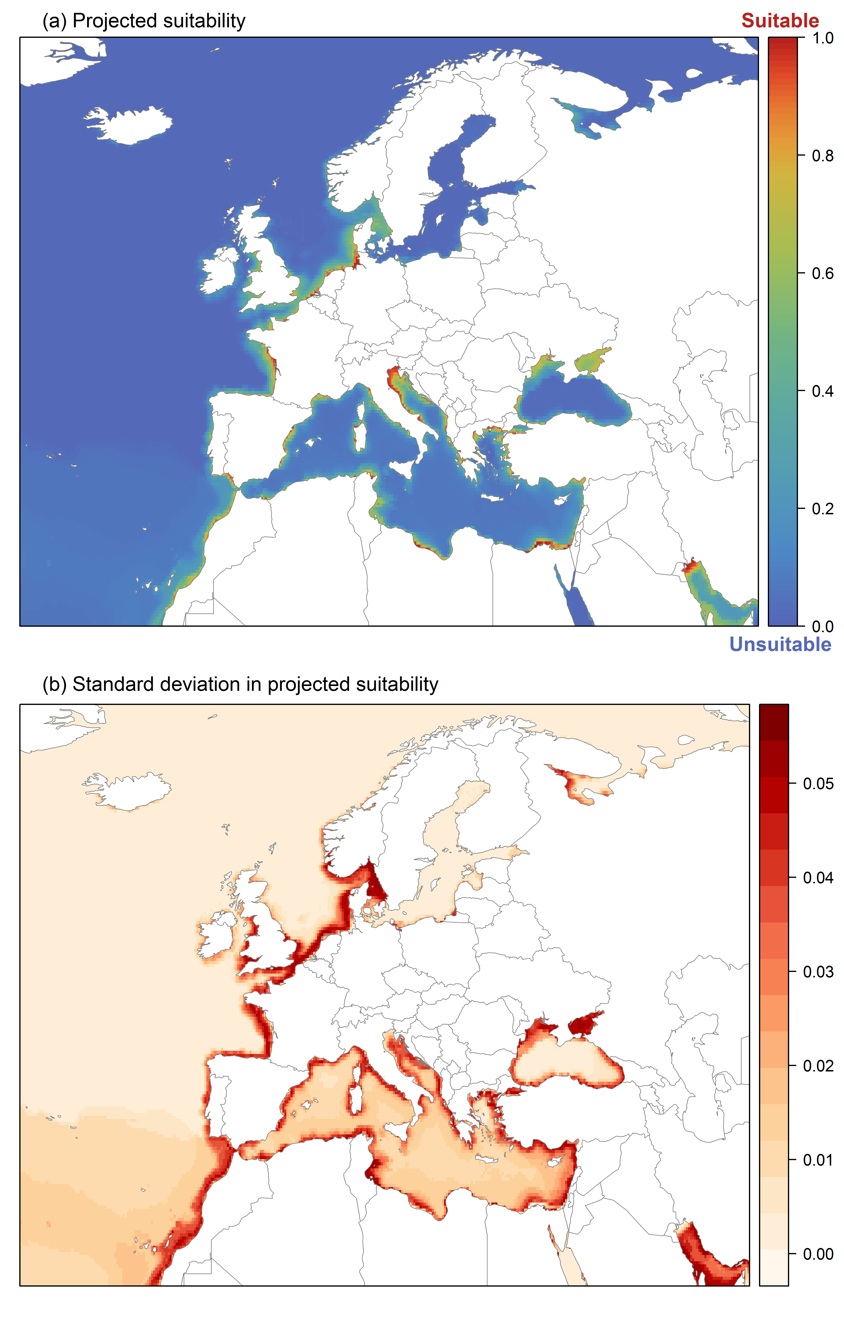

Page Break
Figure 8. The most strongly limiting factors for Mulinia lateralis establishment estimated by the model in Europe and the Mediterranean region in current climatic conditions.
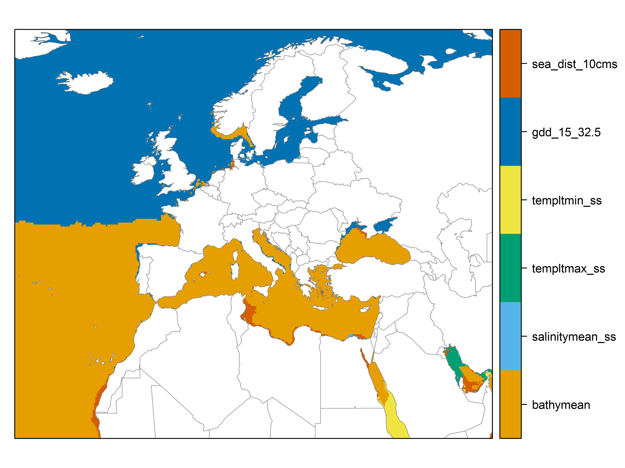

Page Break
Figure 9. (a) Projected suitability for Mulinia lateralis establishment in Europe and the Mediterranean region in the 2070s under climate change scenario RCP 2.6. Values > 0.77 are suitable for the species, with 98% of global presence records above this threshold under current climate. Values below 0.77 indicate lower relative suitability. (b) Uncertainty in the ensemble projections, expressed as the among-algorithm standard deviation in predicted suitability, averaged across the 10 datasets.
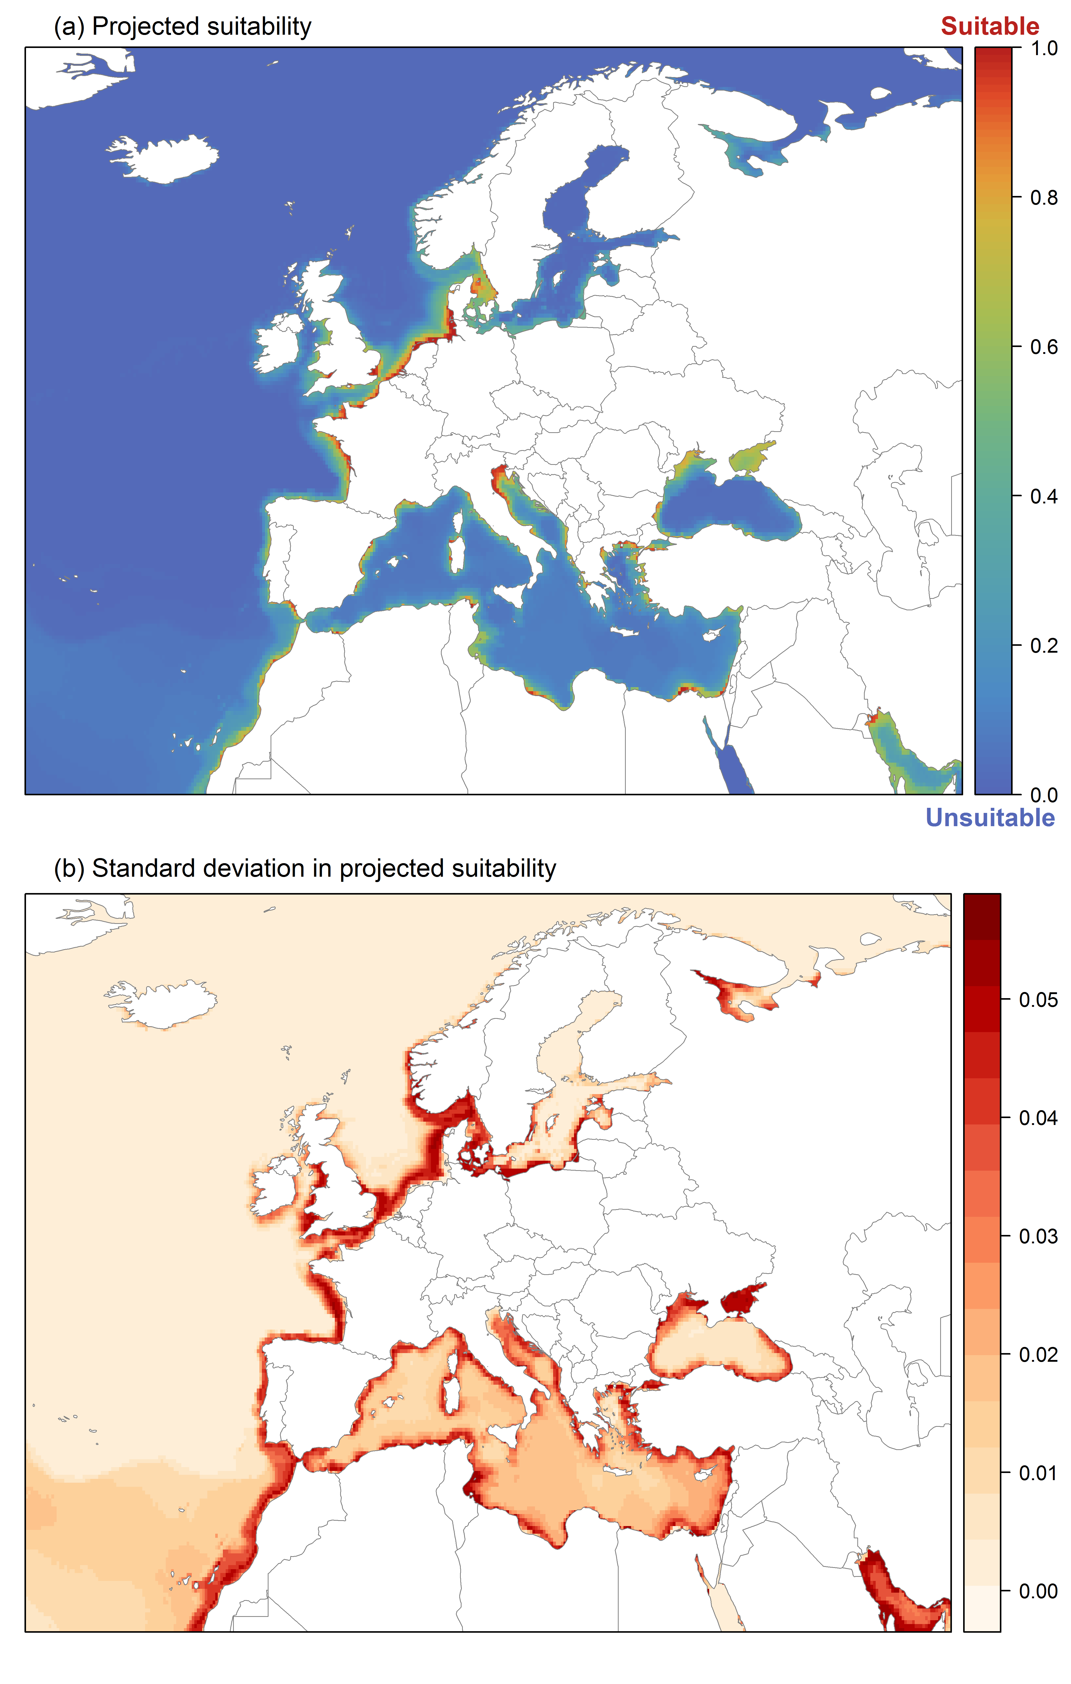

Page Break
Figure 10. (a) Projected suitability for Mulinia lateralis establishment in Europe and the Mediterranean region in the 2070s under climate change scenario RCP 4.5. Values > 0.77 are suitable for the species, with 98% of global presence records above this threshold under current climate. Values below 0.77 indicate lower relative suitability. (b) Uncertainty in the ensemble projections, expressed as the among-algorithm standard deviation in predicted suitability, averaged across the 10 datasets.
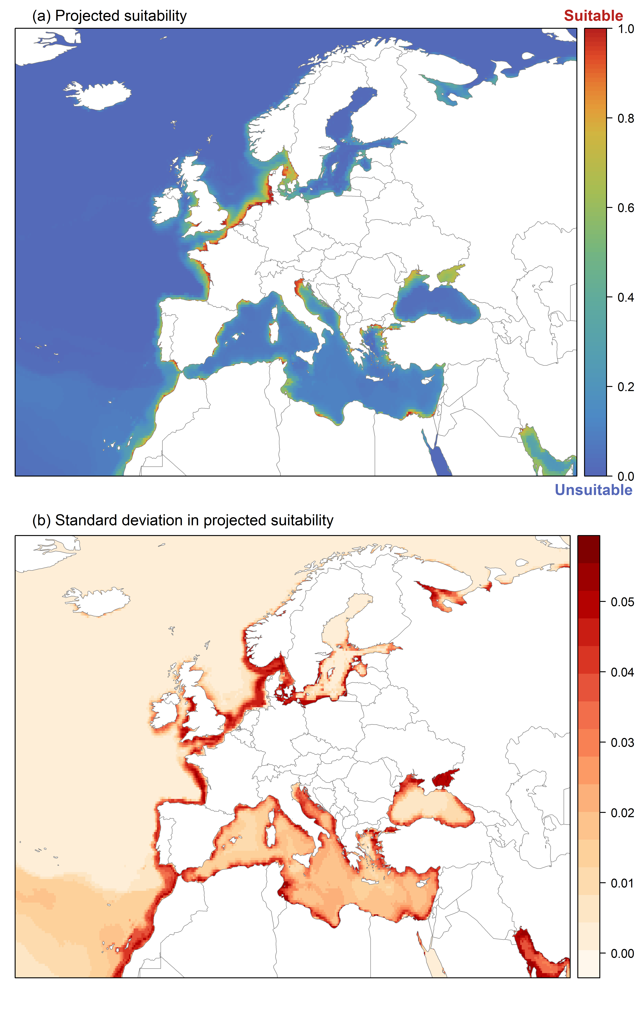

Page Break
Figure 11. Variation in projected suitability for Mulinia lateralis establishment among marine subregions of Europe. The bar plots show the proportion of grid cells in each region classified as suitable (with values > 0.77) in the current climate and projected climate for the 2070s under two RCP emissions scenarios. Error bars indicate uncertainty due to both the choice of classification threshold and uncertainty in the projections themselves (cf. part (b) of Figures 7, 9 and 10). The location of each region is also shown. Macaronesia is excluded as it is not part of the study area.
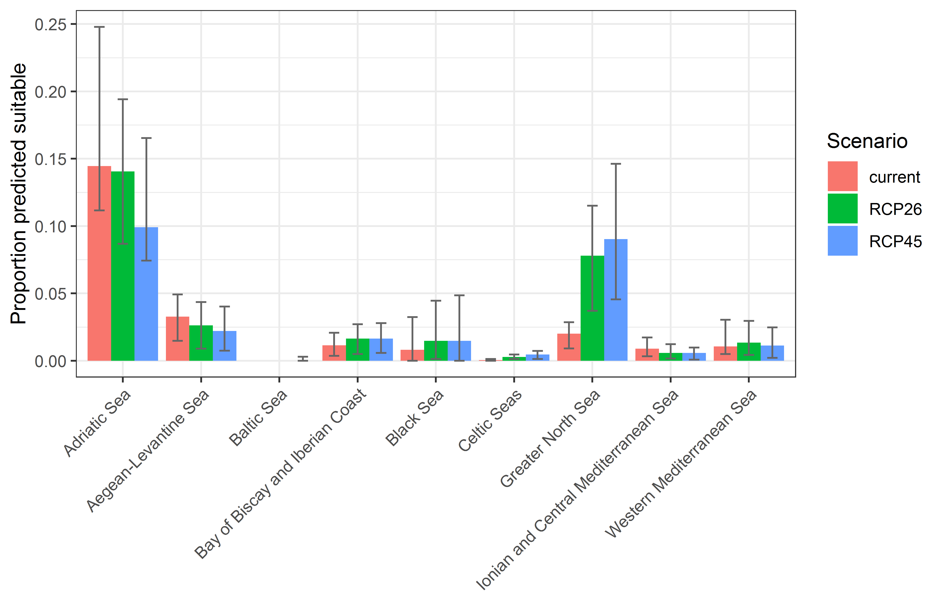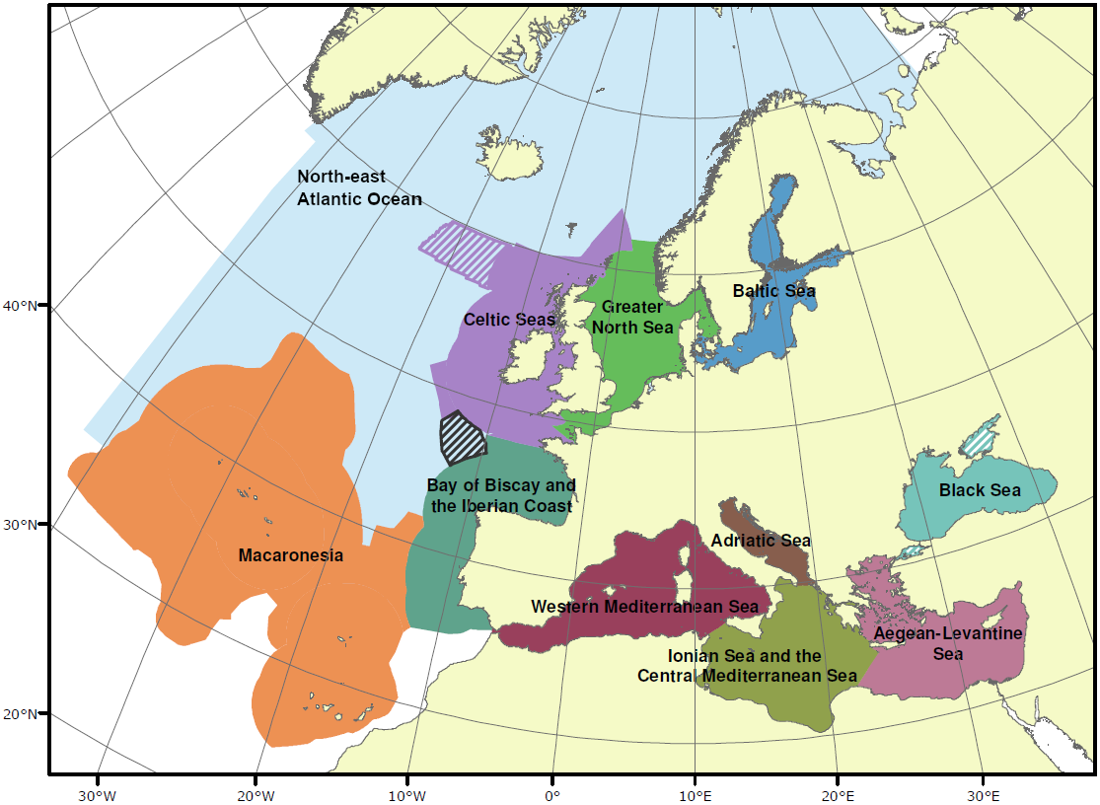

Page Break
Table 2. Variation in projected suitability for Mulinia lateralis establishment among marine subregions of Europe (numerical values of Figure 11 above). The numbers are the proportion of grid cells in each region classified as suitable in the current climate and projected climate for the 2070s under two RCP emissions scenarios.
 | current climate |  |  | 2070s RCP2.6 |  |  | 2070s RCP4.5
 | lower | central estimate | upper | lower | central estimate | upper | lower | central estimate | upper
Adriatic Sea | 0.11 | 0.14 | 0.25 | 0.09 | 0.14 | 0.19 | 0.07 | 0.10 | 0.17
Aegean-Levantine Sea | 0.01 | 0.03 | 0.05 | 0.01 | 0.03 | 0.04 | 0.01 | 0.02 | 0.04
Baltic Sea | 0.00 | 0.00 | 0.00 | 0.00 | 0.00 | 0.00 | 0.00 | 0.00 | 0.00
Bay of Biscay and Iberian Coast | 0.00 | 0.01 | 0.02 | 0.00 | 0.02 | 0.03 | 0.01 | 0.02 | 0.03
Black Sea | 0.00 | 0.01 | 0.03 | 0.00 | 0.01 | 0.04 | 0.00 | 0.01 | 0.05
Celtic Seas | 0.00 | 0.00 | 0.00 | 0.00 | 0.00 | 0.00 | 0.00 | 0.00 | 0.01
Greater North Sea | 0.01 | 0.02 | 0.03 | 0.04 | 0.08 | 0.12 | 0.05 | 0.09 | 0.15
Ionian and Central Mediterranean Sea | 0.00 | 0.01 | 0.02 | 0.00 | 0.01 | 0.01 | 0.00 | 0.01 | 0.01
Western Mediterranean Sea | 0.00 | 0.01 | 0.03 | 0.00 | 0.01 | 0.03 | 0.00 | 0.01 | 0.02

Page Break
Figure 12. Variation in projected suitability for Mulinia lateralis establishment among the territorial coastal waters of European Union countries and the UK (from osm-boundaries.com). The bar plots show the proportion of grid cells in each country classified as suitable (with values > 0.77) in the current climate and projected climate for the 2070s under two RCP emissions scenarios. Error bars indicate uncertainty due to both the choice of classification threshold and uncertainty in the projections themselves (cf. part (b) of Figures 7, 9 and 10). The location of each region is also shown.
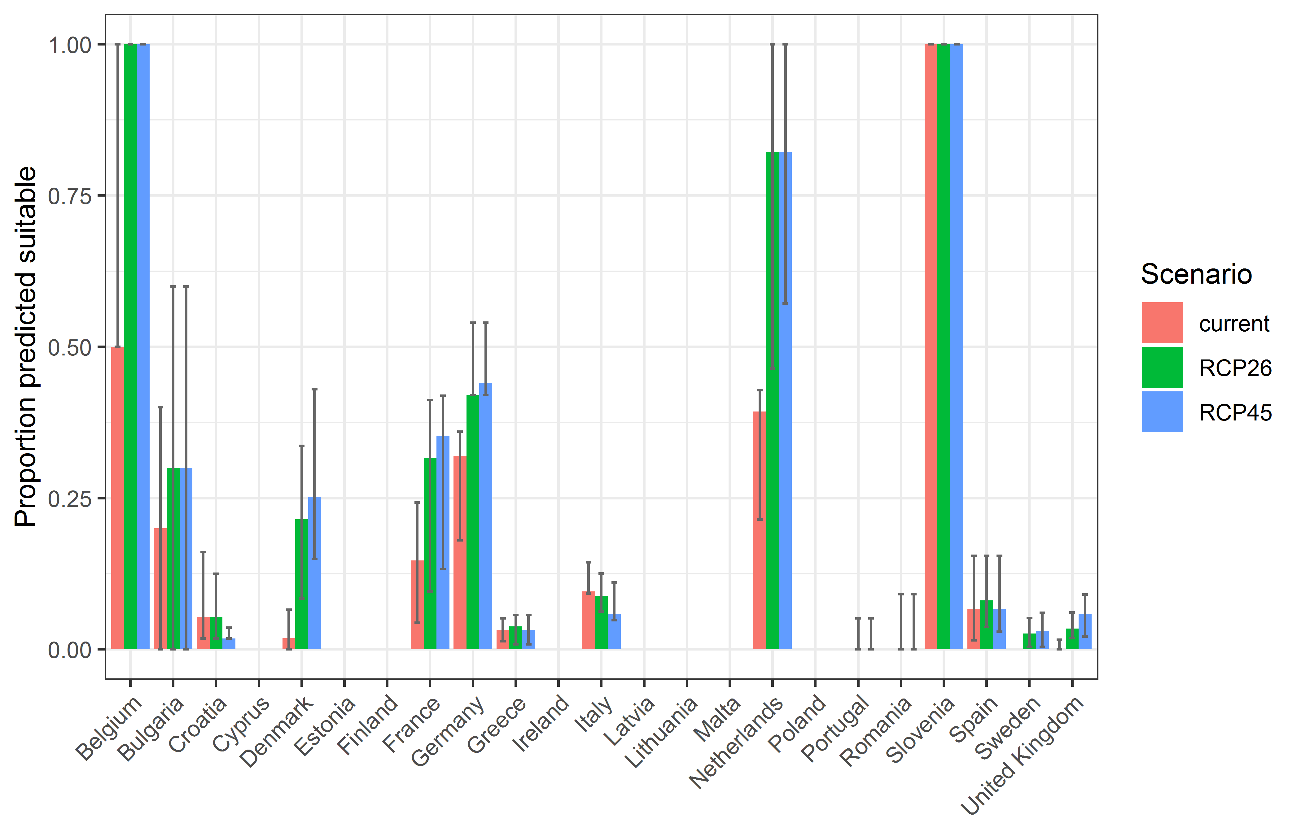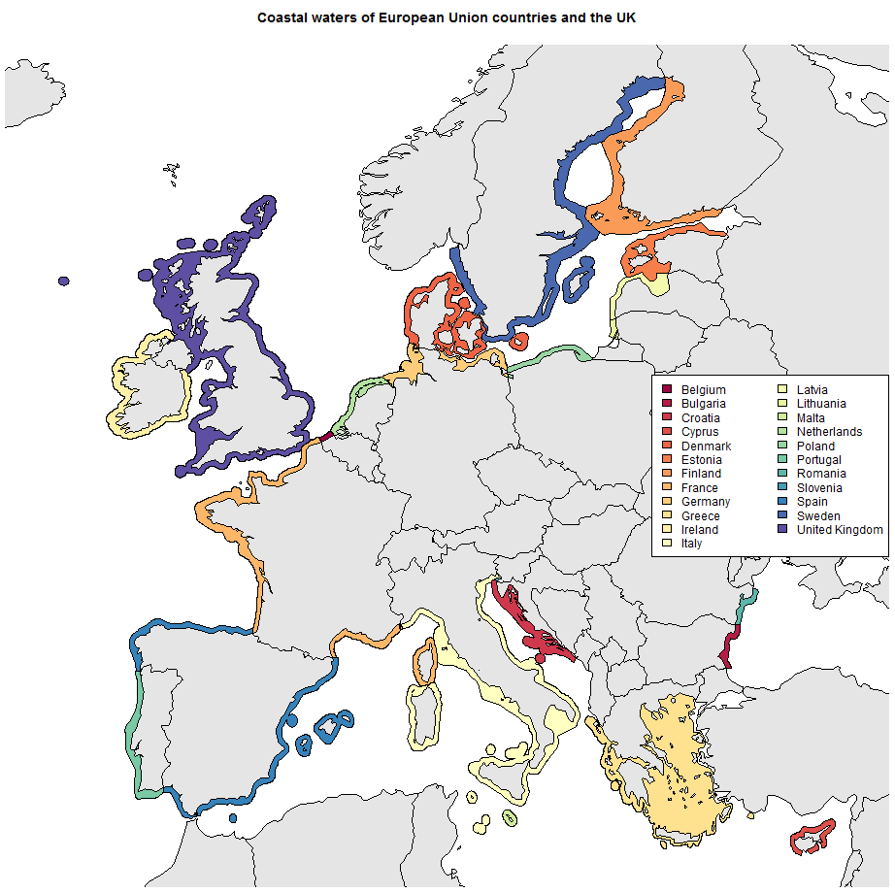

Page Break
Table 3. Variation in projected suitability for Mulinia lateralis establishment among territorial waters of European Union countries and the UK (numerical values of Figure 12 above). The numbers are the proportion of grid cells in each country classified as suitable in the current climate and projected climate for the 2070s under two RCP emissions scenarios.

 | current climate |  |  | 2070s RCP 2.6 |  |  | 2070s RCP 4.5
 | lower | central estimate | upper | lower | central estimate | upper | lower | central estimate | upper
Belgium | 0.50 | 0.50 | 1.00 | 1.00 | 1.00 | 1.00 | 1.00 | 1.00 | 1.00
Bulgaria | 0.00 | 0.20 | 0.40 | 0.00 | 0.30 | 0.60 | 0.00 | 0.30 | 0.60
Croatia | 0.02 | 0.05 | 0.16 | 0.02 | 0.05 | 0.12 | 0.02 | 0.02 | 0.04
Cyprus | 0.00 | 0.00 | 0.00 | 0.00 | 0.00 | 0.00 | 0.00 | 0.00 | 0.00
Denmark | 0.00 | 0.02 | 0.07 | 0.08 | 0.21 | 0.34 | 0.15 | 0.25 | 0.43
Estonia | 0.00 | 0.00 | 0.00 | 0.00 | 0.00 | 0.00 | 0.00 | 0.00 | 0.00
Finland | 0.00 | 0.00 | 0.00 | 0.00 | 0.00 | 0.00 | 0.00 | 0.00 | 0.00
France | 0.04 | 0.15 | 0.24 | 0.10 | 0.32 | 0.41 | 0.13 | 0.35 | 0.42
Germany | 0.18 | 0.32 | 0.36 | 0.42 | 0.42 | 0.54 | 0.42 | 0.44 | 0.54
Greece | 0.01 | 0.03 | 0.05 | 0.01 | 0.04 | 0.06 | 0.01 | 0.03 | 0.06
Ireland | 0.00 | 0.00 | 0.00 | 0.00 | 0.00 | 0.00 | 0.00 | 0.00 | 0.00
Italy | 0.09 | 0.10 | 0.14 | 0.06 | 0.09 | 0.13 | 0.05 | 0.06 | 0.11
Latvia | 0.00 | 0.00 | 0.00 | 0.00 | 0.00 | 0.00 | 0.00 | 0.00 | 0.00
Lithuania | 0.00 | 0.00 | 0.00 | 0.00 | 0.00 | 0.00 | 0.00 | 0.00 | 0.00
Malta | 0.00 | 0.00 | 0.00 | 0.00 | 0.00 | 0.00 | 0.00 | 0.00 | 0.00
Netherlands | 0.21 | 0.39 | 0.43 | 0.46 | 0.82 | 1.00 | 0.57 | 0.82 | 1.00
Poland | 0.00 | 0.00 | 0.00 | 0.00 | 0.00 | 0.00 | 0.00 | 0.00 | 0.00
Portugal | 0.00 | 0.00 | 0.00 | 0.00 | 0.00 | 0.05 | 0.00 | 0.00 | 0.05
Romania | 0.00 | 0.00 | 0.00 | 0.00 | 0.00 | 0.09 | 0.00 | 0.00 | 0.09
Slovenia | 1.00 | 1.00 | 1.00 | 1.00 | 1.00 | 1.00 | 1.00 | 1.00 | 1.00
Spain | 0.01 | 0.07 | 0.15 | 0.04 | 0.08 | 0.15 | 0.03 | 0.07 | 0.15
Sweden | 0.00 | 0.00 | 0.00 | 0.00 | 0.03 | 0.05 | 0.00 | 0.03 | 0.06
UK | 0.00 | 0.00 | 0.02 | 0.02 | 0.03 | 0.06 | 0.02 | 0.06 | 0.09

Caveats to the modelling
To remove spatial recording biases, the selection of the background sample from the accessible background was weighted by the density of Bivalvia records on the Global Biodiversity Information Facility (GBIF). While this is preferable to not accounting for recording bias at all, it may not provide the perfect measure of recording bias.
There was substantial variation among modelling algorithms in the partial response plots (Figure 5). In part this will reflect their different treatment of interactions among variables. Since partial plots are made with other variables held at their median, there may be values of a particular variable at which this does not provide a realistic combination of variables to predict from.
Other variables potentially affecting the distribution of the species, such as sediment composition, were not included in the model, due to the lack of suitable global layers.
M. lateralis is primarily an inshore, estuarine species and coarse grain temperature maps may not accurately reflect local conditions, e.g. water temperature in shallow, sheltered areas or in harbours and marinas. Finally, even though the model takes into account salinity variability in the form of distance from river mouths, a future scenario for river discharge was not taken into account and would take very elaborate data processing to bring into the model. We used the same predictor layer for both current and future climate conditions.

Page Break

References
- Allouche, O., Tsoar, A., & Kadmon, R. (2006). Assessing the accuracy of species distribution models: prevalence, kappa and the true skill statistic (TSS), Journal of Applied Ecology, 43, 1223-1232.
- Assis, J., Tyberghein, L., Bosch, S., Verbruggen, H., Serrão, E. A., & De Clerck, O. (2018). Bio‐ORACLE v2. 0: Extending marine data layers for bioclimatic modelling. Global Ecology and Biogeography, 27(3), 277-284.
- Chapman, D., Pescott, O. L., Roy, H. E., &Tanner, R. (2019). Improving species distribution models for invasive non-native species with biologically informed pseudo-absence selection. Journal of Biogeography. https://doi.org/10.1111/jbi.13555.
- Cohen, J. (1960). A coefficient of agreement of nominal scales. Educational and Psychological Measurement, 20, 37-46.
- Elith, J., Kearney, M., & Phillips, S. (2010). The art of modelling range-shifting species. Methods in Ecology and Evolution, 1, 330-342.
- Fielding, A. H., & Bell, J. F. (1997). A review of methods for the assessment of prediction errors in conservation presence/absence models. Environmental Conservation, 24, 38-49.
- Hijmans, R. J. (2000). raster: Geographic Data Analysis and Modeling, R package version 3.4-5, URL: https://CRAN.R-project.org/package=raster
- Iglewicz, B., & Hoaglin, D.C. (1993). How to detect and handle outliers, Asq Press.
- Lehner, B., Verdin, K., & Jarvis, A. (2008). New global hydrography derived from spaceborne elevation data. Eos, Transactions American Geophysical Union, 89(10), 93-94.
URL: https://www.hydrosheds.org/page/hydrorivers (accessed 30/3/2021).
- Manel, S., Williams, H. C., & Ormerod, S. J. (2001). Evaluating presence-absence models in ecology: the need to account for prevalence. Journal of Applied Ecology, 38, 921-931.
- McMaster, G. S., & Wilhelm, W. (1997). Growing degree-days: one equation, two interpretations. Agricultural and Forest Meteorology, 87, 291-300.
- McPherson, J. M., Jetz, W., & Rogers, D. J. (2004). The effects of species’ range sizes on the accuracy of distribution models: ecological phenomenon or statistical artefact? Journal of Applied Ecology, 41, 811-823.
- Sbrocco, E. J., & Barber, P. H. (2013). MARSPEC: Ocean climate layers for marine spatial ecology. Ecology 94, 979. http://dx.doi.org/10.1890/12-1358.1
- Thuiller, W., Lafourcade, B., Engler, R., & Araújo, M. B. (2009.) BIOMOD-a platform for ensemble forecasting of species distributions. Ecography, 32, 369-373.
- Thuiller, W., Georges, D., Engler, R., & Breiner, F. (2020). biomod2: Ensemble Platform for Species Distribution Modeling. R package version 3.4.6. https://CRAN.R-project.org/package=biomod2
- Tyberghein, L., Verbruggen, H., Pauly, K., Troupin, C., Mineur, F., & De Clerck, O. (2012). Bio-ORACLE: A global environmental dataset for marine species distribution modelling. Global Ecology and Biogeography, 21, 272–281.

This template is based on the Great Britain non-native species risk assessment scheme (GBNNRA). A number of amendments have been introduced to ensure compliance with Regulation (EU) 1143/2014 on IAS and relevant legislation, including the Delegated Regulation (EU) 2018/968 of 30 April 2018, supplementing Regulation (EU) No 1143/2014 of the European Parliament and of the Council with regard to risk assessments in relation to invasive alien species (see https://eur-lex.europa.eu/legal-content/en/TXT/?uri=CELEX%3A32018R0968).
Convention on Biological Diversity, Decision VI/23
https://circabc.europa.eu/sd/a/7e5f0bd4-34e8-4719-a2f7-c0cd7ec6a86e/2020-CBD-pathways-interpretation.pdf
https://circabc.europa.eu/sd/a/0aeba7f1-c8c2-45a1-9ba3-bcb91a9f039d/TSSR-2016-010%20CBD%20pathways%20key%20full%20only.pdf
NIS: non-indigenous species, term used in the Marine Strategy Framework Directive, synonym of “alien species” as used in the framework of Regulation (EU) 1143/2014
Not to be confused with “no impact”.
Note: in the CICES classification provisioning of water is considered as an abiotic service whereas the rest of ecosystem services listed here are considered biotic.

