**Risk assessment template developed under the "Study on Invasive Alien Species – Development of risk assessments to tackle priority species and enhance prevention"   
Contract No 07.0202/2020/834529/ETU/ENV.D.2[1]**

**Name of organism:** *Marisa cornuarietis* (Linnaeus 1758)

**Author(s) of the assessment:**

Frances Lucy, IT Sligo, Sligo, Ireland and Darren Garland, IT Sligo, Sligo, Ireland

**Risk Assessment Area:** The risk assessment area is the territory of the European Union 27 and the United Kingdom, excluding the EU-outermost regions.

**Peer review 1:** Elena Tricarico, Department of Biology, University of Florence, Sesto Fiorentino (FI), Italy

**Peer review 2:**Hugo Verreycken, INBO, Brussels, Belgium

**Date of completion:** 15 October 2021

**Date of revision: 30 September 2022**

**Contents**

SECTION A – Organism Information and Screening 4

SECTION B – Detailed assessment 12

1 PROBABILITY OF INTRODUCTION AND ENTRY 12

2 PROBABILITY OF ESTABLISHMENT 22

3 PROBABILITY OF SPREAD 28

4 MAGNITUDE OF IMPACT 34

Biodiversity and ecosystem impacts 34

Ecosystem Services impacts 37

Economic impacts 39

Social and human health impacts 41

Other impacts 42

RISK SUMMARIES 45

REFERENCES 47

Distribution Summary 49

ANNEX I Scoring of Likelihoods of Events 51

ANNEX II Scoring of Magnitude of Impacts 52

ANNEX III Scoring of Confidence Levels 53

ANNEX IV CBD pathway categorisation scheme 54

ANNEX V Ecosystem services classification (CICES V5.1, simplified) and examples 55

ANNEX VI EU Biogeographic Regions and MSFD Subregions 59

ANNEX VII Delegated Regulation (EU) 2018/968 of 30 April 2018 60

ANNEX VIII Projection of environmental suitability for *Marisa cornuarietis* establishment in Europe 61

# SECTION A – Organism Information and Screening

|  |
| --- |
| **A1. Identify the organism. Is it clearly a single taxonomic entity and can it be adequately distinguished from other entities of the same rank?**  including the following elements:   * the taxonomic family, order and class to which the species belongs; * the scientific name and author of the species, as well as a list of the most common synonym names; * names used in commerce (if any) * a list of the most common subspecies, lower taxa, varieties, breeds or hybrids   As a general rule, one risk assessment should be developed for a single species. However, there may be cases where it may be justified to develop one risk assessment covering more than one species (e.g. species belonging to the same genus with comparable or identical features and impact). It shall be clearly stated if the risk assessment covers more than one species, or if it excludes or only includes certain subspecies, lower taxa, hybrids, varieties or breeds (and if so, which subspecies, lower taxa, hybrids, varieties or breeds). Any such choice must be properly justified. |

Response: *Marisa cornuarietis* (Linnaeus 1758) is the species for which this risk assessment has been conducted. It is a single species (no lower taxa or hybrids) belonging to the genus *Marisa*, which is part of the Ampullariidae family, commonly known as the apple snails (Barker 2019).

Domain: Eukaryota

Kingdom: Metazoa

Phylum: Mollusca

Class: Gastropoda

Subclass: Caenogastropoda

Order: Architaenioglossa

Family: Ampullariidae

Genus: *Marisa*

Species: *Marisa cornuarietis*

The Ampullariidae family consists of 9 genera and 120 species (Arias & Torralba-Burrial 2014). The genus *Marisa* consists of two species: *M. cornuarietis* and *M. planogyra* (Pilsbry 1933). According to the Integrated Taxonomic Information System (www.itis.org) *M. cornuarietis* is commonly referred to as the giant ramshorn snail or golden horn marisa. In the RA area, the common English name for *M. cornuarietis* is giant ramshorn snail (Arias & Torralba-Burrial 2014). Other common names are: Paradiesschnecke, Brasilianische Streifenschnecke (DE) paratiisikotilo (FI).

|  |
| --- |
| **A2. Provide information on the existence of other species that look very similar [that may be detected in the risk assessment area, either in the environment, in confinement or associated with a pathway of *introduction*]**  Include both native and non-native species that could be confused with the species being assessed, including the following elements:   * other alien species with similar invasive characteristics, to be avoided as substitute species (in this case preparing a risk assessment for more than one species together may be considered); * other alien species without similar invasive characteristics, potential substitute species; * native species, potential misidentification and mis-targeting |

Response: Barker (2019) details two species similar in appearance to *M.* *cornuarietis,* these include *M. planogyra* and *Planorbarius corneus. M. planogyra* is nonnative to the EU while *Planobarius corneus* occurs throughout Europe. The general morphological features of adult *Marisa cornuarietis* according to Barker (2019) include: a dextrally coiled shell, shell in adults 18-22 mm in height, 48-56 mm in diameter, more-or-less glossy but with growth lines that are most prominent near the aperture *M. cornuarietis* isdifferentiatedfrom *M. planogyra* asthe latterhasasmallershellsizewhichisabout30mm*,* is more strongly planispiral, with both dorsal and ventral (umbilical) aspects strongly concave and openly perspective. *Planorbarius* *corneus* is distinguished from *M.* *cornuarietis* as it only grows to a shell size of 35-40mm, the shell is sinistral lacking spiral colour bands and the mantle cavity is sealed except for a small contractile opening *(pneumostome).* Furthermore, juveniles of *P. corneus* lack an elevated spire.

|  |
| --- |
| **A3. Does a relevant earlier risk assessment exist? Give details of any previous risk assessment, including the final scores and its validity in relation to the risk assessment area.** |

Response: No risk assessment specific only to *M. cornuarietis* has previously been carried out for the RA area. However, a risk assessment of incidental molluscs associated with aquarium trade was carried out for the EU region in 2017 (Patoka *et al*. 2017). This risk assessment included *M. cornuarietis* andutilisedtheFreshwaterInvertebrateInvasivenessScoringKit (FI-ISK). A scoring kit based on 49 questions focused on zoogeography, biology, and ecology (e.g. has the species established beyond its native range? Is the species’ reproductive tolerance suited to climates in the risk assessment area? Is the species unpalatable to predators? Does the species tolerate a wide range of salinity regimes?). After processing, the FI-ISK distinguishes potentially invasive and non-invasive species by invasiveness score.

Patoka *et al*. (2017) concluded that *M. cornuarietis* was established in the European Union, its temperature suitability was 25.25% (based on proportion of all meteorological stations monitored within the EU), its potential invasiveness score was 15, which deemed to be of medium invasiveness in the EU (low-risk: score<1, medium-risk: score >1 and <16, and high-risk: score >16). This risk assessment is valid for the RA area of this current risk assessment for *M. cornuarietis*.

|  |
| --- |
| **A4. Where is the organism native?**  including the following elements:   * an indication of the continent or part of a continent, climatic zone and habitat where the species is naturally occurring * if applicable, indicate whether the species could naturally spread into the risk assessment area |

Response: The species native range extends from the northern part of South America (from Brazil and Bolivia to Venezuela, Colombia) to Central America (Panama, Costa Rica) (Arias & Torralba-Burrial 2014). It must be noted that its native range may only encompass Venezuela and Columbia but it is unknown if its wide ranging occurrence in the other aforementioned areas is natural or a result of introductions (Cowie *et al.* 2017). It primarily inhabits freshwater lotic and lentic systems including lakes, river, ponds, irrigation channels, swamps and wetlands where it occurs at depths of less than 1 metre (Arias & Torralba-Burrial 2014). *Marisa cornuarietis* is an omnivore renowned for its voracious appetite feeding on live or decaying plants and fish, snail eggs and juveniles (Benson *et al*. 2021). Climatic conditions have been cited as a factor limiting the establishment of this snail species as per its temperature requirements. Another limiting factor in its ability to establish new areas are physiochemical parameters of potential water bodies it could inhabit (Arias & Torralba-Burrial 2014).

The main limiting factors for survival are thermal requirements. The species thrives in water temperatures ranging from 18 to 30 °C with an ideal range of 20-26 °C (Frisóczki *et al.* 2016). At temperatures below 18 °C the snail becomes inactive, and it cannot thrive for extended periods of time below 12 °C (Frisóczki *et al.* 2016). Temperatures of 8 °C have been proven to be lethal to *M. cornuarietis* after8hoursofexposure. Another limiting factor impeding this alien species successful establishment is calcium concentration in the water body as this organism utilises this mineral for its shell (Arias & Torralba-Burrial 2014). These factors limit the species successful establishment in the environment to areas where calcium concentrations are sufficient and year-round temperatures meet their biological requirements. The species could not naturally spread to the risk assessment area due to the sea barriers between continents.

|  |
| --- |
| **A5. What is the global non-native distribution of the organism outside the risk assessment area?** |

Response: *Marisa cornuarietis* has been introduced in North America, some Caribbean islands (Cuba, Guadeloupe, Martinique, Puerto Rico, Jamaica) and Africa (Egypt, Sudan, Tanzania) (Arias & Torralba-Burrial 2014) (Brown et al., 2022).

|  |
| --- |
| **A6. In which biogeographic region(s) or marine subregion(s) in the risk assessment area has the species been recorded and where is it established? The information needs be given separately for recorded (including casual or transient occurrences) and established occurrences. “Established” means the process of an alien species successfully producing viable offspring with the likelihood of continued survival[2].**  **A6a. Recorded: List regions**  **A6b. Established: List regions**  Freshwater / terrestrial biogeographic regions:   * Alpine, Atlantic, Black Sea, Boreal, Continental, Mediterranean, Pannonian, Steppic   Marine regions:   * Baltic Sea, North-east Atlantic Ocean, Mediterranean Sea, Black Sea   Marine subregions:   * Greater North Sea, incl. the Kattegat and the English Channel, Celtic Seas, Bay of Biscay and the Iberian Coast, Western Mediterranean Sea, Adriatic Sea, Ionian Sea, Central Mediterranean Sea, Aegean-Levantine Sea.   Comment on the sources of information on which the response is based and discuss any uncertainty in the response.  For delimitation of EU biogeographical regions please refer to Annex VI.  For delimitation of EU marine regions and subregions consider the Marine Strategy Framework Directive areas; please refer to Annex VI. |

Response (6a): The species was first recorded in the risk assessment area in 2014 in the Atlantic biogeographic region (northern Spain, Arias & Torralba-Burrial 2014) and has subsequently been found in the Pannonian biogeographic region (Hungary) at the outflow of a thermal spa (Cowie *et al*. 2017).

Response (6b): Due to its viable reproduction in the risk assessment area since 2014, it is deemed to be established in both the Atlantic and in the Pannonian biogeographical regions (Arias & Torralba-Burrial 2014, Cowie *et al*. 2017).

|  |
| --- |
| **A7. In which biogeographic region(s) or marine subregion (s) in the risk assessment area could the species establish in the future under current climate and under foreseeable climate change? The information needs be given separately for current climate and under foreseeable climate change conditions.**  **A7a. Current climate: List regions**  **A7b. Future climate: List regions**  With regard to EU biogeographic and marine (sub) regions, see above.  With regard to climate change, provide information on   * the applied timeframe (e.g. 2050/2070) * the applied scenario (e.g. RCP 4.5) * what aspects of climate change are most likely to affect the risk assessment (e.g. increase in average winter temperature, increase in drought periods)   The assessment does not have to include a full range of simulations on the basis of different climate change scenarios, as long as an assessment with a clear explanation of the assumptions is provided. However, if new, original models are executed for this risk assessment, the following RCP pathways shall be applied: RCP 2.6 (likely range of 0.4-1.6°C global warming increase by 2065) and RCP 4.5 (likely range of 0.9-2.0°C global warming increase by 2065). Otherwise, the choice of the assessed scenario has to be explained. |

Response (7a): Under current climate conditions, according to a Species Distribution model (Annex VIII), *M. cornuarietis* could potentially establish in several biogeographical regions of the risk assessment area including the Continental, Alpine, Atlantic and Black Sea regions. This is in addition to expansion in the Atlantic and the Pannonian regions. Figure 5 illustrates the projected the current suitability of regions in the RA area. Note that the current model suggests that it should not be present in the Pannonian region, although present there in water associated with a thermal spring.

Response (7b): Predicted future climate conditions for the 2070s under both scenarios (RCP2.6, RCP4.5) indicate a low probability of *M. cornuarietis* establishing in the Alpine, Pannonian and Steppic regions, and also extending within the Atlantic, Black Sea, Continental and Mediterranean regions, compared to the present climatic conditions within the RA area. Increase in average winter temperature is the most likely factor to increase probability of projected suitability for this species. Figure 8 illustrates projected future suitability (2070s) of regions in the RA area under climate change scenario RCP4.5.

|  |
| --- |
| **A8. In which EU Member States has the species been recorded and in which EU Member States has it established? List them with an indication of the timeline of observations. The information needs be given separately for recorded and established occurrences.**  **A8a. Recorded: List Member States**  **A8b. Established: List Member States**  Austria, Belgium, Bulgaria, Croatia, Cyprus, Czech Republic, Denmark, Estonia, Finland, France, Germany, Greece, Hungary, Ireland, Italy, Latvia, Lithuania, Luxembourg, Malta, Netherlands, Poland, Portugal, Romania, Slovakia, Slovenia, Spain, Sweden.  The description of the invasion history of the species shall include information on countries invaded and an indication of the timeline of the first observations, establishment and spread. |

Response (8a): The species was first recorded in the risk assessment area in 2014 in northern Spain (Arias & Torralba-Burrial 2014) and has been found in one area in Hungary close to the outflow of a thermal spa in 2015-2016 (Cowie *et al.* 2017). In Spain, Arias & Torralba-Burrial (2014) state that several specimens of *M. cornuarietis* were reported from multiple searches of the Nora River with adults and juveniles found indicating a thriving and reproducing population. In Hungary, the population occurring downstream of a thermal spa in the Eger stream had a mixture of both adult and juvenile individuals indicating a reproducing population in the locality (Cowie *et al.* 2017).

Response (8b): The information from both the Spanish and Hungarian populations indicate that populations are established there within at least the last ten years (Arias & Torralba-Burrial 2014, Cowie et al. 2017).

|  |
| --- |
| **A9. In which EU Member States could the species establish in the future under current climate and under foreseeable climate change? The information needs be given separately for current climate and under foreseeable climate change conditions.**  **A9a. Current climate: List Member States**  **A9b. Future climate: List Member States**  With regard to EU Member States, see above.  With regard to climate change, provide information on   * the applied timeframe (e.g. 2050/2070) * the applied scenario (e.g. RCP 4.5) * what aspects of climate change are most likely to affect the risk assessment (e.g. increase in average winter temperature, increase in drought periods)   The assessment does not have to include a full range of simulations on the basis of different climate change scenarios, as long as an assessment with a clear explanation of the assumptions is provided. However, if new, original models are executed for this risk assessment, the following RCP pathways shall be applied: RCP 2.6 (likely range of 0.4-1.6°C global warming increase by 2065) and RCP 4.5 (likely range of 0.9-2.0°C global warming increase by 2065). Otherwise, the choice of the assessed scenario has to be explained. |

Response (9a): Under current climate conditions, the SDM (Annex VIII) indicates that *M. cornuarietis* could establish in France, Spain, Italy, Slovenia, Greece, Portugal, Croatia, and the UK. There is a degree of uncertainty, as noted in Figure 5b and Table 1.

Response (9b): In the 2070s, under climate change scenario RCP 4.5, *M. cornuarietis* could establish in many EU Member States In particular, there seems to be a high establishment potential for the majority of Member States with increased potential (compared to current conditions) for Austria, Belgium, Bulgaria, Czech Republic, Denmark, Finland, Germany, Ireland, Luxembourg, the Netherlands and Sweden (Figure 7a) (Annex VIII). There is however considerable uncertainty associated with the model. Increase in average winter temperature is the most likely climate change factor to increase probability of establishment.

|  |
| --- |
| **A10. Is the organism known to be invasive (i.e. to threaten or adversely impact upon biodiversity and related ecosystem services) anywhere outside the risk assessment area?** |

Response: The species is currently considered invasive in the USA and in Egypt, Tanzania and the Caribbean. *M. cornuarietis* impact on biodiversity and ecosystem services where introduced is directly related to density, with few impacts observed where densities remain low (Arias & Torralba-Burrial 2014). For example, in the USA alien populations of *M. cornuarietis* have shown to negatively impact macrophytes when the snail density becomes high with reduced macrophyte diversity and species elimination potentially occurring(Arias & Torralba-Burrial 2014). For this reason, in Puerto Rico and Florida, the species has been introduced for the purposes of aquatic weed control (Barker 2019).

This species is a voracious omnivore which can directly impact native snail populations through direct competition and predation(Arias & Torralba-Burrial 2014). The food habits of *M. cornuarietis* has previously led this species to be utilised as a biological control agent to control the snail vectors of *Schistosoma* spp., the cause of human schistosomiasis, through competition and predation, in Egypt, Tanzania and the Caribbean (Cowie *et al.* 2017). However, due to its invasive features, the introduction of the species for the purposes of controlling other organisms is no longer considered environmentally acceptable (Barker 2019).

|  |
| --- |
| **A11. In which biogeographic region(s) or marine subregion(s) in the risk assessment area has the species shown signs of invasiveness? Indicate the area endangered by the organism as detailed as possible.**  Freshwater / terrestrial biogeographic regions:   * Alpine, Atlantic, Black Sea, Boreal, Continental, Mediterranean, Pannonian, Steppic   Marine regions:   * Baltic Sea, North-east Atlantic Ocean, Mediterranean Sea, Black Sea   Marine subregions:  Greater North Sea, incl. the Kattegat and the English Channel, Celtic Seas, Bay of Biscay and the Iberian Coast, Western Mediterranean Sea, Adriatic Sea, Ionian Sea, Central Mediterranean Sea, Aegean-Levantine Sea |

Response: The species has only been recorded in the wild in two biogeographical regions of the risk assessment area (Arias & Torralba-Burrial 2014, Cowie et al. 2017): Pannonian and Atlantic. In these areas the species has become established, but no impact is currently known, although it is expected they will show signs of invasiveness in the future when they occur in high densities.

|  |
| --- |
| **A12. In which EU Member States has the species shown signs of invasiveness? Indicate the area endangered by the organism as detailed as possible.**  Austria, Belgium, Bulgaria, Croatia, Cyprus, Czech Republic, Denmark, Estonia, Finland, France, Germany, Greece, Hungary, Ireland, Italy, Latvia, Lithuania, Luxembourg, Malta, Netherlands, Poland, Portugal, Romania, Slovakia, Slovenia, Spain, Sweden |

Response: Reported occurrences of the species do not report signs of invasive characteristics in the risk assessment area. However, the species has been reported as alien and established in Spain and it is expected that indicators of invasiveness will increase in the future with increased population densities. Particularly in Spain, where the climate facilitates the widespread occurrence of the species. In Hungary, the negative impacts of the species may be localised to hydrothermal waters.

|  |
| --- |
| **A13. Describe any known socio-economic benefits of the organism.**  including the following elements:   * Description of known uses for the species, including a list and description of known uses in the risk assessment area and third countries, if relevant. * Description of social and economic benefits deriving from those uses, including a description of the environmental, social and economic relevance of each of those uses and an indication of associated beneficiaries, quantitatively and/or qualitatively depending on what information is available.   If the information available is not sufficient to provide a description of those benefits for the entire risk assessment area, qualitative data or different case studies from across the risk assessment area or third countries shall be used, if available. |

Response: *M. cornuarietis* is a known biological control agent beneficial to humans under certain circumstances outside the RA area. It has been used to control snail vectors of *Schistosoma* spp., the cause of human schistosomiasis (Cowie *et al*. 2017). The control is through predation and competition with the potential to eradicate other snail species which are vectors of this parasitic disease (Pointier & David 2004). In addition, this species has previously been used to control aquatic weeds due to it voracious appetite in multiple weed control programs (Barker 2019). *M. cornuarietis* has been introduced to multiple territories outside of the risk assessment area for the control of both weeds and schistosomiasis (Arias & Torralba-Burrial 2014).

*M. cornuarietis* is also widely utilised as an aquatic pet and is traded worldwide in aquatic retail outlets but it is not possible to quantify the economic benefits of the trade of this species. Furthermore, the species is routinely used in laboratory and education settings due to its availability via aquatic retail (Barker 2019).

# SECTION B – Detailed assessment

|  |
| --- |
| **Important instructions:**   * In the case of lack of information the assessors are requested to use a standardized answer: “No information has been found.” In this case, no score and confidence should be given and the standardized “score” is N/A (not applicable). * With regard to the scoring of the likelihood of events or the magnitude of impacts see Annexes I and II. * With regard to the confidence levels, see Annex III. * Highlight the selected response score and confidence level in **bold** but keep the other scores in normal text (so that the selected score is evident in the final document). |

## 1 PROBABILITY OF INTRODUCTION AND ENTRY

|  |
| --- |
| **Important instructions:**   * **Introduction** is the movement of the species into the risk assessment area (it may be either in captive conditions and/or in the environment, depending on the relevant pathways). * **Entry** is the release/escape/arrival in the environment, i.e. occurrence in the wild * Introduction and entry may coincide for species entering through pathways such as “corridor” or “unaided”, but it also may differ. If different, please consider all relevant pathways, both for the introduction into the risk assessment area and the entry in the environment. * The classification of pathways developed by the Convention of Biological Diversity (CBD) should be used (see Annex IV). For detailed explanations of the CBD pathway classification scheme consult the IUCN/CEH guidance document[3] and the provided key to pathways[4]. * For organisms which are already present (recorded or established) in the risk assessment area, the likelihood of introduction and entry should be scored as “very likely” by default. * Repeated (independent) introductions and entries at separate locations in the risk assessment area should be considered here (see Qu. 1.7). |

|  |
| --- |
| **Qu. 1.1. List relevant pathways through which the organism could be introduced into the risk assessment area and/or enter into the environment. Where possible give details about the specific origins and end points of the pathways as well as a description of any associated commodities.**  For each pathway answer questions 1.2 to 1.8 (copy and paste additional rows at the end of this section as necessary). Please attribute unique identifiers to each question if you consider more than one pathway, e.g. 1.2a, 1.3a, etc. and then 1.2b, 1.3b etc. for the next pathway.  In this context a pathway is the route or mechanism of introduction and/or entry of the species.  The description of commodities with which the introduction of the species is generally associated shall include a list and description of commodities with an indication of associated risks (e.g. the volume of trade; the likelihood of a commodity being contaminated or acting as vector).  If there are no active pathways or potential future pathways this should be stated explicitly here, and there is no need to answer the questions 1.2-1.9. |

Pathway name: Two main pathways of introduction for the species have been defined:

**Escape from confinement – Pet/Aquarium/Terrarium species (including live food for such species)**

*Marisa cornuarietis* is utilised for aquarium trade, laboratory studies (ecotoxicological studies) and educational purposes (primarily due to its availability via the aquatic retail).

It has previously been introduced to non-native regions through the aquarium trade (Pointier & David 2004). Establishment of the species in the wild has been attributed to the deliberate dumping of unwanted aquarium contents into natural water bodies (Barkler. 2019). The species have been utilised in the aquarium trade since the 1930s and contemporarily, the species is available to purchase both online and in aquatic retail outlets (Benson *et al.* 2021).

**Contaminant on plants (excluding parasites and species transported by host and vector)**

Another pathway for introduction is contamination on aquatic plants. *Marisa cornuarietis* has been noted to be introduced via attaching to floating macrophytes in the wild (Benson *et al*. 2021). Individual specimens can be introduced on aquatic plants utilised for the aquatic plant trade and pond gardening and landscaping. This pathway is believed to have contributed to the introduction of this apple snail species to new regions (Barker 2019).

**Escape from confinement – Pet/Aquarium/Terrarium species (including live food for such species)**

**Qu. 1.2a. Is introduction and/or entry along this pathway intentional (e.g. the organism is imported for trade) or unintentional (e.g. the organism is a contaminant of imported goods)?**

|  |  |  |  |
| --- | --- | --- | --- |
| **RESPONSE** | **intentional**  **unintentional** | **CONFIDENCE** | low  **medium**  high |

Response: *M. cornuarietis* introduction to its non-native regions through this pathway can be both intentional and unintentional. The species has previously been introduced to the wild through the intentional disposal of aquarium contents in areas outside of the RA such as Florida and the Caribbean islands (Pointier & David 2004), which is considered being an active pathway of introduction and entry also for the risk assessment area. From August 2013, all species of Ampullariidae have been included in the Spanish legislation (Royal Decree 630/2013) as invasive species and listed in the Catálogo Español de Especies Exóticas Invasoras. Listing demands that procedures are in place to prevent introduction and establishment in Spain and its European territories (CABI.org). Since 2013 the intentional release of *Marisa cornuarietis* to the wild is prohibited within the European Union (Frisóczki *et al.* 2016).

Unintentional escape from confinement, e.g. aquaria, can also occur (Arias & Torralba-Burrial 2014). It is believed that this is how the species first entered the wild in the RA area (Arias & Torralba-Burrial 2014, Frisóczki *et al*. 2016).

|  |
| --- |
| **Qu. 1.3a. How likely is it that large numbers of the organism will be introduced and/or enter into the environment through this pathway from the point(s) of origin over the course of one year?**  Including the following elements:   * Discuss how likely the organism is to get onto the pathway in the first place. Also comment on the volume of movement along this pathway. * an indication of the propagule pressure (e.g. estimated volume or number of individuals / propagules, or frequency of passage through pathway), including the likelihood of reinvasion after eradication * If relevant, comment on the likelihood of introduction and/or entry based on propagule pressure (i.e. for some species low propagule pressure (1-2 individuals) could result in subsequent establishment whereas for others high propagule pressure (many thousands of individuals) may not. |

|  |  |  |  |
| --- | --- | --- | --- |
| **RESPONSE** | very unlikely  unlikely  moderately likely  **likely**  very likely | **CONFIDENCE** | low  **medium**  high |

Response: It is envisaged that the introduction of non- native species is likely to increase with increased global trade (Patoka *et al.* 2018). Contemporarily, it is likely a significant number of specimens of *Marisa cornuarietis* can potentially be introduced via this pathway as the species is commonly traded in aquatic retail outlets inside the RA region. Published literature only provides broad generalisations with regard to the number of individuals coming into the RA area for the pet trade, but the frequency is believed to be continuous as the target species is available for purchase online year round. The introductions and entry into the wild of *Marisa cornuarietis* in two separated biogeographical regions in the RA area are both suspected to be a result of the discarding of aquarium contents (Arias & Torralba-Burrial 2014, Frisóczki *et al*. 2016). Both introductions occurred within a short timeframe believed to be in the 2010s with both regions having regulations prohibiting the introduction of *Marisa cornuarietis* to the wild. Furthermore, both entries into the wild resulted in established populations. Due to the widespread availability of the species for the pet trade, reinvasion is likely to occur in the RA area if the species has been eradicated in the wild due to the possibility of further intentional or unintentional releases.

**Qu. 1.4a. How likely is the organism to survive, reproduce, or increase during transport and storage along the pathway (excluding management practices that would kill the organism)?**

|  |  |  |  |
| --- | --- | --- | --- |
| **RESPONSE** | very unlikely  unlikely  moderately likely  likely  **very likely** | **CONFIDENCE** | low  medium  **high** |

Response: *M.cornuarietis* is regularly imported into the RA area for the purposes of aquatic ornamental trade. The cited primary risk of spread for this species is aquatic trade (Barker. 2019) It is highly likely it will survive transport and subsequent storage in aquariums because the retailers create optimal conditions for transport. Furthermore, the species commonly reproduces in aquarium settings where its numbers are likely to increase.

**Qu. 1.5a. How likely is the organism to survive existing management practices before and during transport and storage along the pathway?**

|  |  |  |  |
| --- | --- | --- | --- |
| **RESPONSE** | very unlikely  unlikely  moderately likely  likely  **very likely** | **CONFIDENCE** | low  medium  **high** |

Response: The management practices currently in place to prevent the introduction of this organism via this pathway are limited to legislation prohibiting the introduction of the species to the wild (Arias & Torralba-Burrial . 2014). Since 2013 the intentional release of *Marisa cornuarietis* to the wild is prohibited within the European Union (Frisóczki *et al.* 2016). The species is sold via the aquarium trade throughout the RA area and they breed in captivity.

**Qu. 1.6a. How likely is the organism to be introduced into the risk assessment area or entry into the environment undetected?**

|  |  |  |  |
| --- | --- | --- | --- |
| RESPONSE | very unlikely  unlikely  moderately likely  likely  **very likely** | **CONFIDENCE** | low  medium  **high** |

Response: The organism is very likely to be introduced into the RA area via the aquarium trade and to enter the environment via this pathway as eggs of individual specimens. These could unintentionally be introduced to the environment through either discarding contents of an aquarium or during routine tank maintenance (Frisoczki *et al*. 2016). Furthermore, adult specimens could be introduced unintentionally via this pathway and go undetected in the natural environment for a significant period of time.

**Qu. 1.7a. How isolated or widespread are possible points of introduction and/or entry into the environment in the risk assessment area?**

|  |  |  |  |
| --- | --- | --- | --- |
| **RESPONSE** | isolated  **widespread**  ubiquitous | **CONFIDENCE** | low  medium  **high** |

Response: The introduction and potential release of this non-native species through this pathway is widespread throughout the RA area due to its widespread trade for aquaria as as an aquarium pet (CABI.org; www.aquariumnexus.com) and widespread proximity to both lotic and lentic freshwater environments.

**Qu. 1.8a. Estimate the overall likelihood of introduction into the risk assessment area and/or entry into the environment based on this pathway?**

|  |  |  |  |
| --- | --- | --- | --- |
| **RESPONSE** | very unlikely  unlikely  moderately likely  likely  **very likely** | **CONFIDENCE** | low  medium  **high** |

Response: In general, the aquarium trade is one of the primary pathways of freshwater snails being translocated around the world (Appleton & Miranda 2015). *M. cornuarietis* is continually being utilised in the RA area for aquaria, making it currently a very likely pathway for introduction. Evidence based on the currently recorded occurrences of the species to the wild in the RA area were all associated with the aquarium pet trade making it highly plausible that the likelihood of further introductions of this species are inevitable under current management strategies.

**Pathway Name: Contaminant on plants (excluding parasites and species transported by host and vector)**

**Qu. 1.2b. Is introduction and/or entry along this pathway intentional (e.g. the organism is imported for trade) or unintentional (e.g. the organism is a contaminant of imported goods)?**

|  |  |  |  |
| --- | --- | --- | --- |
| **RESPONSE** | intentional  **unintentional** | **CONFIDENCE** | low  medium  **high** |

Response: Introduction via this pathway is unintentional as *Marisa cornuarietis* is a contaminant on aquatic plants sold for trade purposes (Barker 2019).

**Qu. 1.3b. How likely is it that large numbers of the organism will be introduced and/or enter into the environment through this pathway from the point(s) of origin over the course of one year?**

Including the following elements:

• Discuss how likely the organism is to get onto the pathway in the first place. Also comment on the volume of movement along this pathway.

• an indication of the propagule pressure (e.g. estimated volume or number of individuals / propagules, or frequency of passage through pathway), including the likelihood of reinvasion after eradication

• if relevant, comment on the likelihood of introduction and/or entry based on propagule pressure (i.e. for some species low propagule pressure (1-2 individuals) could result in subsequent establishment whereas for others high propagule pressure (many thousands of individuals) may not.

|  |  |  |  |
| --- | --- | --- | --- |
| **RESPONSE** | very unlikely  unlikely  moderately likely  likely  **very likely** | **CONFIDENCE** | low  **medium**  high |

Response: The transport and sale of aquatic plants for trade purposes is a significant economic activity which occurs throughout the year in the RA area. Given that *M. cornuarietis* can be a contaminant on plants it is very likely that a large number of specimens enter the RA area. In terms of the number of specimens which reach the natural environment in the RA area via this pathway, no data are available. One fertilized female which spreads through this pathway has the potential to produce hundreds of eggs or more as they can store sperm needed in their genital tract. It is suspected that the species was introduced to the environment via the disposal of aquarium contents in other regions (Barker 2019), suggesting it is highly plausible that the species is and will continue to be introduced unintentionally to the environment.

**Qu. 1.4b. How likely is the organism to survive, reproduce, or increase during transport and storage along the pathway (excluding management practices that would kill the organism)?**

|  |  |  |  |
| --- | --- | --- | --- |
| **RESPONSE** | very unlikely  unlikely  moderately likely  likely  **very likely** | **CONFIDENCE** | low  medium  **high** |

Response: Given that the species is transported and sold via aquatic trade (Barker 2019), it is highly likely that both its adults, eggs and juveniles will survive via this pathway as aquatic plants will come from regions inhabited by *M. cornuarietis* and have similar thermal requirements to the target species facilitating its survival and reproduction from the transport and storage of the plant matter.

**Qu. 1.5b. How likely is the organism to survive existing management practices before and during transport and storage along the pathway?**

|  |  |  |  |
| --- | --- | --- | --- |
| **RESPONSE** | very unlikely  unlikely  moderately likely  likely  **very likely** | **CONFIDENCE** | low  **medium**  high |

Response: Plants transported for aquarium trade that the species could potentially hitchhike on would more than likely have thermal requirements that would facilitate the survival of the species. Current management practices permit its safe passage in the RA area from this pathway as the species is not on the EPPO lists and no specific biosecurity measures are apparently currently in place during inspections at EU borders to prevent the species from using this pathway.

**Qu. 1.6b. How likely is the organism to be introduced into the risk assessment area or entry into the environment undetected?**

|  |  |  |  |
| --- | --- | --- | --- |
| **RESPONSE** | very unlikely  unlikely  moderately likely  likely  **very likely** | **CONFIDENCE** | low  medium  **high** |

Response: The species has previously been found in the wild in the RA area both in Hungary and Spain. On both occasions the origin for entry was suspected to have been via the disposal of aquarium contents and/or aquatic plant trade or direct trade of the species (Arias & Torralba-Burrial 2014, Frisóczki *et al*. 2016). There is a very low chance of noticing anyone disposing of aquatic plants that are contaminated with this species. Given the species large size, it may be found in the wild via searches by experienced personnel and citizen scientists trained to identify this species (Barker 2019). However, populations in the wild may not be identified until they are established in a region.

**Qu. 1.7b. How isolated or widespread are possible points of introduction and/or entry into the environment in the risk assessment area?**

|  |  |  |  |
| --- | --- | --- | --- |
| **RESPONSE** | isolated  **widespread**  ubiquitous | **CONFIDENCE** | low  **medium**  high |

Response: Aquatic plant trade and aquarium pet trade are widespread occurring year-round in the RA area. This indicates that *M. cornuarietis* can be introduced or enter the natural environment via this pathway in a significant proportion of the RA area.

**Qu. 1.8b. Estimate the overall likelihood of introduction into the risk assessment area and/or entry into the environment based on this pathway?**

|  |  |  |  |
| --- | --- | --- | --- |
| **RESPONSE** | very unlikely  unlikely  moderately likely  likely  **very likely** | **CONFIDENCE** | low  **medium**  high |

Response: Given that the two recorded establishments in the RA area were suspected of coming from this pathway, it is highly indicative that the introduction and entry of this species has previously occurred and will likely occur again under current management strategies as no biosecurity protocols are in place to prevent its transport via this pathway.

|  |
| --- |
| **Qu. 1.9. Estimate the overall likelihood of introduction into the risk assessment area or entry into the environment based on all pathways and specify if different in relevant biogeographical regions in current conditions.**  Provide a thorough assessment of the risk of introduction in relevant biogeographical regions in current conditions: providing insight into the risk of introduction into the risk assessment area. |

|  |  |  |  |
| --- | --- | --- | --- |
| **RESPONSE** | very unlikely  unlikely  moderately likely  likely  **very likely** | **CONFIDENCE** | low  medium  **high** |

Response: The species is already present in the RA area. The Aquarium trade specifically aimed at the sale of this species, and the aquarium plant trade through which *M. cornuarietis* may be introduced into the risk assessment area as a contaminant, are the two most likely pathways. The two known introductions in the RA area are associated with these activities in both the Atlantic and Pannonian biogeographic region (Arias & Torralba-Burrial 2014, Cowie *et al*. 2017).

|  |
| --- |
| **Qu. 1.10. Estimate the overall likelihood of introduction into the risk assessment area or entry into the environment based on all pathways in foreseeable climate change conditions?**  Thorough assessment of the risk of introduction in relevant biogeographical regions in foreseeable climate change conditions: explaining how foreseeable climate change conditions will influence this risk.  With regard to climate change, provide information on   * the applied timeframe (e.g. 2050/2070) * the applied scenario (e.g. RCP 4.5) * what aspects of climate change are most likely to affect the likelihood of introduction (e.g. change in trade or user preferences)   The thorough assessment does not have to include a full range of simulations on the basis of different climate change scenarios, as long as an assessment of likely introduction within a medium timeframe scenario (e.g. 30-50 years) with a clear explanation of the assumptions is provided. However, if new, original models are executed for this risk assessment, the following RCP pathways shall be applied: RCP 2.6 (likely range of 0.4-1.6°C global warming increase by 2065) and RCP 4.5 (likely range of 0.9-2.0°C global warming increase by 2065). Otherwise, the choice of the assessed scenario has to be explained. |

|  |  |  |  |
| --- | --- | --- | --- |
| **RESPONSE** | very unlikely  unlikely  moderately likely  likely  **very likely** | **CONFIDENCE** | low  **medium**  high |

Response: Although the number of introductions is unlikely to change under future climate conditions, this warm water species is likely to be introduced to more biogeographical regions where the potential for establishment is high under predicted climate models (Annex VIII) (Beckman *et al.* 2021). Predicted increases in annual precipitation and temperature will make these biogeographical regions susceptible to introductions and facilitate the establishment of the species in these biogeographical regions of the RA area.

## 2 PROBABILITY OF ESTABLISHMENT

|  |
| --- |
| **Important instructions:**   * For organisms which are already established in parts of the risk assessment area or have previously been eradicated, the likelihood of establishment should be scored as “very likely” by default. * Discuss the risk also for those parts of the risk assessment area, where the species is not yet established. |

|  |
| --- |
| **Qu. 2.1. How likely is it that the organism will be able to establish in the risk assessment area based on similarity of climatic and abiotic conditions in its distribution elsewhere in the world?** |

|  |  |  |  |
| --- | --- | --- | --- |
| **RESPONSE** | very unlikely  unlikely  **moderately likely**  likely  very likely | **CONFIDENCE** | low  medium  **high** |

Response: The species is already established in both Spain and Hungary (Atlantic and Pannonian biogeographic regions), although their occurrence in Hungary is limited to the outflow of a thermal spa as natural climatic conditions in Hungary do not support the species year-round, which impedes their further spread in Hungary (see section A4 and Annex VIII). Other biogeographical regions which have a climate that can support the species requirements in which there are water bodies that have sufficient calcium concentrations (below 25 mg/l deemed suboptimal according to Arias & Torralba-Burrial 2014) are susceptible to introduced populations becoming established (Annex VIII). No information is available in regard to the extent of water bodies in which abiotic conditions are currently suitable for *M. cornuarietis* in the risk assessment area. However, information has been published on this species relating to the extent of areas where climatic conditions are currently suitable in the EU, a region encompassing the majority of the RA area (Patoka *et al*. 2017). Temperature suitability predictions based on all EU meteorological stations estimate 25.25% of the regions with currently climatic conditions suitable for the establishment of *M. cornuarietis.*

|  |
| --- |
| **Qu. 2.2. How widespread are habitats or species necessary for the survival, development and multiplication of the organism in the risk assessment area? Consider if the organism specifically requires another species to complete its life cycle.** |

|  |  |  |  |
| --- | --- | --- | --- |
| **RESPONSE** | very isolated  isolated  **moderately widespread**  widespread  ubiquitous | **CONFIDENCE** | low  medium  **high** |

Response: *M. cornuarietis* can inhabit a multitude of lotic and lentic habitats such as lakes, river, ponds, irrigation channels, swamps and wetlands where it occurs at depths of less than 1 metre (Arias & Torralba-Burrial 2014). These habitats are widespread in the RA area, suggesting that where climatic and abiotic factors are favourable, these habitats are suitable for the establishment of populations of *M. cornuarietis.*

In terms of other organisms needed for its establishment, *Marisa cornuarietis* is an omnivore renowned for its voracious appetite feeding on live or decaying plants, fish, snail eggs, and juvenile snails (Benson *et al*. 2021). This generalist feeding behavior suggests that where the species is introduced to natural waters and where abiotic and climatic factors are favourable, it will thrive. Furthermore, as the species is already established in two, separate biogeographical regions of the RA area, habitats and the species required as food for its establishment are available in the RA region.

|  |
| --- |
| **Qu. 2.3. How likely is it that establishment will occur despite competition from existing species in the risk assessment area?** |

|  |  |  |  |
| --- | --- | --- | --- |
| **RESPONSE** | very unlikely  unlikely  moderately likely  likely  v**ery likely** | **CONFIDENCE** | low  medium  **high** |

Response: There is limited information available in regard to species that will compete with *M. cornuarietis* in the RA area. Furthermore, there is limited information from other regions of the world indicating species that compete with *M. cornuarietis*. On the contrary, in many published works, the ability of *M. cornuarietis* to outcompete native snails and significantly alter macrophyte community structure (Arias & Torralba-Burrial 2014; Seaman & Porterfield 1964; Benson *et al*. 2021) in their newly established habitats indicates they are an ecosystem engineer. In any case, the establishment of this species in two separate biogeographical region of the RA signifies that it is able to establish despite the presence of other species with which it may compete.

|  |
| --- |
| **Qu. 2.4. How likely is it that establishment will occur despite predators, parasites or pathogens already present in the risk assessment area?** |

|  |  |  |  |
| --- | --- | --- | --- |
| **RESPONSE** | very unlikely  unlikely  moderately likely  likely  **very likely** | **CONFIDENCE** | low  **medium**  high |

Response: Similar to competition, there is limited information on predators, pathogens or parasites which will impede the establishment of the species in areas with suitable climatic conditions (Seaman and Porterfield 1964; Snyder and Kale 1983; Howells et al. 2006). However, the establishment of the species in two separate biogeographical regions of the RA indicate that establishment has occurred without the influence of avian or mammal predators, molluscan parasites or pathogens impeding the process.

|  |
| --- |
| **Qu. 2.5. How likely is the organism to establish despite existing management practices in the risk assessment area? Explain if existing management practices could facilitate establishment.** |

|  |  |  |  |
| --- | --- | --- | --- |
| RESPONSE | very unlikely  unlikely  moderately likely  likely  **very likely** | **CONFIDENCE** | low  **medium**  high |

Response: In certain regions, e.g. Belgium (Species Act 2009), and Spain the introduction of *Marisa cornuarietis* is prohibited. From August 2013, all species of Ampullariidae have been included in the Spanish legislation (Royal Decree 630/2013) as invasive species and listed in the Catálogo Español de Especies Exóticas Invasoras. However, the species has been introduced and entered into the wild and established populations in regions where such introductions are prohibited (Arias & Torralba-Burrial 2014, Frisóczki *et al.* 2016). As the species is commonly traded for aquatic retail, it is difficult to control incidences of entry into the wild and establishment in the RA either from intentional or unintentional introductions.

|  |
| --- |
| **Qu. 2.6. How likely is it that biological properties of the organism would allow it to survive eradication campaigns in the risk assessment area?** |

|  |  |  |  |
| --- | --- | --- | --- |
| **RESPONSE** | very unlikely  unlikely  moderately likely  **likely**  very likely | **CONFIDENCE** | low  **medium**  high |

Response: No information was found in relation to eradication techniques of *Marissa cornuarietis.* However, information in relation to the control of apple snails, the family to which *Marisa cornuarietis* belongs, was available. Currently no management practices to control introduced populations in the RA area have been implemented.

Multiple control techniques for apple snails have been developed which include mechanical, chemical and biological control methods. Mechanical, control methods commonly used include snail traps, hand collection and mechanical collection (Gilioli *et al*. 2017). Biological controls methods include the use of molluscivorous fish and ducks (Teo 2001, Ip *et al.* 2014). Chemical control for apple snails routinely used molluscicides (Schnorbach *et al*. 2006). It is plausible that control methods listed above could be utilised for *M. cornuarietis* given the similarities between species upon which the control mechanisms were applied. However, *M. cornuarietis* may survive control techniques where the established population of the species in the RA is not isolated. In interconnected water courses where the species has spread sufficiently the species may avoid these control mechanisms.

|  |
| --- |
| **Qu. 2.7. How likely are the biological characteristics of the organism to facilitate its establishment in the risk assessment area?**  including the following elements:   * a list and description of the reproduction mechanisms of the species in relation to the environmental conditions in the risk assessment area * an indication of the propagule pressure of the species (e.g. number of gametes, seeds, eggs or propagules, number of reproductive cycles per year) of each of those reproduction mechanisms in relation to the environmental conditions in the risk assessment area. * If relevant, comment on the likelihood of establishment based on propagule pressure (i.e. for some species low propagule pressure (1-2 individuals) could result in establishment whereas for others high propagule pressure (many thousands of individuals) may not. * If relevant, comment on the adaptability of the organism to facilitate its establishment and if low genetic diversity in the founder population would have an influence on establishment. |

|  |  |  |  |
| --- | --- | --- | --- |
| **RESPONSE** | very unlikely  unlikely  moderately likely  likely  **very likely** | **CONFIDENCE** | low  medium  **high** |

Response: 25.25% of the RA area is suitable in terms of temperature for this invasive species (Patoka *et al*. 2017). Furthermore, these areas support habitats with suitable water quality parameters for the species and it has already established reproductive populations in two biogeographical regions of the RA area indicating its biological characteristics are suitable for establishment in the RA area. *Marisa cornuarietis* reproduces sexually with breeding occurring in groups. Females are estimated to produce 1700 eggs per year and they have the ability to store sperm in their genital tract for months which facilitates spawning to coincide with favorable environmental conditions (Barker 2019). This indicates that even very few introduced specimens could facilitate the establishment of new populations within the RA area.

|  |
| --- |
| **Qu. 2.8. If the organism does not establish, then how likely is it that casual populations will continue to occur?**  Consider, for example, a species which cannot reproduce in the risk assessment area, because of unsuitable climatic conditions or host plants, but is present because of recurring introduction, entry and release events. This may also apply for long-living organisms. |

|  |  |  |  |
| --- | --- | --- | --- |
| **RESPONSE** | very unlikely  unlikely  moderately likely  likely  **very likely** | **CONFIDENCE** | low  medium  **high** |

Response: This species has established two populations in the RA area in the last decade. Considering its availability in the ornamental trade, casual populations may occur in areas which are subject to continuing introductions even if their climatic conditions are not suitable to for the survival of the species throughout the year (for example, *Marisa cornuarietis* is not well adapted to surviving for extended periods of time below 12 °C, as reported by Frisóczki *et al.* 2016).

|  |
| --- |
| **Qu. 2.9. Estimate the overall likelihood of establishment in the risk assessment area under current climatic conditions. In addition, details of the likelihood of establishment in relevant biogeographical regions under current climatic conditions should be provided.**  Thorough assessment of the risk of establishment in relevant biogeographical regions in current conditions: providing insight in the risk of establishment in (new areas in) the risk assessment area. |

|  |  |  |  |
| --- | --- | --- | --- |
| **RESPONSE** | very unlikely  unlikely  moderately likely  likely  **very likely** | **CONFIDENCE** | low  medium  **high** |

Response: The species is already established in two biogeographical regions of the RA area (Arias & Torralba-Burrial 2014, Frisóczki *et al*. 2016). A previous risk assessment for the EU that was completed in 2017 detailed 25.25% of the EU was suitable for the establishment of *M. cornuarietis* under current climatic conditions (Patoka *et al*. 2017). This information indicates that the species can establish in multiple biogeographical regions of the RA area (Annex VIII).

|  |
| --- |
| **Qu. 2.10. Estimate the overall likelihood of establishment in the risk assessment area under foreseeable climate change conditions. In addition, details of the likelihood of establishment in relevant biogeographical regions under foreseeable climate change conditions should be provided.**  Thorough assessment of the risk of establishment in relevant biogeographical regions in foreseeable climate change conditions: explaining how foreseeable climate change conditions will influence this risk.  With regard to climate change, provide information on   * the applied timeframe (e.g. 2050/2070) * the applied scenario (e.g. RCP 4.5) * what aspects of climate change are most likely to affect the likelihood of establishment (e.g. increase in average winter temperature, increase in drought periods)   The thorough assessment does not have to include a full range of simulations on the basis of different climate change scenarios, as long as an assessment of likely establishment within a medium timeframe scenario (e.g. 30-50 years) with a clear explanation of the assumptions is provided. However, if new, original models are executed for this risk assessment, the following RCP pathways shall be applied: RCP 2.6 (likely range of 0.4-1.6°C global warming increase by 2065) and RCP 4.5 (likely range of 0.9-2.0°C global warming increase by 2065). Otherwise, the choice of the assessed scenario has to be explained. |

|  |  |  |  |
| --- | --- | --- | --- |
| **RESPONSE** | very unlikely  unlikely  moderately likely  likely  **very likely** | **CONFIDENCE** | low  medium  **high** |

Response:

Under future predicted climate models for the 2070s (both RCP 2.6 and RCP 4.5) the species is likely to establish in more biogeographical regions (Annex VIII) in comparison to current conditions. Annual precipitation and annual minimum winter temperatures have been identified as drivers in predicting the suitability of an area to *M. cornuarietis* establishment in the future with increases in both cited as a driver of establishment in new areas. Individual biogeographical suitability under predicted climate conditions for *M. cornuarietis* are illustrated in Figures 7 and 8 in Annex VIII.

## 3 PROBABILITY OF SPREAD

|  |
| --- |
| **Important instructions:**   * Spread is defined as the expansion of the geographical distribution of an alien species within the risk assessment area. * Repeated releases at separate locations do not represent continuous spread and should be considered in the probability of introduction and entry section (Qu. 1.7). |

|  |
| --- |
| **Qu. 3.1. How important is the expected spread of this organism within the risk assessment area by natural means? (List and comment on each of the mechanisms for natural spread.)**  including the following elements:   * a list and description of the natural spread mechanisms of the species in relation to the environmental conditions in the risk assessment area. * an indication of the rate of spread discussed in relation to the species biology and the environmental conditions in the risk assessment area.   The description of spread patterns here refers to the CBD pathway category “Unaided (Natural Spread)”. It should include elements of the species life history and behavioural traits able to explain its ability to spread, including: reproduction or growth strategy, dispersal capacity, longevity, dietary requirements, environmental and climatic requirements, specialist or generalist characteristics. |

|  |  |  |  |
| --- | --- | --- | --- |
| **RESPONSE** | minimal  minor  **moderate**  major  massive | **CONFIDENCE** | low  **medium**  high |

Response: In the two regions where *M. cornuarietis* has established, it is expected to spread in Spain only due to the availability of habitat and suitable climatic conditions. The population downstream of a thermal spa in Hungary is expected not to spread as the thermal requirements of the species will not be supported year-round in the region.

*M. cornuarietis* has been noted to be able to spread naturally in localised areas (Barker 2019) often thriving due to generalist feeding behavior. The species is largely immobile and its spread is limited by water parameters, hydrological characteristics of the catchment and the species thermal requirement (Barker 2019). Spread has also been noted following stream flooding during storms (Hunt 1958). Its life cycle is dependent on water temperature with specimens surviving for a maximum of two year (Benson *et al.* 2021). Furthermore, the species has been noted to spread downstream of localised sites on floating vegetation (Barker 2019) but no rate of spread has been found in the literature. Similarly, spread can occur via hitchhiking on fauna but limited information on such occurrences have been identified Females which spread to new areas may be able to spawn due to their ability to store sperm for months at a time which facilitates the establishment of new populations in new areas. Furthermore, it can produce up to 1700 eggs per year and spawn year-round under favourable conditions (Barker 2019, Benson *et al*. 2021).

|  |
| --- |
| **Qu. 3.2a. List and describe relevant pathways of spread other than "unaided". For each pathway answer questions 3.3 to 3.9 (copy and paste additional rows at the end of this section as necessary). Please attribute unique identifiers to each question if you consider more than one pathway, e.g. 3.3a, 3.4a, etc. and then 3.3b, 3.4b etc. for the next pathway.**  including the following elements:   * a list and description of pathways of spread with an indication of their importance and associated risks (e.g. the likelihood of spread in the risk assessment area, based on these pathways; likelihood of survival, or reproduction, or increase during transport and storage; ability and likelihood of transfer from the pathway to a suitable habitat or host) in relation to the environmental conditions in the risk assessment area. * an indication of the rate of spread for each pathway discussed in relation to the species biology and the environmental conditions in the risk assessment area. * All relevant pathways of spread (except “Unaided (Natural Spread)”, which is assessed in Qu. 3.1) should be considered. The classification of pathways developed by the Convention of Biological Diversity shall be used (see Annex IV). |

Pathway names: Three pathways of spread have been identified: **Corridor – Interconnected waterways / basins / seas (A), Unintentional – Transport stowaway Angling equipment/ boat hull fouling (B) and Unintentional- Transport –Contamination on plants(C).** These pathways importance for the spread of *M. cornuarietis* is currently undefined in the RA area.

|  |
| --- |
| **Qu. 3.3a. Is spread along this pathway intentional (e.g. the organism is deliberately transported from one place to another) or unintentional (e.g. the organism is a contaminant of translocated goods within the risk assessment area)?** |

|  |  |  |  |
| --- | --- | --- | --- |
| **RESPONSE** | intentional  **unintentional** | **CONFIDENCE** | low  medium  **high** |

Response: In the RA area, the majority of water bodies are interconnected in some way which provides corridors of spread. allowing passive drift with water currents to facilitate settlement and establishment. For example, waterways and reservoirs connecting the Danube and Rhine basins have facilitated the establishment of the quagga mussel and later spread between previously isolated catchments (Bij de Vaate et al., 2013).

|  |
| --- |
| **Qu. 3.4a. How likely is it that a number of individuals sufficient to originate a viable population will spread along this pathway from the point(s) of origin over the course of one year?**  including the following elements:   * an indication of the propagule pressure (e.g. estimated volume or number of specimens, or frequency of passage through pathway), including the likelihood of reinvasion after eradication * if appropriate, indicate the rate of spread along this pathway * if appropriate, include an explanation of the relevance of the number of individuals for spread with regard to the biology of species (e.g. some species may not necessarily rely on large numbers of individuals). |

|  |  |  |  |
| --- | --- | --- | --- |
| **RESPONSE** | very unlikely  unlikely  moderately likely  likely  **very likely** | **CONFIDENCE** | low  **medium**  high |

Response: It is very likely that a sufficient number of individuals may spread along this pathway to originate a viable population. One fertilized female which spreads through this pathway has the potential to produce hundreds of eggs or more as they can store sperm needed in their genital tract (Howells et al. 2006). Reinvasion is highly likely if the waterbody is interconnected to a waterbody with an established population of *M. cornuarietis.* No data is available on numbers spread along this pathway.

|  |
| --- |
| **Qu. 3.5a. How likely is the organism to survive, reproduce, or increase during transport and storage along the pathway (excluding management practices that would kill the organism)?** |

|  |  |  |  |
| --- | --- | --- | --- |
| **RESPONSE** |  | **CONFIDENCE** |  |

Response: The question does not apply for this pathway

|  |
| --- |
| **Qu. 3.6a. How likely is the organism to survive existing management practices during spread?** |

|  |  |  |  |
| --- | --- | --- | --- |
| **RESPONSE** | very unlikely  unlikely  moderately likely  likely  **very likely** | **CONFIDENCE** | low  **medium**  high |

Response: Currently, there are no known legislated management practices for this species in place in the RA area to limit their spread once established. In regions outside the RA area there is no published literature on management techniques for stopping the spread of the species in waterways. The species is likely to survive any engineering of waterways, e.g. development of reservoirs or diversion of river sections.

|  |
| --- |
| **Qu. 3.7a. How likely is the organism to spread in the risk assessment area undetected?** |

|  |  |  |  |
| --- | --- | --- | --- |
| **RESPONSE** | very unlikely  unlikely  moderately likely  **likely**  very likely | **CONFIDENCE** | low  **medium**  high |

Response: No information has been found in relation to monitoring of the species in the RA area. As this species is aquatic and its established populations are not routinely monitored under EU regulations e.g. Habitats and Water Framework Directive, there will probably be a lag between when a species invades a new area and when it is detected. However, monitoring for other snails or invertebrates may coincide with the early detection of this species if personnel are aware of the taxonomic characteristics of the species in order to identify their presence in non-native regions.

|  |
| --- |
| **Qu. 3.8a. How likely is the organism to be able to transfer from the pathway to a suitable habitat or host during spread?** |

|  |  |  |  |
| --- | --- | --- | --- |
| **RESPONSE** | very unlikely  unlikely  moderately likely  likely  **very likely** | **CONFIDENCE** | low  medium  **high** |

Response: 25.25% of the RA area is suitable for *M. cornuarietis* in terms of suitable water temperature (Patoka *et al*. 2017). Furthermore, these thermally suitable areas support habitats with suitable physiochemical parameters (calcium concentrations) for *M. cornuarietis*. The species is also a generalist omnivore (Arias & Torralba-Burrial 2014). These aquatic corridors which occur throughout the RA area facilitate the species spread to new habitats suitable for its establishment. Additionally, the climate modelling provided in the Annex indicated several regions are currently suitable for *M. cornuarietis* in the RA area.

|  |
| --- |
| **Qu. 3.9a. Estimate the overall potential rate of spread based on this pathway in relation to the environmental conditions in the risk assessment area. (please provide quantitative data where possible).** |

|  |  |  |  |
| --- | --- | --- | --- |
| **RESPONSE** | very slowly  slowly  **moderately**  rapidly  very rapidly | **CONFIDENCE** | **low**  medium  high |

Response: No information is available in relation to the rate of spread using this pathway. Given that there are still relatively low numbers of established populations in the RA area (one of which is isolated and not spreading), the rate of spread is considered moderate. The environmental conditions facilitating spread through this pathway are restricted in terms of temperature and physiochemical parameters of interconnected water bodies.

|  |
| --- |
| **Qu. 3.3b. Is spread along this pathway intentional (e.g. the organism is deliberately transported from one place to another) or unintentional (e.g. the organism is a contaminant of translocated goods within the risk assessment area)?** |

|  |  |  |  |
| --- | --- | --- | --- |
| **RESPONSE** | intentional  **unintentional** | **CONFIDENCE** | low  **medium**  high |

Angling forms a significant proportion of recreational activities in freshwater sites in the RA area, However, spread via this pathway is generally unintentional as eggs, juveniles and adult specimens of *Marisa cornuarietis* can attach to nets, boats, waders, etc. and be transported to other water bodies. This is aided by the species capacity to aerially respirate via a lung (Barker 2019),

|  |
| --- |
| **Qu. 3.4b. How likely is it that a number of individuals sufficient to originate a viable population will spread along this pathway from the point(s) of origin over the course of one year?**  including the following elements:   * an indication of the propagule pressure (e.g. estimated volume or number of specimens, or frequency of passage through pathway), including the likelihood of reinvasion after eradication * if appropriate, indicate the rate of spread along this pathway * if appropriate, include an explanation of the relevance of the number of individuals for spread with regard to the biology of species (e.g. some species may not necessarily rely on large numbers of individuals). |

|  |  |  |  |
| --- | --- | --- | --- |
| **RESPONSE** | very unlikely  unlikely  moderately likely  likely  **very likely** | **CONFIDENCE** | low  **medium**  high |

Due to the species high fecundity rate in conjunction with the potential for eggs to be transported via this pathway, it is highly likely a sufficient number of individuals could be transported to originate a viable population over the course of one year. A single female is estimated to produce 1700 eggs per year and they have the ability to store sperm in their genital tract for months which facilitates spawning to coincide with favorable environmental conditions (Barker 2019).

|  |
| --- |
| **Qu. 3.5b. How likely is the organism to survive, reproduce, or increase during transport and storage along the pathway (excluding management practices that would kill the organism)?** |

|  |  |  |  |
| --- | --- | --- | --- |
| **RESPONSE** | very unlikely  unlikely  moderately likely  likely  **very likely** | **CONFIDENCE** | low  **medium**  high |

Regarding local spread due to anglers moving between water bodies, it is highly likely as the species will survive as in egg masses and in adults due to their capacity to breathe terrestrially via a lung. Reproduction is unlikely during transport. It must be noted that eggs could be attached to angling equipment and the number of specimens transported may be increased

|  |
| --- |
| **Qu. 3.6b. How likely is the organism to survive existing management practices during spread?** |

|  |  |  |  |
| --- | --- | --- | --- |
| **RESPONSE** | very unlikely  unlikely  moderately likely  **likely**  very likely | **CONFIDENCE** | **low**  medium  high |

Indirect biosecurity measures applied by recreational users of water bodies in the RA area may impede the spread of this invasive species. Disinfectants commonly used for cleaning angling equipment for biosecurity purposes may potentially be useful against the spread of this invasive species (De Stasio *et al*. 2019). However, it must be noted that these measures are usually the responsibility of individuals to disinfect their equipment before using water bodies and disinterest or lack of public awareness in recreational anglers may facilitate the spread of *Marisa cornuarietis.* Due to this, it is likely a certain proportion of stowaways on angling equipment. Eggs and snails can attach to boat hulls, facilitating the spread of the species to new water bodies if biosecurity measures are not applied.

|  |
| --- |
| **Qu. 3.7b. How likely is the organism to spread in the risk assessment area undetected?** |

|  |  |  |  |
| --- | --- | --- | --- |
| **RESPONSE** | very unlikely  unlikely  moderately likely  **likely**  very likely | **CONFIDENCE** | **low**  medium  high |

As no information is available regarding the monitoring of this species in the RA area, it is plausible that the species may spread from angling activities from one water body to another. This is especially the case with the eggs, which could easily go undetected in apparatus containing water or moist keep nets.

|  |
| --- |
| **Qu. 3.8b. How likely is the organism to be able to transfer from the pathway to a suitable habitat or host during spread?** |

|  |  |  |  |
| --- | --- | --- | --- |
| **RESPONSE** | very unlikely  unlikely  moderately likely  likely  **very likely** | **CONFIDENCE** | low  ***medium***  high |

Stowaways on angling equipment generally facilitate local spread. Due to this, the climatic conditions of areas where established populations are being transported from are generally similar, thus allowing organisms to establish in new waterways where suitable physico-chemical parameters facilitate.

|  |
| --- |
| **Qu. 3.9b. Estimate the overall potential rate of spread based on this pathway in relation to the environmental conditions in the risk assessment area. (please provide quantitative data where possible).** |

|  |  |  |  |
| --- | --- | --- | --- |
| **RESPONSE** | very slowly  slowly  **moderately**  rapidly  very rapidly | **CONFIDENCE** | **low**  medium  high |

Given that there are still relatively low numbers of established populations in the RA area (one of which is isolated and not spreading), the rate of spread is considered moderate. Environmental conditions facilitating spread through this pathway are restricted in terms of temperature and physiochemical parameters and spread is considered local/regional.

|  |
| --- |
| **Qu. 3.3c. Is spread along this pathway intentional (e.g. the organism is deliberately transported from one place to another) or unintentional (e.g. the organism is a contaminant of translocated goods within the risk assessment area)?** |

|  |  |  |  |
| --- | --- | --- | --- |
| **RESPONSE** | intentional  **unintentional** | **CONFIDENCE** | low  medium  **high** |

Spread along this pathway is unintentional as *Marisa cornuarietis* specimens and eggs can be unintentionally transported to new water bodies through commercial trade of plants for gardening and landscaping and aquatic plant trade (Barker. 2019).

|  |
| --- |
| **Qu. 3.4c. How likely is it that a number of individuals sufficient to originate a viable population will spread along this pathway from the point(s) of origin over the course of one year?**  including the following elements:   * an indication of the propagule pressure (e.g. estimated volume or number of specimens, or frequency of passage through pathway), including the likelihood of reinvasion after eradication * if appropriate, indicate the rate of spread along this pathway * if appropriate, include an explanation of the relevance of the number of individuals for spread with regard to the biology of species (e.g. some species may not necessarily rely on large numbers of individuals). |

|  |  |  |  |
| --- | --- | --- | --- |
| **RESPONSE** | very unlikely  unlikely  moderately likely  likely  **very likely** | **CONFIDENCE** | low  **medium**  high |

Due to the reproductive capacity of the species and the capacity for eggs to be transported attached to plants (Barker 2019), it is very likely that this method of spread can facilitate populations spread to create independent new populations of the species over the course of one year.

|  |
| --- |
| **Qu. 3.5c. How likely is the organism to survive, reproduce, or increase during transport and storage along the pathway (excluding management practices that would kill the organism)?** |

|  |  |  |  |
| --- | --- | --- | --- |
| **RESPONSE** | very unlikely  unlikely  moderately likely  likely  **very likely** | **CONFIDENCE** | low  **medium**  high |

It is highly likely that species can survive and reproduce during transport and storage along this pathway as transported plants, especially those selected for the aquatic ornamental trade, will likely have similar temperature and physicochemical requirement similar to the invasive species (Barker 2019). Traders will create ideal conditions for transport of the plants and therefore conditions will also be ideal for *M. cornuarietis*.

|  |
| --- |
| **Qu. 3.6c. How likely is the organism to survive existing management practices during spread?** |

|  |  |  |  |
| --- | --- | --- | --- |
| **RESPONSE** | very unlikely  unlikely  moderately likely  likely  **very likely** | **CONFIDENCE** | low  **medium**  high |

No specific management practices exist and therefore the species is likely to survive.

|  |
| --- |
| **Qu. 3.7c. How likely is the organism to spread in the risk assessment area undetected?** |

|  |  |  |  |
| --- | --- | --- | --- |
| **RESPONSE** | very unlikely  unlikely  moderately likely  **likely**  very likely | **CONFIDENCE** | low  **medium**  high |

The species is likely to spread undetected in the RA area. Response: No information has been found in relation to monitoring of the species in the RA area. As this species is aquatic and its established populations are not routinely monitored under EU regulations, e.g. Habitats and Water Framework Directive, there will probably be a lag between when a species invades a new area and when it is detected. However, monitoring for other snails or invertebrates may coincide with the early detection of this species if personnel are aware of the taxonomic characteristics of the species in order to identify their presence in non-native regions.

|  |
| --- |
| **Qu. 3.8c. How likely is the organism to be able to transfer from the pathway to a suitable habitat or host during spread?** |

|  |  |  |  |
| --- | --- | --- | --- |
| **RESPONSE** | very unlikely  unlikely  moderately likely  likely  **very likely** | **CONFIDENCE** | low  medium  **high** |

This is considered highly likely as plants from which *M.cornuarietis* are hitchhikers generally have similar environmental requirements as the invasive species. Furthermore, it has been highlighted that introductions of this invasive species has occurred in other regions due to the hitchhiking on aquatic plants (Barker 2019).

|  |
| --- |
| **Qu. 3.9c. Estimate the overall potential rate of spread based on this pathway in relation to the environmental conditions in the risk assessment area. (please provide quantitative data where possible).** |

|  |  |  |  |
| --- | --- | --- | --- |
| **RESPONSE** | very slowly  slowly  **moderately**  rapidly  very rapidly | **CONFIDENCE** | **low**  medium  high |

25.25% of the RA area is deemed suitable for *Marisa cornuarietis* with regard to temperature (*Patoka et al.* 2017). These thermally suitable areas support habitats which are optimal in terms of their physicochemicalattributes for this invasive species. This, in conjunction with the widespread transport of plant material, for horticulture, gardening and aquaria, further exacerbates the rate of spread through this pathway in the RA area.

|  |
| --- |
| **Qu. 3.10. Within the risk assessment area, how difficult would it be to contain the organism in relation to these pathways of spread?** |

|  |  |  |  |
| --- | --- | --- | --- |
| **RESPONSE** | very easy  easy  with some difficulty  difficult  **very difficult** | **CONFIDENCE** | low  medium  **high** |

Response: In the RA area, containment of populations who utilise these pathways of spread is very difficult. In ponds, which are not interconnected with other water bodies, containment may be possible (Pointier & David 2004). However, in interconnected and large waterbodies containment will almost be impossible. The high potential of *M. cornuarietis* specimens and eggs to attach on floating vegetation and being carried with water currents to new areas and establish at considerable distances from its original sites is the main factor for the difficulty of containment. Additionally, specimens may also be swept away in strong currents. The species will also potentially spread to new areas unnoticed due to monitoring programs not being in place to identify this species. Round goby, zebra mussel and quagga mussel are examples of aquatic invasive species that have spread throughout interconnected waterways in the RA area (Bij de Waate et al. 2002, 2013)

|  |
| --- |
| **Qu. 3.11. Estimate the overall potential rate of spread in relevant biogeographical regions under current conditions for this organism in the risk assessment area (indicate any key issues and provide quantitative data where possible).**  Thorough assessment of the risk of spread in relevant biogeographical regions in current conditions, providing insight in the risk of spread into (new areas in) the risk assessment area. |

|  |  |  |  |
| --- | --- | --- | --- |
| **RESPONSE** | very slowly  slowly  **moderately**  rapidly  very rapidly | **CONFIDENCE** | low  **medium**  high |

Response: A previous risk assessment conducted by Patoka *et al* (2017) determined that climatic conditions were currently suitable for *Marisa cornuarietis* in 25.25% of the RA area. As the species thrives in water temperatures from 18 to 30 °C with an ideal range of 20- 26 °C (Frisóczki *et al.* 2016) the areas to which it can spread are limited but still significant in the RA area. Their spread is further restricted by their calcium requirements for shell building (Barker 2019).

|  |
| --- |
| **Qu. 3.12. Estimate the overall potential rate of spread in relevant biogeographical regions in foreseeable climate change conditions (provide quantitative data where possible).**  Thorough assessment of the risk of spread in relevant biogeographical regions in foreseeable climate change conditions: explaining how foreseeable climate change conditions will influence this risk, specifically if rates of spread are likely slowed down or accelerated. |

|  |  |  |  |
| --- | --- | --- | --- |
| **RESPONSE** | very slowly  slowly  **moderately**  rapidly  very rapidly | **CONFIDENCE** | **low**  medium  high |

Response: The rate of spread is not expected to change, however both, the establishment rate and the biogeographical regions in which the species can potentially spread to are predicted to increase in the future (Annex VIII).

## 4 MAGNITUDE OF IMPACT

|  |
| --- |
| Important instructions:   * Questions 4.1-4.5 relate to biodiversity and ecosystem impacts, 4.6-4.8 to impacts on ecosystem services, 4.9-4.13 to economic impact, 4.14-4.15 to social and human health impact, and 4.16-4.18 to other impacts. These impacts can be interlinked, for example, a disease may cause impacts on biodiversity and/or ecosystem functioning that leads to impacts on ecosystem services and finally economic impacts. In such cases the assessor should try to note the different impacts where most appropriate, cross-referencing between questions when needed. * Each set of questions starts with the impact elsewhere in the world, then considers impacts in the risk assessment area (=EU excluding outermost regions) separating known impacts to date (i.e. past and current impacts) from potential future impacts (including foreseeable climate change). * Only negative impacts are considered in this section (socio-economic benefits are considered in Qu. A.7) * In absence of specific studies or other direct evidences this should be clearly stated by using the standard answer “No information has been found on the issue”. This is necessary to avoid confusion between “no information found” and “no impact found”. In this case, no score and confidence should be given and the standardized “score” is N/A (not applicable). |

### Biodiversity and ecosystem impacts

|  |
| --- |
| **Qu. 4.1. How important is the impact of the organism on biodiversity at all levels of organisation caused by the organism in its non-native range excluding the risk assessment area?**  including the following elements:   * Biodiversity means the variability among living organisms from all sources, including terrestrial, marine and other aquatic ecosystems and the ecological complexes of which they are part; this includes diversity within species, between species and of ecosystems * impacted chemical, physical or structural characteristics and functioning of ecosystems |

|  |  |  |  |
| --- | --- | --- | --- |
| **RESPONSE** | minimal  minor  **moderate**  major  massive | **CONFIDENCE** | low  **medium**  high |

Response: The impact of *M. cornuarietis* is believed to be density-dependent, with low densities coinciding with minimal impacts in the USA (Arias & Torralba-Burrial 2014). The densities of *M cornuarietis* in its currently introduced range can reach 50-175 individuals per m2. Under these densities the most severe impacts of this species are observed.

The species is known as a voracious omnivore which can potentially significantly impact macrophyte flora (Pointier & David 2004). In the USA non-native populations of *Marissa cornuarietis* have shown to negatively impact macrophytes when the snail density becomes high with reduced macrophyte diversity and species elimination potentially occurring(Arias & Torralba-Burrial 2014). Their ability to influence macrophyte composition and biomass in waterbodies is believed to be due to their dietary habits, high reproductive output and capacity to form dense populations (Barker 2019). This impact is linked to indirect impacts to the affected nutrient balance, turbidity and trophic structure in the ecosystem. Furthermore, their herbivory can have a significant effect on native aquatic flora (Barker 2019). This species can directly impact native snail populations through direct competition and predation(Arias & Torralba-Burrial 2014). It is a competitive feeder which actively feed on eggs and juveniles of certain snail species (Barker 2019, Benson *et al*. 2021). Furthermore, its appetite can potentially outcompete native snails (Pointier & David 2004).

|  |
| --- |
| **Qu. 4.2. How important is the current known impact of the organism on biodiversity at all levels of organisation (e.g. decline in native species, changes in native species communities, hybridisation) in the risk assessment area (include any past impact in your response)?**  Discuss impacts that are currently occurring or are likely occurring or have occurred in the past in the risk assessment area. Where there is no direct evidence of impact in the risk assessment area (for example no studies have been conducted), evidence from outside of the risk assessment area can be used to infer impacts within the risk assessment area. |

|  |  |  |  |
| --- | --- | --- | --- |
| **RESPONSE** | minimal  minor  **moderate**  major  massive | **CONFIDENCE** | **low**  medium  high |

Response: No published literature states the impacts of the established populations of *Marisa cornuarietis* in the RA area. It can be assumed that the same biodiversity impacts will occur in the RA which were discussed in Qu 4.1 where high densities occur. Arias & Torralba-Burrial (2014) reiterated these remarks highlighting the potential for Red List snails to be impacted by *M. cornuarietis.*

|  |
| --- |
| **Qu. 4.3. How important is the potential future impact of the organism on biodiversity at all levels of organisation likely to be in the risk assessment area?**  See comment above. The potential future impact shall be assessed only for the risk assessment area. A potential increase in the distribution range due to climate change does not *per se* justify a higher impact score. |

|  |  |  |  |
| --- | --- | --- | --- |
| **RESPONSE** | minimal  minor  **moderate**  major  massive | **CONFIDENCE** | **low**  medium  high |

Response: There is limited published literature in relation to the expected impacts of established *Marisa cornuarietis* populations in the RA area. However, given that it can be assumed that similar impacts will be observed as to what has occurred in other regions, loss of macrophyte diversity and indigenous snail populations will occur where its population density reaches high levels in affected water bodies. This in turn will cause the biotope wide changes discussed in Qu 4.1 but not in the near future. The two established populations are not currently situated in ideal conditions, however, it must be noted they are still established populations. The Hungarian population is isolated, while the population inhabiting the Nora river in Spain is subject to less than ideal calcium concentrations in the water (Frisóczki *et al*. 2016, Arias & Torralba-Burrial 2014). Arias & Torralba-Burrial (2014) have noted the widespread use of the species in the aquarium trade and, given the environmental plasticity and natural spread of the established population in Spain, a further expansion is expected.

|  |
| --- |
| **Qu. 4.4. How important is decline in conservation value with regard to European and national nature conservation legislation caused by the organism currently in the risk assessment area?**  including the following elements:   * native species impacted, including red list species, endemic species and species listed in the Birds and Habitats directives * protected sites impacted, in particular Natura 2000 * habitats impacted, in particular habitats listed in the Habitats Directive, or red list habitats * the ecological status of water bodies according to the Water Framework Directive and environmental status of the marine environment according to the Marine Strategy Framework Directive |

|  |  |  |  |
| --- | --- | --- | --- |
| **RESPONSE** | minimal  minor  **moderate**  major  massive | **CONFIDENCE** | **low**  medium  high |

Response: No published information in relation to impacts on species or habitats protected under European or National conservation legislation in the RA area is available. Given that the species is expected to spread naturally and continued introductions will occur (Arias & Torralba-Burrial 2014), impacts to protected and/or endangered species or habitats, particularly aquatic snails, macrophytes, and their associated protected habitats could potentially occur where snail densities reach significant levels similar to what has occurred in regions outside of the RA area (50-175 individuals per m2) (Barker 2019). For example, Arias & Torralba-Burrial (2014) highlighted the potential for Red List organisms to be impacted by *M. cornuarietis.* In Europe, almost half of aquatic snails are threatened with extinction with 20% of species considered endemic *(Cuttlod et al. 2011).* Due to this, it is likely that *M. cornuarietis* may cause a severe impact to threatened European snails in the future. Aquatic freshwater habitats are also at risk due to the colonisation of the species and its ability to be an ecosystem engineer. The Habitats Directive Annex 1 Lake Habitats Mixed *Najas flexilis* lake habitat (3130) and Hard-water lake habitat (3140) may be impacted by the invasion of this species.

|  |
| --- |
| **Qu. 4.5. How important is decline in conservation value with regard to European and national nature conservation legislation caused by the organism likely to be in the future in the risk assessment area?**   * See guidance to Qu. 4.3. and 4.4. |

|  |  |  |  |
| --- | --- | --- | --- |
| **RESPONSE** | minimal  minor  **moderate**  major  massive | **CONFIDENCE** | **low**  medium  high |

Response: In the near future, no major changes are expected to occur to the conservation value of protected habitats and species in the RA area. This is primarily due to the species occupation of less than ideal habitats in the RA area. The population in Hungary is expected not to spread via natural means due to their thermal requirements. The established population in Spain is currently spreading, but exists under less than ideal physicochemical parameters. However, given the potential for future introductions and the species ability to spread via natural and interconnected waterways, it is plausible that the full impacts of this species will develop in water bodies in the RA in the future.

### Ecosystem Services impacts

|  |
| --- |
| **Qu. 4.6. How important is the impact of the organism on provisioning, regulating, and cultural services in its non-native range excluding the risk assessment area?**   * For a list of services use the CICES classification V5.1 provided in Annex V. * Impacts on ecosystem services build on the observed impacts on biodiversity (habitat, species, genetic, functional) but focus exclusively on reflecting these changes in relation to their links with socio-economic well-being. * Quantitative data should be provided whenever available and references duly reported. |

|  |  |  |  |
| --- | --- | --- | --- |
| **RESPONSE** | minimal  minor  **moderate**  major  massive | **CONFIDENCE** | **Low**  medium  high |

Response: Under the CICES classification V5.1 provided in Annex V for the provisioning, regulating, and cultural services *Marisa cornuarietis* can potentially have negative impacts in several services. It must be noted however that no information directly addressing impacts on ecosystem services has been found.

The species can impact

(1) Provisioning/Genetic material from plant/animals. *M. cornuarietis* is known to cause species decline and loss of certain macrophytes species under certain circumstances resulting in the loss of genetic diversity (Arias & Torralba-Burrial 2014). Additionally, the species’ voracious appetite can cause the elimination of indigenous snails under certain circumstances (Pointier & David 2004) thus reducing genetic diversity.

(2) Provisioning/ Wild plants. This is due to the species generalist herbivory feeding habits (Barker 2019) which can potentially eliminate wild aquatic plants used for nutritional purposes.

(3) Regulation & Maintenance. *M cornuarietis* can impact Transformation/mediation of wastes and water conditions services. This is due to the species feeding habits which can consume significant quantities of macrophyte biomass, which in turn can potentially impact bioremediation services of aquatic macrophytes in controlled and natural environments. Due to changes in macrophyte community structure there can be changes in nutrient balance, turbidity, benthos and trophic structure of water bodies (Horgan et al. 2014).

(4) Cultural services, this species can potentially impact protected species and habitats which are classed as biotic characteristics of non-use value.

|  |
| --- |
| **Qu. 4.7. How important is the impact of the organism on provisioning, regulating, and cultural services currently in the different biogeographic regions or marine sub-regions where the species has established in the risk assessment area (include any past impact in your response)?**   * See guidance to Qu. 4.6. |

|  |  |  |  |
| --- | --- | --- | --- |
| **RESPONSE** | minimal  **minor**  moderate  major  massive | **CONFIDENCE** | **low**  medium  high |

Response: As the species is a relatively new arrival to the RA area, no information has been published in relation to its impact on provisioning, regulating and cultural services. However, multiple potential impacts have been stated by Arias & Torralba-Burrial (2014). It is expected that impacts observed in the species non-native range outside the RA area could potentially also occur in the RA, including high impact on other provisioning services (e.g. rice and other wetland crops).

|  |
| --- |
| **Qu. 4.8. How important is the impact of the organism on provisioning, regulating, and cultural services likely to be in the different biogeographic regions or marine sub-regions where the species can establish in the risk assessment area in the future?**   * See guidance to Qu. 4.6. |

|  |  |  |  |
| --- | --- | --- | --- |
| **RESPONSE** | minimal  minor  **moderate**  major  massive | **CONFIDENCE** | **low**  medium  high |

Response: No information has been found in relation to this issue but the impacts stated in 4.6 could potentially occur in suitable habitats located in the 25.25 % of the RA regions thermally suitable for the species to become established. In the predicted future models (Annex VIII) when the potential area for the species to become established in the RA increases, the impacts will entail other biogeographical areas not currently prone to the negative impacts of *Marisa cornuarietis.* At present, these impacts and their extent is unknown.

### Economic impacts

|  |
| --- |
| **Qu. 4.9. How great is the overall economic cost caused by the organism within its current area of distribution (excluding the risk assessment area), including both costs of / loss due to damage and the cost of current management.**   * Where economic costs of / loss due to the organism have been quantified for a species anywhere in the world these should be reported here. The assessment of the potential costs of / loss due to damage shall describe those costs quantitatively and/or qualitatively depending on what information is available. Cost of / loss due to damage within different economic sectors can be a direct or indirect consequence of the earlier-noted impacts on ecosystem services. In such case, please provide an indication of the interlinkage. As far as possible, it would be useful to separate costs of / loss due to the organism from costs of current management. |

|  |  |  |  |
| --- | --- | --- | --- |
| **RESPONSE** | minimal  minor  **moderate**  major  massive | **CONFIDENCE** | **low**  medium  high |

Response: The economic impacts associated with *M. cornuarietis* are dependent on the density of infestation (Arias & Torralba-Burrial 2014). No information providing estimates of the economic cost associated with the species was found. Limited evidence of active control programs of the species is available. The economic implications of introductions of the species are currently unknown but they are known to incur costs in relation to multiple ecosystem services e.g. agriculture (Howells *et al.* 2006, Horgan *et al.* 2014).

|  |
| --- |
| **Qu. 4.10. How great is the economic cost of / loss due to damage (excluding costs of management) of the organism currently in the risk assessment area (include any past costs in your response)?**   * Where economic costs of / loss due to the organism have been quantified for a species anywhere in the EU these should be reported here. Assessment of the potential costs of damage on human health, safety, and the economy, including the cost of non-action. A full economic assessment at EU scale might not be possible, but qualitative data or different case studies from across the EU (or third countries if relevant) may provide useful information to inform decision making. In absence of specific studies or other direct evidences this should be clearly stated by using the standard answer “No information has been found on the issue”. This is necessary to avoid confusion between “no information found” and “no impact found”. In this case, no score and confidence should be given and the standardized “score” is N/A (not applicable). Cost of / loss due to damage within different economic sectors can be a direct or indirect consequence of the earlier-noted impacts on ecosystem services. In such case, please provide an indication of the interlinkage. |

|  |  |  |  |
| --- | --- | --- | --- |
| **RESPONSE** | N/A | **CONFIDENCE** |  |

Response: No information has been found on the issue.

|  |
| --- |
| **Qu. 4.11. How great is the economic cost of / loss due to damage (excluding costs of management) of the organism likely to be in the future in the risk assessment area?**   * See guidance to Qu. 4.10. |

|  |  |  |  |
| --- | --- | --- | --- |
| **RESPONSE** | minimal  minor  **moderate**  major  massive | **CONFIDENCE** | **low**  medium  high |

Response: No economic projections regarding this species are known for the current or future impacts in the RA area. Established populations are currently isolated to small regions, but with the expected potential for continued introductions and natural spread, it is plausible that moderate costs may be incurred in the future from the impacts imparted in the RA region by this species.

A negative economic implication of this species is due to it voracious herbivorous diet. The species is a known pest to crops in certain regions incurring costs in relation to lost production and control measures (Barker 2019). It is currently unknown if the species will negatively influence agriculture inside the RA area.

|  |
| --- |
| **Qu. 4.12. How great are the economic costs / losses associated with managing this organism currently in the risk assessment area (include any past costs in your response)?**   * In absence of specific studies or other direct evidences this should be clearly stated by using the standard answer “No information has been found on the issue”. This is necessary to avoid confusion between “no information found” and “no impact found”. In this case, no score and confidence should be given and the standardized “score” is N/A (not applicable). |

|  |  |  |  |
| --- | --- | --- | --- |
| **RESPONSE** | N/A | **CONFIDENCE** |  |

Response: No information has been found on the issue.

|  |
| --- |
| **Qu. 4.13. How great are the economic costs / losses associated with managing this organism likely to be in the future in the risk assessment area?**   * See guidance to Qu. 4.12. |

|  |  |  |  |
| --- | --- | --- | --- |
| **RESPONSE** | N/A | **CONFIDENCE** |  |

Response: No information has been found on the issue.

### Social and human health impacts

|  |
| --- |
| **Qu. 4.14. How important is social, human health or other impact (not directly included in any earlier categories) caused by the organism for the risk assessment area and for third countries, if relevant (e.g. with similar eco-climatic conditions).**  The description of the known impact and the assessment of potential future impact on human health, safety and the economy, shall, if relevant, include information on   * illnesses, allergies or other affections to humans that may derive directly or indirectly from a species; * damages provoked directly or indirectly by a species with consequences for the safety of people, property or infrastructure; * direct or indirect disruption of, or other consequences for, an economic or social activity due to the presence of a species.   Social and human health impacts can be a direct or indirect consequence of the earlier-noted impacts on ecosystem services. In such case, please provide an indication of the interlinkage. |

|  |  |  |  |
| --- | --- | --- | --- |
| **RESPONSE** | **N/A** | **CONFIDENCE** |  |

Response: No information has been found on the issue.

|  |
| --- |
| **Qu. 4.15. How important is social, human health or other impact (not directly included in any earlier categories) caused by the organism in the future for the risk assessment area.**   * In absence of specific studies or other direct evidences this should be clearly stated by using the standard answer “No information has been found on the issue”. This is necessary to avoid confusion between “no information found” and “no impact found”. In this case, no score and confidence should be given and the standardized “score” is N/A (not applicable). |

|  |  |  |  |
| --- | --- | --- | --- |
| **RESPONSE** | **N/A** | **CONFIDENCE** |  |

Response: No information has been found on the issue.

### Other impacts

|  |
| --- |
| **Qu. 4.16. How important is the organism in facilitating other damaging organisms (e.g. diseases) as food source, a host, a symbiont or a vector etc.?** |

|  |  |  |  |
| --- | --- | --- | --- |
| **RESPONSE** | **N/A** | **CONFIDENCE** |  |

Response: No information has been found on the issue.

|  |
| --- |
| **Qu. 4.17. How important might other impacts not already covered by previous questions be resulting from introduction of the organism?** |

|  |  |  |  |
| --- | --- | --- | --- |
| **RESPONSE** | **N/A** | **CONFIDENCE** |  |

Response: No information has been found on the issue.

|  |
| --- |
| **Qu. 4.18. How important are the expected impacts of the organism despite any natural control by other organisms, such as predators, parasites or pathogens that may already be present in the risk assessment area?** |

|  |  |  |  |
| --- | --- | --- | --- |
| **RESPONSE** | minimal  minor  **moderate**  major  massive | **CONFIDENCE** | **low**  medium  high |

Response: *Marisa cornuarietis* has been noted to be predated on by fish and birds (Barker 2019). Hypothetically, this may provide some natural control in the RA area; however, at present, natural control mechanisms in the RA area are unknown.

|  |
| --- |
| **Qu. 4.19. Estimate the overall impact in the risk assessment area under current climate conditions. In addition, details of overall impact in relevant biogeographical regions should be provided.**  Thorough assessment of the overall impact on biodiversity and ecosystem services, with impacts on economy as well as social and human health as aggravating factors, in current conditions. |

|  |  |  |  |
| --- | --- | --- | --- |
| **RESPONSE** | minimal  minor  **moderate**  major  massive | **CONFIDENCE** | **low**  medium  high |

Response: As the RA conducted by Patoka *et al.* (2017) concluded that 25.25% of the RA area is subject to the establishment of *Marisa cornuarietis* where suitable habitat is occurring. It is expected that, under current climate conditions and the potential for further introductions throughout the RA, thermally suitable areas in relevant biogeographical regions will be prone to the aforementioned impacts of this species introduction and subsequent establishment.

|  |
| --- |
| **Qu. 4.20. Estimate the overall impact in the risk assessment area in foreseeable climate change conditions. In addition, details of overall impact in relevant biogeographical regions should be provided.**  Thorough assessment of the overall impact on biodiversity and ecosystem services, with impacts on economy as well as social and human health as aggravating factors, under future conditions.   * See also guidance to Qu. 4.3. |

|  |  |  |  |
| --- | --- | --- | --- |
| **RESPONSE** | minimal  minor  **moderate**  major  massive | **CONFIDENCE** | **low**  medium  high |

Response: The significance of the impacts is not expected to change under future climate conditions, although some biogeographical regions (see Q. A7) (Annex VIII) may have a higher suitability of establishment in the future, leading to a potential increase in the distribution of the impacts caused by this species.

|  |  |  |  |
| --- | --- | --- | --- |
| RISK SUMMARIES | | | |
|  | **RESPONSE** | **CONFIDENCE** | **COMMENT** |
| **Summarise Introduction and Entry\*** | very unlikely  unlikely  moderately likely  likely  **very likely** | low  medium  **high** | Direct trade of *Marisa cornuarietis* through aquaria or the species being a contaminant on traded plants are the most likely causes of introduction. The species is already introduced and has entered into the wild in the Atlantic and the Pannonian biogeographical regions in the RA area. It is very likely that the species will be repeatedly introduced and enter into the wild through these pathways. |
| **Summarise Establishment**\* | very unlikely  unlikely  moderately likely  likely  **very likely** | low  medium  **high** | Currently, the species is established in two EU Member States (Spain and Hungary). Establishment is expected in 25% of the RA area (Patoka *et al*. 2017), depending on physico-chemical parameters such as calcium concentrations and suitable habitats such as lakes, rivers, ponds, streams. Further establishment of new populations is very likely. Under predicted future climate conditions, the species area within the RA where it could establish will increase. |
| **Summarise Spread**\* | very slowly  slowly  **moderately**  rapidly  very rapidly | **low**  medium  high | Spread is restricted by environmental conditions. Unaided spread and spread via interconnected corridors, as a transport stowaway on angling equipment and via –contamination on plants, are deemed important for the species. Under predicted future climate conditions, these pathways will still be the primary ways the species will spread. |
| **Summarise Impact**\* | minimal  minor  **moderate**  major  massive | low  **medium**  high | The impacts of *M. cornuarietis* are currently unknown in the RA area due to its relatively recent arrival, but impacts are expected to be similar to other regions of the world where the species has established in its non-native range. Impacts on indigenous flora and fauna and some ecosystem services (e.g. provisioning) have been identified in areas outside the RA and severity is dependent on population density. Economic costs (on agriculture) can also occur. |
| **Conclusion of the risk assessment  (overall risk)** | low  **moderate**  high | **low**  medium  high | The species is established in two regions of the RA area and has the potential to spread. It is known to be invasive in regions outside the native range due to their ability to outcompete and displace native flora and fauna, and impacts on the economy are possible. |

*in current climate conditions and in foreseeable future climate conditions

# REFERENCES

Appleton, C Miranda, N. 2015. Two Asian Freshwater Snails Newly Introduced into South Africa and an Analysis of Alien Species Reported to Date. African Invertebrates, 56(1), 1–17. doi:10.5733/afin.056.0102

Arias, A Torralba-Burrial , A, 2014. First European record of the giant ramshorn snail *Marisa cornuarietis* (Linnaeus, 1758) (Gastropoda: Ampullariidae) from northern Spain. Limnetica, 33(1):65-72.

Barker, G. 2019. *Marisa cornuarietis* (giant ramshorn). In: Invasive Species compendium. CAB International, Wallingford, UK. www.cabi.org/isc. (Accessed 4 April 2021).

Benson, A Daniel, W Morningstar, C. 2021. *Marisa cornuarietis* (Linnaeus, 1758): U.S. Geological Survey, Nonindigenous Aquatic Species Database, Gainesville, FL, https://nas.er.usgs.gov/queries/factsheet.aspx?SpeciesID=981, Revision Date: 9/27/2019, Peer Review Date: 9/27/2019, Access Date: 3/22/2021

Bij de Vaate, A., Jazdzewski, K., Ketelaars, H.A.M., Gollasch, S., Van der Velde, G.. 2002. Geographical patterns in range extension of Ponto-Caspian macroinvertebrate species in Europe. Canadian Journal of Fisheries and Aquatic Sciences 59: 1159–1174, http://dx.doi.org/10.1139/f02-098

Bij de Vaate, A., van der Velde, G., Leuven, R., Heiler, K.C., 2013. Spread of the quagga mussel, Dreissena rostriformis bugensis in Western Europe. Quagga and Zebra Mussels: Biology, Impacts, and Control 83-92.

Brown, M., Lindo, J.,Robinson., 2022. *Marisa cornuarietis* (Linnaeus, 1758) (Gastropoda: Ampullariidae): a new addition to the freshwater malacofauna of Jamaica with health and economic implications. BioInvasions Records (11)2 p. 440-448

Cowie, J Hayes, K Strong, E Thiengo, S. 2017. Non-native apple snails: systematics, distribution, invasion history and reasons for introduction In Joshi, R. C., Cowie, R. H., Sebastian, L. S., (2017). Biology and management of invasive apple snails, 406 pp. Philippine Rice Research Institute, Muñoz, Philippines. English language.

Cuttelod, A Seddon, M Neubert, E. 2011. European Red List of Non-marine Molluscs. Luxembourg: Publications Office of the European Union.

De Stasio, B Acy, C Frankel, K Fritz, G Lawhun, S. 2019. Tests of disinfection methods for invasive snails and zooplankton: effects of treatment methods and contaminated material. Lake and Reservoir Management 35:156–166.

Frisóczki, B Horotán, V Katalin Varga, J.2016. A new alien snail species from the Eger stream, Hungary (Mollusca, Ampullariidae)*.* Opuscola Zoologica (BUDAPEST), 47 (2), 197-201. ISSN 0237-5419

Gilioli, G Schrader, G Carlsson, N Van Donk, E Van Leeuwen, C Martín, P Vos, S. 2017. Environmental risk assessment for invasive alien species: A case study of apple snails affecting ecosystem services in Europe. Environmental Impact Assessment Review, 65, 1–11. doi:10.1016/j.eiar.2017.03.008

Horgan, F. Stuart, A. Kudavidanage, E. 2014. Impact of invasive apple snails on the functioning and services of natural and managed wetlands. Acta Oecologica, 54, 90–100. doi:10.1016/j.actao.2012.10.002

Howells, R Burlakova, L Karatayev, A Marfurt R Burks. R 2006. Native and introduced Ampullariidae in North America: History, status, and ecology. In: Global Advances in Ecology and Management of Golden Apple Snails. R. C Joshi (ed.): 73–112. Philippine Rice Research Institute (PhilRice), Philippines.

Ip, K Liang, Y Lin, L Wu, H Xue, J Qiu, J. 2014. Biological control of invasive apple snails by two species of carp: Effects on non-target species matter. Biological Control, 71, 16–22. doi:10.1016/j.biocontrol.2013.12.009

Leuven, R. Van der Velde, G., Baijens, I Snijders, J., Van der Zwart, C. Lenders, H Bij de Vaate A. 2009. The river Rhine: a global highway for dispersal of aquatic invasive species. Biological Invasions 11: 1989 – 2008.<https://doi.org/10.1007/s10530-009-9491-7>

Patoka, J Magalhães, A Kouba, A Faulkes, Z Jerikho, R Vitule, J. 2018. Invasive aquatic pets: failed policies increase risks of harmful invasions. Biodiversity and Conservation, 27(11), 3037–3046. doi:10.1007/s10531-018-1581-3

Patoka, J Kopecky, O Vrabec, V Kalous, L. 2017. Aquarium molluscs as a case study in risk assessment of incidental freshwater fauna. Biological Invasions 19(7) p. 2039-2046 DOI 10.1007/s10530-017-1412-6

Pointier, J David, P. 2004. Biological control of *Biomphalaria glabrata*, the intermediate host of schistosomes, by *Marisa cornuarietis* in ponds of Guadeloupe: long-term impact on the local snail fauna and aquatic flora. Biological Control 29(1), 81-89

Schnorbach, J Rauen, H Bieri, M. 2006. Chemical control of the golden apple snail, *Pomacea canaliculata*. In Joshi, R Sebastian, L. 2006. In: Global advances in ecology and management of golden apple snails. Philippine Rice Research Institute (PhilRice) Los Baños Philippines.

Seaman, D. Porterfield, W. 1964. Control of Aquatic Weeds by the Snail *Marisa cornuarietis*. Weeds, 12(2), 87. doi:10.2307/4040601

Snyder, N.F.R.,Kale HW. 1983. Mollusk predation by snail kites in Colombia. The Auk, 100:93-97.

Teo, S. 2001. Evaluation of different duck varieties for the control of the golden apple snail (*Pomacea canaliculata*) in transplanted and direct seeded rice. Crop Protection, 20(7), 599–604. doi:10.1016/s0261-2194(01)00029-1

# Distribution Summary

Please answer as follows:

Yes if recorded, established or invasive

– if not recorded, established or invasive

? Unknown; data deficient

The columns refer to the answers to Questions A5 to A12 under Section A.

For data on marine species at the Member State level, delete Member States that have no marine borders. In all other cases, provide answers for all columns.

Member States, and the United Kingdom

|  |  |  |  |  |  |
| --- | --- | --- | --- | --- | --- |
|  | Recorded | Established (currently) | Possible establishment (under current climate) | Possible establishment (under foreseeable climate) | Invasive (currently) |
| Austria | – | – | – | Yes | – |
| Belgium | – | – | – | Yes | – |
| Bulgaria | – | – | – | Yes | – |
| Croatia | – | – | Yes | Yes | – |
| Cyprus | – | – | – | – | – |
| Czech Republic | – | – | – | –Yes | – |
| Denmark | – | – | – | –Yes | – |
| Estonia | – | – | – | – | – |
| Finland | – | – | – | –Yes | – |
| France | – | – | Yes | –Yes | – |
| Germany | – | – | – | –Yes | – |
| Greece | – | – | Yes | –Yes | – |
| Hungary | Yes | Yes | – | – | – |
| Ireland | – | – | – | –Yes | – |
| Italy | – | – | Yes | –Yes | – |
| Latvia | – | – | – | – | – |
| Lithuania | – | – | – | –Yes | – |
| Luxembourg | – | – | – | Yes | – |
| Malta | – | – | – | – | – |
| Netherlands | – | – |  | Yes | – |
| Poland | – | – | – | – | – |
| Portugal | – | – | Yes | –Yes | – |
| Romania | – | – | – | – | – |
| Slovakia | – | – | – | – | – |
| Slovenia | – | – | – | –Yes | – |
| Spain | Yes | Yes | Yes | –Yes | – |
| Sweden | – | – | – | –Yes | – |
| United Kingdom | – | – | –Yes | –Yes | – |

Biogeographical regions of the risk assessment area

|  |  |  |  |  |  |
| --- | --- | --- | --- | --- | --- |
|  | Recorded | Established (currently) | Possible establishment (under current climate) | Possible establishment (under foreseeable climate) | Invasive (currently) |
| Alpine | – | – | Yes | Yes | – |
| Atlantic | Yes | Yes | Yes | Yes | – |
| Black Sea | – | – | Yes | Yes | – |
| Boreal | – | – | – | – | – |
| Continental |  |  | Yes | Yes | – |
| Mediterranean |  |  | Yes | Yes | – |
| Pannonian | Yes | Yes | – | – | – |
| Steppic | – | – | – | –Yes | – |

# ANNEX I Scoring of Likelihoods of Events

(taken from UK Non-native Organism Risk Assessment Scheme User Manual, Version 3.3, 28.02.2005)

|  |  |  |
| --- | --- | --- |
| **Score** | **Description** | **Frequency** |
| Very unlikely | This sort of event is theoretically possible, but is never known to have occurred and is not expected to occur | 1 in 10,000 years |
| Unlikely | This sort of event has occurred somewhere at least once in the last millenium | 1 in 1,000 years |
| Moderately likely | This sort of event has occurred somewhere at least once in the last century | 1 in 100 years |
| Likely | This sort of event has happened on several occasions elsewhere, or on at least once in the last decade | 1 in 10 years |
| Very likely | This sort of event happens continually and would be expected to occur | Once a year |

# ANNEX II Scoring of Magnitude of Impacts

(modified from UK Non-native Organism Risk Assessment Scheme User Manual, Version 3.3, 28.02.2005)

|  |  |  |  |  |
| --- | --- | --- | --- | --- |
| **Score** | **Biodiversity and ecosystem impact** | **Ecosystem Services impact** | **Economic impact (Monetary loss and response costs per year)** | **Social and human health impact, and other impacts** |
|  | *Question 4.1-5* | *Question 4.6-8* | *Question 4.9-13* | *Question 4.14-18* |
| Minimal | Local, short-term population loss, no significant ecosystem effect | No services affected[5] | Up to 10,000 Euro | No social disruption. Local, mild, short-term reversible effects to individuals. |
| Minor | Some ecosystem impact, reversible changes, localised | Local and temporary, reversible effects to one or few services | 10,000-100,000 Euro | Significant concern expressed at local level. Mild short-term reversible effects to identifiable groups, localised. |
| Moderate | Measureable long-term damage to populations and ecosystem, but reversible; little spread, no extinction | Measureable, temporary, local and reversible effects on one or several services | 100,000-1,000,000 Euro | Temporary changes to normal activities at local level. Minor irreversible effects and/or larger numbers covered by reversible effects, localised. |
| Major | Long-term irreversible ecosystem change, spreading beyond local area | Local and irreversible or widespread and reversible effects on one / several services | 1,000,000-10,000,000 Euro | Some permanent change of activity locally, concern expressed over wider area. Significant irreversible effects locally or reversible effects over large area. |
| Massive | Widespread, long-term population loss or extinction, affecting several species with serious ecosystem effects | Widespread and irreversible effects on one / several services | Above 10,000,000 Euro | Long-term social change, significant loss of employment, migration from affected area. Widespread, severe, long-term, irreversible health effects. |

# ANNEX III Scoring of Confidence Levels

(modified from Bacher *et al*. 2017)

Each answer provided in the risk assessment must include an assessment of the level of confidence attached to that answer, reflecting the possibility that information needed for the answer is not available or is insufficient or available but conflicting.

The responses in the risk assessment should clearly support the choice of the confidence level.

|  |  |
| --- | --- |
| **Confidence level** | **Description** |
| Low | There is no direct observational evidence to support the assessment, e.g. only inferred data have been used as supporting evidence *and/or* Impacts are recorded at a spatial scale which is unlikely to be relevant to the assessment area *and/or* Evidence is poor and difficult to interpret, e.g. because it is strongly ambiguous *and/or* The information sources are considered to be of low quality or contain information that is unreliable. |
| Medium | There is some direct observational evidence to support the assessment, but some information is inferred *and/or* Impacts are recorded at a small spatial scale, but rescaling of the data to relevant scales of the assessment area is considered reliable, or to embrace little uncertainty *and/or* The interpretation of the data is to some extent ambiguous or contradictory. |
| High | There is direct relevant observational evidence to support the assessment (including causality) *and* Impacts are recorded at a comparable scale *and/or* There are reliable/good quality data sources on impacts of the taxa *and* The interpretation of data/information is straightforward *and/or* Data/information are not controversial or contradictory. |

# ANNEX IV CBD pathway categorisation scheme

Overview of CBD pathway categorisation scheme showing how the 44 pathways relate to the six main pathway categories. All of the pathways can be broadly classified into 1) those that involve intentional transport (blue), 2) those in which the taxa are unintentionally transported (green) and 3) those where taxa moved between regions without direct transportation by humans and/or via artificial corridors (orange and yellow). **Note that the pathways in the category “Escape from confinement” can be considered intentional for the introduction into the risk assessment area and unintentional for the entry into the environment.** 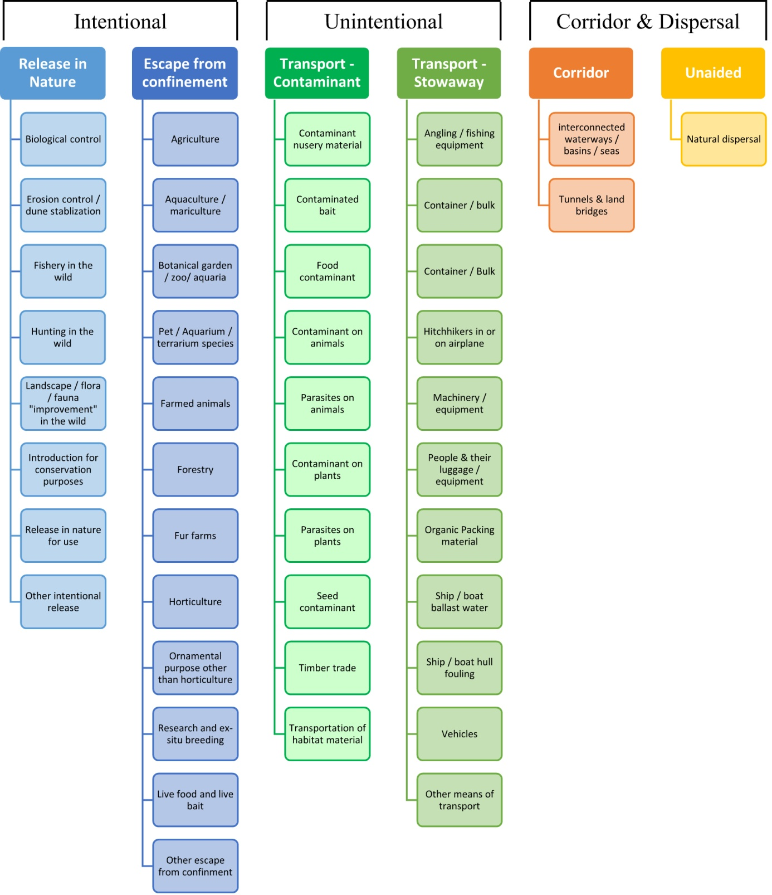

# ANNEX V Ecosystem services classification (CICES V5.1, simplified) and examples

For the purposes of this risk assessment, please feel free to use what seems as the most appropriate category / level / combination of impact (Section – Division – Group), reflecting information available.

|  |  |  |  |
| --- | --- | --- | --- |
| **Section** | **Division** | **Group** | **Examples (i.e. relevant CICES “classes”)** |
| **Provisioning** | **Biomass** | **Cultivated *terrestrial* plants** | Cultivated terrestrial plants (including fungi, algae) grown for nutritional purposes;  Fibres and other materials from cultivated plants, fungi, algae and bacteria for direct use or processing (excluding genetic materials);  Cultivated plants (including fungi, algae) grown as a source of energy  *Example: negative impacts of non-native organisms to crops, orchards, timber etc.* |
|  |  | **Cultivated *aquatic* plants** | Plants cultivated by in- situ aquaculture grown for nutritional purposes;  Fibres and other materials from in-situ aquaculture for direct use or processing (excluding genetic materials);  Plants cultivated by in- situ aquaculture grown as an energy source.  *Example: negative impacts of non-native organisms to aquatic plants cultivated for nutrition, gardening etc. purposes.* |
|  |  | **Reared animals** | Animals reared for nutritional purposes;  Fibres and other materials from reared animals for direct use or processing (excluding genetic materials);  Animals reared to provide energy (including mechanical)  *Example: negative impacts of non-native organisms to livestock* |
|  |  | **Reared *aquatic* animals** | Animals reared by in-situ aquaculture for nutritional purposes;  Fibres and other materials from animals grown by in-situ aquaculture for direct use or processing (excluding genetic materials);  Animals reared by in-situ aquaculture as an energy source  *Example: negative impacts of non-native organisms to fish farming* |
|  |  | **Wild plants** (terrestrial and aquatic) | Wild plants (terrestrial and aquatic, including fungi, algae) used for nutrition;  Fibres and other materials from wild plants for direct use or processing (excluding genetic materials);  Wild plants (terrestrial and aquatic, including fungi, algae) used as a source of energy  *Example: reduction in the availability of wild plants (e.g. wild berries, ornamentals) due to non-native organisms (competition, spread of disease etc.)* |
|  |  | **Wild animals** (terrestrial and aquatic) | Wild animals (terrestrial and aquatic) used for nutritional purposes;  Fibres and other materials from wild animals for direct use or processing (excluding genetic materials);  Wild animals (terrestrial and aquatic) used as a source of energy  *Example: reduction in the availability of wild animals (e.g. fish stocks, game) due to non-native organisms (competition, predations, spread of disease etc.)* |
|  | **Genetic material** from all biota | **Genetic material** from plants, algae or fungi | Seeds, spores and other plant materials collected for maintaining or establishing a population;  Higher and lower plants (whole organisms) used to breed new strains or varieties;  Individual genes extracted from higher and lower plants for the design and construction of new biological entities  *Example: negative impacts of non-native organisms due to interbreeding* |
|  |  | **Genetic material** from animals | Animal material collected for the purposes of maintaining or establishing a population;  Wild animals (whole organisms) used to breed new strains or varieties;  Individual genes extracted from organisms for the design and construction of new biological entities  *Example: negative impacts of non-native organisms due to interbreeding* |
|  | **Water[6]** | **Surface water** used for nutrition, materials or energy | Surface water for drinking;  Surface water used as a material (non-drinking purposes);  Freshwater surface water, coastal and marine water used as an energy source  *Example: loss of access to surface water due to spread of non-native organisms* |
|  |  | **Ground water** for used for nutrition, materials or energy | Ground (and subsurface) water for drinking;  Ground water (and subsurface) used as a material (non-drinking purposes);  Ground water (and subsurface) used as an energy source  *Example: reduced availability of ground water due to spread of non-native organisms and associated increase of ground water consumption by vegetation.* |
| **Regulation & Maintenance** | **Transformation** of biochemical or physical inputs to ecosystems | **Mediation of wastes or toxic substances** of anthropogenic origin by living processes | Bio-remediation by micro-organisms, algae, plants, and animals; Filtration/sequestration/storage/accumulation by micro-organisms, algae, plants, and animals  *Example: changes caused by non-native organisms to ecosystem functioning and ability to filtrate etc. waste or toxics* |
|  |  | **Mediation of nuisances** of anthropogenic origin | Smell reduction; noise attenuation; visual screening (e.g. by means of green infrastructure)  *Example: changes caused by non-native organisms to ecosystem structure, leading to reduced ability to mediate nuisances.* |
|  | **Regulation** of physical, chemical, biological conditions | **Baseline flows and extreme event** regulation | Control of erosion rates;  Buffering and attenuation of mass movement;  Hydrological cycle and water flow regulation (Including flood control, and coastal protection);  Wind protection;  Fire protection  *Example: changes caused by non-native organisms to ecosystem functioning or structure leading to, for example, destabilisation of soil, increased risk or intensity of wild fires etc.* |
|  |  | **Lifecycle maintenance**, habitat and gene pool protection | Pollination (or 'gamete' dispersal in a marine context);  Seed dispersal;  Maintaining nursery populations and habitats (Including gene pool protection)  *Example: changes caused by non-native organisms to the abundance and/or distribution of wild pollinators; changes to the availability / quality of nursery habitats for fisheries* |
|  |  | **Pest and disease control** | Pest control;  Disease control  *Example: changes caused by non-native organisms to the abundance and/or distribution of pests* |
|  |  | **Soil quality** regulation | Weathering processes and their effect on soil quality;  Decomposition and fixing processes and their effect on soil quality  *Example: changes caused by non-native organisms to vegetation structure and/or soil fauna leading to reduced soil quality* |
|  |  | **Water** conditions | Regulation of the chemical condition of freshwaters by living processes;  Regulation of the chemical condition of salt waters by living processes  *Example: changes caused by non-native organisms to buffer strips along water courses that remove nutrients in runoff and/or fish communities that regulate the resilience and resistance of water bodies to eutrophication* |
|  |  | **Atmospheric** composition and conditions | Regulation of chemical composition of atmosphere and oceans;  Regulation of temperature and humidity, including ventilation and transpiration  *Example: changes caused by non-native organisms to ecosystems’ ability to sequester carbon and/or evaporative cooling (e.g. by urban trees)* |
| **Cultural** | **Direct, in-situ and outdoor interactions** with living systems that depend on presence in the environmental setting | **Physical and experiential** interactions with natural environment | Characteristics of living systems that that enable activities promoting health, recuperation or enjoyment through active or immersive interactions;  Characteristics of living systems that enable activities promoting health, recuperation or enjoyment through passive or observational interactions  *Example: changes caused by non-native organisms to the qualities of ecosystems (structure, species composition etc.) that make it attractive for recreation, wild life watching etc.* |
|  |  | **Intellectual and representative** interactions with natural environment | Characteristics of living systems that enable scientific investigation or the creation of traditional ecological knowledge;  Characteristics of living systems that enable education and training;  Characteristics of living systems that are resonant in terms of culture or heritage;  Characteristics of living systems that enable aesthetic experiences  *Example: changes caused by non-native organisms to the qualities of ecosystems (structure, species composition etc.) that have cultural importance* |
|  | **Indirect, remote, often indoor interactions** with living systems that do not require presence in the environmental setting | **Spiritual, symbolic** and other interactions with natural environment | Elements of living systems that have symbolic meaning;  Elements of living systems that have sacred or religious meaning;  Elements of living systems used for entertainment or representation  *Example: changes caused by non-native organisms to the qualities of ecosystems (structure, species composition etc.) that have sacred or religious meaning* |
|  |  | Other biotic characteristics that have a **non-use value** | Characteristics or features of living systems that have an existence value;  Characteristics or features of living systems that have an option or bequest value  *Example: changes caused by non-native organisms to ecosystems designated as wilderness areas, habitats of endangered species etc.* |

# ANNEX VI EU Biogeographic Regions and MSFD Subregions

See <https://www.eea.europa.eu/data-and-maps/figures/biogeographical-regions-in-europe-2> ,

<http://ec.europa.eu/environment/nature/natura2000/biogeog_regions/>

and

https://www.eea.europa.eu/data-and-maps/data/msfd-regions-and-subregions-1/technical-document/pdf

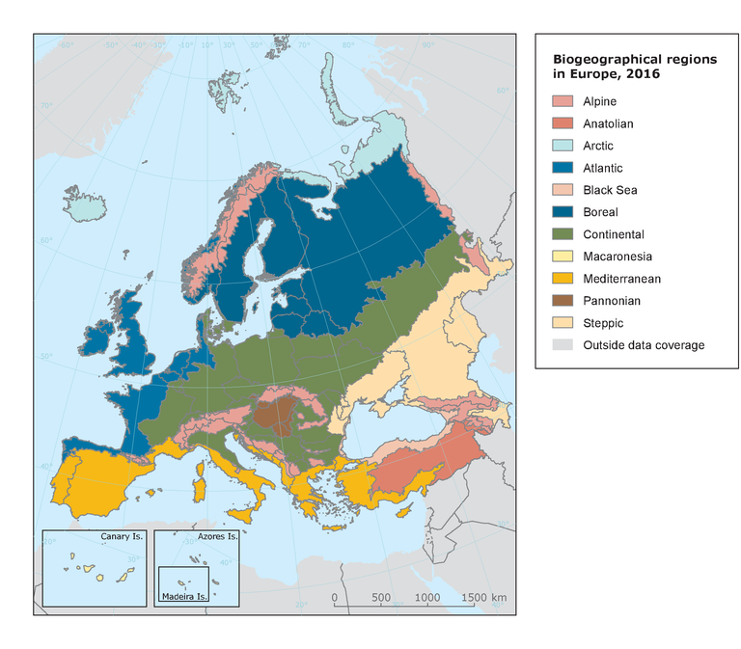 

# ANNEX VII Delegated Regulation (EU) 2018/968 of 30 April 2018

see <https://eur-lex.europa.eu/legal-content/en/TXT/?uri=CELEX%3A32018R0968>

# ANNEX VIII Projection of environmental suitability for *Marisa cornuarietis* establishment in Europe

Björn Beckmann, Frances Lucy, Darren Garland and Dan Chapman

27 September 2021

## Aim

To project the suitability for potential establishment of *Marisa cornuarietis* in Europe, under current and predicted future climatic conditions.

## Data for modelling

Species occurrence data were obtained from the Global Biodiversity Information Facility (GBIF) (228 records), iNaturalist (111 records), the Integrated Digitized Biocollections (iDigBio) (70 records), the Biodiversity Information Serving Our Nation database (BISON) (38 records), and additional records from the risk assessment team. We scrutinised occurrence records from regions where the species is not known to be established and removed any dubious records or where the georeferencing was too imprecise (e.g. records referenced to a country or island centroid) or outside of the coverage of the predictor layers (e.g. small island or coastal occurrences). We excluded a record from Hungary at the outflow of a thermal spa (Frisoczki et al. 2016), because even though this is an established outdoor population, the artificially warm and constant conditions here would not be reflected in the predictor layers. The remaining records were gridded at a 0.25 x 0.25 degree resolution for modelling, yielding 118 grid cells with occurrences (Figure 1a). As a proxy for recording effort, the density of Ampullariidae records held by GBIF was also compiled on the same grid (Figure 1b).

**Figure 1.** (a) Occurrence records obtained for *Marisa cornuarietis* and used in the modelling, showing native and invaded distributions. (b) The recording density of Ampullariidae on GBIF, which was used as a proxy for recording effort.

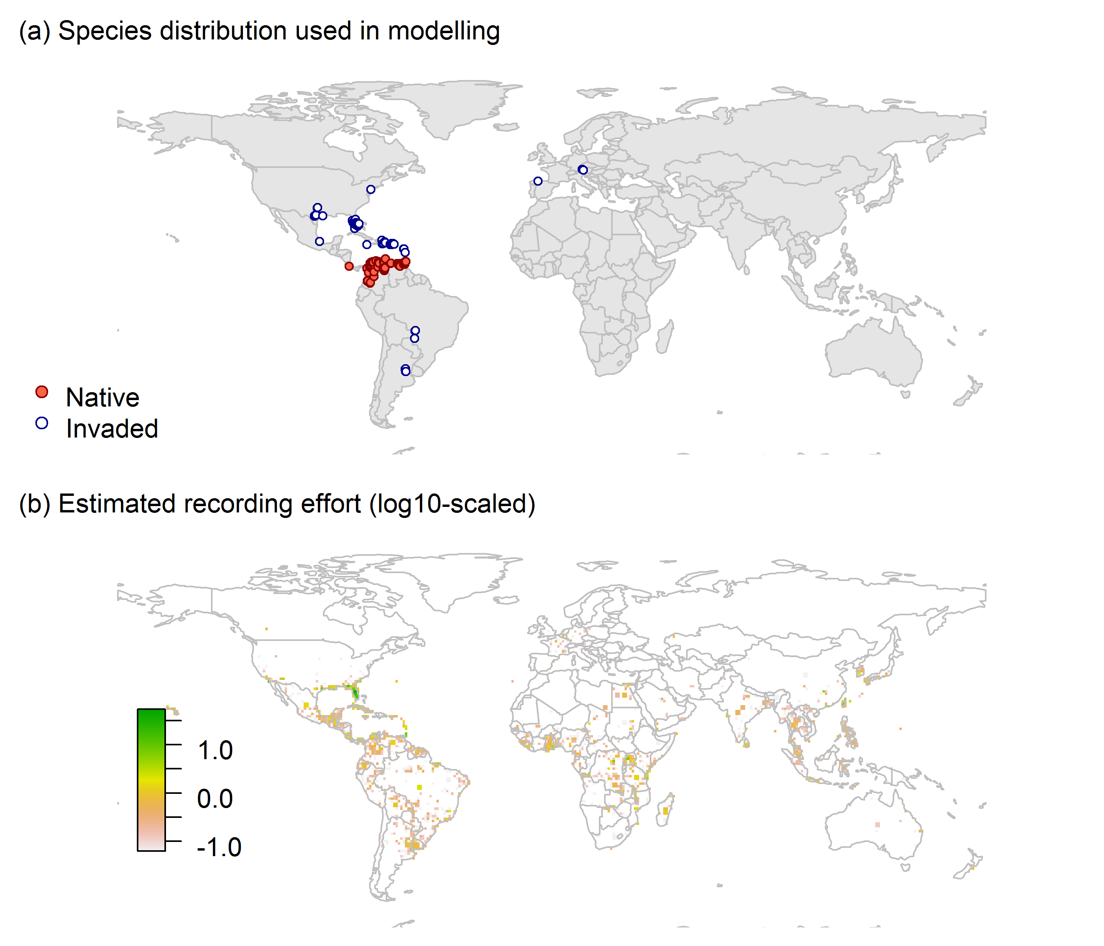

Climate data were selected from the ‘Bioclim’ variables contained within the WorldClim database (Hijmans et al., 2005), originally at 5 arcminute resolution (0.083 x 0.083 degrees of longitude/latitude) and aggregated to a 0.25 x 0.25 degree grid for use in the model.

Based on the biology of *Marisa cornuarietis*, the following climate variables were used in the modelling:

* Mean temperature of the warmest quarter (Bio10)
* Mean temperature of the coldest quarter (Bio11)
* Annual precipitation (Bio12)
* Precipitation seasonality (Bio15)

To estimate the effect of climate change on the potential distribution, equivalent modelled future climate conditions for the 2070s under the Representative Concentration Pathways (RCP) 2.6 and 4.5 were also obtained. These represent low and medium emissions scenarios, respectively. The above variables were obtained as averages of outputs of eight Global Climate Models (BCC-CSM1-1, CCSM4, GISS-E2-R, HadGEM2-AO, IPSL-CM5A-LR, MIROC-ESM, MRI-CGCM3, NorESM1-M), downscaled and calibrated against the WorldClim baseline (see <http://www.worldclim.org/cmip5_5m> ).

## Species distribution model

A presence-background (presence-only) ensemble modelling strategy was employed using the BIOMOD2 R package version 3.4.6 (Thuiller et al., 2020, Thuiller et al., 2009). These models contrast the environment at the species’ occurrence locations against a random sample of the global background environmental conditions (often termed ‘pseudo-absences’) in order to characterise and project suitability for occurrence. This approach has been developed for distributions that are in equilibrium with the environment. Because invasive species’ distributions are not at equilibrium and subject to dispersal constraints at a global scale, we took care to minimise the inclusion of locations suitable for the species but where it has not been able to disperse to (Chapman et al. 2019). Therefore the background sampling region included:

* The area accessible by native *Marisa cornuarietis* populations, in which the species is likely to have had sufficient time to disperse to all locations. Based on presumed maximum dispersal distances, the accessible region was defined as a 400km buffer around the native range occurrences; AND
* A 50km buffer around the non-native occurrences, encompassing regions likely to have had high propagule pressure for introduction by humans and/or dispersal of the species; AND
* Regions where we have an *a priori* expectation of high unsuitability for the species so that absence is assumed irrespective of dispersal constraints (see Figure 2). The following rules were applied to define a region expected to be highly unsuitable for *Marisa cornuarietis* at the spatial scale of the model:
  + Mean temperature of the warmest quarter (Bio10) < 14°C
  + Mean temperature of the coldest quarter (Bio11) < -1.3°C
  + Annual precipitation (Bio12) < 500mm

Altogether, 2.5% of occurrence grid cells were located in the unsuitable background region.

Within the unsuitable background region, 10 samples of 5000 randomly sampled grid cells were obtained. In the accessible background (comprising the accessible areas around native and non-native occurrences as detailed above), the same number of pseudo-absence samples were drawn as there were presence records (118), weighting the sampling by a proxy for recording effort (Figure 1(b)).

**Figure 2.** The background from which pseudo-absence samples were taken in the modelling of *Marisa cornuarietis*. Samples were taken from a 400km buffer around the native range and a 50km buffer around non-native occurrences (together forming the accessible background), and from areas expected to be highly unsuitable for the species (the unsuitable background region). Samples from the accessible background were weighted by a proxy for recording effort (Figure 1(b)).

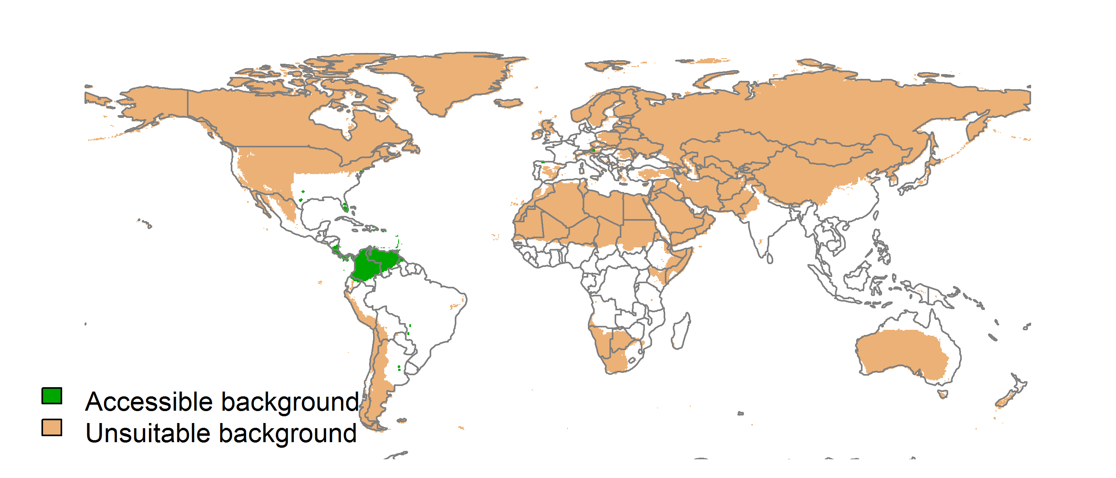

Each dataset (i.e. combination of the presences and the individual background samples) was randomly split into 80% for model training and 20% for model evaluation. With each training dataset, seven statistical algorithms were fitted with the default BIOMOD2 settings and rescaled using logistic regression, except where specified below:

* Generalised linear model (GLM)
* Generalised boosting model (GBM)
* Generalised additive model (GAM) with a maximum of four degrees of freedom per smoothing spline
* Artificial neural network (ANN)
* Multivariate adaptive regression splines (MARS)
* Random forest (RF)
* Maxent

Since the total background sample was larger than the number of occurrences, prevalence fitting weights were applied to give equal overall importance to the occurrences and the background. Normalised variable importance was assessed and variable response functions were produced using BIOMOD2’s default procedure.

Model predictive performance was assessed by the following three measures:

* AUC, the area under the receiver operating characteristic curve (Fielding & Bell 1997). Predictions of presence-absence models can be compared with a subset of records set aside for model evaluation (here 20%) by constructing a confusion matrix with the number of true positive, false positive, false negative and true negative cases. For models generating non-dichotomous scores (as here) a threshold can be applied to transform the scores into a dichotomous set of presence-absence predictions. Two measures that can be derived from the confusion matrix are sensitivity (the proportion of observed presences that are predicted as such, quantifying omission errors), and specificity (the proportion of observed absences that are predicted as such, quantifying commission errors). A receiver operating characteristic (ROC) curve can be constructed by using all possible thresholds to classify the scores into confusion matrices, obtaining sensitivity and specificity for each matrix, and plotting sensitivity against the corresponding proportion of false positives (equal to 1 - specificity). The use of all possible thresholds avoids the need for a selection of a single threshold, which is often arbitrary, and allows appreciation of the trade-off between sensitivity and specificity. The area under the ROC curve (AUC) is often used as a single threshold-independent measure for model performance (Manel et al. 2001). AUC is the probability that a randomly selected presence has a higher model-predicted suitability than a randomly selected absence (Allouche et al. 2006).
* Cohen’s Kappa (Cohen 1960). This measure corrects the overall accuracy of model predictions (ratio of the sum of true presences plus true absences to the total number of records) by the accuracy expected to occur by chance. The Kappa statistic ranges from -1 to +1, where +1 indicates perfect agreement and values of zero or less indicate a performance no better than random. Advantages of Kappa are its simplicity, the fact that both commission and omission errors are accounted for in one parameter, and its relative tolerance to zero values in the confusion matrix (Manel et al. 2001). However, Kappa has been criticised for being sensitive to prevalence (the proportion of sites in which the species was recorded as present) and may therefore be inappropriate for comparisons of model accuracy between species or regions (McPherson et al. 2004, Allouche et al. 2006).
* TSS, the true skill statistic (Allouche et al. 2006). TSS is defined as sensitivity + specificity - 1, and corrects for Kappa’s dependency on prevalence. TSS compares the number of correct forecasts, minus those attributable to random guessing, to that of a hypothetical set of perfect forecasts. Like Kappa, TSS takes into account both omission and commission errors, and success as a result of random guessing, and ranges from -1 to +1, where +1 indicates perfect agreement and values of zero or less indicate a performance no better than random (Allouche et al. 2006).

An ensemble model was created by first rejecting poorly performing algorithms with relatively extreme low AUC values and then averaging the predictions of the remaining algorithms, weighted by their AUC. To identify poorly performing algorithms, AUC values were converted into modified z-scores based on their difference to the median and the median absolute deviation across all algorithms (Iglewicz & Hoaglin 1993). Algorithms with z < -2 were rejected. In this way, ensemble projections were made for each dataset and then averaged to give an overall suitability, as well as its standard deviation.

Projections were classified into suitable and unsuitable regions using a “lowest presence threshold” (Pearson et al. 2007), setting the cut-off as the lowest value at which 98% of all presence records are classified correctly under the current climate (here 0.69). In order to express the sensitivity of classifications to the choice of this threshold, thresholds at which 95% and 99% of records are classified correctly (here 0.86 and 0.65 respectively) were used in the calculation of error bars in Figures 9 and 10 below in addition to taking account of uncertainty in the projections themselves.

We also produced a limiting factor map for Europe following Elith et al. (2010). For this, projections were made separately with each individual variable fixed at a near-optimal value. These were chosen as the median values at the occurrence grid cells. Then, the most strongly limiting factors were identified as the ones resulting in the highest increase in suitability in each grid cell.

## Results

The ensemble model suggested that suitability for *Marisa cornuarietis* was most strongly determined by Annual precipitation (Bio12), accounting for 42.3% of variation explained, followed by Mean temperature of the coldest quarter (Bio11) (41.2%), Mean temperature of the warmest quarter (Bio10) (13.5%) and Precipitation seasonality (Bio15) (2.9%) (Table 1, Figure 3).

**Table 1.** Summary of the cross-validation predictive performance (AUC, Kappa, TSS) and variable importance of the fitted model algorithms and the ensemble (AUC-weighted average of the best performing algorithms). Results are the average from models fitted to 10 different background samples of the data.

|  |  |  |  |  |  |  |  |  |
| --- | --- | --- | --- | --- | --- | --- | --- | --- |
|  |  |  |  |  | **Variable importance (%)** | | | |
| **Algorithm** | **AUC** | **Kappa** | **TSS** | **Used in the ensemble** | **Annual precipitation (Bio12)** | **Mean temperature of the coldest quarter (Bio11)** | **Mean temperature of the warmest quarter (Bio10)** | **Precipitation seasonality (Bio15)** |
| GLM | 0.989 | 0.643 | 0.955 | yes | 40 | 47 | 8 | 5 |
| GAM | 0.988 | 0.650 | 0.959 | yes | 40 | 41 | 16 | 3 |
| GBM | 0.986 | 0.652 | 0.934 | yes | 47 | 38 | 15 | 0 |
| ANN | 0.987 | 0.634 | 0.973 | yes | 37 | 47 | 11 | 4 |
| MARS | 0.985 | 0.643 | 0.957 | no | 38 | 47 | 8 | 7 |
| RF | 0.986 | 0.640 | 0.940 | yes | 47 | 33 | 18 | 2 |
| Maxent | 0.969 | 0.648 | 0.911 | no | 39 | 38 | 16 | 6 |
| **Ensemble** | **0.988** | **0.647** | **0.975** |  | **42** | **41** | **13** | **3** |

**Figure 3.** Partial response plots from the fitted models. Thin coloured lines show responses from the algorithms in the ensemble, while the thick black line is their ensemble. In each plot, other model variables are held at their median value in the training data. Some of the divergence among algorithms is because of their different treatment of interactions among variables.

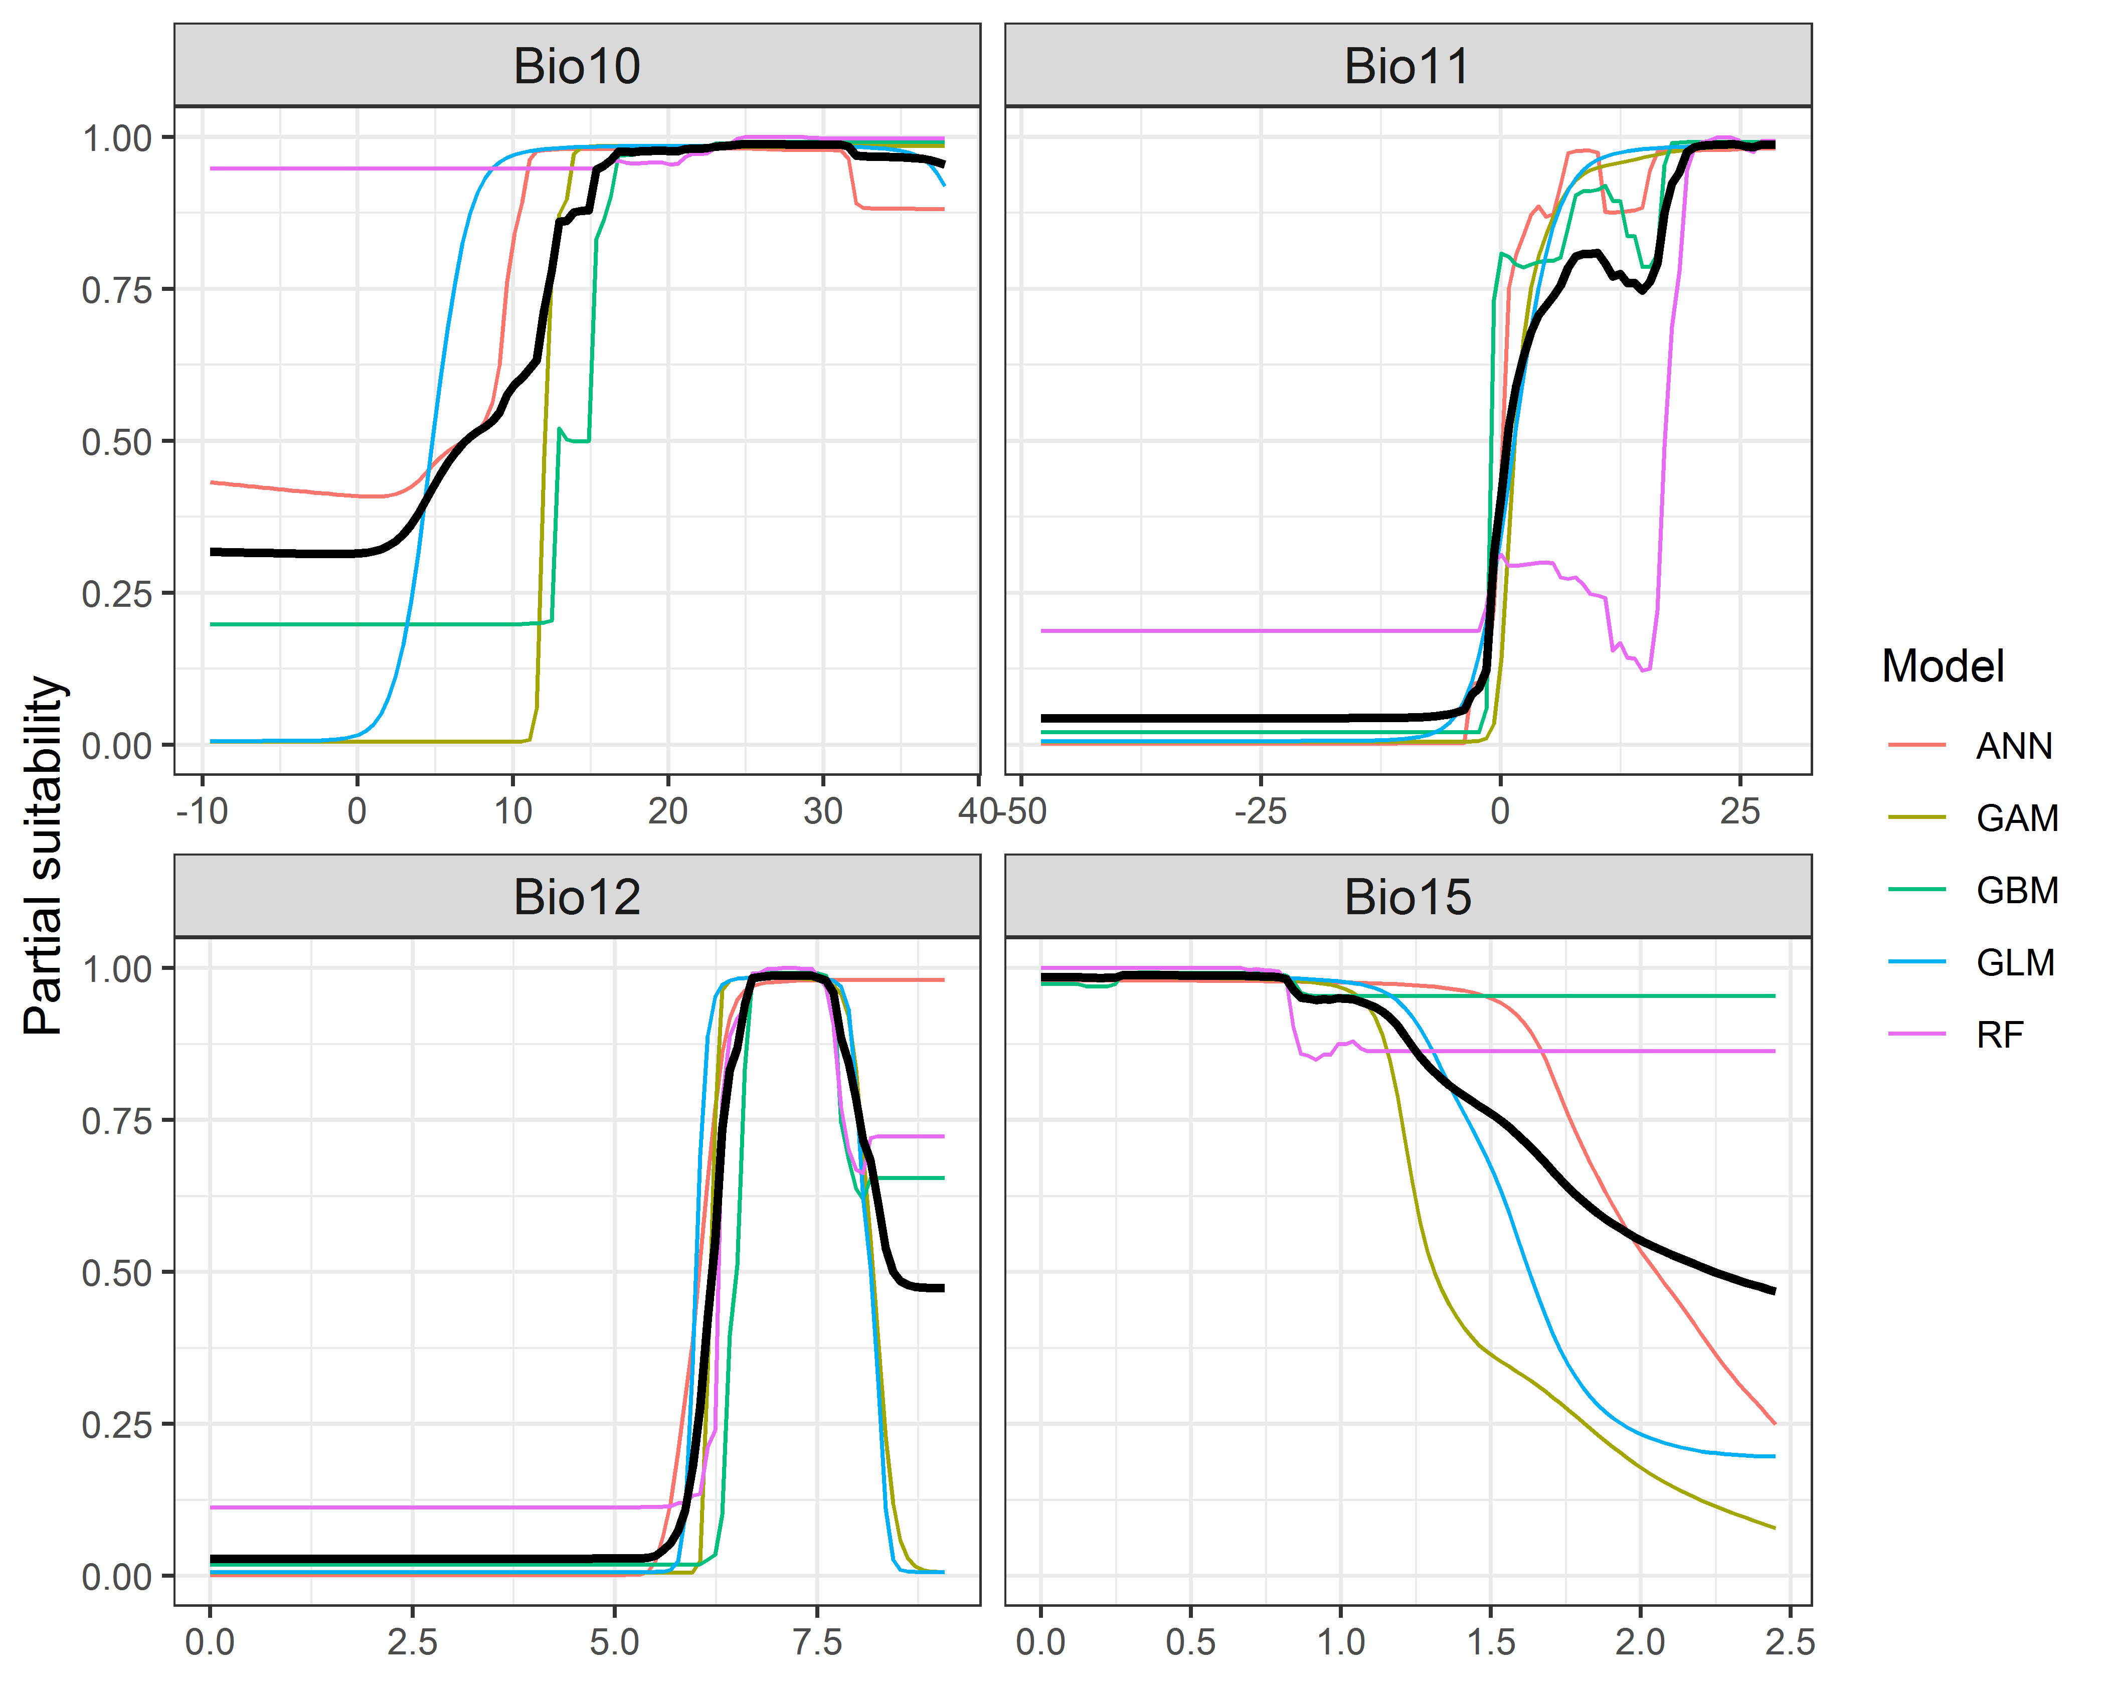

**Figure 4.** (a) Projected global suitability for *Marisa cornuarietis* establishment in the current climate. For visualisation, the projection has been aggregated to a 0.5 x 0.5 degree resolution, by taking the maximum suitability of constituent higher resolution grid cells. Values > 0.69 are suitable for the species, with 98% of global presence records above this threshold. Values below 0.69 indicate lower relative suitability. (b) Uncertainty in the ensemble projections, expressed as the among-algorithm standard deviation in predicted suitability, averaged across the 10 datasets.

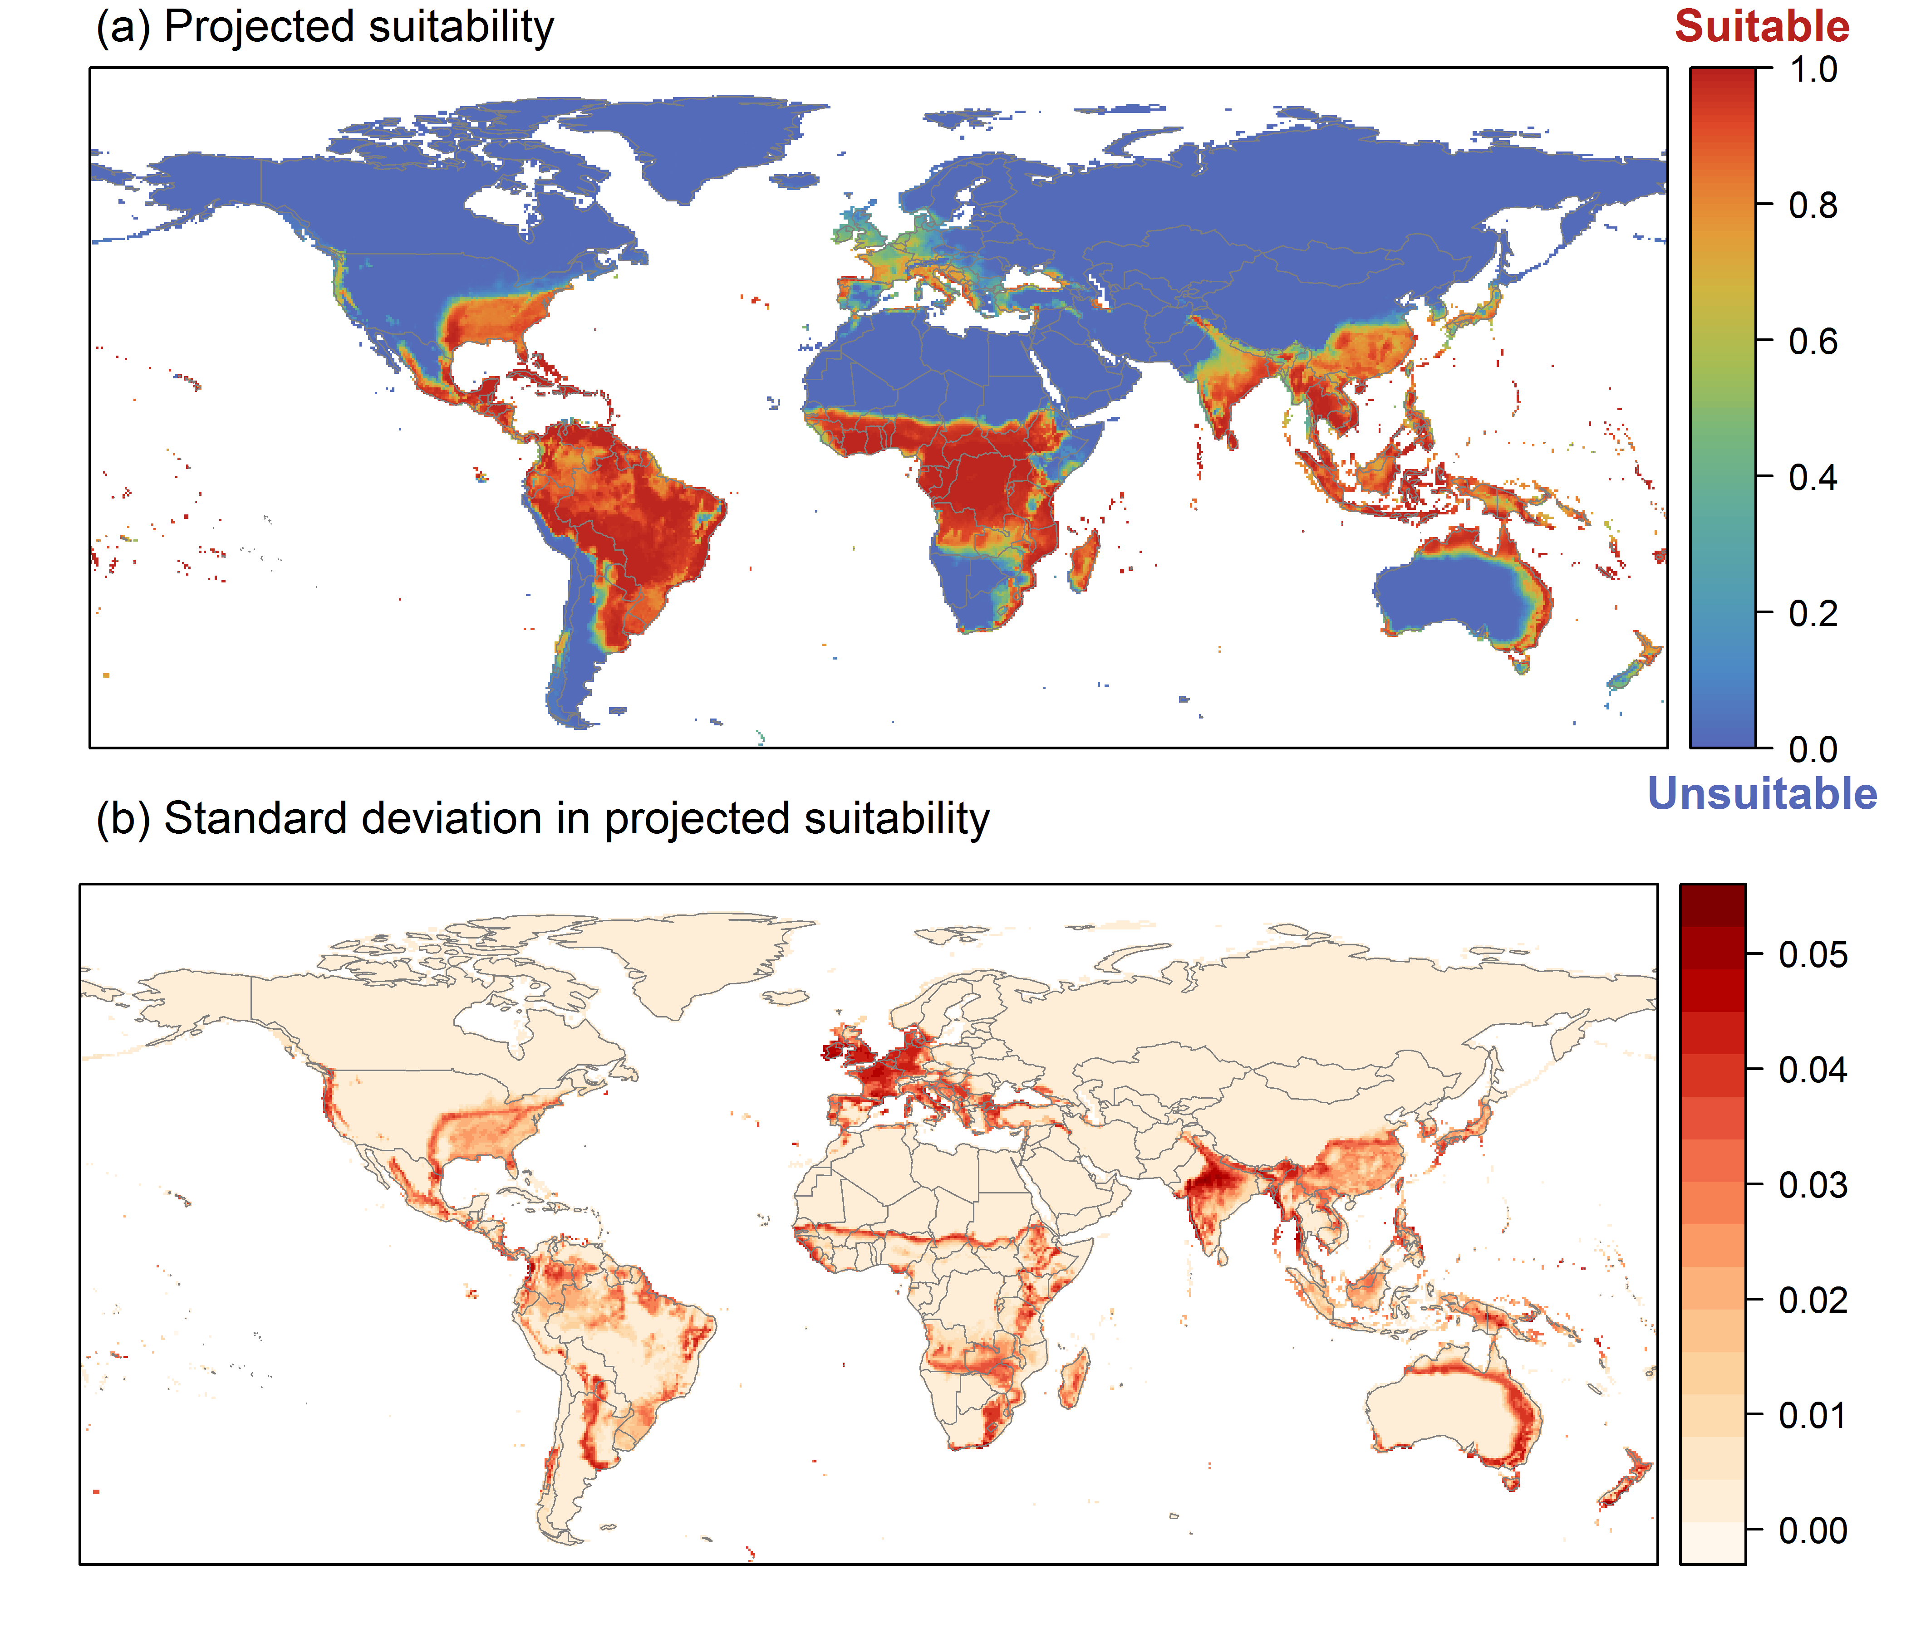

**Figure 5.** (a) Projected current suitability for *Marisa cornuarietis* establishment in Europe and the Mediterranean region. Values > 0.69 are suitable for the species, with 98% of global presence records above this threshold. Values below 0.69 indicate lower relative suitability. (b) Uncertainty in the ensemble projections, expressed as the among-algorithm standard deviation in predicted suitability, averaged across the 10 datasets.

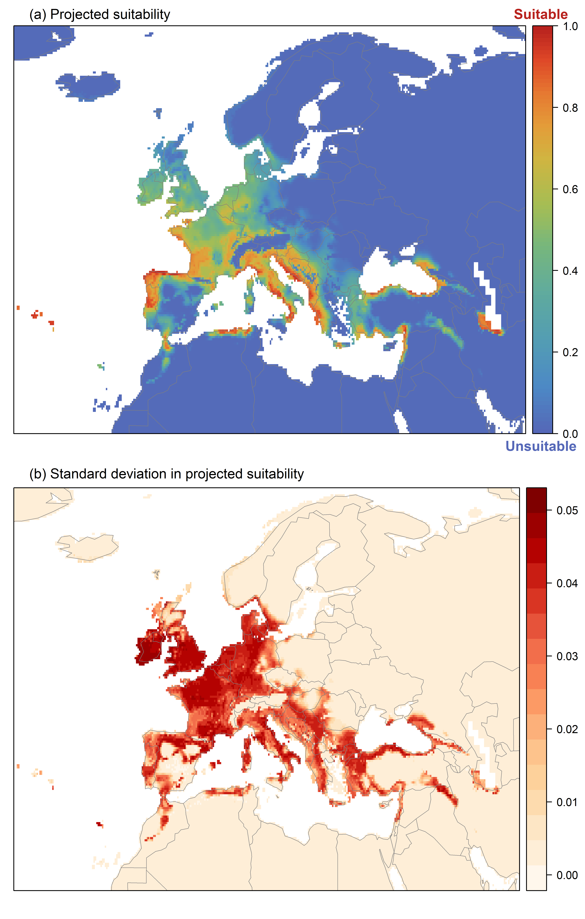

**Figure 6.** The most strongly limiting factors for *Marisa cornuarietis* establishment estimated by the model in Europe and the Mediterranean region in current climatic conditions.

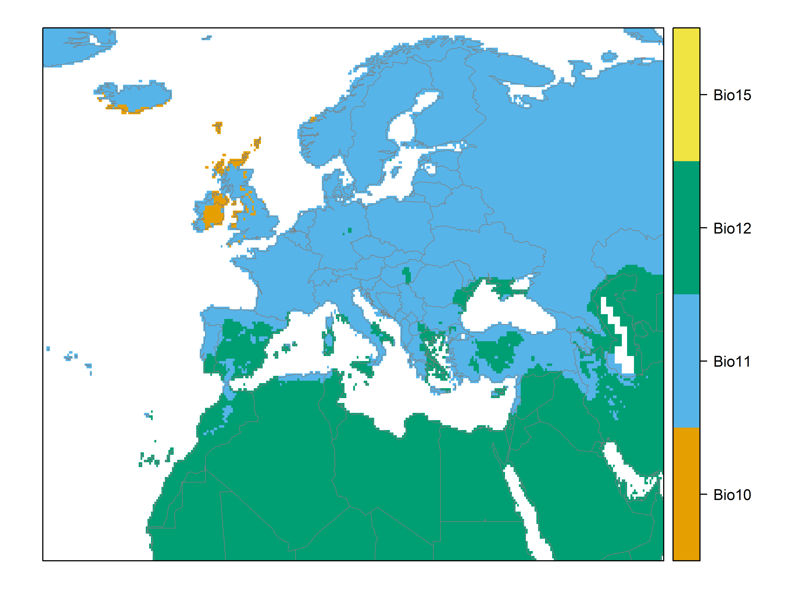

**Figure 7.** (a) Projected suitability for *Marisa cornuarietis* establishment in Europe and the Mediterranean region in the 2070s under climate change scenario RCP2.6. Values > 0.69 are suitable for the species, with 98% of global presence records above this threshold under current climate. Values below 0.69 indicate lower relative suitability. (b) Uncertainty in the ensemble projections, expressed as the among-algorithm standard deviation in predicted suitability, averaged across the 10 datasets.

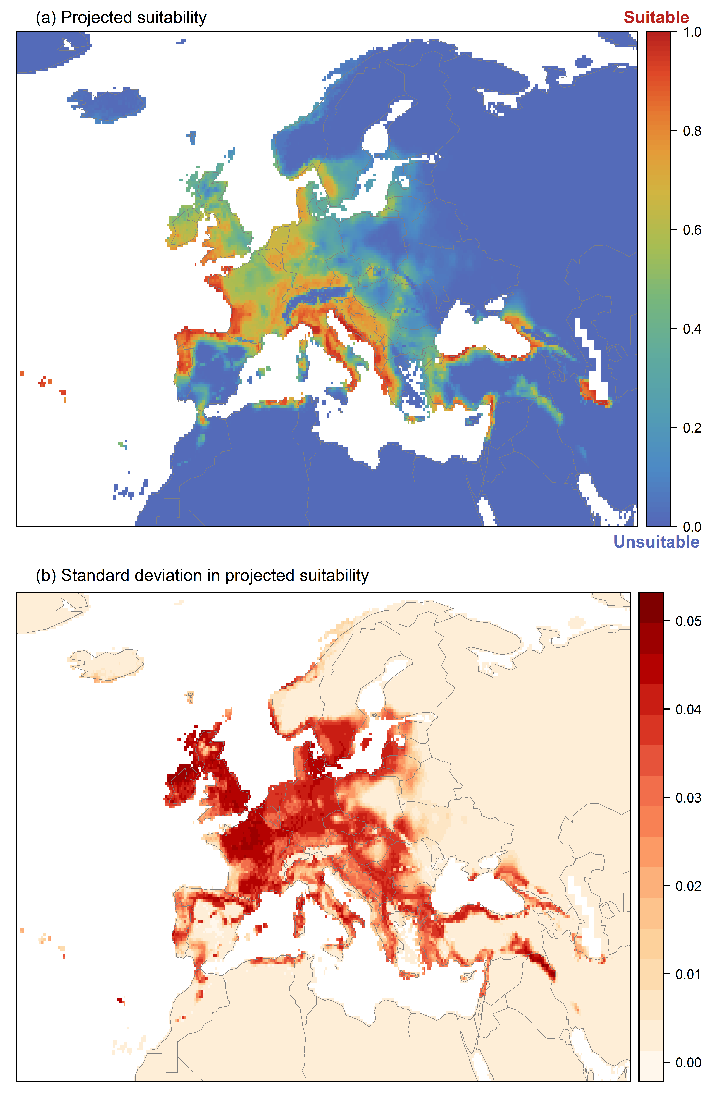

**Figure 8.** (a) Projected suitability for *Marisa cornuarietis* establishment in Europe and the Mediterranean region in the 2070s under climate change scenario RCP4.5. Values > 0.69 are suitable for the species, with 98% of global presence records above this threshold under current climate. Values below 0.69 indicate lower relative suitability. (b) Uncertainty in the ensemble projections, expressed as the among-algorithm standard deviation in predicted suitability, averaged across the 10 datasets.

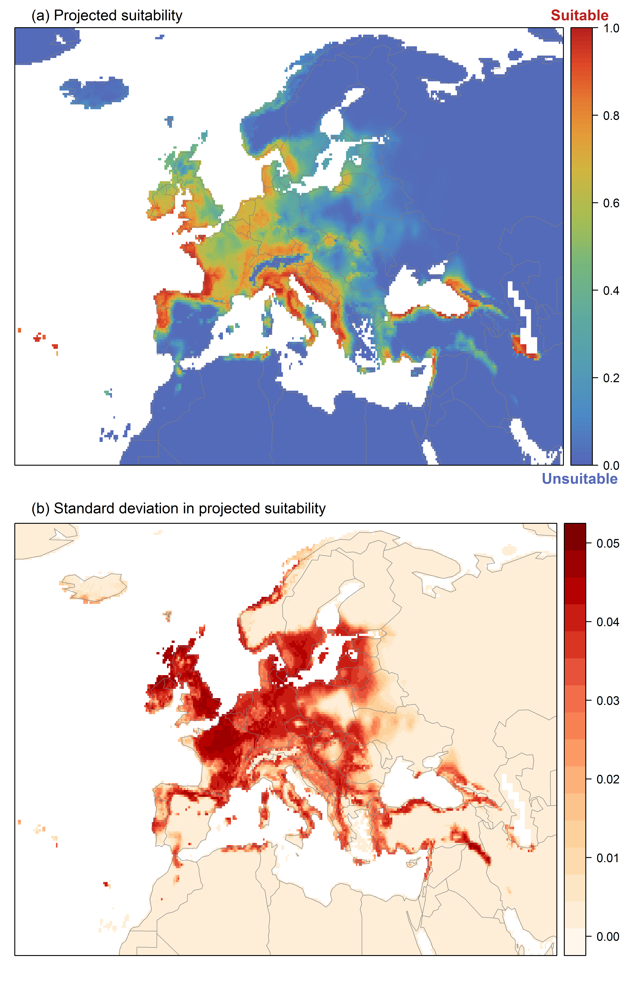

**Figure 9.** Variation in projected suitability for *Marisa cornuarietis* establishment among Biogeographical Regions of Europe (<https://www.eea.europa.eu/data-and-maps/data/biogeographical-regions-europe-3>). The bar plots show the proportion of grid cells in each region classified as suitable (with values > 0.69) in the current climate and projected climate for the 2070s under two RCP emissions scenarios. Error bars indicate uncertainty due to both the choice of classification threshold (cf. p.5/6) and uncertainty in the projections themselves (cf. part (b) of Figures 5, 7 and 8). The location of each region is also shown. The Arctic and Macaronesian regions are not part of the study area, but are included for completeness.

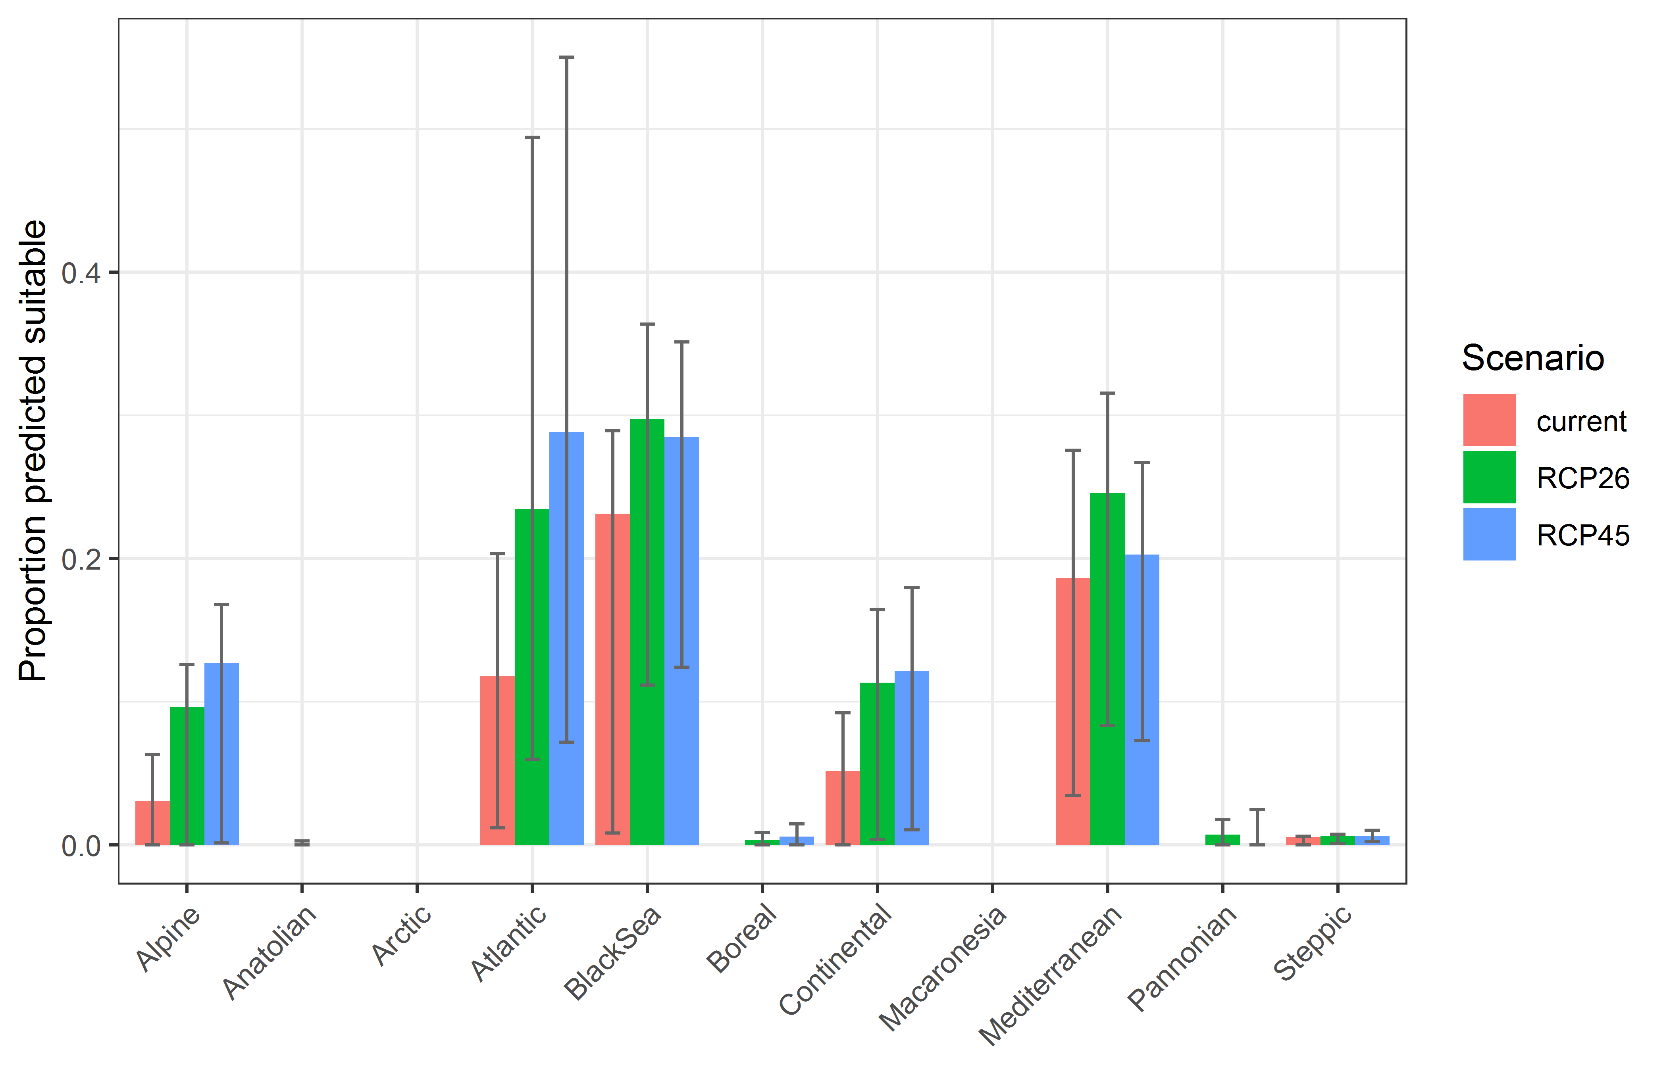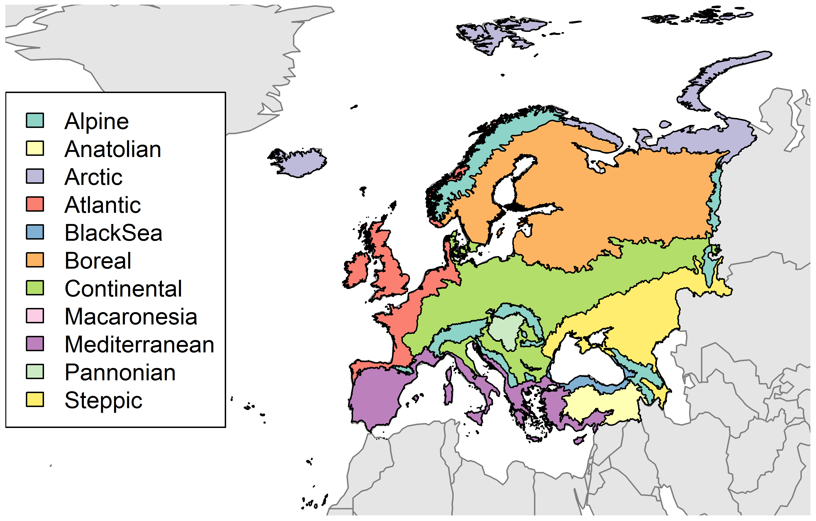

**Table 2.** Variation in projected suitability for *Marisa cornuarietis* establishment among Biogeographical regions of Europe (numerical values of Figure 9 above). The numbers are the proportion of grid cells in each region classified as suitable in the current climate and projected climate for the 2070s under two RCP emissions scenarios. The Arctic and Macaronesian biogeographical regions are not part of the study area, but are included for completeness.

|  |  |  |  |  |  |  |  |  |  |
| --- | --- | --- | --- | --- | --- | --- | --- | --- | --- |
|  | **current climate** | | | **2070s RCP2.6** | | | **2070s RCP4.5** | | |
|  | lower | **central estimate** | upper | lower | **central estimate** | upper | lower | **central estimate** | upper |
| Alpine | 0.00 | 0.03 | 0.06 | 0.00 | 0.10 | 0.13 | 0.00 | 0.13 | 0.17 |
| Anatolian | 0.00 | 0.00 | 0.00 | 0.00 | 0.00 | 0.00 | 0.00 | 0.00 | 0.00 |
| Arctic | 0.00 | 0.00 | 0.00 | 0.00 | 0.00 | 0.00 | 0.00 | 0.00 | 0.00 |
| Atlantic | 0.01 | 0.12 | 0.20 | 0.06 | 0.23 | 0.49 | 0.07 | 0.29 | 0.55 |
| Black Sea | 0.01 | 0.23 | 0.29 | 0.11 | 0.30 | 0.36 | 0.12 | 0.29 | 0.35 |
| Boreal | 0.00 | 0.00 | 0.00 | 0.00 | 0.00 | 0.01 | 0.00 | 0.01 | 0.01 |
| Continental | 0.00 | 0.05 | 0.09 | 0.00 | 0.11 | 0.16 | 0.01 | 0.12 | 0.18 |
| Macaronesia | 0.00 | 0.00 | 0.00 | 0.00 | 0.00 | 0.00 | 0.00 | 0.00 | 0.00 |
| Mediterranean | 0.03 | 0.19 | 0.28 | 0.08 | 0.25 | 0.32 | 0.07 | 0.20 | 0.27 |
| Pannonian | 0.00 | 0.00 | 0.00 | 0.00 | 0.01 | 0.02 | 0.00 | 0.00 | 0.02 |
| Steppic | 0.00 | 0.01 | 0.01 | 0.00 | 0.01 | 0.01 | 0.00 | 0.01 | 0.01 |

**Figure 10.** Variation in projected suitability for *Marisa cornuarietis* establishment among European Union countries and the UK. The bar plots show the proportion of grid cells in each country classified as suitable (with values > 0.69) in the current climate and projected climate for the 2070s under two RCP emissions scenarios. Error bars indicate uncertainty due to both the choice of classification threshold (cf. p.5/6) and uncertainty in the projections themselves (cf. part (b) of Figures 5, 7 and 8).

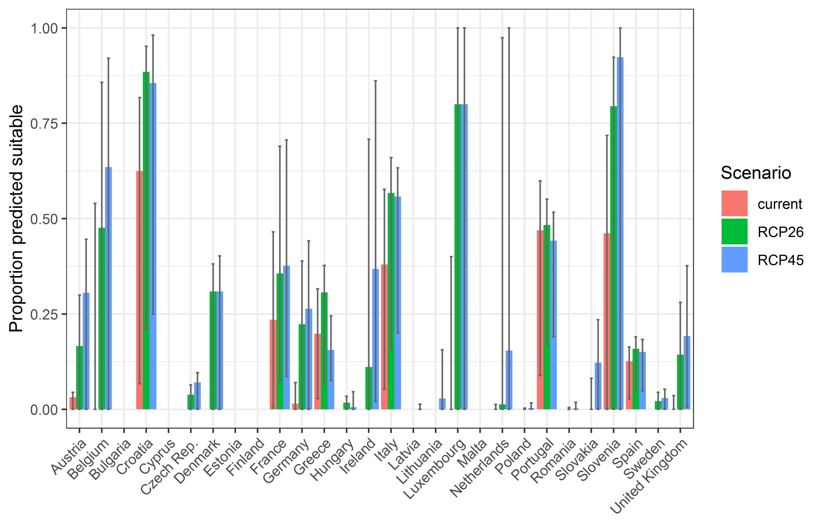

**Table 3.** Variation in projected suitability for *Marisa cornuarietis* establishment among European Union countries and the UK (numerical values of Figure 10 above). The numbers are the proportion of grid cells in each country classified as suitable in the current climate and projected climate for the 2070s under two RCP emissions scenarios.

|  |  |  |  |  |  |  |  |  |  |
| --- | --- | --- | --- | --- | --- | --- | --- | --- | --- |
|  | **current climate** | | | **2070s RCP2.6** | | | **2070s RCP4.5** | | |
|  | lower | **central estimate** | upper | lower | **central estimate** | upper | lower | **central estimate** | upper |
| Austria | 0.00 | 0.03 | 0.04 | 0.00 | 0.17 | 0.30 | 0.00 | 0.31 | 0.45 |
| Belgium | 0.00 | 0.00 | 0.54 | 0.00 | 0.48 | 0.86 | 0.00 | 0.63 | 0.92 |
| Bulgaria | 0.00 | 0.00 | 0.00 | 0.00 | 0.00 | 0.00 | 0.00 | 0.00 | 0.00 |
| Croatia | 0.07 | 0.62 | 0.82 | 0.21 | 0.88 | 0.95 | 0.25 | 0.86 | 0.98 |
| Cyprus | 0.00 | 0.00 | 0.00 | 0.00 | 0.00 | 0.00 | 0.00 | 0.00 | 0.00 |
| Czech Rep. | 0.00 | 0.00 | 0.00 | 0.00 | 0.04 | 0.06 | 0.00 | 0.07 | 0.10 |
| Denmark | 0.00 | 0.00 | 0.00 | 0.00 | 0.31 | 0.38 | 0.00 | 0.31 | 0.40 |
| Estonia | 0.00 | 0.00 | 0.00 | 0.00 | 0.00 | 0.00 | 0.00 | 0.00 | 0.00 |
| Finland | 0.00 | 0.00 | 0.00 | 0.00 | 0.00 | 0.00 | 0.00 | 0.00 | 0.00 |
| France | 0.00 | 0.24 | 0.47 | 0.08 | 0.36 | 0.69 | 0.09 | 0.38 | 0.71 |
| Germany | 0.00 | 0.01 | 0.07 | 0.00 | 0.22 | 0.39 | 0.00 | 0.26 | 0.44 |
| Greece | 0.03 | 0.20 | 0.32 | 0.07 | 0.31 | 0.38 | 0.08 | 0.16 | 0.25 |
| Hungary | 0.00 | 0.00 | 0.00 | 0.00 | 0.02 | 0.03 | 0.00 | 0.01 | 0.05 |
| Ireland | 0.00 | 0.00 | 0.00 | 0.00 | 0.11 | 0.71 | 0.02 | 0.37 | 0.86 |
| Italy | 0.05 | 0.38 | 0.58 | 0.16 | 0.57 | 0.66 | 0.20 | 0.56 | 0.63 |
| Latvia | 0.00 | 0.00 | 0.00 | 0.00 | 0.00 | 0.00 | 0.00 | 0.00 | 0.01 |
| Lithuania | 0.00 | 0.00 | 0.00 | 0.00 | 0.00 | 0.00 | 0.00 | 0.03 | 0.16 |
| Luxembourg | 0.00 | 0.00 | 0.40 | 0.00 | 0.80 | 1.00 | 0.00 | 0.80 | 1.00 |
| Malta | 0.00 | 0.00 | 0.00 | 0.00 | 0.00 | 0.00 | 0.00 | 0.00 | 0.00 |
| Netherlands | 0.00 | 0.00 | 0.01 | 0.00 | 0.01 | 0.97 | 0.00 | 0.15 | 1.00 |
| Poland | 0.00 | 0.00 | 0.00 | 0.00 | 0.00 | 0.00 | 0.00 | 0.00 | 0.02 |
| Portugal | 0.09 | 0.47 | 0.60 | 0.17 | 0.48 | 0.55 | 0.19 | 0.44 | 0.52 |
| Romania | 0.00 | 0.00 | 0.00 | 0.00 | 0.00 | 0.00 | 0.00 | 0.00 | 0.02 |
| Slovakia | 0.00 | 0.00 | 0.00 | 0.00 | 0.00 | 0.08 | 0.00 | 0.12 | 0.23 |
| Slovenia | 0.00 | 0.46 | 0.72 | 0.00 | 0.79 | 0.92 | 0.00 | 0.92 | 1.00 |
| Spain | 0.03 | 0.13 | 0.16 | 0.05 | 0.16 | 0.19 | 0.05 | 0.15 | 0.18 |
| Sweden | 0.00 | 0.00 | 0.00 | 0.00 | 0.02 | 0.04 | 0.00 | 0.03 | 0.05 |
| UK | 0.00 | 0.00 | 0.04 | 0.00 | 0.14 | 0.28 | 0.01 | 0.19 | 0.38 |

## Caveats to the modelling

The number of presence records available for modelling (118 at the model resolution) was low, and therefore the indication they provide of the species’ environmental preferences may not be very comprehensive.

To remove spatial recording biases, the selection of the background sample from the accessible background was weighted by the density of Ampullariidae records on the Global Biodiversity Information Facility (GBIF). While this is preferable to not accounting for recording bias at all, it may not provide the perfect measure of recording bias.

There was substantial variation among modelling algorithms in the partial response plots (Figure 3). In part this will reflect their different treatment of interactions among variables. Since partial plots are made with other variables held at their median, there may be values of a particular variable at which this does not provide a realistic combination of variables to predict from.

Other variables potentially affecting the distribution of the species, such as types of land cover were not included in the model.

## References

* Allouche O, Tsoar A, Kadmon R (2006) Assessing the accuracy of species distribution models: prevalence, kappa and the true skill statistic (TSS). *Journal of Applied Ecology*, 43, 1223-1232.
* Chapman D, Pescott OL, Roy HE, Tanner R (2019) Improving species distribution models for invasive non-native species with biologically informed pseudo-absence selection. *Journal of Biogeography*, <https://doi.org/10.1111/jbi.13555>.
* Cohen J (1960) A coefficient of agreement of nominal scales. *Educational and Psychological Measurement*, 20, 37-46.
* Elith J, Kearney M, Phillips S (2010) The art of modelling range-shifting species. *Methods in Ecology and Evolution*, 1, 330-342.
* Fielding AH, Bell JF (1997) A review of methods for the assessment of prediction errors in conservation presence/absence models. *Environmental Conservation*, 24, 38-49.
* Hijmans RJ, Cameron SE, Parra JL, Jones PG, Jarvis A (2005) Very high resolution interpolated climate surfaces for global land areas. *International Journal of Climatology*, 25, 1965-1978.
* Iglewicz B, Hoaglin DC (1993) How to detect and handle outliers. Asq Press.
* Manel S, Williams HC, Ormerod SJ (2001) Evaluating presence-absence models in ecology: the need to account for prevalence. *Journal of Applied Ecology*, 38, 921-931.
* McPherson JM, Jetz W, Rogers DJ (2004) The effects of species’ range sizes on the accuracy of distribution models: ecological phenomenon or statistical artefact? *Journal of Applied Ecology*, 41, 811-823.
* Pearson RG, Raxworthy CJ, Nakamura M, Townsend Peterson A (2007), Predicting species distributions from small numbers of occurrence records: a test case using cryptic geckos in Madagascar. *Journal of Biogeography*, 34: 102-117. <https://doi.org/10.1111/j.1365-2699.2006.01594.x>
* Thuiller W, Lafourcade B, Engler R, Araújo MB (2009) BIOMOD-a platform for ensemble forecasting of species distributions. *Ecography*, 32, 369-373.
* Thuiller W, Georges D, Engler R, Breiner F (2020). biomod2: Ensemble Platform for Species Distribution Modeling. R package version 3.4.6. <https://CRAN.R-project.org/package=biomod2>

1. This template is based on the Great Britain non-native species risk assessment scheme (GBNNRA). A number of amendments have been introduced to ensure compliance with Regulation (EU) 1143/2014 on IAS and relevant legislation, including the Delegated Regulation (EU) 2018/968 of 30 April 2018, supplementing Regulation (EU) No 1143/2014 of the European Parliament and of the Council with regard to risk assessments in relation to invasive alien species (see <https://eur-lex.europa.eu/legal-content/en/TXT/?uri=CELEX%3A32018R0968>).
2. Convention on Biological Diversity, Decision VI/23
3. <https://circabc.europa.eu/sd/a/7e5f0bd4-34e8-4719-a2f7-c0cd7ec6a86e/2020-CBD-pathways-interpretation.pdf>
4. <https://circabc.europa.eu/sd/a/0aeba7f1-c8c2-45a1-9ba3-bcb91a9f039d/TSSR-2016-010%20CBD%20pathways%20key%20full%20only.pdf>
5. Not to be confused with “no impact”.
6. Note: in the CICES classification provisioning of water is considered as an abiotic service whereas the rest of ecosystem services listed here are considered biotic.