**Risk assessment template developed under the "Study on Invasive Alien Species – Development of risk assessments to tackle priority species and enhance prevention"   
Contract No 07.0202/2019/812602/ETU/ENV.D.2[1]**

**Name of organism:** *Faxonius immunis* (Hagen, 1870)

**Author(s) of the assessment:** Elena Tricarico, Department of Biology, University of Florence, Italy

Frances Lucy, Institute of Technology Sligo, Ireland

**Risk Assessment Area:** The risk assessment area is the territory of the European Union 27 and the United Kingdom, excluding the EU-outermost regions.

**Peer review 1:** Christoph Chucholl, Fisheries Research Station Baden-Württemberg, Langenargen, Germany

**Peer review 2:** Antonín Kouba, University of South Bohemia in České Budějovice, Faculty of Fisheries and Protection of Waters, South Bohemian Research Center of Aquaculture and Biodiversity of Hydrocenoses, Vodňany, Czech Republic

**Date of completion:** 15/10/2020

**Date of revision:** 15/10/2021

**Contents**

SECTION A – Organism Information and Screening 3

SECTION B – Detailed assessment 11

1 PROBABILITY OF INTRODUCTION AND ENTRY 11

2 PROBABILITY OF ESTABLISHMENT 22

3 PROBABILITY OF SPREAD 28

4 MAGNITUDE OF IMPACT 33

Biodiversity and ecosystem impacts 33

Ecosystem Services impacts 36

Economic impacts 38

Social and human health impacts 40

Other impacts 41

RISK SUMMARIES 44

REFERENCES 45

Distribution Summary 51

ANNEX I Scoring of Likelihoods of Events 53

ANNEX II Scoring of Magnitude of Impacts 54

ANNEX III Scoring of Confidence Levels 55

ANNEX IV CBD pathway categorisation scheme 56

ANNEX V Ecosystem services classification (CICES V5.1, simplified) and examples 57

ANNEX VI EU Biogeographic Regions and MSFD Subregions 61

ANNEX VII Delegated Regulation (EU) 2018/968 of 30 April 2018 62

ANNEX VIII Species Distribution Model 63

# SECTION A – Organism Information and Screening

|  |
| --- |
| **A1. Identify the organism. Is it clearly a single taxonomic entity and can it be adequately distinguished from other entities of the same rank?**  including the following elements:   * the taxonomic family, order and class to which the species belongs; * the scientific name and author of the species, as well as a list of the most common synonym names; * names used in commerce (if any) * a list of the most common subspecies, lower taxa, varieties, breeds or hybrids   As a general rule, one risk assessment should be developed for a single species. However, there may be cases where it may be justified to develop one risk assessment covering more than one species (e.g. species belonging to the same genus with comparable or identical features and impact). It shall be clearly stated if the risk assessment covers more than one species, or if it excludes or only includes certain subspecies, lower taxa, hybrids, varieties or breeds (and if so, which subspecies, lower taxa, hybrids, varieties or breeds). Any such choice must be properly justified. |

Response: The species is a single taxonomic entity, and it can be distinguished from other entities. The genus *Orconectes* (except cave-dwelling species) is now classified as *Faxonius* (Crandall & De Grave 2017).

*Faxonius immunis* (Hagen, 1870) (Malacostraca, Decapoda, Cambaridae)

Maiynomyms: *Orconectes immunis*, *Cambarus immunis, Cambarus signifer*

Common names: calico crayfish, papershell crayfish, mud crayfish (EN), Kalikokrebs (GE), Ecrevisse calicot, Écrevisse calico, Écrevisse à carapace fine (FR)

No hybrids with congeneric *Faxonius* species have been reported. No subspecies, lower taxa, varieties or breeds are currently known. Genetic studies using cytochrome c oxidase subunit I (COI) on European and North American specimens of *F. immunis* suggested that calico crayfish might represent a cryptic species complex (Filipová et al. 2011a).

|  |
| --- |
| **A2. Provide information on the existence of other species that look very similar [that may be detected in the risk assessment area, either in the environment, in confinement or associated with a pathway of introduction]**  Include both native and non-native species that could be confused with the species being assessed, including the following elements:   * other alien species with similar invasive characteristics, to be avoided as substitute species (in this case preparing a risk assessment for more than one species together may be considered); * other alien species without similar invasive characteristics, potential substitute species; * native species, potential misidentification and mis-targeting |

Response: Native and non-native crayfish species present in the risk assessment area can be distinguished based on morphological and colour characteristics (Souty-Grosset et al. 2006; Kouba et al. 2014; IUCN 2018). The hair tufts on the ventral side of the chelae joints of the 1st and 2nd pereiopod are key features for recognizing the species together with a distinct tooth followed by a notch on the dactylus (movable finger) of the chelipeds. In addition, *F. immunis* features a very narrow areola (dorsal gap between the branchiocardiac grooves on the carapace), which – among other morphological characteristics of cambarid crayfish – clearly separates it from any native crayfish species, even if for non-experts sometimes difficulties can arise.

These are the other non-native *Faxonius* species present in Europe:

* *Faxonius juvenilis* (France) (Kouba et al. 2014);
* *Faxonius limosus*, present in Europe since the end of 19th Century, and established in Austria, Belarus, Belgium, Bulgaria, Croatia, Czech Republic, France, Germany, Hungary, Italy, Latvia, Lithuania, Luxembourg, Montenegro, Netherlands, Poland, Romania, Russia, Serbia, Slovakia, Slovenia, Spain, Switzerland, United Kingdom (Kouba et al. 2014; CABI 2020);
* *Faxonius virilis* (in the Netherlands and UK; Kouba et al. 2014);
* *Faxonius rusticus*, reported in 2019 in France (<http://especes-exotiques-envahissantes.fr/espece/faxonius-rusticus/?lang=en> )

*Faxonius immunis* has a brown or grey-green body with a less pronounced rostrum than *F. limosus*, no hepatic spines on lateral margins of carapace in front of the cervical groove, a typical pale zone in the middle of the carapace and pleon with four dark bands running along dorsal surface of pleon, and broad, flattened tuberculate chela with red/orange tips, with inner side of the dactylus straight at the distal part, followed by the distinct tooth and notch straight margin of movable finger and hair tufts on the ventral side of the chelae joints of the 1st and 2nd pereiopod (Souty-Grosset et al. 2006). Another key identification character of the species is the shape of the first pleopod of a Form I male: the corneous tip is short and sharply curved with an almost 90-degree bend. Form II pleopods retain this sharp curve (Schainost 2016).

|  |
| --- |
| **A3. Does a relevant earlier risk assessment exist? Give details of any previous risk assessment, including the final scores and its validity in relation to the risk assessment area.** |

Response: For Europe, the species has been screened using FI-ISK, a tool for identifying potentially invasive freshwater invertebrates, with Italy used as the risk assessment area (Tricarico et al. 2010); the final outcome for *F. immunis* was high risk of invasiveness, and this is relevant to EU countries having similar conditions to Italy. For Germany, the species was assessed using a modified version of the GABLIS-protocol, with the outcome “Invasive species-Action List”, based on the transmission of crayfish plague and the localized distribution (Rabitsch & Nehring 2017). Species on the Action list should be eradicated immediately. For the Rhine-Meuse river district, in the Netherlands, the species has been screened using the internet-based Harmonia+ risk assessment protocol (D’hondt et al. 2015), with an outcome of high risk (Lemmers et al. 2021).For USA, the species has screened by U.S. Fish and Wildlife Service (2015) with an uncertain outcome: “The biology and ecology of *O. immunis* have some documentation in the scientific literature. Controlled studies on the ecological impacts of *O. immunis* suggest that introduction of this species outside its native range could have detrimental impacts to native flora and fauna, but the only documented impacts to date have been on another non-native species. Certainty of this assessment is low”.

|  |
| --- |
| **A4. Where is the organism native?**  including the following elements:   * an indication of the continent or part of a continent, climatic zone and habitat where the species is naturally occurring * if applicable, indicate whether the species could naturally spread into the risk assessment area |

Response: The species is native to North America, ranging from southern Quebec and New England westward across the upper Midwest to Wyoming and eastern Colorado and south to extreme northwestern Tennessee (Hobbs 1989; Hosabettu & Daniel 2020), and covering different climatic zones (following the classification of Köppen: oceanic; warm summer/humid continental; hot summer/humid continental; cold semi-arid; warm summer/mediterranean continental). It occurs in ponds, roadside ditches, flood plains, stagnant waters and sluggish streams with abundant aquatic plants and plant debris for cover; it has a preference for soft substrate and can tolerate high turbidity. The species usually avoids fast flowing, summer-cool streams (Souty-Grosset et al. 2006; Adams et al. 2010; but see Bovbjerg 1970). It is able to construct deep burrows and spread along the watercourses; in Germany the species has been found to actively disperse over land, moving from pond to pond (no dispersal rate has been reported in the study), over the entire year, especially between March and May, during the spawning season of this species, and between September and November, when *F. immunis* is mating (Hermann et al. 2018).

|  |
| --- |
| **A5. What is the global non-native distribution of the organism outside the risk assessment area?** |

Response: The species has been probably introduced in the USA in New England, New Hampshire, Rhode Island, Vermont and Massachusetts. Its presence in Connecticut is uncertain (Taylor et al. 2007; Adam et al. 2010; <https://nas.er.usgs.gov/viewer/omap.aspx?speciesID=210>).

|  |
| --- |
| **A6. In which biogeographic region(s) or marine subregion(s) in the risk assessment area has the species been recorded and where is it established? The information needs be given separately for recorded (including casual or transient occurrences) and established occurrences. “Established” means the process of an alien species successfully producing viable offspring with the likelihood of continued survival[2].**  **A6a. Recorded: List regions**  **A6b. Established: List regions**  Freshwater / terrestrial biogeographic regions:   * Alpine, Atlantic, Black Sea, Boreal, Continental, Mediterranean, Pannonian, Steppic   Marine regions:   * Baltic Sea, North-east Atlantic Ocean, Mediterranean Sea, Black Sea   Marine subregions:   * Greater North Sea, incl. the Kattegat and the English Channel, Celtic Seas, Bay of Biscay and the Iberian Coast, Western Mediterranean Sea, Adriatic Sea, Ionian Sea, Central Mediterranean Sea, Aegean-Levantine Sea.   Comment on the sources of information on which the response is based and discuss any uncertainty in the response.  For delimitation of EU biogeographical regions please refer to <https://www.eea.europa.eu/data-and-maps/figures/biogeographical-regions-in-europe-2> (see also Annex VI).  For delimitation of EU marine regions and subregions consider the Marine Strategy Framework Directive areas; please refer to <https://www.eea.europa.eu/data-and-maps/data/msfd-regions-and-subregions/technical-document/pdf> (see also Annex VI). |

Response (6a): Continental (Gelmar et al. 2006; Collas et al. 2011) and Atlantic (Vermiert 2020). The response is based on publications reporting the presence of the species in these biogeographic regions, so the level of confidence is high.

Response (6b): Continental (Gelmar et al. 2006; Collas et al. 2011; Chucholl 2012) and Atlantic (Vermiert 2020). The response is based on publications reporting the presence and establishment of the species in these biogeographic regions, so the level of confidence is high.

|  |
| --- |
| **A7. In which biogeographic region(s) or marine subregion(s) in the risk assessment area could the species establish in the future under current climate and under foreseeable climate change? The information needs be given separately for current climate and under foreseeable climate change conditions.**  **A7a. Current climate: List regions**  **A7b. Future climate: List regions**  With regard to EU biogeographic and marine (sub)regions, see above.  With regard to climate change, provide information on   * the applied timeframe (e.g. 2050/2070) * the applied scenario (e.g. RCP 4.5) * what aspects of climate change are most likely to affect the risk assessment (e.g. increase in average winter temperature, increase in drought periods)   The assessment does not have to include a full range of simulations on the basis of different climate change scenarios, as long as an assessment with a clear explanation of the assumptions is provided. However, if new, original models are executed for this risk assessment, the following RCP pathways shall be applied: RCP 2.6 (likely range of 0.4-1.6°C global warming increase by 2065) and RCP 4.5 (likely range of 0.9-2.0°C global warming increase by 2065). Otherwise, the choice of the assessed scenario has to be explained. |

Response (7a): Alpine (very few areas), Atlantic (very few areas), Black Sea, Boreal (very few areas), Continental, Mediterranean, Pannonian, Steppic

Response (7b): 2070 RCP 2.6/RCP 4.5 Alpine, Atlantic, Black Sea, Boreal, Continental, Mediterranean, Pannonian, Steppic. The differences between the two RCPs are, compared to the current situation, that under RCP 2.6 scenario there would be an increase of suitable areas in all the listed biogeographic regions (except a slight decrease in Pannonian), especially in Alpine, Atlantic, Black Sea, Boreal, Continental. On the contrary, under RCP 4.5, there would be an increase of suitable areas in Alpine, Atlantic, Boreal, Continental regions (more than under RCP 2.6), an increase similar to those under RCP 2.6 in Black Sea and Pannonian regions, but a decrease in Mediterranean and Steppic regions compared to RCP 2.6.

These responses are based on the SDM (Annex VIII). The model indicates that maximum temperature of the warmest month is the climatic variable currently limiting the establishment in the northern and coldest biogeographic regions. Temperature increase will favour the species establishment in the future, even if the increase forecasted under RCP 4.5 would decrease the percentage of suitable areas in Mediterranean region, that probably would become too warm for the species. The importance of temperature as predictor, followed by terrain slope, has been confirmed also by SDMs conducted on the species for southwestern Germany (Chucholl 2016).

|  |
| --- |
| **A8. In which EU Member States has the species been recorded and in which EU Member States has it established? List them with an indication of the timeline of observations. The information needs be given separately for recorded and established occurrences.**  **A8a. Recorded: List Member States**  **A8b. Established: List Member States**  Austria, Belgium, Bulgaria, Croatia, Cyprus, Czech Republic, Denmark, Estonia, Finland, France, Germany, Greece, Hungary, Ireland, Italy, Latvia, Lithuania, Luxembourg, Malta, Netherlands, Poland, Portugal, Romania, Slovakia, Slovenia, Spain, Sweden  The description of the invasion history of the species shall include information on countries invaded and an indication of the timeline of the first observations, establishment and spread. |

Response (8a): the first reliable record of the species was in Germany in 1993 in the catchment of the Upper Rhine Plain, followed by another record in 1997, always in the same region (Dehus et al. 1999; Gelmar et al. 2006); in France the first record was in 2010 in Alsace, in the Rothbach river, a tributary of the Rhine river (Collas et al. 2011). The species has been reported for the Netherlands in 2019 (Ottburg et al. 2019) but, after a check with German experts, it seemed to be a misidentification (Fran Oficialdegui, pers. comm.).

Response (8b): Germany, France (Gelmar et al. 2006; Collas et al. 2011; Chucholl 2012; Hermann et al. 2018a). In Germany, the species, after the two records in 1993 and 1997, established and started expanding along the Upper Rhine Plain. The species is reported also in the area of the Black Forest (Chucholl & Brinker 2017). In 2018, new records of the species were reported in the floodplain of the River Rhine between Wiesbaden and Ginsheim, being the first records for the federal state of Hesse, 53 kilometres from the next known locality (Herrmann et al. 2018b). In 2010, an established population was reported for the first time in France; the origin of French population is uncertain. Natural dispersal from Germany could have not occurred as this first French record was far from the areas where the species was reported for Germany. The hypotheses are two: some alive individuals were introduced from Germany or some individuals, kept at home for ornamental reasons, were dumped into the water (Collas et al. 2011). After this first record in France, the species started colonizing the French part of Rhine, some tributaries, and canals.

The species is currently colonizing a stretch of more than 150 km along the Upper Rhine plain in south-western Germany and eastern France (Filipová et al. 2011a; Ott 2017). In addition, there is an apparently disjunct occurrence downstream in the lower section of the Rhine (Düssel catchment) in western Germany (Vermiert 2020). Further isolated occurrences outside of the Upper Rhine Plain were recently reported from south-western Germany (i.e. near the city of Sindelfingen: Chucholl, unpubl. data, 2020).

In the Netherlands seven individuals were reported for three localities (Ottburg et al. 2019; Lemmers et al. 2021), but it was a misidentification.

|  |
| --- |
| **A9. In which EU Member States could the species establish in the future under current climate and under foreseeable climate change? The information needs be given separately for current climate and under foreseeable climate change conditions.**  **A9a. Current climate: List Member States**  **A9b. Future climate: List Member States**  With regard to EU Member States, see above.  With regard to climate change, provide information on   * the applied timeframe (e.g. 2050/2070) * the applied scenario (e.g. RCP 4.5) * what aspects of climate change are most likely to affect the risk assessment (e.g. increase in average winter temperature, increase in drought periods)   The assessment does not have to include a full range of simulations on the basis of different climate change scenarios, as long as an assessment with a clear explanation of the assumptions is provided. However, if new, original models are executed for this risk assessment, the following RCP pathways shall be applied: RCP 2.6 (likely range of 0.4-1.6°C global warming increase by 2065) and RCP 4.5 (likely range of 0.9-2.0°C global warming increase by 2065). Otherwise, the choice of the assessed scenario has to be explained. |

Response (9a): Austria, Bulgaria, Croatia, Czech Republic, France, Germany, Greece, Hungary, Italy, Poland, Portugal, Romania, Slovakia, Slovenia, Spain

Response (9b): 2070 RCP 2.6 Austria, Belgium, Bulgaria, Croatia, Czech Republic, Estonia, Finland, France, Germany, Greece, Hungary, Italy, Latvia, Lithuania, Luxembourg, Netherlands, Poland, Portugal, Romania, Slovakia, Slovenia, Spain, and Sweden; 2070 RCP 4.5: Austria, Belgium, Bulgaria, Croatia, Czech Republic, Estonia, Finland, France, Germany, Greece, Hungary, Italy, Latvia, Lithuania, Luxembourg, Netherlands, Poland, Portugal, Romania, Slovakia, Slovenia, Spain, Sweden; and in the United Kingdom. Under RCP 2.6, compared to the current situation, there will be an increase of suitable areas in all the listed countries (but slightly in Greece, Italy and Sweden), except in Austria, Croatia, Hungary, Portugal, Slovenia, Spain that will experience a decrease. Under RCP 4.5, compared to the current situation, there will be a much more marked increase of suitable areas in the listed countries (but very slightly in the United Kingdom), except Croatia, Greece, Hungary, Portugal, Spain, that will experience a decrease, and Austria and Slovenia that will remain the same.

These responses are based on the SDM (Annex VIII). Maximum temperature of the warmest month is resulted to be the climatic variable currently limiting the spread in the northern and coldest biogeographic regions. Temperature increase will favour the species spread in the future, but not Croatia, Greece, Hungary, Portugal, Spain, that probably would become too warm for the species.

|  |
| --- |
| **A10. Is the organism known to be invasive (i.e. to threaten or adversely impact upon biodiversity and related ecosystem services) anywhere outside the risk assessment area?** |

Response: In USA, the species has been hypothesized to possibly cause impacts in its US introduced range (Jansen et al. 2009), being omnivorous and more aggressive than *F. limosus*, but up to now there are no published data of adverse impacts for this area.

|  |
| --- |
| **A11. In which biogeographic region(s) or marine subregion(s) in the risk assessment area has the species shown signs of invasiveness? Indicate the area endangered by the organism as detailed as possible.**  Freshwater / terrestrial biogeographic regions:   * Alpine, Atlantic, Black Sea, Boreal, Continental, Mediterranean, Pannonian, Steppic   Marine regions:   * Baltic Sea, North-east Atlantic Ocean, Mediterranean Sea, Black Sea   Marine subregions:  Greater North Sea, incl. the Kattegat and the English Channel, Celtic Seas, Bay of Biscay and the Iberian Coast, Western Mediterranean Sea, Adriatic Sea, Ionian Sea, Central Mediterranean Sea, Aegean-Levantine Sea |

Response: Continental and Atlantic: in Germany, the species has been proved to carry the crayfish plague lethal for European native crayfish (Filipová et al. 2013; Schrimpf et al. 2013) and to reduce native amphibians and macroinvertebrates, especially dragonfly larvae, other insects and molluscs (Ott 2016; Martens et al. 2018). Please see also Section 4 of the present Risk Assessment on impacts.

|  |
| --- |
| **A12. In which EU Member States has the species shown signs of invasiveness? Indicate the area endangered by the organism as detailed as possible.**  Austria, Belgium, Bulgaria, Croatia, Cyprus, Czech Republic, Denmark, Estonia, Finland, France, Germany, Greece, Hungary, Ireland, Italy, Latvia, Lithuania, Luxembourg, Malta, Netherlands, Poland, Portugal, Romania, Slovakia, Slovenia, Spain, Sweden |

Response: Germany; the species has been proved to carry the crayfish plague lethal for European native crayfish (Filipová et al. 2013; Schrimpf et al. 2013) and to reduce native amphibians and macroinvertebrates, especially dragonfly larvae, other insects and molluscs (Ott 2016; Martens et al. 2018). In France, turbid waters are reported in invaded ponds due to the species burrowing activity (Francois et al. 2019). Moreover, it could outcompete the congeneric alien *F. limosus* (Chucholl et al. 2008).

|  |
| --- |
| **A13. Describe any known socio-economic benefits of the organism.**  including the following elements:   * Description of known uses for the species, including a list and description of known uses in the risk assessment area and third countries, if relevant. * Description of social and economic benefits deriving from those uses, including a description of the environmental, social and economic relevance of each of those uses and an indication of associated beneficiaries, quantitatively and/or qualitatively depending on what information is available.   If the information available is not sufficient to provide a description of those benefits for the entire risk assessment area, qualitative data or different case studies from across the risk assessment area or third countries shall be used, if available. |

Response: In North America, the species was grown and sold as bait (Huner 1994). Estimated 175 metric tonnes of crayfish were cultivated and another estimated 400-500 metric tonnes were harvested for this purpose (Huner 1997). It has been proposed that this species can be used to control submerged aquatic vegetation but the high numbers of required crayfish plus the possible impacts caused by its introduction has prevented promotion of its use (Letson & Makarewicz 1994).

No detailed economic data have been found on the use of the species in the ornamental pet trade, even though its presence in such trade has been reported (Chucholl 2013; Faulkes 2015).

# SECTION B – Detailed assessment

|  |
| --- |
| **Important instructions:**   * In the case of lack of information the assessors are requested to use a standardized answer: “No information has been found.” * With regard to the scoring of the likelihood of events or the magnitude of impacts see Annexes I and II. * With regard to the confidence levels, see Annex III. * Highlight the selected response score and confidence level in **bold** but keep the other scores in normal text (so that the selected score is evident in the final document). |

## 1 PROBABILITY OF INTRODUCTION AND ENTRY

|  |
| --- |
| **Important instructions:**   * **Introduction** is the movement of the species into the risk assessment area (it may be either in captive conditions and/or in the environment, depending on the relevant pathways). * **Entry** is the release/escape/arrival in the environment, i.e. occurrence in the wild * Introduction and entry may coincide for species entering through pathways such as “corridor” or “unaided”, but it also may differ. If different, please consider all relevant pathways, both for the introduction into the risk assessment area and the entry in the environment. * The classification of pathways developed by the Convention of Biological Diversity (CBD) should be used (see Annex IV). For detailed explanations of the CBD pathway classification scheme consult the IUCN/CEH guidance document[3] and the provided key to pathways[4]. * For organisms which are already present (recorded or established) in the risk assessment area, the likelihood of introduction and entry should be scored as “very likely” by default. * Repeated (independent) introductions and entries at separate locations in the risk assessment area should be considered here (see Qu. 1.7). |

|  |
| --- |
| **Qu. 1.1. List relevant pathways through which the organism could be introduced into the risk assessment area and/or enter into the environment. Where possible give details about the specific origins and end points of the pathways as well as a description of any associated commodities.**  For each pathway answer questions 1.2 to 1.7 (copy and paste additional rows at the end of this section as necessary). Please attribute unique identifiers to each question if you consider more than one pathway, e.g. 1.2a, 1.3a, etc. and then 1.2b, 1.3b etc. for the next pathway.  In this context a pathway is the route or mechanism of introduction and/or entry of the species.  The description of commodities with which the introduction of the species is generally associated shall include a list and description of commodities with an indication of associated risks (e.g. the volume of trade; the likelihood of a commodity being contaminated or acting as vector).  If there are no active pathways or potential future pathways this should be stated explicitly here, and there is no need to answer the questions 1.2-1.9. |

Pathway name: Escape from confinement: Live food and live bait; Pet/aquarium/terrarium species; Contaminant on animals.

The introduction pathway to Europe is unknown; both pet trade and as live bait have been suggested (Dehus et al. 1999; Gelmar et al. 2006). As underlined by Gelmar et al. (2006) and Chucholl (2012), the species was not known in the German pet trade before its establishment in the Upper Rhine, it is however a common and popular species for fishing bait in the USA and Canada, therefore the introduction as live bait seems more likely. The “ornamental” trade became active only since its establishment in Germany (Chucholl 2013) and could well lead to repeated introductions, even if until now the species spread has mainly been reported as occurring naturally along the Rhine basin (Kouba et al. 2014; Hermann et al. 2018; but see France and recent findings in southwestern Germany: Collas et al. 2011; Vermiert 2020). The species seems to have been introduced in France as contaminant of fish stocks (Collas et al. 2015).

**Escape from confinement: Live food and live bait**

|  |
| --- |
| **Qu. 1.2a. Is introduction and/or entry along this pathway intentional (e.g. the organism is imported for trade) or unintentional (e.g. the organism is a contaminant of imported goods)?** |

|  |  |  |  |
| --- | --- | --- | --- |
| **RESPONSE** | **intentional**  unintentional | **CONFIDENCE** | low  medium  **high** |

Response: The species probably was introduced as fishing bait, possibly by Canadian soldiers, who had been stationed at an airbase near the two localities where the species was first discovered (Chucholl 2013). The entry could have been intentional too, but unintentional escapes were also possible.

|  |
| --- |
| **Qu. 1.3a. How likely is it that large numbers of the organism will be introduced and/or enter into the environment through this pathway from the point(s) of origin over the course of one year?**  including the following elements:   * discuss how likely the organism is to get onto the pathway in the first place. Also comment on the volume of movement along this pathway. * an indication of the propagule pressure (e.g. estimated volume or number of individuals / propagules, or frequency of passage through pathway), including the likelihood of reinvasion after eradication * if relevant, comment on the likelihood of introduction and/or entry based on propagule pressure (i.e. for some species low propagule pressure (1-2 individuals) could result in subsequent establishment whereas for others high propagule pressure (many thousands of individuals) may not. |

|  |  |  |  |
| --- | --- | --- | --- |
| **RESPONSE** | very unlikely  unlikely  moderately likely  **likely**  very likely | **CONFIDENCE** | low  **medium**  high |

Response: Introduction of crayfish as food and bait in Europe has decreased in importance through the years, although still continues in some areas (Kouba et al. 2014). Considering the possibility of repeated and independent introductions via this pathway, the probability of introducing a large number of individuals is moderately likely. Source of these repeated introductions could be individuals from North America (even if there is a ban for using crayfish as a bait in numerous North American states) or from populations already established in Europe (Germany and France). No data are available of numbers of crayfish introduced as living bait into the risk assessment area. Likelihood of reinvasion is also moderately likely because of the possible repeated use as live bait.

|  |
| --- |
| **Qu. 1.4a. How likely is the organism to survive, reproduce, or increase during transport and storage along the pathway (excluding management practices that would kill the organism)?** |

|  |  |  |  |
| --- | --- | --- | --- |
| **RESPONSE** | very unlikely  unlikely  moderately likely  likely  **very likely** | **CONFIDENCE** | low  **medium**  high |

Response: The species is established in the wild, proving that it can survive during the transport along this pathway (Dehus et al. 1999; Chucholl 2012). Reproduction and increase during the transport and storage, however, are unlikely, unless specimens are specifically kept and multiplied for use as baits. There is however no information that this has happened in the risk assessment area.

|  |
| --- |
| **Qu. 1.5a. How likely is the organism to survive existing management practices before and during transport and storage along the pathway?** |

|  |  |  |  |
| --- | --- | --- | --- |
| **RESPONSE** | very unlikely  unlikely  moderately likely  likely  **very likely** | **CONFIDENCE** | low  medium  **high** |

Response: There are no biosecurity measures targeting the species before and during the transport; there could be border inspections for checking the introduction of crayfish already in the list of species of Union concern, and possibly during these checks also *F. immunis* could be intercepted. But up to now no interceptions have been reported for this species. Also for the entry there are no biosecurity measures, except for the code of conducts on IAS and recreational angling.

|  |
| --- |
| **Qu. 1.6a. How likely is the organism to be introduced into the risk assessment area or entry into the environment undetected?** |

|  |  |  |  |
| --- | --- | --- | --- |
| **RESPONSE** | very unlikely  unlikely  moderately likely  likely  **very likely** | **CONFIDENCE** | low  medium  **high** |

Response: The species was previously detected in the wild only after its introduction and entry (Gelmar et al. 2006), so the probability of being introduced and released undetected is very likely. Even if the introduction would be carried out by anglers (intentionally or accidentally), it would not be reported, and thus the species would be undetected for the majority of people. Usually, the species would be detected only after establishing or when spreading.

|  |
| --- |
| **Qu. 1.7a. How isolated or widespread are possible points of introduction and/or entry into the environment in the risk assessment area?** |

|  |  |  |  |
| --- | --- | --- | --- |
| **RESPONSE** | isolated  **widespread**  ubiquitous | **CONFIDENCE** | low  medium  **high** |

Response: Repeated introductions and entry are linked to widespread release/escape by citizens/anglers, wherever they have access to rivers, lakes and any other suitable water bodies. The recent findings in southwestern Germany, and in the Netherlands, disjunct from the other records, confirms the likelihood of repeated introductions (Ottburg et al., 2019; Vermiert 2020).

|  |
| --- |
| **Qu. 1.8a. Estimate the overall likelihood of introduction into the risk assessment area and/or entry into the environment based on this pathway?** |

|  |  |  |  |
| --- | --- | --- | --- |
| **RESPONSE** | very unlikely  unlikely  moderately likely  **likely**  very likely | **CONFIDENCE** | low  **medium**  high |

Response: The species presumably entered the risk assessment area via this pathway; however, this pathway is decreasing in importance for crayfish, because their use as bait is currently forbidden in many U.S. states (the native area of many alien crayfish), so we can hypothesize that repeated and independent introductions as live bait are less frequent compared to the past (Kouba et al. 2014). However, we cannot completely discard the possibility that high abundance of the species in invaded European waterbodies means easy access to anglers who can use it as bait (C. Chucholl, pers. comm.)

**Escape from confinement: Pet/aquarium/terrarium species**

|  |
| --- |
| **Qu. 1.2b. Is introduction and/or entry along this pathway intentional (e.g. the organism is imported for trade) or unintentional (e.g. the organism is a contaminant of imported goods)?** |

|  |  |  |  |
| --- | --- | --- | --- |
| **RESPONSE** | **intentional**  unintentional | **CONFIDENCE** | low  medium  **high** |

Response: For this pathway, we are considering the possibility of repeated and independent introductions in the risk assessment area, as the species is already present in Europe. The species is deliberately introduced for ornamental reasons in aquaria and garden ponds (Holdich et al. 2009). The entry into the environment can be either intentional or unintentional, depending on whether it is the result of deliberate releases or accidental escapes.

|  |
| --- |
| **Qu. 1.3b. How likely is it that large numbers of the organism will be introduced and/or enter into the environment through this pathway from the point(s) of origin over the course of one year?**  including the following elements:   * discuss how likely the organism is to get onto the pathway in the first place. Also comment on the volume of movement along this pathway. * an indication of the propagule pressure (e.g. estimated volume or number of individuals / propagules, or frequency of passage through pathway), including the likelihood of reinvasion after eradication * if relevant, comment on the likelihood of introduction and/or entry based on propagule pressure (i.e. for some species low propagule pressure (1-2 individuals) could result in subsequent establishment whereas for others high propagule pressure (many thousands of individuals) may not. |

|  |  |  |  |
| --- | --- | --- | --- |
| **RESPONSE** | very unlikely  unlikely  moderately likely  **likely**  very likely | **CONFIDENCE** | **low**  medium  high |

Response: The species is already used as an ornamental species in Europe (Holdich et al. 2009; Chucholl 2013), even if numbers in trade may be lower compared to other more colorful alien crayfish (e.g. *Cambarellus* spp., *Procambarus* spp., *Cherax* spp.: Chucholl & Wendler 2017). Source of these repeated introductions could be specimens from populations established in Europe (Germany and France). For introductions and entry, we can hypothesize few crayfish, as they are bought by a single person and then eventually released by them as unwanted pets. Likelihood of reinvasion is likely because of the use as pet and the possibility of owners dumping unwanted pets into the wild. In addition, the species requires cold winter temperatures for reproduction, which may prompt deliberate releases into garden ponds, from where the species can easily escape (e.g., by over land migration).

|  |
| --- |
| **Qu. 1.4b. How likely is the organism to survive, reproduce, or increase during transport and storage along the pathway (excluding management practices that would kill the organism)?** |

|  |  |  |  |
| --- | --- | --- | --- |
| **RESPONSE** | very unlikely  unlikely  moderately likely  likely  **very likely** | **CONFIDENCE** | low  **medium**  high |

Response: As testified by other alien crayfish introduced for this purpose (and established in the wild) and the use of the species in aquaria and ponds (Kouba et al. 2014), it can survive during the transport along this pathway. There is no reproduction or increase during transport, but the species could reproduce during storage in aquaria.

|  |
| --- |
| **Qu. 1.5b. How likely is the organism to survive existing management practices before and during transport and storage along the pathway?** |

|  |  |  |  |
| --- | --- | --- | --- |
| **RESPONSE** | very unlikely  unlikely  moderately likely  likely  **very likely** | **CONFIDENCE** | low  medium  **high** |

Response: There are no biosecurity measures targeting the species before and during the transport; there could be border inspections for checking the introduction of crayfish already in the list of species of Union concern, and possibly during these checks also *F. immunis* could be intercepted. But up to now no interceptions have been reported for this species. Also for the entry there are no biosecurity measures, except for the code of conducts on IAS and pets. The introduction of the species in France testified its survival to any possible management practices (Chucholl 2012).

|  |
| --- |
| **Qu. 1.6b. How likely is the organism to be introduced into the risk assessment area or entry into the environment undetected?** |

|  |  |  |  |
| --- | --- | --- | --- |
| **RESPONSE** | very unlikely  unlikely  moderately likely  **likely**  very likely | **CONFIDENCE** | low  medium  **high** |

Response: Pet owners can purchase the species online and can release individuals into the wild “secretly”, so the species is usually detected only once established. Calico crayfish could have been introduced and released into the wild in France as ornamental species (Chucholl 2013). This has happened also for many other invasive crayfish already present in Europe (Kouba et al. 2014).

|  |
| --- |
| **Qu. 1.7b. How isolated or widespread are possible points of introduction and/or entry into the environment in the risk assessment area?** |

|  |  |  |  |
| --- | --- | --- | --- |
| **RESPONSE** | isolated  **widespread**  ubiquitous | **CONFIDENCE** | low  medium  **high** |

Response: As there are no restrictions and it can be purchased online, its repeated introductions could be widespread; also entry could be widespread, being linked to release by private citizens potentially in all lakes, rivers and other suitable water bodies wherever they can have access. Urban waters are in general more prone to this phenomenon (Chucholl 2015; Patoka et al. 2016; Weiperth et al. 2017).

|  |
| --- |
| **Qu. 1.8b. Estimate the overall likelihood of introduction into the risk assessment area and/or entry into the environment based on this pathway?** |

|  |  |  |  |
| --- | --- | --- | --- |
| **RESPONSE** | very unlikely  unlikely  moderately likely  **likely**  very likely | **CONFIDENCE** | low  **medium**  high |

Response: The species is used in aquaria and garden ponds (Holdich et al. 2009), so the probability of repeated introductions is likely.

**Contaminant on animals**

|  |
| --- |
| **Qu. 1.2c. Is introduction and/or entry along this pathway intentional (e.g. the organism is imported for trade) or unintentional (e.g. the organism is a contaminant of imported goods)?** |

|  |  |  |  |
| --- | --- | --- | --- |
| **RESPONSE** | intentional  **unintentional** | **CONFIDENCE** | low  medium  **high** |

Response: For this pathway, we are considering the possibility of repeated and independent introductions in the risk assessment area, as the species is already present in Europe. The species could be accidentally introduced through fish stocking (Collas et al. 2015).

|  |
| --- |
| **Qu. 1.3c. How likely is it that large numbers of the organism will be introduced and/or enter into the environment through this pathway from the point(s) of origin over the course of one year?**  including the following elements:   * discuss how likely the organism is to get onto the pathway in the first place. Also comment on the volume of movement along this pathway. * an indication of the propagule pressure (e.g. estimated volume or number of individuals / propagules, or frequency of passage through pathway), including the likelihood of reinvasion after eradication * if relevant, comment on the likelihood of introduction and/or entry based on propagule pressure (i.e. for some species low propagule pressure (1-2 individuals) could result in subsequent establishment whereas for others high propagule pressure (many thousands of individuals) may not. |

|  |  |  |  |
| --- | --- | --- | --- |
| **RESPONSE** | very unlikely  unlikely  **moderately likely**  likely  very likely | **CONFIDENCE** | **low**  medium  high |

Response: Source of these repeated introductions could be specimens from populations established in Europe. For introductions and entry, we can hypothesize few crayfish, as the species is introduced as contaminant. Likelihood of reinvasion could be moderately likely, it depends by the frequency of these stocking activities in the ponds, from where the species can easily escape (e.g., by over land migration).

|  |
| --- |
| **Qu. 1.4c. How likely is the organism to survive, reproduce, or increase during transport and storage along the pathway (excluding management practices that would kill the organism)?** |

|  |  |  |  |
| --- | --- | --- | --- |
| **RESPONSE** | very unlikely  unlikely  moderately likely  likely  **very likely** | **CONFIDENCE** | low  **medium**  high |

Response: As testified by the presence of the species in France (Collas et al. 2015), it can survive during the transport along this pathway. There is no reproduction or increase during transport.

|  |
| --- |
| **Qu. 1.5c. How likely is the organism to survive existing management practices before and during transport and storage along the pathway?** |

|  |  |  |  |
| --- | --- | --- | --- |
| **RESPONSE** | very unlikely  unlikely  moderately likely  **likely**  very likely | **CONFIDENCE** | **low**  medium  high |

Response: It depends by the biosecurity measures targeting fish stocks, e.g. if stocks are inspected before the release.

|  |
| --- |
| **Qu. 1.6c. How likely is the organism to be introduced into the risk assessment area or entry into the environment undetected?** |

|  |  |  |  |
| --- | --- | --- | --- |
| **RESPONSE** | very unlikely  unlikely  moderately likely  **likely**  very likely | **CONFIDENCE** | low  medium  **high** |

Response: Its presence in France shows the possibility to be introduced and enter into the environments undetected (Colls et al. 2015). (

|  |
| --- |
| **Qu. 1.7c. How isolated or widespread are possible points of introduction and/or entry into the environment in the risk assessment area?** |

|  |  |  |  |
| --- | --- | --- | --- |
| **RESPONSE** | isolated  **widespread**  ubiquitous | **CONFIDENCE** | low  **medium**  high |

Response: Its repeated introductions could be widespread; also entry could be widespread, being linked to release into fish ponds that are numerous.

|  |
| --- |
| **Qu. 1.8b. Estimate the overall likelihood of introduction into the risk assessment area and/or entry into the environment based on this pathway?** |

|  |  |  |  |
| --- | --- | --- | --- |
| **RESPONSE** | very unlikely  unlikely  **moderately likely**  likely  very likely | **CONFIDENCE** | low  **medium**  high |

Response: Even if the other two previous listed pathways are more common, we cannot completely discard the probability to be introduced as contaminant as probably happened in France (Collas et al. 2015).

|  |
| --- |
| **Qu. 1.9. Estimate the overall likelihood of introduction into the risk assessment area or entry into the environment based on all pathways and specify if different in relevant biogeographical regions in current conditions.**  Provide a thorough assessment of the risk of introduction in relevant biogeographical regions in current conditions: providing insight into the risk of introduction into the risk assessment area. |

|  |  |  |  |
| --- | --- | --- | --- |
| **RESPONSE** | very unlikely  unlikely  moderately likely  likely  **very likely** | **CONFIDENCE** | low  medium  **high** |

Response: The species is already present in the Continental and Atlantic biogeographic regions in the EU (Kouba et al. 2014). Being a species present in Internet trade, it could be sold all across the risk assessment area, , in particular, according to the model developed on current climate, Black Sea, Continental. Mediterranean, Pannonian, and Steppic regions are (potentially) affected regarding introduction and entry.

|  |
| --- |
| **Qu. 1.10. Estimate the overall likelihood of introduction into the risk assessment area or entry into the environment based on all pathways in foreseeable climate change conditions?**  Thorough assessment of the risk of introduction in relevant biogeographical regions in foreseeable climate change conditions: explaining how foreseeable climate change conditions will influence this risk.  With regard to climate change, provide information on   * the applied timeframe (e.g. 2050/2070) * the applied scenario (e.g. RCP 4.5) * what aspects of climate change are most likely to affect the likelihood of introduction (e.g. change in trade or user preferences)   The thorough assessment does not have to include a full range of simulations on the basis of different climate change scenarios, as long as an assessment of likely introduction within a medium timeframe scenario (e.g. 30-50 years) with a clear explanation of the assumptions is provided. However, if new, original models are executed for this risk assessment, the following RCP pathways shall be applied: RCP 2.6 (likely range of 0.4-1.6°C global warming increase by 2065) and RCP 4.5 (likely range of 0.9-2.0°C global warming increase by 2065). Otherwise, the choice of the assessed scenario has to be explained. |

|  |  |  |  |
| --- | --- | --- | --- |
| **RESPONSE** | very unlikely  unlikely  moderately likely  likely  **very likely** | **CONFIDENCE** | low  medium  **high** |

Response: It is an adaptable species and, and we can expect that it could be still used in aquaria and urban ponds also in the future.

## 2 PROBABILITY OF ESTABLISHMENT

|  |
| --- |
| **Important instructions:**   * For organisms which are already established in parts of the risk assessment area or have previously been eradicated, the likelihood of establishment should be scored as “very likely” by default. * Discuss the risk also for those parts of the risk assessment area, where the species is not yet established. |

|  |
| --- |
| **Qu. 2.1. How likely is it that the organism will be able to establish in the risk assessment area based on similarity of climatic and abiotic conditions in its distribution elsewhere in the world?** |

|  |  |  |  |
| --- | --- | --- | --- |
| **RESPONSE** | very unlikely  unlikely  moderately likely  likely  **very likely** | **CONFIDENCE** | low  medium  **high** |

Response: The species is already established in the risk assessment area (Kouba et al. 2014). According to the model developed on current climate, the species could find many suitable areas and water bodies in Black Sea, Continental, Mediterranean, Pannonian, and Steppic regions, being a high adaptable species. Further suitable areas, even if few, are predicted also for Alpine, Atlantic and Boreal regions.

|  |
| --- |
| **Qu. 2.2. How widespread are habitats or species necessary for the survival, development and multiplication of the organism in the risk assessment area? Consider if the organism specifically requires another species to complete its life cycle.** |

|  |  |  |  |
| --- | --- | --- | --- |
| **RESPONSE** | very isolated  isolated  moderately widespread  **widespread**  ubiquitous | **CONFIDENCE** | low  medium  **high** |

Response: The species shows a high degree of plasticity in North America: it occurs in ponds, roadside ditches, flood plains, stagnant waters and sluggish streams with abundant aquatic plants and plant debris for cover; it has a preference for soft mud substrate (Maude & Williams 1983) and can tolerate high turbidity. It has a low potential to colonize highly fast flowing streams (Souty-Grosset et al. 2006; Adams et al. 2010): when its ability to maintain itself in a current was tested, it started to slip downstream when flow exceeded 26 cm/sec (Maude & Williams 1983). It can tolerate water temperature up to 30 °C and low oxygen level (Tack 1941); egg development is faster at 25 °C than at 12 °C, but at 30 °C eggs die (Rach & Dawson 1991). It is able to construct deep burrows used during dry periods and in fall-winter when water temperatures are too low. As underlined by Chucholl (2012), this capability also allows it to inhabit shallow and temporary water bodies, a niche formerly not occupied by any native crayfish in Central Europe.

|  |
| --- |
| **Qu. 2.3. How likely is it that establishment will occur despite competition from existing species in the risk assessment area?** |

|  |  |  |  |
| --- | --- | --- | --- |
| **RESPONSE** | very unlikely  unlikely  moderately likely  likely  **very likely** | **CONFIDENCE** | low  medium  **high** |

Response: In laboratory experiments, *F. immunis* was shown to be superior to the non-native *F. limosus* in direct aggressive interactions and competition for shelter (Chucholl et al. 2008). In the Upper Rhine, the abundance of *F. limosus* decreased after the colonization of *F. immunis* (Gelmar et al. 2006), probably because the latter is a strongly r-selected (i.e producing many eggs and offsprings) and burrowing species (Gelmar et al. 2006; Chucholl 2012). In the native range, *F. virilis* can outcompete *F. immunis* in streams because of greater aggressive behaviour (Bovbjerg 1970). This leads the latter to avoid the competition occupying temporary backwaters or pools. From laboratory experiments, there are contrasting results on interspecific pairs composed by the non-native marbled crayfish *Procambarus virginalis* *and F. immunis*: for Hossain et al. (2020), the former is competitively superior to *F. immunis*, while for Günter (2016) *F. immunis* is clearly superior in size-matched interspecific bouts. However, in natural conditions, the situation could be affected by other variables (e.g. predator pressure).

The possible competition with *Procambarus clarkii* and *Pacifastacus leniusculus*, the most widespread non-native species in Europe after *F. limosus*, has been experimentally tested only in the case of *P. leniuscusculus*. According to Wendler & Chucholl (2016). *F. immunis* is dominant over size- and sex-matched *P. leniusculus* in both direct interactions and competition for shelter. The inverse situation occurs, when *P. leniusculus* has a size advantage of 4 mm, which is closer to field conditions, since the latter grows considerably larger. The congeneric *F. limosus* outcompetes the native *Austropotamobius pallipes* (Kouba et al. 2014), so *F. immunis*, more aggressive than *F. limosus*, could outcompete the native one.

|  |
| --- |
| **Qu. 2.4. How likely is it that establishment will occur despite predators, parasites or pathogens already present in the risk assessment area?** |

|  |  |  |  |
| --- | --- | --- | --- |
| **RESPONSE** | N/A  very unlikely  unlikely  moderately likely  likely  **very likely** | **CONFIDENCE** | low  medium  **high** |

Response: As with other crayfish, birds, fish and aquatic mammals can predate the species (Hamr 2002), but they do not have a major impact on the population, as they usually do not cause its extinction. *Faxonius immunis* can carry and transmit the crayfish plague (Schrimpf et al. 2013), but as other North American crayfish species *F. immunis* is not severely affected (Svoboda et al. 2017). Moreover, the already established populations of the species in Germany and France demonstrate that they can establish permanent populations despite resident fish and birds.

|  |
| --- |
| **Qu. 2.5. How likely is the organism to establish despite existing management practices in the risk assessment area? Explain if existing management practices could facilitate establishment.** |

|  |  |  |  |
| --- | --- | --- | --- |
| **RESPONSE** | very unlikely  unlikely  moderately likely  **likely**  very likely | **CONFIDENCE** | low  **medium**  high |

Response: Management practices can be more effective at the early stage of invasion in a closed system, but not in an open system, such as a river. In USA calico crayfish has been demonstrated as highly sensitive to the insecticide permethrin (Thurston et al. 1985) but this cannot be used in every country and waterbodies. Early warning and rapid response processes for crayfish would not limit/prevent establishment in some cases (e.g. if the species results to be more diffused than expected). To prevent new introductions, a complete banning of the species from the trade plus an intensive educational campaign for citizens to avoid its further spread should be promoted. Management practices that promote the use of alien crayfish as a product, e.g. for bait or human consumption, may facilitate establishment (Kouba et al. 2014). Management practices in the environment, e.g. ecosystem restoration via creation of corridors and connections, can favour the spread and establishment of the species, as, for example, happened for the red swamp crayfish *Procambarus clarkii* in Italy (Mazza et al. 2018).

|  |
| --- |
| **Qu. 2.6. How likely is it that biological properties of the organism would allow it to survive eradication campaigns in the risk assessment area?** |

|  |  |  |  |
| --- | --- | --- | --- |
| **RESPONSE** | very unlikely  unlikely  moderately likely  **likely**  very likely | **CONFIDENCE** | low  **medium**  high |

Response: It depends on the invaded habitat and the applied eradication methodology. As with all crayfish species, eradication is very challenging: this species is difficult to detect at low densities, and it cannot be easily removed by only physical means. Moreover, the species digs deep burrows that can allow it to survive some physical and chemical management actions, and has a high reproductive rate that facilitates the recovery of the population in case of incomplete eradication. In addition, it readily moves over land, allowing it to potentially avoid adverse conditions during eradication attempts. Eradication from complex natural habitats, in particular streams and rivers, is currently considered not feasible due to a lack of effective targeted methods and prohibitive collateral damage of non-selective methods (e.g., biocides) (Gherardi et al. 2011).

|  |
| --- |
| **Qu. 2.7. How likely are the biological characteristics of the organism to facilitate its establishment in the risk assessment area?**  including the following elements:   * a list and description of the reproduction mechanisms of the species in relation to the environmental conditions in the risk assessment area * an indication of the propagule pressure of the species (e.g. number of gametes, seeds, eggs or propagules, number of reproductive cycles per year) of each of those reproduction mechanisms in relation to the environmental conditions in the risk assessment area. * If relevant, comment on the likelihood of establishment based on propagule pressure (i.e. for some species low propagule pressure (1-2 individuals) could result in establishment whereas for others high propagule pressure (many thousands of individuals) may not. * If relevant, comment on the adaptability of the organism to facilitate its establishment and if low genetic diversity in the founder population would have an influence on establishment. |

|  |  |  |  |
| --- | --- | --- | --- |
| **RESPONSE** | very unlikely  unlikely  moderately likely  likely  **very likely** | **CONFIDENCE** | low  medium  **high** |

Response: The species is omnivorous, with no ontogenetic shift in the diet observed in Europe (Chucholl 2012). It is a strongly r-selected species: it has a high growth rate, with early maturity occurring also at the end of first summer in young of the year; but its life span is short (estimated 2.5 years; Chucholl 2012). Laboratory experiments have showed that *F. immunis* juveniles were larger than *F. virilis* at the third instar and gained weight more rapidly (Wetzel & Brown 1993). In Europe, the species may reproduce two to three times during its life-time, depending on whether they attain sexual maturity at the end of their first summer, and a female can produce up to 500 eggs (Chucholl 2012). Contrary to other cambarids, mating occurs in autumn and female incubate the eggs during the winter in the burrows, releasing the offspring in early spring (Chucholl 2012). As in other *Faxonius* species, storage of spermatophores in the *annulus ventralis* could enable females to mate with a suitable mate even at low population densities (and this is very important when establishing in a new environment; Buřič et al. 2013). Moreover, extended maternal care (especially present in cambarids and parastacids) allow a good survival of offspring (Mathews 2011). Low genetic diversity is not a problem for successful invasion in crayfish as reported for the congeneric *F. limosus* (Filipová et al. 2011b).

In the USA (but the species could follow the same patterns in Europe: C. Chucholl, pers. comm.), it can tolerate low oxygen levels and water temperature up to 30 °C (even 36 °C: Wiens & Armitage 1961) and low oxygen levels (Tack 1941); egg development is faster at 25°C than at 12°C, but at 30°C eggs die (Rach & Dawson 1991). When temperature preferences were tested, calico crayfish avoided temperature extremes (6 °C and 36 °C): they wandered freely through the intermediate, being most active at night when they tended to select a temperature around 22 °C while, during the day, they were inactive and selected areas with a temperature around 4 degrees cooler (Crawshaw 1974). The species has been reported also to have a high dispersal capability overland (Hermann et al. 2018).

|  |
| --- |
| **Qu. 2.8. If the organism does not establish, then how likely is it that casual populations will continue to occur?**  Consider, for example, a species which cannot reproduce in the risk assessment area, because of unsuitable climatic conditions or host plants, but is present because of recurring introduction, entry and release events. This may also apply for long-living organisms. |

|  |  |  |  |
| --- | --- | --- | --- |
| **RESPONSE** | very unlikely  unlikely  moderately likely  **likely**  very likely | **CONFIDENCE** | low  **medium**  high |

Response: Continuous release of the species as unwanted pet (or bait) would likely occur.

|  |
| --- |
| **Qu. 2.9. Estimate the overall likelihood of establishment in the risk assessment area under current climatic conditions. In addition, details of the likelihood of establishment in relevant biogeographical regions under current climatic conditions should be provided.**  Thorough assessment of the risk of establishment in relevant biogeographical regions in current conditions: providing insight in the risk of establishment in (new areas in) the risk assessment area. |

|  |  |  |  |
| --- | --- | --- | --- |
| **RESPONSE** | very unlikely  unlikely  moderately likely  likely  **very likely** | **CONFIDENCE** | low  medium  **high** |

Response: The species is already established in the Continental and Atlantic biogeographic regions of Europe (Kouba et al. 2014; Vermiert 2020). According to the model developed on current climate, the species could find many suitable areas to establish permanent populations in Black Sea, Continental, Mediterranean, Pannonian, and Steppic regions, while very few suitable areas are present in Alpine, Atlantic and Boreal regions.

|  |
| --- |
| **Qu. 2.10. Estimate the overall likelihood of establishment in the risk assessment area under foreseeable climate change conditions. In addition, details of the likelihood of establishment in relevant biogeographical regions under foreseeable climate change conditions should be provided.**  Thorough assessment of the risk of establishment in relevant biogeographical regions in foreseeable climate change conditions: explaining how foreseeable climate change conditions will influence this risk.  With regard to climate change, provide information on   * the applied timeframe (e.g. 2050/2070) * the applied scenario (e.g. RCP 4.5) * what aspects of climate change are most likely to affect the likelihood of establishment (e.g. increase in average winter temperature, increase in drought periods)   The thorough assessment does not have to include a full range of simulations on the basis of different climate change scenarios, as long as an assessment of likely establishment within a medium timeframe scenario (e.g. 30-50 years) with a clear explanation of the assumptions is provided. However, if new, original models are executed for this risk assessment, the following RCP pathways shall be applied: RCP 2.6 (likely range of 0.4-1.6°C global warming increase by 2065) and RCP 4.5 (likely range of 0.9-2.0°C global warming increase by 2065). Otherwise, the choice of the assessed scenario has to be explained. |

|  |  |  |  |
| --- | --- | --- | --- |
| **RESPONSE** | very unlikely  unlikely  moderately likely  likely  **very likely** | **CONFIDENCE** | low  **medium**  high |

Response: Based on the SDM (Annex VIII), in the 2070s under climate change scenario RCP2.6/RCP 4.5, the areas suitable for the species will increase (except for a slight decrease in the Mediterranean region under RCP 4.5) in the future, particularly in the Alpine, Atlantic, Boreal and Continental regions.

## 3 PROBABILITY OF SPREAD

|  |
| --- |
| **Important instructions:**   * Spread is defined as the expansion of the geographical distribution of an alien species within the risk assessment area. * Repeated releases at separate locations do not represent continuous spread and should be considered in the probability of introduction and entry section (Qu. 1.7). |

|  |
| --- |
| **Qu. 3.1. How important is the expected spread of this organism within the risk assessment area by natural means? (List and comment on each of the mechanisms for natural spread.)**  including the following elements:   * a list and description of the natural spread mechanisms of the species in relation to the environmental conditions in the risk assessment area. * an indication of the rate of spread discussed in relation to the species biology and the environmental conditions in the risk assessment area.   The description of spread patterns here refers to the CBD pathway category “Unaided (Natural Spread)”. It should include elements of the species life history and behavioural traits able to explain its ability to spread, including: reproduction or growth strategy, dispersal capacity, longevity, dietary requirements, environmental and climatic requirements, specialist or generalist characteristics. |

|  |  |  |  |
| --- | --- | --- | --- |
| **RESPONSE** | minimal  minor  moderate  **major**  massive | **CONFIDENCE** | low  medium  **high** |

Response: Currently, the species is colonizing new areas upstream and downstream by natural spread. Since its first report, it is currently reported in a stretch of more than 150 km, spreading through canals, ditches and streams, colonizing a variety of aquatic systems from the floodplain to the slope of the Black Forest and occupying different habitat types (Chucholl 2012; Ott 2017). In Germany, the species has been found to actively disperse overland, moving from pond to pond (no dispersal rate has been reported in the study), over the entire year, especially between March and May, during the spawning season of this species, and between September and November, when *F. immunis* is mating (Hermann et al. 2018).

|  |
| --- |
| **Qu. 3.2a. List and describe relevant pathways of spread other than "unaided". For each pathway answer questions 3.3 to 3.9 (copy and paste additional rows at the end of this section as necessary). Please attribute unique identifiers to each question if you consider more than one pathway, e.g. 3.3a, 3.4a, etc. and then 33b, 3.4b etc. for the next pathway.**  including the following elements:   * a list and description of pathways of spread with an indication of their importance and associated risks (e.g. the likelihood of spread in the risk assessment area, based on these pathways; likelihood of survival, or reproduction, or increase during transport and storage; ability and likelihood of transfer from the pathway to a suitable habitat or host) in relation to the environmental conditions in the risk assessment area. * an indication of the rate of spread for each pathway discussed in relation to the species biology and the environmental conditions in the risk assessment area. * All relevant pathways of spread (except “Unaided (Natural Spread)”, which is assessed in Qu. 4.1) should be considered. The classification of pathways developed by the Convention of Biological Diversity shall be used (see Annex IV). |

**Pathway name: Corridor (interconnected waterways/basins/seas)**

|  |
| --- |
| **Qu. 3.3a. Is spread along this pathway intentional (e.g. the organism is deliberately transported from one place to another) or unintentional (e.g. the organism is a contaminant of translocated goods within the risk assessment area)?** |

|  |  |  |  |
| --- | --- | --- | --- |
| **RESPONSE** | intentional  **unintentional** | **CONFIDENCE** | low  medium  **high** |

Response: The Rhine river is connected with other rivers by canals, so the species could spread using this pathway, as happened for other aquatic alien species (Leuven et al. 2009).

|  |
| --- |
| **Qu. 3.4a. How likely is it that a number of individuals sufficient to originate a viable population will spread along this pathway from the point(s) of origin over the course of one year?**  including the following elements:   * an indication of the propagule pressure (e.g. estimated volume or number of specimens, or frequency of passage through pathway), including the likelihood of reinvasion after eradication * if appropriate, indicate the rate of spread along this pathway * if appropriate, include an explanation of the relevance of the number of individuals for spread with regard to the biology of species (e.g. some species may not necessarily rely on large numbers of individuals). |

|  |  |  |  |
| --- | --- | --- | --- |
| **RESPONSE** | very unlikely  unlikely  moderately likely  **likely**  very likely | **CONFIDENCE** | low  **medium**  high |

Response: There are no data on the propagule pressure, but, as shown by the natural spread of the species along the Rhine, the species could spread also through this pathway. Some traits mentioned above- successful reproduction, low genetic diversity, possible maternal care- could facilitate the spread. Reinvasion could happen, as the species actively disperses, even overland (Chucholl 2012; Hermann et al. 2018). As rate, we can consider a similar rate to the reported natural spread: in around ten years it colonized a stretch of almost 100 km along the Rhine (Chucholl 2012).

|  |
| --- |
| **Qu. 3.5a. How likely is the organism to survive, reproduce, or increase during transport and storage along the pathway (excluding management practices that would kill the organism)?** |

|  |  |  |  |
| --- | --- | --- | --- |
| **RESPONSE** | very unlikely  unlikely  moderately likely  likely  **very likely** | **CONFIDENCE** | low  **medium**  high |

Response: The species could survive along this pathway, as also showed by its active dispersal along the Rhine. It could even reproduce while spreading. This happened for other macroinvertebrates (Leuven et al. 2009).

|  |
| --- |
| **Qu. 3.6a. How likely is the organism to survive existing management practices during spread?** |

|  |  |  |  |
| --- | --- | --- | --- |
| **RESPONSE** | very unlikely  unlikely  moderately likely  **likely**  very likely | **CONFIDENCE** | **low**  medium  high |

Response: Some barriers along the interconnected water bodies could slow the spread of species, but they would not affect its survival.

|  |
| --- |
| **Qu. 3.7a. How likely is the organism to spread in the risk assessment area undetected?** |

|  |  |  |  |
| --- | --- | --- | --- |
| **RESPONSE** | very unlikely  unlikely  moderately likely  likely  **very likely** | **CONFIDENCE** | low  **medium**  high |

Response: Interconnected canals and rivers allowed the undetected spread of many invasive species in Europe (Panov et al. 2007, 2009); this could happen also for *F. immunis*.

|  |
| --- |
| **Qu. 3.8a. How likely is the organism to be able to transfer from the pathway to a suitable habitat or host during spread?** |

|  |  |  |  |
| --- | --- | --- | --- |
| **RESPONSE** | very unlikely  unlikely  moderately likely  likely  **very likely** | **CONFIDENCE** | low  medium  **high** |

Response: During natural dispersal, the species usually arrives and settles in suitable habitats or moves on; the same could happen using this pathway.

|  |
| --- |
| **Qu. 3.9a. Estimate the overall potential rate of spread based on this pathway in relation to the environmental conditions in the** risk assessment area**. (please provide quantitative data where possible).** |

|  |  |  |  |
| --- | --- | --- | --- |
| **RESPONSE** | very slowly  slowly  moderately  **rapidly**  very rapidly | **CONFIDENCE** | low  **medium**  high |

Response: Considering that the Rhine is connected with other rivers and that the species could rapidly disperse unaided (almost 100 km within 10 years: Chucholl 2012), we could hypothesize a similar rapid spread along this pathway.

|  |
| --- |
| **Qu. 3.10. Within the risk assessment area, how difficult would it be to contain the organism in relation to these pathways of spread?** |

|  |  |  |  |
| --- | --- | --- | --- |
| **RESPONSE** | very easy  easy  with some difficulty  **difficult**  very difficult | **CONFIDENCE** | low  **medium**  high |

Response: Once in an aquatic system, particularly a well-connected one such as the Rhine basin, it is difficult to contain the species. Physical barriers have been tested on other alien crayfish, but they can also stop native species movement (Gherardi et al. 2011). Containment could be hypothesized for closed (or almost confined systems: e.g. ponds or areas that could be fenced).

|  |
| --- |
| **Qu. 3.11. Estimate the overall potential rate of spread in relevant biogeographical regions under current conditions for this organism in the risk assessment area (indicate any key issues and provide quantitative data where possible).**  Thorough assessment of the risk of spread in relevant biogeographical regions in current conditions, providing insight in the risk of spread into (new areas in) the risk assessment area. |

|  |  |  |  |
| --- | --- | --- | --- |
| **RESPONSE** | very slowly  slowly  moderately  **rapidly**  very rapidly | **CONFIDENCE** | low  medium  **high** |

Response: The species has colonized almost 100 km of river area within approx. 10 years (Chucholl 2012). We can expect that the species will continue to spread (unaided or using corridors) in the Continental and Atlantic region. The lower Rhine drainage is probably very prone to invasion by *F. immunis* (C. Chucholl, pers. comm.) , as evidenced by the recent reports in the Netherlands (Ottburg et al. 2019).

|  |
| --- |
| **Qu. 3.12. Estimate the overall potential rate of spread in relevant biogeographical regions in foreseeable climate change conditions (provide quantitative data where possible).**  Thorough assessment of the risk of spread in relevant biogeographical regions in foreseeable climate change conditions: explaining how foreseeable climate change conditions will influence this risk, specifically if rates of spread are likely slowed down or accelerated. |

|  |  |  |  |
| --- | --- | --- | --- |
| **RESPONSE** | very slowly  slowly  moderately  **rapidly**  very rapidly | **CONFIDENCE** | low  medium  **high** |

Response: It is likely that the species will be able to spread also in the future, as the availability of suitable areas will increase with climate change (Annex VIII). As climate change will favour the species, we can hypothesize that in the future at least a similar rate of spread to the current one could occur, considering that all the regions will almost become suitable.

## 4 MAGNITUDE OF IMPACT

|  |
| --- |
| Important instructions:   * Questions 4.1-4.5 relate to biodiversity and ecosystem impacts, 4.6-4.8 to impacts on ecosystem services, 4.9-4.13 to economic impact, 4.14-4.15 to social and human health impact, and 4.16-4.18 to other impacts. These impacts can be interlinked, for example, a disease may cause impacts on biodiversity and/or ecosystem functioning that leads to impacts on ecosystem services and finally economic impacts. In such cases the assessor should try to note the different impacts where most appropriate, cross-referencing between questions when needed. * Each set of questions starts with the impact elsewhere in the world, then considers impacts in the risk assessment area (=EU27+UK excluding outermost regions) separating known impacts to date (i.e. past and current impacts) from potential future impacts (including foreseeable climate change). * Only negative impacts are considered in this section (socio-economic benefits are considered in Qu. A.7) |

### Biodiversity and ecosystem impacts

|  |
| --- |
| **Qu. 4.1. How important is the impact of the organism on biodiversity at all levels of organisation caused by the organism in its non-native range excluding the risk assessment area?**  including the following elements:   * Biodiversity means the variability among living organisms from all sources, including terrestrial, marine and other aquatic ecosystems and the ecological complexes of which they are part; this includes diversity within species, between species and of ecosystems * impacted chemical, physical or structural characteristics and functioning of ecosystems |

|  |  |  |  |
| --- | --- | --- | --- |
| **RESPONSE** | minimal  minor  **moderate**  major  massive | **CONFIDENCE** | **low**  medium  high |

Response: In the USA, the species has been hypothesized to have the potential to cause impacts in the introduced range (Jansen et al. 2009), being omnivorous and more aggressive than the congeneric *F. limosus*, but up to now there are no published data and details of impacts for this area.

|  |
| --- |
| **Qu. 4.2. How important is the current known impact of the organism on biodiversity at all levels of organisation (e.g. decline in native species, changes in native species communities, hybridisation) in the risk assessment area (include any past impact in your response)?**  Discuss impacts that are currently occurring or are likely occurring or have occurred in the past in the risk assessment area. Where there is no direct evidence of impact in the risk assessment area (for example no studies have been conducted), evidence from outside of the risk assessment area can be used to infer impacts within the risk assessment area. |

|  |  |  |  |
| --- | --- | --- | --- |
| **RESPONSE** | minimal  minor  moderate  **major**  massive | **CONFIDENCE** | low  medium  **high** |

Response: In Europe, the species has been found to carry crayfish plague, lethal for European native crayfish (Schrimpf et al. 2013). The species is omnivorous: from the stomach content analyses, Chucholl (2012) showed that in Germany the main food item is detritus, followed by macroinvertebrates and macrophytes, with no ontogenetic shift in the diet clearly reported up to now. In the same study, the species was found to prey on a wide spectrum of macroinvertebrates, mainly Chironomidae larvae, Cladocera and Ephemeroptera larvae. Moreover, “The relatively high importance of Cladocera in its diet, along with the positive selection of *Dreissena*, indicates that *O. immunis* is able to access the plankton pool as an energy resource, in addition to benthic macroinvertebrates, macrophytes and detritus. The relatively high importance of energy-rich macroinvertebrate prey in its diet probably supports the sustained high growth rate of *O. immunis*” (Chucholl 2012). Chucholl (2012) noted that “in Lake Bärensee (the study lake in Germany), the decline of macrophyte species coincided with the first observations of *O. immunis* in the lake, suggesting that *O. immunis* might negatively affect macrophyte biomass, as was experimentally shown by Letson and Makarewicz (1994)”.

From studies carried out in USA, it results that plant material is often the dominant food item found in the stomachs, followed by zooplankton (*Daphnia*), insect remains, isopods (*Asellus*), midge larvae (*Chironomus*), rotifers and diatoms (Tack 1941), and that calico crayfish juveniles were found to filter feed whereas adults may do so opportunistically (Budd et al. 1978).

In Germany, Hermann et al. (2016) from laboratory experiments on juvenile growth in Europe inferred that juveniles could eat mainly macrozoobenthos, in accordance with findings in other crayfish species (juveniles usually are more carnivores), even if no other evidence on this issue has been reported. Ott (2016) reports negative impacts on amphibians, molluscs, caddisflies, and dragonflies in the river Rhine. Ott (2018) reports that “In the floodplain of the river Rhine in the two German federal states of Baden-Württemberg and Rhineland-Palatinate the calico crayfish (*Orconectes immunis*) increased its distribution area remarkably, which has a strong influence on the dragonfly fauna of the floodplain, also affecting several dragonfly species of the EC habitats directive (e.g. *Leucorrhinia caudalis*, *Ophiogomphus cecilia*).” In Germany, Herrmann et al. (2018c) and Martens et al. (2018) found a significant reduction in Coleoptera, Odonata, Mollusca and Trichoptera between the years 2015 and 2017 in a pond created for amphibian conservation, comparing the populations of these invertebrates before and after *F. immuni*s has built up high population densities. They also found that that *F. immunis* can grow up to densities > 15 crayfish/m² in small conservation ponds leading to minimum levels of presence of odonates. In agreement with the major impact of *F. immunis* on macroinvertebrates in small ponds, Wendler (2018) demonstrated *F. immunis* to exhibit the highest *per capita* effect on gammarid prey among four invasive and one native crayfish species using comparative function response analysis. Finally, it is a burrowing species, so together with damages to riverbank, increase in turbidity with cascade effects on native species (less oxygen and light for the species living under the water surface with their consequent reduction) can be expected, as recorded for other invasive alien crayfish intensively burrowing in Europe (e.g. *Procambarus clarkii*; Souty-Grosset et al. 2016).

A recent laboratory experiment on functional response of different alien crayfish present in Europe, *F. immunis* included, showed that this species, together with the signal crayfish *Pacifastacus leniusculus*, is one of the most impactful invaders, with the highest effects on macrobenthos and detritus (Chucholl & Chucholl 2021).

|  |
| --- |
| **Qu. 4.3. How important is the potential future impact of the organism on biodiversity at all levels of organisation likely to be in the risk assessment area?**  See comment above. The potential future impact shall be assessed only for the risk assessment area. |

|  |  |  |  |
| --- | --- | --- | --- |
| **RESPONSE** | minimal  minor  moderate  **major**  massive | **CONFIDENCE** | low  medium  **high** |

Response: According to the SDM (Annex VIII), the species will find more suitable climatic areas in Europe in the future, starting from the Continental and Atlantic regions already invaded. Being an omnivorous species, it can cause a decrease in macrophyte cover, macroinvertebrates abundance and diversity, changing trophic interaction and community composition.

|  |
| --- |
| **Qu. 4.4. How important is decline in conservation value with regard to European and national nature conservation legislation caused by the organism currently in the risk assessment area?**  including the following elements:   * native species impacted, including red list species, endemic species and species listed in the Birds and Habitats directives * protected sites impacted, in particular Natura 2000 * habitats impacted, in particular habitats listed in the Habitats Directive, or red list habitats * the ecological status of water bodies according to the Water Framework Directive and environmental status of the marine environment according to the Marine Strategy Framework Directive |

|  |  |  |  |
| --- | --- | --- | --- |
| **RESPONSE** | minimal  minor  moderate  **major**  massive | **CONFIDENCE** | low  medium  **high** |

Response: Impact on native crayfish species listed in the Habitat Directive, such as the white-clawed crayfish, *Austropotamobius pallipes*, the stone crayfish *A. torrentium* and the noble crayfish *Astacus astacus*, could be significant through disease (i.e. crayfish plague lethally affecting native species; Schrimpf et al. 2013). Impact could be significant also on native macroinvertebrates (e.g. odonates *Leucorrhinia caudalis*, *Ophiogomphus cecilia*, both species in the European Red List of Dragonflies and in the Habitat Directive) and amphibians (e.g. *Rana* spp: Ott 2016, 2017). All invaded habitats could be affected as a result of the species consumption of macroinvertebrates and macrophytes, in addition to burrowing and sediment mobilization (“milky water”). In this way, it can alter the ecological status of water bodies according to the Water Framework Directive. It has negative effects in protected areas (Francois et al. 2019) and has the potential to affect habitats and species listed in the Habitat Directive (e.g. 3150 Natural eutrophic lakes with *Magnopotamion* or *Hydrocharition*; 3270 Rivers with muddy banks with *Chenopodion rubri* pp and *Bidention* pp vegetation; abovementioned dragonflies and crayfish).

|  |
| --- |
| **Qu. 4.5. How important is decline in conservation value with regard to European and national nature conservation legislation caused by the organism likely to be in the future in the risk assessment area?**  including the following elements:   * native species impacted, including red list species and species listed in the Birds and Habitats directives * protected sites impacted, in particular Natura 2000 * habitats impacted, in particular habitats listed in the Habitats Directive, or red list habitats * the ecological status of water bodies according to the Water Framework Directive and environmental status of the marine environment according to the Marine Strategy Framework Directive |

|  |  |  |  |
| --- | --- | --- | --- |
| **RESPONSE** | minimal  minor  moderate  **major**  massive | **CONFIDENCE** | low  medium  **high** |

Response: According to the SDM (Annex VIII), the species will find more suitable climatic areas in Europe in the future, so we can expect a major impact on species and habitats of conservation concerns listed in the answer of Qu. 4.4. areas.

### Ecosystem Services impacts

|  |
| --- |
| **Qu. 4.6. How important is the impact of the organism on provisioning, regulating, and cultural services in its non-native range excluding the risk assessment area?**   * For a list of services use the CICES classification V5.1 provided in Annex V. * Impacts on ecosystem services build on the observed impacts on biodiversity (habitat, species, genetic, functional) but focus exclusively on reflecting these changes in relation to their links with socio-economic well-being. * Quantitative data should be provided whenever available and references duly reported. * In absence of specific studies or other direct evidences this should be clearly stated by using the standard answer “No information has been found on the issue”. This is necessary to avoid confusion between “no information found” and “no impact found”. |

|  |  |  |  |
| --- | --- | --- | --- |
| **RESPONSE** | minimal  minor  **moderate**  major  massive | **CONFIDENCE** | **low**  medium  high |

Response: In the USA introduced range, no information has been found. We cannot discard, however, that, being a burrowing species, together with damage to riverbanks, the increase in turbidity can have cascading effects on native species and ecosystem services (please see the response to the subsequent Qu 4.7 for details) (e.g. *Procambarus clarkii*; Souty-Grosset et al. 2016).

|  |
| --- |
| **Qu. 4.7. How important is the impact of the organism on provisioning, regulating, and cultural services currently in the different biogeographic regions or marine sub-regions where the species has established in the risk assessment area (include any past impact in your response)?**   * See guidance to Qu. 4.6. |

|  |  |  |  |
| --- | --- | --- | --- |
| **RESPONSE** | minimal  minor  moderate  **major**  massive | **CONFIDENCE** | low  **medium**  high |

Response: Increase in turbidity is reported in some ponds (Francois et al. 2019). Being a burrowing species, it can damage riverbanks leading to soil erosion and changes in sediments (regulating services: baseline flows and extreme event regulation; soil quality regulation), while the increase in turbidity can have a cascade effect on native species, primary production and trophic chains (provisioning services: wild plants and wild animals) and water quality (regulating services: water conditions, and provisioning services: water quality), as recorded for other invasive alien crayfish intensively burrowing in Europe (e.g. *Procambarus clarkii*; Souty-Grosset et al. 2016). Also cultural services can be impacted, because “milky water” ponds do not attract people (physical and experiential interactions with natural environment), and the species alters the pristine characteristics of the habitat (intellectual and representative interactions with natural environment).

|  |
| --- |
| **Qu. 4.8. How important is the impact of the organism on provisioning, regulating, and cultural services likely to be in the different biogeographic regions or marine sub-regions where the species can establish in the risk assessment area in the future?**   * See guidance to Qu. 4.6. |

|  |  |  |  |
| --- | --- | --- | --- |
| **RESPONSE** | minimal  minor  moderate  **major**  massive | **CONFIDENCE** | low  **medium**  high |

Response: According to the predictive climatic models, the species will find more suitable climatic areas in Europe in the future (see Annex VIII), so we can expect still major impacts on ecosystem services (provisioning: wild plants, wild animals, water quality; regulating services: baseline flows and extreme event regulation, soil quality regulation, water conditions; cultural services: physical and experiential interactions with natural environment, intellectual and representative interactions with natural environment).

### Economic impacts

|  |
| --- |
| **Qu. 4.9. How great is the overall economic cost caused by the organism within its current area of distribution (excluding the risk assessment area), including both costs of / loss due to damage and the cost of current management.**   * Where economic costs of / loss due to the organism have been quantified for a species anywhere in the world these should be reported here. The assessment of the potential costs of / loss due to damage shall describe those costs quantitatively and/or qualitatively depending on what information is available. Cost of / loss due to damage within different economic sectors can be a direct or indirect consequence of the earlier-noted impacts on ecosystem services. In such case, please provide an indication of the interlinkage. As far as possible, it would be useful to separate costs of / loss due to the organism from costs of current management. |

|  |  |  |  |
| --- | --- | --- | --- |
| **RESPONSE** | minimal  **minor**  moderate  major  massive | **CONFIDENCE** | **low**  medium  high |

Response: Souty-Grosset et al. (2006) report that the species in the USA is considered a pest in rice paddies, where it burrows extensively and causes damage to young rice plants. However, there is no quantification of this damage available. No information has been found for costs of damaged banks and their management.

|  |
| --- |
| **Qu. 4.10. How great is the economic cost of / loss due to damage (excluding costs of management) of the organism currently in the risk assessment area (include any past costs in your response)?**   * Where economic costs of / loss due to the organism have been quantified for a species anywhere in the EU these should be reported here. Assessment of the potential costs of damage on human health, safety, and the economy, including the cost of non-action. A full economic assessment at EU scale might not be possible, but qualitative data or different case studies from across the EU (or third countries if relevant) may provide useful information to inform decision making. In absence of specific studies or other direct evidences this should be clearly stated by using the standard answer “No information has been found on the issue”. This is necessary to avoid confusion between “no information found” and “no impact found”. Cost of / loss due to damage within different economic sectors can be a direct or indirect consequence of the earlier-noted impacts on ecosystem services. In such case, please provide an indication of the interlinkage. |

|  |  |  |  |
| --- | --- | --- | --- |
| **RESPONSE** | minimal  minor  **moderate**  major  massive | **CONFIDENCE** | **low**  medium  high |

Response: No information has been found on the issue in the risk assessment area. We can only hypothesize the response by considering the estimated costs caused by *Procambarus clarkii* for damaging banks (e.g. 1000 euro/m2, info provided by an Italian Land Reclamation Authority reported in Souty-Grosset et al. 2016), because also *F. immunis* is considered a highly burrowing species as *P. clarkii*.

|  |
| --- |
| **Qu. 4.11. How great is the economic cost of / loss due to damage (excluding costs of management) of the organism likely to be in the future in the risk assessment area?**   * See guidance to Qu. 4.10. |

|  |  |  |  |
| --- | --- | --- | --- |
| **RESPONSE** | minimal  minor  moderate  **major**  massive | **CONFIDENCE** | **low**  medium  high |

Response: This very much depends on the time elapsed between first introduction and when action is taken to control the species. If action is taken immediately to mitigate its spread, then costs could be relatively low (for example damage to banks would be limited), but if left to spread the costs would potentially be major (the costs linked to riverbanks could increase; increase of turbidity could also affect fish populations with a potential consequence on fishing activities).

|  |
| --- |
| **Qu. 4.12. How great are the economic costs / losses associated with managing this organism currently in the risk assessment area (include any past costs in your response)?**   * In absence of specific studies or other direct evidences this should be clearly stated by using the standard answer “No information has been found on the issue”. This is necessary to avoid confusion between “no information found” and “no impact found”. |

|  |  |  |  |
| --- | --- | --- | --- |
| **RESPONSE** | minimal  **minor**  moderate  major  massive | **CONFIDENCE** | **low**  medium  high |

Response: No published information has been found on the issue. Management actions are ongoing in some ponds in Germany, but no detailed information is available on costs. Considering the current extent of the species, we can only hypothesize the response, because the species could be managed only in certain areas (closed and/or confined water bodies).

|  |
| --- |
| **Qu. 4.13. How great are the economic costs / losses associated with managing this organism likely to be in the future in the risk assessment area?**   * See guidance to Qu. 4.12. |

|  |  |  |  |
| --- | --- | --- | --- |
| **RESPONSE** | minimal  minor  **moderate**  major  massive | **CONFIDENCE** | **low**  medium  high |

Response: This very much depends on when action is taken to control the species if it is introduced. If action is taken immediately to mitigate its spread, then costs could be relatively low, but if left to spread the costs would potentially be major. Intensive trapping an area of 10,000 m2 with 120 traps for 171 trap days could cost approximately 30,000 euro to reduce species abundance by at least 70%. But intensive trapping should be permanently maintained through time. Eradication of crayfish from a water body of 19,000 m2 could cost around 46,500 euro of biocides. Drainage at least once of a pond of approximately 400,000 m3 could cost around 40-50,000 euro (E. Tricarico, pers. comm.). Costs are estimated on the basis of the experience with measures targeting other invasive crayfish present in the risk assessment area.

### Social and human health impacts

|  |
| --- |
| **Qu. 4.14. How important is social, human health or other impact (not directly included in any earlier categories) caused by the organism for the risk assessment area and for third countries, if relevant (e.g. with similar eco-climatic conditions).**  The description of the known impact and the assessment of potential future impact on human health, safety and the economy, shall, if relevant, include information on   * illnesses, allergies or other affections to humans that may derive directly or indirectly from a species; * damages provoked directly or indirectly by a species with consequences for the safety of people, property or infrastructure; * direct or indirect disruption of, or other consequences for, an economic or social activity due to the presence of a species.   Social and human health impacts can be a direct or indirect consequence of the earlier-noted impacts on ecosystem services. In such case, please provide an indication of the interlinkage. |

|  |  |  |  |
| --- | --- | --- | --- |
| **RESPONSE** | **minimal**  minor  moderate  major  massive | **CONFIDENCE** | low  medium  **high** |

Response: No human health impacts have been reported up to now. Risk of flooding might increase if dykes are destabilized by crayfish burrowing.

|  |
| --- |
| **Qu. 4.15. How important is social, human health or other impact (not directly included in any earlier categories) caused by the organism in the future for the risk assessment area.**   * In absence of specific studies or other direct evidences this should be clearly stated by using the standard answer “No information has been found on the issue”. This is necessary to avoid confusion between “no information found” and “no impact found”. |

|  |  |  |  |
| --- | --- | --- | --- |
| **RESPONSE** | minimal  **minor**  moderate  major  massive | **CONFIDENCE** | **low**  medium  high |

Response: As in the future, the suitable areas for the species will increase we can hypothesize that risk of flooding might increase for crayfish burrowing, because they actively dig and this could lead to instability/collapse of banks, as already happened for a similar burrowing species *Procambarus clarkii* (Haubrock et al. 2019).

### Other impacts

|  |
| --- |
| **Qu. 4.16. How important is the organism in facilitating other damaging organisms (e.g. diseases) as food source, a host, a symbiont or a vector etc.?** |

|  |  |  |  |
| --- | --- | --- | --- |
| **RESPONSE** | minimal  minor  moderate  **major**  massive | **CONFIDENCE** | low  medium  **high** |

Response: The species carries the crayfish plague, lethal for European native crayfish (Filipová e al. 2013; Schrimpf et al. 2013). We cannot discard the possibility that the species could carry other pathogens and diseases as found for the congeneric *F. limosus*.

|  |
| --- |
| **Qu. 4.17. How important might other impacts not already covered by previous questions be resulting from introduction of the organism?** |

|  |  |  |  |
| --- | --- | --- | --- |
| **RESPONSE** | minimal  minor  moderate  major  massive | **CONFIDENCE** | low  medium  high |

Response: NA

|  |
| --- |
| **Qu. 4.18. How important are the expected impacts of the organism despite any natural control by other organisms, such as predators, parasites or pathogens that may already be present in the risk assessment area?** |

|  |  |  |  |
| --- | --- | --- | --- |
| **RESPONSE** | minimal  minor  moderate  **major**  massive | **CONFIDENCE** | low  **medium**  high |

Response: Even if fish and birds could predate on the species, they regulate the population to a low level of density but do not cause extinction. A recent study showed that the species, together with the signal crayfish *Pacifastacus leniusculus*, is one of the most impactful invaders (Chucholl & Chucholl 2021), thus overcoming also other notable invasive crayfish as *Faxonius limosus* and *Procambarus fallax* forma *virginalis*.

|  |
| --- |
| **Qu. 4.19. Estimate the overall impact in the risk assessment area under current climate conditions. In addition, details of overall impact in relevant biogeographical regions should be provided.**  Thorough assessment of the overall impact on biodiversity and ecosystem services, with impacts on economy as well as social and human health as aggravating factors, in current conditions. |

|  |  |  |  |
| --- | --- | --- | --- |
| **RESPONSE** | minimal  minor  moderate  **major**  massive | **CONFIDENCE** | low  **medium**  high |

Response: Some studies already demonstrated relevant ecological impacts (reduction of macroinvertebrate abundance; decline of macrophytes; vector of crayfish plague, lethal for native crayfish; highly burrowing activity with damages to banks) in the Continental region where the species is present (Chucholl 2012; Ott 2016, 2018; Herrmann et al., 2018c; Martens et al. 2018), but further studies are needed to better assess them, particularly in different habitats and through time, and to deeply investigate the effects of its intense burrowing activity. Studies to understand the ecosystem services impacts and quantify the economic impacts are also necessary.

|  |
| --- |
| **Qu. 4.20. Estimate the overall impact in the risk assessment area in foreseeable climate change conditions. In addition, details of overall impact in relevant biogeographical regions should be provided.**  Thorough assessment of the overall impact on biodiversity and ecosystem services, with impacts on economy as well as social and human health as aggravating factors, under future conditions. |

|  |  |  |  |
| --- | --- | --- | --- |
| **RESPONSE** | minimal  minor  moderate  **major**  massive | **CONFIDENCE** | low  **medium**  high |

Response: As the species will find more suitable areas for introduction, entry and establishment in the future (see Annex VIII), an increase of its impacts has to be expected. According to the SDM (Annex VIII), impacts might increase in the Alpine, Atlantic, Black Sea, Boreal, and Continental biogeographical regions (under both RCP 2.6 and RCP 4.5), but decrease in the Mediterranean and Steppic regions (under RCP 4.5).

|  |  |  |  |
| --- | --- | --- | --- |
| RISK SUMMARIES | | | |
|  | **RESPONSE** | **CONFIDENCE** | **COMMENT** |
| **Summarise Introduction and Entry\*** | very unlikely  unlikely  moderately likely  likely  **very likely** | low  medium  **high** | The species is already present in Europe (France and Germany) since 1993. |
| **Summarise Establishment**\* | very unlikely  unlikely  moderately likely  likely  **very likely** | low  medium  **high** | The species is already established in Europe (Germany from 1997, France from 2010). |
| **Summarise Spread**\* | very slowly  slowly  moderately  **rapidly**  very rapidly | low  medium  **high** | After its first detection in 1993, the species is currently colonizing a riverine stretch of more than 150 km, and it is still spreading. Considering the favourable current and future climatic conditions and its capability to disperse also overland, the species will continue to spread rapidly. |
| **Summarise Impact**\* | minimal  minor  moderate  **major**  massive | low  medium  **high** | The studies on the impacts are recent and still ongoing, but they have already demonstrated ecological impacts (reduction of macroinvertebrate abundance; decline of macrophytes; vector of crayfish plague; highly burrowing activity with damages to banks). Considering that the species is omnivorous, colonizes a wide range of habitats and extensively burrows, with favorable current and future climate conditions we can expect major impacts. |
| **Conclusion of the risk assessment  (overall risk)** | low  moderate  **high** | low  **medium**  high | Based on the evidence from the recent literature , species and habitats protected under the EU Nature Directives are under threat and there is risk that this will increase in the future if the species spreads. The species can cause also moderate economic damages in the future. |

*in current climate conditions and in foreseeable future climate conditions

# REFERENCES

Adams S, Schuster GA, Taylor CA. 2010. *Orconectes immunis*. The IUCN Red List of Threatened Species, version 2015.1. Available at: <http://www.iucnredlist.org/details/153925/0>. Access Date: 5/27/2020

Bovbjerg RV. 1970. Ecological isolation and competitive exclusion in two crayfish (*Orconectes virilis* and *Orconectes immunis*). Ecology 51: 225-236.

Budd TW, Lewis JC, Tracey ML. 1978. The filter-feeding apparatus in crayfish. Canadian Journal of Zoology 56: 695-707.

Buřič M. Kouba A. Kozak P. 2013. Reproductive plasticity in freshwater invader: from long-term sperm storage to parthenogenesis. PloS one 8(10): e77597.

CABI 2020. *Faxonius limosus* factsheet. <https://www.cabi.org/isc/datasheet/72033> Access date: 5/28/2020

Collas M, Burgun V, Poulet N, Penil C., Grandjean F. 2015. La situation des écrevisses en France - Résultats de l’enquête nationale 2014. Vincennes: Onema. p. 32.

Chucholl C. 2012. Understanding invasion success: life-history traits and feeding habits of the alien crayfish *Orconectes immunis* (Decapoda, Astacida, Cambaridae). Knowledge and Management of Aquatic Ecosystems 404: 04.

Chucholl C. 2013. Invaders for sale: trade and determinants of introduction of ornamental freshwater crayfish. Biological Invasions 15: 125-141.

Chucholl C. 2015. Marbled crayfish gaining ground in Europe: the role of the pet trade as invasion pathway. In: Kawai T, Faulkes Z, Scholtz G (Eds) Freshwater Crayfish: A Global Overview. CRC Press, Boca Raton, pp. 83-114.

Chucholl C. 2016. The bad and the super-bad: prioritising the threat of six invasive alien to three imperilled native crayfishes. Biological Invasions 18: 1967-1988.

Chucholl C, Brinker A. 2017. Der Schutz der Flusskrebse – ein Leitfaden. Ministerium für Ländlichen Raum und Verbraucherschutz Baden-Württemberg, Stuttgart, 84 p

Chucholl F, Chucholl C. 2021. Differences in the functional responses of four invasive and one native crayfish species suggest invader-specific ecological impacts. Freshwater Biology, DOI: 10.1111/fwb.13813

Chucholl C, Wendler F. 2017. Positive selection of beautiful invaders: long-term persistence and bio-invasion risk of freshwater crayfish in the pet trade. Biological Invasions 19: 197-208.

Chucholl C, Stich HB, Maier G. 2008. Aggressive interactions and competition for shelter between a recently introduced and an established invasive crayfish: *Orconectes immunis* vs. *O. limosus*. Fundamental and Applied Limnology Archiv für Hydrobiologie 172: 27-36.

Collas M, Beinsteiner D, Fritsch S, Morelle S. 2011. Premiere observation en France *d’Orconectes immunis* (Hagen, 1870) l’ecrevisse calicot, Office National de l’Eau et des Milieux Aquatiques, La Petite Pierre, France, 22 p.

Crandall KA, De Grave S. 2017. An updated classification of the freshwater crayfishes (Decapoda: Astacidea) of the world, with a complete species list. Journal of Crustacean Biology 37(5): 615-653.

Crawshaw LI. 1974. Temperature selection and activity in the crayfish, *Orconectes immunis*. Journal of Comparative Physiology 95: 315-322.

D’hondt B, Vanderhoeven S, Roelandt S, Mayer F, Versteirt V, Adriaens T, Ducheyne E, Martin GS, Grégoire J, Stiers I, Quoilin S, Cigar J, Heughebaert A, Branquart E. 2015. Harmonia+ and Pandora+: risk screening tools for potentially invasive plants, animals and their pathogens. Biological Invasions 17: 1869–1883.

Dehus P, Dussling U, Hoffmann C. 1999. Notes on the occurrence of the calico crayfish (*Orconectes immunis*) in Germany. Freshwater Crayfish 12: 786-790.

Dussling U, Hoffmann C. 1998. First discovery of a population of *Orconectes immunis* in Germany. Crayfish News 20(4): 5.

Faulkes Z, 2015. The global trade in crayfish as pets. Crustacean Research 44: 75-92.

Filipová L, Grandjean F, Chucholl C, Soes DM, Petrusek A. 2011a. Identification of exotic North American crayfish in Europe by DNA barcoding. Knowledge & Management of Aquatic Ecosystems 401: 11.

Filipová L, Lieb DA, Grandjean F, Petrusek A. 2011b. Haplotype variation in the spiny-cheek crayfish *Orconectes limosus*: colonization of Europe and genetic diversity of native stocks. Journal of the North American Benthological Society 30(4): 871-881.

Filipová L, Petrusek A, Matasova K, Delaunay C, Grandjean, F. 2013. Prevalence of the crayfish plague pathogen *Aphanomyces astaci* in populations of the signal crayfish *Pacifastacus leniusculus* in France: evaluating the threat to native crayfish. PLoS One 8(7): e70157.

Francois M, Grac C, Combroux I. 2019. Calico crayfish (*Faxonius immunis*) a new invasive species in France: from biological traits to preventive measures. Aquatic biodiversity International Conference. 25-28 sept. 2019. Sibiu, Transylvania, Romania.

Gelmar C, Pätzold F, Grabow K, Martens A. 2006. Der Kalikokrebs *Orconectes immunis* am nördlichen Oberrhein: ein neuer amerikanischer Flusskrebs breitet sich rasch in Mitteleuropa aus (Crustacea: Cambaridae). Lauterbornia 56: 15-25.

Gherardi F, Aquiloni L, Diéguez-Uribeondo J, Tricarico E, 2011. Managing invasive crayfish: is there any hope? Aquatic Sciences 73: 185-200.

Günter C. 2016. Agonistic interaction and competition for shelter between two invasive crayfish species, *Procambarus fallax* forma *virginalis* and *Orconectes immunis*. Master degree course, University of Freiburg, Germany, 36 p.

Hamr P. 2002. *Orconectes*. In: Holdich DM (ed) Biology of freshwater crayfish. Blackwell Science, Oxford, pp 585-608.

Haubrock PJ, Inghilesi AF, Mazza G, Bendoni M, Solari L, Tricarico E. 2019. Burrowing activity of *Procambarus clarkii* on levees: analyzing behaviour and burrow structure. Wetlands Ecology and Management 27: 497-511.

Herrmann A, Schnabler A, Grabow K, Martens A. 2016. Laborversuche zum Einfluss der Nahrungszusammensetzung auf die Jugendentwicklung des Flusskrebses *Orconectes immunis*. Deutsche Gesellschaft für Limnologie (DGL) Erweiterte Zusammenfassungen der Jahrestagung 2016 (Wien). Bok of Abstract: pp. 40-45.

Herrmann A, Schnabler A, Martens A. 2018a. Phenology of overland dispersal in the invasive crayfish *Faxonius immunis* (Hagen) at the Upper Rhine River area. Knowledge & Management of Aquatic Ecosystems 419: 30.

Herrmann A, Stephan A, Martens A. 2018b. Erste Funde des Kalikokrebses *Faxonius immunis* in Hessen (Crustacea: Cambaridae). Lauterbornia 85: 91-94.

Herrmann A, Stephan A, Keller M, Martens A. 2018c. Zusammenbruch der Makrozoobenthos-Diversität eines Kleingewässers nach der Invasion durch den Kalikokrebs Orconectes immunis: eine Fallstudie. In: Deutsche Gesellschaft für Limnologie (DGL), 160-166.

Hobbs HH Jr. 1989. An illustrated checklist of the American crayfishes (Decapoda: Astacidae, Cambaridae, and Parastacidae). Smithsonian Contributions to Zoology 480:1-236.

Holdich DM, Reynolds JD, Souty-Grosset C, Sibley PJ. 2009. A review of the ever increasing threat to European crayfish from non-indigenous crayfish species. Knowledge & Management of Aquatic Ecosystems 394−395: 11.

Hosabettu M, Daniel WM. 2020. *Faxonius immunis* (Hagen, 1870): U.S. Geological Survey, Nonindigenous Aquatic Species Database, Gainesville, FL, https://nas.er.usgs.gov/queries/FactSheet.aspx?speciesID=210, Revision Date: 4/1/2020, Access Date: 5/29/2020

Hossain MS, Guo W, Martens A, Adámek Z, Kouba A, Buřič M. 2020. Potential of marbled crayfish *Procambarus virginalis* to supplant invasive *Faxonius immunis*. Aquatic Ecology 54: 45-56.

Huner JV (ed) 1994. Freshwater Crayfish Aquaculture in North America, Europe, and Australia. Families Astacidae, Cambaridae, Parastacidae. Food Product Press, NY (US), pp. 310.

Huner JV. 1997. The capture and culture fisheries for North American crawfish. World Aquaculture 28: 44-50.

IUCN. 2018. Identification guide of Invasive Alien Species of Union concern. Support for the identification of IAS of Union concern in the framework of a surveillance system. Project task 07.0202/2017/763436/SER/ENV.D2 (v1.1). Request number: TSSR-2018-09. Pp. 49.

Kouba A, Petrusek A, Kozák P. 2014. Continental-wide distribution of crayfish species in Europe: update and maps. Knowledge and Management of Aquatic Ecosystems 413: 05.

Jansen W, Geard N, Mosindy T, Olson G, Turner M. 2009. Relative abundance and habitat association of three crayfish (*Orconectes virilis*, *O. rusticus*, and *O. immunis*) near an invasion front of *O. rusticus*, and long-term changes in their distribution in Lake of the Woods, Canada. Aquatic Invasions 4: 627-649.

Lemmers P, Collas FPL, Gylstra R, Crombaghs BHJM, van der Velde G, Leuven RSEW. 2021. Risks and management of alien freshwater crayfish species in the Rhine-Meuse river district. Management of Biological Invasions 12 12: 193–220.

Letson MA, Makarewicz JC. 1994. An experimental test of the crayfish (*Orconectes immunis*) as a control mechanism for submersed aquatic macrophytes. Lake and Reservoir Management 10(2): 127-132.

Leuven RSEW, van der Velde G, Baijens I, et al. 2009. The river Rhine: a global highway for dispersal of aquatic invasive species. Biological Invasions11: :1989-2008.

Martens A, Herrmann A, Stephan A. 2018. Overkill – Case studies on the impact of the invasive crayfish *Faxonius immunis* (Hagen) on dragonfly larvae and other macroinvertebrates in conservation ponds. 5th European Congress on Odonatology, 9-12th July 2018, Brno, Czech Republic. Book of Abstracts: pag. 45.

Mathews L. 2011. Mother—offspring recognition and kin-preferential behaviour in the crayfish *Orconectes limosus*. Behaviour 148(1): 71-87.

Maude SH, Williams DD. 1983. Behavior of crayfish in water currents: hydrodynamics of eight species with reference to their distribution patterns in southern Ontario. Canadian Journal of Fisheries and Aquatic Sciences 40(1): 68-77.

Mazza G, Scalici M, Inghilesi AF, Aquiloni L, Pretto T, Monaco A, Tricarico E. 2018. The Red Alien vs. the Blue Destructor: the eradication of *Cherax destructor* by *Procambarus clarkii* in Latium (Central Italy). Diversity 10: 126.

Ott J. 2016. Der Kalikokrebs (*Orconectes immunis*) (Hagen, 1870) - eine gravierende Bedrohung für FFH-Libellenund Amphibien-Arten in der Rheinaue (Crustacea: Decapoda: Cambaridae). Fauna Flora Rheinland-Pfalz 13: 495-504.

Ott J. 2017. Sind Auenamphibien noch zu retten? Der ungebremste Vormarsch des Kalikokrebses (*Orconectes immunis*) (Hagen, 1870) und seine Folgen in der rheinlandpfälzischen Rheinaue (Crustacea: Decapoda: Cambaridae). Rana 18: 100-113. (in German)

Ott J. 2018. Invasive crayfish and their impact on dragonflies on the European level. 5th European Congress on Odonatology, 9-12th July 2018, Brno, Czech Republic. Book of Abstracts: pp. 43-44.

Ottburg FGWA, Lammertsma D, Bloem A, Van Kessel N (2019) Nieuwe zoetwaterkreeft voor Nederland ook in de Amerongse Bovenpolder, <https://www.naturetoday.com/intl/nl/nature-reports/message/?msg=25732> (in Dutch; last access 30/09/2021)

Panov V, Dgebuadze Y, Shiganova T, Filippov A, Minchin D. 2007. A risk assessment of biological invasions: Inland waterways of Europe—The northern invasion corridor case study. In: Gherardi F, editor. Biological invaders in inland waters: Profiles, distribution and threats. Invading nature— Springer Series in Invasion Ecology, Volume 2. Heidelberg (DE): Springer. p 639-656.

Panov VE, Alexandrov B, Arbaciauskas K et al (2009) Assessing the risks of aquatic species invasions via European inland waterways: the concepts and environmental indicators. Integrated Environmental Assessment and Management 5: 110-126.

Parpet J-F, Gelder SR. 2020. North American Branchiobdellida (Annelida: Clitellata) or Crayfish Worms in France: the most diverse distribution of these exotic ectosymbionts in Europe. Zoosymposia 17: 121-140.

Patoka J, Buřič M, Kolář V, Bláha M, Petrtýl M, Franta P, Tropek R, Kalous L, Petrusek A, Kouba A. 2016. Predictions of marbled crayfish establishment in conurbations fulfilled: evidences from the Czech Republic. Biologia 71(12): 1380-1385.

Rabitsch W, Nehring S 2017. Naturschutzfachliche Invasivitätsbewertungen für in Deutschland wild lebende gebietsfremde aquatische Pilze, Niedere Pflanzen und Wirbellose Tiere. BfN-Skripten 458: 222 pp.

Rach JJ, Dawson VK. 1991. Aspects of the life history of the calico crayfish with special reference to egg hatching success. The Progressive Fish-Culturist 53: 141-145.

Schainost SC. 2016. The Crayfish of Nebraska. Nebraska Game and Parks Commission -- White Papers, Conference Presentations, & Manuscripts. 69, pp. 150.

Schrimpf A, Chucholl C, Schmidt T, Schultz R. 2013. Crayfish plague agent detected in populations of the invasive North American crayfish *Orconectes immunis* (Hagen, 1870) in the Rhine River, Germany. Aquatic Invasions 8(1): 103-109.

Souty Grosset C, Holdich DM, Noel PY, Reynolds JD, Haffner P (eds) 2006. Atlas of crayfish in Europe. Museum national d’Histoire naturelle. Paris 187p (Patrimoines naturels 64)

Souty-Grosset C, Anastácio P, Aquiloni L, Banha F, Choquer J, Chucoll C, Tricarico E. 2016. Impacts of the red swamp crayfish *Procambarus clarkii* on European aquatic ecosystems and human well-being. Limnologica 58: 78-93.

Svoboda J, Mrugała A, Kozubíková‐Balcarová E, Petrusek A. 2017. Hosts and transmission of the crayfish plague pathogen *Aphanomyces astaci*: a review. Journal of Fish Diseases 40(1): 127-140

Tack IP. 1941. The life history and ecology of the crayfish *Cambarus immunis* Hagen. American Midland Naturalist 25: 420-446.

Taylor CA, Schuster GA, Cooper JE, DiStefano RJ, Eversole AG, Hamr P, Hobbs HH, Robison HW, Skelton CE, Thoma RF. 2007. A reassessment of the conservation status of crayfishes of the United States and Canada after 10+ years of increased awareness. Fisheries 32: 372-389.

Thurston RV, Gilfoil TA, Meyn EL, Zajdei RK, Aoki TI, Veith GD. 1985. Comparative toxicity often organic chemicals to ten common aquatic species. Water Resources 9: 1145-1155.

**Tricarico E,** Mazza G, Orioli G, Rossano C, Scapini F, Gherardi F. 2010. The killer shrimp *Dikerogammarus villosus* (Sowinsky, 1894) is spreading in Italy. Aquatic Invasions 5: 211-214.

Tricarico E, Vilizzi L, Gherardi F, Copp GH. 2010. Calibration of FI-ISK, an Invasiveness Screening Tool for Non-native Freshwater Invertebrates. Risk Analysis 30: 285-292.

U.S. Fish and Wildlife Service. 2015. Calico crayfish (*Orconectes immunis*). Ecological Risk Screening Summary https://www.fws.gov/fisheries/ans/erss/uncertainrisk/Orconectes-immunis-ERSS-June2015.pdf

Vermiert A-M. 2020. Detektion und Risikobewertung des invasiven Kalikokrebses (*Faxonius immunis*) nach Einwanderung ins Gewässersystem Düssel. forum flusskrebse 32: 24-39. (in German)

Weiperth A, Gál B, Kuříková P, Bláha M, Kouba A, Patoka J. 2017. *Cambarellus patzcuarensis* in Hungary: The first dwarf crayfish established outside of North America. Biologia 72(12): 1529-1532.

Wendler F. 2018. All you can eat – comparing the ecological impact of native and invasive crayfish species. Master thesis at the University of Freiburg, Germany, 59 p.

Wendler F, Chucholl C. 2016. Invader showdown: interference competition between *Orconectes immunis* and *Pacifastacus leniusculus*. Poster presentation at the 21st Symposium of the International Association of Astacology, Madrid, Spain.

Wetzel JE, Brown PB. 1993. Growth and Survival of Juvenile *Orconectes virilis* and *Orconectes immunis* at Different Temperatures. Journal of the World Aquaculture Society 24(3): 339-343.

Wiens W, Armitage KB. 1961. The Oxygen Consumption of the Crayfish *Orconectes immunis* and *Orconectes nais* in Response to Temperature and to Oxygen Saturation. Physiological Zoology 34: 39-54.

# Distribution Summary

Please answer as follows:

Yes if recorded, established or invasive

– if not recorded, established or invasive

? Unknown; data deficient and/or?

The columns refer to the answers to Questions A5 to A12 under Section A.

For data on marine species at the Member State level, delete Member States that have no marine borders. In all other cases, provide answers for all columns.

Member States and the United Kingdom

|  |  |  |  |  |  |
| --- | --- | --- | --- | --- | --- |
|  | Recorded | Established (currently) | Possible establishment (under current climate) | Possible establishment (under foreseeable climate) | Invasive (currently) |
| Austria | - | - | X | X | - |
| Belgium | - | - |  | X | - |
| Bulgaria | - | - | X | X | - |
| Croatia | - | - | X | X | - |
| Cyprus | - | - |  |  | - |
| Czech Republic | - | - | X | X | - |
| Denmark | - | - |  |  | - |
| Estonia | - | - |  | X | - |
| Finland | - | - |  | X | - |
| France | YES | YES | X | X | YES |
| Germany | YES | YES | X | X | YES |
| Greece | - | - | X | X | - |
| Hungary | - | - | X | X | - |
| Ireland | - | - |  |  | - |
| Italy | - | - | X | X | - |
| Latvia | - | - |  | X | - |
| Lithuania | - | - |  | X | - |
| Luxembourg | - | - |  | X | - |
| Malta | - | - |  |  | - |
| Netherlands | - | - |  | X | - |
| Poland | - | - | X | X | - |
| Portugal | - | - | X | X | - |
| Romania | - | - | X | X | - |
| Slovakia | - | - | X | X | - |
| Slovenia | - | - | X | X | - |
| Spain | - | - | X | X | - |
| Sweden | - | - |  | X | - |
| United Kingdom | - | - | - | X | - |

Biogeographical regions of the risk assessment area

|  |  |  |  |  |  |
| --- | --- | --- | --- | --- | --- |
|  | Recorded | Established (currently) | Possible establishment (under current climate) | Possible establishment (under foreseeable climate) | Invasive (currently) |
| Alpine | - | - | X | X | - |
| Atlantic | YES | YES | X | X | ? |
| Black Sea | - | - | X | X | - |
| Boreal | - | - | X | X | - |
| Continental | YES | YES | X | X | YES |
| Mediterranean | - | - | X | X | - |
| Pannonian | - | - | X | X | - |
| Steppic | - | - | X | X | - |

Marine regions and subregions of the risk assessment area

|  |  |  |  |  |  |
| --- | --- | --- | --- | --- | --- |
|  | Recorded | Established (currently) | Possible establishment (under current climate) | Possible establishment (under foreseeable climate) | Invasive (currently) |
| Baltic Sea |  |  |  |  |  |
| Black Sea |  |  |  |  |  |
| North-east Atlantic Ocean |  |  |  |  |  |
| Bay of Biscay and the Iberian Coast |  |  |  |  |  |
| Celtic Sea |  |  |  |  |  |
| Greater North Sea |  |  |  |  |  |
| Mediterranean Sea |  |  |  |  |  |
| Adriatic Sea |  |  |  |  |  |
| Aegean-Levantine Sea |  |  |  |  |  |
| Ionian Sea and the Central Mediterranean Sea |  |  |  |  |  |
| Western Mediterranean Sea |  |  |  |  |  |

# ANNEX I Scoring of Likelihoods of Events

(taken from UK Non-native Organism Risk Assessment Scheme User Manual, Version 3.3, 28.02.2005)

|  |  |  |
| --- | --- | --- |
| **Score** | **Description** | **Frequency** |
| Very unlikely | This sort of event is theoretically possible, but is never known to have occurred and is not expected to occur | 1 in 10,000 years |
| Unlikely | This sort of event has occurred somewhere at least once in the last millenium | 1 in 1,000 years |
| Moderately likely | This sort of event has occurred somewhere at least once in the last century | 1 in 100 years |
| Likely | This sort of event has happened on several occasions elsewhere, or on at least once in the last decade | 1 in 10 years |
| Very likely | This sort of event happens continually and would be expected to occur | Once a year |

# ANNEX II Scoring of Magnitude of Impacts

(modified from UK Non-native Organism Risk Assessment Scheme User Manual, Version 3.3, 28.02.2005)

|  |  |  |  |  |
| --- | --- | --- | --- | --- |
| **Score** | **Biodiversity and ecosystem impact** | **Ecosystem Services impact** | **Economic impact (Monetary loss and response costs per year)** | **Social and human health impact, and other impacts** |
|  | *Question 5.1-5* | *Question 5.6-8* | *Question 5.9-13* | *Question 5.14-18* |
| Minimal | Local, short-term population loss, no significant ecosystem effect | No services affected[5] | Up to 10,000 Euro | No social disruption. Local, mild, short-term reversible effects to individuals. |
| Minor | Some ecosystem impact, reversible changes, localised | Local and temporary, reversible effects to one or few services | 10,000-100,000 Euro | Significant concern expressed at local level. Mild short-term reversible effects to identifiable groups, localised. |
| Moderate | Measureable long-term damage to populations and ecosystem, but reversible; little spread, no extinction | Measureable, temporary, local and reversible effects on one or several services | 100,000-1,000,000 Euro | Temporary changes to normal activities at local level. Minor irreversible effects and/or larger numbers covered by reversible effects, localised. |
| Major | Long-term irreversible ecosystem change, spreading beyond local area | Local and irreversible or widespread and reversible effects on one / several services | 1,000,000-10,000,000 Euro | Some permanent change of activity locally, concern expressed over wider area. Significant irreversible effects locally or reversible effects over large area. |
| Massive | Widespread, long-term population loss or extinction, affecting several species with serious ecosystem effects | Widespread and irreversible effects on one / several services | Above 10,000,000 Euro | Long-term social change, significant loss of employment, migration from affected area. Widespread, severe, long-term, irreversible health effects. |

# ANNEX III Scoring of Confidence Levels

(modified from Bacher et al. 2017)

Each answer provided in the risk assessment must include an assessment of the level of confidence attached to that answer, reflecting the possibility that information needed for the answer is not available or is insufficient or available but conflicting.

The responses in the risk assessment should clearly support the choice of the confidence level.

|  |  |
| --- | --- |
| **Confidence level** | **Description** |
| Low | There is no direct observational evidence to support the assessment, e.g. only inferred data have been used as supporting evidence *and/or* Impacts are recorded at a spatial scale which is unlikely to be relevant to the assessment area *and/or* Evidence is poor and difficult to interpret, e.g. because it is strongly ambiguous *and/or* The information sources are considered to be of low quality or contain information that is unreliable. |
| Medium | There is some direct observational evidence to support the assessment, but some information is inferred *and/or* Impacts are recorded at a small spatial scale, but rescaling of the data to relevant scales of the assessment area is considered reliable, or to embrace little uncertainty *and/or* The interpretation of the data is to some extent ambiguous or contradictory. |
| High | There is direct relevant observational evidence to support the assessment (including causality) *and* Impacts are recorded at a comparable scale *and/or* There are reliable/good quality data sources on impacts of the taxa *and* The interpretation of data/information is straightforward *and/or* Data/information are not controversial or contradictory. |

# ANNEX IV CBD pathway categorisation scheme

Overview of CBD pathway categorisation scheme showing how the 44 pathways relate to the six main pathway categories. All of the pathways can be broadly classified into 1) those that involve intentional transport (blue), 2) those in which the taxa are unintentionally transported (green) and 3) those where taxa moved between regions without direct transportation by humans and/or via artificial corridors (orange and yellow). **Note that the pathways in the category “Escape from confinement” can be considered intentional for the introduction into the risk assessment area and unintentional for the entry into the environment.** 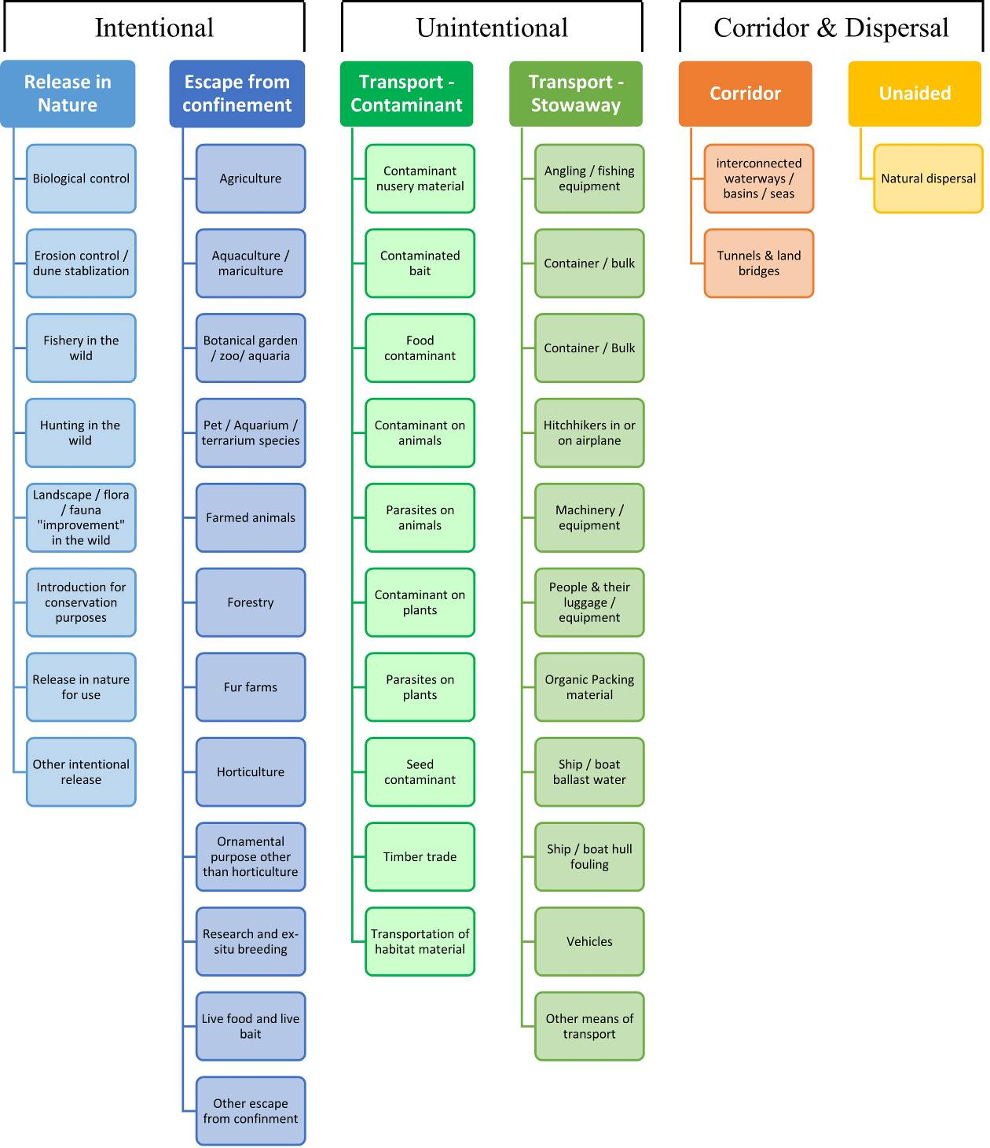

# ANNEX V Ecosystem services classification (CICES V5.1, simplified) and examples

For the purposes of this risk assessment, please feel free to use what seems as the most appropriate category / level / combination of impact (Section – Division – Group), reflecting information available.

|  |  |  |  |
| --- | --- | --- | --- |
| **Section** | **Division** | **Group** | **Examples (i.e. relevant CICES “classes”)** |
| **Provisioning** | **Biomass** | **Cultivated *terrestrial* plants** | Cultivated terrestrial plants (including fungi, algae) grown for nutritional purposes;  Fibres and other materials from cultivated plants, fungi, algae and bacteria for direct use or processing (excluding genetic materials);  Cultivated plants (including fungi, algae) grown as a source of energy  *Example: negative impacts of non-native organisms to crops, orchards, timber etc.* |
|  |  | **Cultivated *aquatic* plants** | Plants cultivated by in- situ aquaculture grown for nutritional purposes;  Fibres and other materials from in-situ aquaculture for direct use or processing (excluding genetic materials);  Plants cultivated by in- situ aquaculture grown as an energy source.  *Example: negative impacts of non-native organisms to aquatic plants cultivated for nutrition, gardening etc. purposes.* |
|  |  | **Reared animals** | Animals reared for nutritional purposes;  Fibres and other materials from reared animals for direct use or processing (excluding genetic materials);  Animals reared to provide energy (including mechanical)  *Example: negative impacts of non-native organisms to livestock* |
|  |  | **Reared *aquatic* animals** | Animals reared by in-situ aquaculture for nutritional purposes;  Fibres and other materials from animals grown by in-situ aquaculture for direct use or processing (excluding genetic materials);  Animals reared by in-situ aquaculture as an energy source  *Example: negative impacts of non-native organisms to fish farming* |
|  |  | **Wild plants** (terrestrial and aquatic) | Wild plants (terrestrial and aquatic, including fungi, algae) used for nutrition;  Fibres and other materials from wild plants for direct use or processing (excluding genetic materials);  Wild plants (terrestrial and aquatic, including fungi, algae) used as a source of energy  *Example: reduction in the availability of wild plants (e.g. wild berries, ornamentals) due to non-native organisms (competition, spread of disease etc.)* |
|  |  | **Wild animals** (terrestrial and aquatic) | Wild animals (terrestrial and aquatic) used for nutritional purposes;  Fibres and other materials from wild animals for direct use or processing (excluding genetic materials);  Wild animals (terrestrial and aquatic) used as a source of energy  *Example: reduction in the availability of wild animals (e.g. fish stocks, game) due to non-native organisms (competition, predations, spread of disease etc.)* |
|  | **Genetic material** from all biota | **Genetic material** from plants, algae or fungi | Seeds, spores and other plant materials collected for maintaining or establishing a population;  Higher and lower plants (whole organisms) used to breed new strains or varieties;  Individual genes extracted from higher and lower plants for the design and construction of new biological entities  *Example: negative impacts of non-native organisms due to interbreeding* |
|  |  | **Genetic material** from animals | Animal material collected for the purposes of maintaining or establishing a population;  Wild animals (whole organisms) used to breed new strains or varieties;  Individual genes extracted from organisms for the design and construction of new biological entities  *Example: negative impacts of non-native organisms due to interbreeding* |
|  | **Water[6]** | **Surface water** used for nutrition, materials or energy | Surface water for drinking;  Surface water used as a material (non-drinking purposes);  Freshwater surface water, coastal and marine water used as an energy source  *Example: loss of access to surface water due to spread of non-native organisms* |
|  |  | **Ground water** for used for nutrition, materials or energy | Ground (and subsurface) water for drinking;  Ground water (and subsurface) used as a material (non-drinking purposes);  Ground water (and subsurface) used as an energy source  *Example: reduced availability of ground water due to spread of non-native organisms and associated increase of ground water consumption by vegetation.* |
| **Regulation & Maintenance** | **Transformation** of biochemical or physical inputs to ecosystems | **Mediation of wastes or toxic substances** of anthropogenic origin by living processes | Bio-remediation by micro-organisms, algae, plants, and animals; Filtration/sequestration/storage/accumulation by micro-organisms, algae, plants, and animals  *Example: changes caused by non-native organisms to ecosystem functioning and ability to filtrate etc. waste or toxics* |
|  |  | **Mediation of nuisances** of anthropogenic origin | Smell reduction; noise attenuation; visual screening (e.g. by means of green infrastructure)  *Example: changes caused by non-native organisms to ecosystem structure, leading to reduced ability to mediate nuisances.* |
|  | **Regulation** of physical, chemical, biological conditions | **Baseline flows and extreme event** regulation | Control of erosion rates;  Buffering and attenuation of mass movement;  Hydrological cycle and water flow regulation (Including flood control, and coastal protection);  Wind protection;  Fire protection  *Example: changes caused by non-native organisms to ecosystem functioning or structure leading to, for example, destabilisation of soil, increased risk or intensity of wild fires etc.* |
|  |  | **Lifecycle maintenance**, habitat and gene pool protection | Pollination (or 'gamete' dispersal in a marine context);  Seed dispersal;  Maintaining nursery populations and habitats (Including gene pool protection)  *Example: changes caused by non-native organisms to the abundance and/or distribution of wild pollinators; changes to the availability / quality of nursery habitats for fisheries* |
|  |  | **Pest and disease control** | Pest control;  Disease control  *Example: changes caused by non-native organisms to the abundance and/or distribution of pests* |
|  |  | **Soil quality** regulation | Weathering processes and their effect on soil quality;  Decomposition and fixing processes and their effect on soil quality  *Example: changes caused by non-native organisms to vegetation structure and/or soil fauna leading to reduced soil quality* |
|  |  | **Water** conditions | Regulation of the chemical condition of freshwaters by living processes;  Regulation of the chemical condition of salt waters by living processes  *Example: changes caused by non-native organisms to buffer strips along water courses that remove nutrients in runoff and/or fish communities that regulate the resilience and resistance of water bodies to eutrophication* |
|  |  | **Atmospheric** composition and conditions | Regulation of chemical composition of atmosphere and oceans;  Regulation of temperature and humidity, including ventilation and transpiration  *Example: changes caused by non-native organisms to ecosystems’ ability to sequester carbon and/or evaporative cooling (e.g. by urban trees)* |
| **Cultural** | **Direct, in-situ and outdoor interactions** with living systems that depend on presence in the environmental setting | **Physical and experiential** interactions with natural environment | Characteristics of living systems that that enable activities promoting health, recuperation or enjoyment through active or immersive interactions;  Characteristics of living systems that enable activities promoting health, recuperation or enjoyment through passive or observational interactions  *Example: changes caused by non-native organisms to the qualities of ecosystems (structure, species composition etc.) that make it attractive for recreation, wild life watching etc.* |
|  |  | **Intellectual and representative** interactions with natural environment | Characteristics of living systems that enable scientific investigation or the creation of traditional ecological knowledge;  Characteristics of living systems that enable education and training;  Characteristics of living systems that are resonant in terms of culture or heritage;  Characteristics of living systems that enable aesthetic experiences  *Example: changes caused by non-native organisms to the qualities of ecosystems (structure, species composition etc.) that have cultural importance* |
|  | **Indirect, remote, often indoor interactions** with living systems that do not require presence in the environmental setting | **Spiritual, symbolic** and other interactions with natural environment | Elements of living systems that have symbolic meaning;  Elements of living systems that have sacred or religious meaning;  Elements of living systems used for entertainment or representation  *Example: changes caused by non-native organisms to the qualities of ecosystems (structure, species composition etc.) that have sacred or religious meaning* |
|  |  | Other biotic characteristics that have a **non-use value** | Characteristics or features of living systems that have an existence value;  Characteristics or features of living systems that have an option or bequest value  *Example: changes caused by non-native organisms to ecosystems designated as wilderness areas, habitats of endangered species etc.* |

# ANNEX VI EU Biogeographic Regions and MSFD Subregions

See <https://www.eea.europa.eu/data-and-maps/figures/biogeographical-regions-in-europe-2> ,

<http://ec.europa.eu/environment/nature/natura2000/biogeog_regions/>

and

https://www.eea.europa.eu/data-and-maps/data/msfd-regions-and-subregions-1/technical-document/pdf

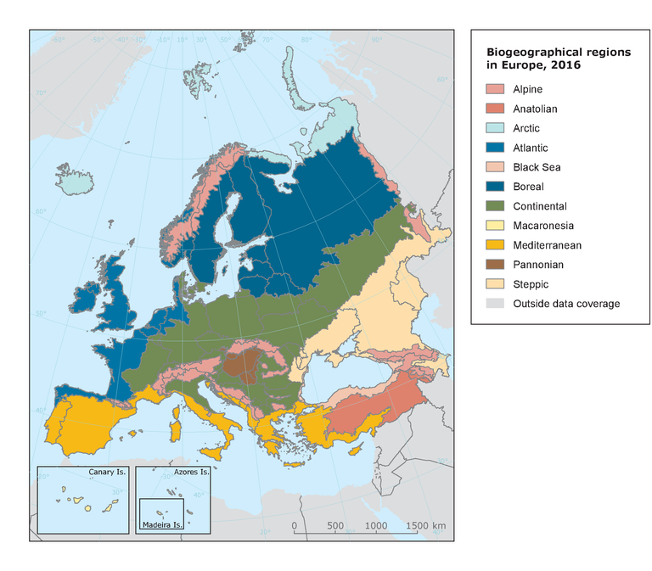 

# ANNEX VII Delegated Regulation (EU) 2018/968 of 30 April 2018

see <https://eur-lex.europa.eu/legal-content/en/TXT/?uri=CELEX%3A32018R0968>

# ANNEX VIII Species Distribution Model

**Projection of environmental suitability for *Faxonius immunis* establishment in Europe**

Björn Beckmann, Elena Tricarico, Frances Lucy and Dan Chapman

10 October 2020

**Aim**

To project the suitability for potential establishment of *Faxonius immunis* in Europe, under current and predicted future climatic conditions.

**Data for modelling**

Species occurrence data were obtained from the Integrated Digitized Biocollections (iDigBio) (1038 records), the Global Biodiversity Information Facility (GBIF) (371 records), the Biodiversity Information Serving Our Nation database (BISON) (247 records), iNaturalist (82 records), and additional records from the risk assessment team. We scrutinised occurrence records from regions where the species is not known to be established and removed any dubious records (e.g. fossils) or where the georeferencing was too imprecise (e.g. records referenced to a country or island centroid) or outside of the coverage of the predictor layers (e.g. small island or coastal occurrences). The remaining records were gridded at a 0.25 x 0.25 degree resolution for modelling, yielding 550 grid cells with occurrences (Figure 1a). As a proxy for recording effort, the density of Decapoda records held by GBIF was also compiled on the same grid (Figure 1b).

*Page Break*

**Figure 1.** (a) Occurrence records obtained for *Faxonius immunis* and used in the modelling, showing native and invaded distributions. (b) The recording density of Decapoda on GBIF, which was used as a proxy for recording effort.

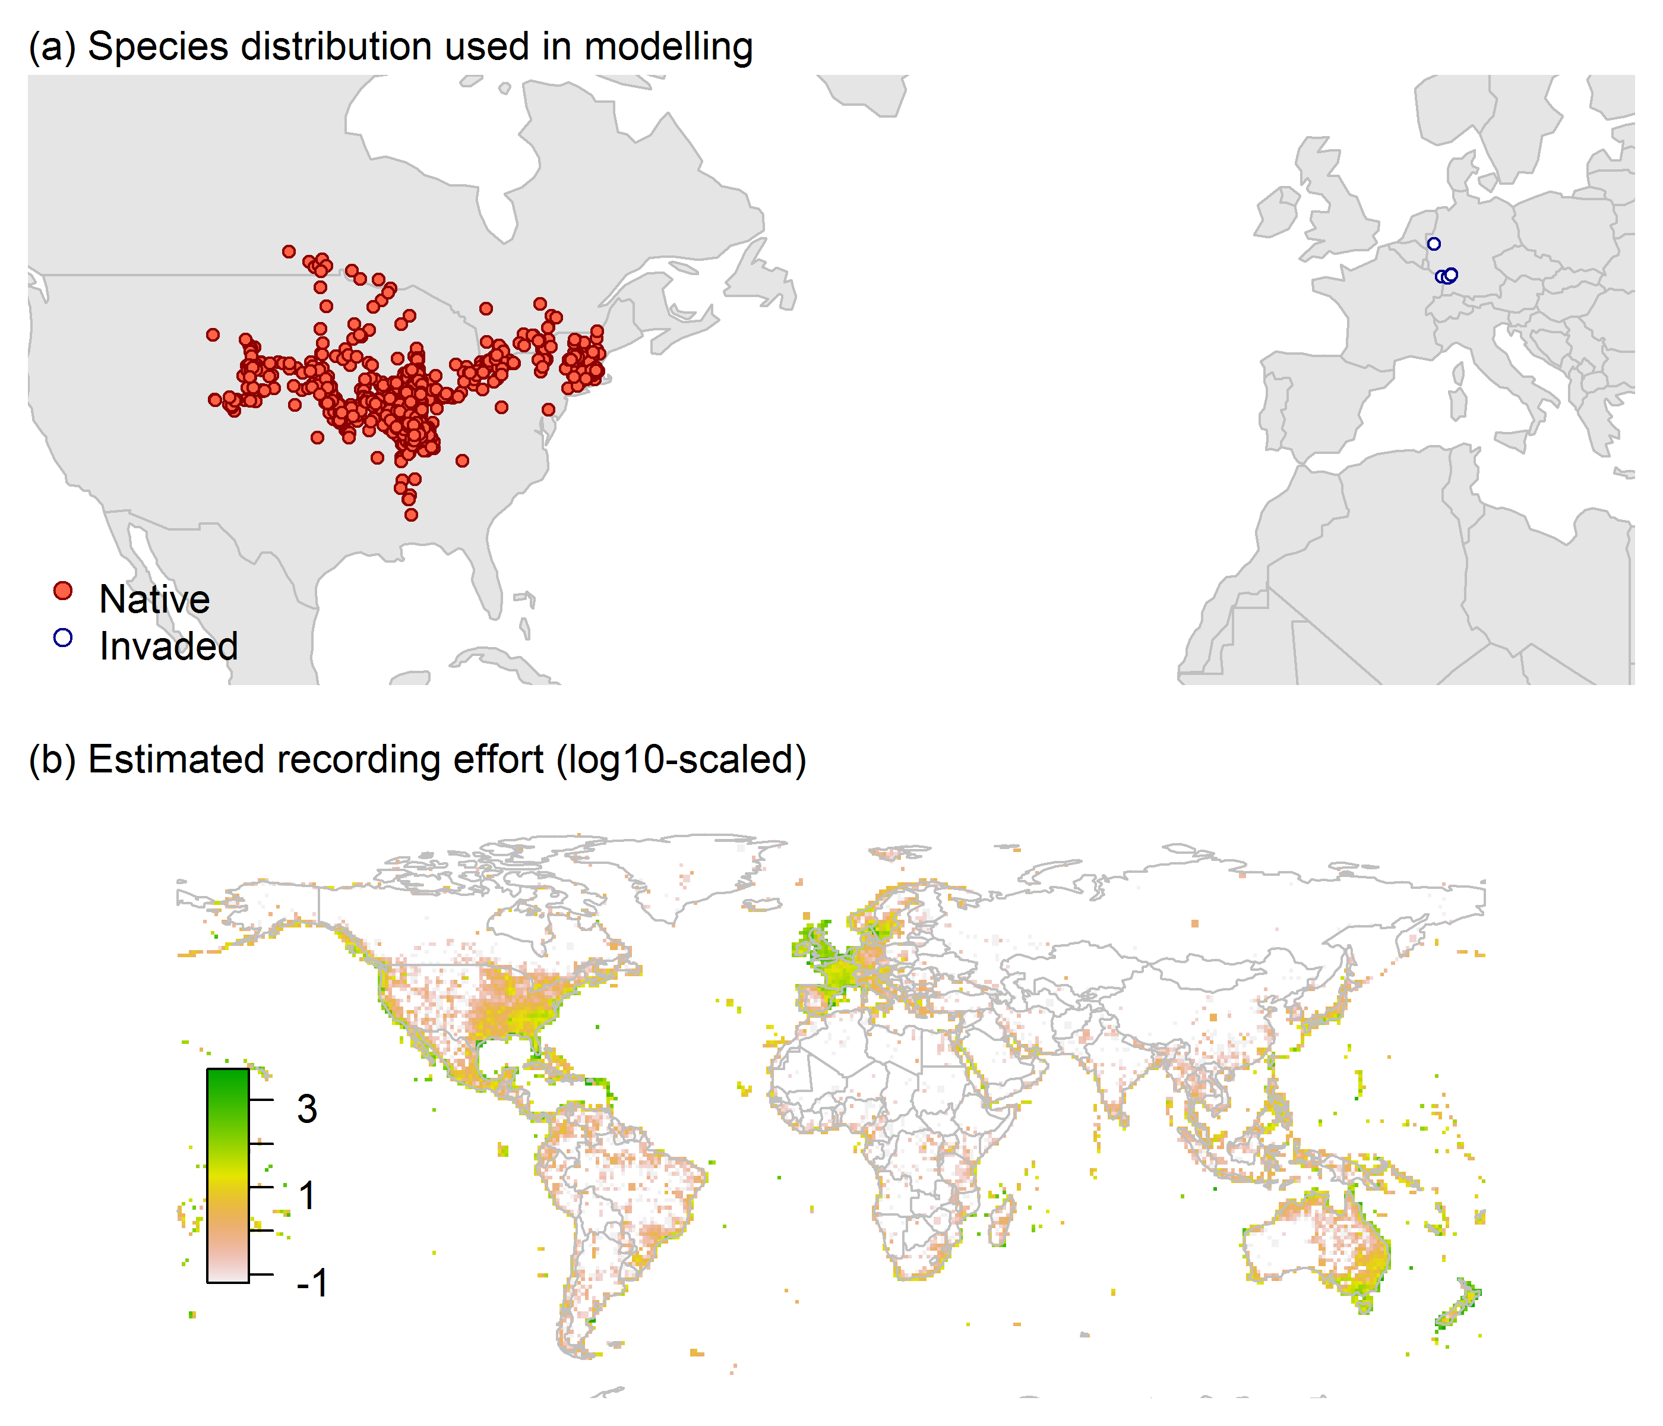

Climate data were selected from the ‘Bioclim’ variables contained within the WorldClim database (Hijmans et al. 2005), originally at 5 arcminute resolution (0.083 x 0.083 degrees of longitude/latitude) and aggregated to a 0.25 x 0.25 degree grid for use in the model.

Based on the biology of *Faxonius immunis*, the following climate variables were used in the modelling:

* Temperature seasonality (Bio4)
* Maximum temperature of the warmest month (Bio5)
* Minimum temperature of the coldest month (Bio6)
* Mean temperature of the wettest quarter (Bio8)
* Annual precipitation (Bio12)
* Precipitation of the wettest month (Bio13)
* Precipitation seasonality (Bio15)

To estimate the effect of climate change on the potential distribution, equivalent modelled future climate conditions for the 2070s under the Representative Concentration Pathways (RCP) 2.6 and 4.5 were also obtained. These represent low and medium emissions scenarios, respectively. The above variables were obtained as averages of outputs of eight Global Climate Models (BCC-CSM1-1, CCSM4, GISS-E2-R, HadGEM2-AO, IPSL-CM5A-LR, MIROC-ESM, MRI-CGCM3, NorESM1-M), downscaled and calibrated against the WorldClim baseline (see <http://www.worldclim.org/cmip5_5m> ).

**Species distribution model**

A presence-background (presence-only) ensemble modelling strategy was employed using the BIOMOD2 R package version 3.4.6 (Thuiller et al. 2009; Thuiller et al. 2020). These models contrast the environment at the species’ occurrence locations against a random sample of the global background environmental conditions (often termed ‘pseudo-absences’) in order to characterise and project suitability for occurrence. This approach has been developed for distributions that are in equilibrium with the environment. Because invasive species’ distributions are not at equilibrium and subject to dispersal constraints at a global scale, we took care to minimise the inclusion of locations suitable for the species but where it has not been able to disperse to (Chapman et al. 2019). Therefore the background sampling region included:

* The area accessible by native *Faxonius immunis* populations, in which the species is likely to have had sufficient time to disperse to all locations. Based on presumed maximum dispersal distances, the accessible region was defined as a 400km buffer around the native range occurrences; AND
* A 30km buffer around the non-native occurrences, encompassing regions likely to have had high propagule pressure for introduction by humans and/or dispersal of the species; AND
* Regions where we have an *a priori* expectation of high unsuitability for the species so that absence is assumed irrespective of dispersal constraints (see Figure 2). The following rules were applied to define a region expected to be highly unsuitable for *Faxonius immunis* at the spatial scale of the model:
  + Minimum temperature of the coldest month (Bio6) < -24°C
  + Maximum temperature of the warmest month (Bio5) < 21°C
  + Annual precipitation (Bio12) < 350mm

Altogether, only 0.7% of occurrence grid cells were located in the unsuitable background region.

Within the unsuitable background region, 10 samples of 5000 randomly sampled grid cells were obtained. In the accessible background (comprising the accessible areas around native and non-native occurrences as detailed above), the same number of pseudo-absence samples were drawn as there were presence records (550), weighting the sampling by a proxy for recording effort (Figure 2).

**Figure 2.** The background from which pseudo-absence samples were taken in the modelling of *Faxonius immunis*. Samples were taken from a 400km buffer around the native range and a 30km buffer around non-native occurrences (together forming the accessible background), and from areas expected to be highly unsuitable for the species (the unsuitable background region). Samples from the accessible background were weighted by a proxy for recording effort (Figure 1(b)).

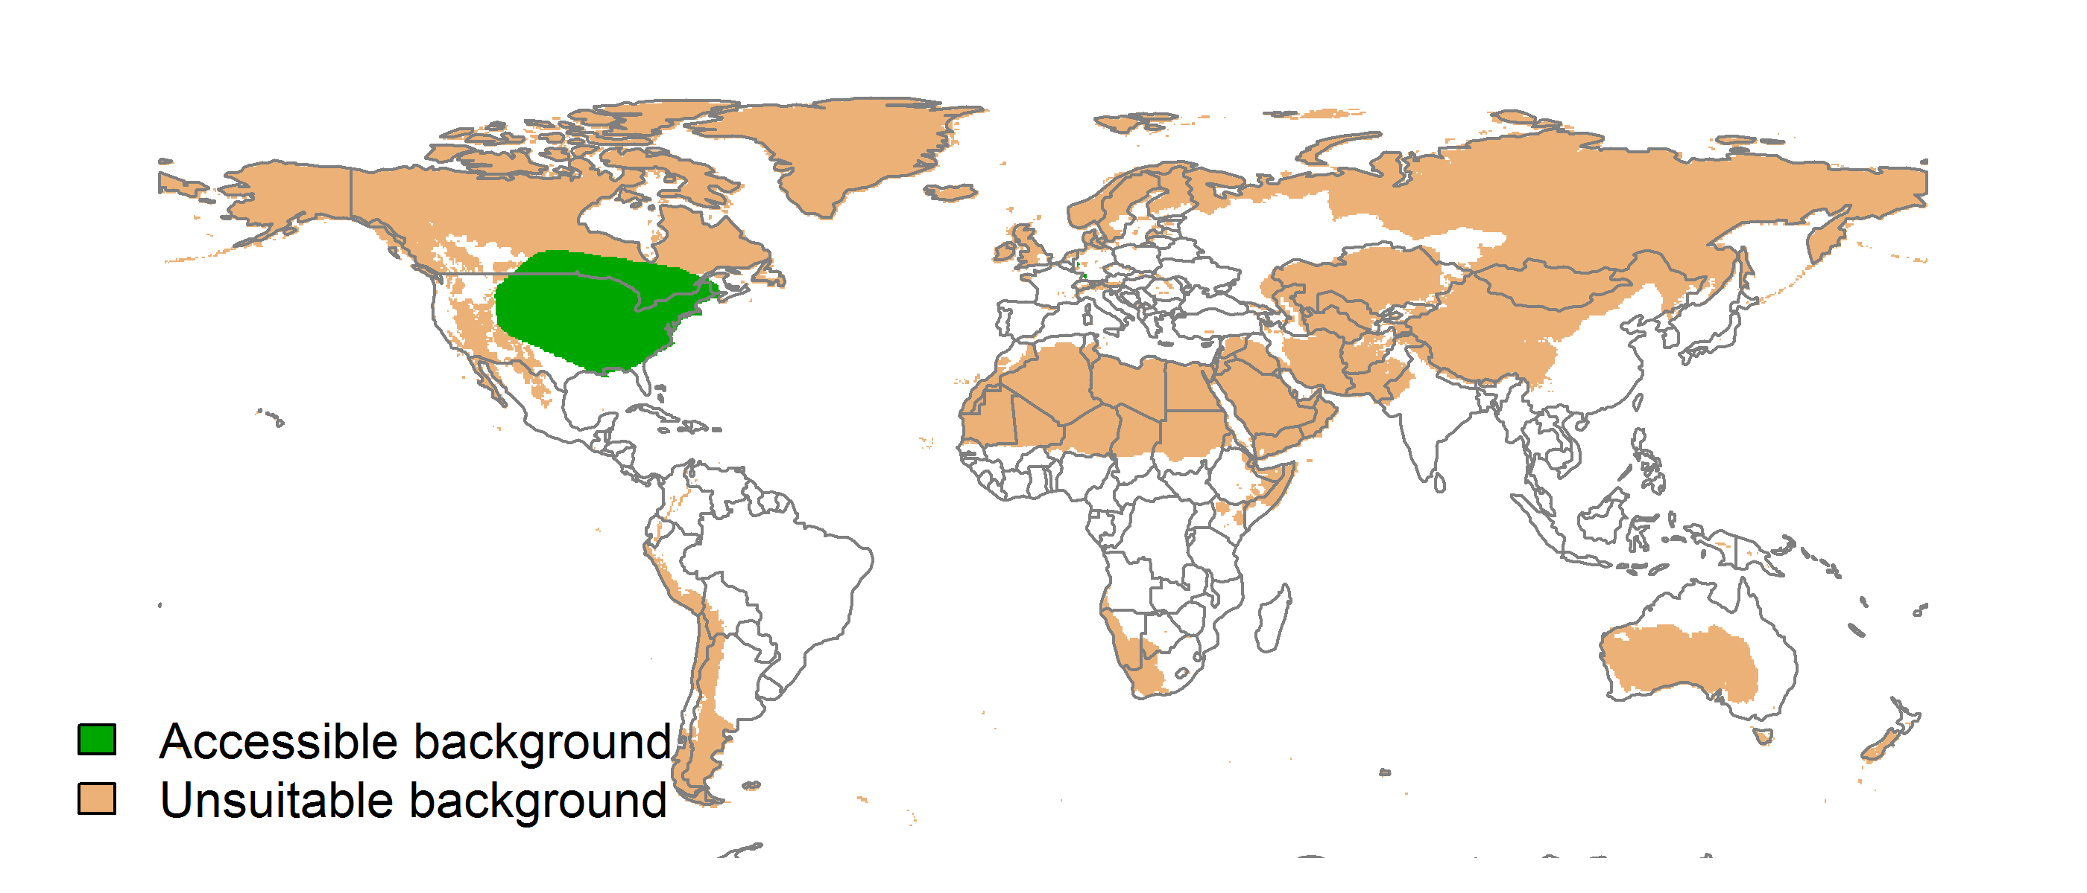

Each dataset (i.e. combination of the presences and the individual background samples) was randomly split into 80% for model training and 20% for model evaluation. With each training dataset, five statistical algorithms were fitted with the default BIOMOD2 settings and rescaled using logistic regression, except where specified below:

* Generalised linear model (GLM)
* Generalised boosting model (GBM)
* Generalised additive model (GAM) with a maximum of four degrees of freedom per smoothing spline
* Random forest (RF)
* Maxent

Since the total background sample was larger than the number of occurrences, prevalence fitting weights were applied to give equal overall importance to the occurrences and the background. Normalised variable importance was assessed and variable response functions were produced using BIOMOD2’s default procedure.

Model predictive performance was assessed by the following three measures:

* AUC, the area under the receiver operating characteristic curve (Fielding & Bell 1997). Predictions of presence-absence models can be compared with a subset of records set aside for model evaluation (here 20%) by constructing a confusion matrix with the number of true positive, false positive, false negative and true negative cases. For models generating non-dichotomous scores (as here) a threshold can be applied to transform the scores into a dichotomous set of presence-absence predictions. Two measures that can be derived from the confusion matrix are sensitivity (the proportion of observed presences that are predicted as such, quantifying omission errors), and specificity (the proportion of observed absences that are predicted as such, quantifying commission errors). A receiver operating characteristic (ROC) curve can be constructed by using all possible thresholds to classify the scores into confusion matrices, obtaining sensitivity and specificity for each matrix, and plotting sensitivity against the corresponding proportion of false positives (equal to 1 - specificity). The use of all possible thresholds avoids the need for a selection of a single threshold, which is often arbitrary, and allows appreciation of the trade-off between sensitivity and specificity. The area under the ROC curve (AUC) is often used as a single threshold-independent measure for model performance (Manel et al. 2001). AUC is the probability that a randomly selected presence has a higher model-predicted suitability than a randomly selected absence (Allouche et al. 2006).
* Cohen’s Kappa (Cohen 1960). This measure corrects the overall accuracy of model predictions (ratio of the sum of true presences plus true absences to the total number of records) by the accuracy expected to occur by chance. The kappa statistic ranges from -1 to +1, where +1 indicates perfect agreement and values of zero or less indicate a performance no better than random. Advantages of kappa are its simplicity, the fact that both commission and omission errors are accounted for in one parameter, and its relative tolerance to zero values in the confusion matrix (Manel et al. 2001). However, Kappa has been criticised for being sensitive to prevalence (the proportion of sites in which the species was recorded as present) and may therefore be inappropriate for comparisons of model accuracy between species or regions (McPherson et al. 2004; Allouche et al. 2006).
* TSS, the true skill statistic (Allouche et al. 2006). TSS is defined as sensitivity + specificity - 1, and corrects for Kappa’s dependency on prevalence. TSS compares the number of correct forecasts, minus those attributable to random guessing, to that of a hypothetical set of perfect forecasts. Like kappa, TSS takes into account both omission and commission errors, and success as a result of random guessing, and ranges from -1 to +1, where +1 indicates perfect agreement and values of zero or less indicate a performance no better than random (Allouche et al. 2006).

An ensemble model was created by first rejecting poorly performing algorithms with relatively extreme low AUC values and then averaging the predictions of the remaining algorithms, weighted by their AUC. To identify poorly performing algorithms, AUC values were converted into modified z-scores based on their difference to the median and the median absolute deviation across all algorithms (Iglewicz & Hoaglin 1993). Algorithms with z < -2 were rejected. In this way, ensemble projections were made for each dataset and then averaged to give an overall suitability, as well as its standard deviation. The projections were then classified into suitable and unsuitable regions using the ‘minROCdist’ method, which minimizes the distance between the ROC plot and the upper left corner of the plot (point (0,1)).

We also produced limiting factor maps for Europe following Elith et al. (2010). For this, projections were made separately with each individual variable fixed at a near-optimal value. These were chosen as the median values at the occurrence grid cells. Then, the most strongly limiting factors were identified as the one resulting in the highest increase in suitability in each grid cell.

*Page Break*

**Results**

The ensemble model suggested that suitability for *Faxonius immunis* was most strongly determined by Maximum temperature of the warmest month (Bio5), accounting for 30.6% of variation explained, followed by Annual precipitation (Bio12) (28.5%), Temperature seasonality (Bio4) (18.5%), Minimum temperature of the coldest month (Bio6) (7.9%), Precipitation of the wettest month (Bio13) (7.5%), Mean temperature of the wettest quarter (Bio8) (4.3%) and Precipitation seasonality (Bio15) (2.5%) (Table 1, Figure 3).

**Table 1.** Summary of the cross-validation predictive performance (AUC, Kappa, TSS) and variable importance of the fitted model algorithms and the ensemble (AUC-weighted average of the best performing algorithms). Results are the average from models fitted to 10 different background samples of the data.

|  |  |  |  |  |  |  |  |  |  |  |  |
| --- | --- | --- | --- | --- | --- | --- | --- | --- | --- | --- | --- |
|  |  |  |  |  | **Variable importance (%)** | | | | | | |
| **Algorithm** | **AUC** | **Kappa** | **TSS** | **Used in the ensemble** | **Maximum temperature of the warmest month (Bio5)** | **Annual precipitation (Bio12)** | **Temperature seasonality (Bio4)** | **Minimum temperature of the coldest month (Bio6)** | **Precipitation of the wettest month (Bio13)** | **Mean temperature of the wettest quarter (Bio8)** | **Precipitation seasonality (Bio15)** |
| GLM | 0.986 | 0.820 | 0.936 | yes | 28 | 33 | 7 | 11 | 10 | 6 | 5 |
| GAM | 0.987 | 0.835 | 0.945 | yes | 26 | 24 | 13 | 16 | 11 | 6 | 3 |
| GBM | 0.988 | 0.831 | 0.948 | yes | 40 | 35 | 19 | 1 | 3 | 1 | 0 |
| RF | 0.990 | 0.862 | 0.950 | yes | 28 | 22 | 35 | 4 | 6 | 4 | 1 |
| Maxent | 0.945 | 0.800 | 0.857 | no | 35 | 20 | 15 | 12 | 9 | 4 | 5 |
| **Ensemble** | **0.990** | **0.856** | **0.946** |  | **31** | **29** | **19** | **8** | **7** | **4** | **3** |

*Page Break*

**Figure 3.** Partial response plots from the fitted models. Thin coloured lines show responses from the algorithms in the ensemble, while the thick black line is their ensemble. In each plot, other model variables are held at their median value in the training data. Some of the divergence among algorithms is because of their different treatment of interactions among variables.

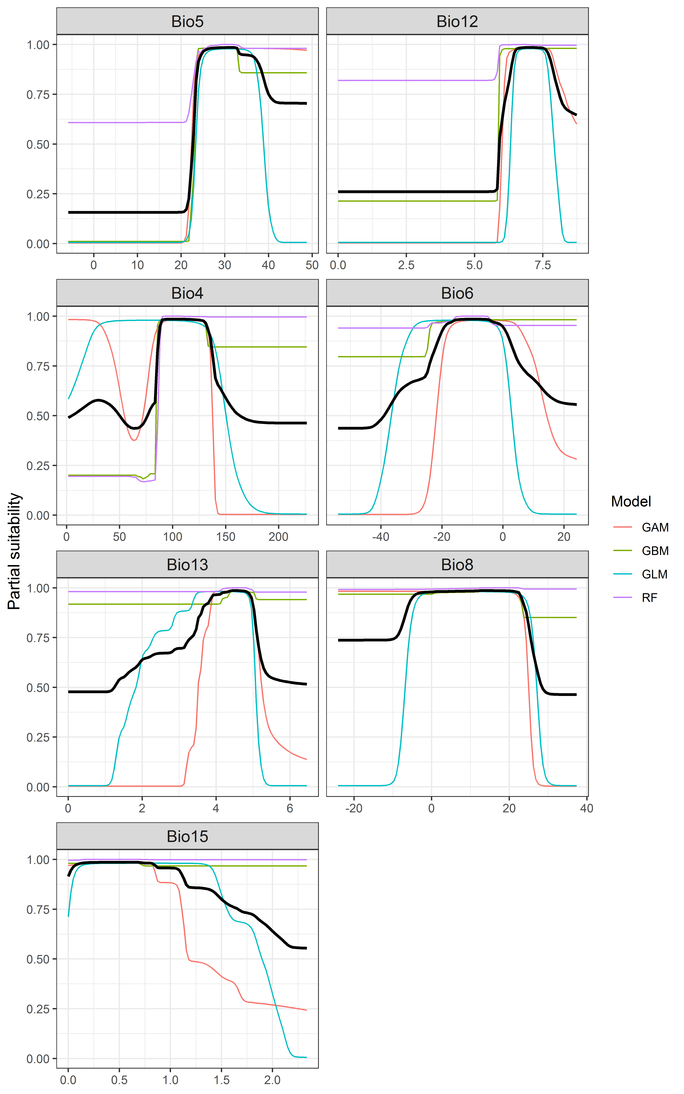

*Page Break*

**Figure 4.** (a) Projected global suitability for *Faxonius immunis* establishment in the current climate. For visualisation, the projection has been aggregated to a 0.5 x 0.5 degree resolution, by taking the maximum suitability of constituent higher resolution grid cells. Values > 0.47 may be suitable for the species. (b) Uncertainty in the ensemble projections, expressed as the among-algorithm standard deviation in predicted suitability, averaged across the 10 datasets.

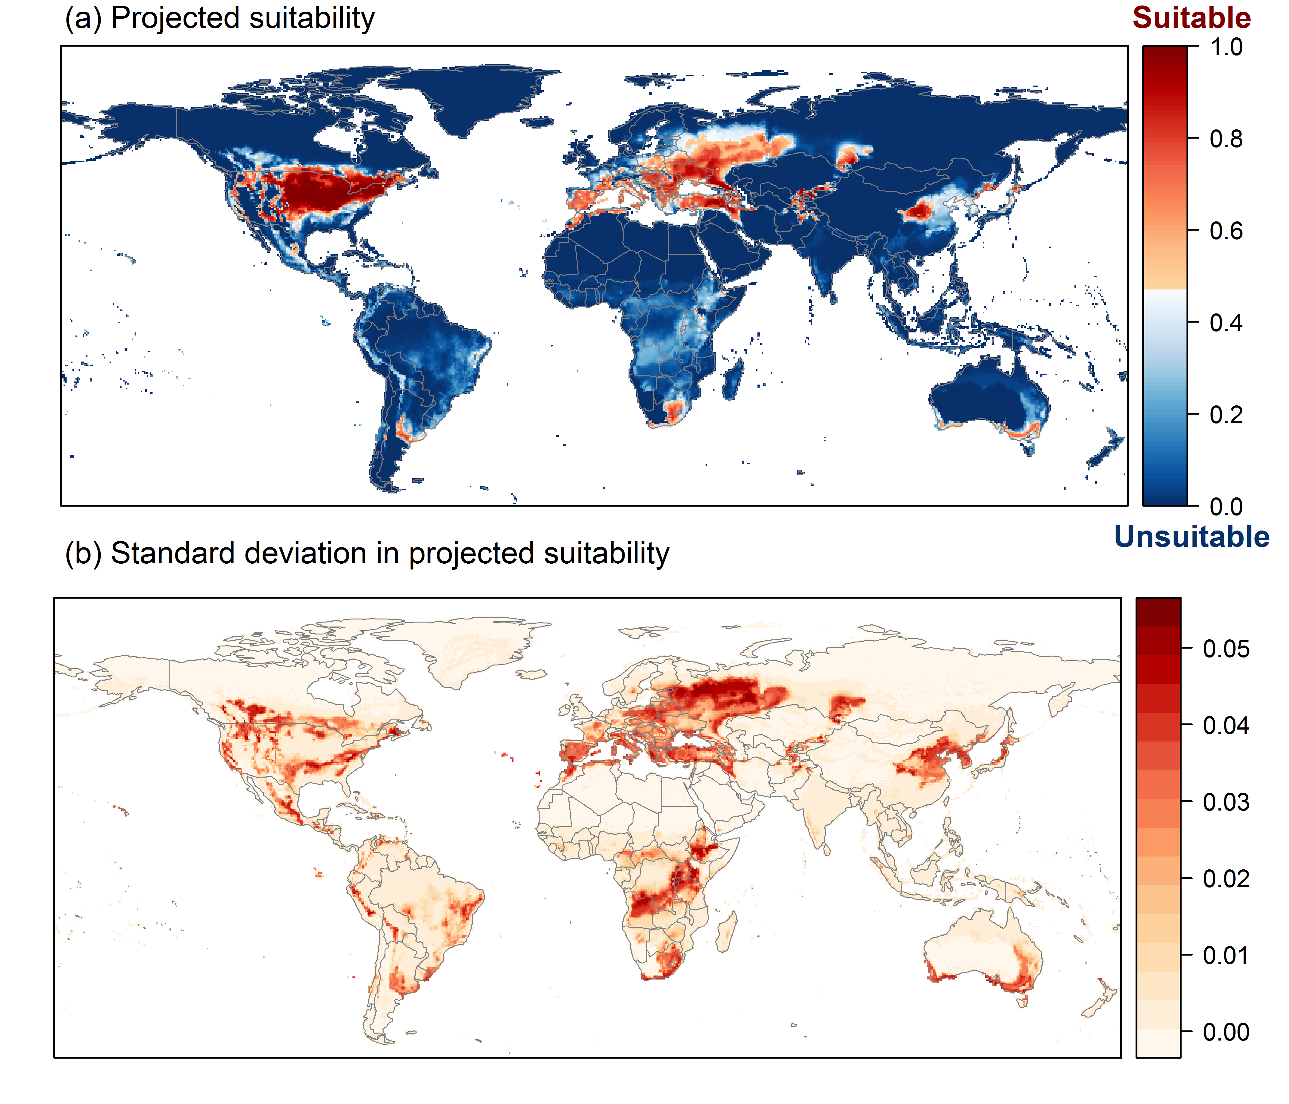

*Page Break*

**Figure 5.** (a) Projected current suitability for *Faxonius immunis* establishment in Europe and the Mediterranean region. (b) Uncertainty in the ensemble projections, expressed as the among-algorithm standard deviation in predicted suitability, averaged across the 10 datasets.

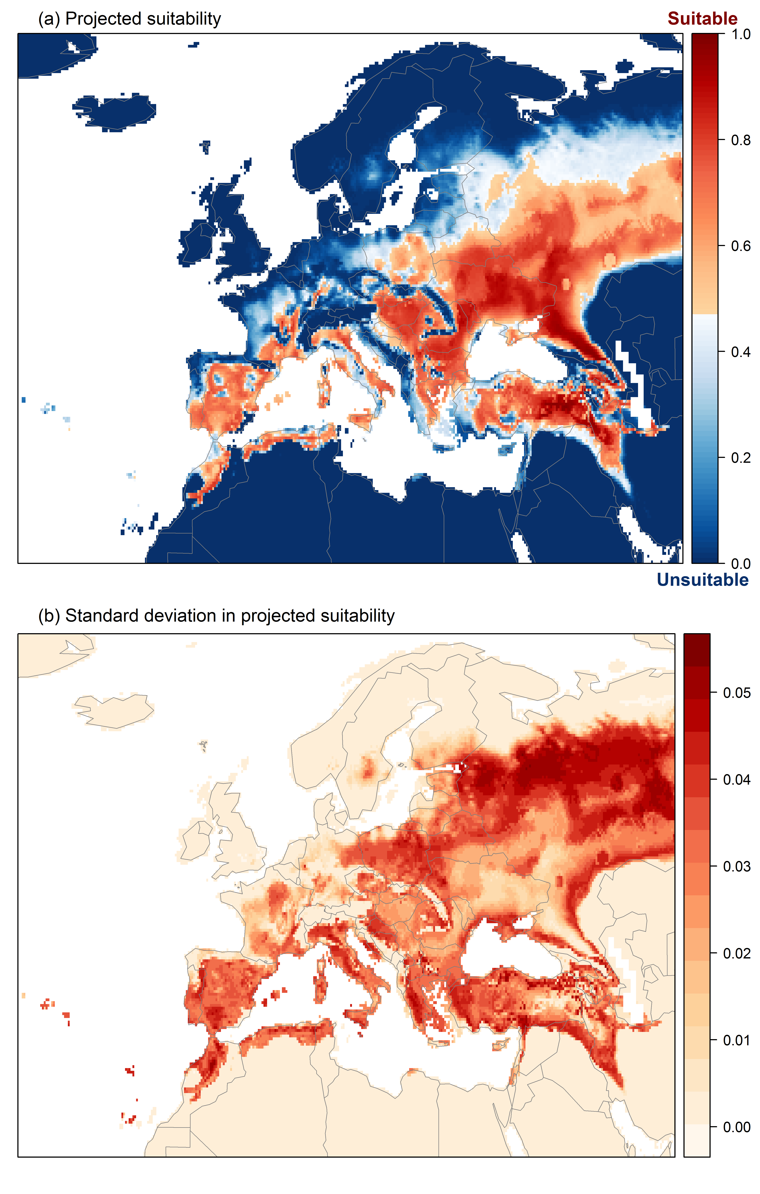

*Page Break*

**Figure 6.** The most strongly limiting factors for *Faxonius immunis* establishment estimated by the model in Europe and the Mediterranean region in current climatic conditions.

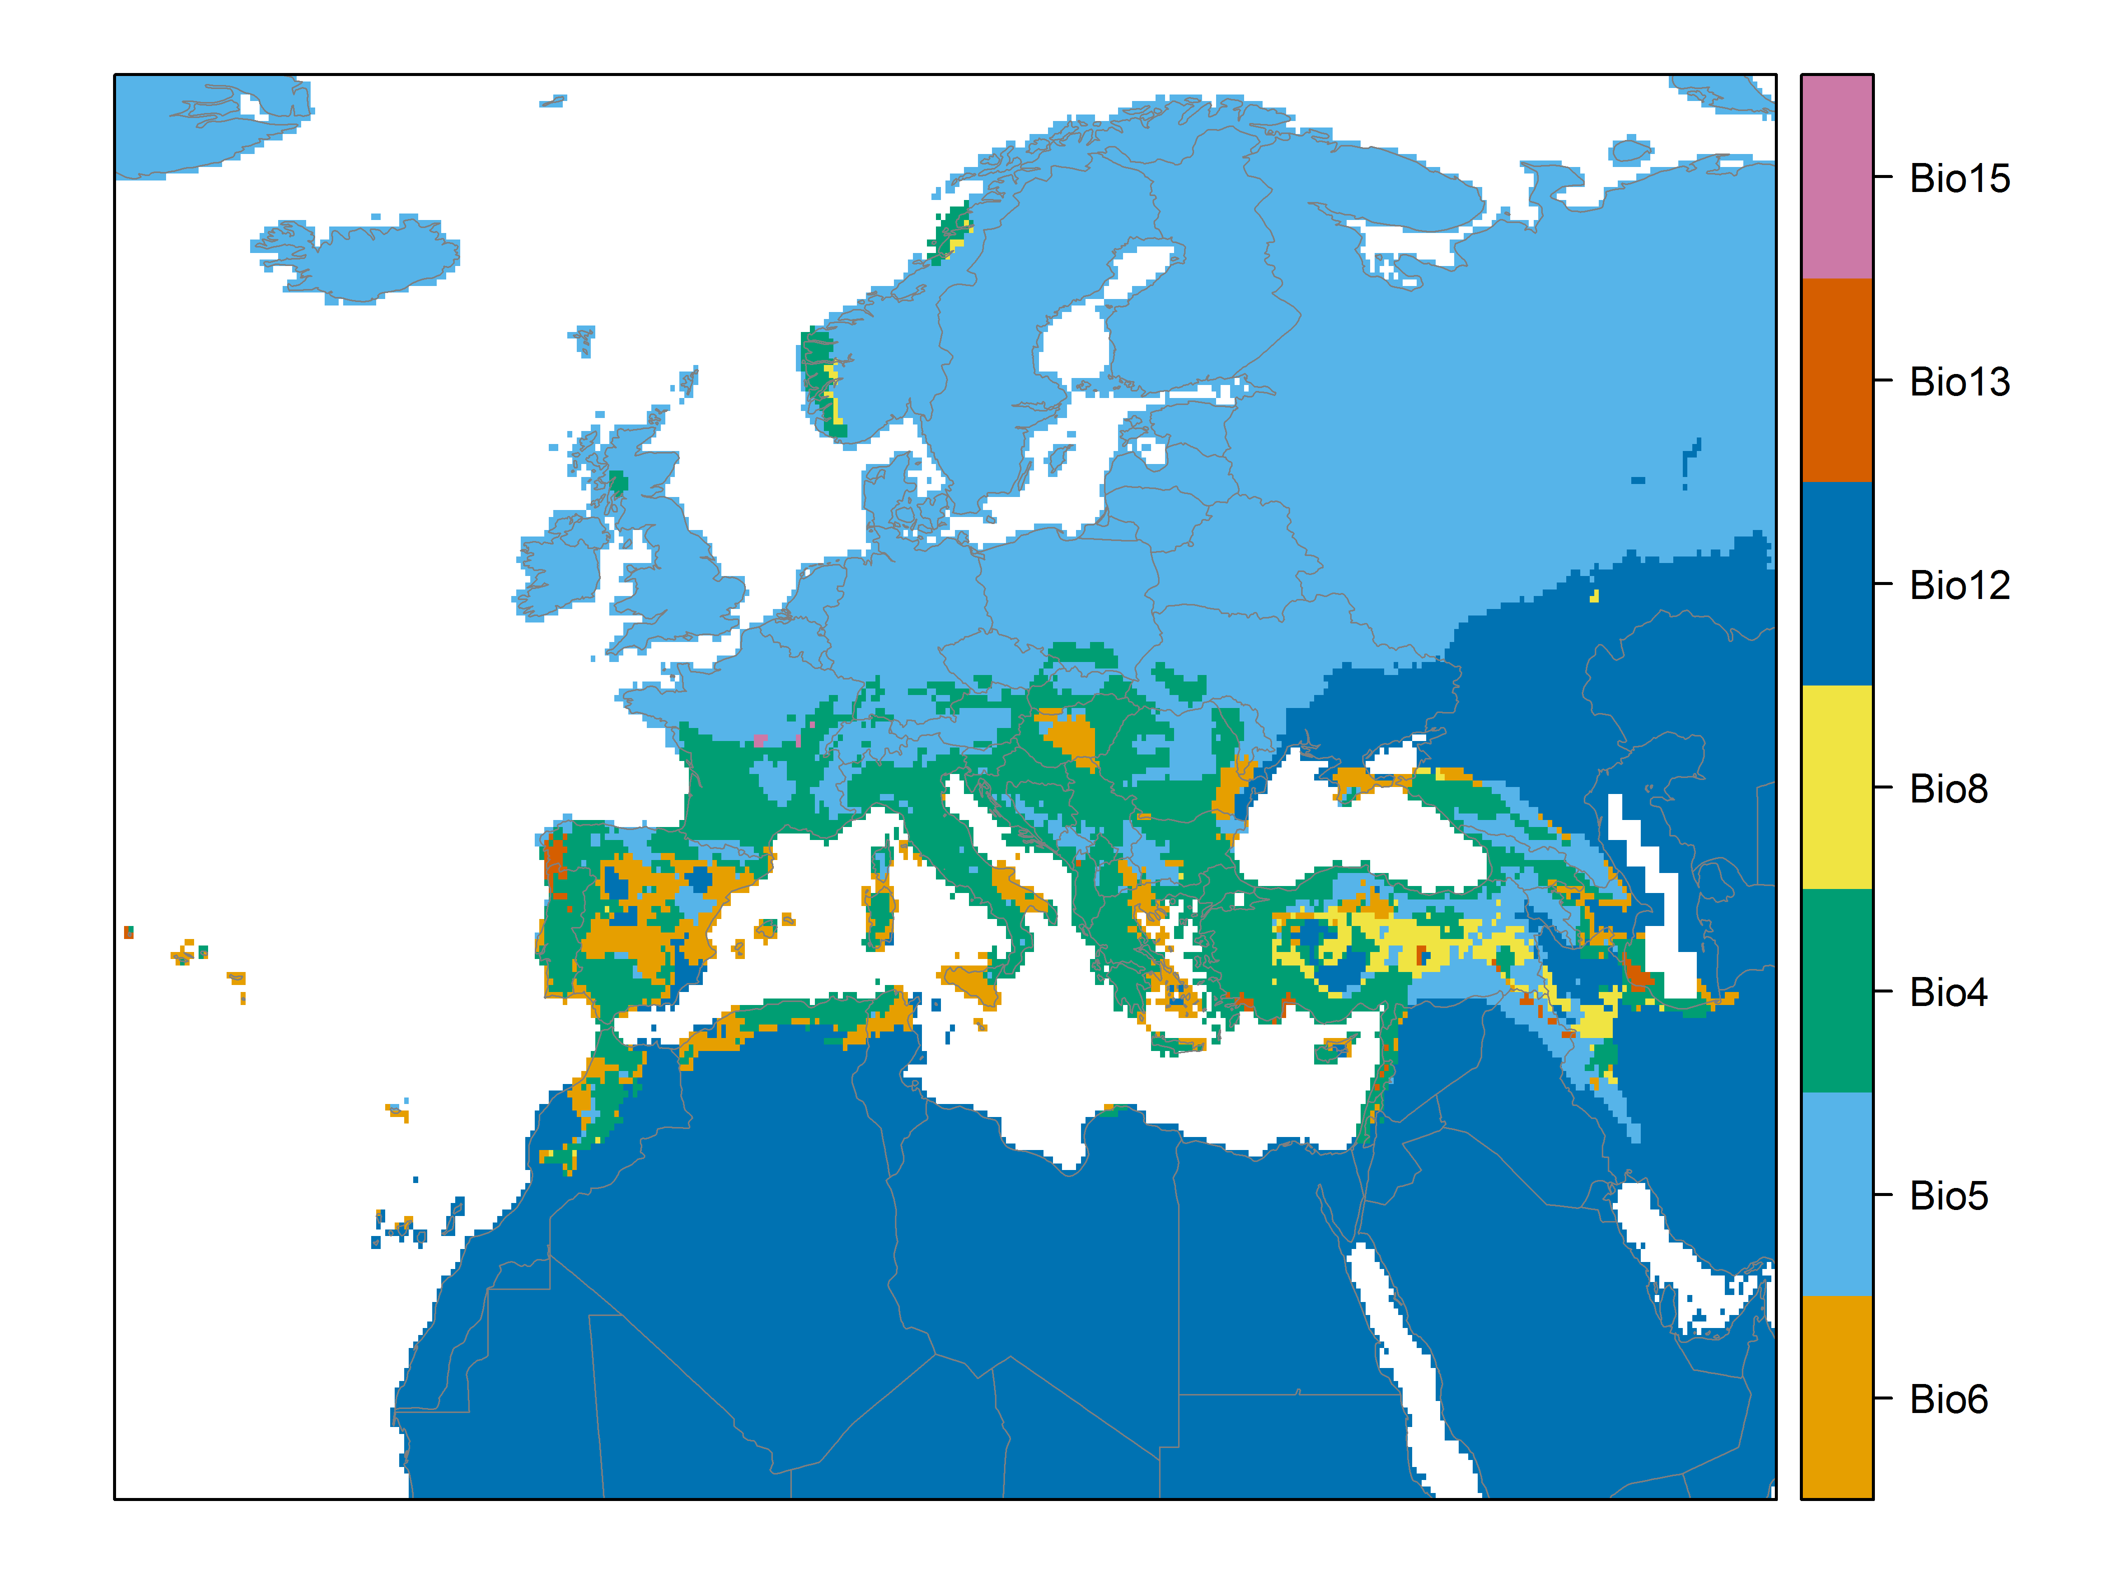

*Page Break*

**Figure 7.** (a) Projected suitability for *Faxonius immunis* establishment in Europe and the Mediterranean region in the 2070s under climate change scenario RCP2.6, equivalent to Figure 5. (b) Uncertainty in the ensemble projections, expressed as the among-algorithm standard deviation in predicted suitability, averaged across the 10 datasets.

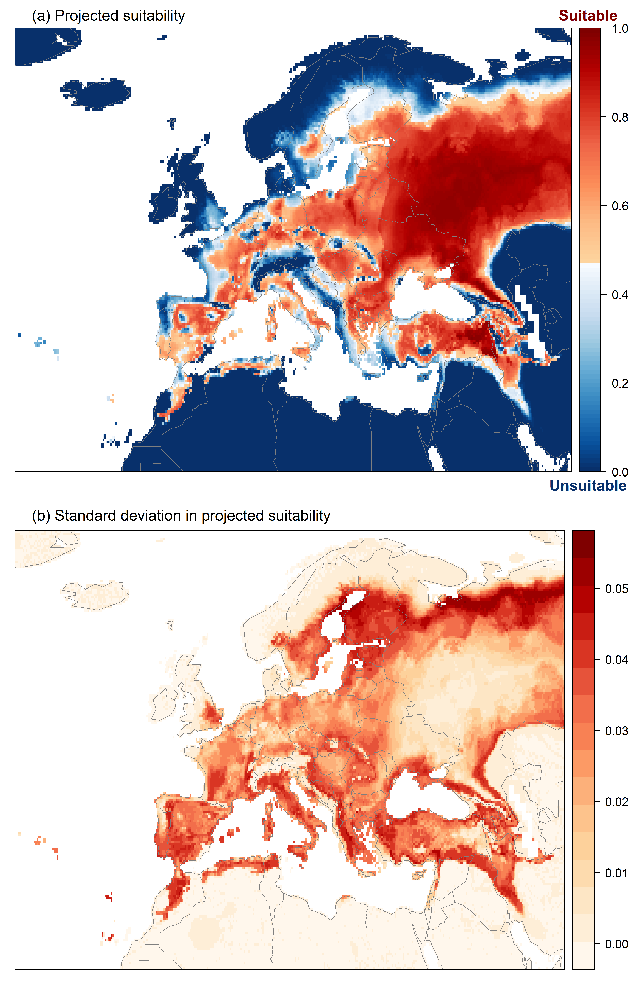

*Page Break*

**Figure 8.** (a) Projected suitability for *Faxonius immunis* establishment in Europe and the Mediterranean region in the 2070s under climate change scenario RCP4.5, equivalent to Figure 5. (b) Uncertainty in the ensemble projections, expressed as the among-algorithm standard deviation in predicted suitability, averaged across the 10 datasets.

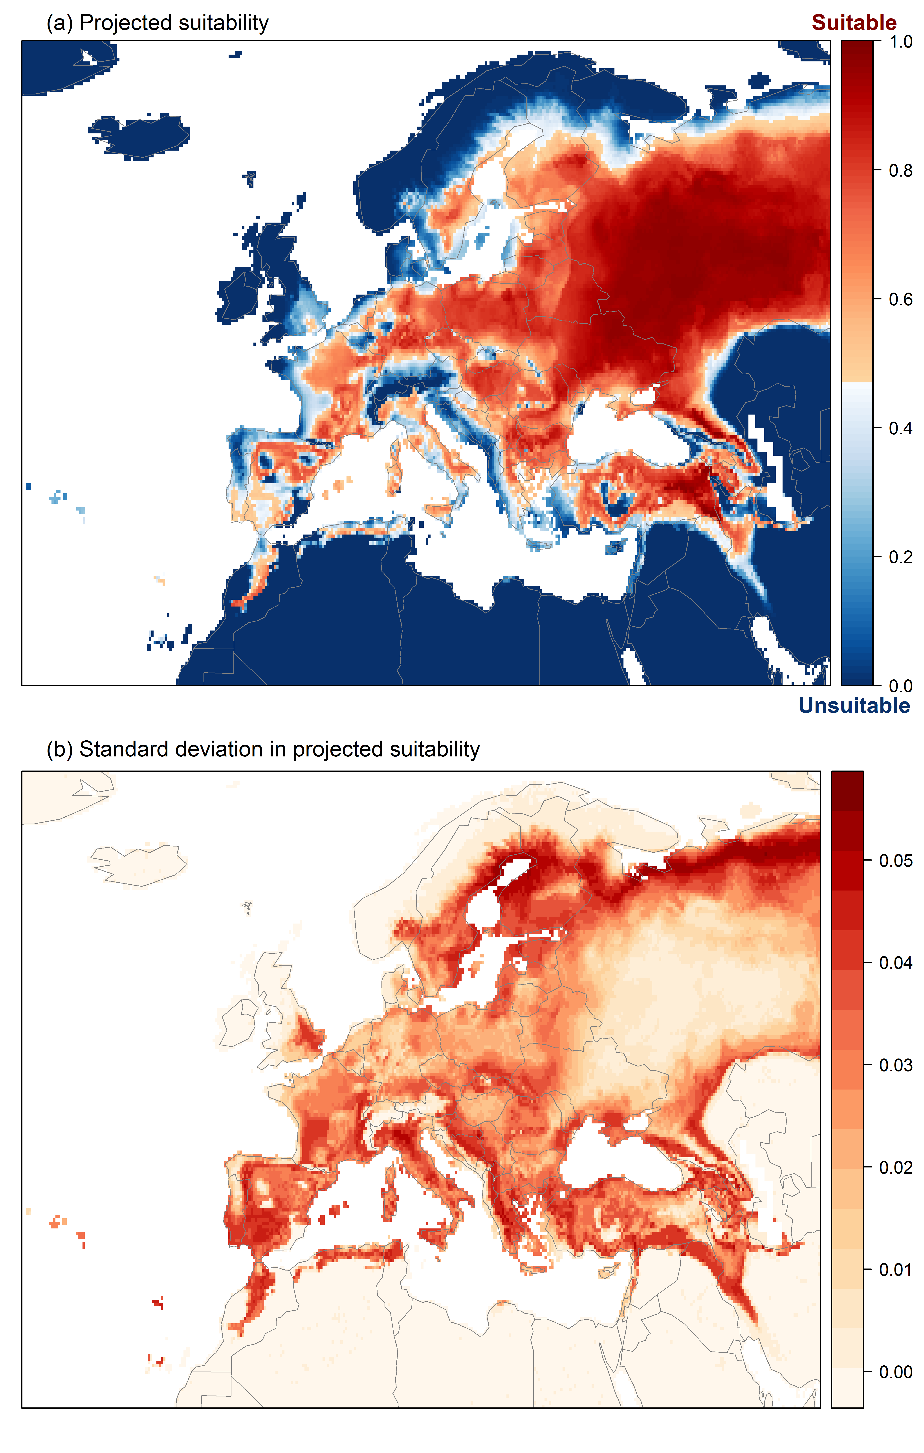

*Page Break*

**Figure 9.** Variation in projected suitability for *Faxonius immunis* establishment among Biogeographical Regions of Europe (<https://www.eea.europa.eu/data-and-maps/data/biogeographical-regions-europe-3>). The bar plots show the proportion of grid cells in each region classified as suitable in the current climate and projected climate for the 2070s under two RCP emissions scenarios. The location of each region is also shown. The Arctic and Macaronesian biogeographical regions are not part of the study area, but are included for completeness.

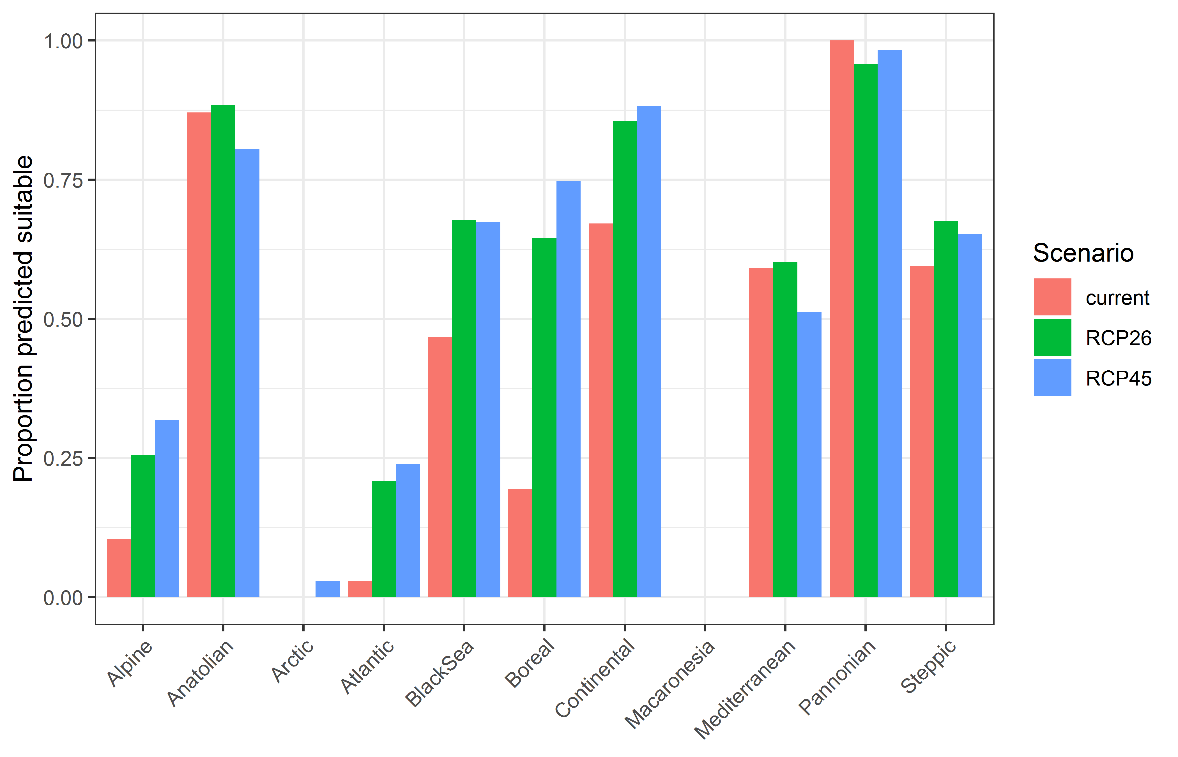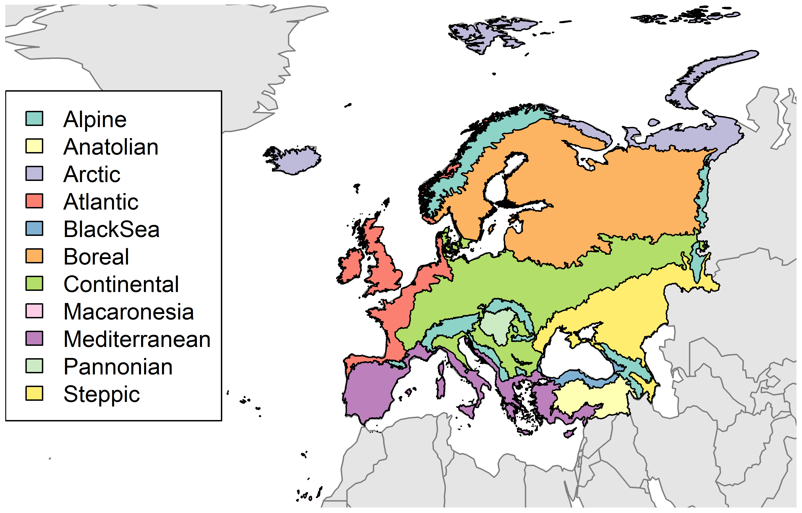

*Page Break*

**Table 2.** Variation in projected suitability for *Faxonius immunis* establishment among Biogeographical regions of Europe (numerical values of Figure 9 above). The numbers are the proportion of grid cells in each region classified as suitable in the current climate and projected climate for the 2070s under two RCP emissions scenarios. The Arctic and Macaronesian biogeographical regions are not part of the study area, but are included for completeness.

|  |  |  |  |
| --- | --- | --- | --- |
| **Biogeographical region** | **Current climate** | **RCP26** | **RCP45** |
| Alpine | 0.10 | 0.25 | 0.32 |
| Anatolian | 0.87 | 0.88 | 0.80 |
| Arctic | 0.00 | 0.00 | 0.03 |
| Atlantic | 0.03 | 0.21 | 0.24 |
| BlackSea | 0.47 | 0.68 | 0.67 |
| Boreal | 0.19 | 0.64 | 0.75 |
| Continental | 0.67 | 0.85 | 0.88 |
| Macaronesia | 0.00 | 0.00 | 0.00 |
| Mediterranean | 0.59 | 0.60 | 0.51 |
| Pannonian | 1.00 | 0.96 | 0.98 |
| Steppic | 0.59 | 0.68 | 0.65 |

*Page Break*

**Figure 10.** Variation in projected suitability for *Faxonius immunis* establishment among European Union countries and the UK. The bar plots show the proportion of grid cells in each country classified as suitable in the current climate and projected climate for the 2070s under two RCP emissions scenarios.

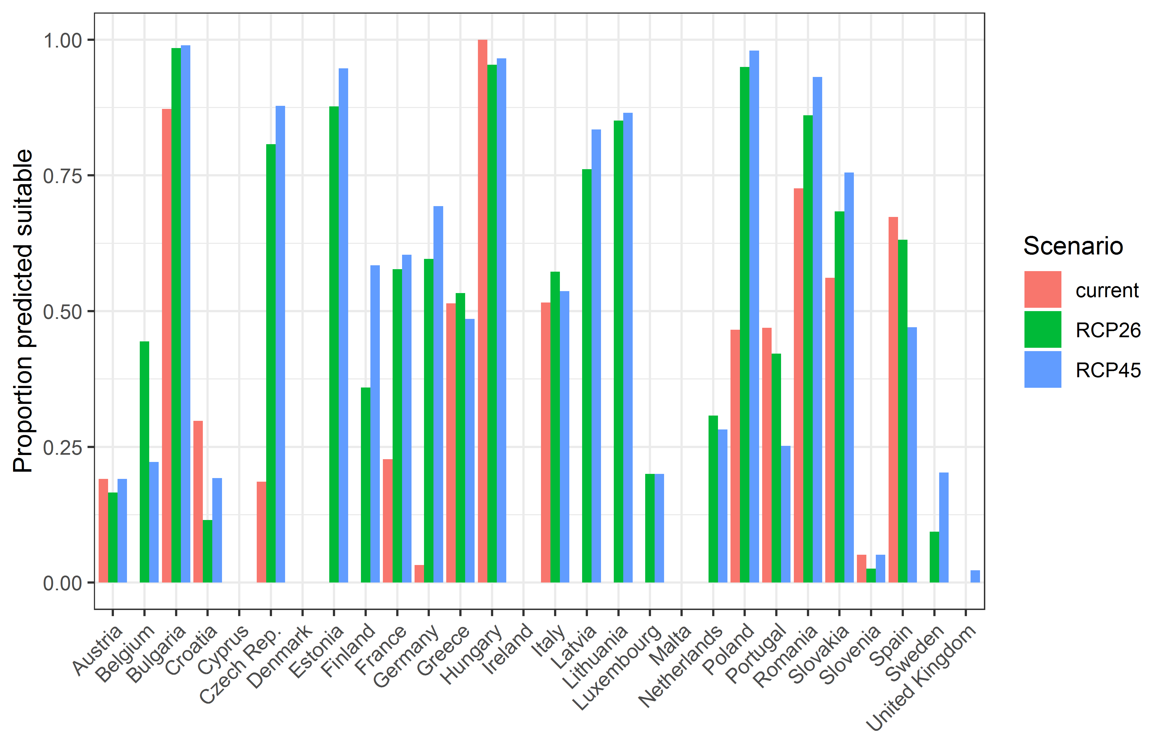

*Page Break*

**Table 3.** Variation in projected suitability for *Faxonius immunis* establishment among European Union countries and the UK (numerical values of Figure 10 above). The numbers are the proportion of grid cells in each country classified as suitable in the current climate and projected climate for the 2070s under two RCP emissions scenarios.

|  |  |  |  |
| --- | --- | --- | --- |
| **Country** | **Current climate** | **RCP26** | **RCP45** |
| Austria | 0.19 | 0.17 | 0.19 |
| Belgium | 0.00 | 0.44 | 0.22 |
| Bulgaria | 0.87 | 0.98 | 0.99 |
| Croatia | 0.30 | 0.12 | 0.19 |
| Cyprus | 0.00 | 0.00 | 0.00 |
| Czech Rep. | 0.19 | 0.81 | 0.88 |
| Denmark | 0.00 | 0.00 | 0.00 |
| Estonia | 0.00 | 0.88 | 0.95 |
| Finland | 0.00 | 0.36 | 0.58 |
| France | 0.23 | 0.58 | 0.60 |
| Germany | 0.03 | 0.60 | 0.69 |
| Greece | 0.51 | 0.53 | 0.49 |
| Hungary | 1.00 | 0.95 | 0.97 |
| Ireland | 0.00 | 0.00 | 0.00 |
| Italy | 0.52 | 0.57 | 0.54 |
| Latvia | 0.00 | 0.76 | 0.83 |
| Lithuania | 0.00 | 0.85 | 0.87 |
| Luxembourg | 0.00 | 0.20 | 0.20 |
| Malta | 0.00 | 0.00 | 0.00 |
| Netherlands | 0.00 | 0.31 | 0.28 |
| Poland | 0.47 | 0.95 | 0.98 |
| Portugal | 0.47 | 0.42 | 0.25 |
| Romania | 0.73 | 0.86 | 0.93 |
| Slovakia | 0.56 | 0.68 | 0.76 |
| Slovenia | 0.05 | 0.03 | 0.05 |
| Spain | 0.67 | 0.63 | 0.47 |
| Sweden | 0.00 | 0.09 | 0.20 |
| United Kingdom | 0.00 | 0.00 | 0.02 |

**Caveats to the modelling**

To remove spatial recording biases, the selection of the background sample from the accessible background was weighted by the density of terrestrial Decapoda records on the Global Biodiversity Information Facility (GBIF). While this is preferable to not accounting for recording bias at all, it may not provide the perfect measure of recording bias.

There was substantial variation among modelling algorithms in the partial response plots (Figure 3). In part this will reflect their different treatment of interactions among variables. Since partial plots are made with other variables held at their median, there may be values of a particular variable at which this does not provide a realistic combination of variables to predict from.

Other variables potentially affecting the distribution of the species, such as types of land cover were not included in the model.

Finally, Filipová et al. (2011) suggested that calico crayfish might represent a cryptic species complex, “making the forecasting of ecological properties of European *F. immunis* populations based on data from populations in its indigenous North American range difficult because the latter might comprise different cryptic species” (Chucholl 2012).

*Page Break*

**References**

* Allouche O, Tsoar A, Kadmon R. 2006. Assessing the accuracy of species distribution models: prevalence, kappa and the true skill statistic (TSS), Journal of Applied Ecology 43: 1223-1232.
* Chapman D, Pescott OL, Roy HE, Tanner R. 2019. Improving species distribution models for invasive non-native species with biologically informed pseudo-absence selection. Journal of Biogeography 46: 1029-1040. <https://doi.org/10.1111/jbi.13555>.
* Chucholl C. 2012. Understanding invasion success: life-history traits and feeding habits of the alien crayfish *Orconectes immunis* (Decapoda, Astacida, Cambaridae). Knowledge and Management of Aquatic Ecosystems 404: 04.
* Cohen J. 1960. A coefficient of agreement of nominal scales. Educational and Psychological Measurement 20: 37-46.
* Elith J, Kearney M, Phillips S. 2010. The art of modelling range-shifting species. Methods in Ecology and Evolution 1: 330-342.
* Fielding AH, Bell JF. 1997. A review of methods for the assessment of prediction errors in conservation presence/absence models. Environmental Conservation 24: 38-49.
* Filipová L, Grandjean F, Chucholl C, Soes DM, Petrusek A. 2011. Identification of exotic North American crayfish in Europe by DNA barcoding. Knowledge & Management of Aquatic Ecosystems 401: 11.
* Hijmans RJ, Cameron SE, Parra JL, Jones PG, Jarvis A. 2005. Very high resolution interpolated climate surfaces for global land areas. International Journal of Climatology 25: 1965-1978.
* Iglewicz B, Hoaglin DC. 1993. How to detect and handle outliers, Asq Press.
* Manel S, Williams HC, Ormerod SJ. 2001. Evaluating presence-absence models in ecology: the need to account for prevalence. Journal of Applied Ecology 38: 921-931.
* McPherson JM, Jetz W, Rogers DJ. 2004 The effects of species’ range sizes on the accuracy of distribution models: ecological phenomenon or statistical artefact? Journal of Applied Ecology 41: 811-823.
* Thuiller W, Lafourcade B, Engler R, Araújo MB. 2009. BIOMOD-a platform for ensemble forecasting of species distributions. Ecography 32: 369-373.
* Thuiller W, Georges D, Engler R, Breiner F. 2020. biomod2: Ensemble Platform for Species Distribution Modeling. R package version 3.4.6. <https://CRAN.R-project.org/package=biomod2>

1. This template is based on the Great Britain non-native species risk assessment scheme (GBNNRA). A number of amendments have been introduced to ensure compliance with Regulation (EU) 1143/2014 on IAS and relevant legislation, including the Delegated Regulation (EU) 2018/968 of 30 April 2018, supplementing Regulation (EU) No 1143/2014 of the European Parliament and of the Council with regard to risk assessments in relation to invasive alien species (see <https://eur-lex.europa.eu/legal-content/en/TXT/?uri=CELEX%3A32018R0968> ).
2. Convention on Biological Diversity, Decision VI/23
3. <https://circabc.europa.eu/sd/a/738e82a8-f0a6-47c6-8f3b-aeddb535b83b/TSSR-2016-010%20CBD%20categories%20on%20pathways%20Final.pdf>
4. <https://circabc.europa.eu/sd/a/0aeba7f1-c8c2-45a1-9ba3-bcb91a9f039d/TSSR-2016-010%20CBD%20pathways%20key%20full%20only.pdf>
5. Not to be confused with “no impact”.
6. Note: in the CICES classification provisioning of water is considered as an abiotic service whereas the rest of ecosystem services listed here are considered biotic.