Risk assessment template developed under the "Study on Invasive Alien Species – Development of risk assessments to tackle priority species and enhance prevention"
Contract No 07.0202/2020/834529/ETU/ENV.D.2

Name of organism: Cherax destructor Clark, 1936

Author(s) of the assessment:
Elena Tricarico, Department of Biology, University of Florence, Italy

Risk Assessment Area: The risk assessment area is the territory of the European Union 27 and the United Kingdom, excluding the EU-outermost regions.

Peer review 1: Antonín Kouba, South Bohemian Research Center of Aquaculture and Biodiversity of Hydrocenoses, Faculty of Fisheries and Protection of Waters, University of South Bohemia in České Budějovice, Vodňany, Czech Republic
Peer review 2: Francisco J. Oficialdegui, Department of Wetland Ecology, Doñana Biological Station (EBD-CSIC), Seville, Spain

Date of completion: 15/10/2021
Date of revision: 30 September 2022

Contents
SECTION A – Organism Information and Screening 3
SECTION B – Detailed assessment 12
1 PROBABILITY OF INTRODUCTION AND ENTRY 12
2 PROBABILITY OF ESTABLISHMENT 24
3 PROBABILITY OF SPREAD 30
4 MAGNITUDE OF IMPACT 36
Biodiversity and ecosystem impacts 36
Ecosystem Services impacts 39
Economic impacts 41
Social and human health impacts 43
Other impacts 44
RISK SUMMARIES 47
REFERENCES 49
Distribution Summary 55
ANNEX I Scoring of Likelihoods of Events 57
ANNEX II Scoring of Magnitude of Impacts 58
ANNEX III Scoring of Confidence Levels 59
ANNEX IV CBD pathway categorisation scheme 60
ANNEX V Ecosystem services classification (CICES V5.1, simplified) and examples 61
ANNEX VI EU Biogeographic Regions and MSFD Subregions 65
ANNEX VII Delegated Regulation (EU) 2018/968 of 30 April 2018 66
ANNEX VIII Species Distribution Model 67

SECTION A – Organism Information and Screening
A1. Identify the organism. Is it clearly a single taxonomic entity and can it be adequately distinguished from other entities of the same rank?
including the following elements:
- the taxonomic family, order and class to which the species belongs;
- the scientific name and author of the species, as well as a list of the most common synonym names;
- names used in commerce (if any)
- a list of the most common subspecies, lower taxa, varieties, breeds or hybrids
As a general rule, one risk assessment should be developed for a single species. However, there may be cases where it may be justified to develop one risk assessment covering more than one species (e.g. species belonging to the same genus with comparable or identical features and impact). It shall be clearly stated if the risk assessment covers more than one species, or if it excludes or only includes certain subspecies, lower taxa, hybrids, varieties or breeds (and if so, which subspecies, lower taxa, hybrids, varieties or breeds). Any such choice must be properly justified.

Response: The species is a single taxonomic entity, and it can be distinguished from other entities.
Cherax destructor Clark, 1936 (Malacostraca, Decapoda, Parastacidae)
Main synonyms: There are no formal synonyms
Common names: common yabby, yabby, yabbies (EN), Australische kreeft; yabby (NL), ecrevisse bleue; ecrevisse de Murray; yabbie (FR); yabby (IT); Blauer Yabby (DE), rak ničivý (CZE), cangrejo australiano (ES), cranc australiá (Catalan), karramarro australiarra (Basque)
The species could hybridize with congeneric Cherax albidus, resulting in only male progeny: this can be used especially for controlling reproduction in ponds in Australia, limiting population size (Lawrence et al. 2000; Souty-Grosset et al. 2006). There is some debate about the presence of several subspecies belonging to C. destructor. There have been suggestions of a synonymy with C. albidus, but this has not been confirmed (Souty-Grosset et al. 2006). For the present Risk Assessment, C. destructor (and its different colour morphs in trade such as the blue one) is considered a unique species.

A2. Provide information on the existence of other species that look very similar [that may be detected in the risk assessment area, either in the environment, in confinement or associated with a pathway of introduction]
Include both native and non-native species that could be confused with the species being assessed, including the following elements:
- other alien species with similar invasive characteristics, to be avoided as substitute species (in this case preparing a risk assessment for more than one species together may be considered);
- other alien species without similar invasive characteristics, potential substitute species;
- native species, potential misidentification and mis-targeting

Response: Native and non-native crayfish species present in the risk assessment area can be distinguished based on morphological and colour characteristics (Souty-Grosset et al. 2006; Kouba et al. 2014). From Souty-Grosset et al. (2006), the species is described as follows: the colour body is green-beige to almost black, blue-grey being common in individuals kept in captivity or even orange in the yabby volcano. Chelae dorsally showing the same colour as the body but with a marbled-like pattern, underside dirty-white or grey coloured. Colour shows a wide variability depending on the location, season and water conditions and may vary from individual to individual in a single location (Withnall 2000). The carapace is smooth with a single pair of post-orbital ridges forming two keels and no spines on shoulders. The rostrum is short, broad-based, triangular and smooth: no spines present along margins. Median carina indistinct. The chelae, usually robust and a peculiarity of the species, are smooth, elongated and large; there is a mat of setae along proximal cut edges of the chelar fingers. Eyes are relatively small. Membranous posterior half of telson.
Another typical features of C. destructor, as in other crayfish species native to the Southern Hemisphere (Parastacoidea: Parastacidae), are the morphological differences between sexes when compared with crayfish from the Northern Hemisphere (Astacoidea: Astacidae, Cambaridae, and Cambaroididae). Overall, in crayfish, females have gonopores located at the base of the third pairs of pereopods, while male genital papillae are at the base of the fifth pair of pereopods, nearest the abdomen. In Astacoidea, males have also the first and second pleopods (ventral appendages) modified in gonopods, while in Parastacoidea males lack of these modified gonopods: the first pleopod is vestigial or missing in both sexes. Moreover, in Cambaridae the females have also a seminal receptacle (annulus ventralis), absent in other Astacoidea and Parastacoidea (IUCN 2018). Thus, to identitify the sex of Cherax individuals, the position of abovementioned gonopores and genital papillae should be assessed.
The congeneric Cherax quadricarinatus is also present in aquaculture facilities and internet trade in Europe (Haubrock et al. 2021), and in the wild in Slovenia (thermal waters: Kouba et al. 2014), Hungary (Weiperth et al. 2019), Malta (Deidun et al. 2018) and Spain (thermal waters: Arias & Torralba-Burrial 2021).
Several Cherax species, primarily of New Guinean origin, are sold in the European pet trade. Some of these (e.g. C. holthuisi, C. boesemani, C. snowden, and several formally undescribed Cherax species: Weiperth et al. 2020; Bláha et al. 2022) have been already found introduced in the European wild, occupying thermal localities. Evidence on their establishment is, however, missing (Weiperth et al. 2020; Bláha et al. 2022). Despite the generally similar morphological appearance, they can be usually distinguish from C. destructor for their diverse colouration. Moreover, the presence of the abovementioned two keels helps to distinguish C. destructor from C. quadricarinatus. However, we should not discard the possibility of misidentification by the wide public, who is not always able to distinguish the different native/alien crayfish species (e.g. in Italy the American spinycheek crayfish Faxonius limosus is frequently mistaken for the native crayfish Austropotamobius pallipes complex; D. Ghia, pers. comm.).

Thus, the identification of C. destructor especially juveniles could require the help of an expert or even the use of DNA barcoding.

A3. Does a relevant earlier risk assessment exist? Give details of any previous risk assessment, including the final scores and its validity in relation to the risk assessment area.

Response: For Europe, the species has been screened using FI-ISK, a tool for identifying potentially invasive freshwater invertebrates, considering as risk assessment area Italy (Tricarico et al. 2010); Czech Republic (Patoka et al. 2014); Greece (Papavlasopoulou et al. 2014); Germany (Chucholl 2013; Chucholl & Wendler 2017), Ukraine (Kotovska et al. 2016), Caspian region (Vodovsky et al. 2017) and Hungary (Weiperth et al. 2019). For all these RAs, the final outcome for C. destructor was high risk of invasiveness due to its potential negative impacts, feeding habits and adaptability to the local conditions.
A similar outcome (high risk) has been reported for Kazakhstan (Uderbayev et al. 2017) using FI-ISK. For New Guinea with the EICAT (Environmental Impact Classification of Alien Taxa) that, however, considers only the magnitude of environmental impacts, the species has been classifiedin the moderate category (Yonvitner et al. 2020).
For USA, the species has screened by U.S. Fish and Wildlife Service (2019) with high risk as outcome again for its high climate match, potential impacts and history of invasiveness. The species was then officially listed as an injurious wildlife species by the U.S. Fish and Wildlife Service in 2016 under the Lacey Act (18.U.S.C.42) (U.S. Fish and Wildlife Service 2016). Many US states listed it as a prohibited species (U.S. Fish and Wildlife Service 2019).

A4. Where is the organism native?
including the following elements:
- an indication of the continent or part of a continent, climatic zone and habitat where the species is naturally occurring
- if applicable, indicate whether the species could naturally spread into the risk assessment area

Response: The species is native to central-eastern Australia (New South Wales, Victoria, eastern South Australia and southern parts of Northern Territory and Queensland) (Souty-Grosset et al. 2006), inhabiting areas with temperate and tropical climates (characterized by high summer temperatures and low annual rainfall). It can colonize a wide range of habitats (alpine streams, subtropical creeks, springs, billabongs, ephemeral lakes, swamps, irrigation ditches: Souty-Grosset et al. 2006). It can construct burrows (0.5 - 2 m deep) that help surviving during the drought (Withnall 2000; Kouba et al. 2016). It is adapted to a wide range of water temperatures (1 - 35 °C). It does not grow at water temperatures below 15 °C and above 34 °C; the optimal growth is around 28 °C (Souty-Grosset et al. 2006). It starts dying at 36 °C and with temperatures below 16 °C it can go into “hibernation” (i.e. metabolism and feeding cease) (Mills 1983; Morrissy et al. 1990; Merrick & Lambert 1991; Morrissy & Cassells 1992; Withnall 2000). However, Veselý et al. (2015) found that yabby can withstand low winter temperatures with foraging activities being observed even in the coldest period of the experiment (2 - 3 °C) with mentioned temperatures lasting for ~ 3 months. It can tolerate salinity (but growth stops at 8 ppt and mortality starts at 16 ppt: Mills & Geddes 1980) and hypoxic waters (oxygen concentration <1 mg L-1: Mills 1983; Morrissy & Cassells 1992). Optimal pH is comprised between 7.5 and 8.5 (with a tolerance up to 7 and 9) (CABI 2011). The species is usually found in turbid waters with muddy or silted bottoms (Withnall 2000).
It can naturally disperse within the same basin; anecdotal reports suggest that C. destructor emerges from hypoxic water and migrates between waterbodies (Morris & Callaghan 1998), but no studies confirmed this ability. A physiological study showed that the species appeared able to breathe air (Morris & Callaghan 1998) and this can be expected, being a drought resilience species such as Procambarus species (Kouba et al. 2016; Guo et al. 2019). Similar to its congeneric C. quadricarinatus (Haubrock et al. 2021), the species is omnivorous and opportunistic (Souty-Grosset et al. 2006), with plant material and detritus being the main component of its diet, followed by a low proportion of arthropods, algae and fungi (Lawrence & Jones 2002; Souty-Grosset et al. 2006; Linton et al. 2009). Predation on small fish has been documented as well (Beatty 2006).

A5. What is the global non-native distribution of the organism outside the risk assessment area?

Response: The species has been introduced in eastern drainages of the non-native range of New South Wales and in Western Australia (Coughran et al. 2009; McCormack 2014), where it became invasive. The species was also introduced in Tasmania, where it established and is spreading after an illegal introduction (Lynas et al. 2007).

A6. In which biogeographic region(s) or marine subregion(s) in the risk assessment area has the species been recorded and where is it established? The information needs be given separately for recorded (including casual or transient occurrences) and established occurrences. “Established” means the process of an alien species successfully producing viable offspring with the likelihood of continued survival.
A6a. Recorded: List regions
A6b. Established: List regions
Freshwater / terrestrial biogeographic regions:
- Alpine, Atlantic, Black Sea, Boreal, Continental, Mediterranean, Pannonian, Steppic
Marine regions:
- Baltic Sea, North-east Atlantic Ocean, Mediterranean Sea, Black Sea
Marine subregions:
- Greater North Sea, incl. the Kattegat and the English Channel, Celtic Seas, Bay of Biscay and the Iberian Coast, Western Mediterranean Sea, Adriatic Sea, Ionian Sea, Central Mediterranean Sea, Aegean-Levantine Sea.
Comment on the sources of information on which the response is based and discuss any uncertainty in the response.
For delimitation of EU biogeographical regions please refer to https://www.eea.europa.eu/data-and-maps/figures/biogeographical-regions-in-europe-2 (see also Annex VI).
For delimitation of EU marine regions and subregions consider the Marine Strategy Framework Directive areas; please refer to https://www.eea.europa.eu/data-and-maps/data/msfd-regions-and-subregions/technical-document/pdf (see also Annex VI).

Response (6a): Mediterranean and Atlantic (Souty-Grosset et al. 2006; Kouba et al. 2014; Deidun et al. 2018; Vigneron et al. 2019; Collas 2020; Julian Reynolds, pers. comm.). The response is based on publications reporting the presence of the species in these biogeographic regions, so the level of confidence is high.
Response (6b): Mediterranean and Atlantic (Souty-Grosset et al. 2006; Kouba et al. 2014; Deidun et al. 2018; Vigneron et al. 2019; Collas 2020; Julian Reynolds, pers. comm.). The response is based on publications reporting the establishment of the species in these biogeographic regions, so the level of confidence is high.

A7. In which biogeographic region(s) or marine subregion(s) in the risk assessment area could the species establish in the future under current climate and under foreseeable climate change? The information needs be given separately for current climate and under foreseeable climate change conditions.
A7a. Current climate: List regions
A7b. Future climate: List regions
With regard to EU biogeographic and marine (sub)regions, see above.
With regard to climate change, provide information on
- the applied timeframe (e.g. 2050/2070)
- the applied scenario (e.g. RCP 4.5)
- what aspects of climate change are most likely to affect the risk assessment (e.g. increase in average winter temperature, increase in drought periods)
The assessment does not have to include a full range of simulations on the basis of different climate change scenarios, as long as an assessment with a clear explanation of the assumptions is provided. However, if new, original models are executed for this risk assessment, the following RCP pathways shall be applied: RCP 2.6 (likely range of 0.4-1.6°C global warming increase by 2065) and RCP 4.5 (likely range of 0.9-2.0°C global warming increase by 2065). Otherwise, the choice of the assessed scenario has to be explained.

Response (7a): Atlantic, Black Sea (very few areas), Continental (very few areas), Mediterranean
Response (7b): 2070 RCP 2.6 Atlantic (increase), Black Sea (still very few areas), Continental (still very few areas), Mediterranean (small decrease); 2070 RCP 4.5 Atlantic (increase), Black Sea and Continental (still very few areas), Mediterranean (small decrease)
These responses are based on the Species Distribution Model (Annex VIII). The ensemble model suggested that suitability for C. destructor was most strongly determined by temperature seasonality, accounting for 36.1% of variation explained, followed by minimum temperature of the coldest month (- 3°C; 23.2%), and maximum temperature of the warmest month (21 °C; 16.5%). The minimum temperature of the coldest month is currently limiting the establishment in the northern and coldest biogeographic regions. The temperature increase will favour the species establishment in the future, even if the range increase forecasted under RCP 4.5 would decrease the percentage of suitable areas in the Mediterranean biogeographic region, probably becoming too dry for the species. The importance of temperature as predictor has also been confirmed by distribution models conducted on the species for Iberian Peninsula (Capinha & Anastácio 2011), with colder areas being less suitable. However, from a laboratory study, Veselý et al. (2015) showed that C. destructor can withstand low winter temperatures typical of lentic habitats in the European temperate zone, thus posing a risk of establishment also to these areas.

A8. In which EU Member States has the species been recorded and in which EU Member States has it established? List them with an indication of the timeline of observations. The information needs be given separately for recorded and established occurrences.
A8a. Recorded: List Member States
A8b. Established: List Member States
Austria, Belgium, Bulgaria, Croatia, Cyprus, Czech Republic, Denmark, Estonia, Finland, France, Germany, Greece, Hungary, Ireland, Italy, Latvia, Lithuania, Luxembourg, Malta, Netherlands, Poland, Portugal, Romania, Slovakia, Slovenia, Spain, Sweden
The description of the invasion history of the species shall include information on countries invaded and an indication of the timeline of the first observations, establishment and spread.

Response (8a): The first known introduction of the species (30 individuals from California) was in Catalonia, Spain, in 1983 for aquaculture purposes, although earlier or later introductions cannot be ruled out. Due to the lack of permits for aquaculture, these crayfish were released in an irrigation pond (Bolea 1996; Souty-Grosset et al. 2006). In Italy, the species was introduced at the end of 1980s in closed systems for aquaculture purposes (D’Agaro et al. 1999) and the first wild population was found in 2008 (Scalici et al. 2009). In France, the species has been found in the wild in 2018 (Vignon et al. 2019), probably introduced for aquaculture in ponds connected to open waters (Collas 2020). The species has also been reported for southern Ireland in 2018 where it was probably introduced in 2010 (Julian Reynolds, pers. comm.).
Response (8b): Spain, Italy?, France, Ireland (Kouba et al. 2014; Deidun et al. 2018; Collas 2020; Julian Reynolds, pers. comm.). In Spain, the species became established in the autonomous communities Navarra and Aragón; then four populations were intentionally eradicated using crayfish plague (Souty-Grosset et al. 2006; Kouba et al. 2014), but at least another established population has been reported in a small irrigation pond close to Bagüés, province Zaragoza, Aragón, and the hypothesis that this population originated from individuals translocated within Spain cannot be discarded (Bolea 1996; Kouba et al. 2014). In Italy, the only established population in Latium disappeared, probably after the crayfish plague was transmitted by the red swamp crayfish Procambarus clarkii spreading in the area (Mazza et al. 2018). Still, another population has been reported in 2016 in Sicily in the province of Siracusa (Deidun et al. 2018); however, it seems to have disappeared, but further studies are needed to confirm this outcome because, if the population density is very low, individuals are more difficult to find, considering also the burrowing habit of the species (Vecchioni et al. 2022). In France, the species is currently reported in a river in the north of Finstère (Brittany) (Collas 2020). The species has also been reported for southern Ireland in the county of Cork in a quarry pool (Julian Reynolds, pers. comm.).

A9. In which EU Member States could the species establish in the future under current climate and under foreseeable climate change? The information needs be given separately for current climate and under foreseeable climate change conditions.
A9a. Current climate: List Member States
A9b. Future climate: List Member States
With regard to EU Member States, see above.
With regard to climate change, provide information on
- the applied timeframe (e.g. 2050/2070)
- the applied scenario (e.g. RCP 4.5)
- what aspects of climate change are most likely to affect the risk assessment (e.g. increase in average winter temperature, increase in drought periods)
The assessment does not have to include a full range of simulations on the basis of different climate change scenarios, as long as an assessment with a clear explanation of the assumptions is provided. However, if new, original models are executed for this risk assessment, the following RCP pathways shall be applied: RCP 2.6 (likely range of 0.4-1.6°C global warming increase by 2065) and RCP 4.5 (likely range of 0.9-2.0°C global warming increase by 2065). Otherwise, the choice of the assessed scenario has to be explained.

Response (9a): Croatia (very few areas), France, Greece, Italy, Portugal, Spain, UK
Response (9b): 2070 RCP 2.6: Belgium, France (slight increase), Germany (very few areas), Greece (decrease), Ireland, Italy (decrease), Portugal (slight decrease), Spain (decrease), and the United Kingdom (increase); 2070 RCP 4.5: Belgium, France (similar), Germany (very few areas), Greece (decrease), Italy (decrease), The Netherlands, Portugal (slight decrease), Spain (decrease), and the United Kingdom (increase).
These responses are based on the SDM (Annex VIII). The ensemble model suggested that suitability for C. destructor was most strongly determined by temperature seasonality (please see Annex VIII for details). The minimum temperature of the coldest month is currently limiting the establishment in the northern and coldest biogeographic regions. The temperature increase will favour the species establishment in the future, even if the rise forecasted under RCP 4.5 would decrease the percentage of suitable areas in the Member States of Mediterranean biogeographic region which probably would become too dry for the species, even if the species is rather drought tolerant. The importance of temperature as predictor has been confirmed also by distribution models conducted on the species for the Iberian Peninsula (Capinha & Anastácio 2011), with colder areas being the less suitable. However, from laboratory study, Veselý, et al. (2015) showed that C. destructor can withstand low winter temperatures typical of lentic habitats (and many lotic waters with temperatures that do not fall below 2.5 °C during the winter) in the European temperate zone, thus posing a severe threat also to these areas.

A10. Is the organism known to be invasive (i.e. to threaten or adversely impact upon biodiversity and related ecosystem services) anywhere outside the risk assessment area?

Response: In Australia, in the non-native range, it is reported to have destroyed macrophytes, caused siltation, and displaced the endemic crayfish Euastacus dharawalus (Coughran & Daily 2012). In addition, other potential impacts on fish, amphibians, freshwater turtles, dragonflies and other invertebrates have been suggested in the non-native Australian range (Bradsell et al. 2002; Lynas et al. 2004; Coughran & Daily 2012; Cerato et al. 2019).

A11. In which biogeographic region(s) or marine subregion(s) in the risk assessment area has the species shown signs of invasiveness? Indicate the area endangered by the organism as detailed as possible.
Freshwater / terrestrial biogeographic regions:
- Alpine, Atlantic, Black Sea, Boreal, Continental, Mediterranean, Pannonian, Steppic
Marine regions:
- Baltic Sea, North-east Atlantic Ocean, Mediterranean Sea, Black Sea
Marine subregions:
Greater North Sea, incl. the Kattegat and the English Channel, Celtic Seas, Bay of Biscay and the Iberian Coast, Western Mediterranean Sea, Adriatic Sea, Ionian Sea, Central Mediterranean Sea, Aegean-Levantine Sea

Response: Up to now, no impacts have been reported in the risk assessment area.

A12. In which EU Member States has the species shown signs of invasiveness? Indicate the area endangered by the organism as detailed as possible.
Austria, Belgium, Bulgaria, Croatia, Cyprus, Czech Republic, Denmark, Estonia, Finland, France, Germany, Greece, Hungary, Ireland, Italy, Latvia, Lithuania, Luxembourg, Malta, Netherlands, Poland, Portugal, Romania, Slovakia, Slovenia, Spain, Sweden

Response: Up to now, no impacts have been reported in the risk assessment area.

A13. Describe any known socio-economic benefits of the organism.
including the following elements:
- Description of known uses for the species, including a list and description of known uses in the risk assessment area and third countries, if relevant.
- Description of social and economic benefits deriving from those uses, including a description of the environmental, social and economic relevance of each of those uses and an indication of associated beneficiaries, quantitatively and/or qualitatively depending on what information is available.
If the information available is not sufficient to provide a description of those benefits for the entire risk assessment area, qualitative data or different case studies from across the risk assessment area or third countries shall be used, if available.

Response: In Australia, it has a relatively high commercial value as food. In its native central-eastern area, it represents about 90% of Australian crayfish production and from 2000 the majority of production derived from the translocated population in Western Australia (Piper 2000; CABI 2011). It is interesting to note that the production and value of the common yabby in aquaculture in Australia could have promoted the introduction of the species elsewhere outside the native range. Moreover, it is commonly used as bait by recreational fishers (Nguyen 2005). It is cultured in several countries in aquaculture facilities as a delicacy and also as ornamental species in aquaria being easy to maintain (CABI 2011).
In Europe, no recent detailed economic data have been found on the use of the species in aquaculture and ornamental pet trade, even though its presence in such activities has frequently been reported (D’Agaro et al. 1999; Chucholl 2013; Kouba et al. 2014; Chucholl & Wendler 2017; Deidun et al. 2018) as well its availability in several e-commerce sites (e.g. ebay for 10-30 € per specimen). D’Agaro et al. (1999) reported in 1995 a price of 8-14 US$ per kg per Cherax sp. (without distinguishing C. destructor from C. quadricarinatus) sold in Italy and a rough estimate of production of Cherax spp. of 5 t per year. Cherax species (C. destructor, C. quadricarinatus and other New Guinean species) are currently becoming more important in the pet trade (Weiperth et al. 2020), considering also the ban of the red swamp crayfish Procambarus clarkii and marbled crayfish P. virginalis.

SECTION B – Detailed assessment
Important instructions:
- In the case of lack of information the assessors are requested to use a standardized answer: “No information has been found.” In this case, no score and confidence should be given and the standardized “score” is N/A (not applicable).
- With regard to the scoring of the likelihood of events or the magnitude of impacts see Annexes I and II.
- With regard to the confidence levels, see Annex III.
- Highlight the selected response score and confidence level in bold but keep the other scores in normal text (so that the selected score is evident in the final document).

1 PROBABILITY OF INTRODUCTION AND ENTRY
Important instructions:
- Introduction is the movement of the species into the risk assessment area (it may be either in captive conditions and/or in the environment, depending on the relevant pathways).
- Entry is the release/escape/arrival in the environment, i.e. occurrence in the wild
- Introduction and entry may coincide for species entering through pathways such as “corridor” or “unaided”, but it also may differ. If different, please consider all relevant pathways, both for the introduction into the risk assessment area and the entry in the environment.
- The classification of pathways developed by the Convention of Biological Diversity (CBD) should be used (see Annex IV). For detailed explanations of the CBD pathway classification scheme consult the IUCN/CEH guidance document and the provided key to pathways.
- For organisms which are already present (recorded or established) in the risk assessment area, the likelihood of introduction and entry should be scored as “very likely” by default.
- Repeated (independent) introductions and entries at separate locations in the risk assessment area should be considered here (see Qu. 1.7).

Qu. 1.1. List relevant pathways through which the organism could be introduced into the risk assessment area and/or enter into the environment. Where possible give details about the specific origins and end points of the pathways as well as a description of any associated commodities.
For each pathway answer questions 1.2 to 1.8 (copy and paste additional rows at the end of this section as necessary). Please attribute unique identifiers to each question if you consider more than one pathway, e.g. 1.2a, 1.3a, etc. and then 1.2b, 1.3b etc. for the next pathway.
In this context a pathway is the route or mechanism of introduction and/or entry of the species.
The description of commodities with which the introduction of the species is generally associated shall include a list and description of commodities with an indication of associated risks (e.g. the volume of trade; the likelihood of a commodity being contaminated or acting as vector).
If there are no active pathways or potential future pathways this should be stated explicitly here, and there is no need to answer the questions 1.2-1.9.

Pathway name: Escape from confinement: Aquaculture / mariculture; Pet/aquarium/terrarium species (including live food for such species); Live food and bait.
The species has been introduced in Spain, France and Italy for aquaculture purposes (Bolea 1996; D’Agaro et al. 1999; Souty-Grosset et al. 2006; Scalici et al. 2009; Kouba et al. 2014; Collas 2020). The species is considered as a delicacy, being sold live for restaurants in Germany and other countries such as Switzerland and England (Souty-Grosset et al. 2006).
The “ornamental” trade became active after its first introduction in Europe (Chucholl 2013; Weiperth et al. 2019) and could lead to repeated introductions (as it probably happened for Ireland: Julian Reynolds, pers. comm) as the specimens for this purpose could be reproduced and sold within Europe. Indeed, hobbyists are always looking for new crayfish species/morphs to have in their aquaria, with the Czech Republic being the hub for freshwater ornamental animals in Europe (Patoka et al. 2015).

Escape from confinement: Aquaculture / mariculture
Qu. 1.2a. Is introduction and/or entry along this pathway intentional (e.g. the organism is imported for trade) or unintentional (e.g. the organism is a contaminant of imported goods)?

RESPONSE | intentional  unintentional | CONFIDENCE | low  medium  high

Response: The species was introduced into the risk assessment area for aquaculture purposes, and it is still farmed in some countries such as Italy (Kouba et al. 2014). The entry into the environment could have been intentional too, but unintentional escapes cannot be ruled out.

Qu. 1.3a. How likely is it that large numbers of the organism will be introduced and/or enter into the environment through this pathway from the point(s) of origin over the course of one year?
including the following elements:

- discuss how likely the organism is to get onto the pathway in the first place. Also comment on the volume of movement along this pathway.
- an indication of the propagule pressure (e.g. estimated volume or number of individuals / propagules, or frequency of passage through pathway), including the likelihood of reinvasion after eradication
- if relevant, comment on the likelihood of introduction and/or entry based on propagule pressure (i.e. for some species low propagule pressure (1-2 individuals) could result in subsequent establishment whereas for others high propagule pressure (many thousands of individuals) may not.

RESPONSE | very unlikely  unlikely  moderately likely  likely  very likely | CONFIDENCE | low  medium  high

Response: Even if the introduction of crayfish as food and bait in Europe has decreased in importance through the years (Kouba et al. 2014), the species is still farmed in some areas. Considering the possibility of repeated and independent introductions via this pathway, the probability of introducing a large number of individuals is moderately likely. However, we cannot discard the possibility that also few individuals would be sufficient to establish a new viable population, as happened in other invasive alien crayfish in Europe (e.g. Faxonius immunis; Kouba et al. 2014). Source of these repeated introductions could be individuals from Australia or other parts of the world where the species is farmed (e.g. Asia) or from individuals present in Europe (the last two situations happened for Spain; Souty-Grosset et al. 2006; Kouba et al. 2014). However, in Spain, this species is currently listed in the List of IAS of National Concern, thus, in theory, further introductions from and within this state should be very unlikely. According to Bolea (1996), 30 individuals were imported to Spain from Los Angeles in the introduction of 1983. No other data are available on numbers of crayfish introduced for aquaculture into other parts of the risk assessment area. The likelihood of reinvasion is also moderately likely because of the possible repeated use in aquaculture.

Qu. 1.4a. How likely is the organism to survive, reproduce, or increase during transport and storage along the pathway (excluding management practices that would kill the organism)?

RESPONSE | very unlikely  unlikely  moderately likely  likely  very likely | CONFIDENCE | low  medium  high

Response: The species is established in the wild, proving that it can survive during the transport along this pathway (Kouba et al. 2014; Deidun et al. 2018). Reproduction and increase in number during the transport are unlikely, but it can reproduce once in the aquaculture facility during the storage.

Qu. 1.5a. How likely is the organism to survive existing management practices before and during transport and storage along the pathway?

RESPONSE | very unlikely  unlikely  moderately likely  likely  very likely | CONFIDENCE | low  medium  high

Response: No biosecurity measures target the species before and during the transport; on the contrary, there could be practices aimed at its long-term survival for further commercial exploitation. There could be border inspections for checking the introduction of crayfish already in the list of species of Union or Member States (e.g. Spain) concern, and possibly during these checks also C. destructor could be intercepted. But up to now no interceptions have been reported for this species. Also, there are no biosecurity measures for the entry, except for the procedures foreseen by the Regulation (EC) No 708/2007 when used in aquaculture.

Qu. 1.6a. How likely is the organism to be introduced into the risk assessment area or entry into the environment undetected?

RESPONSE | very unlikely  unlikely  moderately likely  likely  very likely | CONFIDENCE | low  medium  high

Response: Theoretically, through this pathway, the introduction of the species into the risk assessment area should be detected as the final purpose is its breeding and trade. However, the species was previously detected in the wild only after its establishment (Bolea 1996; Scalici et al. 2009; Deidun et al. 2018), so there is high probability of being undetected in the wild in the first stages of the invasion process. It will be very likely to detect it only after establishing or when spreading. Its correct identification can also require an expert to confirm its presence.

Qu. 1.7a. How isolated or widespread are possible points of introduction and/or entry into the environment in the risk assessment area?

RESPONSE | isolated  widespread  ubiquitous | CONFIDENCE | low  medium  high

Response: Repeated introductions and entry are linked to aquaculture facilities, so possible introduction points and entry can be identified (see for example in Italy: D’Agaro et al. 1999).

Qu. 1.8a. Estimate the overall likelihood of introduction into the risk assessment area and/or entry into the environment based on this pathway?

RESPONSE | very unlikely  unlikely  moderately likely  likely  very likely | CONFIDENCE | low  medium  high

Response: The species entered the risk assessment area via this pathway, and it is still farmed in some areas (e.g. Italy), so we cannot completely discard the possibility that new escapes could be reported in the near future, as it already happened in Sicily in 2016 (Deidun et al. 2018).

Escape from confinement: Pet/aquarium/terrarium species (including live food for such species)
Qu. 1.2b. Is introduction and/or entry along this pathway intentional (e.g. the organism is imported for trade) or unintentional (e.g. the organism is a contaminant of imported goods)?

RESPONSE | intentional  unintentional | CONFIDENCE | low  medium  high

Response: For this pathway, as happened for other Cherax species and alien crayfish, we consider the possibility of repeated and independent introductions in the risk assessment area and entries into the wild, as the species is present in the European ornamental trade (Chucholl 2013; Weiperth et al. 2019; E. Tricarico, unpublished, 2021). The entry into the environment can be either intentional or unintentional, depending on whether it is the result of deliberate releases or accidental escapes. Moreover, the possible misidentification by the wide public, who is not always able to distinguish the different crayfish species, can facilitate the entry and introduction into the wild of the species.

Qu. 1.3b. How likely is it that large numbers of the organism will be introduced and/or enter into the environment through this pathway from the point(s) of origin over the course of one year?
including the following elements:

- discuss how likely the organism is to get onto the pathway in the first place. Also comment on the volume of movement along this pathway.
- an indication of the propagule pressure (e.g. estimated volume or number of individuals / propagules, or frequency of passage through pathway), including the likelihood of reinvasion after eradication
- if relevant, comment on the likelihood of introduction and/or entry based on propagule pressure (i.e. for some species low propagule pressure (1-2 individuals) could result in subsequent establishment whereas for others high propagule pressure (many thousands of individuals) may not.

RESPONSE | very unlikely  unlikely  moderately likely  likely  very likely | CONFIDENCE | low  medium  high

Response: The species is used as an ornamental species in Europe (Chucholl 2013; Weiperth et al. 2019), and it is commonly offered in the internet trade being appreciated by the hobbyists (Chucholl & Wendler 2017). Source of these repeated introductions could be specimens from populations established in Europe or present in aquaculture and e-commerce. For introductions and entry, we can hypothesize few crayfish, as they are bought by a single person and then eventually released by them as unwanted pets. We cannot discard the possibility that few individuals can lead to a new viable population that could establish a new viable population as happened in other invasive alien crayfish in Europe (e.g. Faxonius immunis; Kouba et al. 2014). Likelihood of reinvasion is likely because of the use as pet and the possibility of owners dumping unwanted pets into the wild as probably happened in Ireland. Moreover, as Procambarus clarkii and virginalis are banned from the pet trade, the interest of hobbysts in C. destructor could increase, hence facilitating its eventual releases.

Qu. 1.4b. How likely is the organism to survive, reproduce, or increase during transport and storage along the pathway (excluding management practices that would kill the organism)?

RESPONSE | very unlikely  unlikely  moderately likely  likely  very likely | CONFIDENCE | low  medium  high

Response: As also testified by introduction in Ireland and other alien crayfish introduced for this purpose (and established in the wild) and the use of the species for ornamental reason (Kouba et al. 2014; Haubrock et al. 2021), it can survive during the transport along this pathway. There is no reproduction or increase in number during transport, but the species could reproduce during storage in aquaria under optimal conditions.

Qu. 1.5b. How likely is the organism to survive existing management practices before and during transport and storage along the pathway?

RESPONSE | very unlikely  unlikely  moderately likely  likely  very likely | CONFIDENCE | low  medium  high

Response: No biosecurity measures target the species before and during the transport; on the contrary, there could be practices aimed at its long-term survival for further commercial exploitation. There could be border inspections for checking the introduction of crayfish already in the list of species of Union or Member State (e.g. Spain) concern, and possibly during these checks also C. destructor could be intercepted. But up to now no interceptions have been reported for this species. Also, there are no biosecurity measures for the entry except for the code of conduct on IAS and pets.

Qu. 1.6b. How likely is the organism to be introduced into the risk assessment area or entry into the environment undetected?

RESPONSE | very unlikely  unlikely  moderately likely  likely  very likely | CONFIDENCE | low  medium  high

Response: Pet owners can purchase the species online without previous indications on the hazards and potential implications of its invasiveness by sellers and can purposely release individuals into the wild, so the species is usually detected only once established. This has happened probably for the introduction in Ireland and also for many other invasive crayfish present in Europe (e.g. the marbled crayfish Procambarus virginalis Kouba et al. 2014, or redclaw crayfish C. quadricarinatus Haubrock et al. 2021). Its correct identification can also require an expert to confirm its presence.

Qu. 1.7b. How isolated or widespread are possible points of introduction and/or entry into the environment in the risk assessment area?

RESPONSE | isolated  widespread  ubiquitous | CONFIDENCE | low  medium  high

Response: As there are no trade restrictions within the risk assessment area (except Spain and the UK) and it can be purchased online, its repeated introductions and entries could be widespread, being linked to release by private citizens potentially in all ponds, lakes, rivers and other suitable water bodies wherever they can have access. Urban and especially thermal waters are in general more prone to the disposal of unwanted pets (Chucholl 2015; Patoka et al. 2016; Weiperth et al. 2017).

Qu. 1.8b. Estimate the overall likelihood of introduction into the risk assessment area and/or entry into the environment based on this pathway?

RESPONSE | very unlikely  unlikely  moderately likely  likely  very likely | CONFIDENCE | low  medium  high

Response: The species is common in ornamental trade (see for example Italy, Czech Republic, Germany, Hungary: Chucholl & Wendler 2017; Weiperth et al. 2019), so the probability of repeated introductions is likely.

Escape from confinement: Live food and bait
Qu. 1.2c. Is introduction and/or entry along this pathway intentional (e.g. the organism is imported for trade) or unintentional (e.g. the organism is a contaminant of imported goods)?

RESPONSE | intentional  unintentional | CONFIDENCE | low  medium  high

Response: The species has been intentionally sold live for restaurants in Germany and other countries such as Switzerland and England (Souty-Grosset et al. 2006; Kouba et al. 2014). The entry into the environment could be intentional, but unintentional escapes are also possible.

Qu. 1.3c. How likely is it that large numbers of the organism will be introduced and/or enter into the environment through this pathway from the point(s) of origin over the course of one year?
including the following elements:

- discuss how likely the organism is to get onto the pathway in the first place. Also comment on the volume of movement along this pathway.
- an indication of the propagule pressure (e.g. estimated volume or number of individuals / propagules, or frequency of passage through pathway), including the likelihood of reinvasion after eradication
- if relevant, comment on the likelihood of introduction and/or entry based on propagule pressure (i.e. for some species low propagule pressure (1-2 individuals) could result in subsequent establishment whereas for others high propagule pressure (many thousands of individuals) may not.

RESPONSE | very unlikely  unlikely  moderately likely  likely  very likely | CONFIDENCE | low  medium  high

Response: Even if the introduction of crayfish as live food and bait in Europe has decreased in importance through the years (Kouba et al. 2014), the species has been reported in fish markets. Considering the possibility of repeated and independent introductions via this pathway, the probability of introducing a large number of individuals is moderately likely. However, we cannot discard the possibility that also few individuals would be sufficient to establish a new viable population, as happened in other invasive alien crayfish in Europe (e.g., Faxonius immunis; Kouba et al. 2014). The source of these repeated introductions could be individuals from aquaculture facilities in native and non-native range in Australia or other parts of the world where the species is farmed (e.g., Asia) or from individuals present in European aquaculture facilities (Souty-Grosset et al. 2006; Kouba et al. 2014). No data are available of numbers of crayfish introduced as live food into the risk assessment area. The likelihood of reinvasion is also moderately likely because of the possible repeated use in aquaculture.

Qu. 1.4c. How likely is the organism to survive, reproduce, or increase during transport and storage along the pathway (excluding management practices that would kill the organism)?

RESPONSE | very unlikely  unlikely  moderately likely  likely  very likely | CONFIDENCE | low  medium  high

Response: The species has been reported live in fish markets, proving that it can survive during the transport along this pathway (Kouba et al. 2014). Moreover, other crayfish introduced for this purpose (e.g. the congeneric Cherax quadricarinatus) have been reported to survive along this pathway and arrive into the wild (Kouba et al. 2014). Reproduction and increase in number during transport are unlikely, but it can occur during the storage.

Qu. 1.5c. How likely is the organism to survive existing management practices before and during transport and storage along the pathway?

RESPONSE | very unlikely  unlikely  moderately likely  likely  very likely | CONFIDENCE | low  medium  high

Response: No biosecurity measures are targeting the species before and during the transport; on the contrary, there could be practices aimed at its long-term survival for further human consumption and commercial exploitation. There could be border inspections for checking the introduction of crayfish already in the list of species of Union and Member State (e,g. Spain) concern, and possibly during these checks also C. destructor could be intercepted. But up to now no interceptions have been reported for this species. Also, there are no biosecurity measures for the entry except for eventual veterinary inspections for specimens coming from third countries.

Qu. 1.6c. How likely is the organism to be introduced into the risk assessment area or entry into the environment undetected?

RESPONSE | very unlikely  unlikely  moderately likely  likely  very likely | CONFIDENCE | low  medium  high

Response: Other crayfish species introduced via this pathway (e.g. Faxonius immunis: Kouba et al. 2014; Procambarus clarkii in France, Oficialdegui et al. 2020) have been detected in the wild only after their establishment. So there is a high probability of the species being detected in the wild only after establishing or when spreading. Its correct identification can also require an expert to confirm its presence.

Qu. 1.7c. How isolated or widespread are possible points of introduction and/or entry into the environment in the risk assessment area?

RESPONSE | isolated  widespread  ubiquitous | CONFIDENCE | low  medium  high

Response: Repeated introductions and entry are linked to fish markets and individuals released by sellers or fishermen, respectively. Possible points of introduction and entry can be widespread and often close to urban settlements as for unwanted pets (Weiperth et al. 2017).

Qu. 1.8c. Estimate the overall likelihood of introduction into the risk assessment area and/or entry into the environment based on this pathway?

RESPONSE | very unlikely  unlikely  moderately likely  likely  very likely | CONFIDENCE | low  medium  high

Response: The species has already been reported in fish markets in the risk assessment area, so we cannot entirely discard the possibility of an introduction through this pathway, even if aquaculture and pet trade are more common pathways (Kouba et al. 2014).

Qu. 1.9. Estimate the overall likelihood of introduction into the risk assessment area or entry into the environment based on all pathways and specify if different in relevant biogeographical regions in current conditions.
Provide a thorough assessment of the risk of introduction in relevant biogeographical regions in current conditions: providing insight into the risk of introduction into the risk assessment area.

RESPONSE | very unlikely  unlikely  moderately likely  likely  very likely | CONFIDENCE | low  medium  high

Response: The species is already present in aquaculture facilities in the Mediterranean biogeographic region and sold in markets in Continental and Atlantic biogeographic regions (e.g., Kouba et al. 2014; Deidun et al. 2018; Collas 2020). Besides, being a species present in e-commerce, it could be sold all across the risk assessment area, hence all biogeographic regions are (potentially) affected regarding introduction and entry.

Qu. 1.10. Estimate the overall likelihood of introduction into the risk assessment area or entry into the environment based on all pathways in foreseeable climate change conditions?
Thorough assessment of the risk of introduction in relevant biogeographical regions in foreseeable climate change conditions: explaining how foreseeable climate change conditions will influence this risk.

With regard to climate change, provide information on
- the applied timeframe (e.g. 2050/2070)
- the applied scenario (e.g. RCP 4.5)
- what aspects of climate change are most likely to affect the likelihood of introduction (e.g. change in trade or user preferences)
The thorough assessment does not have to include a full range of simulations on the basis of different climate change scenarios, as long as an assessment of likely introduction within a medium timeframe scenario (e.g. 30-50 years) with a clear explanation of the assumptions is provided. However, if new, original models are executed for this risk assessment, the following RCP pathways shall be applied: RCP 2.6 (likely range of 0.4-1.6°C global warming increase by 2065) and RCP 4.5 (likely range of 0.9-2.0°C global warming increase by 2065). Otherwise, the choice of the assessed scenario has to be explained.

RESPONSE | very unlikely  unlikely  moderately likely  likely  very likely | CONFIDENCE | low  medium  high

Response: It is a species adapted to a warm climate, we can expect that it could be still used in aquaculture and pet trade also in the future.

2 PROBABILITY OF ESTABLISHMENT
Important instructions:
- For organisms which are already established in parts of the risk assessment area or have previously been eradicated, the likelihood of establishment should be scored as “very likely” by default.
- Discuss the risk also for those parts of the risk assessment area, where the species is not yet established.

Qu. 2.1. How likely is it that the organism will be able to establish in the risk assessment area based on similarity of climatic and abiotic conditions in its distribution elsewhere in the world?

RESPONSE | very unlikely  unlikely  moderately likely  likely  very likely | CONFIDENCE | low  medium  high

Response: The species is already established in the risk assessment area (Kouba et al. 2014; Deidun et al. 2018; Collas 2020). In Australia it inhabits areas with temperate and tropical climates (characterized by high summer temperatures and low annual rainfall: Souty-Grosset et al. 2006). However, from a laboratory study, Veselý et al. (2015) showed that it can withstand low winter temperatures typical of lentic habitats in the European temperate zone, thus posing a risk of establishment also to these areas besides the Mediterranean one.

Qu. 2.2. How widespread are habitats or species necessary for the survival, development and multiplication of the organism in the risk assessment area? Consider if the organism specifically requires another species to complete its life cycle.

RESPONSE | very isolated  isolated  moderately widespread  widespread  ubiquitous | CONFIDENCE | low  medium  high

Response: The habitats required for survival and reproduction are widespread as the species can colonize a wide range of habitats (alpine streams, subtropical creeks, springs, billabongs, ephemeral lakes, swamps, irrigation ditches: Beatty et al. 2005; Souty-Grosset et al. 2006).

Qu. 2.3. How likely is it that establishment will occur despite competition from existing species in the risk assessment area?

RESPONSE | very unlikely  unlikely  moderately likely  likely  very likely | CONFIDENCE | low  medium  high

Response: Interspecific aggressive interactions between C. destructor and other crayfish species have not yet been studied in the wild in the risk assessment area. However, recent laboratory studies showed that the species is dominant over the marbled crayfish P. virginalis, already proved to outcompete other alien crayfish present in Europe such as P. clarkii, Faxonius limosus and F. immunis (e.g. Hossain et al. 2019). Indeed, in interspecific agonistic encounters C. destructor won a significantly higher percentage of fights against P. virginalis (but not against signal crayfish Pacifastacus leniusculus: Fořt et al. 2019) and at 22ºC, in mixed stocks of juveniles of C. destructor and P. virginalis, the former grew faster and reached higher survival rate (Kouba et al. 2021a). In any case, the species did manage to establish successfully in Italy (but more studies on the population in Sicily are needed to confirm its presence), France, Ireland and Spain. Cherax destructor has chelae of considerable size (Austin & Knott 1996), and we can hypothesize that it could outcompete other European native and non-native crayfish.

Qu. 2.4. How likely is it that establishment will occur despite predators, parasites or pathogens already present in the risk assessment area?

RESPONSE | very unlikely  unlikely  moderately likely  likely  very likely | CONFIDENCE | low  medium  high

Response: North American crayfish species present in Europe can carry the crayfish plague caused by the oomycete Aphanomyces astaci: C. destructor is susceptible to the crayfish plague, and, if it comes in contact with them or water contaminated with spores, it can die, as happened in Italy (Mazza et al. 2018). Moreover, four populations in Spain were intentionally eradicated using this disease (Kouba et al. 2014). However, Mrugala et al. (2016) in laboratory experiments found that C. destructor individuals exposed to the least virulent A. astaci strain (genotype group A) can partly survive and that not all the individuals died after being infected with the two more virulent strains (genotype B and E). Furthermore, compared to the native noble crayfish Astacus astacus also tested in the study, the mortality of C. destructor was significantly delayed. Based on these results, the authors suggested that under favourable conditions (e.g. fluctuations of spore concentration), C. destructor may survive and contribute to crayfish plague spread in Central Europe.
As with other crayfish species, birds, fish, terrapins, and aquatic mammals can predate the species (Withnall 2000), but they do not significantly impact the establishment of populations, as they usually do not cause its extinction. Eventually, the established populations in Spain, France, and Ireland demonstrate that they can establish permanent populations despite resident fish and birds, or mammals (otters).

Qu. 2.5. How likely is the organism to establish despite existing management practices in the risk assessment area? Explain if existing management practices could facilitate establishment.

RESPONSE | very unlikely  unlikely  moderately likely  likely  very likely | CONFIDENCE | low  medium  high

Response: Management practices that promote the commercial use of alien crayfish as a product, e.g. for human consumption or pet trade, may facilitate establishment (Kouba et al. 2014). Management practices in the environment, e.g. ecosystem restoration via the creation of ecological corridors and connections between water bodies, can favour the spread and establishment of the species, as, for example, happened for the red swamp crayfish Procambarus clarkii in Italy (Mazza et al. 2018).

Qu. 2.6. How likely is it that biological properties of the organism would allow it to survive eradication campaigns in the risk assessment area?

RESPONSE | very unlikely  unlikely  moderately likely  likely  very likely | CONFIDENCE | low  medium  high

Response: The likelihood of surviving eradication campaigns depends on the invaded habitat and the applied eradication methodology. As with all crayfish species, eradication is very challenging: this species is difficult to detect at low densities, it cannot be easily removed by only physical means, and the use of crayfish plague as mean of eradication could have several impacts on native crayfish (Gherardi et al. 2011). Moreover, the species digs burrows and moves overland that can allow it to survive some physical and chemical management actions (Souty-Grosset et al. 2006), and has a high reproductive rate (Lawrence & Jones 2002) that facilitates the recovery of the population in case of incomplete eradication. Eradication from complex natural habitats, in particular streams and rivers, is not feasible due to a lack of effective targeted methods and prohibitive collateral damage of non-selective methods (e.g., crayfish plague) (Gherardi et al. 2011), plus the risk of recolonisation.

Qu. 2.7. How likely are the biological characteristics of the organism to facilitate its establishment in the risk assessment area?
including the following elements:
- a list and description of the reproduction mechanisms of the species in relation to the environmental conditions in the risk assessment area
- an indication of the propagule pressure of the species (e.g. number of gametes, seeds, eggs or propagules, number of reproductive cycles per year) of each of those reproduction mechanisms in relation to the environmental conditions in the risk assessment area.
- If relevant, comment on the likelihood of establishment based on propagule pressure (i.e. for some species low propagule pressure (1-2 individuals) could result in establishment whereas for others high propagule pressure (many thousands of individuals) may not.
- If relevant, comment on the adaptability of the organism to facilitate its establishment and if low genetic diversity in the founder population would have an influence on establishment.

RESPONSE | very unlikely  unlikely  moderately likely  likely  very likely | CONFIDENCE | low  medium  high

Response: The species is omnivorous and opportunistic (Souty-Grosset et al. 2006). Plant material and detritus seem to be the main component of its diet, followed by a low proportion of arthropods, algae and fungi (Lawrence & Jones 2002; Souty-Grosset et al. 2006; Linton et al. 2009), but predation on small fish has been documented as well (Beatty 2006). It is an r-selected species: it has a high growth rate, with early maturity occurring also before one year of age (Lawrence & Jones 2002). The life span is three years, possibly up to six years (Souty-Grosset et al. 2006). In its native range in Australia, with water temperature above 15°C, the species reproduce from early spring to early summer: a female can produce from 30 to 450 eggs, for an average of 350 (Lawrence & Jones 2002). In case of constant water temperatures between 18°C and 20°C and artificial light of 14 hours, a female can spawn five times per year (Lawrence & Jones 2002; Souty-Grosset et al. 2006). It can construct burrows (0.5-2m deep) to survive during the drought (Withnall 2000). It is adapted to a wide range of water temperatures (1°C-35°C), and it can naturally disperse within the same basin (Souty-Grosset et al. 2006). Anecdotal reports suggest that C. destructor emerges from hypoxic water and migrates between waterbodies (Morris & Callaghan 1998). From laboratory study, Veselý, et al. (2015) showed that C. destructor can withstand low winter temperatures typical of lentic habitats in the European temperate zone, thus posing a serious threat to these areas. We do not have any data on propagule pressure. Still, we cannot discard the possibility that few individuals can establish viable populations. Thus, the founder's genetics could not influence its establishment as happened in other introduced crayfish in Europe (e.g. the parthenogenetic marbled crayfish P. virginalis and the spinycheek crayfish F. limosus: Kouba et al. 2014).
Beatty et al. (2005) studied the population and reproductive biology of a translocated Western Australian population of C. destructor: the species matured at the end of its first year of life, have a protracted spawning period (July-January), a high fecundity (210 eggs on average) and fast growth rate.

Qu. 2.8. If the organism does not establish, then how likely is it that casual populations will continue to occur?
Consider, for example, a species which cannot reproduce in the risk assessment area, because of unsuitable climatic conditions or host plants, but is present because of recurring introduction, entry and release events. This may also apply for long-living organisms.

RESPONSE | very unlikely  unlikely  moderately likely  likely  very likely | CONFIDENCE | low  medium  high

Response: Continuous escape from aquaculture and/or escape/release of the species as unwanted pet in climatically unsuitable regions is likely to occur and may lead to casual populations in these areas as happened to the congeneric Cherax quadricarinatus (Kouba et al. 2014; Haubrock et al. 2021).

Qu. 2.9. Estimate the overall likelihood of establishment in the risk assessment area under current climatic conditions. In addition, details of the likelihood of establishment in relevant biogeographical regions under current climatic conditions should be provided.
Thorough assessment of the risk of establishment in relevant biogeographical regions in current conditions: providing insight in the risk of establishment in (new areas in) the risk assessment area.

RESPONSE | very unlikely  unlikely  moderately likely  likely  very likely | CONFIDENCE | low  medium  high

Response: The species is already established in the Mediterranean and Atlantic biogeographic region (Kouba et al. 2014). According to the model developed on current climate (Annex VIII), the species could find many suitable areas to establish permanent populations in the Atlantic and Mediterranean biogeographic regions, while very few suitable areas are present in the Black Sea and Continental biogeographic regions, even if the importance of thermal waters in these areas as sink/source of alien crayfish should not be discarded.

Qu. 2.10. Estimate the overall likelihood of establishment in the risk assessment area under foreseeable climate change conditions. In addition, details of the likelihood of establishment in relevant biogeographical regions under foreseeable climate change conditions should be provided.
Thorough assessment of the risk of establishment in relevant biogeographical regions in foreseeable climate change conditions: explaining how foreseeable climate change conditions will influence this risk.
With regard to climate change, provide information on
- the applied timeframe (e.g. 2050/2070)
- the applied scenario (e.g. RCP 4.5)
- what aspects of climate change are most likely to affect the likelihood of establishment (e.g. increase in average winter temperature, increase in drought periods)
The thorough assessment does not have to include a full range of simulations on the basis of different climate change scenarios, as long as an assessment of likely establishment within a medium timeframe scenario (e.g. 30-50 years) with a clear explanation of the assumptions is provided. However, if new, original models are executed for this risk assessment, the following RCP pathways shall be applied: RCP 2.6 (likely range of 0.4-1.6°C global warming increase by 2065) and RCP 4.5 (likely range of 0.9-2.0°C global warming increase by 2065). Otherwise, the choice of the assessed scenario has to be explained.

RESPONSE | very unlikely  unlikely  moderately likely  likely  very likely | CONFIDENCE | low  medium  high

Response: The species is adapted to a warm climate and, according to the SDM (2070 RCP 2.6/RCP 4.5; Annex VIII), the areas suitable for the species will increase in the Atlantic biogeographic region (while a small decrease could happen in the Mediterranean biogeographic region), while they will remain almost the same for the Black Sea and Continental biogeographic regions. The minimum temperature of the coldest month is currently limiting the establishment in the northern and coldest biogeographic regions (but apparently not in the coastal areas of some Member States such as Ireland and France), so with a warmer climate we can expect an increase in the establishment.

3 PROBABILITY OF SPREAD
Important instructions:
- Spread is defined as the expansion of the geographical distribution of an alien species within the risk assessment area.
- Repeated releases at separate locations do not represent continuous spread and should be considered in the probability of introduction and entry section (Qu. 1.7).

Qu. 3.1. How important is the expected spread of this organism within the risk assessment area by natural means? (List and comment on each of the mechanisms for natural spread.)
including the following elements:
- a list and description of the natural spread mechanisms of the species in relation to the environmental conditions in the risk assessment area.
- an indication of the rate of spread discussed in relation to the species biology and the environmental conditions in the risk assessment area.

The description of spread patterns here refers to the CBD pathway category “Unaided (Natural Spread)”. It should include elements of the species life history and behavioural traits able to explain its ability to spread, including: reproduction or growth strategy, dispersal capacity, longevity, dietary requirements, environmental and climatic requirements, specialist or generalist characteristics.

RESPONSE | minimal  minor  moderate  major  massive | CONFIDENCE | low  medium  high

Response: Currently, the species is restricted to a few locations in the risk assessment area. There are no detailed studies on its locomotory activity, but it can naturally disperse within the same basin (Souty-Grosset et al. 2006). In the introduced range of Western Australia, it is reported that in 1982 it was found for the first time in the wild, and in three years colonized many sites, showing a continuous spread (Austin 1985; Lynas et al. 2004). Its current distribution occurs from Hutt River in the north to Esperance in the southeast of Australia (Morrissy & Cassells 1992; Horwitz & Knott 1995; Beatty et al. 2005). As reported, anecdotal reports suggest that C. destructor emerges from hypoxic water and migrates between waterbodies (Morris & Callaghan 1998), which may increase chances to spread across different water bodies.
The species can colonize a wide range of habitats (alpine streams, subtropical creeks, springs, billabongs, ephemeral lakes, swamps, irrigation ditches: Beatty et al. 2005; Souty-Grosset et al. 2006), digging burrows to survive during the drought and the winter (Withnall 2000; Veselý et al. 2015; Kouba et al. 2016). It is adapted to a wide range of water temperatures (1°C - 35°C). It can tolerate salinity (up to 8 ppt: Mills & Geddes 1980) and hypoxic waters (oxygen concentration <1 mg L-1: Morrissy & Cassells 1992). Optimal pH is comprised between 7.5 and 8.5 (CABI 2011). The species is omnivorous and opportunistic (Souty-Grosset et al. 2006); it has a high growth rate, with early maturity also occurring before one year of age (Lawrence & Jones 2002). The life span is three years, possibly up to six years (Souty-Grosset et al. 2006), and a female can produce from 30 to 450 eggs, for an average of 350 (Lawrence & Jones 2002).

Qu. 3.2a. List and describe relevant pathways of spread other than "unaided". For each pathway answer questions 3.3 to 3.9 (copy and paste additional rows at the end of this section as necessary). Please attribute unique identifiers to each question if you consider more than one pathway, e.g. 3.3a, 3.4a, etc. and then 3.3b, 3.4b, etc. for the next pathway.
including the following elements:
- a list and description of pathways of spread with an indication of their importance and associated risks (e.g. the likelihood of spread in the risk assessment area, based on these pathways; likelihood of survival, or reproduction, or increase during transport and storage; ability and likelihood of transfer from the pathway to a suitable habitat or host) in relation to the environmental conditions in the risk assessment area.
- an indication of the rate of spread for each pathway discussed in relation to the species biology and the environmental conditions in the risk assessment area.
- All relevant pathways of spread (except “Unaided (Natural Spread)”, which is assessed in Qu. 3.1) should be considered. The classification of pathways developed by the Convention of Biological Diversity shall be used (see Annex IV).

Pathway name: Corridor (Interconnected waterways/basins/seas)
Qu. 3.3a. Is spread along this pathway intentional (e.g. the organism is deliberately transported from one place to another) or unintentional (e.g. the organism is a contaminant of translocated goods within the risk assessment area)?

RESPONSE | intentional  unintentional | CONFIDENCE | low  medium  high

Response: There are interconnected rivers and basins in the risk assessment area throughout human infrastructures (e.g., canals) so we cannot discard the possibility of the species spreading through this pathway, as happened for other crayfish species (e.g. Faxonius and Procambarus spp. Kouba et al. 2014).

Qu. 3.4a. How likely is it that a number of individuals sufficient to originate a viable population will spread along this pathway from the point(s) of origin over the course of one year?
including the following elements:
- an indication of the propagule pressure (e.g. estimated volume or number of specimens, or frequency of passage through pathway), including the likelihood of reinvasion after eradication
- if appropriate, indicate the rate of spread along this pathway
- if appropriate, include an explanation of the relevance of the number of individuals for spread with regard to the biology of species (e.g. some species may not necessarily rely on large numbers of individuals).

RESPONSE | very unlikely  unlikely  moderately likely  likely  very likely | CONFIDENCE | low  medium  high

Response: There are no data on the propagule pressure, but, as shown by the natural spread of the species in the invaded range in Australia (Lynas et al. 2004), the species could also spread through this pathway. Some traits mentioned above – such as successful reproduction – could facilitate the spread. Reinvasion could happen, as the species seems capable to disperse also overland (Morris & Callaghan 1998).

Qu. 3.5a. How likely is the organism to survive, reproduce, or increase during transport and storage along the pathway (excluding management practices that would kill the organism)?

RESPONSE | very unlikely  unlikely  moderately likely  likely  very likely | CONFIDENCE | low  medium  high

Response: The species could survive along this pathway, as shown by its active dispersal in the invaded range in Australia (Lynas et al. 2004). It could even reproduce while spreading, as happened for other macroinvertebrates and crayfish (Leuven et al. 2009).

Qu. 3.6a. How likely is the organism to survive existing management practices during spread?

RESPONSE | very unlikely  unlikely  moderately likely  likely  very likely | CONFIDENCE | low  medium  high

Response: Some barriers along the interconnected water bodies could slow the spread of species, but they would not affect its survival as showed in other alien crayfish (e.g., Krieg & Zenker 2020). Water drainage could potentially affect the survival of individuals, even if the species can withstand drought conditions remaining in the burrows.

Qu. 3.7a. How likely is the organism to spread in the risk assessment area undetected?

RESPONSE | very unlikely  unlikely  moderately likely  likely  very likely | CONFIDENCE | low  medium  high

Response: Interconnected canals and rivers allowed the undetected spread of many invasive species in Europe, especially at low densities (Panov et al. 2007, 2009); this could also happen for C. destructor.

Qu. 3.8a. How likely is the organism to be able to transfer from the pathway to a suitable habitat or host during spread?

RESPONSE | very unlikely  unlikely  moderately likely  likely  very likely | CONFIDENCE | low  medium  high

Response: During natural dispersal in Australia (Lynas et al. 2004), the species usually arrives and settles in suitable habitats or moves on; the same could happen using this pathway.

Qu. 3.9a. Estimate the overall potential rate of spread based on this pathway in relation to the environmental conditions in the risk assessment area. (please provide quantitative data where possible).

RESPONSE | very slowly  slowly  moderately  rapidly  very rapidly | CONFIDENCE | low  medium  high

Response: No quantitative data are available on the spread rate. Based on the situation observed in Australia (Lynas et al. 2004), we could hypothesise a moderate rate of dispersal using this pathway.

Qu. 3.10. Within the risk assessment area, how difficult would it be to contain the organism in relation to these pathways of spread?

RESPONSE | very easy  easy  with some difficulty  difficult  very difficult | CONFIDENCE | low  medium  high

Response: Once in an aquatic system, it could be difficult to contain the species. Physical barriers have been tested on other alien crayfish, but they can also stop native species movement (Gherardi et al. 2011). Containment could be hypothesized for closed or almost confined systems: e.g. ponds or areas that could be fenced. The use of pyrethroids is not always feasible for their toxicity to other non-target species and to be effective against C. destructor a higher dose than other alien crayfish is required (Lidova et al. 2019).

Qu. 3.11. Estimate the overall potential rate of spread in relevant biogeographical regions under current conditions for this organism in the risk assessment area (indicate any key issues and provide quantitative data where possible).
Thorough assessment of the risk of spread in relevant biogeographical regions in current conditions, providing insight in the risk of spread into (new areas in) the risk assessment area.

RESPONSE | very slowly  slowly  moderately  rapidly  very rapidly | CONFIDENCE | low  medium  high

Response: According to what was reported for invaded areas in Australia (Lynas et al. 2004), we can hypothesize that species can moderately spread by natural means in the Mediterranean biogeographic region where it is currently present. Moreover, we should also consider that this area is occupied by North American crayfish species, especially P. clarkii, carrying highly virulent strains of A. astaci to which C. destructor is susceptible and that could act as a sort of barrier for the species dispersal.

Qu. 3.12. Estimate the overall potential rate of spread in relevant biogeographical regions in foreseeable climate change conditions (provide quantitative data where possible).
Thorough assessment of the risk of spread in relevant biogeographical regions in foreseeable climate change conditions: explaining how foreseeable climate change conditions will influence this risk, specifically if rates of spread are likely slowed down or accelerated.

RESPONSE | very slowly  slowly  moderately  rapidly  very rapidly | CONFIDENCE | low  medium  high

Response: As climate change will favour the species, we can hypothesize that in the future the species can spread by natural means at least similar to the current spread rates, considering also the presence of North American crayfish carrying highly virulent A. astaci strain.

4 MAGNITUDE OF IMPACT
Important instructions:
- Questions 4.1-4.5 relate to biodiversity and ecosystem impacts, 4.6-4.8 to impacts on ecosystem services, 4.9-4.13 to economic impact, 4.14-4.15 to social and human health impact, and 4.16-4.18 to other impacts. These impacts can be interlinked, for example, a disease may cause impacts on biodiversity and/or ecosystem functioning that leads to impacts on ecosystem services and finally economic impacts. In such cases the assessor should try to note the different impacts where most appropriate, cross-referencing between questions when needed.
- Each set of questions starts with the impact elsewhere in the world, then considers impacts in the risk assessment area (=EU27+UK excluding outermost regions) separating known impacts to date (i.e. past and current impacts) from potential future impacts (including foreseeable climate change).
- Only negative impacts are considered in this section (socio-economic benefits are considered in Qu. A.7)
- In absence of specific studies or other direct evidences this should be clearly stated by using the standard answer “No information has been found on the issue”. This is necessary to avoid confusion between “no information found” and “no impact found”. In this case, no score and confidence should be given and the standardized “score” is N/A (not applicable).

Biodiversity and ecosystem impacts
Qu. 4.1. How important is the impact of the organism on biodiversity at all levels of organisation caused by the organism in its non-native range excluding the risk assessment area?
including the following elements:
- Biodiversity means the variability among living organisms from all sources, including terrestrial, marine and other aquatic ecosystems and the ecological complexes of which they are part; this includes diversity within species, between species and of ecosystems
- impacted chemical, physical or structural characteristics and functioning of ecosystems

RESPONSE | minimal  minor  moderate  major  massive | CONFIDENCE | low  medium  high

Response: In non-native range in Australia, it is reported to have destroyed macrophytes, caused siltation, displaced the endemic crayfish Euastacus dharawalus and threatened 11 endemic crayfish of Western Australia (Gherardi 2010; Coughran & Daily 2012). Other potential impacts on fish, amphibians, dragonflies, snails and other invertebrates have been suggested (Beatty 2006; Lynas et al. 2004; Coughran & Daily 2012; Cerato et al. 2019). Moreover, laboratory studies conducted in Australia showed its aggressive and predatory behaviour towards tortoise hatchlings, hypothesizing possible negative impact on native endangered freshwater turtles (Bradsell et al. 2002).

Qu. 4.2. How important is the current known impact of the organism on biodiversity at all levels of organisation (e.g. decline in native species, changes in native species communities, hybridisation) in the risk assessment area (include any past impact in your response)?
Discuss impacts that are currently occurring or are likely occurring or have occurred in the past in the risk assessment area. Where there is no direct evidence of impact in the risk assessment area (for example no studies have been conducted), evidence from outside of the risk assessment area can be used to infer impacts within the risk assessment area.

RESPONSE | minimal  minor  moderate  major  massive | CONFIDENCE | low  medium  high

Response: In the risk assessment area, up to now, no impacts have been reported. The species is possibly resistant to crayfish plague in some cases, becoming an additional vector of this disease that is lethal for European native crayfish (Mrugala et al. 2016). Moreover, we cannot discard other potential impacts as possible competition with native crayfish, considering its bigger chelae, and possible negative impacts on macroinvertebrates and macrophytes, being an omnivorous species (Souty-Grosset et al. 2006).

Qu. 4.3. How important is the potential future impact of the organism on biodiversity at all levels of organisation likely to be in the risk assessment area?
See comment above. The potential future impact shall be assessed only for the risk assessment area. A potential increase in the distribution range due to climate change does not per se justify a higher impact score.

RESPONSE | minimal  minor  moderate  major  massive | CONFIDENCE | low  medium  high

Response: According to the SDM (Annex VIII), the species will find more suitable climatic areas in the risk assessment area for its establishment in the future, especially in the Atlantic biogeographic region. Considering that the species is better adapted to warm climates, we cannot discard the hypothesis of a higher impact in the risk assessment area than under current conditions. Being an omnivorous species, it can cause a decrease in macrophyte cover, macroinvertebrates abundance and diversity, changing trophic interaction and community composition (Beatty 2006; Lynas et al. 2004; Coughran & Daily 2012; Cerato et al. 2019).

Qu. 4.4. How important is decline in conservation value with regard to European and national nature conservation legislation caused by the organism currently in the risk assessment area?
including the following elements:
- native species impacted, including red list species, endemic species and species listed in the Birds and Habitats directives
- protected sites impacted, in particular Natura 2000
- habitats impacted, in particular habitats listed in the Habitats Directive, or red list habitats
- the ecological status of water bodies according to the Water Framework Directive and environmental status of the marine environment according to the Marine Strategy Framework Directive

RESPONSE | minimal  minor  moderate  major  massive | CONFIDENCE | low  medium  high

Response: In the risk assessment area, up to now, no impacts have been reported. The species is possibly resistant to crayfish plague in some cases, becoming an additional vector of this disease that is lethal for European native crayfish (Mrugala et al. 2016), listed in the Habitat Directive, such as the white-clawed crayfish, Austropotamobius pallipes, the stone crayfish A. torrentium and the noble crayfish Astacus astacus. The microsporidia Thelohania (now Astathelohania) parastaci and montirivulorum have been found on the species, even if no information on potential transmission to native European crayfish is available (Stratton et al. 2022). Native crayfish are usually affected by T. contejeani. All the Thelohania species usually cause chronic infections, wiht muscle function loss and ultimately death.

Qu. 4.5. How important is decline in conservation value with regard to European and national nature conservation legislation caused by the organism likely to be in the future in the risk assessment area?
- See guidance to Qu. 4.3. and 4.4.

RESPONSE | minimal  minor  moderate  major  massive | CONFIDENCE | low  medium  high

Response: According to the SDM (Annex VIII), the species will find more suitable climatic areas in the risk assessment area in the future, so we can expect a major impact on conservation concern species and habitats as listed below.
Impact on native crayfish species listed in the Habitat Directive, such as the white-clawed crayfish, Austropotamobius pallipes, the stone crayfish A. torrentium and the noble crayfish Astacus astacus, could be significant through disease if C. destructor can survive and transmit the crayfish plague, lethally affecting native species (Mrugala et al. 2016). Moreover, several other diseases causing severe mortalities (specifically viruses) and other parasites are known mainly in aquaculture and pet trade of Cherax species, C. destructor included (e.g. Haubrock et al. 2021; Ložek et al. 2021) but their potential spillover on native crayfish has not yet been assessed and cannot be completely discarded. Finally, C. destructor has chelae of considerable size (Austin & Knott 1996), and, based on laboratory experiments conducted on interspecific conditions with other alien crayfish (Fořt et al. 2019; Kouba et al. 2021a), we can hypothesize that it can outcompete native crayfish. The impact could also be significant on native macroinvertebrates (e.g. snails, odonates Leucorrhinia caudalis, Ophiogomphus cecilia, both species in the European Red List of Dragonflies and in the Habitat Directive), amphibians and reptiles (e.g. Triturus spp., Rana spp. in the Habitat Directive). All invaded habitats could be affected due to the species consumption of macroinvertebrates and macrophytes, in addition to burrowing and siltation. In this way, it could alter the ecological status of water bodies according to the Water Framework Directive. It could have negative effects on protected areas, potentially affecting habitats and species listed in the Habitat Directive (e.g. 3150 Natural eutrophic lakes with Magnopotamion or Hydrocharition; 3270 Rivers with muddy banks with Chenopodion rubri pp and Bidention pp vegetation; abovementioned dragonflies, reptiles and crayfish).

Ecosystem Services impacts
Qu. 4.6. How important is the impact of the organism on provisioning, regulating, and cultural services in its non-native range excluding the risk assessment area?
- For a list of services use the CICES classification V5.1 provided in Annex V.
- Impacts on ecosystem services build on the observed impacts on biodiversity (habitat, species, genetic, functional) but focus exclusively on reflecting these changes in relation to their links with socio-economic well-being.
- Quantitative data should be provided whenever available and references duly reported.
- In absence of specific studies or other direct evidences this should be clearly stated by using the standard answer “No information has been found on the issue”. This is necessary to avoid confusion between “no information found” and “no impact found”.

RESPONSE | minimal  minor  moderate  major  massive | CONFIDENCE | low  medium  high

Response: In the Australian introduced range, being a burrowing species, together with damage to riverbanks, siltation is reported together with destruction of macrophytes (Coughran & Daily 2012) with possible cascading effects on native species and ecosystem services (e.g. regulating services: baseline flows and extreme event regulation, water quality, soil quality regulation; provisioning services: wild plants and wild animals; cultural services: intellectual and representative interactions with natural environment considering the impact on local fauna and flora, and on native endangered crayfish species important for local people).

Qu. 4.7. How important is the impact of the organism on provisioning, regulating, and cultural services currently in the different biogeographic regions or marine sub-regions where the species has established in the risk assessment area (include any past impact in your response)?
- See guidance to Qu. 4.6.

RESPONSE | N/A  minimal  minor  moderate  major  massive | CONFIDENCE | low  medium  high

Response: No information has been found on the issue. In the risk assessment area, up to now no impacts on ecosystem services have been reported.

Qu. 4.8. How important is the impact of the organism on provisioning, regulating, and cultural services likely to be in the different biogeographic regions or marine sub-regions where the species can establish in the risk assessment area in the future?
- See guidance to Qu. 4.6.

RESPONSE | minimal  minor  moderate  major  massive | CONFIDENCE | low  medium  high

Response: According to the predictive climatic models, the species will find more suitable climatic areas in the risk assessment area in the future (see Annex VIII), so we can expect major impacts on ecosystem services. Indeed, being a burrowing species, it can damage riverbanks leading to soil erosion and changes in sediments (regulating services: baseline flows and extreme event regulation; soil quality regulation), while the increase in turbidity can have a cascade effect on native species, primary production and trophic chains (provisioning services: wild plants and wild animals) and water quality (regulating services: water conditions, and provisioning services: water quality), as recorded for other invasive alien crayfish intensively burrowing in Europe (e.g. Procambarus clarkii; Souty-Grosset et al. 2016). Also, cultural services can be impacted because turbid ponds do not attract people (physical and experiential interactions with natural environment), and the species alters the pristine characteristics of the habitat and community composition (intellectual and representative interactions with natural environment).

Economic impacts
Qu. 4.9. How great is the overall economic cost caused by the organism within its current area of distribution (excluding the risk assessment area), including both costs of / loss due to damage and the cost of current management.
- Where economic costs of / loss due to the organism have been quantified for a species anywhere in the world these should be reported here. The assessment of the potential costs of / loss due to damage shall describe those costs quantitatively and/or qualitatively depending on what information is available. Cost of / loss due to damage within different economic sectors can be a direct or indirect consequence of the earlier-noted impacts on ecosystem services. In such case, please provide an indication of the interlinkage. As far as possible, it would be useful to separate costs of / loss due to the organism from costs of current management.

RESPONSE | minimal  minor  moderate  major  massive | CONFIDENCE | low  medium  high

Response: For Australia, Frost (1975) reported that “the burrows could destroy the integrity of dam walls” and Williams (1980) reported that “Many...construct burrows into which they retreat with the onset of unfavourable conditions. It is these burrows which are often so much of a nuisance in farm dams where they may cause the collapse of retaining walls and drainage canals”. “There are, however, indications that the reported damage to irrigation facilities occurs only under certain conditions” (de Moor 2002). No detailed information has been found for the costs of damaged banks and their management (see Kouba et al. 2021b). It is also considered a threat for the fishery of the congeneric C. tenuimanus and C. cainii (Souty-Grosset et al. 2006).

Qu. 4.10. How great is the economic cost of / loss due to damage (excluding costs of management) of the organism currently in the risk assessment area (include any past costs in your response)?
- Where economic costs of / loss due to the organism have been quantified for a species anywhere in the EU these should be reported here. Assessment of the potential costs of damage on human health, safety, and the economy, including the cost of non-action. A full economic assessment at EU scale might not be possible, but qualitative data or different case studies from across the EU (or third countries if relevant) may provide useful information to inform decision making. In absence of specific studies or other direct evidences this should be clearly stated by using the standard answer “No information has been found on the issue”. This is necessary to avoid confusion between “no information found” and “no impact found”. In this case, no score and confidence should be given and the standardized “score” is N/A (not applicable). Cost of / loss due to damage within different economic sectors can be a direct or indirect consequence of the earlier-noted impacts on ecosystem services. In such case, please provide an indication of the interlinkage.

RESPONSE | N/A  minimal  minor  moderate  major  massive | CONFIDENCE | low  medium  high

Response: No information has been found on the issue. In the risk assessment area, up to now, no economic impacts have been reported.

Qu. 4.11. How great is the economic cost of / loss due to damage (excluding costs of management) of the organism likely to be in the future in the risk assessment area?
- See guidance to Qu. 4.10.

RESPONSE | minimal  minor  moderate  major  massive | CONFIDENCE | low  medium  high

Response: This depends on the time elapsed between the first introduction and when (and if) action is taken to control the species. If action is taken immediately to mitigate its spread, then costs could be relatively low (for example damage to banks would be limited), but if left to spread the costs would potentially be major (the costs linked to riverbanks could increase; increase of turbidity could also affect fish populations with a potential consequence on fishing activities).

Qu. 4.12. How great are the economic costs / losses associated with managing this organism currently in the risk assessment area (include any past costs in your response)?
- In absence of specific studies or other direct evidences this should be clearly stated by using the standard answer “No information has been found on the issue”. This is necessary to avoid confusion between “no information found” and “no impact found”. In this case, no score and confidence should be given and the standardized “score” is N/A (not applicable).

RESPONSE | minimal  minor  moderate  major  massive | CONFIDENCE | low  medium  high

Response: Even if no detailed costs have been found on the issue in the risk assessment area (Kouba et al. 2021b), we can hypothesize a minimal cost for the eradication of the species in Spain using the to C. destructor letal strains of the crayfish plague: indeed, cages containing individuals of either C. destructor infected in the laboratory or signal crayfish Pacifastacus leniusculus with severe signs of infection were introduced into the invaded ponds (Gherardi et al. 2011).

Qu. 4.13. How great are the economic costs / losses associated with managing this organism likely to be in the future in the risk assessment area?
- See guidance to Qu. 4.12.

RESPONSE | minimal  minor  moderate  major  massive | CONFIDENCE | low  medium  high

Response: If action is taken immediately to mitigate its spread, then costs could be relatively low, but if left to spread, the costs would potentially be major. Considering management activities on other invasive alien crayfish in Europe, intensive trapping an area of 10,000 m² with 120 traps for 171 trap days could cost approximately 30,000 euro to reduce species abundance by at least 70%. But intensive trapping should be permanently maintained through time. Eradication of crayfish from a water body of 19,000 m² could cost around 46,500 euro of biocides. Drainage at least once of a pond of approximately 400,000 m³ could cost around 40-50,000 euro (E. Tricarico, unpublished, 2021). Costs are estimated based on the experience with measures targeting other invasive crayfish present in the risk assessment area. Costs of using crayfish plague could be lower, but with potentially adverse effects on native European crayfish.

Social and human health impacts
Qu. 4.14. How important is social, human health or other impact (not directly included in any earlier categories) caused by the organism for the risk assessment area and for third countries, if relevant (e.g. with similar eco-climatic conditions).
The description of the known impact and the assessment of potential future impact on human health, safety and the economy, shall, if relevant, include information on
- illnesses, allergies or other affections to humans that may derive directly or indirectly from a species;
- damages provoked directly or indirectly by a species with consequences for the safety of people, property or infrastructure;
- direct or indirect disruption of, or other consequences for, an economic or social activity due to the presence of a species.
Social and human health impacts can be a direct or indirect consequence of the earlier-noted impacts on ecosystem services. In such case, please provide an indication of the interlinkage.

RESPONSE | minimal  minor  moderate  major  massive | CONFIDENCE | low  medium  high

Response: No human health impacts have been reported up to now. The risk of flooding might increase if dykes are destabilized by crayfish burrowing (e.g. Procambarus clarkii: Haubrock et al. 2019). Possible risks could come from consumption of crayfish caught in contamined waters by e.g. heavy metals as happened in other crayfish (e.g. the red swamp crayfish P. clarkii: Anandkumar et al. 2020).

Qu. 4.15. How important is social, human health or other impact (not directly included in any earlier categories) caused by the organism in the future for the risk assessment area.
- In absence of specific studies or other direct evidences this should be clearly stated by using the standard answer “No information has been found on the issue”. This is necessary to avoid confusion between “no information found” and “no impact found”. In this case, no score and confidence should be given and the standardized “score” is N/A (not applicable).

RESPONSE | minimal  minor  moderate  major  massive | CONFIDENCE | low  medium  high

Response: As in the future, the suitable areas for the species will increase we can hypothesize that risk of flooding might increase for crayfish burrowing because they actively dig, and this could lead to instability/collapse of banks, as already happened for a similar burrowing species Procambarus clarkii (Haubrock et al. 2019). The risk of consuming contaminated individuals could also persist similar to the current one.

Other impacts
Qu. 4.16. How important is the organism in facilitating other damaging organisms (e.g. diseases) as food source, a host, a symbiont or a vector etc.?

RESPONSE | minimal  minor  moderate  major  massive | CONFIDENCE | low  medium  high

Response: If the species survives the crayfish plague, it could transmit it to European native crayfish (Mrugala et al. 2016). Moreover, we cannot discard the potential spillover of other diseases and parasites transmitted by the species.

Qu. 4.17. How important might other impacts not already covered by previous questions be resulting from introduction of the organism?

RESPONSE | N/A  minimal  minor  moderate  major  massive | CONFIDENCE | low  medium  high

Response: No information has been found on the issue.

Qu. 4.18. How important are the expected impacts of the organism despite any natural control by other organisms, such as predators, parasites or pathogens that may already be present in the risk assessment area?

RESPONSE | minimal  minor  moderate  major  massive | CONFIDENCE | low  medium  high

Response: Even if fish and birds could predate on the species, they regulate the population to a low density level but do not cause extinction. Other invasive crayfish through the transmission of crayfish plague may slow the establishment and spread of the species, and maybe the impacts, but further studies are needed to assess this aspect (also because the species seems resistant to this disease in some cases).

Qu. 4.19. Estimate the overall impact in the risk assessment area under current climate conditions. In addition, details of overall impact in relevant biogeographical regions should be provided.
Thorough assessment of the overall impact on biodiversity and ecosystem services, with impacts on economy as well as social and human health as aggravating factors, in current conditions.

RESPONSE | minimal  minor  moderate  major  massive | CONFIDENCE | low  medium  high

Response: No specific studies are available for the risk assessment area. However, studies from the Australian invaded range demonstrated potential and actual relevant ecological and economic impacts (reduction of macroinvertebrate abundance; decline of macrophytes; highly burrowing activity with damages to banks, impacts on fishery: Bradsell et al. 2002; Beatty 2006; Lynas et al. 2004; Coughran & Daily 2012; Cerato et al. 2019). Moreover, laboratory studies conducted in Europe showed the potential to withstand low temperatures and survival of crayfish plague, becoming an additional vector of the disease (Veselý et al. 2015; Kouba et al. 2016; Mrugala et al. 2016, 2019), and the possibility to outcompete native crayfish (e.g. Fořt et al. 2019; Kouba et al. 2021a). Thus, we can hypothesise moderate impacts under current climate in the Mediterranean and Atlantic biogeographic region.

Qu. 4.20. Estimate the overall impact in the risk assessment area in foreseeable climate change conditions. In addition, details of overall impact in relevant biogeographical regions should be provided.
Thorough assessment of the overall impact on biodiversity and ecosystem services, with impacts on economy as well as social and human health as aggravating factors, under future conditions.
- See also guidance to Qu. 4.3.

RESPONSE | minimal  minor  moderate  major  massive | CONFIDENCE | low  medium  high

Response: As the species will find more suitable areas for establishment in the future (see Annex VIII), we can expect its impacts to be major in the future, especially in Atlantic and Mediterranean biogeographic regions.

RISK SUMMARIES
 | RESPONSE | CONFIDENCE | COMMENT
Summarise Introduction and Entry* | very unlikely  unlikely  moderately likely  likely  very likely | low  medium  high | The species was already introduced in the risk assessment area via pet trade, aquaculture, and live food. It also entered into the wild intentionally and unintentionally. It is expected that in the future, due to its tolerance to warm climate and the increasing use of colourful crayfish species in aquaria, it could be still used in aquaculture and pet trade. Moreover, the possible misidentification by the wide public, not always being able to recognize the different crayfish species, can favour its introduction.
Summarise Establishment* | very unlikely  unlikely  moderately likely  likely  very likely | low  medium  high | The species is already established in the Mediterranean and Atlantic biogeographic regions of the risk assessment area (France, Ireland, and Spainsince the late 1980s), and it is likely that under future climate it could establish also more in the Atlantic biogeographic region (and partly in few areas of the Black Sea and Continental biogeographic regions).
Summarise Spread* | very slowly  slowly  moderately  rapidly  very rapidly | low  medium  high | The species is currently reported from few locations in the risk assessment area. Considering the favourable current and future climatic conditions and its capability to disperse unaided and via interconnected water basins, the species would be able to moderately spread as shown in the invaded range in Australia. In addition, their susceptibility (or not) to crayfish plague could interfere with the survival of individuals as they spread into other habitats already colonized by North American crayfish species.
Summarise Impact* | minimal  minor  moderate  major  massive | low  medium  high | No studies on impacts are available for the few locations of introduction in the risk assessment area. The studies on the impacts are from its Australian invaded range, but demonstrated ecological and economic impacts (reduction of macroinvertebrate abundance; decline of macrophytes; highly burrowing activity with damages to banks; impacts on fishery). A study in Europe confirmed its susceptibility to crayfish plague with a certain resistance (that could allow the species to transmit it to European native crayfish with lethal consequences). The potential spillover of other lethal diseases and parasites carried by the species on native European crayfish cannot be completely discarded. Considering the current climate, we can expect moderate impacts in the risk assessment area, but even major impacts under the future climate.
Conclusion of the risk assessment  (overall risk) | low  moderate  high | low  medium  high | Based on the literature from Australia, its adaptability and the still active pathways (e.g. aquaculture and pet trade), we can expect that the species may establish wild populations and could pose a high risk to the biodiversity of the risk assessment area and cause also moderate economic damages in the future.
*in current climate conditions and in foreseeable future climate conditions

REFERENCES
Anandkumar A, Li J, Prabakaran K, Jia ZX, Leng Z, Nagarajan R, Du D. 2020. Accumulation of toxic elements in an invasive crayfish species (Procambarus clarkii) and its health risk assessment to humans. Journal of Food Composition and Analysis 88: 103449.
Arias Rodríguez A, Torralba Burrial A. 2021. First record of the redclaw crayfish Cherax quadricarinatus (Von Martens, 1868) on the Iberian Peninsula. Limnetica 40: 33-42.
Austin CM, 1985. Introduction of the yabbie, Cherax destructor (Decapoda: Parastacidae) into southwestern Australia. Western Australian Naturalist 16: 78-82.
Austin CM, Knott B. 1996. Systematics of the freshwater crayfish genus Cherax Erichson (Decapoda: Parastacidae) in south-western Australia: electrophoretic, morphological and habitat variation. Australian Journal of Zoology 44: 223-258.
Beatty SJ. 2006. The diet and trophic positions of translocated, sympatric populations of Cherax destructor and Cherax cainii in the Hutt River, Western Australia: evidence of resource overlap. Marine and Freshwater Research 57: 825-835.
Beatty SJ, Morgan D, Gill H. 2005. Role of life history strategy in the colonisation of Western Australian aquatic systems by the introduced crayfish Cherax destructor Clark, 1936. Hydrobiologia 549: 219-237.
Bolea L. 1996. Primera cita de Cherax destructor (Crustacea: Decapoda: Parastacidae) en Europa. Boletín de la Sociedad Entomológica Aragonesa 14: 49-51.
Bláha M, Weiperth A, Patoka J, Szajbert B, Réka Balogh E, Staszny A, Ferincz A, Lente V, Maciaszek R, Kouba A. 2022. The pet trade as a source of non-native decapods: the case of crayfish and shrimps in a thermal waterbody in Hungary. Environmental Monitoring and Assessment 194: 795.Bradsell P, Prince J, Kuchling G, Knott B. 2002. Aggressive interactions between freshwater turtle, Chelodina oblonga, hatchlings and freshwater crayfish, Cherax spp.: Implications for the conservation of the critically endangered western swamp turtle, Pseudemydura umbrina. Wildlife Research 29: 295-301.
CABI 2011. Cherax destructor factsheet. https://www.cabi.org/isc/datasheet/72033 Access date: 5/27/2021
Capinha C, Anastácio P. 2011. Assessing the environmental requirements of invaders using ensembles of distribution models. Diversity and Distributions 17: 13-24.
Cerato S, Davis AR, Coleman D, Wong MYL. 2019. Reversal of competitive dominance between invasive and native freshwater crayfish species under near future elevated water temperature. Aquatic Invasions 14: 518-530.
Chucholl C. 2013. Invaders for sale: trade and determinants of introduction of ornamental freshwater crayfish. Biological Invasions 15: 125-141.
Chucholl C. 2015. Marbled crayfish gaining ground in Europe: the role of the pet trade as invasion pathway. In: Kawai T, Faulkes Z, Scholtz G (Eds) Freshwater Crayfish: A Global Overview. CRC Press, Boca Raton, pp. 83-114.
Chucholl C, Wendler F. 2017. Positive selection of beautiful invaders: long-term persistence and bio-invasion risk of freshwater crayfish in the pet trade. Biological Invasions 19: 197-208.
Collas M. 2020. Écrevisses exotiques envahissantes en France Le rythme des introductions en milieu naturel s’accélère. Le Courrier de la Nature 325: 24-31.
Coughran J, McCormack R, Daly G. 2009. Translocation of the yabby Cherax destructor into eastern drainages of New South Wales, Australia. Australian Zoologist 35: 100-103.
Coughran J, Daly G. 2012. Potential threats from a translocated crayfish: The case of Cherax destructor in coastal drainages of New South Wales, Australia. Crustacean Research 7: 5-13.
Crandall KA, De Grave S. 2017. An updated classification of the freshwater crayfishes (Decapoda: Astacidea) of the world, with a complete species list. Journal of Crustacean Biology 37: 615-653.
D’Agaro E, De Luise G, Lanari D. 1999. The current status of crayfish farming in Italy. Freshwater Crayfish 12: 506-517.
Deidun A, Sciberras A, Formosa J, Zava B, Insacco G, Corsini-Foka M, Crandall KA. 2018. Invasion by non-indigenous freshwater decapods of Malta and Sicily, central Mediterranean Sea. Journal of Crustacean Biology 38: 748-753.
de Moor I. 2002. Potential impacts of alien freshwater crayfish in South Africa. African Journal of Aquatic Science 27: 125-139.
Fořt M, Hossain MS, Kouba A, Buřič M, Kozák P. 2019. Agonistic interactions and dominance establishment in three crayfish species non-native to Europe. Limnologica 74: 73-79.
Frost JV. 1975. Australian crayfish. Freshwater Crayfish 2: 87-95.
Gherardi, F. 2010. Understanding the impact of invasive crayfish. Revue scientifique et technique (International Office of Epizootics) 29: 241-254.
Gherardi F, Aquiloni L, Diéguez-Uribeondo J, Tricarico E, 2011. Managing invasive crayfish: is there any hope? Aquatic Sciences 73: 185-200.
Guo W, Kubec J, Veselý L, Hossain MS, Buřič M, McClain R, Kouba A. 2019. High air humidity is sufficient for successful egg incubation and early post‐embryonic development in the marbled crayfish (Procambarus virginalis). Freshwater Biology 64: 1603-1612.
Haubrock PJ, Inghilesi AF, Mazza G, Bendoni M, Solari L, Tricarico E. 2019. Burrowing activity of Procambarus clarkii on levees: analyzing behaviour and burrow structure. Wetlands Ecology and Management 27: 497-511.
Haubrock PJ, Oficialdegui FJ, Zeng Y, Patoka J, Yeo DC, Kouba A. 2021. The redclaw crayfish: a prominent aquaculture species with invasive potential in tropical and subtropical biodiversity hotspots. Reviews in Aquaculture 13: 1488-1530.
Horwitz P, Knott B. 1995. The distribution of the yabby Cherax destructor complex in Australia: speculators, hypotheses and the need for research. Freshwater Crayfish 10: 81-91.
Hossain MS, Guo W, Martens A, Adámek Z, Kouba A, Buric M. 2019. Potential of marbled crayfish Procambarus virginalis to supplant invasive Faxonius immunis. Aquatic Ecology 54: 45-56.
IUCN. 2018. Identification guide of Invasive Alien Species of Union concern. Support for the identification of IAS of Union concern in the framework of a surveillance system. Project task 07.0202/2017/763436/SER/ENV.D2 (v1.1). Request number: TSSR-2018-09. Pp. 49.
Kotovska G, Khrystenko D, Patoka J, Kouba A. 2016. East European crayfish stocks at risk: arrival of non-indigenous crayfish species. Knowledge & Management of Aquatic Ecosystems 417: 37.
Kouba A, Petrusek A, Kozák P. 2014. Continental-wide distribution of crayfish species in Europe: update and maps. Knowledge and Management of Aquatic Ecosystems 413: 05.
Kouba A, Tíkal J, Císař P, Veselý L, Fořt M, Příborský J, Patoka J, Buřič M. 2016. The significance of droughts for hyporheic dwellers: evidence from freshwater crayfish. Scientific reports 6: 1-7.
Kouba A, Lipták B, Kubec J, Bláha M, Veselý L, Haubrock PJ, Oficialdegui FJ, Niksirat H, Patoka J, Buřič M. 2021a. Survival, growth, and reproduction: comparison of marbled crayfish with four prominent crayfish invaders. Biology 10: 422.
Kouba A, Oficialdegui FJ, Cuthbert RN, Kourantidou M, South J, Tricarico E, et al. 2021b. SI on economic costs of invasions – feeling the pinch: global economic costs of crayfish invasions and comparison with other aquatic crustaceans. Res. Sq. 13: 1488–1530. doi: 10.21203/rs.3.rs-381161/v1
Krieg R. Zenker A. 2020. A review of the use of physical barriers to stop the spread of non-indigenous crayfish species. Reviews in Fish Biology and Fisheries 30: 423-435.
Lawrence C, Jones C. 2002. Cherax. In: Holdich DM, ed. Biology of freshwater crayfish. Oxford, UK: Blackwell Science, 702 pp
Lawrence C, Morrissy NM, Vercoe PE, Williams IH. 2000. Hybridization in Australian freshwater crayfish- production of all-male progeny. Journal of the World Aquaculture Society 31: 651-658.
Leuven RSEW, van der Velde G, Baijens I, et al. 2009. The river Rhine: a global highway for dispersal of aquatic invasive species. Biological Invasions 11: :1989-2008.
Lidova J, Buřič M, Kouba A, Velisek J. 2019. Acute toxicity of two pyrethroid insecticides for five non-indigenous crayfish species in Europe. Veterinární medicína 64: 125-133.
Linton SM, Allardyce BJ, Hagen W, Wencke P, Saborowski R. 2009. Food utilisation and digestive ability of aquatic and semi-terrestrial crayfishes, Cherax destructor and Engaeus sericatus (Astacidae, Parastacidae). Journal of Comparative Physiology B 179: 493-507.
Ložek F, Patoka J, Bláha,M. 2021. Another hitchhiker exposed: Diceratocephala boschmai (Platyhelminthes: Temnocephalida) found associated with ornamental crayfish Cherax spp. Knowledge & Management of Aquatic Ecosystems 422: 25.
Lynas J, Lindhjem P, Storey A, Knott B. 2004. Is the Yabby, Cherax destructor (Parastacidae) in Western Australia an ecological threat? Freshwater Crayfish 14: 37-44.
Lynas J, Storey A, Knott B. 2007. Introduction and spread of crayfish (Parastacidae) in Western Australia and their potential to displace indigenous species. In: Biological invaders in inland waters: profiles, distribution and threats [ed. by Gherardi, F.]. Dordrecht, The Netherlands: Springer, 577-596.
Mazza G, Scalici M, Inghilesi AF, Aquiloni L, Pretto T, Monaco A, Tricarico E. 2018. The Red Alien vs. the Blue Destructor: the eradication of Cherax destructor by Procambarus clarkii in Latium (Central Italy). Diversity 10: 126.
McCormack RB. 2014. New records and review of the translocation of the yabby Cherax destructor into eastern drainages of New South Wales, Australia. Australian Zoologist 37: 85-94.
Merrick JR, Lambert CN. 1991. The yabby, marron and red claw: production and marketing. Macarthur Press, New South Wales, Australia.
Mills BJ. 1983. Aquaculture of yabbies. In: Proceedings of the First Freshwater Aquaculture Workshop, Department of Agriculture, New South Wales, Australia, 89-98.
Mills BJ, Geddes MC. 1980. Salinity tolerance and osmoregulation of the Australian freshwater crayfish Cherax destructor Clark (Decapoda: Parastacidae). Australian Journal of Marine and Freshwater Research 31: 667-676.
Morris S, Callaghan J. 1998. Respiratory and metabolic responses of the Australian Yabby Cherax destructor to progressive and sustained environmental hypoxia. Journal of Comparative Physiology B 168: 377-388.
Morrissy NM, Cassells G. 1992. Spread of the introduced yabby, Cherax albidus Clark, 1936 in Western Australia. Fisheries Research Report No. 92. Western Australia, Australia: Department of Fisheries.
Morrissy NM, Evans L, Huner JV. 1990. Australian freshwater crayfish: aquaculture species. World Aquaculture 21: 113-122.
Mrugała A, Veselý L, Petrusek A, Viljamaa-Dirks S, Kouba A. 2016. May Cherax destructor contribute to Aphanomyces astaci spread in Central Europe? Aquatic Invasions 11: 459-468.
Mrugała A, Buřič M, Petrusek A, Kouba A. 2019. May atyid shrimps act as potential vectors of crayfish plague? NeoBiota 51: 65.
Nguyen TTT. 2005. A genetic investigation on translocation of Australian commercial freshwater crayfish, Cherax destructor. Aquatic Living Resources 18: 319-323.
Oficialdegui FJ, Sánchez MI, Clavero M. 2020. One century away from home: how the red swamp crayfish took over the world. Reviews in Fish Biology and Fisheries 30: 121-135.
Panov V, Dgebuadze Y, Shiganova T, Filippov A, Minchin D. 2007. A risk assessment of biological invasions: Inland waterways of Europe—The northern invasion corridor case study. In: Gherardi F, editor. Biological invaders in inland waters: Profiles, distribution and threats. Invading nature— Springer Series in Invasion Ecology, Volume 2. Heidelberg (DE): Springer. p 639-656.
Panov VE, Alexandrov B, Arbaciauskas K et al (2009) Assessing the risks of aquatic species invasions via European inland waterways: the concepts and environmental indicators. Integrated Environmental Assessment and Management 5: 110-126.
Papavlasopoulou I, Perdikaris C, Vardakas L, Paschos I. 2014. Enemy at the gates: introduction potential of non indigenous freshwater crayfish in Greece via the aquarium trade. Central European Journal of Biology 9: 1-8.
Patoka J, Kalous L, Kopecky O. 2014. Risk assessment of the crayfish pet trade based on data from the Czech Republic. Biological Invasions 16: 2489-2494.
Patoka J, Kalous L, Kopecky O. 2015. Imports of ornamental crayfish: the first decade from the Czech Republic's perspective. Knowledge and Management for Aquatic Ecosystems 416: art.4.
Patoka J, Buřič M, Kolář V, Bláha M, Petrtýl M, Franta P, Tropek R, Kalous L, Petrusek A, Kouba A. 2016. Predictions of marbled crayfish establishment in conurbations fulfilled: evidences from the Czech Republic. Biologia 71: 1380-1385.
Piper LR. 2000. Potential for expansion of the freshwater crayfish industry in Australia. RIRDC Publication No 00/142. Rural Industry Research and Development Corporation. https://www.agrifutures.com.au/wp-content/uploads/publications/00-142.pdf
Scalici M, Chiesa S, Gherardi F, Ruffini M, Gibertini G, Nonnis Marzano F. 2009. The new threat to Italian inland waters from the alien crayfish “gang”: the Australian Cherax destructor Clark, 1936. Hydrobiologia 632: 341-345.
Souty Grosset C, Holdich DM, Noel PY, Reynolds JD, Haffner P (eds) 2006. Atlas of crayfish in Europe. Museum national d’Histoire naturelle. Paris 187p (Patrimoines naturels 64)
Souty-Grosset C, Anastácio P, Aquiloni L, Banha F, Choquer J, Chucoll C, Tricarico E. 2016. Impacts of the red swamp crayfish Procambarus clarkii on European aquatic ecosystems and human well-being. Limnologica 58: 78-93.
Stratton CE, Reisinger LS, Behringer DC, Bojko J. (2022). Revising the freshwater Thelohania to Astathelohania gen. et comb. nov., and description of two new species. Microorganisms 10: 636.
Tricarico E, Vilizzi L, Gherardi F, Copp GH. 2010. Calibration of FI-ISK, an Invasiveness Screening Tool for Non-native Freshwater Invertebrates. Risk Analysis 30: 285-292.
Uderbayev T, Patoka J, Beisembayev R, Petrtýl M, Bláha M, Kouba A. 2017. Risk assessment of pet-traded decapod crustaceans in the Republic of Kazakhstan, the leading country in Central Asia. Knowledge & Management of Aquatic Ecosystems 418: 30.
U.S. Fish and Wildlife Service. 2016. Injurious wildlife species; listing 10 freshwater fish and 1 crayfish). Falls Church, Virginia. 81 Federal Register 67862. September 30. Available: https://www.govinfo.gov/content/pkg/FR-2016-09-30/pdf/2016-22778.pdf.
U.S. Fish and Wildlife Service. 2019. Yabby (Cherax destructor). Ecological Risk Screening Summary https://www.fws.gov/fisheries/ans/erss/highrisk/ERSS-Cherax-destructor_Final.pdfVeselý L, Buřič M, Kouba A. 2015. Hardy exotics species in temperate zone: can "warm water" crayfish invaders establish regardless of low temperatures? Scientific Reports 5: art.16340.
Vecchioni L, Marrone F, Chirco P, Arizza V, Tricarico E, Arculeo M. (2022) An update of the known distribution and status of Cherax spp. in Italy (Crustacea, Parastacidae). BioInvasions Records, in press.
Vigneron T, Collas M, Grandjean F, et al. 2019. Premier signalement de Cherax destructor en milieu naturel en France (Bretagne). Disponible sur le site du Centre de ressources espèces exotiques envahissantes : http://especes-exotiques-envahissantes.fr
Vodovsky N, Patoka J, Kouba A. 2017. Ecosystem of Caspian Sea threatened by pet-traded non-indigenous crayfish. Biological Invasions 19: 2207-2217.
Weiperth A, Gál B, Kuříková P, Bláha M, Kouba A, Patoka J. 2017. Cambarellus patzcuarensis in Hungary: The first dwarf crayfish established outside of North America. Biologia 72: 1529-1532.
Weiperth A, Gál B, Kuříková P, Langrová I, Kouba A, Patoka J. 2019. Risk assessment of pet-traded decapod crustaceans in Hungary with evidence of Cherax quadricarinatus (von Martens, 1868) in the wild. North-Western Journal of Zoology 15: e171303.
Weiperth A, Bláha M, Szajbert B, Seprős R, Bányai Z, Patoka J, Kouba A. 2020. Hungary: a European hotspot of non-native crayfish biodiversity. Knowledge & Management of Aquatic Ecosystems 421: 43.
Williams WD. 1980. Australian Freshwater Life. The Invertebrates of Australian Inland Waters (2nd ed.). Macmillan (Australia), Melbourne.
Withnall F. 2000. Biology of Yabbies (Cherax destructor). Department of Natural Resources and Environment, Aquaculture Notes, State of Victoria, Australia.
Yonvitner Y, Patoka J, Yuliana E, Bohatá L, Tricarico E, Karella T, Kouba A, Reynolds JD. 2020. Enigmatic hotspot of crayfish diversity at risk: Invasive potential of non‐indigenous crayfish if introduced to New Guinea. Aquatic Conservation: Marine and Freshwater Ecosystems 30: 219-224.

Distribution Summary
Please answer as follows:
Yes if recorded, established or invasive
– if not recorded, established or invasive
? Unknown; data deficient and/or?

The columns refer to the answers to Questions A5 to A12 under Section A.
For data on marine species at the Member State level, delete Member States that have no marine borders. In all other cases, provide answers for all columns.

Member States and the United Kingdom

 | Recorded | Established (currently) | Possible establishment (under current climate) | Possible establishment (under foreseeable climate) | Invasive (currently)
Austria | - | - |  |  | -
Belgium | - | - |  | YES | -
Bulgaria | - | - |  |  | -
Croatia | - | - | YES |  | -
Cyprus | - | - |  |  | -
Czech Republic | - | - |  |  | -
Denmark | - | - |  |  | -
Estonia | - | - |  |  | -
Finland | - | - |  |  | -
France | YES | YES | YES | YES | -
Germany | - | - |  | YES | -
Greece | - | - | YES | YES | -
Hungary | - | - |  |  | -
Ireland | YES | YES |  | YES | -
Italy | YES | ? | YES | YES | -
Latvia | - | - |  |  | -
Lithuania | - | - |  |  | -
Luxembourg | - | - |  |  | -
Malta | - | - |  |  | -
Netherlands | - | - |  | YES | -
Poland | - | - |  |  | -
Portugal | - | - | YES | YES | -
Romania | - | - |  |  | -
Slovakia | - | - |  |  | -
Slovenia | - | - |  |  | -
Spain | YES | YES | YES | YES | -
Sweden | - | - |  | YES | -
United Kingdom | - | - | YES |  | -

Biogeographical regions of the risk assessment area

 | Recorded | Established (currently) | Possible establishment (under current climate) | Possible establishment (under foreseeable climate) | Invasive (currently)
Alpine | - | - | - | - | -
Atlantic | YES | YES | YES | YES | -
Black Sea | - | - | YES | YES | -
Boreal | - | - | - | - | -
Continental | - | - | YES | YES | -
Mediterranean | YES | YES | YES | YES | -
Pannonian | - | - | - | - | -
Steppic | - | - | - | - | -

ANNEX I Scoring of Likelihoods of Events
(taken from UK Non-native Organism Risk Assessment Scheme User Manual, Version 3.3, 28.02.2005)

Score | Description | Frequency
Very unlikely | This sort of event is theoretically possible, but is never known to have occurred and is not expected to occur | 1 in 10,000 years
Unlikely | This sort of event has occurred somewhere at least once in the last millenium | 1 in 1,000 years
Moderately likely | This sort of event has occurred somewhere at least once in the last century | 1 in 100 years
Likely | This sort of event has happened on several occasions elsewhere, or on at least once in the last decade | 1 in 10 years
Very likely | This sort of event happens continually and would be expected to occur | Once a year

ANNEX II Scoring of Magnitude of Impacts
(modified from UK Non-native Organism Risk Assessment Scheme User Manual, Version 3.3, 28.02.2005)

Score | Biodiversity and ecosystem impact | Ecosystem Services impact | Economic impact (Monetary loss and response costs per year) | Social and human health impact, and other impacts
 | Question 5.1-5 | Question 5.6-8 | Question 5.9-13 | Question 5.14-18
Minimal | Local, short-term population loss, no significant ecosystem effect | No services affected | Up to 10,000 Euro | No social disruption. Local, mild, short-term reversible effects to individuals.
Minor | Some ecosystem impact, reversible changes, localised | Local and temporary, reversible effects to one or few services | 10,000-100,000 Euro | Significant concern expressed at local level. Mild short-term reversible effects to identifiable groups, localised.
Moderate | Measureable long-term damage to populations and ecosystem, but reversible; little spread, no extinction | Measureable, temporary, local and reversible effects on one or several services | 100,000-1,000,000 Euro | Temporary changes to normal activities at local level. Minor irreversible effects and/or larger numbers covered by reversible effects, localised.
Major | Long-term irreversible ecosystem change, spreading beyond local area | Local and irreversible or widespread and reversible effects on one / several services | 1,000,000-10,000,000 Euro | Some permanent change of activity locally, concern expressed over wider area. Significant irreversible effects locally or reversible effects over large area.
Massive | Widespread, long-term population loss or extinction, affecting several species with serious ecosystem effects | Widespread and irreversible effects on one / several services | Above 10,000,000 Euro | Long-term social change, significant loss of employment, migration from affected area. Widespread, severe, long-term, irreversible health effects.

ANNEX III Scoring of Confidence Levels
(modified from Bacher et al. 2017)

Each answer provided in the risk assessment must include an assessment of the level of confidence attached to that answer, reflecting the possibility that information needed for the answer is not available or is insufficient or available but conflicting.

The responses in the risk assessment should clearly support the choice of the confidence level.

Confidence level | Description
Low | There is no direct observational evidence to support the assessment, e.g. only inferred data have been used as supporting evidence and/or Impacts are recorded at a spatial scale which is unlikely to be relevant to the assessment area and/or Evidence is poor and difficult to interpret, e.g. because it is strongly ambiguous and/or The information sources are considered to be of low quality or contain information that is unreliable.
Medium | There is some direct observational evidence to support the assessment, but some information is inferred and/or Impacts are recorded at a small spatial scale, but rescaling of the data to relevant scales of the assessment area is considered reliable, or to embrace little uncertainty and/or The interpretation of the data is to some extent ambiguous or contradictory.
High | There is direct relevant observational evidence to support the assessment (including causality) and Impacts are recorded at a comparable scale and/or There are reliable/good quality data sources on impacts of the taxa and The interpretation of data/information is straightforward and/or Data/information are not controversial or contradictory.

ANNEX IV CBD pathway categorisation scheme
Overview of CBD pathway categorisation scheme showing how the 44 pathways relate to the six main pathway categories. All of the pathways can be broadly classified into 1) those that involve intentional transport (blue), 2) those in which the taxa are unintentionally transported (green) and 3) those where taxa moved between regions without direct transportation by humans and/or via artificial corridors (orange and yellow). Note that the pathways in the category “Escape from confinement” can be considered intentional for the introduction into the risk assessment area and unintentional for the entry into the environment. 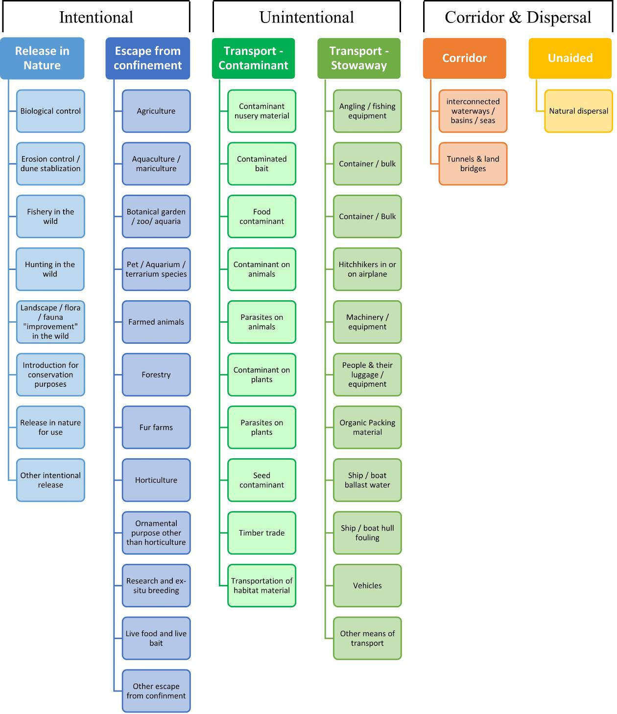

ANNEX V Ecosystem services classification (CICES V5.1, simplified) and examples
For the purposes of this risk assessment, please feel free to use what seems as the most appropriate category / level / combination of impact (Section – Division – Group), reflecting information available.

Section | Division | Group | Examples (i.e. relevant CICES “classes”)
Provisioning | Biomass | Cultivated terrestrial plants | Cultivated terrestrial plants (including fungi, algae) grown for nutritional purposes;  Fibres and other materials from cultivated plants, fungi, algae and bacteria for direct use or processing (excluding genetic materials);  Cultivated plants (including fungi, algae) grown as a source of energy  Example: negative impacts of non-native organisms to crops, orchards, timber etc.
 |  | Cultivated aquatic plants | Plants cultivated by in- situ aquaculture grown for nutritional purposes;  Fibres and other materials from in-situ aquaculture for direct use or processing (excluding genetic materials);  Plants cultivated by in- situ aquaculture grown as an energy source.  Example: negative impacts of non-native organisms to aquatic plants cultivated for nutrition, gardening etc. purposes.
 |  | Reared animals | Animals reared for nutritional purposes;  Fibres and other materials from reared animals for direct use or processing (excluding genetic materials);  Animals reared to provide energy (including mechanical)  Example: negative impacts of non-native organisms to livestock
 |  | Reared aquatic animals | Animals reared by in-situ aquaculture for nutritional purposes;  Fibres and other materials from animals grown by in-situ aquaculture for direct use or processing (excluding genetic materials);  Animals reared by in-situ aquaculture as an energy source  Example: negative impacts of non-native organisms to fish farming
 |  | Wild plants (terrestrial and aquatic) | Wild plants (terrestrial and aquatic, including fungi, algae) used for nutrition;  Fibres and other materials from wild plants for direct use or processing (excluding genetic materials);  Wild plants (terrestrial and aquatic, including fungi, algae) used as a source of energy  Example: reduction in the availability of wild plants (e.g. wild berries, ornamentals) due to non-native organisms (competition, spread of disease etc.)
 |  | Wild animals (terrestrial and aquatic) | Wild animals (terrestrial and aquatic) used for nutritional purposes;  Fibres and other materials from wild animals for direct use or processing (excluding genetic materials);  Wild animals (terrestrial and aquatic) used as a source of energy  Example: reduction in the availability of wild animals (e.g. fish stocks, game) due to non-native organisms (competition, predations, spread of disease etc.)
 | Genetic material from all biota | Genetic material from plants, algae or fungi | Seeds, spores and other plant materials collected for maintaining or establishing a population;  Higher and lower plants (whole organisms) used to breed new strains or varieties;  Individual genes extracted from higher and lower plants for the design and construction of new biological entities  Example: negative impacts of non-native organisms due to interbreeding
 |  | Genetic material from animals | Animal material collected for the purposes of maintaining or establishing a population;  Wild animals (whole organisms) used to breed new strains or varieties;  Individual genes extracted from organisms for the design and construction of new biological entities  Example: negative impacts of non-native organisms due to interbreeding
 | Water | Surface water used for nutrition, materials or energy | Surface water for drinking;  Surface water used as a material (non-drinking purposes);  Freshwater surface water, coastal and marine water used as an energy source  Example: loss of access to surface water due to spread of non-native organisms
 |  | Ground water for used for nutrition, materials or energy | Ground (and subsurface) water for drinking;  Ground water (and subsurface) used as a material (non-drinking purposes);  Ground water (and subsurface) used as an energy source  Example: reduced availability of ground water due to spread of non-native organisms and associated increase of ground water consumption by vegetation.
Regulation & Maintenance | Transformation of biochemical or physical inputs to ecosystems | Mediation of wastes or toxic substances of anthropogenic origin by living processes | Bio-remediation by micro-organisms, algae, plants, and animals; Filtration/sequestration/storage/accumulation by micro-organisms, algae, plants, and animals  Example: changes caused by non-native organisms to ecosystem functioning and ability to filtrate etc. waste or toxics
 |  | Mediation of nuisances of anthropogenic origin | Smell reduction; noise attenuation; visual screening (e.g. by means of green infrastructure)  Example: changes caused by non-native organisms to ecosystem structure, leading to reduced ability to mediate nuisances.
 | Regulation of physical, chemical, biological conditions | Baseline flows and extreme event regulation | Control of erosion rates;  Buffering and attenuation of mass movement;  Hydrological cycle and water flow regulation (Including flood control, and coastal protection);  Wind protection;  Fire protection  Example: changes caused by non-native organisms to ecosystem functioning or structure leading to, for example, destabilisation of soil, increased risk or intensity of wild fires etc.
 |  | Lifecycle maintenance, habitat and gene pool protection | Pollination (or 'gamete' dispersal in a marine context);  Seed dispersal;  Maintaining nursery populations and habitats (Including gene pool protection)  Example: changes caused by non-native organisms to the abundance and/or distribution of wild pollinators; changes to the availability / quality of nursery habitats for fisheries
 |  | Pest and disease control | Pest control;  Disease control  Example: changes caused by non-native organisms to the abundance and/or distribution of pests
 |  | Soil quality regulation | Weathering processes and their effect on soil quality;  Decomposition and fixing processes and their effect on soil quality  Example: changes caused by non-native organisms to vegetation structure and/or soil fauna leading to reduced soil quality
 |  | Water conditions | Regulation of the chemical condition of freshwaters by living processes;  Regulation of the chemical condition of salt waters by living processes  Example: changes caused by non-native organisms to buffer strips along water courses that remove nutrients in runoff and/or fish communities that regulate the resilience and resistance of water bodies to eutrophication
 |  | Atmospheric composition and conditions | Regulation of chemical composition of atmosphere and oceans;  Regulation of temperature and humidity, including ventilation and transpiration  Example: changes caused by non-native organisms to ecosystems’ ability to sequester carbon and/or evaporative cooling (e.g. by urban trees)
Cultural | Direct, in-situ and outdoor interactions with living systems that depend on presence in the environmental setting | Physical and experiential interactions with natural environment | Characteristics of living systems that that enable activities promoting health, recuperation or enjoyment through active or immersive interactions;  Characteristics of living systems that enable activities promoting health, recuperation or enjoyment through passive or observational interactions  Example: changes caused by non-native organisms to the qualities of ecosystems (structure, species composition etc.) that make it attractive for recreation, wild life watching etc.
 |  | Intellectual and representative interactions with natural environment | Characteristics of living systems that enable scientific investigation or the creation of traditional ecological knowledge;  Characteristics of living systems that enable education and training;  Characteristics of living systems that are resonant in terms of culture or heritage;  Characteristics of living systems that enable aesthetic experiences  Example: changes caused by non-native organisms to the qualities of ecosystems (structure, species composition etc.) that have cultural importance
 | Indirect, remote, often indoor interactions with living systems that do not require presence in the environmental setting | Spiritual, symbolic and other interactions with natural environment | Elements of living systems that have symbolic meaning;  Elements of living systems that have sacred or religious meaning;  Elements of living systems used for entertainment or representation  Example: changes caused by non-native organisms to the qualities of ecosystems (structure, species composition etc.) that have sacred or religious meaning
 |  | Other biotic characteristics that have a non-use value | Characteristics or features of living systems that have an existence value;  Characteristics or features of living systems that have an option or bequest value  Example: changes caused by non-native organisms to ecosystems designated as wilderness areas, habitats of endangered species etc.

ANNEX VI EU Biogeographic Regions and MSFD Subregions
See

http://ec.europa.eu/environment/nature/natura2000/biogeog_regions/

and

https://www.eea.europa.eu/data-and-maps/data/msfd-regions-and-subregions-1/technical-document/pdf
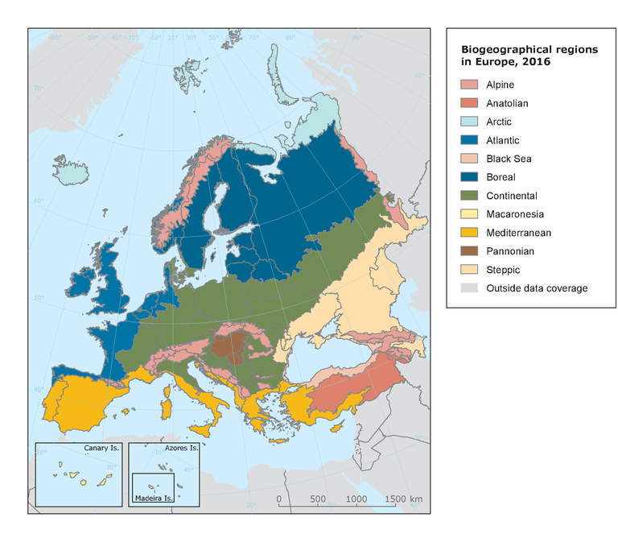

ANNEX VII Delegated Regulation (EU) 2018/968 of 30 April 2018
see https://eur-lex.europa.eu/legal-content/en/TXT/?uri=CELEX%3A32018R0968

ANNEX VIII Species Distribution Model
Projection of environmental suitability for Cherax destructor establishment in Europe
Björn Beckmann, Elena Tricarico and Dan Chapman

23 September 2021

Aim
To project the suitability for potential establishment of Cherax destructor in Europe, under current and predicted future climatic conditions.

Data for modelling
Species occurrence data were obtained from the Global Biodiversity Information Facility (GBIF) (3995 records), the Atlas of Living Australia (976 records), iNaturalist (64 records), the Integrated Digitized Biocollections (iDigBio) (1 records), and additional records from the risk assessment team. We scrutinised occurrence records from regions where the species is not known to be established and removed any dubious records or where the georeferencing was too imprecise (e.g. records referenced to a country or island centroid) or outside of the coverage of the predictor layers (e.g. small island or coastal occurrences). The remaining records were gridded at a 0.25 x 0.25 degree resolution for modelling, yielding 348 grid cells with occurrences (Figure 1a). As a proxy for recording effort, the density of terrestrial Decapoda records held by GBIF was also compiled on the same grid (Figure 1b).

Figure 1. (a) Occurrence records obtained for Cherax destructor and used in the modelling, showing native and invaded distributions. (b) The recording density of terrestrial Decapoda on GBIF, which was used as a proxy for recording effort.
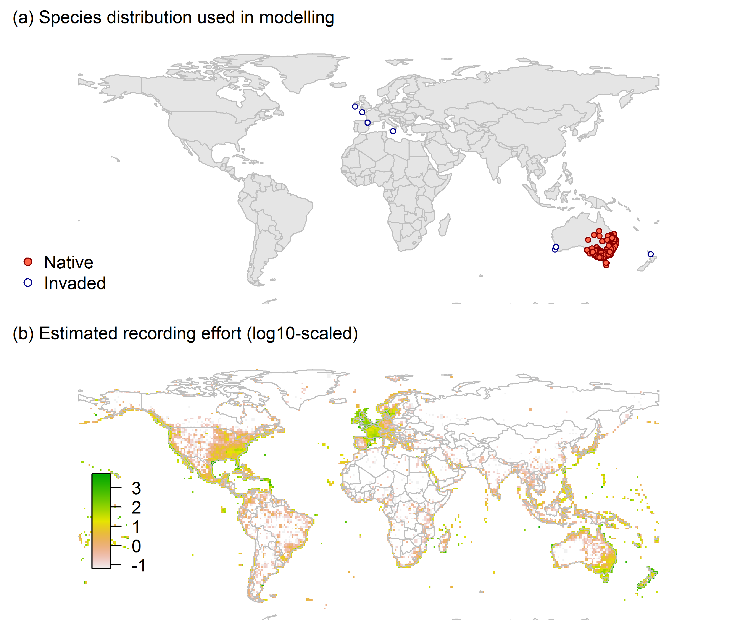

Climate data were selected from the ‘Bioclim’ variables contained within the WorldClim database (Hijmans et al. 2005), originally at 5 arcminute resolution (0.083 x 0.083 degrees of longitude/latitude) and aggregated to a 0.25 x 0.25 degree grid for use in the model.
Based on the biology of Cherax destructor, the following climate variables were used in the modelling:
- Temperature seasonality (Bio4)
- Maximum temperature of the warmest month (Bio5)
- Minimum temperature of the coldest month (Bio6)
- Mean temperature of the wettest quarter (Bio8)
- Annual precipitation (Bio12)
- Precipitation of the wettest month (Bio13)
- Precipitation seasonality (Bio15)
To estimate the effect of climate change on the potential distribution, equivalent modelled future climate conditions for the 2070s under the Representative Concentration Pathways (RCP) 2.6 and 4.5 were also obtained. These represent low and medium emissions scenarios, respectively. The above variables were obtained as averages of outputs of eight Global Climate Models (BCC-CSM1-1, CCSM4, GISS-E2-R, HadGEM2-AO, IPSL-CM5A-LR, MIROC-ESM, MRI-CGCM3, NorESM1-M), downscaled and calibrated against the WorldClim baseline (see http://www.worldclim.org/cmip5_5m).

Species distribution model
A presence-background (presence-only) ensemble modelling strategy was employed using the BIOMOD2 R package version 3.4.6 (Thuiller et al. 2020; Thuiller et al. 2009). These models contrast the environment at the species’ occurrence locations against a random sample of the global background environmental conditions (often termed ‘pseudo-absences’) in order to characterise and project suitability for occurrence. This approach has been developed for distributions that are in equilibrium with the environment. Because invasive species’ distributions are not at equilibrium and subject to dispersal constraints at a global scale, we took care to minimise the inclusion of locations suitable for the species but where it has not been able to disperse to (Chapman et al. 2019). Therefore the background sampling region included:
- The area accessible by native Cherax destructor populations, in which the species is likely to have had sufficient time to disperse to all locations. Based on presumed maximum dispersal distances, the accessible region was defined as a 400km buffer around the native range occurrences; AND
- A 30km buffer around the non-native occurrences, encompassing regions likely to have had high propagule pressure for introduction by humans and/or natural dispersal of the species; AND
- Regions where we have an a priori expectation of high unsuitability for the species so that absence is assumed irrespective of dispersal constraints (see Figure 2). The following rules were applied to define a region expected to be highly unsuitable for Cherax destructor at the spatial scale of the model:
  - Minimum temperature of the coldest month (Bio6) < -3°C
  - Maximum temperature of the warmest month (Bio5) < 20°C
  - Annual precipitation (Bio12) < 200mm

Altogether, 1.1% of occurrence grid cells were located in the unsuitable background region.
Within the unsuitable background region, 10 samples of 5000 randomly sampled grid cells were obtained. In the accessible background (comprising the accessible areas around native and non-native occurrences as detailed above), the same number of pseudo-absence samples were drawn as there were presence records (348), weighting the sampling by a proxy for recording effort (Figure 2).

Figure 2. The background from which pseudo-absence samples were taken in the modelling of Cherax destructor. Samples were taken from a 400km buffer around the native range and a 30km buffer around non-native occurrences (together forming the accessible background), and from areas expected to be highly unsuitable for the species (the unsuitable background region). Samples from the accessible background were weighted by a proxy for recording effort (Figure 1(b)).

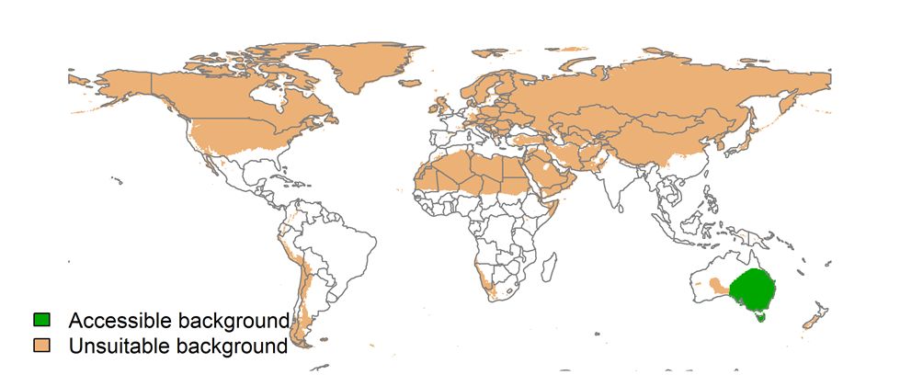
Each dataset (i.e. combination of the presences and the individual background samples) was randomly split into 80% for model training and 20% for model evaluation. With each training dataset, seven statistical algorithms were fitted with the default BIOMOD2 settings and rescaled using logistic regression, except where specified below:
- Generalised linear model (GLM)
- Generalised boosting model (GBM)
- Generalised additive model (GAM) with a maximum of four degrees of freedom per smoothing spline
- Artificial neural network (ANN)
- Multivariate adaptive regression splines (MARS)
- Random forest (RF)
- Maxent

Since the total background sample was larger than the number of occurrences, prevalence fitting weights were applied to give equal overall importance to the occurrences and the background. Normalised variable importance was assessed and variable response functions were produced using BIOMOD2’s default procedure.
Model predictive performance was assessed by the following three measures:
- AUC, the area under the receiver operating characteristic curve (Fielding & Bell 1997). Predictions of presence-absence models can be compared with a subset of records set aside for model evaluation (here 20%) by constructing a confusion matrix with the number of true positive, false positive, false negative and true negative cases. For models generating non-dichotomous scores (as here) a threshold can be applied to transform the scores into a dichotomous set of presence-absence predictions. Two measures that can be derived from the confusion matrix are sensitivity (the proportion of observed presences that are predicted as such, quantifying omission errors), and specificity (the proportion of observed absences that are predicted as such, quantifying commission errors). A receiver operating characteristic (ROC) curve can be constructed by using all possible thresholds to classify the scores into confusion matrices, obtaining sensitivity and specificity for each matrix, and plotting sensitivity against the corresponding proportion of false positives (equal to 1 - specificity). The use of all possible thresholds avoids the need for a selection of a single threshold, which is often arbitrary, and allows appreciation of the trade-off between sensitivity and specificity. The area under the ROC curve (AUC) is often used as a single threshold-independent measure for model performance (Manel et al. 2001). AUC is the probability that a randomly selected presence has a higher model-predicted suitability than a randomly selected absence (Allouche et al. 2006).
- Cohen’s Kappa (Cohen 1960). This measure corrects the overall accuracy of model predictions (ratio of the sum of true presences plus true absences to the total number of records) by the accuracy expected to occur by chance. The kappa statistic ranges from -1 to +1, where +1 indicates perfect agreement and values of zero or less indicate a performance no better than random. Advantages of kappa are its simplicity, the fact that both commission and omission errors are accounted for in one parameter, and its relative tolerance to zero values in the confusion matrix (Manel et al. 2001). However, Kappa has been criticised for being sensitive to prevalence (the proportion of sites in which the species was recorded as present) and may therefore be inappropriate for comparisons of model accuracy between species or regions (McPherson et al. 2004; Allouche et al. 2006).
- TSS, the true skill statistic (Allouche et al. 2006). TSS is defined as sensitivity + specificity - 1, and corrects for Kappa’s dependency on prevalence. TSS compares the number of correct forecasts, minus those attributable to random guessing, to that of a hypothetical set of perfect forecasts. Like kappa, TSS takes into account both omission and commission errors, and success as a result of random guessing, and ranges from -1 to +1, where +1 indicates perfect agreement and values of zero or less indicate a performance no better than random (Allouche et al. 2006).
An ensemble model was created by first rejecting poorly performing algorithms with relatively extreme low AUC values and then averaging the predictions of the remaining algorithms, weighted by their AUC. To identify poorly performing algorithms, AUC values were converted into modified z-scores based on their difference to the median and the median absolute deviation across all algorithms (Iglewicz & Hoaglin 1993). Algorithms with z < -2 were rejected. In this way, ensemble projections were made for each dataset and then averaged to give an overall suitability, as well as its standard deviation. The projections were then classified into suitable and unsuitable regions using a “minimum presence threshold”, setting the cut-off as the lowest value at which 98% of all presence records are classified correctly.
Projections were classified into suitable and unsuitable regions using a “lowest presence threshold” (Pearson et al. 2007), setting the cut-off as the lowest value at which 98% of all presence records are classified correctly under the current climate (here 0.68). In order to express the sensitivity of classifications to the choice of this threshold, thresholds at which 95% and 99% of records are classified correctly (here 0.81 and 0.55 respectively) were used in the calculation of error bars in Figs. 9 and 10 below in addition to taking account of uncertainty in the projections themselves.
We also produced limiting factor maps for Europe following Elith et al. (2010). For this, projections were made separately with each individual variable fixed at a near-optimal value. These were chosen as the median values at the occurrence grid cells. Then, the most strongly limiting factors were identified as the one resulting in the highest increase in suitability in each grid cell.

Results
The ensemble model suggested that suitability for Cherax destructor was most strongly determined by Temperature seasonality (Bio4), accounting for 36.1% of variation explained, followed by Minimum temperature of the coldest month (Bio6) (23.2%), Maximum temperature of the warmest month (Bio5) (16.5%), Annual precipitation (Bio12) (11.3%), Precipitation of the wettest month (Bio13) (5.7%), Precipitation seasonality (Bio15) (4.7%) and Mean temperature of the wettest quarter (Bio8) (2.6%) (Table 1, Figure 3).
Table 1. Summary of the cross-validation predictive performance (AUC, Kappa, TSS) and variable importance of the fitted model algorithms and the ensemble (AUC-weighted average of the best performing algorithms). Results are the average from models fitted to 10 different background samples of the data.
 |  |  |  |  | Variable importance (%)
Algorithm | AUC | Kappa | TSS | Used in the ensemble | Temperature seasonality (Bio4) | Minimum temperature of the coldest month (Bio6) | Maximum temperature of the warmest month (Bio5) | Annual precipitation (Bio12) | Precipitation of the wettest month (Bio13) | Precipitation seasonality (Bio15) | Mean temperature of the wettest quarter (Bio8)
GLM | 0.985 | 0.742 | 0.935 | yes | 28 | 23 | 14 | 8 | 16 | 10 | 2
GAM | 0.984 | 0.743 | 0.938 | yes | 37 | 24 | 12 | 14 | 5 | 5 | 4
GBM | 0.985 | 0.731 | 0.939 | yes | 56 | 4 | 24 | 15 | 0 | 1 | 0
ANN | 0.985 | 0.750 | 0.935 | yes | 28 | 29 | 20 | 5 | 7 | 5 | 5
MARS | 0.983 | 0.716 | 0.926 | yes | 31 | 37 | 13 | 14 | 0 | 3 | 2
RF | 0.979 | 0.729 | 0.920 | no | 20 | 24 | 28 | 18 | 3 | 4 | 4
Maxent | 0.976 | 0.711 | 0.911 | no | 29 | 20 | 18 | 19 | 4 | 5 | 6
Ensemble | 0.986 | 0.745 | 0.939 |  | 36 | 23 | 17 | 11 | 6 | 5 | 3

Figure 3. Partial response plots from the fitted models. Thin coloured lines show responses from the algorithms in the ensemble, while the thick black line is their ensemble. In each plot, other model variables are held at their median value in the training data. Some of the divergence among algorithms is because of their different treatment of interactions among variables.
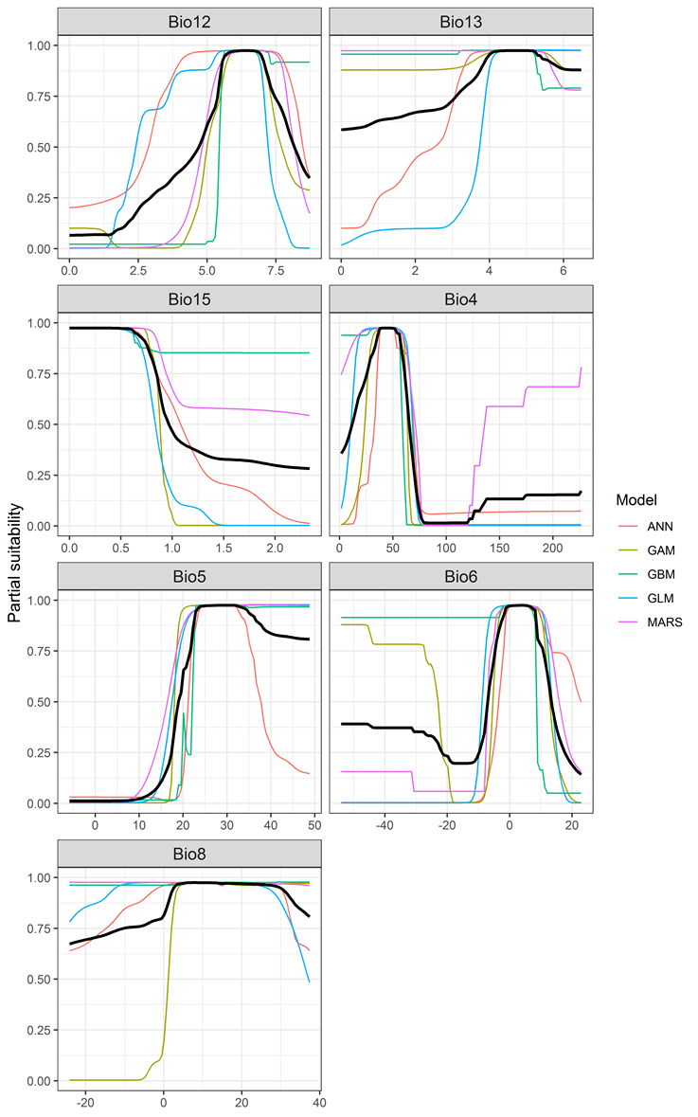

Figure 4. (a) Projected global suitability for Cherax destructor establishment in the current climate. For visualisation, the projection has been aggregated to a 0.5 x 0.5 degree resolution, by taking the maximum suitability of constituent higher resolution grid cells. Values > 0.68 are suitable for the species, with 98% of global presence records above this threshold. Values below 0.68 indicate lower relative suitability. (b) Uncertainty in the ensemble projections, expressed as the among-algorithm standard deviation in predicted suitability, averaged across the 10 datasets.

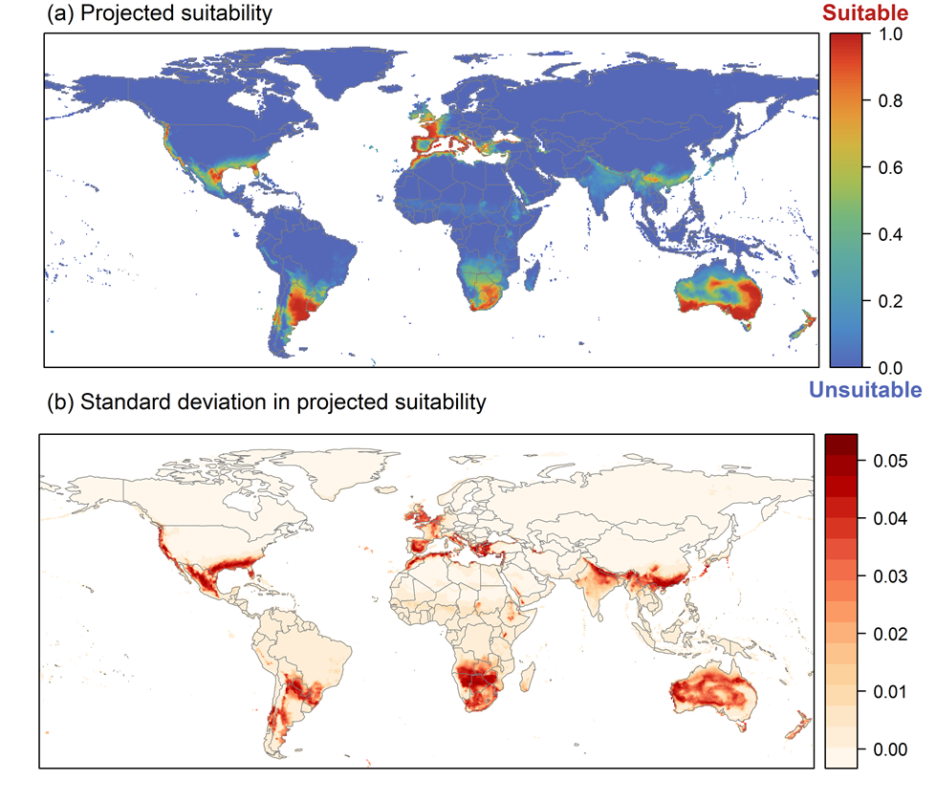

Figure 5. (a) Projected current suitability for Cherax destructor establishment in Europe and the Mediterranean region. Values > 0.68 are suitable for the species, with 98% of global presence records above this threshold. Values below 0.68 indicate lower relative suitability. (b) Uncertainty in the ensemble projections, expressed as the among-algorithm standard deviation in predicted suitability, averaged across the 10 datasets.
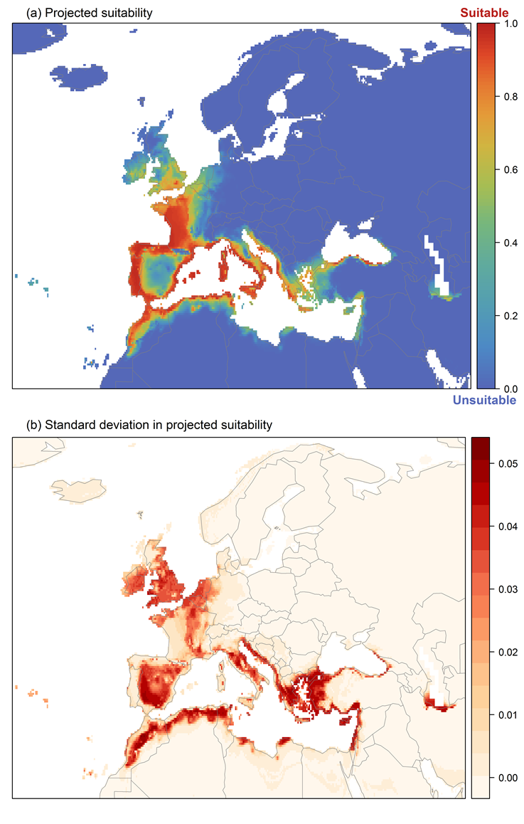

Figure 6. The most strongly limiting factors for Cherax destructor establishment estimated by the model in Europe and the Mediterranean region in current climatic conditions.

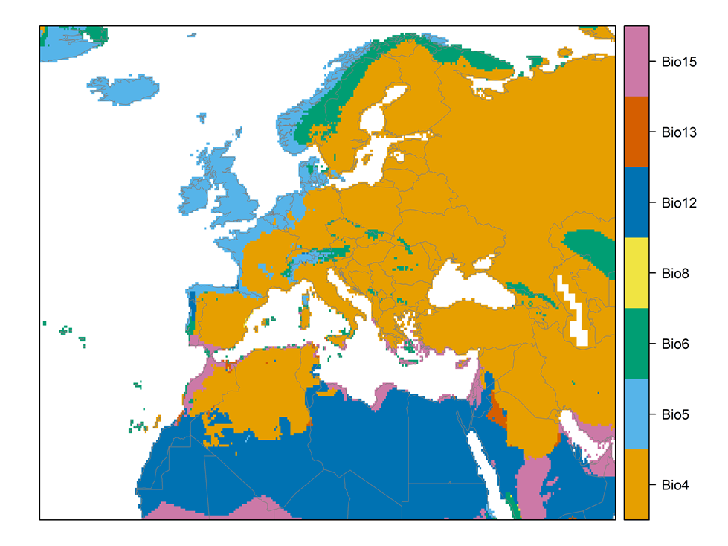

Figure 7. (a) Projected suitability for Cherax destructor establishment in Europe and the Mediterranean region in the 2070s under climate change scenario RCP2.6. Values > 0.68 are suitable for the species, with 98% of global presence records above this threshold under current climate. Values below 0.68 indicate lower relative suitability. (b) Uncertainty in the ensemble projections, expressed as the among-algorithm standard deviation in predicted suitability, averaged across the 10 datasets.
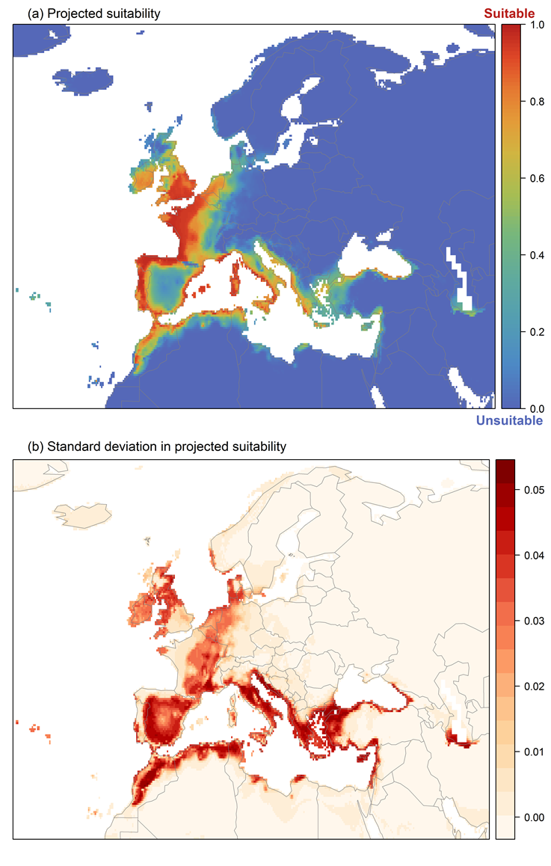
Figure 8. (a) Projected suitability for Cherax destructor establishment in Europe and the Mediterranean region in the 2070s under climate change scenario RCP4.5. Values > 0.68 are suitable for the species, with 98% of global presence records above this threshold under current climate. Values below 0.68 indicate lower relative suitability. (b) Uncertainty in the ensemble projections, expressed as the among-algorithm standard deviation in predicted suitability, averaged across the 10 datasets.
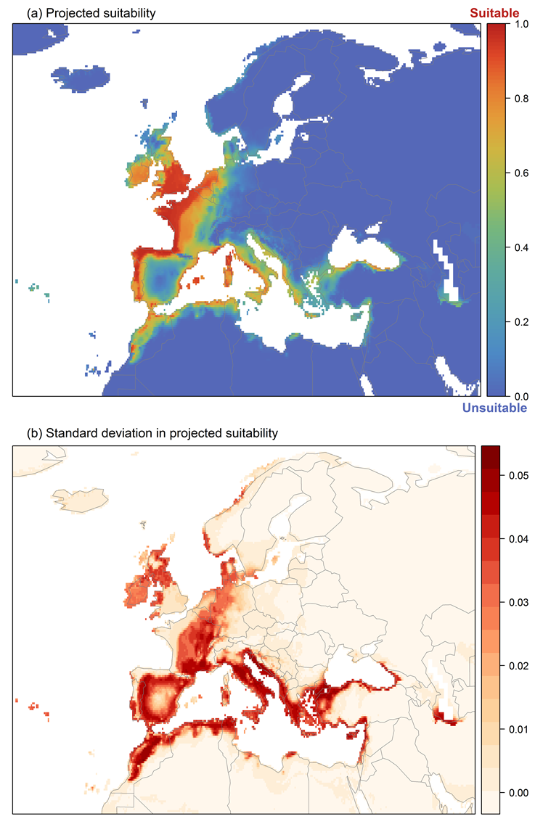

Figure 9. Variation in projected suitability for Cherax destructor establishment among Biogeographical Regions of Europe (https://www.eea.europa.eu/data-and-maps/data/biogeographical-regions-europe-3). The bar plots show the proportion of grid cells in each region classified as suitable (with values > 0.68) in the current climate and projected climate for the 2070s under two RCP emissions scenarios. Error bars indicate uncertainty due to both the choice of classification threshold (cf. p.5/6) and uncertainty in the projections themselves (cf. part (b) of Figures 5, 7 and 8). The location of each region is also shown. The Arctic and Macaronesian regions are not part of the study area, but are included for completeness.
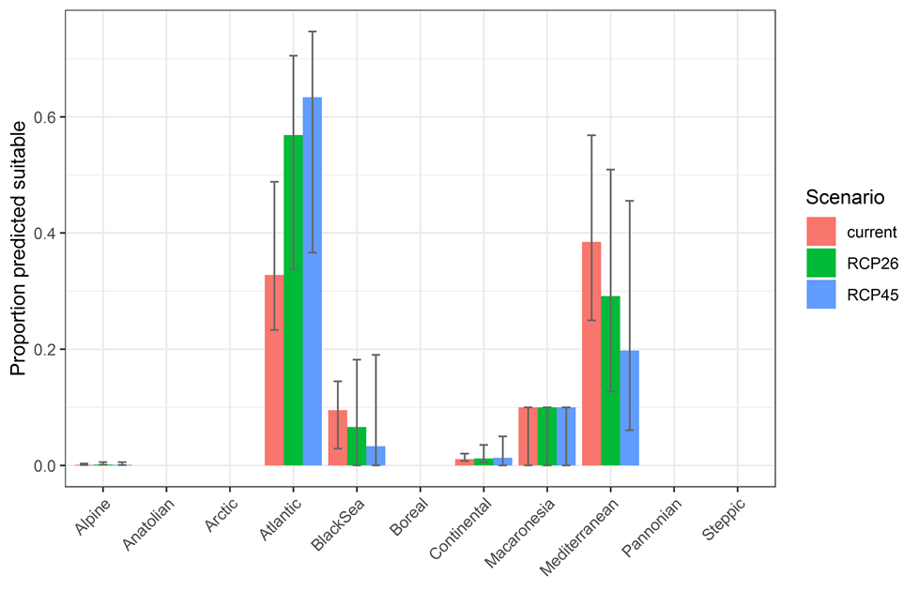
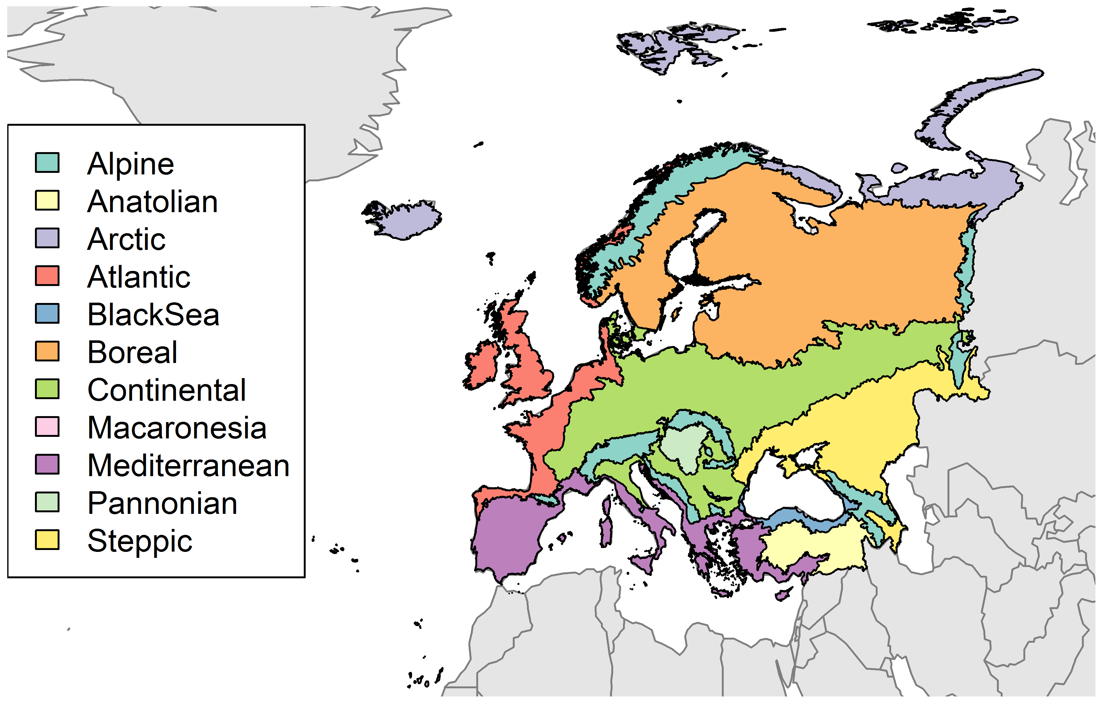

Table 2. Variation in projected suitability for Cherax destructor establishment among Biogeographical regions of Europe (numerical values of Figure 9 above). The numbers are the proportion of grid cells in each region classified as suitable in the current climate and projected climate for the 2070s under two RCP emissions scenarios. The Arctic and Macaronesian biogeographical regions are not part of the study area, but are included for completeness.

 | current climate |  |  | 2070s RCP2.6 |  |  | 2070s RCP4.5
 | lower | central estimate | upper | lower | central estimate | upper | lower | central estimate | upper
Alpine | 0.00 | 0.00 | 0.00 | 0.00 | 0.00 | 0.01 | 0.00 | 0.00 | 0.01
Anatolian | 0.00 | 0.00 | 0.00 | 0.00 | 0.00 | 0.00 | 0.00 | 0.00 | 0.00
Arctic | 0.00 | 0.00 | 0.00 | 0.00 | 0.00 | 0.00 | 0.00 | 0.00 | 0.00
Atlantic | 0.23 | 0.33 | 0.49 | 0.34 | 0.57 | 0.71 | 0.37 | 0.63 | 0.75
Black Sea | 0.03 | 0.10 | 0.14 | 0.00 | 0.07 | 0.18 | 0.00 | 0.03 | 0.19
Boreal | 0.00 | 0.00 | 0.00 | 0.00 | 0.00 | 0.00 | 0.00 | 0.00 | 0.00
Continental | 0.01 | 0.01 | 0.02 | 0.01 | 0.01 | 0.04 | 0.00 | 0.01 | 0.05
Macaronesia | 0.00 | 0.10 | 0.10 | 0.00 | 0.10 | 0.10 | 0.00 | 0.10 | 0.10
Mediterranean | 0.25 | 0.38 | 0.57 | 0.13 | 0.29 | 0.51 | 0.06 | 0.20 | 0.46
Pannonian | 0.00 | 0.00 | 0.00 | 0.00 | 0.00 | 0.00 | 0.00 | 0.00 | 0.00
Steppic | 0.00 | 0.00 | 0.00 | 0.00 | 0.00 | 0.00 | 0.00 | 0.00 | 0.00

Figure 10. Variation in projected suitability for Cherax destructor establishment among European Union countries and the UK. The bar plots show the proportion of grid cells in each country classified as suitable (with values > 0.68) in the current climate and projected climate for the 2070s under two RCP emissions scenarios. Error bars indicate uncertainty due to both the choice of classification threshold (cf. p.5/6) and uncertainty in the projections themselves (cf. part (b) of Figures 5, 7 and 8).

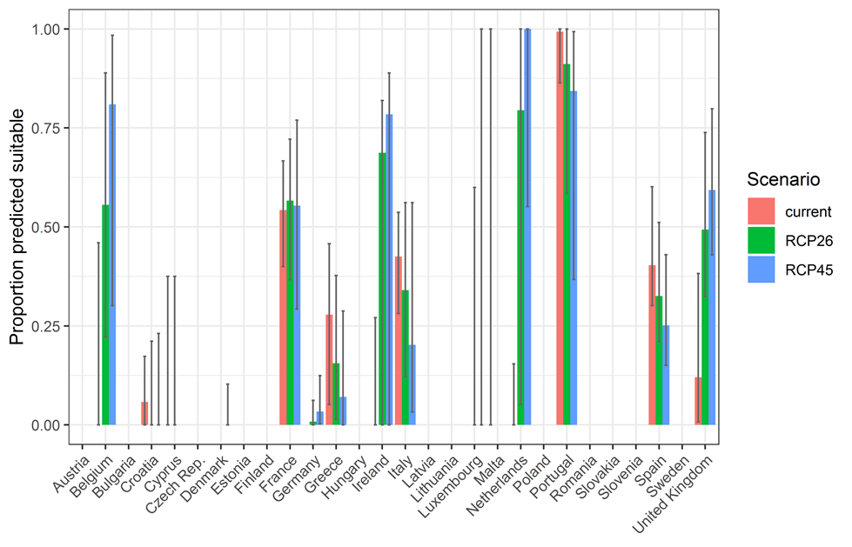

Table 3. Variation in projected suitability for Cherax destructor establishment among European Union countries and the UK (numerical values of Figure 10 above). The numbers are the proportion of grid cells in each country classified as suitable in the current climate and projected climate for the 2070s under two RCP emissions scenarios.
 | current climate |  |  | 2070s RCP2.6 |  |  | 2070s RCP4.5
 | lower | central estimate | upper | lower | central estimate | upper | lower | central estimate | upper
Austria | 0.00 | 0.00 | 0.00 | 0.00 | 0.00 | 0.00 | 0.00 | 0.00 | 0.00
Belgium | 0.00 | 0.00 | 0.46 | 0.22 | 0.56 | 0.89 | 0.30 | 0.81 | 0.98
Bulgaria | 0.00 | 0.00 | 0.00 | 0.00 | 0.00 | 0.00 | 0.00 | 0.00 | 0.00
Croatia | 0.00 | 0.06 | 0.17 | 0.00 | 0.00 | 0.21 | 0.00 | 0.00 | 0.23
Cyprus | 0.00 | 0.00 | 0.38 | 0.00 | 0.00 | 0.38 | 0.00 | 0.00 | 0.00
Czech Rep. | 0.00 | 0.00 | 0.00 | 0.00 | 0.00 | 0.00 | 0.00 | 0.00 | 0.00
Denmark | 0.00 | 0.00 | 0.00 | 0.00 | 0.00 | 0.00 | 0.00 | 0.00 | 0.10
Estonia | 0.00 | 0.00 | 0.00 | 0.00 | 0.00 | 0.00 | 0.00 | 0.00 | 0.00
Finland | 0.00 | 0.00 | 0.00 | 0.00 | 0.00 | 0.00 | 0.00 | 0.00 | 0.00
France | 0.40 | 0.54 | 0.67 | 0.37 | 0.57 | 0.72 | 0.29 | 0.55 | 0.77
Germany | 0.00 | 0.00 | 0.00 | 0.00 | 0.01 | 0.06 | 0.00 | 0.03 | 0.12
Greece | 0.05 | 0.28 | 0.46 | 0.01 | 0.16 | 0.38 | 0.00 | 0.07 | 0.29
Hungary | 0.00 | 0.00 | 0.00 | 0.00 | 0.00 | 0.00 | 0.00 | 0.00 | 0.00
Ireland | 0.00 | 0.00 | 0.27 | 0.00 | 0.69 | 0.82 | 0.00 | 0.78 | 0.89
Italy | 0.28 | 0.43 | 0.54 | 0.12 | 0.34 | 0.56 | 0.03 | 0.20 | 0.56
Latvia | 0.00 | 0.00 | 0.00 | 0.00 | 0.00 | 0.00 | 0.00 | 0.00 | 0.00
Lithuania | 0.00 | 0.00 | 0.00 | 0.00 | 0.00 | 0.00 | 0.00 | 0.00 | 0.00
Luxembourg | 0.00 | 0.00 | 0.00 | 0.00 | 0.00 | 0.60 | 0.00 | 0.00 | 1.00
Malta | 0.00 | 0.00 | 1.00 | 0.00 | 0.00 | 0.00 | 0.00 | 0.00 | 0.00
Netherlands | 0.00 | 0.00 | 0.15 | 0.05 | 0.79 | 1.00 | 0.55 | 1.00 | 1.00
Poland | 0.00 | 0.00 | 0.00 | 0.00 | 0.00 | 0.00 | 0.00 | 0.00 | 0.00
Portugal | 0.86 | 0.99 | 1.00 | 0.59 | 0.91 | 1.00 | 0.37 | 0.84 | 0.99
Romania | 0.00 | 0.00 | 0.00 | 0.00 | 0.00 | 0.00 | 0.00 | 0.00 | 0.00
Slovakia | 0.00 | 0.00 | 0.00 | 0.00 | 0.00 | 0.00 | 0.00 | 0.00 | 0.00
Slovenia | 0.00 | 0.00 | 0.00 | 0.00 | 0.00 | 0.00 | 0.00 | 0.00 | 0.00
Spain | 0.30 | 0.40 | 0.60 | 0.21 | 0.33 | 0.51 | 0.15 | 0.25 | 0.43
Sweden | 0.00 | 0.00 | 0.00 | 0.00 | 0.00 | 0.00 | 0.00 | 0.00 | 0.00
UK | 0.01 | 0.12 | 0.38 | 0.32 | 0.49 | 0.74 | 0.43 | 0.59 | 0.80

Caveats to the modelling
To remove spatial recording biases, the selection of the background sample from the accessible background was weighted by the density of Decapoda records on the Global Biodiversity Information Facility (GBIF). While this is preferable to not accounting for recording bias at all, it may not provide the perfect measure of recording bias.
There was substantial variation among modelling algorithms in the partial response plots (Figure 3). In part this will reflect their different treatment of interactions among variables. Since partial plots are made with other variables held at their median, there may be values of a particular variable at which this does not provide a realistic combination of variables to predict from.
Other variables potentially affecting the distribution of the species, such as types of land cover were not included in the model.

References
- Allouche O, Tsoar A, Kadmon R. 2006. Assessing the accuracy of species distribution models: prevalence, kappa and the true skill statistic (TSS), Journal of Applied Ecology 43: 1223-1232.
- Chapman D, Pescott OL, Roy HE, Tanner R. 2019. Improving species distribution models for invasive non-native species with biologically informed pseudo-absence selection. Journal of Biogeography 46: 1029-1040.
- Cohen J. 1960. A coefficient of agreement of nominal scales. Educational and Psychological Measurement 20: 37-46.
- Elith J, Kearney M, Phillips S. 2010. The art of modelling range-shifting species. Methods in Ecology and Evolution 1: 330-342.
- Fielding AH, Bell JF. 1997. A review of methods for the assessment of prediction errors in conservation presence/absence models. Environmental Conservation 24: 38-49.
- Hijmans RJ, Cameron SE, Parra JL, Jones PG, Jarvis A. 2005. Very high resolution interpolated climate surfaces for global land areas. International Journal of Climatology 25: 1965-1978.
- Iglewicz B, Hoaglin DC. 1993. How to detect and handle outliers. Asq Press.
- Manel S, Williams HC, Ormerod SJ. 2001. Evaluating presence-absence models in ecology: the need to account for prevalence. Journal of Applied Ecology 38: 921-931.
- McPherson JM, Jetz W, Rogers DJ. 2004. The effects of species’ range sizes on the accuracy of distribution models: ecological phenomenon or statistical artefact? Journal of Applied Ecology 41: 811-823.
- Pearson RG, Raxworthy CJ, Nakamura M, Townsend Peterson A. 2007., Predicting species distributions from small numbers of occurrence records: a test case using cryptic geckos in Madagascar. Journal of Biogeography 34: 102-117.
- Thuiller W, Lafourcade B, Engler R, Araújo MB. 2009. BIOMOD-a platform for ensemble forecasting of species distributions. Ecography 32: 369-373.
- Thuiller W, Georges D, Engler R and Breiner F. 2020. biomod2: Ensemble Platform for Species Distribution Modeling. R package version 3.4.6. https://CRAN.R-project.org/package=biomod2

This template is based on the Great Britain non-native species risk assessment scheme (GBNNRA). A number of amendments have been introduced to ensure compliance with Regulation (EU) 1143/2014 on IAS and relevant legislation, including the Delegated Regulation (EU) 2018/968 of 30 April 2018, supplementing Regulation (EU) No 1143/2014 of the European Parliament and of the Council with regard to risk assessments in relation to invasive alien species (see https://eur-lex.europa.eu/legal-content/en/TXT/?uri=CELEX%3A32018R0968).
Crandall & De Grave (2017) reported Cherax davisi Clark, 1941a and Cherax esculus Riek, 1956 as possible synonyms but they were not mentioned in the current literature or other websites.
https://www.pixtastock.com/photo/38959707
Convention on Biological Diversity, Decision VI/23
https://circabc.europa.eu/sd/a/7e5f0bd4-34e8-4719-a2f7-c0cd7ec6a86e/2020-CBD-pathways-interpretation.pdf
https://circabc.europa.eu/sd/a/0aeba7f1-c8c2-45a1-9ba3-bcb91a9f039d/TSSR-2016-010%20CBD%20pathways%20key%20full%20only.pdf
Not to be confused with “no impact”.
Note: in the CICES classification provisioning of water is considered as an abiotic service whereas the rest of ecosystem services listed here are considered biotic.

