**Risk assessment template developed under the "Study on Invasive Alien Species – Development of risk assessments to tackle priority species and enhance prevention"   
Contract No 07.0202/2020/834529/ETU/ENV.D.2[1]**

**Name of organism:** Sika deer (*Cervus nippon*)

**Author(s) of the assessment:**

*Riccardo Scalera, IUCN SSC Invasive Species Specialist Group, Rome, Italy*

*Tim Adriaens, Research Institute for Nature and Forest (INBO), Brussels, Belgium*

*Bram D’hondt, Research Institute for Nature and Forest (INBO), Brussels, Belgium*

*Peter Robertson, Newcastle University, United Kingdom*

*Björn Beckmann, Centre for Ecology and Hydrology (CEH), Wallingford, United Kingdom*

**Risk Assessment Area:** The risk assessment area is the territory of the European Union 27 and the United Kingdom, excluding the EU-outermost regions

**Peer review 1:** Wojciech Solarz, Institute of Nature Conservation, Polish Academy of Sciences, Kraków, Poland

**Peer review 2:** Alastair I. Ward, University of Hull, Hull, United Kingdom

**Date of completion: 15 October 2021**

**Date of revision: 30 September 2022**

**Contents**

SECTION A – Organism Information and Screening 3

SECTION B – Detailed assessment 15

1 PROBABILITY OF INTRODUCTION AND ENTRY 15

2 PROBABILITY OF ESTABLISHMENT 32

3 PROBABILITY OF SPREAD 39

4 MAGNITUDE OF IMPACT 45

Biodiversity and ecosystem impacts 45

Ecosystem Services impacts 51

Economic impacts 53

Social and human health impacts 56

Other impacts 58

RISK SUMMARIES 62

REFERENCES 64

Distribution Summary 72

ANNEX I Scoring of Likelihoods of Events 74

ANNEX II Scoring of Magnitude of Impacts 75

ANNEX III Scoring of Confidence Levels 76

ANNEX IV CBD pathway categorisation scheme 77

ANNEX V Ecosystem services classification (CICES V5.1, simplified) and examples 78

ANNEX VI EU Biogeographic Regions and MSFD Subregions 82

ANNEX VII Delegated Regulation (EU) 2018/968 of 30 April 2018 83

ANNEX VIII Projection of environmental suitability for sika deer *Cervus nippon* establishment in Europe 84

# SECTION A – Organism Information and Screening

|  |
| --- |
| **A1. Identify the organism. Is it clearly a single taxonomic entity and can it be adequately distinguished from other entities of the same rank?**  including the following elements:   * the taxonomic family, order and class to which the species belongs; * the scientific name and author of the species, as well as a list of the most common synonym names; * names used in commerce (if any) * a list of the most common subspecies, lower taxa, varieties, breeds or hybrids   As a general rule, one risk assessment should be developed for a single species. However, there may be cases where it may be justified to develop one risk assessment covering more than one species (e.g. species belonging to the same genus with comparable or identical features and impact). It shall be clearly stated if the risk assessment covers more than one species, or if it excludes or only includes certain subspecies, lower taxa, hybrids, varieties or breeds (and if so, which subspecies, lower taxa, hybrids, varieties or breeds). Any such choice must be properly justified. |

This risk assessment covers one species, the sika deer *Cervus nippon* Temminck, 1838, also known as Japanese Sika (deer) (Class: Mammalia, Order: Artiodactyla, Family: Cervidae, Subfamily: Cervinae, Genus: *Cervus*). All subspecies and hybrids are also included in the risk assessment (see details below).

Synonym(s): Main synonyms are *Cervus sika* and *Cervus japonicus* (for additional information see Feldhamer 1980).

Sika are native to Japan, Taiwan and Eastern Asia (namely China, Korea, Russia, Vietnam) and two main lineages are recognised, a northern and a southern one, with several subspecies, ranging from 10 to 16 (see, for example, Wilson and Reeder 2005, Wilson and Mittermeier 2011) whose validity is questionable. The study of the species taxonomy is also affected by the fact that many source populations have uncertain or mixed origin due to several introductions and translocations that occurred in the past (Feldhamer 1980, Wilson and Reeder 2005, Wilson and Mittermeier 2011, Harris 2015, CABI 2021). Some subspecies are possibly extinct in the wild (Wilson and Mittermeier 2011). The following list of main subspecies (including information on those possibly extinct in the wild, and on the relevant distribution) is excerpted from Wilson and Mittermeier (2011). This list may become modified with new research:

* *C. n. nippon* Temminck, 1838 — S Japan (S Honshu, Shikoku, Kiushu, N Ryukyu, and several smaller associated Is).
* *C. n. centralis* Kishida, 1936 — C Japan (N & C Honshu).
* *C. n. grassianus* Heade, 1884 — N China (Shanxi); possibly extinct in the wild.
* *C. n. kopschi* Swinhoe, 1873 — SE China.
* *C. n. mandarinus* Milne-Edwards, 1871 — N China (Hebei & Shandong); possibly extinct in the wild.
* *C. n. mantschuricus* Swinhoe, 1864 — Ussuriland (Russian Far East), NE China (Hei-longjiang), and possibly North Korea.
* *C. n. pseudaxis* Gervais, 1841 — N Vietnam; probably extinct in the wild.
* *C. n. sichuanicus* Guo, Cheng & Wang, 1978 — SW China (Sichuan & Gansu).
* *C. n. taiouanus* Blyth, 1860 — Taiwan.
* *C. n. yesanzsis* Heude, 1884 — N Japan (Hokkaido).

For the purpose of the present risk assessment, it is important to point out that sika deer represent a monophyletic lineage that is endemic to Asia and has speciated long ago away from *C. elaphus* (Cook et al. 1999). It is also of interest to remark that introduced populations are mostly from animals originating from Japan, but also from other parts of Asia (as in the case of the Czech Republic, Linnell and Zachos 2011)*.* However, the exact geographical origin of sika deer introduced in Europe cannot be clearly ascertained due to the lack of documented evidences, and the fact that different subspecies had been mixed and intercrossed (Bartoš 2009). In particular, animals introduced in Europe are deemed to originate mainly from captive Asian populations, which were probably subject to human manipulation through farming, artificial selection and translocations (Baiwy et al. 2013).

Sikamay hybridise and produce fertile offspring with the only congeneric species in the risk assessment area, the native red deer (*Cervus elaphus*)(Wilson and Reeder 2005). Introgression may also occur, as the fertile hybrids usually backcross with either parent species, and this leads to increased phenotypic similarity between the two species, which makes further hybridisation more likely (Zachos and Hartl 2011). Hybrids occur when sika are introduced outside their natural range, however, sika and red deer also hybridise naturally where they overlap in Far East Russia (Bartoš 2009). Since sika and sika-red deer hybrids are present in Europe both in captivity and in the wild, and since many free ranging populations of sika include to some extent sika-hybrids (Baiwy et al. 2013), the present risk assessment applies both to pure sika deer and its hybrids when referring to the Risk Assessment area.

|  |
| --- |
| **A2. Provide information on the existence of other species that look very similar [that may be detected in the risk assessment area, either in the environment, in confinement or associated with a pathway of introduction]**  Include both native and non-native species that could be confused with the species being assessed, including the following elements:   * other alien species with similar invasive characteristics, to be avoided as substitute species (in this case preparing a risk assessment for more than one species together may be considered); * other alien species without similar invasive characteristics, potential substitute species; * native species, potential misidentification and mis-targeting |

Sika are small to medium-sized deer, and are extremely variable in size and body weight both between and within subspecies. Females are about 60-95 cm at shoulder height, and males 65-115 cm. Their weight ranges from 20-90 kg in females and 30-140 kg in males (Wilson and Mittermeier 2011). Sexual dimorphism is very pronounced, as body measurements of adult males averaged 8.7% more than those of females (Feldhamer 1980), while males are 40-70% heavier than females (Wilson and Mittermeier 2011). The species shows extensive variation in size and colours within and between populations (Baiwy et al. 2013). Pelage can vary from chestnut to yellow in summer, and grey to almost black in winter, depending on the subspecies. Similarly, the distinct white spots can be present throughout the year, or only in summer, depending on the subspecies. The rump (caudal) patch, which is the most characteristic feature, is white with a black outline on top, and is crossed by the tail, which is white with a median black stripe of variable thickness. Also the head has some distinctive features, with dark lines above the eyes and a short stubby muzzle which give sika deer a typical “frowning” expression (Booy et al. 2015). The pale U-shaped band between the eyes is also distinctive. A good distinguishing character is the prominent white scent gland often visible on the lower hind legs. Stags have relatively simple antlers, but can grow up to 98 cm long. At maturity, they usually develop up to four points on each side (CABI 2021, Feldhamer 1980, Wilson and Mittermeier 2011).

Sika can be easily mistaken for red deer, which are native to the EU, and fallow deer (*Dama dama*), which are alien and which - similarly to sika - has been introduced in the risk assessment area, where it may compete with native deer. In general, adult sika are similar in size to adult fallow deer but smaller than red deer (CABI 2021). Adult sika can be confused with adult fallow deer for the spotted coat and the tail that look very similar. The rump can help distinguish the three species, as most fallow deer have a peculiar dark border, which is absent in the red deer, and which is only partially developed in the sika. The antlers may look similar to those of the red deer, but in sika, the brow tines of the antlers are always at an acute angle to the main beam of the antler while in red deer, they present an obtuse angle (CABI 2021). Moreover, the antlers of the sika are not palmate as in the fallow deer. While adult red deer and sika are usually easier to distinguish because of the lack of the spotted coat and of dark stripes in tail and rump patch, calves can be similar.

Hybrids can be difficult to distinguish from red deer or pure sika (CABI 2021). First generation (F1) hybrids show traits of both species, and introgressed hybrids are difficult to identify in the field (MacDevitt et al. 2009, Lammertsma et al. 2012). Not surprisingly, the presence of sika hybrids may go undetected for a long time, and may be disbelieved even by hunters until demonstrated by DNA analysis (Lammertsma et al. 2012). Some authors stressed that species determination of shot specimen is difficult even for experienced gamekeepers and zoologists (Macháček et al. 2014).

|  |
| --- |
| **A3. Does a relevant earlier risk assessment exist? Give details of any previous risk assessment, including the final scores and its validity in relation to the risk assessment area.** |

A few risk assessments exist already for sika deer, for example at the EU level, and for Poland, Belgium, and the Netherlands. Other types of assessments were also made in Ireland, Italy, Germany and at the global level. Below, the details of each assessment are briefly reported.

Sika deer was assessed at the EU level in 2014, following a workshop (Roy et al. 2015) aimed at assessing and integrating the information from a previous risk assessment made at the GB level which resulted in a “high” risk with “low” uncertainty (GB Non-Native Species Secretariat 2011). The participants to the workshop confirmed the compliance of the GB risk assessment with the EU Regulation No 1143/2014 and therefore its conclusions were upscaled at the EU level. However, the species was not retained for being listed among those of Union concern at that time.

A risk assessment for the sika deer exists for Poland (Solarz et al. 2018). The species is considered very invasive based on its impact on the environment, and the resulting statement in relation to the risk for the country is that the sika is a “*High risk species, occurring in the wild, with isolated populations (black list)*” (Solarz et al. 2018). It is one of the top six priority species for management actions and, possibly, eradication according to the level of spread, impacts and manageability. In relation to the risk assessment area, this result may be considered valid particularly for the Continental biogeographic region.

A risk analysis of the sika deer was carried out in Belgium (Baiwy et al. 2013), and as reported in the summary of impact “*It is very likely that the establishment of sika deer in Belgium will result in an increase of the biomass and density of deer per hectare and will produce strong negative impacts on native vegetation through overgrazing, especially on acidic soils. It could also cause the local decline of native deer species, favour disease transmission to native ungulates and induce extensive hybridization with the red deer. During irruptive events, a degradation of the conservation status of ecosystems is also expected to occur locally (alteration of vegetation, inhibition of tree regeneration, soil trampling, etc.).*” Also in this case, in relation to the risk assessment area, such conclusions may be considered valid for the Continental biogeographic region.

In the Netherlands, the risk assessment of the sika deer (Lammertsma et al. 2012) resulted the species being classified as a category A "black list species" and since the sika is not yet naturalized in the country, is also classified as an "Alert list species" (according to the ISEIA score, Branquart et al. 2007). Otherwise, the threat category in the Dutch risk assessment using Bomford (2003) is “extreme”. The main concerns in the country are damage to forestry (silviculture, timber production) and agriculture, Natura 2000 areas, competition with native ungulates and hybridisation and introgression with native red deer.

In Ireland, the sika was considered among the 15 high risk impact terrestrial vertebrates (O’Flynn et al. 2014).

In Italy, the sika deer is the second one in the ranked lists of priority species for management actions and, possibly, eradication according to the predicted likelihood of spread, potential impacts on biodiversity and well-being and manageability (Bertolino et al. 2020).

In Germany, sika deer has been assessed with the GABLIS protocol (Rabitsch & Nehring 2015). The result of the assessment was “potentially invasive – Watch List”, based on the – at this time – still rare hybridisation with red deer.

A global assessment was also carried out to rank alien ungulates based on their risks of causing environmental impacts using the EICAT classification: the highest impact score reached by the sika is "Major" (Volery et al. 2021, IUCN 2020a, 2020b). The species was previously assessed also by Nentwig et al. (2018) according to whom out of 486 alien species established in Europe from a wide range of taxonomic groups, the sika deer ranked 31, among those with the highest environmental and socioeconomic impact (following the generic impact scoring system GISS, as calculated by Nentwig et al. 2010).

|  |
| --- |
| **A4. Where is the organism native?**  including the following elements:   * an indication of the continent or part of a continent, climatic zone and habitat where the species is naturally occurring * if applicable, indicate whether the species could naturally spread into the risk assessment area |

The sika is native to Japan, Taiwan and east Asia, from eastern Russia to China (where it is now rare and localized). In Taiwan it was reintroduced; it occurred also in North and South Korea, and Vietnam, where it is now probably extinct (see Wilson and Reader 2005, Harris 2015, CABI 2021).

In its native range the sika deer inhabits a wide range of habitats in low-elevation plains and surrounding hills, and a wide range of forest types, from the tropical jungles of Vietnam to broad-leaved deciduous forests of Far East Russia and northern Japan, with a preference for early succession stages over mature woodlands (Baiwy et al. 2013). Low temperatures in winter and the depth of snow cover are the main limiting factors. In a study carried out in Japan, Kaji et al. (2004) suggest that there is strong density dependence in population and the availability of food is a limiting factor in concordance with climatic factors such as variation in snow depth and/or duration of deep snow (see also Kaji et al. 2009, Takatsuki 1992). In particular, more than 40 cm of snow is considered limiting by Wilson and Mittermeier (2011) while according to Genovesi and Putman (2009) sika deer is favored by warm climates (12° to 46° N) and selects areas where snowfall does not exceed 10-20 cm and where snow-free sites are available. In Japan, sika deer are mostly concentrated in areas with snow depths less than 50 cm, with some populations living in the 'habitable area' of 50-100 cm of snow, but they rarely live in the 'inhabitable area' with snow depths higher than 100 cm (Takatsuki 1992).

The species appears highly adaptable and is found on a wide range of forest habitats with dense undergrowth and adjacent open grounds, from the sea level up to 3000 meters a.s.l. according to Wilson and Mittermeier (2011) (but only up to 1800 meters according to Feldhamer 1980). In Europe, managed and natural forests such as coniferous or mixed forests (on acidic soils with dense undergrowth), are the preferred habitats, but since sika are an opportunistic species and forage in open, grassy areas, they are also found in open mid-forest spaces, heathlands, meadows near the forest border, plantations and orchards, grasslands (grazing systems), freshwater marshes and riverbanks, moorlands and estuarine reed beds, saltmarshes provided some woodland cover is available (Lammertsma et al. 2012, Baiwy et al. 2013, Harris 2015, Solarz at al. 2018, CABI 2021). Overall, sika deer has a very broad ecological amplitude. Its distribution and habitat selection are also affected by landscape configuration and human disturbance (Uzal et al. 2013).

With respect to feeding ecology, sika may act both as a browser and a grazer, and feed on a wide variety of plant species (Harris 2015, Takatsuki 2009b). Food composition is highly variable and depends on genetic groups, resource availability, vegetation type and climatic conditions (Baiwy et al. 2013, Takatsuki 2009b). Like other ungulates sika deer feed on a variety of grasses, herbs, young shoots of trees and shrubs, and even fruit (Solarz at al. 2018). Their diet is most often constituted of graminoids, forbs, shrubs, twigs, tree foliage, fruits, fungi and agricultural crops, but also pine needles, bark, gorse, with no significant reliance on any particular food sources (CABI 2021, Baiwy et al. 2013, Harris 2015). In fact, also plants that are usually considered unpalatable to deer are eaten (Feldhamer 1980). In total, more than a hundred species of plant are known to be part of the sika deer diet. Feldhamer and Demarais (2008) reported details on plant species found in the diet of sika in the US.

Both habitat and diet requirements are described and discussed extensively in the monograph by McCullough et al. (2009).

|  |
| --- |
| **A5. What is the global non-native distribution of the organism outside the risk assessment area?** |

Outside the risk assessment area, the sika deer was successfully introduced in the following countries: Armenia, Azerbaijan, New Zealand, Philippines (Solo Island), United States, and also small islands off Japan (Kerama Islands, Ryukyu Islands). For details, see Long (2003), Lever (1985), Wilson and Reader (2005), Harris et al. (2015), CABI (2021).

The species is also present in Europe outside the risk assessment area, e.g. in Switzerland, Ukraine, western Russia (including in the Kaliningrad District of Russian Federation), and possibly Moldova (Bartoš 2009, Biedrzycka et al. 2012, CABI 2021). As a side note, the species had been introduced to the Karelian Isthmus, the area between Saint Petersburg and the Finnish border. At the time of the collapse of the Soviet Union, the population was up to 1000 individuals. In the 1980s, there were some generic observations of “reed deer” in SE Finland, as it was not known that sika deer had been introduced nearby. After the collapse of the Soviet Union, the sika deer population was poached intensively, and in the early 2000s, hardly any specimens were left. There has not been a permanent population on the Finnish side, only presumed vagrant animals (Heikki Henttonen, pers. comm. 2022).

Historic introductions of sika deer occurred also in Australia, South Africa, and possibly Morocco and Madagascar, but no established populations are confirmed (Long 2003, Lever 1985). Nevertheless, in Australia, the species is still being kept in captivity, for example in deer farms in Victoria (Forsyth et al. 2015).

|  |
| --- |
| **A6. In which biogeographic region(s) or marine subregion(s) in the risk assessment area has the species been recorded and where is it established? The information needs be given separately for recorded (including casual or transient occurrences) and established occurrences. “Established” means the process of an alien species successfully producing viable offspring with the likelihood of continued survival[2].**  **A6a. Recorded: List regions**  **A6b. Established: List regions**  Freshwater / terrestrial biogeographic regions:   * Alpine, Atlantic, Black Sea, Boreal, Continental, Mediterranean, Pannonian, Steppic   Marine regions:   * Baltic Sea, North-east Atlantic Ocean, Mediterranean Sea, Black Sea   Marine subregions:   * Greater North Sea, incl. the Kattegat and the English Channel, Celtic Seas, Bay of Biscay and the Iberian Coast, Western Mediterranean Sea, Adriatic Sea, Ionian Sea, Central Mediterranean Sea, Aegean-Levantine Sea.   Comment on the sources of information on which the response is based and discuss any uncertainty in the response.  For delimitation of EU biogeographical regions please refer to <https://www.eea.europa.eu/data-and-maps/figures/biogeographical-regions-in-europe-2> (see also Annex VI).  For delimitation of EU marine regions and subregions consider the Marine Strategy Framework Directive areas; please refer to <https://www.eea.europa.eu/data-and-maps/data/msfd-regions-and-subregions/technical-document/pdf> (see also Annex VI). |

Response (6a): Alpine, Atlantic, Boreal, Continental, Mediterranean, Pannonian.

Response (6b): Alpine, Atlantic, Boreal, Continental, Mediterranean, Pannonian.

The source of information on which the response is based can be found in Qu. A8.

|  |
| --- |
| **A7. In which biogeographic region(s) or marine subregion(s) in the risk assessment area could the species establish in the future under current climate and under foreseeable climate change? The information needs be given separately for current climate and under foreseeable climate change conditions.**  **A7a. Current climate: List regions**  **A7b. Future climate: List regions**  With regard to EU biogeographic and marine (sub)regions, see above.  With regard to climate change, provide information on   * the applied timeframe (e.g. 2050/2070) * the applied scenario (e.g. RCP 4.5) * what aspects of climate change are most likely to affect the risk assessment (e.g. increase in average winter temperature, increase in drought periods)   The assessment does not have to include a full range of simulations on the basis of different climate change scenarios, as long as an assessment with a clear explanation of the assumptions is provided. However, if new, original models are executed for this risk assessment, the following RCP pathways shall be applied: RCP 2.6 (likely range of 0.4-1.6°C global warming increase by 2065) and RCP 4.5 (likely range of 0.9-2.0°C global warming increase by 2065). Otherwise, the choice of the assessed scenario has to be explained. |

Response (7a): Alpine, Atlantic, Black Sea, Boreal, Continental, Mediterranean, Pannonian, Steppic (see details in Annex VIII).

Response (7b): Alpine, Atlantic, Black Sea, Boreal, Continental, Mediterranean, Pannonian, Steppic (see details in Annex VIII).

Note: establishment and invasiveness in Boreal and Alpine biogeographic regions is uncertain because of species sensitivity to deep snow cover as described above (Kaji et al. 2004). Moreover, it is uncertain how sika will respond to the gradual desertification of the Mediterranean region (Alastair I Ward, pers. comm. 2021). Also, the species distribution in the Alpine region is not very clear, because records within Austria are limited to the Continental region (Austria, Review by the Scientific Forum of Risk Assessments, 2022), and those of Italy concern hybrid animals (see details in A8).

|  |
| --- |
| **A8. In which EU Member States has the species been recorded and in which EU Member States has it established? List them with an indication of the timeline of observations. The information needs be given separately for recorded and established occurrences.**  **A8a. Recorded: List Member States**  **A8b. Established: List Member States**  Austria, Belgium, Bulgaria, Croatia, Cyprus, Czech Republic, Denmark, Estonia, Finland, France, Germany, Greece, Hungary, Ireland, Italy, Latvia, Lithuania, Luxembourg, Malta, Netherlands, Poland, Portugal, Romania, Slovakia, Slovenia, Spain, Sweden  The description of the invasion history of the species shall include information on countries invaded and an indication of the timeline of the first observations, establishment and spread. |

Response (8a): Austria, Belgium, Czech Republic, Denmark, Estonia, Finland, France, Germany, Ireland, Italy, Lithuania, Luxembourg, Netherlands, and Poland.

Response (8b): Austria, Czech Republic, Denmark, France, Germany, Ireland, Lithuania, Netherlands, and Poland.

In the EU, the sika deer is considered established in Austria, Czech Republic, Denmark, France, Germany, Hungary, Ireland, Lithuania, the Netherlands and Poland. The first introductions of sika deer in the risk assessment area date back to 1860 in Ireland (McDevitt et al. 2009) where the species is relatively widespread at present (Carden et al. 2011). In the same year the first introductions were carried out also in the UK (GB Non-Native Species Secretariat 2011).

In France, sika were introduced successively at least since 1966 (Pascal et al. 2006, Bartoš 2009, Lever 1985) and is now present with scattered populations throughout the country (Saint-Andrieux et al. 2009). In the Czech Republic sika were introduced in 1891 and are now relatively widespread in the country (Bartoš 2009, Lever 1985). In Germany, which currently hosts scattered populations throughout the country, the first introductions occurred within the zoo of Cologne between 1860 and 1864 (Pagel and Spieß 2011) - hence before the year 1893 reported by Bartoš (2009) - with the first releases into the wild in 1930 (Niethammer 1963). Also in Denmark, where the first introductions of sika deer occurred in 1900 (Asferg and Madsen 2007), there are currently some scattered populations throughout the country (Bartoš 2009). In Austria, where two main populations are present, the species was first introduced in 1907 (Bartoš 2009). In Hungary the sika was introduced in 1910 (Bartoš 2009); however, it only lives in Fehérvárcsurgó, in a closed game farm (Gergő Nagy, pers. comm. 2022). In Poland, the species was introduced in 1985 with first releases into the wild in 1910 and is still localised (Bartoš 2009, Kopij 2017).

In Lithuania, the sika deer was released into the wild in 1954 (Pūraitė and Paulauskas 2016, Baleišis et al. 1987), where there is documented evidence of hybridisation with red deer where both species are known to occur (Biedrzycka et al. 2012). A study by Pūraitė and Paulauskas (2016) suggests hybridisation of the two species in the wild, as there were wild living specimens, which are attributed to red deer according to their phenotype, but are closer to sika deer according to their genotype.

In the Netherlands sika deer were reported near 's-Graveland since 2005 on several occasions, (Lammertsma et al. 2012) and recently some evidence of reproduction may suggest that the species is established in the country (see <https://www.naturetoday.com/intl/nl/nature-reports/message/?msg=26813> and https://www.verspreidingsatlas.nl/1024302 ).

Other records are reported for countries such as Estonia, Luxembourg, Belgium and Italy, but the species is not (yet) considered established in there, as described below.

In particular, there are records of the species in Estonia where sika deer were introduced in 1956, but the population is probably extinct at present, although single immigrants from neighboring areas may occur (Bartoš 2009).

Also in Luxembourg the species was first reported in 2012-2013, when some hunted animals were identified as sika. The presence of the species in the area was explained with the escape of sika deer from an enclosure in Gemünd, Germany, near the Luxembourg border, between 2011 and 2012 (Cellina and Schley 2014). It is not clear whether the species is currently established in Luxemburg.

In Belgium casual observations of sika deer were reported from different localities during recent years (Baiwy et al. 2013). In particular, two individuals were seen in Les Marionville (Saint-Ghislain) in November 2011 (Lammertsma et al. 2012) and a single male was shot in 2011 in the Famenne, near Houyet (Cellina and Schley 2014). In Flanders, sika deer have been present in Limburg province (Zonhoven) since 2012 and reproduce since at least 2018 (e.g. <https://waarnemingen.be/observation/160293818/>). As of September 2022, about 20 to 30 animals are thought to be present (Patrick Engels, Agentschap voor Natuur en Bos, pers. comm.).

The species and its hybrids were recently reported also for Italy (Raganella Pelliccioni et al. 2013) in the Modena and Bolzano provinces, where animals have apparently been present since the early 2000s (Ferri et al. 2014, Ferri et al. 2016).

In Finland, some potential vagrant sika deer individuals were detected in the 1980´s in southeast Finland, close to the Russian border (Heikki Henttonen, pers. comm. 2022). These individuals originated from a population in the Karelian Isthmus, the area between Saint Petersburg and the Finnish border (see details in A5). After the 1980s, sika deer has not been observed in Finland (Heikki Henttonen, pers. comm. 2022).

According to Bartoš (2009) there are internet advertisements for hunting sika deer in countries such as Finland, Bulgaria, and Slovenia, suggesting the existence of the species there as well. In fact this statement may be confusing and misleading. For example, according to Heikki Henttonen (pers. comm. 2022) there certainly has not been hunting for sika deer in Finland, because there are no sika deer in the wild, neither enclosed ones, except some vagrants found in SE Finland close to the Russian border in the 1980s. (Note: the species is listed in the hunting act as a pre-management purpose in case the species would spread to Finland; Heikki Henttonen, pers. comm. 2022).

An advertisement for hunting sika deer was also found for Slovakia (i.e. <http://www.shootingenterprise.com/japanese-sika-deer-hunting-and-stalking>). However, Moravčíková et al. (2017) did not confirm the species occurrence in the country. Moreover, no sign of hybridisation of red deer was found in Slovakia based on genetic studies (Moravčíková et al. 2017).

|  |
| --- |
| **A9. In which EU Member States could the species establish in the future under current climate and under foreseeable climate change? The information needs be given separately for current climate and under foreseeable climate change conditions.**  **A9a. Current climate: List Member States**  **A9b. Future climate: List Member States**  With regard to EU Member States, see above.  With regard to climate change, provide information on   * the applied timeframe (e.g. 2050/2070) * the applied scenario (e.g. RCP 4.5) * what aspects of climate change are most likely to affect the risk assessment (e.g. increase in average winter temperature, increase in drought periods)   The assessment does not have to include a full range of simulations on the basis of different climate change scenarios, as long as an assessment with a clear explanation of the assumptions is provided. However, if new, original models are executed for this risk assessment, the following RCP pathways shall be applied: RCP 2.6 (likely range of 0.4-1.6°C global warming increase by 2065) and RCP 4.5 (likely range of 0.9-2.0°C global warming increase by 2065). Otherwise, the choice of the assessed scenario has to be explained. |

Response (9a): As set out in Annex VIII, all Member States have some proportion of its territory deemed as currently suitable (Austria, Belgium, Bulgaria, Croatia, Czech Republic, Denmark, Estonia, Finland, France, Germany, Greece, Hungary, Ireland, Italy, Latvia, Lithuania, Luxembourg, Netherlands, Poland, Portugal, Romania, Slovakia, Slovenia, Spain, Sweden), with the exception of Cyprus (the range of estimates encompassing zero). The resolution of the model is too coarse to allow for an estimate for Malta (Annex VIII)

Suitability is most explained by annual precipitation, minimum temperature and potential snow cover, the optimal values of which are shown in Annex VIII.

Response (9b): Under foreseeable climate change, the suitability to sika deer of Member States is estimated to be generally similar to the current situation (Annex VIII).

Given the response of sika deer to environmental variables, all Member States but Cyprus have some proportion of its territory deemed as suitable in the future (Austria, Belgium, Bulgaria, Croatia, Czech Republic, Denmark, Estonia, Finland, France, Germany, Greece, Hungary, Ireland, Italy, Latvia, Lithuania, Luxembourg, Netherlands, Poland, Portugal, Romania, Slovakia, Slovenia, Spain, Sweden). The resolution of the model is too coarse to allow for an estimate for Malta (Annex VIII).

|  |
| --- |
| **A10. Is the organism known to be invasive (i.e. to threaten or adversely impact upon biodiversity and related ecosystem services) anywhere outside the risk assessment area?** |

The species is considered invasive in many countries outside its native range, for example in the US (Feldhamer and Demarais 2008) and New Zealand (Davidson 1973).

As detailed in the section below, sika is known to pose a threat to native species through competition with other deer species and through hybridisation with native red deer. They can also have an impact on vegetation and habitats, which in turn can affect ecosystem services, as well as human health, crops and the economy. The effects of sika deer on vegetation in its native range Japan was reviewed by Takatsuki (2009a). In Japan, roadkills and rail accidents are also reported (Kaji et al. 2010).

Further details and refs. see answer to Qu 4.1 below.

|  |
| --- |
| **A11. In which biogeographic region(s) or marine subregion(s) in the risk assessment area has the species shown signs of invasiveness? Indicate the area endangered by the organism as detailed as possible.**  Freshwater / terrestrial biogeographic regions:   * Alpine, Atlantic, Black Sea, Boreal, Continental, Mediterranean, Pannonian, Steppic   Marine regions:   * Baltic Sea, North-east Atlantic Ocean, Mediterranean Sea, Black Sea   Marine subregions:  Greater North Sea, incl. the Kattegat and the English Channel, Celtic Seas, Bay of Biscay and the Iberian Coast, Western Mediterranean Sea, Adriatic Sea, Ionian Sea, Central Mediterranean Sea, Aegean-Levantine Sea |

Response: Alpine, Atlantic, Boreal, Continental, Mediterranean, Pannonian.

|  |
| --- |
| **A12. In which EU Member States has the species shown signs of invasiveness? Indicate the area endangered by the organism as detailed as possible.**  Austria, Belgium, Bulgaria, Croatia, Cyprus, Czech Republic, Denmark, Estonia, Finland, France, Germany, Greece, Hungary, Ireland, Italy, Latvia, Lithuania, Luxembourg, Malta, Netherlands, Poland, Portugal, Romania, Slovakia, Slovenia, Spain, Sweden |

Response: Czech Republic, Denmark, France, Ireland, Poland. The list of Member States could be extended to all countries where the presence of hybrids has been recorded, i.e. Czech Republic, Germany, Lithuania, France, Italy, Ireland and Poland (hence including countries where the establishment of the species is not confirmed yet, e.g. Italy and Lithuania) because if sika hybrids are within a population of red deer, then hybrids must be established and therefore sika are invading and invasive even if pure sika (if any of those exist anywhere) are not present (Alastair I Ward, pers. comm. 2021). For details on invasiveness and impacts, see section B below.

|  |
| --- |
| **A13. Describe any known socio-economic benefits of the organism.**  including the following elements:   * Description of known uses for the species, including a list and description of known uses in the risk assessment area and third countries, if relevant. * Description of social and economic benefits deriving from those uses, including a description of the environmental, social and economic relevance of each of those uses and an indication of associated beneficiaries, quantitatively and/or qualitatively depending on what information is available.   If the information available is not sufficient to provide a description of those benefits for the entire risk assessment area, qualitative data or different case studies from across the risk assessment area or third countries shall be used, if available. |

As summarised by Roy et al. (2014) and CABI (2021) the sika deer is a game species frequently introduced outside Asia as an additional asset for hunting, although there is little or no quantitative information available on the economic value of this.

As noted by the GB Non-Native Species Secretariat (2011) for UK, sika stags have increasingly become a valuable sporting asset (Pérez-Espona et al.2009), and the species seems still in high demand for hunting purposes.

In Germany the International Sika Deer Society forced policy to step back from eradication attempts in NRW (http://sikawild.org/ausrottung). The number of animals culled per year is low in most European countries (a few hundred individuals) with an associated hunting value of several hundred to more than 2000 euro per individual (e.g. http://www.globus- jagdreisen.de/de/jagdlaender/europa/schottland/jagd-auf-sikahirsche/ , <http://www.premium-jagdreisen.de/product_info.php?products_id=29> (Solarz & Okarma, 2014). In Hungary for example the sika is a game species and it is huntable year-round, but in spite of this its economic value is very low, as in the last three hunting seasons no individual had been shot (Gergő Nagy, pers. comm. 2022).

Sika are also widely kept on farms for production of venison and, at least within their native range, antler velvet – in China, Japan and Russia. Economic values vary with demand, and although sika are farmed for meat in numbers significantly lower than other cervids, may be an important constituent of local economies. For example, in Poland, the commercial value of farmed sika deer was roughly estimated at 215,000 to 251,000 € (Solarz & Okarma, 2014) of which about 97% (for meat and skin) being a one-off estimate, and the rest (for antlers) calculated yearly, although in successive years the value could have dropped (Wojciech Solarz, pers. comm. 2022) as a result of imposing restriction on the species.

In the US, the primary goal of deer farms is the production of brood stock, venison, and by-products such as antler velvet and hides, but some enterprises also offer opportunities for visitor viewing and photography (Feldhamer and Demarais 2008).

The species is kept in zoological gardens and for ornamental purposes by private owners. The ISIS database roughly estimates that 885 individuals are kept across 48 European institutions (ISIS, 2014). Sika deer are also perceived as a local attraction for nature lovers and the general public (Solarz & Okarma, 2014).

# SECTION B – Detailed assessment

|  |
| --- |
| **Important instructions:**   * In the case of lack of information the assessors are requested to use a standardized answer: “No information has been found.” In this case, no score and confidence should be given and the standardized “score” is N/A (not applicable). * With regard to the scoring of the likelihood of events or the magnitude of impacts see Annexes I and II. * With regard to the confidence levels, see Annex III. * Highlight the selected response score and confidence level in **bold** but keep the other scores in normal text (so that the selected score is evident in the final document). |

## 1 PROBABILITY OF INTRODUCTION AND ENTRY

|  |
| --- |
| **Important instructions:**   * **Introduction** is the movement of the species into the risk assessment area (it may be either in captive conditions and/or in the environment, depending on the relevant pathways). * **Entry** is the release/escape/arrival in the environment, i.e. occurrence in the wild * Introduction and entry may coincide for species entering through pathways such as “corridor” or “unaided”, but it also may differ. If different, please consider all relevant pathways, both for the introduction into the risk assessment area and the entry in the environment. * The classification of pathways developed by the Convention of Biological Diversity (CBD) should be used (see Annex IV). For detailed explanations of the CBD pathway classification scheme consult the IUCN/CEH guidance document[3] and the provided key to pathways[4]. * For organisms which are already present (recorded or established) in the risk assessment area, the likelihood of introduction and entry should be scored as “very likely” by default. * Repeated (independent) introductions and entries at separate locations in the risk assessment area should be considered here (see Qu. 1.7). |

|  |
| --- |
| **Qu. 1.1. List relevant pathways through which the organism could be introduced into the risk assessment area and/or enter into the environment. Where possible give details about the specific origins and end points of the pathways as well as a description of any associated commodities.**  For each pathway answer questions 1.2 to 1.8 (copy and paste additional rows at the end of this section as necessary). Please attribute unique identifiers to each question if you consider more than one pathway, e.g. 1.2a, 1.3a, etc. and then 1.2b, 1.3b etc. for the next pathway.  In this context a pathway is the route or mechanism of introduction and/or entry of the species.  The description of commodities with which the introduction of the species is generally associated shall include a list and description of commodities with an indication of associated risks (e.g. the volume of trade; the likelihood of a commodity being contaminated or acting as vector).  If there are no active pathways or potential future pathways this should be stated explicitly here, and there is no need to answer the questions 1.2-1.9. |

The following active pathways of introduction have been identified in the risk assessment area:

1. Hunting (Release in nature)
2. Farmed animals (including animals left under limited control) (Escape from confinement)
3. Botanical garden/zoo/aquaria (excluding domestic aquaria) (Escape from confinement)
4. Natural dispersal across borders of invasive alien species that have been introduced through pathways 1 to 5.

For some of the introductions carried out in Europe the ultimate purpose of the releases is not explicitly reported, therefore it is not possible to establish with certainty which is the relevant pathway. For example, in Lithuania fenced sika deer herds are numerous and possibly formed hybrids with red deer after escape (Baleišis et al. 1987, Andersone-Lilley et al. 2010), but details on the purpose of the enclosures, e.g. whether for hunting, farming or ornamental purposes are not provided. The same applies in the case of Austria where sika escaped from the enclosures when they fell into disrepair or were destroyed at the end of World War II (Bartoš 2009). However, the three pathways a), b), and c) above are considered active in the EU and as such are described in detail in the next questions below. Here follows a short summary of the main evidence regarding the relevant introductions in the EU (with examples also from other countries, if appropriate).

1. There is documented evidence that the species was introduced into the EU for **hunting purposes**, and it is possible to expect further introductions of this species through the same pathway, although data on relevant frequency and volumes of animals are not available. In France, for example, deliberate introductions into the wild of sika as a game species were carried out during the twentieth century (Pascal et al. 2006). Also in Denmark the species was introduced as a game species for hunting purposes (Asferg and Madsen 2007). The species was bred for game and used for sport hunting also in the European part of the former USSR (Bartoš 2009), as well as in other countries outside Europe, e.g. in the US (Feldhamer and Demarais 2008). For some of the introductions carried out in Europe the ultimate purpose of the releases is not explicitly reported, therefore it is not possible to establish with certainty whether there was any link with the hunting sector. For example, in Poland no information about cases of intentional introduction of species for hunting purposes was retrieved for at least several decades, if not for a century (Wojciech Solarz, pers. comm. 2021), however according to Solarz et al. (2018) there is some risk of introducing this species in new areas because some hunters are interested in introducing sika deer in locations not suitable for the red deer (although so far no relocations from the two existing Polish populations took place). Moreover, in Europe, as reported by Bartoš (2009), various breeders intentionally crossed red and sika deer for trophy improvement, although this was rarely documented, which led to the risk of deer translocations being carried out with animals of unknown status. In his review Bartoš (2009) pointed out how “European hunters’ interests may be the main factor leading to ignoring the threat of sika deer presence”.
2. **Deer farming** for sika has been growing consistently in Europe (with the notable exception of Denmark where there are some legal restrictions) and escapes from farms are reported in the risk assessment area (Bartoš 2009). For example, in Poland the species is kept in deer farms and agrotourism farms (the number of farm deer may exceed 1,000 individuals) where cases of escapes are known (Solarz et al. 2018). In Lithuania, about 1,000 sika deer are farmed in the Kaunas and Klaipeda districts (Bartoš 2009). Also in the Netherlands a possible pathway is escape or deliberate release from deer farms (Lammertsma et al. 2012). In Italy, deer farming is also present, and the escape of 3-4 sika deer from a farm was reported in Emilia Romagna in 1999 (Ferri et al. 2014). According to Bartoš (2009) there is an unknown number of farms keeping sika deer in continental Europe, however numbers and locations continually change over time, and only fragmentary information is available, hence it is difficult to get any reliable data and/or trend estimates. In Germany, according to Bartoš (2009), frequent escapes of sika deer from an enclosure near Neuhaus, Möhnesee, occurred. Conversely, in Belgium, deer farming is not considered as a major pathway for introduction in the country (Baiwy et al. 2013). In Denmark the species was frequently kept in deer farms (Asferg and Madsen 2007). In the UK, escape of sika as well as of sika-red hybrids from deer farms is considered a main pathway (GB Non-Native Species Secretariat 2011). In fact, escape from farms is a well- known risk also in regions other than the EU, e.g. in the US (Feldhamer and Demarais 2008) and in Asia, particularly in China, where sika are widely kept in captivity for farming of venison or antler velvet (Harris 2015, CABI 2021). Also, the translocation of sika from the Russian far east to Ukraine and other areas of the former Soviet Union, e.g. around 1933, was aimed at meeting the increasing demand for medical products from antlers (Bartoš 2009).
3. Escapes of sika deer from **deer parks** are well documented in the risk assessment area (Bartoš 2009). For example, in France, an increasing number of small free-living sika deer populations have been reported during the last decades, mostly as a result of escapes from deer parks (Baiwy et al. 2013). In this country the reported origin of the sika deer in the Forêt de la Harth, is the Mulhouse Zoo and the Huttenheim enclosure near Strasbourg (Bartoš 2009). In Poland the species is kept in zoological gardens, as well as minizoos where cases of escapes are known (Solarz et al. 2018). According to Bartoš (2009), in Czech Republic, sika deer were frequently imported in the late nineteenth and early twentieth century for deer parks, from where they escaped (see also Dvořák and Palyzová 2016). In Denmark, sika were introduced in deer parks and zoos from where they managed to escape and disperse over long distances, but their numbers in zoos have declined since the 1970s (Asferg and Madsen 2007, Bartoš 2009). In Germany, the largest sika population (in Möhnesee) apparently originated from Hagenbeck and from the Hellabrun Zoo (Munich), while the second largest population located at Hochrhein originated from Basel Zoo (Switzerland), along with St. Peter Game Park in Freiburg, and Hagenbeck (Hamburg) (Bartoš 2009). The most probable pathway of sika deer entry in Belgium, where observations of isolated specimens escaped from captivity have been reported in recent years, is the accidental/deliberated releases of individuals from deer parks (Baiwy et al. 2013). Sika deer destined to hobby parks as ornamental species have been imported to Belgium several times from Ireland and Germany (Baiwy et al. 2013). Similarly, a possible pathway in the Netherlands is escape or deliberate release from enclosed parks (Lammertsma et al. 2012). In this country, sika are kept in several parks, and the few observed sika deer reported in the wild near ‘s Graveland are deemed likely to originate from captivity (Lammertsma et al. 2012). In Ireland, sika were introduced in deer parks, some of which are not enclosed (Carden et al. 2011). Also, in the UK, escape of sika as well as of sika-red hybrids from enclosed parks is considered a main pathway from the late 19th century onwards (GB Non-Native Species Secretariat 2011).
4. The “Natural dispersal across borders of invasive alien species that have been introduced through pathways 1 to 5” is the fourth pathway still active in the EU, see details below.

Another pathway known for the sika is “Landscape / flora / fauna “improvement” in the wild (release in nature)”. This pathway is only known in regions other than Europe, for example in New Zealand, e.g. in relation to introductions carried out by acclimatisation societies which were active in the 19th century (Nugent and Speedy 2021, Banwell, 2009). Sika deer were also translocated from the Russian far east to Ukraine and other areas of the former Soviet Union to supplement sika deer populations that had declined during the second half of the nineteenth century (Bartoš 2009). Such translocations can be assigned to the pathway “Introduction for conservation purposes or wildlife management”. However, as no escapes are reported in Europe from the two pathways above, they are not considered active in the risk assessment area, and not considered further in this risk assessment.

1. **Pathway name: Hunting (release in nature)**

|  |
| --- |
| **Qu. 1.2a. Is introduction and/or entry along this pathway intentional (e.g. the organism is imported for trade) or unintentional (e.g. the organism is a contaminant of imported goods)?** |

|  |  |  |  |
| --- | --- | --- | --- |
| **RESPONSE** | **intentional**  unintentional | **CONFIDENCE** | low  medium  **high** |

This pathway refers to animals introduced into the risk assessment area to be hunted for venison and/or to provide recreational hunting opportunities (including collection of hunting trophies).

Sika were widely introduced to many countries to hunting parks from which they have subsequently escaped or have been released. Only fragmentary information is available on numbers and locations where sika were introduced for hunting, hence it is difficult to get any reliable data and/or trend estimates (Bartoš 2009).

Both the introduction and the entry in the risk assessment area through this pathway is intentional (except in the case of misidentification, in which case the entry (and possibly the introduction as well) would be unintentional. See further details below.

|  |
| --- |
| **Qu. 1.3a. How likely is it that large numbers of the organism will be introduced and/or enter into the environment through this pathway from the point(s) of origin over the course of one year?**  including the following elements:   * discuss how likely the organism is to get onto the pathway in the first place. Also comment on the volume of movement along this pathway. * an indication of the propagule pressure (e.g. estimated volume or number of individuals / propagules, or frequency of passage through pathway), including the likelihood of reinvasion after eradication * if relevant, comment on the likelihood of introduction and/or entry based on propagule pressure (i.e. for some species low propagule pressure (1-2 individuals) could result in subsequent establishment whereas for others high propagule pressure (many thousands of individuals) may not. |

|  |  |  |  |
| --- | --- | --- | --- |
| **RESPONSE** | very unlikely  unlikely  moderately likely  **likely**  very likely | **CONFIDENCE** | low  medium  **high** |

As discussed under Qu. 1.1, there is documented evidence that the species was introduced into the EU for hunting purposes, although it is unlikely that large numbers of animals (e.g. hundreds) are introduced for hunting within the course of one year. Depending on the objectives of the release, it would be expected, however, to be a number large enough to establish viable wild populations, considering that a very small number of hinds and a few stags are deemed sufficient to found a new population. In New Zealand, for example, it is documented that a herd descended from only 4-5 deer, of which one male only (Nugent and Speedy 2021). Also in Japan, a population introduced in a small island descended from one male and two females only (Kaji et al. 2009). Also in the EU, there is evidence of populations funded by few individuals, i.e. in Poland, where one of the two populations went through narrow bottlenecks down to 5 individuals, from which it recovered successively (Solarz 2011, and <https://www.iop.krakow.pl/gatunkiobce/default4e83.html?nazwa=opis&id=108&je=pl> ).

The capacity to hybridise with red deer and produce offspring with intermediate morphological features carries the inherent risk of introducing sika hybrids mislabelled as red deer, as postulated for Italy (Ferri et al. 2014, Ferri et al. 2016).

|  |
| --- |
| **Qu. 1.4a. How likely is the organism to survive, reproduce, or increase during transport and storage along the pathway (excluding management practices that would kill the organism)?** |

|  |  |  |  |
| --- | --- | --- | --- |
| **RESPONSE** | very unlikely  unlikely  moderately likely  likely  **very likely** | **CONFIDENCE** | low  medium  **high** |

The species is able to survive during passage along the pathway, as demonstrated by the fact that it has been successfully introduced in several countries in the EU and that secondary translocations occurred too. Hence, it is very likely that the animals survive during transport and storage along this pathway, which has an interest in ensuring animal welfare standards, although overall sika appear more prone to and suffer higher levels of mortality as result of stress from handling and transport than red and fallow deer (GB Non-Native Species Secretariat 2011). The species is unlikely to reproduce or increase during transport, but this might happen during extended periods of storage.

|  |
| --- |
| **Qu. 1.5a. How likely is the organism to survive existing management practices before and during transport and storage along the pathway?** |

|  |  |  |  |
| --- | --- | --- | --- |
| **RESPONSE** | very unlikely  unlikely  moderately likely  likely  **very likely** | **CONFIDENCE** | low  medium  **high** |

The likelihood of the sika deer to survive existing management practicesin a released area will vary depending on the type of hunting regime applied to ungulate in general and the extent of disturbance in the area (e.g. agricultural practices). In principle it might be high, provided that the species requirements are duly considered and ensured. According to the GB Non-Native Species Secretariat (2011), sika “is very adaptable and has established and persisted under current agricultural and forestry practices and commercial exploitation by shooting”.

|  |
| --- |
| **Qu. 1.6a. How likely is the organism to be introduced into the risk assessment area or enter into the environment undetected?** |

|  |  |  |  |
| --- | --- | --- | --- |
| **RESPONSE** | very unlikely  unlikely  **moderately likely**  likely  very likely | **CONFIDENCE** | low  medium  **high** |

In principle, the intentional introduction for hunting purposes cannot go undetected (but see below about the risk of misidentification and/or mislabelling, particularly of hybrids).

This is a medium sized deer which may be easily detected by hunters (as well as naturalists, and farmers, provided that access in hunting estates is allowed) but only in areas where there are no other similar deer species or hybrids (e.g. sika are mistaken by some for fallow or red deer, see section A.2). In fact, as pointed out by the GB Non-Native Species Secretariat (2011), the co-occurrence of other deer species would allow the presence and spread of sika and sika hybrids to go undetected for a long time not only by landowners and the general public (which may not be fully familiar with deer species) but even by hunters, until demonstrated by DNA analysis (Bartoš 2009, Biedrzycka et al. 2012, Lammertsma et al. 2012).

The preliminary results of the surveys carried out in Italy show that the species is present in the country and was likely imported as a generic “deer” (hence was likely considered to be red deer *C. elaphus*) or simply the documentation of the animals imported for deer farming were not checked. This led to the hypothesis that such deer could originate from animals introduced from Scotland (where hybrids are known to occur) which have escaped in the area where sika and their hybrids were now detected (Ferri et al. 2014, Ferri et al. 2016). It required a large awareness campaign among hunters to start detecting more sika individuals in the wild, and there is concern that the species may be more widespread than is currently known (Ferri et al. 2014, Ferri et al. 2016).

As a result, sika deer is moderately likely to be introduced in the risk assessment area undetected (although this is valid for authorised releases only, as any illegal introduction would very likely go undetected).

|  |
| --- |
| **Qu. 1.7a. How isolated or widespread are possible points of introduction and/or entry into the environment in the risk assessment area?** |

|  |  |  |  |
| --- | --- | --- | --- |
| **RESPONSE** | isolated  **widespread**  ubiquitous | **CONFIDENCE** | low  medium  **high** |

Possible points of introduction and subsequent entry are widespread. This is supported by the fact that the sika deer has already escaped (or been deliberately released) several times from various locations in the risk assessment area.

|  |
| --- |
| **Qu. 1.8a. Estimate the overall likelihood of introduction into the risk assessment area and/or entry into the environment based on this pathway?** |

|  |  |  |  |
| --- | --- | --- | --- |
| **RESPONSE** | very unlikely  unlikely  moderately likely  **likely**  very likely | **CONFIDENCE** | low  medium  **high** |

The species was already introduced to the risk assessment area in the past along this pathway, although this was explicitly documented in only a limited number of occasions.

1. **Pathway name: Farmed animals (including animals left under limited control) (Escape from confinement)**

|  |
| --- |
| **Qu. 1.2b. Is introduction and/or entry along this pathway intentional (e.g. the organism is imported for trade) or unintentional (e.g. the organism is a contaminant of imported goods)?** |

|  |  |  |  |
| --- | --- | --- | --- |
| **RESPONSE** | **intentional**  unintentional | **CONFIDENCE** | low  medium  **high** |

This pathway refers to animals that have been introduced for farming into deer farms, where they were kept with the primary purpose to provide food (it does not include animals held in zoos, deer parks and the likes, which are treated below in chapters 1.2c to 1.7c).

Sika were widely introduced to many countries to deer farms from which they have subsequently escaped or have been released. However, the number of sika deer farms present in the EU is unknown, and no information is available about the numbers of sika deer kept in such facilities.

The introduction in the risk assessment area through this pathway is intentional. However, the entry into the environment is either intentional or unintentional, depending on whether it is the result of deliberate releases or accidental escapes.

|  |
| --- |
| **Qu. 1.3b. How likely is it that large numbers of the organism will be introduced and/or enter into the environment through this pathway from the point(s) of origin over the course of one year?**  including the following elements:   * discuss how likely the organism is to get onto the pathway in the first place. Also comment on the volume of movement along this pathway. * an indication of the propagule pressure (e.g. estimated volume or number of individuals / propagules, or frequency of passage through pathway), including the likelihood of reinvasion after eradication * if relevant, comment on the likelihood of introduction and/or entry based on propagule pressure (i.e. for some species low propagule pressure (1-2 individuals) could result in subsequent establishment whereas for others high propagule pressure (many thousands of individuals) may not. |

|  |  |  |  |
| --- | --- | --- | --- |
| **RESPONSE** | very unlikely  **unlikely**  moderately likely  likely  very likely | **CONFIDENCE** | low  medium  **high** |

As discussed under Qu. 1.1, there is documented evidence that the species was introduced in the EU through this pathway, and it is possible to expect further introductions of sika deer motivated by farming purposes, although quantitative data are lacking.

It is not very likely that large numbers of animals are introduced for farming within one year. Introduction is not expected to take place with large quantities (e.g. hundreds) of animals at one time. It would be expected, however, to be a number large enough to establish viable wild populations, considering that a very small number of hinds and a few stags are deemed sufficient to found a new population. This also leads to the conclusions that in the event of an escape or a deliberate release, a few individuals may fund a new population. In New Zealand, for example, it is documented that a herd descended from only 4-5 deer, of which one male only (Nugent and Speedy 2021). Also in Japan, a population introduced in a small island descended from one male and two females only (Kaji et al. 2009).

|  |
| --- |
| **Qu. 1.4b. How likely is the organism to survive, reproduce, or increase during transport and storage along the pathway (excluding management practices that would kill the organism)?** |

|  |  |  |  |
| --- | --- | --- | --- |
| **RESPONSE** | very unlikely  unlikely  moderately likely  likely  **very likely** | **CONFIDENCE** | low  medium  **high** |

The species is able to survive during passage along the pathway, as demonstrated by the fact that it has been frequently kept in captive facilities and from there successfully introduced in the past in several countries in the EU. Hence, it is very likely that the animals survive during transport and storage along the pathway, provided appropriate animal welfare standards are ensured (as reported by the GB Non-Native Species Secretariat (2011) overall sika appear more prone to and suffer higher levels of mortality as result of stress from handling and transport than is the case for red and fallow deer). Also, the likelihood of the sika deer to survive, reproduce, or increase in a fenced area is high, provided that the species requirements are duly considered and ensured. The species is unlikely to reproduce or increase during such transport.

|  |
| --- |
| **Qu. 1.5b. How likely is the organism to survive existing management practices before and during transport and storage along the pathway?** |

|  |  |  |  |
| --- | --- | --- | --- |
| **RESPONSE** | very unlikely  unlikely  moderately likely  likely  **very likely** | **CONFIDENCE** | low  medium  **high** |

The likelihood of the sika deer to survive existing management practicesin a fenced area will vary depending on the type of deer management and extent of disturbance in the area. In principle it might be very likely, provided that the species requirements are duly considered and ensured. According to GB Non-Native Species Secretariat (2011), sika “is very adaptable and has established and persisted under current agri-forestry practices and commercial exploitation by shooting”.

See answer to Qu. 1.5a.

|  |
| --- |
| **Qu. 1.6b. How likely is the organism to be introduced into the risk assessment area or enter into the environment undetected?** |

|  |  |  |  |
| --- | --- | --- | --- |
| **RESPONSE** | very unlikely  unlikely  **moderately likely**  likely  very likely | **CONFIDENCE** | low  medium  **high** |

In principle, the intentional introduction for farming purposes cannot go undetected (but see below about the risk of misidentification and/or mislabelling, particularly of hybrids). However, things may be different for escaped animals.

See answer to Qu. 1.6a.

|  |
| --- |
| **Qu. 1.7b. How isolated or widespread are possible points of introduction and/or entry into the environment in the risk assessment area?** |

|  |  |  |  |
| --- | --- | --- | --- |
| **RESPONSE** | isolated  **widespread**  ubiquitous | **CONFIDENCE** | low  medium  **high** |

Possible points of introduction and subsequent entry are widespread. This is supported by the fact that the sika deer has already escaped (or been deliberately released) several times from various locations as documented in the risk assessment area (see also Qu 1.3b).

|  |
| --- |
| **Qu. 1.8b. Estimate the overall likelihood of introduction into the risk assessment area and/or entry into the environment based on this pathway?** |

|  |  |  |  |
| --- | --- | --- | --- |
| **RESPONSE** | very unlikely  unlikely  moderately likely  likely  **very likely** | **CONFIDENCE** | low  medium  **high** |

The species has already entered the wild through this pathway (as escapee from a deer farm), and the risk for such events to happen again is very high as long as animals are kept in such facilities. Despite the lack of precise information about the distribution of deer farms in Europe, the quality of the deer farm facilities, the numbers of animals they hold and their security appliances and contingency plans (if available), sika deer are deemed to be abundant in deer farms and hence likelihood of further introductions or transport of animals between existing facilities (from outside the EU into the risk assessment area) and/or entry into the environment is very likely.

1. **Pathway name: Botanical garden/zoo/aquaria (excluding domestic aquaria) (Escape from confinement)**

|  |
| --- |
| **Qu. 1.2c. Is introduction and/or entry along this pathway intentional (e.g. the organism is imported for trade) or unintentional (e.g. the organism is a contaminant of imported goods)?** |

|  |  |  |  |
| --- | --- | --- | --- |
| **RESPONSE** | **intentional**  unintentional | **CONFIDENCE** | low  medium  **high** |

Sika deer are known to be kept in deer parks, zoological gardens, minizoos, hobby zoos, wildlife parks and similar captive facilities for ornamental reasons.

The introduction in the risk assessment area through this pathway is intentional. However, the entry into the environment is either intentional or unintentional, depending on whether it is the result of deliberate releases or accidental escapes.

|  |
| --- |
| **Qu. 1.3c. How likely is it that large numbers of the organism will be introduced and/or enter into the environment through this pathway from the point(s) of origin over the course of one year?**  including the following elements:   * discuss how likely the organism is to get onto the pathway in the first place. Also comment on the volume of movement along this pathway. * an indication of the propagule pressure (e.g. estimated volume or number of individuals / propagules, or frequency of passage through pathway), including the likelihood of reinvasion after eradication * if relevant, comment on the likelihood of introduction and/or entry based on propagule pressure (i.e. for some species low propagule pressure (1-2 individuals) could result in subsequent establishment whereas for others high propagule pressure (many thousands of individuals) may not. |

|  |  |  |  |
| --- | --- | --- | --- |
| **RESPONSE** | very unlikely  unlikely  moderately likely  **likely**  very likely | **CONFIDENCE** | low  medium  **high** |

According to Bartoš (2009) there is an unknown number of deer parks and zoological gardens containing sika deer in continental Europe. Numbers and locations continually change over time, and only fragmentary information is available, hence it is difficult to get any reliable data and/or trend estimates.

As discussed under Qu. 1.1, there is documented evidence that sika deer was introduced into the EU for deer farming, and it is possible to expect further introductions of this species for the purposes of keeping animals in deer parks and zoological facilities. It is considered unlikely that large numbers of animals escape from zoos or deer parks within the same year, yet few founders are needed to establish new populations in the environment. It would be expected, however, to be a number large enough to establish viable wild populations, considering that a very small number of hinds and a few stags are deemed sufficient to found a new population (see also Qu. 1.3b).

|  |
| --- |
| **Qu. 1.4c. How likely is the organism to survive, reproduce, or increase during transport and storage along the pathway (excluding management practices that would kill the organism)?** |

|  |  |  |  |
| --- | --- | --- | --- |
| **RESPONSE** | very unlikely  unlikely  moderately likely  likely  **very likely** | **CONFIDENCE** | Low  medium  **high** |

The species is able to survive during passage along the pathway, as demonstrated by the fact that it has been frequently kept in captive facilities and from there successfully introduced in the past in several countries in the EU. Hence, it is very likely that the animals survive during transport and storage along the pathway, provided appropriate animal welfare standards are ensured (as reported by the GB Non-Native Species Secretariat (2011) overall sika appear more prone to and suffer higher levels of mortality as result of stress from man-handling and transport than is the case for red and fallow deer). Also, the likelihood of the sika deer to survive, reproduce, or increase in a fenced area is high, provided that the species requirements are duly considered and ensured. The species is unlikely to reproduce or increase during such transport, but this can definitely happen once released in the wild.

See Qu 1.4b.

|  |
| --- |
| **Qu. 1.5c. How likely is the organism to survive existing management practices before and during transport and storage along the pathway?** |

|  |  |  |  |
| --- | --- | --- | --- |
| **RESPONSE** | very unlikely  unlikely  moderately likely  likely  **very likely** | **CONFIDENCE** | low  medium  **high** |

The likelihood of the sika deer to survive existing management practicesin a fenced area will vary depending on the type of deer management and extent of disturbance in the area. In principle it might be high, provided that the species requirements are duly considered and ensured. According to GB Non-Native Species Secretariat (2011), sika “is very adaptable and has established and persisted under current agri-forestry practices and commercial exploitation by shooting”.

See Qu 1.5b.

|  |
| --- |
| **Qu. 1.6c. How likely is the organism to be introduced into the risk assessment area or enter into the environment undetected?** |

|  |  |  |  |
| --- | --- | --- | --- |
| **RESPONSE** | very unlikely  unlikely  **moderately likely**  likely  very likely | **CONFIDENCE** | low  medium  **high** |

In principle, the intentional introduction in deer parks, zoological gardens, and similar captive facilities cannot go undetected (but see below about the risk of misidentification and/or mislabelling, particularly of hybrids). However, things may be different for escaped animals.

See Qu. 1.6a.

|  |
| --- |
| **Qu. 1.7c. How isolated or widespread are possible points of introduction and/or entry into the environment in the risk assessment area?** |

|  |  |  |  |
| --- | --- | --- | --- |
| **RESPONSE** | isolated  **widespread**  ubiquitous | **CONFIDENCE** | low  medium  **high** |

Possible points of introduction and subsequent entry are widespread. This is supported by the fact that the sika deer has already escaped (or been deliberately released) several times from various locations as documented in the risk assessment area.

|  |
| --- |
| **Qu. 1.8c. Estimate the overall likelihood of introduction into the risk assessment area and/or entry into the environment based on this pathway?** |

|  |  |  |  |
| --- | --- | --- | --- |
| **RESPONSE** | very unlikely  unlikely  moderately likely  **likely**  very likely | **CONFIDENCE** | low  medium  **high** |

The species has already entered the wild through this pathway (as escapee from a zoo or deer park), and the risk for such events to happen again is high as long as animals are kept in such facilities. Despite the lack of precise information about the distribution of zoos and deer parks in Europe where the species is held and their biosecurity, sika deer are known to be abundant in zoos and deer parks and hence likelihood of further introductions or transport of animals between existing facilities (from outside the EU into the risk assessment area) is likely. The score takes into account the possibility that not all facilities may comply fully with the very high standards that qualify modern zoos and parks.

1. **Pathway name: Natural dispersal across borders of invasive alien species that have been introduced through pathways 1 to 5.**

|  |
| --- |
| **Qu. 1.2d. Is introduction and/or entry along this pathway intentional (e.g. the organism is imported for trade) or unintentional (e.g. the organism is a contaminant of imported goods)?** |

|  |  |  |  |
| --- | --- | --- | --- |
| **RESPONSE** | intentional  **unintentional** | **CONFIDENCE** | low  medium  **high** |

This pathway refers to animals that spread to new regions by natural dispersal, without action or assistance by humans, from regions in which they are alien and were introduced by one of the other introduction pathways.

This pathway is unintentional, as it depends on the dispersal capacities of the species. It is facilitated by the habitat conditions present in the area (including, for instance, the forest management regime and the recreational hunting practices, the extent of suitable ecological corridors etc.).

|  |
| --- |
| **Qu. 1.3d. How likely is it that large numbers of the organism will be introduced and/or enter into the environment through this pathway from the point(s) of origin over the course of one year?**  including the following elements:   * discuss how likely the organism is to get onto the pathway in the first place. Also comment on the volume of movement along this pathway. * an indication of the propagule pressure (e.g. estimated volume or number of individuals / propagules, or frequency of passage through pathway), including the likelihood of reinvasion after eradication * if relevant, comment on the likelihood of introduction and/or entry based on propagule pressure (i.e. for some species low propagule pressure (1-2 individuals) could result in subsequent establishment whereas for others high propagule pressure (many thousands of individuals) may not. |

|  |  |  |  |
| --- | --- | --- | --- |
| **RESPONSE** | very unlikely  unlikely  moderately likely  **likely**  very likely | **CONFIDENCE** | low  **medium**  high |

A major example is the presence of vagrant sika deer that appeared in SE Finland in the 1980’s from the introduced population on the Russian side close to Saint Petersburg (Heikki Henttonen, pers. comm. 2022). According to Solarz et al. (2018) the dispersal capacity of the species would allow the immigration of individuals from outside the risk assessment area, e.g. from Kaliningrad Oblast (Russia), also to Poland. The same authors report that records from northern Poland suggest that there could have been immigration in the past, when single individuals could have dispersed from the Kaliningrad Oblast to the area of the Kadyń population. Also the occurrence of the species in Estonia may be due to animals dispersing from Russia, for example there is evidence of single individuals dispersed to Alutaguse from the population in neighboring areas of Russia (Bartoš 2009). Further introductions of this species due to natural dispersal from areas outside the risk assessment area, particularly from Russia, are likely to occur. It is considered possible that large numbers of animals can disperse naturally across countries within one year.

|  |
| --- |
| **Qu. 1.4d. How likely is the organism to survive, reproduce, or increase during transport and storage along the pathway (excluding management practices that would kill the organism)?** |

|  |  |  |  |
| --- | --- | --- | --- |
| **RESPONSE** | very unlikely  unlikely  **moderately likely**  likely  very likely | **CONFIDENCE** | low  medium  **high** |

The likelihood of the animals to survive, reproduce, or increase during natural dispersal will vary on the extent of deer management and disturbance in the area (for examples in relation to land use practices, hunting, and other pressures). According to GB Non-Native Species Secretariat (2011), sika “is very adaptable and has established and persisted under current agri-forestry practices and commercial exploitation by shooting”.

|  |
| --- |
| **Qu. 1.5d. How likely is the organism to survive existing management practices before and during transport and storage along the pathway?** |

|  |  |  |  |
| --- | --- | --- | --- |
| **RESPONSE** | very unlikely  unlikely  **moderately likely**  likely  very likely | **CONFIDENCE** | low  medium  **high** |

See Qu. 1.4d.

|  |
| --- |
| **Qu. 1.6d. How likely is the organism to be introduced into the risk assessment area or enter into the environment undetected?** |

|  |  |  |  |
| --- | --- | --- | --- |
| **RESPONSE** | very unlikely  unlikely  moderately likely  **likely**  very likely | **CONFIDENCE** | low  medium  **high** |

The unintentional introduction due to natural dispersal may go undetected, at least in early stages of colonisation, until it gets the attention of hunters, naturalists, and farmers (but also in this case only in areas where there are no other similar deer species or hybrids, because sika can be mistaken for fallow or red deer, see section A.2). In fact, as pointed out by the GB Non-Native Species Secretariat (2011), the co-occurrence of other deer species would allow the presence and spread of sika and sika hybrids to go undetected for a long time not only by landowners and the general public not fully familiar with deer species, but even by hunters until demonstrated by DNA analysis (Bartoš 2009, Biedrzycka et al. 2012, Lammertsma et al. 2012). This was the case in Finland in the 1980s, because it was not known that there was an introduced sika deer population on the Russian side (Heikki Henttonen, pers. comm. 2022).

See answer to Qu. 1.6a.

|  |
| --- |
| **Qu. 1.7d. How isolated or widespread are possible points of introduction and/or entry into the environment in the risk assessment area?** |

|  |  |  |  |
| --- | --- | --- | --- |
| **RESPONSE** | **isolated**  widespread  ubiquitous | **CONFIDENCE** | low  **medium**  high |

Possible points of entry are possibly isolated. They are mostly localised in European Russia, i.e. in the Kaliningrad District of Russian Federation (Biedrzycka et al. 2012), Switzerland, Ukraine, and possibly Moldova (Bartoš 2009, CABI 2021).

|  |
| --- |
| **Qu. 1.8d. Estimate the overall likelihood of introduction into the risk assessment area and/or entry into the environment based on this pathway?** |

|  |  |  |  |
| --- | --- | --- | --- |
| **RESPONSE** | very unlikely  unlikely  moderately likely  **likely**  very likely | **CONFIDENCE** | low  **medium**  high |

The species was already introduced into the risk assessment area in the past along this pathway (see Qu. 1.3d and the case of single individuals deemed to immigrate into the Finnish and Polish population from Russia), and the risk for such events to happen again is high as long as animals are present in the wild in EU neighbouring countries. Additionally, it is thought that if the population on the Karelian isthmus had not been exterminated by poaching after the Soviet Union collapse, there could well have been more dispersal into SE Finland (Heikki Henttonen, pers. comm. 2022). Hence likelihood of natural spread of animals from outside the EU into the risk assessment area is likely.

|  |
| --- |
| **Qu. 1.9. Estimate the overall likelihood of introduction into the risk assessment area or entry into the environment based on all pathways and specify if different in relevant biogeographical regions in current conditions.**  Provide a thorough assessment of the risk of introduction in relevant biogeographical regions in current conditions: providing insight in to the risk of introduction into the risk assessment area. |

|  |  |  |  |
| --- | --- | --- | --- |
| **RESPONSE** | very unlikely  unlikely  moderately likely  likely  **very likely** | **CONFIDENCE** | low  medium  **high** |

The most likely pathway of sika deer entry into the wild within the EU, as documented in the risk assessment area already, is the escape of individuals from deer parks and deer farms and, less likely, the deliberate release for hunting. Natural dispersal across EU-borders is another important pathway.

This seems to contradict CABI (2021), according to which further introductions seem unlikely because most countries/states now do not allow deliberate introductions or releases of exotic ungulates. CABI (2021) also argued that there is now a greater awareness of risks associated with such introductions through damage to agriculture and forestry, competition with native wildlife species and the risk of hybridisation with red deer. However, as documented above, as long as sika populations exist in the wild in neighbouring regions, along with deer parks and deer farms within EU Member States and neighboring countries, the risk of further escapes/releases or dispersal is deemed very likely.

|  |
| --- |
| **Qu. 1.10. Estimate the overall likelihood of introduction into the risk assessment area or entry into the environment based on all pathways in foreseeable climate change conditions?**  Thorough assessment of the risk of introduction in relevant biogeographical regions in foreseeable climate change conditions: explaining how foreseeable climate change conditions will influence this risk.  With regard to climate change, provide information on   * the applied timeframe (e.g. 2050/2070) * the applied scenario (e.g. RCP 4.5) * what aspects of climate change are most likely to affect the likelihood of introduction (e.g. change in trade or user preferences)   The thorough assessment does not have to include a full range of simulations on the basis of different climate change scenarios, as long as an assessment of likely introduction within a medium timeframe scenario (e.g. 30-50 years) with a clear explanation of the assumptions is provided. However, if new, original models are executed for this risk assessment, the following RCP pathways shall be applied: RCP 2.6 (likely range of 0.4-1.6°C global warming increase by 2065) and RCP 4.5 (likely range of 0.9-2.0°C global warming increase by 2065). Otherwise, the choice of the assessed scenario has to be explained. |

|  |  |  |  |
| --- | --- | --- | --- |
| **RESPONSE** | very unlikely  unlikely  moderately likely  likely  **very likely** | **CONFIDENCE** | low  **medium**  high |

There is no evidence that climate change will have any effect on the likelihood of introduction or entry into the environment via hunting, farming or keeping animals in zoological facilities. The degree to which natural dispersal from regions outside the risk assessment area could be affected by climate change, is unknown.

## 2 PROBABILITY OF ESTABLISHMENT

|  |
| --- |
| **Important instructions:**   * For organisms which are already established in parts of the risk assessment area or have previously been eradicated, the likelihood of establishment should be scored as “very likely” by default. * Discuss the risk also for those parts of the risk assessment area, where the species is not yet established. |

|  |
| --- |
| **Qu. 2.1. How likely is it that the organism will be able to establish in the risk assessment area based on similarity of climatic and abiotic conditions in its distribution elsewhere in the world?** |

|  |  |  |  |
| --- | --- | --- | --- |
| **RESPONSE** | very unlikely  unlikely  moderately likely  likely  **very likely** | **CONFIDENCE** | low  medium  **high** |

The species is already established in the risk assessment area, where the environmental conditions are in general similar to those of the native and alien range of the species. Sika are well adapted across a wide range of regions characterized by a diversity of climatic and abiotic conditions (see descriptions in A.4) which are likely to favour the establishment of the species in the risk assessment area.

For example, according to GB Non-Native Species Secretariat (2011), sika have adapted well to the mild climatic conditions of southern Britain and the more extreme and cooler conditions in northern Scotland. Such considerations apply to many other European countries as well.

In Belgium, according to Baiwy et al. (2013) the sika deer is likely to establish in most parts of the country on the basis of climatic conditions.

|  |
| --- |
| **Qu. 2.2. How widespread are habitats or species necessary for the survival, development and multiplication of the organism in the risk assessment area? Consider if the organism specifically requires another species to complete its life cycle.** |

|  |  |  |  |
| --- | --- | --- | --- |
| **RESPONSE** | very isolated  isolated  moderately widespread  **widespread**  ubiquitous | **CONFIDENCE** | low  medium  **high** |

Sika deer seem characterised by a high degree of flexibility and are well adapted to a wide variety of natural and semi-natural habitats and food, according to availability (see descriptions in **A.4**). Habitats and food necessary for its survival, development and reproduction are widespread throughout the risk assessment area, as demonstrated by the successful establishment of the species in several locations in the risk assessment area.

As noted by Lammertsma et al. (2012) for the Netherlands, it is plausible that sika and sika-hybrids can occupy the same habitats as red deer, which is a widespread species in the risk assessment area.

No other organism is required for sika deer to complete its life cycle.

|  |
| --- |
| **Qu. 2.3. How likely is it that establishment will occur despite competition from existing species in the risk assessment area?** |

|  |  |  |  |
| --- | --- | --- | --- |
| **RESPONSE** | very unlikely  unlikely  moderately likely  likely  **very likely** | **CONFIDENCE** | low  medium  **high** |

There is potential for competition with the native red deer and roe deer (*Capreolus capreolus*), as well as other ungulates in the risk assessment area, but as noted for other introduced deer species such competition is unlikely to prevent establishment (sika may in fact outcompete native ungulates). See Qu. 4.2 for details.

As pointed out by Baiwy et al. (2013) invasion histories of sika deer in habitats already occupied by other ungulate species in the UK, Germany and North America show that competition is unlikely to prevent its establishment or even slow down population expansion. Similarly, Lammertsma et al. (2012) noted that sika deer are sympatric with other deer species in Europe, but competition with these species did not prevent establishment in Germany and the Czech Republic, as well as the UK (GB Non-Native Species Secretariat 2011).

|  |
| --- |
| **Qu. 2.4. How likely is it that establishment will occur despite predators, parasites or pathogens already present in the risk assessment area?** |

|  |  |  |  |
| --- | --- | --- | --- |
| **RESPONSE** | very unlikely  unlikely  moderately likely  likely  **very likely** | **CONFIDENCE** | low  medium  **high** |

The risk assessment area is certainly characterised by the presence of potential predators, parasites or pathogens of sika deer - the same that would be considered for other ungulates, like the wolf (*Canis lupus*), which is a main predator (Wilson and Mittermeier 2011), but also lynx (*Lynx lynx*), red fox (*Vulpes vulpes*) and raptors. However, there are several species of native and alien deer already occurring in the risk assessment area, and predators do not seem to represent a limiting factor for their populations (Feldhamer 1980). In any case, such predators are not widespread in large parts of Europe. For Belgium, the only predator mentioned in the national risk assessment for sika (Baiwy et al. 2013) is the red fox, which may play a role in limiting population growth rate through predation on fawns. This risk assessment however pre-dated the arrival and establishment of the wolf in Belgium. Similarly, as noted by the GB Non-Native Species Secretariat (2011) the only abundant natural enemy in the UK is the red fox, which may predate on neonates, and potentially some raptors (e.g. the golden eagle *Aquila chrysaetos*) which could also take sika fawns, but have been rarely reported to do so.

In Europe, sika deer can be infected by numerous endemic wildlife diseases and parasites (see Baiwy et al. 2013, Böhm et al. 2007) but they do not seem to suffer very much from them and usually show a high resistance to infection (although several of those diseases often represent lethal infections among farmed deer).

|  |
| --- |
| **Qu. 2.5. How likely is the organism to establish despite existing management practices in the risk assessment area? Explain if existing management practices could facilitate establishment.** |

|  |  |  |  |
| --- | --- | --- | --- |
| **RESPONSE** | very unlikely  unlikely  moderately likely  likely  **very likely** | **CONFIDENCE** | low  medium  **high** |

Deer in Europe are usually subject to hunting and culling, which are regulated by law (see Bartoš 2009, Apollonio et al. 2010). However, the management of the sika or its commercial exploitation by shooting did not seem to prevent its establishment (which in any case would not be the goal of this kind of management at all). For example, in Denmark there is evidence from the annual bag statistics that the free-living population has increased over the last decades (see https://fauna.au.dk/jagt-og-vildtforvaltning/vildtudbytte/udbyttet-online-siden-1941/soejlediagram ; Denmark, Review by the Scientific Forum of Risk Assessments, 2022).

On the other hand, the species persisted under current agricultural and forestry practices, e.g. in the UK, where the GB Non-Native Species Secretariat (2011) also noted that “Continued increases in afforestation in general would produce further suitable habitat, aiding the spread and establishment of sika, whereas current policies to establish fewer conifer thickets (one of their preferred habitats) in preference for more deciduous planting may possibly negate this to some extent”.

Poaching and overhunting are also factors which may lead to the extinction of introduced populations, but this did not seem to represent a limiting factor for their populations in the risk assessment area. It can be expected that many populations introduced for hunting are subject to sustainable harvesting as for red deer.

|  |
| --- |
| **Qu. 2.6. How likely is it that biological properties of the organism would allow it to survive eradication campaigns in the risk assessment area?** |

|  |  |  |  |
| --- | --- | --- | --- |
| **RESPONSE** | very unlikely  unlikely  moderately likely  likely  **very likely** | **CONFIDENCE** | low  medium  **high** |

Sika deer are medium sized animals and there are effective eradication methods available. However, one particular concern associated with the effective eradication of sika deer is hybridisation with native red deer. The presence of hybrids complicates the practicalities of eradication programmes, as it would require the selective culling of animals with hybrid characteristics which are not always easily identifiable in the field. However, it should be noted that several sika populations are likely to be represented by sika-hybrid, which would entail the need to remove also those red deer population showing a certain level of introgression, which may be considered unlikely given the many caveats and constraints of a similar operation.

|  |
| --- |
| **Qu. 2.7. How likely are the biological characteristics of the organism to facilitate its establishment in the risk assessment area?**  including the following elements:   * a list and description of the reproduction mechanisms of the species in relation to the environmental conditions in the risk assessment area * an indication of the propagule pressure of the species (e.g. number of gametes, seeds, eggs or propagules, number of reproductive cycles per year) of each of those reproduction mechanisms in relation to the environmental conditions in the risk assessment area. * If relevant, comment on the likelihood of establishment based on propagule pressure (i.e. for some species low propagule pressure (1-2 individuals) could result in establishment whereas for others high propagule pressure (many thousands of individuals) may not. * If relevant, comment on the adaptability of the organism to facilitate its establishment and if low genetic diversity in the founder population would have an influence on establishment. |

|  |  |  |  |
| --- | --- | --- | --- |
| **RESPONSE** | very unlikely  unlikely  moderately likely  likely  **very likely** | **CONFIDENCE** | low  medium  **high** |

The sika deer presents a suite of life-history traits typical of successful invasive deer species such as a large native range with high local abundance, a gregarious behaviour, a wide habitat and diet breadth, a long life span, an early sexual maturity (Baiwy et al. 2013). Moreover sika may be able to overcome severe environmental conditions sometimes better than the local species (Bartoš 2009). The resilience of sika towards changes in its environment is also considered greater than for red deer (Ferretti and Lovari 2014). The diverse dietary requirements and the ecological flexibility which characterise the sika deer, along with the species’ adaptability may facilitate the establishment of the species. Low numbers of founding individuals were not associated with a significant reduction in genetic diversity (founder effect) as shown in a study in Germany and Austria (Pitra and Lutz 2005). Another trait that is deemed to be correlated with greater establishment success is the interspecific variation in adult body size (overall or within sex): according to González-Suárez et al (2015) sika deer was predicted to establish a population in about 88% of introductions of 10 individuals (observed success was 82%, nine out of 11 attempts, with a median of seven released individuals)

According to Harris (2015) the species is crepuscular (i.e. active primarily during the twilight period), but sometimes active by day and night, and forages solitarily or in small herds, with dominant males with harems during the period of rut. Potentially sika reach reproductive maturity at one year and can live up to 15-16 years, and may reach 25 years in captivity (Wilson and Mittermeier 2011). However, the mean life span reported in a study in Japan is 2.1–3.1 years for males and 3.6–3.9 years for females (Kaji et al. 2010). In Europe, sika deer breed in September-November (exceptionally until mid-February), hence the rutting season may overlap with that of red deer, with which they hybridise (Bartoš 2009, Baiwy et al. 2013, Biedrzycka et al. 2012, Harris 2015, CABI 2021). Sika are polygamous and the breeding group of a successful territorial male may number as many as 12 females (Feldhamer 1980). Mating strategy within sika may be much more flexible (Endo 2009), with stags adopting a number of different strategies depending on circumstance, and hinds reaching puberty at 16-18 months, and thereafter breeding each year (Wilson and Mittermeier 2011, CABI 2021). Sika usually give birth between April and June to a single fawn, occasionally twins, after a 30 weeks gestation period (Feldhamer 1980). The reproductive rate is high, with a conception rate of 80-90% and an adult pregnancy rate of 85-100% (hence higher than for red deer). No signs of density-dependent reduction in fecundity among sika were reported, not even at population densities up to 35 animals per km2, but juvenile mortality can be high, with about 50% of fawns surviving their first winter in Ireland and Japan (Feldhamer 1980, CABI 2021). Apparently, as discussed in the sections above (see for example point 1.3a), it seems that a very small number of hinds and a few stags are sufficient to establish a new population. In New Zealand it is documented that a herd descended from only 4-5 deer, with one male only (Nugent and Speedy 2021). Also, in Japan, a population introduced to a small island descended from one male and two females only (Kaji et al. 2009). Increase in population size can be very high following introduction or colonization of new areas and density can exceed 50-100 individuals per km2. An irruptive population in Japan increased from 54 animals in 1986 to 592 animals in 1998, then after a decline to 177 animals in 1999, it reached a second peak of 626 animals in 2003, decreased to 341 deer in 2004, and eventually reached a third peak of 603 in 2005 (Kaji et al. 2004, Kaji et al. 2009). As summarized by CABI (2021) sika are less social than other deer species, living in small groups or solitarily (sexes are strongly segregated) with group size depending on the type of habitat (Wilson and Mittermeier 2011).

|  |
| --- |
| **Qu. 2.8. If the organism does not establish, then how likely is it that casual populations will continue to occur?**  Consider, for example, a species which cannot reproduce in the risk assessment area, because of unsuitable climatic conditions or host plants, but is present because of recurring introduction, entry and release events. This may also apply for long-living organisms. |

|  |  |  |  |
| --- | --- | --- | --- |
| **RESPONSE** | very unlikely  unlikely  moderately likely  **likely**  very likely | **CONFIDENCE** | **low**  medium  high |

It is likely that high numbers of individuals are still kept and bred in captivity in the risk assessment area, which leads to a constant risk of some being intentionally released or accidentally escaping in the wild, building up casual occurrences.

The risk that casual population will occur seems likely, but no sufficient data are available to support any statement on this regard.

|  |
| --- |
| **Qu. 2.9. Estimate the overall likelihood of establishment in the risk assessment area under current climatic conditions. In addition, details of the likelihood of establishment in relevant biogeographical regions under current climatic conditions should be provided.**  Thorough assessment of the risk of establishment in relevant biogeographical regions in current conditions: providing insight in the risk of establishment in (new areas in) the risk assessment area. |

|  |  |  |  |
| --- | --- | --- | --- |
| **RESPONSE** | very unlikely  unlikely  moderately likely  likely  **very likely** | **CONFIDENCE** | low  medium  **high** |

The species is already established in the risk assessment area and it is very likely that this will continue in current climatic conditions, as also supported by the description of the climatic zone and habitat in A4, and of the overall environmental suitability analysed and discussed in Annex VIII.

|  |
| --- |
| **Qu. 2.10. Estimate the overall likelihood of establishment in the risk assessment area under foreseeable climate change conditions. In addition, details of the likelihood of establishment in relevant biogeographical regions under foreseeable climate change conditions should be provided.**  Thorough assessment of the risk of establishment in relevant biogeographical regions in foreseeable climate change conditions: explaining how foreseeable climate change conditions will influence this risk.  With regard to climate change, provide information on   * the applied timeframe (e.g. 2050/2070) * the applied scenario (e.g. RCP 4.5) * what aspects of climate change are most likely to affect the likelihood of establishment (e.g. increase in average winter temperature, increase in drought periods)   The thorough assessment does not have to include a full range of simulations on the basis of different climate change scenarios, as long as an assessment of likely establishment within a medium timeframe scenario (e.g. 30-50 years) with a clear explanation of the assumptions is provided. However, if new, original models are executed for this risk assessment, the following RCP pathways shall be applied: RCP 2.6 (likely range of 0.4-1.6°C global warming increase by 2065) and RCP 4.5 (likely range of 0.9-2.0°C global warming increase by 2065). Otherwise, the choice of the assessed scenario has to be explained. |

|  |  |  |  |
| --- | --- | --- | --- |
| **RESPONSE** | very unlikely  unlikely  moderately likely  likely  **very likely** | **CONFIDENCE** | low  medium  **high** |

Under foreseeable climate change conditions, the projected suitability for sika establishment is relatively stable in both the Atlantic and Continental biogeographic regions, while it is deemed to increase in the Alpine and Boreal biogeographic regions. Conversely, in the Mediterranean biogeographic region the suitability is expected to decrease in future climate change (see Annex VIII for details).

In contrast to the results of the SDM in Annex VIII, Polaina et al. (2021) predict suitability only in Western Europe (Ireland, UK, France, Belgium, Netherlands, Germany, Denmark), and a decline (contraction to the north-west) with climate change. While the modelling approach of the study in general seems valid, it may suffer from three flaws for this species: 1) The model uses 18 predictors, which is a large number, especially given the low number of presence points used (368). 2) The predictors are the same as for all the other species studied (mammals, birds, a reptile and an amphibian), suggesting little species-specific selection of predictors. The two most important predictors in the model (temperature seasonality and precipitation seasonality) would not a priori be considered particularly important for the species, while others that should be considered important, such as snow cover, are missing. 3) While the definition of the area for drawing pseudo-absences is based on a global climate model for the species, the projection of suitability is based on presences only in some European countries, and excludes presences in Ukraine and Russia as well as occurrences in the native range and North America. Taken together, these three issues seem to result in far too specific a fit of the model to the Western European presence points of the species, and poor ability to extrapolate to other areas and climates. In a large meta-analysis of invasive alien species distribution models, Liu et al. (2020) make exactly these points – models are most likely to have poor transferability between regions and climates if they are based on few presence points, many predictors, and little species-specific expert input.

As described by Ward (2005), sika have expanded their range in the UK at an annual rate of 5.3% in recent years and are predicted to be capable of spreading throughout the majority of Great Britain (Acevedo et al. 2010). Each of the few significant population declines throughout the 100-year history of the species presence in Poland was contributed by severe winter conditions, particularly by the deep snow cover (Solarz & Okarma 2014). The species favours warm climates, naturally ranging throughout the subtropics of Japan and China. Warmer, wetter conditions and milder winters in the risk assessment area, as predicted by climate change models, are therefore likely to favour the establishment of sika in Europe.

## 3 PROBABILITY OF SPREAD

|  |
| --- |
| **Important instructions:**   * Spread is defined as the expansion of the geographical distribution of an alien species within the risk assessment area. * Repeated releases at separate locations do not represent continuous spread and should be considered in the probability of introduction and entry section (Qu. 1.7). |

|  |
| --- |
| **Qu. 3.1. How important is the expected spread of this organism within the risk assessment area by natural means? (List and comment on each of the mechanisms for natural spread.)**  including the following elements:   * a list and description of the natural spread mechanisms of the species in relation to the environmental conditions in the risk assessment area. * an indication of the rate of spread discussed in relation to the species biology and the environmental conditions in the risk assessment area.   The description of spread patterns here refers to the CBD pathway category “Unaided (Natural Spread)”. It should include elements of the species life history and behavioural traits able to explain its ability to spread, including: reproduction or growth strategy, dispersal capacity, longevity, dietary requirements, environmental and climatic requirements, specialist or generalist characteristics. |

|  |  |  |  |
| --- | --- | --- | --- |
| **RESPONSE** | minimal  minor  moderate  **major**  massive | **CONFIDENCE** | low  **medium**  high |

The potential of sika deer to spread within the risk assessment area by natural means is likely to be major. For example, in the Netherlands, according to Lammertsma et al. (2012), the most likely pathway for sika and its hybrids is natural dispersal from the populations in Germany. Sika have the capacity to migrate long distances, especially in mountainous areas, although characterized as sedentary (Bartoš 2009, Wilson and Mittermeier 2011). Overall, patterns of dispersal and range expansion seem to be depending on local population densities, sex and age of animals (young males are likely to disperse longer distances), presence of barriers such as railways and canals, types of habitats and water availability, presence of woodland corridors, extent of deer management and disturbance (Ward 2005, GB Non-Native Species Secretariat 2011, CABI 2021, Harris 2015). Although the information on dispersal patterns is often anecdotal, showing the need to fill in a number of gaps in knowledge through dedicated research (CABI 2021), there are several data which may help understand the spread potentialities of the species, as described below.

In New Zealand sika deer dispersed rapidly at a speed reaching 1.6 km per year (Davidson 1973, Nugent et al. 2001), while in the UK the range expansion was estimated at 3-5 km per year (Ward 2005). In Poland for some reason, both populations have been remaining virtually within the same small areas since their introduction in 1910 (Wojciech Solarz, pers. comm. 2021) However, travel distances up to 80-160 km/year are also reported, e.g. in Poland (Bartoš, 2009), although this is an estimate of possible migration of single individuals that appeared in areas where there were no sika, and whose appearance could as well be a result of an escape from some local farm (Wojciech Solarz, pers. comm. 2021). This is in line with data of seasonal (altitudinal) migration distances reported in Japan, where sika are known to cover mean distances of 35 km between winter and summer ranges (Wilson and Mittermeier 2011). Also, a study on female sika deer in their native range in Japan, showed that the distance of their seasonal movements ranged between 7.2 and 101.7 km (Igota et al. 2004). Sika deer are excellent swimmers and can travel 12 km by swimming in the sea (Feldhamer 1980).

In Ireland, between 1978-2008 the range increased by 353%, with an annual rate of 5%, while range expansion in the UK varied from 5.3% to 7.3% yearly, depending on the studies, mostly as a consequence of both slow natural expansion and accidental escapes from parks and farms (Ward 2005, Pérez-Espona et al. 2009; Carden et al. 2011). Also in the Czech Republic, in the period 2003 – 2010, sika population occupied on average 55 thousand ha of new territories every year (Dvořák and Palyzová 2016).

It is worth to consider that in the UK, where natural spread is considered a main pathway, the establishment of new populations may be supported not only by the recruitment of further animals through the concurrent releases from enclosures, but also by the possibility of dispersing animals hybridising with red deer, if failing to encounter members of their own species (GB Non-Native Species Secretariat 2011). This may increase the risk of the animals to pass unnoticed, and the population of sika-hybrids to further spread. However, there are populations in the UK which showed a very slow expansion of their range, probably because of the presence of barriers, such as roads, railways and urban settlements (GB Non-Native Species Secretariat 2011, Carden et al. 2011). In Poland, although sika deer have been established for over 100 years, there was no significant expansion of their range, maybe due to limiting factors such as low temperatures in winter and the depth of snow cover (Solarz et al. 2018, Kopij 2017). No natural spread was reported in Austria and Denmark either (Baiwy et al. 2013, Asferg and Madsen 2007).

|  |
| --- |
| **Qu. 3.2a. List and describe relevant pathways of spread other than "unaided". For each pathway answer questions 3.3 to 3.9 (copy and paste additional rows at the end of this section as necessary). Please attribute unique identifiers to each question if you consider more than one pathway, e.g. 3.3a, 3.4a, etc. and then 3.3b, 3.4b etc. for the next pathway.**  including the following elements:   * a list and description of pathways of spread with an indication of their importance and associated risks (e.g. the likelihood of spread in the risk assessment area, based on these pathways; likelihood of survival, or reproduction, or increase during transport and storage; ability and likelihood of transfer from the pathway to a suitable habitat or host) in relation to the environmental conditions in the risk assessment area. * an indication of the rate of spread for each pathway discussed in relation to the species biology and the environmental conditions in the risk assessment area. * All relevant pathways of spread (except “Unaided (Natural Spread)”, which is assessed in Qu. 3.1) should be considered. The classification of pathways developed by the Convention of Biological Diversity shall be used (see Annex IV). |

No specific pathways other than the natural spread was identified, other than those already discussed under Qu. 1.1:

1. Hunting (Release in nature)
2. Farmed animals (including animals left under limited control) (Escape from confinement)
3. Botanical garden/zoo/aquaria (excluding domestic aquaria) (Escape from confinement)
4. Natural dispersal across borders of invasive alien species that have been introduced through pathways 1 to 5.

|  |
| --- |
| **Qu. 3.3a. Is spread along this pathway intentional (e.g. the organism is deliberately transported from one place to another) or unintentional (e.g. the organism is a contaminant of translocated goods within the risk assessment area)?** |

|  |  |  |  |
| --- | --- | --- | --- |
| **RESPONSE** | intentional  unintentional | **CONFIDENCE** | low  medium  high |

Response: N/A

|  |
| --- |
| **Qu. 3.4a. How likely is it that a number of individuals sufficient to originate a viable population will spread along this pathway from the point(s) of origin over the course of one year?**  including the following elements:   * an indication of the propagule pressure (e.g. estimated volume or number of specimens, or frequency of passage through pathway), including the likelihood of reinvasion after eradication * if appropriate, indicate the rate of spread along this pathway * if appropriate, include an explanation of the relevance of the number of individuals for spread with regard to the biology of species (e.g. some species may not necessarily rely on large numbers of individuals). |

|  |  |  |  |
| --- | --- | --- | --- |
| **RESPONSE** | very unlikely  unlikely  moderately likely  likely  very likely | **CONFIDENCE** | low  medium  high |

Response: N/A

|  |
| --- |
| **Qu. 3.5a. How likely is the organism to survive, reproduce, or increase during transport and storage along the pathway (excluding management practices that would kill the organism)?** |

|  |  |  |  |
| --- | --- | --- | --- |
| **RESPONSE** | very unlikely  unlikely  moderately likely  likely  very likely | **CONFIDENCE** | low  medium  high |

Response: N/A

|  |
| --- |
| **Qu. 3.6a. How likely is the organism to survive existing management practices during spread?** |

|  |  |  |  |
| --- | --- | --- | --- |
| **RESPONSE** | very unlikely  unlikely  moderately likely  likely  very likely | **CONFIDENCE** | low  medium  high |

Response: N/A

|  |
| --- |
| **Qu. 3.7a. How likely is the organism to spread in the risk assessment area undetected?** |

|  |  |  |  |
| --- | --- | --- | --- |
| **RESPONSE** | very unlikely  unlikely  moderately likely  likely  very likely | **CONFIDENCE** | low  medium  high |

Response: N/A

|  |
| --- |
| **Qu. 3.8a. How likely is the organism to be able to transfer from the pathway to a suitable habitat or host during spread?** |

|  |  |  |  |
| --- | --- | --- | --- |
| **RESPONSE** | very unlikely  unlikely  moderately likely  likely  very likely | **CONFIDENCE** | low  medium  high |

Response: N/A

|  |
| --- |
| **Qu. 3.9a. Estimate the overall potential rate of spread based on this pathway in relation to the environmental conditions in the risk assessment area (please provide quantitative data where possible).** |

|  |  |  |  |
| --- | --- | --- | --- |
| **RESPONSE** | very slowly  slowly  moderately  rapidly  very rapidly | **CONFIDENCE** | low  medium  high |

Response: N/A

|  |
| --- |
| **Qu. 3.10. Within the risk assessment area, how difficult would it be to contain the organism in relation to these pathways of spread?** |

|  |  |  |  |
| --- | --- | --- | --- |
| **RESPONSE** | very easy  easy  with some difficulty  difficult  **very difficult** | **CONFIDENCE** | low  **medium**  high |

Effective containment measures to prevent the spread of sika deer through the pathway above are the same as those to control/eradicate the species (see for example discussion on **Qu. 2.6.)**, hence their applicability is context dependent, and depends on the size of the population and the invasion stage.

Like for many other invasive alien species of vertebrates, eradication is likely achievable only in parts of the risk assessment area where recent introductions have occurred or sub-populations remain quite localized, and in any case nationwide containment is likely to be prohibitively costly, as pointed out by the GB Non-Native Species Secretariat (2011) regarding the situation in the UK. However, it should be noted that several sika populations are likely to be represented by sika-hybrid, which would entail the need to remove also those red deer population showing a certain level of introgression, which may be considered unlikely given the many caveats and constraints of a similar operation.

In the UK according to the GB Non-Native Species Secretariat (2011) “*the past level of culling has mostly failed to prevent range expansion in many areas, in large part likely due to lack of coordination of culling across sub-population ranges, with some landowners carrying out little or no control of numbers. However, in some areas such as the New Forest, where Sika have been established for many years, regular culling has succeeded in containing numbers, with limited range expansion observed over the past 30 years*”.

In Ireland there were several outlying records which may be a result of illegal translocations (Carden et al. 2011, Murphy et al. 2013), but the purpose of such introductions is not reported. It is not always easy to deal with illegal movement of species, as it requires the enforcement of a sound legislation and the implementation of effective communication campaigns.

|  |
| --- |
| **Qu. 3.11. Estimate the overall potential rate of spread in relevant biogeographical regions under current conditions for this organism in the risk assessment area (indicate any key issues and provide quantitative data where possible).**  Thorough assessment of the risk of spread in relevant biogeographical regions in current conditions, providing insight in the risk of spread into (new areas in) the risk assessment area. |

|  |  |  |  |
| --- | --- | --- | --- |
| **RESPONSE** | very slowly  slowly  **moderately**  rapidly  very rapidly | **CONFIDENCE** | low  **medium**  high |

There is documented evidence that the species spread in some EU countries by natural means, and it is possible to expect this to happen also in the future. For example, a possible pathway in the Netherlands is dispersal from seven established populations in Germany, especially from the Möhnesee area, which lies approximately 80 km from the Dutch border although this is considered not likely to occur given the current hunting management of the species in Germany (Lammertsma et al. 2012). On the other hand, sika were recorded to migrate 80-160 km in Poland (although there is no certainty, as discussed in Qu. 3.1), and were often seen roaming together with red deer (Bartoš 2009). Also in Luxembourg the presence of the species in the area was explained with the escape of sika deer from an enclosure in Gemünd, Germany, near the Luxembourg border (Cellina and Schley 2014). Similarly, a possible pathway of sika deer entry in Belgium is the natural spread of individuals from neighboring countries (Baiwy et al. 2013). It is worth to point out that also the sika population in Switzerland originated from animals dispersed from the population in Germany (Bartoš 2009).

Therefore, in the light of the evidence of the species spread by natural means within the EU, and the data discussed in Qu. 3.1, the rate of spread is considered moderate, as the species may suddenly appear in any Member State with sika populations (or their hybrids) already occurring in neighbouring countries.

It has to be emphasized, however, that in Austria for several decades no spread has been observed from the two populations present in the province of Lower Austria. The hunting bag was stable between 2003 and 2014, peaked in 2015-2016 and is in decline since then. The rate of spread in Lower Austria is considered slow rather than moderate (Austria, Review by the Scientific Forum of Risk Assessments, 2022).

|  |
| --- |
| **Qu. 3.12. Estimate the overall potential rate of spread in relevant biogeographical regions in foreseeable climate change conditions (provide quantitative data where possible).**  Thorough assessment of the risk of spread in relevant biogeographical regions in foreseeable climate change conditions: explaining how foreseeable climate change conditions will influence this risk, specifically if rates of spread are likely slowed down or accelerated. |

|  |  |  |  |
| --- | --- | --- | --- |
| **RESPONSE** | very slowly  slowly  **moderately**  rapidly  very rapidly | **CONFIDENCE** | low  **medium**  high |

The rate of spread is expected to be the same whether in current conditions or future climate change conditions, because there are no specific elements of the species biology (i.e. in relation to dispersal patterns) which seem affected by the climate, except for the area which may be suitable, which may increase as shown in Annex VIII (i.e. in Northern Europe, in relation to a potential decrease of snow cover).

## 4 MAGNITUDE OF IMPACT

|  |
| --- |
| Important instructions:   * Questions 4.1-4.5 relate to biodiversity and ecosystem impacts, 4.6-4.8 to impacts on ecosystem services, 4.9-4.13 to economic impact, 4.14-4.15 to social and human health impact, and 4.16-4.18 to other impacts. These impacts can be interlinked, for example, a disease may cause impacts on biodiversity and/or ecosystem functioning that leads to impacts on ecosystem services and finally economic impacts. In such cases the assessor should try to note the different impacts where most appropriate, cross-referencing between questions when needed. * Each set of questions starts with the impact elsewhere in the world, then considers impacts in the risk assessment area (=EU excluding outermost regions) separating known impacts to date (i.e. past and current impacts) from potential future impacts (including foreseeable climate change). * Only negative impacts are considered in this section (socio-economic benefits are considered in Qu. A.7) * In absence of specific studies or other direct evidences this should be clearly stated by using the standard answer “No information has been found on the issue”. This is necessary to avoid confusion between “no information found” and “no impact found”. In this case, no score and confidence should be given and the standardized “score” is N/A (not applicable). |

### Biodiversity and ecosystem impacts

|  |
| --- |
| **Qu. 4.1. How important is the impact of the organism on biodiversity at all levels of organisation caused by the organism in its non-native range excluding the risk assessment area?**  including the following elements:   * Biodiversity means the variability among living organisms from all sources, including terrestrial, marine and other aquatic ecosystems and the ecological complexes of which they are part; this includes diversity within species, between species and of ecosystems * impacted chemical, physical or structural characteristics and functioning of ecosystems |

|  |  |  |  |
| --- | --- | --- | --- |
| **RESPONSE** | minimal  minor  moderate  **major**  massive | **CONFIDENCE** | low  medium  **high** |

Sika is known to pose a threat to native species through competition with other deer species and through hybridisation with native red deer. They can also have an impact on vegetation and habitats, which in turn can affect ecosystem services, as well as on health, crops and the economy.

According to Bartoš (2009) sika appear to be successful competitors with local deer species due to anatomical and behavioral features. This is particularly the case with the red deer, e.g. in Russia and New Zealand, or white-tailed deer (*Odocoileus virginianus*) in North America (Feldhamer and Demarais 2008, CABI 2021, Lever 1994).

In New Zealand, competition between sika deer and red deer is reported. In areas where the vegetation had been heavily browsed by red deer, sika replaced them demonstrating greater adaptability and further degrading the plant communities (Lever 1994). In the United States, sika are displacing white-tailed deer because of their wider range of diet (Feldhamer and Demarais 2008, Lever 1994). In this country, the occurrence of parasites in sika is also reported, although no specific information on transmission is provided (Mason 1994). However, this shows the potential for the spread of pathogens to native wildlife.

There are studies carried out in the species native range, which are reported here to provide examples on additional possible impact of the species in its introduced range. In Japan, particularly in places where sika population density is high (e.g. 50 deer/km2 according to Takatsuki and Ito 2009), the species demonstrates strong negative effects on vegetation in both agricultural and forested habitats, including on overall regeneration in many natural forests and conifer plantations (Takatsuki 2009a, Takatsuki and Ito 2009, Akashi et al. 2011). Deer grazing and browsing may cause significant changes in vegetation structure and species composition as well as significant soil erosion and changes in water flow (Diaz et al. 2005, Takatsuki 2009a, Lammertsma et al. 2012) which, overall, are deemed to exceed the impacts of comparable deer species (Baiwy et al. 2013). A recent study on dung beetles (Scarabaeinae) carried out in Japan, showed a larval resource shift from carnivore feces to deer feces associated with an increase in deer density (despite a number of caveats), which may affect ecosystem functions such as soil nutrient cycling and seed dispersal (Yama et al. 2019). By modifying the composition and physical structure of habitats, deer may exert cascading effects on other animals (Reimoser and Putman 2011). For example, in a site in Japan, it was demonstrated that foraging opportunities and population densities of raccoon dogs (*Nyctereutes procyonoides*) and Japanese badgers (*Meles anakuma*) increased in response to the increased abundance of earthworms and insects caused by the habitat modification of high deer density (Seki and Koganezawa 2013, Seki et al. 2014). Other indirect effects of sika deer, although not well studied, seem to be the reduction of understory bamboo cover, which in turn improved the survival of tree seedlings and caused the decline of wood mice *Apodemus* spp. (Takatsuki 2009a). In Japan, high population densities of sika led to irreversible changes on the vegetation, with some plants locally decreasing to near extinction (Kaji et al. 2009, Baiwy et al. 2013). For example, a study carried out in a subalpine area at Mt. Kita showed that the impact of sika deer was more severe in the *Betula* forests than in grasslands, where more plant species are available for browsing. Specifically, browsing on less frequently occurring plants (including red listed species) led to deterioration of the vegetation, the disappearance of common species and consequently the homogenization of vegetation (Nagaike 2012).

|  |
| --- |
| **Qu. 4.2. How important is the current known impact of the organism on biodiversity at all levels of organisation (e.g. decline in native species, changes in native species communities, hybridisation) in the risk assessment area (include any past impact in your response)?**  Discuss impacts that are currently occurring or are likely occurring or have occurred in the past in the risk assessment area. Where there is no direct evidence of impact in the risk assessment area (for example no studies have been conducted), evidence from outside of the risk assessment area can be used to infer impacts within the risk assessment area. |

|  |  |  |  |
| --- | --- | --- | --- |
| **RESPONSE** | minimal  minor  moderate  **major**  massive | **CONFIDENCE** | low  medium  **high** |

**Competition with native ungulates**

Sika deer competes with native ungulate species like roe deer, red deer, and wild boar, for both food and space (but also through mate competition with red deer), apparently reducing the fitness of other species (for example by outcompeting roe deer or disturbing red deer rutting) because of their ecological flexibility, as well as their anatomical and behavioural features (Bartoš 2009, Lammertsma et al. 2012, Macháček et al. 2014). However, there are very few definitive studies of the effects of sika on other deer species (Ferretti and Lovari 2014).

As reported by Solarz at al. (2018) sika deer have a strong effect on herbaceous vegetation, thus limiting the feeding base of European bison (*Bison bonasus*), although the lack of dedicated research makes it difficult to clearly state to what extent the food niche of these two species would overlap.

In general, outcomes of competition dynamics between sika and other ungulates cannot be predicted and differs between areas (Bartoš 2009). The lack of evidence in the scientific literature does not allow to demonstrate unequivocally the effect of competition between sika and other deer, also because most deer populations are under a management regime (CABI 2021, Ferretti and Lovari 2014, Solarz at al. 2018). Anecdotal observations, correlative studies and spatial segregation suggest that native deer species as well as other introduced ungulates (e.g. fallow deer) may decline in areas invaded by sika deer due to competition (Baiwy et al. 2013). On the other hand, there are studies which lead to the conclusion that sika are weak competitors and are not expected to displace native species (e.g. Acevedo et al. 2010 for the UK), but recognize that additional risks may occur, such as spread of diseases and genetic introgression). Overall, direct competition for resources between red deer and sika is not well documented in UK (GB Non-Native Species Secretariat 2011), despite the documented overlap of diet (Ferretti and Lovari 2014). Similarly, some overlap of habitat use was noted between roe deer and sika, but his did not seem to have any direct competitive effects in terms of population dynamics (Ferretti and Lovari 2014).

**Hybridisation with red deer**

A peculiar type of interspecific interaction is mate competition of sika deer with red deer. In particular, red deer stags (especially young) may be attacked by sika males, which are extremely aggressive in the rutting season and may mate with red deer hinds, with the inherent risk of hybridisation and introgression between the two species (Zachos and Hartl 2011, Baiwy et al. 2013, Pérez-Espona et al. 2009). Because red deer harems are dispersed over large areas, even a low number of successful sika stags may trigger the hybridisation process by simultaneously siring multiple hybrids (Zachos and Hartl 2011). The impact of hybridisation between sika and red deer is one of the greatest threats associated to the spread of this invasive alien species (see Linnell and Zachos 2011, Zachos and Hartl 2011, Bartoš 2009).

So far, hybridisation between the two species has been documented in Ireland, Germany, Czech Republic, Lithuania, Austria and the United Kingdom (Pérez-Espona et al. 2009, Ferretti and Lovari 2014, Linnell and Zachos 2011, Bartoš 2009) as well as France (Pascal et al. 2006), Italy (Ferri et al. 2014, Ferri et al. 2016), Poland, Kaliningrad District (Russia), and Lithuania (Biedrzycka et al. 2012). In Austria, the situation seems quite dynamic, as no hybridisation events with red deer had been observed in a study by Weisz (2002) while they were documented in a successive work by Bartoš (2009). Moreover, it is likely that this list is not exhaustive, as shown by the unexpectedly documented cases in countries where the species was not even known to occur, like in Italy (Ferri et al. 2014, Ferri et al. 2016). Some authors have also noted the development of a "hybrid swarm", e.g. in Poland (Biedrzycka et al. 2012), in the UK (Scotland, Senn and Pemberton 2009), although evidence is not always straightforward, e.g. see the case in Ireland (MacDevitt et al. 2009).

According to Bartoš (2009) in many areas where sika coexist with red deer, it is still believed by many hunters that no interbreeding has occurred, despite evidence to the contrary, including modern genetic techniques. Disregard of hybridisation has resulted in introgression of sika and red deer genes in many areas (Bartoš 2009). Interbreeding of sika with red deer seems to be a rare event in general (Pérez-Espona et al. 2009) and there are sites where no hybrids are reported, however, the presence of isolated sika males in areas (harems) with red deer hinds may increase the likelihood of cross breeding (Pérez-Espona et al. 2009, Bartoš 2009). Overall, the impact may be locally significant, for example the level of introgression found in a study carried out in 5 regions in Poland, the Kaliningrad District (Russia), and Lithuania, is 15.5% in all regions studied (Biedrzycka et al. 2012), but reached up to 47% in some extremely strongly hybridised populations, i.e. in Ireland (Smith et al. 2014). Ireland is also known to have reported the first hybrids between sika deer and red deer in Europe (Powerscourt 1884), although red deer populations are alien too in this country (Smith et al. 2014).

As pointed out by Linnell and Zachos (2011) hybridisation in the wild between sika and red deer is not as common as previously feared but it nonetheless does occur, at least locally, in frequencies high enough to threaten the genetic integrity of red deer populations. For example, Goodman et al (1999) demonstrated how hybridisation is generally rarer than expected across Scotland (UK), but is quite pronounced at some locations. Future range shifts of both species may create new conditions of sympatry, which may increase the opportunities for further hybridisation (Zachos and Hartl 2011).

**Impact on vegetation and ecosystems**

In Europe, sika deer can reach higher local densities than red deer and can induce strong vegetation damage due to overgrazing, as shown in a long term study in Ireland (Perrin et al. 2006, 2011). The impact seems especially evident on acidic soils (Baiwy et al. 2013), and may favour the spread of alien plants (Ferretti and Lovari 2014).

In the UK, sika have caused detrimental impacts on the biodiversity of ground vegetation in semi-natural heathland and wetland areas when present at high density (GB Non-Native Species Secretariat 2011). Severe and permanent changes in the structure and composition of vegetation in forests, heaths and wetlands are reported, with effects extended also to faunal communities. In particular, the ecological impacts of sika deer on saltmarshes in the UK are described in detail (Diaz et al. 2005, Hannaford et al. 2006). However, the studies also highlight that depending on the intensity of grazing, the effect of sika may be beneficial in terms of conservation management, for example, invertebrates’ abundance was more abundant in grazed plots than in ungrazed plots (Hannaford et al. 2006).

In forest habitats in Ireland sika deer suppressed the natural regeneration of most tree species (but canopy condition was another factor affecting regeneration), with the exception of the few plants not eaten, such as European beech *Fagus sylvatica* (Perrin et al. 2006, 2011).

The sika deer has a great potential for negative impacts on ecosystems (Ferretti and Lovari 2014). As noted by Baiwy et al. (2013) during irruptive events, a degradation of the conservation status of ecosystems is also expected to occur locally (alteration of vegetation, inhibition of tree regeneration, soil trampling, etc.).

No specific impacts on ecosystems is documented in France (Pascal et al. 2006).

By modifying the structure of forest ecosystems and the natural dynamics of vegetation through excessive browsing and trampling, sika may also cause soil erosion with cascading effects and this may also affect forest animal species, particularly soil invertebrates, birds nesting on the ground and in shrubs, small rodents and their predators (Reimoser and Putman 2011, Diaz et al. 2005, Baiwy et al. 2013, Solarz et al. 2018).

In conclusion, as pointed out by Lammertsma et al. (2012), effects of sika will depend on factors like population dynamics and density, habitat use, diet, available vegetation, interactions with other ungulates and site management.

|  |
| --- |
| **Qu. 4.3. How important is the potential future impact of the organism on biodiversity at all levels of organisation likely to be in the risk assessment area?**  See comment above. The potential future impact shall be assessed only for the risk assessment area. A potential increase in the distribution range due to climate change does not *per se* justify a higher impact score. |

|  |  |  |  |
| --- | --- | --- | --- |
| **RESPONSE** | minimal  minor  moderate  **major**  massive | **CONFIDENCE** | low  **medium**  high |

In the event of substantial spread and increase in numbers of sika deer to new parts of the risk assessment area, the impact may be expected to increase in scale. The risk of introgression with native red deer populations is undisputable, and because of the potentially irreversible consequences on the genetic integrity of the red deer populations, the impact is considered major. Since there is evidence that this has already occurred and is still occurring (see discussion in Qu.4.2), the confidence is high.

|  |
| --- |
| **Qu. 4.4. How important is decline in conservation value with regard to European and national nature conservation legislation caused by the organism currently in the risk assessment area?**  including the following elements:   * native species impacted, including red list species, endemic species and species listed in the Birds and Habitats directives * protected sites impacted, in particular Natura 2000 * habitats impacted, in particular habitats listed in the Habitats Directive, or red list habitats * the ecological status of water bodies according to the Water Framework Directive and environmental status of the marine environment according to the Marine Strategy Framework Directive |

|  |  |  |  |
| --- | --- | --- | --- |
| **RESPONSE** | minimal  minor  **moderate**  major  massive | **CONFIDENCE** | low  **medium**  high |

The sika deer represents a potential threat for several species and habitats protected by the Birds and Habitats directives, as well as a number of IUCN red-listed species in the risk assessment area. According to the IUCN Red list, because of the risk of hybridisation, sika deer represent a main threat for the red deer*,* although the latter species is considered of Low concern at the global level (Lovari et al. 2018). The level of threat, however. may increase should sika be further introduced and spread, and may be locally relevant in case of distinct isolated populations of red deer, such as the one in the Mesola wood (Po Delta Park, Italy). As mentioned above, sika deer may also represent a threat to other ungulates, including *Cervus elaphus corsicanus*, whose populations in Corsica (France) and Sardinia (Italy) are protected by the Habitats directive (although their occurrence in the Tyrrenian islands is due to ancient introductions). In Poland, it is expected that, as a result of competition with native ungulates, the further spread of sika deer could cause decreases in the population size of native species, including those of special concern like the European bison *B. bonasus* (Solarz at al. 2018). While it cannot be excluded that interspecific interactions with sika deer may lead to the local decline of native deer species, they seem unlikely to cause large-scale species displacement (Baiwy et al. 2013).

Sika impact woodland habitats and saltmarshes by browsing on plants and trampling ground flora (Diaz et al. 2005, Hannaford et al. 2006, Perrin et al. 2006, 2011). In Ireland, the potential negative impact on woodland habitats protected under the European Union’s Habitats Directive is stressed by Carden et al. (2011). Besides the fact that several plants may be susceptible to sika deer impact, it is necessary to consider the cascading effects that sika deer populations may exert on other animals through the modification of vegetation structure and composition (Baiwy et al. 2013).

|  |
| --- |
| **Qu. 4.5. How important is decline in conservation value with regard to European and national nature conservation legislation caused by the organism likely to be in the future in the risk assessment area?**   * See guidance to Qu. 4.3. and 4.4. |

|  |  |  |  |
| --- | --- | --- | --- |
| **RESPONSE** | minimal  minor  moderate  **major**  massive | **CONFIDENCE** | low  **medium**  high |

In the event of substantial spread and increase in numbers of sika deer to new parts of the risk assessment area, the impact may be expected to increase accordingly. While there is no documented evidence of the species being able to cause the extinction of native species, the long-term irreversible risk of introgression on the European populations of red deer may be relevant.

### Ecosystem Services impacts

|  |
| --- |
| **Qu. 4.6. How important is the impact of the organism on provisioning, regulating, and cultural services in its non-native range excluding the risk assessment area?**   * For a list of services use the CICES classification V5.1 provided in Annex V. * Impacts on ecosystem services build on the observed impacts on biodiversity (habitat, species, genetic, functional) but focus exclusively on reflecting these changes in relation to their links with socio-economic well-being. * Quantitative data should be provided whenever available and references duly reported. |

|  |  |  |  |
| --- | --- | --- | --- |
| **RESPONSE** | minimal  minor  moderate  **major**  massive | **CONFIDENCE** | low  **medium**  high |

Sika deer is known to affect several ecosystem services, not only through the impacts on biodiversity (through competition on other ungulates, hybridisation with red deer, and damages to vegetation and ecosystems), but also due to the impacts documented on agricultural crops through browsing and bark stripping.

The erosion caused by the trampling behaviour, compounded by the death of trees caused by the habit of rubbing their antlers on tree barks, may result in destabilisation of stream banks, changes in stream flow and increased erosion. In New Zealand, soil erosion was accelerated by sika through thinning of understory caused by excessive trampling (Lever 1994).

The potential effect on the nitrogen cycle has been suggested as documented for ungulates in general (Hobbs 1996, Solarz 2018). The role of sika deer in the transmission of diseases is a possible threat to both wildlife and livestock, and to humans (Solarz et al. 2018). On the basis of the impacts described above, the following list of potential impacts on ecosystem services was compiled:

Provisioning (Biomass)

* Cultivated terrestrial plants
* Reared animals
* Wild plants (terrestrial and aquatic)
* Wild animals (terrestrial and aquatic)
* Genetic material from animals

Regulation & Maintenance (Regulation of physical, chemical, biological conditions)

* Regulation of baseline flows and extreme event
* Lifecycle maintenance, habitat and gene pool protection
* Pest and disease control
* Regulation of soil quality

Cultural (Direct, in-situ and outdoor interactions with living systems that depend on presence in the environmental setting)

* Physical and experiential interactions with natural environment
* Intellectual and representative interactions with natural environment

|  |
| --- |
| **Qu. 4.7. How important is the impact of the organism on provisioning, regulating, and cultural services currently in the different biogeographic regions or marine sub-regions where the species has established in the risk assessment area (include any past impact in your response)?**   * See guidance to Qu. 4.6. |

|  |  |  |  |
| --- | --- | --- | --- |
| **RESPONSE** | minimal  minor  moderate  **major**  massive | **CONFIDENCE** | low  **medium**  high |

The impacts on ecosystem services for the risk assessment area are the same as described in Qu. 4.6.

Specific references for the risk assessment area, are the following. Damages to trees through fraying and bark stripping are reported in Ireland (Lever 1994). In the UK, intensive trampling was documented to trigger soil erosion processes on heaths and saltmarshes (Diaz et al. 2005).

Despite the lack of quantitative data, some impacts (particularly on provisioning services) are well documented in the risk assessment area, hence the medium confidence score.

|  |
| --- |
| **Qu. 4.8. How important is the impact of the organism on provisioning, regulating, and cultural services likely to be in the different biogeographic regions or marine sub-regions where the species can establish in the risk assessment area in the future?**   * See guidance to Qu. 4.6. |

|  |  |  |  |
| --- | --- | --- | --- |
| **RESPONSE** | minimal  minor  moderate  **major**  massive | **CONFIDENCE** | low  **medium**  high |

In the event of substantial spread and increase in numbers of sika deer to new parts of the risk assessment area, the impact may be expected to increase accordingly. There is no evidence, however, that the level of impact will increase in the future. The level of confidence is medium because despite the lack of quantitative data, some impacts (particularly on provisioning services) are well documented in the risk assessment area (for details, see reply to Qu.4.6. and 4.7).

### Economic impacts

|  |
| --- |
| **Qu. 4.9. How great is the overall economic cost caused by the organism within its current area of distribution (excluding the risk assessment area), including both costs of / loss due to damage and the cost of current management.**   * Where economic costs of / loss due to the organism have been quantified for a species anywhere in the world these should be reported here. The assessment of the potential costs of / loss due to damage shall describe those costs quantitatively and/or qualitatively depending on what information is available. Cost of / loss due to damage within different economic sectors can be a direct or indirect consequence of the earlier-noted impacts on ecosystem services. In such case, please provide an indication of the interlinkage. As far as possible, it would be useful to separate costs of / loss due to the organism from costs of current management. |

|  |  |  |  |
| --- | --- | --- | --- |
| **RESPONSE** | minimal  minor  moderate  major  **massive** | **CONFIDENCE** | low  medium  **high** |

According to Harris (2015), in its native range in Japan, the sika deer is considered an agricultural and forest-plantation pest (see also Kaji et al. 2010).

On the island of Hokkaido, damage to forestry and agriculture increased to nearly 2 billion Japanese yen (JPY) (corresponding to 18 million USD) by 1990 and to over 5 billion JPY (corresponding to 45 million USD) by 1996 (Kaji 1999, Kaji et al. 2010). Damage to crops in Japan was significant in 2010 and was estimated at around 4.1 million USD, and the damage caused was demonstrated in 36.1% of 341 farms (Tsukada et al. 2013). In a dairy farm in central Japan, sika deer consumed an estimated 20% of the total herbage production with an economic loss estimated to exceed USD 0.13 million per year (Tsukada 2013). The level of herbage damage caused by sika deer, however, was different among different meadows (Tsukada et al. 2013). According to Kawata (2011) cost of agricultural/forestry damage caused by sika deer in Hokkaido, Japan, are slightly different, as they equal 0.35, 2.1 and 24 million USD, in 1970, 1980, and 1990 respectively; the damage reached its peak in 1996 with a cost of 60 million USD, and eventually the total cost of damage stabilized at around 36 million USD after 2000.

|  |
| --- |
| **Qu. 4.10. How great is the economic cost of / loss due to damage (excluding costs of management) of the organism currently in the risk assessment area (include any past costs in your response)?**   * Where economic costs of / loss due to the organism have been quantified for a species anywhere in the EU these should be reported here. Assessment of the potential costs of damage on human health, safety, and the economy, including the cost of non-action. A full economic assessment at EU scale might not be possible, but qualitative data or different case studies from across the EU (or third countries if relevant) may provide useful information to inform decision making. In absence of specific studies or other direct evidences this should be clearly stated by using the standard answer “No information has been found on the issue”. This is necessary to avoid confusion between “no information found” and “no impact found”. In this case, no score and confidence should be given and the standardized “score” is N/A (not applicable). Cost of / loss due to damage within different economic sectors can be a direct or indirect consequence of the earlier-noted impacts on ecosystem services. In such case, please provide an indication of the interlinkage. |

|  |  |  |  |
| --- | --- | --- | --- |
| **RESPONSE** | minimal  minor  **moderate**  major  massive | **CONFIDENCE** | low  **medium**  high |

Commercial forest plantations are used by sika deer for both food and cover and may suffer extensive damage due to bark stripping, browsing and antler abrasions (Murphy et al. 2013). In Ireland, where deer are generally perceived as a problem for the damage they cause to woodland, the types of impacts and damage in plantation forests and crops were reviewed by Murphy et al. (2013). The same authors also stressed that calculating the potential economic cost of damage is difficult, since relatively few studies have been carried out in the country, and national baseline quantitative data are lacking. However, in Ireland, the potential loss of income caused by sika deer was estimated at approximately €1,200 per ha (Murphy et al. 2013).

In the UK, extensive damage by sika is reported to commercial forestry, especially at high density in Scotland, both through browsing of young trees and shoots, as well as bark-stripping, bole scoring and fraying (Gill et al. 2000, see also GB Non-Native Species Secretariat 2011). Damage to forestry is also considered significant in a number of countries to which sika have been introduced, once populations reach sufficient density (CABI 2021). In particular, damage levels to regenerating woodland are considered broadly tolerable if densities do not exceed 4 deer per 100 ha (Reimoser and Putman 2011). However, this threshold refers primarily to impacts of red and sika deer in commercial forests in Scotland, hence any generalisation would be too speculative in the absence of a detailed characterisation of other (potentially) affected plantations. Also Gill et al. (2000) in their review on the economic implications of deer damage in Scotland pointed out that no estimates are available specifically for sika deer, although it is likely that in certain habitat types the damage inflicted by this species is higher than that by the native red and roe deer.

On the other hand, agricultural crop damage has not been reported as of widespread economic significance in the UK. Economic losses to agriculture have not been studied in detail specifically for sika, but even at high density tend to be of mostly localised importance without causing a significant economic problem on a regional or a national scale (GB Non-Native Species Secretariat 2011, Putman et al. 2011, Pérez-Espona et al. 2009).

Similar conclusions arise from experience with sika in other European countries, where damage to arable and horticultural crops currently appears to be of minor significance (Pérez-Espona et al. 2009). These populations, however, are managed through hunting. If sika deer were not controlled, it is likely that significant damage would occur to agricultural crops (Lammertsma et al. 2012). On the other hand, as pointed out by Solarz at al. (2018) there are no published studies on the effect of the species on the condition or yield of crops by changing the properties of the agroecosystem, including the circulation of nutrients, hydrology, physical properties, and trophic networks.

As reported by the GB Non-Native Species Secretariat (2011) for UK, it is important to note that much of the potential habitat available for the sika in the risk assessment area already has one or more other ungulates present (and often under management), hence economic impacts may not necessarily be additive or increase, unless the overall numbers of deer increase. Also, as noted for the UK, the presence of sika hybrids may compromise the genetic integrity of native red deer stocks, potentially reducing their trophy value, hence leading into net changes to income (e.g. through stalking and trophy shooting) and other associated economic losses which are however difficult to predict (GB Non-Native Species Secretariat 2011).

|  |
| --- |
| **Qu. 4.11. How great is the economic cost of / loss due to damage (excluding costs of management) of the organism likely to be in the future in the risk assessment area?**   * See guidance to Qu. 4.10. |

|  |  |  |  |
| --- | --- | --- | --- |
| **RESPONSE** | minimal  minor  moderate  **major**  massive | **CONFIDENCE** | **low**  medium  high |

Overabundant deer are known to inflict major economic losses in forestry and, although to a lesser extent (hence with a reduced level of impact), can also cause damages in agriculture, and transportation and contribute to the transmission of several diseases affecting both animals and humans (see details in Qu.4.10, Qu.4.14 and Qu.4.16). In the event of substantial spread and increase in numbers of sika deer to new parts of the risk assessment area, the impact (which in fact is calculated in euro/ha) may be expected to increase accordingly.

|  |
| --- |
| **Qu. 4.12. How great are the economic costs / losses associated with managing this organism currently in the risk assessment area (include any past costs in your response)?**   * In absence of specific studies or other direct evidences this should be clearly stated by using the standard answer “No information has been found on the issue”. This is necessary to avoid confusion between “no information found” and “no impact found”. In this case, no score and confidence should be given and the standardized “score” is N/A (not applicable). |

|  |  |  |  |
| --- | --- | --- | --- |
| **RESPONSE** | minimal  minor  **moderate**  major  massive | **CONFIDENCE** | **low**  medium  high |

Economic costs associated with managing the sika deer in the risk assessment area would depend on the objective and the status of the species.

In Ireland, a study carried out on a sample site demonstrated that the cost and maintenance of fencing reduced returns by €1,971.59 per ha, which was higher than the loss of €459.83 per ha were no fencing was used (Murphy et al. 2013). The losses without fencing were approximately one quarter of the overall costs of erecting and maintaining fencing, but the authors recognize that the cost benefit of fencing may differ in different types of plantations. In any case, it is worth mentioning that fencing may also have side effects, since the complete exclusion of grazing animals may be beneficial in terms of natural regeneration for certain species of woodlands, as shown on a long term study in Ireland, but may be undesirable if the management objectives are to achieve high levels of ground flora diversity (Perrin et al. 2006, 2011) and allowing for native deer species migrations.

In general, as noted by the GB Non-Native Species Secretariat (2011) for UK, within forest plantations greater effort tends to be required per sika culled as compared to red deer.

|  |
| --- |
| **Qu. 4.13. How great are the economic costs / losses associated with managing this organism likely to be in the future in the risk assessment area?**   * See guidance to Qu. 4.12. |

|  |  |  |  |
| --- | --- | --- | --- |
| **RESPONSE** | minimal  minor  moderate  **major**  massive | **CONFIDENCE** | **low**  medium  high |

In the event of substantial spread and increase in numbers of sika deer to new parts of the risk assessment area, the costs may be expected to increase accordingly. If the species spreads and is to be managed, some costs are bound to be incurred, even if there is no information on what these costs currently are. The spread of sika may cause extensive indirect costs for the reduction of damages to ecosystems or crops, or for roadside protections, due to the need for high net fences or culling by professional hunters and government agencies (GB Non-Native Species Secretariat 2011, Baiwy et al. 2013). However, it is not possible to estimate the exact monetary value, as it depends on deer management systems and policies involved, which vary considerably across the different countries of Europe depending on species present, legislation, cultural tradition and the status of deer as *res nullius* or *res communis*.

In the UK, according to a review on the economic implications of deer damage in Scotland (Gill et al. 2000) culling appears to be a far more cost effective option than fencing (which could cost in the region 10-30% of yield for Sitka spruce) in view of the fact that much of the cost of deer control can be offset against revenue from venison.

### Social and human health impacts

|  |
| --- |
| **Qu. 4.14. How important is social, human health or other impact (not directly included in any earlier categories) caused by the organism for the risk assessment area and for third countries, if relevant (e.g. with similar eco-climatic conditions).**  The description of the known impact and the assessment of potential future impact on human health, safety and the economy, shall, if relevant, include information on   * illnesses, allergies or other affections to humans that may derive directly or indirectly from a species; * damages provoked directly or indirectly by a species with consequences for the safety of people, property or infrastructure; * direct or indirect disruption of, or other consequences for, an economic or social activity due to the presence of a species.   Social and human health impacts can be a direct or indirect consequence of the earlier-noted impacts on ecosystem services. In such case, please provide an indication of the interlinkage. |

|  |  |  |  |
| --- | --- | --- | --- |
| **RESPONSE** | minimal  **minor**  moderate  major  massive | **CONFIDENCE** | low  medium  **high** |

Overall, as pointed out for alien mammals in general (Capizzi et al. 2018), sika deer can act as vectors of both alien and native pathogens, and as host of either native or alien parasites (which in turn can be acting as vectors of either native or alien pathogens). In this way sika deer may either introduce new pathogens, alter the epidemiology of local pathogens, become reservoir hosts, and increase disease risk for humans, along with other species (e.g. by introducing changes in the vector-host-parasite relationship). For example, increase of deer populations generally contribute to the increase of tick populations, and hence increase the risk of tick-borne diseases to humans (Jauni Miia, pers. comm. 2022), as specifically noted for sika in the UK with the tick *Ixodes ricinus* which is a vector for Lyme disease (GB Non-Native Species Secretariat 2011, Pérez-Espona et al. 2009). Also, bovine tuberculosis and avian tuberculosis have been found in sika deer - both in free-living populations and in captivity - which can infect animals as well as humans (Solarz et al. 2018).

A short review of disease and parasites found in sika deer in both its native and alien range, is found in Feldhamer (1980). Feldhamer and Demarais (2008) reported those disease and parasites found in sika in the US. Current and possible future infections of sika deer which may have an impact on livestock and/or human health in the UK are reviewed by Böhm et al. (2007). In Japan, there is direct evidence for zoonotic transmission risk of hepatitis E virus from sika deer to human beings (Tei et al. 2003, Takahashi 2022) although prevalence in sika deer was found to be lower than the in two other possible reservoirs, pigs and wild boar (Matsuura et al. 2007).

In addition to carrying diseases that can infect humans, sika deer may cause road and rail collisions. In Denmark, a total of 33,605 collision sites between medium-sized and large wildlife and vehicles were recorded from 2003 to 2012, of which 141 sika (Elmeros et al. 2014). Deer/vehicle collisions with sika were estimated at 350-600 per year by Langbein (2007), contributing to about 1% of all deer/vehicle collisions in England and Scotland (Langbein 2007, 2011). Sika do not appear any more prone to involvement in such collisions than other deer species. In Japan, on Hokkaido, the number deer-vehicle traffic accidents increased from 293 in 1993 to 1,474 in 2007, successively 1,628 accidents were reported in 2008 and 1,838 in 2009 (Kawata 2011). In the same region, deer-train collisions involving sika deer were also reported: on a 330 km railway section there were 696 accidents between 1987 and 1995 (Onoyama et al. 1998).

As pointed out by Solarz at al. (2018) there is no available information suggesting that the species has biological, physical and/or chemical properties that are harmful to people, although it cannot be ruled out that because of sika deer size, there may be cases of kicking or injuring with antlers in specific circumstances, i.e. when in contact with humans.

|  |
| --- |
| **Qu. 4.15. How important is social, human health or other impact (not directly included in any earlier categories) caused by the organism in the future for the risk assessment area.**   * In absence of specific studies or other direct evidences this should be clearly stated by using the standard answer “No information has been found on the issue”. This is necessary to avoid confusion between “no information found” and “no impact found”. In this case, no score and confidence should be given and the standardized “score” is N/A (not applicable). |

|  |  |  |  |
| --- | --- | --- | --- |
| **RESPONSE** | minimal  minor  **moderate**  major  massive | **CONFIDENCE** | **low**  medium  high |

In the event of substantial spread and increase in numbers of sika deer to new parts of the risk assessment area, the impact may be expected to increase accordingly.

For example, it was pointed out in the UK, by the GB Non-Native Species Secretariat (2011), that in the event of substantial spread and increase in numbers of sika to new parts of the risk assessment area, increased social harm through deer/vehicle collisions may be expected.

### Other impacts

|  |
| --- |
| **Qu. 4.16. How important is the organism in facilitating other damaging organisms (e.g. diseases) as food source, a host, a symbiont or a vector etc.?** |

|  |  |  |  |
| --- | --- | --- | --- |
| **RESPONSE** | minimal  minor  **moderate**  major  massive | **CONFIDENCE** | low  **medium**  high |

The sika deer, as other ungulates, can be a carrier of a number of diseases and parasites that may be harmful to native species. Deer, in general, may transmit infectious diseases directly to other species of deer (as well as to livestock, and to humans), especially if their density is high (Côté et al. 2004). The risk of disease transmission is not limited to the animals in the wild, since sika deer kept in captivity may be acting as a source of infection as well. As Feldhamer and Demarais (2008) noted, disease transmission may occur between captive deer and livestock, and between captive deer and free-ranging wildlife populations adjacent to the fences.

Bovine tuberculosis and avian tuberculosis have been found in sika deer - both in free-living populations and in captivity - which can be infecting both animals, as well as humans (Solarz et al. 2018). In particular, Bovine tuberculosis has been recorded in sika deer in Ireland, the UK (GB Non-Native Species Secretariat 2011, Delahay et al. 2002), and New Zealand (Nugent et al. 2001). In the UK and Ireland sika are not the principal wildlife reservoir for Bovine tuberculosis but have a potential role in perpetuating the disease (Ward and Smith 2012). In the UK, like all other established deer species are carriers of ticks *Ixodes ricinus* which are a vector for Lyme disease (GB Non-Native Species Secretariat 2011).

In Eastern and Central Europe, sika are deemed to play an important role in the epidemiology of the highly pathogenic *Ashworthius sidemi* (Vadlejch et al. 2017, Solarz et al. 2018). In the previous century this non-specific blood-sucking gastrointestinal nematode of Asiatic origin was introduced with sika into Europe, e.g. Slovakia, Czech Republic and France as well as Ukraine (Demiaszkiewicz 2014, Demiaszkiewicz et al. 2013, Ferté et al. 2000, Kotrla and Kotrly 1973, Magdálek et al. 2022) and since then it spread in Poland too (Vadlejch et al. 2017). *Ashworthius sidemi* is known to infect European bison, roe deer, red deer, fallow deer, elk (*Alces alces*) as well as domestic sheep (*Ovis aries*) and cattle (*Bos taurus*) (see Vadlejch et al. 2017, Hoberg 2010, Baiwy et al. 2013, Demiaszkiewicz et al. 2013). This is creating greatest concern particularly for the conservation of European bison, for which diseases are considered a main threat (Plumb et al. 2020). Although there has been no case of death caused by this nematode, it may reduce the condition of bison and lead to death, especially of young animals, according to Solarz et al. (2018). *Spiculopteragia houdemeri* is another nematode recently found in the Czech territory. According to Magdálek et al. (2022), it was probably introduced after the fall of the Iron Curtain when the migration of infected sika deer from Austria was allowed, and it currently occurs in native cervids in localities co-habited with sika deer.

In Ireland, a study on the prevalence and distribution in free-ranging deer, of a number of existing and emerging pathogens - namely bovine viral diarrhoea virus (BVDV), bovine herpesvirus-1 (BoHV-1), Schmallenberg virus (SBV) and bluetongue virus (BTV) - indicates that sika do not represent a risk for the transmission of these viruses to cattle and sheep although they can be infected (Graham et al. 2017). An example is relative to the chronic wasting disease which keeps emerging in Norway and is known to be transmissible to sika, so this species could exacerbate an epidemic (Osterholm et al. 2019). Eight out of nine sika deer populations in Germany and Austria that were tested for *Sarcocystis* species had positively tested animals (Rehbein et al. 2022). *Sarcocystis* that use cervids as their intermediate hosts (also known from roe, fallow and red deer in Germany) have canids, mustelids, and corvid birds as definitive hosts.

In conclusion, it is evident that a lot of European diseases and parasites of ungulates may infect sika deer and could potentially be amplified by it (reservoir function) and spillback to native deer. Some of them like bovine tuberculosis and sarcoptic mange may even be at threat for wildlife populations. However, few information is available in the scientific literature about the potential role of sika in this as compared to other deer species, but it has clearly the capacity to increase native disease persistence and prevalence due to the formation of overabundant populations (Baiwy et al. 2013).

|  |
| --- |
| **Qu. 4.17. How important might other impacts not already covered by previous questions be resulting from introduction of the organism?** |

|  |  |  |  |
| --- | --- | --- | --- |
| **RESPONSE** | **N/A**  minimal  minor  moderate  major  massive | **CONFIDENCE** | low  medium  high |

No information has been found.

|  |
| --- |
| **Qu. 4.18. How important are the expected impacts of the organism despite any natural control by other organisms, such as predators, parasites or pathogens that may already be present in the risk assessment area?** |

|  |  |  |  |
| --- | --- | --- | --- |
| **RESPONSE** | minimal  minor  moderate  **major**  massive | **CONFIDENCE** | low  medium  **high** |

As described in Qu.2.4 the risk assessment area is certainly characterised by the presence of potential predators, parasites or pathogens of sika deer. However, there are several species of native and alien deer already occurring, and this does not seem to represent a limiting factor for the relevant populations. In fact, the role of predators in controlling ungulate populations remains uncertain as pointed out by Côté et al. (2004), and may be not effective, at least in some systems.

|  |
| --- |
| **Qu. 4.19. Estimate the overall impact in the risk assessment area under current climate conditions. In addition, details of overall impact in relevant biogeographical regions should be provided.**  Thorough assessment of the overall impact on biodiversity and ecosystem services, with impacts on economy as well as social and human health as aggravating factors, in current conditions. |

|  |  |  |  |
| --- | --- | --- | --- |
| **RESPONSE** | minimal  minor  moderate  **major**  massive | **CONFIDENCE** | low  medium  **high** |

The species is known to exert a multifaceted impact on both biodiversity and ecosystem services, by feeding on native vegetation and contributing to the loss of habitat structure and function (hence indirectly affecting other species, including birds, reptiles, invertebrates, etc.). Hybridisation with red deer and competition with other ungulates is documented. The species is known to contribute to the spread of diseases and pathogens affecting wild animals, livestock and humans. It can also damage crops and compete with livestock. Moreover, it can be a threat for human health in relation to possible deer/vehicle collisions. It is worth pointing it out that the species does not even have to establish to generate problems. Even single escapees may be dangerous, particularly with regard to hybridisation and parasite transmission.

The overall impact is deemed similar in all biogeographical regions where the species is known to occur.

|  |
| --- |
| **Qu. 4.20. Estimate the overall impact in the risk assessment area in foreseeable climate change conditions. In addition, details of overall impact in relevant biogeographical regions should be provided.**  Thorough assessment of the overall impact on biodiversity and ecosystem services, with impacts on economy as well as social and human health as aggravating factors, under future conditions.   * See also guidance to Qu. 4.3. |

|  |  |  |  |
| --- | --- | --- | --- |
| **RESPONSE** | minimal  minor  moderate  **major**  massive | **CONFIDENCE** | low  **medium**  high |

In foreseeable climate change conditions, the area suitable for the species in the risk assessment area may increase in the Alpine and Boreal biogeographic regions (see Annex VIII), hence the impact may be expected to increase accordingly. In case of a future expansion of the species range, other habitats and native species may be affected. However, given the caveats to the modelling, e.g. with respect to missed environmental variables, we score the confidence as medium.

|  |  |  |  |
| --- | --- | --- | --- |
| RISK SUMMARIES | | | |
|  | **RESPONSE** | **CONFIDENCE** | **COMMENT** |
| **Summarise Introduction and Entry\*** | very unlikely  unlikely  moderately likely  likely  **very likely** | low  medium  **high** | Sika have been widely introduced to numerous countries in the risk assessment area (in the wild and in confinement). Further introductions for hunting, farming or exhibitions are very likely. Releases or escapes from captive facilities have been documented in the past in the risk assessment area and are very likely to take place again. |
| **Summarise Establishment**\* | very unlikely  unlikely  moderately likely  likely  **very likely** | low  medium  **high** | The species is already established in several EU Member States and in neighbouring countries such as Switzerland, Ukraine, western Russia and the UK. The species life-history, available habitat conditions and management practices in the EU offer the potential to support self-sustaining populations of sika deer also in other countries and biogeographical regions where it is not yet present. |
| **Summarise Spread**\* | very slowly  slowly  **moderately**  rapidly  very rapidly | low  medium  **high** | Natural spread into new parts of the risk assessment area has occurred already and is likely to occur also in the future. Occasional releases from parks and farms may aid dispersing individuals to establish new populations. |
| **Summarise Impact**\* | minimal  minor  moderate  **major**  massive | low  medium  **high** | The species is known to exert a multifaceted impact on both biodiversity and ecosystem services, by feeding on native vegetation and contributing to the loss of habitat structure and function (hence indirectly affecting other species, including birds, reptiles, invertebrates, etc.). Competition with other ungulates is documented, and hybridisation with native red deer *Cervus elaphus* represents a major threat due to genetic introgression. The species is known to contribute to the spread of diseases and pathogens affecting wildlife, livestock and humans. This could have an impact on native species, for example the European bison (*Bison bonasus*) as a consequence of the spread of the pathogenic nematode *Ashworthius sidemi.* Sika can also damage forest (commercial) plantations and crops and can be a threat in relation to possible road and rail collisions. The overall impact may increase in future conditions, should the species expand its range significantly. |
| **Conclusion of the risk assessment  (overall risk)** | low  moderate  **high** | low  medium  **high** | The sika deer represents a high risk in the risk assessment area, given its ability to establish in the wild, the potential for spread, and the documented impact in most Member States where established populations occur and other parts of the introduced range. |

*in current climate conditions and in foreseeable future climate conditions

# REFERENCES

Acevedo P, Ward AI, Real R, Smith GC (2010) Assessing biogeographical relationships of ecologically related species using favourability functions: a case study on British deer. Diversity and Distributions 16: 515-528.

Akashi N, Unno A, Terazawa K (2011) Effects of deer abundance on broad-leaved tree seedling establishment in the understory of *Abies sacchalinensis* plantations. Journal of forest research 16: 500-508.

Andersone-Lilley Ž, Balčiauskas L, Ozoliņš J, Randveer T, Tonisson J (2010) Ungulates and their management in the Baltics (Estonia, Latvia and Lithuania). In: Apollonio M, Andersen R, and Putman R (Eds). European ungulates and their management in the 21st century. Cambridge, UK: Cambridge University Press.

Apollonio M, Andersen R, Putman R (eds.) (2010) European Ungulates and their Management in the 21st Century. Cambridge University Press, Cambridge, 604 pp.

Asferg T, Madsen AB (2007) Sika, *Cervus nippon* Temminck, 1838. PP. 232-235. In: HJ Baagøe, TS. Jensen (red). Dansk Pattedyratlas. Gyldendal, København.

Baiwy E, Schockert V, Branquart E (2013) Risk analysis of the sika deer, *Cervus nippon*, Risk analysis report of non-native organisms in Belgium. Cellule interdépartementale sur les Espèces invasives (CiEi), DGO3, SPW / Editions, 38 pages.

Baleišis R, Bluzma P, Balčiauskas L (1987) Lietuvos kanopiniai žvėrys. Vilnius: 1–198.

Banwell DB (2009) The sika in New Zealand. In: Sika deer: biology and management of native and introduced populations. In: McCullough DR, Takatsuki S, Kaji K (Eds), Sika deer: biology and management of native and introduced populations, Springer Japan: 643-656.

Bartoš L (2009) Sika deer in Continental Europe. In: McCullough DR, Takatsuki S, Kaji K (Eds), Sika deer: biology and management of native and introduced populations, Springer Japan: 573-594.

Bertolino S, Ancillotto L, Bartolommei P, Benassi G, Capizzi D, Gasperini S, Lucchesi M, Mori E, Scillitani L, Sozio G, Falaschi M, Ficetola GF, Cerri J, Genovesi P, Carnevali L, Loy A, Monaco A (2020) A framework for prioritising present and potentially invasive mammal species for a national list. In: Wilson JR, Bacher S, Daehler CC, Groom QJ, Kumschick S, Lockwood JL, Robinson TB, Zengeya TA, Richardson DM (Eds) Frameworks used in Invasion Science. NeoBiota 62: 31–54.

Biedrzycka A, Solarz W, Okarma H (2012) Hybridization between native and introduced species of deer in Eastern Europe. Journal of Mammalogy, 93(5):1331–1341

Böhm M, White PCL, Chambers J, Smith L, Hutchings MR (2007) Wild deer as a source of infection for livestock and humans in the UK. Vet. J. 174, 260–276.

Booy O, Wade M, Roy H (2015) Field guide to Invasive Plants and Animals in Britain. Bloomsbury Publishing.

CABI (2021) *Cervus nippon* [original text by Rory Putman, 2009]. In: Invasive Species Compendium. Wallingford, UK: CAB International. www.cabi.org/isc.

Carden RF, Carlin CM, Marnell F, McElholm D, Hetherington J, Gammell MP (2011) Distribution and range expansion of deer in Ireland. Mammal Review 41: 313-325

Cellina S, Schley L (2014) Premières observations du cerf sika (*Cervus nippon*) au Luxembourg. Bulletin de la Société des naturalistes luxembourgeois 115 : 193-194.

Cook CE, Wang Y, Sensabaugh G (1999) A Mitochondrial Control Region and Cytochrome b Phylogeny of Sika Deer (*Cervus nippon*) and Report of Tandem Repeats in the Control Region. Molecular Phylogenetics and Evolution, 12(1), 47–56.

Côté SD, Rooney TP, Tremblay J, Dussault C, Waller DM (2004) Ecological Impacts of Deer Overabundance. Annual Review of Ecology, Evolution & Systematics, 35 (1), 113-147.

Davidson M (1973) Characteristics, liberation and dispersal of sika deer (*Cervus nippon*) in New Zealand. New Zealand Journal of Forestry Science 3: 153-180

Delahay RJ, De Leeuw ANS, Barlow AM, Clifton-hadley RS, Cheeseman CL (2002) The status of *Mycobacterium bovis* infection in UK wild mammals: a review. Veterinary Journal, 164, 90–105.

Demiaszkiewicz AW (2014) Migrations and the introduction of wild ruminants as a source of parasite exchange and emergence of new parasitoses. Annals of Parasitology 60: 25-30.

Demiaszkiewicz AW, Kuligowska I, Lachowicz J, Pyziel AM, Moskwa B (2013) The first detection of nematodes *Ashworthius sidemi* in elk *Alces alces* (L.) in Poland and remarks of ashworthiosis foci limitations. Acta Parasitologica 58: 515-518.

Diaz A, Pinn E, Hannaford J (2005) 14. Ecological Impacts of Sika Deer on Poole Harbour Saltmarshes. Proceedings in Marine Science 7: 175- 188.

Dvořák J, Palyzová, L (2016) Analysis of the development and spatial distribution of sika deer (*Cervus nippon*) populations on the territory of the Czech Republic. Acta Univ. Agric. Silvic. Mendel. Brun, 64, pp.1507-1515.

Elmeros M, Andersen PN, Sunde P, Haugaard L, Skov Fl, Madsen AB (2014) Påkørte større vilde dyr i Danmark 2003-2012. Aarhus Universitet, DCE – Nationalt Center for Miljø og Energi, 82 s. - Videnskabelig rapport fra DCE - Nationalt Center for Miljø og Energi nr. 91. http://dce2.au.dk/pub/SR91.pdf

Endo A (2009) Variation in mating behaviour of sika deer: mating behavior of sika deer on Nozaki Island. In: McCullough DR, Takatsuki S, Kaji K (Eds), Sika deer: biology and management of native and introduced populations, Springer Japan: 285-296.

Feldhamer GA, Demarais S (2008) Free- ranging and confined sika deer in North America: Current status, biology, and management. In: McCullough DR, Takatsuki S, Kaji K (Eds), Sika deer: biology and management of native and introduced populations, Springer Japan: 615–641.

Feldhamer GA (1980) *Cervus nippon*. Mammalian Species 128:1-7

Ferretti F, Lovari S (2014) Introducing aliens: problems associated with invasive exotics. In Putman R, Apollonio M (eds) The Behaviour and Management of European Ungulates. Whittles Publishing, Caithness

Ferri M, Dal Zotto M, Sala L, Todaro A, Barancekovà M, Fontana R, Lanzi A, Armaroli E, Musarò C, Andina L, Allegri M, Adorni PL, Peloso F, Gelmini L, Levrini M, De Pietri A (2014) Three sika deer *Cervus nippon* recently hunted in the Emilia-Romagna’s area of <A.C.A.T.E.R. West> question the management of Italian *Cervus elaphus* population. IX Congresso Italiano di Teriologia. Hystrix, It. J. Mamm. 25 (Supplement)

Ferri M, Fontana R, Lanzi A, Armaroli E (2016) Presenza di cervi sika *Cervus nippon* e loro ibridi in italia. Una lunga indagine preliminare, tra ufficialità e citizen science. Pp.67-68. In: Angelici F.M., Rossi L. (Eds). Atti del III Congresso Nazionale “Fauna Problematica” (Cesena, 24-26 novembre 2016). Cesena, xiii+204 pp.

Ferté H, Cléra D, Depaquit J, Gobert S, Léger N (2000) Status and origin of Haemonchinae (Nematoda: Trichostrongylidae) in deer: a survey conducted in France from 1985 to 1998. Parasitol Res 86: 582-587

Fitter RSR (1959) The Ark in our Midst. The Story of the Introduced Animals of Britain: Birds, Beasts, reptiles, Amphibians, Fishes. London, Collins.

Forsyth DM, Stamation K, Woodford L (2015) Distributions of Sambar Deer, Rusa Deer and Sika Deer in Victoria. Arthur Rylah Institute for Environmental Research Unpublished Client Report for the Biosecurity Branch, Department of Economic Development, Jobs, Transport and Resources. Department of Environment, Land, Water and Planning, Heidelberg, Victoria.

GB Non-Native Species Secretariat (2011) GB non-native organism assessment scheme: *Cervus nippon*, Sika deer. Available online at: <https://secure.fera.defra.gov.uk/nonnativespecies/downloadDocument.cfm?id=384>

Genovesi P, Putman R (2009) *Cervus nippon* Temminck, sika deer (Cervidea, mammalia). In: DAISIE (editor) Handbook of Alien Species in Europe. Invading Nature: Springer Series in Invasion Ecology, Springer, Dordrecht, The Netherlands, Pp. 361

Gill R, Webber J, Peace A (2000) The economic implications of deer damage. A review of current evidence. Final Report for The Deer Commission for Scotland. Pp.53.

Goodman SJ, Barton NH, Swanson G, Abernethy K, Pemberton JM (1999) Introgression through rare hybridization: A genetic study of a hybrid zone between red and sika deer (genus Cervus) in Argyll, Scotland. Genetics. 152(1):355-71.

Graham DA, Gallagher C, Carden RF, Lozano J-M, Moriarty J, O’Neill R (2017) A survey of free-ranging deer in Ireland for serological evidence of exposure to bovine viral diarrhoea virus, bovine herpes virus-1, bluetongue virus and Schmallenberg virus. Irish Veterinary Journal 70:13-24.

González-Suárez, M., Bacher, S. & Jeschke, J. M. (2015) Intraspecific trait variation is correlated with establishment success of alien mammals. Am. Nat. 185:737–746.

Hannaford J, Pinn EH, Diaz A (2006) The impact of sika deer grazing on the vegetation and infauna of Arne saltmarsh. Marine Pollution Bulletin, 53(1-4): 56-62

Harris RB (2015) *Cervus nippon*. The IUCN Red List of Threatened Species 2015: e.T41788A22155877. <http://dx.doi.org/10.2305/IUCN.UK.2015-2.RLTS.T41788A22155877.en>

Hobbs NT (1996) Modification of ecosystems by ungulates. J Wildl Manage 60(4):695–713

Hoberg EP (2010) Invasive processes, mosaics and the structure of helminth parasite faunas. Revue Scientifique et Technique-Office International des Epizooties 29: 255-272.

Igota H, Sakuragi M, Uno H, Kaji K, Kaneko M, Akamatsu R, Maekawa K (2004) Seasonal migration patterns of female sika deer in eastern Hokkaido, Japan. Ecological Research 19: 169-178.

IUCN (2020a) Guidelines for using the IUCN Environmental Impact Classification for Alien Taxa (EICAT) Categories and Criteria): First edition. Gland, Switzerland and Cambridge, UK: IUCN.

IUCN (2020b) IUCN EICAT Categories and Criteria. The Environmental Impact Classification for Alien Taxa (EICAT): First edition. Gland, Switzerland and Cambridge, UK: IUCN.

Kaji K, Takahashi K, Okada H, Kohira M, Yamanaka M (2009) Irruptive behavior of Sika Deer. In: McCullough DR, Takatsuki S and Kaji K (eds.) Sika Deer: biology, conservation and management of native and introduced populations, International Springer/ Springer Japan, 421-435.

Kaji K, Okada H, Yamanaka M, Matsuda H, Yabe T (2004) Irruption of a colonizing Sika Deer population. J. Wildl. Managem. 68(4): 889-899.

Kaji K, Saitoh T, Uno H, Matsuda H, Yamamura K (2010) Adaptive management of sika deer populations in Hokkaido, Japan: theory and practice. Population Ecology, 52:373–387

Kawata Y (2011) An analysis of natural factors of traffic accidents involving Yezo deer (*Cervus nippon* yesoensis). Bulg. J. Vet. Med., 14, No 1, 1−10.

King CM (1990) The Handbook of New Zealand Mammals. Oxford University Press, 600 pp.

Kopij G (2017) Expansion of alien carnivore and ungulate species in SW Poland. Russian Journal of Biological Invasions, 8(3), 290–299.

Kotrla B, Kotrly A (1973) The first finding of the nematode *Ashworthius sidemi* Schulz, 1933 in Sika nippon from Czechoslovakia. Folia Parasitologica 24: 377-378.

Kowal J, Nosal P, Bonczar Z, Wajdzik M (2012) Parasites of captive fallow deer (*Dama dama* L.) from southern Poland with special emphasis on *Ashworthius sidemi*. Annals of Parasitology 58: 23-26.

Lammertsma DR, Groot Bruinderink GWTA, Griffioen A.J (2012) Risk assessment of Sika Deer *Cervus nippon* in the Netherlands. Wageningen, Alterra, Alterra-Report 2295. 30 blz.; 3 fig.; 6. tab.; 51 ref.

Langbein J (2007) National Deer-Vehicle Collisions Project: England 2003-2005. Final Report to the Highways Agency. The Deer Initiative, Wrexham.

Langbein (2011) Monitoring reported deer road casualties and related accidents in England to 2010. Monitoring reported deer road casualties and related accidents in England to 2010. Report to The Highways Agency. Research Report 11/3

Lever C (1985) Naturalized mammals of the world. Longman Inc., New York, USA

Lever C (1994) Naturalized Animals: The Ecology of Successfully Introduced Species, T. & A. D. Poyser, London, xiii + 354 pp

Linnell JDC, Zachos F (2011) Status and distribution patterns of European ungulates: genetics, population history and conservation. In: Putman R, Apollonio M, Andersen R (eds) Ungulate management in Europe—problems and practices. Cambridge University Press, Cambridge, pp 12–53

Liu C, Wolter C, Xian W, Jeschke JM (2020) Species distribution models have limited spatial transferability for invasive species. Ecology Letters 23: 1682–1692.

Long JL (2003) Introduced mammals of the world. CABI and CSIRO publishing, Melbourne, Australia

Lovari S, Lorenzini R, Masseti M, Pereladova O, Carden RF, Brook SM, Mattioli S (2018) *Cervus elaphus* (errata version published in 2019). The IUCN Red List of Threatened Species 2018: e.T55997072A142404453. https://dx.doi.org/10.2305/IUCN.UK.2018-2.RLTS.T55997072A142404453.en. Downloaded on 26 June 2021.

Macháček Z, Dvořák S, Ježek M, Zahradník D (2014) Impact of interspecific relations between native red deer (*Cervus elaphus*) and introduced sika deer (*Cervus nippon*) on their rutting season in the Doupovské hory Mts. J Forest Sci, 60:272–280.

Magdálek J, Bourgoin G, Vadlejch J (2022) Non-native Nematode *Ashworthius sidemi* Currently Dominates the Abomasal Parasite Community of Cervid Hosts in the Czech Republic. Front. Vet. Sci., 28 April 2022 <https://doi.org/10.3389/fvets.2022.862092>

Matsuura Y, Suzuki M, Yoshimatsu K, Arikawa J, Takashima I, Yokoyama M, et al. (2007) Prevalence of antibody to hepatitis E virus among wild sika deer, *Cervus nippon*, in Japan. Arch Virol. 152:1375–81.

McDevitt AD, Edwards CJ, O’Toole P, O’Sullivan P, O’Reilly C, Carden RF (2009) Genetic structure of, and hybridisation between, red (*Cervus elaphus*) and sika (*Cervus nippon*) deer in Ireland. Mamm. Biol. 74, 263–273.

Moravčíková N, Kasarda R, Kadlečík O (2017) The degree of genetic admixture within species from genus *Cervus*. Agriculture and Forestry, 63(1), 137–143.

Murphy V, Carden RF, Harrison S, O'Halloran J, Irwin S. Butler F (2013) Deer in Irish commercial forests. Irish Forestry 70 (1&2):91-103

Nagaike T (2012) Effects of browsing by sika deer (*Cervus nippon*) on subalpine vegetation at Mt. Kita, central Japan. Ecol Res, 27: 467–473.

Nentwig W, Bacher S, Kumschick S, Pyšek P, Vilà M (2018) More than “100 worst” alien species in Europe. Biological Invasions 20:1611–1621

Nentwig W, Kühnel E, Bacher S (2010) A generic impact scoring system applied to alien mammals in Europe. Conserv Biol 24:302–311

Niethammer G (1963) Die Einbürgerung von Säugetieren und Vögeln in Europa. Parey, Berlin: 319 S.

Nugent GKW, Fraser G, Asher W, Tustin KG (2001) Advances in New Zealand mammalogy 1990–2000: Deer, Journal of the Royal Society of New Zealand, 31(1)263-298

Nugent G, Speedy C (2021) *Cervus nippon*. In The Hand-book of New Zealand Mammals. 3rd edn. (Eds CM King and DM Forsyth) Family Cervidae, pp. 447-527. CSIRO Publishing, Melbourne.

O’Flynn C, Kelly J, Lysaght L (2014) Ireland’s invasive and non-native species – trends in introductions. National Biodiversity Data Centre Series No. 2. Ireland

Onoyama K, Ohsumi N, Mitsumochi N, Kishihara T. (1998) Data analysis of deer-train collisions in eastern Hokkaido, Japan. In: Hayashi C, Ohsumi N, Yajima K, Tanaka Y, Bock H-H, Baba Y. (eds.). Data Science, Classification, and Related Methods, pp. 746-751. Springer-Verlag, Tokyo

Osterholm MT, Anderson CJ, Zabel MD, Scheftel JM, Moore KA, Appleby BS (2019) Chronic wasting disease in cervids: implications for prion transmission to humans and other animal species. MBio, 10(4), pp.e01091-19.

Pagel T, Spieß W (2011) Der Zoologische Garten in Cöln eröffnet am 22. Juli 1860 - 150 Jahre Wildtierhaltung und -zucht. Zool. Gart. N.F. 80: 117-202.

Pascal M, Lorvelec O, Vigne JD (2006) Invasions biologiques et extinctions : 11 000 ans d’histoire des vertébrés en France. Versailles, FRA : Editions Quae, 352 pp.

Pepper S, Barbour A, Glass J (2020) The Management of Wild Deer in Scotland: Report of the Deer Working Group. Scottish Government, Environment and Forestry Directorate. https://www.gov.scot/publications/management-wild-deer-scotland/

Pérez-Espona S, Pemberton JM, Putman RJ (2009) Red and sika deer in the British Isles, current management issues and management policy. Mammalian Biology - Zeitschrift fur Saugetierkunde, 74 (4) 247-262

Perrin PM, Kelly DL, Mitchell FJG (2006) Long-term deer exclusion in yew-wood and oakwood habitats in southwest Ireland: Natural regeneration and stand dynamics. Forest Ecology and Management 236: 356-367

Perrin PM, Mitchell FJG, Kelly DL (2011) Long-term deer exclusion in yew-wood and oakwood habitats in southwest Ireland: changes in ground flora and species diversity. Forest Ecology and Management 262: 2328- 2337

Pitra C, Lutz W (2005) Population genetic structure and the effect of founder events on the genetic variability of introduced sika deer, *Cervus nippon*, in Germany and Austria. European Journal of Wildlife Research 51, 95–100.

Plumb G, Kowalczyk R, Hernandez-Blanco JA (2020) Bison bonasus. The IUCN Red List of Threatened Species 2020: e.T2814A45156279. https://dx.doi.org/10.2305/IUCN.UK.2020-3.RLTS.T2814A45156279.en. Downloaded on 12 March 2021.

Polaina E, Soultan A, Pärt T, Recio MR (2021) The future of invasive terrestrial vertebrates in Europe under climate and land-use change. Environmental Research Letters 16(4): 044004

Powerscourt V (1884) On the acclimatisation of the Japanese deer at Powerscourt. Proceedings of the Zoological Society of London 1884:207-209.

Pūraitė I, Paulauskas A (2016) Genetic diversity of the sika deer *Cervus nippon* in Lithuania. Balkan Journal of Wildlife Research, 3(1), pp. 19-25.

Putman RJ, Langbein J, Green P, Watson P (2011) Identifying threshold densities for wild deer in the UK above which negative impacts may occur. Mammal Rev. 41 (3): 175–196.

Raganella Pelliccioni E, Riga F, Toso S (2013) Linee guida per la gestione degli Ungulati, Cervidi e Bovidi. Manuali e Linee Guida 91/2013 ISPRA.

Rehbein S, Lindner T, Visser M, Lutz W, Reindl H (2022). Distribution, prevalence, and intensity of *Sarcocystis* infections in sika deer (*Cervus nippon*) of free-ranging populations in Germany and Austria. Parasitol. Res. https://doi.org/10.1007/s00436-022-07545-0

Reimoser F, Putman RJ (2011) Impacts of wild ungulates on vegetation: Costs and benefits. In: Putman RJ, Apollonio M, Andersen R (Eds.), Ungulate Management in Europe - Problems and Practices. Cambridge University Press, pp.144-191

Roy H, Scalera R, Booy O, Branquart E, Gallardo B, Genovesi P, Josefsson M, Kettunen M, Linnamagi M, Lucy F, Martinou A, Moore N, Pergl J, Rabitsch W, Solarz W, Trichkova T, van Valkenburg J, Zenetos A, Bazos I, Galanidis A, Sheehan R (2015) Organisation and running of a scientific workshop to complete selected invasive alien species (IAS) risk assessments. ARES(2014)2425342 - 22/07/2014. Brussels, European Commission, 291pp.

Saint-Andrieux C, Pfaff E, Guibert B (2009) Le daim et le cerf sika en France: nouvel inventaire. Faune sauvage 285: 10-15.

Seki Y, Okuda K, Koganezawa M (2014) Indirect effects of sika deer on Japanese badgers. Mamm. Stud. 39: 201–208.

Seki Y, Koganezawa M. (2013) Does sika deer overabundance exert cascading effects on the raccoon dog population?. J. For. Res. 18:121–127.

Smith SL, Carden RF, Coad B, Birkitt T, Pemberton JM (2014). A survey of the hybridisation status of Cervus deer species on the island of Ireland. Conservation Genetics 15: 823-835. Solarz W (2011) Sika deer *Cervus nippon* Temminck, 1838. In: Głowaciński Z, Okarma H, Pawłowski J, Solarz W (eds.) Alien Species In The Fauna Of Poland. I. An Overview Of The Status. Institute of Nature Conservation PAS, Krakow, pp. 479-485.

Solarz W, Okarma H (2014) Program zarządzania populacją jelenia sika (*Cervus nippon*) na terenie PolskiReport for the General Directorate for Environmental Protection GDOŚ. Krakow, 79 pp, unpublished.

Solarz W, Okarma H, Mazurska K (2018) Jeleń sika (jeleń wschodni) *Cervus nippon* Temminck, 1838. Harmonia+PL – procedura oceny ryzyka negatywnego oddziaływania inwazyjnych i potencjalnie inwazyjnych gatunków obcych w Polsce.

Takahashi M, Nishizono A, Kawakami M, Fukui E, Isogai E, Matsuoka H, Yamamoto S, Mizuo H, Nagashima S, Murata K, Okamoto H (2022) Identification of hepatitis E virus in wild sika deer in Japan, Virus Research, 308

Takatsuki S (1992) Foot morphology and distribution of sika deer in relation to snow depth in Japan. Ecological Research 7: 19-23

Takatsuki S (2009a) Effects of Sika Deer on vegetation in Japan: A review. Biological Conservation 142(9):1922-1929

Takatsuki S (2009b) Geographical variations in food habits of sika deer: the northern grazer vs. the southern browser. In: McCullough DR, Takatsuki S, Kaji K (Eds), Sika deer: biology and management of native and introduced populations, Springer Japan: 231-238.

Takatsuki S, Ito TY (2009) Plants and plant communities on Kinkazan Island, Northern Japan in relation to sika deer herbivory. In: McCullough DR, Takatsuki S, Kaji K (Eds), Sika deer: biology and management of native and introduced populations, Springer Japan: 125-144.

Tei S, Kitajima N, Takahashi K, Mishiro S (2003) Zoonotic transmission of hepatitis E virus from deer to human beings. Lancet 362-371–3.

Tsukada H, Kida T, Kitagawa M, Suyama T, Shimizu N (2013) Simple quantitative method for estimation of herbage damage caused by sika deer (*Cervus nippon*). Grassland Science 59: 146-155

Uzal A, Walls S, Stillman RA, Diaz A (2013) Sika deer distribution and habitat selection: the influence of the availability and distribution of food, cover, and threats. Eur. J. Wildlife Res. 59: 563–572.

Vadlejch J, Kyriánová IA, Rylková K, Zikmund M, Langrová I (2017) Health risks associated with wild animal translocation: a case of the European bison and an alien parasite. Biological Invasions, 19(4), 1121–1125.

Volery L, Jatavallabhula D, Scillitani L, Bertolino S, Bacher S (2021) Ranking alien species based on their risks of causing environmental impacts: A global assessment of alien ungulates. Global change biology 27(5):1003-1016

Ward AI (2005) Expanding ranges of wild and feral deer in Great Britain. Mammal Review 35:165-173.

Ward A, Smith GC (2012) Predicting the status of wild deer as hosts of *Mycobacterium bovis* infection in Britain. European Journal of Wildlife Diseases 58:127–135

Weisz I (2002) Genetic differentiation of red deer in Lower Austria. Dissertation, Vet.med. Uni Wien., https://permalink.obvsg.at/AC03450072

Wilson DE, Reeder DM (eds) (2005) Mammal Species of the World. A Taxonomic and Geographic Reference (3rd ed) 2142 pp. Johns Hopkins University Press

Wilson DE, Mittermeier RA (eds) (2011) Handbook of the Mammals of the World. Vol. 2. Hoofed mammals. Lynx Edicions, Barcelona (Spain.)

Wyman MT, Locatelli Y, Charlton BD, Reby D (2016) Female sexual preferences toward conspecific and hybrid male mating calls in two species of polygynous deer, *Cervus elaphus* and *C. nippon*. Evolutionary Biology, Springer, 43:227-241.

Yama H, Naganuma T, Tochigi K, Trentin BE, Nakashita R, Inagaki A, et al. (2019) Increasing sika deer population density may change resource use by larval dung beetles. PLoS ONE 14(12): e0226078.

Zachos FE, Hartl GB (2011) Phylogeography, population genetics and conservation of the European red deer *Cervus elaphus*. Mamm Rev 41:138–150.

# Distribution Summary

Please answer as follows:

Yes if recorded, established or invasive

– if not recorded, established or invasive

? Unknown; data deficient

The columns refer to the answers to Questions A5 to A12 under Section A.

For data on marine species at the Member State level, delete Member States that have no marine borders. In all other cases, provide answers for all columns.

Member States and the United Kingdom

|  |  |  |  |  |  |
| --- | --- | --- | --- | --- | --- |
|  | Recorded | Established (currently) | Possible establishment (under current climate) | Possible establishment (under foreseeable climate) | Invasive (currently) |
| Austria | Yes | Yes | Yes | Yes |  |
| Belgium | Yes |  | Yes | Yes |  |
| Bulgaria |  |  | Yes | Yes |  |
| Croatia |  |  | Yes | Yes |  |
| Cyprus |  |  |  |  |  |
| Czech Republic | Yes | Yes | Yes | Yes | Yes |
| Denmark | Yes | Yes | Yes | Yes | Yes |
| Estonia | Yes |  | Yes | Yes |  |
| Finland | Yes |  | Yes | Yes |  |
| France | Yes | Yes | Yes | Yes | Yes |
| Germany | Yes | Yes | Yes | Yes |  |
| Greece |  |  | Yes | Yes |  |
| Hungary | Yes | Yes | Yes | Yes |  |
| Ireland | Yes | Yes | Yes | Yes | Yes |
| Italy | Yes | ? | Yes | Yes | Yes |
| Latvia |  |  | Yes | Yes |  |
| Lithuania | Yes | Yes | Yes | Yes | Yes |
| Luxembourg | Yes | ? | Yes | Yes |  |
| Malta |  |  |  |  |  |
| Netherlands | Yes | Yes | Yes | Yes |  |
| Poland | Yes | Yes | Yes | Yes | Yes |
| Portugal |  |  | Yes | Yes |  |
| Romania |  |  | Yes | Yes |  |
| Slovakia |  |  | Yes | Yes |  |
| Slovenia |  |  | Yes | Yes |  |
| Spain |  |  | Yes | Yes |  |
| Sweden |  |  | Yes | Yes |  |
| United Kingdom | Yes | Yes | Yes | Yes | Yes |

Biogeographical regions of the risk assessment area

|  |  |  |  |  |  |
| --- | --- | --- | --- | --- | --- |
|  | Recorded | Established (currently) | Possible establishment (under current climate) | Possible establishment (under foreseeable climate) | Invasive (currently) |
| Alpine | Yes | Yes | Yes | Yes | Yes |
| Atlantic | Yes | Yes | Yes | Yes | Yes |
| Black Sea |  |  | Yes | Yes |  |
| Boreal | Yes | Yes | Yes | Yes | Yes |
| Continental | Yes | Yes | Yes | Yes | Yes |
| Mediterranean | Yes | Yes | Yes | Yes | Yes |
| Pannonian | Yes | Yes | Yes | Yes | Yes |
| Steppic |  |  | Yes | Yes |  |

# ANNEX I Scoring of Likelihoods of Events

(taken from UK Non-native Organism Risk Assessment Scheme User Manual, Version 3.3, 28.02.2005)

|  |  |  |
| --- | --- | --- |
| **Score** | **Description** | **Frequency** |
| Very unlikely | This sort of event is theoretically possible, but is never known to have occurred and is not expected to occur | 1 in 10,000 years |
| Unlikely | This sort of event has occurred somewhere at least once in the last millenium | 1 in 1,000 years |
| Moderately likely | This sort of event has occurred somewhere at least once in the last century | 1 in 100 years |
| Likely | This sort of event has happened on several occasions elsewhere, or on at least once in the last decade | 1 in 10 years |
| Very likely | This sort of event happens continually and would be expected to occur | Once a year |

# ANNEX II Scoring of Magnitude of Impacts

(modified from UK Non-native Organism Risk Assessment Scheme User Manual, Version 3.3, 28.02.2005)

|  |  |  |  |  |
| --- | --- | --- | --- | --- |
| **Score** | **Biodiversity and ecosystem impact** | **Ecosystem Services impact** | **Economic impact (Monetary loss and response costs per year)** | **Social and human health impact, and other impacts** |
|  | *Question 5.1-5* | *Question 5.6-8* | *Question 5.9-13* | *Question 5.14-18* |
| Minimal | Local, short-term population loss, no significant ecosystem effect | No services affected[5] | Up to 10,000 Euro | No social disruption. Local, mild, short-term reversible effects to individuals. |
| Minor | Some ecosystem impact, reversible changes, localised | Local and temporary, reversible effects to one or few services | 10,000-100,000 Euro | Significant concern expressed at local level. Mild short-term reversible effects to identifiable groups, localised. |
| Moderate | Measureable long-term damage to populations and ecosystem, but reversible; little spread, no extinction | Measureable, temporary, local and reversible effects on one or several services | 100,000-1,000,000 Euro | Temporary changes to normal activities at local level. Minor irreversible effects and/or larger numbers covered by reversible effects, localised. |
| Major | Long-term irreversible ecosystem change, spreading beyond local area | Local and irreversible or widespread and reversible effects on one / several services | 1,000,000-10,000,000 Euro | Some permanent change of activity locally, concern expressed over wider area. Significant irreversible effects locally or reversible effects over large area. |
| Massive | Widespread, long-term population loss or extinction, affecting several species with serious ecosystem effects | Widespread and irreversible effects on one / several services | Above 10,000,000 Euro | Long-term social change, significant loss of employment, migration from affected area. Widespread, severe, long-term, irreversible health effects. |

# ANNEX III Scoring of Confidence Levels

(modified from Bacher et al. 2017)

Each answer provided in the risk assessment must include an assessment of the level of confidence attached to that answer, reflecting the possibility that information needed for the answer is not available or is insufficient or available but conflicting.

The responses in the risk assessment should clearly support the choice of the confidence level.

|  |  |
| --- | --- |
| **Confidence level** | **Description** |
| Low | There is no direct observational evidence to support the assessment, e.g. only inferred data have been used as supporting evidence *and/or* Impacts are recorded at a spatial scale which is unlikely to be relevant to the assessment area *and/or* Evidence is poor and difficult to interpret, e.g. because it is strongly ambiguous *and/or* The information sources are considered to be of low quality or contain information that is unreliable. |
| Medium | There is some direct observational evidence to support the assessment, but some information is inferred *and/or* Impacts are recorded at a small spatial scale, but rescaling of the data to relevant scales of the assessment area is considered reliable, or to embrace little uncertainty *and/or* The interpretation of the data is to some extent ambiguous or contradictory. |
| High | There is direct relevant observational evidence to support the assessment (including causality) *and* Impacts are recorded at a comparable scale *and/or* There are reliable/good quality data sources on impacts of the taxa *and* The interpretation of data/information is straightforward *and/or* Data/information are not controversial or contradictory. |

# ANNEX IV CBD pathway categorisation scheme

Overview of CBD pathway categorisation scheme showing how the 44 pathways relate to the six main pathway categories. All of the pathways can be broadly classified into 1) those that involve intentional transport (blue), 2) those in which the taxa are unintentionally transported (green) and 3) those where taxa moved between regions without direct transportation by humans and/or via artificial corridors (orange and yellow). **Note that the pathways in the category “Escape from confinement” can be considered intentional for the introduction into the risk assessment area and unintentional for the entry into the environment.** 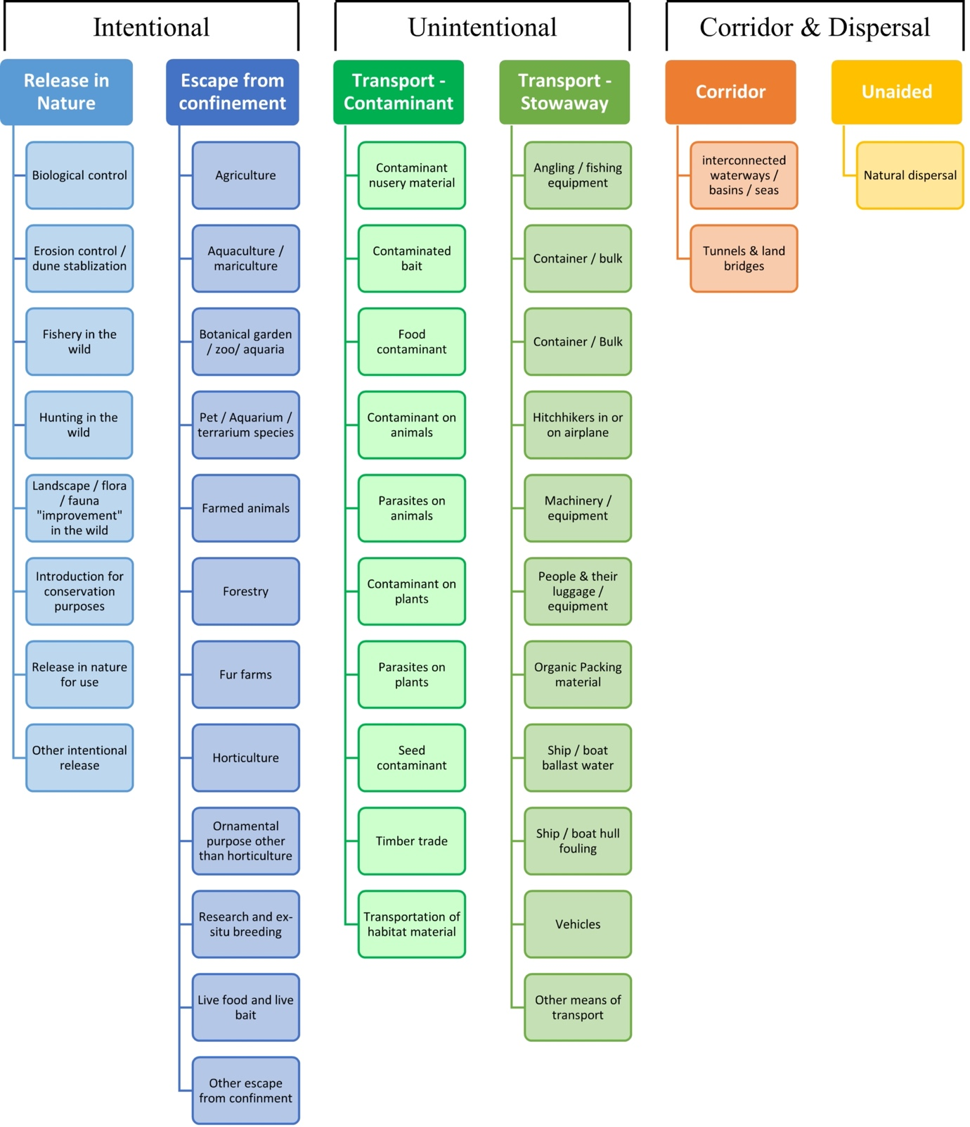

# ANNEX V Ecosystem services classification (CICES V5.1, simplified) and examples

For the purposes of this risk assessment, please feel free to use what seems as the most appropriate category / level / combination of impact (Section – Division – Group), reflecting information available.

|  |  |  |  |
| --- | --- | --- | --- |
| **Section** | **Division** | **Group** | **Examples (i.e. relevant CICES “classes”)** |
| **Provisioning** | **Biomass** | **Cultivated *terrestrial* plants** | Cultivated terrestrial plants (including fungi, algae) grown for nutritional purposes;  Fibres and other materials from cultivated plants, fungi, algae and bacteria for direct use or processing (excluding genetic materials);  Cultivated plants (including fungi, algae) grown as a source of energy  *Example: negative impacts of non-native organisms to crops, orchards, timber etc.* |
|  |  | **Cultivated *aquatic* plants** | Plants cultivated by in- situ aquaculture grown for nutritional purposes;  Fibres and other materials from in-situ aquaculture for direct use or processing (excluding genetic materials);  Plants cultivated by in- situ aquaculture grown as an energy source.  *Example: negative impacts of non-native organisms to aquatic plants cultivated for nutrition, gardening etc. purposes.* |
|  |  | **Reared animals** | Animals reared for nutritional purposes;  Fibres and other materials from reared animals for direct use or processing (excluding genetic materials);  Animals reared to provide energy (including mechanical)  *Example: negative impacts of non-native organisms to livestock* |
|  |  | **Reared *aquatic* animals** | Animals reared by in-situ aquaculture for nutritional purposes;  Fibres and other materials from animals grown by in-situ aquaculture for direct use or processing (excluding genetic materials);  Animals reared by in-situ aquaculture as an energy source  *Example: negative impacts of non-native organisms to fish farming* |
|  |  | **Wild plants** (terrestrial and aquatic) | Wild plants (terrestrial and aquatic, including fungi, algae) used for nutrition;  Fibres and other materials from wild plants for direct use or processing (excluding genetic materials);  Wild plants (terrestrial and aquatic, including fungi, algae) used as a source of energy  *Example: reduction in the availability of wild plants (e.g. wild berries, ornamentals) due to non-native organisms (competition, spread of disease etc.)* |
|  |  | **Wild animals** (terrestrial and aquatic) | Wild animals (terrestrial and aquatic) used for nutritional purposes;  Fibres and other materials from wild animals for direct use or processing (excluding genetic materials);  Wild animals (terrestrial and aquatic) used as a source of energy  *Example: reduction in the availability of wild animals (e.g. fish stocks, game) due to non-native organisms (competition, predations, spread of disease etc.)* |
|  | **Genetic material** from all biota | **Genetic material** from plants, algae or fungi | Seeds, spores and other plant materials collected for maintaining or establishing a population;  Higher and lower plants (whole organisms) used to breed new strains or varieties;  Individual genes extracted from higher and lower plants for the design and construction of new biological entities  *Example: negative impacts of non-native organisms due to interbreeding* |
|  |  | **Genetic material** from animals | Animal material collected for the purposes of maintaining or establishing a population;  Wild animals (whole organisms) used to breed new strains or varieties;  Individual genes extracted from organisms for the design and construction of new biological entities  *Example: negative impacts of non-native organisms due to interbreeding* |
|  | **Water[6]** | **Surface water** used for nutrition, materials or energy | Surface water for drinking;  Surface water used as a material (non-drinking purposes);  Freshwater surface water, coastal and marine water used as an energy source  *Example: loss of access to surface water due to spread of non-native organisms* |
|  |  | **Ground water** for used for nutrition, materials or energy | Ground (and subsurface) water for drinking;  Ground water (and subsurface) used as a material (non-drinking purposes);  Ground water (and subsurface) used as an energy source  *Example: reduced availability of ground water due to spread of non-native organisms and associated increase of ground water consumption by vegetation.* |
| **Regulation & Maintenance** | **Transformation** of biochemical or physical inputs to ecosystems | **Mediation of wastes or toxic substances** of anthropogenic origin by living processes | Bio-remediation by micro-organisms, algae, plants, and animals; Filtration/sequestration/storage/accumulation by micro-organisms, algae, plants, and animals  *Example: changes caused by non-native organisms to ecosystem functioning and ability to filtrate etc. waste or toxics* |
|  |  | **Mediation of nuisances** of anthropogenic origin | Smell reduction; noise attenuation; visual screening (e.g. by means of green infrastructure)  *Example: changes caused by non-native organisms to ecosystem structure, leading to reduced ability to mediate nuisances.* |
|  | **Regulation** of physical, chemical, biological conditions | **Baseline flows and extreme event** regulation | Control of erosion rates;  Buffering and attenuation of mass movement;  Hydrological cycle and water flow regulation (Including flood control, and coastal protection);  Wind protection;  Fire protection  *Example: changes caused by non-native organisms to ecosystem functioning or structure leading to, for example, destabilisation of soil, increased risk or intensity of wild fires etc.* |
|  |  | **Lifecycle maintenance**, habitat and gene pool protection | Pollination (or 'gamete' dispersal in a marine context);  Seed dispersal;  Maintaining nursery populations and habitats (Including gene pool protection)  *Example: changes caused by non-native organisms to the abundance and/or distribution of wild pollinators; changes to the availability / quality of nursery habitats for fisheries* |
|  |  | **Pest and disease control** | Pest control;  Disease control  *Example: changes caused by non-native organisms to the abundance and/or distribution of pests* |
|  |  | **Soil quality** regulation | Weathering processes and their effect on soil quality;  Decomposition and fixing processes and their effect on soil quality  *Example: changes caused by non-native organisms to vegetation structure and/or soil fauna leading to reduced soil quality* |
|  |  | **Water** conditions | Regulation of the chemical condition of freshwaters by living processes;  Regulation of the chemical condition of salt waters by living processes  *Example: changes caused by non-native organisms to buffer strips along water courses that remove nutrients in runoff and/or fish communities that regulate the resilience and resistance of water bodies to eutrophication* |
|  |  | **Atmospheric** composition and conditions | Regulation of chemical composition of atmosphere and oceans;  Regulation of temperature and humidity, including ventilation and transpiration  *Example: changes caused by non-native organisms to ecosystems’ ability to sequester carbon and/or evaporative cooling (e.g. by urban trees)* |
| **Cultural** | **Direct, in-situ and outdoor interactions** with living systems that depend on presence in the environmental setting | **Physical and experiential** interactions with natural environment | Characteristics of living systems that that enable activities promoting health, recuperation or enjoyment through active or immersive interactions;  Characteristics of living systems that enable activities promoting health, recuperation or enjoyment through passive or observational interactions  *Example: changes caused by non-native organisms to the qualities of ecosystems (structure, species composition etc.) that make it attractive for recreation, wild life watching etc.* |
|  |  | **Intellectual and representative** interactions with natural environment | Characteristics of living systems that enable scientific investigation or the creation of traditional ecological knowledge;  Characteristics of living systems that enable education and training;  Characteristics of living systems that are resonant in terms of culture or heritage;  Characteristics of living systems that enable aesthetic experiences  *Example: changes caused by non-native organisms to the qualities of ecosystems (structure, species composition etc.) that have cultural importance* |
|  | **Indirect, remote, often indoor interactions** with living systems that do not require presence in the environmental setting | **Spiritual, symbolic** and other interactions with natural environment | Elements of living systems that have symbolic meaning;  Elements of living systems that have sacred or religious meaning;  Elements of living systems used for entertainment or representation  *Example: changes caused by non-native organisms to the qualities of ecosystems (structure, species composition etc.) that have sacred or religious meaning* |
|  |  | Other biotic characteristics that have a **non-use value** | Characteristics or features of living systems that have an existence value;  Characteristics or features of living systems that have an option or bequest value  *Example: changes caused by non-native organisms to ecosystems designated as wilderness areas, habitats of endangered species etc.* |

# ANNEX VI EU Biogeographic Regions and MSFD Subregions

See <https://www.eea.europa.eu/data-and-maps/figures/biogeographical-regions-in-europe-2> ,

<http://ec.europa.eu/environment/nature/natura2000/biogeog_regions/>

and

https://www.eea.europa.eu/data-and-maps/data/msfd-regions-and-subregions-1/technical-document/pdf

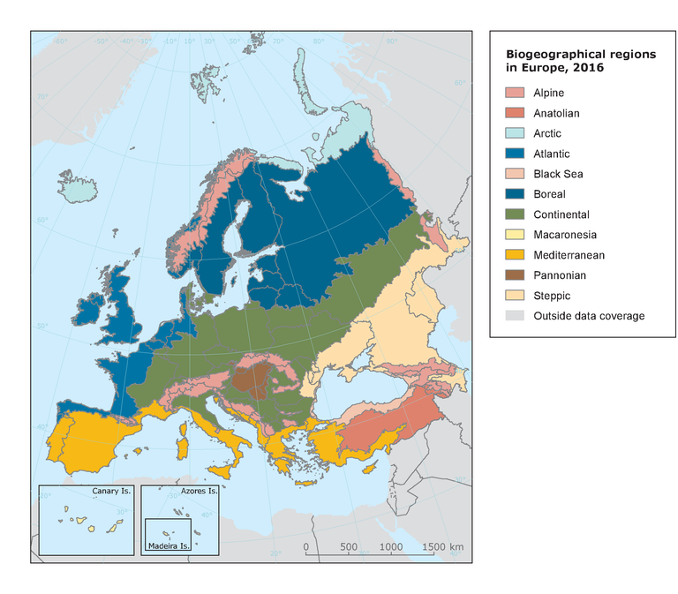 

# ANNEX VII Delegated Regulation (EU) 2018/968 of 30 April 2018

see <https://eur-lex.europa.eu/legal-content/en/TXT/?uri=CELEX%3A32018R0968>

# ANNEX VIII Projection of environmental suitability for sika deer *Cervus nippon* establishment in Europe

Björn Beckmann, Riccardo Scalera, Tim Adriaens, Wolfgang Rabitsch and Dan Chapman

31 May 2021

## Aim

To project the suitability for potential establishment of *Cervus nippon* in Europe, under current and predicted future climatic conditions.

## Data for modelling

Species occurrence data were obtained from the Global Biodiversity Information Facility (GBIF) (5114 records), iNaturalist (793 records), the Biodiversity Information Serving Our Nation database (BISON) (31 records), the Atlas of Living Australia (14 records), and additional records from the risk assessment team. We scrutinised occurrence records from regions where the species is not known to be established and removed any dubious records or where the georeferencing was too imprecise (e.g. records referenced to a country or island centroid) or outside of the coverage of the predictor layers (e.g. small island or coastal occurrences). We removed records dated pre-1950, as these might refer to populations no longer in existence. The remaining records were gridded at a 0.25 x 0.25 degree resolution for modelling, yielding 550 grid cells with occurrences (Figure 1a). As a proxy for recording effort, the density of Mammalia records held by GBIF was also compiled on the same grid (Figure 1b).

**Figure 1.** (a) Occurrence records obtained for *Cervus nippon* and used in the modelling, showing native and invaded distributions. (b) The recording density of Mammalia on GBIF, which was used as a proxy for recording effort.

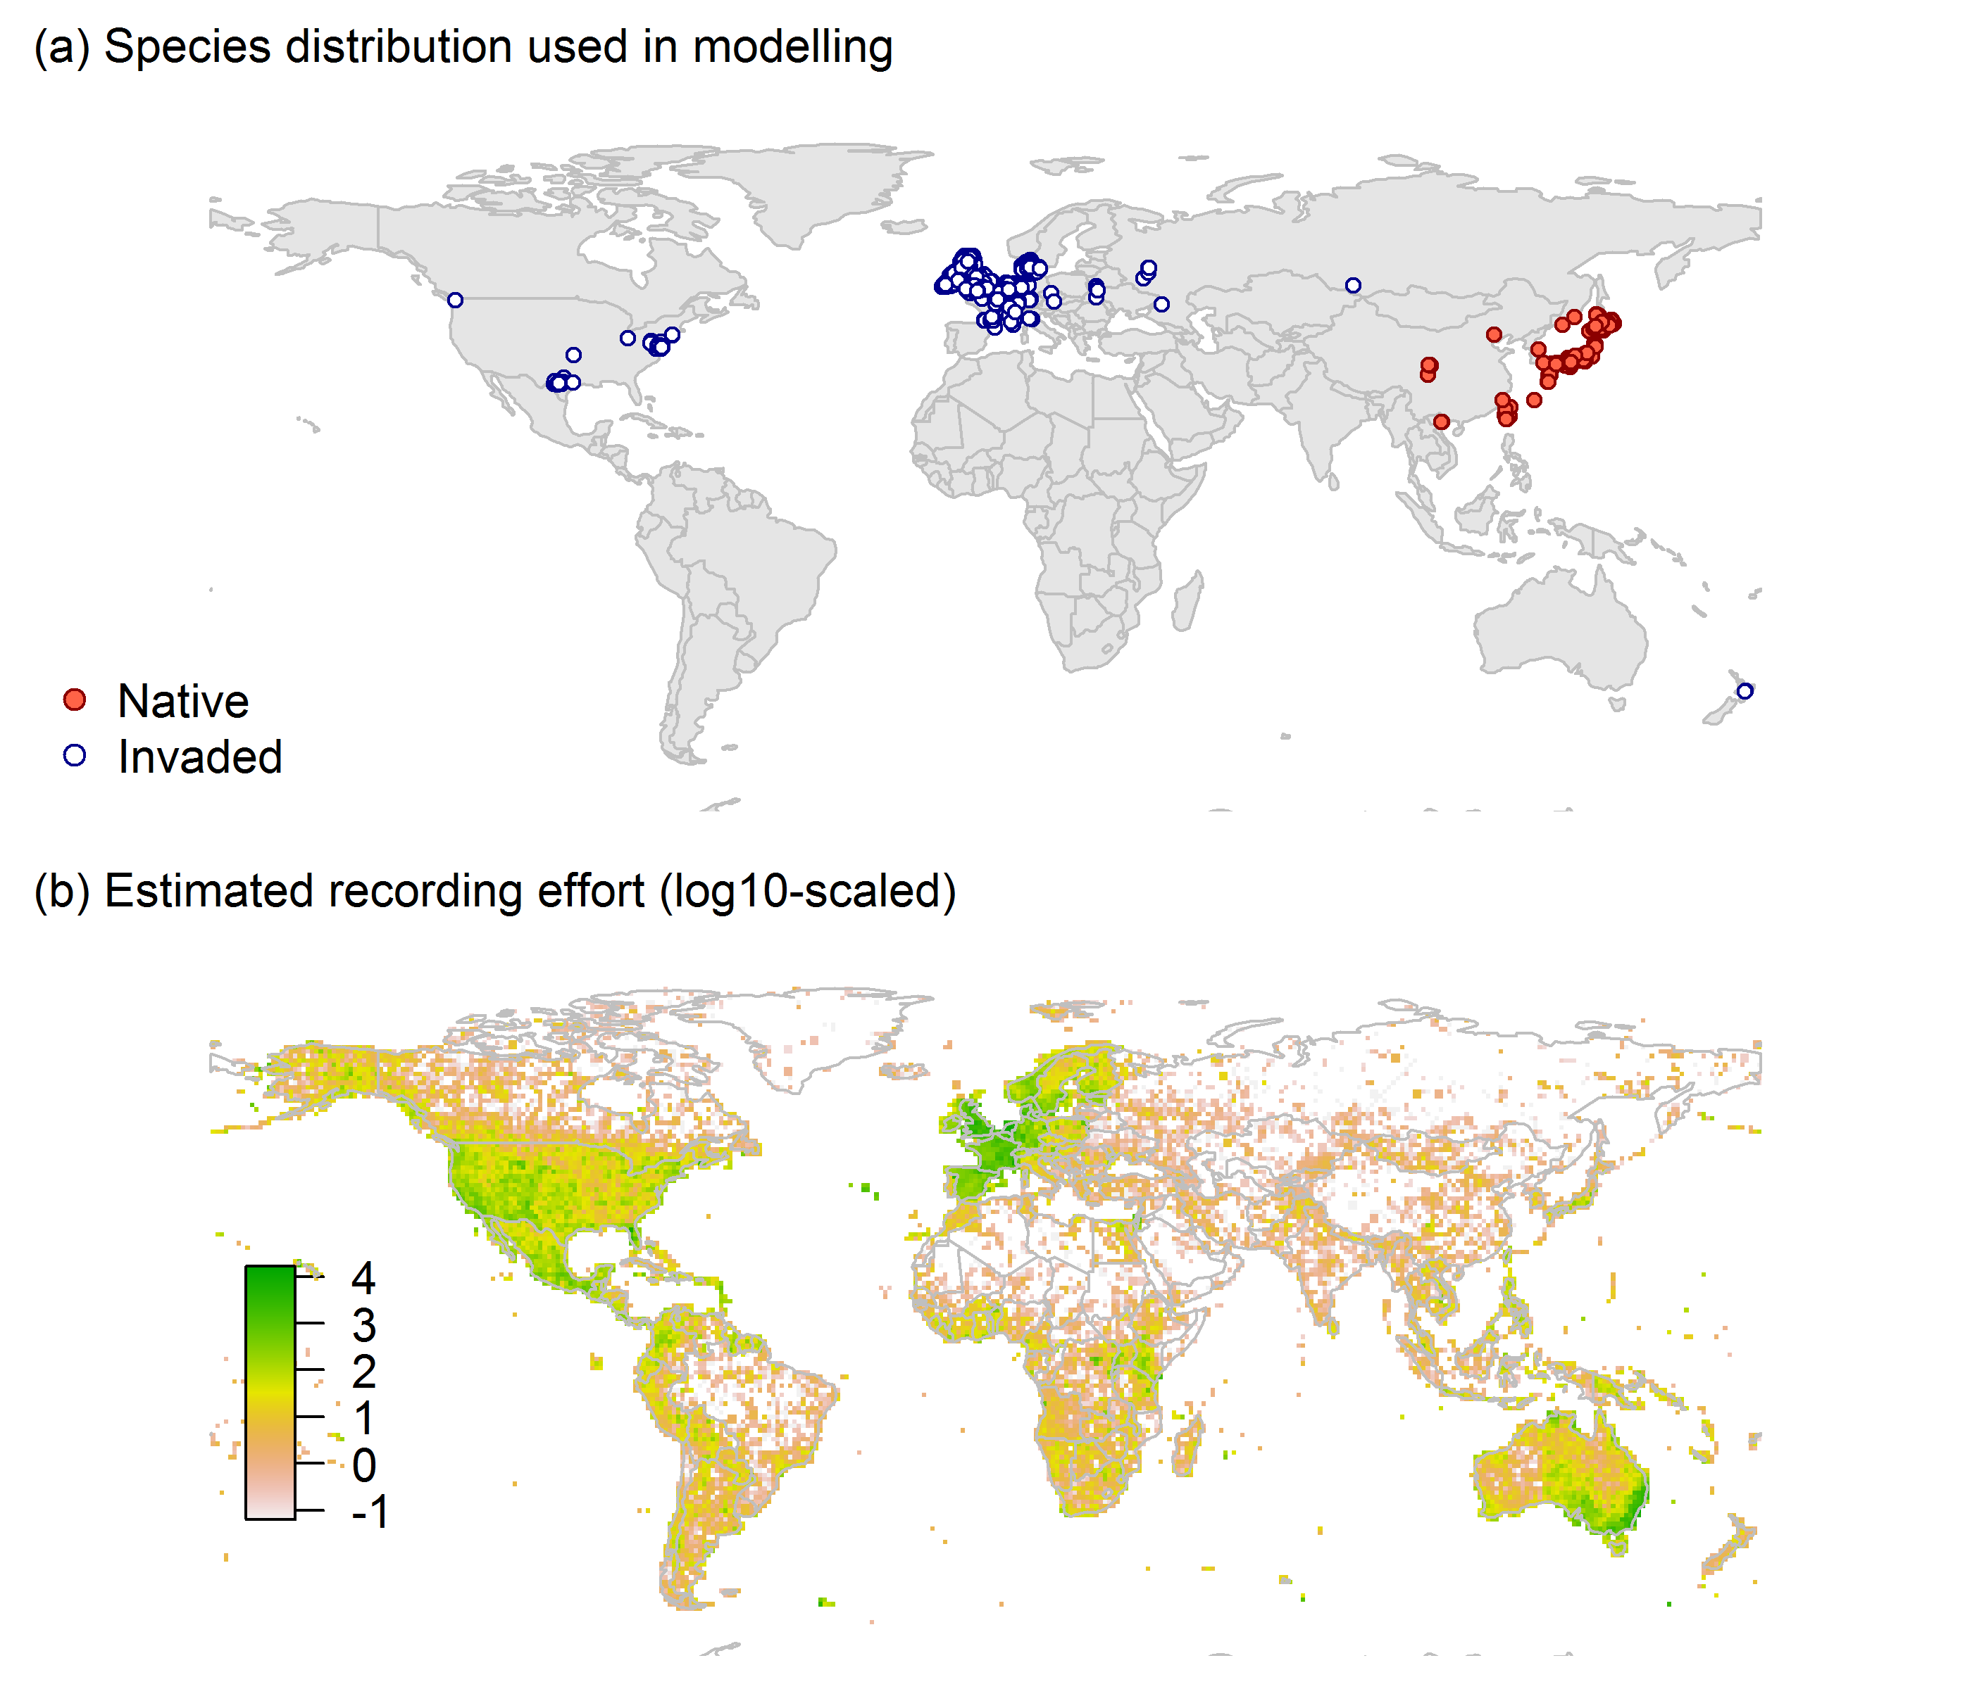

Climate data were selected from the ‘Bioclim’ variables contained within the WorldClim database (Hijmans et al., 2005), originally at 5 arcminute resolution (0.083 x 0.083 degrees of longitude/latitude) and aggregated to a 0.25 x 0.25 degree grid for use in the model.

Based on the biology of *Cervus nippon*, the following climate variables were used in the modelling:

* Minimum temperature of the coldest month (Bio6)
* Mean temperature of the warmest quarter (Bio10)
* Annual precipitation (Bio12)
* As a proxy for potential depth and duration of snow cover (Snow), the inverse of the mean temperature of the coldest quarter (Bio11) was multiplied with mean precipitation of the coldest quarter (Bio19), to produce a number that is greatest in areas where winters are both cold and have high precipitation. The numbers were scaled to values between 0 and 1 (Fig. 2).

**Figure 2.** Proxy for potential snow cover (Snow): the inverse of the mean temperature of the coldest quarter (Bio11) was multiplied with mean precipitation of the coldest quarter (Bio19), to produce a number that is greatest in areas where winters are both cold and have high precipitation. The numbers were scaled to values between 0 and 1.

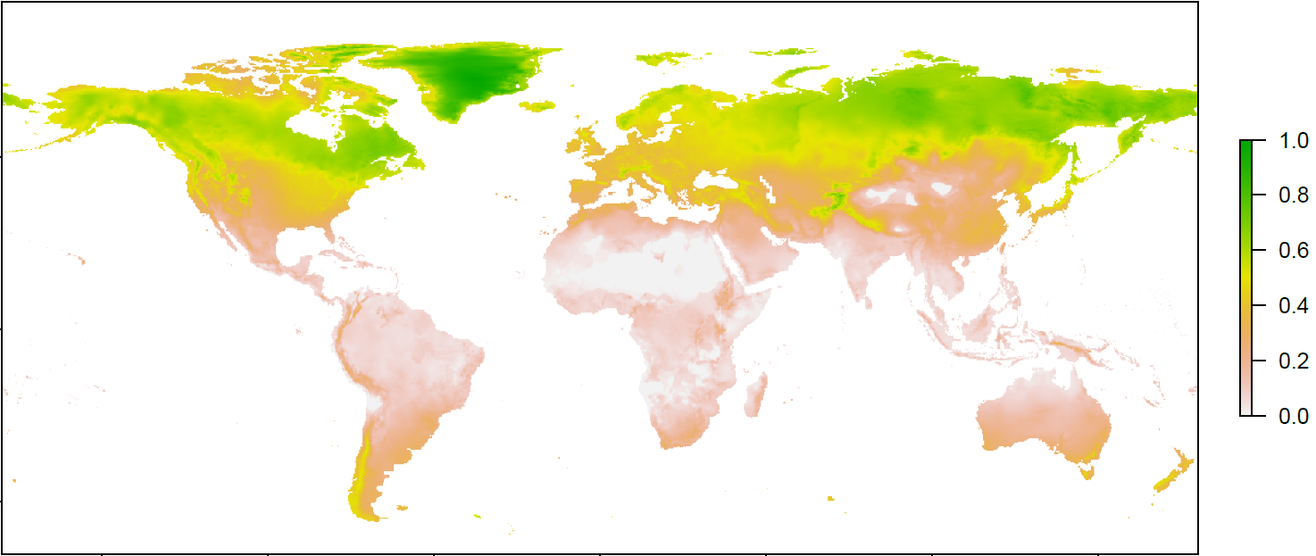

To estimate the effect of climate change on the potential distribution, equivalent modelled future climate conditions for the 2070s under the Representative Concentration Pathways (RCP) 2.6 and 4.5 were also obtained. These represent low and medium emissions scenarios, respectively. The above variables were obtained as averages of outputs of eight Global Climate Models (BCC-CSM1-1, CCSM4, GISS-E2-R, HadGEM2-AO, IPSL-CM5A-LR, MIROC-ESM, MRI-CGCM3, NorESM1-M), downscaled and calibrated against the WorldClim baseline (see <http://www.worldclim.org/cmip5_5m> ).

The following habitat layers were also used:

* Tree cover (Tree): This was estimated from the MODerate-resolution Imaging Spectroradiometer (MODIS) satellite continuous tree cover raster product, produced by the Global Land Cover Facility (<http://glcf.umd.edu/data/vcf/>). The raw product contains the percentage cover by trees in each 0.002083 x 0.002083 degree grid cell. We aggregated this to the mean cover in our 0.25 x 0.25 degree grid cells.

## Species distribution model

A presence-background (presence-only) ensemble modelling strategy was employed using the BIOMOD2 R package version 3.4.6 (Thuiller et al., 2020, Thuiller et al., 2009). These models contrast the environment at the species’ occurrence locations against a random sample of the global background environmental conditions (often termed ‘pseudo-absences’) in order to characterise and project suitability for occurrence. This approach has been developed for distributions that are in equilibrium with the environment. Because invasive species’ distributions are not at equilibrium and subject to dispersal constraints at a global scale, we took care to minimise the inclusion of locations suitable for the species but where it has not been able to disperse to (Chapman et al. 2019). Therefore the background sampling region included:

* The area accessible by native *Cervus nippon* populations, in which the species is likely to have had sufficient time to disperse to all locations. Based on presumed maximum dispersal distances, the accessible region was defined as a 300km buffer around the native range occurrences; AND
* A 30km buffer around the non-native occurrences, encompassing regions likely to have had high propagule pressure for introduction by humans and/or dispersal of the species; AND
* Regions where we have an *a priori* expectation of high unsuitability for the species so that absence is assumed irrespective of dispersal constraints (see Figure 2). The following rules were applied to define a region expected to be highly unsuitable for *Cervus nippon* at the spatial scale of the model:
  + Minimum temperature of the coldest month (Bio6) < -18°C
  + Mean temperature of the warmest quarter (Bio10) < 9°C
  + Annual precipitation (Bio12) < 545mm
  + Proxy for potential snow cover (Snow) > 0.6

Altogether, only 1.1% of occurrence grid cells were located in the unsuitable background region.

Within the unsuitable background region, 10 samples of 5000 randomly sampled grid cells were obtained. In the accessible background (comprising the accessible areas around native and non-native occurrences as detailed above), the same number of pseudo-absence samples were drawn as there were presence records (550), weighting the sampling by a proxy for recording effort (Figure 2).

**Figure 2.** The background from which pseudo-absence samples were taken in the modelling of *Cervus nippon*. Samples were taken from a 300km buffer around the native range and a 30km buffer around non-native occurrences (together forming the accessible background), and from areas expected to be highly unsuitable for the species (the unsuitable background region). Samples from the accessible background were weighted by a proxy for recording effort (Figure 1(b)).

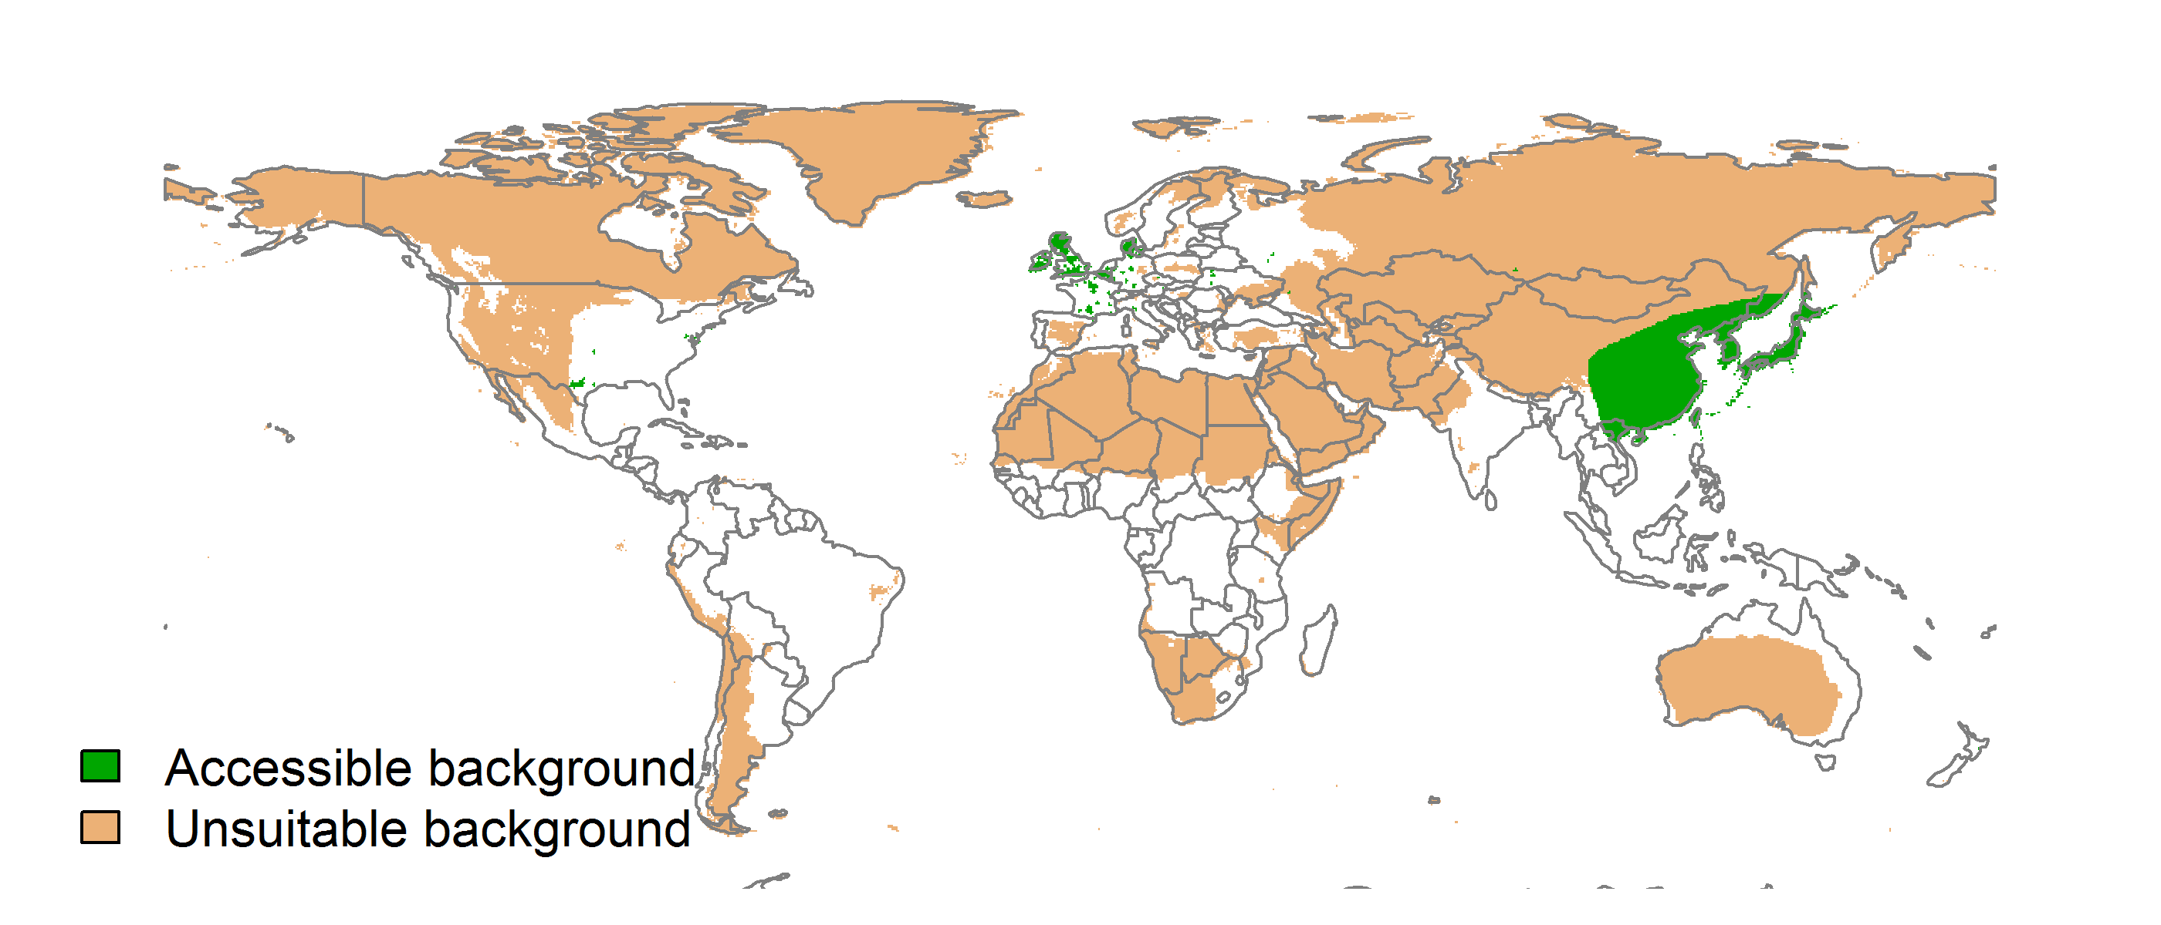

Each dataset (i.e. combination of the presences and the individual background samples) was randomly split into 80% for model training and 20% for model evaluation. With each training dataset, seven statistical algorithms were fitted with the default BIOMOD2 settings and rescaled using logistic regression, except where specified below:

* Generalised linear model (GLM)
* Generalised boosting model (GBM)
* Generalised additive model (GAM) with a maximum of four degrees of freedom per smoothing spline
* Artificial neural network (ANN)
* Multivariate adaptive regression splines (MARS)
* Random forest (RF)
* Maxent

Since the total background sample was larger than the number of occurrences, prevalence fitting weights were applied to give equal overall importance to the occurrences and the background. Normalised variable importance was assessed and variable response functions were produced using BIOMOD2’s default procedure.

Model predictive performance was assessed by the following three measures:

* AUC, the area under the receiver operating characteristic curve (Fielding & Bell 1997). Predictions of presence-absence models can be compared with a subset of records set aside for model evaluation (here 20%) by constructing a confusion matrix with the number of true positive, false positive, false negative and true negative cases. For models generating non-dichotomous scores (as here) a threshold can be applied to transform the scores into a dichotomous set of presence-absence predictions. Two measures that can be derived from the confusion matrix are sensitivity (the proportion of observed presences that are predicted as such, quantifying omission errors), and specificity (the proportion of observed absences that are predicted as such, quantifying commission errors). A receiver operating characteristic (ROC) curve can be constructed by using all possible thresholds to classify the scores into confusion matrices, obtaining sensitivity and specificity for each matrix, and plotting sensitivity against the corresponding proportion of false positives (equal to 1 - specificity). The use of all possible thresholds avoids the need for a selection of a single threshold, which is often arbitrary, and allows appreciation of the trade-off between sensitivity and specificity. The area under the ROC curve (AUC) is often used as a single threshold-independent measure for model performance (Manel, Williams & Ormerod 2001). AUC is the probability that a randomly selected presence has a higher model-predicted suitability than a randomly selected absence (Allouche et al. 2006).
* Cohen’s Kappa (Cohen 1960). This measure corrects the overall accuracy of model predictions (ratio of the sum of true presences plus true absences to the total number of records) by the accuracy expected to occur by chance. The kappa statistic ranges from -1 to +1, where +1 indicates perfect agreement and values of zero or less indicate a performance no better than random. Advantages of kappa are its simplicity, the fact that both commission and omission errors are accounted for in one parameter, and its relative tolerance to zero values in the confusion matrix (Manel, Williams & Ormerod 2001). However, Kappa has been criticised for being sensitive to prevalence (the proportion of sites in which the species was recorded as present) and may therefore be inappropriate for comparisons of model accuracy between species or regions (McPherson, Jetz & Rogers 2004, Allouche et al. 2006).
* TSS, the true skill statistic (Allouche et al. 2006). TSS is defined as sensitivity + specificity - 1, and corrects for Kappa’s dependency on prevalence. TSS compares the number of correct forecasts, minus those attributable to random guessing, to that of a hypothetical set of perfect forecasts. Like kappa, TSS takes into account both omission and commission errors, and success as a result of random guessing, and ranges from -1 to +1, where +1 indicates perfect agreement and values of zero or less indicate a performance no better than random (Allouche et al. 2006).

An ensemble model was created by first rejecting poorly performing algorithms with relatively extreme low AUC values and then averaging the predictions of the remaining algorithms, weighted by their AUC. To identify poorly performing algorithms, AUC values were converted into modified z-scores based on their difference to the median and the median absolute deviation across all algorithms (Iglewicz & Hoaglin 1993). Algorithms with z < -2 were rejected. In this way, ensemble projections were made for each dataset and then averaged to give an overall suitability, as well as its standard deviation.

Projections were classified into suitable and unsuitable regions using a “lowest presence threshold” (Pearson et al. 2007), setting the cut-off as the lowest value at which 98% of all presence records are classified correctly under the current climate (here 0.64). In order to express the sensitivity of classifications to the choice of this threshold, thresholds at which 95% and 99% of records are classified correctly (here 0.73 and 0.49 respectively) were used in the calculation of error bars in Figs. 9 and 10 below in addition to taking account of uncertainty in the projections themselves.

We also produced a limiting factor map for Europe following Elith et al. (2010). For this, projections were made separately with each individual variable fixed at a near-optimal value. These were chosen as the median values at the occurrence grid cells. Then, the most strongly limiting factors were identified as the ones resulting in the highest increase in suitability in each grid cell.

## Results

The ensemble model suggested that suitability for *Cervus nippon* was most strongly determined by Annual precipitation (Bio12), accounting for 53.8% of variation explained, followed by Minimum temperature of the coldest month (Bio6) (21.3%), Proxy for potential snow cover (Snow) (12.3%), Mean temperature of the warmest quarter (Bio10) (11.4%) and Global tree cover (Tree) (1.2%) (Table 1, Figure 3).

**Table 1.** Summary of the cross-validation predictive performance (AUC, Kappa, TSS) and variable importance of the fitted model algorithms and the ensemble (AUC-weighted average of the best performing algorithms). Results are the average from models fitted to 10 different background samples of the data.

|  |  |  |  |  |  |  |  |  |  |
| --- | --- | --- | --- | --- | --- | --- | --- | --- | --- |
|  |  |  |  |  | **Variable importance (%)** | | | | |
| **Algorithm** | **AUC** | **Kappa** | **TSS** | **Used in the ensemble** | **Annual precipitation (Bio12)** | **Minimum temperature of the coldest month (Bio6)** | **Proxy for potential snow cover (Snow)** | **Mean temperature of the warmest quarter (Bio10)** | **Global tree cover (Tree)** |
| GLM | 0.958 | 0.611 | 0.887 | yes | 56 | 15 | 15 | 12 | 1 |
| GAM | 0.961 | 0.618 | 0.890 | yes | 50 | 19 | 18 | 12 | 0 |
| GBM | 0.957 | 0.611 | 0.887 | yes | 58 | 25 | 3 | 13 | 0 |
| ANN | 0.960 | 0.608 | 0.882 | yes | 50 | 26 | 8 | 13 | 2 |
| MARS | 0.954 | 0.600 | 0.883 | yes | 60 | 19 | 17 | 4 | 0 |
| RF | 0.941 | 0.592 | 0.883 | no | 59 | 19 | 7 | 10 | 5 |
| Maxent | 0.955 | 0.611 | 0.881 | yes | 48 | 23 | 13 | 13 | 3 |
| **Ensemble** | **0.961** | **0.615** | **0.890** |  | **54** | **21** | **12** | **11** | **1** |

**Figure 3.** Partial response plots from the fitted models. Thin coloured lines show responses from the algorithms in the ensemble, while the thick black line is their ensemble. In each plot, other model variables are held at their median value in the training data. Some of the divergence among algorithms is because of their different treatment of interactions among variables.

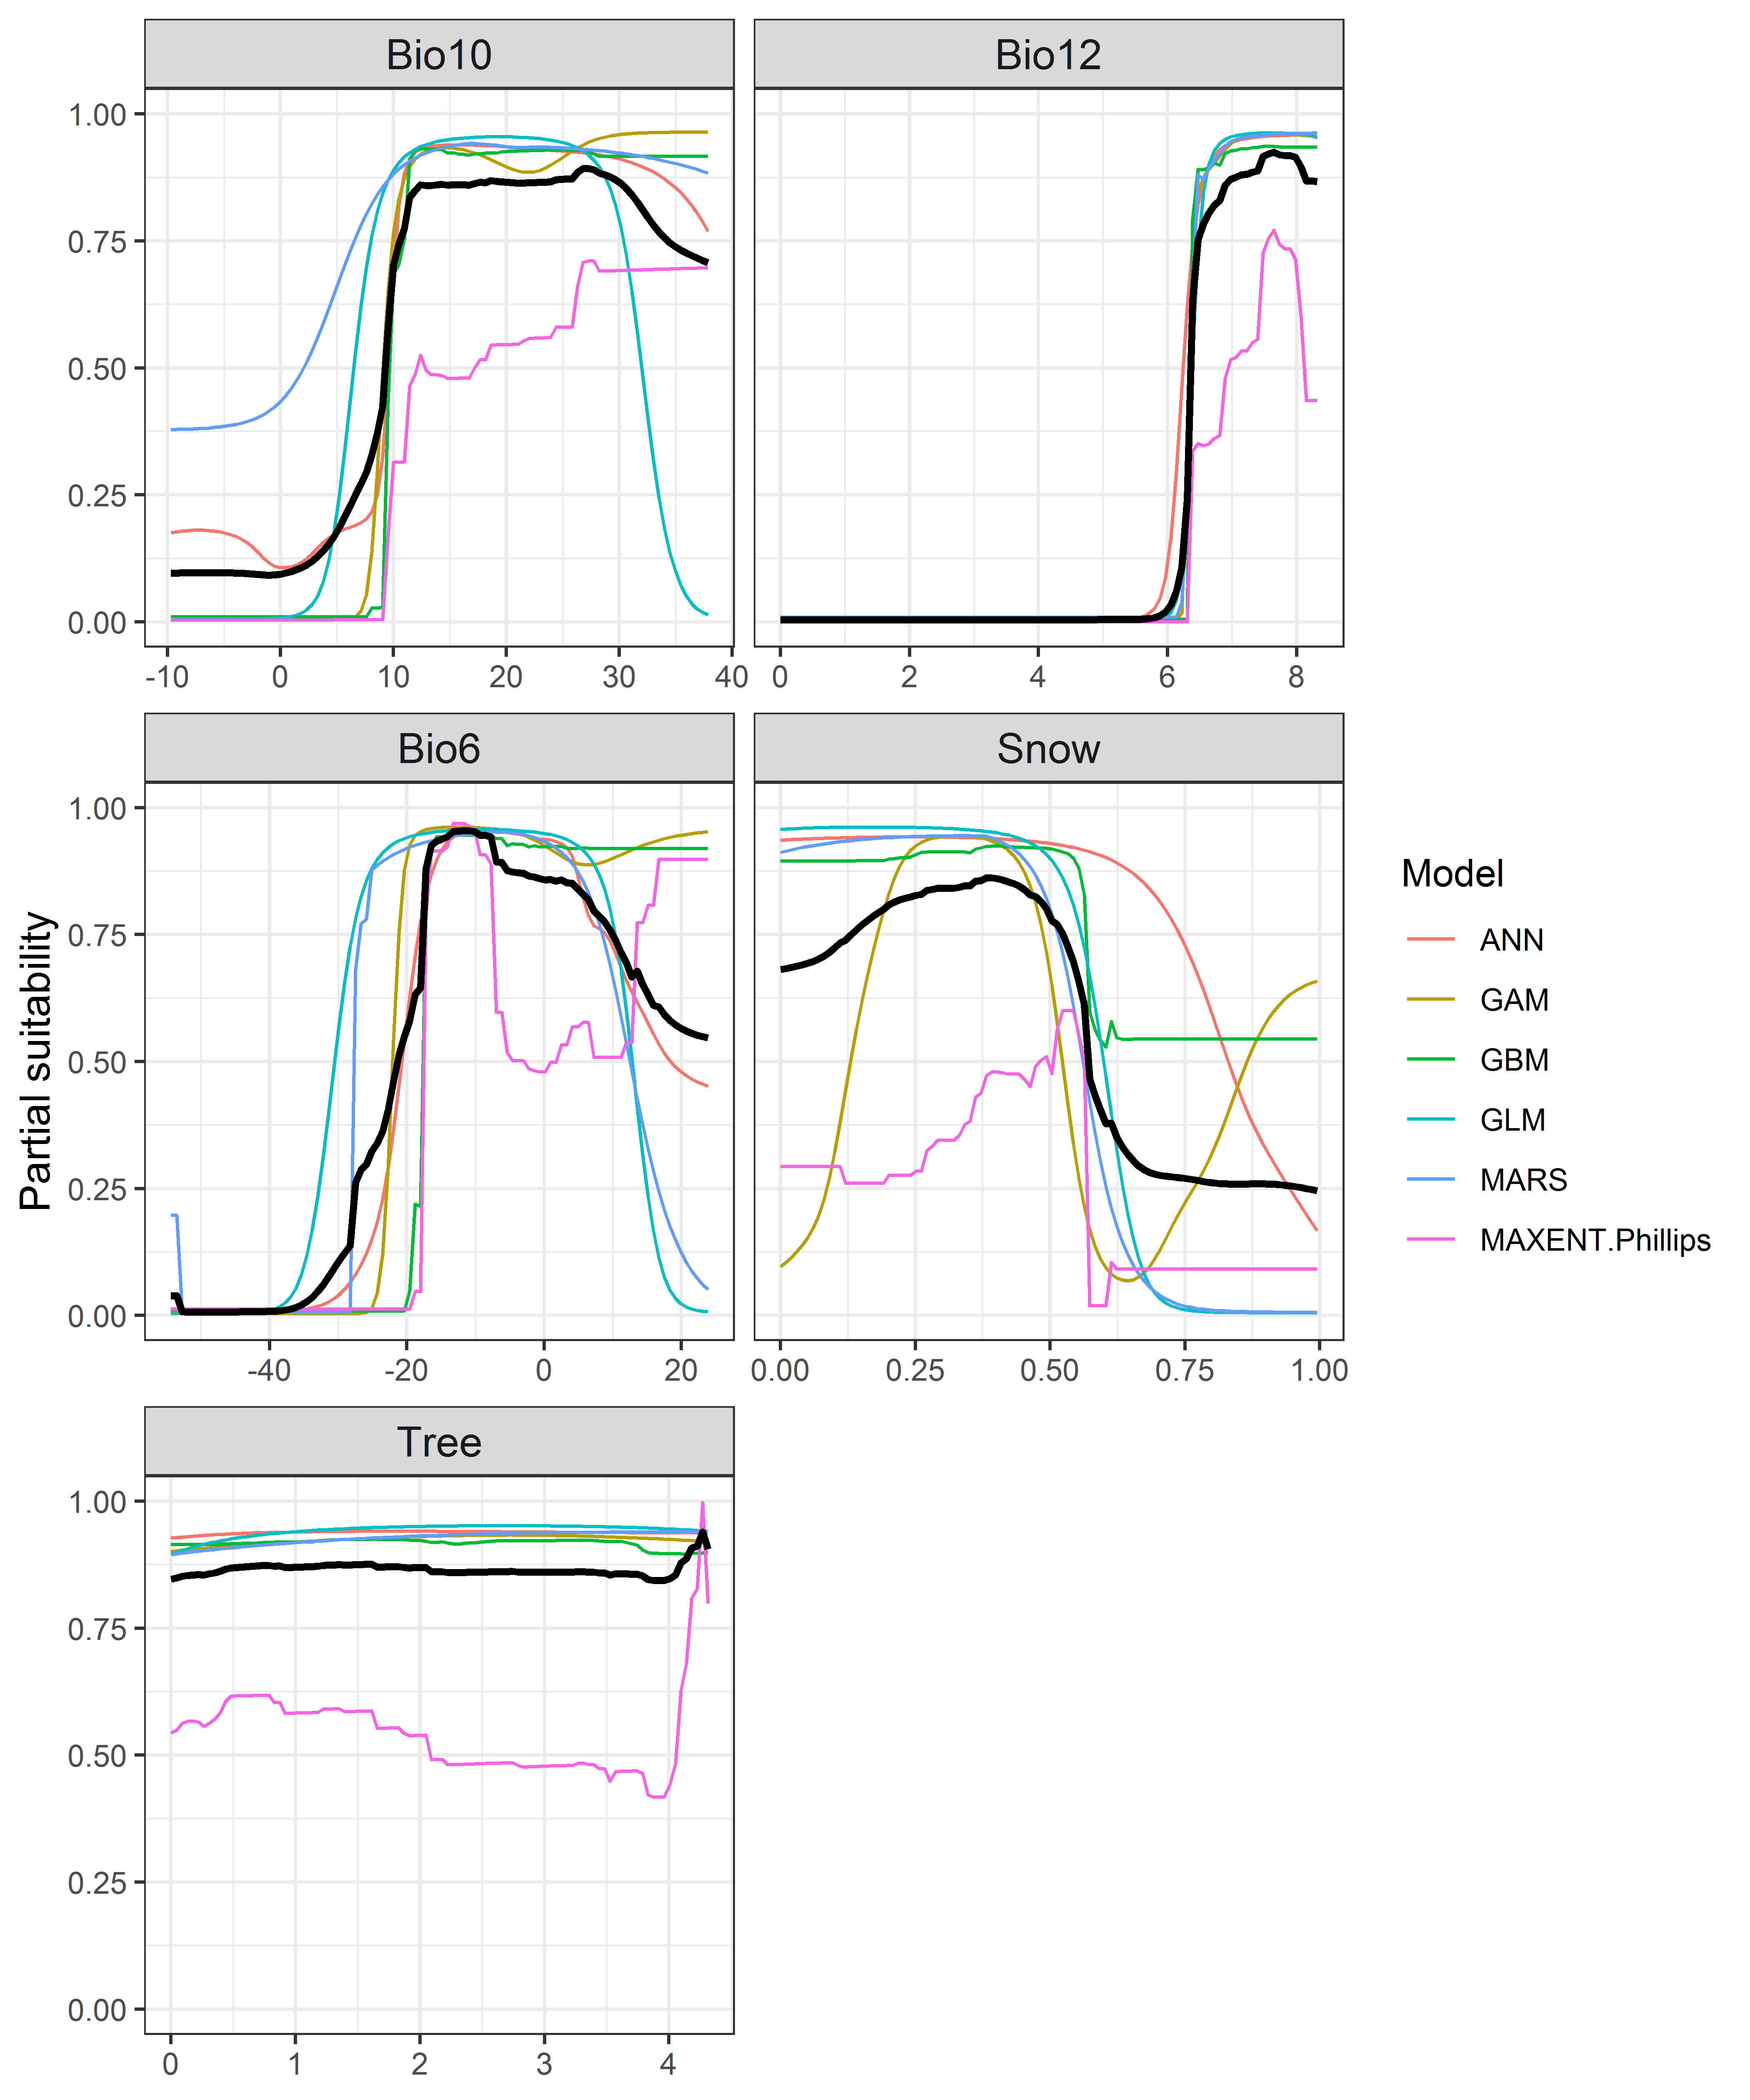

**Figure 4.** (a) Projected global suitability for *Cervus nippon* establishment in the current climate. For visualisation, the projection has been aggregated to a 0.5 x 0.5 degree resolution, by taking the maximum suitability of constituent higher resolution grid cells. Values > 0.64 are suitable for the species, with 98% of global presence records above this threshold. Values below 0.64 indicate lower relative suitability. (b) Uncertainty in the ensemble projections, expressed as the among-algorithm standard deviation in predicted suitability, averaged across the 10 datasets.

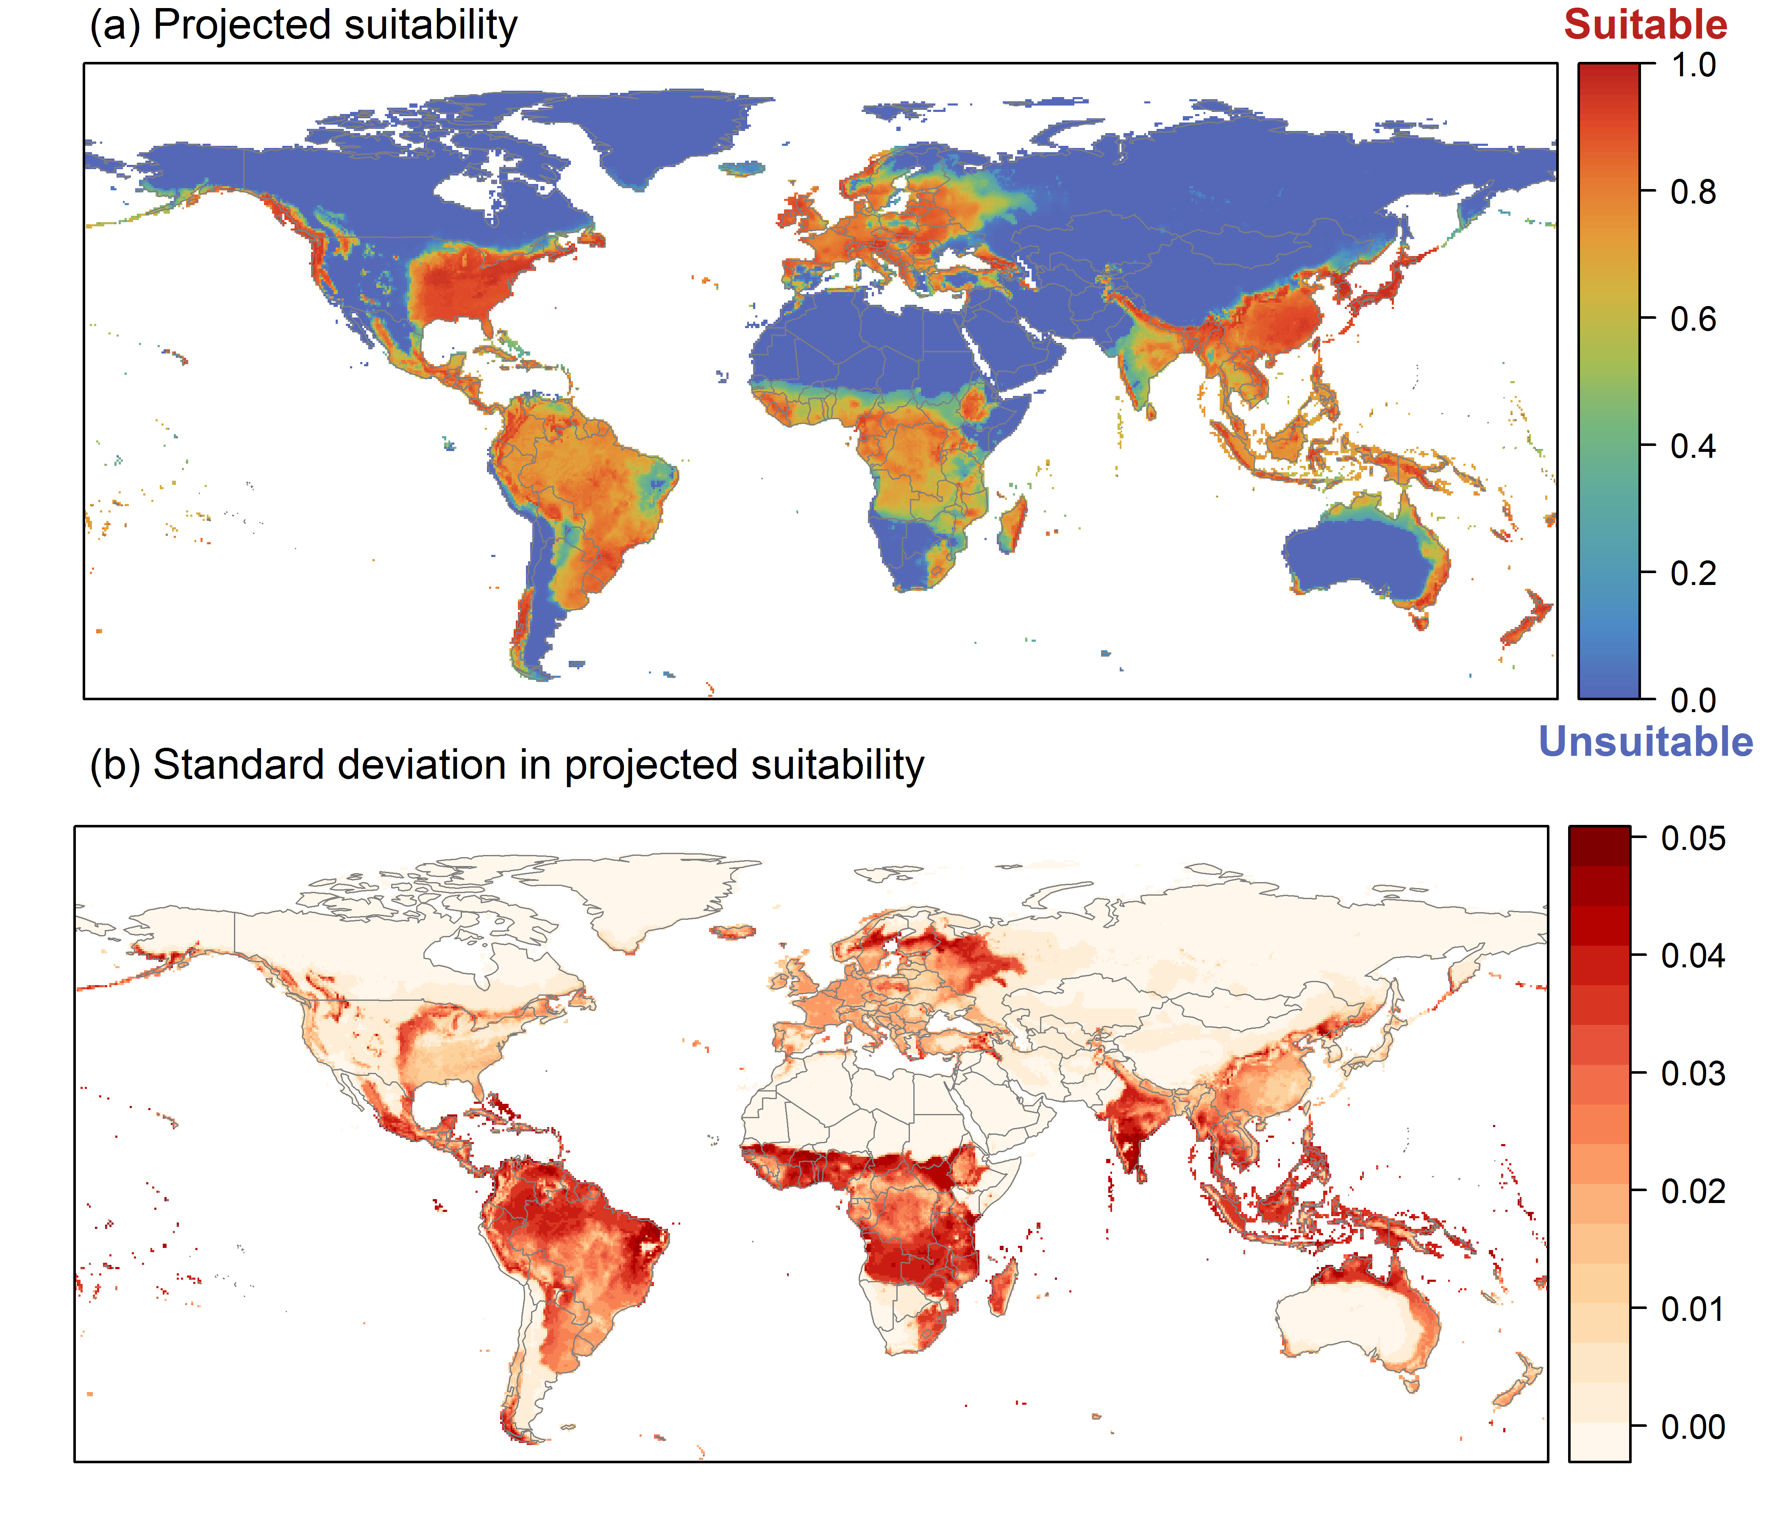

**Figure 5.** (a) Projected current suitability for *Cervus nippon* establishment in Europe and the Mediterranean region. Values > 0.64 are suitable for the species, with 98% of global presence records above this threshold. Values below 0.64 indicate lower relative suitability. (b) Uncertainty in the ensemble projections, expressed as the among-algorithm standard deviation in predicted suitability, averaged across the 10 datasets.

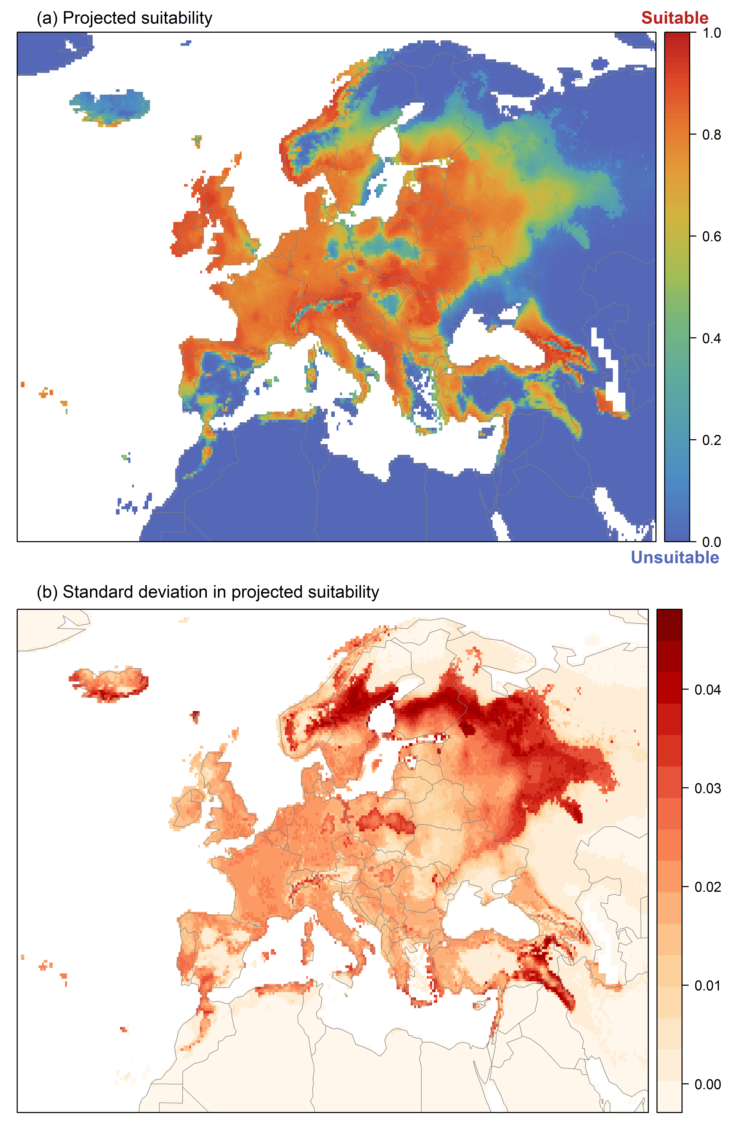

**Figure 6.** The most strongly limiting factors for *Cervus nippon* establishment estimated by the model in Europe and the Mediterranean region in current climatic conditions.

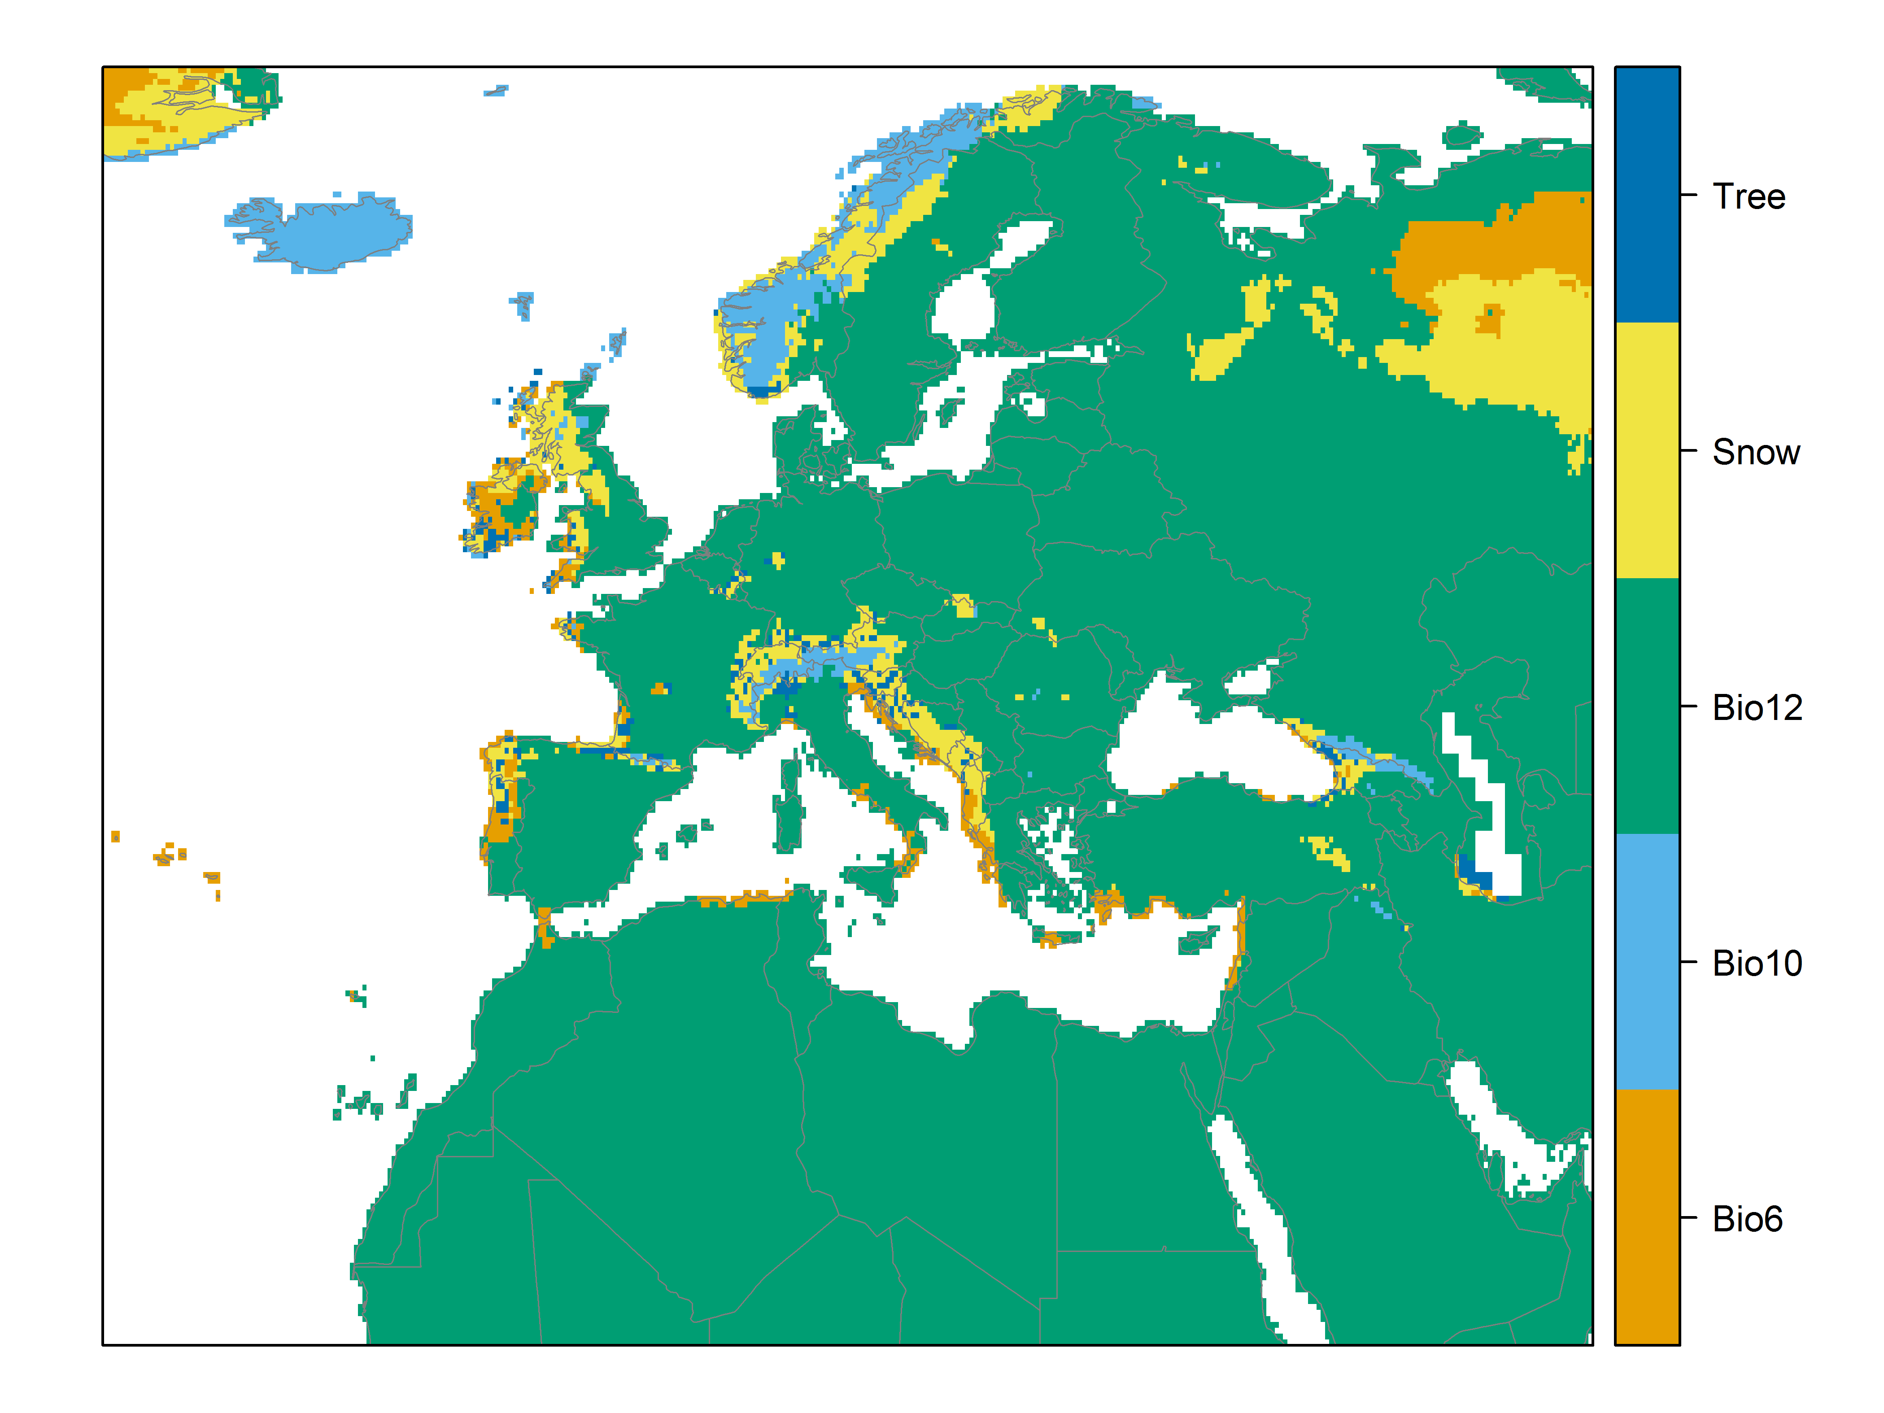

**Figure 7.** (a) Projected suitability for *Cervus nippon* establishment in Europe and the Mediterranean region in the 2070s under climate change scenario RCP2.6 (low emissions scenario). Values > 0.64 are suitable for the species, with 98% of global presence records above this threshold under current climate. Values below 0.64 indicate lower relative suitability. (b) Uncertainty in the ensemble projections, expressed as the among-algorithm standard deviation in predicted suitability, averaged across the 10 datasets.

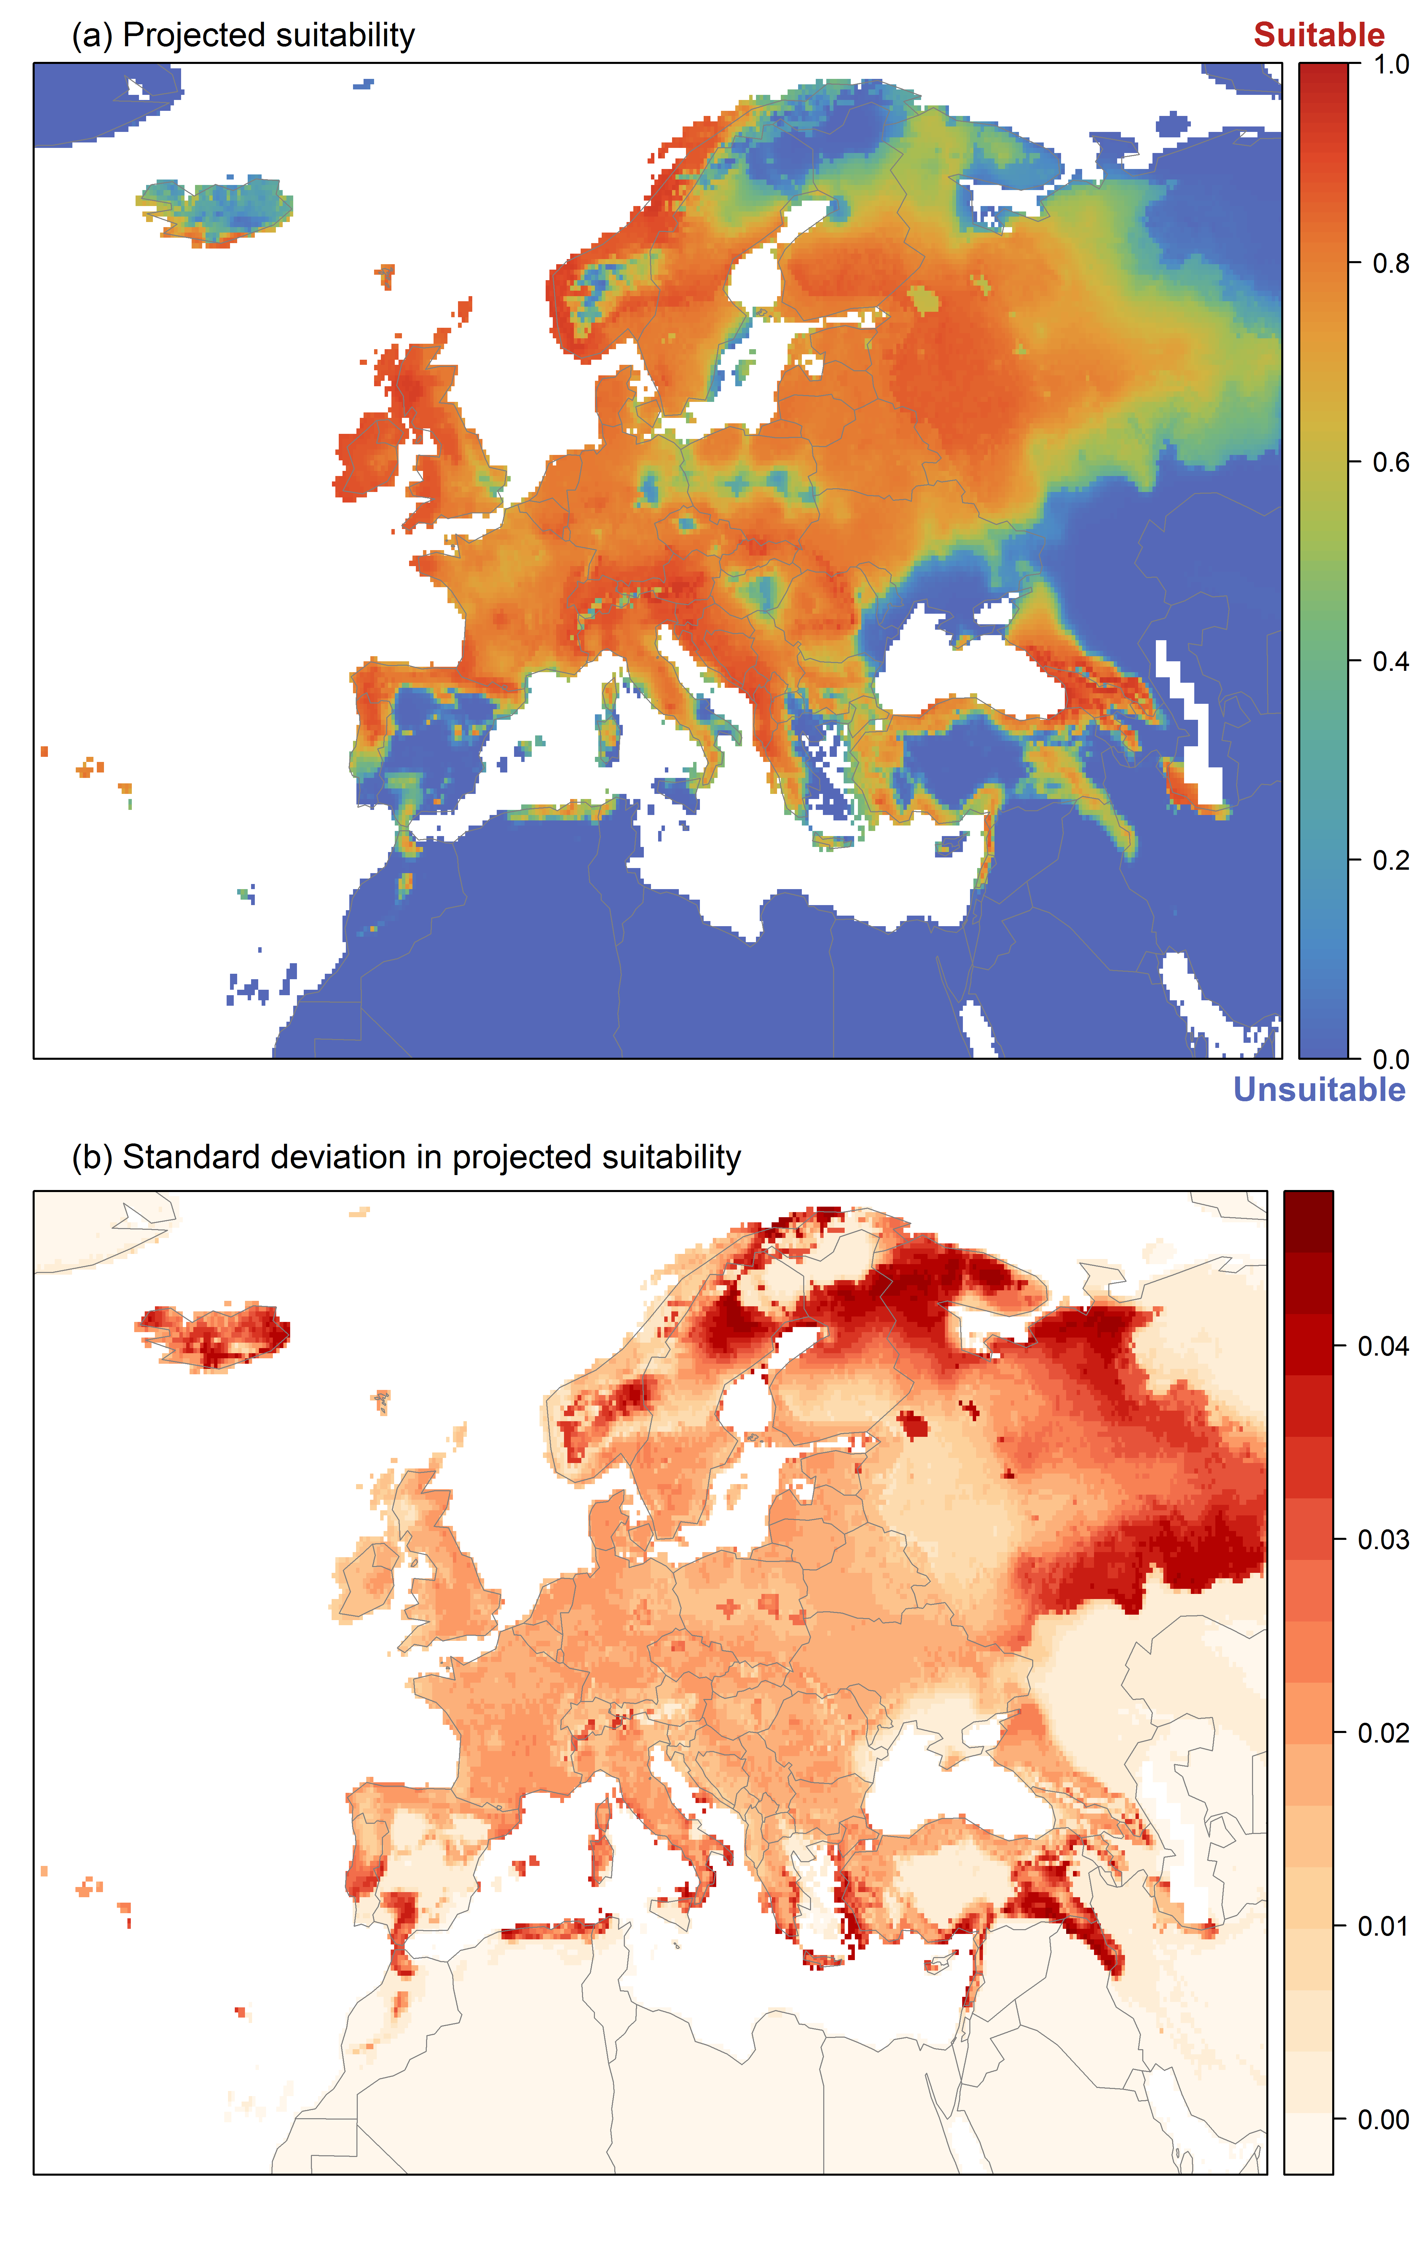

**Figure 8.** (a) Projected suitability for *Cervus nippon* establishment in Europe and the Mediterranean region in the 2070s under climate change scenario RCP4.5 (medium emissions scenario). Values > 0.64 are suitable for the species, with 98% of global presence records above this threshold under current climate. Values below 0.64 indicate lower relative suitability. (b) Uncertainty in the ensemble projections, expressed as the among-algorithm standard deviation in predicted suitability, averaged across the 10 datasets.

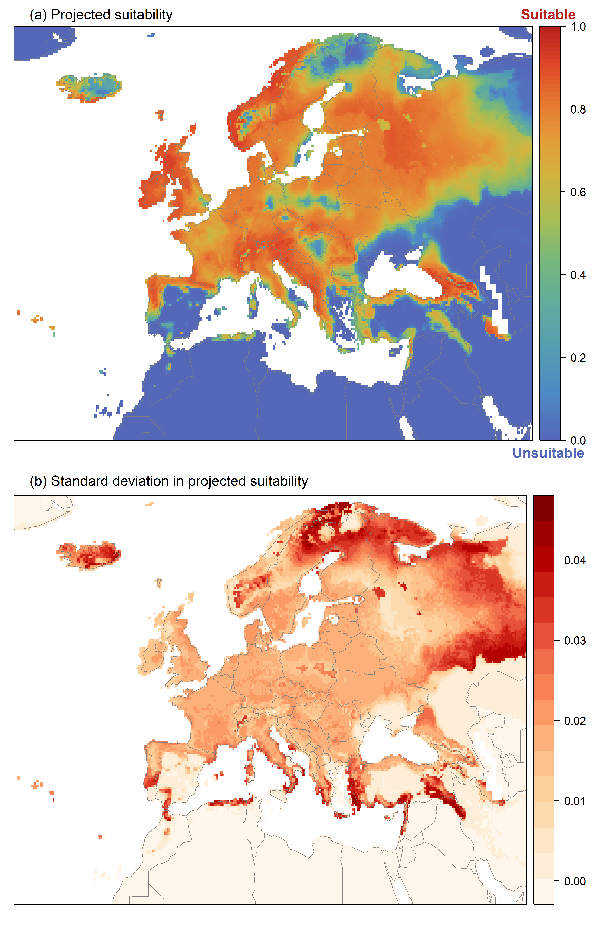

**Figure 9.** Variation in projected suitability for *Cervus nippon* establishment among Biogeographical Regions of Europe (<https://www.eea.europa.eu/data-and-maps/data/biogeographical-regions-europe-3>). The bar plots show the proportion of grid cells in each region classified as suitable (with values > 0.64) in the current climate and projected climate for the 2070s under two RCP emissions scenarios (RCP26, low emissions scenario; RCP45, medium emissions scenario). Error bars indicate uncertainty due to both the choice of classification threshold (cf. p.6) and uncertainty in the projections themselves (cf. part (b) of Figs. 5,7,8). The location of each region is also shown. The Arctic and Macaronesian regions are not part of the study area, but are included for completeness.

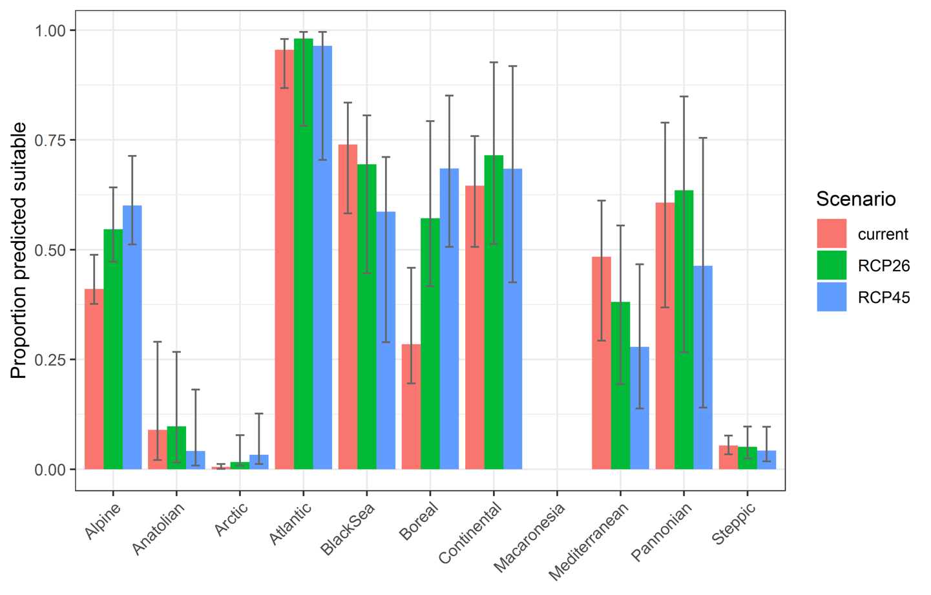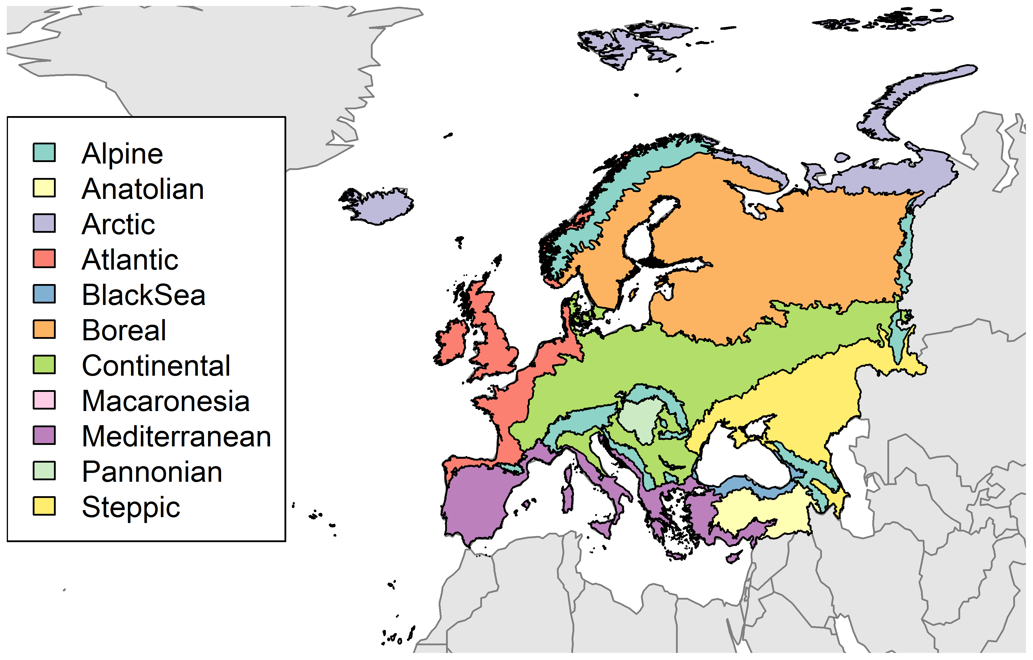

**Table 2.** Variation in projected suitability for *Cervus nippon* establishment among Biogeographical regions of Europe (numerical values of Figure 9 above). The numbers are the proportion of grid cells in each region classified as suitable in the current climate and projected climate for the 2070s under two RCP emissions scenarios (RCP2.6, low emissions scenario; RCP4.5, medium emissions scenario). The Arctic and Macaronesian biogeographical regions are not part of the study area, but are included for completeness.

|  |  |  |  |  |  |  |  |  |  |
| --- | --- | --- | --- | --- | --- | --- | --- | --- | --- |
|  | **current climate** | | | **2070s RCP2.6** | | | **2070s RCP4.5** | | |
|  | lower | **central estimate** | upper | lower | **central estimate** | upper | lower | **central estimate** | upper |
| Alpine | 0.38 | **0.41** | 0.49 | 0.47 | **0.55** | 0.64 | 0.51 | **0.60** | 0.71 |
| Anatolian | 0.02 | **0.09** | 0.29 | 0.02 | **0.10** | 0.27 | 0.01 | **0.04** | 0.18 |
| Arctic | 0.00 | **0.01** | 0.01 | 0.01 | **0.02** | 0.08 | 0.01 | **0.03** | 0.13 |
| Atlantic | 0.87 | **0.96** | 0.98 | 0.78 | **0.98** | 1.00 | 0.70 | **0.96** | 1.00 |
| BlackSea | 0.58 | **0.74** | 0.83 | 0.45 | **0.69** | 0.81 | 0.29 | **0.59** | 0.71 |
| Boreal | 0.20 | **0.28** | 0.46 | 0.42 | **0.57** | 0.79 | 0.51 | **0.68** | 0.85 |
| Continental | 0.51 | **0.65** | 0.76 | 0.51 | **0.71** | 0.93 | 0.43 | **0.68** | 0.92 |
| Macaronesia | 0.00 | **0.00** | 0.00 | 0.00 | **0.00** | 0.00 | 0.00 | **0.00** | 0.00 |
| Mediterranean | 0.29 | **0.48** | 0.61 | 0.19 | **0.38** | 0.56 | 0.14 | **0.28** | 0.47 |
| Pannonian | 0.37 | **0.61** | 0.79 | 0.27 | **0.64** | 0.85 | 0.14 | **0.46** | 0.75 |
| Steppic | 0.03 | **0.05** | 0.08 | 0.02 | **0.05** | 0.10 | 0.02 | **0.04** | 0.10 |

**Figure 10.** Variation in projected suitability for *Cervus nippon* establishment among European Union countries and the UK. The bar plots show the proportion of grid cells in each country classified as suitable (with values > 0.64) in the current climate and projected climate for the 2070s under two RCP emissions scenarios (RCP26, low emissions scenario; RCP45, medium emissions scenario). Error bars indicate uncertainty due to both the choice of classification threshold (cf. p.6) and uncertainty in the projections themselves (cf. part (b) of Figs. 5,7,8).

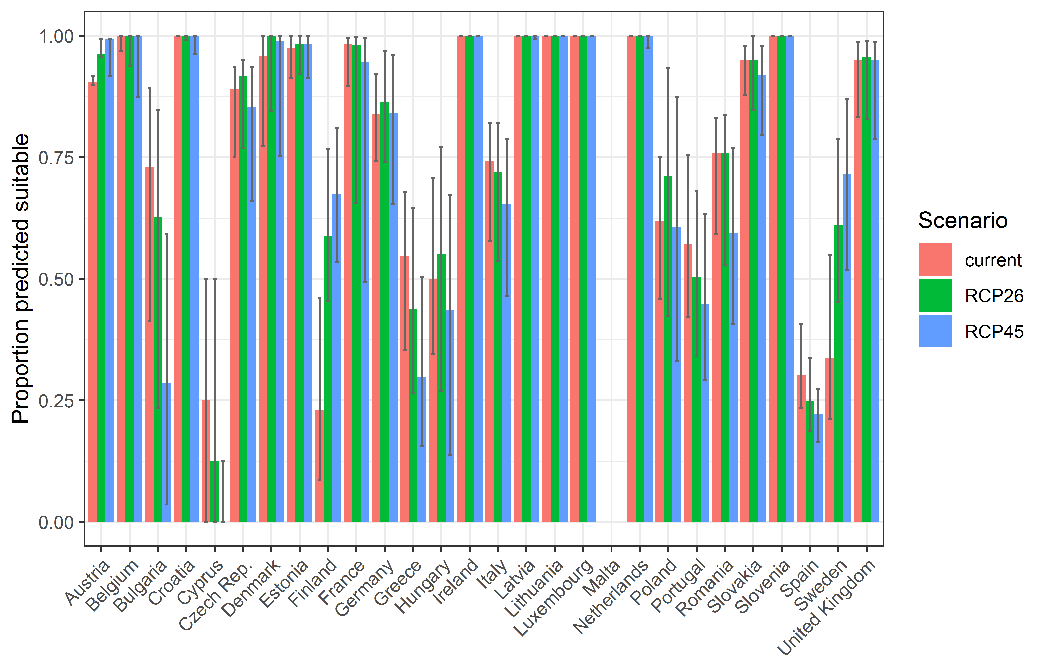

**Table 3.** Variation in projected suitability for *Cervus nippon* establishment among European Union countries and the UK (numerical values of Figure 10 above). The numbers are the proportion of grid cells in each country classified as suitable in the current climate and projected climate for the 2070s under two RCP emissions scenarios (RCP2.6, low emissions scenario; RCP4.5, medium emissions scenario).

|  |  |  |  |  |  |  |  |  |  |
| --- | --- | --- | --- | --- | --- | --- | --- | --- | --- |
|  | **current climate** | | | **2070s RCP2.6** | | | **2070s RCP4.5** | | |
|  | lower | **central estimate** | upper | lower | **central estimate** | upper | lower | **central estimate** | upper |
| Austria | 0.90 | **0.90** | 0.92 | 0.96 | **0.96** | 0.99 | 0.92 | **0.99** | 0.99 |
| Belgium | 0.97 | **1.00** | 1.00 | 0.94 | **1.00** | 1.00 | 0.87 | **1.00** | 1.00 |
| Bulgaria | 0.41 | **0.73** | 0.89 | 0.23 | **0.63** | 0.85 | 0.04 | **0.29** | 0.59 |
| Croatia | 1.00 | **1.00** | 1.00 | 0.99 | **1.00** | 1.00 | 0.96 | **1.00** | 1.00 |
| Cyprus | 0.00 | **0.25** | 0.50 | 0.00 | **0.12** | 0.50 | 0.00 | **0.00** | 0.12 |
| Czech Rep. | 0.75 | **0.89** | 0.94 | 0.77 | **0.92** | 0.95 | 0.66 | **0.85** | 0.94 |
| Denmark | 0.77 | **0.96** | 1.00 | 0.85 | **1.00** | 1.00 | 0.75 | **0.99** | 1.00 |
| Estonia | 0.91 | **0.97** | 1.00 | 0.92 | **0.98** | 1.00 | 0.91 | **0.98** | 1.00 |
| Finland | 0.09 | **0.23** | 0.46 | 0.46 | **0.59** | 0.77 | 0.53 | **0.68** | 0.81 |
| France | 0.90 | **0.98** | 1.00 | 0.66 | **0.98** | 1.00 | 0.49 | **0.95** | 0.99 |
| Germany | 0.74 | **0.84** | 0.92 | 0.74 | **0.86** | 0.97 | 0.65 | **0.84** | 0.96 |
| Greece | 0.35 | **0.55** | 0.68 | 0.26 | **0.44** | 0.65 | 0.16 | **0.30** | 0.50 |
| Hungary | 0.34 | **0.50** | 0.71 | 0.27 | **0.55** | 0.77 | 0.14 | **0.44** | 0.67 |
| Ireland | 1.00 | **1.00** | 1.00 | 1.00 | **1.00** | 1.00 | 1.00 | **1.00** | 1.00 |
| Italy | 0.58 | **0.74** | 0.82 | 0.54 | **0.72** | 0.82 | 0.47 | **0.65** | 0.79 |
| Latvia | 1.00 | **1.00** | 1.00 | 1.00 | **1.00** | 1.00 | 0.99 | **1.00** | 1.00 |
| Lithuania | 1.00 | **1.00** | 1.00 | 1.00 | **1.00** | 1.00 | 1.00 | **1.00** | 1.00 |
| Luxembourg | 1.00 | **1.00** | 1.00 | 1.00 | **1.00** | 1.00 | 1.00 | **1.00** | 1.00 |
| Malta | 0.00 | **0.00** | 0.00 | 0.00 | **0.00** | 0.00 | 0.00 | **0.00** | 0.00 |
| Netherlands | 1.00 | **1.00** | 1.00 | 1.00 | **1.00** | 1.00 | 0.97 | **1.00** | 1.00 |
| Poland | 0.46 | **0.62** | 0.75 | 0.42 | **0.71** | 0.93 | 0.33 | **0.61** | 0.87 |
| Portugal | 0.42 | **0.57** | 0.76 | 0.34 | **0.50** | 0.68 | 0.29 | **0.45** | 0.63 |
| Romania | 0.59 | **0.76** | 0.83 | 0.53 | **0.76** | 0.84 | 0.41 | **0.59** | 0.77 |
| Slovakia | 0.88 | **0.95** | 0.98 | 0.85 | **0.95** | 1.00 | 0.80 | **0.92** | 0.98 |
| Slovenia | 1.00 | **1.00** | 1.00 | 1.00 | **1.00** | 1.00 | 1.00 | **1.00** | 1.00 |
| Spain | 0.23 | **0.30** | 0.41 | 0.19 | **0.25** | 0.34 | 0.16 | **0.22** | 0.27 |
| Sweden | 0.21 | **0.34** | 0.55 | 0.45 | **0.61** | 0.79 | 0.52 | **0.71** | 0.87 |
| UK | 0.83 | **0.95** | 0.99 | 0.83 | **0.95** | 0.99 | 0.79 | **0.95** | 0.99 |

## Caveats to the modelling

To remove spatial recording biases, the selection of the background sample from the accessible background was weighted by the density of Mammalia records on the Global Biodiversity Information Facility (GBIF). While this is preferable to not accounting for recording bias at all, it may not provide the perfect measure of recording bias.

There was substantial variation among modelling algorithms in the partial response plots (Figure 3). In part this will reflect their different treatment of interactions among variables. Since partial plots are made with other variables held at their median, there may be values of a particular variable at which this does not provide a realistic combination of variables to predict from.

Other variables potentially affecting the distribution of the species, such as types of land cover other than trees were not included in the model.

## References

Allouche O, Tsoar A, Kadmon R (2006) Assessing the accuracy of species distribution models: prevalence, kappa and the true skill statistic (TSS), Journal of Applied Ecology, 43, 1223-1232.

Chapman D, Pescott OL, Roy HE, Tanner R (2019) Improving species distribution models for invasive non-native species with biologically informed pseudo-absence selection. Journal of Biogeography, <https://doi.org/10.1111/jbi.13555>.

Cohen J (1960) A coefficient of agreement of nominal scales. Educational and Psychological Measurement, 20, 37-46.

Elith J, Kearney M, Phillips S (2010) The art of modelling range-shifting species. Methods in Ecology and Evolution, 1, 330-342.

Fielding AH, Bell JF (1997) A review of methods for the assessment of prediction errors in conservation presence/absence models. Environmental Conservation, 24, 38-49.

Hijmans RJ, Cameron SE, Parra JL, Jones PG, Jarvis A (2005) Very high resolution interpolated climate surfaces for global land areas. International Journal of Climatology, 25, 1965-1978.

Iglewicz B, Hoaglin DC (1993) How to detect and handle outliers, Asq Press.

Manel S, Williams HC, Ormerod SJ (2001) Evaluating presence-absence models in ecology: the need to account for prevalence. Journal of Applied Ecology, 38, 921-931.

McPherson JM, Jetz W, Rogers DJ (2004) The effects of species’ range sizes on the accuracy of distribution models: ecological phenomenon or statistical artefact? Journal of Applied Ecology, 41, 811-823.

Pearson RG, Raxworthy CJ, Nakamura M, Townsend Peterson A (2007), Predicting species distributions from small numbers of occurrence records: a test case using cryptic geckos in Madagascar. Journal of Biogeography, 34: 102-117. <https://doi.org/10.1111/j.1365-2699.2006.01594.x>

Thuiller W, Lafourcade B, Engler R, Araújo MB (2009) BIOMOD-a platform for ensemble forecasting of species distributions. Ecography, 32, 369-373.

Thuiller W, Georges D, Engler R and Breiner F (2020). biomod2: Ensemble Platform for Species Distribution Modeling. R package version 3.4.6. <https://CRAN.R-project.org/package=biomod2>

1. This template is based on the Great Britain non-native species risk assessment scheme (GBNNRA). A number of amendments have been introduced to ensure compliance with Regulation (EU) 1143/2014 on IAS and relevant legislation, including the Delegated Regulation (EU) 2018/968 of 30 April 2018, supplementing Regulation (EU) No 1143/2014 of the European Parliament and of the Council with regard to risk assessments in relation to invasive alien species (see <https://eur-lex.europa.eu/legal-content/en/TXT/?uri=CELEX%3A32018R0968> ).
2. Convention on Biological Diversity, Decision VI/23
3. <https://circabc.europa.eu/sd/a/7e5f0bd4-34e8-4719-a2f7-c0cd7ec6a86e/2020-CBD-pathways-interpretation.pdf>
4. <https://circabc.europa.eu/sd/a/0aeba7f1-c8c2-45a1-9ba3-bcb91a9f039d/TSSR-2016-010%20CBD%20pathways%20key%20full%20only.pdf>
5. Not to be confused with “no impact”.
6. Note: in the CICES classification provisioning of water is considered as an abiotic service whereas the rest of ecosystem services listed here are considered biotic.