**Risk assessment template developed under the "Study on Invasive Alien Species – Development of risk assessments to tackle priority species and enhance prevention"   
Contract No 090201/2021/856738/ETU/ENV.D2[1]**

**Name of organism: *Misgurnus bipartitus* (Sauvage & Dabry de Thiersant, 1874)**

**Author(s) of the assessment:**

Hugo Verreycken, INBO, Brussels, Belgium

**Risk Assessment Area:** The risk assessment area is the territory of the European Union 27, excluding the EU-outermost regions.

**Peer review 1:** Emili García-Berthou, University of Girona, Girona, Catalonia, Spain

**Peer review 2:** Elena Tricarico, Department of Biology, Florence, Italy

**Date of completion:** 15/10/2022

**Date of revision:** 01/12/2023

**Contents**

SECTION A – Organism Information and Screening 4

SECTION B – Detailed assessment 14

1 PROBABILITY OF INTRODUCTION AND ENTRY 14

2 PROBABILITY OF ESTABLISHMENT 24

3 PROBABILITY OF SPREAD 30

4 MAGNITUDE OF IMPACT 37

RISK SUMMARIES 49

REFERENCES 50

Distribution Summary 57

ANNEX I Scoring of Likelihoods of Events 59

ANNEX II Scoring of Magnitude of Impacts 59

ANNEX III Scoring of Confidence Levels 60

ANNEX IV CBD pathway categorisation scheme 61

ANNEX V Ecosystem services classification (CICES V5.1, simplified) and examples 62

ANNEX VI EU Biogeographic Regions and MSFD Subregions 67

ANNEX VII Delegated Regulation (EU) 2018/968 of 30 April 2018 68

ANNEX VIII Species Distribution Model (B. Beckmann, H. Verreycken and D. Chapman) 78

# SECTION A – Organism Information and Screening

|  |
| --- |
| **A1. Identify the organism. Is it clearly a single taxonomic entity and can it be adequately distinguished from other entities of the same rank?**  including the following elements:   * the taxonomic family, order and class to which the species belongs; * the scientific name and author of the species, as well as a list of the most common synonym names; * names used in commerce (if any) * a list of the most common subspecies, lower taxa, varieties, breeds or hybrids   As a general rule, one risk assessment should be developed for a single species. However, there may be cases where it may be justified to develop one risk assessment covering more than one species (e.g. species belonging to the same genus with comparable or identical features and impact). It shall be clearly stated if the risk assessment covers more than one species, or if it excludes or only includes certain subspecies, lower taxa, hybrids, varieties or breeds (and if so, which subspecies, lower taxa, hybrids, varieties or breeds). Any such choice must be properly justified. |

Response:

The present risk assessment covers one species (no lower taxa): *Misgurnus bipartitus* (Sauvage & Dabry de Thiersant, 1874). It belongs to the genus *Misgurnus* Lacepède 1803, which is part of the Cobitidae (loaches or weatherfishes) (Froese and Pauly 2022).

Actinopterygii > Cypriniformes (Carps) > Cobitidae (Loaches or weatherfishes) > Cobitinae > *Misgurnus* Lacepède 1803 > *Misgurnus bipartitus* (Sauvage & Dabry de Thiersant, 1874)

Kingdom: Animalia

Phylum: Chordata

Class: Actinopterygii (ray-finned fishes)

Order: Cypriniformes (Carps)

Family: Cobitidae (Loaches)

Genus: *Misgurnus* Lacepède 1803

Cobitidae consists of 28 genera and 262 species (Froese and Pauly 2022); but the taxonomy is not fully clear and the number of recognised species differs from study to study and database to database and is still subject to new research.

Recently, Eschmeyer’s Catalog of Fishes (Fricke et al. 2023), reintegrated the genus *Paramisgurnus* within the genus *Misgurnus*. Following Fricke et al. (2023), the genus *Misgurnus* now contains 12 valid species:*Misgurnus amamianus* Nakajima & Hashiguchi 2022

*Misgurnus anguillicaudatus* (Cantor 1842)

*Misgurnus bipartitus* (Sauvage and Dabry de Thiersant 1874)

*Misgurnus buphoensis* Kim and Park 1995

*Misgurnus chipisaniensis* Shedko & Vasil'eva 2022

*Misgurnus fossilis* (Linnaeus 1758)

*Misgurnus mohoity* (Dybowski 1869)

*Misgurnus multimaculatus* Rendahl 1944

*Misgurnus nahangensis* (Nguyen & Bui 2009)

*Misgurnus nikolskyi* Vasil'eva 2001

*Misgurnus tonkinensis* Rendahl 1937

*Misgurnus dabryanus* (Guichenot 1872)

The latter species was only recently renamed from *Paramisgurnus dabryanus* Dabry de Thiersant, 1872 to *Misgurnus dabryanus* (Guichenot 1872)(Fricke et al. 2023).

Where FishBase (Froese and Pauly 2022), as well as ITIS mention *M. bipartitus* as a synonym for *M. mohoity*, recent studies e.g. Yi et al. (2016a, 2017), Zangl et al. (2020), Brys et al. (2020), Belle at al. (2021), consider *M. bipartitus* and *M. mohoity* as separate species. Since the recent website update also Eschmeyer's Catalog of Fishes (Fricke et al. 2023) recognizes both species as separate taxa. A taxonomic synonym for *M. bipartitus* is *Nemacheilus bipartitus* (Fricke et al. 2022)

Yi et al. (2017) describe four different weatherloaches in the genera *Misgurnus* and *Paramisgurnus* (Cypriniformes: Cobitidae) which are distributed in China: *M. anguillicaudatus*, *M. mohoity*, *M. bipartitus*, and *M. dabryanus*. Among these species, *M. anguillicaudatus* and *M. dabryanus* are widespread found in most areas, except in the Qinghai-Tibet Plateau, whereas *M. bipartitus* is restricted in the north of Yellow River, and *M. mohoity* only occurs in Amur River Basin, Inner Mongolia and the Far East region of Russia (Perdices et al. 2012, Belle et al. 2021.

According to Kottelat and Freyhof (2007), only two non-native Asian’ or ‘oriental’ weatherfish were recorded in the risk assessment (RA) area (*M. anguillicaudatus* and *M. dabryanus*). However, Zięba et al. (2010) report that a fish imported under the name *Misgurnus anguillicaudatus* in the UK was found to be *M. mizolepis*. This reproducing loach population in a pond in Essex is since eradicated (Zięba et al. 2010). *M. bipartitus* is the fourth Asian or oriental weatherfish of the genus *Misgurnus* in the RA area (Brys et al. 2020, Zangl et al. 2020).

The three Asian or oriental weatherfish species that have been established in Europe to date, *M. bipartitus*, *M. anguillicaudatus* and *M. dabryanus*, can usually be easily distinguished from the European weatherfish *M. fossilis* by the lack of the characteristic longitudinal stripes of the latter species, which are also easily recognisable in juvenile animals. In contrast to *M. fossilis*, the males of the non-native species develop a lamina circularis at the base of the pectoral fins. *M. dabryanus* differs from the other two non-native species by its large body size, the pronounced fat ridge on the caudal peduncle, the larger scales and the absence of a black spot at the base of the caudal fin. This black dot is clearly pronounced in *M. bipartitus*, but is also absent in *M. fossilis* (Jung et al. 2021).

Yi et al. (2017) made a morphological comparison and DNA barcoding of four closely related *Misgurnus* species to evaluate the feasibility of morphological and genetic identification of the species *M. dabryanus*, *M. anguillicaudatus*, *M. bipartitus* and *M. mohoity*. Twelve morphological characters were measured in 542 individuals to perform the comparative analysis. Among these characters, only the caudal peduncle length revealed significant difference (P < 0.05) among these four species.

Li et al. (2010) measured eleven morphometrical items to evaluate the morphological variations in ‘Amur’ weatherfish *M. mohoity*, ‘northern oriental’ weatherfish *M. bipartitus* and ‘oriental’ weatherfish *M. anguillicaudatus* by three methods of multivariate analysis. Cluster analysis showed that ‘northern oriental’ weatherfish was close to ‘oriental’ weatherfish, and distantly related to ‘Amur’ weatherfish in genetic relationship (Li et al. 2010). Population genetic studies by Yi et al. (2016a, 2018) corroborate this close relationship between *M. anguillicaudatus* and *M. bipartitus*.

Vasil’eva (2001) gives the following morphological characteristics for the differentiation between *M. anguillicaudatus* and *M. bipartitus*:

The length of the caudal peduncle is 1.1-1.9 times the height of the caudal peduncle, the distance between the base of the ventral fin and the base of the anal fin is 1.3-1.4 times the distance between the base of the anal fin and the base of the caudal fin, 43 – 47 vertebrae => *M. anguillicaudatus*

The length of the caudal peduncle is 1.9-2.9 times the height of the caudal peduncle, the distance between the base of the ventral fin and the base of the anal fin is 2.0-2.5 times the distance between the base of the anal fin and the base of the caudal fin, 48 – 51 vertebrae => *M. bipartitus*.

No preferred common name in English for *M. bipartitus* could be found. Generally, all weatherfish from Asia are called Asian or oriental weatherfish, but also dojo, pond loach and Asian weatherloach are used as common names. Yi et al. (2016b, 2017) use ‘northern’ weatherfish as common name for *M. bipartitus*. Because of its Asian origin and more northerly native range, however, we agree with Li et al. (2010) and propose to use **‘northern oriental weatherfish’** for *M. bipartitus* in this risk assessment.

Many weatherfish species are known to hybridise naturally e.g. *M. anguillicaudatus* is known to hybridise naturally with *M. dabryanus* (You et al. 2009). Artificial hybrids were produced between *M. dabryanus* and *M. bipartitus* (Zhang et al. 2019) and between *M. anguillicaudatus* and *M. bipartitus* (Chu et al. 2019) and used in aquaculture. Artificial reproduction was also used to successfully crossbreed *M. anguillicaudatus* with the native *M. fossilis* (Wanzenböck et al. 2021), but, although likely, no data are available about possible hybridisation of *M. bipartitus* with *M. fossilis*. Recently, hybrids between *M. bipartitus* and *M. anguillicaudatus* have been found in Catalonia (Clavero et al. 2023). Hybrids between these two species are explicitly included in this risk assessment, as it has to be assumed that impacts are identical to the parental species.

The known common names of *M. bipartitus* in European languages other than English are the following: NL: Noord-Aziatische modderkruiper, DE: Nordasiatischer Schlammpeitzger, Nordchinesischen Schlammpeitzger, FI: Marmorimutakala.

|  |
| --- |
| **A2. Provide information on the existence of other species that look very similar [that may be detected in the risk assessment area, either in the environment, in confinement or associated with a pathway of introduction]**  Include both native and non-native species that could be confused with the species being assessed, including the following elements:   * other alien species with similar invasive characteristics, to be avoided as substitute species (in this case preparing a risk assessment for more than one species together may be considered); * other alien species without similar invasive characteristics, potential substitute species; * native species, potential misidentification and mis-targeting |

Response: Loaches and weatherfishes from the genus *Misgurnus* have a long eel-like body and ten chin barbels. Sportvisserij Nederland[2] describes *Misgurnus bipartitus* as “shows similarities to the native weatherfish *M. fossilis*. Both can grow to more than 25 centimeters in length and have ten chin barbels. However, *M. bipartitus* has no obvious longitudinal stripes on the sides and is more olive-coloured and more even in colour, with a marbled to speckle-like pattern”. Males can be distinguished from females (sexual dimorphism) by the enlarged second ray of the pectoral fin and the elongated reddish brown thickening on the dorsal side at the level of the dorsal fin.

In the RA area, only one species of the genus *Misgurnus* is native (*Misgurnus fossilis*) with distribution in Europe north of the Alps, from the Meuse eastwards to the Neva drainages and Lake Ladoga, the northern Black Sea basin from the Danube eastward to Kuban, in the Caspian basin in the Volga and Ural drainages and in the Black Sea basin but not south of the Danube and Kuban (Kottelat and Freyhof 2007). The European weatherfish *M. fossilis* also has an anguilliform body shape and ten barbels but has a broad midlateral line from eye to caudal base and a narrow stripe from opercle at least to pelvic origin instead of irregular spots on the body for *M. bipartitus*. Other native loaches belong to separate genera (*Cobitis* and *Sabanejewia*) and can be readily distinguished from *Misgurnus* because the suborbital spine is externally visible (*versus* hidden under muscles in *Misgurnus*) and the lower lip has 0-2 short, barbel-like mental lobes (vs. 4 long, barbel-like mental lobes in *Misgurnus*) (Kottelat and Freyhof 2007).

Discussed below are other non-native *Misgurnus* species that look similar and can be potential substitute species though some are already present in the RA.

*Misgurnus bipartitus* is morphologically very similar to *M. anguillicaudatus*, but good morphological identification keys are not readily available (Frable 2008). Yi et al. (2017) provide a morphological comparison of four Chinese *Misgurnus* species (*M. dabryanus*, *M. anguillicaudatus*, *M. bipartitus*, *M. mohoity*) and conclude that morphometric measurements can be used to distinguish between these species but also warn that “efficient delimitation of these four closely related species based on one or several morphological characters seems to be difficult and limited”. Population genetic studies by Yi et al. (2017, 2018), however, showed that these genetic analysis can be used as an efficient identifier of the different Chinese weatherfish species.

Zangl et al. (2020) based their morphological identification of *M. bipartitus* on characters given in the key by Vasil’eva (2001 and the translated Chinese key therein) namely the caudal peduncle depth 2.4–2.5 times in caudal peduncle length vs. 1.3–1.8 times in *M. anguillicaudatus* and the maximum body depth 8.2–8.6 times in standard length (SL) *vs.* < 7.5 times in *M. anguillicaudatus*. The latter species is more elongated (Nichols 1943).

The large-scale loach *M. dabryanus* can be distinguished from *M. fossilis* by the absence of a broad midlateral stripe from eye to caudal base, and the absence of the narrow stripe from opercle to the pelvic origin (Stoeckle et al. 2019).

As systematics and taxonomy are still not fully resolved in the genus *Misgurnus* correct identification of *Misgurnus* species remains difficult (Zangl et al. 2020). Many authors, however, are able to correctly identify, morphologically as well as genetically, the different oriental weatherfish species (Yi et al. 2016b, 2017, 2018; Zangl et al. 2020, Jung et al. 2021)

|  |
| --- |
| **A3. Does a relevant earlier risk assessment exist? Give details of any previous risk assessment, including the final scores and its validity in relation to the risk assessment area.** |

Response: No other earlier risk assessments were found for *M. bipartitus*. Because of its ressemblance with *M. anguillicaudatus*, risk assessments for this latter species may be applicable for *M. bipartitus* as well. Jung et al. (2021) assume that although no English-language publications on the biology and ecology of *M. bipartitus* are available, it can be assumed that papers on *M. anguillicaudatus* and the populations described therein can also be used for other oriental *Misgurnus* species.

For *M. anguillicaudatus*, a risk assessment was performed for South Australia in 2014 (Fredberg et al. 2014). The authors used FISK and NAPRA tools to assess, rank and score the environmental, economic and social impacts and costs of *M. anguillicaudatus* and found that the species has a high risk of establishment and several potential impacts were suggested, including competition for spawning sites and for food and shelter, disturbance and/or predation of fish and frog eggs, alteration of habitat and decreased water quality. Fredberg et al. (2014), however, concluded that these impacts were largely speculative and further research is needed to fill several knowledge gaps.

For the USA, an Ecological Risk Screening Summary was written by the U.S. Fish and Wildlife Service (2012). *Misgurnus anguillicaudatus* is established in the US and they concluded that there is a high risk of additional introductions, establishment, and impacts in other areas because this species is highly adaptable, quick to reproduce, and is extremely popular in the aquaculture and aquarium industry. The climate match with the native range is high and multiple impacts are expected (reductions in macroinvertebrate populations, altered aquatic habitats, and the fish are vectors for certain fish parasites). Their overall risk was estimated as high but with a medium certainty of the assessment.

In the Netherlands, Spikmans et al. (2010) made a pest risk analysis for ten non-native fish species based on literature and climate match. For oriental weatherfish, *M. anguillicaudatus*, they found a high current climate match with most of the Dutch rivers suitable for establishment of this fish. They do not assess the invasiveness of this species but only summarise the literature on possible impacts (high predation on macroinvertebrates with possible reduction of availability of these macroinvertebrates for other species, competition for habitat with other benthic species and disease transmission).

Almeida et al. (2013) applied FISK for *M.* *anguillicaudatus* in the Iberian Peninsula and it was assessed as "High risk of becoming invasive".

All the above risk assessments for *M. anguillicaudatus* are probably valid for *M. bipartitus* and for the RA area because of a high similarity in morphology between both species and a reasonable to good climate match and the high adaptability of these Asian or oriental weatherfishes.

|  |
| --- |
| **A4. Where is the organism native?**  including the following elements:   * an indication of the continent or part of a continent, climatic zone and habitat where the species is naturally occurring * if applicable, indicate whether the species could naturally spread into the risk assessment area |

Response: Yi et al. (2017) found that the distribution of *M. bipartitus* in China is restricted to the area north of the Yellow River. Specimens of the northern oriental weatherfish were detected in the Liao River basin and in Songhua river basin. Zhang et al. (2018) report specimens from the Yalu river on the Chinese-North Korean border.

Jung et al. (2021) state that due to the taxonomic uncertainties, older data on the distribution area of the oriental weatherfishes must be interpreted with caution. In China, the north area of the Yellow River is given as the natural distribution area for *M. bipartitus* (Yi et al. 2017). However, the distribution map contained in this paper, which only refers to China, suggests that the species may also occur in North Korea. Other authors also indicate Russia and Japan or Mongolia as natural distribution areas (Chen 1981, Fricke et al. 2022). In any case, the species is used intensively for fishing in China and, according to Huang et al. (2015), commonly raised in aquaculture for food purposes. It is therefore possible that the original distribution area can no longer be reconstructed with certainty.

The native distribution, as described by Yi et al. (2017), appears to be situated mainly in the Dwa (warm continental climate/humid continental climate) and Dwb (temperate continental climate/humid continental climate) zones of the Köpper-Geiger map (Peel et al. 2007).

Information on the natural habitat of *M. bipartitus* was not available but it can be assumed that it lives in stagnant or weak flowing waters of swamps with a muddy bottom along rivers and lakes, pools, ponds and rice fields as most oriental weatherfishes do (Froese and Pauly 2022). Natural spread from its native area into the risk assessment area is not possible.

|  |
| --- |
| **A5. What is the global non-native distribution of the organism outside the risk assessment area?** |

Response: Outside the RA area, no data on the non-native distribution of the northern oriental weatherfish are available. Some introduced populations of oriental *Misgurnus* species outside the RA area may be *M. bipartitus* but may not have been recognised as such because of misidentification as happened in the RA area (Brys et al. 2020, Zangl et al. 2020).

|  |
| --- |
| **A6. In which biogeographic region(s) or marine subregion(s) in the risk assessment area has the species been recorded and where is it established? The information needs be given separately for recorded (including casual or transient occurrences) and established occurrences. “Established” means the process of an alien species successfully producing viable offspring with the likelihood of continued survival[3].**  **A6a. Recorded: List regions**  **A6b. Established: List regions**  Freshwater / terrestrial biogeographic regions:   * Alpine, Atlantic, Black Sea, Boreal, Continental, Mediterranean, Pannonian, Steppic   Marine regions:   * Baltic Sea, North-east Atlantic Ocean, Mediterranean Sea, Black Sea   Marine subregions:   * Greater North Sea, incl. the Kattegat and the English Channel, Celtic Seas, Bay of Biscay and the Iberian Coast, Western Mediterranean Sea, Adriatic Sea, Ionian Sea, Central Mediterranean Sea, Aegean-Levantine Sea.   Comment on the sources of information on which the response is based and discuss any uncertainty in the response.  For delimitation of EU biogeographical regions please refer to <https://www.eea.europa.eu/data-and-maps/figures/biogeographical-regions-in-europe-2> (see also Annex VI).  For delimitation of EU marine regions and subregions consider the Marine Strategy Framework Directive areas; please refer to <https://www.eea.europa.eu/data-and-maps/data/msfd-regions-and-subregions/technical-document/pdf> (see also Annex VI). |

Response (6a): **Atlantic** (Brys et al. 2020, Jung et al. 2021) and **Continental** (Zangl et al. 2020, Jung et al. 2021). In the **Mediterranean region**, recently hybrids between *M. bipartitus* and *M. anguillicaudatus*, but no pure *M. bipartitus*, were found in Catalonia (Clavero et al. 2023).

Response (6b): **Atlantic** (Brys et al. (2020) report natural reproduction and presence of young fishes in The Netherlands and Belgium), **Continental** (Jung et al. (2021) report adults and juveniles which suggests that a successfully reproducing population has been established in the river Inn in Germany and Austria). **Mediterranean** (Clavero et al. (2023) report established populations of the hybrids between *M. bipartitus* and *M. anguillicaudatus*.)

|  |
| --- |
| **A7. In which biogeographic region(s) or marine subregion(s) in the risk assessment area could the species establish in the future under current climate and under foreseeable climate change? The information needs be given separately for current climate and under foreseeable climate change conditions.**  **A7a. Current climate: List regions**  **A7b. Future climate: List regions**  With regard to EU biogeographic and marine (sub)regions, see above.  With regard to climate change, provide information on   * the applied timeframe (e.g. 2050/2070) * the applied scenario (e.g. RCP 4.5) * what aspects of climate change are most likely to affect the risk assessment (e.g. increase in average winter temperature, increase in drought periods)   The assessment does not have to include a full range of simulations on the basis of different climate change scenarios, as long as an assessment with a clear explanation of the assumptions is provided. However, if new, original models are executed for this risk assessment, the following RCP pathways shall be applied: RCP 2.6 (likely range of 0.4-1.6°C global warming increase by 2065) and RCP 4.5 (likely range of 0.9-2.0°C global warming increase by 2065). Otherwise, the choice of the assessed scenario has to be explained. |

Response (7a): Due to the very low number of occurrence data in the native as well as the invaded range, the variation in projected suitability in the SDM results in a low confidence of the model predictions (Annex VIII). Favourable conditions, e.g. temperature, are not known for *M. bipartitus* but this species could probably currently establish in all EU biogeographic regions (Annex VIII). Many regions seem to currently have a low suitability for establishment. The highest current suitability is in the Steppic and Pannonian regions followed by the Continental, Mediterraean, and Black Sea regions that have, however, medium suitability (see Annex VIII Fig. 9). The Atlantic region where the establishment of the northern oriental weatherfish is proven seems to have a very low predicted establishment suitability which confirms the low confidence of the model.

Response (7b): The species could establish in the 2070s under climate change scenario RCP2.6 and scenario RCP4.5 in all EU biogeographic regions (Annex VIII). The highest suitability is in the Pannonian and Continental region. In the Black Sea, Boreal and the Atlantic region an increase in suitability is forecasted, while in the Mediterranean and Steppic regions a lower establishment possibility is expected for the two climate change scenarios (Annex VIII Fig. 9).

The ensemble model suggested that suitability for *M. bipartitus* was most strongly determined by Mean temperature of the warmest quarter (Bio10), accounting for 47.7% of variation explained, followed by Annual precipitation (Bio12) (37.1%) and Mean temperature of the coldest quarter (Bio11) (15.2%) (Annex VIII). However, care must be taken while interpreting the results of the SDM especially for Question A7b as freshwater fish species are rather dispersal limited than climate limited and furthermore is the SDM based on very few records.

|  |
| --- |
| **A8. In which EU Member States has the species been recorded and in which EU Member States has it established? List them with an indication of the timeline of observations. The information needs be given separately for recorded and established occurrences.**  **A8a. Recorded: List Member States**  **A8b. Established: List Member States**  Austria, Belgium, Bulgaria, Croatia, Cyprus, Czech Republic, Denmark, Estonia, Finland, France, Germany, Greece, Hungary, Ireland, Italy, Latvia, Lithuania, Luxembourg, Malta, Netherlands, Poland, Portugal, Romania, Slovakia, Slovenia, Spain, Sweden  The description of the invasion history of the species shall include information on countries invaded and an indication of the timeline of the first observations, establishment and spread. |

Response (8a): Netherlands, Belgium, Germany and Austria.

The northern oriental weatherfish was probably first recorded in the Netherlands in 2012 (van Kessel et al. 2013a) although it was registered as *M. anguillicaudatus* at that time. Recent genetic work (Brys et al. 2020), however, proved that this species was *M. bipartitus* and that it has spread to the northeast of Belgium from 2019 onwards. Zangl et al. (2020) showed that two records from the river Inn in Austria in Octobre 2018 proved to be *M. bipartitus* and came to the conclusion that the oriental weatherfish reported by Belle et al. (2017) from the same river but in Germany had the exact same haplotype and must also be *M. bipartitus*, as recognized by Belle et al. (2021).

Confirmed populations of *M. bipartitus* exist in Austria and Germany (Zangl et al. 2020, Jung et al. 2021) and Belgium and The Netherlands (Brys et al. 2020). Although the species as such is not reported elsewhere in the EU, Clevero et al. (2023) report hybrids between *M. bipartitus* and *M. anguillicaudatus* from Catalonia in Spain.

Populations of oriental weatherfish *M. anguillicaudatus* in the RA area are reported from The Netherlands (van Kessel et al. 2013a, Niemeijer and van Kessel 2016), Germany (Freyhof and Korte 2005), Spain (Franch et al. 2008), and Italy (Razzetti et al. 2001) but some of these populations are possibly misidentified and could in fact be *M. bipartitus* (see Zangl et al. 2020). Hybrids between *M. anguillicaudatus* and *M. bipartitus* were recently reported from Catalonia in Spain. Other Asian weatherfish species are reported from Switzerland, Germany and Spain, namely *M. dabryanus* (large-scale loach) (Freyhof and Brooks 2011, Stoeckle et al. 2019, Clavero et al. 2023) and from a previous MS, the UK, *M. mizolepis* (Zięba et al. 2010).

Response (8b): Netherlands, Belgium, Germany and Austria

In the Netherlands, *M. bipartitus* is expanding since its first record in 2012 (van Kessel et al. 2013a), in the following years plenty young-of-the-year specimens were caught (Binnendijk et al. 2017). This population has expanded its distribution into the northeast of Belgium (Brys et al. 2020) and over 2000 specimens of this species between 6.3 and 20.8 cm were caught in fykes in the Summer of 2021 in wetlands near the river Lossing. Despite the fact that these populations are expanding their range and that large numbers of *M. bipartitus* can occur at infested sites, at the moment, this species is only present in a very small area (probably <250 km²) in the northeast of Belgium and the southeast of the Netherlands.

First specimens of *M. bipartitus* were caught in 2016 in the River Inn (in South Germany and Austria) (Belle et al. 2017, Zangl et al. 2020), and now the species is established (Jung et al. 2021). Clavero et al. (2023) report established, expanding populations of hybrid *M. bipartitus* x *M. anguillicaudatus* from the River Ter in Catalonia (Spain).

|  |
| --- |
| **A9. In which EU Member States could the species establish in the future under current climate and under foreseeable climate change? The information needs be given separately for current climate and under foreseeable climate change conditions.**  **A9a. Current climate: List Member States**  **A9b. Future climate: List Member States**  With regard to EU Member States, see above.  With regard to climate change, provide information on   * the applied timeframe (e.g. 2050/2070) * the applied scenario (e.g. RCP 4.5) * what aspects of climate change are most likely to affect the risk assessment (e.g. increase in average winter temperature, increase in drought periods)   The assessment does not have to include a full range of simulations on the basis of different climate change scenarios, as long as an assessment with a clear explanation of the assumptions is provided. However, if new, original models are executed for this risk assessment, the following RCP pathways shall be applied: RCP 2.6 (likely range of 0.4-1.6°C global warming increase by 2065) and RCP 4.5 (likely range of 0.9-2.0°C global warming increase by 2065). Otherwise, the choice of the assessed scenario has to be explained. |

Response (9a): Under current climate conditions *M. bipartitus* could probably only establish in some EU MS; there seems to be a high establishment potential only in Bulgaria and Hungary and to a lesser extent Croatia, France, Greece, Italy, Portugal, Romania, Slovakia and Spain (Appendix VIII, Fig. 10). Low establishment potential was found for Austria, Belgium, Cyprus, Czech Republic, Germany, Luxembourg, The Netherlands, Poland, and Slovenia.

Response (9b): In the 2070s, under climate change scenario RCP2.6 and scenario RCP4.5 *M. bipartitus* could establish in almost all EU MS except Cyprus, Ireland and Malta: especially increased potential (compared to current conditions) would be available for Belgium, the Czech Republic, France, Germany, Luxembourg, The Netherlands, Poland and Slovakia. In the Mediterraean countries suitable establishment area would clearly diminish while in the north European countries (Denmark, Estonia, Finland, Latvia, Lithuania and Sweden more suitability is predicted (Fig. 10). Note, however, that the SDM has a low confidence due to the low number of available data.

The ensemble model suggested that suitability for *M. bipartitus* was most strongly determined by Mean temperature of the warmest quarter (Bio10), accounting for 47.7% of variation explained, followed by Annual precipitation (Bio12) (37.1%) and Mean temperature of the coldest quarter (Bio11) (15.2%) (Annex VIII).

|  |
| --- |
| **A10. Is the organism known to be invasive (i.e. to threaten or adversely impact upon biodiversity and related ecosystem services) anywhere outside the risk assessment area?** |

Response: No data are available for the northern oriental weatherfish *M. bipartitus*.

The congener species *M. anguillicaudatus* probably displays a similar behaviour as *M. bipartitus* and the first species is known to be invasive in several parts of the world. Several authors reported adverse impacts for the oriental weatherfish as follows: niche overlap, competition for resources and space, introduction of parasites, predation on eggs of fishes and restructuring of the aquatic ecosystem. No English-language publications on the biology and ecology of *M. bipartitus* are available but it can be assumed that papers on *M. anguillicaudatus* and the populations described therein can also be used for *M. bipartitus* (Jung et al. 2021).

|  |
| --- |
| **A11. In which biogeographic region(s) or marine subregion(s) in the risk assessment area has the species shown signs of invasiveness? Indicate the area endangered by the organism as detailed as possible.**  Freshwater / terrestrial biogeographic regions:   * Alpine, Atlantic, Black Sea, Boreal, Continental, Mediterranean, Pannonian, Steppic   Marine regions:   * Baltic Sea, North-east Atlantic Ocean, Mediterranean Sea, Black Sea   Marine subregions:  Greater North Sea, incl. the Kattegat and the English Channel, Celtic Seas, Bay of Biscay and the Iberian Coast, Western Mediterranean Sea, Adriatic Sea, Ionian Sea, Central Mediterranean Sea, Aegean-Levantine Sea |

Response: Established populations in the RA area are reported in the Atlantic (Brys et al. 2020) and the Continental (Zangl et al. 2020, Jung et al. 2021). Although it is not explicitly stated in the papers that report the establishment of self-sustaining populations, most authors mention potential negative impacts that imply invasiveness. The large densities recorded in border area between The Netherlands and Belgium (Atlantic region) must almost certainly impact the indigenous benthic fishes there because of competition for food and habitat.

|  |
| --- |
| **A12. In which EU Member States has the species shown signs of invasiveness? Indicate the area endangered by the organism as detailed as possible.**  Austria, Belgium, Bulgaria, Croatia, Cyprus, Czech Republic, Denmark, Estonia, Finland, France, Germany, Greece, Hungary, Ireland, Italy, Latvia, Lithuania, Luxembourg, Malta, Netherlands, Poland, Portugal, Romania, Slovakia, Slovenia, Spain, Sweden |

Response: Invasiveness is not explicitly stated in the papers that report established populations in the RA area. Most impacts mentioned are anecdotal but imply invasiveness. High impacts are expected in the Netherlands (southeastern part near Weert) and Belgium (northeastern part near Bocholt) (e.g. hybridisation with *M. fossilis* Brys et al. 2020) and in the River Inn and its tributaries in Germany and Austria (Zangl et al. 2020, Jung et al. 2021). The large densities recorded in border area between The Netherlands and Belgium must almost certainly impact the indigenous benthic fishes there because of competition for food and habitat.

|  |
| --- |
| **A13. Describe any known socio-economic benefits of the organism.**  including the following elements:   * Description of known uses for the species, including a list and description of known uses in the risk assessment area and third countries, if relevant. * Description of social and economic benefits deriving from those uses, including a description of the environmental, social and economic relevance of each of those uses and an indication of associated beneficiaries, quantitatively and/or qualitatively depending on what information is available.   If the information available is not sufficient to provide a description of those benefits for the entire risk assessment area, qualitative data or different case studies from across the risk assessment area or third countries shall be used, if available. |

Response: It is possible that *Misgurnus bipartitus* is sold as an ornamental fish in the aquarium trade in the RA area (Jung et al. 2021), and it is used as a food source in Asia (Park et al. 2006). However, no published figures on quantities and costs were found.

In China (and other Asian countries), all weatherfish, including *M. bipartitus* (Yi et al. 2016b, 2017), are highly valued food fish and also used in traditional Chinese medicine. Since the 1990s the entire life cycle of this fish can be produced in aquaculture facilities and as of 2010 more than 204.552 tons were produced in aquaculture in China (Milton et al. 2018).

# SECTION B – Detailed assessment

|  |
| --- |
| **Important instructions:**   * In the case of lack of information the assessors are requested to use a standardized answer: “No information has been found.” In this case, no score and confidence should be given and the standardized “score” is N/A (not applicable). * With regard to the scoring of the likelihood of events or the magnitude of impacts see Annexes I and II. * With regard to the confidence levels, see Annex III. * Highlight the selected response score and confidence level in **bold** but keep the other scores in normal text (so that the selected score is evident in the final document). |

## 1 PROBABILITY OF INTRODUCTION AND ENTRY

|  |
| --- |
| **Important instructions:**   * **Introduction** is the movement of the species into the risk assessment area (it may be either in captive conditions and/or in the environment, depending on the relevant pathways). * **Entry** is the release/escape/arrival in the environment, i.e. occurrence in the wild * Introduction and entry may coincide for species entering through pathways such as “corridor” or “unaided”, but it also may differ. If different, please consider all relevant pathways, both for the introduction into the risk assessment area and the entry in the environment. * For each described pathway, in each of the questions below, ensure that there are separate comments explicitly addressing both the “introduction” and “entry” where applicable and as appropriate. * The classification of pathways developed by the Convention of Biological Diversity (CBD) should be used (see Annex IV). For detailed explanations of the CBD pathway classification scheme consult the IUCN/CEH guidance document[4] and the provided key to pathways[5]. * For organisms which are already present (recorded or established) in the risk assessment area, the likelihood of introduction and entry should be scored as “very likely” by default. * Repeated (independent) introductions and entries at separate locations in the risk assessment area should be considered here (see Qu. 1.7). |

|  |
| --- |
| **Qu. 1.1. List relevant pathways through which the organism could be introduced into the risk assessment area and/or enter into the environment. Where possible give details about the specific origins and end points of the pathways as well as a description of any associated commodities.**  For each pathway answer questions 1.2 to 1.7 (copy and paste additional rows at the end of this section as necessary). Please attribute unique identifiers to each question if you consider more than one pathway, e.g. 1.2a, 1.3a, etc. and then 1.2b, 1.3b etc. for the next pathway.  In this context a pathway is the route or mechanism of introduction and/or entry of the species.  The description of commodities with which the introduction of the species is generally associated shall include a list and description of commodities with an indication of associated risks (e.g. the volume of trade; the likelihood of a commodity being contaminated or acting as vector).  If there are no active pathways or potential future pathways this should be stated explicitly here, and there is no need to answer the questions 1.2-1.9. |

Two main pathways are identified:

Pathway name: Escape from confinement – Pet/Aquarium/Terrarium species

This pathway is estimated to be the most important for introduction and entry of several oriental weatherfishes in the RA area, with several species being available for sale on the internet[6] (though no proof for sale of *M. bipartitus* could be found) and in shops (Jung et al. 2021). Disposal of aquarium fishes and escape into the environment from ponds happens frequently (Chan et al. 2019). Some oriental weatherfish sold in the aquarium trade or on the internet may actually be different species as was experienced in the Netherlands where *Misgurnus dabryanus* was sold under the name *Misgurnus anguillicaudatus* (Jelger Helder, pers. comm. 15 June 2022).

Pathway name: Escape from confinement – Live food and live bait

Although no data are available on the use of northern oriental weatherfish as live food or in aquaculture or as live bait in the RA area, it is an important food source in its native range, especially in China. So it can be assumed that this fish is intentionally imported to e.g. Chinatowns in Europe. The use of this species as live bait in the RA area is unclear and only mentioned as a possible introduction route by Franch et al. (2008). In Australia as well as in the USA and Japan, Koster et al. (2002) confirmed the use of this species as live bait.

**Pathway: Escape from confinement – Pet/Aquarium/Terrarium species**

|  |
| --- |
| **Qu. 1.2a. Is introduction and/or entry along this pathway intentional (e.g. the organism is imported for trade) or unintentional (e.g. the organism is a contaminant of imported goods)?** |

|  |  |  |  |
| --- | --- | --- | --- |
| **RESPONSE** | **intentional**  unintentional | **CONFIDENCE** | low  medium  **high** |

Response: *Misgurnus bipartitus* has been imported into the RA area as an aquarium and garden pond species and as such the introduction is intentional. Entry into the environment was probably both intentional (release of unwanted specimens) and unintentional (flooding of garden ponds).

|  |
| --- |
| **Qu. 1.3a. How likely is it that large numbers of the organism will be introduced and/or enter into the environment through this pathway from the point(s) of origin over the course of one year?**  including the following elements:   * discuss how likely the organism is to get onto the pathway in the first place. Also comment on the volume of movement along this pathway. * an indication of the propagule pressure (e.g. estimated volume or number of individuals / propagules, or frequency of passage through pathway), including the likelihood of reinvasion after eradication * if relevant, comment on the likelihood of introduction and/or entry based on propagule pressure (i.e. for some species low propagule pressure (1-2 individuals) could result in subsequent establishment whereas for others high propagule pressure (many thousands of individuals) may not. |

|  |  |  |  |
| --- | --- | --- | --- |
| **RESPONSE** | very unlikely  unlikely  **moderately likely**  likely  very likely | **CONFIDENCE** | **low**  medium  high |

Response: For the RA area, no exact data are available for *M. bipartitus* but some authors (e.g. Zangl et al. 2020) mention this pathway (“aquarium trade”) as the most likely for Germany and Austria. Although the propagule pressure of introductions into the RA area may be high, the entry of the introduced fishes into the environment will be much lower. Still, releases of aquarium fish occur frequently (Chan et al. 2019). No information has been found on the percentage of introduced fishes for ornamental purposes in the risk assessment area or entering the natural environment.

Even low numbers of introduced specimens may establish new populations. Some indications exist that some weatherfish can reproduce by gynogenesis (Morishima et al. 2002), a form of asexual reproduction in which growth and development of embryos occur without fertilization and where the egg are stimulated to develop simply by the presence of sperm: in the case of the congener species *M. anguillicaudatus* the sperm of a cyprinid species e.g. gibel carp *Carassius gibelio* was sufficient. This means that even the escape into the wild of one mature female can be enough to start a population. However, for *M. bipartitus* no data are available about reproduction by gynogenesis.

Also, single introduction events can lead to large established populations (Binnendijk et al. 2017).

|  |
| --- |
| **Qu. 1.4a. How likely is the organism to survive, reproduce, or increase during transport and storage along the pathway (excluding management practices that would kill the organism)?** |

|  |  |  |  |
| --- | --- | --- | --- |
| **RESPONSE** | very unlikely  unlikely  moderately likely  likely  **very likely** | **CONFIDENCE** | low  **medium**  high |

Response: Live transport of aquarium species is well organised, the survival during the passage would be high as with other fish transports. Moreover, Asian weatherfish are hardy fish that can withstand reduced dissolved oxygen conditions (Koetsier and Urquhart 2012) and low temperatures (Urquhart and Koetsier 2014). Reproduction during transport is unlikely but not impossible because reproduction as well as fertilization of the eggs happens in the water column. Eggs of similar Asian weatherfish hatch within 30 hours and larvae remain in the water column for a short period before settling on the bottom (Frable 2008). Survival of specimens that get released in the wild (dumped from aquaria or escaped after flooding) is bound to be high because of the hardiness of these weatherfish and their abiltity to survive several days out of the water in favourable conditions (Koster et al. 2002).

|  |
| --- |
| **Qu. 1.5a. How likely is the organism to survive existing management practices before and during transport and storage along the pathway?** |

|  |  |  |  |
| --- | --- | --- | --- |
| **RESPONSE** | very unlikely  unlikely  moderately likely  likely  **very likely** | **CONFIDENCE** | low  **medium**  high |

Response: Intentional fish transport is meant to keep the fish alive, so no management practices to imperil the survival would be in place. Aquarium holders will do their best to keep their fish alive under the best conditions and no management practices would be in place to prevent entry and survival in the wild.

|  |
| --- |
| **Qu. 1.6a. How likely is the organism to be introduced into the risk assessment area or entry into the environment undetected?**  Please note that “detection” here is considered as any system or event that may actively contribute to record the presence of a species in a way that appropriate management measures could be potentially undertaken by relevant authorities. |

|  |  |  |  |
| --- | --- | --- | --- |
| **RESPONSE** | very unlikely  unlikely  moderately likely  likely  **very likely** | **CONFIDENCE** | low  medium  **high** |

Response: *Misgurnus* species can be difficult to distinguish from each other for non-trained people, e.g. *M. anguillicaudatus* imported for the aquarium trade in Great Britain turned out to be *M. mizolepis* instead (Zięba et al. 2010), the same can happen the other way round. Oriental weatherfish can easily be distinguished from the European weatherfish because of the lack of longitudinal dark lines in the oriental species. Other native, anguilliform species never have 10 barbels. So trained border inspectors would be able to detect oriental weatherfishes. It would be difficult for non-ichthyologists, however, to seperate *M. bipartitus* from the other oriental weatherfishes. Escape into the environment of aquarium and pond fishes happens frequently and may be noticed only years later (Chan et al. 2019). *M. bipartitus* can be detected during regular monitoring for e.g. the Water Framework Directive but there may be several years between first occurrence and first detection. Also, this species has a benthic lifestyle and often lives in marshlike habitats which are difficult to sample. New detection methods, e.g. environmental DNA (eDNA) may be used for better and quicker detection of this cryptic species (Brys et al. 2020).

|  |
| --- |
| **Qu. 1.7a. How isolated or widespread are possible points of introduction and/or entry into the environment in the risk assessment area?** |

|  |  |  |  |
| --- | --- | --- | --- |
| **RESPONSE** | isolated  **widespread**  ubiquitous | **CONFIDENCE** | **low**  medium  high |

Response: Introductions via the aquarium trade can happen in any place, especially since several *Misgurnus* species are also for sale through the internet but no proof could be found for *M. bipartitus*. Intentional as well as unintentional entry into the environment can also occur in most places but propagule pressure is bound to be higher in a neighbourhood with dense human populations (Copp et al. 2005).

|  |
| --- |
| **Qu. 1.8a. Estimate the overall likelihood of introduction into the risk assessment area and/or entry into the environment based on this pathway?** |

|  |  |  |  |
| --- | --- | --- | --- |
| **RESPONSE** | very unlikely  unlikely  moderately likely  likely  **very likely** | **CONFIDENCE** | low  medium  **high** |

Response: The northern oriental weatherfish has been introduced in two Member States of the RA area from the aquarium trade (Zangl et al. 2020, Jung et al. 2021). Additional introductions are still possible and probably ongoing since oriental *Misgurnus* species are readily available via the aquarium trade and the internet. Entry into the environment has been encountered for several decades now, with natural populations in at least four MS (The Netherlands, Belgium, Germany and Austria).

**Pathway: Escape from confinement – Live food and live bait**

|  |
| --- |
| **Qu. 1.2b. Is introduction and/or entry along this pathway intentional (e.g. the organism is imported for trade) or unintentional (e.g. the organism is a contaminant of imported goods)?** |

|  |  |  |  |
| --- | --- | --- | --- |
| **RESPONSE** | **intentional**  unintentional | **CONFIDENCE** | low  medium  **high** |

Response: As weatherfish are highly valued as a food source (especially in China), intentional import of this species to e.g. Chinatowns in the RA area cannot be excluded. The intentional import of the northern oriental weatherfish for use as live bait is not documented for the RA area but was for its congener *M. anguillicaudatus* in Australia, the USA and Japan (Koster et al. 2002). Entry into the environment along this pathway can probably both be intentional (release of unwanted specimens) and unintentional (flooding of keeping/aquaculture ponds).

|  |
| --- |
| **Qu. 1.3b. How likely is it that large numbers of the organism will be introduced and/or enter into the environment through this pathway from the point(s) of origin over the course of one year?**  including the following elements:   * discuss how likely the organism is to get onto the pathway in the first place. Also comment on the volume of movement along this pathway. * an indication of the propagule pressure (e.g. estimated volume or number of individuals / propagules, or frequency of passage through pathway), including the likelihood of reinvasion after eradication * if relevant, comment on the likelihood of introduction and/or entry based on propagule pressure (i.e. for some species low propagule pressure (1-2 individuals) could result in subsequent establishment whereas for others high propagule pressure (many thousands of individuals) may not. |

|  |  |  |  |
| --- | --- | --- | --- |
| **RESPONSE** | very unlikely  unlikely  **moderately likely**  likely  very likely | **CONFIDENCE** | **low**  medium  high |

Response: Although no information has been found on organised imports of live weatherfish for food or as baits into the RA area, it is still possible that this species, farmed in large numbers in Asia, is intentionally imported to e.g. Chinatowns in Europe as was the case with other non-native oriental species e.g. the Asian snail *Sinotaia quadrata* (Cianfanelli et al. 2017). Several authors (Franch et al. 2008, Milton et al. 2018) report that its congener *M. anguillicaudatus* is important as a food source, especially in China (and some other East Asian countries). The use of *M. bipartitus* in the RA area as live bait is unknown. The use as live bait was only mentioned for *M. anguillicaudatus* as a possible introduction route by Franch et al. (2008) and was confirmed for Australia, the USA and Japan (Koster et al. 2002).

|  |
| --- |
| **Qu. 1.4b. How likely is the organism to survive, reproduce, or increase during transport and storage along the pathway (excluding management practices that would kill the organism)?** |

|  |  |  |  |
| --- | --- | --- | --- |
| **RESPONSE** | very unlikely  unlikely  moderately likely  likely  **very likely** | **CONFIDENCE** | low  **medium**  high |

Response: Live transport of food species is well organised, the survival during the passage would be high as with other fish transports. Moreover, weatherfish are hardy fish that can withstand reduced dissolved oxygen conditions (Koetsier and Urquhart 2012) and low temperatures (Urquhart and Koetsier 2014). Reproduction during the transport is unlikely but not impossible because reproduction as well as fertilization of the eggs happens in the water column. Eggs of some weatherfish hatch within 30 hours and larvae remain in water column for a short period before settling on the bottom (Frable 2008). Survival of specimens that get released in the environment (e.g. release of excess live bait) is expected to be high because of the hardiness of weatherfish and their abiltity to survive several days out of the water (Koster et al. 2002).

|  |
| --- |
| **Qu. 1.5b. How likely is the organism to survive existing management practices before and during transport and storage along the pathway?** |

|  |  |  |  |
| --- | --- | --- | --- |
| **RESPONSE** | very unlikely  unlikely  moderately likely  likely  **very likely** | **CONFIDENCE** | low  **medium**  high |

Response: Intentional fish transport is meant to keep the fish alive, so no management practices to imperil the survival would be in place (Rixon et al. 2005). Neither would management practices be in place to prevent survival of escaped fish in the wild.

|  |
| --- |
| **Qu. 1.6b. How likely is the organism to be introduced into the risk assessment area or entry into the environment undetected?** |

|  |  |  |  |
| --- | --- | --- | --- |
| **RESPONSE** | very unlikely  unlikely  moderately likely  likely  **very likely** | **CONFIDENCE** | low  **medium**  high |

Response: *Misgurnus* species can be difficult to distinguish from each other for non-trained people, e.g. *M. anguillicaudatus* imported for the aquarium trade in Great Britain turned out to be *M. mizolepis* instead (Zięba et al. 2010), the same happened in the Netherlands where *M. dabryanus* was sold as *M. anguiliicaudatus* (Jelger Helder, pers. comm., 15 June 2022). Oriental weatherfish can easily be distinguished from the European weatherfish because of the lack of longitudinal dark lines in the oriental species. Other native, anguilliform species never have 10 barbels.

Escape into the wild of live food fishes happens frequently and may be noticed only years later (Rixon et al. 2005).

|  |
| --- |
| **Qu. 1.7b. How isolated or widespread are possible points of introduction and/or entry into the environment in the risk assessment area?** |

|  |  |  |  |
| --- | --- | --- | --- |
| **RESPONSE** | isolated  **widespread**  ubiquitous | **CONFIDENCE** | **low**  medium  high |

Response: Introductions for the live food trade or as live bait can happen in any place. Although no information has been found on organised import of live weatherfish for food into the RA area, it is possible that this species is imported in Asian parts of cities in Europe. Intentional as well as unintentional entry into the environment can occur in these places where propagule pressure is higher near the neighbourhood of live food markets, but these live food markets are probably not widespread in the RA area.

|  |
| --- |
| **Qu. 1.8b. Estimate the overall likelihood of introduction into the risk assessment area and/or entry into the environment based on this pathway?** |

|  |  |  |  |
| --- | --- | --- | --- |
| **RESPONSE** | very unlikely  unlikely  **moderately likely**  likely  very likely | **CONFIDENCE** | **low**  medium  high |

Response: Importation of live fishes is known as an important pathway for the introduction of invasive, non-native fishes in some regions in the world (Rixon et al. 2005), but probably less so in the RA area. However no specific information has been found on this subject.

|  |
| --- |
| **Qu. 1.9. Estimate the overall likelihood of introduction into the risk assessment area or entry into the environment based on all pathways and specify if different in relevant biogeographical regions in current conditions.**  Provide a thorough assessment of the risk of introduction in relevant biogeographical regions in current conditions: providing insight in to the risk of introduction into the risk assessment area. |

|  |  |  |  |
| --- | --- | --- | --- |
| **RESPONSE** | very unlikely  unlikely  moderately likely  likely  **very likely** | **CONFIDENCE** | low  **medium**  high |

Response: The northern oriental weatherfish is already established in two biogeographic regions (Atlantic and Continental) of the RA area. Additional introductions are still possible and probably ongoing since several *Misgurnus* species are readily available via the aquarium trade and the internet. It is also a highly valued food fish in Asia which may be a reason to introduce this fish to the RA area. Two biogeographic regions have already reported established populations in the wild as a consequence of deliberate introductions from aquaria or unintentional escapes from garden ponds.

|  |
| --- |
| **Qu. 1.10. Estimate the overall likelihood of introduction into the risk assessment area or entry into the environment based on all pathways in foreseeable climate change conditions?**  Thorough assessment of the risk of introduction in relevant biogeographical regions in foreseeable climate change conditions: explaining how foreseeable climate change conditions will influence this risk.  With regard to climate change, provide information on   * the applied timeframe (e.g. 2050/2070) * the applied scenario (e.g. RCP 4.5) * what aspects of climate change are most likely to affect the likelihood of introduction (e.g. change in trade or user preferences)   The thorough assessment does not have to include a full range of simulations on the basis of different climate change scenarios, as long as an assessment of likely introduction within a medium timeframe scenario (e.g. 30-50 years) with a clear explanation of the assumptions is provided. However, if new, original models are executed for this risk assessment, the following RCP pathways shall be applied: RCP 2.6 (likely range of 0.4-1.6°C global warming increase by 2065) and RCP 4.5 (likely range of 0.9-2.0°C global warming increase by 2065). Otherwise, the choice of the assessed scenario has to be explained. |

|  |  |  |  |
| --- | --- | --- | --- |
| **RESPONSE** | very unlikely  unlikely  moderately likely  likely  **very likely** | **CONFIDENCE** | low  **medium**  high |

Response: The species is established in NW Europe (Atlantic and Continental regions) and the risk of introduction and/or entry is very likely and will probably not change much in foreseeable climate change conditions. Possibly northern MS may be at higher risk of invasion in the future because the temperature range of *M. bipartitus* is very broad and specimens have already been found in a coldstretch of the River Inn in Germany and Austria (Zangl et al. 2020). It is not clear which aspects of climate change are most likely to affect introduction and entry into the risk assessment area.

## 2 PROBABILITY OF ESTABLISHMENT

|  |
| --- |
| **Important instructions:**   * For organisms which are already established in parts of the risk assessment area or have previously been eradicated, the likelihood of establishment should be scored as “very likely” by default. * Discuss the risk also for those parts of the risk assessment area, where the species is not yet established. |

|  |
| --- |
| **Qu. 2.1. How likely is it that the organism will be able to establish in the risk assessment area based on similarity of climatic and abiotic conditions in its distribution elsewhere in the world?** |

|  |  |  |  |
| --- | --- | --- | --- |
| **RESPONSE** | very unlikely  unlikely  moderately likely  likely  **very likely** | **CONFIDENCE** | low  medium  **high** |

Response: Northern oriental weatherfish is a fish native to the region north of the Yellow river in Asia (Yi et al. 2017). In the RA area, the species is already established in NW Europe (The Netherlands, Belgium) and in Central Europe (Germany and Austria). Probably most temperate MS can contain established populations of *M. bipartitus*, because it is a very hardy species that can tolerate harsh conditions like reduced dissolved oxygen conditions and low temperatures (as proven for its congerer *M. anguillicaudatus* by Koetsier and Urquhart (2012) and Urquhart and Koetsier (2014)). Specimens of this fish have already been found and are established in a cold stretch of the River Inn in Germany and Austria (Zangl et al. 2020, Jung et al. 2021).

|  |
| --- |
| **Qu. 2.2. How widespread are habitats or species necessary for the survival, development and multiplication of the organism in the risk assessment area? Consider if the organism specifically requires another species to complete its life cycle.** |

|  |  |  |  |
| --- | --- | --- | --- |
| **RESPONSE** | very isolated  isolated  moderately widespread  **widespread**  ubiquitous | **CONFIDENCE** | low  **medium**  high |

Response: *M. bipartitus*, like most weatherfish, occurs in rivers, lakes and ponds and also in swamps and ricefields (You et al. 2009). It prefers muddy bottoms, where they hide in the muck and leaf litter with only their heads sticking out. These species are very hardy and can survive a wide range of temperatures and environmental conditions. They are typically found in slow or still waters with muddy or silty bottoms abundant with aquatic plants (Froese and Pauly 2022). Weatherfish can breathe atmospheric oxygen by using its intestine as an accessory respiratory organ, allowing it to live in oxygen-poor waters and to bury itself in soft substrates to survive long droughts (i.e. several weeks) (Koetsier and Urquhart 2012). All these suitable habitats are widely available in the RA area.

|  |
| --- |
| **Qu. 2.3. How likely is it that establishment will occur despite competition from existing species in the risk assessment area?** |

|  |  |  |  |
| --- | --- | --- | --- |
| **RESPONSE** | very unlikely  unlikely  moderately likely  likely  **very likely** | **CONFIDENCE** | low  medium  **high** |

Response: *Misgurnus bipartitus* is established in the RA area where also several other species occur. For instance, in the Dutch and Belgian population, northern oriental weatherfish co-exist with *M. fossilis* and *Cobitis taenia* (spined loach), two species with a similar habitat use and food items, still *M. bipartitus* occurs in high densities there (Brys et al. 2020). Also Pander et al. (2021) reported northern oriental weatherfish from the River Inn where they co-exist with 40 other fish species.

|  |
| --- |
| **Qu. 2.4. How likely is it that establishment will occur despite predators, parasites or pathogens already present in the risk assessment area?** |

|  |  |  |  |
| --- | --- | --- | --- |
| **RESPONSE** | N/A  very unlikely  unlikely  moderately likely  likely  **very likely** | **CONFIDENCE** | low  medium  **high** |

Response: *M. bipartitus* became established in some regions in the RA area despite the presence of native predators (e.g. northern pike E*sox lucius* and Eurasian perch *Perca fluviatilis*), parasites or pathogens (Binnendijk et al. 2017).

|  |
| --- |
| **Qu. 2.5. How likely is the organism to establish despite existing management practices in the risk assessment area? Explain if existing management practices could facilitate establishment.** |

|  |  |  |  |
| --- | --- | --- | --- |
| **RESPONSE** | very unlikely  unlikely  moderately likely  likely  **very likely** | **CONFIDENCE** | low  **medium**  high |

Response: In the context of European, national and regional legislations (e.g. Decision on the free migration of fish species in the hydrographic catchment areas of the Benelux countries[7]) several actions are undertaken to remove fish migration barriers from rivers and streams. These management practices to restore the natural connections may actually facilitate spread and enhance establishment of non-native species to new areas (Krieg and Zenker 2020).

|  |
| --- |
| **Qu. 2.6. How likely is it that biological properties of the organism would allow it to survive eradication campaigns in the risk assessment area?** |

|  |  |  |  |
| --- | --- | --- | --- |
| **RESPONSE** | very unlikely  unlikely  moderately likely  **likely**  very likely | **CONFIDENCE** | low  **medium**  high |

Response: Most weatherfish can breathe atmospheric oxygen by using its intestine as an accessory respiratory organ, allowing it to live in oxygen-poor waters and to bury itself in soft substrates to survive long droughts (Koetsier and Urquhart 2012). Eradication campaigns for fish often use the principle of water removal (e.g. drying of ponds) or oxygen depletion (e.g. use of piscicides) to kill unwanted fish species. Because of its unique feature to breathe atmospheric oxygen, northern oriental weatherfish may be able to survive oxygen deprived conditions for many days. In experimental circumstances in the USA, some individuals of *M. anguillicaudatus* survived for over 81 days in desiccated conditions with soil moisture content less than 3 % (Koetsier and Urquhart 2012).

|  |
| --- |
| **Qu. 2.7. How likely are the biological characteristics of the organism to facilitate its establishment in the risk assessment area?**  including the following elements:   * a list and description of the reproduction mechanisms of the species in relation to the environmental conditions in the risk assessment area * an indication of the propagule pressure of the species (e.g. number of gametes, seeds, eggs or propagules, number of reproductive cycles per year) of each of those reproduction mechanisms in relation to the environmental conditions in the risk assessment area. * If relevant, comment on the likelihood of establishment based on propagule pressure (i.e. for some species low propagule pressure (1-2 individuals) could result in establishment whereas for others high propagule pressure (many thousands of individuals) may not. * If relevant, comment on the adaptability of the organism to facilitate its establishment and if low genetic diversity in the founder population would have an influence on establishment. |

|  |  |  |  |
| --- | --- | --- | --- |
| **RESPONSE** | very unlikely  unlikely  moderately likely  likely  **very likely** | **CONFIDENCE** | low  **medium**  high |

Response: Very little information about the biological characteristics of *M. bipartitus* is available. One can, however, assume that these characteristics are very similar to the ones of its congener species *M. anguillicaudatus* and other *Misgurnus* species. *Misgurnus anguillicaudatus* matures quickly, can reproduce multiple times in a season, and produces a great number of offspring (Nico et al. 2020). The male wraps his body around the female and stimulates her to release a cloud of eggs, which he simultaneously fertilizes. These fish are nonguarders and release their eggs in open water as well as on substratum (Breder and Rosen 1966). This indicates broad environmental conditions for reproduction. Yamamoto and Tagawa (2000) reported 2000 eggs per female for introduced weatherfish in Hawaii. However, Urquhart (2013) found an estimated number of mature ova in female fish ranged from zero up to 46,18 for a self-sustaining population in Idaho (USA). Within this study area, oriental weatherfish lived 5–7 years, reaching sexual maturity within the first year of life. Females remained fecund throughout their lifetime, and spawned twice per year, with young produced in the late spring (May) and early autumn (October) seasons.

Weatherfish are also very hardy species with broad temperature tolerances (Urquhart and Koetsier 2014) and can withstand low dissolved oxygen conditions and dessication (Koetsier and Urquhart 2012).

No data are available about the genetic diversity of the northern oriental weatherfish populations in the RA area. Belcik (2017) investigated the population genetics of introduced oriental weatherfish populations in their introduced range in the USA and concluded they result from a single introduction with a subsequent range expansion. This author also suggests that the population is genetically identical to the weatherfish introduced into Australia before 1984, and that these populations were derived from the same native population in Asia. Therefore, it seems fair to conclude that low genetic diversity of this species probably has not inhibited its ability to establish in new areas. Binnendijk et al. (2013) also assume a single introduction in the southeast of the Netherlands was responsible for the establishment for a large population of northern oriental weatherfish.

|  |
| --- |
| **Qu. 2.8. If the organism does not establish, then how likely is it that casual populations will continue to occur?**  Consider, for example, a species which cannot reproduce in the risk assessment area, because of unsuitable climatic conditions or host plants, but is present because of recurring introduction, entry and release events. This may also apply for long-living organisms. |

|  |  |  |  |
| --- | --- | --- | --- |
| **RESPONSE** | very unlikely  unlikely  moderately likely  **likely**  very likely | **CONFIDENCE** | low  **medium**  high |

Response: Most MS contain suitable habitat for northern oriental weatherfish to survive and inhabit, even if establishment would not be possible, there is a continued chance of e.g. aquarium specimens being dumped (Chan et al. 2019) as there is a continued sale of *Misgurnus* species for the aquarium trade throughout the RA area and they will survive because of their broad tolerance for physiological variables, a flexible diet and a high reproductive potential (Koetsier and Urquhart 2012).

|  |
| --- |
| **Qu. 2.9. Estimate the overall likelihood of establishment in the risk assessment area under current climatic conditions. In addition, details of the likelihood of establishment in relevant biogeographical regions under current climatic conditions should be provided.**  Thorough assessment of the risk of establishment in relevant biogeographical regions in current conditions: providing insight in the risk of establishment in (new areas in) the risk assessment area. |

|  |  |  |  |
| --- | --- | --- | --- |
| **RESPONSE** | very unlikely  unlikely  moderately likely  likely  **very likely** | **CONFIDENCE** | low  medium  **high** |

Response: *M. bipartitus* is established in several MS in the RA area (the Netherlands, Belgium, Germany, Austria) (Atlantic and Continental regions). Suitable habitats are available all over the RA area and because of its flexibility and broad tolerance for physiological variables, new introductions of northern oriental weatherfish will almost certainly lead to new established populations (Jung et al. 2021).

|  |
| --- |
| **Qu. 2.10. Estimate the overall likelihood of establishment in the risk assessment area under foreseeable climate change conditions. In addition, details of the likelihood of establishment in relevant biogeographical regions under foreseeable climate change conditions should be provided.**  Thorough assessment of the risk of establishment in relevant biogeographical regions in foreseeable climate change conditions: explaining how foreseeable climate change conditions will influence this risk.  With regard to climate change, provide information on   * the applied timeframe (e.g. 2050/2070) * the applied scenario (e.g. RCP 4.5) * what aspects of climate change are most likely to affect the likelihood of establishment (e.g. increase in average winter temperature, increase in drought periods)   The thorough assessment does not have to include a full range of simulations on the basis of different climate change scenarios, as long as an assessment of likely establishment within a medium timeframe scenario (e.g. 30-50 years) with a clear explanation of the assumptions is provided. However, if new, original models are executed for this risk assessment, the following RCP pathways shall be applied: RCP 2.6 (likely range of 0.4-1.6°C global warming increase by 2065) and RCP 4.5 (likely range of 0.9-2.0°C global warming increase by 2065). Otherwise, the choice of the assessed scenario has to be explained. |

|  |  |  |  |
| --- | --- | --- | --- |
| **RESPONSE** | very unlikely  unlikely  moderately likely  likely  **very likely** | **CONFIDENCE** | low  **medium**  high |

Response: In the 2070s, under climate change scenario RCP2.6 and scenario RCP4.5 *M. bipartitus* could establish in more EU biogeographical regions than under current conditions: especially increased potential (compared to current conditions) would be available for the Alpine, Continental, Black Sea and Boreal regions. In the Pannonian and Steppic regions suitable establishment area would clearly diminish (Annex VIII Fig. 9).

The ensemble model suggested that suitability for *M. bipartitus* was most strongly determined by Mean temperature of the warmest quarter (Bio10) (47.7% of variation explained) (Annex VIII).

## 3 PROBABILITY OF SPREAD

|  |
| --- |
| **Important instructions:**   * Spread is defined as the expansion of the geographical distribution of an alien species within the risk assessment area. * Repeated releases at separate locations do not represent continuous spread and should be considered in the probability of introduction and entry section (Qu. 1.7). |

|  |
| --- |
| **Qu. 3.1. How important is the expected spread of this organism within the risk assessment area by natural means? (List and comment on each of the mechanisms for natural spread.)**  including the following elements:   * a list and description of the natural spread mechanisms of the species in relation to the environmental conditions in the risk assessment area. * an indication of the rate of spread discussed in relation to the species biology and the environmental conditions in the risk assessment area.   The description of spread patterns here refers to the CBD pathway category “Unaided (Natural Spread)”. It should include elements of the species life history and behavioural traits able to explain its ability to spread, including: reproduction or growth strategy, dispersal capacity, longevity, dietary requirements, environmental and climatic requirements, specialist or generalist characteristics. |

|  |  |  |  |
| --- | --- | --- | --- |
| **RESPONSE** | minimal  minor  **moderate**  major  massive | **CONFIDENCE** | low  medium  **high** |

Response: Natural spread can occur between connecting waters. In the RA area, in The Netherlands, natural spread was relatively high; from the discovery in 2012 to the end of 2016, the oriental weatherfish had moved twelve kilometers downstream and one kilometer (and possibly more) upstream (Binnendijk et al. 2017). By 2018, it had spread 25 km downstream the same river system. By 2019, the first specimens of *M. bipartitus* were discovered in a connecting river in Belgium. The Belgian population originates from natural spread from the neighbouring population in The Netherlands, through a natural connection.There were seven years between first records in the Netherlands and Belgium (Brys et al. 2020).

For the congener oriental weatherfish (*M. anguillicaudatus*) it was proven that, although overland movements are theoretically possible because of its air breathing capacity, even in worsening environmental conditions (dessication experiments) they rather bury themselves in the mud than trying to move away (Koetsier and Urquhart 2012). In contrast to the European weatherfish (*M. fossilis*), the oriental weatherfish (*M. anguillicaudatus*) is considered to be a comparatively euryoecious species. In its original range, the species occurs in a large number of slow-flowing and stagnant water bodies (Jung et al. 2021).

Due to its hidden lifestyle, *M. anguillicaudatus* shows a low susceptibility to predation and a high reproduction rate, whereby it can even reproduce asexually (gynogenetically) (Morishimaet al. 2002).

In its natural range, *M. anguillicaudatus* spawns several times a year between mid-April and mid-October (Milton et al. 2018). The species spawns in open water or over aquatic plants or other substrate, with the male entwining the female during mating (GISD 2022). Similar characteristics and behaviour can be expected for *M. bipartitus*.

|  |
| --- |
| **Qu. 3.2a. List and describe relevant pathways of spread other than "unaided". For each pathway answer questions 3.3 to 3.9 (copy and paste additional rows at the end of this section as necessary). Please attribute unique identifiers to each question if you consider more than one pathway, e.g. 3.3a, 3.4a, etc. and then 3.3b, 3.4b etc. for the next pathway.**  including the following elements:   * a list and description of pathways of spread with an indication of their importance and associated risks (e.g. the likelihood of spread in the risk assessment area, based on these pathways; likelihood of survival, or reproduction, or increase during transport and storage; ability and likelihood of transfer from the pathway to a suitable habitat or host) in relation to the environmental conditions in the risk assessment area. * an indication of the rate of spread for each pathway discussed in relation to the species biology and the environmental conditions in the risk assessment area. * All relevant pathways of spread (except “Unaided (Natural Spread)”, which is assessed in Qu. 3.1) should be considered. The classification of pathways developed by the Convention of Biological Diversity shall be used (see Annex IV). |

One pathway for spread was identified: Corridor – Interconnected waterways / basins / seas. In the introduced range, secondary spread was noticed from initial infestation sources. In the RA area most river catchments are connected by man-made canals, which act as corridors for the spread of invasive aquatic species (Leuven et al. 2009), however, it is unclear how important this pathway is for *M. bipartitus* in the RA area.

**Pathway name: Corridor – Interconnected waterways / basins / seas**

|  |
| --- |
| **Qu. 3.3a. Is spread along this pathway intentional (e.g. the organism is deliberately transported from one place to another) or unintentional (e.g. the organism is a contaminant of translocated goods within the risk assessment area)?** |

|  |  |  |  |
| --- | --- | --- | --- |
| **RESPONSE** | intentional  **unintentional** | **CONFIDENCE** | low  medium  **high** |

Response: In the RA area most river catchments are either naturally connected or by man-made canals, channels and ditches, which act as corridors for the spread of invasive aquatic species (Leuven et al. 2009). The spread through these systems is unintentiontal.

|  |
| --- |
| **Qu. 3.4a. How likely is it that a number of individuals sufficient to originate a viable population will spread along this pathway from the point(s) of origin over the course of one year?**  including the following elements:   * an indication of the propagule pressure (e.g. estimated volume or number of specimens, or frequency of passage through pathway), including the likelihood of reinvasion after eradication * if appropriate, indicate the rate of spread along this pathway * if appropriate, include an explanation of the relevance of the number of individuals for spread with regard to the biology of species (e.g. some species may not necessarily rely on large numbers of individuals). |

|  |  |  |  |
| --- | --- | --- | --- |
| **RESPONSE** | very unlikely  unlikely  **moderately likely**  likely  very likely | **CONFIDENCE** | low  **medium**  high |

Response: Range expension of the northern oriental weatherfish through man-made channels and canals was not investigated in the RA area. However, in the USA, the congener oriental weatherfish (*M. anguillicaudatus*) used the North Shore Channel and the Chicago Sanitary and Ship Canal to move from the Lake Michigan Basin side toward the rivers and tributaries of the Mississippi River Basin (Belcik 2017). In Australia, these fish have also been collected from concrete flood control channels, and rock-filled wire cages used as soil conservation structures (Koster et al. 2002). In the native range, weatherfish are known to inhabit irrigation channels for rice fields (Fujimoto et al. 2008b). The above information indicates that channels and canals are valid corridors for the spread of weatherfish.

No numbers are available to give an indication of the propagule pressure through this pathway. However, a few specimens are enough to start a new population (e.g. Dutch population: van Kessel et al. 2013a). On top of this, indications exist that some oriental weatherfish can reproduce by gynogenesis (Morishima et al. 2002).

Reinvasion after eradication is very likely as long as neighbouring populations exist which are connected with the water body where the eradication took place.

|  |
| --- |
| **Qu. 3.5a. How likely is the organism to survive, reproduce, or increase during transport and storage along the pathway (excluding management practices that would kill the organism)?** |

|  |  |  |  |
| --- | --- | --- | --- |
| **RESPONSE** | **N/A**  very unlikely  unlikely  moderately likely  likely  very likely | **CONFIDENCE** | low  medium  high |

Response: N/A, in this pathway there is no actual transport and storage phase, the species moves through the corridor by itself so this question is considered not applicable in this case.

|  |
| --- |
| **Qu. 3.6a. How likely is the organism to survive existing management practices during spread?** |

|  |  |  |  |
| --- | --- | --- | --- |
| **RESPONSE** | very unlikely  unlikely  moderately likely  **likely**  very likely | **CONFIDENCE** | low  **medium**  high |

Response: There is no published information available about the impact of management practices on the survival of *M. bipartitus*. Machine removal of debris and mud from ditches is known, however, to also remove weatherfish from the ditches as they are often hidden in the mud (own observations). In certain cases (dry, warm periods), the fish don’t find their way back to the water and die.

|  |
| --- |
| **Qu. 3.7a. How likely is the organism to spread in the risk assessment area undetected?**  Please note that “detection” here is considered as any system or event that may actively contribute to record the presence of a species in a way that appropriate management measures could be potentially undertaken by relevant authorities. |

|  |  |  |  |
| --- | --- | --- | --- |
| **RESPONSE** | very unlikely  unlikely  moderately likely  likely  **very likely** | **CONFIDENCE** | low  **medium**  high |

Response: No information has been found on dedicated monitoring of northern oriental weatherfish in the RA area. *M. bipartitus* can be detected during regular monitoring but there may be several years between first occurrence and first detection. Also, this species has a benthic lifestyle and often lives in marshlike habitats which are difficult to sample. These habitats are often not suitable for angling. Fyke nets of fishermen may occasionally catch weatherfish. New detection methods, e.g. environmental DNA (eDNA) may be used for better and quicker detection of this cryptic species (Brys et al. 2020).

|  |
| --- |
| **Qu. 3.8a. How likely is the organism to be able to transfer from the pathway to a suitable habitat or host during spread?** |

|  |  |  |  |
| --- | --- | --- | --- |
| **RESPONSE** | very unlikely  unlikely  moderately likely  **likely**  very likely | **CONFIDENCE** | **low**  medium  high |

Response: Much of the RA area offers suitable habitat for northern oriental weatherfish. The corridors provide a perfect pathway between the suitable habitats in different river catchments. There are no data about the presence of northern oriental weatherfish in canals in the RA area.

|  |
| --- |
| **Qu. 3.9a. Estimate the overall potential rate of spread based on this pathway in relation to the environmental conditions in the risk assessment area. (please provide quantitative data where possible).** |

|  |  |  |  |
| --- | --- | --- | --- |
| **RESPONSE** | very slowly  slowly  **moderately**  rapidly  very rapidly | **CONFIDENCE** | **low**  medium  high |

Response: No information has been found on the potential spread through this pathway in the RA area, but considering the moderate expected spread by natural means and the estimated relatively low number of existing populations of northern oriental weatherfish in the RA area, the rate of spread based on this pathway is thought to be moderate even though environmental conditions are favourable in most MS of the RA area.

|  |
| --- |
| **Qu. 3.10. Within the risk assessment area, how difficult would it be to contain the organism in relation to these pathways of spread?** |

|  |  |  |  |
| --- | --- | --- | --- |
| **RESPONSE** | very easy  easy  with some difficulty  difficult  **very difficult** | **CONFIDENCE** | low  **medium**  high |

Response: Natural spread is very difficult to contain. In the RA area most river catchments are connected by artificial canals. Once northern oriental weatherfish is established, it will spread almost unnoticed, until one or a few specimens are coincidentally detected. Containment of this species in large river and other natural water systems is almost impossible, in common with most fish species. In smaller systems oriental weatherfish may be contained using piscicides (e.g. rotenone) but with high collateral damage. Also, piscicides may have legal restrictions of its use in all Member States of the EU.

|  |
| --- |
| **Qu. 3.11. Estimate the overall potential rate of spread in relevant biogeographical regions under current conditions for this organism in the risk assessment area (indicate any key issues and provide quantitative data where possible).**  Thorough assessment of the risk of spread in relevant biogeographical regions in current conditions, providing insight in the risk of spread into (new areas in) the risk assessment area. |

|  |  |  |  |
| --- | --- | --- | --- |
| **RESPONSE** | very slowly  slowly  **moderately**  rapidly  very rapidly | **CONFIDENCE** | low  **medium**  high |

Response: Little appears to be known about the general movement patterns of weatherfish (Koster et al. 2002). As indicated in Q 3.1, the rate of spread is not very fast (probably less than 10 km per year). A study by Schultz (1960) on the congener oriental weatherfish determined that in the Shiawassee River in Michigan, their expansion was slow, around 0.8 km per year but a study conducted in Australia concluded that oriental weatherfish can expand their range more quickly at about 7.2 km per year (Lintermans et al. 1990). Frable (2008) states that within just two years, oriental weatherfish populations had spread more than 35 km in Washington. Koster et al. (2002) report that oriental weatherfish may be restricted in their ability to colonise in an upstream direction.

Currently there are only a few known established populations of northern oriental weatherfish in the RA area (Atlantic and Continental biogeographic regions) and, despite the high availability of suitable habitats, it is estimated that the overall potential rate of spread under current conditions is rather slow (e.g. 25 km downstream over 6 years in the Netherlands). Data analysis of catches along the river Inn suggest a range expansion of over 140 km from its initial record in 2013 to the German-Austrian border within less than ten years (Jung et al. 2021).

|  |
| --- |
| **Qu. 3.12. Estimate the overall potential rate of spread in relevant biogeographical regions in foreseeable climate change conditions (provide quantitative data where possible).**  Thorough assessment of the risk of spread in relevant biogeographical regions in foreseeable climate change conditions: explaining how foreseeable climate change conditions will influence this risk, specifically if rates of spread are likely slowed down or accelerated. |

|  |  |  |  |
| --- | --- | --- | --- |
| **RESPONSE** | very slowly  slowly  **moderately**  rapidly  very rapidly | **CONFIDENCE** | **low**  medium  high |

Response: Although the establishment potential is expected to increase in the foreseeable climate change conditions, the rate of spread rate is not expected to change compared to current conditions.

## 4 MAGNITUDE OF IMPACT

|  |
| --- |
| Important instructions:   * Questions 4.1-4.5 relate to biodiversity and ecosystem impacts, 4.6-4.8 to impacts on ecosystem services, 4.9-4.13 to economic impact, 4.14-4.15 to social and human health impact, and 4.16-4.18 to other impacts. These impacts can be interlinked, for example, a disease may cause impacts on biodiversity and/or ecosystem functioning that leads to impacts on ecosystem services and finally economic impacts. In such cases the assessor should try to note the different impacts where most appropriate, cross-referencing between questions when needed. * Each set of questions starts with the impact elsewhere in the world, then considers impacts in the risk assessment area (=EU+UK, excluding outermost regions) separating known impacts to date (i.e. past and current impacts) from potential future impacts (including foreseeable climate change). * Only negative impacts are considered in this section (socio-economic benefits are considered in Qu. A.7) * In absence of specific studies or other direct evidences this should be clearly stated by using the standard answer “No information has been found on the issue”. This is necessary to avoid confusion between “no information found” and “no impact found”. In this case, no score and confidence should be given and the standardized “score” is N/A (not applicable). Note that in principle, even if no information is available for the risk assessment area, this does not apply to Qu. 4.2 and 4.3, because the information on impact can be inferred from regions outside the risk assessment area. If no information is available from regions outside the risk assessment area either, then this should be discussed explicitly. |

### Biodiversity and ecosystem impacts

|  |
| --- |
| **Qu. 4.1. How important is the impact of the organism on biodiversity at all levels of organisation caused by the organism in its non-native range excluding the risk assessment area?**  including the following elements:   * Biodiversity means the variability among living organisms from all sources, including terrestrial, marine and other aquatic ecosystems and the ecological complexes of which they are part; this includes diversity within species, between species and of ecosystems * impacted chemical, physical or structural characteristics and functioning of ecosystems |

|  |  |  |  |
| --- | --- | --- | --- |
| **RESPONSE** | minimal  minor  **moderate**  major  massive | **CONFIDENCE** | low  **medium**  high |

Response: No data are available about the impact of *M. bipartitus* on biodiversity. One may assume, however, that the impact will be very similar to the impacts of the congener species *M. anguillicaudatus*, which are described here below. It must be noticed that most authors describe potential rather than observed impacts.

Fredberg et al. (2014) suggest several potential impacts of oriental weatherfish *M. anguillicaudatus* in Australia including competition for spawning sites and for food and shelter, disturbance and/or predation of fish and frog eggs, alteration of habitat and decreased water quality. They, however, concluded that these impacts were largely speculative and further research is needed to fill several knowledge gaps.

Keller and Lake (2007) report the potential impacts of *M. anguillicaudatus* for Australia. In a mesocosm experiment, they found that oriental weatherfish caused significant reductions in macroinvertebrate numbers and biomass and that this fish was also associated with elevated ammonia, nitrate/nitrite (NOx), and turbidity levels. However, the authors conclude: “We are not able to conclusively determine that oriental weatherfish are having large impacts in natural systems”.

For the USA, the U.S. Fish and Wildlife Service (2012) reported that there is a high risk of impacts because *M. anguillicaudatus* is highly adaptable, quick to reproduce, and is extremely popular in the aquaculture and aquarium industry. The climate match with the native range is high and multiple impacts are expected (reductions in macroinvertebrate populations, altered aquatic habitats, and the fish are vectors for certain fish parasites).

Schmidt and Schmidt (2014) conclude that *M. anguillicaudatus* does not seem to affect other vertebrates in the Hudson River Valley (New York, US) but that attention should be paid on the potential negative interactions with the native eastern mudminnow *Umbra pygmaea*.

In Asia, *Misgurnus* species are known to hybridise with other species of *Misgurnus* (You et al. 2009; Fujimoto et al. 2008a) but it is not clear what the impact of this phenomenon will be. *Misgurnus anguillicaudatus* is known to hybridise naturally with *M. dabryanus* (You et al. 2009). No data are available on natural hybrids of *M. bipartitus* but in aquaculture, artificial hybrids were produced between *P. dabryanus* and *M. bipartitus* (Zhang et al. 2019) and between *M. anguillicaudatus* and *M. bipartitus* (Chu et al. 2019).

|  |
| --- |
| **Qu. 4.2. How important is the current known impact of the organism on biodiversity at all levels of organisation (e.g. decline in native species, changes in native species communities, hybridisation) in the risk assessment area (include any past impact in your response)?**  Discuss impacts that are currently occurring or are likely occurring or have occurred in the past in the risk assessment area. Where there is no direct evidence of impact in the risk assessment area (for example no studies have been conducted), evidence from outside of the risk assessment area can be used to infer impacts within the risk assessment area. |

|  |  |  |  |
| --- | --- | --- | --- |
| **RESPONSE** | minimal  minor  **moderate**  major  massive | **CONFIDENCE** | **low**  medium  high |

Response: No studies were found that explicitly investigate the impact of *M. bipartitus* in the RA area. Within the RA area, the same biodiversity impacts as in Qu 4.1 can be assumed however; e.g. competition for food and habitat with other benthic species or increase in turbidity. Of major concern is the fact that *M. bipartitus* may hybridise naturally with other weatherfishes e.g. with the native *M. fossilis* (Jung et al. 2021) and hybrids of *M. bipartitus* x *M. anguillicaudatus* have been found in the River Ter in Catalonia (Spain) (Clavero et al. 2023). The European weatherfish *M. fossilis* is highly endangered in parts of its native territory, e.g. Belgium (Verreycken et al. 2014) with populations declining everywhere in the EU (Freyhof and Brooks 2011). Co-occurrence of northern oriental weatherfish with European weatherfish was found in sites in The Netherlands and in Belgium and because northern oriental weatherfish occurs in much larger numbers than the rare European weatherfish, the latter is automatically exposed to a much greater hybridisation pressure (Brys et al. 2020). *M. anguillicaudatus* has been shown to hybridise with the European threatened species (*M. fossilis*) in the laboratory (Wanzenböck et al. 2021), although those authors suggest that the European weatherfish is probably more threatened through competition of oriental weatherfish than through hybridisation.

|  |
| --- |
| **Qu. 4.3. How important is the potential future impact of the organism on biodiversity at all levels of organisation likely to be in the risk assessment area?**  See comment above. The potential future impact shall be assessed only for the risk assessment area. A potential increase in the distribution range due to climate change does not *per se* justify a higher impact score. |

|  |  |  |  |
| --- | --- | --- | --- |
| **RESPONSE** | minimal  minor  **moderate**  major  massive | **CONFIDENCE** | **low**  medium  high |

Response: Probably the current potential impact will not change much in the near future. However, if *M. bipartitus* spreads further and more northern oriental weatherfish populations would establish then the potential impact might increase. Especially in areas where *M. fossilis* populations are already declining for other reasons e.g. habitat loss, the arrival of *M. bipartitus* will cause extra pressure on the native weatherfish e.g. as a consequence of competition for food and habitat.

|  |
| --- |
| **Qu. 4.4. How important is decline in conservation value with regard to European and national nature conservation legislation caused by the organism currently in the risk assessment area?**  including the following elements:   * native species impacted, including red list species, endemic species and species listed in the Birds and Habitats directives * protected sites impacted, in particular Natura 2000 * habitats impacted, in particular habitats listed in the Habitats Directive, or red list habitats * the ecological status of water bodies according to the Water Framework Directive and environmental status of the marine environment according to the Marine Strategy Framework Directive |

|  |  |  |  |
| --- | --- | --- | --- |
| **RESPONSE** | minimal  minor  moderate  **major**  massive | **CONFIDENCE** | low  **medium**  high |

Response: The European weatherfish *M. fossilis* is protected by the EU legislation (Habitats Directive Annex II) and by the Bern Convention (Annex III). It is listed as a species of Least Concern but as declining everywhere in the native range on the European IUCN Red List of Threatened Species (Freyhof and Brooks 2011). Hartvich et al. (2010) report the conservation status of *M. fossilis* as follows: Endangered on the Red List in the Czech Republic; Danger of extinction, category 1 in Austria; Vulnerable in Croatia, Near Threatened in Slovakia and Vulnerable in Poland. The species is also listed as Endangered on the Red List of Flanders (Belgium) (Verreycken et al. 2014) and as Vulnerable on the Red List of The Netherlands (Spikmans and Kranenbarg 2016). The goal to preserve and improve populations of *M. fossilis* in the EU can be seriously hampered by the presence of northern oriental weatherfish through possible competition and hybridisation. Probably also other benthic native species, e.g. stone loach (*Barbatula barbatula*) and spined loach (*Cobitis taenia*) are impacted directly by the northern oriental weatherfish because of competition for food and habitat.

The impact of northern oriental weatherfish on protected sites in the RA area (e.g. Natura 2000 habitats e.g. marshlands in Noord-Oost Limburg on the Belgian-Dutch border or particular habitats listed in the Habitats Directive) is not clear. However, as northern oriental weatherfish can possibly be associated with elevated ammonia, nitrate/nitrite (NOx), and turbidity levels, as was proven for *M.* *anguillicaudatus* in mesocosm experiments in Australia (Keller and Lake 2007), the impact on these protected habitats may become moderate to major should high densities of northern oriental weatherfish establish there.

Also the ecological status of water bodies according to the Water Framework Directive (WFD) can be lower due to the presence of non-native species and the alteration of habitat and decreased water quality as a possible consequence of the presence of the non-native species. Some groups (e.g. habitat-sensitive) fish species are of great importance for the WFD assessment of certain water types. Water managers assess the ecological status of waters, among other things, on the relative share of "habitat sensitive" species in the WFD assessment. The negative effects on these species as a result of competition with non-native species may have a negative effect on the results of WFD assessments (van Kessel et al. 2013b).

|  |
| --- |
| **Qu. 4.5. How important is decline in conservation value with regard to European and national nature conservation legislation caused by the organism likely to be in the future in the risk assessment area?**  including the following elements:   * native species impacted, including red list species and species listed in the Birds and Habitats directives * protected sites impacted, in particular Natura 2000 * habitats impacted, in particular habitats listed in the Habitats Directive, or red list habitats * the ecological status of water bodies according to the Water Framework Directive and environmental status of the marine environment according to the Marine Strategy Framework Directive |

|  |  |  |  |
| --- | --- | --- | --- |
| **RESPONSE** | minimal  minor  moderate  **major**  massive | **CONFIDENCE** | **low**  medium  high |

Response: No major changes in impact are expected for the future. However, should *M. bipartitus* further expand its spread and establish in more sites, then slightly higher impacts as mentioned in Qu. 4.4. can be expected. The SDM (Annex VIII) shows diminished suitability in the Mediterranean countries and higher projected suitability for *Misgurnus bipartitus* establishment in the Northern European countries (but with high uncertainty) in the future.

### Ecosystem Services impacts

|  |
| --- |
| **Qu. 4.6. How important is the impact of the organism on provisioning, regulating, and cultural services in its non-native range excluding the risk assessment area?**   * For a list of services use the CICES classification V5.1 provided in Annex V. * Impacts on ecosystem services build on the observed impacts on biodiversity (habitat, species, genetic, functional) but focus exclusively on reflecting these changes in relation to their links with socio-economic well-being. * Quantitative data should be provided whenever available and references duly reported. * In absence of specific studies or other direct evidences this should be clearly stated by using the standard answer “No information has been found on the issue”. This is necessary to avoid confusion between “no information found” and “no impact found”. |

|  |  |  |  |
| --- | --- | --- | --- |
| **RESPONSE** | minimal  **minor**  moderate  major  massive | **CONFIDENCE** | **low**  medium  high |

Response: No information has been found on the issue but three ecosystem services impacts can be possible to a lesser extent (1) Provisioning/Genetic material/ Genetic material from animals i.e. possible loss of local genetic material of *M. fossilis* as a consequence of hydridisation with northern oriental weatherfish (Brys et al. 2020), (2) Regulations and Maintenance/Regulation of physical/chemical/biological condition/Water condition through elevated ammonia, nitrate/nitrite (NOx), and turbidity levels (cfr. *M. anguillicaudatus*, Keller and Lake 2007) and (3) Regulations and Maintenance/Pest and Disease control when harmful parasites are introduced (cfr. *M. anguillicaudatus*, Reyda et al. 2019).

|  |
| --- |
| **Qu. 4.7. How important is the impact of the organism on provisioning, regulating, and cultural services currently in the different biogeographic regions or marine sub-regions where the species has established in the risk assessment area (include any past impact in your response)?**   * See guidance to Qu. 4.6. |

|  |  |  |  |
| --- | --- | --- | --- |
| **RESPONSE** | minimal  **minor**  moderate  major  massive | **CONFIDENCE** | **low**  medium  high |

Response: Based on the information from outside the RA area the impact is expected to be minor (see Qu. 4.6.).

|  |
| --- |
| **Qu. 4.8. How important is the impact of the organism on provisioning, regulating, and cultural services likely to be in the different biogeographic regions or marine sub-regions where the species can establish in the risk assessment area in the future?**   * See guidance to Qu. 4.6. |

|  |  |  |  |
| --- | --- | --- | --- |
| **RESPONSE** | minimal  **minor**  moderate  major  massive | **CONFIDENCE** | **low**  medium  high |

Response: The impact is not expected to change in the future.

### Economic impacts

|  |
| --- |
| **Qu. 4.9. How great is the overall economic cost caused by the organism within its current area of distribution (excluding the risk assessment area), including both costs of / loss due to damage and the cost of current management.**   * Where economic costs of / loss due to the organism have been quantified for a species anywhere in the world these should be reported here. The assessment of the potential costs of / loss due to damage shall describe those costs quantitatively and/or qualitatively depending on what information is available. Cost of / loss due to damage within different economic sectors can be a direct or indirect consequence of the earlier-noted impacts on ecosystem services. In such case, please provide an indication of the interlinkage. As far as possible, it would be useful to separate costs of / loss due to the organism from costs of current management. |

|  |  |  |  |
| --- | --- | --- | --- |
| **RESPONSE** | minimal  **minor**  moderate  major  massive | **CONFIDENCE** | **low**  medium  high |

Response: No economic costs (e.g. management) of *M. bipartitus* are available for the non-native range outside the RA area, if any. Only one case is available for the congener species *M. anguillicaudatus*. Established populations of oriental weatherfish are not actively managed in any state or territory in Australia, nor at a national level (Koster et al. 2002) but eradication with rotenone was trialled in the Wingecarribee River system and was unsuccessful. Eradication campaigns with rotenone are known to be costly. In the USA, rotenone treatments of large areas to remove (but not completely eradicate) common carps and ictalurid catfishes were reported to cost between U$25,000 for 31 ha (≈ €730/ha) and U$40,000 for 492 ha (≈€74/ha) (U.S. Fish and Wildlife Service - Environmental Conservation Online System 2020). In Hawaii, the control of tilapia with rotenone (CFT Legumine) was estimated to cost U$5000 for 81 ha (€56/ha) (only product was counted, not personnel and equipment) (Tavares 2009).

|  |
| --- |
| **Qu. 4.10. How great is the economic cost of / loss due to damage (excluding costs of management) of the organism currently in the risk assessment area (include any past costs in your response)?**   * Where economic costs of / loss due to the organism have been quantified for a species anywhere in the EU these should be reported here. Assessment of the potential costs of damage on human health, safety, and the economy, including the cost of non-action. A full economic assessment at EU scale might not be possible, but qualitative data or different case studies from across the EU (or third countries if relevant) may provide useful information to inform decision making. In absence of specific studies or other direct evidences this should be clearly stated by using the standard answer “No information has been found on the issue”. This is necessary to avoid confusion between “no information found” and “no impact found”. In this case, no score and confidence should be given and the standardized “score” is N/A (not applicable). Cost of / loss due to damage within different economic sectors can be a direct or indirect consequence of the earlier-noted impacts on ecosystem services. In such case, please provide an indication of the interlinkage. |

|  |  |  |  |
| --- | --- | --- | --- |
| **RESPONSE** | **N/A**  minimal  minor  moderate  major  massive | **CONFIDENCE** | low  medium  high |

Response: No information has been found on the issue.

|  |
| --- |
| **Qu. 4.11. How great is the economic cost of / loss due to damage (excluding costs of management) of the organism likely to be in the future in the risk assessment area?**   * See guidance to Qu. 4.10. |

|  |  |  |  |
| --- | --- | --- | --- |
| **RESPONSE** | **N/A**  minimal  minor  moderate  major  massive | **CONFIDENCE** | low  medium  high |

Response: No information has been found on the issue.

|  |
| --- |
| **Qu. 4.12. How great are the economic costs / losses associated with managing this organism currently in the risk assessment area (include any past costs in your response)?**   * In absence of specific studies or other direct evidences this should be clearly stated by using the standard answer “No information has been found on the issue”. This is necessary to avoid confusion between “no information found” and “no impact found”. In this case, no score and confidence should be given and the standardized “score” is N/A (not applicable). |

|  |  |  |  |
| --- | --- | --- | --- |
| **RESPONSE** | **minimal**  minor  moderate  major  massive | **CONFIDENCE** | **low**  medium  high |

Response: Currently the costs for managing this non-native species in the RA area are minimal as no management programmes are ongoing. The only reported management programme of northern oriental weatherfish in the RA area is for the Netherlands. Efforts to eradicate (or at least manage) the Dutch population (Binnendijk et al. 2017) failed. Over several years and multiple times per year Binnendijk et al. (2017) tried to catch (with dipnets and electrofishing) as many loaches as possible and removed them from the invaded site. Although many specimens were captured (n= 763), eradication efforts were stopped because the numbers kept increasing with new and smaller young-of-the-year individuals (i.e. natural reproduction) caught each year. The costs of these management efforts were not reported. Other eradication methods were deemed unfeasible on the basis of financial, practical, ecological or legal reasons (Binnendijk et al. 2017). In Belgium, recently a management programme for *M. bipartitus* was proposed. This would entail regular physical removal of the species by using fyke nets. Early trials with fyke nets in 2021 yielded over 2000 specimens in just two nights (INBO, unpublished data, 2022).

|  |
| --- |
| **Qu. 4.13. How great are the economic costs / losses associated with managing this organism likely to be in the future in the risk assessment area?**   * See guidance to Qu. 4.12. |

|  |  |  |  |
| --- | --- | --- | --- |
| **RESPONSE** | minimal  **minor**  moderate  major  massive | **CONFIDENCE** | **low**  medium  high |

Response: Currently no targeted management schemes exist for northern oriental weatherfish in the RA area although one is soon about to be started in the northeast of Flanders (Belgium). Fyke nets will be used to physically remove as many specimens as possible from this invaded area. The costs would only include the purchase of fyke nets as the work would be performed by volunteers (Jeroen Van Wichelen, pers. comm. 30 June 2022). In the past, only one management programme of oriental weatherfish in the RA area was reported, i.e. for The Netherlands (Binnendijk et al. 2017). However, if *M. bipartitus* were to further spread and establish large populations, then management costs would increase with expanding populations.

### Social and human health impacts

|  |
| --- |
| **Qu. 4.14. How important is social, human health or other impact (not directly included in any earlier categories) caused by the organism for the risk assessment area and for third countries, if relevant (e.g. with similar eco-climatic conditions).**  The description of the known impact and the assessment of potential future impact on human health, safety and the economy, shall, if relevant, include information on   * illnesses, allergies or other affections to humans that may derive directly or indirectly from a species; * damages provoked directly or indirectly by a species with consequences for the safety of people, property or infrastructure; * direct or indirect disruption of, or other consequences for, an economic or social activity due to the presence of a species.   Social and human health impacts can be a direct or indirect consequence of the earlier-noted impacts on ecosystem services. In such case, please provide an indication of the interlinkage. |

|  |  |  |  |
| --- | --- | --- | --- |
| **RESPONSE** | **minimal**  minor  moderate  major  massive | **CONFIDENCE** | **low**  medium  high |

Response: No information has been found on the issue and although no information on social and human health impacts is available for the RA area, it can be assumed that these will only be minimal since reports from the congener species *M. anguillicaudatus* from other (longer) invaded areas (e.g. Australia and the USA) do not explicitly mention these impacts either (Frable 2008, Koster et al. 2002).

|  |
| --- |
| **Qu. 4.15. How important is social, human health or other impact (not directly included in any earlier categories) caused by the organism in the future for the risk assessment area.**   * In absence of specific studies or other direct evidences this should be clearly stated by using the standard answer “No information has been found on the issue”. This is necessary to avoid confusion between “no information found” and “no impact found”. In this case, no score and confidence should be given and the standardized “score” is N/A (not applicable). |

|  |  |  |  |
| --- | --- | --- | --- |
| **RESPONSE** | **N/A**  minimal  minor  moderate  major  massive | **CONFIDENCE** | low  medium  high |

Response: No information has been found on the issue.

### Other impacts

|  |
| --- |
| **Qu. 4.16. How important is the organism in facilitating other damaging organisms (e.g. diseases) as food source, a host, a symbiont or a vector etc.?** |

|  |  |  |  |
| --- | --- | --- | --- |
| **RESPONSE** | minimal  minor  **moderate**  major  massive | **CONFIDENCE** | low  **medium**  high |

Response: No information has been found on the issue for *M. bipartitus.* The congener *M. anguillicaudatus* has been responsible for the establishment of the parasitic flatworm *Gyrodactylus macracanthus* (Dove and Ernst 1998) in Australia. Ogawa (1994) names this loach as host of the gill parasite *Ancyrocephalus cruciatus*, fin parasite *Gyrodactylus micracanthus*, and other unidentified fin and gill parasites of the genus *Gyrodactylus*. *Misgurnus anguillicaudatus* can host the parasite *Acanthocephalus opsariichthydis* (Amin et al. 2007). In addition, the gill parasites *Trichodina lechriodentata* and *Trichodina modesta* were found in oriental weatherfish (Zhao and Tang 2007). Reyda et al. (2019) report the introduction of at least three *Gyrodactylus* species in the USA through oriental weatherfish. These parasites can potentially infect indigenous fish species and can cause mortalities in aquaculture as was the case with another *Gyrodactylus* parasite (*G. salaris*) in Norway (Salte et al. 2010).

|  |
| --- |
| **Qu. 4.17. How important might other impacts not already covered by previous questions be resulting from introduction of the organism?** |

|  |  |  |  |
| --- | --- | --- | --- |
| **RESPONSE** | **N/A**  minimal  minor  moderate  major  massive | **CONFIDENCE** | low  medium  high |

Response: No information has been found on the issue.

|  |
| --- |
| **Qu. 4.18. How important are the expected impacts of the organism despite any natural control by other organisms, such as predators, parasites or pathogens that may already be present in the risk assessment area?** |

|  |  |  |  |
| --- | --- | --- | --- |
| **RESPONSE** | minimal  minor  **moderate**  major  massive | **CONFIDENCE** | low  **medium**  high |

Response: The natural control of the populations of northern oriental weatherfish by other organisms may be limited but their role is mostly unknown. Though there have been occasional reports of the congener oriental weatherfish being eaten by redfin perch *Perca fluviatilis* and brown trout *Salmo trutta*, they often occur in shallow degraded habitats which large native predators may avoid (Koster et al. 2002). In the Dutch population, top predators like pike *Esox lucius* and perch *Perca fluviatilis* were present in the fish community (Binnendijk et al. 2017) and not limiting the establishment of *M. bipartitus.*

|  |
| --- |
| **Qu. 4.19. Estimate the overall impact in the risk assessment area under current climate conditions. In addition, details of overall impact in relevant biogeographical regions should be provided.**  Thorough assessment of the overall impact on biodiversity and ecosystem services, with impacts on economy as well as social and human health as aggravating factors, in current conditions. |

|  |  |  |  |
| --- | --- | --- | --- |
| **RESPONSE** | minimal  minor  **moderate**  major  massive | **CONFIDENCE** | low  **medium**  high |

Response: The main concern of *M. bipartitus* is the potential hybridisation and the competition for food and habitat with the native *M. fossilis*. The European weatherfish is highly endangered in parts of its native territory with populations declining everywhere in the EU (Freyhof and Brooks 2013). Co-occurrence of northern oriental weatherfish with European weatherfish can expose a great hybridisation pressure on the latter (Brys et al. 2020). Northern oriental weatherfish may also indirectly affect native species through competition and may affect the aquatic environment by modifying conditions such as altering water quality and uprooting plants (like the congener oriental weatherfish, Keller and Lake 2007). The latter species was also identified as carrier of several parasites and some of these (e.g. *Gyrodactlylus* species) may be harmful to wild populations of native fish and to the aquaculture industry. Co-existence of *M. bipartitus* and *M. fossilis* was noticed in the Atlantic region (population on the Belgian-Dutch border, Brys et al. 2020). It is not clear whether this is also true for the population on the German-Austrian border (Continental region, Jung et al. 2021).

|  |
| --- |
| **Qu. 4.20. Estimate the overall impact in the risk assessment area in foreseeable climate change conditions. In addition, details of overall impact in relevant biogeographical regions should be provided.**  Thorough assessment of the overall impact on biodiversity and ecosystem services, with impacts on economy as well as social and human health as aggravating factors, under future conditions. |

|  |  |  |  |
| --- | --- | --- | --- |
| **RESPONSE** | minimal  minor  **moderate**  major  massive | **CONFIDENCE** | **low**  medium  high |

Response: No large changes in impact are to be expected in future climate conditions although the SDM indicates that some biogeographical regions (especially the Continental but also the Alpine, Black Sea and Boreal regions) may have a higher establishment suitability. Little is known about the overall impact in the risk assessment area in the current situation (see Qu. 4.19), however, in the future, the overall impact may increase if more northern oriental weatherfish populations become established, especially in areas where the native *M. fossilis* is declining.

|  |  |  |  |
| --- | --- | --- | --- |
| RISK SUMMARIES | | | |
|  | **RESPONSE** | **CONFIDENCE** | **COMMENT** |
| **Summarise Introduction and Entry\*** | very unlikely  unlikely  moderately likely  likely  **very likely** | low  **medium**  high | The northern oriental weatherfish has been introduced and is present in the environment in four member states (MS) of the RA area. Additional introductions are possible and probably ongoing since oriental *Misgurnus* species are available via the aquarium trade and the internet, although no evidence exists for *M. bipartitus* in particular. |
| **Summarise Establishment**\* | very unlikely  unlikely  moderately likely  likely  **very likely** | low  **medium**  high | At least four MS (Belgium, Germany, Austria and The Netherlands) have established populations in the environment as a consequence of deliberate introductions and unintentional escapes. The species could currently establish in many EU biogeographic regions and according to the species distribution model (with low confidence however) conditions might improve for some regions under climate change (especially the Continental but also the Alpine, Boreal and Black Sea regions) but also diminish for other regions (Pannonian and Steppic regions). |
| **Summarise Spread**\* | very slowly  slowly  **moderately**  rapidly  very rapidly | **low**  medium  high | The rate of spread is not very fast (probably less than 15 km per year). Currently there are only a few known established populations in the RA area and despite the high availability of suitable habitat it is estimated that the overall potential rate of spread under current and future conditions is only moderate. This slow spread can probably be partly explained by its benthic life where it often resides in the mud. |
| **Summarise Impact**\* | minimal  minor  **moderate**  major  massive | **low**  medium  high | The main concern of *M. bipartitus* is the potential hybridisation with the native *M. fossilis*, which is endangered in some European countries. Northern oriental weatherfish can probably also directly affect native benthic species through competition for food and habitat and may affect the aquatic environment by modifying conditions such as altering water quality and uprooting plants and carry several parasites which may be harmful to wild populations of native fish and to the aquaculture industry. Future impacts are mostly unknown but may increase if more populations of oriental weatherfish were to establish. |
| **Conclusion of the risk assessment  (overall risk)** | low  **moderate**  high | **low**  medium  high | Since the risks of introduction and entry and of establishment are high (with high confidence) and impacts are moderate (with low confidence), the overall risk is moderate (but with low confidence). Specifically, the risk for the declining native European weatherfish *M. fossilis* is of great concern. |

*in current climate conditions and in foreseeable future climate conditions

# REFERENCES

Almeida D., Ribeiro F., Leunda P.M., Vilizzi L., Copp G.H. (2013). Effectiveness of FISK, an invasiveness screening tool for non‐native freshwater fishes, to perform risk identification assessments in the Iberian Peninsula. Risk Analysis 33: 1404-1413.

Amin O.M., Nagasawa K., Grygier M.J. (2007). Host and seasonal distribution in fish Acanthocephalans from the Lake Biwa basin, Japan. Comparative Parasitology 74: 244- 253.

Belcik J. (2017). Population Genetics and Distribution of the Oriental Weatherfish, *Misgurnus anguillicaudatus*, in Chicago Area Waterways. Master's Theses. 3556. https://ecommons.luc.edu/luc_theses/3556.

Belle C.C., Stoeckle B.C., Cerwenka A.F., Kuehn R., Mueller M., Pander J., Geist J. (2017). Genetic species identification in weatherfish and first molecular confirmation of Oriental Weatherfish *Misgurnus anguillicaudatus* (Cantor, 1842) in Central Europe. Knowledge and Management of Aquatic Ecosystems 418: 31, <https://doi.org/10.1051/kmae/2017025>.

Belle C.C., Stoeckle B.C., Cerwenka A.F., Kuehn R., Pander J., Geist J.P. (2021). Taxonomic requirements for better documenting and understanding biological invasions–the example of genetic weatherfish *Misgurnus/Paramisgurnus* sp. identification. BioInvasions Record, 10: 506–520.

Binnendijk E., Lemmers P., Crombaghs B.H.J.M. (2017). Verspreiding en bestrijding van de Aziatische modderkruiper - Een nieuwe exoot in Nederland. Natuurhistorisch Maandblad 9: 164-169 [in Dutch].

Bogutskaya N.G., Naseka A.M. (2004). Catalogue of agnathans and fishes of fresh and brackish waters of Russia with comments on nomenclature and taxonomy. KMK Scientific Press Ltd. Moscow. 389 p.

Breder C.M., Rosen D.E. (1966). Modes of reproduction in fishes. T.F.H. Publications, Neptune City, New Jersey. 941 p.

Brys R., Neyrinck S., Halfmaerten D., Auwerx J., Van Wichelen J., Verreycken H. (2020). Noord-Aziatische modderkruiper: een nieuwe invasieve vissoort die op basis van zijn eDNA niet langer ongezien de grens over duikt. Natuur.Focus 19: 70-74 [in Dutch].

Chan F.T., Beatty S.J., Gilles A., Hill J.E., Kozic S., Luo D., Morgan D.L., Pavia Jr. R.T.B., Therriault T.W., Verreycken H., Vilizzi L., Wei H., Yeo D.C.J., Zeng Y., Zięba G., Copp G.H. (2019). Leaving the fish bowl: the ornamental trade as a global vector for freshwater fish invasions. Aquatic Ecosystem Health and Management 22: 417-439. DOI: 10.1080/14634988.2019.1685849.

Chen J. (1981). A Study of the Classification of the Subfamily Cobitinae of China. Transactions of the Chinese Ichthyological Societey 1: 21–32 [in Chinese with English Abstract].

Chu D.C., Zhang H.M., Li X.D., Jiang H.M.,; Lv J.X., Shao C.C., Mu L.Y., Wang X.Y., Wang Y.A., Deng Z.X. (2019). Molecular characteristics of mitochondrial DNA and phylogenetic analysis of the hybrid loach of *Misgurnus anguillicaudatus* (female) and *M. bipartitus* (male). Mitochondrial DNA Part B-Resourses 4: 779-780. 10.1080/23802359.2019.1566788

Cianfanelli S., Stasolla G., Inghilesi A.F., Tricarico E., Goti E., Strangi A., Bodon M. (2017). First European record of *Sinotaia quadrata* (Benson, 1842), an alien invasive freshwater species: accidental or voluntary introduction? (Caenogastropoda: Viviparidae). Bollettino Malacologico 53: 150-160.

Clavero M., Suh J., Franch N., Aparicio E., Buchaca T., Caner J., Garcia-Rodriguez S., Llimona F., Pou-Rovira Q., Rocaspana R., Ventura M. (2023) Invaders they are a-changing: A recent, unexpected surge of invasive loaches in Catalonia. Freshwater Biology 68: 621–631. DOI: 10.1111/fwb.14051.

Copp G.H., Wesley K.J., Vilizzi L. (2005). Pathways of ornamental and aquarium fish introductions into urban ponds of Epping Forest (London, England): the human vector. Journal of Applied Ichthyology 21: 263–274.

Dove A.D.M., Ernst, I. (1998). Concurrent invaders - four exotic species of Monogenea now established on exotic freshwater fishes in Australia. International Journal for Parasitology 28: 1755-1764.

Frable B. (2008). Invasive Species Profile: Oriental Weatherfish, *Misgurnus anguillicaudatus* (Candor, 1824) FISH 423.

Franch N., Clavero M., Garrido M., Gaya N., López V., Pou-Rovira Q., Queral J.M. (2008). On the establishment and range expansion of oriental weatherfish (*Misgurnus anguillicaudatus*) in the NE Iberian Peninsula. Biological Invasions 10: 1327–1331. http://dx.doi.org/10.1007/s10530-007-9207-9.

Fredberg J.F., Thwaites L.A., Earl J. (2014). Oriental weatherfish *Misgurnus anguillicaudatus* in the River Murray, South Australia: A risk assessment. Report to Biosecurity SA. South Australian Research and Development Institute (Aquatic Sciences), Adelaide. SARDI Publication No. F2014/000381-1, SARDI Research Report Series No. 786, 114 pp.

Freyhof J., Brooks E. (2011). European Red List of Freshwater Fishes. Luxembourg: Publications Office of the European Union. 62 p.

Freyhof J., Korte E. (2005). The first record of *Misgurnus anguillicaudatus* in Germany. Journal of Fish Biology 66: 568–571. <http://dx.doi.org/10.1111/j.0022-1112.2005.00606.x>.

Fricke R., Eschmeyer W.N., Van der Laan R. (eds) (2023). Eschmeyer's Catalog of Fishes: Genera, Species, References. (http://researcharchive.calacademy.org/research/ichthyology/catalog/fishcatmain.asp). Electronic version accessed 20 July 2023.

Froese R., Pauly D. (Eds). (2022). FishBase. World Wide Web electronic publication. www.fishbase.org, version (02/2022).

Fujimoto T., Yasui G.S., Yoshikawa H., Yamaha E., Arai K. (2008a). Genetic and reproductive potential of spermatozoa of diploid and triploid males obtained from interspecific hybridization of *Misgurnus anguillicaudatus* female with *M. mizolepis* male. Journal of Applied Ichthyology 24: 430–437. <http://dx.doi.org/10.1111/j.1439-0426.2008.01131.x>.

Fujimoto Y., Ouchi Y., Hakuba T., Chiba H., Iwata M. (2008b). Influence of modern irrigation, drainage system and water management on spawning migration of mud loach, *Misgurnus anguillicaudatus* C. Environmental Biology of Fishes 81: 185–194. DOI 10.1007/s10641-007-9188-7

GISD (Global Invasive Species Database) (2022). Species profile *Misgurnus anguillicaudatus*. online: http:// www.iucngisd.org/gisd/species.php?sc=1537. Accessed 30/06/2022.

Hartvich P., Lusk S., Rutkayová J. (2010). Threatened fishes of the world: *Misgurnus fossilis* (Linnaeus, 1758) (Cobitidae). Environmental Biology of Fishes 87: 39–40. DOI 10.1007/s10641-009-9564-6.

Huang S.Q., Tian X.C., Wang W.M., Song W., Zhang X.J., Bai X.H., Cao X.J. (2015). The complete mitochondrial genome of natural *Misgurnus bipartitus* (Cypriniformes: Cobitidae). Mitochondrial DNA 2: 680-681. 10.3109/19401736.2013.840605

Jung M., Ratschan C., Zauner G., Friedrich T., Zangl L. (2021) Erste Nachweise des Nordchinesischen Schlammpeitzgers (*Misgurnus bipartitus* Sauvage & Dabry de Thiersant, 1874) und Ausbreitung in Österreich. [First records of northern weatherfish (*Misgurnus bipartitus* Sauvage & Dabry de Thiersant, 1874) and its spreading in Austria] Österreichs Fischerei 74: 217 – 232. [in German with English summary].

Keller R.P., Lake P.S. (2007). Potential impacts of a recent and rapidly spreading coloniser of Australian freshwaters: Oriental weatherfish (*Misgurnus anguillicaudatus*). Ecology of Freshwater Fish 16: 124–132.

Koetsier P., Urquhart A.N. (2012). Desiccation Tolerance in a Wild Population of the Invasive Oriental Weatherfish *Misgurnus anguillicaudatus* in Idaho, USA. Transactions of the American Fisheries Society 141: 365–369.

Koster W.M., Raadik T.A., Clunie P. (2002). Scoping study of the potential spread and impact of the exotic fish Oriental weatherfish in the Murray-Darling Basin, Australia: a resource document. Melbourne: Arthur Rylah Institute for Environmental Research. 78 pp.

Kottelat M., Freyhof J. (2007). Handbook of European freshwater fishes. Publications Kottelat, Cornol and Freyhof, Berlin. 646 pp.

Krieg R., Zenker A. (2020) A review of the use of physical barriers to stop the spread of non-indigenous crayfish species. Reviews in Fish Biology and Fisheries 30: 423–435. https://doi.org/10.1007/s11160-020-09606-y

Leuven R.S.E.W., van der Velde G., Baijens I., Snijders J., van der Zwart C., Lenders H.J.R., bij de Vaate A. (2009). The river Rhine: a global highway for dispersal of aquatic invasive species. Biological Invasions 11: 1989 – 2008. <https://doi.org/10.1007/s10530-009-9491-7>.

Li Y.J., Zhang M.Z., Yu Z., Pang Y.M., Qian C., Arai K. (2010). Morphological variations in Amur weatherfish *Misgurnus mohoity*, northern weatherfish *Misgurnus bipartitus* and oriental weatherfish *Misgurnus anguillicaudatus* in China. Journal of Dalian Ocean University 25: 397–401. [in Chinese with English abstract].

Lintermans M., Rutzou T., Kukolic K. (1990). The status, distribution and possible impacts of the Oriental Weatherloach *Misgurnus anguillicaudatus* in the Ginninderra Creek catchment. Research report 2. ACT Parks and Conservation service, Tuggeranong, Australia.

Milton J., Ahmad Paray B., Rather I.A. (2018). A review on the biology and physiology of loach *Misgurnus anguillicaudatus* in China. Indian Journal of Geo Marine Sciences 47: 759-765.

Morishima K., Horie S., Yamaha E., Arai K. (2002). A cryptic clonal line of loach *Misgurnus anguillicaudatus* (Teleostei: Cobitidae) evidence by induced gynogenesis, interspecific hybridization, microsatellite genotyping and multilocus DNA fingerprinting. Zoological Science 19: 565-575.

Nichols J.T. (1943). The freshwater fishes of China. American Museum of Natural History, New York, NY. Natural history of Central Asia 9: 204-209.

Nico L., Fuller P., Neilson M., Larson J., Fusaro A., Makled T.H., Loftus B. (2020). *Misgurnus anguillicaudatus* (Cantor, 1842): U.S. Geological Survey, Nonindigenous Aquatic Species Database, Gainesville, FL, and NOAA Great Lakes Aquatic Nonindigenous Species Information System, Ann Arbor, MI, https://nas.er.usgs.gov/queries/greatLakes/FactSheet.aspx?SpeciesID=498&Potential=N&Type=0&HUCNumber=, Revision Date: 9/12/2019, Peer Review Date: 1/27/2016, Access Date: 18/05/2020.

Niemeijer B., van Kessel N. (2016). Aziatische modderkruiper – Onderzoek naar de actuele verspreiding en mogelijkheden voor bestrijding. Natuurbalans – Limes Divergens BV, Nijmegen. 20 p. + Annex [In Dutch].

Ogawa K. (1994). Monogenean parasites of freshwater fishes of Hokkaido, Japan. Scientific Reports of the Hokkaido Fish Hatchery 48: 59-67.

Pander J., Nagel C., Geist J. (2021). Integration of Constructed Floodplain Ponds into Nature-Like Fish Passes Supports Fish Diversity in a Heavily Modified Water Body. Water 13: 1018. 10.3390/w13081018

Park I.S., Nam Y.K., Kim D.S. (2006). Growth performance, morphometric traits and gonad development of induced reciprocal diploid and triploid hybrids between the mud loach (*Misgurnus mizolepis* Günther) and cyprinid loach (*Misgurnus anguillicaudatus* Cantor). Aquaculture Research 37: 1246–1253. http://dx.doi.org/10.1111/j.1365-2109.2006.01556.x.

Peel M.C., Finlayson B.L., McMahon T. A. (2007). Updated world map of the Köppen-Geiger climate classification. Hydrology and Earth System Sciences 11: 1633–1644. https://doi.org/10.5194/hess-11-1633-2007.

Perdices A., Vasil'ev V., Vasil'eva E. (2012). Molecular phylogeny and intraspecific structure of loaches (genera *Cobitis* and *Misgurnus*) from the Far East region of Russia and some conclusions on their systematics. Ichthyological Research 59: 113-123. 10.1007/s10228-011-0259-6

Razzetti E., Nardi P.A., Strosselli S., Bernini F. (2001). Prima segnalazione di *Misgurnus anguillicaudatus* (Cantor, 1842) in acque interne italiane. Annali del Museo Civico di Storia Naturale di Genova 93: 559–563.

Reyda F.B., Wells S.M., Ermolenko A.V., Ziętara M.S., Lumme J.I. (2019). Global parasite trafficking: Asian *Gyrodactylus* (Monogenea) arrived to the U.S.A. via invasive fish *Misgurnus anguillicaudatus* as a threat to amphibians. Biological Invasions 22: 391–402.

Rixon C.A.M., Duggan I.C., Bergeron N.M.N., Ricciardi A., MacIsaac M.J. (2005). Invasion risks posed by the aquarium trade and live fish markets on the Laurentian Great Lakes. Biodiversity and Conservation 14: 1365–1381.

Salte R., Bentsen H.B., Moen T., Tripathy S., Bakke T.A., Ødegård J., Omholt S., Hansen L.P. (2010). Prospects for a gentic management strategy to control *Gyrodactylus salaris* infection in wild Atlantic salmon (*Salmo salar*) stocks. Canadian Journal for Fisheries and Aquatic Science 67: 121–129.

Schmidt R.E., Schmidt A.J. (2014). *Misgurnus anguillicaudatus*, an Exotic Species in the Hudson River Valley, New York. Northeastern Naturalist 21: 134–145.

Schultz E.E. (1960). Establishment and early dispersal of a loach, *Misgurnus anguillicaudatus* (Cantor), in Michigan. Transactions of the American Fisheries Society 89: 376-377.

Spikmans F., Kranenbarg J. (2016) Nieuwe Rode Lijst vissen Nederland: Lichte verbetering voor zoetwatervissen. RAVON 18: 9-12 [in Dutch].

Spikmans F., van Kessel N., Dorenbosch M., Kranenbarg J., Bosveld J., Leuven R. (2010). Plaag Risico Analyses van tien exotische vissoorten in Nederland. Nederlands Centrum voor Natuuronderzoek: Stichting RAVON, Radboud Universiteit Nijmegen, Stichting Bargerveen & Natuurbalans – Limes Divergens, Nijmegen. Rapportnummer: 2009-25, 84 pp. [in Dutch].

Stoeckle B.C., Belle C.C., Geist J., Oehm J., Effenberger M., Heiss M., Seifert K., Kuehn R. (2019). Molecular confirmation of the large-scale loach *Paramisgurnus dabryanus* Dabry de Thiersant, 1872 (Cypriniformes, Cobitidae) in Europe. BioInvasions Records 8:419–426. <https://doi.org/10.3391/bir.2019.8.2.24>.

Tavares J. (2009). Invasive fish control and eradication: a preliminary plan for the Kawaiele Bird Sanctuary, Mānā Plain Conservation Area, Kauai, Hawai. Division of Aquatic Resources, DAR/DLNR State of Hawai’i, 75 p. https://dlnr.hawaii.gov/ais/files/2014/02/Tilapia-control-plan-for-Kawaiele-Bird-Sanctuary.pdf.

U.S. Fish and Wildlife Service - Environmental Conservation Online System (2020). <https://ecos.fws.gov/ServCat/DownloadFile/111521?Reference=56967>; <https://ecos.fws.gov/ServCat/DownloadFile/45335?Reference=44580>; <https://ecos.fws.gov/ServCat/DownloadFile/45480?Reference=44676>. Accessed 5 June 2020.

U.S. Fish and Wildlife Service (2012). *Misgurnus anguillicaudatus* Ecological Risk Screening Summary. Web Version - 21/08/2012. <https://www.fws.gov/fisheries/ans/erss/highrisk/Misgurnus-anguillicaudatus-WEB-8-21-12.pdf>.

Urquhart A.N. (2013). Life History and Environmental Tolerance of the Invasive Oriental Weatherfish (*Misgurnus anguillicaudatus*) in Southwestern Idaho, USA. Master thesis, Boise State University, 120 p.

Urquhart A.N., Koetsier P. (2014). Low-Temperature Tolerance and Critical Thermal Minimum of the Invasive Oriental Weatherfish *Misgurnus anguillicaudatus* in Idaho, USA. Transactions of the American Fisheries Society 143: 68–76.

van Kessel N., Dorenbosch M., Crombaghs B., Niemeijer B., Binnendijk E. (2013a). First record of Asian weather loach *Misgurnus anguillicaudatus* (Cantor, 1842) in the River Meuse basin. Bioinvasions Records2: 167–171. <https://doi.org/10.3391/bir.2013.2.2.14>.

van Kessel N., Kranenbarg J., Dorenbosch M., de Bruin A., Nagelkerke L.A.J., van der Velde G., Leuven R.S.E.W. (2013b). Mitigatie van effecten van uitheemse grondels: kansen voor natuurvriendelijke oevers en uitgekiende kunstwerken. Verslagen Milieukunde 436. Afdeling Milieukunde, Instituut voor Water en Wetland Research, Radboud Universiteit Nijmegen. 88 p. [in Dutch].

Vasil’eva E.D. (2001). Loaches (genus *Misgurnus*, Cobitidae) of Russian Asia. I. the species composition in waters of Russia (with a description of a new species) and some nomenclature and taxonomic problems of related forms from adjacent countries. Journal of Ichthyology 41: 553–563.

Verreycken H., Belpaire C., Van Thuyne G., Breine J., Buysse D., Coeck J., Mouton A., Stevens M., Vandenneucker T., De Bruyn L., Maes D. (2014). IUCN Red List of freshwater fishes and lampreys in Flanders (north Belgium). Fisheries Management and Ecology 21: 122–132. DOI: 10.1111/fme.12052.

Wanzenböck J., Hopfinger M., Wanzenböck S., Fuxjäger L., Rund H., Lamatsch D.K. (2021). First successful hybridization experiment between native European weatherfish (*Misgurnus fossilis*) and non-native Oriental weatherfish (*M. anguillicaudatus*) reveals no evidence for postzygotic barriers. NeoBiota 69: 29–50. https://doi.org/10.3897/neobiota.69.67708

Yamamoto M.N., Tagawa A.W. (2000). Hawai'i's native and exotic freshwater animals. Mutual Publishing, Honolulu, Hawaii. 200 p.

Yi S., Wang S., Zhong J., Wang W.M. (2016a). Comprehensive Transcriptome Analysis Provides Evidence of Local Thermal Adaptation in Three Loaches (Genus: *Misgurnus*). International Journal of Molecular Sciences 17: 1943. 10.3390/ijms17121943

Yi S., Zhong J., Huang S., Wang S., Wang W. (2017). Morphological comparison and DNA barcoding of four closely related species in the genera *Misgurnus* and *Paramisgurnus* (Cypriniformes: Cobitidae). Biochemical Systematics and Ecology 70: 50–59. https://doi.org/10.1016/j.bse.2016.10.019.

Yi S., Zhong J., Wang S., Huang S., Wang W. (2016b). Mitochondrial DNA reveals evolutionary status and population genetics of two closely related fish (*Misgurnus bipartitus* and *Misgurnus mohoity*) in northeast China. Biochemical Systematics and Ecology 68: 192-199. 10.1016/j.bse.2016.07.018

Yi S., Zhou X.Y., Li J., Zhang M.M., Luo S.S. (2018). Full-length transcriptome of *Misgurnus anguillicaudatus* provides insights into evolution of genus *Misgurnus*. Scientific Reports 8: 11699. 10.1038/s41598-018-29991-6

You C., Yu X., Tong J. (2009). Detection of hybridization between two loach species (*Paramisgurnus dabryanus* and *Misgurnus anguillicaudatus*) in wild populations. Environmental Biology of Fishes 86: 65–71. DOI 10.1007/s10641-007-9282-x.

Zangl L., Jung M., Gessl W., Koblmüller S., Ratschan C. (2020). Oriental or not: First record of an alien weatherfish (*Misgurnus*) species in Austria verified by molecular data. BioInvasions Records 9: 375–383. https://doi.org/10.3391/bir.2020.9.2.23.

Zhang G.S., Yang X., Shao C.C., Wang Y.N., Wang X.Y., Mu L.Y., Lv J.X., Wang J. (2019). Complete mitochondrial genome of the hybrid loach of *Paramisgurnus dabryanus* ssp. (female) and *Misgurnus bipartitus* (male). Mitochondrial DNA Part B-Resourses 4: 1727-1728. 10.1080/23802359.2019.1610098

Zhang Y.Y., Bai Q.L., Jia Z.Y., Ma C.X., Jia Y.Y. (2018) Length-weight relationships for four endemic fish species from the Yalu River, China. Journal of Applied Ichthyology 34: 1212-1213. 10.1111/jai.13740

Zhao Y., Tang F. (2007). Trichodinid ectoparasites (Ciliophora: Peritricha) from *Misgurnus anguillicaudatus* (Cantor) and *Anodonta woodiana* (Lea) in China, with descriptions of two new species of *Trichodina* Ehrenberg, 1838. Systematic Parasitology 67: 65–72.

Zięba G., Copp G.H., Davies G.D., Stebbing P.D., Wesley K.J., Britton J.R. (2010). Recent releases and dispersal of non-native fishes in England and Wales, with emphasis on sunbleak *Leucaspius delineatus* (Heckel, 1843). Aquatic Invasions 5: 155-161.

# Distribution Summary

Please answer as follows:

Yes if recorded, established or invasive

– if not recorded, established or invasive

? Unknown; data deficient

The columns refer to the answers to Questions A5 to A12 under Section A.

For data on marine species at the Member State level, delete Member States that have no marine borders. In all other cases, provide answers for all columns.

Member States

|  |  |  |  |  |  |
| --- | --- | --- | --- | --- | --- |
|  | Recorded | Established (currently) | Possible establishment (under current climate) | Possible establishment (under foreseeable climate) | Invasive (currently) |
| Austria | Yes | Yes | Yes | Yes | ? |
| Belgium | Yes | Yes | Yes | Yes | Yes |
| Bulgaria | – | – | Yes | Yes | – |
| Croatia | – | – | Yes | Yes | – |
| Cyprus | – | – | Yes | ? | – |
| Czech Republic | – | – | Yes | Yes | – |
| Denmark | – | – | ? | Yes | – |
| Estonia | – | – | ? | Yes | – |
| Finland | – | – | ? | Yes | – |
| France | – | – | Yes | Yes | – |
| Germany | Yes | Yes | Yes | Yes | ? |
| Greece | – | – | Yes | Yes | – |
| Hungary | – | – | Yes | Yes | – |
| Ireland | – | – | ? | ? | – |
| Italy | – | – | Yes | Yes | – |
| Latvia | – | – | ? | Yes | – |
| Lithuania | – | – | ? | Yes | – |
| Luxembourg | – | – | Yes | Yes | – |
| Malta | – | – | ? | ? | – |
| Netherlands | Yes | Yes | Yes | Yes | Yes |
| Poland | – | – | Yes | Yes | – |
| Portugal | – | – | Yes | Yes | – |
| Romania | – | – | Yes | Yes | – |
| Slovakia | – | – | Yes | Yes | – |
| Slovenia | – | – | Yes | Yes | – |
| Spain | ? | ? | Yes | Yes | – |
| Sweden | – | – | ? | Yes | – |

Biogeographical regions of the risk assessment area

|  |  |  |  |  |  |
| --- | --- | --- | --- | --- | --- |
|  | Recorded | Established (currently) | Possible establishment (under current climate) | Possible establishment (under foreseeable climate) | Invasive (currently) |
| Alpine | – | – | Yes | Yes | – |
| Atlantic | Yes | Yes | Yes | Yes | Yes |
| Black Sea | – | – | Yes | Yes | – |
| Boreal | – | – | ? | Yes | – |
| Continental | Yes | Yes | Yes | Yes | ? |
| Mediterranean | ? | ? | Yes | Yes | – |
| Pannonian | – | – | Yes | Yes | – |
| Steppic | – | – | Yes | Yes | – |

# ANNEX I Scoring of Likelihoods of Events

(taken from UK Non-native Organism Risk Assessment Scheme User Manual, Version 3.3, 28.02.2005)

|  |  |  |
| --- | --- | --- |
| **Score** | **Description** | **Frequency** |
| Very unlikely | This sort of event is theoretically possible, but is never known to have occurred and is not expected to occur | 1 in 10,000 years |
| Unlikely | This sort of event has occurred somewhere at least once in the last millenium | 1 in 1,000 years |
| Moderately likely | This sort of event has occurred somewhere at least once in the last century | 1 in 100 years |
| Likely | This sort of event has happened on several occasions elsewhere, or on at least once in the last decade | 1 in 10 years |
| Very likely | This sort of event happens continually and would be expected to occur | Once a year |

# ANNEX II Scoring of Magnitude of Impacts

(modified from UK Non-native Organism Risk Assessment Scheme User Manual, Version 3.3, 28.02.2005)

|  |  |  |  |  |
| --- | --- | --- | --- | --- |
| **Score** | **Biodiversity and ecosystem impact** | **Ecosystem Services impact** | **Economic impact (Monetary loss and response costs per year)** | **Social and human health impact, and other impacts** |
|  | *Question 5.1-5* | *Question 5.6-8* | *Question 5.9-13* | *Question 5.14-18* |
| Minimal | Local, short-term population decline, no significant ecosystem impact | No services affected[8] | Up to 10,000 Euro | No social disruption. Local, mild, short-term reversible effects to individuals. |
| Minor | Local, short-term population loss, Localized reversible ecosystem impact | Local and temporary, reversible effects to one or few services | 10,000-100,000 Euro | Significant concern expressed at local level. Mild short-term reversible effects to identifiable groups, localised. |
| Moderate | Local to regional long-term population decline/loss, Measureable reversible long-term damage to ecosystem, little spread, no extinction | Measureable, temporary, local and reversible effects on one or several services | 100,000-1,000,000 Euro | Temporary changes to normal activities at local level. Minor irreversible effects and/or larger numbers covered by reversible effects, localised. |
| Major | Long-term irreversible ecosystem change, spreading beyond local area, population loss or extinction of single species | Local and irreversible or widespread and reversible effects on one / several services | 1,000,000-10,000,000 Euro | Some permanent change of activity locally, concern expressed over wider area. Significant irreversible effects locally or reversible effects over large area. |
| Massive | Long-term irreversible ecosystem change, widespread, population loss or extinction of several species | Widespread and irreversible effects on one / several services | Above 10,000,000 Euro | Long-term social change, significant loss of employment, migration from affected area. Widespread, severe, long-term, irreversible health effects. |

# ANNEX III Scoring of Confidence Levels

(modified from Bacher et al. 2017)

Each answer provided in the risk assessment must include an assessment of the level of confidence attached to that answer, reflecting the possibility that information needed for the answer is not available or is insufficient or available but conflicting.

The responses in the risk assessment should clearly support the choice of the confidence level.

|  |  |
| --- | --- |
| **Confidence level** | **Description** |
| Low | There is no direct observational evidence to support the assessment, e.g. only inferred data have been used as supporting evidence *and/or* Impacts are recorded at a spatial scale which is unlikely to be relevant to the assessment area *and/or* Evidence is poor and difficult to interpret, e.g. because it is strongly ambiguous *and/or* The information sources are considered to be of low quality or contain information that is unreliable. |
| Medium | There is some direct observational evidence to support the assessment, but some information is inferred *and/or* Impacts are recorded at a small spatial scale, but rescaling of the data to relevant scales of the assessment area is considered reliable, or to embrace little uncertainty *and/or* The interpretation of the data is to some extent ambiguous or contradictory. |
| High | There is direct relevant observational evidence to support the assessment (including causality) *and* Impacts are recorded at a comparable scale *and/or* There are reliable/good quality data sources on impacts of the taxa *and* The interpretation of data/information is straightforward *and/or* Data/information are not controversial or contradictory. |

# ANNEX IV CBD pathway categorisation scheme

Overview of CBD pathway categorisation scheme showing how the 44 pathways relate to the six main pathway categories. All of the pathways can be broadly classified into 1) those that involve intentional transport (blue), 2) those in which the taxa are unintentionally transported (green) and 3) those where taxa moved between regions without direct transportation by humans and/or via artificial corridors (orange and yellow). **Note that the pathways in the category “Escape from confinement” can be considered intentional for the introduction into the risk assessment area and unintentional for the entry into the environment.** 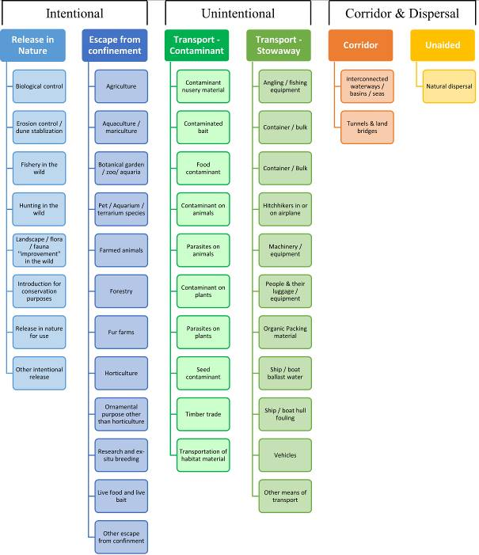

**ANNEX V Ecosystem services classification (CICES V5.1, simplified) and examples**

For the purposes of this risk assessment, please feel free to use what seems as the most appropriate category / level / combination of impact (Section – Division – Group), reflecting information available.

|  |  |  |  |
| --- | --- | --- | --- |
| **Section** | **Division** | **Group** | **Examples (i.e. relevant CICES “classes”)** |
| **Provisioning** | **Biomass** | **Cultivated *terrestrial* plants** | Cultivated terrestrial plants (including fungi, algae) grown for nutritional purposes;  Fibres and other materials from cultivated plants, fungi, algae and bacteria for direct use or processing (excluding genetic materials);  Cultivated plants (including fungi, algae) grown as a source of energy  *Example: negative impacts of non-native organisms to crops, orchards, timber etc.* |
|  |  | **Cultivated *aquatic* plants** | Plants cultivated by in- situ aquaculture grown for nutritional purposes;  Fibres and other materials from in-situ aquaculture for direct use or processing (excluding genetic materials);  Plants cultivated by in- situ aquaculture grown as an energy source.  *Example: negative impacts of non-native organisms to aquatic plants cultivated for nutrition, gardening etc. purposes.* |
|  |  | **Reared animals** | Animals reared for nutritional purposes;  Fibres and other materials from reared animals for direct use or processing (excluding genetic materials);  Animals reared to provide energy (including mechanical)  *Example: negative impacts of non-native organisms to livestock* |
|  |  | **Reared *aquatic* animals** | Animals reared by in-situ aquaculture for nutritional purposes;  Fibres and other materials from animals grown by in-situ aquaculture for direct use or processing (excluding genetic materials);  Animals reared by in-situ aquaculture as an energy source  *Example: negative impacts of non-native organisms to fish farming* |
|  |  | **Wild plants** (terrestrial and aquatic) | Wild plants (terrestrial and aquatic, including fungi, algae) used for nutrition;  Fibres and other materials from wild plants for direct use or processing (excluding genetic materials);  Wild plants (terrestrial and aquatic, including fungi, algae) used as a source of energy  *Example: reduction in the availability of wild plants (e.g. wild berries, ornamentals) due to non-native organisms (competition, spread of disease etc.)* |
|  |  | **Wild animals** (terrestrial and aquatic) | Wild animals (terrestrial and aquatic) used for nutritional purposes;  Fibres and other materials from wild animals for direct use or processing (excluding genetic materials);  Wild animals (terrestrial and aquatic) used as a source of energy  *Example: reduction in the availability of wild animals (e.g. fish stocks, game) due to non-native organisms (competition, predations, spread of disease etc.)* |
|  | **Genetic material** from all biota | **Genetic material** from plants, algae or fungi | Seeds, spores and other plant materials collected for maintaining or establishing a population;  Higher and lower plants (whole organisms) used to breed new strains or varieties;  Individual genes extracted from higher and lower plants for the design and construction of new biological entities  *Example: negative impacts of non-native organisms due to interbreeding* |
|  |  | **Genetic material** from animals | Animal material collected for the purposes of maintaining or establishing a population;  Wild animals (whole organisms) used to breed new strains or varieties;  Individual genes extracted from organisms for the design and construction of new biological entities  *Example: negative impacts of non-native organisms due to interbreeding* |
|  | **Water[9]** | **Surface water** used for nutrition, materials or energy | Surface water for drinking;  Surface water used as a material (non-drinking purposes);  Freshwater surface water, coastal and marine water used as an energy source  *Example: loss of access to surface water due to spread of non-native organisms* |
|  |  | **Ground water** for used for nutrition, materials or energy | Ground (and subsurface) water for drinking;  Ground water (and subsurface) used as a material (non-drinking purposes);  Ground water (and subsurface) used as an energy source  *Example: reduced availability of ground water due to spread of non-native organisms and associated increase of ground water consumption by vegetation.* |
| **Regulation & Maintenance** | **Transformation** of biochemical or physical inputs to ecosystems | **Mediation of wastes or toxic substances** of anthropogenic origin by living processes | Bio-remediation by micro-organisms, algae, plants, and animals; Filtration/sequestration/storage/accumulation by micro-organisms, algae, plants, and animals  *Example: changes caused by non-native organisms to ecosystem functioning and ability to filtrate etc. waste or toxics* |
|  |  | **Mediation of nuisances** of anthropogenic origin | Smell reduction; noise attenuation; visual screening (e.g. by means of green infrastructure)  *Example: changes caused by non-native organisms to ecosystem structure, leading to reduced ability to mediate nuisances.* |
|  | **Regulation** of physical, chemical, biological conditions | **Baseline flows and extreme event** regulation | Control of erosion rates;  Buffering and attenuation of mass movement;  Hydrological cycle and water flow regulation (Including flood control, and coastal protection);  Wind protection;  Fire protection  *Example: changes caused by non-native organisms to ecosystem functioning or structure leading to, for example, destabilisation of soil, increased risk or intensity of wild fires etc.* |
|  |  | **Lifecycle maintenance**, habitat and gene pool protection | Pollination (or 'gamete' dispersal in a marine context);  Seed dispersal;  Maintaining nursery populations and habitats (Including gene pool protection)  *Example: changes caused by non-native organisms to the abundance and/or distribution of wild pollinators; changes to the availability / quality of nursery habitats for fisheries* |
|  |  | **Pest and disease control** | Pest control;  Disease control  *Example: changes caused by non-native organisms to the abundance and/or distribution of pests* |
|  |  | **Soil quality** regulation | Weathering processes and their effect on soil quality;  Decomposition and fixing processes and their effect on soil quality  *Example: changes caused by non-native organisms to vegetation structure and/or soil fauna leading to reduced soil quality* |
|  |  | **Water** conditions | Regulation of the chemical condition of freshwaters by living processes;  Regulation of the chemical condition of salt waters by living processes  *Example: changes caused by non-native organisms to buffer strips along water courses that remove nutrients in runoff and/or fish communities that regulate the resilience and resistance of water bodies to eutrophication* |
|  |  | **Atmospheric** composition and conditions | Regulation of chemical composition of atmosphere and oceans;  Regulation of temperature and humidity, including ventilation and transpiration  *Example: changes caused by non-native organisms to ecosystems’ ability to sequester carbon and/or evaporative cooling (e.g. by urban trees)* |
| **Cultural** | **Direct, in-situ and outdoor interactions** with living systems that depend on presence in the environmental setting | **Physical and experiential** interactions with natural environment | Characteristics of living systems that that enable activities promoting health, recuperation or enjoyment through active or immersive interactions;  Characteristics of living systems that enable activities promoting health, recuperation or enjoyment through passive or observational interactions  *Example: changes caused by non-native organisms to the qualities of ecosystems (structure, species composition etc.) that make it attractive for recreation, wild life watching etc.* |
|  |  | **Intellectual and representative** interactions with natural environment | Characteristics of living systems that enable scientific investigation or the creation of traditional ecological knowledge;  Characteristics of living systems that enable education and training;  Characteristics of living systems that are resonant in terms of culture or heritage;  Characteristics of living systems that enable aesthetic experiences  *Example: changes caused by non-native organisms to the qualities of ecosystems (structure, species composition etc.) that have cultural importance* |
|  | **Indirect, remote, often indoor interactions** with living systems that do not require presence in the environmental setting | **Spiritual, symbolic** and other interactions with natural environment | Elements of living systems that have symbolic meaning;  Elements of living systems that have sacred or religious meaning;  Elements of living systems used for entertainment or representation  *Example: changes caused by non-native organisms to the qualities of ecosystems (structure, species composition etc.) that have sacred or religious meaning* |
|  |  | Other biotic characteristics that have a **non-use value** | Characteristics or features of living systems that have an existence value;  Characteristics or features of living systems that have an option or bequest value  *Example: changes caused by non-native organisms to ecosystems designated as wilderness areas, habitats of endangered species etc.* |

# ANNEX VI EU Biogeographic Regions and MSFD Subregions

See <https://www.eea.europa.eu/data-and-maps/figures/biogeographical-regions-in-europe-2> ,

<http://ec.europa.eu/environment/nature/natura2000/biogeog_regions/>

and

https://www.eea.europa.eu/data-and-maps/data/msfd-regions-and-subregions-1/technical-document/pdf

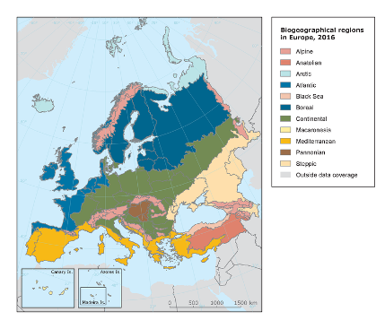 

# ANNEX VII Delegated Regulation (EU) 2018/968 of 30 April 2018

see <https://eur-lex.europa.eu/legal-content/en/TXT/?uri=CELEX%3A32018R0968>

# ANNEX VIII Species Distribution Model

# Projection of environmental suitability for *Misgurnus bipartitus* establishment in Europe

Björn Beckmann, Hugo Verreycken and Dan Chapman

## Aim

To project the suitability for potential establishment of *Misgurnus bipartitus* in Europe, under current and predicted future climatic conditions.

## Data for modelling

Species occurrence data were obtained from the Global Biodiversity Information Facility (GBIF) (3 records), and additional records from the risk assessment team (49 records). With very little precise information available about distribution in the native range (9 records), we additionally selected 25 equidistant points along each of the two main rivers of the native range, Liao and Songhua in northeastern China (Yi et al. 2017). The records were gridded at a 0.25 x 0.25 degree resolution for modelling, yielding a total of 52 grid cells with occurrences (Figure 1a). As a proxy for recording effort, the density of Actinopterygii records held by GBIF was also compiled on the same grid (Figure 1b).

**Figure 1.** (a) Occurrence records obtained for *Misgurnus bipartitus* and used in the modelling, showing native and invaded distributions. (b) The recording density of Actinopterygii on GBIF, which was used as a proxy for recording effort.

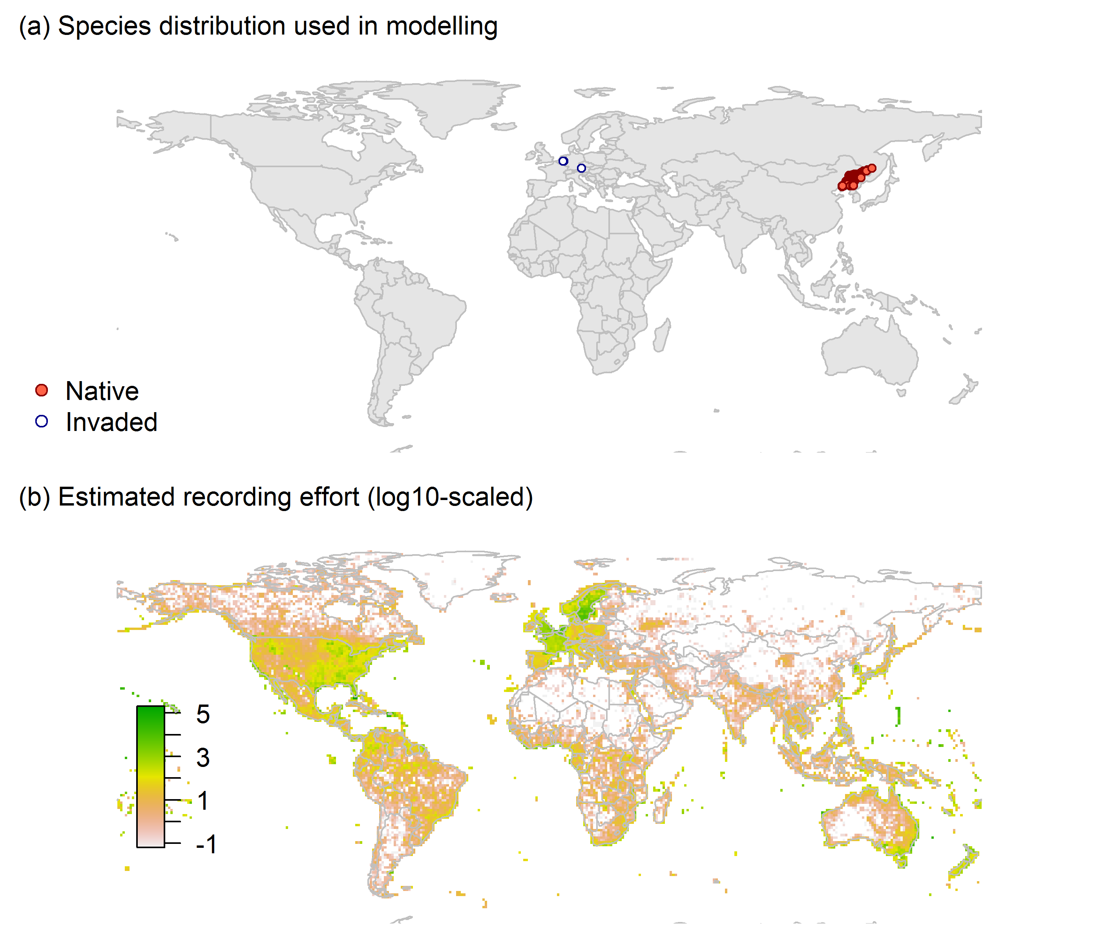

Climate data were selected from the ‘Bioclim’ variables contained within the WorldClim database (Hijmans et al., 2005), originally at 5 arcminute resolution (0.083 x 0.083 degrees of longitude/latitude) and aggregated to a 0.25 x 0.25 degree grid for use in the model.

Based on the biology of *Misgurnus bipartitus*, the following climate variables were used in the modelling:

* Mean temperature of the warmest quarter (Bio10)
* Mean temperature of the coldest quarter (Bio11)
* Annual precipitation (Bio12)

To estimate the effect of climate change on the potential distribution, equivalent modelled future climate conditions for the 2070s under the Representative Concentration Pathways (RCP) 2.6 and 4.5 were also obtained. These represent low and medium emissions scenarios, respectively. The above variables were obtained as averages of outputs of eight Global Climate Models (BCC-CSM1-1, CCSM4, GISS-E2-R, HadGEM2-AO, IPSL-CM5A-LR, MIROC-ESM, MRI-CGCM3, NorESM1-M), downscaled and calibrated against the WorldClim baseline (see <http://www.worldclim.org/cmip5_5m> ).

## Species distribution model

A presence-background (presence-only) ensemble modelling strategy was employed using the BIOMOD2 R package version 3.4.6 (R Core Team, 2020, Thuiller et al., 2020, Thuiller et al., 2009). These models contrast the environment at the species’ occurrence locations against a random sample of the global background environmental conditions (often termed ‘pseudo-absences’) in order to characterise and project suitability for occurrence. This approach has been developed for distributions that are in equilibrium with the environment. Because invasive species’ distributions are not at equilibrium and subject to dispersal constraints at a global scale, we took care to minimise the inclusion of locations suitable for the species but where it has not been able to disperse to (Chapman et al. 2019). Therefore the background sampling region included:

* The area accessible by native *Misgurnus bipartitus* populations, in which the species is likely to have had sufficient time to disperse to all locations. Based on presumed maximum dispersal distances, the accessible region was defined as a 400km buffer around the native range occurrences; AND
* A 50km buffer around the non-native occurrences, encompassing regions likely to have had high propagule pressure for introduction by humans and/or dispersal of the species; AND
* Regions where we have an *a priori* expectation of high unsuitability for the species so that absence is assumed irrespective of dispersal constraints (see Figure 2). The following rules were applied to define a region expected to be highly unsuitable for *Misgurnus bipartitus* at the spatial scale of the model:
  + Mean temperature of the warmest quarter (Bio10) < 13°C
  + Mean temperature of the coldest quarter (Bio11) < -19°C
  + Annual precipitation (Bio12) < 250mm

Altogether, 1.9% of occurrence grid cells were located in the unsuitable background region.

Within the unsuitable background region, 10 samples of 500 randomly sampled grid cells were obtained. In the accessible background (comprising the accessible areas around native and non-native occurrences as detailed above), the same number of pseudo-absence samples were drawn as there were presence records (52), weighting the sampling by a proxy for recording effort (Figure 1(b)).

**Figure 2.** The background from which pseudo-absence samples were taken in the modelling of *Misgurnus bipartitus*. Samples were taken from a 400km buffer around the native range and a 50km buffer around non-native occurrences (together forming the accessible background), and from areas expected to be highly unsuitable for the species (the unsuitable background region). Samples from the accessible background were weighted by a proxy for recording effort (Figure 1(b)).

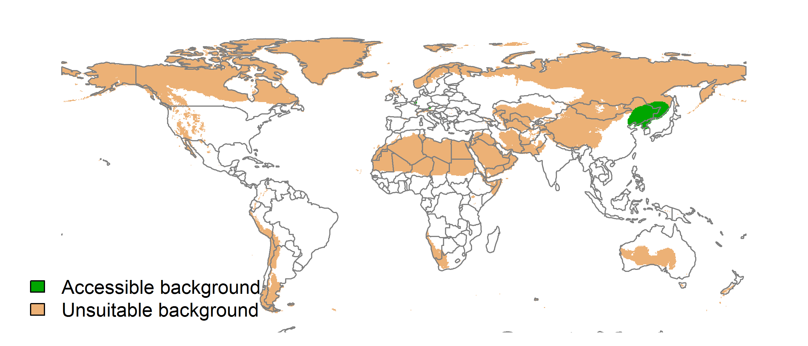

Each dataset (i.e. combination of the presences and the individual background samples) was randomly split into 80% for model training and 20% for model evaluation. With each training dataset, seven statistical algorithms were fitted with the default BIOMOD2 settings and rescaled using logistic regression, except where specified below:

* Generalised linear model (GLM)
* Generalised boosting model (GBM)
* Generalised additive model (GAM) with a maximum of four degrees of freedom per smoothing spline
* Artificial neural network (ANN)
* Multivariate adaptive regression splines (MARS)
* Random forest (RF)
* Maxent

Since the total background sample was larger than the number of occurrences, prevalence fitting weights were applied to give equal overall importance to the occurrences and the background. Normalised variable importance was assessed and variable response functions were produced using BIOMOD2’s default procedure.

Model predictive performance was assessed by the following three measures:

* AUC, the area under the receiver operating characteristic curve (Fielding & Bell 1997). Predictions of presence-absence models can be compared with a subset of records set aside for model evaluation (here 20%) by constructing a confusion matrix with the number of true positive, false positive, false negative and true negative cases. For models generating non-dichotomous scores (as here) a threshold can be applied to transform the scores into a dichotomous set of presence-absence predictions. Two measures that can be derived from the confusion matrix are sensitivity (the proportion of observed presences that are predicted as such, quantifying omission errors), and specificity (the proportion of observed absences that are predicted as such, quantifying commission errors). A receiver operating characteristic (ROC) curve can be constructed by using all possible thresholds to classify the scores into confusion matrices, obtaining sensitivity and specificity for each matrix, and plotting sensitivity against the corresponding proportion of false positives (equal to 1 - specificity). The use of all possible thresholds avoids the need for a selection of a single threshold, which is often arbitrary, and allows appreciation of the trade-off between sensitivity and specificity. The area under the ROC curve (AUC) is often used as a single threshold-independent measure for model performance (Manel et al. 2001). AUC is the probability that a randomly selected presence has a higher model-predicted suitability than a randomly selected absence (Allouche et al. 2006).
* Cohen’s Kappa (Cohen 1960). This measure corrects the overall accuracy of model predictions (ratio of the sum of true presences plus true absences to the total number of records) by the accuracy expected to occur by chance. The Kappa statistic ranges from -1 to +1, where +1 indicates perfect agreement and values of zero or less indicate a performance no better than random. Advantages of Kappa are its simplicity, the fact that both commission and omission errors are accounted for in one parameter, and its relative tolerance to zero values in the confusion matrix (Manel et al. 2001). However, Kappa has been criticised for being sensitive to prevalence (the proportion of sites in which the species was recorded as present) and may therefore be inappropriate for comparisons of model accuracy between species or regions (McPherson et al. 2004, Allouche et al. 2006).
* TSS, the true skill statistic (Allouche et al. 2006). TSS is defined as sensitivity + specificity - 1, and corrects for Kappa’s dependency on prevalence. TSS compares the number of correct forecasts, minus those attributable to random guessing, to that of a hypothetical set of perfect forecasts. Like Kappa, TSS takes into account both omission and commission errors, and success as a result of random guessing, and ranges from -1 to +1, where +1 indicates perfect agreement and values of zero or less indicate a performance no better than random (Allouche et al. 2006).

An ensemble model was created by first rejecting poorly performing algorithms with relatively extreme low AUC values and then averaging the predictions of the remaining algorithms, weighted by their AUC. To identify poorly performing algorithms, AUC values were converted into modified z-scores based on their difference to the median and the median absolute deviation across all algorithms (Iglewicz & Hoaglin 1993). Algorithms with z < -2 were rejected. In this way, ensemble projections were made for each dataset and then averaged to give an overall suitability, as well as its standard deviation.

Projections were classified into suitable and unsuitable regions using a “lowest presence threshold” (Pearson et al. 2007), setting the cut-off as the lowest value at which 98% of all presence records are classified correctly under the current climate (here 0.59). In order to express the sensitivity of classifications to the choice of this threshold, thresholds at which 95% and 99% of records are classified correctly (here 0.7 and 0.53 respectively) were used in the calculation of error bars in Figures 9 and 10 below in addition to taking account of uncertainty in the projections themselves.

We also produced a limiting factor map for Europe following Elith et al. (2010). For this, projections were made separately with each individual variable fixed at a near-optimal value. These were chosen as the median values at the occurrence grid cells. Then, the most strongly limiting factors were identified as the ones resulting in the highest increase in suitability in each grid cell.

## Results

The ensemble model suggested that suitability for *Misgurnus bipartitus* was most strongly determined by Mean temperature of the warmest quarter (Bio10), accounting for 47.7% of variation explained, followed by Annual precipitation (Bio12) (37.1%) and Mean temperature of the coldest quarter (Bio11) (15.2%) (Table 1, Figure 3).

**Table 1.** Summary of the cross-validation predictive performance (AUC, Kappa, TSS) and variable importance of the fitted model algorithms and the ensemble (AUC-weighted average of the best performing algorithms). Results are the average from models fitted to 10 different background samples of the data.

|  |  |  |  |  |  |  |  |
| --- | --- | --- | --- | --- | --- | --- | --- |
|  |  |  |  |  | **Variable importance (%)** | | |
| **Algorithm** | **AUC** | **Kappa** | **TSS** | **Used in the ensemble** | **Mean temperature of the warmest quarter (Bio10)** | **Annual precipitation (Bio12)** | **Mean temperature of the coldest quarter (Bio11)** |
| GLM | 0.994 | 0.902 | 0.977 | yes | 46 | 37 | 17 |
| GAM | 0.989 | 0.912 | 0.964 | yes | 43 | 39 | 18 |
| GBM | 0.986 | 0.939 | 0.956 | yes | 51 | 46 | 3 |
| ANN | 0.990 | 0.924 | 0.945 | yes | 46 | 22 | 32 |
| MARS | 0.989 | 0.901 | 0.957 | yes | 52 | 42 | 6 |
| RF | 0.977 | 0.939 | 0.935 | no | 55 | 37 | 9 |
| Maxent | 0.965 | 0.909 | 0.930 | no | 42 | 30 | 28 |
| **Ensemble** | **0.995** | **0.943** | **0.965** |  | **48** | **37** | **15** |

**Figure 3.** Partial response plots from the fitted models. Thin coloured lines show responses from the algorithms in the ensemble, while the thick black line is their ensemble. In each plot, other model variables are held at their median value in the training data. Some of the divergence among algorithms is because of their different treatment of interactions among variables.

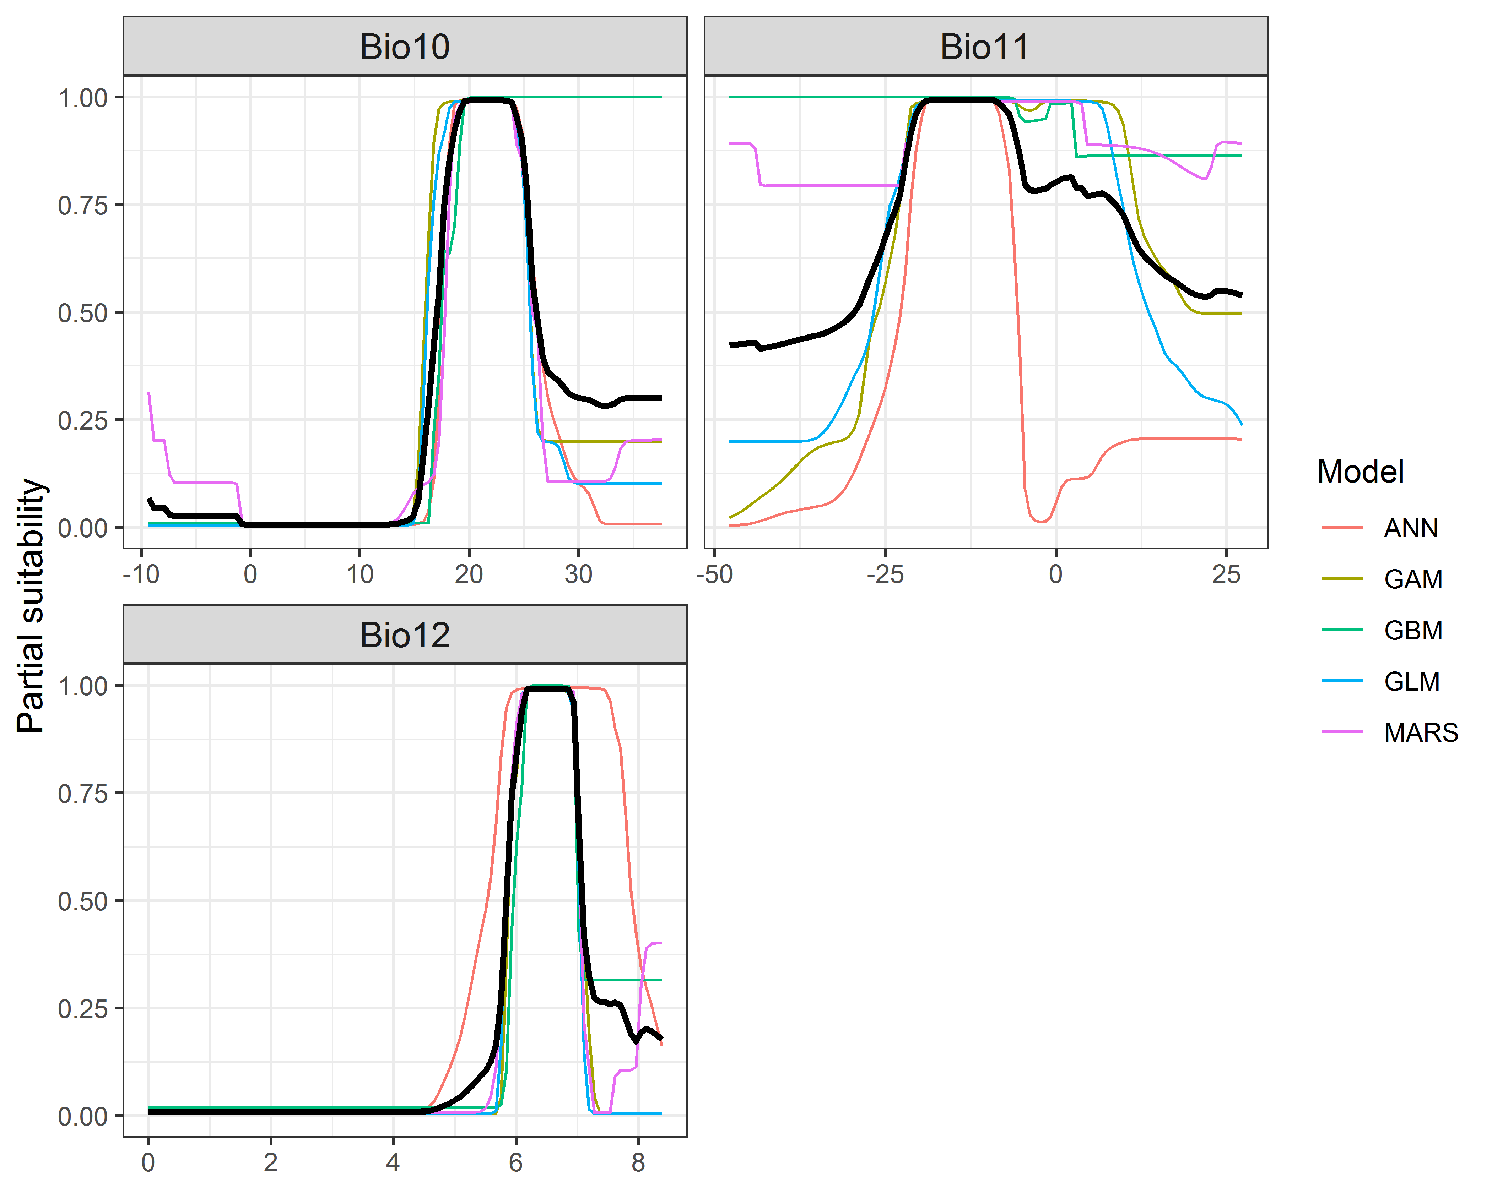

**Figure 4.** (a) Projected global suitability for *Misgurnus bipartitus* establishment in the current climate. For visualisation, the projection has been aggregated to a 0.5 x 0.5 degree resolution, by taking the maximum suitability of constituent higher resolution grid cells. Values > 0.59 are suitable for the species, with 98% of global presence records above this threshold. Values below 0.59 indicate lower relative suitability. (b) Uncertainty in the ensemble projections, expressed as the among-algorithm standard deviation in predicted suitability, averaged across the 10 datasets.

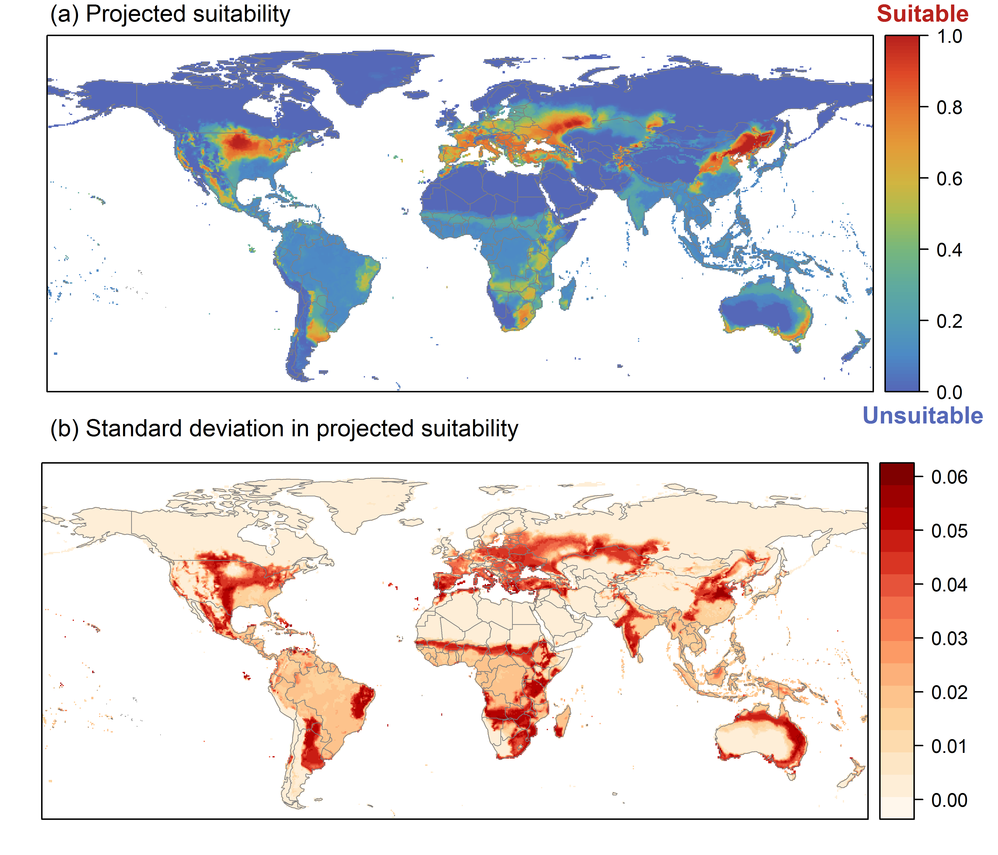

**Figure 5.** (a) Projected current suitability for *Misgurnus bipartitus* establishment in Europe and the Mediterranean region. Values > 0.59 are suitable for the species, with 98% of global presence records above this threshold. Values below 0.59 indicate lower relative suitability. (b) Uncertainty in the ensemble projections, expressed as the among-algorithm standard deviation in predicted suitability, averaged across the 10 datasets.

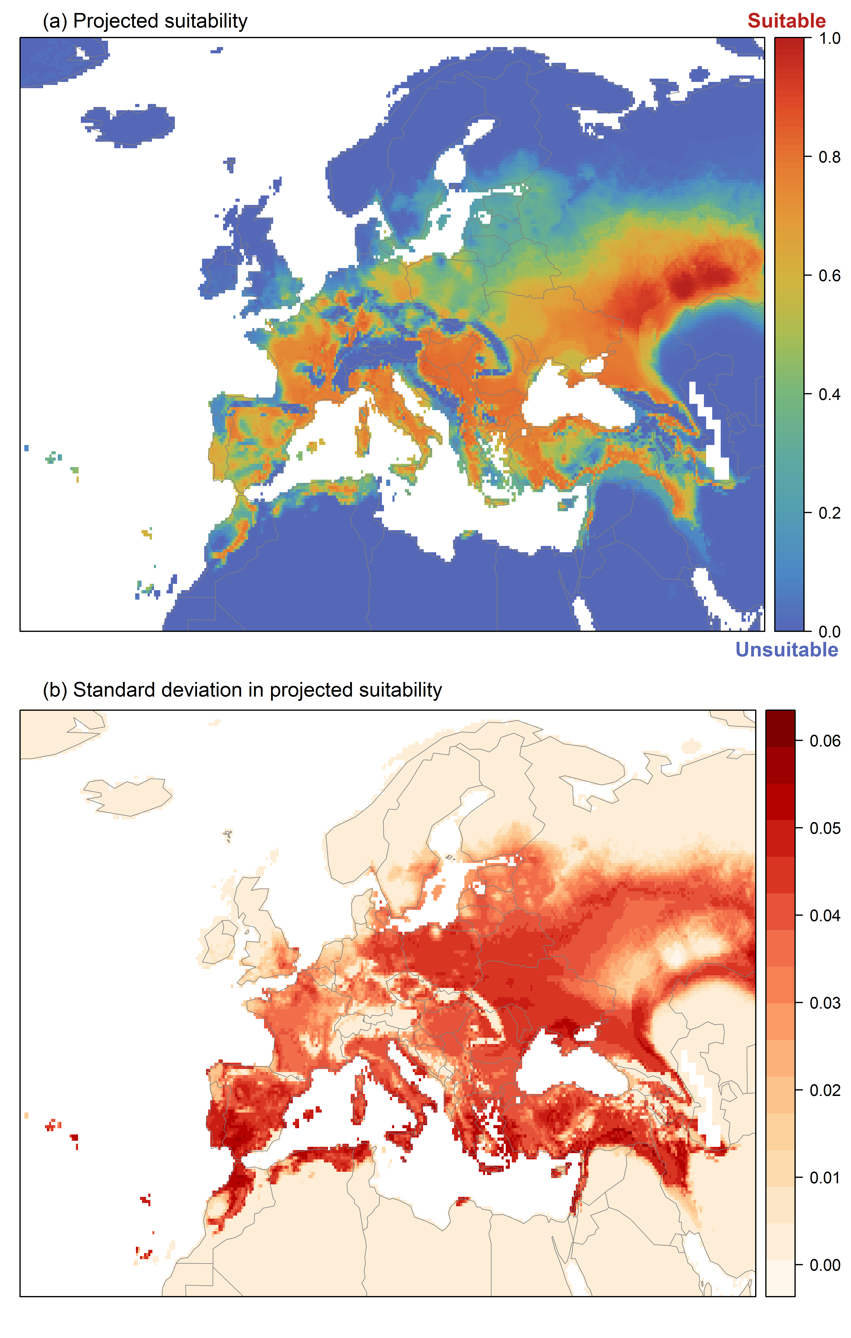

**Figure 6.** The most strongly limiting factors for *Misgurnus bipartitus* establishment estimated by the model in Europe and the Mediterranean region in current climatic conditions.

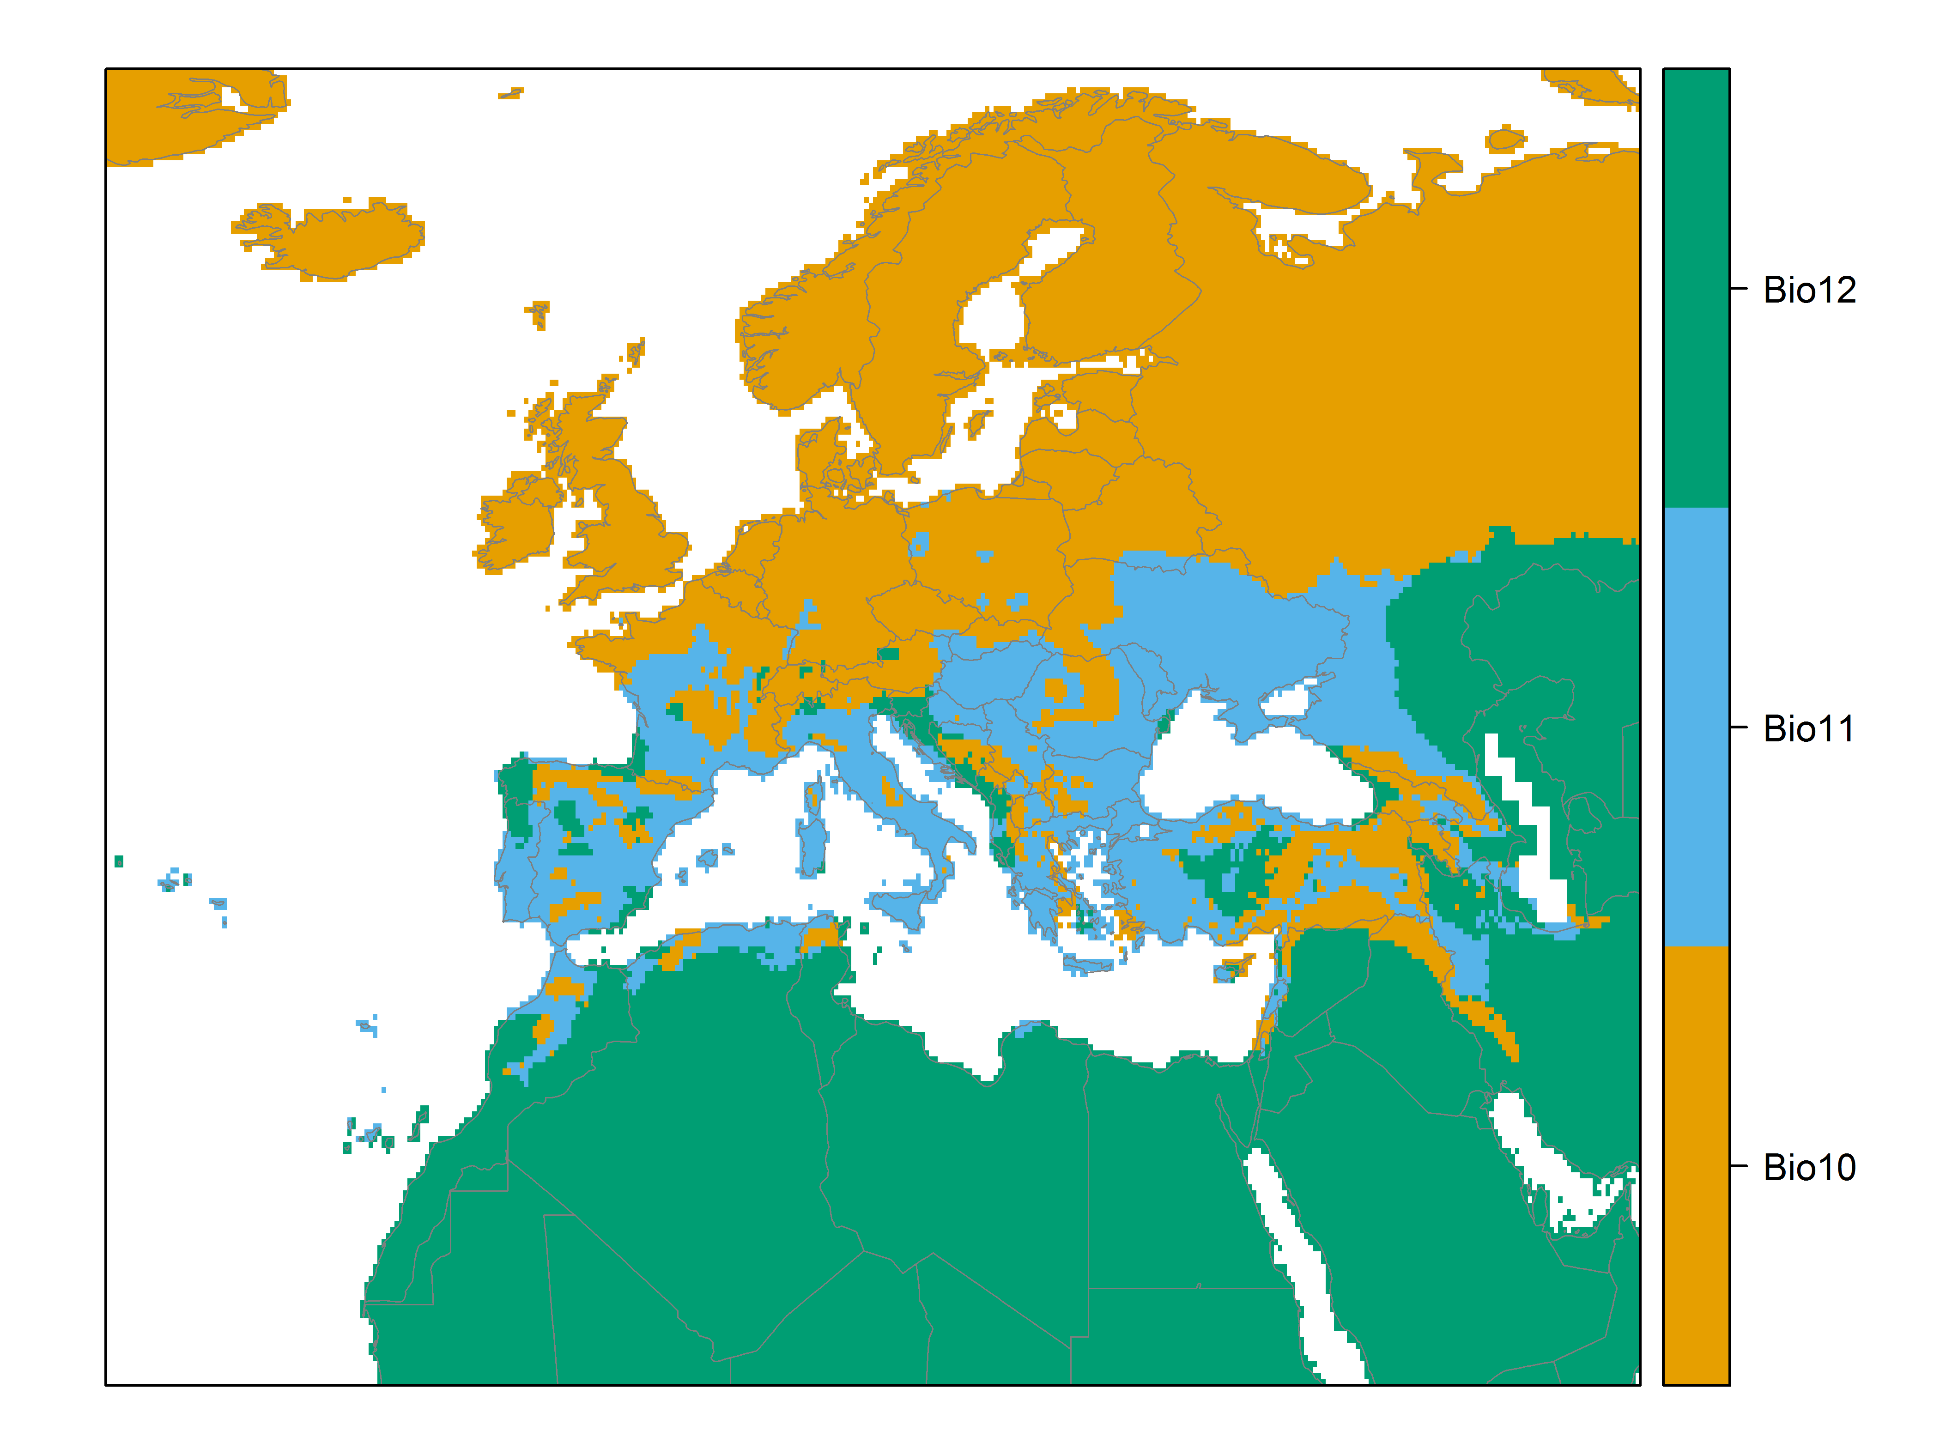

**Figure 7.** (a) Projected suitability for *Misgurnus bipartitus* establishment in Europe and the Mediterranean region in the 2070s under climate change scenario RCP2.6. Values > 0.59 are suitable for the species, with 98% of global presence records above this threshold under current climate. Values below 0.59 indicate lower relative suitability. (b) Uncertainty in the ensemble projections, expressed as the among-algorithm standard deviation in predicted suitability, averaged across the 10 datasets.

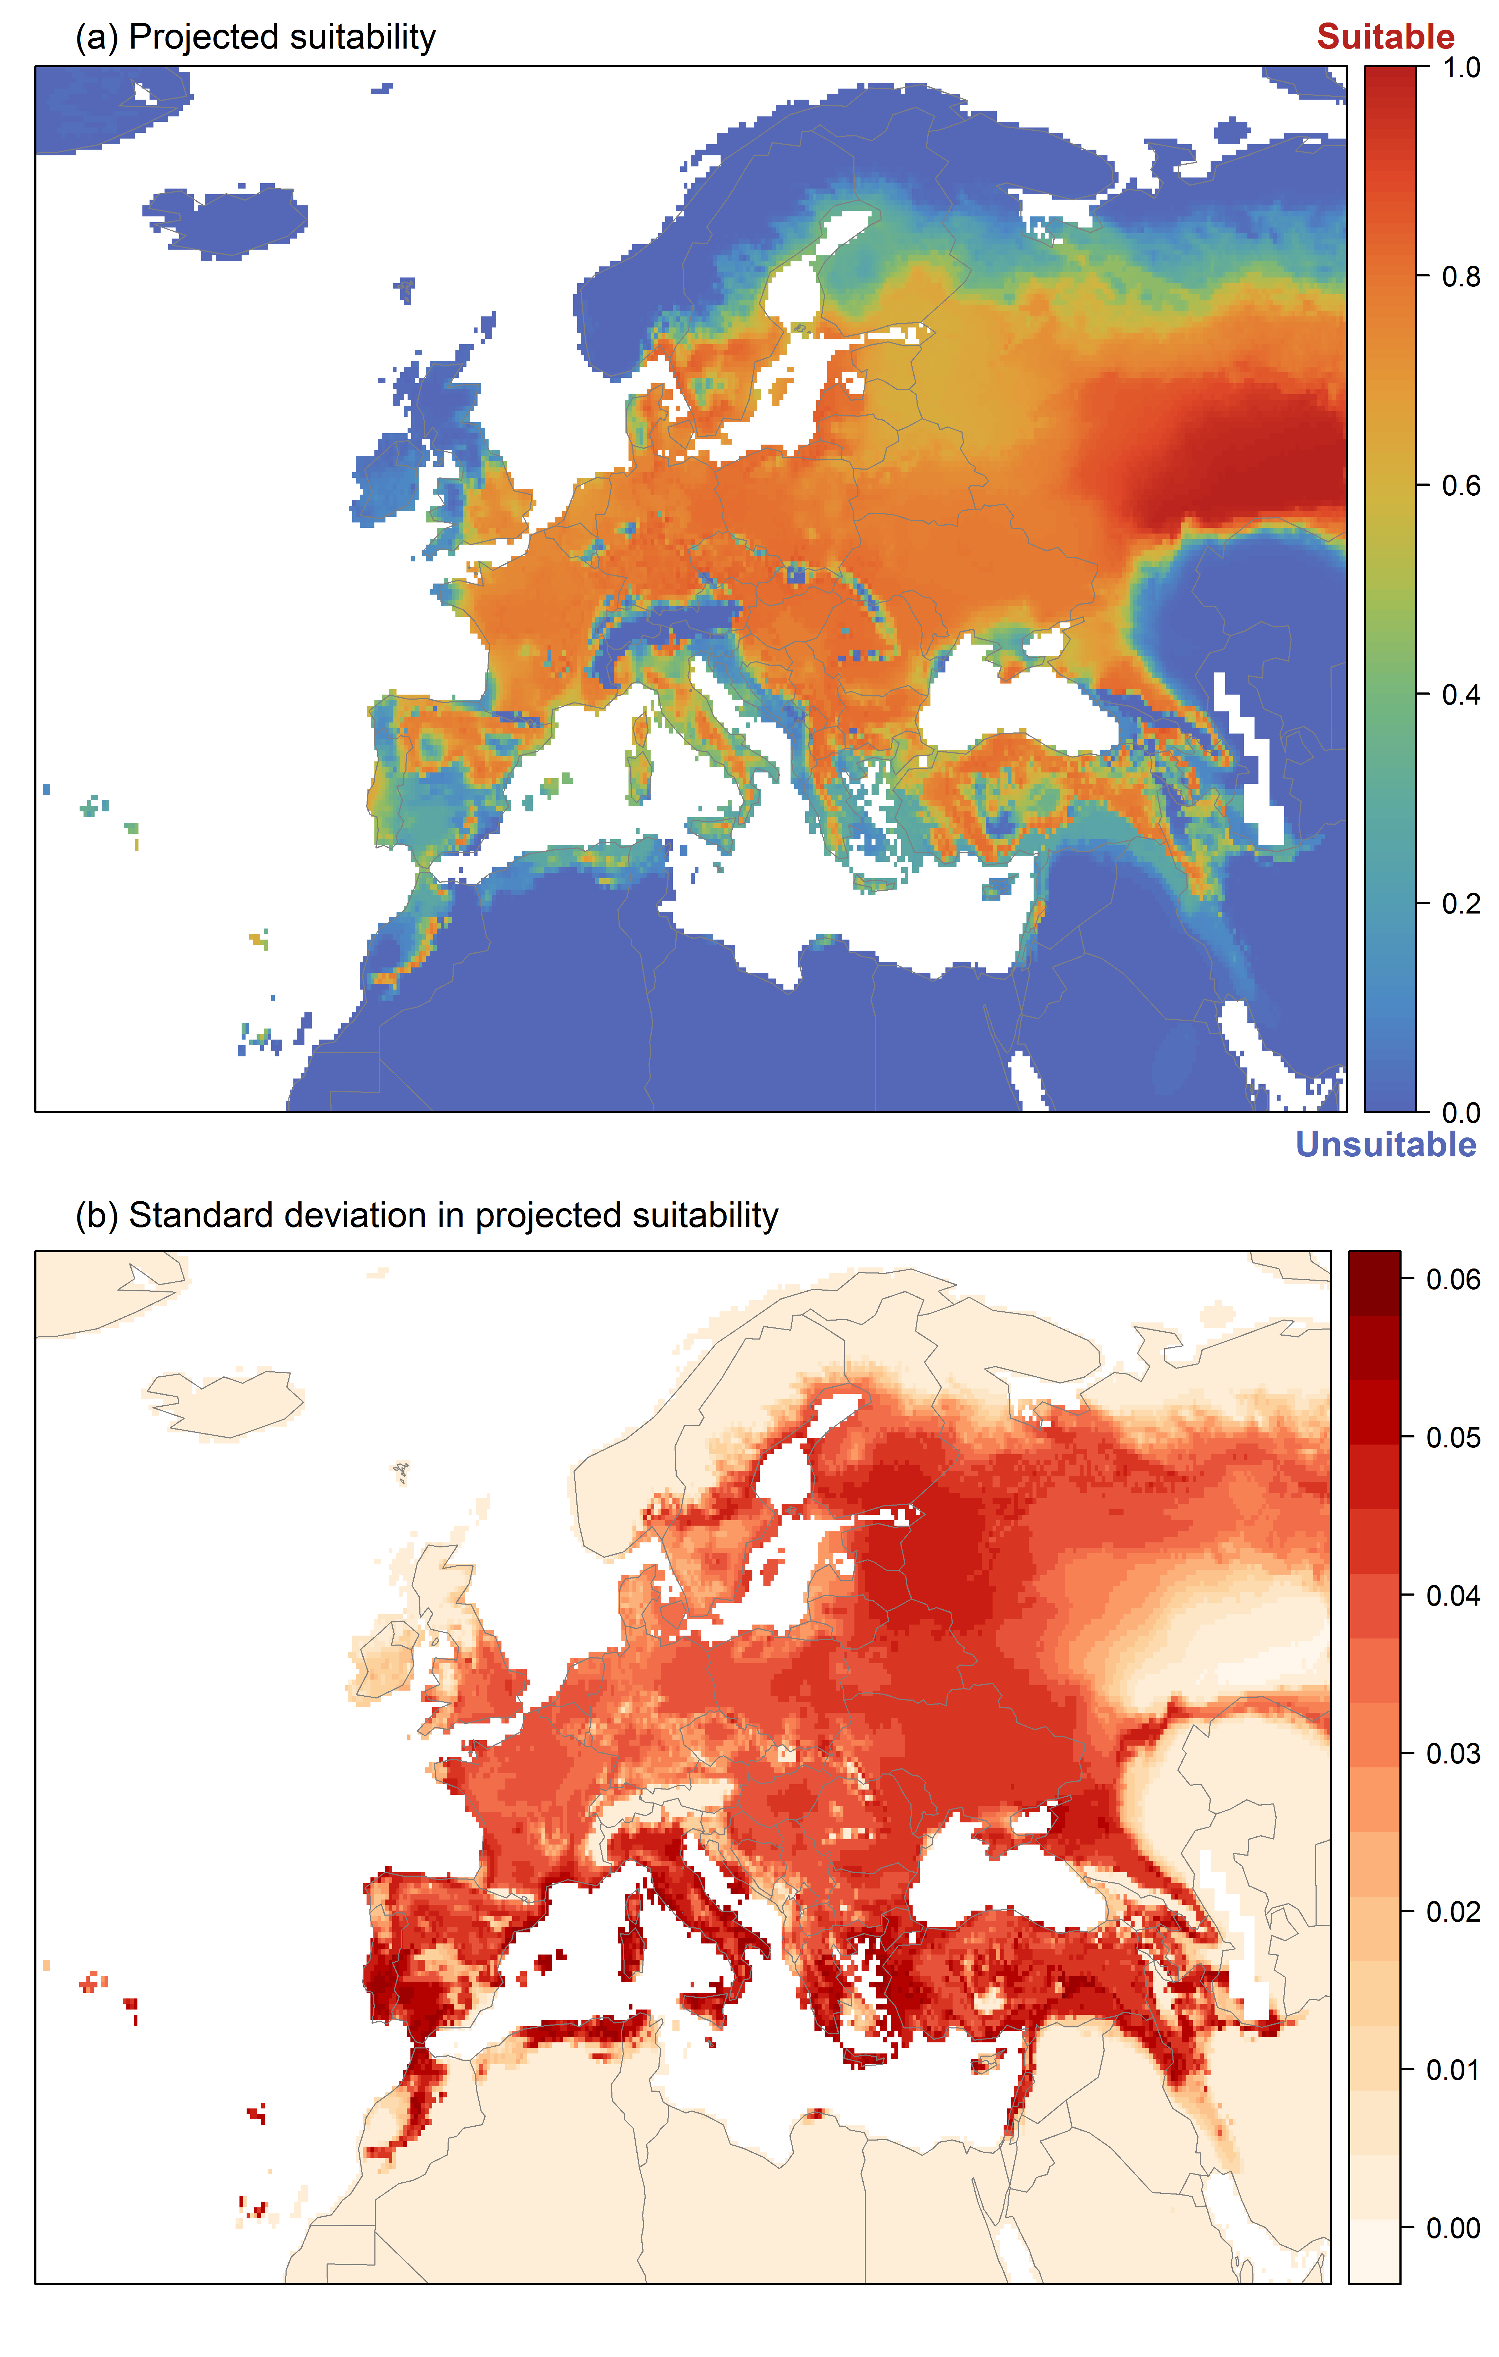

**Figure 8.** (a) Projected suitability for *Misgurnus bipartitus* establishment in Europe and the Mediterranean region in the 2070s under climate change scenario RCP4.5. Values > 0.59 are suitable for the species, with 98% of global presence records above this threshold under current climate. Values below 0.59 indicate lower relative suitability. (b) Uncertainty in the ensemble projections, expressed as the among-algorithm standard deviation in predicted suitability, averaged across the 10 datasets.

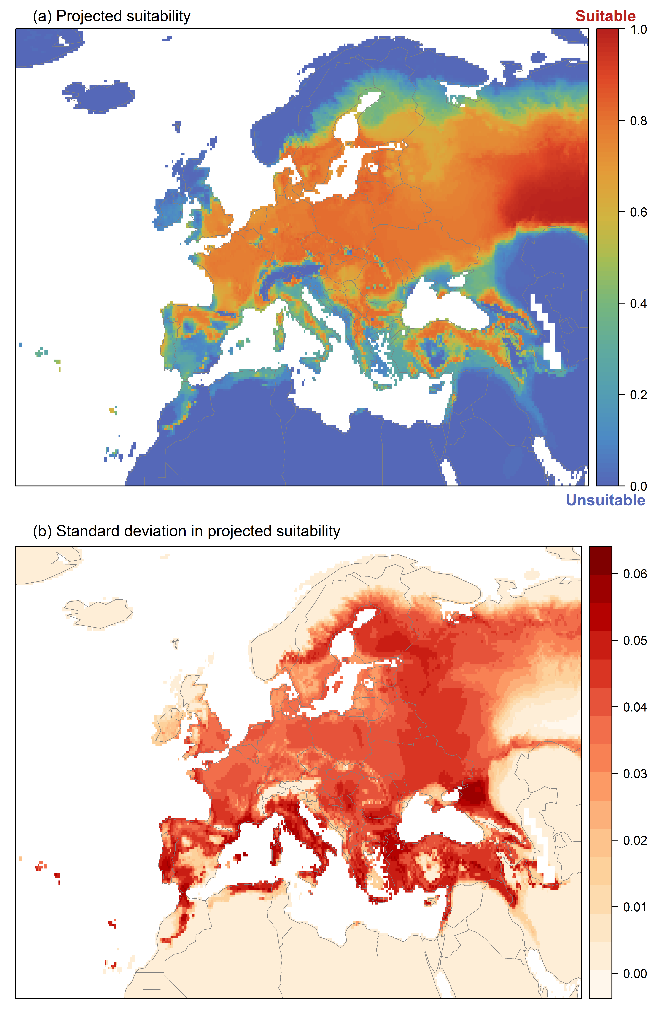

**Figure 9.** Variation in projected suitability for *Misgurnus bipartitus* establishment among Biogeographical Regions of Europe (<https://www.eea.europa.eu/data-and-maps/data/biogeographical-regions-europe-3>). The bar plots show the proportion of grid cells in each region classified as suitable (with values > 0.59) in the current climate and projected climate for the 2070s under two RCP emissions scenarios. Error bars indicate uncertainty due to both the choice of classification threshold (cf. p.5/6) and uncertainty in the projections themselves (cf. part (b) of Figures 5, 7 and 8). The location of each region is also shown. The Arctic and Macaronesian regions are not part of the study area, but are included for completeness.

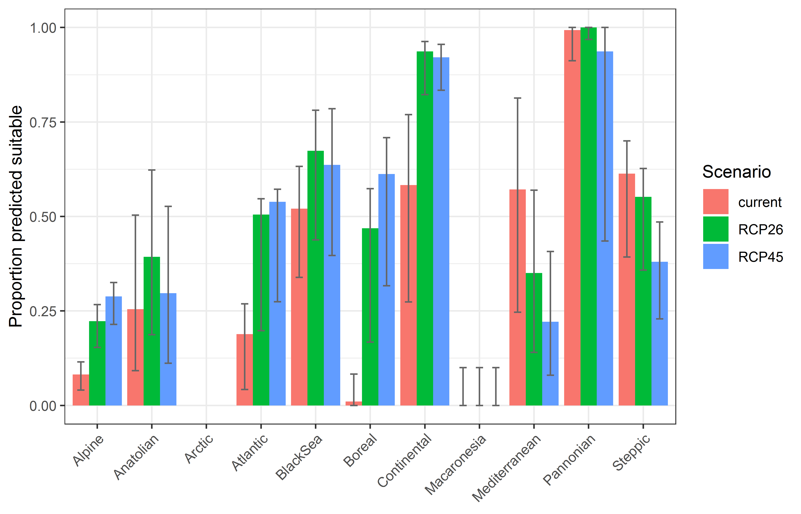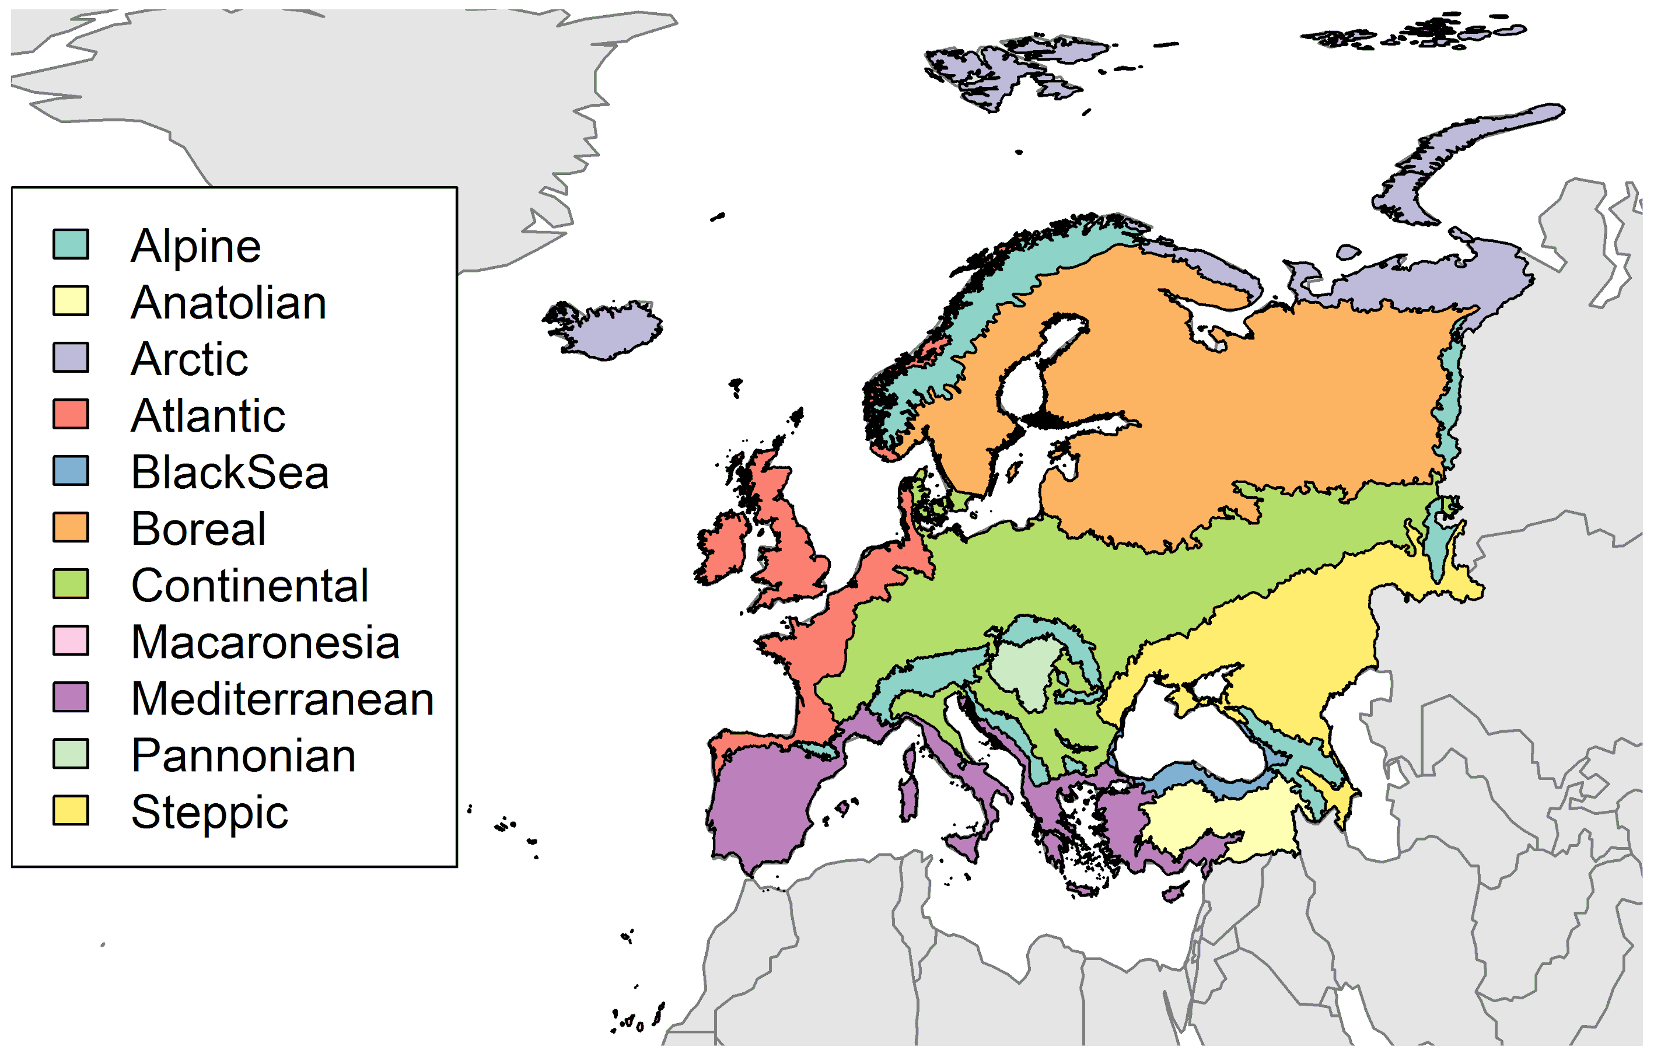

**Table 2.** Variation in projected suitability for *Misgurnus bipartitus* establishment among Biogeographical regions of Europe (numerical values of Figure 9 above). The numbers are the proportion of grid cells in each region classified as suitable in the current climate and projected climate for the 2070s under two RCP emissions scenarios. The Arctic and Macaronesian biogeographical regions are not part of the study area, but are included for completeness.

|  |  |  |  |  |  |  |  |  |  |
| --- | --- | --- | --- | --- | --- | --- | --- | --- | --- |
|  | **current climate** | | | **2070s RCP2.6** | | | **2070s RCP4.5** | | |
|  | lower | **central estimate** | upper | lower | **central estimate** | upper | lower | **central estimate** | upper |
| Alpine | 0.04 | 0.08 | 0.12 | 0.15 | 0.22 | 0.27 | 0.21 | 0.29 | 0.33 |
| Anatolian | 0.09 | 0.25 | 0.50 | 0.19 | 0.39 | 0.62 | 0.11 | 0.30 | 0.53 |
| Arctic | 0.00 | 0.00 | 0.00 | 0.00 | 0.00 | 0.00 | 0.00 | 0.00 | 0.00 |
| Atlantic | 0.04 | 0.19 | 0.27 | 0.20 | 0.51 | 0.55 | 0.27 | 0.54 | 0.57 |
| Black Sea | 0.34 | 0.52 | 0.63 | 0.44 | 0.67 | 0.78 | 0.40 | 0.64 | 0.79 |
| Boreal | 0.00 | 0.01 | 0.08 | 0.17 | 0.47 | 0.57 | 0.32 | 0.61 | 0.71 |
| Continental | 0.27 | 0.58 | 0.77 | 0.82 | 0.94 | 0.96 | 0.83 | 0.92 | 0.96 |
| Macaronesia | 0.00 | 0.00 | 0.10 | 0.00 | 0.00 | 0.10 | 0.00 | 0.00 | 0.10 |
| Mediterranean | 0.25 | 0.57 | 0.81 | 0.14 | 0.35 | 0.57 | 0.08 | 0.22 | 0.41 |
| Pannonian | 0.91 | 0.99 | 1.00 | 0.97 | 1.00 | 1.00 | 0.44 | 0.94 | 1.00 |
| Steppic | 0.39 | 0.61 | 0.70 | 0.36 | 0.55 | 0.63 | 0.23 | 0.38 | 0.49 |

**Figure 10.** Variation in projected suitability for *Misgurnus bipartitus* establishment among European Union countries and the UK. The bar plots show the proportion of grid cells in each country classified as suitable (with values > 0.59) in the current climate and projected climate for the 2070s under two RCP emissions scenarios. Error bars indicate uncertainty due to both the choice of classification threshold (cf. p.5/6) and uncertainty in the projections themselves (cf. part (b) of Figures 5, 7 and 8).

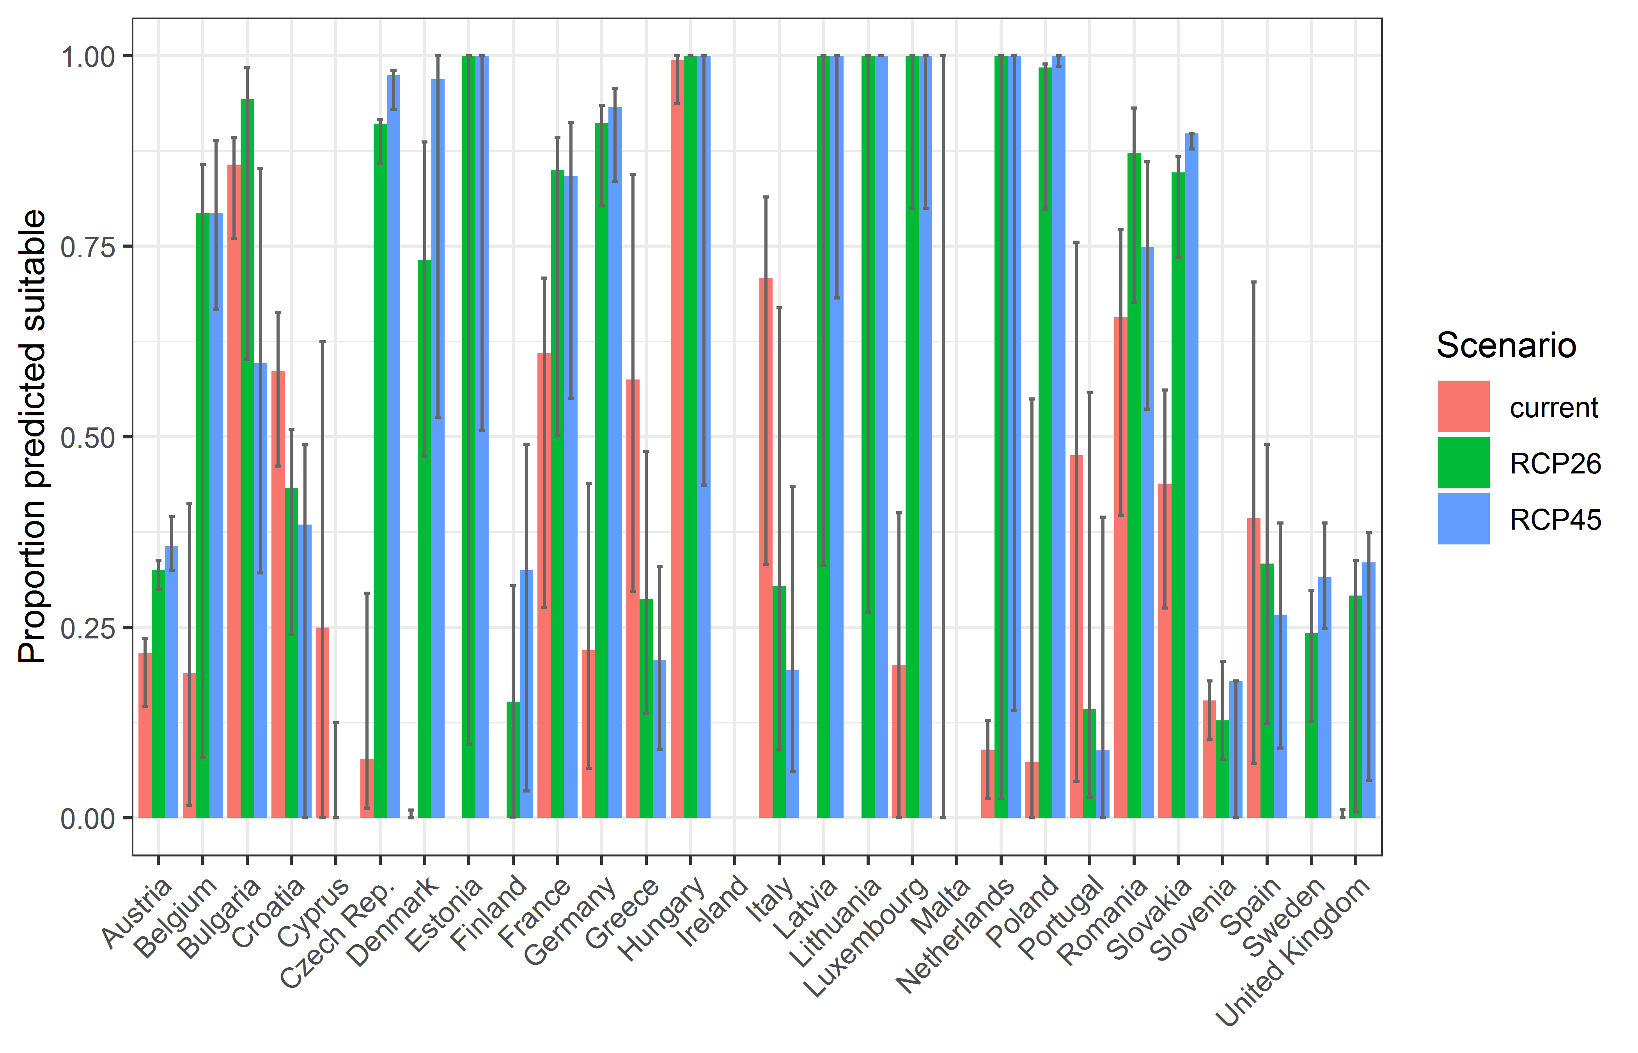

**Table 3.** Variation in projected suitability for *Misgurnus bipartitus* establishment among European Union countries and the UK (numerical values of Figure 10 above). The numbers are the proportion of grid cells in each country classified as suitable in the current climate and projected climate for the 2070s under two RCP emissions scenarios.

|  |  |  |  |  |  |  |  |  |  |
| --- | --- | --- | --- | --- | --- | --- | --- | --- | --- |
|  | **current climate** | | | **2070s RCP2.6** | | | **2070s RCP4.5** | | |
|  | lower | **central estimate** | upper | lower | **central estimate** | upper | lower | **central estimate** | upper |
| Austria | 0.15 | 0.22 | 0.24 | 0.30 | 0.32 | 0.34 | 0.32 | 0.36 | 0.39 |
| Belgium | 0.02 | 0.19 | 0.41 | 0.08 | 0.79 | 0.86 | 0.67 | 0.79 | 0.89 |
| Bulgaria | 0.76 | 0.86 | 0.89 | 0.60 | 0.94 | 0.98 | 0.32 | 0.60 | 0.85 |
| Croatia | 0.46 | 0.59 | 0.66 | 0.24 | 0.43 | 0.51 | 0.00 | 0.38 | 0.49 |
| Cyprus | 0.00 | 0.25 | 0.62 | 0.00 | 0.00 | 0.12 | 0.00 | 0.00 | 0.00 |
| Czech Rep. | 0.01 | 0.08 | 0.29 | 0.86 | 0.91 | 0.92 | 0.93 | 0.97 | 0.98 |
| Denmark | 0.00 | 0.00 | 0.01 | 0.47 | 0.73 | 0.89 | 0.53 | 0.97 | 1.00 |
| Estonia | 0.00 | 0.00 | 0.00 | 0.10 | 1.00 | 1.00 | 0.51 | 1.00 | 1.00 |
| Finland | 0.00 | 0.00 | 0.00 | 0.00 | 0.15 | 0.30 | 0.04 | 0.32 | 0.49 |
| France | 0.28 | 0.61 | 0.71 | 0.50 | 0.85 | 0.89 | 0.55 | 0.84 | 0.91 |
| Germany | 0.06 | 0.22 | 0.44 | 0.80 | 0.91 | 0.94 | 0.84 | 0.93 | 0.96 |
| Greece | 0.30 | 0.58 | 0.84 | 0.14 | 0.29 | 0.48 | 0.09 | 0.21 | 0.33 |
| Hungary | 0.94 | 0.99 | 1.00 | 1.00 | 1.00 | 1.00 | 0.44 | 1.00 | 1.00 |
| Ireland | 0.00 | 0.00 | 0.00 | 0.00 | 0.00 | 0.00 | 0.00 | 0.00 | 0.00 |
| Italy | 0.33 | 0.71 | 0.81 | 0.09 | 0.30 | 0.67 | 0.06 | 0.19 | 0.43 |
| Latvia | 0.00 | 0.00 | 0.00 | 0.33 | 1.00 | 1.00 | 0.68 | 1.00 | 1.00 |
| Lithuania | 0.00 | 0.00 | 0.00 | 0.27 | 1.00 | 1.00 | 1.00 | 1.00 | 1.00 |
| Luxembourg | 0.00 | 0.20 | 0.40 | 0.80 | 1.00 | 1.00 | 0.80 | 1.00 | 1.00 |
| Malta | 0.00 | 0.00 | 1.00 | 0.00 | 0.00 | 0.00 | 0.00 | 0.00 | 0.00 |
| Netherlands | 0.03 | 0.09 | 0.13 | 0.03 | 1.00 | 1.00 | 0.14 | 1.00 | 1.00 |
| Poland | 0.00 | 0.07 | 0.55 | 0.80 | 0.98 | 0.99 | 0.99 | 1.00 | 1.00 |
| Portugal | 0.05 | 0.48 | 0.76 | 0.03 | 0.14 | 0.56 | 0.00 | 0.09 | 0.39 |
| Romania | 0.40 | 0.66 | 0.77 | 0.68 | 0.87 | 0.93 | 0.54 | 0.75 | 0.86 |
| Slovakia | 0.28 | 0.44 | 0.56 | 0.73 | 0.85 | 0.87 | 0.88 | 0.90 | 0.90 |
| Slovenia | 0.10 | 0.15 | 0.18 | 0.08 | 0.13 | 0.21 | 0.00 | 0.18 | 0.18 |
| Spain | 0.07 | 0.39 | 0.70 | 0.12 | 0.33 | 0.49 | 0.09 | 0.27 | 0.39 |
| Sweden | 0.00 | 0.00 | 0.00 | 0.13 | 0.24 | 0.30 | 0.25 | 0.32 | 0.39 |
| UK | 0.00 | 0.00 | 0.01 | 0.01 | 0.29 | 0.34 | 0.05 | 0.34 | 0.37 |

## Caveats to the modelling

The number of presence records available for modelling (52 at the model resolution) was low, and therefore the indication they provide of the species’ environmental preferences may not be very comprehensive.

To remove spatial recording biases, the selection of the background sample from the accessible background was weighted by the density of Actinopterygii records on the Global Biodiversity Information Facility (GBIF). While this is preferable to not accounting for recording bias at all, it may not provide the perfect measure of recording bias.

There was substantial variation among modelling algorithms in the partial response plots (Figure 3). In part this will reflect their different treatment of interactions among variables. Since partial plots are made with other variables held at their median, there may be values of a particular variable at which this does not provide a realistic combination of variables to predict from.

Other variables potentially affecting the distribution of the species, such as types of land cover were not included in the model.

## References

* Allouche O, Tsoar A, Kadmon R (2006) Assessing the accuracy of species distribution models: prevalence, kappa and the true skill statistic (TSS). *Journal of Applied Ecology*, 43, 1223-1232.
* Chapman D, Pescott OL, Roy HE, Tanner R (2019) Improving species distribution models for invasive non-native species with biologically informed pseudo-absence selection. *Journal of Biogeography*, <https://doi.org/10.1111/jbi.13555>.
* Cohen J (1960) A coefficient of agreement of nominal scales. *Educational and Psychological Measurement*, 20, 37-46.
* Elith J, Kearney M, Phillips S (2010) The art of modelling range-shifting species. *Methods in Ecology and Evolution*, 1, 330-342.
* Fielding AH, Bell JF (1997) A review of methods for the assessment of prediction errors in conservation presence/absence models. *Environmental Conservation*, 24, 38-49.
* Hijmans RJ, Cameron SE, Parra JL, Jones PG, Jarvis A (2005) Very high resolution interpolated climate surfaces for global land areas. *International Journal of Climatology*, 25, 1965-1978.
* Iglewicz B, Hoaglin DC (1993) How to detect and handle outliers. Asq Press.
* Manel S, Williams HC, Ormerod SJ (2001) Evaluating presence-absence models in ecology: the need to account for prevalence. *Journal of Applied Ecology*, 38, 921-931.
* McPherson JM, Jetz W, Rogers DJ (2004) The effects of species’ range sizes on the accuracy of distribution models: ecological phenomenon or statistical artefact? *Journal of Applied Ecology*, 41, 811-823.
* Pearson RG, Raxworthy CJ, Nakamura M, Townsend Peterson A (2007), Predicting species distributions from small numbers of occurrence records: a test case using cryptic geckos in Madagascar. *Journal of Biogeography*, 34: 102-117. <https://doi.org/10.1111/j.1365-2699.2006.01594.x>
* R Core Team (2020). R: A language and environment for statistical computing. R Foundation for Statistical Computing, Vienna, Austria. URL <https://www.R-project.org/>.
* Thuiller W, Lafourcade B, Engler R, Araújo MB (2009) BIOMOD-a platform for ensemble forecasting of species distributions. *Ecography*, 32, 369-373.
* Thuiller W, Georges D, Engler R, Breiner F (2020). biomod2: Ensemble Platform for Species Distribution Modeling. R package version 3.4.6. <https://CRAN.R-project.org/package=biomod2>
* Yi S., Zhong J., Huang S., Wang S., Wang W. (2017). Morphological comparison and DNA barcoding of four closely related species in the genera *Misgurnus* and *Paramisgurnus* (Cypriniformes: Cobitidae). Biochemical Systematics and Ecology 70: 50–59. https://doi.org/10.1016/j.bse.2016.10.019.

1. This template is based on the Great Britain non-native species risk assessment scheme (GBNNRA). A number of amendments have been introduced to ensure compliance with Regulation (EU) 1143/2014 on IAS and relevant legislation, including the Delegated Regulation (EU) 2018/968 of 30 April 2018, supplementing Regulation (EU) No 1143/2014 of the European Parliament and of the Council with regard to risk assessments in relation to invasive alien species (see <https://eur-lex.europa.eu/legal-content/en/TXT/?uri=CELEX%3A32018R0968> ).
2. https://www.sportvisserijnederland.nl/vis-water/vissoorten/203/Noord-Aziatische%20modderkruiper.html?tab=1
3. Convention on Biological Diversity, Decision VI/23
4. https://op.europa.eu/en/publication-detail/-/publication/f8627bbc-1f15-11eb-b57e-01aa75ed71a1
5. <https://circabc.europa.eu/sd/a/0aeba7f1-c8c2-45a1-9ba3-bcb91a9f039d/TSSR-2016-010%20CBD%20pathways%20key%20full%20only.pdf>
6. <https://www.justcichlids.com/index.php/pages/Dojo-loach-for-sale.html>; <https://verduijncichlids.com/product/misgurnus-anguillicaudatus/>
7. https://www.vmm.be/wetgeving/M_2009_1_NL.pdf
8. Not to be confused with “no impact”.
9. Note: in the CICES classification provisioning of water is considered as an abiotic service whereas the rest of ecosystem services listed here are considered biotic.