Risk assessment template developed under the "Study on Invasive Alien Species – Development of risk assessments to tackle priority species and enhance prevention"
Contract No 090201/2021/856738/ETU/ENV.D2

Name of organism: Cipangopaludina chinensis (Gray, 1833)

Author(s) of the assessment: Frances Lucy and Eithne Davis, Atlantic Technological University, Sligo, Ireland
Risk Assessment Area: The risk assessment area is the territory of the European Union 27, excluding the EU-outermost regions.

Peer review 1: Elena Tricarico, Department of Biology, University of Florence, Sesto Fiorentino (FI), Italy
Peer review 2: Frank Collas, Radboud University, Nijmegen, The Netherlands

Date of completion: 15/10/2022
Date of revision: 01/12/2023

Contents
SECTION A – Organism Information and Screening 3
SECTION B – Detailed assessment 12
1. PROBABILITY OF INTRODUCTION AND ENTRY 12
2. PROBABILITY OF ESTABLISHMENT 30
3 PROBABILITY OF SPREAD 36
4. MAGNITUDE OF IMPACT 59
RISK SUMMARIES 71
References 73
ANNEX I Scoring of Likelihoods of Events 78
ANNEX II Scoring of Magnitude of Impacts 79
ANNEX III Scoring of Confidence Levels 80
ANNEX IV CBD pathway categorisation scheme 81
ANNEX V Ecosystem services classification (CICES V5.1, simplified) and examples 82
ANNEX VI EU Biogeographic Regions and MSFD Subregions 86
ANNEX VII Delegated Regulation (EU) 2018/968 of 30 April 2018 87
ANNEX VIII Species distribution model 88

SECTION A – Organism Information and Screening
A1. Identify the organism. Is it clearly a single taxonomic entity and can it be adequately distinguished from other entities of the same rank?
including the following elements:
- the taxonomic family, order and class to which the species belongs;
- the scientific name and author of the species, as well as a list of the most common synonym names;
- names used in commerce (if any)
- a list of the most common subspecies, lower taxa, varieties, breeds or hybrids
As a general rule, one risk assessment should be developed for a single species. However, there may be cases where it may be justified to develop one risk assessment covering more than one species (e.g. species belonging to the same genus with comparable or identical features and impact). It shall be clearly stated if the risk assessment covers more than one species, or if it excludes or only includes certain subspecies, lower taxa, hybrids, varieties or breeds (and if so, which subspecies, lower taxa, hybrids, varieties or breeds). Any such choice must be properly justified.

Response: The risk assessment outlined here refers to one species: Cipangopalidina chinensis (Gray 1834).
Kingdom: Animalia
Phylum: Mollusca
Class: Gastropoda
Order: Architaenioglossa
Family: Viviparoidae
Sub-family: Bellamyinae
Genus: Cipangopaludina (Hannibal, 1912)

The integrated Taxonomic Information System (ITIS 2022) lists two valid taxa in the genus Cipangopaludina (Hannibal 1912):
Cipangopaludina chinensis (Gray, 1834)
Cipangopaludina japonica (von Martens, 1861)

According to ITIS (2022), C. chinensis includes two subspecies:
Cipangopaludina chinensis chinensis (Gray, 1834)
Cipangopaludina chinensis malleata (Reeve, 1863)

This risk assessment includes the sub-species Cipangopaludina chinensis chinensis and C. c. malleata. There are no known hybrids or varieties known.

Synonyms: No valid synonyms according to WORMS (WoRMS - World Register of Marine Species - Cipangopaludina chinensis (Gray, 1833) but was commonly known as Bellamya chinensis (Gray, 1833).

The common name (English) is Chinese mystery snail. In a commercial context, it is often simply referred to as “mystery snail”, or “trapdoor snail”. Other common names include vivipare chinoise (FR), Chinese moerasslak (NL and BE), Oriental mysterysnail, Asian applesnail and Chinese applesnail.

Cipangopaludina chinensis has been assessed as “Least Concern” in the IUCN Red List of Threatened species, with a globally increasing population trend (Köhler et al. 2012).

A2. Provide information on the existence of other species that look very similar [that may be detected in the risk assessment area, either in the environment, in confinement or associated with a pathway of introduction]
Include both native and non-native species that could be confused with the species being assessed, including the following elements:
- other alien species with similar invasive characteristics, to be avoided as substitute species (in this case preparing a risk assessment for more than one species together may be considered);
- other alien species without similar invasive characteristics, potential substitute species;
- native species, potential misidentification and mis-targeting

Response: Cipangopaludina japonica (von Martens, 1861) (Common name – Japanese mystery snail) is another alien species, in the same genus, which has been confused with Cipangopaludina chinensis as the species is very similar both in appearance and habitat requirements. These two species have sometimes been considered to be conspecific. Morphological examinations have either shown them to be distinct (Smith 2000) or alternatively almost indistinguishable conchologically with the only variable character being a slightly more extended spire in some C. japonica specimens (David and Cote 2019). Biomolecular research however, has shown them to be distinct species, living sympatrically in New York state waterways (David and Cote 2019) and also in Texas, USA (Perez et al. 2016). However, in the United States they are often confused with each other (Perez et al. 2016).
Adult shells of Cipangopaludina chinensis are up to 70mm in height and 51mm in width, with uniform colouring of light to dark brownish olive-green. It has up to seven convex whorls with a clear suture. In embryonic shells extracted from the brood pouch, the frontal view shows a depressed protoconch below the successive whorl (Soes et al. 2011). The shell of juveniles is more lightly-coloured, with a distinct cartilaginous ridge on the whorls (Lu et al. 2014). In comparison, Cipangopaludina japonica embryonic shells display an elevated protoconch. Morphological differences in the adult can include a more elongated and less “shouldered” shell in Cipangopaludina japonica (Smith 2000).
The species native to the EU, which could potentially be confused with Cipangopaludina chinensis, are Viviparus viviparus (the common river snail), V. contectus (Lister’s river snail), V. sphaeridius and V. acerosus (the Danube river snail), V. ater, V. janinensis, and V. mamillatus. These species can be separated from Cipangopaludina. chinensis by examination of shell taxonomy including whorls, umbilicus and operculum shape. Viviparus viviparus, and V. contectus, could be considered as suitable substitute species for Cipangopaludina chinensis. All perform a similar function in the pond or aquarium environment. In some EU regions, these Viviparus species are not native which should be taken into consideration when discussing alternatives.
There are no adult native species that can be considered for potential misidentification. Potentially juveniles of native Planorbidae could be confused with juvenile Cipangopaludina chinensis, although very preliminary basic taxonomy would rule that out.

A3. Does a relevant earlier risk assessment exist? Give details of any previous risk assessment, including the final scores and its validity in relation to the risk assessment area.

Response: No earlier risk assessment exists for this species for the risk assessment area.
Previous horizon scanning studies have been completed which included C. chinensis (Carboneras et al. 2017, Roy et al 2018).
A previous risk assessment for Cipangopaludina chinensis was conducted in The Netherlands in 2017 using the Harmonia (D’Hondt et al. 2015) and ISEIA (Branquart 2009) protocols (Matthews et al. 2017). The results of this indicated a high risk of introduction and establishment, and a medium risk of spread and environmental impact.
In New York, where C. chinensis is established, a risk assessment was produced in the form of an invasiveness ranking exercise, scoring the risk of invasiveness as “very high”, the highest category that can be achieved within that ranking system (U.S. Fish and Wildlife Service 2018), Adams and Schwartzberg 2013). Given the similarity of climate and conditions within the risk assessment area to the invaded areas of the United States, this scoring carries relevance for Europe.

A4. Where is the organism native?
including the following elements:
- an indication of the continent or part of a continent, climatic zone and habitat where the species is naturally occurring
- if applicable, indicate whether the species could naturally spread into the risk assessment area

Response: Cipangopaludina chinensis is naturally occurring in Asia, from Southeast Asia to Japan and eastern Russia. Its native distribution includes Burma, Thailand, South Vietnam, China, Korea, Japan, the Philippines and Java (CABI 2022). C. chinensis has a minimum lifespan of four to five years (Stephen et al. 2013).
The climate in the areas where C. chinensis naturally occurs is varied. Being an aquatic species, temperature is the most significant variable, and the species can tolerate temperatures between 0° and 45°C (Haak 2015).
Cipangopaludina chinensis primarily inhabits slow-moving, muddy freshwater habitats such as slow-moving streams, lakes, ponds, rice-paddies, canals and ditches at depths of up to 20m, occurring at densities of up to 25 individuals/m² (Pace 1973).
There is no indication that natural dispersal to the risk assessment area is likely.

A5. What is the global non-native distribution of the organism outside the risk assessment area?

Response: Cipangopaludina chinensis is widely distributed throughout North America (Kipp et al. 2014). The species is present in the USA, (where it was introduced in the 19th century), including Hawaii, and in southern parts of Canada (Haak 2015). In the USA, the majority of the records are concentrated in the north-east, but it has been recorded throughout the country (Matthews et al. 2017).

A6. In which biogeographic region(s) or marine subregion(s) in the risk assessment area has the species been recorded and where is it established? The information needs be given separately for recorded (including casual or transient occurrences) and established occurrences. “Established” means the process of an alien species successfully producing viable offspring with the likelihood of continued survival.
A6a. Recorded: List regions
A6b. Established: List regions
Freshwater / terrestrial biogeographic regions:
- Alpine, Atlantic, Black Sea, Boreal, Continental, Mediterranean, Pannonian, Steppic
Marine regions:
- Baltic Sea, North-east Atlantic Ocean, Mediterranean Sea, Black Sea
Marine subregions:
- Greater North Sea, incl. the Kattegat and the English Channel, Celtic Seas, Bay of Biscay and the Iberian Coast, Western Mediterranean Sea, Adriatic Sea, Ionian Sea, Central Mediterranean Sea, Aegean-Levantine Sea.
Comment on the sources of information on which the response is based and discuss any uncertainty in the response.
For delimitation of EU biogeographical regions please refer to https://www.eea.europa.eu/data-and-maps/figures/biogeographical-regions-in-europe-2 (see also Annex VI).
For delimitation of EU marine regions and subregions consider the Marine Strategy Framework Directive areas; please refer to https://www.eea.europa.eu/data-and-maps/data/msfd-regions-and-subregions/technical-document/pdf (see also Annex VI).

Response (6a): Cipangopaludina chinensis has been recorded in the Atlantic biogeographic region: The Netherlands and Belgium (Soes et al. 2016, Collas et al. 2017), and more recently in Spain (De Arenas et al. 2020), Germany (iNaturalist 2021) and Britain (iNaturalist 2022). The first recording in The Netherlands was in 2007 (Soes et al. 2011). The first confirmed recording in Belgium was in 2017 (Van den Neuker et al. 2017).
Response (6b): C. chinensis is established in the Atlantic biogeographic region: The Netherlands and Belgium (Soes et al. 2016, Collas et al. 2017). The first confirmation of an established population in The Netherlands was in 2007, and it has been found in at least 12 separate locations (Matthews et al. 2017). More recently, the species has been recorded in Spain (De Arenas et al. 2020), Germany (iNaturalist 2021) Britain (iNaturalist 2022) and may have become established in some or all of these countries.

A7. In which biogeographic region(s) or marine subregion(s) in the risk assessment area could the species establish in the future under current climate and under foreseeable climate change? The information needs be given separately for current climate and under foreseeable climate change conditions.
A7a. Current climate: List regions
A7b. Future climate: List regions
With regard to EU biogeographic and marine (sub)regions, see above.
With regard to climate change, provide information on
- the applied timeframe (e.g. 2050/2070)
- the applied scenario (e.g. RCP 4.5)
- what aspects of climate change are most likely to affect the risk assessment (e.g. increase in average winter temperature, increase in drought periods)
The assessment does not have to include a full range of simulations on the basis of different climate change scenarios, as long as an assessment with a clear explanation of the assumptions is provided. However, if new, original models are executed for this risk assessment, the following RCP pathways shall be applied: RCP 2.6 (likely range of 0.4-1.6°C global warming increase by 2065) and RCP 4.5 (likely range of 0.9-2.0°C global warming increase by 2065). Otherwise, the choice of the assessed scenario has to be explained.

Response (7a): The biogeographical regions in the risk assessment area in which C. chinensis could establish under current conditions are Alpine, Atlantic, Black Sea, Boreal, Continental, Mediterranean, Pannonian, and Steppic (see Annex VIII), with Black Sea, Continental, Mediterranean and Pannonian illustrating very high suitablity for the species.
Cipangopaludina chinensis is tolerant of a wide range of temperatures, from 0 to 45°C (Burnett et al. 2018), and is not expected to be impacted by extreme water temperatures. However, though temperature is not expected to be a limiting factor in the spread of the species, reproduction has been found to cease at temperatures below 12°C (Haak 2015).This may have implications on its’ establishment.
Response (7b): Under climate change scenario RCP2.6 and RCP4.5: Alpine, Atlantic and Boreal areas will increase their suitability for species establishment, with the Black Sea, Continental, Mediterranean, Pannonian, and Steppic regions remaining highly suitable (see Annex VIII).
Cipangopaludina chinensis is tolerant of a wide range of temperatures, from 0 to 45°C (Burnett et al. 2018), and is not expected to be impacted by extreme water temperatures. However, though temperature is not expected to be a limiting factor in the spread of the species, reproduction has been found to cease at temperatures below 12°C (Haak 2015).This may have implications on its’ establishment.

A8. In which EU Member States has the species been recorded and in which EU Member States has it established? List them with an indication of the timeline of observations. The information needs be given separately for recorded and established occurrences.
A8a. Recorded: List Member States
A8b. Established: List Member States
Austria, Belgium, Bulgaria, Croatia, Cyprus, Czech Republic, Denmark, Estonia, Finland, France, Germany, Greece, Hungary, Ireland, Italy, Latvia, Lithuania, Luxembourg, Malta, Netherlands, Poland, Portugal, Romania, Slovakia, Slovenia, Spain, Sweden
The description of the invasion history of the species shall include information on countries invaded and an indication of the timeline of the first observations, establishment and spread.

Response (8a - Recorded): Netherlands, Belgium, Spain and Germany
The first report of Cipangopaludina chinensis in the risk assessment area was at the Eijsder Beemden in The Netherlands in March 2007 (Matthews et al. 2017, Collas et al. 2017). In July 2010 it was recorded in Eijsder Beemden (south Netherlands), on the River Meuse floodplain. Later that year (2010) it was recorded in Vinkeveen (central Netherlands). To date, there have been records of C. chinensis in 26 locations in The Netherlands (GBIF 2022).
In 2017 the species was first reported in one area of Belgium. It has subsequently been recorded in a further four discrete areas (Van den Neuker et al. 2017, GBIF 2022). The distribution of records in both countries indicates a series of unrelated introduction events rather than secondary spread.
Cipangopaludina chinensis has subsequently been recorded in Spain (De Arenas et al. 2020), Germany (iNaturalist 2021) and Britain (iNaturalist 2022).
Response (8b - Established): Netherlands, Belgium
The records in The Netherlands are widely spread throughout the country, including several locations in the Rhine and Meuse river basins, such that the species can be considered to have established itself in The Netherlands at densities higher than those recorded in the United States where it is considered to be invasive, and with a slow rate of dispersal (Collas et al. 2017, 2018).
To date, there have been 8 records of C. chinensis in Belgium, in five separate areas, with multiple occurrences in Zonhoven (Flanders), Antwerpen, Lanaye, Warsage and Balen (GBIF 2022). The species is likely at an early stage of establishment in Belgium.

A9. In which EU Member States could the species establish in the future under current climate and under foreseeable climate change? The information needs be given separately for current climate and under foreseeable climate change conditions.
A9a. Current climate: List Member States
A9b. Future climate: List Member States
With regard to EU Member States, see above.
With regard to climate change, provide information on
- the applied timeframe (e.g. 2050/2070)
- the applied scenario (e.g. RCP 4.5)
- what aspects of climate change are most likely to affect the risk assessment (e.g. increase in average winter temperature, increase in drought periods)
The assessment does not have to include a full range of simulations on the basis of different climate change scenarios, as long as an assessment with a clear explanation of the assumptions is provided. However, if new, original models are executed for this risk assessment, the following RCP pathways shall be applied: RCP 2.6 (likely range of 0.4-1.6°C global warming increase by 2065) and RCP 4.5 (likely range of 0.9-2.0°C global warming increase by 2065). Otherwise, the choice of the assessed scenario has to be explained.

Response (9a): Under current climate conditions, C. chinensis could potentially establish in Austria, Belgium, Bulgaria, Croatia, Cyprus, Czech Republic, Denmark, Estonia, Finland, France, Germany, Greece, Hungary, Ireland, Italy, Latvia, Lithuania, Luxembourg, Malta, Netherlands, Poland, Portugal, Romania, Slovakia, Slovenia, Spain, Sweden (see Annex VIII). Establishment is likely to be limited by temperature in the northern latitudes and high-altitude areas such as the Alps.
Response (9b): Under both the RCP2.6 and RCP4.5 scenarios, C. chinensis could potentially establish in Austria, Belgium, Bulgaria, Croatia, Cyprus, Czech Republic, Denmark, Estonia, Finland, France, Germany, Greece, Hungary, Ireland, Italy, Latvia, Lithuania, Luxembourg, Malta, Netherlands, Poland, Portugal, Romania, Slovakia, Slovenia, Spain, Sweden (see Annex VIII). Under these scenarios, there is minimal limitation by temperature in the northern latitudes.

A10. Is the organism known to be invasive (i.e. to threaten or adversely impact upon biodiversity and related ecosystem services) anywhere outside the risk assessment area?

Response: A recent literature review (Kingsbury et al. 2021) analysed the impacts of C. chinensis on native ecosystems and biodiversity in North America, and concluded that the main impacts are decreased biomass and displacement of native species due to resource competition, fouling of beaches, clogging of pipes and screens associated with water and industry, and promotion of algal growth through enrichment of water from faeces. In addition, C. chinensis acts as a host for parasites, a bioaccumulation mechanism for contaminants, and a potential transfer mechanism for contaminants when predated upon.

A11. In which biogeographic region(s) or marine subregion(s) in the risk assessment area has the species shown signs of invasiveness? Indicate the area endangered by the organism as detailed as possible.
Freshwater / terrestrial biogeographic regions:
- Alpine, Atlantic, Black Sea, Boreal, Continental, Mediterranean, Pannonian, Steppic
Marine regions:
- Baltic Sea, North-east Atlantic Ocean, Mediterranean Sea, Black Sea
Marine subregions:
Greater North Sea, incl. the Kattegat and the English Channel, Celtic Seas, Bay of Biscay and the Iberian Coast, Western Mediterranean Sea, Adriatic Sea, Ionian Sea, Central Mediterranean Sea, Aegean-Levantine Sea

Response: To date, C. chinensis has only been recorded in the Atlantic biogeographic region of the risk assessment area. Here, C. chinensis has achieved an early stage of establishment, but no adverse impacts have been reported to date. There have, however, been anecdotal reports of mass mortalities at the Eijsder Beemden site being perceived as unattractive to the public.

A12. In which EU Member States has the species shown signs of invasiveness? Indicate the area endangered by the organism as detailed as possible.
Austria, Belgium, Bulgaria, Croatia, Cyprus, Czech Republic, Denmark, Estonia, Finland, France, Germany, Greece, Hungary, Ireland, Italy, Latvia, Lithuania, Luxembourg, Malta, Netherlands, Poland, Portugal, Romania, Slovakia, Slovenia, Spain, Sweden

Response: C. chinensis is considered established in The Netherlands and in Belgium. It has also been recorded more recently in Spain (De Arenas et al. 2020), Germany (iNaturalist 2021) and Britain (iNaturalist 2022). So far, it has not been recorded in any other Member State in the risk assessment area (GBIF 2022). Experience from similar climatic regions and habitats in the USA indicates that once established, it has a high potential for invasiveness (Karatayev et al. 2009, Adams and Schwartzberg 2013). The presence of established populations in the Meuse and Rhine rivers pose a high risk for unintentional dispersal both upstream and to unconnected waterways through the movement of boats and through dredging, particularly given that C. chinensis is tolerant of extended periods of desiccation (Havel 2011).

A13. Describe any known socio-economic benefits of the organism.
including the following elements:
- Description of known uses for the species, including a list and description of known uses in the risk assessment area and third countries, if relevant.
- Description of social and economic benefits deriving from those uses, including a description of the environmental, social and economic relevance of each of those uses and an indication of associated beneficiaries, quantitatively and/or qualitatively depending on what information is available.
If the information available is not sufficient to provide a description of those benefits for the entire risk assessment area, qualitative data or different case studies from across the risk assessment area or third countries shall be used, if available.

Response: C. chinensis is popular amongst aquarists, who value their ability to graze algae from hard surfaces in gardens, aquaria and ponds, and their function in clarifying pond water through filter-feeding. This is probably the most common reason for trade in C. chinensis in the risk assessment area. It is not possible to quantify the economic value of trade in this species (Matthews et al. 2017).
The initial introduction of C. chinensis into the US in 1890 is thought to be as a live food source, where the species was made available for sale in food markets in San Francisco. It is believed that the species was intentionally released in the US to provide a sustainable food source (Haak 2015).
In its native range it is also used as food for fish, poultry, and livestock, and in traditional medicine (Köhler et al. 2012). Several studies exist regarding various compounds that can be retrieved from C. chinensis (e.g. polysaccharides with an inflammatory effect). Removal of heavy metals is also an effect of the snail, giving it a potential role in sewage treatment (Kurihara and Suzuki 1987). Studies show that the presence of C. chinensis in paddy fields results in increased crop biomass (Dewi et al. 2017).

SECTION B – Detailed assessment
Important instructions:
- In the case of lack of information the assessors are requested to use a standardized answer: “No information has been found.” In this case, no score and confidence should be given and the standardized “score” is N/A (not applicable).
- With regard to the scoring of the likelihood of events or the magnitude of impacts see Annexes I and II.
- With regard to the confidence levels, see Annex III.
- Highlight the selected response score and confidence level in bold but keep the other scores in normal text (so that the selected score is evident in the final document).

1. PROBABILITY OF INTRODUCTION AND ENTRY
Important instructions:
- Introduction is the movement of the species into the risk assessment area (it may be either in captive conditions and/or in the environment, depending on the relevant pathways).
- Entry is the release/escape/arrival in the environment, i.e. occurrence in the wild
- Introduction and entry may coincide for species entering through pathways such as “corridor” or “unaided”, but it also may differ. If different, please consider all relevant pathways, both for the introduction into the risk assessment area and the entry in the environment.
- For each described pathway, in each of the questions below, ensure that there are separate comments explicitly addressing both the “introduction” and “entry” where applicable and as appropriate. The classification of pathways developed by the Convention of Biological Diversity (CBD) should be used (see Annex IV). For detailed explanations of the CBD pathway classification scheme consult the IUCN/CEH guidance document and the provided key to pathways.
- For organisms which are already present (recorded or established) in the risk assessment area, the likelihood of introduction and entry should be scored as “very likely” by default.
- Repeated (independent) introductions and entries at separate locations in the risk assessment area should be considered here (see Qu. 1.7).

Qu. 1.1. List relevant pathways through which the organism could be introduced into the risk assessment area and/or enter into the environment. Where possible give details about the specific origins and end points of the pathways as well as a description of any associated commodities.
For each pathway answer questions 1.2 to 1.8 (copy and paste additional rows at the end of this section as necessary). Please attribute unique identifiers to each question if you consider more than one pathway, e.g. 1.2a, 1.3a, etc. and then 1.2b, 1.3b etc. for the next pathway.
In this context a pathway is the route or mechanism of introduction and/or entry of the species.
The description of commodities with which the introduction of the species is generally associated shall include a list and description of commodities with an indication of associated risks (e.g. the volume of trade; the likelihood of a commodity being contaminated or acting as vector).
If there are no active pathways or potential future pathways this should be stated explicitly here, and there is no need to answer the questions 1.2-1.9.

Response: The primary source of introductions of Cipangopaludina chinensis to the risk assessment area is the import of live snails via the aquarium and pond trade, due to their function in maintaining water quality through grazing of algae and filter-feeding. The following potential pathways of introduction and entry, as defined by the CBD pathway categorisation scheme, have been identified.
Intentional and Unintentional Pathways of introduction

- Intentional: Escape from confinement: Pet/aquarium/terrarium species
- Intentional: Escape from confinement: Live food and live bait
- Unintentional: Transport/contaminant: Contaminant on plants
- Unintentional: Transport -stowaway: Angling/fishing equipment
- Unintentional: Transport -stowaway: Ship/boat ballast water

Pathways of Spread (addressed in Section 3. Probability of Spread)
- Intentional: Escape from confinement: Pet: Other escape from confinement (Pond escapee)
- Unintentional: Transport/contaminant: Contaminant on plants
- Unintentional: Transport/contaminant: Transportation of habitat material (Dredging material)
- Unintentional: Transport -stowaway: Angling/fishing equipment
- Unintentional: Transport -stowaway: Ship/boat ballast water
- Corridor and Dispersal: Corridor: Interconnected waterways/basins/seas
- Corridor and Dispersal: Unaided: Natural Dispersal

Pathway name: Escape from confinement: Pet/aquarium/terrarium species

Qu. 1.2a. Is introduction and/or entry along this pathway intentional (e.g. the organism is imported for trade) or unintentional (e.g. the organism is a contaminant of imported goods)?

RESPONSE | intentional  unintentional | CONFIDENCE | low  medium  high

Response: Evidence from North America identifies deliberate release from aquaria as a likely means of introduction of C. chinensis into the environment (Waltz 2008). Slipways and boat launching sites are potentially high-risk areas for this activity (McAlpine et al. 2016), though this activity has not been recorded in the risk assessment area to date. It was also observed that the first record in the Netherlands was in an isolated floodplain lake (very isolated, low connectivity with rivers). This lake is too small to use a boat in. In the same lake, various alien crayfish are found and other alien snail species (Physella acuta). The most logical way for the species to have ended up there is intentional release (or as a stowaway in plant material) (FPL Collas, personal observation).

Qu. 1.3a. How likely is it that large numbers of the organism will be introduced and/or enter into the environment through this pathway from the point(s) of origin over the course of one year?
including the following elements:

- discuss how likely the organism is to get onto the pathway in the first place. Also comment on the volume of movement along this pathway.
- an indication of the propagule pressure (e.g. estimated volume or number of individuals / propagules, or frequency of passage through pathway), including the likelihood of reinvasion after eradication
- if relevant, comment on the likelihood of introduction and/or entry based on propagule pressure (i.e. for some species low propagule pressure (1-2 individuals) could result in subsequent establishment whereas for others high propagule pressure (many thousands of individuals) may not.

RESPONSE | very unlikely  unlikely  moderately likely  likely  very likely | CONFIDENCE | low  medium  high

Response: Deliberate release from aquaria has been a feature in the entry into the environment of other aquatic invasive species (Mackie 2000a, Mazza et al. 2015). Given the availability of C. chinensis for purchase through both aquarium and pond centres (Van den Neucker et al. 2017), and also the online trade, there is every reason to believe that this pathway is a likely source of release into the environment for the species (Preston et al. 2021, Matthews et al. 2017, New York Invasive Species Information 2017). There is no information available on the number of individuals who might be involved in a single release event. A single brood-carrying female has the potential to start a population, given the viviparous nature of the species, and the range of stages of maturity of a single brood (Keller et al. 2007, Matthews et al. 2017).

Qu. 1.4a. How likely is the organism to survive, reproduce, or increase during transport and storage along the pathway (excluding management practices that would kill the organism)?

RESPONSE | very unlikely  unlikely  moderately likely  likely  very likely | CONFIDENCE | low  medium  high

Response: C. chinensis’ high tolerance of drought (Havel 2011, 2014) and poor water quality (Unstad et al. 2013) makes it very likely to survive. It is known to reproduce in storage in stocking and rearing ponds (Soes et al. 2016, Van den Neucker et al. 2017). No information is available on its reproduction during transport, but the longevity of the species, alongside its persistence, makes it very likely to survive transport and reproduce once it is in situ (Havel 2011). The release of juveniles has been observed subsequent to exposure to desiccation, and during transportation, in what appears to be a stress response, increasing the likelihood of introduction. (FPL Collas, personal observation)

Qu. 1.5a. How likely is the organism to survive existing management practices before and during transport and storage along the pathway?

RESPONSE | very unlikely  unlikely  moderately likely  likely  very likely | CONFIDENCE | low  medium  high

Response: The species is very likely to survive release from aquaria. Cipangopaludina chinensis is highly tolerant of poor water quality and drought (Jokinen 1982), and should survive introduction to any relatively still waterbody with a muddy or silty substrate. (Unstad et al. 2013) Observations have been recorded of the species surviving on gravel/boulders with a small film of silt or algae, and on bare sand. (FPL Collas, personal observation)

Qu. 1.6a. How likely is the organism to be introduced into the risk assessment area or entry into the environment undetected?
Please note that “detection” here is considered as any system or event that may actively contribute to record the presence of a species in a way that appropriate management measures could be potentially undertaken by relevant authorities.

RESPONSE | very unlikely  unlikely  moderately likely  likely  very likely | CONFIDENCE | low  medium  high

Response: C. chinensis has already entered the environment in four countries of the risk assessment area, The Netherlands and Belgium, Spain and Germany, plus Britain. There is no requirement for measures to be put in place for early detection and rapid eradication of the species.

Qu. 1.7a. How isolated or widespread are possible points of introduction and/or entry into the environment in the risk assessment area?

RESPONSE | isolated  widespread  ubiquitous | CONFIDENCE | low  medium  high

Response: Any open water area is a potential point of entry for deliberate release into the environment from aquariums. The availability of the species via aquarium and pond centres, and through online trade (Van den Neucker et al 2017), gives unrestricted availability of C. chinensis to hobbyists throughout the risk assessment area (Mazza et al. 2015). Any ponds/canals could be a good site for this method of introduction, especially close to settlements, as has happened for other ornamental species.

Qu. 1.8a. Estimate the overall likelihood of introduction into the risk assessment area and/or entry into the environment based on this pathway?

RESPONSE | very unlikely  unlikely  moderately likely  likely  very likely | CONFIDENCE | low  medium  high

Response: The introduction of C. chinensis and entry into the environment in The Netherlands and Belgium is speculated to be associated with deliberate releases because of its dispersal pattern in proximity to points of sale (Van den Neucker et al. 2017). In the USA, where the species is widespread, this pathway is considered high risk (New York Invasive Species Information 2017).

Pathway name: Escape from confinement: live food and live bait

Qu. 1.2b. Is introduction and/or entry along this pathway intentional (e.g. the organism is imported for trade) or unintentional (e.g. the organism is a contaminant of imported goods)?

RESPONSE | intentional  unintentional | CONFIDENCE | low  medium  high

Response: C. chinensis is considered to have been originally introduced to the United States as a live food source (Wood 1892; Haak 2015).

Qu. 1.3b. How likely is it that large numbers of the organism will be introduced and/or enter into the environment through this pathway from the point(s) of origin over the course of one year?
including the following elements:

- discuss how likely the organism is to get onto the pathway in the first place. Also comment on the volume of movement along this pathway.
- an indication of the propagule pressure (e.g. estimated volume or number of individuals / propagules, or frequency of passage through pathway), including the likelihood of reinvasion after eradication
- if relevant, comment on the likelihood of introduction and/or entry based on propagule pressure (i.e. for some species low propagule pressure (1-2 individuals) could result in subsequent establishment whereas for others high propagule pressure (many thousands of individuals) may not.

RESPONSE | very unlikely  unlikely  moderately likely  likely  very likely | CONFIDENCE | low  medium  high

Response: There is currently no evidence in the literature that C. chinensis is being used for human consumption within the risk assessment area. As there are currently no restrictions on trade, only a low certainty score could be associated with this, and there is always the possibility that this situation could change, as probably occurred for other introduced molluscs in Europe (e.g. Cianfanelli et al. 2017).

Qu. 1.4b. How likely is the organism to survive, reproduce, or increase during transport and storage along the pathway (excluding management practices that would kill the organism)?

RESPONSE | very unlikely  unlikely  moderately likely  likely  very likely | CONFIDENCE | low  medium  high

Response: C. chinensis is highly tolerant of drought and poor water quality (Unstad et al. 2013, Haak et al. 2014). It is likely to survive transport and storage without difficulty. Brood-carrying females are likely to survive and reproduce, potentially starting a new population (Keller et al. 2007, Matthews et al. 2017).

Qu. 1.5b. How likely is the organism to survive existing management practices before and during transport and storage along the pathway?

RESPONSE | very unlikely  unlikely  moderately likely  likely  very likely | CONFIDENCE | low  medium  high

Response: Should C. chinensis be kept as a live food source within the RA area, management practices along this pathway would favour the survival of healthy specimens (Claudi & Leach 2000). Being highly tolerant of a wide range of environmental conditions (Collas et al. 2017), the species is highly likely to survive as an escapee.

Qu. 1.6b. How likely is the organism to be introduced into the risk assessment area or entry into the environment undetected?
Please note that “detection” here is considered as any system or event that may actively contribute to record the presence of a species in a way that appropriate management measures could be potentially undertaken by relevant authorities.

RESPONSE | very unlikely  unlikely  moderately likely  likely  very likely | CONFIDENCE | low  medium  high

Response: Given the lack of any restrictions around the trade of C. chinensis, any importation of this species for the food trade may easily go undetected, as already happened for other freshwater invertebrates in Europe (e.g. Claudi & Leach 2000, Kouba et al. 2014, Cianfanelli et al. 2017).

Qu. 1.7b. How isolated or widespread are possible points of introduction and/or entry into the environment in the risk assessment area?

RESPONSE | isolated  widespread  ubiquitous | CONFIDENCE | low  medium  high

Response: While it has been posited that slipways and boat launch areas are the most likely points of entry for deliberate release (McAlpine et al. 2016), any accessible open water area is a potential point of entry into the environment. Populations of other non-indigenous species of snails and molluscs within the risk assessment area have been linked to deliberate introduction for human consumption, so while there is no current evidence of the species being sold as a live food source, this risk remains high.

Qu. 1.8b. Estimate the overall likelihood of introduction into the risk assessment area and/or entry into the environment based on this pathway?

RESPONSE | very unlikely  unlikely  moderately likely  likely  very likely | CONFIDENCE | low  medium  high

Response: The current lack of any indication that C. chinensis is being used as a human food source within the risk assessment area does not ensure that it could not be used this way in the future, particularly as various recipes for the species are available online. Should this happen, the likelihood of introduction through this pathway is high.
Pathway name: Unintentional: Transport/contaminant: Contaminant on plants

Qu. 1.2c. Is introduction and/or entry along this pathway intentional (e.g. the organism is imported for trade) or unintentional (e.g. the organism is a contaminant of imported goods)?

RESPONSE | intentional  unintentional | CONFIDENCE | low  medium  high

Response: It is likely that C. chinensis has been spread through the movement of aquatic plants, as observed through links with imported lotus plants in the USA (Havel 2011, Haak 2015). There is also a likelihood that contamination alongside goldfish introduced as a method of biocontrol against mosquito larvae has been a source of introduction of the species to the USA (Jokinen 1982, Waltz 2008).

Qu. 1.3c. How likely is it that large numbers of the organism will be introduced and/or enter into the environment through this pathway from the point(s) of origin over the course of one year?
including the following elements:

- discuss how likely the organism is to get onto the pathway in the first place. Also comment on the volume of movement along this pathway.
- an indication of the propagule pressure (e.g. estimated volume or number of individuals / propagules, or frequency of passage through pathway), including the likelihood of reinvasion after eradication
- if relevant, comment on the likelihood of introduction and/or entry based on propagule pressure (i.e. for some species low propagule pressure (1-2 individuals) could result in subsequent establishment whereas for others high propagule pressure (many thousands of individuals) may not.

RESPONSE | very unlikely  unlikely  moderately likely  likely  very likely | CONFIDENCE | low  medium  high

Response: Aquatic plants are commonly introduced and released/escape from confinement in the risk assessment area (Roy et al. 2015, Ng et al. 2016), and therefore associated contaminant species are likely to be introduced in the same way. Propagule pressure is likely to play a significant role in the speed at which the species could establish and spread, as seen with other mollusc species (Potamopyrgus antipodarum) (Gallardo et al. 2020). This pathway has not been directly observed within the risk assessment area, but there are currently no restrictions on trade. Due to the lack of evidence confidence score is low.

Qu. 1.4c. How likely is the organism to survive, reproduce, or increase during transport and storage along the pathway (excluding management practices that would kill the organism)?

RESPONSE | very unlikely  unlikely  moderately likely  likely  very likely | CONFIDENCE | low  medium  high

Response:
C. chinensis is highly tolerant of drought and poor water quality, and should be resilient to any disruption to conditions during transport. It is likely to survive transport and storage without difficulty. Brood-carrying females are likely to survive and reproduce, potentially starting a new population (Keller et al. 2007, Matthews et al. 2017).

Qu. 1.5c. How likely is the organism to survive existing management practices before and during transport and storage along the pathway?

RESPONSE | very unlikely  unlikely  moderately likely  likely  very likely | CONFIDENCE | low  medium  high

Response: Pathway management practices for aquatic plants replicate the natural conditions required to support the survival of the plants, and are therefore also favourable to the survival of C. chinensis, The species is very likely to survive this pathway (Havel 2011).

Qu. 1.6c. How likely is the organism to be introduced into the risk assessment area or entry into the environment undetected?
Please note that “detection” here is considered as any system or event that may actively contribute to record the presence of a species in a way that appropriate management measures could be potentially undertaken by relevant authorities.

RESPONSE | very unlikely  unlikely  moderately likely  likely  very likely | CONFIDENCE | low  medium  high

Response: Given the lack of any restrictions around the trade of C. chinensis and many other aquatic plants and animals, any importation associated with this pathway may easily go undetected. Moreover, being C. chinensis accidentally introduced as a contaminant, the probability of being undetected is very likely. Controls on aquatic plants by phytosanitary services are random and, on few organisms, (plus C. chinensis is not present in any phytosanitary lists) thus favouring its introduction undetected.

Qu. 1.7c. How isolated or widespread are possible points of introduction and/or entry into the environment in the risk assessment area?

RESPONSE | isolated  widespread  ubiquitous | CONFIDENCE | low  medium  high

Response: Shops stocking aquatic plants are common in the risk assessment area, and any accessible open water area where plants can disperse or be released is a potential point of entry into the environment.

Qu. 1.8c. Estimate the overall likelihood of introduction into the risk assessment area and/or entry into the environment based on this pathway?

RESPONSE | very unlikely  unlikely  moderately likely  likely  very likely | CONFIDENCE | low  medium  high

Response: Aquarium and pond escapees are a common occurrence in the risk assessment area, and should these be contaminated with C. chinensis, then coincidental contamination is likely. The scattered distribution of C. chinensis in The Netherlands and Belgium suggests that this is a likely source of introduction and entry into the environment (Matthews et al. 2017).

Pathway name: Unintentional: Transport -stowaway: Angling/fishing equipment
Qu. 1.2d. Is introduction and/or entry along this pathway intentional (e.g. the organism is imported for trade) or unintentional (e.g. the organism is a contaminant of imported goods)?

RESPONSE | intentional  unintentional | CONFIDENCE | low  medium  high

Response: Introduction or entry via this pathway is unintentional. The unintentional spread of aquatic invasive species through the movement of recreational boats and angling equipment is well-documented. Cipangopaludina chinensis could spread along this pathway by attaching itself to boat hulls, macrophytes caught on trailers, and on various types of fishing equipment (Matthews et al. 2017).

Qu. 1.3d. How likely is it that large numbers of the organism will be introduced and/or enter into the environment through this pathway from the point(s) of origin over the course of one year?
including the following elements:

- discuss how likely the organism is to get onto the pathway in the first place. Also comment on the volume of movement along this pathway.
- an indication of the propagule pressure (e.g. estimated volume or number of individuals / propagules, or frequency of passage through pathway), including the likelihood of reinvasion after eradication
- if relevant, comment on the likelihood of introduction and/or entry based on propagule pressure (i.e. for some species low propagule pressure (1-2 individuals) could result in subsequent establishment whereas for others high propagule pressure (many thousands of individuals) may not.

RESPONSE | very unlikely  unlikely  moderately likely  likely  very likely | CONFIDENCE | low  medium  high

Response: Cipangopaludina chinensis is very likely to attach itself to boat hulls and equipment in areas where the species is already present, and this pathway has been observed in North America, where the species is widespread (McAlpine et al. 2016). Cipangopaludina chinensis has already become established on two rivers with high traffic for boating activity in the risk assessment area, the Rhine and the Meuse (Collas et al. 2017). This species is likely to follow the same pattern as previous aquatic IAS infestations, and the movement of recreational craft and angling equipment is a high -risk activity for unintentional spread (Roy et al. 2015). A single brood-carrying female has the potential to originate a viable population (Keller et al. 2007) since the air-exposed individuals can survive for at least 54 days after which living juveniles were produced (Havel et al. 2014).

Qu. 1.4d. How likely is the organism to survive, reproduce, or increase during transport and storage along the pathway (excluding management practices that would kill the organism)?

RESPONSE | very unlikely  unlikely  moderately likely  likely  very likely | CONFIDENCE | low  medium  high

Response: Cipangopaludina chinensis is highly tolerant of drought and poor water quality (Havel 2011), and should be resilient to any disruption to conditions during transport. It is likely to survive transport and storage without difficulty. Brood-carrying females are likely to survive and reproduce, potentially starting a new population (Keller et al. 2007, Matthews et al. 2017, Havel et al. 2014).

Qu. 1.5d. How likely is the organism to survive existing management practices before and during transport and storage along the pathway?

RESPONSE | very unlikely  unlikely  moderately likely  likely  very likely | CONFIDENCE | low  medium  high

Response: C. chinensis has already entered the environment in four countries of the risk assessment area, The Netherlands and Belgium, Spain and Germany, plus Britain. There is no requirement for measures to be put in place for early detection and rapid eradication of the species.

Qu. 1.6d. How likely is the organism to be introduced into the risk assessment area or entry into the environment undetected?
Please note that “detection” here is considered as any system or event that may actively contribute to record the presence of a species in a way that appropriate management measures could be potentially undertaken by relevant authorities.
RESPONSE | very unlikely  unlikely  moderately likely  likely  very likely | CONFIDENCE | low  medium  high

Response: C. chinensis has already entered the environment in four countries of the risk assessment area, The Netherlands and Belgium, Spain and Germany, plus Britain. There is no requirement for measures to be put in place for early detection and rapid eradication of the species. The pattern of spread in the United States, where C. chinensis is widespread, shows that populations tend to be centred around marinas and launch sites, suggesting that boats and angling are likely to have had a part to play in the spread of the species. (Waltz 2008). It is likely that the same behaviour could happen in the risk assessment area, similar to other species of mollusc introduced to Europe (e.g. Dreissena sp, Kouba et al. 2014).

Qu. 1.7d. How isolated or widespread are possible points of introduction and/or entry into the environment in the risk assessment area?

RESPONSE | isolated  widespread  ubiquitous | CONFIDENCE | low  medium  high

Response: Any slipway or launch site in an open water area is a potential point of entry for introduction and/or entry into the environment from contaminated angling equipment. Any ponds/canals where angling takes place could be a good site for this method of introduction, especially close to settlements, as has happened for other ornamental species (Kouba et al. 2014).

Qu. 1.8d. Estimate the overall likelihood of introduction into the risk assessment area and/or entry into the environment based on this pathway?

RESPONSE | very unlikely  unlikely  moderately likely  likely  very likely | CONFIDENCE | low  medium  high

Response: The introduction of C. chinensis and entry into the environment based on this pathway is very likely (Havel 2011). Angling and boating activity has long been documented as a mechanism for the entry of invasive species such as Dreissena sp. The propensity of juvenile C. chinensis to attach themselves to the roots of emergent macrophytes means that they could very easily be taken up with trailers and boats infested with aquatic plants (Havel 2011). In the USA, where the species is widespread, this pathway is considered high risk (New York Invasive Species Information 2017).

Pathway name: Unintentional: Transport -stowaway: Ship/boat ballast water

Qu. 1.2e. Is introduction and/or entry along this pathway intentional (e.g. the organism is imported for trade) or unintentional (e.g. the organism is a contaminant of imported goods)?

RESPONSE | intentional  unintentional | CONFIDENCE | low  medium  high

Response: Commercial shipping between waterways is a likely pathway for the unintentional spread of snail species (Waltz 2008, McAlpine et al. 2016, New York Invasive Species Information 2017). The principle mechanism for this is through hull-fouling and contaminated ballast water (Gollasch 2006).

Qu. 1.3e. How likely is it that large numbers of the organism will be introduced and/or enter into the environment through this pathway from the point(s) of origin over the course of one year?
including the following elements:

- discuss how likely the organism is to get onto the pathway in the first place. Also comment on the volume of movement along this pathway.
- an indication of the propagule pressure (e.g. estimated volume or number of individuals / propagules, or frequency of passage through pathway), including the likelihood of reinvasion after eradication
- if relevant, comment on the likelihood of introduction and/or entry based on propagule pressure (i.e. for some species low propagule pressure (1-2 individuals) could result in subsequent establishment whereas for others high propagule pressure (many thousands of individuals) may not.

RESPONSE | very unlikely  unlikely  moderately likely  likely  very likely | CONFIDENCE | low  medium  high

Response: Given the low propagule pressure required for the establishment of the species (Collas et al. 2017), this is a valid pathway of entry into the risk assessment area despite the regulations around ballast water discharge. Ballast water taken on board in any waterway in which C. chinensis inhabits is likely to contain some live animals. The volume of movement is high, linking waterways worldwide (Gollasch and David 2021).

Qu. 1.4e. How likely is the organism to survive, reproduce, or increase during transport and storage along the pathway (excluding management practices that would kill the organism)?

RESPONSE | very unlikely  unlikely  moderately likely  likely  very likely | CONFIDENCE | low  medium  high

Response: C. chinensis is highly tolerant of drought and poor water quality (Unstad et al. 2013, Haak et al. 2014). It is likely to survive transport and storage without difficulty. Brood-carrying females are likely to survive and reproduce, potentially starting a new population (Keller et al. 2007, Matthews et al. 2017).

Qu. 1.5e. How likely is the organism to survive existing management practices before and during transport and storage along the pathway?

RESPONSE | very unlikely  unlikely  moderately likely  likely  very likely | CONFIDENCE | low  medium  high

Response: Should C. chinensis be discharged in ballast waters within the RA area, management practices along this pathway should ensure that it remains in an unsuitable marine environment. Should any small amount of ballast water enter freshwater habitats, the species is highly likely to survive as an escapee, given its’ ability to establish a population from a single brood-carrying female, and its’ tolerance of a wide range of environmental conditions (Collas et al. 2017),

Qu. 1.6e. How likely is the organism to be introduced into the risk assessment area or entry into the environment undetected?
Please note that “detection” here is considered as any system or event that may actively contribute to record the presence of a species in a way that appropriate management measures could be potentially undertaken by relevant authorities.

RESPONSE | very unlikely  unlikely  moderately likely  likely  very likely | CONFIDENCE | low  medium  high

Response: Given the lack of any requirements to monitor for the presence of C. chinensis, and the difficulty of detection in an aquatic habitat, an introduction may easily go undetected, as has already been observed for other freshwater invertebrates in Europe (e.g. Kouba et al. 2014, Cianfanelli et al. 2017).

Qu. 1.7e. How isolated or widespread are possible points of introduction and/or entry into the environment in the risk assessment area?

RESPONSE | isolated  widespread  ubiquitous | CONFIDENCE | low  medium  high

Response: Any navigable waterway within the risk assessment area is a potential point of entry into the environment. Populations of other non-indigenous species of snails and molluscs within the risk assessment area have been linked to ballast water, so while there is no current evidence of the species being introduced in this way, this risk remains high.

Qu. 1.8e. Estimate the overall likelihood of introduction into the risk assessment area and/or entry into the environment based on this pathway?

RESPONSE | very unlikely  unlikely  moderately likely  likely  very likely | CONFIDENCE | low  medium  high

Response: While adherence to good ballast water management practices will reduce the risk of introduction, a risk remains. The low propagule pressure required to establish a population (Collas et al. 2017) makes this species a high risk for establishment following introduction in ballast water.

Qu. 1.9. Estimate the overall likelihood of introduction into the risk assessment area or entry into the environment based on all pathways and specify if different in relevant biogeographical regions in current conditions.
Provide a thorough assessment of the risk of introduction in relevant biogeographical regions in current conditions: providing insight into the risk of introduction into the risk assessment area.

RESPONSE | very unlikely  unlikely  moderately likely  likely  very likely | CONFIDENCE | low  medium  high

Response: The main source of new introductions into the risk assessment area is via the aquarium and pond trade (including online), because of the species function in managing algae and water clarity. There is a slight risk that it may be deliberately introduced in the future as a food source (Karatayev et al. 2009), but there is currently no evidence that C. chinensis is being traded for human consumption within the risk assessment area.
Its presence in the aquatic and pond trade makes it likely to escape into the environment from open stocking and rearing ponds. Deliberate releases are a risk, as witnessed in North America, as is its introduction and entry through contamination of imported aquatic plants and fish.

Qu. 1.10. Estimate the overall likelihood of introduction into the risk assessment area or entry into the environment based on all pathways in foreseeable climate change conditions?
Thorough assessment of the risk of introduction in relevant biogeographical regions in foreseeable climate change conditions: explaining how foreseeable climate change conditions will influence this risk.

With regard to climate change, provide information on
- the applied timeframe (e.g. 2050/2070)
- the applied scenario (e.g. RCP 4.5)
- what aspects of climate change are most likely to affect the likelihood of introduction (e.g. change in trade or user preferences)
The thorough assessment does not have to include a full range of simulations on the basis of different climate change scenarios, as long as an assessment of likely introduction within a medium timeframe scenario (e.g. 30-50 years) with a clear explanation of the assumptions is provided. However, if new, original models are executed for this risk assessment, the following RCP pathways shall be applied: RCP 2.6 (likely range of 0.4-1.6°C global warming increase by 2065) and RCP 4.5 (likely range of 0.9-2.0°C global warming increase by 2065). Otherwise, the choice of the assessed scenario has to be explained.

RESPONSE | very unlikely  unlikely  moderately likely  likely  very likely | CONFIDENCE | low  medium  high

Response: The current rate of importation of C. chinensis into the risk assessment area through the aquarium and pond trade is likely to continue, without being influenced by any change in climatic conditions. Human-mediated and natural dispersal are likely to increase as the species becomes established in more locations, and it is probable that it is currently in a lag phase on the invasion curve. Predicted climate models (see Annex VIII) suggest that C. chinensis will be able to survive in more northerly latitudes as these biogeographical regions experience a warmer climate. Increases in temperature will make these biogeographical regions of the risk assessment area susceptible to new introductions and increased spread in the future.

2. PROBABILITY OF ESTABLISHMENT
Important instructions:
- For organisms which are already established in parts of the risk assessment area or have previously been eradicated, the likelihood of establishment should be scored as “very likely” by default.
- Discuss the risk also for those parts of the risk assessment area, where the species is not yet established.

Qu. 2.1. How likely is it that the organism will be able to establish in the risk assessment area based on similarity of climatic and abiotic conditions in its distribution elsewhere in the world?

RESPONSE | very unlikely  unlikely  moderately likely  likely  very likely | CONFIDENCE | low  medium  high

Response: Cipangopaludina chinensis has already established itself in The Netherlands and Belgium, and has also been recorded in Spain and Germany, plus Britain. As the climatic and abiotic conditions in these countries are similar to much of the risk assessment area, it is very likely that C. chinensis will be able to establish in the RA area without great difficulty (Matthews et al. 2017).
The climatic and abiotic conditions of heavily invaded areas of North America are similar to large parts of the risk assessment area; it is very likely that the establishment and spread that has been seen there will be repeated throughout Europe (Karatayev et al. 2009, Collas et al. 2017). This likelihood has been confirmed by the Species Distribution Models (see Annex VIII).

Qu. 2.2. How widespread are habitats or species necessary for the survival, development and multiplication of the organism in the risk assessment area? Consider if the organism specifically requires another species to complete its life cycle.

RESPONSE | very isolated  isolated  moderately widespread  widespread  ubiquitous | CONFIDENCE | low  medium  high

Response: Cipangopaludina chinensis thrives in slow-flowing waters (flow rates of 0.03 to 0.08 m/sec) with a muddy substrate, in temperatures of 19.0 to 21.4°C (Collas et al. 2017). In the Netherlands, at Zutphen the species occurs in a drainage canal to the river IJssel. After elevated discharges (> 0.54 m/s) the species was still found implying that it can withstand higher flow rates. During flooding in July 2021 the site at Eijsder Beemden was completely submerged and fast flowing. After the discharge reduced, the species was still present (FPL Collas, personal observation). These conditions are common in waterways throughout the risk assessment area. Studies of C. chinensis identified temperature tolerances of between 0°C and 45°C (Burnett et al. 2018), where 0°C was the lowest limit tested, and not necessarily the lowest temperature at which the species can survive. Reproduction appears to be limited to temperatures >12°C (Haak 2015). In The Netherlands, a mass release of juveniles by C. chinensis was observed at the Eijsder Beemden on the 17th of May, 2022.
Cipangopaludina chinensis does not require any other species to complete its’ lifecycle. Being viviparous, the introduction of a brood-carrying female is highly likely to result in successful invasion (Keller et al. 2007). It is likely that any new introduction and entry into the environment within the risk assessment area will result in survival and establishment of the species.

Qu. 2.3. How likely is it that establishment will occur despite competition from existing species in the risk assessment area?

RESPONSE | very unlikely  unlikely  moderately likely  likely  very likely | CONFIDENCE | low  medium  high

Response: There is no evidence to date that competition from existing species has been an obstacle to the establishment of C. chinensis. Many native snails are impacted by the arrival of non-native species, and C. chinensis has been seen to damage the native snail population in North America (Solomon et al. 2010).

Qu. 2.4. How likely is it that establishment will occur despite predators, parasites or pathogens already present in the risk assessment area?

RESPONSE | very unlikely  unlikely  moderately likely  likely  very likely | CONFIDENCE | low  medium  high

Response: While mesocosm experiments have shown that rusty crayfish Faxonius rusticus will predate on, and reduce the abundance of C. chinensis, it does not impact the overall biomass, which remains the same. Larger adult snails in particular are resistant to predation by crayfish species, due to the size and thickness of their shells (Johnson et al. 2007), however, there is the potential that rats/rodents might consume the snail, impacting the population. Moreover, Quagga and Zebra mussels can adhere quite heavily on the shell of the snail.
In its native range, C. chinensis is often infected by trematode species, which lowers its reproduction and survival rates (Bury et al. 2007). In North America, trematode infection is rare (Harried et al. 2015).
However, the species is known to be subject to natural predation. In North America, species preying on Cipangopaludina chinensis included largemouth bass (Micropterus salmoides), pumpkinseed sunfish (Lepomis gibbosus), signal crayfish (Pacifastacus leniusculus) and ringed crayfish (Faxonius neglectus). (Kingsbury et al. 2021). As some of these species occur in the RA area and other species with a similar ecological niche occur, it is plausible that at least some natural control may exist in the RA area for this species (Kingsbury et al. 2021). However, usually, such predation does not lead to extinction.

Qu. 2.5. How likely is the organism to establish despite existing management practices in the risk assessment area? Explain if existing management practices could facilitate establishment.

RESPONSE | very unlikely  unlikely  moderately likely  likely  very likely | CONFIDENCE | low  medium  high

Response: Cipangopaludina chinensis is very likely to establish in the risk assessment area, given the suitability of climate and habitat offered. (see also Annex VIII). Existing management practices in the risk assessment area are unlikely to impact on the ability of C. chinensis to establish. Current management practices such as dredging and weed control may facilitate the spread of the species (Kingsbury et al. 2021), and the creation of ecological corridors, such as opening of waterways, may favour its’ establishment.

Qu. 2.6. How likely is it that biological properties of the organism would allow it to survive eradication campaigns in the risk assessment area?

RESPONSE | very unlikely  unlikely  moderately likely  likely  very likely | CONFIDENCE | low  medium  high

Response: Cipangopaludina chinensis is highly resilient, having a heavy operculum with which it can seal itself into its’ shell in adverse conditions such as poor water quality or drought. This makes it highly tolerant of traditional eradication techniques such as desiccation or chemical treatments (Havel 2011). Manual removal is currently the only management option available. Large adult snails are easily removed, but juvenile specimens are likely to avoid detection due to their small size and tendency to hide in crevices and sediments (Dillon 2000). C. chinensis is very likely to survive any eradication attempts in the risk assessment area, particularly given its reproductive capacity as detailed in Q. 2.7.

Qu. 2.7. How likely are the biological characteristics of the organism to facilitate its establishment in the risk assessment area?
including the following elements:
- a list and description of the reproduction mechanisms of the species in relation to the environmental conditions in the risk assessment area
- an indication of the propagule pressure of the species (e.g. number of gametes, seeds, eggs or propagules, number of reproductive cycles per year) of each of those reproduction mechanisms in relation to the environmental conditions in the risk assessment area.
- If relevant, comment on the likelihood of establishment based on propagule pressure (i.e. for some species low propagule pressure (1-2 individuals) could result in establishment whereas for others high propagule pressure (many thousands of individuals) may not.
- If relevant, comment on the adaptability of the organism to facilitate its establishment and if low genetic diversity in the founder population would have an influence on establishment.

RESPONSE | very unlikely  unlikely  moderately likely  likely  very likely | CONFIDENCE | low  medium  high

Response: Cipangopaludina chinensis is a viviparous snail, with brood-carrying females giving birth to live offspring at a rate of between 27 and 100 offspring/female/year (Jokinen 1982, Haak 2015, Stephen et al. 2013). Females carry developing embryos of varying sizes and stages of development, in a continuous reproductive strategy. Females are capable of reproduction within their first year, and live to a maximum of approximately five years in the wild, making explosive population growth possible in invaded ecosystems (Stephen et al. 2013). One brood-carrying female has the potential to establish a new population in a previously uninvaded waterbody (Kingsbury et al. 2021).
Females can carry approximately 100 embryos at a time at varying stages of development, and are reported to produce 65 live offspring per year (Keller et al. 2017, Haak 2015). Live young are borne in summer and early autumn. These young then overwinter in deeper water. It primarily inhabits slow-moving, muddy freshwater habitats such as slow-moving streams, lakes, ponds, rice-paddies, canals and ditches at depths of up to 20m, occurring at densities of up to 25 individuals/m² (Pace 1973, Kroiss 2005), Cipangopaludina chinensis is a facultative filter-feeding detritivore (Olden et al. 2013), grazing on periphyton and filter-feeding algae, but it does not graze aquatic plants, which makes it a popular choice amongst aquarists (Soes et al. 2011).
Cipangopaludina chinensis is tolerant of a wide range of temperatures, from 0 to 45°C (Burnett et al. 2018), and is not expected to be impacted by extreme water temperatures. Temperature is not expected to be a limiting factor in the spread of the species, though reproduction has been found to cease at temperatures below 12°C (Haak 2015). In Taiwan (within its native range) it lives in waters ranging in pH from 4–9, however shell growth may be impacted by extreme pH levels (Chiu et al. 2002).

Qu. 2.8. If the organism does not establish, then how likely is it that casual populations will continue to occur?
Consider, for example, a species which cannot reproduce in the risk assessment area, because of unsuitable climatic conditions or host plants, but is present because of recurring introduction, entry and release events. This may also apply for long-living organisms.

RESPONSE | very unlikely  unlikely  moderately likely  likely  very likely | CONFIDENCE | low  medium  high

Response: It is likely that any casual population entering the environment of the risk assessment area will establish, except perhaps in the colder regions of northern and northwestern Europe (see Annex VIII). In these areas, there is a risk of establishment in isolated areas of higher temperature, such as around outfall pipes of industrial cooling systems and thermal areas. Given the popularity of the species in pond and aquarium owners in the risk assessment area, and the lack of any restrictions on the trade of C. chinensis, repeated introductions and release or escape events are very likely, and thus casual populations can likely occur.

Qu. 2.9. Estimate the overall likelihood of establishment in the risk assessment area under current climatic conditions. In addition, details of the likelihood of establishment in relevant biogeographical regions under current climatic conditions should be provided.
Thorough assessment of the risk of establishment in relevant biogeographical regions in current conditions: providing insight in the risk of establishment in (new areas in) the risk assessment area.

RESPONSE | very unlikely  unlikely  moderately likely  likely  very likely | CONFIDENCE | low  medium  high

Response: Cipangopaludina chinensis is already established in at least two countries of the risk assessment area, The Netherlands and Belgium. Species Distribution Models (see Annex VIII) indicate that conditions within much of the risk assessment area are suitable for the species’ establishment under current climatic conditions (in the Alpine, Atlantic, Black Sea, Boreal, Continental, Mediterranean, Pannonian, and Steppic biogeographic regions).

Qu. 2.10. Estimate the overall likelihood of establishment in the risk assessment area under foreseeable climate change conditions. In addition, details of the likelihood of establishment in relevant biogeographical regions under foreseeable climate change conditions should be provided.
Thorough assessment of the risk of establishment in relevant biogeographical regions in foreseeable climate change conditions: explaining how foreseeable climate change conditions will influence this risk.
With regard to climate change, provide information on
- the applied timeframe (e.g. 2050/2070)
- the applied scenario (e.g. RCP 4.5)
- what aspects of climate change are most likely to affect the likelihood of establishment (e.g. increase in average winter temperature, increase in drought periods)
The thorough assessment does not have to include a full range of simulations on the basis of different climate change scenarios, as long as an assessment of likely establishment within a medium timeframe scenario (e.g. 30-50 years) with a clear explanation of the assumptions is provided. However, if new, original models are executed for this risk assessment, the following RCP pathways shall be applied: RCP 2.6 (likely range of 0.4-1.6°C global warming increase by 2065) and RCP 4.5 (likely range of 0.9-2.0°C global warming increase by 2065). Otherwise, the choice of the assessed scenario has to be explained.

RESPONSE | very unlikely  unlikely  moderately likely  likely  very likely | CONFIDENCE | low  medium  high

Response: The biogeographical regions in the risk assessment area in which C. chinensis could establish under climate change scenario RCP2.6 includes some Alpine areas, along with the Atlantic, Black Sea, Boreal, Continental, Mediterranean, Pannonian, and Steppic regions.
The biogeographical regions in the risk assessment area in which C. chinensis could establish under climate change scenario RCP4.5 also includes extended Alpine and Atlantic areas, along with Black Sea, Boreal, Continental, Mediterranean, Pannonian, and Steppic regions.
The primary influence of climate change on the ability of C. chinensis to establish in these biogeographic regions of the risk assessment area is increased temperature, as this is currently the main limiting factor in its potential spread.

3 PROBABILITY OF SPREAD
Important instructions:
- Spread is defined as the expansion of the geographical distribution of an alien species within the risk assessment area.
- Repeated releases at separate locations do not represent continuous spread and should be considered in the probability of introduction and entry section (Qu. 1.7).

Qu. 3.1. How important is the expected spread of this organism within the risk assessment area by natural means? (List and comment on each of the mechanisms for natural spread.)
including the following elements:
- a list and description of the natural spread mechanisms of the species in relation to the environmental conditions in the risk assessment area.
- an indication of the rate of spread discussed in relation to the species biology and the environmental conditions in the risk assessment area.
The description of spread patterns here refers to the CBD pathway category “Unaided (Natural Spread)”. It should include elements of the species life history and behavioural traits able to explain its ability to spread, including: reproduction or growth strategy, dispersal capacity, longevity, dietary requirements, environmental and climatic requirements, specialist or generalist characteristics.

RESPONSE | minimal  minor  moderate  major  massive | CONFIDENCE | low  medium  high

Response: Cipangopaludina chinensis is already present in several countries of the risk assessment area; The Netherlands, where it has become established in several discrete locations along waterways, and in Belgium, where establishment is at an early stage. The species is present in the basins of two major waterways, the Rhine and the Meuse, from where natural dispersal downstream is very likely (Matthews et al. 2017). There is also the possibility of spread via the Rhine – Main – Danube Canal (Leuven et al. 2009).
It is likely that waterfowl and aquatic mammals would act as vectors of spread for C. chinensis, both within natural river systems and to other unaffected waterbodies (Mackie 2000b). It is unlikely that large numbers of C. chinensis individuals would be transported through waterfowl and aquatic mammals. No information is available on the survival of C. chinensis during transport (Coughlan et al. 2017), though the high tolerance to air exposure (Havel 2011, Havel et al. 2014) implies that large transport distances are possible.
Natural dispersal downstream in rivers and streams is inevitable wherever C. chinensis has entered an aquatic system (Matthews et al. 2017). C. chinensis has been recorded to spread at a rate of 100 meters per year through natural movement in studies undertaken in The Netherlands (Collas et al. 2017).
Cipangopaludina chinensis is a viviparous snail, with brood-carrying females giving birth to live offspring at a rate of between 27 and 100 offspring/female/year (Jokinen 1982, Haak 2015, Stephen et al. 2013). Females carry developing embryos of varying sizes and stages of development, in a continuous reproductive strategy. Females are capable of reproduction within their first year, and live to approximately five years, making explosive population growth possible in invaded ecosystems (Stephen et al. 2013). One brood-carrying female has the potential to establish a new population in a previously uninvaded waterbody (Kingsbury et al. 2021). It does not require any other species to complete its lifecycle.
Cipangopaludina chinensis is a facultative detritivore, filter-feeding and grazing on epiphytic diatoms, periphyton and detritus (Olden et al. 2013). The species is mainly found in slow-flowing waters (flow rates of 0.03 to 0.08 m/sec) with a muddy substrate, in temperatures of 19.0 to 21.4°C. (Collas et al. 2017). It has also been observed to withstand higher flow rates (>0.54 m/s) (FPL Collas, personal observation).These conditions are common in natural river systems and waterways throughout the risk assessment area. It inhabits sediments in still and slow-flowing waters. During an event in which snails were released at the Eijsder Beemden the juveniles were seen crawling around, not necessarily in rocks (FPL Collas, personal observation).
In the Netherlands, at Zutphen, the species occurs in a drainage canal to the river IJssel. After elevated discharges (> 0.54 m/s), the species was still found, implying that it can withstand higher flow rates. During flooding in July 2021 the site at Eijsder Beemden was completely submerged and fast flowing. After the discharge had reduced, the species was still present (FPL Collas, personal observation).

Qu. 3.2a. List and describe relevant pathways of spread other than "unaided". For each pathway answer questions 3.3 to 3.9 (copy and paste additional rows at the end of this section as necessary). Please attribute unique identifiers to each question if you consider more than one pathway, e.g. 3.3a, 3.4a, etc. and then 3.3b, 3.4b etc. for the next pathway.
including the following elements:
- a list and description of pathways of spread with an indication of their importance and associated risks (e.g. the likelihood of spread in the risk assessment area, based on these pathways; likelihood of survival, or reproduction, or increase during transport and storage; ability and likelihood of transfer from the pathway to a suitable habitat or host) in relation to the environmental conditions in the risk assessment area.
- an indication of the rate of spread for each pathway discussed in relation to the species biology and the environmental conditions in the risk assessment area.
- All relevant pathways of spread (except “Unaided (Natural Spread)”, which is assessed in Qu. 3.1) should be considered. The classification of pathways developed by the Convention of Biological Diversity shall be used (see Annex IV).

The following are the pathways identified as having the potential to facilitate the spread of Cipangopaludina chinensis within the risk assessment area:
- Intentional: Escape from confinement: Pet: Other escape from confinement (Pond escapee)
- Unintentional: Transport/contaminant: Contaminant on plants
- Unintentional: Transport/contaminant: Transportation of habitat material (Dredging material)
- Unintentional: Transport -stowaway: Angling/fishing equipment
- Unintentional: Transport -stowaway: Ship/boat ballast water
- Corridor and Dispersal: Corridor: Interconnected waterways/basins/seas
- Corridor and Dispersal: Unaided: Natural Dispersal

Pathway name: Intentional: Escape from confinement: Pet: Other escape from confinement
Qu. 3.3a. Is spread along this pathway intentional (e.g. the organism is deliberately transported from one place to another) or unintentional (e.g. the organism is a contaminant of translocated goods within the risk assessment area)?

RESPONSE | intentional  unintentional | CONFIDENCE | low  medium  high

Response: Cipangopaludina chinensis is imported into the risk assessment area for its services in maintaining water clarity in ponds and aquaria without damaging plant species (Soes et al. 2016). This is currently the primary means of introduction of the species into the area. It is available both in shops and garden centres, and through online trade (Van den Neucker et al. 2017, Collas et al. 2017, Matthews et al. 2017). Aquaria and pond trade centres stocking molluscs such as C. chinensis are common throughout the risk assessment area. Online sales are a further source of introduction (Van den Neucker et al. 2017, Matthews et al. 2017). While the introduction into the risk assessment area through this pathway is intentional, the entry (escape) into the environment is unintentional.

Qu. 3.4a. How likely is it that a number of individuals sufficient to originate a viable population will spread along this pathway from the point(s) of origin over the course of one year?
including the following elements:
- an indication of the propagule pressure (e.g. estimated volume or number of specimens, or frequency of passage through pathway), including the likelihood of reinvasion after eradication
- if appropriate, indicate the rate of spread along this pathway
- if appropriate, include an explanation of the relevance of the number of individuals for spread with regard to the biology of species (e.g. some species may not necessarily rely on large numbers of individuals).

RESPONSE | very unlikely  unlikely  moderately likely  likely  very likely | CONFIDENCE | low  medium  high

Response: C. chinensis entry into the environment in The Netherlands and Belgium has been linked to its introduction and presence in garden and pond centres (Matthews et al. 2017). There are currently no trade restrictions around the import and sale of C. chinensis, and the introduction of the species is likely to continue. There are no figures available for the number of individuals being introduced and spread through this pathway, but it is actively for sale in the risk assessment area (Collas et al. 2017, Van den Neucker et al. 2017).

Qu. 3.5a. How likely is the organism to survive, reproduce, or increase during transport and storage along the pathway (excluding management practices that would kill the organism)?

RESPONSE | very unlikely  unlikely  moderately likely  likely  very likely | CONFIDENCE | low  medium  high

Response: Cipangopaludina chinensis high tolerance of drought and poor water quality makes it very likely to survive. It is known to reproduce in storage in stocking and rearing ponds (Havel 2011). No published information is available on its reproduction during transport, but the longevity of the species, alongside its persistence, makes it very likely to survive transport and reproduce once it is in situ (Havel 2011). Individuals collected have been observed to release juveniles during transport and stressful conditions (FPL Collas, personal observation)

Qu. 3.6a. How likely is the organism to survive existing management practices during spread?

RESPONSE | very unlikely  unlikely  moderately likely  likely  very likely | CONFIDENCE | low  medium  high

Response: Cipangopaludina chinensis is actively for sale in the risk assessment area, and continues to be imported due to demand from garden and pond centres. Conditions during transportation and storage are favourable to the survival of the species (Prezant et al. 2006, Breedveld 2015).

Qu. 3.7a. How likely is the organism to spread in the risk assessment area undetected?
Please note that “detection” here is considered as any system or event that may actively contribute to record the presence of a species in a way that appropriate management measures could be potentially undertaken by relevant authorities.

RESPONSE | very unlikely  unlikely  moderately likely  likely  very likely | CONFIDENCE | low  medium  high

Response: C. chinensis has already entered the environment in four countries of the risk assessment area, The Netherlands and Belgium, Spain and Germany, plus Britain. The species is difficult to detect at early stages of invasion, and juveniles can easily go undetected due to their tendency to hide in silt and small crevices. There is no requirement for measures to be put in place for detection of the species.

Qu. 3.8a. How likely is the organism to be able to transfer from the pathway to a suitable habitat or host during spread?

RESPONSE | very unlikely  unlikely  moderately likely  likely  very likely | CONFIDENCE | low  medium  high

Response: Cipangopaludina chinensis is known to attach itself to emerging macrophytes, particularly in its’ juvenile stage (Collas et al. 2017). This facilitates its’ potential for transportation throughout the risk assessment area.

Qu. 3.9a. Estimate the overall potential rate of spread based on this pathway in relation to the environmental conditions in the risk assessment area. (please provide quantitative data where possible).

RESPONSE | very slowly  slowly  moderately  rapidly  very rapidly | CONFIDENCE | low  medium  high

Response: No quantitative data is available on the rate of spread due to this pathway. However, environmental conditions in the risk assessment area are suitable for the survival and establishment of C. chinensis, and this pathway is known as a means of spread for other aquatic invasive species (Collas et al. 2017). The introduction of C. chinensis and entry into the environment in The Netherlands, Belgium, Spain, Germany and Britain illustrates the possibility of introduction and entry, and subsequent spread elsewhere, given that no restrictions exist within the risk assessment area. Any open water area in proximity to a stocking pond containing C. chinensis with a hydrological connection, or which is at risk of flooding, is a potential point of escape into the environment. The availability of the species via stocking ponds at pond centres perpetuates the risk (Collas et al. 2017, Matthews et al. 2017). A number of the introductions of C. chinensis into the environment in The Netherlands and Belgium are speculated to be associated with escape from stocking ponds due to its dispersal pattern in proximity to points of sale (Matthews et al. 2017). In the USA, where the species is widespread, this pathway is considered high risk (New York Invasive Species Information 2017).

Pathway name: Unintentional: Transport/contaminant: Contaminant on plants
Qu. 3.3b. Is spread along this pathway intentional (e.g. the organism is deliberately transported from one place to another) or unintentional (e.g. the organism is a contaminant of translocated goods within the risk assessment area)?

RESPONSE | intentional  unintentional | CONFIDENCE | low  medium  high

Response: It is likely that C. chinensis has been spread through the movement of aquatic plants, as observed through links with imported lotus plants in the USA (Havel 2011, Haak 2015). There is also a likelihood that contamination alongside goldfish introduced as a method of biocontrol against mosquito larvae has been a source of introduction of the species to the USA (Jokinen 1982, Waltz 2008).

Qu. 3.4b. How likely is it that a number of individuals sufficient to originate a viable population will spread along this pathway from the point(s) of origin over the course of one year?
including the following elements:
- an indication of the propagule pressure (e.g. estimated volume or number of specimens, or frequency of passage through pathway), including the likelihood of reinvasion after eradication
- if appropriate, indicate the rate of spread along this pathway
- if appropriate, include an explanation of the relevance of the number of individuals for spread with regard to the biology of species (e.g. some species may not necessarily rely on large numbers of individuals).

RESPONSE | very unlikely  unlikely  moderately likely  likely  very likely | CONFIDENCE | low  medium  high

Response: Aquatic plants are commonly introduced and released/escape from confinement in the risk assessment area (Roy et al. 2015), and therefore associated contaminant species are likely to be introduced in the same way. Only a single brood-carrying female is required to establish a novel population (Collas et al. 2017) This pathway has not been directly observed within the risk assessment area, but as there are currently no restrictions on trade. Due to the lack of evidence, the confidence score is low.

Qu. 3.5b. How likely is the organism to survive, reproduce, or increase during transport and storage along the pathway (excluding management practices that would kill the organism)?

RESPONSE | very unlikely  unlikely  moderately likely  likely  very likely | CONFIDENCE | low  medium  high

Response: C. chinensis is highly tolerant of drought and poor water quality, and should be resilient to any disruption to conditions during transport. It is likely to survive transport and storage without difficulty. Brood-carrying females are likely to survive and reproduce, potentially starting a new population (Keller et al. 2007, Matthews et al. 2017).

Qu. 3.6b. How likely is the organism to survive existing management practices during spread?

RESPONSE | very unlikely  unlikely  moderately likely  likely  very likely | CONFIDENCE | low  medium  high

Response: Pathway management practices for aquatic plants replicate the natural conditions required to support the survival of the plants, and are therefore also favourable to the survival of C. chinensis (Soes et al. 2011, Stephen et al. 2013). The species is very likely to survive this pathway.

Qu. 3.7b. How likely is the organism to spread in the risk assessment area undetected?
Please note that “detection” here is considered as any system or event that may actively contribute to record the presence of a species in a way that appropriate management measures could be potentially undertaken by relevant authorities.

RESPONSE | very unlikely  unlikely  moderately likely  likely  very likely | CONFIDENCE | low  medium  high

Response: Given the lack of any restrictions around the trade of C. chinensis and many other aquatic plants and animals, any importation associated with this pathway may easily go undetected. Moreover, being C. chinensis accidentally introduced as contaminant, the probability of being undetected is very likely. Controls on aquatic plants by phytosanitary services are random and only performed on a few organisms (plus C. chinensis is not present in any phytosanitary lists) thus favouring its introduction undetected.

Qu. 3.8b. How likely is the organism to be able to transfer from the pathway to a suitable habitat or host during spread?

RESPONSE | very unlikely  unlikely  moderately likely  likely  very likely | CONFIDENCE | low  medium  high

Response: Cipangopaludina chinensis is tolerant of a broad range of habitats, and conditions in the risk assessment area are suitable for it’s survival and spread (Collas et al. 2017). Individuals, and particularly juveniles, have been known to attach themselves to the roots of aquatic plants, enabling their unintentional spread (Leuven et al. 2009).

Qu. 3.9b. Estimate the overall potential rate of spread based on this pathway in relation to the environmental conditions in the risk assessment area. (please provide quantitative data where possible).

RESPONSE | N/A  very slowly  slowly  moderately  rapidly  very rapidly | CONFIDENCE | low  medium  high

Response: No quantitative data is available on the rate of spread due to this pathway. However, environmental conditions in the risk assessment area are suitable for the survival and establishment of C. chinensis, and this pathway is known as a means of spread for other aquatic invasive species (Collas et al. 2017).

Pathway name: Unintentional: Transport/contaminant: Transportation of habitat material (Dredging and weed control)
This pathway was debated at length, as there is no specific category for dredging and weed-control material. “Transportation of habitat material” was selected as the most appropriate category.

Qu. 3.3c. Is spread along this pathway intentional (e.g. the organism is deliberately transported from one place to another) or unintentional (e.g. the organism is a contaminant of translocated goods within the risk assessment area)?

RESPONSE | intentional  unintentional | CONFIDENCE | low  medium  high

Response: Cipangopaludina chinensis is a sediment-dwelling species, particularly in the juvenile stage, and would be easily unintentionally transported in dredged sediments and discarded plant material (Kingsbury et al. 2021).

Qu. 3.4c. How likely is it that a number of individuals sufficient to originate a viable population will spread along this pathway from the point(s) of origin over the course of one year?
including the following elements:
- an indication of the propagule pressure (e.g. estimated volume or number of specimens, or frequency of passage through pathway), including the likelihood of reinvasion after eradication
- if appropriate, indicate the rate of spread along this pathway
- if appropriate, include an explanation of the relevance of the number of individuals for spread with regard to the biology of species (e.g. some species may not necessarily rely on large numbers of individuals).

RESPONSE | very unlikely  unlikely  moderately likely  likely  very likely | CONFIDENCE | low  medium  high

Response: C. chinensis has already entered the environment in several countries of the risk assessment area, The Netherlands, Belgium, Spain and Germany, plus Britain. Dredging and maintenance are regularly undertaken in ditches and waterways, making it highly likely that the species will be spread unintentionally in vector material (Matthews et al. 2017).

Qu. 3.5c. How likely is the organism to survive, reproduce, or increase during transport and storage along the pathway (excluding management practices that would kill the organism)?

RESPONSE | very unlikely  unlikely  moderately likely  likely  very likely | CONFIDENCE | low  medium  high

Response: C. chinensis is highly tolerant of long periods of drought, of at least 54 days (Havel et al. 2014). It is likely to survive transport and storage along the pathway without difficulty. Brood-carrying females are likely to survive and reproduce, potentially starting a new population (Keller et al. 2007, Matthews et al. 2017).

Qu. 3.6c. How likely is the organism to survive existing management practices during spread?

RESPONSE | very unlikely  unlikely  moderately likely  likely  very likely | CONFIDENCE | low  medium  high

Response: The species is highly likely to survive any management practices that exist along this pathway, as it is highly tolerant of poor water quality and long periods of drought (Prezant et al. 2006, Breedveld 2015). Even manual removal will be largely unsuccessful due to the small nature of the juveniles and the fact that they hide in crevices.

Qu. 3.7c. How likely is the organism to spread in the risk assessment area undetected?
Please note that “detection” here is considered as any system or event that may actively contribute to record the presence of a species in a way that appropriate management measures could be potentially undertaken by relevant authorities.

RESPONSE | very unlikely  unlikely  moderately likely  likely  very likely | CONFIDENCE | low  medium  high

Response: Given the tendency for juveniles to hide in silt, macrophytes, and crevices of rocks, any spread of this species associated with this pathway is likely to go undetected (Leuven et al. 2009, Havel et al. 2014, Matthews et al. 2017).

Qu. 3.8c. How likely is the organism to be able to transfer from the pathway to a suitable habitat or host during spread?

RESPONSE | very unlikely  unlikely  moderately  likely  very likely | CONFIDENCE | low  medium  high

Response: Cipangopaludina chinensis is very likely to be transferred to any aquatic receiving environment that may be connected to dredging and weed control efforts (Burnett et al. 2018).

Qu. 3.9c. Estimate the overall potential rate of spread based on this pathway in relation to the environmental conditions in the risk assessment area. (please provide quantitative data where possible).

RESPONSE | N/A  very slowly  slowly  moderately  rapidly  very rapidly | CONFIDENCE | low  medium  high

Response: No quantitative data is available on the rate of spread due to this pathway. However, environmental conditions in the risk assessment area are suitable for the survival and establishment of C. chinensis, and this pathway is known as a means of spread for other aquatic invasive species (Collas et al. 2017). No responses have been assigned to this question, due to an absence of quantitative data.

Pathway name: Unintentional: Transport - stowaway: Angling/fishing equipment
Qu. 3.3d. Is spread along this pathway intentional (e.g. the organism is deliberately transported from one place to another) or unintentional (e.g. the organism is a contaminant of translocated goods within the risk assessment area)?

RESPONSE | intentional  unintentional | CONFIDENCE | low  medium  high

Response: Unintentional spread of aquatic invasive species through the movement of recreational boats and angling equipment is well-documented. Cipangopaludina chinensis could spread along this pathway by attaching itself to boat hulls, macrophytes caught on trailers, and through various types of fishing equipment (Matthews et al. 2017). Adult females have been observed to release live young even after 54 days of air exposure, increasing the risk of spread in this fashion (Havel et al. 2014).

Qu. 3.4d. How likely is it that a number of individuals sufficient to originate a viable population will spread along this pathway from the point(s) of origin over the course of one year?
including the following elements:
- an indication of the propagule pressure (e.g. estimated volume or number of specimens, or frequency of passage through pathway), including the likelihood of reinvasion after eradication
- if appropriate, indicate the rate of spread along this pathway
- if appropriate, include an explanation of the relevance of the number of individuals for spread with regard to the biology of species (e.g. some species may not necessarily rely on large numbers of individuals).

RESPONSE | very unlikely  unlikely  moderately likely  likely  very likely | CONFIDENCE | low  medium  high

Response: This pathway has been observed in North America, where the species is widespread (McAlpine et al. 2016). Cipangopaludina chinensis has already become established on two rivers with high traffic for boating activity in the risk assessment area, the Rhine and the Meuse (Collas et al. 2017). This species is likely to follow the same pattern as previous aquatic IAS infestations, and movement of recreational craft and angling equipment is a high -risk activity for unintentional spread (Roy et al. 2015). A single brood-carrying female has the potential to originate a viable population (Keller et al. 2007) since the air exposed individuals can survive for at least 54 days after which living juveniles were produced (Havel et al. 2014).

Qu. 3.5d. How likely is the organism to survive, reproduce, or increase during transport and storage along the pathway (excluding management practices that would kill the organism)?

RESPONSE | very unlikely  unlikely  moderately likely  likely  very likely | CONFIDENCE | low  medium  high

Response: Cipangopaludina chinensis is highly tolerant of drought and poor water quality, and should be resilient to any disruption to conditions during transport. It is likely to survive transport and storage without difficulty. Brood-carrying females are likely to survive and reproduce, potentially starting a new population (Keller et al. 2007, Matthews et al. 2017, Havel et al. 2014).

Qu. 3.6d. How likely is the organism to survive existing management practices during spread?

RESPONSE | very unlikely  unlikely  moderately likely  likely  very likely | CONFIDENCE | low  medium  high

Response: Cipangopaludina chinensis is highly tolerant of drought conditions. It closes its’ operculum in the presence of poor water quality, and can survive air exposure for more than nine weeks (Unstad et al. 2013), and release live young after 54 days of air exposure (Havel et al. 2014). Biosecurity measures in recreational boating may not be sufficient to prevent survival and spread of the species.

Qu. 3.7d. How likely is the organism to spread in the risk assessment area undetected?
Please note that “detection” here is considered as any system or event that may actively contribute to record the presence of a species in a way that appropriate management measures could be potentially undertaken by relevant authorities.

RESPONSE | very unlikely  unlikely  moderately likely  likely  very likely | CONFIDENCE | low  medium  high

Response: Detection of juvenile individuals is difficult due to their tendency to hide in silt and crevices and to attach themselves to macrophytes (Prezant et al. 2006, Breedveld 2015). There is no requirement for surveillance measures at present.

Qu. 3.8d. How likely is the organism to be able to transfer from the pathway to a suitable habitat or host during spread?

RESPONSE | very unlikely  unlikely  moderately likely  likely  very likely | CONFIDENCE | low  medium  high

Response: Cipangopaludina chinensis is tolerant of a broad range of habitats, and conditions in the risk assessment area are suitable (Collas et al. 2017). Individuals dropping off hulls, trailers and equipment, particularly in slow-moving rivers or in lakes, are likely to survive, with the potential for establishment.

Qu. 3.9d. Estimate the overall potential rate of spread based on this pathway in relation to the environmental conditions in the risk assessment area. (please provide quantitative data where possible).

RESPONSE | N/A  very slowly  slowly  moderately  rapidly  very rapidly | CONFIDENCE | low  medium  high

Response: Recreational boating and angling often involve movement between waterways which have no natural hydrological connectivity, and can facilitate the spread of a species across wide distances. Cipangopaludina chinensis has already established itself in The Netherlands and Belgium. As the climatic and abiotic conditions in these countries are similar to much of the risk assessment area, the indications are that C. chinensis will be able to effectively establish in many further areas without great difficulty (Matthews et al. 2017). This has been effectively shown in the SDM prepared for this document (see Annex VIII).
The climactic and abiotic conditions in heavily invaded areas of North America are similar enough to much of the risk assessment area to indicate that the distribution pattern that has been seen there will be repeated throughout Europe (Karatayev et al. 2009, Collas et al. 2017). This has previously been observed in the pattern of spread of Dreissena polymorpha, which has invaded most of the risk assessment area (GBIFa). Recreational boating and angling are considered to be high-risk activities for spread in North America (McAlpine et al. 2016).
No responses have been assigned to this question, due to an absence of quantitative data.

Pathway name: Unintentional: Transport -stowaway: Ship/boat ballast water

Qu. 3.3e. Is spread along this pathway intentional (e.g. the organism is deliberately transported from one place to another) or unintentional (e.g. the organism is a contaminant of translocated goods within the risk assessment area)?

RESPONSE | intentional  unintentional | CONFIDENCE | low  medium  high

Response: Commercial shipping between waterways is a likely pathway for the unintentional spread of snail species (Waltz 2008, McAlpine et al. 2016, New York Invasive Species Information 2017). The principle mechanism for this is through hull-fouling and contaminated ballast water (Gollasch 2006).

Qu. 3.4e. How likely is it that a number of individuals sufficient to originate a viable population will spread along this pathway from the point(s) of origin over the course of one year?
including the following elements:
- an indication of the propagule pressure (e.g. estimated volume or number of specimens, or frequency of passage through pathway), including the likelihood of reinvasion after eradication
- if appropriate, indicate the rate of spread along this pathway
- if appropriate, include an explanation of the relevance of the number of individuals for spread with regard to the biology of species (e.g. some species may not necessarily rely on large numbers of individuals).

RESPONSE | very unlikely  unlikely  moderately likely  likely  very likely | CONFIDENCE | low  medium  high

Response: Given the low propagule pressure required for the establishment of the species (Collas et al. 2017), this is a valid pathway of entry into the risk assessment area despite the regulations around ballast water discharge. Ballast water taken on board in any waterway in which C. chinensis inhabits is likely to contain some live animals. The volume of movement is high, linking waterways worldwide (Gollasch and David 2021).

Qu. 3.5e. How likely is the organism to survive, reproduce, or increase during transport and storage along the pathway (excluding management practices that would kill the organism)?

RESPONSE | very unlikely  unlikely  moderately likely  likely  very likely | CONFIDENCE | low  medium  high

Response: C. chinensis is highly tolerant of drought and poor water quality (Unstad et al. 2013, Haak et al. 2014). It is likely to survive transport and storage without difficulty. Brood-carrying females are likely to survive and reproduce, potentially starting a new population (Keller et al. 2007, Matthews et al. 2017).

Qu. 3.6e. How likely is the organism to survive existing management practices during spread?

RESPONSE | very unlikely  unlikely  moderately likely  likely  very likely | CONFIDENCE | low  medium  high

Response: Should C. chinensis be discharged in ballast waters within the RA area, management practices along this pathway should ensure that it remains in an unsuitable marine environment. Should any small amount of ballast water enter freshwater habitats, the species is highly likely to survive as an escapee, given its’ ability to establish a population from a single brood-carrying female, and its’ tolerance of a wide range of environmental conditions (Collas et al. 2017).

Qu. 3.7e. How likely is the organism to spread in the risk assessment area undetected?
Please note that “detection” here is considered as any system or event that may actively contribute to record the presence of a species in a way that appropriate management measures could be potentially undertaken by relevant authorities.

RESPONSE | very unlikely  unlikely  moderately likely  likely  very likely | CONFIDENCE | low  medium  high

Response: Given the lack of any requirements to monitor for the presence of C. chinensis, and the difficulty of detection in an aquatic habitat, and introduction may easily go undetected, as has already been observed for other freshwater invertebrates in Europe (e.g. Kouba et al. 2014, Cianfanelli et al. 2017).

Qu. 3.8e. How likely is the organism to be able to transfer from the pathway to a suitable habitat or host during spread?

RESPONSE | very unlikely  unlikely  moderately likely  likely  very likely | CONFIDENCE | low  medium  high

Response: Cipangopaludina chinensis is tolerant of a broad range of habitats, and conditions in the risk assessment area are suitable (Collas et al. 2017). Individuals released into waterways, particularly in slow-moving rivers or in lakes, are likely to survive, with the potential for establishment.

Qu. 3.9e. Estimate the overall potential rate of spread based on this pathway in relation to the environmental conditions in the risk assessment area. (please provide quantitative data where possible).

RESPONSE | very slowly  slowly  moderately  rapidly  very rapidly | CONFIDENCE | low  medium  high

Response: No quantitative data is available on the rate of spread due to this pathway. However, environmental conditions in the risk assessment area are suitable for the survival and establishment of C. chinensis, and ballast water is known as a means of spread for other aquatic invasive species (Gollasch 2006).

Pathway name: Corridor and Dispersal: Corridor: Interconnected waterways/basins/seas
Qu. 3.3f. Is spread along this pathway intentional (e.g. the organism is deliberately transported from one place to another) or unintentional (e.g. the organism is a contaminant of translocated goods within the risk assessment area)?

RESPONSE | intentional  unintentional | CONFIDENCE | low  medium  high

Response: Natural dispersal downstream in rivers and streams is inevitable wherever C. chinensis has entered an aquatic system (Matthews et al. 2017). It is also capable of moving upstream unaided, up to 100m/yr (Collas et al. 2017).

Qu. 3.4f. How likely is it that a number of individuals sufficient to originate a viable population will spread along this pathway from the point(s) of origin over the course of one year?
including the following elements:
- an indication of the propagule pressure (e.g. estimated volume or number of specimens, or frequency of passage through pathway), including the likelihood of reinvasion after eradication
- if appropriate, indicate the rate of spread along this pathway
- if appropriate, include an explanation of the relevance of the number of individuals for spread with regard to the biology of species (e.g. some species may not necessarily rely on large numbers of individuals).

RESPONSE | very unlikely  unlikely  moderately likely  likely  very likely | CONFIDENCE | low  medium  high

Response: It is very likely that natural dispersal downstream will occur, sufficient to originate a viable population. Any upstream population will continue to disperse in this manner, and should eradication measures be implemented in the downstream area, reinvasion is likely. C. chinensis has been recorded to spread at a rate of 100 meters per year in studies undertaken in The Netherlands. (Collas et al. 2017). A single brood-carrying female has the potential to originate a viable population (Keller et al. 2007).

Qu. 3.5f. How likely is the organism to survive, reproduce, or increase during transport and storage along the pathway (excluding management practices that would kill the organism)?

RESPONSE | very unlikely  unlikely  moderately likely  likely  very likely | CONFIDENCE | low  medium  high

Response: Conditions in the risk assessment area favour the survival and reproduction of C. chinensis.

Qu. 3.6f. How likely is the organism to survive existing management practices during spread?

RESPONSE | very unlikely  unlikely  moderately likely  likely  very likely | CONFIDENCE | low  medium  high

Response: No management measures exist along this pathway which are likely to impact on the survival of this species.

Qu. 3.7f. How likely is the organism to spread in the risk assessment area undetected?
Please note that “detection” here is considered as any system or event that may actively contribute to record the presence of a species in a way that appropriate management measures could be potentially undertaken by relevant authorities.

RESPONSE | very unlikely  unlikely  moderately likely  likely  very likely | CONFIDENCE | low  medium  high

Response: Given the lack of any monitoring requirements for C. chinensis, and the tendency for juveniles to hide in silt and macrophytes, any spread of this species associated with this pathway is likely to go undetected. European waterways are interconnected thereby facilitating movement of species between and within river basins.

Qu. 3.8f. How likely is the organism to be able to transfer from the pathway to a suitable habitat or host during spread?

RESPONSE | very unlikely  unlikely  moderately likely  likely  very likely | CONFIDENCE | low  medium  high

Response: Cipangopaludina chinensis is very likely to transfer to a suitable habitat during the process of dispersal. The species has a wide habitat preference, and juveniles in particular will readily attach to macrophytes, increasing the opportunity for the species to transfer if disturbed (Prezant et al. 2006, Breedveld 2015).

Qu. 3.9f. Estimate the overall potential rate of spread based on this pathway in relation to the environmental conditions in the risk assessment area. (please provide quantitative data where possible).

RESPONSE | very slowly  slowly  moderately  rapidly  very rapidly | CONFIDENCE | low  medium  high

Response: Cipangopaludina chinensis has been recorded to spread at a rate of 100 meters per year through in studies undertaken in The Netherlands. (Collas et al. 2017). It is very likely that natural dispersal both upstream and downstream will occur, sufficient to originate a viable population. Any new population will further disperse in this manner, and should eradication measures be implemented in the downstream area, reinvasion is likely. The species shows evidence of movement throughout the year. In winter, it migrates to deeper waters, and emerges in summer in a wider range, implying that it potentially moves >100m per annum. (Collas et al. 2017).

Pathway name: Corridor and Dispersal: Unaided: Natural Dispersal
Qu. 3.3g. Is spread along this pathway intentional (e.g. the organism is deliberately transported from one place to another) or unintentional (e.g. the organism is a contaminant of translocated goods within the risk assessment area)?

RESPONSE | intentional  unintentional | CONFIDENCE | low  medium  high

Response: Natural dispersal downstream in rivers and streams is inevitable wherever C. chinensis has entered an aquatic system (Matthews et al. 2017). It is also capable of moving upstream unaided, up to 100m/yr (Collas et al. 2017).

Qu. 3.4g. How likely is it that a number of individuals sufficient to originate a viable population will spread along this pathway from the point(s) of origin over the course of one year?
including the following elements:
- an indication of the propagule pressure (e.g. estimated volume or number of specimens, or frequency of passage through pathway), including the likelihood of reinvasion after eradication
- if appropriate, indicate the rate of spread along this pathway
- if appropriate, include an explanation of the relevance of the number of individuals for spread with regard to the biology of species (e.g. some species may not necessarily rely on large numbers of individuals).

RESPONSE | very unlikely  unlikely  moderately likely  likely  very likely | CONFIDENCE | low  medium  high

Response: It is very likely that natural dispersal downstream will occur, sufficient to originate a viable population. Any upstream population will continue to disperse in this manner, and should eradication measures be implemented in the downstream area, reinvasion is likely. C. chinensis has been recorded to spread at a rate of 100 meters per year in studies undertaken in The Netherlands. (Collas et al. 2017). A single brood-carrying female has the potential to originate a viable population (Keller et al. 2007).

Qu. 3.5g. How likely is the organism to survive, reproduce, or increase during transport and storage along the pathway (excluding management practices that would kill the organism)?

RESPONSE | very unlikely  unlikely  moderately likely  likely  very likely | CONFIDENCE | low  medium  high

Response: Conditions in the risk assessment area favour the survival and reproduction of C. chinensis.

Qu. 3.6g. How likely is the organism to survive existing management practices during spread?

RESPONSE | very unlikely  unlikely  moderately likely  likely  very likely | CONFIDENCE | low  medium  high

Response: No management measures exist along this pathway which are likely to impact on the survival of this species.

Qu. 3.7g. How likely is the organism to spread in the risk assessment area undetected?
Please note that “detection” here is considered as any system or event that may actively contribute to record the presence of a species in a way that appropriate management measures could be potentially undertaken by relevant authorities.

RESPONSE | very unlikely  unlikely  moderately likely  likely  very likely | CONFIDENCE | low  medium  high

Response: Given the lack of any monitoring requirements for C. chinensis, and the tendency for juveniles to hide in silt and macrophytes, any spread of this species associated with this pathway is likely to go undetected. European waterways are interconnected thereby facilitating movement of species between and within river basins.

Qu. 3.8g. How likely is the organism to be able to transfer from the pathway to a suitable habitat or host during spread?

RESPONSE | very unlikely  unlikely  moderately likely  likely  very likely | CONFIDENCE | low  medium  high

Response: Cipangopaludina chinensis is very likely to transfer to a suitable habitat during the process of dispersal. The species has a wide habitat preference, and juveniles in particular will readily attach to macrophytes, increasing the opportunity for the species to transfer if disturbed (Prezant et al. 2006, Breedveld 2015).

Qu. 3.9g. Estimate the overall potential rate of spread based on this pathway in relation to the environmental conditions in the risk assessment area. (please provide quantitative data where possible).

RESPONSE | very slowly  slowly  moderately  rapidly  very rapidly | CONFIDENCE | low  medium  high

Response: Cipangopaludina chinensis has been recorded to spread at a rate of 100 meters per year through in studies undertaken in The Netherlands. (Collas et al. 2017). It is very likely that natural dispersal both upstream and downstream will occur, sufficient to originate a viable population. Any new population will further disperse in this manner, and should eradication measures be implemented in the downstream area, reinvasion is likely. The species shows evidence of movement throughout the year. In winter, it migrates to deeper waters, and emerges in summer in a wider range, implying that it potentially moves >100m per annum (Collas et al. 2017).

Qu. 3.10. Within the risk assessment area, how difficult would it be to contain the organism in relation to these pathways of spread?

RESPONSE | very easy  easy  with some difficulty  difficult  very difficult | CONFIDENCE | low  medium  high

Response: The ability of this species to withstand desiccation and to tolerate poor water quality, combined with its propensity to attach to vectors, and its ability
The ability of C. chinensis to withstand drought and poor water quality, to attach unnoticed to surfaces, and to bury itself in deep mud all contribute to the risk of it passing unnoticed along any of these pathways. In interconnected waterways, there would seem no way of effectively stopping the spread of the species once it had established.

Qu. 3.11. Estimate the overall potential rate of spread in relevant biogeographical regions under current conditions for this organism in the risk assessment area (indicate any key issues and provide quantitative data where possible).
Thorough assessment of the risk of spread in relevant biogeographical regions in current conditions, providing insight in the risk of spread into (new areas in) the risk assessment area.

RESPONSE | very slowly  slowly  moderately  rapidly  very rapidly | CONFIDENCE | low  medium  high

Response: There is a shortage of quantitative data around the spread of C. chinensis. Reviewing the various pathways discussed in this risk assessment and the scoring which was reasoned for each of them, the combined scoring of those various studies gives a medium confidence score for the possibility of this species spreading rapidly.

Qu. 3.12. Estimate the overall potential rate of spread in relevant biogeographical regions in foreseeable climate change conditions (provide quantitative data where possible).
Thorough assessment of the risk of spread in relevant biogeographical regions in foreseeable climate change conditions: explaining how foreseeable climate change conditions will influence this risk, specifically if rates of spread are likely slowed down or accelerated.

RESPONSE | very slowly  slowly  moderately  rapidly  very rapidly | CONFIDENCE | low  medium  high

Response: Cipangopaludina chinensis has few climactic sensistivities, other than a cessation of reproduction below 12°C (Haak 2015). Its’ range is expected to expand somewhat due to predicted climate change conditions, but the potential for its spread does not change greatly with this. It is still likely to spread rapidly where it establishes in a region or waterbody.

4. MAGNITUDE OF IMPACT
Important instructions:
- Questions 4.1-4.5 relate to biodiversity and ecosystem impacts, 4.6-4.8 to impacts on ecosystem services, 4.9-4.13 to economic impact, 4.14-4.15 to social and human health impact, and 4.16-4.18 to other impacts. These impacts can be interlinked, for example, a disease may cause impacts on biodiversity and/or ecosystem functioning that leads to impacts on ecosystem services and finally economic impacts. In such cases the assessor should try to note the different impacts where most appropriate, cross-referencing between questions when needed.
- Each set of questions starts with the impact elsewhere in the world, then considers impacts in the risk assessment area (=EU excluding outermost regions) separating known impacts to date (i.e. past and current impacts) from potential future impacts (including foreseeable climate change).
- Only negative impacts are considered in this section (socio-economic benefits are considered in Qu. A.7)
- In absence of specific studies or other direct evidences this should be clearly stated by using the standard answer “No information has been found on the issue”. This is necessary to avoid confusion between “no information found” and “no impact found”. In this case, no score and confidence should be given and the standardized “score” is N/A (not applicable). Note that in principle, even if no information is available for the risk assessment area, this does not apply to Qu. 4.2 and 4.3, because the information on impact can be inferred from regions outside the risk assessment area. If no information is available from regions outside the risk assessment area either, then this should be discussed explicitly.

Biodiversity and ecosystem impacts
Qu. 4.1. How important is the impact of the organism on biodiversity at all levels of organisation caused by the organism in its non-native range excluding the risk assessment area?
including the following elements:
- Biodiversity means the variability among living organisms from all sources, including terrestrial, marine and other aquatic ecosystems and the ecological complexes of which they are part; this includes diversity within species, between species and of ecosystems
- impacted chemical, physical or structural characteristics and functioning of ecosystems

RESPONSE | minimal  minor  moderate  major  massive | CONFIDENCE | low  medium  high

Response: Studies of Cipangopaludina chinensis indicate mixed results and lack of clarity in whether or not the species has a moderate impact on biodiversity by altering the community structure (Crone 2022, Sura and Mahon 2011). Its presence is likely to impact foraging behavior of native species, impacting rate of growth and population dynamics (Sura & Mahon 2011) In mesocosm studies, an abundance of C. chinensis resulted in reduced populations of some native snail species, possibly as a result of increased predation on the native snail by crayfish (Johnson et al. 2007). The greater size and thickness of C. chinensis’ shell can make the native easier prey. When co-existing with other invasive species this effect is magnified (Johnson et al 2008). As the species becomes established at a larger scale within the risk assessment area, effects similar to those in North America are likely to be seen. It is considered invasive in North America, where it has been established for over a century (Kingsbury et al. 2021).
In its native Asian range, Cipangopaludina chinensis is a known host for trematode species which has the potential to impact negatively on native species (Harried et al. 2015). However, impact due to trematodes has not been observed outside of its native range.
The filtration rate of C. chinensis is comparable to some highly invasive freshwater bivalves such as Dreissena spp. and Lymnoperna spp., and this high filtration rate can give the species a competitive advantage over native bivalve assemblages (Karatayev et al. 2009, Solomon et al. 2010).
Cipangopaludina chinensis can increase the N:P ratio in the invaded environment, because it excretes less phosphorus compare to native snails such as Physella gyrina, Lymnaea stagnalis and Helisoma trivolis) (Johnson et al. 2009) .Observations in North American mesocosm experiments have shown the ability of C. chinensis to alter microbial communities, changing their composition and decreasing their diversity (Johnson et al. 2007). Cascading changes to community structures have been observed due to grazing habits of C. chinensis (Sura and Mahon 2011).

Qu. 4.2. How important is the current known impact of the organism on biodiversity at all levels of organisation (e.g. decline in native species, changes in native species communities, hybridisation) in the risk assessment area (include any past impact in your response)?
Discuss impacts that are currently occurring or are likely occurring or have occurred in the past in the risk assessment area. Where there is no direct evidence of impact in the risk assessment area (for example no studies have been conducted), evidence from outside of the risk assessment area can be used to infer impacts within the risk assessment area.

RESPONSE | minimal  minor  moderate  major  massive | CONFIDENCE | low  medium  high

Response: Where the species is currently present, no immediate impacts on biodiversity have been observed. Few studies have been undertaken on impacts, and more data is needed on the possible biodiversity impacts of this species.

Qu. 4.3. How important is the potential future impact of the organism on biodiversity at all levels of organisation likely to be in the risk assessment area?
See comment above. The potential future impact shall be assessed only for the risk assessment area. A potential increase in the distribution range due to climate change does not per se justify a higher impact score.

RESPONSE | minimal  minor  moderate  major  massive | CONFIDENCE | low  medium  high

Response: Further studies are needed to accurately predict the impacts of this species on the biodiversity of the risk assessment area (Collas et al. 2017). Further expansion of the species range in the risk assessment area is expected, and it is unlikely that any eradication efforts within existing populations will be effective (Matthews et al. 2017). Therefore, it is very likely that the major impact discussed in Qu. 4.2 will be seen at a wider scale.

Qu. 4.4. How important is decline in conservation value with regard to European and national nature conservation legislation caused by the organism currently in the risk assessment area?
including the following elements:
- native species impacted, including red list species, endemic species and species listed in the Birds and Habitats directives
- protected sites impacted, in particular Natura 2000
- habitats impacted, in particular habitats listed in the Habitats Directive, or red list habitats
- the ecological status of water bodies according to the Water Framework Directive and environmental status of the marine environment according to the Marine Strategy Framework Directive

RESPONSE | minimal  minor  moderate  major  massive | CONFIDENCE | low  medium  high

Response: No published information is currently available on the potential impacts of C. chinensis on species or habitats protected under European or National conservation legislation within the risk assessment area. Where native species are already under pressure and/or threatened with extinction, they are likely to experience increased survival pressures due to C. chinensis’ further interference with community structure and the freshwater ecosystem (Collas et al. 2017, Van den Neucker et al. 2017). This could potentially have an impact on the conservation objectives of Habitat Directive Annex 1 Lake Habitats.

Qu. 4.5. How important is decline in conservation value with regard to European and national nature conservation legislation caused by the organism likely to be in the future in the risk assessment area?
- See guidance to Qu. 4.3. and 4.4.

RESPONSE | minimal  minor  moderate  major  massive | CONFIDENCE | low  medium  high

Response: No immediate change to the conservation value of habitats in the risk assessment area is predicted from the current status of C. chinensis. It is, however, highly likely that the species will have an impact on protected species and habitats as its range expands. As the existing populations spread via the many potential pathways for this species, and as new introductions occur, it is likely that, within time, the risk assessment area will experience the full impacts of this species. While the impacts of the species on water quality may affect native species (Johnson et al. 2007, Solomon et al. 2010), it is with the cumulative impact alongside other aquatic invasives, plus the negative impact of climate change on native assemblages, that the highest potential impacts from this species will be experienced (Johnson et al. 2007, Olden et al. 2013).

Ecosystem Services impacts
Qu. 4.6. How important is the impact of the organism on provisioning, regulating, and cultural services in its non-native range excluding the risk assessment area?
- For a list of services use the CICES classification V5.1 provided in Annex V.
- Impacts on ecosystem services build on the observed impacts on biodiversity (habitat, species, genetic, functional) but focus exclusively on reflecting these changes in relation to their links with socio-economic well-being.
- Quantitative data should be provided whenever available and references duly reported.

RESPONSE | minimal  minor  moderate  major  massive | CONFIDENCE | low  medium  high

Response: Increased levels of siltation and alteration to the biochemistry of the waterbodies due to the presence of C. chinensis have been observed in mesocosm experiments (Johnson et al. 2009). Some alterations may be seen to provisioning services with the alteration of microbial communities, and it is also possible that regulating services such as water quality and baseline flow regulation during extreme events may be impacted. In the United States, large numbers of dead and decaying individuals have been reported on shorelines, with the potential to cause a decline in the recreational value of these areas (Collas et al. 2017). This has the potential to negatively impact cultural ecosystem services.

Qu. 4.7. How important is the impact of the organism on provisioning, regulating, and cultural services currently in the different biogeographic regions or marine sub-regions where the species has established in the risk assessment area (include any past impact in your response)?
- See guidance to Qu. 4.6.

RESPONSE | minimal  minor  moderate  major  massive | CONFIDENCE | low  medium  high

Response: In The Netherlands, large numbers of dead and decaying individuals have been reported on shorelines, with the potential to cause a decline in the recreational value of these areas (Collas et al. 2017). This has the potential to negatively impact cultural ecosystem services.

Qu. 4.8. How important is the impact of the organism on provisioning, regulating, and cultural services likely to be in the different biogeographic regions or marine sub-regions where the species can establish in the risk assessment area in the future?
- See guidance to Qu. 4.6.

RESPONSE | minimal  minor  moderate  major  massive | CONFIDENCE | low  medium  high

Response: Given the lack of adequate information, a confidence level of “low” has been attached to this estimation of “minor” impact. The species is new to the risk assessment area, and it is possible that further information on novel interactions could alter this evaluation. At least, an impact similar to the one currently suggested can be hypothesized.

Economic impacts
Qu. 4.9. How great is the overall economic cost caused by the organism within its current area of distribution (excluding the risk assessment area), including both costs of / loss due to damage and the cost of current management.
- Where economic costs of / loss due to the organism have been quantified for a species anywhere in the world these should be reported here. The assessment of the potential costs of / loss due to damage shall describe those costs quantitatively and/or qualitatively depending on what information is available. Cost of / loss due to damage within different economic sectors can be a direct or indirect consequence of the earlier-noted impacts on ecosystem services. In such case, please provide an indication of the interlinkage. As far as possible, it would be useful to separate costs of / loss due to the organism from costs of current management.

RESPONSE | minimal  minor  moderate  major  massive | CONFIDENCE | low  medium  high

Response: No current costs of impacts or management efforts of C. chinensis are available from its current area of distribution outside of the RA area. Inferred costs may include the cleaning of clogged water intake pipes, damage to nets due to the size and weight of the shell, and cleaning of decaying dead individuals from recreational beaches, but no published information was found on these costs.

Qu. 4.10. How great is the economic cost of / loss due to damage (excluding costs of management) of the organism currently in the risk assessment area (include any past costs in your response)?
- Where economic costs of / loss due to the organism have been quantified for a species anywhere in the EU these should be reported here. Assessment of the potential costs of damage on human health, safety, and the economy, including the cost of non-action. A full economic assessment at EU scale might not be possible, but qualitative data or different case studies from across the EU (or third countries if relevant) may provide useful information to inform decision making. In absence of specific studies or other direct evidences this should be clearly stated by using the standard answer “No information has been found on the issue”. This is necessary to avoid confusion between “no information found” and “no impact found”. In this case, no score and confidence should be given and the standardized “score” is N/A (not applicable). Cost of / loss due to damage within different economic sectors can be a direct or indirect consequence of the earlier-noted impacts on ecosystem services. In such case, please provide an indication of the interlinkage.

RESPONSE | N/A  minimal  minor  moderate  major  massive | CONFIDENCE | low  medium  high

Response: No quantitative information has been found on the economic costs associated with this species in the risk assessment area. At present there are also no reports of C. chinensis interfering with commercial species or food sources in North America, and it is likely that this situation will be the same in the risk assessment area.

Qu. 4.11. How great is the economic cost of / loss due to damage (excluding costs of management) of the organism likely to be in the future in the risk assessment area?
- See guidance to Qu. 4.10.

RESPONSE | N/A  minimal  minor  moderate  major  massive | CONFIDENCE | low  medium  high

Response: No quantitative information has been found on the economic costs associated with this species in the risk assessment area. At present there are also no reports of C. chinensis interfering with commercial species or food sources in North America, and it is likely that this situation will be the same in the risk assessment area. As the range of this species increases, any costs are likely to increase.

Qu. 4.12. How great are the economic costs / losses associated with managing this organism currently in the risk assessment area (include any past costs in your response)?
- In absence of specific studies or other direct evidences this should be clearly stated by using the standard answer “No information has been found on the issue”. This is necessary to avoid confusion between “no information found” and “no impact found”. In this case, no score and confidence should be given and the standardized “score” is N/A (not applicable).

RESPONSE | N/A  minimal  minor  moderate  major  massive | CONFIDENCE | low  medium  high

Response: No information has been found on this issue.
No quantitative information has been found on the economic costs associated with this species. No management measures for C. chinensis are currently being undertaken within the risk assessment area.

Qu. 4.13. How great are the economic costs / losses associated with managing this organism likely to be in the future in the risk assessment area?
- See guidance to Qu. 4.12.

RESPONSE | N/A  minimal  minor  moderate  major  massive | CONFIDENCE | low  medium  high

Response: No information has been found on this issue. Rated as N/A, with low confidence due to the lack of any data.
Current management practices are not technically effective at successfully eradicating C. chinensis from invaded sites. It is possible that future efforts at eradication, or at the very least management, would include combined methods, e.g. management of water levels, manual removal and increased flow rates.

Social and human health impacts
Qu. 4.14. How important is social, human health or other impact (not directly included in any earlier categories) caused by the organism for the risk assessment area and for third countries, if relevant (e.g. with similar eco-climatic conditions).
The description of the known impact and the assessment of potential future impact on human health, safety and the economy, shall, if relevant, include information on
- illnesses, allergies or other affections to humans that may derive directly or indirectly from a species;
- damages provoked directly or indirectly by a species with consequences for the safety of people, property or infrastructure;
- direct or indirect disruption of, or other consequences for, an economic or social activity due to the presence of a species.
Social and human health impacts can be a direct or indirect consequence of the earlier-noted impacts on ecosystem services. In such case, please provide an indication of the interlinkage.

RESPONSE | minimal  minor  moderate  major  massive | CONFIDENCE | low  medium  high

Response: In its native range, Cipangopaludina chinensis is a known host for the trematode Echinostoma gotoi, which can cause illness in humans if consumed. No such infections have been reported so far in the United States or Canada, and there is no indication that the species is being sold for consumption in the EU (Bury et al. 2007). In The Netherlands and the United States, large numbers of dead and decaying individuals have been reported on shorelines, with the potential to cause a decline in the recreational value of these areas (Collas et al. 2017).

Qu. 4.15. How important is social, human health or other impact (not directly included in any earlier categories) caused by the organism in the future for the risk assessment area.
- In absence of specific studies or other direct evidences this should be clearly stated by using the standard answer “No information has been found on the issue”. This is necessary to avoid confusion between “no information found” and “no impact found”. In this case, no score and confidence should be given and the standardized “score” is N/A (not applicable).

RESPONSE | minimal  minor  moderate  major  massive | CONFIDENCE | low  medium  high

Response: In its native range, Cipangopaludina chinensis is a known host for the trematode Echinostoma gotoi, which can cause illness in humans if consumed. No such infections have been reported so far in the United States or Canada (Bury et al. 2007), but it is possible that similar impacts could be discovered as the species establishes itself in the risk assessment area. In The Netherlands and the United States, large numbers of dead and decaying individuals have been reported on shorelines, with the potential to cause a decline in the recreational value of these areas (Collas et al. 2017), and this will impact an increasing number of recreational areas.
It can be presumed that, within the RA area, establishment of the species will follow a similar pattern to that experienced in North America, but it is altogether possible that local conditions could result in unforeseen interactions and an altered set of impacts.

Other impacts
Qu. 4.16. How important is the organism in facilitating other damaging organisms (e.g. diseases) as food source, a host, a symbiont or a vector etc.?

RESPONSE | minimal  minor  moderate  major  massive | CONFIDENCE | low  medium  high

Response: In its native Asian range, Cipangopaludina chinensis is a known host for trematode species which have the potential to impact negatively on native species (Harried et al. 2015). In humans, echinostomiasis can develop from eating undercooked or raw snails infected with the trematode Echinostoma gotoi. There are concerns that C. chinensis could potentially serve as an intermediary host for parasites, however this is considered unlikely (Johnson et al. 2007, Karatayev et al. 2009, Soes et al. 2011). No such impacts have been seen in North America.

Qu. 4.17. How important might other impacts not already covered by previous questions be resulting from introduction of the organism?

RESPONSE | N/A  minimal  minor  moderate  major  massive | CONFIDENCE | low  medium  high

Response: No information has been found on this issue.

Qu. 4.18. How important are the expected impacts of the organism despite any natural control by other organisms, such as predators, parasites or pathogens that may already be present in the risk assessment area?

RESPONSE | minimal  minor  moderate  major  massive | CONFIDENCE | low  medium  high

Response: The species is highly likely to establish and spread despite natural control. Mesocosm experiments have shown that rusty crayfish Faxonius rusticus will predate on, and reduce, the abundance of C. chinensis, without having an impact on the overall biomass, which remains the same. Larger adult snails, in particular, are resistant to predation by crayfish species, due to the size and thickness of their shells (Johnson et al. 2007). In North America, species preying on C. chinensis include largemouth bass (Micropterus salmoides), pumpkinseed sunfish (Lepomis gibbosus), signal crayfish (Pacifastacus leniusculus) and ringed crayfish (Faxonius neglectus) (Kingsbury et al. 2021). As some of these species occur in the RA area and other species with a similar ecological niche occur, it is plausible that at least some natural control may exist in the RA area for this species (Kingsbury et al. 2021). Predation of the species in the Netherlands has been observed (Matthews et al. 2017; Soes et al. 2011, 2016).
In the invaded areas of North America, no evidence has been seen of C. chinensis being controlled by any natural means despite predation, and the impacts of the species are considered to be low.

Qu. 4.19. Estimate the overall impact in the risk assessment area under current climate conditions. In addition, details of overall impact in relevant biogeographical regions should be provided.
Thorough assessment of the overall impact on biodiversity and ecosystem services, with impacts on economy as well as social and human health as aggravating factors, in current conditions.

RESPONSE | minimal  minor  moderate  major  massive | CONFIDENCE | low  medium  high

Response: Current population levels of Cipangopaludina chinensis in the risk assessment area are not resulting in any significant impacts, though further studies are necessary if this is to be confirmed. It is likely that its ecology as a facultative detritivore has cascade impacts on the biodiversity of invaded waters. Its ability to filter feed as well as graze, unlike most native snails, gives it a competitive advantage. The filtration rate of C. chinensis is comparable to some highly invasive freshwater bivalves such as Dreissena spp. and Limnoperna spp., and this high filtration rate can also give the species a competitive advantage over native bivalve assemblages (Karatayev et al. 2009, Solomon et al. 2010, Collas et al. 2017).
High levels of nitrogen and phosphorous excreted by C. chinensis can alter algal communities and water chemistry (Olden et al. 2013). Observations in mesocosm experiments have shown the ability of C. chinensis to alter microbial communities, changing the composition and decreasing variability (Johnson et al. 2007). Cascading changes to community structures have been observed due to the grazing habits of C. chinensis (Sura and Mahon 2011).
There is potential that the species may act as an intermediary host for parasites, but this has not been observed outside of its native range. This could have implications for human health, though there is no current evidence that C. chinensis is valued as a food source in the risk assessment area.
The species is established in several countries of the Atlantic biogeographical region within the risk assessment area, The Netherlands, Belgium, Spain and Germany, plus Britain, and the main impacts reported so far have been large numbers of dead and decaying individuals on shorelines.

Qu. 4.20. Estimate the overall impact in the risk assessment area in foreseeable climate change conditions. In addition, details of overall impact in relevant biogeographical regions should be provided.
Thorough assessment of the overall impact on biodiversity and ecosystem services, with impacts on economy as well as social and human health as aggravating factors, under future conditions.
- See also guidance to Qu. 4.3.

RESPONSE | minimal  minor  moderate  major  massive | CONFIDENCE | low  medium  high

Response: The potential range of the species in the risk assessment area is likely to extend as temperatures rise with climate change conditions (see Annex VIII). With this change in climatic conditions, it is possible that native species which are already experiencing pressures will be outcompeted further by Cipangopaludina chinensis, but there is no information currently available on this. At least, an impact similar to the one currently suggested can be hypothesized.

RISK SUMMARIES
 | RESPONSE | CONFIDENCE | COMMENT
Summarise Introduction and Entry* | very unlikely  unlikely  moderately likely  likely  very likely | low  medium  high | The primary source of introductions of Cipangopaludina chinensis to the risk assessment area is the import of live snails via the aquarium and pond trade, due to their function in maintaining water quality through the grazing of algae and filter-feeding. The species has already been introduced and entered the environment in the risk assessment area.
Summarise Establishment* | very unlikely  unlikely  moderately likely  likely  very likely | low  medium  high | Cipangopaludina chinensis has already become established in The Netherlands and Belgium, and has also been recorded in Spain and Germany, plus Britain. As the climatic and abiotic conditions in these countries are similar to a large area of the risk assessment area, C. chinensis will be able to establish in large areas without great difficulty. One brood-carrying female has the potential to establish a new population in a previously uninvaded waterbody.
Summarise Spread* | very slowly  slowly  moderately  rapidly  very rapidly | low  medium  high | It is very likely that the pathways available to Cipangopaludina chinensis within the risk assessment area will result in the further spread to originate multiple viable populations. These pathways also are a likely source of reintroduction, should any successful eradication attempt be undertaken.
Summarise Impact* | minimal  minor  moderate  major  massive | low  medium  high | Current population levels of Cipangopaludina chinensis in a natural setting in the risk assessment area have not been documented for their biodiversity impacts, though further studies are necessary if this is to be confirmed. Results found in mesocosm studies should be investigated in the natural environment. The main impacts reported so far have been large numbers of dead and decaying individuals on shorelines. It is likely that its ecology as a facultative detritivore has cascade impacts on the biodiversity of invaded waters. Its ability to filter feed as well as graze, unlike most native snails, gives it a competitive advantage. Cipangopaludina chinensis' high filtration rate can also give the species a competitive advantage over native bivalve assemblages. High levels of nitrogen and phosphorous excreted by C. chinensis are capable of altering algal communities and water chemistry. There is potential that the species may act as an intermediary host for parasites, but this has not been observed outside of its native range. This could have implications for human health, though there is no current evidence that C. chinensis is valued as a food source in the risk assessment area.
Conclusion of the risk assessment  (overall risk) | low  moderate  high | low  medium  high | The conclusion of this risk assessment is that the likelihood of introduction and entry as well as spread of this species is high. The impacts are assessed to be moderate with a low level of confidence. Given this lack of understanding, coupled with the lack of effective measures for control or eradication, prevention should be prioritized for the entry of this species, and regulations around its import into the risk assessment area should be considered. As it may be possible to eradicate an invasion at the very early stages, monitoring for early detection and rapid response may be the only effective measures in controlling the introduction and spread of Cipangopaludina chinensis.
*in current climate conditions and in foreseeable future climate conditions

References
Adams D, Schwartzberg E (2013) New York Fish & Aquatic Invertebrate Invasiveness Ranking Form. https://www.google.com/url?sa=t&rct=j&q=&esrc=s&source=web&cd=&ved=2ahUKEwioh6677ov4AhXRT8AKHfK7BxEQFnoECAUQAQ&url=https%3A%2F%2Fnyis.info%2Fwp-content%2Fuploads%2F2017%2F10%2F55afa_Bellamya-chinensis-Ecological.pdf&usg=AOvVaw1bAn-OdkccvOJpt0Bi4pb7 (accessed 26/05/2022)
Branquart E (Ed.) (2009) Guidelines for environmental impact assessment and list classification of non-native organisms in Belgium. http://ias.biodiversity.be/documents/ISEIA_protocol.pdf. (accessed 26/05/2022).
Breedveld SKD (2015) Risk analysis of the non-native Chinese mystery snail (Cipangopaludina chinensis) in the Netherlands. Department of Environmental Science. Radboud University, Nijmegen. 51 pp.
Burnett JL, Pope KL, Wong A, Allen CR, Haak DM, Stephen BJ, Uden DR (2018) Thermal Tolerance Limits of the Chinese Mystery Snail (Bellamya chinensis): Implications for Management. American Malacological Bulletin, 36(1), 140–144. http://doi.org/10.4003/006.036.0106.
Bury JA, Sietman BE, Karns BN (2007) Distribution of the non-native viviparid snails Cipangopaludina chinensis and Viviparus georgianus, in Minnesota and the first record of Cipangopaludina chinensis from Wisconsin. Journal of Freshwater Ecology, 22, 697–703.
CABI Distribution Maps, https://www.cabi.org/isc/datasheet/113323#toDistributionMaps (Accessed 26/05/2022)
Carboneras C, Genovesi P, Vila M, Blackburn TM, Carrete M, Clavero M, D’hondt B, Orueta JF, Gallardo B, Geraldes P, Gonzalez-Mareno P, Gregory RD, Nentwig W, Paquet JY, Pysek P, Rabitsch W, Ramirez I, Scalera R, Tella JL, Walton P, Wynde R (2017) A prioritised list of invasive alien species to assist the effective implementation of EU legislation. Journal of Applied Ecology, 55, 539–547. https://doi.org/10.1111/1365-2664.12997
Chiu YW, Chen HC, Lee SC, Chen CA (2002) Morphometric analysis of shell and operculum variations in the viviparid Snail, Cipangopaludina chinensis (Mollusca: Gastropoda), in Taiwan. Zoological Studies, 41, 321–331.
Cianfanelli S, Stasolla G, Inghilesi AF, Tricarico E, Goti E, Strangi A, Bodon M (2017) First European record of Sinotaia quadrata (Benson, 1842), an alien invasive freshwater species: accidental or voluntary introduction? (Caenogastropoda: Viviparidae). Bollettino Malacologico, 53, 150–160.
Claudi R, Leach JH (2000) Chapter 21. Introduction of molluscs through the import of live food. In: Nonindigenous freshwater organisms vectors, biology and impacts. Lewis publishers. Boca Raton, pp 305–313. Collas FPL, Breedveld SKD, Matthews J., van derr Velde G, Leuven RSEW (2017) Invasion biology and risk assessment of the recently introduced Chinese mystery snail, Bellamya (Cipangopaludina) chinensis (Gray 1834), in the Rhine and Meuse basins in Western Europe. Aquatic Invasions, 12, 275–286. https://doi.org/10.3391/ai.2017.12.3.02
Coughlan NE, Stevens AL, Kelly TC, Dick JT, Jansen M (2017) Zoochorous dispersal of freshwater bivalves: an overlooked vector in biological invasions? Knowledge and Management of Aquatic Ecosystems, 418, 42.
Crone ER (2022) Effects of invasive species on native herpetofauna and pond communities in urban environments. Master’s thesis. Colorado State University. https://api.mountainscholar.org/server/api/core/bitstreams/26711f1d-1036-448f-ac6a-cf615a2b8f99/content (Accessed 16/11/2023)
David AA, Cote SC (2019) Genetic evidence confirms the presence of the Japanese mystery snail, Cipangopaludina japonica (von Martens, 1861) (Caenogastropoda: Viviparidae) in northern New York. BioInvasions Records, 8(4), 793–803. https://doi.org/10.3391/bir. 2019.8.4.07
De Arenas JHN, Recert CU, Ferrero-Vicente L, Deltoro V, Quiñonero-Salgado S (2020) Primera población de Cipangopaludina chinensis (Gray in Griffith & Pidgeon, 1833) (Gastropoda: Viviparidae) en la península Ibérica. Molluscat Spira, 7, 187–190.
Dewi VK, Sato S, Yasuda H (2016) Effects of a mud snail Cipangopaludina chinensis laeta (Architaenioglossa: Viviparidae) on the abundance of terrestrial arthropods through rice plant development in a paddy field. Applied Entomology and Zoology, DOI 10.1007/s13355-016-0458-8
Dillon RT (2000) The Ecology of Freshwater Molluscs. Cambridge University Press, Cambridge, UK: 524 pp.
D’hondt B, Vanderhoeven S, Roelandt S, Mayer F, Versteirt V, Adriaens T, Ducheyne E, San Martin G, Grégoire J-C, Stiers I, Quoilin S, Cigar J, Heughebaert A, Branquart E (2015) Harmonia+ and Pandora: risk screening tools for potentially invasive plants, animals and their pathogens. Biological Invasions, 17, 1869–1883.
Gallardo B, Castro-Diez P, Saldana-Lopez A, Alonso A (2020) Integrating climate, water chemistry and propagule pressure indicators into aquatic species distribution models. Ecological Indicators, 112, https://doi.org/10.1016/j.ecolind.2019.106060
GBIF (2022) https://www.gbif.org/occurrence/map?continent=EUROPE&country=BE&country=NL&taxon_key=9738098 (Accessed 24/05/2022)
Gollasch S, David M (2021) Abiotic and biological differences in ballast water uptake and discharge samples. Marine Pollution Bulletin 164, 112046. https://doi.org/10.1016/j.marpolbul.2021.112046
Gollasch S (2006) Overview on introduced aquatic species in European navigational and adjacent waters. Helgoland Marine Research, 60, 80–89.
Haak DM, Stephen BJ, Kill RA, Smeenk NA, Allen CR, Pope KL (2014) Toxicity of copper sulfate and rotenone to Chinese mystery snail (Bellamya chinensis). Management of Biological Invasions 5(4), 371-375. http://dx.doi.org/10.3391/mbi.2014.5.4.08
Haak DM (2015) Bioenergetics and habitat suitability models for the Chinese mystery snail (Bellamya chinensis). University of Nebraska-Lincoln, Nebraska, USA. 234 pp.
Harried B, Fischer K, Perez KE, Sandland GJ (2015) Assessing infection patterns in Chinese mystery snails from Wisconsin, USA using field and laboratory approaches. Aquatic Invasions, 10, 169–175. https://doi.org/10.3391/ai.2015.10.2.05
Havel JE, Bruckerhoff LA, Funkhouser MA, Gemberling AR (2014) Resistance to desiccation in aquatic invasive snails and implications for their overland dispersal. Challenges in Aquatic Sciences. 741, 89-100. https://doi.org/10.1007/s10750-014-1839-z
Havel JE (2011) Survival of the exotic Chinese mystery snail (Cipangopaludina chinensis malleata) during air exposure and implications for overland dispersal by boats. Hydrobiologia, 668, 195–202.
iNaturalist (2021) https://www.inaturalist.org/observations/75219011
iNaturalist (2022) https://www.inaturalist.org/observations/105706182
ITIS (2022) https://www.itis.gov/servlet/SingleRpt/SingleRpt?search_topic=TSN&search_value=331585#null (Accessed 26/05/2022)
Johnson PTJ, Olden JD, Solomon CT, Vander Zanden MJ (2008) Interactions among invaders: community and ecosystem effects of multiple invasive species in an experimental aquatic system. Oecologia, 159, 161-170. https://doi.org/10.1007/s00442-008-1176-x
Johnson SG, Hulsey CD, De León FJG (2007) Spatial mosaic evolution of snail defensive traits. BMC Evolutionary Biology 7, 50. https://doi.org/10.1186/1471-2148-7-50
Jokinen EJ (1982) Cipangopaludina chinensis (Gastropoda: Viviparidae) in North America, Review and Update. Nautilus, 96(3), 89–95.
Karatayev AY, Burlakova LE, Karatayev VA, Padilla DK (2009) Introduction, distribution, spread, and impacts of exotic freshwater gastropods in Texas. Hydrobiologia, 619, 181–194. doi:10.1007/s10750-008-9639-y
Kingsbury S, McAlpine D, Cheng Y, Parker E, Cambell L (2021) A review of the non-indigenous Chinese mystery snail, Cipangopaludina chinensis (Viviparidae), in North America, with emphasis on occurrence in Canada and the potential impact on indigenous aquatic species. Environmental Reviews, 29, 182–200. https://doi.org/10.1139/er-2020-0064
Kipp RM, Benson AJ, Larson J, Fusaro A (2014) Cipangopaludina chinensis malleata. USGS Nonindigenous Aquatic Species Database, Gainesville, Florida. https://nas.er.usgs.gov/queries/factsheet.aspx?SpeciesID=1044 (accessed 26/05/2022)
Keller RP, Drake JM, Lodge DM (2007) Fecundity as a basis for risk assessment of nonindigenous freshwater molluscs. Conservation Biology, 21, 191–200.
Köhler F, Do V, Jinghua F (2012) Cipangopaludina chinensis. The IUCN Red List of Threatened Species 2012: e.T166265A1124988. https://dx.doi.org/10.2305/IUCN.UK.2012-1.RLTS.T166265A1124988.en. (accessed 26/05/2022)
Kouba A, Petrusek A, Kozák P. (2014) Continental-wide distribution of crayfish species in Europe: update and maps. Knowledge and Management of Aquatic Ecosystems, 413, 05 DOI:10.1051/kmae/2014007
Kroiss S (2005) The mystery of the Chinese mystery snail: ecological impacts of an invader. Undergraduate Ecology Research Reports. Institute of Ecosystem Studies: Millbrook, NY, 12 pp https://www.google.com/url?sa=t&rct=j&q=&esrc=s&source=web&cd=&ved=2ahUKEwiZ17neh4z4AhVZg1wKHUtcBowQFnoECAIQAQ&url=https%3A%2F%2Fwww.caryinstitute.org%2Fsites%2Fdefault%2Ffiles%2Fpublic%2Freprints%2FKroiss_2005_REU.pdf&usg=AOvVaw2eZk6AJ5YYL9UErFty0UDr (accessed 26/05/2022)
Kurihara Y, Suzuki T (1987) Removal of Heavy Metals and Sewage Sludge Using the Mud Snail, Cipangopaludina chinensis mallei at a REEVE, in Paddy Fields as Artificial Wetlands. Water Science and Technology, 19(12), 281-286. https://doi.org/10.2166/wst.1987.0157
Leuven RSEW, van der Velde G, Baijens I, Snijders J, van der Zwart C, Lenders HJR, Bij de Vaate A (2009) The river Rhine: a global highway for dispersal of aquatic invasive species. Biological Invasions, 11, 1989–2008. https://doi.org/10.1007/s10530-009-9491-7
Lu HF, Du LN, Li ZQ, Chen XY, Yang JX (2014) Morphological analysis of the Chinese Cipangopaludina species (Gastropoda; Caenogastropoda: Viviparidae). Zoological Research, 35, 510–527.
Mackie GL (2000a) Mollusc introductions through the aquarium trade. In: Claudi R, Leach JH (eds) Nonindigenous Freshwater Organisms. Vectors, Biology and Impacts. Lewis Publishers, Boca Raton, USA. pp. 135–149.
Mackie GL (2000b) Introduction of molluscs through the import of live food. In: Claudi R, Leach JH (eds) Nonindigenous Freshwater Organisms. Vectors, Biology and Impacts. Lewis Publishers, Boca Raton, USA. pp. 305–313.
Matthews J, Collas FPL, de Hoop L, van der Velde G & Leuven RSEW (2017) Risk Assessment of the alien Chinese mystery snail (Cipangopaludina chinensis), Netherlands Food and Consumer Product Safety Authority. https://repository.ubn.ru.nl/bitstream/handle/2066/177194/177194.pdf (accessed 23/05/2022)
Mazza G, Aquiloni L, Inghilesi AF, Giuliani C, Lazzaro L, Ferretti G, Lastrucci L, Foggi B, Tricarico E (2015) Aliens just a click away: the online aquarium trade in Italy. Management of Biological Invasions, 6, 253–261.
McAlpine DF, Lepitzki DAW, Schueler FW, McAlpine FJT, Hebda A, Forsyth RG, Nicolai A, Maunder JE, Noseworthy RG (2016) Occurrence of the Chinese mystery snail, Cipangopaludina chinensis (Gray, 1834) (Mollusca: Viviparidae) in the Saint John River system, New Brunswick, with review of status in Atlantic Canada. BioInvasions Records, 5, 149–154.
Molluscabase - Cipangopaludina chinensis (Gray, 1833) https://www.molluscabase.org/aphia.php?p=taxdetails&id=594807
Ng TH, Tan SK, Wong WH, Meier R, Chan SY, Tan HH, Yeo DCJ (2016) Molluscs for Sale: Assessment of Freshwater Gastropods and Bivalves in the Ornamental Pet Trade. PLoS ONE, 11(8), e0161130. https://doi.org/10.1371/journal.pone.0161130
New York Invasive Species Information (2017) New York fish & aquatic invertebrate invasiveness ranking form, Bellamya chinensis 2017 https://www.google.com/url?sa=t&rct=j&q=&esrc=s&source=web&cd=&cad=rja&uact=8&ved=2ahUKEwjpx_6YuI74AhUMYcAKHdwlA0AQFnoECAgQAQ&url=https%3A%2F%2Fnyis.info%2Fwp-content%2Fuploads%2F2017%2F10%2F55afa_Bellamya-chinensis-Ecological.pdf&usg=AOvVaw1bAn-OdkccvOJpt0Bi4pb7 (accessed 20/05/2022)
Olden JD, Ray L, Mims MC, Horner-Devine MC (2013) Filtration rates of the non-native Chinese mystery snail (Bellamya chinensis) and potential impacts on microbial communities. Limnetica, 32, 107–120. doi: 10.23818/limn.32.11
Pace GL (1973) The Freshwater Snails of Taiwan (Formosa). Malacological Review Supplement 1: 1–117.
Perez BJ, Segrest AH, Campos SR, Minton RL, Burks RL (2016) First record of Japanese Mystery Snail Cipangopaludina japonica (von Martens, 1861) in Texas. Check List, 12, 1–17. https://doi.org/10.15560/12.5.1973
Preston DL, Crone ER, Miller-ter Kuile A, Lewis CD, Sauer EL, Trovillion DC (2021) Non-native freshwater snails: a global synthesis of invasion status, mechanisms of introduction, and interactions with natural enemies. Freshwater Biology, 67, 227–239.
Prezant RS, Chapman EJ, McDougall A (2006) In utero predator-induced responses in the viviparid snail Cipangopaludina chinensis. Canadian Journal of Zoology, 84, 600–608. https://doi.org/10.1139/z06-034
Roy H, Bacher S, Essl F, Adriaens T, Aldridge DC, Bishop JDD, Blackburn TM, Branquart E, Brodie J, Carboneras C, Cottier-Cook EJ, Copp GH, Dean HJ, Ellenberg J, Gallardo B, Garcia M, Garcia-Berthou E, Genovesi P, Hulme PE, Kenis M, Kerckhof F, Kettunen M, Minchin D, Nentwig W, Nieto A, Pergl J, Pescott OL, Peyton J, Preda C, Roques A, Rorke SL, Scalera R, Schindler S, Schonrogge K, Sewell J, Solarz W, Stewart AJA, Tricarico E, Vanderhoeven S, van der Velde G, Vila M, Wood CA, Zenetos A, Rabitsch W (2018) Developing a list of invasive alien species likely to threaten biodiversity and ecosystems in the European Union. Global Change Biology, 25, 1032–1048.
Roy HE, Adriaens T, Aldridge DC, Bacher S, Bishop JDD, Blackburn TM, Branquart E, Brodie J, Carboneras C, Cook EJ, Copp GH, Dean HJ, Eilenberg J, Essl F, Gallardo B, Garcia M, Garcia-Berthou E, Genovesi P, Hulme PE, Kenis M, Kerckhof F, Kettunen M, Minchin D, Nentwig W, Nieto A, Pergl J, Pescott O, Peyton J, Preda C, Rabitsch W, Roques A, Rorke S, Scalera R, Schindler S, Schönrogge K, Sewell J, Solarz W, Stewart A, Tricarico E, Vanderhoeven S, van der Velde G, Vilà M, Wood CA, Zenetos A (2015) Invasive Alien Species – Prioritising prevention efforts through horizon scanning ENV.B.2/ETU/2014/0016. European Commission.
Smith DG (2000) Notes on the taxonomy of introduced Bellamya (Gastropoda: Viviparidae) species in northeastern North America. The Nautilus, 114, 31–37.
Soes DM, Majoor GD, Keulen SMA (2011) Cipangopaludina chinensis (Gray, 1834) (Gastropoda: Viviparidae), a new alien snail species for the European fauna. Aquatic Invasions, 6, 97–102.
Soes DM, Neckheim CM, Majoor GD, Keulen SMA (2016) Het huidige voorkomen van de Chinese moerasslak Cipangopaludina chinensis (Gray, 1834) in Nederland. Spirula Correspondentieblad van de Nederlandse Malacologische Vereniging, 406, 11–18.
Solomon CT, Olden JD, Johnson PTJ, Dillon RT , Vander Zanden MJ (2010) Distribution and community-level effects of the Chinese mystery snail (Cipangopaludina chinensis) in northern Wisconsin lakes. Biological Invasions, 12, 1591–1605.
Stephen BJ, Allen CR, Chaine NM, Fricke KA, Haak DM, Hellman ML, et al. (2013) Fecundity of the Chinese mystery snail in a Nebraska reservoir. Journal of Freshwater Ecology, 28, 439–444.
Sura, SA and Mahon, HK (2011) Effects of competition and predation on the feeding rate of the freshwater snail, Helisoma trivolvis. The American Midland Naturalist, 166, 358–368.
Unstad KM, Uden DR, Allen CR, Chaine NM, Haak DM, Kill RA, Pope KL, Stephen BJ, Wong A. (2013) Survival and behavior of Chinese mystery snails (Bellamya chinensis) in response to simulated water body drawdowns and extended air exposure. Management of Biological Invasions 4(2), 123–127. doi: http://dx.doi.org/10.3391/mbi.2013.4.2.04
U.S. Fish and Wildlife Service (2018) Chinese Mystery Snail (Cipangopaludina chinensis) Ecological Risk Screening Summary. https://www.fws.gov/sites/default/files/documents/Ecological-Risk-Screening-Summary-Chinese-Mystery-Snail.pdf (accessed 08/09/2022)
Van den Neucker T, Schildermans T, Scheers K (2017) The invasive Chinese mystery snail Cipangopaludina chinensis (Gastropoda: Viviparidae) expands its European range to Belgium. Knowledge and Management of Aquatic Ecosystems, 418, 1–3.
Waltz J (2008) Chinese mystery snail (Cipangopaludina chinensis) review. University of Washington, Washington, USA: 51 pp.
Wood WM. (1892) Paludina japonica for sale in the San Francisco Chinese markets. Nautilus, 5(10), 114-115.
WoRMS - World Register of Marine Species - Cipangopaludina chinensis (Gray, 1833) https://www.marinespecies.org/aphia.php?p=taxdetails&id=594807

ANNEX I Scoring of Likelihoods of Events
(taken from UK Non-native Organism Risk Assessment Scheme User Manual, Version 3.3, 28.02.2005)

Score | Description | Frequency
Very unlikely | This sort of event is theoretically possible, but is never known to have occurred and is not expected to occur | 1 in 10,000 years
Unlikely | This sort of event has occurred somewhere at least once in the last millenium | 1 in 1,000 years
Moderately likely | This sort of event has occurred somewhere at least once in the last century | 1 in 100 years
Likely | This sort of event has happened on several occasions elsewhere, or on at least once in the last decade | 1 in 10 years
Very likely | This sort of event happens continually and would be expected to occur | Once a year

ANNEX II Scoring of Magnitude of Impacts
(modified from UK Non-native Organism Risk Assessment Scheme User Manual, Version 3.3, 28.02.2005)

Score | Biodiversity and ecosystem impact | Ecosystem Services impact | Economic impact (Monetary loss and response costs per year) | Social and human health impact, and other impacts
 | Question 4.1-5 | Question 4.6-8 | Question 4.9-13 | Question 4.14-18
Minimal | Local, short-term population decline, no significant ecosystem impact | No services affected | Up to 10,000 Euro | No social disruption. Local, mild, short-term reversible effects to individuals.
Minor | Local, short-term population loss, Localized reversible ecosystem impact | Local and temporary, reversible effects to one or few services | 10,000-100,000 Euro | Significant concern expressed at local level. Mild short-term reversible effects to identifiable groups, localised.
Moderate | Local to regional long-term population decline/loss, Measureable reversible long-term damage to ecosystem, little spread, no extinction | Measureable, temporary, local and reversible effects on one or several services | 100,000-1,000,000 Euro | Temporary changes to normal activities at local level. Minor irreversible effects and/or larger numbers covered by reversible effects, localised.
Major | Long-term irreversible ecosystem change, spreading beyond local area, population loss or extinction of single species | Local and irreversible or widespread and reversible effects on one / several services | 1,000,000-10,000,000 Euro | Some permanent change of activity locally, concern expressed over wider area. Significant irreversible effects locally or reversible effects over large area.
Massive | Long-term irreversible ecosystem change, widespread, population loss or extinction of several species | Widespread and irreversible effects on one / several services | Above 10,000,000 Euro | Long-term social change, significant loss of employment, migration from affected area. Widespread, severe, long-term, irreversible health effects.

ANNEX III Scoring of Confidence Levels
(modified from Bacher et al. 2017)

Each answer provided in the risk assessment must include an assessment of the level of confidence attached to that answer, reflecting the possibility that information needed for the answer is not available or is insufficient or available but conflicting.

The responses in the risk assessment should clearly support the choice of the confidence level.

Confidence level | Description
Low | There is no direct observational evidence to support the assessment, e.g. only inferred data have been used as supporting evidence and/or Impacts are recorded at a spatial scale which is unlikely to be relevant to the assessment area and/or Evidence is poor and difficult to interpret, e.g. because it is strongly ambiguous and/or The information sources are considered to be of low quality or contain information that is unreliable.
Medium | There is some direct observational evidence to support the assessment, but some information is inferred and/or Impacts are recorded at a small spatial scale, but rescaling of the data to relevant scales of the assessment area is considered reliable, or to embrace little uncertainty and/or The interpretation of the data is to some extent ambiguous or contradictory.
High | There is direct relevant observational evidence to support the assessment (including causality) and Impacts are recorded at a comparable scale and/or There are reliable/good quality data sources on impacts of the taxa and The interpretation of data/information is straightforward and/or Data/information are not controversial or contradictory.

ANNEX IV CBD pathway categorisation scheme
Overview of CBD pathway categorisation scheme showing how the 44 pathways relate to the six main pathway categories. All of the pathways can be broadly classified into 1) those that involve intentional transport (blue), 2) those in which the taxa are unintentionally transported (green) and 3) those where taxa moved between regions without direct transportation by humans and/or via artificial corridors (orange and yellow). Note that the pathways in the category “Escape from confinement” can be considered intentional for the introduction into the risk assessment area and unintentional for the entry into the environment. 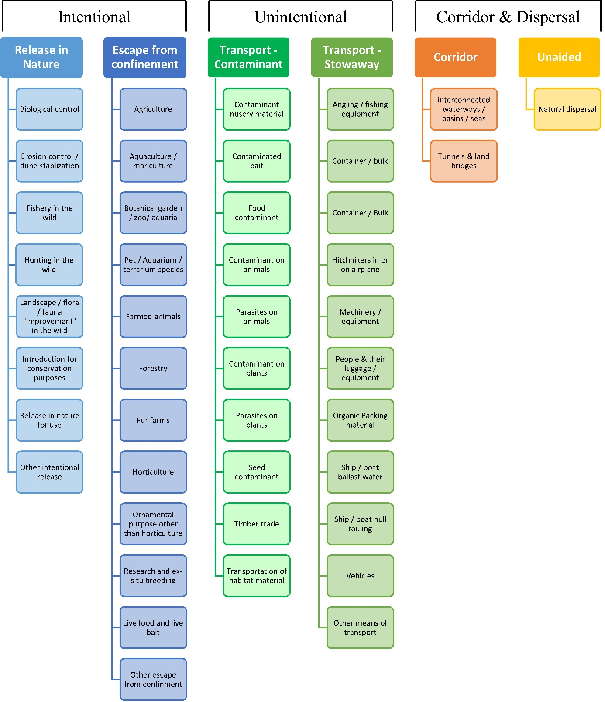

ANNEX V Ecosystem services classification (CICES V5.1, simplified) and examples
For the purposes of this risk assessment, please feel free to use what seems as the most appropriate category / level / combination of impact (Section – Division – Group), reflecting information available.

Section | Division | Group | Examples (i.e. relevant CICES “classes”)
Provisioning | Biomass | Cultivated terrestrial plants | Cultivated terrestrial plants (including fungi, algae) grown for nutritional purposes;  Fibres and other materials from cultivated plants, fungi, algae and bacteria for direct use or processing (excluding genetic materials);  Cultivated plants (including fungi, algae) grown as a source of energy  Example: negative impacts of non-native organisms to crops, orchards, timber etc.
 |  | Cultivated aquatic plants | Plants cultivated by in- situ aquaculture grown for nutritional purposes;  Fibres and other materials from in-situ aquaculture for direct use or processing (excluding genetic materials);  Plants cultivated by in- situ aquaculture grown as an energy source.  Example: negative impacts of non-native organisms to aquatic plants cultivated for nutrition, gardening etc. purposes.
 |  | Reared animals | Animals reared for nutritional purposes;  Fibres and other materials from reared animals for direct use or processing (excluding genetic materials);  Animals reared to provide energy (including mechanical)  Example: negative impacts of non-native organisms to livestock
 |  | Reared aquatic animals | Animals reared by in-situ aquaculture for nutritional purposes;  Fibres and other materials from animals grown by in-situ aquaculture for direct use or processing (excluding genetic materials);  Animals reared by in-situ aquaculture as an energy source  Example: negative impacts of non-native organisms to fish farming
 |  | Wild plants (terrestrial and aquatic) | Wild plants (terrestrial and aquatic, including fungi, algae) used for nutrition;  Fibres and other materials from wild plants for direct use or processing (excluding genetic materials);  Wild plants (terrestrial and aquatic, including fungi, algae) used as a source of energy  Example: reduction in the availability of wild plants (e.g. wild berries, ornamentals) due to non-native organisms (competition, spread of disease etc.)
 |  | Wild animals (terrestrial and aquatic) | Wild animals (terrestrial and aquatic) used for nutritional purposes;  Fibres and other materials from wild animals for direct use or processing (excluding genetic materials);  Wild animals (terrestrial and aquatic) used as a source of energy  Example: reduction in the availability of wild animals (e.g. fish stocks, game) due to non-native organisms (competition, predations, spread of disease etc.)
 | Genetic material from all biota | Genetic material from plants, algae or fungi | Seeds, spores and other plant materials collected for maintaining or establishing a population;  Higher and lower plants (whole organisms) used to breed new strains or varieties;  Individual genes extracted from higher and lower plants for the design and construction of new biological entities  Example: negative impacts of non-native organisms due to interbreeding
 |  | Genetic material from animals | Animal material collected for the purposes of maintaining or establishing a population;  Wild animals (whole organisms) used to breed new strains or varieties;  Individual genes extracted from organisms for the design and construction of new biological entities  Example: negative impacts of non-native organisms due to interbreeding
 | Water | Surface water used for nutrition, materials or energy | Surface water for drinking;  Surface water used as a material (non-drinking purposes);  Freshwater surface water, coastal and marine water used as an energy source  Example: loss of access to surface water due to spread of non-native organisms
 |  | Ground water for used for nutrition, materials or energy | Ground (and subsurface) water for drinking;  Ground water (and subsurface) used as a material (non-drinking purposes);  Ground water (and subsurface) used as an energy source  Example: reduced availability of ground water due to spread of non-native organisms and associated increase of ground water consumption by vegetation.
Regulation & Maintenance | Transformation of biochemical or physical inputs to ecosystems | Mediation of wastes or toxic substances of anthropogenic origin by living processes | Bio-remediation by micro-organisms, algae, plants, and animals; Filtration/sequestration/storage/accumulation by micro-organisms, algae, plants, and animals  Example: changes caused by non-native organisms to ecosystem functioning and ability to filtrate etc. waste or toxics
 |  | Mediation of nuisances of anthropogenic origin | Smell reduction; noise attenuation; visual screening (e.g. by means of green infrastructure)  Example: changes caused by non-native organisms to ecosystem structure, leading to reduced ability to mediate nuisances.
 | Regulation of physical, chemical, biological conditions | Baseline flows and extreme event regulation | Control of erosion rates;  Buffering and attenuation of mass movement;  Hydrological cycle and water flow regulation (Including flood control, and coastal protection);  Wind protection;  Fire protection  Example: changes caused by non-native organisms to ecosystem functioning or structure leading to, for example, destabilisation of soil, increased risk or intensity of wild fires etc.
 |  | Lifecycle maintenance, habitat and gene pool protection | Pollination (or 'gamete' dispersal in a marine context);  Seed dispersal;  Maintaining nursery populations and habitats (Including gene pool protection)  Example: changes caused by non-native organisms to the abundance and/or distribution of wild pollinators; changes to the availability / quality of nursery habitats for fisheries
 |  | Pest and disease control | Pest control;  Disease control  Example: changes caused by non-native organisms to the abundance and/or distribution of pests
 |  | Soil quality regulation | Weathering processes and their effect on soil quality;  Decomposition and fixing processes and their effect on soil quality  Example: changes caused by non-native organisms to vegetation structure and/or soil fauna leading to reduced soil quality
 |  | Water conditions | Regulation of the chemical condition of freshwaters by living processes;  Regulation of the chemical condition of salt waters by living processes  Example: changes caused by non-native organisms to buffer strips along water courses that remove nutrients in runoff and/or fish communities that regulate the resilience and resistance of water bodies to eutrophication
 |  | Atmospheric composition and conditions | Regulation of chemical composition of atmosphere and oceans;  Regulation of temperature and humidity, including ventilation and transpiration  Example: changes caused by non-native organisms to ecosystems’ ability to sequester carbon and/or evaporative cooling (e.g. by urban trees)
Cultural | Direct, in-situ and outdoor interactions with living systems that depend on presence in the environmental setting | Physical and experiential interactions with natural environment | Characteristics of living systems that that enable activities promoting health, recuperation or enjoyment through active or immersive interactions;  Characteristics of living systems that enable activities promoting health, recuperation or enjoyment through passive or observational interactions  Example: changes caused by non-native organisms to the qualities of ecosystems (structure, species composition etc.) that make it attractive for recreation, wild life watching etc.
 |  | Intellectual and representative interactions with natural environment | Characteristics of living systems that enable scientific investigation or the creation of traditional ecological knowledge;  Characteristics of living systems that enable education and training;  Characteristics of living systems that are resonant in terms of culture or heritage;  Characteristics of living systems that enable aesthetic experiences  Example: changes caused by non-native organisms to the qualities of ecosystems (structure, species composition etc.) that have cultural importance
 | Indirect, remote, often indoor interactions with living systems that do not require presence in the environmental setting | Spiritual, symbolic and other interactions with natural environment | Elements of living systems that have symbolic meaning;  Elements of living systems that have sacred or religious meaning;  Elements of living systems used for entertainment or representation  Example: changes caused by non-native organisms to the qualities of ecosystems (structure, species composition etc.) that have sacred or religious meaning
 |  | Other biotic characteristics that have a non-use value | Characteristics or features of living systems that have an existence value;  Characteristics or features of living systems that have an option or bequest value  Example: changes caused by non-native organisms to ecosystems designated as wilderness areas, habitats of endangered species etc.

ANNEX VI EU Biogeographic Regions and MSFD Subregions
See https://www.eea.europa.eu/data-and-maps/figures/biogeographical-regions-in-europe-2 ,
http://ec.europa.eu/environment/nature/natura2000/biogeog_regions/

and

https://www.eea.europa.eu/data-and-maps/data/msfd-regions-and-subregions-1/technical-document/pdf
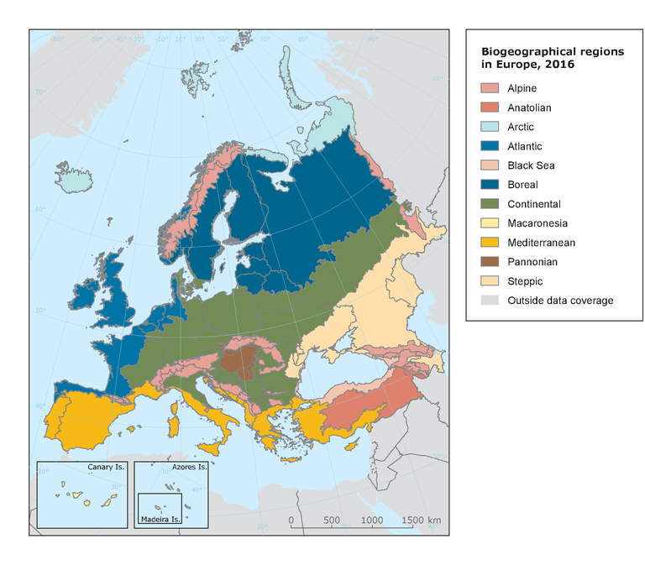

ANNEX VII Delegated Regulation (EU) 2018/968 of 30 April 2018
see https://eur-lex.europa.eu/legal-content/en/TXT/?uri=CELEX%3A32018R0968

ANNEX VIII Species distribution model
Projection of environmental suitability for Cipangopaludina chinensis establishment in Europe

Björn Beckmann, Frances Lucy, Eithne Davis and Dan Chapman

Aim
To project the suitability for potential establishment of Cipangopaludina chinensis in Europe, under current and predicted future climatic conditions.

Data for modelling
Species occurrence data were obtained from the Global Biodiversity Information Facility (GBIF) (4646 records), iNaturalist (3196 records), the Biodiversity Information Serving Our Nation database (BISON) (1831 records), the Integrated Digitized Biocollections (iDigBio) (301 records), and additional records from the risk assessment team. We scrutinised occurrence records from regions where the species is not known to be established and removed any dubious records or where the georeferencing was too imprecise (e.g. records referenced to a country or island centroid) or outside of the coverage of the predictor layers (e.g. small island or coastal occurrences). The remaining records were gridded at a 0.25 x 0.25 degree resolution for modelling, yielding 1288 grid cells with occurrences (Figure 1a). As a proxy for recording effort, the density of Gastropoda records held by GBIF was also compiled on the same grid (Figure 1b).

Figure 1. (a) Occurrence records obtained for Cipangopaludina chinensis and used in the modelling, showing native and invaded distributions. (b) The recording density of Gastropoda on GBIF, which was used as a proxy for recording effort.
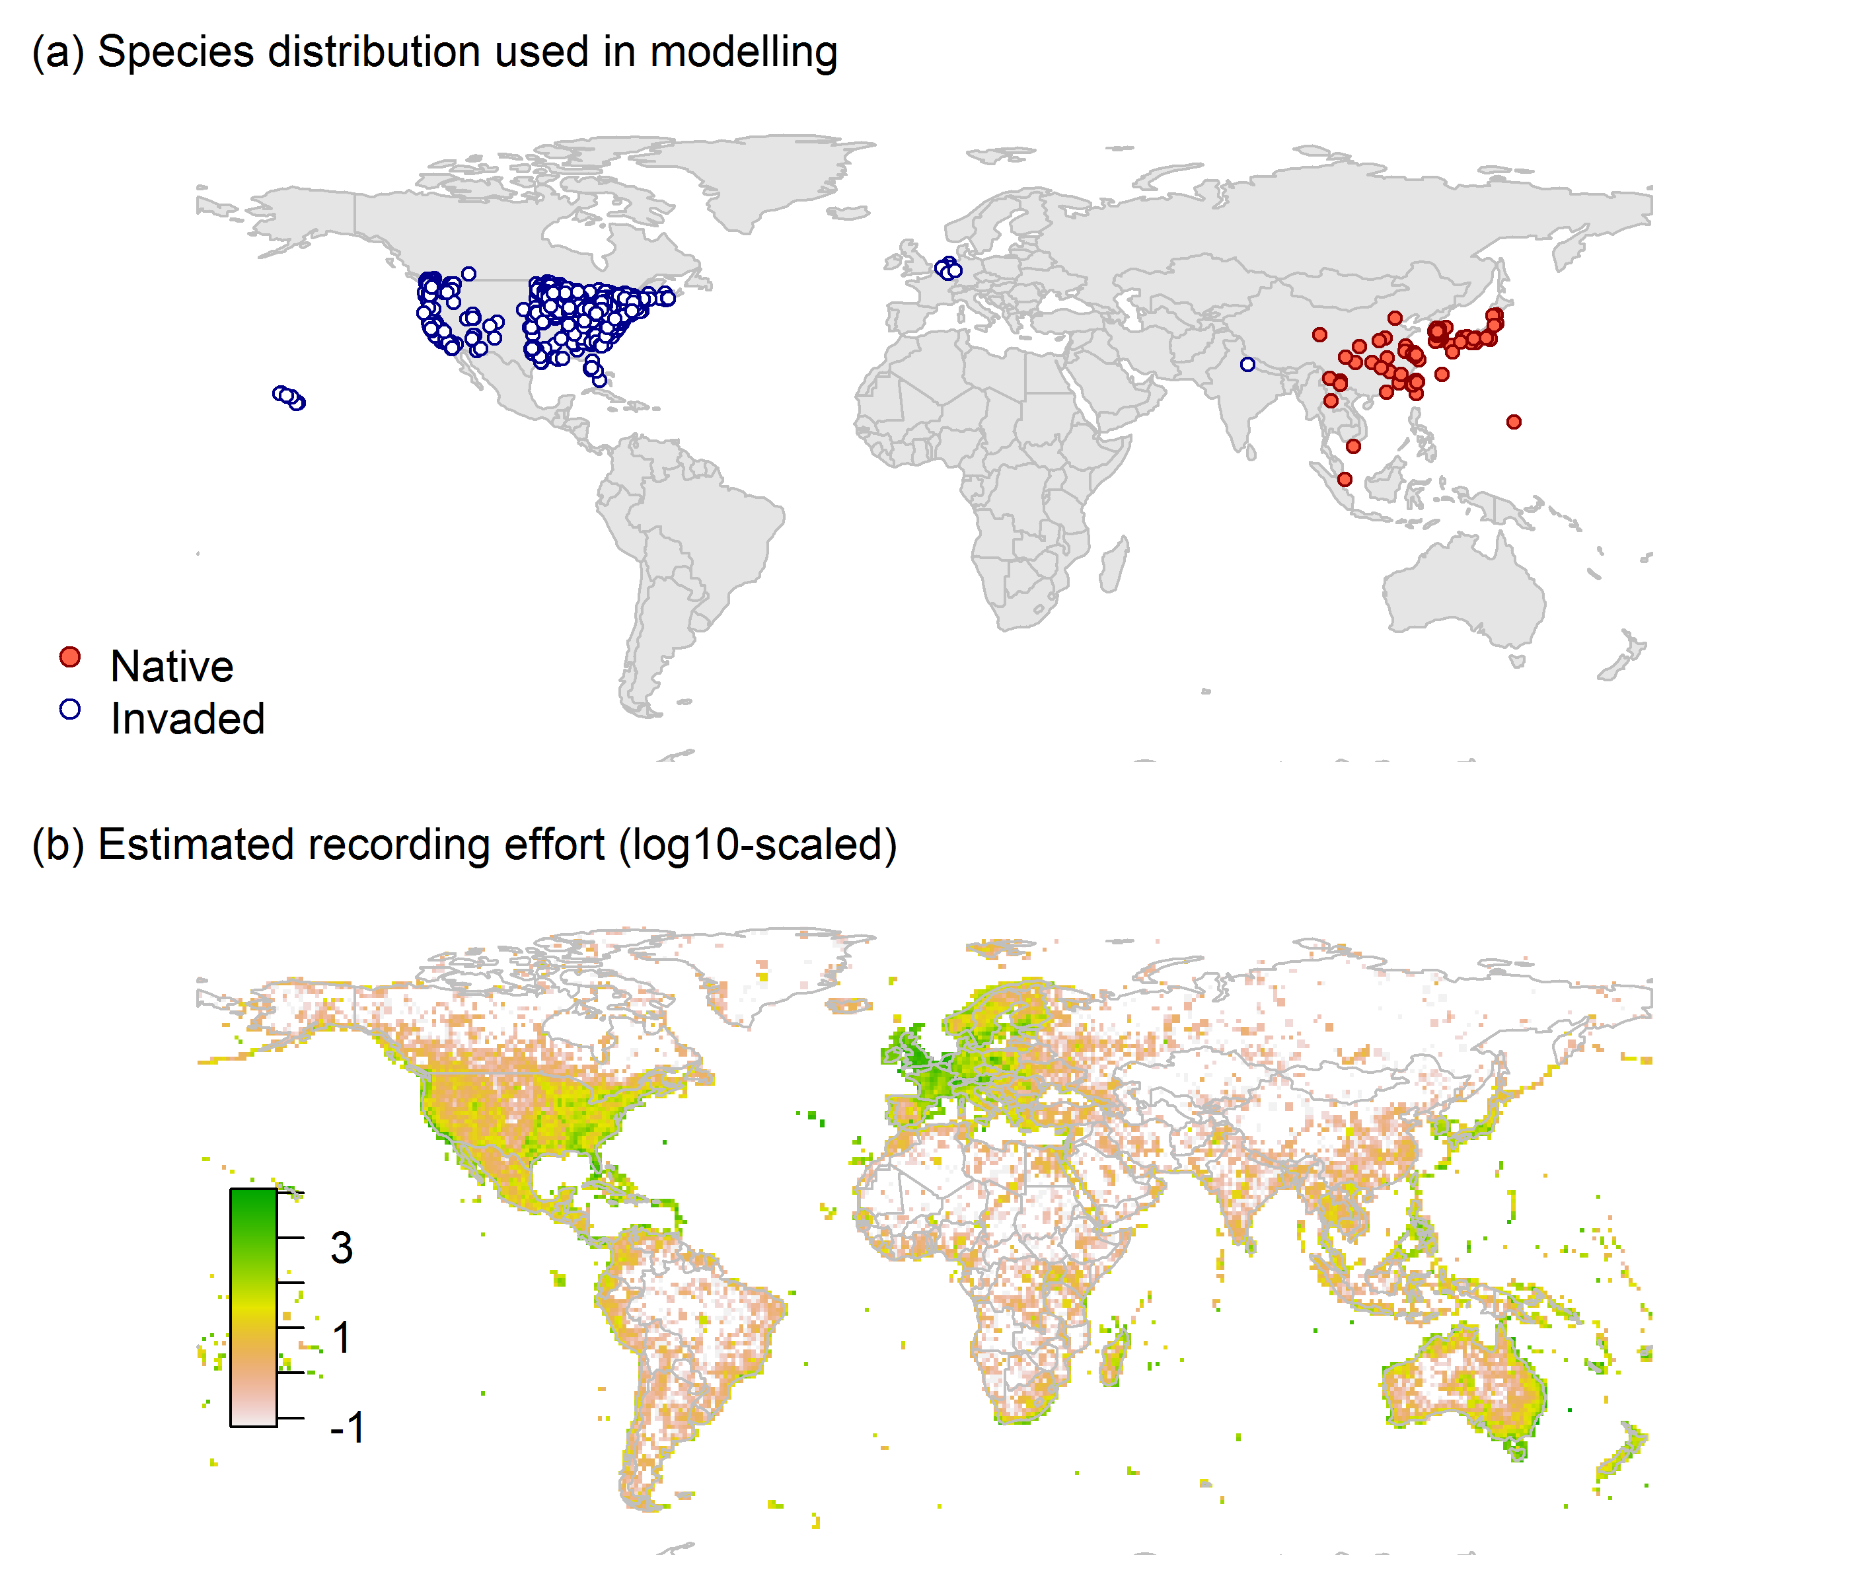

Climate data were selected from the ‘Bioclim’ variables contained within the WorldClim database (Hijmans et al., 2005), originally at 5 arcminute resolution (0.083 x 0.083 degrees of longitude/latitude) and aggregated to a 0.25 x 0.25 degree grid for use in the model.
Based on the biology of Cipangopaludina chinensis, the following climate variables were used in the modelling:
- Mean temperature of the warmest quarter (Bio10)
- Mean temperature of the coldest quarter (Bio11)
- Annual precipitation (Bio12)
- Precipitation seasonality (Bio15)
To estimate the effect of climate change on the potential distribution, equivalent modelled future climate conditions for the 2070s under the Representative Concentration Pathways (RCP) 2.6 and 4.5 were also obtained. These represent low and medium emissions scenarios, respectively. The above variables were obtained as averages of outputs of eight Global Climate Models (BCC-CSM1-1, CCSM4, GISS-E2-R, HadGEM2-AO, IPSL-CM5A-LR, MIROC-ESM, MRI-CGCM3, NorESM1-M), downscaled and calibrated against the WorldClim baseline (see http://www.worldclim.org/cmip5_5m ).
The following habitat layers were also used:
- Human influence index (HII): As many non-native invasive species associate with anthropogenically disturbed habitats. We used the Global Human Influence Index Dataset of the Last of the Wild Project (Wildlife Conservation Society - WCS & Center for International Earth Science Information Network - CIESIN - Columbia University, 2005), which is developed from nine global data layers covering human population pressure (population density), human land use and infrastructure (built-up areas, nighttime lights, land use/land cover) and human access (coastlines, roads, railroads, navigable rivers). The index ranges between 0 and 1 and was ln+1 transformed for the modelling to improve normality.

Species distribution model
A presence-background (presence-only) ensemble modelling strategy was employed using the BIOMOD2 R package version 3.4.6 (Thuiller et al., 2020, Thuiller et al., 2009). These models contrast the environment at the species’ occurrence locations against a random sample of the global background environmental conditions (often termed ‘pseudo-absences’) in order to characterise and project suitability for occurrence. This approach has been developed for distributions that are in equilibrium with the environment. Because invasive species’ distributions are not at equilibrium and subject to dispersal constraints at a global scale, we took care to minimise the inclusion of locations suitable for the species but where it has not been able to disperse to (Chapman et al. 2019). Therefore the background sampling region included:
- The area accessible by native Cipangopaludina chinensis populations, in which the species is likely to have had sufficient time to disperse to all locations. Based on presumed maximum dispersal distances, the accessible region was defined as a 400km buffer around the native range occurrences; AND
- A 50km buffer around the non-native occurrences, encompassing regions likely to have had high propagule pressure for introduction by humans and/or dispersal of the species; AND
- Regions where we have an a priori expectation of high unsuitability for the species so that absence is assumed irrespective of dispersal constraints (see Figure 2). The following rules were applied to define a region expected to be highly unsuitable for Cipangopaludina chinensis at the spatial scale of the model:
  - Mean temperature of the warmest quarter (Bio10) < 14°C
  - Mean temperature of the coldest quarter (Bio11) < -14°C
  - Annual precipitation (Bio12) < 250mm

Altogether, 1.3% of occurrence grid cells were located in the unsuitable background region.
Within the unsuitable background region, 10 samples of 5000 randomly sampled grid cells were obtained. In the accessible background (comprising the accessible areas around native and non-native occurrences as detailed above), the same number of pseudo-absence samples were drawn as there were presence records (1288), weighting the sampling by a proxy for recording effort (Figure 1(b)).

Figure 2. The background from which pseudo-absence samples were taken in the modelling of Cipangopaludina chinensis. Samples were taken from a 400km buffer around the native range and a 50km buffer around non-native occurrences (together forming the accessible background), and from areas expected to be highly unsuitable for the species (the unsuitable background region). Samples from the accessible background were weighted by a proxy for recording effort (Figure 1(b)).
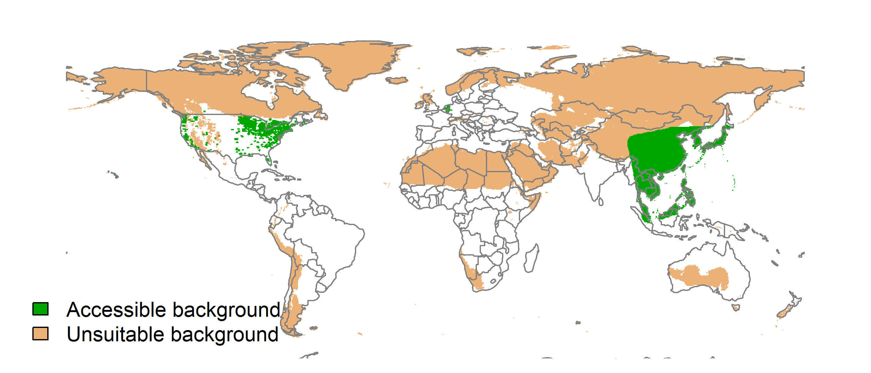

Each dataset (i.e. combination of the presences and the individual background samples) was randomly split into 80% for model training and 20% for model evaluation. With each training dataset, seven statistical algorithms were fitted with the default BIOMOD2 settings and rescaled using logistic regression, except where specified below:
- Generalised linear model (GLM)
- Generalised boosting model (GBM)
- Generalised additive model (GAM) with a maximum of four degrees of freedom per smoothing spline
- Artificial neural network (ANN)
- Multivariate adaptive regression splines (MARS)
- Random forest (RF)
- Maxent

Since the total background sample was larger than the number of occurrences, prevalence fitting weights were applied to give equal overall importance to the occurrences and the background. Normalised variable importance was assessed and variable response functions were produced using BIOMOD2’s default procedure.
Model predictive performance was assessed by the following three measures:
- AUC, the area under the receiver operating characteristic curve (Fielding & Bell 1997). Predictions of presence-absence models can be compared with a subset of records set aside for model evaluation (here 20%) by constructing a confusion matrix with the number of true positive, false positive, false negative and true negative cases. For models generating non-dichotomous scores (as here) a threshold can be applied to transform the scores into a dichotomous set of presence-absence predictions. Two measures that can be derived from the confusion matrix are sensitivity (the proportion of observed presences that are predicted as such, quantifying omission errors), and specificity (the proportion of observed absences that are predicted as such, quantifying commission errors). A receiver operating characteristic (ROC) curve can be constructed by using all possible thresholds to classify the scores into confusion matrices, obtaining sensitivity and specificity for each matrix, and plotting sensitivity against the corresponding proportion of false positives (equal to 1 - specificity). The use of all possible thresholds avoids the need for a selection of a single threshold, which is often arbitrary, and allows appreciation of the trade-off between sensitivity and specificity. The area under the ROC curve (AUC) is often used as a single threshold-independent measure for model performance (Manel et al. 2001). AUC is the probability that a randomly selected presence has a higher model-predicted suitability than a randomly selected absence (Allouche et al. 2006).
- Cohen’s Kappa (Cohen 1960). This measure corrects the overall accuracy of model predictions (ratio of the sum of true presences plus true absences to the total number of records) by the accuracy expected to occur by chance. The Kappa statistic ranges from -1 to +1, where +1 indicates perfect agreement and values of zero or less indicate a performance no better than random. Advantages of Kappa are its simplicity, the fact that both commission and omission errors are accounted for in one parameter, and its relative tolerance to zero values in the confusion matrix (Manel et al. 2001). However, Kappa has been criticised for being sensitive to prevalence (the proportion of sites in which the species was recorded as present) and may therefore be inappropriate for comparisons of model accuracy between species or regions (McPherson et al. 2004, Allouche et al. 2006).
- TSS, the true skill statistic (Allouche et al. 2006). TSS is defined as sensitivity + specificity - 1, and corrects for Kappa’s dependency on prevalence. TSS compares the number of correct forecasts, minus those attributable to random guessing, to that of a hypothetical set of perfect forecasts. Like Kappa, TSS takes into account both omission and commission errors, and success as a result of random guessing, and ranges from -1 to +1, where +1 indicates perfect agreement and values of zero or less indicate a performance no better than random (Allouche et al. 2006).
An ensemble model was created by first rejecting poorly performing algorithms with relatively extreme low AUC values and then averaging the predictions of the remaining algorithms, weighted by their AUC. To identify poorly performing algorithms, AUC values were converted into modified z-scores based on their difference to the median and the median absolute deviation across all algorithms (Iglewicz & Hoaglin 1993). Algorithms with z < -2 were rejected. In this way, ensemble projections were made for each dataset and then averaged to give an overall suitability, as well as its standard deviation.
Projections were classified into suitable and unsuitable regions using a “lowest presence threshold” (Pearson et al. 2007), setting the cut-off as the lowest value at which 98% of all presence records are classified correctly under the current climate (here 0.35). In order to express the sensitivity of classifications to the choice of this threshold, thresholds at which 95% and 99% of records are classified correctly (here 0.53 and 0.21 respectively) were used in the calculation of error bars in Figures 9 and 10 below in addition to taking account of uncertainty in the projections themselves.
We also produced a limiting factor map for Europe following Elith et al. (2010). For this, projections were made separately with each individual variable fixed at a near-optimal value. These were chosen as the median values at the occurrence grid cells. Then, the most strongly limiting factors were identified as the ones resulting in the highest increase in suitability in each grid cell.

Results
The ensemble model suggested that suitability for Cipangopaludina chinensis was most strongly determined by Mean temperature of the warmest quarter (Bio10), accounting for 30.9% of variation explained, followed by Mean temperature of the coldest quarter (Bio11) (28.2%), Annual precipitation (Bio12) (25.5%), Human influence index (HII) (12.3%) and Precipitation seasonality (Bio15) (3.1%) (Table 1, Figure 3).

Table 1. Summary of the cross-validation predictive performance (AUC, Kappa, TSS) and variable importance of the fitted model algorithms and the ensemble (AUC-weighted average of the best performing algorithms). Results are the average from models fitted to 10 different background samples of the data.
 |  |  |  |  | Variable importance (%)
Algorithm | AUC | Kappa | TSS | Used in the ensemble | Mean temperature of the warmest quarter (Bio10) | Mean temperature of the coldest quarter (Bio11) | Annual precipitation (Bio12) | Human influence index (HII) | Precipitation seasonality (Bio15)
GLM | 0.935 | 0.651 | 0.810 | yes | 35 | 21 | 27 | 15 | 2
GAM | 0.947 | 0.669 | 0.814 | yes | 27 | 29 | 26 | 17 | 1
GBM | 0.956 | 0.695 | 0.815 | yes | 27 | 29 | 22 | 21 | 0
ANN | 0.958 | 0.713 | 0.823 | yes | 33 | 37 | 20 | 7 | 3
MARS | 0.922 | 0.624 | 0.760 | no | 30 | 24 | 21 | 25 | 0
RF | 0.939 | 0.651 | 0.806 | yes | 36 | 18 | 30 | 8 | 9
Maxent | 0.954 | 0.691 | 0.810 | yes | 28 | 34 | 27 | 6 | 4
Ensemble | 0.954 | 0.694 | 0.821 |  | 31 | 28 | 25 | 12 | 3

Figure 3. Partial response plots from the fitted models. Thin coloured lines show responses from the algorithms in the ensemble, while the thick black line is their ensemble. In each plot, other model variables are held at their median value in the training data. Some of the divergence among algorithms is because of their different treatment of interactions among variables.
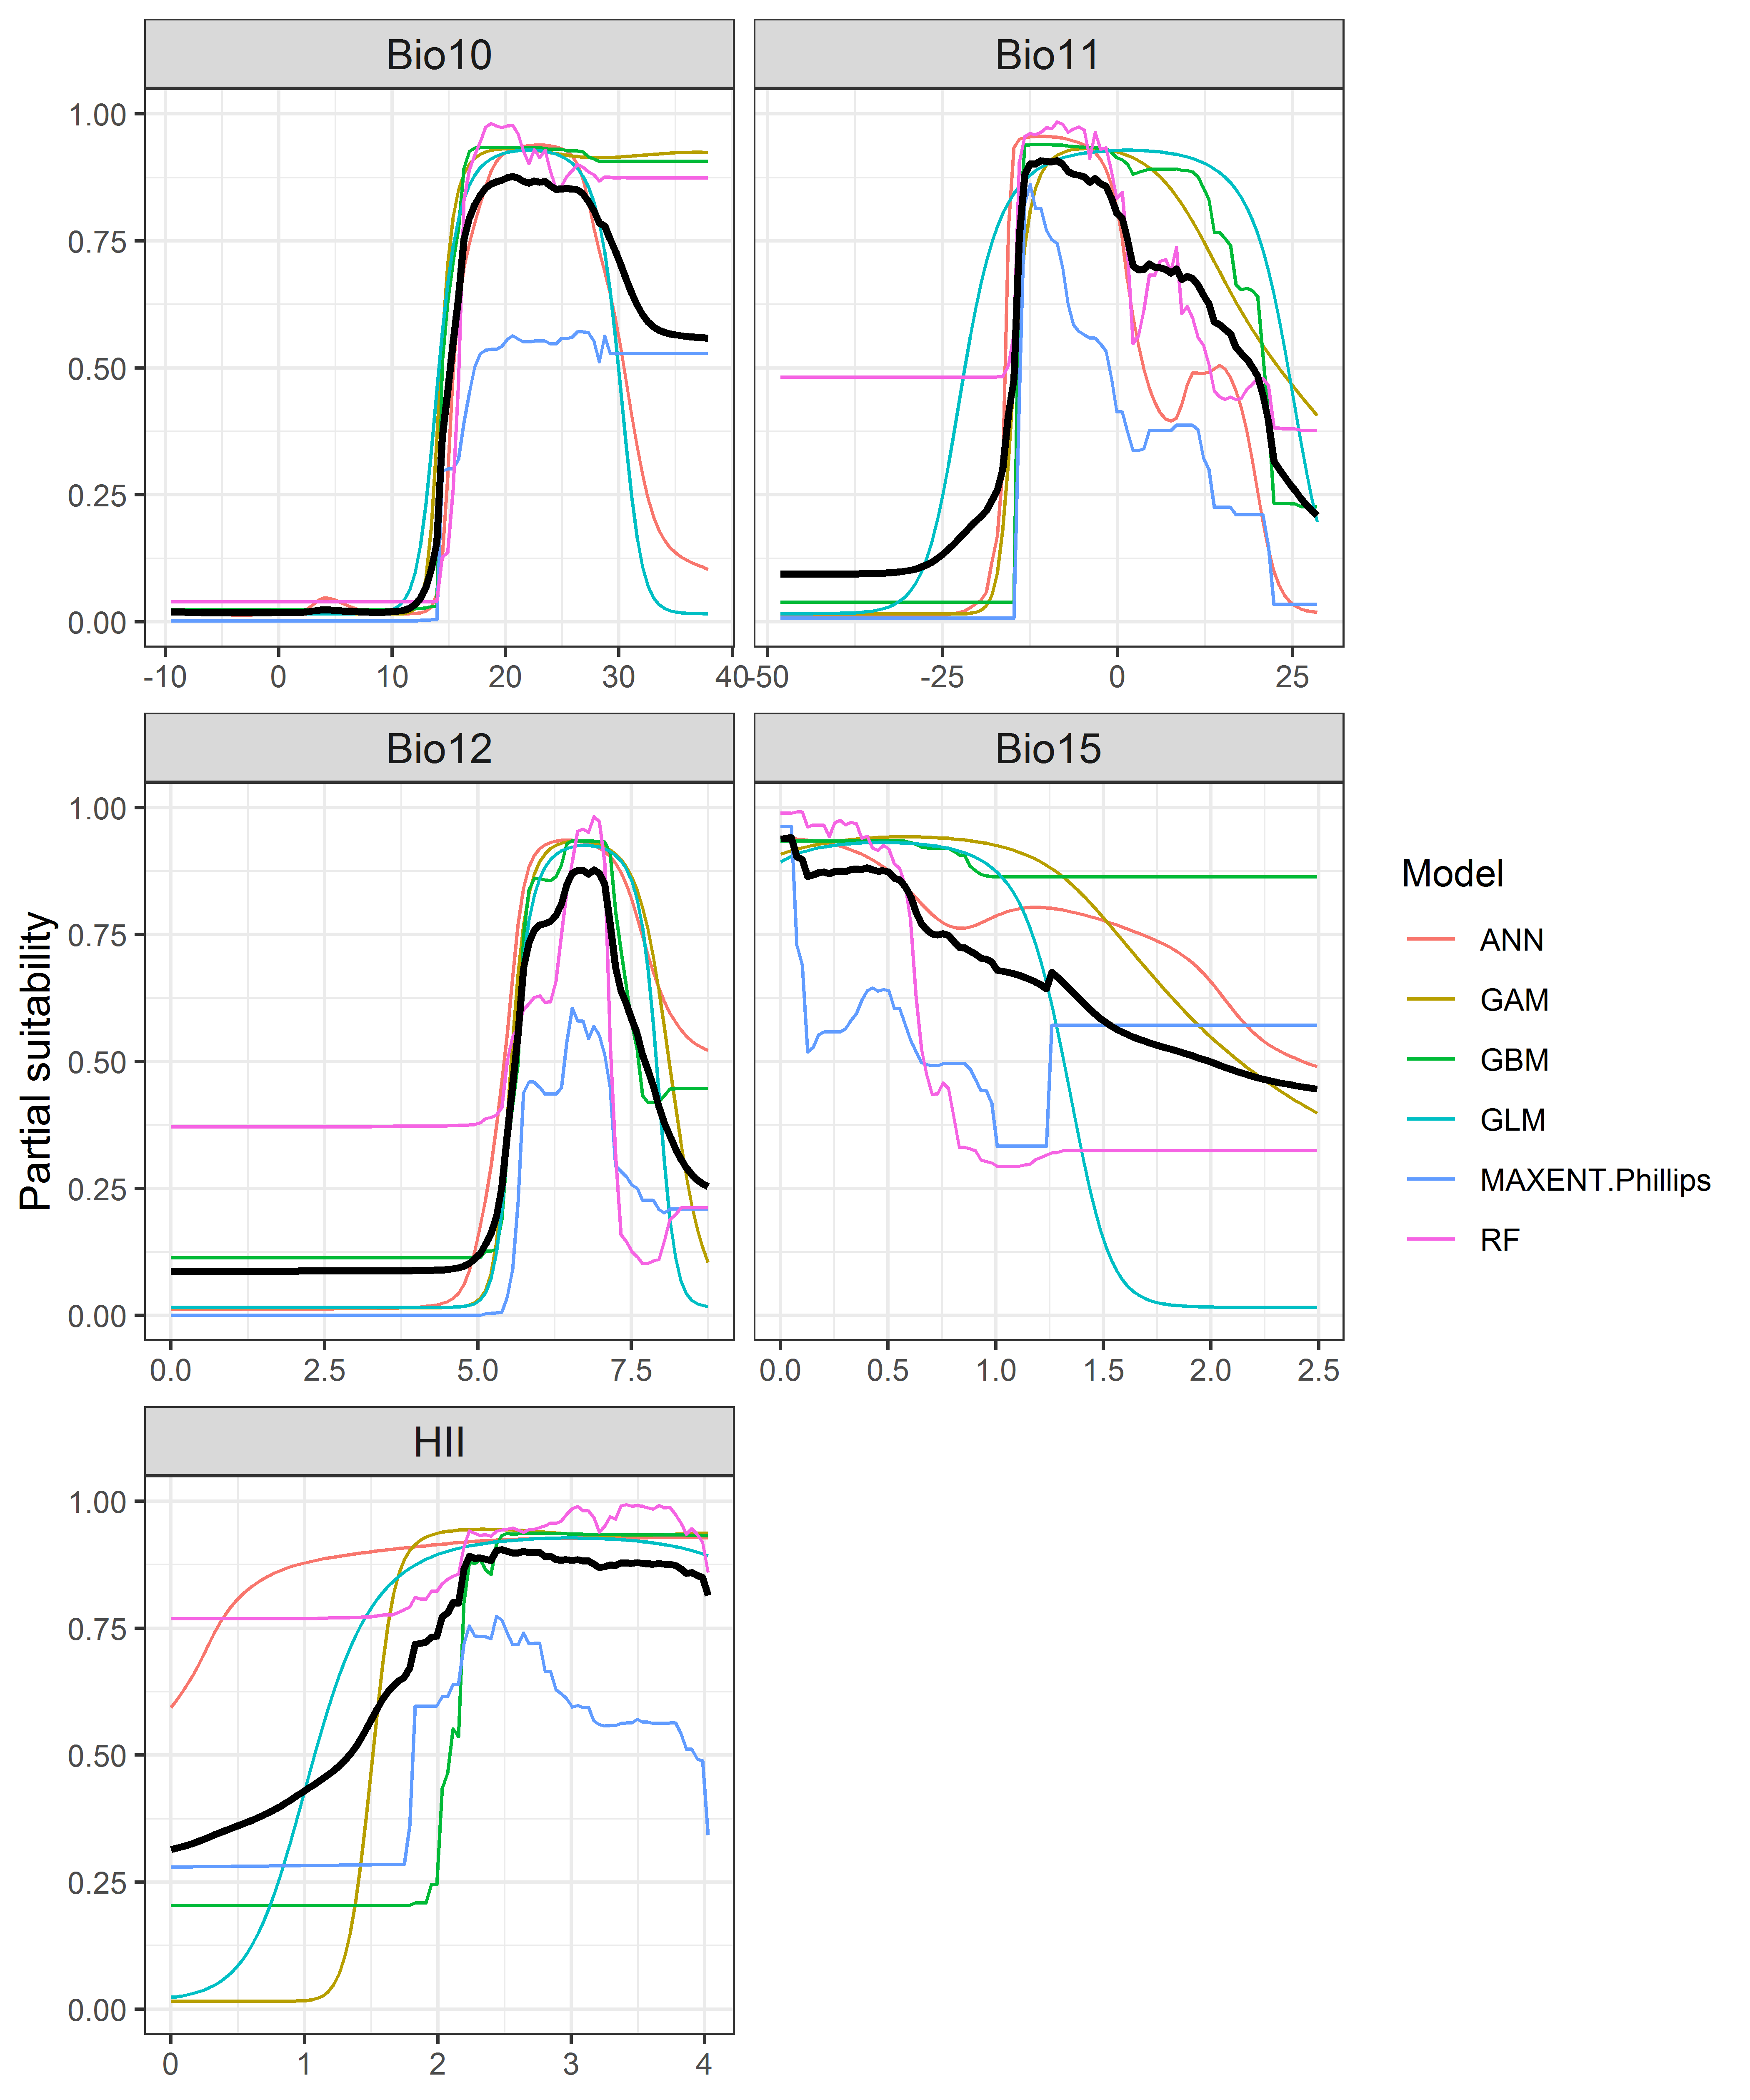

Figure 4. (a) Projected global suitability for Cipangopaludina chinensis establishment in the current climate. For visualisation, the projection has been aggregated to a 0.5 x 0.5 degree resolution, by taking the maximum suitability of constituent higher resolution grid cells. Values > 0.35 are suitable for the species, with 98% of global presence records above this threshold. Values below 0.35 indicate lower relative suitability. (b) Uncertainty in the ensemble projections, expressed as the among-algorithm standard deviation in predicted suitability, averaged across the 10 datasets.

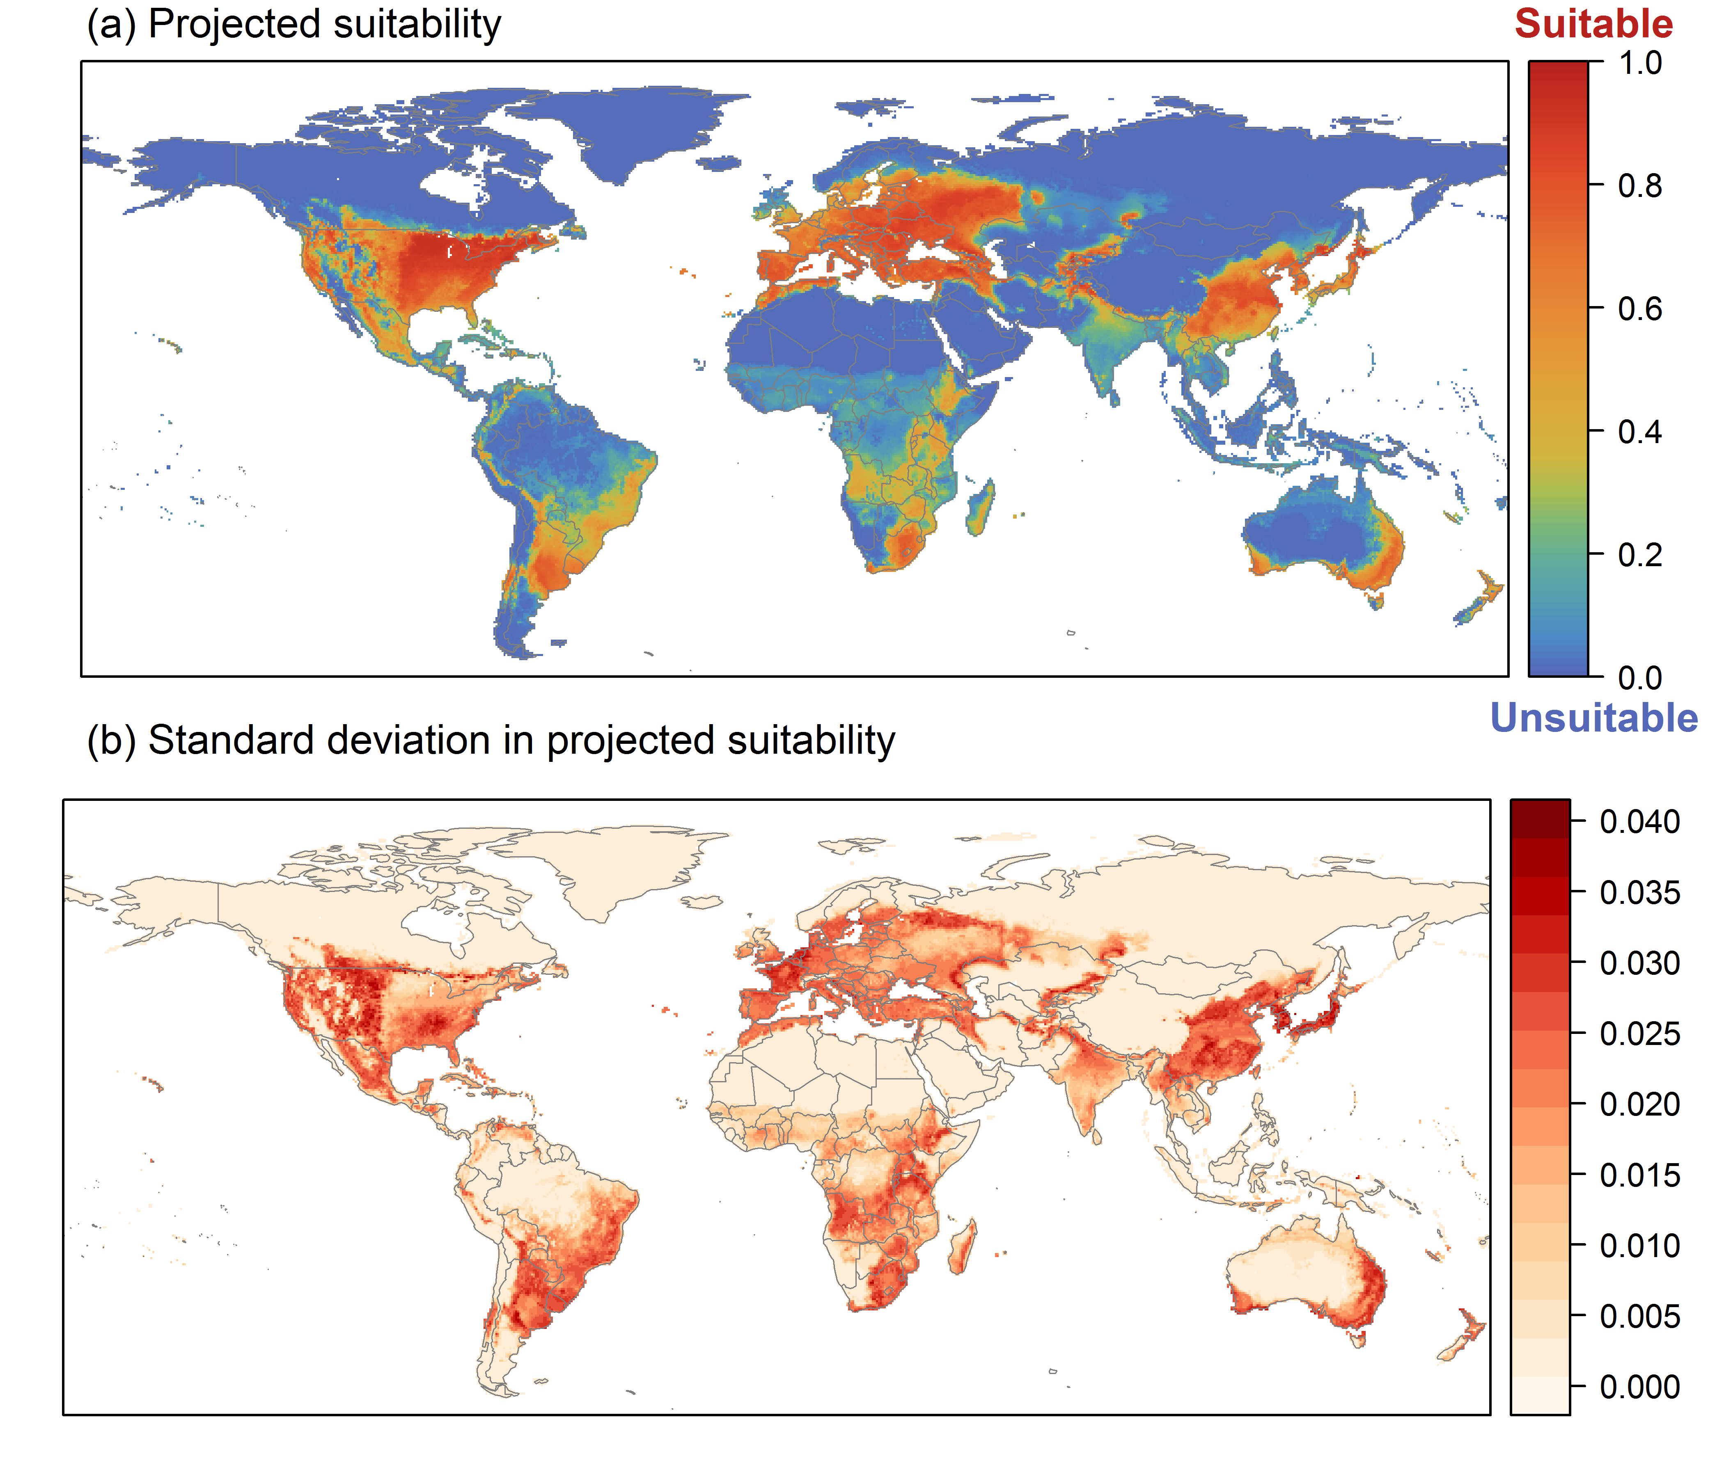

Figure 5. (a) Projected current suitability for Cipangopaludina chinensis establishment in Europe and the Mediterranean region. Values > 0.35 are suitable for the species, with 98% of global presence records above this threshold. Values below 0.35 indicate lower relative suitability. (b) Uncertainty in the ensemble projections, expressed as the among-algorithm standard deviation in predicted suitability, averaged across the 10 datasets.
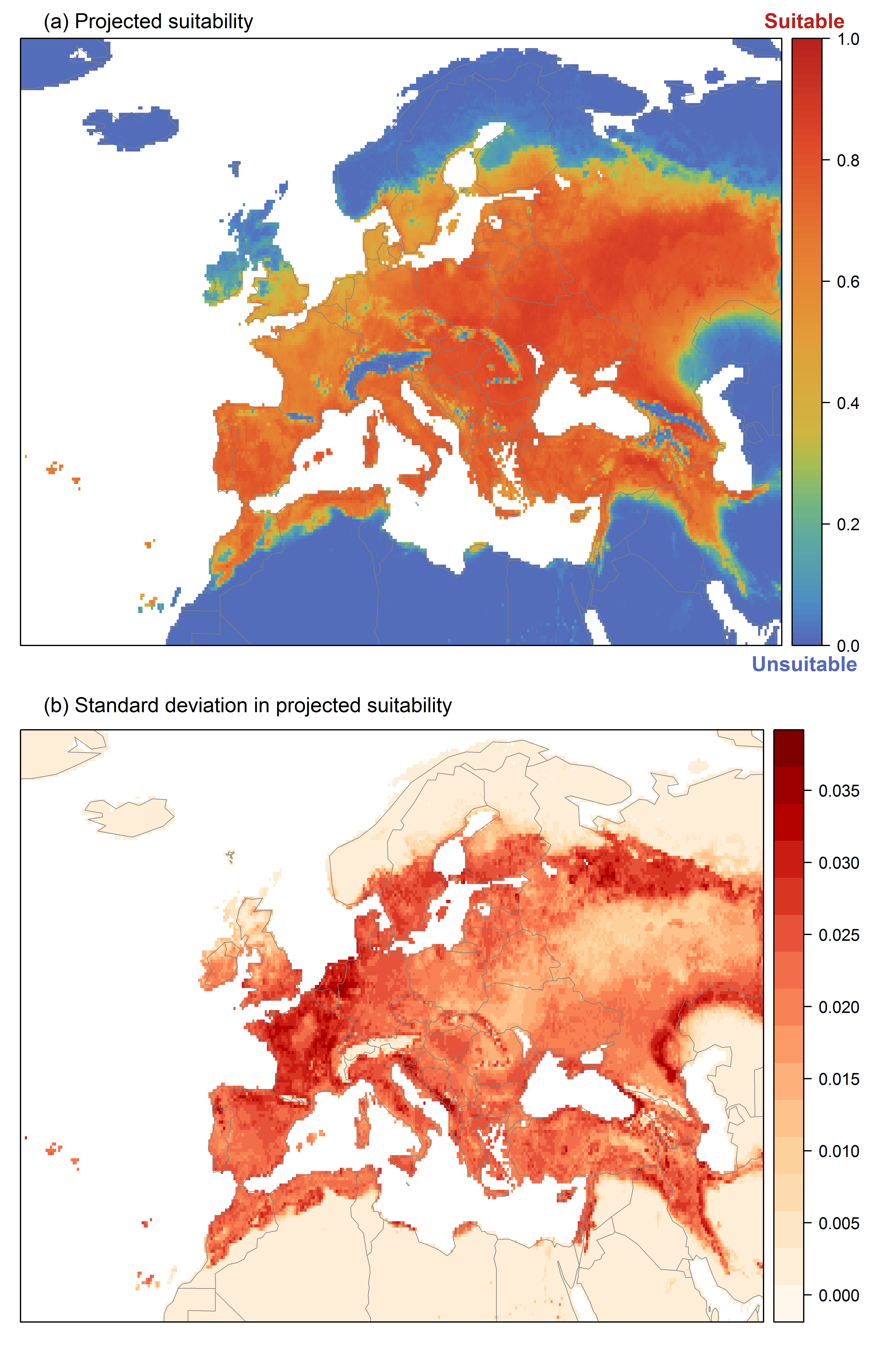

Figure 6. The most strongly limiting factors for Cipangopaludina chinensis establishment estimated by the model in Europe and the Mediterranean region in current climatic conditions.
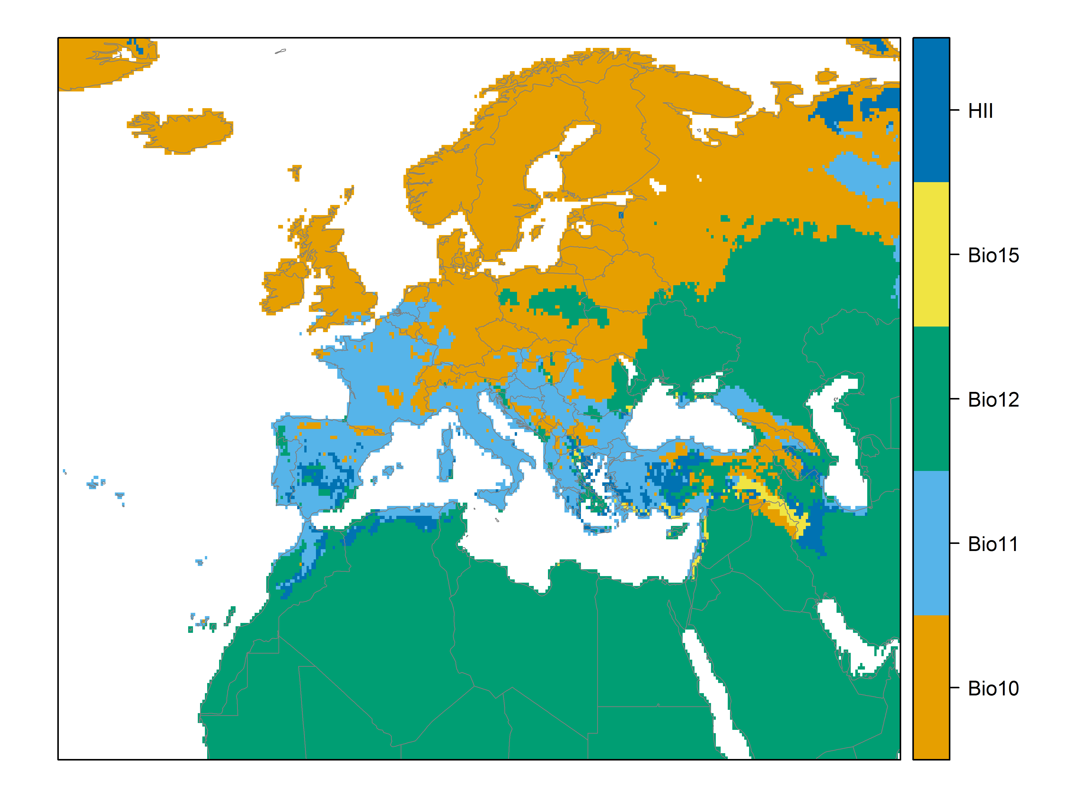

Figure 7. (a) Projected suitability for Cipangopaludina chinensis establishment in Europe and the Mediterranean region in the 2070s under climate change scenario RCP2.6. Values > 0.35 are suitable for the species, with 98% of global presence records above this threshold under current climate. Values below 0.35 indicate lower relative suitability. (b) Uncertainty in the ensemble projections, expressed as the among-algorithm standard deviation in predicted suitability, averaged across the 10 datasets.
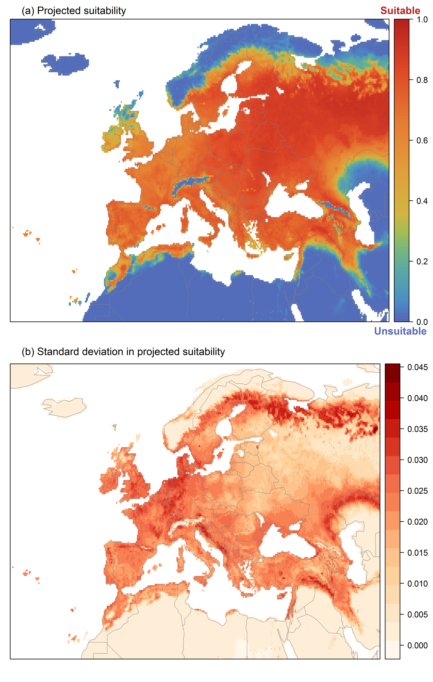

Figure 8. (a) Projected suitability for Cipangopaludina chinensis establishment in Europe and the Mediterranean region in the 2070s under climate change scenario RCP4.5. Values > 0.35 are suitable for the species, with 98% of global presence records above this threshold under current climate. Values below 0.35 indicate lower relative suitability. (b) Uncertainty in the ensemble projections, expressed as the among-algorithm standard deviation in predicted suitability, averaged across the 10 datasets.
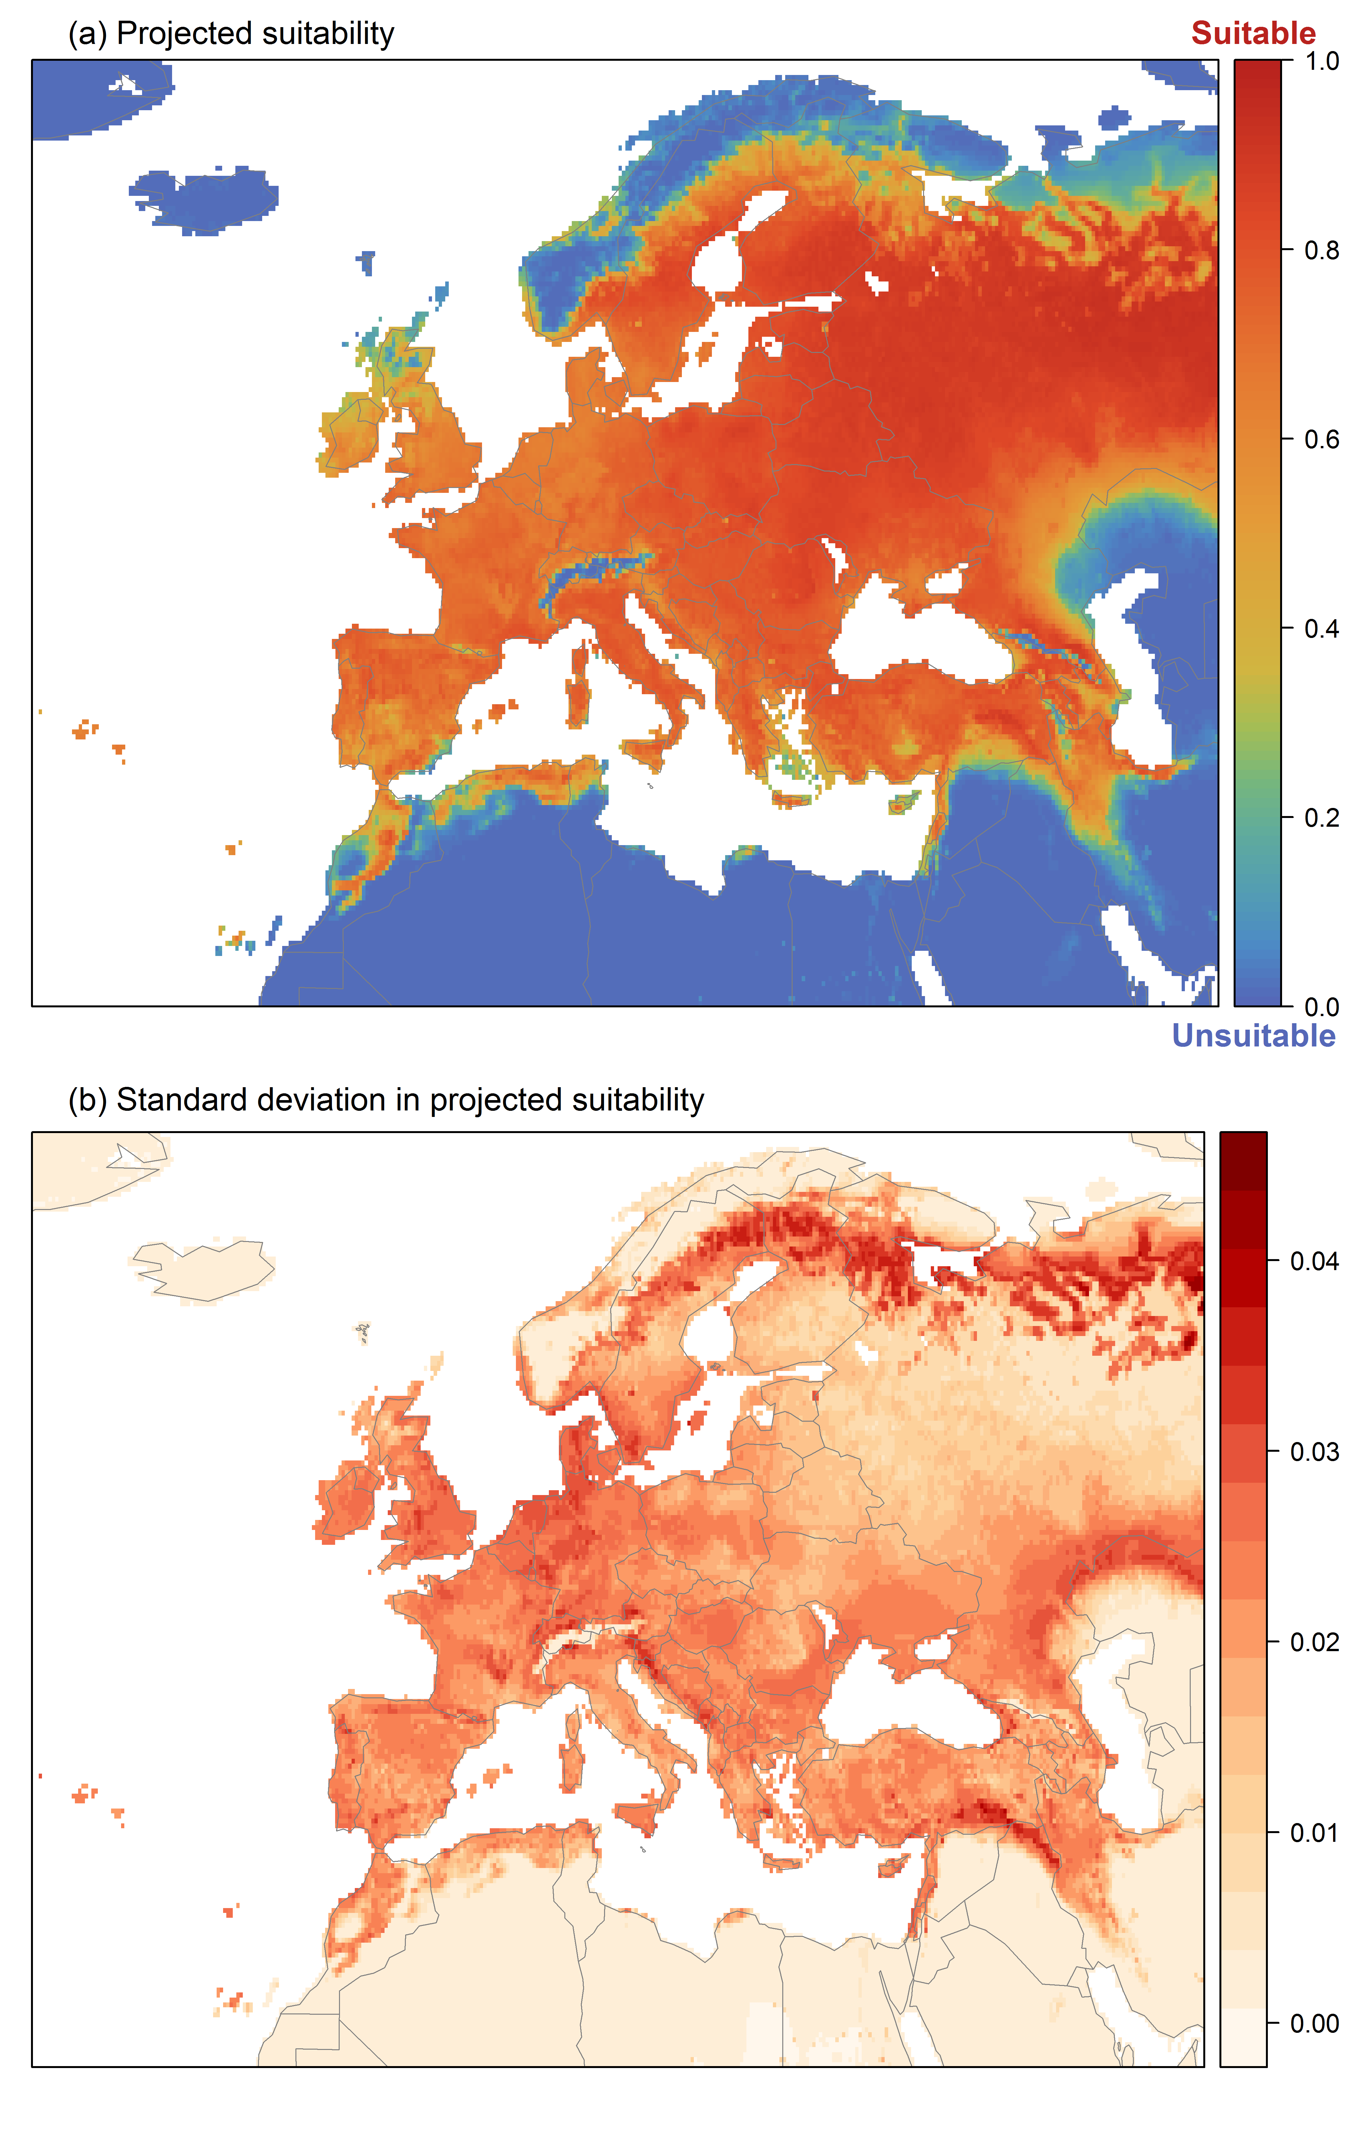

Figure 9. Variation in projected suitability for Cipangopaludina chinensis establishment among Biogeographical Regions of Europe (https://www.eea.europa.eu/data-and-maps/data/biogeographical-regions-europe-3). The bar plots show the proportion of grid cells in each region classified as suitable (with values > 0.35) in the current climate and projected climate for the 2070s under two RCP emissions scenarios. Error bars indicate uncertainty due to both the choice of classification threshold (cf. p.5/6) and uncertainty in the projections themselves (cf. part (b) of Figures 5, 7 and 8). The location of each region is also shown. The Anatolian, Arctic and Macaronesian regions are not part of the study area, but are included for completeness.
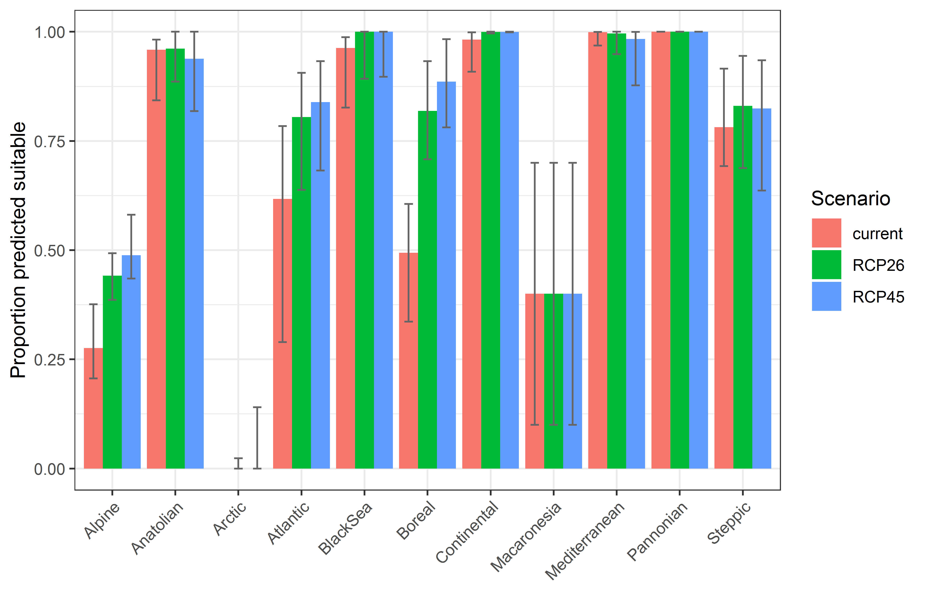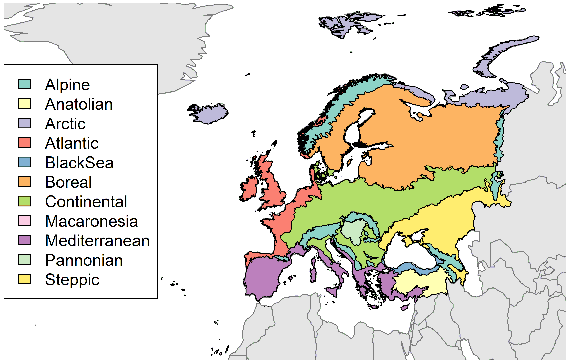

Table 2. Variation in projected suitability for Cipangopaludina chinensis establishment among Biogeographical regions of Europe (numerical values of Figure 9 above). The numbers are the proportion of grid cells in each region classified as suitable in the current climate and projected climate for the 2070s under two RCP emissions scenarios. The Anatolian, Arctic and Macaronesian biogeographical regions are not part of the study area, but are included for completeness.

 | current climate |  |  | 2070s RCP2.6 |  |  | 2070s RCP4.5
 | lower | central estimate | upper | lower | central estimate | upper | lower | central estimate | upper
Alpine | 0.21 | 0.28 | 0.38 | 0.39 | 0.44 | 0.49 | 0.43 | 0.49 | 0.58
Anatolian | 0.84 | 0.96 | 0.98 | 0.89 | 0.96 | 1.00 | 0.82 | 0.94 | 1.00
Arctic | 0.00 | 0.00 | 0.00 | 0.00 | 0.00 | 0.02 | 0.00 | 0.00 | 0.14
Atlantic | 0.29 | 0.62 | 0.78 | 0.64 | 0.80 | 0.91 | 0.68 | 0.84 | 0.93
Black Sea | 0.83 | 0.96 | 0.99 | 0.89 | 1.00 | 1.00 | 0.90 | 1.00 | 1.00
Boreal | 0.34 | 0.49 | 0.61 | 0.71 | 0.82 | 0.93 | 0.78 | 0.89 | 0.98
Continental | 0.91 | 0.98 | 1.00 | 1.00 | 1.00 | 1.00 | 1.00 | 1.00 | 1.00
Macaronesia | 0.10 | 0.40 | 0.70 | 0.10 | 0.40 | 0.70 | 0.10 | 0.40 | 0.70
Mediterranean | 0.97 | 1.00 | 1.00 | 0.95 | 1.00 | 1.00 | 0.88 | 0.98 | 1.00
Pannonian | 1.00 | 1.00 | 1.00 | 1.00 | 1.00 | 1.00 | 1.00 | 1.00 | 1.00
Steppic | 0.69 | 0.78 | 0.92 | 0.69 | 0.83 | 0.94 | 0.64 | 0.82 | 0.93

Figure 10. Variation in projected suitability for Cipangopaludina chinensis establishment among European Union countries and the UK. The bar plots show the proportion of grid cells in each country classified as suitable (with values > 0.35) in the current climate and projected climate for the 2070s under two RCP emissions scenarios. Error bars indicate uncertainty due to both the choice of classification threshold (cf. p.5/6) and uncertainty in the projections themselves (cf. part (b) of Figures 5, 7 and 8). Malta has been excluded because the Human Influence Index dataset lacks coverage for Malta.
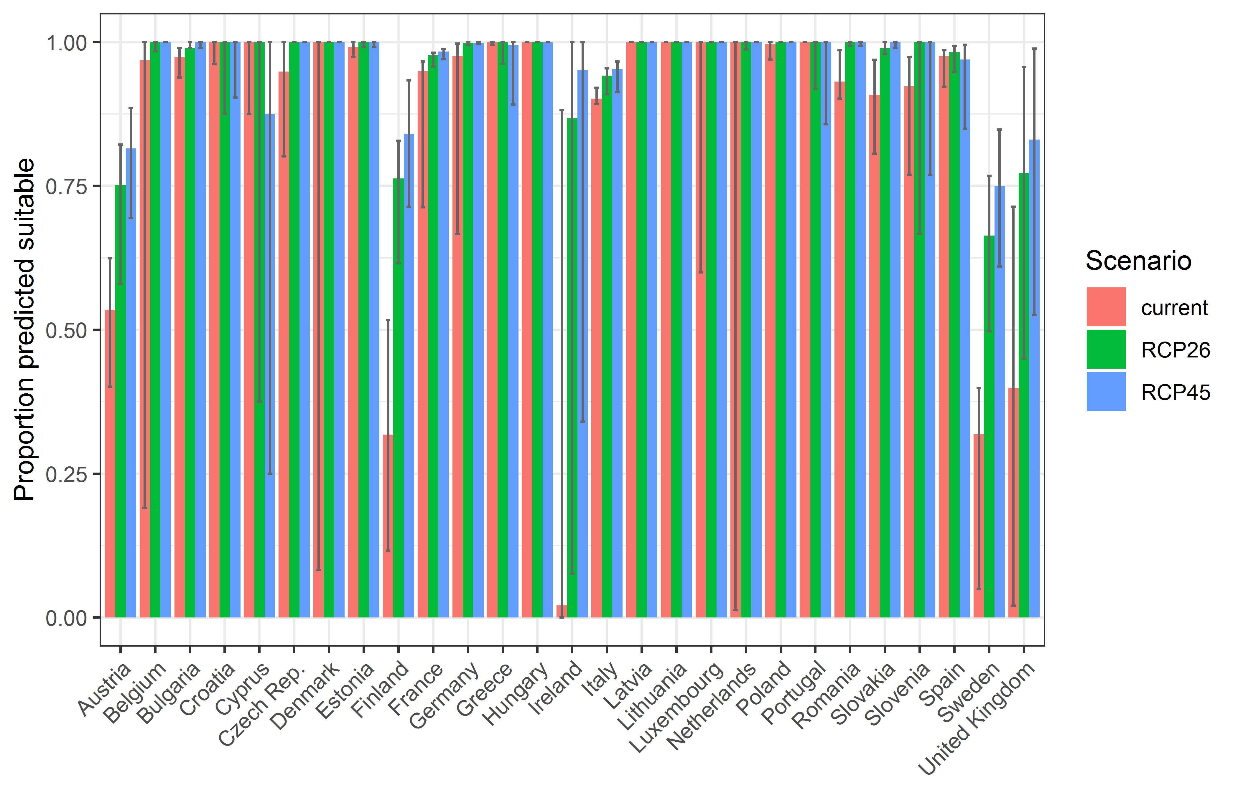

Table 3. Variation in projected suitability for Cipangopaludina chinensis establishment among European Union countries and the UK (numerical values of Figure 10 above). The numbers are the proportion of grid cells in each country classified as suitable in the current climate and projected climate for the 2070s under two RCP emissions scenarios.
 | current climate |  |  | 2070s RCP2.6 |  |  | 2070s RCP4.5
 | lower | central estimate | upper | lower | central estimate | upper | lower | central estimate | upper
Austria | 0.40 | 0.54 | 0.62 | 0.58 | 0.75 | 0.82 | 0.69 | 0.82 | 0.89
Belgium | 0.19 | 0.97 | 1.00 | 0.98 | 1.00 | 1.00 | 1.00 | 1.00 | 1.00
Bulgaria | 0.94 | 0.97 | 0.99 | 0.99 | 0.99 | 1.00 | 0.99 | 1.00 | 1.00
Croatia | 0.96 | 1.00 | 1.00 | 0.88 | 1.00 | 1.00 | 0.90 | 1.00 | 1.00
Cyprus | 0.88 | 1.00 | 1.00 | 0.38 | 1.00 | 1.00 | 0.25 | 0.88 | 1.00
Czech Rep. | 0.80 | 0.95 | 1.00 | 1.00 | 1.00 | 1.00 | 1.00 | 1.00 | 1.00
Denmark | 0.08 | 1.00 | 1.00 | 1.00 | 1.00 | 1.00 | 1.00 | 1.00 | 1.00
Estonia | 0.97 | 0.99 | 1.00 | 0.99 | 1.00 | 1.00 | 0.99 | 1.00 | 1.00
Finland | 0.12 | 0.32 | 0.52 | 0.62 | 0.76 | 0.83 | 0.71 | 0.84 | 0.93
France | 0.71 | 0.95 | 0.97 | 0.96 | 0.98 | 0.98 | 0.97 | 0.98 | 0.99
Germany | 0.67 | 0.98 | 1.00 | 0.99 | 1.00 | 1.00 | 1.00 | 1.00 | 1.00
Greece | 1.00 | 1.00 | 1.00 | 0.96 | 1.00 | 1.00 | 0.89 | 1.00 | 1.00
Hungary | 1.00 | 1.00 | 1.00 | 1.00 | 1.00 | 1.00 | 1.00 | 1.00 | 1.00
Ireland | 0.00 | 0.02 | 0.88 | 0.08 | 0.87 | 1.00 | 0.34 | 0.95 | 1.00
Italy | 0.89 | 0.90 | 0.92 | 0.91 | 0.94 | 0.95 | 0.91 | 0.95 | 0.97
Latvia | 1.00 | 1.00 | 1.00 | 1.00 | 1.00 | 1.00 | 1.00 | 1.00 | 1.00
Lithuania | 1.00 | 1.00 | 1.00 | 1.00 | 1.00 | 1.00 | 1.00 | 1.00 | 1.00
Luxembourg | 0.60 | 1.00 | 1.00 | 1.00 | 1.00 | 1.00 | 1.00 | 1.00 | 1.00
Netherlands | 0.01 | 1.00 | 1.00 | 0.99 | 1.00 | 1.00 | 1.00 | 1.00 | 1.00
Poland | 0.97 | 1.00 | 1.00 | 1.00 | 1.00 | 1.00 | 1.00 | 1.00 | 1.00
Portugal | 1.00 | 1.00 | 1.00 | 0.92 | 1.00 | 1.00 | 0.86 | 1.00 | 1.00
Romania | 0.90 | 0.93 | 0.99 | 0.99 | 1.00 | 1.00 | 0.99 | 1.00 | 1.00
Slovakia | 0.81 | 0.91 | 0.97 | 0.98 | 0.99 | 1.00 | 0.99 | 1.00 | 1.00
Slovenia | 0.77 | 0.92 | 0.97 | 0.67 | 1.00 | 1.00 | 0.77 | 1.00 | 1.00
Spain | 0.92 | 0.98 | 0.99 | 0.95 | 0.98 | 0.99 | 0.85 | 0.97 | 1.00
Sweden | 0.05 | 0.32 | 0.40 | 0.50 | 0.66 | 0.77 | 0.61 | 0.75 | 0.85
UK | 0.02 | 0.40 | 0.71 | 0.45 | 0.77 | 0.96 | 0.53 | 0.83 | 0.99

Caveats to the modelling
To remove spatial recording biases, the selection of the background sample from the accessible background was weighted by the density of Gastropoda records on the Global Biodiversity Information Facility (GBIF). While this is preferable to not accounting for recording bias at all, it may not provide the perfect measure of recording bias.
There was substantial variation among modelling algorithms in the partial response plots (Figure 3). In part this will reflect their different treatment of interactions among variables. Since partial plots are made with other variables held at their median, there may be values of a particular variable at which this does not provide a realistic combination of variables to predict from.
Other variables potentially affecting the distribution of the species, such as types of land cover were not included in the model.

References

- Allouche O, Tsoar A, Kadmon R (2006) Assessing the accuracy of species distribution models: prevalence, kappa and the true skill statistic (TSS). Journal of Applied Ecology, 43, 1223-1232.
- Chapman D, Pescott OL, Roy HE, Tanner R (2019) Improving species distribution models for invasive non-native species with biologically informed pseudo-absence selection. Journal of Biogeography, https://doi.org/10.1111/jbi.13555.
- Cohen J (1960) A coefficient of agreement of nominal scales. Educational and Psychological Measurement, 20, 37-46.
- Elith J, Kearney M, Phillips S (2010) The art of modelling range-shifting species. Methods in Ecology and Evolution, 1, 330-342.
- Fielding AH, Bell JF (1997) A review of methods for the assessment of prediction errors in conservation presence/absence models. Environmental Conservation, 24, 38-49.
- Hijmans RJ, Cameron SE, Parra JL, Jones PG, Jarvis A (2005) Very high resolution interpolated climate surfaces for global land areas. International Journal of Climatology, 25, 1965-1978.
- Iglewicz B, Hoaglin DC (1993) How to detect and handle outliers. Asq Press.
- Manel S, Williams HC, Ormerod SJ (2001) Evaluating presence-absence models in ecology: the need to account for prevalence. Journal of Applied Ecology, 38, 921-931.
- McPherson JM, Jetz W, Rogers DJ (2004) The effects of species’ range sizes on the accuracy of distribution models: ecological phenomenon or statistical artefact? Journal of Applied Ecology, 41, 811-823.
- Pearson RG, Raxworthy CJ, Nakamura M, Townsend Peterson A (2007), Predicting species distributions from small numbers of occurrence records: a test case using cryptic geckos in Madagascar. Journal of Biogeography, 34: 102-117. https://doi.org/10.1111/j.1365-2699.2006.01594.x
- Thuiller W, Lafourcade B, Engler R, Araújo MB (2009) BIOMOD-a platform for ensemble forecasting of species distributions. Ecography, 32, 369-373.
- Thuiller W, Georges D, Engler R, Breiner F (2020). biomod2: Ensemble Platform for Species Distribution Modeling. R package version 3.4.6. https://CRAN.R-project.org/package=biomod2

This template is based on the Great Britain non-native species risk assessment scheme (GBNNRA). A number of amendments have been introduced to ensure compliance with Regulation (EU) 1143/2014 on IAS and relevant legislation, including the Delegated Regulation (EU) 2018/968 of 30 April 2018, supplementing Regulation (EU) No 1143/2014 of the European Parliament and of the Council with regard to risk assessments in relation to invasive alien species (see https://eur-lex.europa.eu/legal-content/en/TXT/?uri=CELEX%3A32018R0968 ).
Convention on Biological Diversity, Decision VI/23
https://op.europa.eu/en/publication-detail/-/publication/f8627bbc-1f15-11eb-b57e-01aa75ed71a1
https://circabc.europa.eu/sd/a/0aeba7f1-c8c2-45a1-9ba3-bcb91a9f039d/TSSR-2016-010%20CBD%20pathways%20key%20full%20only.pdf
Not to be confused with “no impact”.
Note: in the CICES classification provisioning of water is considered as an abiotic service whereas the rest of ecosystem services listed here are considered biotic.

