**Risk assessment template developed under the "Study on Invasive Alien Species – Development of risk assessments to tackle priority species and enhance prevention"   
Contract No 090201/2021/856738/ETU/ENV.D2[1]**

**Name of organism: *Acacia mearnsii* De Wild.**

**Author(s) of the assessment:**

Giuseppe Brundu, Department of Agricultural Sciences, University of Sassari, Italy

Rob Tanner, European and Mediterranean Plant Protection Organization, Paris, France

Björn Beckmann, UK Centre for Ecology & Hydrology, United Kingdom

**Risk Assessment Area:** The risk assessment area is the territory of the European Union 27, excluding the EU-outermost regions.

**Peer review 1:**

Helmut Kudrnovsky, Umweltbundesamt/Environment Agency Austria, Vienna, Austria

**Peer review 2:**

Richard Shaw, CABI, Bakeham Lane, Egham, Surrey, UK

**Date of completion:** 15/10/2022

**Date of revision:** 01/12/2023

**Contents**

SECTION A – Organism Information and Screening 3

SECTION B – Detailed assessment 18

1 PROBABILITY OF INTRODUCTION AND ENTRY 18

2 PROBABILITY OF ESTABLISHMENT 29

3 PROBABILITY OF SPREAD 36

4 MAGNITUDE OF IMPACT 46

RISK SUMMARIES 58

REFERENCES 59

Distribution Summary 64

ANNEX I Scoring of Likelihoods of Events 66

ANNEX II Scoring of Magnitude of Impacts 67

ANNEX III Scoring of Confidence Levels 68

ANNEX IV CBD pathway categorisation scheme 69

ANNEX V Ecosystem services classification (CICES V5.1, simplified) and examples 70

ANNEX VI EU Biogeographic Regions and MSFD Subregions 74

ANNEX VII Delegated Regulation (EU) 2018/968 of 30 April 2018 75

ANNEX VIII Species Distribution Model 76

**SECTION A – Organism Information and Screening**

|  |
| --- |
| **A1. Identify the organism. Is it clearly a single taxonomic entity and can it be adequately distinguished from other entities of the same rank?**  including the following elements:   * the taxonomic family, order and class to which the species belongs; * the scientific name and author of the species, as well as a list of the most common synonym names; * names used in commerce (if any) * a list of the most common subspecies, lower taxa, varieties, breeds or hybrids   As a general rule, one risk assessment should be developed for a single species. However, there may be cases where it may be justified to develop one risk assessment covering more than one species (e.g. species belonging to the same genus with comparable or identical features and impact). It shall be clearly stated if the risk assessment covers more than one species, or if it excludes or only includes certain subspecies, lower taxa, hybrids, varieties or breeds (and if so, which subspecies, lower taxa, hybrids, varieties or breeds). Any such choice must be properly justified. |

Response:

*Acacia mearnsii* is a spreading shrub or mostly erect tree to 10 (–16) m high. Bark of trunk smooth, corrugated at base when old, black or grey. Branchlets angular with short ridges, non-glaucous, densely velvety-tomentose. Young foliage-tips yellow or greenish yellow, velvety-pubescent. Leaves sub-coriaceous, dark green and glossy above, concolorous or slightly paler beneath; petiole above pulvinus 0.5–2.5 cm long, shortly ridged, with an orbicular grey-tomentellose gland at base of or to 8 mm below lowest pair of pinnae (group of leaflets); rachis mostly 3–13.5 cm long, with a similar gland near base of each pair of pinnae, usually with 1 or 2 often confluent interjugary glands between some or all pairs of pinnae; pinnae 7–31 pairs, 1.5–6 cm long; pinnules (leaflets) (16–) 25–78 pairs, cultrate to narrowly oblong or slightly spathulate, 1–3.5 mm long, 0.5–0.8 mm wide, with inconspicuous midnerve, ±glabrous above, densely grey-puberulous below, broadly rounded and auriculate at base, broadly rounded, truncate or obtuse at apex. Inflorescences in axillary racemes, or terminal or axillary false panicles. Heads 20–38-flowered, pale yellow or cream-coloured. Legumes are barely constricted between seeds to ±sub-moniliform or irregularly more deeply indented, 3–15 cm long, 4.5–8 mm wide, coriaceous, black, red-brown or dark brown, slightly scabrous, grey-puberulous. 2n = 2x = 26 (diploids).

[Source: Flora of Australia, volume 11A, Mimosaceae, Acacia, Part 1, p. 238 - Commonwealth of Australia 2001, available at: https://www.awe.gov.au/science-research/abrs/publications/flora-of-australia/vol11] [Accessed 06.06.2022]

**Scientific valid name**

*Acacia mearnsii* [as ‘mearnsi’] De Wild., Pl. Bequaert. 3: 61 (1925).

**Main synonyms**

*Acacia decurrens sensu* Bak.f., Leg. Trop. Afr. 3:853 (1930) *saltem pro parte, non* Willd., *sensu stricto*. *A. decurrens* var. *mollis* Lindley, Edwards Bot. Reg. 5:t. 371 (1819). *A. mollissima sensu auct. mult.* Benth., Hook. Lond. J. Bot. 1:385 (1842). *Racospermum mearnsii* (DeWild) Pedley, Bot. J. Linn. Soc. (London) 92:249 (1986).

*Acacia decurrens* Willd. is sometimes reported as *Acacia decurrens* (J.C.Wendl.) Willd., as in the case of GBIF. However, *Flora of Australia*. Australian Biological Resources Study, Canberra. [Date Accessed: 28 April 2022] (<http://www.ausflora.org.au>) clearly states that according to J.H. Ross, *Flora of Southern Africa* 16: 108 (1975), '*A decurrens* is usually attributed to "(J.C.Wendl.) Willd." with *Mimosa decurrens* J.C.Wendl., *Botanische Beobachtungen* 57 (1798), being taken as a basionym. However, Willdenow cites only *Mimosa decurrens* Donn, *Hortus Cantabrigiensis* 1: 114 (1796) which is a *nomen nudum*. As he provided no reference to Wendland, either direct or indirect, Willdenow's binomial must be treated as a new name.'

Importantly, in *Acacia mearnsii* the chromosome numbers are for the diploids 2n = 2x = 26, and for the tetraploids 2n = 4x = 52 (WRI, 1951/1952). These tetraploids are cited in a paper from Beck et al. (2003) and the genotype tested derived from experiments done in the 1950s at the Wattle Research Institute (WRI) in South Africa, where tetraploidy was induced using colchicine and confirmed through chromosome counts. In order to meet the needs of the forestry industry, breeding and production programmes are constantly being adapted to provide suitable genotypes for particular purposes, and polyploidization has been recognized as a valuable technique in breeding strategies and is being investigated as a procedure to increase bulk for the pulp industry and to introduce sterility in the black wattle to help restrict the spread of wattle outside plantation boundaries (Beck et al., 2003). More precisely, the production of a sterile variety of black wattle can be obtained through the production of a triploid, which is produced by crossing tetraploids and diploids (Beck-Pay, 2012a). Due to the uneven chromosome number, triploids are unable to undergo successful sexual reproduction and are thus sterile (Beck-Pay, 2012b).

On the web it is sometimes found the **cultigen** *Acacia mearnsii* 'Aestivalis' also reported as *Acacia mearnsii* var. *aestivalis.* However, these two entities are not reported on Flora of Australia on-line (<https://profiles.ala.org.au/opus/foa>) nor in other major international databases (e.g., WATTLE Acacias of Australia ver. 3), and the confirmation of their effective existence would require further investigations. It cannot be excluded that breeding for tannins or for forestry/ornamental uses has led to the release of cultigens (varieties, clones or other) in some part of the introduction range.

Naturally occurring interspecific **hybrids** in Australia involving *A. mearnsii* are surprisingly uncommon. Only one, with *A. parramattensis*, has been recorded (Dr M. Tindale 1988 pers. comm., as reported by Brown & Ho, 1997). In fact, differences in flowering times between closely related bipinnate acacias can create an effective breeding barrier. On the other hand, species of subgenus/section *Botrycephalae* are particularly prone to hybridisation with each other when cultivated. Therefore, hybrids between *A. mearnsii* and *A. baileyana*, *A. dealbata*, *A. decurrens* and *A. irrorata* (Moffet 1965a, b; Moffett & Nixon 1958) have been manipulated or observed in South Africa (Brown & Ho, 1997; Rojas-Sandoval & Pasiecznik 2022). In most cases, these hybrids are intermediate between the two parental species involved. However there is no available information on the biology/ecology and invasive potential of these hybrids.

**Common names**

English: black wattle; green wattle

Spanish: mimosa, acácia negra; aromo, mimosa negra

French: acacia noir; mimosa vert; mimosa duveteux

German: Gerberakazie, grüne Akazie, schwarze Akazie, Schwarzholzakazie

Italian: mimosa di Mearns

Portuguese: acácia-negra, acácia

|  |
| --- |
| **A2. Provide information on the existence of other species that look very similar [that may be detected in the risk assessment area, either in the environment, in confinement or associated with a pathway of introduction]**  Include both native and non-native species that could be confused with the species being assessed, including the following elements:   * other alien species with similar invasive characteristics, to be avoided as substitute species (in this case preparing a risk assessment for more than one species together may be considered); * other alien species without similar invasive characteristics, potential substitute species; * native species, potential misidentification and mis-targeting |

Response:

*Acacia dealbata* is a quite popular ornamental tree planted in the EU (also recorded as escaped from cultivation) and it might be confused with *A. mearnsii*. However, the leaves of *A. dealbata* are grey-green, giving the trees a much lighter appearance than *A. mearnsii* (olive-green leaves). Furthermore, in *A. dealbata* the glands occur only at the junctions of pinnae pairs (rather than both at and between the junctions). When in flower, the two species are more easily separated as the flowers of *A. dealbata* are bright yellow (due to the color of the stamens’ filaments), while those of *A. mearnsii* are very pale yellow or cream. *Acacia dealbata*, is one of the most invasive Australian acacias in southern Europe, invades farmland, and native forest, establishing monocultures and modifying the ecosystem structure. This invasive species has become a serious environmental problem in Albania, France, Italy, Portugal and Spain. In Portugal and Northwestern Spain it is widespread (Lorenzo et al., 2010), so that it should not be ever considered as a potential substitute species.

Other similar species are *A. decurrens* Willd. (which is different to the synonym *A. decurrens sensu* Bak) and *A. parramattensis*. Both *A. mearnsii* and *A. decurrens* Willd. are important tannin-producing species, so that they can occur in the same plantations where they can outcross. The main character distinguishing *A. decurrens* Willd. from *A. mearnsii* and *A. parramattensis* is its decurrent winged ridges on the stems below the petioles. In the leaves of *A. mearnsii* the pinnules are densely hairy on the lower surface and the branchlets are velvety-pubescent, while in *A. parramattensis* pinnules are glabrous except along margins, broadly rounded or subacute apically, and branchlets are almost terete or slightly angular, with ridges, appressed-puberulous with grey, white or yellow hairs, glabrescent, non-glaucous.

Importantly, *Acacia decurrens* Willd. (also native to Australia) has been introduced to many parts of the world as an ornamental, shade and shelter, but mostly for its use in the tannin dye industry. The species has become a serious weed problem in its native Australia, as well as elsewhere, including Hawaii, Colombia, New Zealand, Indonesia and South Africa. The species spreads rapidly via seed and root suckers; produces seeds that can remain viable for up to 5 years; benefits from fires and disturbances; and develops dense thickets which outcompete native biodiversity and obstruct water flow. The species is registered as a Category 2 invader in South Africa and on a list of invasive species in Colombia (CABI 2022). On the GBIF web site, *Acacia decurrens* (J.C.Wendl.) Willd[2]. is reported as “introduced” in Spain and Portugal. These occurrences are based on DAISIE - Inventory of alien invasive species in Europe(GBIF, 2019; DAISIE, 2015) However, these occurrences need further investigations, as the DAISIE Inventory might have used different nomenclatural sources or may have interpreted differently than here reported the synonymy for *Acacia mearnsii* (with particular reference to the entities *A. decurrens auct.*, and *A. mollissima auct.*). In fact, CABI Invasive Species Compendium reports the species “*Acacia decurrens*” (without any Authority name) as “Present/Introduced” in France, Italy, and Portugal. However, the presence of *Acacia decurrens* (J.C.Wendl.) Willd. can be certainly excluded for Italy.

*Acacia mearnsii* cannot be confused with any EU native tree species.

|  |
| --- |
| **A3. Does a relevant earlier risk assessment exist? Give details of any previous risk assessment, including the final scores and its validity in relation to the risk assessment area.** |

Response:

According to the Australian/New Zealand Weed Risk Assessment adapted for Hawai‘i (available at the web site of Pacific Island Ecosystems at Risk – PIER, 2005) *Acacia mearnsii* scored 15 (High Risk). In the Australia Weed Risk Assessment (A-WRA) scheme, and in its modified versions, the total score for a plant species relates to an import policy recommendation. A score of greater than 6 means that the plant will be rejected for importation, and it is classed as “pest” (Pheloung et al., 1999). In some cases, A-WRA and in its modified versions**,** are applied also as a post-entry screening tool**. However, the results of this risk assessment cannot be considered of high relevance for the risk assessment area due to habitat and climatic differences.**

The prioritization system described by Robertson et al. (2003) was designed to assess objectively research and control priorities of invasive alien plants at a national scale in South Africa. The evaluation consists of seventeen criteria, grouped into five modules that assess: invasiveness, spatial characteristics, potential impact, potential for control, and conflicts of interest for each plant species under consideration. According to this system *Acacia mearnsii* ranks in the 9th position. **This result is of relevance for the risk assessment area as there are climatically similar areas between South Africa and the Mediterranean biogeographic region.**

Andreu and Vilà (2010) applied the Weber and Gut (2004)[3] method in Spain. Questions were answered with information gathered from scientific literature, Internet searches, floras, horticultural manuals and books. *Acacia mearnsii* scored 31 (High Risk). **This result is of high relevance for the risk assessment area being Spain part of the risk assessment area.**

Gassó et al. (2010) applied the original A-WRA, adapted to Spain by modifying the question 2.01 from ‘‘Species suited to Australian climates’’ to ‘‘Species suited to Mediterranean climates’’. This question and the 2.02 “Quality of climate match data“ were answered without performing any climatic model (this is however possible when applying the A-WRA). *Acacia mearnsii* scored 17 (Reject). **This result is of high relevance for the risk assessment area being Spain part of the risk assessment area.**

In a study from Morais et al. (2017) the A-WRA scheme was adapted to Portuguese mainland conditions (P-WRA) by modifying eight of 49 questions with new instructions for those questions included. Two questions related to climate matching were answered without performing any climatic modeling and those questions received the maximum score of 2. *Acacia mearnsii* scored 27 (Reject). **This result is of high relevance for the risk assessment area, being Portugal part of the risk assessment area.**

The study from Jansen & Kumschick (2022) makes use of environmental and socio-economic impact classification schemes for alien taxa (EICAT and SEICAT) to assess the impacts that 33 acacias introduced to South Africa have at a global scale. EICAT is an impact assessment process that classifies alien species into one of five categories, according to the magnitude of the detrimental impacts to the environment. SEICAT is a standardized method for classifying alien taxa in terms of the magnitude of their impacts on human well-being, based on the capability approach from welfare economic. According to this study the impact of *Acacia mearnsii* on biodiversity (EICAT) was ranked “major”[4], while the SEICAT score was “minor” [5]. **This result is of relevance for the risk assessment area as there are climatically similar areas between South Africa and the Mediterranean biogeographic region.**

|  |
| --- |
| **A4. Where is the organism native?**  including the following elements:   * an indication of the continent or part of a continent, climatic zone and habitat where the species is naturally occurring * if applicable, indicate whether the species could naturally spread into the risk assessment area |

Response:

*Acacia mearnsii* is native to south-eastern Australia (New South Wales, South Australia, Tasmania, Victoria) (Flora of Australia, 2022). In New South Wales it is reported to occur naturally along the coast and tablelands just north of Sydney. It is widespread in Victoria and Tasmania and in South Australia. *Acacia mearnsii* grows naturally in gullies or on hillsides, in wet sclerophyll forests, open woodlands, tussock grasslands and coastal scrub in south-eastern Australia.

In the native range, *A. mearnsii* occurs predominantly in the Köppen-Geiger climate classifications of Cfb (Temperate [oceanic climate](https://en.wikipedia.org/wiki/Oceanic_climate)), Cfa ([Humid subtropical climate](https://en.wikipedia.org/wiki/Humid_subtropical_climate)) and Csa ([Hot-summer Mediterranean climate](https://en.wikipedia.org/wiki/Mediterranean_climate#Hot-summer_mediterranean_climate)).

*Acacia mearnsii* cannot naturally spread from its native range into the risk assessment area.

|  |
| --- |
| **A5. What is the global non-native distribution of the organism outside the risk assessment area?** |

Response:

**Africa and Indian Ocean**

|  |  |  |
| --- | --- | --- |
| Algeria | Recorded, invasive | Boudiaf et al., 2013; Meddour et al., 2020; CABI, 2022 |
| Angola | Recorded, established | CABI, 2022 |
| Botswana | Recorded, established | CABI, 2022 |
| Burundi | Recorded, invasive | CABI, 2022 |
| Cabo Verde | Recorded, no information | CABI, 2022 |
| DR, Congo | Recorded, no information | CABI, 2022 |
| Eritrea | Recorded, no information | CABI, 2022; Hedberg & Edwards, 1990 |
| Eswatini | Recorded, invasive | CABI, 2022 |
| Ethiopia | Recorded, invasive | CABI, 2022; Witt et al., 2018 |
| Kenya | Recorded, invasive | CABI, 2022; Witt et al., 2018 |
| Lesotho | Recorded, established | CABI, 2022 |
| Madagascar | Recorded, no information | CABI, 2022; Du Puy et al., 2002 |
| Malawi | Recorded, no information | CABI, 2022 |
| Morocco | Recorded, no information | CABI, 2022; Sherry, 1971 |
| Mozambique | Recorded, established | CABI, 2022 |
| Namibia | Recorded, no information | CABI, 2022 |
| Réunion | Recorded, invasive | CABI, 2022; Tassin, 2002 |
| Rwanda | Recorded, invasive | CABI, 2022; Witt et al., 2018 |
| Seychelles | Recorded, invasive | CABI, 2022 |
| South Africa | Recorded, invasive | CABI, 2022; Witt et al., 2018 |
| Sudan | Recorded, no information | CABI, 2022; Darbyshire et al., 2015 |
| Tanzania | Recorded, invasive | CABI, 2022; Kingazi, 2020 |
| Uganda | Recorded, invasive | CABI, 2022; Witt et al., 2018 |
| Zambia | Recorded, no information | CABI, 2022 |
| Zimbabwe | Recorded, no information | CABI, 2022 |

**Asia**

|  |  |  |
| --- | --- | --- |
| Afghanistan | Recorded, no information | CABI, 2022 |
| Bangladesh | Recorded, no information | CABI, 2022 |
| Bhutan | Recorded, no information | CABI, 2022 |
| China | Recorded, invasive | CABI, 2022; Yongqi & Fuwen, 2006 |
| India | Recorded, invasive | CABI, 2022; Prabha et al., 2020 |
| Indonesia | Recorded, no information | CABI, 2022; Berenscholt et al., 1988 |
| Israel | Recorded, no information | ISSG, 2022 |
| Japan | Recorded, no information | CABI, 2022 |
| Malaysia | Recorded, no information | CABI, 2022 |
| Myanmar | Recorded, no information | CABI, 2022 |
| Pakistan | Recorded, no information | CABI, 2022 |
| Philippines | Recorded, no information | CABI, 2022 |
| Sri Lanka | Recorded, no information | CABI, 2022 |
| Taiwan | Recorded, no information | CABI, 2022 |
| Thailand | Recorded, no information | CABI, 2022 |
| Turkey | Recorded, no information | CABI, 2022 |
| Vietnam | Recorded, no information | CABI, 2022 |

**North and Central America** **and the Caribbean**

|  |  |  |
| --- | --- | --- |
| Jamaica | Recorded, no information | CABI, 2022 |
| United States (California, Hawaii) | Recorded, invasive | CABI, 2022; California Cal-IPC, 2022; Hawaii Invasive Species Council, 2022 |

**South America**

|  |  |  |
| --- | --- | --- |
| Bolivia | Recorded, no information | CABI, 2022 |
| Brazil | Recorded, invasive | CABI, 2022; Zenni & Ziller, 2011 |
| Chile | Recorded, planted | CABI, 2022 |
| Ecuador | Recorded, no information | CABI, 2022; Jørgensen & León-Yánes, 1990 |

**Oceania**

|  |  |  |
| --- | --- | --- |
| New Zealand | Recorded, invasive | CABI, 2022; Webb et al., 1988 |
| Papua New Guinea | Recorded, no information | CABI, 2022 |

|  |
| --- |
| **A6. In which biogeographic region(s) or marine subregion(s) in the risk assessment area has the species been recorded and where is it established? The information needs be given separately for recorded (including casual or transient occurrences) and established occurrences. “Established” means the process of an alien species successfully producing viable offspring with the likelihood of continued survival[6].**  **A6a. Recorded: List regions**  **A6b. Established: List regions**  Freshwater / terrestrial biogeographic regions:   * Alpine, Atlantic, Black Sea, Boreal, Continental, Mediterranean, Pannonian, Steppic   Marine regions:   * Baltic Sea, North-east Atlantic Ocean, Mediterranean Sea, Black Sea   Marine subregions:   * Greater North Sea, incl. the Kattegat and the English Channel, Celtic Seas, Bay of Biscay and the Iberian Coast, Western Mediterranean Sea, Adriatic Sea, Ionian Sea, Central Mediterranean Sea, Aegean-Levantine Sea.   Comment on the sources of information on which the response is based and discuss any uncertainty in the response.  For delimitation of EU biogeographical regions please refer to <https://www.eea.europa.eu/data-and-maps/figures/biogeographical-regions-in-europe-2> (see also Annex VI).  For delimitation of EU marine regions and subregions consider the Marine Strategy Framework Directive areas; please refer to <https://www.eea.europa.eu/data-and-maps/data/msfd-regions-and-subregions/technical-document/pdf> (see also Annex VI). |

Response (6a): Atlantic, Mediterranean (Brundu et al., 2019; Dessi et al., 2021)

Response (6b): Atlantic, Mediterranean (Brundu et al., 2019; Dessi et al., 2021)

|  |
| --- |
| **A7. In which biogeographic region(s) or marine subregion(s) in the risk assessment area could the species establish in the future under current climate and under foreseeable climate change? The information needs be given separately for current climate and under foreseeable climate change conditions.**  **A7a. Current climate: List regions**  **A7b. Future climate: List regions**  With regard to EU biogeographic and marine (sub)regions, see above.  With regard to climate change, provide information on   * the applied timeframe (e.g. 2050/2070) * the applied scenario (e.g. RCP 4.5) * what aspects of climate change are most likely to affect the risk assessment (e.g. increase in average winter temperature, increase in drought periods)   The assessment does not have to include a full range of simulations on the basis of different climate change scenarios, as long as an assessment with a clear explanation of the assumptions is provided. However, if new, original models are executed for this risk assessment, the following RCP pathways shall be applied: RCP 2.6 (likely range of 0.4-1.6°C global warming increase by 2065) and RCP 4.5 (likely range of 0.9-2.0°C global warming increase by 2065). Otherwise, the choice of the assessed scenario has to be explained. |

Response (7a): Atlantic, Black Sea, Continental, Mediterranean

Response (7b): Atlantic, Black Sea, Continental, Mediterranean

The applied timeframe for climate change for this risk assessment is 2070 and RCP 4.5 (see SDM (see Annex VIII).

The following aspects of climate change are likely to negatively affect establishment of the species in the risk assessment area:

* periods of drought - *A. mearnsii* utilizes a high amount of water ([Dye](https://onlinelibrary.wiley.com/doi/10.1111/j.1472-4642.2011.00816.x#b20) et al.[, 200](https://onlinelibrary.wiley.com/doi/10.1111/j.1472-4642.2011.00816.x#b20)4; Dye & Jarmain, 2004).

The following aspects of climate change are likely to positively affect establishment of the species in the risk assessment area:

* average winter temperature - *A. mearnsii* does not withstand prolonged minus temperatures and therefore an increase in winter temperature may increase the area for establishment (see SDM (see Annex VIII).

|  |
| --- |
| **A8. In which EU Member States has the species been recorded and in which EU Member States has it established? List them with an indication of the timeline of observations. The information needs be given separately for recorded and established occurrences.**  **A8a. Recorded: List Member States**  **A8b. Established: List Member States**  Austria, Belgium, Bulgaria, Croatia, Cyprus, Czech Republic, Denmark, Estonia, Finland, France, Germany, Greece, Hungary, Ireland, Italy, Latvia, Lithuania, Luxembourg, Malta, Netherlands, Poland, Portugal, Romania, Slovakia, Slovenia, Spain, Sweden  The description of the invasion history of the species shall include information on countries invaded and an indication of the timeline of the first observations, establishment and spread. |

Response (8a) and (8b): There is little information available on the invasion history of *A. mearnsii* in the EU. In Italy (Sardinia) it was introduced in the Villacidro area in the 1920s in experimental plots of provenance trials (Pavari, de Philippis 1941) and, more recently elsewhere for ornamental purposes (Vannelli 1987). In France (Corse) it was only as recent as 2017 that the species was regarded as invasive. There is no information on the date the species was first recorded as established in France. In Portugal, the species was recorded as naturalized since the early 1902 (Le Floch, 1991).

In all countries where *A. mearnsii* is recorded as established and or invasive, it is not a widespread species, especially compared to other invasive *Acacia* species (for example *A. dealbata*).

|  |  |  |
| --- | --- | --- |
| **Member State** | **Status** | **Reference** |
| **France (mainland)** | Recorded | Vieites & González-Prieto, 2020 |
| Corse (FR) | Recorded, established | Jeanmonod & Schlussel, 2001 |
| **Italy (mainland)** | Recorded | Portal of the flora of Italy, (2022) |
| Sardinia (IT) | Recorded, established | Brundu et al. 2019; Puddu et al. 2016 |
| **Portugal (mainland)** | Recorded, established | Vieites & González-Prieto, 2020 |
| Madeira (PT)* | Recorded, established | Hansen 1971; CABI, 2022 |
| **Spain (mainland)** | Recorded, established | Vieites & González-Prieto, 2020; pers comm, E. Marchante |
| Canary Islands (ES)* | Recorded, established | Verloove, 2021 |

* Outside of the RA area

|  |
| --- |
| **A9. In which EU Member States could the species establish in the future under current climate and under foreseeable climate change? The information needs be given separately for current climate and under foreseeable climate change conditions.**  **A9a. Current climate: List Member States**  **A9b. Future climate: List Member States**  With regard to EU Member States, see above.  With regard to climate change, provide information on   * the applied timeframe (e.g. 2050/2070) * the applied scenario (e.g. RCP 4.5) * what aspects of climate change are most likely to affect the risk assessment (e.g. increase in average winter temperature, increase in drought periods)   The assessment does not have to include a full range of simulations on the basis of different climate change scenarios, as long as an assessment with a clear explanation of the assumptions is provided. However, if new, original models are executed for this risk assessment, the following RCP pathways shall be applied: RCP 2.6 (likely range of 0.4-1.6°C global warming increase by 2065) and RCP 4.5 (likely range of 0.9-2.0°C global warming increase by 2065). Otherwise, the choice of the assessed scenario has to be explained. |

The applied timeframe for climate change for this risk assessment is 2070 and RCP 4.5 (see SDM (see Annex VIII).

Response (9a): Bulgaria, Croatia, Cyprus, France, Greece, Italy, Portugal, Spain

Response (9b): Belgium, Bulgaria, Croatia, Cyprus, France, Germany, Greece, Italy, Malta, The Netherlands, Portugal, Romania, Spain

The following aspects of climate change are likely to negatively affect establishment of the species in the risk assessment area:

* periods of drought - *A. mearnsii* utilizes a high amount of water ([Dye](https://onlinelibrary.wiley.com/doi/10.1111/j.1472-4642.2011.00816.x#b20) et al.[, 200](https://onlinelibrary.wiley.com/doi/10.1111/j.1472-4642.2011.00816.x#b20)4; Dye & Jarmain, 2004).

The following aspects of climate change are likely to positively affect establishment of the species in the risk assessment area:

* average winter temperature - *A. mearnsii* does not withstand prolonged minus temperatures and therefore an increase in winter temperature may increase the area for establishment (SDM,see Annex VIII).

|  |
| --- |
| **A10. Is the organism known to be invasive (i.e. to threaten or adversely impact upon biodiversity and related ecosystem services) anywhere outside the risk assessment area?** |

Response: Yes. *Acacia mearnsii* is invasive in all continents where it is introduced. For example, in Africa i.e., Algeria (Meddour et al., 2020), Burundi (CABI, 2022), Eswatini (CABI, 2022), Ethiopia (Witt et al., 2018), Kenya (Witt et al., 2018), Malawi, Namibia (CABI, 2022), Rwanda (Witt et al., 2018), Reunion (Tassin, 2002), Seychelles (CABI, 2022), South Africa (De Wit et al., 2001), Tanzania (Kingazi, 2020), Uganda (Witt et al., 2018), Zimbabwe (CABI, 2022).

In Asia, the species is considered invasive in China (Yunnan) (Liu et al., 2016) and India (Prabha et al., 2020). In addition, it is considered invasive in North America (California Cal-IPC, 2022) and Hawaii (Hawaii Invasive Species Council, 2022), in New Zealand (Webb et al., 1988), and in South America, Brazil (Zenni & Ziller, 2011).

In South Africa, *A. mearnsii* is considered one of the most invasive species in the country, where it has significant negative impacts on water resources, biodiversity, and the stability and integrity of riparian ecosystems (De Wit et al., 2001; Witt et al., 2018).

|  |
| --- |
| **A11. In which biogeographic region(s) or marine subregion(s) in the risk assessment area has the species shown signs of invasiveness? Indicate the area endangered by the organism as detailed as possible.**  Freshwater / terrestrial biogeographic regions:   * Alpine, Atlantic, Black Sea, Boreal, Continental, Mediterranean, Pannonian, Steppic   Marine regions:   * Baltic Sea, North-east Atlantic Ocean, Mediterranean Sea, Black Sea   Marine subregions:  Greater North Sea, incl. the Kattegat and the English Channel, Celtic Seas, Bay of Biscay and the Iberian Coast, Western Mediterranean Sea, Adriatic Sea, Ionian Sea, Central Mediterranean Sea, Aegean-Levantine Sea |

Response: In the risk assessment area, *A. mearnsii* has shown invasive behavior in the Atlantic (Portugal, Invasoras.pt, 2022), and Mediterranean (France, Italy: Brundu et al., 2019; Dessi et al., 2021) biogeographical regions.

|  |
| --- |
| **A12. In which EU Member States has the species shown signs of invasiveness? Indicate the area endangered by the organism as detailed as possible.**  Austria, Belgium, Bulgaria, Croatia, Cyprus, Czech Republic, Denmark, Estonia, Finland, France, Germany, Greece, Hungary, Ireland, Italy, Latvia, Lithuania, Luxembourg, Malta, Netherlands, Poland, Portugal, Romania, Slovakia, Slovenia, Spain, Sweden |

Response: In the risk assessment area, *A. mearnsii* has shown invasive behavior in Portugal (Invasoras.pt, 2022), France (Corse) and Italy (Sardinia, Brundu et al., 2019). Signs of invasiveness have also been observed in Spain (Canary Islands, DAISIE, 2015), though this is outside of the risk assessment area. Habitats in the Mediterranean region with availability of water (i.e. near rivers or areas with a high water table) constitute the endangered area.

|  |
| --- |
| **A13. Describe any known socio-economic benefits of the organism.**  including the following elements:   * Description of known uses for the species, including a list and description of known uses in the risk assessment area and third countries, if relevant. * Description of social and economic benefits deriving from those uses, including a description of the environmental, social and economic relevance of each of those uses and an indication of associated beneficiaries, quantitatively and/or qualitatively depending on what information is available.   If the information available is not sufficient to provide a description of those benefits for the entire risk assessment area, qualitative data or different case studies from across the risk assessment area or third countries shall be used, if available. |

Response: *Acacia mearnsii* is an important plantation species for tannin production and woodchip exports in South Africa and Brazil and the current total planted area of black wattle is 110 000 ha in South Africa and about 170 000 ha in Brazil. Due to the high prices fetched by the wattle wood chips in the international market, black wattle is generally considered a profitable crop (Chan et al., 2015).

*Acacia mearnsii’s* bark tannins are used in the leather industry, adhesives for wood composites, water flocculants and specialty products for the chemical, food and beverage industries. The world demand for vegetable tannins has remained unchanged over the past two decades due to intense competition from synthetic tannins (Chan et al., 2015).

Furthermore, *Acacia mearnsii* offers important economic advantages for pulp production by a higher wood density and pulp yield, which translate into higher digester productivity and factory output, and is highly suitable for hardwood bleached kraft pulping, dissolving and semi-chemical pulps. These factors make *A. mearnsii* a sought-after species and have ensured a sustained demand for wattle wood chips in the Japanese market, and today continue to attract new customers in emerging markets (China and India) (Chan et al., 2015).

None of the aforementioned uses are relevant to the risk assessment area. The only benefits currently realized for the species in the risk assessment area are from sales in the horticulture trade. However, there are no qualitative figures on the number of sales of *A. mearnsii* in the EU.

**SECTION B – Detailed assessment**

|  |
| --- |
| **Important instructions:**   * In the case of lack of information the assessors are requested to use a standardized answer: “No information has been found.” In this case, no score and confidence should be given and the standardized “score” is N/A (not applicable). * With regard to the scoring of the likelihood of events or the magnitude of impacts see Annexes I and II. * With regard to the confidence levels, see Annex III. * Highlight the selected response score and confidence level in **bold** but keep the other scores in normal text (so that the selected score is evident in the final document). |

**1 PROBABILITY OF INTRODUCTION AND ENTRY**

|  |
| --- |
| **Important instructions:**   * **Introduction** is the movement of the species into the risk assessment area (it may be either in captive conditions and/or in the environment, depending on the relevant pathways). * **Entry** is the release/escape/arrival in the environment, i.e. occurrence in the wild * Introduction and entry may coincide for species entering through pathways such as “corridor” or “unaided”, but it also may differ. If different, please consider all relevant pathways, both for the introduction into the risk assessment area and the entry in the environment. * For each described pathway, in each of the questions below, ensure that there are separate comments explicitly addressing both the “introduction” and “entry” where applicable and as appropriate. The classification of pathways developed by the Convention of Biological Diversity (CBD) should be used (see Annex IV). For detailed explanations of the CBD pathway classification scheme consult the IUCN/CEH guidance document[7] and the provided key to pathways[8]. * For organisms which are already present (recorded or established) in the risk assessment area, the likelihood of introduction and entry should be scored as “very likely” by default. * Repeated (independent) introductions and entries at separate locations in the risk assessment area should be considered here (see Qu. 1.7). |

|  |
| --- |
| **Qu. 1.1. List relevant pathways through which the organism could be introduced into the risk assessment area and/or enter into the environment. Where possible give details about the specific origins and end points of the pathways as well as a description of any associated commodities.**  For each pathway answer questions 1.2 to 1.8 (copy and paste additional rows at the end of this section as necessary). Please attribute unique identifiers to each question if you consider more than one pathway, e.g. 1.2a, 1.3a, etc. and then 1.2b, 1.3b etc. for the next pathway.  In this context a pathway is the route or mechanism of introduction and/or entry of the species.  The description of commodities with which the introduction of the species is generally associated shall include a list and description of commodities with an indication of associated risks (e.g. the volume of trade; the likelihood of a commodity being contaminated or acting as vector).  If there are no active pathways or potential future pathways this should be stated explicitly here, and there is no need to answer the questions 1.2-1.9. |

The following pathways are considered relevant for this risk assessment:

1. **Horticulture (escape from confinement)**
2. **Ornamental purposes other than horticulture**

Pathways considered but excluded from the risk assessment:

*Acacia mearnsii* has been widely cultivated as a tree species for forestry in a number of countries throughout the world including Brazil, South Africa, East Africa (Zimbabwe, Kenya, Tanzania, Rwanda, Burundi), India and Indonesia. In China and other countries, it has also been grown for vegetable tannin production (Chan et al., 2014) and it has been also frequently associated with plantations of eucalypts in mixed stands. However, in the EU, apart from historic planted experimental plots, e.g., planted for reforestation in Villacidro, Sardinia (Brundu et al., 2019), the authors of this risk assessment do not consider that the pathway ‘**forestry** **(including reforestation)**’is an active pathway or a pathway that would become active in the foreseeable future. Therefore, the pathway is not considered further in the risk assessment.

The pathway ‘**Erosion control/dune stabilization (windbreaks, hedges,...)**’ was considered for this species as a possible pathway for the risk assessment area. However, following a literature review there was no evidence found to support the inclusion of this pathway in the risk assessment. Similar to the forestry pathway, Erosion control/dune stabilization is not an active pathway or a pathway that would become active in the foreseeable future in the risk assessment area. Therefore, the pathway is not considered further in the risk assessment.

The authors considered the pathway ‘**Transport contaminant (transport of habitat material (soil, vegetation)**’. Seed of *A. mearnsii* could potentially be included in soil and other growing media (see for example 3.3b) but the movement of such material into the EU is highly regulated (IUCN, 2019). In addition, the movement of soil and habitats material from countries where the species is present is highly unlikely to occur. Based on this, the pathway is not considered further for introduction and entry.

**Pathway name: Horticulture (escape from confinement)**

|  |
| --- |
| **Qu. 1.2a. Is introduction and/or entry along this pathway intentional (e.g. the organism is imported for trade) or unintentional (e.g. the organism is a contaminant of imported goods)?** |

|  |  |  |  |
| --- | --- | --- | --- |
| **RESPONSE** | **intentional**  unintentional | **CONFIDENCE** | low  medium  **high** |

Response: *Acacia mearnsii* is reported as available via the horticulture industry in the EU (e.g. Invasoras.pt, 2022). However, the actual number of references that record horticulture as a pathway is very low.

The horticulture pathway covers large-scale/commercial cultivation of plants in a controlled or confinement environment and is the intentional introduction of the species into the risk assessment area for commercial cultivation. The Horticulture pathway focuses on plants kept in commercial culturing facilities (nurseries, greenhouses) from where they may accidentally escape due to mismanagement, or during transport to/from locations as part of the nursery trade. Therefore, this pathway includes the bulk shipment of live plants for nurseries and gardens centers, and the intentional introduction of seeds for planting.

The pathway includes the movement of plant material via e-commerce. An internet search shows that *A. mearnsii* can be ordered online at local or regional tree nurseries in several EU Member States as well as at online retailers like eBay or Amazon.

|  |
| --- |
| **Qu. 1.3a. How likely is it that large numbers of the organism will be introduced and/or enter into the environment through this pathway from the point(s) of origin over the course of one year?**  including the following elements:   * discuss how likely the organism is to get onto the pathway in the first place. Also comment on the volume of movement along this pathway. * an indication of the propagule pressure (e.g. estimated volume or number of individuals / propagules, or frequency of passage through pathway), including the likelihood of reinvasion after eradication * if relevant, comment on the likelihood of introduction and/or entry based on propagule pressure (i.e. for some species low propagule pressure (1-2 individuals) could result in subsequent establishment whereas for others high propagule pressure (many thousands of individuals) may not. |

|  |  |  |  |
| --- | --- | --- | --- |
| **RESPONSE** | very unlikely  unlikely  **moderately likely**  likely  very likely | **CONFIDENCE** | **low**  medium  high |

Response: The pathway ‘Horticulture’ is the deliberate movement of the plant into the risk assessment area for use as an ornamental species. However, it should be noted that the frequency and volume of individuals entering the risk assessment area is potentially low as much of the material introduced in nurseries and garden centers is likely to have been propagated within the risk assessment area already.

There is no direct evidence that *A. mearnsii* has escaped into the natural environment as a result of this pathway. More so, commercial horticulture practices would grow plants that would be deliberately planted in the risk assessment area. Suppliers can be found via online stores such as [Ebay](https://www.ebay.fr/itm/370991706544) and [Etsy](https://www.etsy.com/fr/listing/993872901/100-graines-dacacia-mearnsii-graines?gpla=1&gao=1&). Additionally, *A. mearnsii* is available via plant nurseries, e.g. <https://www.mimosa-cavatore.fr/de-3-a-5m/117-2010-acacia-mearnsii.html>. There is no data on the number of suppliers in the EU. It is likely that the actual number of suppliers is low as they would be specialized suppliers of trees.

It is moderately likely that the species will enter the natural environment via this pathway. Potentially, if planted in nurseries and garden centers, plant material may escape from confined areas into the natural environment (through the movement of seed). Although plants grown in nurseries and garden centers will not all be grown to maturity, some stock plants may be to produce seed for sale. Dumping of material into the natural environment may occur though unlikely with good horticulture industry practice. However, if seed is included with material that is dumped, there is a risk of propagation in the natural environment. Seed can remain viable for long periods of time and can germinate under a wide range of environmental conditions. There is no comprehensive data on the volumes of movement along this pathway apart from the data detailed in Table 1. This shows seed lots imported from Australia.

Table 1. number of individual *Acacia mearnsii* seed lot orders dispatched from the Australian Tree Seed Center at CSIRO (1980–2010) by geographical region. A seed lot represents one source population (provenance) but may contain seed from more than one tree. From Griffin et al*.*, 2011.

|  |  |  |  |  |  |  |  |  |  |
| --- | --- | --- | --- | --- | --- | --- | --- | --- | --- |
| Austral Asia | Pacific | S. America | C. America | S.E. Asia | E. Asia | S. Asia | Africa | Europe/N. America | Med/Mid. East |
| 1074 | 4 | 470 | 21 | 368 | 582 | 90 | 275 | 58 | 17 |

|  |
| --- |
| **Qu. 1.4a. How likely is the organism to survive, reproduce, or increase during transport and storage along the pathway (excluding management practices that would kill the organism)?** |

|  |  |  |  |
| --- | --- | --- | --- |
| **RESPONSE** | very unlikely  unlikely  **moderately likely**  likely  very likely | **CONFIDENCE** | **low**  medium  high |

Response: The pathway ‘Horticulture’ is the deliberate movement of plant material into the risk assessment area and as such plant material would be maintained and moved in a way to ensure survival. It is very likely that the species will survive during transport and storage.

It is very unlikely that *A. mearnsii* will reproduce or increase during transport and storage. This is a tree species that will only produce seed upon maturity.

Plant material may be maintained to produce seed for sale and therefore it is likely that the organism will be allowed to reproduce. *Acacia mearnsii* is a hermaphroditic species with male and female reproductive organs within the same flower. Therefore, only one individual is required to produce viable seed.

|  |
| --- |
| **Qu. 1.5a. How likely is the organism to survive existing management practices before and during transport and storage along the pathway?** |

|  |  |  |  |
| --- | --- | --- | --- |
| **RESPONSE** | very unlikely  unlikely  moderately likely  likely  **very likely** | **CONFIDENCE** | **low**  medium  high |

Response: As the pathway is intentional, it is very likely that the organism will survive existing management practices. Plant material is the commodity itself and it is deliberately moved for sale within the risk assessment area. Therefore, management practices before and during transport are not considered in this question. Management practices during storage at the end point (nursery and garden centre) may affect the survival of the species for example cleaning, temperature storage etc. However, the species is likely to survive.

|  |
| --- |
| **Qu. 1.6a. How likely is the organism to be introduced into the risk assessment area or entry into the environment undetected?**  Please note that “detection” here is considered as any system or event that may actively contribute to record the presence of a species in a way that appropriate management measures could be potentially undertaken by relevant authorities. |

|  |  |  |  |
| --- | --- | --- | --- |
| **RESPONSE** | very unlikely  unlikely  **moderately likely**  likely  very likely | **CONFIDENCE** | low  **medium**  high |

Response: As the pathway is intentional, it is moderately likely that the organism will be introduced into the risk assessment area undetected. The movement of the species into the risk assessment area would be for the horticultural trade.

Seed may be moved into the environment from mature trees by small mammals and ants (Richardson and Kluge, 2008). Cronk and Fuller (1995) highlight that seed can be dispersed by small mammals but there is no further information in the current literature. Additionally, seed could be moved from nurseries through strong winds or the dumping of plant material. If this occurs, the seed and developing sapling may remain undetected in the environment.

|  |
| --- |
| **Qu. 1.7a. How isolated or widespread are possible points of introduction and/or entry into the environment in the risk assessment area?** |

|  |  |  |  |
| --- | --- | --- | --- |
| **RESPONSE** | isolated  **widespread**  ubiquitous | **CONFIDENCE** | **low**  medium  high |

Response: For live plant imports in the risk assessment area (introduction), each EU Member State has official entry points where plant material can be imported into. Tree nurseries or plant retailers are common in all EU Member States; but only a selection of them may sell seeds or live plants of *A. mearnsii.* Points of introduction are not evenly distributed over the Member States area. For example, some countries (e.g. The Netherlands, Italy and Germany) are larger importers compared to other EU countries. In summary, possible points of introduction and of entry into the environment are assessed as widespread for this pathway.

|  |
| --- |
| **Qu. 1.8a. Estimate the overall likelihood of introduction into the risk assessment area and/or entry into the environment based on this pathway?** |

|  |  |  |  |
| --- | --- | --- | --- |
| **RESPONSE** | very unlikely  unlikely  **moderately likely**  likely  very likely | **CONFIDENCE** | **low**  medium  high |

Response: The pathway horticulture involves the movement of plant material for planting from outside of the risk assessment area via nurseries and garden centers. Although the entry of the species into the risk assessment area from outside is potentially low, due to most plant material being propagated from within the risk assessment area, there is the potential of *A. mearnsii* entering the environment via the pathway by seed (e.g. https://www.etsy.com/nl/listing/700834086/100-acacia-mearnsii-zaden-black-wattle).

As the species may enter the environment via seed, the overall likelihood is scored as moderately likely. However, due to the lack of evidence of this occurring in the risk assessment area, a low confidence is given.

**Pathway name: Ornamental purposes other than horticulture**

|  |
| --- |
| **Qu. 1.2b. Is introduction and/or entry along this pathway intentional (e.g. the organism is imported for trade) or unintentional (e.g. the organism is a contaminant of imported goods)?** |

|  |  |  |  |
| --- | --- | --- | --- |
| **RESPONSE** | **intentional**  unintentional | **CONFIDENCE** | low  medium  **high** |

Response: *Acacia mearnsii* is cultivated for ornamental use in European gardens and parks and this is clear from the fact that the species is available via online suppliers e.g. <https://www.rarepalmseeds.com/acacia-mearnsii>. Suppliers can be found via online stores such as [Ebay](https://www.ebay.fr/itm/370991706544) and [Etsy](https://www.etsy.com/fr/listing/993872901/100-graines-dacacia-mearnsii-graines?gpla=1&gao=1&). Additionally, *A. mearnsii* is available via plant nurseries, e.g. <https://www.mimosa-cavatore.fr/de-3-a-5m/117-2010-acacia-mearnsii.html>. The pathway ornamental purposes other than horticulture is the intentional introduction of the species into gardens.

|  |
| --- |
| **Qu. 1.3b. How likely is it that large numbers of the organism will be introduced and/or enter into the environment through this pathway from the point(s) of origin over the course of one year?**  including the following elements:   * discuss how likely the organism is to get onto the pathway in the first place. Also comment on the volume of movement along this pathway. * an indication of the propagule pressure (e.g. estimated volume or number of individuals / propagules, or frequency of passage through pathway), including the likelihood of reinvasion after eradication * if relevant, comment on the likelihood of introduction and/or entry based on propagule pressure (i.e. for some species low propagule pressure (1-2 individuals) could result in subsequent establishment whereas for others high propagule pressure (many thousands of individuals) may not. |

|  |  |  |  |
| --- | --- | --- | --- |
| **RESPONSE** | very unlikely  unlikely  moderately likely  **likely**  very likely | **CONFIDENCE** | low  **medium**  high |

Response: An online search indicates that sales of the species in garden centres and nurseries, and by online suppliers is relatively limited in the EU (see examples of suppliers below). However, the pathway is active and there could also be the potential for misidentification of plants (e.g. *A. decurrens* and *A. parramattensis*) and the common name (black wattle) is often used for a number of *Acacia* species. Suppliers can be found via online stores such as [Ebay](https://www.ebay.fr/itm/370991706544) and [Etsy](https://www.etsy.com/fr/listing/993872901/100-graines-dacacia-mearnsii-graines?gpla=1&gao=1&). Additionally, *A. mearnsii* is available via plant nurseries, e.g. <https://www.mimosa-cavatore.fr/de-3-a-5m/117-2010-acacia-mearnsii.html>.

It is likely that the species will enter the natural environment via this pathway (Brundu et al*.*, 2019). Potentially, if planted in gardens, seed may escape from confined areas into the natural environment. Plantings may occur close to suitable habitats for the species to survive and persist. Dumping of material into the natural environment may occur. The species is fast growing and pruning of branches which may contain seed pods may be needed for mature trees. If dumping occurs in habitats suitable to the survival of the species, this could lead to establishment. In theory, only one individual is required to produce viable propagules. Acacia mearnsii is a hermaphroditic species with male and female reproductive organs within the same flower. The species has been shown to have high levels of self-incompatibility (Knox, 1989). Seeds from the accumulated soil seed bank or recently released from pods may also be dispersed along with transportation of contaminated soils. Additionally, if planted close to water courses, pods are easily transported and dispersed by water.

|  |
| --- |
| **Qu. 1.4b. How likely is the organism to survive, reproduce, or increase during transport and storage along the pathway (excluding management practices that would kill the organism)?** |

|  |  |  |  |
| --- | --- | --- | --- |
| **RESPONSE** | very unlikely  unlikely  moderately likely  **likely**  very likely | **CONFIDENCE** | low  **medium**  high |

Response: As the pathway is intentional (ornamental use in garden and parks), it is likely that the organism will survive both transport and storage along the pathway. Seeds have been shown to survive storage and transport from Australia (Griffin et al*.*, 2011) and live plants are likely to be packaged to preserve the root ball to guarantee survival. It is very unlikely that *A. mearnsii* will reproduce or increase during transport and storage. This is a tree species that will only produce seed upon maturity.

|  |
| --- |
| **Qu. 1.5b. How likely is the organism to survive existing management practices before and during transport and storage along the pathway?** |

|  |  |  |  |
| --- | --- | --- | --- |
| **RESPONSE** | very unlikely  unlikely  moderately likely  **likely**  very likely | **CONFIDENCE** | **low**  medium  high |

Response: As the pathway is intentional for ornamental purposes in gardens and parks, it is likely that the organism will survive existing management practices (e.g. quarantine measures, treatment of insect pests or pathogens). Management practices before and during transport are very likely to facilitate the survival of the species as it is the commodity itself. Management practices during storage may affect the survival of the species and this could increase or decrease the length of time seed is viable. For example, temperature may affect the survival of the seed. Management practices, i.e. removal and dumping, in gardens and waste disposal may increase the survival of the species and facilitate the reproduction as the species. Other management practices (e.g. chemical control of weeds in gardens), may have an impact on the survival and reproduction of the species.

|  |
| --- |
| **Qu. 1.6b. How likely is the organism to be introduced into the risk assessment area or entry into the environment undetected?**  Please note that “detection” here is considered as any system or event that may actively contribute to record the presence of a species in a way that appropriate management measures could be potentially undertaken by relevant authorities. |

|  |  |  |  |
| --- | --- | --- | --- |
| **RESPONSE** | very unlikely  unlikely  **moderately likely**  likely  very likely | **CONFIDENCE** | low  **medium**  high |

Response: As the pathway is intended for ornamental use in gardens and parks, it is very unlikely that the organism introduction into the risk assessment area is undetected. There is a small possibility of misidentification, (see A.2) though this would only be relevant for two species and therefore not a significant issue.

However, it is moderately likely that *A. mearnsii* can enter the environment undetected as the species will be planted in parks and gardens where there is the potential for escape. The planting of *A. mearnsii* in gardens and parks may lead to the species being in close proximity to natural habitats. This can be facilitated by spread vectors such as water and soil that can spread seeds and small mammals that may consume the seed pods and seeds and spread propagules into the environment.

|  |
| --- |
| **Qu. 1.7b. How isolated or widespread are possible points of introduction and/or entry into the environment in the risk assessment area?** |

|  |  |  |  |
| --- | --- | --- | --- |
| **RESPONSE** | isolated  **widespread**  ubiquitous | **CONFIDENCE** | low  **medium**  high |

Response: For the introduction of seed imports and dried plumes via e-commerce, the entry points are widespread as anyone with an internet connection and a postal address can obtain seeds of the species from outside the risk assessment area. Therefore, introduction points are widespread within the risk assessment area.

|  |
| --- |
| **Qu. 1.8b. Estimate the overall likelihood of introduction into the risk assessment area and/or entry into the environment based on this pathway?** |

|  |  |  |  |
| --- | --- | --- | --- |
| **RESPONSE** | very unlikely  unlikely  **moderately likely**  likely  very likely | **CONFIDENCE** | **low**  medium  high |

Response: There is no information on the number of sales of *A. mearnsii* in the risk assessment area. Additionally, there is no indication that the species is a popular species in the ornamental trade. *A. mearnsii* is not a popular ornamental species for the risk assessment area. However, *A. mearnsii* would be planted in areas close to the natural environment and therefore it is moderately likely that it can enter the environment but due to the lack of evidence a low confidence is given.

|  |
| --- |
| **Qu. 1.9. Estimate the overall likelihood of introduction into the risk assessment area or entry into the environment based on all pathways and specify if different in relevant biogeographical regions in current conditions.**  Provide a thorough assessment of the risk of introduction in relevant biogeographical regions in current conditions: providing insight in to the risk of introduction into the risk assessment area. |

|  |  |  |  |
| --- | --- | --- | --- |
| **RESPONSE** | very unlikely  unlikely  moderately likely  likely  **very likely** | **CONFIDENCE** | low  **medium**  high |

Response: *Acacia mearnsii* is recorded in 4 EU Member States and it is established in 3 of them (see Qu. A.8). Historically, it is likely that *A. mearnsii* entered the risk assessment area as a forestry species (whether planted or planted for experimental purposes, see Qu. 1.1.). As discussed in Qu. 1.1, this pathway is unlikely to be an active pathway and therefore is not considered in the risk assessment. Based on the current literature, there is limited evidence to show that seed enters the EU for horticulture purposes (Table 1, Q 1.3a). However, there is no evidence that the species has entered the natural environment based on this pathway. For ornamental purposes other than horticulture, although the species is available via e-commerce, there is no direct evidence that *A. mearnsii* has entered the risk assessment area via this pathway, but it is likely. By default, as the species is already established in the risk assessment area, this question is scored very likely. A medium confidence is given as there is uncertainty for transfer to the natural environment by these pathways.

Under the current conditions, the risk of introduction into the risk assessment area and entry into the environment is considered as very likely with a high confidence. There are differences at the biogeographical region level. The species is recorded and established in the Atlantic and Mediterranean biogeographical regions. The Mediterranean region will be the region that is at most risk from the introduction of *A. mearnsii* due to suitable climatic conditions that favor the establishment of the species (Annex VIII)*.*

|  |
| --- |
| **Qu. 1.10. Estimate the overall likelihood of introduction into the risk assessment area or entry into the environment based on all pathways in foreseeable climate change conditions?**  Thorough assessment of the risk of introduction in relevant biogeographical regions in foreseeable climate change conditions: explaining how foreseeable climate change conditions will influence this risk.  With regard to climate change, provide information on   * the applied timeframe (e.g. 2050/2070) * the applied scenario (e.g. RCP 4.5) * what aspects of climate change are most likely to affect the likelihood of introduction (e.g. change in trade or user preferences)   The thorough assessment does not have to include a full range of simulations on the basis of different climate change scenarios, as long as an assessment of likely introduction within a medium timeframe scenario (e.g. 30-50 years) with a clear explanation of the assumptions is provided. However, if new, original models are executed for this risk assessment, the following RCP pathways shall be applied: RCP 2.6 (likely range of 0.4-1.6°C global warming increase by 2065) and RCP 4.5 (likely range of 0.9-2.0°C global warming increase by 2065). Otherwise, the choice of the assessed scenario has to be explained. |

|  |  |  |  |
| --- | --- | --- | --- |
| **RESPONSE** | very unlikely  unlikely  moderately likely  likely  **very likely** | **CONFIDENCE** | **low**  medium  high |

Response: The main aspects of climatic change, which will influence the entry of *A. mearnsii* into the risk assessment area, include increased minimum temperature of winter months, increased spring and summer temperatures (Annex VIII).

Climate change (RCP 4.5 2070) will expand the potential distribution the species can establish in, making the species more available to gardeners. For example, northern European countries (the Netherlands, Belgium) may become more suitable for growing the species and the horticulture pathway may expand in this area to meet further demand. Ornamental plants traded for private gardens and landscape improvements may also see a higher volume and frequency.

**2 PROBABILITY OF ESTABLISHMENT**

|  |
| --- |
| **Important instructions:**   * For organisms which are already established in parts of the risk assessment area or have previously been eradicated, the likelihood of establishment should be scored as “very likely” by default. * Discuss the risk also for those parts of the risk assessment area, where the species is not yet established. |

|  |
| --- |
| **Qu. 2.1. How likely is it that the organism will be able to establish in the risk assessment area based on similarity of climatic and abiotic conditions in its distribution elsewhere in the world?** |

|  |  |  |  |
| --- | --- | --- | --- |
| **RESPONSE** | very unlikely  unlikely  moderately likely  likely  **very likely** | **CONFIDENCE** | low  medium  **high** |

Response: *Acacia mearnsii* is already established in the natural environment in the risk assessment area: France (including Corsica), Italy (only in Sardinia), Portugal and Spain (see Qu. A8b). It is very likely that the species can establish in other countries within the RA area with similar climate and habitat conditions (see Qu. A9a).

The SDM (Annex VIII) shows the potential distribution of the species based on the current occurrences of the species both in the risk assessment area and elsewhere in the world. The authors consider the model might over-represent the potential for establishment in the risk assessment area. This is likely to be due to due to habitat preference rather than temperature limitation. The authors consider that much of the projected distribution in the Continental biogeographical region is unlikely. The area of establishment under current conditions will be highest in the Mediterranean and Atlantic biogeographical regions.

In the native and introduced ranges (outside of the EU), *A. mearnsii* occurs predominantly in the Köppen-Geiger climate classifications of Cfb (Temperateoceanic climate), Cfa (Humid subtropical climate), Csa (Hot-summer Mediterranean climate) and BSh (Hot semi-arid climates). MacLeod and Korycinska (2019) estimate that the percentage of 5-minute grid cells for each aforementioned climate category occurring in Europe are as follows: Cfb 48.62 %, Cfa 6.31 %, Csa 10.13 % and BSh 0.13 %.

Duke (1983) reported that *A. mearnsii* can tolerate an annual precipitation between 660–2280 mm, an annual mean temperature of 14.7–27.8 °C, and a soil pH of 5.0–7.2. All of these conditions are present in the risk assessment area.

*Acacia mearnsii* can grow on a variety of different substrates including basalt, dolerite, granite and sandstone, but is common on soils derived from metamorphic shales and slates. The soils are mainly loams, sandy loams, and deep forest podzols of moderate to low fertility. The best soils for *A. mearnsii* are moist, relatively deep, light-textured, and well-drained although it is often found on moderately heavy soils and occasionally on shallow soils. The soils are usually acidic, pH 5–6.5. It is not common on poorly-drained or very infertile sites.

Figure 2. Global map showing the distribution of the Köppen-Geiger climate classification (Cfb, Cfa and Csa) most suited to the occurrence of *Acacia mearnsii*.

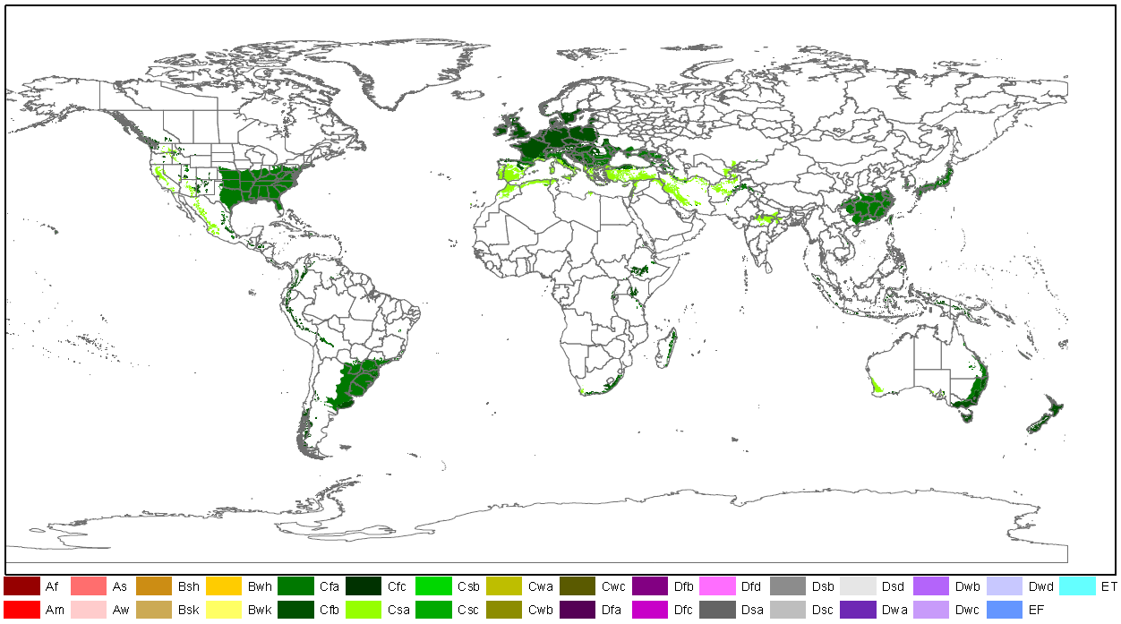

|  |
| --- |
| **Qu. 2.2. How widespread are habitats or species necessary for the survival, development and multiplication of the organism in the risk assessment area? Consider if the organism specifically requires another species to complete its life cycle.** |

|  |  |  |  |
| --- | --- | --- | --- |
| **RESPONSE** | very isolated  isolated  moderately widespread  **widespread**  ubiquitous | **CONFIDENCE** | low  medium  **high** |

Response: *Acacia mearnsii* does not require another species to complete its life cycle. In its native range, *A. mearnsii* forms part of the understorey in eucalypt woodland (Weber, 2003). The Flora of Australia (2022) details habitats in the native range to include open forests, woodland, tussock grassland. In other areas where *A. mearnsii* is invasive, it occurs along river corridors and in coastal scrub, forest and grassland. In South Africa, it invades the fynbos habitat (a belt of natural shrubland or heathland located in the Western Cape and Eastern Cape) and pine plantations (Wells, 1991, Geldenhuys, 1986). Its fast growth rate and pioneering behavior allows the species to colonize vacant spaces in natural habitats (Liu et al., 2016). This is highlighted with observations of the species growing in closed forests where there was once a gap that *A. mearnsii* colonised. It is also found on forest edges (Wells, 1991).

Witt et al. (2018) highlight that the species can invade crop plantations in Africa. In Rwanda, self-established stands are common above 1600 m altitude, with the species mainly found in the Congo Nile Crest, Non-volcanic Highlands and Central Plateau agro-ecological zones (Seburanga, 2015, 2016). It is also found in montane rainforest (Seburanga, 2015). *A. mearnsii* has invaded natural cork oak (*Quercus suber*) forests in Algeria (Boudiaf et al., 2013, 2014). Having pioneering behavior, *A. mearnsii* can easily establish in degraded ruderal habitats areas.

In the risk assessment area, *A. mearnsii* is recorded along waterways (rivers) and in ruderal or urban areas (Invasoras.pt, 2022; Brundu et al., 2019). In Sardinia, the species is reported along the banks of the River Leni where it grows in native plant communities (Brundu et al., 2019). The species is also reported to grow in wooded coastal areas (Brundu et al., 2019). In Corse, *A. mearnsii* is observed on roadsides, field margins, urban and peri-urban wastelands. It also sometimes colonises black alder communities in humid coastal depressions and on the sandy-humus substrates of vast fixed and flat back dunes (Lido de la Marana or Mucchiatana) (pers. comm. Yohan Petit 2022, Conservatoire Botanique National de Corse). Areas of the risk assessment region, most suitable for the establishment of the species would be the Mediterranean region in habitats with availability of water (i.e. near rivers or areas with a high water table) constitute the endangered area.

|  |
| --- |
| **Qu. 2.3. How likely is it that establishment will occur despite competition from existing species in the risk assessment area?** |

|  |  |  |  |
| --- | --- | --- | --- |
| **RESPONSE** | very unlikely  unlikely  moderately likely  **likely**  very likely | **CONFIDENCE** | low  **medium**  high |

Response: Competition with native vegetation is unlikely to limit the establishment of *A. mearnsii* in the risk assessment area. As a fast-growing tree species, *A. mearnsii* can outcompete native plant species. Additionally, *A. mearnsii* can alter the soil chemistry of an area as it can fix nitrogen which leads to an increase in soil nitrogen which affects nutrient cycling patterns. This will have the effect of supporting the species establishment at a cost to other plant species. The species also has allelopathic properties that can support the establishment of the species while at a cost to native plant species. Zhou et al. (2011) suggest that the allelopathic properties of *A. mearnsii* can prevent the germination of native seeds.

It is likely that *A. mearnsii* will establish despite competition from native species. Tassin et al (2009) indicate that *A. mearnsii* patches are poorly colonized by native plants species over a long time period which suggests a lack of competition.

|  |
| --- |
| **Qu. 2.4. How likely is it that establishment will occur despite predators, parasites or pathogens already present in the risk assessment area?** |

|  |  |  |  |
| --- | --- | --- | --- |
| **RESPONSE** | very unlikely  unlikely  moderately likely  likely  **very likely** | **CONFIDENCE** | low  **medium**  high |

Response: It is very likely that establishment will occur despite predators, parasites or pathogens already present in the risk assessment area. It should be noted that apart from the beetle that is detailed, there are no host specific natural enemies of *A. mearnsii* in the risk assessment area. There is recent evidence that *A. mearnsii* seeds are attacked in Corsica and Sardinia by the polyphagous beetle *Stator limbatus* (Coleoptera, Chrysomelidae) (Cocco et al., 2021). In both islands, *S. limbatus* emerged from *A. mearnsii* seeds, with infestation rates of up to 74.2 and 90.8% in 2019 and 2020, respectively. However, currently, there is no evidence to suggest *S. limbatus* has any impact on the establishment of *A. mearnsii*.

|  |
| --- |
| **Qu. 2.5. How likely is the organism to establish despite existing management practices in the risk assessment area? Explain if existing management practices could facilitate establishment.** |

|  |  |  |  |
| --- | --- | --- | --- |
| **RESPONSE** | very unlikely  unlikely  moderately likely  **likely**  very likely | **CONFIDENCE** | low  **medium**  high |

Response: The establishment of *A. mearnsii* is suited to a number of different habitat types, including disturbed habitats. Management of urban and semi-urban habitats is likely to increase disturbance of the habitat, which can act to promote the germination of seeds in the seed bank. Road management activities have been shown to favor the reproduction of *Acacia* species in Australia (though not demonstrated for *A. mearnsii*) (Spooner, 2004). It is therefore likely that the current urbanization trend occurring in Europe may favor the establishment of the species. In addition, *A. mearnsii* can resprout after cutting (both stumps and roots) and seeds are stimulated by disturbance such as management of the species or other invasive plants or fire.

|  |
| --- |
| **Qu. 2.6. How likely is it that biological properties of the organism would allow it to survive eradication campaigns in the risk assessment area?** |

|  |  |  |  |
| --- | --- | --- | --- |
| **RESPONSE** | very unlikely  unlikely  moderately likely  likely  **very likely** | **CONFIDENCE** | **low**  medium  high |

Response: The main factors limiting the likelihood of success of any attempted eradication of the species are the large amount of seeds produces and the long-lived seed bank (50–100 years) (CABI, 2022). It should be noted that the longevity of the seed bank is reported from the plants native range. The density of the seed bank has been shown to be up to 38 000 seeds per m2 in South Africa (Gibson et al., 2011). Such a dense seed bank can hinder eradication campaigns as there is the potential for propagules to remain hidden in the soil. Therefore, unless eradication campaigns are thorough and remove all reproductive material, it is very likely that the species can survive eradication attempts carried out without adequate follow-ups. A low confidence is given as there is no published information for the risk assessment area on eradication campaigns. Riveiro et al. (2020) show that fire can reduce the viability of seed, though can also stimulate germination and break dormancy, as in the case of other *Acacia* species. No information was found in the literature on the presence of lignotubers in the native and invasive range.

|  |
| --- |
| **Qu. 2.7. How likely are the biological characteristics of the organism to facilitate its establishment in the risk assessment area?**  including the following elements:   * a list and description of the reproduction mechanisms of the species in relation to the environmental conditions in the risk assessment area * an indication of the propagule pressure of the species (e.g. number of gametes, seeds, eggs or propagules, number of reproductive cycles per year) of each of those reproduction mechanisms in relation to the environmental conditions in the risk assessment area. * If relevant, comment on the likelihood of establishment based on propagule pressure (i.e. for some species low propagule pressure (1-2 individuals) could result in establishment whereas for others high propagule pressure (many thousands of individuals) may not. * If relevant, comment on the adaptability of the organism to facilitate its establishment and if low genetic diversity in the founder population would have an influence on establishment. |

|  |  |  |  |
| --- | --- | --- | --- |
| **RESPONSE** | very unlikely  unlikely  moderately likely  **likely**  very likely | **CONFIDENCE** | low  **medium**  high |

Response: In the risk assessment area, sexual reproduction is the only reproductive mechanism recorded. In the current literature it is noted that *A. mearnsii* can resprout from the basal roots and stumps, though this is often after fire (natural or used as a management tool) or after management (CABI, 2022). The species is fast growing and seeds can be dispersed from the parent plant. Mature seed is available some 12-14 months after flowering. It is not retained on the tree for longer than two to three weeks, making timing of seed collection critical (Searle, 1997). Large quantities of seed are produced and these may accumulate to high densities. The density of the seed bank has been shown to be up to 38 000 seeds per m2 in South Africa (Gibson et al., 2011). Seeds are also very long-lived, as is common with hard-coated legume seeds, and it may be assumed that seeds could remain viable for 50–100 years (CABI, 2022). Seeds from mature pods of *A. mearnsii* collected from six locations in the Mediterranean region, three from France, two from Italy and one from Portugal were shown to have high levels of germination >95 % at a range of temperatures (Dessì et al., 2021). Scarification was also shown to be important to break dormancy and promote germination. The study confirms that *A. mearnsii* has a physical dormancy, a trait that promotes the establishment of a persistent soil seed bank (Dessì et al., 2021). Hard seeds are highly dependent on scarification for germination, an adaptation that allows the seeds to delay germination until conditions are more suitable, promoting the survival of seedlings in nature (Dessì et al., 2021).

|  |
| --- |
| **Qu. 2.8. If the organism does not establish, then how likely is it that casual populations will continue to occur?**  Consider, for example, a species which cannot reproduce in the risk assessment area, because of unsuitable climatic conditions or host plants, but is present because of recurring introduction, entry and release events. This may also apply for long-living organisms. |

|  |  |  |  |
| --- | --- | --- | --- |
| **RESPONSE** | very unlikely  unlikely  moderately likely  **likely**  very likely | **CONFIDENCE** | **low**  medium  high |

Response: In areas where *A. mearnsii* is not present, casual populations may occur in urban habitats or semi-urban habitats. Casual populations may occur in surrounding habitats. Casual populations are likely to occur in areas outside the optimum climatic conditions at the margin of suitable and unsuitable areas (see Annex VIII). Countries where casual populations may occur include those in central and eastern Europe (Annex VIII).

|  |
| --- |
| **Qu. 2.9. Estimate the overall likelihood of establishment in the risk assessment area under current climatic conditions. In addition, details of the likelihood of establishment in relevant biogeographical regions under current climatic conditions should be provided.**  Thorough assessment of the risk of establishment in relevant biogeographical regions in current conditions: providing insight in the risk of establishment in (new areas in) the risk assessment area. |

|  |  |  |  |
| --- | --- | --- | --- |
| **RESPONSE** | very unlikely  unlikely  moderately likely  likely  **very likely** | **CONFIDENCE** | low  medium  **high** |

Response: The overall likelihood of *A. mearnsii* establishing in the risk assessment area is very likely with high confidence. The species is already established in the Mediterranean and Atlantic biogeographical regions. Member States where the species is established include France, Italy, Portugal and Spain. The Mediterranean and Atlantic biogeographical regions have a high proportion of area suitable for the establishment of the species and thus further establishment is likely in these areas under the current climatic conditions.

|  |
| --- |
| **Qu. 2.10. Estimate the overall likelihood of establishment in the risk assessment area under foreseeable climate change conditions. In addition, details of the likelihood of establishment in relevant biogeographical regions under foreseeable climate change conditions should be provided.**  Thorough assessment of the risk of establishment in relevant biogeographical regions in foreseeable climate change conditions: explaining how foreseeable climate change conditions will influence this risk.  With regard to climate change, provide information on   * the applied timeframe (e.g. 2050/2070) * the applied scenario (e.g. RCP 4.5) * what aspects of climate change are most likely to affect the likelihood of establishment (e.g. increase in average winter temperature, increase in drought periods)   The thorough assessment does not have to include a full range of simulations on the basis of different climate change scenarios, as long as an assessment of likely establishment within a medium timeframe scenario (e.g. 30-50 years) with a clear explanation of the assumptions is provided. However, if new, original models are executed for this risk assessment, the following RCP pathways shall be applied: RCP 2.6 (likely range of 0.4-1.6°C global warming increase by 2065) and RCP 4.5 (likely range of 0.9-2.0°C global warming increase by 2065). Otherwise, the choice of the assessed scenario has to be explained. |

|  |  |  |  |
| --- | --- | --- | --- |
| **RESPONSE** | very unlikely  unlikely  moderately likely  likely  **very likely** | **CONFIDENCE** | low  **medium**  high |

Response: The overall likelihood of establishing in the risk assessment area under future climatic conditions (2070 RCP. 2.6) is very likely with medium confidence. This score is based on the species modelling presented in annex VIII. The species is already established in the Mediterranean and Atlantic biogeographical regions. The Continental and Atlantic biogeographical regions will potentially see a slight increase in establishment potential with future climate change whereas the Mediterranean region may show a decrease with droughts and temperature.

**3 PROBABILITY OF SPREAD**

|  |
| --- |
| **Important instructions:**   * Spread is defined as the expansion of the geographical distribution of an alien species within the risk assessment area. * Repeated releases at separate locations do not represent continuous spread and should be considered in the probability of introduction and entry section (Qu. 1.7). |

|  |
| --- |
| **Qu. 3.1. How important is the expected spread of this organism within the risk assessment area by natural means? (List and comment on each of the mechanisms for natural spread.)**  including the following elements:   * a list and description of the natural spread mechanisms of the species in relation to the environmental conditions in the risk assessment area. * an indication of the rate of spread discussed in relation to the species biology and the environmental conditions in the risk assessment area.   The description of spread patterns here refers to the CBD pathway category “Unaided (Natural Spread)”. It should include elements of the species life history and behavioural traits able to explain its ability to spread, including: reproduction or growth strategy, dispersal capacity, longevity, dietary requirements, environmental and climatic requirements, specialist or generalist characteristics. |

|  |  |  |  |
| --- | --- | --- | --- |
| **RESPONSE** | minimal  minor  moderate  **major**  massive | **CONFIDENCE** | low  **medium**  high |

Response: *Acacia mearnsii* reproduces by seed which is produced in high quantity and can remain viable in the soil for very long periods of time (50–100 years). Note: there are no qualitative figures on the rate of spread of *A. mearnsii* anywhere in the introduced or native range.

Natural spread is generally limited to the spread of pods or seeds by water or spread by small wild mammals, ants or livestock. There is no information on the role of natural spread by ants and mammals for the species in the risk assessment area. Although high rates of spread have been detailed in other regions of the world (e.g. South Africa), and which are in part attributed to natural spread this will not necessarily be the same in the risk assessment area. CABI (2022) details the discrepancies in the literature relating to natural spread. It is highlighted that Weber (2003) details that water, birds and mammals (but does not specify the species) may disperse seed but Cronk and Fuller (1995) cite mammals (but does not specify the species) and Dean et al. (1986) list only water. Even though mammals may spread the seed in some regions, it does not mean that mammal species in the risk assessment area will consume and spread seeds.

CABI (2022) highlights that *A. mearnsii* can spread easily down rivers via waterbodies. In the risk assessment area, there is some information highlighting natural spread along waterbodies (Brundu et al., 2019). In the site of first introduction in Sardinia (Italy), *A. mearnsii* has naturalized extensively, particularly along the banks of the river Leni and has become invasive. Its spread along the river Leni extends for about 10 km, including both the downstream stretch of the dam for about 2 km, and upstream for about 7 km. These figures however do not have a time period detailed.

In Portugal, *A. mearnsii* spreads easily by seed (pers. comm. E Marchante, 2023).

|  |
| --- |
| **Qu. 3.2a. List and describe relevant pathways of spread other than "unaided". For each pathway answer questions 3.3 to 3.9 (copy and paste additional rows at the end of this section as necessary). Please attribute unique identifiers to each question if you consider more than one pathway, e.g. 3.3a, 3.4a, etc. and then 3.3b, 3.4b etc. for the next pathway.**  including the following elements:   * a list and description of pathways of spread with an indication of their importance and associated risks (e.g. the likelihood of spread in the risk assessment area, based on these pathways; likelihood of survival, or reproduction, or increase during transport and storage; ability and likelihood of transfer from the pathway to a suitable habitat or host) in relation to the environmental conditions in the risk assessment area. * an indication of the rate of spread for each pathway discussed in relation to the species biology and the environmental conditions in the risk assessment area. * All relevant pathways of spread (except “Unaided (Natural Spread)”, which is assessed in Qu. 3.1) should be considered. The classification of pathways developed by the Convention of Biological Diversity shall be used (see Annex IV). |

**Spread pathways are detailed in order of importance:**

**Ornamental purposes other than horticulture (escape from confinement)**

This spread pathway is the intentional spread of the species to private gardens and urban and semi-urban plants. This pathway would be the most relevant for spread and includes the highest movement of plant propagules. There is evidence that the species is available via online suppliers for purchase of live plants and online suppliers sell seed for planting. There is no data on the rate of spread associated with this pathway. However, it is likely that the species can be moved over long distances via this human mediated pathway (50-100 km and more). There is no data to substantiate the distance given.

**Transport – Contaminant (transport of habitat material (soil, vegetation))**

This spread pathway deals with the potential spread of contaminated habitat material. There is no quantitative evidence/ interceptions to support the movement of the species along this spread pathway. However, the pathway is highlighted as a potential pathway in the literature, e.g. De Wit et al. (2001) detail that the species can spread via seed through the movement of soil. There is no evidence that the species has moved along this spread pathway in the EU. There is no data on the rate of spread associated with this pathway. However, it is very likely that the species can be moved over long distances via this human mediated pathway (50-100 km and more). There is no data to substantiate the distance given.

**Spread pathway: Ornamental purposes other than horticulture (escape from confinement)**

|  |
| --- |
| **Qu. 3.3a. Is spread along this pathway intentional (e.g. the organism is deliberately transported from one place to another) or unintentional (e.g. the organism is a contaminant of translocated goods within the risk assessment area)?** |

|  |  |  |  |
| --- | --- | --- | --- |
| **RESPONSE** | **intentional**  unintentional | **CONFIDENCE** | low  medium  **high** |

Response: This spread pathway is intentional. *Acacia mearnsii* is sold within the risk assessment area as an ornamental species and planted in gardens and parks.

|  |
| --- |
| **Qu. 3.4a. How likely is it that a number of individuals sufficient to originate a viable population will spread along this pathway from the point(s) of origin over the course of one year?**  including the following elements:   * an indication of the propagule pressure (e.g. estimated volume or number of specimens, or frequency of passage through pathway), including the likelihood of reinvasion after eradication * if appropriate, indicate the rate of spread along this pathway * if appropriate, include an explanation of the relevance of the number of individuals for spread with regard to the biology of species (e.g. some species may not necessarily rely on large numbers of individuals). |

|  |  |  |  |
| --- | --- | --- | --- |
| **RESPONSE** | very unlikely  unlikely  **moderately likely**  likely  very likely | **CONFIDENCE** | low  **medium**  high |

Response: There is no quantitative information on the number of sales of the species in the risk assessment area or the numbers of sites where the species has been planted. Sales of the species within the risk assessment area will be both whole plants and seeds. Plants can be purchased from garden centers within the risk assessment area and moved to gardens where they are planted. However, *A. mearnsii* is not a popular ornamental species. The species may also be dumped from waste garden material (pruning of branches with seed pods) into the natural environment, though again, there are no details and the volume of movement or frequency. Given the numerous, long lived and highly viable seed bank and only one seed is enough to start a new population a medium confidence is given.

|  |
| --- |
| **Qu. 3.5a. How likely is the organism to survive, reproduce, or increase during transport and storage along the pathway (excluding management practices that would kill the organism)?** |

|  |  |  |  |
| --- | --- | --- | --- |
| **RESPONSE** | very unlikely  unlikely  moderately likely  likely  **very likely** | **CONFIDENCE** | low  **medium**  high |

Response: It is very likely that *A. mearnsii* plant material will survive during transport and storage along this pathway. A high seed viability would be an important factor for the suppliers to sell and continue to sell their stock. Once planted in a garden, the species would be planted and cared for so that the species grows and thrives. When dried, the seeds of *A. mearsnii* can remain viable for a number of years (more than 50) (Cabi, 2022) and therefore this will increase the chance of survival during transport. Live plants will be moved along the pathway and packaged to promote their survival. It is unlikely the plants will reproduce or increase during their transport along this pathway.

|  |
| --- |
| **Qu. 3.6a. How likely is the organism to survive existing management practices during spread?** |

|  |  |  |  |
| --- | --- | --- | --- |
| **RESPONSE** | very unlikely  unlikely  moderately likely  **likely**  very likely | **CONFIDENCE** | low  **medium**  high |

Response: *Acacia mearnsii* is likely to survive existing management practices during spread. Management of urban and semi-urban habitats is likely to increase disturbance of the habitat, which can act to bury the long-lived seeds. If plant material is dumped with viable seeds attached, the species is likely to be deposited in ruderal habitats and potentially on waste ground where management practices may be minimal and the native vegetation sparse, this may make the survival of the species in these areas more likely. In addition, *A. mearnsii* can resprout after cut (both stumps and roots) and seeds are stimulated by disturbance such as management of the species or other invasive species or fire.

|  |
| --- |
| **Qu. 3.7a. How likely is the organism to spread in the risk assessment area undetected?**  Please note that “detection” here is considered as any system or event that may actively contribute to record the presence of a species in a way that appropriate management measures could be potentially undertaken by relevant authorities. |

|  |  |  |  |
| --- | --- | --- | --- |
| **RESPONSE** | very unlikely  unlikely  **moderately likely**  likely  very likely | **CONFIDENCE** | low  **medium**  high |

Response: If plant material is dumped with viable seeds attached, the species is likely to be deposited in ruderal habitats and potentially on waste ground where management practices may be minimal and the native vegetation sparse, this may make the survival of the species in these areas more likely. Therefore, the initial stage of spread may occur. However, the species is unlikely to establish grow to maturity and spread as the species is a tree species which is easily visible. However, it is very easily confused with *A. dealbata* that is also present in the risk assessment area where *A. mearnsii* is established and as such may be remain undetected/misidentified for some time.

|  |
| --- |
| **Qu. 3.8a. How likely is the organism to be able to transfer from the pathway to a suitable habitat or host during spread?** |

|  |  |  |  |
| --- | --- | --- | --- |
| **RESPONSE** | very unlikely  unlikely  moderately likely  likely  **very likely** | **CONFIDENCE** | low  **medium**  high |

Response: The species has been shown to spread to ruderal habitats and natural habitats (Brundu et al., 2019). The presence of the species in urban and semi-urban habitats in the risk assessment area, including waste/abandoned lands highlights that the species spread (Invasoras.pt, 2022).

|  |
| --- |
| **Qu. 3.9a. Estimate the overall potential rate of spread based on this pathway in relation to the environmental conditions in the risk assessment area. (please provide quantitative data where possible).** |

|  |  |  |  |
| --- | --- | --- | --- |
| **RESPONSE** | very slowly  slowly  **moderately**  rapidly  very rapidly | **CONFIDENCE** | low  **medium**  high |

Response: *Acacia mearnsii* is utilized as a garden ornamental species which is sold in the risk assessment area (Invasoras.pt, 2022). It has also been planted in urban and semi-urban habitats (Invasoras.pt, 2022). The overall potential rate of spread of *A. mearnsii* into the natural environment from planted individuals in urban and semi-urban environments is moderately with a medium confidence. Although planted individuals would need to mature and spread via seed (which would be scored as slowly), there is the potential for dumping of the species as garden waste which could act to spread the species faster.

**Spread pathway: Transport- Contaminant (transport of habitat material (soil, vegetation))**

|  |
| --- |
| **Qu. 3.3b. Is spread along this pathway intentional (e.g. the organism is deliberately transported from one place to another) or unintentional (e.g. the organism is a contaminant of translocated goods within the risk assessment area)?** |

|  |  |  |  |
| --- | --- | --- | --- |
| **RESPONSE** | intentional  **unintentional** | **CONFIDENCE** | low  medium  **high** |

Response: The spread of *A. mearnsii* via transport of habitat material (soil, sand, vegetation) is the unintentional spread of the species within the risk assessment area. Seed material, and pods containing seeds could be spread as a contaminant of material via this pathway.

|  |
| --- |
| **Qu. 3.4b. How likely is it that a number of individuals sufficient to originate a viable population will spread along this pathway from the point(s) of origin over the course of one year?**  including the following elements:   * an indication of the propagule pressure (e.g. estimated volume or number of specimens, or frequency of passage through pathway), including the likelihood of reinvasion after eradication * if appropriate, indicate the rate of spread along this pathway * if appropriate, include an explanation of the relevance of the number of individuals for spread with regard to the biology of species (e.g. some species may not necessarily rely on large numbers of individuals). |

|  |  |  |  |
| --- | --- | --- | --- |
| **RESPONSE** | very unlikely  unlikely  **moderately likely**  likely  very likely | **CONFIDENCE** | low  **medium**  high |

Response: There is no information available on the volumes of movement along this pathway. The seedbank of *Acacia mearnsii* can be highly dense with up to 38 000 seeds m2 (Gibson et al., 2011). Seed can also persist for a long period of time as they are hard coated and only one seed is enough to start a viable population (CABI, 2022).

|  |
| --- |
| **Qu. 3.5b. How likely is the organism to survive, reproduce, or increase during transport and storage along the pathway (excluding management practices that would kill the organism)?** |

|  |  |  |  |
| --- | --- | --- | --- |
| **RESPONSE** | very unlikely  unlikely  moderately likely  **likely**  very likely | **CONFIDENCE** | low  **medium**  high |

Response: There is no quantitative evidence for the survival, reproduction or increase of *A. mearnsii* as a contaminant of habitat material. Seeds are small and could survive during transport along this spread pathway. Habitat material would be suitable for the survival of the species over short- to medium time periods (days or weeks) and seed can survive for many years.

|  |
| --- |
| **Qu. 3.6b. How likely is the organism to survive existing management practices during spread?** |

|  |  |  |  |
| --- | --- | --- | --- |
| **RESPONSE** | very unlikely  unlikely  **moderately likely**  likely  very likely | **CONFIDENCE** | low  **medium**  high |

Response: Management practices applied to the movement of soil can constitute visual inspection and potentially heat treatment of the material to kill any contamination. Careful management practices coupled with inspections would be needed to ensure that the species does not spread with contaminated soil and vegetation. This is often not feasible with small seeds, especially if there are large quantities of habitat material.

|  |
| --- |
| **Qu. 3.7b. How likely is the organism to spread in the risk assessment area undetected?**  Please note that “detection” here is considered as any system or event that may actively contribute to record the presence of a species in a way that appropriate management measures could be potentially undertaken by relevant authorities. |

|  |  |  |  |
| --- | --- | --- | --- |
| **RESPONSE** | very unlikely  unlikely  **moderately likely**  likely  very likely | **CONFIDENCE** | low  **medium**  high |

Response: Soil and other habitat material can be moved freely throughout the risk assessment area and *A. mearnsii* can be spread within such material. Seeds may be buried in soil and other material, making them difficult to detect. Therefore, it is moderately likely that *A. mearnsii* can spread within the risk assessment area undetected.

|  |
| --- |
| **Qu. 3.8b. How likely is the organism to be able to transfer from the pathway to a suitable habitat or host during spread?** |

|  |  |  |  |
| --- | --- | --- | --- |
| **RESPONSE** | very unlikely  unlikely  moderately likely  **likely**  very likely | **CONFIDENCE** | low  **medium**  high |

Response: It would be likely that *A. mearnsii* can transfer to a suitable habitat if seed is present as a contaminant of soil or habitat material. Soil and habitat material can be physically transferred and deposited in habitats that would be suitable for the establishment of *A. mearnsii*. This fact that the species is recorded in ruderal habitats in Portugal (Invasoras.pt, 2022) further supports the hypothesis that the species can be moved by soil and habitat material.

|  |
| --- |
| **Qu. 3.9b. Estimate the overall potential rate of spread based on this pathway in relation to the environmental conditions in the risk assessment area. (please provide quantitative data where possible).** |

|  |  |  |  |
| --- | --- | --- | --- |
| **RESPONSE** | very slowly  slowly  **moderately**  rapidly  very rapidly | **CONFIDENCE** | low  **medium**  high |

Response: There is no quantitative data on the spread of the species in relation to habitat material. Habitat material can be moved freely within the single market in the EU enabling contaminated material to spread over long distances. Seed may be included in soil and habitat material as a contaminant. Because of the lack of data, confidence is medium.

|  |
| --- |
| **Qu. 3.10. Within the risk assessment area, how difficult would it be to contain the organism in relation to these pathways of spread?** |

|  |  |  |  |
| --- | --- | --- | --- |
| **RESPONSE** | very easy  easy  with some difficulty  **difficult**  very difficult | **CONFIDENCE** | low  **medium**  high |

Response: Natural spread would be difficult to control within the risk assessment area especially in riparian habitats. This is because seed can become incorporated into water bodies and moved down stream. For example, in Sardinia (Italy) about 10 km of river have been invaded by *A. mearnsii* in the lower part of the river. The invasions started from a few planted individuals (in the beginning of the XX century) and from there the species naturally colonised the river (competing with native *Alnus glutinosa* riparian forest) moving downstream (Brundu 2022, personal observation). This natural spread is currently ongoing. Additionally, if spread does occur via small mammals and/or ants this would make containment difficult as spread can occur in all directions and seed can be deposited beneath other vegetation, thereby making it difficult to detect. Preventing the natural spread from already established populations, including those in private gardens, will be difficult as access to land may be restricted and riparian forest might be difficult to survey.

As the species may be spread as a contaminant of soil and habitat material, biosecurity measures and inspections would need to be adopted where these spread pathways are active, and the species is present. This would involve multiple stakeholders and communication and awareness raising to reduce the spread via this pathway. A ban on sale could act to prevent further spread of the species within the risk assessment area as this would limit the amount of propagules within the risk assessment area.

|  |
| --- |
| **Qu. 3.11. Estimate the overall potential rate of spread in relevant biogeographical regions under current conditions for this organism in the risk assessment area (indicate any key issues and provide quantitative data where possible).**  Thorough assessment of the risk of spread in relevant biogeographical regions in current conditions, providing insight in the risk of spread into (new areas in) the risk assessment area. |

|  |  |  |  |
| --- | --- | --- | --- |
| **RESPONSE** | very slowly  slowly  moderately  **rapidly**  very rapidly | **CONFIDENCE** | low  **medium**  high |

Response: In the risk assessment area, *A. mearnsii* reproduces and spreads via seed. Therefore, spread by natural means can be assessed as major. Human mediated spread includes escapes from confinement and unintentional movement of the species through contamination of habitat material. For human mediated spread, the rate of spread can be estimated as moderately. Combining all scores, a rapid response if given for the overall potential of spread in relevant biogeographical regions. Spread would be highest in biogeographical regions where the species is already present, such as Atlantic, Continental and Mediterranean biogeographical regions.

|  |
| --- |
| **Qu. 3.12. Estimate the overall potential rate of spread in relevant biogeographical regions in foreseeable climate change conditions (provide quantitative data where possible).**  Thorough assessment of the risk of spread in relevant biogeographical regions in foreseeable climate change conditions: explaining how foreseeable climate change conditions will influence this risk, specifically if rates of spread are likely slowed down or accelerated. |

|  |  |  |  |
| --- | --- | --- | --- |
| **RESPONSE** | very slowly  slowly  **moderately**  rapidly  very rapidly | **CONFIDENCE** | **low**  medium  high |

Response: The overall potential rate of spread in the risk assessment area under future climatic conditions (2070 RCP. 2.6, see SDM Annex VIII) is moderately with a low confidence. The predicted rate of spread would be maintained in the areas where the species is already established: Mediterranean, Continental and Atlantic biogeographical regions. The Continental and Atlantic biogeographical regions would potentially see a slight increase in establishment potential with future climate change and this may affect spread as there would be increased propagule pressure, whereas the Mediterranean region shows a slight decrease. The Pannonian region shows a steep increase in suitability.

**4 MAGNITUDE OF IMPACT**

|  |
| --- |
| Important instructions:   * Questions 4.1-4.5 relate to biodiversity and ecosystem impacts, 4.6-4.8 to impacts on ecosystem services, 4.9-4.13 to economic impact, 4.14-4.15 to social and human health impact, and 4.16-4.18 to other impacts. These impacts can be interlinked, for example, a disease may cause impacts on biodiversity and/or ecosystem functioning that leads to impacts on ecosystem services and finally economic impacts. In such cases the assessor should try to note the different impacts where most appropriate, cross-referencing between questions when needed. * Each set of questions starts with the impact elsewhere in the world, then considers impacts in the risk assessment area (=EU excluding outermost regions) separating known impacts to date (i.e. past and current impacts) from potential future impacts (including foreseeable climate change). * Only negative impacts are considered in this section (socio-economic benefits are considered in Qu. A.7) * In absence of specific studies or other direct evidences this should be clearly stated by using the standard answer “No information has been found on the issue”. This is necessary to avoid confusion between “no information found” and “no impact found”. In this case, no score and confidence should be given and the standardized “score” is N/A (not applicable). Note that in principle, even if no information is available for the risk assessment area, this does not apply to Qu. 4.2 and 4.3, because the information on impact can be inferred from regions outside the risk assessment area. If no information is available from regions outside the risk assessment area either, then this should be discussed explicitly. |

**Biodiversity and ecosystem impacts**

|  |
| --- |
| **Qu. 4.1. How important is the impact of the organism on biodiversity at all levels of organisation caused by the organism in its non-native range excluding the risk assessment area?**  including the following elements:   * Biodiversity means the variability among living organisms from all sources, including terrestrial, marine and other aquatic ecosystems and the ecological complexes of which they are part; this includes diversity within species, between species and of ecosystems * impacted chemical, physical or structural characteristics and functioning of ecosystems |

|  |  |  |  |
| --- | --- | --- | --- |
| **RESPONSE** | minimal  minor  moderate  major  **massive** | **CONFIDENCE** | low  medium  **high** |

Response: *A. mearnsii* is recorded as being highly competitive and invasive in areas where it has been planted and escaped from cultivation. *Acacia mearnsii* is invasive in Africa (Algeria (Meddour et al., 2020), Burundi (CABI, 2022), Eswatini (CABI, 2022), Ethiopia (Witt et al., 2018), Kenya (Witt et al., 2018), Malawi, Namibia (CABI, 2022), Rwanda (Witt et al., 2018), Reunion (Tassin, 2002), Seychelles (CABI, 2022), South Africa (De Wit et al., 2001), Tanzania (Kingazi, 2020), Uganda (Witt et al., 2018), Zimbabwe), Asia (China (Yunnan) (Liu et al., 2016), India (Prabha et al., 2020), North America (California Cal-IPC, 2022), Hawaii Invasive Species Council, 2022), New Zealand (Webb et al., 1988), South America Brazil (Zenni & Ziller, 2011). In South Africa, *A. mearnsii* is considered one of the most invasive species in the country (De Wit et al., 2001; Witt et al., 2018).

The following text details evidence of impacts on biodiversity for different countries/regions.

**Algeria:** In Algeria, *A. mearnsii* has been recorded as having a negative impact on cork oak (*Quercus suber*) forests in El Kala National Park in north-eastern Algeria. Here, *A. mearnsii* can reduce the growth of cork oak. Meddour et al. (2020) class *A. mearnsii* as a dangerous invasive species in Algeria - causing ecological damage.

**India**: *Acacia mearnsii* can invade and suppress native vegetation (ISSG, 2022). Witt (2017) details that *A. mearnsii* is extremely invasive in India, having invaded tropical montane forest and associated grasslands. In tropical montane forests, *A. mearnsii* produces a high mass of leaf litter, much greater than that of uninvaded area (Prabha et al., 2020). This litter can inhibit establishment of native seedlings (Prabha et al., 2020). Joshi et al. (2019) highlight that *A. mearnsii* alters habitats by invading grasslands, including the displacement of native grass species.

**Israel**: *Acacia mearnsii* can reduce biological diversity by forming monospecific stands (ISSG, 2022).

**Reunion**: *Acacia mearnsii* is reported as a competitor being able to modify plant successions by modifying soil nitrogen contents. The total surface of *A. mearnsii* patches on the island is estimated between 5.300 ha and 5.800 ha (Tassin, 2002, Tassin et al., 2006, 2009). It is one of the 5 invasive species in Reunion Island with the most important ecological impact (Tassin et al., 2006). At high altitudes, this tree can reduce the access to water for other plant species and would progressively replace the endemic *Acacia heterophylla* (Tassin, 2002).

**South Africa**: In South Africa, *A. mearnsi*i is reported as the most prominent invasive *Acacia* (Witt et al., 2018). It can alter habitats which have a negative impact on native plant species and higher trophic levels and bird species richness is lower in areas with *A. mearnsii* stands (ISSG, 2022). Total plant cover at the ground level is lower in areas invaded by *A. mearnsii*. It causes a displacement of diverse indigenous plant communities by developing single species (monospecific) stands.

*Acacia mearnsii* may have allelopathic properties, which can impact the growth of native plant species and affect succession and habitat structure. Its leaves and branches have allelopathic properties, and Zhou et al. (2011) suggest that invasiveness of the tree may be related to allelopathic inhibition of seed germination of native species. In Réunion Island invasion patches of *A. mearnsii* are poor colonizing sites for native plant species, with allelopathy suspected as one of the strongest factors preventing colonization (Tassin et al., 2009). Increases in nitrogen levels in nutrient poor environments can make habitats unsuitable for native plant species and lead to a higher level of susceptibility of invasion by other non-native species thereby reducing biodiversity (Wit et al., 2001).

In South Africa, following the invasion, plant litter increased (from 1.3 to 4.2%), carbon content of the soil increased (from 2 to 4%), and nitrogen concentrations increased too (from 0.1 to 0.2%). Overall, the grazing capacity was reduced from 2 ha per livestock unit in uninvaded sites to 4 ha in lightly invaded sites, and from 2 ha to 8 ha in densely invaded sites (Yapi et al., 2014). Increased biomass can increase the risk of fire, which can have a negative impact on habitat and native species (De Wit et al., 2001).

|  |
| --- |
| **Qu. 4.2. How important is the current known impact of the organism on biodiversity at all levels of organisation (e.g. decline in native species, changes in native species communities, hybridisation) in the risk assessment area (include any past impact in your response)?**  Discuss impacts that are currently occurring or are likely occurring or have occurred in the past in the risk assessment area. Where there is no direct evidence of impact in the risk assessment area (for example no studies have been conducted), evidence from outside of the risk assessment area can be used to infer impacts within the risk assessment area. |

|  |  |  |  |
| --- | --- | --- | --- |
| **RESPONSE** | minimal  minor  moderate  **major**  massive | **CONFIDENCE** | **low**  medium  high |

Response: In the SW of Sardinia (Italy), *A. mearnsii* is present in riparian plant communities which are included in the class *Nerio oleandri-Tamaricetea africanae* Braun-Blanq. & O.Bolòs 1958, consisting of oleander thickets linked to the fluvial dynamics of torrential watercourses, and the alliances *Osmundo regalis-Alnion glutinosae* (Braun-Blanq., P.Silva & Rozeira 1956) Dierschke & Rivas-Mart. in Rivas-Mart. 1975 and *Populion albae* Braun-Blanq. ex. Tchou 1948 (riparian forest with alders and willows), represented by wooded communities that generally develop along riverbeds. In these situations, *A. mearnsii* often dominates with other alien species such as *Eucalyptus camaldulensis* Dehnh. subsp. *camaldulensis* and *E. globulus* Labill. subsp. *globulus*. In the NE of Sardinia *A. mearnsii* is present within open coastland shrublands on sandy soils that have been reforested with non-native species. In both the invaded areas *A. mearnsii* formsvery close stands*.*

In Portugal, *Acacia mearnsii* is clearly invasive, but it is much less widespread than other *Acacia* species such as *A. dealbata*, *A. melanoxylon,* and *A. longifolia*; except on the island of Madeira where it is more widespread than other *Acacia* species (but this is out of the risk assessment area). In areas where the species is invasive in Portugal, the impacts may be similar to other species of *Acacia* like *A. dealbata*, e.g. negative impacts on native plant species, competition for water resources (pers. comm. E. Marchante, University of Coimbra (PT), 2022).

In Corse, where *A. mearnsii* invades flat back dunes (Lido de la Marana or Mucchiatana), it competes with *Halimium halimifolium* formations that occur in cork oak woodlands. Some dense stands are therefore likely to compete with native species, which, subject to more precise study, could lead to a change in the composition, structure and functioning of invaded ecosystems (pers comm. Yohan Petit Conservatoire Botanique National de Corse (FR), 2022).

A low confidence is given due to the lack of scientific studies to assess the effect.

|  |
| --- |
| **Qu. 4.3. How important is the potential future impact of the organism on biodiversity at all levels of organisation likely to be in the risk assessment area?**  See comment above. The potential future impact shall be assessed only for the risk assessment area. A potential increase in the distribution range due to climate change does not *per se* justify a higher impact score. |

|  |  |  |  |
| --- | --- | --- | --- |
| **RESPONSE** | minimal  minor  moderate  **major**  massive | **CONFIDENCE** | **low**  medium  high |

Response: *Acacia mearnsii* is likely to continue to spread and could displace native species as it has in other parts of the world, but there is no firm evidence of impact in the risk assessment area yet, so confidence level is low. New areas may become more suitable for the establishment of *A. mearnsii* and additional spread would lead to impacts being realized over a larger area of the risk assessment area.

|  |
| --- |
| **Qu. 4.4. How important is decline in conservation value with regard to European and national nature conservation legislation caused by the organism currently in the risk assessment area?**  including the following elements:   * native species impacted, including red list species, endemic species and species listed in the Birds and Habitats directives * protected sites impacted, in particular Natura 2000 * habitats impacted, in particular habitats listed in the Habitats Directive, or red list habitats * the ecological status of water bodies according to the Water Framework Directive and environmental status of the marine environment according to the Marine Strategy Framework Directive |

|  |  |  |  |
| --- | --- | --- | --- |
| **RESPONSE** | minimal  minor  moderate  **major**  massive | **CONFIDENCE** | **low**  medium  high |

Response: In Sardinia, *A. mearnsii* is recorded within two Special Areas of Conservation (SACs): “Berchida e Bidderosa” (Natura 2000 code ITB020012) (north eastern Sardinia) and “Monte Linas – Marganai” (Natura 2000 code ITB041111) (southwestern Sardinia), where the most extensive populations of *A. mearnsii* are located. In these areas *A. mearnsii* shows clear invasive traits where it is observed to form very dense stands that are expected to outcompete native vegetation (Cocco et al., 2021). There are no studies that have actually researched the impact in this region, hence a low uncertainty.

There is no specific information on Habitats Directive native species that are impacted by *A. mearnsii*. A low confidence is given due to the lack of scientific studies to assess the effect.

|  |
| --- |
| **Qu. 4.5. How important is decline in conservation value with regard to European and national nature conservation legislation caused by the organism likely to be in the future in the risk assessment area?**   * See guidance to Qu. 4.3. and 4.4. |

|  |  |  |  |
| --- | --- | --- | --- |
| **RESPONSE** | minimal  minor  moderate  **major**  massive | **CONFIDENCE** | **low**  medium  high |

Response: It is likely that the *A. mearnsii* will have a major effect on the decline in conservation value in the risk assessment area in the future. It is unlikely that the score detailed in 4.4 will decrease. The species can displace native vegetation and transform the habitat which can reduce the conservation value of areas of high conservation value. As the species can transform habitats, this can lead to species suppression and exclusion in areas of conservation value.

A low confidence is given due to the lack of scientific studies to assess the effect.

**Ecosystem Services impacts**

|  |
| --- |
| **Qu. 4.6. How important is the impact of the organism on provisioning, regulating, and cultural services in its non-native range excluding the risk assessment area?**   * For a list of services use the CICES classification V5.1 provided in Annex V. * Impacts on ecosystem services build on the observed impacts on biodiversity (habitat, species, genetic, functional) but focus exclusively on reflecting these changes in relation to their links with socio-economic well-being. * Quantitative data should be provided whenever available and references duly reported. |

|  |  |  |  |
| --- | --- | --- | --- |
| **RESPONSE** | minimal  minor  moderate  major  **massive** | **CONFIDENCE** | low  **medium**  high |

Response: *Acacia mearnsii* can reduce surface water flow which can have an impact on native biodiversity and the availability of water for irrigation. Riparian stands of *A. mearnsii* in South Africa use more water than adjacent dryland invasions by the same species or the native vegetation the invaders replaced ([Dye](https://onlinelibrary.wiley.com/doi/10.1111/j.1472-4642.2011.00816.x#b20) al.[, 200](https://onlinelibrary.wiley.com/doi/10.1111/j.1472-4642.2011.00816.x#b20)4; Dye & Jarmain, 2004). In South Africa, soil moisture was also found to be significantly lower on densely invaded sites (Yapi et al., 2014). *Acacia mearnsii* can act to destabilize river banks in South Africa (De Wit et al, 2001). The invasion of riverbanks can cause deep channeling followed by slumping during floods.

*Acacia mearnsii* has been shown to cause a loss in grazing potential where it invades pasture land in South Africa (De Wit et al., 2001). This can have negative impacts on the production capacity of pasture land. The impacts of *A. mearnsii* in uninvaded, lightly invaded, densely invaded and cleared sites were examined in a grassland ecosystem in the Eastern Cape by Yapi et al. (2014). The impacts of treatments on forage quality and quantity, as well as on soil resources were also examined. The study revealed that invasion by *A. mearnsii* reduced grazing capacity by 56% and 72% on lightly and densely invaded sites respectively. Loss of grazing capacity during invasions was largely due to reduction in total groundcover (by up to 42%) and of herbaceous biomass. Subsequent clearing of invaded sites allowed both basal cover and biomass to return to pre-invasion levels (Yapi et al., 2014).

In Tanzania, *A. mearnsii* has been shown to have impacts on provisioning ecosystem services by affecting the productivity of planted species (*Pinus patula*) (Kingazi, 2020). *Acacia mearnsii* density was shown to negatively affect the density of *P. patula*. *Pinus patula* showed a smaller basal area and lower volume in invaded areas compared to uninvaded.

*Acacia mearnsii* can have negative impacts on cultural ecosystem services. De Wit et al. (2001) highlight that invasive plants can detract from the wilderness character of the rural landscape. This is emphasized as the species can change the habitat structure of areas it invades.

|  |
| --- |
| **Qu. 4.7. How important is the impact of the organism on provisioning, regulating, and cultural services currently in the different biogeographic regions or marine sub-regions where the species has established in the risk assessment area (include any past impact in your response)?**   * See guidance to Qu. 4.6. |

|  |  |  |  |
| --- | --- | --- | --- |
| **RESPONSE** | minimal  minor  moderate  **major**  massive | **CONFIDENCE** | **low**  medium  high |

Response: There are no scientific studies that have assessed the impact of *A. mearnsii* on ecosystem services in the risk assessment area. However, all of the aforementioned impacts that were assessed under question 4.6, are relevant for the risk assessment area. *Acacia mearnsii* grows along riparian systems in Italy and therefore there is the potential of negative impacts on water resources and destabilization of river banks. A low confidence is given due to the lack of scientific studies to assess the effect.

|  |
| --- |
| **Qu. 4.8. How important is the impact of the organism on provisioning, regulating, and cultural services likely to be in the different biogeographic regions or marine sub-regions where the species can establish in the risk assessment area in the future?**   * See guidance to Qu. 4.6. |

|  |  |  |  |
| --- | --- | --- | --- |
| **RESPONSE** | minimal  minor  moderate  **major**  massive | **CONFIDENCE** | **low**  medium  high |

Response: The impacts in the future are likely to be similar than in the current situation, though they could also be higher due to a larger area infested and an accumulation of impacts, but based on the lack of evidence and the low level of confidence the score remains the same as for question 4.7. The ecosystem services that may be impacted by the species (e.g. fire and water availability) are also key ecosystem services that may be impacted by climate change in the future.

**Economic impacts**

|  |
| --- |
| **Qu. 4.9. How great is the overall economic cost caused by the organism within its current area of distribution (excluding the risk assessment area), including both costs of / loss due to damage and the cost of current management.**   * Where economic costs of / loss due to the organism have been quantified for a species anywhere in the world these should be reported here. The assessment of the potential costs of / loss due to damage shall describe those costs quantitatively and/or qualitatively depending on what information is available. Cost of / loss due to damage within different economic sectors can be a direct or indirect consequence of the earlier-noted impacts on ecosystem services. In such case, please provide an indication of the interlinkage. As far as possible, it would be useful to separate costs of / loss due to the organism from costs of current management. |

|  |  |  |  |
| --- | --- | --- | --- |
| **RESPONSE** | minimal  minor  moderate  **major**  massive | **CONFIDENCE** | low  **medium**  high |

Response: Information cited in PIER (2007) notes that *A. mearnsii* can invade and disrupt pasture land thus reducing carrying capacity and profitability of livestock ranching, and as with other invasive alien species, control entail an economic cost. A cost-benefit analysis in South Africa by De Wit et al. (2001) concludes that allowing the species to spread out of the plantations incurs around twice as much cost as the benefit it delivers to the country as whole. In South Africa, it is reported as the costliest invasive tree species (Fernandez et al., 2023). Van Wilgen et al. (2008) assessed that acacias (*A. cyclops, A. longifolia, A. mearnsii, A. melanoxylon* and *A. saligna*) and other woody plants (*Eucalyptus* spp., *Hakea* spp., *Pinus pinaster* and *Prosopis glandulosa*) reduce river flow in fynbos ecosystems by 15% (1 064 million m3 per year) and could potentially reduce it up to 37% (2,494 million m3 per year) if infestation of alien plants were to reach their full potential. Liu et al. (2016) describe the rapid spread of *A. mearnsii* across Kunming Changshui Airport in China. They report that it is changing the structure of local vegetation and increasing the probability of birds strikes at the airport.

|  |
| --- |
| **Qu. 4.10. How great is the economic cost of / loss due to damage (excluding costs of management) of the organism currently in the risk assessment area (include any past costs in your response)?**   * Where economic costs of / loss due to the organism have been quantified for a species anywhere in the EU these should be reported here. Assessment of the potential costs of damage on human health, safety, and the economy, including the cost of non-action. A full economic assessment at EU scale might not be possible, but qualitative data or different case studies from across the EU (or third countries if relevant) may provide useful information to inform decision making. In absence of specific studies or other direct evidences this should be clearly stated by using the standard answer “No information has been found on the issue”. This is necessary to avoid confusion between “no information found” and “no impact found”. In this case, no score and confidence should be given and the standardized “score” is N/A (not applicable). Cost of / loss due to damage within different economic sectors can be a direct or indirect consequence of the earlier-noted impacts on ecosystem services. In such case, please provide an indication of the interlinkage. |

|  |  |  |  |
| --- | --- | --- | --- |
| **RESPONSE** | **N/A**  minimal  minor  moderate  major  massive | **CONFIDENCE** | low  medium  high |

Response: No information has been found on the issue.

|  |
| --- |
| **Qu. 4.11. How great is the economic cost of / loss due to damage (excluding costs of management) of the organism likely to be in the future in the risk assessment area?**   * See guidance to Qu. 4.10. |

|  |  |  |  |
| --- | --- | --- | --- |
| **RESPONSE** | minimal  minor  **moderate**  major  massive | **CONFIDENCE** | **low**  medium  high |

Response: It is assumed that increased spread and associated impact will have a greater than 10,000 Euro per year cost across the many countries that would be host to the plant, especially given its allergenic impacts (human health costs), but confidence is low.

A low confidence is given due to the lack of scientific studies to assess the effect.

|  |
| --- |
| **Qu. 4.12. How great are the economic costs / losses associated with managing this organism currently in the risk assessment area (include any past costs in your response)?**   * In absence of specific studies or other direct evidences this should be clearly stated by using the standard answer “No information has been found on the issue”. This is necessary to avoid confusion between “no information found” and “no impact found”. In this case, no score and confidence should be given and the standardized “score” is N/A (not applicable). |

|  |  |  |  |
| --- | --- | --- | --- |
| **RESPONSE** | **N/A**  minimal  minor  moderate  major  massive | **CONFIDENCE** | low  medium  high |

Response: No information has been found on the issue.

|  |
| --- |
| **Qu. 4.13. How great are the economic costs / losses associated with managing this organism likely to be in the future in the risk assessment area?**   * See guidance to Qu. 4.12. |

|  |  |  |  |
| --- | --- | --- | --- |
| **RESPONSE** | minimal  minor  **moderate**  major  massive | **CONFIDENCE** | **low**  medium  high |

Response: Costs will vary depending on the area infested and the type of habitat. There are no figures for the control of *A. mearnsii* in the risk assessment area, but figures are available for controlling similar species *(Acacia saligna*) in the EU. Here the species is managed (local eradication, control) by many LIFE projects, thus some information exists on control costs, e.g., LIFE08NAT/IT/000353 (€9.40 per square meter), LIFE13 NAT/IT/000433 (€17,000.00 per ha) or LIFE13 NAT/CY/000176 (€10,000.00 per ha labour cost, excluding the costs of the herbicide) (data from Scalera et al*.*, 2017), while reports from another project from Cyprus have estimated the labour cost of control at €8,630 per ha (www.care-mediflora.eu).

**Social and human health impacts**

|  |
| --- |
| **Qu. 4.14. How important is social, human health or other impact (not directly included in any earlier categories) caused by the organism for the risk assessment area and for third countries, if relevant (e.g. with similar eco-climatic conditions).**  The description of the known impact and the assessment of potential future impact on human health, safety and the economy, shall, if relevant, include information on   * illnesses, allergies or other affections to humans that may derive directly or indirectly from a species; * damages provoked directly or indirectly by a species with consequences for the safety of people, property or infrastructure; * direct or indirect disruption of, or other consequences for, an economic or social activity due to the presence of a species.   Social and human health impacts can be a direct or indirect consequence of the earlier-noted impacts on ecosystem services. In such case, please provide an indication of the interlinkage. |

|  |  |  |  |
| --- | --- | --- | --- |
| **RESPONSE** | minimal  **minor**  moderate  major  massive | **CONFIDENCE** | low  **medium**  high |

Response: In China, *A. mearnsii* has been shown to have an impact on infrastructure and transport. For example at Kunming Changshui Airport (Yunnan Province, China), *A. mearnsii* has spread rapidly around the airport and birds can use the trees for resting and nesting. This can increase the probability of bird strikes at the airport which can cause damage to planes (Liu et al., 2016).

|  |
| --- |
| **Qu. 4.15. How important is social, human health or other impact (not directly included in any earlier categories) caused by the organism in the future for the risk assessment area.**   * In absence of specific studies or other direct evidences this should be clearly stated by using the standard answer “No information has been found on the issue”. This is necessary to avoid confusion between “no information found” and “no impact found”. In this case, no score and confidence should be given and the standardized “score” is N/A (not applicable). |

|  |  |  |  |
| --- | --- | --- | --- |
| **RESPONSE** | **N/A**  minimal  minor  moderate  major  massive | **CONFIDENCE** | low  medium  high |

Response: No information has been found on the issue.

**Other impacts**

|  |
| --- |
| **Qu. 4.16. How important is the organism in facilitating other damaging organisms (e.g. diseases) as food source, a host, a symbiont or a vector etc.?** |

|  |  |  |  |
| --- | --- | --- | --- |
| **RESPONSE** | **N/A**  minimal  minor  moderate  major  massive | **CONFIDENCE** | low  medium  high |

Response: No information has been found on the issue

|  |
| --- |
| **Qu. 4.17. How important might other impacts not already covered by previous questions be resulting from introduction of the organism?** |

|  |  |  |  |
| --- | --- | --- | --- |
| **RESPONSE** | **N/A**  minimal  minor  moderate  major  massive | **CONFIDENCE** | low  medium  high |

Response: No information has been found on the issue.

|  |
| --- |
| **Qu. 4.18. How important are the expected impacts of the organism despite any natural control by other organisms, such as predators, parasites or pathogens that may already be present in the risk assessment area?** |

|  |  |  |  |
| --- | --- | --- | --- |
| **RESPONSE** | minimal  minor  moderate  **major**  massive | **CONFIDENCE** | **low**  medium  high |

Response: There is recent evidence that *A. mearnsii* seeds are attacked in Corsica and Sardinia by the polyphagous beetle *Stator limbatus* (Coleoptera, Chrysomelidae) (Cocco et al., 2021). In both islands, *S. limbatus* emerged from *A. mearnsii* seeds, with infestation rates of up to 74.2 and 90.8% in 2019 and 2020, respectively. However, currently, there is no evidence to suggest *S. limbatus* has any impact on the invasiveness of *A. mearnsii*. There is no additional information on the impact of natural enemies in the EU. It is likely that those species that do feed on the species will not inflict a significant amount of damage.

|  |
| --- |
| **Qu. 4.19. Estimate the overall impact in the risk assessment area under current climate conditions. In addition, details of overall impact in relevant biogeographical regions should be provided.**  Thorough assessment of the overall impact on biodiversity and ecosystem services, with impacts on economy as well as social and human health as aggravating factors, in current conditions. |

|  |  |  |  |
| --- | --- | --- | --- |
| **RESPONSE** | minimal  minor  moderate  **major**  massive | **CONFIDENCE** | **low**  medium  high |

Response: The overall impact is estimatedto be major in the risk assessment area. Where the species is present, it can compete with native plant communities and can transform the composition, structure and functioning of invaded ecosystems.

A low confidence is given due to the lack of scientific studies to assess these effects.

|  |
| --- |
| **Qu. 4.20. Estimate the overall impact in the risk assessment area in foreseeable climate change conditions. In addition, details of overall impact in relevant biogeographical regions should be provided.**  Thorough assessment of the overall impact on biodiversity and ecosystem services, with impacts on economy as well as social and human health as aggravating factors, under future conditions.   * See also guidance to Qu. 4.3. |

|  |  |  |  |
| --- | --- | --- | --- |
| **RESPONSE** | minimal  minor  moderate  **major**  massive | **CONFIDENCE** | **low**  medium  high |

Response: *Acacia mearnsii* is likely to continue to spread and displace native species as it has in other parts of the world. Furthermore, with climate change, the negative impacts of the species on ecosystem services may be more profound for example the species will compete for water consumption which may be more limited. New areas may become more suitable for the establishment of *A. mearnsii* and additional spread would lead to more impacts in the risk assessment area.

A low confidence is given due to the lack of scientific studies to assess the effect.

|  |  |  |  |
| --- | --- | --- | --- |
| **RISK SUMMARIES** | | | |
|  | **RESPONSE** | **CONFIDENCE** | **COMMENT** |
| **Summarise Introduction and Entry\*** | very unlikely  unlikely  moderately likely  likely  **very likely** | low  medium  **high** | *Acacia mearnsii* may enter the EU via the pathways horticulture and ornamental purposes other than horticulture. The pathways are active and there is evidence (availability in trade) the species moves along these pathways. |
| **Summarise Establishment**\* | very unlikely  unlikely  moderately likely  likely  **very likely** | low  medium  **high** | *Acacia mearnsi*i is established in the risk assessment area and further establishment is likely in both current and future climatic conditions. The species has a wide tolerance of habitats and other abiotic parameters which will promote its establishment in the EU. |
| **Summarise Spread**\* | very slowly  slowly  **moderately**  rapidly  very rapidly | **low**  medium  high | *Acacia mearnsii* can spread via natural means (seed) and via the pathways ornamental purposes other than horticulture and contamination of habitat material. Combined, these pathways result in an overall moderate rate of spread. |
| **Summarise Impact**\* | minimal  minor  moderate  **major**  massive | **low**  medium  high | *Acacia mearnsii* has shown extensive impact on biodiversity and ecosystem services in its invaded range outside of the risk assessment area. These impacts could be realized in the risk assessment area. The low confidence score incorporates uncertainty in the lack of scientific publications on impact in the risk assessment area. |
| **Conclusion of the risk assessment  (overall risk)** | low  moderate  **high** | low  **medium**  high | Overall, *A. mearnsii* has a high risk to the EU with a medium confidence. This score takes into account the major impact score but also the high likelihood of entry and establishment, coupled with a moderate spread. A medium confidence score reflects uncertainty in the lack of scientific publications but there is scientific evidence for comparable *Acacia* species in the risk assessment area and for *A. mearnsii* outside of the risk assessment area. |

*in current climate conditions and in foreseeable future climate conditions

**REFERENCES**

Andreu J, Vilà M (2010) Risk analysis of potential invasive plants in Spain. Journal for Nature Conservation, 18, 34-44.

Berenschot LM, Filius BM, Hardjosoediro S, (1988) Factors determining the occurrence of the agroforestry system with *Acacia mearnsii* in Central Java. Agroforestry Systems, 6(2), 119-135.

Beck SL, Dunlop RW, Fossey A (2003) Stomatal length and frequency as a measure of ploidy level in black wattle, *Acacia mearnsii* (de Wild), Botanical Journal of the Linnean Society, 141, 177-181.

Beck-Pay SL (2012a) Optimisation of pollen viability tests for *Acacia podalyriifolia* and two ploidys of *Acacia mearnsii*. South African Journal of Botany, 78, 285-289.

Beck-Pay SL (2012b) Identification of pre-zygotic reproductive and morphological barriers limiting controlled crossed seed production of triploid *Acacia mearnsii*. South African Journal of Botany, 79, 51-61.

Blanchard R, Holmes PM (2008) Riparian vegetation recovery after invasive alien tree clearance in the Fynbos Biome, South African Journal of Botany, 74, 421-431.

Boudiaf I, Baudoin E, Sanguin H, Beddiar A, Thioulouse J, Galiana A, Prin Y, Roux Cle, Lebrun M, Duponnois R (2013) The exotic legume tree species, *Acacia mearnsii*, alters microbial soil functionalities and the early development of a native tree species, *Quercus suber*, in North Africa. Soil Biology & Biochemistry, 65, 172-179.

Boudiaf I, Beddiar A, Le Roux C, Prin Y, Duponnois R (2013) Identification de l'acacia australien envahissant dans le parc Parc National d'El Kala en Algérie: *Acacia mearnsii* De Wild. In: OPTIMA (Organization for the Phyto-Taxonomic Investigation of the Mediterranean Area), XIV OPTIMA Meeting Abstracts, Orto Botanico, Palermo 9-15 September 2013, p. 102. Orto Botanico ed Herbarium Mediterraneum, Università degli Studi di Palermo, Palermo, Italy.

Boudiaf I, Beddiar A, Roux Cle, Prin Y, Duponnois R (2014) Invasion of a natural *Quercus suber* stand in Algeria by *Acacia mearnsii* originating from Australia. IOBC/WPRS Bulletin, 101, 11-14. [Proceedings of the IOBC/WPRS Working Group "Integrated Protection in Oak Forests", Avignon, France, 7-11 October 2013]

Brundu B, Podda L, Lozano V, Porceddu M, Bacchetta G (2019) Distribuzione e invasività di *Acacia mearnsii* in Sardegna. Notiziario della Societa Botanica Italiana, 3, 5-6.

CABI (2022) *Acacia mearnsii* (black wattle). <https://www.cabi.org/isc/datasheet/2326>

California Cal-IPC (2022) <https://www.cal-ipc.org/>

Chan JM, Day P, Feely J, Thompson R, Little KM, Norris CH (2015) *Acacia mearnsii* industry overview: current status, key research and development issues. Southern Forests: a Journal of Forest Science, 77(1), 19-30.

Cocco A, Brundu G, Berquier C, Andreï-Ruiz MC, Pusceddu M, Porceddu M, Podda L, Satta A, Petit Y, Floris I (2021) Establishment and new hosts of the non-native seed beetle *Stator limbatus* (Coleoptera, Chrysomelidae, Bruchinae) on acacias in Europe . NeoBiota, 70, 167-192.

Cronk QCB, Fuller JL (1995) Plant invaders: the threat to natural ecosystems. Chapman & Hall Ltd, London, UK: 241 pp.

DAISIE (2015) Delivering Alien Invasive Species Inventories for Europe. https://www.gbif.org/dataset/39f36f10-559b-427f-8c86-2d28afff68ca

Darbyshire I, Kordofani M, Farag I, Candiga R, Pickering H (eds.) (2015) The Plants of Sudan and South Sudan. Royal Botanic Gardens, Kew: 400 pp.

Dean SJ, Holmes PM, Weiss PW (1986) Seed biology of invasive alien plants in South Africa and South West Africa / Namibia. In: Macdonald IAW, Kruger FJ, Ferrar AA (eds.), The Ecology and Management of Biological Invasions in Southern Africa. Oxford University Press, Cape Town: 157-170.

Dessì L, Podda L, Brundu G, Lozano V, Carrouée A, Marchante E, Marchante H, Petit Y, Porceddu M, Bacchetta G (2021) Seed germination ecophysiology of *Acacia dealbata* Link and *Acacia mearnsii* De Wild.: two invasive species in the Mediterranean basin. Sustainability, 13, 11588.

De Wit MP, Crookes DJ, Van Wilgen BW (2001) Conflicts of interest in environmental management: estimating the costs and benefits of a tree invasion. Biological Invasions, 3, 167-178.

Du Puy DJ, Labat NN, Rabevohitra R, Villiers JF, Bosser J, Moat J (2002) The Leguminosae of Madagascar. Royal Botanic Gardens, Kew: 737 pp.

Duke JA (1983) *Acacia mearnsii*. Handbook of Energy Crops. Unpublished.

Dye P, Jarmain C (2004) Water use by Black Wattle (*Acacia mearnsii*): Implications for the link between removal of invading trees and catchment stream flow response. South Afr. J. Sci., 100, 40-44.

Dye PJ, Moses G, Vilakazi P, Ndlela R, Royappen M (2001) Comparative water use of wattle thickets and indigenous plant communities at riparian sites in the Western Cape and KwaZulu-Natal. Water SA, 27, 529-538.

Fernandez RD, Haubrock PJ, Cuthbert RN, Heringer G, Kourantidou M, Hudgins EJ, Angulo E, Diagne CA, Courchamp F, Nuñez MA (2023) Underexplored and growing economic costs of invasive alien trees. Sci Rep 13, 8945.

Flora of Australia (2022) https://profiles.ala.org.au/opus/foa

Gassó N, Basnou C, Vilà M (2010) Predicting plant invaders in the Mediterranean through a weed risk assessment system. Biological Invasions, 12(3), 463-476.

GBIF (2019) DAISIE inventory of alien invasive species in Europe. <https://www.gbif.org/dataset/39f36f10-559b-427f-8c86-2d28afff68ca>

Geldenhuys CJ (1986) Costs and benefits of the Australian blackwood *Acacia melanoxylon* in South African forestry. In: Macdonald, I.A.W., Kruger, F.J. & Ferrar, A.A. (eds), The ecology and management of biological invasions in Southern Africa. Oxford University Press, Cape Town, 275-283.

Gibson MR, Richardson DM, Marchante E, Marchante H, Rodger JG, Stone GN, Byrne M, Ramirez A, George N, Harris C, Johnson SD, Le Roux J. Murphy DJ, Matthew AP, Prescott N, Wandrag M, Wilson RU (2011) Reproductive biology of Australian acacias: important mediators of invasiveness? Diversity and Distributions, 17, 911-933.

Griffin AR, Midgley SJ, Bush D, Cunningham P, Rinaudo T (2011) Global plantings and utilisation of Australian acacias – past, present and future. Diversity and Distributions, 17, 837-847.

Hansen H (1971) Contributions to the flora of the Madeira archipelago. Bocagiana, 27, 1-14.

Hawaii Invasive Species Council (2022) https://dlnr.hawaii.gov/hisc/2022hisam/

Hedberg I, Edwards S (eds.) (1989 [1990] Flora of Ethiopia and Eritrea 3. The National Herbarium, Addis Ababa University, Ethiopia & The Department of Systematic Botany: 659 pp.

Invasoras.pt (2022) *Acacia mearnsii* <https://invasoras.pt/en/invasive-plant/acacia-mearnsii>

ISSG Global Invasive species Database (2022) *Acacia mearnsii*<http://www.iucngisd.org/gisd/species.php?sc=51>

Jansen C, Kumschick S (2022) A global impact assessment of Acacia species introduced to South Africa. Biological Invasions 24, 175-187.

Jeanmonod D Schlussel A (2001) Notes et contributions à la flore de Corse, XVII Conservatoire ET Jardin Botaniques DE Genève

Jørgensen PM, León-Yánes S (eds.) (1999) Catalogue of the Vascular Plants of Ecuador. Missouri Botanical Garden Press, St. Louis: 1181 pp.

Joshi AA, Ratnam J, Sankaran M (2019) Frost maintains forests and grasslands as alternate states in a montane tropical forest–grassland mosaic; but alien tree invasion and warming can disrupt this balance. Journal of Ecology, 108, 122-132.

Kenrick J, Knox RB (1989) Quantitative analysis of self-incompatibility in trees of seven species of Acacia. Journal of Heredity, 80, 240-245.

Kok E, Stoof C (2021) Forest fires in Europe, Middle East and North Africa 2020 EUR 30862 EN, Publications Office of the European Union Luxembourg, ISBN 978-92-76-42351, doi: 10.2760/216466,JRC 1267665

Kingazi N (2020) Invasion threats of *Acacia mearnsii* on the growth and performance of *Pinus patula* in Sao Hill Forest plantation. MSc Dissertation, Nelson Mandela African Institution of Science and Technology Arusha, Tanzania.

Lorenzo P, Rodríguez-Echeverría S, González L, Freitas H (2010). Effect of invasive *Acacia dealbata* Link on soil microorganisms as determined by PCR-DGGE. Applied Soil Ecology, 44(3), 245-251.

Liu Min, Yang MingYu, Song Ding, Zhang ZhiMing, Ou XiaoKun (2016) Invasive *Acacia mearnsii* De Wilde in Kunming, Yunnan Province, China: a new biogeographic distribution that threatens airport safety. NeoBiota, 29, 53-62.

MacLeod A, Korycinska A (2019) Detailing Köppen–Geiger climate zones at sub-national to continental scale: a resource for pest risk analysis EPPO Bulletin, 49, 73-82.

Meddour R, Sahar O, Fried G (2020) A preliminary checklist of the alien flora of Algeria (North Africa): taxonomy, traits and invasiveness potential. Botany Letters, 167, 453-470.

Moffett AA (1965) Genetical studies in Acacias. III. Chlorosis studies in interspecific hybrids. Heredity, 20(4), 609-620.

Moffett AA (1965) Genetical studies in Acacias. IV. Natural hybrids between *Acacia irrorata* and *A. mearnsii*. Heredity, 20(4), 621-629.

Moffett AA, Nixon K (1958) Genetical studies in acacias. II. Leaf characters in hybrids between black and green wattles. Heredity, 12, 199-212. Morais M, Marchante E, Marchante H (2017) Big troubles are already here: risk assessment protocol shows high risk of many alien plants present in Portugal. Journal for Nature Conservation, 35, 1-12.

Philp J, Sherry SP (1946), The degree of natural crossing in green wattle (*A. decurrens* Willd.) and its bearing on wattle breeding, J. S. African Forest. Assoc., 14, 1-28.

PIER (2005) *Acacia mearnsii* risk assessment results. <http://www.hear.org/pier/wra/pacific/acacia_mearnsii_htmlwra.htm>

Prabha S, Arulmani K, Velumani R, Senthivelu M, Padmini S (2020) Invasion impacts of *Acacia mearnsii* on soil properties of Shola forests in the Western Ghats. International Journal of Ecology and Environmental Sciences, 3, 204-207.

Puddu S, Podda L, Mayoral O, Delage A, Hugot L, Petit Y. & Bacchetta G. (2016). Comparative analysis of the alien vascular flora of Sardinia and Corsica. Notulae Botanicae Horti Agrobotanici Cluj-Napoca, 44(2), 337-346.

Railoun MZ, Simaika JP, Jacobs SM (2021) Leaf litter production and litter nutrient dynamics of invasive *Acacia mearnsii* and native tree species in riparian forests of the Fynbos biome, South Africa. Forest Ecology and Management, 498, 119515.

Richardson DM, Kluge RL (2008) Seed banks of invasive Australian *Acacia* species in South Africa: role in invasiveness and options for management. Perspectives in Plant Ecology, Evolution and Systematics, 10, 161-177.

Riveiro SF, Cruz O, Casal M, Reyes O (2020) Fire and seed maturity drive the viability, dormancy, and germination of two invasive species: *Acacia longifolia* (Andrews) Willd. and *Acacia mearnsii* De Wild. Annals of Forest Science, 77, 60.

Rojas-Sandoval J, Pasiecznik N (2022) *Acacia mearnsii* (black wattle). CABI Compendium. CABI International. doi: 10.1079/cabicompendium.2326.

Ruwanza S, Tshililo K (2013) Short term soil and vegetation recovery after *Acacia mearnsii* removal in Vhembe biosphere reserve, South Africa. Applied Ecology and Environmental Research, 17, 1705-1716.

Searle SD (1997) *Acacia mearnsii* De Wild. (black wattle) in Australia. In: Brown AG, Ho CK (eds.), Black Wattle and its Utilisation. Canberra, Australia: Rural Industries Research and Development Corporation, 1-12.

Seburanga JL (2015) Black wattle (*Acacia mearnsii* De Wild.) in Rwanda's forestry: implications for nature conservation. Journal of Sustainable Forestry, 34(3), 276-299.

Seburanga JL (2016) Self-established black wattle populations in Rwanda: implications for nature conservation. Small-scale Forestry, 15(1), 127-134.

Sherry SP (1971) The Black Wattle (*Acacia mearnsii* De Wild.). Univ. Natal Prs 1971.

Spooner P (2004) Response of *Acacia* species to disturbance by roadworks in roadside environments in southern New South Wales, Australia. Biological Conservation, 122, 231-242.

Tassin J (2002) Dynamiques et conséquences de l’invasion des paysages agricoles des hauts de La Réunion par *Acacia mearnsii* de Wild. Thèse de Doctorat, Université de Toulouse III, France. 215 pp.

Tassin J, Médoc JM, Kull CA, Rivière JN, Balent G (2009) Can invasion patches of *Acacia mearnsii* serve as colonizing sites for native plant species on Réunion (Mascarene archipelago)? African Journal of Ecology, 47(3), 422-432.

Verloove F (2021) New records in vascular plants alien to Tenerife (Spain, Canary Islands). Biodiversity Data Journal, 9, e62878.

Vieites-Blanco C González-Prieto SJ (2020) Invasiveness, ecological impacts and control of acacias in southwestern Europe – a review. Web Ecol., 20, 33-51.

Webb CJ, Sykes WR, Garnock-Jones PJ (1988) Flora of New Zealand 4: 1-1365.

Weber E (2003) Invasive plant species of the world: A reference guide to environmental weeds. CAB International, Wallingford, UK: 548 pp.

Weber E, Gut D (2004) Assessing the risk of potentially invasive plant species in central Europe. Journal for Nature Conservation, 12, 171-179.

Wells MJ (1991) Introduced plants of the fynbos biome of South Africa. In: Groves RH, Castri F di (eds), Biogeography of mediterranean invasions. Cambridge University Press, Cambridge: 115-129.

Witt A, Beale T & van Wilgen BW (2018) An assessment of the distribution and potential ecological impacts of invasive alien plant species in eastern Africa. Transactions of the Royal Society of South Africa, 73, 217-236.

WRI (1951-1952) Genetics Report from Wattle Research Institute, South Africa.

Yapi TS, O’Farrell PJ, Dziba LE, Esler KJ (2018) Alien tree invasion into a South African montane grassland ecosystem: impact of *Acacia* species on rangeland condition and livestock carrying capacity, International Journal of Biodiversity Science, Ecosystem Services & Management, 14:1, 105-116.

Yongqi F, Fuwen W (2006) Invasive potential of two introduced tree species: *Acacia mearnsii* and *Acacia dealbata*. Scientia Silvae Sinicae, 42(10), 48-53.

Zenni RD, Ziller SR (2011) An overview of invasive plants in Brazil. Revista Brasil. Bot., 34, 431-446.

Zhou WeiJia, Wu YingYin, Zheng SiSi, Zheng QianQian, Li Qiong, Ding BingYing (2011) Allelopathic effect of *Acacia mearnsii* on the seed germination of several plants. Bulletin of Botanical Research, 31(2), 235-240.

**Distribution Summary**

Please answer as follows:

Yes if recorded, established or invasive

– if not recorded, established or invasive

? Unknown; data deficient

The columns refer to the answers to Questions A5 to A12 under Section A.

For data on marine species at the Member State level, delete Member States that have no marine borders. In all other cases, provide answers for all columns.

Member States

|  |  |  |  |  |  |
| --- | --- | --- | --- | --- | --- |
|  | Recorded | Established (currently) | Possible establishment (under current climate) | Possible establishment (under foreseeable climate) | Invasive (currently) |
| Austria | – | – | – | – | – |
| Belgium | – | – | – | – | – |
| Bulgaria | – | – | – | – | – |
| Croatia | – | – | YES | YES | – |
| Cyprus | – | – | YES | YES | – |
| Czech Republic | – | – | – | – | – |
| Denmark | – | – | – | – | – |
| Estonia | – | – | – | – | – |
| Finland | – | – | – | – | – |
| France | YES | YES | YES | YES | YES |
| Germany | – | – | – | – | – |
| Greece | – | – | YES | YES | – |
| Hungary | – | – | – | – | – |
| Ireland | – | – | – | – | – |
| Italy | YES | YES | YES | YES | YES |
| Latvia | – | – | – | – | – |
| Lithuania | – | – | – | – | – |
| Luxembourg | – | – | – | – | – |
| Malta | – | – | YES | YES | – |
| Netherlands | – | – | – | – | – |
| Poland | – | – | – | – | – |
| Portugal | YES | YES | YES | YES | YES |
| Romania | – | – | YES | YES | – |
| Slovakia | – | – | – | – | – |
| Slovenia | – | – | – | – | – |
| Spain | YES | - | YES | YES | - |
| Sweden | – | – | – | – | – |

Biogeographical regions of the risk assessment area

|  |  |  |  |  |  |
| --- | --- | --- | --- | --- | --- |
|  | Recorded | Established (currently) | Possible establishment (under current climate) | Possible establishment (under foreseeable climate) | Invasive (currently) |
| Alpine | – | – | – | – | – |
| Atlantic | YES | YES | YES | YES | YES |
| Black Sea | – | – | YES | YES | – |
| Boreal | – | – | – | – | – |
| Continental | – | – | YES | YES | – |
| Mediterranean | YES | YES | YES | YES | YES |
| Pannonian | – | – | – | – | – |
| Steppic | – | – | – | – | – |

**ANNEX I Scoring of Likelihoods of Events**

(taken from UK Non-native Organism Risk Assessment Scheme User Manual, Version 3.3, 28.02.2005)

|  |  |  |
| --- | --- | --- |
| **Score** | **Description** | **Frequency** |
| Very unlikely | This sort of event is theoretically possible, but is never known to have occurred and is not expected to occur | 1 in 10,000 years |
| Unlikely | This sort of event has occurred somewhere at least once in the last millenium | 1 in 1,000 years |
| Moderately likely | This sort of event has occurred somewhere at least once in the last century | 1 in 100 years |
| Likely | This sort of event has happened on several occasions elsewhere, or on at least once in the last decade | 1 in 10 years |
| Very likely | This sort of event happens continually and would be expected to occur | Once a year |

**ANNEX II Scoring of Magnitude of Impacts**

(modified from UK Non-native Organism Risk Assessment Scheme User Manual, Version 3.3, 28.02.2005)

|  |  |  |  |  |
| --- | --- | --- | --- | --- |
| **Score** | **Biodiversity and ecosystem impact** | **Ecosystem Services impact** | **Economic impact (Monetary loss and response costs per year)** | **Social and human health impact, and other impacts** |
|  | *Question 4.1-5* | *Question 4.6-8* | *Question 4.9-13* | *Question 4.14-18* |
| Minimal | Local, short-term population decline, no significant ecosystem impact | No services affected[9] | Up to 10,000 Euro | No social disruption. Local, mild, short-term reversible effects to individuals. |
| Minor | Local, short-term population loss, Localized reversible ecosystem impact | Local and temporary, reversible effects to one or few services | 10,000-100,000 Euro | Significant concern expressed at local level. Mild short-term reversible effects to identifiable groups, localised. |
| Moderate | Local to regional long-term population decline/loss, Measureable reversible long-term damage to ecosystem, little spread, no extinction | Measureable, temporary, local and reversible effects on one or several services | 100,000-1,000,000 Euro | Temporary changes to normal activities at local level. Minor irreversible effects and/or larger numbers covered by reversible effects, localised. |
| Major | Long-term irreversible ecosystem change, spreading beyond local area, population loss or extinction of single species | Local and irreversible or widespread and reversible effects on one / several services | 1,000,000-10,000,000 Euro | Some permanent change of activity locally, concern expressed over wider area. Significant irreversible effects locally or reversible effects over large area. |
| Massive | Long-term irreversible ecosystem change, widespread, population loss or extinction of several species | Widespread and irreversible effects on one / several services | Above 10,000,000 Euro | Long-term social change, significant loss of employment, migration from affected area. Widespread, severe, long-term, irreversible health effects. |

# ANNEX III Scoring of Confidence Levels

(modified from Bacher et al. 2017)

Each answer provided in the risk assessment must include an assessment of the level of confidence attached to that answer, reflecting the possibility that information needed for the answer is not available or is insufficient or available but conflicting.

The responses in the risk assessment should clearly support the choice of the confidence level.

|  |  |
| --- | --- |
| **Confidence level** | **Description** |
| Low | There is no direct observational evidence to support the assessment, e.g. only inferred data have been used as supporting evidence *and/or* Impacts are recorded at a spatial scale which is unlikely to be relevant to the assessment area *and/or* Evidence is poor and difficult to interpret, e.g. because it is strongly ambiguous *and/or* The information sources are considered to be of low quality or contain information that is unreliable. |
| Medium | There is some direct observational evidence to support the assessment, but some information is inferred *and/or* Impacts are recorded at a small spatial scale, but rescaling of the data to relevant scales of the assessment area is considered reliable, or to embrace little uncertainty *and/or* The interpretation of the data is to some extent ambiguous or contradictory. |
| High | There is direct relevant observational evidence to support the assessment (including causality) *and* Impacts are recorded at a comparable scale *and/or* There are reliable/good quality data sources on impacts of the taxa *and* The interpretation of data/information is straightforward *and/or* Data/information are not controversial or contradictory. |

**ANNEX IV CBD pathway categorisation scheme**

Overview of CBD pathway categorisation scheme showing how the 44 pathways relate to the six main pathway categories. All of the pathways can be broadly classified into 1) those that involve intentional transport (blue), 2) those in which the taxa are unintentionally transported (green) and 3) those where taxa moved between regions without direct transportation by humans and/or via artificial corridors (orange and yellow). **Note that the pathways in the category “Escape from confinement” can be considered intentional for the introduction into the risk assessment area and unintentional for the entry into the environment.** 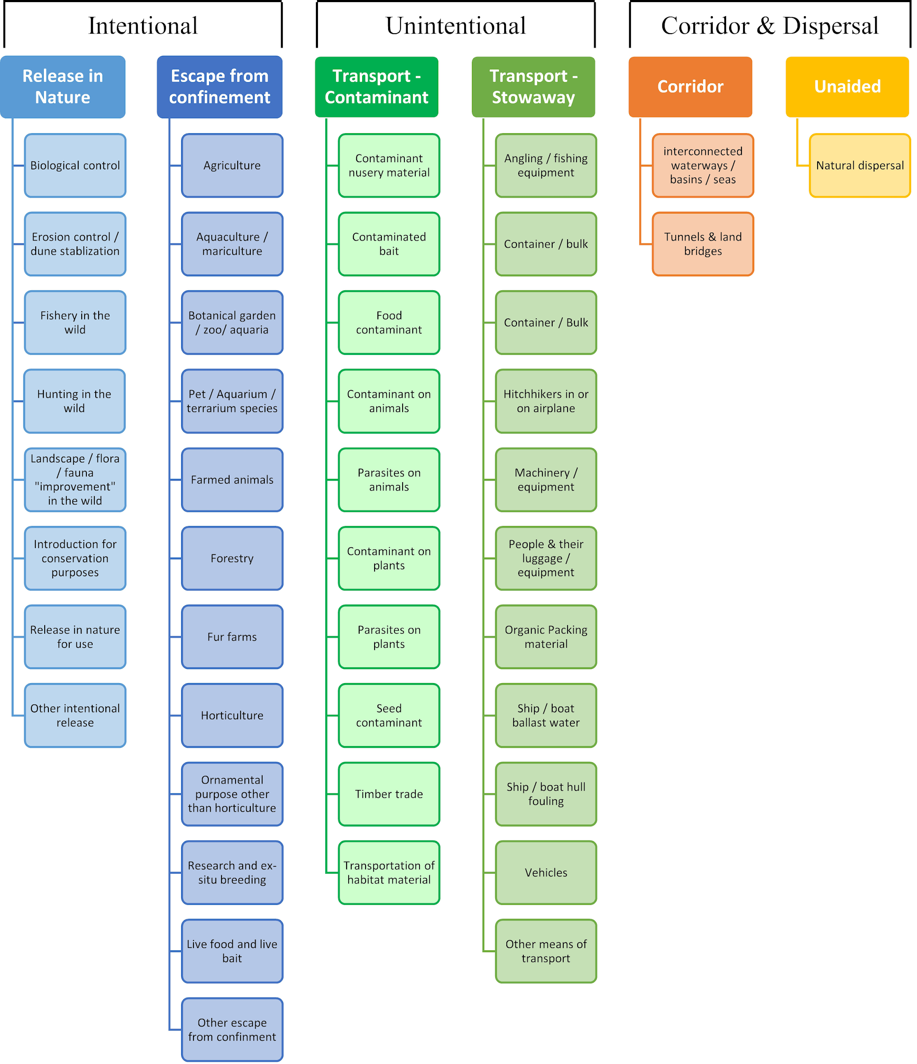

**ANNEX V Ecosystem services classification (CICES V5.1, simplified) and examples**

For the purposes of this risk assessment, please feel free to use what seems as the most appropriate category / level / combination of impact (Section – Division – Group), reflecting information available.

|  |  |  |  |
| --- | --- | --- | --- |
| **Section** | **Division** | **Group** | **Examples (i.e. relevant CICES “classes”)** |
| **Provisioning** | **Biomass** | **Cultivated *terrestrial* plants** | Cultivated terrestrial plants (including fungi, algae) grown for nutritional purposes;  Fibres and other materials from cultivated plants, fungi, algae and bacteria for direct use or processing (excluding genetic materials);  Cultivated plants (including fungi, algae) grown as a source of energy  *Example: negative impacts of non-native organisms to crops, orchards, timber etc.* |
|  |  | **Cultivated *aquatic* plants** | Plants cultivated by in- situ aquaculture grown for nutritional purposes;  Fibres and other materials from in-situ aquaculture for direct use or processing (excluding genetic materials);  Plants cultivated by in- situ aquaculture grown as an energy source.  *Example: negative impacts of non-native organisms to aquatic plants cultivated for nutrition, gardening etc. purposes.* |
|  |  | **Reared animals** | Animals reared for nutritional purposes;  Fibres and other materials from reared animals for direct use or processing (excluding genetic materials);  Animals reared to provide energy (including mechanical)  *Example: negative impacts of non-native organisms to livestock* |
|  |  | **Reared *aquatic* animals** | Animals reared by in-situ aquaculture for nutritional purposes;  Fibres and other materials from animals grown by in-situ aquaculture for direct use or processing (excluding genetic materials);  Animals reared by in-situ aquaculture as an energy source  *Example: negative impacts of non-native organisms to fish farming* |
|  |  | **Wild plants** (terrestrial and aquatic) | Wild plants (terrestrial and aquatic, including fungi, algae) used for nutrition;  Fibres and other materials from wild plants for direct use or processing (excluding genetic materials);  Wild plants (terrestrial and aquatic, including fungi, algae) used as a source of energy  *Example: reduction in the availability of wild plants (e.g. wild berries, ornamentals) due to non-native organisms (competition, spread of disease etc.)* |
|  |  | **Wild animals** (terrestrial and aquatic) | Wild animals (terrestrial and aquatic) used for nutritional purposes;  Fibres and other materials from wild animals for direct use or processing (excluding genetic materials);  Wild animals (terrestrial and aquatic) used as a source of energy  *Example: reduction in the availability of wild animals (e.g. fish stocks, game) due to non-native organisms (competition, predations, spread of disease etc.)* |
|  | **Genetic material** from all biota | **Genetic material** from plants, algae or fungi | Seeds, spores and other plant materials collected for maintaining or establishing a population;  Higher and lower plants (whole organisms) used to breed new strains or varieties;  Individual genes extracted from higher and lower plants for the design and construction of new biological entities  *Example: negative impacts of non-native organisms due to interbreeding* |
|  |  | **Genetic material** from animals | Animal material collected for the purposes of maintaining or establishing a population;  Wild animals (whole organisms) used to breed new strains or varieties;  Individual genes extracted from organisms for the design and construction of new biological entities  *Example: negative impacts of non-native organisms due to interbreeding* |
|  | **Water[10]** | **Surface water** used for nutrition, materials or energy | Surface water for drinking;  Surface water used as a material (non-drinking purposes);  Freshwater surface water, coastal and marine water used as an energy source  *Example: loss of access to surface water due to spread of non-native organisms* |
|  |  | **Ground water** for used for nutrition, materials or energy | Ground (and subsurface) water for drinking;  Ground water (and subsurface) used as a material (non-drinking purposes);  Ground water (and subsurface) used as an energy source  *Example: reduced availability of ground water due to spread of non-native organisms and associated increase of ground water consumption by vegetation.* |
| **Regulation & Maintenance** | **Transformation** of biochemical or physical inputs to ecosystems | **Mediation of wastes or toxic substances** of anthropogenic origin by living processes | Bio-remediation by micro-organisms, algae, plants, and animals; Filtration/sequestration/storage/accumulation by micro-organisms, algae, plants, and animals  *Example: changes caused by non-native organisms to ecosystem functioning and ability to filtrate etc. waste or toxics* |
|  |  | **Mediation of nuisances** of anthropogenic origin | Smell reduction; noise attenuation; visual screening (e.g. by means of green infrastructure)  *Example: changes caused by non-native organisms to ecosystem structure, leading to reduced ability to mediate nuisances.* |
|  | **Regulation** of physical, chemical, biological conditions | **Baseline flows and extreme event** regulation | Control of erosion rates;  Buffering and attenuation of mass movement;  Hydrological cycle and water flow regulation (Including flood control, and coastal protection);  Wind protection;  Fire protection  *Example: changes caused by non-native organisms to ecosystem functioning or structure leading to, for example, destabilisation of soil, increased risk or intensity of wild fires etc.* |
|  |  | **Lifecycle maintenance**, habitat and gene pool protection | Pollination (or 'gamete' dispersal in a marine context);  Seed dispersal;  Maintaining nursery populations and habitats (Including gene pool protection)  *Example: changes caused by non-native organisms to the abundance and/or distribution of wild pollinators; changes to the availability / quality of nursery habitats for fisheries* |
|  |  | **Pest and disease control** | Pest control;  Disease control  *Example: changes caused by non-native organisms to the abundance and/or distribution of pests* |
|  |  | **Soil quality** regulation | Weathering processes and their effect on soil quality;  Decomposition and fixing processes and their effect on soil quality  *Example: changes caused by non-native organisms to vegetation structure and/or soil fauna leading to reduced soil quality* |
|  |  | **Water** conditions | Regulation of the chemical condition of freshwaters by living processes;  Regulation of the chemical condition of salt waters by living processes  *Example: changes caused by non-native organisms to buffer strips along water courses that remove nutrients in runoff and/or fish communities that regulate the resilience and resistance of water bodies to eutrophication* |
|  |  | **Atmospheric** composition and conditions | Regulation of chemical composition of atmosphere and oceans;  Regulation of temperature and humidity, including ventilation and transpiration  *Example: changes caused by non-native organisms to ecosystems’ ability to sequester carbon and/or evaporative cooling (e.g. by urban trees)* |
| **Cultural** | **Direct, in-situ and outdoor interactions** with living systems that depend on presence in the environmental setting | **Physical and experiential** interactions with natural environment | Characteristics of living systems that that enable activities promoting health, recuperation or enjoyment through active or immersive interactions;  Characteristics of living systems that enable activities promoting health, recuperation or enjoyment through passive or observational interactions  *Example: changes caused by non-native organisms to the qualities of ecosystems (structure, species composition etc.) that make it attractive for recreation, wild life watching etc.* |
|  |  | **Intellectual and representative** interactions with natural environment | Characteristics of living systems that enable scientific investigation or the creation of traditional ecological knowledge;  Characteristics of living systems that enable education and training;  Characteristics of living systems that are resonant in terms of culture or heritage;  Characteristics of living systems that enable aesthetic experiences  *Example: changes caused by non-native organisms to the qualities of ecosystems (structure, species composition etc.) that have cultural importance* |
|  | **Indirect, remote, often indoor interactions** with living systems that do not require presence in the environmental setting | **Spiritual, symbolic** and other interactions with natural environment | Elements of living systems that have symbolic meaning;  Elements of living systems that have sacred or religious meaning;  Elements of living systems used for entertainment or representation  *Example: changes caused by non-native organisms to the qualities of ecosystems (structure, species composition etc.) that have sacred or religious meaning* |
|  |  | Other biotic characteristics that have a **non-use value** | Characteristics or features of living systems that have an existence value;  Characteristics or features of living systems that have an option or bequest value  *Example: changes caused by non-native organisms to ecosystems designated as wilderness areas, habitats of endangered species etc.* |

**ANNEX VI EU Biogeographic Regions and MSFD Subregions**

See <https://www.eea.europa.eu/data-and-maps/figures/biogeographical-regions-in-europe-2> ,

<http://ec.europa.eu/environment/nature/natura2000/biogeog_regions/>

and

https://www.eea.europa.eu/data-and-maps/data/msfd-regions-and-subregions-1/technical-document/pdf

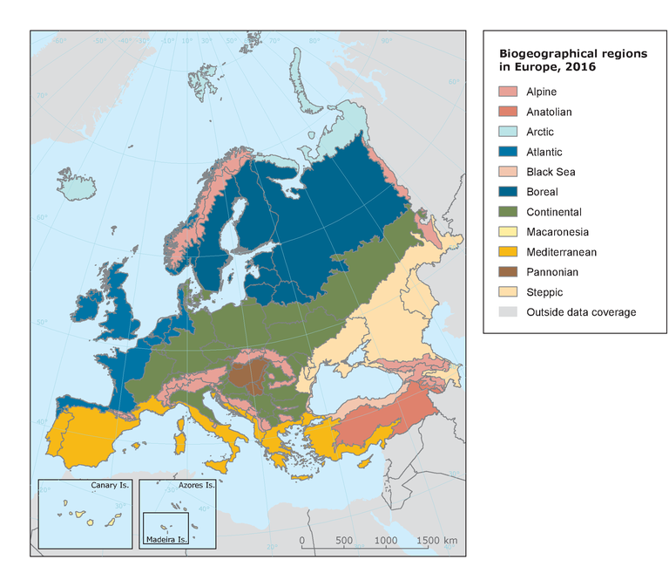 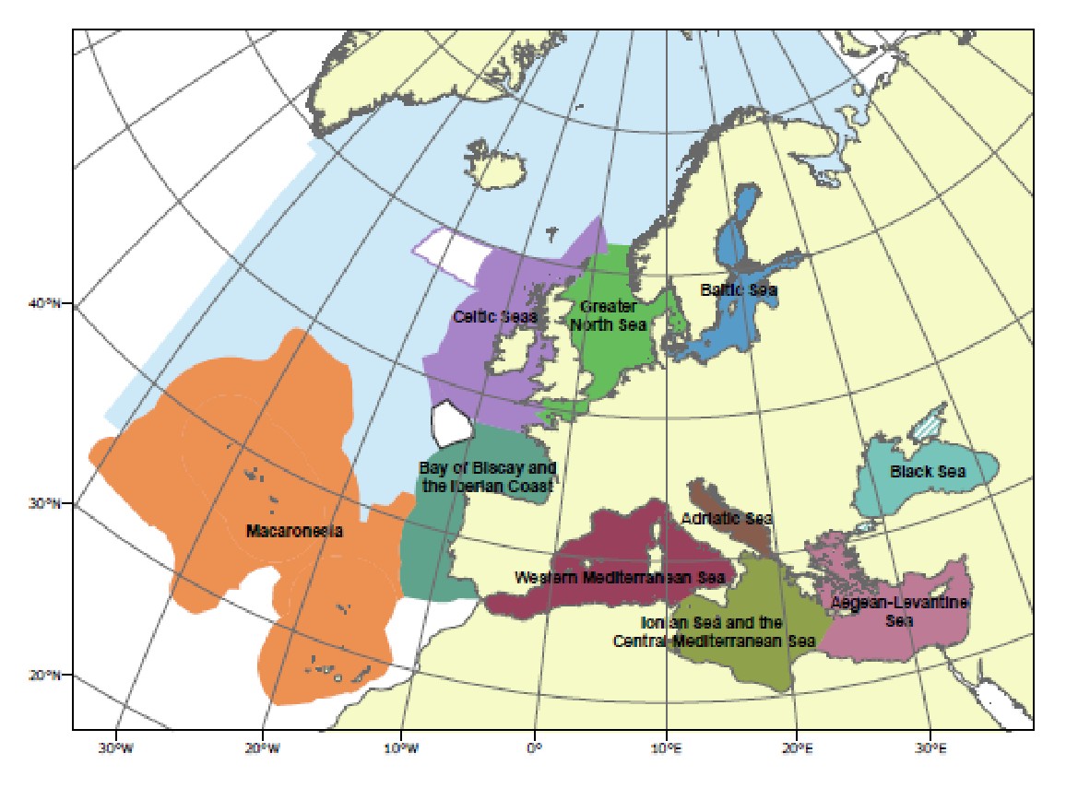

**ANNEX VII Delegated Regulation (EU) 2018/968 of 30 April 2018**

see <https://eur-lex.europa.eu/legal-content/en/TXT/?uri=CELEX%3A32018R0968>

# ANNEX VIII Species Distribution Model

# Projection of environmental suitability for *Acacia mearnsii* establishment in Europe

Björn Beckmann, Rob Tanner, Giuseppe Brundu and Dan Chapman

## Aim

To project the suitability for potential establishment of *Acacia mearnsii* in Europe, under current and predicted future climatic conditions.

## Data for modelling

Species occurrence data were obtained from the Global Biodiversity Information Facility (GBIF) (20228 records), the Atlas of Living Australia (16991 records), iNaturalist (4446 records), Giuseppe (25 records), the Biodiversity Information Serving Our Nation database (BISON) (8 records), and additional records from the risk assessment team. We scrutinised occurrence records from regions where the species is not known to be established and removed any dubious records or where the georeferencing was too imprecise (e.g. records referenced to a country or island centroid) or outside of the coverage of the predictor layers (e.g. small island or coastal occurrences). We removed records dated pre-1950, as these might refer to populations no longer in existence. We also removed records from botanical gardens. As the species is frequently planted for forestry and records referring to plantations may not be marked as such, we only used records from countries where the species is naturalised or invasive (or native) according to the CABI datasheet. The remaining records were gridded at a 0.25 x 0.25 degree resolution for modelling, yielding 941 grid cells with occurrences (Figure 1a). As a proxy for recording effort, the density of Tracheophyta records held by GBIF was also compiled on the same grid (Figure 1b).

**Figure 1.** (a) Occurrence records obtained for *Acacia mearnsii* and used in the modelling, showing native and invaded distributions. (b) The recording density of Tracheophyta on GBIF, which was used as a proxy for recording effort.

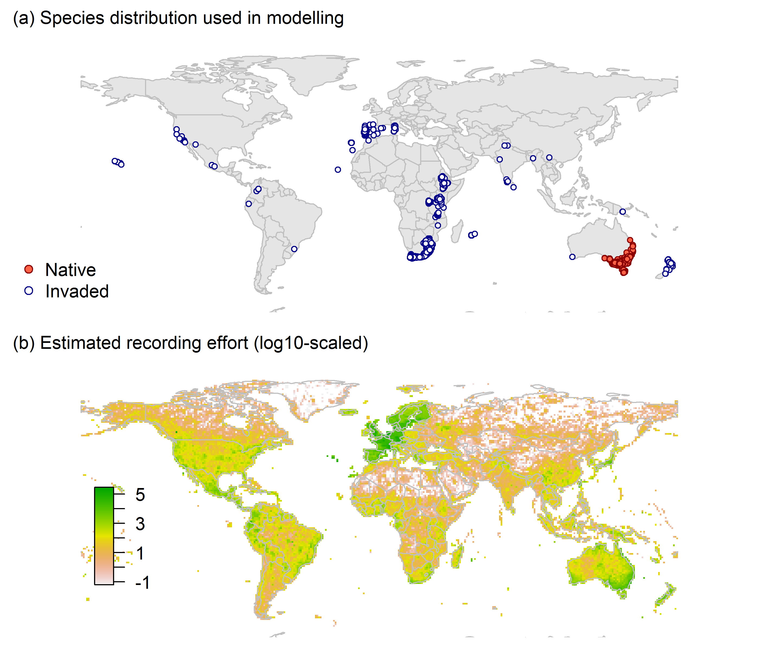

Climate data were selected from the ‘Bioclim’ variables contained within the WorldClim database (Hijmans et al., 2005), originally at 5 arcminute resolution (0.083 x 0.083 degrees of longitude/latitude) and aggregated to a 0.25 x 0.25 degree grid for use in the model.

Based on the biology of *Acacia mearnsii*, the following climate variables were used in the modelling:

* Maximum temperature of the warmest month (Bio5)
* Minimum temperature of the coldest month (Bio6)
* Climatic moisture index (CMI): ratio of mean annual precipitation to potential evapotranspiration, log+1 transformed. For its calculation, monthly potential evapotranspirations were estimated from the WorldClim monthly temperature data and solar radiation using the simple method of Zomer et al. (2008) which is based on the Hargreaves evapotranspiration equation (Hargreaves, 1994).

To estimate the effect of climate change on the potential distribution, equivalent modelled future climate conditions for the 2070s under the Representative Concentration Pathways (RCP) 2.6 and 4.5 were also obtained. These represent low and medium emissions scenarios, respectively. The above variables were obtained as averages of outputs of eight Global Climate Models (BCC-CSM1-1, CCSM4, GISS-E2-R, HadGEM2-AO, IPSL-CM5A-LR, MIROC-ESM, MRI-CGCM3, NorESM1-M), downscaled and calibrated against the WorldClim baseline (see <http://www.worldclim.org/cmip5_5m> ).

The following habitat layers were also used:

* Human influence index (HII): As many non-native invasive species associate with anthropogenically disturbed habitats. We used the Global Human Influence Index Dataset of the Last of the Wild Project (Wildlife Conservation Society - WCS & Center for International Earth Science Information Network - CIESIN - Columbia University, 2005), which is developed from nine global data layers covering human population pressure (population density), human land use and infrastructure (built-up areas, nighttime lights, land use/land cover) and human access (coastlines, roads, railroads, navigable rivers). The index ranges between 0 and 1 and was ln+1 transformed for the modelling to improve normality.

## Species distribution model

A presence-background (presence-only) ensemble modelling strategy was employed using the BIOMOD2 R package version 3.4.6 (Thuiller et al., 2020, Thuiller et al., 2009). These models contrast the environment at the species’ occurrence locations against a random sample of the global background environmental conditions (often termed ‘pseudo-absences’) in order to characterise and project suitability for occurrence. This approach has been developed for distributions that are in equilibrium with the environment. Because invasive species’ distributions are not at equilibrium and subject to dispersal constraints at a global scale, we took care to minimise the inclusion of locations suitable for the species but where it has not been able to disperse to (Chapman et al. 2019). Therefore the background sampling region included:

* The area accessible by native *Acacia mearnsii* populations, in which the species is likely to have had sufficient time to disperse to all locations. Based on presumed maximum dispersal distances, the accessible region was defined as a 400km buffer around the native range occurrences; AND
* A 30km buffer around the non-native occurrences, encompassing regions likely to have had high propagule pressure for introduction by humans and/or dispersal of the species; AND
* Regions where we have an *a priori* expectation of high unsuitability for the species so that absence is assumed irrespective of dispersal constraints (see Figure 2). The following rules were applied to define a region expected to be highly unsuitable for *Acacia mearnsii* at the spatial scale of the model:
  + Maximum temperature of the warmest month (Bio5) < 23°C
  + Minimum temperature of the coldest month (Bio6) < 0°C
  + Climatic moisture index (CMI) < 0.25

Altogether, 14.6% of occurrence grid cells were located in the unsuitable background region.

Within the unsuitable background region, 10 samples of 5000 randomly sampled grid cells were obtained. In the accessible background (comprising the accessible areas around native and non-native occurrences as detailed above), the same number of pseudo-absence samples were drawn as there were presence records (941), weighting the sampling by a proxy for recording effort (Figure 1(b)).

**Figure 2.** The background from which pseudo-absence samples were taken in the modelling of *Acacia mearnsii*. Samples were taken from a 400km buffer around the native range and a 30km buffer around non-native occurrences (together forming the accessible background), and from areas expected to be highly unsuitable for the species (the unsuitable background region). Samples from the accessible background were weighted by a proxy for recording effort (Figure 1(b)).

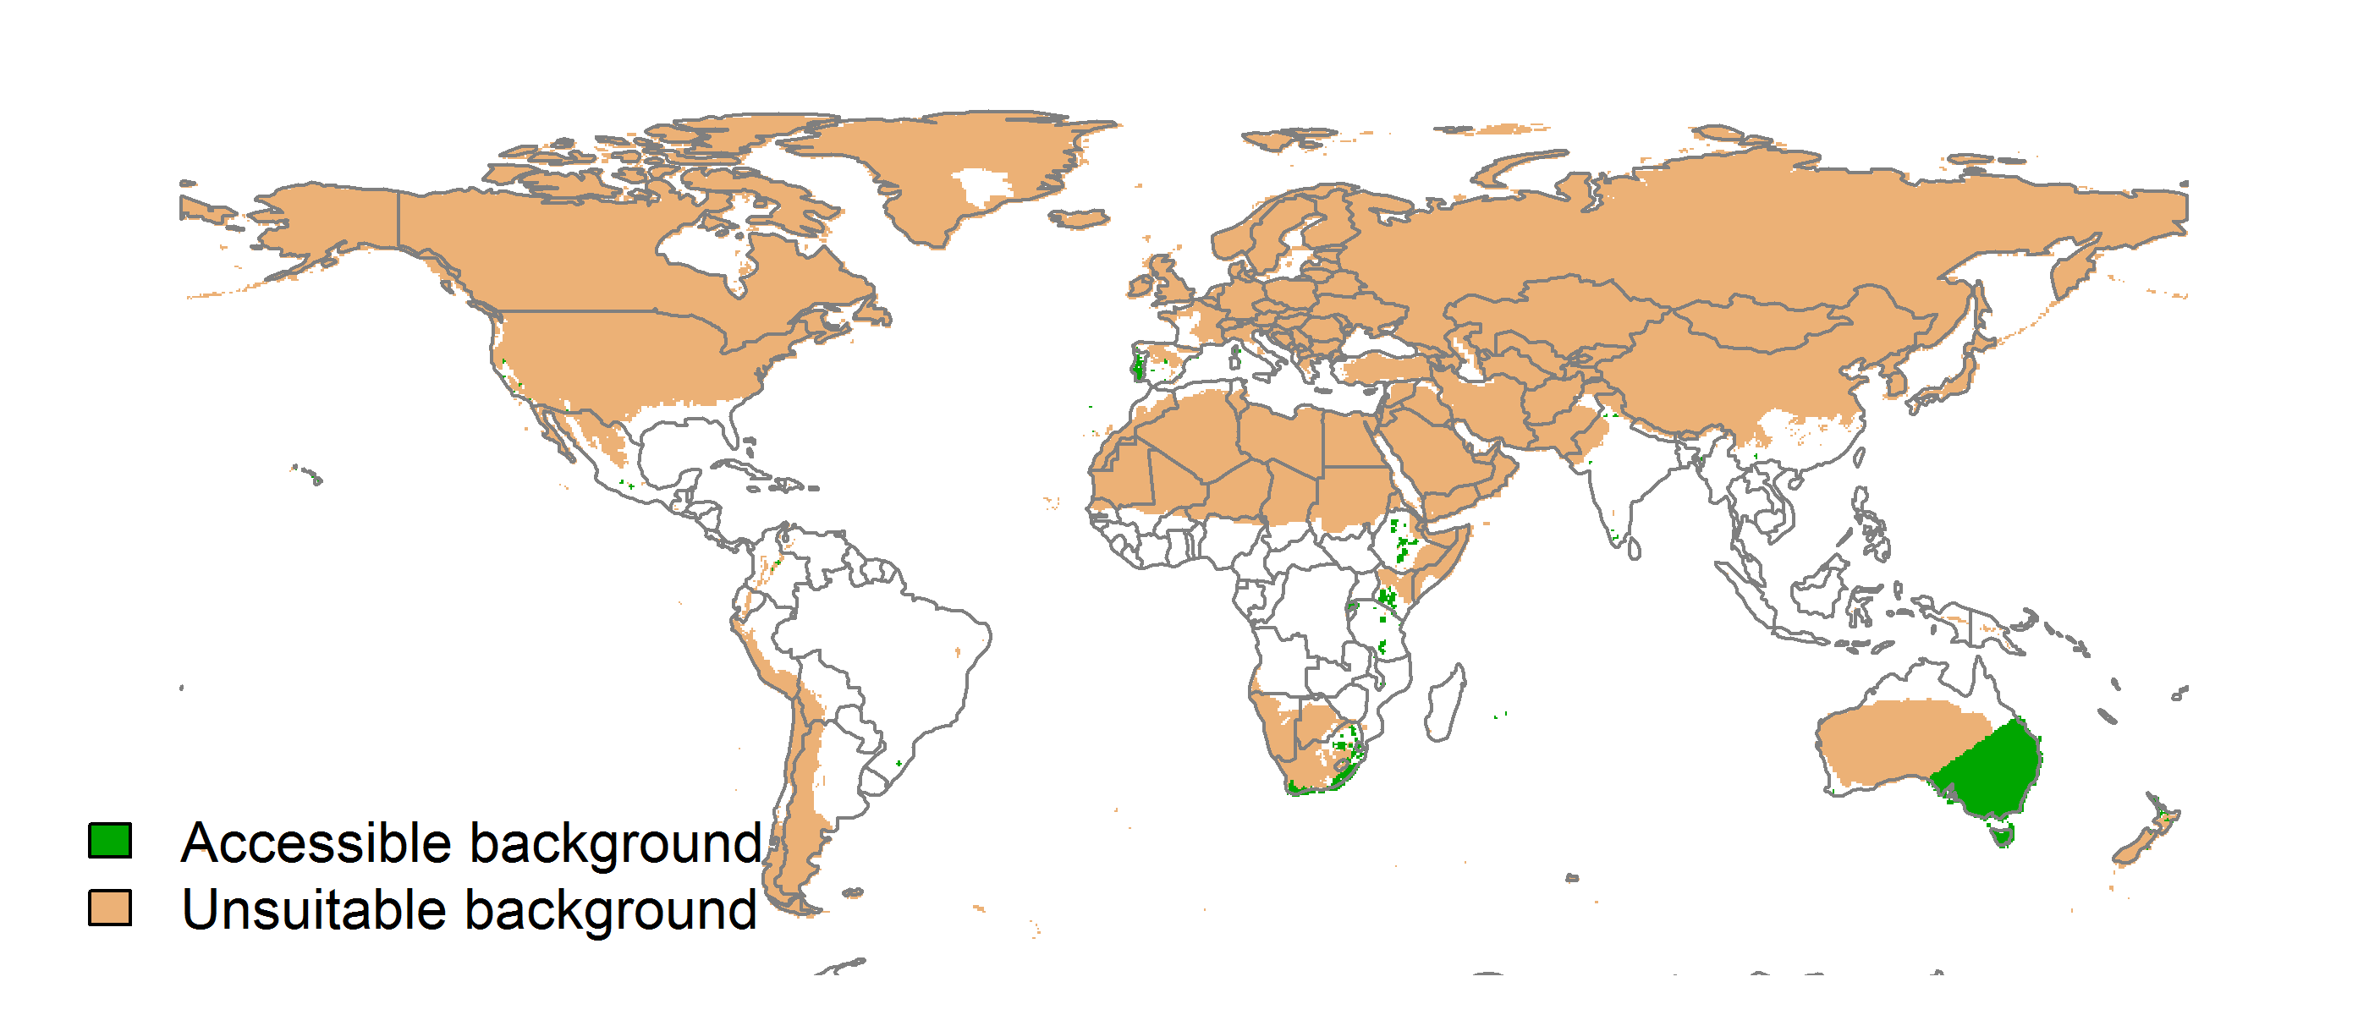

Each dataset (i.e. combination of the presences and the individual background samples) was randomly split into 80% for model training and 20% for model evaluation. With each training dataset, seven statistical algorithms were fitted with the default BIOMOD2 settings and rescaled using logistic regression, except where specified below:

* Generalised linear model (GLM)
* Generalised boosting model (GBM)
* Generalised additive model (GAM) with a maximum of four degrees of freedom per smoothing spline
* Artificial neural network (ANN)
* Multivariate adaptive regression splines (MARS)
* Random forest (RF)
* Maxent

Since the total background sample was larger than the number of occurrences, prevalence fitting weights were applied to give equal overall importance to the occurrences and the background. Normalised variable importance was assessed and variable response functions were produced using BIOMOD2’s default procedure.

Model predictive performance was assessed by the following three measures:

* AUC, the area under the receiver operating characteristic curve (Fielding & Bell 1997). Predictions of presence-absence models can be compared with a subset of records set aside for model evaluation (here 20%) by constructing a confusion matrix with the number of true positive, false positive, false negative and true negative cases. For models generating non-dichotomous scores (as here) a threshold can be applied to transform the scores into a dichotomous set of presence-absence predictions. Two measures that can be derived from the confusion matrix are sensitivity (the proportion of observed presences that are predicted as such, quantifying omission errors), and specificity (the proportion of observed absences that are predicted as such, quantifying commission errors). A receiver operating characteristic (ROC) curve can be constructed by using all possible thresholds to classify the scores into confusion matrices, obtaining sensitivity and specificity for each matrix, and plotting sensitivity against the corresponding proportion of false positives (equal to 1 - specificity). The use of all possible thresholds avoids the need for a selection of a single threshold, which is often arbitrary, and allows appreciation of the trade-off between sensitivity and specificity. The area under the ROC curve (AUC) is often used as a single threshold-independent measure for model performance (Manel et al. 2001). AUC is the probability that a randomly selected presence has a higher model-predicted suitability than a randomly selected absence (Allouche et al. 2006).
* Cohen’s Kappa (Cohen 1960). This measure corrects the overall accuracy of model predictions (ratio of the sum of true presences plus true absences to the total number of records) by the accuracy expected to occur by chance. The Kappa statistic ranges from -1 to +1, where +1 indicates perfect agreement and values of zero or less indicate a performance no better than random. Advantages of Kappa are its simplicity, the fact that both commission and omission errors are accounted for in one parameter, and its relative tolerance to zero values in the confusion matrix (Manel et al. 2001). However, Kappa has been criticised for being sensitive to prevalence (the proportion of sites in which the species was recorded as present) and may therefore be inappropriate for comparisons of model accuracy between species or regions (McPherson et al. 2004, Allouche et al. 2006).
* TSS, the true skill statistic (Allouche et al. 2006). TSS is defined as sensitivity + specificity - 1, and corrects for Kappa’s dependency on prevalence. TSS compares the number of correct forecasts, minus those attributable to random guessing, to that of a hypothetical set of perfect forecasts. Like Kappa, TSS takes into account both omission and commission errors, and success as a result of random guessing, and ranges from -1 to +1, where +1 indicates perfect agreement and values of zero or less indicate a performance no better than random (Allouche et al. 2006).

An ensemble model was created by first rejecting poorly performing algorithms with relatively extreme low AUC values and then averaging the predictions of the remaining algorithms, weighted by their AUC. To identify poorly performing algorithms, AUC values were converted into modified z-scores based on their difference to the median and the median absolute deviation across all algorithms (Iglewicz & Hoaglin 1993). Algorithms with z < -2 were rejected. In this way, ensemble projections were made for each dataset and then averaged to give an overall suitability, as well as its standard deviation.

Projections were classified into suitable and unsuitable regions using a “lowest presence threshold” (Pearson et al. 2007), setting the cut-off as the lowest value at which 98% of all presence records are classified correctly under the current climate (here 0.37). In order to express the sensitivity of classifications to the choice of this threshold, thresholds at which 95% and 99% of records are classified correctly (here 0.54 and 0.23 respectively) were used in the calculation of error bars in Figures 9 and 10 below in addition to taking account of uncertainty in the projections themselves.

We also produced a limiting factor map for Europe following Elith et al. (2010). For this, projections were made separately with each individual variable fixed at a near-optimal value. These were chosen as the median values at the occurrence grid cells. Then, the most strongly limiting factors were identified as the ones resulting in the highest increase in suitability in each grid cell.

## 

## Results

The ensemble model suggested that suitability for *Acacia mearnsii* was most strongly determined by Minimum temperature of the coldest month (Bio6), accounting for 55.9% of variation explained, followed by Maximum temperature of the warmest month (Bio5) (19.3%), Climatic moisture index (CMI) (14.3%) and Human influence index (HII) (10.4%) (Table 1, Figure 3).

**Table 1.** Summary of the cross-validation predictive performance (AUC, Kappa, TSS) and variable importance of the fitted model algorithms and the ensemble (AUC-weighted average of the best performing algorithms). Results are the average from models fitted to 10 different background samples of the data.

|  |  |  |  |  |  |  |  |  |
| --- | --- | --- | --- | --- | --- | --- | --- | --- |
|  |  |  |  |  | **Variable importance (%)** | | | |
| **Algorithm** | **AUC** | **Kappa** | **TSS** | **Used in the ensemble** | **Minimum temperature of the coldest month (Bio6)** | **Maximum temperature of the warmest month (Bio5)** | **Climatic moisture index (CMI)** | **Human influence index (HII)** |
| GLM | 0.946 | 0.629 | 0.833 | yes | 55 | 19 | 13 | 13 |
| GAM | 0.949 | 0.643 | 0.842 | yes | 52 | 25 | 9 | 13 |
| GBM | 0.950 | 0.650 | 0.849 | yes | 60 | 18 | 16 | 6 |
| ANN | 0.947 | 0.655 | 0.852 | yes | 52 | 16 | 12 | 20 |
| MARS | 0.947 | 0.638 | 0.838 | yes | 64 | 18 | 18 | 0 |
| RF | 0.928 | 0.639 | 0.848 | no | 50 | 16 | 18 | 16 |
| Maxent | 0.948 | 0.638 | 0.836 | yes | 52 | 20 | 18 | 10 |
| **Ensemble** | **0.952** | **0.655** | **0.845** |  | **56** | **19** | **14** | **10** |

**Figure 3.** Partial response plots from the fitted models. Thin coloured lines show responses from the algorithms in the ensemble, while the thick black line is their ensemble. In each plot, other model variables are held at their median value in the training data. Some of the divergence among algorithms is because of their different treatment of interactions among variables.

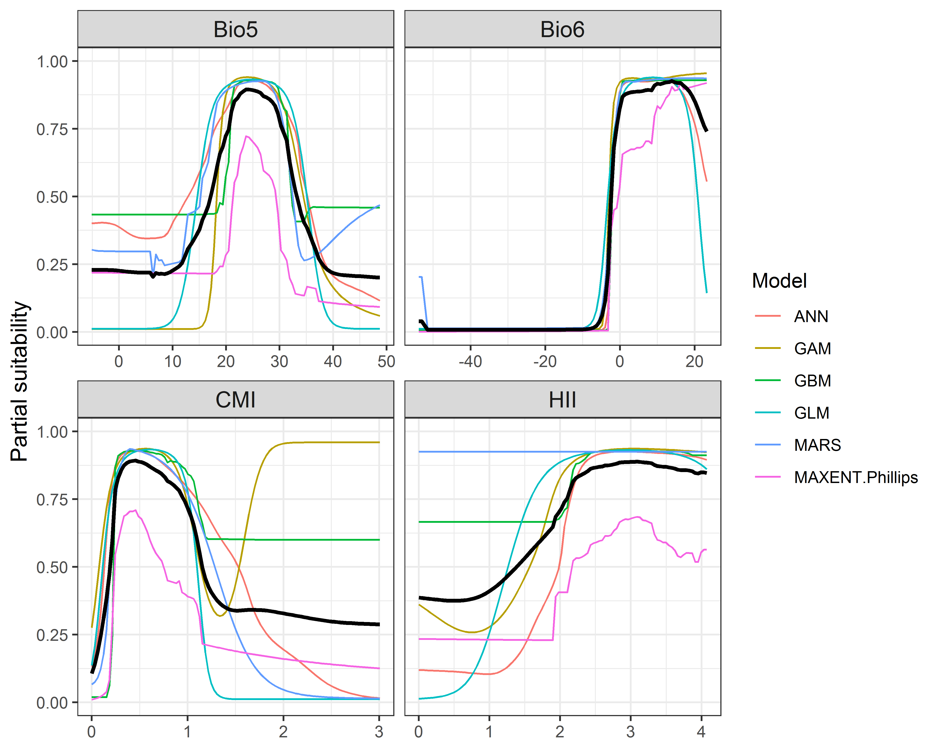

**Figure 4.** (a) Projected global suitability for *Acacia mearnsii* establishment in the current climate. For visualisation, the projection has been aggregated to a 0.5 x 0.5 degree resolution, by taking the maximum suitability of constituent higher resolution grid cells. Values > 0.37 are suitable for the species, with 98% of global presence records above this threshold. Values below 0.37 indicate lower relative suitability. (b) Uncertainty in the ensemble projections, expressed as the among-algorithm standard deviation in predicted suitability, averaged across the 10 datasets.

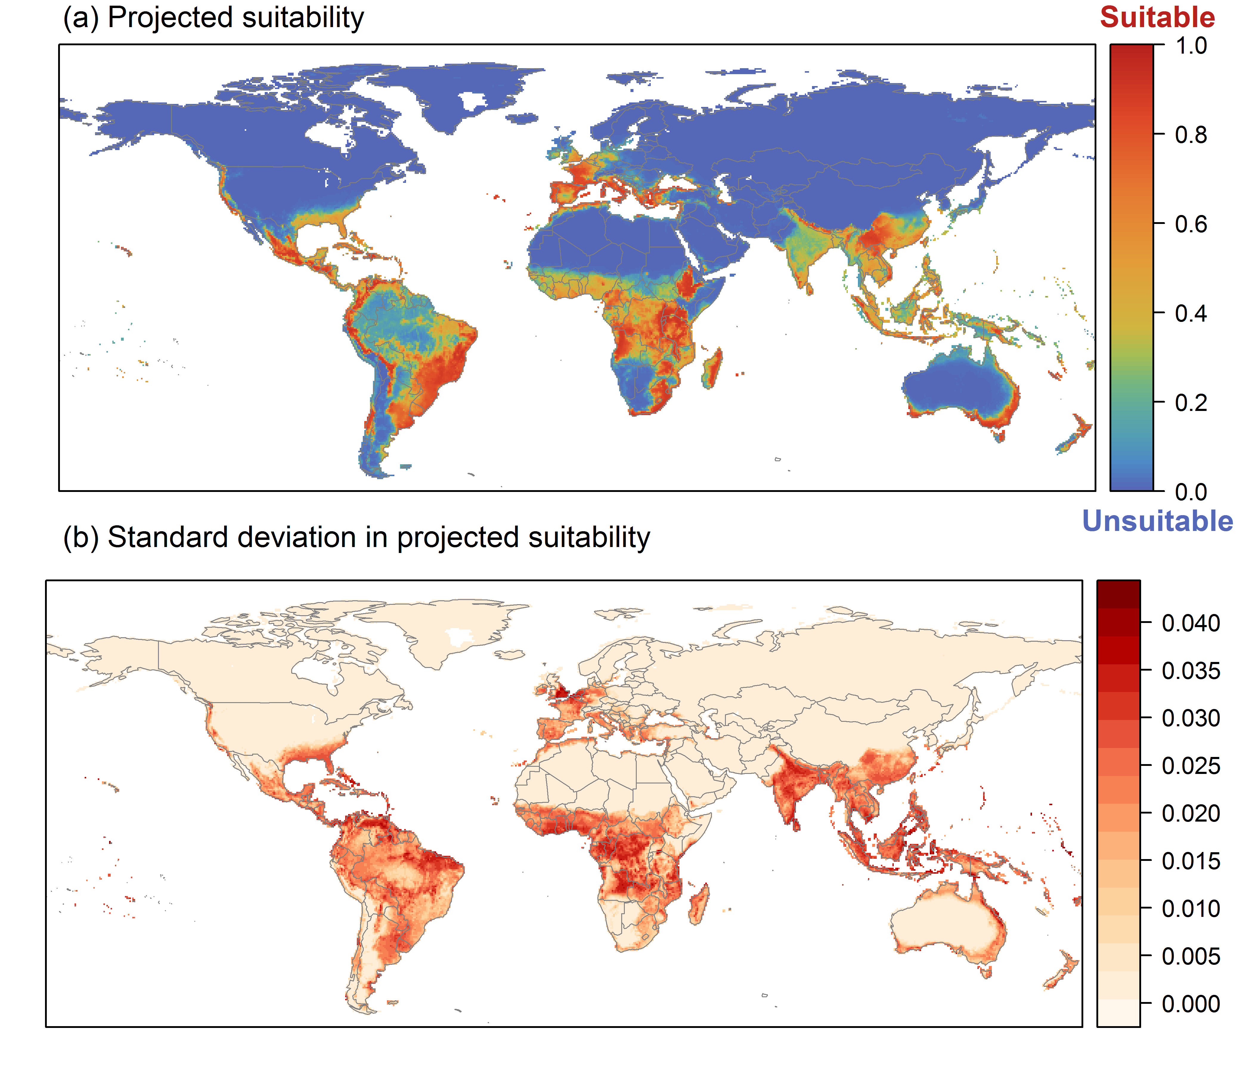

**Figure 5.** (a) Projected current suitability for *Acacia mearnsii* establishment in Europe and the Mediterranean region. Values > 0.37 are suitable for the species, with 98% of global presence records above this threshold. Values below 0.37 indicate lower relative suitability. (b) Uncertainty in the ensemble projections, expressed as the among-algorithm standard deviation in predicted suitability, averaged across the 10 datasets.

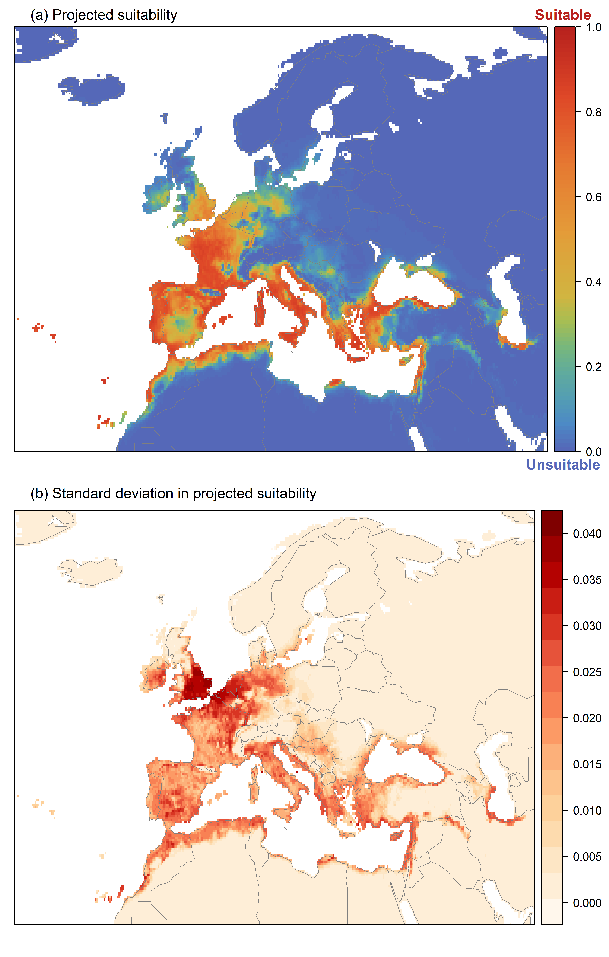

**Figure 6.** The most strongly limiting factors for *Acacia mearnsii* establishment estimated by the model in Europe and the Mediterranean region in current climatic conditions.

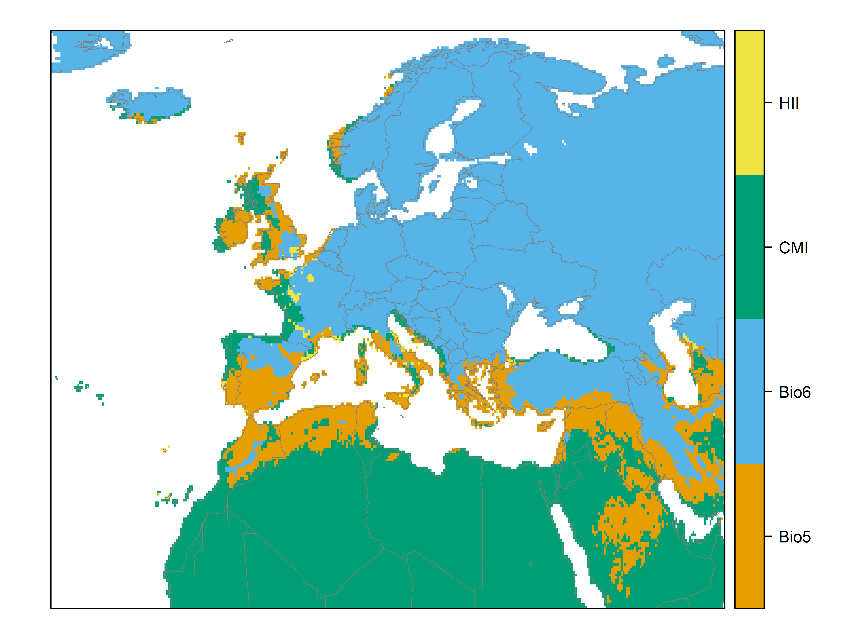

**Figure 7.** (a) Projected suitability for *Acacia mearnsii* establishment in Europe and the Mediterranean region in the 2070s under climate change scenario RCP2.6. Values > 0.37 are suitable for the species, with 98% of global presence records above this threshold under current climate. Values below 0.37 indicate lower relative suitability. (b) Uncertainty in the ensemble projections, expressed as the among-algorithm standard deviation in predicted suitability, averaged across the 10 datasets.

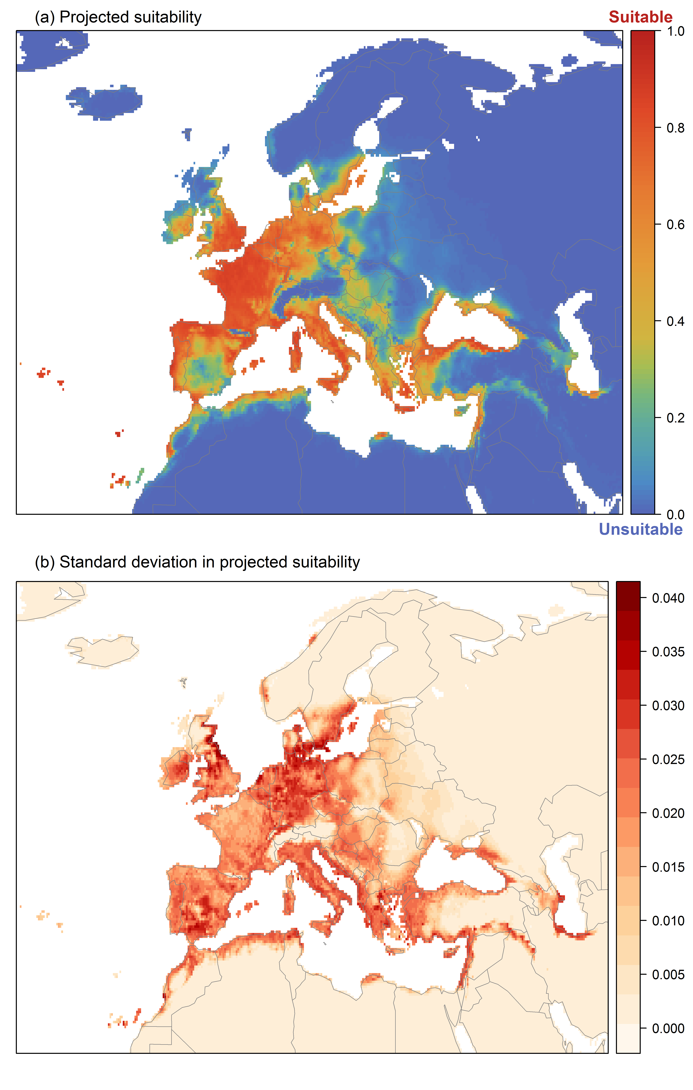

**Figure 8.** (a) Projected suitability for *Acacia mearnsii* establishment in Europe and the Mediterranean region in the 2070s under climate change scenario RCP4.5. Values > 0.37 are suitable for the species, with 98% of global presence records above this threshold under current climate. Values below 0.37 indicate lower relative suitability. (b) Uncertainty in the ensemble projections, expressed as the among-algorithm standard deviation in predicted suitability, averaged across the 10 datasets.

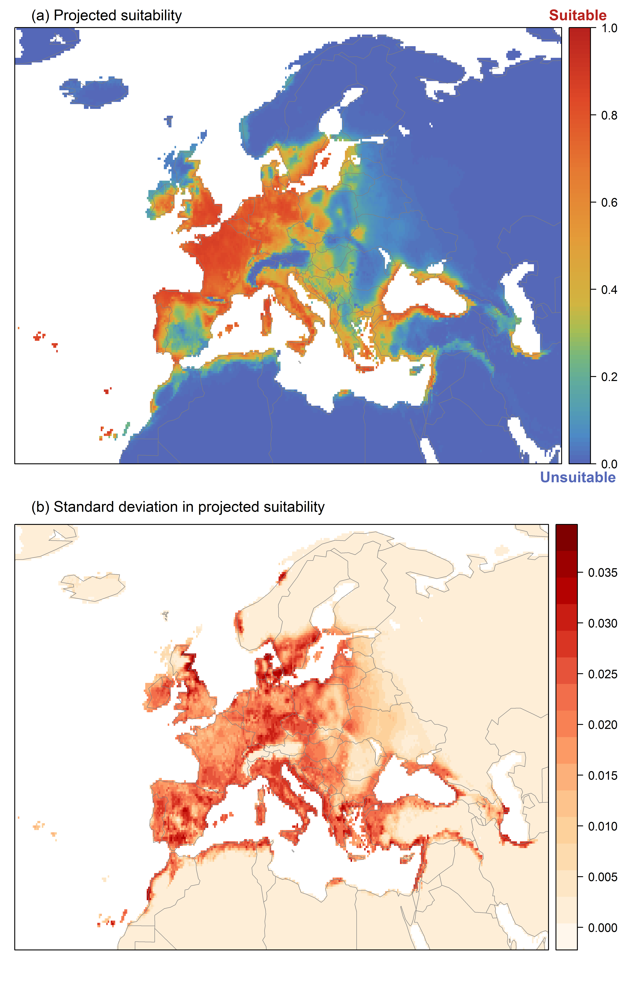

**Figure 9.** Variation in projected suitability for *Acacia mearnsii* establishment among Biogeographical Regions of Europe (<https://www.eea.europa.eu/data-and-maps/data/biogeographical-regions-europe-3>). The bar plots show the proportion of grid cells in each region classified as suitable (with values > 0.37) in the current climate and projected climate for the 2070s under two RCP emissions scenarios. Error bars indicate uncertainty due to both the choice of classification threshold (cf. p.5/6) and uncertainty in the projections themselves (cf. part (b) of Figures 5, 7 and 8). The location of each region is also shown. The Arctic and Macaronesian regions are not part of the study area, but are included for completeness.

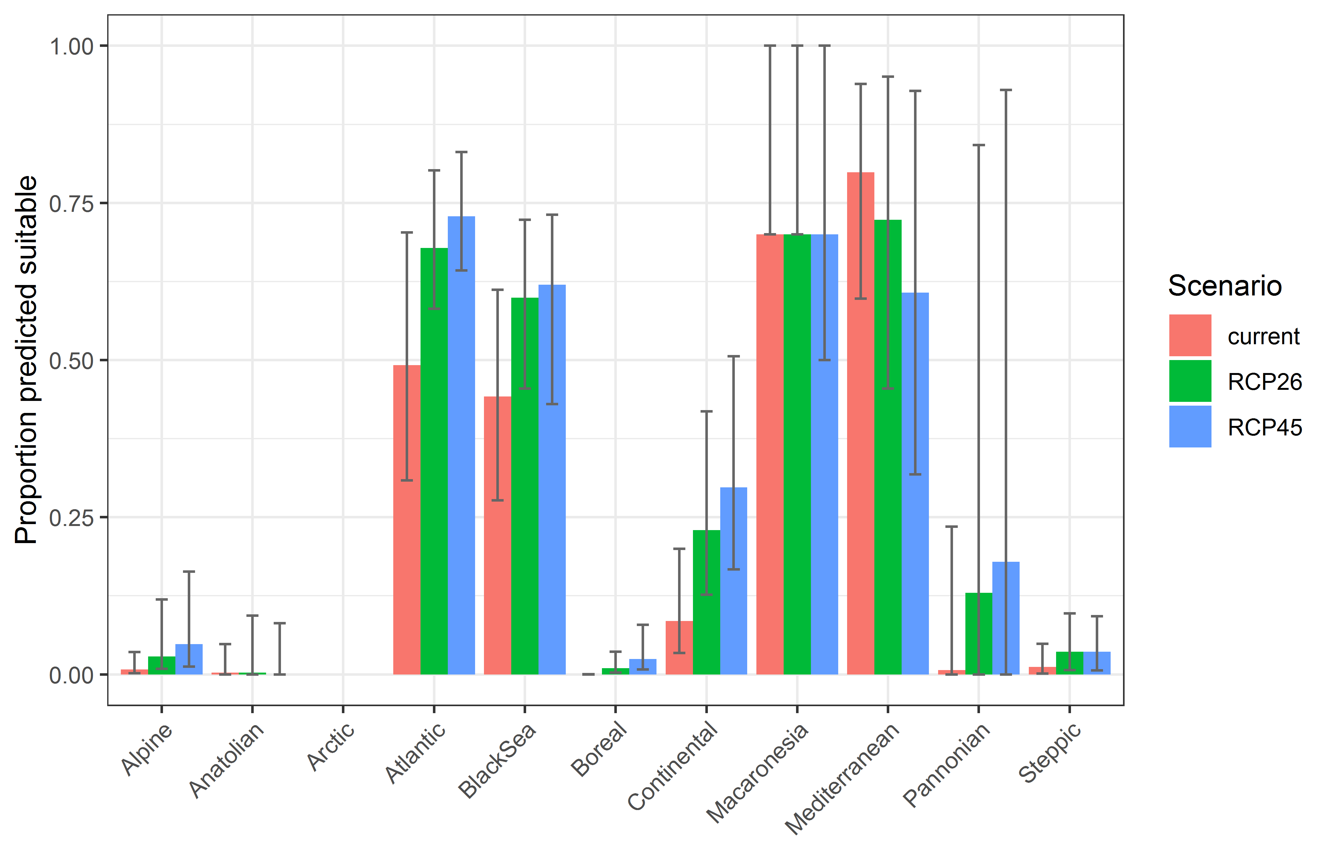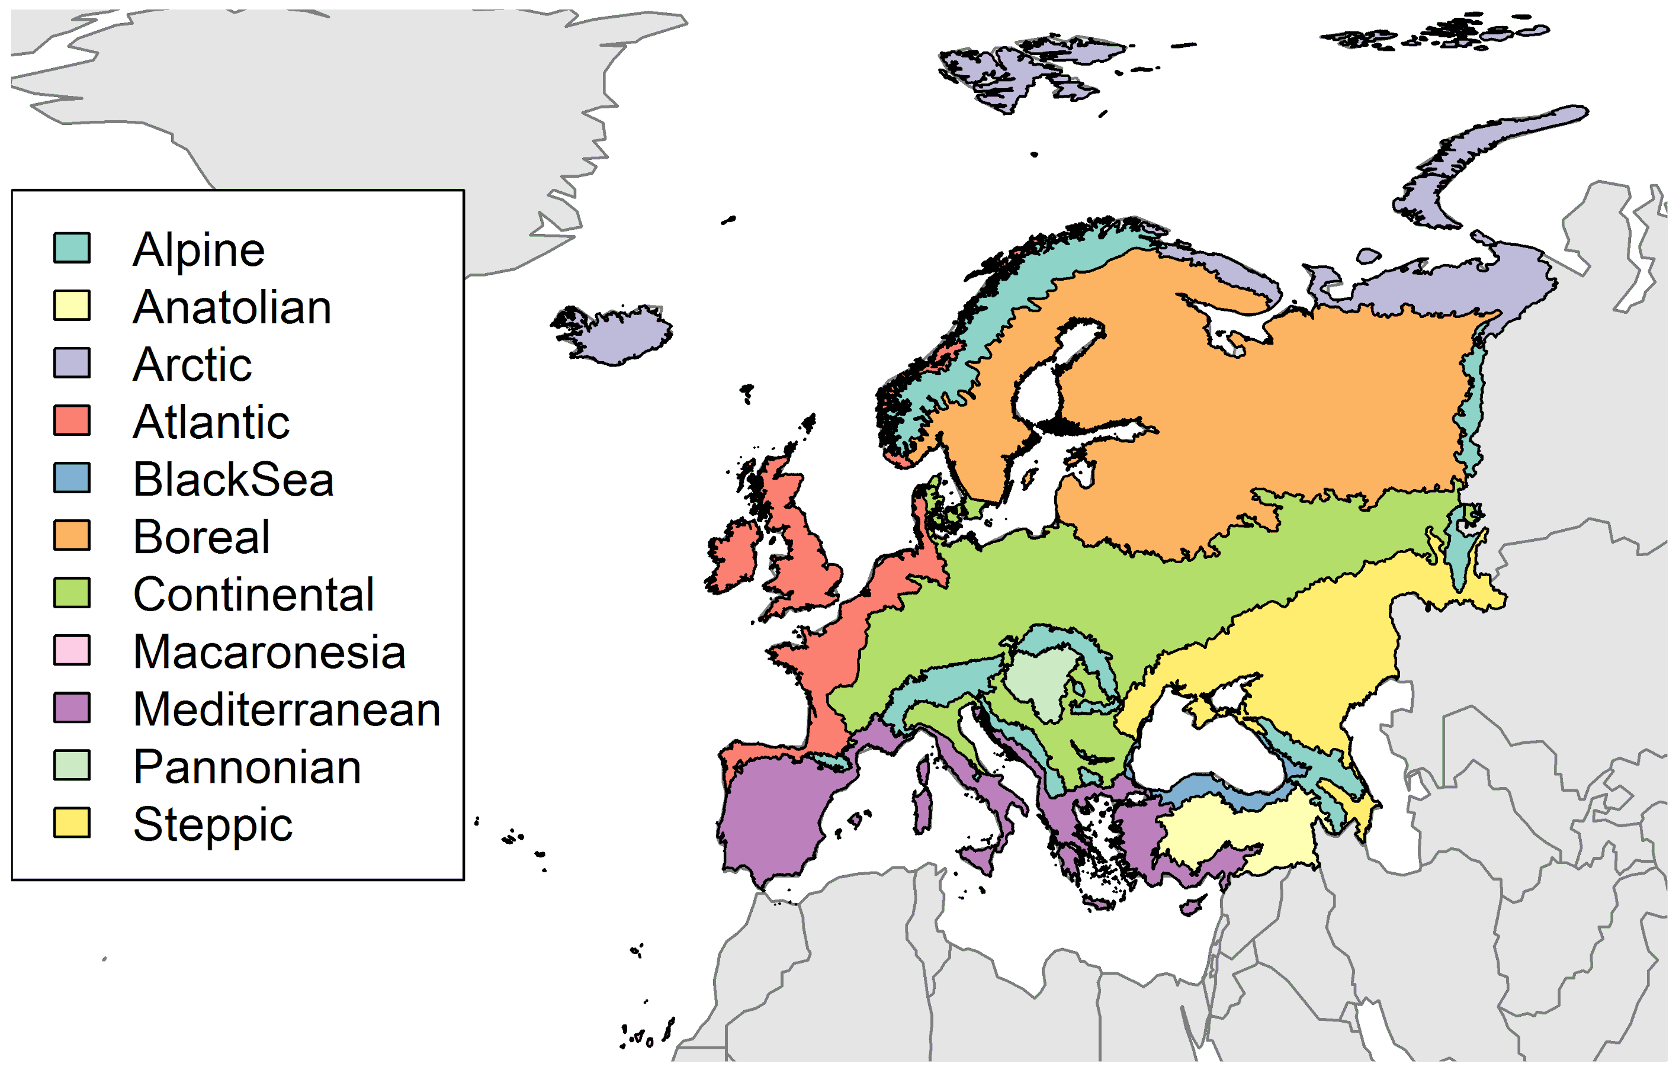

**Table 2.** Variation in projected suitability for *Acacia mearnsii* establishment among Biogeographical regions of Europe (numerical values of Figure 9 above). The numbers are the proportion of grid cells in each region classified as suitable in the current climate and projected climate for the 2070s under two RCP emissions scenarios. The Arctic and Macaronesian biogeographical regions are not part of the study area, but are included for completeness.

|  |  |  |  |  |  |  |  |  |  |
| --- | --- | --- | --- | --- | --- | --- | --- | --- | --- |
|  | **current climate** | | | **2070s RCP2.6** | | | **2070s RCP4.5** | | |
|  | lower | **central estimate** | upper | lower | **central estimate** | upper | lower | **central estimate** | upper |
| Alpine | 0.00 | 0.01 | 0.04 | 0.01 | 0.03 | 0.12 | 0.01 | 0.05 | 0.16 |
| Anatolian | 0.00 | 0.00 | 0.05 | 0.00 | 0.00 | 0.09 | 0.00 | 0.00 | 0.08 |
| Arctic | 0.00 | 0.00 | 0.00 | 0.00 | 0.00 | 0.00 | 0.00 | 0.00 | 0.00 |
| Atlantic | 0.31 | 0.49 | 0.70 | 0.58 | 0.68 | 0.80 | 0.64 | 0.73 | 0.83 |
| Black Sea | 0.28 | 0.44 | 0.61 | 0.45 | 0.60 | 0.72 | 0.43 | 0.62 | 0.73 |
| Boreal | 0.00 | 0.00 | 0.00 | 0.00 | 0.01 | 0.04 | 0.01 | 0.02 | 0.08 |
| Continental | 0.03 | 0.09 | 0.20 | 0.13 | 0.23 | 0.42 | 0.17 | 0.30 | 0.51 |
| Macaronesia | 0.70 | 0.70 | 1.00 | 0.70 | 0.70 | 1.00 | 0.50 | 0.70 | 1.00 |
| Mediterranean | 0.60 | 0.80 | 0.94 | 0.45 | 0.72 | 0.95 | 0.32 | 0.61 | 0.93 |
| Pannonian | 0.00 | 0.01 | 0.24 | 0.00 | 0.13 | 0.84 | 0.00 | 0.18 | 0.93 |
| Steppic | 0.00 | 0.01 | 0.05 | 0.01 | 0.04 | 0.10 | 0.01 | 0.04 | 0.09 |

**Figure 10.** Variation in projected suitability for *Acacia mearnsii* establishment among European Union countries and the UK. The bar plots show the proportion of grid cells in each country classified as suitable (with values > 0.37) in the current climate and projected climate for the 2070s under two RCP emissions scenarios. Error bars indicate uncertainty due to both the choice of classification threshold (cf. p.5/6) and uncertainty in the projections themselves (cf. part (b) of Figures 5, 7 and 8). Malta has been excluded because the Human Influence Index dataset lacks coverage for Malta.

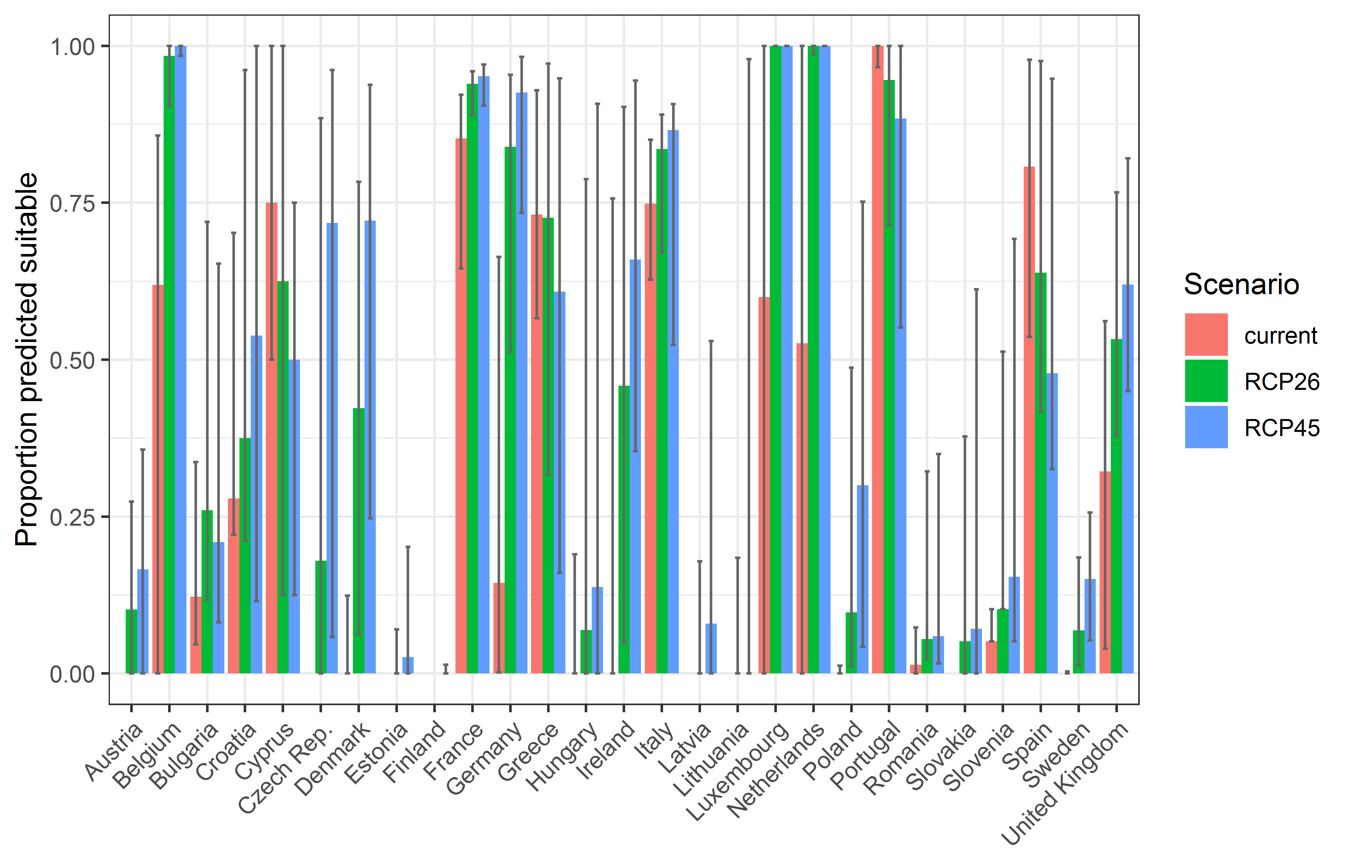

**Table 3.** Variation in projected suitability for *Acacia mearnsii* establishment among European Union countries and the UK (numerical values of Figure 10 above). The numbers are the proportion of grid cells in each country classified as suitable in the current climate and projected climate for the 2070s under two RCP emissions scenarios.

|  |  |  |  |  |  |  |  |  |  |
| --- | --- | --- | --- | --- | --- | --- | --- | --- | --- |
|  | **current climate** | | | **2070s RCP2.6** | | | **2070s RCP4.5** | | |
|  | lower | **central estimate** | upper | lower | **central estimate** | upper | lower | **central estimate** | upper |
| Austria | 0.00 | 0.00 | 0.00 | 0.00 | 0.10 | 0.27 | 0.00 | 0.17 | 0.36 |
| Belgium | 0.00 | 0.62 | 0.86 | 0.90 | 0.98 | 1.00 | 0.98 | 1.00 | 1.00 |
| Bulgaria | 0.05 | 0.12 | 0.34 | 0.12 | 0.26 | 0.72 | 0.08 | 0.21 | 0.65 |
| Croatia | 0.22 | 0.28 | 0.70 | 0.21 | 0.38 | 0.96 | 0.12 | 0.54 | 1.00 |
| Cyprus | 0.50 | 0.75 | 1.00 | 0.12 | 0.62 | 1.00 | 0.12 | 0.50 | 0.75 |
| Czech Rep. | 0.00 | 0.00 | 0.00 | 0.00 | 0.18 | 0.88 | 0.06 | 0.72 | 0.96 |
| Denmark | 0.00 | 0.00 | 0.12 | 0.06 | 0.42 | 0.78 | 0.25 | 0.72 | 0.94 |
| Estonia | 0.00 | 0.00 | 0.00 | 0.00 | 0.00 | 0.07 | 0.00 | 0.03 | 0.20 |
| Finland | 0.00 | 0.00 | 0.00 | 0.00 | 0.00 | 0.00 | 0.00 | 0.00 | 0.01 |
| France | 0.65 | 0.85 | 0.92 | 0.89 | 0.94 | 0.96 | 0.90 | 0.95 | 0.97 |
| Germany | 0.00 | 0.14 | 0.66 | 0.51 | 0.84 | 0.95 | 0.73 | 0.93 | 0.98 |
| Greece | 0.57 | 0.73 | 0.93 | 0.32 | 0.73 | 0.97 | 0.16 | 0.61 | 0.95 |
| Hungary | 0.00 | 0.00 | 0.19 | 0.00 | 0.07 | 0.79 | 0.00 | 0.14 | 0.91 |
| Ireland | 0.00 | 0.00 | 0.76 | 0.05 | 0.46 | 0.90 | 0.35 | 0.66 | 0.94 |
| Italy | 0.63 | 0.75 | 0.85 | 0.67 | 0.84 | 0.89 | 0.52 | 0.87 | 0.91 |
| Latvia | 0.00 | 0.00 | 0.00 | 0.00 | 0.00 | 0.18 | 0.00 | 0.08 | 0.53 |
| Lithuania | 0.00 | 0.00 | 0.00 | 0.00 | 0.00 | 0.18 | 0.00 | 0.00 | 0.98 |
| Luxembourg | 0.00 | 0.60 | 1.00 | 1.00 | 1.00 | 1.00 | 1.00 | 1.00 | 1.00 |
| Netherlands | 0.00 | 0.53 | 1.00 | 0.99 | 1.00 | 1.00 | 1.00 | 1.00 | 1.00 |
| Poland | 0.00 | 0.00 | 0.01 | 0.01 | 0.10 | 0.49 | 0.04 | 0.30 | 0.75 |
| Portugal | 0.97 | 1.00 | 1.00 | 0.71 | 0.95 | 1.00 | 0.55 | 0.88 | 1.00 |
| Romania | 0.00 | 0.01 | 0.07 | 0.02 | 0.05 | 0.32 | 0.02 | 0.06 | 0.35 |
| Slovakia | 0.00 | 0.00 | 0.00 | 0.00 | 0.05 | 0.38 | 0.00 | 0.07 | 0.61 |
| Slovenia | 0.05 | 0.05 | 0.10 | 0.10 | 0.10 | 0.51 | 0.05 | 0.15 | 0.69 |
| Spain | 0.54 | 0.81 | 0.98 | 0.42 | 0.64 | 0.98 | 0.33 | 0.48 | 0.95 |
| Sweden | 0.00 | 0.00 | 0.00 | 0.01 | 0.07 | 0.18 | 0.05 | 0.15 | 0.26 |
| UK | 0.04 | 0.32 | 0.56 | 0.38 | 0.53 | 0.77 | 0.45 | 0.62 | 0.82 |

## Caveats to the modelling

To remove spatial recording biases, the selection of the background sample from the accessible background was weighted by the density of Tracheophyta records on the Global Biodiversity Information Facility (GBIF). While this is preferable to not accounting for recording bias at all, it may not provide the perfect measure of recording bias.

There was substantial variation among modelling algorithms in the partial response plots (Figure 3). In part this will reflect their different treatment of interactions among variables. Since partial plots are made with other variables held at their median, there may be values of a particular variable at which this does not provide a realistic combination of variables to predict from.

Other variables potentially affecting the distribution of the species, such as types of land cover were not included in the model.

## References

* Allouche O, Tsoar A, Kadmon R (2006) Assessing the accuracy of species distribution models: prevalence, kappa and the true skill statistic (TSS). *Journal of Applied Ecology*, 43, 1223-1232.
* Chapman D, Pescott OL, Roy HE, Tanner R (2019) Improving species distribution models for invasive non-native species with biologically informed pseudo-absence selection. *Journal of Biogeography*, <https://doi.org/10.1111/jbi.13555>.
* Cohen J (1960) A coefficient of agreement of nominal scales. *Educational and Psychological Measurement*, 20, 37-46.
* Elith J, Kearney M, Phillips S (2010) The art of modelling range-shifting species. *Methods in Ecology and Evolution*, 1, 330-342.
* Fielding AH, Bell JF (1997) A review of methods for the assessment of prediction errors in conservation presence/absence models. *Environmental Conservation*, 24, 38-49.
* Hargreaves GH (1994) Defining and Using Reference Evapotranspiration. *Journal of Irrigation and Drainage Engineering*, 120.
* Hijmans RJ, Cameron SE, Parra JL, Jones PG, Jarvis A (2005) Very high resolution interpolated climate surfaces for global land areas. *International Journal of Climatology*, 25, 1965-1978.
* Iglewicz B, Hoaglin DC (1993) How to detect and handle outliers. Asq Press.
* Manel S, Williams HC, Ormerod SJ (2001) Evaluating presence-absence models in ecology: the need to account for prevalence. *Journal of Applied Ecology*, 38, 921-931.
* McPherson JM, Jetz W, Rogers DJ (2004) The effects of species’ range sizes on the accuracy of distribution models: ecological phenomenon or statistical artefact? *Journal of Applied Ecology*, 41, 811-823.
* Pearson RG, Raxworthy CJ, Nakamura M, Townsend Peterson A (2007), Predicting species distributions from small numbers of occurrence records: a test case using cryptic geckos in Madagascar. *Journal of Biogeography*, 34: 102-117. <https://doi.org/10.1111/j.1365-2699.2006.01594.x>
* Thuiller W, Lafourcade B, Engler R, Araújo MB (2009) BIOMOD-a platform for ensemble forecasting of species distributions. *Ecography*, 32, 369-373.
* Thuiller W, Georges D, Engler R, Breiner F (2020). biomod2: Ensemble Platform for Species Distribution Modeling. R package version 3.4.6. <https://CRAN.R-project.org/package=biomod2>
* Zomer RJ, Trabucco A, Bossio DA, Verchot LV (2008) Climate change mitigation: A spatial analysis of global land suitability for clean development mechanism afforestation and reforestation. *Agriculture, Ecosystems & Environment*, 126, 67-80.

1. This template is based on the Great Britain non-native species risk assessment scheme (GBNNRA). A number of amendments have been introduced to ensure compliance with Regulation (EU) 1143/2014 on IAS and relevant legislation, including the Delegated Regulation (EU) 2018/968 of 30 April 2018, supplementing Regulation (EU) No 1143/2014 of the European Parliament and of the Council with regard to risk assessments in relation to invasive alien species (see <https://eur-lex.europa.eu/legal-content/en/TXT/?uri=CELEX%3A32018R0968> ).
2. The World Flora Online (WFO - <http://www.worldfloraonline.org/taxon/wfo-0000192434>) uses the name *Acacia decurrens* Willd., while GBIF (https://www.gbif.org/species/2979778) uses the name *Acacia decurrens* (J.C.Wendl.) Willd.
3. The Weber and Gut (2004) risk assessment system was developed to assess the invasion potential of new “environmental weeds” in central Europe. A pre-evaluation step excludes species that are officially controlled, widespread, or intended for use in protected cultures only. Species eligible for risk assessment are classified into three categories (high risk, further observation required, low risk) by rating them according to various biogeographical and ecological aspects. Assessed species are classified into “high risk”, “intermediate risk”, and “low risk”.
4. According to EICAT a taxon is considered to have “Major” impacts when it causes community changes through the local or sub-population extinction (or presumed extinction) of at least one native taxon, that would be naturally reversible if the alien taxon was no longer present. Its impacts do not lead to naturally irreversible local population, sub-population or global taxon extinctions.
5. According to the SEICAT system “minor” means: “Negative effect on peoples’ well-being, such that the alien species makes it difficult for people to participate in their normal activities. Individual people in an activity suffer in at least one constituent of well-being (i.e. security; material and immaterial assets; health; social, spiritual and cultural relations). Reductions of well-being can be detected through e.g. income loss, health problems, higher effort or expenses to participate in activities, increased difficulty in accessing goods, disruption of social activities, induction of fear, but no changes in activity size, i.e. the number of people participating in that activity remains the same”.
6. Convention on Biological Diversity, Decision VI/23
7. https://op.europa.eu/en/publication-detail/-/publication/f8627bbc-1f15-11eb-b57e-01aa75ed71a1
8. <https://circabc.europa.eu/sd/a/0aeba7f1-c8c2-45a1-9ba3-bcb91a9f039d/TSSR-2016-010%20CBD%20pathways%20key%20full%20only.pdf>
9. Not to be confused with “no impact”.
10. Note: in the CICES classification provisioning of water is considered as an abiotic service whereas the rest of ecosystem services listed here are considered biotic.