**dRisk assessment template developed under the "Study on Invasive Alien Species – Development of risk assessments to tackle priority species and enhance prevention"  
Contract No 07.0202/2020/834529/ETU/ENV.D.2[1]**

**Name of organism: *Pycnonotus jocosus* (Linnaeus, 1758), red-whiskered bulbul**

**Author(s) of the assessment:**

* *Tim Adriaens, Institute for Nature and Forest Research (INBO), Brussels, Belgium*
* *Bram D’hondt, Institute for Nature and Forest Research (INBO), Brussels, Belgium*
* *Riccardo Scalera, IUCN SSC Invasive Species Specialist Group, Rome, Italy*
* *Björn Beckmann, Centre for Ecology and Hydrology (CEH), Wallingford, United Kingdom*
* *Peter Robertson, Newcastle University, United Kingdom*

**Risk Assessment Area:** The risk assessment area is the territory of the European Union 27 and the United Kingdom, excluding the EU-outermost regions.

**Peer review 1:** *Tom Evans, Institute of Biology Berlin University, Berlin, Germany*

**Peer review 2:** *Enrique Murgui, Grupo para el Estudio de las Aves, Valencia, Spain*

**Acknowledgments:** We thank Antonio Polo for sharing information on the species in Valencia province and Chris Feare for information on the eradication campaign in the Seychelles.

**Date of completion:** 15/10/2021

**Date of revision: 30 September 2022**

**Contents**

SECTION A – Organism Information and Screening 3

SECTION B – Detailed assessment 18

1 PROBABILITY OF INTRODUCTION AND ENTRY 18

2 PROBABILITY OF ESTABLISHMENT 31

3 PROBABILITY OF SPREAD 38

4 MAGNITUDE OF IMPACT 44

RISK SUMMARIES 63

REFERENCES 65

Distribution Summary 76

ANNEX I Scoring of Likelihoods of Events 78

ANNEX II Scoring of Magnitude of Impacts 79

ANNEX III Scoring of Confidence Levels 80

ANNEX IV CBD pathway categorisation scheme 81

ANNEX V Ecosystem services classification (CICES V5.1, simplified) and examples 83

ANNEX VI EU Biogeographic Regions and MSFD Subregions 87

ANNEX VII Delegated Regulation (EU) 2018/968 of 30 April 2018 88

ANNEX VIII Projection of environmental suitability for the establishment of the red-whiskered bulbul *Pycnonotus jocosus* in Europe 89

# SECTION A – Organism Information and Screening

|  |
| --- |
| **A1. Identify the organism. Is it clearly a single taxonomic entity and can it be adequately distinguished from other entities of the same rank?**  including the following elements:   * the taxonomic family, order and class to which the species belongs; * the scientific name and author of the species, as well as a list of the most common synonym names; * names used in commerce (if any) * a list of the most common subspecies, lower taxa, varieties, breeds or hybrids   As a general rule, one risk assessment should be developed for a single species. However, there may be cases where it may be justified to develop one risk assessment covering more than one species (e.g. species belonging to the same genus with comparable or identical features and impact). It shall be clearly stated if the risk assessment covers more than one species, or if it excludes or only includes certain subspecies, lower taxa, hybrids, varieties or breeds (and if so, which subspecies, lower taxa, hybrids, varieties or breeds). Any such choice must be properly justified. |

This risk assessment covers one species, the red-whiskered bulbul *Pycnonotus jocosus* (Linnaeus, 1758), sometimes also called crested bulbul, red-eared bulbul or Persian nightingale. *Lanius jocosus* is an older synonym. This medium-sized passerine songbird (class Aves, order Passeriformes) from Asia belongs to the bulbul family (Pycnonotidae).

Common names regularly used within the risk assessment area include bulbul Orfeo and bulbul orfeu (Spanish/Catalan), roodoorbuulbuul (Dutch), Rotohrbülbül (German), bulbul orphée, condé or merle de Maurice (French), tuta-de-faces-vermelhas (Portuguese), vörösfülű bülbül (Hungarian), bilbil zbroczony (Polish), bulbul baffirossi, bulbul dai mustacchi rossi, bulbul mustacchi rossi (Italian).

Nine subspecies of the red-whiskered bulbul are currently recognized (Clements 2007, Clements et al. 2021, Gill et al. 2022), some of which were originally described as separate species (*P. j. fuscicaudatus* under the genus *Otocampsa*, *P. j. emeria* under the genus *Motacilla*, *P. j. pyrrhotis* and *P. j. monticola* under the genus *Ixos*) (Avibase, https://avibase.bsc-eoc.org/):

* *P. j. abuensis* (Whistler, 1931): north-western India
* *P. j. fuscicaudatus* (Gould, 1866): western and central India.
* *P. j. pyrrhotis* (Bonaparte, 1850): northern India and Nepal.
* *P. j. emeria* (Linnaeus, 1758): eastern India to south-western Thailand, Bangladesh and Myanmar.
* *P. j. whistleri* Deignan, 1948: Andaman Islands.
* *P. j. monticola* (Horsfield, 1840): eastern Himalayas, north-eastern India, southern Tibet, northern Myanmar and southern China.
* *P. j. pattani* Deignan, 1948: southern Myanmar, Thailand, northern peninsular Malaysian, Laos and southern Indochina.
* *P. j. jocosus* (Linnaeus, 1758): south-eastern China.
* *P. j. hainanensis* (Hachisuka, 1939): northern Vietnam and south-eastern China.

A number of hybrids with the red-whiskered bulbul have been identified: *P. jocosus* x *cafer*, *P. jocosus* x *melanicterus*, *P. jocosus* x *xanthorrhous*, *P. jocosus* x *xanthopygos*, *P. jocosus* x *leucotis*, *P. jocosus* x *leucogenis* (Avibase, <https://avibase.bsc-eoc.org/>). This risk assessment deals with *Pycnonotys jocosus* sensu latu (i.e. including all described subspecies). We do not exclude *P. jocosus* hybrids though information on impacts is lacking for hybrids.

|  |
| --- |
| **A2. Provide information on the existence of other species that look very similar [that may be detected in the risk assessment area, either in the environment, in confinement or associated with a pathway of introduction]**  Include both native and non-native species that could be confused with the species being assessed, including the following elements:   * other alien species with similar invasive characteristics, to be avoided as substitute species (in this case preparing a risk assessment for more than one species together may be considered); * other alien species without similar invasive characteristics, potential substitute species; * native species, potential misidentification and mis-targeting |

The red-whiskered bulbul is a dark, medium-sized, rather slender bulbul species. It is almost unmistakable due to the combination of its conspicuous black head tuft, usually held vertically, the white and red cheeks and the red undertail-coverts. With a length of 18-20.5 cm the species is about the size of a song thrush *Turdus philomelos* or a European starling *Sturnus vulgaris*. Adults have a black head with an erect spiky crest and ear coverts have red whiskers behind the eyes above a white patch, separated from the white chin and throat by a narrow black malar (Brazil 2009). The throat is white and surrounded by extensions of the crest. The back, wings and tail are of a uniform dusky grey-brown colour but nape and neck-sides are black. The belly is whitish, with cream-coloured sides. The beak is black with the upper mandible somewhat curved and the eyes are dark brown. There is no clear sexual dimorphism between male and female. Juveniles have a shorter, browner crest, lack the red postocular patch and have a duller orange or pink vent (Robson 2000). The red-whiskered bulbul has a pleasant song consisting of rich warbled phrases. Calls include high-pitched pips, a long buzzy note, and a sharp “*pik-pik-a-wew*” (Islam and Williams 2020). The vocalisation could potentially be confused with that of Iberian grey shrike (*Lanius meridionalis*) and great grey shrike (*L. excubitor*). These species also occur in Iberia but are not commonly found in the urban green areas (unless as rare winter visitors) around Valencia where red-whiskered bulbul is established (personal communication E. Murgui, September 2021).

Other species of *Pycnonotus* have been recorded in the risk assessment area, such as the brown bulbul (*P. barbatus*), the red-vented bulbul (*P. cafer*), and rarely the white-eared bulbul (*P. leucotis*), the Arabian bulbul (*P. xanthopygos*) and the bimaculate bulbul (*P. bimaculatus*) (Santos 2015). Of these, only *P. barbatus*, albeit very rare,can be considered native in southern Spain, all other bulbuls are non-native species in the risk assessment area. None of these species have a conspicuous crest, nor do they have red and white cheeks (Mo 2015). The white-eared bulbul has white cheeks, but its caudal undertail-coverts are not red but yellow. The red-vented bulbul does have red caudal undertail-coverts and has a small crest but it does not have white cheeks. The other bulbul species have neither white cheeks nor red caudal undertail-coverts, which are mostly white or yellow. The brown-breasted bulbul *P. xanthorrous*, a species from China, Burma and northern Indochina which has not been observed in the risk assessment area, superficially resembles red-whiskered bulbul but has a blackish head white throat patch, lacks the red and white cheeks and its vent is ochre to yellow (Robson 2000).

In Australia, the Department of Primary Industries and Regional Development (2018) reported possible confusion with the native eastern whipbird *Psophodes olivaceus*. This species is darkish all over with a white throat patch, but does not occur in the risk assessment area and confusion with any crested native European bird is unlikely.

The only bulbul species native to parts of the risk assessment area, that somewhat resembles the red-whiskered bulbul and that therefore could be misidentified as such is the common bulbul (*P. barbatus*). This species is one of the commonest birds in Africa (including in the Spanish enclaves of Ceuta and Melilla, where it is common) in well-vegetated areas in dry landscapes such as gardens, orchards, and oases but is still very rare in the wild in the risk assessment area. In recent years (since 2013), common bulbul has bred in Tarifa (Cádiz, Andalusia, Spain) (van den Berg and Haas 2013). However, common bulbul is a rather dull, nondescript brown bird with a darker face and throat, lacking white cheeks or a prominent crest. The belly is pallid and the undertail white (north part of its range) or yellow (south part of its range) and is therefore unlikely to be confused with the red-whiskered bulbul.

The identification of hybrids which other *Pycnonotus* species (see A1) might be more problematic*.* First and second generation hybrids often show intermediate characteristics, but further third and fourth generation hybrids acquired through further back crossing are often indistinguishable from pure-bred red-whiskered bulbul. Red-whiskered bulbuls are also sometimes cross-bred with stripe-throated bulbul *P. finlaysoni* and black-crested bulbul *Rubigula flaviventris* (McCarthy 2006; Techachoochert and Round 2013). Techachoochert and Round (2013) further report cross-breeding of red-whiskered bulbul with yellow-vented bulbul *P. goaivier* is common in Thailand. Hybrids are usually backcrosses with red-whiskered bulbuls from which they are almost indistinguishable (Techachoochert and Round 2013).

|  |
| --- |
| **A3. Does a relevant earlier risk assessment exist? Give details of any previous risk assessment, including the final scores and its validity in relation to the risk assessment area.** |

No existing risk assessments with direct relevance for the risk assessment area were found. A scientific risk assessment conducted by the Department of Primary Industries and Regional Development, Western Australia and endorsed by the national Invasive Plants and Animals Committee, indicates that the red-whiskered bulbul poses a serious threat (the second highest of four categories) to Australia (Department of Primary Industries and Regional Development 2018). The species does not occur in Western Australia but has the legal status of a Prohibited Declared Pest species and may only be imported and kept subject to permits available to research organisations or similarly secure institutions. Part of the assessment showed that the climates of the species native range and of some areas of Australia are very similar. The current distribution of the species in Australia along the east coast is in humid subtropical and oceanic climate (Köppen–Geiger climate classification Cfa and Cfb respectively, e.g. Sydney, see A5).

In Mexico, the red-whiskered bulbul was scored as a high risk species using the Método de Evaluación Rápida de Invasividad (MERI) scoring system (Comisión Nacional para el Conocimiento y Uso de la Biodiversidad (2020). The species was officially listed as an invasive species for the country (Secretaría del Medio Ambiente y Recursos Naturales 2016).

Evans et al. (2016), in their global assessment of the impacts of alien birds using the Environmental Impact Classification for Alien Taxa (EICAT) protocol, classified the species as having a Major (MR) environmental impact with low confidence, with predation being the most important impact mechanism. Martin-Albarracin et al. (2015), in a global analysis of alien bird impact for 39 bird species, identified the red-whiskered bulbul as one of the three species with the highest global impact because of high local impact and a strong intrinsic ability to affect ecosystems. In this risk assessment the red-whiskered bulbul received a higher impact score than the related red-vented bulbul *P. cafer* for the impact criteria competition and interactions with other non-native organisms (for more details see Qu. 4.1).

|  |
| --- |
| **A4. Where is the organism native?**  including the following elements:   * an indication of the continent or part of a continent, climatic zone and habitat where the species is naturally occurring * if applicable, indicate whether the species could naturally spread into the risk assessment area |

The red-whiskered bulbul is native to tropical Asia. It has a very large range and occurs from Pakistan throughout India and southwest to China (Guangdong, southern Jiangxi and southern Fujian) (Robson 2000; Brazil 2009). Islands and countries within the native range include: Andaman Islands, Bangladesh, Bhutan, Cambodia, China, India, Laos, Myanmar, northern Malaysia, Nepal, Thailand and Vietnam (Hart 2020). According to BirdLife International (2017, 2021b) the species is least concern on the Red List but shows a decreasing population trend. Fishpool and Tobias (2017) report red-whiskered bulbul is in decline following local declines and extinctions owing to hunting and trapping pressure. For instance, in Thailand, Techachoochert and Round (2013) report the species is much in demand due to its sweet, chuckling song, and is possibly the most widely kept native cage-bird species in the country, but has nearly vanished from most of its Thai range due to the illegal trapping of wild birds for sale. Also, the practice of cross-breeding red-whiskered bulbul with yellow-vented bulbul presents a possible threat. Breeders believe the hybrids are more aggressive and sing more vigorously giving them an advantage in bird-singing competitions. The global population size has not been quantified, but the species is described as common in many areas, abundant in south and west India and very common in Hong Kong (Fishpool and Tobias 2017). National population sizes have been estimated at c.10,000-100,000 breeding pairs in China and c.100-10,000 introduced breeding pairs in Japan (Brazil 2009; BirdLife International 2017, 2021b).

The species occupies a range of lowland (< 2.000 m) habitats. Red-whiskered bulbul is a resident (non-migratory) species which is mostly closely associated with human habitation in native and introduced ranges (Islam and Williams 2000). It often occurs in wooded habitats (forest edges, mangrove, secondary forest), reed beds, near habitation, in villages, (sub)urban parks and gardens, orchards, scrubland and agricultural habitats where it usually occurs in pairs or small groups (Grimmet et al. 2001; Brazil 2009; Hart 2020). It tends to avoid densely vegetated areas such as continuous forest and their preferred habitat consists of well-watered, open wooded areas (Robson 2000). The species shows communal roosting behaviour outside of the breeding season and was reported roosting in various species of trees (*Pinus*, *Casuarina*, *Ficus*) in Florida (Carleton and Owre 1975).

|  |
| --- |
| **A5. What is the global non-native distribution of the organism outside the risk assessment area?** |

The red-whiskered bulbul has been introduced to many regions of the world as a cage bird and with releases for religious purposes (see A13). It was introduced in Europe within the risk assessment area (Spain) and on the Canary Islands (Tenerife) outside the risk assessment area as an escaped cage bird. Globally, it is widely kept as a cage bird and was introduced to many places, including Australia, Madagascar, Hawaii, Japan, the Seychelles, Indonesia, the Arabian Peninsula, Zimbabwe, South Africa and North America (California and Florida) (Dyer et al. 2017). Is has established populations in Australia, Borneo, the Canary Islands, Hawaii, Hong Kong, Indonesia, Japan, Juan de Nova Island, southern Malaysia, Mauritius, Nicobar Islands, Oman, Réunion, Saudi Arabia, Singapore, Spain, Taiwan, the United Arab Emirates and the USA (Hart 2020 and references therein). In Singapore the species represents the most commonly traded cage bird and is among the cheapest to purchase (Chiok & Chng 2021).

In **Taiwan** the species was first observed in 1985 with nesting documented since 2010 at two localities in Taipei City (Walther 2011).

On the **Canary Islands** a small population was established on Tenerife in the urban area Los Realejos (Barranco Godines) before some of those birds were removed in 2007 (Santos 2015). The species has been observed on the island of Tenerife (Lorenzo 2010). The first reported observation was in 1997 at Las Casas de la Cumbrilla, in Anaga. Later, the species was recorded in Los Realejos, where it formed a breeding nucleus. Solitary individuals were observed here in 1998, in 2000 and in 2001, when a juvenile was accidentally captured, indicating reproduction. Further observations followed: two individuals in 2001, ten individuals in 2003, including a juvenile, and two individuals in 2003, including a juvenile, two in 2005, one of them carrying nest material. By 2006 a population of more than 15 individuals was estimated in Los Realejos. Between 2006 and 2007 some control measures were carried out on this population (Santos 2015). The control action, commissioned by the Cabildo de Tenerife, succeeded in reducing the initial population from 15 individuals (using air rifles mostly but with one bird trapped in a trap with a female decoy – mist netting proved ineffective) to just three. It is thought that this nucleus has disappeared now.

The red-whiskered bulbul established in **Japan** (Hyogo, Tottori, and Kanagawa prefectures (National Institute for Environmental Studies 2017)) (Eguchi and Amano 2004a, b). The species is reported being scarce (i.e. between 100-10.000 breeding pairs) in Japan.

The red-whiskered bulbul has been reported from **South Africa** and **Zimbabwe** but is not currently considered established anywhere on continental Africa (Hart 2020).

The species has been introduced to several Indian Ocean islands: Mauritius, Réunion (France), Mayotte (Comoros), Juan de Nova (France) and Assumption (Seychelles). It has been a very successful invader on Mauritius and Réunion. On the **Mascarene Islands**, expansion appeared to be fast. Bulbuls were introduced in 1892 to northern Mauritius (Carié 1910), and 18 years later were abundant throughout the 1865 km2 island (Clergeau and Mandon-Dalger 2001). Since then, the red-whiskered bulbul became one of the most abundant birds on the island. On Assumption Island (Seychelles) it was introduced in the 1970s and reached a population of over a thousand birds, but was recently successfully eradicated. Soon after the start of the Assumption eradication campaign, in early 2012, birds also invaded the neighbouring Aldabra Atoll (Bunbury et al. 2019). Both islands are however considered free of bulbuls again. Cruz and Reynolds (2019) and Bunbury et al. (2019) reported 5.279 red-whiskered bulbuls removed by 2014 from Assumption and a single bird from Aldabra. A combination of mist-netting and shooting was used to target the bulbuls over a 3-year period starting 2011-2012. The population on Dzaoudzi (Mayotte, Comoros) is said to have been eradicated early on in its development by a combination of trapping and shooting (Avery & Feare 2020).

On **Réunion** it was introduced in 1972 (Barau 1978) and is now widely distributed in almost all parts of the 2515 km2 island, occupying areas of native forest. In Nicobar, the species was introduced at the end of the 19th century on the island of Camorta, and was later introduced to other islands such as Nancowry, Trinkat, Katchall, Teressa and Car Nicobar (Mo 2015, Lever 2005).

In **Australia** there are four established populations on the east coast and the populations in Queensland and New South Wales are expanding (Department of Primary Industries and Regional Development 2018). These are all located in temperate climate zones of Australia. Interestingly, despite abundance in suburbia and colonisation of semi-rural districts (especially orchards), the red-whiskered bulbul also expanded its range further north and seemed not limited by the availability of fruit here (Mo 2015). Peri-urban populations might act as bridgehead for invasion into other areas. In Sydney the species was introduced in the late 19th century. The red-whiskered bulbul became common and widespread in the suburban areas of Sydney in the 1920s with flocks of up to 100 birds (MacPherson 1921, 1923) and now occupies a large area, occurring particularly in peri-urban areas (Mo 2015). The species was introduced to Melbourne (Victoria) as early as the beginning of the 19th century, and to Coffs Harbour (New South Wales) and Mackay (Queensland) in the 1970s-80s. There are also records of introductions and breeding in other parts of the country (Mo 2015).

The species was introduced to the **United States** during the 1960s in the states of Florida and California. In Florida, the population could now number several thousands of birds. Carleton and Owre (1975) provide a detailed account of the invasion history of the species in the United States. Red-whiskered bulbuls were first detected in Miami in 1960, when a few birds escaped while being transferred from one aviary to another; these birds were shipped to Miami from Calcutta, India. By fall 1961 they had spread about 56 km southwest of Miami and the first proof of reproduction was reported. In 1963, a flock of 23 birds was seen in Kendall, which increased to between 40 and 50 by 1964 (Banks and Laybourne 1968). During that first decade, Carleton (1971) estimated an annual increase of 30-40% in the total population. By winter of 1969-1970, total population was estimated at <250, and it was hypothesized that between 5 and 10 breeding pairs were the founders of this population, which occupied 8.2 km2 of suburban Kendall (Carleton and Owre 1975). By 1973, the population had doubled to about 500 and continued to increase and expand in a southerly direction (Lever 1987). In California, where the species maintains only two small populations, red-whiskered bulbuls became established around 1968 from aviary escapees at the Los Angeles Arboretum and Huntington Gardens. These birds were either deliberately or accidentally released (Hardy 1973, Lever 1987). Because this population increased substantially and became a threat to the local citrus crop, the California Department of Agriculture initiated an eradication program that has been only partially successful (Long 1981).

In **Hawaii**, the red-whiskered bulbul was introduced to the island of Oahu in the 1960s and is now established in the southeast of the island, mainly in urban areas, favoured by the cultivation of exotic fruit trees such as papaya. In contrast to the Californian population, which grew in number but appears to remain limited in distribution, populations on Hawaii have undergone growth and range expansion, although the red-whiskered bulbul has shown a less dramatic increase in numbers and range than the red-vented bulbul there (Islam and Williams 2000).

The species was also introduced in **Brazil**, but it is not known whether it established populations there (Serpa 2008, Pacheco et al. 2021).

|  |
| --- |
| **A6. In which biogeographic region(s) or marine subregion(s) in the risk assessment area has the species been recorded and where is it established? The information needs be given separately for recorded (including casual or transient occurrences) and established occurrences. “Established” means the process of an alien species successfully producing viable offspring with the likelihood of continued survival[2].**  **A6a. Recorded: List regions**  **A6b. Established: List regions**  Freshwater / terrestrial biogeographic regions:   * Alpine, Atlantic, Black Sea, Boreal, Continental, Mediterranean, Pannonian, Steppic   Marine regions:   * Baltic Sea, North-east Atlantic Ocean, Mediterranean Sea, Black Sea   Marine subregions:   * Greater North Sea, incl. the Kattegat and the English Channel, Celtic Seas, Bay of Biscay and the Iberian Coast, Western Mediterranean Sea, Adriatic Sea, Ionian Sea, Central Mediterranean Sea, Aegean-Levantine Sea.   Comment on the sources of information on which the response is based and discuss any uncertainty in the response.  For delimitation of EU biogeographical regions please refer to <https://www.eea.europa.eu/data-and-maps/figures/biogeographical-regions-in-europe-2> (see also Annex VI).  For delimitation of EU marine regions and subregions consider the Marine Strategy Framework Directive areas; please refer to <https://www.eea.europa.eu/data-and-maps/data/msfd-regions-and-subregions/technical-document/pdf> (see also Annex VI). |

Response (6a - recorded): Mediterranean, Atlantic, Continental

The red-whiskered bulbul was recorded in the Mediterranean, Atlantic and Continental biogeographic regions with proof of these being escaped birds. Presumably a similar situation might occur in all of the other biogeographic regions (see below for more detail).

Response (6b - established): Mediterranean

The red-whiskered bulbul is known to be established in Spain in a river valley around Valencia in the Mediterranean biogeographic region where a breeding population of 100-150 birds exists (see A8 for more detail).

|  |
| --- |
| **A7. In which biogeographic region(s) or marine subregion(s) in the risk assessment area could the species establish in the future under current climate and under foreseeable climate change? The information needs be given separately for current climate and under foreseeable climate change conditions.**  **A7a. Current climate: List regions**  **A7b. Future climate: List regions**  With regard to EU biogeographic and marine (sub)regions, see above.  With regard to climate change, provide information on   * the applied timeframe (e.g. 2050/2070) * the applied scenario (e.g. RCP 4.5) * what aspects of climate change are most likely to affect the risk assessment (e.g. increase in average winter temperature, increase in drought periods)   The assessment does not have to include a full range of simulations on the basis of different climate change scenarios, as long as an assessment with a clear explanation of the assumptions is provided. However, if new, original models are executed for this risk assessment, the following RCP pathways shall be applied: RCP 2.6 (likely range of 0.4-1.6°C global warming increase by 2065) and RCP 4.5 (likely range of 0.9-2.0°C global warming increase by 2065). Otherwise, the choice of the assessed scenario has to be explained. |

Response (7a – current climate):

The species distribution model (Annex VIII) indicates suitable areas in the Mediterranean, Atlantic, Black Sea (and Anatolian) biogeographic regions under current climate. In the Mediterranean, the model predicts about 48% (26%-69%) of the surface area as suitable for establishment. For the Atlantic 9% (2%-50%) and for the Black Sea 8% (0%-26%) of the biogeographic region is predicted suitable under current climate. The Pannonian, Steppic, Continental, Alpine and Boreal biogeographic regions are not predicted to be at risk under current climate.

The ensemble model suggested that the climatic and environmental suitability for red-whiskered bulbul was most strongly determined by Annual mean temperature (Bio1), accounting for 41% of the variation explained, followed by Minimum temperature of the coldest month (Bio6) (21%), and Precipitation of the wettest month (Bio13) (9%). Annual precipitation (Bio12) and Climatic moisture index (CMI) account for 7% of the variation, Mean temperature of the warmest quarter (Bio10) for 6%. The other variables included in the model had less explanatory power. Human influence index (HII) accounts for 5%; Precipitation of the driest month (Bio14) for 4% and Global tree cover (Tree) only explained about 1%. For more details, see Annex VIII.

Compared to the range of the red-vented bulbul *P. cafer*, the native distribution area of the red-whiskered bulbul is more extensive, especially across southeast Asia, and spans a bigger range of climate types including tropical, arid and temperate climate zones.

Response (7b – future climate):

Under future climate, the modelled suitability for establishment is predicted to increase in the Mediterranean biogeographic region from 48% (26%-69%) to 63% (39%-80%) and 67% (44%-85%) under RCP 2.6 and RCP 4.5 respectively by 2070. Note that there is considerable uncertainty on the predictions and potentially under climate change the suitable region in the Mediterranean could go up to 85% by 2070. In the Black Sea biogeographic region the proportion suitable increases from 8% (0%-26%) to 25% (4%-45%) and 32% (12%-55%) under both future emission scenarios with an upper limit of 55% of the region becoming suitable by 2070. In the Atlantic biogeographic region, where regular escaped birds are reported, the proportion of grid cells classified as suitable for establishment increases from 9% (5%-50%) to 20% (4%-78%) under RCP 2.6 and 25% (6%-85%) under RCP 4.5 by 2070. Also, here, there is considerable uncertainty on the predictions with a central estimate of 25%, but an upper range of 85% of the Atlantic biogeographic region becoming suitable by 2070. As for the other regions that were predicted unsuitable under current climate, only the Continental and Pannonian biogeographic regions are predicted to become suitable considering an upper estimate of 13% and 41% becoming suitable under RCP 4.5 by 2070, respectively (Annex VIII).

|  |
| --- |
| **A8. In which EU Member States has the species been recorded and in which EU Member States has it established? List them with an indication of the timeline of observations. The information needs be given separately for recorded and established occurrences.**  **A8a. Recorded: List Member States**  **A8b. Established: List Member States**  Austria, Belgium, Bulgaria, Croatia, Cyprus, Czech Republic, Denmark, Estonia, Finland, France, Germany, Greece, Hungary, Ireland, Italy, Latvia, Lithuania, Luxembourg, Malta, Netherlands, Poland, Portugal, Romania, Slovakia, Slovenia, Spain, Sweden.  The description of the invasion history of the species shall include information on countries invaded and an indication of the timeline of the first observations, establishment and spread. |

Response (8a - recorded):

The red-whiskered bulbul has been observed in several EU Member States that have well established birding communities. In **Germany**, a singing male was reported in July 1994 in the area of Lake Constance (Heine et al. 1999); a further two observations have been reported, a calling adult in Wedel along the Elbe near Hamburg in 2012 (D. Eichstedt, naturgucker.de) and in 2019 an adult male reported as a probable escape from Heidelberg Zoo (C. Stepf, naturgucker.de). In **Belgium**, there are several observations of individual birds since 1994 in at least nine locations, including an observation with photo in 2019 in Namur province (I. Volont, waarnemingen.be), with a maximum number of two birds seen together in an apple tree in Broechem (Antwerp) and Ukkel (resp. D. van Tulder and A. De Broyer, waarnemingen.be). Sometimes birds hang around for some time, such as the bird in Uccle that was present from February 1998 until December 1999 and was often heard singing (A. De Broyer, waarnemingen.be). In **The Netherlands**, observations of at least 11 birds were reported through the online recording system waarneming.nl since 1990 across the country (4-7 birds reported since 2001), mostly in (sub)urban areas, suggesting captive origin. Most of these birds consider single observatins, but some birds were present for at least a few weeks and observed by several people. At least one bird survived the winter of 2005-2006 (B. van Herk, waarneming.nl).

Additionally, the species has been observed in **Denmark**, the **United Kingdom** and **Switzerland** (Santos et al. 2007). In **Portugal**, an individual was recorded in Cascais in 2007 (T. Martins).

Outside the core population around Valencia, in **Spain**, isolated birds have also been reported in the province of Alicante and in Catalonia. In the province of Alicante, a bird was detected in 2003 in the town of Albir, in Altea. In 1993 a single bird was observed at the mouth of the river Tordera, between the provinces of Barcelona and Girona (Grupo de Aves Exóticas, unpublished). In 2008 a verified sighting was performed in a suburban area in the outskirts of Benidorm bordering the Serra Gelada Natural Park (obs. Mathieu Woldhuis, observation.org), about 100 km south of the established population in the Turia river basin, and again in the same neighbourhood, in 2014, two escaped birds were reported (obs. R. Effern, observation.org).

In **Italy**, Andreotti et al. (2001) listed the species as a Category 4 species i.e. the red-whiskered bulbul has been recorded breeding in Italy but is not listed as a regular breeding bird in the country. This status is based on Brichetti and Massa (1998). There are however no recent sightings of the species on the recording platform ornitho.it. The species is not in the updated Italian bird checklist (Baccetti et al. 2020) and there are no recent sightings (personal communication E. Caprio, May 2021; A. Andreotti and L. Serra, June 2021).

Response (8b - established):

The red-whiskered bulbul is known to be established in **Spain** with one breeding population in a river valley near the city of Valencia, centred around the town of Paterna, where the species was originally introduced. Here, it occupies suburban habitats, generally residential areas with an abundance of parks and gardens. It is always found in the vicinity of a river valley, in its lower part, which it uses to disperse and expand its range. The red-whiskered bulbul established here shortly after the first observation of two birds in 2003 in the town of La Cañada (Paterna), in the lower Rio Turia basin area (Santos 2015; Polo-Aparisi and Polo-Aparisi 2021). Detailed impact studies or recent (post 2016) population estimates for Spain are lacking, but recent assessments consider the population in La Cañada to have increased from 2,428 in 2015 to 3,214 in 2020 and that from this core, the species continues to expand and consolidate its range (Domínguez-Pérez & Gil-Delgado 2022). The introduction of the species is probably due to the accidental escape or deliberate release from captivity. According to Santos (2015), the species is able to withstand natural population fluctuations, and its population is expanding.

In 2005 a group of twelve birds was observed in the Rio Turia area, with breeding success of this core population later confirmed by the presence of juveniles (Grupo de Aves Exóticas 2007). The red-whiskered bulbul then began to expand and progressively colonised other municipalities (Santos 2015). Heading west, the species was observed for the first time in San Antonio de Benagéber in 2004, in L'Eliana in 2006, in Riba-roja de Túria in 2011, in Bétera in 2013 and in La Pobla de Vallbona in 2014. In an easterly direction, it was observed for the first time in Burjassot in 2012, in Mislata in 2013 and in Valencia in 2014. Currently red-whiskered bulbul can be found in La Cañada, La Vallesa and El Plantío (Paterna), Colinas de Sant Antoni (San Antonio de Benagéber), Entrepins, Los Almendros, Montesol y Mas del Carmen (L'Eliana), Mas de Traver (Riba-roja de Túria), Montesano (Bétera), Montecolorado and Vista Calderona (La Pobla de Vallbona), El Park de La Granja (Burjassot), the Military Hospital and the Park of La Canaleta (Mislata), and the Parque de Cabecera and the Botanical Gardens (Valencia). Despite this expansion, more numerous groups of birds, to a maximum of twelve birds, have only been recorded in the municipalities of Paterna, San Antonio de Benagéber and L'Eliana. Observations in other municipalities tend to correspond to solitary or paired individuals. It is very likely, however that in the future the species will continue to expand and colonise other localities along the Turia valley (Santos 2015). The recent breeding bird atlas of Valencia province (with data until 2016) describes the expansion in the Turia area from the first records in Paterna in 2003. Up until 2016, the species was observed during the breeding period in six 5km2 squares (UTM grid), during winter in seven 5km2 squares, never in groups of more than 12 birds flocking together (Polo-Aparisi and Polo-Aparisi 2021). Its current distribution mostly involves (sub)urban areas where the birds nest and feed in private gardens and public green areas. The red-whiskered bulbul feeds here on a wide array of fruits and other plant resources, both exotic and native plant species (see also Qu. 4.3). It also consumes invertebrates. The breeding population has been estimated at 58 (range 26-130) breeding pairs and a wintering population of 258 (137-465) individuals. Polo-Aparisi and Polo-Aparisi (2021) stated that the species will probably increase its range and population in the forthcoming years.

In the city of Valencia, the first records originate from 2013. Since then, the red-whiskered bulbul has been appearing regularly but never abundantly. Monthly surveys in Valencia city parks showed yearly records of maximum 8 birds (unpublished data E. Murgui). A small breeding population is now confined to a few urban parks in the west of the city (Parc de Benicalap, Parc de Polífil and Parc de Capçalera) which are relatively close to the river Turia that probably acts as a dispersal corridor. Currently, the population here is small (2-3 breeding pairs) and is not perceived as a threat (Murgui, in press). The birds were observed capturing invertebrates and consuming fruits of *Cotoneaster* spp., mastic *Pistacia lentiscus* and pomegranate *Punica granatum* (Murgui, in press). Domínguez-Pérez and Gil-Delgado (2022) have shown a significant increase both in numbers and in density in the Valencia area. They report that in 17 years the species spread as far as 20 km from La Cañada.

Outside the Valencia area, there are several documented observations of red-whiskered bulbul elsewhere in Spain (see A8a).

|  |
| --- |
| **A9. In which EU Member States could the species establish in the future under current climate and under foreseeable climate change? The information needs be given separately for current climate and under foreseeable climate change conditions.**  **A9a. Current climate: List Member States**  **A9b. Future climate: List Member States**  With regard to EU Member States, see above.  With regard to climate change, provide information on   * the applied timeframe (e.g. 2050/2070) * the applied scenario (e.g. RCP 4.5) * what aspects of climate change are most likely to affect the risk assessment (e.g. increase in average winter temperature, increase in drought periods)   The assessment does not have to include a full range of simulations on the basis of different climate change scenarios, as long as an assessment with a clear explanation of the assumptions is provided. However, if new, original models are executed for this risk assessment, the following RCP pathways shall be applied: RCP 2.6 (likely range of 0.4-1.6°C global warming increase by 2065) and RCP 4.5 (likely range of 0.9-2.0°C global warming increase by 2065). Otherwise, the choice of the assessed scenario has to be explained. |

Response (9a) Under current climate, suitable area for establishment of the red-vented bulbul is estimated to be present in Mediterranean Member States including Spain (35% (16%-53%) of the grid cells in the country predicted suitable), Portugal (96%, 86%-100%), Cyprus (100%, 75%-100%), Greece (49%, 29%-73%) and Italy (39%, 19%-65%). Suitable area is also predicted to a lesser extent in Ireland (20%), Croatia (13%) and France (10%) (Annex VIII). There is uncertainty on the predicted suitability under current climate in southwest Iberia, the eastern Mediterranean and the west coast of Ireland. Particularly in Iberia, some areas in the southwest (Andalucia, Extremadura and nearby regions of Portugal) which have a mesomediterranean climate with hot, dry summers and cold, rainy winters, and some in the northwest with colder climates (e.g. Galicia) seem less suitable to the red-whiskered bulbul (personal communication E. Murgui, September 2021) The presence of suitable area on Malta is likely, as similar conditions are present as in other Mediterranean Member States, but Malta was excluded from the distribution model because the Human Influence Index lacks coverage for the country.

Response (9b) Under foreseeable climate change conditions, by 2070, Portugal and Cyprus are still predicted 100% suitable for the establishment of the red-whiskered bulbul. In Greece and Italy the proportion suitable area for establishment is predicted to increase under RCP 2.6 and to almost double under RCP 4.5 to about 75%. In Spain, 44% and 47% of the area would be suitable under RCP 2.6 and RCP 4.5 respectively (but potentially going up to 75% of the territory under RCP 4.5), in Croatia 25%. In France, the suitable area for establishment would increase from 10% to 22% and 29% under RCP 2.6 and RCP 4.5 respectively. In Ireland these proportions could go up to 63% and 67% under RCP 2.6 and RCP 4.5 respectively yet with considerable uncertainty on the predictions (0%-100%). Also, under climate change, additional Member States suitable for establishment include Slovenia and Bulgaria as well as the United Kingdom (Annex VIII). There is some uncertainty on the predicted suitability under foreseeable climate change in southwest Iberia, the eastern Mediterranean and the west coast of Ireland (see also 9a).

|  |
| --- |
| **A10. Is the organism known to be invasive (i.e. to threaten or adversely impact upon biodiversity and related ecosystem services) anywhere outside the risk assessment area?** |

The red-whiskered bulbul is known to be invasive on the Seychelles, Mauritius and on Hawaii. Environmental impacts are documented through the dispersal of seeds of invasive plants (including within the birds’ native range, Elsamol et al. 2019; Wen 2019; Soumya and Sajeev 2020), interspecific competition with native birds and predation on reptiles, insects, spiders and other invertebrates (Hawaii Invasive Species Council 2017; Cottrell 2017). It is also a pest of agriculture and gardens, feeding on fruits, vegetables, flower buds and insects.

On the Nicobar Islands, competition by red-whiskered bulbul has been implicated in the decline of the endemic Nicobar bulbul *Ixos nicobariensis* (Sankaran 1998; BirdLife International 2021a), although loss and degradation of remaining primary forest are believed to be the primary cause of this decline (Goyal et al. 2019). In Australia, the species may be aggressive to other bird species, either defensively (Wood 1999) or in competition for resources. Agonistic responses toward flocks of silvereye *Zosterops lateralis* and rosellas *Platycercus* spp. feeding on camphor laurel *Cinnamomum camphora* fruits in Sydney have been reported (MacPherson 1921, 1923). In Hawaii, red-whiskered bulbul chases native birds, competing with them for food and space (Hawaii Invasive Species Council 2017). In Mauritius, where the species was introduced in the late 1800s and became the most abundant bird species, the red-whiskered bulbul contributed to population declines of native white-eyes (*Zosterops*) and the endemic Mauritius bulbul *Hypsipetes olivaceus* through resource competition (Linnebjerg et al. 2010). Islam and Williams (2000) report that populations of geckos are severely depressed on Mauritius probably because of predation by bulbuls on young geckos. It also represents a threat to native invertebrates, and caused the disappearance of red-legged golden orb-weaver spiders (*Trichonephila inaurata*) by predation (Islam and Williams 2000). It facilitated the spread of invasive plant species such as *Ligustrum robustum*, *Lantana camara* and *Cordia interrupta*, which, prior to the introduction of the red-whiskered bulbul, were quiescent sleeper weeds (Linnebjerg et al. 2009, 2010). Linnebjerg et al. (2010) in an analysis of faecal pellets found the diet to consist primarily of fleshy fruits with seeds of ten plant species being present in 92% of all faecal pellets six of which were notorious invasive plant species on Mauritius (*Clidemia hirta*, *Ligustrum robustum*, *Litsea glutinosa*, *Psidium cattleianum*, *Rubus alceifolius* and *R. rosifolius*). Gut passage of seeds by the red-whiskered bulbul improved the germination success of the invasive plants *Clidemia hirta* (Linnebjerg et al. 2009), and *Schinus terebinthifolius* (Mandon-Dalger et al. 2004), on Mauritius and Réunion, respectively. In Hawaii, the red-whiskered bulbul spreads the seeds of invasive plants such as *Miconia calvescens*, ivy (*Hedera*), gourd and false kava (*Piper auritum*). Mo (2015) also identified the spread of exotic weeds as the main impact in Australia. In Florida, the red-whiskered bulbul’s diet overlaps with the northern mockingbird *Mimus polyglottos* resulting in competition for mango, christmasberry, fig (*Ficus* spp.), day hessamine, lantana (*Lantana* spp.) and jasmine, especially during winter when insects are scarce (*Jasminum* spp.) (Carleton 1971; Gore and Doubilet 1976).

|  |
| --- |
| **A11. In which biogeographic region(s) or marine subregion(s) in the risk assessment area has the species shown signs of invasiveness? Indicate the area endangered by the organism as detailed as possible.**  Freshwater / terrestrial biogeographic regions:   * Alpine, Atlantic, Black Sea, Boreal, Continental, Mediterranean, Pannonian, Steppic   Marine regions:   * Baltic Sea, North-east Atlantic Ocean, Mediterranean Sea, Black Sea   Marine subregions:  Greater North Sea, incl. the Kattegat and the English Channel, Celtic Seas, Bay of Biscay and the Iberian Coast, Western Mediterranean Sea, Adriatic Sea, Ionian Sea, Central Mediterranean Sea, Aegean-Levantine Sea |

No information was found on invasiveness of the established population of red-whiskered bulbul in the Mediterranean biogeographic region within the risk assessment area (Valencia, Spain).

|  |
| --- |
| **A12. In which EU Member States has the species shown signs of invasiveness? Indicate the area endangered by the organism as detailed as possible.**  Austria, Belgium, Bulgaria, Croatia, Cyprus, Czech Republic, Denmark, Estonia, Finland, France, Germany, Greece, Hungary, Ireland, Italy, Latvia, Lithuania, Luxembourg, Malta, Netherlands, Poland, Portugal, Romania, Slovakia, Slovenia, Spain, Sweden. |

The red-whiskered bulbul is established in one area in Spain (see A8b) and no information was found on its invasiveness there.

|  |
| --- |
| **A13. Describe any known socio-economic benefits of the organism.**  including the following elements:   * Description of known uses for the species, including a list and description of known uses in the risk assessment area and third countries, if relevant. * Description of social and economic benefits deriving from those uses, including a description of the environmental, social and economic relevance of each of those uses and an indication of associated beneficiaries, quantitatively and/or qualitatively depending on what information is available.   If the information available is not sufficient to provide a description of those benefits for the entire risk assessment area, qualitative data or different case studies from across the risk assessment area or third countries shall be used, if available. |

The red-whiskered bulbul is widely kept as a cage bird both in private collections and in zoos, and therefore represents economic, ornamental, sentimental, educational and aesthetic value as a pet, zoo animal and companion animal. Prices advertised by online shops range from 300-350 US$ per bird (<https://www.softbillsforsale.com/sale/red-whiskered-bulbul.asp>) to 350-500 AU$ (https://www.gumtree.com.au/s-sydney/red+whiskered+bulbul/k0l3003435r20). In their native range, red-whiskered bulbuls are also commonly bought and released for religious ceremonial purposes (prayer release i.e. religious practice in which captive wildlife are released as a demonstration of compassion and kindness in order to receive merit or good karma (Severinghaus and Chi 1999)) although no data could be found on the extent of this practice within the risk assessment area. Also, in the native range, red-whiskered bulbuls are used in bird singing competitions (Techachoochert and Round 2013). Mo (2015) mentions the species is appreciated as a predator of some invertebrate pests but without further details on species or regions.

# SECTION B – Detailed assessment

|  |
| --- |
| **Important instructions:**   * In the case of lack of information the assessors are requested to use a standardized answer: “No information has been found.” In this case, no score and confidence should be given and the standardized “score” is N/A (not applicable). * With regard to the scoring of the likelihood of events or the magnitude of impacts see Annexes I and II. * With regard to the confidence levels, see Annex III. * Highlight the selected response score and confidence level in **bold** but keep the other scores in normal text (so that the selected score is evident in the final document). |

## 1 PROBABILITY OF INTRODUCTION AND ENTRY

|  |
| --- |
| **Important instructions:**   * **Introduction** is the movement of the species into the risk assessment area (it may be either in captive conditions and/or in the environment, depending on the relevant pathways). * **Entry** is the release/escape/arrival in the environment, i.e. occurrence in the wild * Introduction and entry may coincide for species entering through pathways such as “corridor” or “unaided”, but it also may differ. If different, please consider all relevant pathways, both for the introduction into the risk assessment area and the entry in the environment. * The classification of pathways developed by the Convention of Biological Diversity (CBD) should be used (see Annex IV). For detailed explanations of the CBD pathway classification scheme consult the IUCN/CEH guidance document[3] and the provided key to pathways[4]. * For organisms which are already present (recorded or established) in the risk assessment area, the likelihood of introduction and entry should be scored as “very likely” by default. * Repeated (independent) introductions and entries at separate locations in the risk assessment area should be considered here (see Qu. 1.7). |

|  |
| --- |
| **Qu. 1.1. List relevant pathways through which the organism could be introduced into the risk assessment area and/or enter into the environment. Where possible give details about the specific origins and end points of the pathways as well as a description of any associated commodities.**  For each pathway answer questions 1.2 to 1.8 (copy and paste additional rows at the end of this section as necessary). Please attribute unique identifiers to each question if you consider more than one pathway, e.g. 1.2a, 1.3a, etc. and then 1.2b, 1.3b etc. for the next pathway.  In this context a pathway is the route or mechanism of introduction and/or entry of the species.  The description of commodities with which the introduction of the species is generally associated shall include a list and description of commodities with an indication of associated risks (e.g. the volume of trade; the likelihood of a commodity being contaminated or acting as vector).  If there are no active pathways or potential future pathways this should be stated explicitly here, and there is no need to answer the questions 1.2-1.9. |

Pathway names:

1. ESCAPE from confinement: Pet/aquarium/terrarium species (including live food for such species)
2. ESCAPE from confinement: Botanical garden/zoo/aquaria (excluding domestic aquaria)
3. RELEASE in nature: Other intentional release

Specifically, these pathways refer to (a.) pet escapes, (b.) escapes from zoos, and (c.) releases for religious purposes respectively.

For the congeneric species *P. cafer*, sightings of birds along coastlines of islands have led to the suggestion of hitchhikers on boats contributing to new introductions (Islam and Williams 2000). No such suggestions were made for the red-whiskered bulbul, so the pathway “TRANSPORT – stowaway: hitchhikers on ship/boat (excluding ballast water and hull fouling)” is not considered active in the Risk assessment area and is not dealt with here.

### ESCAPE from confinement: Pet/aquarium/terrarium species (including live food for such species)

|  |
| --- |
| **Qu. 1.2a. Is introduction and/or entry along this pathway intentional (e.g. the organism is imported for trade) or unintentional (e.g. the organism is a contaminant of imported goods)? --** |

|  |  |  |  |
| --- | --- | --- | --- |
| **RESPONSE** | **intentional**  unintentional | **CONFIDENCE** | low  medium  **high** |

Red-whiskered bulbuls are intentionally introduced in the risk assessment area for the pet trade. Also their release is intentional. The escape of animals kept as pets, by itself, qualifies as unintentional.

|  |
| --- |
| **Qu. 1.3a. How likely is it that large numbers of the organism will be introduced and/or enter into the environment through this pathway from the point(s) of origin over the course of one year?**  including the following elements:   * discuss how likely the organism is to get onto the pathway in the first place. Also comment on the volume of movement along this pathway. * an indication of the propagule pressure (e.g. estimated volume or number of individuals / propagules, or frequency of passage through pathway), including the likelihood of reinvasion after eradication * if relevant, comment on the likelihood of introduction and/or entry based on propagule pressure (i.e. for some species low propagule pressure (1-2 individuals) could result in subsequent establishment whereas for others high propagule pressure (many thousands of individuals) may not. |

|  |  |  |  |
| --- | --- | --- | --- |
| **RESPONSE** | very unlikely  unlikely  moderately likely  likely  **very likely** | **CONFIDENCE** | low  **medium**  high |

The red-whiskered bulbul is among the most popular bulbul species to be held as cage birds by hobbyists. Wild caught bird trade (as opposed to captive bred) has been suspended in the EU since 2005, when a temporary ban on wild bird imports was installed to prevent the spread of avian influenza (Reino et al., 2017). The ban was made permanent in 2007 and considers all wild caught bird imports regardless of species’ conservation status. This ban has been effective in reducing propagule pressure (Cardador et al., 2019). Given the European wild bird trade ban, the legal circuit of captive red-whiskered bulbuls exclusively consists of animals bred and raised in confinement, which are known to have lower invasive potential than wild‐caught birds due to changes in behavioural and physiological traits which lower their chances of successful establishment (Cabezas et al., 2013; Carrete and Tella 2015). Red-whiskered bulbuls are usually kept in pairs, not as solitary birds, nor in groups. The species is easily found on hobbyist websites for exchange (individuals for sale, or requested), with prices generally around 80-120 € per bird and 180 € to 400 € per pair (e.g. <https://www.softbillsforsale.com/sale/red-whiskered-bulbul.asp>, <https://www.prachtfinken-freunde.de/>).

However, there are no official figures on the size of the captive population or trade volumes in the risk assessment area. There are also no formal figures on their risk of escaping, although of the 11 bird families considered, alien Pycnonotidae were found to be among the families with a significantly higher probability of escaping captivity than the overall escape rate in Taiwan (Shieh et al. 2006). Similar figures for Europe are lacking. Since the animals are usually kept in pairs, there is a fairly high chance of reproduction if the environment proves suitable.

Despite a lack of accurate figures, outside the risk assessment area entry events of the red-whiskered bulbul are commonly attributed to escape or unauthorised release of privately owned cage birds (Hardy 1973; Islam and Williams 2000; Eguchi and Amano 2004a,b; Clergeau and Mandon-Dalger 2001; Mo 2015; Cruz and Reynolds 2019). The same is true for the suspected origin of birds observed within the risk assessment area (Santos 2015; see Qu. A8. for an overview of observations). We therefore scored medium confidence.

|  |
| --- |
| **Qu. 1.4a. How likely is the organism to survive, reproduce, or increase during transport and storage along the pathway (excluding management practices that would kill the organism)?** |

|  |  |  |  |
| --- | --- | --- | --- |
| **RESPONSE** | very unlikely  unlikely  moderately likely  **likely**  very likely | **CONFIDENCE** | low  **medium**  high |

Birds kept as pets are usually taken care of, with animal welfare and reproduction being of interest to the owner. There are specialist groups of hobbyists that specialize in the keeping of bulbuls. For example, in the Netherlands, the species is kept and bred by members of a bird breeders association specialized in insect and fruit-eating species who adopted a code of best practice for keeping red-vented bulbuls (NBvB 2014). It is known as a species which likes spacious aviaries with appropriate planting and it is mentioned that they are winter hardy. Also, they are known to be sociable birds which like the company of conspecifics or other tropical birds (NBvB 2014). We scored the likelihood and confidence lower in comparison with Qu. 1.4b (holdings in zoos), since holding conditions under private ownership are much more varied.

|  |
| --- |
| **Qu. 1.5a. How likely is the organism to survive existing management practices before and during transport and storage along the pathway?** |

|  |  |  |  |
| --- | --- | --- | --- |
| **RESPONSE** | very unlikely  unlikely  **moderately likely**  likely  very likely | **CONFIDENCE** | low  **medium**  high |

There are no known management practices for birds kept as pets. Control mechanisms should however be in place to ensure the adherence to legislation on animal welfare. In case of an infringement, authorities may decide to seize birds, for them to be re-homed or euthanized (both are considered moderately likely). There is however also the possibility of birds being illegally traded, for example on online platforms, with little or no control.

|  |
| --- |
| **Qu. 1.6a. How likely is the organism to be introduced into the risk assessment area or entry into the environment undetected?** |

|  |  |  |  |
| --- | --- | --- | --- |
| **RESPONSE** | very unlikely  unlikely  **moderately likely**  likely  very likely | **CONFIDENCE** | **low**  medium  high |

If the red-whiskered bulbul would escape from a privately owned cage or aviary, it is unlikely that this would go unnoticed as private owners are well aware of the number of birds they possess. Yet, in comparison with Qu. 1.6b (holdings in zoos), its likelihood is scored higher (moderately likely), and the confidence lower, since less control mechanisms are in place to ascertain discovery. It is also questionable if pet owners will (or can) take the necessary efforts to retrieve birds following an escape.

|  |
| --- |
| **Qu. 1.7a. How isolated or widespread are possible points of introduction and/or entry into the environment in the risk assessment area?** |

|  |  |  |  |
| --- | --- | --- | --- |
| **RESPONSE** | isolated  **widespread**  ubiquitous | **CONFIDENCE** | low  **medium**  high |

See Qu. 1.3c. As the red-whiskered bulbul is considered a fairly popular cage bird, it can be assumed that private holdings are widespread in the risk assessment area. Formal numbers are lacking but there is good observational evidence of regular and widespread escapes within the risk assessment area (see Qu. A8), hence the confidence on this response is medium.

|  |
| --- |
| **Qu. 1.8a. Estimate the overall likelihood of introduction into the risk assessment area and/or entry into the environment based on this pathway?** |

|  |  |  |  |
| --- | --- | --- | --- |
| **RESPONSE** | very unlikely  unlikely  moderately likely  likely  **very likely** | **CONFIDENCE** | low  medium  **high** |

Worldwide, the entry of the red-whiskered bulbul into the environment is commonly attributed to escape (or unauthorised release) of cage birds. The many observations of individual escaped birds illustrate this happens quite frequently across the risk assessment area (see A8a). As this is also the suggested pathway that led to the established population in Spain (Santos 2015), the likelihood is considered very likely (in accordance with the instructions). Because there is direct observational evidence of escapes across the risk assessment area we scored high confidence.

### ESCAPE from confinement: Botanical garden/zoo/aquaria (excluding domestic aquaria)

|  |
| --- |
| **Qu. 1.2b. Is introduction and/or entry along this pathway intentional (e.g. the organism is imported for trade) or unintentional (e.g. the organism is a contaminant of imported goods)?** |

|  |  |  |  |
| --- | --- | --- | --- |
| **RESPONSE** | **intentional**  unintentional | **CONFIDENCE** | low  medium  **high** |

Red-whiskered bulbuls are intentionally introduced in the risk assessment area to be put on display in zoos.

|  |
| --- |
| **Qu. 1.3b. How likely is it that large numbers of the organism will be introduced and/or enter into the environment through this pathway from the point(s) of origin over the course of one year?**  including the following elements:   * discuss how likely the organism is to get onto the pathway in the first place. Also comment on the volume of movement along this pathway. * an indication of the propagule pressure (e.g. estimated volume or number of individuals / propagules, or frequency of passage through pathway), including the likelihood of reinvasion after eradication * if relevant, comment on the likelihood of introduction and/or entry based on propagule pressure (i.e. for some species low propagule pressure (1-2 individuals) could result in subsequent establishment whereas for others high propagule pressure (many thousands of individuals) may not. |

|  |  |  |  |
| --- | --- | --- | --- |
| **RESPONSE** | very unlikely  **unlikely**  moderately likely  likely  very likely | **CONFIDENCE** | low  **medium**  high |

It is difficult to assess the exact extent to which the red-whiskered bulbul is kept in zoological collections within the risk assessment area. Information provided by the database *zootierliste.de* (accessed 17 May 2021) shows that the species is present (or was recently present, considering some lag in website updates) in a considerable number of collections. In total, 67 holdings of red-whiskered bulbul (incl. *P. jocosus jocosus*) are mentioned, in Belgium (1), Denmark (4), Germany (30), France (3), Greece (1), the Netherlands (9), Austria (1), Poland (2), Slovakia (1), Spain (2, one of which is on Tenerife), Czechia (4), Hungary (1), and the United Kingdom (8). No information is available on the number of birds kept in other, non-EAZA (cf. https://www.eaza.net/) associated or private zoos, nor on trends in the captive population. By comparison, the red-vented bulbul, an aesthetically less attractive species, is on display in a much lower (<10) number of EAZA zoos in the risk assessment area (*zootierliste.de*). There are examples of historic escapes from a collection where the red-whiskered bulbul was on display, for example in Miami where birds escaped from the Miami Rare Bird Farm, a working breeding farm as well as tourist attraction, in 1960 (Owre 1973; Kenward 2009). Nowadays, zoological collections on public display are set within tight legal frameworks (Council Directive 1999/22/EC of 29 March 1999 on the keeping of wild animals in zoos), with the risk of escape being of prime importance. Nonetheless, the risk of escapes can never be fully excluded as illustrated by the suspected escape from a German zoo in 2019 (see Qu. A8). As that risk is generally well-monitored by holding owners and public authorities, the likelihood for entry into the environment through escape from such collections can be considered unlikely, at least for EAZA associated zoos which are usually characterized by very high standards. The risk may however be higher for other facilities, like private backyards or illegal holdings (Cassey and Hogg 2015) and it is known that not all facilities are associated to EAZA.

|  |
| --- |
| **Qu. 1.4b. How likely is the organism to survive, reproduce, or increase during transport and storage along the pathway (excluding management practices that would kill the organism)?** |

|  |  |  |  |
| --- | --- | --- | --- |
| **RESPONSE** | very unlikely  unlikely  moderately likely  likely  **very likely** | **CONFIDENCE** | low  medium  **high** |

When birds are put on display in living collections, care is taken by holding owners to keep birds in good condition both during transport and storage. Holding would typically also include a possibility for reproduction as zoo keepers would actively encourage breeding to maintain a captive population for display.

|  |
| --- |
| **Qu. 1.5b. How likely is the organism to survive existing management practices before and during transport and storage along the pathway?** |

|  |  |  |  |
| --- | --- | --- | --- |
| **RESPONSE** | very unlikely  unlikely  moderately likely  likely  **very likely** | **CONFIDENCE** | low  medium  **high** |

Management practices of birds in zoological collections are likely to increase the prospects of survival. Control mechanisms should be in place to ensure the adherence to legislation on animal display and welfare.

|  |
| --- |
| **Qu. 1.6b. How likely is the organism to be introduced into the risk assessment area or entry into the environment undetected?** |

|  |  |  |  |
| --- | --- | --- | --- |
| **RESPONSE** | very unlikely  **unlikely**  moderately likely  likely  very likely | **CONFIDENCE** | low  **medium**  high |

If the red-whiskered bulbul would escape from zoological collections, it is unlikely that this would go unnoticed. Although some time lag between the actual escape and its discovery may exist, the species is conspicuous, easy to identify, and the coverage by birdwatchers is fairly good so the species is unlikely to be unnoticed for a very long time. Also, zoos are likely to have to report on escapes (more than private people keeping birds as pets) (Council Directive 1999/22/EC of 29 March 1999 on the keeping of wild animals in zoos) and are known to sometimes initiate recapture efforts in case of accidental escapes. Such mechanisms might however not be adhered to by a lot of the non-official zoos that might not be up standard with the housing of birds. It is noteworthy that birds have a lower retrieval rate than escaped mammals and reptiles in such cases (Cassey and Hogg 2015).

|  |
| --- |
| **Qu. 1.7b. How isolated or widespread are possible points of introduction and/or entry into the environment in the risk assessment area?** |

|  |  |  |  |
| --- | --- | --- | --- |
| **RESPONSE** | isolated  **widespread**  ubiquitous | **CONFIDENCE** | low  medium  **high** |

See Qu. 1.3b. There is a considerable geographic spread of zoological facilities within the risk assessment area.

|  |
| --- |
| **Qu. 1.8b. Estimate the overall likelihood of introduction into the risk assessment area and/or entry into the environment based on this pathway?** |

|  |  |  |  |
| --- | --- | --- | --- |
| **RESPONSE** | very unlikely  unlikely  moderately likely  **likely**  very likely | **CONFIDENCE** | low  **medium**  high |

Documented escapes of red-whiskered bulbul from zoological collections (on display to the wider public, as opposed to the next pathway) are scarce but do exist (e.g. in Germany, California, Florida, see A5, A8a). There are also numerous examples of other bird species escaping such facilities. For example, after storm damage in Planckendael Zoo (Belgium) in February 2020, although most of the 45 escaped birds could be retrieved (this could be more difficult with small passerine birds like bulbuls). The risk of escape from zoological collections with high housing standards can be considered small. There are however many other types of facilities across the RA area with relatively poor standards. Also, Cassey and Hogg (2015) showed that compared to mammals and reptiles, bird escapes were significantly less likely to be retrieved, and more likely to remain undetected. Considering that both official and non-official holdings are relatively widespread (and considering that observations of escapes were regularly reported since 1990 (see A8a), even if they cannot unequivocally be attributed to escapes from zoos), the overall risk of at least one entry event happening within the risk assessment area within the next 10 years was scored likely, with medium confidence because there is direct observational evidence.

### RELEASE in nature: Other intentional release (i.e. prayer release)

|  |
| --- |
| **Qu. 1.2c. Is introduction and/or entry along this pathway intentional (e.g. the organism is imported for trade) or unintentional (e.g. the organism is a contaminant of imported goods)?** |

|  |  |  |  |
| --- | --- | --- | --- |
| **RESPONSE** | **intentional**  unintentional | **CONFIDENCE** | low  medium  **high** |

By definition, prayer release is intentionally performed in the belief that one can accrue merits by freeing captive animals into the wild (Severinghaus and Chi 1999). The importance of such releases as a pathway of introduction was stressed for a variety of taxa but especially for birds including bulbuls (Gilbert et al. 2012; Magellan 2019).

|  |
| --- |
| **Qu. 1.3c. How likely is it that large numbers of the organism will be introduced and/or enter into the environment through this pathway from the point(s) of origin over the course of one year?**  including the following elements:   * discuss how likely the organism is to get onto the pathway in the first place. Also comment on the volume of movement along this pathway. * an indication of the propagule pressure (e.g. estimated volume or number of individuals / propagules, or frequency of passage through pathway), including the likelihood of reinvasion after eradication * if relevant, comment on the likelihood of introduction and/or entry based on propagule pressure (i.e. for some species low propagule pressure (1-2 individuals) could result in subsequent establishment whereas for others high propagule pressure (many thousands of individuals) may not. |

|  |  |  |  |
| --- | --- | --- | --- |
| **RESPONSE** | very unlikely  **unlikely**  moderately likely  likely  very likely | **CONFIDENCE** | low  **medium**  high |

The ritual of animal release is regularly performed in Buddhist practice (Shiu and Stokes 2008). It is thus most prevalent in Asia, where the practice may to a limited extent also be performed by people that adhere to other religions. The species may be local or exotic, and bred or wild-caught. For Taiwan, *Pycnonotus sinensis* is known to be used in prayer release (Severinghaus and Chi 1999), and given that the red-whiskered bulbul is sold in shops (Su et al. 2014; 2016), it probably is too.

There is proof that prayer release is also performed by Buddhist groups in Western countries, with the local frequencies of release being as high as once per month (United States, Campbell et al. 2021; Canada and Australia, Shiu and Stokes 2008). However, the species pool used is very diverse (including invertebrates and fishes), with awareness on the environmental concerns and legal restrictions having grown considerably (Shiu and Stokes 2008).

No data could be found on the extent of prayer release within the risk assessment area, but given the above, the overall volume of entry is probably limited. In contrast to Asia, there are no supply chains dedicated to the practice. Therefore, for the red-whiskered bulbul in particular, entry of large numbers of birds into the European environment through this pathway is deemed unlikely, overall.

|  |
| --- |
| **Qu. 1.4c. How likely is the organism to survive, reproduce, or increase during transport and storage along the pathway (excluding management practices that would kill the organism)?** |

|  |  |  |  |
| --- | --- | --- | --- |
| **RESPONSE** | very unlikely  unlikely  moderately likely  likely  **very likely** | **CONFIDENCE** | low  medium  **high** |

As prayer release is centered around the respect for lives of beings, care is taken by practitioners to keep captive birds alive and in good condition until the moment of release. The same would be expected from actors earlier in the supply chain (breeders, sellers), since the birds would be of commercial interest to them.

|  |
| --- |
| **Qu. 1.5c. How likely is the organism to survive existing management practices before and during transport and storage along the pathway?** |

|  |  |  |  |
| --- | --- | --- | --- |
| **RESPONSE** | very unlikely  unlikely  **moderately likely**  likely  very likely | **CONFIDENCE** | **low**  medium  high |

There are no known management practices for birds subject to prayer release, maybe except for law enforcement measures on intended (illegal) release, in which case seized birds may become re-homed or euthanized depending on the authorities (both are considered moderately likely).

|  |
| --- |
| **Qu. 1.6c. How likely is the organism to be introduced into the risk assessment area or entry into the environment undetected?** |

|  |  |  |  |
| --- | --- | --- | --- |
| **RESPONSE** | **very unlikely**  unlikely  moderately likely  likely  very likely | **CONFIDENCE** | low  medium  **high** |

See Qu. 1.2a. As prayer release is intentional by definition, neither introduction nor entry would happen undetected, except for the theoretical scenario in which birds escape the cage environment prior to release.

|  |
| --- |
| **Qu. 1.7c. How isolated or widespread are possible points of introduction and/or entry into the environment in the risk assessment area?** |

|  |  |  |  |
| --- | --- | --- | --- |
| **RESPONSE** | **isolated**  widespread  ubiquitous | **CONFIDENCE** | low  medium  **high** |

There is no information on religious groups, notably Buddhist groups, in the risk assessment area that perform prayer release, let alone release involving the red-whiskered bulbul. Given that this religion is less prevalent, and given legal constraints, environmental awareness and the lack of supply chains dedicated to this purpose, the possible points of introduction for this pathway would anyhow be (very) limited in number in the risk assessment area.

|  |
| --- |
| **Qu. 1.8c. Estimate the overall likelihood of introduction into the risk assessment area and/or entry into the environment based on this pathway?** |

|  |  |  |  |
| --- | --- | --- | --- |
| **RESPONSE** | very unlikely  **unlikely**  moderately likely  likely  very likely | **CONFIDENCE** | **low**  medium  high |

In Eastern Asia, prayer release of *P. jocosus* poses a real risk (Severinghaus and Chi 1999; Su et al. 2014; Campbell et al. 2021). Although prayer release is known to have occurred in Western countries outside Europe, and may thus occur in the risk assessment area too, the likelihood for it involving this species is however deemed very small. For it to happen, the pathway would need to coincidentally bring together planned releases with the trade in red-whiskered bulbul.

|  |
| --- |
| **Qu. 1.9. Estimate the overall likelihood of introduction into the risk assessment area or entry into the environment based on all pathways and specify if different in relevant biogeographical regions in current conditions.**  Provide a thorough assessment of the risk of introduction in relevant biogeographical regions in current conditions: providing insight in to the risk of introduction into the risk assessment area. |

|  |  |  |  |
| --- | --- | --- | --- |
| **RESPONSE** | very unlikely  unlikely  moderately likely  likely  **very likely** | **CONFIDENCE** | low  medium  **high** |

Introduction into the risk assessment area has occurred (since the species is kept in zoos and as a pet bird), and the same is true for entry into the environment (given that the species is recorded in multiple countries, and locally established). The escape of pet birds from confinement is considered to be the prime pathway, in line with the species’ invasion history outside of the risk assessment area. Further escapes or unauthorised releases are very likely to occur in the future, but the expected frequency is unclear. The contribution of prayer release is considered negligible, in contrast to the situation in Eastern Asia.

There is no evident geographical variation in holdings of red-whiskered bulbul (in zoos or as pets) throughout the risk assessment area. In terms of introduction and entry, we therefore consider all biogeographical regions to be equally prone. From the information available, it can be assumed that there are more red-whiskered bulbuls in zoos and collections than red-vented bulbuls. We scored very likely with high confidence because the interpretation of information is straightforward and not controversial/contradictory (see A8).

|  |
| --- |
| **Qu. 1.10. Estimate the overall likelihood of introduction into the risk assessment area or entry into the environment based on all pathways in foreseeable climate change conditions?**  Thorough assessment of the risk of introduction in relevant biogeographical regions in foreseeable climate change conditions: explaining how foreseeable climate change conditions will influence this risk.  With regard to climate change, provide information on   * the applied timeframe (e.g. 2050/2070) * the applied scenario (e.g. RCP 4.5) * what aspects of climate change are most likely to affect the likelihood of introduction (e.g. change in trade or user preferences)   The thorough assessment does not have to include a full range of simulations on the basis of different climate change scenarios, as long as an assessment of likely introduction within a medium timeframe scenario (e.g. 30-50 years) with a clear explanation of the assumptions is provided. However, if new, original models are executed for this risk assessment, the following RCP pathways shall be applied: RCP 2.6 (likely range of 0.4-1.6°C global warming increase by 2065) and RCP 4.5 (likely range of 0.9-2.0°C global warming increase by 2065). Otherwise, the choice of the assessed scenario has to be explained. |

|  |  |  |  |
| --- | --- | --- | --- |
| **RESPONSE** | very unlikely  unlikely  moderately likely  likely  **very likely** | **CONFIDENCE** | low  medium  **high** |

Climate change is not expected to alter patterns of introduction in the risk assessment area, nor of entry into the environment (for any of the three pathways described). The response and its confidence are therefore scored equal to Qu. 1.9.

## 2 PROBABILITY OF ESTABLISHMENT

|  |
| --- |
| **Important instructions:**   * For organisms which are already established in parts of the risk assessment area or have previously been eradicated, the likelihood of establishment should be scored as “very likely” by default. * Discuss the risk also for those parts of the risk assessment area, where the species is not yet established. |

|  |
| --- |
| **Qu. 2.1. How likely is it that the organism will be able to establish in the risk assessment area based on similarity of climatic and abiotic conditions in its distribution elsewhere in the world?** |

|  |  |  |  |
| --- | --- | --- | --- |
| **RESPONSE** | very unlikely  unlikely  moderately likely  likely  **very likely** | **CONFIDENCE** | low  medium  **high** |

See also Qu. A7 and Annex VIII. The red-whiskered bulbul is already established in Spain so suitable climatic and abiotic conditions are present in the risk assessment area. Using the climate matching methodology of Faulkner et al. (2014), and using the available validated distribution data (N = 7,208) of the red-vented bulbul *P. cafer* in the native and invaded range gathered for the species distribution model (Annex VIII), we determined the degree (%) overlap with Köppen Geiger climate classification classes (Rubel and Kottek 2010; Beck et al. 2018) present in the risk assessment area. This shows that under current climate (2001-2025), there are similarly suitable climates for the red-whiskered bulbul in the risk assessment area, primarily humid subtropical climate (Cfa, 36% overlap), temperate oceanic climate (Cfb, 16% overlap), to a lesser extent other climates such as hot-summer Mediterranean climate (Csa, 3% overlap) which are present in a number of EU Member States (cf. <https://www.plantmaps.com/koppen-climate-classification-map-europe.php>). This rough climate matching is refined and corroborated by the species distribution model (Annex VIII). Apart from climatological overlap, the species is associated with human influenced landscapes and can occupy a range of lowland habitats (forest edges, reed beds, gardens, orchards, scrubland and agricultural areas) (Hart 2020) which are not rare in Europe (see A4). The species distribution model (SDM), based on worldwide occurrence data, indicates suitable area in the Mediterranean, Black Sea and Atlantic biogeographic regions. The surface area suitable for establishment is about 48%, 8% and 9% respectively.

|  |
| --- |
| **Qu. 2.2. How widespread are habitats or species necessary for the survival, development and multiplication of the organism in the risk assessment area? Consider if the organism specifically requires another species to complete its life cycle.** |

|  |  |  |  |
| --- | --- | --- | --- |
| **RESPONSE** | very isolated  isolated  moderately widespread  **widespread**  ubiquitous | **CONFIDENCE** | low  **medium**  high |

See Qu. A7, and Annex VIII. The SDM suggests that human influence on the environment is a poorer predictor for the occurrence of the red-whiskered bulbul than are climate variables. Nonetheless, the species is described as being associated with human habitation, preferring (semi)open vegetation (e.g. parks, gardens, orchards) in its native and introduced range (Islam and Williams 2000). Such (sub)urban landscapes are widespread in each of the biogeographic regions mentioned under Qu. 2.1.

The red-whiskered bulbul has a broad diet, consisting primarily of plants (petals, stamens, nectar, leaves, fleshy fruits), and secondarily of invertebrates (Islam and Williams 2000; Linnebjerg et al. 2009). Therefore, there is supposedly no dietary constraint for the species’ establishment in the above biogeographic regions. But since no dietary studies have been performed within the risk assessment area, this conclusion comes with some uncertainty.

|  |
| --- |
| **Qu. 2.3. How likely is it that establishment will occur despite competition from existing species in the risk assessment area?** |

|  |  |  |  |
| --- | --- | --- | --- |
| **RESPONSE** | very unlikely  unlikely  moderately likely  likely  **very likely** | **CONFIDENCE** | low  medium  **high** |

Following entry into the environment, the red-whiskered bulbul would probably compete for food (see Qu. 2.2.) and space (e.g. for nesting) with other bird species. Concerning food, however, the species’ broad diet and the abundance of food items (e.g. leaves, fruits) would provide plenty of opportunity for niche differentiation with other omnivorous species.

The nests are open cups, and are generally well concealed in dense foliage. Height ranges described in literature are 0.6–2.4 m (Carleton and Owre, 1975), 1.5–3.6 m (van Riper et al., 1979), 0.9–3.8 m (Li et al., 2015) and 0.6–2.1 m (Khan and Naher, 2020). Li et al. (2015) found nests in 50 different plant species in China. Of the species mentioned by Islam and Williams (2000), *Nerium* (oleander) and *Hedera* (ivy) are widespread in the risk assessment area. House sparrow *Passer domesticus* has been frequently observed in association with the red-whiskered bulbul roosts in Florida, but without evident signs of direct competition (Islam and Williams 2000).

On Oahu (Hawaii), both the red-whiskered and the red-vented bulbul were introduced one year apart. Their population growth rates did not differ, but *P. cafer* became the more abundant species, which is attributed to a wider availability of dry habitats in favour of *P. cafer* (Williams and Giddings, 1984) compared to *P. jocosus*, which also prefers more open habitats with more non-native plant species (Wilcox & Tarwater 2022).

The existing literature suggests that the species is able to establish in new environments and to compete with a range of bird species there (see Qu. 4.1). Also, the current population in the risk assessment area established in a wet, riparian urban green area, which probably also attracts a good number of native songbirds. Yet, this did not hamper successful establishment. We therefore scored very likely with high confidence.

|  |
| --- |
| **Qu. 2.4. How likely is it that establishment will occur despite predators, parasites or pathogens already present in the risk assessment area?** |

|  |  |  |  |
| --- | --- | --- | --- |
| **RESPONSE** | very unlikely  unlikely  moderately likely  likely  **very likely** | **CONFIDENCE** | low  medium  **high** |

Predators: Potential predators (of relevance to the risk assessment area) of the red-whiskered bulbul are rats, cats, snakes (e.g. *Coluber* spp.), magpies (*Pica pica*), corvids (e.g. *Corvus cornix*, *C. corone*) and birds of prey (e.g. *Falco* spp.; Carleton and Owre, 1975; Islam and Williams 2000; Li et al. 2015). Li et al. (2015) report relatively high rates of nest predation in the species’ native range in China. They mention nest predation by squirrels therefore red squirrel (*Sciurus vulgaris*) and introduced grey squirrel (*S. carolinensis*) can also be considered potential predators of nestlings. From a comparison of population expanse across tropical islands, Clergeau and Mandon-Dalger (2001) estimate predation to be less important as a constraint than inter-specific competition.

Parasites: Two ixodid tick species (*Haemaphysalis spinigera*, *H. wellingtoni*) were described on the red-whiskered bulbul from an Indian forest, both of which were highly abundant across the local pool of bird species (Rajagopalan, 1972). Furthermore, toxoplasmosis and three species of *Haemoproteus*, a blood parasite, have been detected (references within Islam and Williams, 2000).

Pathogens: The avian malaria parasite *Plasmodium* (*Novyella*) *jiangi* was first described from the red-whiskered bulbul (He and Huang, 1993), but its identity is doubtful (Valkiūnas and Iezhova 2018).

There is no reason to assume that predators, parasites or pathogens in the risk assessment area will cause a disproportionately high mortality during establishment of the red-whiskered bulbul. The species is already established in the risk assessment area (see A8b).

|  |
| --- |
| **Qu. 2.5. How likely is the organism to establish despite existing management practices in the risk assessment area? Explain if existing management practices could facilitate establishment.** |

|  |  |  |  |
| --- | --- | --- | --- |
| **RESPONSE** | very unlikely  unlikely  moderately likely  likely  **very likely** | **CONFIDENCE** | low  medium  **high** |

There are currently no dedicated management schemes (directed toward the species or its habitat) in place to prevent the red-whiskered bulbul from establishing. Hunting is unlikely to hamper establishment as hunting small passerines is a rather rare activity in the risk assessment area (especially also near human settlements). The species thrives in cultivated landscapes such as in agricultural areas or smaller scale vegetable gardens that can provide food. Birds are opportunistic in using natural and man-made nest material and can nest in hedges, shrubs and trees (Carleton and Owre 1975) therefore it is unlikely that commonly applied park and garden management is going to hamper successful establishment across the risk assessment area.

|  |
| --- |
| **Qu. 2.6. How likely is it that biological properties of the organism would allow it to survive eradication campaigns in the risk assessment area?** |

|  |  |  |  |
| --- | --- | --- | --- |
| **RESPONSE** | very unlikely  unlikely  **moderately likely**  likely  very likely | **CONFIDENCE** | low  **medium**  high |

Red-whiskered bulbul have several (2-3) broods per year, a rather high (70-80% depending on the habitat) nesting success and low (10-17%) chick mortality in their native range (Hart 2020). Despite this, a well-designed eradication campaign should be able to eradicate the red-whiskered bulbul in early stages of invasion, considering elements of visibility, the popularity of birdwatching (cf. citizen science), and the species’ communal roosting behaviour which facilitates the mist-net catch along flight lines towards roosts. Also, the birds have a habit of vocalising from prominent perches which makes them conspicuous during eradication campaigns, for example when locating them for targeting of the last few birds through shooting campaigns (Bunbury et al., 2019). Different techniques have proven effective, such as mist-netting (Bunbury et al., 2019), trapping (Clergeau et al., 2002), and shooting (Clark, 1976). This is exemplified by successful campaigns in California (Clark, 1976), on Assumption and Aldabra (Seychelles; Bunbury et al. 2019), and on Tenerife (Cruz and Reynolds, 2019). Nonetheless, the time frame for (cost)effective eradication may be as short as five years following entry into the environment, as the species may rapidly spread in some situations (Clergeau and Mandon-Dalger, 2001). Considering these elements and examples of successful eradications, we scored moderately likely with medium confidence.

|  |
| --- |
| **Qu. 2.7. How likely are the biological characteristics of the organism to facilitate its establishment in the risk assessment area?**  including the following elements:   * a list and description of the reproduction mechanisms of the species in relation to the environmental conditions in the risk assessment area * an indication of the propagule pressure of the species (e.g. number of gametes, seeds, eggs or propagules, number of reproductive cycles per year) of each of those reproduction mechanisms in relation to the environmental conditions in the risk assessment area. * If relevant, comment on the likelihood of establishment based on propagule pressure (i.e. for some species low propagule pressure (1-2 individuals) could result in establishment whereas for others high propagule pressure (many thousands of individuals) may not. * If relevant, comment on the adaptability of the organism to facilitate its establishment and if low genetic diversity in the founder population would have an influence on establishment. |

|  |  |  |  |
| --- | --- | --- | --- |
| **RESPONSE** | very unlikely  unlikely  moderately likely  **likely**  very likely | **CONFIDENCE** | low  **medium**  high |

Populations of the red-whiskered bulbul may develop from as little as a few breeding pairs (e.g. Pranty, 2010; Mo, 2015). A population could establish from just one single pair given that genetic diversity in founder birds is sufficiently high. For example, in Florida, the size of the founding population was reported small from “a few birds” (Fisk, 1966; Rand, 1980), “between 5 and 10 breeding pairs” (Carleton and Owre, 1975), or “five to ten” birds (Robertson and Woolfenden, 1992).

There is considerable variation in the species’ fecundity throughout its range. There is generally one brood per year, such as in China, with a mean clutch size of 2.5 eggs (Li et al., 2015). However, two and even three broods per year are described in parts of its native and non-native range, e.g. India and Hawaii (Islam and Williams, 2000; Mo, 2015; Li et al., 2015; and references therein). Clutch size generally varies between two and five eggs.

Since the species performs well close to human populations, with requirements for food and nesting that are easily fulfilled, its characteristics fit well with the environment it is most likely to enter in first. This makes survival at the very first stage likely. Climate (see Qu. 2.1.) and mortality events through competition (see Qu. 2.3.), predation or disease (see Qu. 2.4.) or human intervention (see Qu. 2.5. and 2.6.) subsequently are critical factors for initial population build-up. As stated above, only climate stands out as a structural constraint at that stage, whereas the others may prove a constraint only by their stochastic nature.

In general, the species shows behavioural flexibility, is a generalist feeder (i.e. shows an opportunistic diet), has multiple broods throughout its lifespan and shows human commensalism (i.e. a propensity to living in close association with humans). These traits have been shown to link to invasion success in birds (Cassey et al. 2004; Callaghan et al. 2019; Sol et al. 2002). Furthermore, studies on introduced populations of red-whiskered bulbul on Réunion demonstrated rapid modification of morphological characters (especially the bill) (Amiot et al. 2007). Such morphological plasticity is potentially of benefit to the species as it increases habitat exploitation and the ability to adapt to new or changing environments.

|  |
| --- |
| **Qu. 2.8. If the organism does not establish, then how likely is it that casual populations will continue to occur?**  Consider, for example, a species which cannot reproduce in the risk assessment area, because of unsuitable climatic conditions or host plants, but is present because of recurring introduction, entry and release events. This may also apply for long-living organisms. |

|  |  |  |  |
| --- | --- | --- | --- |
| **RESPONSE** | very unlikely  unlikely  moderately likely  likely  **very likely** | **CONFIDENCE** | low  medium  **high** |

See section B1. Since the red-whiskered bulbul is kept as a popular pet bird, has a rather long expected lifespan of 15-25 years in captivity (Pangsuban and Thavarorith 2021), and is kept in zoological collections, there is a continuous risk of escape or unauthorised release. In the biogeographic regions that are not climatically suited (see Qu. 2.1.), casual records would be expected on a (close to) yearly basis as they currently already do (see Qu. A8a).

|  |
| --- |
| **Qu. 2.9. Estimate the overall likelihood of establishment in the risk assessment area under current climatic conditions. In addition, details of the likelihood of establishment in relevant biogeographical regions under current climatic conditions should be provided.**  Thorough assessment of the risk of establishment in relevant biogeographical regions in current conditions: providing insight in the risk of establishment in (new areas in) the risk assessment area. |

|  |  |  |  |
| --- | --- | --- | --- |
| **RESPONSE** | very unlikely  unlikely  moderately likely  likely  **very likely** | **CONFIDENCE** | low  medium  **high** |

The red-whiskered bulbul is already established in the risk assessment area (in Spain, see Qu. A8b). Despite some uncertainties on the model predictions in specific areas in the risk assessment area (see Qu. 9a), biogeographical regions predicted suitable for establishment are the Mediterranean (48% surface area), Black Sea (8%) and Atlantic (9%) biogeographic regions (see Qu. A7 and Annex VIII). This is exemplified by the presence of the established population near Valencia (Meditterranean, Qu. A8). Countries of the risk assessment area particularly at risk are Spain, Portugal, Cyprus, Greece, Italy and Malta (with France and Croatia to a lesser extent; see Qu. A9 and Annex VIII).

Competition (see Qu. 2.3.), predation or disease (see Qu. 2.4.) and current management (see Qu. 2.5. and 2.6.) are not considered constraints for establishment. They are expected to contribute to failed establishment in the first stages by chance only. In line with the guidance, as the species is already established in parts of the risk assessment area, the likelihood of establishment is scored as very likely.

|  |
| --- |
| **Qu. 2.10. Estimate the overall likelihood of establishment in the risk assessment area under foreseeable climate change conditions. In addition, details of the likelihood of establishment in relevant biogeographical regions under foreseeable climate change conditions should be provided.**  Thorough assessment of the risk of establishment in relevant biogeographical regions in foreseeable climate change conditions: explaining how foreseeable climate change conditions will influence this risk.  With regard to climate change, provide information on   * the applied timeframe (e.g. 2050/2070) * the applied scenario (e.g. RCP 4.5) * what aspects of climate change are most likely to affect the likelihood of establishment (e.g. increase in average winter temperature, increase in drought periods)   The thorough assessment does not have to include a full range of simulations on the basis of different climate change scenarios, as long as an assessment of likely establishment within a medium timeframe scenario (e.g. 30-50 years) with a clear explanation of the assumptions is provided. However, if new, original models are executed for this risk assessment, the following RCP pathways shall be applied: RCP 2.6 (likely range of 0.4-1.6°C global warming increase by 2065) and RCP 4.5 (likely range of 0.9-2.0°C global warming increase by 2065). Otherwise, the choice of the assessed scenario has to be explained. |

|  |  |  |  |
| --- | --- | --- | --- |
| **RESPONSE** | very unlikely  unlikely  moderately likely  likely  **very likely** | **CONFIDENCE** | low  medium  **high** |

Under foreseeable climate change conditions, the suitability of already-suitable biogeographic regions would increase, i.e. the Mediterranean (±60% surface area), Black Sea (±25%), Atlantic (±20%) biogeographic regions (see Qu. A7 and Annex VIII). This results in the same countries particularly at risk (Spain, Portugal, Cyprus, Greece, Italy, Malta, France, Croatia and Ireland), with the addition of Slovenia, Bulgaria and the United Kingdom under foreseeable climate change conditions (see Qu. A9 and Annex VIII).

## 3 PROBABILITY OF SPREAD

|  |
| --- |
| **Important instructions:**   * Spread is defined as the expansion of the geographical distribution of an alien species within the risk assessment area. * Repeated releases at separate locations do not represent continuous spread and should be considered in the probability of introduction and entry section (Qu. 1.7). |

|  |
| --- |
| **Qu. 3.1. How important is the expected spread of this organism within the risk assessment area by natural means? (List and comment on each of the mechanisms for natural spread.)**  including the following elements:   * a list and description of the natural spread mechanisms of the species in relation to the environmental conditions in the risk assessment area. * an indication of the rate of spread discussed in relation to the species biology and the environmental conditions in the risk assessment area.   The description of spread patterns here refers to the CBD pathway category “Unaided (Natural Spread)”. It should include elements of the species life history and behavioural traits able to explain its ability to spread, including: reproduction or growth strategy, dispersal capacity, longevity, dietary requirements, environmental and climatic requirements, specialist or generalist characteristics. |

|  |  |  |  |
| --- | --- | --- | --- |
| **RESPONSE** | minimal  minor  **moderate**  major  massive | **CONFIDENCE** | low  **medium**  high |

Invasion histories within and outside the risk assessment area illustrate the red-whiskered bulbul is a mobile bird species with a capacity for natural spread (e.g. Clergeau and Mandon-Dalger, 2001; Mo, 2015; Santos 2015; Polo-Aparisi and Polo-Aparisi 2021). There is however considerable variation in reported spread rates for invasion histories outside the risk assessment area (Clergeau and Mandon-Dalger, 2001). Pranty (2010) describes the red-whiskered bulbul as “by far the most range-restricted exotic bird” established in Florida State, despite a 50-year presence. Also, in the risk assessment area, the established population around Valencia showed relatively moderate expansion from its original introduction point in 2003. In 15 years (2003-2019) the species has spread to only a few adjacent municipalities not very far from the original introduction area (Paterna). The spread has occurred mostly along the course of the river Turia which could act as a dispersal corridor, suggesting spread is influenced by landscape features. By 2016 it covered an area of seven 5 km2 squares (Polo-Aparisi and Polo-Aparisi 2021) (see Qu A8b). In contrast, the species has spread much faster elsewhere, as evidenced by patterns from Hawaii (Oahu) and the Mascarenes (Mauritius and Réunion). There, the red-whiskered bulbul colonized the entire area considered suitable within a few decades. This led Clergeau and Mandon-Dalger (2001) to estimate dispersion rates in continental areas to be about 3 km in ten years, but on islands, to be up to 30 km in ten years. Their data suggest that the rate of expansion is slower within the first five years after introduction. The also note that the rate of spread on Réunion was most likely determined by habitat suitability, as bulbuls first colonized the wet eastern coast, and then dry habitats and high altitudes (Mandon-Dalger et al. 1999). Within ten years of their initial introduction, bulbuls occupied ca 380 km2. Although the speed of dispersal was not the same in all directions, they estimated an average dispersion rate of ca 6.2 km/yr during the first ten years, and 14.7 km/yr between 1985 and 1995. A limited spread rate overall has been attributed in part to the species’ preference for communal roosting (Mo, 2015). The higher spread on islands has been suggested to be due to the smaller size of their bird communities, thus limiting competition (Clergeau and Mandon-Dalger, 2001).

Given contrasting evidence, and a limited insight into how local species pools and habitat suitability may constrain the spread rate of the red-whiskered bulbul within the risk assessment area, we estimate spread to be moderate, with a medium confidence since there is documented evidence available.

|  |
| --- |
| **Qu. 3.2a. List and describe relevant pathways of spread other than "unaided". For each pathway answer questions 3.3 to 3.9 (copy and paste additional rows at the end of this section as necessary). Please attribute unique identifiers to each question if you consider more than one pathway, e.g. 3.3a, 3.4a, etc. and then 3.3b, 3.4b etc. for the next pathway.**  including the following elements:   * a list and description of pathways of spread with an indication of their importance and associated risks (e.g. the likelihood of spread in the risk assessment area, based on these pathways; likelihood of survival, or reproduction, or increase during transport and storage; ability and likelihood of transfer from the pathway to a suitable habitat or host) in relation to the environmental conditions in the risk assessment area. * an indication of the rate of spread for each pathway discussed in relation to the species biology and the environmental conditions in the risk assessment area. * All relevant pathways of spread (except “Unaided (Natural Spread)”, which is assessed in Qu. 3.1) should be considered. The classification of pathways developed by the Convention of Biological Diversity shall be used (see Annex IV). |

Pathway name: Following entry into the environment through any of the pathways addressed under Section B1, and disregarding range expansion through multiple entries by the same pathways, spread is expected to occur only unaided, i.e. natural spread through bird flight. No indication for other spread pathways is found in literature.

|  |
| --- |
| **Qu. 3.3a. Is spread along this pathway intentional (e.g. the organism is deliberately transported from one place to another) or unintentional (e.g. the organism is a contaminant of translocated goods within the risk assessment area)?** |

|  |  |  |  |
| --- | --- | --- | --- |
| **RESPONSE** | intentional  unintentional | **CONFIDENCE** | low  medium  high |

N/A (see Qu. 3.2a.).

|  |
| --- |
| **Qu. 3.4a. How likely is it that a number of individuals sufficient to originate a viable population will spread along this pathway from the point(s) of origin over the course of one year?**  including the following elements:   * an indication of the propagule pressure (e.g. estimated volume or number of specimens, or frequency of passage through pathway), including the likelihood of reinvasion after eradication * if appropriate, indicate the rate of spread along this pathway * if appropriate, include an explanation of the relevance of the number of individuals for spread with regard to the biology of species (e.g. some species may not necessarily rely on large numbers of individuals). |

|  |  |  |  |
| --- | --- | --- | --- |
| **RESPONSE** | very unlikely  unlikely  moderately likely  likely  very likely | **CONFIDENCE** | low  medium  high |

N/A (see Qu. 3.2a.).

|  |
| --- |
| **Qu. 3.5a. How likely is the organism to survive, reproduce, or increase during transport and storage along the pathway (excluding management practices that would kill the organism)?** |

|  |  |  |  |
| --- | --- | --- | --- |
| **RESPONSE** | very unlikely  unlikely  moderately likely  likely  very likely | **CONFIDENCE** | low  medium  high |

N/A (see Qu. 3.2a.).

|  |
| --- |
| **Qu. 3.6a. How likely is the organism to survive existing management practices during spread?** |

|  |  |  |  |
| --- | --- | --- | --- |
| **RESPONSE** | very unlikely  unlikely  moderately likely  likely  very likely | **CONFIDENCE** | low  medium  high |

N/A (see Qu. 3.2a.).

|  |
| --- |
| **Qu. 3.7a. How likely is the organism to spread in the risk assessment area undetected?** |

|  |  |  |  |
| --- | --- | --- | --- |
| **RESPONSE** | very unlikely  unlikely  moderately likely  likely  very likely | **CONFIDENCE** | low  medium  high |

N/A (see Qu. 3.2a.).

|  |
| --- |
| **Qu. 3.8a. How likely is the organism to be able to transfer from the pathway to a suitable habitat or host during spread?** |

|  |  |  |  |
| --- | --- | --- | --- |
| **RESPONSE** | very unlikely  unlikely  moderately likely  likely  very likely | **CONFIDENCE** | low  medium  high |

N/A (see Qu. 3.2a.).

|  |
| --- |
| **Qu. 3.9a. Estimate the overall potential rate of spread based on this pathway in relation to the environmental conditions in the risk assessment area (please provide quantitative data where possible).** |

|  |  |  |  |
| --- | --- | --- | --- |
| **RESPONSE** | very slowly  slowly  moderately  rapidly  very rapidly | **CONFIDENCE** | low  medium  high |

N/A (see Qu. 3.2a.).

|  |
| --- |
| **Qu. 3.10. Within the risk assessment area, how difficult would it be to contain the organism in relation to these pathways of spread?** |

|  |  |  |  |
| --- | --- | --- | --- |
| **RESPONSE** | very easy  easy  **with some difficulty**  difficult  very difficult | **CONFIDENCE** | low  **medium**  high |

As spread is considered to be driven only by natural dispersal, efforts to contain the red-whiskered bulbul would translate into measures for early detection and rapid eradication or containment around sites of entry. Some of the species’ characteristics are favourable for such campaigns, e.g. its visibility, vocal nature, and communal roosting behaviour. Possible techniques include mist-netting (Bunbury et al., 2019), cage trapping (Clergeau et al., 2002), and shooting (Clark, 1976). Some campaigns have led to successful eradication (see Qu. 2.6.; Clark, 1976; Bunbury et al. 2019; Cruz and Reynolds, 2019).

Containment campaigns would thus be easy, in a relative sense to other introduced animal species. Yet, the human environment may also bring some drawbacks, such as public opposition or legal restrictions (e.g. on shooting). Given that the rate of spread can vary considerably (see Qu. 3.1.), the window of opportunity for containment or rapid response is not so clear but would best be conceived as less than five years (Clergeau and Mandon-Dalger, 2001). We therefore classify the difficulty as moderate.

|  |
| --- |
| **Qu. 3.11. Estimate the overall potential rate of spread in relevant biogeographical regions under current conditions for this organism in the risk assessment area (indicate any key issues and provide quantitative data where possible).**  Thorough assessment of the risk of spread in relevant biogeographical regions in current conditions, providing insight in the risk of spread into (new areas in) the risk assessment area. |

|  |  |  |  |
| --- | --- | --- | --- |
| **RESPONSE** | very slowly  slowly  **moderately**  rapidly  very rapidly | **CONFIDENCE** | low  **medium**  high |

As spread is considered to be driven only by natural dispersal, the response is set as equal to that of Qu. 3.1. There is no established link between red-whiskered bulbul fecundity and climate, though the number of broods per year correlates with warmer regions and lower seasonality (e.g. China versus India, Li et al., 2015; Florida versus Hawaii, Islam and Williams, 2001). If this is the case, the rate of spread may be higher in e.g. the Mediterranean biogeographic region as compared to the Atlantic biogeographic region.

|  |
| --- |
| **Qu. 3.12. Estimate the overall potential rate of spread in relevant biogeographical regions in foreseeable climate change conditions (provide quantitative data where possible).**  Thorough assessment of the risk of spread in relevant biogeographical regions in foreseeable climate change conditions: explaining how foreseeable climate change conditions will influence this risk, specifically if rates of spread are likely slowed down or accelerated. |

|  |  |  |  |
| --- | --- | --- | --- |
| **RESPONSE** | very slowly  slowly  **moderately**  rapidly  very rapidly | **CONFIDENCE** | **low**  medium  high |

Only through the hypothesized relation between fecundity and climate, under Qu. 3.11, would an increased rate of spread be expected under climate change conditions. Given foreseeable change, we nonetheless expect that the increase would be marginal (i.e. no consistent increase to two broods per year).

## 4 MAGNITUDE OF IMPACT

|  |
| --- |
| Important instructions:   * Questions 4.1-4.5 relate to biodiversity and ecosystem impacts, 4.6-4.8 to impacts on ecosystem services, 4.9-4.13 to economic impact, 4.14-4.15 to social and human health impact, and 4.16-4.18 to other impacts. These impacts can be interlinked, for example, a disease may cause impacts on biodiversity and/or ecosystem functioning that leads to impacts on ecosystem services and finally economic impacts. In such cases the assessor should try to note the different impacts where most appropriate, cross-referencing between questions when needed. * Each set of questions starts with the impact elsewhere in the world, then considers impacts in the risk assessment area (=EU excluding outermost regions) separating known impacts to date (i.e. past and current impacts) from potential future impacts (including foreseeable climate change). * Only negative impacts are considered in this section (socio-economic benefits are considered in Qu. A.7) * In absence of specific studies or other direct evidences this should be clearly stated by using the standard answer “No information has been found on the issue”. This is necessary to avoid confusion between “no information found” and “no impact found”. In this case, no score and confidence should be given and the standardized “score” is N/A (not applicable). |

### Biodiversity and ecosystem impacts

|  |
| --- |
| **Qu. 4.1. How important is the impact of the organism on biodiversity at all levels of organisation caused by the organism in its non-native range excluding the risk assessment area?**  including the following elements:   * Biodiversity means the variability among living organisms from all sources, including terrestrial, marine and other aquatic ecosystems and the ecological complexes of which they are part; this includes diversity within species, between species and of ecosystems * Impacted chemical, physical or structural characteristics and functioning of ecosystems |

|  |  |  |  |
| --- | --- | --- | --- |
| **RESPONSE** | minimal  minor  moderate  **major**  massive | **CONFIDENCE** | low  **medium**  high |

The red-whiskered bulbul impacts species and ecosystems through a number of impact mechanisms which are discussed below. Apart from impacts on individual species with documented cases of extinctions and declines in native species in the invaded range, the species can also exert ecosystem-level impacts through the facilitation of plant invasions and changes in species compositions in natural areas. As these changes are probably irreversible without severe management interventions and because of the documented local extinctions of native species, we scored major impact. This is in line with Evans et al. (2016) who classified the species as having a Major (MR) environmental impact using the Environmental Impact Classification for Alien Taxa (EICAT) protocol with predation being the most severe impact mechanism (see also A.3). Martin-Albarracin et al. (2015), in a global analysis of alien bird impacts for 39 species, identified the red-whiskered bulbul as one of the three species with the highest global impact because of severe local impacts and a strong intrinsic ability to affect ecosystems. Note that, in this risk assessment, the red-whiskered bulbul received a higher impact score than the related red-vented bulbul *P. cafer* for the impact criteria competition and interactions with other non-native organisms, based on the evidence provided in Carleton and Owre (1975) for Florida and the studies of Linnebjerg et al. (2009, 2010), Tassin et al. (2007) and Jones (1996) for Indian ocean populations. According to their scoring system used (an adapted scheme based on Kumschick and Nentwig (2010) and Blackburn et al. (2014), where 0 indicates no impact detected and 5 massive impact), the red-whiskered bulbul received a score of 4 on competition (i.e. c*ompetition with many native species, several declining in population size, competition for food and/or space, behavioural changes in out-competed species*) and 5 on interactions with other non-native organisms (i.e. *Dispersal of seeds of non-native plants facilitates replacement or local extinction of one or several native species, and produces irreversible changes in community composition that would not have occurred in the absence of the species*). Baker et al. (2014), in a global analysis of alien bird impacts, also report interference competition and predation as impact mechanisms for the species.

Impact mechanisms:

1: Frugivory (spreading the fruit/seeds of alien plants)

As well as being seed-eaters and generalist insectivores, red-whiskered bulbul are frugivorous and are notorious for spreading alien invasive weeds including *Lantana* spp., *Rubus* spp., *Phytolacca* spp., *Chrysanthemoides* spp. and *Ligustrum* spp. in Mediterranean parts of Australia and this is considered their biggest impact on ecosystems (Mo 2015). Of particular concern is the movement of the birds between plantations and natural forest areas which alters the plant species composition of natural areas (Linnebjerg et al. 2009). Invasions of the species could therefore facilitate invasive plants (Traveset and Richardson 2006, 2014; MacFarlane et al., 2016). On Mauritius, the red-whiskered bulbul facilitated the spread of invasive alien plant species like *Ligustrum robustum*, *Lantana camara* and *Cordia interrupta*, which, prior to the introduction of the red-whiskered bulbul, were sleeper weeds (Linnebjerg et al. 2009, 2010). Linnebjerg et al. (2010), in an analysis of faecal pellets, found the diet to consist primarily of fleshy fruits with seeds of ten plant species being present in 92% of all faecal pellets, six of which were notorious invasive alien plant species on Mauritius (*Clidemia hirta, Ligustrum robustum, Litsea glutinosa, Psidium cattleianum, Rubus alceifolius* and *R. rosifolius*). Gut passage of seeds by the red-whiskered bulbul improved the germination success of the invasive plants *Clidemia hirta* (Linnebjerg et al., 2009), and *Schinus terebinthifolius* (Mandon-Dalger et al., 2004), on Mauritius and Réunion, respectively. On Réunion, involvement of the red-whiskered bulbul in facilitating plant invasions was reported by Clergeau and Mandon-Dalger (2001) and Mandon-Dalger et al. (2004). There, red-whiskered bulbul was implicated in invasion of the Brazilian pepper tree *S. terebenthifolius* and the birds were suspected to form satellite foci of plant infestations. Although the authors note consequences of long distance dispersal of this invasive alien shrub through ornithochorie by red-whiskered bulbul for ecological restoration, they note that the recruitment of *S. terebenthifolius* is also dependent on the soaking of fruits in water to activate germination after deposition and early seedling development. In Hawaii, where the species tends to be a seed-specialist (Sperry et al. 2021), red-whiskered bulbuls spread the seeds of invasive alien *Miconia calvescens*, ivy (*Hedera*), gourd and false kava (*Piper auritum*). In Australia, red-whiskered bulbul has been implicated in the establishment of African Olive *Olea europaea cuspidata* in western Sydney, which is considered an environmental weed in eastern Australia (Cuneo and Leishman 2006). Other noxious weeds that red-whiskered bulbul was reported feeding on in Australia include Lantana *L. camara*, inkweed *Phytolacca octandra*, bitou bush *Chrysanthemoides monilifera* and Chinese privet *Ligustrum sinense* (see Mo 2015 and references therein).

Clergeau, P., and I. Mandon-Dalger. 2001. Fast colonization of introduced

bird: the case of Pycnonotus jocosus on Mascarene Islands. Bio-

tropica 33:542–546

Clergeau, P., and I. Mandon-Dalger. 2001. Fast colonization of introduced

bird: the case of Pycnonotus jocosus on Mascarene Islands. Bio-

tropica 33:542–546

2: Competition

In Florida, red-whiskered bulbul overlaps in diet with northern mockingbird *Mimus polyglottos* and competes with this native species for fruits of mango, christmasberry, fig (*Ficus* spp.), day hessamine, lantana (*Lantana* spp.) and jasmine (*Jasminum* spp.), especially during winter when insects are scarce (Carleton 1971; Gore and Doubilet 1976). In Hong Kong, where the red-whiskered and Chinese bulbuls (*P. sinensis*) have long been abundant residents, co-occured in the same habitats and have similar food and environmental requirements, red-whiskered bulbul has recently replaced the Chinese bulbul in urban and suburban contexts and caused *P. sinensis* to retreat in more rural areas including mountains, mangroves and forests (Chan 2004). Chan (2004) hypothesizes red-whiskered bulbul is a better competitor for food and nesting sites in human-modified habitats as the reason for this change. The same happened on the Nicobar islands where the species, after it has been introduced from the Andaman islands in the late 1800s, displaced the endemic Nicobar bulbul (*Ixos nicobariensis*) (Sankaran 1998) which is now considered near threatened and more confined to primary forest (Goyal 2020). In Sydney, agonistic responses toward flocks of silvereye *Zosterops lateralis* and rosellas *Platycercus* spp. feeding on camphor laurel *Cinnamomum camphora* fruits have been reported (MacPherson 1923). However, Mo (2015) states that concerns over interspecific competition would be most relevant to invasions of islands and that despite field observations, there is no evidence that interspecific competition is ecologically significant in Australia.

3: Hybridisation

Red-whiskered bulbuls have been hybridized with several other bulbul species in captivity to increase their qualities as pets (McCarthy 2006; Techachoochert and Round 2013) (see A1, A2). Techachoochert and Round (2013) point out this practice might represent a genetic risk to wild native populations of the red-whiskered bulbul. It also highlights a potential risk of the species (or their hybrids) interbreeding with other native bulbul species (Hart 2020).

4: Predation

The Red-whiskered Bulbul preys on arthropods such as cicadas, flies, aphids (MacPherson 1921, 1923), ants, moths and their larvae (Chisholm 1933, Chaffer 1933) and spiders (Islam and Williams 2000). Xiaohua (1992) found arthropods comprising approximately 28% of the diet in southern China. It is also known to be a predator of smaller (or juvenile) vertebrates like geckos and lizards (Mo 2015). Islam and Williams (2000) report that populations of geckos severely declined on Mauritius probably because of predation by bulbuls on young geckos. There have also been reports of predation of chicks of other bird species, for instance on the Mascarene islands (Philippe and Mandon-Dalger 2001) and Assumption (Roberts 1988) although it was unclear whether these represented real predation events or rather aggressive interactions (Baker et al. 2014). Red-whiskered bulbuls are known to display intra- and interspecific territorial aggression year-round which intensifies during their nesting period (Hart 2020). The red-whiskered bulbul also represents a threat to native invertebrates, and caused the extinction of native orb-weaver spiders (*Trichonephila inaurata*) on Mauritius by predation (Islam and Williams 2000). Such impacts could also have indirect effects on prey species or other native predators through cascading effects. On Hawaii, predation by red-whiskered bulbul on larvae and adults of the iconic monarch butterfly *Danaus plexippus* (Lepidoptera: Nymphalidae) led to changes in the proportions of colour morphs in the population (Stimson and Kasuya 2000). Bulbuls are not deterred by the cardiac glycosides in the monarchs' tissues and can exert heavy predation on larvae feeding on their host plant milkweed (Stimson and Berman 1990). However, we could find no evidence of population level impacts on these species.

5: Pathogen transmission

Red-whiskered bulbuls are a potential reservoir of avian malaria (He and Huang 1993, Thinh et al. 2012) (see Qu 2.4, Qu. 4.16), which is a well-known threat to native forest birds, such as on Hawaii (Samuel et al. 2011). In India, red-whiskered bulbuls carry several species of bird lice (Arya et al. 2010, Saxena et al. 2012). Hart (2020) notes that it is likely that other parasites and diseases are hosted by red-whiskered bulbul and that given their interspecies roosting behaviour they could be important reservoirs of avian pathogens.

|  |
| --- |
| **Qu. 4.2. How important is the current known impact of the organism on biodiversity at all levels of organisation (e.g. decline in native species, changes in native species communities, hybridisation) in the risk assessment area (include any past impact in your response)?**  Discuss impacts that are currently occurring or are likely occurring or have occurred in the past in the risk assessment area. Where there is no direct evidence of impact in the risk assessment area (for example no studies have been conducted), evidence from outside of the risk assessment area can be used to infer impacts within the risk assessment area. |

|  |  |  |  |
| --- | --- | --- | --- |
| **RESPONSE** | minimal  **minor**  moderate  major  massive | **CONFIDENCE** | **low**  medium  high |

Although there is evidence of the red-whiskered bulbul foraging on non-native plants (see Qu 4.3), no studies have been found quantifying the impact of red-whiskered bulbul in the risk assessment area (Spain). Recent population estimates are lacking but in 2016 the population in Valencia was estimated at 100-150 individuals (Santos 2015) and that around La Cañada at 3.214 in 2020 (Domínguez–Pérez and Gil–Delgado 2022). Since this established population is presumably still fairly small, impact can be assumed to be minor but with low confidence due to the lack of impact studies. Also, the Spanish population is likely interacting with relatively common native species. Although hybridization with the co-occurring non-native red-vented bulbul could theoretically occur in the risk assessment area, there are currently no native bulbul species in the area so impact would occur through other impact mechanisms (predation, frugivory, competition with native bird species).

|  |
| --- |
| **Qu. 4.3. How important is the potential future impact of the organism on biodiversity at all levels of organisation likely to be in the risk assessment area?**  See comment above. The potential future impact shall be assessed only for the risk assessment area. A potential increase in the distribution range due to climate change does not *per se* justify a higher impact score. |

|  |  |  |  |
| --- | --- | --- | --- |
| **RESPONSE** | minimal  minor  moderate  **major**  massive | **CONFIDENCE** | **low**  medium  high |

In the light of the species’ impact documented locally from Spain and, more generally, from outside the risk assessment area, we assume that the red-whiskered bulbul may represent a threat to biodiversity due to its role in the dispersal of seeds of invasive plants, but also because of interspecific competition with native birds; predation on reptiles, insects, spiders and other invertebrates; and hybridization with native bulbul (but see below for details). Along with the information available from the risk assessment area, we describe potential impacts on species and habitats (especially in island ecosystems) based on evidence elsewhere in the invaded range.

1: Frugivory (spreading the fruit/seeds of alien plants)

In Spain, red-whiskered bulbuls have been reported feeding on seeds and fruits of native as well as non-native plant species e.g. kurrajong (*Brachychiton populneus*), fig (*Ficus carica*), strawberry tree (*Arbutus unedo*), loquat (*Eriobotrya japonica*), privet (*Ligustrum vulgare*), chinaberry tree (*Melia azedarach*), pomegranate (*Punica granatum*), Peruvian pepper (*Schinus molle*), date palm (*Phoenix dactylifera*), oleander (*Nerium oleander*) flowers, feijoa (*Acca sellowiana*) and yucca (*Yucca* sp.) (Santos 2015; Polo-Aparisi and Polo-Aparisi 2021). Spread of typical garden ornamentals by red-whiskered bulbul could be an issue in the Mediterranean considering the habitat preference of the species for gardens and man-made habitat, for example *Trachycarpus* *fortunei*, *Mahonia aquifolium*, non-native *Ribes* [sp](http://sp.pl)., *Parthenocissus* [sp](http://sp.pl)., *Cotoneaster* [sp](http://sp.pl)., *Rosa* [sp](http://sp.pl)., *Elaeagnus* [sp](http://sp.pl)., *Ziziphus jujuba*, *Morus* [sp](http://sp.pl)., *Pittosporum* [sp](http://sp.pl)., *Myoporum* [sp](http://sp.pl)., *Mirabilis jalapa*, *Opuntia* [sp](http://sp.pl)., *Lycium* [sp](http://sp.pl)., *Lonicera* [sp](http://sp.pl)., *Aralia* [sp](http://sp.pl). and *Hedera* [sp](http://sp.pl). With regards to IAS of Union concern (Union list as it stands in April 2021), *Persicaria perfoliata* is the only listed species that produces berry-like fruits (personal communication G. Brundu, 23/10/2019). This Union list species has however not been found across the EU by 2017 (Tsiamis et al. 2017). American pokeweed (*Phytolacca americana*) and oriental bittersweet (*Celastrus orbiculatus*) are relevant to mention as candidate species proposed for uptake on the Union List in 2022. Both species occur in open, disturbed habitats and are popular with berry eating birds (McDonnell et al., 1984; Beringen et al., 2017). It should be noted that these alien plants can also be spread by native birds (e.g. thrushes) and there is currently no information suggesting red-whiskered bulbul would do this to a greater extent.

It is well known that island ecosystems are especially sensitive to the impacts of invasive alien species because of high levels of endemism (e.g. Tershy et al., 2015; Bellard et al., 2016). The Mediterranean basin is particularly vulnerable to invasive alien plant invasions because its climatic conditions potentially allow the establishment of sub-tropical and tropical plant species (Lloret et al., 2005; Vila et al., 2006, 2008; Hulme et al., 2008; Lambdon et al., 2008; Brunel et al., 2010; Brundu 2015). A number of established and emerging invasive alien plants for Mediterranean countries produce fleshy fruits and could therefore potentially be spread by birds such as the red-whiskered bulbul in the risk assessment area (cf. Gosper et al., 2005; Spotswood et al., 2012, 2013). American pokeweed (*Phytolacca americana*) and Indian pokeweed (*P. acinosa*) produce fleshy purple berries that are spread by birds (McDonnell et al., 1984). Other examples of (potentially) invasive alien plants that might be spread by red-whiskered bulbuls in the risk assessment area include Brazilian peppertree (*Schinus terebinthifolius*), a commonly planted ornamental in the Mediterranean which is reported to be spread by the red-vented bulbul (Thibault et al., 2018), silver-leaved nightshade (*Solanum elaeagnifolium*), a common agricultural weed (Brunel et al., 2010), sticky nightshade (*S. sisymbriifolium*), a weed of pastures and irrigated crops, roseleaf bramble (*Rubus rosifolius*), Chinese privet (*Ligustrum sinense*) and garden privet (*L. ovalifolium*) (Tanner 2017). Some of these species typically occur in human-modified areas such as parks, gardens and ruderal terrains and red-whiskered bulbul is currently also confined to this kind of habitat.

2: Competition

Impact on native bird species could occur through competition for food or space including harassment of native birds (mostly passerine birds, see Qu 4.1) by (groups of) red-whiskered bulbul, which is reported as an aggressive species in the invaded range through territorial interactions. Where the species occurs in urban, human influenced landscapes, most of the passerine species it would compete with are relatively common (e.g. blackcap *Sylvia atricapilla*, Sardinian warbler *S. melanocephala*, common blackbird *Turdus merula*) and the presence of the bulbul is expected to lead mostly to niche contraction rather than declines or extinctions, at least on larger land masses. Competition for food would likely occur with bird species that exploit similar resources such as species of Turdidae, Sylviidae and Sturnidae that occur in urban, wasteland and farmland areas. Also, several common species with broad diets such as great tit (*Parus major*), greenfinch (*Chloris chloris*) or wood pigeon (*Columba palumbus*) could be impacted yet the population level impact on these very common species would probably be small. However, based on evidence elsewhere in the invaded range (see Qu 4.1), the impact on small populations on islands might be severe.

3: Hybridisation

Hybridisation is unlikely to be an issue, as the only native species of the genus, common bulbul (*P. barbatus*), is currently still a very rare bird in the risk assessment area yet might increase its distribution with climate change.

4: Predation

The red-whiskered Bulbul might have an impact on arthropods such as cicadas, flies, aphids, ants, moths and their larvae and spiders (see Qu 4.1). In Valencia the species was observed catching insects on trees (Santos 2015; Polo-Aparisi and Polo-Aparisi 2021). It is also known to be a predator of smaller (or juvenile) vertebrate prey like lizards and possibly chicks of songbirds (Mo 2015). Depending on the population size and the subsequent levels of predation exerted, this could represent a problem for rare prey species of red-whiskered bulbul. Populations on islands (including isolated habitats which can be relatively species-poor), could be severely impacted should bulbuls establish and develop a feeding preference for such species. In extreme cases this could also lead to (local) extinctions (cf. the disappearance of *Trichonephila* orb-weaver spiders on Mauritius, see A10 and Qu 4.1). To exemplify a few sensitive receptors of conservation concern, we compiled a list of lizards that could potentially be predated upon using Speybroeck et al. (2016) and data compiled on native reptiles on Mediterranean islands by Ficetola et al. (2014). A lot of those have restricted, endemic ranges within Mediterranean islands. These include: Greek Algyroides (*Algyroides moreoticus*) (endemic), Dalmatian Algyroides (*A. nigropunctatus*) and Peloponnese slow worm (*Anguis cephallonica*) on Ionian islands; Sicilian wall lizard (*Podarcis waglerianus*) (endemic) on Sicily and the threatened Aeolian wall lizard (*Podarcis raffoneae*) (endemic) on some smaller Aeolian islets; Milos wall lizard (*Podarcis milensis*) (endemic), Balkan green lizard (*Lacerta trilineata hansschweizeri*) (endemic subspecies), Skyros wall lizard (*Podarcis gaigeae*) (endemic) and Erhard’s wall lizard (*Podarcis erhardii*) on the Aegean islands; Cretan wall lizard (*Podarcis cretensis*) (endemic), Kotschy’s gecko (*Mediodactylus kotschyi bartoni*) (endemic subspecies), Balkan green lizard (*L. trilineata polylepidota*) (endemic subspecies) and Pori wall lizard (*Podarcis levendis*) (endemic) on Crete; Pygmy algyroides (*A. fitzingeri*) (endemic), Tyrrhenian wall lizard (*Podarcis tiliguerta*) (endemic) and European leaf-toad gecko (*Euleptes europaea*) (endemic) on the Thyrrenian islands; Ibiza wall lizard (*Podarcis pityusensis*) (endemic) and Lilford’s wall lizard (*Podarcis lilfordi*) (endemic) on the Balearic islands; Kotschy’s gecko (*Mediodactylus kotschyi*) on Cyprus and the eastern Mediterranean. Likewise, the list of insects (Lepidoptera, Coleoptera and Orthoptera) that could be predated upon by bulbuls is very long. Considering documented predation on monarch butterfly (*Danaus plexippus*) on Hawaii (see Q 5.1), this species could also be impacted in southern Spain where it is established yet rare (Gil 2006; Lafranchis 2004). Also similar species of Nymphalidae (and other families such as Papilionidae) with conspicuous colours and/or conspicuous larvae could be impacted in Spain and the Mediterranean, such as the African queen (*Danaus chrysippus*) but documented information is lacking for the risk assessment area. Because there is evidence of local extinctions, and because the species has a wide ecological amplitude which is not confined to urban or rural habitats, in line with current assessments of alien bird impacts (e.g. Martin-Albarracin et al. 2015, Evans et al. 2016), we scored major but with low confidence because impacts are inferred from other areas.

|  |
| --- |
| **Qu. 4.4. How important is decline in conservation value with regard to European and national nature conservation legislation caused by the organism currently in the risk assessment area?**  including the following elements:   * native species impacted, including red list species, endemic species and species listed in the Birds and Habitats directives * protected sites impacted, in particular Natura 2000 * habitats impacted, in particular habitats listed in the Habitats Directive, or red list habitats * the ecological status of water bodies according to the Water Framework Directive and environmental status of the marine environment according to the Marine Strategy Framework Directive |

|  |  |  |  |
| --- | --- | --- | --- |
| **RESPONSE** | minimal  **minor**  moderate  major  massive | **CONFIDENCE** | **low**  medium  high |

We found no documented impact information for the population around Valencia. Currently, in the risk assessment area, there is no evidence that red-whiskered bulbul occurs or is spreading in high conservation value habitats. The part of the Rio Turia basin in Valencia, where the species currently has its main stronghold in only a small part of the lower course of the river (but seems to be spreading, see A8a), is an important suburban green space for the city with cultural value (e.g. the Garden of the Turia which was developed over the old course of the river close to the river’s mouth) and flood defence functions provided by an artificial canal developed after the severe floods in 1950. Although the area is not a NATURA2000 site, it is a part of the Turia Natural Park, which encompasses 4,680 ha of protected land along the river, with valuable Mediterranean riparian forest, stands of Aleppo pine (*Pinus halepensis*), Mediterranean scrub and typical Valencian agricultural landscapes rich in biodiversity and traditional values (https://www.valenciaturisme.org/en/parquenatural/parque-natural-del-rio-turia/). As the species is currently limited in distribution and numbers, and confined to only a small part of the Rio Turia basin, we scored minor impact. The confidence on this response is low in the absence of studies on the subject.

|  |
| --- |
| **Qu. 4.5. How important is decline in conservation value with regard to European and national nature conservation legislation caused by the organism likely to be in the future in the risk assessment area?**   * See guidance to Qu. 4.3 and 4.4. |

|  |  |  |  |
| --- | --- | --- | --- |
| **RESPONSE** | minimal  minor  **moderate**  major  massive | **CONFIDENCE** | **low**  medium  high |

Based on what is known of its ecological amplitude and habitat characteristics, the red-whiskered bulbul could potentially establish and spread in a variety of habitats, mostly (peri)urban habitats as is the case Valencia, but the species is known to cross the barrier between man-made and natural (forest) areas. Currently, the red-whiskered bulbul rarely occurs outside urban areas in the risk assessment area, and most of the landscape around the currently invaded area consists of irrigated orange grove and row crop farmland which are probably mostly unsuitable for the species. More inland areas consist of dry cultivation areas (olive, almond, carob trees, vineyards) and natural habitats consisting of dry treeless shrubland and pine woods where the red-whiskered bulbul would probably also have a hard time finding food (pers. comm. E. Murgui, September 2021). However, in other parts of the risk assessment area, the landscape context might be different. In (sub)urban and rural-agricultural areas, impact (e.g. through competition) would occur on rather common species (see Qu. 5.3). However, if the species becomes more widespread, also conservation value habitats could be invaded where the bulbuls could affect species of concern. Moreover, they could also have more systemic, irreversible ecosystem-level effects through the spread of invasive alien plant species from ruderal to natural areas (see Qu. 4.1). Habitats protected by the Habitats Directive which could potentially be invaded and impacted upon through seed dispersal of invasive alien plants include sub-Mediterranean and temperate scrub, Mediterranean arborescent matorral (maquis), Mediterranean sclerophyllous forests (e.g. wild olive woodland, cork-oak forests), garrigue (also known as phrygana in the eastern Mediterranean)and maquis shrubland, which is a complex of several possible vegetation types but characterized by densely growing evergreen shrubs. Several of these vegetation types have unique representation as specific habitats of the Habitats Directive on islands in the Mediterranean (e.g. Tyrrhenian islands, Ionian islands, Cyprus, Malta) (based on European Commission 2013). The Mediterranean scrub biome is also home to a number of breeding birds that could be affected by the red-whiskered bulbul through competition for nesting space and food*.* These include a range of songbirds (shrikes, warblers, buntings etc.) and include many species protected by the Birds Directive as well as species listed as vulnerable on the IUCN Red List e.g. Iberian grey shrike (*Lanius meridionalis*), bunting species (*Emberiza spp.*) or commoner species of similar habitats like European stonechat (*Saxicola rubicola*). Other vertebrate species that could potentially be affected include geckos and small lizards, many of which are endemic or have very restricted ranges and are listed on the Annexes II and IV of the EU Habitats Directive (see Qu 4.3).

We scored moderate impact because, although the species is known to invade natural areas, presumably it is still primarily bound to human-influenced landscape. Confidence is low because most of the assumed future impacts on conservation values are inferred from cases outside the risk assessment area.

### Ecosystem Services impacts

|  |
| --- |
| **Qu. 4.6. How important is the impact of the organism on provisioning, regulating, and cultural services in its non-native range excluding the risk assessment area?**   * For a list of services use the CICES classification V5.1 provided in Annex V. * Impacts on ecosystem services build on the observed impacts on biodiversity (habitat, species, genetic, functional) but focus exclusively on reflecting these changes in relation to their links with socio-economic well-being. * Quantitative data should be provided whenever available and references duly reported. |

|  |  |  |  |
| --- | --- | --- | --- |
| **RESPONSE** | minimal  minor  **moderate**  major  massive | **CONFIDENCE** | low  **medium**  high |

1 / Provisioning ecosystem services: red-whiskered bulbul may have an impact on provisioning services such as cultivated terrestrial plants grown for nutritional purposes and as ornamentals and also on wild plants used for nutrition. The species is considered a pest for horticultural and agricultural produce outside its native range, especially in gardens and orchards where it impacts flowers, fruits and vegetables. It is a reported nuisance species in gardens causing damage to fruits such as peas, figs and strawberries (MacPherson 1923, Mo 2015), but also to the buds and ripening fruit of orchard crops, including guava, mango, orange, papaya, plum, raspberry, strawberry and flowers including orchids, seedlings, vegetables and ripening crops such as coffee and pea (Department of Primary Industries and Regional Development 2018). It also causes crop failure in soft-fruit and citrus orchards (Chaffer 1933), as it has in California (Islam and Williams 2000) and on Hawaii (Williams and Giddings 1984). Apart from this direct economic impact, the species impacts by spreading weeds into natural areas and the human environment (see Qu 4.1 - frugivory).

2 / Cultural ecosystem services: impacts on cultural ecosystem services may include disturbance of the heritage of isolated island ecosystems. In particular, changes in vegetation structure and species composition could be caused by seed dispersal of invasive weedy plant species (see Qu. 4.1). This may make landscapes less attractive for recreation and wildlife watching, and impact the qualities of ecosystems with cultural importance.

We scored this as moderate since impacts on provisioning services represent measureable, temporary, local (but probably reversible) effects, although loss of agricultural production might locally be irreversible. We scored confidence as medium because there is evidence from the invaded range of both types of impacts to ecosystem services.

|  |
| --- |
| **Qu. 4.7. How important is the impact of the organism on provisioning, regulating, and cultural services currently in the different biogeographic regions or marine sub-regions where the species has established in the risk assessment area (include any past impact in your response)?**   * See guidance to Qu. 4.6. |

|  |  |  |  |
| --- | --- | --- | --- |
| **RESPONSE** | minimal  **minor**  moderate  major  massive | **CONFIDENCE** | **low**  medium  high |

No information was found on reported damages in the Valencia area where the red-whiskered bulbul is established. However, it has been reported feeding on seeds and fruits of native as well as non-native plant species there including species of nutritional and ornamental value (Santos 2015) (see Qu. 4.3). Therefore, and because the population is increasing (see A8a), it is reasonable to assume there is an actual impact on provisioning ecosystem services in that area but it is unmeasurable, hence minor impact. As no information has been found on the area where it is currently established (Valencia), the confidence on this assessment is low.

|  |
| --- |
| **Qu. 4.8. How important is the impact of the organism on provisioning, regulating, and cultural services likely to be in the different biogeographic regions or marine sub-regions where the species can establish in the risk assessment area in the future?**   * See guidance to Qu. 4.6. |

|  |  |  |  |
| --- | --- | --- | --- |
| **RESPONSE** | minimal  minor  **moderate**  major  massive | **CONFIDENCE** | low  **medium**  high |

Wherever it could potentially establish in the risk assessment area (see Annex VIII), the red-whiskered bulbul could impact upon several ecosystem services (Annex V), including:

* Provisioning - Biomass - Cultivated terrestrial plants - Cultivated terrestrial plants grown for nutritional purposes
* Regulation and Maintenance - Regulation of physical, chemical, biological conditions - Lifecycle maintenance, habitat and gene pool protection - Seed dispersal
* Cultural - Direct, in-situ and outdoor interactions with living systems that depend on presence in the environmental setting - Physical and experiential interactions with the natural environment - Characteristics of living systems that enable activities promoting health, recuperation or enjoyment through passive or observational interactions
* Cultural - Direct, in-situ and outdoor interactions with living systems that depend on presence in the environmental setting - Physical and experiential interactions with the natural environment - Intellectual and representative interactions with natural environment - Characteristics of living systems that enable aesthetic experiences
* Cultural - Indirect, remote, often indoor interactions with living systems that do not require presence in the environmental setting - Other biotic characteristics that have a non-use value - Characteristics or features of living systems that have an option or bequest value

Impacts would be comparable to other areas outside the native range (see Qu 4.6). Besides crop damage (e.g. olives, grapes, figs, peaches) or ornamental plant damage in the endangered area (Annex VIII), the red-whiskered bulbul also impacts seed dispersal and could act as a vector for seeds of invasive plant species causing changes in ecosystem structure and species composition of ecosystems; it could also lead to local extinctions of endemic species on islands, including habitat islands on the mainland (for examples see Qu. 4.3 and Qu. 4.4). This could impact on culturally valued elements of ecosystems (structure, species composition etc.) that make them attractive to ecotourism, recreation, wildlife watching, or that have cultural and intrinsic value, particularly on Mediterranean islands.

### Economic impacts

|  |
| --- |
| **Qu. 4.9. How great is the overall economic cost caused by the organism within its current area of distribution (excluding the risk assessment area), including both costs of / loss due to damage and the cost of current management.**   * Where economic costs of / loss due to the organism have been quantified for a species anywhere in the world these should be reported here. The assessment of the potential costs of / loss due to damage shall describe those costs quantitatively and/or qualitatively depending on what information is available. Cost of / loss due to damage within different economic sectors can be a direct or indirect consequence of the earlier-noted impacts on ecosystem services. In such case, please provide an indication of the interlinkage. As far as possible, it would be useful to separate costs of / loss due to the organism from costs of current management. |

|  |  |  |  |
| --- | --- | --- | --- |
| **RESPONSE** | minimal  minor  **moderate**  major  massive | **CONFIDENCE** | **low**  medium  high |

The fruit diet of the red-whiskered bulbul may have direct economic impacts, by causing production loss of cultivated plants, or indirect impacts, by spreading weed species into the human environment that are problematic.

Regarding the first (damage by herbivory), van Riper et al. (1979) reported consumption of fruits of the following species with a commercial interest from Hawaii: date palm (*Phoenix dactylifera*), papaya (*Carica papaya*), mango (*Mangifera indica*), autograph tree (*Clusia rosea*), figs (*Ficus*), loquat (*Eriobotrya japonica*), avocado (*Persea americana*), octopus tree (*Schefflera actinophylla*), and mock orange (*Murraya exotica*). Largely the same species are mentioned for Florida, where also citrus is a suggested food item (Carleton and Owre, 1975). For Australia, reference is made to damage to guava, peas, figs, strawberries and other soft fruits (MacPherson, 1923; Chaffer 1933). The species is also reported to damage agriculture in Japan (National Institute for Environmental Studies, 2017). In accordance with such observations, the red-whiskered bulbul is widely regarded as an agricultural threat to fruit orchards, vegetable gardens, and flower nurseries in introduced and native ranges (references in Islam and Williams, 2000). However, some debate exists on the extent to which the red-whiskered bulbul is responsible for the initial damage to larger fruits. Van Riper et al. (1979) noted that birds pierced the skin of the fruits, except for mature avocados, yet also noted that prior skin tearing from fruit ripening cannot be excluded. From limited experimentation and surveys with growers, although citrus (*Citrus* spp.) and mango (*Mangifera indica*) are readily consumed by the birds, Carleton and Owre (1975) concluded that the red-whiskered bulbul only damages fruits secondarily. On the internet, video footage can be found of red-whiskered bulbul damaging and eating white and red grapes and clearly causing the primary damage to these soft fruits (e.g. https://www.naturefootage.com/video-clips/ASHA170208_0012/the-red-whiskered-bulbuls-pycnonotus-jocosus-landed-on-the-branch). Overall no studies were found that provide formal, quantitative data on production losses. Mo (2015) ranks the species’ importance as an agricultural pest to be more limited in Australia as compared to e.g. Common starling (*Sturnus vulgaris*).

Regarding the second (damage by weed dispersal), the red-whiskered bulbul can disperse many weeds that are a concern to agriculture or human settlements. These have been dealt with in Qu. 4.1.

As the species is a recognized agricultural pest species in many parts of the world and there are many, although mostly anecdotal, records of economic damages (many more probably remain unreported), we assume yearly damages can easily mount up to € 100,000-1,000,000 per year and scored moderate with low confidence.

|  |
| --- |
| **Qu. 4.10. How great is the economic cost of / loss due to damage (excluding costs of management) of the organism currently in the risk assessment area (include any past costs in your response)?**   * Where economic costs of / loss due to the organism have been quantified for a species anywhere in the EU these should be reported here. Assessment of the potential costs of damage on human health, safety, and the economy, including the cost of non-action. A full economic assessment at EU scale might not be possible, but qualitative data or different case studies from across the EU (or third countries if relevant) may provide useful information to inform decision making. In absence of specific studies or other direct evidences this should be clearly stated by using the standard answer “No information has been found on the issue”. This is necessary to avoid confusion between “no information found” and “no impact found”. In this case, no score and confidence should be given and the standardized “score” is N/A (not applicable). Cost of / loss due to damage within different economic sectors can be a direct or indirect consequence of the earlier-noted impacts on ecosystem services. In such case, please provide an indication of the interlinkage. |

|  |  |  |  |
| --- | --- | --- | --- |
| **RESPONSE** | **minimal**  minor  moderate  major  massive | **CONFIDENCE** | **low**  medium  high |

No studies were found that quantify the economic impact of the red-whiskered bulbul in its currently established population within the risk assessment area (Spain). Since this population is presumably still fairly small (estimated at 100-150 birds in 2015 (Santos 2015) but recent estimates suggest a few thousand individuals Domínguez–Pérez and Gil–Delgado 2022), the current impact is assumed to be minimal with low confidence.

|  |
| --- |
| **Qu. 4.11. How great is the economic cost of / loss due to damage (excluding costs of management) of the organism likely to be in the future in the risk assessment area?**   * See guidance to Qu. 4.10. |

|  |  |  |  |
| --- | --- | --- | --- |
| **RESPONSE** | minimal  minor  **moderate**  major  massive | **CONFIDENCE** | **low**  medium  high |

Given uncertainty on the extent to which the species is the causative agent of direct damage to fruits, future economic damage is expected to be limited to private (garden) or public (park) areas, allotments etc. In gardens the species might impact small agricultural produce of vegetables and be perceived as a nuisance species, such as in other areas of the world (e.g. Hawaii) (see Qu 4.9). Indirect economic damage, through dispersal of weeds, is harder to assess.

In a recent horizon scan for future problematic invaders in Cyprus, the red-whiskered bulbul was identified as a top ranking species in terms of future economic impacts, which is linked to favourable conditions for establishment and the presence of economically important sensitive receptor crops like citrus and grapes (Peyton et al. 2019, 2020). Spain is an important producer of fresh fruit (e.g. strawberries) and vegetables (<https://wits.worldbank.org/>), with the area of Valencia where the species is currently established as an important citrus region. More widely, the European Union produces a wide range of fruit, berries and nuts. In 2019, the EU-27 produced 13.7 million tonnes of pome fruit (apples, pears and quinces), 7.3 million tonnes of stone fruit (peaches, nectarines, apricots, cherries, plums, sloes and medlar), 2.5 million tonnes of sub-tropical and tropical fruits (such as figs, kiwis, avocados and bananas), 0.6 million tonnes of berries (excluding strawberries), and 1.1 million tonnes of nuts. In addition, the EU also produced 10.6 million tonnes of citrus fruit (such as oranges, satsumas, clementines, mandarins, lemons, limes and grapefruit) in 2019 (source: Eurostat). Spain and Italy are the key producers of fruit and large parts of their territory are within the endangered area for invasion by red-whiskered bulbul (see Annex VIII). Grapes are of particular concern since red-whiskered bulbuls might find suitable habitat in vineyards and could cause damages to the wine industry.

We scored moderate because although potentially impacted crops are widely present in the risk assessment area and therefore crop production could be impacted, research has shown red-whiskered bulbuls mostly induce damages secondarily and rely on other species to break open the skin of the fruit with the exception of some fruits such as citrus, grapes and mango that are readily consumed (Carlton and Owre, 1975). Also, growers can implement risk management strategies to reduce bird damages using netting, growing indoors or using bird repellents (these however, represent a cost). Confidence is low because most of the documented cases of damage to crops are anecdotal and there is no direct evidence of damages for the risk assessment area.

|  |
| --- |
| **Qu. 4.12. How great are the economic costs / losses associated with managing this organism currently in the risk assessment area (include any past costs in your response)?**   * In absence of specific studies or other direct evidences this should be clearly stated by using the standard answer “No information has been found on the issue”. This is necessary to avoid confusion between “no information found” and “no impact found”. In this case, no score and confidence should be given and the standardized “score” is N/A (not applicable). |

|  |  |  |  |
| --- | --- | --- | --- |
| **RESPONSE** | minimal  **minor**  moderate  major  massive | **CONFIDENCE** | **low**  medium  high |

The species is not under post-border management in Spain. However, the species is listed on the Spanish catalogue of invasive alien species (Royal Decree 630/2013 and its modifications 216/2019). This implies the species cannot be kept, transported or traded (Article 7). Transition measures oblige owners to report the possession of birds acquired prior to their incorporation on this list to the competent authorities (by January 2022). There are also provisions on border controls, early warning systems and management actions which in practice have to be implemented by the regional administrations, water authorities and national parks. As the implementation of these preventive actions requires human resources and capacity, this surely represents a cost. We therefore scored minor but with low confidence because this actual cost is not documented.

|  |
| --- |
| **Qu. 4.13. How great are the economic costs / losses associated with managing this organism likely to be in the future in the risk assessment area?**   * See guidance to Qu. 4.12. |

|  |  |  |  |
| --- | --- | --- | --- |
| **RESPONSE** | minimal  minor  **moderate**  major  massive | **CONFIDENCE** | **low**  medium  high |

In a future situation where the suitable area for establishment within the risk assessment area increases (see Qu. 2.10.) and the species becomes widespread over that area (see Qu. 3.12.), the overall cost of management could become substantial. For comparison, on a small island like Assumption (11.6 km2), a total of 5.297 birds were removed with mist netting accounting for 80% of captures and shooting the majority of the rest (Seychelles; Bunbury et al. 2019) (see also Qu. 2.6). This eradication, after some initial desktop work for planning, took three years (2012-2014) and involved a team of between 3 and 30 people (Uranie 2015). Other documented eradications include the removal of a single bird from Aldabra (Bunbury et al. 2019), seven birds from Fuerteventura (Canary Islands) (Saavedra & Reynolds, 2019) and 75 birds in California (Clark, 1976). None of these actions was documented in terms of cost, but Saavedra & Reynolds (2019) provide a long list of activities requiring human and financial resources during such interventions. As a comparison, Parkes et al. (2006) estimated that the costs to achieve eradication of common myna (*Acridotheres tristis*) from Mangaia (Cook Islands, 5.180 ha) with appropriate levels of monitoring would be about NZ$100,000 (c. € 55,000), with 80% of that budget needed for preparation and training and surveillance, including detecting surviving birds. However, here, the method proposed was toxic baiting.

Given that effective management measures exist (see Qu. 2.6), and that these are relatively easy and cost-efficient to apply, but considering the cost of eradication campaigns on other bird species, we estimate that in a worst case scenario the management costs could easily exceed €100,000 and therefore scored moderate. Since data on costs from the literature are not species specific, confidence is low.

### Social and human health impacts

|  |
| --- |
| **Qu. 4.14. How important is social, human health or other impact (not directly included in any earlier categories) caused by the organism for the risk assessment area and for third countries, if relevant (e.g. with similar eco-climatic conditions).**  The description of the known impact and the assessment of potential future impact on human health, safety and the economy, shall, if relevant, include information on   * illnesses, allergies or other affections to humans that may derive directly or indirectly from a species; * damages provoked directly or indirectly by a species with consequences for the safety of people, property or infrastructure; * direct or indirect disruption of, or other consequences for, an economic or social activity due to the presence of a species.   Social and human health impacts can be a direct or indirect consequence of the earlier-noted impacts on ecosystem services. In such case, please provide an indication of the interlinkage. |

|  |  |  |  |
| --- | --- | --- | --- |
| **RESPONSE** | minimal  **minor**  moderate  major  massive | **CONFIDENCE** | low  **medium**  high |

No social or human health impact has been described for the red-whiskered bulbul so far. Red-whiskered bulbul, like many other bird species, is a potential host and reservoir of avian influenza (see Q4.1). Thinh et al. (2012), out of 16 birds tested in Cuc Phuong National Park (northern Vietnam, 2007), describe one virus antibody-positive individual for the H9 hemagglutinin subtype, a low pathogenic avian influenza virus subtype widespread in nature in many species of wild waterfowl and shorebirds worldwide (Alexander, 2000). Influenza A viruses (IAVs) of the H9 subtype are enzootic in Asia, the Middle East, and parts of North and Central Africa, where they cause significant economic losses to the poultry industry (In Europe, vaccination has been adopted to prevent reoccurrences especially in turkeys in Germany and Italy (Capua and Alexander 2009)). Some strains of H9N2 viruses have been linked to zoonotic episodes of mild respiratory diseases (Carnaccini and Perez, 2020). H9N2 viruses are considered of pandemic concern by the World Health Organization (WHO). Another bulbul species, the black-capped bulbul *P. melanicterus*, tested positive for the H5 subtype. Thinh et al. (2012) also point out that sociality (bulbuls often occur in small groups and display communal roosting behaviour) is thought to enhance pathogen transmission among animals, in part because transmission is density-dependent. Because there is no evidence that the red-whiskered bulbul was directly implicated in transmission of highly pathogenic influenza and because poultry farming in the risk assessment area could locally be affected but the impact mitigated through vaccination campaigns, we scored minor.

|  |
| --- |
| **Qu. 4.15. How important is social, human health or other impact (not directly included in any earlier categories) caused by the organism in the future for the risk assessment area.**   * In absence of specific studies or other direct evidences this should be clearly stated by using the standard answer “No information has been found on the issue”. This is necessary to avoid confusion between “no information found” and “no impact found”. In this case, no score and confidence should be given and the standardized “score” is N/A (not applicable). |

|  |  |  |  |
| --- | --- | --- | --- |
| **RESPONSE** | **minimal**  minor  moderate  major  massive | **CONFIDENCE** | low  **medium**  high |

No changes to the response in Qu. 4.14. are expected under future conditions.

### Other impacts

|  |
| --- |
| **Qu. 4.16. How important is the organism in facilitating other damaging organisms (e.g. diseases) as food source, a host, a symbiont or a vector etc.?** |

|  |  |  |  |
| --- | --- | --- | --- |
| **RESPONSE** | minimal  **minor**  moderate  major  massive | **CONFIDENCE** | **low**  medium  high |

A limited number of ectoparasites (ticks; Rajagopalan, 1972) and endoparasites (*Haemoproteus*; Islam and Williams, 2000) have been recorded in the red-whiskered bulbul, none of which are exclusively or disproportionally linked to the species. The avian malaria parasite *Plasmodium* (*Novyella*) *jiangi* is an exception, as it was newly described from the species (He and Huang, 1993). However, the identity of this taxon is doubtful (Valkiūnas and Iezhova 2018) (see also Qu. 2.4).

|  |
| --- |
| **Qu. 4.17. How important might other impacts not already covered by previous questions be resulting from introduction of the organism?** |

|  |  |  |  |
| --- | --- | --- | --- |
| **RESPONSE** | **N/A**  minimal  minor  moderate  major  massive | **CONFIDENCE** | low  medium  high |

No other possible impacts were found.

|  |
| --- |
| **Qu. 4.18. How important are the expected impacts of the organism despite any natural control by other organisms, such as predators, parasites or pathogens that may already be present in the risk assessment area?** |

|  |  |  |  |
| --- | --- | --- | --- |
| **RESPONSE** | minimal  minor  **moderate**  major  massive | **CONFIDENCE** | **low**  medium  high |

Potential predators described in literature (e.g. Li et al. 2019), and of relevance to the risk assessment area, are rats, cats, squirrels, snakes (*Coluber* spp.), corvids and birds of prey (*Falco* spp.; Carleton and Owre, 1975; Islam and Williams 2000; Li et al. 2015) (see also Qu. 2.4). Specific predators that occur in the suitable area, and that thrive well near human settlements, may thus be House cat (*Felis catus*), Brown rat (*Rattus norvegicus*), Black rat (*Rattus rattus*), Stone marten (*Martes foina*), Barn owl (*Tyto alba*), Sparrowhawk (*Accipiter nisus*), Ladder snake (*Zamenis scalaris*) or any related species with a similar feeding ecology. However, neither predators, parasites nor pathogens are expected to constrain the expected impacts of the red-whiskered bulbul in the risk assessment area.

|  |
| --- |
| **Qu. 4.19. Estimate the overall impact in the risk assessment area under current climate conditions. In addition, details of overall impact in relevant biogeographical regions should be provided.**  Thorough assessment of the overall impact on biodiversity and ecosystem services, with impacts on economy as well as social and human health as aggravating factors, in current conditions. |

|  |  |  |  |
| --- | --- | --- | --- |
| **RESPONSE** | minimal  minor  moderate  **major**  massive | **CONFIDENCE** | low  **medium**  high |

Under current conditions and should the species firmly establish and spread in natural areas, the species could exert a major impact on biodiversity and ecosystem services through the spread of invasive alien plants and associated changes in natural species compositions, predation, competition and to a lesser extent pathogen transmission (see Qu 4.2). This could especially be the case on islands with small populations of endemic species. The endangered area for the red-whiskered bulbul covers the Mediterranean, Black sea, Atlantic (and Anatolian) biogeographic regions (A2.1, A2.9, A2.10, Annex VIII).

|  |
| --- |
| **Qu. 4.20. Estimate the overall impact in the risk assessment area in foreseeable climate change conditions. In addition, details of overall impact in relevant biogeographical regions should be provided.**  Thorough assessment of the overall impact on biodiversity and ecosystem services, with impacts on economy as well as social and human health as aggravating factors, under future conditions.  See also guidance to Qu. 4.3. |

|  |  |  |  |
| --- | --- | --- | --- |
| **RESPONSE** | minimal  minor  moderate  **major**  massive | **CONFIDENCE** | **low**  medium  high |

Under future climate, the suitable region for establishment in the risk assessment area is predicted to almost double in the Mediterranean biogeographic region and to increase in the other biogeographic regions (Black Sea). Also, in the Atlantic biogeographic region, where regular escaped birds are reported, the suitability for establishment increases slightly (see also Qu 2.10, Annex VIII).

|  |  |  |  |
| --- | --- | --- | --- |
| RISK SUMMARIES | | | |
|  | **RESPONSE** | **CONFIDENCE** | **COMMENT** |
| **Summarise Introduction and Entry\*** | very unlikely  unlikely  moderately likely  likely  **very likely** | low  medium  **high** | The red-whiskered bulbul is present in zoos and private collections in multiple countries geographically spread within the risk assessment area, presumably in good numbers. It is the most popular bulbul species with specialised breeders and bird keepers although quantitative data on size and trends in captive population are lacking. The many confirmed observations of escaped birds across the risk assessment area confirm that continued escapes (and/or releases) are very likely. |
| **Summarise Establishment**\* | very unlikely  unlikely  moderately likely  likely  **very likely** | low  medium  **high** | The species is already established in the risk assessment area (Spain) and this population is increasing in abundance and spreading. Several biogeographic regions are vulnerable to invasion by red-whiskered bulbul. Predators or pathogens are unlikely to prevent successful establishment and the proportion of the area suitable for establishment is expected to increase under foreseeable climatic conditions. |
| **Summarise Spread**\* | very slowly  slowly  **moderately**  rapidly  very rapidly | low  **medium**  high | Population growth rates and geographic spread of red-whiskered bulbul outside the risk assessment area vary, with island populations showing rapid spread and mainland populations often showing longer lag times. The current established population in the risk assessment area is spreading since its introduction about two decades ago; this area however provides continuous suitable habitat to the species. Climate change could foster reproduction which might positively enhance dispersal and spread. |
| **Summarise Impact**\* | minimal  minor  moderate  **major**  massive | low  **medium**  high | The red-whiskered bulbul can impact on native species and ecosystems through competition, frugivory and spreading of invasive alien plants, predation on (in)vertebrates and pathogen transmission. It is also a reported pest species impacting on garden plants, fruits and vegetables. Although the current impact in the risk assessment area is moderate, there is sufficient evidence elsewhere of ecosystem level effects through the spread of invasive plants from the urban to the natural (mostly forest) biome, competitive exclusion of other bird species and local extinction by predation. |
| **Conclusion of the risk assessment  (overall risk)** | low  moderate  **high** | **low**  medium  high | Considering the multi-faceted potential ecological and economic impacts of the red-whiskered bulbul, its large native range in line with broad climatic and environmental amplitudes, the suitable area for establishment which spans multiple biogeographic regions and countries, the presence of sensitive island biota (where endemic invertebrates would be particularly at risk in case of spread of the red-whiskered bulbul), ecosystem-level effects, and documented competitive exclusions and local extinctions of native species, the overall risk is scored high (with low confidence due to the lack of specific evidence for the risk assessment area, although such impact is very well documented elsewhere in the alien range). This score is in line with several environmental impact assessments of alien birds using established scoring protocols. There is an urgent need to collect evidence of impacts in the risk assessment area. |

*in current climate conditions and in foreseeable future climate conditions

# REFERENCES

Alexander, D. (2000). A review of avian influenza in different bird species. *Veterinary Microbiol* 74: 3–13.

Amiot, C., Lorvelec, O., Mandon-Dalger, I., Sardella, A., Lequilliec, P., Clergeau, P. (2007). Rapid morphological divergence of introduced Red‐whiskered Bulbuls *Pycnonotus jocosus* in contrasting environments. *Ibis* 149: 482-489.

Andreotti, A., Baccetti, N., Perfetti, A., Besa, M., Genovesi, P., Guberti, V. (2001). Mammiferi ed Uccelli esotici in Italia: analisi del fenomeno, impatto sulla biodiversità e linee guida gestionali. Quad. Cons. Natura, 2, Min. Ambiente - Ist. Naz. Fauna Selvatica.

Arya, G., Bansal, N., Khan, V., Ahmad, A., Saxena, A. (2010). Population characteristics of Phthiraptera occurring on Red whiskered bulbul (*Pycnonotus jocosus*). *Journal of Applied and Natural Science* 2:263-265.

Avery, M.L., Feare, C.J. (2020). Control or eradication: Problems in the management of invasive birds. United States Departure of Agriculture National Wildlife Research Center - Staff Publications. 2389. https://digitalcommons.unl.edu/icwdm_usdanwrc/2389

Baccetti, N., Fracasso, G., Commissione Ornitologica Italiana (2020). Lista Ciso-Coi 2020 Degli Uccelli Italiani (CISO-COI Checklist of Italian birds). : <https://ciso-coi.it/coi/checklist-ciso-coi-degli-uccelli-italiani/>

Baker, J., Harvey, K.J., French, K. (2014). Threats from introduced birds to native birds. *Emu* 114: 1–12.

Banks, R.C., Laybourne, R.C. (1968). The Red-whiskered Bulbul in Florida. *Auk* 85: 141.

Barau, A. (1978). L'histoire des oiseaux de la Réunion du Dodo a nos jours. *Bulletin de l’Académie de l’île de la Réunion* 24: 41-71.

Beck, H. E., Zimmermann, N.E., McVicar, T.R., Vergopolan, N., Berg, A., Wood, E.F. (2018). Present and future Köppen-Geiger climate classification maps at 1-km resolution. *Scientific data* 5:180214.

Bellard, C., Cassey, P., Blackburn, T. M. (2016). Alien species as a driver of recent extinctions. *Biology Letters*, 12:20150623.

Beringen, R., van Duinen, G.A., de Hoop, L., de Hullu, P.C., Matthews, J., Odé, B., van Valkenburg, J.L.C.H., van der Velde, G., Leuven, R.S.E.W. (2017). Risk assessment of the alien Staff-vine (*Celastrus orbiculatus*). Department of Environmental Science, Faculty of Science, Institute for Water and Wetland Research, Radboud University, Heyendaalseweg 135, 6525 AJ Nijmegen, The Netherlands.

BirdLife International (2017). *Pycnonotus jocosus* (amended version of 2016 assessment). *The IUCN Red List of Threatened Species* 2017: e.T22712634A119273079. <https://dx.doi.org/10.2305/IUCN.UK.2017-3.RLTS.T22712634A119273079.en>. Downloaded on 07 May 2021.

BirdLife International (2021a) Species factsheet: *Ixos nicobariensis*. Downloaded from http://www.birdlife.org on 03/09/2021.

BirdLife International (2021b) Species factsheet: *Pycnonotus jocosus*. Downloaded from http://www.birdlife.org on 07/05/2021.

Blackburn, T.M., Essl, F., Evans, T., Hulme, P.E., Jeschke, J.M., Kühn, I., et al. (2014). A unified classification of alien species based on the magnitude of their environmental impacts. *PLoS biology* 12: e1001850.

Brazil, M. (2009). Birds of East Asia. Christopher Helm, London.

Brichetti, P., Massa, B. (1998). Checklist degli uccelli italiani aggiornata a tutto il 1997. *Rivista Italiana di Ornitologia* 68: 129-152.

Brundu, G. (2015). Plant invaders in European and Mediterranean inland waters: profiles, distribution, and threats. *Hydrobiologia*, 746:61-79.

Brunel, S., Schrader, G., Brundu, G., Fried, G. (2010). Emerging invasive alien plants for the Mediterranean Basin. *EPPO Bulletin*, 40:219-238.

Bunbury, N., Haverson., P., Page, N., Agricole, J., Angell, G., Banville, P., Constance, A., Friedlander, J., Leite, L., Mahoune, T., Melton-Durup, E., Moumou, J., Raines, K., van de Crommenacker J., Fleischer-Dogley F. (2019). Five eradications, three species, three islands: overview, insights and recommendations from invasive bird eradications in the Seychelles. In: Veitch, C.R., Clout, M.N., Martin, A.R., Russell, J.C., West, C.J. (eds.). Island invasives: scaling up to meet the challenge, pp. 282-288. Occasional Paper SSC no. 62. Gland, Switzerland: IUCN.

Cabezas, S., Carrete, M., Tella, J.L., Marchant, T.A., Bortolotti, G.R. (2013). Differences in acute stress responses between wild-caught and captive-bred birds: A physiological mechanism contributing to current avian invasions? *Biological Invasions* 15: 521–527.

Callaghan, C.T., Major, R.E., Wilshire, J.H., Martin, J.M., Kingsford, R.T., Cornwell, W.K. (2019). Generalists are the most urban-tolerant of birds: a phylogenetically controlled analysis of ecological and life history traits using a novel continuous measure of bird responses to urbanization. *Oikos* 128: 845-858.

Campbell, T., Shaw, B., Hammond, E., Bao, L., Yang, S., Jurich, P., Fox, S. (2021). Qualitative interviews of practitioners of Buddhist life release rituals residing in the United States: implications for reducing invasion risk. *Management of Biological Invasions* 12: 178-192.

Capua, I., Alexander, D.J. (2009). Avian influenza infection in birds: a challenge and opportunity for the poultry veterinarian. *Poultry Science* 88: 842–846.

Cardador, L., Tella, J. L., Anadón, J. D., Abellán, P., Carrete, M. (2019). The European trade ban on wild birds reduced invasion risks. *Conservation Letters* 12: e12631.

Carié, P. (1910). Note sur l'acclimatation du Bulbul *Otocompsa jocosa* a l'île Maurice. *Bulletin De la Société Nationale d’ Acclimatation de France.* 57: 462-464.

Carleton, A.R. (1971). Studies on a population of the Red-whiskered Bulbul, *Pycnonotus jocosus* (Linnaeus), in Dade County, Florida. Master's thesis, Univ. of Florida, Coral Gables

Carleton, A.R., Owre, O.T. (1975). The red-whiskered bulbul in Florida: 1960-71. *Auk* 92(1): 40-57.

Carnaccini, S., Perez, D.R. (2020). H9 influenza viruses: an emerging challenge. *Cold Spring Harbor Perspectives in Medicine* 10(6): a038588.

Carrete, M., Tella, J.L. (2015). Rapid loss of antipredatory behaviour in captive-bred birds is linked to current avian invasions. *Scientific Reports*, 5: 18274.

Cassey, P., Hogg, C. J. (2015). Escaping captivity: the biological invasion risk from vertebrate species in zoos. *Biological Conservation* 181: 18-26.

Cassey, P., Blackburn, T.M., Sol, D., Duncan, R.P., Lockwood, J. (2004). Introduction effort and establishment success in birds. *Proceedings of the Royal Society of London, series B* 271: S405–S408.

Chaffer, N. (1933). The bulbul. *Emu* 33: 136-137.

Chan, E. (2004). Space partitioning by two common Bulbuls in Hong Kong. *Porcupine* 31: 8-9.

Chiok, W.X., Chng, S.C.L (2021). Trading Faces: Live bird trade on Facebook in Singapore. TRAFFIC, Southeast Asia Regional Office, Petaling Jaya, Selangor, Malaysia.

Chisholm, E.C. (1933). A plea for some unprotected birds. *Emu* 32: 247-249.

Clark, D.O. (1976). An overview of depredating bird damage control in California. In: Proceeedings of the Seventh Bird Control Seminar. University of Nebraska, Lincoln, pp. 21-27.

Clements, J.F. (2007). The Clements Checklist of Birds of the World 6th Edition.

Clements, J.F., Schulenberg, T.S., Iliff, M.J., Billerman, S.M., Fredericks, T.A., Gerbracht, J.A., Lepage, D., Sullivan, B.L., Wood, C.L. (2021). The eBird/Clements checklist of Birds of the World: v2021. https://www.birds.cornell.edu/clementschecklist/download/

Clergeau, P., Mandon-Dalger, I. (2001). Fast colonization of an introduced bird: the case of *Pycnonotus jocosus* on the Mascarene Islands. *Biotropica* 33: 542-546.

Clergeau, P., Dalger, I.M., Georger, S. (2002). Mise en place d'une gestion intégrée d'un oiseau ravageur des cultures à la Réunion. *Ingénieries eau-agriculture-territoires* (30), p 71.

Comisión Nacional para el Conocimiento y Uso de la Biodiversidad (2020). Método de Evaluación Rápida de Invasividad (MERI) para especies exóticas en México. Conabio. https://www.biodiversidad.gob.mx/media/1/especies/Invasoras/files/Instrutivo_MERI_2020.pdf

Cottrell, V. (2017). *Pycnonotus jocosus* (Red-whiskered bulbul). *CABI Invasive Species Compendium datasheet*. Accessed on 23/09/2019.

Cruz, S. S., Reynolds, S. (2019). Eradication and control programmes for invasive mynas (*Acridotheres* spp.) and bulbuls (*Pycnonotus* spp.): defining best practice in managing invasive bird populations on oceanic islands. In: Veitch, C.R., Clout, M.N., Martin, A.R., Russell, J.C., West, C.J. (eds.). Island invasives: scaling up to meet the challenge, pp. 302-308. Occasional Paper SSC no. 62. Gland, Switzerland: IUCN.

Cuneo, P., Leishman, M.R. (2006). African Olive (*Olea europaea* subsp. *cuspidata*) as an environmental weed in eastern Australia: a review. *Cunninghamia* 9: 545-557.

Department of Primary Industries and Regional Development (2018). Red-whiskered bulbul: animal pest alert. <https://www.agric.wa.gov.au/birds/red-whiskered-bulbul-animal-pest-alert?page=0%2C2>

Domínguez–Pérez, L., Gil–Delgado, J. A. (2022). Population increase of the invasive red–whiskered bulbul *Pycnonotus jocosus* in Valencia, Spain. *Animal Biodiversity and Conservation* 45: 85–95.

Dyer, E. E., Redding, D. W., Blackburn, T. M. (2017). The global avian invasions atlas, a database of alien bird distributions worldwide. *Nature Scientific Data*, 4:170041.

Eguchi, K., Amano, H.E. (2004a). Invasive birds in Japan. *Global Environmental Research* 8(1): 29–39.

Eguchi, K., Amano, H.E. (2004b). Spread of exotic birds in Japan. *Ornithological Science* 3(1):3-11.

Elsamol, K.B., Sreekumar, V.B., Thasini, V.M., Nimisha, E.S. (2019). Avian frugivory and seed dispersal of an exotic palm *Ptychosperma macarthurii* (H. Wendl. ex HJ Veitch) H. Wendl. ex Hook. f. *Tropical Ecology* 60: 159-162.

European Commission (2013). Interpretation Manual of European Union Habitats - EUR27. DG Environment, Nature ENV B.3, Brussels

Evans, T., Kumschick, S., Blackburn, T. M. (2016). Application of the Environmental Impact Classification for Alien Taxa (EICAT) to a global assessment of alien bird impacts. *Diversity and Distributions*, 22:919-931.

Faulkner, K.T., Robertson, M.P., Rouget, M., Wilson, J.R. (2014). A simple, rapid methodology for developing invasive species watch lists. *Biological Conservation* 179: 25-32.

Ficetola, G.F., Cagnetta, M., Padoa‐Schioppa, E., Quas, A., Razzetti, E., Sindaco, R., Bonardi, A. (2014). Sampling bias inverts ecogeographical relationships in island reptiles. *Global Ecology and Biogeography*, 23:1303–1313. https://doi.org/10.1111/geb.12201

Fishpool, L., Tobias, J. (2017). Red-whiskered bulbul (*Pycnonotus jocosus*). In: del Hoyo J, Elliot A, Sargatal J, Christie DA, Juana E de, eds. Handbook of the birds of the world alive. Barcelona, Spain: Lynx Edicions. <http://www.hbw.com/species/red-whiskered-bulbul-pycnonotus-jocosus>

Fisk, E.J. (1966). A happy newcomer in a fruitful land. *Florida Naturalist* 39: 10-11.

Gil, F. (2006). A new host plant for *Danaus plexippus* (Linnaeus, 1758) in Europe. A study of cryptic preimaginal polymorphism within *Danaus chrysippus* (Linnaeus, 1758) in southern Spain (Andalusia) (Lepidoptera, Nymphalidae, Danainae). *Atalanta* 37(1/2):143-149.

Gilbert, M., Chea, S., Joyner, P.H., Thomson, R.L., Poole, C. (2012). Characterizing the trade of wild birds for meritrelease in Phnom Penh, Cambodia and associated risks tohealth and ecology. *Biological Conservation* 153: 10–16.

Gore, R., Doubilet, D. (1976). Florida, Noah's Ark for exotic newcomers. *National Geographic Magazine* 150: 538-558.

Gosper, C.R., Stansbury, C.D., Vivian‐Smith, G. (2005). Seed dispersal of fleshy‐fruited invasive plants by birds: contributing factors and management options. *Diversity and Distributions*, 11:549-558.

Goyal, N. (2020). Nicobar Bulbul (*Hypsipetes nicobariensis*), version 2.0. In: Billerman, S.M., Keeney, B.K. (eds). Birds of the World. Cornell Lab of Ornithology, Ithaca, NY, USA. https://doi.org/10.2173/bow.nicbul2.02

Goyal, N., Singh, P., Nair, M.V. (2019). Patterns in spatial segregation between the endemic Nicobar Bulbul (*Ixos nicobariensis*) and the introduced Red-whiskered Bulbul (*Pycnonotus jocosus*) on two islands of central Nicobar. *Wilson Journal of Ornithology* 131: 650-658.

Grimmet, R., Inskipp, C., Inskipp, T. (2001). Pocket guide to the Birds of the Indian subcontinent. Christopher Helm, London.

Grupo de Aves Exóticas (2007). Noticiario de aves exóticas 2003/2005. <http://www.seo.org/conocenos/grupos-de-trabajo/grupo-de-aves-exoticas>].

Hardy, J.W. (1973). Feral exotic birds in southern California. *Wilson Bulletin* 85: 506-512.

Hart, L.A. (2020). Red-whiskered bulbul (*Pycnonotus jocosus* Linnaeus, 1758). In: Downs, C.T. and Hart, L.A. (eds). *Invasive Birds: Global trends and impacts*. CAB International, Wallingford, UK, pp. 53-59.

Hawaii Invasive Species Council (2017). Red-whiskered bulbul (*Pycnonotus jocosus*). Hawaii, USA. <http://dlnr.hawaii.gov/hisc/info/invasive-species-profiles/red-whiskered-bulbul/>

He, J.G., Huang, J.C. (1993). A new species of avian malaria parasite from *Pycnonotus jocosus* (Sporozoa: Plasmodiidae). *Acta Zootaxonomica Sinica* 18: 129-133.

Heine, G., Jacoby, H., Leuzinger, H., Stark, H. (1999). Die Vögel des Bodenseegebietes. *Ornithol. Jh. Bad.-Württ.* Sonderheft: 1-847.

Hulme, P.E., Brundu, G., Camarda, I., Dalias, P., Lambdon, P., Lloret, F., Medail, F., Moragues, E., Suehs, C., Traveset, A. , Troubabis, A., Vilà, M. (2008). Assessing the risks to Mediterranean islands ecosystems from alien plant introductions. In: Tokarska-Guzik, B., Brock, J.H., Brundu, G., Child, L., Daehler, C.C., Pyšek P (eds) *Plant invasions: human perception, ecological impacts and management*. Leiden: Backhuys Publishers pp. 39-56.

Invasive Species Specialist Group (IUCN SSC). Global Invasive Species Database. <http://www.issg.org/database/species/ecology.asp?si=1230>

Gill, F., Donsker, D. & Rasmussen, P. (Eds) (2022). IOC World Bird List (v12.2). doi : 10.14344/IOC.ML.12.1. https://www.worldbirdnames.org/

Islam, K., Williams, R.N. (2000). Red-vented Bulbul (*Pycnonotus cafer*) and Red-whiskered Bulbul (*Pycnonotus jocosus*). The Birds of North America, 520: 20.

Islam, K., Williams, R.N. (2020). Red-whiskered Bulbul (*Pycnonotus jocosus*), version 1.0. In: Billerman, S.M. (ed.). Birds of the World. Cornell Lab of Ornithology, Ithaca, NY, USA. https://doi.org/10.2173/bow.rewbul.01

Jones, C. (1996). Bird introductions to Mauritius: status and relationships with native birds. In: Holmes, J.S., Simons, J.R. (eds). The introduction and naturalization of birds. The Stationery Office, London.

Kenward, S.F. (2009). The Rare Bird Farm. In: The Birth of Kendall.

Khan, S.I., Naher, H. (2020). Breeding biology of the Red-whiskered bulbul, *Pycnonotus jocosus* (Linnaeus, 1758) in Madhupur National Park, Bangladesh. *Journal of the Asiatic Society of Bangladesh, Science* 46: 179-189K.

Kumschick, S., Nentwig, W. (2010). Some alien birds have as severe an impact as the most effectual alien mammals in Europe. *Biological Conservation* 143: 2757–2762.

Lafranchis, T. (2004). Butterflies of Europe. New Field Guide and Key. Diatheo, Paris, France.

Lambdon, P.W., Pyšek, P., Basnou, C., Hejda, M., Arianoutsou, M., Essl, F., Jarošík, V., Pergl, J., Winter, M., Anastasiu, P. (2008). Alien flora of Europe: species diversity, temporal trends, geographical patterns and research needs. *Preslia*, 80:101-149.

Le Gros, A., Clergeau, P., Zuccon, D., Cornette, R., Mathys, B., Samadi, S. (2016). Invasion history and demographic processes associated with rapid morphological changes in the Red‐whiskered bulbul established on tropical islands. *Molecular Ecology* 25: 5359-5376.

Lever C (1987). Naturalized birds of the World. Longman, London

Lever, C. (2005). Naturalized Birds of the World. T. and A.D. Poyser, London.

Li, H., Zhang, M.X., Yang, X.J., Cui, L.W., Quan, R.C. (2015). The breeding biology of Red-whiskered Bulbul (*Pycnonotus jocosus*) in Xishuangbanna, southwest China. *Zoological Research* 36: 233-240.

Li, H., Goodale, E., Quan, R.C. (2019). Nest predation on an abundant generalist bird in tropical China. *Wilson Journal of Ornithology* 131: 514-523.

Linnebjerg, J.F., Hansen, D.M., Olesen, J.M. (2009). Gut-passage effect of the introduced Red-whiskered Bulbul (*Pycnonotus jocosus*) on germination of invasive plant species in Mauritius. *Austral Ecology* 34: 272–277.

Linnebjerg, J.F., Hansen, D.M., Bunbury, N., Olesen, J.M. (2010). Diet composition of the invasive red-whiskered bulbul *Pycnonotus jocosus* in Mauritius. *Journal of Tropical Ecology*, 26:347–350.

Lloret, F., Médail, F., Brundu, G., Camarda, I., Moragues, E., Rita, J., Lambdon, P., Hulme, P.E. (2005). Species attributes and invasion success by alien plants on Mediterranean islands. *Journal of Ecology* 93:512-520.

Long, J.L. (1981). Introduced birds of the world. David and Charles, London

Lorenzo, J.A. (2010). *Pycnonotus jocosus*. En: Base de Datos de Especies Introducidas en Canarias, 2014. Gobierno de Canarias. <http://www.interreg-bionatura.com/especies/pdf/Pycnonotus%20jocosus.pdf>

MacFarlane, A. E., Kelly, D., Briskie, J. V. (2016). Introduced blackbirds and song thrushes: useful substitutes for lost mid-sized native frugivores, or weed vectors? *New Zealand Journal of Ecology* 40:80-87.

MacPherson, J. (1921). The Red-eyed Bul-bul. *Emu* 21: 145-146. http://dx.doi.org/10.1071/MU921145b

MacPherson, J. (1923). Further notes on the Red-eyed Bulbul. *Emu* 23: 218-219. http://dx.doi.org/10.1071/MU923218

Magellan, K. (2019). Prayer animal release: An understudied pathway for introduction of invasive aquatic species. *Aquatic Ecosystem Health and Management* 22: 452–461.

Mandon-Dalger, I., Lecorre, P., Clergeau, P., Probst, J.M., Besnard, N. (1999). Modalites de colonisation de File de la Réunion par le bulbul *Pycnonotus jocosus*. *Revue d'Ecologie (La Terre et la Vie)* 54: 283-295.

Mandon-Dalger, I., Clergeau, P., Tassin, J., Riviere, J., Gatti, S. (2004). Relationships between alien plants and an alien bird species on Réunion Island. *Journal of Tropical Ecology* 20: 635–642.

Martin-Albarracin, V. L., Amico, G. C., Simberloff, D. et al. (2015). Impact of non-native birds on native ecosystems: a global analysis. *PLoS One*, 10:e0143070.

McCarthy, E.M. (2006). Handbook of avian hybrids of the world. New York: Oxford University Press.

McDonnell, M.J., Stiles, E.W., Cheplick, G.P., Armesto, J.J. (1984). Bird‐dispersal of Phytolacca americana L. and the influence of fruit removal on subsequent fruit development. *American Journal of Botany*, 71:895-901.

Mo, M. (2015). The Red-whiskered Bulbul *Pycnonotus jocosus* in Australia–a global perspective, history of introduction, current status and potential impacts. *Australian Zoologist* 37: 461-471.

Murgui, E. (in press). Atlas of the breeding and wintering birds of València. Societat Valenciana d’Ornitologia.

National Institute for Environmental Studies (2017). Invasive Species of Japan. Tsukuba, Japan: National Institute for Environmental Studies. <http://www.nies.go.jp/biodiversity/invasive/index-en.html>)

Owre, O.T. (1973). A consideration of the exotic avifauna of southeastern Florida. *The Wilson Bulletin* 85: 491-500.

Pacheco, J.F., Silveira, L.F., Aleixo, A., Agne, C.E., Bencke, G.A., Bravo, G.A., Brito, G.R., Cohn-Haft, M., Maurício, G.N., Naka, L.N., Olmos, F. (2021). Annotated checklist of the birds of Brazil by the Brazilian Ornithological Records Committee, second edition. *Ornithology Research* 29: 94-105.

Pangsuban, S., Thavarorith, W. (2021). Food for Feeding Red-Whiskered Bulbul (*Pycnonotus jocosus Pattani*). *Journal of Physics*: Conference Series. p 012109. DOI:10.1088/1742-6596/1835/1/012109

Peyton, J., Martinou, A.F., Pescott, O.L., Demetriou, M., Adriaens, T., Arianoutsou, M., Bazos, I., Bean, C.W., Booy, O., Botham, M. et al. (2019). Horizon scanning for invasive alien species with the potential to threaten biodiversity and human health on a Mediterranean island. *Biological Invasions* 21: 2107-2125.

Peyton, J.M., Martinou, A.F., Adriaens, T., Chartosia, N., Karachle, P.K., Rabitsch, W., Tricarico, E., Arianoutsou, M., Bacher, S., Bazos, I. et al. (2020). Horizon scanning to predict and prioritize invasive alien species with the potential to threaten human health and economies on Cyprus. *Frontiers in Ecology and Evolution* 8: 1-15.

Philippe, C., Mandon-Dalger, I. (2001). Fast colonization of an introduced bird: the case of *Pycnonotus jocosus* on the Mascarene Islands. *Biotropica* 33: 542–546.

Polo-Aparisi, T., Polo-Aparisi, M. (2021) (eds.). Atles deis ocells de Valencia. Societat Valenciana d'Ornitologia (SVO). Valencia.

Pranty, B. (2010). Status and current range of Red-whiskered Bulbuls (*Pycnonotus jocosus*) in Florida. *Florida Field Naturalist* 38: 146-149.

Rajagopalan, P.K. (1972). Ixodid ticks (Acarina: Ixodidae) parasitizing wild birds in the Kyasanur forest disease area of Shimoga district, Mysore State, India. *The Journal of the Bombay Natural History Society* 69: 55-78.

Rand, A.C. (1980). Factors responsible for the successful establishment of exotic avian species in southeastern Florida. Proceedings of the 9th Vertebrate Pest Conference (1980). University of Nebraska, Lincoln. http://digitalcommons.unl.edu/vpc9/32

Reino, L., Figueira, R., Beja, P., Araújo, M.B., Capinha, C., Strubbe, D. (2017). Networks of global bird invasion altered by regional trade ban. *Scientific Advances* 3: e1700783.

Roberts, P. (1988). Introduced birds on Assumption Island – a threat to Aldabra. *Oryx* 22: 15-17.

Robertson, W.B., Woolfenden, G.E. (1992). Florida bird species: an annotated list. Special Publication No. 6. Florida Ornithological Society, Gainesville, Florida.

Robson, C. (2000). A field guide to the Birds of South-East Asia. London: New Holland.

Rubel, F., Kottek, M. (2010). Observed and projected climate shifts 1901-2100 depicted by world maps of the Köppen-Geiger climate classification. *Meteorologische Zeitschrift* 19: 135-141.

Saavedra, S., Reynolds, S.J. (2019). Eradication and control programmes for invasive mynas (*Acridotheres* spp.) and bulbuls (*Pycnonotus* spp.): Defining best practice in managing invasive bird populations on oceanic islands. In Island invasives: Scaling up to meet the challenge. Occasional Paper of the IUCN Species Survival Commission No. 62. IUCN.

Samuel, M.D., Hobbelen, P.H., DeCastro, F., Ahumada, J.A., LaPointe, D.A., Atkinson, C.T., Woodworth, B.L., Hart, P.J., Duffy, D.C. (2011). The dynamics, transmission, and population impacts of avian malaria in native Hawaiian birds: a modelling approach. *Ecological Applications* 21: 2960-2973.

Sankaran, R. (1998). An annotated list of the endemic avifauna of the Nicobar Islands. *Forktail* 13: 17-22.

Santos, D.M. (2015). *Pycnonotus jocosus*. En: Fichas de aves introducidas en España. Grupo de Aves Exóticas (SEO/BirdLife). <http://seo.org/conocenos/grupos-de-trabajo/grupo-de-aves-exoticas>

Santos, D.M., Clavell, J., Sol, D. (2007). Lista europea de aves: categorías C y E. Grupo de Aves Exóticas (SEO/BirdLife). http://www.seo.org/conocenos/grupos-de-trabajo/grupo-de-aves-exoticas

Saxena, A.K., Arya, G., Bansal, N. (2012). Egg laying site and oviposition pattern of two phthirapteran species parasitizing red whiskered Bulbul (*Pycnonotus jocosus*). *Türkiye Parazitolojii Dergisi* 36: 166.

Secretaría del Medio Ambiente y Recursos Naturales (2016). Acuerdo por el que se determina la Lista de las Especies Exóticas Invasoras para México. DOF: 07/12/2016 p 2-52. http://extwprlegs1.fao.org/docs/pdf/mex161143.pdf

Serpa, G.A. (2008). Primeiros registros da introdução e reprodução do Bulbul-de-bigode-vermelho *Pycnonotus jocosus* (Pycnonotidae) em território brasileiro. *Atualidades Ornitológicas* 141: 12–13.

Severinghaus, L.L., Chi, L. (1999). Prayer animal release in Taiwan. *Biological Conservation* 89(3): 301-304.

Shieh, B., Lin, Y., Lee, T., Chang, C., Cheng, K. (2006). Pet trade as sources of introduced bird species in Taiwan. *Taiwania* 51: 81-86.

Shiu, H., Stokes, L. (2008). Buddhist Animal Release Practices: Historic, Environmental, Public Health And Economic Concerns. *Contemporary Buddhism* 9(2): 181-196.

Sol, D., Timmermans, S., Lefebvre, L. (2002). Behavioural flexibility and invasion success in birds. *Animal Behaviour* 63: 495–502.

Soumya, R., Sajeev, T.V. (2020). Introduction of *Lantana camara* L. and *Chromolaena odorata* (L.) King and Robins to India and their spread to Kerala: political ecology perspective. *Tropical Ecology* 61: 387-399.

Sperry, J.H., O’Hearn, D., Drake, D.R., Hruska, A.M., Case, S.B., Vizentin-Bugoni, J., Arnett, C., Chambers, T., Tarwater C.E. (2021). Fruit and seed traits of native and invasive plant species in Hawai’i: implications for seed dispersal by non-native birds. *Biological Invasions* 23: 1819-1835.

Speybroeck, J., Beukema, W., Bok, B., Van Der Voort, J. (2016). Field guide to the amphibians and reptiles of Britain and Europe: Bloomsbury Publishing.

Spotswood, E.N., Meyer, J.Y., Bartolome, J.W. (2012). An invasive tree alters the structure of seed dispersal networks between birds and plants in French Polynesia. *Journal of Biogeography* 39: 2007-2020.

Spotswood, E.N., Meyer, J.Y., Bartolome, J.W. (2013). Preference for an invasive fruit trumps fruit abundance in selection by an introduced bird in the Society Islands, French Polynesia. *Biological Invasions* 15: 2147-2156.

Stimson, J., Berman, M. (1990). Predator Induced Color Polymorphism in *Danaus plexippus* L (Lepidoptera, Nymphalidae) in Hawaii. *Heredity* 65: 401-406.

Stimson, J., Kasuya, M. (2000). Decline in the frequency of the white morph of the monarch butterfly (Danaus plexippus plexippus L., Nymphalidae) on Oahu, Hawaii. *Journal of the Lepidopterists' Society* 54: 29-32.

Su, S., Cassey, P., Blackburn, T. M. (2014). Patterns of non-randomness in the composition and characteristics of the Taiwanese bird trade. *Biological Invasions* 16: 2563-2575.

Su, S., Cassey, P., Blackburn, T. M. (2016). The wildlife pet trade as a driver of introduction and establishment in alien birds in Taiwan. *Biological invasions* 18: 215-229.

Tanner, R. (2017). The European and Mediterranean Plant Protection Organization Updates from EPPO. 12th meeting Bern Convention Group of Experts on Invasive Alien Species. Madeira, 2017-06-1/3.

Tassin, J., Rivière, J.-N., Clergeau, P. (2007). Reproductive versus vegetative recruitment of the invasive tree *Schinus terebenthifolius*: implications for restoration on Réunion Island. *Restoration Ecology* 15: 412-419.

Techachoochert, S., Round, P.D. (2013). Red-whiskered Bulbul: are trapping and unregulated avicultural practices pushing this species towards extinction in Thailand. *BirdingASIA* 20: 49-52.

Tershy, B.R., Shen, K.W., Newton, K.M., et al. (2015). The importance of islands for the protection of biological and linguistic diversity. *Bioscience* 65: 592-597.

Thibault, M., Vidal, E., Potter, M. A., Dyer, E., Brescia, F. (2018). The red-vented bulbul (*Pycnonotus cafer*): serious pest or understudied invader? *Biological Invasions* 20(1): 121-136.

Thinh, T.V., Gilbert, M., Bunpapong, N., Amonsin, A., Nguyen, D.T., Doherty, P.F. Jr, Huyvaert, K.P. (2012). Avian influenza viruses in wild land birds in northern Vietnam. *Journal of Wildlife Diseases* 48(1): 195-200.

Traveset, A., Richardson, D. M. (2006). Biological invasions as disruptors of plant reproductive mutualisms. *Trends in Ecology & Evolution* 21: 208-216.

Traveset, A., Richardson, D. M. (2014). Mutualistic interactions and biological invasions. *Annual Review of Ecology, Evolution, and Systematics* 45: 89-113.

Tsiamis, K., Gervasini, E., Deriu, I., D`amico, F., Nunes, A., Addamo, A., De Jesus Cardoso, A. (2017). Baseline Distribution of Invasive Alien Species of Union concern. Ispra (Italy): Publications Office of the European Union. EUR 28596 EN, doi:10.2760/772692

Uranie, S. (2015). Eradication success – Seychelles wins war against invasive red-whiskered bulbul. Seychelles News Agency, February 8 2015. Victoria, Seychelles: Seychelles News Agency.

Valkiūnas, G., Iezhova, T.A. (2018). Keys to the avian malaria parasites. *Malaria Journal* 17: 1-24.

van den Berg, A.B., Haas, M. (2013). WP reports. *Dutch Birding*, 35(4):251–262.

van Riper, C., van Riper, S.G., Berger, A. J. (1979). The red-whiskered bulbul in Hawaii. *The Wilson Bulletin* 91: 323-328.

Vila, M., Siamantziouras, A.S.D., Brundu, G., Camarda, I., Lambdon, P., Medail, F., Moragues, E., Suehs, C.M., Traveset, A., Troumbis, A.Y., Hulme, P.E. (2008). Widespread resistance of Mediterranean island ecosystems to the establishment of three alien species. *Diversity and Distributions* 14:839-851.

Vila, M., Tessier, M., Suehs, C. M., Brundu, G., Carta, L., Galanidis, A., Lambdon, P., Manca, M., Medail, F., Moragues, E., Traveset, A., Troumbis, A.Y., Hulme, P.E. (2006). Local and regional assessments of the impacts of plant invaders on vegetation structure and soil properties of Mediterranean islands. *Journal of Biogeography* 33: 853-861.

Walther, B.A. (2011). First documented nesting of the red-whiskered bulbul *Pycnonotus jocosus* in Taiwan. *Taiwan Journal of Biodiversity Research* 13(2): 121-133.

Wen, B. (2019). Seed germination ecology of Alexandra palm (*Archontophoenix alexandrae*) and its implication on invasiveness. *Scientific Reports* 9: 4057.

Wilcox, R.C., Tarwater, C.E. (2022). Space use patterns and the extent of complementarity across scales in introduced seed dispersers. *Biological Invasions* online early doi: 0.1007/s10530-022-02786-7

Williams, R.N., Giddings, L.V. (1984). Differential range expansion and population growth of bulbuls in Hawaii. The Wilson Bulletin 96: 647-655.

Wood, K.A. (1999). Roosting habits of the Red-whiskered Bulbul at Wollongong, New South Wales. *Australian Bird Watcher* 18: 75-80.

Xiaohua, L. (1992). A preliminary study on the ecology of Red-whiskered Bulbul. *Journal of Guangxi Academy Sciences* 1992: 54-62.

# Distribution Summary

Please answer as follows:

Yes if recorded, established or invasive

– if not recorded, established or invasive

? Unknown; data deficient

The columns refer to the answers to Questions A5 to A12 under Section A.

For data on marine species at the Member State level, delete Member States that have no marine borders. In all other cases, provide answers for all columns.

Member States and the United Kingdom

|  |  |  |  |  |  |
| --- | --- | --- | --- | --- | --- |
|  | Recorded | Established (currently) | Possible establishment (under current climate) | Possible establishment (under foreseeable climate) | Invasive (currently) |
| Austria | - | - | - | - | - |
| Belgium | Yes | - | - | - | - |
| Bulgaria | - | - | - | Yes | - |
| Croatia | - | - | Yes | Yes | - |
| Cyprus | - | - | Yes | Yes | - |
| Czech Republic | - | - | - | - | - |
| Denmark | Yes | - | - | - | - |
| Estonia | - | - | - | - | - |
| Finland | - | - | - | - | - |
| France | ? | - | Yes | Yes | - |
| Germany | Yes | - | - | - | - |
| Greece | - | - | Yes | Yes | - |
| Hungary | - | - | - | - | - |
| Ireland | - | - | Yes | Yes | - |
| Italy | Yes | - | Yes | Yes | - |
| Latvia | - | - | - | - | - |
| Lithuania | - | - | - | - | - |
| Luxembourg | - | - | - | - | - |
| Malta | - | - | Yes | Yes | - |
| Netherlands | Yes | - | - | - | - |
| Poland | - | - | - | - | - |
| Portugal | - | - | Yes | Yes | - |
| Romania | - | - | - | - | - |
| Slovakia | - | - | - | - | - |
| Slovenia | - | - | - | Yes | - |
| Spain | Yes | Yes | Yes | Yes | ? |
| Sweden | - | - | - | - | - |
| United Kingdom | Yes | - | - | Yes | - |

Biogeographical regions of the risk assessment area

|  |  |  |  |  |  |
| --- | --- | --- | --- | --- | --- |
|  | Recorded | Established (currently) | Possible establishment (under current climate) | Possible establishment (under foreseeable climate) | Invasive (currently) |
| Alpine | - | - | - | - | - |
| Atlantic | Yes | - | Yes | Yes | - |
| Black Sea | - | - | Yes | Yes | - |
| Boreal | - | - | - | - | - |
| Continental | Yes | - | - | ? | - |
| Mediterranean | Yes | Yes | Yes | Yes | ? |
| Pannonian | - | - | - | ? | - |
| Steppic | - | - | - | ? | - |

# ANNEX I Scoring of Likelihoods of Events

(taken from UK Non-native Organism Risk Assessment Scheme User Manual, Version 3.3, 28.02.2005)

|  |  |  |
| --- | --- | --- |
| **Score** | **Description** | **Frequency** |
| Very unlikely | This sort of event is theoretically possible, but is never known to have occurred and is not expected to occur | 1 in 10,000 years |
| Unlikely | This sort of event has occurred somewhere at least once in the last millennium | 1 in 1,000 years |
| Moderately likely | This sort of event has occurred somewhere at least once in the last century | 1 in 100 years |
| Likely | This sort of event has happened on several occasions elsewhere, or on at least once in the last decade | 1 in 10 years |
| Very likely | This sort of event happens continually and would be expected to occur | Once a year |

# ANNEX II Scoring of Magnitude of Impacts

(modified from UK Non-native Organism Risk Assessment Scheme User Manual, Version 3.3, 28.02.2005)

|  |  |  |  |  |
| --- | --- | --- | --- | --- |
| **Score** | **Biodiversity and ecosystem impact** | **Ecosystem Services impact** | **Economic impact (Monetary loss and response costs per year)** | **Social and human health impact, and other impacts** |
|  | *Question 5.1-5* | *Question 5.6-8* | *Question 5.9-13* | *Question 5.14-18* |
| Minimal | Local, short-term population loss, no significant ecosystem effect | No services affected[5] | Up to 10,000 Euro | No social disruption. Local, mild, short-term reversible effects to individuals. |
| Minor | Some ecosystem impact, reversible changes, localised | Local and temporary, reversible effects to one or few services | 10,000-100,000 Euro | Significant concern expressed at local level. Mild short-term reversible effects to identifiable groups, localised. |
| Moderate | Measureable long-term damage to populations and ecosystem, but reversible; little spread, no extinction | Measureable, temporary, local and reversible effects on one or several services | 100,000-1,000,000 Euro | Temporary changes to normal activities at local level. Minor irreversible effects and/or larger numbers covered by reversible effects, localised. |
| Major | Long-term irreversible ecosystem change, spreading beyond local area | Local and irreversible or widespread and reversible effects on one / several services | 1,000,000-10,000,000 Euro | Some permanent change of activity locally, concern expressed over wider area. Significant irreversible effects locally or reversible effects over large area. |
| Massive | Widespread, long-term population loss or extinction, affecting several species with serious ecosystem effects | Widespread and irreversible effects on one / several services | Above 10,000,000 Euro | Long-term social change, significant loss of employment, migration from affected area. Widespread, severe, long-term, irreversible health effects. |

# ANNEX III Scoring of Confidence Levels

(modified from Bacher et al. 2017)

Each answer provided in the risk assessment must include an assessment of the level of confidence attached to that answer, reflecting the possibility that information needed for the answer is not available or is insufficient or available but conflicting.

The responses in the risk assessment should clearly support the choice of the confidence level.

|  |  |
| --- | --- |
| **Confidence level** | **Description** |
| Low | There is no direct observational evidence to support the assessment, e.g. only inferred data have been used as supporting evidence *and/or* Impacts are recorded at a spatial scale which is unlikely to be relevant to the assessment area *and/or* Evidence is poor and difficult to interpret, e.g. because it is strongly ambiguous *and/or* The information sources are considered to be of low quality or contain information that is unreliable. |
| Medium | There is some direct observational evidence to support the assessment, but some information is inferred *and/or* Impacts are recorded at a small spatial scale, but rescaling of the data to relevant scales of the assessment area is considered reliable, or to embrace little uncertainty *and/or* The interpretation of the data is to some extent ambiguous or contradictory. |
| High | There is direct relevant observational evidence to support the assessment (including causality) *and* Impacts are recorded at a comparable scale *and/or* There are reliable/good quality data sources on impacts of the taxa *and* The interpretation of data/information is straightforward *and/or* Data/information are not controversial or contradictory. |

# ANNEX IV CBD pathway categorisation scheme

Overview of CBD pathway categorisation scheme showing how the 44 pathways relate to the six main pathway categories. All of the pathways can be broadly classified into 1) those that involve intentional transport (blue), 2) those in which the taxa are unintentionally transported (green) and 3) those where taxa moved between regions without direct transportation by humans and/or via artificial corridors (orange and yellow). **Note that the pathways in the category “Escape from confinement” can be considered intentional for the introduction into the risk assessment area and unintentional for the entry into the environment.** 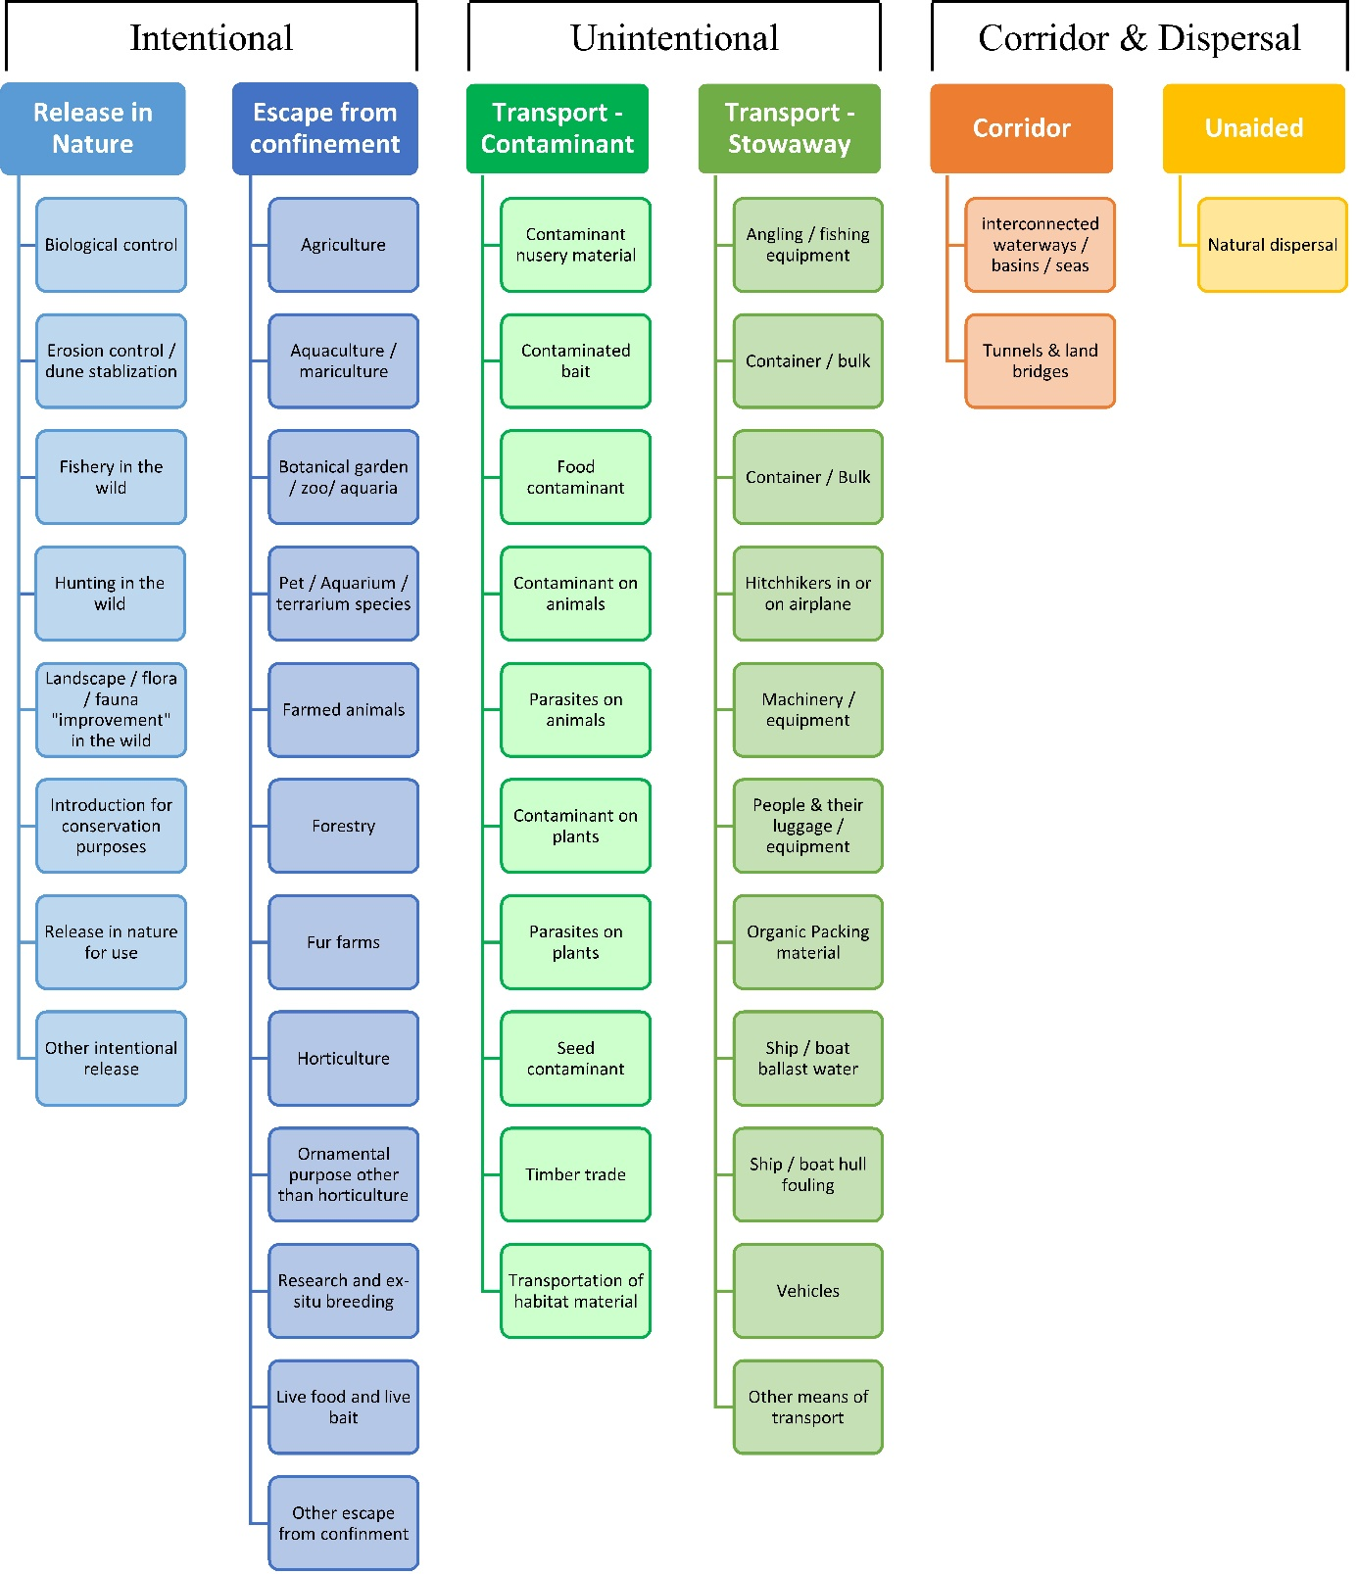

# ANNEX V Ecosystem services classification (CICES V5.1, simplified) and examples

For the purposes of this risk assessment, please feel free to use what seems as the most appropriate category / level / combination of impact (Section – Division – Group), reflecting information available.

|  |  |  |  |
| --- | --- | --- | --- |
| **Section** | **Division** | **Group** | **Examples (i.e. relevant CICES “classes”)** |
| **Provisioning** | **Biomass** | **Cultivated *terrestrial* plants** | Cultivated terrestrial plants (including fungi, algae) grown for nutritional purposes;  Fibres and other materials from cultivated plants, fungi, algae and bacteria for direct use or processing (excluding genetic materials);  Cultivated plants (including fungi, algae) grown as a source of energy  *Example: negative impacts of non-native organisms to crops, orchards, timber etc.* |
|  |  | **Cultivated *aquatic* plants** | Plants cultivated by in- situ aquaculture grown for nutritional purposes;  Fibres and other materials from in-situ aquaculture for direct use or processing (excluding genetic materials);  Plants cultivated by in- situ aquaculture grown as an energy source.  *Example: negative impacts of non-native organisms to aquatic plants cultivated for nutrition, gardening etc. purposes.* |
|  |  | **Reared animals** | Animals reared for nutritional purposes;  Fibres and other materials from reared animals for direct use or processing (excluding genetic materials);  Animals reared to provide energy (including mechanical)  *Example: negative impacts of non-native organisms to livestock* |
|  |  | **Reared *aquatic* animals** | Animals reared by in-situ aquaculture for nutritional purposes;  Fibres and other materials from animals grown by in-situ aquaculture for direct use or processing (excluding genetic materials);  Animals reared by in-situ aquaculture as an energy source  *Example: negative impacts of non-native organisms to fish farming* |
|  |  | **Wild plants** (terrestrial and aquatic) | Wild plants (terrestrial and aquatic, including fungi, algae) used for nutrition;  Fibres and other materials from wild plants for direct use or processing (excluding genetic materials);  Wild plants (terrestrial and aquatic, including fungi, algae) used as a source of energy  *Example: reduction in the availability of wild plants (e.g. wild berries, ornamentals) due to non-native organisms (competition, spread of disease etc.)* |
|  |  | **Wild animals** (terrestrial and aquatic) | Wild animals (terrestrial and aquatic) used for nutritional purposes;  Fibres and other materials from wild animals for direct use or processing (excluding genetic materials);  Wild animals (terrestrial and aquatic) used as a source of energy  *Example: reduction in the availability of wild animals (e.g. fish stocks, game) due to non-native organisms (competition, predations, spread of disease etc.)* |
|  | **Genetic material** from all biota | **Genetic material** from plants, algae or fungi | Seeds, spores and other plant materials collected for maintaining or establishing a population;  Higher and lower plants (whole organisms) used to breed new strains or varieties;  Individual genes extracted from higher and lower plants for the design and construction of new biological entities  *Example: negative impacts of non-native organisms due to interbreeding* |
|  |  | **Genetic material** from animals | Animal material collected for the purposes of maintaining or establishing a population;  Wild animals (whole organisms) used to breed new strains or varieties;  Individual genes extracted from organisms for the design and construction of new biological entities  *Example: negative impacts of non-native organisms due to interbreeding* |
|  | **Water[6]** | **Surface water** used for nutrition, materials or energy | Surface water for drinking;  Surface water used as a material (non-drinking purposes);  Freshwater surface water, coastal and marine water used as an energy source  *Example: loss of access to surface water due to spread of non-native organisms* |
|  |  | **Ground water** for used for nutrition, materials or energy | Ground (and subsurface) water for drinking;  Ground water (and subsurface) used as a material (non-drinking purposes);  Ground water (and subsurface) used as an energy source  *Example: reduced availability of ground water due to spread of non-native organisms and associated increase of ground water consumption by vegetation.* |
| **Regulation & Maintenance** | **Transformation** of biochemical or physical inputs to ecosystems | **Mediation of wastes or toxic substances** of anthropogenic origin by living processes | Bio-remediation by micro-organisms, algae, plants, and animals; Filtration/sequestration/storage/accumulation by micro-organisms, algae, plants, and animals  *Example: changes caused by non-native organisms to ecosystem functioning and ability to filtrate etc. waste or toxics* |
|  |  | **Mediation of nuisances** of anthropogenic origin | Smell reduction; noise attenuation; visual screening (e.g. by means of green infrastructure)  *Example: changes caused by non-native organisms to ecosystem structure, leading to reduced ability to mediate nuisances.* |
|  | **Regulation** of physical, chemical, biological conditions | **Baseline flows and extreme event** regulation | Control of erosion rates;  Buffering and attenuation of mass movement;  Hydrological cycle and water flow regulation (Including flood control, and coastal protection);  Wind protection;  Fire protection  *Example: changes caused by non-native organisms to ecosystem functioning or structure leading to, for example, destabilisation of soil, increased risk or intensity of wild fires etc.* |
|  |  | **Lifecycle maintenance**, habitat and gene pool protection | Pollination (or 'gamete' dispersal in a marine context);  Seed dispersal;  Maintaining nursery populations and habitats (Including gene pool protection)  *Example: changes caused by non-native organisms to the abundance and/or distribution of wild pollinators; changes to the availability / quality of nursery habitats for fisheries* |
|  |  | **Pest and disease control** | Pest control;  Disease control  *Example: changes caused by non-native organisms to the abundance and/or distribution of pests* |
|  |  | **Soil quality** regulation | Weathering processes and their effect on soil quality;  Decomposition and fixing processes and their effect on soil quality  *Example: changes caused by non-native organisms to vegetation structure and/or soil fauna leading to reduced soil quality* |
|  |  | **Water** conditions | Regulation of the chemical condition of freshwaters by living processes;  Regulation of the chemical condition of salt waters by living processes  *Example: changes caused by non-native organisms to buffer strips along water courses that remove nutrients in runoff and/or fish communities that regulate the resilience and resistance of water bodies to eutrophication* |
|  |  | **Atmospheric** composition and conditions | Regulation of chemical composition of atmosphere and oceans;  Regulation of temperature and humidity, including ventilation and transpiration  *Example: changes caused by non-native organisms to ecosystems’ ability to sequester carbon and/or evaporative cooling (e.g. by urban trees)* |
| **Cultural** | **Direct, in-situ and outdoor interactions** with living systems that depend on presence in the environmental setting | **Physical and experiential** interactions with natural environment | Characteristics of living systems that that enable activities promoting health, recuperation or enjoyment through active or immersive interactions;  Characteristics of living systems that enable activities promoting health, recuperation or enjoyment through passive or observational interactions  *Example: changes caused by non-native organisms to the qualities of ecosystems (structure, species composition etc.) that make it attractive for recreation, wild life watching etc.* |
|  |  | **Intellectual and representative** interactions with natural environment | Characteristics of living systems that enable scientific investigation or the creation of traditional ecological knowledge;  Characteristics of living systems that enable education and training;  Characteristics of living systems that are resonant in terms of culture or heritage;  Characteristics of living systems that enable aesthetic experiences  *Example: changes caused by non-native organisms to the qualities of ecosystems (structure, species composition etc.) that have cultural importance* |
|  | **Indirect, remote, often indoor interactions** with living systems that do not require presence in the environmental setting | **Spiritual, symbolic** and other interactions with natural environment | Elements of living systems that have symbolic meaning;  Elements of living systems that have sacred or religious meaning;  Elements of living systems used for entertainment or representation  *Example: changes caused by non-native organisms to the qualities of ecosystems (structure, species composition etc.) that have sacred or religious meaning* |
|  |  | Other biotic characteristics that have a **non-use value** | Characteristics or features of living systems that have an existence value;  Characteristics or features of living systems that have an option or bequest value  *Example: changes caused by non-native organisms to ecosystems designated as wilderness areas, habitats of endangered species etc.* |

# ANNEX VI EU Biogeographic Regions and MSFD Subregions

See <https://www.eea.europa.eu/data-and-maps/figures/biogeographical-regions-in-europe-2> ,

<http://ec.europa.eu/environment/nature/natura2000/biogeog_regions/>

and

https://www.eea.europa.eu/data-and-maps/data/msfd-regions-and-subregions-1/technical-document/pdf

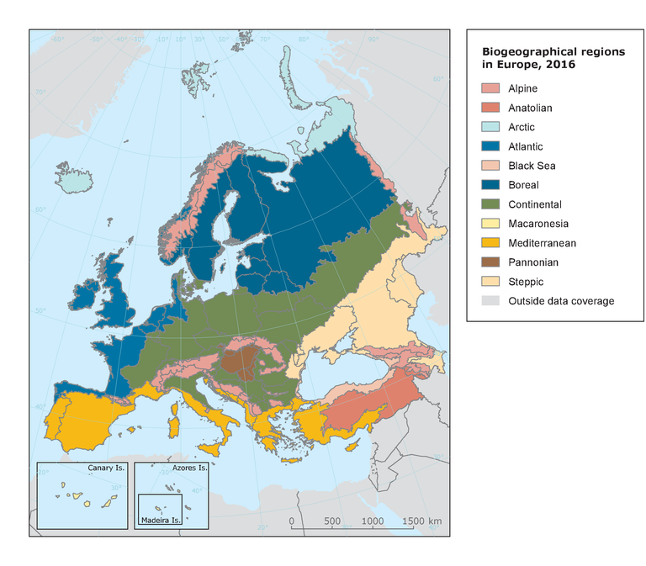 

# ANNEX VII Delegated Regulation (EU) 2018/968 of 30 April 2018

see <https://eur-lex.europa.eu/legal-content/en/TXT/?uri=CELEX%3A32018R0968>

# ANNEX VIII Projection of environmental suitability for the establishment of the red-whiskered bulbul *Pycnonotus jocosus* in Europe

Björn Beckmann, Tim Adriaens, Bram D’hondt, Riccardo Scalera, Wolfgang Rabitsch and Dan Chapman

15 June 2021 (version 3)

## Aim

To project the suitability for potential establishment of the red-whiskered bulbul *Pycnonotus jocosus* in Europe, under current and predicted future climatic conditions.

## Data for modelling

Species occurrence data were obtained from the Global Biodiversity Information Facility (GBIF) (291092 records), the Biodiversity Information Serving Our Nation database (BISON) (10458 records), iNaturalist (3915 records), the Integrated Digitized Biocollections (iDigBio) (38 records), the VertNet databases (30 records), and additional records from the risk assessment team. We scrutinised occurrence records from regions where the species is not known to be established and removed any dubious records or where the georeferencing was too imprecise (e.g. records referenced to a country or island centroid) or outside of the coverage of the predictor layers (e.g. small island or coastal occurrences). The remaining records were gridded at a 0.25 x 0.25 degree resolution for modelling, yielding 2.307 grid cells with occurrences (Figure 1a). As a proxy for recording effort, the density of Aves records held by GBIF was also compiled on the same grid (Figure 1b).

**Figure 1.** (a) Occurrence records obtained for the red-whiskered bulbul and used in the modelling, showing native and invaded distributions. (b) The recording density of Aves on GBIF, which was used as a proxy for recording effort.

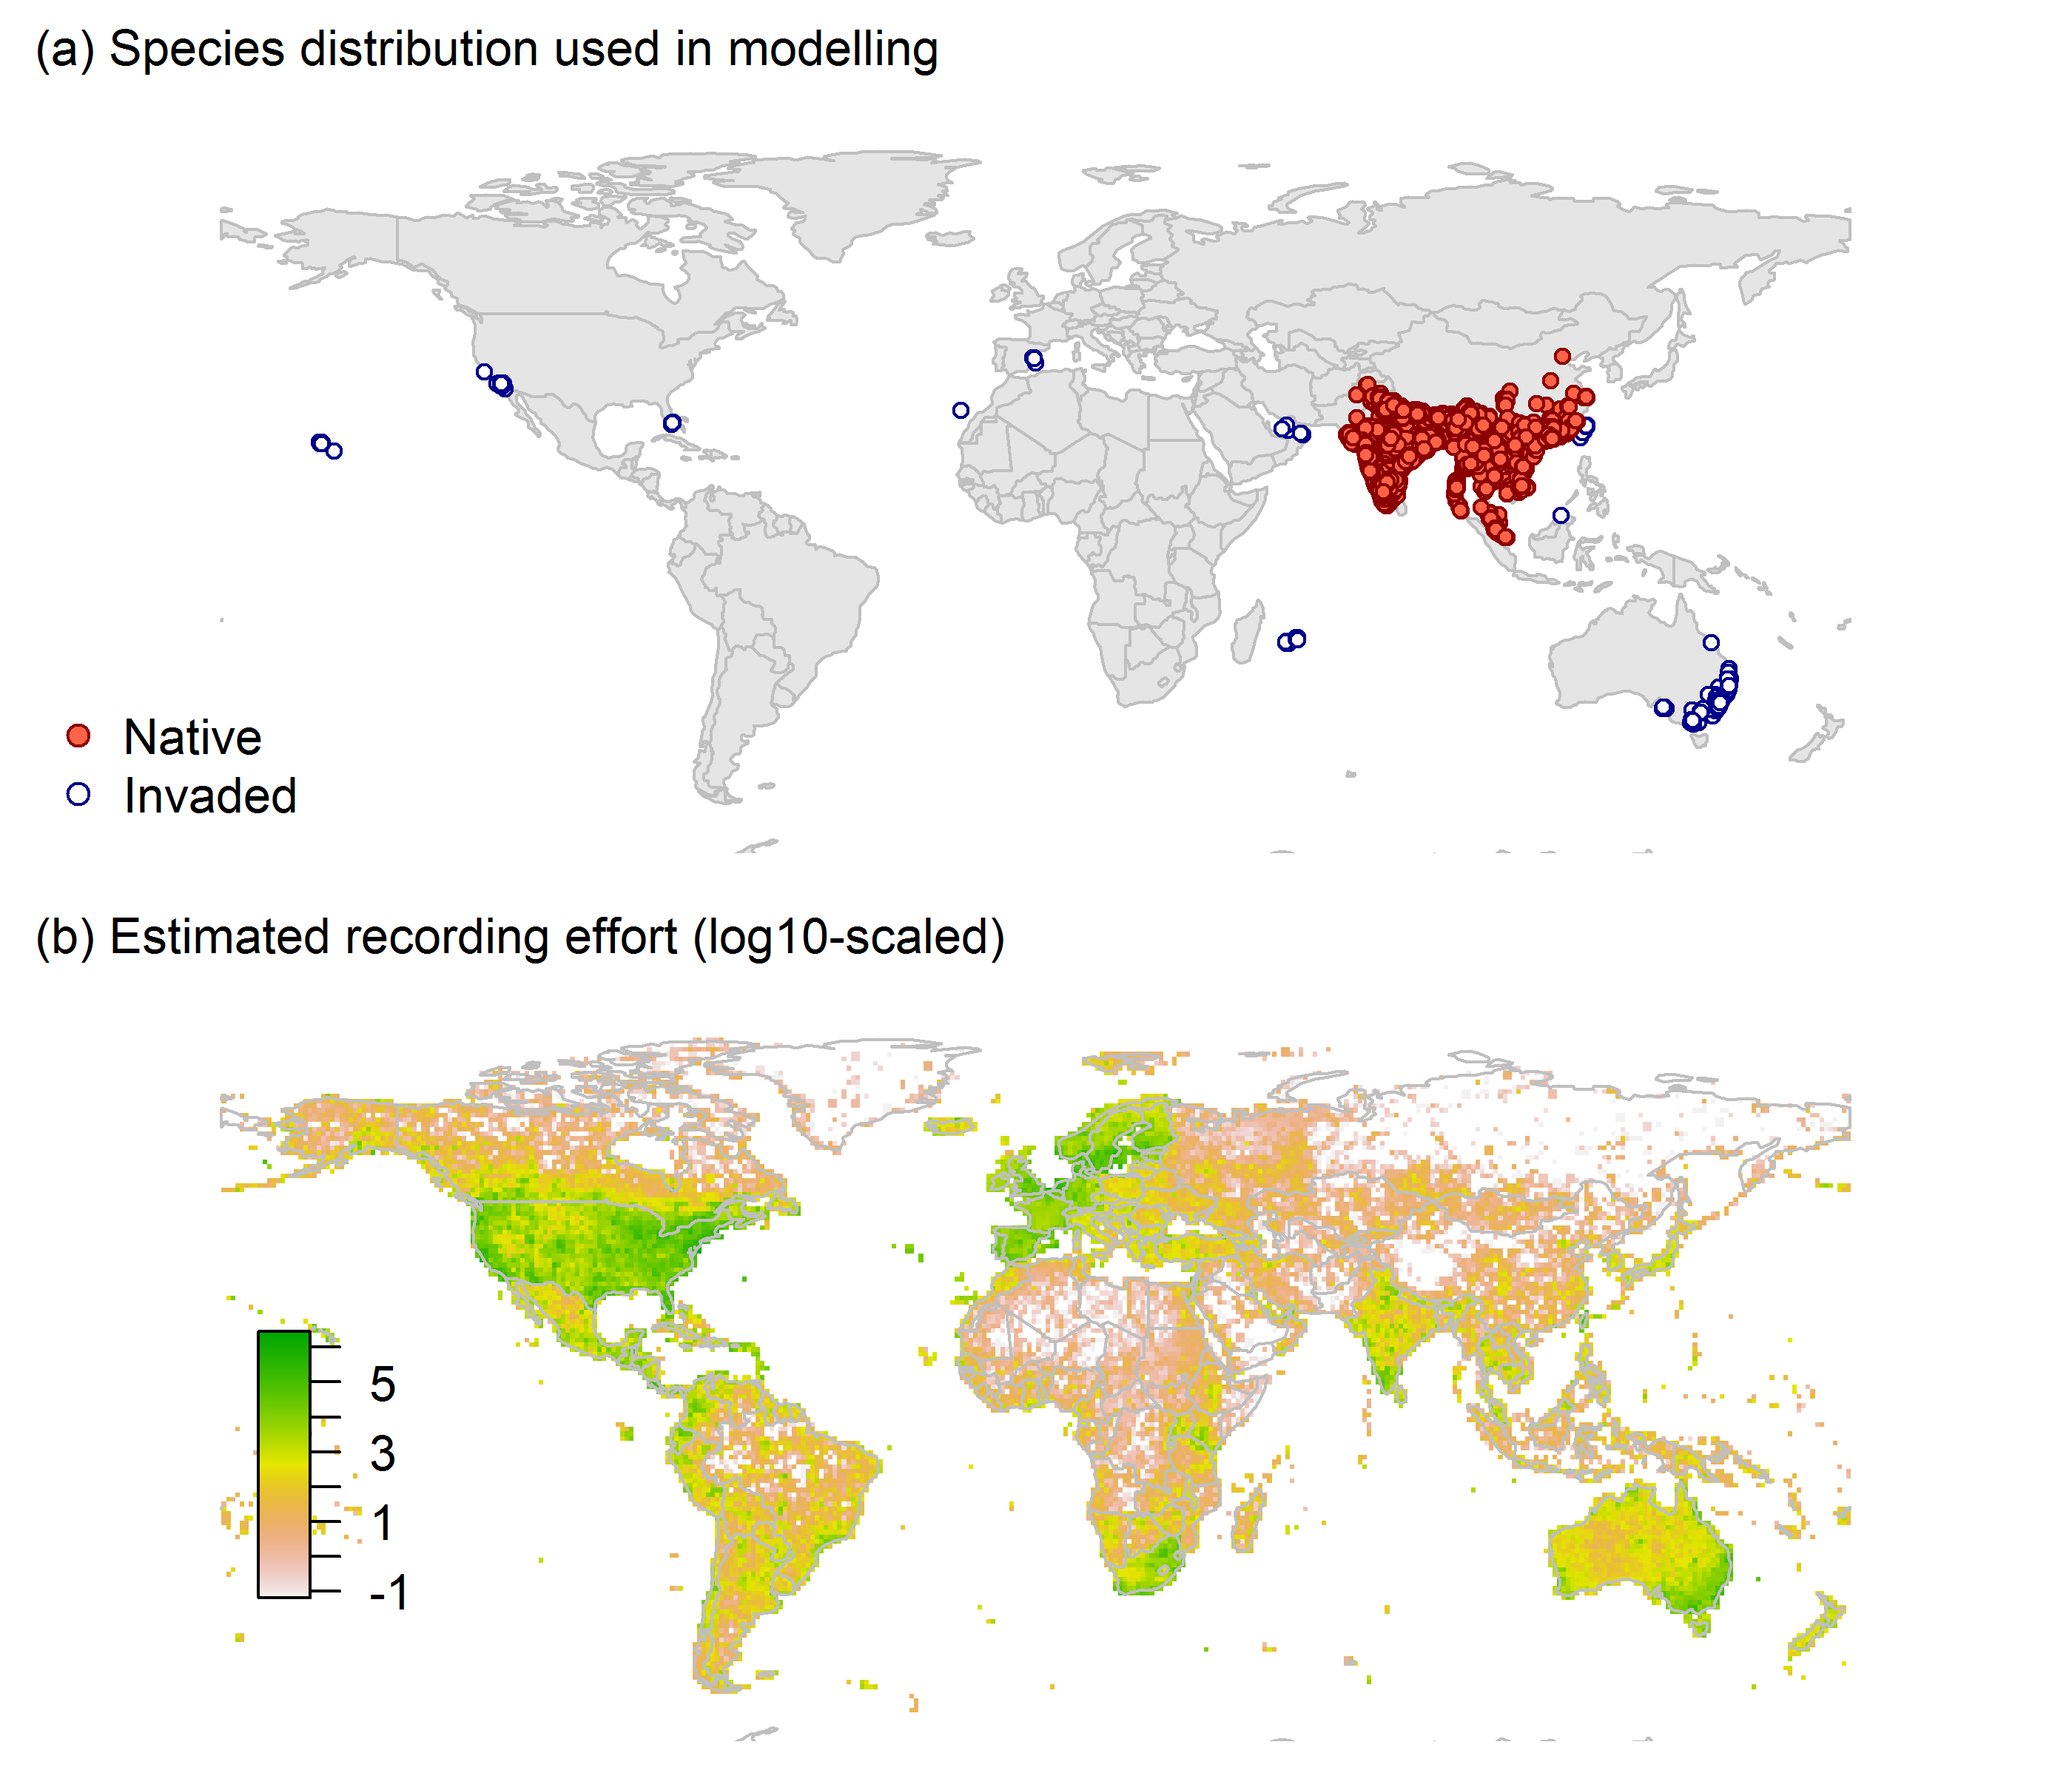

Climate data were selected from the ‘Bioclim’ variables contained within the WorldClim database (Hijmans et al., 2005), originally at 5 arcminute resolution (0.083 x 0.083 degrees of longitude/latitude) and aggregated to a 0.25 x 0.25 degree grid for use in the model.

Based on the biology of the red-whiskered bulbul, the following climate variables were used in the modelling:

* Annual mean temperature (Bio1)
* Minimum temperature of the coldest month (Bio6)
* Mean temperature of the warmest quarter (Bio10)
* Annual precipitation (Bio12)
* Precipitation of the wettest month (Bio13)
* Precipitation of the driest month (Bio14)
* Climatic moisture index (CMI): ratio of mean annual precipitation to potential evapotranspiration, log+1 transformed. For its calculation, monthly potential evapotranspirations were estimated from the WorldClim monthly temperature data and solar radiation using the simple method of Zomer et al. (2008) which is based on the Hargreaves evapotranspiration equation (Hargreaves, 1994).

To estimate the effect of climate change on the potential distribution, equivalent modelled future climate conditions for the 2070s under the Representative Concentration Pathways (RCP) 2.6 and 4.5 were also obtained. These represent low and medium emissions scenarios, respectively. The above variables were obtained as averages of outputs of eight Global Climate Models (BCC-CSM1-1, CCSM4, GISS-E2-R, HadGEM2-AO, IPSL-CM5A-LR, MIROC-ESM, MRI-CGCM3, NorESM1-M), downscaled and calibrated against the WorldClim baseline (<http://www.worldclim.org/cmip5_5m> ).

The following habitat layers were also used:

* Tree cover (Tree): This was estimated from the MODerate-resolution Imaging Spectroradiometer (MODIS) satellite continuous tree cover raster product, produced by the Global Land Cover Facility (<http://glcf.umd.edu/data/vcf/>). The raw product contains the percentage cover by trees in each 0.002083 x 0.002083 degree grid cell. We aggregated this to the mean cover in our 0.25 x 0.25 degree grid cells.
* Human influence index (HII): As many non-native invasive species associate with anthropogenically disturbed habitats. We used the Global Human Influence Index Dataset of the Last of the Wild Project (Wildlife Conservation Society - WCS & Center for International Earth Science Information Network - CIESIN - Columbia University, 2005), which is developed from nine global data layers covering human population pressure (population density), human land use and infrastructure (built-up areas, nighttime lights, land use/land cover) and human access (coastlines, roads, railroads, navigable rivers). The index ranges between 0 and 1 and was ln+1 transformed for the modelling to improve normality.

## Species distribution model

A presence-background (presence-only) ensemble modelling strategy was employed using the BIOMOD2 R package version 3.4.6 (Thuiller et al., 2020, Thuiller et al., 2009). These models contrast the environment at the species’ occurrence locations against a random sample of the global background environmental conditions (often termed ‘pseudo-absences’) in order to characterise and project suitability for occurrence. This approach has been developed for distributions that are in equilibrium with the environment. Because invasive species’ distributions are not at equilibrium and subject to dispersal constraints at a global scale, we took care to minimise the inclusion of locations suitable for the species but where it has not been able to disperse to (Chapman et al. 2019). Therefore the background sampling region included:

* The area accessible by native red-whiskered bulbul populations, in which the species is likely to have had sufficient time to disperse to all locations. Based on presumed maximum dispersal distances, the accessible region was defined as a 400km buffer around the native range occurrences; AND
* A 30 km buffer around the non-native occurrences, encompassing regions likely to have had high propagule pressure for introduction by humans and/or dispersal of the species; AND
* Regions where we have an *a priori* expectation of high unsuitability for the species so that absence is assumed irrespective of dispersal constraints (see Figure 2). The following rules were applied to define a region expected to be highly unsuitable for the red-whiskered bulbul at the spatial scale of the model:
  + Annual mean temperature (Bio1) < 4°C
  + Annual precipitation (Bio12) < 55mm

Altogether, only 0.3% of occurrence grid cells were located in the unsuitable background region.

Within the unsuitable background region, 10 samples of 5.000 randomly sampled grid cells were obtained. In the accessible background (comprising the accessible areas around native and non-native occurrences as detailed above), the same number of pseudo-absence samples were drawn as there were presence records (2307), weighting the sampling by a proxy for recording effort (Figure 2).

**Figure 2.** The background from which pseudo-absence samples were taken in the modelling of the red-whiskered bulbul. Samples were taken from a 400 km buffer around the native range and a 30 km buffer around non-native occurrences (together forming the accessible background), and from areas expected to be highly unsuitable for the species (the unsuitable background region). Samples from the accessible background were weighted by a proxy for recording effort (Figure 1(b)).

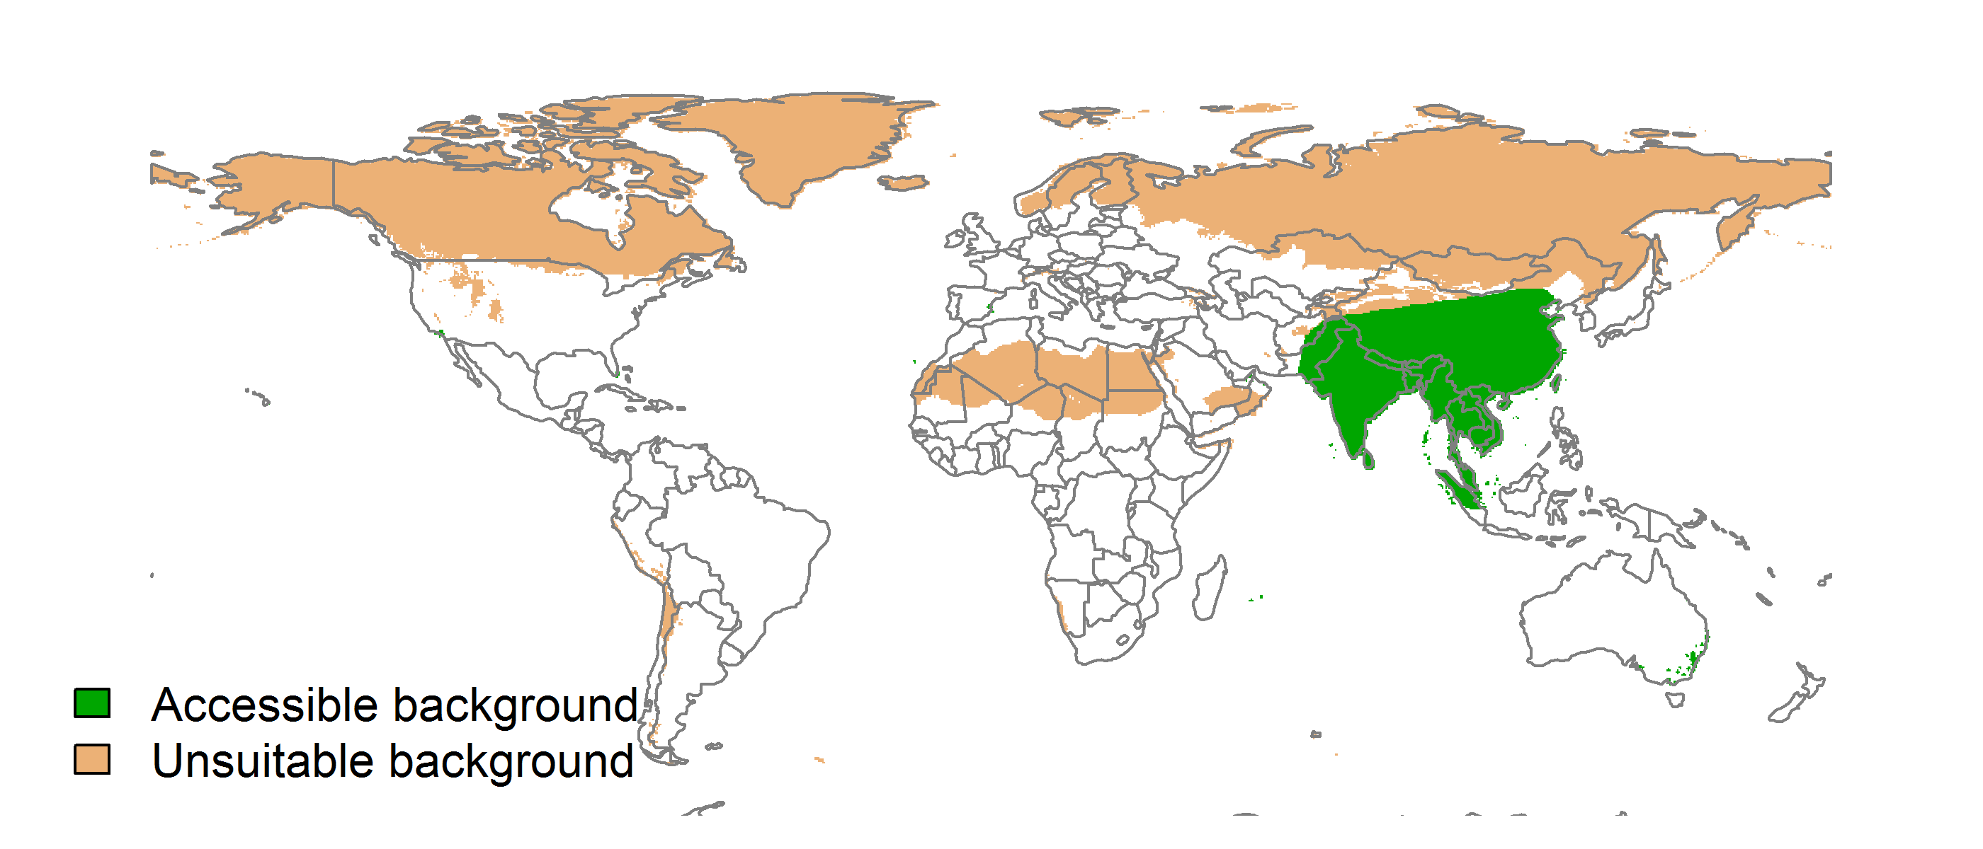

Each dataset (i.e. combination of the presences and the individual background samples) was randomly split into 80% for model training and 20% for model evaluation. With each training dataset, seven statistical algorithms were fitted with the default BIOMOD2 settings and rescaled using logistic regression, except where specified below:

* Generalised linear model (GLM)
* Generalised boosting model (GBM)
* Generalised additive model (GAM) with a maximum of four degrees of freedom per smoothing spline
* Artificial neural network (ANN)
* Multivariate adaptive regression splines (MARS)
* Random forest (RF)
* Maxent

Since the total background sample was larger than the number of occurrences, prevalence fitting weights were applied to give equal overall importance to the occurrences and the background. Normalised variable importance was assessed and variable response functions were produced using BIOMOD2’s default procedure.

Model predictive performance was assessed by the following three measures:

* AUC, the area under the receiver operating characteristic curve (Fielding & Bell 1997). Predictions of presence-absence models can be compared with a subset of records set aside for model evaluation (here 20%) by constructing a confusion matrix with the number of true positive, false positive, false negative and true negative cases. For models generating non-dichotomous scores (as here) a threshold can be applied to transform the scores into a dichotomous set of presence-absence predictions. Two measures that can be derived from the confusion matrix are sensitivity (the proportion of observed presences that are predicted as such, quantifying omission errors), and specificity (the proportion of observed absences that are predicted as such, quantifying commission errors). A receiver operating characteristic (ROC) curve can be constructed by using all possible thresholds to classify the scores into confusion matrices, obtaining sensitivity and specificity for each matrix, and plotting sensitivity against the corresponding proportion of false positives (equal to 1 - specificity). The use of all possible thresholds avoids the need for a selection of a single threshold, which is often arbitrary, and allows appreciation of the trade-off between sensitivity and specificity. The area under the ROC curve (AUC) is often used as a single threshold-independent measure for model performance (Manel, Williams & Ormerod 2001). AUC is the probability that a randomly selected presence has a higher model-predicted suitability than a randomly selected absence (Allouche et al. 2006).
* Cohen’s Kappa (Cohen 1960). This measure corrects the overall accuracy of model predictions (ratio of the sum of true presences plus true absences to the total number of records) by the accuracy expected to occur by chance. The kappa statistic ranges from -1 to +1, where +1 indicates perfect agreement and values of zero or less indicate a performance no better than random. Advantages of kappa are its simplicity, the fact that both commission and omission errors are accounted for in one parameter, and its relative tolerance to zero values in the confusion matrix (Manel, Williams & Ormerod 2001). However, Kappa has been criticised for being sensitive to prevalence (the proportion of sites in which the species was recorded as present) and may therefore be inappropriate for comparisons of model accuracy between species or regions (McPherson, Jetz & Rogers 2004, Allouche et al. 2006).
* TSS, the true skill statistic (Allouche et al. 2006). TSS is defined as sensitivity + specificity - 1, and corrects for Kappa’s dependency on prevalence. TSS compares the number of correct forecasts, minus those attributable to random guessing, to that of a hypothetical set of perfect forecasts. Like Kappa, TSS takes into account both omission and commission errors, and success as a result of random guessing, and ranges from -1 to +1, where +1 indicates perfect agreement and values of zero or less indicate a performance no better than random (Allouche et al. 2006).

An ensemble model was created by first rejecting poorly performing algorithms with relatively extreme low AUC values and then averaging the predictions of the remaining algorithms, weighted by their AUC. To identify poorly performing algorithms, AUC values were converted into modified z-scores based on their difference to the median and the median absolute deviation across all algorithms (Iglewicz & Hoaglin 1993). Algorithms with z < -2 were rejected. In this way, ensemble projections were made for each dataset and then averaged to give an overall suitability, as well as its standard deviation.

Projections were classified into suitable and unsuitable regions using a “lowest presence threshold” (Pearson et al. 2007), setting the cut-off as the lowest value at which 98% of all presence records are classified correctly under the current climate (here 0.29). In order to express the sensitivity of classifications to the choice of this threshold, thresholds at which 95% and 99% of records are classified correctly (here 0.42 and 0.2 respectively) were used in the calculation of error bars in Figs. 9 and 10 below in addition to taking account of uncertainty in the projections themselves (cf. part (b) of Figs. 5,7,8). In other words, the upper error bars in Figs. 9 and 10 show proportions classified as suitable with a threshold of 0.2 (at which 99% of presence records are classified correctly), and are based on projected suitabilities plus the standard error in projections, while the lower error bars show proportions classified as suitable with a threshold of 0.42 (at which 95% of presence records are classified correctly), and are based on projected suitabilities minus the standard error in projections.

We also produced a limiting factor map for Europe following Elith et al. (2010). For this, projections were made separately with each individual variable fixed at a near-optimal value. These were chosen as the median values at the occurrence grid cells. Then, the most strongly limiting factors were identified as the ones resulting in the highest increase in suitability in each grid cell.

## Results

The ensemble model suggested that suitability for the red-whiskered bulbulwas most strongly determined by Annual mean temperature (Bio1), accounting for 40.5% of variation explained, followed by Minimum temperature of the coldest month (Bio6) (20.8%), Precipitation of the wettest month (Bio13) (8.7%), Annual precipitation (Bio12) (7.2%), Climatic moisture index (CMI) (6.8%), Mean temperature of the warmest quarter (Bio10) (6.2%), Human influence index (HII) (4.6%), Precipitation of the driest month (Bio14) (4.2%) and Global tree cover (Tree) (1%) (Table 1, Figure 3).

**Table 1.** Summary of the cross-validation predictive performance (AUC, Kappa, TSS) and variable importance of the fitted model algorithms and the ensemble (AUC-weighted average of the best performing algorithms). Results are the average from models fitted to 10 different background samples of the data.

|  |  |  |  |  |  |  |  |  |  |  |  |  |  |
| --- | --- | --- | --- | --- | --- | --- | --- | --- | --- | --- | --- | --- | --- |
|  |  |  |  |  | **Variable importance (%)** | | | | | | | | |
| **Algorithm** | **AUC** | **Kappa** | **TSS** | **Used in the ensemble** | **Annual mean temperature (Bio1)** | **Minimum temperature of the coldest month (Bio6)** | **Precipitation of the wettest month (Bio13)** | **Annual precipitation (Bio12)** | **Climatic moisture index (CMI)** | **Mean temperature of the warmest quarter (Bio10)** | **Human influence index (HII)** | **Precipitation of the driest month (Bio14)** | **Global tree cover (Tree)** |
| GLM | 0.895 | 0.561 | 0.703 | yes | 54 | 5 | 2 | 9 | 14 | 6 | 5 | 4 | 0 |
| GAM | 0.896 | 0.561 | 0.701 | yes | 57 | 5 | 4 | 2 | 12 | 7 | 8 | 4 | 1 |
| GBM | 0.897 | 0.571 | 0.699 | yes | 25 | 43 | 24 | 1 | 1 | 1 | 1 | 4 | 0 |
| ANN | 0.905 | 0.584 | 0.705 | yes | 25 | 24 | 11 | 12 | 2 | 17 | 6 | 3 | 1 |
| MARS | 0.894 | 0.561 | 0.703 | yes | 56 | 8 | 2 | 17 | 8 | 4 | 0 | 4 | 0 |
| RF | 0.832 | 0.514 | 0.682 | no | 20 | 19 | 22 | 6 | 6 | 6 | 7 | 10 | 4 |
| Maxent | 0.892 | 0.557 | 0.694 | yes | 27 | 39 | 8 | 3 | 4 | 2 | 8 | 5 | 4 |
| **Ensemble** | **0.903** | **0.576** | **0.703** |  | **41** | **21** | **9** | **7** | **7** | **6** | **5** | **4** | **1** |

**Figure 3.** Partial response plots from the fitted models. Thin coloured lines show responses from the algorithms in the ensemble, while the thick black line is their ensemble. In each plot, other model variables are held at their median value in the training data. Some of the divergence among algorithms is because of their different treatment of interactions among variables.

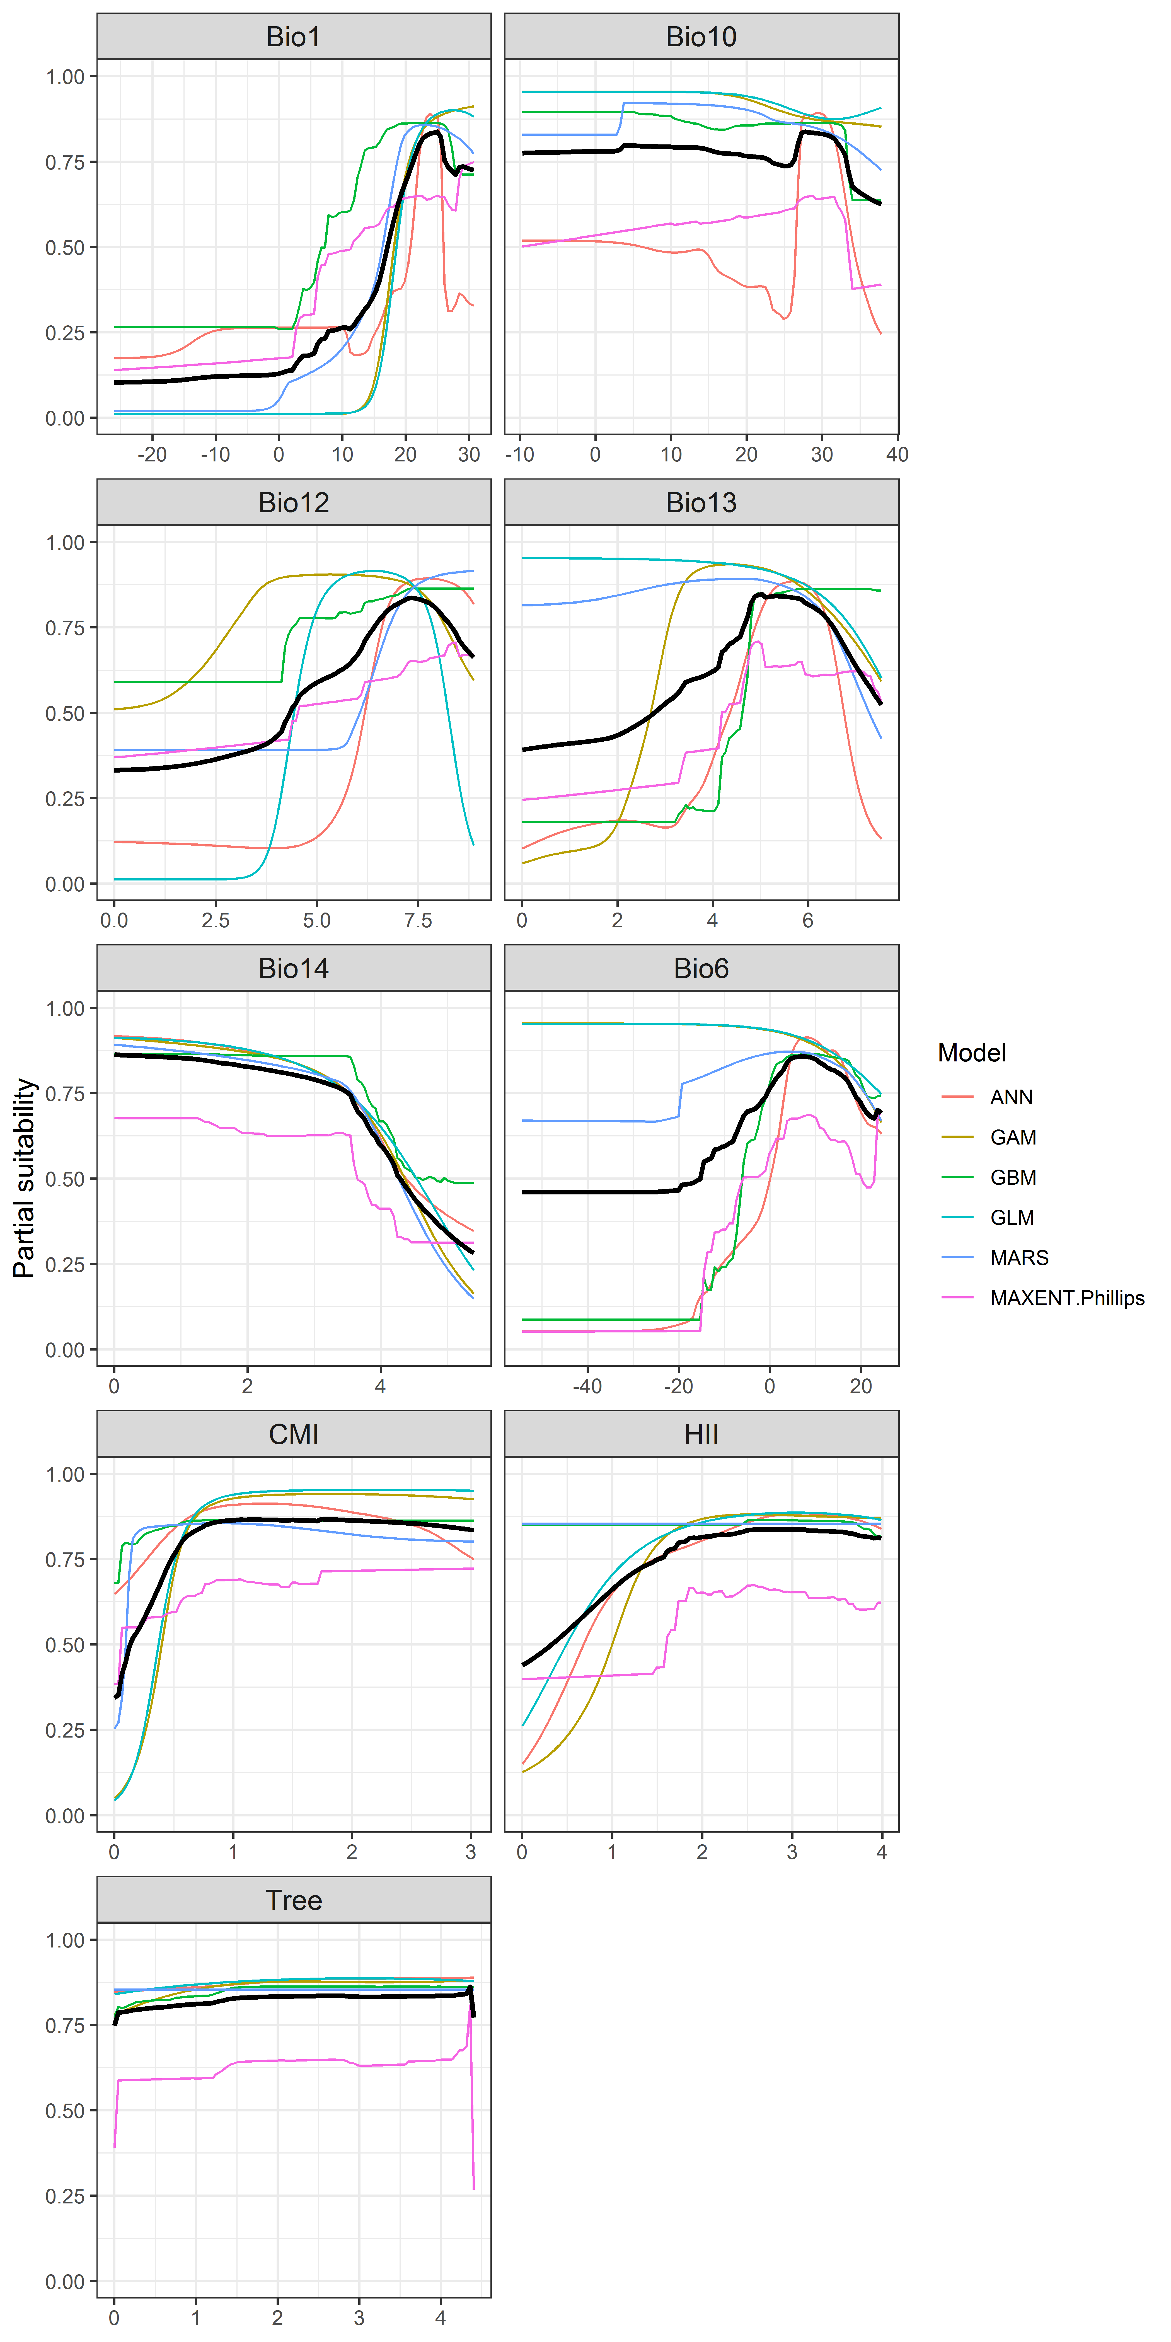

**Figure 4.** (a) Projected global suitability for the establishment of the red-whiskered bulbulin the current climate. For visualisation, the projection has been aggregated to a 0.5 x 0.5 degree resolution, by taking the maximum suitability of constituent higher resolution grid cells. Values > 0.29 are suitable for the species, with 98% of global presence records above this threshold. Values below 0.29 indicate lower relative suitability. (b) Uncertainty in the ensemble projections, expressed as the among-algorithm standard deviation in predicted suitability, averaged across the 10 datasets.

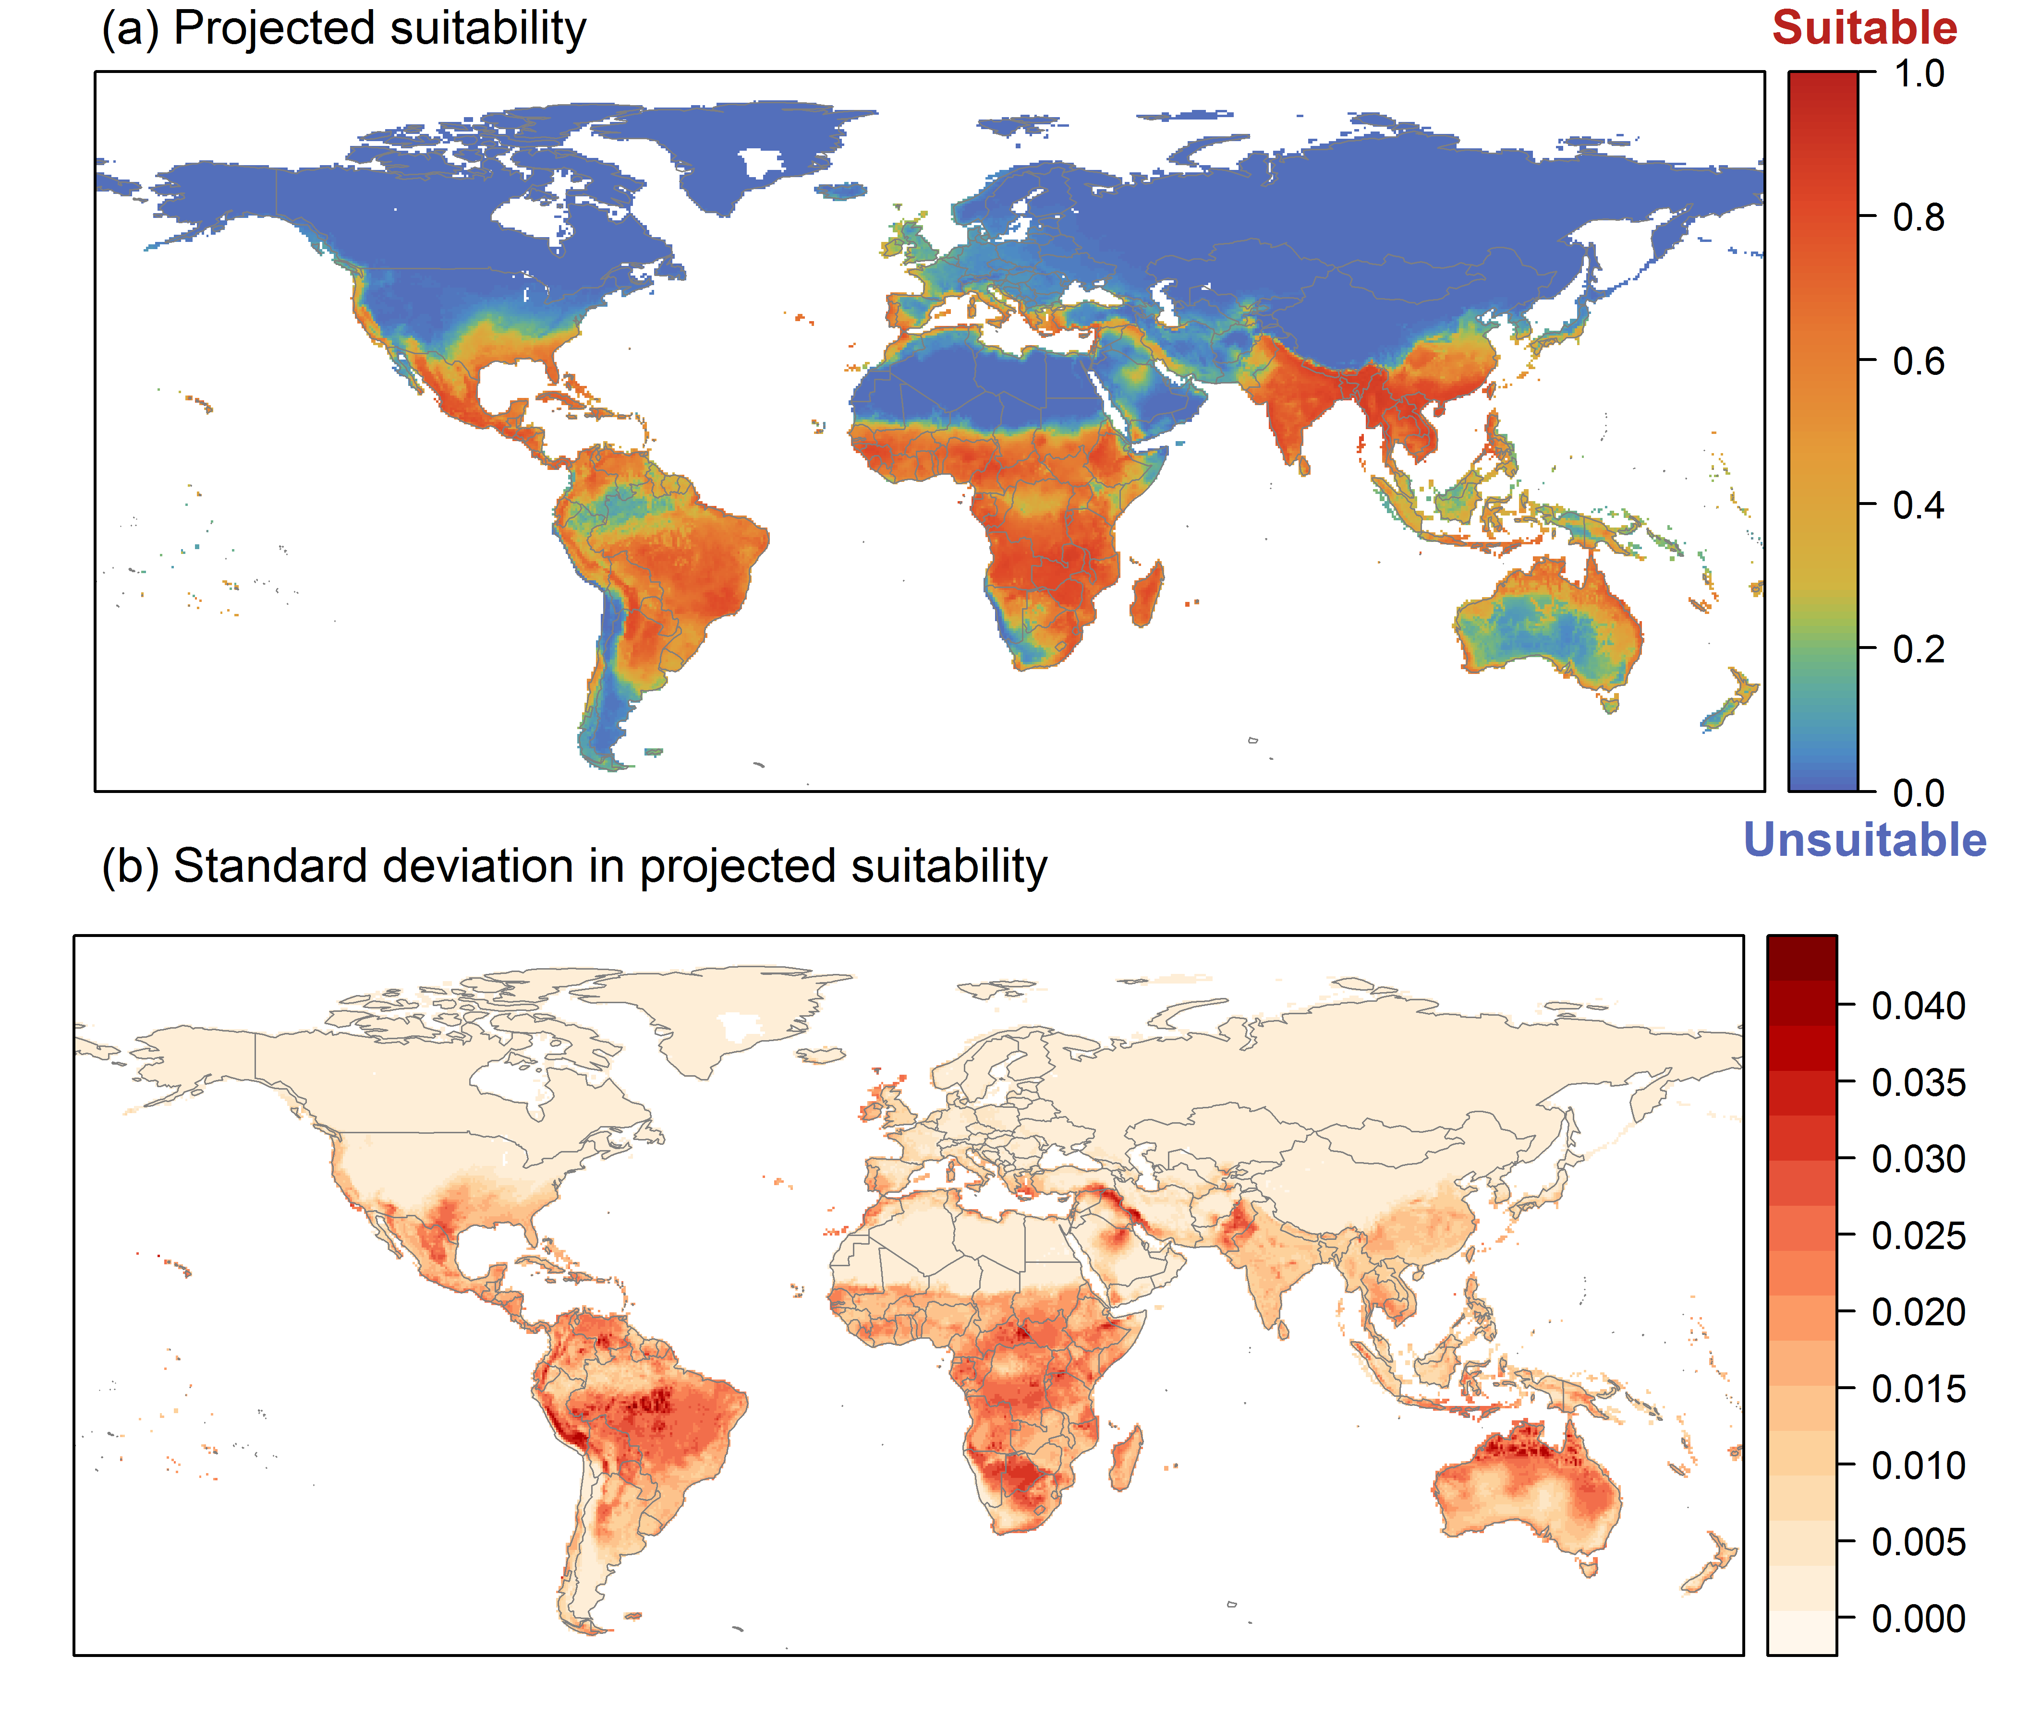

**Figure 5.** (a) Projected current suitability for the establishment of the red-whiskered bulbulin Europe and the Mediterranean region. Values > 0.29 are suitable for the species, with 98% of global presence records above this threshold. Values below 0.29 indicate lower relative suitability. (b) Uncertainty in the ensemble projections, expressed as the among-algorithm standard deviation in predicted suitability, averaged across the 10 datasets.

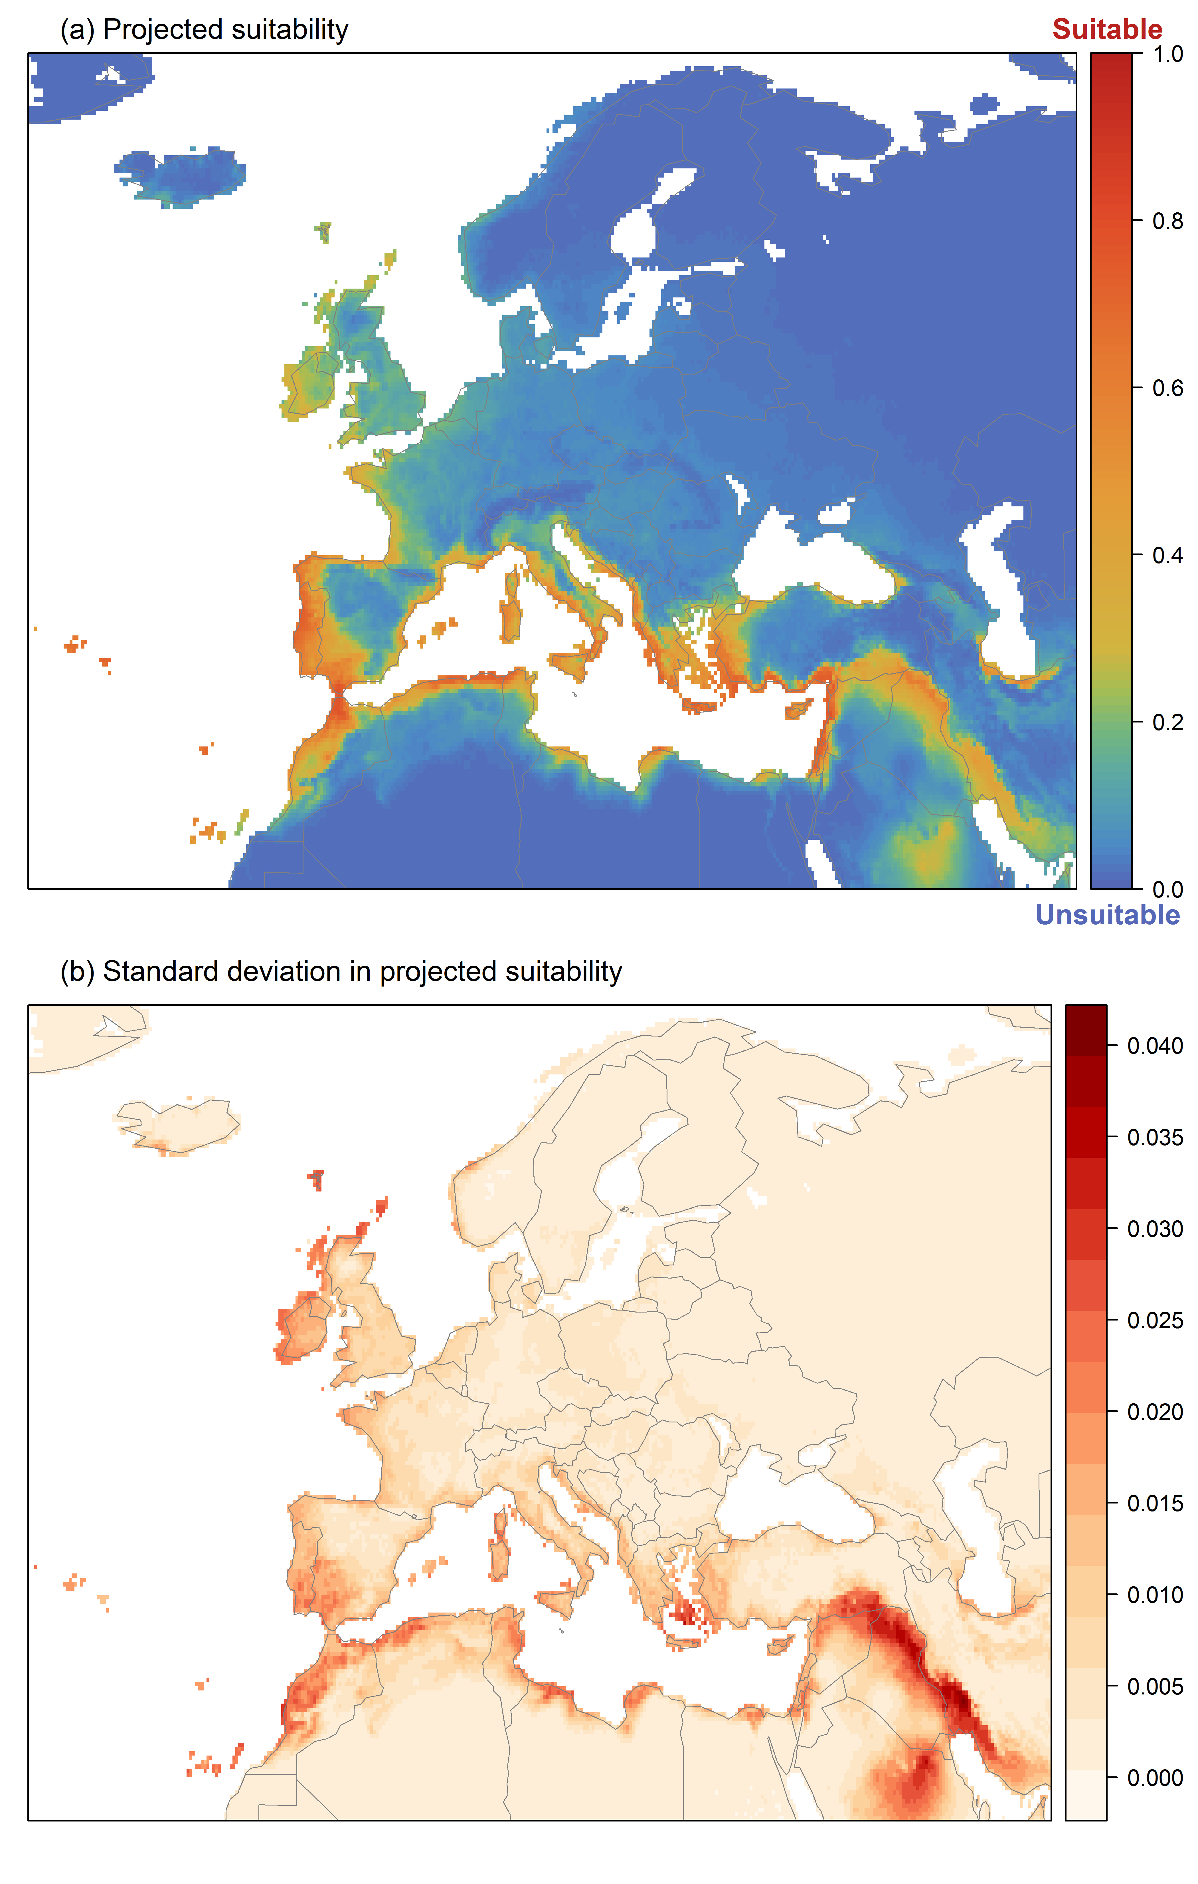

**Figure 6.** The most strongly limiting factors for the establishment of the red-whiskered bulbul estimated by the model in Europe and the Mediterranean region in current climatic conditions.

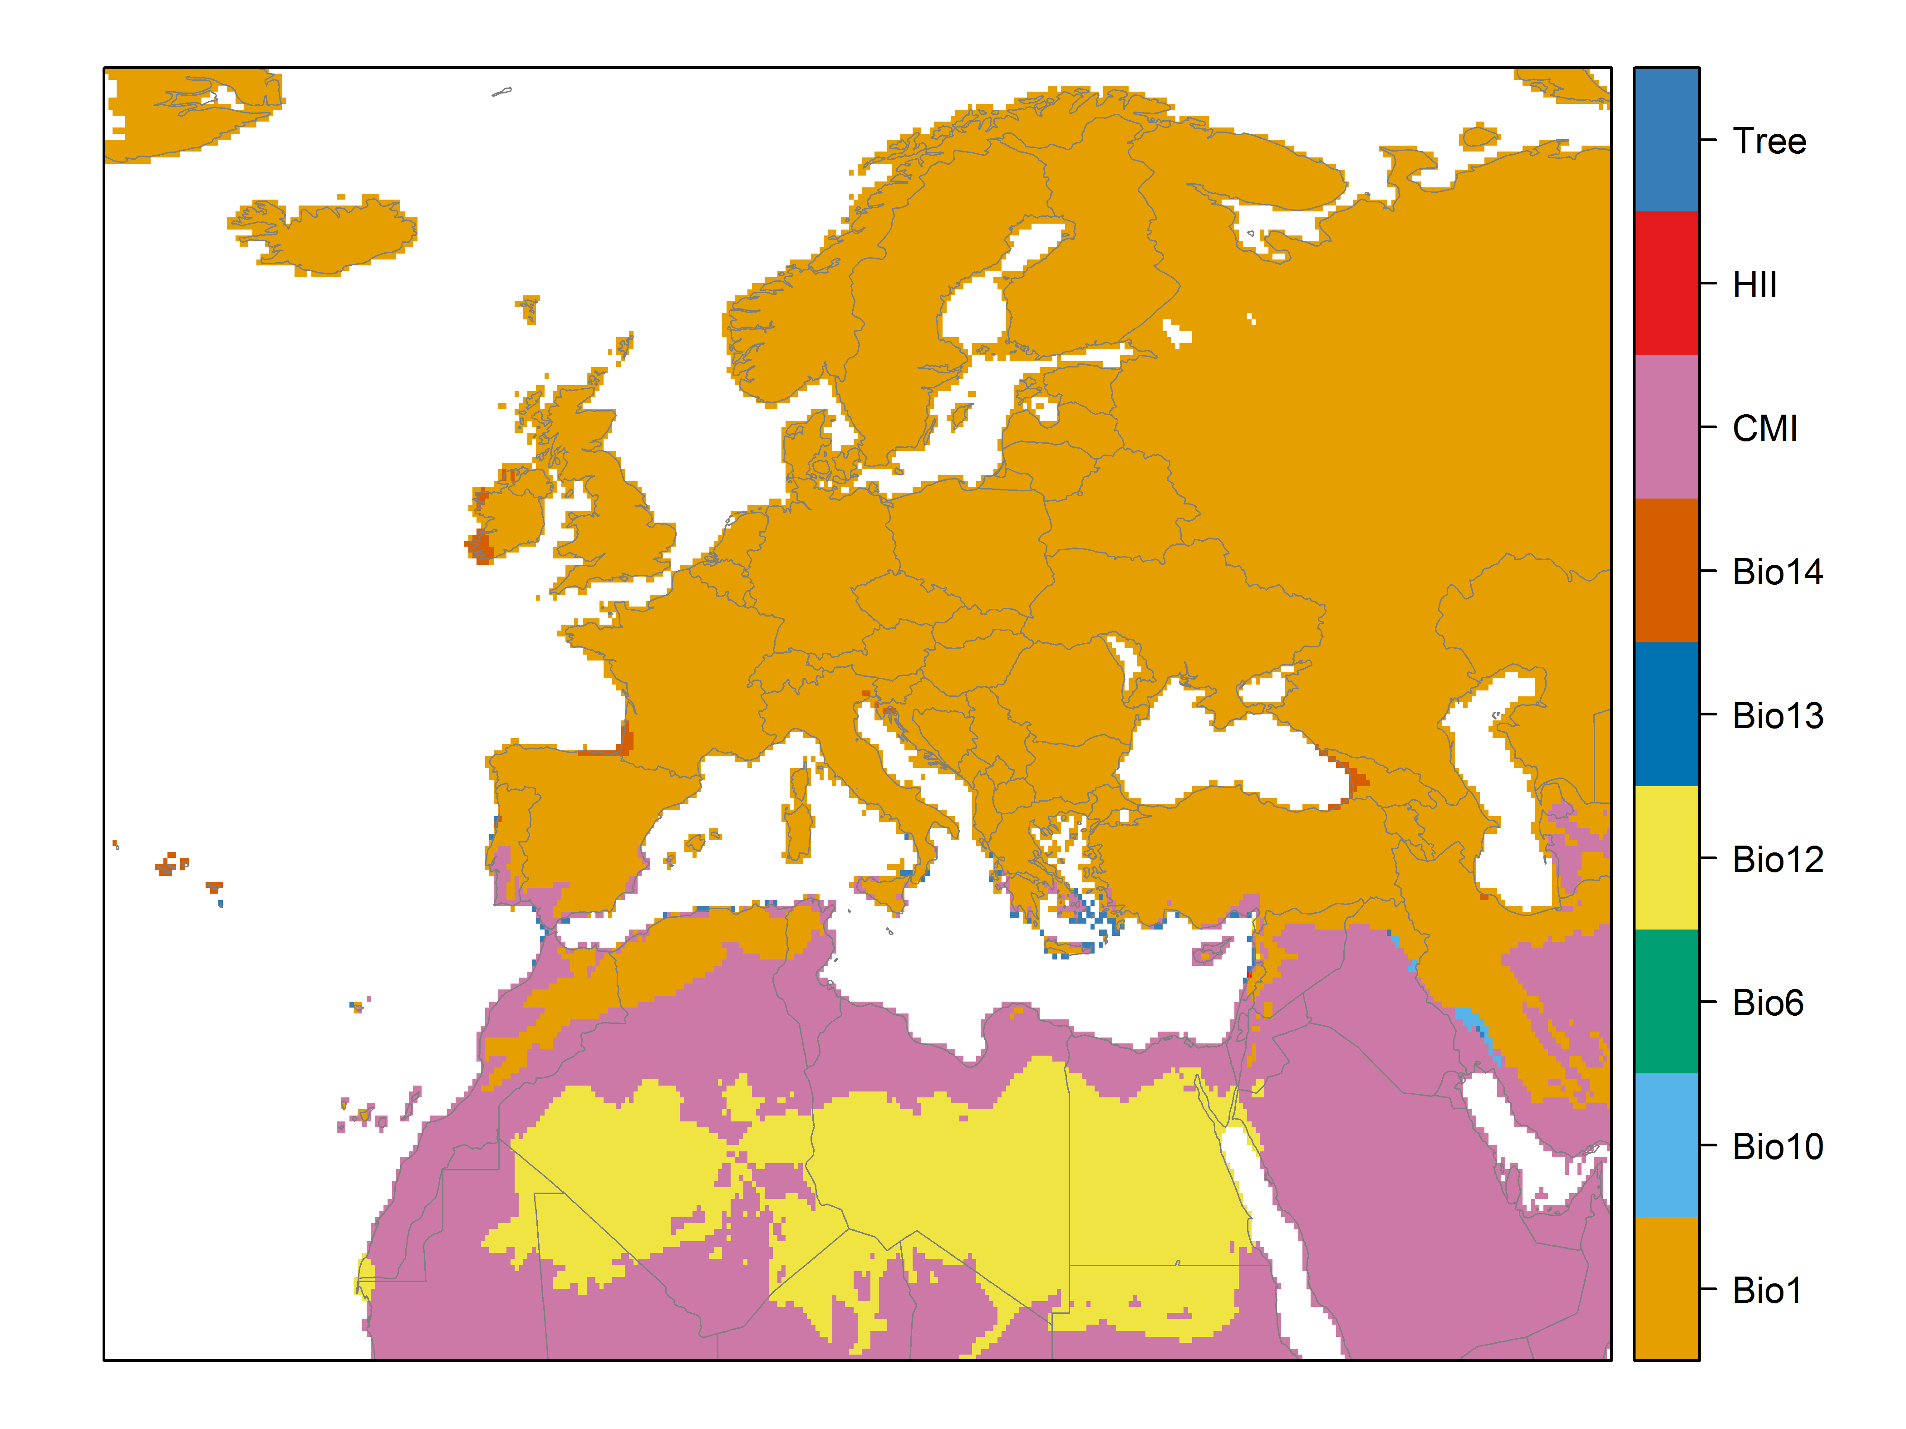

**Figure 7.** (a) Projected suitability for the establishment of the red-whiskered bulbulin Europe and the Mediterranean region in the 2070s under climate change scenario RCP2.6. Values > 0.29 are suitable for the species, with 98% of global presence records above this threshold under current climate. Values below 0.29 indicate lower relative suitability. (b) Uncertainty in the ensemble projections, expressed as the among-algorithm standard deviation in predicted suitability, averaged across the 10 datasets.

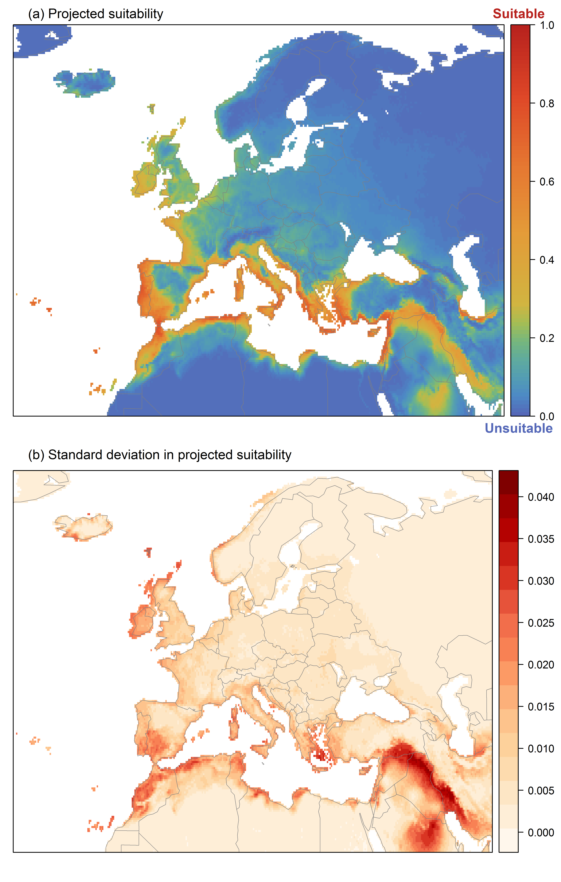

**Figure 8.** (a) Projected suitability for the establishment of the red-whiskered bulbul in Europe and the Mediterranean region in the 2070s under climate change scenario RCP4.5. Values > 0.29 are suitable for the species, with 98% of global presence records above this threshold under current climate. Values below 0.29 indicate lower relative suitability. (b) Uncertainty in the ensemble projections, expressed as the among-algorithm standard deviation in predicted suitability, averaged across the 10 datasets.

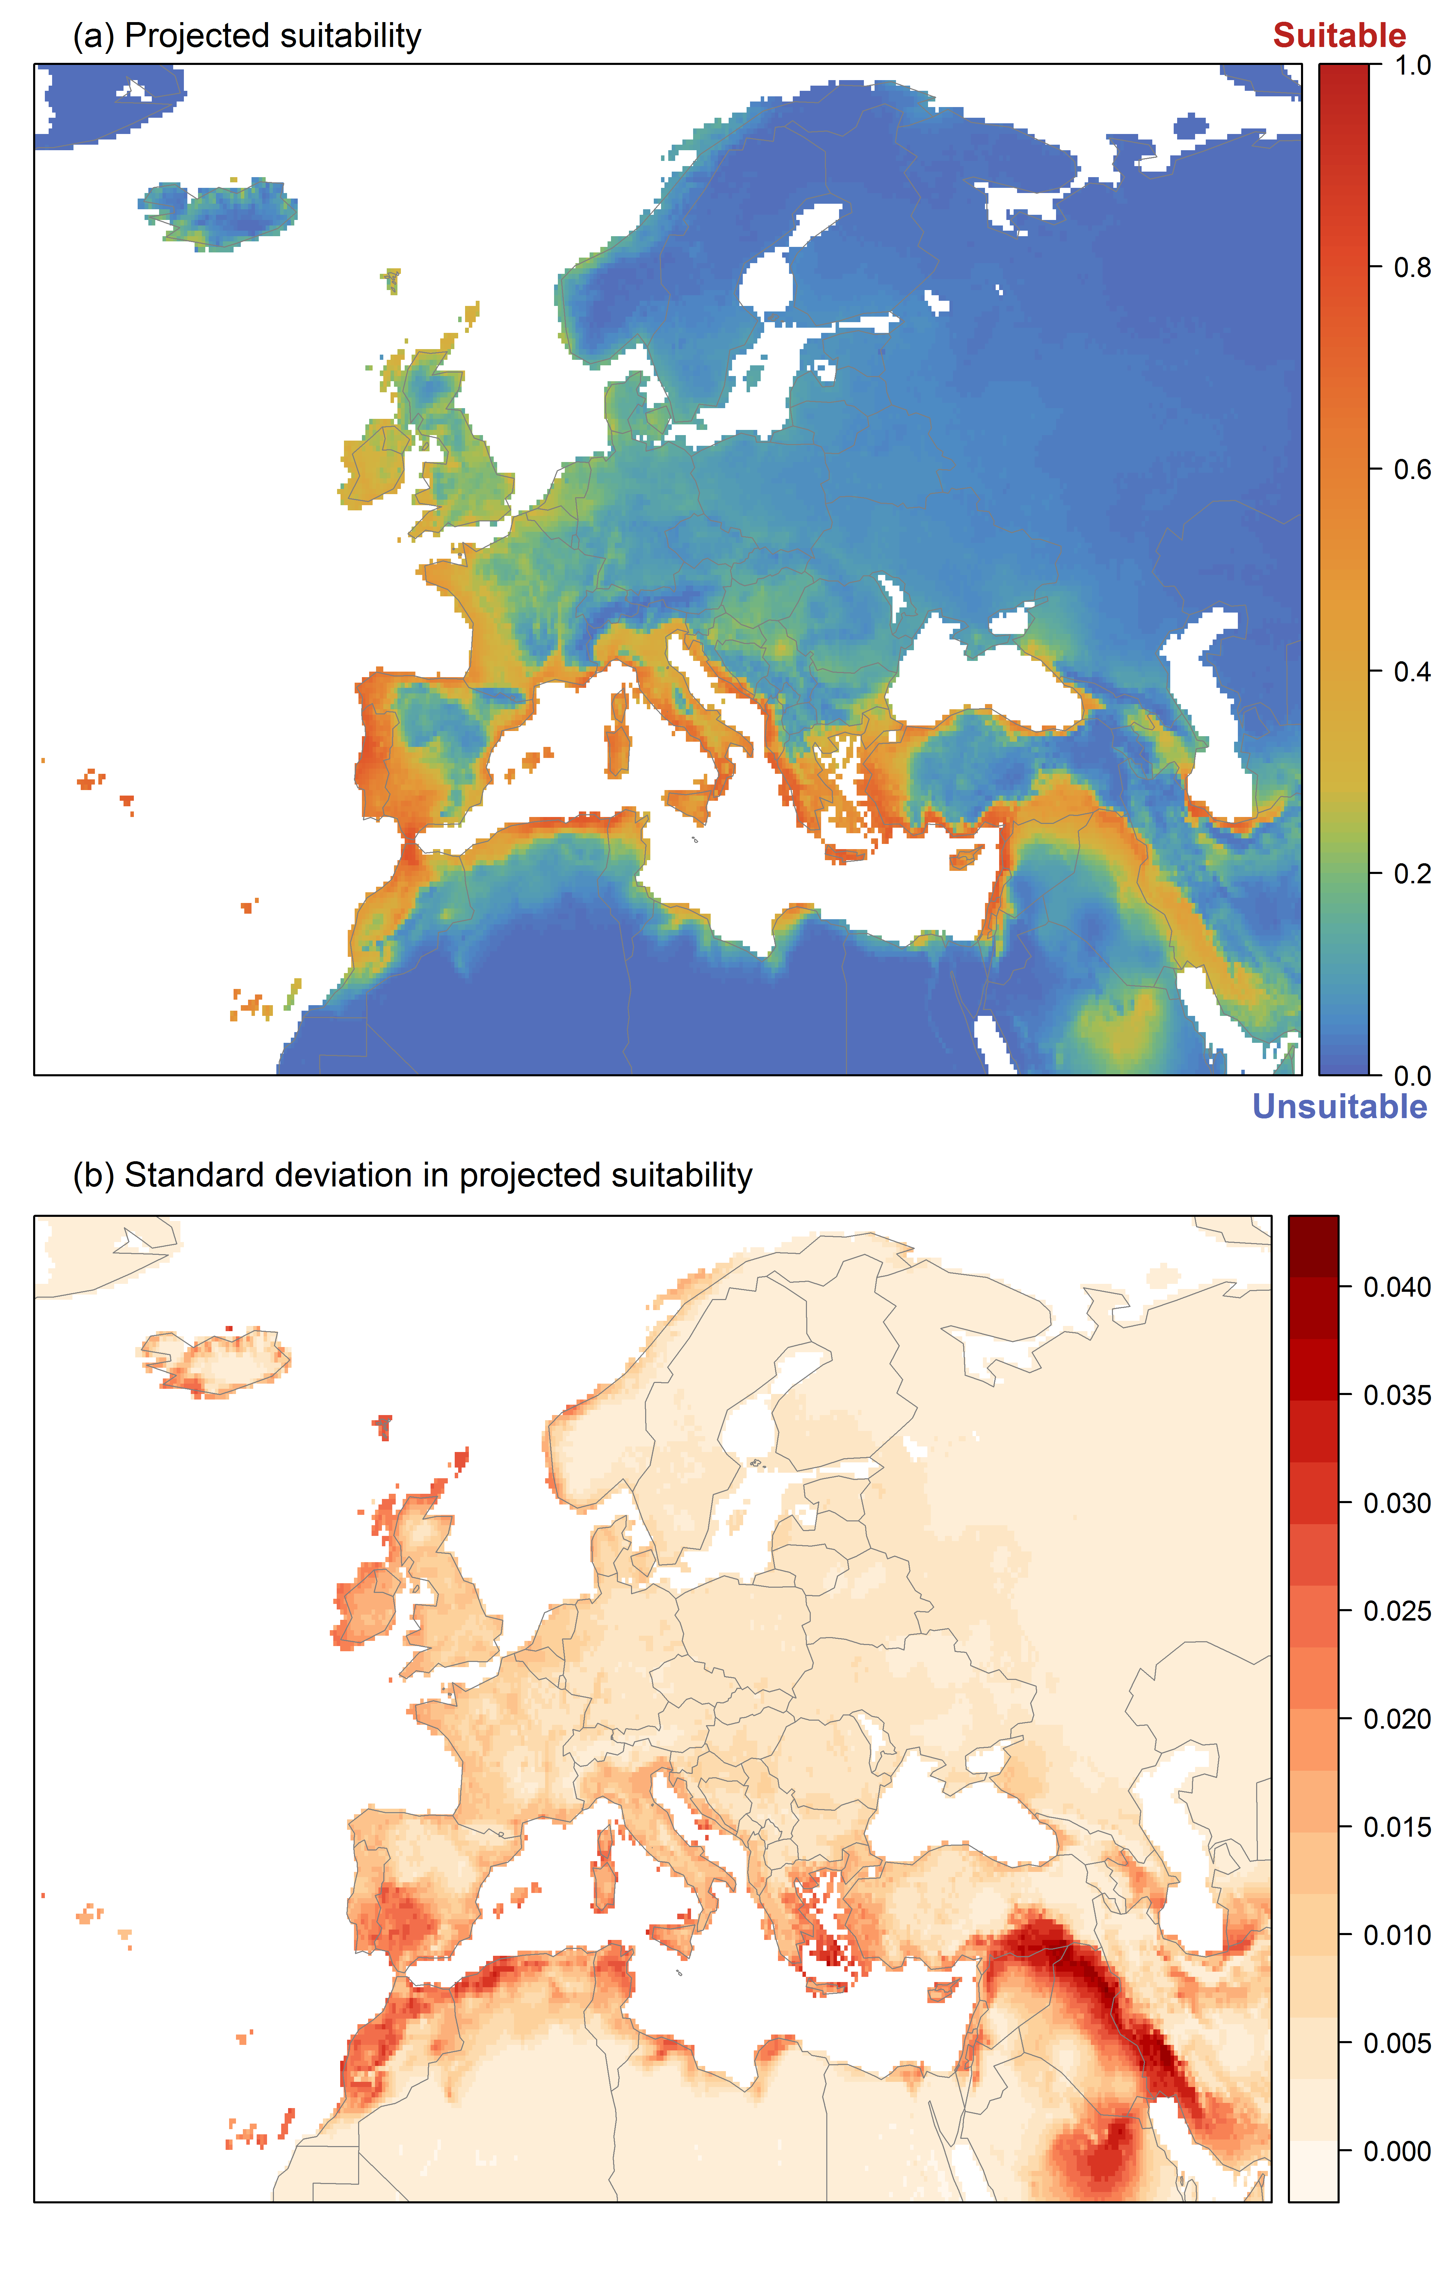

**Figure 9.** Variation in projected suitability for the establishment of the red-whiskered bulbulamong Biogeographical Regions of Europe (<https://www.eea.europa.eu/data-and-maps/data/biogeographical-regions-europe-3>). The bar plots show the proportion of grid cells in each region classified as suitable (with values > 0.29) in the current climate and projected climate for the 2070s under two RCP emissions scenarios. Error bars indicate uncertainty due to both the choice of classification threshold (cf. p.94-95) and uncertainty in the projections themselves (cf. part (b) of Figs. 5,7,8). The location of each region is also shown. The Arctic and Macaronesian regions are not part of the study area, but are included for completeness.

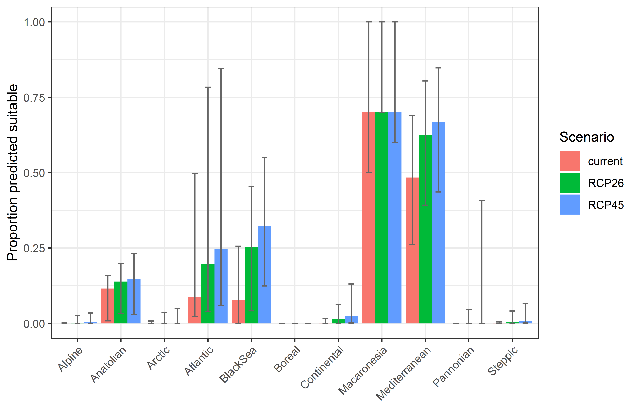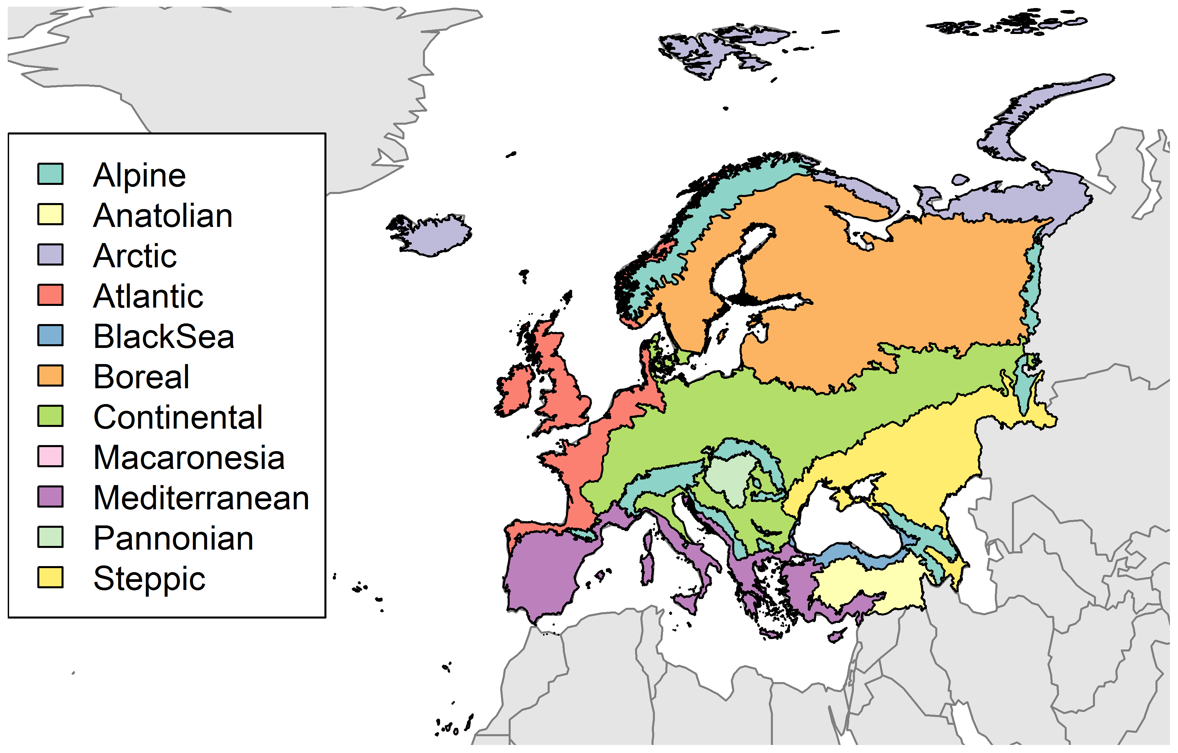

**Table 2.** Variation in projected suitability for the establishment of the red-whiskered bulbulamong Biogeographical regions of Europe (numerical values of Figure 9 above). The numbers are the proportion of grid cells in each region classified as suitable in the current climate and projected climate for the 2070s under two RCP emissions scenarios. The Arctic and Macaronesian biogeographical regions are not part of the study area, but are included for completeness.

|  |  |  |  |  |  |  |  |  |  |
| --- | --- | --- | --- | --- | --- | --- | --- | --- | --- |
|  | **current climate** | | | **2070s RCP2.6** | | | **2070s RCP4.5** | | |
|  | lower | **central estimate** | upper | lower | **central estimate** | upper | lower | **central estimate** | upper |
| Alpine | 0.00 | 0.00 | 0.00 | 0.00 | 0.00 | 0.03 | 0.00 | 0.00 | 0.03 |
| Anatolian | 0.01 | 0.12 | 0.16 | 0.03 | 0.14 | 0.20 | 0.03 | 0.15 | 0.23 |
| Arctic | 0.00 | 0.00 | 0.01 | 0.00 | 0.00 | 0.04 | 0.00 | 0.00 | 0.05 |
| Atlantic | 0.02 | 0.09 | 0.50 | 0.04 | 0.20 | 0.78 | 0.06 | 0.25 | 0.85 |
| Black Sea | 0.00 | 0.08 | 0.26 | 0.04 | 0.25 | 0.45 | 0.12 | 0.32 | 0.55 |
| Boreal | 0.00 | 0.00 | 0.00 | 0.00 | 0.00 | 0.00 | 0.00 | 0.00 | 0.00 |
| Continental | 0.00 | 0.00 | 0.02 | 0.00 | 0.01 | 0.06 | 0.00 | 0.02 | 0.13 |
| Macaronesia | 0.50 | 0.70 | 1.00 | 0.70 | 0.70 | 1.00 | 0.60 | 0.70 | 1.00 |
| Mediterranean | 0.26 | 0.48 | 0.69 | 0.39 | 0.63 | 0.80 | 0.44 | 0.67 | 0.85 |
| Pannonian | 0.00 | 0.00 | 0.00 | 0.00 | 0.00 | 0.05 | 0.00 | 0.00 | 0.41 |
| Steppic | 0.00 | 0.00 | 0.00 | 0.00 | 0.00 | 0.04 | 0.00 | 0.01 | 0.07 |

**Figure 10.** Variation in projected suitability for the establishment of the red-whiskered bulbulamong European Union countries and the UK. The bar plots show the proportion of grid cells in each country classified as suitable (with values > 0.29) in the current climate and projected climate for the 2070s under two RCP emissions scenarios. Error bars indicate uncertainty due to both the choice of classification threshold (cf. p. 94-95) and uncertainty in the projections themselves (cf. part (b) of Figs. 5,7,8). Malta has been excluded because the Human Influence Index dataset lacks coverage for Malta.

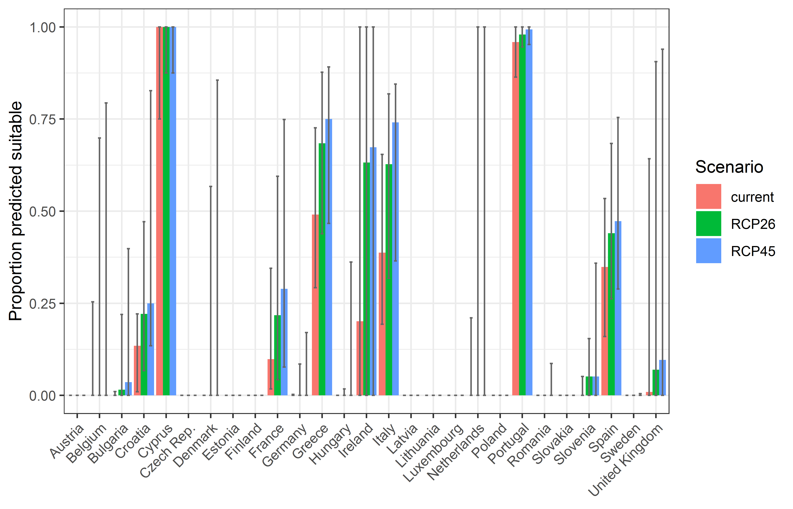

**Table 3.** Variation in projected suitability for the establishment of the red-whiskered bulbulamong European Union countries and the UK (numerical values of Figure 10 above). The numbers are the proportion of grid cells in each country classified as suitable in the current climate and projected climate for the 2070s under two RCP emissions scenarios.

|  |  |  |  |  |  |  |  |  |  |
| --- | --- | --- | --- | --- | --- | --- | --- | --- | --- |
|  | **current climate** | | | **2070s RCP2.6** | | | **2070s RCP4.5** | | |
|  | lower | **central estimate** | upper | lower | **central estimate** | upper | lower | **central estimate** | upper |
| Austria | 0.00 | 0.00 | 0.00 | 0.00 | 0.00 | 0.00 | 0.00 | 0.00 | 0.00 |
| Belgium | 0.00 | 0.00 | 0.25 | 0.00 | 0.00 | 0.70 | 0.00 | 0.00 | 0.79 |
| Bulgaria | 0.00 | 0.00 | 0.01 | 0.00 | 0.02 | 0.22 | 0.00 | 0.04 | 0.40 |
| Croatia | 0.01 | 0.13 | 0.22 | 0.07 | 0.22 | 0.47 | 0.13 | 0.25 | 0.83 |
| Cyprus | 0.75 | 1.00 | 1.00 | 0.88 | 1.00 | 1.00 | 0.88 | 1.00 | 1.00 |
| Czech Rep. | 0.00 | 0.00 | 0.00 | 0.00 | 0.00 | 0.00 | 0.00 | 0.00 | 0.00 |
| Denmark | 0.00 | 0.00 | 0.00 | 0.00 | 0.00 | 0.57 | 0.00 | 0.00 | 0.86 |
| Estonia | 0.00 | 0.00 | 0.00 | 0.00 | 0.00 | 0.00 | 0.00 | 0.00 | 0.00 |
| Finland | 0.00 | 0.00 | 0.00 | 0.00 | 0.00 | 0.00 | 0.00 | 0.00 | 0.00 |
| France | 0.02 | 0.10 | 0.34 | 0.04 | 0.22 | 0.59 | 0.08 | 0.29 | 0.75 |
| Germany | 0.00 | 0.00 | 0.00 | 0.00 | 0.00 | 0.09 | 0.00 | 0.00 | 0.17 |
| Greece | 0.29 | 0.49 | 0.73 | 0.44 | 0.68 | 0.88 | 0.47 | 0.75 | 0.89 |
| Hungary | 0.00 | 0.00 | 0.00 | 0.00 | 0.00 | 0.02 | 0.00 | 0.00 | 0.36 |
| Ireland | 0.00 | 0.20 | 1.00 | 0.00 | 0.63 | 1.00 | 0.00 | 0.67 | 1.00 |
| Italy | 0.19 | 0.39 | 0.65 | 0.32 | 0.63 | 0.82 | 0.36 | 0.74 | 0.84 |
| Latvia | 0.00 | 0.00 | 0.00 | 0.00 | 0.00 | 0.00 | 0.00 | 0.00 | 0.00 |
| Lithuania | 0.00 | 0.00 | 0.00 | 0.00 | 0.00 | 0.00 | 0.00 | 0.00 | 0.00 |
| Luxembourg | 0.00 | 0.00 | 0.00 | 0.00 | 0.00 | 0.00 | 0.00 | 0.00 | 0.00 |
| Netherlands | 0.00 | 0.00 | 0.21 | 0.00 | 0.00 | 1.00 | 0.00 | 0.00 | 1.00 |
| Poland | 0.00 | 0.00 | 0.00 | 0.00 | 0.00 | 0.00 | 0.00 | 0.00 | 0.00 |
| Portugal | 0.86 | 0.96 | 1.00 | 0.95 | 0.98 | 1.00 | 0.95 | 0.99 | 1.00 |
| Romania | 0.00 | 0.00 | 0.00 | 0.00 | 0.00 | 0.00 | 0.00 | 0.00 | 0.09 |
| Slovakia | 0.00 | 0.00 | 0.00 | 0.00 | 0.00 | 0.00 | 0.00 | 0.00 | 0.00 |
| Slovenia | 0.00 | 0.00 | 0.05 | 0.00 | 0.05 | 0.15 | 0.00 | 0.05 | 0.36 |
| Spain | 0.16 | 0.35 | 0.53 | 0.26 | 0.44 | 0.68 | 0.29 | 0.47 | 0.75 |
| Sweden | 0.00 | 0.00 | 0.00 | 0.00 | 0.00 | 0.00 | 0.00 | 0.00 | 0.00 |
| UK | 0.00 | 0.01 | 0.64 | 0.00 | 0.07 | 0.91 | 0.00 | 0.10 | 0.94 |

## Caveats to the modelling

To remove spatial recording biases, the selection of the background sample from the accessible background was weighted by the density of Aves records on the Global Biodiversity Information Facility (GBIF). While this is preferable to not accounting for recording bias at all, it may not provide the perfect measure of recording bias.

There was substantial variation among modelling algorithms in the partial response plots (Figure 3). In part this will reflect their different treatment of interactions among variables. Since partial plots are made with other variables held at their median, there may be values of a particular variable at which this does not provide a realistic combination of variables to predict from.

Other variables potentially affecting the distribution of the species, such as types of land cover other than trees were not included in the model.

## References

Allouche O, Tsoar A, Kadmon R (2006) Assessing the accuracy of species distribution models: prevalence, kappa and the true skill statistic (TSS), Journal of Applied Ecology, 43, 1223-1232.

Chapman D, Pescott OL, Roy HE, Tanner R (2019) Improving species distribution models for invasive non-native species with biologically informed pseudo-absence selection. Journal of Biogeography, <https://doi.org/10.1111/jbi.13555>.

Cohen J (1960) A coefficient of agreement of nominal scales. Educational and Psychological Measurement, 20, 37-46.

Elith J, Kearney M, Phillips S (2010) The art of modelling range-shifting species. Methods in Ecology and Evolution, 1, 330-342.

Fielding AH, Bell JF (1997) A review of methods for the assessment of prediction errors in conservation presence/absence models. Environmental Conservation, 24, 38-49.

Hargreaves GH (1994) Defining and Using Reference Evapotranspiration. Journal of Irrigation and Drainage Engineering, 120.

Hijmans RJ, Cameron SE, Parra JL, Jones PG, Jarvis A (2005) Very high resolution interpolated climate surfaces for global land areas. International Journal of Climatology, 25, 1965-1978.

Iglewicz B, Hoaglin DC (1993) How to detect and handle outliers, Asq Press.

Manel S, Williams HC, Ormerod SJ (2001) Evaluating presence-absence models in ecology: the need to account for prevalence. Journal of Applied Ecology, 38, 921-931.

McPherson JM, Jetz W, Rogers DJ (2004) The effects of species’ range sizes on the accuracy of distribution models: ecological phenomenon or statistical artefact? Journal of Applied Ecology, 41, 811-823.

Pearson RG, Raxworthy CJ, Nakamura M, Townsend Peterson A (2007), Predicting species distributions from small numbers of occurrence records: a test case using cryptic geckos in Madagascar. Journal of Biogeography, 34: 102-117. <https://doi.org/10.1111/j.1365-2699.2006.01594.x>

Thuiller W, Georges D, Engler R and Breiner F (2020). biomod2: Ensemble Platform for Species Distribution Modeling. R package version 3.4.6. <https://CRAN.R-project.org/package=biomod2>

Thuiller W, Lafourcade B, Engler R, Araújo MB (2009) BIOMOD-a platform for ensemble forecasting of species distributions. Ecography, 32, 369-373.

Zomer RJ, Trabucco A, Bossio DA, Verchot LV (2008) Climate change mitigation: A spatial analysis of global land suitability for clean development mechanism afforestation and reforestation. Agriculture, Ecosystems & Environment, 126, 67-80.

1. This template is based on the Great Britain non-native species risk assessment scheme (GBNNRA). A number of amendments have been introduced to ensure compliance with Regulation (EU) 1143/2014 on IAS and relevant legislation, including the Delegated Regulation (EU) 2018/968 of 30 April 2018, supplementing Regulation (EU) No 1143/2014 of the European Parliament and of the Council with regard to risk assessments in relation to invasive alien species (see <https://eur-lex.europa.eu/legal-content/en/TXT/?uri=CELEX%3A32018R0968> ).
2. Convention on Biological Diversity, Decision VI/23
3. <https://circabc.europa.eu/sd/a/7e5f0bd4-34e8-4719-a2f7-c0cd7ec6a86e/2020-CBD-pathways-interpretation.pdf>
4. <https://circabc.europa.eu/sd/a/0aeba7f1-c8c2-45a1-9ba3-bcb91a9f039d/TSSR-2016-010%20CBD%20pathways%20key%20full%20only.pdf>
5. Not to be confused with “no impact”.
6. Note: in the CICES classification provisioning of water is considered as an abiotic service whereas the rest of ecosystem services listed here are considered biotic.