**Risk assessment template developed under the "Study on Invasive Alien Species – Development of risk assessments to tackle priority species and enhance prevention"   
Contract No 07.0202/2020/834529/ETU/ENV.D.2[1]**

**Name of organism:** *Bipalium kewense* Moseley, 1878

**Author(s) of the assessment:**

Leigh Winsor, College of Science and Engineering, James Cook University, Townsville, QLD, Australia

Archie K. Murchie, Agri-Food & Biosciences Institute, Belfast, BT9 5PX

Jean-Lou Justine, ISYEB (Institut de Systématique, Évolution, Biodiversité), Muséum National d'Histoire Naturelle, Paris, France

Björn Beckmann, Centre for Ecology & Hydrology, Penicuik, EH26 0QB

**Risk Assessment Area:** The risk assessment area is the territory of the European Union 27 and the United Kingdom, excluding the EU-outermost regions.

**Peer review 1:** Dr Richard Shaw, CABI, Egham, UK

**Peer review 2:** Dr Brian Boag, James Hutton Institute, Invergowrie Dundee, UK

**Date of completion: 15 October 2021**

**Date of revision: 30 September 2022**

**Contents**

SECTION A – Organism Information and Screening 3

SECTION B – Detailed assessment 16

1 PROBABILITY OF INTRODUCTION AND ENTRY 16

2 PROBABILITY OF ESTABLISHMENT 29

3 PROBABILITY OF SPREAD 41

4 MAGNITUDE OF IMPACT 60

Biodiversity and ecosystem impacts 60

Ecosystem Services impacts 64

Economic impacts 65

Social and human health impacts 68

Other impacts 70

RISK SUMMARIES 75

REFERENCES 77

Distribution Summary 86

ANNEX I Scoring of Likelihoods of Events 88

ANNEX II Scoring of Magnitude of Impacts 89

ANNEX III Scoring of Confidence Levels 90

ANNEX IV CBD pathway categorisation scheme 91

ANNEX V Ecosystem services classification (CICES V5.1, simplified) and examples 92

ANNEX VI EU Biogeographic Regions and MSFD Subregions 96

ANNEX VII Delegated Regulation (EU) 2018/968 of 30 April 2018 97

ANNEX VIII Species distribution model …..………………………………………………………………………………….99

# SECTION A – Organism Information and Screening

|  |
| --- |
| **A1. Identify the organism. Is it clearly a single taxonomic entity and can it be adequately distinguished from other entities of the same rank?**  including the following elements:   * the taxonomic family, order and class to which the species belongs; * the scientific name and author of the species, as well as a list of the most common synonym names; * names used in commerce (if any) * a list of the most common subspecies, lower taxa, varieties, breeds or hybrids   As a general rule, one risk assessment should be developed for a single species. However, there may be cases where it may be justified to develop one risk assessment covering more than one species (e.g. species belonging to the same genus with comparable or identical features and impact). It shall be clearly stated if the risk assessment covers more than one species, or if it excludes or only includes certain subspecies, lower taxa, hybrids, varieties or breeds (and if so, which subspecies, lower taxa, hybrids, varieties or breeds). Any such choice must be properly justified. |

Response:

*Bipalium kewense* Moseley, 1868

Phylum Platyhelminthes, Class Rhabditophora, Order Tricladida, Sub-Order Continenticola, Family Geoplanidae, Subfamily Rhynchodeminae

Synonyms: *Sphyrocephalus kewense* Hallez, 1890; *Bipalium kewense* Moseley var *viridis* Lehnert, 1891; *Placocephalus kewensis* (Moseley, 1878)*, Placocephalus isabellinus* Geba, 1909*; Bipalium costaricencis* Hyman, 1939. A comprehensive synonymy is available (Winsor, 1983).

The organism is a single taxonomic entity. There are no known valid varieties, breeds, or hybrids. COI sequences for *Bipalium kewense* suggest that it is clonal, with identical molecular records from several continents (Justine *et al*., 2018).

Common names: Kew flatworm, Shovel-headed Garden worm; Hammerhead flatworm; Hamerhoofdlandplatworm (NL); Hammerhaidwurm (DE).

|  |
| --- |
| **A2. Provide information on the existence of other species that look very similar [that may be detected in the risk assessment area, either in the environment, in confinement or associated with a pathway of introduction]**  Include both native and non-native species that could be confused with the species being assessed, including the following elements:   * other alien species with similar invasive characteristics, to be avoided as substitute species (in this case preparing a risk assessment for more than one species together may be considered); * other alien species without similar invasive characteristics, potential substitute species; * native species, potential misidentification and mis-targeting |

Response:

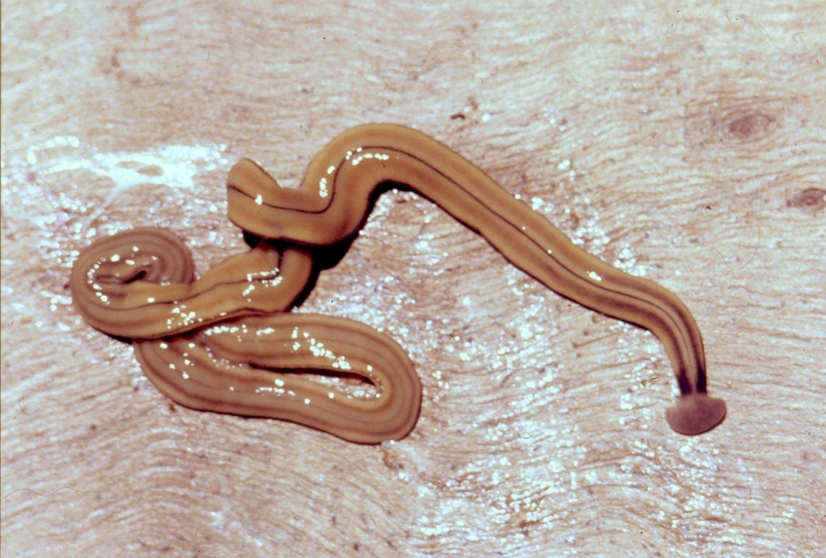*Bipalium kewense* is a long, thin flatworm, whose body shape is characterized by a typical “hammerhead” (see Figure 1, *Bipalium kewense* from Townsville, tropical north Queensland, Australia Life size). Living specimens may attain a length of up to 450 mm. The dorsal ground colour is usually a light ochre, with five black to grey-brown-coloured longitudinal stripes: a median, paired lateral, and paired marginal stripes which all begin at or near the base of the headplate where the latter joins the body at the “neck”. The headplate is usually the same colour as the body, or slightly darker, with recurved posterior margins. The median stripe is black, narrow, with sharp margins, extending caudally from below the neck over the entire body length, and is broadest over the pharyngeal area. Paired dark to pale brown-coloured lateral stripes with diffuse margins, constant over the entire body length, are separated from the median and marginal stripes by an equal width of ground colour. The paired black, fine, marginal stripes, with sharp margins, extend the entire body length. The paired lateral and marginal stripes unite just behind the neck to form an incomplete black transverse neck band, interrupted dorsally by a small median gap, and ventrally by the creeping sole. The headplate is a greyish colour with a light ochre margin. The ventral surface is a light ochre colour, with a distinct off-white creeping sole, delineated by paired, narrow, longitudinal diffuse grey-violet stripes beginning at the ventral termination of the collar, and extending the entire body length (Justine *et al*, 2018). Variations observed in the external morphology of *B. kewense* have been described by Winsor (1983a). A specimen 450 mm long, and 7.6 mm wide weighed 1.5 g (Daly *et al*., 1976). Juvenile specimens hatched from an egg cocoon have the same dark collar and paired dorsal medio-lateral stripes as the adults, some may exhibit a dark mid-dorsal stripe, but do not exhibit the paired marginal stripes. The headplate is lightly coloured, darker around the anterior margin; the mass of juveniles varied from 7.5 mg – 14.7 mg (Ducey *et al.*, 2006). The ground colour and darker longitudinal stripes of juveniles develop further with age.

The egg capsule or cocoon of *B. kewense* measures 5 – 6 mm diameter in two successive lays over a week (specimen from New Orleans, Louisiana, USA, Connella and Stern, 1969), and 9.5 mm diameter declining to 3 mm diameter in nine successive lays over 103 days from a single copulation, with cocoons 3 mm - 6 mm sterile (specimen from Charters Towers, Queensland, Australia, Winsor, 1984, unpubl.). The cocoon wall is stabilized by quinone tanning on exposure to air, usually within 24 hours changing in colour from lemon when freshly laid by the planarian through cherry-red, tan, dark brown then black, as has been described for species in all the subfamilies of the Geoplanidae (Winsor, 1998).

Morphologically, *B. kewense* is differentiated externally from similar striped species by the incomplete (or interrupted) black transverse band at the neck (the “collar”), the thin dorsal median longitudinal stripe that begins at or below the transverse neck band, the pattern and form of the dorsal and ventral stripes, and the relative position of body apertures. A detailed comparison with similar bipaliine taxa is provided elsewhere (Winsor 1983a; Justine *et al*., 2018).

*Bipalium kewense* cannot be confused with any native European land flatworm species as none of the latter possess the characteristic bipaliine headplate (hammerhead). The species can be confused with *Diversibipalium multilineatum*, another five striped bipaliine species originally from Japan (Kawakatsu *et al*., 2001), with similar characteristics, also recorded in Europe (Justine *et al*., 2018). Corrêa (1947) considered that the juvenile *B. kewense* of Arndt (1934, Fig. 5a) collected from the Berlin Botanic Gardens to be a *Dolichoplana* (Rhynchodemini), because juvenile *B. kewense* have a headplate the same as an adult specimen and are not tapered anteriorly as in species of *Dolichoplana*. Following examination of the specimen it was later identified as *Dolichoplana feildeni* (syn *D. striata*), a non-bipaliine species alien in Europe (Winsor, 1983a).

|  |
| --- |
| **A3. Does a relevant earlier risk assessment exist? Give details of any previous risk assessment, including the final scores and its validity in relation to the risk assessment area.** |

Response:

A risk assessment of alien flatworms, including *Bipalium kewense*, that occur in The Netherlands has been undertaken (Thunissen *et al,* 2020 and 2022). The overall risk score for *B. kewense* according to the Harmonia+ protocol that was used is low (RS < 0.33), with a maximum of 0.13, and an average score of 0.02; the species is not expected to survive outdoors in The Netherlands (by way of contrast *Arthurdendyus triangulatus* has a maximum risk score of 0.79 and an average score of 0.14, (high RS >0.66) with the ability to reduce populations of earthworms, and possible survivability outdoors). These results would probably be valid for other countries in the EU risk assessment area that have the same climate as The Netherlands (Köppen-Geiger climate classification Cfb), that would include Belgium, Germany, France, the United Kingdom, Ireland, and northern Spain (Thunissen *et al,* 2022).

|  |
| --- |
| **A4. Where is the organism native?**  including the following elements:   * an indication of the continent or part of a continent, climatic zone and habitat where the species is naturally occurring. * if applicable, indicate whether the species could naturally spread into the risk assessment area |

Response:

The natural range of *Bipalium kewense,* appears to extend from northern Vietnam south to Cambodia. There is some uncertainty in determining the likely natural range of *B. kewense*, and the co-occurrence of other Bipaliine species assists in differentiating areas of possible natural occurrences from areas where the species may have been introduced. Records of non-sexual specimens in Malaysia and Indonesia may represent southern extensions in this species natural range (Winsor, 1983a). Records from Thailand may represent the western extension of its range. All the records of *B. kewense* in Singapore appear to be from urban locations and are possibly introductions.

Based upon the occurrence of sexual and non-sexual specimens of *B. kewense* obtained from the central highlands of Vietnam at 1300 – 2000 m elevation, where they were found together with a suite of species of Bipaliinae with similar occurrences, de Beauchamp (1939, 1961) considered that *B. kewense* originated from Vietnam. At that time, this area was relatively remote, with an average density of under 10 inhabitants per sq. km, areas of which were used for big game hunting, with a tea plantation at 1500 m, and coffee plantation at 600 m (Stuttard, 1943), and within the area of the natural occurrence of the Bipaliinae that extends throughout the Indomalayan zoogeographic realm. Non-sexual specimens have also been recorded in Ninh Binh, northern Vietnam.

The Central Highlands region in Vietnam is characterized by a Tropical Monsoon climate (“Am” in the Köppen-Geiger climate classification), and most months in the year are marked by significant rainfall, with a short dry season. The minimum temperatures range from 14.5oC (January) to 18.7oC (May), and maximum temperatures range from 23.5oC (November) to 27.1 oC (March), with precipitation ranging from 27 mm (February) to 297 mm (September), with about 2161 mm annually (data for Dalat at 1,486 m elevation from Climate-data.org 2020). Lower temperatures would be expected at the higher altitudes around 2000 m elevation. Seasonal evaporation in the highlands is dependent upon the relative humidity, cloudiness, and winds. The high plateaux of Vietnam that include the Biosphere Reserve Lang Bien, are characterized by local winds that differ in their excessive aridity from the general character of the monsoon (Stoddard, 1943).

Several forest systems are present in the area, the composition of which depends upon altitude, aspect, soil nutrients, and other factors. The vegetation of the area is characterized as lower montane forests (1000 m – 1800 m elevation) (Tran Van Do *et al*., 2017). The plant family best represented in the upper canopy of these forests is the Fagaceae, together with the Magnoliaceae, Aceraceae, Podocarpaceae, Lauraceae, and Theaceae. The diversity of conifers is high in montane forests, with five genera present (*Podocarpus* sensu latu., *Calocedrus*, *Fokienia*, *Cephalotaxus*, and *Taxus*). Several important endemic species are present, including *Pinus dalatensis* and *P. krempfii*. Epiphytes form a notable part of the biodiversity of these montane forests. There is high diversity of the orchids in the upper canopy and ferns in the middle and lower canopy (Wikramanayake, 2022).

Unfortunately, detailed habitat data for the few records within the natural range are lacking. Of the two records from Thailand, one was from secondary rainforest, and the other unknown. The climate of both locations (Sihanoukville and Chumphon) is similar to those in Vietnam, characterized by a Tropical Monsoon climate (“Am” in the Köppen-Geiger climate classification), and most months in the year are marked by significant rainfall, with a short dry season. The sole location in Cambodia (Ream, Surat Thani) has a Tropical Savannah climate (“Aw” in the Köppen-Geiger climate classification), characterized a monthly mean temperature above 18oC in every month of the year and typically a pronounced dry season, with the driest month having precipitation less than 60mm. In essence, a tropical savanna climate tends to either see less rainfall than a tropical monsoon climate or have more pronounced dry seasons than a tropical monsoon climate. The Tropical Savanna climate are most commonly found in Africa, Asia and South America and is also prevalent in sections of Central America, northern Australia and North America, specifically in sections of Mexico and the state of Florida in the US (<https://www.weatherbase.com/weather/weather-summary.php3?s=66984&cityname=Siem+Reap,+Cambodia> ) retrieved 24 June 2021 (*B. kewense,* as an alien species, is recorded outdoors in all these countries).

*Bipalium kewense*, like all land planarians, is sensitive to moisture and atmospheric humidity. Land planarians have practically no water-saving adaptations, being dependent upon moisture in their microhabitat, yet are sensitive to too much water and thus generally avoid wet places. Flatworms are mostly strongly seasonal in occurrence, probably reflecting attempts to maintain themselves within a constant microclimate by vertical migration through the continuum of habitat niches, between one extreme with those of the litter and soil faunas, and the other extreme with the faunas of rocks and trees (Wallwork, 1970). When the moisture conditions are optimal or too wet, and cover is present, they will occupy the cryptozoic and litter microhabitats on the soil surface and may even venture up trees. When conditions are too dry for them, they retreat into the soil. In the absence of surface cover terrestrial flatworms can live entirely in soil as permanent members of the soil fauna and can be generally regarded as facultative soil animals. Most species appear not to burrow but make use of existing pore spaces to migrate within the soil (Winsor *et al*., 1998). Land planarians naturally disperse by creeping on the substrate surface.

Like many species of land planarians, *B. kewense* climbs trees, and given that epiphytic orchids form a notable part in the biodiversity of the montane forests within its natural range (Wikramanayake, 2022), this could explain the view (Bell, 1886a, 1886b) that it was introduced to Europe by the orchid trade. It could not have spread naturally into the risk assessment area.

|  |
| --- |
| **A5. What is the global non-native distribution of the organism outside the risk assessment area?** |

Response:

*Bipalium kewense* is undoubtedly the most widespread species of land flatworm worldwide. It was first found in Hong Kong in 1856, then in Australia in 1874, before the species was formally described in 1878 from a specimen found in the hothouse, Kew Gardens, London. It is now recorded in 67 countries outside the risk assessment area. In the United States, the early records were from hothouses on the east coast, and more recent records are from outdoor urban gardens and parks in centres further inland, suggesting acclimatization (Winsor, 1983) The colonizing success of *B. kewense* can largely be attributed to its ability to reproduce asexually by fragmentation (Hyman, 1943, 1951).

When the world distribution of the species was first mapped (Graff, 1899), *B. kewense* had been recorded in eight countries or territories (other than England, Ireland, Germany, and Austria which are in the risk assessment area), namely: Australia, Brazil, Hong Kong, Madeira, New Zealand, Samoa, South Africa, and the United States of America.

With the taxonomic revision of *B. kewense*, and mapping of its distribution worldwide and in the US (Winsor, 1983a), a further 32 countries or territories were added (but excluding four countries in the risk assessment area where it had been recorded): Argentina, Azores autonomous region of Portugal, Barbados, Bermuda, Cambodia, Canada, Cape Verde Islands, Colombia, Costa Rica, El Salvador, Fiji, French Polynesia (Tahiti, Tabuai Islands), Hawaii, India, Indonesia, Israel, Jamaica, Japan, La Reunion, Madagascar, Malaysia, Mauritius, Mexico, Peru, Puerto Rico, Ryukyus Islands, Saint Helena Island, Singapore, Taiwan, Tonga, Vietnam, and Zimbabwe.

Sporadic reports of occurrence of *B. kewense* in a further 30 countries or territories outside of the risk assessment area include: Kenya, China (mainland), the Natuna Islands, Ogasawara Islands of Japan, Sri Lanka, Thailand, and Uruguay (summarized by Ogren *et al*., 1992), Pakistan (Justine *et al.*, 2018), Pitcairn Island (Winsor, 1992 unpubl.); Egypt (Ali, 2008); Ecuador (Wizen, 2015); Cuba (Morffe, 2016); Sao Tome (Sluys *et al*., 2017), Caribbean French Islands (Martinique, Guadeloupe, Saint Barthelemy, Saint Martin, and Monserrat), French Guiana, Monaco, and Pakistan (Justine *et al.*, 2018). Observations and mapped locations of *B. kewense* in iNaturalist <https://www.inaturalist.org/> (individually checked and verified by Winsor in 2021 specifically in preparation for this risk assessment) in new countries outside the risk area include Chile, Galapagos Islands, Nicaragua, and Paraguay (2018); Afghanistan, Guatemala, and Philippines (2020); and Panama (2021).

|  |
| --- |
| **A6. In which biogeographic region(s) or marine subregion(s) in the risk assessment area has the species been recorded and where is it established? The information needs be given separately for recorded (including casual or transient occurrences) and established occurrences. “Established” means the process of an alien species successfully producing viable offspring with the likelihood of continued survival[2].**  **A6a. Recorded: List regions**  **A6b. Established: List regions**  Freshwater / terrestrial biogeographic regions:   * Alpine, Atlantic, Black Sea, Boreal, Continental, Mediterranean, Pannonian, Steppic   Marine regions:   * Baltic Sea, North-east Atlantic Ocean, Mediterranean Sea, Black Sea   Marine subregions:   * Greater North Sea, incl. the Kattegat and the English Channel, Celtic Seas, Bay of Biscay and the Iberian Coast, Western Mediterranean Sea, Adriatic Sea, Ionian Sea, Central Mediterranean Sea, Aegean-Levantine Sea.   Comment on the sources of information on which the response is based and discuss any uncertainty in the response.  For delimitation of EU biogeographical regions please refer to <https://www.eea.europa.eu/data-and-maps/figures/biogeographical-regions-in-europe-2> (see also Annex VI).  For delimitation of EU marine regions and subregions consider the Marine Strategy Framework Directive areas; please refer to <https://www.eea.europa.eu/data-and-maps/data/msfd-regions-and-subregions/technical-document/pdf> (see also Annex VI). |

Response (6a):

*Bipalium kewense* is recorded from the Alpine (in a hothouse), Atlantic, Continental, and Mediterranean biogeographic regions (see A.8a following for records and authority).

Response (6b):

*Bipalium kewense* is established outdoors in the Atlantic, Continental, and Mediterranean biogeographic regions (see A.8b following for records and authority).

|  |
| --- |
| **A7. In which biogeographic region(s) or marine subregion(s) in the risk assessment area could the species establish in the future under current climate and under foreseeable climate change? The information needs be given separately for current climate and under foreseeable climate change conditions.**  **A7a. Current climate: List regions**  **A7b. Future climate: List regions**  With regard to EU biogeographic and marine (sub)regions, see above.  With regard to climate change, provide information on   * the applied timeframe (e.g. 2050/2070) * the applied scenario (e.g. RCP 4.5) * what aspects of climate change are most likely to affect the risk assessment (e.g. increase in average winter temperature, increase in drought periods)   The assessment does not have to include a full range of simulations on the basis of different climate change scenarios, as long as an assessment with a clear explanation of the assumptions is provided. However, if new, original models are executed for this risk assessment, the following RCP pathways shall be applied: RCP 2.6 (likely range of 0.4-1.6°C global warming increase by 2065) and RCP 4.5 (likely range of 0.9-2.0°C global warming increase by 2065). Otherwise, the choice of the assessed scenario has to be explained. |

Response (7a):

Alpine, Atlantic, Black Sea, Continental, Mediterranean, Pannonian and Steppic in the risk assessment area; and in the Anatolian and Macaronesia biogeographic regions (refer to Figures 1 and 2, Annex VIII).

Response (7b):

Under Climate Change with timeframe 2070, and emission scenarios RCP 2.6 and RCP 4.5: Alpine, Atlantic, Black Sea, Continental, Mediterranean, Pannonian and Steppic in the risk assessment area; and in the Anatolian and Macaronesia biogeographic regions (Figure 7Annex VIII). There are increases in the projected suitability for the establishment of *B. kewense* generally north and northeastwards under both RCP 2.6 and RCP 4.5 in the Atlantic, Black Sea, Continental, Pannonian and Steppic biogeographical regions in the risk assessment area, and in the Anatolian biogeographic region (Figures 7 and 8 Annex VIII). The lower to mid-levels of mountainous areas (also Pyrenees) appear to become increasingly suitable for the establishment of the species under the RCP 2.6 and 4.5 scenarios. For the Mediterranean region, there is little change between the current projected suitability and those under RCP 2.6 and RCP 4.5.

In the Atlantic biogeographical region, Belgium, Denmark, Ireland, the Netherlands , and the United Kingdom contain some of the largest conglomerations of people in Europe, many of whom live near the coast (<https://www.eea.europa.eu/publications/report_2002_0524_154909/biogeographical-regions-in-europe/the_atlantic_region.pdf/view> retrieved 25 June 2021). In the Continental region countries such as Austria, Czech Republic, Germany, Poland, and Slovakia, the urban areas are among the largest and most extensive in Europe. A large proportion of the population lives in the vicinity of forests. Some new afforestation occurs around big cities for recreational purposes (<https://www.eea.europa.eu/publications/report_2002_0524_154909/biogeographical-regions-in-europe/continental_biogeografical_region.pdf/view> retrieved 25 June 2021).

In these countries within both the Atlantic and Continental biogeographical regions, *B. kewense* is currently present largely in “protected” environments such as hothouses. Under the climate warming scenarios, there would probably no longer be the need for hothouses in these countries, and there could be a loss of containment of *B. kewense* from “protected” environments into outdoor urban gardens and parks where it could establish in the warmer conditions.

|  |
| --- |
| **A8. In which EU Member States has the species been recorded and in which EU Member States has it established? List them with an indication of the timeline of observations. The information needs be given separately for recorded and established occurrences.**  **A8a. Recorded: List Member States**  **A8b. Established: List Member States**  Austria, Belgium, Bulgaria, Croatia, Cyprus, Czech Republic, Denmark, Estonia, Finland, France, Germany, Greece, Hungary, Ireland, Italy, Latvia, Lithuania, Luxembourg, Malta, Netherlands, Poland, Portugal, Romania, Slovakia, Slovenia, Spain, Sweden, and the United Kingdom  The description of the invasion history of the species shall include information on countries invaded and an indication of the timeline of the first observations, establishment and spread. |

Response (8a):

*Bipalium kewense* has been recorded in managed facilities (hothouses / greenhouses) in the following Member States:

Austria (Graff, 1893), Belgium (Woestijne, 1907), Czech Republic (Mrazek, 1902), Denmark (Kirkegaard, 1971), Finland (Söderström, 1936), Germany (Graff, 1899), Ireland (Bell, 1892), the Netherlands (De Waart, 2016; Thunissen *et al*, 2020, 2022), Poland (Pax, 1921), Slovakia (Košel, 2002), and the United Kingdom (Moseley, 1878).

*Bipalium kewense* has been recorded in urban gardens and urban environments in the following Member States:

France, including Corsica (Justine *et al*., 2018), Italy, including Sardinia (Gremigni, 2003), Portugal (Ogren *et al*., 1992, Silva, 2020), Malta (T. Cassar and D. Mifsud, 2021 unpubl.), Spain (Filella-Subirà, 1983), United Kingdom Glasgow Botanic Gardens and gardens in Sussex and Liverpool) (Boag *et al*., 2010).

*Bipalium kewense* was first recorded in 1877 in the United Kingdom, in the hothouse in Kew Gardens, London (Moseley, 1878). Subsequently in 1866 in Germany, from the orchid house, Botanic Gardens, Berlin (Graff, 1899); Ireland, in the hothouse at Stafford House, Kildare, 1892 (Bell, 1892); Austria, 1893 (Graff, 1893), in a hothouse in Graz; Poland, 1898, in a hothouse, Wroclaw (Pax, 1921); Czech Republic, 1902, in a greenhouse in Prague (Mrazek, 1902); Belgium 1907 in a hothouse (Woestijne, 1907); The Netherlands 1912, in a greenhouse ( Thunissen *et al*, 2020, 2022); Finland 1935, in a hothouse (Söderström, 1936); Denmark, in a hothouse (Kirkegaard, 1971); Spain 1982, in private gardens (Filella-Subirà, 1983); France 1999, in private gardens (Justine *et al*. 2018); Portugal, urban outdoors (Ogren *et al*., 1992, Silva, 2020); Slovakia, in a hothouse (Košel, 2002); Italy 2021, urban outdoors (Bello *et al*., 1995, Gremigni, 2003, Mori *et al*. 2021); Malta 2021, in an urban garden (T. Cassar and D. Mifsud, 2021,unpubl.).

Response (8b):

Of the foregoing countries in which *B. kewense* has been recorded, it is present in the following outdoor locations: in a private garden in Malta in 2021 (T. Cassar and D. Mifsud, 2021, unpubl.); in Portugal in private gardens in Mealharda circa 1990 and Gemunde 24 Aug 2020, (Silva, 2020); numerous outdoor occurrences in France (Justine *et al*., 2018); in outdoor urban sites and private gardens in Italy, Mori *et al*. (2021); and outdoor locations in Spain, all from private gardens, are taken, in chronological order: Caldes d’Estrac (Barcelona) 1982, Girona (Girona) 1994, Barcelona, 1995, and Bètera (València), 1999 (Álvarez-Presas *et al*. (2014).

The most comprehensive recent study of the distribution *B. kewense* is from France (Justine *et al*., 2018). From metropolitan France, including Corsica, 36 records were obtained, with *B. kewense* established in nine administrative departments; 34 of these records were from outdoor sites, with more than half (16) from the department Pyrénées-Atlantiques. The dates of records ranged from 1999-2017, with the oldest record in the Department of Pyrénées-Atlantiques: “In France, the outdoors occurrence of *B. kewense* was reported in Orthez and Bayonne in 2005 (Vivant 2005), Urcuit in 1999, in Arthez de Béarn, Hasparren, Villefranque, Urt (all in 2014), near Jurançon (2016), Nay (2016) and Saint Jean de Luz (2016), Ustaritz (2017) and in Bayonne and Orthez again (2014). Specimens records were from Saint-Pée-sur-Nivelle (2013), Ustaritz (2014), Bassussary (2014) and Orthez (2014). All these localities are in the Department of Pyrenées-Atlantiques, plus three records from the Department of Landes, north of Pyrenées-Atlantiques, along the Atlantic coast. The remark by Vivant that the animal was collected “five times in the last 20 years”, the record from 1999, and the recent record and specimens in the same locality (Orthez) in 2014 strongly suggests that the species is now established in the open in Orthez and in several localities of the Department of Pyrenées-Atlantiques (Justine *et al*., 2018). All these records are from gardens, and it is not known whether the species has colonized semi-natural habitats.

Additional unpublished results (2018 - 2021) confirm that the species is well established in France, mainly in the Department of the Pyrénées-Atlantiques (Justine, unpubl, records of *B. kewense* in iNaturalist <https://www.inaturalist.org/observations?place_id=any&subview=map&taxon_id=64221>).

|  |
| --- |
| **A9. In which EU Member States could the species establish in the future under current climate and under foreseeable climate change? The information needs be given separately for current climate and under foreseeable climate change conditions.**  **A9a. Current climate: List Member States**  **A9b. Future climate: List Member States**  With regard to EU Member States, see above.  With regard to climate change, provide information on   * the applied timeframe (e.g. 2050/2070) * the applied scenario (e.g. RCP 4.5) * what aspects of climate change are most likely to affect the risk assessment (e.g. increase in average winter temperature, increase in drought periods)   The assessment does not have to include a full range of simulations on the basis of different climate change scenarios, as long as an assessment with a clear explanation of the assumptions is provided. However, if new, original models are executed for this risk assessment, the following RCP pathways shall be applied: RCP 2.6 (likely range of 0.4-1.6°C global warming increase by 2065) and RCP 4.5 (likely range of 0.9-2.0°C global warming increase by 2065). Otherwise, the choice of the assessed scenario has to be explained. |

Response (9a):

Under present climate conditions, *B. kewense* could establish in the following European countries. Figures in brackets are the central estimate of the percentage of the country projected to be suitable in the species distribution model – please note uncertainties around these estimates (Table 3, Annex VIII): Austria (3%), Belgium (70%), Bulgaria (60%), Croatia (76%), Cyprus (100%), France (78%), central Germany (14%), Greece (92%), Hungary (43%), Italy (82%), Luxembourg (60%), Malta (not modelled but deemed suitable), The Netherlands (41%), Portugal (100%), southern Romania (18%), Slovakia (2%), Slovenia (28%), Spain (89%), and the United Kingdom (but not northern Scotland) (18%) (refer also to Figures 4 and 5, Annex VIII ).

In order to model the establishment of *B. kewense* under current climate and under predicted climate change conditions in the 2070s under low and medium emissions scenarios (RCP2.6 and RCP4.5)**,** climate variables based upon the biology of *B. kewense*. were selected, and an ensemble model constructed (Annex VIII). The model suggested that the suitability of particular location for the establishment of *B. kewense* was most strongly determined by the minimum temperature of the coldest month in that region, followed by annual precipitation, then the presence of human-disturbed habitats, then the mean temperature of the warmest quarter, followed last by the Climatic Moisture Index for that area. The seasonality of precipitation did not impact on the suitability of an area for the establishment of *B. kewense*.

*Bipalium kewense* is established outdoors in the Atlantic and Mediterranean biogeographic regions. Under both RCP 2.6 and RCP 4.5 scenarios the Atlantic region will become increasing suitable northwards for the establishment of the flatworm. Within this region the area most at risk appears to be the Department of Pyrenées-Atlantiques, France, the climate of which appears to be particularly favourable for flatworms. However, all current records there are from gardens, and it is not known whether the species has colonised semi-natural habitats (Justine *et al*, 2018). Similarly the Mediterranean region under RCP 2.6 shows increased suitability for the establishment of *B. kewense*, though under the RCP 4.5 scenario the region is considered to be less suitable for the establishment of the flatworm.

In a recent paper modelling the invasion of five bipaliin species (Fourcade *et al*, 2022), *B. kewense* appears to be extremely influenced by temperature variables, while response to precipitation was less evident. As *B. kewense* appears to be more tolerant of drought, it has the potential to colonize a larger global range but limited in its expansion only by cold winter temperatures.

Response (9b):

Under predicted future warmer climate conditions in the 2070s, *B. kewense* could establish in the following European countries. Figures in brackets are the central estimates of the percentage of each country projected to be suitable in the species distribution model for low (RCP2.6) and medium (RCP4.5) emissions scenarios. Please note uncertainties around these estimates (Table 3, Annex VIII): Austria (30-39%), Belgium (97-98%), Bulgaria (89-94%), Croatia (95-99%), Cyprus (88-50%), Czech Republic (41-81%), southern Denmark (4-7%), France (90-92%), Germany (86-95%), Greece (95-85%), Hungary (100%), Ireland (1%), Italy (88-89%), Luxembourg (100%), Malta (not modelled, but deemed suitable), Netherlands (74-83%), western and central Poland (22-49%), Portugal (100%), Romania (59-75%), Slovakia (45-62%), Slovenia (72-82%), Spain (95-89%), southern coastal Sweden (1%), and the United Kingdom excluding Scotland (38-42%).

Refer to Figures 7(a) Annex VIII illustrating the projected suitability for *Bipalium kewense* establishment in Europe and the Mediterranean region in the 2070s under climate change scenario RCP2.6, and Figure 8(a) Annex VIII showing the projected suitability for *Bipalium kewense* establishment in Europe and the Mediterranean region in the 2070s under climate change scenario RCP4.5.

|  |
| --- |
| **A10. Is the organism known to be invasive (i.e. to threaten or adversely impact upon biodiversity and related ecosystem services) anywhere outside the risk assessment area?** |

Response:

There is no evidence that the species is invasive (i.e. threatens or adversely impacts upon biodiversity and related ecosystem services) anywhere outside the risk assessment area. However, no studies have been conducted that would support or refute this statement. The data for this species is deficient.

*Bipalium kewense* is a minor pest in a few urban earthworm farms (vermiculture of non-native earthworm species) in New South Wales and in Queensland, Australia (Winsor, 1998) where it is readily removed by handpicking or flooding the beds.

|  |
| --- |
| **A11. In which biogeographic region(s) or marine subregion(s) in the risk assessment area has the species shown signs of invasiveness? Indicate the area endangered by the organism as detailed as possible.**  Freshwater / terrestrial biogeographic regions:   * Alpine, Atlantic, Black Sea, Boreal, Continental, Mediterranean, Pannonian, Steppic   Marine regions:   * Baltic Sea, North-east Atlantic Ocean, Mediterranean Sea, Black Sea   Marine subregions:  Greater North Sea, incl. the Kattegat and the English Channel, Celtic Seas, Bay of Biscay and the Iberian Coast, Western Mediterranean Sea, Adriatic Sea, Ionian Sea, Central Mediterranean Sea, Aegean-Levantine Sea |

Response:

There is presently no evidence that the species is invasive in the risk assessment areas of the EU (i.e. threatens or adversely impacts upon biodiversity and related ecosystem services). However, no studies have been conducted that would support or refute this statement. The data for this species is deficient.

|  |
| --- |
| **A12. In which EU Member States has the species shown signs of invasiveness? Indicate the area endangered by the organism as detailed as possible.**  Austria, Belgium, Bulgaria, Croatia, Cyprus, Czech Republic, Denmark, Estonia, Finland, France, Germany, Greece, Hungary, Ireland, Italy, Latvia, Lithuania, Luxembourg, Malta, Netherlands, Poland, Portugal, Romania, Slovakia, Slovenia, Spain, Sweden, and the United Kingdom |

Response:

There is presently no evidence that the species is invasive in the risk assessment areas of the EU (i.e. threatens or adversely impacts upon biodiversity and related ecosystem services). However, no studies have been conducted that would support or refute this statement. The data for this species is deficient.

|  |
| --- |
| **A13. Describe any known socio-economic benefits of the organism.**  including the following elements:   * Description of known uses for the species, including a list and description of known uses in the risk assessment area and third countries, if relevant. * Description of social and economic benefits deriving from those uses, including a description of the environmental, social and economic relevance of each of those uses and an indication of associated beneficiaries, quantitatively and/or qualitatively depending on what information is available.   If the information available is not sufficient to provide a description of those benefits for the entire risk assessment area, qualitative data or different case studies from across the risk assessment area or third countries shall be used, if available. |

Response:

There is evidence that other species alien flatworms have been inadvertently disseminated in potted plants from infected garden centres and botanic gardens to the public or other botanic gardens. This is a non-intentional transfer and, if known it can adversely affect the reputation of the business or botanic garden concerned (Boag and Neilson, 2014).

*Bipalium kewense* has no known uses outside the research field. It is undoubtedly the most studied species of land planarian and acts as an experimental animal and as an example of a terrestrial flatworm, largely because of its of its widespread occurrence, size, and availability. There has been, and continues to be, economic benefits from funds directed to research on this organism.

*B. kewense* has been used as the subject of various anatomical and histological studies (Bergendal, 1892; Graff, 1899; Pfitzner, 1958; Hauser, 1966; Silveira, 1969, 1970, 1971, 1972, 1978; Storch and Abraham, 1972; Sun *et al*., 1975, 1979; Storch and Welsch, 1977; Ali, 2008), behavioural studies (Lehnert, 1891; Kew, 1900; Barnwell *et al*., 1964; Barnwell *et al*., 1965; Barnwell, 1966; Morton and Kleinginna, 1971), biochemical studies (Campbell, 1960, 1965, 1970, 1973; Campbell and Lee, 1963; Reddy and Campbell, 1970; Tramell and Campbell, 1971; Scheid and Awapara, 1972; Phillips and Dresden, 1973; Dresden and Landsperger, 1977), biology (Lehnert, 1891; Johri, 1952; Dundee and Dundee, 1963; Froehlich, 1956; Connella and Stern, 1969; Olewine, 1972; Chandler, 1974; Ducey *et al*., 2006), genomic studies (Gastineau *et al*., 2019), laboratory maintenance (Barnwell, 1967; Neck, 1987; Olewine and Morton, 1971), physiologicalstudies (Daly and Matthews, 1975, 1982; Daly *et al*., 1977), pseudoparasitism (Walton and Yokogawa, 1972; Daly *et al*., 1976, 1977; Winsor, 1980, 1983b), regeneration (Morgan, 1900; Brøndsted, 1969), and toxicology (Arndt, 1925; Stokes *et al*., 2014).

Understanding the processes of cell proliferation, differentiation and pattern formation in regenerative organisms can help find ways to enhance the poor regenerative abilities shown by many other animals, including humans. Studying regeneration in a relatively simple creature, like a planarian whose neoblasts act as stem cells, can hold important clues into how human cells can be coaxed to behave similarly and help humans regenerate injured or missing tissues. Some of the earliest studies on planarian regeneration used *B. kewense* as the experimental model (Morgan, 1900; Brøndsted, 1969). Progress towards understanding the mechanics of regeneration was hampered by an incomplete understanding of basic cell biology and genetics, in addition to a lack of tools for experimentation, and only recently have significant advances in molecular biology (for example Gastineau *et al*., 2019 using *B. kewense*), genetics, and sequencing technologies reignited interest in planarians as an attractive model in which to study regeneration (Elliot and Alvarado, 2013).

The social benefits of the knowledge generated by these studies of *B. kewense* are intangible and difficult to quantify, let alone place a monetary value upon them. As such, in economic terms, these studies and their outcomes are regarded as externalities - the overall cost and benefit to society being defined as „the sum of the imputed [monetary value](https://en.wikipedia.org/wiki/Value_(economics)) of benefits and costs to all parties involved“ (Laffont, 2017). Research and development, and education are examples of such positive externalities ("Externalities - Definition and examples", *Conceptually*. Retrieved 21 June 2021).

# SECTION B – Detailed assessment

|  |
| --- |
| **Important instructions:**   * In the case of lack of information the assessors are requested to use a standardized answer: “No information has been found.” * With regard to the scoring of the likelihood of events or the magnitude of impacts see Annexes I and II. * With regard to the confidence levels, see Annex III. * Highlight the selected response score and confidence level in **bold** but keep the other scores in normal text (so that the selected score is evident in the final document). |

## 1 PROBABILITY OF INTRODUCTION AND ENTRY

|  |
| --- |
| **Important instructions:**   * **Introduction** is the movement of the species into the risk assessment area (it may be either in captive conditions and/or in the environment, depending on the relevant pathways). * **Entry** is the release/escape/arrival in the environment, i.e. occurrence in the wild * Introduction and entry may coincide for species entering through pathways such as “corridor” or “unaided”, but it also may differ. If different, please consider all relevant pathways, both for the introduction into the risk assessment area and the entry in the environment. * The classification of pathways developed by the Convention of Biological Diversity (CBD) should be used (see Annex IV). For detailed explanations of the CBD pathway classification scheme consult the IUCN/CEH guidance document[3] and the provided key to pathways[4]. * For organisms which are already present (recorded or established) in the risk assessment area, the likelihood of introduction and entry should be scored as “very likely” by default. * Repeated (independent) introductions and entries at separate locations in the risk assessment area should be considered here (see Qu. 1.7). |

|  |
| --- |
| **Qu. 1.1. List relevant pathways through which the organism could be introduced into the risk assessment area and/or enter into the environment. Where possible give details about the specific origins and end points of the pathways as well as a description of any associated commodities.**  For each pathway answer questions 1.2 to 1.7 (copy and paste additional rows at the end of this section as necessary). Please attribute unique identifiers to each question if you consider more than one pathway, e.g. 1.2a, 1.3a, etc. and then 1.2b, 1.3b etc. for the next pathway.  In this context a pathway is the route or mechanism of introduction and/or entry of the species.  The description of commodities with which the introduction of the species is generally associated shall include a list and description of commodities with an indication of associated risks (e.g. the volume of trade; the likelihood of a commodity being contaminated or acting as vector).  If there are no active pathways or potential future pathways this should be stated explicitly here, and there is no need to answer the questions 1.2-1.9. |

Response:

The main driver of historic biological invasions and the passive dispersal of terrestrial flatworms was probably horticulturalists of the 19th Century using the then recently invented Wardian cases that are wooden hermetically sealed glazed cases, the forerunner of the modern terrarium, named after their inventor Dr Nathaniel Ward designed to safely transport back by sea to the hothouses and gardens of Europe rare plants (Keogh, 2020), together with soil containing cryptic exotic animal species (Winsor *et al*., 2004, Keogh, 2020). Therefore, over 30 non-native species of land planarians, including *B. kewense*, have established in various countries outside their native range (Winsor *et al*., 2004). In human-modified habitats, flatworms and their cocoons continue to be associated with rooted and potted plants, rhizomes, and certain types of fresh vegetable production (Alford *et al*., 1996). Subsequent secondary dispersal of these invasive flatworm species occurs through the exchange and purchase of plants from nurseries, botanic gardens, garden centres and gardeners (Alford *et al*., 1996) especially infested nurseries and garden centres (Boag *et al*., 1994; Moore *et al*., 1998), and active inadvertent dispersal through social traditions of exchanging plants and recycling topsoil (Christensen and Mather 1998).

The pathways considered in this risk assessment for *B. kewense* are “contaminant nursery material” (unintentional), and “Botanic Garden / Zoos & Aquaria (excluding domestic aquaria)” (unintentional). These two pathways are similar and represent unintentional introduction via trade and movement of living plants.

**Pathway name: Contaminant nursery material**

|  |
| --- |
| **Qu. 1.2a. Is introduction and/or entry along this pathway intentional (e.g. the organism is imported for trade) or unintentional (e.g. the organism is a contaminant of imported goods)?** |

|  |  |  |  |
| --- | --- | --- | --- |
| **RESPONSE** | intentional  **unintentional** | **CONFIDENCE** | low  medium  **high** |

This pathway is unintentional. Trade in exotic plants is increasing and landscaping, the process of making a garden or other piece of land more attractive by altering the existing design, adding ornamental features, often requiring potted trees and shrubs, poses a particular risk. Terrestrial flatworms have been intercepted in the UK on plant material, particularly tree ferns (*Dicksonia* spp.), from Australia and New Zealand (Cannon and Baker, 2007; Matthews, 2005). Data from other EU countries on interceptions of terrestrial flatworms on imported products at ports are sparse. *Bipalium kewense* was detected in potted flowering plants (*Agapanthus*) imported from South Africa to France in August 2019 by the authorities of Paris Charles de Gaulle airport. The single specimen was barcoded for molecular confirmation of identification (Justine, 2019 unpubl.)

|  |
| --- |
| **Qu. 1.3a. How likely is it that large numbers of the organism will be introduced and/or enter into the environment through this pathway from the point(s) of origin over the course of one year?**  including the following elements:   * discuss how likely the organism is to get onto the pathway in the first place. Also comment on the volume of movement along this pathway. * an indication of the propagule pressure (e.g. estimated volume or number of individuals / propagules, or frequency of passage through pathway), including the likelihood of reinvasion after eradication. * if relevant, comment on the likelihood of introduction and/or entry based on propagule pressure (i.e. for some species low propagule pressure (1-2 individuals) could result in subsequent establishment whereas for others high propagule pressure (many thousands of individuals) may not. |

|  |  |  |  |
| --- | --- | --- | --- |
| **RESPONSE** | very unlikely  unlikely  **moderately likely**  likely  very likely | **CONFIDENCE** | low  **medium**  high |

Response:

With greater awareness of the problems caused by alien flatworms and more stringent EU plant health legislation under the ‘Plant Health Law’ (Regulation (EU) 2016/2031), the likelihood of entry of alien flatworms should be lessened. However, this is set against increasing international trade in plants (Migliorini *et al.*, 2015), with the value of imported plants for planting increasing by 60% over the past fifteen years (Eschen *et al.*, 2015). The key factor here is the level of importation of potted plants from affected regions. The largest risk to the risk assessment area would be from regions like China (via Hong Kong), Indonesia, Thailand, and Florida in the US, which are producers of potted plants (van Uffelen and de Groot, 2005; EPPO, 2012).

No information has been found regarding interceptions of *B. kewense* during plant trade except anecdotal records in France and U.K. only (see Q 1.2a), so an estimate of the propagule pressure is difficult. Experience with other alien flatworms would suggest that the number of individuals would be low and sporadic, with one or two individuals in a contaminated shipment.

Land planarians are hermaphrodite. *Bipalium kewense* can reproduce asexually by fragmentation. The colonizing success of *B. kewense* can largely be attributed to this asexual mode of reproduction (Hyman, 1943, 1951), in which an individual specimen can eventually give rise to a colony through reproduction by fission, as opposed to sexual reproduction that will require another sexually mature individual, and the time and energy expended in searching for this sexual partner.

In the fission process (Barnwell, 1967; Connella and Stern, 1969) one or two portions of the tail section, 1 - 4 cm long (zooids), are shed a few days after the adult fed and are able to crawl. Although fragile, there is the possibility that these zooids, especially given their small size, could pass undetected and be transported together with potted plants. After several days or weeks, the dropped tail sections (zooids) regenerate so that they grow to become small versions of adult specimens. A regenerating *B. kewense* will not attack and eat earthworms until the head region has completely regenerated into the adult shape. However, the ability of a regenerated *B. kewense* to eat depends primarily upon a regenerated pharynx than a regenerated head (Barnwell, 1966). Adult planarians raised in laboratory terraria shed an average of one or two fragments per month (Connella and Stern, 1969). This average rate of fragment production under laboratory conditions may not be an accurate estimate of fragment production in outdoor environments. Field observations of a *B. kewense* population in Tennessee US revealed few sightings of fragments over a year, with the ratio of fragments to adult specimens was greatest during the cold months (Chandler, 1976).

Sexual specimens of *B. kewense* have been recorded from eleven countries with tropical or subtropical climates (Winsor, 1983a). However, the production of egg cocoons by this species (see response at A2) appears to be rarely observed, with only two occurrences in over a century of international study noted in the literature (Ducey et al, 2006), and unpublished observations (Winsor, 1984 unpublished). Given the apparent paucity of sexual reproduction, especially in largely non-tropical / subtropical countries, the likelihood of the introduction of an egg cocoon of *B. kewense* is considered unlikely in the risk assessment area.

|  |
| --- |
| **Qu. 1.4a. How likely is the organism to survive, reproduce, or increase during transport and storage along the pathway (excluding management practices that would kill the organism)?** |

|  |  |  |  |
| --- | --- | --- | --- |
| **RESPONSE** | very unlikely  unlikely  moderately likely  **likely**  very likely | **CONFIDENCE** | low  **medium**  high |

Response:

Within a potted plant or enclosed in a plant’s root ball, *B. kewense* would be in a “protected” environment. The conditions necessary to keep the plant healthy, would presumably match those of the source location and therefore be amenable to *B. kewense.* Cold storage may have an impact on *B. kewense* survival as it is largely a tropical species, albeit originally from the cool central highlands in Vietnam. There are no specific data looking at this, but Barnwell (1969) noted that when the temperature dropped to -6.7oC or -9.4oC, planarians were not found in their usual places, but a few days later when conditions were warmer, they reappeared. He also stated that they could survive temperatures near -17oC, but after temperatures fell below this for several nights in 1966 in Athens, Georgia, US, no *B. kewense* were seen for over two years. The likelihood of survival of adults, egg cocoons and juveniles and fragments will vary with shipment journey time and storage conditions, which will be dependent on the plant product transported.

|  |
| --- |
| **Qu. 1.5a. How likely is the organism to survive existing management practices before and during transport and storage along the pathway?** |

|  |  |  |  |
| --- | --- | --- | --- |
| **RESPONSE** | very unlikely  unlikely  moderately likely  **likely**  very likely | **CONFIDENCE** | low  **medium**  high |

Response:

Plant health inspection and phytosanitation are the most practical means of preventing invasion by cryptic flatworm species. Legislation in the EU now requires that plants for planting from third countries meet strict criteria. In particular, the growing media must be free from soil or subjected to suitable treatment to ensure freedom from pests (EU Commission Implementing Regulation (EU) 2019/2072). However, legislation is dependent on plant health certification by exporting producers and only a small proportion of the plant trade can be directly inspected by the importing country.

However, as of the 14th December 2019, Professional Sellers, Importers  / Exporters of plants, and Online / Offline sellers of plants who may sell plants on online platforms such as eBay, Etsy, Facebook, a private website, Instagram or any other venue, will need to be able to issue plant passports in accord with the EU Plant Passport Regulation  (Implementing Regulation (EU) 2017/2313), enacted to protect the environment, and trade, from plant pests and diseases (<https://www.bb-automation.com/pflanzenpass?lang=en#:~:text=The%20plant%20passport%20is%20used,producer%20to%20the%20retail%20trade> ). Inspections, if thorough, and other requirements of the EU Plant Passporting may go some way to limiting the inadvertent importation of flatworms.

Aside from plant health inspection, and the EU Plant Passport Regulation, there are no existing management practices implemented specifically against invasive flatworms. Hot water treatment has been considered for flatworm management for imported potted plants (Justine *et al.*, 2014b; Murchie and Moore, 1998).

As the flatworms are sheltering within the soil or in the plant container, other pest management practices along the pathway are unlikely to affect them. For example, treatment with insecticides to control foliar pests is unlikely to penetrate the root ball or if systemic affect the flatworms as they are not feeding on the plant.

|  |
| --- |
| **Qu. 1.6a. How likely is the organism to be introduced into the risk assessment area or entry into the environment undetected?** |

|  |  |  |  |
| --- | --- | --- | --- |
| **RESPONSE** | very unlikely  unlikely  moderately likely  likely  **very likely** | **CONFIDENCE** | low  medium  **high** |

Response:

If *B. kewense* is embedded in the growing medium or root ball, detection is difficult without destruction of the potted plant. Adult flatworms are comparatively large and distinctive, so once uncovered would be visible easily with the naked eye. Egg capsules (cocoons) are 3-9.5 mm in diameter and would be much harder to detect and to differentiate from other detritus.

As *B. kewense* is cryptic, soil-dwelling, and nocturnal, it is most likely detected in the environment under refuges such as plant pots or other items in close contact with the soil, when these are moved. Whilst the flatworms are likely to be noticed by gardeners in these cases, it is worthwhile bearing in mind the comments of Justine *et al.* (2018) with respect to *Bipalium* spp. and *Diversibipalium* spp. in France, where the authors expressed their amazement that these highly noticeable non-native flatworms had escaped attention of scientists and officials for 20 years.

|  |
| --- |
| **Qu. 1.7a. How isolated or widespread are possible points of introduction and/or entry into the environment in the risk assessment area?** |

|  |  |  |  |
| --- | --- | --- | --- |
| **RESPONSE** | isolated  **widespread**  ubiquitous | **CONFIDENCE** | low  medium  **high** |

Response:

Importation of potted plants into the EU occurs throughout Europe. The pathway would encompass ports to wholesale suppliers to local dissemination via garden centres, landscapers, and supermarkets. There is substantial internal trade in the EU. Increasing online trade may make dissemination points more dispersed as wholesalers may freight directly to the public.

As the flatworms would be enclosed in potted plants, opportunities for entry into the environment would also be widespread. In warm areas of Europe, ornamental plants that could house *B. kewense* may be placed directly outdoors allowing direct dissemination of the flatworm into the local environment. In northern areas of Europe such plants may be housed indoors, with less opportunity for transfer. However, during the summer months tropical plants may be housed in conservatories or glasshouses from which the flatworm could escape into the wild.

|  |
| --- |
| **Qu. 1.8a. Estimate the overall likelihood of introduction into the risk assessment area and/or entry into the environment based on this pathway?** |

|  |  |  |  |
| --- | --- | --- | --- |
| **RESPONSE** | very unlikely  unlikely  moderately likely  likely  **very likely** | **CONFIDENCE** | low  medium  **high** |

Response:

*Bipalium kewense* has already been introduced and established in the risk assessment area through this pathway. The risk of further introductions into the EU depends on the extent of trade with regions maintaining populations of *B. kewense*, and the effectiveness of measures by the trading partners to prevent the introduction, achieve early detection, rapidly eradicate, and manage the species.

**Pathway name: Botanic Garden / Zoos and Aquaria**

|  |  |  |  |  |
| --- | --- | --- | --- | --- |
| **Qu. 1.2b. Is introduction and/or entry along this pathway intentional (e.g. the organism is imported for trade) or unintentional (e.g. the organism is a contaminant of imported goods)?** | | | | |
| **RESPONSE** | | intentional  **unintentional** | **CONFIDENCE** | Low  medium  **high** |

Response:

Botanic gardens are a main pathway for the introduction / entry of *Bipalium kewense*, evidenced by the following records that include some additional records from Germany to those in earlier responses (8a and 8b): *Bipalium kewense* was first recorded in the risk assessment region in the hothouse in Kew Gardens, London, United Kingdom, 1877 (Moseley, 1878). Subsequently it was found in the orchid house, old Botanic Gardens, Berlin, Germany 1886 (Graff, 1899), and within Germany a hothouse in Frankfurt am Main, 1887; hothouses in Dresden and Leipzig in 1891; hothouse in Heidelberg, 1896; Botanic Gardens and Zoological Gardens, Hamburg, 1901 (associated with plants from Brazil); orchid house, Bellevue Palace, Berlin, 1912; palm house, Dahlem Botanic Gardens, 1923; fern house and hothouse Botanic Gardens Breslau, 1930; hothouse, Bonn, 1933; and a hothouse, Gottingen (no date) (locations summarized by Arndt, 1934). In addition, it was recorded in the hothouse at Stafford House, Kildare, Ireland, 1892 (Bell, 1892); a hothouse in Graz, Austria, 1893 (Graff, 1893); in a hothouse, Wroclaw, Poland, 1898 (Pax, 1921); a greenhouse in Prague, Czech Republic, 1902 (Mrazek, 1902); hothouse Belgium 1907 (Woestijne, 1907); greenhouse in the Netherlands 1912 (Thunissen *et al,* 2020, 2022); and a hothouse in Finland 1935 (Söderström, 1936).

Although these records are historical, there remains a high possibility that these locations continue to harbour populations of *B. kewense*, and may act as reservoirs of “infection”, especially if the garden sells plants to the public*.* For example, in Kew Gardens, *B. kewense* was found in a hothouse in 1966, and again in May 1980 by the Keeper in the tropical fern house in which the original specimen of *B. kewense* was found in 1877 (Winsor, 1983a). The implication here is that the species has continued to survive in this location for 103 years (whether other people have seen specimens over the 103 years is not known; there were no museum records from this location). However, many exotic plants are transferred to hothouses, often historic in nature, and once the plants are in place they are not disturbed further. There is a possibility that Botanic Gardens will continue to be an entry point from outside the EU.

There is a single report of B. kewense found in the Glasgow Botanic Gardens close to but outside the hothouses (Boag et al., 2010). There was no suggestion it was able to live under Scottish climatic conditions. However, it did show it had the capability to migrate when conditions were suitable. In other words it could have moved from one greenhouse to another when weather conditions were favourable but the general climate for the region was not (Boag 2021, unpublished).

|  |
| --- |
| **Qu. 1.3b. How likely is it that large numbers of the organism will be introduced and/or enter into the environment through this pathway from the point(s) of origin over the course of one year?**  including the following elements:   * discuss how likely the organism is to get onto the pathway in the first place. Also comment on the volume of movement along this pathway. * an indication of the propagule pressure (e.g. estimated volume or number of individuals / propagules, or frequency of passage through pathway), including the likelihood of reinvasion after eradication * if relevant, comment on the likelihood of introduction and/or entry based on propagule pressure (i.e. for some species low propagule pressure (1-2 individuals) could result in subsequent establishment whereas for others high propagule pressure (many thousands of individuals) may not. |

|  |  |  |  |
| --- | --- | --- | --- |
| **RESPONSE** | very unlikely  unlikely  moderately likely  **likely**  very likely | **CONFIDENCE** | **Low**  medium  high |

Response:

The introduction of alien flatworms via importation of exotic plants to botanic gardens has occurred with *B. kewense* (Winsor, 1983a). However, most of these introductions happened in the past when biosecurity and quarantine protocols were less stringent.

The mechanism of contamination of botanic specimen plants and propagule pressure is similar to that of nursery plants (above 1.3a). Land planarians are hermaphrodite. *Bipalium kewense* can reproduce asexually by fragmentation. The colonizing success of *B. kewense* can largely be attributed to this asexual mode of reproduction (Hyman, 1943, 1951), in which an individual specimen can eventually give rise to a colony through reproduction by fission, as opposed to sexual reproduction that will require another sexually mature individual, and the time and energy expended in searching for this sexual partner.

In the fission process (Barnwell, 1967; Connella and Stern, 1969) one or two portions of the tail section, 1 - 4 cm long, are shed a few days after the adult fed and are able to crawl. After several days or weeks, the dropped tail sections regenerate so that they grow to become small versions of adult specimens. Adult planarians raised in laboratory terraria shed an average of one or two fragments per month (Connella and Stern, 1969). This average rate of fragment production under laboratory conditions may not be an accurate estimate of fragment production in outdoor or managed environments. Field observations of a *B. kewense* population in Tennessee US revealed few sightings of fragments over a year, with the ratio of fragments to adult specimens was greatest during the cold months (Chandler, 1976).

Botanic gardens may seek more exotic plants collected from the wild, which may increase the likelihood of contamination with flatworms compared to contamination by flatworms of locally reared plants. On the other hand, the quantities imported will be smaller and awareness of biosecurity risk and mitigation procedures are likely to be greater in botanic gardens, which justifies a reduced likelihood compared to the pathway “contaminant nursery material”. In addition, in temperate countries at least, exotic plants collected from the tropics will probably be kept in hothouses as is already the case with many locations from which *B. kewense* has been recorded. Such arrangements are likely to limit the flatworm’s entry to the human-modified environment outside the hothouse or managed facility. Estimates of the propagule pressure along this pathway are difficult to generate because of unknown variables, for example the availability of food, temperatures at which the facility is run, introduction of new plant stock, and plant hygiene practices in the facility.

|  |
| --- |
| **Qu. 1.4b. How likely is the organism to survive, reproduce, or increase during transport and storage along the pathway (excluding management practices that would kill the organism)?** |

|  |  |  |  |
| --- | --- | --- | --- |
| **RESPONSE** | very unlikely  unlikely  moderately likely  **likely**  very likely | **CONFIDENCE** | low  medium  **high** |

Response:

As with the nursery plant pathway (above, 1.4a), *B. kewense* is likely to survive well in transported and stored exotic plants, assuming that the conditions necessary for the plants’ survival matches that of the flatworms. Without more details of the conditions of transport of contaminated material, it is difficult to go beyond generalisations, but *B. kewense* has certainly been transported successfully around the world with plant material.

**Qu. 1.5b. How likely is the organism to survive existing management practices before and during transport and storage along the pathway?**

|  |  |  |  |
| --- | --- | --- | --- |
| **RESPONSE** | very unlikely  unlikely  **moderately likely**  likely  very likely | **CONFIDENCE** | **low**  medium  high |

Response:

The response to this question is similar to that for nursery plants (above, 1.5a). There are no management measures widely specifically implemented against *B. kewense.* One would expect that high value or rare exotic plants in transit to botanic gardens would be subject to high biosecurity assessments with intense inspection and scrutiny for pests and diseases. Biosecurity risk and mitigation procedures are likely to be greater in botanic gardens. However, flatworms sheltering in root balls can be difficult to detect without damaging the plant, so the confidence score is low.

|  |
| --- |
| **Qu. 1.6b. How likely is the organism to be introduced into the risk assessment area or entry into the environment undetected?** |

|  |  |  |  |
| --- | --- | --- | --- |
| **RESPONSE** | very unlikely  unlikely  moderately likely  **likely**  very likely | **CONFIDENCE** | low  medium  **high** |

Response:

*Bipalium kewense* would shelter in soil surrounding root balls and is unlikely to be detected without potentially damaging sampling (see response above, 1.6a). For high value exotic plants, it may be possible to wash the roots and re-pot, which would expose the flatworms. However, small individuals or egg capsules may still go undetected.

As botanic gardens have dedicated botanists and gardeners, it could be argued that detection outside the hothouse or managed facility may be more likely as they may be trained in the recognition of pest and exotic species, than for nursery stock. However, the focus of phytosanitary and biosecurity measures, and education of staff in botanic gardens appear to be exclusively concerned with plant pests, especially microbial pathogens, insects, and invasive plant species (Hulme, 2011, Heyward with Sharrock, 2013, Wondafrash et al., 2021), rather than on non-plant pests such as alien land planarians that may be unintentionally brought into the gardens as contaminant on plants.

|  |
| --- |
| **Qu. 1.7b. How isolated or widespread are possible points of introduction and/or entry into the environment in the risk assessment area?** |

|  |  |  |  |
| --- | --- | --- | --- |
| **RESPONSE** | Isolated  **widespread**  ubiquitous | **CONFIDENCE** | Low  **medium**  high |

Response:

Most cities in Europe have botanic gardens and similar establishments. Typically, these would comprise both “protected” environments such as glasshouses, hothouses, and landscaped gardens.

|  |
| --- |
| **Qu. 1.8b. Estimate the overall likelihood of introduction into the risk assessment area and/or entry into the environment based on this pathway?** |

|  |  |  |  |
| --- | --- | --- | --- |
| **RESPONSE** | very unlikely  unlikely  moderately likely  likely  **very likely** | **CONFIDENCE** | low  medium  **high** |

Response:

There are many botanic gardens in Europe often dating from the 19th century. Most have civic, educational, conservation or academic functions. Yet, botanic gardens have been criticised as sources of invasive alien species and encouraged to adopt and implement codes of practice to prevent the spread of unwanted species (Hulme, 2011). Botanic Gardens Conservation International, the body representing some 600 institutional members in 100 countries, specifically acknowledges the threats posed by invasive alien species and the role of botanic gardens in their dissemination but also detection (Hayden, 2020). BGCI advocates careful planning, preparation and management of plant material being exchanged, together with good record keeping and robust procedures to ensure that „neither the plant itself nor any associated pests or diseases will affect the collections of the botanic garden or the wider environment“ (<https://www.bgci.org/our-work/plant-conservation/plant-health-and-biosecurity/> ).

*Bipalium kewense* has certainly been introduced many times into new regions via botanic gardens, and the recent finding of *Platydemus manokwari* in a botanic garden hothouse in France (Justine *et al*., 2018), and other alien species of flatworms in greenhouses in the Netherlands (De Waart, 2019; Thunissen *et al,* 2020, 2022) demonstrates that this remains a viable and active pathway. As with nursery plants, the extent of the risk depends on the quantities and types of plants transported from regions with *B. kewense* to Europe by botanic gardens.

|  |
| --- |
| **Qu. 1.9. Estimate the overall likelihood of introduction into the risk assessment area or entry into the environment based on all pathways and specify if different in relevant biogeographical regions in current conditions.**  Provide a thorough assessment of the risk of introduction in relevant biogeographical regions in current conditions: providing insight into the risk of introduction into the risk assessment area. |

|  |  |  |  |
| --- | --- | --- | --- |
| **RESPONSE** | very unlikely  unlikely  moderately likely  likely  **very likely** | **CONFIDENCE** | low  medium  **high** |

Response:

*Bipalium kewense* has been introduced into the risk assessment area by the botanic garden and contaminated nursery material pathways in the past as evidenced by the widespread findings of this flatworm in botanic gardens and urban hothouses. The most likely pathway for introduction of *B. kewense* is with living plants, either through botanic gardens or the contaminated nursery material pathways, which appear to be still active today. Major risk factors include: (a) the extent to which botanic gardens act as reservoirs of *B. kewense*, (b) propagule pressure arising from the asexual mode of reproduction of *B. kewense* in which fragments are shed that will subsequently regenerate into mature flatworms, (c) the efficacy of phytosanitary and biosecurity measures employed by botanic gardens and nurseries to plants, (d) trade and exchange of plants between botanic gardens within and between Member States, and between Member States and other countries, and the phytosanitary and biosecurity measures taken in these countries, and (e) the extent of education of botanic garden and nursery staff, and the public, about alien flatworms.

*Bipalium kewense* is established outdoors in the Atlantic and Mediterranean biogeographic regions. In the Atlantic region the area most at risk is the Department of Pyrénées-Atlantiques, France. However, all records are from gardens, and it is not known whether the species has colonised semi-natural habitats (see also the response at A9a).

|  |
| --- |
| **Qu. 1.10. Estimate the overall likelihood of introduction into the risk assessment area or entry into the environment based on all pathways in foreseeable climate change conditions?**  Thorough assessment of the risk of introduction in relevant biogeographical regions in foreseeable climate change conditions: explaining how foreseeable climate change conditions will influence this risk.  With regard to climate change, provide information on   * the applied timeframe (e.g. 2050/2070) * the applied scenario (e.g. RCP 4.5) * what aspects of climate change are most likely to affect the likelihood of introduction (e.g. change in trade or user preferences)   The thorough assessment does not have to include a full range of simulations on the basis of different climate change scenarios, as long as an assessment of likely introduction within a medium timeframe scenario (e.g. 30-50 years) with a clear explanation of the assumptions is provided. However, if new, original models are executed for this risk assessment, the following RCP pathways shall be applied: RCP 2.6 (likely range of 0.4-1.6°C global warming increase by 2065) and RCP 4.5 (likely range of 0.9-2.0°C global warming increase by 2065). Otherwise, the choice of the assessed scenario has to be explained. |

|  |  |  |  |
| --- | --- | --- | --- |
| **RESPONSE** | very unlikely  unlikely  moderately likely  likely  **very likely** | **CONFIDENCE** | low  medium  **high** |

Response:

*Bipalium kewense* has already been introduced to the risk assessment area through the botanic garden, and contaminated nursery material pathways. The pathways themselves (transport of exotic plants) will be little affected directly by climate change. However, as the climate warms, there are two issues that will increase the risk of *B. kewense* establishment in the wild, and possible further introductions and entry into the wild.

Firstly, the flatworm is likely to extend its range outside the risk assessment area. The current predicted areas for establishment of *B. kewense* includes substantial regions of Asia, south-eastern USA, north-western North America – Alaska, central and South America, and central east Africa (SDM Annex VIII Figure 4). With greater colonisation of these regions, the risk of inadvertent transport with ornamental or exotic plants to the risk assessment area increases. This factor will likely apply equally to the biogeographical regions suitable for establishment (e.g., mainly the Atlantic and Mediterranean regions), although as this movement is dependent on human agency, the risk will be dependent on human population density, and also the success of phytosanitary and plant passport controls.

Secondly, as the EU climate warms, the range of garden plants likely to be grown outdoors will alter. This may include exotic plants from flatworm-infected regions and therefore increase the risk of entry of *B. kewense* into the surrounding environment. This risk will be greater in the Atlantic biogeographical region as it extends further north, and probably presents a relatively higher risk than import from external countries (see also the response at A9a).

## 2 PROBABILITY OF ESTABLISHMENT

|  |
| --- |
| **Important instructions:**   * For organisms which are already established in parts of the risk assessment area or have previously been eradicated, the likelihood of establishment should be scored as “very likely” by default. * Discuss the risk also for those parts of the risk assessment area, where the species is not yet established. |

|  |
| --- |
| **Qu. 2.1. How likely is it that the organism will be able to establish in the risk assessment area based on similarity of climatic and abiotic conditions in its distribution elsewhere in the world?** |

|  |  |  |  |
| --- | --- | --- | --- |
| **RESPONSE** | very unlikely  unlikely  moderately likely  likely  **very likely** | **CONFIDENCE** | low  medium  **high** |

Response:

*Bipalium kewense* is already established outdoors in the risk assessment area in the low altitude region of the Pyrénées-Atlantiques along the coast with an Atlantic climate, suggesting that the region is particularly suitable for land planarians (Justine *et al*., 2018). It has also established outdoors in Malta in 2021 (T. Cassar and D. Mifsud, 2021, unpubl.); in Portugal in Mealharda and Gemunde (Silva, 2020); in Italy, especially western Italy (Mori *et al*. 2021), and outdoor locations in Spain, Caldes d’Estrac (Barcelona), Girona (Girona), Barcelona, and Bètera (València), (Álvarez-Presas *et al*. 2014). Therefore, the confidence is that establishment in the risk assessment area is very likely, and confidence is high.

Countries within the natural range of *Bipalium kewense* have Köppen Climate Classification Type A Tropical climates (Tropical Rainforest, Tropical Monsoon, and Tropical Savannah climates) that do not occur in the risk assessment area, and Köppen classification Type C Temperate climates (Humid sub-tropical, and Monsoon-influenced humid subtropical climate) that are present in the risk assessment area.

The locations within the risk assessment area where *B. kewense* has established outdoors all have Köppen Climate Classification Type C climates as follows:

The low altitude region of the Pyrénées-Atlantiques in France (numerous records), the northern and eastern Italy (sparse records), and Girona, Spain have Humid sub-tropical climates characterized by the coldest month averaging above 0 °C, at least one month's average temperature above 22 °C, and at least four months averaging above 10 °C. There is no significant precipitation difference between seasons, and no dry months in the summer. This climate type extends to the UK, and the Atlantic coast of western Europe.

Most of central and western Italy (numerous records), Malta, Greece and Spain have hot summer Mediterranean climates characterized by the coldest month averaging above 0 °C, at least one month's average temperature above 22 °C, and at least four months averaging above 10 °C. There is at least three times as much precipitation in the wettest month of winter as in the driest month of summer, and driest month of summer receives less than 30 mm. This climate type extends to the Mediterranean coast of France and Greece.

Mealharda and Gemunde in Portugal, and Valencia in Spain have Cold summer Mediterranean climates characterized by the coldest month averaging above 0 °C and 1–3 months averaging above 10 °C. There is at least three times as much precipitation in the wettest month of winter as in the driest month of summer, and driest month of summer receives less than 30 mm.

Laboratory work suggests that *B. kewense* will tolerate a wide range of temperatures, with the optimum temperature for growth and reproduction being between 15.6oC and 32oC. The species will survive near freezing temperatures, but they do not regenerate or grow as rapidly at these low temperatures (Barnwell, 1967). Soil temperatures will generally be higher than air temperatures, depending upon the thermal conductivity of the substratum. In another study (Chandler, 1976) the numbers of specimens of *B. kewense* that were sighted declined when the soil temperature reached a minimum of 3.9oC (minimum air temperature in the same location was -6.6oC); sightings of *B. kewense* increased with a rise in soil temperature. “In Billère (Pyrénées-Atlantiques, France), repeated records of *B. kewense* from the same garden were obtained between September and December 2017 and January 2018, live and outdoors, even in winter; they were also found at various depths under the soil surface in January, clearly a way for the species to survive the cold season” (Justine *et al*, 2018).

However, *B. kewense* has only been found in hothouses and not outdoors in Austria, Belgium, Czech Republic, Denmark, Finland, Germany, the Netherlands, Poland, and Slovakia. Except for the Netherlands and the UK (in proximity to a hothouse), the other remaining countries all have Köppen Climate Classification Type D Continental climates, characterized by having at least one month averaging below 0 °C and at least one month averaging above 10 °C. Most of these countries have Hot summer [humid continental climate](https://en.wikipedia.org/wiki/Humid_continental_climate)s, with the coldest month averaging below 0 °C, at least one month's average temperature above 22 °C, and at least four months averaging above 10 °C, with no significant precipitation difference between seasons.

As would be expected, the establishment of *B. kewense* outdoors (in countries and regions with Type C climates with the minimum temperature of the coldest month averaging above 0 °C ), and the factors limiting this, chiefly minimum temperature of the coldest month (countries with Type D climates with the minimum temperature of the coldest month averaging below 0 °C) broadly accord with the ensemble model (Annex VIII). The model suggested that the suitability of particular location for the establishment of *B. kewense* was most strongly determined by the minimum temperature of the coldest month in that region, followed by annual precipitation, (then the presence of human-disturbed habitats), then the mean temperature of the warmest quarter, followed last by the Climatic Moisture Index for that area. The seasonality of precipitation did not impact on the suitability of an area for the establishment of *B. kewense*. These findings accord with those for *B. kewense* in the modelling for invasion by five bipaliin species in a changing climate (Fourcade *et al*, 2022).

(Climate data for the Köppen Climate Classifications previously discussed were derived from <https://en.wikipedia.org/wiki/K%C3%B6ppen_climate_classification> retrieved 25 June 2021).

|  |
| --- |
| **Qu. 2.2. How widespread are habitats or species necessary for the survival, development and multiplication of the organism in the risk assessment area? Consider if the organism specifically requires another species to complete its life cycle.** |

|  |  |  |  |
| --- | --- | --- | --- |
| **RESPONSE** | very isolated  isolated  moderately widespread  **widespread**  ubiquitous | **CONFIDENCE** | low  medium  **high** |

Response:

Habitats, and prey suitable for the survival of *Bipalium kewense*, are widespread in the risk assessment area.

The habitat of the natural range of *Bipalium kewense* includes tropical montane forests and rainforests, absent in the risk assessment area. The preferred microhabitats of land planarians including *B. kewense* are those of the litter fauna, cryptofauna, and soil fauna (Winsor, 1998). The niches occupied by these flatworms are continuous between one extreme with those of the litter and soil faunas, and the other extreme with the faunas of rocks and trees (Wallwork, 1970). The prey of *Bipalium kewense* in its natural range is unknown. Nothing is known about the preferences of soil type by *B. kewense*, other than a requirement for a humid microhabitat.

Outside its natural range, the outdoor occurrence of *B. kewense* appears to be almost exclusively restricted to public and private gardens and parks. Unlike some other species of alien Bipaliinae, for example *Bipalium adventitium* in the USA (Ducey *et al*.,2005), there is no evidence to date of *B. kewense* surviving, developing, and reproducing in native forests or other natural habitats in countries with Type C Temperate climates (Köppen Climate Classifications – see Qu 2.1).

In a four-year experimental study of *Bipalium kewense* it was found that of the prey proffered to the planarians, *B. kewense* very rarely predated upon slugs, but preferred live earthworms (Lehnert, 1891). This preference for earthworms by *B. kewense* has been confirmed by subsequent studies and observations (Johri, 1952; Wallen, 1954, Froehlich, 1956, Dundee and Dundee, 1963; Barnwell, 1967; Connella and Stern, 1969; Olewine, 1972; Chandler, 1974, Winsor, 1985). However there are no quantitative studies on the impacts of *B. kewense* upon native or alien populations of earthworms.

Based on evidence from countries outside the natural range of *B. kewense*, and outside of the risk assessment area, the most common habitats of this flatworm are public and private urban parks and gardens.  To these could be added private and public (communal) allotments used to grow produce for private consumption. Under the EUNIS Habitat Classification, these habitats would be classified as “Regularly or recently cultivated agricultural, horticultural and domestic habitats”, defined as “Habitats maintained solely by frequent tilling or arising from recent abandonment of previously tilled ground such as arable land and gardens. Includes tilled ground subject to inundation. Excludes lawns and sports fields (E2.6), shrub orchards (FB), tree nurseries (G5.7) and tree-crop plantations (G3.F etc.).” (European Nature Information System EUNIS <https://eunis.eea.europa.eu/habitats/352> retrieved 26 June 2021).

In these sites there are undoubtedly refuges on the soil surface for sheltering during the day and in adverse weather conditions, such as mulch, leaf litter, masonry, timber, plant pots, and especially within the soil of potted plants. In addition, there is a strong likelihood that such urban habitats will be well watered, and they are also likely to be excellent habitats for species of earthworms, thus providing the prey upon which *B. kewense* feeds.

*Bipalium kewense* is already established outdoors in private urban gardens in France (Justine *et al*., 2018), Italy (Mori *et al.,* 2021), Malta (T. Cassar and D. Mifsud, 2021 unpubl.), Portugal (Silva, 2020), Spain (Filella-Subirà, 1983; Álvarez-Presas *et al*. 2014), and United Kingdom (Boag *et al*., 2010).

|  |
| --- |
| **Qu. 2.3. How likely is it that establishment will occur despite competition from existing species in the risk assessment area?** |

|  |  |  |  |
| --- | --- | --- | --- |
| **RESPONSE** | very unlikely  unlikely  moderately likely  likely  **very likely** | **CONFIDENCE** | low  **medium**  high |

Response:

No direct information has been found concerning competition in the establishment of *B. kewense* from existing species in any area. However, *B. kewense* is established in the risk assessment area despite potential predators so the response is very likely with medium confidence. It has been postulated that invasive flatworms in Europe may be exploiting an underdeveloped predatory niche, which comes from the abundance of prey species combined with the paucity of the native flatworm fauna in Europe compared to Asia, South America, and Australasia (Boag and Yeates, 2001; Boag *et al*., 2010).

|  |
| --- |
| **Qu. 2.4. How likely is it that establishment will occur despite predators, parasites or pathogens already present in the risk assessment area?** |

|  |  |  |  |
| --- | --- | --- | --- |
| **RESPONSE** | very unlikely  unlikely  moderately likely  likely  **very likely** | **CONFIDENCE** | low  **medium**  high |

Response:

Land planarians are apex predators in their microhabitat (Sluys, 2016). Although few of the studies on the natural enemies of flatworms specifically include *B. kewense*, the results can be reasonably extrapolated to land planarians in general because of their shared characteristics such as diet, dermal secretions, and habitat. Some species of land planarians prey on planarians (Boll *et al*., 2015), including *O. nungara* (Boll and Leal-Zanchet, 2017). Amongst potential vertebrate predators, cats and amphibians find planarians distasteful, though a shrew ate a specimen of *A. triangulatus* under laboratory conditions (Cannon *et al*., 1999) and there is anecdotal evidence that some birds in the risk assessment area may take planarians (Cannon *et al*., 1999). The larvae and adults of staphylinid and carabid beetles have devoured *A. triangulatus* under laboratory and field conditions (Gibson *et al*., 1997), and the larvae of the mycetophilid fly, *Planivora insignis* parasitizes some species of Tasmanian land planarians (Hickman, 1964). These largely isolated observations provide no indication of the overall impact on land planarian populations and their establishment. Gregarine parasites, common in the seminal vesicles of earthworms, are frequently found infesting the gut of flatworms (Graff, 1899), and where the planarians testes are involved, may cause sterility (Winsor *et al*., 2004). The parasitic burden of a flatworm may be significant under conditions of physiological stress such as partial desiccation. Laboratory cultures of *B. kewense* are vulnerable to bacterial and fungal infections (Barnwell, 1969, Rodrigues, 1972). However, our knowledge of pathogens and parasites of land planarians is extremely limited.

|  |
| --- |
| **Qu. 2.5. How likely is the organism to establish despite existing management practices in the risk assessment area? Explain if existing management practices could facilitate establishment.** |

|  |  |  |  |
| --- | --- | --- | --- |
| **RESPONSE** | very unlikely  unlikely  moderately likely  **likely**  very likely | **CONFIDENCE** | low  **medium**  high |

Response:

There are no specific management practices routinely applied for *B. kewense* in the risk assessment area. Nevertheless, there are risk management practices that are applied against other pests that may have an untargeted impact on *B. kewense.* However, there is no evidence of pesticide effects on *B. kewense,* and terrestrial flatworms are difficult to target as they are normally sheltered under refuges or in the soil.

Cultivation of the soil is likely to affect *B. kewense* as they are soft-bodied organisms and susceptible to physical damage, though the species successfully reproduces by fission, and damaged specimens will readily regenerate if the conditions are conducive to this.

*Bipalium kewense* is associated with disturbed and man-modified habitats, so agricultural practices and forestry that disturb habitats and create refuges on the soil surface may benefit flatworms. These would include practices such as logging, baled silage and use of plastic membrane weed suppressants.

Prolonged, or intensive drought will dry topsoil and could destroy populations of land planarians, though in an urban environment these effects may be ameliorated by people watering their gardens. However, in the event of accompanying water restrictions the resulting reduction in moisture in the soil could adversely affect planarian populations (Winsor, 2021, unpubl).

|  |
| --- |
| **Qu. 2.6. How likely is it that biological properties of the organism would allow it to survive eradication campaigns in the risk assessment area?** |

|  |  |  |  |
| --- | --- | --- | --- |
| **RESPONSE** | very unlikely  unlikely  moderately likely  likely  **very likely** | **CONFIDENCE** | low  **medium**  high |

Response:

*Bipalium kewense* is a cryptic soil dwelling species. Once established in the wild it would be difficult to eradicate from anything other than a small, localised area. Timing of any eradication campaign would be important, as flatworms are seasonal. Under adverse dry or cold weather conditions, or removal of surface litter to expose and dry the soil surface and remove surface microhabitat, land planarians, including *B. kewense*, are likely move deeper into the soil where they are still likely to find prey in the soil fauna. Egg cocoons are small (3mm – 9.5 mm diameter), black and inconspicuous, and would be readily mixed within disturbed soil, and could easily be overlooked, though sexual reproduction is rare and unlikely to occur in the risk assessment area. Hot water treatment may be used to cleanse plants of terrestrial flatworms, either by immersion (Sugiura, 2008; Murchie and Moore, 1998) or as a drench (Justine *et al.*, 2014b), and these methods could be effective for *B*. *kewense*.

Similarly, small regenerating body fragments shed by asexual means of reproduction by adult *B. kewense* are easily overlooked and are able to hide in refugia such as tiny cracks and holes in available microhabitats such as timber and rocks. Shed fragments are vulnerable to desiccation and they cannot feed until the head and pharynx are regenerated (Barnwell, 1967).

Planarians are able to live for long periods without feeding and remain intact even after severe starvation has reduced their body size significantly (Brøndsted, 1969), though there are no experimental data for the survival and regeneration of land planarians following starvation. Depletion of potential food sources may be unsuccessful strategy in eradicating flatworms.

Cultivation of the soil is likely to affect *B. kewense* as they are soft-bodied organisms and susceptible to physical damage and dehydration. However, as the species successfully reproduces by fission, damaged specimens will readily regenerate provided the conditions are conducive for this. *Bipalium kewense* is well adapted to survive most eradication campaigns at anything other than a very small scale so the response is very likely with a medium confidence.

|  |
| --- |
| **Qu. 2.7. How likely are the biological characteristics of the organism to facilitate its establishment in the risk assessment area?**  including the following elements:   * a list and description of the reproduction mechanisms of the species in relation to the environmental conditions in the risk assessment area * an indication of the propagule pressure of the species (e.g. number of gametes, seeds, eggs or propagules, number of reproductive cycles per year) of each of those reproduction mechanisms in relation to the environmental conditions in the risk assessment area. * If relevant, comment on the likelihood of establishment based on propagule pressure (i.e. for some species low propagule pressure (1-2 individuals) could result in establishment whereas for others high propagule pressure (many thousands of individuals) may not. * If relevant, comment on the adaptability of the organism to facilitate its establishment and if low genetic diversity in the founder population would have an influence on establishment. |

|  |  |  |  |
| --- | --- | --- | --- |
| **RESPONSE** | very unlikely  unlikely  moderately likely  likely  **very likely** | **CONFIDENCE** | low  medium  **high** |

Response:

*Bipalium kewense*, in common with many species of land planarians, has biological characteristics that would facilitate its establishment in the risk assessment area, especially its modes of reproduction.

Land planarians are hermaphrodite. *Bipalium kewense* can reproduce asexually by fragmentation, a more efficient method than sexual reproduction for converting food energy to offspring, favoured over sexual reproduction in ecological circumstances when food is limiting (Calow *et al.*, 1979). The colonizing success of *B. kewense* can largely be attributed to this asexual mode of reproduction (Hyman, 1943, 1951), in which an individual specimen can give rise to a colony through reproduction by fission, as opposed to sexual reproduction that will require another sexually mature individual, and the time and energy expended in searching for this sexual partner.

In the fission process (Barnwell, 1967; Connella and Stern, 1969) one or two portions of the tail section, 1 - 4 cm long that are able to crawl, are shed a few days after the adult has fed. After several days or weeks, the dropped tail sections will regenerate so that they grow to become small versions of adult specimens. A regenerating *B. kewense* will not attack and eat earthworms until the head region has completely regenerated into the adult shape. However, the ability of a regenerated *B. kewense* to eat depends primarily upon a regenerated pharynx than a regenerated head (Barnwell, 1966). Adult planarians raised in laboratory terraria shed an average of one or two fragments per month (Connella and Stern, 1969). Field observations of a *B. kewense* population in Tennessee US revealed few sightings of fragments over a year, with the ratio of fragments to adult specimens greatest during the cold months (Chandler, 1976). Anterior fission has also been observed in damaged and diseased individuals of *B. kewense* (Ducey *et al*., 2005).

*Bipalium kewense* also reproduces sexually, and mature specimens, indicated by the presence of a gonopore, have been found in eleven countries with tropical or subtropical climates, none of which are in the risk assessment area (Winsor, 1983a). Sexual reproduction by *B. kewense* is an uncommon or underreported event (Ducey *et al*., 2006). Sexual maturity is seasonal. In the USA (Louisiana), adult *B. kewense* were found to be sexually mature over a five-month period from October to February, and non-sexual from March to September (Connella and Stern, 1969).

Following copulation, the fertilized eggs of the planarian are enclosed within a cocoon that is then expelled via the gonopore and attached with mucus to the substratum. The cocoon wall is stabilized by quinone tanning on exposure to air, usually within 24 hours changing in colour from lemon when freshly laid by the planarian through cherry-red, tan, dark brown then black, as has been described for species in all the subfamilies of the Geoplanidae (Winsor, 1998). The cocoon protects the developing young from desiccation.

A single specimen from New Orleans, Louisiana US (Connella and Stern 1969), laid three cocoons, 8 and 21 days apart, with one hatching after 21 days containing 3 juveniles. Another specimen from Cypress, Texas US laid a single cocoon from which emerged seven juveniles after 21 days after laying (Ducey *et al* 2006). The adult flatworm was reproducing by fission 10 days prior to, and five days following laying the cocoon. Cocoons laid by a specimen of *B. kewense* from Queensland, Australia (Charters Towers) measured 9.5 mm diameter declining to cocoons 3 mm diameter from nine successive occasions over 103 days from a single copulation, resulting in a total of six hatchlings (2 juveniles present in each of two cocoons, and one juvenile in each of two single cocoons, with one cocoon damaged); the four cocoons 3 mm - 6 mm were sterile (Winsor, 1984, unpubl.).

In Murfreesboro, Tennessee US (Type C Humid subtropical climate in the Köppen climate classification.) field observations of *B. kewense* revealed the most sightings occurred when the mean air temperature was 18.3oC, and mean soil temperature at 25 mm depth was 18.9oC. Less sightings occurred when the mean air temperature was 5oC and mean soil temperature 10.6oC, and most monthly sightings occurred when the mean air temperature was 22.8oC, and mean soil temperature 19.5oC (Chandler, 1976). Soil moisture was usually above 90% for the entire period of observations. Barnwell (1969) noted that when the temperature dropped to -6.7oC or -9.4oC, planarians were not found in their usual places, but a few days later when conditions were warmer, they reappeared. He also stated that they could survive temperatures near -17oC, but after temperatures fell below this for several nights in 1966 in Athens, Georgia, US, no *B. kewense* were seen for over two years; regions where *B. kewense* could survive outdoors would be limited by the minimum temperature of the coldest month (refer to Qu 2.1).

Like the subtropical humid climates in Tennessee and Georgia in the US, locations within the risk assessment area where *B. kewense* has established outdoors also have Köppen Climate Classification Type C climates (see details in Qu 2.1). Citizen Science observations in France report that specimens of *B. kewense* bury themselves in soil to a depth of up to 20 mm during winter (Justine, 2018, unpubl.).

*Bipalium kewense*, like all land planarians, is sensitive to moisture and atmospheric humidity. “Land planarians have practically no water-saving adaptations, being dependent upon moisture in their microhabitat, yet are sensitive to too much water and thus generally avoid wet places. Flatworms are mostly strongly seasonal in occurrence, probably reflecting attempts to maintain themselves within a constant microclimate by vertical migration through the continuum of habitat niches. When the moisture conditions are optimal or too wet, and cover is present, they will occupy the cryptozoic and litter microhabitats on the soil surface and may even venture up trees. When conditions are too dry for them, they retreat into the soil. In the absence of surface cover terrestrial flatworms can live entirely in soil as permanent members of the soil fauna and can be generally regarded as facultative soil animals. Most species appear not to burrow but make use of existing pore spaces to migrate within the soil” (Winsor *et al*., 1998).

The limit of desiccation without fatal effects, determined for a *Diversibipalium* sp. that can generally be applied to other land planarians, is 40%-50% of body weight (Kawaguti, 1932). The rate of evaporation from a planarian is proportional to its surface area (Kawaguti, 1932). *Bipalium kewense* is one of the particularly elongate species of land planarians and consequently has a relatively large surface area and is potentially more vulnerable to desiccation. This may also explain the apparent relatively low vagility of *B. kewense*, as there are costs in energy and moisture loss in moving its particularly elongate body over the substratum. This is especially evident in specimens found crawling over cement pathways in which the latter readily absorbs moisture, and on asphalt pathways where the specimens may still be found at sunrise, and subsequently desiccate in the heat (Fletcher, 1887). The proportional rate of evaporation for smaller specimens is greater than for larger ones (Kawaguti, 1932), and this would put regenerating fission propagules at risk in dry conditions. Prolonged, or intensive drought will dry topsoil and could destroy populations of land planarians, though in an urban environment these effects may be ameliorated by people watering their gardens. However, in the increasingly frequent event of accompanying water restrictions the resulting reduction in moisture content in the soil could adversely affect planarian populations (Winsor, 2021, unpubl). Under summer conditions in north Queensland, Australia, living specimens of *Bipalium kewense* were found coiled between an impervious plastic plant box and the hard dry soil beneath; the planarians were entirely covered with a thick coat of mucus that was more viscous than is normally encountered (Winsor, 2021, unpubl). This behaviour would protect the planarian from desiccation, but for what duration is unknown.

Low propagule pressure through asexual reproduction could result in the establishment of the species if climatic conditions were favourable. The rarity of sexual reproduction in the species, and the relatively low fecundity of this means of reproduction, suggests that propagules generated through sexual reproduction are insignificant compared to those produced by asexual reproduction. It is not known whether low genetic diversity in the founder population would have an influence on establishment of the species. However, genetic analyses suggest that many introduced populations are clonal.

|  |
| --- |
| **Qu. 2.8. If the organism does not establish, then how likely is it that casual populations will continue to occur?**  Consider, for example, a species which cannot reproduce in the risk assessment area, because of unsuitable climatic conditions or host plants, but is present because of recurring introduction, entry and release events. This may also apply for long-living organisms. |

|  |  |  |  |
| --- | --- | --- | --- |
| **RESPONSE** | **N/A**  very unlikely  unlikely  moderately likely  likely  very likely | **CONFIDENCE** | low  medium  high |

Response:

Even if specimens of *B. kewense* do not establish in an area, there is a possibility that they could be re-introduced via potted plants.

*Bipalium kewense* is already established outdoors in some countries within the risk assessment area. However, continuing trade in plants from regions in which the species is established will continue to pose a risk of introduction to uninfected areas. If such an introduction is to a “protected environment" (e.g. a hothouse) in an uninfected region, a flatworm population will probably survive and likely establish within these limited confines. In the wild, if conditions are not suitable for establishment, then it is unlikely that a transient population would survive. It would either establish or die-off.

*Bipalium kewense* is one of the particularly elongate species of land planarians and consequently has a relatively large surface area and is potentially more vulnerable to desiccation. This may also explain the apparent relatively low vagility of *B. kewense*, as there are costs in energy and moisture loss in moving its particularly elongate body over the substratum. The rate of evaporation for smaller specimens is greater than for larger ones (Kawaguti, 1932), and this would put regenerating fission propagules at risk in dry conditions. Under summer conditions in north Queensland, Australia, living specimens of *Bipalium kewense* were found coiled between an impervious plastic plant box and the hard dry soil beneath; the planarians were entirely covered with a thick coat of mucus that was more viscous than is normally encountered (Winsor, 2021, unpubl). This behaviour would protect the planarian from desiccation, but for what duration is unknown. Prolonged, or intensive drought will dry topsoil and could destroy populations of land planarians, though in an urban environment these effects may be ameliorated by people watering their gardens. However, in the event of accompanying water restrictions the resulting reduction in moisture content in the soil could adversely affect planarian populations (Winsor, 2021, unpubl.). When drought conditions ease, re-introduction of *B. kewense* could occur if people re-establish their gardens using contaminated nursery material.

|  |
| --- |
| **Qu. 2.9. Estimate the overall likelihood of establishment in the risk assessment area under current climatic conditions. In addition, details of the likelihood of establishment in relevant biogeographical regions under current climatic conditions should be provided.**  Thorough assessment of the risk of establishment in relevant biogeographical regions in current conditions: providing insight in the risk of establishment in (new areas in) the risk assessment area. |

|  |  |  |  |
| --- | --- | --- | --- |
| **RESPONSE** | very unlikely  unlikely  moderately likely  likely  **very likely** | **CONFIDENCE** | low  medium  **high** |

Response:

*Bipalium kewense* is a predominantly a tropical and subtropical species, and at present it is established in urban gardens outdoors in the risk assessment area. Therefore the score is very likely with high confidence.

In the Atlantic biogeographical region, *B. kewense* is established outdoors in France in the department Pyrénées-Atlantiques, the climate of which appears particularly conducive to flatworms, and food and habitat are readily available in the urban gardens that thrive in this climate (Justine *et al*. 2018). In the United Kingdom, *B. kewense* has been recorded from “protected” environments (e.g. hothouses), just outside hothouses of the Glasgow Botanic Gardens, and urban gardens in Liverpool and Sussex (Boag *et al*., 2010). Australian and New Zealand land planarians have been recorded outdoors from the warmer regions in the U.K. such as the Isles of Scilly or Cornwall, Continental (Jones, 2005), but to date no *B. kewense* has been found*.*

In the Mediterranean biogeographic region, the species is established in Italy (Mori *et al.* 2021), Malta (T. Cassar and D. Mifsud, 2021 unpubl.), Portugal (Silva, 2020), and Spain (Filella-Subirà, 1983; Álvarez-Presas *et al*. 2014). In urban gardens the availablility of food (earthworms) is unlikely to be a limiting factor. If the urban habitat is conducive to land planarians, the species could establish in Cyprus, Greece and Turkey. For example the Australian flatworm *Caenoplana bicolor* is established in western Crete, in the urban environment of Vryses square with Plane trees and the Vrysianos stream (Vardinoyannis and Alexandrakis, 2019). This type of habitat would probably also suit *B. kewense*.

In the Continental biogeographical region, *B. kewense* has only been recorded in “protected” environments (e.g. hothouses) in Austria, Belgium, Czech Republic, Denmark, Finland, Germany, The Netherlands, Poland, Slovakia, and the United Kingdom. The main factor constraining the establishment of *B. kewense* outdoors in this biogeographic region is chiefly the minimum temperature of the coldest month (See Qu 2.1).

|  |
| --- |
| **Qu. 2.10. Estimate the overall likelihood of establishment in the risk assessment area under foreseeable climate change conditions. In addition, details of the likelihood of establishment in relevant biogeographical regions under foreseeable climate change conditions should be provided.**  Thorough assessment of the risk of establishment in relevant biogeographical regions in foreseeable climate change conditions: explaining how foreseeable climate change conditions will influence this risk.  With regard to climate change, provide information on   * the applied timeframe (e.g. 2050/2070) * the applied scenario (e.g. RCP 4.5) * what aspects of climate change are most likely to affect the likelihood of establishment (e.g. increase in average winter temperature, increase in drought periods)   The thorough assessment does not have to include a full range of simulations on the basis of different climate change scenarios, as long as an assessment of likely establishment within a medium timeframe scenario (e.g. 30-50 years) with a clear explanation of the assumptions is provided. However, if new, original models are executed for this risk assessment, the following RCP pathways shall be applied: RCP 2.6 (likely range of 0.4-1.6°C global warming increase by 2065) and RCP 4.5 (likely range of 0.9-2.0°C global warming increase by 2065). Otherwise, the choice of the assessed scenario has to be explained. |

|  |  |  |  |
| --- | --- | --- | --- |
| **RESPONSE** | very unlikely  unlikely  moderately likely  likely  **very likely** | **CONFIDENCE** | low  medium  **high** |

Response:

With warmer temperatures and increased rainfall, climate change is highly likely to make biogeographical regions more amenable for the expanded establishment of *B. kewense* so the score remains very likely with high confidence.

Under Climate Change with timeframe 2070, and emission scenarios RCP 2.6 and RCP 4.5: Alpine, Atlantic, Black Sea, Continental, Mediterranean, Pannonian and Steppic in the risk assessment area; and in the Anatolian and Macaronesia biogeographic regions (Refer to Figures 7 and 8Annex VIII). There are increases in the projected suitability for the establishment of *B. kewense* generally north and northeastwards under both RCP 2.6 and RCP 4.5 in the Atlantic, Black Sea, Continental, Pannonian and Steppic biogeographical regions in the risk assessment area, and in the Anatolian biogeographic region (Refer to Figures 7 and 8 Annex VIII). The lower to mid-levels of the Alpine region appear to become increasing suitable for the establishment of the species under the RCP 2.6 and 4.5 scenarios. For the Mediterranean region, there is little change between the current projected suitability and those under RCP 2.6 and RCP 4.5. However, in the Macaronesia region, the projected suitability for the establishment of *B. kewense* is the same for current and RCP 2.6 scenarios, but a decline in suitability under the RCP 4.5 scenario as region will exceed the mean temperature of the warmest quarter.

## 3 PROBABILITY OF SPREAD

|  |
| --- |
| **Important instructions:**   * Spread is defined as the expansion of the geographical distribution of an alien species within the risk assessment area. * Repeated releases at separate locations do not represent continuous spread and should be considered in the probability of introduction and entry section (Qu. 1.7). |

|  |
| --- |
| **Qu. 3.1. How important is the expected spread of this organism within the risk assessment area by natural means? (List and comment on each of the mechanisms for natural spread.)**  including the following elements:   * a list and description of the natural spread mechanisms of the species in relation to the environmental conditions in the risk assessment area. * an indication of the rate of spread discussed in relation to the species biology and the environmental conditions in the risk assessment area.   The description of spread patterns here refers to the CBD pathway category “Unaided (Natural Spread)”. It should include elements of the species life history and behavioural traits able to explain its ability to spread, including: reproduction or growth strategy, dispersal capacity, longevity, dietary requirements, environmental and climatic requirements, specialist or generalist characteristics. |

|  |  |  |  |
| --- | --- | --- | --- |
| **RESPONSE** | minimal  **minor**  moderate  major  massive | **CONFIDENCE** | low  **medium**  high |

Response:

Terrestrial flatworms move by creeping on the soil surface. In general, human-aided dispersal is long distance with natural dispersal local. Flatworms will gradually move out from the initial foci to colonise favourable surrounding areas. *Bipalium kewense* appears to have low vagility (Winsor, 2021 unpubl.). Natural spread within the risk assessment area will be dependent on climatic conditions. It may be that *B. kewense* is restricted to particular microhabitats and is unable to move naturally between these.

The life stages of *B. kewense* (mainly fission, with adult and regenerating propagules, and very rarely egg capsule and resulting juveniles) are all soil-litter bound and there is no specific dispersal phase. Some species of terrestrial flatworms can survive long periods of submersion in water, and it is possible that they can be dispersed by rafting on various objects such as logs in floodwater, or by sea, although this has not been confirmed by direct observation in the field. The occurrence of *B. kewense* on the second terrace of the Guadeloupe River in the Guadeloupe River State Park, Kendall County Texas US, was attributed to flood-borne specimens from an upstream urban area (Neck, 1987). There is no evidence to support dispersal of *B. kewense* by birds or other animals, though other flatworm species have been reported on pet and livestock fur (Moore et al., 1998).

*Bipalium kewense* feeds exclusively upon earthworms and there is no evidence of dispersal to follow prey populations; rather, the flatworms will move locally to hunt individuals.

|  |
| --- |
| **Qu. 3.2a. List and describe relevant pathways of spread other than "unaided". For each pathway answer questions 3.3 to 3.9 (copy and paste additional rows at the end of this section as necessary). Please attribute unique identifiers to each question if you consider more than one pathway, e.g. 3.3a, 3.4a, etc. and then 3.3b, 3.4b etc. for the next pathway.**  including the following elements:   * a list and description of pathways of spread with an indication of their importance and associated risks (e.g. the likelihood of spread in the risk assessment area, based on these pathways; likelihood of survival, or reproduction, or increase during transport and storage; ability and likelihood of transfer from the pathway to a suitable habitat or host) in relation to the environmental conditions in the risk assessment area. * an indication of the rate of spread for each pathway discussed in relation to the species biology and the environmental conditions in the risk assessment area. * All relevant pathways of spread (except “Unaided (Natural Spread)”, which is assessed in Qu. 3.1) should be considered. The classification of pathways developed by the Convention of Biological Diversity shall be used (see Annex IV). |

Response:

Invasive alien terrestrial flatworms are cryptic soil-dwelling organisms that are mostly spread through human activities. As with ‘introduction into the risk assessment area’, the most likely pathway for spread of *B. kewense* within the risk assessment area, at least initially, involves potted plants.

*Bipalium kewense* was described from a specimen found in a hothouse at Kew Gardens, and subsequently in gardens with direct relations with Kew, but around this period the species was also found in hothouses that had no connection with Kew. The consensus of opinion at that time was that both Kew and other hothouses had been stocked from an unidentified common source, and all agreed that it had come to them in connection with orchids from Burma (Bell, 1886a, 1886b) during the Victorian craze for orchids that lasted up to the First World War (Hansen 2001). There is no evidence that this pathway “Botanic Garden / zoo /aquaria” remains active for *B. kewense* and will not be discussed further (See also Q 1.2b). There is a report (Boag *et al*., 2010), of a specimen of *B. kewense* found in the Glasgow Botanic Gardens, close to but outside the glasshouses. It is not known whether the specimen escaped from the glasshouses or came to that spot via some other pathway such as contaminate nursery material (unintentional) or transportation of habitat material (unintentional).

Potted plants can be bought by the public and disseminated from garden centres, nurseries, DIY stores and supermarkets and these have all been classed under the ‘Contaminant nursery material’ pathway (unintentional). The second pathway considered is ‘Transportation of habitat material’ (unintentional). This refers to the movement of soil and compost, which may contain *B. kewense.* A third pathway is ‘Machinery/equipment’. There is some overlap with the movement of soil, as flatworms may be carried in soil adhering to machinery or equipment. A fourth pathway is ‘Contaminant on plants (except parasites, species transported by host/vector” in which there is personal transfer of potentially contaminant plants between gardeners.

For another flatworm species (*Arthurdendyus triangulatus*) a range of miscellaneous pathways for spread have been documented, including being caught on pet and livestock fur, stuck to plastic silage bale wrapping and broadcast with farmyard manure (Boag and Yeates, 2001; Moore *et al.*, 1998; Boag *et al.*, 1999). However, there is no evidence of these pathways being active for *B. kewense*.

For all pathways, contamination with *B. kewense* is likely to be sporadic and random. The potential propagule pressure along these pathways is likely to be individually low; however, a single adult flatworm reproducing asexually could eventually give rise to a population under suitable conditions. Given the rarity and climatic constraints on sexual reproduction in *B. kewense*, the potential for this to happen from a single fertilized egg capsule is extremely low in the risk assessment area.

Pathway name: **Contaminant nursery material**

|  |
| --- |
| **Qu. 3.3a. Is spread along this pathway intentional (e.g. the organism is deliberately transported from one place to another) or unintentional (e.g. the organism is a contaminant of translocated goods within the risk assessment area)?** |

|  |  |  |  |
| --- | --- | --- | --- |
| **RESPONSE** | intentional  **unintentional** | **CONFIDENCE** | low  medium  **high** |

Response:

There is evidence that other alien flatworms have been unintentionally disseminated in potted plants from infected garden centres to the public (key reference Alford *et al*., 1996). There is no direct evidence of *B. kewense* being disseminated in this way within the risk assessment area, or outside it. It is assumed that like other alien flatworms for which there is evidence, this is pathway also applies to *B. kewense*.

|  |
| --- |
| **Qu. 3.4a. How likely is it that a number of individuals sufficient to originate a viable population will spread along this pathway from the point(s) of origin over the course of one year?**  including the following elements:   * an indication of the propagule pressure (e.g. estimated volume or number of specimens, or frequency of passage through pathway), including the likelihood of reinvasion after eradication. * if appropriate, indicate the rate of spread along this pathway. * if appropriate, include an explanation of the relevance of the number of individuals for spread with regard to the biology of species (e.g. some species may not necessarily rely on large numbers of individuals). |

|  |  |  |  |
| --- | --- | --- | --- |
| **RESPONSE** | very unlikely  unlikely  **moderately likely**  likely  very likely | **CONFIDENCE** | **low**  medium  high |

Response:

Unintentional transport of *B. kewense* via contaminant nursery material is considered the most likely means for spread of *B. kewense*. Usually, such spread is anecdotal and undocumented. However, Fletcher (1887) gives the historic example of specimens of *B. kewense* found in Hyde Park, Sydney, that had evidently strayed from the enclosure around Captain Cook’s statute, which had been stocked with plants from the Botanic Gardens nursery.

Low propagule pressure through asexual reproduction (refer to Qu 2.7) could still result in the establishment of the species if climatic conditions were favourable. Similarly, the species may be re-introduced via the same pathway following eradication (refer to Qu 2.6).

There are no data or estimates on the number or volume of specimens passing along this pathway in the course of a year, but the trade pathway is large with more than 22 billion euros of plant and flowers produced in the EU in 2019. (<https://ec.europa.eu/info/sites/default/files/food-farming-fisheries/plants_and_plant_products/documents/flowers-ornamental-plants-statistics_en.pdf>).

*Bipalium kewense* is one of the particularly elongate species of land planarians and consequently has a relatively large surface area and is potentially more vulnerable to desiccation than for example the smaller alien species *Obama nungara*. This may explain the apparent relatively low vagility of *B. kewense*, as there are costs in energy and moisture loss in moving its particularly elongate body over the substratum. This is especially evident in specimens found crawling over cement pathways in which the latter readily absorb moisture, and on asphalt pathways where the specimens may still be found at sunrise, and subsequently desiccate in the heat (Fletcher, 1887).

Generally, *B. kewense* is only found in the open at night when the humidity is relatively high, and on wet overcast days, possibly seeking earthworm prey that is also often in the open under these conditions. The distance the flatworm travels appears to be only within a few metres from its normal place of refuge but may vary depending upon the availability of prey and alternative refugia (Winsor, 2021, unpubl.).

|  |
| --- |
| **Qu. 3.5a. How likely is the organism to survive, reproduce, or increase during transport and storage along the pathway (excluding management practices that would kill the organism)?** |

|  |  |  |  |
| --- | --- | --- | --- |
| **RESPONSE** | very unlikely  unlikely  moderately likely  **likely**  very likely | **CONFIDENCE** | low  **medium**  high |

Response:

If *B. kewense* is transferred with potted plants containing soil, then providing these plants are not exposed to temperature extremes, and sufficient moisture is retained, it is likely that flatworms will survive. Reproduction by fragmentation may be possible in transit and during storage in the garden centres or nurseries depending upon the availability of earthworms, as asexual reproduction generally follows feeding on prey. The spread worldwide of the species attests to its survivability via this pathway.

|  |
| --- |
| **Qu. 3.6a. How likely is the organism to survive existing management practices during spread?** |

|  |  |  |  |
| --- | --- | --- | --- |
| **RESPONSE** | very unlikely  unlikely  moderately likely  **likely**  very likely | **CONFIDENCE** | low  **medium**  high |

Response:

National phytosanitary measures within Member States may be implemented at nurseries / garden centers to control flatworms, if a consignment is suspected to be contaminated, but are rarely executed in practice. In such a case, use of hot-water treatment shows promise for flatworm management (Murchie and Moore, 1998; Sugiura, 2008; Justine *et al.*, 2014b). However, we know of no instances where any routine management is practiced against invasive flatworms.

|  |
| --- |
| **Qu. 3.7a. How likely is the organism to spread in the risk assessment area undetected?** |

|  |  |  |  |
| --- | --- | --- | --- |
| **RESPONSE** | very unlikely  unlikely  moderately likely  likely  **very likely** | **CONFIDENCE** | low  medium  **high** |

Response:

*Bipalium kewense* is a cryptic, nocturnal soil and litter-dwelling species. It can shelter within plant pots, root balls and within plant material making it difficult to detect unless the plants are uprooted and checked by experts, and the growing medium and root balls examined directly. *Bipalium kewense* has already spread along this pathway, and has been largely undetected, as documented in France (Justine *et al*., 2018). It is very likely that its spread would be undetected, and confidence is high.

|  |
| --- |
| **Qu. 3.8a. How likely is the organism to be able to transfer from the pathway to a suitable habitat or host during spread?** |

|  |  |  |  |
| --- | --- | --- | --- |
| **RESPONSE** | very unlikely  unlikely  moderately likely  likely  **very likely** | **CONFIDENCE** | low  medium  **high** |

Response:

If local conditions are favourable, it is highly probably that *B. kewense* would transfer from plant root balls or plant pots) to an urban garden or other site where there was earthworm prey. This is essentially direct transfer to an urban environment.

|  |
| --- |
| **Qu. 3.9a. Estimate the overall potential rate of spread based on this pathway in relation to the environmental conditions in the risk assessment area** **(please provide quantitative data where possible).** |

|  |  |  |  |
| --- | --- | --- | --- |
| **RESPONSE** | very slowly  **slowly**  moderately  rapidly  very rapidly | **CONFIDENCE** | **low**  medium  high |

Response:

If *B. kewense* established itself in garden centres or nurseries in the risk assessment area, then there is great capacity for secondary spread through this means, especially in countries with temperate climates (Type C climates with the minimum temperature of the coldest month averaging above 0 °C. see Qu 2.1) where the species is presently established outdoors in urban gardens.

However, *B. kewense* will have limited distribution within the risk assessment area in countries with the minimum temperature of the coldest month averaging below 0 °C (Type D climates – see Qu 2.1 ) where the species is only found in “protected facilities” (e.g. hothouses).

The extent of spread is difficult to predict as although most garden centres will operate locally, some may trade on the internet, whilst customers may purchase plants on holiday or travelling. Such spread is therefore likely to be mostly localised but with some random long-distance transfers.

As transfer of plants is human-mediated and likely to be via cars and vans, environmental conditions are unlikely to have an impact on this means of transfer *per se*. *Bipalium kewense* has already established in suitable climates within the risk assessment area. However, spread has not been particularly fast compared to species such as *Obama nungara*. Justine *et al*. (2018) admitted surprise that *B. kewense* has probably been undetected in some regions of France for over 20 years, which also suggests that spread has not been extensive or rapid.

There is no quantitative data available that would facilitate estimates for the potential rate of spread for *B. kewense* or other flatworm species.

**Pathway name: Transportation of habitat material**

**Qu. 3.3b. Is spread along this pathway intentional (e.g. the organism is deliberately transported from one place to another) or unintentional (e.g. the organism is a contaminant of translocated goods within the risk assessment area)?**

|  |  |  |  |
| --- | --- | --- | --- |
| **RESPONSE** | intentional  **unintentional** | **CONFIDENCE** | Low  medium  **high** |

Response:

Terrestrial flatworms may be spread with contaminated soil or material left on the soil surface beneath which they have sheltered. Such transport is unintentional.

**Qu. 3.4b. How likely is it that a number of individuals sufficient to originate a viable population will spread along this pathway from the point(s) of origin over the course of one year?**

including the following elements:

* an indication of the propagule pressure (e.g. estimated volume or number of specimens, or frequency of passage through pathway), including the likelihood of reinvasion after eradication.
* if appropriate, indicate the rate of spread along this pathway.
* if appropriate, include an explanation of the relevance of the number of individuals for spread with regard to the biology of species (e.g. some species may not necessarily rely on large numbers of individuals).

|  |  |  |  |
| --- | --- | --- | --- |
| **RESPONSE** | very unlikely  unlikely  **moderately likely**  likely  very likely | **CONFIDENCE** | **Low**  medium  high |

Response:

Movement of topsoil, mulch, and compost has spread terrestrial flatworms, such as *A. triangulatus* (Justine *et al.*, 2014b; Cannon *et al.*, 1999; Christensen and Mather, 1998; Moore *et al.*, 1998). Given that *B. kewense* shelters under soil refuges in the same way as *A. triangulatus*, it is reasonable to assume that this flatworm species could be spread in a similar manner. As with potted plants, much will depend on the ability of *B. kewense* to survive outdoors within the risk assessment area. Such spread is largely random and unpredictable. There are no specific data for *B. kewense.* The volume of topsoil and compost movement is such that the starter populations will be larger than with individual potted plants making the chance of successful establishment higher.

**Qu. 3.5b. How likely is the organism to survive, reproduce, or increase during transport and storage along the pathway (excluding management practices that would kill the organism)?**

|  |  |  |  |
| --- | --- | --- | --- |
| **RESPONSE** | very unlikely  unlikely  **moderately likely**  likely  very likely | **CONFIDENCE** | Low  **medium**  high |

Response:

Soil, mulch, and compost can provide microhabitats that retain moisture and buffer temperature fluctuations. Depending on the environmental conditions, *B. kewense* would likely survive transport and storage in soil especially if the volume is large. Large fragile elongate specimens may get damaged in the process of loading and unloading, possibly resulting in additional propagules via reproductive fragmentation.

**Qu. 3.6b. How likely is the organism to survive existing management practices during spread?**

|  |  |  |  |
| --- | --- | --- | --- |
| **RESPONSE** | very unlikely  unlikely  moderately likely  likely  **very likely** | **CONFIDENCE** | Low  medium  **high** |

Response:

Management practices vary depending on the substrate moved. There are currently no management practices that would prevent transport of *B. kewense* if carried in large quantities of soil, mulch, or compost. Subsequent cultivation of the soil would be detrimental to *B. kewense* as the flatworm could be physically damaged (bearing in mind comments about regeneration of fragments).

|  |
| --- |
| **Qu. 3.7b. How likely is the organism to spread in the risk assessment area undetected?** |

|  |  |  |  |
| --- | --- | --- | --- |
| **RESPONSE** | very unlikely  unlikely  moderately likely  likely  **very likely** | **CONFIDENCE** | Low  medium  **high** |

Response:

Detecting *B. kewense,* a cryptic and a brown-ochre coloured flatworm, in large quantities of soil, mulch, or compost would be exceedingly difficult. Most often terrestrial flatworms are found in the location afterwards, and retrospective association made with a recent delivery of materials.

|  |
| --- |
| **Qu. 3.8b. How likely is the organism to be able to transfer from the pathway to a suitable habitat or host during spread?** |

|  |  |  |  |
| --- | --- | --- | --- |
| **RESPONSE** | very unlikely  unlikely  moderately likely  likely  **very likely** | **CONFIDENCE** | Low  medium  **high** |

Response:

Topsoil, mulch, or compost used in garden and landscaping would directly transfer *B. kewense* into a suitable habitat assuming that the minimum temperature of the coldest month in the area averaged above 0 °C.

|  |
| --- |
| **Qu. 3.9b. Estimate the overall potential rate of spread based on this pathway in relation to the environmental conditions in the risk assessment area (please provide quantitative data where possible).** |

|  |  |  |  |
| --- | --- | --- | --- |
| **RESPONSE** | very slowly  slowly  **moderately**  rapidly  very rapidly | **CONFIDENCE** | Low  **medium**  high |

Response:

As with movements of ornamental and garden plants, most topsoil, mulch, and compost will be used in the local vicinity. It is difficult to quantify the potential for spread *B. kewense* as there is a deficiency of relevant data*.* As with potted plants, much will depend on the ability of the flatworm and any fragments resulting from asexual reproduction of *B. kewense*, to survive outdoors provided that the minimum temperature of the coldest month in the area averaged above 0 °C.

If the topsoil, mulch, and compost are heaped and the flatworm can burrow into and below the mass, then it is expected that specimens would survive in this “semi-protected” environment. However, if the topsoil, mulch, or compost is spread, then there is a high likelihood that the flatworms would desiccate.

**Pathway name: Machinery/equipment (transport stowaway)**

|  |
| --- |
| **Qu. 3.3c. Is spread along this pathway intentional (e.g. the organism is deliberately transported from one place to another) or unintentional (e.g. the organism is a contaminant of translocated goods within the risk assessment area)?** |

|  |  |  |  |
| --- | --- | --- | --- |
| **RESPONSE** | intentional  **unintentional** | **CONFIDENCE** | Low  medium  **high** |

Response:

Transfer along this pathway is unintentional. Terrestrial flatworms can be carried in soil remnants left on machinery or equipment. In addition, flatworms are covered in mucus and may adhere directly to machinery and equipment, and in particular wooden and plastic pallets that have remained in-situ for some period of time.

|  |
| --- |
| **Qu. 3.4c. How likely is it that a number of individuals sufficient to originate a viable population will spread along this pathway from the point(s) of origin over the course of one year?**  including the following elements:   * an indication of the propagule pressure (e.g. estimated volume or number of specimens, or frequency of passage through pathway), including the likelihood of reinvasion after eradication. * if appropriate, indicate the rate of spread along this pathway. * if appropriate, include an explanation of the relevance of the number of individuals for spread with regard to the biology of species (e.g. some species may not necessarily rely on large numbers of individuals). |

|  |  |  |  |
| --- | --- | --- | --- |
| **RESPONSE** | very unlikely  unlikely  **moderately likely**  likely  very likely | CONFIDENCE | Low  **medium**  high |

Response:

There are no records of *B. kewense* being transported inadvertently in soil on boots or machinery. However, it is possible that flatworms will stick directly to soil-working machinery or equipment, especially wooden and plastic pallets in contact with the soil, and particularly if it is left to stand in one place for a prolonged period prior to relocation and thus allowing flatworms time to settle underneath. This is a random and sporadic spread. There are no data available to estimate the propagule pressure. The rate of spread along this pathway will be determined by the movement of machines or equipment including pallets. As these are likely to horticultural or agricultural, most movement will be local. The likelihood of transport in this manner and the confidence level is dependent on distance. The longer the distance travelled the less likely flatworms will survive as they will be subject to mechanical damage and desiccation (please see below, Qu 3.5c).

|  |
| --- |
| **Qu. 3.5c. How likely is the organism to survive, reproduce, or increase during transport and storage along the pathway (excluding management practices that would kill the organism)?** |

|  |  |  |  |
| --- | --- | --- | --- |
| **RESPONSE** | very unlikely  **unlikely**  moderately likely  likely  very likely | **CONFIDENCE** | **low**  medium  high |

Response:

Adult specimens of *B. kewense* are unlikely to survive well when transported stuck to machinery or equipment, including wooden and plastic pallets. They will be prone to desiccation, exposed to temperature extremes and physical damage. Flatworms are only likely to survive short-range transport along this pathway. Egg cocoons may be more resilient than adults and being smaller and immobile, may be carried embedded within small quantities of soil stuck to machinery, but there is no evidence of this occurring for *B. kewense*.

|  |
| --- |
| **Qu. 3.6c. How likely is the organism to survive existing management practices during spread?** |

|  |  |  |  |
| --- | --- | --- | --- |
| **RESPONSE** | very unlikely  unlikely  **moderately likely**  likely  very likely | **CONFIDENCE** | **low**  medium  high |

Response:

Sometimes agricultural equipment and machinery may be power washed and / or sprayed with disinfectant between sites for biosecurity purposes. The effects of disinfectants on *B. kewense* are not known but the power washing process may dislodge them. Working machinery is likely to be detrimental to *B. kewense* survival as moving parts will increase the risk of physical damage but bearing in mind the ability of this flatworm to regrow from fragments.

|  |
| --- |
| **Qu. 3.7c. How likely is the organism to spread in the risk assessment area undetected?** |

|  |  |  |  |
| --- | --- | --- | --- |
| **RESPONSE** | very unlikely  unlikely  **moderately likely**  likely  very likely | **CONFIDENCE** | **low**  medium  high |

Response:

Other terrestrial flatworm species have been seen in transit on equipment or machinery, but this is mostly happenstance. In Scotland and Northern Ireland, *A. triangulatus* has been seen on hay and silage bales and the equipment used to move these (Boag *et al.*, 1999; Moore *et al.*, 1998). There is no evidence of spread of *Bipalium kewense* via this, or the food contaminant pathways.

|  |
| --- |
| **Qu. 3.8c. How likely is the organism to be able to transfer from the pathway to a suitable habitat or host during spread?** |

|  |  |  |  |
| --- | --- | --- | --- |
| **RESPONSE** | very unlikely  unlikely  **moderately likely**  likely  very likely | **CONFIDENCE** | **low**  medium  high |

Response:

Soil-working machinery or equipment could transfer *B. kewense* directly to a new soil habitat. However, terrestrial flatworms are susceptible to physical damage, especially elongate specimens such as *B. kewense*, and may not survive intensive cultivation practices. Furthermore, the absence of refuges and greater movement of air (and hence lower relative humidity) that occur near the centre of fields may explain why terrestrial flatworms have difficulty in becoming established in arable land, yet can readily be found in nurseries, gardens centres and urban gardens (Yeates *et al*., 1998). Movement of more static equipment, especially wooden and plastic pallets resting on the soil surface, to garden and semi-natural sites poses the greatest risk for this pathway.

|  |
| --- |
| **Qu. 3.9c. Estimate the overall potential rate of spread based on this pathway in relation to the environmental conditions in the risk assessment area (please provide quantitative data where possible).** |

|  |  |  |  |
| --- | --- | --- | --- |
| **RESPONSE** | very slowly  **slowly**  moderately  rapidly  very rapidly | **CONFIDENCE** | **low**  medium  high |

Response:

Agricultural and horticultural machinery and equipment are predominantly used locally, although sometimes they can be moved long distances between sites. There are no quantitative data on the rate of spread of *B. kewense* or other terrestrial flatworms along this pathway. As with the other pathways above, it is likely to be random and sporadic.

Pathway name: “**Contaminant on plants (except parasites, species transported by host/vector)”** Unintentional.

|  |
| --- |
| **Qu. 3.3d. Is spread along this pathway intentional (e.g. the organism is deliberately transported from one place to another) or unintentional (e.g. the organism is a contaminant of translocated goods within the risk assessment area)?** |

|  |  |  |  |
| --- | --- | --- | --- |
| **RESPONSE** | intentional  **unintentional** | **CONFIDENCE** | low  medium  **high** |

Response:

The pathway “Contaminant on plants” concerns the unintentional transfer of potentially contaminated plants between gardeners. There is a single report of this type of occurrence in London, Ontario, Canada (Judd, 1957), where a resident obtained two plants of *Amaryllis* that had been potted and kept in a greenhouse for the previous six months; on receipt the plants were placed in a sink and thoroughly watered with liquid fertilizer; a few minutes later a specimen of *B. kewense* emerged from one of the pots.

|  |
| --- |
| **Qu. 3.4d. How likely is it that a number of individuals sufficient to originate a viable population will spread along this pathway from the point(s) of origin over the course of one year?**  including the following elements:   * an indication of the propagule pressure (e.g. estimated volume or number of specimens, or frequency of passage through pathway), including the likelihood of reinvasion after eradication. * if appropriate, indicate the rate of spread along this pathway. * if appropriate, include an explanation of the relevance of the number of individuals for spread with regard to the biology of species (e.g. some species may not necessarily rely on large numbers of individuals). |

|  |  |  |  |
| --- | --- | --- | --- |
| **RESPONSE** | very unlikely  unlikely  **moderately likely**  likely  very likely | **CONFIDENCE** | **low**  medium  high |

Response:

There are no data or estimates on the number or volume of specimens passing along this pathway in the course of a year. Exchange of plants and seeds (plant swapping) is a widespread social practice amongst gardeners.

Low propagule pressure through asexual reproduction of *B. kewense* (refer to Qu 2.7) could still result in the establishment of the species if conditions were favourable in the area to which the contaminated potted plant was taken (refer to Qu 2.1).

Similarly, the species may be re-introduced via the same pathway following eradication (refer to Qu 2.6).

|  |
| --- |
| **Qu. 3.5d. How likely is the organism to survive, reproduce, or increase during transport and storage along the pathway (excluding management practices that would kill the organism)?** |

|  |  |  |  |
| --- | --- | --- | --- |
| **RESPONSE** | very unlikely  unlikely  moderately likely  **likely**  very likely | **CONFIDENCE** | low  **medium**  high |

Response:

If *B. kewense* is transferred with potted plants containing soil, then providing these plants are not exposed to temperature extremes, and sufficient moisture is retained, it is likely that flatworms will survive. Reproduction by fragmentation may be possible in transit and during storage in the garden centres or nurseries depending upon the availability of earthworms, as asexual reproduction generally follows feeding on prey.

|  |
| --- |
| **Qu. 3.6d. How likely is the organism to survive existing management practices during spread?** |

|  |  |  |  |
| --- | --- | --- | --- |
| **RESPONSE** | very unlikely  unlikely  moderately likely  **likely**  very likely | **CONFIDENCE** | **low**  medium  high |

Response:

National phytosanitary measures within Member States may be implemented at nurseries / garden centers to control flatworms but such measures are highly unlikely to be implemented by private individuals socially exchanging plants.

|  |
| --- |
| **Qu. 3.7d. How likely is the organism to spread in the risk assessment area undetected?** |

|  |  |  |  |
| --- | --- | --- | --- |
| **RESPONSE** | very unlikely  unlikely  moderately likely  likely  **very likely** | **CONFIDENCE** | low  medium  **high** |

Response:

*Bipalium kewense* is a cryptic, nocturnal soil and litter-dwelling species. It can shelter within plant pots, root balls and within plant material making it difficult to detect unless the plants are uprooted and checked by experts, and the growing medium and root balls examined directly. The state of knowledge by the average home gardener about alien flatworms throughout the risk assessment area is not known, but from the lack of public awareness of terrestrial flatworms in France (Justine *et al*., 2018) it is probably poor, possibly because the planarians are generally cryptic and concealed. However, many urban gardeners have joined the citizen science network organized in France for collecting information about land planarians (Justine *et al*., 2018), and as a result the awareness of the public about land planarians has improved. *Bipalium kewense* has already spread along this pathway in Canada (Judd, 1957), but it is not documented in the risk assessment area.

|  |
| --- |
| **Qu. 3.8d. How likely is the organism to be able to transfer from the pathway to a suitable habitat or host during spread?** |

|  |  |  |  |
| --- | --- | --- | --- |
| **RESPONSE** | very unlikely  unlikely  moderately likely  likely  **very likely** | **CONFIDENCE** | low  medium  **high** |

Response:

If climatic conditions are favourable (see Qu 2.1), it is highly probable that *B. kewense* would transfer from plant pots arising from a social plant exchange to an urban garden where there was earthworm prey. Also the plants may well be planted out into the garden after being transported in pots.

|  |
| --- |
| **Qu. 3.9d. Estimate the overall potential rate of spread based on this pathway in relation to the environmental conditions in the risk assessment area** **(please provide quantitative data where possible).** |

|  |  |  |  |
| --- | --- | --- | --- |
| **RESPONSE** | very slowly  **slowly**  moderately  rapidly  very rapidly | **CONFIDENCE** | **low**  medium  high |

Response:

If *B. kewense* established itself in urban gardens in the risk assessment area, then there is great capacity for spread through this pathway, especially in countries with temperate climates (Type C climates with the minimum temperature of the coldest month averaging above 0 °C. see Qu 2.1) where the species is presently established outdoors in urban gardens.

However, *B. kewense* will have limited potential for spread via social plant exchanges within the risk assessment area in countries with the minimum temperature of the coldest month averaging below 0 °C (Type D climates – see Qu 2.1 ) where the species has only been found in “protected facilities” (e.g. hothouses).

The extent of spread is difficult to predict as social plant exchanges are likely to be local, such as within families and social networks. Such spread is therefore likely to be mostly localised but with some random long-distance transfers.

As transfer of plants is human-mediated and likely to be via cars and vans, environmental conditions are unlikely to have an impact on this means of transfer *per se*. *Bipalium kewense* has already established in suitable climates within the risk assessment area. Justine *et al*. (2018) admitted surprise that *B. kewense* has probably been undetected in some regions of France for over 20 years, which also suggests that spread had not been extensive or rapid.

There is no quantitative data available that would facilitate estimates for the potential rate of spread for *B. kewense* or other flatworm species via this pathway.

|  |
| --- |
| **Qu. 3.10. Within the risk assessment area, how difficult would it be to contain the organism in relation to these pathways of spread?** |

|  |  |  |  |
| --- | --- | --- | --- |
| **RESPONSE** | very easy  easy  with some difficulty  difficult  **very difficult** | **CONFIDENCE** | low  **medium**  high |

Response:

*Bipalium kewense* is a cryptic soil-dwelling flatworm that is already present in the risk assessment area. It can be spread by potted plants, soil, and agricultural/horticultural equipment. The potential individual pathways within this context are numerous and exceedingly difficult to manage. Other than direct and potentially destructive inspection, *B. kewense* would be difficult to detect and there are no universal control measures that could be applied to bulk quantities of either plants, soil, mulch, or compost.

|  |
| --- |
| **Qu. 3.11. Estimate the overall potential rate of spread in relevant biogeographical regions under current conditions for this organism in the risk assessment area (indicate any key issues and provide quantitative data where possible).**  Thorough assessment of the risk of spread in relevant biogeographical regions in current conditions, providing insight in the risk of spread into (new areas in) the risk assessment area. |

|  |  |  |  |
| --- | --- | --- | --- |
| **RESPONSE** | very slowly  slowly  **moderately**  rapidly  very rapidly | **CONFIDENCE** | **low**  medium  high |

Response:

*Bipalium kewense* is a predominantly a tropical and subtropical species, and at present it is established in urban gardens outdoors in the risk assessment area.

Wherever it is established *B. kewense* will most likely continue to spread via various pathways given that the species has been in the risk assessment area mainly within “protected” environments such as hothouses since the late 19th Century, and outdoors in more recent times. Potted plants kept in the same locality would be the initial reservoir for spread within the risk assessment area; spread via contaminant nursery material, and contaminant on plants via the horticultural trade or between amateur gardeners would be difficult to detect and manage.

Local spread would possibly occur via the machinery / equipment pathway through transport of soil or equipment and materials in contact with the soil surface. Given the right conditions, *B. kewense* might also gradually colonise surrounding areas through natural dispersal.

In the Atlantic biogeographical region, *B. kewense* is established outdoors in France in the department Pyrénées-Atlantiques, the climate of which appears particularly conducive to flatworms, and food and habitat are readily available in the urban gardens that thrive in this climate (Justine *et al*. 2018). In the U.K., *B. kewense* has only been recorded from “protected” environments (e.g. hothouses). Australian and New Zealand land planarians have been recorded outdoors from the warmer regions in the U.K. such as the Isles of Scilly or Cornwall, Continental (Jones, 2005), but to date not *B. kewense* has been found*.*

In the Mediterranean biogeographic region, the species is established in Italy (Mori *et al.* 2021), Malta (T. Cassar and D. Mifsud, 2021 unpubl.), Portugal (Silva, 2020), and Spain (Filella-Subirà, 1983; Álvarez-Presas *et al*. 2014). In urban gardens the availablility of food (earthworms) is unlikely to be a limiting factor. If the urban habitat is conducive to land planarians, the species could establish in Cyprus, Greece and Turkey. For example the Australian flatworm *Caenoplana bicolor* is established in western Crete, in the urban environment of Vryses square with Plane trees and the Vrysianos stream (Vardinoyannis and Alexandrakis, 2019). This type of habitat would probably also suit *B. kewense*.

In the Continental biogeographical region, *B. kewense* has only been recorded in “protected” environments (e.g. hothouses) in Austria, Belgium, Czech Republic, Denmark, Finland, Germany, The Netherlands, Poland, Slovakia, and the United Kingdom. The main factor constraining the establishment of *B. kewense* outdoors in this biogeographic region is chiefly the minimum temperature of the coldest month (See Qu 2.1).

The rate of spread of *B. kewense* in the biogeographical regions in the risk assessment area under current conditions can be crudely estimated as follows: based upon literature records, the first occurrence of *Bipalium kewense* in countries and territories in the risk assessment area can be divided into two distinct periods between 1877– 1971 and 1982– 2021:

* The first period concerns the occurrence of the species in managed facilities such as hothouses largely in the Alpine, Atlantic, and Continental biogeographic regions, from 1877 – 1912, with a rate of spread of one country every 4.4 years, slowing between 1913 and 2002 with an overall rate (1877 – 2002) of one country every 11.4 years. These reports concern land planarians such as *B. kewense*, *Dolichoplana striata*, and some South American species brought to Europe from overseas via Wardian Cases largely during the period of Empires. The three later hothouse records in 1935, 1971 and 2002 may have been as a result of distribution from existing sources within the risk assessment area.
* The second period concerns the occurrence of the species outdoors in urban situations largely in the southern Atlantic and Mediterranean biogeographic regions from 1982 - 2002, with a rate of one country every 4 years, starting to slow between 2002 – 2021 with only a single report, and an overall rate (1982-2021) of one country every 6.5 years. These reports possibly concern “new arrivals” via the plant trade rather than redistribution from managed facilities and may have been spread together with other alien land planarians such as recently reported outdoor occurrences of species of *Caenoplana*, *Bipalium*, *Diversibipalium* and *Obama* that have not generally been recorded in managed facilities.

Both periods are characterised by a rapid series of species occurrence reports, followed by a slowing of reports trending towards a plateauing of occurrences. Given these approximately parallel trends, under current conditions, it is expected that the rate of spread (taken as the rate of publication of occurrences in new countries within the risk assessment area) should slow. However, the rate of spread within countries where *B. kewense* is present outdoors could increase. A more accurate study might be based on identified museum specimens, and / or dated photographs confirmed as of *B. kewense*, as in GBIF and iNaturalist. Also, new reports in all countries should be considered.

An additional indicator for the rate of spread of *B. kewense* that could be used to predict possible areas of likely establishment and measure spread rate is new urban developments within the Atlantic and Mediterranean biogeographic regions. In Australia, through enquiries to State museums and posts on iNaturalist Australia and Questagame, the interstate spread of a suite of native and alien land planarians via contaminant nursery material (unintentional) and transportation of habitat material (unintentional) is being casually monitored and suggests that the spread of the flatworms has some relationship to new housing developments in outer suburbs where owners plant gardens and landscape their properties (Winsor, 2021 unpubl.).

|  |
| --- |
| **Qu. 3.12. Estimate the overall potential rate of spread in relevant biogeographical regions in foreseeable climate change conditions (provide quantitative data where possible).**  Thorough assessment of the risk of spread in relevant biogeographical regions in foreseeable climate change conditions: explaining how foreseeable climate change conditions will influence this risk, specifically if rates of spread are likely slowed down or accelerated. |

|  |  |  |  |
| --- | --- | --- | --- |
| **RESPONSE** | very slowly  slowly  **moderately**  rapidly  very rapidly | **CONFIDENCE** | **low**  medium  high |

Response:

*Bipalium kewense* is mostly found in tropical and subtropical regions, albeit at altitude within these areas (Justine *et al.*, 2014a). The optimum temperature for rearing *B. kewense* is between 15.6oC and 32oC and the flatworm is dependent on high humidity and soil moisture (Barnwell, 1968, as see Qu 2.7). Increased temperature and rainfall brought upon climate change could increase the rate of natural spread of *B. kewense*. For the human-dependent pathways, it is more difficult to suggest an effect of climate change. Changes in consumer preference for ornamental plants and the possibility of growing more exotic species may lead to greater south-to-north European plant trade, which would facilitate the spread of *B. kewense*. The Atlantic biogeographical region would be most affected, but not the only one affected by this scenario as it extends further north (see also the response at A9a).

## 4 MAGNITUDE OF IMPACT

|  |
| --- |
| Important instructions:   * Questions 4.1-4.5 relate to biodiversity and ecosystem impacts, 4.6-4.8 to impacts on ecosystem services, 4.9-4.13 to economic impact, 4.14-4.15 to social and human health impact, and 4.16-4.18 to other impacts. These impacts can be interlinked, for example, a disease may cause impacts on biodiversity and/or ecosystem functioning that leads to impacts on ecosystem services and finally economic impacts. In such cases the assessor should try to note the different impacts where most appropriate, cross-referencing between questions when needed. * Each set of questions starts with the impact elsewhere in the world, then considers impacts in the risk assessment area (=EU excluding outermost regions) separating known impacts to date (i.e. past and current impacts) from potential future impacts (including foreseeable climate change). * Only negative impacts are considered in this section (socio-economic benefits are considered in Qu. A.7) * In absence of specific studies or other direct evidences this should be clearly stated by using the standard answer “No information has been found on the issue”. This is necessary to avoid confusion between “no information found” and “no impact found”. |

### Biodiversity and ecosystem impacts

|  |
| --- |
| **Qu. 4.1. How important is the impact of the organism on biodiversity at all levels of organisation caused by the organism in its non-native range excluding the risk assessment area?**  including the following elements:   * Biodiversity means the variability among living organisms from all sources, including terrestrial, marine and other aquatic ecosystems and the ecological complexes of which they are part; this includes diversity within species, between species and of ecosystems. * impacted chemical, physical or structural characteristics and functioning of ecosystems |

|  |  |  |  |
| --- | --- | --- | --- |
| **RESPONSE** | minimal  **minor**  moderate  major  massive | **CONFIDENCE** | low  **medium**  high |

Response:

Little specific information has been found on this issue. Full evaluation of the impacts of *B. kewense* is hampered by the absence of ecological studies. The prey of *Bipalium kewense* in its natural range is unknown.

However, in a four-year experimental study of two species of land planarians *Rhynchodemus sylvaticus*, a molluscivorous species, and *Bipalium kewense* (Lehnert, 1891), it was found that of the prey proffered to the planarians, *B. kewense* very rarely predated upon slugs, but preferred live earthworms. This prey preference, confirmed by subsequent studies and observations (Johri, 1952; Wallen, 1954, Froehlich, 1956, Dundee and Dundee, 1963; Barnwell, 1967; Connella and Stern, 1969; Olewine, 1972; Chandler, 1974, Winsor, 1985), is reinforced to the extent that the collagenase present in this species is most active against earthworm (invertebrate-type) collagen (Dresden and Landsperger, 1977).

There are no quantitative studies on the impacts of *B. kewense* upon natural earthworm populations. However, a US high school experimental container-based study considered predation of the introduced epigean earthworm species *Eisenia fetida* by *B. kewense* (Ruff, 2021). It found that there was a strong negative correlation between earthworm (n = 15) survival over time (11 days) due to the presence of *B. kewense*. Extrapolation of such laboratory-based experimental results to a naturally established earthworm fauna do not necessarily follow, as container-based studies are inherently limited by the size of the container, which *inter alia*, would restrict earthworm movement (Murchie and Gordon, 2013).

*Bipalium kewense* is practicably solely a predator of earthworms, yet in New South Wales and Queensland, Australia it is regarded as an occasional minor pest in some urban domestic and commercial vermiculture farms that cultivate alien species of earthworms, where it is readily controlled by hand picking following water-flooding the beds (Winsor, 1998). Distribution data worldwide suggests that *B. kewense* is largely restricted to urban gardens, parks, and human-modified habitats. In Australia, the common earthworms in south-eastern urban gardens are mostly introductions from Europe with the Grey worm, *Aporrectodea caliginosa*, an alien species of earthworm originally from and common in the UK, to be most common species in urban habitats and orchards, with native species rarer in disturbed habitats (Baker *et al*., 1997). Consequently, these introduced earthworms that predominate in urban habitats (public and private gardens and parks) are the most likely prey for *B. kewense* in south-eastern Australia. In one study under laboratory conditions (Connella and Stern, 1969), *B. kewense* was fed with the native North American earthworm species *Diplocardia singularis* raised specifically for that purpose.

Therefore despite *B. kewense* being recorded in many countries around the world, only isolated accounts of predation of earthworms largely under experimental conditions, have been reported (Lehnert, 1891, Johri, 1952, Dundee and Dundee, 1963, Connella and Stern, 1969, Olewine, 1972; Chandler, 1974, Winsor et al., 2004, Ducey et al., 2006). Whilst these studies confirm that *B. kewense* feeds upon earthworms, the actual impact of the planarian on earthworm populations and possibly flow-on effects on biodiversity are unknown.

Data on predatory behaviour and reproduction are available for two invasive bipaliines in North America, *Bipalium adventitium* (key recent reference Ducey et al., 2005), and *Bipalium* sp. cf *vagum* (Ducey et al., 2007), though unlike *B. kewense*, both these species are relatively small (5-10 cm long, and 3.5 cm long respectively), and propagate principally by sexual rather than asexual reproduction. Given the different principal reproductive strategies, and relative fecundity, the ecological impacts of *B. adventitium* may not necessarily extrapolate to become those of *B. kewense*.

|  |
| --- |
| **Qu. 4.2. How important is the current known impact of the organism on biodiversity at all levels of organisation (e.g. decline in native species, changes in native species communities, hybridisation) in the risk assessment area (include any past impact in your response)?**  Discuss impacts that are currently occurring or are likely occurring or have occurred in the past in the risk assessment area. Where there is no direct evidence of impact in the risk assessment area (for example no studies have been conducted), evidence from outside of the risk assessment area can be used to infer impacts within the risk assessment area. |

|  |  |  |  |
| --- | --- | --- | --- |
| **RESPONSE** | minimal  **minor**  moderate  major  massive | **CONFIDENCE** | **low**  medium  high |

Response:

No information has been found on this issue. *Bipalium kewense* does not appear to be established outside urban and agricultural land, or in wild habitats in the risk assessment area.

However, following treatment of pastureland via contaminated “transportation of habitat material”, the species *Bipalium kewense* became established in grassland in the warmer far north of the North Island of New Zealand. European earthworms have been deliberately introduced into pasture in New Zealand to increase their yields and *B. kewense* might have a negative impact if they were to significantly reduce the numbers of the European earthworms (Boag, 2021, unpublished).

No studies have been conducted on the ecological impact of the *B. kewense* on earthworm populations, nor on species preyed upon by the flatworm, either within the risk assessment area, or in other countries outside the risk assessment area where the species is established. Whilst not conclusive, the lack of studies on these topics suggest that concerns have not been raised nor obvious impacts reported.

|  |
| --- |
| **Qu. 4.3. How important is the potential future impact of the organism on biodiversity at all levels of organisation likely to be in the risk assessment area?**  See comment above. The potential future impact shall be assessed only for the risk assessment area. |

|  |  |  |  |
| --- | --- | --- | --- |
| **RESPONSE** | minimal  **minor**  moderate  major  massive | **CONFIDENCE** | **low**  medium  high |

Response:

Unlike *Arthurdendyus triangulatus*, *Bipalium kewense* does not appear to have invaded large areas of agricultural land and there are no records from pastures in the risk assessment area. However, *Bipalium kewense* is established in grassland in the warmer far north of New Zealand; whether there is any impact on earthworm populations in this area is currently unknown. At the present time, *B. kewense* is mostly regarded as a species of urban habitats in Europe and in other countries where it is regarded as an alien species. In a risk assessment of alien terrestrial flatworm species performed with the Harmonia+ protocol, the risk posed by *Bipalium kewense* for the Netherlands was scored as low (Risk Score 0.13), compared to the other vermivorous species where *Arthurdendyus triangulatus* scored high (Risk Score 0.79), and *Obama nungara* presents a medium risk (Risk Score 0.5) (Thunnissen *et al* 2022); due to the limited quantitative information available about land planarians and their impact, these authors rate the certainty of most of their risk scores as low to moderate. Data from the species distribution models (Appendix VIII) suggest that *B. kewense* will spread under climate change scenarios and will likely invade natural habitats.

|  |
| --- |
| **Qu. 4.4. How important is decline in conservation value with regard to European and national nature conservation legislation caused by the organism currently in the risk assessment area?**  including the following elements:   * native species impacted, including red list species, endemic species and species listed in the Birds and Habitats directives * protected sites impacted, in particular Natura 2000 * habitats impacted, in particular habitats listed in the Habitats Directive, or red list habitats * the ecological status of water bodies according to the Water Framework Directive and environmental status of the marine environment according to the Marine Strategy Framework Directive |

|  |  |  |  |
| --- | --- | --- | --- |
| **RESPONSE** | **minimal**  minor  moderate  major  massive | **CONFIDENCE** | **low**  medium  high |

Response:

No specific information has been found on the issue. However, there is no evidence that *Bipalium kewense* is established in natural habitats in the risk assessment areas.

|  |
| --- |
| **Qu. 4.5. How important is decline in conservation value with regard to European and national nature conservation legislation caused by the organism likely to be in the future in the risk assessment area?**   * See guidance to Qu. 4.4. |

|  |  |  |  |
| --- | --- | --- | --- |
| **RESPONSE** | **minimal**  minor  moderate  major  massive | **CONFIDENCE** | **low**  medium  high |

Response:

No information has been found on the issue. The impact on habitats and sites is difficult to determine at this stage, as the earthworm species preyed upon by *B. kewense* in outdoor locations, currently all urban, have not been identified.

### Ecosystem Services impacts

|  |
| --- |
| **Qu. 4.6. How important is the impact of the organism on provisioning, regulating, and cultural services in its non-native range excluding the risk assessment area?**   * For a list of services use the CICES classification V5.1 provided in Annex V. * Impacts on ecosystem services build on the observed impacts on biodiversity (habitat, species, genetic, functional) but focus exclusively on reflecting these changes in relation to their links with socio-economic well-being. * Quantitative data should be provided whenever available and references duly reported. |

|  |  |  |  |
| --- | --- | --- | --- |
| **RESPONSE** | **N/A**  minimal  minor  moderate  major  massive | **CONFIDENCE** | low  medium  high |

Response:

No information has been found on the issue. The impact on habitats and sites is difficult to determine at this stage, as the earthworm species preyed upon by *B. kewense* in outdoor locations, currently all urban, have not been identified.

|  |
| --- |
| **Qu. 4.7. How important is the impact of the organism on provisioning, regulating, and cultural services currently in the different biogeographic regions or marine sub-regions where the species has established in the risk assessment area (include any past impact in your response)?**   * See guidance to Qu. 4.6. |

|  |  |  |  |
| --- | --- | --- | --- |
| **RESPONSE** | **N/A**  minimal  minor  moderate  major  massive | **CONFIDENCE** | low  medium  high |

Response:

No information has been found on the issue. The impact on habitats and sites is difficult to determine at this stage, as the earthworm species preyed upon by *B. kewense* in outdoor locations, currently all urban, have not been identified.

|  |
| --- |
| **Qu. 4.8. How important is the impact of the organism on provisioning, regulating, and cultural services likely to be in the different biogeographic regions or marine sub-regions where the species can establish in the risk assessment area in the future?**   * See guidance to Qu. 4.6. |

|  |  |  |  |
| --- | --- | --- | --- |
| **RESPONSE** | **N/A**  minimal  minor  moderate  major  massive | **CONFIDENCE** | low  medium  high |

Response:

No information has been found on this issue that specifically relates to *Bipalium kewense*. Although *Bipalium kewense* is an earthworm predator it does not seem to occur in the high population densities seen in other invasive earthworm predators such as *A. triangulatus* and *O. nungara*. It has not been recorded from fields and agricultural land, nor natural habitats in the risk assessment area, and has only been recorded in urban habitats such as gardens and parks.

### Economic impacts

|  |
| --- |
| **Qu. 4.9. How great is the overall economic cost caused by the organism within its current area of distribution (excluding the risk assessment area), including both costs of / loss due to damage and the cost of current management.**   * Where economic costs of / loss due to the organism have been quantified for a species anywhere in the world these should be reported here. The assessment of the potential costs of / loss due to damage shall describe those costs quantitatively and/or qualitatively depending on what information is available. Cost of / loss due to damage within different economic sectors can be a direct or indirect consequence of the earlier-noted impacts on ecosystem services. In such case, please provide an indication of the interlinkage. As far as possible, it would be useful to separate costs of / loss due to the organism from costs of current management. |

|  |  |  |  |
| --- | --- | --- | --- |
| **RESPONSE** | **N/A**  minimal  minor  moderate  major  massive | **CONFIDENCE** | low  medium  high |

Response:

No information has been found on this issue that specifically relates to *Bipalium kewense* in the risk assessment area.

*Bipalium kewense* has been recorded as a minimal pest of urban earthworm farming cultivating alien earthworm species in Australia and is readily controlled by occasional hand picking from water-flooded beds as required. Compared to other flatworms, the native Australian species, *Dolichoplana* sp., was more damaging for commercial earthworm farmers (Winsor, 1998) as the earthworm stock provided to these franchisee farmers was found to be already contaminated by the flatworm, and as a consequence at least one grower lost his business (Winsor, 2021 unpubl.).

*Bipalium kewense* is established in grassland in the warmer far north of the North Island of New Zealand. New Zealand depends upon agricultural exports, mainly from sheep and cattle, for their livelihood. European earthworms have been deliberately introduced into pasture in New Zealand to increase their yields and *B. kewense* might have a negative impact if they were to significantly reduce the numbers of the European earthworms (Boag 2021, unpublished).

In the absence of data on this question from the risk assessment area, the question is regarded as inapplicable to the species.

|  |
| --- |
| **Qu. 4.10. How great is the economic cost of / loss due to damage (excluding costs of management) of the organism currently in the risk assessment area (include any past costs in your response)?**   * Where economic costs of / loss due to the organism have been quantified for a species anywhere in the EU these should be reported here. Assessment of the potential costs of damage on human health, safety, and the economy, including the cost of non-action. A full economic assessment at EU scale might not be possible, but qualitative data or different case studies from across the EU (or third countries if relevant) may provide useful information to inform decision making. In absence of specific studies or other direct evidence this should be clearly stated by using the standard answer “No information has been found on the issue”. This is necessary to avoid confusion between “no information found” and “no impact found”. Cost of / loss due to damage within different economic sectors can be a direct or indirect consequence of the earlier-noted impacts on ecosystem services. In such case, please provide an indication of the interlinkage. |

|  |  |  |  |
| --- | --- | --- | --- |
| **RESPONSE** | **N/A**  minimal  minor  moderate  major  massive | **CONFIDENCE** | low  medium  high |

Response:

No information has been found on the issue specifically relating to *Bipalium kewense*, and the question considered Not Applicable to the species.

However, in Scotland, some 26% of botanic gardens, nurseries and garden centres were found to be infected with *Arthurdendyus triangulatus* (Boag *et al*,1994). Subsequent anecdotal evidence suggested that because of reputational risks, the proportion of infested botanic gardens, garden centres and nurseries decreased; the main conduit of spread of the flatworm was then via the non-commercial exchange of potted plants within communities (Boag and Neilson, 2014). Given the anecdotal nature of this information, actual economic costs were not able to be calculated.

|  |
| --- |
| **Qu. 4.11. How great is the economic cost of / loss due to damage (excluding costs of management) of the organism likely to be in the future in the risk assessment area?**   * See guidance to Qu. 4.10. |

|  |  |  |  |
| --- | --- | --- | --- |
| **RESPONSE** | **N/A**  minimal  minor  moderate  major  massive | **CONFIDENCE** | low  medium  high |

Response:

No information has been found on the issue.

There is no evidence of *B. kewense* causing economic losses in any of the countries that it has become established. Following treatment of pastureland via contaminated “transportation of habitat material”, the species *Bipalium kewense* established in grassland in the warmer far north of the North Island of New Zealand. European earthworms have been deliberately introduced into pasture in New Zealand to increase their yields and *B. kewense* might have a negative impact if they were to significantly reduce the numbers of the European earthworms (Boag 2021, unpublished).

In addition, unlike *A. triangulatus*, and apart from the single example in New Zealand (above) it has not established widely in agricultural pasture, where predation on earthworms causes economic losses to grass production (Murchie, 2018). There is potential that *B. kewense* could migrate from garden locations to surrounding habitats but so far it does not appear to have done so, despite being established outdoors, e.g. in France for c. 30 years.

In the risk assessment area, it is envisaged that with increasingly stringent plant quarantine protocols the scenario provided in Q4.10 concerning the possible reputational risks to botanic gardens, nurseries and garden centres, as potential conduits for alien flatworm species should be further reduced. Spread of alien flatworms via potted plants within the community may be mitigated by public education concerning potential risks of spreading alien flatworms.

|  |
| --- |
| **Qu. 4.12. How great are the economic costs / losses associated with managing this organism currently in the risk assessment area (include any past costs in your response)?**   * In absence of specific studies or other direct evidence this should be clearly stated by using the standard answer “No information has been found on the issue”. This is necessary to avoid confusion between “no information found” and “no impact found”. |

|  |  |  |  |
| --- | --- | --- | --- |
| **RESPONSE** | **N/A**  minimal  minor  moderate  major  massive | **CONFIDENCE** | low  medium  high |

Response:

No information has been found on the issue, hence rated as Not Applicable

*Bipalium kewense* has not established in natural or agricultural habitats in the risk assessment area but rather in “protected” sites such as hothouses, and in urban gardens. Management practices are therefore limited to these locations and are not thought to be costly. Management of the flatworm in private urban gardens would presumably be up to landowners to implement, if indeed they were concerned. Management practices for other invasive alien flatworms in Europe, e.g. *A. triangulatus* are mainly physical control measure applied by horticultural producers, garden centres and nurseries (EPPO, 2001b; MAFF, 1996). The extent of implementation of these and the associated costs are unknown.

|  |
| --- |
| **Qu. 4.13. How great are the economic costs / losses associated with managing this organism likely to be in the future in the risk assessment area?**   * See guidance to Qu. 4.12. |

|  |  |  |  |
| --- | --- | --- | --- |
| **RESPONSE** | **N/A**  minimal  minor  moderate  major  massive | **CONFIDENCE** | low  medium  high |

Response:

No information has been found on the issue, hence rated as Not Applicable

At the present time, there are no published economic costs associated with managing this flatworm.

In the future management options applied to other more damaging flatworm species, would equally affect *B. kewense* but would not necessarily be justified for this species alone unless problems become more apparent than have been currently observed.

### Social and Human health impacts

|  |
| --- |
| **Qu. 4.14. How important is social, human health or other impact (not directly included in any earlier categories) caused by the organism for the risk assessment area and for third countries, if relevant (e.g. with similar eco-climatic conditions).**  The description of the known impact and the assessment of potential future impact on human health, safety and the economy, shall, if relevant, include information on   * illnesses, allergies or other affections to humans that may derive directly or indirectly from a species; * damages provoked directly or indirectly by a species with consequences for the safety of people, property or infrastructure; * direct or indirect disruption of, or other consequences for, an economic or social activity due to the presence of a species.   Social and human health impacts can be a direct or indirect consequence of the earlier-noted impacts on ecosystem services. In such case, please provide an indication of the interlinkage. |

|  |  |  |  |
| --- | --- | --- | --- |
| **RESPONSE** | **minimal**  minor  moderate  major  massive | **CONFIDENCE** | low  medium  **high** |

Response:

*Bipalium kewense* is not known to have any important social or human health impacts.

However, there is evidence that other species alien flatworms have been inadvertently disseminated in potted plants from infected garden centres and botanic gardens to the public or other botanic gardens. If this non-intentional transfer becomes known, could possibly adversely affect the reputation of the business or botanic garden concerned (Boag and Neilson, 2014).

The presence of invasive alien flatworms can be distressing to some gardeners as they regard these species to be ‘slimy’ and harmful.

*Bipalium kewense* has been implicated in cases of gastrointestinal pseudoparasitism (where there is no harm to humans, native or domestic animals), based upon circumstantial evidence of humans (Walton and Yokogawa, 1972; Daly *et al*., 1977).

Three toxins have been reported from *B. kewense*: a cardiotoxin, related in its effects but not necessarily in its chemistry, to cardiac glucosides, that is localized in dermal mucus, and a haemolytic toxin distributed throughout the planarian body (Arndt, 1925). More recently tetrodotoxin (TTX) was detected in *B. kewense*, largely concentrated in the head region, used to subdue large earthworm prey by reducing it to a partial paralytic state to facilitate feeding (Stokes *et al*., 2014). The presence of TTX may also serve for defence by *B. kewense* against predators, and the species may accumulate TTX in the egg cocoon as does *Bipalium adventitium* (Stokes *et al*., 2014). There is no evidence that these toxins result in any injury to humans through normal handling.

On the basis of this evidence, the impacts are considered minimal (only relating to possible loss of reputation of nurseries selling contaminated stock) with high confidence.

|  |
| --- |
| **Qu. 4.15. How important is social, human health or other impact (not directly included in any earlier categories) caused by the organism in the future for the risk assessment area.**   * In absence of specific studies or other direct evidence this should be clearly stated by using the standard answer “No information has been found on the issue”. This is necessary to avoid confusion between “no information found” and “no impact found”. |

|  |  |  |  |
| --- | --- | --- | --- |
| **RESPONSE** | **N/A**  minimal  minor  moderate  major  massive | **CONFIDENCE** | low  medium  high |

Response:

No information has been found on this issue, hence rated as Not Applicable.

It is expected that the importance of social, health or other impacts caused by the organism (as in Qu 4.14) would change little in the future.

### Other impacts

|  |
| --- |
| **Qu. 4.16. How important is the organism in facilitating other damaging organisms (e.g. diseases) as food source, a host, a symbiont or a vector etc.?** |

|  |  |  |  |
| --- | --- | --- | --- |
| **RESPONSE** | **N/A**  minor  moderate  major  massive | **CONFIDENCE** | low  medium  high |

Response:

Unlike species of the Rhynchodeminid planarians, none of the Bipaliinae have been implicated as paratenic or carrier hosts of the rat lung worm (the nematode *Angiostrongylus cantonensis* that is responsible for eosinophilic meningitis, especially in the Pacific Region, and other species of *Angiostrongylus*). *Bipalium kewense* predates solely upon earthworms and does not predate upon land molluscs.

On the basis of the biological characteristics of *B. kewense*, this question is Not Applicable to the species.

|  |
| --- |
| **Qu. 4.17. How important might other impacts not already covered by previous questions be resulting from introduction of the organism?** |

|  |  |  |  |
| --- | --- | --- | --- |
| **RESPONSE** | **N/A**  minimal  minor  moderate  major  massive | **CONFIDENCE** | low  medium  high |

Response:

No information has been found on the issue, hence rated as Not Applicable.

*Bipalium kewense* has been present in the risk assessment area in “protected” environment sites, such as hothouses etc., for some 144 years, and possibly in outdoor locations for at least 30 years.

The absence of ecological studies on this species hampers an informed assessment of possible impacts. However, there are no reports of *B. kewense* impacting on specific members of the soil fauna, such as earthworm species identified in studies within the risk assessment area (Rutgers et al., 2016).

Boag *et al*. (2010) argue that there is a readily available niche for land planarians from the southern hemisphere to exploit in Europe and North America, and this seems to be supported by recent accounts of alien land planarians in France (Justine *et al*., 2018) and in Italy (Mori *et al*., 2021), and the spread of Hammerhead flatworms in North America, perhaps facilitated by *Lumbricus terrestris*, itself a problematic alien species in North America (Murchie and Gordon, 2013).

*Bipalium kewense* has been implicated in cases of gastrointestinal pseudoparasitism, based upon circumstantial evidence, of humans (Walton and Yokogawa, 1972; Daly *et al*., 1977), a dog and a cat (Daly *et al*., 1976). On the basis of experimental physiological studies of *B. kewense* (Daly *et al*. 1977) demonstrated the failure to establish even short-term passage of the flatworm in the digestive tract of dogs. The canine body temperature of 37oC is lethal to terrestrial flatworms and their sensitivity to faeces makes gastrointestinal pseudoparasitism unlikely in these organisms. A more reasonable explanation for the phenomenon is the accidental attachment, in an outdoor environment, of highly sticky specimens of *B. kewense* to dogs, cats and humans. This phenomenon has observed in interactions between other species of land planarians and native and domestic animals (Winsor, 1980).

The presence of toxins in *B. kewense*, together with repugnatorial dermal secretions, may explain the three reports of vomiting of specimens of *B. kewense* by cats (Winsor, 1983b). These toxins and repugnatorial dermal secretions are used by the flatworm in obtaining prey, and for defense against potential predators.

In the absence of information on additional potential impacts resulting from the introduction of *B. kewense*, the response is that the question is not applicable to this species.

|  |
| --- |
| **Qu. 4.18. How important are the expected impacts of the organism despite any natural control by other organisms, such as predators, parasites or pathogens that may already be present in the risk assessment area?** |

|  |  |  |  |
| --- | --- | --- | --- |
| **RESPONSE** | **N/A**  minimal  minor  moderate  major  massive | **CONFIDENCE** | low  medium  high |

Response:

No information has been found on the issue, and the question regarded as Not Applicable to the species.

The impact on *B. kewense* by predators, parasites (nematodes) and pathogens is expected to be low (Winsor 2021, unpublished), and the importance of the expected impacts of *B. kewense,* essentially be unchanged.

|  |
| --- |
| **Qu. 4.19. Estimate the overall impact in the risk assessment area under current climate conditions. In addition, details of overall impact in relevant biogeographical regions should be provided.**  Thorough assessment of the overall impact on biodiversity and ecosystem services, with impacts on economy as well as social and human health as aggravating factors, in current conditions. |

|  |  |  |  |
| --- | --- | --- | --- |
| **RESPONSE** | minimal  **minor**  moderate  major  massive | **CONFIDENCE** | low  **medium**  high |

Response:

*Bipalium kewense* is exclusively a predator of earthworms. It has been present in the risk assessment area for some 144 years, initially in botanic garden and urban hothouses, and in outdoor urban environments for at least 30 years in south-eastern France. Despite numerous studies in which *B. kewense* was used as a representative of a free-living triclad flatworm, there is a deficiency of ecological studies for this species. There are no quantitative studies on the impacts of populations of *B. kewense* upon earthworms.

However, world-wide, *B. kewense* has not been implicated in the observable decline of earthworm populations, nor implicated in concerns about the demise of earthworms causing changes to pastureland in the risk assessment area (U.K.) as is the situation for the New Zealand flatworm *A. triangulatus*. Nor has it exhibited invasiveness of outdoor natural habitats as has *B. adventitium* in the US. *Bipalium kewense* has had no discernable impacts on ecological services, the economy, or adversely impacted aspects of social and human health. There is presently no evidence to suggest that it will cease being benign.

The response to this question is that the impacts are considered minor (relating to possible loss of reputation of nurseries selling contaminated stock, and despite the deficiency of ecological studies and absence of quantitative studies on the impacts of the species earthworm populations) with medium confidence based on comparison with other alien terrestrial flatworms and ratings elsewhere in this section.

|  |
| --- |
| **Qu. 4.20. Estimate the overall impact in the risk assessment area in foreseeable climate change conditions. In addition, details of overall impact in relevant biogeographical regions should be provided.**  Thorough assessment of the overall impact on biodiversity and ecosystem services, with impacts on economy as well as social and human health as aggravating factors, under future conditions. |

|  |  |  |  |
| --- | --- | --- | --- |
| **RESPONSE** | minimal  **minor**  moderate  major  massive | **CONFIDENCE** | **low**  medium  high |

Response:

Under Climate Change with timeframe 2070, and emission scenarios RCP 2.6 and RCP 4.5 there are increases in the projected suitability for the establishment of *B. kewense* generally north and northeastwards under both RCP 2.6 and RCP 4.5 in the Atlantic, Black Sea, Continental, Pannonian and Steppic biogeographical regions in the risk assessment area, and in the Anatolian biogeographic region (refer to Figures 7 and 8Annex VIII). The lower to mid-levels of the Alpine region appear to become increasing suitable for the establishment of the species under the RCP 2.6 and 4.5 scenarios.

For the Mediterranean region, there is little change between the current projected suitability and those under RCP 2.6 and RCP 4.5. Arid and desert conditions are increasing, and water will become more and more scarce ( <https://www.eea.europa.eu/publications/report_2002_0524_154909/biogeographical-regions-in-europe/mediterranean_biogeografical_region.pdf/view> retrieved 25 June 2021), making this region inimical for the establishment of *B. kewense.*

These predicted changes to the climate in the risk assessment area could result in the establishment and spread of *B. kewense* as the Continental, Alpine and Boreal biogeographical regions warm and become more temperate.

In the Atlantic biogeographical region Belgium, Denmark, Ireland, the Netherlands , and the United Kingdom contain some of the largest conglomeration of people in Europe, any of whom live near the coast (<https://www.eea.europa.eu/publications/report_2002_0524_154909/biogeographical-regions-in-europe/the_atlantic_region.pdf/view> retrieved 25 June 2021). In the Continental region countries such as Austria, Czech Republic, Germany, Poland, and Slovakia, the urban areas are among the largest and most extensive in Europe. A large proportion of the population lives in the vicinity of forests. Some new afforestation occurs around big cities for recreational purposes (<https://www.eea.europa.eu/publications/report_2002_0524_154909/biogeographical-regions-in-europe/continental_biogeografical_region.pdf/view> retrieved 25 June 2021).

In these countries within both the Atlantic and Continental biogeographical regions, *B. kewense* is currently present only in “protected” environments such as hothouses. Under the climate warming scenarios, there would probably no longer be the need for hothouses in these countries, and there could be a loss of containment of *B. kewense* from “protected” environments into outdoor urban gardens and parks where it could establish in the warmer conditions. This would bring *B. kewense* into contact with a broader range of potential prey species, but the impact would likely remain localised and reversible. ‘Low’ confidence reflects a lack of current information on the ecological impact of *B. kewense* under current conditions but especially given potential additional prey species.

Any impacts on biodiversity, ecosystem services and human health are likely to increase under climate change and mostly occur in the same biogeographic regions.

|  |  |  |  |
| --- | --- | --- | --- |
| RISK SUMMARIES | | | |
|  | **RESPONSE** | **CONFIDENCE** | **COMMENT** |
| **Summarise Introduction and Entry\*** | very unlikely  unlikely  moderately likely  likely  **very likely** | low  medium  **high** | *Bipalium kewense* has already been unintentionally introduced via the live plant trade, especially potted plants for gardens and via the botanic garden pathway. The species has been present in “protected” environments (e.g. hothouses) in Europe for 144 years, and in urban outdoor habitats for possibly 30+ years. Climate change will probably see the movement of the flatworm from the “protected” facilities into outdoor urban gardens and parks. |
| **Summarise Establishment**\* | very unlikely  unlikely  moderately likely  likely  **very likely** | low  medium  **high** | The species is already established outdoors in urban gardens in several Member States: France, Italy, Portugal, Spain, and Malta. It is expected that the outdoor occurrence of *B. kewense* will follow the increasing urbanization in the risk assessment area. Climate change will enable the increased spread northwards from the present biographical regions where *B. kewense* occurs. |
| **Summarise Spread**\* | very slowly  slowly  **moderately**  rapidly  very rapidly | **low**  medium  high | *Bipalium kewense* was originally spread by human-assisted transport over long distances followed subsequently by slow and local natural dispersal within urban habitats. Flatworms can be readily spread via ‘Contaminant nursery material’ pathway that includes potted plants and plants for planting; the ‘Transportation of habitat material’ (unintentional) pathway movement of soil and compost, which may contain *B. kewense*. The ‘Machinery / equipment’ pathway with which there is some overlap with the movement of soil, as flatworms may be carried in soil adhering to machinery or equipment. The “Contaminant on plants” pathway concerns the personal exchange of potentially contaminant plants between gardeners within communities. This spread will probably be moderate but confidence in this score is low because of lack of monitoring data. |
| **Summarise Impact**\* | minimal  **minor**  moderate  major  massive | **low**  medium  high | There is lack of information on the ecological, economic, and social impact of *B. kewense*, despite the flatworm having colonized urban habitats in many regions worldwide and having been the subject of numerous scientific studies. It is likely that under climate change scenarios there would only be local impacts , possibly reversible, on ecosystems and only localised control costs and public concern. If future data becomes available revealing biodiversity impacts the PRA would need to be revised. |
| **Conclusion of the risk assessment  (overall risk)** | low  **moderate**  high | **low**  medium  high | *Bipalium kewense* is the most widely dispersed flatworm species in the world. It is established in many EU Member States, and it is likely that it will continue to spread, at least in urban situations. While the risk assessment area has been colonized by many other species of terrestrial flatworms that have had clear deleterious consequences, no information to this effect was found for *B. kewense*. However, deleterious impacts on soil invertebrates are not as readily observed as above-ground impacts and it remains feasible that *B. kewense* predation could have unforeseen effects on soil fauna. The overall assessment is therefore ‘moderate’ based on expert opinion regarding the ability of the flatworm to establish and spread, and that it predates upon earthworms. In the absence of detailed studies on the impact of *B. kewense*, the confidence however is low. |

*in current climate conditions and in foreseeable future climate conditions

# REFERENCES

Alford D.V., Lole M.J., Emmett B.J. (1996) Alien terrestrial planarians in England and Wales, and implications for horticultural trade. *Brighton Crop Protection Conference – Pests and Diseases,* Vo. 3,1083-1088.

Ali A.S. (2008) *Biological, histological, physiological and ultrastructural studies on terrestrial turbellarian* Bipalium kewense*, 1st record in Egypt*. Ph.D Thesis, Ain Shams University, Cairo.

Álvarez-Presas M., Mateos E., Tudo A., Jones H., Riutort M. (2014) Diversity of introduced terrestrial flatworms in the Iberian Peninsula: a cautionary tale. *PeerJ,* **2**,e430.

Arndt W. (1925) Über die Gifte der Plattwürmer. *Verhandlungen der Deutschen Zoologischen Gesellschaft,* **30**, 135-145.

Arndt W. (1934) Die Landplanarienfunde in Deutschland. Mit einer Ubersicht aber die zurzeit aus Europa bekannten Terricolen. *Zoogeografica,* **2**, 375-392.

Baker G.H., Thumlert T.A., Meisel L.S., Carter P.J., Kilpin G.P. (1997) “Earthworms Downunder”: a survey of the earthworm fauna of urban and agricultural soils in Australia. *Soil Biology and Biochemistry*, **29**, 589-597.

Barnwell G.M. (1966) The role of encephalization in the feeding behaviour of a land planarian *Bipalium kewense. Worm Runner’s Digest,***8**,41-47.

Barnwell G*.*M. (1967) Laboratory maintenance of *Bipalium kewense.*In J. V. McConnell (Ed.), *A**Manual of Psychological Experimentation on Planarians*,72-74, 2nd ed. Ann Arbor: University of Michigan.

Barnwell G*.*M. (1969) The adaptability and distribution of the land planarian *Bipalium kewense.**Journal of Biological Psychology,***11**,30-32.

Barnwell G. M., Peacock, L. J., Taylor, R. E. (1964) A light-dark discrimination problem with terrestrial planarians. *Worm Runner‘s Digest****,* 6**, 52-53.

Barnwell G.M., Peacock L.J., Taylor R.E. (1965) *Feeding behavior of a land planarian,* Bipalium kewense*. Unpublished manuscript presented to the Southern Society for Philosophy and Psychology, Atlanta, GA, April, 15-17, 1965.*

Bell F.J. (1886a) On *Bipalium kewense*. *Journal of the Royal Microscopical Society*, **6**, 1107-1108.

Bell, F.J ( 1886b) Note on *Bipalium kewense*, and the generic characters of land planarians. *Proceedings of the Zoological Society of London,***18,** 166-168.

Bell F.J. (1892) Remarks upon the occurrence of *Bipalium kewense* in one of the warmhouses at Straffan House, Kildare. *Proceedings of the Zoological Society of London*, 542.

Bello G., Falleni, A., Fredj G., Gremigni V., Hochberg F.G., Vernet G. (1995) 'Turbellaria', Gnathostomulida, Orthonectida, Dicyemida, Nemertea. In: Minelli, A., Ruffo, S. & La Posta, S. (Eds.), *Checklist delle specie della fauna italiana.* Vol. **4**. Calderini, Bologna, 1–35.

Bergendal D. (1892) Studien -über Turbellarien I. Űber die vermehrung lurch Quertheilung des *Bipalium kewense* Moseley. *Svenska Vetenskapsakademien Handlingar*, **25**, 3-42.

Boag B., Jones H. D., Neilson R., Santoro G. (1999) Spatial distribution and relationship between the New Zealand flatworm *Arthurdendyus triangulata* and earthworms in a grass field in Scotland. *Pedobiologia,* **43**, 340-344.

Boag B., Palmer L.F., Neilson R., Chambers S.J. (1994) Distribution and prevalence of the predatory planarian *Artioposthia triangulata* (Dendy) (Tricladida: Terricola) in Scotland. *Annals of Applied Biology,* **124**,165-171.

Boag B., Neilson R. (2014) The spread and movement of the New Zealand flatworm (*Arthurdendyus triangulatus*) in Scotland. *Proceedings of Crop Protection in Northern Britain 2014*, 55-59.

Boag B., Neilson R., Jones H.D. (2010) Quantifying the risk to biodiversity by alien terrestrial planarians. *Aspects of Applied Biology*, **104**, 55-61.

Boag B., Yeates G.W. (2001) The potential impact of the New Zealand flatworm, a predator of earthworms, in western Europe. *Ecological Applications,* **11**, 1276-1286.

Boll P.K., Rossi I., Amaral S.V., Leal-Zanchet A.M. (2015) A taste for exotic food: Neotropical land planarians feeding on an invasive flatworm. *PeerJ* 3:e1307; <https://doi.org10.7717/peerj.1307>

Boll P.K., Leal-Zanchet A.M. (2017) Diversity out of simplicity: interactionbehavior of land planarians with co-occurring invertebrates. *Zoology* <https://doi.org/10.1016/j.zool.2017.11.005>

Brøndsted H.V (1969) Planarian regeneration. Pergamon Press: Oxford.

Calow P., Beveridge M., Sibly R. (1979) Heads and tails: Adaptational aspects of asexual reproduction in freshwater triclads. *American Zoologist,* **19**, 715-727.

Campbell J.W. (1960) The occurrence of 8-alanine and 8-amino-isobutyric acid in flatworms. *Biological Bulletin. Marine Biological Laboratory, Woods Hole, Mass.,* **119**,75-79.

Campbell J. W. (1965) Arginine and Urea biosynthesis in the land planarian: Its significance in biochemical evolution. *Nature,* **208**, 1299-1301.

Campbell J. W. (1970) In B. Schmidt-Nielsen (Ed.), *Urea and the Kidney:* 48. Amsterdam: Excerpta Medica Foundation.

Campbell J. W. (1973) Arginine and Urea biosynthesis in the land planarian: its significance in biochemical evolution. In *Biology of Turbellaria. Experimental Advances,* 133-138. New York: MSS Information Corporation.

Campbell J.W., Lee, T. W. (1963) Ornithine transcarbamylase and arginase activity in flatworms. *Comparative Biochemistry and Physiology,* **8**,29-38.

Cannon R. J. C., Baker R. H. A., Taylor M. C., Moore J. P. (1999) A review of the status of the New Zealand flatworm in the UK. *Annals of Applied Biology,* **135**, 597-614.

Cannon R. J. C., Baker R. H. A. (2007) Invasive, non-native plant pests. *Outlooks on Pest Management,* **18**, 130-134.

Chandler C. M. (1975) Field observations on the land planarian, *Bipalium kewense* (Turbellaria, Tricladida). *Association Southeastern Biology Bulletin,* **22**,46.

Christensen O.M., Mather J.G. (1998) The “New Zealand flatworm”, *Artioposthia triangulata*, in Europe: the Faroese situation. *Pedobiologia*, **42**, 532-540.

Climate-data.org. (2020) *Dalat Climate (Vietnam)* [Online] Available: <https://en.climate-data.org/asia/vietnam/lam-dong-province/dalat-4237/> [Accessed 18 March 2021].

Connella J.V, Stern D.H. (1969) Land planarians: Sexuality and occurrence. *Transactions of the American Microscopical Society,* **88**,309-311.

Corrêa D.D. (1947) A primeira *Dolichoplana* (Tricladida Terricola) do Brasil. *Boletim da Faculdade de Filosofia, Ciéncias e Letras, Universidade de São Paulo,* **12**, 57-81.

Daly J.J., Farris H.E., Matthews, H.M. (1976) Pseudoparasitism of dogs and cats by the land planarian *Bipalium kewense*. *Veterinary Medicine Small Animal Clinician* ,**71**, 1540-1542.

Daly J. J.,Matthews, H. M. (1975) Respiration of the land planarian *Bipalium kewense. Texas Reports in**Biology and Medicine,* **33**,332-333.

Daly J. J.,Matthews H. M., Farris, H. E. (1977) Evidence against gastrointestinal pseudoparasitism by the land planarian *Bipalium kewense* Moseley, 1878. *Health Laboratory Science,* **14*,***39-43.

Daly J. J. Matthews H. M. (1982) Effect of weight and temperature upon oxygen consumption of the land planarian *Bipalium kewense. Physiological Zoology,* **55**,148-1 54.

De Beauchamp P. (1939) Planaires terrestres de L’Indochine française récoltées par M. C. Dawydoff. *Memoires du Museum National D’Histoire Naturelle*, **10**, 300-337.

De Beauchamp P. (1961) Classes de Turbellaires. In: Grasse, P.P. (Ed) *Traité de Zoologie Anatomie-Systématique Biologie,* **4**, 113-123.

De Waart S. (2016) Exotische Landplatwormen i Nederland (Platyhelminthes: Tricladida). *Nederlandse Faunistische Mededelingen*, **47**, 1-10.

Dresden M. H., Landsperger, W. J. (1977) Structure and function of an invertebrate collagenase. *Federation Proceedings,* **36**, 678.

Ducey P.K., West L-J., Shaw, G., De Lisle, J. (2005) Reproductive ecology and evolution in the invasive terrestrial planarian *Bipalium adventitium* across North America. *Pedobiologia*, **49**, 367-377.

Ducey P.K., Cerqua J. West L-J., Warner M. (2006) Rare egg capsule production in the invasive terrestrial planarian *Bipalium kewense*. *Southwestern Naturalist*, **51**, 252-254.

Ducey P.K., McCormick M., Davidson, E. (2007) Natural history observations on *Bipalium* cf. *vagum* Jones and Sterrer (Platyhelminthes: Tricladida), a terrestrial broadhead planarian new to North America. *Southeastern Naturalist*, **6**, 449-460.

Dundee, D. S., Dundee, H. A. (1963) Observations on the land planarian *Bipalium kewense* Moseley in the Gulf Coast. *Systematic Zoology ,***12**,36-37.

Elliot, S.A., Alvarado, A.S. (2013) The history and enduring contributions of planarians to the study of animal regeneration. *Wiley Interdisciplinary Review in Developmental Biology,* **2**, 301-326.

EPPO (2001a) Import requirements concerning *Arthurdendyus triangulatus*. *EPPO Bulletin,* **31**, 5-6.

EPPO (2001b) Nursery inspection, exclusion and treatment for *Arthurdendyus triangulatus*. *EPPO Bulletin,* **31**, 7-10.

EPPO (2012) EPPO study on the risk of imports of plants for planting. *In:* *Technical Document No. 1061*. Paris: EPPO.

Eschen R., Grégoire J.-C., Hengeveld G. M., de Hoop B. M., Rigaux L., Potting R. P. J. (2015) Trade patterns of the tree nursery industry in Europe and changes following findings of citrus longhorn beetle, *Anoplophora chinensis* Forster. *Neobiota,* **26**, 1-20.

European Environment Agency (2002) *The Atlantic biogeographical region* [Online]. Available: <https://www.eea.europa.eu/publications/report_2002_0524_154909/biogeographical-regions-in-europe/the_atlantic_region.pdf/view> [Accessed June 2021].

European Environment Agency (2002) *The Continental biogeographical region* [Online]. Available: <https://www.eea.europa.eu/publications/report_2002_0524_154909/biogeographical-regions-in-europe/continental_biogeografical_region.pdf/view> [Accessed June 2021].

European Environment Agency (2002) *The Mediterranean biogeographical region* [Online]. Available: <https://www.eea.europa.eu/publications/report_2002_0524_154909/biogeographical-regions-in-europe/mediterranean_biogeografical_region.pdf/view> [Accessed June 2021].

European Environment Agency (2012) *Average annual precipitation* [Online]. Available: <https://www.eea.europa.eu/data-and-maps/figures/average-annual-precipitation> [Accessed April 2021].

Filella-Subirà E. (1983)Nota sobre la presència de la planària terestre *Bipalium kewense* Moseley, 1878 a Catalunya. *Butlletí de la Institució Catalana d’Història Natural,* **49**:151.

Fletcher J.J. (1887) Remarks on an introduced species of land planarian apparently *Bipalium kewense* Moseley. *Proceedings of the Linnaean Society of New South Wales,* **2***,* 244-249.

Fourcade Y, Winsor L, Justine J-L (2022) Hammerhead worms everywhere? Modelling the invasion of bipaliin flatworms in a changing climate. *Diversity and Distributions* **28**, 1-15  <https://doi.org/10.1111/ddi.13489>.

Froehlich C.G. (1956) On the biology of land planarians *Boletim da Faculdade de filosofia, ciéncias e letras, Universidade de São Paulo,* **20***,* 263-272.

Gastineau R., Justine J-L., Lemieux, C., Turmel, M., Witkowski, A. (2019) Complete mitogenome of the giant invasive hammerhead flatworms *Bipalium kewense*. *Mitochondria DNA Part B,* **4**(1), 1343-1334. <https://doi.org/10.1080/238022359.2019.1596768>

Gibson P.H., Cosens, D., Buchanan, K. (1997) A chance observation and pilot laboratory studies on predation of the New Zealand flatworm by the larvae and adults of carabid and staphylinid beetles. *Annalas of Applied Biology*, **130**, 581-585.

Graff L. von. (1893) Veber das vorkommen von *Xerobdella lecomtei*, *Geonemertes chalicophora*, *Rhynchodemus terrestris* und *Bipalium kewense* in Steiermark. Mittheilungen des Naturwissenschaftlichen Vereins film. Steiermark, 85-89.

Graff L. von. (1899) *Monographie der Turbellaria. II Tricladida Terricola (Landplanarien)*. Text & Atlas. Wilhelm Engelmann: Leipzig.

Gremigni V. 2003. Turbellaria. In: Stoch F, ed. *Checklist of the species of the Italian fauna On-line Version 20* [*http://wwwfaunaitaliait/checklist/indexhtml*](http://wwwfaunaitaliait/checklist/indexhtml)*.*

Hansen E. (2001) *Orchid Fever*. Methuen Publishing Ltd, London.

Hauser J. (1966) Beiträge zur Turbellarienhistologie. Der struktur der kriechliche von *Bipalium kewense.* *Pesquisas Zoologia*, **19**, 1-23.

Hayden K. (2020) Botanic gardens and plant pathogens: a risk-based approach at the Royal Botanic Garden Edinburgh. *Sibbaldia: the International Journal of Botanic Garden Horticulture,* **18**, 127-139.

Heywood, V.H. with Sharrock, S. (2013) European Code of Conduct for Botanic Gardens on Invasive Alien Species. Council of Europe, Strasbourg, Botanic Gardens Conservation International, Richmond.

Hickman V.V. 1964) On *Planarivora insignis* Gen. et sp.n. (Diptera; Mycetophilidae), whose larval stages are parasitic in land planarians. *Papers and Proceedings of the Royal Society of Tasmania,* **99***,*1-8.

Hulme P. E. (2011) Addressing the threat to biodiversity from botanic gardens. *Trends in Ecology & Evolution,* **26**, 168-174.

Hyman L.H. (1943) Endemic and exotic land planarians in the United States with a discussion of necessary changes of names in the Rhynchodemidae. *American Museum Novitates,* **1241**, 1-21.

Hyman L.H. (1951) *The Invertebrates: Platyhelminthes and Rhynchocoela. The acoelomate Bilateria*. Vol **2**. New York, McGraw-Hill.

Johri L.N. 1952. Report on a turbellaria *Placocephalus kewense*, from Delhi State and its feeding behaviour on the live earthworm, *Pheretima posthuma. Science and Culture Calcutta* **18**, 291.

Jones, H.D. (2005) British Land Flatworms. *British Wildlife*, **16**, 189-194.

Justine J-L., Thévenot, J, Winsor, L. (2014a) Les sept plathelminthes invasifs introduits en France. *Phytoma*, 28-32.

Justine J.-L., Winsor L., Gey D., Gros P., Thévenot J. (2014b) The invasive New Guinea flatworm *Platydemus manokwari* in France, the first record for Europe: time for action is now. *PeerJ,* **2**, e297.

Justine, J-L., Winsor, L., Gey, D., Gros, P., Thevenot, J. (2018) Giant worms chez moi! Hammerhead flatworms (Platyhelminthes, Geoplanidae, *Bipalium* spp., *Diversibipalium* spp.) in metropolitan France and overseas French territories. *PeerJ,* **6**, e4672.

Judd W.W. (1957) A terrestrial flatworm collected at London, Ontario. *Canadian Field Naturalist,* **71**, 154.

Kawaguti, S. (1932) On the physiology of land planarians. III. The problems of desiccation. *Memoirs of the Faculty of Science and Agriculture, Taihoku Imperial University, Formosa, Japan,* **7**, 39-55.

Kawakatsu M., Ogren, R.E., Froehlich, E.M., Sasaki, G-Y. (2001) Additions and corrections of the previous land planarian indices of the world (Turbellaria, Seriata, Tricladida, Terricola). Additions and corrections of the previous land planarian indices of the world – 9. *Bulletin of the Fuji Womens’ College*, **39**, 111-120.

Keogh L. (2020) *The Wardian Case – how a simple box moved plants around the world*. University of Chicago Press and Royal Botanic Gardens, Kew, Surrey UK.

Kew H. W. (1900) On slime threads of planarian worms. *Naturalist, Hull,* 307-317.

Kirkegaard J.B. (1971) Orme. *Danmarks dyreverden*, Bd.**1**,100-209.

Košel V. (2001) What do we know on terrestrial Tricladida (Turbellaria) from the former Czechoslovakia? In: Tajovský, K.,Balík, V., and Pižl, V. (Eds.), *Studies on soil fauna in Central Europe*. 79-81. ISB AS CR, České Budĕjovice.

[Laffont](https://en.wikipedia.org/wiki/Jean-Jacques_Laffont) J.J. (2017). Externalities. In: N. Durlauf, L E. Blume (Eds).[*The New Palgrave Dictionary of Economics*](https://en.wikipedia.org/wiki/The_New_Palgrave_Dictionary_of_Economics) *Online*, 2nd Ed. 10.1057/978-1-349-95121-5_126-2.

Lehnert G. H.(1891) Beobachten an landplanarien. *Archivfur Naturgeschichte,* **56***,* 306-350.

MAFF (1996) *Code of practice to prevent the spread of non-indigenous flatworms.* London: Ministry of Agriculture, Fisheries and Food.

Matthews L. (2005) Imported tree ferns as a potential source of invasive alien antipodean invertebrates. *In:* *Loving the Aliens??!!? Ecology, History, Culture and Management of Exotic Plants and Animals: Issues for Nature Conservation*. (ed. by I. D. Rotherham). Abstracts of an international conference at Sheffield Hallam University, UK: Wildtrack Publishing, Sheffield, UK.

Migliorini D., Ghelardini L., Tondini E., Luchi N., Santini A. (2015) The potential of symptomless potted plants for carrying invasive soilborne plant pathogens. *Diversity and Distributions,* **21**, 1218-1229.

Moore J.P., Dynes C., Murchie A.K. (1998) Status and public perception of the “New Zealand flatworm” *Artioposthia triangulata* (Dendy), in Northern Ireland. *Pedobiologia,* **42**, 563-571.

Morffe J., García, N., Adams, B.J., Hasegawa, K. (2016) First record of the land planarian *Bipalium kewense* Moseley, 1878 (Tricladida: Geoplanidae: Bipaliinae) from Cuba. *BioInvasions Records*, **5**(3), 127-132.

Moseley H.N. (1878) Description of a new species of landplanarian from the hothouses at Kew Gardens. *Annals and Magazine of Natural History,* **1**, 237-239.

Morgan T.H. (1900) Regeneration in *Bipalium*. *Archiv für Entwickelungsmechanik der Organismen*, **9**, 563-585.

Mori E., Magoga, G., Panella, M., Montagna, M., Winsor, L., Jean-Lou Justine, J-L, Menchetti, M., Schifani, E., Melone, B., Mazza, G. (2021) Opening Pandora’s box: the silent invasion of alien flatworms in Italy. *Biological* Invasions24, 205-216. <https://doi.org/10.1007/s10530-021-02638-w> Morton R. and Kleinginna P. (1971) Running speed and mortality rate of *Bipalium kewense* as a function of different levels of illumination. *Journal of Biological Psychology,* **13**,25-26.

Mrazek A. (1902) Ein Beitrag,zur Kenntniss der Fauna der Warmhauser. *Situngsberichte der Kaiserlichen Bohmischen Gesellschaft der Wissenschaften*, **37**, 1-21.

Murchie A. K. (2018) Earthworms and grassland productivity: impact of the New Zealand flatworm and slurry. In:B. Horan, D. Hennessy, M. O’Donovan, E. Kennedy, B. McCarthy, J. A. Finn & B. O’Brien Cork (Eds.), *Grassland Science in Europe*. Wageningen Academic Publishers, pp. 643-645.

Murchie A. K., Moore J. P. (1998) Hot-water treatment to prevent transference of the 'New Zealand flatworm', *Artioposthia triangulata*. *Pedobiologia,* **42**, 572.

Murchie A.K., Gordon A.W (2013) The impact of the “New Zealand flatworm”, Arthurdendyus triangulatus, on earthworm populations in the field. *Biological Invasions*, **15**, 569-586.

Neck R.W. (1987) A predatory terrestrial flatworm *Bipalium kewense*, in Texas: feral populations and laboratory observations. *The Texas Journal of Science*, **39**, 267-271.

Ogren R.E., Kawakatsu, M., Froehlich, E.M. (1992) Additions and corrections of the previous land planarian indices of the world (Turbellaria, Tricladida, Terricola). *Bulletin of the Fuji Womens’ College,* **30**, 59-103.

Olewine D. A. (1972) Further observations in Georgia on the land planarians, *Bipalium kewense* and *Geoplana vaga* (Turbellaria: Tricladida: Terricola). *Association of**Southeastern Biologists Bulletin,* **19**, 88.

Olewine D**.** A., Morton, R. L. (1971) Observations on the collection and maintenance in the laboratory of the land planarian, *Bipalium kewense. Association of**Southeastern Biologists Bulletin,***18**,49.

Pax F. (1921) *Die tierwelt Schlesiens*. G. Fischer Verleger. Jena. 342pp.

Pfitzner I. (1958) Die belingungen der fortbewegung bei den deutschen landplanarien. *Zoologische Beiträge*, **3***,* 235-311

Phillips J., Dresden M. H. (1973) A collagenase in extracts of the invertebrate *Bipalium kewense. Biochemical Journal,* **133***,* 329-334.

Reddy S*.* R. R., Campbell, J. W. (1970) Molecular weights of Arginase from different species. *Comparative Biochemistry and Physiology,* **32**, 499-509.

Rodrigues R.M. de A. (1972) Ciclo biologico de *Geoplana burmeisteri* Max Schultz, 1857 (Turbellaria, Tricladida, Terricola). MSc Thesis, Universidade de São Paulo, São, Paulo.

Ruff K. (2021) Determining the ecological impacts of the invasive land planarian *Bipalium kewense*: an analysis of predatory behaviour and reproductive potential. National High School Journal of Science 1-12. <https://nhsjs.com/2021/determining-the-ecological-impacts-of-the-invasive-land-planarian-bipalium-kewense-an-analysis-of-predatory-behavior-and-reproductive-potential/>.

Rutgers M., Orgiazzi A., Gardi C., Römbke J., Jänsch S., Keith A.M., Neilson R., Boag B., Schmidt O., Murchie A.K., Blackshaw R.P, Pérès G., Cluzeau D., Muriel Guernion,. Briones M.J.I., Rodeiro J., Piñeiro R., Cosín D.J.D., Sousa J.P., Suhadolc M., Koso I., Krogh P-H., Faber J.H., Mulder C., Bogte J.J., van Wijnen J.H., Schouten A.J., de Zwart,D. (2016) Mapping earthworm communities in Europe. *Applied Soil Ecology*, **97**, 98–111.

Scheid M. J., Awapara, J. (1972) Stereospecificity of some lactic dehydrogenases. *Comparative Biochemistry and Physiology,* **433***,* 619-626.

Silva C.M. (2020) Nature - The place where you live - Tudo para ser descoberto com Encanto. <http://www.naturetheplacewhereyoulive.blogspot.com/2020/08/bipaliidae-bipalium-kewense-moseley1878.html>

Silveira M. (1969) Ultra-estrutura da sola rastejadora de planárias terrestres. *Ciencza e Cultura* ***(****São**Paulo),* **21**, 484*.*

Silveira M. (1970) Microscopia electrônica do sistema nefridial de planárias. *Proceedings of the 22nd Annual Meeting, Sociedade Brasiliera para o Progresso Ciencia,* 309*.*

Silveira M. (1971) Sobre a ocorrência de “vesiculas discioidais”. em cklulas epiteliais de *Bipalium kewense. Ciencia e Cultura* ***(****São**Paulo),* **23***,* 431.

Silveira M. (1972) Association of polysaccharide material with certain flagellar and ciliary structures in turbellarian flatworms. *Revista Microscopia Electrônica (Merida),* **1***,* 96.

Silveira M. (1978) Ultra-estrutura de receptores sensoriais de Turbellarios. *Proceedings of the VI Coloquio Brasileiro de Minoscopia Electrdnica, São Paulo,* 32-33.

Sluys R. (2016) Invasion of the flatworms. *American Scientist,* **104**, 288-295.

Sluys R., Neumann M., De Lima R.F., Drewes R.C. (2017) Land flatworms (Platyhelminthes, Geoplanidae) of São Tomé: a first account on their diversity, with the description of five new species. *Zootaxa,* **4221**(3), 291-322.

Söderström S. (1936) Ett fynd av *Bipalium kewense* Moseley i ett växthus i Haga. *Memoranda Societatis Profauna et Flora Fennica*, 11, 189.

Stokes A.N, Ducey P.K, Neuman-Lee L, Hanifin C.T, French S.S, Pfrender M.E, Brodie E.D, III., Brodie, Jr E.D. (2014) Confirmation and distribution of Tetrodotoxin for the first time in terrestrial invertebrates: Two terrestrial flatworm species (*Bipalium adventitium* and *Bipalium kewense*). *PLoS ONE,* **9**, e100718.

Storch V., Abraham, R. (1972) Elektronenmikroskopische Untersuchungen über die Sinneskante des terricolen Turbellars *Bipalium kewense* Moseley (Tricladida). *Zeitschrift für Zellforschung und mikroskopische* *Anatomie,* **133***,* 267-275.

Storch V., Welsch, U. (1977) Septate junctions in the cephalic epidermis of Turbellarians (*Bipalium). Cell and Tissue Research,* **184**, 423-425.

Stuttard J. C. (Ed.) (1943) *Admiralty Naval Intelligence Division B.R.* ***510*** *Geographical Series: Indo-china.* Cambridge: University Press.

Sugiura S. (2008) Hot water tolerance of soil animals: utility of hot water immersion in preventing invasions of alien soil animals. *Applied Entomology and Zoology,* **43**, 207-212.

Sun C. N., Cheng Chew S. B., White, H. J. (1975) Arrangement of myofilaments, sarcoplasmic reticulum and dense bodies in *Bipalium kewensis. Journal of Cell Biology,* **67***,* 422a.

Sun C. N., Cheng Chew S. B., White H. J. (1979) The fine structure of smooth muscle in *Bipalium kewense* Moseley, its possible relation to evolution of skeletal muscle. *Cytologia,* **44**,181-190.

Thunnissen N.W , Collas F.P.L, Jongejans E, van der Velde G, de Waart , S.A., Leuven R.S.E.W. (2020) Risicobeoordeling van uitheemse landplatwormen. <https://www.nvwa.nl/documenten/plant/planten-in-de-natuur/exoten/publicaties/risicobeoordeling-landplatwormen>.

Thunnissen N.W , de Waart , S.A., Collas F.P.L, Jongejans E, Jan Hendriks A, van der Velde G, Leuven R.S.E.W. (2022) Risk screening and management of alien terrestrial planarians in The Netherlands. *Management of Biological Invasions* 13(1) 81–100, <https://doi.org/10.3391/mbi.2022.13.1.05>.

Tramell P. R., Campbell, J. W. (1971) Carbamyl phosphate synthesis in Invertebrates. *Comparative Biochemistry and Physiology,* **4OB***,* 395-406

Tran Van Do, Tamotsu Sato, Vo Dai Hai, Nguyen Toan Thang, Nguyen Trong Binh, Nguyen Huy Son, Dang Van Thuyet, Bui The Doi, Hoang Van Thang, Trieu Thai Hung, Tran Van Con, Osamu Kozan, Le Van Thanh, Ngo Van Cam. (2017) Aboveground biomass and tree species diversity along altitudinal gradient in Central Highland, Vietnam. *Tropical Ecology*, **58** (1), 95-104.

Vardinoyannis K, Alexandrakis, G, (2019) First record of the land planarian *Caenoplana bicolor* (Graff, 1899) (Platyhelminthes, Tricladida, Continenticola) in Greece. *BioInvasions* *Records,* **8**, 500-504.

van Uffelen R. L. M., de Groot N. S. P. (2005) *Floriculture world wide; production, trade and consumption patterns show market opportunities and challenges.* The Hague, The Netherlands: Wageningen University and Research Centre.

Vivant J. (2005) *Bipalium kewense* Moseley, ver tropical terricole, existe à Orthez (Pyr. atl.). *Bulletin de la Société Mycologique Landaise*, ***30***, 46-48.

Wallwork J.A. (1970) Ecology of soil animals. McGraw-Hill, New York.

Walton B. C., Yokogawa M. (1972) Terrestrial Turbellarians (Tricladida: Bipaliidae) as pseudoparasites of man. *Journal of Parasitology,* **58**, 444-446.

Wikramanayake E. (2022) Southern Annamites Montane Rainforests. <https://www.oneearth.org/ecoregions/southern-annamites-montane-rainforests/> [Accessed on 2 Sept 2022].

Winsor L. (1980) Pseudoparasitism of domestic and native animals by geoplanid land planarians. *Australian Veterinary Journal,* **56**, 194-196.

Winsor, L. (1983a) A revision of the cosmopolitan land planarian *Bipalium kewense* Moseley, 1878 (Turbellaria: Tricladida: Terricola). *Zoological Journal of the Linnaean Society 79*: 61-100.

Winsor L. (1983b) Vomiting of land planarians (Turbellaria: Tricladida: Terricola) ingested by cats. *Australian Veterinary Journal,* **60***,* 282-283.

Winsor L. (1998) Flatworm infestation of commercial earthworm farms in Australia (abstract). *Pedobiologia,* **42**, 573.

Winsor L., Johns P.M., Yeates G.W. (1998) Introduction, and ecological and systematic background, to the Terricola (Tricladida). *Pedobiologia,* **42**, 389-404.

Winsor L, Johns P.M, Barker, G.M. (2004) Terrestrial planarians (Platyhelminthes: Tricladida: Terricola) predaceous on terrestrial gastropods. In: Barker G.M. (Ed.), *Natural enemies of terrestrial molluscs*. Oxfordshire, UK: CAB International, pp. 227-278.

Wizen G. 2015. nature picture library. Caption: Huge terrestrial flatworm (*Bipalium kewense*), Mindo, Ecuador, March. Nature Picture Library, Image number 01504312. Available from: <https://www.naturepl.com/search/preview/huge-terrestrial-flatworm-bipalium-kewense-mindo-ecuador-march/0_01504312.html>. [Accessed on 06 Nov 2017].

Woestijne M. van de. (1907) La decouverte en Belgique de *Placocephalus kewensis*. *Bulletin des Seances de la Societe Malacologique de Belgique*, **42**, 110-112.

Wondafrash M., Wingfield, M.J., Wilson, J.R.U., Hurley, B.P., Slippers, B., Paap, T. (2021) Botanical gardens as key resources and hazards for biosecurity. *Biodiversity and Conservation*, <https://doi.org/10.1007/s10531-021-02180-0> .

# Distribution Summary

Please answer as follows:

Yes if recorded, established or invasive

– if not recorded, established or invasive

? Unknown; data deficient

The columns refer to the answers to Questions A5 to A12 under Section A.

For data on marine species at the Member State level, delete Member States that have no marine borders. In all other cases, provide answers for all columns.

Member States, and the United Kingdom

|  |  |  |  |  |  |
| --- | --- | --- | --- | --- | --- |
|  | Recorded | Established (currently) | Possible establishment (under current climate) | Possible establishment (under foreseeable climate) | Invasive (currently) |
| Austria | Yes | - | Yes | Yes |  |
| Belgium | Yes | ? | Yes | Yes |  |
| Bulgaria | ? | - | Yes | Yes |  |
| Croatia | ? | - | Yes | Yes |  |
| Cyprus | ? | - | Yes | Yes |  |
| Czech Republic | Yes | ? |  | Yes |  |
| Denmark | Yes | ? |  | Yes |  |
| Estonia | ? | - |  |  |  |
| Finland | Yes | ? |  |  |  |
| France | Yes | Yes | Yes | Yes |  |
| Germany | Yes | ? | Yes | Yes |  |
| Greece | ? | - | Yes | Yes |  |
| Hungary | ? | - | Yes | Yes |  |
| Ireland | Yes | ? |  | ? |  |
| Italy | Yes | Yes | Yes | Yes |  |
| Latvia | ? | - |  |  |  |
| Lithuania | ? | - |  |  |  |
| Luxembourg | ? | - | Yes | Yes |  |
| Malta | Yes | Yes | Yes | Yes |  |
| Netherlands | Yes | - | Yes | Yes |  |
| Poland | Yes | ? |  | Yes |  |
| Portugal | Yes | Yes | Yes | Yes |  |
| Romania | ? | - | Yes | Yes |  |
| Slovakia | Yes | - | Yes | Yes |  |
| Slovenia | ? | - | Yes | Yes |  |
| Spain | Yes | Yes | Yes | Yes |  |
| Sweden | ? | - |  | ? |  |
| United Kingdom | Yes | - | Yes | Yes |  |

Biogeographical regions of the risk assessment area

|  |  |  |  |  |  |
| --- | --- | --- | --- | --- | --- |
|  | Recorded | Established (currently) | Possible establishment (under current climate) | Possible establishment (under foreseeable climate) | Invasive (currently) |
| Alpine | Yes(in hothouse) | yes | yes | yes |  |
| Atlantic | yes | yes | yes | yes |  |
| Black Sea |  |  | yes | yes |  |
| Boreal |  |  |  |  |  |
| Continental | yes | yes | yes | yes |  |
| Mediterranean | yes | yes | yes | yes |  |
| Pannonian |  |  | yes | yes |  |
| Steppic |  |  | yes | yes |  |

# ANNEX I Scoring of Likelihoods of Events

(taken from UK Non-native Organism Risk Assessment Scheme User Manual, Version 3.3, 28.02.2005)

|  |  |  |
| --- | --- | --- |
| **Score** | **Description** | **Frequency** |
| Very unlikely | This sort of event is theoretically possible, but is never known to have occurred and is not expected to occur | 1 in 10,000 years |
| Unlikely | This sort of event has occurred somewhere at least once in the last millennium | 1 in 1,000 years |
| Moderately likely | This sort of event has occurred somewhere at least once in the last century | 1 in 100 years |
| Likely | This sort of event has happened on several occasions elsewhere, or on at least once in the last decade | 1 in 10 years |
| Very likely | This sort of event happens continually and would be expected to occur | Once a year |

# ANNEX II Scoring of Magnitude of Impacts

(modified from UK Non-native Organism Risk Assessment Scheme User Manual, Version 3.3, 28.02.2005)

|  |  |  |  |  |
| --- | --- | --- | --- | --- |
| **Score** | **Biodiversity and ecosystem impact** | **Ecosystem Services impact** | **Economic impact (Monetary loss and response costs per year)** | **Social and human health impact, and other impacts** |
|  | *Question 5.1-5* | *Question 5.6-8* | *Question 5.9-13* | *Question 5.14-18* |
| Minimal | Local, short-term population loss, no significant ecosystem effect | No services affected[5] | Up to 10,000 Euro | No social disruption. Local, mild, short-term reversible effects to individuals. |
| Minor | Some ecosystem impact, reversible changes, localised | Local and temporary, reversible effects to one or few services | 10,000-100,000 Euro | Significant concern expressed at local level. Mild short-term reversible effects to identifiable groups, localised. |
| Moderate | Measureable long-term damage to populations and ecosystem, but reversible; little spread, no extinction | Measureable, temporary, local and reversible effects on one or several services | 100,000-1,000,000 Euro | Temporary changes to normal activities at local level. Minor irreversible effects and/or larger numbers covered by reversible effects, localised. |
| Major | Long-term irreversible ecosystem change, spreading beyond local area | Local and irreversible or widespread and reversible effects on one / several services | 1,000,000-10,000,000 Euro | Some permanent change of activity locally, concern expressed over wider area. Significant irreversible effects locally or reversible effects over large area. |
| Massive | Widespread, long-term population loss or extinction, affecting several species with serious ecosystem effects | Widespread and irreversible effects on one / several services | Above 10,000,000 Euro | Long-term social change, significant loss of employment, migration from affected area. Widespread, severe, long-term, irreversible health effects. |

# ANNEX III Scoring of Confidence Levels

(modified from Bacher *et al*. 2017)

Each answer provided in the risk assessment must include an assessment of the level of confidence attached to that answer, reflecting the possibility that information needed for the answer is not available or is insufficient or available but conflicting.

The responses in the risk assessment should clearly support the choice of the confidence level.

|  |  |
| --- | --- |
| **Confidence level** | **Description** |
| Low | There is no direct observational evidence to support the assessment, e.g. only inferred data have been used as supporting evidence *and/or* Impacts are recorded at a spatial scale which is unlikely to be relevant to the assessment area *and/or* Evidence is poor and difficult to interpret, e.g. because it is strongly ambiguous *and/or* the information sources are considered to be of low quality or contain information that is unreliable. |
| Medium | There is some direct observational evidence to support the assessment, but some information is inferred *and/or* Impacts are recorded at a small spatial scale, but rescaling of the data to relevant scales of the assessment area is considered reliable, or to embrace little uncertainty *and/or* The interpretation of the data is to some extent ambiguous or contradictory. |
| High | There is direct relevant observational evidence to support the assessment (including causality) *and* Impacts are recorded at a comparable scale *and/or* There are reliable/good quality data sources on impacts of the taxa *and* The interpretation of data/information is straightforward *and/or* Data/information are not controversial or contradictory. |

# ANNEX IV CBD pathway categorisation scheme

Overview of CBD pathway categorisation scheme showing how the 44 pathways relate to the six main pathway categories. All of the pathways can be broadly classified into 1) those that involve intentional transport (blue), 2) those in which the taxa are unintentionally transported (green) and 3) those where taxa moved between regions without direct transportation by humans and/or via artificial corridors (orange and yellow). **Note that the pathways in the category “Escape from confinement” can be considered intentional for the introduction into the risk assessment area and unintentional for the entry into the environment.** 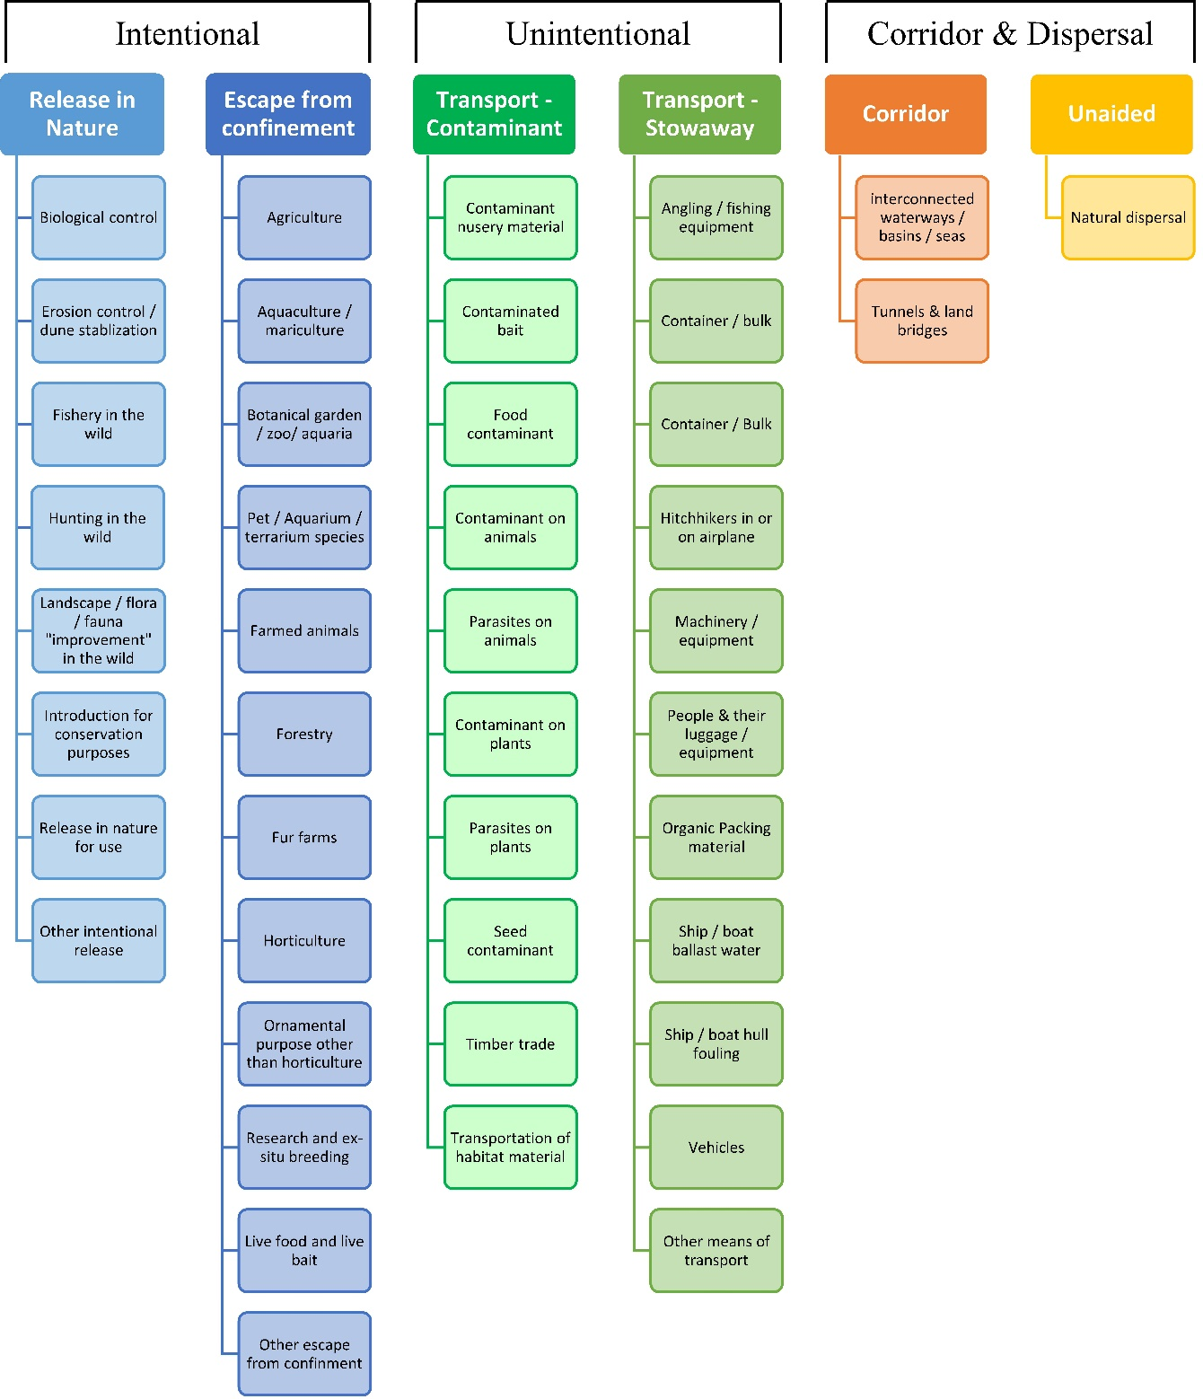

# ANNEX V Ecosystem services classification (CICES V5.1, simplified) and examples

For the purposes of this risk assessment, please feel free to use what seems as the most appropriate category / level / combination of impact (Section – Division – Group), reflecting information available.

|  |  |  |  |
| --- | --- | --- | --- |
| **Section** | **Division** | **Group** | **Examples (i.e. relevant CICES “classes”)** |
| **Provisioning** | **Biomass** | **Cultivated *terrestrial* plants** | Cultivated terrestrial plants (including fungi, algae) grown for nutritional purposes;  Fibres and other materials from cultivated plants, fungi, algae and bacteria for direct use or processing (excluding genetic materials);  Cultivated plants (including fungi, algae) grown as a source of energy  *Example: negative impacts of non-native organisms to crops, orchards, timber etc.* |
|  |  | **Cultivated *aquatic* plants** | Plants cultivated by in- situ aquaculture grown for nutritional purposes;  Fibres and other materials from in-situ aquaculture for direct use or processing (excluding genetic materials);  Plants cultivated by in- situ aquaculture grown as an energy source.  *Example: negative impacts of non-native organisms to aquatic plants cultivated for nutrition, gardening etc. purposes.* |
|  |  | **Reared animals** | Animals reared for nutritional purposes;  Fibres and other materials from reared animals for direct use or processing (excluding genetic materials);  Animals reared to provide energy (including mechanical)  *Example: negative impacts of non-native organisms to livestock* |
|  |  | **Reared *aquatic* animals** | Animals reared by in-situ aquaculture for nutritional purposes;  Fibres and other materials from animals grown by in-situ aquaculture for direct use or processing (excluding genetic materials);  Animals reared by in-situ aquaculture as an energy source  *Example: negative impacts of non-native organisms to fish farming* |
|  |  | **Wild plants** (terrestrial and aquatic) | Wild plants (terrestrial and aquatic, including fungi, algae) used for nutrition;  Fibres and other materials from wild plants for direct use or processing (excluding genetic materials);  Wild plants (terrestrial and aquatic, including fungi, algae) used as a source of energy  *Example: reduction in the availability of wild plants (e.g. wild berries, ornamentals) due to non-native organisms (competition, spread of disease etc.)* |
|  |  | **Wild animals** (terrestrial and aquatic) | Wild animals (terrestrial and aquatic) used for nutritional purposes;  Fibres and other materials from wild animals for direct use or processing (excluding genetic materials);  Wild animals (terrestrial and aquatic) used as a source of energy  *Example: reduction in the availability of wild animals (e.g. fish stocks, game) due to non-native organisms (competition, predations, spread of disease etc.)* |
|  | **Genetic material** from all biota | **Genetic material** from plants, algae or fungi | Seeds, spores and other plant materials collected for maintaining or establishing a population;  Higher and lower plants (whole organisms) used to breed new strains or varieties;  Individual genes extracted from higher and lower plants for the design and construction of new biological entities  *Example: negative impacts of non-native organisms due to interbreeding* |
|  |  | **Genetic material** from animals | Animal material collected for the purposes of maintaining or establishing a population;  Wild animals (whole organisms) used to breed new strains or varieties;  Individual genes extracted from organisms for the design and construction of new biological entities  *Example: negative impacts of non-native organisms due to interbreeding* |
|  | **Water[6]** | **Surface water** used for nutrition, materials or energy | Surface water for drinking;  Surface water used as a material (non-drinking purposes);  Freshwater surface water, coastal and marine water used as an energy source  *Example: loss of access to surface water due to spread of non-native organisms* |
|  |  | **Ground water** for used for nutrition, materials or energy | Ground (and subsurface) water for drinking;  Ground water (and subsurface) used as a material (non-drinking purposes);  Ground water (and subsurface) used as an energy source  *Example: reduced availability of ground water due to spread of non-native organisms and associated increase of ground water consumption by vegetation.* |
| **Regulation & Maintenance** | **Transformation** of biochemical or physical inputs to ecosystems | **Mediation of wastes or toxic substances** of anthropogenic origin by living processes | Bio-remediation by micro-organisms, algae, plants, and animals; Filtration/sequestration/storage/accumulation by micro-organisms, algae, plants, and animals  *Example: changes caused by non-native organisms to ecosystem functioning and ability to filtrate etc. waste or toxics* |
|  |  | **Mediation of nuisances** of anthropogenic origin | Smell reduction; noise attenuation; visual screening (e.g. by means of green infrastructure)  *Example: changes caused by non-native organisms to ecosystem structure, leading to reduced ability to mediate nuisances.* |
|  | **Regulation** of physical, chemical, biological conditions | **Baseline flows and extreme event** regulation | Control of erosion rates;  Buffering and attenuation of mass movement;  Hydrological cycle and water flow regulation (Including flood control, and coastal protection);  Wind protection;  Fire protection  *Example: changes caused by non-native organisms to ecosystem functioning or structure leading to, for example, destabilisation of soil, increased risk or intensity of wild fires etc.* |
|  |  | **Lifecycle maintenance**, habitat and gene pool protection | Pollination (or 'gamete' dispersal in a marine context);  Seed dispersal;  Maintaining nursery populations and habitats (Including gene pool protection)  *Example: changes caused by non-native organisms to the abundance and/or distribution of wild pollinators; changes to the availability / quality of nursery habitats for fisheries* |
|  |  | **Pest and disease control** | Pest control;  Disease control  *Example: changes caused by non-native organisms to the abundance and/or distribution of pests* |
|  |  | **Soil quality** regulation | Weathering processes and their effect on soil quality;  Decomposition and fixing processes and their effect on soil quality  *Example: changes caused by non-native organisms to vegetation structure and/or soil fauna leading to reduced soil quality* |
|  |  | **Water** conditions | Regulation of the chemical condition of freshwaters by living processes;  Regulation of the chemical condition of salt waters by living processes  *Example: changes caused by non-native organisms to buffer strips along water courses that remove nutrients in runoff and/or fish communities that regulate the resilience and resistance of water bodies to eutrophication* |
|  |  | **Atmospheric** composition and conditions | Regulation of chemical composition of atmosphere and oceans;  Regulation of temperature and humidity, including ventilation and transpiration  *Example: changes caused by non-native organisms to ecosystems’ ability to sequester carbon and/or evaporative cooling (e.g. by urban trees)* |
| **Cultural** | **Direct, in-situ and outdoor interactions** with living systems that depend on presence in the environmental setting | **Physical and experiential** interactions with natural environment | Characteristics of living systems that that enable activities promoting health, recuperation or enjoyment through active or immersive interactions;  Characteristics of living systems that enable activities promoting health, recuperation or enjoyment through passive or observational interactions  *Example: changes caused by non-native organisms to the qualities of ecosystems (structure, species composition etc.) that make it attractive for recreation, wild life watching etc.* |
|  |  | **Intellectual and representative** interactions with natural environment | Characteristics of living systems that enable scientific investigation or the creation of traditional ecological knowledge;  Characteristics of living systems that enable education and training;  Characteristics of living systems that are resonant in terms of culture or heritage;  Characteristics of living systems that enable aesthetic experiences  *Example: changes caused by non-native organisms to the qualities of ecosystems (structure, species composition etc.) that have cultural importance* |
|  | **Indirect, remote, often indoor interactions** with living systems that do not require presence in the environmental setting | **Spiritual, symbolic** and other interactions with natural environment | Elements of living systems that have symbolic meaning;  Elements of living systems that have sacred or religious meaning;  Elements of living systems used for entertainment or representation  *Example: changes caused by non-native organisms to the qualities of ecosystems (structure, species composition etc.) that have sacred or religious meaning* |
|  |  | Other biotic characteristics that have a **non-use value** | Characteristics or features of living systems that have an existence value;  Characteristics or features of living systems that have an option or bequest value  *Example: changes caused by non-native organisms to ecosystems designated as wilderness areas, habitats of endangered species etc.* |

# ANNEX VI EU Biogeographic Regions and MSFD Subregions

See <https://www.eea.europa.eu/data-and-maps/figures/biogeographical-regions-in-europe-2> ,

<http://ec.europa.eu/environment/nature/natura2000/biogeog_regions/>

and

https://www.eea.europa.eu/data-and-maps/data/msfd-regions-and-subregions-1/technical-document/pdf

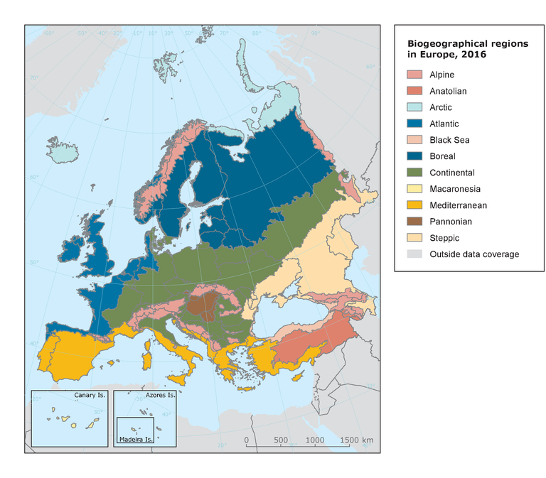 

# ANNEX VII Delegated Regulation (EU) 2018/968 of 30 April 2018

see <https://eur-lex.europa.eu/legal-content/en/TXT/?uri=CELEX%3A32018R0968>

# ANNEX VIII Species Distribution Model

# Projection of environmental suitability for *Bipalium kewense* establishment in Europe

Björn Beckmann, Leigh Winsor, Jean-Lou Justine, Archie Murchie and Dan Chapman

19 June 2021

## Aim

To project the suitability for potential establishment of *Bipalium kewense* in Europe, under current and predicted future climatic conditions.

## Data for modelling

Species occurrence data were obtained from iNaturalist (1776 records), the Global Biodiversity Information Facility (GBIF) (1001 records), the Biodiversity Information Serving Our Nation database (BISON) (145 records), the Atlas of Living Australia (9 records), and additional records from the risk assessment team. We scrutinized occurrence records from regions where the species is not known to be established and removed any dubious records or where the georeferencing was too imprecise (e.g. records referenced to a country or island centroid) or outside of the coverage of the predictor layers (e.g. small island or coastal occurrences). The remaining records were gridded at a 0.25 x 0.25 degree resolution for modelling, yielding 688 grid cells with occurrences (Figure 1a). As a proxy for recording effort, the density of Platyhelminthes records held by GBIF was also compiled on the same grid (Figure 1b).

**Figure 1.** (a) Occurrence records obtained for *Bipalium kewense* and used in the modelling, showing native and invaded distributions. (b) The recording density of Platyhelminthes on GBIF, which was used as a proxy for recording effort.

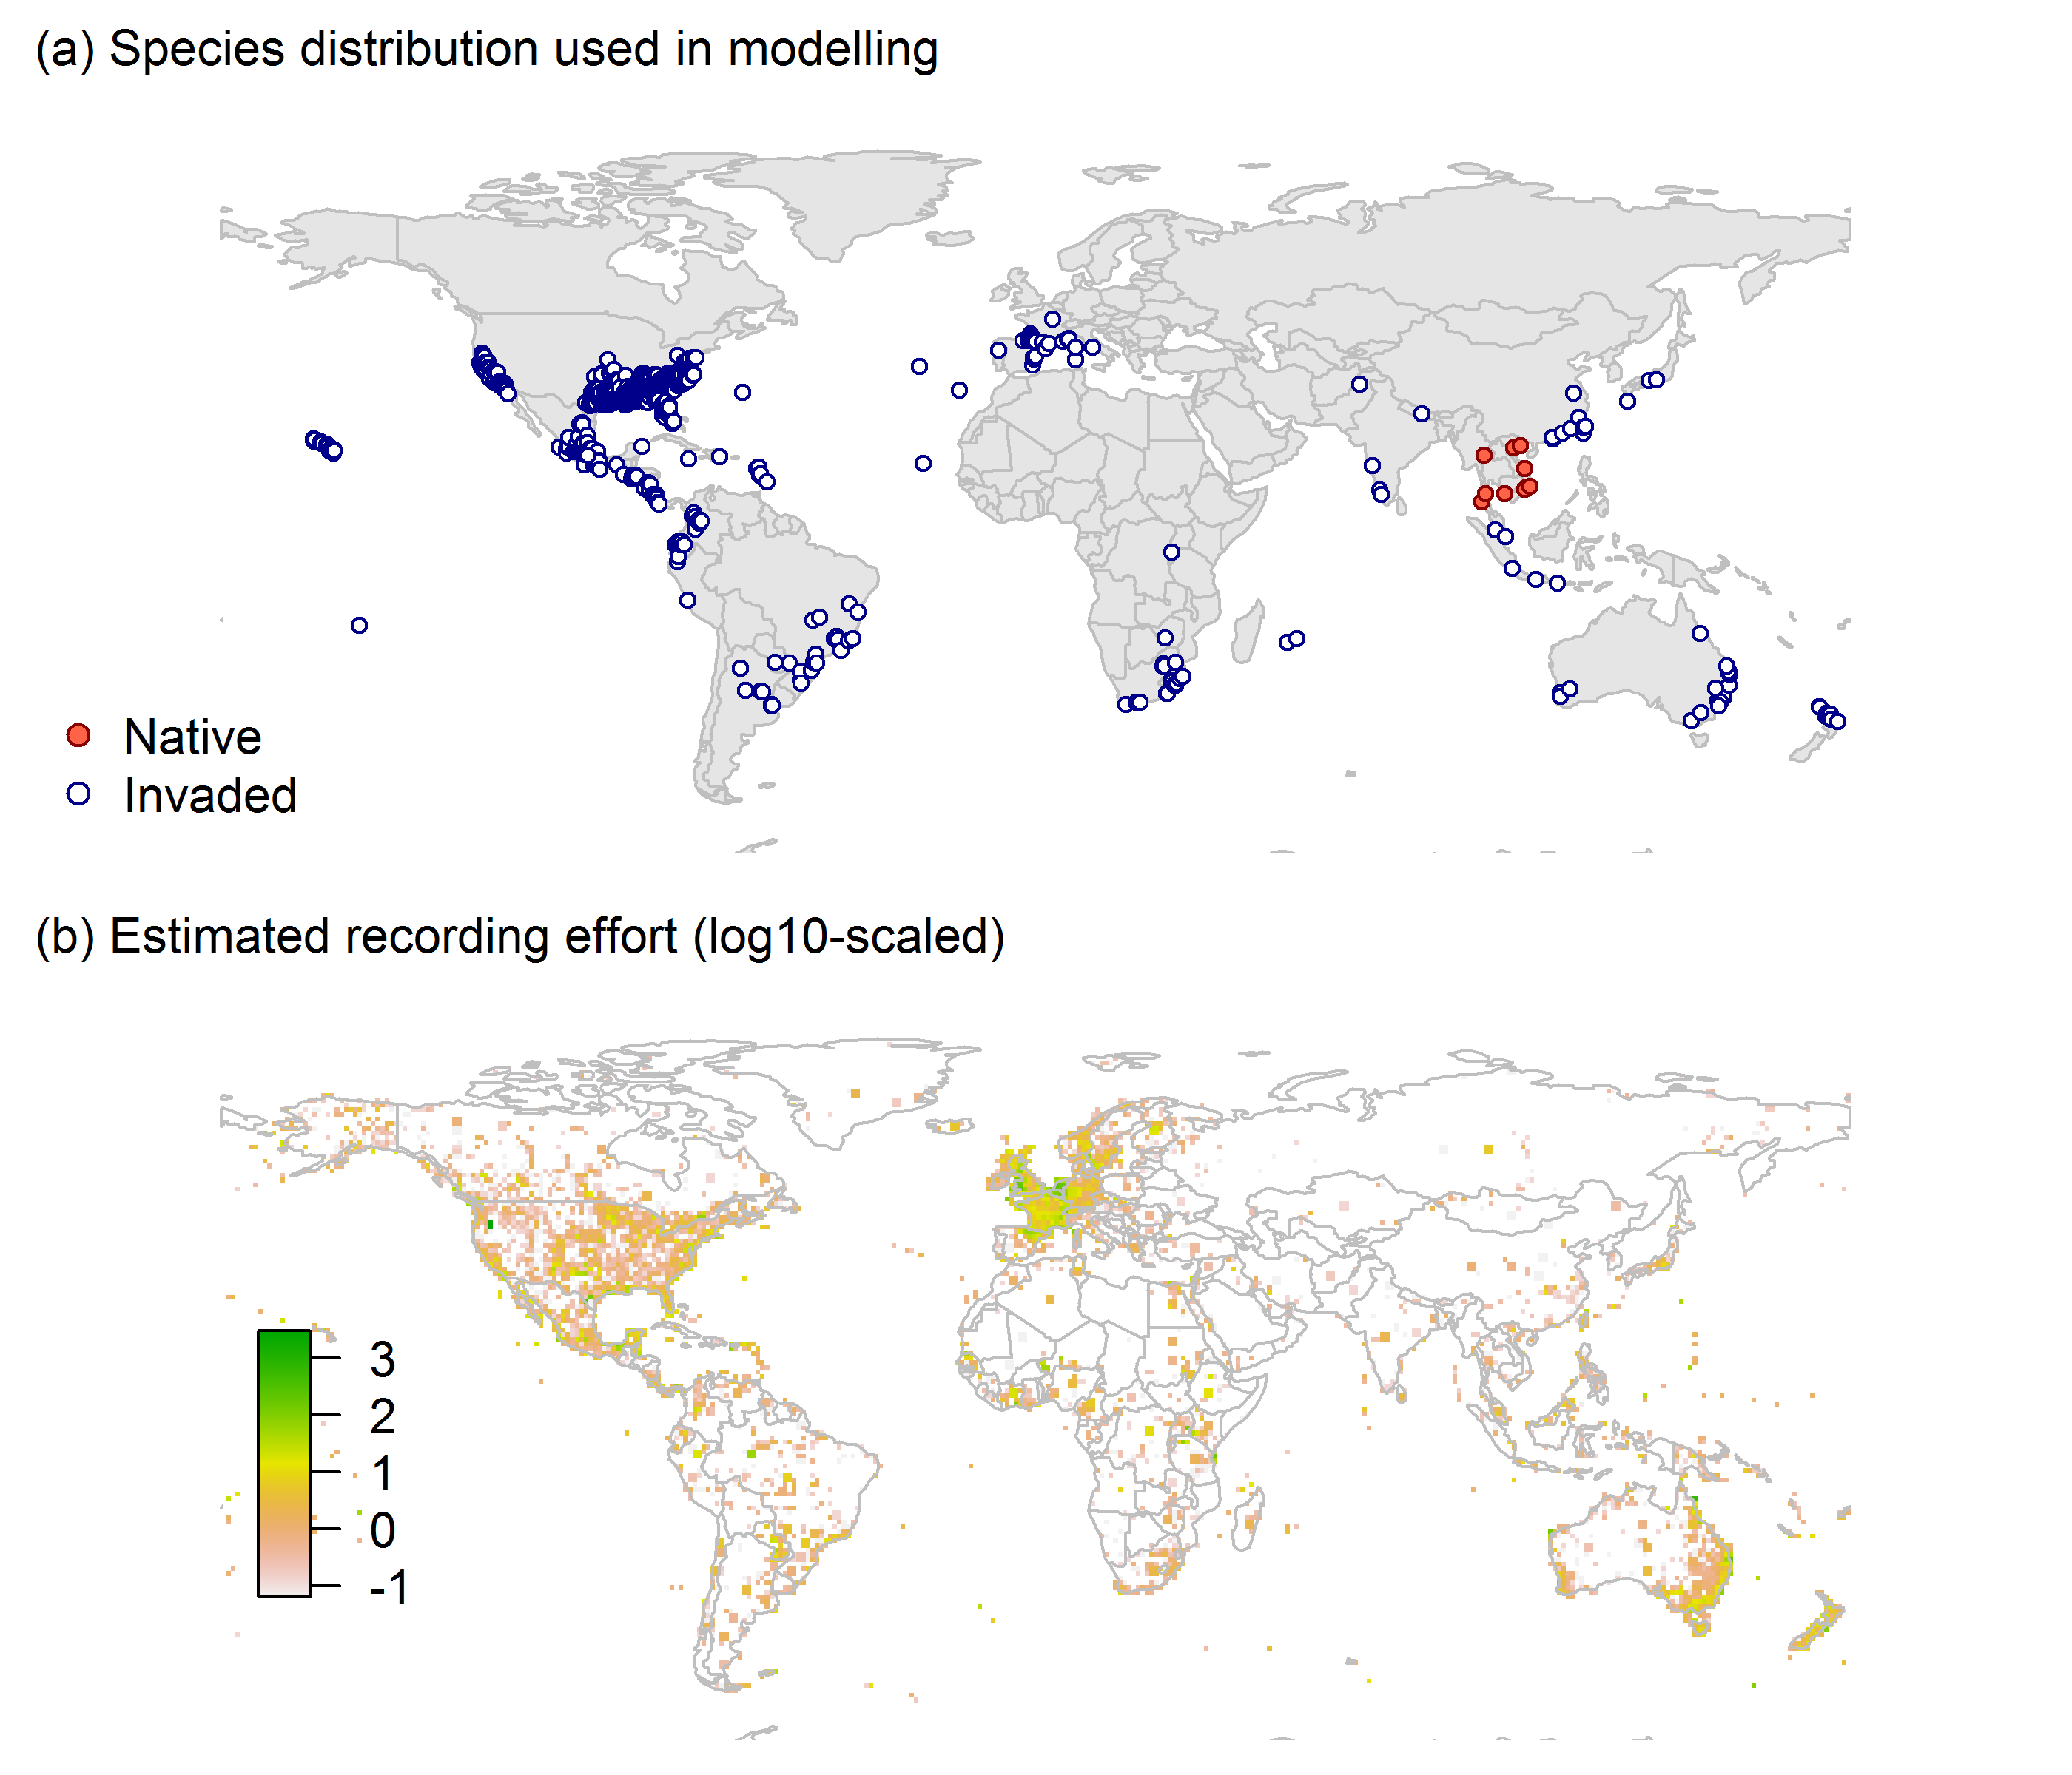

Climate data were selected from the ‘Bioclim’ variables contained within the WorldClim database (Hijmans et al., 2005), originally at 5 arcminute resolution (0.083 x 0.083 degrees of longitude/latitude) and aggregated to a 0.25 x 0.25 degree grid for use in the model.

Based on the biology of *Bipalium kewense*, the following climate variables were used in the modelling:

* Minimum temperature of the coldest month (Bio6)
* Mean temperature of the warmest quarter (Bio10)
* Annual precipitation (Bio12)
* Precipitation seasonality (Bio15)
* Climatic moisture index (CMI): ratio of mean annual precipitation to potential evapotranspiration, log+1 transformed. For its calculation, monthly potential evapotranspirations were estimated from the WorldClim monthly temperature data and solar radiation using the simple method of Zomer et al. (2008) which is based on the Hargreaves evapotranspiration equation (Hargreaves, 1994).

To estimate the effect of climate change on the potential distribution, equivalent modelled future climate conditions for the 2070s under the Representative Concentration Pathways (RCP) 2.6 and 4.5 were also obtained. These represent low and medium emissions scenarios, respectively. The above variables were obtained as averages of outputs of eight Global Climate Models (BCC-CSM1-1, CCSM4, GISS-E2-R, HadGEM2-AO, IPSL-CM5A-LR, MIROC-ESM, MRI-CGCM3, NorESM1-M), downscaled and calibrated against the WorldClim baseline (see <http://www.worldclim.org/cmip5_5m> ).

The following habitat layers were also used:

* Human influence index (HII): As many non-native invasive species associate with anthropogenically disturbed habitats. We used the Global Human Influence Index Dataset of the Last of the Wild Project (Wildlife Conservation Society - WCS & Center for International Earth Science Information Network - CIESIN - Columbia University, 2005), which is developed from nine global data layers covering human population pressure (population density), human land use and infrastructure (built-up areas, nighttime lights, land use/land cover) and human access (coastlines, roads, railroads, navigable rivers). The index ranges between 0 and 1 and was ln+1 transformed for the modelling to improve normality.

## Species distribution model

A presence-background (presence-only) ensemble modelling strategy was employed using the BIOMOD2 R package version 3.4.6 (Thuiller et al., 2020, Thuiller et al., 2009). These models contrast the environment at the species’ occurrence locations against a random sample of the global background environmental conditions (often termed ‘pseudo-absences’) in order to characterise and project suitability for occurrence. This approach has been developed for distributions that are in equilibrium with the environment. Because invasive species’ distributions are not at equilibrium and subject to dispersal constraints at a global scale, we took care to minimise the inclusion of locations suitable for the species but where it has not been able to disperse to (Chapman et al. 2019). Therefore the background sampling region included:

* The area accessible by native *Bipalium kewense* populations, in which the species is likely to have had sufficient time to disperse to all locations. Based on presumed maximum dispersal distances, the accessible region was defined as a 300km buffer around the native range occurrences; AND
* A 30km buffer around the non-native occurrences, encompassing regions likely to have had high propagule pressure for introduction by humans and/or dispersal of the species; AND
* Regions where we have an *a priori* expectation of high unsuitability for the species so that absence is assumed irrespective of dispersal constraints (see Figure 2). The following rules were applied to define a region expected to be highly unsuitable for *Bipalium kewense* at the spatial scale of the model:
  + Minimum temperature of the coldest month (Bio6) < -7°C
  + Mean temperature of the warmest quarter (Bio10) < 13°C
  + Annual precipitation (Bio12) < 270mm

Altogether, 1.2% of occurrence grid cells were located in the unsuitable background region.

Within the unsuitable background region, 10 samples of 5000 randomly sampled grid cells were obtained. In the accessible background (comprising the accessible areas around native and non-native occurrences as detailed above), the same number of pseudo-absence samples were drawn as there were presence records (688), weighting the sampling by a proxy for recording effort (Figure 2).

**Figure 2.** The background from which pseudo-absence samples were taken in the modelling of *Bipalium kewense*. Samples were taken from a 300km buffer around the native range and a 30km buffer around non-native occurrences (together forming the accessible background), and from areas expected to be highly unsuitable for the species (the unsuitable background region). Samples from the accessible background were weighted by a proxy for recording effort (Figure 1(b)).

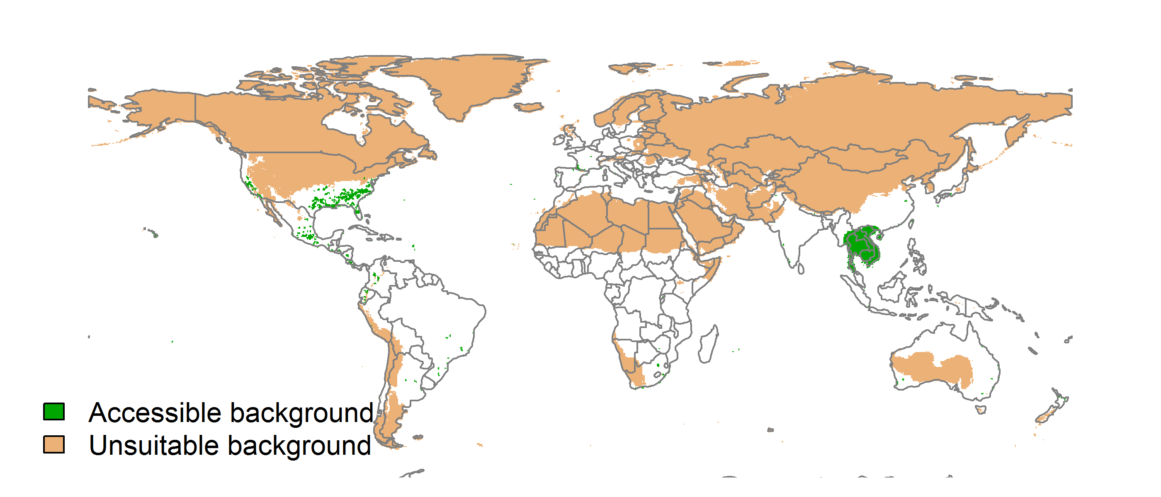

Each dataset (i.e. combination of the presences and the individual background samples) was randomly split into 80% for model training and 20% for model evaluation. With each training dataset, seven statistical algorithms were fitted with the default BIOMOD2 settings and rescaled using logistic regression, except where specified below:

* Generalised linear model (GLM)
* Generalised boosting model (GBM)
* Generalised additive model (GAM) with a maximum of four degrees of freedom per smoothing spline
* Artificial neural network (ANN)
* Multivariate adaptive regression splines (MARS)
* Random forest (RF)
* Maxent

Since the total background sample was larger than the number of occurrences, prevalence fitting weights were applied to give equal overall importance to the occurrences and the background. Normalised variable importance was assessed, and variable response functions were produced using BIOMOD2’s default procedure.

Model predictive performance was assessed by the following three measures:

* AUC, the area under the receiver operating characteristic curve (Fielding & Bell 1997). Predictions of presence-absence models can be compared with a subset of records set aside for model evaluation (here 20%) by constructing a confusion matrix with the number of true positive, false positive, false negative and true negative cases. For models generating non-dichotomous scores (as here) a threshold can be applied to transform the scores into a dichotomous set of presence-absence predictions. Two measures that can be derived from the confusion matrix are sensitivity (the proportion of observed presences that are predicted as such, quantifying omission errors), and specificity (the proportion of observed absences that are predicted as such, quantifying commission errors). A receiver operating characteristic (ROC) curve can be constructed by using all possible thresholds to classify the scores into confusion matrices, obtaining sensitivity and specificity for each matrix, and plotting sensitivity against the corresponding proportion of false positives (equal to 1 - specificity). The use of all possible thresholds avoids the need for a selection of a single threshold, which is often arbitrary, and allows appreciation of the trade-off between sensitivity and specificity. The area under the ROC curve (AUC) is often used as a single threshold-independent measure for model performance (Manel, Williams & Ormerod 2001). AUC is the probability that a randomly selected presence has a higher model-predicted suitability than a randomly selected absence (Allouche et al. 2006).
* Cohen’s Kappa (Cohen 1960). This measure corrects the overall accuracy of model predictions (ratio of the sum of true presences plus true absences to the total number of records) by the accuracy expected to occur by chance. The kappa statistic ranges from -1 to +1, where +1 indicates perfect agreement and values of zero or less indicate a performance no better than random. Advantages of kappa are its simplicity, the fact that both commission and omission errors are accounted for in one parameter, and its relative tolerance to zero values in the confusion matrix (Manel, Williams & Ormerod 2001). However, Kappa has been criticised for being sensitive to prevalence (the proportion of sites in which the species was recorded as present) and may therefore be inappropriate for comparisons of model accuracy between species or regions (McPherson, Jetz & Rogers 2004, Allouche et al. 2006).
* TSS, the true skill statistic (Allouche et al. 2006). TSS is defined as sensitivity + specificity - 1, and corrects for Kappa’s dependency on prevalence. TSS compares the number of correct forecasts, minus those attributable to random guessing, to that of a hypothetical set of perfect forecasts. Like kappa, TSS takes into account both omission and commission errors, and success as a result of random guessing, and ranges from -1 to +1, where +1 indicates perfect agreement and values of zero or less indicate a performance no better than random (Allouche et al. 2006).

An ensemble model was created by first rejecting poorly performing algorithms with relatively extreme low AUC values and then averaging the predictions of the remaining algorithms, weighted by their AUC. To identify poorly performing algorithms, AUC values were converted into modified z-scores based on their difference to the median and the median absolute deviation across all algorithms (Iglewicz & Hoaglin 1993). Algorithms with z < -2 were rejected. In this way, ensemble projections were made for each dataset and then averaged to give an overall suitability, as well as its standard deviation.

Projections were classified into suitable and unsuitable regions using a “lowest presence threshold” (Pearson et al. 2007), setting the cut-off as the lowest value at which 98% of all presence records are classified correctly under the current climate (here 0.59). In order to express the sensitivity of classifications to the choice of this threshold, thresholds at which 95% and 99% of records are classified correctly (here 0.71 and 0.45 respectively) were used in the calculation of error bars in Figs. 9 and 10 below in addition to taking account of uncertainty in the projections themselves.

We also produced a limiting factor map for Europe following Elith et al. (2010). For this, projections were made separately with each individual variable fixed at a near-optimal value. These were chosen as the median values at the occurrence grid cells. Then, the most strongly limiting factors were identified as the ones resulting in the highest increase in suitability in each grid cell.

## Results

The ensemble model suggested that suitability for *Bipalium kewense* was most strongly determined by Minimum temperature of the coldest month (Bio6), accounting for 37.5% of variation explained, followed by Annual precipitation (Bio12) (23.5%), Human influence index (HII) (22.5%), Mean temperature of the warmest quarter (Bio10) (9.7%), Climatic moisture index (CMI) (6.4%) and Precipitation seasonality (Bio15) (0.4%) (Table 1, Figure 3).

**Table 1.** Summary of the cross-validation predictive performance (AUC, Kappa, TSS) and variable importance of the fitted model algorithms and the ensemble (AUC-weighted average of the best performing algorithms). Results are the average from models fitted to 10 different background samples of the data.

|  |  |  |  |  |  |  |  |  |  |  |
| --- | --- | --- | --- | --- | --- | --- | --- | --- | --- | --- |
|  |  |  |  |  | **Variable importance (%)** | | | | | |
| **Algorithm** | **AUC** | **Kappa** | **TSS** | **Used in the ensemble** | **Minimum temperature of the coldest month (Bio6)** | **Annual precipitation (Bio12)** | **Human influence index (HII)** | **Mean temperature of the warmest quarter (Bio10)** | **Climatic moisture index (CMI)** | **Precipitation seasonality (Bio15)** |
| GLM | 0.944 | 0.623 | 0.873 | yes | 24 | 37 | 21 | 8 | 10 | 0 |
| GAM | 0.951 | 0.621 | 0.875 | yes | 30 | 34 | 25 | 3 | 7 | 0 |
| GBM | 0.944 | 0.618 | 0.875 | yes | 47 | 10 | 28 | 12 | 3 | 0 |
| ANN | 0.953 | 0.627 | 0.871 | yes | 48 | 15 | 19 | 14 | 4 | 0 |
| MARS | 0.949 | 0.619 | 0.876 | yes | 37 | 22 | 25 | 8 | 8 | 0 |
| RF | 0.920 | 0.595 | 0.865 | no | 45 | 21 | 13 | 11 | 5 | 5 |
| Maxent | 0.945 | 0.617 | 0.872 | yes | 40 | 22 | 17 | 13 | 7 | 1 |
| **Ensemble** | **0.949** | **0.623** | **0.876** |  | **37** | **23** | **23** | **10** | **6** | **0** |

**Figure 3.** Partial response plots from the fitted models. Thin coloured lines show responses from the algorithms in the ensemble, while the thick black line is their ensemble. In each plot, other model variables are held at their median value in the training data. Some of the divergence among algorithms is because of their different treatment of interactions among variables.

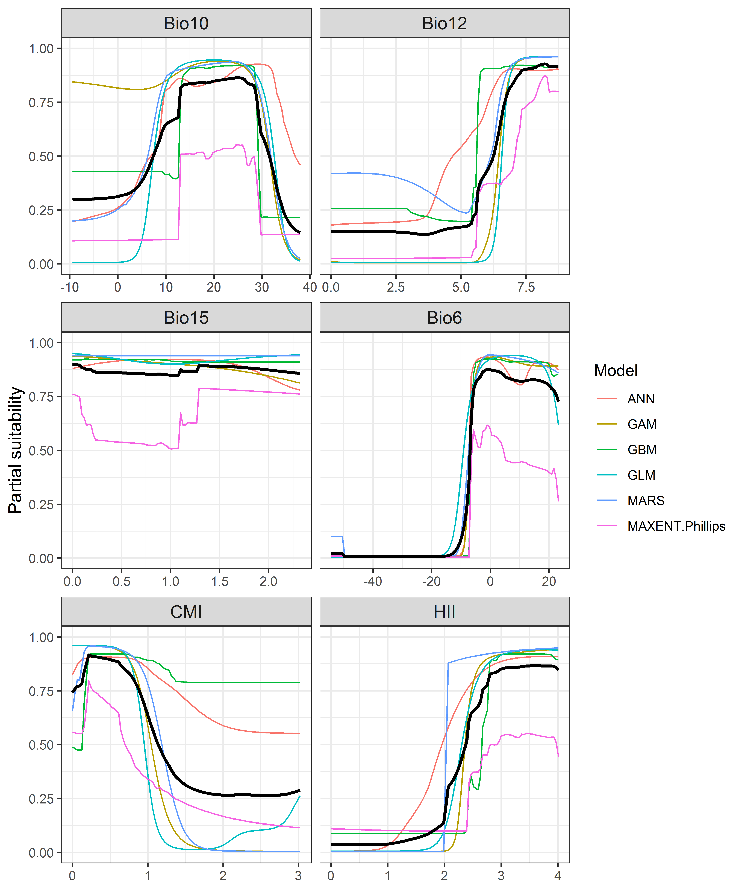

**Figure 4.** (a) Projected global suitability for *Bipalium kewense* establishment in the current climate. For visualisation, the projection has been aggregated to a 0.5 x 0.5 degree resolution, by taking the maximum suitability of constituent higher resolution grid cells. Values > 0.59 are suitable for the species, with 98% of global presence records above this threshold. Values below 0.59 indicate lower relative suitability. (b) Uncertainty in the ensemble projections, expressed as the among-algorithm standard deviation in predicted suitability, averaged across the 10 datasets.

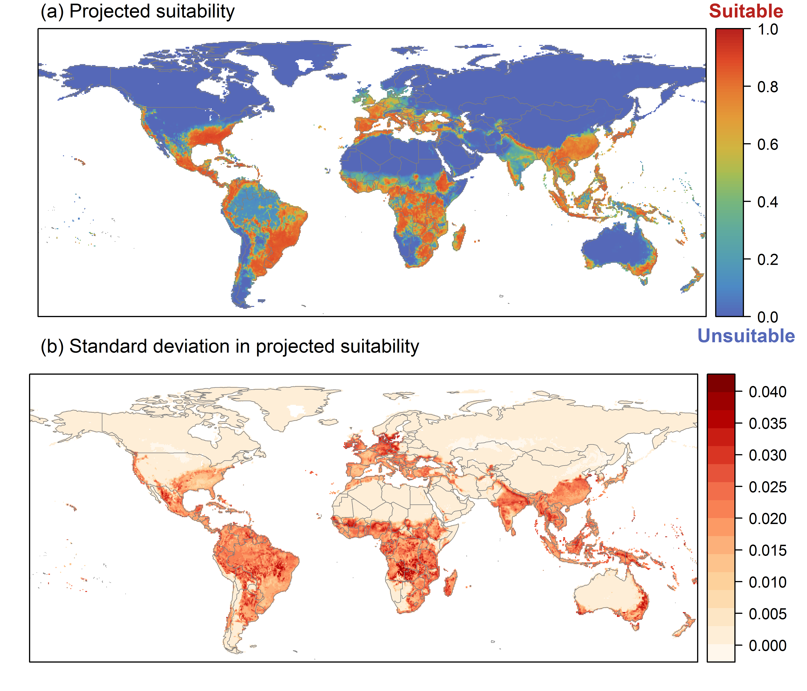

**Figure 5.** (a) Projected current suitability for *Bipalium kewense* establishment in Europe and the Mediterranean region. Values > 0.59 are suitable for the species, with 98% of global presence records above this threshold. Values below 0.59 indicate lower relative suitability. (b) Uncertainty in the ensemble projections, expressed as the among-algorithm standard deviation in predicted suitability, averaged across the 10 datasets.

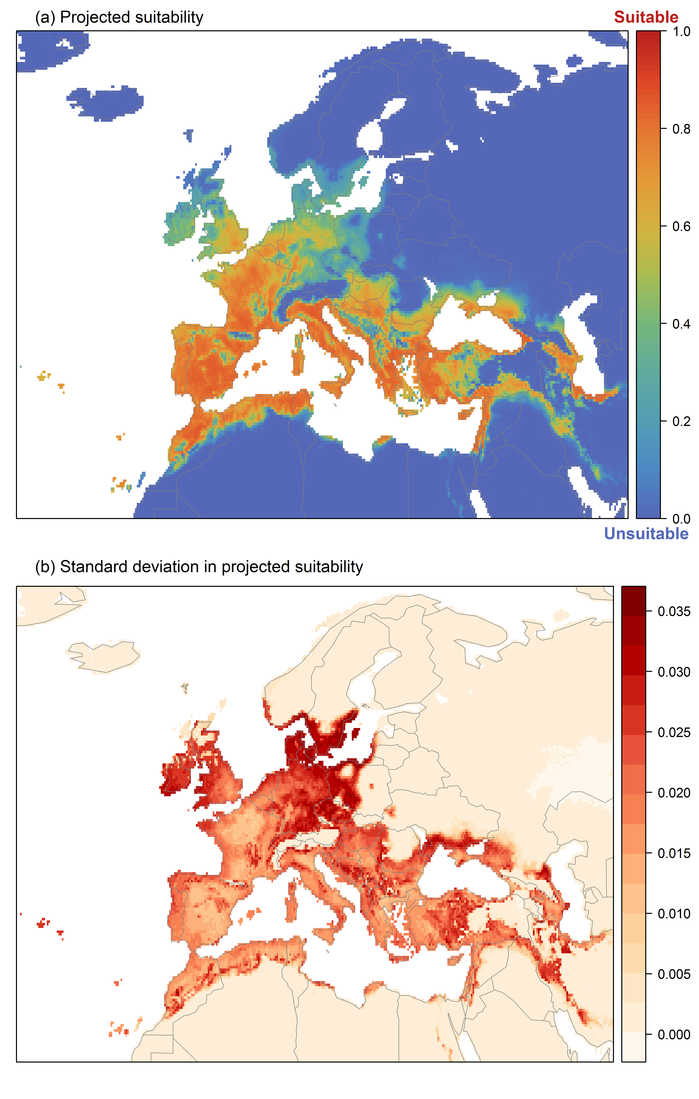

**Figure 6.** The most strongly limiting factors for *Bipalium kewense* establishment estimated by the model in Europe and the Mediterranean region in current climatic conditions.

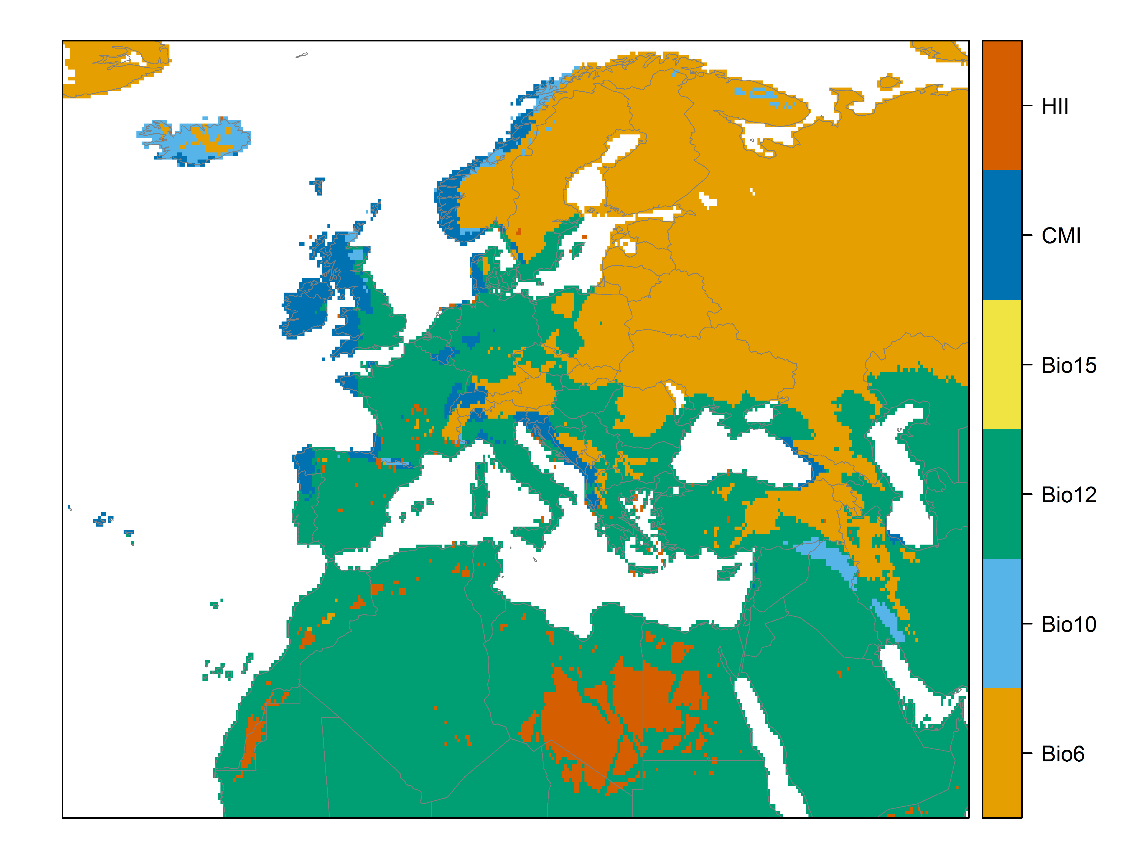

**Figure 7.** (a) Projected suitability for *Bipalium kewense* establishment in Europe and the Mediterranean region in the 2070s under climate change scenario RCP2.6. Values > 0.59 are suitable for the species, with 98% of global presence records above this threshold under current climate. Values below 0.59 indicate lower relative suitability. (b) Uncertainty in the ensemble projections, expressed as the among-algorithm standard deviation in predicted suitability, averaged across the 10 datasets.

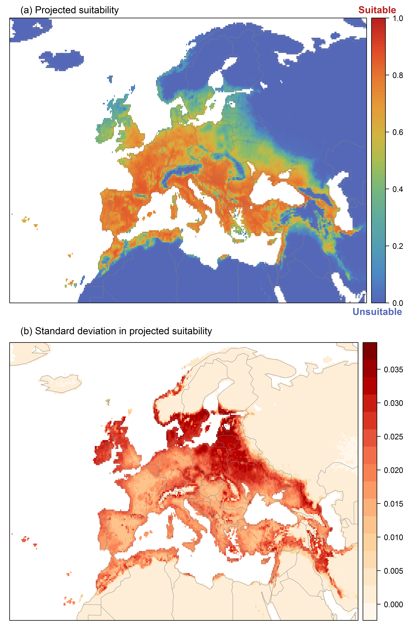

**Figure 8.** (a) Projected suitability for *Bipalium kewense* establishment in Europe and the Mediterranean region in the 2070s under climate change scenario RCP4.5. Values > 0.59 are suitable for the species, with 98% of global presence records above this threshold under current climate. Values below 0.59 indicate lower relative suitability. (b) Uncertainty in the ensemble projections, expressed as the among-algorithm standard deviation in predicted suitability, averaged across the 10 datasets.

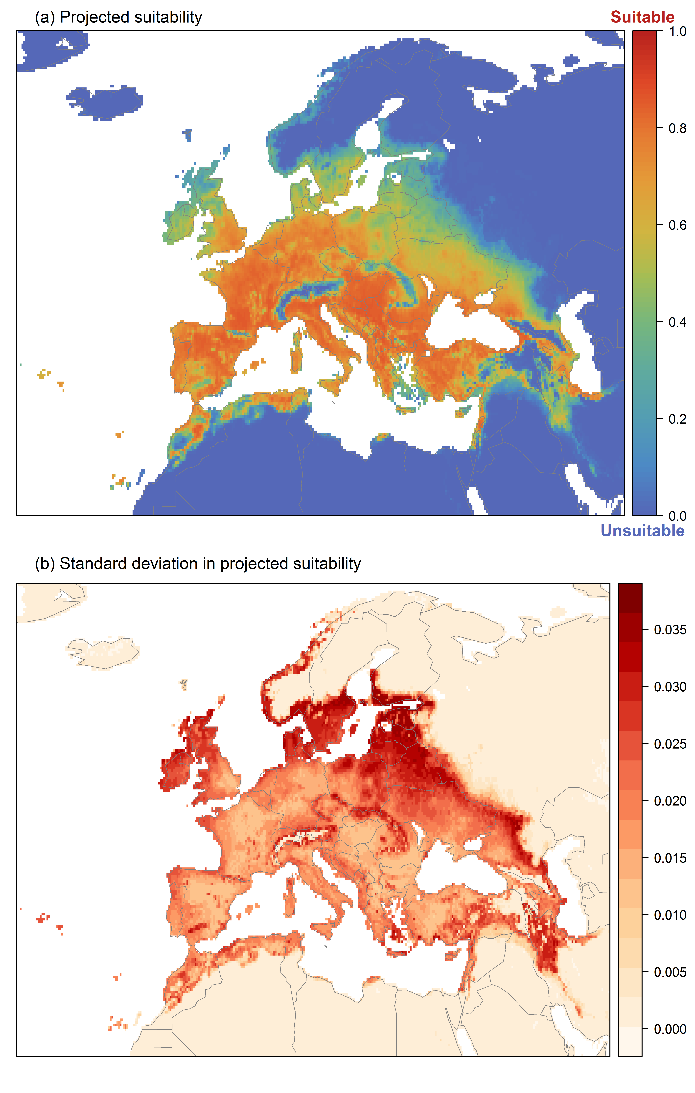

**Figure 9.** Variation in projected suitability for *Bipalium kewense* establishment among Biogeographical Regions of Europe (<https://www.eea.europa.eu/data-and-maps/data/biogeographical-regions-europe-3>). The bar plots show the proportion of grid cells in each region classified as suitable (with values > 0.59) in the current climate and projected climate for the 2070s under two RCP emissions scenarios. Error bars indicate uncertainty due to both the choice of classification threshold (cf. p.6) and uncertainty in the projections themselves (cf. part (b) of Figs. 5,7,8). The location of each region is also shown. The Arctic and Macaronesian regions are not part of the study area, but are included for completeness.

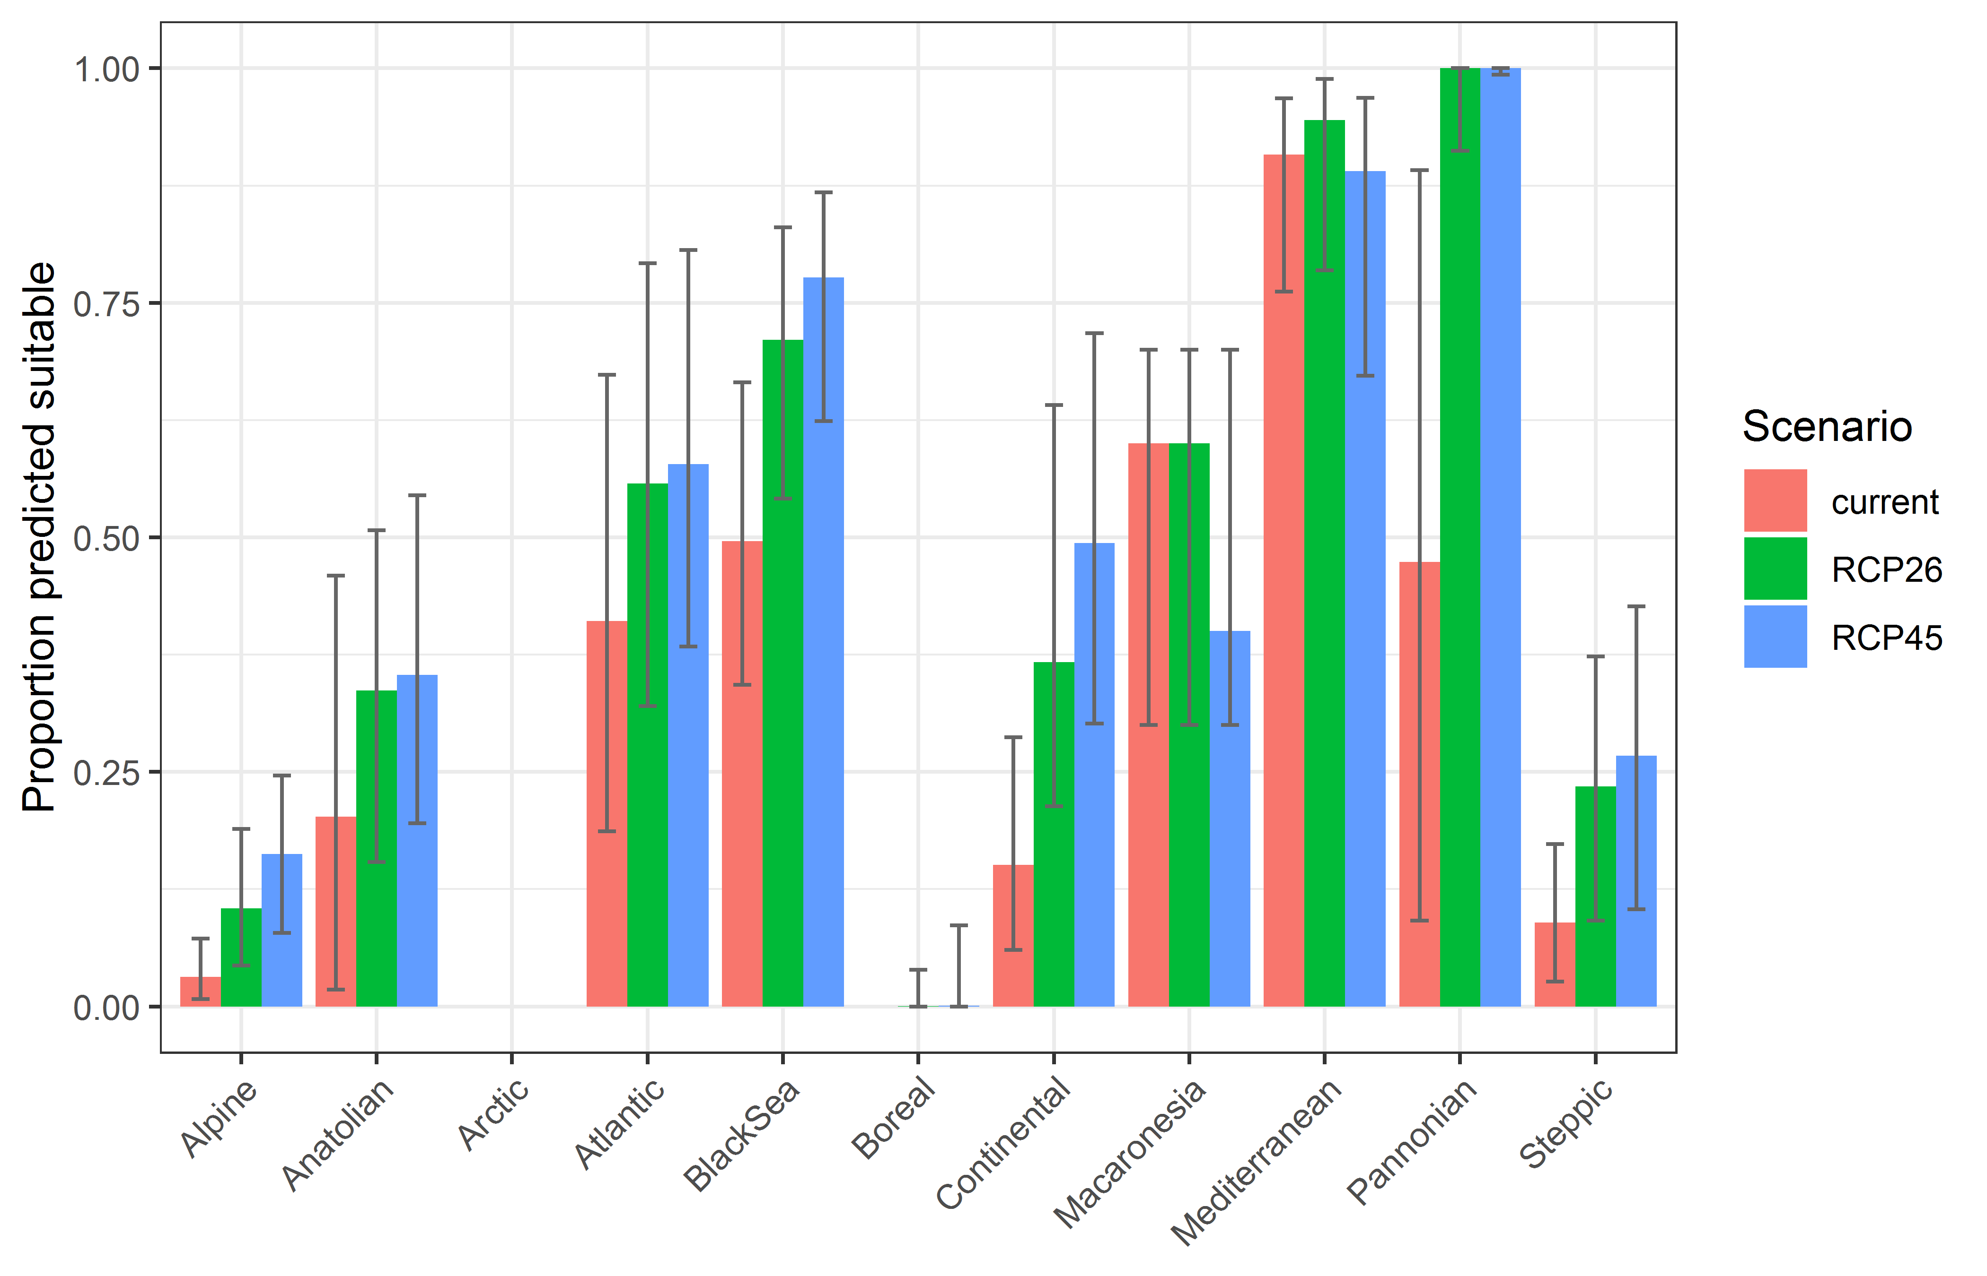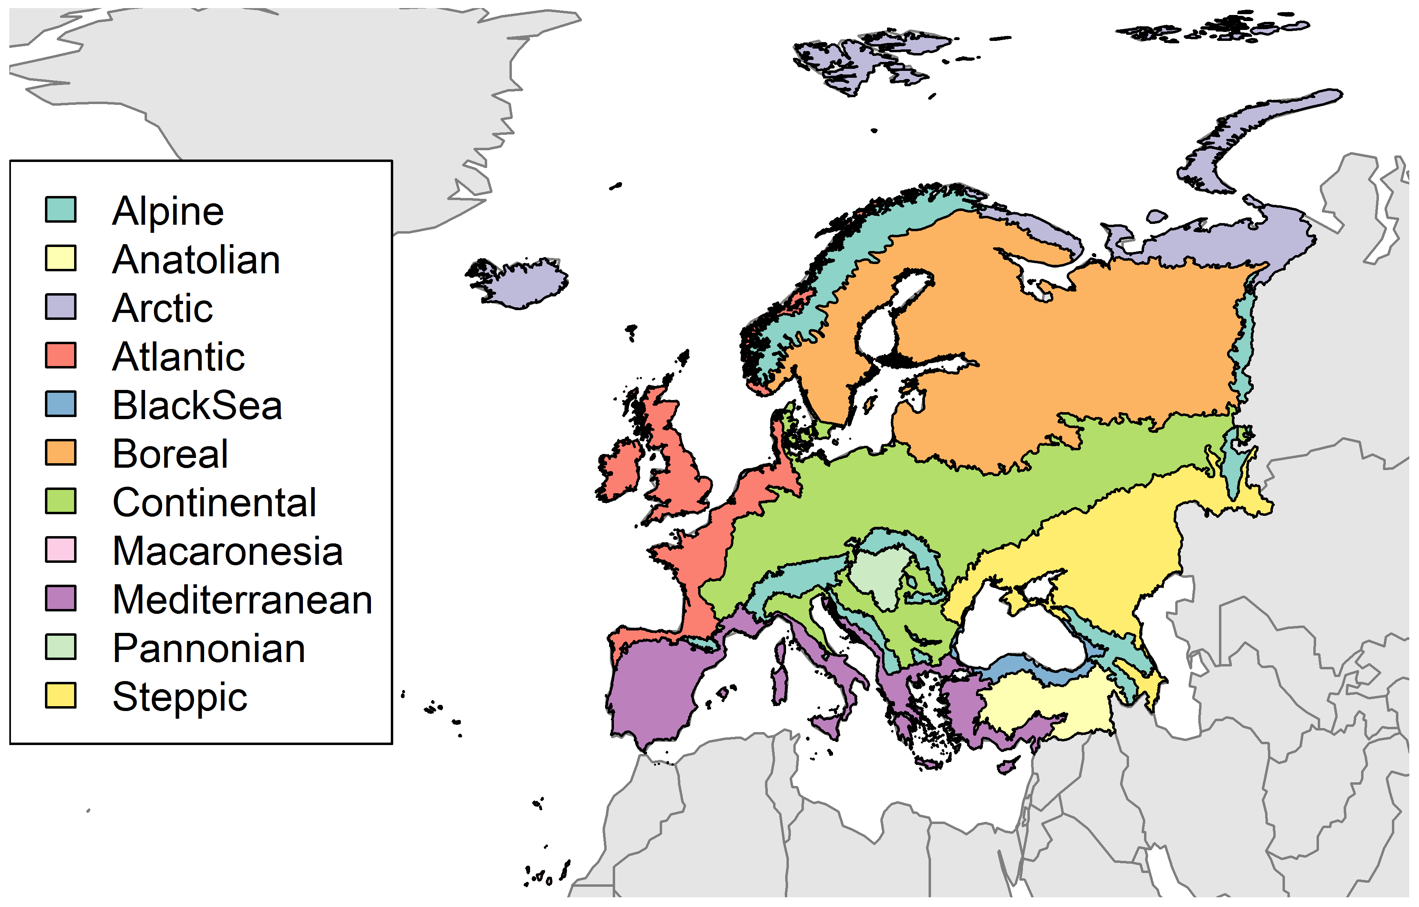

**Table 2.** Variation in projected suitability for *Bipalium kewense* establishment among Biogeographical regions of Europe (numerical values of Figure 9 above). The numbers are the proportion of grid cells in each region classified as suitable in the current climate and projected climate for the 2070s under two RCP emissions scenarios. The Arctic and Macaronesian biogeographical regions are not part of the study area, but are included for completeness.

|  |  |  |  |  |  |  |  |  |  |
| --- | --- | --- | --- | --- | --- | --- | --- | --- | --- |
|  | **current climate** | | | **2070s RCP2.6** | | | **2070s RCP4.5** | | |
|  | lower | **central estimate** | upper | lower | **central estimate** | upper | lower | **central estimate** | upper |
| Alpine | 0.01 | 0.03 | 0.07 | 0.04 | 0.10 | 0.19 | 0.08 | 0.16 | 0.25 |
| Anatolian | 0.02 | 0.20 | 0.46 | 0.15 | 0.34 | 0.51 | 0.20 | 0.35 | 0.54 |
| Arctic | 0.00 | 0.00 | 0.00 | 0.00 | 0.00 | 0.00 | 0.00 | 0.00 | 0.00 |
| Atlantic | 0.19 | 0.41 | 0.67 | 0.32 | 0.56 | 0.79 | 0.38 | 0.58 | 0.81 |
| Black Sea | 0.34 | 0.50 | 0.67 | 0.54 | 0.71 | 0.83 | 0.62 | 0.78 | 0.87 |
| Boreal | 0.00 | 0.00 | 0.00 | 0.00 | 0.00 | 0.04 | 0.00 | 0.00 | 0.09 |
| Continental | 0.06 | 0.15 | 0.29 | 0.21 | 0.37 | 0.64 | 0.30 | 0.49 | 0.72 |
| Macaronesia | 0.30 | 0.60 | 0.70 | 0.30 | 0.60 | 0.70 | 0.30 | 0.40 | 0.70 |
| Mediterranean | 0.76 | 0.91 | 0.97 | 0.78 | 0.94 | 0.99 | 0.67 | 0.89 | 0.97 |
| Pannonian | 0.09 | 0.47 | 0.89 | 0.91 | 1.00 | 1.00 | 0.99 | 1.00 | 1.00 |
| Steppic | 0.03 | 0.09 | 0.17 | 0.09 | 0.23 | 0.37 | 0.10 | 0.27 | 0.43 |

**Figure 10.** Variation in projected suitability for *Bipalium kewense* establishment among European Union countries and the UK. The bar plots show the proportion of grid cells in each country classified as suitable (with values > 0.59) in the current climate and projected climate for the 2070s under two RCP emissions scenarios. Error bars indicate uncertainty due to both the choice of classification threshold (cf. p.6) and uncertainty in the projections themselves (cf. part (b) of Figs. 5,7,8). Malta has been excluded because the Human Influence Index dataset lacks coverage for Malta.

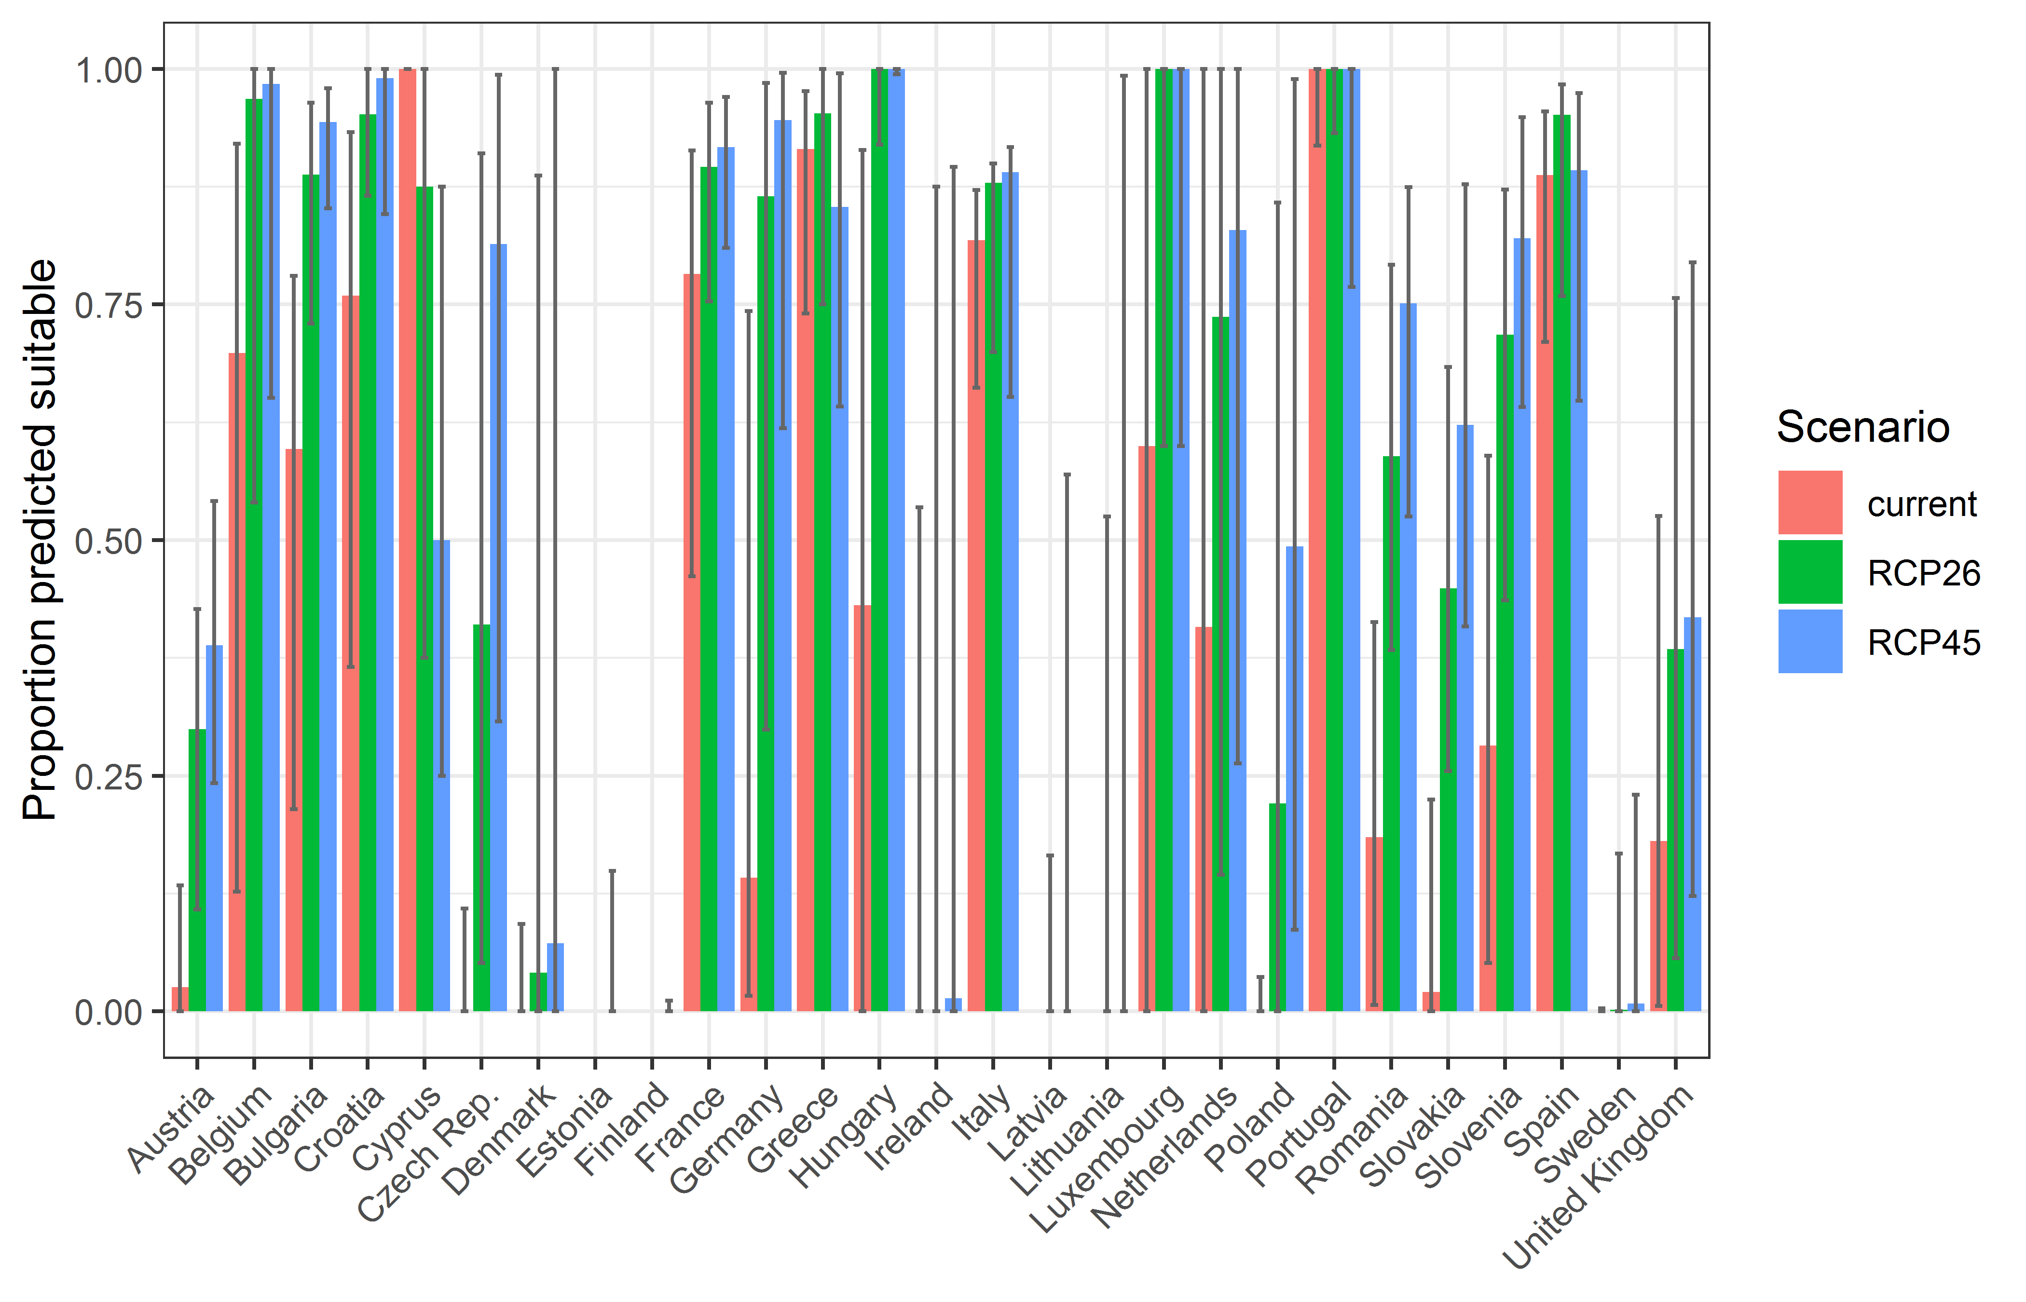

**Table 3.** Variation in projected suitability for *Bipalium kewense* establishment among European Union countries and the UK (numerical values of Figure 10 above). The numbers are the proportion of grid cells in each country classified as suitable in the current climate and projected climate for the 2070s under two RCP emissions scenarios.

|  |  |  |  |  |  |  |  |  |  |
| --- | --- | --- | --- | --- | --- | --- | --- | --- | --- |
|  | **current climate** | | | **2070s RCP2.6** | | | **2070s RCP4.5** | | |
|  | lower | **central estimate** | upper | lower | **central estimate** | upper | lower | **central estimate** | upper |
| Austria | 0.00 | 0.03 | 0.13 | 0.11 | 0.30 | 0.43 | 0.24 | 0.39 | 0.54 |
| Belgium | 0.13 | 0.70 | 0.92 | 0.54 | 0.97 | 1.00 | 0.65 | 0.98 | 1.00 |
| Bulgaria | 0.21 | 0.60 | 0.78 | 0.73 | 0.89 | 0.96 | 0.85 | 0.94 | 0.98 |
| Croatia | 0.37 | 0.76 | 0.93 | 0.87 | 0.95 | 1.00 | 0.85 | 0.99 | 1.00 |
| Cyprus | 1.00 | 1.00 | 1.00 | 0.38 | 0.88 | 1.00 | 0.25 | 0.50 | 0.88 |
| Czech Rep. | 0.00 | 0.00 | 0.11 | 0.05 | 0.41 | 0.91 | 0.31 | 0.81 | 0.99 |
| Denmark | 0.00 | 0.00 | 0.09 | 0.00 | 0.04 | 0.89 | 0.00 | 0.07 | 1.00 |
| Estonia | 0.00 | 0.00 | 0.00 | 0.00 | 0.00 | 0.00 | 0.00 | 0.00 | 0.15 |
| Finland | 0.00 | 0.00 | 0.00 | 0.00 | 0.00 | 0.00 | 0.00 | 0.00 | 0.01 |
| France | 0.46 | 0.78 | 0.91 | 0.75 | 0.90 | 0.96 | 0.81 | 0.92 | 0.97 |
| Germany | 0.02 | 0.14 | 0.74 | 0.30 | 0.86 | 0.99 | 0.62 | 0.95 | 1.00 |
| Greece | 0.74 | 0.92 | 0.98 | 0.75 | 0.95 | 1.00 | 0.64 | 0.85 | 1.00 |
| Hungary | 0.00 | 0.43 | 0.91 | 0.92 | 1.00 | 1.00 | 0.99 | 1.00 | 1.00 |
| Ireland | 0.00 | 0.00 | 0.53 | 0.00 | 0.00 | 0.88 | 0.00 | 0.01 | 0.90 |
| Italy | 0.66 | 0.82 | 0.87 | 0.70 | 0.88 | 0.90 | 0.65 | 0.89 | 0.92 |
| Latvia | 0.00 | 0.00 | 0.00 | 0.00 | 0.00 | 0.17 | 0.00 | 0.00 | 0.57 |
| Lithuania | 0.00 | 0.00 | 0.00 | 0.00 | 0.00 | 0.52 | 0.00 | 0.00 | 0.99 |
| Luxembourg | 0.00 | 0.60 | 1.00 | 0.60 | 1.00 | 1.00 | 0.60 | 1.00 | 1.00 |
| Netherlands | 0.00 | 0.41 | 1.00 | 0.14 | 0.74 | 1.00 | 0.26 | 0.83 | 1.00 |
| Poland | 0.00 | 0.00 | 0.04 | 0.00 | 0.22 | 0.86 | 0.09 | 0.49 | 0.99 |
| Portugal | 0.92 | 1.00 | 1.00 | 0.93 | 1.00 | 1.00 | 0.77 | 1.00 | 1.00 |
| Romania | 0.01 | 0.18 | 0.41 | 0.38 | 0.59 | 0.79 | 0.53 | 0.75 | 0.87 |
| Slovakia | 0.00 | 0.02 | 0.22 | 0.26 | 0.45 | 0.68 | 0.41 | 0.62 | 0.88 |
| Slovenia | 0.05 | 0.28 | 0.59 | 0.44 | 0.72 | 0.87 | 0.64 | 0.82 | 0.95 |
| Spain | 0.71 | 0.89 | 0.95 | 0.76 | 0.95 | 0.98 | 0.65 | 0.89 | 0.97 |
| Sweden | 0.00 | 0.00 | 0.00 | 0.00 | 0.00 | 0.17 | 0.00 | 0.01 | 0.23 |
| UK | 0.01 | 0.18 | 0.53 | 0.06 | 0.38 | 0.76 | 0.12 | 0.42 | 0.79 |

## Caveats to the modelling

To remove spatial recording biases, the selection of the background sample from the accessible background was weighted by the density of Platyhelminthes records on the Global Biodiversity Information Facility (GBIF). While this is preferable to not accounting for recording bias at all, it may not provide the perfect measure of recording bias.

There was substantial variation among modelling algorithms in the partial response plots (Figure 3). In part this will reflect their different treatment of interactions among variables. Since partial plots are made with other variables held at their median, there may be values of a particular variable at which this does not provide a realistic combination of variables to predict from.

Other variables potentially affecting the distribution of the species, such as types of land cover were not included in the model.

## References

* Allouche O, Tsoar A, Kadmon R (2006) Assessing the accuracy of species distribution models: prevalence, kappa and the true skill statistic (TSS), Journal of Applied Ecology, 43, 1223-1232.
* Chapman D, Pescott OL, Roy HE, Tanner R (2019) Improving species distribution models for invasive non-native species with biologically informed pseudo-absence selection. Journal of Biogeography, 46, 1029-1040. <https://doi.org/10.1111/jbi.13555>.
* Cohen J (1960) A coefficient of agreement of nominal scales. Educational and Psychological Measurement, 20, 37-46.
* Elith J, Kearney M, Phillips S (2010) The art of modelling range-shifting species. Methods in Ecology and Evolution, 1, 330-342.
* Fielding AH, Bell JF (1997) A review of methods for the assessment of prediction errors in conservation presence/absence models. Environmental Conservation, 24, 38-49.
* Global Biodiversity Information Facility (GBIF.org) (2021) https://www.gbif.org/occurrence/search?q=Bipalium%20kewense
* Hargreaves GH (1994) Defining and Using Reference Evapotranspiration. Journal of Irrigation and Drainage Engineering, 120.
* Hijmans RJ, Cameron SE, Parra JL, Jones PG, Jarvis A (2005) Very high resolution interpolated climate surfaces for global land areas. International Journal of Climatology, 25, 1965-1978.
* Iglewicz B, Hoaglin DC (1993) How to detect and handle outliers, ASQC Press.
* Manel S, Williams HC, Ormerod SJ (2001) Evaluating presence-absence models in ecology: the need to account for prevalence. Journal of Applied Ecology, 38, 921-931.
* McPherson JM, Jetz W, Rogers DJ (2004) The effects of species’ range sizes on the accuracy of distribution models: ecological phenomenon or statistical artefact? Journal of Applied Ecology, 41, 811-823.
* Pearson RG, Raxworthy CJ, Nakamura M, Townsend Peterson A (2007), Predicting species distributions from small numbers of occurrence records: a test case using cryptic geckos in Madagascar. Journal of Biogeography, 34: 102-117. <https://doi.org/10.1111/j.1365-2699.2006.01594.x>
* Thuiller W, Lafourcade B, Engler R, Araújo MB (2009) BIOMOD-a platform for ensemble forecasting of species distributions. Ecography, 32, 369-373.
* Thuiller W, Georges D, Engler R and Breiner F (2020). biomod2: Ensemble Platform for Species Distribution Modeling. R package version 3.4.6. <https://CRAN.R-project.org/package=biomod2>
* Zomer RJ, Trabucco A, Bossio DA, Verchot LV (2008) Climate change mitigation: A spatial analysis of global land suitability for clean development mechanism afforestation and reforestation. Agriculture, Ecosystems & Environment, 126, 67-80.

1. This template is based on the Great Britain non-native species risk assessment scheme (GBNNRA). A number of amendments have been introduced to ensure compliance with Regulation (EU) 1143/2014 on IAS and relevant legislation, including the Delegated Regulation (EU) 2018/968 of 30 April 2018, supplementing Regulation (EU) No 1143/2014 of the European Parliament and of the Council with regard to risk assessments in relation to invasive alien species (see <https://eur-lex.europa.eu/legal-content/en/TXT/?uri=CELEX%3A32018R0968> ).
2. Convention on Biological Diversity, Decision VI/23
3. <https://circabc.europa.eu/sd/a/738e82a8-f0a6-47c6-8f3b-aeddb535b83b/TSSR-2016-010%20CBD%20categories%20on%20pathways%20Final.pdf>
4. <https://circabc.europa.eu/sd/a/0aeba7f1-c8c2-45a1-9ba3-bcb91a9f039d/TSSR-2016-010%20CBD%20pathways%20key%20full%20only.pdf>
5. Not to be confused with “no impact”.
6. Note: in the CICES classification provisioning of water is considered as an abiotic service whereas the rest of ecosystem services listed here are considered biotic.