**Risk assessment template developed under the "Study on Invasive Alien Species – Development of risk assessments to tackle priority species and enhance prevention"   
Contract No 090201/2021/856738/ETU/ENV.D2[1]**

**Name of organism:** *Zostera japonica* Ascherson & Graebner

**Author(s) of the assessment:**

Marika Galanidi, Dr, Ustun Energy Engineering Ltd, Izmir, Turkey

Christine A. Wood, The Marine Biological Association, Plymouth, UK

Björn Beckmann, Dr, Centre for Ecology & Hydrology, Edinburgh, UK

**Risk Assessment Area:** The risk assessment area is the territory of the European Union 27, excluding the EU-outermost regions.

**Peer review 1:** Argyro Zenetos, research Director Hellenic Centre for Marine Research, Anavyssos Greece

**Peer review 2:** Francisco Arenas, CIIMAR - Matosinhos, Portugal

**Date of completion:** 15/10/2022

**Date of revision:** 01/12/2023

**Contents**

SECTION A – Organism Information and Screening 3

SECTION B – Detailed assessment 18

1 PROBABILITY OF INTRODUCTION AND ENTRY 18

2 PROBABILITY OF ESTABLISHMENT 32

3 PROBABILITY OF SPREAD 43

4 MAGNITUDE OF IMPACT 63

RISK SUMMARIES 80

REFERENCES 83

Distribution Summary 100

ANNEX I Scoring of Likelihoods of Events 102

ANNEX II Scoring of Magnitude of Impacts 103

ANNEX III Scoring of Confidence Levels 104

ANNEX IV CBD pathway categorisation scheme 105

ANNEX V Ecosystem services classification (CICES V5.1, simplified) and examples 106

ANNEX VI EU Biogeographic Regions and MSFD Subregions 110

ANNEX VII Delegated Regulation (EU) 2018/968 of 30 April 2018 111

ANNEX VIII Species Distribution Model 112

# SECTION A – Organism Information and Screening

|  |
| --- |
| **A1. Identify the organism. Is it clearly a single taxonomic entity and can it be adequately distinguished from other entities of the same rank?**  including the following elements:   * the taxonomic family, order and class to which the species belongs; * the scientific name and author of the species, as well as a list of the most common synonym names; * names used in commerce (if any) * a list of the most common subspecies, lower taxa, varieties, breeds or hybrids   As a general rule, one risk assessment should be developed for a single species. However, there may be cases where it may be justified to develop one risk assessment covering more than one species (e.g. species belonging to the same genus with comparable or identical features and impact). It shall be clearly stated if the risk assessment covers more than one species, or if it excludes or only includes certain subspecies, lower taxa, hybrids, varieties or breeds (and if so, which subspecies, lower taxa, hybrids, varieties or breeds). Any such choice must be properly justified. |

Response: This risk assessment covers one species*:* *Zostera japonica* Ascherson & Graebner, 1907

**Phylum**: Tracheophyta, **Class**: Magnoliopsida, **Order**: Alismatales, **Family**: Zosteraceae, **Subgenus**: Zosterella

**Synonyms**:

*Nanozostera americana* (Hartog) Tomlinson & Posluszny, 2001 (synonym)

*Zostera americana* Hartog, 1970 unaccepted (synonym)

*Zostera* subg. *Zosterella americana* den Hartog, 1970 (alternate representation)

*Zostera* subg. *Zosterella japonica* Ascherson & Graebner, 1907 (alternate representation)

*Zostera nana* Roth, 1827. This species was subsequently split into *Zostera noltei* in Europe and *Z. japonica* in Asia (Harrison & Bigley, 1982). *Zostera noltei* is distributed in Western Europe, the western Baltic, the Mediterranean and the Black Seas, as well as the Caspian and the Aral Seas (Green & Short, 2003) but forms a monophyletic group with *Z. japonica*, which is distributed in East and South-East Asia (Tanaka et al., 2003). To explain the disjunct distribution, den Hartog (1970) and Phillips & Menez (1988) suggested that *Z. noltei* moved to the Mediterranean from the Indo-Pacific area through the Tethyan Sea before the closure of the Suez Isthmus in the Miocene, 5–24 million years ago (in Tanaka et al., 2003).

NOTE: *Zostera noltei* is also encountered in the scientific literature under the alternative spelling *Z. noltii*. For the purposes of this document, the species is referred to as *Z. noltei*, following WoRMS (<https://www.marinespecies.org/aphia.php?p=taxdetails&id=495082>) and Algaebase (<https://www.algaebase.org/search/species/detail/?species_id=21523>). Nevertheless, data and literature searches in relation to *Z. noltei* were performed with both spellings.

**Common names**: Japanese eelgrass (US); Dwarf eelgrass (US), note this name is also used for the native *Zostera noltei* in the EU; Japanisches Seegras (DE).

*Zostera japonica* is a very small seagrass species that grows as an annual or short-lived perennial. The vegetative shoots consist of a leaf bundle containing 2 - 4 leaves, enclosed at the base by an open, persistent leaf sheath 3 - 6 cm long, with two overlapping membranous flaps. The leaf blades are alternately arranged, up to 30 cm long, but typically less than 15 cm, and 0.8 - 1.3 mm wide, each generally having three parallel leaf veins (Hitchcock et al., 1969; Shin & Choi, 1998; Haynes, 2000; Green & Short, 2003; SeagrassNet NP, 2009).

Flowering shoots arise as erect, sparsely branching stems, up to 30 cm tall. The branches bear 2 - 5 inflorescences, consisting of staminate and pistillate flowers, alternating in two rows on a flattened fleshy spadix, 1.5 - 2 cm long and 1.5 - 2.5 mm wide. The spadix has tiny flap-like marginal projections (retinacula) scarcely 1 mm long (Hitchcock et al., 1969), and is enclosed within a protective spathe 3 - 6 cm (Hitchcock et al., 1969; Shin & Choi, 1998; Haynes, 2000).

The rhizomes are creeping, 0.5 - 1.5 mm in diameter, the internodes are 1 - 3 cm long, with two elongated roots and one shoot at each node.

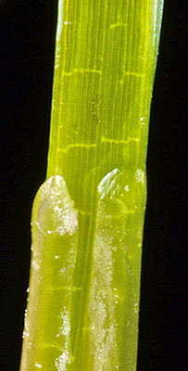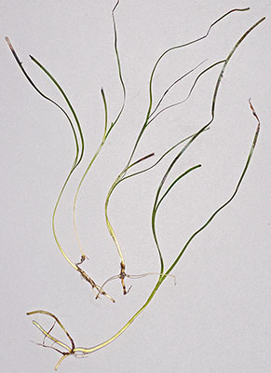

Figure 2: *Zostera japonica* showing overlapping flaps of leaf sheath, from Yaquina Bay, Oregon. © Gerald D. Carr.

Figure 1: *Zostera japonica* from Yaquina Bay, Oregon. © Gerald D. Carr.

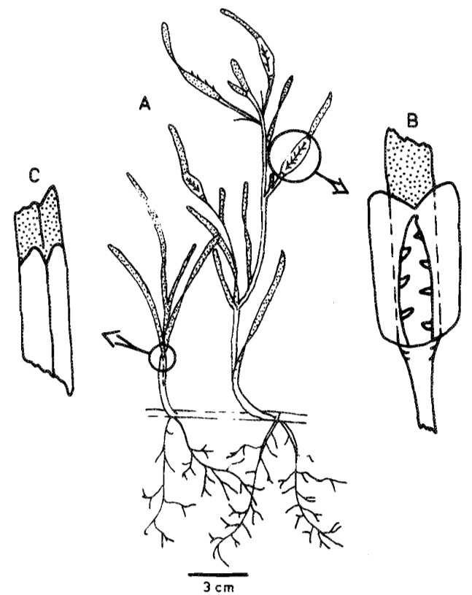

Figure 3: *Zostera japonica* morphology*.* A. Whole plant, showing vegetative shoot (left), branched flowering shoot (right), horizontal rhizome, and roots. B. Detail of inflorescence with flowers removed and spathe opened to show, in this specimen, seven retinacula. C*.* Detail of leaf sheath (unshaded), showing the two overlapping flaps. Adapted from FIG. 1 in Harrison & Bigley (1982), with the permission of R.E. Bigley.

|  |
| --- |
| **A2. Provide information on the existence of other species that look very similar [that may be detected in the risk assessment area, either in the environment, in confinement or associated with a pathway of introduction]**  Include both native and non-native species that could be confused with the species being assessed, including the following elements:   * other alien species with similar invasive characteristics, to be avoided as substitute species (in this case preparing a risk assessment for more than one species together may be considered); * other alien species without similar invasive characteristics, potential substitute species; * native species, potential misidentification and mis-targeting |

Response: Borum et al. (2004) provided a detailed comparison of the four European native species of seagrasses, with which *Zostera japonica* could potentially be confused: *Zostera marina* (eelgrass), including ‘*Z. marina* var *angustifolia* and *Z. angustifolia*’, which is regarded as a separate species or variety by some authors but has repeatedly been found genetically indistinguishable from *Z. marina* (Coyer et al., 2013; Olsen et al., 2013; Talbot et al., 2016) and is rather considered an ecotype of *Z. marina* (Becheler et al., 2010); *Zostera noltei* (dwarf eelgrass); *Cymodocea nodosa* (seahorse grass); and *Posidonia oceanica*. In addition, there is one non-native seagrass present in the Mediterranean, *Halophila stipulacea*. Another potential source of confusion is with species of the genus *Ruppia* (widgeon grasses). Both, *Cymodocea nodosa* and *Posidonia oceanica* only occur subtidally. In addition, they both have vertical rhizomes. *Cymodocea nodosa* has only one root per rhizome node (SeagrassNet NA, 2009). *Halophila stipulacea* has oblong leaves that look very different from the linear leaves of *Z. japonica*. *Ruppia* species can be identified by their very thin leaves that taper to a point (Ca Sea Grant, 2009; SeagrassNet NA, 2009), and long white rhizome segments. Each node forms a leaf bundle and only one long root.

Identification features of the *Zostera* species are shown in Table 1.

**Table 1**. Key distinguishing features of species that could be confused with *Zostera japonica*.

|  |  |  |  |
| --- | --- | --- | --- |
| **Species** | ***Zostera japonica*2,4** | ***Zostera noltei*** | ***Zostera marina*** |
| **Leaves per bundle** | 2 - 4 | 2 - 5 | 3 - 7 |
| **Leaf length cm** | 10 - 30 | 5 - 25 | 30 - 60 to 1.5 m |
| **Leaf width mm** | 0.8 - 1.3 | 0.5 - 2 | 2 - 10 |
| **Leaf sheath1** | 2 overlapping flaps | 2 overlapping flaps | Complete tube |
| **Rhizome diameter mm** | 0.5 - 1.5 | 0.5 - 2 | 2 - 6 |
| **Rhizome colour** |  | Light green becoming yellow or brown | White-green becoming dark brown |
| **Roots** | 2 elongated roots per node | 1- 4 thin roots per node | 2 root bundles per node |
| **Retinacula3** | 1 x 0.6 mm | 1 x 0.3 mm | None |
|  |  |  |  |
| **Spathe cross-section4** |  |  |  |
| **Habitat** | Intertidal mud & sand | Intertidal mud & sand | Mainly subtidal to 10 - 15 m |
| **Other distinguishing features** | 1 shoot at each node.  3 parallel leaf veins. | 1 shoot at each node. | Terminal shoots on rhizomes.  In transition zone specimens may be stunted. |
| **Distribution in Europe** | Not known to be present. | Almost throughout, northern limit is S Norway. | Throughout, sparser in Mediterranean. |

1 Harrison & Bigley, 1982, Fig. 1C (see Figure 3 above.)

2 Shin & Choi, 1998

3 Retinacula – sterile flaps on the flowering spadix, Bigley, 1981; Shin & Choi, 1998, Fig. 2

4 Bigley, 1981, Fig. 32 (see Figure 4 below.)

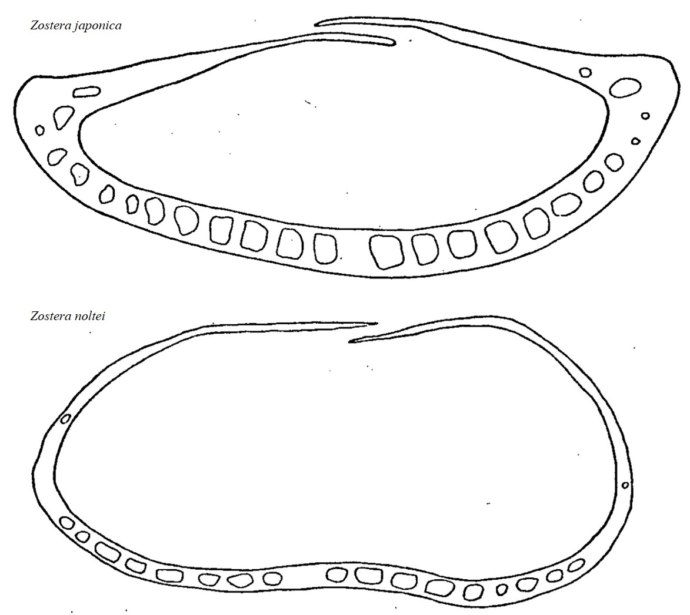

Figure 4: Spathe cross-sections of *Zostera japonica* and *Zostera noltei*. Adapted from Fig. 32 in Bigley (1981), with permission of R. E. Bigley.

Differentiation of *Zostera japonica* and *Z. noltei* could be extremely challenging in the field. As shown in Table 1, only a few features of the reproductive spathes differentiate the species. DNA analysis may be useful; however, that also is not straightforward (Daru & Yessoufou, 2016; Westfall et al., 2020; Ortega et al., 2020). Les et al. (2002) showed differences between them using nuclear (ITS/5.8S) and chloroplast (*rbcL* and *trnK* intron) sequences, whereas Tanaka et al. (2003) used the chloroplast *matK* region. The whole chloroplast genome has been sequenced for *Z. japonica*, but not for Z. *noltei* (Chen & Yang, 2019). Coyer et al. (2004) could not distinguish the species using microsatellites, however a four-locus analysis utilising one nuclear and three chloroplast loci (ITS1, matK, rbcL, psbA-trnH) demonstrated a well-defined *N. noltei* clade within the more diverse

*N. japonica* clade (Coyer et al., 2013).

|  |
| --- |
| **A3. Does a relevant earlier risk assessment exist? Give details of any previous risk assessment, including the final scores and its validity in relation to the risk assessment area.** |

Response: No formal risk assessment has been carried out.

Tsiamis et al. (2020) ranked *Zostera japonica* as a high priority marine invasive alien species for risk assessment under Article 5 of the EU IAS Regulation. They assigned weighted final scores of 6/12 for likelihood of arrival, 12/12 for likelihood of establishment, 12/12 for likelihood of spread, and 12/12 for potential impact, giving a total score of 42/48. It ranked third amongst species currently absent from European waters.

Extensive work has been carried out in N America, where *Z. japonica* is considered invasive in some states, while others consider it benign or perhaps beneficial. The States of California and Washington list it as a noxious weed (Shafer et al., 2014; CDFA, 2021; WA NWCB, 2013; 2021). However, *Z. japonica* does not appear on the Federal or the Oregon invasive species or noxious weed lists.

|  |
| --- |
| **A4. Where is the organism native?**  including the following elements:   * an indication of the continent or part of a continent, climatic zone and habitat where the species is naturally occurring * if applicable, indicate whether the species could naturally spread into the risk assessment area |

Response:

*Zostera japonica* is native to the Northwest Pacific, encompassing the Cold Temperate Northwest Pacific, the Warm Temperate Northwest Pacific, and the Central Indo-Pacific (Short et al., 2007; Spalding et al., 2007).

Its range extends from the Kamchatka peninsula in Russia at 54 oN, through Sakhalin, and the Kuril Islands; throughout Japan including the Ryuku islands; Korea; eastern mainland China; Taiwan; and Vietnam as far south as the northern edge of the Mekong delta at 10 oN (Miki, 1933; Shin & Choi, 1998; Kafanov & Plekhov, 2001; Green & Short, 2003; GBIF, 2022a; OBIS, 2022).

It is mainly distributed on intertidal sand and mud flats, in sheltered bays, estuaries and around islands (Green & Short, 2003). In its native range, *Z. japonica* has been reported to grow as deep as 7 m, although it typically grows intertidally and at depths < 1 m (Hayashida, 2000; Nakaoka & Aioi, 2001; Abe et al., 2010).

In the IUCN Red List, this species is listed as “Least Concern”, with the comment “This species is widespread and common in intertidal areas. It is threatened at a local level in some areas by human activities” (Short et al., 2010a).

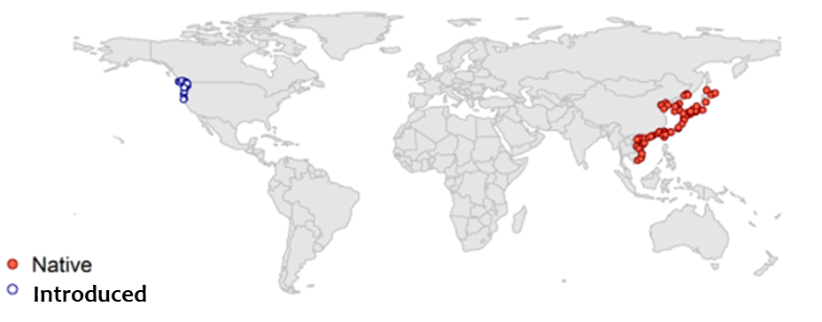

Figure 5: Occurrence records of *Z. japonica* in the native (red) and introduced (blue) range. Data points retrieved from the literature, biodiversity databases and screened as explained in responses A4-A6 and the modelling Annex (Annex VIII). Map created by Bjorn Beckmann for the purposes of this RA.

|  |
| --- |
| **A5. What is the global non-native distribution of the organism outside the risk assessment area?** |

Response: Outside its native distribution, *Zostera japonica* has been introduced to the Northeast Pacific, where currently its distribution is limited to the Cold Temperate Northeast Pacific marine ecoregion (Spalding et al., 2007). Its current range extends along the coast of N America, from Vancouver Island and the Strait of Georgia, in British Columbia, Canada, to the Eel River, just south of Humboldt Bay in California, US (Mach et al., 2014; Stillman et al., 2015; GBIF, 2022a; OBIS, 2022), with a latitudinal range of 50 oN – 40 oN.

Talbot et al. (2016) consider more northerly records of *Z. japonica* from Prince of Wales Island, Alaska (UAM Herb: 248738–41) dubious, as genetic analysis failed to detect it in the same region (Alexander Archipelago in southeastern Alaska).

*Zostera japonica* was introduced to the US more than 50 years ago, apparently with the importation of seed oysters (*Magallana gigas*) used in the mariculture industry (Harrison & Bigley, 1982). Although it was first reported in Willapa Bay, Washington in 1957, the actual date of introduction may have been decades earlier as large shipments of oysters were transported with minimal precautions into this region from 1919 to the early 1950s (Harrison & Bigley, 1982). The first Canadian record was from Boundary Bay, British Columbia in 1969 (Harrison & Bigley 1982; Baldwin & Lavvorn, 1994). Given the initially disjunct distribution, it is possible there have been multiple introductions (Harrison & Bigley, 1982).

In Canada, by 1975 the species had spread throughout Boundary Bay and the northern area of Puget Sound. By 1978, its range had extended northward into the Strait of Georgia and along the Fraser River, then in 1979 it reached Vancouver Island, 35 km across the Strait of Georgia from the nearest colonized site on the mainland (Phillips & Shaw, 1976; Harrison & Bigley, 1982).

In the US, *Z. japonica* also rapidly spread southward, such that by the 1980s, it was established in several estuaries between the southern Strait of Georgia and Coos Bay, Oregon (Harrison & Bigley, 1982; Posey, 1988; Bayer, 1996; Larned, 2003). In 1999, it was found to be present in most estuaries between the Powell River, British Columbia and the Coquille River, Oregon (Larned, 2003). By 2002, it had extended its range further southward to Humboldt Bay, California (Dean et al., 2008, in Shafer et al., 2014).

Shafer et al. (2014) noted that N American populations of *Z. japonica* are currently limited to bays and estuaries in British Columbia, Canada; and Washington, Oregon and northern California, US. However, within this range, dramatic expansions have occurred in some areas, creating large beds that occupy many hectares of intertidal flats in Boundary Bay, British Columbia, and in Padilla, Samish, and Willapa Bays, Washington (Posey 1988; Baldwin & Lovvorn 1994; Bulthuis, 1995; Dumbauld & Wyllie-Echeverria, 2003).

Harrison & Bigley (1982) described extensive beds of *Z. japonica* on the 17,000 ha of intertidal flats in Willapa Bay, with dense populations covering all substrates except those with excessive clay or gravel.

Young et al. (2008) determined that *Z. japonica* distribution in Yaquina Bay, Oregon, increased from 0.037 km2 in 1998 to almost 0.19 km2 in 2007, roughly a 400 % increase over 9 years.

Throughout its established range in N America, *Z. japonica* grows in sheltered bays, estuaries and around islands, but its distribution extends further up estuaries than that of the native *Z. marina* (Lee & Brown, 2009). It is found primarily in the mid- to upper-intertidal zones (Shafer et al., 2014; Young et al., 2015). There are currently no documented cases of *Z. japonica* growing below mean sea level (Shafer et al., 2014).

|  |
| --- |
| **A6. In which biogeographic region(s) or marine subregion(s) in the risk assessment area has the species been recorded and where is it established? The information needs be given separately for recorded (including casual or transient occurrences) and established occurrences. “Established” means the process of an alien species successfully producing viable offspring with the likelihood of continued survival[2].**  **A6a. Recorded: List regions**  **A6b. Established: List regions**  Freshwater / terrestrial biogeographic regions:   * Alpine, Atlantic, Black Sea, Boreal, Continental, Mediterranean, Pannonian, Steppic   Marine regions:   * Baltic Sea, North-east Atlantic Ocean, Mediterranean Sea, Black Sea   Marine subregions:   * Greater North Sea, incl. the Kattegat and the English Channel, Celtic Seas, Bay of Biscay and the Iberian Coast, Western Mediterranean Sea, Adriatic Sea, Ionian Sea, Central Mediterranean Sea, Aegean-Levantine Sea.   Comment on the sources of information on which the response is based and discuss any uncertainty in the response.  For delimitation of EU biogeographical regions please refer to <https://www.eea.europa.eu/data-and-maps/figures/biogeographical-regions-in-europe-2> (see also Annex VI).  For delimitation of EU marine regions and subregions consider the Marine Strategy Framework Directive areas; please refer to <https://www.eea.europa.eu/data-and-maps/data/msfd-regions-and-subregions/technical-document/pdf> (see also Annex VI). |

Response (6a): None.

Response (6b): None.

Boudouresque et al. (2011) raised the possibility of *Zostera japonica* being present in the Thau Lagoon, southern France (Mediterranean), an invasion hot-spot resulting from Pacific oyster importation in the 1970s. However, no published evidence could be found of any subsequent investigation. Nevertheless Thierry Thibaut (Aix-Marseille University) in a personal communication (September 2023) communicated that older colleagues had looked for *Z. japonica* in French lagoons in the past but never found it. An undetected introduction however is not out of the question precisely because of the difficulty in discriminating the two species in the field.

Confusion over the use of the same common name of Dwarf eelgrass, for *Z. japonica* and *Z. noltei*, appears to be the reason for its misreported presence around the coast of Ireland (Celtic Seas) on a website and leaflet produced by a company specializing in non-native species removals (JKC, 2021).

|  |
| --- |
| **A7. In which biogeographic region(s) or marine subregion(s) in the risk assessment area could the species establish in the future under current climate and under foreseeable climate change? The information needs be given separately for current climate and under foreseeable climate change conditions.**  **A7a. Current climate: List regions**  **A7b. Future climate: List regions**  With regard to EU biogeographic and marine (sub)regions, see above.  With regard to climate change, provide information on   * the applied timeframe (e.g. 2050/2070) * the applied scenario (e.g. RCP 4.5) * what aspects of climate change are most likely to affect the risk assessment (e.g. increase in average winter temperature, increase in drought periods)   The assessment does not have to include a full range of simulations on the basis of different climate change scenarios, as long as an assessment with a clear explanation of the assumptions is provided. However, if new, original models are executed for this risk assessment, the following RCP pathways shall be applied: RCP 2.6 (likely range of 0.4-1.6°C global warming increase by 2065) and RCP 4.5 (likely range of 0.9-2.0°C global warming increase by 2065). Otherwise, the choice of the assessed scenario has to be explained. |

Response (7a): The response is based on combining physiological tolerances and the results from the distribution modeling (see Qu. 2.1, Qu. 2.9 and Annex VIII for details). For purposes of mapping and assessing the risk of establishment, the following tolerance limits where defined:

* Minimum long-term temperature > -0.5 °C
* Mean surface salinity > 10 psu and < 38 psu
* Water depth < 100 m

Baltic Sea: moderately likely, medium confidence (western part)

Greater North Sea: likely, low confidence (see Qu. 2.9 for rationale)

Celtic Seas: moderately likely, medium confidence

Bay of Biscay and the Iberian coast: likely, low confidence

Western Mediterranean Sea: moderately likely, medium confidence (northern part)

Adriatic Sea: moderately likely, medium confidence (northern part)

Aegean-Levantine Sea: moderately likely, medium confidence (Aegean)

Central Mediterranean Sea and the Ionian: moderately likely, medium confidence

Black Sea: moderately likely, medium confidence

In the Mediterranean Sea, high summer temperatures in lagoons and shallow waters, and the high salinity in the Levantine and the southern Central Mediterranean are expected to reduce the likelihood of establishment. A useful criterion for the potential extent of the species in this subregion is likely to be the current distribution range of its sister species *Z. noltei* (i.e., the Western Mediterranean, the northern Adriatic and locally the Aegean and Ionian coast of Greece) (GBIF, 2022b).

The Baltic Sea offers conditions suitable for establishment in its western part; whereas further east, consistently low salinities are expected to limit the potential for establishment.

In the Black Sea, abiotic conditions are close to the optimal temperature and salinity for *Z. japonica*. However, the native *Zostera* beds in the region are fragmented and declining, mainly due to pollution and eutrophication (Jahnke et al., 2016).

Response (7b): The response is based on combining physiological tolerances and the results from the distribution modeling (see Qu. 2.1, Qu. 2.9 and Annex VIII for details). The methodology for the developed models is described in Annex VIII, and considers scenarios RCP 2.6 and RCP 4.5 by 2070. See also Qu. 2.10. The results are the same under both scenarios.

Baltic Sea: moderately likely, medium confidence (western part)

Greater North Sea: likely, low confidence

Celtic Seas: moderately likely, medium confidence

Bay of Biscay and the Iberian coast: likely, low confidence

Western Mediterranean Sea: moderately likely, medium confidence (northern part)

Adriatic Sea: moderately likely, medium confidence (northern part)

Aegean-Levantine Sea: moderately likely, medium confidence (Aegean)

Central Mediterranean Sea and the Ionian: moderately likely, medium confidence

Black Sea: moderately likely, medium confidence

The species distribution model (SDM) predicted a small increase in projected suitability for *Z. japonica* for the Greater North Sea and the Black Sea. The aspect of climate change most likely to affect the organism’s ability to establish is an increase in winter sea surface temperatures. Higher winter temperatures in Atlantic Europe will favour a shift from short-lived annual to perennial populations.

Climate change is expected to enhance the hydrological cycle in northern latitudes reducing the salinity in the Baltic Sea, due to increased river runoff and net precipitation (Kniebusch et al., 2019; Lehmann et al., 2022). Thus, even though increased minimum temperatures might favour *Z. japonica*, reduced salinity will likely have the opposite effect (see Qu 2.1 for salinity requirements of the species).

Suitable conditions in the Mediterranean are likely to become even more restricted spatially and temporally, rendering establishment in this marine subregion more localized.

Note: Even though the SDM takes into account salinity variability in the form of distance from river mouths, a future scenario for river discharge was not taken into account and would take very elaborate data processing to bring into the model. It is anticipated that extreme weather phenomena, like droughts and storms/flooding, will be more frequent and intense under future climate conditions and this will increase the uncertainty of predictions.

|  |
| --- |
| **A8. In which EU Member States has the species been recorded and in which EU Member States has it established? List them with an indication of the timeline of observations. The information needs be given separately for recorded and established occurrences.**  **A8a. Recorded: List Member States**  **A8b. Established: List Member States**  Austria, Belgium, Bulgaria, Croatia, Cyprus, Czech Republic, Denmark, Estonia, Finland, France, Germany, Greece, Hungary, Ireland, Italy, Latvia, Lithuania, Luxembourg, Malta, Netherlands, Poland, Portugal, Romania, Slovakia, Slovenia, Spain, Sweden  The description of the invasion history of the species shall include information on countries invaded and an indication of the timeline of the first observations, establishment and spread. |

Response (8a): None.

Response (8b): None.

Boudouresque et al. (2011) raised the possibility of *Zostera japonica* being present in the Thau Lagoon, southern France (Mediterranean), an invasion hot-spot resulting from Pacific oyster importation in the 1970s. However, no evidence could be found of any subsequent investigation.

Confusion over the use of the same common name of Dwarf eelgrass, for *Z. japonica* and *Z. noltei*, appears to be the reason for its misreported presence around the coast of Ireland (Celtic Seas) on a website and leaflet produced by a company specializing in non-native species removals (JKC, 2021).

|  |
| --- |
| **A9. In which EU Member States could the species establish in the future under current climate and under foreseeable climate change? The information needs be given separately for current climate and under foreseeable climate change conditions.**  **A9a. Current climate: List Member States**  **A9b. Future climate: List Member States**  With regard to EU Member States, see above.  With regard to climate change, provide information on   * the applied timeframe (e.g. 2050/2070) * the applied scenario (e.g. RCP 4.5) * what aspects of climate change are most likely to affect the risk assessment (e.g. increase in average winter temperature, increase in drought periods)   The assessment does not have to include a full range of simulations on the basis of different climate change scenarios, as long as an assessment with a clear explanation of the assumptions is provided. However, if new, original models are executed for this risk assessment, the following RCP pathways shall be applied: RCP 2.6 (likely range of 0.4-1.6°C global warming increase by 2065) and RCP 4.5 (likely range of 0.9-2.0°C global warming increase by 2065). Otherwise, the choice of the assessed scenario has to be explained. |

Response (9a): The Species Distribution Model outlined in Annex VIII provides a projection of environmental suitability for *Zostera japonica* establishment in Europe. According to the model, the species could establish in Belgium, Bulgaria, Croatia, Denmark, France, Germany, Greece, Ireland, Italy, The Netherlands, Portugal, Romania, Slovenia, Spain and Sweden.

Consideration of the physiological tolerances (see Qu. 2.1, Qu. 2.9 and Annex VIII for details) suggests Slovenia and Spain should also be considered as suitable for establishment. Given the limitations of the modeling approach for interidal species, which are both under the influence of marine and terrestrial environmental variables (see Annex VIII), a useful criterion for the potential extent of the species in the RA area is likely to be the current distribution range of its sister species *Z. noltei*, with very similar habitat requirements (see Qu. 2.9 and 4.3 for details). *Zostera noltei* in the Baltic is restricted to the western part, not beyond the Arcona Basin, i.e., as far as Germany (HELCOM, 2013a). The predictions of the model for suitable habitats further in the Baltic are thus considered equivocal, especially considering that sustained periods of salinities under 10 psu were found to stress *Z. japonica* in its invaded range (Shafer et al., 2011; Kaldy & Shafer, 2013).

Response (9b): Belgium, Bulgaria, Croatia, Denmark, France, Germany, Greece, Ireland, Italy, The Netherlands, Portugal, Romania, Slovenia, Spain, and Sweden. This response is based on the RCP 2.6 and RCP 4.5 scenarios for the period to 2070 (see Annex VIII for details on modelling and future climate conditions in the RA area). There is no predicted difference between the two climate change scenarios.

|  |
| --- |
| **A10. Is the organism known to be invasive (i.e. to threaten or adversely impact upon biodiversity and related ecosystem services) anywhere outside the risk assessment area?** |

Response: Yes.

In the US, the States of California and Washington list *Zostera japonica* as a noxious weed (Shafer et al., 2014; CDFA, 2021; WA NWCB, 2013; 2021). However, it does not appear on the Federal or the Oregon invasive species or noxious weed lists.

Over the last 50 years there has been a dramatic increase in the distribution of *Z. japonica* in N America, this has led to a shift from unstructured mudflat to a vegetated habitat. The consequent ecological effects include changes to benthic community composition and abundance, nutrient cycling, carbon usage, and primary and secondary production (Posey, 1988; Hahn, 2003b; Larned, 2003; Bando, 2006; Williams, 2007; Shafer et al., 2014).

As healthy seagrass is considered a prime indicator of estuarine ecosystem function, some of these changes may be considered beneficial (Williams, 2007; Shafer et al., 2014), and Mach et al. (2010) concluded that, at that time, there was insufficient evidence to determine the relative economic or environmental harm associated with the presence of this seagrass in N America.

However, Mach et al. (2014), in a review of the ecological impacts of *Z. japonica,* found evidence of a significant negative effect on large infaunal invertebrates in unvegetated habitats. Corbett et al. (2011, in WA NWCB, 2013) suggest that feeding activity of the endangered green sturgeon is significantly reduced in tideflats covered in *Z. japonica* compared to the bare sand substrate in which their feeding pits are typically found. Mach et al. (2014) also noted studies reporting a significant negative effect of *Z. japonica* on other macrophytes when these species occupy overlapping habitats. Boardman & Ruesink (2022) reported that *Z. japonica* had an adverse impact on biomass of the intertidal seagrass *Ruppia maritima* in contrast with Harrison (1982), who did not find any significant interference between the two species.

Ecosystem services reported as negatively affected:

Provisioning: Biomass - *Z. japonica* may obstruct harvest methods, thus increasing management costs, and lessen the production of harvestable shellfish (Fisher et al., 2011; WA NWCB, 2013; Mach et al., 2014). For example, in Willapa Bay WA, US, studies were conducted to assess the effects of *Z. japonica* on the commercial farming of Manila clams (*Ruditapes philippinarum*) and Pacific oysters (*Magallana* *gigas*). The growth of young clams, total clam harvests, clam quality and clam harvest efficiency, were greater where *Z. japonica* was chemically controlled than where it was not treated. The response of oysters to *Z. japonica* control varied by site; there was no effect at one site, while the other sites had a 15 % increase in shucked meat with *Z. japonica* control. The potential economic impact of a *Z. japonica* infestation of a shellfish bed was ~$47,000 ha−1 for Manila clams and $4000 ha−1 for oysters for each crop harvest cycle (Patten, 2014). Tsai et al. (2010) also reported a 17 % reduction in the weight of dry meat per clam when *Z. japonica* was present (Shafer et al., 2014).

Regulation & Maintenance: Hydrological cycle and water flow regulation - WA NWCB (2013) report that reduction to water flow and tideland drainage could result from dense mats of *Z. japonica* that can slow water flow by up to 40 % as compared to unvegetated mudflats, causing deposition of silt and detritus (Tsai et al., 2010; Fisher et al., 2011)). Preliminary data from Yaquina Bay, Oregon, suggests that the presence of *Z. japonica* may alter water column-benthic nutrient fluxes (Larned, 2003).

Cultural: Physical and experiential interactions with natural environment - Sediment build up can prevent waterfront homeowners from using their docks and forcing expensive dredging to remove the sediment (Reicher, 2010).

|  |
| --- |
| **A11. In which biogeographic region(s) or marine subregion(s) in the risk assessment area has the species shown signs of invasiveness? Indicate the area endangered by the organism as detailed as possible.**  Freshwater / terrestrial biogeographic regions:   * Alpine, Atlantic, Black Sea, Boreal, Continental, Mediterranean, Pannonian, Steppic   Marine regions:   * Baltic Sea, North-east Atlantic Ocean, Mediterranean Sea, Black Sea   Marine subregions:  Greater North Sea, incl. the Kattegat and the English Channel, Celtic Seas, Bay of Biscay and the Iberian Coast, Western Mediterranean Sea, Adriatic Sea, Ionian Sea, Central Mediterranean Sea, Aegean-Levantine Sea |

Response: None.

|  |
| --- |
| **A12. In which EU Member States has the species shown signs of invasiveness? Indicate the area endangered by the organism as detailed as possible.**  Austria, Belgium, Bulgaria, Croatia, Cyprus, Czech Republic, Denmark, Estonia, Finland, France, Germany, Greece, Hungary, Ireland, Italy, Latvia, Lithuania, Luxembourg, Malta, Netherlands, Poland, Portugal, Romania, Slovakia, Slovenia, Spain, Sweden |

Response: None.

|  |
| --- |
| **A13. Describe any known socio-economic benefits of the organism.**  including the following elements:   * Description of known uses for the species, including a list and description of known uses in the risk assessment area and third countries, if relevant. * Description of social and economic benefits deriving from those uses, including a description of the environmental, social and economic relevance of each of those uses and an indication of associated beneficiaries, quantitatively and/or qualitatively depending on what information is available.   If the information available is not sufficient to provide a description of those benefits for the entire risk assessment area, qualitative data or different case studies from across the risk assessment area or third countries shall be used, if available. |

Response: In general, seagrass meadows are considered to be key ecosystems, supporting fisheries, carbon sequestration and coastal protection, and are globally threatened (de Los Santos et al., 2019). Hou et al. (2020) describe seagrass beds as one of the most important primary producers in coastal ecosystems, contributing the greatest productivity, and having extremely important ecological functions. They can reduce suspended particles in water, increase its transparency, remove nutrients from sediments, improve water quality, weaken waves, control coastal erosion, and provide habitats for species of ecological and economical value such as scallops, shrimp, crabs and juvenile fish.

In its non-native range in N America, Hay (2011) discusses the economic value of the benefits that *Z. japonic*a can provide, the most significant being: its ability to minimize sediment and pollution within the water column, regulate water flow in estuarine systems, retain and form soil, provide refugia for native species, and also act as primary producers to support the estuarine and marine ecosystems as a whole. Mach et al. (2014) argue that *Z. japonica* has economic benefits by providing nursery grounds for commercial fish and shellfish species.

Finally, Kwak et al. (2014) demonstrated strong antioxidant activity of solvent-fractionated crude extracts of *Z. japonica* and suggested that the species may be used as a potential source of natural antioxidants for the development of cosmetic product or functional food in the future.

# SECTION B – Detailed assessment

|  |
| --- |
| **Important instructions:**   * In the case of lack of information the assessors are requested to use a standardized answer: “No information has been found.” In this case, no score and confidence should be given and the standardized “score” is N/A (not applicable). * With regard to the scoring of the likelihood of events or the magnitude of impacts see Annexes I and II. * With regard to the confidence levels, see Annex III. * Highlight the selected response score and confidence level in **bold** but keep the other scores in normal text (so that the selected score is evident in the final document). |

## 1 PROBABILITY OF INTRODUCTION AND ENTRY

|  |
| --- |
| **Important instructions:**   * **Introduction** is the movement of the species into the risk assessment area (it may be either in captive conditions and/or in the environment, depending on the relevant pathways). * **Entry** is the release/escape/arrival in the environment, i.e. occurrence in the wild * Introduction and entry may coincide for species entering through pathways such as “corridor” or “unaided”, but it also may differ. If different, please consider all relevant pathways, both for the introduction into the risk assessment area and the entry in the environment. * For each described pathway, in each of the questions below, ensure that there are separate comments explicitly addressing both the “introduction” and “entry” where applicable and as appropriate. The classification of pathways developed by the Convention of Biological Diversity (CBD) should be used (see Annex IV). For detailed explanations of the CBD pathway classification scheme consult the IUCN/CEH guidance document[3] and the provided key to pathways[4]. * For organisms which are already present (recorded or established) in the risk assessment area, the likelihood of introduction and entry should be scored as “very likely” by default. * Repeated (independent) introductions and entries at separate locations in the risk assessment area should be considered here (see Qu. 1.7). |

|  |
| --- |
| **Qu. 1.1. List relevant pathways through which the organism could be introduced into the risk assessment area and/or enter into the environment. Where possible give details about the specific origins and end points of the pathways as well as a description of any associated commodities.**  For each pathway answer questions 1.2 to 1.8 (copy and paste additional rows at the end of this section as necessary). Please attribute unique identifiers to each question if you consider more than one pathway, e.g. 1.2a, 1.3a, etc. and then 1.2b, 1.3b etc. for the next pathway.  In this context a pathway is the route or mechanism of introduction and/or entry of the species.  The description of commodities with which the introduction of the species is generally associated shall include a list and description of commodities with an indication of associated risks (e.g. the volume of trade; the likelihood of a commodity being contaminated or acting as vector).  If there are no active pathways or potential future pathways this should be stated explicitly here, and there is no need to answer the questions 1.2-1.9. |

Pathway name:

**TRANSPORT-CONTAMINANT (Contaminant on animals)**

*Zostera japonica* is believed to have been introduced to the NW Pacific coast (US and Canada) with oyster seed shipments from Japan in the first half of the previous century (Kaldy, 2006). Harrison (1976) indicates that eelgrass was used as packaging material in the oyster crates; alternatively, Harrison & Bigley (1982) propose that dormant seeds could have survived among oyster shells and then germinated upon release to a suitable habitat.

Boudouresque et al. (2011) raised the possibility of *Zostera japonica* being present in the Thau Lagoon, southern France (Mediterranean), an invasion hot-spot resulting from Pacific oyster importation in the 1970s. However, no published evidence could be found of any subsequent investigation. Thierry Thibaut (Aix-Marseille University, pers. comm., Septemebr 2023) communicated that older colleagues had looked for *Z. japonica* in French lagoons in the past but never found it. An undetected introduction however is not out of the question precisely because of the difficulty in discriminating the two species in the field.

**TRANSPORT-STOWAWAY** **(ship/boat ballast water and sediments)**

Floating reproductive shoots with seeds could be entrained in ballast water, released seeds from decaying shoots can settle and bury in tank sediments and be resuspended upon release of ballast water. Only scant evidence could be found for the transportation of seagrass shoots or the presence of seeds in ballast tanks.

**TRANSPORT-STOWAWAY** **Hitchhikers on ship/boat (excluding ship/boat hull fouling)**

Recreational boats constitute a common vector of Non-Indigenous Species (NIS) macrophytes (Boudouresque & Verlaque, 2002; Thibaut et al., 2022), they are strongly suspected of being responsible for the regional spread of *Z. japonica* in N America (Shafer et al., 2014), and the trans-oceanic transport of *Halophila stipulacea* from the Mediterranean to the Caribbean (Ruiz & Ballantine, 2004). *Zostera japonica* is typically an intertidal species, although in its native range it is known from depths down to 7 m, so it could conceivably be entrained by recreational vessel anchors/chains. Mechanical disturbance by anchors and chains can dislodge sections of seagrass shoots, rhizomes, and roots from the sediment, which may be able to survive for a relatively long time in damp and sheltered areas of vessels, such as an anchor well (Ruiz & Ballantine, 2004). However, this is not expected to be a frequent occurrence; mega-yachts and cruise ships are assumed to travel much less frequently between the *Z. japonica* native range (primarily Japan, Korea and China) and the RA area, compared with recreational routes across the Atlantic between the East Atlantic and the RA area (quantitative data was not found on the issue but see marinetraffic.com for a visual of the trans-Atlantic shipping route). Consequently, this is considered a very unlikely means of introduction and is not elaborated any further in the RA.

**UNAIDED (Natural dispersal)**

Eelgrass species have a significant potential for natural dispersal, either through floating fragments or via ingestion and excretion of seeds by waterfowl. Rafting shoots of *Zostera* species can drift for distances in the range of at least 150 - 200 km (Erftemeijer et al., 2008; Källström et al., 2008) and potentially up to 1000 km (González & Edding, 1990; Berković et al., 2014; Jahnke et al., 2016). Predation of seeds by migratory birds can be very variable but is assumed to disperse propagules for tens of km and possibly even more (Sumoski & Orth, 2012), while mega-herbivores such as marine turtles can transport viable *Zostera* seeds potentially for hundreds of kilometres (Tol et al., 2017). Given the distance between potential donor areas and the RA area, neither of these two mechanisms can act as a pathway of primary introduction for *Z. japonica* in EU waters (see also Qu. 3.1 for more details on natural dispersal within the RA area).

Pathway name:

**TRANSPORT-CONTAMINANT (Contaminant on animals)**

|  |
| --- |
| **Qu. 1.2a. Is introduction and/or entry along this pathway intentional (e.g. the organism is imported for trade) or unintentional (e.g. the organism is a contaminant of imported goods)?** |

|  |  |  |  |
| --- | --- | --- | --- |
| **RESPONSE** | intentional  **unintentional** | **CONFIDENCE** | low  medium  **high** |

Response:

It can be stated with high certainty that this pathway is unintentional. See categorization of pathways in Annex IV and guidance notes in the beginning of this section.

|  |
| --- |
| **Qu. 1.3a. How likely is it that large numbers of the organism will be introduced and/or enter into the environment through this pathway from the point(s) of origin over the course of one year?**  including the following elements:   * discuss how likely the organism is to get onto the pathway in the first place. Also comment on the volume of movement along this pathway. * an indication of the propagule pressure (e.g. estimated volume or number of individuals / propagules, or frequency of passage through pathway), including the likelihood of reinvasion after eradication * if relevant, comment on the likelihood of introduction and/or entry based on propagule pressure (i.e. for some species low propagule pressure (1-2 individuals) could result in subsequent establishment whereas for others high propagule pressure (many thousands of individuals) may not. |

|  |  |  |  |
| --- | --- | --- | --- |
| **RESPONSE** | very unlikely  **unlikely**  moderately likely  likely  very likely | **CONFIDENCE** | low  **medium**  high |

Response: *Zostera japonica* utilizes the same habitat (i.e., primarily intertidal soft sediments), and is known to co-exist with the oyster *Magallana gigas* and the clam *Ruditapes philippinarum*, two introduced species that are extensively cultivated in the RA area (Wisehart et al., 2007; Park et al., 2011; Patten, 2014). Shoot fragments or buried seeds of the species may well be entrained in harvested bivalves destined for exports (Harrison & Bigley, 1982). Even though this is the most likely pathway of *Z. japonica*’s historical introduction in the NE Pacific and it has been suspected as a source of a possible undetected introduction of the species in the Thau lagoon in the 1970s (Boudouresque et al., 2011), bivalve imports are much better regulated nowadays (e.g., COUNCIL REGULATION (EC) No 708/2007) and far less frequent from countries outside the EU. Since no evidence could be found about the presence of the species in EU waters, risk of entry via this pathway is assessed based on the current vector activity and intensity. Nowadays, bivalve culture in Europe is largely dependent on harvesting/collecting wild seed from locations near to aquaculture plots, bivalve seed from hatcheries to a smaller extent and, when necessary, imports of seed from other EU countries (Robert et al., 2013; Muehlbauer et al., 2014; Occhipinti-Ambrogi et al., 2016; Marchini et al., 2016). Small quantities of bivalves and other cultured molluscs may still be imported from non-EU countries, but such imports are assumed to be rare, such that they are currently considered an unlikely pathway of introduction of *Z. japonica* in the RA area. Nevertheless, the sparseness and difficulty to access quantitative bivalve import data from overseas, as well as the possibility of unreported/illegal importations (Mineur et al., 2014) lowers the confidence of this assessment.

|  |
| --- |
| **Qu. 1.4a. How likely is the organism to survive, reproduce, or increase during transport and storage along the pathway (excluding management practices that would kill the organism)?** |

|  |  |  |  |
| --- | --- | --- | --- |
| **RESPONSE** | very unlikely  unlikely  moderately likely  **likely**  very likely | **CONFIDENCE** | low  **medium**  high |

Response:

Under artificial cold storage conditions (4 °C and 34 psu), *Z. japonica* seeds can survive and successfully germinate even after 14 months of storage (Kaldy et al., 2015). In the wild, in the cold temperate part of the species’ distribution, buried seeds survive winter sea temperatures as low as 0 °C, being largely responsible for population recruitment during particularly cold years (Zhang et al., 2019). Thus, survival of *Z. japonica* propagules, especially seeds, transported with bivalve consignments is considered likely.

|  |
| --- |
| **Qu. 1.5a. How likely is the organism to survive existing management practices before and during transport and storage along the pathway?** |

|  |  |  |  |
| --- | --- | --- | --- |
| **RESPONSE** | very unlikely  unlikely  **moderately likely**  likely  very likely | **CONFIDENCE** | low  **medium**  high |

Response:

The implementation of EC regulation 708/2007 (EC, 2007) concerning use of alien and locally absent species in aquaculture introduces a high biosecurity level for most bivalve transfers from areas outside the EU, that has already proven to be effective in preventing new introductions of marine alien species (Katsanevakis et al., 2013). *Magallana gigas* and *Ruditapes philippinarum,* both co-existing with *Z. japonica* in potential donor regions, constitute exceptions and can be moved without any risk assessment or quarantine measures, thus increasing risk of introduction of the species, unless stricter national/regional regulations apply (e.g., see WG-AS & Gittenberger (2018)). On the other hand, shellfish growers are aware of the risks posed to bivalve stock by the introduction of alien/invasive species and would be expected to adhere to codes of conduct for thorough inspections and other additional measures if necessary.

|  |
| --- |
| **Qu. 1.6a. How likely is the organism to be introduced into the risk assessment area or entry into the environment undetected?**  Please note that “detection” here is considered as any system or event that may actively contribute to record the presence of a species in a way that appropriate management measures could be potentially undertaken by relevant authorities. |

|  |  |  |  |
| --- | --- | --- | --- |
| **RESPONSE** | very unlikely  unlikely  moderately likely  **likely**  very likely | **CONFIDENCE** | low  **medium**  high |

Response:

In situations where regular inspection of stock is a normal part of shellfish farm operations, eelgrass shoots would be hard to miss. However, in the field, it is very difficult to distinguish *Z. japonica* from the native *Z. noltei* (see Qu. A2) and could easily go unidentified. Conversely, in the event that seeds of *Z. japonica* are entrained in shellfish consignements, their small size, in the range of 1.9-2.6 mm (Wyllie-Echeverria et al., 2006), would make it likely that they remain undetected.

|  |
| --- |
| **Qu. 1.7a. How isolated or widespread are possible points of introduction and/or entry into the environment in the risk assessment area?** |

|  |  |  |  |
| --- | --- | --- | --- |
| **RESPONSE** | isolated  **widespread**  ubiquitous | **CONFIDENCE** | low  **medium**  high |

Response:

Concerning the two species that are exempted from the EC regulation 708/2007 (EC, 2007), i.e., *M. gigas* and *R. philippinarum*, their cultivation is widespread throughout the RA area, particularly that of *M. gigas*. *Magallana gigas* is extensively cultivated, particularly in Atlantic Europe (Muehlbauer et al., 2014) but also in some of the Mediterranean countries (Greece, Italy, Mediterranean France and Spain) to a smaller extent (Rodrigues et al., 2015). *Ruditapes philippinarum* is cultivated mainly in Italy, Spain, Portugal, France and Ireland, where the species has naturalized and developed substantial wild populations, which provide the seed for culture operations, alongside hatcheries (Moura et al., 2017). Other non-native bivalve species (potential vectors of *Z. japonica*) intended for aquaculture would be subjected to the Regulation stipulations for strict inspections, quarantine, etc, making introduction highly unlikely (see Qu. 1.5a for more detail). Besides, these two are the main species that fulfil both conditions, i.e., have been/are still occasionally imported for aquaculture into the RA area and can act as vectors of *Z. japonica* as they occupy the same habitat and frequently co-exist.

|  |
| --- |
| **Qu. 1.8a. Estimate the overall likelihood of introduction into the risk assessment area and/or entry into the environment based on this pathway?** |

|  |  |  |  |
| --- | --- | --- | --- |
| **RESPONSE** | very unlikely  **unlikely**  moderately likely  likely  very likely | **CONFIDENCE** | low  **medium**  high |

Response:

The species may be introduced, primarily on imported oysters *M. gigas* and clams *R. philippinarum* from the NW Pacific. Available literature suggests that shellfish imports from countries outside the EU are generally limited in the past couple of decades and well regulated. The risk of introduction is associated with a few species listed in Annex IV of Council Regulation (EC) No 708/2007 (EC, 2007) if stricter local/regional regulations are not in place (see Qu. 1.5a) and with illegal/unreported transfers. Even for the exempted species of Annex IV, however, the amount imported from outside the EU is assumed to be at levels low enough to render this pathway unlikely. It should be noted here that work by Mineur et al. (2012; 2014) suggests that, despite existing regulations, the pathway was still active in large European oyster culture grounds until at least 2011. The authors attributed new macrophyte NIS introductions to unreported oyster imports from the NW Pacific. Since no more recent data could be found and the source of these introductions cannot be verified, an unlikely score with medium confidence is maintained for this pathway.

Pathway name: **TRANSPORT-STOWAWAY** **(ship/boat ballast water and sediments)**

|  |
| --- |
| **Qu. 1.2b. Is introduction and/or entry along this pathway intentional (e.g. the organism is imported for trade) or unintentional (e.g. the organism is a contaminant of imported goods)?** |

|  |  |  |  |
| --- | --- | --- | --- |
| **RESPONSE** | intentional  **unintentional** | **CONFIDENCE** | low  medium  **high** |

Response: It can be stated with high certainty that this pathway is unintentional. See categorization of pathways in Annex IV and guidance notes in the beginning of this section.

|  |
| --- |
| **Qu. 1.3b. How likely is it that large numbers of the organism will be introduced and/or enter into the environment through this pathway from the point(s) of origin over the course of one year?**  including the following elements:   * discuss how likely the organism is to get onto the pathway in the first place. Also comment on the volume of movement along this pathway. * an indication of the propagule pressure (e.g. estimated volume or number of individuals / propagules, or frequency of passage through pathway), including the likelihood of reinvasion after eradication * if relevant, comment on the likelihood of introduction and/or entry based on propagule pressure (i.e. for some species low propagule pressure (1-2 individuals) could result in subsequent establishment whereas for others high propagule pressure (many thousands of individuals) may not. |

|  |  |  |  |
| --- | --- | --- | --- |
| **RESPONSE** | very unlikely  unlikely  **moderately likely**  likely  very likely | **CONFIDENCE** | low  **medium**  high |

Response:

Vegetative shoots of *Z. japonica* as well as flowering shoots with seeds can float on the sea surface and are documented to be dispersed by currents for hundreds of kilometres and for weeks to months of transport (McMahon et al., 2014 and references therein). Similarly, dormant seeds may be mobilized through sediment resuspension and enter the water column, albeit for brief periods of time due to their negative buoyancy. It can thus be envisaged that propagules can be taken up in ballast water and transferred to new destinations. The uptake of whole *Z. japonica* plants in ballast water in particular has been implicated in the spread of the species along the NE Pacific coast from British Columbia to California (Cohen & Carlton, 1995). Furthermore, the species was included in the list of potential arrivals, mediated by ballast water, to be risk assessed for the Baltic Sea (Leppäkoski & Gollasch, 2006). Nevertheless, the only evidence that could be found in the literature for the presence of any type of seagrass propagule in ship ballast water comes from Carlton & Geller (1993), who reported the presence of Zosteracea in ballast water from one ship arriving from Japan to the Port of Coos Bay, Oregon, after a transoceanic trip of 11 to 21 days.

|  |
| --- |
| **Qu. 1.4b. How likely is the organism to survive, reproduce, or increase during transport and storage along the pathway (excluding management practices that would kill the organism)?** |

|  |  |  |  |
| --- | --- | --- | --- |
| **RESPONSE** | very unlikely  **unlikely**  moderately likely  likely  very likely | **CONFIDENCE** | **low**  medium  high |

Response:

No information could be found on the potential survival of seagrass propagules in ballast tanks specifically.

Under natural conditions in the wild, seeds of *Zostera* species on rafting reproductive shoots can remain viable for extended periods of time (Harwell & Orth, 2002), certainly for longer than the trans-oceanic travel duration from potential donor areas. Plant fragments can also remain viable for long periods; e.g., Berković et al. (2014) found that 15 % of *Z. noltei* vegetative fragments in mesocosm experiments were viable and growing after 55 days. In the dark conditions of the ballast tank, however, *Z. japonica* shoots are unlikely to remain viable for the whole trip duration from potential donor areas.

Empirical determinations of minimum light requirements for growth of seagrasses have reported values between 5 % and 25 % of surface irradiance (Ralph et al., 2007 and references therein). Bertelli & Unsworth (2018) calculated a minimum light requirement (MLR) threshold for *Z. marina* of 20.12 µmol photons m-2s-1 or the equivalent of 12.9 % surface irradiance and predicted shoot mortality within 4 - 6 weeks at light levels below that threshold. In their experiments, all photophysiological responses to shading were exhibited by day 5 of the treatments. Other studies, however, have determined lower light compensation points for *Z. marina* at comparable temperatures, as low as approximately 7 µmol photons m-2s-1 both for whole plants and cut leaf blades (Abe et al., 2003 and references therein). In Abe et al. (2003), the compensation point of young *Z. marina* in April at 10 °C was 5.7 % of sea surface irradiance. Jiménez et al. (1987) estimated light compensation points of 30 - 35 µmol photons m-2s-1 at 15 °C for both *Z. marina* and *Z. noltei* collected in Spain.

Thus, even if survival is possible for a few days, especially under lower temperatures, considering that a journey from the north-west Pacific to the RA area lasts approximately 5-6 weeks (information retrieved from shipping companies’ itinerary pages), it is predicted that shoots will eventually start decaying. Vegetative propagules are unlikely to remain viable, whereas decaying reproductive shoots will gradually become less buoyant and eventually settle at the bottom of the tank, where the spathes/seeds will be released or detached (Hosokawa et al., 2015).

*Zostera japonica* seeds are more likely to remain dormant under low temperature (<5 - 10 °C) and high salinity conditions (>10 psu) (Abe et al., 2009; Kaldy et al., 2015). Considering that ballast water temperature follows the ambient sea surface temperature (Gollasch et al., 2000; Lenz et al., 2018), and in tropical seas sea surface temperature can reach values of >30 °C in the summer and as high as 27 - 28 °C in the winter, it is likely that a high proportion of any transported seeds can germinate and produce seedlings (Kaldy et al., 2015). In such cases, it would be necessary for the nutrient reserves present in the seeds to sustain the seedling until such time as it was released in a suitable environment (Wyllie-Echeverria at al., 2006). Furthermore, Kishima et al. (2011) found that an increased proportion of *Z. japonica* seeds showed signs of degradation, presumably due to biological processes by bacteria, mold, etc., when stored at 23 °C.

Survival of *Z. japonica* seeds in ballast sediments, which are typically anoxic, is uncertain. Contrasting results have been found for the congener *Z. marina*, with some studies demonstrating reduced survival (Hootsmans et al., 1987) and development under anoxic conditions (Churchill, 1992, in Orth et al., 2000); on the other hand, high seed survival rate was observed after a severe anoxic episode in the Thau lagoon (Plus et al., 2003).

|  |
| --- |
| **Qu. 1.5b. How likely is the organism to survive existing management practices before and during transport and storage along the pathway?** |

|  |  |  |  |
| --- | --- | --- | --- |
| **RESPONSE** | very unlikely  **unlikely**  moderately likely  likely  very likely | **CONFIDENCE** | low  **medium**  high |

Response: The International Maritime Organization (IMO) Ballast Water Management Convention (BWMC) entered into force in September 2017. It requires ships in international traffic to apply ballast water management measures, in particular:

* ballast water exchange in open seas, away from coastal areas (D-1 standard for an interim period)
* fulfil a certain discharge standard (D-2 standard according to the ship specific application schedule phased in up to 8 September 2024). D-2 standard requires the installation of a certified ballast water treatment device, which enables sterilization to avoid transfers of ballast water mediated species.

Ballast Water Exchange (BWE) is currently practiced and requires ships to exchange a minimum of 95 % ballast water volume whenever possible at least 200 nautical miles (nm) from the nearest land and in water depths of at least 200 metres. When this is not possible, the BWE shall be conducted at least 50 nm from the nearest land and in waters at least 200 metres in depth (David et al., 2007; and BWMC Guideline 6). Even though BWE can reduce the concentration of live organisms in ballast by 80 - 95 % (Ruiz & Reid 2007; Darling et al., 2018), its application has severe limitations, primarily dependant on shipping patterns of a port (e.g., shipping routes, length of voyages) and local specifics i.e., distance from nearest shore, water depth (David et al., 2007). This is particularly the case for EU Seas where it is often not possible to meet these conditions. In addition, organisms may still remain in the volume of ballast not exchanged and in ballast sediment, or BWE may not be possible due to weather conditions or other safety restrictions. The survival of organisms in the water column and in sediments (including *Z. japonica* shoots and seeds) is thus not unlikely when only BWE measures are implemented.

As a result, ballast water treatment (BWT) has been deemed necessary, such that ships shall discharge less than 10 viable organisms per cubic metre greater than or equal to 50 micrometres in minimum dimension (IMO D-2 standard). Ballast water treatment options include mechanical (filtration, separation), physical (heat treatment, ozone, UV light) and chemical methods (biocides). Efficiencies of various technologies utilised for ballast water treatment are reviewed in Tsolaki & Diamadopoulos (2010), and can vary with treatment method but the application of many combined methods (e.g., Filtration+UV or Hydroclone+chemical disinfectant) can decrease live zooplankton to undetectable levels, practically diminishing propagule pressure. Under the D-2 standard, all ships shall be required to regularly remove and dispose of sediments from spaces designed to carry ballast water in accordance with the ship’s Ballast Water Management Plan. Sediments will be disposed of at designated sediment reception facilities in ports (GloBallast, 2017).

As such, the survival of *Z. japonica* propagules in ballast water and sediments, with full implementation of the D-2 standard (i.e. after 2024) is considered unlikely. Even without BWT, however, propagules of the species are unlikely to remain viable in ballast tanks during transport from the current distribution range (see previous question).

|  |
| --- |
| **Qu. 1.6b. How likely is the organism to be introduced into the risk assessment area or entry into the environment undetected?**  Please note that “detection” here is considered as any system or event that may actively contribute to record the presence of a species in a way that appropriate management measures could be potentially undertaken by relevant authorities. |

|  |  |  |  |
| --- | --- | --- | --- |
| **RESPONSE** | very unlikely  unlikely  moderately likely  **likely**  very likely | **CONFIDENCE** | low  **medium**  high |

Response: Eelgrass shoots, vegetative or reproductive, released with ballast water in ports would be hard to miss; *Z. japonica,* however, is very difficult to distinguish in the field from the native *Z. noltei* (see Qu. A2) and could easily go unidentified. Conversely, if seeds of *Z. japonica* are the life stage transported, their small size, in the range of 1.9 - 2.6 mm (Wyllie-Echeverria et al., 2006) and negative buoyancy, would make it likely that they remain undetected.

Concerning molecular methods of identification, these are not yet well resolved below the family level in marine macrophytes, largely due to the scarcity of relevant DNA resources, such as suitable barcodes, species-specific primers and reference libraries (Ortega et al., 2020). Specifically, in relation to *Z. japonica* and the closely related, native to the RA, *Z. noltei*, they can be differentiated using nuclear (ITS/5.8S) and chloroplast (*rbcL* and *trnK* intron) sequences (Les et al., 2002), as well as the chloroplast *matK* region (Tanaka et al., 2003). However, cross-amplification of microsatellite primers between the two species wasfound by Reusch (2000) and by Coyer et al. (2004).

|  |
| --- |
| **Qu. 1.7b. How isolated or widespread are possible points of introduction and/or entry into the environment in the risk assessment area?** |

|  |  |  |  |
| --- | --- | --- | --- |
| **RESPONSE** | isolated  **widespread**  ubiquitous | **CONFIDENCE** | **low**  medium  high |

Response: In Atlantic Europe, the main ports of entry are located within a relatively confined region, i.e. both coasts of the English Channel, but principally the Le Havre-Hamburg range along the north coast of continental Europe. Ports in northern and western Europe are often situated in or near estuaries with large expanses of intertidal sediments, which constitute a preferred habitat of *Z. japonica* (see Qu. A5 for details).

Conversely, in the Mediterranean Sea, potential recipient ports are relatively evenly spaced but slightly more concentrated along the central and western Mediterranean, with a small number in Malta, southern Italy, and Spain acting as the main transshipment hubs (Rodrigue, 2020). However, areas with a considerable tidal regime that would favour the establishment of the species, are confined to the Northern Adriatic, the Gulf of Gabes (outside the RA area), and the Alboran Sea, such that suitable and high-risk entry points in the Mediterranean are rather less widespread.

|  |
| --- |
| **Qu. 1.8b. Estimate the overall likelihood of introduction into the risk assessment area and/or entry into the environment based on this pathway?** |

|  |  |  |  |
| --- | --- | --- | --- |
| **RESPONSE** | very unlikely  **unlikely**  moderately likely  likely  very likely | **CONFIDENCE** | **low**  medium  high |

Response: Transport of full plants of *Z. japonica*, including reproductive shoots with seeds, in ballast water is conceivable and has been considered a likely mechanism of spread of the species in its invaded range. Direct entrainment of seeds from suspended sediments is deemed far less likely, given the shallow waters/intertidal habitats the species prefers. Survival of any transported propagules is highly uncertain due to the absence of photosynthetically active radiation in ballast tanks, and the high temperatures likely to be encountered for parts of the year during the passage from the native range, while transportation during the winter months would offer the best chances of survival of seeds during passage from tropical waters. The above notwithstanding, *Z. japonica* has only been introduced in one other area of the world and that was via a different pathway (i.e., contaminant on imported oysters) and there are only three other seagrass species known to be introduced outside their native range (Williams, 2007). As far as management practices are concerned, full compliance with the D-2 standard of the BWMC is expected to further reduce the likelihood of introduction of *Zostera japonica* into Europe with ballast water and sediments. However, this is not expected to happen before 2024 and there may be operational difficulties in fully implementing it.

|  |
| --- |
| **Qu. 1.9. Estimate the overall likelihood of introduction into the risk assessment area or entry into the environment based on all pathways and specify if different in relevant biogeographical regions in current conditions.**  Provide a thorough assessment of the risk of introduction in relevant biogeographical regions in current conditions: providing insight in to the risk of introduction into the risk assessment area. |

|  |  |  |  |
| --- | --- | --- | --- |
| **RESPONSE** | very unlikely  **unlikely**  moderately likely  likely  very likely | **CONFIDENCE** | low  **medium**  high |

Response: *Zostera japonica* has already been introduced once outside its native range through shellfish transfers, but this pathway is not as relevant anymore, as the sector relies heavily on intra-European shellfish stocks. Available literature suggests that shellfish imports from countries outside the EU in the past couple of decades are generally limited and well regulated. The risk of introduction is associated with the species *M. gigas* and *R. philippinarum*, listed in Annex IV of Council Regulation (EC) No 708/2007 (EC, 2007) if stricter local/regional regulations are not in place and with illegal/unreported transfers. Thus, although the possibility of introduction through such an event cannot be entirely excluded, the likelihood is considered low, and lack of relevant data precludes a more confident assessment. However, in the event that the species is introduced as a contaminant in aquaculture, viable propagules are likely to enter the RA area in highly suitable habitats. On the other hand, even though transport of rafting fragments of *Z. japonica*, including reproductive shoots with seeds, in ballast water is conceivable and has been considered a likely mechanism of spread of the species in its invaded range, the survival of propagules under ballast tanks conditions for the duration of an inter-oceanic journey is highly uncertain and appears rather unlikely. Overall, the risk of introduction and entry in the RA area is judged as low, albeit with some uncertainty.

|  |
| --- |
| **Qu. 1.10. Estimate the overall likelihood of introduction into the risk assessment area or entry into the environment based on all pathways in foreseeable climate change conditions?**  Thorough assessment of the risk of introduction in relevant biogeographical regions in foreseeable climate change conditions: explaining how foreseeable climate change conditions will influence this risk.  With regard to climate change, provide information on   * the applied timeframe (e.g. 2050/2070) * the applied scenario (e.g. RCP 4.5) * what aspects of climate change are most likely to affect the likelihood of introduction (e.g. change in trade or user preferences)   The thorough assessment does not have to include a full range of simulations on the basis of different climate change scenarios, as long as an assessment of likely introduction within a medium timeframe scenario (e.g. 30-50 years) with a clear explanation of the assumptions is provided. However, if new, original models are executed for this risk assessment, the following RCP pathways shall be applied: RCP 2.6 (likely range of 0.4-1.6°C global warming increase by 2065) and RCP 4.5 (likely range of 0.9-2.0°C global warming increase by 2065). Otherwise, the choice of the assessed scenario has to be explained. |

|  |  |  |  |
| --- | --- | --- | --- |
| **RESPONSE** | very unlikely  **unlikely**  moderately likely  likely  very likely | **CONFIDENCE** | low  **medium**  high |

Response: Increased frequency of extreme phenomena under future climate conditions is anticipated to increase the potential propagule pressure of *Z. japonica* in two ways. Storms and waves cause fragmentation and heavy losses of seagrass biomass in shallow/intertidal habitats (Yue et al., 2021), increasing rafting material available for uptake into ballast tanks. This, however, does not change the likelihood of survival of entrained propagules, which remains low. At the same time, marine heat waves can cause mass mortality of aquaculture bivalves, leading to increased shellfish transfers to replenish the stocks (Rodrigues et al., 2015). More shellfish movements may be associated with a higher risk of introduction if the stocks/seed originate from areas outside the EU where *Z. japonica* is established and the necessary precautions are not taken.

## 2 PROBABILITY OF ESTABLISHMENT

|  |
| --- |
| **Important instructions:**   * For organisms which are already established in parts of the risk assessment area or have previously been eradicated, the likelihood of establishment should be scored as “very likely” by default. * Discuss the risk also for those parts of the risk assessment area, where the species is not yet established. |

|  |
| --- |
| **Qu. 2.1. How likely is it that the organism will be able to establish in the risk assessment area based on similarity of climatic and abiotic conditions in its distribution elsewhere in the world?** |

|  |  |  |  |
| --- | --- | --- | --- |
| **RESPONSE** | very unlikely  unlikely  moderately likely  **likely**  very likely | **CONFIDENCE** | low  **medium**  high |

Response: In its native range, *Z. japonica* has an exceptionally wide distribution range extending from subtropical Vietnam to Kamchatka, Russia in the NW Pacific (Green & Short, 2003), corresponding to a fairly wide ecological range which largely overlaps with the abiotic conditions encountered in the RA area, as seen in detail below.

The optimal water temperature for seed germination is in the range of 15 - 20 °C, for early growth (seedling stage) in the range of 20 - 25 °C (Abe et al., 2009), and for leaf elongation, growth and productivity at 20 °C (Shafer et al., 2008). The upper critical temperature for the survival of shoots and seedlings in field and laboratory experiments respectively is reported as 29 °C (Abe et al., 2009; Morita et al., 2010), Murase et al. (2007) however has reported that *Z. japonica* vegetative shoots in natural conditions could survive exposure up to 32 - 33 °C for at least 12 days. The species has a lethal thermal threshold at 35 °C (Kaldy & Shafer, 2013). As regards low temperature tolerances, *Z. japonica* at high latitudes relies on seed banks in the sediment to persevere through the winter (Ruesink et al., 2010; Yue et al., 2020) and is known to survive mean monthly air temperatures of -5 °C or daily extremes of -13 °C in China (Zhang et al., 2019). Its distribution is documented at minimum seawater temperatures below 0 °C (Zhang et al., 2015). Seed germination in the laboratory can occur at temperatures between 5 °C and 25 °C (Abe et al., 2009) and in the field at temperatures as low as 6 °C (Arasaki, 1950a; b). Thus, it is evident that the species’ establishment success is not likely to be limited by the range of temperatures encountered in the RA area, although its life cycle will be different with a shorter and earlier reproduction period in more southern latitudes (Phillips, 1984; Huong et al., 2003), see also Qu. 2.7.

Concerning salinity requirements and thresholds, *Z. japonica* can withstand a wide range of salinities, being able to grow in the range of 0 - 35 psu (Hou et al., 2020), with an optimal salinity for growth at 20 psu (Shafer et al., 2011). *Z. japonica* seed germination in the invaded range is favoured by cold temperature stratification with brief pulses of low salinity (<10 psu) conditions, similar to estuarine salinity dynamics (Kaldy et al., 2015) that develop in late winter/early spring in the RA area. On the other hand, sustained periods of salinities under 10 psu were found to stress *Z. japonica* (Shafer et al., 2011; Kaldy & Shafer, 2013).

In China, high salinities (>25 psu), in combination with high turbidity were demonstrated to negatively affect the growth of juvenile plants (Hou et al., 2020). Furthermore, germination of *Z. japonica* seed from Oregon was found to be inhibited at salinities of 20 psu and above (Kaldy et al., 2015). In central Japan, however, *Z. japonica* seed germination has been reported to occur at salinities of 32.5 - 33.5 psu (Yokota et al., 2005). Thus, the critical factors that affect seed germination of *Z. japonica* have not been confirmed. Studies (experimental or based on field observations) documenting the response of *Z. japonica* plants to salinities >35 psu could not be found, but the closely related congeneric *Z. noltei* survives well at salinities up to 41 psu in lagoonal (Sousa et al., 2017) and experimental conditions (Fernández-Torquemada & Sánchez-Lizaso, 2011).

Suitable salinity conditions for *Z. japonica* are found in most EU Regional Seas, including the Black Sea and parts of the Baltic, which are characterised by lower salinities, but are likely to be limited to only euryhaline habitats of the Mediterranean Sea, where salinities typically range between 37 - 39 psu. Even in low salinity parts of the Mediterranean (western Mediterranean, northern Adriatic, northern Aegean), some degree of freshwater influence appears to be necessary for the species to complete its life cycle.

|  |
| --- |
| **Qu. 2.2. How widespread are habitats or species necessary for the survival, development and multiplication of the organism in the risk assessment area? Consider if the organism specifically requires another species to complete its life cycle.** |

|  |  |  |  |
| --- | --- | --- | --- |
| **RESPONSE** | very isolated  isolated  **moderately widespread**  widespread  ubiquitous | **CONFIDENCE** | low  medium  **high** |

Response: *Zostera japonica* is mainly distributed on intertidal sand and mud flats, in sheltered bays, estuaries and around islands (Green & Short, 2003), although, in its native range, it has been reported to grow as deep as 7 m. Such habitats are relatively widespread in the RA area; in particular, estuaries and intertidal areas are especially widespread in the NE Atlantic region while lagoons, characterized by shallow waters and freshwater influence, are more common in the Mediterranean re gion (Figure 6).

The organism does not require another species to complete its life cycle.

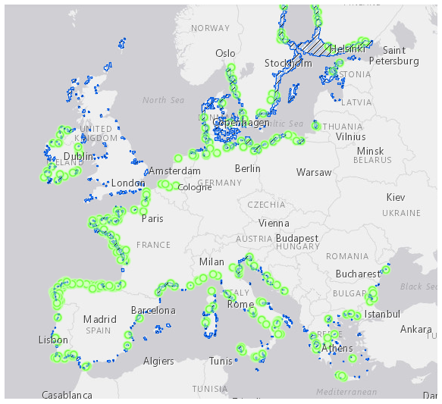

Figure 6: Coastal lagoons (blue polygons) and Estuaries (green circles) in the Natura 2000 network of Europe (source: Natura 2000 Network Viewer).

|  |
| --- |
| **Qu. 2.3. How likely is it that establishment will occur despite competition from existing species in the risk assessment area?** |

|  |  |  |  |
| --- | --- | --- | --- |
| **RESPONSE** | very unlikely  unlikely  moderately likely  **likely**  very likely | **CONFIDENCE** | **low**  medium  high |

Response: In the RA area, *Z. japonica* is expected to co-occur with other macrophytes in intertidal and shallow subtidal sedimentary habitats, predominantly with the congeneric *Z. marina* and *Z. noltei*, especially the latter, which is very similar functionally and ecologically (i.e. a small, intertidal, fast-growing species with similar habitat requirements and physiological tolerances to abiotic factors – see Qu. A1 and 4.3 for details).

The literature suggests that seagrass species may minimise competition by exhibiting tidal zonation or phenological variations in size and their reproductive cycle, but also frequently co-exist in mixed beds. In its native range *Z. japonica* co-occurs with a variety of other species including *Z. marina*, *Z. caespitosa*, *Halophila* spp., *Cymodocea* spp., and *Halodule* spp. (Green & Short, 2003; Sugimoto et al., 2017; Jiang et al., 2018; Sudo & Nakaoka, 2020), in multi-specific seagrass meadows, where *Z. japonica* is always found in the uppermost parts of the bed. In N America, at the lower end of its intertidal range, it can co-occur with *Z. marina* (Ruesink et al., 2010) andat the upper end, occasionally with *Ruppia maritima* (Harrison & Bigley, 1982), although the three species were recently described to co-occur in a mixed bed in Willapa Bay, Washington (Boardman & Ruesink, 2022). Mosaic patterns occur when complex micro-topographic relief creates well-drained areas and submerged depressions within the same bed (Hannam & Wyllie-Echeverria, 2015).

The potential for establishment of *Z. japonica* will undoubtedly be linked to its interaction with *Z. noltei* and the density/distribution it achieves in relation to its sister species. However, *Z. japonica* and *Z. noltei* do not currently co-exist anywhere in the world, thus it is not possible to predict with any degree of certainty the outcome of any potential competition between them. This is furthermore likely to be affected by the donor region given the high degree of phenotypic plasticity exhibited by *Z. japonica* throughout its wide geographic range (Ito et al., 2021). *Zostera noltei* may have a slight competitive advantage over *Z. japonica* in the Mediterranean Sea, where seawater temperatures in lagoons and shallow waters can reach high values during summer heat waves, and the native species has a maximum limiting temperature between 37 °C and 38 °C (Massa et al., 2009), i.e., at least two degrees higher than documented for *Z. japonica*.

|  |
| --- |
| **Qu. 2.4. How likely is it that establishment will occur despite predators, parasites or pathogens already present in the risk assessment area?** |

|  |  |  |  |
| --- | --- | --- | --- |
| **RESPONSE** | N/A  very unlikely  unlikely  moderately likely  **likely**  very likely | **CONFIDENCE** | low  **medium**  high |

Response: In its native range, *Z. japonica* constitutes an important food source for a number of migrating birds, such as the whooper swan *Cygnus cygnus* L. (1758), the tundra swan *Cygnus columbianus* Ord. (1815) and other Anatidae, as well as for herbivorous fish, e.g., *Siganus fuscescens* (Houttuyn, 1782) (Sugimoto et al., 2017; Zhang et al., 2019; Sato et al., 2020). Similarly, in the invaded range, the species is preyed upon by migratory waterfowl species (Baldwin & Lovvorn, 1994; Lamberson et al., 2011). A virtually identical group of migratory birds feed on *Z. marina* and *Z. noltei* in Europe (Jacobs et al., 1981; Tubbs & Tubbs, 1983; Clausen et al., 2002; Gayet et al., 2012; Balsby et al., 2017). Herbivory by waterfowl can remove significant amounts of eelgrass biomass and exert top-down control on seagrass beds (see Kollars et al., 2017 for review). Up to 50 % removal of above-ground biomass was estimated for *Z. japonica* in Boundary Bay, Canada (Baldwin & Lovvorn, 1994) and an almost complete disappearance of a *Z. japonica* bed was reported in Japan (Sato et al., 2020). Waterfowl species are also reported to remove rhizomes or uproot whole plants of *Z. japonica* (Kollars et al., 2017), which can undermine the subsequent recovery of the bed. Nevertheless, *Z. japonica*, especially in colder temperate areas, relies on seed banks for recruitment and has successfully persisted in the invaded range despite significant predation. Furthermore, consumption of seeds (presumably within reproductive shoots) is a well-known mechanism of dispersal for *Zostera* species (Sumoski & Orth, 2012) and this could in fact enhance the establishment potential of the invader.

Regarding the impact of pathogens, in its native and non-native range, *Z. japonica* has suffered from the wasting disease caused by the endophytic protist *Labyrinthula zosterae*, which is considered responsible for the world’s largest losses of the seagrass *Zostera marina* (Moore & Short, 2006; Bockelmann et al., 2013), and the phytomyxid pathogen *Plasmodiophora bicaudata* (Sullivan et al., 2018)*.* These pathogens are already present in European populations of *Z. marina* and *Z. noltei* (Garcias-Bonet et al., 2011; Sullivan et al., 2018) and may infect introduced *Z. japonica* as well. In Japan however, even though *L. zosterae* occurs fairly frequently within *Zostera* populations, it appears to play a minor role as a disease agent and exhibits relatively low levels of infection on *Z. japonica* in particular (Short et al., 1993). Furthermore, the presumably pathogenic strain of *L. zosterae* currently widespread in eelgrass meadows in the Atlantic and the Pacific is not associated with disease symptoms or mass-mortalities (Brakel et al., 2019). Considering that low salinities (in the range of 10 - 12 psu) are demonstrated to reduce the pathogenicity of *Labyrinthula* spp. (McKone & Tanner, 2009; Brakel et al., 2019), *Z. japonica* in low salinity areas may have an additional advantage against this pathogen.

|  |
| --- |
| **Qu. 2.5. How likely is the organism to establish despite existing management practices in the risk assessment area? Explain if existing management practices could facilitate establishment.** |

|  |  |  |  |
| --- | --- | --- | --- |
| **RESPONSE** | very unlikely  unlikely  moderately likely  **likely**  very likely | **CONFIDENCE** | low  **medium**  high |

Response: While Ballast Water Exchange (BWE) and Ballast Water Treatment (BWT) can reduce propagule pressure and, consequently, the rate of establishment (see Qu. 1.5a for details), these management practices are not always possible or yet in effect. On the other hand, bivalve transportations for aquaculture purposes (which constitute a pathway of introduction and spread) offer suitable habitats to *Zostera japonica* in the form of the aquaculture plots themselves and, thus, facilitate establishment. Moreover, seed relaying offers favourable substrates and conditions for settlement and growth, enhancing establishment potential.

In parts of its invaded range in N America, *Z. japonica* has been afforded protection under laws and policies aimed at protecting its congener *Z. marina* and eelgrass habitats in general due to their important ecological functions and ecosystem services they provide (Shafer et al., 2014). In the RA area, the native eelgrass species *Z. marina* and *Z. noltei* and, collectively, “Zostera or eelgrass beds” are protected habitats under EU, OSPAR and HELCOM provisions (OSPAR, 2009; HELCOM, 2013b; Gubbay et al., 2016) and their protection is included in several Action Plans (e.g.; de Jonge et al., 2000; UNEP/MAP, 2019; Jahnke et al., 2020; HELCOM, 2021). In addition, *Z. noltei* is included in the site descriptions for over 40 Natura 2000 sites throughout Europe, which are also under protection status. Considering that *Z. japonica* has very similar habitat requirements and can potentially settle in close proximity and co-exist with the native eelgrass species, it is likely that it will also be protected by any destructive practices that can hamper its establishment, such as for example anchor damage, towed fishing gears, high nutrient loads, etc.

|  |
| --- |
| **Qu. 2.6. How likely is it that biological properties of the organism would allow it to survive eradication campaigns in the risk assessment area?** |

|  |  |  |  |
| --- | --- | --- | --- |
| **RESPONSE** | very unlikely  unlikely  moderately likely  **likely**  very likely | **CONFIDENCE** | low  medium  **high** |

Response: A variety of methods has been employed for the local eradication of *Z. japonica* patches in Humboldt Bay, California, from mechanical removal and covering with plastic sheets to the application of herbicides and heat treatment (Frimodig & Ramey 2009; Ramey et al., 2011). Even though some of these methods were initially successful at eliminating small patches locally, total eradication in the Bay was not achieved after almost ten years of concerted efforts, and the areal distribution of patches continued to expand (Shafer et al., 2014).

An important reproductive feature of *Z. japonica* is that it reproduces vegetatively via rhizomatous growth, and also produces seeds. Vegetative growth in particular may allow the species to overcome Allee effects that can periodically eliminate small initial populations and permit isolated patches to grow into established clonal beds (Almasi & Eldridge, 2008; Fisher et al., 2011). The same can be envisaged for anthropogenic removal efforts that may miss parts of the below-ground biomass, even if they are carried out before the flowering period of the species to ensure seed production does not take place. This is further supported by the ability of *Z. japonica* to rapidly recover from intense clamming activities via asexual reproduction, through new shoot formation from buried below-ground tissues (Park et al., 2011). The propensity of seagrass species to produce “wrack”, i.e., rafts of various fragments, that can drift and disperse for long distances, can also contribute to incomplete detection and removal, and the establishment of new patches.

|  |
| --- |
| **Qu. 2.7. How likely are the biological characteristics of the organism to facilitate its establishment in the risk assessment area?**  including the following elements:   * a list and description of the reproduction mechanisms of the species in relation to the environmental conditions in the risk assessment area * an indication of the propagule pressure of the species (e.g. number of gametes, seeds, eggs or propagules, number of reproductive cycles per year) of each of those reproduction mechanisms in relation to the environmental conditions in the risk assessment area. * If relevant, comment on the likelihood of establishment based on propagule pressure (i.e. for some species low propagule pressure (1-2 individuals) could result in establishment whereas for others high propagule pressure (many thousands of individuals) may not. * If relevant, comment on the adaptability of the organism to facilitate its establishment and if low genetic diversity in the founder population would have an influence on establishment. |

|  |  |  |  |
| --- | --- | --- | --- |
| **RESPONSE** | very unlikely  unlikely  **moderately likely**  likely  very likely | **CONFIDENCE** | low  **medium**  high |

Response: Seagrasses can reproduce both asexually via clonal growth and sexually via flowering and seed production (den Hartog, 1970). *Zostera japonica* demonstrates a strong seasonality in vegetative growth and reproduction and a wide variation in the phenology of reproductive traits, depending on latitude, temperature, local environmental stressors and the origin of the populations (Ito et al., 2021).

At the northern limits of its invaded range in British Columbia, *Z. japonica* is considered to be an annual or short-lived perennial and rarely over-winters (Shafer et al., 2014); new populations are initiated each year from seed produced the previous year (Harrison, 1982). Oregon populations of *Z. japonica* are perennial, persisting throughout the year (Kaldy, 2006) with clonal production more important than seed production. Conversely, Ito et al. (2021), in a global meta-analysis of growth and reproductive traits of *Z. japonica* native and invasive populations found no significant latitude and temperature effects on reproductive ratios in Asian populations and postulate that sexual vs asexual reproduction may rather depend on local environmental conditions and particularly on environmental stress, which enhances sexual reproduction (Cabaço & Santos, 2012; Kendrick et al., 2012; Suonan et al., 2017). This study however did not take into account the recently described Chinese populations, which exhibit a markedly higher investment in sexual reproduction at colder locations (Zhang et al., 2019; 2021; Yue et al., 2020).

As there is little evidence that vegetative shoots with attached roots and rhizomes, if dislodged, can successfully reestablish naturally (Ewanchuk & Williams, 1996; Jahnke et al., 2016), the discussion will focus on the potential for establishment of sexually produced propagules. Generally, flowering in *Z. japonica* occurs from spring until autumn, with variations in the onset and extent of the period depending predominantly on temperature (Wai, 1998; Huong et al., 2003; Yokota et al., 2005; Kaldy, 2006; Morita et al., 2011; Suonan et al., 2017; Zhang et al., 2019). Germination of seeds occurs in late winter/early spring in N America but can start as early as November in parts of the native range (Yokota et al., 2005; Morita et al., 2011). Consequently, reproductive shoots are more likely to arrive in the RA area during the colder months, where they can find suitable conditions for survival and further development.

Being a monoecious species, i.e., having both the male and female flowers in the same individual, is a trait that favours establishment of transported individuals, since fertilisation can potentially be accomplished by the same plant (Jahnke et al., 2020 but see Reusch, 2000 for outcrossing rates). Seedling production can be very variable depending on local environmental conditions; indicatively, potential seed production of a *Z. japonica* bed in Korea was estimated at between 7850 seeds/m2 and 1560 seeds/m2 along a high to low disturbance gradient (Suonan et al., 2017), while in the Yellow River Delta, China, it varied between 13,137 seeds/m2 and 30,784 seeds/m2 (Zhang et al., 2019). In the Yellow River Delta population, seed production per flowering shoot was approximately 6-15 seeds/shoot (Zhang et al., 2019). Seed germination rates in the invaded range were found to be fairly high both under experimental conditions (up to 60 % - Kaldy et al., 2015) and according to field observations (45 - 57 % of new shoots develop from seed - Ruesink et al., 2010). Despite that, early work in N America indicated that the probability of a seedling surviving its first year is small, in the range of 4 % (Harrison & Bigley, 1982). This estimate comes in agreement with similar estimates for *Zostera marina*; for example, Orth et al. (2012) estimated a 2 - 7% rate of seedling establishment in unvegetated plots and attributed it to wave action and currents that can erode sediments and remove shallow seedlings without a substantial root system. Similarly, Hosokawa et al. (2015) found that fewer than 5 % of dispersed *Z. marina* seeds had germinated and hypothesized heavy losses due to predation by herbivores.

Thus, establishment of a new patch from released seeds, although certainly possible, will depend on the biomass and seed content of entrained reproductive shoots (or the amount of seeds directly imported with shellfish stock), the condition of the reproductive propagules post-transport and the local biotic and abiotic conditions they meet upon entry into the RA area. Propagules entering Atlantic Europe close to estuarine environments (where quite often harbours, marinas and shellfish culture plots are located) during the colder months of the year have a better chance of establishment.

|  |
| --- |
| **Qu. 2.8. If the organism does not establish, then how likely is it that casual populations will continue to occur?**  Consider, for example, a species which cannot reproduce in the risk assessment area, because of unsuitable climatic conditions or host plants, but is present because of recurring introduction, entry and release events. This may also apply for long-living organisms. |

|  |  |  |  |
| --- | --- | --- | --- |
| **RESPONSE** | very unlikely  **unlikely**  moderately likely  likely  very likely | **CONFIDENCE** | **low**  medium  high |

Response: The species is not very likely to enter the RA area in the first place (see Risk of Introduction section), thus the probability of recurring introduction events is considered to be low. In the event that viable propagules are released in areas with conditions unsuitable for the completion of its life cycle (e.g. with seasonal maxima of temperature and salinity beyond the species’ tolerance limits) it is possible that small patches may still develop from seed germination but their survival is uncertain and their occurrence unpredictable.

|  |
| --- |
| **Qu. 2.9. Estimate the overall likelihood of establishment in the risk assessment area under current climatic conditions. In addition, details of the likelihood of establishment in relevant biogeographical regions under current climatic conditions should be provided.**  Thorough assessment of the risk of establishment in relevant biogeographical regions in current conditions: providing insight in the risk of establishment in (new areas in) the risk assessment area. |

|  |  |  |  |
| --- | --- | --- | --- |
| **RESPONSE** | very unlikely  unlikely  **moderately likely**  likely  very likely | **CONFIDENCE** | low  **medium**  high |

Response: Abiotic conditions for successful reproduction are encountered in most parts of the RA area. However, long-term establishment most likely requires specific water body types, such as estuaries, lagoons and sheltered inshore waters with intertidal sediments, which are more common in Atlantic Europe.

In the Mediterranean Sea, high summer temperatures in lagoons and shallow waters and the high salinity in the Levantine and the southern Central Mediterranean are expected to reduce the likelihood of establishment. A useful criterion for the potential extent of the species in this subregion is likely to be the current distribution range of its sister species *Z. noltei* (i.e., predominantly the north Western Mediterranean, the northern Adriatic, the lagoons of the Aegean and Ionian coasts of Greece but also along the north African coast – see Qu. 4.3 for more details). This comes in contrast with the results of the habitat suitability model (Annex VIII), which predicts absence of the species in the western Mediterranean, our modeling approach however, with the current resolution and the available predictive layers at the global scale, has certain limitations when it comes to euryhaline species of the intertidal/shallow subtidal, since it cannot accurately capture small scale salinity variations of inshore areas and does not reflect well the extent of the intertidal zone. Furthermore, there is a distinct lack of information documenting how *Z. japonica* may respond to locally and seasonally high salinities, thus predictions about its potential distribution in the Mediterranean Sea are characterized by high uncertainty. As a result, predictions of the proportion of suitable habitat by marine subregion and Member State under different climate scenarios in Tables 2 and 3 of the modelling annex should be interpreted with caution.

The Baltic Sea offers conditions suitable for establishment in its western part; further east, consistently low salinities are expected to limit the potential for establishment. In the Black Sea, abiotic conditions are close to the optimal temperature and salinity for *Z. japonica* potentially allowing establishment, however, the native *Zostera* beds in the region are fragmented and declining mainly due to pollution and eutrophication (Jahnke et al., 2016).

More critically than abiotic conditions, however, the potential for establishment will depend on the number of introduced propagules, their post-transport condition and the survival of the first seedlings, parameters that are all characterized by low to moderate probability of success and high uncertainty. Hence, the likelihood of establishment is considered to be moderate in most parts of the RA area. In the Greater North Sea and the Bay of Biscay, which host the best combination of abiotic conditions, suitable habitats and pathway pressure, the potential for establishment may be higher, especially if seeds are introduced via shellfish transfers, but this score is associated with high uncertainty.

Regarding biotic interactions, competition and predation have not hindered establishment of *Z. japonica* in its current invaded range thus far and are expected to regulate populations of the species in ways similar to what is observed in its current distribution range. Biotic interactions with the native con-generic *Z. noltei*, which is very similar ecologically and functionally, have the potential to alter the likelihood of establishment but this is very difficult to predict.

Baltic Sea: moderately likely, medium confidence (western part)

Greater North Sea: likely, low confidence

Celtic Seas: moderately likely, medium confidence

Bay of Biscay and the Iberian coast: likely, low confidence

Western Mediterranean Sea: moderately likely, medium confidence

Adriatic Sea: moderately likely, medium confidence (northern part)

Aegean-Levantine Sea: moderately likely, medium confidence (primarily the Aegean)

Central Mediterranean Sea and the Ionian: moderately likely, medium confidence

Black Sea: moderately likely, medium confidence

|  |
| --- |
| **Qu. 2.10. Estimate the overall likelihood of establishment in the risk assessment area under foreseeable climate change conditions. In addition, details of the likelihood of establishment in relevant biogeographical regions under foreseeable climate change conditions should be provided.**  Thorough assessment of the risk of establishment in relevant biogeographical regions in foreseeable climate change conditions: explaining how foreseeable climate change conditions will influence this risk.  With regard to climate change, provide information on   * the applied timeframe (e.g. 2050/2070) * the applied scenario (e.g. RCP 4.5) * what aspects of climate change are most likely to affect the likelihood of establishment (e.g. increase in average winter temperature, increase in drought periods)   The thorough assessment does not have to include a full range of simulations on the basis of different climate change scenarios, as long as an assessment of likely establishment within a medium timeframe scenario (e.g. 30-50 years) with a clear explanation of the assumptions is provided. However, if new, original models are executed for this risk assessment, the following RCP pathways shall be applied: RCP 2.6 (likely range of 0.4-1.6°C global warming increase by 2065) and RCP 4.5 (likely range of 0.9-2.0°C global warming increase by 2065). Otherwise, the choice of the assessed scenario has to be explained. |

|  |  |  |  |
| --- | --- | --- | --- |
| **RESPONSE** | very unlikely  unlikely  **moderately likely**  likely  very likely | **CONFIDENCE** | low  **medium**  high |

Response: The species distribution model predicted an overall increase in the suitable area for the species under future climate conditions (RCP 2.6 and RCP 4.5 by 2070), as well as a small northward expansion in Atlantic Europe. Higher winter temperatures in Atlantic Europe will favour a shift from short-lived annual to perennial populations. The increase in suitable habitat in the Mediterranean is due to the warming trend of its cooler and fresher parts, where the species is more likely to establish. This comes in agreement with predictions and expectations of seagrass responses to climate change in general (e.g., Duarte, 2002). Although *Z. japonica* exhibits thermal adaptive mechanisms when periodically exposed to high temperatures up to 32 °C (Zhang et al., 2017), it still may not survive extreme temperatures likely to develop in the exposed tidal zone, particularly in the Mediterranean, which are higher than its upper lethal threshold of 35 °C (Massa et al., 2009). The rapid rise in the occurrence of Marine Heat Waves can be potentially even more catastrophic than the increase in average seawater temperature (Nguyen et al., 2021), and such events have already been linked with Zostera bed die-offs (Massa et al., 2009; Jarvis et al., 2014). Thus, establishment in the southern parts of the RA area may be hindered even more. Conversely, higher seawater temperatures in Atlantic Europe and the Black Sea are likely to favour *Z. japonica*, especially in its interaction with *Z. marina*, which has lower thermal limits.

At the same time, increased storm activity throughout the RA area is expected to negatively affect the species with direct damage (breakage and uprooting of plants – although this may also have a positive effect by enhancing natural dispersal) and indirect impacts due to coastal erosion and increased sedimentation coupled with reduced light availability (Duarte, 2002; Nguyen et al., 2021).

Baltic Sea: moderately likely, medium confidence (western part)

Greater North Sea: likely, low confidence

Celtic Seas: moderately likely, medium confidence

Bay of Biscay and the Iberian coast: likely, low confidence

Western Mediterranean Sea: moderately likely, medium confidence

Adriatic Sea: moderately likely, medium confidence (northern part)

Aegean Levantine Sea: moderately likely, medium confidence (primarily the Aegean)

Central Mediterranean Sea and the Ionian: moderately likely, medium confidence

Black Sea: moderately likely, medium confidence

## 3 PROBABILITY OF SPREAD

|  |
| --- |
| **Important instructions:**   * Spread is defined as the expansion of the geographical distribution of an alien species within the risk assessment area. * Repeated releases at separate locations do not represent continuous spread and should be considered in the probability of introduction and entry section (Qu. 1.7). |

|  |
| --- |
| **Qu. 3.1. How important is the expected spread of this organism within the risk assessment area by natural means? (List and comment on each of the mechanisms for natural spread.)**  including the following elements:   * a list and description of the natural spread mechanisms of the species in relation to the environmental conditions in the risk assessment area. * an indication of the rate of spread discussed in relation to the species biology and the environmental conditions in the risk assessment area.   The description of spread patterns here refers to the CBD pathway category “Unaided (Natural Spread)”. It should include elements of the species life history and behavioural traits able to explain its ability to spread, including: reproduction or growth strategy, dispersal capacity, longevity, dietary requirements, environmental and climatic requirements, specialist or generalist characteristics. |

|  |  |  |  |
| --- | --- | --- | --- |
| **RESPONSE** | minimal  minor  moderate  **major**  massive | **CONFIDENCE** | low  **medium**  high |

Response: Different life stages of seagrasses have different dispersal capabilities in space and time. Even though not all the relevant information is available for *Z. japonica* specifically, a significant body of research has focused on the dispersal mechanisms and potential of *Zostera* species (*Z. marina* and *Z. noltei* in particular) such that inference can be made from congeneric species.

Pollen and seeds of *Zostera* spp. are negatively buoyant such that primary dispersal occurs generally within the parent bed, in the range of centimetres to 100 metres (Harwell & Orth, 2002). Secondary dispersal is however possible, through resuspension of sediments during storms (Kendrick et al., 2012) and with biotic dispersal mechanisms, primarily predation but also entanglement of reproductive material (McMahon et al., 2014). Sumoski & Orth (2012) estimated a maximum dispersal distance for *Z. marina* seeds by waterbirds of up to 20 km with a gut retention time up to 5 h, but point out that much longer seed retention times have been reported in waterfowl, up to 24 h in some species (Charalambidou et al., 2003; Figuerola et al., 2010), which can significantly enhance the biotic dispersal potential of seeds. Furthermore, mega-herbivores such as marine turtles can transport viable *Zostera* seeds potentially for hundreds of kilometres (Tol et al., 2017; Tavares et al., 2022).

Rafting shoots have a much larger dispersal potential, in the range of at least 150 - 200 km (Erftemeijer et al. 2008; Källström et al., 2008) and potentially much longer. For example, Berković et al. (2014) estimated a maximum potential dispersal distance of 2300 km by vegetative fragments of *Z. noltei* in the Ria Formosa. Regarding floating vegetative fragments, even though survival has been demonstrated in *Z. marina* and *Z. noltei* for 6 and 7 weeks respectively (Ewanchuk & Williams, 1996; Berković et al., 2014), their potential to re-establish is very small (Ewanchuk & Williams, 1996). In a study of genetic connectivity among *Z. noltei* populations in the Black Sea, Jahnke et al. (2016) showed that re-establishment of asexual propagules was unlikely in that region, having found no identical clones at more than one site. On the other hand, the same study demonstrated that dispersal and germination of seeds contained in spathes of floating shoots can occur at distances up to 600 km. Throughout this RA it has been assumed that reproductive fragments are the main long dispersal propagule of *Z. japonica* and it is considered highly likely that should the species establish in the RA area, the potential for long range natural dispersal is significant and can extend for hundreds of kilometres, depending on the local hydrodynamic regime, as well as the migratory movements of herbivores.

|  |
| --- |
| **Qu. 3.2a. List and describe relevant pathways of spread other than "unaided". For each pathway answer questions 3.3 to 3.9 (copy and paste additional rows at the end of this section as necessary). Please attribute unique identifiers to each question if you consider more than one pathway, e.g. 3.3a, 3.4a, etc. and then 3.3b, 3.4b etc. for the next pathway.**  including the following elements:   * a list and description of pathways of spread with an indication of their importance and associated risks (e.g. the likelihood of spread in the risk assessment area, based on these pathways; likelihood of survival, or reproduction, or increase during transport and storage; ability and likelihood of transfer from the pathway to a suitable habitat or host) in relation to the environmental conditions in the risk assessment area. * an indication of the rate of spread for each pathway discussed in relation to the species biology and the environmental conditions in the risk assessment area. * All relevant pathways of spread (except “Unaided (Natural Spread)”, which is assessed in Qu. 3.1) should be considered. The classification of pathways developed by the Convention of Biological Diversity shall be used (see Annex IV). |

**TRANSPORT-CONTAMINANT (Contaminant on animals)**

*Zostera japonica* is believed to have been introduced to the NW Pacific coast (US and Canada) with oyster seed shipments from Japan in the first half of the previous century. Harrison (1976) indicates that eelgrass was used as packaging material in the oyster crates; alternatively, Harrison & Bigley (1982) propose that dormant seeds could have survived among oyster shells and then germinated upon release to a suitable habitat.

**TRANSPORT-STOWAWAY** **Hitchhikers on ship/boat (excluding ship/boat hull fouling)**

Recreational boats constitute a common vector of NIS macrophytes ((Boudouresque & Verlaque, 2002; Thibaut et al., 2022) and are strongly suspected of being responsible for the regional spread of *Z. japonica* in N America (Shafer et al., 2014). Mechanical disturbance by anchors and chains can dislodge sections of seagrass shoots, rhizomes, and roots from the sediment, which may be able to survive for a relatively long time in damp and sheltered areas of vessels, such as an anchor well (Ruiz & Ballantine, 2004).

**TRANSPORT-STOWAWAY (fishing equipment)**

Fishing equipment has the potential to act as a dispersal vector for *Z. japonica* in much the same way as recreational boats and activities, by fragmenting and entraining reproductive shoots on the seabed, as well as by entangling drifting plant material in nets and static gear.

**TRANSPORT-STOWAWAY** **(ship/boat ballast water and sediments)**

Floating reproductive shoots could be entrained in ballast water; it is considered possible that shoots can remain viable for short, intra-regional journeys. Alternatively, seeds can settle and bury in tank sediments and be resuspended upon release of ballast water. While only scant evidence could be found for the transportation of seagrass shoots or the presence of seeds in ballast tanks, the uptake of whole *Z. japonica* plants in ballast water has been implicated in the spread of the species along the NE Pacific coast from British Columbia to California (Cohen & Carlton, 1995).

Pathway name: **TRANSPORT-CONTAMINANT (Contaminant on animals)**

|  |
| --- |
| **Qu. 3.3a. Is spread along this pathway intentional (e.g. the organism is deliberately transported from one place to another) or unintentional (e.g. the organism is a contaminant of translocated goods within the risk assessment area)?** |

|  |  |  |  |
| --- | --- | --- | --- |
| **RESPONSE** | intentional  **unintentional** | **CONFIDENCE** | low  medium  **high** |

Response: *Zostera japonica* has no commercial value and is considered a pest by shellfish growers (Fisher et al., 2011); any spread as a result of infestation is accidental and unintentional.

|  |
| --- |
| **Qu. 3.4a. How likely is it that a number of individuals sufficient to originate a viable population will spread along this pathway from the point(s) of origin over the course of one year?**  including the following elements:   * an indication of the propagule pressure (e.g. estimated volume or number of specimens, or frequency of passage through pathway), including the likelihood of reinvasion after eradication * if appropriate, indicate the rate of spread along this pathway * if appropriate, include an explanation of the relevance of the number of individuals for spread with regard to the biology of species (e.g. some species may not necessarily rely on large numbers of individuals). |

|  |  |  |  |
| --- | --- | --- | --- |
| **RESPONSE** | very unlikely  unlikely  moderately likely  **likely**  very likely | **CONFIDENCE** | Low  **medium**  high |

Response: Cultivated shellfish are frequently moved between sites locally, regionally and internationally, for the purposes of: restocking; to enhance production; relaying for fattening purposes; relaying for cleansing; or to keep fresh and alive before consumption (McKindsey et al., 2007; Brenner et al., 2014; Muehlbauer et al., 2014). Shellfish transports constitute one of the main vectors of marine macrophyte introductions and spread (Boudouresque et al., 2011; Sfriso & Marchini, 2014).

Production of bivalve molluscs in the EU averages 500,000 tonnes annually (350,000 tonnes of mussels, 100,000 tonnes of oysters and 50,000 tonnes of clams), France and Spain are the most important countries in terms of production volume and value (DG SANTE, 2018). Spain, Ireland, France and Italy are the most important regarding trade of live bivalve molluscs for farming and relaying. France is particularly important in terms of the number of movements of live bivalve molluscs for relaying before putting on the market, and the natural production of seed spat of Pacific oysters and mussels that is subject to movements either within France or to other member states. There are also a large number of movements from Spain, particularly from Galicia to Italy, for relaying and purification (Robert et al., 2013; DG SANTE, 2018). Mussel bottom culture is typically practiced on shallow mudflats in areas where there are extensive naturally occurring mussel seed beds. In the Netherlands, Germany, and Ireland, seed fished from natural beds is the main source for bottom culture (Kamermans & Smaal, 2002).

*Zostera japonica* utilizes the same habitat (i.e., primarily intertidal soft sediments) and is known to co-exist both in its native and the invaded range with the oyster *Magallana gigas* and the clam *Ruditapes philippinarum* (Wisehart et al., 2007; Park et al., 2011; Patten, 2014; Dumbauld & McCoy, 2015), two introduced species that are extensively cultivated in the RA area. Shoot fragments or released seeds of the species may well be entrained in harvested bivalves destined for translocation. Furthermore, drifting wrack can become entangled in aquaculture cages and suspended culture equipment, such as longlines and seed collectors. *Zostera japonica* densities in bivalve beds will vary seasonally and by location; as an indication of potential propagule pressure, Park et al. (2011) observed a total shoot density of 1965 shoots m-2 prior to clam harvesting in a commercial clam bed in Korea.

Little information could be found on the possible association of *Z. japonica* with mussels. In the RA area, mixed stands of *Zostera marina* with *Mytilus edulis* are a common phenomenon (Reusch et al., 1994) and in the NW Pacific, *Z. japonica* is known to co-exist with the date mussel *Arcuatula senhousia* (Lee et al., 2001), however no association is reported between the invader and native mussels in the invaded N American range. Nevertheless, it is considered possible that mussel translocations can also constitute a mechanism for spread should *Z. japonica* establish in the RA area.

|  |
| --- |
| **Qu. 3.5a. How likely is the organism to survive, reproduce, or increase during transport and storage along the pathway (excluding management practices that would kill the organism)?** |

|  |  |  |  |
| --- | --- | --- | --- |
| **RESPONSE** | very unlikely  unlikely  moderately likely  **likely**  very likely | **CONFIDENCE** | low  medium  **high** |

Response: Judging by its invasion history in N America, *Z. japonica* has already survived in oyster shipments, either as seeds or as flowering shoots. In fact, based on the the widely separated centres of distribution in N America, Harrison & Bigley (1982) hypothesised that the species may have been introduced on more than one occasion. Survival of shoots in the wet, cool conditions of a cargo hold with dredged shellfish is highly likely; similarly for seeds, which are more likely to stay dormant under low temperature conditions (Abe et al., 2009) and thus are also likely to remain viable in packing conditions.

Reproduction and growth during transit is unlikely as the period between dredging and relaying of the target species is short, particularly for spat, as the shellfish need to be kept alive and healthy; however, if mature seeds are present in the entrained material they may start to germinate.

|  |
| --- |
| **Qu. 3.6a. How likely is the organism to survive existing management practices during spread?** |

|  |  |  |  |
| --- | --- | --- | --- |
| **RESPONSE** | very unlikely  unlikely  moderately likely  **likely**  very likely | **CONFIDENCE** | low  **medium**  high |

Response: At the EU level, COUNCIL REGULATION (EC) No 708/2007 (EC, 2007) concerning use of alien and locally absent species in aquaculture defines the procedures to be followed that minimize the risk of introducing non-target alien species accompanying commercial shellfish spat and stocks. It requires a permit procedure, involving risk assessment for the non-target species and a quarantine period for the translocated stock. Importantly, in relation to spread within the RA area, the regulation does not apply to movements of locally absent species within the member states (i.e. in this case cultivated native species of bivalves) “except for cases where, on the basis of scientific advice, there are grounds for foreseeing environmental threats due to the translocation, Art. 2 para. 2.” Additionally, movements of the bivalves *Magallana gigas* and *Ruditapes philippinarum*, listed in Annex IV of the Council Regulation, which could be contaminated with *Z. japonica*, are permitted without any risk assessment or quarantine. However, local/national legislation exists that can limit the translocation possibilities of species like *M. gigas*, e.g. see WG-AS & Gittenberger (2018) for the trilateral Wadden Sea area. Moreover, if the import region is a Natura 2000 area, regulations can be much stricter as they aim to protect the conservation objectives of the protected area first.

In general, restrictions on transfers based on the risk associated with the source areas is an effective management method, as long as extensive and up-to-date data on the distribution of the high-risk non-native species are available. However, delays in identifying new non-native species, and their distribution in the RA area, can mean that spread, particularly within member states, is not prevented. Visual inspections of the dredged shellfish are unlikely to detect *Z. japonica* seeds due to their small size, and shoots may be easily mistaken for the native *Z. noltei*. Where the commercial shellfish are cleaned before transfer this will reduce the level of contamination by *Z. japonica.* Moves within the commercial shellfish sector towards hatchery culture of spat, and rope culture for mussels, will reduce the need for dredging (Robert et al., 2013; Smaal et al., 2019).

|  |
| --- |
| **Qu. 3.7a. How likely is the organism to spread in the risk assessment area undetected?**  Please note that “detection” here is considered as any system or event that may actively contribute to record the presence of a species in a way that appropriate management measures could be potentially undertaken by relevant authorities. |

|  |  |  |  |
| --- | --- | --- | --- |
| **RESPONSE** | very unlikely  unlikely  moderately likely  **likely**  very likely | **CONFIDENCE** | low  medium  **high** |

Response: Perfunctory visual inspections during bivalve aquaculture operations are likely to miss spathes and released seeds of *Z. japonica* as they are small (in the range of 5 cm and 2 mm respectively); additionally, the plant morphology is very similar to the dwarf eelgrass native species *Z. noltei*, as described in A.2, such that shoots could easily go undetected.

|  |
| --- |
| **Qu. 3.8a. How likely is the organism to be able to transfer from the pathway to a suitable habitat or host during spread?** |

|  |  |  |  |
| --- | --- | --- | --- |
| **RESPONSE** | very unlikely  unlikely  moderately likely  likely  **very likely** | **CONFIDENCE** | low  **medium**  high |

Response: If bivalve seed/stock contaminatedwith *Zostera japonica* is relayed on cultivation plots without any prior management measures, the likelihood of transfer to other suitable habitats is very high (the cultivation plots themselves are suitable habitats, see Qu. 3.4a). These plots are often situated in coastal areas in close proximity to additional suitable natural habitat to which individuals may spread.

|  |
| --- |
| **Qu. 3.9a. Estimate the overall potential rate of spread based on this pathway in relation to the environmental conditions in the risk assessment area. (please provide quantitative data where possible).** |

|  |  |  |  |
| --- | --- | --- | --- |
| **RESPONSE** | very slowly  slowly  **moderately**  rapidly  very rapidly | **CONFIDENCE** | low  **medium**  high |

Response: Bivalve transfers are a likely mechanism of entraining and translocating *Z. japonica* in the RA area, particularly considering that suitable environmental conditions for the establishment of new populations are widespread in areas where a high volume of transfer operations takes place (i.e. throughout shallow coastal areas of Atlantic Europe, as well as the northern Adriatic, northern Aegean and the western Mediterranean). Taking into account the degree of regulation and management in the industry and the fact that in many cases transfers are predominantly conducted within Member States, a moderate rate of spread via this pathway may be expected.

Pathway name: **TRANSPORT-STOWAWAY** **Hitchhikers on ship/boat (excluding ship/boat hull fouling)**

|  |
| --- |
| **Qu. 3.3b. Is spread along this pathway intentional (e.g. the organism is deliberately transported from one place to another) or unintentional (e.g. the organism is a contaminant of translocated goods within the risk assessment area)?** |

|  |  |  |  |
| --- | --- | --- | --- |
| **RESPONSE** | intentional  **unintentional** | **CONFIDENCE** | low  medium  **high** |

Response: It can be stated with high certainty that this pathway is unintentional. See categorization of pathways in Annex IV and guidance notes in the beginning of this section.

|  |
| --- |
| **Qu. 3.4b. How likely is it that a number of individuals sufficient to originate a viable population will spread along this pathway from the point(s) of origin over the course of one year?**  including the following elements:   * an indication of the propagule pressure (e.g. estimated volume or number of specimens, or frequency of passage through pathway), including the likelihood of reinvasion after eradication * if appropriate, indicate the rate of spread along this pathway * if appropriate, include an explanation of the relevance of the number of individuals for spread with regard to the biology of species (e.g. some species may not necessarily rely on large numbers of individuals). |

|  |  |  |  |
| --- | --- | --- | --- |
| **RESPONSE** | very unlikely  unlikely  moderately likely  **likely**  very likely | **CONFIDENCE** | low  **medium**  high |

Response: Recreational boats constitute a common vector of NIS macrophytes (Boudouresque & Verlaque, 2002; Thibaut et al., 2022) and are strongly suspected of being responsible for the regional spread of *Z. japonica* in N America (Fisher et al., 2011; Shafer et al., 2014). Mechanical disturbance by anchors and chains can dislodge sections of seagrass shoots, rhizomes, and roots from the sediment, leaving bare patches and causing extensive damage. Small pleasure boat anchors undoubtedly uproot shoots; e.g., an estimated 68,000 shoots ha-1 of *Posidonia oceanica* were uprooted in a 1.4 ha area of a popular anchoring spot in Corsica (Boudouresque et al., 2009). Chain attachments in particular are known to pull out macrophyte fragments with a very high frequency (West et al., 2007), but the amount of propagules removed will also depend on the size of the boat and the type of anchor used (Milazzo et al., 2004). Due to its intertidal habitat and high-density growth strategy, entanglement of *Z. japonica* fragments on boat trailers is another distinct possibility.

Regarding the magnitude and potential dispersal distance of the vector itself, an indication of the number of recreational vessels in the RA area is given by the European Boating Industry (2022), which estimates that over 6 million boats are kept in European waters while 10,000 marinas provide over 1 million berths both inland and in coastal areas. Extrapolating from Gittenberger et al. (2017), approximately 30 % of these vessels travel distances >100 km from their home port. Assuming travel speeds of 5 knots (Fletcher et al., 2017), considerable distances can be travelled within the RA area within a matter of days, which significantly increases the likelihood that sufficient viable propagules of *Z. japonica* can spread along this pathway from already established populations in the RA area.

|  |
| --- |
| **Qu. 3.5b. How likely is the organism to survive, reproduce, or increase during transport and storage along the pathway (excluding management practices that would kill the organism)?** |

|  |  |  |  |
| --- | --- | --- | --- |
| **RESPONSE** | very unlikely  unlikely  moderately likely  **likely**  very likely | **CONFIDENCE** | low  **medium**  high |

Response: This will depend on the length of period propagules will remain on the vessels and how sheltered from direct sunlight and wind they will be. For example, exposure periods of one to a few hours may occur when a boat travels within an estuary or between adjacent bays, or a few days between more distant locations with the use of a trailer (West et al., 2007).

Being an intertidal species, *Z. japonica* has a relatively high tolerance to desiccation, which is effected by a combination of individual leaf physiological adaptations morphological features, and plant growth strategies that provide shading and protection from evaporation (Shafer et al., 2007; Park et al., 2021). Kim et al. (2020) showed that the photosynthetic yield of densely overlapping leaves of *Z. japonica*, naturally lying on the sediment during low tide,decreased slightly after 3 h of air exposure, with an approximately 22 % reduction of its initial value. In contrast, the photosynthetic yield of the disturbed *Z. japonica* leaves decreased by approximately 80 %, over the 50 min of air exposure. Thus, it can be envisaged that a dense clump of *Z. japonica* fragments in a wet and shaded spot on a vessel (such as under a coil of rope, an anchor well or a storage area) can survive transport along this pathway for short to medium distances.

Individual seeds of *Zostera japonica* are strongly desiccation sensitive, with a complete loss of viability after 24 h of desiccation (Yue et al., 2019), if, however, they remain attached to the live wet fragments, such limitations will be largely alleviated.

|  |
| --- |
| **Qu. 3.6b. How likely is the organism to survive existing management practices during spread?** |

|  |  |  |  |
| --- | --- | --- | --- |
| **RESPONSE** | very unlikely  unlikely  moderately likely  **likely**  very likely | **CONFIDENCE** | low  **medium**  high |

Response: This depends to a large extent on how informed boat users are on the importance of not releasing hitchhiking species from one waterbody to another and how diligent they are in cleaning their vessels and equipment, practices that are entirely voluntary. A study in Dutch marinas by Gittenberger et al. (2017) reported that none of the 77 boat owners interviewed indicated that they were aware of the potential environmental impact of hull fouling. In the UK, despite a nationwide “Check, Clean, Dry” campaign being run since 2011, more than 50 % of the 680 anglers interviewed by Smith et al. (2020) had no awareness of it; and an estimated 40 % presented a high biosecurity risk by not implementing sufficient biosecurity measures in relation to damp angling equipment. Taking the above into account and considering that moorings and anchorages are common over seagrass beds (Unsworth et al., 2017), including within Marine Protected Areas (e.g. Milazzo et al., 2004), the potential for *Z. japonica* to survive existing management practices is high. It is noteworthy, however. that action plans and management measures are increasingly being adopted for the protection of seagrass beds with measures to restrict or prohibit moorings/anchoring or install environmentally friendly anchorages in a number of countries, such as Italy, Slovenia, and Croatia (UNEP/MAP, 2019).

|  |
| --- |
| **Qu. 3.7b. How likely is the organism to spread in the risk assessment area undetected?**  Please note that “detection” here is considered as any system or event that may actively contribute to record the presence of a species in a way that appropriate management measures could be potentially undertaken by relevant authorities. |

|  |  |  |  |
| --- | --- | --- | --- |
| **RESPONSE** | very unlikely  unlikely  moderately likely  **likely**  very likely | **CONFIDENCE** | low  **medium**  high |

Response: This ties in with the adoption of management measures, as mentioned in the previous question, and the degree of awareness of boat users. Another factor is the size of the transported propagules, with smaller fragments/clumps, which are frequently trapped by chains, more likely to escape the attention of boat users and thus be transported to new sites (West et al., 2007). Finally, due to the close resemblance of *Z. japonica* to *Z. noltei*, as described in A.2, the invader is more likely than not to be mistaken for the native species and go undetected.

|  |
| --- |
| **Qu. 3.8b. How likely is the organism to be able to transfer from the pathway to a suitable habitat or host during spread?** |

|  |  |  |  |
| --- | --- | --- | --- |
| **RESPONSE** | very unlikely  unlikely  moderately likely  **likely**  very likely | **CONFIDENCE** | Low  **medium**  high |

Response: Judging by how frequently macrophytes are first detected in the proximity of harbours and marinas, hitchhiking on vessels is considered to be one of their main mechanisms of spread (Gambi et al., 2009; Willette et al., 2014; Winters et al., 2020). Seagrass shoots entangled in chains, ropes and anchors have a high likelihood of being released to a suitable habitat as a boat moves from location to location and the anchor is dropped again, or if cleaning of the equipment takes place in a new location.

|  |
| --- |
| **Qu. 3.9b. Estimate the overall potential rate of spread based on this pathway in relation to the environmental conditions in the risk assessment area. (please provide quantitative data where possible).** |

|  |  |  |  |
| --- | --- | --- | --- |
| **RESPONSE** | very slowly  slowly  **moderately**  rapidly  very rapidly | **CONFIDENCE** | Low  **medium**  high |

Response: Judging by how frequently macrophytes are first detected in the proximity of harbours and marinas, hitchhiking on vessels is considered one of their main mechanisms of spread (Gambi et al., 2009; Willette et al., 2014; Winters et al., 2020). Under the prevailing environmental conditions in the RA area, the peak growth period of the species will coincide with the peak period in recreational boating activities (i.e., late spring and summer), especially in Atlantic Europe, increasing the chances of propagules being entrained. Considering the survival period of exposed *Z. japonica* can extend from a few hours to, possibly, a few days in sheltered and wet niche areas, and assuming a moderate range of movement for small recreational vessels, a moderate rate of spread is estimated via this pathway.

Pathway name: **TRANSPORT-STOWAWAY (fishing equipment)**

|  |
| --- |
| **Qu. 3.3c. Is spread along this pathway intentional (e.g. the organism is deliberately transported from one place to another) or unintentional (e.g. the organism is a contaminant of translocated goods within the risk assessment area)?** |

|  |  |  |  |
| --- | --- | --- | --- |
| **RESPONSE** | intentional  **unintentional** | **CONFIDENCE** | low  medium  **high** |

Response: *Zostera japonica* is not a target organism for fisheries; it can be stated with high confidence that this pathway is unintentional.

|  |
| --- |
| **Qu. 3.4c. How likely is it that a number of individuals sufficient to originate a viable population will spread along this pathway from the point(s) of origin over the course of one year?**  including the following elements:   * an indication of the propagule pressure (e.g. estimated volume or number of specimens, or frequency of passage through pathway), including the likelihood of reinvasion after eradication * if appropriate, indicate the rate of spread along this pathway * if appropriate, include an explanation of the relevance of the number of individuals for spread with regard to the biology of species (e.g. some species may not necessarily rely on large numbers of individuals). |

|  |  |  |  |
| --- | --- | --- | --- |
| **RESPONSE** | very unlikely  unlikely  moderately likely  **likely**  very likely | **CONFIDENCE** | low  **medium**  high |

Response: Fishing equipment has the potential to act as a dispersal vector for *Z. japonica* in much the same way as recreational boating, by fragmenting and entraining reproductive shoots on the seabed, as well as by entangling drifting plant material in nets and static gear. Even though trawling is prohibited in the Mediterranean Sea within 3 nautical miles from the coast or above the 50 m isobath (EU Regulation 1967/2006) and in other parts of the RA area with local/temporal restrictions, non-destructive practices such as static nets, longlines, fishing traps and pots, which are common over seagrass beds (Nordlund et al., 2018) can still entangle plant material. Flowering shoot density during the reproductive period of *Z. japonica* has been reported in the range of approximately 500 - 1300 reproductive shoots m-2 (Suonan et al., 2017; Zhang et al., 2019; see also Qu. 2.7 for potential density estimates) and while this will also depend on latitude/temperature effects on reproductive ratios, it is considered that fishing activities have the potential to transport a sufficient number of propagules for the establishment of a new population.

|  |
| --- |
| **Qu. 3.5c. How likely is the organism to survive, reproduce, or increase during transport and storage along the pathway (excluding management practices that would kill the organism)?** |

|  |  |  |  |
| --- | --- | --- | --- |
| **RESPONSE** | very unlikely  unlikely  moderately likely  **likely**  very likely | **CONFIDENCE** | low  **medium**  high |

Response: For desiccation tolerance, see Qu. 3.5b. If *Zostera japonica* remains entangled in/under wet fishing equipment or in damp crevices on the deck, it has a relatively high chance of survival until the fishing gear is submerged again or the vessel returns to harbour.

|  |
| --- |
| **Qu. 3.6c. How likely is the organism to survive existing management practices during spread?** |

|  |  |  |  |
| --- | --- | --- | --- |
| **RESPONSE** | very unlikely  unlikely  moderately likely  **likely**  very likely | **CONFIDENCE** | low  **medium**  high |

Response: There are currently no management practices addressing macrophytes caught on fishing gear during fishing operations, and their discarding at sea. Handling of by-catch can be variable and depends on fishing gear and practices, such that survival of the species is generally considered likely during fishing operations.

|  |
| --- |
| **Qu. 3.7c. How likely is the organism to spread in the risk assessment area undetected?**  Please note that “detection” here is considered as any system or event that may actively contribute to record the presence of a species in a way that appropriate management measures could be potentially undertaken by relevant authorities. |

|  |  |  |  |
| --- | --- | --- | --- |
| **RESPONSE** | very unlikely  unlikely  moderately likely  **likely**  very likely | **CONFIDENCE** | low  **medium**  high |

Response: Big clumps of entangled seagrass are unlikely to go unnoticed and may be removed on the spot when fishing gear is retrieved, while smaller fragments/clumps may escape the attention of fishermen. Regardless of clump size however, due to the high resemblance of *Z. japonica* to *Z. noltei*, as described in A.2, the invader is more likely than not to be mistaken for the native species and go undetected.

|  |
| --- |
| **Qu. 3.8c. How likely is the organism to be able to transfer from the pathway to a suitable habitat or host during spread?** |

|  |  |  |  |
| --- | --- | --- | --- |
| **RESPONSE** | very unlikely  unlikely  moderately likely  **likely**  very likely | **CONFIDENCE** | low  **medium**  high |

Response: This will depend on cleaning practices, fishing operations (e.g., if the gear is used multiple times during the same fishing trip before being cleaned and stored) and where the species has been entrained. If discarded at sea, it is very likely that individuals will survive and be released over suitable depths and substrates.

|  |
| --- |
| **Qu. 3.9c. Estimate the overall potential rate of spread based on this pathway in relation to the environmental conditions in the risk assessment area. (please provide quantitative data where possible).** |

|  |  |  |  |
| --- | --- | --- | --- |
| **RESPONSE** | very slowly  slowly  **moderately**  rapidly  very rapidly | **CONFIDENCE** | low  **medium**  high |

Response: Entanglement in fishing equipment is considered a moderate risk vector for the translocation and spread of *Z. japonica*, mainly during the peak reproductive period of the species, when flowering shoot density can be high. Due to the intertidal/shallow subtidal habitat of the species, it is more likely to be dispersed by small scale and artisanal fishing gear, whose timeframe of operation matches rather well the survival timeframe of exposed *Z. japonica* (even though the potential for entanglement of drifting wrack still exists); as such the geographic spread of *Z. japonica* via this route would be relatively limited, hence a moderately rapid rate of spread may be expected.

Pathway name: **TRANSPORT-STOWAWAY** **(ship/boat ballast water and sediments)**

|  |
| --- |
| **Qu. 3.3d Is spread along this pathway intentional (e.g. the organism is deliberately transported from one place to another) or unintentional (e.g. the organism is a contaminant of translocated goods within the risk assessment area)?** |

|  |  |  |  |
| --- | --- | --- | --- |
| **RESPONSE** | intentional  **unintentional** | **CONFIDENCE** | low  medium  **high** |

Response: It can be stated with high certainty that this pathway is unintentional. See categorization of pathways in Annex IV and guidance notes in the beginning of this section.

|  |
| --- |
| **Qu. 3.4d How likely is it that a number of individuals sufficient to originate a viable population will spread along this pathway from the point(s) of origin over the course of one year?**  including the following elements:   * an indication of the propagule pressure (e.g. estimated volume or number of specimens, or frequency of passage through pathway), including the likelihood of reinvasion after eradication * if appropriate, indicate the rate of spread along this pathway * if appropriate, include an explanation of the relevance of the number of individuals for spread with regard to the biology of species (e.g. some species may not necessarily rely on large numbers of individuals). |

|  |  |  |  |
| --- | --- | --- | --- |
| **RESPONSE** | very unlikely  unlikely  **moderately likely**  likely  very likely | **CONFIDENCE** | **low**  medium  high |

Response: This will depend on the density of established *Z. japonica* beds, local hydrodynamic conditions and the time of the year (i.e., highest potential during seagrass senescence). Hosokawa et al. (2015) determined that spathes on drifting live reproductive shoots have the potential to be a major means of dispersal along the shoreline of Kurihama Bay, Japan, between May and July. On the US Pacific Northwest coast, Reimer et al. (2018) found *Z. marina* and *Z. japonica* to be major components of the macrophyte wrack in half of the 12 investigated sites in September and October. Similar periods of senescence are expected in the RA area, with some variability along the north-south axis. During these periods in particular, it is considered possible that sufficient numbers of drifting *Z. japonica* can be taken up and transferred with ballast water along this pathway.

With respect to pathway pressure within the EU, transshipment operations constitute the main maritime traffic that will act as the vector for spread. Important transshipment hubs are situated along the southern Mediterranean (serving the rest of the Mediterranean and the Black Sea) and the Le Havre-Hamburg range, serving the UK, the Baltic and Scandinavia (Notteboom et al., 2013). Ports in Atlantic Europe are more often situated in/close to estuaries such that *Z. japonica* wrack would be more likely to be entrained in ballast water in this region.

Furthermore, in many parts of the European Seas, ballast in passenger ferries and cruise ships is also a potential vector, mainly due to high traffic volume potential. Due to the routes taken, measures described in the ballast water convention cannot easily be followed (exchange at depth and distance from shore) so the risk of depositing propagules at suitable locations is higher.

|  |
| --- |
| **Qu. 3.5d. How likely is the organism to survive, reproduce, or increase during transport and storage along the pathway (excluding management practices that would kill the organism)?** |

|  |  |  |  |
| --- | --- | --- | --- |
| **RESPONSE** | very unlikely  unlikely  **moderately likely**  likely  very likely | **CONFIDENCE** | **low**  medium  high |

Response: Based on information on the tolerance of *Zostera* species to light limitation presented in Qu. 1.4b and the fact that Short Sea Shipping routes/trips between EU ports are shorter than international shipping voyages from potential donor areas (primarily the NW Pacific), survival of *Z. japonica* shoots in ballast water for a few days during passage along this pathway is considered possible but characterised by high uncertainty. Sea surface temperatures (which determine ballast water temperature) are generally within the range for *Z. japonica* survival, particularly in Atlantic Europe. In the Mediterranean, high water temperatures during the summer months may accelerate shoot and seed degradation in ballast tanks. This is also the case for ferry routes between many European locations.

|  |
| --- |
| **Qu. 3.6d. How likely is the organism to survive existing management practices during spread?** |

|  |  |  |  |
| --- | --- | --- | --- |
| **RESPONSE** | very unlikely  unlikely  **moderately likely**  likely  very likely | **CONFIDENCE** | low  **medium**  high |

Response: For details on Ballast Water Management, see Qu. 1.5b. Ballast Water Exchange (BWE) for EU Short Sea Shipping routes is usually restricted to the second criterion of at least 50 nm from the nearest land, and in waters at least 200 metres in depth in the Mediterranean Sea, and even this is often not feasible in northern European Seas (David et al., 2007). Thus, BWE is not likely to be effective in preventing the spread of *Zostera japonica* (and other organisms potentially transferred in ballast water) within European Seas. Regarding the IMO D2 standard, compliance can practically diminish propagule pressure, but full implementation of the BWMC is not expected to happen before 2024. However, even then some of the regulations and requirements under the BWMC may be relaxed for shorter, low-risk shipping routes under regional exemption options.

|  |
| --- |
| **Qu. 3.7d. How likely is the organism to spread in the risk assessment area undetected?**  Please note that “detection” here is considered as any system or event that may actively contribute to record the presence of a species in a way that appropriate management measures could be potentially undertaken by relevant authorities. |

|  |  |  |  |
| --- | --- | --- | --- |
| **RESPONSE** | very unlikely  unlikely  moderately likely  **likely**  very likely | **CONFIDENCE** | low  **medium**  high |

Response: Eelgrass shoots, vegetative or reproductive, released with ballast water in ports would be hard to miss; *Z. japonica* however is very difficult to distinguish in the field from the native *Z. noltei* (see A.2) and could easily go unidentified. Conversely, if seeds of *Z. japonica* are the life stage transported, their small size, in the range of 1.9 - 2.6 mm (Wyllie-Echeverria et al., 2006) and negative buoyancy, would make it likely that they remain undetected.

After September 2017, with the BWMC coming into effect and gradually being implemented, detection of plant material in ballast water/sediments during Port State Control inspections may be possible. According to Resolution MEPC.252(67), if initial inspections of ballast water samples indicate non-compliance with the D-2 standard, detailed inspections will be carried out. However, full implementation of the BWMC is not anticipated until 2024; moreover, molecular methods that reliably distinguish *Z. japonica* from *Z. noltei* would have to be further refined (see Qu. 1.6b). Until then, the risk that *Z. japonica* will enter the RA area undetected in ballast waters and sediments remains likely.

|  |
| --- |
| **Qu. 3.8d. How likely is the organism to be able to transfer from the pathway to a suitable habitat or host during spread?** |

|  |  |  |  |
| --- | --- | --- | --- |
| **RESPONSE** | very unlikely  unlikely  **moderately likely**  likely  very likely | **CONFIDENCE** | low  **medium**  high |

Response: *Zostera japonica* is typically found in euryhaline, intertidal, soft-sediment habitats, common around ports and harbours, which are widely distributed in the RA area. If ballast water exchange occurs in open seas rather than in coastal areas, any viable propagules will have to drift towards the coast and encounter such habitats. If, however, untreated ballast water is released in ports, estuaries, or other coastal areas, then propagules have a considerable chance of being released close to suitable habitats, especially in Atlantic Europe.

|  |
| --- |
| **Qu. 3.9d. Estimate the overall potential rate of spread based on this pathway in relation to the environmental conditions in the risk assessment area. (please provide quantitative data where possible).** |

|  |  |  |  |
| --- | --- | --- | --- |
| **RESPONSE** | very slowly  slowly  **moderately**  rapidly  very rapidly | **CONFIDENCE** | **low**  medium  high |

Response: Given: a) the amount of maritime traffic between ports and harbours within the RA area (thousands of journeys per year); b) the ballast volume of commercial vessels (104 - 105 tonnes) (GloBallast, 2021); c) the common occurrence of drifting wrack for certain parts of the year where *Z. japonica* is established; and d) its potential to survive in ballast tanks for relatively short regional journeys; spread within the RA area is considered possible via this pathway and may act as a vector for long dispersal jumps to other subregions. Nevertheless, throughout its presence in the currently invaded range (N America) *Z. japonica* has not been observed to spread with long dispersal jumps, with the exception of its occurrence in Humboldt Bay, California, where the mode of introduction is unknown (Schlosser & Eicher, 2007). For these reasons, combined with the high uncertainty of propagule survival and the seasonality of propagule pressure, a moderate rate of spread with low confidence is proposed. In the Mediterranean potential donor/recipient sites are potentially fewer and more isolated, resulting in a reduced importance of ballast water as a pathway of spread in this region.

|  |
| --- |
| **Qu. 3.10. Within the risk assessment area, how difficult would it be to contain the organism in relation to these pathways of spread?** |

|  |  |  |  |
| --- | --- | --- | --- |
| **RESPONSE** | very easy  easy  with some difficulty  difficult  **very difficult** | **CONFIDENCE** | low  medium  **high** |

Response: Naturally dispersing organisms are very difficult to contain; in the case of *Z. japonica*, besides the considerable drift range of floating shoots, an additional consideration is biotic dispersal of seeds by herbivores, especially waterfowl. This is exemplified in California, where, despite repeated eradication efforts, the areal distribution of *Z. japonica* patches continued to expand from year to year (Ramey et al., 2011; Shafer et al., 2014).

Regarding human-mediated spread, the current legal instruments and levels of implementation of voluntary measures are not sufficient to ensure containment of the organism, when transferred by bivalve movements, ballast water (but this can change with full implementation of the D-2 Standard), or as a hitchhiker on vessels’ niche areas. In relation to shellfish culture, it may be feasible to prevent long dispersal jumps, if additional restrictions on the movements of *M. gigas* and *R. philippinarum* based on the risk associated with the source areas are adopted by the industry. Similarly, greater dissemination and adoption of voluntary biosecurity measures by recreational boat users can contribute towards limiting spread.

|  |
| --- |
| **Qu. 3.11. Estimate the overall potential rate of spread in relevant biogeographical regions under current conditions for this organism in the risk assessment area (indicate any key issues and provide quantitative data where possible).**  Thorough assessment of the risk of spread in relevant biogeographical regions in current conditions, providing insight in the risk of spread into (new areas in) the risk assessment area. |

|  |  |  |  |
| --- | --- | --- | --- |
| **RESPONSE** | very slowly  slowly  **moderately**  rapidly  very rapidly | **CONFIDENCE** | low  **medium**  high |

Response: *Zostera japonica* has the potential to establish more widespread and prolific populations in Atlantic Europe, where the risk of natural spread with drifting reproductive shoots will be high, especially over the flowering and senescence period of the species (summer and early autumn). Although distances travelled will depend on local hydrodynamic conditions, natural spread of up to a few hundred kilometres may be expected. This can be augmented by biotic dispersal of seeds after ingestion by waterfowl, with movements in the order of tens of kilometres or even more. Bivalve transfers and hitchhiking on vessels (leisure craft as well as fishing vessels and equipment) are the most likely mechanisms of human-mediated spread in the RA area, which is expected to proceed at a more moderate rate at the regional scale but with a high propagule pressure potential. Ballast water and sediment transport is the most likely vector to facilitate long distance jumps of the species within European waters, until the BWMC is fully implemented. Due to the sparse documentation for this vector and the high uncertainty of propagule survival, even for small intra-European journeys, ballast water is considered a less important pathway of spread for *Z. japonica*.

In the Mediterranean Sea, if the species is introduced and establishes, its distribution is likely to be more disjunct, being restricted to the cooler, northern and western basins of this marine region, due to less favourable environmental conditions for seed germination and the extreme temperature and salinity conditions developing at suitable habitats (i.e., lagoons) in the summer. Natural dispersal is expected to be more limited and human-aided spread will likely proceed at a slower rate due to the smaller number of potential nodes. The Black Sea in contrast is expected to offer more widespread suitable habitats and conditions, with an enhanced potential of natural spread.

|  |
| --- |
| **Qu. 3.12. Estimate the overall potential rate of spread in relevant biogeographical regions in foreseeable climate change conditions (provide quantitative data where possible).**  Thorough assessment of the risk of spread in relevant biogeographical regions in foreseeable climate change conditions: explaining how foreseeable climate change conditions will influence this risk, specifically if rates of spread are likely slowed down or accelerated. |

|  |  |  |  |
| --- | --- | --- | --- |
| **RESPONSE** | very slowly  slowly  **moderately**  rapidly  very rapidly | **CONFIDENCE** | low  **medium**  high |

Response: Increased frequency of extreme phenomena under future climate conditions is anticipated to increase the potential propagule pressure of *Z. japonica* in two ways. Storms and waves cause fragmentation and heavy losses of seagrass biomass in shallow/intertidal habitats (Yue et al., 2021), increasing rafting material available for uptake into ballast tanks. This, however, does not change the likelihood of survival of entrained propagules, which remains low. At the same time, marine heat waves can cause mass mortality of aquaculture bivalves, leading to increased shellfish transfers to replete the stocks (Rodrigues et al., 2015). More shellfish movements may be associated with a higher risk of transfer if the stocks/seed originate in areas where *Z. japonica* is established and the necessary precautions are not taken. With respect to potential donor populations within the RA area, these are likely to be even more restricted in the Mediterranean Sea due to the increase in temperature and the frequency of marine heat waves (see Qu. 2.10), such that the potential for spread is expected to be more significant in Atlantic Europe.

## 4 MAGNITUDE OF IMPACT

|  |
| --- |
| Important instructions:   * Questions 4.1-4.5 relate to biodiversity and ecosystem impacts, 4.6-4.8 to impacts on ecosystem services, 4.9-4.13 to economic impact, 4.14-4.15 to social and human health impact, and 4.16-4.18 to other impacts. These impacts can be interlinked, for example, a disease may cause impacts on biodiversity and/or ecosystem functioning that leads to impacts on ecosystem services and finally economic impacts. In such cases the assessor should try to note the different impacts where most appropriate, cross-referencing between questions when needed. * Each set of questions starts with the impact elsewhere in the world, then considers impacts in the risk assessment area (=EU excluding outermost regions) separating known impacts to date (i.e. past and current impacts) from potential future impacts (including foreseeable climate change). * Only negative impacts are considered in this section (socio-economic benefits are considered in Qu. A.7) * In absence of specific studies or other direct evidences this should be clearly stated by using the standard answer “No information has been found on the issue”. This is necessary to avoid confusion between “no information found” and “no impact found”. In this case, no score and confidence should be given and the standardized “score” is N/A (not applicable). Note that in principle, even if no information is available for the risk assessment area, this does not apply to Qu. 4.2 and 4.3, because the information on impact can be inferred from regions outside the risk assessment area. If no information is available from regions outside the risk assessment area either, then this should be discussed explicitly. |

**Biodiversity and ecosystem impacts**

|  |
| --- |
| **Qu. 4.1. How important is the impact of the organism on biodiversity at all levels of organisation caused by the organism in its non-native range excluding the risk assessment area?**  including the following elements:   * Biodiversity means the variability among living organisms from all sources, including terrestrial, marine and other aquatic ecosystems and the ecological complexes of which they are part; this includes diversity within species, between species and of ecosystems * impacted chemical, physical or structural characteristics and functioning of ecosystems |

|  |  |  |  |
| --- | --- | --- | --- |
| **RESPONSE** | minimal  minor  moderate  **major**  massive | **CONFIDENCE** | low  medium  **high** |

Response: In its non-native range in N America, *Zostera japonica* has a propensity to radically alter the intertidal environment and the biological communities inherent within those environments, acting as an ecosystem engineer, resulting in a variety of biodiversity and ecosystem impacts (Fisher et al., 2011).

Habitat structure: There has been a dramatic increase in the distribution of *Zostera japonica* since its introduction around 50 years ago, see response at Qu. A5 for more details of spread. It has colonised unvegetated tidal flats, significantly altering the physical habitat structure (Posey, 1988; Baldwin & Lovvorn, 1994). In some areas such as Boundary Bay, British Columbia, and in Padilla, Samish, and Willapa Bays, Washington the seagrass now occupies many hectares of intertidal flats (Posey, 1988; Baldwin & Lovvorn, 1994; Bulthuis, 1995; Dumbauld & Wyllie-Echeverria, 2003). Harrison & Bigley (1982) described extensive beds of *Z. japonica* on the 17,000 ha of intertidal flats in Willapa Bay, with dense populations covering all substrates except those with excessive clay or gravel. Young et al. (2008) determined that *Z. japonica* distribution in Yaquina Bay, Oregon, increased from 0.037 km2 in 1998 to almost 0.19 km2 in 2007, roughly a 400 % increase over 9 years.

Colonization by *Z. japonica* can also substantially decrease water flow to mudflats, reportedly by up to 40 %; this action recruits fine sediment and detritus into the mid-intertidal zone (Tsai et al., 2010), and can lead to a rise in elevation and increased turbidity, as reported from Willapa Bay, Washington (Fisher et al., 2011).

Nutrient and carbon cycling: In Padilla Bay, Washington, Hahn (2003b) found that Z. *japonica* decomposes more rapidly than its native congener, *Z. marina*, accelerating rates of decomposition and altering the associated decomposer community, which may lead to higher carbon and nutrient turnover. Larned (2003) demonstrated that *Z. japonica* invasions alter water column-benthos nutrient fluxes in Yaquina Bay, Oregon, where bare sediments colonized by *Z. japonica* switched from functioning as net sources to net sinks of inorganic nutrients, suggesting that *Z. japonica* may have the potential to limit nitrogen levels in previously unvegetated estuaries that are already nitrogen-limited. These alterations may in turn affect pelagic primary production. Thus, *Z. japonica* can influence the biogeochemistry of entire estuaries (Williams, 2007).

Species diversity and abundance: The introduction of *Z. japonica* changed the richness and densities of the benthic and infaunal species, altering the community composition (Posey, 1988; Hahn, 2003a). Mach et al. (2014), in a review of the ecological impacts of *Z. japonica*, found evidence of a significant negative effect on large infaunal invertebrates in unvegetated habitats. Tsai et al. (2010) noted a reduction in infaunal clam condition in the presence of *Z. japonica*. In British Columbia, the ghost shrimp *Neotrypaea californiensis* suffered a sharp population decline in areas that had been invaded by the seagrasses *Zostera marina* and *Z. japonica* over a period of 8 years (Harrison, 1987), and Berkenbusch et al. (2007) found that there was a general decrease in *N. californiensis* sediment turnover activity and abundance at study sites in Netarts Bay, Oregon, where *Z. japonica* was present. Hahn (2003b) also observed differences in the microbial community in the sediment compared to that in *Z. marina* beds, which is important to the detrital food web.

It has been suggested that feeding activity of the endangered green sturgeon is significantly reduced in tideflats covered by *Z. japonica* compared to the bare sand substrate in which their feeding pits are typically found, possibly resulting from a decrease in burrowing shrimps on which they feed (Corbett et al., 2011 in WA NWCB, 2013; Fisher et al., 2011). *Z. japonica* has also been reported as contributing to declines in shorebird foraging habitats by causing changes in benthic invertebrate community structure (Durance, 2002 in GISD, 2022; Dudoit, 2006), although Mach et al. (2014) found no significant effect on waterfowl.

Mach et al. (2014) also noted studies reporting that *Z. japonica* had a significant negative effect on other macrophytes when these species occupied overlapping habitats. Where *Z. japonica* occurs in mixed beds with the native *Z. marina* the density and biomass of both species are reduced (Harrison, 1982; Hahn, 2003a; Bando, 2006; Hannam & Wyllie-Echeverria, 2015). For example, in Padilla Bay, Washington, each species had a negative effect on shoot density in the other, and the leaves of *Z. marina* were shorter when grown with the invader (Hahn, 2003a). Boardman & Ruesink (2022) reported that *Z. japonica* had an adverse impact on biomass of the intertidal widgeon grass *Ruppia maritima* in Willapa Bay, Washington. However, Harrison (1982) found little evidence of interference between the two species at a site in the Fraser River delta, British Columbia, although Z*. japonica* had higher biomass than *R. maritima* at all sites and at virtually all times during his two-year study.

It should be noted that there are a number of perceived benefits from the introduction of *Z. japonica* in N America, such as increased seagrass habitat, increased small benthic invertebrate richness and abundance, and provision of foraging habitat for some birds. There is thus a conflict between the perceived positive and negative biodiversity and ecosystem impacts and these benefits (Shafer et al., 2014).

|  |
| --- |
| **Qu. 4.2. How important is the current known impact of the organism on biodiversity at all levels of organisation (e.g. decline in native species, changes in native species communities, hybridisation) in the risk assessment area (include any past impact in your response)?**  Discuss impacts that are currently occurring or are likely occurring or have occurred in the past in the risk assessment area. Where there is no direct evidence of impact in the risk assessment area (for example no studies have been conducted), evidence from outside of the risk assessment area can be used to infer impacts within the risk assessment area. |

|  |  |  |  |
| --- | --- | --- | --- |
| **RESPONSE** | **N/A** | **CONFIDENCE** |  |

Response: *Zostera japonica* is not known to be currently present in the risk assessment area.

|  |
| --- |
| **Qu. 4.3. How important is the potential future impact of the organism on biodiversity at all levels of organisation likely to be in the risk assessment area?**  See comment above. The potential future impact shall be assessed only for the risk assessment area. A potential increase in the distribution range due to climate change does not *per se* justify a higher impact score. |

|  |  |  |  |
| --- | --- | --- | --- |
| **RESPONSE** | minimal  minor  **moderate**  major  massive | **CONFIDENCE** | **low**  medium  high |

Response: As the species is not currently present in the RA area, this response is primarily based on the impacts reported from its non-native range in N. America, but adjusted to take account of the presence in the RA area of the functionally similar *Z. noltei*.

In the risk assessment area, the functional and ecological niche that *Zostera japonica* occupies is fulfilled by the native, very closely related sister species Z*. noltei* (see response at A1). This species is a foundation seagrass species of muddy intertidal systems in Europe. It is distributed from the southern coasts of Norway to the Mediterranean Sea, the Black Sea, the Canary Islands, and has been recorded as far south as Mauritania, on Africa’s west coast (Green & Short, 2003; Borum et al., 2004; GBIF, 2022a). *Z. noltei* forms dense beds in the muddy sand of intertidal and shallow subtidal areas, and in estuaries and coastal lagoons. In the Mediterranean Bioregion it forms single species meadows at suitable habitats (e.g., the lagoons of the Northern Aegean and the Ionian, often reported as *Zostera nana* in older literature (Haritonidis & Tsekos, 2005; Nicolaidou et al., 2005), the Gulf of Gabes (Mosbahi et al., 2016), the Northern Adriatic (Ivajnšić et al., 2022) and the Western Mediterranan), and in the Black Sea it is found in pure and mixed stands on sandy substrates (Milchakova & Phillips, 2003; Short et al., 2010b). The two species, *Z. japonica* and *Z. noltei*, appear to have very similar temperature and salinity requirements and are both tolerant of desiccation (Massa et al., 2008; Abe et al., 2009; Fernández-Torquemada & Sánchez-Lizaso, 2011; Kaldy & Shafer, 2013; Yue et al., 2019). *Z. noltei* is also directly analogous to *Z. japonica* with respect to plant architecture and vertical distribution (Bigley & Barreca, 1982).

*Z. noltei* does not occur in the current invaded range of *Z. japonica* in N America, nor is there an equivalent intertidal seagrass species. Thus, the major shifts in habitat structure, converting bare mud to extensive seagrass beds; the changes to nutrient and carbon cycling; and changes to species diversity and abundance, seen in N America (see Qu. 4.1) are less likely to occur to the same extent in Europe, as areas of suitable habitat may already be occupied by *Z. noltei*. However, it is possible that *Z. japonica* will be able to establish on currently unvegetated shores where *Z. noltei* is not present, in which case the impact on habitat structure and nutrient cycling would be much greater.

There may be an impact through competition on other macrophytes that occupy the intertidal such as *Z. marina* and *Ruppia maritima*, as reported from N America (see Qu. 4.1).

Thus, the potential biodiversity impacts of *Z. japonica* will depend largely on its interaction with the native *Z. noltei* and the density/distribution it achieves in relation to its sister species. However, *Z. japonica* and *Z. noltei* do not currently co-exist anywhere in the world, thus it is not possible to predict with any degree of certainty the outcome of any potential competition between them. However, it is likely that the genetic diversity and fitness of the *Z. noltei* populations would be negatively impacted to some degree. The worst-case scenario would be that *Z. japonica* out-competes *Z. noltei* to such an extent that it becomes extinct, although this seems unlikely.

The literature suggests that seagrass species frequently co-exist in mixed beds. In its native range *Z. japonica* co-occurs with a variety of other species including *Z. marina*, *Z. caespitosa*, *Halophila* spp., *Cymodocea* spp., and *Halodule* spp. (Green & Short, 2003; Sugimoto et al., 2017; Jiang et al., 2018; Sudo & Nakaoka, 2020). In these temperate multi-specific seagrass meadows, *Z. japonica* is always found in the uppermost parts of the bed. In N America, at the lower end of its intertidal range, it can co-occur with *Z. marina*; andat the upper end, occasionally with *Ruppia maritima* (Harrison & Bigley, 1982). Similarly, in Europe *Z. noltei* is found in mixed beds with *Z. marina*, *R. maritima* and *Cymodocea nodosa* (Ceccherelli & Campo, 2002; Green & Short, 2003), confirming again the similarities between *Z. japonica* and *Z. noltei*.

With regards to hybridization, *Zostera marina* is known to hybridize with *Z. pacifica* (Olsen et al., 2014) and hybridization is very common in seagrasses generally (Daru & Yessoufou, 2016). Thus, there is a high risk that *Z. japonica* could hybridise with *Z. noltei*, especially considering their close relatedness and identical chromosome number (12) (Tanaka et al., 2003). This would directly affect the genetic diversity and fitness of the native *Z. noltei* populations. Such hybridization could result in maladaptation and seriously undermine restoration efforts; on the other hand, it could enhance the survival and longevity of the mixed meadows, particularly if the donor (i.e., invasive) populations happen to include “future climate-adapted” genotypes (Pazzaglia et al., 2021).

In its native and non-native range, *Z. japonica* has suffered from the wasting disease caused by the endophytic protist *Labyrinthula zosterae*, which is considered responsible for the world’s largest losses of the seagrass *Zostera marina* (Moore & Short, 2006; Bockelmann et al., 2013), and the phytomyxid pathogen *Plasmodiophora bicaudata* (Sullivan et al., 2018)*.* However, these diseases are already present in European populations of *Z. marina* and *Z. noltei*, so any additional impact from new introductions alongside *Z. japonica* is likely to be marginal (Garcias-Bonet et al., 2011; Sullivan et al., 2018).

Climate change may facilitate expansion of *Z. japonica* northward through both increased fitness and the ability to out-compete *Z. marina,* but this would also apply to the native *Z. noltei* as they have similar temperature and desiccation tolerances. Massa et al. (2008) predict a retraction of *Z. noltei*’s range in the Mediterranean due to rising temperatures in the exposed intertidal zone, above its sub-lethal limit of 38o C, again this is likely to apply equally to *Z. japonica*.

|  |
| --- |
| **Qu. 4.4. How important is decline in conservation value with regard to European and national nature conservation legislation caused by the organism currently in the risk assessment area?**  including the following elements:   * native species impacted, including red list species, endemic species and species listed in the Birds and Habitats directives * protected sites impacted, in particular Natura 2000 * habitats impacted, in particular habitats listed in the Habitats Directive, or red list habitats * the ecological status of water bodies according to the Water Framework Directive and environmental status of the marine environment according to the Marine Strategy Framework Directive |

|  |  |  |  |
| --- | --- | --- | --- |
| **RESPONSE** | **N/A** | **CONFIDENCE** |  |

Response: *Zostera japonica* is not known to be currently present in the risk assessment area.

|  |
| --- |
| **Qu. 4.5. How important is decline in conservation value with regard to European and national nature conservation legislation caused by the organism likely to be in the future in the risk assessment area?**   * See guidance to Qu. 4.3. and 4.4. |

|  |  |  |  |
| --- | --- | --- | --- |
| **RESPONSE** | minimal  minor  **moderate**  major  massive | **CONFIDENCE** | **low**  medium  high |

Response: As the species is not currently present in the RA area, this response is based on the impacts reported from its non-native range in N America, but adjusted to take account of the presence in the RA area of the functionally similar *Z. noltei*.

Seagrasses are among the most productive marine ecosystems and, under the EU Habitats Directive, are considered habitats that must be preserved and, where possible, recovered.

If *Zostera japonica* is introduced into the RA area the conservation status of many estuarine and lagoonal Natura 2000 sites, MPAs and SSSIs could be degraded. If *Z. japonica* establishes in areas of currently unvegetated muddy/sandy shores. The biodiversity of saline (X02) and brackish lagoon habitats (X03) within the Mediterranean, along the Atlantic coast, and in the Black Sea could be impacted. Lagoonal habitats are important as nursery areas for many fish populations (Pérez-Ruzafa et al., 2019), as well as feeding grounds for waterfowl, so any changes in trophic interactions and the overall food web could have short to medium term effects on their conservation value, which is already degraded/unfavourable in large parts of the RA area (EEA – Habitats Directive reporting under Article under Article 17).

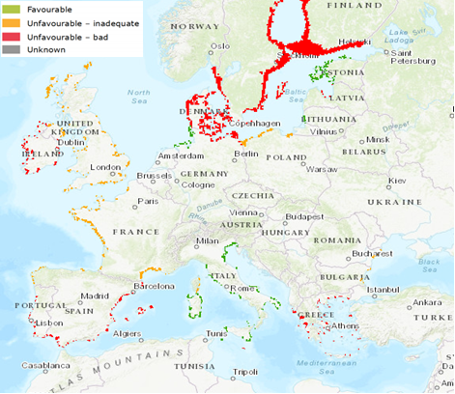

Figure 7: Conservation status of coastal lagoons (Habitat 1150) for the period 2013 - 2018 for EU28. (Source: European Environment Agency, available at https://nature-art17.eionet.europa.eu/article17/)

However, the most likely impacts will result from competition with *Z. noltei* and, to a lesser extent, *Z. marina*, both are protected species within the EU and are IUCN Red List species (categorized as of ‘Least Concern’). *Z. noltei* has suffered local declines in some regions due to loss of water clarity from sedimentation, coastal development, wasting disease, competition from the non-native seaweed *Caulerpa racemosa*, and shellfishing activities; it is also sensitive to eutrophication and shading (Ceccherelli & Campo, 2002; Short et al., 2010b; Garmendia et al., 2021).

Hybridization between *Z. japonica* and *Z. noltei* could also impact the genetic diversity and fitness of the local *Z. noltei* populations, and affect restoration efforts negatively or positively, depending on where the source popualations originate in (see Qu. 4.3. for details).

Habitats threatened are the littoral seagrass beds, EUNIS codes A2.61 and A5.53, and of specific concern are the EU Red List habitat types MEDA5.53, BLSA5.53, BLSA5.5w, BLSA5.5z, and NEAA2.61 where *Z. noltei* is included as a characteristic species. In addition, it is included in the site descriptions for over 40 Natura 2000 sites throughout Europe.

The OSPAR Commission (2009) include *Zostera* beds on their ‘List of Threatened and/or Declining Species and Habitats’.In addition*, Z. noltei* and *Z. marina* are mentioned in the SPA/BD Protocol (Annex II: *Endangered or threatened species that the Parties shall manage with the aim of maintaining them in a favourable state of conservation. They shall ensure their maximum possible protection and recovery)* (SPA/BD, 1995).

It should be noted that if *Z. japonica* establishes in areas of currently unvegetated muddy/sandy shores it is possible that the conservation status of a protected area is considered overall to be enhanced (additional seagrass habitat providing improved ecological functioning and ecosystem services, versus changes in biodiversity and loss of species or genetic diversity).

With respect to the environmental status of any conservation sites if invaded, the impact of *Z. japonica* could be related to the MSFD descriptors D1 (biodiversity), D2 (NIS), D3 (fishing), and D4 (food webs).

**Ecosystem Services impacts**

|  |
| --- |
| **Qu. 4.6. How important is the impact of the organism on provisioning, regulating, and cultural services in its non-native range excluding the risk assessment area?**   * For a list of services use the CICES classification V5.1 provided in Annex V. * Impacts on ecosystem services build on the observed impacts on biodiversity (habitat, species, genetic, functional) but focus exclusively on reflecting these changes in relation to their links with socio-economic well-being. * Quantitative data should be provided whenever available and references duly reported. |

|  |  |  |  |
| --- | --- | --- | --- |
| **RESPONSE** | minimal  minor  **moderate**  major  massive | **CONFIDENCE** | low  medium  **high** |

Response: In its non-native range in N America the following ecosystem services are impacted.

Provisioning: Biomass - *Z. japonica* can obstruct shellfish harvesting methods, thus increasing management costs, and reducing the production of harvestable shellfish (Fisher et al., 2011; WA NWCB, 2013; Mach et al., 2014). For example, in Willapa Bay Washington, US, studies were conducted to assess the effects of *Z. japonica* on the commercial farming of Manila clams (*Ruditapes philippinarum*) and Pacific oysters (*Magallana* *gigas*). The growth of young clams, total clam harvest, clam quality and harvest efficiency, were greater where *Z. japonica* was chemically controlled than where it was not treated. The response of oysters to *Z. japonica* control varied by site; there was no effect at one site, while the other sites had a 15 % increase in shucked meat with *Z. japonica* control. The potential economic impact of a *Z. japonica* infestation of a shellfish bed was estimated as ~$47,000 ha−1 for Manila clams and $4000 ha−1 for oysters for each crop harvest cycle (Patten, 2014). Tsai et al. (2010) also reported a 17 % reduction in the weight of dry meat per clam when *Z. japonica* was present (Shafer et al., 2014). In Washington, colonization of the upper intertidal by *Z. japonica*, in a region that was previously unoccupied by vegetation, and its perceived conflict with clam aquaculture has been the primary driver for control in the state (Sund, 2015).

Regulation & Maintenance: Hydrological cycle and water flow regulation - WA NWCB (2013) report that reduction to water flow and tideland drainage could result from dense mats of *Z. japonica*, these can slow water flow by up to 40 % as compared to unvegetated mudflats, causing deposition of silt and detritus (Tsai et al., 2010; Fisher et al., 2011). Preliminary data from Yaquina Bay, Oregon, suggests that the presence of *Z. japonica* may alter water column-benthic nutrient fluxes (Larned, 2003).

Cultural: Physical and experiential interactions with natural environment - Sediment build up can prevent waterfront homeowners from using their docks and forcing expensive dredging to remove the sediment (Reicher, 2010). Any sediment build up may also affect the amenity and recreational value of infested areas by reducing recreational harvests of shellfish such as clams and cockles (WA NWCB, 2013).

|  |
| --- |
| **Qu. 4.7. How important is the impact of the organism on provisioning, regulating, and cultural services currently in the different biogeographic regions or marine sub-regions where the species has established in the risk assessment area (include any past impact in your response)?**   * See guidance to Qu. 4.6. |

|  |  |  |  |
| --- | --- | --- | --- |
| **RESPONSE** | **N/A** | **CONFIDENCE** |  |

Response: *Zostera japonica* is not known to be currently present in the risk assessment area.

|  |
| --- |
| **Qu. 4.8. How important is the impact of the organism on provisioning, regulating, and cultural services likely to be in the different biogeographic regions or marine sub-regions where the species can establish in the risk assessment area in the future?**   * See guidance to Qu. 4.6. |

|  |  |  |  |
| --- | --- | --- | --- |
| **RESPONSE** | minimal  minor  **moderate**  major  massive | **CONFIDENCE** | **low**  medium  high |

Response: As the species is not currently present in the RA area, this response is based on its impact in its non-native range, but adjusted to take account of the presence in the RA area of the functionally similar *Z. noltei*, meaning that major shifts in habitat structure and the changes to water flow, nutrient and carbon cycling mainly responsible for potential ecosystem services impacts are less likely to occur to the same extent in Europe, unless *Z. japonica* establishes in currently unvegetated shores (see Qu. 4.3). In this case, impacts on ecosystem services are expected to be of a similar magnitude as was observed in N America (i.e., moderate) but less widespread and or a more localized nature.

Provisioning: Biomass - *Z. japonica* can obstruct shellfish harvest methods, thus increasing management costs and reducing the production of harvestable shellfish (see Qu.4.6. for more detail). Sediment build up could make shores less suitable for shellfish culture (WA NWCB, 2013). Production of bivalve molluscs in the EU averages 500,000 tonnes annually (350,000 tonnes of mussels, 100,000 tonnes of oysters and 50,000 tonnes of clams), France and Spain are the most important countries in terms of production volume and value (DG SANTE, 2018). Thus, any impact on commercial shellfish farming would be most significant in the Celtic Seas, Bay of Biscay and Iberian Coast, and Western Mediterranean Sea sub-regions.

Regulation & Maintenance: Hydrological cycle and water flow regulation - WA NWCB (2013) report that reduction to water flow and tideland drainage could result from dense mats of *Z. japonica*, these can slow water flow by up to 40 % as compared to unvegetated mudflats, causing deposition of silt and detritus (Tsai et al., 2010; Fisher et al., 2011). Preliminary data from Yaquina Bay, Oregon, suggests that the presence of *Z. japonica* may alter water column-benthic nutrient fluxes (Larned, 2003).

Cultural: Physical and experiential interactions with natural environment - Sediment build up can prevent waterfront homeowners from using their docks and forcing expensive dredging to remove the sediment (Reicher, 2010). Any sediment build up may also affect the amenity and recreational value of infested areas by reducing recreational harvests of shellfish such as clams and cockles (WA NWCB, 2013).

**Economic impacts**

|  |
| --- |
| **Qu. 4.9. How great is the overall economic cost caused by the organism within its current area of distribution (excluding the risk assessment area), including both costs of / loss due to damage and the cost of current management.**   * Where economic costs of / loss due to the organism have been quantified for a species anywhere in the world these should be reported here. The assessment of the potential costs of / loss due to damage shall describe those costs quantitatively and/or qualitatively depending on what information is available. Cost of / loss due to damage within different economic sectors can be a direct or indirect consequence of the earlier-noted impacts on ecosystem services. In such case, please provide an indication of the interlinkage. As far as possible, it would be useful to separate costs of / loss due to the organism from costs of current management. |

|  |  |  |  |
| --- | --- | --- | --- |
| **RESPONSE** | minimal  minor  moderate  **major**  massive | **CONFIDENCE** | low  **medium**  high |

Response: In N Americait has been reported that *Zostera japonica* can obstruct shellfish harvesting methods, thus increasing management costs, and reducing the production of harvestable shellfish (Fisher et al., 2011; WA NWCB, 2013; Mach et al., 2014). For example, in Willapa Bay Washington, US, studies were conducted to assess the effects of *Z. japonica* on the commercial farming of Manila clams (*Ruditapes philippinarum*) and Pacific oysters (*Magallana* *gigas*) (see Qu. 4.6. for more detail). The potential economic impact of a *Z. japonica* infestation of a shellfish bed was estimated as ~$47,000 ha−1 for Manila clams and $4000 ha−1 for oysters for each crop harvest cycle (Patten, 2014). Tsai et al. (2010) also reported a 17 % reduction in the weight of dry meat per clam when *Z. japonica* was present (Shafer et al., 2014).

WA NWCB (2013) reported that there are approximately 6,000 acres of suitable tideland for commercial clam production in Willapa Bay, of which 2,800 acres were lying fallow in 2012 due to infestations of *Z. japonica*. This was estimated to represent an economic loss of around $29M. Harvesting clams in *Z. japonica* infested areas makes it more difficult to locate and access the clams beneath the dense mats, and there is an additional cost (est. $0.05/lb) to clean off the plant material and silt from the clams harvested from these areas.

Simenstad (1994, in Mach et al., 2010) described an indirect negative impact of *Z. japonica* on economically and ecologically important fish species: surf smelt, Pacific herring, Pacific sand lance, and chum salmon. This relationship was predicted as a result of reduced copepod biomass in *Z. japonica* bedsas these fish are reliant on the copepods as a food source.

Sediment build-up can prevent waterfront homeowners from using their docks and forcing expensive dredging to remove the sediment (Reicher, 2010).

|  |
| --- |
| **Qu. 4.10. How great is the economic cost of / loss due to damage (excluding costs of management) of the organism currently in the risk assessment area (include any past costs in your response)?**   * Where economic costs of / loss due to the organism have been quantified for a species anywhere in the EU these should be reported here. Assessment of the potential costs of damage on human health, safety, and the economy, including the cost of non-action. A full economic assessment at EU scale might not be possible, but qualitative data or different case studies from across the EU (or third countries if relevant) may provide useful information to inform decision making. In absence of specific studies or other direct evidences this should be clearly stated by using the standard answer “No information has been found on the issue”. This is necessary to avoid confusion between “no information found” and “no impact found”. In this case, no score and confidence should be given and the standardized “score” is N/A (not applicable). Cost of / loss due to damage within different economic sectors can be a direct or indirect consequence of the earlier-noted impacts on ecosystem services. In such case, please provide an indication of the interlinkage. |

|  |  |  |  |
| --- | --- | --- | --- |
| **RESPONSE** | **N/A** | **CONFIDENCE** |  |

Response: *Zostera japonica* is not known to be currently present in the risk assessment area.

|  |
| --- |
| **Qu. 4.11. How great is the economic cost of / loss due to damage (excluding costs of management) of the organism likely to be in the future in the risk assessment area?**   * See guidance to Qu. 4.10. |

|  |  |  |  |
| --- | --- | --- | --- |
| **RESPONSE** | minimal  minor  **moderate**  major  massive | **CONFIDENCE** | **low**  medium  high |

Response: Economic impacts in the RA area are anticipated to occur primarily in association with cultivated and/or harvested from the wild populations of shellfish. Oysters such as *Magallana gigas* with a commercial harvest of 140,000 tonnes, were worth €640 million Euros in 2018, of which 85 % were bottom cultured (STECF, 2021),and clams such as *Ruditapes philippinarum*, providing approximately40,000 tonnes, worth €180 million in 2018 (STECF, 2021). If as in N America, *Z. japonica* becomes established in commercial shellfish beds then this could result in some areas having to be abandoned, a reduction in the harvest, or a rise in harvesting costs. Considering the high value of the shellfish farming industry in Europe, moderate economic losses are a plausible scenario, although this estimate comes with high uncertainty.

It should be noted that there is also some evidence of positive effects of seagrass beds on bivalves. Growth of native clams *R. decussatus* was slower on bare sediment areas than in seagrass covered patches (*Z. noltei*) under experimentally induced thermal stress in the field (Román et al., 2022). This was not the case for the much more resilient introduced species *R. philippinarum* (Román et al., 2022), however it is evident that some seagrass coverage can buffer the negative effect of warming on bivalve growth, particularly in species living close to their thermal tolerance limits, which could prove beneficial under future climate conditions.

France and Spain are the most important countries in terms of production volume and value (DG SANTE, 2018). Thus, any impact on commercial shellfish farming would be most significant in the Celtic Seas, Bay of Biscay and Iberian Coast, and Western Mediterranean Sea sub-regions.

|  |
| --- |
| **Qu. 4.12. How great are the economic costs / losses associated with managing this organism currently in the risk assessment area (include any past costs in your response)?**   * In absence of specific studies or other direct evidences this should be clearly stated by using the standard answer “No information has been found on the issue”. This is necessary to avoid confusion between “no information found” and “no impact found”. In this case, no score and confidence should be given and the standardized “score” is N/A (not applicable). |

|  |  |  |  |
| --- | --- | --- | --- |
| **RESPONSE** | **N/A** | **CONFIDENCE** |  |

Response: *Zostera japonica* is not known to be currently present in the risk assessment area.

|  |
| --- |
| **Qu. 4.13. How great are the economic costs / losses associated with managing this organism likely to be in the future in the risk assessment area?**   * See guidance to Qu. 4.12. |

|  |  |  |  |
| --- | --- | --- | --- |
| **RESPONSE** | minimal  minor  **moderate**  major  massive | **CONFIDENCE** | **low**  medium  high |

Response: As *Zostera japonica* has not yet arrived in the RA area, preventing its introduction and facilitating early detection would be the initial strategy. Costs related to shipping (ballast/fouling) will be borne by the shipping companies. Significant costs can be associated with the ratification of relevant legislation, e.g. the Ballast Water Management Convention, in ensuring its compliance, related to planning, monitoring, enforcement and capacity building. However, these costs are not specific to *Z. japonica* and will prevent/reduce the introduction of a wide range of species carried by ballast water. Likewise, international imports of Pacific Oysters are already limited and highly regulated, and the costs of legislation and monitoring are already accounted for.

Existing monitoring schemes for the implementation of the Marine Strategy Framework Directive (MSFD) and the Water Framework Directive (WFD), are likely to be useful for early detection, particularly if molecular methods are employed.

It is generally agreed that eradication of *Z. japonica* is not feasible in areas where it has become well established, although control may be possible in limited areas (Shafer et al., 2014). Mobilisation of volunteers can prove effective for rapid response removals at the very early stages of invasion (Ramey et al., 2011). Spread of *Z. japonica* within the RA areaby recreational boat userscould be reduced by rinsing mud and debris from boats, gear, and boots before moving to a new site (WA NWCB, 2013). This may require some minor expenditure for public education.

Shellfish farming: Significant costs are anticipated if the shellfish aquaculture sector is heavily impacted, but overall estimates will depend on the extent and intensity of infestation. Regardless of the control method chosen, it is likely to be a labour-intensive and costly endeavour requiring constant maintenance, because *Z. japonica* populations are capable of rapid recovery following the cessation of disturbance (Park et al., 2011; Shafer et al., 2014). Unfortunately, no information could be found on the actual costs of control.

In Humboldt Bay, California, a number of different control tactics have been tested including excavation, smothering, flame heat treatments, and heater cartridges (Schlosser et al., 2011). The most effective technique tried to date was manual excavation of *Z. japonica* beds from the intertidal (WA NWCB, 2013). In Washington, application of the herbicide Imazamox has been used in shellfish beds (Patten, 2015). This herbicide is approved for use within the EU (Lewis et al., 2016).

Short (2013) reported that in Asia, *Z. japonica* and aquaculture coexist and there has been no need for *Z. japonica* eradication in estuarine waters. In South Korea, conflict over the use of the intertidal has been minimized by employing off-bottom oyster aquaculture and the rotational harvesting of clam species including *Ruditapes philippinarum*). Park et al. (2011) conclude that rotational harvesting of Manila clams meets the needs of the aquaculture industry while allowing normal vegetative regrowth of *Z. japonica*.

*Dredging*: Sediment build up in areas used by shipping, or recreational boating may require expensive dredging to remove the sediment (Reicher, 2010).

**Social and human health impacts**

|  |
| --- |
| **Qu. 4.14. How important is social, human health or other impact (not directly included in any earlier categories) caused by the organism for the risk assessment area and for third countries, if relevant (e.g. with similar eco-climatic conditions).**  The description of the known impact and the assessment of potential future impact on human health, safety and the economy, shall, if relevant, include information on   * illnesses, allergies or other affections to humans that may derive directly or indirectly from a species; * damages provoked directly or indirectly by a species with consequences for the safety of people, property or infrastructure; * direct or indirect disruption of, or other consequences for, an economic or social activity due to the presence of a species.   Social and human health impacts can be a direct or indirect consequence of the earlier-noted impacts on ecosystem services. In such case, please provide an indication of the interlinkage. |

|  |  |  |  |
| --- | --- | --- | --- |
| **RESPONSE** | minimal  **minor**  moderate  major  massive | **CONFIDENCE** | **low**  medium  high |

Response: *Zostera japonica* is not known to be currently present in the risk assessment area.

The following details refer to impacts reported in the non-native range in N America.

Cultural: Physical and experiential interactions with natural environment - Sediment build up may affect the amenity and recreational value of infested areas by reducing recreational harvests of shellfish such as clams and cockles (WA NWCB, 2013). Sediment build up can also prevent waterfront homeowners from using their docks and forcing expensive dredging to remove the sediment (Reicher, 2010).

|  |
| --- |
| **Qu. 4.15. How important is social, human health or other impact (not directly included in any earlier categories) caused by the organism in the future for the risk assessment area.**   * In absence of specific studies or other direct evidences this should be clearly stated by using the standard answer “No information has been found on the issue”. This is necessary to avoid confusion between “no information found” and “no impact found”. In this case, no score and confidence should be given and the standardized “score” is N/A (not applicable). |

|  |  |  |  |
| --- | --- | --- | --- |
| **RESPONSE** | minimal  **minor**  moderate  major  massive | **CONFIDENCE** | **low**  medium  high |

Response: No information has been found on the issue. See Qu. 4.14 for potential impacts in the future.

**Other impacts**

|  |
| --- |
| **Qu. 4.16. How important is the organism in facilitating other damaging organisms (e.g. diseases) as food source, a host, a symbiont or a vector etc.?** |

|  |  |  |  |
| --- | --- | --- | --- |
| **RESPONSE** | minimal  **minor**  moderate  major  massive | **CONFIDENCE** | **low**  medium  high |

Response: In its native and non-native range, *Z. japonica* has suffered from the wasting disease caused by the endophytic protist *Labyrinthula zosterae*, which is considered responsible for the world’s largest losses of the seagrass *Zostera marina* (Moore & Short, 2006; Bockelmann et al., 2013), and the phytomyxid pathogen *Plasmodiophora bicaudata* (Sullivan et al., 2018)*.* However, these diseases are already present in European populations of *Z. marina* and *Z. noltei*, so any additional impact from new introductions alongside *Z. japonica* is likely to be marginal (Garcias-Bonet et al., 2011; Sullivan et al., 2018), see Qu. 2.4 for more detail.

|  |
| --- |
| **Qu. 4.17. How important might other impacts not already covered by previous questions be resulting from introduction of the organism?** |

|  |  |  |  |
| --- | --- | --- | --- |
| **RESPONSE** | **N/A** | **CONFIDENCE** |  |

Response: No additional impacts could be identified.

|  |
| --- |
| **Qu. 4.18. How important are the expected impacts of the organism despite any natural control by other organisms, such as predators, parasites or pathogens that may already be present in the risk assessment area?** |

|  |  |  |  |
| --- | --- | --- | --- |
| **RESPONSE** | minimal  minor  **moderate**  major  massive | **CONFIDENCE** | **low**  medium  high |

Response: Some natural control from grazing by migratory birds, and possibly herbivorous fish; and pathogens such *Labyrinthula zosterae*,may reduce the overall level of impact to some extent.

*Predators*: Sato et al. (2020) reported that, on the Asadokoro tide flats in Japan, grazing pressure by migrating birds such as whooper swans (*Cygnus cygnus*) and brent geese (*Branta bernicla*) had a major effect on the biomass of *Z. japonica*, with most of the plants in the shallows disappearing, including the below ground parts.

In Boundary Bay, British Columbia, *Z. japonica* comprised the largest single percentage of the diet for wigeon, pintails, mallards, and brent geese (Baldwin & Lavvorn, 1994). A virtually identical group of migratory birds feed on *Z. noltei* in the Europe (Jacobs et al., 1981; Clausen et al., 2002; Gayet et al., 2012). Thus, it is probable that grazing by waterfowl would also exert some control over *Z. japonica* introductions in the RA area.

Grazing by herbivorous fish may also act as a regulator of biomass (Sugimoto et al., 2017).

*Pathogens*: See Qu. 4.3 regarding impact of pathogens.

However, this natural control is unlikely to be sufficient to significantly reduce the overall level of impact.

|  |
| --- |
| **Qu. 4.19. Estimate the overall impact in the risk assessment area under current climate conditions. In addition, details of overall impact in relevant biogeographical regions should be provided.**  Thorough assessment of the overall impact on biodiversity and ecosystem services, with impacts on economy as well as social and human health as aggravating factors, in current conditions. |

|  |  |  |  |
| --- | --- | --- | --- |
| **RESPONSE** | minimal  minor  **moderate**  major  massive | **CONFIDENCE** | **low**  medium  high |

Response: The potential biodiversity and ecosystem services impacts of *Z. japonica* will depend largely on its interaction with the native *Z. noltei* and the density/distribution it achieves in relation to its sister species. It may act as a direct substitute, in which case biodiversity impacts will be limited to competition with, hybridization with, or possible extinction of *Z. noltei*, under this scenario ecosystem services would be largely unaffected (see Qu. 4.3 and Qu. 4.8 for more detail).

However, it may be a more aggressive coloniser than *Z. noltei*, in which case it could establish on currently unvegetated shores resulting in much greater ecosystem services impacts on habitat structure, nutrient cycling, and sedimentation. There could also be wider biodiversity impacts through competition with other macrophytes that occupy the intertidal such as *Z. marina* and *Ruppia maritima* (see Qu. 4.3 and Qu. 4.8 for more detail).

Economic impacts are anticipated to occur primarily in association with cultivated and/or harvested from the wild populations of shellfish. If as in N America, *Z. japonica* becomes established in commercial shellfish beds then this could result in some areas having to be abandoned, a reduction in the harvest, or a rise in harvesting costs. Considering the high value of the shellfish farming industry in Europe, moderate economic losses are a plausible scenario, although this estimate comes with high uncertainty (See Qu. 4.11 for more detail). Significant costs are anticipated if the shellfish aquaculture sector is heavily impacted, but overall estimates will depend on the extent and intensity of infestation (see Qu. 4.13 for more detail).

France and Spain are the most important countries in terms of production volume and value (DG SANTE, 2018). Thus, any impact on commercial shellfish farming would be most significant in the Celtic Seas, Bay of Biscay and Iberian Coast, and Western Mediterranean Sea sub-regions.

|  |
| --- |
| **Qu. 4.20. Estimate the overall impact in the risk assessment area in foreseeable climate change conditions. In addition, details of overall impact in relevant biogeographical regions should be provided.**  Thorough assessment of the overall impact on biodiversity and ecosystem services, with impacts on economy as well as social and human health as aggravating factors, under future conditions.   * See also guidance to Qu. 4.3. |

|  |  |  |  |
| --- | --- | --- | --- |
| **RESPONSE** | minimal  minor  **moderate**  major  massive | **CONFIDENCE** | **low**  medium  high |

Response: Climate change may facilitate expansion of *Z. japonica* northward through both increased fitness and the ability to out-compete *Z. marina,* but this would also apply to the native *Z. noltei* as they have similar temperature and desiccation tolerances. Massa et al. (2008) predict a retraction of *Z. noltei*’s range in the Mediterranean due to rising temperatures in the exposed intertidal zone, above its sub-lethal limit of 38o C, again this is likely to apply equally to *Z. japonica*.

|  |  |  |  |
| --- | --- | --- | --- |
| RISK SUMMARIES | | | |
|  | **RESPONSE** | **CONFIDENCE** | **COMMENT** |
| **Summarise Introduction and Entry\*** | very unlikely  **unlikely**  moderately likely  likely  very likely | low  **medium**  high | *Zostera japonica* has a low likelihood to enter the RA area. Of the two active introduction pathways considered, shellfish imports for cultivation may transport sufficient viable propagules but are highly regulated in the RA area and very limited in volume from areas outside the EU. The possibility of unreported/illegal bivalve introductions, however, cannot be dismissed, hence the medium confidence of the assessment. Ballast water may entrain floating shoots, but the survival of propagules under ballast tanks conditions for the duration of an inter-oceanic journey is unlikely. No change in the overall likelihood of introduction is predicted under forseeable climate change. |
| **Summarise Establishment**\* | very unlikely  unlikely  **moderately likely**  likely  very likely | low  **medium**  high | Abiotic conditions suitable for establishment abound in Atlantic Europe and the Black Sea and are expected to limit establishment to localised areas only in the Mediterranean and the Baltic. Predation by, and competition with native species may moderate establishment to some extent, but are not expected to be prohibitive factors. More importantly, the potential for establishment will depend on the number of introduced propagules, their post-transport condition and the survival of the first seedlings, parameters that are all characterized by low to moderate probability of success and high uncertainty. Hence, the overall likelihood of establishment is considered to be moderate in the RA area, unless seeds are introduced on shellfish culture grounds.  Under foreseeable climate conditions a small increase in suitable habitat is expected, but no significant change in the overall likelihood of establishment. |
| **Summarise Spread**\* | very slowly  slowly  **moderately**  rapidly  very rapidly | low  **medium**  high | *Zostera japonica* has the potential to spread for hundreds of kms with drifting reproductive shoots, especially over the flowering and senescence period of the species (summer and early autumn). Bivalve transfers and hitchhiking on vessels (leisure craft as well as fishing vessels and equipment) are the most likely mechanisms of human-mediated spread in the RA area; this is expected to proceed at a moderate rate at the regional scale but with a high propagule pressure potential. In the Mediterranean, natural dispersal is expected to be more limited and human-aided spread will likely proceed at a slower rate due to the smaller number of potential nodes. Climate change has the potential to enhance spread by creating higher volumes of wrack and potentially bivalve transfers.  No change in the overall likelihood of spread is predicted under forseeable climate change. |
| **Summarise Impact**\* | minimal  minor  **moderate**  major  massive | low  **medium**  high | Biodiversity and ecosystem services impacts will depend largely on how successfully it competes with, or hybridizes with the native *Z. noltei*. It could establish on currently unvegetated shores resulting in ecosystem services impacts on habitat structure, nutrient cycling, and sedimentation. There could also be wider biodiversity impacts through competition with other macrophytes.  Economic impacts are primarily related to commercially cultivated and/or harvested from the wild shellfish. There may be losses of shellfish beds, harvest reductions, and/or increased harvesting costs.  No change in the overall impact is predicted under foreseeable climate change. |
| **Conclusion of the risk assessment  (overall risk)** | low  **moderate**  high | low  **medium**  high | *Zostera japonica* is a seagrass species, invasive in N America, where it has exhibited ecosystem-wide impacts. In the RA area, the likelihood of arrival is low due to the small volume of (regulated and legal) bivalve imports from potential donor areas and the low likelihood of propagule survival with other vectors. These factors are also expected to reduce the potential for establishment, which is otherwise not widely limited by abiotic conditions. Should the species establish, the potential for local expansion and regional spread is significant, both by natural dispersal and by anthropogenic means. Expected impacts are generally moderate, since a functionally equivalent species already exists in the RA area, but possible hybridization with native eelgrass species would jeopardise current restoration efforts. Due to the importance of seagrass habitats for coastal ecosystems, *Z. japonica* is considered a moderate risk species for the RA area, but the overall confidence of the assessment is low.  No change in the overall likelihood of impact is predicted under foreseeable climate change. |

*in current climate conditions and in foreseeable future climate conditions

# REFERENCES

Abe, M., Hashimoto, N., Kurashima, A., & Maegawa, M. (2003). Estimation of light requirement for the growth of *Zostera marina* in central Japan. *Fisheries Science*, *69*, 890–895.

Abe, M., Yokota, K., Kurashima, A., & Maegawa, M. (2009). High water temperature tolerance in photosynthetic activity of *Zostera japonica* Ascherson & Graebner seedlings from Ago Bay, Mie Prefecture, central Japan. *Fisheries Science*, *75*(5), 1117-1123.

Abe, M., Yokota, K., Kurashima, A., & Maegawa, M. (2010). Estimation of light requirement for growth of *Zostera japonica* cultured seedlings based on photosynthetic properties. *Fisheries Science*, *76*(2), 235-242.

Almasi, K. N., & Eldridge, P. M. (2008). A dynamic model of an estuarine invasion by a nonnative seagrass. *Estuaries and Coasts, 31,* 163-176.

Arasaki, S. (1950a). Studies on the ecology of *Zostera marina* and *Zostera nana* (I). *Nippon Suisan Gakkaishi, 15*, 567–572.

Arasaki, S. (1950b). Studies on the ecology of *Zostera marina*, *Z. nana* (II). *Nippon Suisan Gakkaishi 16,* 70–76.

Baldwin, J. R., & Lovvorn, J. R. (1994). Expansion of seagrass habitat by the exotic *Zostera japonica*, and its use by dabbling ducks and brant in Boundary Bay, British Columbia. *Marine ecology progress series. Oldendorf*, *103*(1), 119-127.

Balsby, T. J. S., Clausen, P., Krause-Jensen, D., Carstensen, J., & Madsen, J. (2017). Long-term patterns of eelgrass (*Zostera marina*) occurrence and associated herbivorous waterbirds in a Danish coastal inlet. *Frontiers in Marine Science*, *3*, 285.

Bando, K. J. (2006). The roles of competition and disturbance in a marine invasion. *Biological Invasions*, *8*(4), 755-763.

Bayer, R. D. (1996). Macrophyton and tides at Yaquina Estuary, Lincoln County, Oregon. *Journal of Oregon Ornithology*, *6,* 781-795.

Becheler, R., Diekmann, O., Hily, C., Moalic, Y., Arnaud-Haond, S. (2010). The concept of population in clonal organisms: mosaics of temporally colonized patches are forming highly diverse meadows of *Zostera marina* in Brittany. *Molecular Ecology, 19*, 2394–2407.

Berkenbusch, K., Rowden, A. A., & Myers, T. E. (2007). Interactions between seagrasses and burrowing ghost shrimps and their influence on infaunal assemblages. *Journal of Experimental Marine Biology and Ecology*, *341*(1), 70-84.

Berković, B., Cabaco, S., Barrio, J. M., Santos, R., Serrão, E. A., & Alberto, F. (2014). Extending the life history of a clonal aquatic plant: Dispersal potential of sexual and asexual propagules of *Zostera noltii.* *Aquatic Botany*, *113*, 123–129.

Bertelli, C. M., & Unsworth, R. K. F. (2018). Light stress responses by the eelgrass, *Zostera marina* (L). *Frontiers in Environmental Science*, *6*, 39.

Bigley, R. E. (1981). *The population biology of two intertidal seagrasses, Zostera japonica and Ruppia maritima, at Roberts Bank, British Columbia* (Doctoral dissertation, University of British Columbia).

Bigley, R. E., & Barreca, J. L. (1982). Evidence for synonymizing *Zostera americana* den Hartog with *Zostera japo*nica Aschers. & Graebn. *Aquatic Botany*, *14*, 349-356.

Boardman, F. C., & Ruesink, J. L. (2022). Competition and coexistence in a rare Northeastern Pacific multispecies seagrass bed. *Aquatic Botany*, *176*, 103450.

Bockelmann, A. C., Tams, V., Ploog, J., Schubert, P. R., & Reusch, T. B. (2013). Quantitative PCR reveals strong spatial and temporal variation of the wasting disease pathogen, *Labyrinthula zosterae* in northern European eelgrass (*Zostera marina*) beds. *PLoS One*, *8*(5), e62169.

Borum, J., Duarte, C. M., Krause-Jensen, D., & Greve, T. M. (2004). *European Seagrasses: An Introduction to Monitoring and Management*. A publication by the EU project Monitoring and Managing of European Seagrasses (M & MS) EVK3-CT-2000-00044. 88 pp.

Boudouresque, C. F., & Verlaque, M. (2002). Biological pollution in the Mediterranean Sea: invasive versus introduced macrophytes. *Marine Pollution Bulletin*, *44*, 32–38.

Boudouresque, C. F., Bernard, G., Pergent, G., Shili, A., & Verlaque, M. (2009). Regression of Mediterranean seagrasses caused by natural processes and anthropogenic disturbances and stress: A critical review. *Botanica Marina*, *52*, 395–418.

Boudouresque, C. F., Klein, J., Ruitton, S., & Verlaque, M. (2011). Biological invasion: the Thau Lagoon, a Japanese biological island in the Mediterranean Sea. In: *Global change: mankind-marine environment interactions* (pp. 151-156). Springer, Dordrecht.

Brakel, J., Jakobsson-Thor, S., Bockelmann, A., & Ross, C. (2019). Modulation of the eelgrass – *Labyrinthula zosterae* interaction under predicted ocean warming, salinity change and light limitation. *Frontiers in Marine Science*, *6*, 268.

Brenner, M., Fraser, D., Van Nieuwenhove, K., O'Beirn, F., Buck, B. H., Mazurié, J., ... & Kamermans, P. (2014). Bivalve aquaculture transfers in Atlantic Europe. Part B: environmental impacts of transfer activities. *Ocean & Coastal Management*, *89*, 139-146.

Bulthuis, D. A. (1995). Distribution of seagrasses in a north Puget Sound estuary: Padilla Bay, Washington, USA. *Aquatic Botany, 50*(1), 99-105.

Cabaço, S., & Santos, R. (2012). Seagrass reproductive effort as an ecological indicator of disturbance. *Ecological Indicators, 23,* 116-122.

Carlton, J. T., & Geller, J. B. (1993). Ecological Roulette: The Global Transport of Nonindigenous Marine Organisms. *Science*, *261*, 78–82.

Ca Sea Grant (2009). Stop the spread of dwarf eelgrass. California Sea Grant and California Department of Fish and Game. 2pp. Available from: <https://caseagrant.ucsd.edu/sites/default/files/web_eelgrass.pdf> [Accessed on 17/02/2022].

CDFA (2021). California Dept. of Food & Agriculture Noxious Weeds List 2021. Available from: <https://www.cdfa.ca.gov/plant/IPC/encycloweedia/weedinfo/winfo_table-sciname.html> [Accessed on 02/02/2022].

Ceccherelli, G., & Campo, D. (2002). Different effects of *Caulerpa racemosa* on two co-occurring seagrasses in the Mediterranean. *Botanica marina*, *45*(1), 71-6. <https://doi.org/10.1515/BOT.2002.009>

Charalambidou, I., Santamaría, L., & Langevoord, O. (2003). Effect of ingestion by five avian dispersers on the retention time, retrieval and germination of *Ruppia maritima* seeds. *Functional Ecology, 17,* 747– 753.

Chen, S., Qiu, G., & Yang, M. (2019). SMRT sequencing of full-length transcriptome of seagrasses *Zostera japonica*. *Scientific reports*, *9*(1), 1-13.

Churchill, A. C. (1992). Growth characteristics of *Zostera marina* seedlings under anaerobic conditions. *Aquatic Botany, 43*, 379-392.

Clausen, P., Nolet, B. A., Fox, A. D., & Klaassen, M. (2002). Long-distance endozoochorous dispersal of submerged macrophyte seeds by migratory waterbirds in northern Europe—a critical review of possibilities and limitations. *Acta oecologica*, *23*(3), 191-203.

Cohen, A. N., & Carlton, J. T. (1995). Nonindigenous aquatic species in a United States estuary: A case study of the biological invasions of the San Francisco Bay and Delta. A report for the United States Fish and Wildlife Service, Washington D.C. and the National Sea Grant College Program Connecticut Sea Grant. 292pp.

Corbett, S., Faist, B., Lindley, S., & Moser, M. (2011). Temporal and spatial patterns of feeding by green sturgeon in a Washington estuary. The Gilbert Ichthyological Society 23rd Annual Meeting. Seabeck Conference Center, Seabeck, WA 30 September to 2 October 2011.

Coyer, J. A., Hoarau, G., Kuo, J., Tronholm, A., Veldsink, J. & Olsen, J. L. (2013). Phylogeny and temporal divergence of the seagrass family Zosteraceae using one nuclear and three chloroplast loci. *Systematics and Biodiversity, 11* (3), 271-284.

Coyer, J. A., Reusch, T. B. H., Stam, W. T., Serrão, E. A., Pearson, G., Procaccini, G., & Olsen, J. L. (2004). Characterization of microsatellite loci in the dwarf eelgrass *Zostera noltii* (Zosteraceae) and cross‐reactivity with *Z. japonica*. *Molecular Ecology Notes*, *4*(3), 497-499.

Darling, J. A., & Frederick, R. M. (2018). Nucleic acids-based tools for ballast water surveillance, monitoring, and research. *Journal of Sea Research, 133*, 43–52.

Daru, B. H., & Yessoufou, K. (2016). A search for a single DNA barcode for seagrasses of the world. In: *DNA Barcoding in Marine Perspectives* (pp. 313-330). Springer, Cham.

David, M., Gollasch, S., Hewitt, C. & Jakomin, L. (2007). Ballast Water Management for European Seas - Is There a Need for a Decision Support System? *Ocean. 2007 - Eur.*, 1–6.

Dean, E., Hrusa, F., Leppig, G., Sanders, A., & Ertter, B. (2008). Catalogue of nonnative vascular plants occurring spontaneously in California beyond those addressed in the Jepson Manual–Part II. *Madroño*, *55*(2), 93-112.

de Jonge, V. D., de Jong, D. J., & van Katwijk, M. M. (2000). Policy plans and management measures to restore eelgrass (*Zostera marina* L.) in the Dutch Wadden Sea. *Helgoland Marine Research*, *54*, 151–158.

de Los Santos, C. B., Krause-Jensen, D., Alcoverro, T., Marbà, N., Duarte, C. M., Van Katwijk, M. M., ... & Santos, R. (2019). Recent trend reversal for declining European seagrass meadows. *Nature communications*, *10*(1), 1-8.

den Hartog, C. (1970). The Sea-Grasses of the World. North-Holland Publication Co., Amsterdam.

DG SANTE. (2018). Overview report-Animal Health Controls for Bivalve Mollusc Aquaculture. Directorate-General for Health and Food Safety (European Commission DG. (SANTE) 2018-6568.

Duarte, C. M. (2002). The future of seagrass meadows. *Environmental Conservation*, *29*(2), 192–206.

Dudoit, C. M. (2006). The Distribution and Abundance of a Non-native Eelgrass, *Zostera japonica*, in Oregon Estuaries. Oregon State University.

Dumbauld, B. R., & Wyllie-Echeverria, S. (2003). The influence of burrowing thalassinid shrimps on the distribution of intertidal seagrasses in Willapa Bay, Washington, USA. *Aquatic Botany*, *77*(1), 27-42.

Dumbauld, B. R., & McCoy, L. M. (2015). Effect of oyster aquaculture on seagrass *Zostera marina* at the estuarine landscape scale in Willapa Bay, Washington (USA). *Aquaculture Environment Interactions*, *7*, 29–47.

Durance, C. (2002). The Search for Introduced Eelgrass - *Zostera japonica*. Eelgrass Watchers 1.

EC (2007) COUNCIL REGULATION (EC) No 708/2007 of 11 June 2007 concerning use of alien and locally absent species in aquaculture. Official Journal of the European Union L 168/1

Erftemeijer, P. L. A., van Beek, J. K. L., Ochieng, C. A., Jager, Z., & Los, H. J., (2008). Eelgrass  
seed dispersal via floating generative shoots in the Dutch Wadden Sea: a model approach. *Marine Ecology Progress Series, 358,* 115e124.

European Boating Industry (2022). Available from: <https://www.europeanboatingindustry.eu/about-the-industry/facts-and-figures> [Accessed on 01/05/2022].

Ewanchuk, P. J., & Williams, S. L. (1996). Survival and re-establishment of vegetative fragments of eelgrass (*Zostera marina*). *Canadian Journal of Botany*, *74*, 1584–1590.

Fernández-Torquemada, Y., & Sánchez-Lizaso, J. L. (2011). Responses of two Mediterranean seagrasses to experimental changes in salinity. *Hydrobiologia*, *669*(1), 21-33.

Figuerola, J., Charalambidou, I., Santamaria, L., & Green, A. J. (2010). Internal dispersal of seeds by waterfowl: effect of seed size on gut passage time and germination patterns. *Naturwissenschaften*, *97*, 555–565.

Fisher, J. P., Bradley, T., & Patton, K. (2011). Invasion of Japanese eelgrass, *Zostera japonica* in the Pacific Northwest: A preliminary analysis of recognized impacts, ecological functions, and risks. Prepared for Willapa-Grays Harbor Oyster Growers Association, Ocean Park, WA.

Fletcher, L. M., Zaiko, A., Atalah, J., Richter, I., Dufour, C. M., Pochon, X., ... & Hopkins, G. A. (2017). Bilge water as a vector for the spread of marine pests: a morphological, metabarcoding and experimental assessment. *Biological Invasions*, *19*(10), 2851-2867.

Frimodig, A., & Ramey, K. (2009). Eelgrass: beneath the surface. Outdoor California: January–February 6–11

Gaeckle, J. (2009). Eelgrass (*Zostera marina* L.) Abundance and Depth Distribution along the City of Bellingham Waterfront, Whatcom County, Washington. *Nearshore Habitat Program, Washington State Department of Natural Resources, Olympia, Washington*, 55.

Gambi, M. C., Barbieri, F., & Bianchi, C. N. (2009). New record of the alien seagrass *Halophila stipulacea* (Hydrocharitaceae) in the western Mediterranean: a further clue to changing Mediterranean Sea biogeography. *Marine Biodiversity Records*, *2*, e84.

García-Escudero, C. A., Tsigenopoulos, C. S., Gerakaris, V., Tsakogiannis, A., & Apostolaki, E. T. (2022). ITS DNA barcoding reveals that Halophila stipulacea still remains the only non-indigenous seagrass of the Mediterranean Sea. *Diversity*, *14*(2), 76.

Garcias-Bonet, N., Sherman, T. D., Duarte, C. M., & Marbà, N. (2011). Distribution and pathogenicity of the protist *Labyrinthula* sp. in western Mediterranean seagrass meadows. *Estuaries and Coasts*, *34*(6), 1161-1168.

Garmendia, J. M., Valle, M., Borja, Á., Chust, G., Rodríguez, J. G., & Franco, J. (2021). Estimated footprint of shellfishing activities in *Zostera noltei* meadows in a northern Spain estuary: Lessons for management. *Estuarine, Coastal and Shelf Science*, *254*, 107320.

Gayet, G., Croce, N., Grillas, P., Nourry, C., Deschamps, C., & du Rau, P. D. (2012). Expected and unexpected effects of waterbirds on Mediterranean aquatic plants. *Aquatic botany*, *103*, 98-105.

GBIF (2022a). *Zostera japonica* Ascherson & Graebner, in GBIF Secretariat (2021). GBIF Backbone Taxonomy. Checklist dataset https://doi.org/10.15468/39omei Available from: <https://www.gbif.org/occurrence/search?taxon_key=2863943> [Accessed via GBIF.org on 28/02/2022].

GBIF (2022b). *Zostera noltii* Hornem, in GBIF Secretariat (2021). GBIF Backbone Taxonomy. Checklist dataset https://doi.org/10.15468/39omei Available from: https://www.gbif.org/occurrence/map?taxon_key=2863938 [Accessed via GBIF.org on 28/04/2022].

Gerakaris, V., Lardi, P. L., & Issaris, Y. (2020). First Record of the Tropical Seagrass Species *Halophila decipiens* Ostenfeld in the Mediterranean Sea. *Aquatic Botany, 160*, 103151.

GISD (2022). Global Invasive Species Database Species profile *Zostera japonica*. Available from: <http://www.iucngisd.org/gisd/species.php?sc=859> [Accessed on 22/03/2022].

Gittenberger, A., Wesdorp, K. H.. & Rensing, M. (2017). Biofouling as a transport vector of non-native marine species in the Dutch Delta, along the North Sea coast and in the Wadden Sea. Commissioned by Office for Risk Assessment and Research, the Netherlands Food and Consumer Product Safety Authority. GiMaRIS rapport 2017_03: 48 pp.

GloBallast (2017). Guidance on best management practices for sediment reception facilities under the Ballast Water Management Convention. GEF-UNDP-IMO GloBallast Partnerships Programme and Florida Institute of Technology. GloBallast, Monograph No. 23.

GloBallast (2021). Globallast website. Available from: <http://archive.iwlearn.net/globallast.imo.org/ballast-water-as-a-vector/index.html> [Accessed on 01/05/2022].

González, S. A., & Edding, M. E., (1990). Extension of the range of *Heterozostera tasmanica* (Martensex Aschers.) den Hartog in Chile. *Aquatic Botany, 38,* 391-395.

Green, E. P., & Short, F. T. (2003). World Atlas of Seagrasses. Prepared by the UIMEP World Conservation Monitoring Centre. University of California Press, Berkeley, USA.

Gubbay, S., Sanders, N., Haynes, T., Janssen, J. A. M., Rodwell, J. R., Nieto, A., ... & Borg, J. (2016). *European red list of habitats. Part 1: Marine habitats*. European Union. . doi:10.2779/032638

Hahn, D. R. (2003a). *Changes in community composition and ecosystem processes associated with biological invasions: impacts of Zostera japonica in the marine intertidal zone.* PhD dissertation, University of Washington, Dept of Biology, Seattle.

Hahn, D. R. (2003b). Alteration of microbial community composition and changes in decomposition associated with an invasive intertidal macrophyte. In: *Marine Bioinvasions: Patterns, Processes and Perspectives* (pp. 45-51). Springer, Dordrecht.

Hannam, M. P., & Wyllie-Echeverria, S. (2015). Microtopography promotes coexistence of an invasive seagrass and its native congener. *Biological Invasions*, *17*(1), 381-395.

Harrison, P. R., (1976). *Zostera japonica* (Aschers. & Graeben.) in British Columbia, Canada. *Syesis, 9,* 359–360.

Harrison, P. G. (1982). Seasonal and year-to-year variations in mixed intertidal populations of *Zostera japonica* Aschers. & Graebn, and *Ruppia maritima* LSL. *Aquatic Botany*, *14*, 357-371.

Harrison, P. G. (1987). Natural expansion and experimental manipulation of seagrass (*Zostera* spp.) abundance and the response of infaunal invertebrates. *Estuarine, Coastal and Shelf Science*, *24*(6), 799-812.

Harrison, P. G., & Bigley, R. E. (1982). The recent introduction of the seagrass *Zostera japonica* Aschers. & Graebn. to the Pacific coast of North America. *Canadian Journal of Fisheries and Aquatic Sciences*, *39*(12), 1642-1648.

Harwell, M. C., & Orth. (2002). Long-distance dispersal potential in a marine macrophyte. *Ecology*, *83*(12), 3319–3330.

Hay, L. (2011). Ecology of Japanese eelgrass, *Zostera japonica*. University of Washington. Available from: <https://depts.washington.edu/oldenlab/wordpress/wp-content/uploads/2013/03/Zostera-japonica_Hay.pdf> [Accessed on 28/02/2022].

Hayashida, F. (2000). Vertical distribution and seasonal variation of eelgrass beds in Iwachi Bay, Izu Peninsula, Japan. *Hydrobiologia*, *428*(1), 179-185.

Haynes, R. R. (2000). *Zostera japonica*. In: Flora of North America volume 22. Flora of North America Editorial Committee, eds. 1993+. New York: Oxford University Press. Available from: <http://www.efloras.org/florataxon.aspx?flora_id=1&taxon_id=222000487> [Accessed on 08/02/2022].

HELCOM (2013a). HELCOM Red List Macrophyte Expert Group 2013, *Zostera noltii* Species Information Sheet.

HELCOM (2013b). HELCOM Red List of Baltic Sea species in danger of becoming extinct. Baltic Sea Environmental Proceedings No. 140.

HELCOM (2021). Baltic Sea Action Plan 2021 Update. Available from: <https://helcom.fi/baltic-sea-action-plan/> [Accessed 01/05/2022].

Hitchcock, C. L., Cronquist, A., Ownbey, M., & Thompson, J. W. (1969). Vascular Plants of the Pacific Northwest, Part 1: Vascular Cryptogams, Gymnosperms, and Monocotyledons. Univ. Washington Press, Seattle, WA.

Hootsmans, M. J. M., Vermaat, J. E., & van Vierssen, W. (1987). Seedbank development, germination and early seedling survival of two seagrass species from The Netherlands: *Zostera marina* L. and *Zostera noltii* Hornem. *Aquatic Botany, 28*, 275–285.

Hosokawa, S., Nakaoka, M., Miyoshi, E., & Kuwae, T. (2015). Seed dispersal in the seagrass *Zostera marina* is mostly within the parent bed in a protected bay. *Marine Ecology Progress Series*, *523*, 41–56.

Hou, C., Song, J., Yan, J., Wang, K., Li, C., & Yi, Y. (2020). Growth indicator response of *Zostera japonica* under different salinity and turbidity stresses in the Yellow River Estuary, China. *Marine Geology*, *424*, 106169.

Huong, T. T. L., Vermaat, J. E., Terrados, J., Tien, N. Van, Duarte, C. M., Borum, J., & Hoang, N. (2003). Seasonality and depth zonation of intertidal *Halophila ovalis* and *Zostera japonica* in Ha Long Bay (northern Vietnam). *Aquatic Botany*, *75*, 147–157.

Ito, M. A., Lin, H., Connor, M. I. O., & Nakaoka, M. (2021). Large-scale comparison of biomass and reproductive phenology among native and non-native populations of the seagrass *Zostera japonica*. *Marine Ecology Progress Series*, *675*, 1–21.

Jacobs, R. P. W. M., den Hartog, C., Braster, B. F., & Carriere, F. C. (1981). Grazing of the seagrass *Zostera noltii* by birds at Terschelling (Dutch Wadden Sea). *Aquatic Botany*, *10*, 241-259.

Jahnke, M., Christensen, A., Micu, D., Milchakova, N., Sezgin, M., Todorova, V., Strungaru, S., & Procaccini, G. (2016). Patterns and mechanisms of dispersal in a keystone seagrass species. *Marine Environmental Research*, *117*, 54–62.

Jahnke, M. J., Moksnens, P-O., Olsen, J. L., Serra, N. S., Jacobi, M. N., Kuusemäe, K., Corell, H., & Jonsson, P. R. (2020). Integrating genetics, biophysical, and demographic insights identifies critical sites for seagrass conservation. *Ecological Applications*, *30*(6), e02121.

Jarvis, J. C., Brush, M. J., & Moore, K. A. (2014). Modeling loss and recovery of *Zostera marina* beds in the Chesapeake Bay: The role of seedlings and seed-bank viability. *Aquatic Botany*, *113*, 32–45.

Jiang, K., Tsang, P. K. E., Xu, N. N., & Chen, X. Y. (2018). High genetic diversity and strong differentiation in dramatically fluctuating populations of *Zostera japonica* (Zosteraceae): implication for conservation. *Journal of Plant Ecology*, *11*(5), 789-797.

Jiménez, C., Niell, F. X., & Algarra, P. (1987). Photosynthetic adaptation of *Zostera noltii* Hornem. *Aquatic Botany*, *29*, 217–226.

JKC (2021). Leaflet - ID Guide Dwarf (Japanese) eelgrass (*Zostera japonica*). Japanese Knotweed Control Ltd, Co. Dublin. Available from: <https://www.japaneseknotweedkillers.com/dwarf-eel-grass> [Accessed on 28/02/2022].

Kafanov, A. I., & Plekhov, S. P. (2001). Bottom Communities of Semyachik Lagoon (Kronotskii Biosphere Reserve, Eastern Kamchatka). *Russian Journal of Marine Biology*, *27*(2), 98-104.

Kaldy, J. E. (2006). Production Ecology of the Non-indigenous Seagrass, Dwarf Eelgrass (*Zostera japonica* Ascher. & Graeb.), in a Pacific Northwest Estuary, USA. *Hydrobiologia*, *553*, 201–217.

Kaldy, J. E., & Shafer, D. J. (2013). Effects of salinity on survival of the exotic seagrass *Zostera japonica* subjected to extreme high temperature stress. *Botanica Marina*, *56*(1), 75-82.

Kaldy, J. E., Shafer, D. J., Ailstock, M. S., & Magoun, A. D. (2015). Effects of temperature, salinity and seed age on induction of *Zostera japonica* germination in North America, USA. *Aquatic Botany*, *126*, 73–79.

Källström, B., Nyqvist, A., Åberg, P., Bodin, M., & André, C. (2008). Seed rafting as a dispersal strategy for eelgrass (Zostera marina). *Aquatic Botany*, *88*(2), 148-153.

Kamermans, P., & Smaal, A. C. (2002). Mussel culture and cockle fisheries in The Netherlands: finding a balance between economy and ecology. *Journal of Shellfish Research*, *21*(2), 509-517.

Katsanevakis, S., Zenetos, A., Belchior, C. & Cardoso, A.C. (2013). Invading European Seas: assessing pathways of introduction of marine aliens. *Ocean & Coastal Management, 76*, 64-74.

Kendrick, G. A., Waycott, M., Carruthers, T. J. B., Cambridge, M. L., & Hovey, R. (2012). The Central Role of Dispersal in the Maintenance and Persistence of Seagrass Populations. *BioScience,* *62*, 56–65.

Kim, S. H., Kim, J. W., Kim, Y. K., Park, S. R., & Lee, K.-S. (2020). Factors controlling the vertical zonation of the intertidal seagrass, *Zostera japonica* in its native range in the northwestern Pacific. *Marine Environmental Research*, *157*, 104959.

Kishima, J., Harada, S., & Sakurai, R. (2011). Suitable water temperature for seed storage of *Zostera japonica* for subtropical seagrass bed restoration. *Ecological Engineering*, *37*(9), 1416–1419.

Kollars, N. M., Henry, A. K., Whalen, M. A., Boyer, K. E., Cusson, M., Eklöf, J. S., Hereu, C. M., Jorgensen, P., Kiriakopolos, S. L., Reynolds, P. L., Tomas, F., Turner, M. S., Wood, K., Rasheed, M. A., & Henry, A. K. (2017). Meta-Analysis of Reciprocal Linkages between Temperate Seagrasses and Waterfowl with Implications for Conservation. *Frontiers in Plant Science*, *8*, 2119.

Kwak, M. K., Kim, D. S., Oh, K.-S., & Seo, Y. (2014). Antioxidant Activity of the Seagrass Zostera japonica. *KSBB Journal* *29*(4), 271-277. Korean Society for Biotechnology and Bioengineering. https://doi.org/10.7841/ksbbj.2014.29.4.271

Lamberson, J. O., Frazier, M. R., Nelson, W. G., & Clinton, P. J. (2011). Utilization patterns of intertidal habitats by birds in Yaquina Estuary, Oregon. US Environmental Protection Agency, Office of Research and Development, National Health and Environmental Effects Research Laboratory, Western Ecology Division, Newport, OR. EPA/600/R-11/118.

Larned, S. T. (2003). Effects of the invasive, nonindigenous seagrass *Zostera japonica* on nutrient fluxes between the water column and benthos in a NE Pacific estuary. *Marine Ecology Progress Series*, *254*, 69-80.

Lee, S. Y., Fong, C. W., & Wu, R. S. S. (2001). The effects of seagrass (*Zostera japonica*) canopy structure on associated fauna: a study using artificial seagrass units and sampling of natural beds. *Journal of Experimental Marine Biology and Ecology*, *259*, 23–50.

Lee II, H., & Brown, C. A. (eds.) (2009). Classification of Regional Patterns of Environmental Drivers and Benthic Habitats in Pacific Northwest Estuaries. U.S. EPA, Office of Research and Development, National Health and Environmental Effects Research Laboratory, Western Ecology Division. EPA/600/R-09/140.

Les, D. H., Moody, M. L., Jacobs, S. W., & Bayer, R. J. (2002). Systematics of seagrasses (Zosteraceae) in Australia and New Zealand. *Systematic Botany*, *27*(3), 468-484.

Lewis, K. A., Tzilivakis, J., Warner, D., & Green, A. (2016). An international database for pesticide risk assessments and management. *Human and Ecological Risk Assessment: An International Journal*, **22**(4), 1050-1064.

Mach, M. E., Wyllie-Echeverria, S., & Ward, J. R. (2010). Distribution and potential effects of a non-native seagrass in Washington State. *Zostera japonica* Workshop, Friday Harbor Laboratories, San Juan Island, WA, p 37. Available from: https://www.dnr.wa.gov/Publications/aqr_zostera_study.pdf [Accessed on 28/02/2022].

Mach, M. E., Wyllie-Echeverria, S., & Chan, K. M. (2014). Ecological effect of a nonnative seagrass spreading in the Northeast Pacific: a review of *Zostera japonica*. *Ocean & coastal management*, *102*, 375-382.

Marchini, A., Ferrario. J., & Occhipinti-Ambrogi, A. (2016). The relative importance of aquaculture and shipping as vectors of introduction of marine alien species: the case of Olbia (Sardinia). *Rapports de la Commission Internationale pour l’Exploration Scientifique de la Mer Méditerranée*, *41,* 430.

Massa, S. I., Arnaud-Haond, S., Pearson, G. A., & Serrão, E. A. (2009). Temperature tolerance and survival of intertidal populations of the seagrass *Zostera noltii* (Hornemann) in Southern Europe (Ria Formosa, Portugal). *Hydrobiologia*, *619*(1), 195-201.

McKindsey, C. W., Landry, T., O'Beirn, F. X., & Davies, I. M. (2007). Bivalve aquaculture and exotic species: a review of ecological considerations and management issues. *Journal of Shellfish Research*, *26*(2), 281-294.

McKone, K. L., & Tanner, C. E. (2009). Role of salinity in the susceptibility of eelgrass *Zostera marina* to the wasting disease pathogen *Labyrinthula zosterae*. *Marine Ecology Progress Series*, *377*, 123–130.

McMahon, K., Dijk, K. Van, Ruiz-Montoya, L., Kendrick, A., Krauss, S. L., Waycott, M., Verduin, J., Lowe, R., Statton, J., Brown, E., Duarte, C., & Mcmahon, K. (2014). The movement ecology of seagrasses. *Proceedings of the Royal Society B*, *281*, 20140878.

Miki, S. (1933). On the Sea-Grasses in Japan (I) *Zostera* and *Phyllospadix*, with Special Reference to Morphological and Ecological Characters. *Shokubutsugaku Zasshi*, *47*(564), 842-862.

Milazzo, M., Badalamenti, F., Ceccherelli, G., & Chemello, R. (2004). Boat anchoring on *Posidonia oceanica* beds in a marine protected area (Italy, western Mediterranean): effect of anchor types in different anchoring stages. *Journal of Experimental Marine Biology and Ecology*, *299*, 51–62.

Mineur, F., Le Roux, A., Stegenga, H., Verlaque, M., & Maggs, C. A. (2012). Four new exotic red seaweeds on European shores. *Biological Conservation*, *14*, 1635–1641.

Mineur, F., Roux, A. L. E., Maggs, C. A., & Verlaque, M. (2014). Positive feedback loop between introductions of non-native marine species and cultivation of oysters in Europe. *Conservation Biology*, *28*(6), 1667–1676.

Moore, K. A., & Short, F. T. (2006). *Zostera*: biology, ecology, and management. In *Seagrasses: Biology, Ecology and Conservation* (pp. 361-386). Springer, Dordrecht.

Morita, T., Kokubu, H., Miyamatsu, A., Fujii, M., Kurashima, A. & Maegawa, M. (2010). The effects of water temperature in the sediment and the desiccation period on the growth and survival of transplant seagrass *Zostera japonica* shoots in mesocosm tank culture. Aquaculture Science, 58, 261–267.

Morita, T., Miyamatsu, A., Fujii, M., Kokubu, H., Abe, M., Kurashima, A., & Maegawa, M. (2011). Germination in *Zostera japonica* is determined by cold stratification, tidal elevation and sediment type. *Aquatic Botany*, *95*(3), 234–241.

Moura, P., Garaulet, L. L., Vasconcelos, P., Chainho, P., Costa, J. L., & Gaspar, M. B. (2017). Age and growth of a highly successful invasive species: The manila clam *Ruditapes philippinarum* (Adams & Reeve, 1850) in the Tagus estuary (Portugal). *Aquatic Invasions,* *12,* 133–146.

Muehlbauer, F., Fraser, D., Brenner, M., Van Nieuwenhove, K., Buck, B. H., Strand, O., ..., & Sanchez-Mata, A. (2014). Bivalve aquaculture transfers in Atlantic Europe. Part A: Transfer activities and legal framework. *Ocean & Coastal Management, 89*, 127–138.

Murase, N., Haraguchi, H., Mizukami, Y., Noda, M., Yoshida, G., & Terawaki, T. (2007). Upper critical temperatures for growth of marine macrophytes in the coastal waters of Yamaguchi Prefecture, Japan. XIXth International Seaweed Symposium, March 2007, JSA, JSP, JSMB.

Nakaoka, M., & Aioi, K. (2001). Ecology of seagrasses *Zostera* spp. (Zosteraceae) in Japanese waters: A review. *Otsuchi marine science*, *26*(7), 22.

Nguyen, H. M., Ralph, P. J., Marín-Guirao, L., Pernice, M., & Procaccini, G. (2021). Seagrasses in an era of ocean warming: a review. *Biological Reviews, 96,* 2009-2030.

Nordlund, L. M., Unsworth, R. K. F., Gullström, M., & Cullen-Unsworth, L. C. (2018). Global significance of seagrass fishery activity. *Fish and Fisheries*, *19*, 399–412.

Notteboom, T., Parola, F., & Satta, G. (2013). Partim transshipment volumes. 7th Framework Programme SST.2013.6-2. Towards a competitive and resource efficient port transport system. Collaborative Project. Deliverable 1.1: State of the European Port System – market trends and structure update.

OBIS (2022). *Zostera japonica.* In: Ocean Biodiversity Information System. Intergovernmental Oceanographic Commission of UNESCO. Available from: <https://obis.org/taxon/495080> [Accessed on 28/02/2022].

Occhipinti-Ambrogi, A., Ferrario, J. & Marchini, A. (2016). Trans-national dispersal of NIS in the Mediterranean Sea: pathways of secondary spread and control strategies. In *EuroMarine workshop “Management of bioinvasions in the Mediterranean Sea - the way forward”.* 3-5 May 2016, Ischia, Italy.

Olsen, J. L., Coyer, J. A., Stam, W. T., Moy, F. E., Christie, H. & Jørgensen, N. M. (2013). Eelgrass *Zostera marina* populations in northern Norwegian fjords are genetically isolated and diverse. *Marine Ecology Progress Series, 486*, 121-132.

Olsen, J. L., Coyer, J. A., & Chesney, B. (2014). Numerous mitigation transplants of the eelgrass *Zostera marina* in southern California shuffle genetic diversity and may promote hybridization with *Zostera pacifica*. *Biological Conservation*, *176*, 133-143.

Ortega, A., Geraldi, N. R., Díaz‐Rúa, R., Ørberg, S. B., Wesselmann, M., Krause‐Jensen, D., & Duarte, C. M. (2020). A DNA mini‐barcode for marine macrophytes. *Molecular ecology resources*, *20*(4), 920-935.

Orth, R. J., Harwell, M. C., Bailey, E. M., Bartholomew, A., Jawad, J. T., Lombana, A. V., ... & Woods, H. E. (2000). A review of issues in seagrass seed dormancy and germination: implications for conservation and restoration. *Marine Ecology Progress Series*, *200*, 277-288.

Orth, R. J., Moore, K. A., Marion, S. R., Wilcox, D. J., & Parrish, D. B. (2012). Seed addition facilitates eelgrass recovery in a coastal bay system. *Marine Ecology Progress Series*, *448*, 177–195.

OSPAR Commission. (2009). Background document for *Zostera* beds, seagrass beds. Biodiversity Series. OSPAR Commission. Available from: <https://www.ospar.org/work-areas/bdc/species-habitats/list-of-threatened-declining-species-habitats/habitats/zostera-beds> [Accessed on 10/03/22].

Park, S. R., Kim, Y. K., Kim, J. H., Kang, C. K., & Lee, K. S. (2011). Rapid recovery of the intertidal seagrass *Zostera japonica* following intense Manila clam (*Ruditapes philippinarum*) harvesting activity in Korea. *Journal of experimental marine biology and ecology*, *407*(2), 275-283.

Park, S. R., Moon, K., Kim, S. H., & Lee, K. (2021). Growth and photoacclimation strategies of three *Zostera* species along a vertical gradient: implications for seagrass zonation patterns. *Frontiers in Marine Science*, *8*, 594779.

Patten, K. (2014). The impacts of nonnative Japanese eelgrass (*Zostera japonica*) on commercial shellfish production in Willapa Bay, WA. *Agricultural Sciences*, *2014*.

Patten, K. D. (2015). Imazamox control of invasive Japanese eelgrass (*Zostera japonica*): Efficacy and nontarget impacts. *Journal of Aquatic Plant Management*, *53*, 185-190.

Pérez-Ruzafa, A., Pérez-Ruzafa, I. M., Newton, A., & Marcos, C. (2019). Coastal lagoons: environmental variability, ecosystem complexity, and goods and services uniformity. In: *Coasts and Estuaries* (pp. 253-276). Elsevier.

Plus, M., Deslous-Paoli, J., & Dagault, F. (2003). Seagrass (*Zostera marina* L.) bed recolonisation after anoxia-induced full mortality. *Aquatic Botany*, *77*, 121–134.

Phillips, R. C. (1984). The ecology of eelgrass meadows in the Pacific Northwest: A community profile. Fish and Wildlife Services, U.S. Department of the Interior.

Phillips, R. C., & Menez, E. G. (1988). Seagrasses. Publications of the Smithsonian Institution, Washington, DC, p. 105.

Phillips, R. C., & Shaw, R. F. (1976). *Zostera noltii* Hornem. *Washington, USA Syesis*, *9*, 355-358.

Posey, M. H. (1988). Community changes associated with the spread of an introduced seagrass, *Zostera japonica*. *Ecology*, *69*(4), 974-983.

Ralph, P. J., Durako, M. J., Enríquez, S., Collier, C. J., & Doblin, M. A. (2007). Impact of light limitation on seagrasses. *Journal of Experimental Marine Biology and Ecology*, *350*, 176–193.

Ramey, K., Schlosser, S., & Manning, S. (2011). *Zostera japonica* eradication Project Annual Report: 2010. Extension Publications, California Sea Grant College Program, UC San Diego. Available from: https://escholarship.org/uc/item/1fh8t6vv [Accessed on 01/05/2022].

Reicher, M. (2010). For humans, eelgrass not always greener: Underwater plant great for wildlife but burdensome, high maintenance for dock owners. LA Times 2010(12):11 Available from: <https://www.latimes.com/socal/daily-pilot/news/tn-dpt-1212-eelgrass-20101211-story.html> [Accessed on 23/02/2022].

Reimer, J. N., Hacker, S. D., Menge, B. A., & Ruggiero, P. (2018). Macrophyte wrack on sandy beaches of the US Pacific Northwest is linked to proximity of source habitat, ocean upwelling, and beach morphology. *Marine Ecology Progress Series*, *594*, 263–269.

Reusch, T. B. H., Chapman, A. R. O, & Gröger, J. P. (1994). Blue mussels *Mytilus edulis* do not interfere with eelgrass *Zostera marina* but fertilize shoot growth through biodeposition. *Marine Ecology Progress Series, 108,* 265-282.

Reusch, T. B. H. (2000). Pollination in the marine realm: microsatellites reveal high outcrossing rates and multiple paternity in eelgrass *Zostera marina*. *Heredity*, *85*, 459–464.

Robert, R., Sanchez, J. L., Perez-Paralle, L., Ponis, E., Kamermans, P. & O'Mahoney, M. (2013). A glimpse on the mollusc industry in Europe. *Aquaculture Europe*, *38*(1), 5–11.

Rodrigue, J-P. (2020). The Geography of Transport Systems. 5th Ed., New York: Routledge, 456 pp.

Rodrigues, L. C., Bergh, J. C. V. D., Massa, F., Theodorou, J. A., Ziveri, P., & Gazeau, F. (2015). Sensitivity of Mediterranean bivalve mollusc aquaculture to climate change, ocean acidification, and other environmental pressures: findings from a producer survey. *Journal of Shellfish Research*, *34*(3), 1161–1176.

Ruesink, J. L., Hong, J., Wisehart, L. M., Hacker, S. D., Dumbauld, B. R., Hessing-Lewis, M., & Trimble, A. C. (2010). Congener comparison of native (*Zostera marina*) and introduced (*Z. japonica*) eelgrass at multiple scales within a Pacific Northwest estuary. *Biological Invasions*, *12*, 1773–1789.

Ruiz, H., & Ballantine, D. L. (2004). Occurrence of the seagrass *Halophila stipulacea* in the tropical west Atlantic. *Bulletin of Marine Science*, *75*, 131–135.

Ruiz, G. M., & Reid, D. F. (2007). Current State of Understanding about the Effectiveness of Ballast Water Exchange (BWE) in Reducing Aquatic Nonindigenous Species (ANS) Introductions to the Great Lakes Basin and Chesapeake Bay, USA: Synthesis and Analysis of Existing Information. NOAA Technical Memorandum GLERL-142

Sato, F., Tanaka, S., Kirihara, S., & Tanaka, Y. (2020). The influence of migratory birds on the distribution of the seagrass *Zostera japonica*. *Botanica Marina*, *63*(6), 521-525.

Schlosser, S., & Eicher, A. (2007). Humboldt Bay Cooperative Eelgrass Project. National Fish and Wildlife Foundation Report. UC Sea Grant Extension Program. 23pp.

Schlosser, S., Ramey, K., & Manning, S. (2011). *Zostera japonica* Eradication Project: Annual Report: 2010. Available from: <https://escholarship.org/content/qt1fh8t6vv/qt1fh8t6vv.pdf> [Accessed on 16/03/2022].

SeagrassNet NA (2009). North Atlantic seagrass brochure. Available from: <http://www.seagrassnet.org/global-monitoring/> [Accessed on 21/02/2022].

SeagrassNet NP (2009). North Pacific seagrass brochure. Available from: <http://www.seagrassnet.org/global-monitoring/> [Accessed on 21/02/2022].

Sfriso, A., & Marchini, A. (2014). Updating of non-indigenous macroalgae in the Italian Coasts. New introductions and cryptic species. *Biologia Marina Mediterranea, 21*, 60–69.

Shafer, D. J., Sherman, T. D., & Wyllie-Echeverria, S. (2007). Do desiccation tolerances control the vertical distribution of intertidal seagrasses? *Aquatic Botany*, *87*, 161–166.

Shafer, D. J., Wyllie-Echeverria, S., & Sherman, T. D. (2008). The potential role of climate in the distribution and zonation of the introduced seagrass Zostera japonica in North America. *Aquatic Botany*, *89*(3), 297-302.

Shafer, D. J., Kaldy, J. E., Sherman, T. D., & Marko, K. M. (2011). Effects of salinity on photosynthesis and respiration of the seagrass *Zostera japonica*: A comparison of two established populations in North America. *Aquatic Botany*, *95*(3), 214–220.

Shafer, D. J., Kaldy, J. E., & Gaeckle, J. L. (2014). Science and management of the introduced seagrass *Zostera japonica* in North America. *Environmental Management*, *53*(1), 147-162.

Shin, H., & Choi, H. K. (1998). Taxonomy and distribution of *Zostera* (Zosteraceae) in eastern Asia, with special reference to Korea. *Aquatic Botany*, *60*(1), 49-66.

Short, F. T., Porter, D., Iijumi, H., & Aioi, K. (1993). Occurrence of the eelgrass pathogen *Labyrinthula zosterae* in Japan. *Disease of Aquatic Organisms*, *16*, 73–77.

Short, F., Carruthers, T., Dennison, W., & Waycott, M. (2007). Global seagrass distribution and diversity: a bioregional model. *Journal of Experimental Marine Biology and Ecology*, *350*(1-2), 3-20.

Short, F. T., Carruthers, T. J. R., Waycott, M., Kendrick, G. A., Fourqurean, J. W., Callabine, A., Kenworthy, W. J., & Dennison, W. C. (2010a). *Zostera japonica*. The IUCN Red List of Threatened Species 2010: e.T173348A6996472. Available from:

<http://dx.doi.org/10.2305/IUCN.UK.2010-3.RLTS.T173348A6996472.en> [Accessed on 28/02/2022].

Short, F. T., Carruthers, T. J. R., Waycott, M., Kendrick, G. A., Fourqurean, J. W., Callabine, A., Kenworthy, W. J., & Dennison, W. C. (2010b). *Zostera noltii*. *The IUCN Red List of Threatened Species* 2010: e.T173361A6999224. Available from:

<https://dx.doi.org/10.2305/IUCN.UK.2010-3.RLTS.T173361A6999224.en> [Accessed on 10/03/2022].

Short, F. T. (2013). Role and growth of *Zostera japonica* in its native range. In: Science Presentation Abstracts from the workshop on The Science and Management of *Zostera japonica* in Washington: A meeting for state agencies June 18 – 19, 2013. Padilla Bay National Estuarine Research Reserve Technical Report No. 36. Available from: <https://www.researchgate.net/publication/273886485_Interactions_Between_Zostera_marina_and_Zostera_japonica> [Accessed on 03/05/2022].

Simenstad, C. A. (1994). Faunal associations and ecological interactions in seagrass communities of the Pacific Northwest coast.  In:S. Wyllie-Echeverria, A. M. Olson, and M. J. Hershman, editors. Seagrass science and policy in the Pacific Northwest: Proceedings of a seminar series (SMA 94-1), EPA 910/R-94-004.

Smaal, A. C., Ferreira, J. G., Grant, J., Petersen, J. K., & Strand, Ø. (2019). Goods and services of marine bivalves (p. 591). Springer Nature.

Smith, E. R. C., Bennion, H., Sayer, C. D., Aldridge, D. C., & Owen, M. (2020). Recreational angling as a pathway for invasive non-native species spread: awareness of biosecurity and the risk of long distance movement into Great Britain. *Biological Invasions,* *22,*1135–1159.

Sousa, A. I., Calado, R., Cleary, D. F. R., Nunes, C., Coimbra, M. A., Serôdio, J., & Lillebø, A. I. (2017). Effect of spatio-temporal shifts in salinity combined with other environmental variables on the ecological processes provided by *Zostera noltei* meadows. *Scientific Reports*, *7*, 1336.

SPA/BD (1995). The Protocol Concerning Specially Protected Areas and Biological Diversity in the Mediterranean (SPA/BD Protocol).

Available from: <http://rac-spa.org/sites/default/files/protocole_aspdb/protocol_eng.pdf> [Accessed on 10/03/2022].

Spalding, M. D., Fox, H. E., Allen, G. R., Davidson, N., Ferdaña, Z. A., Finlayson, M. A. X., ... & Robertson, J. (2007). Marine ecoregions of the world: a bioregionalization of coastal and shelf areas. *BioScience*, *57*(7), 573-583.

STECF (2021). Scientific, Technical and Economic Committee for Fisheries (STECF) – The EU Aquaculture Sector – Economic report 2020 (STECF-20-12). EUR 28359 EN, Publications Office of the European Union, Luxembourg, 2021, ISBN 978-92-76-36192-3, doi:10.2760/441510, JRC124931.

Stillman, R. A., Wood, K. A., Gilkerson, W., Elkinton, E., Black, J. M., Ward, D. H., & Petrie, M. (2015). Predicting effects of environmental change on a migratory herbivore. *Ecosphere, 6*(7), 1-19.

Sudo, K., & Nakaoka, M. (2020). Fine‐scale distribution of tropical seagrass beds in Southeast Asia. *Ecological research*, *35*(6), 994-1000.

Sugimoto, K., Nakano, Y., Okuda, T., Nakai, S., Nishijima, W., & Okada, M. (2017). Coexistence between *Zostera marina* and *Zostera japonica* in seagrass beds of the Seto Inland Sea, Japan. *Journal of Ecology and Environment*, *41*(1), 1-9.

Sullivan, B. K., Trevathan-Tackett, S. M., Neuhauser, S., & Govers, L. L. (2018). Host-pathogen dynamics of seagrass diseases under future global change. *Marine pollution bulletin*, *134*, 75-88.

Sumoski, S. E., & Orth, R. J. (2012). Biotic dispersal in eelgrass *Zostera marina*. *Marine Ecology Progress Series*, *471*, 1–10.

Sund, D. (2015). *Utilization of the Non-Native Seagrass, Zostera japonica, by Crab and Fish in Pacific Northwest Estuaries.* Oregon State University. Available from: <https://ir.library.oregonstate.edu/concern/graduate_thesis_or_dissertations/c247dv692> [Accessed on 11/03/2022].

Suonan, Z., Kim, S. H., Qin, L., & Lee, K. (2017). Reproductive strategy of the intertidal seagrass *Zostera japonica* under different levels of disturbance and tidal inundation. *Estuarine, Coastal and Shelf Science*, *197*, 185–193.

Talbot, S. L., Sage, G. K., Rearick, J. R., Fowler, M. C., Muñiz-Salazar, R., Baibak, B., ... & Ward, D. H. (2016). The structure of genetic diversity in eelgrass (*Zostera marina* L.) along the north Pacific and Bering Sea coasts of Alaska. *PloS one, 11*(4), e0152701.

Tanaka, N., Kuo, J., Omori, Y., Nakaoka, M., & Aioi, K. (2003). Phylogenetic relationships in the genera *Zostera* and *Heterozostera* (Zosteraceae) based on matK sequence data. *Journal of Plant Research*, *116*(4), 273-279.

Thibaut, T., Blanfun, A., Boudouresque, C. F., Holon, F., Agel, N., Descamps, P., & Deter, J. (2022). Distribution of the seagrass *Halophila stipulacea*: A big jump to the northwestern Mediterranean Sea. *Aquatic Botany*, *176*, 103465.

Tol, S. J., Jarvis, J. C., York, P. H., Grech, A., Congdon, B. C., & Coles, R. G. (2017). Long distance biotic dispersal of tropical seagrass seeds by marine mega-herbivores. *Scientific Reports,* *7*, 4458. https://doi.org/10.1038/s41598-017-04421-1

Tsai, C., Yang, S., Trimble, A. C., & Ruesink, J. L. (2010). Interactions between two introduced species: *Zostera japonica* (dwarf eelgrass) facilitates itself and reduces condition of *Ruditapes philippinarum* (Manila clam) on intertidal flats. *Marine Biology*, *157*(9), 1929-1936.

Tsiamis, K., Azzurro, E., Bariche, M., Çinar, M. E., Crocetta, F., De Clerck, O., ... & Cardoso, A. C. (2020). Prioritizing marine invasive alien species in the European Union through horizon scanning. *Aquatic Conservation: Marine and Freshwater Ecosystems*, *30*(4), 794-845.

Tsolaki, E. & Diamadopoulos, E. (2010). Technologies for ballast water treatment: a review. *Journal of Chemical technology and Biotechnology*, *85*(1), 19–32.

Tubbs, C. R., & Tubbs, J. M. (1983). The distribution of *Zostera* and its exploitation by wild-fowl in the Solent, Southern England. *Aquatic Botany*, *15*, 223–239.

UNEP/MAP (2019). Updating of the Action Plan for the Conservation of Marine Vegetation in the Mediterranean Sea and the Reference List of Marine Habitat Types for the Selection of Sites to be included in the National Inventories of Natural Sites of Conservation Interest in the Mediterranean. Fourteenth Meeting of SPA/BD Thematic Focal Points, Portorož, Slovenia, 18-21 June 2019. United Nations Environment Programme / Mediterranean Action Plan (UN Environment/MAP), Specially Protected Areas Regional Activity Centre (SPA/RAC).

Unsworth, R. K. F., Williams, B., Jones, B. L., & Cullen-Unsworth, L. C. (2017). Rocking the Boat: Damage to Eelgrass by Swinging Boat Moorings. *Frontiers in Plant Science, 8,* 1309.

WA NWCB (2013). Written findings of the Washington State Noxious Control Board - *Zostera japonica*. Available from: <https://www.nwcb.wa.gov/images/weeds/Zostera-japonica-written-findings2014.pdf> [Accessed on 23/02/2022].

WA NWCB (2021). Washington State Noxious Weed Control Board Noxious Weed List 2021. Available from: <https://www.nwcb.wa.gov/pdfs/2021-State-Weed-List_Scientific_Name-8.5x11.pdf> [Accessed on 02/02/22].

Wai, F. C. (1998). Some aspects of the ecology of the seagrass *Zostera japonica* in Hong Kong. Masters thesis. University of Hong Kong, Hong Kong China.

West, E. J., Barnes, P. B., Wright, J. T., & Davis, A. R. (2007). Anchors aweigh: Fragment generation of invasive *Caulerpa taxifolia* by boat anchors and its resistance to desiccation. *Aquatic Botany*, *87*, 196–202.

Westfall, K. M., Therriault, T. W., & Abbott, C. L. (2020). A new approach to molecular biosurveillance of invasive species using DNA metabarcoding. *Global Change Biology*, *26*(2), 1012-1022.

WG-AS & Gittenberger, A. (2018). Trilateral Wadden Sea Alien Species Management and Action Plan. In: Busch, J. A., Lüerssen, G., de Jong, F. (Eds.), Common Wadden Sea Secretariat (CWSS), Wilhelmshaven, Germany.

Willette, D. A., Chalifour, J., Debrot, A. O. D., Engel, M. S., Miller, J., Oxenford, H. A., Short, F. T., Steiner, S. C. C., & Védie, F. (2014). Continued expansion of the trans-Atlantic invasive marine angiosperm *Halophila stipulacea* in the Eastern Caribbean. *Aquatic Botany*, *112*, 98–102.

Williams, S. L. (2007). Introduced species in seagrass ecosystems: status and concerns. *Journal of Experimental Marine Biology and Ecology*, *350*(1-2), 89-110.

Winters, G., Beer, S., Willette, D. A., Viana, I. G., & Chiquillo, K. L. (2020). The tropical seagrass *Halophila stipulacea* : Reviewing what we know from its native and invasive habitats, alongside identifying knowledge gaps. *Frontiers in Marine Science*, *7*, 300.

Wisehart, L. M., Dumbauld, B. R., Ruesink, J. L., & Hacker, S. D. (2007). Importance of eelgrass early life history stages in response to oyster aquaculture disturbance. *Marine Ecology Progress Series*, *344*, 71–80.

Wyllie-Echeverria, S., Wyllie-Echeverria, V. R., Churchill, A. C., & Cox, P. A. (2006). Further evidence for seed size variation in the genus *Zostera*: Exploratory studies with *Z. japonica* and *Z. asiatica*. *Aliso: A Journal of Systematic and Evolutionary Botany*, *22*(1), 20.

Yokota, K., Abe, M., Goto, M., Kurashima, A., & Maegawa, M. (2005). Photosynthetic activity and temperature characteristics of *Zostera japonica* from Ago Bay, Mie Prefecture, central Japan. *Japanese Society of Phycology* (in Japanese).

Young, D. R., Clinton, P. J., Specht, D. T., DeWitt, T. H., & Lee, H. (2008). Monitoring the expanding distribution of nonindigenous dwarf eelgrass *Zostera japonica* in a Pacific Northwest USA estuary using high-resolution digital aerial orthophotography. *Journal of spatial science*, *53*(1), 87-97.

Young, D., Clinton, P., Specht, D., & Collura, T. C. M. (2015). Comparison of non-native dwarf eelgrass (*Zostera japonica*) and native eelgrass (*Zostera marina*) distributions in a northeast Pacific estuary: 1997–2014. *Botanica Marina*, *58*(4), 239-250.

Yue, S., Zhou, Y., Zhang, Y., Xu, S., Gu, R., Xu, S., ... & Zhao, P. (2019). Effects of salinity and temperature on seed germination and seedling establishment in the endangered seagrass *Zostera japonica* Asch. & Graebn. in northern China. *Marine Pollution Bulletin*, *146*, 848-856.

Yue, S., Zhang, X., Xu, S., & Zhang, Y. (2020). Reproductive strategies of the seagrass *Zostera japonica* under different geographic conditions in northern China. *Frontiers in Marine Science*, *7*, 574790.

Yue, S., Zhang, X., Xu, S., Liu, M., & Qiao, Y. (2021). The super typhoon Lekima (2019) resulted in massive losses in large seagrass (*Zostera japonica*) meadows, soil organic carbon and nitrogen pools in the intertidal Yellow River Delta, China. *Science of the Total Environment*, *793*, 148398.

Zhang, X., Zhou, Y., Xue, D., & Liu, J-X. (2015). Development of Microsatellite Loci for the Endangered Seagrass *Zostera japonica* (Zosteraceae). *Applications in Plant Sciences*, *3*(9), 1500064.

Zhang, D., Sheng, Q., Xiao, Z., & Yang, Q. (2017). Adaptive strategies of *Zostera japonica* photosynthetic electron transport in response to thermal stress. *Marine Biology*, *164*, 35.

Zhang, X., Lin, H., Song, X., Xu, S., Yue, S., & Gu, R. (2019). A unique meadow of the marine angiosperm *Zostera japonica*, covering a large area in the turbid intertidal Yellow River Delta, China. *Science of the Total Environment*, *686*, 118–130.

Zhang, J., Wang, K., Yi, Q., Pei, Y., Hou, C., & Yi, Y. (2021). Growth of *Zostera japonica* in different sediment habitats of the Yellow River estuary in China. *Environmental Science and Pollution Research*, *28*, 31151–31162.

# Distribution Summary

Please answer as follows:

Yes if recorded, established or invasive

– if not recorded, established or invasive

? Unknown; data deficient

The columns refer to the answers to Questions A5 to A12 under Section A.

For data on marine species at the Member State level, delete Member States that have no marine borders. In all other cases, provide answers for all columns.

Member States

|  |  |  |  |  |  |
| --- | --- | --- | --- | --- | --- |
|  | Recorded | Established (currently) | Possible establishment (under current climate) | Possible establishment (under foreseeable climate) | Invasive (currently) |
| Belgium | - | - | Yes | Yes | - |
| Bulgaria | - | - | Yes | Yes | - |
| Croatia | - | - | Yes | Yes | - |
| Cyprus | - | - | No | No | - |
| Denmark | - | - | Yes | Yes | - |
| Estonia | - | - | No | No | - |
| Finland | - | - | No | No | - |
| France | - | - | Yes | Yes | - |
| Germany | - | - | Yes | Yes | - |
| Greece | - | - | Yes | Yes | - |
| Ireland | - | - | Yes | Yes | - |
| Italy | - | - | Yes | Yes | - |
| Latvia | - | - | No | No | - |
| Lithuania | - | - | No | No | - |
| Malta | - | - | No | No | - |
| Netherlands | - | - | Yes | Yes | - |
| Poland | - | - | Yes? | Yes? | - |
| Portugal | - | - | Yes | Yes | - |
| Romania | - | - | Yes | Yes | - |
| Slovenia | - | - | Yes | Yes | - |
| Spain | - | - | Yes | Yes | - |
| Sweden | - | - | Yes | Yes | - |

Marine regions and subregions of the risk assessment area

|  |  |  |  |  |  |
| --- | --- | --- | --- | --- | --- |
|  | Recorded | Established (currently) | Possible establishment (under current climate) | Possible establishment (under foreseeable climate) | Invasive (currently) |
| Baltic Sea | - | - | Yes (western) | Yes (western) | - |
| Black Sea | - | - | Yes | Yes | - |
| North-east Atlantic Ocean | - | - | Yes | Yes | - |
| Bay of Biscay and the Iberian Coast | - | - | Yes | Yes | - |
| Celtic Sea | - | - | Yes | Yes | - |
| Greater North Sea | - | - | Yes | Yes | - |
| Mediterranean Sea | - | - | Yes | Yes | - |
| Adriatic Sea | - | - | Yes | Yes | - |
| Aegean-Levantine Sea | - | - | Yes | Yes | - |
| Ionian Sea and the Central Mediterranean Sea | - | - | Yes | Yes | - |
| Western Mediterranean Sea | - | - | Yes | Yes | - |

# ANNEX I Scoring of Likelihoods of Events

(taken from UK Non-native Organism Risk Assessment Scheme User Manual, Version 3.3, 28.02.2005)

|  |  |  |
| --- | --- | --- |
| **Score** | **Description** | **Frequency** |
| Very unlikely | This sort of event is theoretically possible, but is never known to have occurred and is not expected to occur | 1 in 10,000 years |
| Unlikely | This sort of event has occurred somewhere at least once in the last millenium | 1 in 1,000 years |
| Moderately likely | This sort of event has occurred somewhere at least once in the last century | 1 in 100 years |
| Likely | This sort of event has happened on several occasions elsewhere, or on at least once in the last decade | 1 in 10 years |
| Very likely | This sort of event happens continually and would be expected to occur | Once a year |

# ANNEX II Scoring of Magnitude of Impacts

(modified from UK Non-native Organism Risk Assessment Scheme User Manual, Version 3.3, 28.02.2005)

|  |  |  |  |  |
| --- | --- | --- | --- | --- |
| **Score** | **Biodiversity and ecosystem impact** | **Ecosystem Services impact** | **Economic impact (Monetary loss and response costs per year)** | **Social and human health impact, and other impacts** |
|  | *Question 4.1-5* | *Question 4.6-8* | *Question 4.9-13* | *Question 4.14-18* |
| Minimal | Local, short-term population decline, no significant ecosystem impact | No services affected[5] | Up to 10,000 Euro | No social disruption. Local, mild, short-term reversible effects to individuals. |
| Minor | Local, short-term population loss, Localized reversible ecosystem impact | Local and temporary, reversible effects to one or few services | 10,000-100,000 Euro | Significant concern expressed at local level. Mild short-term reversible effects to identifiable groups, localised. |
| Moderate | Local to regional long-term population decline/loss, Measureable reversible long-term damage to ecosystem, little spread, no extinction | Measureable, temporary, local and reversible effects on one or several services | 100,000-1,000,000 Euro | Temporary changes to normal activities at local level. Minor irreversible effects and/or larger numbers covered by reversible effects, localised. |
| Major | Long-term irreversible ecosystem change, spreading beyond local area, population loss or extinction of single species | Local and irreversible or widespread and reversible effects on one / several services | 1,000,000-10,000,000 Euro | Some permanent change of activity locally, concern expressed over wider area. Significant irreversible effects locally or reversible effects over large area. |
| Massive | Long-term irreversible ecosystem change, widespread, population loss or extinction of several species | Widespread and irreversible effects on one / several services | Above 10,000,000 Euro | Long-term social change, significant loss of employment, migration from affected area. Widespread, severe, long-term, irreversible health effects. |

# ANNEX III Scoring of Confidence Levels

(modified from Bacher et al. 2017)

Each answer provided in the risk assessment must include an assessment of the level of confidence attached to that answer, reflecting the possibility that information needed for the answer is not available or is insufficient or available but conflicting.

The responses in the risk assessment should clearly support the choice of the confidence level.

|  |  |
| --- | --- |
| **Confidence level** | **Description** |
| Low | There is no direct observational evidence to support the assessment, e.g. only inferred data have been used as supporting evidence *and/or* Impacts are recorded at a spatial scale which is unlikely to be relevant to the assessment area *and/or* Evidence is poor and difficult to interpret, e.g. because it is strongly ambiguous *and/or* The information sources are considered to be of low quality or contain information that is unreliable. |
| Medium | There is some direct observational evidence to support the assessment, but some information is inferred *and/or* Impacts are recorded at a small spatial scale, but rescaling of the data to relevant scales of the assessment area is considered reliable, or to embrace little uncertainty *and/or* The interpretation of the data is to some extent ambiguous or contradictory. |
| High | There is direct relevant observational evidence to support the assessment (including causality) *and* Impacts are recorded at a comparable scale *and/or* There are reliable/good quality data sources on impacts of the taxa *and* The interpretation of data/information is straightforward *and/or* Data/information are not controversial or contradictory. |

# ANNEX IV CBD pathway categorisation scheme

Overview of CBD pathway categorisation scheme showing how the 44 pathways relate to the six main pathway categories. All of the pathways can be broadly classified into 1) those that involve intentional transport (blue), 2) those in which the taxa are unintentionally transported (green) and 3) those where taxa moved between regions without direct transportation by humans and/or via artificial corridors (orange and yellow). **Note that the pathways in the category “Escape from confinement” can be considered intentional for the introduction into the risk assessment area and unintentional for the entry into the environment.** 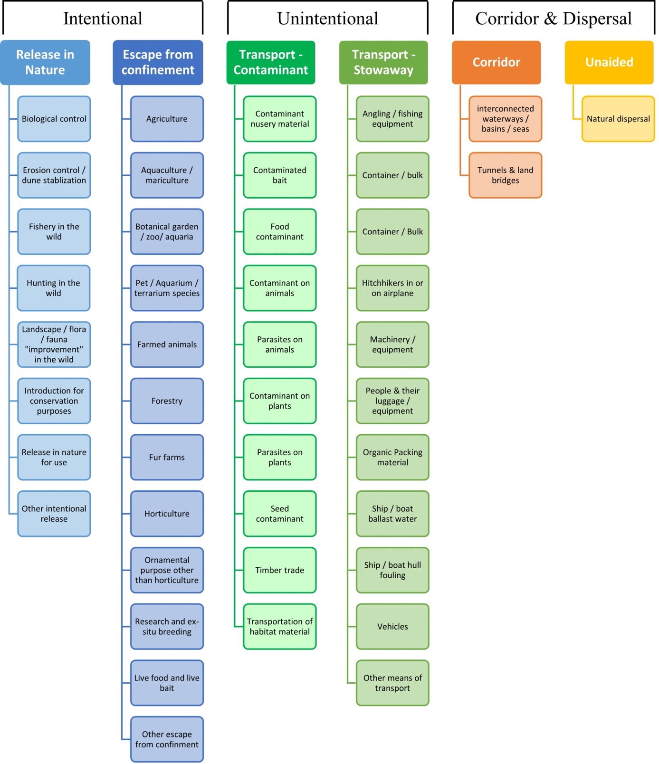

# ANNEX V Ecosystem services classification (CICES V5.1, simplified) and examples

For the purposes of this risk assessment, please feel free to use what seems as the most appropriate category / level / combination of impact (Section – Division – Group), reflecting information available.

|  |  |  |  |
| --- | --- | --- | --- |
| **Section** | **Division** | **Group** | **Examples (i.e. relevant CICES “classes”)** |
| **Provisioning** | **Biomass** | **Cultivated *terrestrial* plants** | Cultivated terrestrial plants (including fungi, algae) grown for nutritional purposes;  Fibres and other materials from cultivated plants, fungi, algae and bacteria for direct use or processing (excluding genetic materials);  Cultivated plants (including fungi, algae) grown as a source of energy  *Example: negative impacts of non-native organisms to crops, orchards, timber etc.* |
|  |  | **Cultivated *aquatic* plants** | Plants cultivated by in- situ aquaculture grown for nutritional purposes;  Fibres and other materials from in-situ aquaculture for direct use or processing (excluding genetic materials);  Plants cultivated by in- situ aquaculture grown as an energy source.  *Example: negative impacts of non-native organisms to aquatic plants cultivated for nutrition, gardening etc. purposes.* |
|  |  | **Reared animals** | Animals reared for nutritional purposes;  Fibres and other materials from reared animals for direct use or processing (excluding genetic materials);  Animals reared to provide energy (including mechanical)  *Example: negative impacts of non-native organisms to livestock* |
|  |  | **Reared *aquatic* animals** | Animals reared by in-situ aquaculture for nutritional purposes;  Fibres and other materials from animals grown by in-situ aquaculture for direct use or processing (excluding genetic materials);  Animals reared by in-situ aquaculture as an energy source  *Example: negative impacts of non-native organisms to fish farming* |
|  |  | **Wild plants** (terrestrial and aquatic) | Wild plants (terrestrial and aquatic, including fungi, algae) used for nutrition;  Fibres and other materials from wild plants for direct use or processing (excluding genetic materials);  Wild plants (terrestrial and aquatic, including fungi, algae) used as a source of energy  *Example: reduction in the availability of wild plants (e.g. wild berries, ornamentals) due to non-native organisms (competition, spread of disease etc.)* |
|  |  | **Wild animals** (terrestrial and aquatic) | Wild animals (terrestrial and aquatic) used for nutritional purposes;  Fibres and other materials from wild animals for direct use or processing (excluding genetic materials);  Wild animals (terrestrial and aquatic) used as a source of energy  *Example: reduction in the availability of wild animals (e.g. fish stocks, game) due to non-native organisms (competition, predations, spread of disease etc.)* |
|  | **Genetic material** from all biota | **Genetic material** from plants, algae or fungi | Seeds, spores and other plant materials collected for maintaining or establishing a population;  Higher and lower plants (whole organisms) used to breed new strains or varieties;  Individual genes extracted from higher and lower plants for the design and construction of new biological entities  *Example: negative impacts of non-native organisms due to interbreeding* |
|  |  | **Genetic material** from animals | Animal material collected for the purposes of maintaining or establishing a population;  Wild animals (whole organisms) used to breed new strains or varieties;  Individual genes extracted from organisms for the design and construction of new biological entities  *Example: negative impacts of non-native organisms due to interbreeding* |
|  | **Water[6]** | **Surface water** used for nutrition, materials or energy | Surface water for drinking;  Surface water used as a material (non-drinking purposes);  Freshwater surface water, coastal and marine water used as an energy source  *Example: loss of access to surface water due to spread of non-native organisms* |
|  |  | **Ground water** for used for nutrition, materials or energy | Ground (and subsurface) water for drinking;  Ground water (and subsurface) used as a material (non-drinking purposes);  Ground water (and subsurface) used as an energy source  *Example: reduced availability of ground water due to spread of non-native organisms and associated increase of ground water consumption by vegetation.* |
| **Regulation & Maintenance** | **Transformation** of biochemical or physical inputs to ecosystems | **Mediation of wastes or toxic substances** of anthropogenic origin by living processes | Bio-remediation by micro-organisms, algae, plants, and animals; Filtration/sequestration/storage/accumulation by micro-organisms, algae, plants, and animals  *Example: changes caused by non-native organisms to ecosystem functioning and ability to filtrate etc. waste or toxics* |
|  |  | **Mediation of nuisances** of anthropogenic origin | Smell reduction; noise attenuation; visual screening (e.g. by means of green infrastructure)  *Example: changes caused by non-native organisms to ecosystem structure, leading to reduced ability to mediate nuisances.* |
|  | **Regulation** of physical, chemical, biological conditions | **Baseline flows and extreme event** regulation | Control of erosion rates;  Buffering and attenuation of mass movement;  Hydrological cycle and water flow regulation (Including flood control, and coastal protection);  Wind protection;  Fire protection  *Example: changes caused by non-native organisms to ecosystem functioning or structure leading to, for example, destabilisation of soil, increased risk or intensity of wild fires etc.* |
|  |  | **Lifecycle maintenance**, habitat and gene pool protection | Pollination (or 'gamete' dispersal in a marine context);  Seed dispersal;  Maintaining nursery populations and habitats (Including gene pool protection)  *Example: changes caused by non-native organisms to the abundance and/or distribution of wild pollinators; changes to the availability / quality of nursery habitats for fisheries* |
|  |  | **Pest and disease control** | Pest control;  Disease control  *Example: changes caused by non-native organisms to the abundance and/or distribution of pests* |
|  |  | **Soil quality** regulation | Weathering processes and their effect on soil quality;  Decomposition and fixing processes and their effect on soil quality  *Example: changes caused by non-native organisms to vegetation structure and/or soil fauna leading to reduced soil quality* |
|  |  | **Water** conditions | Regulation of the chemical condition of freshwaters by living processes;  Regulation of the chemical condition of salt waters by living processes  *Example: changes caused by non-native organisms to buffer strips along water courses that remove nutrients in runoff and/or fish communities that regulate the resilience and resistance of water bodies to eutrophication* |
|  |  | **Atmospheric** composition and conditions | Regulation of chemical composition of atmosphere and oceans;  Regulation of temperature and humidity, including ventilation and transpiration  *Example: changes caused by non-native organisms to ecosystems’ ability to sequester carbon and/or evaporative cooling (e.g. by urban trees)* |
| **Cultural** | **Direct, in-situ and outdoor interactions** with living systems that depend on presence in the environmental setting | **Physical and experiential** interactions with natural environment | Characteristics of living systems that that enable activities promoting health, recuperation or enjoyment through active or immersive interactions;  Characteristics of living systems that enable activities promoting health, recuperation or enjoyment through passive or observational interactions  *Example: changes caused by non-native organisms to the qualities of ecosystems (structure, species composition etc.) that make it attractive for recreation, wild life watching etc.* |
|  |  | **Intellectual and representative** interactions with natural environment | Characteristics of living systems that enable scientific investigation or the creation of traditional ecological knowledge;  Characteristics of living systems that enable education and training;  Characteristics of living systems that are resonant in terms of culture or heritage;  Characteristics of living systems that enable aesthetic experiences  *Example: changes caused by non-native organisms to the qualities of ecosystems (structure, species composition etc.) that have cultural importance* |
|  | **Indirect, remote, often indoor interactions** with living systems that do not require presence in the environmental setting | **Spiritual, symbolic** and other interactions with natural environment | Elements of living systems that have symbolic meaning;  Elements of living systems that have sacred or religious meaning;  Elements of living systems used for entertainment or representation  *Example: changes caused by non-native organisms to the qualities of ecosystems (structure, species composition etc.) that have sacred or religious meaning* |
|  |  | Other biotic characteristics that have a **non-use value** | Characteristics or features of living systems that have an existence value;  Characteristics or features of living systems that have an option or bequest value  *Example: changes caused by non-native organisms to ecosystems designated as wilderness areas, habitats of endangered species etc.* |

# ANNEX VI EU Biogeographic Regions and MSFD Subregions

See <https://www.eea.europa.eu/data-and-maps/figures/biogeographical-regions-in-europe-2> ,

<http://ec.europa.eu/environment/nature/natura2000/biogeog_regions/>

and

https://www.eea.europa.eu/data-and-maps/data/msfd-regions-and-subregions-1/technical-document/pdf

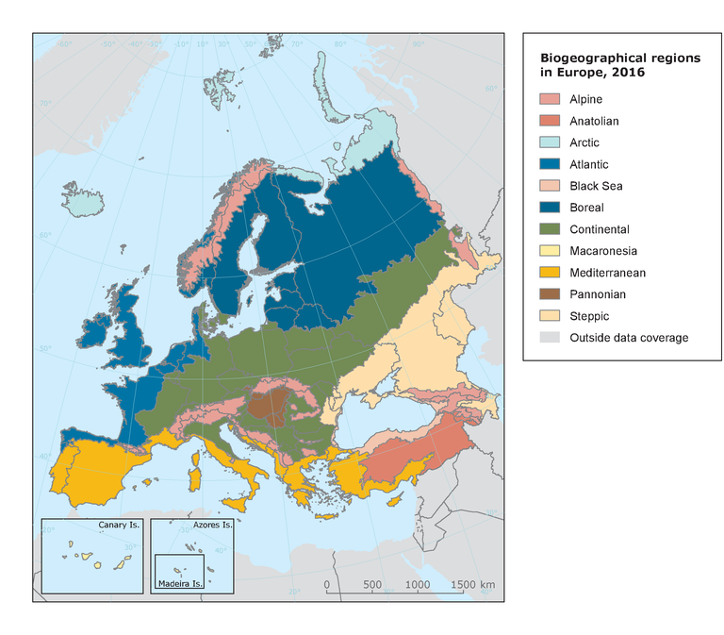 

# ANNEX VII Delegated Regulation (EU) 2018/968 of 30 April 2018

see <https://eur-lex.europa.eu/legal-content/en/TXT/?uri=CELEX%3A32018R0968>

**ANNEX VIII Species Distribution Model**

**Projection of environmental suitability for *Zostera japonica* establishment in Europe**

Björn Beckmann, Christine Wood, Marika Galanidi and Dan Chapman

**Aim**

To project the suitability for potential establishment of *Zostera japonica* in Europe, under current and predicted future climatic conditions.

**Data for modelling**

Species occurrence data for *Zostera japonica* were obtained from the Global Biodiversity Information Facility (GBIF) (13047 records), the Biodiversity Information Serving Our Nation database (BISON) (126 records), the Integrated Digitized Biocollections (iDigBio) (23 records), iNaturalist (17 records), and additional records from the risk assessment team (113 records). We scrutinised occurrence records and removed any dubious ones and records where the georeferencing was too imprecise or outside of the coverage of the predictor layers. We excluded records where the average depth of the grid cell at the model resolution was deeper than -100m (19 records in 10 grid cells). The records were gridded at a 0.25 x 0.25 degree resolution for modelling, yielding 117 grid cells with occurrences. In addition, we used occurrence data for the closely related species *Zostera noltei* (including records registered under the spelling *Z. noltii*) from GBIF (5573 records) and iNaturalist (155 records), filtered in all the same ways as the *Zostera japonica* records, yielding an additional 314 grid cells with occurrences (Figure 1a). As a proxy for recording effort, the density of Plantae records held by GBIF was also compiled on the same grid (Figure 1b).

*Page Break*

**Figure 1.** (a) Occurrence records obtained for *Zostera japonica* and used in the modelling, showing native and invaded distributions. (b) The recording density of Plantae on GBIF, which was used as a proxy for recording effort.

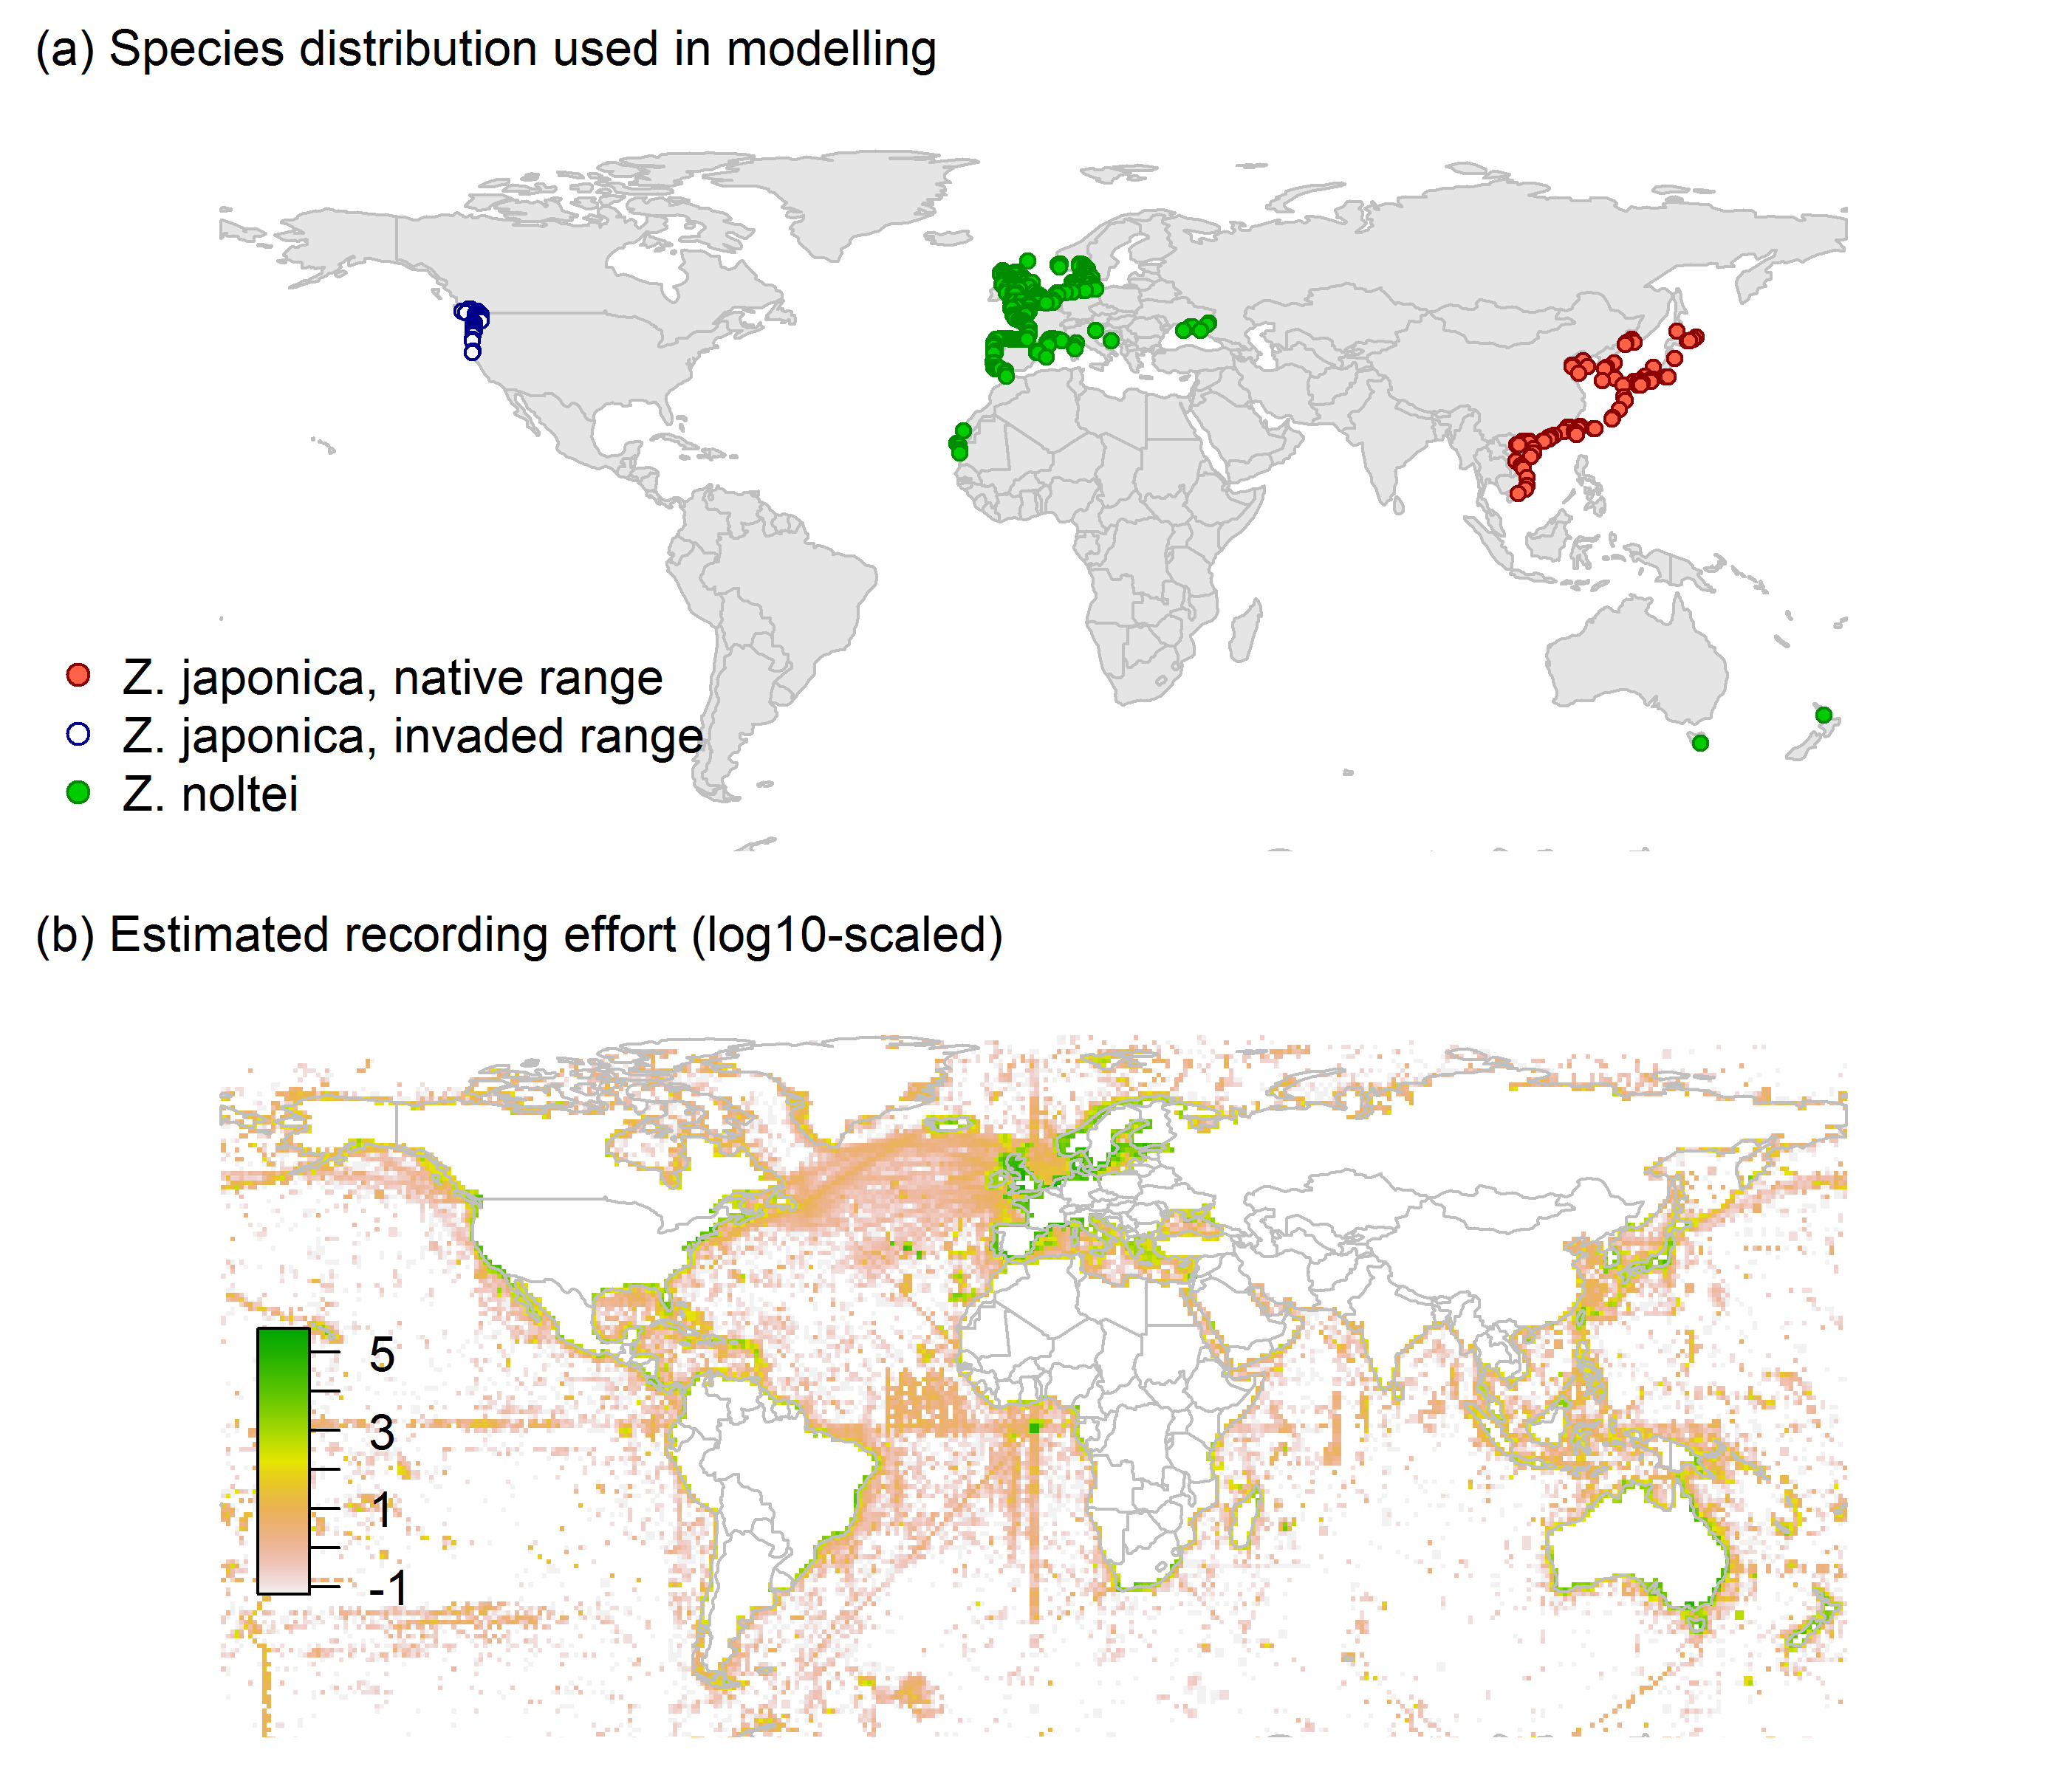

Predictors describing the marine environment were selected from the ‘Bio-ORACLE2’ set of GIS rasters providing geophysical, biotic and environmental data for surface and benthic marine realms (Tyberghein et al., 2012, Assis et al. 2017), supplemented by variables calculated from MARSPEC monthly sea surface temperature data (Sbrocco & Barber 2013). Both were originally at 5 arcminute resolution (0.083 x 0.083 degrees of longitude/latitude) and aggregated to a 0.25 x 0.25 degree grid for use in the model.

Based on the biology of *Zostera japonica*, the following variables were used in the modelling:

* Maximum long-term temperature (templtmax_ss)
* Minimum long-term temperature (templtmin_ss)
* Mean salinity (salinitymean_ss)
* Mean bathymetry (bathymean)
* Sea distance to nearest river mouth with average discharge >10 m3/s (sea_dist_10cms)

All parameters (except depth) are measured at the sea surface.

To estimate the effect of climate change on the potential distribution of *Zostera japonica*, equivalent modelled future conditions for the 2070s under the Representative Concentration Pathways (RCP) 2.6 and 4.5 were also obtained. These represent low and medium emissions scenarios, respectively. Projections for the 2070s were calculated as averages of projections for the 2040s and 2090s (which are the time periods available on Bio-ORACLE).

**Species distribution model**

A presence-background (presence-only) ensemble modelling strategy was employed using the BIOMOD2 R package version 3.4.6 (Thuiller et al., 2020, Thuiller et al., 2009). These models contrast the environment at the species’ occurrence locations against a random sample of the global background environmental conditions (often termed ‘pseudo-absences’) in order to characterise and project suitability for occurrence. This approach has been developed for distributions that are in equilibrium with the environment. Because invasive species’ distributions are not at equilibrium and subject to dispersal constraints at a global scale, we took care to minimise the inclusion of locations suitable for the species but where it has not been able to disperse to (Chapman et al. 2019). Therefore, the background sampling region included:

* The area accessible by native *Zostera japonica* populations, in which the species is likely to have had sufficient time to disperse to all locations. Based on presumed maximum dispersal distances, the accessible region was defined as a 400km buffer around the native range occurrences; AND
* A 100km buffer around the non-native occurrences, encompassing regions likely to have had high propagule pressure for introduction by humans and/or dispersal of the species; AND
* Regions where we have an *a priori* expectation of high unsuitability for the species so that absence is assumed irrespective of dispersal constraints (see Figure 2).

Environmental tolerance thresholds were determined based on the following information.

A) The upper critical temperature for the survival of shoots and seedlings in field and laboratory experiments respectively is reported as 29°C (Abe et al., 2009; Morita et al., 2010), Murase et al. (2007) however has reported that Z. japonica vegetative shoots in natural conditions could survive exposure up to 32–33°C for at least 12 days. The species has a lethal thermal threshold at 35°C (Kaldy & Shafer, 2013). Since these thresholds are not exceeded in the RA area, maximum temperature was not used for the definition of the unsuitable background.

B) As regards low temperature tolerances, its distribution is documented at minimum monthly seawater temperatures slightly below 0 °C (Zhang et al., 2015).

C) Concerning salinity requirements and thresholds, *Z. japonica* can withstand a wide range of salinities, being able to grow in the range of 0-35 psu (Hou et al., 2020). *Z. japonica* seed germination in the invaded range is favoured by cold temperature stratification with brief pulses of low salinity (<10 psu) (Kaldy et al., 2015) but has been reported to occur at salinities of 32.5–33.5 psu in Japan (Yokota et al., 2005). However, sustained periods of salinities under 10 psu were found to stress *Z. japonica* in its invaded range (Shafer et al., 2011; Kaldy & Shafer, 2013). Considering that small scale salinity variations of inshore areas are not likely to be reflected in the predictor data layer, which is modelled itself and not highly resolved, we opted for salinity thresholds a few units above and below the values indicated in the literature.

D) The bathymetry threshold for the unsuitable background was guided by the spatial resolution of the model, which is too coarse (at approximately 20km grid square size) to accurately capture the true depth distribution of the presence records. Setting a more accurate but much higher depth limit would exclude a significant number of presence records and result in the loss of information.

Consequently, the following rules were applied to define a region expected to be highly unsuitable for *Zostera japonica* at the spatial scale of the model:

* + Minimum long-term temperature (templtmin_ss) < -0.5°C
  + Mean salinity (salinitymean_ss) < 10psu
  + Mean salinity (salinitymean_ss) > 38psu
  + Mean bathymetry (bathymean) < -100m

Altogether, 4% of occurrence grid cells were located in the unsuitable background region.

Within the unsuitable background region, 10 samples of 5000 randomly sampled grid cells were obtained (i.e. ten times the number of occurrence grid cells). In the accessible background (comprising the accessible areas around native and non-native occurrences as detailed above), the same number of pseudo-absence samples were drawn as there were presence records (429), weighting the sampling by a proxy for recording effort (Figure 1(b)).

*Page Break*

**Figure 2.** The background from which pseudo-absence samples were taken in the modelling of *Zostera japonica*. Samples were taken from a 400km buffer around the native range and a 100km buffer around non-native occurrences (together forming the accessible background), and from areas expected to be highly unsuitable for the species (the unsuitable background region). Samples from the accessible background were weighted by a proxy for recording effort (Figure 1(b)).

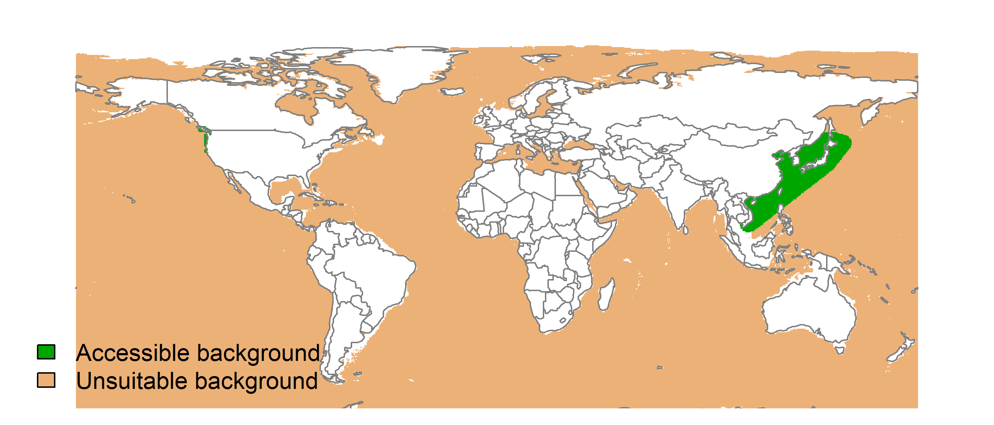

Each dataset (i.e. combination of the presences and the individual background samples) was randomly split into 80% for model training and 20% for model evaluation. With each training dataset, five statistical algorithms were fitted with the default BIOMOD2 settings and rescaled using logistic regression, except where specified below:

* Generalised linear model (GLM)
* Generalised boosting model (GBM)
* Generalised additive model (GAM) with a maximum of four degrees of freedom per smoothing spline
* Artificial neural network (ANN)
* Multivariate adaptive regression splines (MARS)
* Random forest (RF)
* Maxent

Since the total background sample was larger than the number of occurrences, prevalence fitting weights were applied to give equal overall importance to the occurrences and the background. Normalised variable importance was assessed and variable response functions were produced using BIOMOD2’s default procedure.

Model predictive performance was assessed by the following three measures:

* AUC, the area under the receiver operating characteristic curve (Fielding & Bell 1997). Predictions of presence-absence models can be compared with a subset of records set aside for model evaluation (here 20%) by constructing a confusion matrix with the number of true positive, false positive, false negative and true negative cases. For models generating non-dichotomous scores (as here) a threshold can be applied to transform the scores into a dichotomous set of presence-absence predictions. Two measures that can be derived from the confusion matrix are sensitivity (the proportion of observed presences that are predicted as such, quantifying omission errors), and specificity (the proportion of observed absences that are predicted as such, quantifying commission errors). A receiver operating characteristic (ROC) curve can be constructed by using all possible thresholds to classify the scores into confusion matrices, obtaining sensitivity and specificity for each matrix, and plotting sensitivity against the corresponding proportion of false positives (equal to 1 - specificity). The use of all possible thresholds avoids the need for a selection of a single threshold, which is often arbitrary, and allows appreciation of the trade-off between sensitivity and specificity. The area under the ROC curve (AUC) is often used as a single threshold-independent measure for model performance (Manel et al. 2001). AUC is the probability that a randomly selected presence has a higher model-predicted suitability than a randomly selected absence (Allouche et al. 2006).
* Cohen’s Kappa (Cohen 1960). This measure corrects the overall accuracy of model predictions (ratio of the sum of true presences plus true absences to the total number of records) by the accuracy expected to occur by chance. The Kappa statistic ranges from -1 to +1, where +1 indicates perfect agreement and values of zero or less indicate a performance no better than random. Advantages of Kappa are its simplicity, the fact that both commission and omission errors are accounted for in one parameter, and its relative tolerance to zero values in the confusion matrix (Manel et al. 2001). However, Kappa has been criticised for being sensitive to prevalence (the proportion of sites in which the species was recorded as present) and may therefore be inappropriate for comparisons of model accuracy between species or regions (McPherson et al. 2004, Allouche et al. 2006).
* TSS, the true skill statistic (Allouche et al. 2006). TSS is defined as sensitivity + specificity - 1, and corrects for Kappa’s dependency on prevalence. TSS compares the number of correct forecasts, minus those attributable to random guessing, to that of a hypothetical set of perfect forecasts. Like Kappa, TSS takes into account both omission and commission errors, and success as a result of random guessing, and ranges from -1 to +1, where +1 indicates perfect agreement and values of zero or less indicate a performance no better than random (Allouche et al. 2006).

An ensemble model was created by first rejecting poorly performing algorithms with relatively extreme low AUC values and then averaging the predictions of the remaining algorithms, weighted by their AUC. To identify poorly performing algorithms, AUC values were converted into modified z-scores based on their difference to the median and the median absolute deviation across all algorithms (Iglewicz & Hoaglin, 1993). Algorithms with z < -2 were rejected. In this way, ensemble projections were made for each dataset and then averaged to give an overall suitability, as well as its standard deviation.

Projections were classified into suitable and unsuitable regions using a “lowest presence threshold” (Pearson et al. 2007), setting the cut-off as the lowest value at which 98% of all presence records are classified correctly under the current climate (here 0.74). In order to express the sensitivity of classifications to the choice of this threshold, thresholds at which 95% and 99% of records are classified correctly (here 0.81 and 0.65 respectively) were used in the calculation of error bars in Figures 9 and 10 below in addition to taking account of uncertainty in the projections themselves (cf. part (b) of Figs. 5,7,8). In other words, the upper error bars in Figs. 9 and 10 show proportions classified as suitable with a threshold of 0.65 (at which 99% of presence records are classified correctly), and are based on projected suitabilities plus the standard error in projections, while the lower error bars show proportions classified as suitable with a threshold of 0.81 (at which 95% of presence records are classified correctly), and are based on projected suitabilities minus the standard error in projections.

We also produced limiting factor maps for Europe following Elith et al. (2010). For this, projections were made separately with each individual variable fixed at a near-optimal value. These were chosen as the median values at the occurrence grid cells. Then, the most strongly limiting factors were identified as the one resulting in the highest increase in suitability in each grid cell.

**Results**

The ensemble model suggested that suitability for *Zostera japonica* was most strongly determined by Mean bathymetry (bathymean), accounting for 67.6% of variation explained, followed by Maximum long-term temperature (templtmax_ss) (18.1%), Minimum long-term temperature (templtmin_ss) (7.8%), Sea distance to nearest river mouth with average discharge >10 m3/s (sea_dist_10cms) (3.5%) and Mean salinity (salinitymean_ss) (3.1%) (Table 1, Figure 3).

**Table 1.** Summary of the cross-validation predictive performance (ROC, Kappa, TSS) and variable importance of the fitted model algorithms and the ensemble (AUC-weighted average of the best performing algorithms). Results are the average from models fitted to 10 different background samples of the data.

|  |  |  |  |  |  |  |  |  |  |
| --- | --- | --- | --- | --- | --- | --- | --- | --- | --- |
|  |  |  |  |  | **Variable importance (%)** | | | | |
| **Algorithm** | **AUC** | **Kappa** | **TSS** | **Used in the ensemble** | **Mean bathymetry (bathymean)** | **Maximum long-term temperature (templtmax_ss)** | **Minimum long-term temperature (templtmin_ss)** | **Mean salinity (salinitymean_ss)** | **Sea distance to nearest river mouth with average discharge >10 m3/s (sea_dist_10cms)** |
| GLM | 0.985 | 0.738 | 0.928 | yes | 71 | 23 | 5 | 0 | 1 |
| GAM | 0.983 | 0.751 | 0.929 | yes | 67 | 24 | 0 | 2 | 7 |
| GBM | 0.989 | 0.791 | 0.932 | yes | 74 | 16 | 10 | 0 | 0 |
| ANN | 0.984 | 0.757 | 0.928 | yes | 60 | 17 | 12 | 3 | 8 |
| MARS | 0.987 | 0.776 | 0.937 | yes | 69 | 16 | 13 | 1 | 1 |
| RF | 0.988 | 0.791 | 0.915 | yes | 65 | 12 | 7 | 12 | 4 |
| Maxent | 0.982 | 0.799 | 0.911 | no | 62 | 9 | 3 | 17 | 9 |
| **Ensemble** | **0.991** | **0.797** | **0.940** |  | **68** | **18** | **8** | **3** | **3** |

*Page Break*

**Figure 3.** Partial response plots from the fitted models. Thin coloured lines show responses from the algorithms in the ensemble, while the thick black line is their ensemble. In each plot, other model variables are held at their median value in the training data. Some of the divergence among algorithms is because of their different treatment of interactions among variables.

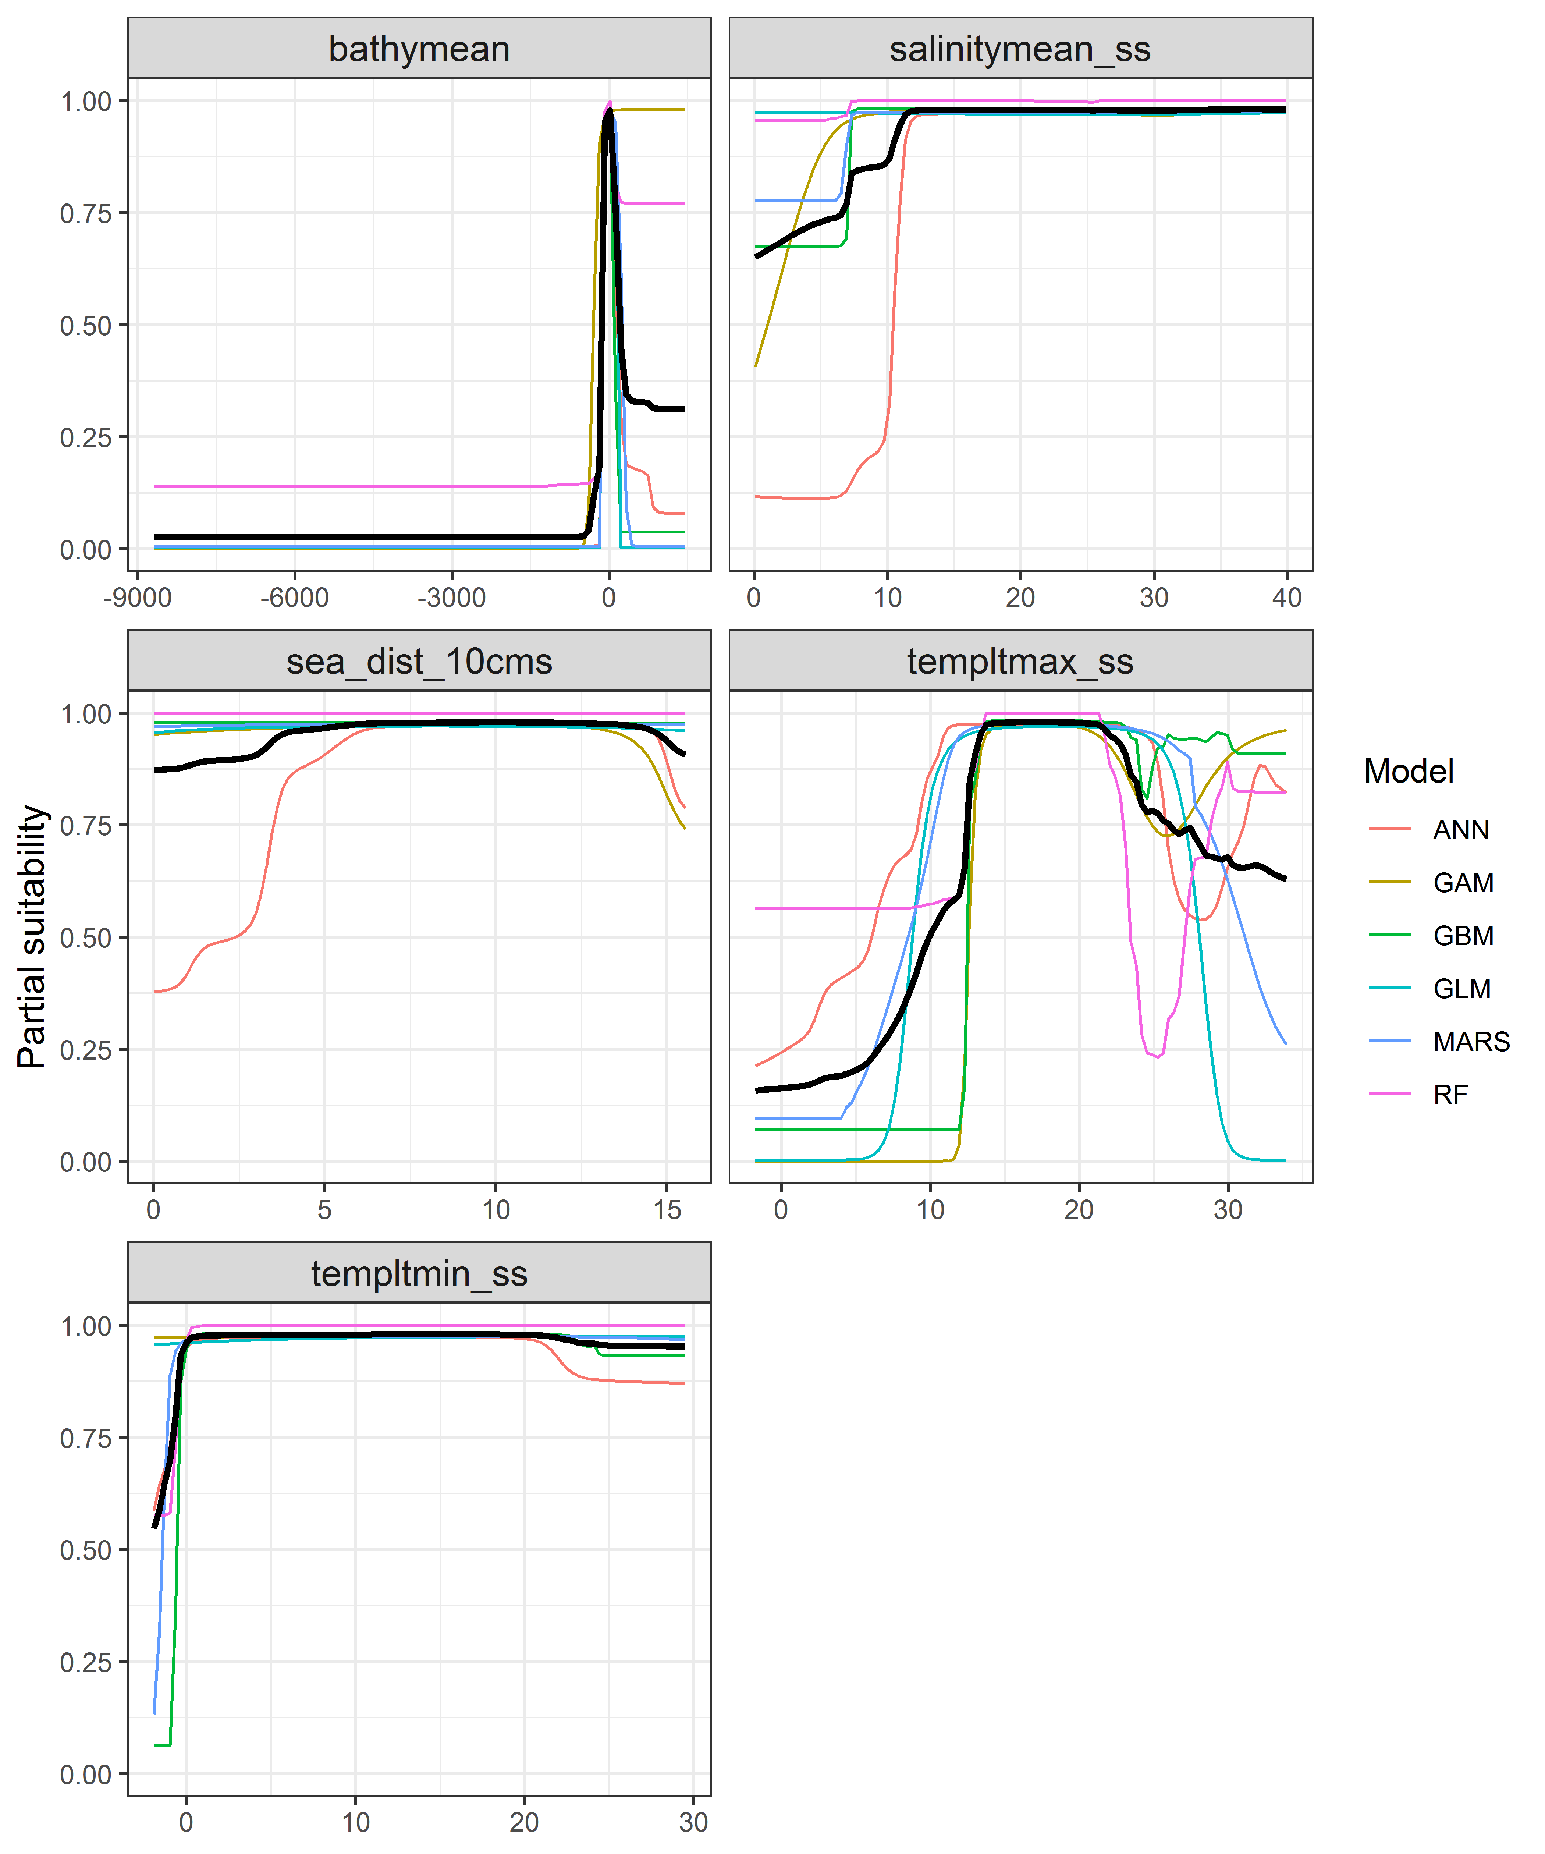

*Page Break*

**Figure 4.** (a) Projected global suitability for *Zostera japonica* establishment in the current climate. For visualisation, the projection has been aggregated to a 0.5 x 0.5 degree resolution, by taking the maximum suitability of constituent higher resolution grid cells. Values > 0.74 are suitable for the species, with 98% of global presence records above this threshold. Values below 0.74 indicate lower relative suitability. (b) Uncertainty in the ensemble projections, expressed as the among-algorithm standard deviation in predicted suitability, averaged across the 10 datasets.

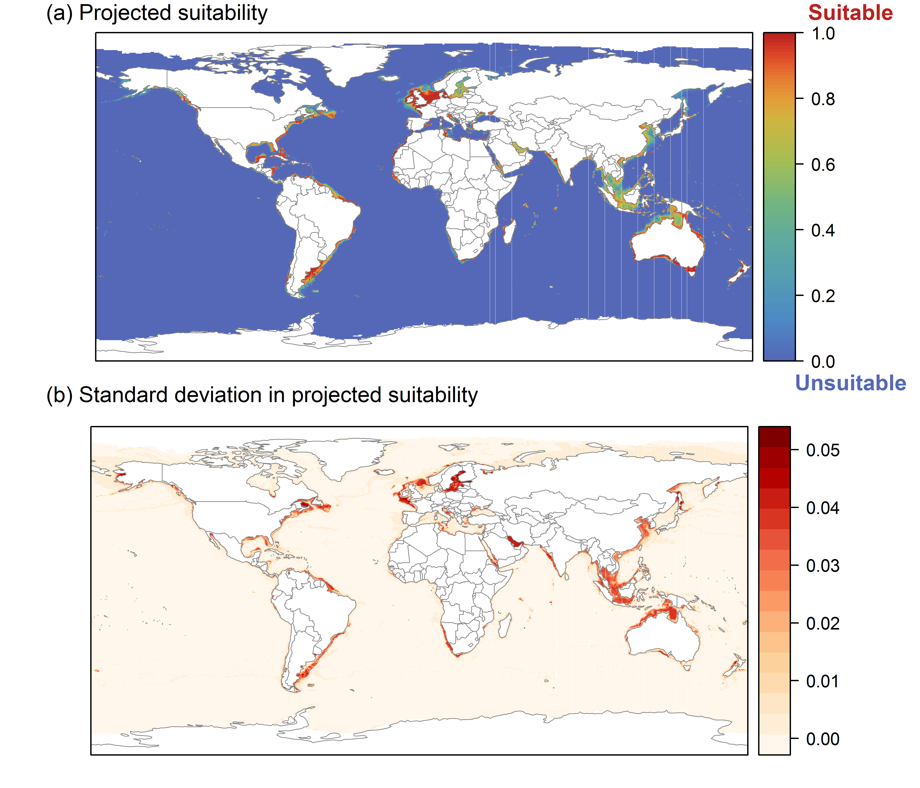

*Page Break*

**Figure 5.** (a) Projected current suitability for *Zostera japonica* establishment in Europe and the Mediterranean region. Values > 0.74 are suitable for the species, with 98% of global presence records above this threshold. Values below 0.74 indicate lower relative suitability. (b) Uncertainty in the ensemble projections, expressed as the among-algorithm standard deviation in predicted suitability, averaged across the 10 datasets.

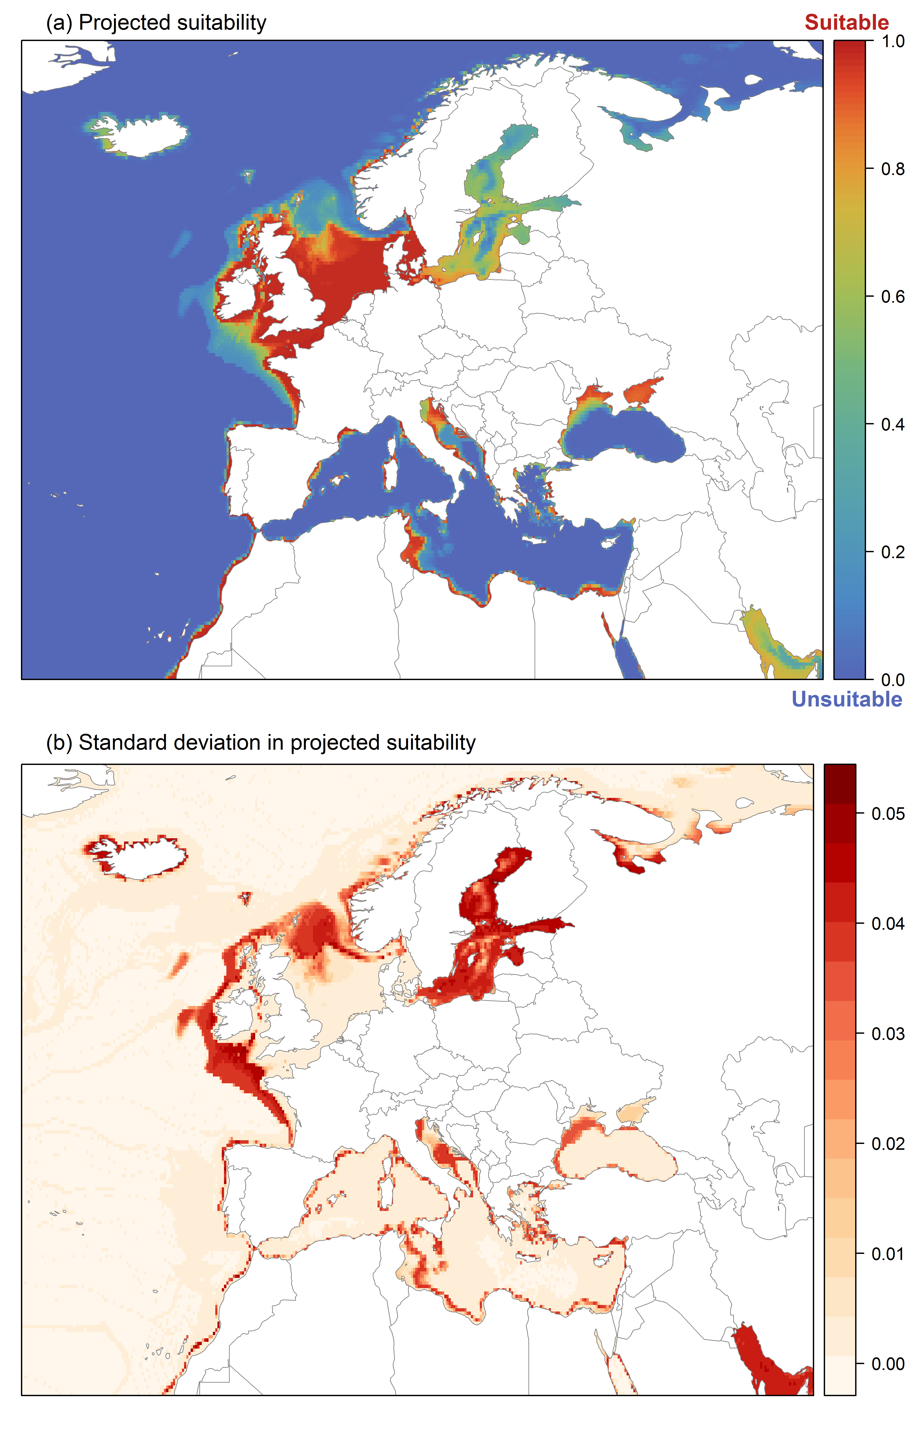

*Page Break*

**Figure 6.** The most strongly limiting factors for *Zostera japonica* establishment estimated by the model in Europe and the Mediterranean region in current climatic conditions.

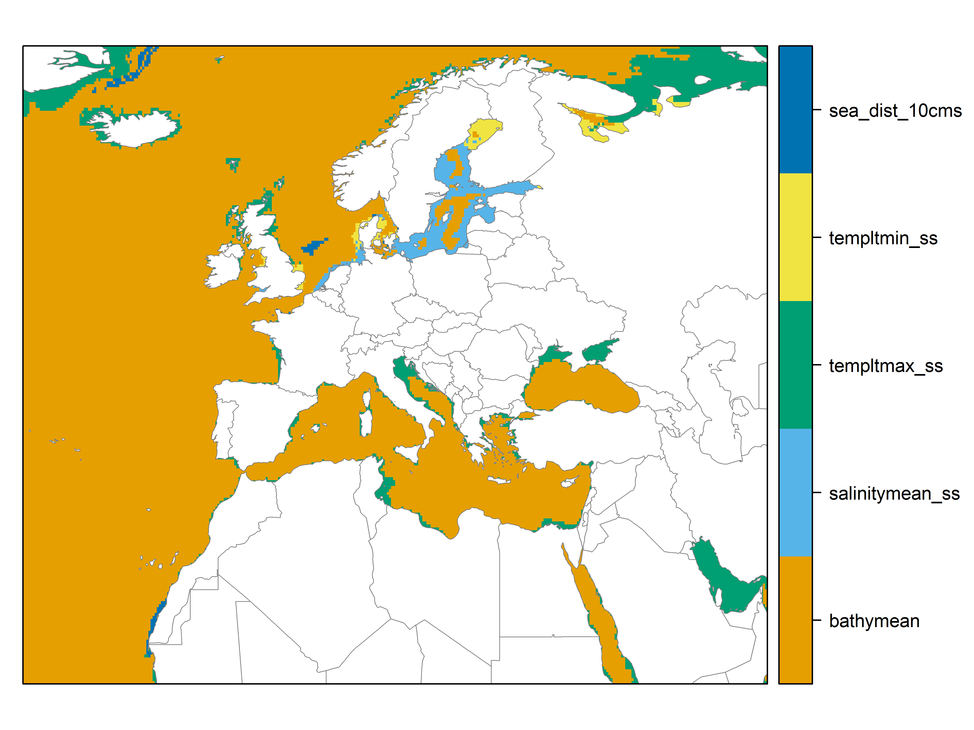

*Page Break*

**Figure 7.** (a) Projected suitability for *Zostera japonica* establishment in Europe and the Mediterranean region in the 2070s under climate change scenario RCP2.6. Values > 0.74 are suitable for the species, with 98% of global presence records above this threshold under current climate. Values below 0.74 indicate lower relative suitability. (b) Uncertainty in the ensemble projections, expressed as the among-algorithm standard deviation in predicted suitability, averaged across the 10 datasets.

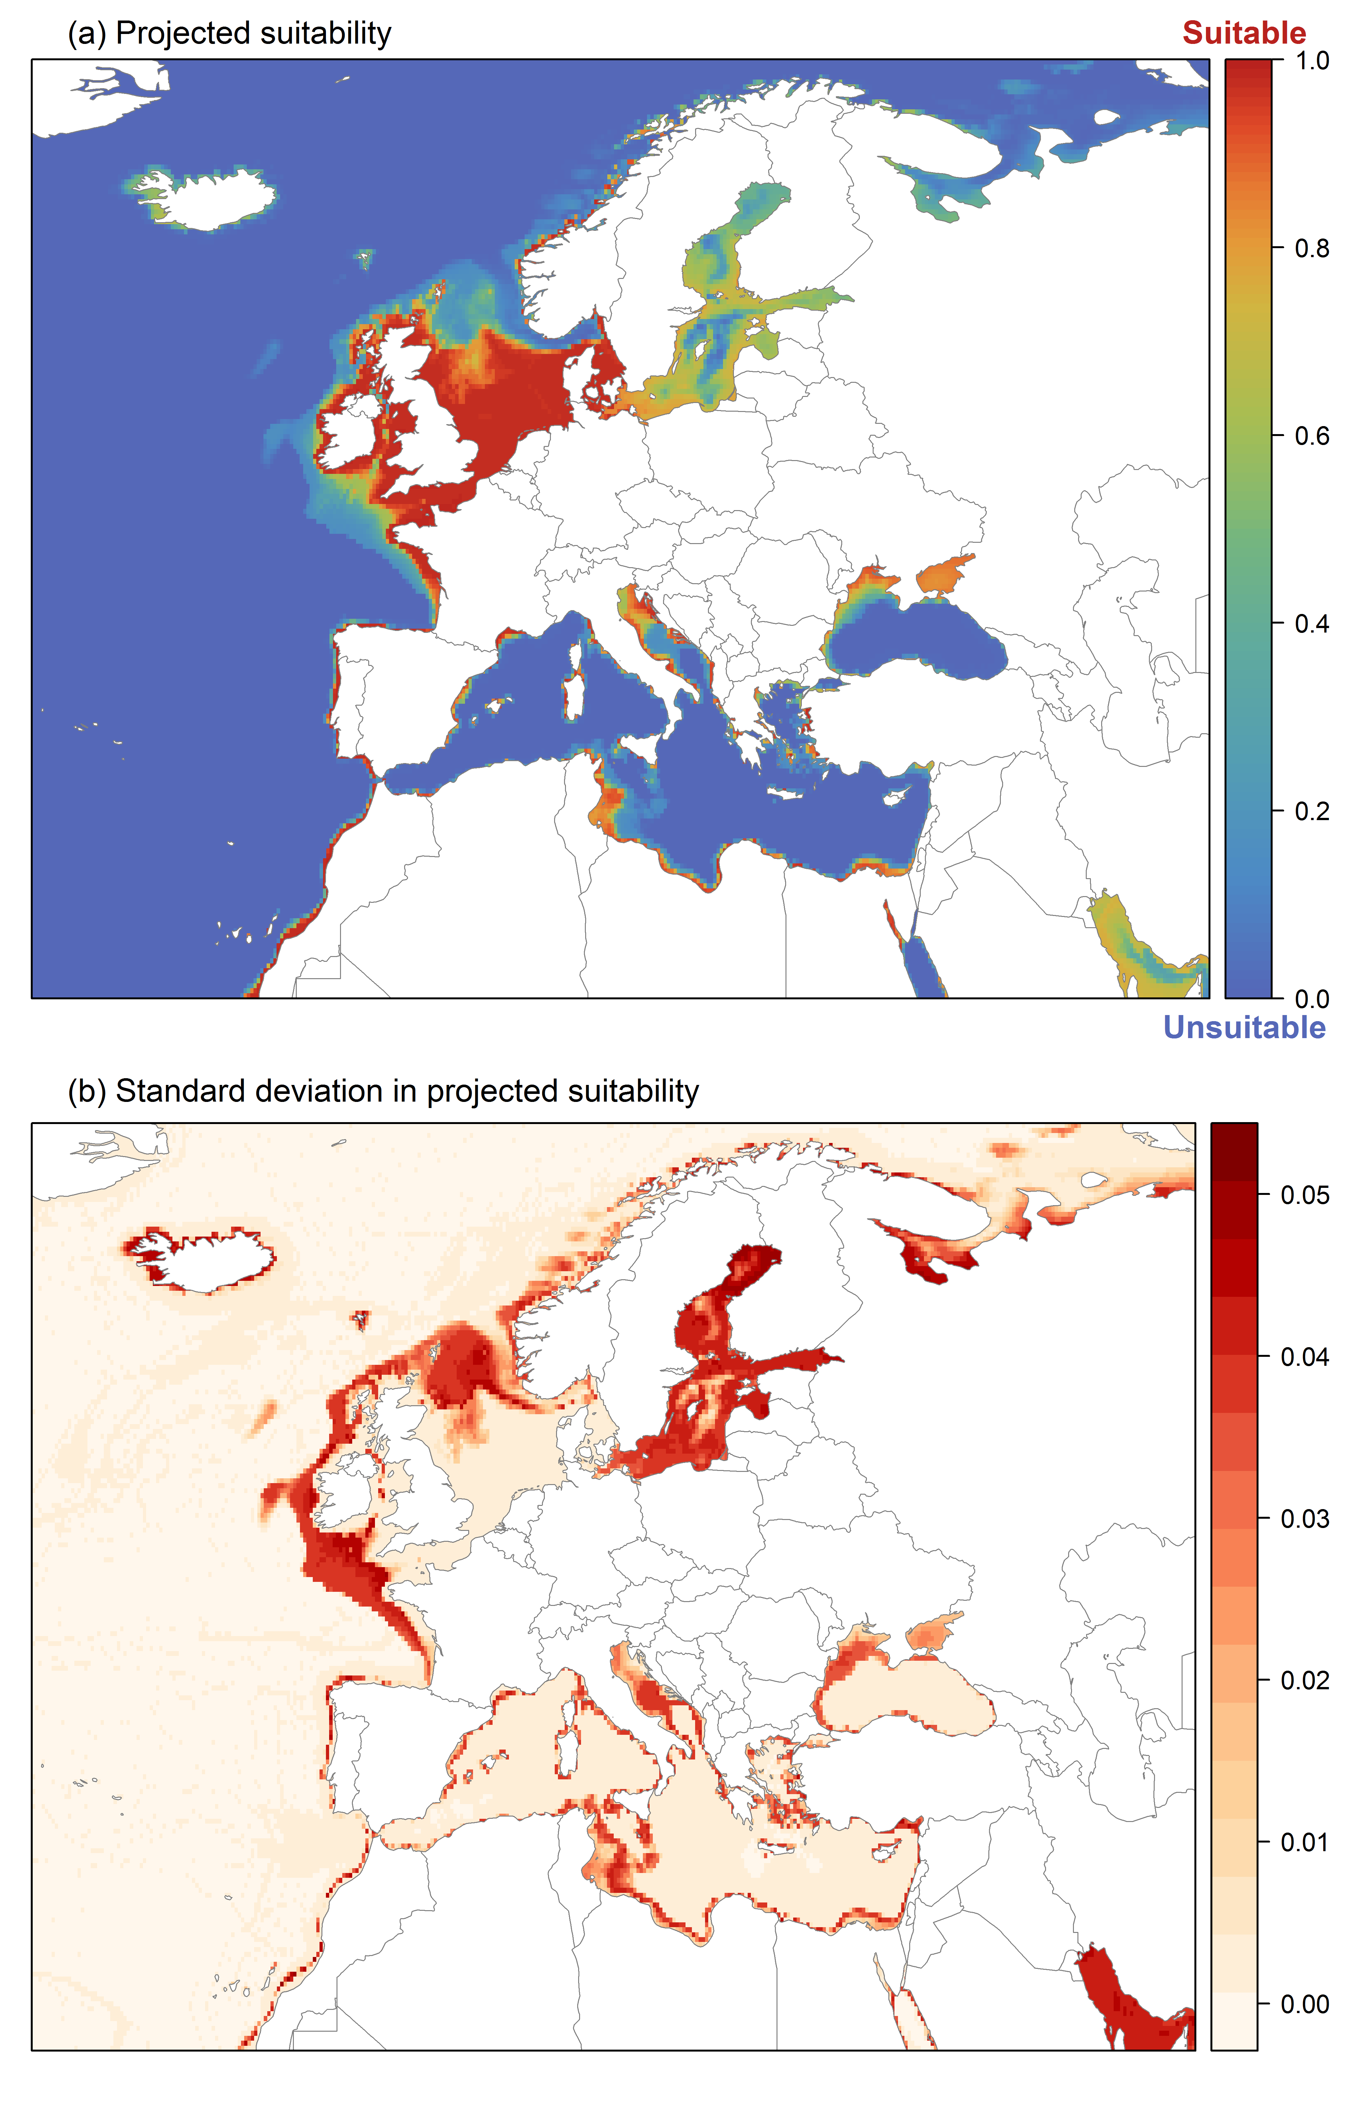

*Page Break*

**Figure 8.** (a) Projected suitability for *Zostera japonica* establishment in Europe and the Mediterranean region in the 2070s under climate change scenario RCP4.5. Values > 0.74 are suitable for the species, with 98% of global presence records above this threshold under current climate. Values below 0.74 indicate lower relative suitability. (b) Uncertainty in the ensemble projections, expressed as the among-algorithm standard deviation in predicted suitability, averaged across the 10 datasets.

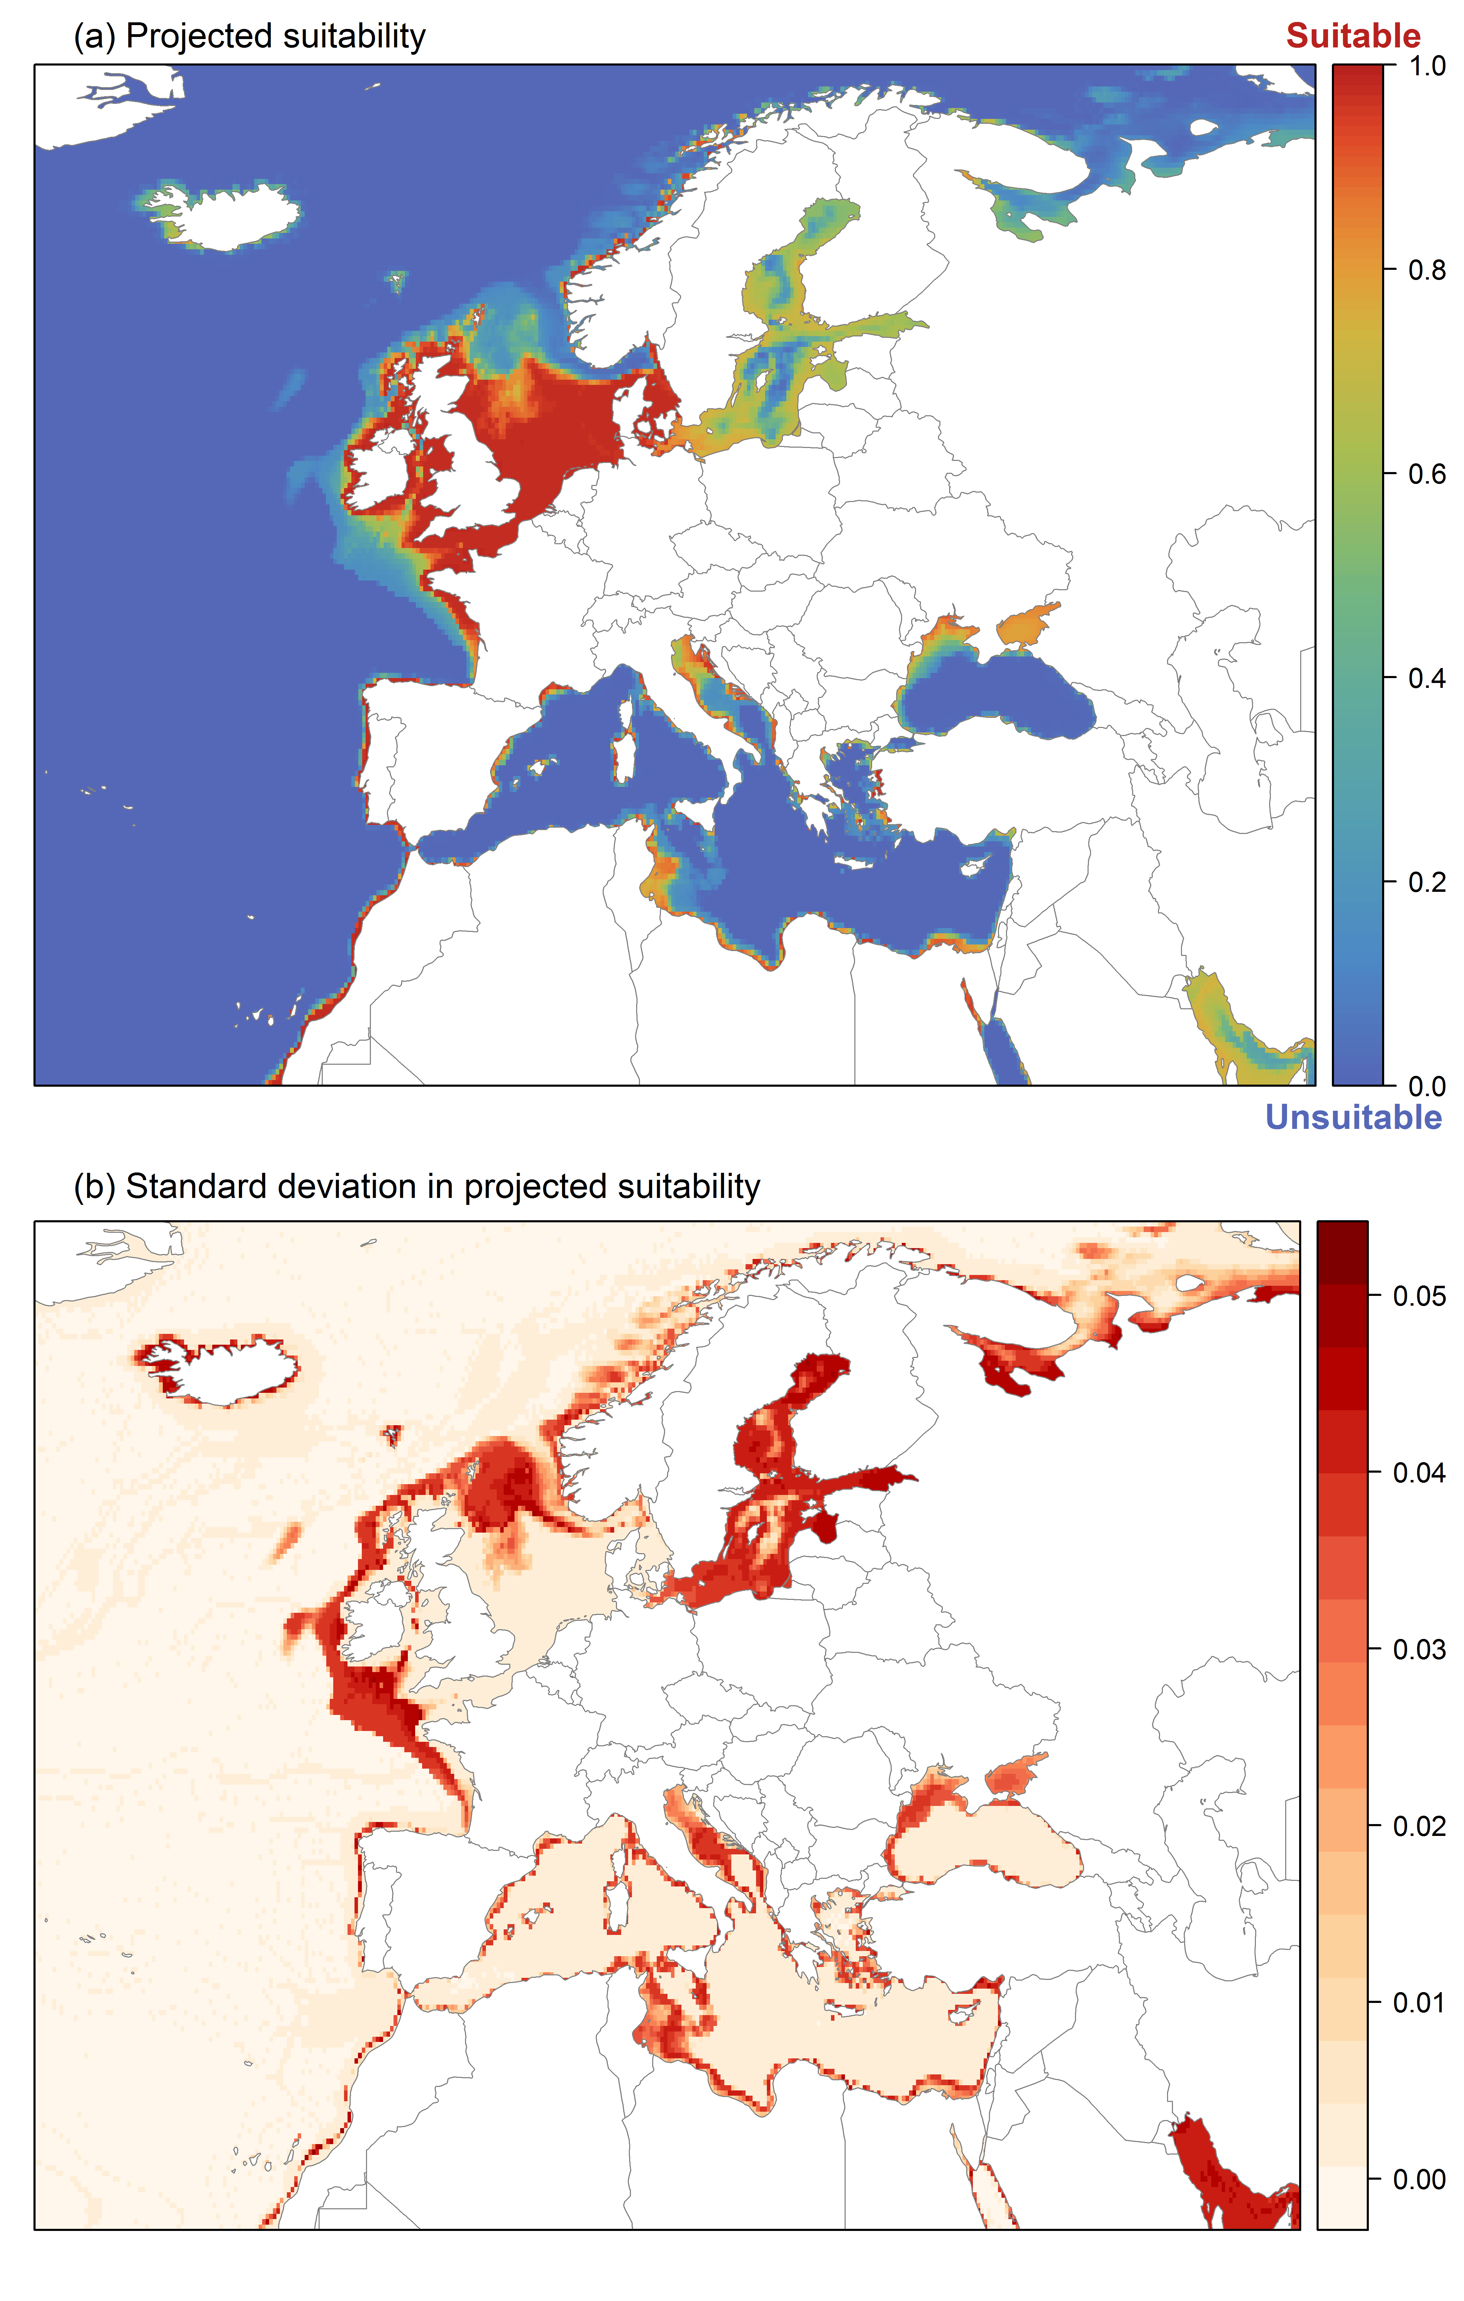

*Page Break*

**Figure 9.** Variation in projected suitability for *Zostera japonica* establishment among marine subregions of Europe. The bar plots show the proportion of grid cells in each region classified as suitable (with values > 0.74) in the current climate and projected climate for the 2070s under two RCP emissions scenarios. Error bars indicate uncertainty due to both the choice of classification threshold (cf. p.5/6) and uncertainty in the projections themselves (cf. part (b) of Figures 5, 7 and 8). The location of each region is also shown. Macaronesia is excluded as it is not part of the study area.

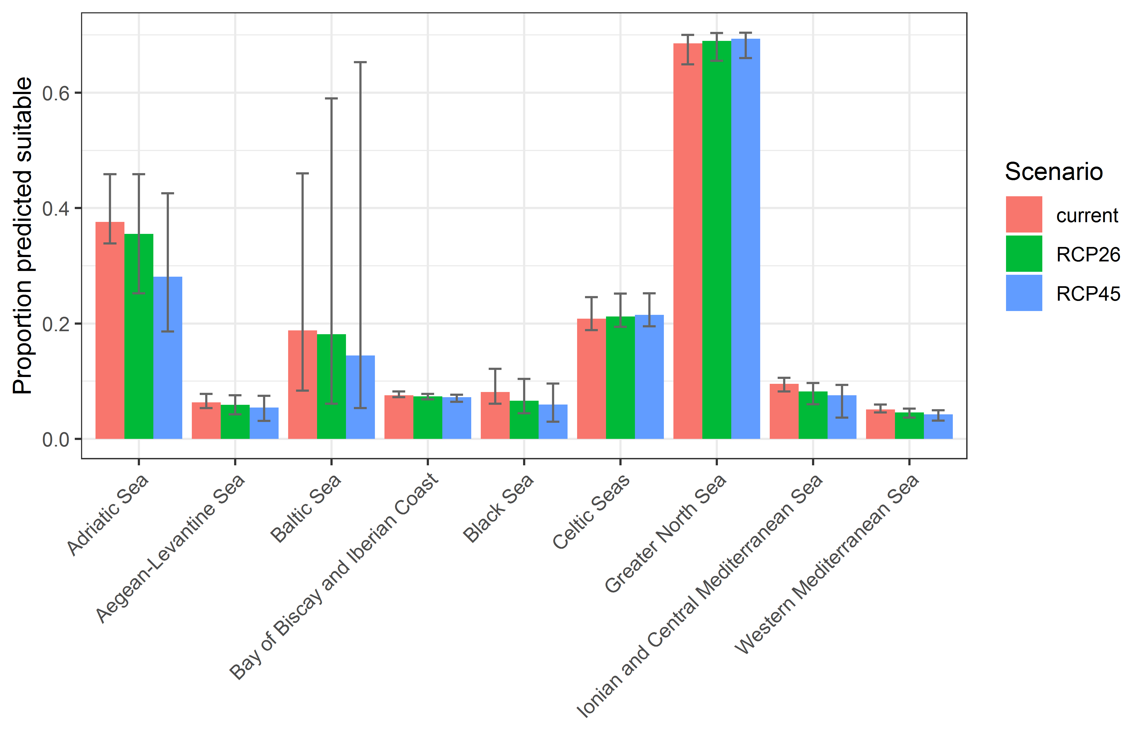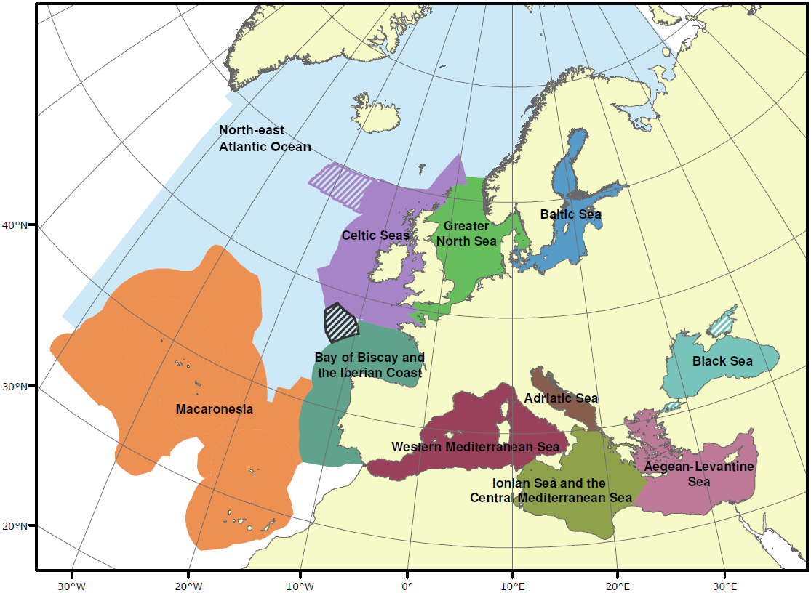

*Page Break*

**Table 2.** Variation in projected suitability for *Zostera japonica* establishment among marine subregions of Europe (numerical values of Figure 9 above). The numbers are the proportion of grid cells in each region classified as suitable in the current climate and projected climate for the 2070s under two RCP emissions scenarios.

|  |  |  |  |  |  |  |  |  |  |
| --- | --- | --- | --- | --- | --- | --- | --- | --- | --- |
|  | **current climate** | | | **2070s RCP2.6** | | | **2070s RCP4.5** | | |
|  | lower | **central estimate** | upper | lower | **central estimate** | upper | lower | **central estimate** | upper |
| Adriatic Sea | 0.34 | 0.38 | 0.46 | 0.25 | 0.36 | 0.46 | 0.19 | 0.28 | 0.43 |
| Aegean-Levantine Sea | 0.05 | 0.06 | 0.08 | 0.04 | 0.06 | 0.08 | 0.03 | 0.05 | 0.07 |
| Baltic Sea | 0.08 | 0.19 | 0.46 | 0.06 | 0.18 | 0.59 | 0.05 | 0.14 | 0.65 |
| Bay of Biscay and  Iberian Coast | 0.07 | 0.08 | 0.08 | 0.07 | 0.07 | 0.08 | 0.06 | 0.07 | 0.08 |
| Black Sea | 0.06 | 0.08 | 0.12 | 0.04 | 0.07 | 0.10 | 0.03 | 0.06 | 0.10 |
| Celtic Seas | 0.19 | 0.21 | 0.25 | 0.19 | 0.21 | 0.25 | 0.20 | 0.21 | 0.25 |
| Greater North Sea | 0.65 | 0.69 | 0.70 | 0.66 | 0.69 | 0.70 | 0.66 | 0.69 | 0.70 |
| Ionian and Central Mediterranean Sea | 0.08 | 0.10 | 0.11 | 0.06 | 0.08 | 0.10 | 0.04 | 0.08 | 0.09 |
| Western  Mediterranean Sea | 0.05 | 0.05 | 0.06 | 0.04 | 0.05 | 0.05 | 0.03 | 0.04 | 0.05 |

*Page Break*

**Figure 10.** Variation in projected suitability for *Zostera japonica* establishment among the territorial coastal waters of European Union countries and the UK (from osm-boundaries.com). The bar plots show the proportion of grid cells in each country classified as suitable (with values > 0.74) in the current climate and projected climate for the 2070s under two RCP emissions scenarios. Error bars indicate uncertainty due to both the choice of classification threshold (cf. p.5/6) and uncertainty in the projections themselves (cf. part (b) of Figs. 5,7,8). The location of each region is also shown.

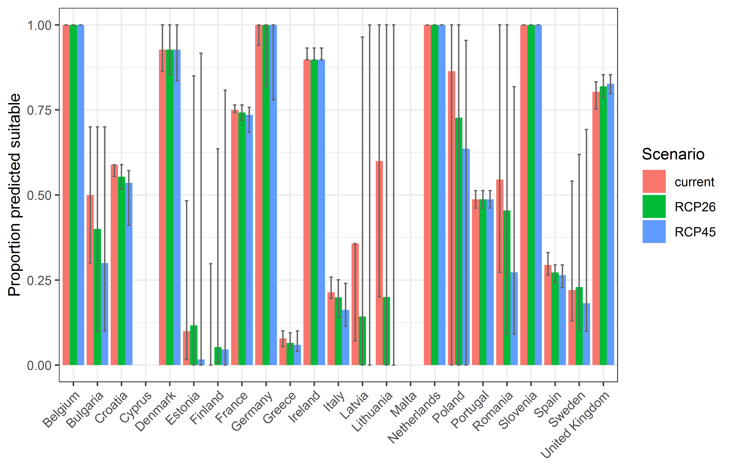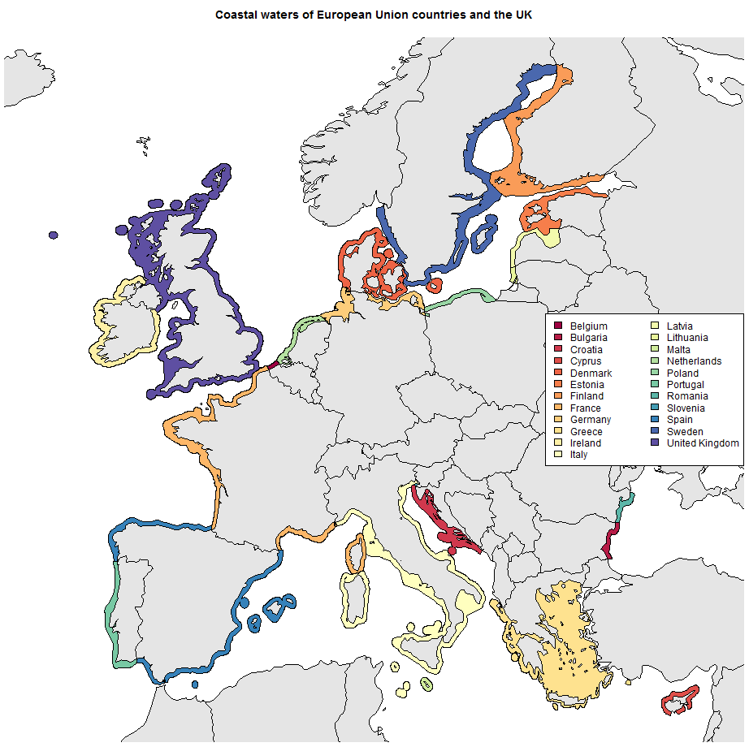

*Page Break*

**Table 3.** Variation in projected suitability for *Zostera japonica* establishment among territorial waters of European Union countries and the UK (numerical values of Figure 10 above). The numbers are the proportion of grid cells in each country classified as suitable in the current climate and projected climate for the 2070s under two RCP emissions scenarios.

|  |  |  |  |  |  |  |  |  |  |
| --- | --- | --- | --- | --- | --- | --- | --- | --- | --- |
|  | **current climate** | | | **2070s RCP2.6** | | | **2070s RCP4.5** | | |
|  | lower | **central estimate** | upper | lower | **central estimate** | upper | lower | **central estimate** | upper |
| Belgium | 1.00 | 1.00 | 1.00 | 1.00 | 1.00 | 1.00 | 1.00 | 1.00 | 1.00 |
| Bulgaria | 0.30 | 0.50 | 0.70 | 0.10 | 0.40 | 0.70 | 0.10 | 0.30 | 0.70 |
| Croatia | 0.55 | 0.59 | 0.59 | 0.52 | 0.55 | 0.59 | 0.41 | 0.54 | 0.57 |
| Cyprus | 0.00 | 0.00 | 0.00 | 0.00 | 0.00 | 0.00 | 0.00 | 0.00 | 0.00 |
| Denmark | 0.86 | 0.93 | 1.00 | 0.85 | 0.93 | 1.00 | 0.84 | 0.93 | 1.00 |
| Estonia | 0.02 | 0.10 | 0.48 | 0.00 | 0.12 | 0.85 | 0.00 | 0.02 | 0.92 |
| Finland | 0.00 | 0.00 | 0.30 | 0.01 | 0.05 | 0.64 | 0.00 | 0.05 | 0.81 |
| France | 0.74 | 0.75 | 0.76 | 0.72 | 0.74 | 0.76 | 0.68 | 0.74 | 0.76 |
| Germany | 0.94 | 1.00 | 1.00 | 0.82 | 1.00 | 1.00 | 0.78 | 1.00 | 1.00 |
| Greece | 0.05 | 0.08 | 0.10 | 0.05 | 0.07 | 0.09 | 0.04 | 0.06 | 0.10 |
| Ireland | 0.90 | 0.90 | 0.93 | 0.90 | 0.90 | 0.93 | 0.90 | 0.90 | 0.93 |
| Italy | 0.20 | 0.21 | 0.26 | 0.14 | 0.20 | 0.25 | 0.11 | 0.16 | 0.24 |
| Latvia | 0.07 | 0.36 | 0.36 | 0.00 | 0.14 | 0.96 | 0.00 | 0.00 | 1.00 |
| Lithuania | 0.20 | 0.60 | 1.00 | 0.00 | 0.20 | 1.00 | 0.00 | 0.00 | 1.00 |
| Malta | 0.00 | 0.00 | 0.00 | 0.00 | 0.00 | 0.00 | 0.00 | 0.00 | 0.00 |
| Netherlands | 1.00 | 1.00 | 1.00 | 1.00 | 1.00 | 1.00 | 1.00 | 1.00 | 1.00 |
| Poland | 0.00 | 0.86 | 1.00 | 0.00 | 0.73 | 1.00 | 0.00 | 0.64 | 0.95 |
| Portugal | 0.46 | 0.49 | 0.51 | 0.46 | 0.49 | 0.51 | 0.46 | 0.49 | 0.51 |
| Romania | 0.27 | 0.55 | 1.00 | 0.09 | 0.45 | 1.00 | 0.09 | 0.27 | 0.82 |
| Slovenia | 1.00 | 1.00 | 1.00 | 1.00 | 1.00 | 1.00 | 1.00 | 1.00 | 1.00 |
| Spain | 0.26 | 0.29 | 0.33 | 0.24 | 0.27 | 0.29 | 0.23 | 0.26 | 0.29 |
| Sweden | 0.13 | 0.22 | 0.54 | 0.10 | 0.23 | 0.62 | 0.10 | 0.18 | 0.69 |
| UK | 0.75 | 0.80 | 0.83 | 0.79 | 0.82 | 0.85 | 0.80 | 0.83 | 0.85 |

**Caveats to the modelling**

To remove spatial recording biases, the selection of the background sample from the accessible background was weighted by the density of Plantae records on the Global Biodiversity Information Facility (GBIF). While this is preferable to not accounting for recording bias at all, it may not provide the perfect measure of recording bias.

There was substantial variation among modelling algorithms in the partial response plots (Figure 3). In part this will reflect their different treatment of interactions among variables. Since partial plots are made with other variables held at their median, there may be values of a particular variable at which this does not provide a realistic combination of variables to predict from.

Other variables potentially affecting the distribution of the species, such as sediment type were not included in the model.

*Page Break*

**References**

* Allouche O, Tsoar A, Kadmon R (2006) Assessing the accuracy of species distribution models: prevalence, kappa and the true skill statistic (TSS). *Journal of Applied Ecology*, 43, 1223-1232.
* Assis J, Tyberghein L, Bosh S, Verbruggen H, Serrão EA, De Clerck O (2017). Bio-ORACLE v2.0: Extending marine data layers for bioclimatic modelling. *Global Ecology and Biogeography*.
* Chapman D, Pescott OL, Roy HE, Tanner R (2019) Improving species distribution models for invasive non-native species with biologically informed pseudo-absence selection. *Journal of Biogeography*, <https://doi.org/10.1111/jbi.13555>.
* Cohen J (1960) A coefficient of agreement of nominal scales. *Educational and Psychological Measurement*, 20, 37-46.
* Elith J, Kearney M, Phillips S (2010) The art of modelling range-shifting species. *Methods in Ecology and Evolution*, 1, 330-342.
* Fielding AH, Bell JF (1997) A review of methods for the assessment of prediction errors in conservation presence/absence models. *Environmental Conservation*, 24, 38-49.
* Iglewicz B, Hoaglin DC (1993) How to detect and handle outliers. Asq Press.
* Manel S, Williams HC, Ormerod SJ (2001) Evaluating presence-absence models in ecology: the need to account for prevalence. *Journal of Applied Ecology*, 38, 921-931.
* McMaster GS, Wilhelm W (1997) Growing degree-days: one equation, two interpretations. *Agricultural and Forest Meteorology*, 87, 291-300.
* McPherson JM, Jetz W, Rogers DJ (2004) The effects of species’ range sizes on the accuracy of distribution models: ecological phenomenon or statistical artefact? *Journal of Applied Ecology*, 41, 811-823.
* Pearson RG, Raxworthy CJ, Nakamura M, Townsend Peterson A (2007), Predicting species distributions from small numbers of occurrence records: a test case using cryptic geckos in Madagascar. *Journal of Biogeography*, 34: 102-117. <https://doi.org/10.1111/j.1365-2699.2006.01594.x>
* Sbrocco EJ, Barber PH (2013) MARSPEC: Ocean climate layers for marine spatial ecology. *Ecology*, 94:979. <http://dx.doi.org/10.1890/12-1358.1>
* Thuiller W, Lafourcade B, Engler R, Araújo MB (2009) BIOMOD-a platform for ensemble forecasting of species distributions. *Ecography*, 32, 369-373.
* Thuiller W, Georges D, Engler R, Breiner F (2020). biomod2: Ensemble Platform for Species Distribution Modeling. R package version 3.4.6. <https://CRAN.R-project.org/package=biomod2>
* Tyberghein L, Verbruggen H, Pauly K, Troupin C, Mineur F, De Clerck O (2012) Bio-ORACLE: A global environmental dataset for marine species distribution modelling. *Global Ecology and Biogeography*, 21, 272–281.

1. This template is based on the Great Britain non-native species risk assessment scheme (GBNNRA). A number of amendments have been introduced to ensure compliance with Regulation (EU) 1143/2014 on IAS and relevant legislation, including the Delegated Regulation (EU) 2018/968 of 30 April 2018, supplementing Regulation (EU) No 1143/2014 of the European Parliament and of the Council with regard to risk assessments in relation to invasive alien species (see <https://eur-lex.europa.eu/legal-content/en/TXT/?uri=CELEX%3A32018R0968> ).
2. Convention on Biological Diversity, Decision VI/23
3. https://op.europa.eu/en/publication-detail/-/publication/f8627bbc-1f15-11eb-b57e-01aa75ed71a1
4. <https://circabc.europa.eu/sd/a/0aeba7f1-c8c2-45a1-9ba3-bcb91a9f039d/TSSR-2016-010%20CBD%20pathways%20key%20full%20only.pdf>
5. Not to be confused with “no impact”.
6. Note: in the CICES classification provisioning of water is considered as an abiotic service whereas the rest of ecosystem services listed here are considered biotic.