Risk assessment template developed under the "Study on Invasive Alien Species – Development of risk assessments to tackle priority species and enhance prevention"
Contract No 07.0202/2019/812602/ETU/ENV.D.2
Name of organism: Broussonetia papyrifera (L.) L'Hér ex Vent.
Author(s) of the assessment:
Helmut Kudrnovsky, Umweltbundesamt/Environment Agency Austria, Vienna, Austria
Richard Shaw, CABI - Centre for Agriculture and Bioscience International, Centre United Kingdom
Björn Beckmann, Centre for Ecology & Hydrology, Edinburgh, United Kingdom

Risk Assessment Area: The risk assessment area is the territory of the European Union 27 and UK, excluding the outermost regions.

Peer review 1: Rob Tanner, European and Mediterranean Plant Protection Organization, Paris, France
Peer review 2: Giuseppe Brundu, Università degli Studi di Sassari, Dipartimento di Agraria, Sassari, Italy

Date of completion: 15/10/2020
Date of revision: 15/10/2021

Contents
SECTION B – Detailed assessment 27
1 PROBABILITY OF INTRODUCTION AND ENTRY 27
2 PROBABILITY OF ESTABLISHMENT 40
3 PROBABILITY OF SPREAD 47
4 MAGNITUDE OF IMPACT 56
Biodiversity and ecosystem impacts 56
Ecosystem Services impacts 59
Economic impacts 61
Social and human health impacts 63
Other impacts 65
RISK SUMMARIES 69
REFERENCES 72
Distribution Summary 83
ANNEX I Scoring of Likelihoods of Events 85
ANNEX II Scoring of Magnitude of Impacts 86
ANNEX III Scoring of Confidence Levels 87
ANNEX IV CBD pathway categorisation scheme 88
ANNEX V Ecosystem services classification (CICES V5.1, simplified) and examples 89
ANNEX VI EU Biogeographic Regions and MSFD Subregions 93
ANNEX VII Delegated Regulation (EU) 2018/968 of 30 April 2018 94
ANNEX VIII Species distribution model 95

SECTION A – Organism Information and Screening
A1. Identify the organism. Is it clearly a single taxonomic entity and can it be adequately distinguished from other entities of the same rank?
including the following elements:
- the taxonomic family, order and class to which the species belongs;
- the scientific name and author of the species, as well as a list of the most common synonym names;
- names used in commerce (if any)
- a list of the most common subspecies, lower taxa, varieties, breeds or hybrids
As a general rule, one risk assessment should be developed for a single species. However, there may be cases where it may be justified to develop one risk assessment covering more than one species (e.g. species belonging to the same genus with comparable or identical features and impact). It shall be clearly stated if the risk assessment covers more than one species, or if it excludes or only includes certain subspecies, lower taxa, hybrids, varieties or breeds (and if so, which subspecies, lower taxa, hybrids, varieties or breeds). Any such choice must be properly justified.

Response: This risk assessment covers one species, the paper mulberry tree Broussonetia papyrifera (L.) L'Hér ex Vent.
Taxonomy
Regnum | Plantae
Infraregnum | Streptophyta
Divisio | Tracheophyta (Vascular plants)
Subdivisio | Spermatophytina (Seed plants)
Class | Magnoliopsida
Superordo | Rosanae
Ordo | Rosales Bercht. & J. Presl
Familia | Moraceae (mulberries)
Genus | Broussonetia

Broussonetia papyrifera (L.) L'Hér ex Vent. is an accepted name of a species with a temperate to subtropical East Asian origin (Chang et al. 2015) in the genus Broussonetia (Family Moraceae) (Euro+Med 2006-; The Plant List 2020). The accepted name is based on Morus papyrifera L. (basionym, Linnaeus 1753) (Euro+Med 2006-; IPNI 2020a). The lectotype for the name was described by Etienne Pierre Ventenat in the Tableau du Règne Végétal, Selon de Méthode de Jussieu (IPNI 2020b).
The genus name honors Pierre Auguste Marie Broussonet (1761-1807), French physician, naturalist and one-time professor of botany at Le Jardin des Plantes de Montpellier. Specific epithet comes from the Egyptian word papyrus meaning paper and the Latin word “ferre” meaning to bear in reference to the use of tree bark to make paper.
Synonyms
According to The Plant List (2013) and Plants of the World Online (2020) synonyms for the species are:
- Broussonetia billardii Carruth.
- Broussonetia cordata Blume
- Broussonetia dissecta Bureau
- Broussonetia elegans K. Koch
- Broussonetia kasii Dippel
- Broussonetia kazi Siebold ex Blume
- Broussonetia maculata Steud.
- Broussonetia nana Bureau
- Broussonetia navicularis Lodd. ex Bureau
- Broussonetia navicularis Lodd. ex K. Koch
- Broussonetia papyrifera var. integrifolia Miq.
- Broussonetia spathulata Steud.
- Broussonetia tricolor K. Koch
- Morus papyrifera L.
- Papyrius papyrifera (L.) Kuntze
- Smithiodendron artocarpoideum Hu
- Stenochasma ancolanum Miq.
- Streblus cordatus Lour.
- Trophis cordata (Lour.) Poir.
Common names
According to CABI (2020) and Euro+Med (2006-) common names in the European region are:
- Dutch (Belgian): papiermoerbei
- Catalan/ Valencian: morera de paper; morera de Xina; morera femella; morera paperera
- Croatian: brusonecija, dudovac
- Czech: papírovník čínský, brousonetie papíronosná
- English: paper mulberry, paper mulberry tree; tapa cloth tree
- French: mûrier à papier; mûrier de Chine; arbre à tapa
- German: Papiermaulbeerbaum; japanischer Papierbaum
- Italian: gelso papirifero del Giappone; moro della China, Brussonezia; gelso da carta; gelso della China;
- Spanish: mora de papel; moral de la China; morera del Japón; morera del papel; papelero
- Portuguese: amoreira do papel; amoreira-do-papel
- Slovak: brusonécia papierová
Most common subspecies, lower taxa, varieties, breeds or hybrids
About 16 or 17 varieties (including five wild) are recognized within this species (CABI 2020; HEAR 2020; Watt 1972). Watt 1972 refers to eleven or twelve varieties in cultivated plants besides which there are five varieties of the wild species, though there are no variety names available in this reference.
These cultural varieties have their origin in the very long use of the plant by humans. Varieties can be distinguished by different leaf shapes and margins and colors of the petiole (Seelenfreund et al. 2017).
Seelenfreund et al. (2017) report three main varieties of paper mulberry (masi) for Fiji: masi vula (white masi); masi damu (red masi); masi vutu. Masi vula can be recognized by the green petiole of the leaves, while masi damu is recognized by the reddish or brown petiole. Masi vutu is recognized not by the color of the petiole, but by the round shape of leaves. On the Vatulele Island, two varieties (bele damu, bele vula) with white and red stemmed leaves independently if the leaves are rounded or lobed. In Tonga, varieties are recognized according to the shape of the leaves: lau ma’opo’opo (more heart-shaped leaves with occasional incuts on one side), lau mahaehae (deeply lobed variety), hiapo lai mangamanga (deeply lobed leaves) and hiapo lau a’opo’opo (crenate leaves). Tapa makers in Hawaii basically recognize two varieties based on leave shape: mana mana lima (regularly lobed leaves) and poa’a’aha/poa aha (non-lobed leaves).
Hybrids are identified on a regional level, e.g. Broussonetia × kazinoki Siebold has long been utilized as a major component in the manufacturing of Korean traditional paper (hanji) and Won (2019) confirmed by a genetic analysis that B. × kazinoki is a hybrid between B. monoica and B. papyrifera. The hybrid is most likely formed naturally in Korea.
Payacan et al. (2017) show a genetic diversity among paper mulberry accessions from Remote Oceania. A clear separation between West and East Polynesia was found that may be indicative of pulses during its dispersal history.
Hybrids and varieties are included in this risk assessment.
A2. Provide information on the existence of other species that look very similar [that may be detected in the risk assessment area, either in the environment, in confinement or associated with a pathway of introduction]
Include both native and non-native species that could be confused with the species being assessed, including the following elements:
- other alien species with similar invasive characteristics, to be avoided as substitute species (in this case preparing a risk assessment for more than one species together may be considered);
- other alien species without similar invasive characteristics, potential substitute species;
- native species, potential misidentification and mis-targeting

Response: Paper mulberry is a medium to large deciduous tree with milky sap. The crown is round and spreading. It is a hardy, fast-growing tree (CABI 2020; Saito et al. 2009, Tanasombat et al. 2005; Whistler & Elevitch 2006). Its stout, grey-brown, spreading branches are brittle and susceptible to wind damage. The branches are marked with stipular scars. Young branchlets are subtomentose and shoots are pubescent when young. The bark is light-grey, smooth, with shallow fissures or ridges. The stem, branches and petioles contain a milky latex. The twigs of paper mulberry are hairy reddish brown, the bark is tan and smooth to moderately furrowed, the wood is soft and brittle, and it has conical buds.
Broussonetia papyrifera has variable mulberry-like papery leaves. The leaves are densely gray-pubescent, often lobed or mitten-shaped, and are alternate, opposite or whorled along the stem. Some leaves are distinctly deep lobed, while others are unlobed. Several different shapes of leaves may appear on the same shoot. The leaves are alternate/subopposite, ovate, acuminate, dentate-crenate, their bases often oblique, scabrous above, with a woolly surface on the lower side. The leaf margin is sharply toothed, the leaf base is heart-shaped to rounded with pointed tips, and the upper leaf surface is rough feeling (CABI 2020).
Broussonetia papyrifera is a dioecious species, with unisexual male and female flowers in inflorescences on separate plants. Trees with staminate inflorescences (hereafter male trees) produce catkins that are long clusters of flowers. Trees with pistillate inflorescences (hereafter female trees) produce ball-shaped flower clusters, which mature into red, globose aggregate fruits. The male flower is 3.5-7.5 cm long, yellowish-white, with pendulous catkin-like spikes. The perianth is campanulate, hairy, 4-fid, and its segments are valvate (CABI 2020). The female flowers are in rounded clusters in globose pedunculate heads about 1.3 cm in diameter. Persistent, hairy, clavate bracts subtend flowers. The fruit is shiny-reddish, fleshy, globose and compound with the achenes hanging on long fleshy stalks. The achenes are 1-2 cm long and wide. Globose infructescence (syncarp), 2-3 cm in diameter, orange-red when ripe, composed of drupes thinly pulpy, invested by the perianth, hanging on long fleshy stalks. Seeds ovoid, slightly compressed, papillate-asperous, crustaceous, with a keel double at the base, 1.8-2.4 mm long (Barker 2002).
Existence of other native species that look very similar
Broussonetia papyrifera has no known close relatives in the risk assessment area. In the Mediterranean biogeographic region there is some risk of confusion with Ficus carica L., in particular with the wild type.
Existence of other non-native species that look very similar
The combination of hairy twigs and leaves, variable leaves, male and female flowers appearing on separate trees, and the fleshy globular fruits helps differentiate paper mulberry from potential look-alikes. The white mulberry (Morus alba) has leaves with larger teeth and its fruits resemble raspberries or blackberries rather than spheres. The fruits of the red mulberry (Morus rubra) resemble cylindrical raspberries (Rawlins et al. 2018; Sarver et al. 2008). Some leaf forms can be confused with white mulberry; however, paper mulberry leaves have a rough, sand paper-like surface, whereas mulberry leaves are smooth (Whistler & Elevitch 2006). There is also a potential risk of confusion with Morus kagayamae Koidz.
Basswood (Tilia americana) has leaves that are very similar to leaves of species of the mulberry family, but are never lobed. Basswood also has clear sap, whereas the sap of the mulberries is milky (Sarver et al. 2008).

A3. Does a relevant earlier risk assessment exist? Give details of any previous risk assessment, including the final scores and its validity in relation to the risk assessment area.

Response: The paper mulberry was added to the EPPO Alert List in 2016 and was prioritized in 2019 as a species with moderate risk and added to the EPPO Observation List in 2019.
Inside of the risk assessment area
Italy
Crosti et al. (2010) used a modified version of the Australian Weed Risk Assessment (A-WRA) adapted for the Mediterranean region of Central Italy, to assess the risk for a number of invasive alien plants in Lazio (Italy, Mediterranean biogeographical region). Broussonetia papyrifera scored 7, resulting in a “reject” decision (potentially invasive) according to the A-WRA.
Outside of the risk assessment area
Hawaii
The Hawaiian Ecosystems at Risk project conducted a risk assessment of B. papyrifera for the Hawaiian Islands (HEAR 2020). The method followed the Australian/New Zealand Weed Risk Assessment adapted for Hawaii. The species is assessed as “low risk” with a score of three. A rating of “low risk” indicates that the plant has a low probability of becoming a serious pest. It is one of the principle plants introduced by early voyaging Polynesians who settled in Hawaiian region. It has become naturalized throughout Asia, from India and Pakistan to the Pacific Islands, and also in North America. Broussonetia papyrifera is an extremely fast growing tree highly suitable for rehabilitating eroded areas and controlling further erosion. However, a few years after introduction it often becomes invasive and is difficult to eradicate. The tree shows the characteristics of a vigorous pioneer, spreading rapidly following extreme canopy disturbance (e.g. cyclones) or farming. Following invasion of an area, it excludes other species and it is very difficult to eradicate. Its growth is extremely fast and it quickly out-competes other species. Mature fruits have not been observed in Hawaii.
As the Hawaii Islands belong to a different climatic and biogeographical region than the area of the risk assessment, basic information of e.g. biology or habitat preferences can be taken into account, though the assessment of e.g. invasiveness has to be reviewed accordingly to different climate conditions.
Australia/Queensland
The Department of Agriculture and Fisheries (Csurhes 2016) conducted an invasive species risk assessment of paper mulberry for the federal state Queensland of Australia. In summary, the species is currently in its early stages of population development in Queensland. It appears to be a ‘high-risk’ species and a worthy candidate for preventative control. However, an assessment of the feasibility of eradication and/or control needs to be made. Currently, B. papyrifera is sparingly naturalized in Queensland. Wild populations have been detected in Brisbane and coastal northern Queensland. Substantial areas of eastern Queensland appear climatically suitable. Elsewhere in Australia, B. papyrifera has been recorded in South Australia and New South Wales. It seems reasonable to predict that B. papyrifera could become widespread and problematic in suitable habitat types in coastal and subcoastal Queensland (where climate, soil and land use are favourable). Habitats most at risk are predicted to include riparian areas; semi-deciduous (closed) forests and vine thickets (especially margins and gaps); and disturbed, open sites generally, where there is relatively well-drained, moist, fertile soil. On some islands in the Pacific, only male plants are cultivated and regeneration is purely vegetative. If male and female plants are present, long-range dispersal is via seeds. Seeds rarely germinate under dense forest canopies, but germination can be prolific in large canopy gaps, roadsides and abandoned farmland. Root suckers are produced when the main stem is cut. Over time, this can lead to the formation of dense thickets. Root suckers can be cut, dug out and replanted (the main form of reproduction when ‘male clones’ are used for agroforestry).
As Australia belongs to a different climatic and biogeographical region than the area of this risk assessment, basic information of e.g. biology or habitat preferences can be taken into account, though the assessment of e.g. invasiveness has to be reviewed accordingly to different climate conditions.
Georgia – United States of America
In 2017, the paper mulberry has been evaluated for the region of the US federal state Georgia (Bucalo 2017). The outcome is an indication of the invasive potential of Paper mulberry in Georgia, and therefore should not be considered for sale or propagation. According to Georgia Exotic Pest Plant Council (GA-EPPC), the species is ranked in the category 3: Exotic plant that is a minor problem in Georgia natural areas, or is not yet known to be a problem in Georgia but is known to be a problem in adjacent states. PRE is a 20-question plant risk assessment tool. It is also an online platform and database enabling those involved in non-native, terrestrial plant production to know before they grow if a plant poses a potential regional invasive risk. In summary, B. papyrifera can spread via seed and vegetative suckers, coppicing and re-sprouting, and it is a very vigorous grower. It is reported as invasive in many states that are a climate match for Georgia. Paper mulberry exhibits aggressive growth and quickly invades disturbed lands, competing with more desirable plant species. The fruits of B. papyrifera are consumed by many types of birds and other small animals which are thought to disseminate the seeds. Detailed species information about such animals dispersing seeds are not available. Water may also play a role of dispersal alongside water courses or irrigation channels. The seeds are spread far and wide by wildlife who feed on the fruits.
As Georgia belongs to a different climatic and biogeographical region than the area of this risk assessment, basic information of e.g. biology or habitat preferences can be taken into account, though the assessment of e.g. invasiveness has to be reviewed accordingly to different climate conditions.

A4. Where is the organism native?
including the following elements:
- an indication of the continent or part of a continent, climatic zone and habitat where the species is naturally occurring
- if applicable, indicate whether the species could naturally spread into the risk assessment area

Response: Broussonetia papyrifera is native to East Asia and mainland Southeast Asia (González-Lorca et al. 2015; Huston 2004; Peñailillo et al. 2016). An accurate native range distribution cannot be given as the species was introduced already prehistorically in the surroundings as a species of cultural importance (González-Lorca et al. 2015), e.g. to Polynesia as a source of bark fiber by Austronesian-speaking voyagers (Peñailillo et al. 2016).
While CABI (2020) lists China, Japan and Taiwan as countries within the native distribution (according to Ghafoor 1985), Csurhes (2016) includes parts of China (Anhui, Fujian, Gansu, Guangdong, Guangxi, Guizhou, Hainan, Hebei, Henan, Hubei, Hunan, Jiangsu, Jiangxi, Shaanxi, Shandong, Shanxi, Sichuan, Xizang, Yunnan and Zhejiang), Japan, Korea, Taiwan, Cambodia, Laos, Myanmar, Thailand, Vietnam and Malaysia into a larger native range (compare POWO 2020). On the other hand, EPPO (2019) considers China, Japan, Korea, Taiwan and Thailand within the native range. Chung et al. (2017) give a comprehensive overview about considerable discrepancies existing in literature regarding distribution ranges of the species.
Broussonetia papyrifera can tolerate a wide range of climates, including humid tropical (monsoon), humid and sub-humid subtropical as well as warm temperate areas (EPPO 2019; Whistler & Elevitch 2006). It can grow in areas with an annual rainfall of 700–2 500 mm (EPPO 2019; CABI 2020), though the species can survive a 3–4 month dry season (Whistler & Elevitch 2006). The paper mulberry is considered being a pioneer species adapted to colonize disturbed sites (Csurhes 2016). The species does not grow well under full shade and is suited to disturbed habitats, in particular to riparian habitats and gaps within subtropical forest (EPPO 2019; Saito et al. 2009; Luna 1996). It exhibits a high reproductive potential, by means of both sexual and vegetative propagation (Maan et al. 2020; Morgan et al. 2019). Broussonetia papyrifera is insect- and wind-pollinated, and can be grown from seed, stem cuttings, coppice and root suckers (CABI 2020). The fruit, which is a compound (syncarp) of juicy, orange-red druplets are dispersed by birds and small mammals (Seelenfreund et al. 2017). Its fecundity is high by virtue of its ability to fruit twice in a year and also achieving reproductive maturity at relatively small size. Thus sexual reproduction maybe the most important mode of reproduction that drives its invasiveness. Though trees start fruiting early, fruiting percentages increase with tree size (Kyereh et al. 2014).
Since the native distribution center in Asia and the European continent are separated by a large distance, the natural spread into the risk assessment area is very unlikely.

A5. What is the global non-native distribution of the organism outside the risk assessment area?

Response: Table 1 and Figure 1 give an overview about the global non-native distribution outside the risk assessment area. Considering the broader native range, available spatial and non-spatial data describe the non-native distribution of B. papyrifera covering parts of North, Middle and South America, Europe, Africa, Asia and Oceanica.
In the neighborhood of the risk assessment area, the species’ status is “introduced” in Switzerland (Aeschimann & Burdet 1994; Hess 1998). In some countries of the Balkan peninsula (Bosnia and Herzegovina and Montenegro; Euro+Med 2006-, Stešević & Petrović 2010) the paper mulberry is assessed as “introduced and naturalized”. Furthermore the occurrence of B. papyrifera is documented in Albania, Georgia, Macedonia, Moldova, Russia and Ukraine (Table 1).
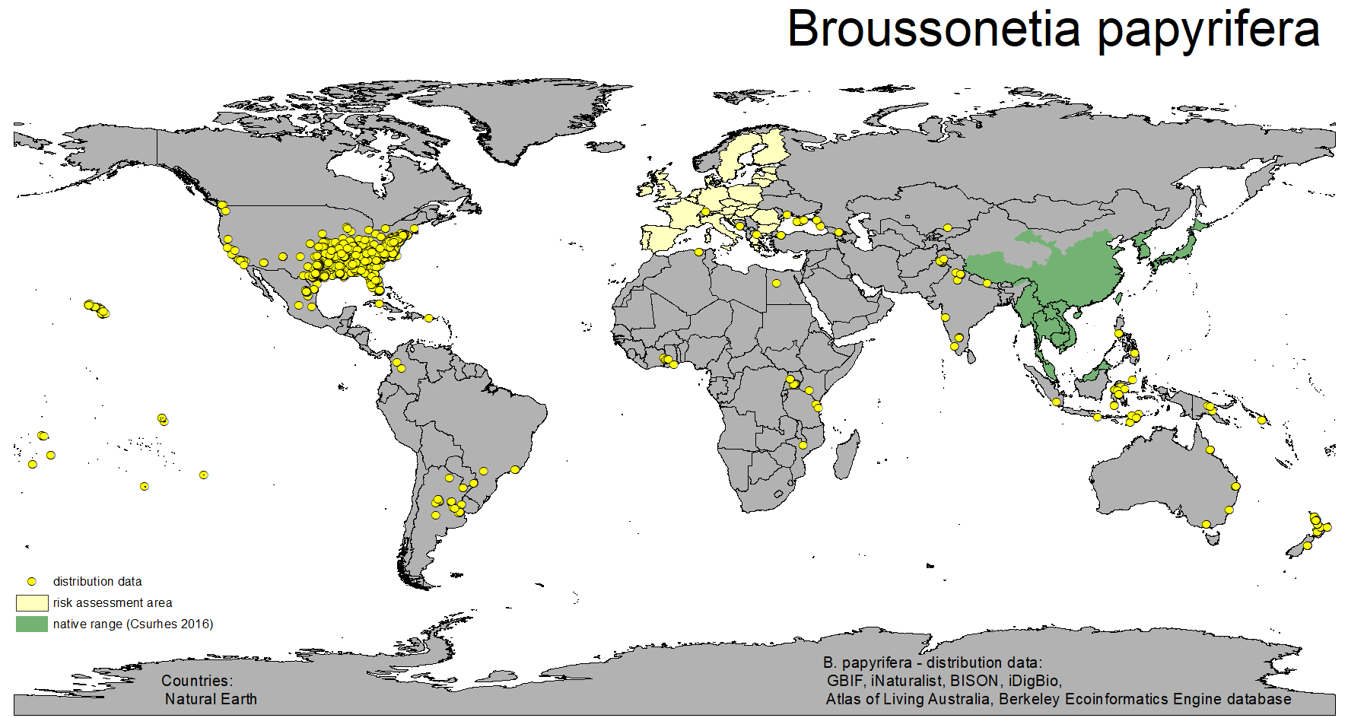
Figure 1 Global non-native occurrences records of Broussonetia papyrifera outside the risk assessment area (map designed by Umweltbundesamt/Environment Agency Austria – 2020/07/01)

Table 1 countries with Broussonetia papyrifera occurrences mentioned in references and databases
continent | country | general remarks | source
Africa | Algeria | no data available | GBIF 2020; iNaturalist 2020
 | Egypt | no data available | GBIF 2020
 | Ghana | invasive | Adigbli et al. 2019; Apetorgbor & Bosu 2011; GBIF 2020; Kyereh et al. (2014); Witt et al. 2018; Haysom & Murphy 2003; Witt & Luke 2017
 | Kenia | no data available | iNaturalist 2020; BioNET-EAFRINET 2020
 | Malawi | no data available | GBIF 2020
 | Tanzania | naturalized | GBIF 2020; iNaturalist 2020; Dawson et al. 2008; Witt & Luke 2017
 | Uganda | introduced; invasive | CABI 2020; POWO 2020; GBIF 2020; Witt et al. 2018; Haysom & Murphy 2003; Witt & Luke 2017
 | Zimbabwe | planted | CABI 2020
Asia | India | planted; introduced; invasive | CABI 2020; GBIF 2020; iNaturalist 2020; ALA 2020; Haysom & Murphy 2003
 | Indonesia | Planted | CABI 2020; GBIF 2020; iNaturalist 2020
 | Kyrgyzstan | no data available | iDigBio 2020
 | Nepal | no data available | iNaturalist 2020
 | Pakistan | planted; introduced; widespread; invasive | CABI 2020; POWO 2020; GBIF 2020; iNaturalist 2020; Witt et al. 2018; Haysom & Murphy 2003; Ahmed et al. 2019; Khan et al. 2020
 | Papua New Guinea | no data available | GBIF 2020
 | Philippines | no data available | Chang et al. 2015; GBIF 2020; iNaturalist 2020
 | Tadzhikistan | no data available | POWO 2020
 | Uzbekistan | no data available | POWO 2020
Europe | Albania | no data available | Euro+Med 2006-; Vangjeli 2017
 | Bosnia and Herzegovina | introduced: naturalized | Euro+Med 2006-; iNaturalist 2020
 | Georgia | no data available | POWO 2020; iNaturalist 2020
 | Macedonia | no data available | iNaturalist 2020
 | Moldova | Cultivated | Euro+Med 2006-; Tzvelev 2004
 | Montenegro | introduced: naturalized | Euro+Med 2006-; Stešević & Petrović 2010; Bulatović et al. 2016
 | Russia | no data available | CABI 2020; GBIF 2020; iNaturalist 2020
 | Serbia | no data available | Rat et al. 2016
 | Switzerland | Introduced: casual | GBIF 2020; iNaturalist 2020; Aeschimann & Burdet 1994; Hess 1998; Mangili et al. 2018; Schoenenberger et al. 2014
 | Ukraine | cultivated; planted | Euro+Med 2006-; CABI 2020; iNaturalist 2020
North and Middle America (incl. Caribbean) | Canada | no data available | BISON 2020
 | Cuba | no data available | GBIF 2020
 | Mexico | no data available | GBIF 2020; iNaturalist 2020
 | United States of America: Alabama, Arkansas, Connecticut, Florida, Georgia, Hawaii, Illinois, Indiana, Kansas, Kentucky, Louisiana, Missouri, New York, North Carolina, Ohio, Oklahoma, Pennsylvania, South Carolina, Tennessee, Texas, Virginia, West Virginia | Introduced: planted | CABI 2020; GBIF 2020; iNaturalist 2020; iDigBio 2020; ALA 2020; BISON 2020; Haysom & Murphy 2003; USDA 2020
Oceania | Australia | no data available | ALA 2020; GBIF 2020
 | East Timor | no data available | GBIF 2020; Haysom & Murphy 2003
 | Easter Island | no data available | POWO 2020; Haysom & Murphy 2003
 | New Zealand | no data available | GBIF 2020; iNaturalist 2020; ALA 2020; Haysom & Murphy 2003
 | Samoa | no data available | CABI 2020; GBIF 2020; Haysom & Murphy 2003
 | Society Island | no data available | POWO 2020; Haysom et al. 2003
 | Solomon Island | planted | CABI 2020; GBIF 2020; ALA 2020; Haysom & Murphy 2003
 | Tonga | planted | CABI 2020; POWO 2020; Haysom & Murphy 2003
 | Vanuatu | no data available | POWO 2020; Haysom & Murphy 2003
 | Wallis-Futuna Island | no data available | POWO 2020; Haysom & Murphy 2003
 | (Pacific Islands) | Naturalized | Haysom & Murphy 2003
South America | Argentina | no data available | POWO 2020; GBIF 2020; iNaturalist 2020; iDigBio 2020
 | Brazil | no data available | GBIF 2020; iNaturalist 2020; iDigBio 2020
 | Colombia | no data available | iNaturalist 2020
 | Peru | no data available | Haysom et al. 2003
 | Uruguay | no data available | GBIF 2020; iNaturalist 2020

A6. In which biogeographic region(s) or marine subregion(s) in the risk assessment area has the species been recorded and where is it established? The information needs be given separately for recorded (including casual or transient occurrences) and established occurrences. “Established” means the process of an alien species successfully producing viable offspring with the likelihood of continued survival.
A6a. Recorded: List regions
A6b. Established: List regions
Freshwater / terrestrial biogeographic regions:
- Alpine, Atlantic, Black Sea, Boreal, Continental, Mediterranean, Pannonian, Steppic
Marine regions:
- Baltic Sea, North-east Atlantic Ocean, Mediterranean Sea, Black Sea
Marine subregions:
- Greater North Sea, incl. the Kattegat and the English Channel, Celtic Seas, Bay of Biscay and the Iberian Coast, Western Mediterranean Sea, Adriatic Sea, Ionian Sea, Central Mediterranean Sea, Aegean-Levantine Sea.
Comment on the sources of information on which the response is based and discuss any uncertainty in the response.
For delimitation of EU biogeographical regions please refer to https://www.eea.europa.eu/data-and-maps/figures/biogeographical-regions-in-europe-2 (see also Annex VI).
For delimitation of EU marine regions and subregions consider the Marine Strategy Framework Directive areas; please refer to https://www.eea.europa.eu/data-and-maps/data/msfd-regions-and-subregions/technical-document/pdf (see also Annex VI).

Response: Figure 2 and Table 2 give an overview about occurrences of the species in the biogeographical regions. The Arctic, Anatolian and Macaronesian biogeographical regions are not part of the risk assessment area, but included for completeness. In the Steppic region, no occurrence information is available.
Sources of information are observation data (GBIF 2020, iDigBio 2020, iNaturalist 2020, ALA 2020), European wide overviews like Euro+Med PlantBase (providing an on-line database and information system for the vascular plants of Europe and the Mediterranean region, against an up-to-date and critically evaluated consensus taxonomic core of the species concerned) or Flora Europaea (Tutin et al. 1964-1980) as well as national floristic or invasive species references (e.g. Greuter et al. 1989, Conti et al. 2005, Nikolić 1994; Boršić et al. 2008; Strid & Tan 1997; Mifsud 2020).

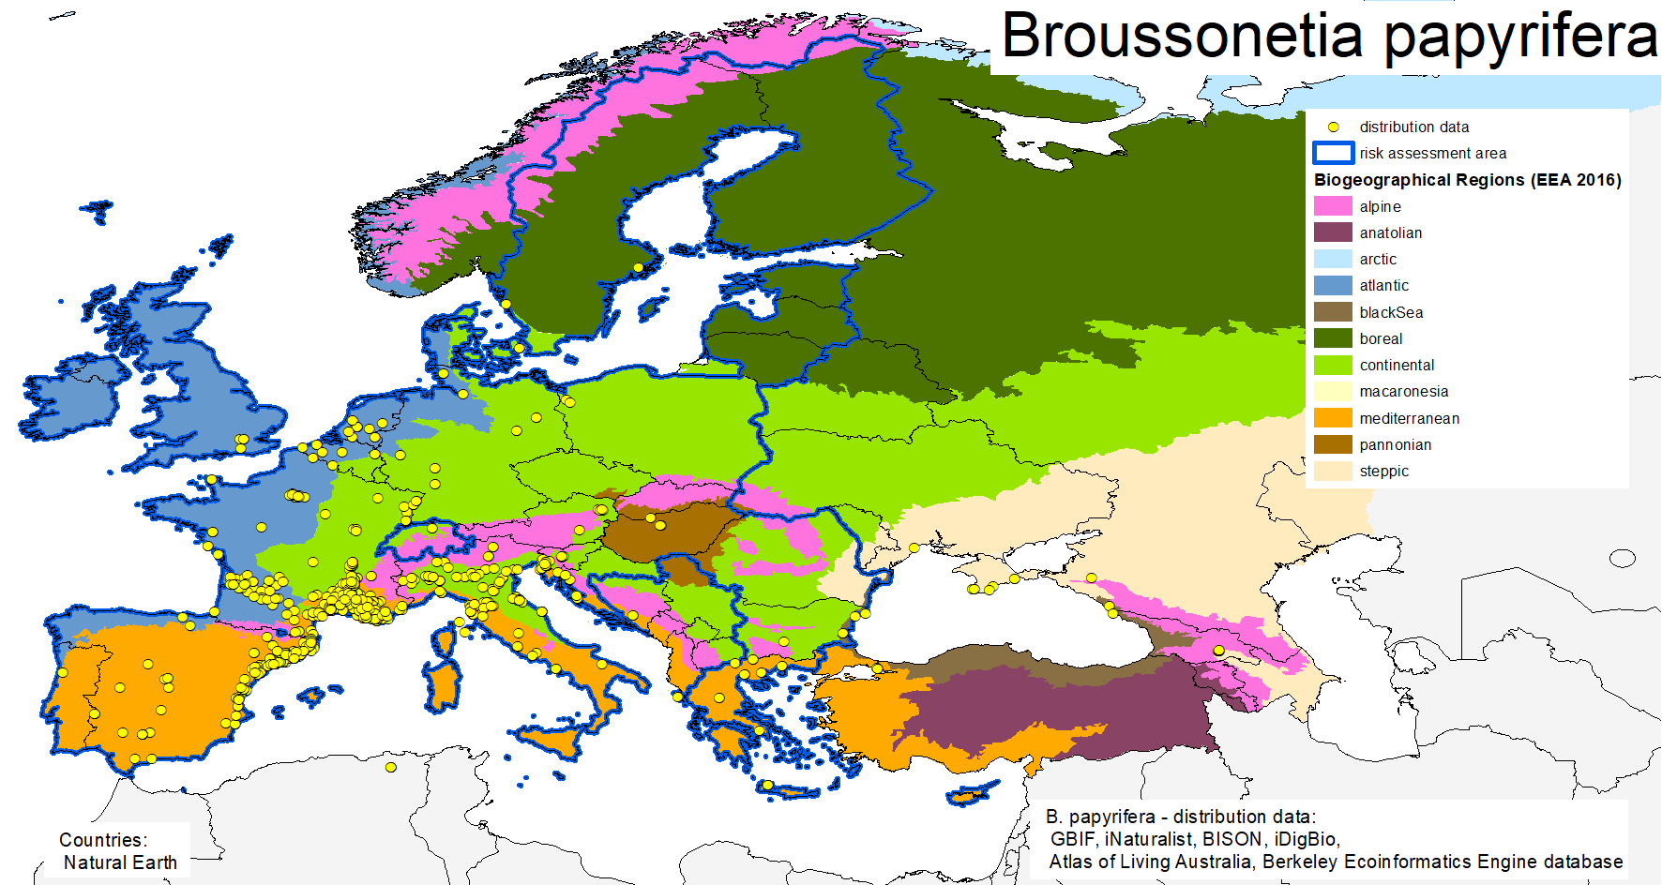
Figure 2 Occurrences records of Broussonetia papyrifera in the biogeographical regions (map designed by Umweltbundesamt/Environment Agency Austria – 2020/07/01)

Table 2 biogeographical regions with recorded/established Broussonetia papyrifera occurrences (green cell – recorded/established yes; white cell – recorded/established no; grey cell – no examined or no data available)
biogeographical region | recorded | established | source of recorded occurrences | source of established occurrences
Alpine |  |  | GBIF 2020; iDigBio 2020; Aeschimann et al. 2004
Anatolian
Arctic
Atlantic |  |  | ALA 2020; GBIF 2020; iNaturalist 2020 | Euro+Med 2006-; Tutin et al. 1964-1980; Greuter et al. 1989;
Black Sea |  |  | GBIF 2020; iNaturalist 2020
Boreal
Continental |  |  | ALA 2020; GBIF 2020; iNaturalist 2020 | Euro+Med 2006-; Tutin et al. 1964-1980; Greuter et al. 1989; Conti et al. 2005
Macaronesian
Mediterranean |  |  | GBIF 2020; iNaturalist 2020 | Euro+Med 2006-; Tutin et al. 1964-1980; Greuter et al. 1989; Conti et al. 2005; Tutin et al. 1964-1980; Greuter et al. 1989; Nikolić 1994; Boršić et al. 2008; Strid & Tan 1997; Mifsud 2020
Pannonian |  |  | GBIF 2020; iNaturalist 2020
Steppic

Response (6a):
Paper mulberry is recorded in the Alpine, Atlantic, Black Sea, Continental, Mediterranean and Pannonian biogeographical regions. No occurrence data is available for the Steppic region. In the Boreal biogeographic region, occurrence data is available only in botanical gardens.
Response (6b):
According to the available information, B. papyrifera can be considered as “established” in the Atlantic, Continental and Mediterranean biogeographical regions.
“Established” means the process of an alien species successfully producing viable offspring with the likelihood of continued survival. In the available references (mainly Euro+Med PlantBase and Flora Europaea), the term “naturalized” is used. In order to answer question 6b, “naturalized” is used as a synonym for “established”. The assessment of established occurrences in biogeographical regions is mainly deduced from the data available on national level (compare Table 5).

A7. In which biogeographic region(s) or marine subregion(s) in the risk assessment area could the species establish in the future under current climate and under foreseeable climate change? The information needs be given separately for current climate and under foreseeable climate change conditions.
A7a. Current climate: List regions
A7b. Future climate: List regions
With regard to EU biogeographic and marine (sub)regions, see above.
With regard to climate change, provide information on
- the applied timeframe (e.g. 2050/2070)
- the applied scenario (e.g. RCP 4.5)
- what aspects of climate change are most likely to affect the risk assessment (e.g. increase in average winter temperature, increase in drought periods)
The assessment does not have to include a full range of simulations on the basis of different climate change scenarios, as long as an assessment with a clear explanation of the assumptions is provided. However, if new, original models are executed for this risk assessment, the following RCP pathways shall be applied: RCP 2.6 (likely range of 0.4-1.6°C global warming increase by 2065) and RCP 4.5 (likely range of 0.9-2.0°C global warming increase by 2065). Otherwise, the choice of the assessed scenario has to be explained.

According to SDM results (Figure 3 and Figure 4, Table 3 and Table 4, see also Annex IX) the biogeographical regions paper mulberry could establish in are as follows:
Response (7a):
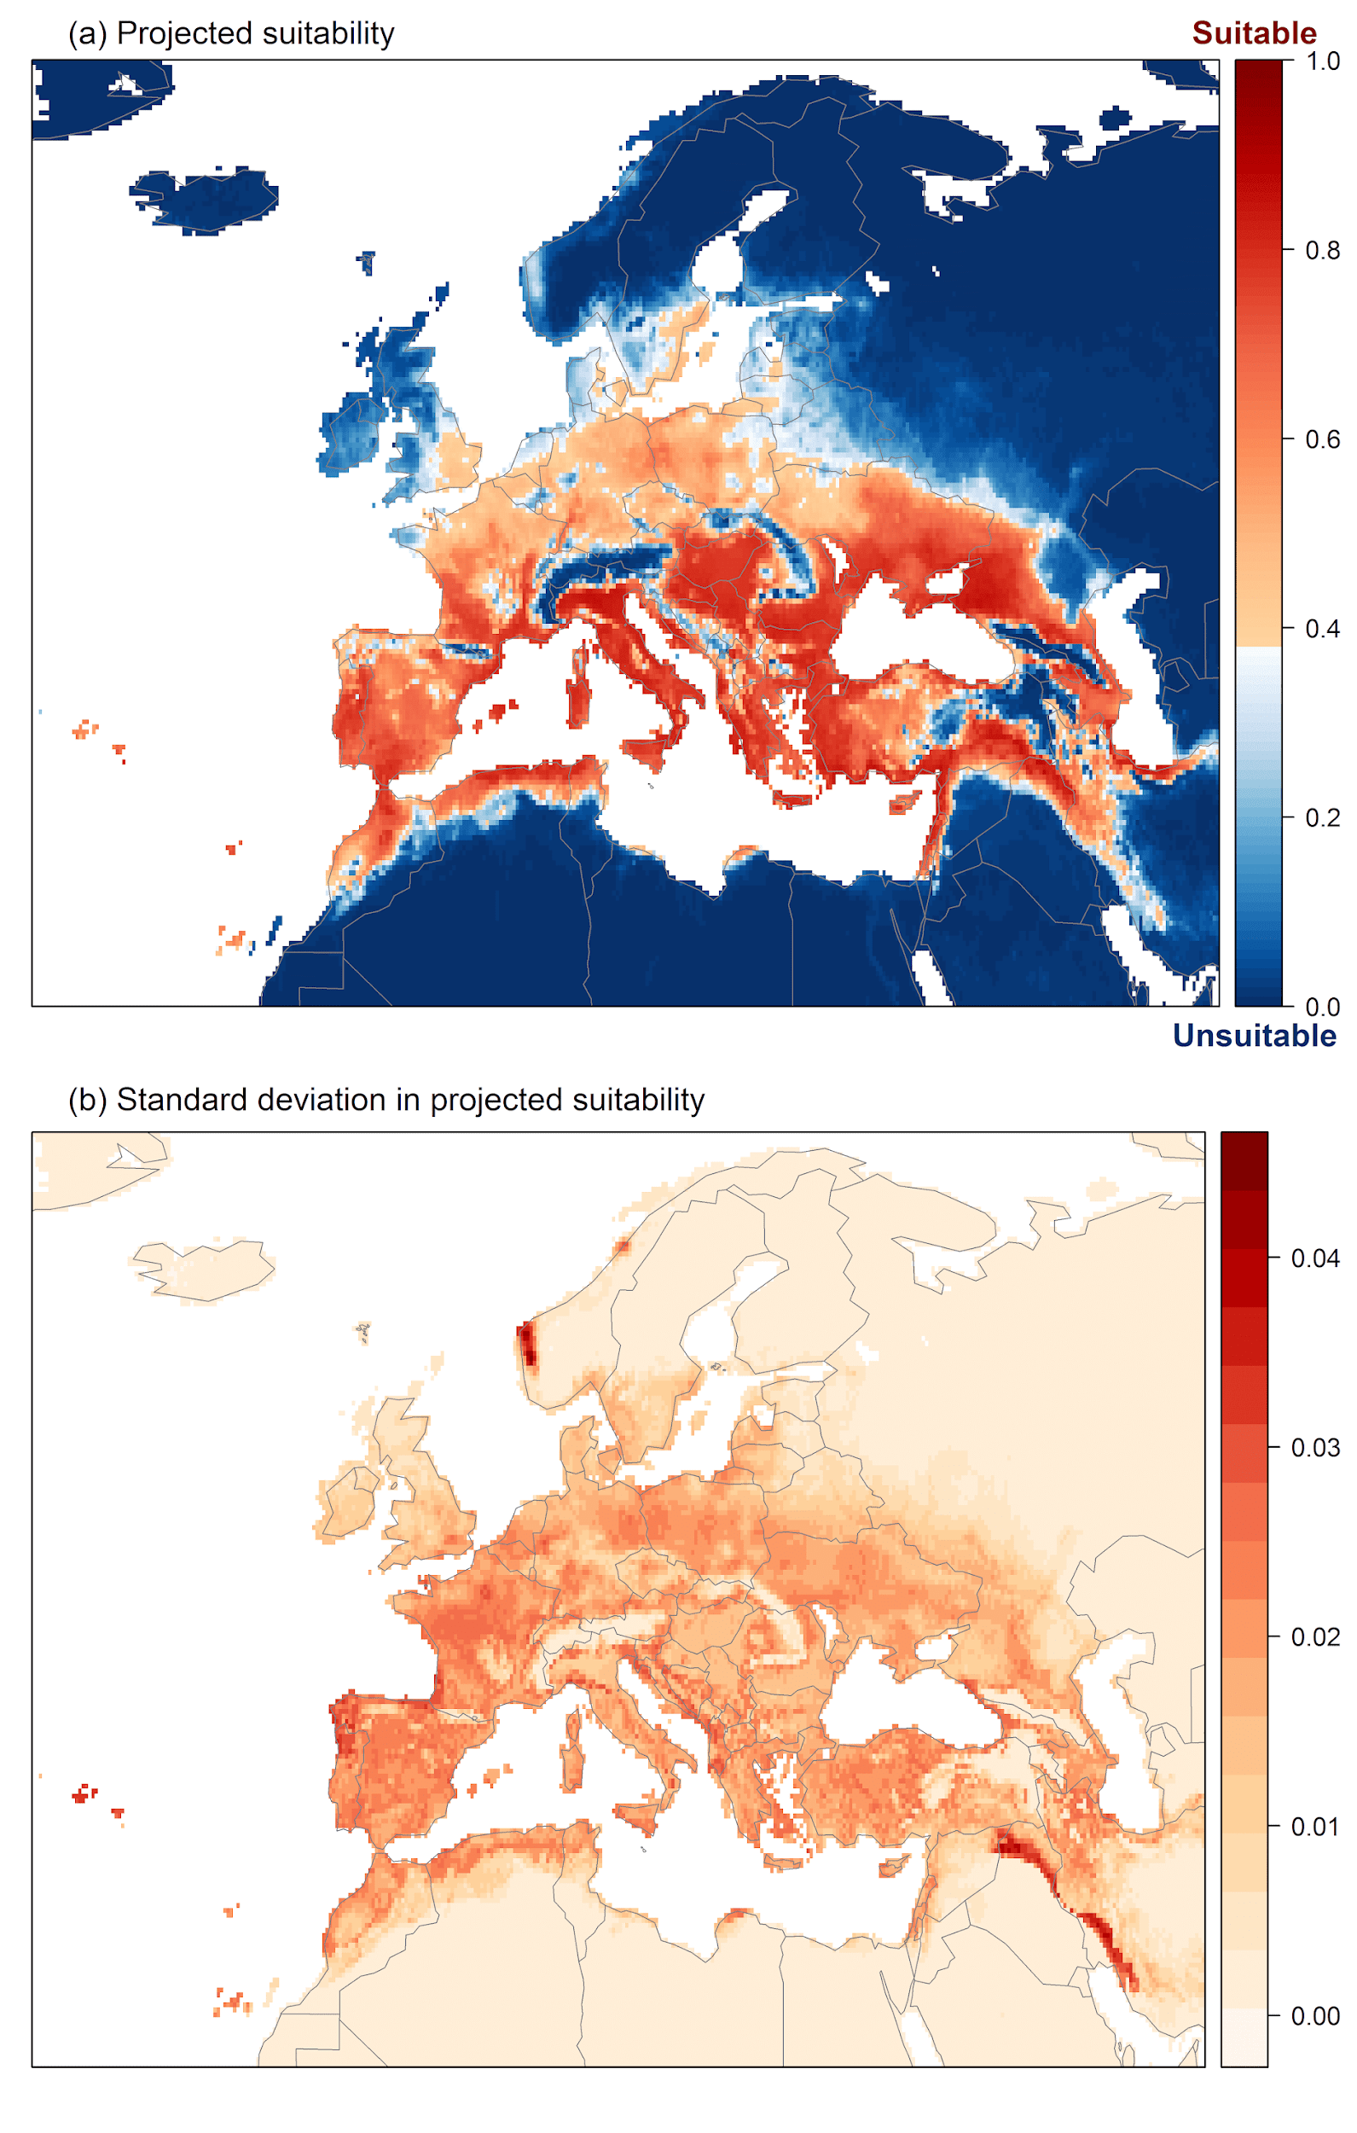
Figure 3 Projected current suitability for Broussonetia papyrifera establishment in Europe

Table 3 Biogeographic regions and suitability under current conditions
Biogeographic region | likeliness | confidence
Alpine | unlikely | medium
Anatolian | likely | high
Arctic | unlikely | high
Atlantic | likely | high
Black Sea | likely | high
Boreal | unlikely | high
Continental | likely | high
Macaronesian | likely | high
Mediterranean | likely | high
Pannonian | likely | high
Steppic | likely | high

Response (7b):
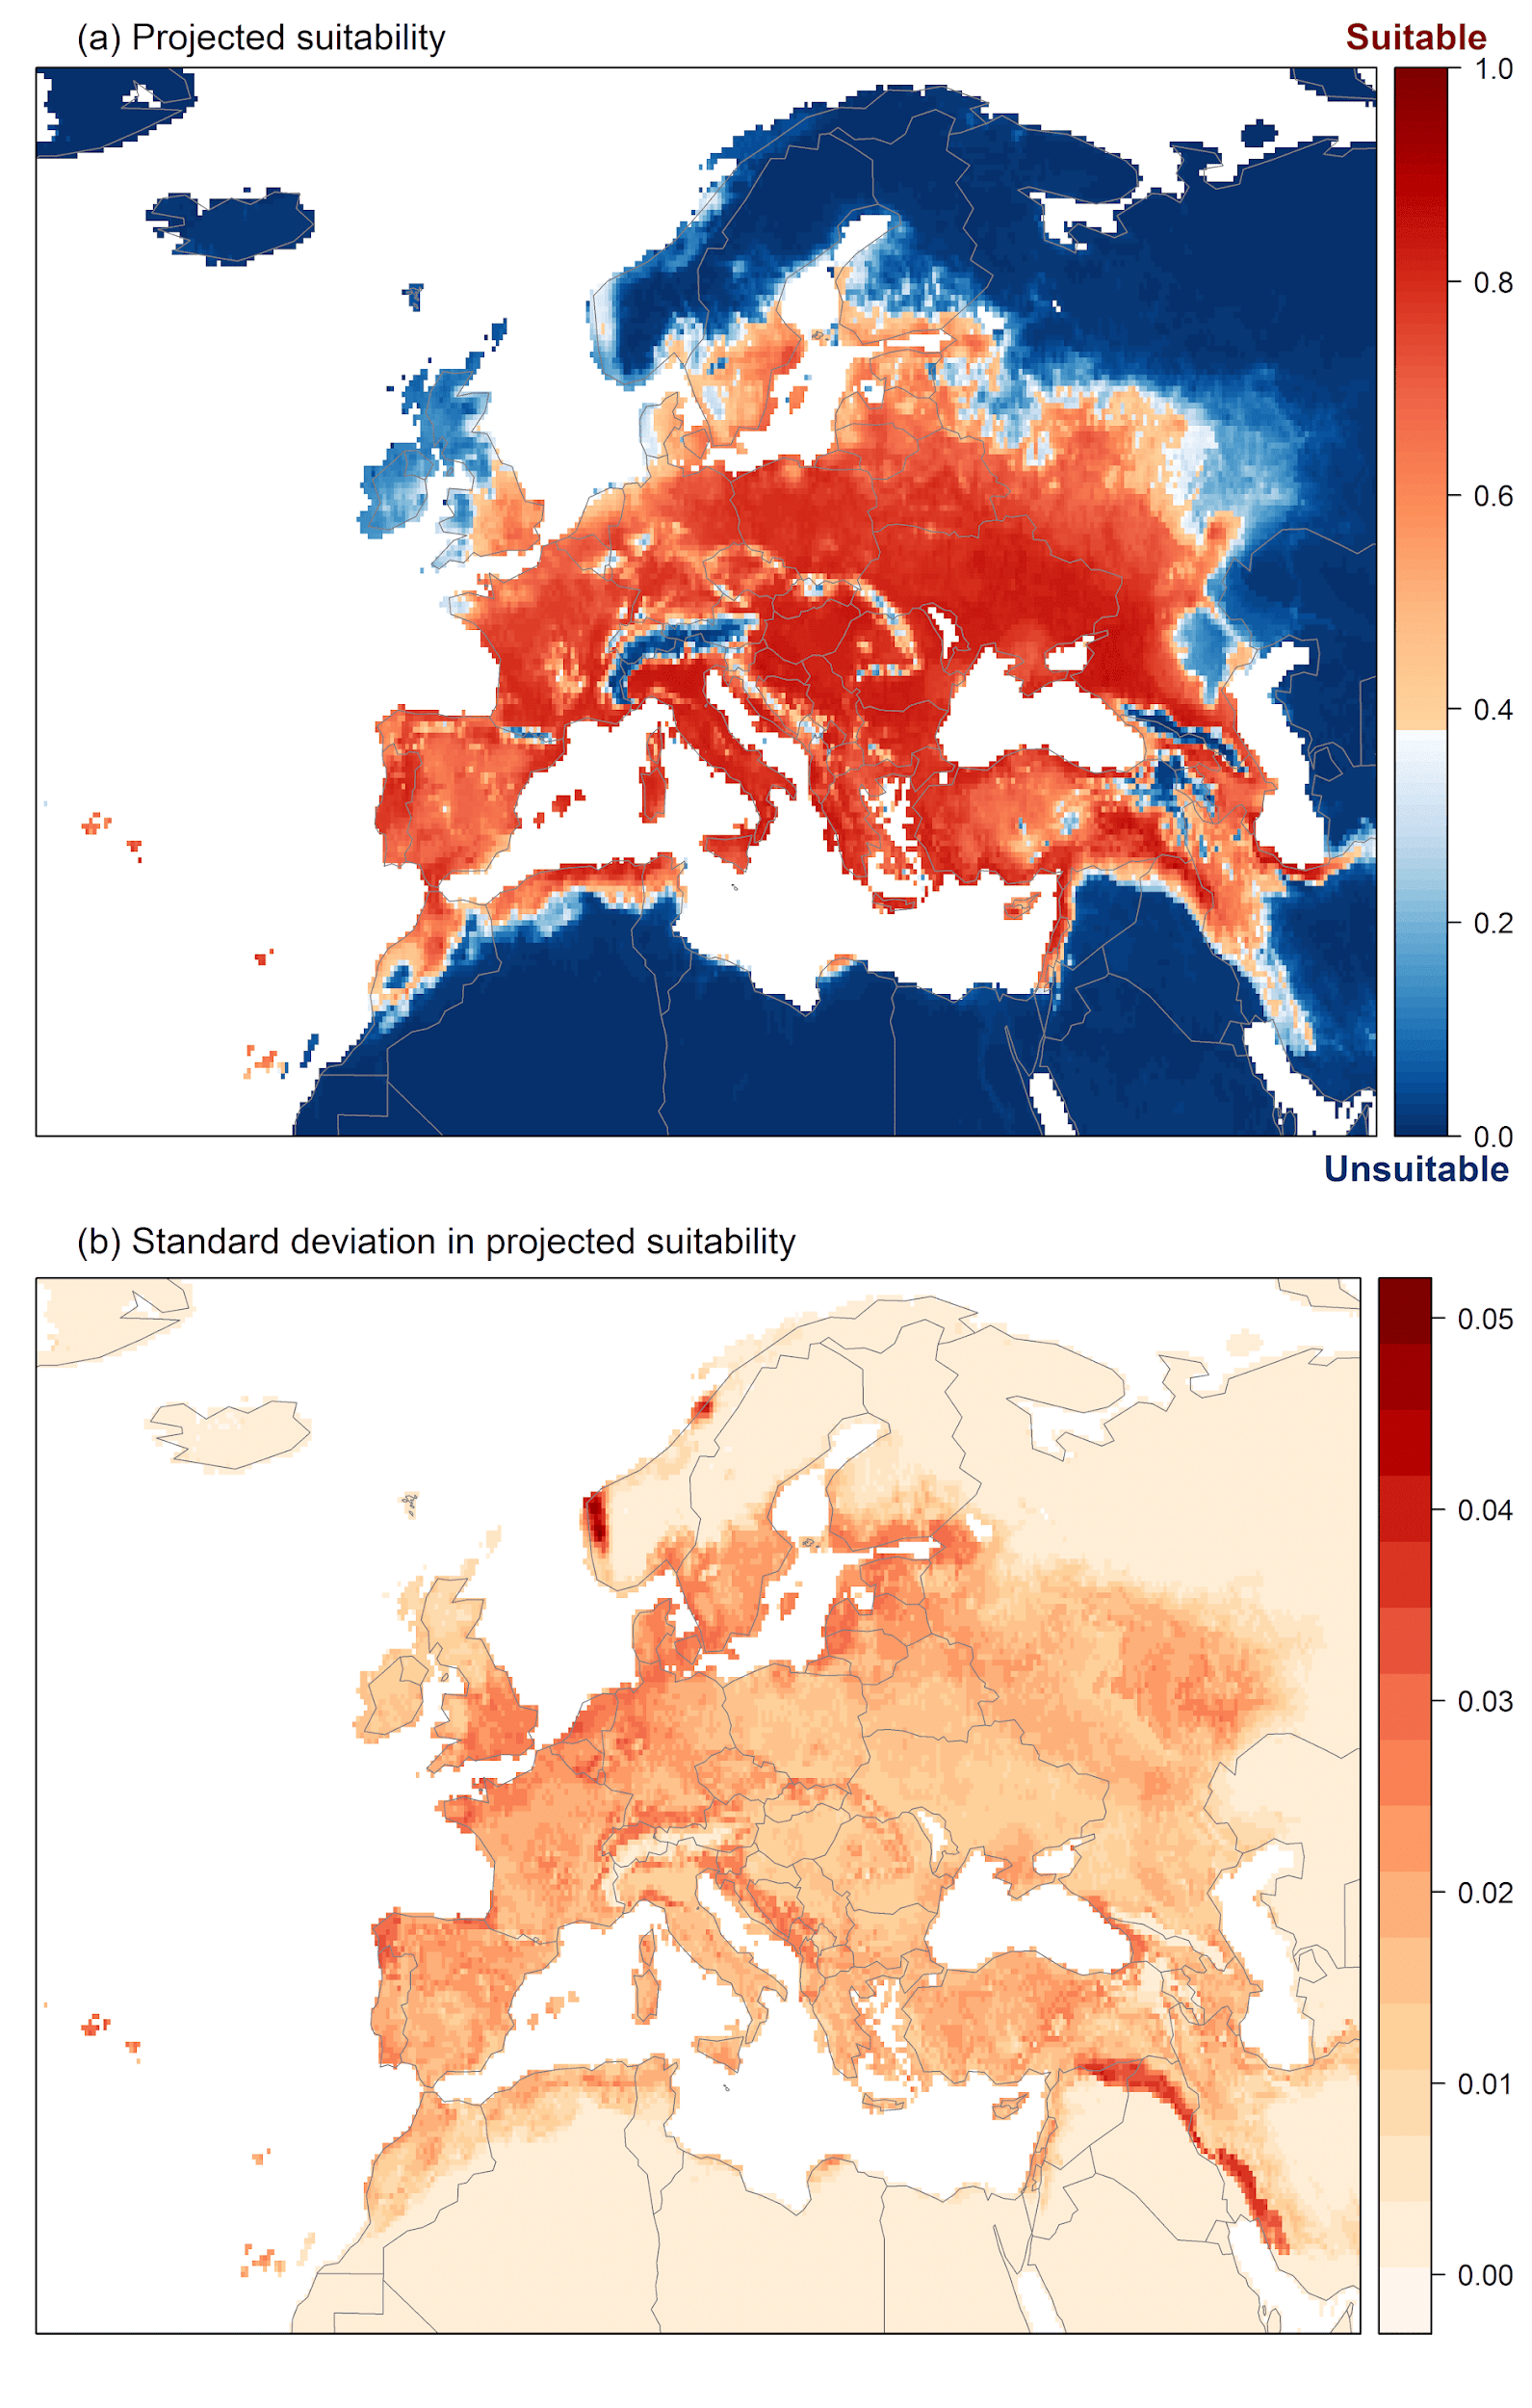 | 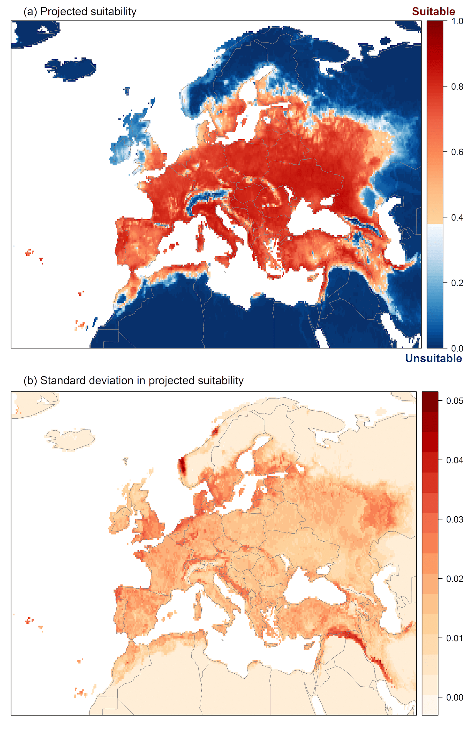
Figure 4 Projected suitability for Broussonetia papyrifera establishment in European region in the 2070s under climate change scenarios; Left: RCP 2.6 scenario, right: RCP 4.5 scenario

Table 4 Biogeographic regions and suitability under projected scenario conditions
biogeographic region | Scenario RCP 2.6 |  | Scenario RCP 4.5
 | likeliness | confidence | likeliness | confidence
Alpine | likely | medium | likely | medium
Anatolian | likely | high | likely | high
Arctic | unlikely | high | unlikely | high
Atlantic | likely | high | likely | high
Black Sea | likely | high | likely | high
Boreal | likely | medium | likely | high
Continental | likely | high | likely | high
Macaronesian | likely | high | likely | high
Mediterranean | likely | high | likely | high
Pannonian | likely | high | likely | high
Steppic | likely | high | likely | high

A8. In which EU Member States has the species been recorded and in which EU Member States has it established? List them with an indication of the timeline of observations. The information needs be given separately for recorded and established occurrences.
A8a. Recorded: List Member States
A8b. Established: List Member States
Austria, Belgium, Bulgaria, Croatia, Cyprus, Czech Republic, Denmark, Estonia, Finland, France, Germany, Greece, Hungary, Ireland, Italy, Latvia, Lithuania, Luxembourg, Malta, Netherlands, Poland, Portugal, Romania, Slovakia, Slovenia, Spain, Sweden
The description of the invasion history of the species shall include information on countries invaded and an indication of the timeline of the first observations, establishment and spread.

Response: Figure 5 and Table 5 give an overview about occurrences of the species in the EU Member States. Sources of information are observation data (GBIF 2020, iDigBio 2020, iNaturalist 2020, ALA 2020), European wide overviews like Euro+Med PlantBase or Flora Europaea as well as national floristic or invasive species references (see Table 5). An indication of the first observation is not possible for every member state but given if possible. Mainly based upon Euro+Med PlantBase and CABI (2020) additional information like cultivated/planted respectively naturalized status is available in some cases. The available European wide (e.g. Euro+Med 2006-; Tutin et al. 1964-1980), national or regional (e.g. Aeschimann et al. 2004) floristic compilations are a reliable source of information.

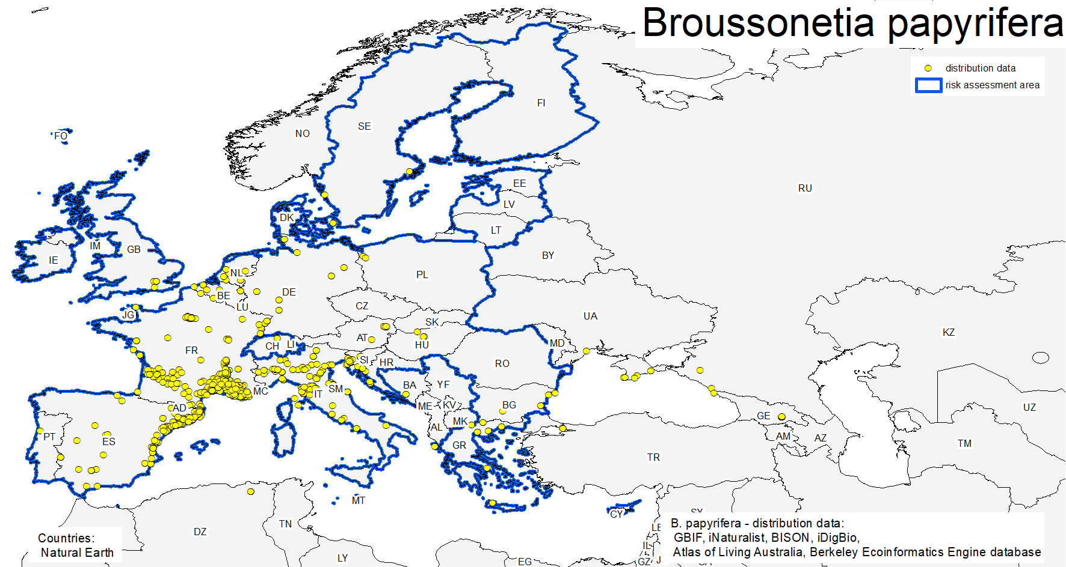
Figure 5 distribution data records of Broussonetia papyrifera in the EU member states (including United Kingdom) (map designed by Umweltbundesamt/Environment Agency Austria – 2020/07/01)

Table 5 EU member states and United Kingdom with recorded/established Broussonetia papyrifera occurrences; * information given by Euro+Med 2006-; ** information by CABI 2020; N/A not available (green cell – recorded/established yes; white cell – recorded/established no; grey cell – no examined or no data available)
country | recorded | established | source recorded | source established | general remarks | timeline of observations
Austria |  |  | Euro+Med 2006-; GBIF 2020; iNaturalist 2020; Fischer et al. 2008; Stöhr et al. 2012; Essl 2006; Essl 2008 |  | Cultivated* | 1863-2019
Belgium |  |  | GBIF 2020; iNaturalist 2020 |  | casual | 2005-2019
Bulgaria |  |  | GBIF 2020; iNaturalist 2020 | Petrova et al. 2013 |  | 1885-2019
Croatia |  |  | Euro+Med 2006-; GBIF 2020; iNaturalist 2020 | Euro+Med 2006-; Nikolić 1994; Boršić et al. 2008; Mitίc et al. 2006; EPPO 2020a, Duplić & Vrdoljak 2016 | cultivated; introduced: naturalized* | 1996-2019
Cyprus
Czechia
Denmark |  |  | ALA 2020; GBIF 2020 |  | cultivated | 1869-N/A
Estonia
Finland
France |  |  | Euro+Med 2006-; GBIF 2020; iNaturalist 2020; Tutin et al. 1964-1980 | Euro+Med 2006-; Tutin et al. 1964-1980; Greuter et al. 1989; Aeschimann et al. 2004; Tela Botanica 2020 | introduced: naturalized* | 1890-2019
Germany |  |  | ALA 2020; GBIF 2020 |  |  | 1828-2019
Greece |  |  | Euro+Med 2006-; GBIF 2020; iNaturalist 2020; iDigBio 2020 | Euro+Med 2006-; Strid & Tan 1997; Zenetos et al. 2016 | introduced: naturalized* | 1985-2019
Hungary |  |  | Euro+Med 2006-; GBIF 2020; iNaturalist 2020;  Király 2009; CABI 2020; Varga 2016 |  | introduced*; planted** | N/A-2019
Ireland
Italy |  |  | Euro+Med 2006-; ALA 2020; GBIF 2020; iNaturalist 2020 | Euro+Med 2006-; Aeschimann et al. 2004; Conti et al. 2005; Tutin et al. 1964-1980; Greuter et al. 1989; Celesti-Grapow et al. 2009; Banfi & Galasso 2010; Galasso et al. 2018; EPPO 2020b | introduced: naturalized*; planted, introduced, widespread** | 1923-2020
Latvia
Lithuania
Luxembourg
Malta |  |  | Euro+Med 2006- | Euro+Med 2006-; Greuter et al. 1989; Mifsud 2020 | introduced: naturalized* | N/A-N/A
Netherlands |  |  | GBIF 2020; iNaturalist 2020; Waarneming.nl (2021) |  |  | 1993-2020
Poland |  |  | iNaturalist 2020 |  |  | 2005-2011
Portugal |  |  | iNaturalist 2020 |  |  | N/A-2018
Romania |  |  | Euro+Med 2006- | Euro+Med 2006-; Tutin et al. 1964-1980; Sîrbu & Oprea 2011; Anastasiu et al. 2016 | introduced: naturalized* | N/A- N/A
Slovakia |  |  | Euro+Med 2006-; iNaturalist 2020; Goliašová & Michalková 2006 |  | cultivated*; planted** | N/A-2017
Slovenia |  |  | GBIF 2020; iNaturalist 2020; EPPO 2020c; Follak et al. 2018; Tavzes 2016 |  | planted** | 1982-2019
Spain |  |  | Euro+Med 2006-; GBIF 2020; iNaturalist 2020; Tutin et al. 1964-1980 | Euro+Med 2006-; Tutin et al. 1964-1980; Greuter et al. 1989; Dana et al. 2004; Bayόn & Vilá 2019; EPPO 2020d | introduced: naturalized*; planted** | 1892-2019
Sweden |  |  | GBIF 2020 |  | cultivated | N/A-2008
United Kingdom |  |  | GBIF 2020; iNaturalist 2020 |  |  | N/A-2019

Response (8a): Paper mulberry is recorded in 19 (Austria, Belgium, Bulgaria, Croatia, Denmark, France, Germany, Greece, Hungary, Italy, Malta, Netherlands, Poland, Portugal, Romania, Slovakia, Slovenia, Spain, Sweden) out of 27 Member States and in the United Kingdom.
Response (8b): Based upon the available data, B. papyrifera can be assessed as established in 8 (Bulgaria, Croatia, France, Greece, Italy, Malta, Romania, Spain) out of 27 Member States. Some of the member states with first observations about 100 or more years ago and Atlantic / Mediterranean climatic conditions (France 1890, Italy 1923, Spain 1892) exhibit a wide distribution of the species (see Figure 5).
By using a subset of GBIF records with a spatial accuracy <= 100m, the EUNIS habitat classes at Level 2 (EEA 2019) can be spatially retrieved from the Ecosystem types of Europe 2012 raster data set (compare Table 6).
Table 6 Selected 283 Broussonetia papyrifera occurrences by GBIF with coordinate accuracy =< 100m and spatially related EUNIS habitat classes at Level 2 (EEA 2019)
EUNIS Label | AT | BE | BG | CH | CY | ES | FR | GR | HR | HU | IT | NL
C1: Surface standing waters |  |  |  |  |  |  |  |  |  |  | 1
C2: Surface running waters |  |  |  |  |  |  | 1
E1: Dry grasslands |  |  |  |  |  |  | 2
E2: Mesic grasslands |  |  |  |  | 1 |  | 16 |  |  |  | 6
E3: Seasonally wet and wet grasslands |  |  | 1
F3: Temperate and mediterranean-montane scrub |  | 1
FB: Shrub plantations |  |  |  |  |  |  | 8
G1: Broadleaved deciduous woodland |  |  |  |  |  | 1 | 9 |  |  |  | 5
G2: Broadleaved evergreen woodland |  |  |  |  |  |  |  |  |  |  | 2
G4: Mixed deciduous and coniferous woodland |  |  |  |  |  |  | 4
G5: Lines of trees, small anthropogenic woodlands, recently felled woodland, early-stage woodland and coppice |  |  |  |  |  |  | 3 |  |  |  | 2
I1: Arable land and market gardens |  |  |  |  |  | 1 | 12 | 1 |  |  | 17
I2: Cultivated areas of gardens and parks |  | 2 |  |  |  | 2 | 5 | 1 |  | 1 | 9
J1: Buildings of cities, towns and villages |  |  |  |  |  | 10 | 66 | 1 | 2 | 1 | 22 | 1
J2: Low density buildings | 1 |  |  | 2 |  | 2 | 42 | 1 |  |  | 7
J4: Transport networks and other constructed hard-surfaced areas |  |  |  |  |  | 1 | 4 |  |  |  | 5

Most of the selected GBIF records are related to urban ecosystem types like Buildings of cities, towns and villages or Low density buildings.
Though for countries like e.g. Italy and France, the records are additionally related to Mesic grasslands, Broadleaved deciduous woodland, Lines of trees, small anthropogenic woodlands, recently felled woodland, early-stage woodland and coppice, Arable land and market gardens, Transport networks and other constructed hard-surfaced areas.
In summary, there is enough evidence that the used occurrence data cover several ecosystem categories from urban to more natural types.

A9. In which EU Member States could the species establish in the future under current climate and under foreseeable climate change? The information needs be given separately for current climate and under foreseeable climate change conditions.
A9a. Current climate: List Member States
A9b. Future climate: List Member States
With regard to EU Member States, see above.
With regard to climate change, provide information on
- the applied timeframe (e.g. 2050/2070)
- the applied scenario (e.g. RCP 4.5)
- what aspects of climate change are most likely to affect the risk assessment (e.g. increase in average winter temperature, increase in drought periods)
The assessment does not have to include a full range of simulations on the basis of different climate change scenarios, as long as an assessment with a clear explanation of the assumptions is provided. However, if new, original models are executed for this risk assessment, the following RCP pathways shall be applied: RCP 2.6 (likely range of 0.4-1.6°C global warming increase by 2065) and RCP 4.5 (likely range of 0.9-2.0°C global warming increase by 2065). Otherwise, the choice of the assessed scenario has to be explained.

The ensemble SDM model (see Annex IX) suggested that suitability for B. papyrifera was most strongly determined by minimum temperature of the coldest month (Bio6), accounting for 31,6 % of variation explained, followed by mean temperature of the warmest quarter (Bio10) (26.6 %), Climatic Moisture Index (CMI) (22.6 %) and Human Influence Index (HII) (19.2 %).

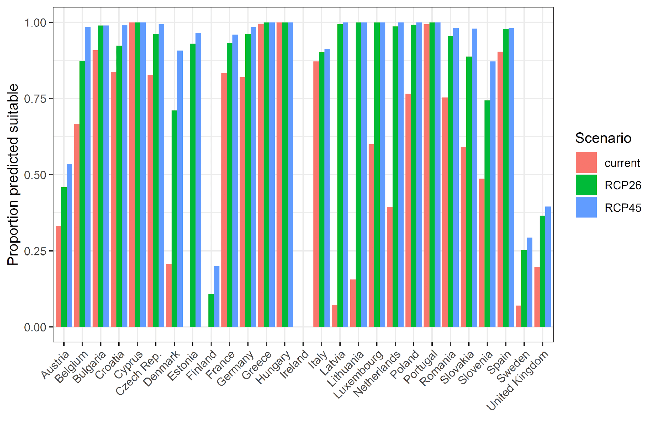Figure 6 Variation in projected suitability for Broussonetia papyrifera establishment among European Union countries and the United Kingdom. The bar plots show the proportion of grid cells in each country classified as suitable in the current climate and projected climate for the 2070 using two different RCP pathways
Response (9a):
Table 6 EU Member States and the United Kingdom with suitability under current conditions
country | likeliness | confidence
Austria | unlikely | medium
Belgium | likely | high
Bulgaria | likely | high
Croatia | likely | high
Cyprus | likely | high
Czechia | likely | medium
Denmark | unlikely | medium
Estonia | unlikely | medium
Finland | unlikely | medium
France | likely | high
Germany | likely | medium
Greece | likely | high
Hungary | likely | high
Ireland | unlikely | high
Italy | likely | high
Latvia | unlikely | medium
Lithuania | unlikely | medium
Luxembourg | likely | medium
Malta | likely | high
Netherlands | likely | medium
Poland | likely | medium
Portugal | likely | high
Romania | likely | high
Slovakia | likely | medium
Slovenia | likely | high
Spain | likely | high
Sweden | unlikely | high
United Kingdom | unlikely | high

Response (9b):
Table 7 EU Member States and the United Kingdom with suitability under projected conditions
country | Scenario RCP 2.6 |  | Scenario RCP 4.5
 | likeliness | confidence | likeliness | confidence
Austria | likely | medium | likely | high
Belgium | likely | high | likely | high
Bulgaria | likely | high | likely | high
Croatia | likely | high | likely | high
Cyprus | likely | high | likely | high
Czechia | likely | medium | likely | high
Denmark | likely | medium | likely | high
Estonia | likely | medium | likely | high
Finland | unlikely | medium | unlikely | high
France | likely | high | likely | high
Germany | likely | high | likely | high
Greece | likely | high | likely | high
Hungary | likely | high | likely | high
Ireland | unlikely | high | unlikely | high
Italy | likely | high | likely | high
Latvia | likely | medium | likely | high
Lithuania | likely | medium | likely | high
Luxembourg | likely | high | likely | high
Malta | likely | high | likely | high
Netherlands | likely | high | likely | high
Poland | likely | high | likely | high
Portugal | likely | high | likely | high
Romania | likely | high | likely | high
Slovakia | likely | high | likely | high
Slovenia | likely | high | likely | high
Spain | likely | high | likely | high
Sweden | likely | medium | likely | medium
United Kingdom | likely | medium | likely | medium

A10. Is the organism known to be invasive (i.e. to threaten or adversely impact upon biodiversity and related ecosystem services) anywhere outside the risk assessment area?

Response: In Pakistan, paper mulberry was intentionally introduced to make the Islamabad (Capital) and Rawalpindi area green. In less than 30 years it not only became highly invasive in the natural vegetation but also caused health problems in the human population (Qazi et al. 2019). It is now commonly found in India and Pakistan from sea level to 1000 m altitude and has become highly invasive and a troublesome weed in many localities. In Pakistan, direct competition of B. papyrifera limits the growth of the native Dalbergia sissoo, Morus alba and Ziziphus sp., an important source of nectar for honey bees, especially near Islamabad and Rawalpindi and Murree Hills (Ahmed et al. 2019; Khan et al. 2020). The thick monocultures at different sites have rapidly replaced the native flora and fauna, although these thickets have also become refuges for wild boar and other mammals, and enhanced the buildup of the crow population (CABI 2020; Qureshi et al. 2020a).
In Uganda, B. papyrifera forms dense stands which displace native plant species and prevent forest regeneration as well as reduce water availability. The plant produces vast quantities of allergenic pollen (Witt et al. 2018).
Paper mulberry was introduced into Ghana in 1969 by the Forestry Research Institute of Ghana (FORIG). The reason for its deliberate introduction was to evaluate its potential for pulp and paper production. However, the plant has now become an invasive of alarming proportion. It is perhaps the most serious non-indigenous woody invasive plant in the closed forest zone of Ghana and the second most important plant invasive after Chromolaena odorata. In Ghana, paper mulberry is highly concentrated in the two forest reserves, namely Pra-Anum and Afram Headwaters Forest Reserves. It is in these forest reserves that the initial experimental trial were carried out. The two reserves are located within the Moist Semi-Deciduous (MSDF) and Dry Semi-Deciduous Forest (DSDF) zones, respectively. These two forest types are types among the most floristically diverse and economically important of all the forest types in Ghana. The high concentration of paper mulberry in these two reserves and nearby reserves or forests were facilitated by extensive deforestation and bushfires. From these two centers, the plant is spreading extensively. Dense stands of Broussonetia can be seen conspicuously in farms and along roads in and around Pra-Anum and Afram Headwaters forest reserves. The species is spreading to other areas up to perhaps 100 km from these point of introduction. In the Pacific Islands paper mulberry is not invasive because only male clones were introduced. Thus, no seeds are produced and propagation is by vegetative means, using root shoot suckers. In Ghana and other places where both fertile male and female plants were introduced the invasive potential of the plant increases significantly (Bosu & Apetorgor 2020).

A11. In which biogeographic region(s) or marine subregion(s) in the risk assessment area has the species shown signs of invasiveness? Indicate the area endangered by the organism as detailed as possible.
Freshwater / terrestrial biogeographic regions:
- Alpine, Atlantic, Black Sea, Boreal, Continental, Mediterranean, Pannonian, Steppic
Marine regions:
- Baltic Sea, North-east Atlantic Ocean, Mediterranean Sea, Black Sea
Marine subregions:
Greater North Sea, incl. the Kattegat and the English Channel, Celtic Seas, Bay of Biscay and the Iberian Coast, Western Mediterranean Sea, Adriatic Sea, Ionian Sea, Central Mediterranean Sea, Aegean-Levantine Sea

Response: Paper mulberry exhibits a widespread distribution in parts of the Atlantic and Mediterranean biogeographical regions (compare Figure 2). There are documented signs of invasiveness in the Continental biogeographical region (Northern Italy - Portale della Flora d'Italia 2020: Friuli Venezia Giulia, Lombardia (Montagnani et al. 2018), Piemonte (Gruppo di Lavoro Specie Esotiche della Regione Piemonte 2015), Veneto) and in the triangle of the Continental, Alpine and Mediterranean regions around Auvergne-Rhône-Alpes (Pôle d'information flore-habitats-fonge d'Auvergne-Rhône-Alpes 2020) and Provence Alpes-Côte d’Azur (Terrin et al. 2014). Regarding Croatia (Vuković et al. 2014, Borsic et al. 2008), no biogeographical region information is available. The endangered area includes natural and ruderal/disturbed habitats.

A12. In which EU Member States has the species shown signs of invasiveness? Indicate the area endangered by the organism as detailed as possible.
Austria, Belgium, Bulgaria, Croatia, Cyprus, Czech Republic, Denmark, Estonia, Finland, France, Germany, Greece, Hungary, Ireland, Italy, Latvia, Lithuania, Luxembourg, Malta, Netherlands, Poland, Portugal, Romania, Slovakia, Slovenia, Spain, Sweden

Response: The species exhibits a widespread distribution in Spain, France and Italy (compare Figure 5). There are documented signs of invasiveness in Italy (Northern Italy - Portale della Flora d'Italia 2020: Friuli Venezia Giulia, Lombardia (Montagnani et al. 2018), Piemonte (Gruppo di Lavoro Specie Esotiche della Regione Piemonte 2015), Veneto). Paper mulberry is listed as invasive in Croatia (Vuković et al. 2014, Borsic et al. 2008). France has some reports of local invasiveness including in the Auvergne-Rhône-Alpes (Pôle d'information flore-habitats-fonge d'Auvergne-Rhône-Alpes 2020) where it is also recorded as an emerging invasive (Debay et al. 2020) and it is listed as “one-to-watch” in the Pays de la Loire (Dortel & Le Bail 2019) and Provence Alpes-Côte d’Azur (Terrin et al. 2014). The endangered area includes natural and ruderal/disturbed habitats.

A13. Describe any known socio-economic benefits of the organism.
including the following elements:
- Description of known uses for the species, including a list and description of known uses in the risk assessment area and third countries, if relevant.
- Description of social and economic benefits deriving from those uses, including a description of the environmental, social and economic relevance of each of those uses and an indication of associated beneficiaries, quantitatively and/or qualitatively depending on what information is available.
If the information available is not sufficient to provide a description of those benefits for the entire risk assessment area, qualitative data or different case studies from across the risk assessment area or third countries shall be used, if available.

Response: Inside of the risk assessment area: Paper mulberry is grown as an ornamental in parks and gardens. No other kind of use is known for the risk assessment area.
Outside of the risk assessment area: Paper mulberry has been cultivated in Asia and some Pacific Islands for many centuries for food, fiber (CABI 2020; POWO 2020), medicine (Hussain et al. 2008) and other uses (Matthews 1996).
The species played a significant role in the development of paper-making (Chang et al. 2015; González-Lorca et al. 2015; POWO 2020). For centuries, the fiber from the inner bark of paper mulberry has been used to make paper in Japan and textiles throughout the Pacific. In both cases the raw material is the soft, inner bark. For paper-making, the inner bark is pounded and mixed with water, and the resulting paste then spread evenly on a mesh to make 'washi' (Japanese handmade paper). Paper-making with paper mulberry fiber was established in China by around 100 AD, and reached Japan by about 600 AD (POWO 2020).
In contrast, in the Pacific region textiles are made by beating together strips of inner bark. This tapa cloth is used for various items of clothing, such as sarongs, scarves and hats, as well as for making bags and other items such as bedding. Until relatively recently, tapa cloth was the main source of clothing worn on Pacific islands such as Fiji, Tonga and Tahiti. Tapa cloth is still worn on ceremonial occasions, during festivals and for traditional dances. The bark fiber (and indeed the roots) can also be made into rope and cord (POWO 2020).
The wood is light and easily worked, and is used for making cups, bowls and furniture (ALA 2020; POWO 2020). The timber, being soft and brittle, is used mainly in the manufacture of cheap furniture, match sticks, packing cases, boxes, plywood, building-boards, sports equipment and pencils (FAO 1980; Sheikh 1993).
The fruits of B. papyrifera are edible, as are the young leaves, when steamed. The leaves, fruit and bark have a variety of traditional medicinal uses. In China the leaves are fed to silk-worms (POWO 2020).
Paper mulberry is a vigorous pioneer species, which can rapidly colonise forest clearings and abandoned farmland. Its ability to colonise degraded lands may make it suitable for reforestation programs in some situations (Luna 1996), although it can become invasive when both male and female trees are present, followed by pollination and seed set. Paper mulberry is frequently planted as a shade tree. It tolerates air pollution, making it suitable for planting along roadsides and in urban settings. It is also grown as an ornamental in parks and gardens. The tree is widely coppiced for tapa and paper production, with the young trees cut every 12-18 months (POWO 2020).
Environmental pollution is an increasing global problem. In this context, B. papyrifera is tested for a possible use of tree planting for short-rotation coppicing and phytoremedation (Capuana 2020; Huang et al. 2019; Huimin et al. 2019; Kang et al. 2018). Soils are often polluted by different metals or organic compounds, so phytoremediation may require multiple plant species and ecotypes since most of the plants suited to this purpose show an aptitude to accumulate only one or a few pollutants. A pot experiment was carried out with the aim of determining the phytoextraction potential of the hyperaccumulator Pteris vittata when co-planted with a woody tree (Morus alba or B. papyrifera) in soil contaminated with Cd, Pb, Zn, or As. The uptake of As was significantly increased when co-planted with Morus or Broussonetia (by 80.0% and 64.2% respectively). However, co-plantation did not have a promoting effect on the metal accumulation of both M. alba. and B. papyrifera (Capuana 2020).
Energy derived from biomass has been considered for many years, but was not pursued as a viable energy alternative to fossil fuels until recently as a result of declining fossil fuel sources and increasing oil prices. Broussonetia papyrifera may be considered as a ‘second-generation’ biofuel plant in short rotation woody crops providing lingo-cellulose, which is the woody structural material of plants that is abundant and diverse and has increasing appeal because it does not divert food away from the animal or the human food chain (Witt 2010; Dimitrou & Rutz 2015).

SECTION B – Detailed assessment
Important instructions:
- In the case of lack of information the assessors are requested to use a standardized answer: “No information has been found.”
- With regard to the scoring of the likelihood of events or the magnitude of impacts see Annexes I and II.
- With regard to the confidence levels, see Annex III.
- Highlight the selected response score and confidence level in bold but keep the other scores in normal text (so that the selected score is evident in the final document).

1 PROBABILITY OF INTRODUCTION AND ENTRY
Important instructions:
- Introduction is the movement of the species into the risk assessment area (it may be either in captive conditions and/or in the environment, depending on the relevant pathways).
- Entry is the release/escape/arrival in the environment, i.e. occurrence in the wild
- Introduction and entry may coincide for species entering through pathways such as “corridor” or “unaided”, but it also may differ. If different, please consider all relevant pathways, both for the introduction into the risk assessment area and the entry in the environment.
- The classification of pathways developed by the Convention of Biological Diversity (CBD) should be used (see Annex IV). For detailed explanations of the CBD pathway classification scheme consult the IUCN/CEH guidance document and the provided key to pathways.
- For organisms which are already present (recorded or established) in the risk assessment area, the likelihood of introduction and entry should be scored as “very likely” by default.
- Repeated (independent) introductions and entries at separate locations in the risk assessment area should be considered here (see Qu. 1.7).

Qu. 1.1. List relevant pathways through which the organism could be introduced into the risk assessment area and/or enter into the environment. Where possible give details about the specific origins and end points of the pathways as well as a description of any associated commodities.
For each pathway answer questions 1.2 to 1.7 (copy and paste additional rows at the end of this section as necessary). Please attribute unique identifiers to each question if you consider more than one pathway, e.g. 1.2a, 1.3a, etc. and then 1.2b, 1.3b etc. for the next pathway.
In this context a pathway is the route or mechanism of introduction and/or entry of the species.
The description of commodities with which the introduction of the species is generally associated shall include a list and description of commodities with an indication of associated risks (e.g. the volume of trade; the likelihood of a commodity being contaminated or acting as vector).
If there are no active pathways or potential future pathways this should be stated explicitly here, and there is no need to answer the questions 1.2-1.9.

Table 8 list of pathways with relevance assessment
Category pathways | Subcategory | relevance
Release in Nature | Biological control | No information has been found.
 | Erosion control / dune stabilization | No information has been found.
 | Landscape / flora / fauna "improvement" in the wild | No information has been found.
 | Introduction for conservation purposes | No information has been found.
 | Release in nature for use | No information has been found.
 | Other intentional release | No information has been found.
Escape from confinement | Agriculture | No information has been found.
 | Botanical garden | relevant
 | Forestry | No information has been found.
 | Horticulture | relevant
 | Ornamental purpose other than horticulture | relevant
 | Research and ex-situ breeding | No information has been found.
 | Other escape from confinement | No information has been found.
Transport Containment | Seed contaminant | No information has been found.
 | Timber trade | No information has been found.
 | Transportation of habitat material | No information has been found.
Transport - Stowaway | Machinery / equipment | No information has been found.
Unaided | Natural dispersal | No information has been found.

Pathways considered but excluded from the risk assessment.
Forestry: Broussonetia papyrifera is mentioned in the context of biofuel plant in short rotation woody crops (Witt 2010; Dimitrou & Rutz 2015). This pathway was not considered for the risk assessment as there is no further evidence that this is an (active) pathway in the EU.
Other escape from confinement: Broussonetia papyrifera is mentioned in the context of phytoremedation (Capuana 2020; Huimin et al. 2019; Kang et al. 2018). This pathway was not considered for the risk assessment as there is no further evidence that this is an (active) pathway in the EU.
Pathway name: Botanical garden/zoo/aquaria (excluding domestic aquaria)
Qu. 1.2a. Is introduction and/or entry along this pathway intentional (e.g. the organism is imported for trade) or unintentional (e.g. the organism is a contaminant of imported goods)?

RESPONSE | intentional  unintentional | CONFIDENCE | low  medium  high

Response: Long before Linnaeus’ time, paper mulberry had been cultivated widely in European gardens (Barker 2002). Currently, the species is regularly displayed in Botanical Gardens across the risk assessment area.
Selection of occurrences in botanical gardens inside the risk assessment area:
- Bochum (Germany)
- Córdoba (Spain)
- Frankenburg (Austria)
- Freiburg (Germany)
- Graz (Austria)
- Ljubljana (Slovenia)
- Meise (Belgium)
- Tübingen (Germany)
- Wrocław (Poland)
- Vienna (Austria)

Qu. 1.3a. How likely is it that large numbers of the organism will be introduced and/or enter into the environment through this pathway from the point(s) of origin over the course of one year?
including the following elements:

- discuss how likely the organism is to get onto the pathway in the first place. Also comment on the volume of movement along this pathway.
- an indication of the propagule pressure (e.g. estimated volume or number of individuals / propagules, or frequency of passage through pathway), including the likelihood of reinvasion after eradication
- if relevant, comment on the likelihood of introduction and/or entry based on propagule pressure (i.e. for some species low propagule pressure (1-2 individuals) could result in subsequent establishment whereas for others high propagule pressure (many thousands of individuals) may not.

RESPONSE | very unlikely  unlikely  moderately likely  likely  very likely | CONFIDENCE | low  medium  high

Response: Broussonetia papyrifera is unisexual and dioecious. Thus, a male and female tree are needed if the ornamental and attractive fruits are to be shown to visitors. The fruits of B. papyrifera are consumed by birds and other small animals which are able to disseminate the seeds outside of botanical gardens. There is evidence in literature about spreading and seed dispersal by birds and small mammals (e.g. fruit bats), though no particular bird or mammal species is mentioned, neither for regions outside of the risk assessment area nor for the risk assessment area. The seed density may be locally high. Root sprouts are produced when the main stem is cut. It can be assumed that these clonal sprouts are local and managed in botanical gardens according to the European Code of Conduct for Botanic Gardens on Invasive Alien Species (Heywood & Sharrock 2013). Nagodă et al. (2014) examined the “Dimitrie Brandza” Botanic Garden (Bucharest) as a potential centre for the dispersal of invasive plants. Paper mulberry has been assessed as: a species surviving in the climatic conditions of the Botanic Garden (Romania), it flowers, bears fruit and produces seeds and seedlings around the parent plant, without any human intervention.

Qu. 1.4a. How likely is the organism to survive, reproduce, or increase during transport and storage along the pathway (excluding management practices that would kill the organism)?

RESPONSE | very unlikely  unlikely  moderately likely  likely  very likely | CONFIDENCE | low  medium  high

Response: As the pathway is intentional, it is likely that the organism will survive. As the intention is showing the species itself as well as the ornamental and attractive fruits to visitors of the botanical garden, it is likely that male and female trees are planted in proximity. Then it is likely that the trees will reproduce during their life. Vegetative growth is controlled by the botanical garden management.

Qu. 1.5a. How likely is the organism to survive existing management practices before and during transport and storage along the pathway?

RESPONSE | very unlikely  unlikely  moderately likely  likely  very likely | CONFIDENCE | low  medium  high

Response: As the pathway is intentional to display paper mulberry in botanical gardens, it is likely that the organism will survive.

Qu. 1.6a. How likely is the organism to be introduced into the risk assessment area or entry into the environment undetected?

RESPONSE | very unlikely  unlikely  moderately likely  likely  very likely | CONFIDENCE | low  medium  high

Response: As the pathway is intended, it is unlikely that the organism introduction into the risk assessment area is undetected. On the other hand, an undetected dispersal of seeds by animals out of the botanical garden into the environment may be possible. A requirement for the latter is that male and female plants are present in the garden. In very rare cases, visitors may collect some fruits/seeds for planting in their garden or the wild.

Qu. 1.7a. How isolated or widespread are possible points of introduction and/or entry into the environment in the risk assessment area?

RESPONSE | isolated  widespread  ubiquitous | CONFIDENCE | low  medium  high

Response: Botanical gardens are neither ubiquitous nor widespread. Thus, the points of introduction into the environment in the risk assessment area are isolated.

Qu. 1.8a. Estimate the overall likelihood of introduction into the risk assessment area and/or entry into the environment based on this pathway?

RESPONSE | very unlikely  unlikely  moderately likely  likely  very likely | CONFIDENCE | low  medium  high

Response: As a tree life cycle in botanical gardens normally span over several decades, planting B. papyrifera in such localities happens rarely. Though, if there are male and female trees in proximity, seeds may be produced over the whole life cycle. Vegetative growth is controlled by the botanical garden management. The overall likelihood of introduction is assessed as unlikely based upon the European Code of Conduct for Botanic Gardens on Invasive Alien Species (Heywood & Sharrock 2013).

Pathway name: Horticulture
Qu. 1.2b. Is introduction and/or entry along this pathway intentional (e.g. the organism is imported for trade) or unintentional (e.g. the organism is a contaminant of imported goods)?

RESPONSE | intentional  unintentional | CONFIDENCE | low  medium  high

Response: The horticulture pathway covers large scale/commercial cultivation of plants in a controlled or confined environment and is the intentional introduction of the species into the risk assessment area for commercial culturing. Paper mulberry had been cultivated widely for ornamental uses in European gardens for hundreds of years (Barker 2002).
The Horticulture pathway focuses on plants kept in commercial culturing facilities (nurseries, greenhouses) from where they may accidentally escape due to mismanagement, or during transport to/from locations as part of the nursery trade. Therefore, this pathway includes the bulk shipment of live plants for nurseries and gardens centres, and the intentional introduction of seeds (and potentially rhizomes) for planting.
An internet search reveals that the plant can be ordered (online) at local or regional tree nurseries in several EU member states (e.g. Spain, France, Ireland, Netherlands, Belgium, Germany, and Austria) as well as at online retailers like eBay or Amazon. Seeds, cuttings or trees are offered.

Qu. 1.3b. How likely is it that large numbers of the organism will be introduced and/or enter into the environment through this pathway from the point(s) of origin over the course of one year?
including the following elements:

- discuss how likely the organism is to get onto the pathway in the first place. Also comment on the volume of movement along this pathway.
- an indication of the propagule pressure (e.g. estimated volume or number of individuals / propagules, or frequency of passage through pathway), including the likelihood of reinvasion after eradication
- if relevant, comment on the likelihood of introduction and/or entry based on propagule pressure (i.e. for some species low propagule pressure (1-2 individuals) could result in subsequent establishment whereas for others high propagule pressure (many thousands of individuals) may not.

RESPONSE | very unlikely  unlikely  moderately likely  likely  very likely | CONFIDENCE | low  medium  high

Response: Seeds, cuttings or trees are offered at tree nurseries or at online retailers. Broussonetia papyrifera is unisexual and dioecious. Thus, it needs at least one male and well one female, tree for fruits to be produced. The fruits of paper mulberry are consumed by birds and other small animals which are able to disseminate the seeds outside of tree nurseries. There is evidence in the global literature on spreading and seed dispersal by birds and small mammals (e.g. fruit bats), though no particular bird or mammal species is mentioned. The seed density may be locally very high, though no figures are available. Root sprouts are produced when the main stem is cut; though no information about management of root sprouts is available in the context of horticulture.

Qu. 1.4b. How likely is the organism to survive, reproduce, or increase during transport and storage along the pathway (excluding management practices that would kill the organism)?

RESPONSE | very unlikely  unlikely  moderately likely  likely  very likely | CONFIDENCE | low  medium  high

Response: The pathway ‘Horticulture’ is the deliberate movement of plant material into the risk assessment area and as such plant material would be maintained and moved to ensure survival. Three types of material can potentially enter the risk assessment area via this pathway (1) seed, (2) live plants and (2) rhizomes. Although seed import cannot be ruled out, it is unlikely to be part of the horticulture pathway for the commercial production of the species.
As the pathway is intentional, it is likely that the organism will survive. As the intention is to produce cuttings and, to a lesser extent, seeds for sale, it is likely that male and female trees are planted in proximity. Therefore, it is very likely that the trees will reproduce during their life.

Qu. 1.5b. How likely is the organism to survive existing management practices before and during transport and storage along the pathway?

RESPONSE | very unlikely  unlikely  moderately likely  likely  very likely | CONFIDENCE | low  medium  high

Response: As the pathway is intentional, it is likely that the organism will survive existing management practices. Plant material is the commodity itself and it is deliberately moved for sale within the risk assessment area.

Qu. 1.6b. How likely is the organism to be introduced into the risk assessment area or entry into the environment undetected?

RESPONSE | very unlikely  unlikely  moderately likely  likely  very likely | CONFIDENCE | low  medium  high

Response: As the pathway is intended, it is unlikely that the organism would be introduced into the risk assessment area undetected. On the other hand, the undetected dispersal of seeds by animals out of the tree nursery or root sprouts into the environment may be possible.

Qu. 1.7b. How isolated or widespread are possible points of introduction and/or entry into the environment in the risk assessment area?

RESPONSE | isolated  widespread  ubiquitous | CONFIDENCE | low  medium  high

Response: For live plant imports in the risk assessment area (introduction), each EU Member country has official entry points where plant material can be imported into. Tree nurseries or plant retailers are common in all EU member states; a selection of them may sell seeds, cuttings or trees of paper mulberry. Furthermore, these points are not evenly distributed over the member states area. In summary, possible points of introduction respectively the entry into the environment are assessed as isolated.

Qu. 1.8b. Estimate the overall likelihood of introduction into the risk assessment area and/or entry into the environment based on this pathway?

RESPONSE | very unlikely  unlikely  moderately likely  likely  very likely | CONFIDENCE | low  medium  high

Response: The horticulture pathway involves the movement of plant material for planting from outside of the risk assessment area via nurseries and garden centers. As in tree nurseries or plant retailers, seeds, cuttings or trees of the paper mulberry are processed more frequently than e.g. in botanical gardens, an introduction into the risk assessment area or into the environment is assessed as moderately likely.

Pathway name: Ornamental purpose other than horticulture
Qu. 1.2c. Is introduction and/or entry along this pathway intentional (e.g. the organism is imported for trade) or unintentional (e.g. the organism is a contaminant of imported goods)?

RESPONSE | intentional  unintentional | CONFIDENCE | low  medium  high

Response: Broussonetia papyrifera had been cultivated widely for ornamental uses in European gardens and parks for hundreds of years (Barker 2002). The introduction into the risk assessment area is intentional for ornamental purposes in gardens and parks. A check based on a small random subset of the available spatial data (GBIF 2020) indicates that private and public gardens are the main locations recorded.

Qu. 1.3c. How likely is it that large numbers of the organism will be introduced and/or enter into the environment through this pathway from the point(s) of origin over the course of one year?
including the following elements:

- discuss how likely the organism is to get onto the pathway in the first place. Also comment on the volume of movement along this pathway.
- an indication of the propagule pressure (e.g. estimated volume or number of individuals / propagules, or frequency of passage through pathway), including the likelihood of reinvasion after eradication
- if relevant, comment on the likelihood of introduction and/or entry based on propagule pressure (i.e. for some species low propagule pressure (1-2 individuals) could result in subsequent establishment whereas for others high propagule pressure (many thousands of individuals) may not.

RESPONSE | very unlikely  unlikely  moderately likely  likely  very likely | CONFIDENCE | low  medium  high

Response: Seeds, cuttings or trees are sold at tree nurseries or at online retailers. B. papyrifera is unisexual and dioecious. Thus, it needs a male, as well as a female tree at least if the desired fruits are to be produced. Though, no information about sex ratio among the plant material sold in the risk assessment area is available to be able giving figures about reproduction. The fruits of B. papyrifera are consumed by birds and other small animals which are able to disseminate the seeds outside of gardens or parks. The seed density may be locally very high. Root sprouts are produced when the main stem is cut; though no information about management of root sprouts is available. In gardens, containment management is less common than in botanical gardens and parks.

Qu. 1.4c. How likely is the organism to survive, reproduce, or increase during transport and storage along the pathway (excluding management practices that would kill the organism)?

RESPONSE | very unlikely  unlikely  moderately likely  likely  very likely | CONFIDENCE | low  medium  high

Response: As the pathway is intentional (ornamental use in garden and parks), it is likely that the organism will survive. Broussonetia papyrifera is dioecious. Thus, it needs a male as well as a female tree to be planted in gardens or parks if fruits are to be produced. However, no information about sex ratio among the plant material sold in the risk assessment area is available to support the estimation of reproduction and the likelihood of increasing populations at such sites.

Qu. 1.5c. How likely is the organism to survive existing management practices before and during transport and storage along the pathway?

RESPONSE | very unlikely  unlikely  moderately likely  likely  very likely | CONFIDENCE | low  medium  high

Response: As the pathway is intentional for ornamental purpose in gardens and parks, it is likely that the organism will survive existing management practices.

Qu. 1.6c How likely is the organism to be introduced into the risk assessment area or entry into the environment undetected?

RESPONSE | very unlikely  unlikely  moderately likely  likely  very likely | CONFIDENCE | low  medium  high

Response: As the pathway is intended for ornamental use in gardens and parks, it is very unlikely that the organism could be introduced into the risk assessment area undetected. On the other hand, an undetected dispersal of seeds by animals out of the gardens or parks or root sprouts into the environment may be possible. However, no information about sex ratio among the plant material in the risk assessment area is available to be able to estimate undetected seed dispersal.

Qu. 1.7c. How isolated or widespread are possible points of introduction and/or entry into the environment in the risk assessment area?

RESPONSE | isolated  widespread  ubiquitous | CONFIDENCE | low  medium  high

Response: Occurrences in gardens and parks are neither ubiquitous nor widespread in the risk assessment area; there may be spatial clusters like in the Mediterranean or Atlantic regions. Additionally, occurrences in gardens may be more common than in botanical gardens, parks and nurseries. However in summary, possible points of introduction are assessed as isolated.

Qu. 1.8c. Estimate the overall likelihood of introduction into the risk assessment area and/or entry into the environment based on this pathway?

RESPONSE | very unlikely  unlikely  moderately likely  likely  very likely | CONFIDENCE | low  medium  high

Response: There are no available sales figures regarding paper mulberry use ingardens. Thus, an introduction into the risk assessment area or into the environment is assessed as moderately likely with a low confidence; because the species is offered by tree nurseries, plant retailers and online in many EU member states.

Qu. 1.9. Estimate the overall likelihood of introduction into the risk assessment area or entry into the environment based on all pathways and specify if different in relevant biogeographical regions in current conditions.
Provide a thorough assessment of the risk of introduction in relevant biogeographical regions in current conditions: providing insight in to the risk of introduction into the risk assessment area.

RESPONSE | very unlikely  unlikely  moderately likely  likely  very likely | CONFIDENCE | low  medium  high

Response: Paper mulberry is recorded in 19 EU member states (plus the United Kingdom) and already established in 8 out of 27 EU member states (see Table 5). According to the guidelines: For organisms which are already present (recorded or established) in the risk assessment area, the likelihood of introduction and entry should be scored as “very likely” by default. This has been scored with a high confidence.
However, there are differences at the biogeographical region level (see Figure 2). The species is recorded in the Alpine, Atlantic, Black Sea, Boreal, Continental, Mediterranean and Pannonian biogeographical regions and can be already assessed as “established” in the Atlantic, Continental and Mediterranean biogeographical regions. The core areas of occurrences are the Atlantic, Mediterranean and Continental region parts in Western Europe.

Qu. 1.10. Estimate the overall likelihood of introduction into the risk assessment area or entry into the environment based on all pathways in foreseeable climate change conditions?
Thorough assessment of the risk of introduction in relevant biogeographical regions in foreseeable climate change conditions: explaining how foreseeable climate change conditions will influence this risk.

With regard to climate change, provide information on
- the applied timeframe (e.g. 2050/2070)
- the applied scenario (e.g. RCP 4.5)
- what aspects of climate change are most likely to affect the likelihood of introduction (e.g. change in trade or user preferences)
The thorough assessment does not have to include a full range of simulations on the basis of different climate change scenarios, as long as an assessment of likely introduction within a medium timeframe scenario (e.g. 30-50 years) with a clear explanation of the assumptions is provided. However, if new, original models are executed for this risk assessment, the following RCP pathways shall be applied: RCP 2.6 (likely range of 0.4-1.6°C global warming increase by 2065) and RCP 4.5 (likely range of 0.9-2.0°C global warming increase by 2065). Otherwise, the choice of the assessed scenario has to be explained.

RESPONSE | very unlikely  unlikely  moderately likely  likely  very likely | CONFIDENCE | low  medium  high

Response: Paper mulberry is recorded in 19 EU member states (plus the United Kingdom) and already established in 8 out of 27 (see Table 5). However, there are differences on the biogeographical region level (see Figure 3). The species is recorded in the Alpine, Atlantic, Black Sea, Boreal, Continental, Mediterranean and Pannonian biogeographical regions and can be already assessed as “established” in the Atlantic, Continental and Mediterranean biogeographical regions. The core areas are the Atlantic, Mediterranean and Continental region parts in Western Europe.
The ensemble SDM model (see Annex IX) suggested that suitability for B. papyrifera was most strongly determined by Minimum temperature of the coldest month (Bio6), accounting for 35% of variation explained, followed by Mean temperature of the warmest quarter (Bio10) (28%), Climatic moisture index (CMI) (25%) and Human influence index (HII) (11%).
The climate change scenarios RCP 2.6 and RCP 4.5 indicate a higher suitability in the Northern parts of Europe (compare Annex IX). Future climate change conditions may change the offer or availability of seeds, cuttings or trees by local or regional tree nurseries in the northern part of Europe as the demand from gardeners may increase with more suitable climate conditions.

2 PROBABILITY OF ESTABLISHMENT
Important instructions:
- For organisms which are already established in parts of the risk assessment area or have previously been eradicated, the likelihood of establishment should be scored as “very likely” by default.
- Discuss the risk also for those parts of the risk assessment area, where the species is not yet established.

Qu. 2.1. How likely is it that the organism will be able to establish in the risk assessment area based on similarity of climatic and abiotic conditions in its distribution elsewhere in the world?

RESPONSE | very unlikely  unlikely  moderately likely  likely  very likely | CONFIDENCE | low  medium  high

Response: Paper mulberry is already established in 8 EU Member States (see Table 5) encompassing the Atlantic, Continental and Mediterranean biogeographical regions. Therefore establishment in the risk assessment area is considered very likely with a high confidence.
Paper mulberry can tolerate a wide range of climates, including humid tropical (monsoon), humid and sub-humid subtropical as well as warm temperate areas (EPPO 2019; Whistler & Elevitch 2006). The explicit Alpine, Boreal, Continental and Steppic parts of the risk assessment area are out of these climatic preferences to some extent (compare SDM in Annex IX).
Broussonetia papyrifera is unisexual and dioecious. Thus, it needs male as well as female trees to produce seeds. As information about sex distribution within the European occurrences is not available, it is not feasible to estimate the likelihood of species establishing from reproductive populations into new areas with suitable climatic and abiotic conditions. Root suckers are produced when the main stem is cut. Over time, this can lead to the formation of dense thickets and can be considered a means of establishment to some extent.

Qu. 2.2. How widespread are habitats or species necessary for the survival, development and multiplication of the organism in the risk assessment area? Consider if the organism specifically requires another species to complete its life cycle.

RESPONSE | very isolated  isolated  moderately widespread  widespread  ubiquitous | CONFIDENCE | low  medium  high

Response: paper mulberry is considered a pioneer species adapted to colonize disturbed sites (Csurhes 2016). The species does not grow well under full shade and is suited to disturbed habitats, in particular to riparian habitats and gaps within subtropical forest (EPPO 2019). The fruits are dispersed by birds and small mammals (Seelenfreund et al. 2017; Wilcox 2004). The habitats are disturbed, open sites generally, where there is relatively well-drained, moist, fertile soil (e.g. along roadsides, Follak et al. 2018). There is some evidence that B. papyrifera also colonizes natural and semi-natural habitats such as thermophilic forests and dry grasslands (Montagnani et al. 2018). Such habitats are unevenly distributed but widespread within the European landscape.

Qu. 2.3. How likely is it that establishment will occur despite competition from existing species in the risk assessment area?

RESPONSE | very unlikely  unlikely  moderately likely  likely  very likely | CONFIDENCE | low  medium  high

Response: There is an indication of competition with other tree species as the species does not grow well under full shade. For the risk assessment area, no explicit information is available on competitive interactions with native plant species.

Qu. 2.4. How likely is it that establishment will occur despite predators, parasites or pathogens already present in the risk assessment area?

RESPONSE | N/A  very unlikely  unlikely  moderately likely  likely  very likely | CONFIDENCE | low  medium  high

Response: No explicit information is available on predators, parasites or pathogens already present in the risk assessment area. Ellis (2020) gives some indication about whiteflies (Aleyrodidae) and scale insects (Diaspididae) as pests (Table 9).

Table 9 parasites on Broussonetia papyrifera (Ellis 2020)
organ | taxonomic group | parasite
leaf | Aleyrodidae | Parabemisia myricae
stem | Diaspididae | Diaspidiotus ostreaeformis

Broussonetia papyrifera can be lopped for fodder. In a study in Taiwan, the leaves were studied for digestibility. Of the various components, 67.7% of dry matter was digestible, crude protein 84.8%, crude fiber 65.5%, crude fat 35.0% and ash 50.3% (Lin et al. 1996). Paper mulberry seedlings and saplings are browsed by cattle (CABI 2020).
Pollack & Stevenson (1973) reported Corynespora cassiicola, a fungal pathogen, causing “frog-eye” lesions on leaves of paper mulberry in Alabama (United States of America). A new disease associated with paper mulberry causing leaf yellowing and curling symptoms was observed in Nanjing, Jiangsu Province, China, in 2014 and 2015. Mei et al. (2016) identified a Candidatus Phytoplasma as the cause of the disease.

Qu. 2.5. How likely is the organism to establish despite existing management practices in the risk assessment area? Explain if existing management practices could facilitate establishment.

RESPONSE | very unlikely  unlikely  moderately likely  likely  very likely | CONFIDENCE | low  medium  high

Response: Paper mulberry is already established in 8 EU Member States as well as in the Atlantic, Continental and Mediterranean biogeographical regions. Thus, existing management practices related to introduction pathways/vectors could not prevent the entry into the environment of sufficient propagules for establishment. Considering the already established populations in Europe and the large EU area to be monitored, further establishment is considered very likely. The planting of paper mulberry trees in parks and gardens would serve as a new possible source of propagules (seeds). Furthermore, intensified land use facilitates establishment by disturbing semi-natural and natural habitats.

Qu. 2.6. How likely is it that biological properties of the organism would allow it to survive eradication campaigns in the risk assessment area?

RESPONSE | very unlikely  unlikely  moderately likely  likely  very likely | CONFIDENCE | low  medium  high

Response: Root shoot suckers are produced when the main stem is cut. Over time, this can lead to the formation of dense thickets (e.g. Bosu & Apetorgor 2020). The organism may survive eradication campaigns as the removal of all plant parts is difficult (CABI 2020, Csurhes 2016), though an eradication on a local level may be feasible.

Qu. 2.7. How likely are the biological characteristics of the organism to facilitate its establishment in the risk assessment area?
including the following elements:
- a list and description of the reproduction mechanisms of the species in relation to the environmental conditions in the risk assessment area
- an indication of the propagule pressure of the species (e.g. number of gametes, seeds, eggs or propagules, number of reproductive cycles per year) of each of those reproduction mechanisms in relation to the environmental conditions in the risk assessment area.
- If relevant, comment on the likelihood of establishment based on propagule pressure (i.e. for some species low propagule pressure (1-2 individuals) could result in establishment whereas for others high propagule pressure (many thousands of individuals) may not.
- If relevant, comment on the adaptability of the organism to facilitate its establishment and if low genetic diversity in the founder population would have an influence on establishment.

RESPONSE | very unlikely  unlikely  moderately likely  likely  very likely | CONFIDENCE | low  medium  high

Response: Paper mulberry exhibits a high reproductive potential, by means of both sexual and vegetative propagation (Maan et al. 2020; Morgan et al. 2019). Broussonetia papyrifera is an extremely fast growing tree. Whistler & Elevitch (2006) indicate a fast growth rate with just 12-18 months required to reach a size of 3-4m. The tree shows the characteristics of a vigorous pioneer on disturbed sites. Lu et al. (1984) carried out a study on B. papyrifera in Taiwan to determine the variation in seed size and weight, average number of days for germination, and growth of seedlings under different nursery conditions. Seeds have a germination rate of 50 % or less in moist soils (EPPO 2019). Studies about the genetic diversity are available for the origin and their surroundings in East Asia (e.g. Liao et al. (2014), Payacan et al. (2017), Peng et al. (2019), Seelenfreund et al. (2011)), though no relevant information can be found for the risk assessment area. Furthermore, no relevant information about propagule pressure within the risk assessment can be found.
The species is dioecious. Thus, it needs male as well as female trees to produce seeds. If male and female plants are present, mid- to long-range dispersal is possible via seeds. The fruits are dispersed by birds and small mammals. Seeds rarely germinate under dense forest canopies, but germination can be prolific in large canopy gaps, roadsides and abandoned farmland.

Qu. 2.8. If the organism does not establish, then how likely is it that casual populations will continue to occur?
Consider, for example, a species which cannot reproduce in the risk assessment area, because of unsuitable climatic conditions or host plants, but is present because of recurring introduction, entry and release events. This may also apply for long-living organisms.

RESPONSE | very unlikely  unlikely  moderately likely  likely  very likely | CONFIDENCE | low  medium  high

Response: The paper mulberry is already established in 8 out of 27 EU member states as well as in the Atlantic, Continental and Mediterranean biogeographical regions. According to the above specified pathways for introduction/entry (e.g. horticulture, ornamental purpose other than horticulture), recurring introductions may occur.
Broussonetia papyrifera can tolerate a wide range of climates, including humid tropical (monsoon), humid and sub-humid subtropical as well as warm temperate areas (EPPO 2019; Whistler & Elevitch 2006). It can grow in areas with an annual rainfall of 700–2 500 mm (EPPO 2019; CABI 2020), though the species can survive a 3–4 month dry season (Whistler & Elevitch 2006).
It is very likely that casual populations will continue to occur, as long as habitats with disturbed site conditions are available in the neighborhood. The tree shows the characteristics of a vigorous pioneer on disturbed sites. Paper mulberry exhibits a high reproductive potential, by means of both sexual and vegetative propagation (Maan et al. 2020; Morgan et al. 2019).

Qu. 2.9. Estimate the overall likelihood of establishment in the risk assessment area under current climatic conditions. In addition, details of the likelihood of establishment in relevant biogeographical regions under current climatic conditions should be provided.
Thorough assessment of the risk of establishment in relevant biogeographical regions in current conditions: providing insight in the risk of establishment in (new areas in) the risk assessment area.

RESPONSE | very unlikely  unlikely  moderately likely  likely  very likely | CONFIDENCE | low  medium  high

Response: The paper mulberry is currently established in 7 EU Member States as well as in the Atlantic, Continental and Mediterranean biogeographical regions.
Broussonetia papyrifera can tolerate a wide range of climates, including humid tropical (monsoon), humid and sub-humid subtropical as well as warm temperate areas (EPPO 2019; Whistler & Elevitch 2006). It can grow in areas with an annual rainfall of 700–2 500 mm (EPPO 2019; CABI 2020), though the species can survive a 3–4 month dry season (Whistler & Elevitch 2006).
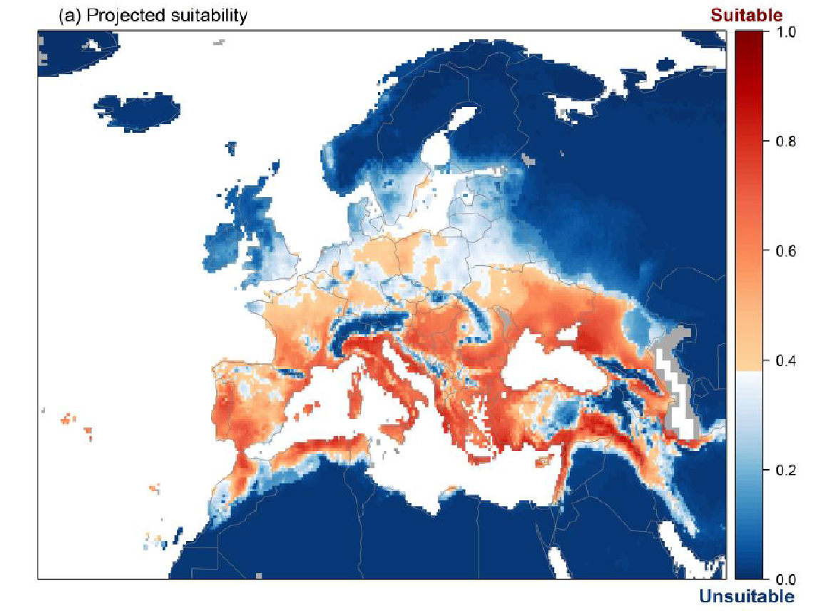
Figure 8 Projected current suitability for Broussonetia papyrifera establishment in Europe

According to the species distribution model (see Annex IV), large parts of the risk assessment area (compare Figure 8) are already suitable under current climatic conditions. The suitability declines in the North (Boreal biogeographical region) and Northwest regions of Europe.

Qu. 2.10. Estimate the overall likelihood of establishment in the risk assessment area under foreseeable climate change conditions. In addition, details of the likelihood of establishment in relevant biogeographical regions under foreseeable climate change conditions should be provided.
Thorough assessment of the risk of establishment in relevant biogeographical regions in foreseeable climate change conditions: explaining how foreseeable climate change conditions will influence this risk.
With regard to climate change, provide information on
- the applied timeframe (e.g. 2050/2070)
- the applied scenario (e.g. RCP 4.5)
- what aspects of climate change are most likely to affect the likelihood of establishment (e.g. increase in average winter temperature, increase in drought periods)
The thorough assessment does not have to include a full range of simulations on the basis of different climate change scenarios, as long as an assessment of likely establishment within a medium timeframe scenario (e.g. 30-50 years) with a clear explanation of the assumptions is provided. However, if new, original models are executed for this risk assessment, the following RCP pathways shall be applied: RCP 2.6 (likely range of 0.4-1.6°C global warming increase by 2065) and RCP 4.5 (likely range of 0.9-2.0°C global warming increase by 2065). Otherwise, the choice of the assessed scenario has to be explained.

RESPONSE | very unlikely  unlikely  moderately likely  likely  very likely | CONFIDENCE | low  medium  high

Response: Paper mulberry is already established in 8 EU Member States as well as in the Atlantic, Continental and Mediterranean biogeographical regions. Broussonetia papyrifera can tolerate a wide range of climates, including humid tropical (monsoon), humid and sub-humid subtropical as well as warm temperate areas (EPPO 2019; Whistler & Elevitch 2006). It can grow in areas with an annual rainfall of 700–2 500 mm (EPPO 2019; CABI 2020), though the species can survive a 3–4 month dry season (Whistler & Elevitch 2006). The climate change scenarios RCP 2.6 and RCP 4.5 indicate a higher suitability in the northern parts of Europe (compare Annex IX) by an increase in average winter temperature.

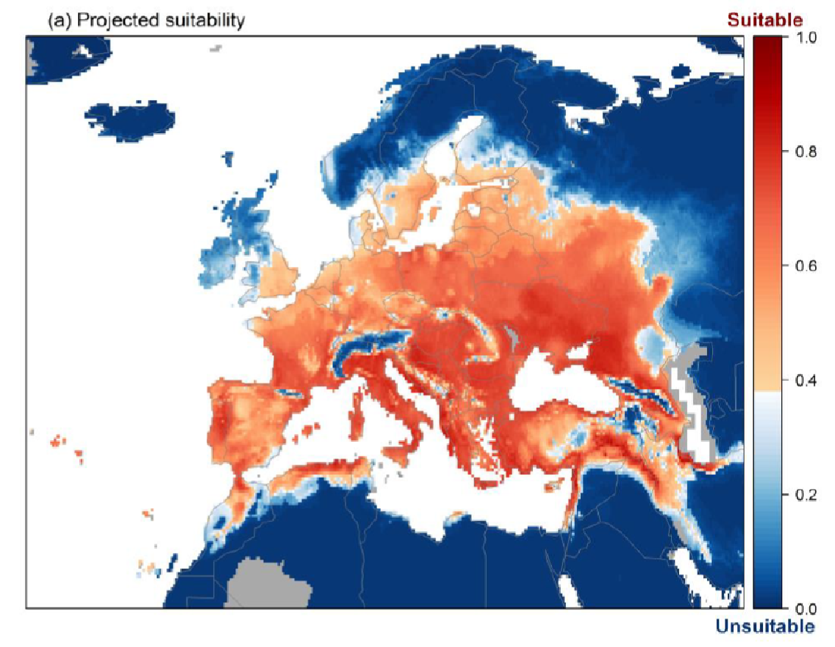
Figure 9 Projected suitability for Broussonetia papyrifera establishment in Europe
in the 2070s under climate change scenario RCP2.6
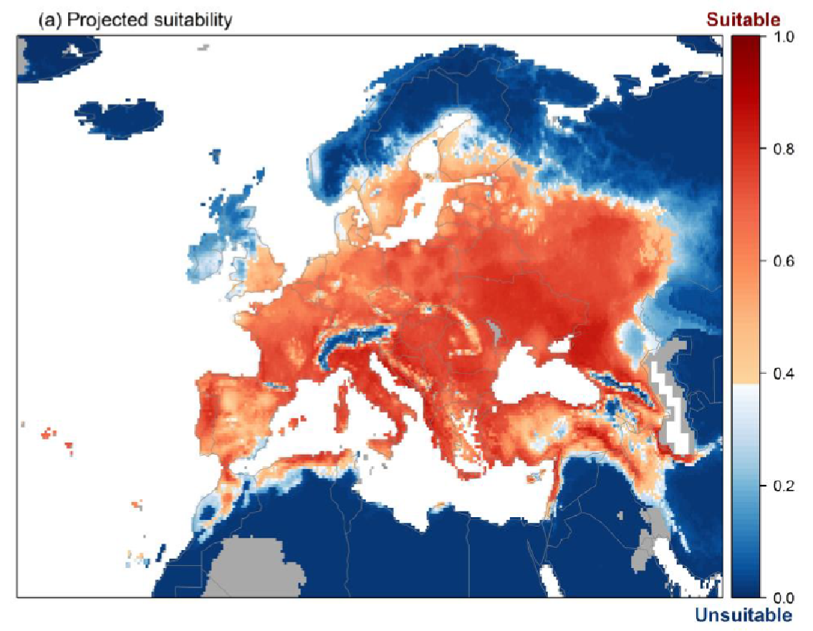
Figure 10 Projected suitability for Broussonetia papyrifera establishment
in Europe in the 2070s under climate change scenario RCP4.5

Both climate change scenarios RCP 2.6 and RCP 4.5 indicate a higher suitability in the northern and eastern parts of Europe (compare Annex IX) by an increase in average summer temperature as well low temperature in winter (Mean temperature of the warmest quarter - Bio10, Minimum temperature of the coldest month - Bio6). Boreal and Continental regions are affected by an increased climatic suitability for B. papyrifera.

3 PROBABILITY OF SPREAD
Important instructions:
- Spread is defined as the expansion of the geographical distribution of an alien species within the risk assessment area.
- Repeated releases at separate locations do not represent continuous spread and should be considered in the probability of introduction and entry section (Qu. 1.7).

Qu. 3.1. How important is the expected spread of this organism within the risk assessment area by natural means? (List and comment on each of the mechanisms for natural spread.)
including the following elements:
- a list and description of the natural spread mechanisms of the species in relation to the environmental conditions in the risk assessment area.
- an indication of the rate of spread discussed in relation to the species biology and the environmental conditions in the risk assessment area.
The description of spread patterns here refers to the CBD pathway category “Unaided (Natural Spread)”. It should include elements of the species life history and behavioural traits able to explain its ability to spread, including: reproduction or growth strategy, dispersal capacity, longevity, dietary requirements, environmental and climatic requirements, specialist or generalist characteristics.

RESPONSE | minimal  minor  moderate  major  massive | CONFIDENCE | low  medium  high

Response: The potential for natural dispersal is assessed as moderate with a medium confidence. References or figures of the spread rate of populations already established in the risk assessment area are not available.
Broussonetia papyrifera is dioecious. Thus, it needs male as well as female trees to produce seeds. Peñailillo et al. (2016) found that contemporary paper mulberry plants are all female in near and remote Oceania, with the exception of Hawaii, where plants of both sexes are found. Information about the sex distribution/ratio within the European occurrences is not available. If male and female plants are present, (long) to mid-range dispersal may occur via seeds as fruits are dispersed by birds and small mammals. Root suckers are produced when the main stem is cut. Over time, this can lead to the formation of dense thickets so clonal growth would allow slow spreading to some extent. Natural spread may occur as long as suitably disturbed habitats are available.

Qu. 3.2a. List and describe relevant pathways of spread other than "unaided". For each pathway answer questions 3.3 to 3.9 (copy and paste additional rows at the end of this section as necessary). Please attribute unique identifiers to each question if you consider more than one pathway, e.g. 3.3a, 3.4a, etc. and then 3.3b, 3.4b etc. for the next pathway.
including the following elements:
- a list and description of pathways of spread with an indication of their importance and associated risks (e.g. the likelihood of spread in the risk assessment area, based on these pathways; likelihood of survival, or reproduction, or increase during transport and storage; ability and likelihood of transfer from the pathway to a suitable habitat or host) in relation to the environmental conditions in the risk assessment area.
- an indication of the rate of spread for each pathway discussed in relation to the species biology and the environmental conditions in the risk assessment area.
- All relevant pathways of spread (except “Unaided (Natural Spread)”, which is assessed in Qu. 4.1) should be considered. The classification of pathways developed by the Convention of Biological Diversity shall be used (see Annex IV).

Table 10 list of spread pathways including relevant assessment and estimated rate of spread
Category pathways | Subcategory | relevance | rate of spread
Release in Nature | Biological control | No information has been found.
 | Erosion control / dune stabilization | No information has been found.
 | Landscape / flora / fauna "improvement" in the wild | No information has been found.
 | Introduction for conservation purposes | No information has been found.
 | Release in nature for use | No information has been found.
 | Other intentional release | No information has been found.
Escape from confinement | Agriculture | No information has been found.
 | Botanical garden | not relevant
 | Forestry | No information has been found.
 | Horticulture | relevant | slow
 | Ornamental purpose other than horticulture | relevant | slow
 | Research and ex-situ breeding | No information has been found.
 | Other escape from confinement | No information has been found.
Transport Containment | Seed contaminant | No information has been found.
 | Timber trade | No information has been found.
 | Transportation of habitat material | No information has been found.
Transport - Stowaway | Machinery / equipment | No information has been found.

Horticulture and ornamental purpose other than horticulture are considered as relevant spread pathways. Broussonetia papyrifera is unisexual and dioecious. Thus, it needs male as well as female trees to produce seeds. Along both pathways, male and female individuals are not always available. There is evidence in the literature of spreading and seed dispersal by birds and small mammals (e.g. fruit bats), though no particular bird or mammal species are mentioned, neither for regions outside of the risk assessment area nor for within the risk assessment area. The rate of reproduction and rate of spread are considered to be slow.
Pathway name: Horticulture
Qu. 3.3a. Is spread along this pathway intentional (e.g. the organism is deliberately transported from one place to another) or unintentional (e.g. the organism is a contaminant of translocated goods within the risk assessment area)?

RESPONSE | intentional  unintentional | CONFIDENCE | low  medium  high

Response: This spread pathway is unintentional. Nurseries and retailers are moving plants or seeds from site a to site b within the risk assessment area. Seeds may be lost while the nursery is transporting trees or seeds. Birds or mammals may disseminate seeds outside of the nurseries.

Qu. 3.4a. How likely is it that a number of individuals sufficient to originate a viable population will spread along this pathway from the point(s) of origin over the course of one year?
including the following elements:
- an indication of the propagule pressure (e.g. estimated volume or number of specimens, or frequency of passage through pathway), including the likelihood of reinvasion after eradication
- if appropriate, indicate the rate of spread along this pathway
- if appropriate, include an explanation of the relevance of the number of individuals for spread with regard to the biology of species (e.g. some species may not necessarily rely on large numbers of individuals).

RESPONSE | very unlikely  unlikely  moderately likely  likely  very likely | CONFIDENCE | low  medium  high

Response: Although the plant can be ordered online at local or regional tree nurseries in several EU member states as well as at online retailers, information on the number male as well as female trees are kept and sold are not available. The seed density may be locally very high, though in many cases low as they are young plants. The fruits of paper mulberry are consumed by birds and other small animals which are able to disseminate the seeds outside of horticulture. Root spread is very unlikely as they will be potted beforehand. In summary it is considered as very unlikely that a number of individuals sufficient to originate a viable population over the course of a year would be spread via this pathway.

Qu. 3.5a. How likely is the organism to survive, reproduce, or increase during transport and storage along the pathway (excluding management practices that would kill the organism)?

RESPONSE | very unlikely  unlikely  moderately likely  likely  very likely | CONFIDENCE | low  medium  high

Response: Reproduction during transport is very unlikely, though moderate likely during storage; while surviving is likely. The higher score is given.

Qu. 3.6a. How likely is the organism to survive existing management practices during spread?

RESPONSE | very unlikely  unlikely  moderately likely  likely  very likely | CONFIDENCE | low  medium  high

Response: Existing management practices related to this spread pathway could not prevent the entry into the environment of sufficient propagules for establishment. The confidence level is low, as no references or figures are available.

Qu. 3.7a. How likely is the organism to spread in the risk assessment area undetected?

RESPONSE | very unlikely  unlikely  moderately likely  likely  very likely | CONFIDENCE | low  medium  high

Response: Undetected dispersal of seeds by animals from a horticultural setting or of plant material during transport by nurseries into the environment may be possible.

Qu. 3.8a. How likely is the organism to be able to transfer from the pathway to a suitable habitat or host during spread?

RESPONSE | very unlikely  unlikely  moderately likely  likely  very likely | CONFIDENCE | low  medium  high

Response: Paper mulberry is considered to be a pioneer species adapted to colonize disturbed sites. The suitable habitats are disturbed, open sites generally, where there is relatively well-drained, moist, fertile soil. Such suitable habitats are unevenly spatially distributed. Furthermore, the plants are grown in protected conditions and correct disposal of plant waste may be applied. The transfer from the pathway to a suitable habitat is assessed as unlikely as all conditions above have to be fulfilled.

Qu. 3.9a. Estimate the overall potential rate of spread based on this pathway in relation to the environmental conditions in the risk assessment area. (please provide quantitative data where possible).

RESPONSE | very slowly  slowly  moderately  rapidly  very rapidly | CONFIDENCE | low  medium  high

Response: The overall potential rate of spread is assessed as very slow as all conditions mentioned in Qu. 3.8a have to be fulfilled.

Pathway name: Ornamental purpose other than horticulture
Qu. 3.3b. Is spread along this pathway intentional (e.g. the organism is deliberately transported from one place to another) or unintentional (e.g. the organism is a contaminant of translocated goods within the risk assessment area)?

RESPONSE | intentional  unintentional | CONFIDENCE | low  medium  high

Response: This spread pathway is unintentional. While maintaining garden stock (bushes and trees), plant materials like seeds and cuttings may be carelessly disposed of. Birds or mammals may disseminate seeds outside of the gardens. There is evidence in literature about spreading and seed dispersal by birds and small mammals (e.g. fruit bats), though no particular bird or mammal species is mentioned, neither for regions outside of the risk assessment area nor for the risk assessment area.

Qu. 3.4b. How likely is it that a number of individuals sufficient to originate a viable population will spread along this pathway from the point(s) of origin over the course of one year?
including the following elements:
- an indication of the propagule pressure (e.g. estimated volume or number of specimens, or frequency of passage through pathway), including the likelihood of reinvasion after eradication
- if appropriate, indicate the rate of spread along this pathway
- if appropriate, include an explanation of the relevance of the number of individuals for spread with regard to the biology of species (e.g. some species may not necessarily rely on large numbers of individuals).

RESPONSE | very unlikely  unlikely  moderately likely  likely  very likely | CONFIDENCE | low  medium  high

Response: Broussonetia papyrifera is unisexual and dioecious. It is unlikely that both, male and female, trees are planted in e.g. gardens in most cases. The fruits of paper mulberry are consumed by birds and other small animals which are able to disseminate the seeds outside of gardens and parks. Plant material may be disposed of to a small extent. In summary it is considered as very unlikely that a number of individuals sufficient to originate a viable population over the course of a year is spread via this pathway.

Qu. 3.5b. How likely is the organism to survive, reproduce, or increase during transport and storage along the pathway (excluding management practices that would kill the organism)?

RESPONSE | very unlikely  unlikely  moderately likely  likely  very likely | CONFIDENCE | low  medium  high

Response: It is very unlikely that the organism will survive, reproduce or increase during transport and storage along this pathway.

Qu. 3.6b. How likely is the organism to survive existing management practices during spread?

RESPONSE | very unlikely  unlikely  moderately likely  likely  very likely | CONFIDENCE | low  medium  high

Response: Existing management practices related to this spread pathways could not prevent the entry into the environment of sufficient propagules for establishment.

Qu. 3.7b. How likely is the organism to spread in the risk assessment area undetected?

RESPONSE | very unlikely  unlikely  moderately likely  likely  very likely | CONFIDENCE | low  medium  high

Response: Undetected dispersal of seeds by animals out of gardens or of plant material by gardeners’ disposal into the environment may be possible.

Qu. 3.8b. How likely is the organism to be able to transfer from the pathway to a suitable habitat or host during spread?

RESPONSE | very unlikely  unlikely  moderately likely  likely  very likely | CONFIDENCE | low  medium  high

Response: Paper mulberry is considered to be a pioneer species adapted to colonize disturbed sites. The habitats are disturbed, open sites generally, where there is relatively well-drained, moist, fertile soil. Such suitable habitats are unevenly spatially distributed. The transfer from the pathway to a suitable habitat is assessed as unlikely as all conditions above have to be fulfilled.

Qu. 3.9b. Estimate the overall potential rate of spread based on this pathway in relation to the environmental conditions in the risk assessment area. (please provide quantitative data where possible).

RESPONSE | very slowly  slowly  moderately  rapidly  very rapidly | CONFIDENCE | low  medium  high

Response: The overall potential rate of spread is assessed as very slow as all conditions mentioned in Qu. 3.8b have to be fulfilled.

Qu. 3.10. Within the risk assessment area, how difficult would it be to contain the organism in relation to these pathways of spread?

RESPONSE | very easy  easy  with some difficulty  difficult  very difficult | CONFIDENCE | low  medium  high

Response: Naturally dispersing organisms are difficult to contain, especially plants with pioneer character. Though, the removal of flowering trees could prevent further spread.

Qu. 3.11. Estimate the overall potential rate of spread in relevant biogeographical regions under current conditions for this organism in the risk assessment area (indicate any key issues and provide quantitative data where possible).
Thorough assessment of the risk of spread in relevant biogeographical regions in current conditions, providing insight in the risk of spread into (new areas in) the risk assessment area.

RESPONSE | very slowly  slowly  moderately  rapidly  very rapidly | CONFIDENCE | low  medium  high

Response: Broussonetia papyrifera is dioecious. If male and female plants are present, mid-range dispersal may occur via seeds as birds and small mammals disperse fruits. Information on sex distribution within the European occurrences is not available. Some of the member states with early observations from about 100 or more years ago and Atlantic / Mediterranean climatic conditions (e.g. France 1890, Italy 1923, Spain 1892) exhibit a wide distribution (see Figure 3). Paper mulberry is considered to be a pioneer species adapted to colonize disturbed sites. The habitats are disturbed, open sites generally, where there is relatively well-drained, moist, fertile soil. Such suitable habitats are unevenly spatially distributed.
The overall potential rate of spread under current conditions is assessed as “slowly” because all constraint conditions (i.e. male and female plant availability, animals disseminating fruits and seeds, suitable habitats in a sufficient quantity) have to be fulfilled. Information on the rate of spread within the risk assessment area could not be found.

Qu. 3.12. Estimate the overall potential rate of spread in relevant biogeographical regions in foreseeable climate change conditions (provide quantitative data where possible).
Thorough assessment of the risk of spread in relevant biogeographical regions in foreseeable climate change conditions: explaining how foreseeable climate change conditions will influence this risk, specifically if rates of spread are likely slowed down or accelerated.

RESPONSE | very slowly  slowly  moderately  rapidly  very rapidly | CONFIDENCE | low  medium  high

Response: The overall potential rate of spread is expected to remain “slowly” as all constraint conditions (i.e. male and female plant availability, animals disseminating fruits and seeds, suitable habitats in a sufficient quantity) have to be fulfilled, but this will likely apply to an even more extensive part of the risk assessment area due to favorable climatic conditions.

4 MAGNITUDE OF IMPACT
Important instructions:
- Questions 4.1-4.5 relate to biodiversity and ecosystem impacts, 4.6-4.8 to impacts on ecosystem services, 4.9-4.13 to economic impact, 4.14-4.15 to social and human health impact, and 4.16-4.18 to other impacts. These impacts can be interlinked, for example, a disease may cause impacts on biodiversity and/or ecosystem functioning that leads to impacts on ecosystem services and finally economic impacts. In such cases the assessor should try to note the different impacts where most appropriate, cross-referencing between questions when needed.
- Each set of questions starts with the impact elsewhere in the world, then considers impacts in the risk assessment area (=EU+UK, excluding outermost regions) separating known impacts to date (i.e. past and current impacts) from potential future impacts (including foreseeable climate change).
- Only negative impacts are considered in this section (socio-economic benefits are considered in Qu. A.7)
- In absence of specific studies or other direct evidences this should be clearly stated by using the standard answer “No information has been found on the issue”. This is necessary to avoid confusion between “no information found” and “no impact found”.

Biodiversity and ecosystem impacts
Qu. 4.1. How important is the impact of the organism on biodiversity at all levels of organisation caused by the organism in its non-native range excluding the risk assessment area?
including the following elements:
- Biodiversity means the variability among living organisms from all sources, including terrestrial, marine and other aquatic ecosystems and the ecological complexes of which they are part; this includes diversity within species, between species and of ecosystems
- impacted chemical, physical or structural characteristics and functioning of ecosystems

RESPONSE | minimal  minor  moderate  major  massive | CONFIDENCE | low  medium  high

Response: Broussonetia papyrifera is a recognized invader in many countries around the world. Much research has been done in sensitive habitats in Pakistan where is it considered to be “one of the most unwieldy woody exotics in the Himalayas foothills due to its adverse effect on the native vegetation” (Malik & Husain 2006) and was further reported as the most critical issue confronting the managers of the Margalla Hills National Park in that country. Malik & Husein (2006) also reported that the weed “has shown vigorous growth extending over large areas excluding many other plant species, so invaded areas have considerably lower richness and biodiversity of herbaceous as well as woody species”. In a thorough biodiversity study of 77 plots in and around Islamabad, Malik & Husein (2007) described the plant as a real threat to scrub forest floristic diversity because instead of small herbaceous vegetation, nothing else grows under the canopy of B. papyrifera. They observed at some plots a high density of B. papyrifera where vegetation is more or less undisturbed so it would seem capable of invading intact vegetation. In Pakistan, direct competition of B. papyrifera limits the growth of the native Dalbergia sissoo, Morus alba and Ziziphus sp., an important source of nectar for honey bees, especially near Islamabad and Rawalpindi. The thick monocultures at different sites have rapidly replaced the native flora and fauna, although these thickets have also become refuges for wild boar and other mammals, and enhanced the build-up of the crow population (CABI 2020). Qureshi et al. (2020a) demonstrated that B. papyrifera reduced the values of diversity indices in invaded plots compared to the control plots in 5 districts in Pakistan. The authors go on to state that this trend of decreased values of ecological indices is “similar to invasion studies on B. papyrifera from Australia, Argentina, Carolina, Columbia, Florida, Georgia, Louisiana, Maryland, North Carolina, Oklahoma, Pennsylvania, South Tennessee, Uganda and Virginia” where it is considered invasive in natural areas (see e.g Csurhes, 2016 and Ghersa et al, 2002).
In Ghana, B papyrifera has the ability to reduce the abundance of indigenous broadleaf forest species (Bosu et al. 2013). According to Agyeman & Kyereh (1997) and Agyeman (2000), paper mulberry is a major threat to native species regeneration and succession in Ghana’s forest ecosystems and is gradually establishing itself as one of the dominant species in the forest–savannah transition ecosystem. It is even able to displace Chromolaena odorata, a highly invasive species in Ghana (Bosu et al. 2013). In Uganda a recent study confirmed that areas that had been invaded by B. papyrifera had much lower diversity indices than the forest reserve which it is actively invading (Yamungu, 2020)
Ghersa et al. (2002) consider B. papyrifera to be one of the worst invasive species in Pampa grasslands in Argentina.
Given the fact that many of the examples listed are at significant scale and of high impact despite being technically reversible a score of major is given with medium confidence.

Qu. 4.2. How important is the current known impact of the organism on biodiversity at all levels of organisation (e.g. decline in native species, changes in native species communities, hybridisation) in the risk assessment area (include any past impact in your response)?
Discuss impacts that are currently occurring or are likely occurring or have occurred in the past in the risk assessment area. Where there is no direct evidence of impact in the risk assessment area (for example no studies have been conducted), evidence from outside of the risk assessment area can be used to infer impacts within the risk assessment area.

RESPONSE | minimal  minor  moderate  major  massive | CONFIDENCE | low  medium  high

Response: Broussonetia papyrifera is reported as invasive in the Lombardy and Piedmont and Ticino (Mangili et al. 2018) areas of Italy. The greatest environmental damage is reported to occur when it colonizes natural and semi-natural formations such as thermophilic forests and dry grasslands (Montagnani et al. 2018). In the framework of the Italian LIFE project LIFE03 NAT/IT/000119 dense stands of B. papyrifera have been highlighted as a clear menace to the conservation of Habitat 6210* (Semi-natural dry grasslands and scrubland facies on calcareous substrates - Festuco-Brometalia - *important orchid sites) so that are tackled in the management plan (Lasen et al. 2008).
Further, the species is listed as invasive in Croatia (Vuković et al. 2014, Borsic et al. 2008), Montenegro (Bulatovic et al. 2016). France has several reports of invasiveness including in the Auvergne-Rhône-Alpes (Pôle d'information flore-habitats-fonge d'Auvergne-Rhône-Alpes 2020) where it is also recorded as an emerging invasive (Debay et al. 2020) and it is listed as “one-to-watch” in the Pays de la Loire (Dortel & Le Bail 2019) and Provence Alpes-Côte d’Azur (Terrin et al. 2014).
Dana et al. (2001), in their assessment of plant invaders in Spain, recorded B. papyrifera on a checklist of species that are considered as highly invasive in other European countries and which may represent a potential threat for Spanish ecosystems.
According to Montagnani et al. (2018) the species creates monotypic populations that exclude other species, inhibiting their renewal and changing the light conditions on the ground. It is able to absorb large quantities of water, with negative effects on water availability for other plants
The score is moderate because of the limited evidence of any impact on biodiversity in the risk assessment area.

Qu. 4.3. How important is the potential future impact of the organism on biodiversity at all levels of organisation likely to be in the risk assessment area?
See comment above. The potential future impact shall be assessed only for the risk assessment area.

RESPONSE | minimal  minor  moderate  major  massive | CONFIDENCE | low  medium  high

Response: The tree is likely to continue to spread slowly and is more likely to displace native species as it has in other parts of the world, even though there is only limited evidence of impact in the risk assessment area as yet, so the score is assessed as major but confidence level is .

Qu. 4.4. How important is decline in conservation value with regard to European and national nature conservation legislation caused by the organism currently in the risk assessment area?
including the following elements:
- native species impacted, including red list species, endemic species and species listed in the Birds and Habitats directives
- protected sites impacted, in particular Natura 2000
- habitats impacted, in particular habitats listed in the Habitats Directive, or red list habitats
- the ecological status of water bodies according to the Water Framework Directive and environmental status of the marine environment according to the Marine Strategy Framework Directive

RESPONSE | minimal  minor  moderate  major  massive | CONFIDENCE | low  medium  high

Response: Only limited information has been found, and the species predominantly is found in areas that are impacted by humans. However, the threats to the goals of the Habitats Directive have been highlighted by the Italian LIFE project LIFE03 NAT/IT/000119.

Qu. 4.5. How important is decline in conservation value with regard to European and national nature conservation legislation caused by the organism likely to be in the future in the risk assessment area?
- See guidance to Qu. 4.4.

RESPONSE | minimal  minor  moderate  major  massive | CONFIDENCE | low  medium  high

Response: As there is no evidence of decline in conservation value in the risk assessment area, there is no baseline on which to extrapolate likely future impacts. It is likely that the tree will spread out from ruderal habitats especially along transport corridors and this is likely to increase the propagule pressure in natural and sensitive environments, much as it has in non-European invasions. Therefore these impacts are likely to become more significant in the future so a score of moderate with low confidence is given.

Ecosystem Services impacts
Qu. 4.6. How important is the impact of the organism on provisioning, regulating, and cultural services in its non-native range excluding the risk assessment area?
- For a list of services use the CICES classification V5.1 provided in Annex V.
- Impacts on ecosystem services build on the observed impacts on biodiversity (habitat, species, genetic, functional) but focus exclusively on reflecting these changes in relation to their links with socio-economic well-being.
- Quantitative data should be provided whenever available and references duly reported.

RESPONSE | minimal  minor  moderate  major  massive | CONFIDENCE | low  medium  high

Response: Qureshi et al. (2020a) refer to damaged ecosystem services due to Broussonetia invasion in Pakistan. It is believed to be allelopathic in the Philippines (Combalicer et al. 2019) which will have an impact on local biodiversity and succession , by affecting soil quality regulation provisioning biomass of wild plants. Further impacts on regulation services, specifically soil quality are through soil nutrient manipulation to its own benefit in Ghana (Kofi Anning et al. 2018). Additional evidence of soil quality regulation and local biodiversity comes from a recent study in India summarised that “the soil in highly invaded areas was more acidic with greater conductivity, phenolic content, and organic carbon content (Maan et al, 2021), but the authors go on to query whether B. papyrifera actually alters soil physico-chemical properties or prefers to inhabit soil with such characteristics.
Broussonetia papyrifera can affect provisioning for water as it is recorded as having the capability of massive water consumption, but also slowing the flow of water in channels and suppressing the growth of other plants. (CABI 2019). Additionally, the flow of most of the drains of Nallah Lai near Rawalpindi and Islamabad, Pakistan, are affected resulting in increased flood risks and impacting on Regulation of baseline flows and extreme events. Its shallow root system makes it susceptible to blowing over during high winds (Malik 2007), posing a hazard to people and causing slope erosion and further degradation of an area. It has a moderate impact score because the impacts are technically reversible and confidence is medium because the impact is more than minor with multiple aspects of provisioning affected but the supporting information could be better.

Qu. 4.7. How important is the impact of the organism on provisioning, regulating, and cultural services currently in the different biogeographic regions or marine sub-regions where the species has established in the risk assessment area (include any past impact in your response)?
- See guidance to Qu. 4.6.

RESPONSE | N/A  minimal  minor  moderate  major  massive | CONFIDENCE | low  medium  high

Response: According to Montagnani et al. (2018) the species creates monotypic populations that exclude other species, inhibiting their renewal and changing the light conditions on the ground. It is able to absorb large quantities of water, with negative effects on water availability for other plants. Therefore, the ecosystem services impacts of B. papyrifera include provisioning of water with local impacts on provisioning of biomass of wild plants with associated impacts on cultural ecosystem services in the category of cultural and experiential. The score is assessed as minor given that it is reported as forming monotypic populations that affect light and water thereby having significant ecosystem impact but since there is little direct assessment published and therefore confidence levels are low.

Qu. 4.8. How important is the impact of the organism on provisioning, regulating, and cultural services likely to be in the different biogeographic regions or marine sub-regions where the species can establish in the risk assessment area in the future?
- See guidance to Qu. 4.6.

RESPONSE | minimal  minor  moderate  major  massive | CONFIDENCE | low  medium  high

Response: There is limited evidence of impact thus far in the risk assessment area but in future conditions, impact on ecosystem services is likely to increase along with other impacts but perhaps not enough to be scored as moderate. Confidence is low because of the lack of published evidence.

Economic impacts
Qu. 4.9. How great is the overall economic cost caused by the organism within its current area of distribution (excluding the risk assessment area), including both costs of / loss due to damage and the cost of current management.
- Where economic costs of / loss due to the organism have been quantified for a species anywhere in the world these should be reported here. The assessment of the potential costs of / loss due to damage shall describe those costs quantitatively and/or qualitatively depending on what information is available. Cost of / loss due to damage within different economic sectors can be a direct or indirect consequence of the earlier-noted impacts on ecosystem services. In such case, please provide an indication of the interlinkage. As far as possible, it would be useful to separate costs of / loss due to the organism from costs of current management.

RESPONSE | minimal  minor  moderate  major  massive | CONFIDENCE | low  medium  high

Response: Quereshi et al. (2020) report choking of sewerage lines in urban set-up and increased crow population acting as seed dispersal vector. The mechanical removal of paper mulberry in Islamabad alone is several million rupees per year (Rashid et al. 2014) which equates to tens of thousands of euros per year. This economic impact appears low in a European setting as it was calculated from Pakistan data, but those costs would be much higher in a European country and management costs are also being incurred in the USA, but no figures were found.
Broussonetia papyrifera, as other invasive tree species, are reported as “not only reducing the land value and causing economic loss to agriculture communities, but are also a source of allergy and related health problems in Islamabad and Peshawar” (Marwat et al. 2010), though no detail is given on the nature and extent of the economic impact.

Qu. 4.10. How great is the economic cost of / loss due to damage (excluding costs of management) of the organism currently in the risk assessment area (include any past costs in your response)?
- Where economic costs of / loss due to the organism have been quantified for a species anywhere in the EU these should be reported here. Assessment of the potential costs of damage on human health, safety, and the economy, including the cost of non-action. A full economic assessment at EU scale might not be possible, but qualitative data or different case studies from across the EU (or third countries if relevant) may provide useful information to inform decision making. In absence of specific studies or other direct evidences this should be clearly stated by using the standard answer “No information has been found on the issue”. This is necessary to avoid confusion between “no information found” and “no impact found”. Cost of / loss due to damage within different economic sectors can be a direct or indirect consequence of the earlier-noted impacts on ecosystem services. In such case, please provide an indication of the interlinkage.

RESPONSE | N/A  minimal  minor  moderate  major  massive | CONFIDENCE | low  medium  high

Response: No information has been found on the issue but the question is applicable so a minimal score is given with low confidence.

Qu. 4.11. How great is the economic cost of / loss due to damage (excluding costs of management) of the organism likely to be in the future in the risk assessment area?
- See guidance to Qu. 4.10.

RESPONSE | minimal  minor  moderate  major  massive | CONFIDENCE | low  medium  high

Response: It is assumed that increased spread and associated impact will have a greater than 10,000 euro per year cost across the many countries that would be host to the plant, especially given its allergenic impacts, but confidence is low.

Qu. 4.12. How great are the economic costs / losses associated with managing this organism currently in the risk assessment area (include any past costs in your response)?
- In absence of specific studies or other direct evidences this should be clearly stated by using the standard answer “No information has been found on the issue”. This is necessary to avoid confusion between “no information found” and “no impact found”.

RESPONSE | minimal  minor  moderate  major  massive | CONFIDENCE | low  medium  high

Response: There is no evidence that any management is being undertaken in the risk assessment area.

Qu. 4.13. How great are the economic costs / losses associated with managing this organism likely to be in the future in the risk assessment area?
- See guidance to Qu. 4.12.

RESPONSE | minimal  minor  moderate  major  massive | CONFIDENCE | low  medium  high

Response: Due to the vigorous regrowth from cut stumps, vegetative root regeneration and seed dispersal, control using traditional methods is both labour intensive and costly with repeated applications needed to achieve a restored habitat. Manual removal (uprooting) and cutting coupled with an application of systemic herbicides have been shown to be effective in controlling shrub forms of the plant. Spread may be limited in the short term so a minor score is given with low confidence given the lack of current management figures in the area on which to build.

Social and human health impacts
Qu. 4.14. How important is social, human health or other impact (not directly included in any earlier categories) caused by the organism for the risk assessment area and for third countries, if relevant (e.g. with similar eco-climatic conditions).
The description of the known impact and the assessment of potential future impact on human health, safety and the economy, shall, if relevant, include information on
- illnesses, allergies or other affections to humans that may derive directly or indirectly from a species;
- damages provoked directly or indirectly by a species with consequences for the safety of people, property or infrastructure;
- direct or indirect disruption of, or other consequences for, an economic or social activity due to the presence of a species.
Social and human health impacts can be a direct or indirect consequence of the earlier-noted impacts on ecosystem services. In such case, please provide an indication of the interlinkage.

RESPONSE | minimal  minor  moderate  major  massive | CONFIDENCE | low  medium  high

Response: As far back as early 20th Century the allergenic pollen of B. papyrifera was recognized as a causal agent for respiratory problems like hay fever and asthma in sensitized patients (Bernton 1928; Balyeat & Rinkel 1931) particularly due to its vast pollen production (Velasco-Jiménez et al. 2014). Asthma leads to difficulty breathing whilst allergic rhinitis (hay fever) is a type of inflammation in the nose that occurs when the immune system overreacts to allergens in the air. Signs and symptoms include a runny or stuffy nose, sneezing, red, itchy, and watery eyes, and swelling around the eyes.
In Islamabad, Pakistan, B. papyrifera is the main source of airborne allergens (Malik & Husein 2007). Its pollen cause rhinitis and asthma in Pakistan (Qureshi et al. 2020a, 2020b) and it is a major cause of urticaria and severe respiratory symptoms (Aslam et al. 2015). Also in Taiwan (Hsu et al. 2008) it is an emerging aeroallergen associated with allergic illness (Wu et al. 2019). During 1995, the Pakistan Medical Research Council found more than 45% of the allergic patients in Islamabad and Rawalpindi showed positive sensitivity to pollen of B. papyrifera, and it was considered extremely important for pollen allergy tests not only because of allergenicity of its pollen, but also for the high quantity of pollen produced and pollen dispersibility (CABI 2019). A study in the same region showed a clear correlation between rate of patient admission for allergies with the flowering period of B. papyrifera (Ghufran et al. 2013), later supported also by a study by Qazi et al. (2019). There is a suggestion that the human reaction is triggered by two proteins of 40kdA which may lead to the development of immunological treatments (Aslam et al, 2015)
In addition, the growth and excessive root systems of B. papyrifera has impeded the flow of most of the drains of Nallah Lai near Rawalpindi and Islamabad, Pakistan, resulting in increased flood risks, and is considered to have assisted in the worst flood of the history in Rawalpindi where many people died or lost their homes (CABI 2019). Its shallow root system makes it susceptible to blowing over during high winds, posing a hazard to people and causing slope erosion and further degradation of an area (National Park Service 2010).
There is limited evidence of human impacts in the risk assessment areas apart from a report of pollenosis relating to Broussonetia in the hospital of Este (Zanforlin & Incorvaia, 2004). Despite this, the evidence from other countries shows that the human health impact is major.

Qu. 4.15. How important is social, human health or other impact (not directly included in any earlier categories) caused by the organism in the future for the risk assessment area.
- In absence of specific studies or other direct evidences this should be clearly stated by using the standard answer “No information has been found on the issue”. This is necessary to avoid confusion between “no information found” and “no impact found”.

RESPONSE | N/A  minimal  minor  moderate  major  massive | CONFIDENCE | low  medium  high

Response:
There is limited evidence of current allergies caused by the pollen of B. papyrifera in the risk assessment area bar one case in Italy (Zanforlin & Incorvaia, 2004). Broussonetia papyrifera pollen is under monitoring in Italy at the national level since 2019 with a recent study showing the highest levels in excess of 100 parts per m³ in Veneto in April 2019 (Arpa FVG report online) . The regional authority for environmental protection of the Tuscany region (ARPAT Toscana) states that so far pollen allergenicity in Italy is low, but the process needs to be monitored in consideration of what is known for other parts the world (ARPAT 2014). The few B papyrifera individuals recorded in a recent assessment in Brussels were not thought by the authors to play a role in pollinosis in the region (yet) (Aerts et al. 2021).
Broussonetia pollen could be confused with the one from Urticaceae species, so that there is some risk of underestimating its presence (http://www.pollnet.it/default_it.asp).

Other impacts
Qu. 4.16. How important is the organism in facilitating other damaging organisms (e.g. diseases) as food source, a host, a symbiont or a vector etc.?

RESPONSE | N/A  minimal  minor  moderate  major  massive | CONFIDENCE | low  medium  high

Response: Whilst there is no evidence of any facilitation of damaging organisms actually occurring in the risk assessment area, there are numerous species of plant damaging organisms present in the native range of the plant that could impact other species in the risk assessment area. Among the most serious pathogenic organisms of which B. papyrifera can being a carrier is the mulberry cerambicide, Apriona germani which can cause serious damage to several deciduous species (EPPO, 2014). In Japan the bacterial blight Pseudomonas syringe pv. broussonetiae affects paper mulberry (Whistler & Elevitch, 2006) as well as the spider mite Tetranichus piercei (Ohno at al. 2010). The fungi Phytophthora boehmeriae and Dendryphiella broussonetiae are also known to attack the plant (Berg 2003) but the host range of these pathogens are not fully known and may be limited.
In China the plant is known to host crown gall (Agrobacterium tumefaciens), which causes tumor-like growths on the plant (Whistler & Elevitch 2006; Li et al. 2015) as well as Candidatus phytoplasma asteris (Mei et al. 2016).
Paper Mulberry is identified as a known host of the citrus long-horned beetle Anoplophora chinensis (OEPP/EPPO (2013)) as well as the spotted lanternfly, Lycorma delicatula (EPPO, 2016). It is also a host of the cassava white peach scale Pseudaulacaspis pentagona in the Solomon Islands (Tsatsia & Jackson 2020). It is also on the host plant list for Xyllela fastidiosa (EFSA 2020).
The score of minor is given with low confidence as the impacts are hypothetical assuming the arrival of the other pests.

Qu. 4.17. How important might other impacts not already covered by previous questions be resulting from introduction of the organism?

RESPONSE | N/A  minimal  minor  moderate  major  massive | CONFIDENCE | low  medium  high

Response: No information has been found on the issue.

Qu. 4.18. How important are the expected impacts of the organism despite any natural control by other organisms, such as predators, parasites or pathogens that may already be present in the risk assessment area?

RESPONSE | minimal  minor  moderate  major  massive | CONFIDENCE | low  medium  high

Response: There are no known natural enemies that would significantly restrict its performance in the risk assessment area.

Qu. 4.19. Estimate the overall impact in the risk assessment area under current climate conditions. In addition, details of overall impact in relevant biogeographical regions should be provided.
Thorough assessment of the overall impact on biodiversity and ecosystem services, with impacts on economy as well as social and human health as aggravating factors, in current conditions.

RESPONSE | minimal  minor  moderate  major  massive | CONFIDENCE | low  medium  high

Response: At this stage of the invasion process the impact of B. papyrifera could be considered relatively minor as there are very few published studies on it. It is considered established in 8 Member States, and can be locally widespread but with only limited records of impacts on biodiversity, ecosystem services and social and human health so far. However, in other relevant biogeographical regions, it has a significant impact on biodiversity by invading not only disturbed ecosystems but also intact forest. Its effects on ecosystem services range from provisioning of wild plants through competition, shading and allelopathy to regulation services through changes in soil nutrients. It can have further provisioning effects on water through its massive water consumption which can reduce availability overall and the rate of flow in specific circumstances, but it can also have a regulating impact on water causing flooding by blocking invaded drainage channels. Given that it has serious impacts outside the risk assessment area and is relatively well-established within the overall impact can be considered moderate but confidence remains low given the lack of published studies in the risk assessment area.
Qu. 4.20. Estimate the overall impact in the risk assessment area in foreseeable climate change conditions. In addition, details of overall impact in relevant biogeographical regions should be provided.
Thorough assessment of the overall impact on biodiversity and ecosystem services, with impacts on economy as well as social and human health as aggravating factors, under future conditions.

RESPONSE | minimal  minor  moderate  major  massive | CONFIDENCE | low  medium  high

Response: Although the impact on biodiversity and ecosystem services could be assumed to be likely to increase significantly based on the experience in Pakistan, where only 30 years after a planting regime impacts were felt some B. papyrifera populations in Europe have been in place for a very long time without major reported problem. If populations do grow as more habitats become suitable for invasion, then direct competition for resources by this dominant tree will decrease biodiversity in invaded areas. The main impact is likely to be as an allergen impacting on human health in a similar way to Ambrosia artemisiifola. This could become a very serious issue, as it has in Pakistan and more recently emerging in Taiwan (Wu et al. 2019).

RISK SUMMARIES
 | RESPONSE | CONFIDENCE | COMMENT
Summarise Introduction and Entry* | very unlikely  unlikely  moderately likely  likely  very likely | low  medium  high | The main introduction and entry pathways are “escapes from confinement” (botanical garden, horticulture and ornamental purpose other than horticulture). Future climate change conditions may change the demand and availability of seeds, cuttings or trees by regional tree nurseries, especially in northern Europe.
Summarise Establishment* | very unlikely  unlikely  moderately likely  likely  very likely | low  medium  high | The paper mulberry is recorded in 19 EU Member states (plus UK) and established in 8. The species is recorded in the Alpine, Atlantic, Black Sea, Boreal, Continental, Mediterranean and Pannonian biogeographical regions and can be assessed as “established” (naturalized) in the Atlantic, Continental and Mediterranean biogeographical regions. The core areas are the Atlantic, Mediterranean and Continental region parts in Western Europe. The climate change scenarios RCP 2.6 and RCP 4.5 indicate a higher suitability to establish in the Northern and Eastern parts of Europe.
Summarise Spread* | very slowly  slowly  moderately  rapidly  very rapidly | low  medium  high | The overall potential rate of spread is expected to remain slowly as all constraint conditions (i.e. male and female plant availability, animals disseminating fruits and seeds, suitable habitats in a sufficient quantity) have to be fulfilled, but this will likely apply to an even more extensive part of the risk assessment area due to favourable climatic conditions.
Summarise Impact* | minimal  minor  moderate  major  massive | low  medium  high | Paper mulberry is considered a pioneer species adapted to colonize disturbed habitats. It exhibits a high reproductive potential, by means of both sexual and vegetative propagation. Root suckers are produced when the main stem is cut. Over time, this can lead to the formation of dense thickets. It is believed to be allelopathic (Combalicer et al. 2019) which will have an impact on local biodiversity and succession. Broussonetia papyrifera, as other invasive tree species is reported as not only reducing the land value and causing economic loss to agriculture communities, but is also a source of allergens which have a direct effect on people and exacerbate other pre-existing respiratory health problems. At this stage of the invasion process the impact of B. papyrifera appears to be minor. Regarding future climate scenarios: although the impact on biodiversity and ecosystem services is likely to increase as more regions become suitably for invasion, the main impact is likely to be as an allergen impacting on human health.  On the topic of biodiversity and ecosystems, the impact on biodiversity on all levels in the risk assessment area is assessed a moderate as the species is reported to invade natural and semi-natural formations such as thermophilic forests and dry grasslands (e.g. in Italy). It is likely that the tree will spread out from ruderal habitats especially along transport corridors and this is likely to increase the propagule pressure in natural and sensitive environments, much as it has in non-European invasions. If populations do grow as more habitats become suitable for invasion, then direct competition for resources by this dominant tree will decrease biodiversity in invaded areas. There is some evidence of current allergies caused by the pollen of B. papyrifera in the risk assessment area as one case in Italy.
Conclusion of the risk assessment  (overall risk) | low  moderate  high | low  medium  high | Broussonetia papyrifera is recorded in 19 (plus UK) and already established in 8 out of 27 EU member states. The species is recorded in the Alpine, Atlantic, Black Sea, Boreal, Continental, Mediterranean and Pannonian biogeographical regions and can be assessed as established in the Atlantic, Continental and Mediterranean biogeographical regions. The core areas are the Atlantic, Mediterranean and Continental region parts in Western Europe. Under future climate conditions, further establishment may be expected, especially in the Northern parts of Europe and to the Alpine biogeographical region to some extent. The main introduction and entry pathways are manmade (botanical garden, horticulture, ornamental purpose other than horticulture). Spread may occur from the introduction and entry pathways as well as from already established occurrences. Spread rate is considered as slow because all constraint conditions (i.e. male and female plant availability, animals disseminating fruits and seeds, suitable habitats in a sufficient quantity) have to be fulfilled. Impacts on biodiversity, ecosystem services and human health are known. Considering all aspects, Broussonetia papyrifera is assessed as a moderately risk species for the European Union.
*in current climate conditions and in foreseeable future climate conditions

REFERENCES
Adigbli, D.M., Anning, A.K., Adomako, J.K. & Fosu-Mensah, B.Y. (2019). Effects of Broussonetia papyrifera invasion and land use on vegetation characteristics in a tropical forest of Ghana. Journal of Forestry Research, 30, 1363-1373.
Aerts, R., Bruffaerts, N., Somers, B., Demoury, C., Plusquin, M., Nawrot, T. S., & Hendrickx, M. (2021). Tree pollen allergy risks and changes across scenarios in urban green spaces in Brussels, Belgium. Landscape and Urban Planning, 207, 104001.
Aeschimann, D. & Burdet, H.M. (1994). Flore de la Suisse, Ed. 2.
Aeschimann, D., Lauber, K., Moser, D.M. & Theurillat, J.-P. (2004). Flora alpina. Ein Atlas sämtlicher 4500 Gefäßpflanzen der Alpen. Haupt Verlag, Bern.
Ahmed, W., Qureshi, R., Munazir, M., Rahim, B.Z., Munir, M., Kousar, R., Maqsood, M., Abbas, Q., Qaseem, M.F., Khan, A.M, Iqbal, M. & Bhatti, M.I. (2019). Diversity and distribution of flora in Murree-Kotli Sattian-Kahutanational Park, Pakistan. Applied Ecology and Environmental Research, 17(4), 9621-9650.
ALA (2020). Broussonetia papyrifera (L.) L'Hér. ex Vent. Atlas of Living Australia. https://bie.ala.org.au/species/https://id.biodiversity.org.au/node/apni/2898957 [accessed 2020/05/06]
Anastasiu, P., Rozylowicz, L., Skolka, M., Preda, C., Memedemin, D. & Cogălniceanu, D. (2016). Alien species in Romania. In: Rat, M., Trichkova, T., Scalera, R., Tomov, R. & Uludag, A. (eds) State of the Art of Alien Species in South-Eastern Europe. ESENIAS Scientific Reports.
Apetorgbor, M.M. & Bosu, P. (2011). Occurrence and control of paper mulberry (Broussonetia papyrifera) in Southern Ghana. Ghana Journal of Forestry, 27, 40-51.
Arpa FVP Primo studio in Italia sulla distribuzione del polline di Broussonetia papyrifera http://www.snpambiente.it/2019/05/10/primo-studio-in-italia-sulla-distribuzione-del-polline-di-broussonetia-papyrifera/ [accessed 2020/09/15]
ARPAT (2014). Nel monitoraggio ARPAT dei pollini rilevata la presenza di Broussonetia. http://www.arpat.toscana.it/notizie/notizie-brevi/2014/nel-monitoraggio-arpat-dei-pollini-rilevata-la-presenza-di-broussonetia?searchterm=None [accessed 2021/09/03]
Aslam, M.S., Khalid, T., Gull, I., Abbas, Z. & Athar, M.A. (2015). Identification of major allergens of Paper Mulberry (Broussonetia papyrifera) pollens and purification of novel 40 kDa allergen protein. Current Allergy & Clinical Immunology, 28(1), 36-41.
Balyeat, R.M. & Rinkel, H.J. (1931). Distribution and importance of the paper mulberry as the cause of hay-fever and asthma in the United States. J. Allergy, 3, 7-15.
Banfi, E. & Galasso, G. (2010.) La flora esotica Lombarda. Regione Lombarda. Comune di Milano. Museo di Storia Naturale di Milano, 273 pp.
Barker, C. (2002). Plate 432. Broussonetia papyrifera. Curtis’s Bot. Magazine, 19(1), 8-18.
Bayόn, A. & Vilá, M. (2019). Horizon scanning to identify invasion risk of ornamental plants marketed in Spain. NeoBiota, 52, 47-86.
Berg, C.C. (2003). Broussonetia papyrifera (L.) L’Hér. ex Vent. Plant Resources of South-East Asia, (17), 91-95.
Bernton, H.S. (1928). Hayfever and asthma caused by the pollen of the paper mulberry. I. Lab. and Clin. Med., 13, 829.
BioNET-EAFRINET (2020). Broussonetia papyrifera (Paper Mulberry). https://keys.lucidcentral.org/keys/v3/eafrinet/weeds/key/weeds/Media/Html/Broussonetia_papyrifera_(Paper_Mulberry).htm [accessed 2020/05/25]
Borsic, I., Milović, M., Dujmović, I., Bogdanovic, S., Cigić, P., Rešetnik, I., Nikolić, T. & Mitic, B. (2008). Preliminary check-list of Invasive Alien Plant Species (IAS) in Croatia. Natura Croatica, 17, 55-71.
Bosu, P.P. & Apetorgor, M.M. (2020). Broussonetia papyrifera in Ghana: Its Invasiveness, Impact and Control attempts. http://www.fao.org/forestry/12727-05cfeb560c6c088dace7823f23aa22fb8.pdf [accessed 2020/05/27]
Bucalo, K. (2017). Broussonetia papyrifera - Georgia. Plant Risk Evaluator – PRE. Evaluation Report. 2017 Farm Bill PRE Project. https://pre.ice.ucdavis.edu/sites/default/files/pdf/farm_bill/PRE-4133.pdf [accessed 2020/05/18]
Bulatović, I., Hadžiablahović, S. & Roganović, D. (2016). Montenegro national report of invasive alien species. In: Rat, M., Trichkova, T., Scalera, R. Tomov, R. & Uludag, A. (eds) State of the Art of Alien Species in South-Eastern Europe. ESENIAS Scientific Reports.
CABI (2020). Broussonetia papyrifera. Datasheet. Invasive Species Compendium. Wallingford, UK. https://www.cabi.org/isc/datasheet/10017 [accessed 2020/03/18]
Capuana, M. (2020). A review of the performance of woody and herbaceous ornamental plants for phytoremediation in urban areas. iForest - Biogeosciences and Forestry, 13/2, 139-151.
Chang, C.-Sh., Liu, H.-L., Moncada, X., Seelenfreund, A., Seelenfreund, D. & Chung, K.-F. (2015). A holistic picture of Austronesian migrations revealed by phylogeography of Pacific paper mulberry. Proceedings of the National Academy of Sciences of the United States, 112, 13537-13542.
Chung, K., Kuo, W., Hsu, Y., et al. (2017). Molecular recircumscription of Broussonetia (Moraceae) and the identity and taxonomic status of B. kaempferi var. australis. Bot. Stud. 58, 11. https://doi.org/10.1186/s40529-017-0165-y
Combalicer, M.S., Carayugan, M.B.A. & Hernandez, J.O. (2019). Allelopathic Property of an Invasive Tree Broussonetia papyrifera (L.) LHer. ex Vent in its Introduced Range in Mount Makiling Forest Reserve, Philippines. Philippine Journal of Science, 148(4), 609-618.
Conti, F.K., Abbate, G., Alessandrini, A. & Blasi, C. (eds) (2005). An annotated checklist of the Italian vascular flora.
Crosti, R., Cascone, C. & Cipollaro, S. (2010). Use of a weed risk assessment for the Mediterranean region of Central Italy to prevent loss of functionality and biodiversity in agro-ecosystems. Biological Invasions, 12, 1607-1616. Doi: 10.1007/s10530-009-9573-6
Csurhes, St. (2016). Paper mulberry. Broussonetia papyrifera. Invasive plant risk assessment. Departement of Agriculture and Fisheries. Biosecurity Queensland. https://www.daf.qld.gov.au/__data/assets/pdf_file/0011/67898/IPA-Paper-Mulberry-Risk-Assessment.pdf [accessed 2020/05/06]
Dana, E.D., Sanz-Elorza, M. & Sobrino, E. (2001). Plant Invaders in Spain [Check-List]. Lazaroa, 22, 12.
Dana, E.D., Sanz-Elorza, M. & Sobrino, E. (2004). Plant invaders in Spain (check-list), 'the unwanted citizens'. http://www.ual.es/personal/edana/alienplants/checklist.pdf [accessed 2020/05/06]
Dawson, W., Mndolwa, A.S., Burslem, D.F.R.P. & Hulme, P.E. (2008). Assessing the risks of plant invasions arising from collections in tropical botanical gardens. Biodiversity and Conservation, 17(8), 1979-1995.
Debay, P., Legland T. & Pache G. (2020). Liste actualisée et hiérarchisée des espèces exotiques envahissantes, bilan de la problématique végétale invasive en Rhône-Alpes. Conservatoire botanique national alpin, 44 pp.
Dimitrou, I. & Rutz, D. (2015). Sustainable Short Rotation Coppice. A Handbook. SRCplus project (IEE/13/574). https://www.srcplus.eu/images/Handbook_SRCplus.pdf [accessed 2020/09/14]
Dortel, F. & Le Bail, J. (2019). Liste des plantes vasculaires invasives, potentiellement invasives et à surveiller en Pays de la Loire. Liste 2018. DREAL Pays de la Loire. Brest: Conservatoire botanique national de Brest, 37 pp.
Duplić A. & Vrdoljak V. (2016). Overview of the invasive alien species in Croatia. In: Rat, M., Trichkova, T., Scalera, R. Tomov, R. & Uludag, A. (2016). State of the Art of Alien Species in South-Eastern Europe. ESENIAS Scientific Reports.
EEA (2019). Ecosystem types of Europe 2012 - Full map (marine and terrestrial habitats) - version 3 revision 1, Feb. 2019 – spatial resolution 100x100m. https://sdi.eea.europa.eu/catalogue/biodiversity/api/records/faff2281-1fca-4548-89d8-c8ec0c507bc7 [accessed 2020/09/04]
EFSA (2020). Update of the Xylella spp. host plant database – systematic literature search up to 30 June 2019. https://doi.org/10.2903/j.efsa.2020.6114
Ellis, W.N. (2020). Broussonetia papyrifera. Paper mulberry. Plant Parasites of Europe. Leafminers, galls and fungi. https://bladmineerders.nl/host-plants/plantae/spermatopsida/angiosperma/eudicots/superrosids/rosids/fabids/rosales/moraceae/broussonetia/broussonetia-papyrifera/ [accessed 2020/07/10]
EPPO (2014). Apriona germari. EPPO Data sheets on quarantine pests. Bull. OEPP/EPPO Bull., 44(2), 155-158.
EPPO (2016). Pest risk analysis for Lycorma delicatula. EPPO, Paris.
EPPO (2019). Mini data sheet on Broussonetia papyrifera. European and Mediterranean Plant Protection Organization. https://gd.eppo.int/download/doc/1414_minids_BRNPA.pdf [accessed 2020/05/06]
EPPO (2020a). Invasive alien plants in Croatia. EPPO Reporting Service no. 09-2006 Num. article: 2006/194. https://gd.eppo.int/reporting/article-1243 [accessed 2020/10/02]
EPPO (2020b). A new publication on the exotic flora of Lombardia (Italy). EPPO Reporting Service no. 01-2011. Num. article: 2011/020. https://gd.eppo.int/reporting/article-62 [accessed 2020/10/02]
EPPO (2020c). Invasive alien plants along roadsides in Europe. EPPO Reporting Service no. 06-2018. Num. article: 2018/131. https://gd.eppo.int/reporting/article-6325 [accessed 2020/10/02]
EPPO (2020d). Invasion risk of ornamental plants marketed in Spain. EPPO Reporting Service no. 11-2019. Num. article: 2019/246. https://gd.eppo.int/reporting/article-6676 [accessed 2020/10/02]
Essl, F. (2006). Bemerkenswerte floristische Funde aus Wien, Niederösterreich, dem Burgenland und der Steiermark, Teil IV. Linzer Biol. Beitr. 38/2: 1071-1103.
Essl, F. (2008). Bemerkenswerte floristische Funde aus Wien, Niederösterreich, dem Burgenland und der Steiermark, Teil V. Linzer Biol. Beitr. 40/1: 341-369.
Euro+Med (2006-). Euro+Med PlantBase - the information resource for Euro-Mediterranean plant diversity. http://ww2.bgbm.org/EuroPlusMed/ [accessed 2020/03/18].
FAO (1980). Pulping and paper-making properties of fast-growing plantation wood species. Food and Agriculture Organization, Forestry Department. 2 vols. FAO Forestry Paper, No. 19, 472 + 392 pp.
Fischer, M.A., Oswald, K. & Adler, W. (2008). Exkursionsflora für Österreich, Liechtenstein und Südtirol. 3. Auflage. Biologiezentrum der Oberösterr. Landesmuseen, Linz.
Follak, S., Eberius, M., Essl, F., Fürdös, A., Sedlacek, N. & Trognitz, F. (2018). Invasive alien plants along roadsides in Europe. EPPO Bulletin, 48, 256-265. https://doi.org/10.1111/epp.12465
Galasso, G., Conti, F., Peruzzi, L., Ardenghi, N.M.G., Banfi, E., Celesti-Grapow, L., Albano, A., Alessandrini, A., Bacchetta, G., Ballelli, S., Bandini Mazzanti, M., Barberis, G., Bernardo, L., Blasi, C., Bouvet, D., Bovio, M., Cecchi, L., Del Guacchio, E., Domina, G., Fascetti, S., Gallo, L., Gubellini, L., Guiggi, A., Iamonico, D., Iberite, M., Jiménez-Mejías, P., Lattanzi, E., Marchetti, D., Martinetto, E., Masin, R.R., Medagli, P., Passalacqua, N.G., Peccenini, S., Pennesi, R., Pierini, B., Podda, L., Poldini, L., Prosser, F., Raimondo, F.M., Roma-Marzio, F., Rosati, L., Santangelo, A., Scoppola, A., Scortegagna, S., Selvaggi, A., Selvi, F., Soldano, A., Stinca, A., Wagensommer, R.P., Wilhalm, T. & Bartolucci, F. (2018). An updated checklist of the vascular flora alien to Italy, Plant Biosystems 152: 556-592. https://doi.org/10.1080/11263504.2018.1441197
Ghafoor, A. (1985). Flora of Pakistan, No. 171, Moraceae. University Karachi, Department of Botany, and National Herbarium (Stewart Collection), Pakistan Agricultural Research Council, Islamabad, Pakistan.
Ghersa, C. M., de la Fuente, E., Suarez, S., & Leon, R. J. (2002). Woody species invasion in the Rolling Pampa grasslands, Argentina. Agriculture, ecosystems & environment, 88(3), 271-278.
Ghufran, M.A., Hamid, N., Ali, A. & Ali, S.M. (2013). Prevalence of allergenic pollen grains in the city of Islamabad, Pakistan and its impact on human health. Pak. J. Bot., 45, 1387-1390.
Goliašová, K. & Michalková, E. (eds) (2006). Flóra Slovenska V/3. Veda, Bratislava.
González-Lorca, J., Rivera-Hutinel, A., Moncada, X., Lobos, S., Seelenfreund, D. & Seelenfreund, A. (2015). Ancient and modern introduction of Broussonetia papyrifera ([L.] Vent.; Moraceae) into the Pacific: genetic, geographical and historical evidence. NZ J. Bot. 53, 75-89. https://doi.org/10.1080/0028825X.2015.1010546
Greuter, W., Burdet, H. M. & Long, G. (1989). Med-checklist: a critical inventory of vascular plants of the circum-mediterranean countries = inventaire critique des plantes vasculaires des pays circumméditerranéens. 4, 4. Genève, Conservatoire et Jardin botaniques.
Gruppo di Lavoro Specie Esotiche della Regione Piemonte (a cura del) (2015). Scheda monografica Broussonetia papyrifera. Regione Piemonte, Torino. https://www.regione.piemonte.it/web/sites/default/files/media/documenti/2019-02/Broussonetia%20papyrifera.pdf [accessed 2020/09/14]
Haysom, K.A. & Murphy, S.T. (2003). The status of invasiveness of forest tree species outside their natural habitat: a global review and discussion paper. Forest Health and Biosecurity Working Paper FBS/3E. Forestry Department. FAO, Rome (unpublished).
HEAR (2020). Broussonetia papyrifera. Risk assessment results. Pacific Island Ecosystems at Risk (PIER). Hawaiian Ecosystems at Risk project (HEAR). http://www.hear.org/pier/wra/pacific/broussonetia_papyrifera_htmlwra.htm [accessed 2020/03/18]
Hess, H.E. (1998). Bestimmungsschlüssel zur Flora der Schweiz und angrenzender Gebiete, Ed. 4.
Heywood, V.H. & Sharrock, S. (2013). European Code of Conduct for Botanic Gardens on Invasive Alien Species. Council of Europe, Strasbourg, Botanic Gardens Conservation International, Richmond.
Huang, H., Zhao, Y., Xu, Z., Zhang, W. & Kangkang, J. (2019). Physiological responses of Broussonetia papyrifera to manganese stress, a candidate plant for phytoremediation. Ecotoxicology and Environmental Safety, 181, 18-25.
Huston, M.A. (2004). Management strategies for plant invasions: manipulating productivity, disturbance, and competition. Divers. Distrib. 10, 167-178. https://doi.org/10.1111/j.1366-9516.2004.00083.x.
Hussain, K., Shahazad, A. & Zia-ul-Hussnain, S. (2008). An Ethnobotanical Survey of Important Wild Medicinal Plants of Hattar District Haripur, Pakistan. Ethnobotanical Leaflets, 2008/1, Article 5.
Hsu, N.Y., Lin, W.P., Wang, J.Y., Wu, P.C. & Su, H.J. (2008). Allergenic Potential of Broussonetia papyrifera Pollens Prevalent in the Atmosphere of Southern Taiwan. Epidemiology, 19(6), S373-S374.
IPNI (2020a). Broussonetia papyrifera (L.) Vent., Tabl. Regn. Vég. 3: 547 (1799). International Plant Names Index. https://www.ipni.org/n/850861-1 [accessed 2020/03/18]
IPNI (2020b). Tableau du Règne Végétal, Selon de Méthode de Jussieu. Paris. https://www.ipni.org/p/10266-2 [accessed 2020/03/18]
Kang, W., Bao, J., Zheng, J., Xu, F. & Wang, L. (2018). Phytoremediation of heavy metal contaminated soil potential by woody plants on Tonglushan ancient copper spoil heap in China. International Journal of Phytoremediation, 20/1, 1-7.
Khan, A., Ahmed, M., Ahmed, F., Saeed, R. & Siddiqui, F. (2020). Vegetation of highly disturbed conifer forests around Murree, Pakistan. Turk. J. Biod., 3(2), 43-53. https://doi.org/10.38059/biodiversity.708154.
Király G. (szerk.) (2009). Új magyar füvészkönyv. Magyarország hajtásos növényei. Határozókulcsok. [New Hungarian Herbal. The Vascular Plants of Hungary. Identification key.] . Aggteleki Nemzeti Park Igazgatóság, Jósvafõ. 628 pp.
Kofi Anning, A., Gyamfi, B. & Tima Effah, A. (2018). Broussonetia papyrifera controls nutrient return to soil to facilitate its invasion in a tropical forest of Ghana. Journal of Plant Ecology, 11, 909-918.
Kyereh, B., Agyeman, V.K. & Bebrese, I.K. (2014). Ecological Characteristics That Enhance Broussonetia papyrifera ’s Invasion in a Semideciduous Forest in Ghana. Journal of Ecosystems 2014, 6 pp. http://dx.doi.org/10.1155/2014/270196
Lasen, C., Minelli, A., Rallo, G., Turin, P. & Viola, F. (2008). Progetto LIFE03 NAT/IT/000119. Salvaguardia di habitat di interesse ecologico nei Colli Euganei. Piano di Gestione.
Li, T., Zhang, Y. & van Achterberg, K. (2015). A new species of subgenus Neodoryctes Szépligeti (Hymenoptera, Braconidae) from China, with a key to Oriental and Palaearctic species. Journal of Hymenoptera Research, 46, 107.
Liao, S.X., Deng, Z.H., Cui, K., Cui, Y.Z. & Zhang, C.H. (2014). Genetic diversity of Broussonetia papyrifera populations in southwest China. Genetics and Molecular Research 13 (3): 7553-7563.
Lin, C.-N., Lu, C.-M., Lin, H.-C., Fang, S.-C., Shieh, B.J., Hsu, M.-F., Wang, J.-P., Ko, F.-N. & Teng, C.M. (1996). Novel Antiplatelet Constituents from Formosan Moraceous Plants. Journal of Natural Products, 59/9, 834-838.
Linnaeus, C. (1753). Species plantarum, exhibentes plantas rite cognitas, ad genera relatas, cum differentiis specificis, nominibus trivialibus, synonymis selectis, locis natalibus, secundum systema sexuale digestas, vol .1. Salvius, Stockholm
Lu, C.M., Hu, T.W. & Liu, C.C. (1984). Study on variation in Broussonetia papyrifera - variation in the average number of days for germination and growth of seedlings under different nursery conditions. Bulletin, Taiwan Forestry Research Institute, No. 431, 21 pp.
Lu, C.M. (1985). Study on the variations of Broussonetia papyrifera (3). Variations of bark color and sexuality segregations of open pollinated seedlings from various seed-lots. Bulletin, Taiwan Forestry Research Institute, No. 452, 11 pp.
Luna, R.K. (1996). Plantation trees. Delhi, India: International Book Distributors.
Maan, I., Kaur, A., Pal Singh, H., Batish, D.R., Ravinder Kumar Kohli, R. (2020). Evaluating the role of phenology in managing urban invasions: A case study of Broussonetia papyrifera. Urban Forestry & Urban Greening, 48, 126583. DOI: https://doi.org/10.1016/j.ufug.2020.126583
Maan, I., Kaur, A., Singh, H. P., Batish, D. R., & Kohli, R. K. (2021). Exotic avenue plantations turning foe: Invasive potential, distribution and impact of Broussonetia papyrifera in Chandigarh, India. Urban Forestry & Urban Greening, 59, 127010.
Malik, R.N. & Husain, S.Z. (2006). Classification and ordination of vegetation communities of the Lohibehr reserve forest and its surrounding areas, Rawalpindi, Pakistan. Pakistan Journal of Botany, 38(3), 543.
Malik, R.N., & Husain, S.Z. (2007). Broussonetia papyrifera (L.) L'hér. Ex Vent.: an environmental constraint on the himalayan foothills vegetation. Pakistan Journal of Botany, 39(4), 1045.
Mangili, S., Schoenenberger, N., Marazzi, B., Selldorf, P. & Frey, D. (2018). Note floristiche ticinesi 2018: Specie vegetali esotiche spontanee nuove per la Svizzera e per il Cantone Ticino. Bollettino della Società ticinese di scienze naturali, 106, 35-42.
Marwat, K.B., Hashim, S. & Ali, H. (2010). Weed management: a case study from north-west Pakistan. Pak. J. Bot, 42, 341-353.
Matthews, P.J. (1996). Ethnobotany, and the origins of Broussonetia papyrifera in Polynesia: An essay on tapa prehistory. Oceanic Culture History: Essays in Honour of Roger Green, eds Davidson JM, Irwin G, Leach BF, Pawley A, Brown D (New Zealand Journal of Archaeology Special Publication, Dunedin, New Zealand), 117-132.
Mei, C., Wang, Q., Gui, J., Ji, Y. & Yu, H. (2016). Molecular identification of ‘Candidatus phytoplasma asteris’ related strain (16SrΙ-B) associated with Broussonetia papyrifera in Nanjing, China. European Journal of Plant Pathology, 145, 203-207.
Mifsud, St. (2020). Broussonetia papyrifera (Paper Mulberry). Wild Plants of the Mediterranean Islands of Malta. http://www.maltawildplants.com/MORA/Broussonetia_papyrifera.php [accessed 2020/05/07]
Mitίc, B., Dobrović, I., Boršić, I., Milović, M., Bogdanović, S., Cigić, P., Rešetnik, I. & Nikolić, T. (2006). Croatian botanical standards for IAS prevention and monitoring. In: From Ecology to Conservation. 4th European Conference on Biological Invasions. Vienna (Austria), 2006-09-27/29, BfN-Skripten 184: 194.
Montagnani, C., Gentili, R. & Citterio S. (2018). Broussonetia papyrifera. In: Bisi, F. et al. (eds) Strategia di azione e degli interventi per il controllo e la gestione delle specie alloctone in Regione Lombardia.
Morgan, E.C., Overholt, W.A. & Sellers, B. (2019). Wildland Weeds: Paper Mulberry, Broussonetia papyrifera. ENY-702, Series of the Entomology and Nematology Department, Florida Cooperative Extension Service. Institute of Food and Agricultural Sciences, University of Florida. https://edis.ifas.ufl.edu/pdffiles/IN/IN49800.pdf [accessed 2020/05/07]
Nagodă E., Comănescu, P. & Anastasiu, P. (2014). Dimitriebrandza Botanic Garden, potential centre for the dispersal of invasive plants? Acta Horti Bot. Bucurest, 41, 13-40.
National Park Service (2010). Plant Invaders of Mid-Atlantic Natural Areas, 4th ed.
Nikolić, T. (ed.) (1994). Flora Croatica. Index Florae Croaticae 1. Croatian Natural History Museum Zagreb.
Ohno, S., Miyagi, A., Ganaha-Kikumura, T., Gotoh, T., Kijima, K., Ooishi, T., Moromizato, C., Haraguchi, D., Yonamine, K. & Uezato, T. (2010). Non-crop host plants of Tetranychus spider mites (Acari: Tetranychidae) in the field in Okinawa, Japan: determination of possible sources of pest species and inference on the cause of peculiar mite fauna on crops. Applied Entomology & Zoology, 45, 465-475.
OEPP/EPPO (2013). EPPO Standard PM 9/16 (1) Anoplophora chinensis: procedures for official control. Bulletin OEPP/EPPO Bulletin 43, 518–526.
Payacan, C., Moncada, X., Rojas, G., Clarke, A., Chung, K.-F., Allaby, R., Seelenfreund, D., & Seelenfreund, A (2017). Phylogeography of herbarium specimens of asexually propagated paper mulberry [Broussonetia papyrifera (L.) L’Hér. ex Vent. (Moraceae)] reveals genetic diversity across the Pacific. Annals of Botany, Volume 120, Issue 3, 387–404. https://doi.org/10.1093/aob/mcx062
Peng, X., Liu, H., Chen, P., Tang, F., Hu, Y., Wang, F., Pi, Z., Zhao, M., Chen, N., Chen, H., Zhang, X., Yan, X., Liu, M., Fu, X., Zhao, G., Yao, P., Wang, L., Dai, H., Li, X., Xiong, W., Xu, W., Zheng, H., Yu, H., & Shen S. (2019). A Chromosome-Scale Genome Assembly of Paper Mulberry (Broussonetia papyrifera) Provides New Insights into ItsForage and Papermaking Usage. Mol. Plant.12, 661–677.
Peñailillo, J., Olivares, G., Moncada, X., Payacán, C., Chang, C.S., Chung, K.F., Matthews, P.J., Seelenfreund, A. & Seelenfreund, D. (2016). Sex Distribution of Paper Mulberry (Broussonetia papyrifera) in the Pacific. PloS ONE, 11(8), e0161148. https://doi.org/10.1371/journal.pone.0161148
Petrova, A., Vladimirov, V. & Georgiev, V. (2013). Invasive Alien Species of Vascular Plants in Bulgaria. Institute of Biodiversity and Ecosystem Research, Bulgarian Academy of Science, Sofia. 320 pp.
Plants of the World online (2020). Broussonetia papyrifera (L.) L'Hér. ex Vent. http://www.plantsoftheworldonline.org/taxon/urn:lsid:ipni.org:names:850861-1 [accessed 2020/09/14]
Pôle d'information flore-habitats-fonge d'Auvergne-Rhône-Alpes (2020). Broussonetia papyrifera (L.) Vent., 1799. https://pifh.fr/donnees/fiche_descriptive/OuvrirFicheDescriptive/86817-0 [accessed 2020/09/14]
Pollack, F.G. & Stevenson, J.A. (1973). A fungal pathogen of Broussonetia papyrifera collected by George Washington Carver. Plant Disease Reporter, 57, 296-297.
Portale della Flora d'Italia (2020). Broussonetia papyrifera (L.) Vent. http://dryades.units.it/floritaly/index.php?procedure=taxon_page&tipo=all&id=289 [accessed 2020/09/14]
POWO (2020). Broussonetia papyrifera (L.) L'Hér. Ex. Plants of the World Online. Facilitated by the Royal Botanic Gardens, Kew. http://powo.science.kew.org/taxon/urn:lsid:ipni.org:names:850861-1 [accessed 2020/05/14]
Qazi, S., Iqbal, J., & Khan, J.A. (2019). Assessment of the health impact of paper mulberry (Broussonetia papyrifera L.), an invasive plant species in Islamabad, Pakistan. Geospatial health, 14(2), DOI: 10.4081/gh.2019.727
Qureshi, H., Anwar, T., Fatima, S., Akhtar, S., Khan, S., Waseem, M., Mohibullah, M., Shirani, M., Riaz, S. & Azeem, M. (2020a). Invasion Impact Analysis of Broussonetia papyrifera in Pakistan. Polish Journal of Environmental Studies, 29(4), 2825-2831. https://doi.org/10.15244/pjoes/111320
Qureshi, H., Anwar, T., Khan, S., Fatimah, H., & Waseem, M. (2020b). Phytochemical constituents of Broussonetia papyrifera (L.) LʹHeʹr. ex Vent: An overview. J. Indian Chem. Soc, 97, 55.
Rashid, M., Abbas, S.H. & Rehman, A. (2014). The status of highly alien invasive plants in Pakistan and their impact on the ecosystem: a review. Innov. J. Agric. Sci., 2, 1-4.
Rat, M., Simonović, P., Glavendekić, M., Paunović, M., Stojanović, V., Karaman, M., Radisic, D. & Anačkov, G. (2016). Overview of the invasive alien species in Serbia. In: Rat, M., Trichkova, T., Scalera, R. Tomov, R. & Uludag, A. (2016). State of the Art of Alien Species in South-Eastern Europe. ESENIAS Scientific Reports.
Rawlins, K.A., Winston, R.L., Bargeron, C.T., Moorhead, D.J. & Carroll., R. (2018). New Invaders of the Northeast and Northcentral United States. USDA Forest Service, Forest Health Assessment and Applied Sciences Team, Morgantown, West Virginia. FHTET-2017-04.
Saito, K. Linquist, B., Keobualapha, B., Shiraiwa, T. & Horie, T. (2009). Broussonetia papyrifera (paper mulberry): its growth, yield and potential as a fallow crop in slash-and-burn upland rice system of northern Laos. Agroforest. Syst., 76: 525-532.
Sarver, M.J., Treher, A., Wilson, L., Naczi, R. & Kuehn, F.B. (2008). Mistaken Identity? Invasive Plants and their Native Look-Alikes: an Identification Guide fort the Mid-Atlantic. Dover, Delaware Departement of Agriculture and USDA Natural Resources Conservation Service.
Schoenenberger, N., Röthlisberger, J. & Carraro, G. (2014). La flora esotica del Cantone Ticino (Svizzera). Bollettino della Società ticinese di scienze naturali, 102, p. 13-3.
Seelenfreund, D., Piña, R., Ho, K.-Y., Lobos, S., Moncada, X. & Seelenfreund, A. (2011). Molecular analysis of Broussonetia papyrifera (L.) Vent. (Magnoliophyta: Urticales) from the Pacific, based on ribosomal sequences of nuclear DNA, New Zealand Journal of Botany, 49:3, 413-420.
Seelenfreund, A., Rivera, A., Rojas, G., Riquelme, I., Moncada, X. & Seelenfreund, D. (2017). On the biology and history of paper mulberry (Broussonetia papyrifera) in Oceania. In: Charleux, M (Ed.) Tapa, de l'écore à l'étoffe, art millénaire d'Océanie. De l'Asie du Sud-Est à la Polynésie orientale/Tapa, From Tree bark to Cloth, An Ancient Art of Oceania, From Southeast Asia to Eastern Polynesia, Paris, Somogy-TAPA Ed., 2017.
Sheikh, M.I. (1993). Trees of Pakistan. GOP-USAID Forestry Planning and Development Project. Islamabad, Pakistan: Pictorial Printers (Pvt.) Ltd.
Sîrbu, C. & Oprea, A. (2011). Plante adventive în flora României. Iaşi: Edit. “Ion Ionescu de la Brad”. 733 pp.
Stešević, D. & Petrović, D. (2010). Preliminary list of plant invaders in Montenegro. Biologica Nyssana 1: 35-42.
Stöhr, O., Pilsl, P., Staudinger, M., Kleesadl, G., Essl, F., Englisch, Th., Lugmair, A. & Wittmann, H. (2012): Beiträge zur Flora von Österreich, IV. Stapfia, 53-136.
Strid, A. & Tan, K. (1997). Flora Hellenica. Vol. 1. Koeltz Scientific Books, Königstein, 547 pp.
Swearingen, J.M. (2009). Paper mulberry. National Park Service, Washington, http://www.nps.gov/plants/alien/fact/brpa1.htm
Tanasombat, M., Okabayashi, Y., Sakurai, K., Thaiutsa, B., Thammincha, S. & Suekeaw, P. (2005). Silvicultural performance of paper mulberry in Thailand. Tropics, 14, 149-162.
Tavzes, B. (2016). Overview of the invasive alien species information and activities in Slovenia. In: Rat, M., Trichkova, T., Scalera, R. Tomov, R. & Uludag, A. (2016). State of the Art of Alien Species in South-Eastern Europe. ESENIAS Scientific Reports.
Tela Botanica (2020). Broussonetia papyrifera (L.) Vent. https://www.tela-botanica.org/bdtfx-nn-11280-synthese [accessed 2020/03/18]
Terrin, E., Diadema, K., & Fort, N. (2014). Stratégie régionale relative aux espèces végétales exotiques envahissantes en Provence-Alpes-Côte d’Azur et son plan d’actions. Rapport inédit, CBNMed, 337.
The Plant List (2013). Broussonetia papyrifera (L.) L'Hér. ex Vent. Version 1.1. Published on the Internet http://theplantlist.org/tpl1.1/record/kew-2683772 [accessed 2020/03/18]
The Plant List (2020). Tableau du Règne Végétal, Selon de Méthode de Jussieu. Paris. https://www.ipni.org/p/10266-2 [accessed 2020/03/18]
Tsatsia, H. & Jackson, G. (2020). Cassava white peach scale (052). Pacific Pests and Pathogens - Fact Sheets. http://www.pestnet.org/fact_sheets/cassava_white_peach_scale_052.htm [accessed 2020/03/18]
Tutin, T.G., Heywood, V.H., Burges, N.A., Valentine, D.H., Walters, S.M. & Webb, D.A. (eds.) (1964-1980). Flora europaea 1-5. Cambridge University Press Cambridge.
Tzvelev, N.N. (Ed.) (2004). Flora Europae Orientalis, Volume 11.
USDA (2020). Broussonetia papyrifera (L.) L'Hér. ex Vent. - paper mulberry. United States Department of Agriculture, Natural Resources Conservation Status. https://plants.usda.gov/core/profile?symbol=BRPA4 [accessed 2020/09/24]
Velasco-Jiménez, M.J., Alcázar, P., Valle, A., Trigo, M.M., Minero, F., Domínguez-Vilches, E. & Galán, C. (2014). Aerobiological and ecological study of the potentially allergenic ornamental plants in south Spain. Aerobiologia, 30(1), 91-101.
Vangjeli, J. (2017). Flora Albanica. Atlas. Volume I: Pteridophyta-Apiaceae. Koeltz Botanical Books. Watt, G. (1972). Dictionary of the economic products of India. Vol. I. Dehra Dun, India: Periodical Experts.
Varga, I. (2016). Report on invasive alien species in Hungary. In: Rat, M., Trichkova, T., Scalera, R. Tomov, R. & Uludag, A. (2016). State of the Art of Alien Species in South-Eastern Europe. ESENIAS Scientific Reports.
Waarneming.nl (2021). Broussonetia papyrifera (L.) L'Hér. ex Vent. Stichting Observation International and local partners.
https://waarneming.nl/species/137595/observations/?after_date=2000-08-30&before_date=2020-08-29&province=&search=&user=&location=&sex=&life_stage=&activity=&method=
[accessed 2021/0/03]
Whistler, W.A. & Elevitch, C.R. (2006). Broussonetia papyrifera (paper mulberry), ver. 2.1. In: Elevitch, C.R. (Ed.) Species Profiles for Pacific Island Agroforestry. Permanent Agriculture Resources (PAR), Holuala, Hawai’i. http://www.traditionaltree.org [accessed 2020/03/18].
Watt, G. (1972). Dictionary of the economic products of India. Vol. I. Dehra Dun, India: Periodical Experts.
Witt, A. (2010). Biofuels and invasive species from an African perspective – a review. GCB Bioenergy, 2, 321-329. doi:10.1111/j.1757-1707.2010.01063.x
Witt, A. & Luke, Qu. (2017). Guide to the naturalized and invasive plants of eastern Africa. CABI, Wallingford, UK, 608 pp.
Witt, A., Beale, T. & van Wilgen, B.W. (2018). An assessment of the distribution and potential ecological impacts of invasive alien plant species in eastern Africa. Transactions of the Royal Society of South Africa, 73:3, 217-236. DOI: 10.1080/0035919X.2018.1529003
Won, H. (2019). Test of the hybrid origin of Broussonetia × kazinoki (Moraceae) in Korea using molecular markers. Korean Journal of Plant Taxonomists, 49(4), 282-293.
Wu, P.C., Su, H.J., Lung, S.C.C., Chen, M.J., & Lin, W.P. (2019). Pollen of Broussonetia papyrifera: An emerging aeroallergen associated with allergic illness in Taiwan. Science of The Total Environment, 657, 804-810.
Yamungu, A. B. B. (2020). Influence of Paper Mulberry Presence on Native Tree Species in Mabira Central Forest Reserve in Uganda. Open Access Library Journal, 7(09), 1. Article ID:103204,12 pages. DOI: 10.4236/oalibj.2020.79399
Zanforlin, M. & Incorvaia, C. (2004). A case of pollinosis to Broussonetia papyrifera. Allergy, 59(10), 1136.
Zenetos, A., Arianoutsou, M. & Baritaki, Ch. (2016). Overview of non-indigenous species in Greece. In: Rat, M., Trichkova, T., Scalera, R. Tomov, R. & Uludag, A. (2016). State of the Art of Alien Species in South-Eastern Europe. ESENIAS Scientific Reports.

Distribution Summary
Please answer as follows:
Yes if recorded, established or invasive
– if not recorded, established or invasive
? Unknown; data deficient

The columns refer to the answers to Questions A5 to A12 under Section A.
For data on marine species at the Member State level, delete Member States that have no marine borders. In all other cases, provide answers for all columns.

Member States and the United Kingdom

 | Recorded | Established (currently) | Possible establishment (under current climate) | Possible establishment (under foreseeable climate) | Invasive (currently)
Austria | Yes | - | - | Yes | -
Belgium | Yes | - | - | Yes | -
Bulgaria | Yes | - | Yes | Yes | -
Croatia | Yes | Yes | Yes | Yes | -
Cyprus | ? | - | Yes | Yes | -
Czech Republic | - | - | - | Yes | -
Denmark | Yes | - | - | Yes | -
Estonia | - | - | - | Yes | -
Finland | - | - | - | - | -
France | Yes | Yes | Yes | Yes | -
Germany | Yes | - | - | Yes | -
Greece | Yes | Yes | Yes | Yes | -
Hungary | Yes | - | Yes | Yes | -
Ireland | - | - | - | - | -
Italy | Yes | Yes | Yes | Yes | -
Latvia | - | - | - | Yes | -
Lithuania | - | - | - | Yes | -
Luxembourg | - | - | - | Yes | -
Malta | Yes | Yes | Yes | Yes | -
Netherlands | Yes | - | - | Yes | -
Poland | Yes | - | - | Yes | -
Portugal | Yes | - | Yes | Yes | -
Romania | Yes | Yes | Yes | Yes | -
Slovakia | Yes | - | - | Yes | -
Slovenia | Yes | - | Yes | Yes | -
Spain | Yes | Yes | Yes | Yes | -
Sweden | - | - | - | Yes | -
United Kingdom | Yes | - | - | Yes

Biogeographical regions of the risk assessment area

 | Recorded | Established (currently) | Possible establishment (under current climate) | Possible establishment (under foreseeable climate) | Invasive (currently)
Alpine | Yes | - | - | Yes | -
Atlantic | Yes | Yes | Yes | Yes | -
Black Sea | Yes | - | Yes | Yes | -
Boreal | Yes | - | - | Yes | -
Continental | Yes | Yes | Yes | Yes | -
Mediterranean | Yes | Yes | Yes | Yes | -
Pannonian | Yes | - | Yes | Yes | -
Steppic | - | - | Yes | Yes | -

ANNEX I Scoring of Likelihoods of Events
(taken from UK Non-native Organism Risk Assessment Scheme User Manual, Version 3.3, 28.02.2005)

Score | Description | Frequency
Very unlikely | This sort of event is theoretically possible, but is never known to have occurred and is not expected to occur | 1 in 10,000 years
Unlikely | This sort of event has occurred somewhere at least once in the last millenium | 1 in 1,000 years
Moderately Likely | This sort of event has occurred somewhere at least once in the last century | 1 in 100 years
Likely | This sort of event has happened on several occasions elsewhere, or on at least once in the last decade | 1 in 10 years
Very likely | This sort of event happens continually and would be expected to occur | Once a year

ANNEX II Scoring of Magnitude of Impacts
(modified from UK Non-native Organism Risk Assessment Scheme User Manual, Version 3.3, 28.02.2005)

Score | Biodiversity and ecosystem impact | Ecosystem Services impact | Economic impact (Monetary loss and response costs per year) | Social and human health impact, and other impacts
 | Question 5.1-5 | Question 5.6-8 | Question 5.9-13 | Question 5.14-18
Minimal | Local, short-term population loss, no significant ecosystem effect | No services affected | Up to 10,000 Euro | No social disruption. Local, mild, short-term reversible effects to individuals.
Minor | Some ecosystem impact, reversible changes, localised | Local and temporary, reversible effects to one or few services | 10,000-100,000 Euro | Significant concern expressed at local level. Mild short-term reversible effects to identifiable groups, localised.
Moderate | Measureable long-term damage to populations and ecosystem, but reversible; little spread, no extinction | Measureable, temporary, local and reversible effects on one or several services | 100,000-1,000,000 Euro | Temporary changes to normal activities at local level. Minor irreversible effects and/or larger numbers covered by reversible effects, localised.
Major | Long-term irreversible ecosystem change, spreading beyond local area | Local and irreversible or widespread and reversible effects on one / several services | 1,000,000-10,000,000 Euro | Some permanent change of activity locally, concern expressed over wider area. Significant irreversible effects locally or reversible effects over large area.
Massive | Widespread, long-term population loss or extinction, affecting several species with serious ecosystem effects | Widespread and irreversible effects on one / several services | Above 10,000,000 Euro | Long-term social change, significant loss of employment, migration from affected area. Widespread, severe, long-term, irreversible health effects.

ANNEX III Scoring of Confidence Levels
(modified from Bacher et al. 2017)

Each answer provided in the risk assessment must include an assessment of the level of confidence attached to that answer, reflecting the possibility that information needed for the answer is not available or is insufficient or available but conflicting.

The responses in the risk assessment should clearly support the choice of the confidence level.

Confidence level | Description
Low | There is no direct observational evidence to support the assessment, e.g. only inferred data have been used as supporting evidence and/or Impacts are recorded at a spatial scale which is unlikely to be relevant to the assessment area and/or Evidence is poor and difficult to interpret, e.g. because it is strongly ambiguous and/or The information sources are considered to be of low quality or contain information that is unreliable.
Medium | There is some direct observational evidence to support the assessment, but some information is inferred and/or Impacts are recorded at a small spatial scale, but rescaling of the data to relevant scales of the assessment area is considered reliable, or to embrace little uncertainty and/or The interpretation of the data is to some extent ambiguous or contradictory.
High | There is direct relevant observational evidence to support the assessment (including causality) and Impacts are recorded at a comparable scale and/or There are reliable/good quality data sources on impacts of the taxa and The interpretation of data/information is straightforward and/or Data/information are not controversial or contradictory.

ANNEX IV CBD pathway categorisation scheme
Overview of CBD pathway categorisation scheme showing how the 44 pathways relate to the six main pathway categories. All of the pathways can be broadly classified into 1) those that involve intentional transport (blue), 2) those in which the taxa are unintentionally transported (green) and 3) those where taxa moved between regions without direct transportation by humans and/or via artificial corridors (orange and yellow). Note that the pathways in the category “Escape from confinement” can be considered intentional for the introduction into the risk assessment area and unintentional for the entry into the environment. 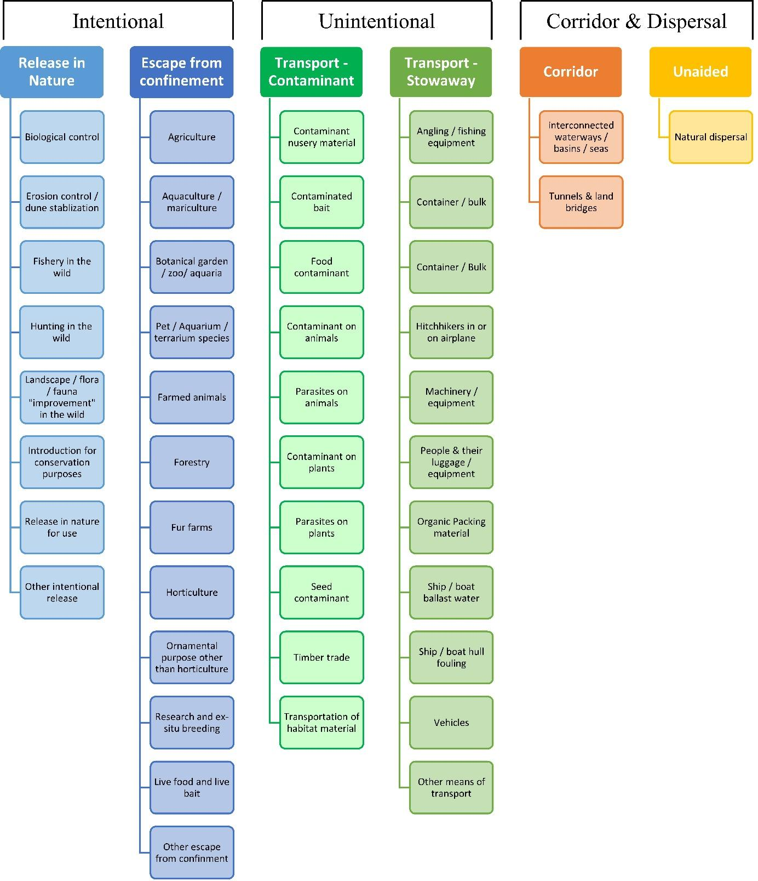

ANNEX V Ecosystem services classification (CICES V5.1, simplified) and examples
For the purposes of this risk assessment, please feel free to use what seems as the most appropriate category / level / combination of impact (Section – Division – Group), reflecting information available.

Section | Division | Group | Examples (i.e. relevant CICES “classes”)
Provisioning | Biomass | Cultivated terrestrial plants | Cultivated terrestrial plants (including fungi, algae) grown for nutritional purposes;  Fibres and other materials from cultivated plants, fungi, algae and bacteria for direct use or processing (excluding genetic materials);  Cultivated plants (including fungi, algae) grown as a source of energy  Example: negative impacts of non-native organisms to crops, orchards, timber etc.
 |  | Cultivated aquatic plants | Plants cultivated by in- situ aquaculture grown for nutritional purposes;  Fibres and other materials from in-situ aquaculture for direct use or processing (excluding genetic materials);  Plants cultivated by in- situ aquaculture grown as an energy source.  Example: negative impacts of non-native organisms to aquatic plants cultivated for nutrition, gardening etc. purposes.
 |  | Reared animals | Animals reared for nutritional purposes;  Fibres and other materials from reared animals for direct use or processing (excluding genetic materials);  Animals reared to provide energy (including mechanical)  Example: negative impacts of non-native organisms to livestock
 |  | Reared aquatic animals | Animals reared by in-situ aquaculture for nutritional purposes;  Fibres and other materials from animals grown by in-situ aquaculture for direct use or processing (excluding genetic materials);  Animals reared by in-situ aquaculture as an energy source  Example: negative impacts of non-native organisms to fish farming
 |  | Wild plants (terrestrial and aquatic) | Wild plants (terrestrial and aquatic, including fungi, algae) used for nutrition;  Fibres and other materials from wild plants for direct use or processing (excluding genetic materials);  Wild plants (terrestrial and aquatic, including fungi, algae) used as a source of energy  Example: reduction in the availability of wild plants (e.g. wild berries, ornamentals) due to non-native organisms (competition, spread of disease etc.)
 |  | Wild animals (terrestrial and aquatic) | Wild animals (terrestrial and aquatic) used for nutritional purposes;  Fibres and other materials from wild animals for direct use or processing (excluding genetic materials);  Wild animals (terrestrial and aquatic) used as a source of energy  Example: reduction in the availability of wild animals (e.g. fish stocks, game) due to non-native organisms (competition, predations, spread of disease etc.)
 | Genetic material from all biota | Genetic material from plants, algae or fungi | Seeds, spores and other plant materials collected for maintaining or establishing a population;  Higher and lower plants (whole organisms) used to breed new strains or varieties;  Individual genes extracted from higher and lower plants for the design and construction of new biological entities  Example: negative impacts of non-native organisms due to interbreeding
 |  | Genetic material from animals | Animal material collected for the purposes of maintaining or establishing a population;  Wild animals (whole organisms) used to breed new strains or varieties;  Individual genes extracted from organisms for the design and construction of new biological entities  Example: negative impacts of non-native organisms due to interbreeding
 | Water | Surface water used for nutrition, materials or energy | Surface water for drinking;  Surface water used as a material (non-drinking purposes);  Freshwater surface water, coastal and marine water used as an energy source  Example: loss of access to surface water due to spread of non-native organisms
 |  | Ground water for used for nutrition, materials or energy | Ground (and subsurface) water for drinking;  Ground water (and subsurface) used as a material (non-drinking purposes);  Ground water (and subsurface) used as an energy source  Example: reduced availability of ground water due to spread of non-native organisms and associated increase of ground water consumption by vegetation.
Regulation & Maintenance | Transformation of biochemical or physical inputs to ecosystems | Mediation of wastes or toxic substances of anthropogenic origin by living processes | Bio-remediation by micro-organisms, algae, plants, and animals; Filtration/sequestration/storage/accumulation by micro-organisms, algae, plants, and animals  Example: changes caused by non-native organisms to ecosystem functioning and ability to filtrate etc. waste or toxics
 |  | Mediation of nuisances of anthropogenic origin | Smell reduction; noise attenuation; visual screening (e.g. by means of green infrastructure)  Example: changes caused by non-native organisms to ecosystem structure, leading to reduced ability to mediate nuisances.
 | Regulation of physical, chemical, biological conditions | Baseline flows and extreme event regulation | Control of erosion rates;  Buffering and attenuation of mass movement;  Hydrological cycle and water flow regulation (Including flood control, and coastal protection);  Wind protection;  Fire protection  Example: changes caused by non-native organisms to ecosystem functioning or structure leading to, for example, destabilisation of soil, increased risk or intensity of wild fires etc.
 |  | Lifecycle maintenance, habitat and gene pool protection | Pollination (or 'gamete' dispersal in a marine context);  Seed dispersal;  Maintaining nursery populations and habitats (Including gene pool protection)  Example: changes caused by non-native organisms to the abundance and/or distribution of wild pollinators; changes to the availability / quality of nursery habitats for fisheries
 |  | Pest and disease control | Pest control;  Disease control  Example: changes caused by non-native organisms to the abundance and/or distribution of pests
 |  | Soil quality regulation | Weathering processes and their effect on soil quality;  Decomposition and fixing processes and their effect on soil quality  Example: changes caused by non-native organisms to vegetation structure and/or soil fauna leading to reduced soil quality
 |  | Water conditions | Regulation of the chemical condition of freshwaters by living processes;  Regulation of the chemical condition of salt waters by living processes  Example: changes caused by non-native organisms to buffer strips along water courses that remove nutrients in runoff and/or fish communities that regulate the resilience and resistance of water bodies to eutrophication
 |  | Atmospheric composition and conditions | Regulation of chemical composition of atmosphere and oceans;  Regulation of temperature and humidity, including ventilation and transpiration  Example: changes caused by non-native organisms to ecosystems’ ability to sequester carbon and/or evaporative cooling (e.g. by urban trees)
Cultural | Direct, in-situ and outdoor interactions with living systems that depend on presence in the environmental setting | Physical and experiential interactions with natural environment | Characteristics of living systems that that enable activities promoting health, recuperation or enjoyment through active or immersive interactions;  Characteristics of living systems that enable activities promoting health, recuperation or enjoyment through passive or observational interactions  Example: changes caused by non-native organisms to the qualities of ecosystems (structure, species composition etc.) that make it attractive for recreation, wild life watching etc.
 |  | Intellectual and representative interactions with natural environment | Characteristics of living systems that enable scientific investigation or the creation of traditional ecological knowledge;  Characteristics of living systems that enable education and training;  Characteristics of living systems that are resonant in terms of culture or heritage;  Characteristics of living systems that enable aesthetic experiences  Example: changes caused by non-native organisms to the qualities of ecosystems (structure, species composition etc.) that have cultural importance
 | Indirect, remote, often indoor interactions with living systems that do not require presence in the environmental setting | Spiritual, symbolic and other interactions with natural environment | Elements of living systems that have symbolic meaning;  Elements of living systems that have sacred or religious meaning;  Elements of living systems used for entertainment or representation  Example: changes caused by non-native organisms to the qualities of ecosystems (structure, species composition etc.) that have sacred or religious meaning
 |  | Other biotic characteristics that have a non-use value | Characteristics or features of living systems that have an existence value;  Characteristics or features of living systems that have an option or bequest value  Example: changes caused by non-native organisms to ecosystems designated as wilderness areas, habitats of endangered species etc.

ANNEX VI EU Biogeographic Regions and MSFD Subregions
See https://www.eea.europa.eu/data-and-maps/figures/biogeographical-regions-in-europe-2 ,
http://ec.europa.eu/environment/nature/natura2000/biogeog_regions/

and

https://www.eea.europa.eu/data-and-maps/data/msfd-regions-and-subregions-1/technical-document/pdf
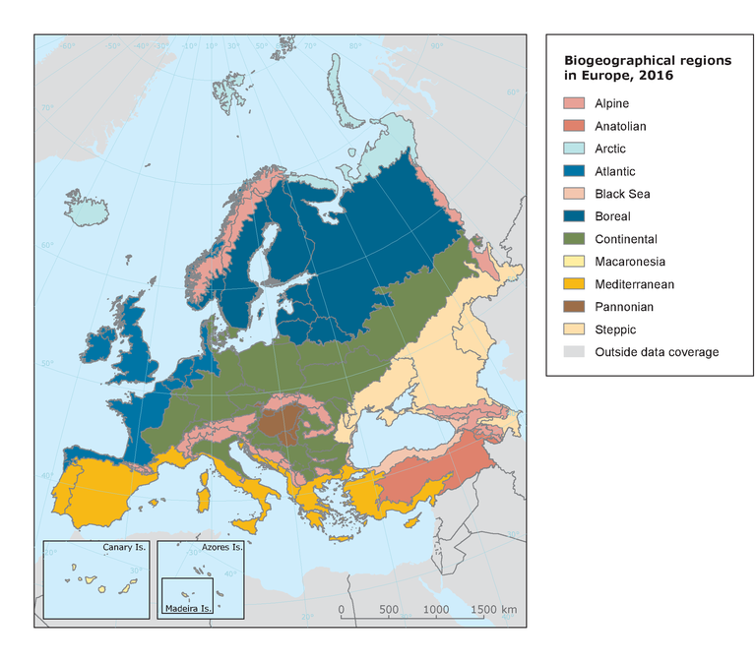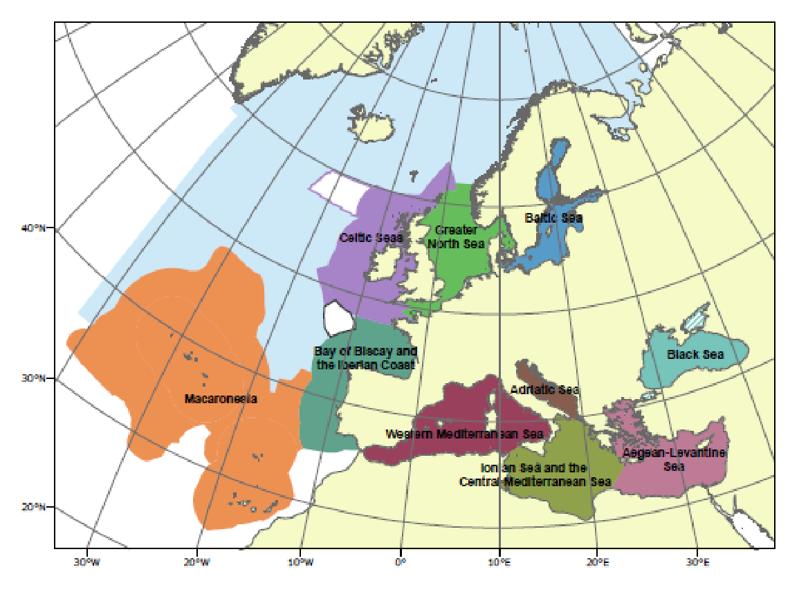

ANNEX VII Delegated Regulation (EU) 2018/968 of 30 April 2018
see https://eur-lex.europa.eu/legal-content/en/TXT/?uri=CELEX%3A32018R0968

ANNEX VIII Species distribution model
Projection of climatic suitability for Broussonetia papyrifera establishment in Europe

Björn Beckmann, Helmut Kudrnovsky, Richard Shaw, David Paternoster and Dan Chapman
10 October 2020
Aim
To project the suitability for potential establishment of Broussonetia papyrifera in Europe, under current and predicted future climatic conditions.
Data for modelling
Species occurrence data were obtained from the Global Biodiversity Information Facility (GBIF) (8684 records), iNaturalist (5474 records), the Biodiversity Information Serving Our Nation database (BISON) (259 records), and additional records from the risk assessment team. We classified records as native- and invaded-range according to the CABI Invasive Species Compendium. We scrutinised occurrence records from regions where the species is not known to be established and removed any which may not refer to populations currently established in the wild (e.g. museum specimens, records from botanical gardens) or where the georeferencing was too imprecise (e.g. records referenced to a country or island centroid) or outside of the coverage of the predictor layers (e.g. small island or coastal occurrences). The remaining records were gridded at a 0.25 x 0.25 degree resolution for modelling, yielding 1773 grid cells with occurrences (Figure 1a). As a proxy for recording effort, the density of Tracheophyta records held by GBIF was also compiled on the same grid (Figure 1b).

Figure 1. (a) Occurrence records obtained for Broussonetia papyrifera and used in the modelling, showing native and invaded distributions. (b) The recording density of Tracheophyta on GBIF, which was used as a proxy for recording effort.
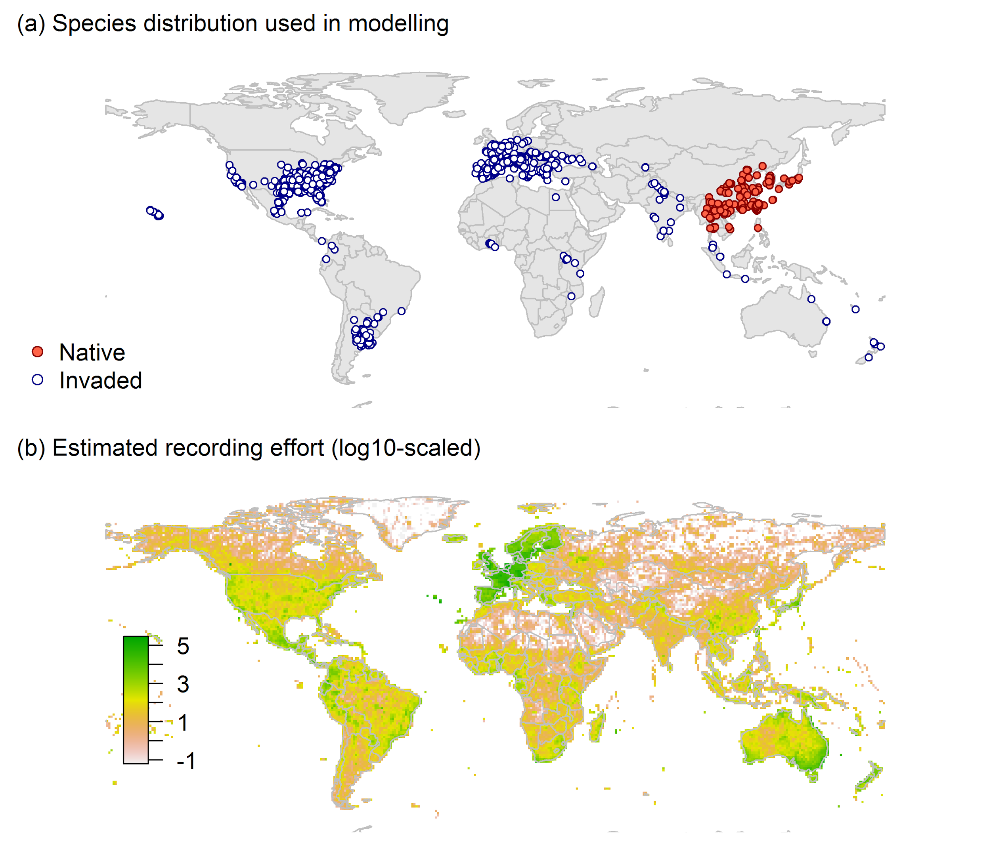

Climate data were selected from the ‘Bioclim’ variables contained within the WorldClim database (Hijmans et al. 2005), originally at 5 arcminute resolution (0.083 x 0.083 degrees of longitude/latitude) and aggregated to a 0.25 x 0.25 degree grid for use in the model.
Based on the biology of Broussonetia papyrifera, the following climate variables were used in the modelling:
- Minimum temperature of the coldest month (Bio6)
- Mean temperature of the warmest quarter (Bio10)
- Climatic moisture index (CMI): ratio of mean annual precipitation to potential evapotranspiration, log+1 transformed. For its calculation, monthly potential evapotranspirations were estimated from the WorldClim monthly temperature data and solar radiation using the simple method of Zomer et al. (2008) which is based on the Hargreaves evapotranspiration equation (Hargreaves, 1994).
To estimate the effect of climate change on the potential distribution, equivalent modelled future climate conditions for the 2070s under the Representative Concentration Pathways (RCP) 2.6 and 4.5 were also obtained. These represent low and medium emissions scenarios, respectively. The above variables were obtained as averages of outputs of eight Global Climate Models (BCC-CSM1-1, CCSM4, GISS-E2-R, HadGEM2-AO, IPSL-CM5A-LR, MIROC-ESM, MRI-CGCM3, NorESM1-M), downscaled and calibrated against the WorldClim baseline (see http://www.worldclim.org/cmip5_5m).
The following habitat layers were also used:
- Human influence index (HII): As many non-native invasive species associate with anthropogenically disturbed habitats. We used the Global Human Influence Index Dataset of the Last of the Wild Project (Wildlife Conservation Society - WCS & Center for International Earth Science Information Network - CIESIN - Columbia University, 2005), which is developed from nine global data layers covering human population pressure (population density), human land use and infrastructure (built-up areas, nighttime lights, land use/land cover) and human access (coastlines, roads, railroads, navigable rivers). The index ranges between 0 and 1 and was ln+1 transformed for the modelling to improve normality.
Species distribution model
A presence-background (presence-only) ensemble modelling strategy was employed using the BIOMOD2 R package version 3.4.6 (Thuiller et al., 2020, Thuiller et al., 2009). These models contrast the environment at the species’ occurrence locations against a random sample of the global background environmental conditions (often termed ‘pseudo-absences’) in order to characterise and project suitability for occurrence. This approach has been developed for distributions that are in equilibrium with the environment. Because invasive species’ distributions are not at equilibrium and subject to dispersal constraints at a global scale, we took care to minimise the inclusion of locations suitable for the species but where it has not been able to disperse to (Chapman et al. 2019). Therefore the background sampling region included:
- The area accessible by native Broussonetia papyrifera populations, in which the species is likely to have had sufficient time to disperse to all locations. Based on presumed maximum dispersal distances, the accessible region was defined as a 400km buffer around the native range occurrences; AND
- A 30km buffer around the non-native occurrences, encompassing regions likely to have had high propagule pressure for introduction by humans and/or dispersal of the species; AND
- Regions where we have an a priori expectation of high unsuitability for the species so that absence is assumed irrespective of dispersal constraints (see Figure 2). The following rules were applied to define a region expected to be highly unsuitable for Broussonetia papyrifera at the spatial scale of the model:
  - Minimum temperature of the coldest month (Bio6) < -12
  - Mean temperature of the warmest quarter (Bio10) < 13
  - Climatic moisture index (CMI) < 0.15

Altogether, only 0.5% of occurrence grid cells were located in the unsuitable background region.
Within the unsuitable background region, 10 samples of 5000 randomly sampled grid cells were obtained. In the accessible background (comprising the accessible areas around native and non-native occurrences as detailed above), the same number of pseudo-absence samples were drawn as there were presence records (1773), weighting the sampling by a proxy for recording effort (Figure 2).

Figure 2. The background from which pseudo-absence samples were taken in the modelling of Broussonetia papyrifera. Samples were taken from a 400km buffer around the native range and a 30km buffer around non-native occurrences (together forming the accessible background), and from areas expected to be highly unsuitable for the species (the unsuitable background region). Samples from the accessible background were weighted by a proxy for recording effort (Figure 1(b)).
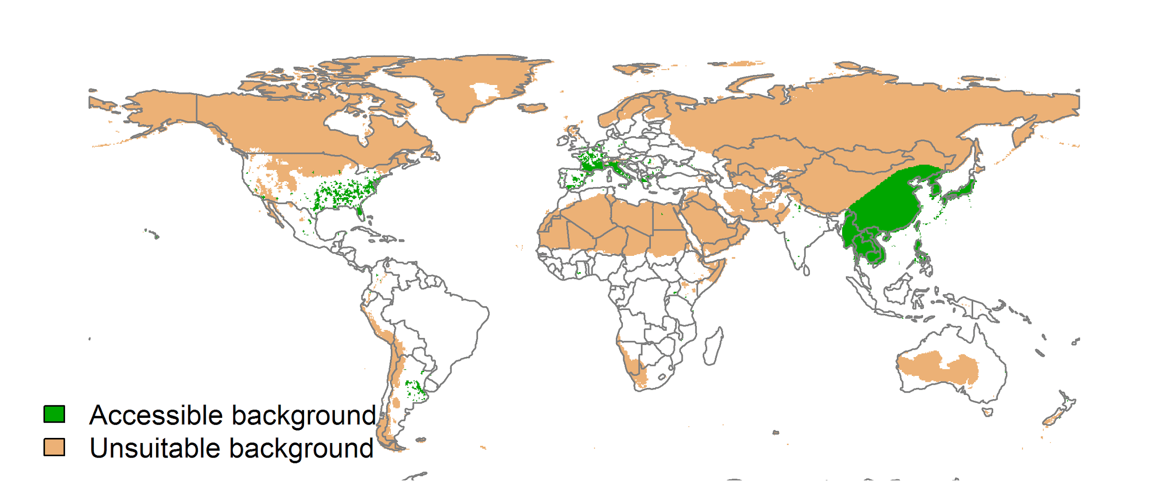

Each dataset (i.e. combination of the presences and the individual background samples) was randomly split into 80% for model training and 20% for model evaluation. With each training dataset, five statistical algorithms were fitted with the default BIOMOD2 settings and rescaled using logistic regression, except where specified below:
- Generalised linear model (GLM)
- Generalised boosting model (GBM)
- Generalised additive model (GAM) with a maximum of four degrees of freedom per smoothing spline
- Random forest (RF)
- Maxent

Since the total background sample was larger than the number of occurrences, prevalence fitting weights were applied to give equal overall importance to the occurrences and the background. Normalised variable importance was assessed and variable response functions were produced using BIOMOD2’s default procedure.
Model predictive performance was assessed by the following three measures:
- AUC, the area under the receiver operating characteristic curve (Fielding & Bell 1997). Predictions of presence-absence models can be compared with a subset of records set aside for model evaluation (here 20%) by constructing a confusion matrix with the number of true positive, false positive, false negative and true negative cases. For models generating non-dichotomous scores (as here) a threshold can be applied to transform the scores into a dichotomous set of presence-absence predictions. Two measures that can be derived from the confusion matrix are sensitivity (the proportion of observed presences that are predicted as such, quantifying omission errors), and specificity (the proportion of observed absences that are predicted as such, quantifying commission errors). A receiver operating characteristic (ROC) curve can be constructed by using all possible thresholds to classify the scores into confusion matrices, obtaining sensitivity and specificity for each matrix, and plotting sensitivity against the corresponding proportion of false positives (equal to 1 - specificity). The use of all possible thresholds avoids the need for a selection of a single threshold, which is often arbitrary, and allows appreciation of the trade-off between sensitivity and specificity. The area under the ROC curve (AUC) is often used as a single threshold-independent measure for model performance (Manel, Williams & Ormerod 2001). AUC is the probability that a randomly selected presence has a higher model-predicted suitability than a randomly selected absence (Allouche et al. 2006).
- Cohen’s Kappa (Cohen 1960). This measure corrects the overall accuracy of model predictions (ratio of the sum of true presences plus true absences to the total number of records) by the accuracy expected to occur by chance. The kappa statistic ranges from -1 to +1, where +1 indicates perfect agreement and values of zero or less indicate a performance no better than random. Advantages of kappa are its simplicity, the fact that both commission and omission errors are accounted for in one parameter, and its relative tolerance to zero values in the confusion matrix (Manel, Williams & Ormerod 2001). However, Kappa has been criticised for being sensitive to prevalence (the proportion of sites in which the species was recorded as present) and may therefore be inappropriate for comparisons of model accuracy between species or regions (McPherson, Jetz & Rogers 2004, Allouche et al. 2006).
- TSS, the true skill statistic (Allouche et al. 2006). TSS is defined as sensitivity + specificity - 1, and corrects for Kappa’s dependency on prevalence. TSS compares the number of correct forecasts, minus those attributable to random guessing, to that of a hypothetical set of perfect forecasts. Like kappa, TSS takes into account both omission and commission errors, and success as a result of random guessing, and ranges from -1 to +1, where +1 indicates perfect agreement and values of zero or less indicate a performance no better than random (Allouche et al. 2006).
An ensemble model was created by first rejecting poorly performing algorithms with relatively extreme low AUC values and then averaging the predictions of the remaining algorithms, weighted by their AUC. To identify poorly performing algorithms, AUC values were converted into modified z-scores based on their difference to the median and the median absolute deviation across all algorithms (Iglewicz & Hoaglin, 1993). Algorithms with z < -2 were rejected. In this way, ensemble projections were made for each dataset and then averaged to give an overall suitability, as well as its standard deviation. The projections were then classified into suitable and unsuitable regions using the ‘minROCdist’ method, which minimizes the distance between the ROC plot and the upper left corner of the plot (point (0,1)).
We also produced limiting factor maps for Europe following Elith et al. (2010). For this, projections were made separately with each individual variable fixed at a near-optimal value. These were chosen as the median values at the occurrence grid cells. Then, the most strongly limiting factors were identified as the one resulting in the highest increase in suitability in each grid cell.
Results
The ensemble model suggested that suitability for Broussonetia papyrifera was most strongly determined by Minimum temperature of the coldest month (Bio6), accounting for 31.6% of variation explained, followed by Mean temperature of the warmest quarter (Bio10) (26.6%), Climatic moisture index (CMI) (22.6%) and Human influence index (HII) (19.2%) (Table 1, Figure 3).

Table 1. Summary of the cross-validation predictive performance (AUC, Kappa, TSS) and variable importance of the fitted model algorithms and the ensemble (AUC-weighted average of the best performing algorithms). Results are the average from models fitted to 10 different background samples of the data.
 |  |  |  |  | Variable importance (%)
Algorithm | AUC | Kappa | TSS | Used in the ensemble | Minimum temperature of the coldest month (Bio6) | Mean temperature of the warmest quarter (Bio10) | Climatic moisture index (CMI) | Human influence index (HII)
GLM | 0.916 | 0.589 | 0.734 | no | 32 | 27 | 17 | 24
GAM | 0.924 | 0.601 | 0.736 | yes | 35 | 26 | 17 | 23
GBM | 0.929 | 0.620 | 0.744 | yes | 34 | 20 | 18 | 28
RF | 0.886 | 0.543 | 0.725 | no | 28 | 30 | 27 | 16
Maxent | 0.924 | 0.604 | 0.737 | yes | 27 | 34 | 33 | 6
Ensemble | 0.928 | 0.617 | 0.741 |  | 32 | 27 | 23 | 19

Figure 3. Partial response plots from the fitted models. Thin coloured lines show responses from the algorithms in the ensemble, while the thick black line is their ensemble. In each plot, other model variables are held at their median value in the training data. Some of the divergence among algorithms is because of their different treatment of interactions among variables.
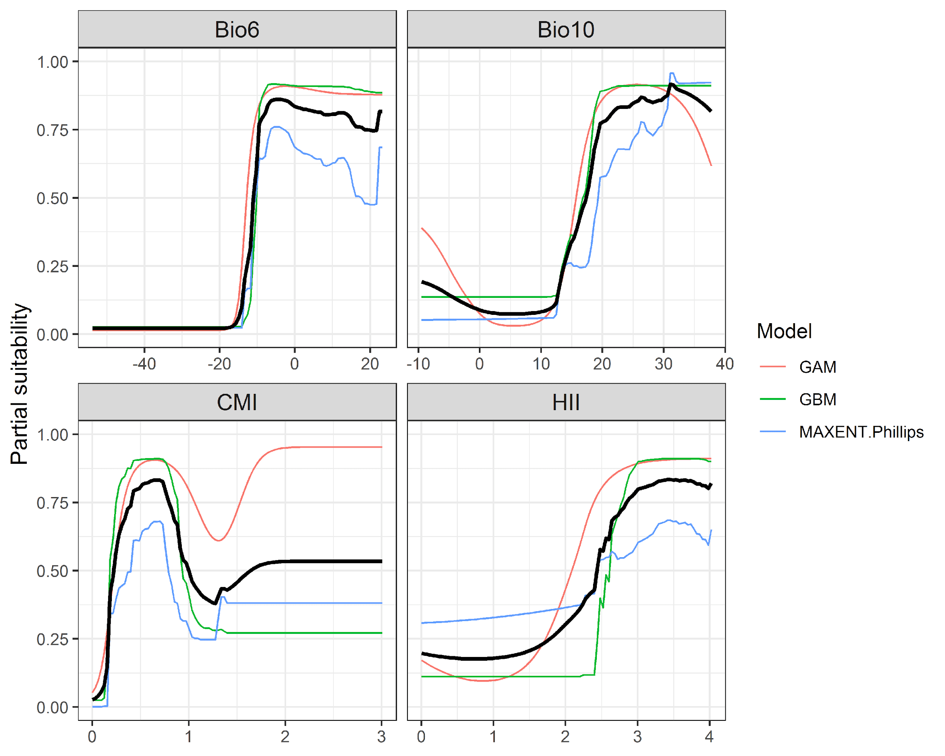

Figure 4. (a) Projected global suitability for Broussonetia papyrifera establishment in the current climate. For visualisation, the projection has been aggregated to a 0.5 x 0.5 degree resolution, by taking the maximum suitability of constituent higher resolution grid cells. Values > 0.38 may be suitable for the species. (b) Uncertainty in the ensemble projections, expressed as the among-algorithm standard deviation in predicted suitability, averaged across the 10 datasets.
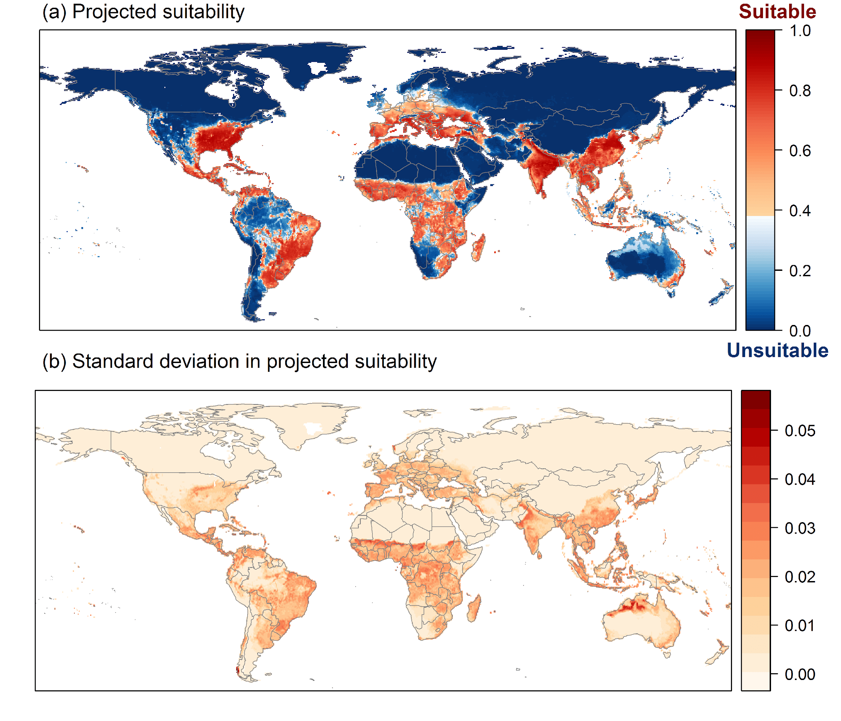

Figure 5. (a) Projected current suitability for Broussonetia papyrifera establishment in Europe and the Mediterranean region. (b) Uncertainty in the ensemble projections, expressed as the among-algorithm standard deviation in predicted suitability, averaged across the 10 datasets.

Figure 6. The most strongly limiting factors for Broussonetia papyrifera establishment estimated by the model in Europe and the Mediterranean region in current climatic conditions.
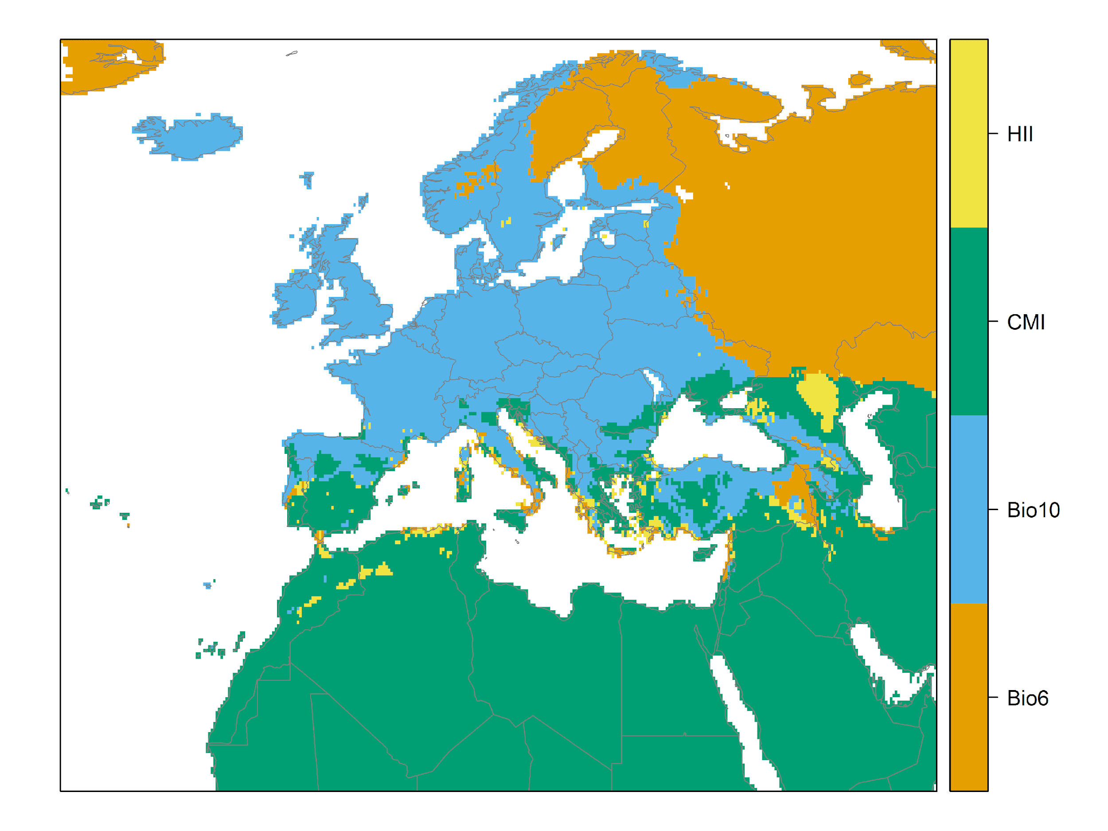

Figure 7. (a) Projected suitability for Broussonetia papyrifera establishment in Europe and the Mediterranean region in the 2070s under climate change scenario RCP2.6, equivalent to Figure 5. (b) Uncertainty in the ensemble projections, expressed as the among-algorithm standard deviation in predicted suitability, averaged across the 10 datasets.

Figure 8. (a) Projected suitability for Broussonetia papyrifera establishment in Europe and the Mediterranean region in the 2070s under climate change scenario RCP4.5, equivalent to Figure 5. (b) Uncertainty in the ensemble projections, expressed as the among-algorithm standard deviation in predicted suitability, averaged across the 10 datasets.

Figure 9. Variation in projected suitability for Broussonetia papyrifera establishment among Biogeographical regions of Europe (https://www.eea.europa.eu/data-and-maps/data/biogeographical-regions-europe-3). The bar plots show the proportion of grid cells in each region classified as suitable in the current climate and projected climate for the 2070s under two RCP emissions scenarios. The location of each region is also shown. The Arctic and Macaronesian biogeographical regions are not part of the study area, but are included for completeness.
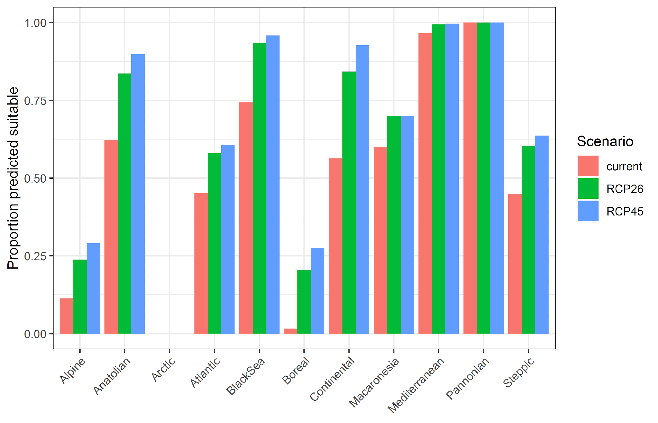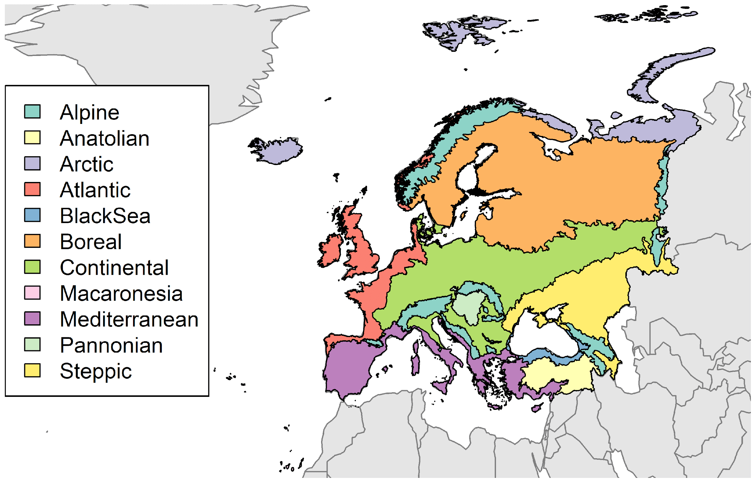

Table 2. Variation in projected suitability for Broussonetia papyrifera establishment among Biogeographical regions of Europe (numerical values of Figure 9 above). The numbers are the proportion of grid cells in each region classified as suitable in the current climate and projected climate for the 2070s under two RCP emissions scenarios. The Arctic and Macaronesian biogeographical regions are not part of the study area, but are included for completeness.
Biogeographical region | Current climate | RCP26 | RCP45
Alpine | 0.11 | 0.24 | 0.29
Anatolian | 0.62 | 0.84 | 0.90
Arctic | 0.00 | 0.00 | 0.00
Atlantic | 0.45 | 0.58 | 0.61
BlackSea | 0.74 | 0.93 | 0.96
Boreal | 0.02 | 0.21 | 0.28
Continental | 0.56 | 0.84 | 0.93
Macaronesia | 0.60 | 0.70 | 0.70
Mediterranean | 0.97 | 0.99 | 1.00
Pannonian | 1.00 | 1.00 | 1.00
Steppic | 0.45 | 0.60 | 0.64

Figure 10. Variation in projected suitability for Broussonetia papyrifera establishment among European Union countries and the UK. The bar plots show the proportion of grid cells in each country classified as suitable in the current climate and projected climate for the 2070s under two RCP emissions scenarios. Malta has been excluded because the Human Influence Index dataset lacks coverage for Malta.
Table 3. Variation in projected suitability for Broussonetia papyrifera establishment among European Union countries and the UK (numerical values of Figure 10 above). The numbers are the proportion of grid cells in each country classified as suitable in the current climate and projected climate for the 2070s under two RCP emissions scenarios. Malta has been excluded because the Human Influence Index dataset lacks coverage for Malta.
Country | Current climate | RCP26 | RCP45
Austria | 0.33 | 0.46 | 0.54
Belgium | 0.67 | 0.87 | 0.98
Bulgaria | 0.91 | 0.99 | 0.99
Croatia | 0.84 | 0.92 | 0.99
Cyprus | 1.00 | 1.00 | 1.00
Czech Rep. | 0.83 | 0.96 | 0.99
Denmark | 0.21 | 0.71 | 0.91
Estonia | 0.00 | 0.93 | 0.96
Finland | 0.00 | 0.11 | 0.20
France | 0.83 | 0.93 | 0.96
Germany | 0.82 | 0.96 | 0.98
Greece | 1.00 | 1.00 | 1.00
Hungary | 1.00 | 1.00 | 1.00
Ireland | 0.00 | 0.00 | 0.00
Italy | 0.87 | 0.90 | 0.91
Latvia | 0.07 | 0.99 | 1.00
Lithuania | 0.16 | 1.00 | 1.00
Luxembourg | 0.60 | 1.00 | 1.00
Netherlands | 0.39 | 0.99 | 1.00
Poland | 0.77 | 0.99 | 1.00
Portugal | 0.99 | 1.00 | 1.00
Romania | 0.75 | 0.95 | 0.98
Slovakia | 0.59 | 0.89 | 0.98
Slovenia | 0.49 | 0.74 | 0.87
Spain | 0.90 | 0.98 | 0.98
Sweden | 0.07 | 0.25 | 0.29
United Kingdom | 0.20 | 0.37 | 0.40

Caveats to the modelling
To remove spatial recording biases, the selection of the background sample from the accessible background was weighted by the density of Tracheophyta records on the Global Biodiversity Information Facility (GBIF). While this is preferable to not accounting for recording bias at all, it may not provide the perfect measure of recording bias.
There was substantial variation among modelling algorithms in the partial response plots (Figure 3). In part this will reflect their different treatment of interactions among variables. Since partial plots are made with other variables held at their median, there may be values of a particular variable at which this does not provide a realistic combination of variables to predict from.
Other variables potentially affecting the distribution of the species, such as types of land cover were not included in the model.

References
Allouche, O., Tsoar, A. & Kadmon, R. (2006) Assessing the accuracy of species distribution models: prevalence, kappa and the true skill statistic (TSS), Journal of Applied Ecology, 43, 1223-1232.
Chapman, D., Pescott, O.L., Roy, H.E. & Tanner, R. (2019). Improving species distribution models for invasive non-native species with biologically informed pseudo-absence selection. Journal of Biogeography, https://doi.org/10.1111/jbi.13555.
Cohen, J. (1960). A coefficient of agreement of nominal scales. Educational and Psychological Measurement, 20, 37-46.
Elith, J., Kearney, M. & Phillips S. (2010). The art of modelling range-shifting species. Methods in Ecology and Evolution, 1, 330-342.
Fielding, A.H. & Bell, J.F. (1997). A review of methods for the assessment of prediction errors in conservation presence/absence models. Environmental Conservation, 24, 38-49.
Hargreaves, G.H. (1994). Defining and Using Reference Evapotranspiration. Journal of Irrigation and Drainage Engineering, 120.
Hijmans, R.J., Cameron, S.E., Parra, J.L., Jones, P.G. &, Jarvis A. (2005) Very high resolution interpolated climate surfaces for global land areas. International Journal of Climatology, 25, 1965-1978.
Iglewicz, B. & Hoaglin, D.C. (1993). How to detect and handle outliers, Asq Press.
Manel, S., Williams, H.C. & Ormerod, S.J. (2001). Evaluating presence-absence models in ecology: the need to account for prevalence. Journal of Applied Ecology, 38, 921-931.
McPherson, J.M., Jetz, W. & Rogers, D.J. (2004). The effects of species’ range sizes on the accuracy of distribution models: ecological phenomenon or statistical artefact? Journal of Applied Ecology, 41, 811-823.
Thuiller, W., Lafourcade, B., Engler, R & Araújo, M.B. (2009). BIOMOD-a platform for ensemble forecasting of species distributions. Ecography, 32, 369-373.
Thuiller, W., Georges, D., Engler, R. & Breiner, F. (2020). biomod2: Ensemble Platform for Species Distribution Modeling. R package version 3.4.6. https://CRAN.R-project.org/package=biomod2
Zomer, R.J., Trabucco, A., Bossio, D.A. & Verchot, L.V. (2008). Climate change mitigation: A spatial analysis of global land suitability for clean development mechanism afforestation and reforestation. Agriculture, Ecosystems & Environment, 126, 67-80.

This template is based on the Great Britain non-native species risk assessment scheme (GBNNRA). A number of amendments have been introduced to ensure compliance with Regulation (EU) 1143/2014 on IAS and relevant legislation, including the Delegated Regulation (EU) 2018/968 of 30 April 2018, supplementing Regulation (EU) No 1143/2014 of the European Parliament and of the Council with regard to risk assessments in relation to invasive alien species (see https://eur-lex.europa.eu/legal-content/en/TXT/?uri=CELEX%3A32018R0968 ).
Convention on Biological Diversity, Decision VI/23
https://circabc.europa.eu/sd/a/738e82a8-f0a6-47c6-8f3b-aeddb535b83b/TSSR-2016-010%20CBD%20categories%20on%20pathways%20Final.pdf
https://circabc.europa.eu/sd/a/0aeba7f1-c8c2-45a1-9ba3-bcb91a9f039d/TSSR-2016-010%20CBD%20pathways%20key%20full%20only.pdf
Not to be confused with “no impact”.
Note: in the CICES classification provisioning of water is considered as an abiotic service whereas the rest of ecosystem services listed here are considered biotic.

