**Risk assessment template developed under the "Study on Invasive Alien Species – Development of risk assessments to tackle priority species and enhance prevention"   
Contract No 07.0202/2020/834529/ETU/ENV.D.2[1]**

**Name of organism:** *Obama nungara* Carbayo, Álvarez-Presas, Jones & Riutort, 2016

**Author(s) of the assessment:**

Archie K. Murchie, Agri-Food & Biosciences Institute, Belfast, BT9 5PX

Leigh Winsor, College of Science and Engineering, James Cook University, Townsville, QLD, Australia

Jean-Lou Justine, ISYEB (Institut de Systématique, Évolution, Biodiversité), Muséum National d'Histoire Naturelle, Paris, France

Björn Beckmann, Centre for Ecology & Hydrology, Penicuik, EH26 0QB

**Risk Assessment Area:** The risk assessment area is the territory of the European Union 27 and the United Kingdom, excluding the EU-outermost regions.

**Peer review 1:** Dr Richard Shaw, CABI, Egham, UK

**Peer review 2:** Dr Brian Boag, James Hutton Institute, Invergowrie Dundee, UK

**Date of completion:** 15/10/2021

**Date of revision: 30 September 2022**

**Contents**

SECTION A – Organism Information and Screening 3

SECTION B – Detailed assessment 12

1 PROBABILITY OF INTRODUCTION AND ENTRY 12

2 PROBABILITY OF ESTABLISHMENT 19

3 PROBABILITY OF SPREAD 25

4 MAGNITUDE OF IMPACT 38

Biodiversity and ecosystem impacts 38

Ecosystem Services impacts 41

Economic impacts 43

Social and human health impacts 46

Other impacts 47

RISK SUMMARIES 51

REFERENCES 53

Distribution Summary 56

ANNEX I Scoring of Likelihoods of Events 58

ANNEX II Scoring of Magnitude of Impacts 59

ANNEX III Scoring of Confidence Levels 60

ANNEX IV CBD pathway categorisation scheme 61

ANNEX V Ecosystem services classification (CICES V5.1, simplified) and examples 62

ANNEX VI EU Biogeographic Regions and MSFD Subregions 66

ANNEX VII Delegated Regulation (EU) 2018/968 of 30 April 2018 67

ANNEX VIII Projection of environmental suitability for Obama nungara establishment in Europe 68

# SECTION A – Organism Information and Screening

|  |
| --- |
| **A1. Identify the organism. Is it clearly a single taxonomic entity and can it be adequately distinguished from other entities of the same rank?**  including the following elements:   * the taxonomic family, order and class to which the species belongs; * the scientific name and author of the species, as well as a list of the most common synonym names; * names used in commerce (if any) * a list of the most common subspecies, lower taxa, varieties, breeds or hybrids   As a general rule, one risk assessment should be developed for a single species. However, there may be cases where it may be justified to develop one risk assessment covering more than one species (e.g. species belonging to the same genus with comparable or identical features and impact). It shall be clearly stated if the risk assessment covers more than one species, or if it excludes or only includes certain subspecies, lower taxa, hybrids, varieties or breeds (and if so, which subspecies, lower taxa, hybrids, varieties or breeds). Any such choice must be properly justified. |

Response: *Obama nungara* Carbayo, Álvarez-Presas, Jones & Riutort, 2016

Phylum Platyhelminthes, Class Rhabditophora (previously Turbellaria), Order Tricladida, Family Geoplanidae, Subfamily Geoplaninae

Synonyms: *Obama marmorata pro parte*

This species was originally mistaken as *Obama marmorata* when first found in Europe (Lago-Barcia *et al.*, 2015) but subsequently identified as a new species *Obama nungara* (Carbayo *et al.*, 2016).

The organism is a single taxonomic entity. There are no known varieties, breeds or hybrids. Through molecular analyses of the COI gene, Justine *et al.* (2020) found *O. nungara* to be composed of three clades. They termed these: ‘Brazil’ - currently confined to Brazil, ‘Argentina 2’ - found in Argentina and Spain; ‘Argentina 1’ - found in Argentina and in Spain, Portugal, France, UK, Italy, Belgium, and Switzerland. As to date there is no information on morphological or physiological differences between the clades, this risk assessment will apply to all

Common names: The ‘Obama flatworm’. Note there is no connection to the former US President Barack Obama. The genus name *Obama* comes from the Tupi language and means leaf-animal. In French, ‘Marron plate’.

|  |
| --- |
| **A2. Provide information on the existence of other species that look very similar [that may be detected in the risk assessment area, either in the environment, in confinement or associated with a pathway of introduction]**  Include both native and non-native species that could be confused with the species being assessed, including the following elements:   * other alien species with similar invasive characteristics, to be avoided as substitute species (in this case preparing a risk assessment for more than one species together may be considered); * other alien species without similar invasive characteristics, potential substitute species; * native species, potential misidentification and mis-targeting |

Response: *Obama nungara* was formally described in 2016 as a new species (Carbayo *et al.*, 2016). The flatworm measures typically 50 – 80 mm in length and 5 mm in width, with brown dorsal colouration, with multiple longitudinal black striae giving a ‘netted’, reticulated appearance, and a beige sole (Soors *et al.*, 2019; Justine *et al.*, 2020). The dorsal colour is variable ranging from orange to almost black. Multiple eyes extend in a lateral band on each side of the body, one third of the flatworm’s body width (Carbayo *et al.*, 2016). Justine *et al.* (2020) gives detailed descriptions suitable for the non-specialist along with photographs of the different colour forms. Egg cocoons are shiny spheroidal capsules which are red when newly laid, turning dark brown to black within a few days (Justine *et al.*, 2020). They measure c. 5 mm in diameter. Juveniles are light cream in colour with fine dark brown stipling (Justine *et al.*, 2020).

*Obama nungara* may be confused with other terrestrial flatworms. Superficially, this may include small native species and invasive alien species such as *Arthurdendyus triangulatus* and *Bipalium kewense*. Native flatworm species are mostly small (< 50 mm length), innocuous animals whereas *O. nungara* can be distinguished from alien flatworms by dorsal colouration (e.g., the pale marginal edge of *A. triangulatus*) and body/head shape (e.g., the shovelhead shape of *Bipalium* spp.).

Justine *et al.* (2020), on the experience of citizen science records, says that *O. nungara* may be confused with: 1) *Parakontikia ventrolineata*, an alien species native to Australia, but this species is smaller and has longitudinal lines on its back and belly; 2) *Platydemus manokwari* but the body shape is different and *P. manokwari* has a clear, pale single longitudinal line on its back and two conspicuous eyes.

*Obama nungara* may be confused with other *Obama* spp., in particular *Obama marmorata* but this species has not been found within the risk assessment area. *Obama marmorata* is up to 100 mm long, 10 mm wide, with the dorsum covered with green brown longitudinal striae on an orange to ivory background (Carbayo *et al.*, 2016).

|  |
| --- |
| **A3. Does a relevant earlier risk assessment exist? Give details of any previous risk assessment, including the final scores and its validity in relation to the risk assessment area.** |

Response: Thunnissen *et al.* (2022) performed a risk assessment of *O. nungara* for The Netherlands using the Harmonia+ risk assessment protocol (D’hondt *et al.*, 2015). They scored *O. nungara* as medium risk (invasion score 1.00 (high) x impact score 0.5 (medium) = risk score of 0.5) acknowledging that confidence was low for impact score due to a lack of quantitative information.

|  |
| --- |
| **A4. Where is the organism native?**  including the following elements:   * an indication of the continent or part of a continent, climatic zone and habitat where the species is naturally occurring * if applicable, indicate whether the species could naturally spread into the risk assessment area |

Response: *Obama nungara* is native to South America, and particularly to Argentina, south-eastern Brazil and Uruguay (Lago-Barcia *et al.*, 2015; Carbayo *et al.*, 2016; Negrete *et al.*, 2020). The specimens found in Europe show most affinity to the Argentinian clade (Justine *et al.*, 2020).

As with other invasive flatworms, *O. nungara* is synanthropic, found in gardens and other modified habitats in its native range (Carbayo *et al.*, 2016; Lago-Barcia *et al.*, 2019; Negrete *et al.*, 2020). In a study on the coexistence of several terrestrial flatworm species in South American Atlantic Forest, *O. nungara* was found in human-disturbed areas (Boll and Leal-Zanchet, 2016). Similarly *O. nungara* has also been collected from human-disturbed native forest habitats (Lago-Barcia *et al.*, 2019). However, Negrete *et al.* (2020) collected many specimens in undisturbed native forests from Tucumán Province, north-western Argentina. It is possible that this is close to the natural habitat of *O. nungara*. However, L. Negrete (2021, pers. comm.) commented that this area is very close to routes with intense trade between provinces, which could suggest *O. nungara* may have been introduced there and has found ideal conditions for establishment. In that same area (Tucumán) large number *Bipalium kewense* (a definite introduction) were found, which would support this conjecture. It is not therefore clear exactly what and where is the native habitat of *O. nungara*.

*Obama nungara* is a predatory, soil-dwelling organism that naturally disperses by creeping on the substrate surface. In common with other terrestrial flatworms, especially these of a synanthropic nature, it is usually found under wood, rocks and debris on the soil surface. It could not naturally spread into the risk assessment area.

|  |
| --- |
| **A5. What is the global non-native distribution of the organism outside the risk assessment area?** |

Response: *Obama nungara* is native to South America and has been recorded from Argentina, Brazil, Uruguay and Chile, with the latter likely to be an introduction. Outside of South America, *O. nungara* has only been recorded in Europe and two records from the USA in 2020, in North Carolina, http://www.inaturalist.org/observations/68472771) and South Carolina (L. Winsor 2021, unpubl.). Most records in Europe are from the risk assessment area but *O. nungara* has established in the wild also in Guernsey (Álvarez-Presas *et al.*, 2014; Carbayo *et al.*, 2016; Webster, 2020), Madeira Island and São Miguel in the Azores (Justine *et al.*, 2020; Lago-Barcia *et al.*, 2020) and Switzerland (Justine *et al.*, 2020).

|  |
| --- |
| **A6. In which biogeographic region(s) or marine subregion(s) in the risk assessment area has the species been recorded and where is it established? The information needs be given separately for recorded (including casual or transient occurrences) and established occurrences. “Established” means the process of an alien species successfully producing viable offspring with the likelihood of continued survival[2].**  **A6a. Recorded: List regions**  **A6b. Established: List regions**  Freshwater / terrestrial biogeographic regions:   * Alpine, Atlantic, Black Sea, Boreal, Continental, Mediterranean, Pannonian, Steppic   Marine regions:   * Baltic Sea, North-east Atlantic Ocean, Mediterranean Sea, Black Sea   Marine subregions:   * Greater North Sea, incl. the Kattegat and the English Channel, Celtic Seas, Bay of Biscay and the Iberian Coast, Western Mediterranean Sea, Adriatic Sea, Ionian Sea, Central Mediterranean Sea, Aegean-Levantine Sea.   Comment on the sources of information on which the response is based and discuss any uncertainty in the response.  For delimitation of EU biogeographical regions please refer to Annex VI.  For delimitation of EU marine regions and subregions consider the Marine Strategy Framework Directive areas; please refer to Annex VI. |

Response (6a): *Obama nungara* has been recorded in the Atlantic, Continental and Mediterranean biogeographic regions (see A.8 for references).

Response (6b): *Obama nungara* has also established in the Atlantic, Continental and Mediterranean biogeographic regions (see A.8 for references).

|  |
| --- |
| **A7. In which biogeographic region(s) or marine subregion(s) in the risk assessment area could the species establish in the future under current climate and under foreseeable climate change? The information needs be given separately for current climate and under foreseeable climate change conditions.**  **A7a. Current climate: List regions**  **A7b. Future climate: List regions**  With regard to EU biogeographic and marine (sub)regions, see above.  With regard to climate change, provide information on   * the applied timeframe (e.g. 2050/2070) * the applied scenario (e.g. RCP 4.5) * what aspects of climate change are most likely to affect the risk assessment (e.g. increase in average winter temperature, increase in drought periods)   The assessment does not have to include a full range of simulations on the basis of different climate change scenarios, as long as an assessment with a clear explanation of the assumptions is provided. However, if new, original models are executed for this risk assessment, the following RCP pathways shall be applied: RCP 2.6 (likely range of 0.4-1.6°C global warming increase by 2065) and RCP 4.5 (likely range of 0.9-2.0°C global warming increase by 2065). Otherwise, the choice of the assessed scenario has to be explained. |

Response (7a): *Obama nungara* is predicted to have a potentially wide distribution in Europe. Under the current climate it could establish in the Atlantic, Mediterranean and Black Sea biogeographical regions and to a lesser extent in the Continental region, with small incursions into Pannonian and Alpine regions (see Annex VIII ‘Projection of environmental suitability for *Obama nungara* establishment in Europe’).

Response (7b): Under climate change scenarios RCP 2.6 (likely range of 0.4-1.6°C global warming increase) and RCP 4.5 (likely range of 0.9-2.0°C global warming increase), *O. nungara* could establish in greater areas of the Atlantic and Continental regions as its range increases northwards and eastwards. The Pannonian region is also markedly more vulnerable to flatworm establishment. However, the Black Sea region only shows a slight increase in the area suitable for *O. nungara* under these climate change scenarios, whilst the flatworm’s range in the Mediterranean declines in the southern localities (see Annex VIII ‘Projection of environmental suitability for *Obama nungara* establishment in Europe’).

|  |
| --- |
| **A8. In which EU Member States has the species been recorded and in which EU Member States has it established? List them with an indication of the timeline of observations. The information needs be given separately for recorded and established occurrences.**  **A8a. Recorded: List Member States**  **A8b. Established: List Member States**  Austria, Belgium, Bulgaria, Croatia, Cyprus, Czech Republic, Denmark, Estonia, Finland, France, Germany, Greece, Hungary, Ireland, Italy, Latvia, Lithuania, Luxembourg, Malta, Netherlands, Poland, Portugal, Romania, Slovakia, Slovenia, Spain, Sweden  The description of the invasion history of the species shall include information on countries invaded and an indication of the timeline of the first observations, establishment and spread. |

Response (8a): *Obama nungara* has been recorded in the wild or as interceptions in the following Member States:

Austria (J-L Justine 2020, unpubl.), Belgium (Soors *et al.*, 2019), France (Justine *et al.*, 2020), Germany (J-L Justine 2020, unpubl.; Kutschera and Ehnes, 2021), Ireland (Justine *et al.*, 2020), Italy (Carbayo *et al.*, 2016), The Netherlands (S. A. de Waart 2021, unpubl.;Thunnissen *et al.*, 2022), Portugal (Justine *et al.*, 2020), Slovakia (L. Winsor 2021, unpubl.) and Spain (Carbayo *et al.*, 2016).

Response (8b): *Obama nungara* has established in France, Belgium, Spain, Portugal and Italy (Justine and Winsor, 2020), and almost certainly in other countries adjoining these but this has not been confirmed to date. In 2021, many individuals were found in a communal garden in Zeist, The Netherlands (observation by (S. A. de Waart 2021, unpubl.). This was above a parking garage, so the ground stays warmer in the winter.

Before being described as a separate species, *O. nungara* was first recorded as an unknown species in Guernsey, the Channel Islands, in 2008 and England, in 2009 (Carbayo *et al.*, 2016). It was subsequently found in Spain in 2010 (Álvarez-Presas *et al.*, 2014), where it was initially misidentified as *Obama marmorata* (Lago-Barcia *et al.*, 2015). Carbayo *et al.* (2016) described the flatworm specimens as a new species, *O. nungara*, listing many additional records from Spain, principally from two regions, Asturias and Cantabria on Spain’s Atlantic coast, and from the Catalonia region on Spain’s north-east Mediterranean coast, as well as detailing a record from Italy (2012). Lago-Barcia *et al.* (2019) extended the known distribution on the Iberian Peninsula, collecting specimens from the Porto region, Portugal. In 2016, there was a record of *O. nungara* being intercepted in the UK on plants that came from the Netherlands (Aldred, 2016).

The most comprehensive study of *O. nungara* distribution is from France (Justine *et al.*, 2020), where 530 records were collected through citizen science from 2013-2018, and the flatworm has established in 72 of the 96 administrative Departments in Metropolitan France, as well as Corsica. From these 530 citizen science records, *O. nungara* was the most recorded flatworm species in France. *Obama nungara* was found established in Belgium in 2017 (Soors *et al.*, 2019).

|  |
| --- |
| **A9. In which EU Member States could the species establish in the future under current climate and under foreseeable climate change? The information needs be given separately for current climate and under foreseeable climate change conditions.**  **A9a. Current climate: List Member States**  **A9b. Future climate: List Member States**  With regard to EU Member States, see above.  With regard to climate change, provide information on   * the applied timeframe (e.g. 2050/2070) * the applied scenario (e.g. RCP 4.5) * what aspects of climate change are most likely to affect the risk assessment (e.g. increase in average winter temperature, increase in drought periods)   The assessment does not have to include a full range of simulations on the basis of different climate change scenarios, as long as an assessment with a clear explanation of the assumptions is provided. However, if new, original models are executed for this risk assessment, the following RCP pathways shall be applied: RCP 2.6 (likely range of 0.4-1.6°C global warming increase by 2065) and RCP 4.5 (likely range of 0.9-2.0°C global warming increase by 2065). Otherwise, the choice of the assessed scenario has to be explained. |

Response (9a): There have been no experimental assessments on the environmental requirements of *O. nungara*. The most comprehensive study of *O. nungara* distribution in Europe is from Metropolitan France (Justine *et al.*, 2020), where the species has achieved a widespread distribution especially along the Atlantic and Mediterranean coasts. There were fewer records in the central plains and mountainous regions of France and none from above 500 m altitude, which the authors attribute to the likelihood of freezing. However, *O. nungara* was found above 500 m at a location on São Miguel in the Azores (Lago-Barcia *et al.*, 2020). Given the wide distribution in France, Soors *et al.* (2019) commented that *O. nungara* has a broad temperature tolerance within a temperate climate.

Using species occurrence data, Negrete *et al.* (2020) modelled and mapped the potential distribution of *O. nungara* using MaxEnt software, under both current and climate change scenarios. They found that the most important factors determining the distribution of *O. nungara* (accounting for 60% of the variance) were annual mean temperature (moderate probability of establishment 9 - 17ºC), temperature range, temperature seasonality and precipitation of the coldest quarter (moderate probability of establishment 140 - 330 mm). In Europe, *O. nungara* was most suited to the climate type Cfb (temperate, oceanic) of the Köppen-Geiger climate classification; whereas in South America Cfa (humid, subtropical) fitted best with the flatworm’s distribution. The model predicted that under the current climate, *O. nungara* has the potential to expand its range in Europe, to establish in Luxembourg, the Netherlands, Germany, and Denmark, as well as regions of Croatia and Greece on the east coast of the Adriatic.

The model developed as part of this risk assessment is presented in detail in Annex VIII. The model is an ensemble of six algorithms. The factors that most strongly predicted *O. nungara* distribution were minimum temperature of the coldest month (38% of variation), human influence index (24%), mean temperature of the warmest quarter (18%), annual precipitation (11%), precipitation seasonality (5%) and climatic moisture index (4%). The flatworm is predicted capable of establishing in large areas (>50% of the region) in Belgium, France, Italy, Luxembourg, the Netherlands and Portugal. Significant areas (>20%) of Croatia, Germany, Greece and Spain, as well as the United Kingdom, are also at risk of this species establishing (Annex VIII).

Response (9b): Negrete *et al.* (2020) modelled the distribution of *O. nungara* under RCP 2.6 and RCP 8.5 climate change scenarios. Under both RCP 2.6 and 8.5, *O. nungara* was predicted to expand its current potential range in Europe by 35%, which would include the following Member States: Luxembourg, The Netherlands, Denmark, Ireland, Croatia, and Greece.

The species distribution model predictions (Annex VIII) under RCP 2.6 and RCP 4.5 show a similar expansion of range to the north and east as with the Negrete *et al.* (2020) under both climate change scenarios, with Austria, the Czech Republic, Denmark, Hungary and Ireland at significant risk with >20% of area suitable for *O. nungara* establishment. Conversely, some Mediterranean countries (Greece, Italy, Portugal and Spain) may see the areas suitable for *O. nungara* establishment decline under both climate change scenarios. Predictions under RCP 2.6 and 8.5, gave the same general trends with the RCP 8.5 predictions more pronounced.

|  |
| --- |
| **A10. Is the organism known to be invasive (i.e. to threaten or adversely impact upon biodiversity and related ecosystem services) anywhere outside the risk assessment area?** |

Response: No evidence of impact is available for *O. nungara* so far, despite other species of alien flatworms being known for their invasive potential due to their predatory impact on soil fauna, but this may be due to the relatively small initial populations.

Outside of the risk assessment area, *O. nungara* has established in the wild in Guernsey (Álvarez-Presas *et al.*, 2014; Carbayo *et al.*, 2016; Webster, 2020), Madeira Island and in São Miguel in the Azores (Justine *et al.*, 2020; Lago-Barcia *et al.*, 2020), Switzerland (Justine *et al.*, 2020), Chile and the US.

|  |
| --- |
| **A11. In which biogeographic region(s) or marine subregion(s) in the risk assessment area has the species shown signs of invasiveness? Indicate the area endangered by the organism as detailed as possible.**  Freshwater / terrestrial biogeographic regions:   * Alpine, Atlantic, Black Sea, Boreal, Continental, Mediterranean, Pannonian, Steppic   Marine regions:   * Baltic Sea, North-east Atlantic Ocean, Mediterranean Sea, Black Sea   Marine subregions:  Greater North Sea, incl. the Kattegat and the English Channel, Celtic Seas, Bay of Biscay and the Iberian Coast, Western Mediterranean Sea, Adriatic Sea, Ionian Sea, Central Mediterranean Sea, Aegean-Levantine Sea |

Response: No evidence of impact is available for the species so far in any EU biogeographical region. *Obama nungara* is a predator of soil invertebrates including earthworms and molluscs (Boll and Leal-Zanchet, 2016). To date, there have been no studies assessing the impact of *O. nungara*. Consequently, it is not yet known whether *O. nungara* will have a negative effect on European soil fauna (Negrete *et al.*, 2020). The greatest densities found so far are in populations occurring within the Atlantic biogeographical region (Justine *et al.*, 2020).

|  |
| --- |
| **A12. In which EU Member States has the species shown signs of invasiveness? Indicate the area endangered by the organism as detailed as possible.**  Austria, Belgium, Bulgaria, Croatia, Cyprus, Czech Republic, Denmark, Estonia, Finland, France, Germany, Greece, Hungary, Ireland, Italy, Latvia, Lithuania, Luxembourg, Malta, Netherlands, Poland, Portugal, Romania, Slovakia, Slovenia, Spain, Sweden |

Response: No evidence of impact is available for the species so far in any EU Member State (please see Qu. A11)*.* High numbers of *O. nungara* have been collected by gardeners in France. In one garden, 944 specimens were collected from May to August from an area of c. 300 m2; whereas in another 1,442 were collected from November to May from a garden of c. 175 m2 (Justine *et al.*, 2020). However, the impact of *O. nungara* on soil fauna has not been assessed.

|  |
| --- |
| **A13. Describe any known socio-economic benefits of the organism.**  including the following elements:   * Description of known uses for the species, including a list and description of known uses in the risk assessment area and third countries, if relevant. * Description of social and economic benefits deriving from those uses, including a description of the environmental, social and economic relevance of each of those uses and an indication of associated beneficiaries, quantitatively and/or qualitatively depending on what information is available.   If the information available is not sufficient to provide a description of those benefits for the entire risk assessment area, qualitative data or different case studies from across the risk assessment area or third countries shall be used, if available. |

Response: There are no known socio-economic benefits. *Obama nungara* could possibly benefit gardeners and farmers by feeding on pest snails and slugs. However, experience with other snail-feeding flatworms such as *P. manokwari*, suggests that the long-term deleterious effects on native mollusc biodiversity outweighs any benefits (Gerlach *et al.*, 2020). Similarly, *O. nungara* will feed on other flatworm species (e.g. *Dolichoplana carvalhoi*) (Boll and Leal-Zanchet, 2016) and therefore there is the tentative possibility of biocontrol of other invasive flatworm species but this remains to be tested and, as above, there is potential for significant non-target effects on indigenous flatworm species.

# SECTION B – Detailed assessment

|  |
| --- |
| **Important instructions:**   * In the case of lack of information the assessors are requested to use a standardized answer: “No information has been found.” In this case, no score and confidence should be given and the standardized “score” is N/A (not applicable). * With regard to the scoring of the likelihood of events or the magnitude of impacts see Annexes I and II. * With regard to the confidence levels, see Annex III. * Highlight the selected response score and confidence level in **bold** but keep the other scores in normal text (so that the selected score is evident in the final document). |

## 1 PROBABILITY OF INTRODUCTION AND ENTRY

|  |
| --- |
| **Important instructions:**   * **Introduction** is the movement of the species into the risk assessment area (it may be either in captive conditions and/or in the environment, depending on the relevant pathways). * **Entry** is the release/escape/arrival in the environment, i.e. occurrence in the wild * Introduction and entry may coincide for species entering through pathways such as “corridor” or “unaided”, but it also may differ. If different, please consider all relevant pathways, both for the introduction into the risk assessment area and the entry in the environment. * The classification of pathways developed by the Convention of Biological Diversity (CBD) should be used (see Annex IV). For detailed explanations of the CBD pathway classification scheme consult the IUCN/CEH guidance document[3] and the provided key to pathways[4]. * For organisms which are already present (recorded or established) in the risk assessment area, the likelihood of introduction and entry should be scored as “very likely” by default. * Repeated (independent) introductions and entries at separate locations in the risk assessment area should be considered here (see Qu. 1.7). |

|  |
| --- |
| **Qu. 1.1. List relevant pathways through which the organism could be introduced into the risk assessment area and/or enter into the environment. Where possible give details about the specific origins and end points of the pathways as well as a description of any associated commodities.**  For each pathway answer questions 1.2 to 1.8 (copy and paste additional rows at the end of this section as necessary). Please attribute unique identifiers to each question if you consider more than one pathway, e.g. 1.2a, 1.3a, etc. and then 1.2b, 1.3b etc. for the next pathway.  In this context a pathway is the route or mechanism of introduction and/or entry of the species.  The description of commodities with which the introduction of the species is generally associated shall include a list and description of commodities with an indication of associated risks (e.g. the volume of trade; the likelihood of a commodity being contaminated or acting as vector).  If there are no active pathways or potential future pathways this should be stated explicitly here, and there is no need to answer the questions 1.2-1.9. |

A main pathway described in this risk assessment for *O. nungara* is “contaminant nursery material” (unintentional) because of the species being considered as associate to the plant trade, the flatworm has been found in nurseries and the recognition of nursery material as a pathway for other invasive flatworms. There is no evidence in the literature of any other pathway being significant for introduction to the risk assessment area. Some thought was given as to whether botanical gardens (unintentional) should also be considered as a pathway as they have been implicated in the introduction of other flatworm species, e.g. *Bipalium kewense* (Winsor, 1983), *Platydemus manokwari* (Justine *et al.*, 2014) and *Arthurdendyus triangulatus* (Boag and Neilson, 2014). However, the pathways are very similar and represent unintentional introduction via trade and movement of living plants, which may be ultimately to a garden centre or botanic garden (in some cases, the same site may function as both). This is different from a plant species being intentionally brought into a botanical garden and escaping into the wild, as under the CBD ‘escape from confinement’ pathways. There is a suggestion of importation to the island of São Miguel on soil on machinery (Lago-Barcia *et al.*, 2020), but this pathway is considered here not active for introduction or entry into the risk assessment area and will be considered under spread within the risk assessment area. EU restrictions on the movement of soil (e.g. under EU Commission Implementing Regulation (EU) 2019/2072) and phytosanitary procedures for the cleansing of imported machinery make this pathway more pertinent within the risk assessment area, where such restrictions are not in place.

Pathway name: **Contaminant nursery material**

It is not known how *O. nungara* was introduced to the risk assessment area but terrestrial flatworms are most commonly introduced via accidental importation in plants for planting (nursery stock) (Sluys, 2016) and this would seem the most likely pathway (Lago-Barcia *et al.*, 2019). The proximity of early records to garden centres, nurseries and gardens (Álvarez-Presas *et al.*, 2014; Carbayo *et al.*, 2016; Justine *et al.*, 2020) strongly support this contention.

|  |
| --- |
| **Qu. 1.2a. Is introduction and/or entry along this pathway intentional (e.g. the organism is imported for trade) or unintentional (e.g. the organism is a contaminant of imported goods)?** |

|  |  |  |  |
| --- | --- | --- | --- |
| **RESPONSE** | intentional  **unintentional** | **CONFIDENCE** | low  medium  **high** |

Response: This pathway is unintentional. Terrestrial flatworms have been intercepted in the UK on plant material, particularly tree ferns (*Dicksonia* spp.), from Australia and New Zealand (Matthews, 2005; Cannon and Baker, 2007). Although within the risk assessment area, there is a record of *O. nungara* being intercepted in the UK on plants that came from the Netherlands (Aldred, 2016), which serves as another example of this potential pathway for introduction.

|  |
| --- |
| **Qu. 1.3a. How likely is it that large numbers of the organism will be introduced and/or enter into the environment through this pathway from the point(s) of origin over the course of one year?**  including the following elements:   * discuss how likely the organism is to get onto the pathway in the first place. Also comment on the volume of movement along this pathway. * an indication of the propagule pressure (e.g. estimated volume or number of individuals / propagules, or frequency of passage through pathway), including the likelihood of reinvasion after eradication * if relevant, comment on the likelihood of introduction and/or entry based on propagule pressure (i.e. for some species low propagule pressure (1-2 individuals) could result in subsequent establishment whereas for others high propagule pressure (many thousands of individuals) may not. |

|  |  |  |  |
| --- | --- | --- | --- |
| **RESPONSE** | very unlikely  **unlikely**  moderately likely  likely  very likely | **CONFIDENCE** | low  **medium**  high |

Response: Terrestrial flatworms are cryptic, nocturnal animals that shelter under debris on the soil surface during the day. Some species, such as *O. nungara*, are synanthropic, being found in man-disturbed habitats, which includes gardens and nurseries. It is postulated that *O. nungara* likely sheltered in plant containers or plant material that was exported from Argentina to Europe (Lago-Barcia *et al.*, 2019; Justine and Winsor, 2020; Justine *et al.*, 2020). Experience with other invasive flatworms would suggest that the number of individuals would be low and sporadic, with one or two individual flatworms in a contaminated shipment. Flatworm egg cocoons may also be present and they could give rise to several individuals; in theory, a single egg cocoon could give rise to a population. As *O. nungara* is not associated with a particular host plant but is rather an opportune contaminant, it is difficult to determine which nursery plant species are likely to be contaminated with flatworms and thus form the precise pathway of introduction. Europe imported US $32 million worth of plants for planting from South America in 2002 (van Uffelen and de Groot, 2005). It is also difficult to determine if *O. nungara* was repeatedly imported with nursery material from South America or arrived only once and was then disseminated throughout Europe. There are two genetically distinct clades of *O. nungara* found in Europe. One found only in Spain and the other much more widespread being found in Spain, Portugal, France, UK, Italy, Belgium, and Switzerland (Justine *et al.*, 2020). This would suggest at least two separate introductions. It should also be considered that phytosanitary procedures in the EU have changed with the adoption in 2019 of EU Commission Implementing Regulation (EU) 2019/2072. The current procedures should minimise the likelihood of contamination with invasive alien flatworms but much depends on compliance, inspection and policing of these phytosanitary requirements.

|  |
| --- |
| **Qu. 1.4a. How likely is the organism to survive, reproduce, or increase during transport and storage along the pathway (excluding management practices that would kill the organism)?** |

|  |  |  |  |
| --- | --- | --- | --- |
| **RESPONSE** | very unlikely  unlikely  moderately likely  **likely**  very likely | **CONFIDENCE** | **low**  medium  high |

Response: Within a potted plant or enclosed in a plant’s root ball, *O. nungara* would be in a ‘protected’ environment and able to survive for extended periods. The conditions necessary to keep the plant healthy would presumably match those of the source location and therefore be amenable to *O. nungara*. Flatworm species such as *A. triangulatus* and *P. manokwari* can survive long periods (months) without food as they metabolise their own tissues and degrow (Kaneda *et al.*, 1990; Blackshaw, 1992; Christensen and Mather, 1995; Baird *et al.*, 2005) but it is not confirmed that *O. nungara* can do likewise. Hypothetically, egg cocoons may be more tolerant of physical disruption and desiccation than adult flatworms during transportation, although this has not been tested for *O. nungara* or other flatworm species.

|  |
| --- |
| **Qu. 1.5a. How likely is the organism to survive existing management practices before and during transport and storage along the pathway?** |

|  |  |  |  |
| --- | --- | --- | --- |
| **RESPONSE** | very unlikely  unlikely  moderately likely  **likely**  very likely | **CONFIDENCE** | low  **medium**  high |

Response: Plant health inspection and phytosanitary measures are the most practical means of preventing invasion by cryptic flatworm species. Legislation in the EU requires that growing media must be free from soil or subjected to suitable treatment to ensure freedom from pests (EU Commission Implementing Regulation (EU) 2019/2072). However, legislation is dependent on plant health certification by exporting producers and only a small proportion of the plant trade can be directly inspected by the importing country.

Aside from plant health inspection, there are no existing management practices implemented against invasive flatworms. Hot water treatment has been suggested for flatworm management for imported plants for planting (Murchie and Moore, 1998; Sugiura, 2008a; Justine *et al.*, 2014), but has not been used for this specific purpose.

If *O. nungara* makes it into a plant consignment shipment undetected, it is likely that it will survive the onward journey.

|  |
| --- |
| **Qu. 1.6a. How likely is the organism to be introduced into the risk assessment area or entry into the environment undetected?** |

|  |  |  |  |
| --- | --- | --- | --- |
| **RESPONSE** | very unlikely  unlikely  moderately likely  likely  **very likely** | **CONFIDENCE** | low  medium  **high** |

Response: *Obama nungara* has already been introduced into the risk assessment area undetected. Terrestrial flatworms are cryptic animals that shelter in crevices in plant material or within root balls and growing media. *Obama nungara* is brown to black and would be difficult to detect in transit. Egg cocoons are similarly dark-coloured and at c. 5 mm diameter (Justine *et al.*, 2020), smaller than the adult flatworms and difficult to see. In most cases, terrestrial flatworms have been detected by gardeners post-introduction (Justine *et al.*, 2020), underneath plant pots, plastic and other items on the soil surface in their own gardens. However, laypeople or nursery workers may not be able to detect the species if they are not familiar with this group.

|  |
| --- |
| **Qu. 1.7a. How isolated or widespread are possible points of introduction and/or entry into the environment in the risk assessment area?** |

|  |  |  |  |
| --- | --- | --- | --- |
| **RESPONSE** | isolated  **widespread**  ubiquitous | **CONFIDENCE** | low  medium  **high** |

Response: Plants transported for nursery stock are mostly imported to wholesalers and then disseminated to multiple retail points. Most large towns would have several garden centres or nurseries. Assuming that infested plants are bought and then planted in the consumers’ gardens, potentially, there would be many thousands of possible points of introduction into the environment within the risk assessment area.

|  |
| --- |
| **Qu. 1.8a. Estimate the overall likelihood of introduction into the risk assessment area and/or entry into the environment based on this pathway?** |

|  |  |  |  |
| --- | --- | --- | --- |
| **RESPONSE** | very unlikely  unlikely  moderately likely  likely  **very likely** | **CONFIDENCE** | low  **medium**  high |

Response: *Obama nungara* has already been introduced at multiple localities within the risk assessment area including on both continental areas and islands, e.g. in Corsica (and outside the risk assessment area, the islands of Guernsey, Madeira and São Miguel). Such a pattern of introduction is indicative of importation via the plant trade. Whilst no one knows for certain how *O. nungara* was introduced to the risk assessment area, there is agreement amongst researchers that plant trade was involved (Soors *et al.*, 2019; Justine and Winsor, 2020; Justine *et al.*, 2020; Negrete *et al.*, 2020). Therefore, the likelihood of introduction through this pathway is considered very likely and confidence is scored as medium due to the lack of data on the specific pathway of introduction.

|  |
| --- |
| **Qu. 1.9. Estimate the overall likelihood of introduction into the risk assessment area or entry into the environment based on all pathways and specify if different in relevant biogeographical regions in current conditions.**  Provide a thorough assessment of the risk of introduction in relevant biogeographical regions in current conditions: providing insight in to the risk of introduction into the risk assessment area. |

|  |  |  |  |
| --- | --- | --- | --- |
| **RESPONSE** | very unlikely  unlikely  moderately likely  likely  **very likely** | **CONFIDENCE** | low  medium  **high** |

Response: *Obama nungara* has already been introduced to several countries in the risk assessment area (in particular France, Spain and Belgium) therefore it is scored as very likely with high confidence. This flatworm has been found at nurseries and garden centres, and in domestic gardens (Álvarez-Presas *et al.*, 2014; Carbayo *et al.*, 2016; Justine *et al.*, 2020), which supports the view that traded live plants were the initial pathway of introduction into the risk assessment area and of entry into the environment.

The first records of *O. nungara* in Europe were from 2008 (Guernsey) and from 2010 in the risk assessment area (Spain) (Carbayo *et al.*, 2016). Eschen *et al.* (2015) commented that previously the EU permitted sufficient soil to maintain plants-for-planting in transit, but did not specify quantities, which in effect allowed a whole ecosystem to be transplanted, leading to a high risk of non-native organisms to be accidentally introduced. Plant health legislation has been updated recently (EU Commission Implementing Regulation (EU) 2019/2072) and there are requirements for plants-for-planting to be bare-rooted or treated to ensure freedom from pests and diseases. If this legislation is comprehensively implemented, the likelihood of inadvertently importing *O. nungara* should be minimal. However, the volume and diversity of trade in plants, and the limited capacities of biosecurity authorities in the EU, makes it almost impossible to monitor, police and completely ensure that consignments are flatworm-free.

|  |
| --- |
| **Qu. 1.10. Estimate the overall likelihood of introduction into the risk assessment area or entry into the environment based on all pathways in foreseeable climate change conditions?**  Thorough assessment of the risk of introduction in relevant biogeographical regions in foreseeable climate change conditions: explaining how foreseeable climate change conditions will influence this risk.  With regard to climate change, provide information on   * the applied timeframe (e.g. 2050/2070) * the applied scenario (e.g. RCP 4.5) * what aspects of climate change are most likely to affect the likelihood of introduction (e.g. change in trade or user preferences)   The thorough assessment does not have to include a full range of simulations on the basis of different climate change scenarios, as long as an assessment of likely introduction within a medium timeframe scenario (e.g. 30-50 years) with a clear explanation of the assumptions is provided. However, if new, original models are executed for this risk assessment, the following RCP pathways shall be applied: RCP 2.6 (likely range of 0.4-1.6°C global warming increase by 2065) and RCP 4.5 (likely range of 0.9-2.0°C global warming increase by 2065). Otherwise, the choice of the assessed scenario has to be explained. |

|  |  |  |  |
| --- | --- | --- | --- |
| **RESPONSE** | very unlikely  unlikely  moderately likely  likely  **very likely** | **CONFIDENCE** | **low**  medium  high |

Response: *Obama nungara* has already been introduced to the risk assessment area and the likelihood is that climate change will increase the risk of this species being introduced to more regions in the future. There are two reasons for this. First, climate change will enable the flatworm to establish in more regions and countries around the world (e.g. North America), some of which will export plants to the risk assessment area. Models predicted an 83% increase of the suitable area at a global level for *O. nungara* under the RCP 2.6 compared to the current predicted distribution (Negrete *et al.*, 2020). Second, as the climate within Europe changes, the planting preferences of gardeners will likely adjust, potentially increasing the market for sub-tropical plant species native to South America within Europe. Relating the likelihood of this happening with the RCP 2.6 and the RCP 4.5 is difficult because of the many interacting and unknown factors involved, hence the confidence level is ‘low’.

## 2 PROBABILITY OF ESTABLISHMENT

|  |
| --- |
| **Important instructions:**   * For organisms which are already established in parts of the risk assessment area or have previously been eradicated, the likelihood of establishment should be scored as “very likely” by default. * Discuss the risk also for those parts of the risk assessment area, where the species is not yet established. |

|  |
| --- |
| **Qu. 2.1. How likely is it that the organism will be able to establish in the risk assessment area based on similarity of climatic and abiotic conditions in its distribution elsewhere in the world?** |

|  |  |  |  |
| --- | --- | --- | --- |
| **RESPONSE** | very unlikely  unlikely  moderately likely  likely  **very likely** | **CONFIDENCE** | low  medium  **high** |

Response: As *Obama nungara* has already established in the risk assessment area, in France, Belgium, Spain, Portugal and Italy (Justine and Winsor, 2020) the response is that establishment in the risk assessment area is very likely and confidence is high. It is likely that it has established in other countries in the risk assessment area where it has been introduced, but there is no published evidence available for those countries. The Species Distribution Model (Annex VIII) demonstrates that significant regions of the risk assessment are climatically suitable for establishment of *O. nungara*.

|  |
| --- |
| **Qu. 2.2. How widespread are habitats or species necessary for the survival, development and multiplication of the organism in the risk assessment area? Consider if the organism specifically requires another species to complete its life cycle.** |

|  |  |  |  |
| --- | --- | --- | --- |
| **RESPONSE** | very isolated  isolated  moderately widespread  **widespread**  ubiquitous | **CONFIDENCE** | low  medium  **high** |

Response: *Obama nungara* has been found most often in gardens and disturbed habitats (Lago-Barcia *et al.*, 2019; Justine *et al.*, 2020; Negrete *et al.*, 2020). So, the habitats necessary for the survival, development and multiplication of the organism are widespread in the risk assessment area. The habitat preferences and natural locations of *O. nungara* are unknown, so it is difficult to specify details beyond this. In the UK and Ireland, *A. triangulatus* was initially found mostly in gardens but migrated out from these to surrounding farmland, in particular pasture (Murchie *et al.*, 2003). Flatworms may be unlikely to establish widely in arable cropping habitats due the likelihood of physical damage when the soil is cultivated.

The flatworm is a generalist predator, recorded as feeding on snails, slugs, earthworms and other flatworms, in Brazil (Boll and Leal-Zanchet, 2016). *Obama nungara’s* prey range within Europe has not been fully assessed but Justine *et al.* (2020) reported *O. nungara* feeding on a snail (*Theba pisana*) and an unidentified earthworm species in France. Spanish-collected *O.nungara* fed on an unidentified earthworm, the snail *Cochlicella acuta* and part of a defrosted cockroachin the laboratory (Carbayo *et al.*, 2016). Given the presumably wide prey range, it is assumed that prey availability will not be a limiting factor in the flatworm’s establishment.

|  |
| --- |
| **Qu. 2.3. How likely is it that establishment will occur despite competition from existing species in the risk assessment area?** |

|  |  |  |  |
| --- | --- | --- | --- |
| **RESPONSE** | very unlikely  unlikely  moderately likely  likely  **very likely** | **CONFIDENCE** | low  medium  **high** |

Response: *Obama nungara* is actually established in the risk assessment area despite potential competitors so the response is very likely with a high confidence. Indigenous *Microplana* spp. flatworms in the risk assessment area are smaller than *O. nungara* and there is no evidence that they can outcompete alien flatworm species. Where invasive flatworms have established, they have often become the dominant flatworm species. This would seem to be the case with *O. nungara*, e.g. in a citizen science survey of flatworms in France, *O. nungara* was the most recorded species (Justine *et al.*, 2020). The potentially broad prey range of *O. nungara* (see Qu. 2.2) also makes it less vulnerable to competition with existing, more specialized predators.

There is a theory that invasive flatworms in Europe may be be exploiting an underdeveloped predatory niche, given the comparatively rich native flatworm fauna in Asia, South America and Australasia (Boag and Yeates, 2001; Boag *et al.*, 2010).

|  |
| --- |
| **Qu. 2.4. How likely is it that establishment will occur despite predators, parasites or pathogens already present in the risk assessment area?** |

|  |  |  |  |
| --- | --- | --- | --- |
| **RESPONSE** | very unlikely  unlikely  moderately likely  likely  **very likely** | **CONFIDENCE** | low  **medium**  high |

Response: Terrestrial flatworms are generally considered unpalatable to vertebrate predators. Although birds and shrews have been found feeding on other species of terrestrial flatworm in the risk assessment area (Cannon *et al.*, 1999; Justine *et al.*, 2014), they are not specialist predators and are unlikely to prevent establishment. Predatory beetles and other generalist invertebrate predators may also attack terrestrial flatworms (Gibson *et al.*, 1997) but their impact at the population level remains unknown. There have been no specific studies on which species predate *O. nungara*, so a medium confidence is given.

|  |
| --- |
| **Qu. 2.5. How likely is the organism to establish despite existing management practices in the risk assessment area? Explain if existing management practices could facilitate establishment.** |

|  |  |  |  |
| --- | --- | --- | --- |
| **RESPONSE** | very unlikely  unlikely  moderately likely  likely  **very likely** | **CONFIDENCE** | low  medium  **high** |

Response: *Obama nungara* is already established in the risk assessment area. As *O. nungara* is synanthropic, disturbance of the habitat and the provision of refuges on the soil surface through gardening or building activities will likely benefit this species. However, direct cultivation of the soil is likely to be harmful to flatworms and limits their establishment. In terms of management of flatworm species, there are no specific management methods widely practiced in the risk assessment area.

|  |
| --- |
| **Qu. 2.6. How likely is it that biological properties of the organism would allow it to survive eradication campaigns in the risk assessment area?** |

|  |  |  |  |
| --- | --- | --- | --- |
| **RESPONSE** | very unlikely  unlikely  moderately likely  **likely**  very likely | **CONFIDENCE** | low  **medium**  high |

Response: *Obama nungara* has already established in many regions in the risk assessment area. *Obama nungara* is a cryptic soil-dwelling animal and difficult to target for eradication as they are hidden in the soil or under refuges on the soil surface and hard to detect. Flatworms are hermaphrodites and produce egg cocoons containing multiple offspring, so a single surviving egg cocoon could give rise to a population. There have been no formal large-scale eradication programmes for terrestrial flatworm species anywhere in the world. Local eradication of *A. triangulatus* by lay-persons has been attempted but not been successful (A.K. Murchie 2021, unpubl.).

|  |
| --- |
| **Qu. 2.7. How likely are the biological characteristics of the organism to facilitate its establishment in the risk assessment area?**  including the following elements:   * a list and description of the reproduction mechanisms of the species in relation to the environmental conditions in the risk assessment area * an indication of the propagule pressure of the species (e.g. number of gametes, seeds, eggs or propagules, number of reproductive cycles per year) of each of those reproduction mechanisms in relation to the environmental conditions in the risk assessment area. * If relevant, comment on the likelihood of establishment based on propagule pressure (i.e. for some species low propagule pressure (1-2 individuals) could result in establishment whereas for others high propagule pressure (many thousands of individuals) may not. * If relevant, comment on the adaptability of the organism to facilitate its establishment and if low genetic diversity in the founder population would have an influence on establishment. |

|  |  |  |  |
| --- | --- | --- | --- |
| **RESPONSE** | very unlikely  unlikely  moderately likely  likely  **very likely** | **CONFIDENCE** | low  medium  **high** |

Response: *Obama nungara* is hermaphrodite and reproduces sexually via egg cocoons, which typically measure c. 3-5 mm diameter and each contain 3-6 offspring (Justine *et al.*, 2020; Negrete *et al.*, 2020). A single cocoon could give rise to a population. The impact of limited genetic diversity on the ability of *O. nungara* to establish is unknown. Inbreeding depression has been observed in freshwater flatworms (Benazzi and Forli, 2009). However, in an exclusively self-fertilising flatworm, no effect was found on fitness (Benazzi, 1991). Justine and Winsor (2020) commented that *O. nungara* reproduces very quickly and numbers can build up rapidly, e.g. 1,442 specimens were collected from a garden area of c. 175 m2 within 7 months (Justine *et al.*, 2020). However, there has been no specific research on *O. nungara’s* fecundity.

Other invasive flatworm species such as *A. triangulatus* and *P. manokwari* can reabsorb tissues when food is scarce, to enable them to survive long periods (months) of starvation. Flatworms can also retreat deep into the soil or within rotten logs during dry periods, where they survive in mucus lined chambers. It seems very likely that *O. nungara* will have similar survival characteristics but this is not been studied.

|  |
| --- |
| **Qu. 2.8. If the organism does not establish, then how likely is it that casual populations will continue to occur?**  Consider, for example, a species which cannot reproduce in the risk assessment area, because of unsuitable climatic conditions or host plants, but is present because of recurring introduction, entry and release events. This may also apply for long-living organisms. |

|  |  |  |  |
| --- | --- | --- | --- |
| **RESPONSE** | **N/A**  very unlikely  unlikely  moderately likely  likely  very likely | **CONFIDENCE** | low  medium  high |

Response: *Obama nungara* has already established in many regions in the risk assessment area.

|  |
| --- |
| **Qu. 2.9. Estimate the overall likelihood of establishment in the risk assessment area under current climatic conditions. In addition, details of the likelihood of establishment in relevant biogeographical regions under current climatic conditions should be provided.**  Thorough assessment of the risk of establishment in relevant biogeographical regions in current conditions: providing insight in the risk of establishment in (new areas in) the risk assessment area. |

|  |  |  |  |
| --- | --- | --- | --- |
| **RESPONSE** | very unlikely  unlikely  moderately likely  likely  **very likely** | **CONFIDENCE** | low  medium  **high** |

Response: *Obama nungara* has already established in the risk assessment area, in many regions of France, Spain and parts of Portugal, Belgium and Italy so the response is very likely with high confidence. The flatworm has established predominantly in the Atlantic and Mediterranean biogeographical regions, and to a lesser extent in the Continental biogeographical region. The Species Distribution Model (SDM) also predicted that *O. nungara* could establish in the Black Sea biogeographical region (Annex VIII). The SDM predicted that 48% of the Atlantic biogeographical region, 38% of the Mediterranean, 9% of the Continental and 29% of the Black Sea region would be suitable for establishment. This is bearing in mind that the Continental biogeographical region is considerably larger than, for example, the Atlantic biogeographical region.

|  |
| --- |
| **Qu. 2.10. Estimate the overall likelihood of establishment in the risk assessment area under foreseeable climate change conditions. In addition, details of the likelihood of establishment in relevant biogeographical regions under foreseeable climate change conditions should be provided.**  Thorough assessment of the risk of establishment in relevant biogeographical regions in foreseeable climate change conditions: explaining how foreseeable climate change conditions will influence this risk.  With regard to climate change, provide information on   * the applied timeframe (e.g. 2050/2070) * the applied scenario (e.g. RCP 4.5) * what aspects of climate change are most likely to affect the likelihood of establishment (e.g. increase in average winter temperature, increase in drought periods)   The thorough assessment does not have to include a full range of simulations on the basis of different climate change scenarios, as long as an assessment of likely establishment within a medium timeframe scenario (e.g. 30-50 years) with a clear explanation of the assumptions is provided. However, if new, original models are executed for this risk assessment, the following RCP pathways shall be applied: RCP 2.6 (likely range of 0.4-1.6°C global warming increase by 2065) and RCP 4.5 (likely range of 0.9-2.0°C global warming increase by 2065). Otherwise, the choice of the assessed scenario has to be explained. |

|  |  |  |  |
| --- | --- | --- | --- |
| **RESPONSE** | very unlikely  unlikely  moderately likely  likely  **very likely** | **CONFIDENCE** | low  medium  **high** |

Response: Under climate change scenarios, *O. nungara* has the potential to increase its range northwards and eastwards into areas of Austria, the Czech Republic, Denmark, Germany, Hungary and Ireland (Annex VIII ‘Projection of environmental suitability for *Obama nungara* establishment in Europe’). Under RCP 4.5, *O. nungara* could potentially establish in southern Sweden. Some Mediterranean countries (Greece, Italy, Portugal and Spain) may become less suitable for *O. nungara* establishment under climate change. The climatic suitability for *O. nungara* was most strongly determined by temperature, human influence and precipitation. Increased annual temperatures will benefit this species and allow northward range expansion, provided soil moisture is maintained. The reduction in the southern range around the Mediterranean is likely due to changes in patterns of precipitation, with correspondingly drier and more arid conditions, which would prohibit *O. nungara* survival.

## 3 PROBABILITY OF SPREAD

|  |
| --- |
| **Important instructions:**   * Spread is defined as the expansion of the geographical distribution of an alien species within the risk assessment area. * Repeated releases at separate locations do not represent continuous spread and should be considered in the probability of introduction and entry section (Qu. 1.7). |

|  |
| --- |
| **Qu. 3.1. How important is the expected spread of this organism within the risk assessment area by natural means? (List and comment on each of the mechanisms for natural spread.)**  including the following elements:   * a list and description of the natural spread mechanisms of the species in relation to the environmental conditions in the risk assessment area. * an indication of the rate of spread discussed in relation to the species biology and the environmental conditions in the risk assessment area.   The description of spread patterns here refers to the CBD pathway category “Unaided (Natural Spread)”. It should include elements of the species life history and behavioural traits able to explain its ability to spread, including: reproduction or growth strategy, dispersal capacity, longevity, dietary requirements, environmental and climatic requirements, specialist or generalist characteristics. |

|  |  |  |  |
| --- | --- | --- | --- |
| **RESPONSE** | minimal  **minor**  moderate  major  massive | **CONFIDENCE** | low  medium  **high** |

Response: Terrestrial flatworms move by creeping on the soil surface. *Obama nungara’s* life stages (egg cocoon, juvenile and adult) are all soil-bound and there is no specific dispersal phase. The general pattern of dispersal of invasive terrestrial flatworms is that of man-made spread via movement of infested potted plants by nurseries, garden centers and gardeners, followed by local colonization of the surrounding area by natural movement. This appears to be what is happening in France (Justine and Winsor, 2020). The exact rate of natural movement by *O. nungara* is not known (has not been studied) and aside from locomotory dispersal, there is no evidence of natural movement by other means (e.g. birds or water). However, for a comparable flatworm such as *A. triangulatus* movement was assessed by tracking the spread of established populations in transects of traps. The maximum rate of movement in the wild was 15 m in 7 days, whereas Gibson and Cosens (1998) found the flatworm to disperse 17 m in 30 days. Such movement is random and represents the locomotory capability of the species. The moving front of invasion into a new area for *P. manokwari* was found to be c. 20-30 m per year in a garden setting (Winsor, 1990) and this might be a more appropriate measure than the ability of individuals to disperse. Either way the importance of natural spread is considered minor with high confidence.

|  |
| --- |
| **Qu. 3.2a. List and describe relevant pathways of spread other than "unaided". For each pathway answer questions 3.3 to 3.9 (copy and paste additional rows at the end of this section as necessary). Please attribute unique identifiers to each question if you consider more than one pathway, e.g. 3.3a, 3.4a, etc. and then 3.3b, 3.4b etc. for the next pathway.**  including the following elements:   * a list and description of pathways of spread with an indication of their importance and associated risks (e.g. the likelihood of spread in the risk assessment area, based on these pathways; likelihood of survival, or reproduction, or increase during transport and storage; ability and likelihood of transfer from the pathway to a suitable habitat or host) in relation to the environmental conditions in the risk assessment area. * an indication of the rate of spread for each pathway discussed in relation to the species biology and the environmental conditions in the risk assessment area. * All relevant pathways of spread (except “Unaided (Natural Spread)”, which is assessed in Qu. 3.1) should be considered. The classification of pathways developed by the Convention of Biological Diversity shall be used (see Annex IV). |

The principal pathway for spread of *O. nungara* is likely to be movement of ‘contaminated nursery material’ (unintentional) from nurseries, garden centres, DIY stores, supermarkets and between gardeners. *Obama nungara* was first found at garden centres and nurseries in Guernsey (Carbayo *et al.*, 2016) and a specimen of *O. nungara* was discovered at a garden centre in Oxfordshire (UK), crawling out of a *Heuchera* plant pot imported from the Netherlands (Aldred, 2016). An example pathway is as follows. A flatworm infested consignment of potted plants from South America is disseminated to wholesalers in the risk assessment area and then to retail outlets. The flatworms may establish within premises along the way where they can shelter in new material, or be transported onwards in the original material. Contaminated stock is bought by gardeners, who may then move plants amongst premises. There was some discussion as to whether this pathway overlaps with the ‘contaminant on plants’ pathway. For example, a gardener may buy infested nursery stock from a garden centre, which allows *O. nungara* to establish and proliferate in their garden. They then move plants from their garden to another site, inadvertently carrying flatworms in the plant’s root balls. However, the flatworms are not attached to the plants in the manner of a phytophagous insect pest but are sheltering within the root ball, soil attached to the plant, or within plant pots.

Flatworms may also be moved in contaminated soil, either on its own (‘transportation of habitat material’ - unintentional) or stuck to machinery as stowaway on “machinery/equipment” (unintentional).

**Pathway name: Contaminant nursery material**

|  |
| --- |
| **Qu. 3.3a. Is spread along this pathway intentional (e.g. the organism is deliberately transported from one place to another) or unintentional (e.g. the organism is a contaminant of translocated goods within the risk assessment area)?** |

|  |  |  |  |
| --- | --- | --- | --- |
| **RESPONSE** | intentional  **unintentional** | **CONFIDENCE** | low  medium  **high** |

Response: This pathway is unintentional. The association of *O. nungara* with nurseries and gardens indicates inadvertent transfer along this pathway within the risk assessment area. Gardeners do not want to buy nursery material that contains flatworms. This is non-intentional transfer and if known it can adversely affect the reputation of the business or botanic garden concerned (Boag and Neilson, 2014).

|  |
| --- |
| **Qu. 3.4a. How likely is it that a number of individuals sufficient to originate a viable population will spread along this pathway from the point(s) of origin over the course of one year?**  including the following elements:   * an indication of the propagule pressure (e.g. estimated volume or number of specimens, or frequency of passage through pathway), including the likelihood of reinvasion after eradication * if appropriate, indicate the rate of spread along this pathway * if appropriate, include an explanation of the relevance of the number of individuals for spread with regard to the biology of species (e.g. some species may not necessarily rely on large numbers of individuals). |

|  |  |  |  |
| --- | --- | --- | --- |
| **RESPONSE** | very unlikely  unlikely  moderately likely  **likely**  very likely | **CONFIDENCE** | low  **medium**  high |

Response: Trade in plants within countries offers numerous opportunities for spread of *O. nungara*. A single fertilised flatworm or an egg cocoon could give rise to a population. As dispersal by this pathway is unintentional, flatworms are usually unnoticed until they have established at a premises or in gardens. Therefore, it is difficult to assess the numbers being spread at any one time. This is particularly so if gardeners move plants between different locations or informally pass them on to neighbours and fellow gardeners. The apparently rapid spread of *O. nungara* in France (Justine *et al.*, 2020) and the discovery of *O. nungara* at nurseries in other countries suggests this is the major route of dissemination. As the timeframe is just one year then the highest likelihood category is not justified and confidence is only medium.

|  |
| --- |
| **Qu. 3.5a. How likely is the organism to survive, reproduce, or increase during transport and storage along the pathway (excluding management practices that would kill the organism)?** |

|  |  |  |  |
| --- | --- | --- | --- |
| **RESPONSE** | very unlikely  unlikely  moderately likely  **likely**  very likely | **CONFIDENCE** | low  medium  **high** |

Response: If *O. nungara* is transferred with nursery plants containing growing media within the risk assessment area, and providing these plants are not exposed to temperature extremes (e.g. direct sunlight, frost), it is likely that flatworms will survive. Reproduction is probably unlikely during transit or storage as mating may be disturbed but there are no barriers to fertilised flatworms laying egg cocoons and these being transported. During storage in the garden centres or nurseries the species is also well able to survive and reproduce.

|  |
| --- |
| **Qu. 3.6a. How likely is the organism to survive existing management practices during spread?** |

|  |  |  |  |
| --- | --- | --- | --- |
| **RESPONSE** | very unlikely  unlikely  moderately likely  **likely**  very likely | **CONFIDENCE** | low  **medium**  high |

Response: National phytosanitary measures within Member States may be implemented at nurseries / garden centres to control flatworms, if a consignment is suspected to be contaminated, but are rarely executed in practice. In such a case, use of hot-water treatment shows promise for flatworm management (Murchie and Moore, 1998; Sugiura, 2008a; Justine *et al.*, 2014). However, we know of no instances where any routine management is practiced against invasive flatworms. As existing management practices are not widely applied in the risk assessment area, it is likely that the flatworm’s survival would not be affected.

|  |
| --- |
| **Qu. 3.7a. How likely is the organism to spread in the risk assessment area undetected?** |

|  |  |  |  |
| --- | --- | --- | --- |
| **RESPONSE** | very unlikely  unlikely  moderately likely  likely  **very likely** | **CONFIDENCE** | low  medium  **high** |

Response: *Obama nungara* is a cryptic, nocturnal soil-dwelling species. It can shelter within plant pots, root balls and within plant material making it very difficult to detect unless the plants are uprooted and the growing media and root balls examined directly by qualified personnel. The spread in France was largely undetected until flatworms had established in gardens. It is very likely that its spread would be undetected and confidence is high.

|  |
| --- |
| **Qu. 3.8a. How likely is the organism to be able to transfer from the pathway to a suitable habitat or host during spread?** |

|  |  |  |  |
| --- | --- | --- | --- |
| **RESPONSE** | very unlikely  unlikely  moderately likely  likely  **very likely** | **CONFIDENCE** | low  medium  **high** |

Response: *Obama nungara* is a synanthropic species, often found in man-made and disturbed habitats (Carbayo *et al.*, 2016; Lago-Barcia *et al.*, 2019; Negrete *et al.*, 2020) and a polyphagous predator (Boll and Leal-Zanchet, 2016). Gardens would seem to provide an ideal habitat (Justine *et al.*, 2020). It is very likely that *O. nungara* is unintentionally spread with infested nursery stock to domestic gardens, botanic gardens, parks and landscaped areas. This is essentially direct transfer to the environment and has been demonstrated widely in France.

|  |
| --- |
| **Qu. 3.9a. Estimate the overall potential rate of spread based on this pathway in relation to the environmental conditions in the risk assessment area. (please provide quantitative data where possible).** |

|  |  |  |  |
| --- | --- | --- | --- |
| **RESPONSE** | very slowly  slowly  moderately  **rapidly**  very rapidly | **CONFIDENCE** | low  **medium**  high |

Response: *Obama nungara* could spread rapidly through the plant trade network but there are no explicit quantitative data (studies have not been conducted). The flatworms are opportunistic contaminants that do not require a specific host plant. This means that if they infested a nursery or garden centre, then there is great opportunity for secondary spread. Most large towns in Europe have plant nurseries, garden centres or DIY stores that sell containerised plants. The rate of spread is difficult to predict as although most garden centres will operate locally, some may trade on the internet, whilst customers may purchase plants on holiday or travelling. A record of *O. nungara* in Scotland was due to a gardener buying a contaminated plant in southern England (H. Jones 2021, pers. comm.). Therefore, although such spread is likely to be mostly localised, there will be some with random long-distance transfers.

As transfer of plants is human-mediated and likely to be via cars and vans, environmental conditions are unlikely to have an impact on this means of transfer *per se* and the environmental conditions in the risk assessment area where the potted plants are likely to end up are very likely to pose no restrictions on this rapid spread.

**Pathway name: Transportation of habitat material (soil, vegetation,…)**

|  |
| --- |
| **Qu. 3.3b. Is spread along this pathway intentional (e.g. the organism is deliberately transported from one place to another) or unintentional (e.g. the organism is a contaminant of translocated goods within the risk assessment area)?** |

|  |  |  |  |
| --- | --- | --- | --- |
| **RESPONSE** | intentional  **unintentional** | **CONFIDENCE** | Low  medium  **high** |

Response: Terrestrial flatworms may be spread with contaminated soil or material left on the soil surface or plant material that they have sheltered beneath. Such transport is unintentional.

|  |
| --- |
| **Qu. 3.4b. How likely is it that a number of individuals sufficient to originate a viable population will spread along this pathway from the point(s) of origin over the course of one year?**  including the following elements:   * an indication of the propagule pressure (e.g. estimated volume or number of specimens, or frequency of passage through pathway), including the likelihood of reinvasion after eradication * if appropriate, indicate the rate of spread along this pathway * if appropriate, include an explanation of the relevance of the number of individuals for spread with regard to the biology of species (e.g. some species may not necessarily rely on large numbers of individuals). |

|  |  |  |  |
| --- | --- | --- | --- |
| **RESPONSE** | very unlikely  unlikely  moderately likely  **likely**  very likely | **CONFIDENCE** | **Low**  medium  high |

Response: Movement of topsoil and compost have spread other terrestrial flatworms, such as *A. triangulatus* (Christensen and Mather, 1998; Moore *et al.*, 1998; Cannon *et al.*, 1999). Although there is no specific data for *O. nungara*, as it shelters under soil refuges in the same way as *A. triangulatus*, including items such as bagged soil / compost, it is reasonable to assume that this flatworm species could be spread in a similar manner. Compost heaps in gardens may have a rich invertebrate fauna including earthworms and molluscs that *O. nungara* may be attracted to and prey on. Mature compost is a valuable growing media and soil conditioner in domestic gardens. As such, it is likely to be distributed in the garden and may be moved to other sites or given to neighbours.

|  |
| --- |
| **Qu. 3.5b. How likely is the organism to survive, reproduce, or increase during transport and storage along the pathway (excluding management practices that would kill the organism)?** |

|  |  |  |  |
| --- | --- | --- | --- |
| **RESPONSE** | very unlikely  unlikely  moderately likely  **likely**  very likely | **CONFIDENCE** | Low  **medium**  high |

Response: Soil can provide a microhabitat that retains moisture and buffers temperature fluctuations. *Obama nungara* would likely survive transport and storage in soil especially if the volume is large. Reproduction is less likely due to the disturbance, so flatworms would probably not mate in transit but fertilised adults could lay egg cocoons. *Obama nungara* is likely to survive storage of soil if it is left outdoors and retains moisture. If the soil is kept indoors it may dry out over time, which would be detrimental for the flatworms.

|  |
| --- |
| **Qu. 3.6b. How likely is the organism to survive existing management practices during spread?** |

|  |  |  |  |
| --- | --- | --- | --- |
| **RESPONSE** | very unlikely  unlikely  **moderately likely**  likely  very likely | **CONFIDENCE** | Low  medium  **high** |

Response: If soil is sterilised by steaming *O. nungara* would be killed. This is sometimes used for large quantities of commercial topsoil but would not be a commonplace approach for domestic soil/compost or for smaller quantities moved within a region. It has also been suggested that soil or compost could be heated by placing in a glasshouse to kill *A. triangulatus* (A.K. Murchie 2021, unpubl.). However, this has not been tested. Subsequent sieving or cultivation of the soil would be detrimental to *O. nungara* as the flatworm could be physically damaged. These options for management along this pathway can only be applied if a consignment is known to be contaminated, rather than as a routine preventive measure.

|  |
| --- |
| **Qu. 3.7b. How likely is the organism to spread in the risk assessment area undetected?** |

|  |  |  |  |
| --- | --- | --- | --- |
| **RESPONSE** | very unlikely  unlikely  moderately likely  likely  **very likely** | **CONFIDENCE** | low  medium  **high** |

Response: *Obama nungara* has mostly been detected in the wild after it has established, or intercepted emerging from containerised plants (Aldred, 2016; Justine *et al.*, 2020). Detecting *O. nungara* in a contaminated consignment of soil / compost would be very difficult and laypersons may not recognise the flatworms, even if seen. It is likely that the flatworm will be buried in cracks and crevices within the soil / compost, and being a nocturnal, brown and cryptic species, they are not easily noticed. Their egg cocoons are black and c. 5 mm in diameter, so even more difficult to detect. Environmental DNA technologies could be used to detect invasive flatworms in soil but this has not been tested as yet.

|  |
| --- |
| **Qu. 3.8b. How likely is the organism to be able to transfer from the pathway to a suitable habitat or host during spread?** |

|  |  |  |  |
| --- | --- | --- | --- |
| **RESPONSE** | very unlikely  unlikely  moderately likely  likely  **very likely** | **CONFIDENCE** | low  medium  **high** |

Response: The movement of contaminated topsoil or compost between gardens and in landscaping would directly transfer *O. nungara* into a suitable habitat. This is providing that the habitat contained suitable refuges on the soil surface (stones, wood, plant pots, plastic sheeting etc.) and prey (e.g. earthworms, slugs, snails). Transfer is therefore, very likely with high confidence.

|  |
| --- |
| **Qu. 3.9b. Estimate the overall potential rate of spread based on this pathway in relation to the environmental conditions in the risk assessment area (please provide quantitative data where possible).** |

|  |  |  |  |
| --- | --- | --- | --- |
| **RESPONSE** | very slowly  slowly  moderately  **rapidly**  very rapidly | **CONFIDENCE** | **low**  medium  high |

Response: This pathway can be quite diverse and vary from movement of contaminated compost between neighbouring gardeners to large quantities of topsoil moved for landscaping purposes onto new construction developments. Larger quantities of topsoil and compost can be split into multiple sub-lots and disseminated extensively to different recipients. Due to the diverse nature of this pathway, it is difficult to quantify the potential for spread of *O. nungara*. So far, we have no direct reports of movement along this pathway for *O. nungara*, but evidence from other invasive alien flatworms suggests it is a significant risk (Christensen and Mather, 1998; Moore *et al.*, 1998). It is, however, likely that the environmental conditions in the receiving area along with the large volume of soil likely to be transported will mean spread will not be limited by environmental conditions.

**Pathway name: machinery/equipment (transport-stowaway)**

|  |
| --- |
| **Qu. 3.3c. Is spread along this pathway intentional (e.g. the organism is deliberately transported from one place to another) or unintentional (e.g. the organism is a contaminant of translocated goods within the risk assessment area)?** |

|  |  |  |  |
| --- | --- | --- | --- |
| **RESPONSE** | intentional  **unintentional** | **CONFIDENCE** | low  medium  **high** |

Response: Transfer along this pathway is unintentional. Terrestrial flatworms and flatworm egg cocoons can be carried in soil remnants left on machinery or equipment. In addition, flatworms are covered in mucus and may adhere directly to machinery and equipment.

|  |
| --- |
| **Qu. 3.4c. How likely is it that a number of individuals sufficient to originate a viable population will spread along this pathway from the point(s) of origin over the course of one year?**  including the following elements:   * an indication of the propagule pressure (e.g. estimated volume or number of specimens, or frequency of passage through pathway), including the likelihood of reinvasion after eradication * if appropriate, indicate the rate of spread along this pathway * if appropriate, include an explanation of the relevance of the number of individuals for spread with regard to the biology of species (e.g. some species may not necessarily rely on large numbers of individuals). |

|  |  |  |  |
| --- | --- | --- | --- |
| **RESPONSE** | very unlikely  unlikely  moderately likely  **likely**  very likely | **CONFIDENCE** | low  **medium**  high |

Response: *Obama nungara* was found on São Miguel in the Azores, in an area free from imported plants, which led Lago-Barcia *et al.* (2020) to suggest that it was transported with machinery used in building work or with tourists visiting the nearby beauty spot. Other invasive flatworms are reported to have been translocated in soil on machinery, boots or stuck to farming materials and equipment (Moore *et al.*, 1998; Boag *et al.*, 1999; Okochi *et al.*, 2004; Sugiura *et al.*, 2006). This is random and sporadic spread. There are no data available to estimate the propagule pressure, although in theory a single egg cocoon could spawn a population. The rate of spread along this pathway will be determined by the volume of movement of machines or equipment.

|  |
| --- |
| **Qu. 3.5c. How likely is the organism to survive, reproduce, or increase during transport and storage along the pathway (excluding management practices that would kill the organism)?** |

|  |  |  |  |
| --- | --- | --- | --- |
| **RESPONSE** | very unlikely  **unlikely**  moderately likely  likely  very likely | **CONFIDENCE** | **low**  medium  high |

Response: The longer the distance travelled the less likely flatworms will survive as they will be subject to mechanical damage and desiccation. Reproduction is unlikely. Egg cocoons embedded in soil on machinery are more likely to survive than adults, being smaller and immobile. Adult flatworms only may survive short-range transport along this pathway. These limitations mean that survival and reproduction are unlikely in this pathway but confidence remains low as there has been no research to date.

|  |
| --- |
| **Qu. 3.6c. How likely is the organism to survive existing management practices during spread?** |

|  |  |  |  |
| --- | --- | --- | --- |
| **RESPONSE** | very unlikely  **unlikely**  moderately likely  likely  very likely | **CONFIDENCE** | low  **medium**  high |

Response: For general biosecurity purposes, machinery should be washed clear of soil when moving between locations. However, this is only likely to occur where there is significant distance involved or movement over state boundaries. Power-washing should dislodge flatworms and may physically damage them. Therefore cleaning equipment and machinery should be straightforward but much depends on how often it is implemented and how thorough the washing. These management practices, if implemented, would make survival on this pathway unlikely.

|  |
| --- |
| **Qu. 3.7c. How likely is the organism to spread in the risk assessment area undetected?** |

|  |  |  |  |
| --- | --- | --- | --- |
| **RESPONSE** | very unlikely  unlikely  moderately likely  **likely**  very likely | **CONFIDENCE** | low  **medium**  high |

Response: *Obama nungara* is a cryptic nocturnal species, so will hide away during the day. It is brown and therefore may be difficult to detect on machinery or equipment carrying soil. Laypersons may not recognise the species as problematic. Egg capsules are 5 mm diameter and black, so are also difficult to detect unless examined close-up. Other flatworms have been detected on farming machinery. For example, *A. triangulatus* has been seen on hay and silage bales and the equipment used to move these (Moore *et al.*, 1998; Boag *et al.*, 1999).

|  |
| --- |
| **Qu. 3.8c. How likely is the organism to be able to transfer from the pathway to a suitable habitat or host during spread?** |

|  |  |  |  |
| --- | --- | --- | --- |
| **RESPONSE** | very unlikely  unlikely  **moderately likely**  likely  very likely | **CONFIDENCE** | **low**  medium  high |

Response: Machinery and equipment used for horticultural or agricultural purposes are likely to be moving between similar habitats and may transport *O. nungara* directly to new habitats. For example, an egg cocoon embedded in soil in the tread of a tractor could be dropped off as soon as the tractor starts working in a new area. *Obama nungara* has mostly been found in gardens within the risk assessment area (Justine *et al.*, 2020) but there seems no reason why they could not establish in horticultural sites or on the margins of agricultural land and being subsequently further spread with machinery. However, terrestrial flatworms are susceptible to physical damage so would not survive intensive cultivation practices or longer transport or storage periods.

|  |
| --- |
| **Qu. 3.9c. Estimate the overall potential rate of spread based on this pathway in relation to the environmental conditions in the risk assessment area (please provide quantitative data where possible).** |

|  |  |  |  |
| --- | --- | --- | --- |
| **RESPONSE** | very slowly  **slowly**  moderately  rapidly  very rapidly | **CONFIDENCE** | **low**  medium  high |

Response: Agricultural and horticultural machinery and equipment are predominantly used locally, although sometimes they can be moved over long distances between sites. Aside from the suggestion that contaminated building machinery may have been the source of *O. nungara* on São Miguel in the Azores (Lago-Barcia *et al.*, 2020), there are no quantitative data on the spread of *O. nungara* along this pathway. As with the other pathways above, it is likely to be random and sporadic but more limited in nature.

|  |
| --- |
| **Qu. 3.10. Within the risk assessment area, how difficult would it be to contain the organism in relation to these pathways of spread?** |

|  |  |  |  |
| --- | --- | --- | --- |
| **RESPONSE** | very easy  easy  with some difficulty  difficult  **very difficult** | **CONFIDENCE** | low  **medium**  high |

Response: *Obama nungara* shelters during the day under debris / materials on the soil surface, including plant pots and containers (terrestrial flatworms seem to have a particular affinity for plastic as it retains moisture and provide a smooth resting place). The flatworm is not therefore associated with a particular host plant or commodity but is inadvertently moved around as a contaminant of potted and containerised plants, soil or compost and machinery / material where it has sheltered. The possibilities for spread within the risk assessment area are therefore large and include the plant trade, domestic movement of plants, movement of soil / compost, and potentially any machinery or material that has been left on the soil surface. The potential individual routes and commodities within pathways are numerous and are both commercial and domestic. The flatworms are difficult to detect and there are no universal control measures that could be applied to bulk quantities of either plants, soil or compost.

|  |
| --- |
| **Qu. 3.11. Estimate the overall potential rate of spread in relevant biogeographical regions under current conditions for this organism in the risk assessment area (indicate any key issues and provide quantitative data where possible).**  Thorough assessment of the risk of spread in relevant biogeographical regions in current conditions, providing insight in the risk of spread into (new areas in) the risk assessment area. |

|  |  |  |  |
| --- | --- | --- | --- |
| **RESPONSE** | very slowly  slowly  moderately  **rapidly**  very rapidly | **CONFIDENCE** | low  **medium**  high |

Response: *Obama nungara* was first detected in France in 2013 but is now established in 72 of the 96 administrative Departments in Metropolitan France in the Atlantic, Continental and Mediterranean Regions (Justine *et al.*, 2020). It may be that the flatworm was present for some time before its first detection. For example, the highly noticeable non-native flatworms *Bipalium* spp. and *Diversibipalium* spp. escaped attention for 20 years in France (Justine *et al.*, 2018). However, the pattern of spread in France and the notification of this species from surrounding countries do indicate that spread has been rapid. This is principally driven by human movement of contaminated materials but local natural movement from gardens to surrounding farmland and wild areas is probable.

|  |
| --- |
| **Qu. 3.12. Estimate the overall potential rate of spread in relevant biogeographical regions in foreseeable climate change conditions (provide quantitative data where possible).**  Thorough assessment of the risk of spread in relevant biogeographical regions in foreseeable climate change conditions: explaining how foreseeable climate change conditions will influence this risk, specifically if rates of spread are likely slowed down or accelerated. |

|  |  |  |  |
| --- | --- | --- | --- |
| **RESPONSE** | very slowly  slowly  moderately  **rapidly**  very rapidly | **CONFIDENCE** | low  **medium**  high |

Response: As spread is mostly man-made, there is little reason to suggest that the potential rate of spread will slow due to climate change. Indeed, it seems likely in the areas affected that plant trade in exotic ornamentals may increase as the region’s climate becomes hotter and wetter. It is feasible that gardeners may seek out new plant species and varieties to grow as the climate changes. In addition, milder, wetter conditions may facilitate the natural spread of *O. nungara* from gardens to the surrounding habitat. The Atlantic biogeographical region would be most affected by this scenario under current and future climatic conditions.

## 4 MAGNITUDE OF IMPACT

|  |
| --- |
| Important instructions:   * Questions 4.1-4.5 relate to biodiversity and ecosystem impacts, 4.6-4.8 to impacts on ecosystem services, 4.9-4.13 to economic impact, 4.14-4.15 to social and human health impact, and 4.16-4.18 to other impacts. These impacts can be interlinked, for example, a disease may cause impacts on biodiversity and/or ecosystem functioning that leads to impacts on ecosystem services and finally economic impacts. In such cases the assessor should try to note the different impacts where most appropriate, cross-referencing between questions when needed. * Each set of questions starts with the impact elsewhere in the world, then considers impacts in the risk assessment area (=EU excluding outermost regions) separating known impacts to date (i.e. past and current impacts) from potential future impacts (including foreseeable climate change). * Only negative impacts are considered in this section (socio-economic benefits are considered in Qu. A.7) * In absence of specific studies or other direct evidences this should be clearly stated by using the standard answer “No information has been found on the issue”. This is necessary to avoid confusion between “no information found” and “no impact found”. In this case, no score and confidence should be given and the standardized “score” is N/A (not applicable). |

### Biodiversity and ecosystem impacts

|  |
| --- |
| **Qu. 4.1. How important is the impact of the organism on biodiversity at all levels of organisation caused by the organism in its non-native range excluding the risk assessment area?**  including the following elements:   * Biodiversity means the variability among living organisms from all sources, including terrestrial, marine and other aquatic ecosystems and the ecological complexes of which they are part; this includes diversity within species, between species and of ecosystems * impacted chemical, physical or structural characteristics and functioning of ecosystems |

|  |  |  |  |
| --- | --- | --- | --- |
| **RESPONSE** | **N/A**  minimal  minor  moderate  major  massive | **CONFIDENCE** | low  medium  high |

Response: No information has been found on the issue. Outside of its native range and the risk assessment area, *O. nungara* has established in the wild in Guernsey (Álvarez-Presas *et al.*, 2014; Carbayo *et al.*, 2016; Webster, 2020), Madeira Island and in São Miguel in the Azores, Switzerland (Justine *et al.*, 2020; Lago-Barcia *et al.*, 2020), Chile and the US. Whilst there is concern expressed in the literature that *O. nungara* will impact on native species, there have been no studies to assess this to date (Justine and Winsor, 2020; Justine *et al.*, 2020; Negrete *et al.*, 2020). These concerns relate to how similar species of invasive flatworms such as *A. triangulatus* and *P. manokwari* have negatively impacted on earthworm and snail biodiversity, respectively, through predation (Murchie and Gordon, 2013; Gerlach *et al.*, 2020). Given *O. nungara’s* broad prey range and potential to establish in large areas of the risk assessment, these concerns are justified.

|  |
| --- |
| **Qu. 4.2. How important is the current known impact of the organism on biodiversity at all levels of organisation (e.g. decline in native species, changes in native species communities, hybridisation) in the risk assessment area (include any past impact in your response)?**  Discuss impacts that are currently occurring or are likely occurring or have occurred in the past in the risk assessment area. Where there is no direct evidence of impact in the risk assessment area (for example no studies have been conducted), evidence from outside of the risk assessment area can be used to infer impacts within the risk assessment area. |

|  |  |  |  |
| --- | --- | --- | --- |
| **RESPONSE** | **N/A**  minimal  minor  moderate  major  massive | **CONFIDENCE** | low  medium  high |

Response: *Obama nungara* has established in France, Belgium, Spain, Portugal and Italy (Justine and Winsor, 2020). As a potentially numerous predator in the soil ecosystem, there is much concern that it will impact upon native species. The prey range of *O. nungara* has been assessed in Brazil, where it fed on snails, slugs, earthworms and other flatworms, when they were presented to flatworms in the laboratory (Boll and Leal-Zanchet, 2016). However, there have been no studies assessing the impact of *O. nungara* predation in the field in the risk assessment area. Other earthworm-feeding and snail-feeding flatworms such as *A. triangulatus* and *P. manokwari* have had demonstrable negative effects on soil fauna. For example, *A. triangulatus* reduced anecic earthworm biomass by 74% in a field study in Northern Ireland (Murchie and Gordon, 2013), whilst *P. manokwari* has been implicated in the extinction of indigenous snail fauna on Pacific islands (Sugiura, 2008b). Due to the lack of data on *O. nungara*, this question has been scored ‘N/A’, as it refers to ‘current known impact’ rather than potential impact (please see Qu. 4.3 below).

|  |
| --- |
| **Qu. 4.3. How important is the potential future impact of the organism on biodiversity at all levels of organisation likely to be in the risk assessment area?**  See comment above. The potential future impact shall be assessed only for the risk assessment area. A potential increase in the distribution range due to climate change does not *per se* justify a higher impact score. |

|  |  |  |  |
| --- | --- | --- | --- |
| **RESPONSE** | minimal  minor  **moderate**  major  massive | **CONFIDENCE** | **low**  medium  high |

Response: There are no specific data on the future impact of *O. nungara* on soil biodiversity in the risk assessment area. However, there are relevant examples from other invasive alien flatworms which have had negative effects on soil biodiversity where they have established, and that are reported here as example of the potential future impact of *O. nungara*. *Arthurdendyus triangulatus* is a predator of earthworms. In field experiments where flatworm density was manipulated, *A. triangulatus* at 0.8 individuals per m2 reduced earthworm biomass by 20%. *Arthurdendyus triangulatus* predation had a disproportionate impact on *Lumbricus terrestris* whose biomass was reduced by 74% (Murchie and Gordon, 2013). Similarly, the snail predator *P. manokwari* has had devastating impacts on endemic snail species on Pacific islands where it has been introduced, in some cases leading to extinctions (Chiba and Cowie, 2016; Gerlach *et al.*, 2020), and potentially could impact snail biodiversity in the risk assessment area (Murchie and Beckmann, 2020). Both snails and earthworms are important food resources for other species, including many birds and mammals, so predation on these invertebrates by *O. nungara* would have consequences further up the food chain.

It has to be expected that *O. nungara*, as a generalist predator feeding on earthworms and molluscs, would have a similar impact such as *A. triangulatus* and *P. manokwari*. High numbers of *O. nungara* are likely to outcompete other soil predators, including indigenous flatworms, but no data are available on such an impact. Justine *et al.* (2020) commented that the ecological impact of *O. nungara* was likely to be high, based on the impact of other flatworms, *O nungara’s* broad prey range and the locally high population densities in France, but this has yet to be studied. The score of moderate is based on expert opinion in the absence of hard data so the confidence is set as low.

|  |
| --- |
| **Qu. 4.4. How important is decline in conservation value with regard to European and national nature conservation legislation caused by the organism currently in the risk assessment area?**  including the following elements:   * native species impacted, including red list species, endemic species and species listed in the Birds and Habitats directives * protected sites impacted, in particular Natura 2000 * habitats impacted, in particular habitats listed in the Habitats Directive, or red list habitats * the ecological status of water bodies according to the Water Framework Directive and environmental status of the marine environment according to the Marine Strategy Framework Directive |

|  |  |  |  |
| --- | --- | --- | --- |
| **RESPONSE** | **minimal**  minor  moderate  major  massive | **CONFIDENCE** | **low**  medium  high |

Response: There are no data on the decline in conservation value caused by presence of *O. nungara*. At the present time, *O. nungara* is mostly restricted to gardens. However, there is one record of *O. nungara* from a high value natural ecosystem in Spain (Lago-Barcia *et al.*, 2020) and as a generalist predator of earthworms and snails, *O. nungara* has the potential to impact on endemic and conservation value species.

|  |
| --- |
| **Qu. 4.5. How important is decline in conservation value with regard to European and national nature conservation legislation caused by the organism likely to be in the future in the risk assessment area?**   * See guidance to Qu. 4.3. and 4.4. |

|  |  |  |  |
| --- | --- | --- | --- |
| **RESPONSE** | minimal  minor  **moderate**  major  massive | **CONFIDENCE** | **low**  medium  high |

Response: *Obama nungara* is a predator of earthworms, terrestrial gastropods and other soil-dwelling invertebrates. In the European region, 22% of the 2,469 native species of gastropods (snails and slugs) are considered threatened (critically endangered, endangered or vulnerable), with 97 species critically endangered (European Commission, 2020). *Obama nungara* has already established in the Mediterranean region, which includes areas of high snail endemicity (Cuttelod *et al.*, 2011) and therefore the flatworm could have a future impact on indigenous snail species. For earthworms, there is no comparable Europe-wide red list and the conservation status of most species is unknown. The only assessment is by the Federal Agency for Nature Conservation (Bundesamt für Naturschutz) who produced an earthworm red list for Germany, with 14 of the 47 earthworm species assessed as ‘extremely rare’ (Phillips *et al.*, 2017). As with snails, there is therefore a potential for *O. nungara* predation to have an impact on rare earthworm species but data are lacking. The score of moderate is based on expert opinion in the absence of hard data so the confidence is set as low.

### Ecosystem Services impacts

|  |
| --- |
| **Qu. 4.6. How important is the impact of the organism on provisioning, regulating, and cultural services in its non-native range excluding the risk assessment area?**   * For a list of services use the CICES classification V5.1 provided in Annex V. * Impacts on ecosystem services build on the observed impacts on biodiversity (habitat, species, genetic, functional) but focus exclusively on reflecting these changes in relation to their links with socio-economic well-being. * Quantitative data should be provided whenever available and references duly reported. |

|  |  |  |  |
| --- | --- | --- | --- |
| **RESPONSE** | **N/A**  minimal  minor  moderate  major  massive | **CONFIDENCE** | low  medium  high |

Response: No information has been found on the issue.

Outside of its native range and the risk assessment area, *O. nungara* has established in the wild in Guernsey (Álvarez-Presas *et al.*, 2014; Carbayo *et al.*, 2016; Webster, 2020), Madeira Island and in São Miguel in the Azores, Switzerland (Justine *et al.*, 2020; Lago-Barcia *et al.*, 2020), Chile and the US. As these records are comparatively recent, no impacts on ecosystem services have been reported so far but likewise, there have been no specific studies on this issue. Please see Qu. 4.8 below for potential future impacts.

|  |
| --- |
| **Qu. 4.7. How important is the impact of the organism on provisioning, regulating, and cultural services currently in the different biogeographic regions or marine sub-regions where the species has established in the risk assessment area (include any past impact in your response)?**   * See guidance to Qu. 4.6. |

|  |  |  |  |
| --- | --- | --- | --- |
| **RESPONSE** | **N/A**  minimal  minor  moderate  major  massive | **CONFIDENCE** | low  medium  high |

Response: No information has been found on the issue.

Most records of *O. nungara* in the risk assessment area are from France and the impact on ecosystem services has not been evaluated (Justine *et al.*, 2020). Please see Qu. 4.8 below for potential future impacts.

|  |
| --- |
| **Qu. 4.8. How important is the impact of the organism on provisioning, regulating, and cultural services likely to be in the different biogeographic regions or marine sub-regions where the species can establish in the risk assessment area in the future?**   * See guidance to Qu. 4.6. |

|  |  |  |  |
| --- | --- | --- | --- |
| **RESPONSE** | minimal  minor  moderate  **major**  massive | **CONFIDENCE** | **low**  medium  high |

Response: There are no data on the impact of *O. nungara* on ecosystem services. However, where established, the flatworm can build up large population levels (Justine *et al.*, 2020) and as a generalist, apex predator in the soil ecosystem, there is future potential that *O. nungara* could have a significant impact on other soil fauna, with knock-on effects on ecosystem services.

If *O. nungara* predation reduces earthworm densities in the future this will have an effect on ‘soil quality regulation’. Earthworms perform a valuable role in aerating and draining the soil, as well as recycling nutrients for plant growth (Edwards and Bohlen, 1996). ‘Water conditions’ could also be potentially affected if reduced earthworm densities change the hydrological aspects of the soil and increase run-off to neighbouring waterways. Snail predation could have an impact on populations of wild snails used as food (‘wild animals used for nutritional purposes’). The presence of invasive alien flatworms can also cause distress to gardeners and others working on the soil, and impact upon their ‘physical and experiential interactions with natural environment’. Especially if present in large numbers, the flatworms are viewed as undesirable, harmful and uncontrollable species. There are numerous examples on social media of people exclaiming upset at having found an invasive alien flatworm in their locality.

### Economic impacts

|  |
| --- |
| **Qu. 4.9. How great is the overall economic cost caused by the organism within its current area of distribution (excluding the risk assessment area), including both costs of / loss due to damage and the cost of current management.**   * Where economic costs of / loss due to the organism have been quantified for a species anywhere in the world these should be reported here. The assessment of the potential costs of / loss due to damage shall describe those costs quantitatively and/or qualitatively depending on what information is available. Cost of / loss due to damage within different economic sectors can be a direct or indirect consequence of the earlier-noted impacts on ecosystem services. In such case, please provide an indication of the interlinkage. As far as possible, it would be useful to separate costs of / loss due to the organism from costs of current management. |

|  |  |  |  |
| --- | --- | --- | --- |
| **RESPONSE** | **N/A**  minimal  minor  moderate  major  massive | **CONFIDENCE** | low  medium  high |

Response: No information has been found on the issue.

*Obama nungara* is not considered a pest within its native South American distribution range. Outside of that and the risk assessment area, *O. nungara* has established in Guernsey (Álvarez-Presas *et al.*, 2014; Carbayo *et al.*, 2016; Webster, 2020), Madeira Island and in São Miguel in the Azores, Switzerland (Justine *et al.*, 2020; Lago-Barcia *et al.*, 2020), Chile and the US. At the present time, there are no reports of any economic damage or costs associated with management.

|  |
| --- |
| **Qu. 4.10. How great is the economic cost of / loss due to damage (excluding costs of management) of the organism currently in the risk assessment area (include any past costs in your response)?**   * Where economic costs of / loss due to the organism have been quantified for a species anywhere in the EU these should be reported here. Assessment of the potential costs of damage on human health, safety, and the economy, including the cost of non-action. A full economic assessment at EU scale might not be possible, but qualitative data or different case studies from across the EU (or third countries if relevant) may provide useful information to inform decision making. In absence of specific studies or other direct evidences this should be clearly stated by using the standard answer “No information has been found on the issue”. This is necessary to avoid confusion between “no information found” and “no impact found”. In this case, no score and confidence should be given and the standardized “score” is N/A (not applicable). Cost of / loss due to damage within different economic sectors can be a direct or indirect consequence of the earlier-noted impacts on ecosystem services. In such case, please provide an indication of the interlinkage. |

|  |  |  |  |
| --- | --- | --- | --- |
| **RESPONSE** | minimal  **minor**  moderate  major  massive | **CONFIDENCE** | **low**  medium  high |

Response: *Obama nungara* has established in France, Belgium, Spain, Portugal and Italy (Justine and Winsor, 2020). At the present time, there are no reports of any economic damage. However, one online retailer denied the presence of *O. nungara* in a shipment despite expert assessment, presumably to safeguard their reputation (H. Jones 2021, unpubl.). Gardeners and consumers are increasingly aware of invasive alien flatworms through magazine articles and online fora, and contamination of products with flatworms could have a potentially serious economic impact on gardening businesses but there are no studies on this or quantitative data available. These possible reputational costs coupled with the extra time spent dealing with investigations of possible contamination are unlikely at present to exceed 100,000 euros per year; so a score of minor with low confidence is given.

|  |
| --- |
| **Qu. 4.11. How great is the economic cost of / loss due to damage (excluding costs of management) of the organism likely to be in the future in the risk assessment area?**   * See guidance to Qu. 4.10. |

|  |  |  |  |
| --- | --- | --- | --- |
| **RESPONSE** | minimal  minor  **moderate**  major  massive | **CONFIDENCE** | **low**  medium  high |

Response: *Obama nungara* is a predator of molluscs and earthworms. Predation on snails may cause biodiversity losses but could also impact on heliciculture (snail farming). Within some parts of Europe, snails (*Cornu aspersum* and *Helix pomatia*, and others) are farmed and collected from the wild as food (Conte, 2015; Waldhorn, 2020). It is feasible that if *O. nungara* spread and established in snail farming / collecting regions, it could impact on snail production for food. Predation on earthworms could have knock-on effects on crop yield. *Arthurdendyus triangulatus* is a flatworm species that predates upon earthworms, and has established in the UK, Ireland and the Faroe Islands. Using figures of a 20% decline in earthworm biomass caused by flatworm predation (Murchie and Gordon, 2013) times the contribution of earthworms to ryegrass above ground biomass of 34% (van Groenigen *et al.*, 2014), the predicted decline in grass yield was 7% in Northern Ireland (Murchie, 2018). The economic impact in Northern Ireland would be in the region of €17 per ha per annum as pasture underpins large dairy and beef production. The concern is that *O. nungara* could be an equivalent predator of earthworms to *A. triangulatus*, and cause similar losses but, unlike *A. triangulatus*, has already established extensively in gardens in France and continental Europe. Permanent grassland covers c. 50 million ha in the EU27 (Huyghe *et al.*, 2014). If *O. nungara* had a similar effect as *A. triangulatus* across pasture production in the EU27, the economic impact could potentially run into several hundred million euros. Nonetheless a moderate score is given for the immediate future as recorded costs are likely to be much lower and no data exist on the impact of *O. nungara* on earthworms.

|  |
| --- |
| **Qu. 4.12. How great are the economic costs / losses associated with managing this organism currently in the risk assessment area (include any past costs in your response)?**   * In absence of specific studies or other direct evidences this should be clearly stated by using the standard answer “No information has been found on the issue”. This is necessary to avoid confusion between “no information found” and “no impact found”. In this case, no score and confidence should be given and the standardized “score” is N/A (not applicable). |

|  |  |  |  |
| --- | --- | --- | --- |
| **RESPONSE** | **N/A**  minimal  minor  moderate  major  massive | **CONFIDENCE** | low  medium  high |

Response: No information has been found on the issue.

As far as we are aware there have been no management practices implemented aside from actions taken by local gardeners to physically collect and destroy *O. nungara* (Justine *et al.*, 2020).

|  |
| --- |
| **Qu. 4.13. How great are the economic costs / losses associated with managing this organism likely to be in the future in the risk assessment area?**   * See guidance to Qu. 4.12. |

|  |  |  |  |
| --- | --- | --- | --- |
| **RESPONSE** | minimal  minor  moderate  **major**  massive | **CONFIDENCE** | **low**  medium  high |

Response: If *O. nungara* were to cause significant problems that necessitated widespread management the costs would be substantial. The flatworm is widely established in gardens and as a soil-dwelling species difficult to target with treatments. In addition, there are no known pesticide treatments or biological control agents. Management therefore would rely on greater plant health inspections to prevent further spread, and physical barriers and heat treatment at nurseries and garden centres, as has been recommended for *A. triangulatus* (EPPO, 2001). Research would also be required into novel approaches for management. This would likely be more than 1m euros across the risk assessment area each year.

### Social and human health impacts

|  |
| --- |
| **Qu. 4.14. How important is social, human health or other impact (not directly included in any earlier categories) caused by the organism for the risk assessment area and for third countries, if relevant (e.g. with similar eco-climatic conditions).**  The description of the known impact and the assessment of potential future impact on human health, safety and the economy, shall, if relevant, include information on   * illnesses, allergies or other affections to humans that may derive directly or indirectly from a species; * damages provoked directly or indirectly by a species with consequences for the safety of people, property or infrastructure; * direct or indirect disruption of, or other consequences for, an economic or social activity due to the presence of a species.   Social and human health impacts can be a direct or indirect consequence of the earlier-noted impacts on ecosystem services. In such case, please provide an indication of the interlinkage. |

|  |  |  |  |
| --- | --- | --- | --- |
| **RESPONSE** | minimal  **minor**  moderate  major  massive | **CONFIDENCE** | **low**  medium  high |

Response: The presence of *O. nungara* in gardens would be distressing to gardeners in a local affected area, as they see this species as a harmful and insidious alien species. This would be a mild short-term upset in most cases. Presence of *O. nungara* in nursery produce could result in reputational damage for nurseries or garden centres.

|  |
| --- |
| **Qu. 4.15. How important is social, human health or other impact (not directly included in any earlier categories) caused by the organism in the future for the risk assessment area.**   * In absence of specific studies or other direct evidences this should be clearly stated by using the standard answer “No information has been found on the issue”. This is necessary to avoid confusion between “no information found” and “no impact found”. In this case, no score and confidence should be given and the standardized “score” is N/A (not applicable). |

|  |  |  |  |
| --- | --- | --- | --- |
| **RESPONSE** | minimal  **minor**  moderate  major  massive | **CONFIDENCE** | **low**  medium  high |

Response: Another snail-eating flatworm, *P. manokwari*, is a paratenic host of parasitic nematodes, *Angiostrongylus* spp. (rat lungworms) (Asato *et al.*, 2004) which have snails as their intermediate host, so there is potential that *O. nungara* could also host and transmit parasites (Negrete *et al.*, 2020). Flatworms, as snail predators, may bioaccumulate nematodes in their tissues and if consumed by humans lead to the potentially fatal condition of angiostrongyliasis. However, human angiostrongyliasis is recorded mainly in tropical and subtropical regions (Barratt *et al.*, 2016) and there is no evidence to date (no studies) that *O. nungara* has hosted lungworm parasites.

Terrestrial flatworms feed by secreting neurotoxins to subdue prey (Stokes *et al.*, 2014) and digestive enzymes to break down prey tissue. Exposure to these through handling of flatworms may cause skin irritation (Blackshaw and Stewart, 1992). However, this is felt mostly as mild dermabrasion.

Due to the lack of data on this topic and that angiostrongyliasis is mainly a tropical disease, which is unlikely to arise in the risk assessment area, the score is ‘minor’ with ‘low’ confidence.

### Other impacts

|  |
| --- |
| **Qu. 4.16. How important is the organism in facilitating other damaging organisms (e.g. diseases) as food source, a host, a symbiont or a vector etc.?** |

|  |  |  |  |
| --- | --- | --- | --- |
| **RESPONSE** | **N/A**  minimal  minor  moderate  major  massive | **CONFIDENCE** | low  medium  high |

Response: No information has been found on the issue.

As mentioned in Qu. 4.15, *O. nungara* could potentially carry nematodes and other parasitic organisms (Negrete *et al.*, 2020). It is possible that flatworms could increase the likelihood of heart lungworm in dogs (*Angiostrongylus vasorum*) but there is no evidence or information for this.

|  |
| --- |
| **Qu. 4.17. How important might other impacts not already covered by previous questions be resulting from introduction of the organism?** |

|  |  |  |  |
| --- | --- | --- | --- |
| **RESPONSE** | **N/A**  minimal  minor  moderate  major  massive | **CONFIDENCE** | low  medium  high |

Response: No information has been found on the issue.

|  |
| --- |
| **Qu. 4.18. How important are the expected impacts of the organism despite any natural control by other organisms, such as predators, parasites or pathogens that may already be present in the risk assessment area?** |

|  |  |  |  |
| --- | --- | --- | --- |
| **RESPONSE** | minimal  minor  moderate  **major**  massive | **CONFIDENCE** | **low**  medium  high |

Response: *Obama nungara* may be predated upon by native birds, shrews and insects, but there are no specific predators likely to provide population control (Justine and Winsor, 2020). Similarly, there are no known parasites or pathogens capable of limiting *O. nungara* populations, that we are aware of, either in the flatworm’s natural range or in the invaded regions.

There is a lack of data on the impact of *O. nungara* and the score of ‘major’ is based on expert opinion and hence confidence is ‘low’.

|  |
| --- |
| **Qu. 4.19. Estimate the overall impact in the risk assessment area under current climate conditions. In addition, details of overall impact in relevant biogeographical regions should be provided.**  Thorough assessment of the overall impact on biodiversity and ecosystem services, with impacts on economy as well as social and human health as aggravating factors, in current conditions. |

|  |  |  |  |
| --- | --- | --- | --- |
| **RESPONSE** | Minimal  minor  moderate  **major**  massive | **CONFIDENCE** | **low**  medium  high |

Response: *Obama nungara* was first discovered in Europe in 2008 but the species was only described in 2016 (Carbayo *et al.*, 2016). The most comprehensive assessment of *O. nungara’s* distribution in Europe was published in 2020 (Justine *et al.*, 2020). There are therefore relatively few scientific papers on *O. nungara* compared to other flatworm species such as *A. triangulatus*, *P. manokwari* and *B. kewense*.

Aside from a laboratory assessment of *O. nungara’s* predatory capabilities from Brazil (Boll and Leal-Zanchet, 2016), there are no European or field assessments of the impact on soil fauna by *O. nungara*. Assessing the impact of *O. nungara* on biodiversity and ecosystem services, the economy and human health, therefore relies heavily on information from other similar species, principally *A. triangulatus* and *P. manokwari*.

Some factors are, however, clear. *Obama nungara* is well established in the risk assessment area and is spreading. *Obama nungara* is synanthropic and ecologically suited to man-disturbed habitats. The flatworm can achieve high local densities. One gardener in south-western France collected 924 specimens from an area of c. 300 m2 over the course of the summer; whereas another gardener in north-western France collected 1,442 specimens from 175 m2 (Justine *et al.*, 2020). *Obama nungara* is a predator of molluscs and earthworms (Boll and Leal-Zanchet, 2016) and this flexibility of prey utilization may allow greater niche expansion than if it was limited to just one food source. This broad prey range could either alleviate the predatory impact of *O. nungara* on any particular species or worsen it. If *O. nungara* feeds on many prey species then the impact on any one particular species may be lessened. Alternatively, *A. triangulatus* preferentially predates anecic earthworms but was able to sustain itself on other earthworm species, thereby circumventing the normal predator / prey cycles, and having a greater impact on the anecic earthworm species (Murchie and Gordon, 2013).

Whilst data are very limited, there is potential that *O. nungara* could have the same impact in continental Europe as *A. triangulatus* has had in regions of the UK, Ireland and Faroe Islands. This is very likely to lead to a decline in earthworm species, with knock-on effects on pasture yield and earthworm feeding wildlife as well as other soil fauna that fall within its prey range. This is likely to be most damaging in the Atlantic biogeographic region, as this region is most suited to flatworm establishment coupled with a relatively high proportion of permanent grassland. *Obama nungara* also has potential to impact on endemic snails, particularly in the Mediterranean biogeographic region, with a potential extinction risk

Scoring the impact of *O. nungara* in the risk assessment area is problematic due to the relatively recent introduction of the flatworm and the lack of scientific studies on it in the field in Europe. Given the densities that can be achieved by *O. nungara* in France, its broad prey range and the known impacts of other similar flatworm species with particular reference to rare and highly-localised endemic species (snails, slugs and earthworms species) that could be driven to extinction, expert opinion assessed the impact as ‘major’ but with ‘low’ confidence. We have chosen to err on the side of caution in presenting the impact risk posed by *Obama nungara* as ‘major’. This is not unreasonable given the densities achieved in some areas of France and that this is a predatory species with few if any natural enemies. However, we concede that the confidence is very low and this assessment might readily change as more studies and evidence are produced.

|  |
| --- |
| **Qu. 4.20. Estimate the overall impact in the risk assessment area in foreseeable climate change conditions. In addition, details of overall impact in relevant biogeographical regions should be provided.**  Thorough assessment of the overall impact on biodiversity and ecosystem services, with impacts on economy as well as social and human health as aggravating factors, under future conditions.   * See also guidance to Qu. 4.3. |

|  |  |  |  |
| --- | --- | --- | --- |
| **RESPONSE** | minimal  minor  moderate  **major**  massive | **CONFIDENCE** | **low**  medium  high |

Response: Climate change predictions suggest that *O. nungara* could establish in substantially more regions of the risk assessment area and extend its range northwards and eastwards (Annex VIII). In the Atlantic biogeographic region this may enable more pasture to be affected (including in Germany, the Netherlands and Denmark). There is some contraction of the predicted range in southern regions, but it is comparatively small compared to the expansion. The impacts on biodiversity, ecosystem services and human health are likely to increase under climate change and mostly occur in the same biogeographic regions.

|  |  |  |  |
| --- | --- | --- | --- |
| RISK SUMMARIES | | | |
|  | **RESPONSE** | **CONFIDENCE** | **COMMENT** |
| **Summarise Introduction and Entry\*** | very unlikely  unlikely  moderately likely  likely  **very likely** | low  medium  **high** | *Obama nungara* has already been introduced to the risk assessment area. The most likely pathway was the plant trade, in particular plants for planting. |
| **Summarise Establishment**\* | very unlikely  unlikely  moderately likely  likely  **very likely** | low  medium  **high** | *Obama nungara* has definitely established in France, Belgium, Spain, Portugal and Italy, and probably other countries in the risk assessment area. Climate change will substantially increase the regions in the risk assessment area suitable for flatworm establishment. |
| **Summarise Spread**\* | very slowly  slowly  moderately  **rapidly**  very rapidly | low  **medium**  high | *Obama nungara* is spread by human-assisted transport followed by natural dispersal. Flatworms can be inadvertently spread with plants for planting, soil or compost, and equipment that has been in contact with the soil surface. First detected in France in 2013, *O. nungara* has spread to 72 of the 96 administrative Departments in Metropolitan France within less than a decade. |
| **Summarise Impact**\* | minimal  minor  moderate  **major**  massive | **low**  medium  high | Little is known about the impact of *O. nungara* as a predator of soil fauna, given its comparatively recent establishment in Europe. *Obama nungara* is a predator of earthworms and molluscs, and can occur in large numbers. The species therefore could potentially reduce both mollusc and earthworm biodiversity and densities, including endemic European species, with a risk of extinction of rare isolated species. Reductions of earthworm densities can have negative effect on ecosystem services and knock-on effects on pasture productivity. Climate change will probably increase the impact of *O. nungara* in the risk assessment area. |
| **Conclusion of the risk assessment  (overall risk)** | low  moderate  **high** | low  **medium**  high | *Obama nungara* has established in the risk assessment area and is spreading. In some domestic gardens it has achieved high densities. It is a predator of molluscs and earthworms with no known natural enemies or means of control other than phytosanitary measures. There is a high risk that *O. nungara* could impact biodiversity in a similar way to the invasive flatworm *Arthurdendyus triangulatus* and deplete native/endemic snail and earthworm populations within the risk assessment area with possible extinctions of rare species. However, there have been no studies on this to date. |

*in current climate conditions and in foreseeable future climate conditions

# REFERENCES

Aldred J. (2016) Warning over invasive flatworm posing threat to UK wildlife. *The Guardian*, 3 November 2016.

Álvarez-Presas M., Mateos E., Tudó À., Jones H., Riutort M. (2014) Diversity of introduced terrestrial flatworms in the Iberian Peninsula: a cautionary tale. *PeerJ,* **2**, e430.

Asato R., Taira K., Nakamura M., Kudaka J., Itokazu K., Kawanaka M. (2004) Changing epidemiology of *Angiostrongyliasis cantonensis* in Okinawa prefecture, Japan. *Japanese Journal of Infectious Diseases,* **57**, 184-186.

Baird J., McDowell S. D. R., Fairweather I., Murchie A. K. (2005) Reproductive structures of *Arthurdendyus triangulatus* (Dendy): seasonality and the effect of starvation. *Pedobiologia,* **49**, 435-442.

Barratt J., Chan D., Sandaradura I., Malik R., Spielman D., Lee R., Marriott D., Harkness J., Ellis J., Stark D. (2016) *Angiostrongylus cantonensis*: a review of its distribution, molecular biology and clinical significance as a human pathogen. *Parasitology,* **143**, 1087-1118.

Benazzi M. (1991) Indefinite self-fertilization in the freshwater planarian *Cura pinguis*. *Rendiconti Lincei,* **2**, 287-289.

Benazzi M., Forli E. G. (2009) Effects of inbreeding on planarian fertility. *Italian Journal of Zoology,* **63**, 105-106.

Blackshaw R. P. (1992) The effect of starvation on size and survival of the terrestrial planarian *Artioposthia triangulata* (Dendy) (Tricladida, Terricola). *Annals of Applied Biology,* **120**, 573-578.

Blackshaw R. P., Stewart V. I. (1992) *Artioposthia triangulata* (Dendy,1894), a predatory terrestrial planarian and its potential impact on lumbricid earthworms. *Agricultural Zoology Reviews,* **5**, 201-219.

Boag B., Jones H. D., Neilson R., Santoro G. (1999) Spatial distribution and relationship between the New Zealand flatworm *Arthurdendyus triangulata* and earthworms in a grass field in Scotland. *Pedobiologia,* **43**, 340-344.

Boag B., Neilson R. (2014) The spread and movement of the New Zealand flatworm (*Arthurdendyus triangulatus*) in Scotland. *Proceedings of Crop Protection in Northern Britain 2014*, 55-59.

Boag B., Neilson R., Jones H. D. (2010) Quantifying the risk to biodiversity by alien terrestrial planarians. *Aspects of Applied Biology,* **104**, 55-61.

Boag B., Yeates G. W. (2001) The potential impact of the New Zealand flatworm, a predator of earthworms, in western Europe. *Ecological Applications,* **11**, 1276-1286.

Boll P. K., Leal-Zanchet A. M. (2016) Preference for different prey allows the coexistence of several land planarians in areas of the Atlantic Forest. *Zoology,* **119**, 162-168.

Cannon R. J. C., Baker R. H. A. (2007) Invasive, non-native plant pests. *Outlooks on Pest Management,* **18**, 130-134.

Cannon R. J. C., Baker R. H. A., Taylor M. C., Moore J. P. (1999) A review of the status of the New Zealand flatworm in the UK. *Annals of Applied Biology,* **135**, 597-614.

Carbayo F., Álvarez‐Presas M., Jones H. D., Riutort M. (2016) The true identity of *Obama* (Platyhelminthes: Geoplanidae) flatworm spreading across Europe. *Zoological Journal of the Linnean Society,* **177**, 5-28.

Chiba S., Cowie R. H. (2016) Evolution and extinction of land snails on oceanic islands. *Annual Review of Ecology, Evolution, and Systematics,* **47**, 123-141.

Christensen O. M., Mather J. G. (1995) Colonisation by the land planarian *Artioposthia triangulata* and impact on lumbricid earthworms at a horticultural site. *Pedobiologia,* **39**, 144-154.

Christensen O. M., Mather J. G. (1998) The 'New Zealand flatworm', *Artioposthia triangulata*, in Europe: the Faroese situation. *Pedobiologia,* **42**, 532-540.

Conte R. (2015) Heliciculture: Purpose and economic perspectives in the European community. *IST Journal. Spring*.

Cuttelod A., Seddon M., Neubert E. (2011) *European Red List of Non-marine Molluscs.* Luxembourg: Publications Office of the European Union.

D’hondt B., Vanderhoeven S., Roelandt S., Mayer F., Versteirt V., Adriaens T., Ducheyne E., San Martin G., Grégoire J.-C., Stiers I., Quoilin S., Cigar J., Heughebaert A., Branquart E. (2015) Harmonia + and Pandora +: risk screening tools for potentially invasive plants, animals and their pathogens. *Biological Invasions,* **17**, 1869-1883.

Edwards C. A., Bohlen P. J. (1996) *Biology and Ecology of Earthworms.* London: Chapman & Hall.

EPPO (2001) Nursery inspection, exclusion and treatment for *Arthurdendyus triangulatus*. *EPPO Bulletin,* **31**, 7-10.

Eschen R., Britton K., Brockerhoff E., Burgess T., Dalley V., Epanchin-Niell R. S., Gupta K., Hardy G., Huang Y., Kenis M., Kimani E., Li H. M., Olsen S., Ormrod R., Otieno W., Sadof C., Tadeu E., Theyse M. (2015) International variation in phytosanitary legislation and regulations governing importation of plants for planting. *Environmental Science & Policy,* **51**, 228-237.

European Commission (2020) *Terrestrial molluscs: IUCN Red List Status* [Online]. Available: <https://ec.europa.eu/environment/nature/conservation/species/redlist/molluscs/terrestrial_molluscs_status.htm> [Accessed May 2020].

Gerlach J., Barker G. M., Bick C. S., Bouchet P., Brodie G., Christensen C. C., Collins T., Coote T., Cowie R. H., Fiedler G. C., Griffiths O. L., Florens F. B. V., Hayes K. A., Kim J., Meyer J.-Y., Meyer W. M., Richling I., Slapcinsky J. D., Winsor L., Yeung N. W. (2020) Negative impacts of invasive predators used as biological control agents against the pest snail *Lissachatina fulica*: the snail *Euglandina* ‘*rosea*’ and the flatworm *Platydemus manokwari*. *Biological Invasions,* 10.1007/s10530-020-02436-w.

Gibson P. H., Cosens D., Buchanan K. (1997) A chance field observation and pilot laboratory studies of predation of the New Zealand flatworm by the larvae and adults of carabid and staphylinid beetles. *Annals of Applied Biology,* **130**, 581-585.

Gibson P. H., Cosens D. J. (1998) Locomotion in the terrestrial planarian *Artioposthia triangulata* (Dendy). *Pedobiologia,* **42**, 241-251.

Huyghe C., De Vliegher A., van Gils B., Peeters A. (2014) Grasslands and Herbivore Production in Europe and Effects of Common Policies;. *In:* *Éditions Quae*, p. 287. Versailles, France.

Justine J.-L., Winsor L. (2020) *Obama nungara: how a flatworm from Argentina jumped the Atlantic and invaded France* [Online]. Available: <https://theconversation.com/obama-nungara-how-a-flatworm-from-argentina-jumped-the-atlantic-and-invaded-france-131186> [Accessed March 2021].

Justine J.-L., Winsor L., Gey D., Gros P., Thevenot J. (2018) Giant worms chez moi! Hammerhead flatworms (Platyhelminthes, Geoplanidae, *Bipalium* spp., *Diversibipalium* spp.) in metropolitan France and overseas French territories. *PeerJ,* **6**, e4672.

Justine J.-L., Winsor L., Gey D., Gros P., Thevenot J. (2020) Obama chez moi! The invasion of metropolitan France by the land planarian *Obama nungara* (Platyhelminthes, Geoplanidae). *PeerJ,* **8**, e8385.

Justine J.-L., Winsor L., Gey D., Gros P., Thévenot J. (2014) The invasive New Guinea flatworm *Platydemus manokwari* in France, the first record for Europe: time for action is now. *PeerJ,* **2**, e297.

Kaneda M., Kitagawa K., Ichinohe F. (1990) Laboratory rearing method and biology of *Platydemus manokwari* de Beauchamp (Tricladida: Terricola: Rhynchodemidae). *Applied Entomology and Zoology,* **25**, 524-528.

Kutschera U., Ehnes I. (2021) *Obama nungara*: A flatworm from South America invades Germany. *Science,* **372/581: E-Letter May 12**, 1-2.

Lago-Barcia D., Fernández-Álvarez F. Á., Brusa F., Rojo I., Damborenea C., Negrete L., Grande C., Noreña C. (2019) Reconstructing routes of invasion of *Obama nungara* (Platyhelminthes: Tricladida) in the Iberian Peninsula. *Biological Invasions,* **21**, 289-302.

Lago-Barcia D., Fernández-Álvarez F. A., Negrete L., Brusa F., Damborenea C., Grande C., Noreña C. (2015) Morphology and DNA barcodes reveal the presence of the non-native land planarian *Obama marmorata* (Platyhelminthes : Geoplanidae) in Europe. *Invertebrate Systematics,* **29**, 12-22.

Lago-Barcia D., González-López J. R., Fernández-Álvarez F. Á. (2020) The invasive land flatworm *Obama nungara* (Platyhelminthes: Geoplanidae) reaches a natural environment in the oceanic island of São Miguel. *Zootaxa,* **4830**, 197-200.

Matthews L. (2005) Imported tree ferns as a potential source of invasive alien antipodean invertebrates. *In:* *Loving the Aliens??!!? Ecology, History, Culture and Management of Exotic Plants and Animals: Issues for Nature Conservation*. Abstracts of an international conference at Sheffield Hallam University, UK: Wildtrack Publishing, Sheffield, UK.

Moore J. P., Dynes C., Murchie A. K. (1998) Status and public perception of the 'New Zealand flatworm', *Artioposthia triangulata* (Dendy), in Northern Ireland. *Pedobiologia,* **42**, 563-571.

Murchie A. K. (2018) Earthworms and grassland productivity: impact of the New Zealand flatworm and slurry. *In*: Grassland Science in Europe, 2018 Eds B. Horan, D. Hennessy, M. O’Donovan, E. Kennedy, B. McCarthy, J. A. Finn & B. O’Brien Cork, Ireland. Wageningen Academic Publishers, pp. 643-645.

Murchie A. K., Beckmann B. (2020) Risk assessment for *Platydemus manokwari* de Beauchamp, 1963. *In:* *EU non-native organism risk assessment scheme*.

Murchie A. K., Gordon A. W. (2013) The impact of the ‘New Zealand flatworm’, *Arthurdendyus triangulatus*, on earthworm populations in the field. *Biological Invasions,* **15**, 569-586.

Murchie A. K., Moore J. P. (1998) Hot-water treatment to prevent transference of the 'New Zealand flatworm', *Artioposthia triangulata*. *Pedobiologia,* **42**, 572.

Murchie A. K., Moore J. P., Walters K. F. A., Blackshaw R. P. (2003) Invasion of agricultural land by the earthworm predator, *Arthurdendyus triangulatus* (Dendy). *Pedobiologia,* **47**, 920-923.

Negrete L., Lenguas Francavilla M., Damborenea C., Brusa F. (2020) Trying to take over the world: Potential distribution of *Obama nungara* (Platyhelminthes: Geoplanidae), the Neotropical land planarian that has reached Europe. *Global change biology,* **26**, 4907-4918.

Okochi I., Sato H., Ohbayashi T. (2004) The cause of mollusk decline on the Ogasawara Islands. *Biodiversity & Conservation,* **13**, 1465-1475.

Phillips H. R. P., Cameron E. K., Ferlian O., Turke M., Winter M., Eisenhauer N. (2017) Red list of a black box. *Nature Ecology & Evolution,* **1**, 0103.

Sluys R. (2016) Invasion of the flatworms. *American Scientist,* **104**, 288-295.

Soors J., Van den Neucker T., Halfmaerten D., Neyrinck S., De Baere M. (2019) On the presence of the invasive planarian *Obama nungara* (Carbayo, Álvarez-Presas, Jones & Riutort, 2016) (Platyhelminthes: Geoplanidae) in an urban area in Belgium. *Belgian Journal of Zoology,* **149**, 43–47.

Stokes A. N., Ducey P. K., Neuman-Lee L., Hanifin C. T., French S. S., Pfrender M. E., Brodie E. D., 3rd, Brodie E. D., Jr. (2014) Confirmation and distribution of tetrodotoxin for the first time in terrestrial invertebrates: two terrestrial flatworm species (*Bipalium adventitium* and *Bipalium kewense*). *PLoS ONE,* **9**, e100718.

Sugiura S. (2008a) Hot water tolerance of soil animals: utility of hot water immersion in preventing invasions of alien soil animals. *Applied Entomology and Zoology,* **43**, 207-212.

Sugiura S. (2008b) *Platydemus  manokwari* [Online]. CABI. Available: www.cabi.org/isc/datasheet/42340 [Accessed May 2014].

Sugiura S., Okochi I., Tamada H. (2006) High predation pressure by an introduced flatworm on land snails on the oceanic Ogasawara Islands. *Biotropica,* **38**, 700-703.

Thunnissen N., de Waart S., Collas F., Jongejans E., Hendriks J., van der Velde G., Leuven R. (2022) Risk screening and management of alien terrestrial planarians in The Netherlands. *Management of Biological Invasions,* **13**, 81-100.

van Groenigen J. W., Lubbers I. M., Vos H. M. J., Brown G. G., De Deyn G. B., van Groenigen K. J. (2014) Earthworms increase plant production: a meta-analysis. *Scientific Reports,* **4**, 6365.

van Uffelen R. L. M., de Groot N. S. P. (2005) *Floriculture world wide; production, trade and consumption patterns show market opportunities and challenges.* The Hague, The Netherlands: Wageningen University and Research Centre.

Waldhorn D. R. (2020) *Snails used for human consumption. The case of meat and slime* [Online]. Available: <https://forum.effectivealtruism.org/posts/C8247akhZpyMXkRb3/snails-used-for-human-consumption-the-case-of-meat-and-slime> [Accessed May 2020].

Webster B. (2020) *Obama* flatworm spreading across Britain. *The Times*, 7 February 2020.

Winsor L. (1983) A revision of the cosmopolitan land planarian *Bipalium kewense* Moseley, 1878 (Turbellaria, Tricladida - Terricola). *Zoological Journal of the Linnean Society,* **79**, 61-100.

Winsor L. (1990) *Taxonomic studies on free-living flatworms (Turbellaria: Platyhelminthes) of the Australian zoogeographic region.* PhD, James Cook University.

# Distribution Summary

Please answer as follows:

Yes if recorded, established or invasive

– if not recorded, established or invasive

? Unknown; data deficient

The columns refer to the answers to Questions A5 to A12 under Section A.

For data on marine species at the Member State level, delete Member States that have no marine borders. In all other cases, provide answers for all columns.

Member States and the United Kingdom

|  |  |  |  |  |  |
| --- | --- | --- | --- | --- | --- |
|  | Recorded | Established (currently) | Possible establishment (under current climate) | Possible establishment (under foreseeable climate) | Invasive (currently) |
| Austria | Yes | ? | No | Yes |  |
| Belgium | Yes | Yes | Yes | Yes | ? |
| Bulgaria |  |  | ? | ? |  |
| Croatia |  |  | Yes | Yes |  |
| Cyprus |  |  | No | No |  |
| Czech Republic |  |  | No | Yes |  |
| Denmark |  |  | No | Yes |  |
| Estonia |  |  | No | No |  |
| Finland |  |  | No | No |  |
| France | Yes | Yes | Yes | Yes | Yes |
| Germany | Yes | ? | Yes | Yes | ? |
| Greece |  |  | Yes | Yes |  |
| Hungary |  |  | No | Yes |  |
| Ireland | Yes | ? | No | Yes |  |
| Italy | Yes | Yes | Yes | Yes | ? |
| Latvia |  |  | No | ? |  |
| Lithuania |  |  | No | ? |  |
| Luxembourg |  |  | Yes | Yes |  |
| Malta |  |  |  |  |  |
| Netherlands | Yes | ? | Yes | Yes | ? |
| Poland |  |  | No | Yes |  |
| Portugal | Yes | Yes | Yes | Yes | ? |
| Romania |  |  | No | ? |  |
| Slovakia | Yes |  | ? | Yes |  |
| Slovenia |  |  | Yes | Yes |  |
| Spain | Yes | Yes | Yes | Yes | ? |
| Sweden |  |  | No | Yes |  |
| United Kingdom | Yes | ? | Yes | Yes | ? |

Biogeographical regions of the risk assessment area

|  |  |  |  |  |  |
| --- | --- | --- | --- | --- | --- |
|  | Recorded | Established (currently) | Possible establishment (under current climate) | Possible establishment (under foreseeable climate) | Invasive (currently) |
| Alpine |  |  | ? | Yes |  |
| Atlantic | Yes | Yes | Yes | Yes | Yes |
| Black Sea |  |  | Yes | Yes |  |
| Boreal |  |  | No | ? |  |
| Continental | Yes | Yes | Yes | Yes |  |
| Mediterranean | Yes | Yes | Yes | Yes | Yes |
| Pannonian |  |  | ? | Yes |  |
| Steppic |  |  | No | ? |  |

# ANNEX I Scoring of Likelihoods of Events

(taken from UK Non-native Organism Risk Assessment Scheme User Manual, Version 3.3, 28.02.2005)

|  |  |  |
| --- | --- | --- |
| **Score** | **Description** | **Frequency** |
| Very unlikely | This sort of event is theoretically possible, but is never known to have occurred and is not expected to occur | 1 in 10,000 years |
| Unlikely | This sort of event has occurred somewhere at least once in the last millennium | 1 in 1,000 years |
| Moderately likely | This sort of event has occurred somewhere at least once in the last century | 1 in 100 years |
| Likely | This sort of event has happened on several occasions elsewhere, or on at least once in the last decade | 1 in 10 years |
| Very likely | This sort of event happens continually and would be expected to occur | Once a year |

# ANNEX II Scoring of Magnitude of Impacts

(modified from UK Non-native Organism Risk Assessment Scheme User Manual, Version 3.3, 28.02.2005)

|  |  |  |  |  |
| --- | --- | --- | --- | --- |
| **Score** | **Biodiversity and ecosystem impact** | **Ecosystem Services impact** | **Economic impact (Monetary loss and response costs per year)** | **Social and human health impact, and other impacts** |
|  | *Question 5.1-5* | *Question 5.6-8* | *Question 5.9-13* | *Question 5.14-18* |
| Minimal | Local, short-term population loss, no significant ecosystem effect | No services affected[5] | Up to 10,000 Euro | No social disruption. Local, mild, short-term reversible effects to individuals. |
| Minor | Some ecosystem impact, reversible changes, localised | Local and temporary, reversible effects to one or few services | 10,000-100,000 Euro | Significant concern expressed at local level. Mild short-term reversible effects to identifiable groups, localised. |
| Moderate | Measureable long-term damage to populations and ecosystem, but reversible; little spread, no extinction | Measureable, temporary, local and reversible effects on one or several services | 100,000-1,000,000 Euro | Temporary changes to normal activities at local level. Minor irreversible effects and/or larger numbers covered by reversible effects, localised. |
| Major | Long-term irreversible ecosystem change, spreading beyond local area | Local and irreversible or widespread and reversible effects on one / several services | 1,000,000-10,000,000 Euro | Some permanent change of activity locally, concern expressed over wider area. Significant irreversible effects locally or reversible effects over large area. |
| Massive | Widespread, long-term population loss or extinction, affecting several species with serious ecosystem effects | Widespread and irreversible effects on one / several services | Above 10,000,000 Euro | Long-term social change, significant loss of employment, migration from affected area. Widespread, severe, long-term, irreversible health effects. |

# ANNEX III Scoring of Confidence Levels

(modified from Bacher et al. 2017)

Each answer provided in the risk assessment must include an assessment of the level of confidence attached to that answer, reflecting the possibility that information needed for the answer is not available or is insufficient or available but conflicting.

The responses in the risk assessment should clearly support the choice of the confidence level.

|  |  |
| --- | --- |
| **Confidence level** | **Description** |
| Low | There is no direct observational evidence to support the assessment, e.g. only inferred data have been used as supporting evidence *and/or* Impacts are recorded at a spatial scale which is unlikely to be relevant to the assessment area *and/or* Evidence is poor and difficult to interpret, e.g. because it is strongly ambiguous *and/or* The information sources are considered to be of low quality or contain information that is unreliable. |
| Medium | There is some direct observational evidence to support the assessment, but some information is inferred *and/or* Impacts are recorded at a small spatial scale, but rescaling of the data to relevant scales of the assessment area is considered reliable, or to embrace little uncertainty *and/or* The interpretation of the data is to some extent ambiguous or contradictory. |
| High | There is direct relevant observational evidence to support the assessment (including causality) *and* Impacts are recorded at a comparable scale *and/or* There are reliable/good quality data sources on impacts of the taxa *and* The interpretation of data/information is straightforward *and/or* Data/information are not controversial or contradictory. |

# ANNEX IV CBD pathway categorisation scheme

Overview of CBD pathway categorisation scheme showing how the 44 pathways relate to the six main pathway categories. All of the pathways can be broadly classified into 1) those that involve intentional transport (blue), 2) those in which the taxa are unintentionally transported (green) and 3) those where taxa moved between regions without direct transportation by humans and/or via artificial corridors (orange and yellow). **Note that the pathways in the category “Escape from confinement” can be considered intentional for the introduction into the risk assessment area and unintentional for the entry into the environment.** 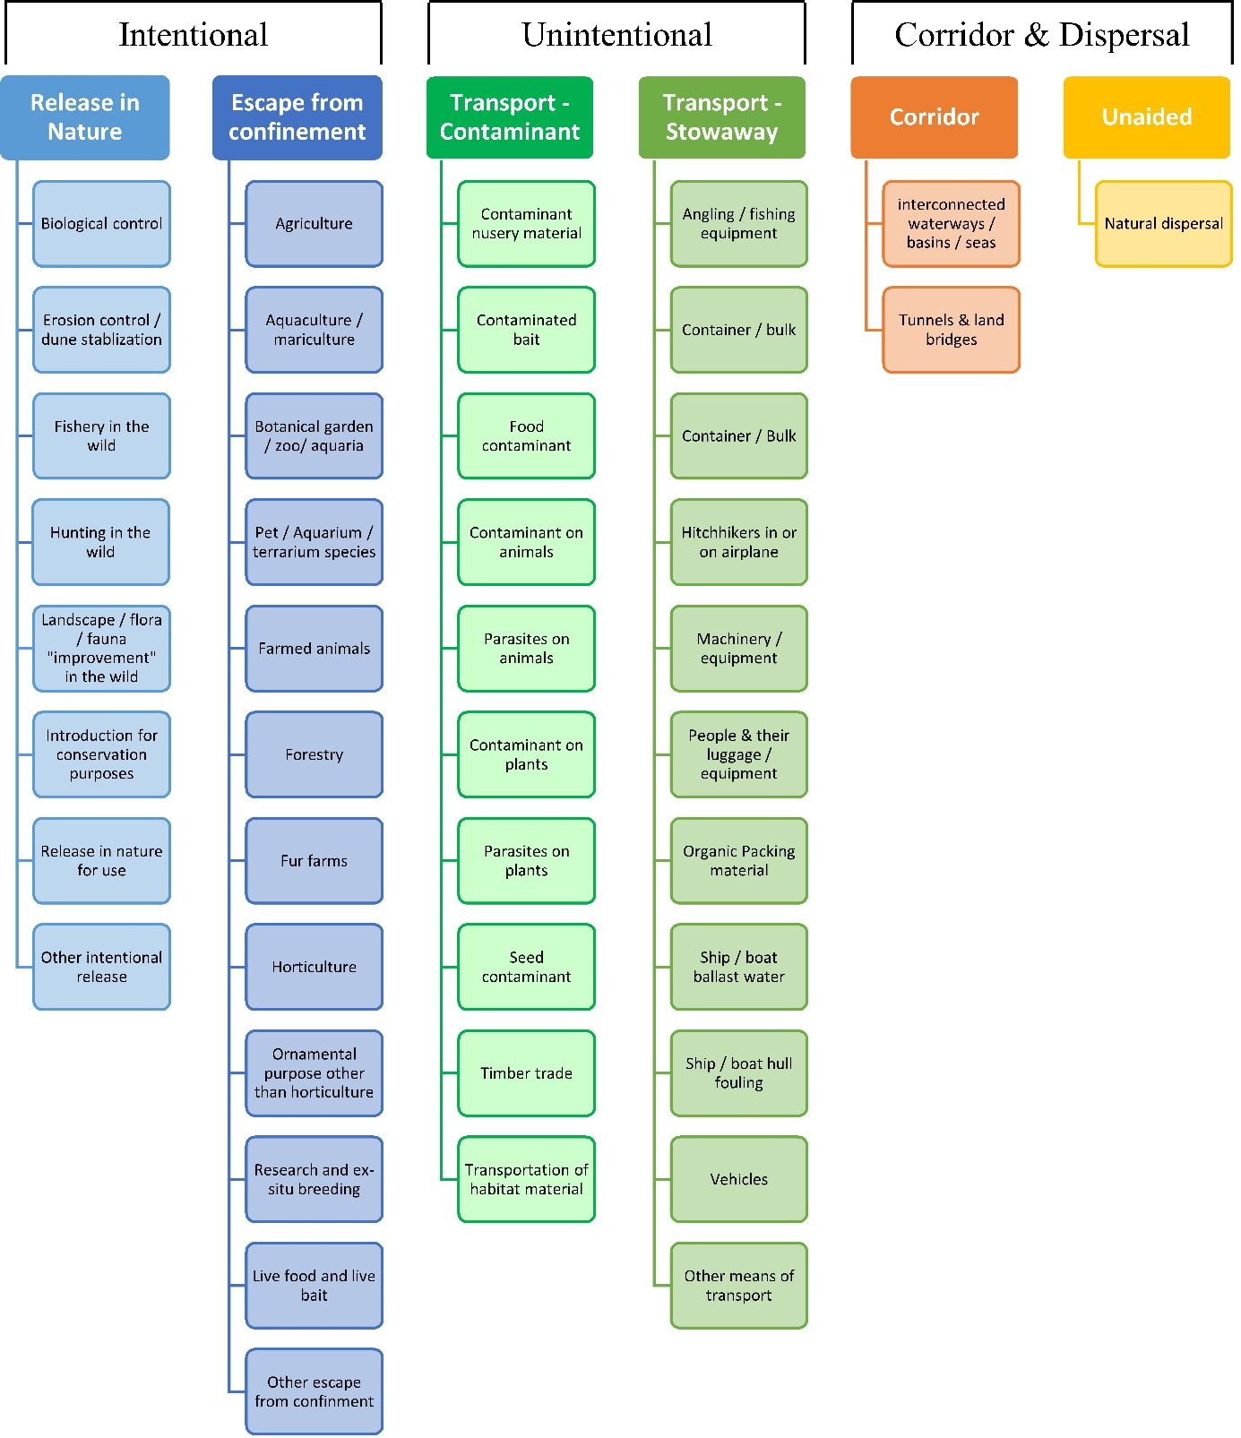

# ANNEX V Ecosystem services classification (CICES V5.1, simplified) and examples

For the purposes of this risk assessment, please feel free to use what seems as the most appropriate category / level / combination of impact (Section – Division – Group), reflecting information available.

|  |  |  |  |
| --- | --- | --- | --- |
| **Section** | **Division** | **Group** | **Examples (i.e. relevant CICES “classes”)** |
| **Provisioning** | **Biomass** | **Cultivated *terrestrial* plants** | Cultivated terrestrial plants (including fungi, algae) grown for nutritional purposes;  Fibres and other materials from cultivated plants, fungi, algae and bacteria for direct use or processing (excluding genetic materials);  Cultivated plants (including fungi, algae) grown as a source of energy  *Example: negative impacts of non-native organisms to crops, orchards, timber etc.* |
|  |  | **Cultivated *aquatic* plants** | Plants cultivated by in- situ aquaculture grown for nutritional purposes;  Fibres and other materials from in-situ aquaculture for direct use or processing (excluding genetic materials);  Plants cultivated by in- situ aquaculture grown as an energy source.  *Example: negative impacts of non-native organisms to aquatic plants cultivated for nutrition, gardening etc. purposes.* |
|  |  | **Reared animals** | Animals reared for nutritional purposes;  Fibres and other materials from reared animals for direct use or processing (excluding genetic materials);  Animals reared to provide energy (including mechanical)  *Example: negative impacts of non-native organisms to livestock* |
|  |  | **Reared *aquatic* animals** | Animals reared by in-situ aquaculture for nutritional purposes;  Fibres and other materials from animals grown by in-situ aquaculture for direct use or processing (excluding genetic materials);  Animals reared by in-situ aquaculture as an energy source  *Example: negative impacts of non-native organisms to fish farming* |
|  |  | **Wild plants** (terrestrial and aquatic) | Wild plants (terrestrial and aquatic, including fungi, algae) used for nutrition;  Fibres and other materials from wild plants for direct use or processing (excluding genetic materials);  Wild plants (terrestrial and aquatic, including fungi, algae) used as a source of energy  *Example: reduction in the availability of wild plants (e.g. wild berries, ornamentals) due to non-native organisms (competition, spread of disease etc.)* |
|  |  | **Wild animals** (terrestrial and aquatic) | Wild animals (terrestrial and aquatic) used for nutritional purposes;  Fibres and other materials from wild animals for direct use or processing (excluding genetic materials);  Wild animals (terrestrial and aquatic) used as a source of energy  *Example: reduction in the availability of wild animals (e.g. fish stocks, game) due to non-native organisms (competition, predations, spread of disease etc.)* |
|  | **Genetic material** from all biota | **Genetic material** from plants, algae or fungi | Seeds, spores and other plant materials collected for maintaining or establishing a population;  Higher and lower plants (whole organisms) used to breed new strains or varieties;  Individual genes extracted from higher and lower plants for the design and construction of new biological entities  *Example: negative impacts of non-native organisms due to interbreeding* |
|  |  | **Genetic material** from animals | Animal material collected for the purposes of maintaining or establishing a population;  Wild animals (whole organisms) used to breed new strains or varieties;  Individual genes extracted from organisms for the design and construction of new biological entities  *Example: negative impacts of non-native organisms due to interbreeding* |
|  | **Water[6]** | **Surface water** used for nutrition, materials or energy | Surface water for drinking;  Surface water used as a material (non-drinking purposes);  Freshwater surface water, coastal and marine water used as an energy source  *Example: loss of access to surface water due to spread of non-native organisms* |
|  |  | **Ground water** for used for nutrition, materials or energy | Ground (and subsurface) water for drinking;  Ground water (and subsurface) used as a material (non-drinking purposes);  Ground water (and subsurface) used as an energy source  *Example: reduced availability of ground water due to spread of non-native organisms and associated increase of ground water consumption by vegetation.* |
| **Regulation & Maintenance** | **Transformation** of biochemical or physical inputs to ecosystems | **Mediation of wastes or toxic substances** of anthropogenic origin by living processes | Bio-remediation by micro-organisms, algae, plants, and animals; Filtration/sequestration/storage/accumulation by micro-organisms, algae, plants, and animals  *Example: changes caused by non-native organisms to ecosystem functioning and ability to filtrate etc. waste or toxics* |
|  |  | **Mediation of nuisances** of anthropogenic origin | Smell reduction; noise attenuation; visual screening (e.g. by means of green infrastructure)  *Example: changes caused by non-native organisms to ecosystem structure, leading to reduced ability to mediate nuisances.* |
|  | **Regulation** of physical, chemical, biological conditions | **Baseline flows and extreme event** regulation | Control of erosion rates;  Buffering and attenuation of mass movement;  Hydrological cycle and water flow regulation (Including flood control, and coastal protection);  Wind protection;  Fire protection  *Example: changes caused by non-native organisms to ecosystem functioning or structure leading to, for example, destabilisation of soil, increased risk or intensity of wild fires etc.* |
|  |  | **Lifecycle maintenance**, habitat and gene pool protection | Pollination (or 'gamete' dispersal in a marine context);  Seed dispersal;  Maintaining nursery populations and habitats (Including gene pool protection)  *Example: changes caused by non-native organisms to the abundance and/or distribution of wild pollinators; changes to the availability / quality of nursery habitats for fisheries* |
|  |  | **Pest and disease control** | Pest control;  Disease control  *Example: changes caused by non-native organisms to the abundance and/or distribution of pests* |
|  |  | **Soil quality** regulation | Weathering processes and their effect on soil quality;  Decomposition and fixing processes and their effect on soil quality  *Example: changes caused by non-native organisms to vegetation structure and/or soil fauna leading to reduced soil quality* |
|  |  | **Water** conditions | Regulation of the chemical condition of freshwaters by living processes;  Regulation of the chemical condition of salt waters by living processes  *Example: changes caused by non-native organisms to buffer strips along water courses that remove nutrients in runoff and/or fish communities that regulate the resilience and resistance of water bodies to eutrophication* |
|  |  | **Atmospheric** composition and conditions | Regulation of chemical composition of atmosphere and oceans;  Regulation of temperature and humidity, including ventilation and transpiration  *Example: changes caused by non-native organisms to ecosystems’ ability to sequester carbon and/or evaporative cooling (e.g. by urban trees)* |
| **Cultural** | **Direct, in-situ and outdoor interactions** with living systems that depend on presence in the environmental setting | **Physical and experiential** interactions with natural environment | Characteristics of living systems that that enable activities promoting health, recuperation or enjoyment through active or immersive interactions;  Characteristics of living systems that enable activities promoting health, recuperation or enjoyment through passive or observational interactions  *Example: changes caused by non-native organisms to the qualities of ecosystems (structure, species composition etc.) that make it attractive for recreation, wild life watching etc.* |
|  |  | **Intellectual and representative** interactions with natural environment | Characteristics of living systems that enable scientific investigation or the creation of traditional ecological knowledge;  Characteristics of living systems that enable education and training;  Characteristics of living systems that are resonant in terms of culture or heritage;  Characteristics of living systems that enable aesthetic experiences  *Example: changes caused by non-native organisms to the qualities of ecosystems (structure, species composition etc.) that have cultural importance* |
|  | **Indirect, remote, often indoor interactions** with living systems that do not require presence in the environmental setting | **Spiritual, symbolic** and other interactions with natural environment | Elements of living systems that have symbolic meaning;  Elements of living systems that have sacred or religious meaning;  Elements of living systems used for entertainment or representation  *Example: changes caused by non-native organisms to the qualities of ecosystems (structure, species composition etc.) that have sacred or religious meaning* |
|  |  | Other biotic characteristics that have a **non-use value** | Characteristics or features of living systems that have an existence value;  Characteristics or features of living systems that have an option or bequest value  *Example: changes caused by non-native organisms to ecosystems designated as wilderness areas, habitats of endangered species etc.* |

# ANNEX VI EU Biogeographic Regions and MSFD Subregions

See <https://www.eea.europa.eu/data-and-maps/figures/biogeographical-regions-in-europe-2> ,

<http://ec.europa.eu/environment/nature/natura2000/biogeog_regions/>

and

https://www.eea.europa.eu/data-and-maps/data/msfd-regions-and-subregions-1/technical-document/pdf

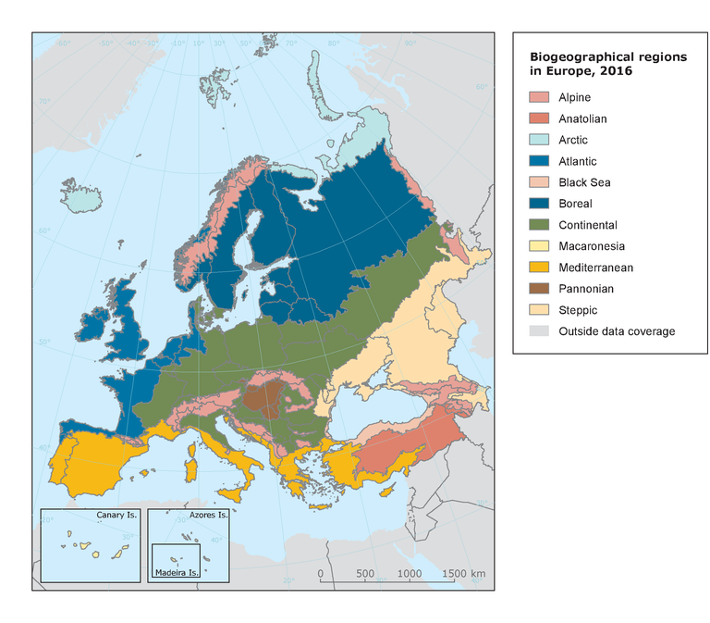 

# ANNEX VII Delegated Regulation (EU) 2018/968 of 30 April 2018

see <https://eur-lex.europa.eu/legal-content/en/TXT/?uri=CELEX%3A32018R0968>

# ANNEX VIII Projection of environmental suitability for Obama nungara establishment in Europe

Björn Beckmann, Archie Murchie, Leigh Winsor, Jean-Lou Justine and Dan Chapman

21 September 2021

## Aim

To project the suitability for potential establishment of *Obama nungara* in Europe, under current and predicted future climatic conditions.

## Data for modelling

Species occurrence data were obtained from the Global Biodiversity Information Facility (GBIF) (543 records), iNaturalist (79 records), and additional records from the risk assessment team. We scrutinised occurrence records from regions where the species is not known to be established and removed any dubious records or where the georeferencing was too imprecise (e.g. records referenced to a country or island centroid) or outside of the coverage of the predictor layers (e.g. small island or coastal occurrences). The remaining records were gridded at a 0.25 x 0.25 degree resolution for modelling, yielding 233 grid cells with occurrences (Figure 1a). As a proxy for recording effort, the density of Platyhelminthes records held by GBIF was also compiled on the same grid (Figure 1b).

##### Page Break

**Figure 1.** (a) Occurrence records obtained for *Obama nungara* and used in the modelling, showing native and invaded distributions. (b) The recording density of Platyhelminthes on GBIF, which was used as a proxy for recording effort.

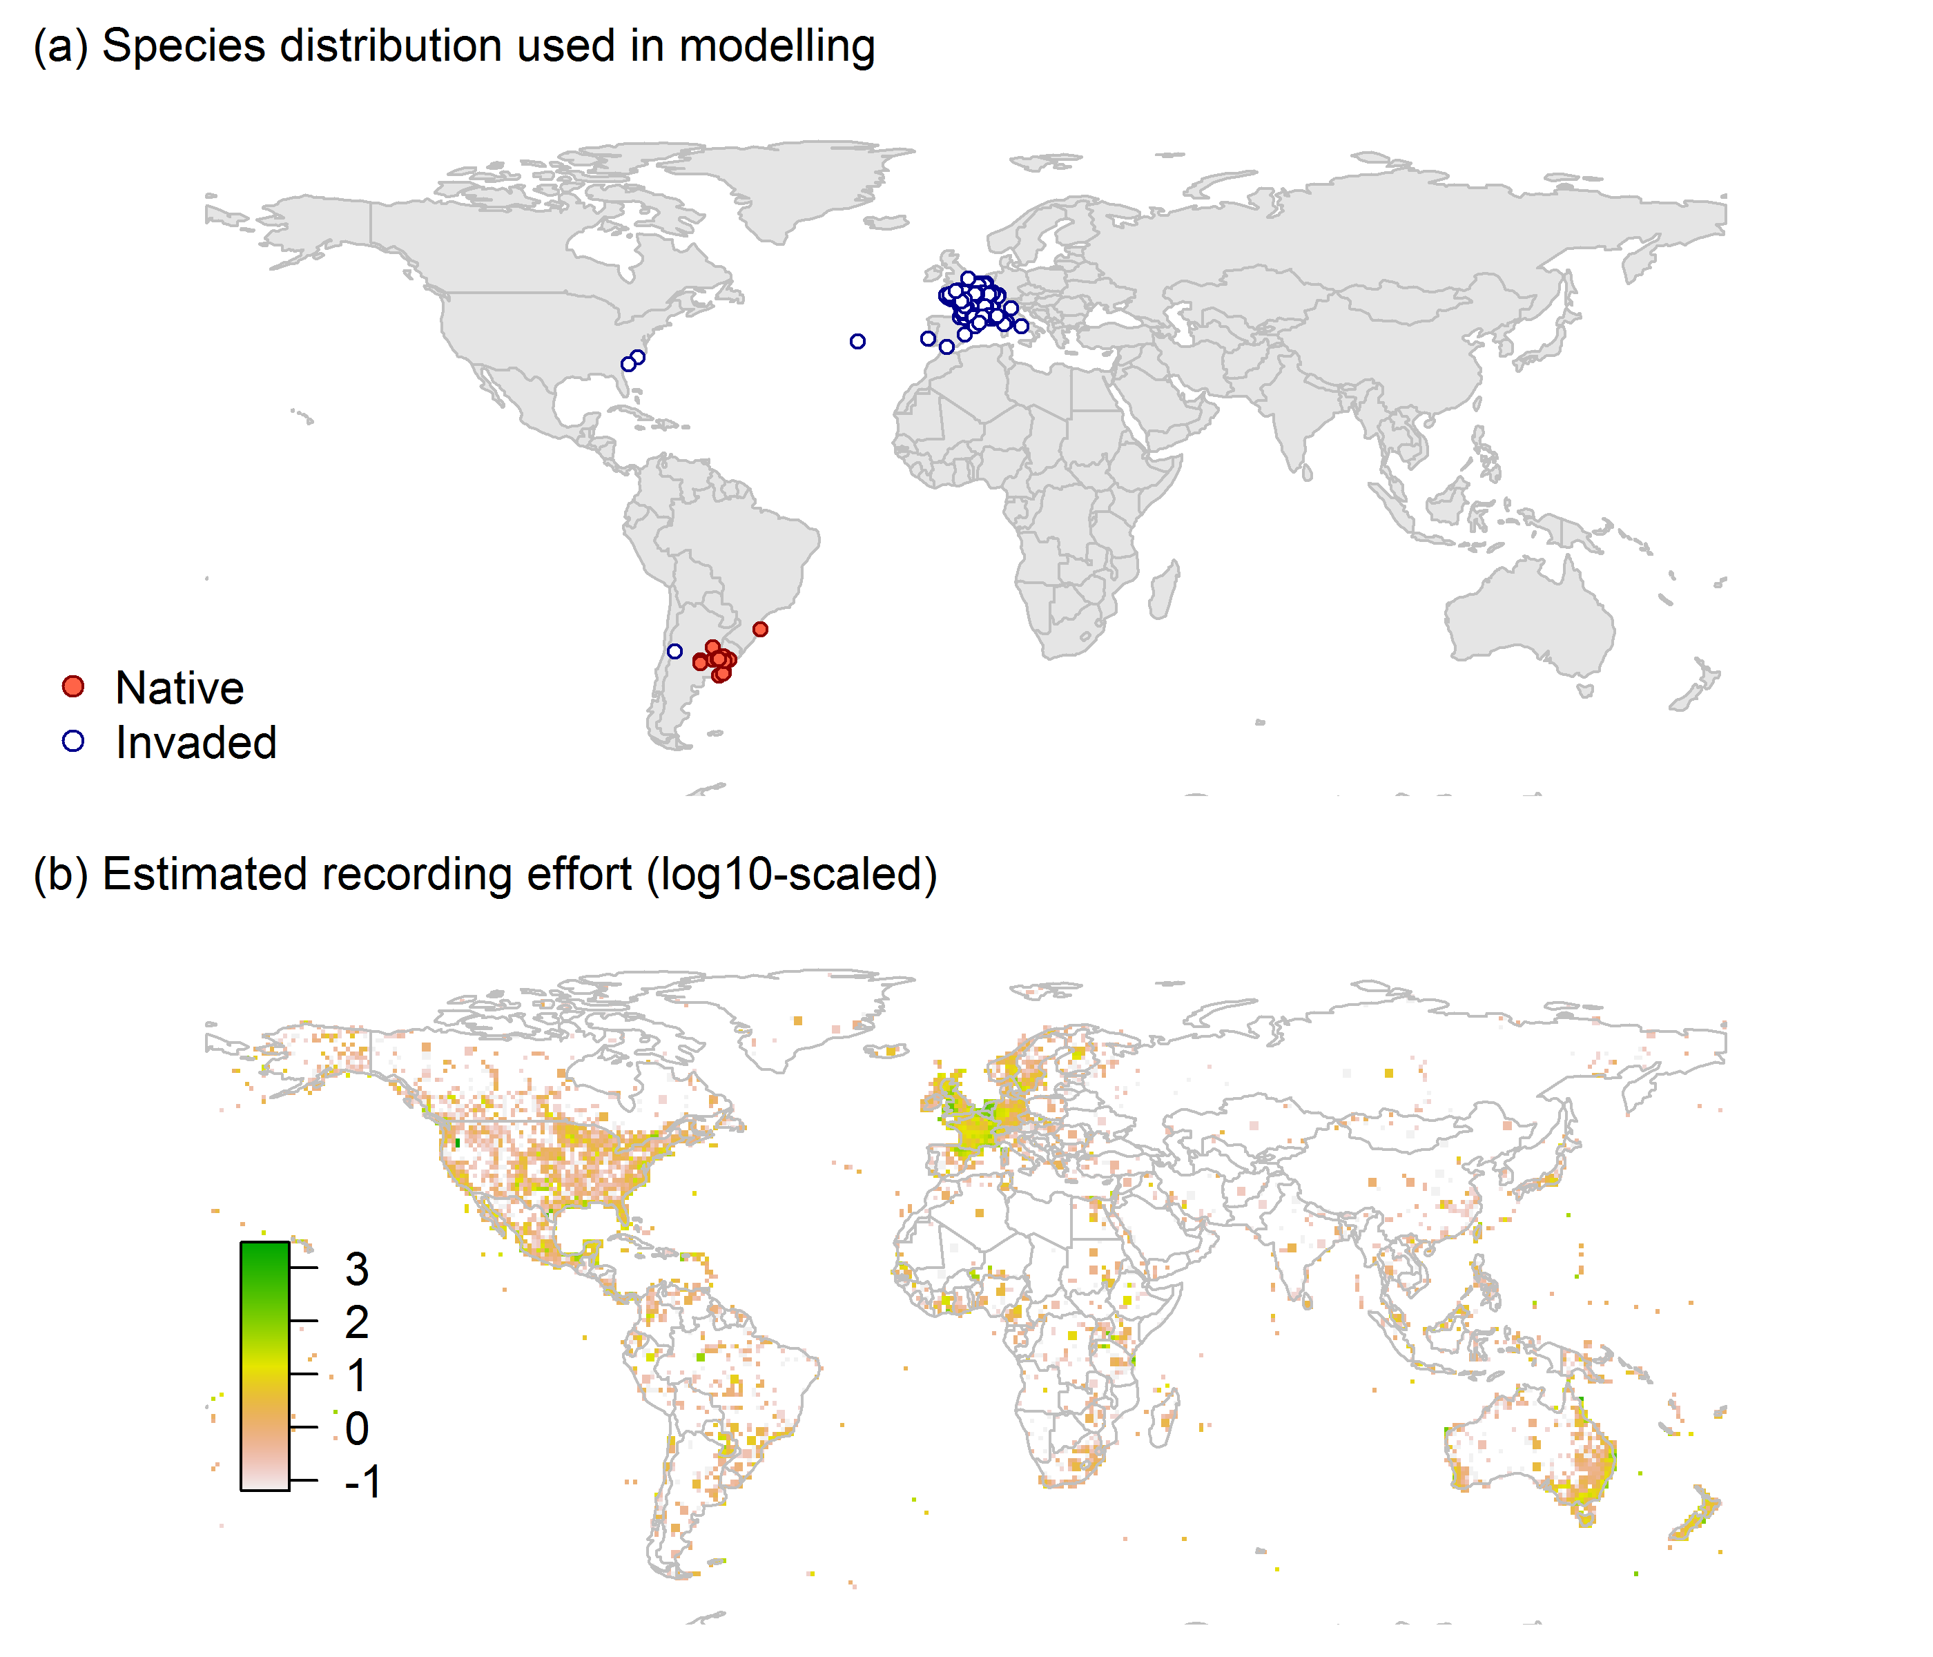

Climate data were selected from the ‘Bioclim’ variables contained within the WorldClim database (Hijmans et al., 2005), originally at 5 arcminute resolution (0.083 x 0.083 degrees of longitude/latitude) and aggregated to a 0.25 x 0.25 degree grid for use in the model.

Based on the biology of *Obama nungara*, the following climate variables were used in the modelling:

* Minimum temperature of the coldest month (Bio6)
* Mean temperature of the warmest quarter (Bio10)
* Annual precipitation (Bio12)
* Precipitation seasonality (Bio15)
* Climatic moisture index (CMI): ratio of mean annual precipitation to potential evapotranspiration, log+1 transformed. For its calculation, monthly potential evapotranspirations were estimated from the WorldClim monthly temperature data and solar radiation using the simple method of Zomer et al. (2008) which is based on the Hargreaves evapotranspiration equation (Hargreaves, 1994).

To estimate the effect of climate change on the potential distribution, equivalent modelled future climate conditions for the 2070s under the Representative Concentration Pathways (RCP) 2.6 and 4.5 were also obtained. These represent low and medium emissions scenarios, respectively. The above variables were obtained as averages of outputs of eight Global Climate Models (BCC-CSM1-1, CCSM4, GISS-E2-R, HadGEM2-AO, IPSL-CM5A-LR, MIROC-ESM, MRI-CGCM3, NorESM1-M), downscaled and calibrated against the WorldClim baseline (see <http://www.worldclim.org/cmip5_5m> ).

The following habitat layers were also used:

* Human influence index (HII): As many non-native invasive species associate with anthropogenically disturbed habitats. We used the Global Human Influence Index Dataset of the Last of the Wild Project (Wildlife Conservation Society - WCS & Center for International Earth Science Information Network - CIESIN - Columbia University, 2005), which is developed from nine global data layers covering human population pressure (population density), human land use and infrastructure (built-up areas, nighttime lights, land use/land cover) and human access (coastlines, roads, railroads, navigable rivers). The index ranges between 0 and 1 and was ln+1 transformed for the modelling to improve normality.

## Species distribution model

A presence-background (presence-only) ensemble modelling strategy was employed using the BIOMOD2 R package version 3.4.6 (Thuiller et al., 2020, Thuiller et al., 2009). These models contrast the environment at the species’ occurrence locations against a random sample of the global background environmental conditions (often termed ‘pseudo-absences’) in order to characterise and project suitability for occurrence. This approach has been developed for distributions that are in equilibrium with the environment. Because invasive species’ distributions are not at equilibrium and subject to dispersal constraints at a global scale, we took care to minimise the inclusion of locations suitable for the species but where it has not been able to disperse to (Chapman et al. 2019). Therefore the background sampling region included:

* The area accessible by native *Obama nungara* populations, in which the species is likely to have had sufficient time to disperse to all locations. Based on presumed maximum dispersal distances, the accessible region was defined as a 300km buffer around the native range occurrences; AND
* A 30km buffer around the non-native occurrences, encompassing regions likely to have had high propagule pressure for introduction by humans and/or dispersal of the species; AND
* Regions where we have an *a priori* expectation of high unsuitability for the species so that absence is assumed irrespective of dispersal constraints (see Figure 2). The following rules were applied to define a region expected to be highly unsuitable for *Obama nungara* at the spatial scale of the model:
  + Minimum temperature of the coldest month (Bio6) < -4°C
  + Mean temperature of the warmest quarter (Bio10) < 15.5°C
  + Annual precipitation (Bio12) < 350mm

Altogether, 0.9% of occurrence grid cells were located in the unsuitable background region.

Within the unsuitable background region, 10 samples of 5000 randomly sampled grid cells were obtained. In the accessible background (comprising the accessible areas around native and non-native occurrences as detailed above), the same number of pseudo-absence samples were drawn as there were presence records (233), weighting the sampling by a proxy for recording effort (Figure 1(b)).

**Figure 2.** The background from which pseudo-absence samples were taken in the modelling of *Obama nungara*. Samples were taken from a 300km buffer around the native range and a 30km buffer around non-native occurrences (together forming the accessible background), and from areas expected to be highly unsuitable for the species (the unsuitable background region). Samples from the accessible background were weighted by a proxy for recording effort (Figure 1(b)).

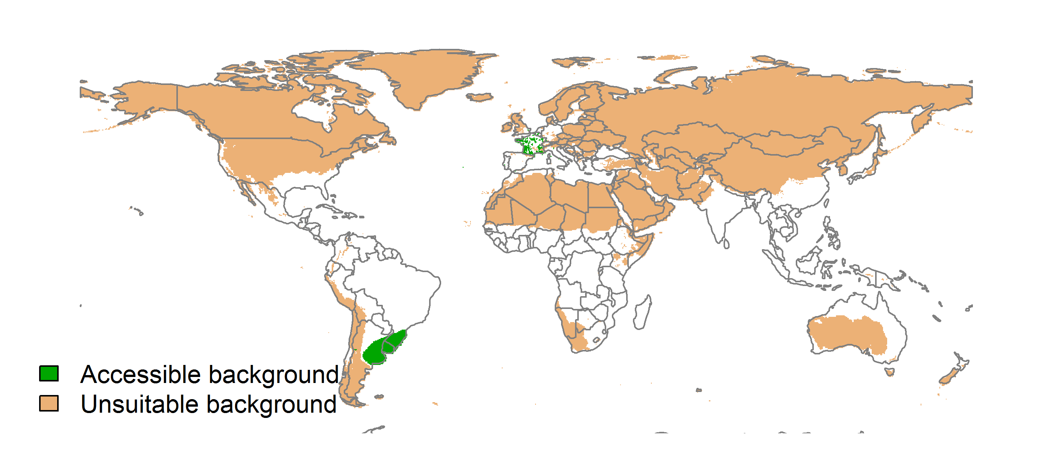

Each dataset (i.e. combination of the presences and the individual background samples) was randomly split into 80% for model training and 20% for model evaluation. With each training dataset, seven statistical algorithms were fitted with the default BIOMOD2 settings and rescaled using logistic regression, except where specified below:

* Generalised linear model (GLM)
* Generalised boosting model (GBM)
* Generalised additive model (GAM) with a maximum of four degrees of freedom per smoothing spline
* Artificial neural network (ANN)
* Multivariate adaptive regression splines (MARS)
* Random forest (RF)
* Maxent

Since the total background sample was larger than the number of occurrences, prevalence fitting weights were applied to give equal overall importance to the occurrences and the background. Normalised variable importance was assessed and variable response functions were produced using BIOMOD2’s default procedure.

Model predictive performance was assessed by the following three measures:

* AUC, the area under the receiver operating characteristic curve (Fielding & Bell 1997). Predictions of presence-absence models can be compared with a subset of records set aside for model evaluation (here 20%) by constructing a confusion matrix with the number of true positive, false positive, false negative and true negative cases. For models generating non-dichotomous scores (as here) a threshold can be applied to transform the scores into a dichotomous set of presence-absence predictions. Two measures that can be derived from the confusion matrix are sensitivity (the proportion of observed presences that are predicted as such, quantifying omission errors), and specificity (the proportion of observed absences that are predicted as such, quantifying commission errors). A receiver operating characteristic (ROC) curve can be constructed by using all possible thresholds to classify the scores into confusion matrices, obtaining sensitivity and specificity for each matrix, and plotting sensitivity against the corresponding proportion of false positives (equal to 1 - specificity). The use of all possible thresholds avoids the need for a selection of a single threshold, which is often arbitrary, and allows appreciation of the trade-off between sensitivity and specificity. The area under the ROC curve (AUC) is often used as a single threshold-independent measure for model performance (Manel et al. 2001). AUC is the probability that a randomly selected presence has a higher model-predicted suitability than a randomly selected absence (Allouche et al. 2006).
* Cohen’s Kappa (Cohen 1960). This measure corrects the overall accuracy of model predictions (ratio of the sum of true presences plus true absences to the total number of records) by the accuracy expected to occur by chance. The Kappa statistic ranges from -1 to +1, where +1 indicates perfect agreement and values of zero or less indicate a performance no better than random. Advantages of Kappa are its simplicity, the fact that both commission and omission errors are accounted for in one parameter, and its relative tolerance to zero values in the confusion matrix (Manel et al. 2001). However, Kappa has been criticised for being sensitive to prevalence (the proportion of sites in which the species was recorded as present) and may therefore be inappropriate for comparisons of model accuracy between species or regions (McPherson et al. 2004, Allouche et al. 2006).
* TSS, the true skill statistic (Allouche et al. 2006). TSS is defined as sensitivity + specificity - 1, and corrects for Kappa’s dependency on prevalence. TSS compares the number of correct forecasts, minus those attributable to random guessing, to that of a hypothetical set of perfect forecasts. Like Kappa, TSS takes into account both omission and commission errors, and success as a result of random guessing, and ranges from -1 to +1, where +1 indicates perfect agreement and values of zero or less indicate a performance no better than random (Allouche et al. 2006).

An ensemble model was created by first rejecting poorly performing algorithms with relatively extreme low AUC values and then averaging the predictions of the remaining algorithms, weighted by their AUC. To identify poorly performing algorithms, AUC values were converted into modified z-scores based on their difference to the median and the median absolute deviation across all algorithms (Iglewicz & Hoaglin 1993). Algorithms with z < -2 were rejected. In this way, ensemble projections were made for each dataset and then averaged to give an overall suitability, as well as its standard deviation.

Projections were classified into suitable and unsuitable regions using a “lowest presence threshold” (Pearson et al. 2007), setting the cut-off as the lowest value at which 98% of all presence records are classified correctly under the current climate (here 0.71). In order to express the sensitivity of classifications to the choice of this threshold, thresholds at which 95% and 99% of records are classified correctly (here 0.79 and 0.62 respectively) were used in the calculation of error bars in Figures 9 and 10 below in addition to taking account of uncertainty in the projections themselves.

We also produced a limiting factor map for Europe following Elith et al. (2010). For this, projections were made separately with each individual variable fixed at a near-optimal value. These were chosen as the median values at the occurrence grid cells. Then, the most strongly limiting factors were identified as the ones resulting in the highest increase in suitability in each grid cell.

##### Page Break

## Results

The ensemble model suggested that suitability for *Obama nungara* was most strongly determined by Minimum temperature of the coldest month (Bio6), accounting for 42.3% of variation explained, followed by Human influence index (HII) (21.8%), Mean temperature of the warmest quarter (Bio10) (15.9%), Annual precipitation (Bio12) (11.8%), Climatic moisture index (CMI) (5.1%) and Precipitation seasonality (Bio15) (3.2%) (Table 1, Figure 3).

**Table 1.** Summary of the cross-validation predictive performance (AUC, Kappa, TSS) and variable importance of the fitted model algorithms and the ensemble (AUC-weighted average of the best performing algorithms). Results are the average from models fitted to 10 different background samples of the data.

|  |  |  |  |  |  |  |  |  |  |  |
| --- | --- | --- | --- | --- | --- | --- | --- | --- | --- | --- |
|  |  |  |  |  | **Variable importance (%)** | | | | | |
| **Algorithm** | **AUC** | **Kappa** | **TSS** | **Used in the ensemble** | **Minimum temperature of the coldest month (Bio6)** | **Human influence index (HII)** | **Mean temperature of the warmest quarter (Bio10)** | **Annual precipitation (Bio12)** | **Climatic moisture index (CMI)** | **Precipitation seasonality (Bio15)** |
| GLM | 0.979 | 0.655 | 0.939 | yes | 37 | 26 | 16 | 14 | 3 | 5 |
| GAM | 0.975 | 0.657 | 0.937 | yes | 29 | 23 | 15 | 23 | 5 | 6 |
| GBM | 0.972 | 0.658 | 0.934 | yes | 40 | 35 | 17 | 6 | 1 | 1 |
| ANN | 0.979 | 0.660 | 0.942 | yes | 43 | 22 | 26 | 5 | 2 | 2 |
| MARS | 0.980 | 0.649 | 0.936 | yes | 55 | 10 | 18 | 3 | 15 | 0 |
| RF | 0.971 | 0.619 | 0.926 | yes | 53 | 16 | 7 | 18 | 4 | 4 |
| Maxent | 0.972 | 0.647 | 0.915 | yes | 41 | 21 | 12 | 14 | 7 | 5 |
| **Ensemble** | **0.977** | **0.654** | **0.940** |  | **42** | **22** | **16** | **12** | **5** | **3** |

##### Page Break

**Figure 3.** Partial response plots from the fitted models. Thin coloured lines show responses from the algorithms in the ensemble, while the thick black line is their ensemble. In each plot, other model variables are held at their median value in the training data. Some of the divergence among algorithms is because of their different treatment of interactions among variables.

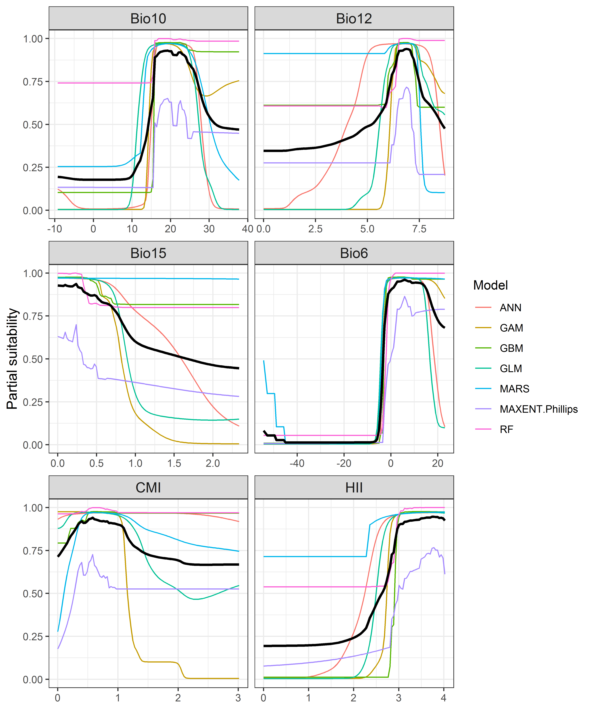

##### Page Break

**Figure 4.** (a) Projected global suitability for *Obama nungara* establishment in the current climate. For visualisation, the projection has been aggregated to a 0.5 x 0.5 degree resolution, by taking the maximum suitability of constituent higher resolution grid cells. Values > 0.71 are suitable for the species, with 98% of global presence records above this threshold. Values below 0.71 indicate lower relative suitability. (b) Uncertainty in the ensemble projections, expressed as the among-algorithm standard deviation in predicted suitability, averaged across the 10 datasets.

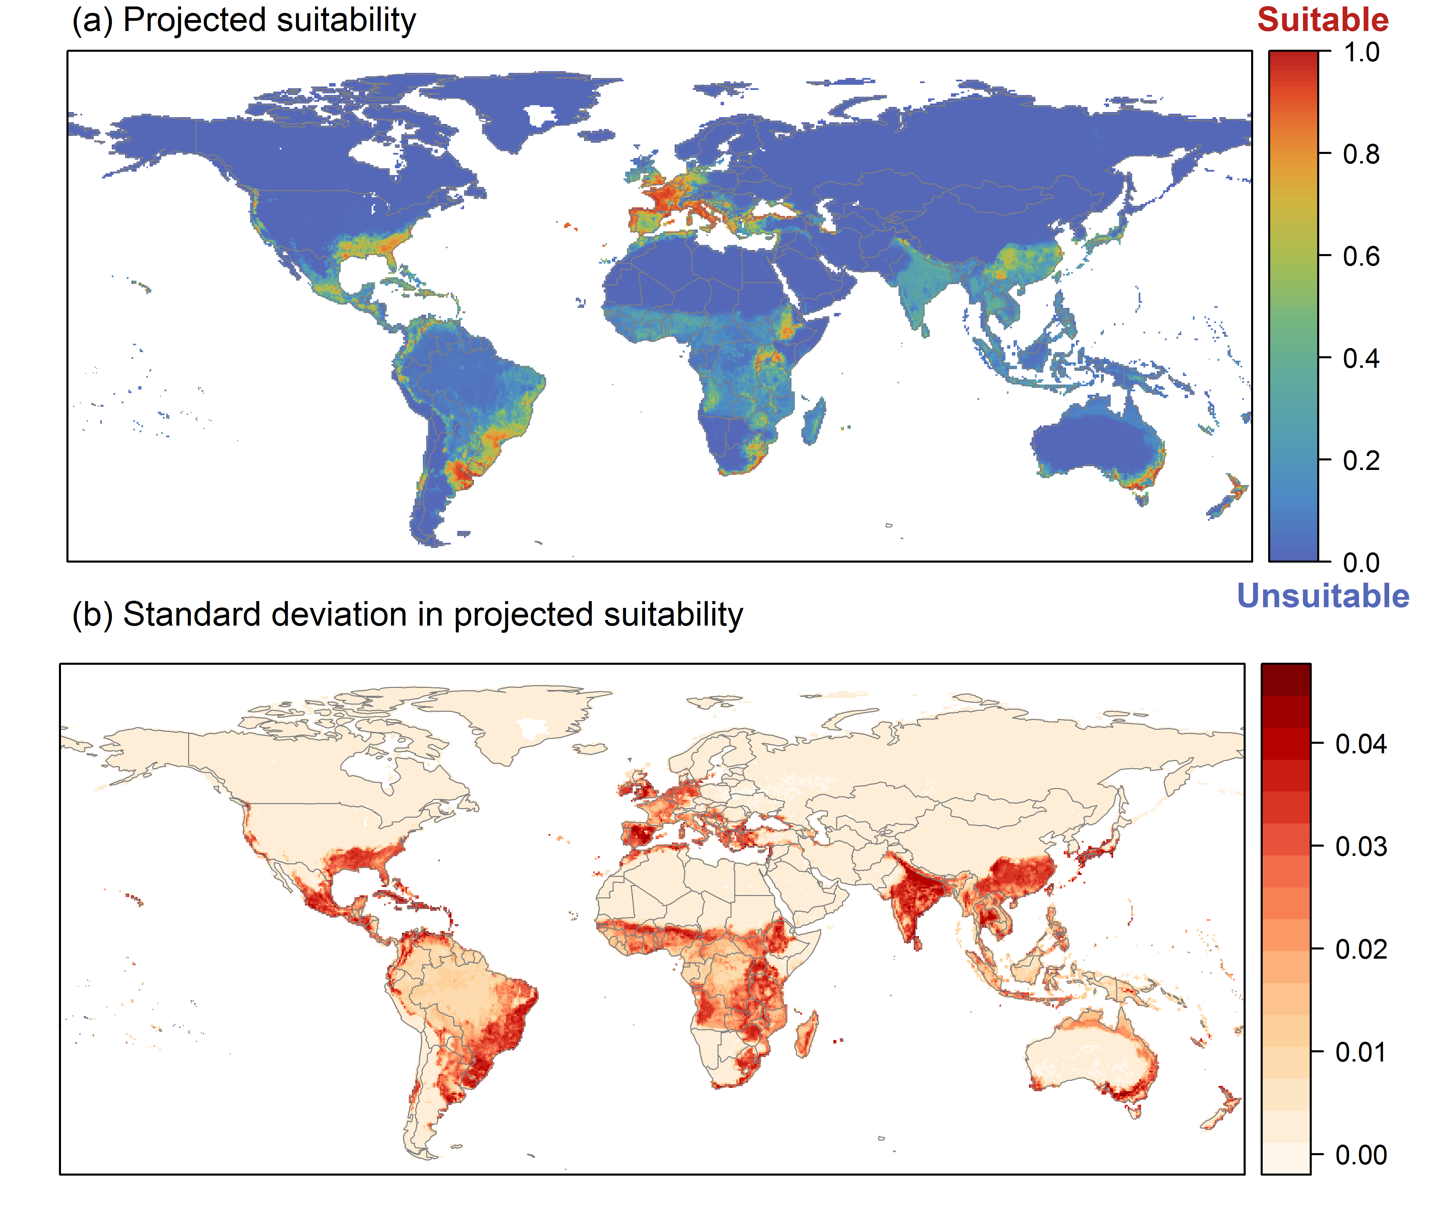

##### Page Break

**Figure 5.** (a) Projected current suitability for *Obama nungara* establishment in Europe and the Mediterranean region. Values > 0.71 are suitable for the species, with 98% of global presence records above this threshold. Values below 0.71 indicate lower relative suitability. (b) Uncertainty in the ensemble projections, expressed as the among-algorithm standard deviation in predicted suitability, averaged across the 10 datasets.

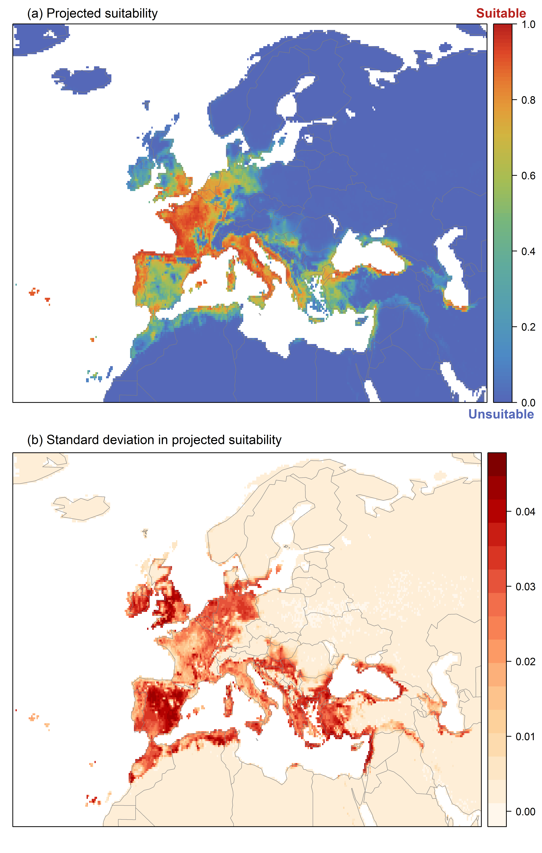

##### Page Break

**Figure 6.** The most strongly limiting factors for *Obama nungara* establishment estimated by the model in Europe and the Mediterranean region in current climatic conditions.

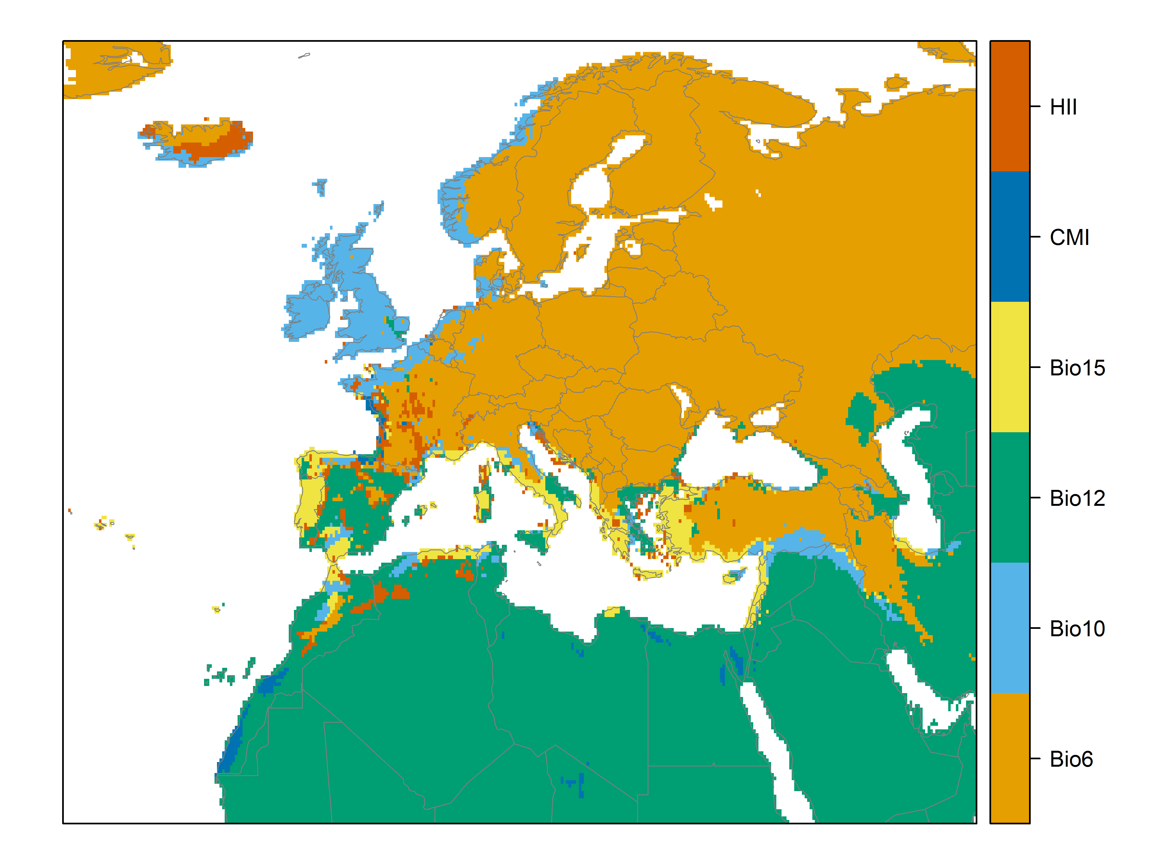

##### Page Break

**Figure 7.** (a) Projected suitability for *Obama nungara* establishment in Europe and the Mediterranean region in the 2070s under climate change scenario RCP2.6. Values > 0.71 are suitable for the species, with 98% of global presence records above this threshold under current climate. Values below 0.71 indicate lower relative suitability. (b) Uncertainty in the ensemble projections, expressed as the among-algorithm standard deviation in predicted suitability, averaged across the 10 datasets.

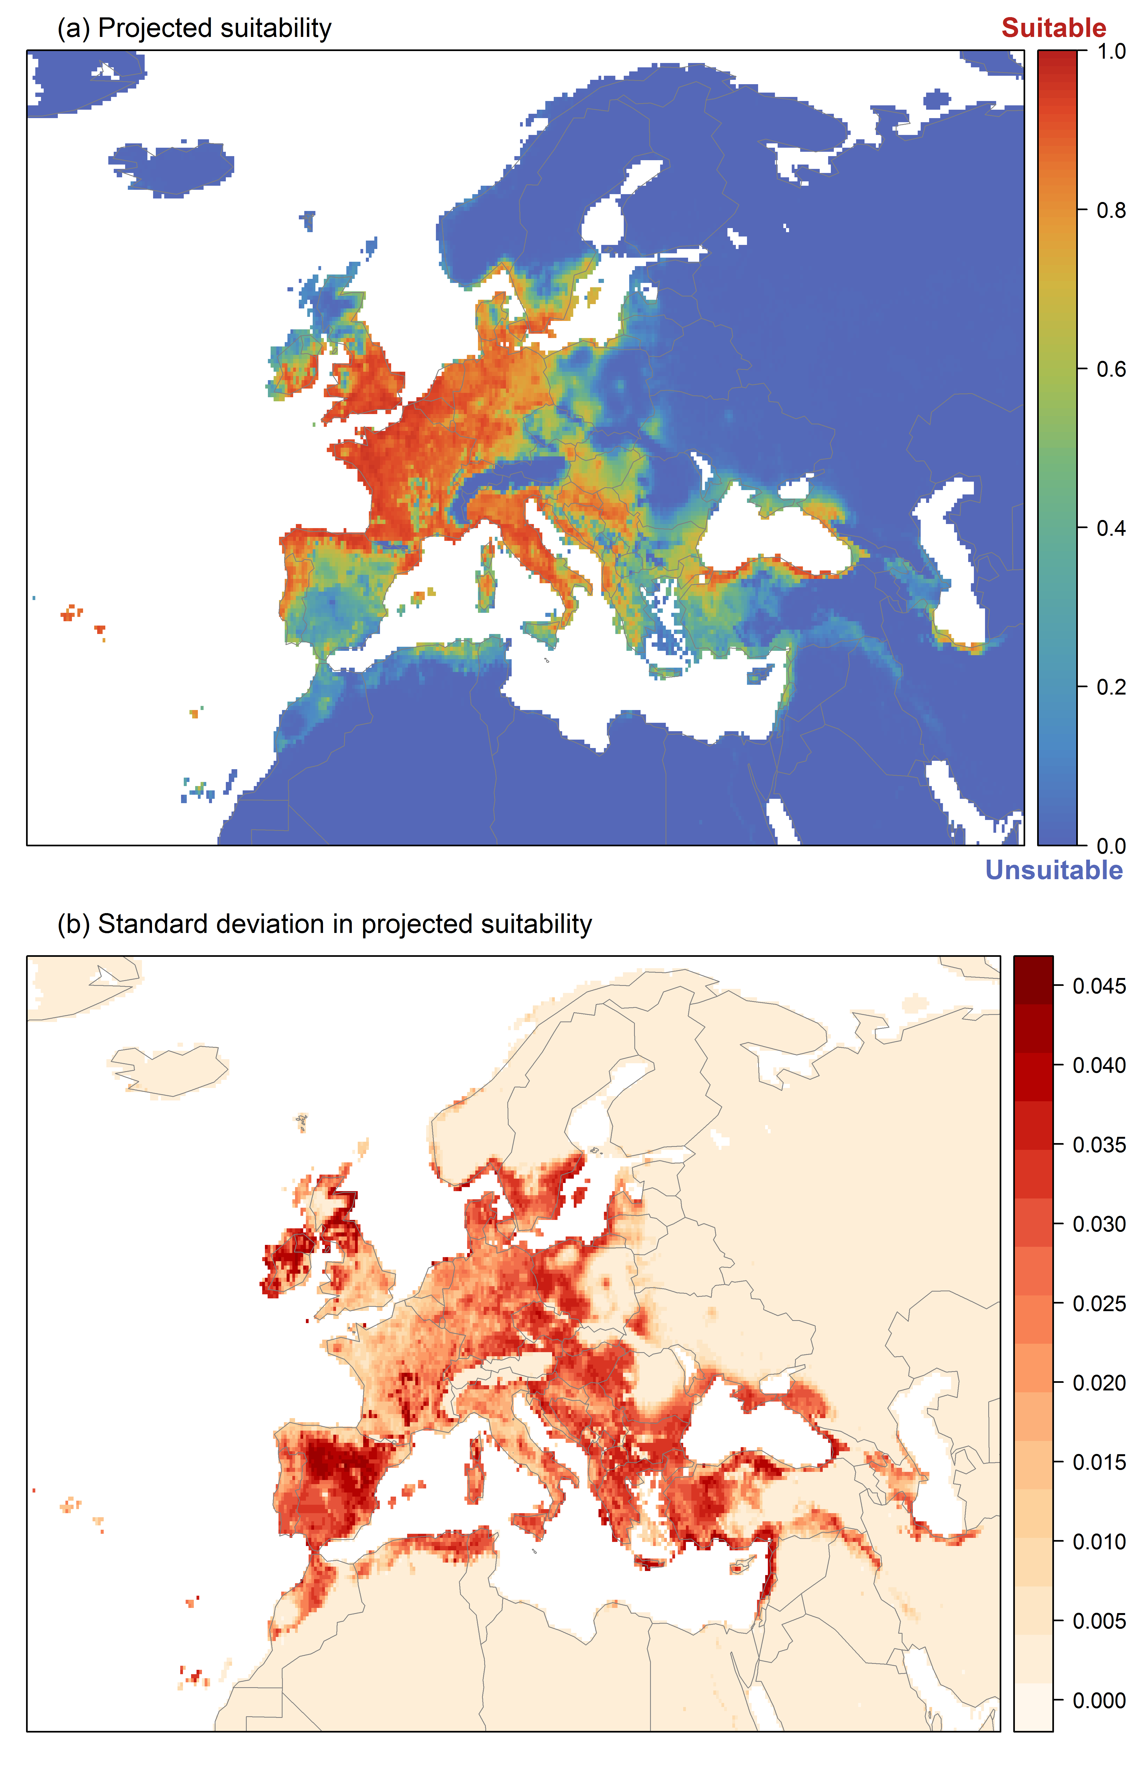

##### Page Break

**Figure 8.** (a) Projected suitability for *Obama nungara* establishment in Europe and the Mediterranean region in the 2070s under climate change scenario RCP4.5. Values > 0.71 are suitable for the species, with 98% of global presence records above this threshold under current climate. Values below 0.71 indicate lower relative suitability. (b) Uncertainty in the ensemble projections, expressed as the among-algorithm standard deviation in predicted suitability, averaged across the 10 datasets.

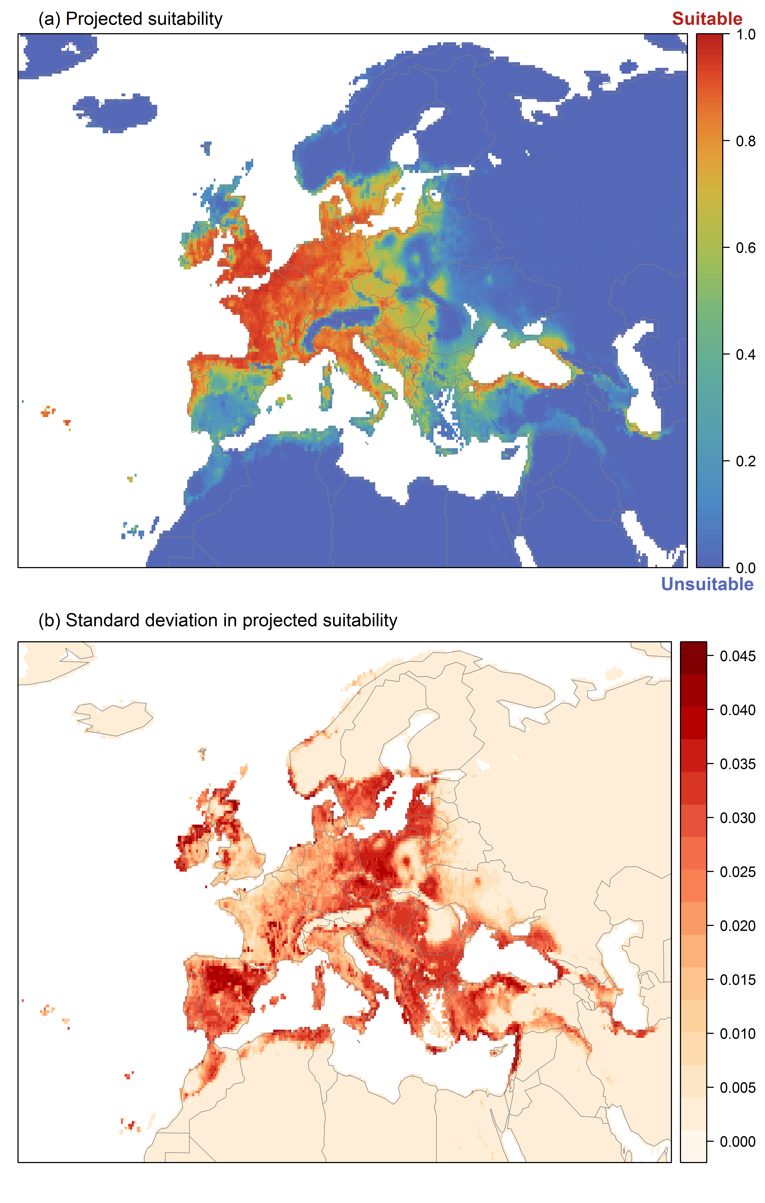

##### Page Break

**Figure 9.** Variation in projected suitability for *Obama nungara* establishment among Biogeographical Regions of Europe (<https://www.eea.europa.eu/data-and-maps/data/biogeographical-regions-europe-3>). The bar plots show the proportion of grid cells in each region classified as suitable (with values > 0.71) in the current climate and projected climate for the 2070s under two RCP emissions scenarios. Error bars indicate uncertainty due to both the choice of classification threshold (cf. p.6) and uncertainty in the projections themselves (cf. part (b) of Figures 5, 7 and 8). The location of each region is also shown. The Arctic and Macaronesian regions are not part of the study area, but are included for completeness.

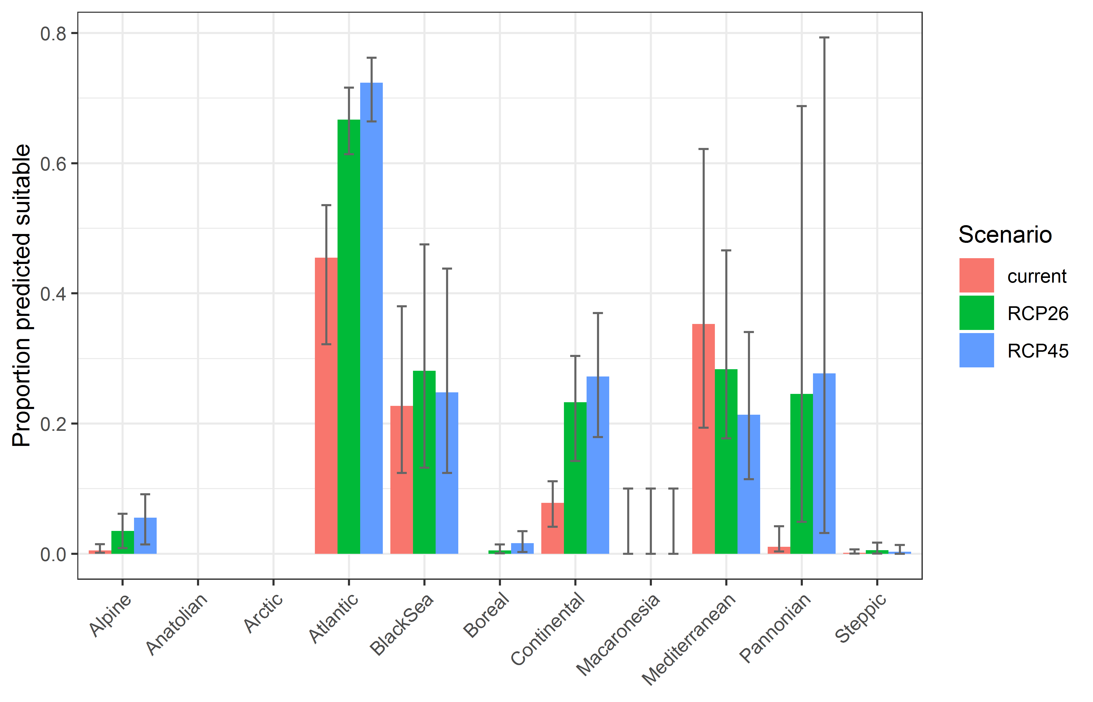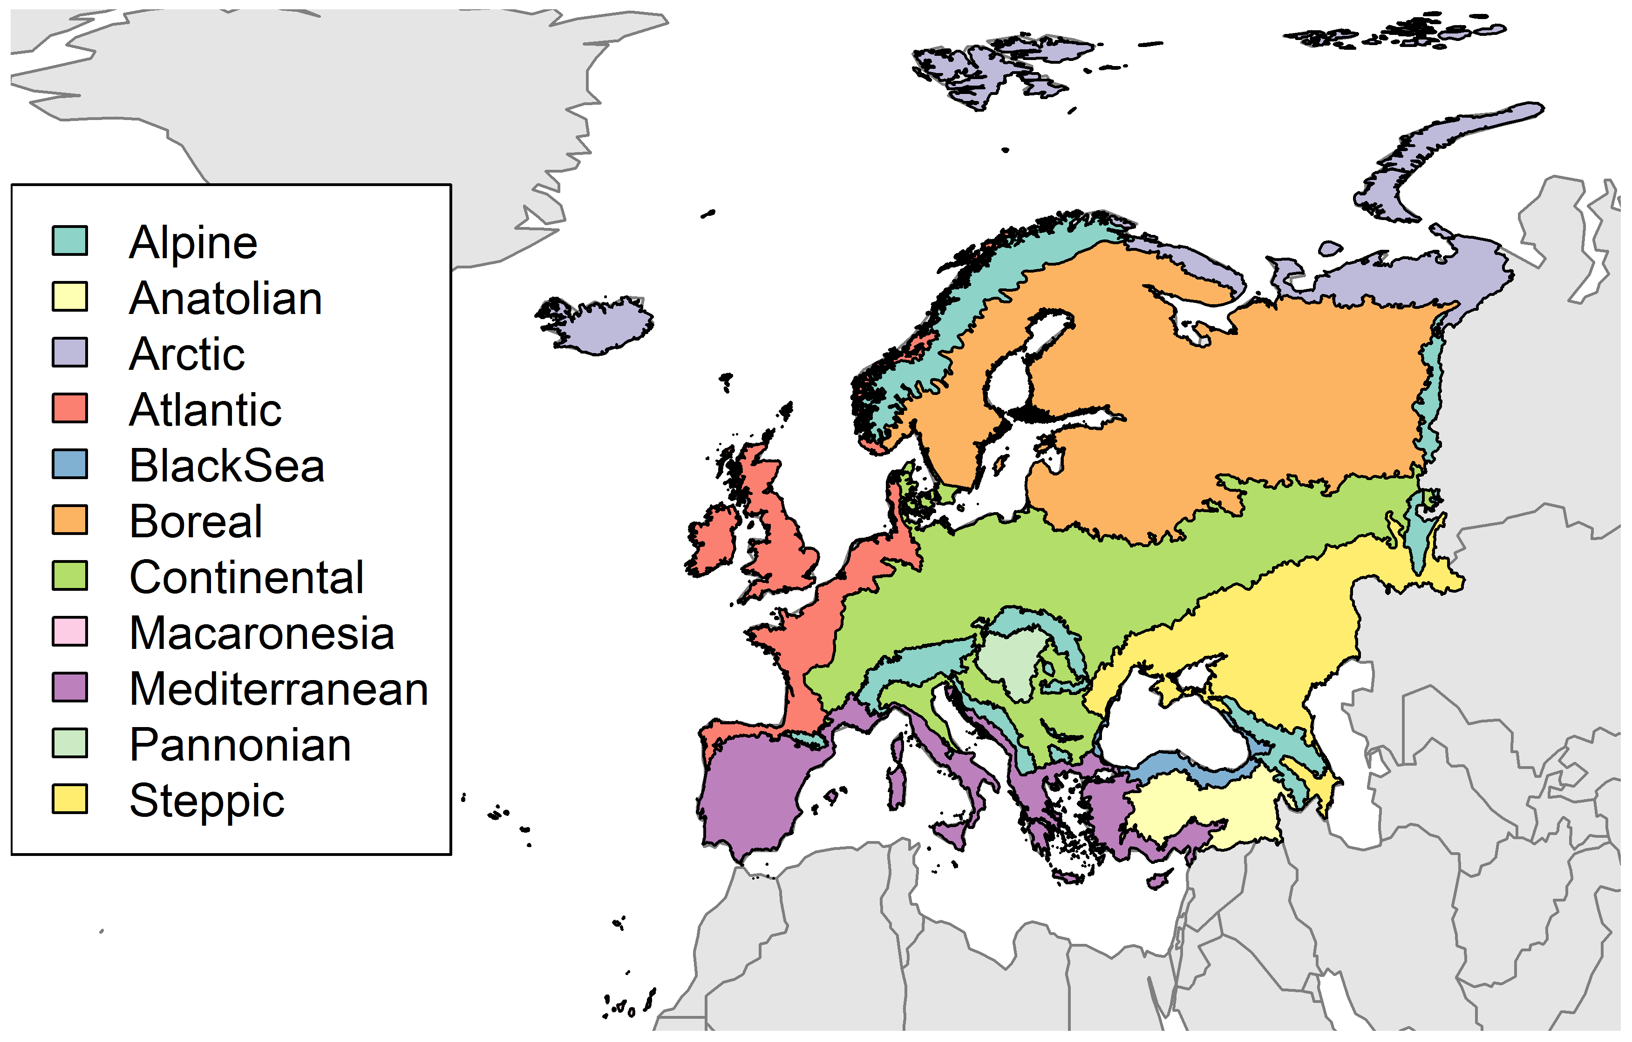

##### Page Break

**Table 2.** Variation in projected suitability for *Obama nungara* establishment among Biogeographical regions of Europe (numerical values of Figure 9 above). The numbers are the proportion of grid cells in each region classified as suitable in the current climate and projected climate for the 2070s under two RCP emissions scenarios. The Arctic and Macaronesian biogeographical regions are not part of the study area, but are included for completeness.

|  |  |  |  |  |  |  |  |  |  |
| --- | --- | --- | --- | --- | --- | --- | --- | --- | --- |
|  | **current climate** | | | **2070s RCP2.6** | | | **2070s RCP4.5** | | |
|  | lower | **central estimate** | upper | lower | **central estimate** | upper | lower | **central estimate** | upper |
| Alpine | 0.00 | 0.00 | 0.01 | 0.01 | 0.03 | 0.06 | 0.01 | 0.06 | 0.09 |
| Anatolian | 0.00 | 0.00 | 0.00 | 0.00 | 0.00 | 0.00 | 0.00 | 0.00 | 0.00 |
| Arctic | 0.00 | 0.00 | 0.00 | 0.00 | 0.00 | 0.00 | 0.00 | 0.00 | 0.00 |
| Atlantic | 0.32 | 0.45 | 0.54 | 0.61 | 0.67 | 0.72 | 0.66 | 0.72 | 0.76 |
| Black Sea | 0.12 | 0.23 | 0.38 | 0.13 | 0.28 | 0.48 | 0.12 | 0.25 | 0.44 |
| Boreal | 0.00 | 0.00 | 0.00 | 0.00 | 0.00 | 0.01 | 0.00 | 0.02 | 0.03 |
| Continental | 0.04 | 0.08 | 0.11 | 0.14 | 0.23 | 0.30 | 0.18 | 0.27 | 0.37 |
| Macaronesia | 0.00 | 0.00 | 0.10 | 0.00 | 0.00 | 0.10 | 0.00 | 0.00 | 0.10 |
| Mediterranean | 0.19 | 0.35 | 0.62 | 0.18 | 0.28 | 0.47 | 0.11 | 0.21 | 0.34 |
| Pannonian | 0.00 | 0.01 | 0.04 | 0.05 | 0.25 | 0.69 | 0.03 | 0.28 | 0.79 |
| Steppic | 0.00 | 0.00 | 0.01 | 0.00 | 0.01 | 0.02 | 0.00 | 0.00 | 0.01 |

##### Page Break

**Figure 10.** Variation in projected suitability for *Obama nungara* establishment among European Union countries and the UK. The bar plots show the proportion of grid cells in each country classified as suitable (with values > 0.71) in the current climate and projected climate for the 2070s under two RCP emissions scenarios. Error bars indicate uncertainty due to both the choice of classification threshold (cf. p.6) and uncertainty in the projections themselves (cf. part (b) of Figures 5, 7 and 8). Malta has been excluded because the Human Influence Index dataset lacks coverage for Malta.

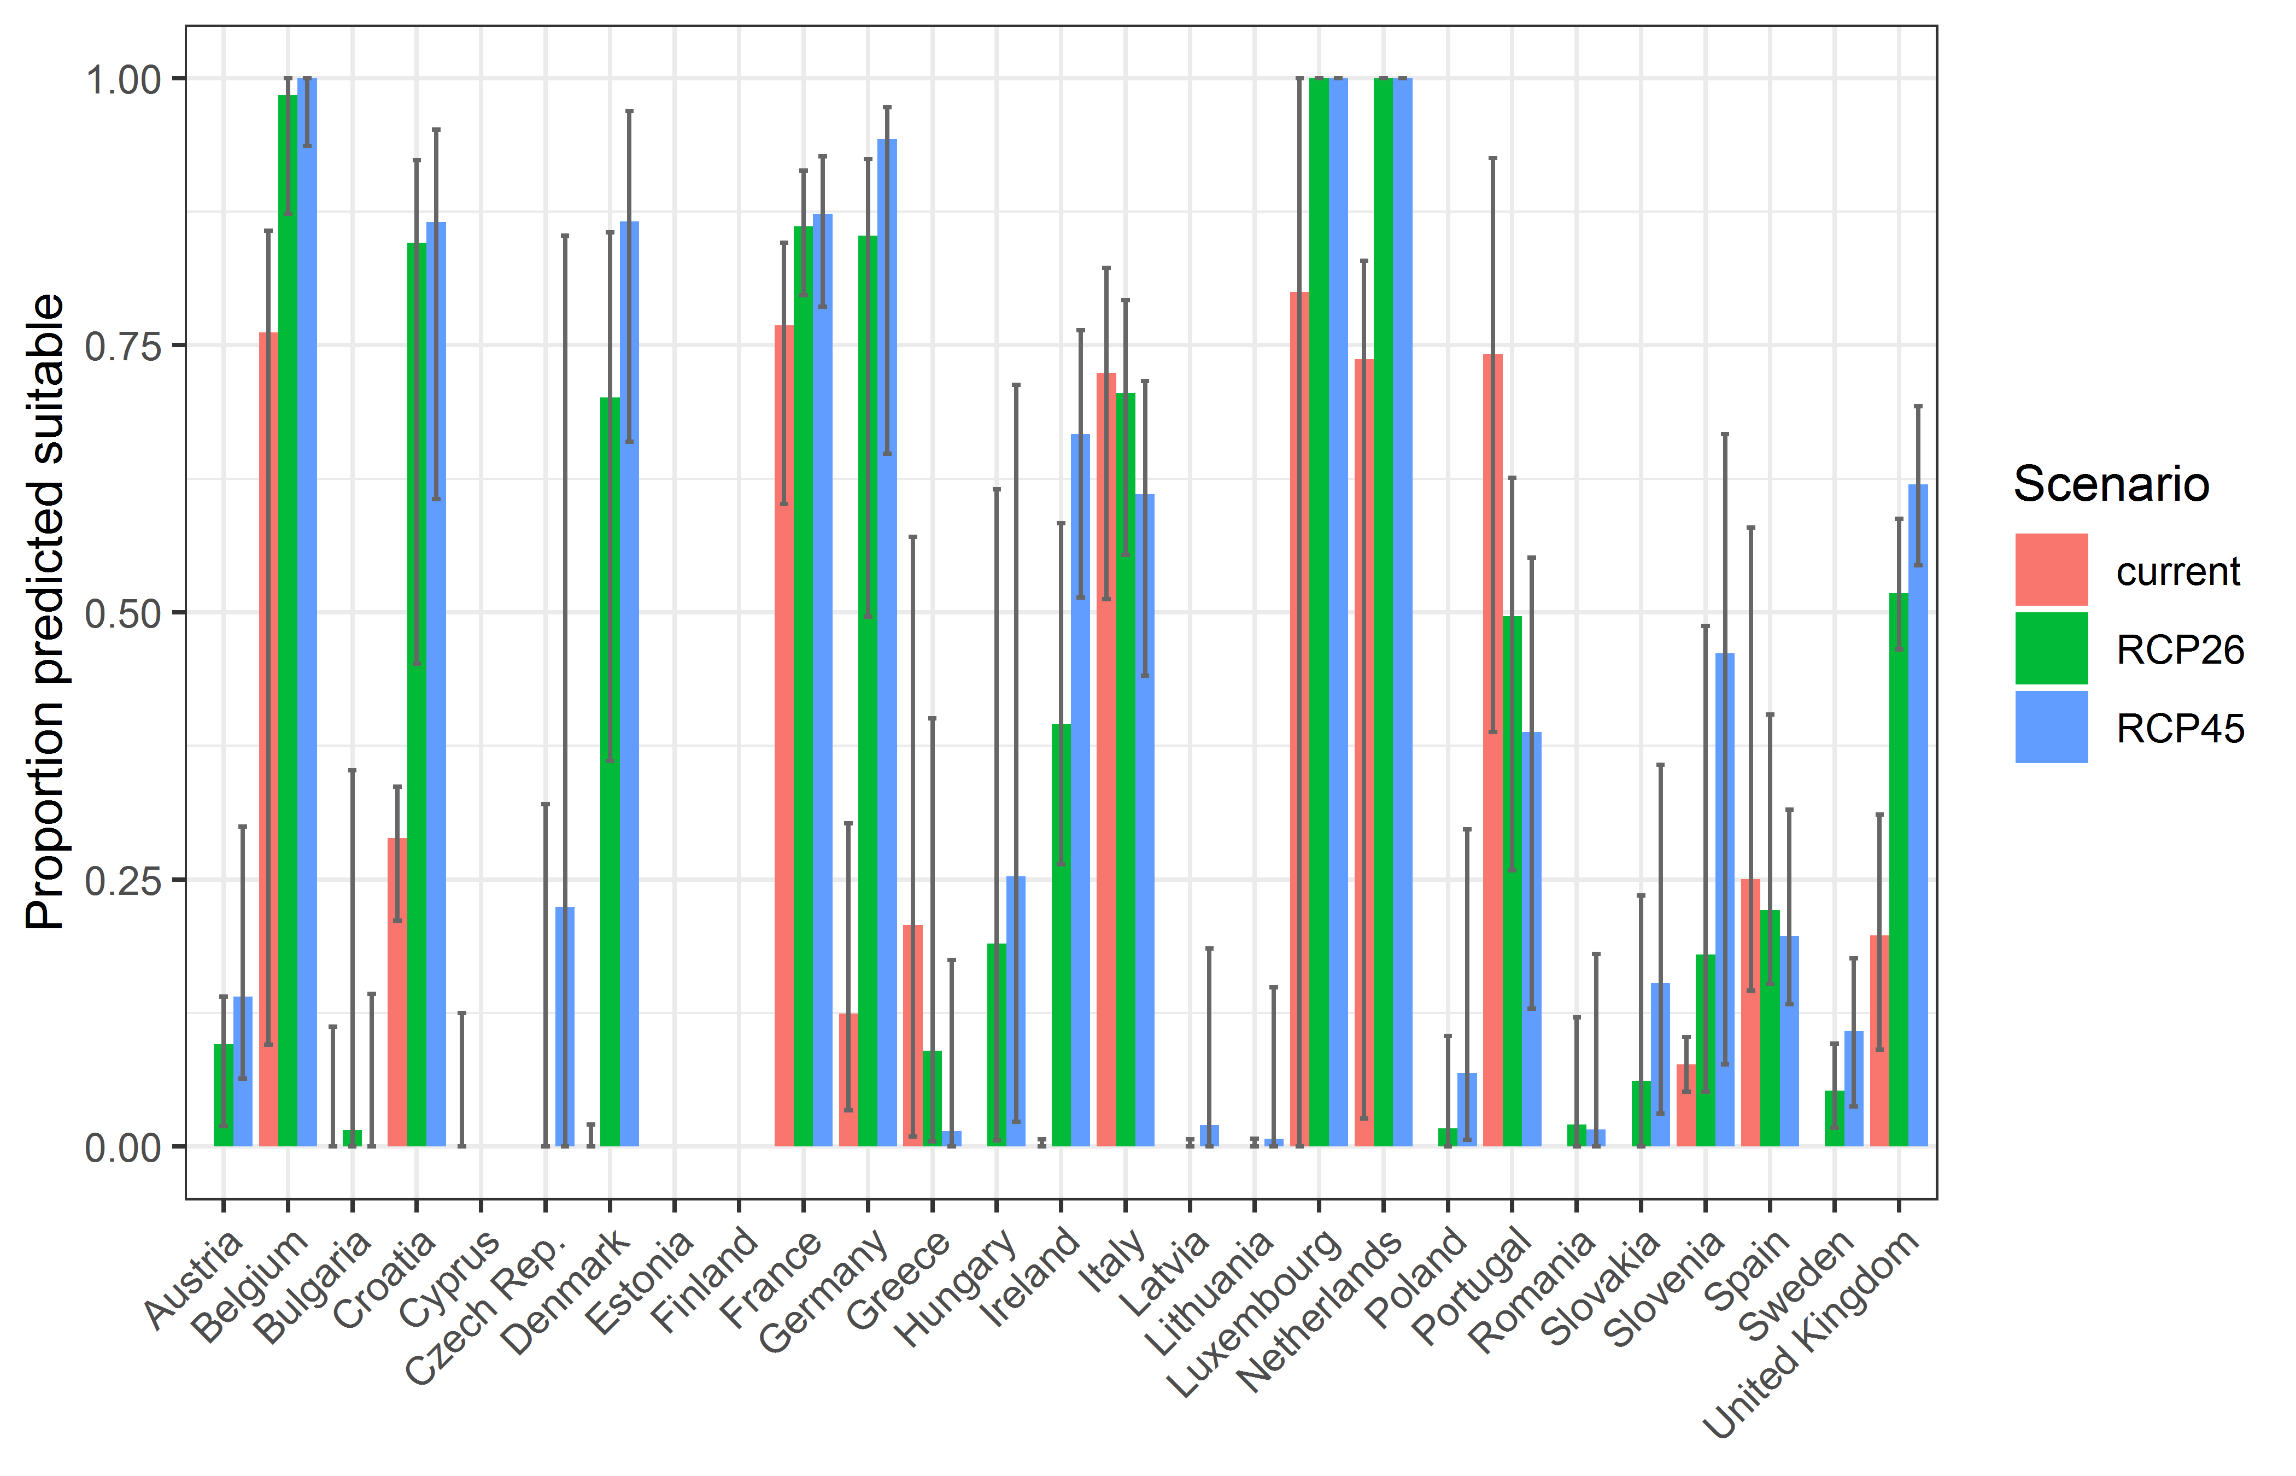

##### Page Break

**Table 3.** Variation in projected suitability for *Obama nungara* establishment among European Union countries and the UK (numerical values of Figure 10 above). The numbers are the proportion of grid cells in each country classified as suitable in the current climate and projected climate for the 2070s under two RCP emissions scenarios.

|  |  |  |  |  |  |  |  |  |  |
| --- | --- | --- | --- | --- | --- | --- | --- | --- | --- |
|  | **current climate** | | | **2070s RCP2.6** | | | **2070s RCP4.5** | | |
|  | lower | **central estimate** | upper | lower | **central estimate** | upper | lower | **central estimate** | upper |
| Austria | 0.00 | 0.00 | 0.00 | 0.02 | 0.10 | 0.14 | 0.06 | 0.14 | 0.30 |
| Belgium | 0.10 | 0.76 | 0.86 | 0.87 | 0.98 | 1.00 | 0.94 | 1.00 | 1.00 |
| Bulgaria | 0.00 | 0.00 | 0.11 | 0.00 | 0.02 | 0.35 | 0.00 | 0.00 | 0.14 |
| Croatia | 0.21 | 0.29 | 0.34 | 0.45 | 0.85 | 0.92 | 0.61 | 0.87 | 0.95 |
| Cyprus | 0.00 | 0.00 | 0.12 | 0.00 | 0.00 | 0.00 | 0.00 | 0.00 | 0.00 |
| Czech Rep. | 0.00 | 0.00 | 0.00 | 0.00 | 0.00 | 0.32 | 0.00 | 0.22 | 0.85 |
| Denmark | 0.00 | 0.00 | 0.02 | 0.36 | 0.70 | 0.86 | 0.66 | 0.87 | 0.97 |
| Estonia | 0.00 | 0.00 | 0.00 | 0.00 | 0.00 | 0.00 | 0.00 | 0.00 | 0.00 |
| Finland | 0.00 | 0.00 | 0.00 | 0.00 | 0.00 | 0.00 | 0.00 | 0.00 | 0.00 |
| France | 0.60 | 0.77 | 0.85 | 0.80 | 0.86 | 0.91 | 0.79 | 0.87 | 0.93 |
| Germany | 0.03 | 0.12 | 0.30 | 0.50 | 0.85 | 0.92 | 0.65 | 0.94 | 0.97 |
| Greece | 0.01 | 0.21 | 0.57 | 0.00 | 0.09 | 0.40 | 0.00 | 0.01 | 0.17 |
| Hungary | 0.00 | 0.00 | 0.00 | 0.01 | 0.19 | 0.61 | 0.02 | 0.25 | 0.71 |
| Ireland | 0.00 | 0.00 | 0.01 | 0.26 | 0.40 | 0.58 | 0.51 | 0.67 | 0.76 |
| Italy | 0.51 | 0.72 | 0.82 | 0.55 | 0.71 | 0.79 | 0.44 | 0.61 | 0.72 |
| Latvia | 0.00 | 0.00 | 0.00 | 0.00 | 0.00 | 0.01 | 0.00 | 0.02 | 0.19 |
| Lithuania | 0.00 | 0.00 | 0.00 | 0.00 | 0.00 | 0.01 | 0.00 | 0.01 | 0.15 |
| Luxembourg | 0.00 | 0.80 | 1.00 | 1.00 | 1.00 | 1.00 | 1.00 | 1.00 | 1.00 |
| Netherlands | 0.03 | 0.74 | 0.83 | 1.00 | 1.00 | 1.00 | 1.00 | 1.00 | 1.00 |
| Poland | 0.00 | 0.00 | 0.00 | 0.00 | 0.02 | 0.10 | 0.01 | 0.07 | 0.30 |
| Portugal | 0.39 | 0.74 | 0.93 | 0.26 | 0.50 | 0.63 | 0.13 | 0.39 | 0.55 |
| Romania | 0.00 | 0.00 | 0.00 | 0.00 | 0.02 | 0.12 | 0.00 | 0.02 | 0.18 |
| Slovakia | 0.00 | 0.00 | 0.00 | 0.00 | 0.06 | 0.23 | 0.03 | 0.15 | 0.36 |
| Slovenia | 0.05 | 0.08 | 0.10 | 0.05 | 0.18 | 0.49 | 0.08 | 0.46 | 0.67 |
| Spain | 0.15 | 0.25 | 0.58 | 0.15 | 0.22 | 0.40 | 0.13 | 0.20 | 0.32 |
| Sweden | 0.00 | 0.00 | 0.00 | 0.02 | 0.05 | 0.10 | 0.04 | 0.11 | 0.18 |
| UK | 0.09 | 0.20 | 0.31 | 0.47 | 0.52 | 0.59 | 0.54 | 0.62 | 0.69 |

## Caveats to the modelling

To remove spatial recording biases, the selection of the background sample from the accessible background was weighted by the density of Platyhelminthes records on the Global Biodiversity Information Facility (GBIF). While this is preferable to not accounting for recording bias at all, it may not provide the perfect measure of recording bias.

There was substantial variation among modelling algorithms in the partial response plots (Figure 3). In part this will reflect their different treatment of interactions among variables. Since partial plots are made with other variables held at their median, there may be values of a particular variable at which this does not provide a realistic combination of variables to predict from.

Other variables potentially affecting the distribution of the species, such as types of land cover were not included in the model.

##### Page Break

## References

* Allouche O, Tsoar A, Kadmon R (2006) Assessing the accuracy of species distribution models: prevalence, kappa and the true skill statistic (TSS). *Journal of Applied Ecology*, 43, 1223-1232.
* Chapman D, Pescott OL, Roy HE, Tanner R (2019) Improving species distribution models for invasive non-native species with biologically informed pseudo-absence selection. *Journal of Biogeography*, <https://doi.org/10.1111/jbi.13555>.
* Cohen J (1960) A coefficient of agreement of nominal scales. *Educational and Psychological Measurement*, 20, 37-46.
* Elith J, Kearney M, Phillips S (2010) The art of modelling range-shifting species. *Methods in Ecology and Evolution*, 1, 330-342.
* Fielding AH, Bell JF (1997) A review of methods for the assessment of prediction errors in conservation presence/absence models. *Environmental Conservation*, 24, 38-49.
* Hargreaves GH (1994) Defining and Using Reference Evapotranspiration. *Journal of Irrigation and Drainage Engineering*, 120.
* Hijmans RJ, Cameron SE, Parra JL, Jones PG, Jarvis A (2005) Very high resolution interpolated climate surfaces for global land areas. *International Journal of Climatology*, 25, 1965-1978.
* Iglewicz B, Hoaglin DC (1993) How to detect and handle outliers. Asq Press.
* Manel S, Williams HC, Ormerod SJ (2001) Evaluating presence-absence models in ecology: the need to account for prevalence. *Journal of Applied Ecology*, 38, 921-931.
* McPherson JM, Jetz W, Rogers DJ (2004) The effects of species’ range sizes on the accuracy of distribution models: ecological phenomenon or statistical artefact? *Journal of Applied Ecology*, 41, 811-823.
* Pearson RG, Raxworthy CJ, Nakamura M, Townsend Peterson A (2007), Predicting species distributions from small numbers of occurrence records: a test case using cryptic geckos in Madagascar. *Journal of Biogeography*, 34: 102-117. <https://doi.org/10.1111/j.1365-2699.2006.01594.x>
* Thuiller W, Lafourcade B, Engler R, Araújo MB (2009) BIOMOD-a platform for ensemble forecasting of species distributions. *Ecography*, 32, 369-373.
* Thuiller W, Georges D, Engler R, Breiner F (2020). biomod2: Ensemble Platform for Species Distribution Modeling. R package version 3.4.6. <https://CRAN.R-project.org/package=biomod2>
* Zomer RJ, Trabucco A, Bossio DA, Verchot LV (2008) Climate change mitigation: A spatial analysis of global land suitability for clean development mechanism afforestation and reforestation. *Agriculture, Ecosystems & Environment*, 126, 67-80.

1. This template is based on the Great Britain non-native species risk assessment scheme (GBNNRA). A number of amendments have been introduced to ensure compliance with Regulation (EU) 1143/2014 on IAS and relevant legislation, including the Delegated Regulation (EU) 2018/968 of 30 April 2018, supplementing Regulation (EU) No 1143/2014 of the European Parliament and of the Council with regard to risk assessments in relation to invasive alien species (see <https://eur-lex.europa.eu/legal-content/en/TXT/?uri=CELEX%3A32018R0968>).
2. Convention on Biological Diversity, Decision VI/23
3. <https://circabc.europa.eu/sd/a/7e5f0bd4-34e8-4719-a2f7-c0cd7ec6a86e/2020-CBD-pathways-interpretation.pdf>
4. <https://circabc.europa.eu/sd/a/0aeba7f1-c8c2-45a1-9ba3-bcb91a9f039d/TSSR-2016-010%20CBD%20pathways%20key%20full%20only.pdf>
5. Not to be confused with “no impact”.
6. Note: in the CICES classification provisioning of water is considered as an abiotic service whereas the rest of ecosystem services listed here are considered biotic.