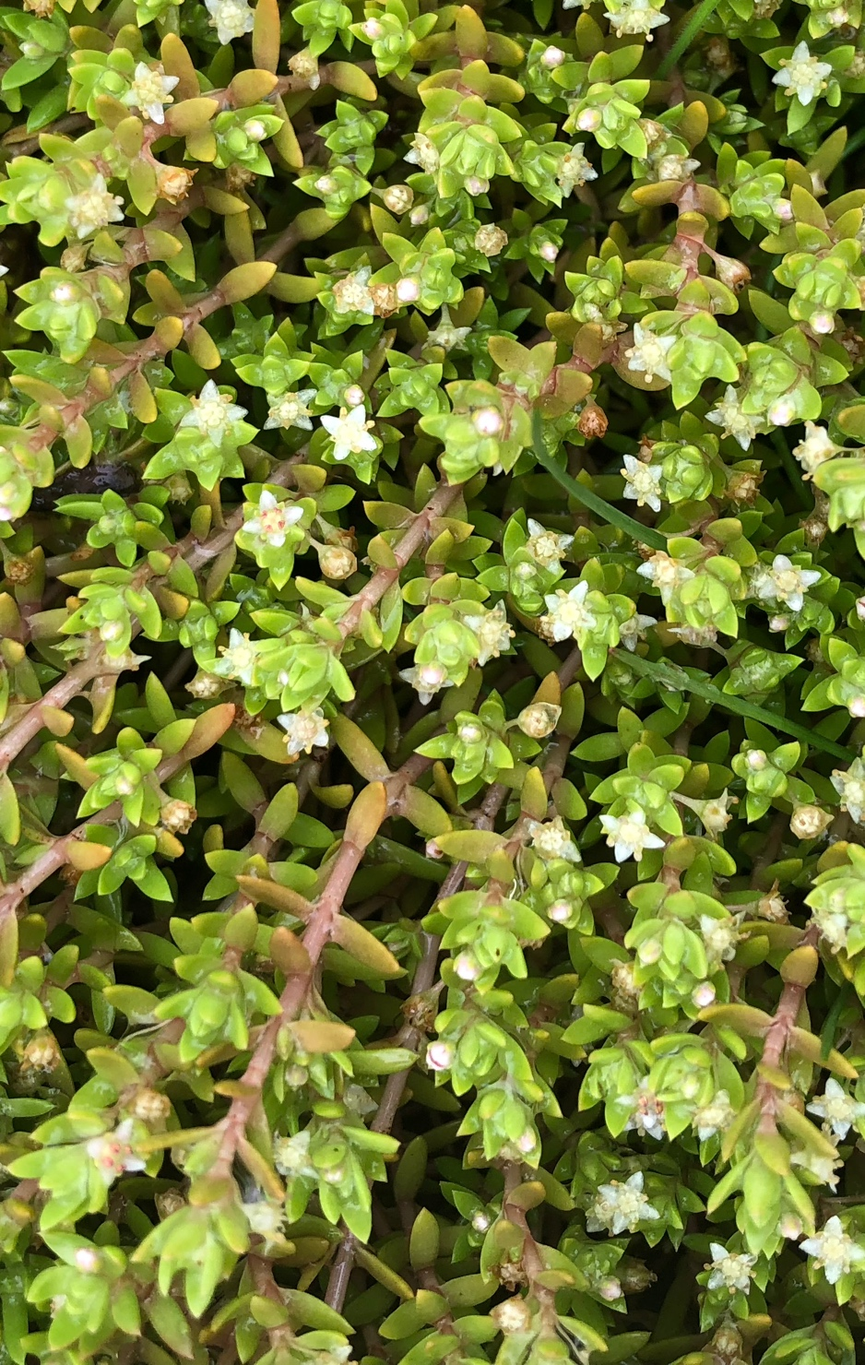
Risk assessment of Australian swamp stonecrop (Crassula helmsii) in Europe
FLORON report FL2019.064.e03
August 2020

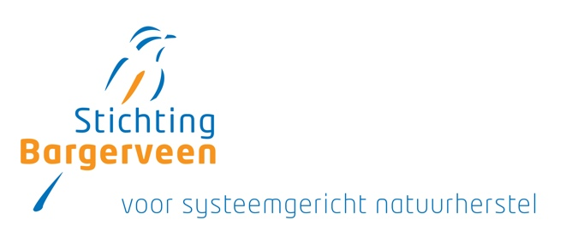


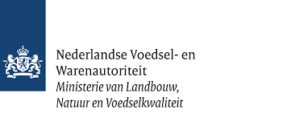
Van der Loop, J.M.M., R. Beringen, R.S.E.W. Leuven,
J.L.C.H. van Valkenburg, H.H. van Kleef, M. Verhofstad & B. Odé

Publication details
Status of publication: final, after review of scientific forum
Report number: FL2019.064.e03

Date of publication: 15 August 2022

Title: Risk assessment of Australian swamp stonecrop (Crassula helmsii) in Europe

Method of citation: Van der Loop, J.M.M., R. Beringen, R.S.E.W. J.L.C.H. van Valkenburg, H.H. van Kleef, M. Verhofstad & B. Odé (2022). Risk assessment of Australian swamp stonecrop (Crassula helmsii) in Europe FLORON report: 2019.064.e03

Cover photograph: Australian swamp stonecrop (J. van der Loop)

Project leader (final editing): Baudewijn Odé

Quality assurance: Rob Leuven

Execution: FLORON, Stichting Bargerveen and Radboud University Nijmegen

Project team: Janneke van der Loop, Ruud Beringen, Rob Leuven, Johan van Valkenburg, Hein van Kleef, Michiel Verhofstad en Baudewijn Odé

Commissioned by: Ministry of Agriculture, Nature and Food Quality
Netherlands Food and Consumer Product Safety Authority (NVWA)
Attn: H. Groenewoud
PO Box 43006
3540 AA Utrecht
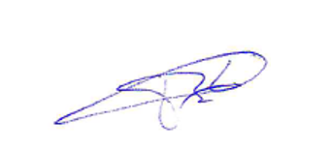
Approval for publication: B. Odé (FLORON project leader)

Initials:

©2024 FLORON, Nijmegen. FLORON studies and protects wild plants
FLORON is a Stichting RAVON brand.

Table of contents
1 Introduction 12
1.1 Background 12
1.2 Advisory request 12
1.3 Document structure 12
2 Material and methods 14
2.1 Literature review 14
2.2 Dispersal in the Netherlands 14
2.3 Dispersal across Europe 15
2.4 Risk assessment and classification using Harmonia⁺ 15
2.5 Comparison with other risk assessments 17
3 Description of species 20
3.1 Taxonomy 20
3.2 Nomenclature 20
3.2.1 Scientific name 20
3.2.2 Synonyms 20
3.2.3 Trade names 20
3.2.4 Vernacular names 20
3.3 Description of species characteristics 21
3.4 Similar species 22
3.5 Native range 22
3.6 Invasion history of potential range 23
3.7 Stand and ecology 23
3.8 Reproduction and Distribution (life cycle) 26
3.8.1 Life cycle 26
3.8.2 Reproduction 27
3.8.3 Dispersal (mechanisms, conditions for germination and establishment) 27
3.9 Ecosystem services 29
4 Introduction pathways (UNEP pathways and vectors) 30
4.1 Introduction to the EU 30
4.2 Intentional and unintentional spread 31
5 Climate and biogeography 33
5.1 Climate match, current climate 33
5.2 Europe biogeography 34
5.3 Climate scenarios 35
6 Presence within the EU 37
6.1 Establishment status within EU countries 37
6.2 Presence outside the EU 37
6.3 Distribution in the Netherlands 38
6.4 Possible future spread 40
7 Impacts 41
7.1 Ecological/biodiversity 41
7.1.1 Biodiversity in general 41
7.1.2 Impact on Red List, rare and/or protected species 42
7.1.3 Impact on EU habitat types 46
7.1.4 Impact of physiochemical properties and structure of ecosystems 48
7.2 Public health and the economy 50
7.2.1 Diseases/allergies or other physical conditions 50
7.2.2 Personal safety & safety of infrastructure 50
7.2.3 Socio-economic impact 50
8 Risk analysis 52
8.1 Risk classification 53
8.2 Risk score and levels of confidence 58
8.3 Comparison with other risk assessments 60
9 Estimation of the potential costs (quantitative or qualitative) 62
9.1 Damage to biodiversity & ecosystem services 62
9.2 Damage to health, safety and the economy 62
9.3 Costs of control 62
10 Management 64
10.1 Prevention 64
10.2 Management and control 65
10.2.1 Mechanical 66
10.2.2 Physical 67
10.2.3 Chemical 68
10.2.4 Biological 69
10.2.5 Taking no action 70
10.2.6 Aftercare for treated areas 70
10.3 Risks of improper management 71
11 Knowledge gaps and recommendations for future (practice-based) research 73
12 Discussion and conclusions 75
12.1 Discussion 75
12.2 Conclusion 75
12.3 Recommendations for management 76
12.3.1 Preventing spread 78
12.3.2 Contamination: Taking no action 78
12.3.3 Contamination: elimination 78
12.3.4 Contamination: Control – traditional versus system-based 79
12.3.5 Additional measures to tackle contamination 79
13 Bibliography 81

Annexes
Annex 1. Sources consulted to carry out the literature review and to determine the spread distribution of Stonecrop.
Annex 2. Plant communities in which Stonecrop was found in the Netherlands.
Annex 3a. Biogeographical regions in Europe.
Annex 3b. Biogeographical regions in Europe.
Annex 4. Natura 2000 sites in the Netherlands in which Stonecrop has been found.
Annex 5. Overview of Ecosystem Services (BISE 2020).

Summary

This report describes a risk assessment of the alien species Australian swamp stonecrop (Crassula helmsii) (hereafter: Stonecrop) in Europe. The species is native to Australia and New Zealand but has been imported in many places in the world as ornamental species for aquaria and garden ponds. It is a small perennial species of water bodies and wetlands. The species is considered invasive in several European countries.

The present risk assessment is based on a detailed risk inventory and supports national and international decision making on the management of Stonecrop. The available information and data were analysed and the risks were classified by a team of experts using the Harmonia⁺ protocol.

The species invades a wide variety of artificial and natural habitats. Vegetative means of dispersal by - even minute - stem fragments being able to sprout and grow to a new plant enhances the invasion potential of the species.

Dispersion within Europe is both human-induced and natural. Main dispersion pathways are active dump of plant material from garden ponds and aquaria in nature, transportation of stem fragments during vegetation management (mowing), and transport of soils infested with plant fragments. Natural dispersion of vegetative fragments may occur passively in water bodies, but also through zoochory. In Europe, seed production seems rare.

Stonecrop frequently grows in dense monospecific stands and can out-compete native plants and animals, thus changing natural ecosystems fundamentally, including the physical and chemical conditions. Both protected habitats and protected plant and animal species listed in the EU Habitat Directive may be negatively affected.

The future climate change is expected to have little effect on the risk of establishment, although high-elevation sites and northern regions may become increasingly vulnerable to Stonecrop invasions, as extreme cold temperatures might become less frequent.

The risk assessment with Harmonia⁺ shows the overall risk score is high for Stonecrop. Especially the risks of establishment and dispersion due to human activities are high, this also holds for risks of negatively impacting biodiversity. Effects on human health, crops and cultivation systems are absent or less prominent.

Being a species with the smallest stem fragments to easily grow into a new plant, eradication is not a simple task. Not only need measures to be thorough to be effective, but also it may easily take some years of follow-up management to get rid of the species. Eradication is especially difficult because the measures taken usually creates an ideal new habitat for this species. In most cases a combination of two or even more measures, applied over several years will be required to achieve total extermination. In some instances, it may be better not to manage sites at all, to avoid dispersion of fragments and get the stand overgrown by trees or other taller vegetation.

Several knowledge gaps exist including some quite fundamental questions. Provenance and ploidy level of Stonecrop throughout Europe may be different, but this is not known. Also, the biotic and abiotic ecological effects of Stonecrop may seem clear, yet, scientific sound effect studies are rare or missing. Furthermore, the impact of seeds both in actual reproduction and in the possible building of a persistent seed bank in Europe are largely unknown. Finally, the effectiveness of different types of eradication measures needs a thorough evaluation.

Samenvatting
Dit rapport beschrijft een risicobeoordeling van de exotische water- en oeverplant Watercrassula (Crassula helmsii) in Europa. Deze soort is inheems in Australië en New-Zeeland maar is op veel plaatsen in de wereld ingevoerd als sierplant en zuurstofplant voor aquaria en tuinvijvers. Het is een kleine overblijvende soort van wateren en moerassen. In diverse Europese landen wordt de soort als invasief beschouwd.

Deze risicobeoordeling is gebaseerd op een uitgebreide risico-inventarisatie en kan het nationale en internationale beleid met betrekking tot beheer en bestrijding van Watercrassula ondersteunen. De beschikbare data en informatie zijn door een team van experts beoordeeld met het Harmonia⁺ protocol.

Watercrassula kan een grote variëteit aan kunstmatige en natuurlijke habitats binnendringen. De soort is in staat zich vegetatief te verspreiden, zelfs met heel kleine stengelfragmenten die weer kunnen uitgroeien tot een nieuwe plant. Daardoor is de mogelijkheid om zich invasief te gedragen groot.

De soort heeft zich binnen Europa zowel op natuurlijke wijze als met hulp van de mens verspreid. De belangrijkste manieren van verspreiding zijn het actief in de natuur achterlaten van planten afkomstig uit tuinvijvers en aquaria, het transporteren van stengelfragmenten door vegetatiebeheer (maaien) en transport van bodemmateriaal met plantenresten van Watercrassula. Natuurlijke verspreiding van vegetatief materiaal kan passief in waterlichamen plaatsvinden, maar ook door transport door dieren. Zaadproductie lijkt zeldzaam in Europa.

Watercrassula vormt geregeld dichte massavegetaties, waardoor inheemse planten en dieren kunnen worden verdrongen. Door een besmetting kunnen natuurlijke ecosystemen fundamenteel veranderen, ook qua fysische en chemische omstandigheden. Dit kan een negatief effect hebben op volgens de EU Habitatrichtlijn beschermde habitats, planten en dieren.

De toekomstige klimaatverandering zal naar verwachting weinig effect hebben op de vestigingskansen voor de soort, hoewel noordelijke streken en hoger gelegen delen mogelijk gevoeliger worden voor invasie door Watercrassula, omdat extreem lage temperaturen minder vaak kunnen voorkomen.

De risicobeoordeling met Harmonia⁺ laat zien dat de algemene risicoscore van Watercrassula hoog is. Met name het risico op vestiging en verspreiding als gevolg van menselijke activiteiten is hoog. Dit geldt ook voor de invloed van de soort op biodiversiteit. De effecten op menselijke gezondheid, landbouwgewassen en andere teelten zijn afwezig of bescheiden.

Het uitroeien van een soort waarvan de kleinste stengelfragmenten nog kunnen uitgroeien tot een nieuwe plant is niet eenvoudig. Maatregelen moeten niet alleen grondig zijn om effectief te kunnen zijn, het kan ook makkelijk enkele jaren nazorg vragen voordat de soort echt verdwenen is. Het uitroeien van de soort is extra moeilijk omdat veel van de maatregelen resulteren in een ideale situatie voor hergroei of nieuwe vestiging van de soort. In veel gevallen zal een combinatie van maatregelen moeten worden toegepast, gedurende een aantal jaren, voordat de soort op een locatie echt is uitgeroeid. In sommige situaties kan het beter zijn om geen beheer toe te passen, om verspreiding van fragmenten te voorkomen en om bomen of andere hoge vegetatie de groeiplaats te laten overgroeien.

Er zijn nog diverse kennishiaten, waaronder sommige vrij fundamentele. De herkomst en het ploïdie niveau van Watercrassula in Europa zou verschillend kunnen zijn, maar dit is niet bekend. Hoewel de effecten op de soortensamenstelling en abiotische eigenschappen van ecosystemen duidelijk lijken, ontbreken zuiver wetenschappelijke studies naar deze effecten nagenoeg. Verder is het belang van zaden, zowel in de actuele reproductie als in de mogelijke opbouw van een langlevende zaadvoorraad in de bodem in Europa, in hoge mate onbekend. Tenslotte is er grote behoefte aan een evaluatie van de verschillende soorten maatregelen om de soort uit te roeien.

- Introduction
  - Background
Australian swamp stonecrop (Crassula helmsii) (hereafter: Stonecrop) is found in several EU Member States, including the Netherlands. The spread of this species originating from Australia and New Zealand has increased in recent decades.
Land management organisations such as nature conservationists, municipalities, provinces, water boards and the Directorate-General for Public Works and Water Management (Rijkswaterstaat) as well as private individuals are increasingly concerned about the damage and costs entailed by Stonecrop, which have even led to questions being asked in Parliament (Proceedings of the House of Representatives of 11 March 2020 question 2020Z04814).

This prompted the Netherlands Food and Consumer Product Safety Authority (Nederlandse Voedsel- en Warenautoriteit, NVWA) to commission a risk assessment.

  - Advisory request
The NVWA instructed FLORON, the Radboud University Nijmegen and Stichting Bargerveen to carry out a risk assessment that meets all the criteria set out in the European Regulation on the prevention and management of the introduction and spread of invasive alien species and the corresponding Commission Delegated Regulation (EU) 2018/968. The assessment must be based on a scientific underpinning of the risks related to Stonecrop. The finished product must meet the European criteria for inclusion in the Union list as much as possible and must inter alia include the following elements:
- cultivation and trade;
- dispersal routes;
- risks to biodiversity;
- risks to the functioning of ecosystems;
- risks to ecosystem services;
- public health risks;
- socio-economic impact;
- risks of improper management;
- knowledge gaps;
- recommendations for further research.
  - Document structure
This report contains both background information on Stonecrop and a risk assessment for this species. Chapter 2 outlines the methodical aspects of these two components. Chapter 3 to 7 subsequently discuss the results of the extensive literature review. The layout of the sections in this chapter has taken into account the Commission Delegated Regulation (EU) 2018/968 and the applicable risk assessment protocol (Harmonia⁺). Chapter 8 provides a discussion of the results of the risk assessment. Chapter 9 sets out the economic aspects, with Chapter 10 subsequently outlining the options for management and control available. Finally, Chapter 11 sets out any knowledge gaps, as well as the conclusions and recommendations.
- Material and methods
  - Literature review
The search engine Google Scholar and Web of Science (both in English) and Google.nl (in Dutch) were used to collect scientific literature (peer reviewed articles, reports and dissertations) using the digital library facilities of the Radboud University Nijmegen, Researchgate and various Open Access facilities of journals, libraries and research institutes. Searches were carried out with the search engines using various search terms for each topic covered in this risk assessment (Table 2.1). The focus of the literature review was on the topics that were addressed either insufficiently or not at all in the risk assessments that were available, on the European context and the scale of the risks, and on the scientific underpinnings required for the assessment of the relevant risk criteria. Insofar as is relevant, the (potential) spread and the risks of the species to the European Union are described both for Member States (including the Netherlands) and biogeographical regions. For each search, the first 30 hits were evaluated for the selection of articles or reports that were relevant to the underpinnings of the risk assessment. The results, the number of hits and potentially useful sources from all searches are listed in Annex 1.

Table 2.1: List of search engines used and examples of the terms used.
Search engine | Search | Terms
Google.nl | Using all key words | Watercrassula
 | Combined with at least 1 of the key words | Habitat, ecosysteem, eisen, standplaats, toleranties, negatieve, effecten, problemen, invasief, risicoanalyses
Google Scholar | Using all key words | Crassula helmsii
 | Combined with at least 1 of the key words | Habitat, ecosystem, demands, stand, tolerances, negative, effects, problems, impact, invasive, risk assessments
Web of Science | Using the key words | Crassula helmsii habitat, ecosystem, demands, stand, tolerances, negative, effects, problems, impact, invasive, risk assessments

The articles and reports referenced in the sources are likewise assessed for potentially new information on Stonecrop. Additional information from publications, such as Floras of the region of provenance, was used for the description of species and habitat characteristics. In addition, this risk assessment made use of foreign risk assessments and factsheets on Stonecrop that were available. These were retrieved using all combinations of the scientific name (including synonyms) and the search terms risk assessment, risk analysis and risk classification (in multiple languages).
  - Dispersal in the Netherlands
The data for dispersal within the Netherlands came from the Dutch National Database Flora and Fauna (Nationale Databank Flora & Fauna, NDFF; https://www.ndff.nl/). The NDFF collects dispersal data provided by volunteers, provinces, municipalities, water boards, research institutes and land managers. In addition to a geographic location, a percentage of observations also include data relating to abundance and biotope.
  - Dispersal across Europe
The data for dispersal outside the Netherlands was gathered by combining information from various sources:
• GBIF.org (3 March 2020) GBIF Occurrence Download https://doi.org/10.15468/dl.h3py4v.
• I-naturalist: https://www.inaturalist.org/.
• EPPO: https://gd.eppo.int/taxon/CSBHE/distribution
• CABI: https://www.cabi.org/isc/datasheet/16463

Additional dispersal data was obtained by conducting searches for the various EU countries on sites containing dispersal data. Furthermore, a Google search was carried out using the key words ‘invasive plants’ AND ‘Crassula helmsii’. The search term ‘invasive plants’ was translated into the official languages of the various EU Member States using Google Translate. Annex 1 contains a list of all the websites that were consulted. The publications that were found on these websites are included in the bibliography.
  - Risk assessment and classification using Harmonia⁺
The risk assessment and classification of Stonecrop was carried out by a team of six experts (the authors of this risk assessment) using the Harmonia⁺ protocol. Each individual expert studied the background information of the species in advance and subsequently completed the online version of the assessment protocol (D’hondt et al. 2014) for the risk classification of the species independently of the other experts. This involved focusing on both the current situation and a future scenario (horizon of approx. 50 years), which entailed an assessment of the impact of climate change on the risks related to Stonecrop.

Following the individual risk assessment, a workshop took place with the team of assessors in which the underpinnings of all the risk scores and the corresponding level of confidence were outlined. The workshop also entailed a discussion of the differences between risk scores and levels of confidence. The discussions in relation to all the Harmonia⁺ protocol criteria resulted in consensus regarding these scores and the (scientific) substantiation thereof.

The various risk score and levels of confidence were subsequently calculated (Box 2.1). The version of the Harmonia⁺ protocol that was used comprises 41 questions in total, which are classified into 7 categories, which are:
1. Context (questions A1-A5);
2. Introduction of species (questions A6-A8);
3. Establishment of species (questions A9-A10);
4. Spread of species (questions A11A12);
5. Potential environmental impact (questions A13-A30);
6. Potential impact of species on ecosystem services (questions A31-A33);
7. Impact of climate change on the risks of a species (questions A34-A41).

The ‘Potential environmental impact of species’ is divided into five subcategories, namely:
1. Impact on biodiversity and ecosystems (Questions A13-A18);
2. Impact on plant cultivation (questions A19-A23);
3. Impact on livestock farming and animal welfare (questions A24-A26);
4. Impact on public health (questions A27-A28);
5. Other impact, as infrastructure degradation (question A29-A30).

Each (sub)category contains multiple risk assessment questions, with completion options provided for risk scores and the corresponding level of confidence for each question. The risk scores allow for three to five scores (e.g. none/very low, low, moderately high, very high) or ‘not applicable’. There are three possible scores for the level of confidence (low, medium or high). Every question of the risk assessment protocol is provide with an explanatory note including examples that serve as a reference in determining the risk scores.

The Harmonia⁺ protocol is a risk screening procedure. This method was solely developed for the assessment of the negative impact of alien species and does not take into account any positive effects. Any available information on the positive effects of the species assessed has been included in the knowledge overview and have been assessed in the component on the effects on ecosystem services.

Box 2.1: Concept and definitions for risk assessment and classification of alien species using the Harmonia⁺ protocol (D’hondt et al. 2014).

Concept
Invasion = f(Introduction; Establishment; Spread; Impact_{a-e})
Risk = Exposure x Probability x Impact

Invasion = risk?
Exposure ≡ f₁(Introduction;Establishment;Spread) = Invasion score
Probability x impact ≡ f₂(Impact_{a}; Impact_{b}; Impact_{c};Impact_{d}; Impact_{e}) = Impact score
with a: environment (biodiversity and ecosystems); b: cultivated plants; c: domesticated animals; d: public health; e: other

Risk = Exposure x Probability x Impact ≡ f₃(Invasion score; Impact score) = Invasion

Calculation methods
f₁ : (weighted) geometric mean or product
f₂ : (weighted) arithmetic mean or maximum
f₃ : product

Box 2.1 outlines the methods used to calculate the various risk scores. In the Harmonia⁺ protocol, a biological invasion is defined as a function (f) of the introduction, establishment, spread and various types of (a-e) impact of a species (D’hondt et al. 2014). The ‘risk’ of an invasion is defined as likelihood that a particular hazard of a species can actually cause harm. This risk increases (1) with the exposure to the hazardous event, (2) with the probability (likelihood) of the hazardous event actually occurring and (3) with potential impact of that event. For that reason, the risk is defined as a product of these three factors, i.e.: exposure x probability x impact.

The protocol allows for the calculation of three scores, i.e. the invasion score, the impact score and the risk score. The invasion score is a measure of exposure and within the protocol is calculated as a function (f1) of the probability of introduction, establishment and spread. The impact score is a measure of probability x impact and within the protocol is calculated as a function (f2) of the probability of the various types of impact (a-e, i.e. impact of biodiversity and ecosystems, cultivated plants, domesticated animals and animal welfare, public health and other effects) occurring. Hence, risk can be calculated as a function (f3) of the invasion and impact score.

Various calculation functions (f1, f2 and f3 in Box 2.1 respectively) can be used to calculate the invasion score, impact score and the risk score. The protocol also for weighting factors to be attributed within and between various risk categories. The default values (= 1) were used at all times for all weighting factors in the risk assessment of Stonecrop. As such, the various types of impact within a given risk category are always given equal weight in the calculation of the risk scores. The maximum value is used at all times for the calculation of the impact score of a specific risk category, in order to avoid the averaging of impacts. The product of the introduction, establishment and spread score is used for the calculation of the invasion score. The maximum of the various impact scores is used at all times for the calculation of the aggregated impact score. Table 2.2 provides an overview of the threshold values and colour schemes used for the ‘low’, ‘medium’, ‘high’ risk classifications.

All assessment questions allow for the level of confidence of the answer to be included. The level of confidence is consistently reported using ‘low’, ‘medium’, ‘high’ for 0-33%, 33-66% and 66-100% probability respectively in accordance with the principle outlined by Mastrandrea et al. (2010; 2011). In Harmonia⁺, the scores 0, 0.5 and 1 are allocated to ‘low’, medium’ and ‘high’ respectively. For each risk category, the arithmetic mean of all confidence scores for the related criteria is calculated and subsequently converted into ‘low’, ‘medium’ or ‘high’ based on the threshold values (Table 2.2). The level of confidence is indicated with colour codes in shades of blue.

Table 2.2: Threshold values and colour schemes of risk and confidence classification.
  - Comparison with other risk assessments
Other risk assessments for Stonecrop that were drafted for other countries or regions were collected by way of a literature review (Section 2.1). The risk assessment available were often carried out using other protocols, which include both compact and rapid assessments for priority or warning lists for alien species and detailed risk assessments of these species for countries in Europe or for all of Europe (Table 8.1). For effective comparison of their outcomes with the current assessments, all risk scores have been harmonised into three risk classes, i.e. low, medium and high risk.
The risk classifications using the Invasive Species Environmental Impact Assessment (ISEIA) protocol (Belgian Forum on Invasive Species 2019a) were used due to the fact that this protocol also distinguishes between three levels of risk, i.e. low risk (Score 4-8; Code C), medium risk (Score 9-10; Code B; watch list) and high risk (Score 11-12; Code A; black list).

Scores for the invasiveness of alien plant species using the Australian Weed Risk Assessment (WRA) system (Pheloung et al. 1999) were harmonised as low risk for WRA scores of < 11, medium risk for scores of 11-20 and high risk for scores of > 20. Scores using the Weber & Gut (2004) system, the combined WRA-WG system (Andreu & Vila 2009) and the combined WG-European and Mediterranean Plant Protection Organisation Pest Risk Assessment Scheme (EPPO) were harmonised as low risk for WG scores of <21, medium risk for scores between 21-27 and high risk for scores of >28. The scores of the Risk Assessment Methodology Invasive Species Ireland (RAMISI; version 2007; Kelly et al. 2013) were harmonised as low risk for scores of <14, medium risk for scores of 14-18 and high risk for scores of > 18.

The Great Britain Non-Native species Risk Assessment (GB-NNRA) protocol, the Methodik der naturschutzfachlichen Invasivitätsbewertung für gebietsfremde Arten (MNIGA; version 1.2) and Naturschutzfachliche Beurteilung (NFB) use three risk categories and have therefore been used unchanged. In a number of cases, no explicit risk categories were listed, however the relevant species were placed on a national or regional list of invasive alien spaces (e.g. blacklist, invasive species list, list of potentially invasive species or list of prohibited species). In such cases, the harmonised risk score sets out that this relates to a high score.

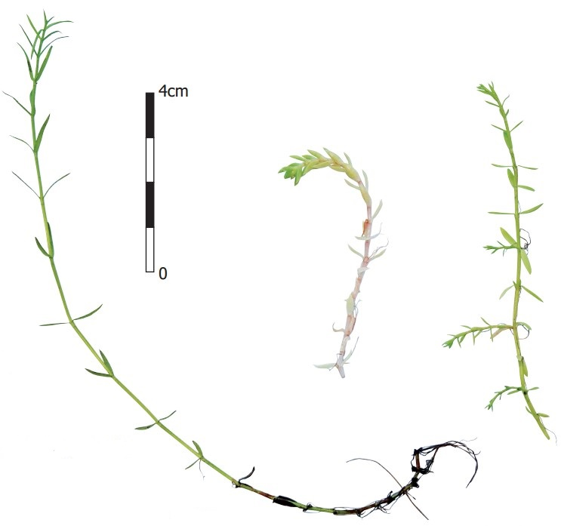
- Description of species
  - Taxonomy
Kingdom: Plantae
Phylum: Tracheophyta
Class: Magnoliopsida
Order: Saxifragales
Family: Crassulaceae
Genus: Crassula

Source: https://www.catalogueoflife.org

Figure 3.1. Growth habits of Australian swamp stonecrop (M. van de Loo)
  - Nomenclature
    - Scientific name
Crassula helmsii (Kirk) Cockayne.

    - Synonyms
Bulliarda recurva Hook.f.
Crassula recurva (Hook.f.) Ostenf.
Tillaea helmsii Kirk
Tillaea recurva (Hook.f.) Hook.f.
Crassula helmsii (Kirk) A.Berger

    - Trade names
In commercial trade, Crassula helmsii is often referred to Crassula recurva. There is no distinction between different cultivars in commercial trade (Hoffman 2016).
    - Vernacular names
Danish | Newzealandsk Korsarve
German | Helms Dickblatt; Zurückgekrümmtes Dickblatt; Nadelkraut; Gekrümmtes nadelkraut
English | Stonecrop; New Zealand stonecrop; Australian stonecrop; Australian swamp stonecrop; Swamp stonecrop; Swamp crassula; Helms crassula; Crassula; New Zealand pigmyweed; Pigmy weed
Estonian | Lõunavesikas
French | Crassule des étangs; Crassule de Helms; Orpin des marais; Orpin australien
Italian | Erba grassa di Helms
Dutch | Watercrassula, Waternaaldkruid, Naaldkruid
Polish | Grubosz Helmsa
Portuguese | Sedum dos Pântanos
Russian | Толстянка Хелмса; Тиллея отогнутая; Крассула хелмси; Буллиарда отвороченная
Spanish | Crásula de agua
Czech | Tlustice novozélandská
Welsh | Planhigyn suddlon; Corchwyn Seland Newydd
Swedish | Sydfyrling; Vattenkrassula
  - Description of species characteristics
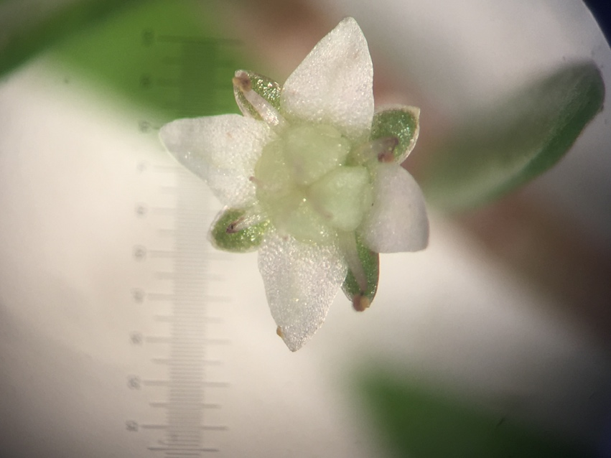
Stonecrop is a perennial, evergreen, hairless, marsh and aquatic plant (Dawson & Warman 1987, Smith & Buckley 2020). The plant forms creeping stems on land and emergent as well as entirely submersed stems in the water. The stems can grow up to approximately 1 metre in length and are minimally branched; adventitious roots are formed on the lower nodes. The leaves are opposite and fuse at the base, linear-lanceolate, and 4-15(-20) mm long, 0.7-1.6(-3.0) mm wide and 0.5-0.8 mm thick. The leaves are flat from above and convex from below and grow in a somewhat thick fleshy (succulent) fashion on plants growing on land. The uniflorous, axillary inflorescences are located at the ends of the stems and are always emergent above the water. The flower stems are 2-8 mm long and curve back when the fruit is ripened. The hermaphroditic flowers have a diameter of 3.0-3.5 mm. The 4 sepals are roughly half as long as the petals and fuse at the base. The freestanding calyx tubes are 1–1.5 mm long and 0.5–0.6 mm wide and triangular ovate and pointed or slightly tapered. The 4 white or pink petals are wide-elliptic ovate, 1.2-1.8 mm long and 0.8-1 mm wide and slightly tapered to a point. The 4 stamen are placed opposite the sepals and are shorter than the sepals. The filaments are thin and curved. The anthers burst open in a longitudinal direction. The ovary consists of 4 pistils positioned opposite the sepals; the pistils are not fused and taper to the top, at which they are truncated. The styles positioned at the top of the pistils are short, slightly curved and bear an inconspicuous stigma. The pistils carry a 0.7 mm-long nectar-producing scale at the base. Each pistil contains 8 seed buds of which not all will develop. The fruit consists of four smooth 2 mm-long follicles opening on the inside, which each contain 3-5 seeds. The seeds are brown and smooth, 0.4-0.5 mm long and 0.25 mm wide and weigh 0.017 mg (De Lange 2014, Stace 2019, South Australian Seed Conservation Centre 2018, Smith & Buckley 2020).
Figure 3.2 Stonecrop flower (Image J. van der Loop)

Stonecrop exhibits some degree of variation within the original area. The New Zealand plants are smaller and more delicate and diploid (2n=14). The Australian plants are bigger and hexaploid (2n=42) (De Lange et al. 2004b, 2008, De Lange 2014). The chromosome number in the United Kingdom is 2n=36 (Stace 2019). The leaves of the Australian plants are more clearly prickly and have more tapered calyx tubes and petals (Laundon 1961).

Due to the difference, the New Zealand and Australian plants were initially considered as being two distinct species, Tillaea helmsii T. Kirk. and Tillaea recurva Hook.f. respectively. In 1907 and 1918 respectively, both species were reclassified into the genus Crassula by the names Crassula helmsii (Kirk) Cockayne (= Crassula helmsii (Kirk) A.Berger) and Crassula recurva (Hook.fil.) Ostenf. Laundon (1961) synonimised both species under the name Crassula helmsii (T.Kirk) Cockayne.
  - Similar species
Although Stonecrop (Crassula helmsii) is similar to Crassula aquatica, this species is far smaller than Stonecrop and barely grows to 5 cm in height; the leaves are only 3-5 mm long and the flowers in the leaf axils have no stem. By contrast, the flower stems in Stonecrop are 2-8 mm long (Stace 2019, Laundon 1961). Due to the opposite leaves, submersed forms of Stonecrop somewhat resemble submersed forms of Callitriche (Water starwort) species, without floating basal rosettes.

A number of closely related and highly similar species can be found in New Zealand, including C. ruamahanga A.P.Druce (De Lange et al. 2008) and C. Moschata G.Forst (De Lange 2014). In total, approx. 30 species of Crassula can be found in New Zealand, including a number of exotic species (De Lange et al. 2011). Crassula natans var. minus (referred to as ‘Floating Crassula’ in Australia!), which originally originated in South Africa, bears a superficial resemblance to Stonecrop. This species is invasive in Australia and was also recently found in New Zealand (De Lange et al. 2011). C. peduncularis is closely related to C. Helmsii. In addition to Australia, Tasmania and New Zealand, this species can also be found in South America (Toelken 1981).

C. helmsii closely resembles Crassula granvikii Mildbr., a species found in the mountain regions of tropical Africa (Uganda, Kenya, Tanzania, Ethiopia, Eritrea, Rwanda, Burundi and Malawi) (Laundon 1961, Catalogueoflife.org).
  - Native range
The original native range of Stonecrop includes Australia (Victoria, New South Wales, Southern Australia, Tasmania and Western Australia) and New Zealand (coastal regions of South Island) (https://bie.ala.org.au/). In New Zealand it is a fairly rare plant that occurs naturally in small dispersed populations and is therefore to local extinction (De Lange et al. 2004a).
  - Invasion history of potential range
Exactly when the plant was introduced is unclear. Reports that the species may have been introduced as early as 1890 (Nehring 2013) are based on confusion with Crassula recurva N.E.Br. (= Crassula alba Forsk.). This species was introduced to the United Kingdom from South Africa (Natal) around 1890 (Brown 1890).

In the UK, the plant was first made available commercially by a nursery by the name Tillaea recurva in 1926 (Laundon 1961). The nursery in question was still operating around 1980, however neither the exact origin, nor the exact import date of the material could be retrieved from the archives at the time. The plants were most likely imported from Australia before 1914. During the First World War, cultivation ponds with Nymphaea species were no longer maintained and Stonecrop proliferated significantly during that period. At the time, Stonecrop was not listed as a separate species, but was sold as an oxygenating plant alongside other plants. Several other nurseries likewise obtained plant material from the nursery in question (Swale & Belcher 1982).

Plants sampled throughout the United Kingdom were found to be genetically identical and found to represent a single line to a significant degree. When comparing the various genetic lines from the original Australian region with the plant material from the United Kingdom, it was found that the British plants most likely originated from the region of the Murray river in Australia (Dawson 1994 in Smith & Buckley 2020).
Please see 6.1 for more information on first finds in various European countries.
  - Stand and ecology
Stonecrop is not very selective in terms of its stand; the species can be found in a broad variety of fresh water habitats, which may be slow moving or stagnant and include pools, lakes, fens, skating rinks, canals, streams and drainage canals, where the species grows both in the water and on the bank (Dawson & Warman 1987, Van Kleef et al. 2017). The species is absent in salt and/or brackish waters (Dawson & Warman 1987).

Nor is Stonecrop very particular in terms of soil type, growing primarily on clay soils in England, but equally on sand, gravel and organic soils (Dawson & Warman 1987, Child & Spencer-Jones 1995, Hussner et al. 2021). In the Netherlands, Stonecrop primarily can be found on sandy soils and to a lesser extent on clay (Van Kleef et al. 2017). The species grows poorly on peat soil in the Netherland (pers. observation J. van der Loop).

In Europe, light and receding water levels and dry periods are not limiting to Stonecrop (Newman & Raven 1995, OEPP/EPPO 2007, Hussner 2009, Smith 2015, Hussner et al. 2021). The level of rainfall required for the terrestrial growth habit of the species in its natural habitat within its native range in Australia is only 220-300 mm during the winter and 100-550 mm in the summer (Leach & Dawson 2000). In England, average rainfall in the areas where Stonecrop has spread is 826 mm per year (Hill et al. 2004). Where there is reduced rainfall, Stonecrop nevertheless remains vigorous, however growth does decrease (Dawson & Warman 1987).

In its natural habitat within the native range in Australia, the average daytime temperature is between 0 and 15º during the months of May to October and between 20 and 25ºC between the months of November to April (Leach and Dawson 1999). The temperature of the stands in England and Ireland together average 3.8°C in January and 15.8°C in July (Hill et al. 2004). The species can withstand frost up to -7ºC (Kirby 1965, OEPP/EPPO 2007 (Dawson 1994 in Smith & Buckley 2020) and even survival for three weeks in a freezer by temperatures of -18°C is observed in the Netherlands (Pers. Observation J. van der Loop).Over the winter Stonecrop is thought to survive best in the fully submerged form (Dawson & Warman 1987), however Hussner et al. (2009 & 2021) states that the species has a high for air frost.

Stonecrop has the potential to be dominant in conditions both poor and rich in nutrients. According to Keeley (1998) and Klavsen and Maberly (2009), the invasive nature of the species is therefore not dependent on the availability of nutrients. In the Netherlands likewise Stonecrop virtually only occurs as a surface-covering plant both in oligo and eutrophic waters. However, in ecosystems that are relatively poor in nutrients, such as fens, dune pools and ice rinks, the plants remain small and are not very competitive. In the absence of nutrients, Stonecrop can therefore only become dominant if there is little coverage by native species (Van Kleef et al. 2017).
In England, Stonecrop has been found in flowing waters with a current of up to 0.32 m/s (Dawson & Warman 1987) and in the Netherlands the species can be found in flowing water, including in the Kleine Beerze stream, along a considerable length (source: observations R. Beringen & M. Janssen in the NDFF). It is unknown what current speeds Stonecrop tolerates in the Kleine Beerze stream.

Stonecrop grows rapidly and is able to overgrow other species when nutrient availability is high (Brunet 2002, Hussner 2009, Klavsen et al. 2011, Ewald 2014, Brouwer et al. 2017, Van Kleef et al. 2017, Van der Loop et al. 2020, Hussner et al. 2021). Nitrogen, phosphorus and carbon can all stimulate the growth of Stonecrop (Brouwer et al. 2017, Van Kleef et al. 2017, Van der Loop et al. 2020). The atmospheric deposition of nitrogen, the fertilisation of surface and groundwater with carbon, nitrogen and phosphorus from agricultural activities as well as manure from waterfowl may contribute to proliferation of the species (Brouwer et al. 2017, Van der Loop et al. 2020).

Stonecrop only uses carbon dioxide (CO₂) as a source from which to draw carbon: the plant is unable to absorb carbon from the water in the form of bicarbonate (HCO₃⁻) and only uses carbon dioxide from the water layer or atmosphere. This means that Stonecrop cannot grow in water with a pH higher than 8, given that only inorganic carbon is present in the form of bicarbonate (Keeley 1998) in such cases. This has been confirmed in studies showing that Stonecrop only grows in waters with a pH between 4.3 and 7.8 and an alkalinity between 0 and 0.92 meq/L (Brunet 2002, Hussner 2009, Klavsen et al. 2011, Van Kleef et al. 2017). Low availability of carbon dioxide underwater, despite the availability of a CAM mechanism in photosynthesis, is limiting to the growth of Stonecrop (please also see 7.1.4.). In waters with prolific Stonecrop growth, the average concentration of CO₂ in the summer is well above 200 µmol/L (Van Kleef et al. 2017). With regard to other aquatic plants, it has likewise been shown that they are no longer limited by carbon above this level of concentration (Bloemendaal & Roelofs 1988).

Waters are vulnerable to invasion by Stonecrop when disturbed and where open niches, such as bare soils, are present (Brouwer et al. 2017, Van Kleef et al. 2017, Smith & Buckley 2020, Van der Loop et al. 2020). This is also the case for many other invasive plant species (Hobbs 1989, 1991, Hobbs & Huenneke 1992, Rejmánek 1999). The establishment and proliferation of Stonecrop is significantly inhibited in certain water types in the presence of native plant species such as Shoreweed (Littorella uniflora Asch.), Marsh St. John’s-wort (Hypericum elodes L.), peat mosses (Sphagnum spec.) and pillwort (Pilularia globulifera L.) (Brouwer et al. 2017, Van Kleef et al. 2017, Van der Loop et al. 2020). Competitors reduce opportunity of establishment by 70% and ensure growth reduction of more than 95% (Van Kleef et al. 2017, Van der Loop et al. 2020).

Stand and ecology in region of provenance
In the region of origin, Australia, Stonecrop can be found in a variety of biotopes, varying from periodically drying flowing and standing waters to the banks of lakes, with the species being both submerged by several metres and emergent on the banks several metres above the water level (Smith & Buckley 2020). Disturbances in the form trampling by livestock and periodically high currents are tolerated to a high degree. The plant does not grow in fast-flowing water and does not tolerate flooding with salt water. In estuaries it will grow in proximity to the sea, but never in contact with seawater. The plant is able to quickly colonise bare areas, for example, after a fire, but cannot compete with tall plants such as Reed. In the south and east of the region of origin, the plant regularly grows alongside Myriophyllum pendunculatum. In the west, it is often found alongside the alien species Crassula natans. The plant can tolerate major water level fluctuations, provided the stand does not dry out. The plant is found both in weakly buffered waters with a low level of conductivity and in slightly salt, brackish waters (Dawson & Warman 1987). Nutrient levels may also vary significantly, however the species does not grow in highly polluted waters (Dawson 1989). In a number of aspects, this differs from the stand and ecology we find in Europe. In Europe, for example, brackish and salt stands seem to be absent and the species also seems to grow in waters that are richer in nutrients than in the region of origin.

Vegetation
The National Vegetation Database (Landelijke Vegetatie Databank) (https://www.synbiosys.alterra.nl/lvd) includes 115 relevées (vegetation sampling plots) in which Stonecrop is present. Stonecrop has been found in a variety of plant communities (Figure 3.3, Annex 2). Most studies were carried out in vegetation from the Littorelletea class, which are pioneer vegetations on mineral soils in shallow, often exposed, low-nutrient, weakly buffered, weakly acidic to neutral waters. These types of vegetation are primarily found in fens.

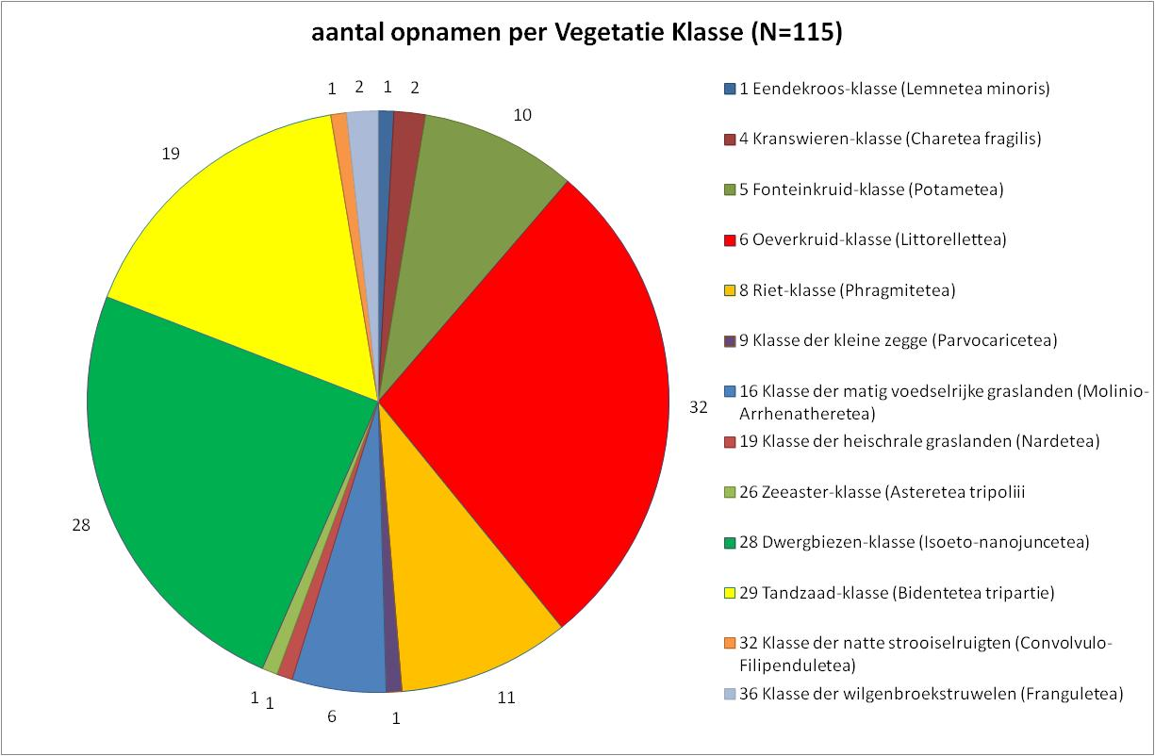
Many studies were also conducted in vegetation belonging to the Nanocyperion flavecentis alliance, which is mainly annual pioneer vegetation on moist, low-nutrient to moderately high-nutrient, weakly buffered, weakly acidic to neutral soils. This vegetation develops on heath cutting sites or along cleaned pools and fens.On more high-nutrient stands, Stonecrop grows in pioneer vegetation of the Bidention alliance. These types of vegetation grow on banks that dry out in the summer along high-nutrient freshwater waters, such as rivers and the IJsselmeer/Markermeer. Stonecrop has been found along the Krammer-Volkerak alongside brackish species such as Celery (Apium graveolens), Sea Aster (Aster tripolium), Distant sedge (Carex distans), Sea milkweed (Glaux maritima) and Blackgrass (Juncus gerardii).
Figure 3.3. Distribution of Stonecrop in the Netherlands among the various Vegetation types (Classes) based on occurrence in vegetation relevées in the Dutch National Vegetation Database (Vegetation classification according to Schaminée et al. 1995-1999).

  - Reproduction and Distribution (life cycle)
    - Life cycle
Stonecrop is a perennial plant that stays green in winter and continues to grow during this period with an occasional decline in biomass but with no real dormant winter period (Dawson & Warman 1987, Hussner 2009, Smith 2015). As a result, Stonecrop has an advantage over other plants that need to create their entire biomass at the start of the growing season, such as P. globulifera, or that are less active during the winter, such as bulbous rush (Juncus bulbosus L.).

In its native range, Stonecrop is in bloom all year round, as long as there is sufficient water (Toelken 1981). The flowering period outside of the natural region is variable, with flowers primarily being observed from June to the end of October (Clapham et al. 1990, FLORON 2020).
    - Reproduction
The dicotyledonous plant flowers each year with small, white or occasionally pink flowers, which produce 2 – 5 seeds that are 0.5 mm in length, independent of its natural or introduced habitat (Allan 1982, Dawson & Warman 1987, OEPP/EPPO 2007). No flowers form when the plant is submerged and when a plant is inundated whilst in bloom, there is abscission of the flowers (Diaz 2012). The flowers are hermaphroditic, tetramerous and the plant is able to pollinate itself by way of geitonogamy (Toelken 1981, Allan 1982), whereby the pollen of one flower is transferred to another flower on the same plant. The plants have a slightly sweet fragrance that attracts several hoverfly species (Syrphidae) in the native range (Dawson & Warman 1987, Diaz 2012). However, these insects only transfer a very small amount of pollen to other sites, which limits genetic exchange (Diaz 2012). Outside of the natural region, there are no known observations of pollinators (Dawson & Warman 1987, Smith & Buckley 2020).

The germination capacity of Stonecrop seed is very low within its natural habitat in the native range in Australia. Only a few plants germinated from sediment collected underneath Stonecrop in South Australia within a 22-week period, which was a very low score compared to other native plants (Nicol et al. 2003). A similar test showed that Stonecrop requires more than 16 weeks to germinate from seed, which again was longer than the other native vegetation tested, and only resulted in the germination of a few plants (Nicol & Ward 2010).

The vigour of the seeds also appears to be low outside of the native region. Seeds collected in England and the Netherlands did not germinate, most likely due to entering dormancy incorrectly for successful germination or because the seeds were difficult to separate from the surrounding tissues of the fruit (Dawson 1994) (pers. observation van der Loop). Denys et al. (2014) and D’hondt et al. (2016) have reported successful reproduction, however, they used entire flowers due to the highly laborious nature of harvesting seeds. It cannot be ruled out that Stonecrop grew out of apical meristematic tissue. In both experiments, the seeds underwent cold treatment to break dormancy. Denys et al. (2014) applied a treatment of 56 days at 4°C and D’hondt et al. (2016) applied 60 to 105 days at 5°C. Due to the difficult germination, both within the original and the secondary region, it has been concluded that seed only contributes to the reproduction, and therefore to distribution, of Stonecrop to a limited extent. However, where a large number of flowers are present, and therefore a very large number of seeds are produced, it may be the case that seed likewise contributes to the dispersal of Stonecrop.

Outside of the native range, Stonecrop primarily reproduces vegetatively from meristematic cell tissue (Dawson & Warman 1987, Robert et al. 2013, Crane et al. 2019). This tissue is located in every apex and node of Stonecrop. Every plant fragment that contains meristematic tissue has the potential to regrow.
    - Dispersal (mechanisms, conditions for germination and establishment)
Stonecrop seeds are not glutinous and do not have structures for attachment. After dropping off, they temporarily stay afloat, allowing them to be displaced by the water current and by the wind, sinking over time. This may contribute to the dispersal of the seeds (Dawson & Warman 1987).

In the native range, it has been observed that the species is spread through consumption and excretion (endozoochory) in the faeces of fallow deer (Dama dama J.L. Frish) and the Eastern grey kangaroo (Marcopus giganteus Shaw) (Claridge et al. 2016). In England, Belgium and the Netherlands, Stonecrop has been observed to be consumed, with vital plant fragments being excreted by waterfowl (geese) and livestock (horses) (Denys et al. 2014a, van Zuidam & Dijkhuis 2018, pers. observation van der Loop, figure 3.4).
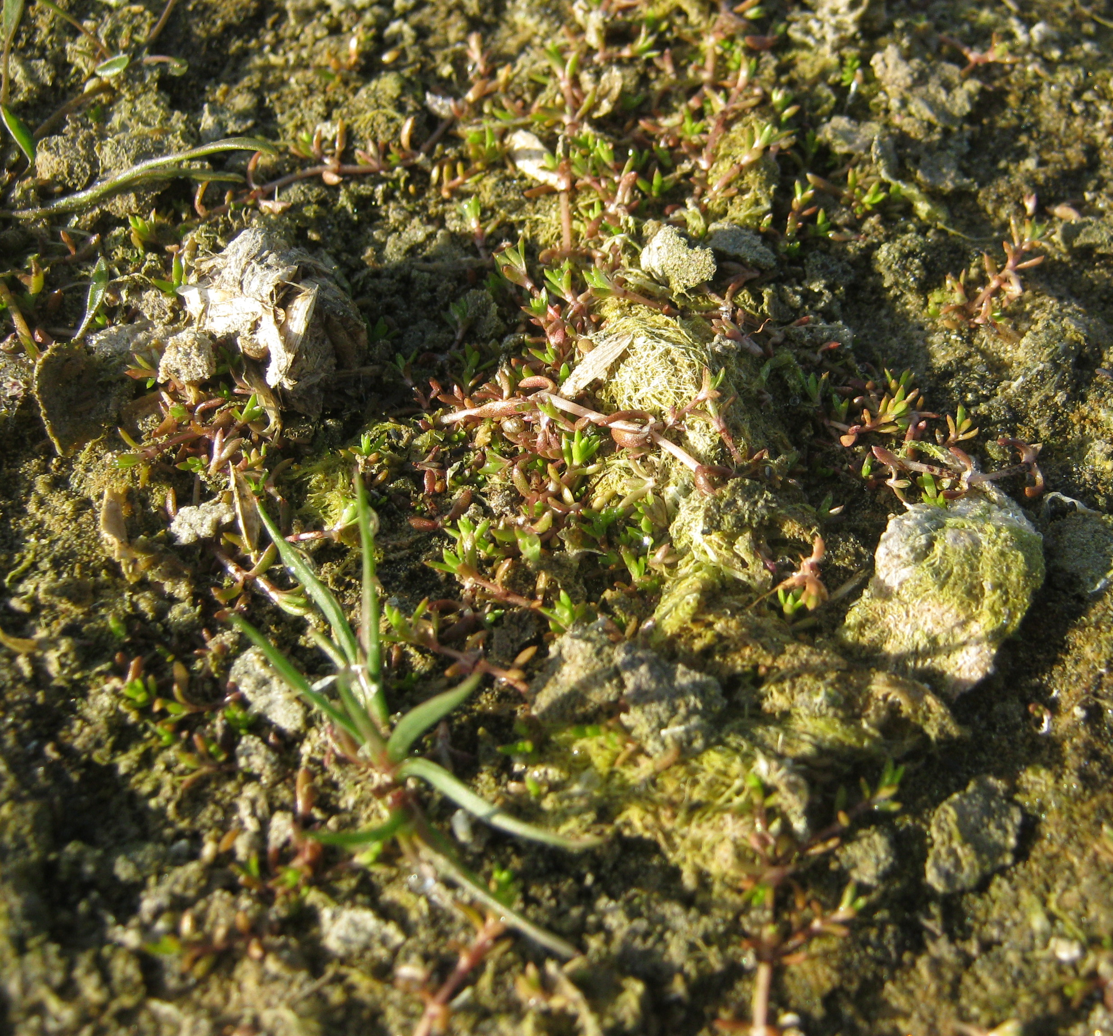

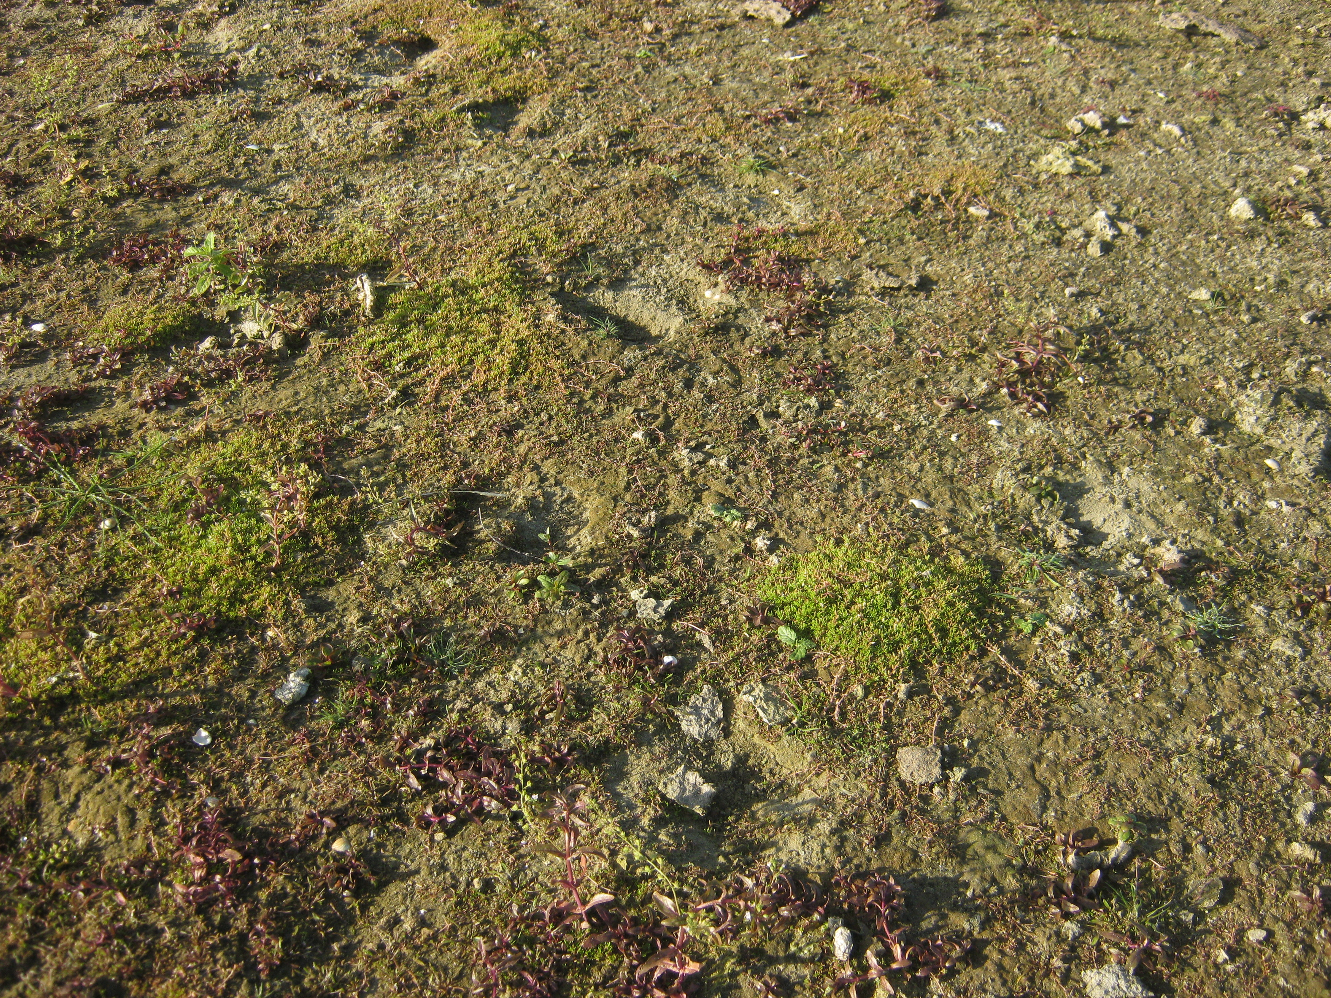

Figure 3.4. Establishment of Stonecrop from goose faeces. Input: young shoots that grow from the faeces. Overview: establishment of Stonecrop at sites where the faeces have since been digested and disappeared. (photos: Awie de Zwart)

Dispersal also takes place as a result of parts of plants, for example, sticking to the legs of animal (ectozoochory) or to materials used in contaminated areas (Dawson & Warman 1987, Denys et al. 2014a, Denys et al. 2014b, Ewald 2014, Dean et al. 2015, Smith 2015).

The most ideal conditions for the germination and growth of fragments of Stonecrop are sites with bare soil, few native plants and that are relatively high in nutrients (Brouwer et al. 2017, Van Kleef et al. 2017, Smith & Buckley 2020, Van der Loop et al. 2020).

  - Ecosystem services
Stonecrop is of minor importance in terms of providing ecosystem services (Annex 5, BISE 2020).

Provisioning services
In various European countries, Stonecrop is still sold as an ornamental, oxygenating aquarium and pond plant that requires little maintenance (Dawson & Warman 1987, OEPP/EPPO 2007). The total economic value of the plant, however, is estimated as low and there are a sufficient number of alternative plant species available for these services (CABI 2016).

Regulating services
In Europe, the flowering period lasts from June to the end of October, allowing Stonecrop to be a source of nectar for insects (Lockton 2009). Outside of its native range, however, no pollinators have as yet been observed Dawson & Warman 1987, Smith & Buckley 2020).

Due to its high biomass production, this species has a positive effect on carbon fixation and nutrient retention. It may be that the species could be used to tackle ecosystems polluted as a result of bioaccumulation of metals such as Cu, Zn and Al. However, no relevant literature was found on the matter.

Cultural services
Based on the available information, the species does not have any cultural relevance in Europe. In general, monocultures reduce the aesthetic value of areas and nature reserves (Sheppard et al. 2006). In that sense, Stonecrop may have a negative impact on cultural services.

- Introduction pathways (UNEP pathways and vectors)
  - Introduction to the EU
The pathways (UNEP 2014) along which Stonecrop can be introduced to the EU and is able to spread within the EU are summarised in Table 4.1. Crassula helmsii is imported into Europe via the horticultural and aquarium sectors for sale to the public in garden centres and aquarium shops (Darwin & Warman 1987). Moreover, the literature shows that Stonecrop arrived in Europe most likely as early as 1914 (Swale & Belcher 1982).
Please note: In this classification, Trade falls under ‘Escape from confinement’.

Table 4.1. Introduction and dispersal pathways for Stonecrop based on UNEP classification of pathways of introduction and vectors (UNEP 2014).
Category | Subcategory | Importance | Example
Release in nature | Other intentional release | Low | - Conscious planting for the benefit of nature / area development
Escape from confinement | Botanical garden / zoo / aquaria (excluding domestic aquaria) | Medium | - Dispersal by wild birds visiting infested locations  - Escape from pruning waste  - Drifting with (waste) water
Escape from confinement | Pet / aquarium / terrarium species | High | - Emptying aquariums in nature  - Escape from pruning waste
Escape from confinement | Horticulture | High | - deliberately imported for trade  - Escape from pruning waste  - Unintended transport when selling other pond plants (see figure 4.1)  - Unintended transport when exchanging (other) pond plants between individuals
Transport-contaminant | Transport of habitat material (soil, vegetation, wood) | High | - Unintentional transport by the transport of other plants and soil  - Escape from open storage depots
Transport-contaminant | Machinery/equipment | High | - Sticking of viable plant parts to wheels / tracks  - Stickting of viable plant parts to tools such as, shovels, dip-nets and wheelbarrows and footwear
Transport-contaminant | Contaminant on plants (excluding parasites, species transported by host/vector) | Medium | - Unintended presence in other transported plants  - Unintended presence in pruning waste
Transport-contaminant | People and their luggage/equipment (in particular tourism) | Medium | - Viable parts of plants that stick to footwear, boats, fishing gear etc.
Corridor | Interconnected waterways/basins/seas | Medium | - Drifting plant fragments in interconnected fresh watersystems
Unaided | Natural dispersal across borders of invasive alien species that have been introduced through other pathways | High | - Dispersed by bird or other animals by lifting viable plant fragments

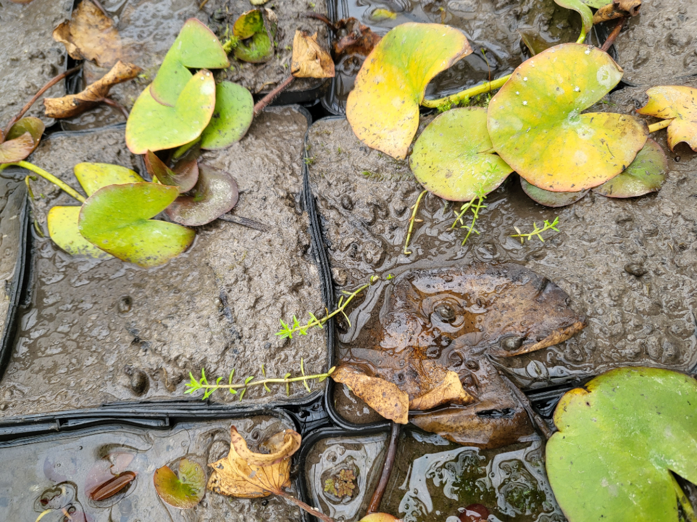
Figure 4.1. Horitculture forms a risk for introduction of Stonecrop by unintended transport as a stowaway when selling other pond plants in Dutch nursery (Photo Martijn van de Loo)
  - Intentional and unintentional spread
Intentional
Within the EU, Stonecrop has been widely traded as an aquarium, pond and ornamental plant and was introduced to Europe from Australia and/or New Zealand (OEPP/EPPO 2007). There are still various ways to purchase the species as an oxygenating plant; in the Netherlands, the species is inter alia available under the name Naaldkruid (Crassula recurva) (Pers. observation J. van der Loop & J. van Valkenburg). New stands may be created outside gardens as a result of the dumping of excess pond/aquarium plants. In the Netherlands, and perhaps other countries, it is also sold periodically in some other retail outlets, such as supermarkets, and is available to buy on the internet (Pers. observation Van der Loop). The Ornamental Aquatic Trade Organization (OATA), the Royal Horticultural Society, and the now-defunct Dutch Covenant Waterplanten (Cooperation Agreement on Aquatic Plants) have called for an end to trade in the plant (OEPP/EPPO 2007). In the United Kingdom, Switzerland, Denmark, Poland and Spain, among others, sales and trade are prohibited or otherwise regulated by law (Table 4.2).
In the Netherlands intentional release of the species is observed in areas of nature development. The argument for this was the rapid growth resulting in faster succession and greenery development in the area (Pers. observation J. van der Loop).

Table 4.2. Links to regulations relating to the sale and trade in Stonecrop.

Link
http://www.legislation.gov.uk/ssi/2019/38/schedule/made
https://www.admin.ch/opc/de/classified-compilation/20062651/index.html#app2ahref2
https://www.retsinformation.dk/eli/lta/2018/1285
http://prawo.sejm.gov.pl/isap.nsf/download.xsp/WDU20112101260/O/D20111260.pdf
https://www.mapa.gob.es/es/pesca/temas/acuicultura/RD_630_2013_Catalogo_spp_exoticas_invasoras_tcm30-77362.pdf

Unintentional
There are several ways in which the species is able to spread further by way of human activities. Soil containing viable stem fragments or loose stem fragments can be spread by way of soil transports or by machinery, vessels, footwear, fishing gear etc. The risk of introduction by boats and anglers arises from any travel to uninfested areas abroad whit equipment inadvertently contaminated with viable plant material. Stonecrop is able to regenerate from tiny stem fragments (Dawson & Warman 1987). In England and the Netherlands, Stonecrop has also been observed to be transported in trade as a stowaway alongside other aquatic plants (Pontederia, Nymphaea, Nymphoides, among others) (Laundon 1961, Pers. observation J. van der Loop, see figure 4.1).

Further spread within Europe can also take place by way of more natural dispersal mechanisms (without people taking a direct role). Detached fragments may be displaced in the presence of flowing water. In Australia, dispersal by way of flowing water (hydrochory) is considered to be the main dispersal mechanism of vegetative fragments within river basins (Nault & Mikulyuk 2011). Natural dispersal of Stonecrop can furthermore take place by way of endozoochoric and exozoochoric dispersal of fragments by waterfowl and other animals (Dawson & Warman 1987, Denys et al. 2014a, Denys et al. 2014b, Ewald 2014, Dean et al. 2015, Smith 2015).
- Climate and biogeography
  - Climate match, current climate
The native range of Stonecrop is situated within the climate regions Cfb and Csb (Table 5.1) under the Köppen-Geiger climate classification system (http://koeppen-geiger.vu-wien.ac.at/present.htm). The vast majority of the native range includes the coastal areas of New Zealand (South Island), the island of Tasmania and South East Australia (roughly the region south of the Murray River). These regions lie within the climate zone Cfb: warm temperate – fully humid and with warm summers. A small part of the range, the Adelaide, Kangaroo Island region and the south westernmost region of Australia, lie within climate zone Csb. The summers in this climate region are drier.

Table 5.1. Köppen-Geiger climate regions within the native range of Stonecrop.
Code |  | Köppen-Geiger classification | Native region in
Cfb |  | Warm temperate – Fully humid – Warm summer | South East Australia, Tasmania and New Zealand
Csb |  | Warm temperate – Dry summer – Warm summer | Adelaide, Kangaroo Island and South West Australia

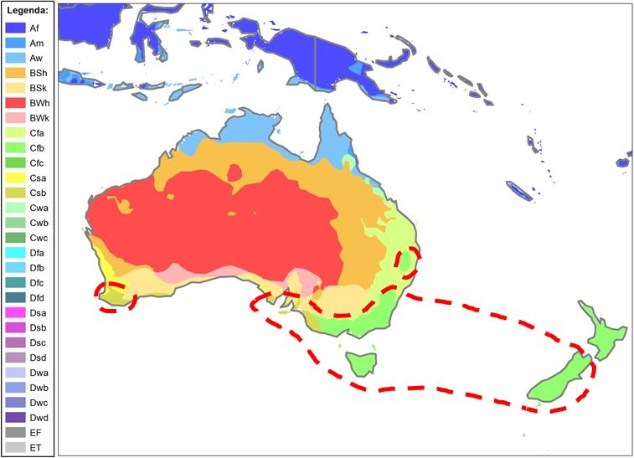
Figure 5.1. Köppen-Geiger climate regions within the native range of Stonecrop (within the red dotted line).

The areas within Europe with climate regions corresponding to those of Stonecrop’s native range (Cfb and Csb) are shown in Figure 5.2. Stonecrop’s distribution in Europe (United Kingdom, Belgium, the Netherlands and the western halves of France and Germany, please see Chapter 6.1) is situated entirely within climate region Cfb, the climate region in which the vast majority of the native range is located.
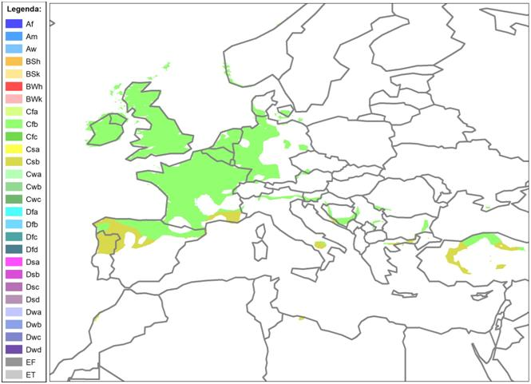
Regions within Europe that may potentially be suitable to Stonecrop in terms of climate conditions and where the species may be expected in future, include southern France, northern Spain and Portugal, the Po Plain and parts of the Balkans. Outside of Europe, areas of Turkey, in particular coastal areas along the Black Sea, would be suitable for the establishment of the species in terms of climate (Figure 5.2).
Figure 5.2. The Köppen-Geiger climate regions Cfb and Csb within Europe.
  - Europe biogeography
In Europe, Stonecrop is primarily found in the Atlantic biogeographical region (Annex 3). The region includes the following countries: Ireland, the United Kingdom, the Netherlands, Belgium, north-western Germany and western France and Denmark. There have been significantly fewer known sightings of Stonecrop in the Continental region: eastern France, central, eastern and southern Germany, the eastern half of Denmark and the adjacent part of Sweden. Well documented recordings from within the Mediterranean region are absent until now.
  - Climate scenarios
Climate models predict higher winter temperatures at higher latitudes, drier summers and greater extremes in precipitation in future (Jacob et al. 2013). While there is no niche modelling available for Stonecrop, it can be deduced that changing climatic conditions will increase the spread and invasiveness of Stonecrop because of the following physiology of the species:

The higher average temperatures will allow Stonecrop to spread to the higher parts of the Central European mountains and spread further north in Scandinavia and the United Kingdom. In addition, the species will be able to continue to grow for longer in the winter season in places where it was previously unable to do so. Many of the competing native species do not continue to grow in winter (Bloemendaal & Roelofs 1988).

Permanent aquifer wetlands with only minor fluctuations in water levels are generally fairly resistant to Stonecrop to due carbon limitation in the water layer (Klavsen & Maberly 2009, Van Kleef et al. 2017). However, due to increasing variation in periods of drought and surplus precipitation, they will develop greater water level fluctuations, after which Stonecrop will be able to establish on dry banks. Unlike many competing native species, Stonecrop is resistant to prolonged dry periods (Section 3.7), which gives it an advantage over a lot of native species. For Stonecrop, the predicted lower rainfall and the resulting changing conditions in southern and eastern Europe and the drier summers in the rest of Europe will not be limiting to the spread of the species (e.g. Hussner et al. 2021).

In many bodies of water, the growth of Stonecrop is limited by the lack of availability of carbon dioxide (Van Kleef et al 2017). As the carbon dioxide concentrations in the atmosphere increase, so too does the availability of CO₂ in the water layers by diffusion. This will increase the spread of submersed Stonecrop – and may incidentally also apply to native competitors that are limited by carbon.

- Presence within the EU
  - Establishment status within EU countries
In Europe, the presence of Stonecrop after establishment has been determined with certainty for the following countries (in parentheses the year of initial observation): United Kingdom (1956), Ireland (1970), Germany (1981), Belgium (1982), Netherlands (1995), France (1999?), Denmark (2003), Sweden (2016), Austria (2019) Luxembourg (2020) and Spain (year unknown) (Figure 6.1.).

In the United Kingdom, Stonecrop is mainly found in the south and east of England (Smith & Buckley 2020). In the Netherlands, the species is distributed across the entire country (Verspreidingsatlas.nl). In Belgium, the species is only widespread in Flanders, with the species only found in primarily isolated stands in Wallonia. The species is largely absent in the Ardennes (Branquart et al. 2013). In France, the species is mainly found in the west in the vicinity of the Atlantic coast, including in the regions of Brittany (Quere & Geslin 2016), Pays de la Loire (Dortel & Le Bail 2019), Normandy (Douville & Waymel 2019) and Poitou-Charentes (Fy 2015). In Germany, most stands are likewise found in the west of the country (Hussner 2008). In Sweden, the species was found in Helsingborg in 2016 but removed immediately after discovery (Artfakta 2020). In Denmark, where the species was first found in 2003, the species is spread to at least eight recorted locations (GBIF 2022, pers. observationL. Briggs). In Austria, Stonecrop has recently been discovered for the first time in the Mühlbach river (Traiskirchen, Niederösterreich) (Sauberer et al. 2020). In 2020 Stonecrop was recorded for the first time at two sites (same km-square) in southwestern Luxembourg (Ries & Krippel 2021). With regard to Spain, it has been reported that there is a localised presence of the species (MAGRAMA 2013). However, no documented observations were found in the sources that were consulted. Although the species was previously reported in Italy, its presence in the Friuli Venezia Giulia region appears questionable (Galasso et al. 2018). Reports from Portugal are currently similarly being called into question:
EPPO: https://gd.eppo.int/taxon/CSBHE/distribution
CABI: https://www.cabi.org/isc/datasheet/16463).

Although Stonecrop is for sale as an oxygenating plant for aquariums or ponds in most European countries, the sources consulted (Annex 1) revealed no indications of the species having established in the wild for the remaining EU countries.
  - Presence outside the EU
The only documented observation from Norway relates to the herbarium material from 2008 from a garden in Tønsberg, south of Oslo (GBIF 2020). The species does not yet appear to have established in the wild here.
Establishment in the wild has similarly not yet been documented in Switzerland; there are, however, a number of non-validated reports from Zurich and the surrounding area (Infoflora). Based on experiences from other European countries, however, the species has already been blacklisted (Buholzer et al. 2014).

In the United States, Stonecrop has been included on the lists of ‘noxious weeds’ in the states of Florida, Indiana, Minnesota, North Carolina and Washington. The regulations in these states anticipate the possible arrival of this invasive species. However, this does not mean that Stonecrop was actually found there. The species is grown on a small scale by hobbyists, however there are no documented cases of Stonecrop having established in the wild in the United States (U.S. Fish & Wildlife Service 2018). A herbarium sample collected from a pond in San Diego in 1976 came from Reading (England) (SEINet year unknown).
Reports of the species’ presence in Russia (near Lake Baikal) may be based on confusion with Crassula aquatica. Recently Stonecrop has no longer been found in this area, however C. aquatica has (https://gd.eppo.int/taxon/CSBHE/distribution/RU_es)

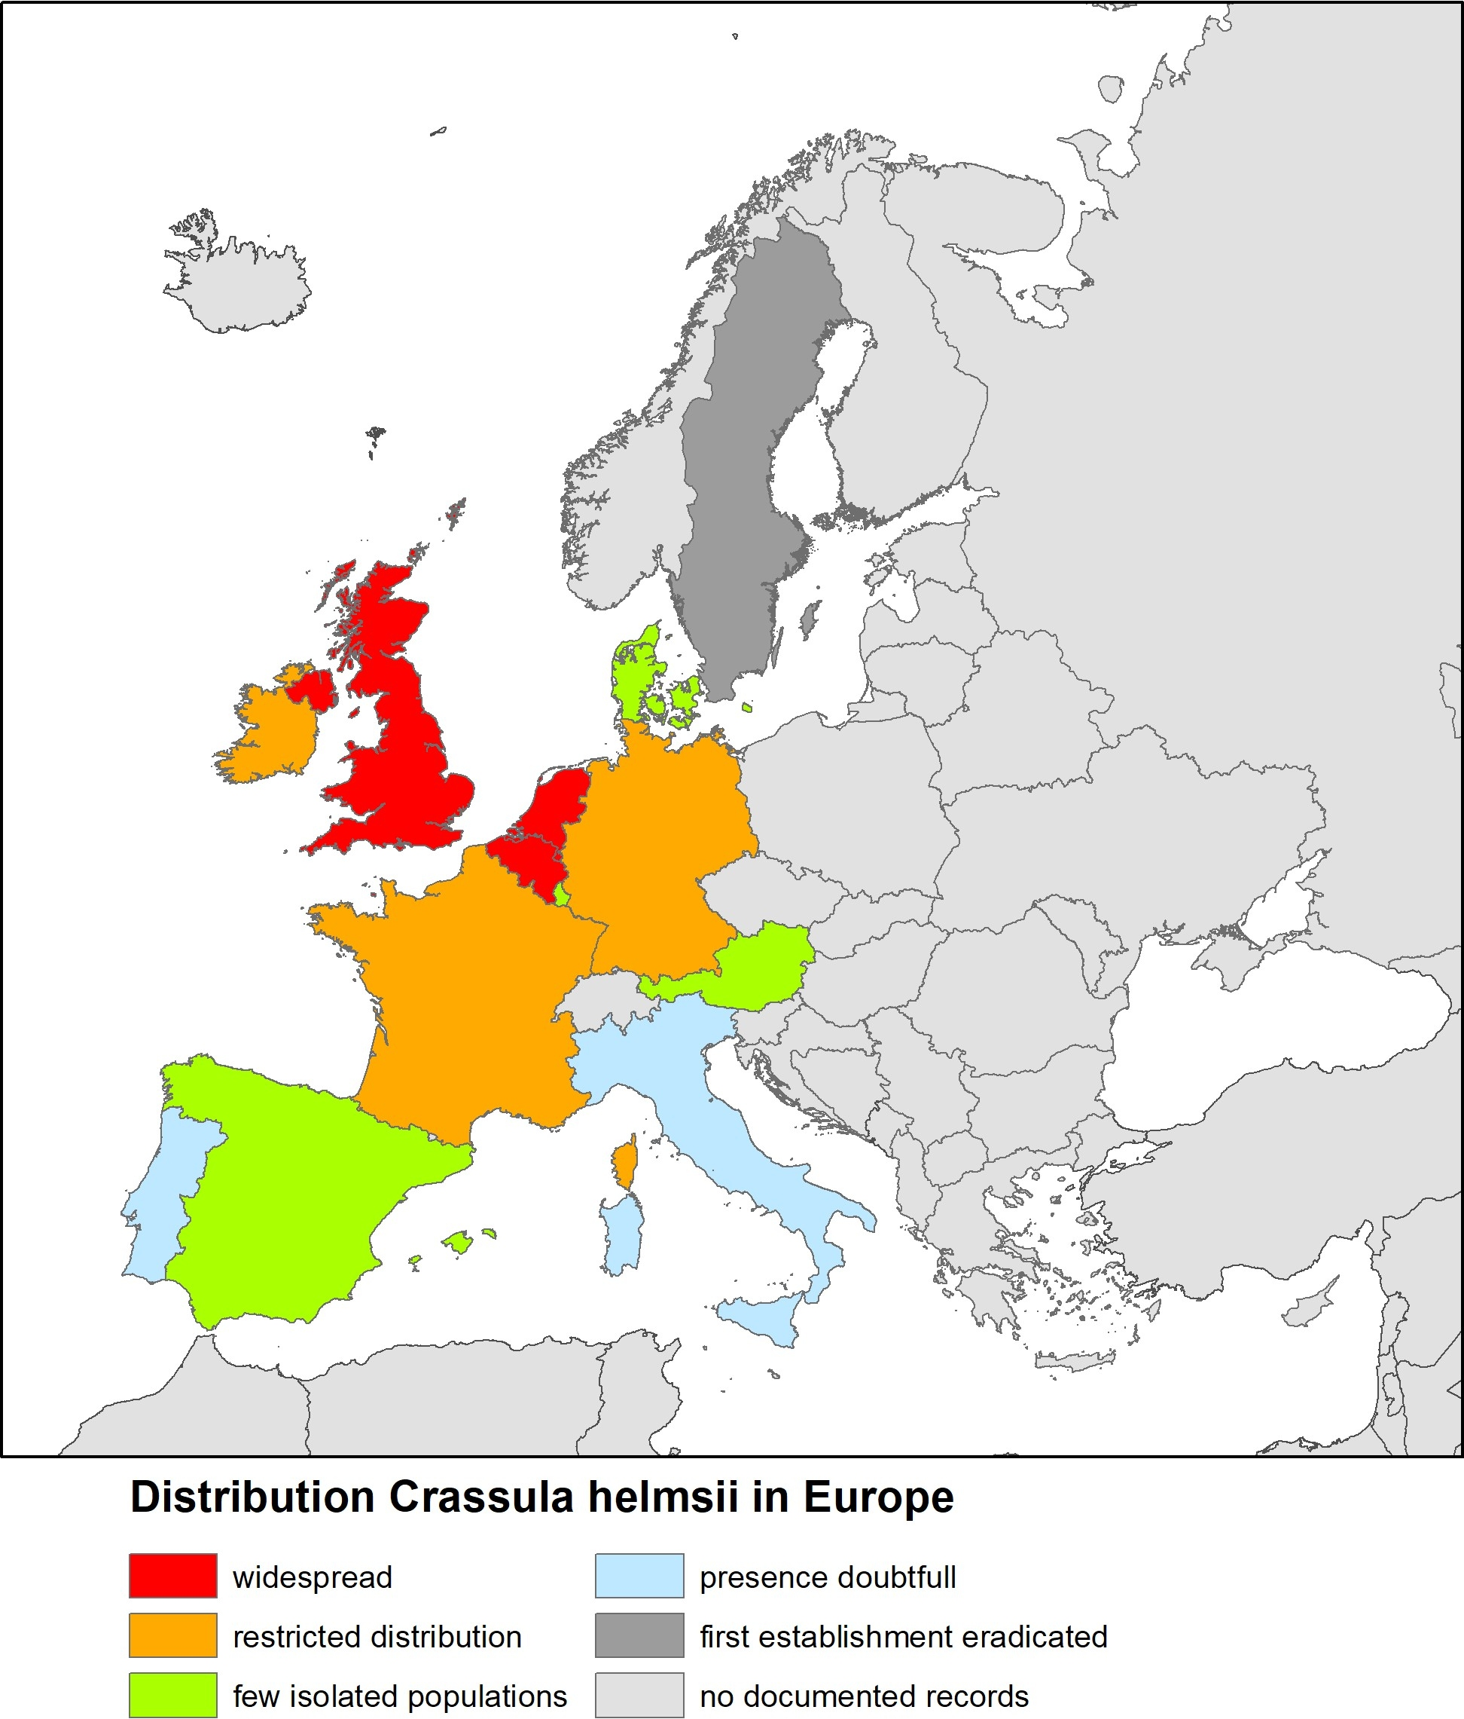
Figure 6.1 Distribution of Stonecrop within the various European countries.
  - Distribution in the Netherlands
In the Netherlands, Stonecrop can be found distributed in the higher pleistocene regions. (Figure 6.2). The species has also be observed in a number of duneland regions, particularly on Schouwen. Observations outside of the pleistocene and in the dunes are mainly from urban areas or in their immediate vicinity. The presence of the species on banks along the closed estuaries, such as the Krammer-Volkerak, Hellegatsplaten and locally along the IJsselmeer is striking. In total, Stonecrop has been observed across 1056 square kilometres (kilometerhokken) in the Netherlands between 1995-2020.

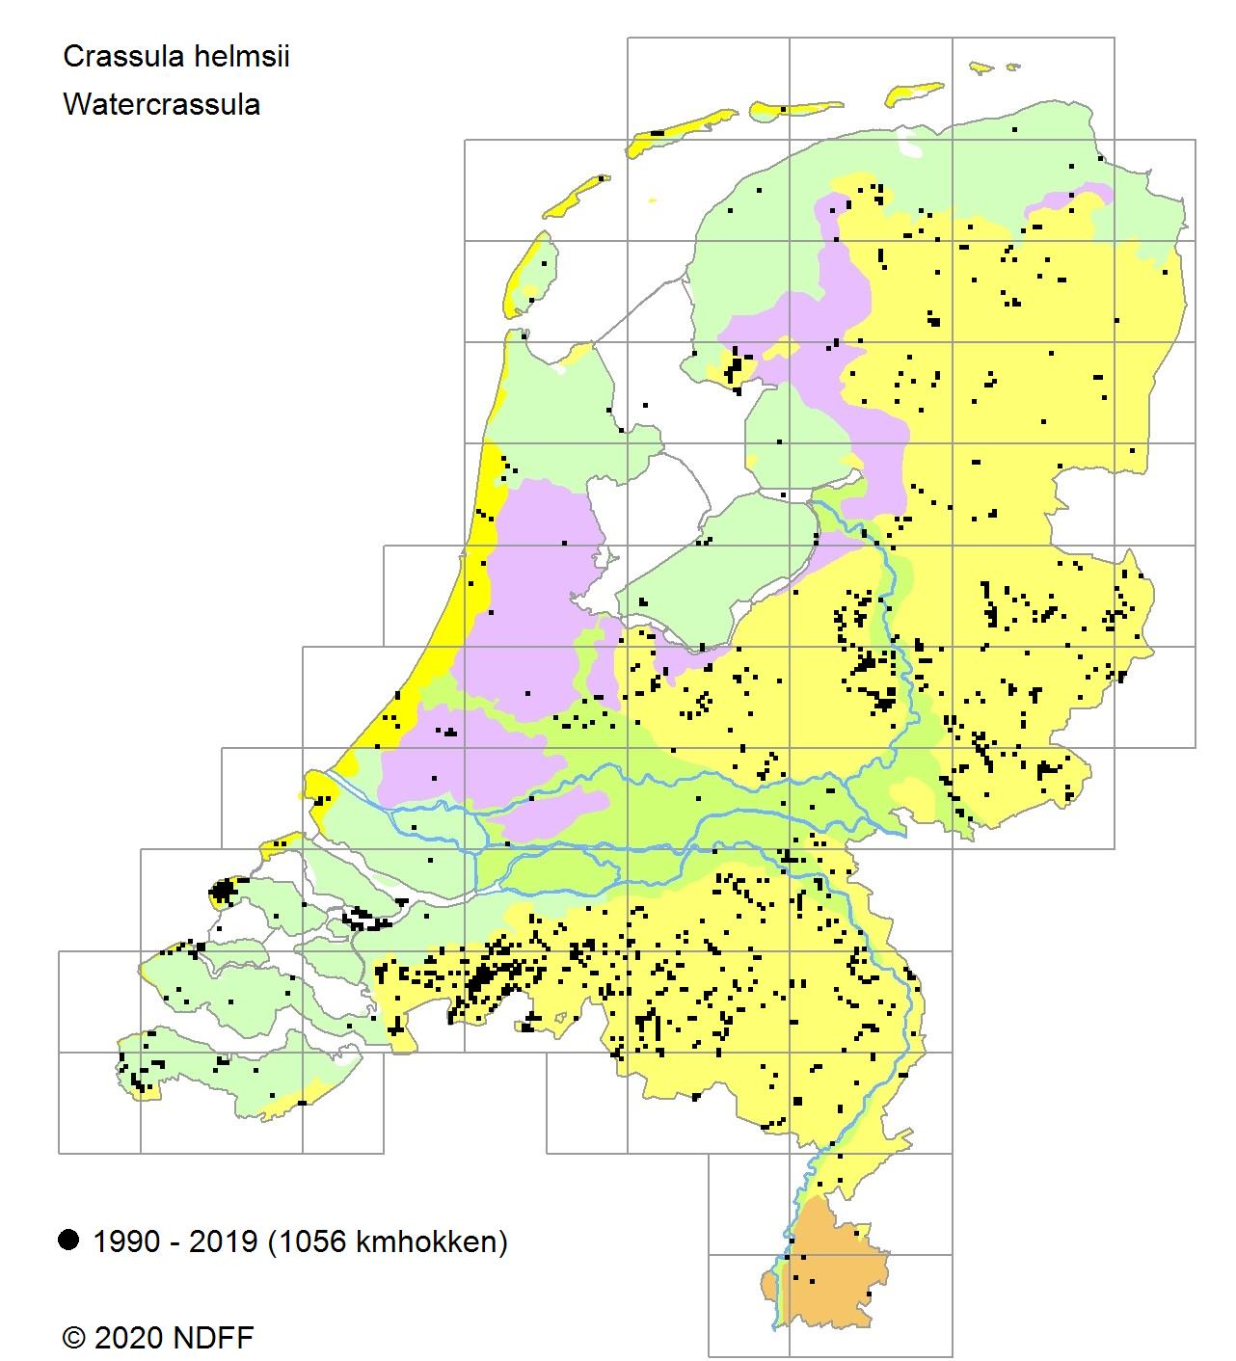
Figure 6.2 Observations of Stonecrop (square kilometres) in the Netherlands.

  - Possible future spread
As previously stated under 5.3, a northward expansion of the European area seems likely, while the areas in the south may be lost. Successive spread in the Netherlands in recent decades has increasingly taken place more to the north. By contrast, in France the species seems to be spreading to the south (Dortel & Le Bail 2019). It may be that the increase in the species’ range (to the north and south) is primarily an illustration of the natural spread by more significant vectors, such as (migratory) birds. In the Netherlands, the advance of this species does not yet seem to have abated, as the trend graph (Verspreidingsatlas.nl, April 2020) for this species shows (Figure 6.3).

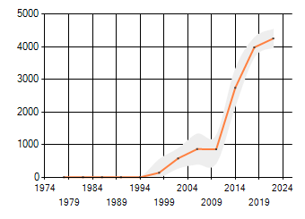

Figure 6.3 Trend chart (Index: 1990 = 100) of Stonecrop in the Netherlands (1995-2018). Please note: There are no known observations in the Netherlands prior to 1995.
- Impacts
  - Ecological/biodiversity
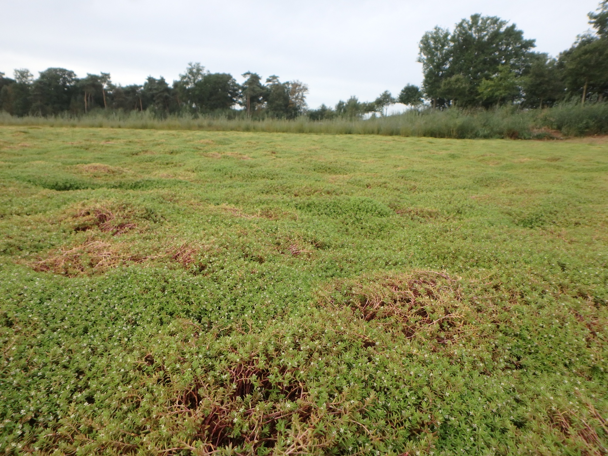
A dominant cover of Stonecrop, with underwater densities of up to 1 kg dry weight/m2 and 45 kg fresh weight/m² forms an impenetrable layer of vegetation on the soil, bank or water surface (Dawson & Warman 1987, OEPP/EPPO 2007, figure 7.1.). The plant becomes established in open niches, including pioneer habitats that have been created following environmental development or on natural pioneer habitats, such on drying banks over the course of the summer. At these sites, Stonecrop hinders the succession of native plant species and the recovery of the natural vegetation (Dawson & Warman 1987, Van Kleef et al. 2017, Van der Loop et al. 2020).

Figure 7.1. Dominant cover of Stonecrop in a fen in the Pannenhoef, a nature reserve in the province of North Brabant. The impact is clearly visible because the water layer has completely disappeared and the species is outcompeting other aquatic flora and fauna (Photo: J. van der Loop).

    - Biodiversity in general
Although Stonecrop is known to compete with other plants, the actual long-term effects on biodiversity are difficult to predict. Nor is it clear whether these effects would be irreversible. In a field studie in England over the period 1999-2002 in Stonecrop infested pounds no significant loss in species numbers of native plants was found; In a laboratory study a thin mat (< 10 mm) of Stonecrop induced a significant germination suppression of native plant species, including an 83% reduction in Hairy willowherb (Epilobium hirsutum), a 69% reduction in Purple loosestrife (Lythrum salicaria) and a 56% decrease in Water mint (Mentha aquatica). If this suppressive effect occurs under field conditions, reproduction by seed could be greatly reduced at pond margins with minimal Stonecrop presence(Langdon et al. 2004). Groups of species indicated to suffer negative effects from the presence of Stonecrop include starwort species (Callitriche sp.), waterweeds (Elodea sp.), charophyte green algae (Charophyceae) and diatoms (Bacillariophyta) (CAPM 2004). In addition, effects on birds, fish, amphibians and invertebrates have been reported as a result of lack of space, the changing of the water flow and the changes to the chemical properties of the water, such as fluctuations in oxygen levels, a changing pH level and the availability of light (Watson 1999, Langdon et al. 2004, Branquart et al. 2013, OEPP/EPPO 2007,). A study into the impact on invertebrates (macro-invertebrates) showed no significant differences in densities and diversity between affected sites and control areas (Smith 2015).

The same effects have been observed in the Netherlands, Belgium, Ireland and Germany, albeit to a more limited extent as a result of a lower number of stands or more recent introductions (Hussner 2009, Caffrey et al. 2012, Boute 2013, CAISIE 2013, Van Kleef et al. 2017, Van Veenhuisen et al. 2021, Van der Loop et al. in press.). Stonecrop’s cover and biomass show a negative correlation with the establishment and biomass increase of other plants both on land and in the water (Van Kleef et al. 2017). This correlation can be interpreted in two ways. On the one hand, the spread of Stonecrop may be at the expense of the space available for the growth of other species. In the event that Stonecrop is the dominant competitor, each 10% Stonecrop increase results in a cover decrease of 7% in the water and 9% on land for other species. One the other hand, it may be that Stonecrop is not the strongest competitor, but that it is native species which limit the coverage of Stonecrop in certain waters.

    - Impact on Red List, rare and/or protected species
Impact on flora
In the Netherlands, Stonecrop sites have been observed at stands of European protected plants (Annex IV EU Habitats Directive). These species must be protected both within and outside Natura 2000 sites.

In the Netherlands, there have been reports of threats to Creeping marshwort (Apium repens Lag.) and Fen orchid (Liparis loeselii L.) (Maas & Van Wijngaarden 2019, Wesseling 2019). Both plant species are designated as protected species in the Nature Conservation Act (Wet natuurbescherming) in which they hold Habitats Directive species IV, Bern I status, and additionally are included on the Netherlands Red List for vascular plants established in 2012. In North Brabant (Esschestroom) and in Zeeland (Groote Gat, Zeelandic Flanders), Stonecrop has appeared near stands of Creeping Marshwort (Apium repens). In both areas, the species was most likely spread by geese (Van Zuidam & Dijkhuis 2018).

In the Kleine Beerze river, Stonecrop grows along a considerable length alongside Floating water-plantain (Luronium natans), similarly a species with Habitats Directive species IV status (source: observations R. Beringen & M. Janssen in the NDFF). The impact of Stonecrop on Floating water-plantain in this scenario is unknown. In France, a negative impact on Floating water-plantain is described in Dortel & Dutartre (2018).

On the Wadden Island Terschelling the species was observed within a natural dune valley (figure 7.2). It possibly originated from a former garden pond. Within 2 years >10 ha of six moist dune valleys were overgrown by Stonecrop, causing a significant loss of native flora. A study on the effects of Stonecrop on the Natura 2000 site concluded that this invasive plant species not only is outcompeting native vegetation but posed a threat to the conservation goals imposed by the European Habitat Directive as well (Van der Loop et al. 2022).

Figure 7.2 A by Stonecrop overgrown moist dune valley in a Natura 2000 site on the Wadden Island Terschelling. A small infestation resulted in a high biomass production of the species outcompeting native species.

Various Red List species can also be found in the 115 vegetation studies including Stonecrop from the National Vegetation Database (Table 7.1). Primarily a number of species of low-nutrient waters have a relatively high presence in the studies which include Stonecrop and, in addition to Luronium natans mentioned in the above, include Apium inundatum, Baldellia ranunculoides subsp. ranunculoides, Eleogiton fluitans, Hypericum elodes, Littorella uniflora and Myriophyllum alterniflorum. A number of the species of the Habitats Directive listed above do not appear in the available vegetation studies.

Table 7.1. Red list and/or protected species in vegetation studies with Stonecrop. HD: Annex EU Habitats Directive; B: protected in the Netherlands under the Nature Conservation Act; RL; Red List category (NT: Near Threatened, VU: Vulnerable, EN: Endangered); Zz: degree of rarity (a: common, z: rare, zz: very rare, zzz: extremely rare); P: percentage of the vegetation studies in which the species was observed (N=115). (Vegetation studies present in the Dutch National Vegetation Database March 2020, Ecological groups according to Arnolds & van der Maarel 1979).
Ecological group | Species | HD | B | RL | Zz | P.
7a-lowland peat areas | Menyanthes trifoliata (Bog bean) |  |  | NT | a | 1.7
2c-pioneer vegetation  moist  moderate low-nutrient | Eleocharis ovata (Ovate spikerush) |  |  | NT | zzz | 0.9
2c-pioneer vegetation  moist  moderate low-nutrient | Illecebrum verticillatum (Coral necklace) |  |  | VU | z | 0.9
2c-pioneer vegetation  moist  moderate low-nutrient | Juncus Tenageia (Sand rush) |  |  | EN | zz | 4.3
2c-pioneer vegetation  moist  moderate low-nutrient | Radiola linoides (Allseed flax) |  |  | EN | zz | 0.9
2c-pioneer vegetation  moist  moderate low-nutrient | Sagina nodosa (Knotted pearlwort) |  |  | VU | z | 0.9
7c-Molinia meadows | Succisa pratensis (Devil’s bit scabious) |  |  | NT | a | 1.7
7e-dry heaths | Euphrasia stricta (Drug eyebright) |  |  | NT | a | 2.6
6b-dry, neutral grasslands | Linum catharticum (Fairy flax) |  |  | VU | z | 1.7
3c-high marshes | Apium graveolens (Celery) |  |  | VU | z | 1.7
3c-high marshes | Glaux maritima (Sea milkweed) |  |  | VU | z | 6.1
7b-alkaline fens | Epipactis palustris (Marsh helleborine) |  |  | VU | z | 0.9
7b-alkaline fens | Parnassia palustris (Marsh grass of parnassus) |  |  | VU | z | 1.7
7d-wet heaths | Gentiana pneumonanthe (Marsh gentian) |  |  | NT | a | 1.7
7d-wet heaths | Pedicularis sylvatica (Small lousewort) |  |  | VU | z | 0.9
2a-disturbed environments | Odontites vernus ssp. serotinus (Red bartsia) |  |  | NT | a | 1.7
4b-oligotrophic waters | Apium inundatum (Lesser marshwort) |  |  | EN | zz | 4.3
4b-oligotrophic waters | Baldellia ranunculoides ssp. ranunculoides (Upriht lesser water-plantain) |  |  | EN | zz | 5.2
4b-oligotrophic waters | Eleogiton fluitans (Floating club-rush) |  |  | VU | z | 9.6
4b-oligotrophic waters | Hypericum elodes (Marsh St. John’s-wort) |  |  | VU | z | 14.8
4b-oligotrophic waters | Littorella uniflora (Shoreweed) |  |  | VU | z | 10.4
4b-oligotrophic waters | Luronium natans (Floating water-plantain) | 2/4 | X | VU | z | 2.6
4b-oligotrophic waters | Myriophyllum alterniflorum (Alternate water-milfoil) |  |  | VU | zz | 0.9
4c-eutrophic river banks | Cicuta virosa (Cowbane) |  |  | VU | z | 0.9
4a-eutrophic waters | Stratiotes aloides (Water pineapple) |  |  | NT | a | 1.7

Dawson & Warman (1987) reported that the dominance of Stonecrop in a pond in the New Forest national park in England led to the crowding out of other plants, including Water purslane (Ludwigia palustris). In another pond, Waterweed (Elodea sp.) was crowded out entirely by Stonecrop within 2 years. In England, Water purslane (Ludwigia palustris L.), Galium constrictum and the very rare Starfruit (Damasonium alisma Mill.) are threatened by the presence of Stonecrop (Leach & Dawson 1999, Watson 2001).

Dortel & Dutartre (2018) identify the following endangered and/or protected species that may face competition from Stonecrop, at least in part of their ecological niche in western France: Apium inundatum, Ranunculus ophioglossifolius, Cardamine parviflora, Crypsis aculeata, Damasonium alisma and Luronium natans.

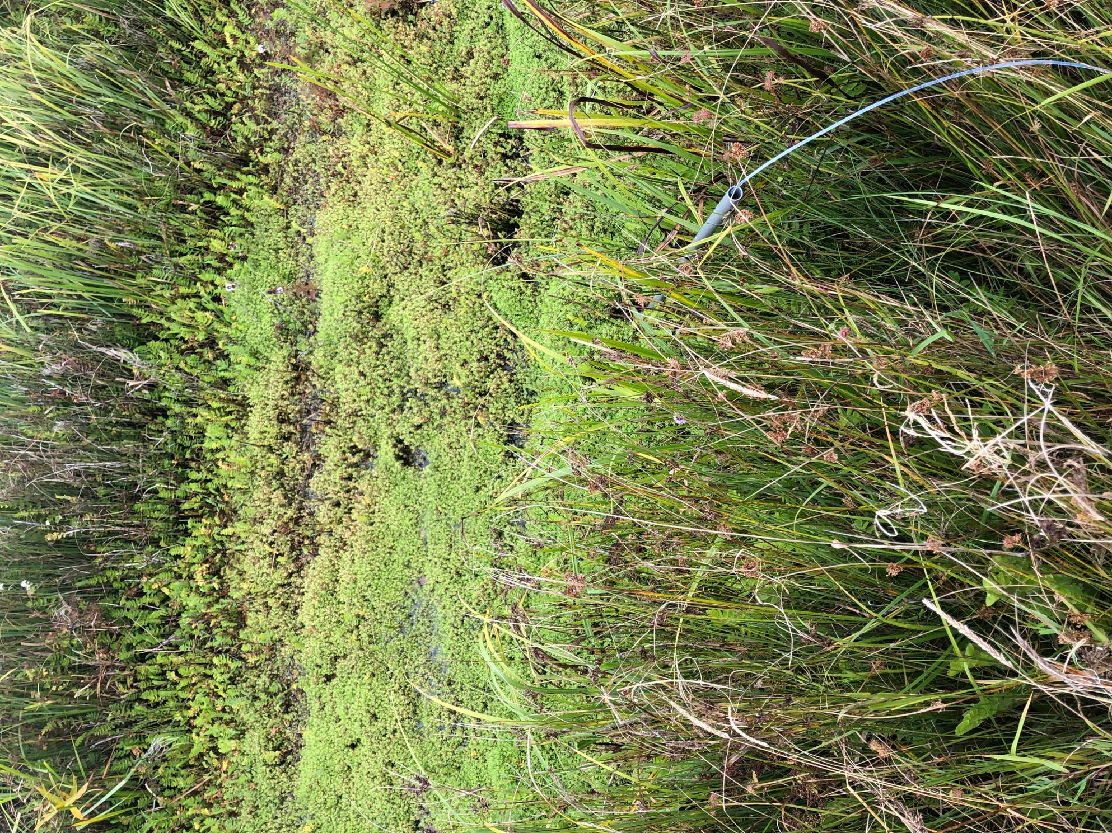
In the Fühlinger See (North Rhine-Westphalia), Hussner (2008) observed that the Stonecrop growing there, up to 10 metres in depth, exerted significant competitive pressure on the original charophyte green algae (Characeae) vegetation.

Figure 7.3. A drainage canal invaded by Stonecrop in the Kop van Schouwen Natura2000 area. The competition with native species can clearly be observed. (Photo: J. van der Loop).

Impact on protected and endangered faunaIn England, there have also been reports of the (potential) disruption of the breeding success of protected amphibians, including the Crested newt (Triturus cristatus Laurenti) and Palmate newt (Triturus helveticus Razumovsky) (Watson 1999, Langdon et al. 2004).

For Ireland and the Netherlands, there have been observations of threats to the Natterjack toad (Epidalea calamita Laurenti) (CAISIE 2013) (Van Veenhuisen et al. 2021, van der Loop et al. in press.). This species requires shallow and open waterbeds to lay its eggs and the number of suitable egg-laying sites is decreasing as a result of the dominant growth of Stonecrop. A recent study by Van der Loop et al. (in press., & Van Veenhuisen et al. 2011) showed that the spawning rate, egg survival of this toad species are negetifely affected in relation to the presence of C. helmsii.The negative effects of Stonecrop on endandered amphibians are recognized by the IUCN. In their ‘Guidelines for amphibian reintroductions and other conservation translocations’ they stated that biosecurity measures must be taken to reduce the threat of invasive Stonecrop (Linhoff et al. 2021).
Both the newt species referred to in the above and the Natterjack toad are included in the Nature Conservation Act under the protection of the Habitats Directive (Annex IV) and/or the Berne Convention (Annex II).
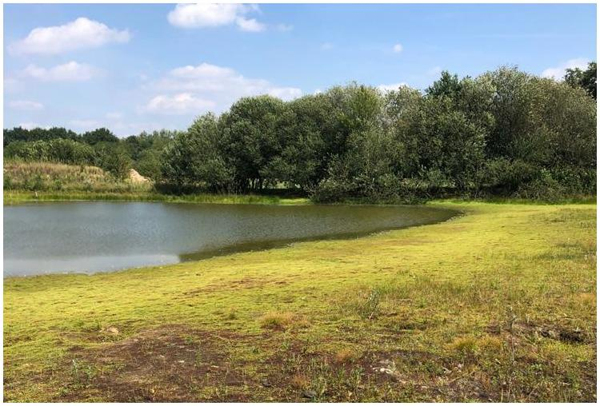
Figure 7.4. The Stonecrop invasion in the Gijzenrooise Zegge reserve, province of North Brabant, resulting in a lower reproduction rate and survival of the Natterjack toad population. (Photo: M. van de Loo).

    - Impact on EU habitat types
Given that Stonecrop places few requirements on the water system for its establishment, many habitat types are vulnerable. The plant is evergreen and winter hardy, resulting in sites inhabited by native plants which die off above ground in winter being taken over by Stonecrop (OEPP/EPPO 2007).
In England, the species can primarily be found on clay soils and organic soils (Dawson & Warman 1987, Dean 2015). All freshwater systems and weak brackish water systems with standing or slow-flowing water form a suitable habitat for Stonecrop both in England and beyond (Dawson & Warman 1987, Dawson 1994, Prinz et al. 2019, Smith & Buckley 2020).
In the Netherlands and Germany, the species can mainly be found on sandy soils (Hussner 2009, Van Kleef et al. 2017, Van der Loop 2017a & 2017b). In these cases, Stonecrop is similarly able to invade virtually all freshwater systems. In the Netherlands, however, the picture appears to be more nuanced. For the Netherlands, the vulnerable habitat types include the habitat types of very weakly buffered and weakly buffered fens (H3110 - Oligotrophic waters containing very few minerals of Atlantic sandy plains – Littorelletalia uniflorae and H3130 - Oligotrophic to mesotrophic standing waters with vegetation of the Littorelletea uniflorae and/or of the Isoëto-Nanojuncetea), Molinia meadows (H6410 - Molinia meadows on calcareous, peaty or clayey-silt-laden soils (Molinion caeruleae)), humid dune slacks (H2190), wet heaths (H4010 - Northern Atlantic wet heaths with Erica tetralix) and pioneer vegetation with Rhynchosporion (H7150 - Depressions on peat substrates of the Rhynchosporion). The species may also be found in other water types and humid environments, but is rarely, if ever, a threat to biodiversity.
For Belgium, weakly buffered fens (H3130), Lakes with water pineapple and pondweed (H3150 - Natural eutrophic lakes with Magnopotamion or Hydrocharition-type vegetation), Streams and rivers with aquatic plants (H3260 - Water courses of plain to montane levels with the Ranunculion fluitantis and Callitricho-Batrachion vegetation) and Rivers with muddy banks (H3270 - Rivers with muddy banks with Chenopodion rubri p.p. and Bidention p.p. vegetation) have been designated as habitat types being threatened by Stonecrop. However, in this regard it is similarly noted that all freshwater systems form a suitable habitat for Stonecrop (Robert et al. 2013).

The EU habitat types that may be impacted by the appearance of Stonecrop are summarised in Table 7.2.

Table 7.2. EU Habitat types in which Stonecrop is able to establish. * are priority habitat types, for which EU countries must take urgent protection measures.
Type | Description | Source:
1150* | Coastal lagoons | Dortel & Dutarte 2018
1410 | Mediterranean salt meadows (Juncetalia maritimi) | Dortel & Dutarte 2018
3110 | Oligotrophic waters containing very few minerals of sandy plains (Littorelletalia uniflorae) | Dortel & Dutarte 2018
3130 | Oligotrophic to mesotrophic standing waters with vegetation of the Littorelletea uniflorae and/or of the Isoëto-Nanojuncetea | Sotek et al. 2018, Dortel & Dutarte 2018, Branquart et al. 2013
3140 | Hard oligo-mesotrophic waters with benthic vegetation of Chara spp. | Dortel & Dutarte 2018
3150 | Natural eutrophic lakes with Magnopotamion or Hydrocharition-type vegetation | Sotek et al. 2018, Dortel & Dutarte 2018, Branquart et al. 2013
3170* | Mediterranean temporary ponds | Dortel & Dutarte 2018
3260 | Water courses of plain to montane levels with the Ranunculion fluitantis and Callitricho-Batrachion vegetation | Sotek et al. 2018, Dortel & Dutarte 2018, Branquart et al. 2013
3270 | Rivers with muddy banks with Chenopodion rubri p.p. and Bidention p.p. vegetation | Sotek et al. 2018, Dortel & Dutarte 2018, Branquart et al. 2013
7150 | Depressions on peat substrates of the Rhynchosporion | Dortel & Dutarte 2018

In the Netherlands, Stonecrop was found in a total of 40 Dutch Natura 2000 areas (Annex 4). What is striking is the relatively high number of Natura 2000 areas in the province of North Brabant and the large number of sightings in these areas. Table 7.2 shows that (EU habitats and) Natura 2000 areas likewise are or may be threatened by this species.

    - Impact of physiochemical properties and structure of ecosystems
Hydrology
Thick deposits of Stonecrop may impair the flow and drainage of water. The damming effect of thick deposits can even lead to local flooding and changes to the stream bed (Kelly & Maguire 2009). The disruption of the flood regime can lead to changes in the species composition and densities (Daehler 2003). In standing waters, a high dominance of Stonecrop can lead to water bodies drying out faster as a result of additional evaporation, which also has a concentrating effect on substances present in the water, resulting in changes to the chemistry of the water (Casanova & Brock 2000, Birken & Cooper 2006).

Oxygen
The presence and breakdown of Stonecrop leads to fluctuations in the oxygen levels of the water (Dawson & Warman 1987, Branquart et al. 2013). Stonecrop may cover the water layer, reducing the degree of diffusion to deeper parts causing oxygen deprivation in those areas. This is stimulated by the accumulation of a layer of dead Stonecrop residues. The degradation processes lead to greater oxygen consumption. The resulting lack of oxygen and the accumulation of organic matter in the underwater soil leads to the mobilisation of phosphate and therefore to internal eutrophication in which toxic sulphide may be released (Bloemendaal & Roelofs 1988). This has an impact on the waterbed communities, resulting in poor water quality that has a negative effect on the species in the water (CAPM 2004, OEPP/EPPO 2007,).

Inorganic carbon
Several studies claim that Stonecrop has an advantage over native plants when CO₂ is present in the water layer in low quantities (Newman & Raven 1995, Keeley 1998). The plant absorbs CO₂ from the water during the night means of CAM photosynthesis (CAM= Crassulacean Acid Metabolism) and stores carbon inter alia in the form of malic acid. As a result, the plant is able to use the carbon dioxide that is released through respiration by plants with normal C3 photosynthesis during the night, when this photosynthesis is halted (Newman & Raven 1995, Keeley 1998). This theoretically gives Stonecrop an advantage over plants with the C3 mechanism (Keeley & Morton 1982, Madsen 1987). However, it appears that the Netherlands, prolific Stonecrop growth only occurs when the average concentration of CO₂ in the summer is well above 200 µmol/L, when the species overgrows other aquatic plants under water. In waters with a lower CO₂ concentration, Stonecrop is limited in its growth and there is virtually no competition. The carbon limitation is lost when the water level drops and parts of the plant are emergent above the water (Van Kleef et al. 2017).

Nitrogen
Studies from England and the Netherlands show that high Stonecrop cover and biomass is associated with low concentrations of organic nitrogen and nitrate in the surface water respectively (Smith 2015, Van Kleef et al. 2017). This shows that the species is able to efficiently extract nitrate from the water during the growing season.

Bioaccumulation
Stonecrop is a hyperaccumulator of copper, storing large quantities of this metal in its leaves, if it is present in the soil in elevated concentrations (Brooks et al. 1977). Primarily in summer, the plant is highly resistant to high concentrations of copper, 9,000 ppm/dry weight compared to 0.6 ppm in a plant control group. Stonecrop can therefore grow in locations that are contaminated with copper and where other plants do not survive (Küpper et al. 2009). At high temperatures, the plant makes more use of CAM photosynthesis (Klavsen & Maberly 2009) and more malic acid is produced at night to bind carbon. Stonecrop is better able to bind copper due to a higher malic acid concentration in the plant cells. Despite the fact that, as far as is known, Stonecrop is able to accumulate the highest concentration of copper compared to other plants, the plant does not actually require additional copper, for example, for its growth or photosynthesis (Shen et al. 1997, Küpper et al. 2001, Küpper et al. 2009). In addition, Stonecrop affected by copper toxicity (excess copper) is able to quickly degrade the pigments in its leaves, resulting in the death of the whole leaf. This is an additional defence mechanism against copper toxicity, as the sacrifice of leaves leads to a reduction of the internal concentration of copper within the plant (Küpper et al. 2009). In the vast majority of natural situations, copper concentrations are so low that Stonecrop does not benefit from this resistance.

Presumably, Stonecrop is similarly adept at extracting other elements from the water. This is shown by the reduced concentrations of silicon, zinc and aluminium that have been measured in plants in relation to high Stonecrop cover and biomass (Van Kleef et al. 2017).v

Allelopathy (secretion of growth-inhibiting substances)
A bioassay with the blue-green algae Dolichospermum flos-aquae (= Anabaena flos-aquae) in which the allelopathic potential of 33 both native and alien aquatic plants was studied, showed that Stonecrop has a relatively high allelopathic potential. Of the alien aquatic plants, only Ludwigia peploides and Ludwigia grandiflora had a greater allelopathic potential (Grutters et al. 2017).
  - Public health and the economy
    - Diseases/allergies or other physical conditions
Based on the available information, the species does not cause any symptoms or signs of illness in humans or domesticated animals.
    - Personal safety & safety of infrastructure
It may be that floating carpets of Stonecrop may be mistaken for dry soil, which can pose a risk to people and animals (Sheppard et al. 2006, OEPP/EPPO 2007). There are no known reports of this occurring.
In cases where Stonecrop forms dense carpets, this may hinder recreational activities, such as boating, fishing, swimming and water skiing (Sheppard et al. 2006, Nault & Mikulyuk 2011). In the Netherlands, these effects have chiefly been observed in smaller flowing water systems, such as drainage canals and small canals (<15 m in diameter). Given that Stonecrop generally grows into the water from the banks or ‘creeps’ across the bed, the narrowing of larger flowing waterways (15 m in width or wider) due to dense growth has not been observed (pers. observation J. van der Loop). However, in isolated, highly eutrophic water, Stonecrop is able to grow to completely obstruct the water body from the bed.
The drainage of water in drainage channels and structures, such as weirs and dams, may be limited when Stonecrop is present (Branquart et al. 2013, Kelly & Maguire 2009). This may lead to flooding (Dawson & Warman 1987, OEPP/EPPO 2007).
    - Socio-economic impact
Monocultures reduce the aesthetic value of areas and nature reserves (Sheppard et al. 2006). In addition, recreational areas are less accessible for swimming activities and launching boats in cases of aquatic plant dominance (Dawson & Warman 1987, Sheppard et al. 2006). In addition, affected areas are often sectioned off by site managers to limit the spread as much as possible, making them inaccessible for recreational purposes (pers. observation J. van der Loop).

Please see section 9.3 for information on the costs of controlling the species.

- Risk analysis
The risk classifications of Stonecrop and the corresponding levels of confidence are set out in Table 8.1. These assessments are briefly discussed in section 8.1, with reference to the numbering of the relevant assessment criteria in parentheses (A1-A41; in accordance with the online version of the Harmonia⁺ protocol). The results of the calculations of the risk scores and level of confidence scores are summarised in Tables 8.2 and 8.3 and are clarified in section 8.2. Section 8.3 compares these results to other risk assessments for the species.
The information used in this chapter stems from the earlier chapters. Also, all used references relating to statements or judgements in this chapter can be found in earlier chapters.

Table 8.1: Risk assessment of Stonecrop using the Harmonia⁺ protocol.
  - Risk classification
Context
This risk assessment was carried out by six experts (A1) for the introduction of Stonecrop (A2) in the EU (A3). The species is already present in various EU Member States and also has established populations in several Member States, including the Netherlands (A4). The domains of this risk assessment are ‘the environment and public health’ (A5). The risk assessment was carried out based on all the available information on Stonecrop (Chapters 3-7). Full consensus was reached regarding all the various risk classifications and relevant levels of confidence during a workshop (Table 8.1). The results of the risk assessment are outlined in detail below.

Introduction
Outside Europe, Stonecrop is likely only to be found within its original, native range (New Zealand and Australia). The probability of introduction into the EU through natural dispersal from this region of origin has been determined to be low (A6). The level of confidence in this regard is high due to the significant distance from the native range and numerous (natural) barriers to dispersal of plants (and plant fragments) or seeds. The scientific literature revealed no indications for dispersal across long distances by way of natural vectors, meaning from the regions of origin in the Southern Hemisphere, surrounded by oceans, to the European continent. There are no known distribution areas outside of Europe from which the species is able to reach EU Member States. For that reason, it can be asserted with a high level of confidence that the natural introduction frequency is less than once every 30 years.
Stonecrop was imported into many EU Member States, being a popular aquarium and pond plant. The species is still traded, although sales has already been restricted in a number of EU Member States. The plant is distributed worldwide via (internet) trade. Escape from garden ponds and parks by way of natural vectors (such as amphibians and birds) is highly plausible. The plant primarily spreads vegetatively by way of small fragments of its stems. Therefore, where pollinators are absent in introduced areas, this does not hinder the spread of the species. Entire plants and plant fragments are able to piggyback as a contaminant through the sale and trade of aquatic and waterside plants, earth movement, horticultural management equipment, footwear or (sports) fishing equipment. The species is also known to be dumped into fens and ponds in the vicinity of residential areas and is regularly found alongside other aquarium and pond plants. How often this takes place within the EU is unknown. At the New Forest National Park (UK), the spread was correlated to the presence of car parks. In view of the widespread distribution in multiple EU Member States, it is highly likely that the combined probability of introduction into the wild and subsequent (un)intended further spread in the EU is greater than once a year. For that reason, the probability of introduction into the wild by way of (un)intentional human activities (A7 and A8) has been assessed as high, with a level of confidence of medium given the absence of quantitative information on the exact relationship between unintentional and intentional human introductions into the wild.

Establishment
Stonecrop has numerous established populations in multiple Member States and is widespread within the EU. Large parts of Europe are climatically suited – in particular the regions with a more Atlantic climate. Severe frost and prolonged drought hinder its growth. The species prefers standing to slow-flowing waters as well as their banks. The plant grows in systems with both oligotrophic sandy and clay soils. The moist sections of the sandy soils and dunes in particular constitute an optimal habitat. Such habitat types are widespread within Europe. The species primarily establishes itself in pioneer conditions, which are the result of natural processes or anthropogenic interventions in many areas. The distribution data and prolific growth confirm that both the climate and habitat conditions are optimal in large parts of the EU (A9 and A10). The level of confidence regarding the suitability of these environmental factors is high. A large amount of data and numerous scientific publications is/are available on the successful establishment of the species in the EU.

Spread
The natural dispersal capacity of Stonecrop for its spread within the EU has been assessed as high with a high level of confidence, due to the fact that sufficient information is available on this issue (A11). This secondary spread primarily takes place vegetatively. Very small plant fragments of Stonecrop as still viable. Plants and fragments are inter alia able to spread through the water currents. In addition, dispersal (both endozoochoric and exozoochoric) by way of waterfowl and other animals has also been detected. Given the available data on dispersal patterns, such as for the Netherlands, a dispersal rate of 5-50 km as a result of transport by water and animals seems realistic. Moreover, this value could equally be higher if the water flows over a long distance and animals migrate long distances. The species is occasionally able to cross large distances, such as from the mainland to the Wadden Islands. However, the extent to which natural causes play a role in the spread is not easily quantifiable.

The species is currently already widespread within the EU and is still commercially available in various Member States (including the Netherlands) and elsewhere. The species is still present in many ponds and is still being planted, making the likelihood of secondary spread or dumping of excess plant material in nature high. The plant can easily stowaway during earth movement, machinery for earthworks or mowing, vehicles, vessels, footwear and sports fishing gear. The probability of spread > 50 km within the EU due to human activity is higher than 1x a year. For that reason, the frequency of secondary spread of Stonecrop through human activity is deemed to be high with a high level of confidence (A12). The relative importance of the various types of dispersal mechanisms, however, cannot be quantified.

Environmental risk
The effects of Stonecrop on native species through predation, parasitism or grazing (herbivory) do not apply (A13). This can be stated with a high level of confidence. This species relates to an autotrophic plant that is not parasitic and has not developed any mechanisms for predation on animal species (such as carnivorous plants). Herbivory is not a plant trait and relates to the grazing of vegetation by herbivorous animals.
The impact of Stonecrop on native species as a result of competition is deemed to be high (A14) with a high level of confidence for this assessment. A relatively large amount of scientific literature is available on the subject. Due to its strong growth and full coverage of the soil or bed, native species are crowded out in low-nutrient, oligotrophic systems. Stonecrop also prevents the establishment of native species in pioneer situations, because the plant is able to quickly take up the available space in such conditions. This effect is less strong in undisturbed vegetation.
The probability of an impact on native species due to interbreeding has been classified as irrelevant/very low, with a high level of confidence (A15). Within the EU, there are no closely related species that could interbreed with Stonecrop.
The probability of an impact on native species due to the transmission of parasites or pathogens carried by Stonecrop has been classified as very low, with a medium level of confidence (A16). Based on the available information, these types of effects have not be identified within the EU despite the plant’s long-term presence, extensive spread and the relatively high level of focus on the species. There is, however, little documentation available for the EU regarding any parasites or pathogens related to Stonecrop.
The probability the Stonecrop will have a significant impact on the integrity of ecosystems due to changes in abiotic factors (A17) and biotic factors (A18) is high. Effects on physicochemical properties (such as light and oxygen content) and biodiversity are a given, due to the high productivity of this species and its frequent full cover of large parts of ecosystems. The species causes shifts in the species composition of vegetation of the Littorellion alliance in and on banks of weakly buffered fens and dune valleys. These effects have been assessed as being irreversible as extensive and highly costly measures are required to remove the species from ecosystems entirely. This is similarly identified in many other risk assessments and articles. However, it should be noted that quantitative information on the subject is scarce in the scientific literature and that such impact assessments rely heavily on the views of experts. That is why the assessment of these aspects relies on a medium level of confidence.

Risk to plant cultivation
The impact of Stonecrop as a result of predation, parasitism or grazing (herbivory) of plant cultivation species does not apply (A19). This can be stated with a high level of confidence. The species assessed relates to an autotrophic plant that is not parasitic and has not developed any mechanisms for the predation of other species. Grazing (herbivory) is a trait of herbivorous animals.
The probability of undesirable effects in plant cultivation due to competition has been assessed as very low for Stonecrop (A20). No references or indications were found in the extensive literature on the environmental impact of this species in relation to Europe in this regard, which is why a high level of confidence has been assigned to these risk classifications.
The probability of an impact on cultivated plants as a result of interbreeding has been assessed to be very low (A21). Within Europe, there are no known cultivated plants or related native plant species that would allow for interbreeding. For that reason, a high level of confidence has been assigned to this risk classification.
The probability of Stonecrop having an impact on the integrity of plant cultivation systems has been deemed to be very low (A22). No references or indications were found in the extensive literature on the environmental impact of this species in this regard, which is why a high level of confidence has been assigned to this risk classification.
No evidence was found in the scientific literature regarding the impact on plant cultivation as a result of the transmission of parasites or pathogens by Stonecrop for the EU and elsewhere, for which reason the likelihood of this occurring was classified as being very low (A23). Due to the absence of explicit references regarding this subject in the literature, this assessment has been assigned a medium level of confidence.

Risk to domesticated animals
Health effects on (individual) domesticated animals due to parasitism or predation do not apply to alien plants and therefore a high level of confidence applies (A24).
The probability of an impact on the health of (individual) domesticated animals due to plant substances of Stonecrop is very low and as such this classification has been assigned a high level of confidence (A25). No evidence was found in the scientific literature regarding the possible production of substances harmful to animals by Stonecrop, while there has been a relatively large amount of research into toxic antibodies and plant toxicity.
Based on the available information, Stonecrop does not affect the health of plants of domesticated animals through the transmission of parasites or pathogens either in the EU or elsewhere in the world (A26). The literature does not describe any parasites or pathogens that can be transmitted to animals by Stonecrop. It can therefore be stated with a high level of confidence that this criterion does not apply.

Public health risks
The risk category ‘The effect of the species on human health through parasitism (A27)’ does not apply to plants, with a high level of confidence. Despite the large amount of literature on the environmental impact of Stonecrop, no evidence was found regarding health effects as a result of human contact with (plant) substances. For that reason, this risk has been deemed to be very low (A28) and a high level of confidence applies to this risk classification. Effects on public health as a result of the transmission of parasites or pathogens do not apply (A29). A high level of confidence likewise applies in this case given that there has been a relatively large amount of research into Stonecrop and the (scientific) literature shows no evidence of such effects.

Risk of other impact
This criterion assesses the likelihood of damage occurring to infrastructure, such as buildings, roads, dykes, and water management structure (A30). Damage of this nature may limit the use of the relevant infrastructure. The likelihood-consequence matrix of the protocol was used for this aspect. Stonecrop is able to decrease water drainage when present at high densities. Water management structures (such as culverts) may become clogged. The likelihood of such effects is high, however the damage is reversible, resulting in a risk classification of medium. Due to the lack of quantitative information regarding the extent of the damage to infrastructure, the level of confidence of this risk classification is medium.

Impact on ecosystem services
Prolific growth of Stonecrop in water catchment areas (such as dunes) may lead to minor negative effects on water extraction due to additional evaporation. In addition, indirect effects in multifunctional ecosystems may likewise lead to negative impact on provisioning services of other species (such as the production of fish or the performance of recreational functions). The species is cultivated as an aquarium and pond plant, for which purposes plants from wild populations could be used. The harvesting and sale of plants from nature is regarded as a positive effect of the species on the provisioning services of ecosystems. The balance of the positive and negative effects on all provisioning services is deemed to be neutral (A31).
The localised blockage of water drainage by Stonecrop is regarded as a negative effect on the regulating service of an ecosystem. Due to its high biomass production, this species also has a positive effect on carbon fixation and nutrient retention. It may be that the species could be used to tackle ecosystems polluted as a result of bioaccumulation of metals such as Cu, Zn and Al. The impact on regulating services (A32) have been assessed as being moderately negative.
The experiential value of ecosystems similarly decreases due to the thick coverage and crowding out of native species. In systems with a (partly) recreational function, activities are therefore hindered (e.g. boating or angling). These types of effects have been assessed as moderately negative in respect of cultural services (A33).
A medium level of confidence applies to the three risk classifications (A31-A33), due to the fact that no quantitative information is available regarding the impact on ecosystems, however sufficient knowledge is available for a theoretical underpinning of the impact of Stonecrop on the performance of ecosystems. In addition, there are no methodologies for the weighing of positive and negative effects on ecosystem services.

Impact of climate change on risks
The risk posed by Stonecrop with regarding to overcoming geographical barriers to its introduction in the EU and its further spread does not change as a result of climate change (A34). A high level of confidence applies in respect of this assessment, given that no relevant evidence was found and there are no known mechanisms that could account for the impact of climate change on barriers to spread. The key introduction pathways and dispersal mechanisms are well known and the risks of introduction and spread are not affected by climate factors within the expected range of temperature and precipitation changes, which assumes a time horizon of 50 to 100 years.
The likelihood of the species managing to overcome barriers to survival and reproduction does increase slightly (A35). This is an expert opinion based on theoretical reasoning, which is why a medium level of confidence applies.
Stonecrop is already established in various climatic regions. These regions will shift slightly north as the climate changes. As a result of higher winter temperatures and reduced snow cover, the area with a suitable climate will increase slightly in the north and in mountainous regions. In the south, this area will most likely decrease due to an increase in drought. On balance, the distribution of the species will not change substantially within the EU. Large parts of the EU will remain suitable for the establishment of the species in the near future. (A36). A medium level of confidence applies in this regard, given that this is a theoretical deduction, with an absence of quantitative information or model calculations.
The likelihood of undesirable effects on the environment (A37) will increase moderately, such as in the area of the physicochemical properties of the water, such as light and oxygen content, for which a medium level of confidence applies. The causality of these types of effects can be theoretically substantiated, however there is an absence of quantitative and experimental underpinning.
The impact of Stonecrop on plant cultivation through grazing or parasitism does not apply. All other effects on plant cultivation are deemed to be very low. It is unlikely that the probability of such effects occurring should change due to climate change (A38). A medium level of confidence applies to this assessment, given that there is a lack of scientific documentation.
Parasitism and transmission of pathogens and parasites by Stonecrop to animals are not applicable. The probability of health risks via skin contact with plants or exposure of animals to plant substances has been assessed as very low in the foregoing. It can be stated with a high level of confidence that the risks the species poses to domesticated animals will not change as a result of climate change (A39). In addition there is no conceivable link to account for this.
Parasitism and transmission of pathogens and parasites from Stonecrop to humans are not applicable. The probability of health risks through skin contact with plants or exposure to plant substances has previously been assessed as very low. It is highly likely that the risks to public health will not change as a result of climate change (A40), which can be asserted with a high level of confidence. It its highly unlikely that the plant should start producing chemicals that pose a risk to humans as a result of climate change.
The probability of undesirable effects of the species on infrastructure or other socio-economic effects will not change as a result of climate change (A41). Given the lack of quantitative information on this matter, this assessment has been made with a low level of confidence.
  - Risk score and levels of confidence
Risk scores and levels of confidence for Stonecrop were calculated based on the risk classifications using the Harmonia⁺ protocol (Table 8.2 and 8.3). Both the maximum and the mean scores per risk category are commonly presented. For that reason, both have been extrapolated based on the data in Table 8.1.
When the maximum score is used for each risk category, this species scores high in terms of its risks of introduction, establishment, spread and environmental impact. The risks of undesirable effects on plant cultivation, domesticated animals and public health score low. The risk of other socio-economic impact is medium. All risk scores have a high level of confidence, with the exception of a medium level of confidence for the risk of other socio-economic effects (due to the lack of quantitative information). The aggregated invasion, impact and risk scores are high.
Table 8.2: Maximum risk (scores) and levels of confidence of Stonecrop with Harmonia⁺.

When the mean score is used for each risk category, this species likewise scores high in terms of its risks of introduction, establishment and spread. The risks to the environment and of other socio-economic impact in this care medium. The risks of undesirable effects on plant cultivation, domesticated animals and public health remain low. All risk scores have a high level of confidence, with the exception of a medium level of confidence for the risk of other socio-economic effects (due to the lack of quantitative information). The aggregated invasion score remains high, but the impact and risk scores fall to medium.

Table 8.3: Mean risk (scores) and levels of confidence of Stonecrop with Harmonia⁺.
  - Comparison with other risk assessments
Risk assessments of the environmental impact of Stonecrop have been carried out for many countries and regions in Europe and the United States. Table 8.4 provides an overview of the protocols used, the impact examined, the risk scores and sources of these risk assessments. It also includes the harmonised risk classifications and list status of this species. The list status indicates whether the species has been placed on a warning or black list for invasive species in a particular country or region. The quantitative risk scores and qualitative definitions have been harmonised into three risk classes, i.e. low, medium and high risk, by the authors of this report (please see 2.7). The harmonisation of risk scores is made more difficult by the significant difficult in risk assessment methods and the absence of relevant protocols (Verbrugge et al. 2012, Matthews et al. 2017). In addition, the results of risk assessments are always contextual and as such are sometimes difficult to compare for different regions or scale levels. After all, the environmental impact of alien species depends on the environmental conditions in the relevant high risk area (such as climate, environmental quality and habitat availability).

Table 8.4: Available risk assessments for Stonecrop for various European countries and the United States.
The harmonised risk classifications for Stonecrop provide a more or less consistent picture and closely match this classification for the EU using the Harmonia⁺ protocol, which uses the maximum value per risk category (section 8.2). The vast majority of the risk classifications (82.6%) indicates a high risk of undesirable effects on native biodiversity and ecosystem performance,
with deviations only from the risk classifications for Luxembourg, Poland and Spain where the risk has been classified as medium. For Luxembourg, this relates to inter alia a classification from 2010, using the Belgian ISEIA protocol. At the time of that assessment, relatively little knowledge was available regarding the precise extent of the effects in Luxembourg and the surrounding countries. A classification using the Belgian Harmonia⁺ protocol was additionally carried out for Luxembourg and for Poland, which most likely used mean risk scores for each impact category (however, based on the available information, this cannot be verified). As a result, the score per impact category is lower than for the maximum approach in the event that one or more subcriteria have been assessed as being low or medium risks. The results of these assessments, however, correspond to the present results based on the mean risks per impact category (Table 8.3).

For Spain, the results of the WRA and WRA-WG protocol were compared, with the latter WRA-WG protocol scoring lower. A study by Andreu & Vila (2009) based on risk assessments of 80 alien species shows that the WRA and WRA-WG scores are significantly correlated. Naturally, individual species are able to score higher or lower with the WRA-WG than with the WRA. In the case of scores situated around threshold value for a specific risk class (low, medium or high), this may occasionally result in a deviating risk classification.

- Estimation of the potential costs (quantitative or qualitative)
  - Damage to biodiversity & ecosystem services
Damage to biodiversity
Based on the literature review in this report, it has been concluded that Stonecrop has a significant impact on the biotic and abiotic environment (please see Chapter 7 and 8). These effects are currently still increasing as a result of an increase in spread. In part, these are effects that may affect native species in certain conditions, however, these species are generally easier to control with appropriate management. There are no known publications that express the damage to biodiversity in financial terms.

Damage to ecosystem services
Stonecrop is sold as an aquarium and pond plant, which means that the species contributes to provisioning services (please see 7.2). The total economic value of this plant species, however, is estimated to be limited, which means that any damage to producers in the event of a ban would be minor (CABI 2016). The overall costs associated with the damage to ecosystem services are unknown. This also applies to the value of regulation and maintenance services, including functioning as a potential nectar source for insects.
  - Damage to health, safety and the economy
The species has an impact on the safety, water infrastructure and the experiential value of nature reserves in all manner of situations (please see 7.3). Floating carpets can be confused with dry soil, for which appropriate warnings would involve certain costs. Hindering recreational activities would entail certain costs if they would have to be suspended. In practice, however, there are plenty of alternative sites available where recreational activities could take place. This may change with the further expansion of Stonecrop. The drainage of canals and water management structures must be safeguarded and the removal of the plant at these locations would entail certain costs, which have not been reported. This also applies to any losses that would occur as a result of the lowering of the aesthetic value of nature reserves.
  - Costs of control
The costs of elimination and/or management of Stonecrop are very high. In theUK the potential costs of control for 600 sites over a period of two to three years were estimated at £2-3 million (Dawson 1998 in Leach & Dawson 1999). Other sources refer to costs of 2.5 to 3.5 million euros for the annual control of the species in England (OEPP/EPPO 2007, Dadds & Bell 2008, Williams et al. 2010). Kelly & Maguire (2009) estimate the costs for the remediation of a small garden pond to be at 600 euros, which may increase up to 6,000 euros for larger ponds and small river systems. They indicate that the efforts and funding must be continuous until the species is fully eliminated. The remediation of a lake, canal or large river system may cost between 60,000 and 115,000 euros in the first year.

In Ireland, the costs for the control, study and restoration of treated areas until 2012 were estimated at 350,000 euros, with the largest expenditure being on the control of the plant in a watercourse on two occasions (Caffrey et al. 2012).
In the Netherlands, more than 6 million euros have been spent of research, elimination and control of Stonecrop from 2017 to the present day (pers. communication J. van der Loop). The responses of the Minister to questions from the House of Representatives even cite a figure of approximately 10 million euros, of which over 4 million euros in 2018 and 2019 was spent on control measures by the provinces of Friesland, Drenthe, Gelderland, Utrecht, North Holland, North Brabant and Limburg (Annex to the Proceedings of the House of Representatives of 18 May 2020, ah-tk-20192020-2806). The majority of the costs were incurred in relation to studies aimed at determining the stand properties and ecology of the species and formulating cost-effective control measures, including the development of system-based management. On the Wadden Islands, approx. 4.5 million euros were spent on eliminating the species (Van der Loop et al. 2022 and pers. communication P. Wassenaar, Stonecrop elimination Terschelling project leader, province of Friesland).
Costs were similarly incurred to prevent flood risks. There are no figures available in this regard (OEPP/EPPO 2007).
- Management
  - Prevention
Legal framework
Stonecrop is handled differently in terms of regulations in the various European countries. Four Member States (Denmark, Ireland, Poland and Spain) have placed the species on their national lists of invasive alien species of Member State concern under EU Regulation 1143/2014. In the United Kingdom, Switzerland, Denmark, Poland and Spain, among others, trade of the species is prohibited or otherwise regulated by law.

Prevention of spread
Plant fragments are easily dispersed through water or adhesion to animals, people or equipment (Dawson & Warman 1987, Crane et al. 2019). The risk of spread by way of humans and equipment can be reduced by way of effective inspection of footwear and equipment following access to contaminated areas and removal of any plant fragments. Larger machinery, such as cranes, must be cleaned with a high-pressure cleaner at a site with a habitat that is unsuitable to Stonecrop (pers. communication J. van der Loop). The killing of small fragments could be accomplished in addition to larger-scale interventions by applying direct steam treatment. The use of steam would kill all smaller fragments of Stonecrop within 10 seconds (Crane et al. 2019). The application of chemical treatment, using Virkon® Aquatic and Virasure® Aquatic, would not be sufficient for Stonecrop in killing all the fragments (Crane et al. 2020). Instead of steam, hot water could be used to sterilise any footwear and equipment. However, this would require temperatures of over 50°C for a period of 15 minutes, which makes this method difficult to be applied in the field (Shannon et al. 2018).
Spread can also be prevented by making adjustments to the infected area. Stonecrop can be spread by recreational users who move from contaminated to uncontaminated sites. Access to contaminated areas by recreational visitors and other visitors must be minimised in order to prevent any spread. It is therefore advisable to restrict public access for recreational users to the contaminated waters by enclosing the contaminated waters. In addition, it is advisable to inform visitors and local residents about the contamination and the associated risks (Van der Loop & van Kleef 2020).
Spread can also take place via animals. Plant fragments can be moved by livestock from infected to uncontaminated areas. In order to prevent spreading to uncontaminated sites, it is advisable to also fence out infected locations for access by livestock. The risk of spreading by water fowl, i.e. ducks, ralls, waders, herons, and geese, can be reduced by a net structure of ropes or other lines over the infested location. Bird-disturbing-kites can be functional for migrating birds. Between aquatic sites, smaller fences may reduce the movement between sites by walking birds (i.e. ducks and geese) (Van der Loop et al. 2020, Van der Loop et al. 2022)

Contamination
It is critical that any large machinery that is used in affected or contaminated areas, and are virtually impossible to clean effectively, such as mowers and crawler cranes, are not used in non-contaminated humid areas. Working safely with the plant requires following certain procedures. The hygiene measures aim to prevent new (cross) contamination at uncontaminated or locations where the invasive species has already been controlled, and consist of several measures such as choosing the right machines, ensuring that hired machines do not pose a risk of contamination, and afterwards the correct cleaning of equipment and machines. But the use of clean footwear and the correct disposal of contaminated material is also important for the careful handling Stonecrop (Van der Loop & van Kleef 2020). In addition, soil disturbances that make the soil more susceptible to contamination with Stonecrop must be limited. It is therefore critical to section off the contaminated areas and make them inaccessible to humans (Van Kleef et al. 2017, Van der Loop & van Kleef 2020).

Establishment
Stonecrop quickly overgrows any open spaces in an ecosystem. Where concentrations of nutrients are high, this occurs even faster (Brouwer et al. 2017, Van Kleef et al. 2017, Van der Loop et al. 2020). It is therefore vital that any disturbance of the soil in a humid system, particularly in the vicinity of known contamination (certainly up to 1 km) should be limited as much as possible. This means that any excavation work, such as for infrastructure purposes and the development of new natural resources, should be avoided where possible in the vicinity of contamination (Van Kleef et al. 2017).

Dispersal in water
Where Stonecrop is located in an open water system, it is vital that the contaminated waters, where possible, are isolated from the transiting water system (Van der Loop & Van Kleef 2017a,b, Van der Loop et al. 2018, Van der Loop et al. 2022). This can be achieved by disconnecting the water flow or making any culverts impenetrable for Stonecrop, without hindering the water flow. If the latter is chosen, it is vital that any structures, such as culverts, should be covered with a sustainable fine-grained geotextile. Root-proof membrane fabric and other thin plastics are unsuitable for the necessary long-term use due to tearing and wear. After covering these structures, it is essential that the ‘sieve’ be regularly cleared to ensure that the water cannot overflow and that no dominant cover of Stonecrop or other species, such as carrier algae, builds up on the sieve intake. Given that Stonecrop is able to grow from meristematic cells, the full control and blocking of Stonecrop cannot be guaranteed (Crane et al. 2019, pers. observation J. van der Loop).
  - Management and control
With regard to taking measures against an established Stonecrop population, it may be possible to remove the species in full (elimination) or to reduce (control) it in terms of biomass. In the case of control, this will require recurring efforts due to the regrowth of the plant.

In general, the effectiveness of elimination measures aimed at Stonecrop is low but not impossible (Dawson 1996, Delbart et al. 2011, Van der Loop et al. 2018, Scheers et al. 2020, Smith & Buckley 2020, Van der Loop et al. 2022). Elimination can only be achieved where appropriate precautions concerning hygienic practices are put in place, including separated soil flows, the separation and cleaning of any equipment used and careful execution (Van der Loop et al. 2018, Van der Loop et al. 2022). In addition, the likelihood of successful elimination increases where the contaminated sites are isolated. Elimination can only be achieved if the site can be drained. If drainage cannot be achieved, the only options remaining are control or to take no action. When choosing the most appropriate measures, the characteristics of the contamination as well as the properties of the area and any surrounding areas must be assessed. As such, taking measures against Stonecrop always requires tailored solutions. All manner of site-specific aspects must be taken into account, such as the storage and processing of contaminated soil, the disposal of contaminated water, the presence of protected species and any relevant environmental impact, such as noise pollution (Van der Loop et al. 2018).

Early identification and rapid elimination
For new, isolated stands, the size of the population will be small and the likelihood of re-establishment will be smaller. In such cases, the probability of successful elimination as a result of small-scale controls will be greater, partly because this does not result in the creation of a new, potentially suitable biotope on a large scale (Van der Loop et al. 2018). This means that being able to respond rapidly to a new, isolated and, as yet, small stand, may be critical. Sightings must then be able to be communicated to the relevant site manager rapidly and the manager must be able to carry out a targeted elimination strategy following a quick assessment. Effective use of information and communication channels and knowledge of the various control options is crucial in such cases (Van der Loop & van Kleef 2020).
    - Mechanical
Manual removal
Manual removal, up to 20 cm in depth, is chiefly effective in the context of early identification and rapid response (Van der Loop et al. 2018). Small, new stands are best removed manually at the earliest possible stage. However, during this period, identifying a population is hampered due to the small size of the plants and the initiation of new contaminations during the control intervention (pers. remarks L. Denys in Robert et al. 2013). It is vital that all parts of the plant are removed in order to prevent growth into a larger population. Manual removal has previously been carried out at sites with cover of < 1 m² (Dawson & Henville 1991, Adriaens et al. 2010, Boute 2013, Torensma 2017). The effectiveness of this labour intensive measure varies given that parts are easily missed during manual removal. The method is insufficient with regard to larger areas > 1m² (pers. communication J. van der Loop).

Mechanical removal
The excavation of the plant is one option for the elimination or control of Stonecrop at dry or drained sites (Leach & Dawson 1999, Boute 2013, Van der Loop in press). It is crucial that very hygienic practices are followed and that all fragments of Stonecrop are carefully removed. Excavation must be carried out up to a depth of >30 cm and preferably in three stages of approx. 10 cm. The success of the elimination can be increased by filling in the excavated profile with clean sand, thus preventing any remaining fragments from regrowing again (pers. observation J. van der Loop).
On the Wadden island of Terschelling in the Netherlands, dominant growth areas (>10 ha) have been successfully completely eliminated from Stonecrop. The eradication method has been described in detail, and can be repeated in other infested locations (Van der Loop et al. 2022). The applied method was excavation of infested locations and replenishing these areas with clean (uncontaminated by Stonecrop) sand to restore boundary conditions suitable for recovery of the treated habitats in this Natura 2000 site. This method has since been successfully repeated at more than 10 locations in the Netherlands, where the species is now completely absent (i.e. 4 locations in De Achterhoek, 3 locations in De Kop van Schouwen, 3 locations in Overijssel pers. communication Martijn van de Loo). The first implementation of this method in Germany has already started (De Vries & Van de Loo 2022).

Sod cutting
The same prerequisites applicable to manual removal apply to control using sod cutting. However, contaminated areas may be up to approx. 0.2 hectares (ha) in size and submersed plants can only be tackled after the water body has been drained (Adriaens et al. 2010, Boute 2013, Denys et al. 2014b, Torensma 2017, Van der Loop et al. 2018). Sod cutting involves the scraping off of the organic top layer of soil (approx. 10 cm) only. One risk of this measure, compared to mechanical excavation, is that parts of plants can easily remain in the soil, which can then regrow. The desired depth of the sod cutting depends on the soil substrate and the depth of the plant roots. Sod cutting on clay soil is much more difficult than on sandy soil (Adriaens et al. 2010). The effectiveness of sod cutting to eliminate Stonecrop is low, however the species can be controlled using this method through the regular repetition of this treatment.
    - Physical
Suppression (Filling in the waterbody with soil)
The suppression of the water system is a rigorous but effective approach to eliminating Stonecrop. Transforming the system from (semi-)aquatic to terrestrial causes Stonecrop to lose its suitable humid habitat (Boute 2013, Sims & Sims 2016, pers. observation J. van der Loop). This method has been successfully performed several times in the Netherlands, with Stonecrop being completely eliminated (i.e. 2 locations in De Achterhoek and 3 locations in De Kop van Schouwen, pers. communication Martijn van de Loo). Similar to excavation or sod cutting, the water system must be completely drained and dry. The supply of soil is crucial for suppression and the site where the soil used for suppression is stored must be situated outside of the contamination zone. Cross-contamination between the contaminant and soil extraction must be prevented, given that bare soil may be created at treated sites, which the plant can use to its advantage. Cross-contamination of the areas can be prevented by maintaining hygiene practices and keeping transport flows separate. Once an entire affected water body has been covered, the soil must then be left untouched to prevent the regrowth of Stonecrop (Van der Loop et al. 2018). It is unclear after how many years (>2 at least, pers. observation J. van der Loop) the covered plants will no longer be viable.

Light limitation
Light limitation can be achieved by covering the contaminated area with tarpaulin or hessian mats on the banks or by colouring the water with a dye. Both methods lead to eliminating or limiting the plant’s ability to photosynthesise, which inhibits the growth of Stonecrop and may lead to the plants dying off (Dawson & Warman 1987, Bridge 2005, Wilton-Jones 2005, Adriaens et al. 2010, CAISIE 2013, Robert et al. 2013, Denys et al. 2014b, Ewald 2014, Torensma 2017). In practice, these methods have proved only to be suitable for the control of Stonecrop – elimination cannot be achieved. Even after five years of being covered, Stonecrop quickly grows back into a new surface-covering contaminant, presumably from surviving fragments or germinating (pers. observation van der Loop, 2017). Although the method of covering is not effective for the complete elimination of Stonecrop, control of the species is also desirable in many cases. Reducing the biomass and capturing the contamination reduces the spread of Stonecrop. Time to draw up an eradication plan can also be gained with this method without the species spreading further in the meantime. Finally, reducing biomass in this way makes it possible to carry out other measures, such as system-based management (Van der Loop et al. 2019, Van der Loop & van Kleef 2020). With regard to the application of dye (Dyofix®), it is the case that plans will stretch towards the light and grow to emerge above the darkened water layer, making this method ineffective for both elimination and control (Boute 2013, Denys et al. 2014b, Ewald 2014).

Liquid nitrogen, scorching, foam and draining
The methods involving the application of liquid nitrogen, scorching with weed burners, covering with foam (Waipuna®) and the draining of contaminated sites are all ineffective in relation to eliminating or controlling Stonecrop. The measures involving nitrogen, scorching and foam can only be applied to a very small area and the plants do not die completely, allowing them to recover quickly (Dawson & Henville 1991, Leach & Dawson 1999, Bridge 2005, Bogaert 2013, Boute 2013, Ewald 2014, Torensma 2017).

Draining, by contrast, is required to carry out all of the aforementioned measures. Merely draining an area, however, is insufficient for the elimination or control of Stonecrop. The plants can withstand drought for a long period of time and, as a rule, the drained sites will quickly fill up again with ground or rainwater (Newman & Raven 1995, Hussner 2009, Boute 2013, CAISIE 2013, Denys et al. 2014b, Torensma 2017, Van der Loop et al. 2018).

Hot water treatment
The use of hot water treatment, where each plant is sprayed with boiling water for 30 seconds, is not an effective method of control for the elimination of Stonecrop (Van Kleef et al. 2019). After treatment, surviving parts of the plant will quickly grow into new contamination. Hot water does, however, lead to significant death of Stonecrop, which makes it a method that is suitable for the management of the species, particularly where regrowth and a consequent higher management frequency are not a problem. Killing the plants in this way leaves behind a deposit of organic matter, which hinders the recovery of the natural community, which is why this method is not suitable for nature reserves.
    - Chemical
Herbicides

Herbicides such us glyphosate, 2,4-D amine, asulam, dalapon, dichlobenil, terbutryn and diquat, both with and without the excipient Alginate® are insufficient for elimination (Barrett 1981, Dawson & Warman 1987, Spencer-Jones 1994, Dawson 1996, Genovesi & Shine 2004, Bridge 2005, Gomes 2005, CAISIE 2013, Robert et al. 2013, Ewald 2014). The parts of the plant affected by the toxin will split off, after which new plants grow from the remaining parts.

Salt water
Salt water causes stress in Stonecrop, resulting in a decrease in growth and survival. This has chiefly been demonstrated in relatively brief laboratory experiments in which the plant dies at levels as low as 4 ppm of NaCl (Charlton et al. 2010, Dean et al. 2013, Torensma 2017). In practice, however, this method is less effective, given that after control with salt water in the salt marshes in England the species had not disappeared 100% (EPPO 2017). The species can then easily regrow. This is due to the salinity in the field rapidly declining as a result of groundwater or rainwater. In addition, stratification of salt and fresh water occurs, with Stonecrop continuing to grow in the freshwater layer (Van der Loop & Van Kleef 2017a, pers. observation J. van der Loop 2016).
    - Biological
Grazing / control through the use of organisms
Outside of Stonecrop’s native range, no organisms have been found that graze on the plant or cause damage to it in any other way, such as through pathogens or due to egg laying (Dawson & Warman 1987, Dawson & Henville 1991). In England, efforts are actively underway to develop a biological method of control. This has involved identifying any natural enemies of the plant in its native range. This study identified the bile-forming mite species Aculus crassulae Knihinicki & Petanović (Eriophyoidea) which causes significant leaf damage to Stonecrop in Australia (Varia et al. 2011). This species appears to specifically use Stonecrop as a host and as such is a good candidate to be used as a biological agent against Stonecrop (Knihinicki et al. 2018). At present, tests are being carried out in England to ascertain whether the mite species is safe to introduce to sites contaminated with Stonecrop and whether the species causes sufficient damage to the plant to eliminate the species or to control it and whether the method is cost effective (Varia et al. 2017).
It has also been suggested that Stonecrop may be susceptible to damage caused by beetles of the leaf beetle (Chrysomelidae) and true weevil (Curculionidae) families (Gassmann et al. 2006), however, there are no relevant studies available.

The grass carp (Ctenopharyngodon idella Valenciennes) had previously been designated as a potential biological agent due to its generalist feeding habits. 18 grass carp were released into an affected fen in the Netherlands (Denys et al. 2014b) with an area of 1.23 hectares, where the only vegetation present in the water was a dominant cover of Stonecrop with a sporadically present Characeae algae species. After 6 years, the carp are still regularly sighted in the fen, however Stonecrop is still the dominant aquatic plant at this site (pers. observation J. van de Loop).

System-based management
System-based management focuses on reducing the available nutrients, by limiting the supply of nutrients on the one hand and increasing competition for nutrients on the other (Hobbs & Huenneke 1992, Funk et al. 2008). Laboratory experiments show that this approach is promising for Stonecrop and demonstrated that establishment and growth are significantly reduced by good coverage of native species as well as that less proliferation of the species occurs with a reduced nutrient load (Brouwer et al. 2017, Van der Loop et al. 2020). This method is currently being developed for application in management practice. The measure consists of:
1. Identifying and tackling sources of eutrophication. These may be highly diverse and, in practice, nitrogen deposition, eutrophic soil due to former agricultural use, supply of carbon and nitrogen-rich surface and groundwater and goose faeces will often be the key sources of nutrients. It is not always easy or possible to reduce eutrophication – but every little helps. Options include disconnecting nature reserves from water supply that is high in nitrogen or reducing goose populations.
2. Breaking Stonecrop’s dominance. The use of hot water and cover using black foil are potential options in addition to sod cutting. In themselves, these methods are not effective for the sustainable control or elimination of Stonecrop. The (dead) biomass must be disposed of to prevent nutrients from being released.
3. Encouraging native plant species in order to prevent the re-establishment and regrowth of Stonecrop. This can be achieved by introducing native vegetation, ensuring that any bare soil is covered as soon as possible. Depending on the method of growth of the desired species, seeds, rooting fragments and entire plants can be used for introduction. The selection of species is site-specific and will change with the degree of annual inundation, soil conditions and the objectives of the area (Van Kleef et al. 2017).
In the last two years tests are being carried out in various field situations to assess whether system-based management of Stonecrop. They have shown that System-based management is a measure that can be applied in practice by making the ecosystem more resilient against the invasive species, by a reduction of Stonecrop’ biomass and the introduction of native species. To reduce plants biomass it is possible to apply a foil-, sod cutting- or sod cutting combined with hot water treatment. In this study, the inn the Netherland native species Littorella uniflora was found most effective to suppress biomass increase of recolonizing Stonecrop (Van der Loop et al. in press.). The system-based measures described in the foregoing are also likely to be suitable to provide unaffected areas with more resistance against Stonecrop invasions.
    - Taking no action
Stonecrop benefits from disruption and eutrophication of the system (Brunet 2002, Hussner 2009, Ewald 2014, Brouwer et al. 2017, Van Kleef et al. 2017, Van der Loop et al. 2020). However, the plant can also establish when this is not the case (Keeley 1998, Klavsen & Maberly 2009). In these cases, the biomass production of Stonecrop remains low and the species does not become dominant. If this is the case and spread to other vulnerable areas is unlikely, then taking no action is the appropriate advice. Implementing measures in conditions such as these would lead to disturbances in the system, which would, as a rule, lead to an increase in Stonecrop (Van Kleef et al. 2017, Van der Loop et al. 2018).
    - Aftercare for treated areas
Many measures aimed at tackling Stonecrop are not permanently effective due to the lack of monitoring and aftercare (Van der Loop et al. 2018). It is crucial that the relevant sites are monitored every 6 months for a 5-year period. Areas where the plant has been subject to control measures are disturbed and are therefore vulnerable to renewed dominance of Stonecrop. The plant is able to regrow from visually dead plant residues, leftover fragments/cells or reintroductions. In the unlikely event that Stonecrop is found again, small-scale measures can be put in place to subsequently eliminate the species. The key condition in this case is that the species is identified before it spreads further.
  - Risks of improper management
Measures aimed at tackling Stonecrop may contribute to the fragmentation and spread if insufficiently careful and diligent practices are not observed. This poses a risk to recolonisation and spread (Dawson & Warman 1987, OEPP/EPPO 2007, Van der Loop et al. 2018). It may, for example, be the case that biomass is temporarily significantly reduced, due to mowing and grazing, but that it may quickly increase again in the disturbed areas (Dawson & Warman 1987, Diaz 2012, Robert et al. 2013, Dean et al. 2015, Van der Loop et al. 2018).

It is vital that regular management practices are modified when Stonecrop is present (please see section 12.3). Activities that cause open, exposed soil on the site must be avoided when the plant is present. Regular management practices of surrounding, unaffected areas may continue to take place if there is limited disturbance of the soil (Van Kleef et al. 2017).

- Knowledge gaps and recommendations for future (practice-based) research
Origin and chromosome number (ploidy)
There are a number of ambiguities regarding the origin of Stonecrop in Europe. In England, DNA analysis revealed that Stonecrop originated from a single DNA line in Australia (Smith & Buckley 2020). Stonecrop’s origins in the Netherlands are unknown.
In addition, different types of ploidy are listed for New Zealand and Australia. Diploid plants are found in New Zealand (2n=14) and hexaploid (2n=42) are found in Australia (De Lange et al. 2008). It is unclear how significant the variation is, due to the fact that samples have been taken from too few plants. In England, the chromosome number is listed as 2n=36 (Stace 2019). This does not correspond to the data from the native range, as this is not a multiple of 7. This may be an erroneous count or it may be that the invasive Stonecrop in England belongs to a different taxon (or may be a hybrid) than the original species in Australia and New Zealand.

Impact on ecosystems
It is unclear what the exact impact is of Stonecrop on water chemistry and biodiversity. A comparison of chemical variables at stand locations and reference areas is required (Smith 2015, Van Kleef et al. 2017, Van der Loop et al. 2018).

Reproduction by seed
In the past, it was thought that Stonecrop had not developed a crucial seed bank in the Netherlands. Laboratory research, however, does not exclude reproduction from seed in Western Europe (Denys et al. 2014a, D’hondt et al. 2016). Most fruit does not bear seed and the germination rate is low. However, in many contaminated areas, the number of flowers is incredibly high, potentially resulting in the number of germinating seed being significant after all. In western Europe seeds survive a normal winter in the field (Denys et al. 2014a, D’hondt et al. 2016). It is unknown whether Stonecrop produces as vital seed bank out of which plants are still able to germinate after several years. This poses a risk only in cases where Stonecrop is removed superficially or when buried plant parts resurface in the future.

Reproduction from buried plant parts
Some measures involve the burial of Stonecrop. As in the case of seed, recolonisation is theoretically possible if the buried plant parts should resurface over time, for example due to the washing away of the soil or the digging up of the soil. At the time this assessment was drafted, whether Stonecrop was able to recolonise from buried plant residue and what corresponding survival period applied was unknown.

Cost-effective control measures
It is crucial that any measures put in place to tackle Stonecrop should be monitored and reported to reduce any knowledge gaps on spread, expansion, costs and impact on ecosystems. This knowledge is critical to arriving at cost-effective control measures for the species (Van der Loop et al. 2018).

Disposal of released material
Many of the control measures applied relate to the removal of the biomass of Stonecrop, with or without soil material. There is no consensus regarding the processing of contaminated material. There are companies that process plant material contaminated with invasive alien species. These certified companies have professional composting facilities that operate using higher temperatures than standard composting facilities and use (certified) quality assurance systems. The websites of the industry associations for compost products (www.bvor.nl or www.biomassawerven.nl) contain an overview of the facilities for the controlled composting of invasive alien species and other organic waste flows. There is no specific research available that shows that regular composting or composting using higher temperatures kills Stonecrop completely.

There are limited options for the processing of contaminated soil material. The contaminated material cannot be composted alongside the soil, due to the fact that an overly high sand fraction in the composted material is undesirable (pers. communication G. van der Weerden, Radboud University Nijmegen). Sand and plant material cannot be separated due to Stonecrop which is easily fragmented. In addition, a high sand fraction makes processing in an incinerator impossible. Creative solutions will have to be found for the disposal of contaminated soil material until proven effective options are available.

Other questions
In addition to the questions discussed in the above, there are various other practical but nevertheless relevant research questions, such as:
- What is the viability of Stonecrop in the intestines of cattle and horses?
- What is the minimum depth for the burial of Stonecrop to preclude regrowth from occurring?
- What is the minimum depth for the sterile excavation of Stonecrop contamination, to ensure that no fragments of the species are left behind?
- What are the minimum densities for the introduction of competitors?
- What previously described control methods can be used on a supplementary basis to achieve higher effectiveness?

- Discussion and conclusions
  - Discussion
There is a considerable amount of literature available on the ecology, risks and control of Stonecrop. Nevertheless, it is not the case that this literature has highlighted the risks to ecology and native biodiversity in Europe to a great extent. It may be that the impacts of this frequently highly dominant species is considered to be so significant that they have not been studied. And yet, clarifying these types of impact is critical to being able to accurately assess and describe the risk that this species entails. In this risk assessment, we have been able to demonstrate the impact of this species on ecology and biodiversity through a combination of scientific evidence and (photographic) description of the degree of dominance and ecological flexibility of Stonecrop.

The Harmonia⁺ protocol was not necessarily developed for species that have long since been established and are widespread. Nevertheless, in conjunction with accurate documentation, it is a valuable tool for the integration of the available knowledge on the species, to highlight risks and identify ambiguities and identify knowledge gaps. In view of the advancing knowledge on this species, it is recommended that the risk assessment be updated periodically.

Stonecrop’s invasive nature lies primarily in the ease with which wet or humid pioneer situations can be contaminated or can become contaminated again following control. This is combined with a generally greater ecological flexibility than many native species of aquatic and shore plants, for example, in terms of drought tolerance. Moreover, thus far the costs of control have proved significantly high, with low corresponding returns. This means that the social support based for the control of such a species could decrease, as is demonstrated by the Parliamentary questions.
  - Conclusion
Both the invasion, impact and risk scores of Stonecrop are high. The risks of significant impact on biodiversity, ecosystems and infrastructure, to a lesser extent, have been assessed as high. There is a low risk to plant cultivation, domesticated animals and public health. The level of confidence of the risk scores is high for most risk assessment categories.

The risks of Stonecrop to wet nature (both in terms of ecology, biodiversity and ecosystem services) are significant in parts of Northwestern Europe. Combined with the impact of climate change, the species may potentially be able to establish itself in other countries or establish further north or higher in the mountains.

Successful control or the prevention of spread – if necessary – requires a more coordinated approach, on an international scale as well as on a local scale, between managers.
  - Recommendations for management
An extensive and in-depth dialogue is currently ongoing between managers (water boards, municipalities, and managers of nature reserves), citizens and green entrepreneurs on methods of control and new control methods are regularly tested or promoted. As such, it is not easy to prescribe a one-size-fits-all method. The best method may vary on a case-by-case basis and will mostly require a combination of measures, which will have to be implemented for years at a time. Table 12.1 sets out recommendations for management, which proved to be effective in practice at the time this assessment was drafted. Various measures can be taken to mitigate the adverse impact of Stonecrop, which serve to eliminate or control the species. However, ‘taking no action’ is equally a potential strategic approach. When choosing the most appropriate measures, the characteristics of the contamination as well as the properties of the area and any surrounding areas must be assessed. An assessment framework has been drawn up to assist decision making with regard to prospective action (Table 12.1). The schedule sets out the decision making process based on these factors. Measures will always have to be taken on a tailored, case-by-case basis and monitoring their effectiveness is crucial to implementing the same measures at other sites.

A key hurdle in relation to control is that parties must cooperate in order to achieve real results. At present it is all too common, for example, for a manager on one side of a water system to be their his/her best, with the manager on the other side failing to take action.

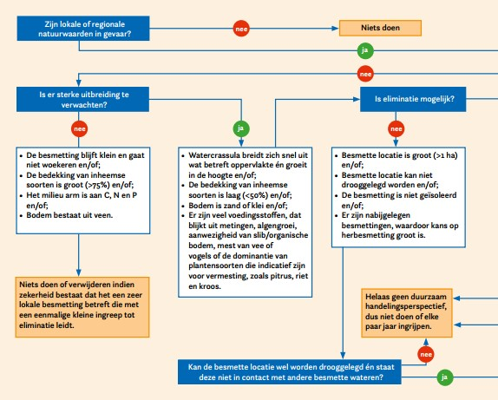
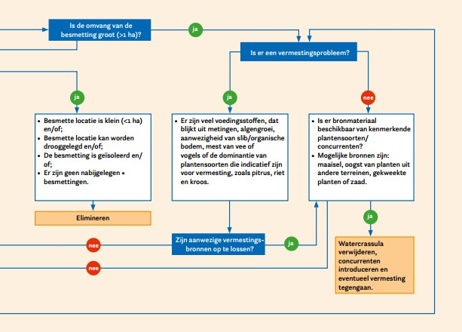

Table 12.1: Assessment framework for measures to tackle Stonecrop (Van der Loop & Van Kleef 2020).

    - Preventing spread
Key methods to prevent the spread of Stonecrop include:
1) prohibiting the import, trade, cultivation and release of the species in nature;
2) preventing contamination through land management, earthworks and redevelopment of nature reserves;
3) preventing contamination via water systems, waterfowl and other animals such as grazers;
4) preventing contamination by recreational visitors;
5) following hygienic practices in relation to vegetation management and other activities in and around contaminated waters;
6) carrying out rapid interventions for new, small-scale establishment, including the dumping of aquarium plants and garden waste.

    - Contamination: Taking no action
Stonecrop benefits from disturbance and eutrophication of the system and yet is likewise able to establish where this is not the case. In these cases, the biomass production of Stonecrop remains low and the species does not become dominant. If this is the case and spread to other vulnerable areas is unlikely, then taking no action is the appropriate advice. Implementing measures in conditions such as these would lead to disturbances in the system, which would, as a rule, lead to an increase in Stonecrop.

    - Contamination: elimination
In the case of elimination, the objective is to remove the Stonecrop contamination entirely. Elimination of contamination can only be achieved if (1)the contamination is isolated, (2) the site can be drained and (3) if recolonisation from surrounding areas can be excluded (Van der Loop et al. 2018, Van der Loop et al. 2022).

There are several options available to eliminate Stonecrop. They are predicated at all times on the site being drained in order to carry out activities in accordance with hygienic practices. Small, localised contaminations (< 1m²) can be removed manually, by excavating up to 20 cm in depth. For large-scale contaminations, water bodies with little natural value can be suppressed (filled –in by soil) in order to prevent Stonecrop from spreading to valuable waters. Suppression involves the (semi-)aquatic environment being transformed into a terrestrial environment, resulting in Stonecrop losing its suitable habitat. It is vital that the buried Stonecrop should not resurface in future. Another method of elimination, involving the preservation of the water body, concerns the removal of Stonecrop by way of excavation. In this case, it is critical that no plant seeds or fragments are left behind from which the population can recover. Any seeds and fragments left behind unexpectedly will subsequently be defused by covering the excavated sections with clean sand, preferably of local origin. Elimination has little chance of success if hygienic practices are insufficient and if Stonecrop is able to relocate from contaminated areas as a result of the activities to sections of the site that have already been treated. A specialist approach to eliminating Stonecrop is therefore required.
    - Contamination: Control – traditional versus system-based
Unfortunately, conditions for elimination are often suboptimal, in which case control of Stonecrop is an option. Many methods of Stonecrop control, such as covering with foil, manual removal, sod cutting and hot water treatment are not suitable for elimination but are suitable for reduction of Stonecrop biomass. Stonecrop almost always manages to recover to equally vigorous growth within one or several years. Such measures do temporarily reduce the risk of spread, but, as a rule, must be repeated multiple times a year. It natural values are threatened, then periodical control of Stonecrop makes less sense. In such cases, it would be better to focus on stabilising the contamination at a low level using system-based control (please see section 10.2.4).
    - Additional measures to tackle contamination
Exclusion from routine management
It is vital that any areas contaminated with Stonecrop should be excluded from routine management. Further activities that cause exposed soil on the site must be limited as much as possible where Stonecrop is present. Examples of such activities include sod cutting, remediation/reprofiling of water bodies and other forms of earthworks. Routine management practices of surrounding, unaffected areas may continue to take place if there is limited disturbance of the soil.

Isolation of known contaminations
Where Stonecrop is able to spread to other waters through water, it is critical that appropriate measures are taken. Depending on the nature of the connections, locks may be diverted and structures can be made impenetrable to Stonecrop.

Preventing unnecessary disturbance and spread
Where competing native species are present in abundance and there are no sources of eutrophication that the species can benefit from, it is vital that the disturbance of systems should be avoided as much as possible, particularly in the vicinity of a known area of contamination (up to 1 km). This means that any excavation work, such as for infrastructure purposes and the development of new natural resources, should be avoided where possible in the vicinity of contamination. This will prevent the spread and establishment of Stonecrop. If the disturbance of existing vegetation is nevertheless required, resulting in a large area of bare soil becoming exposed, it is essential that measures be put in place to allow the vegetation to recover rapidly.

Hygienic practices
The risk of spread by way of humans and equipment can be reduced by way of effective inspection of footwear and equipment following access to contaminated areas and removal of any plant fragments. Larger machinery such as cranes will have to be sprayed down with a high-pressure cleaner. It is critical that any large machinery that is used in affected or contaminated areas is not used in non-contaminated humid areas. When hiring equipment or hiring contractors with their own equipment, it is vital that parties are aware in advance of any contact with Stonecrop of that machinery. If this is the case, or if this is in doubt, the machinery must be cleaned.

The material, meaning soil and plant material, that is released during the removal of the biomass must be handled with care. The contaminated soil should not be used in the vicinity of water bodies, such as in the construction of dykes. Access to contaminated areas by recreational visitors and other visitors must be minimised in order to prevent any spread. To that end, contaminated areas can be sectioned off and made inaccessible to the general public.

- Bibliography
Adriaens, T., Lommaert, L., Packet, J. & Denys, L. (2010). Kwesties uit het veld - Bestrijding van Watercrassula, een lastige invasieve exoot. Natuur.focus 9:128-129.
Allan, H. H. (1982). Flora of New Zealand, Vol. I: Indigenous Tracheophyta–Psilopsida. Lycopsida, Filicopsida, Gymnospermae, Dicotyledons, Wellington: Government Printer.
Andreu, J. & Vila, M. (2009). Risk analysis of potential invasive plants in Spain. Journal for Nature Conservation 18 (1): 34-44 (http://www.montsevila.org/papers/Andreu&Vila09.pdf) (consulted May 2020).
Anonymus, (2011). Interpretation Manual of European Union Habitats - EUR28. European Commission DG Environment (https://ec.europa.eu/environment/nature/legislation/habitatsdirective/docs/Int_Manual_EU28.pdf) (consulted May 2020).
APHIS, (2013). Weed Risk Assessment for Crassula helmsii (Kirk) Cockayne (Crassulaceae) – Swamp stonecrop. United States Department of Agriculture (USDA) - Animal and Plant Health Inspection Service (APHIS) - Plant Protection and Quarantine (PPQ), Raleigh, NC, 19 p. (https://www.aphis.usda.gov/plant_health/plant_pest_info/weeds/downloads/wra/Crassula_helmsii_WRA.pdf)(consulted May 2020).
Arianoutsou, M., Bazos I., Delipetrou, P. & Kokkoris Y., (2010). The alien flora of Greece: taxonomy, life traits and habitat preferences. Biological invasions 12(10): 3525-3549 (DOI 10.1007/s10530-010-9749-0).
Arnolds, E.J.M. & van der Maarel, E., (1979). De oecologische groepen in de Standaardlijstvan de Nederlandse flora 1975. Gorteria 9: 303-312. (http://natuurtijdschriften.nl/download?type=document&docid=536375) (consulted May 2020).
Artfakta från ArtDatabanken (2020). Sydfyrling - Crassula helmsii. (https://artfakta.se/artbestamning/taxon/crassula-helmsii-265281) (consulted March 2020).
Barrett, P. (1981). Diquat and sodium alginate for weed control in rivers. Journal of aquatic plant management 19: 51-52.
Biodiversity Information System for Europe (BISE) (2020). Common International Classification of Ecosystem Services (CICES), version 4.3. (https://biodiversity.europa.eu/maes/common-international-classification-of-ecosystem-services-cices-classification-version-4.3) (consulted March 2020).
Birken, A.S. & Cooper, D. J. (2006). Processes of Tamarix invasion and floodplain development along the lower Green River, Utah. Ecological Applications 16: 1103-1120.
Bloemendaal, F. & Roelofs J. (1988). Waterplanten en waterkwaliteit. Koninklijke Nederlandse Natuurhistorische Vereniging Utrecht.
Bogaert, S. (2013). Eco-efficiënte en effectieve onkruidbestrijding met heet water. Report University of Ghent, Ghent.
Bousquet, T., Waymel, J., Zambettakis, C. & Geslin, J. (2016). Liste des plantes vasculaires invasives de Basse‐Normandie. DREAL de Normandie/Région de Normandie. Villers‐Bocage: Conservatoire botanique national de Brest, 28 p. + annexes (http://cen-normandie.fr/sites/default/files/fichiers/liste_plantes_vasculaires_invasives_basse-normandie_2016_cbnb.pdf) (consulted May 2020).
Boute, M. (2013). INVEXO Kennisdocument Watercrassula - Pilots bestrijding exoten waterschap De Dommel en waterschap Aa en Maas. Boute Ecologie & Water Advies, Stevensweert.
Branquart, E., Stiers, I., Triest, L., Vanderhoeven, S., van Landuyt, W., van Rossum, F. & Verloove. F. (2013). Invasive species in Belgium. Crassula helmsii - New Zealand pigmyweed. Belgian Biodiversity Platform, Brussels. (http://ias.biodiversity.be/species/show/50) (consulted May 2020).
Branquart, E., Brundu, G., Buholzer, S., Chapman, D., Ehret, P., Fried, G., Starfinger, U., van Valkenburg J. & Tanner, R. (2016). A prioritization process for invasive alien plant species incorporating the requirements of EU Regulation no. 1143/2014. EPPO Bulletin 46 (3): 603–617 (http://www.iap-risk.eu/media/files/prioritization_process_for_EU_invasive_alien_plant_species.pdf) (consulted May 2020)
Bridge, T. (2005). Controlling New Zealand pygmyweed Crassula helmsii using hot foam, herbicide and by burying at Old Moor RSPB Reserve, South Yorkshire, England. Conservation Evidence 2:33-34.
Brooks, R., Lee, J., Reeves, R. D., & Jaffré, T. (1977). Detection of nickeliferous rocks by analysis of herbarium specimens of indicator plants. Journal of Geochemical Exploration 7:49-57.
Brouwer, E. & den Hartog, C. (1996). Crassula helmsii (Kirk) Cockayne, een adventief op droogvallende, zandige oevers. Gorteria 22(6): 149-152.
Brouwer, E., Denys, L., Lucassen, E. C. H. E. T., Buiks, M. & Onkelinx, T. (2017). Competitive strength of Australian swamp stonecrop (Crassula helmsii) invading moorland pools. Aquatic Invasions 12:321-331.
Brunet, J. (2002). Effect of chemical and physical environment on Crassula helmsii spread. Centre for Ecology & Hydrology, Bangor.
Brown, N.E. (1890). New or noteworthy plants. The Gardeners' Chronicle, third series (8): 684 (https://www.biodiversitylibrary.org/pdf4/111144500083854.pdf) (consulted May 2020).
Bruyns, P.V., Hanáček P. & Klaka, C. (2019). Crassula, insights into an old, arid-adapted group of southern African leafsucculents. Molecular Phylogenetics and Evolution 131: 35-47 (https://doi.org/10.1016/j.ympev.2018.10.045) (consulted 2020).
Buholzer, S., Nobis, M., Schoenenberger N. & Rometsch S. (2014). Liste der gebietsfremden invasiven Pflanzen der Schweiz. Info Flora, Chambésy-Genève. (https://www.infoflora.ch/de/assets/content/documents/neophyten/neophyten_diverses/Schwarze%20Liste_Watch%20Liste_2014.pdf) (consulted May 2020)
CABI. (2016). Datasheet report for Crassula helmsii (Australian swamp stonecrop). Invasive Species Compendium. CAB International. (https://www.cabi.org/isc/datasheet/16463) (consulted May 2020)
Caffrey, J., Millane, M. & Moran, H. (2012). Control of Crassula helmsii in the Grand Canal. Internal Report. Inland Fisheries Ireland, Dublin. pp.12.
CAISIE. (2013). Control of aquatic invasive species and restoration of natural communities in Ireland - Final Report - Covering the project activities from 01st January 2009 to 31st January 2013. Inland Fisheries Ireland, Galway.
Cambron, M., Capriotti, T., Mommaerts, C., Villard, A. & Manceau, R. (2017). Code de conduite professionnel relatif aux plantes exotiques envahissantes en France métropolitaine: Crassula helmsii (Kirk) Cockayne. Val’hor, 6 p. (https://www.codeplantesenvahissantes.fr/fileadmin/user_upload/Crassula_helmssi.pdf) (consulted May 2020).
CAPM. (2004). Information Sheet 11: Australian Swamp Stonecrop. Centre for Ecology and Hydrology, Natural Environment Research Council (GB). (http://www.ceh.ac.uk/sections/wq/CAPMInformationsheets.htm) (consulted April 2020).
Casanova, M. T. & Brock, M. A. (2000). How do depth, duration & frequency of flooding influence the establishment of wetland plant communities? Plant Ecology 147:237-250.
Charlton, P. E., Gurney, M. & Graeme Lyons, G. (2010). Largescale eradication of New Zealand pygmyweed Crassula helmsii from grazing marsh by inundation with seawater, Old Hall Marshes RSPB reserve, Essex, England. Conservation Evidence 7:130-133.
Child, L. E. & Spencer-Jones, D. (1995). Treatment of Crassula helmsii - A case study. Page 263 in Pyšek, P., Prach, K., Rejmánek, M. & Wade, M. editors. Plant Invasions - General Aspects and Special Problems. SPB Academic Publishing, Amsterdam.
Clapham, A. R., Tutin, T. G. & Moore, D. M. (1990). Flora of the British Isles. CUP Archive.
Claridge, A. W., Hunt, R., Thrall, P. H. & Mills, D. J. (2016). Germination of native and introduced plants from scats of Fallow Deer (Dama dama) and Eastern Grey Kangaroo (Macropus giganteus) in a south‐eastern Australian woodland landscape. Ecological Management & Restoration 17:56-62.
Crane, K., Cuthbert, R. N., Cunningham, E. M., Bradbeer, S. J., Eagling, L., Kregting, L., Dick, J. T. A., Dunn, A. M., Smith, E. R. C. & Shannon, C. (2020). Tomorrow Never Dies: biodegradation and subsequent viability of invasive macrophytes following exposure to aquatic disinfectants. Management of Biological Invasions 11:26-43.
Crane, K., Cuthbert, R. N., Dick, J. T. A., Kregting, L., MacIsaac, H. J. & Coughlan, N. E. (2019). Full steam ahead: direct steam exposure to inhibit spread of invasive aquatic macrophytes. Biological Invasions 21:1311-1321.
D’hondt, B., Denys, L., Jambon, W., De Wilde, R., Adriaens, T., Packet J. & van Valkenburg, J. (2016). Reproduction of Crassula helmsii by seed in Western Europe. Aquatic Invasions 11:125-130. (http://www.aquaticinvasions.net/2016/AI_2016_Dhondt_etal.pdf) (consulted May 2020)
D’hondt, B., Vanderhoeven, Roelandt, S., Mayer, F., Versteirt, V., Ducheyne, E., San Martin, G., Grégoire, J-C., Stiers, I., Quoilin, S., & Branquart, E. (2014). Harmonia⁺ and Pandora⁺: risk screening tools for potentially invasive organisms. Belgian Biodiversity Platform, Brussels. 63 p. (http://www.biodiversity.be/2514/download) (consulted May 2020).
Dadds, N. & Bell, S. (2008). Invasive non-native plants associated with fresh waters: A guide to their identification. Plantlife Royal Botanic Garden Edinburgh Scottish Natural Heritage, Scottish Environment Protection Agency, Scottish Water.
Daehler, C. C. (2003). Performance comparisons of co-occurring native and alien invasive plants: implications for conservation and restoration. Annual Review of Ecology, Evolution, and Systematics 34:183-211.
Dawson, F.H. (1989). Natural habitat and population control mechanism of Crassula helmsii (Australian Swamp Stonecrop) in Australia. Freshwater Biological Association, Ambleside, UK. 33 p. (RL/T11053F2/1) (http://aquaticcommons.org/5236/1/1989_daws_natu.pdf) (consulted May 2020).
Dawson, F. H. (1994). Spread of Crassula helmsii in Britain. Ecology and management of invasive riverside plants:1-13.
Dawson, F. (1996). Crassula helmsii: attempts at elimination using herbicides. Management and Ecology of Freshwater Plants 340:241-245.
Dawson, F. & Henville P. (1991). An investigation of the control of Crassula helmsii by herbicidal chemicals (with interim guidelines on control). Final report. United Kindom, Peterborough.
Dawson, F. & Warman, E. (1987) Crassula helmsii (T. Kirk) Cockayne: is it an aggressive alien aquatic plant in Britain? Biological Conservation 42:247-272. (https://doi.org/10.1016/0006-3207(87)90071-1) (consulted May 2020).
De Lange, P.J., (2014). Fact sheet: Crassula helmsii. New Zealand Plant Conservation Network (http://www.nzpcn.org.nz/flora_details.aspx?ID=248) (consulted May 2020).
De Lange, P. J., Heenan, P. B., Keeling, D. J., Murray, B. G., Smissen, R. & Sykes, W. R. (2008). Biosystematics and conservation: a case study with two enigmatic and uncommon species of Crassula from New Zealand. Annals of botany 101:881-899.
De Lange, P.J., Norton, D.A., Heenan, P.B., Courtney, S.P., Molloy, B.P.J., Ogle, C.C., Rance, B.D., Johnson, P.N. & Hitchmough, R., (2004a). Threatened and uncommon plants of New Zealand. New Zealand Journal of Botany 42(1): 45-76 (https://doi.org/10.1080/0028825X.2004.9512890) (consulted May 2020)
De Lange, P.J., Murray, B.G. & Datson, P.M. (2004b). Contributions to a chromosome atlas of the New Zealand flora 38. Counts for 50 families. New Zealand Journal of Botany 42(5): 873-904 (https://doi.org/10.1080/0028825X.2004.9512936) (consulted May 2020).
De Lange P.J., Rolfe, J.R. & Townsend, A.J. (2011). Crassula natans var. minus (Crassulaceae) a new trans-Tasman natural weed arrival to northern New Zealand. New Zealand Journal of Botany 49(3): 361-366 (https://www.tandfonline.com/doi/full/10.1080/0028825X.2011.574708) (consulted May 2020).
De Vries W., Van de Loo M. (2022) Combating Crassula helmsii in Schleswig-Holstein. Action Plan Blomnath, February 2022. Soontiëns Ecology, can be requested via info@soontiensecology.nl
Dean, C. (2015). The Ecology, impacts and control of Crassula helmsii. Bournemouth University, Poole.
Dean, C., Day, J., Gozlan, R. E., Green, I., Yates, B. & Diaz, A. (2013). Estimating the minimum salinity level for the control of New Zealand Pygmyweed Crassula helmsii in brackish water habitats. Conservation Evidence 10:89-92.
Dean, C. E., Day, J., Gozlan R. E., & Diaz, A. (2015). Grazing vertebrates promote invasive Swamp stonecrop (Crassula helmsii) abundance. Invasive Plant Science and Management 8:131-138.
Delbart, E., Monty, A. & Mahy, G. (2011). Management of Crassula helmsii in Belgium-more difficult than it appears? Bulletin OEPP/EPPO Bulletin 41:226-231.
Denys, L., Packet, J., Jambon, W. & Scheers, K. (2014a). Dispersal of the non-native invasive species Crassula helmsii (Crassulaceae) may involve seeds and endozoochorous transport by birds. New Journal of Botany 4:104-106.
Denys, L., van Valkenburg, J., Packet, J., Scheers, K., De Hoop, E. & Adriaens, T. (2014b). Attempts to control aquatic Crassula helmsii at Huis ter Heide (Tilburg, The Netherlands), with special reference to dye treatment. RINSE, European Regional Development Fund, Natuurmonumenten, Nederlandse Voedsel- en Warenautoriteit, Research Institute for Nature and Forest, Ghent.
Diaz, A. (2012). Crassual helmsii (T. Kirk) Cockayne (New Zealand pygmyweed). Pages 37-46 in R. A. Francis, editor. A handbook of global freshwater invasive species. Earthscan, Abingdon, Oxon, UK.
Domingues de Almeide, J. & Freitas, H. (2012). Exotic flora of continental Portugal – a new assessment. Bocconea 24: 231-237 (http://www.herbmedit.org/bocconea/24-231.pdf) (consulted May 2020).
Dortel, F. & Dutartre, A. (2018). La Crassule de Helms (Crassula helmsii Cockayne, 1907) : Fiche d’alerte détaillée, première analyse des risques, possibilités de régulation et mesures de biosécurité. Conservatoire Botanique National de Brest & GT IBMA, 23 p. (http://www.gt-ibma.eu/wp-content/uploads/2018/01/dortel_dutartre_2017_crassule_de_helms_synthese_vf.pdf) (consulted May 2020).
Dortel, F. & Le Bail, J. (2019). Liste des plantes vasculaires invasives, potentiellement invasives et à surveiller en Pays de la Loire. Liste 2018. DREAL Pays de la Loire. Brest: Conservatoire botanique national de Brest, 37 p., 3 annexes (http://www.cbnbrest.fr/site/pdf/invasives_pdl.pdf) (consulted May 2020).
Douville, C. & Waymel, J. (2019). Observatoire des plantes vasculaires exotiques envahissantes de Normandie. Liste des plantes vasculaires exotiques envahissantes de Normandie pour la priorisation des actions de contrôle, de connaissance et d’information/sensibilisation & bilan des actions 2018. DREAL Normandie/Région Normandie. Conservatoire botanique national de Bailleul/Conservatoire botanique national de Brest, 20 p. + annexes (http://cen-normandie.fr/sites/default/files/fichiers/observatoire_eee_normandie-07-08-2019-vf.pdf) (consulted May 2020).
Ellison, C. & Pratt, C. (2018). Update on the CABI UK invasive weeds biocontrol programme. CABI powerpoint (http://www.nonnativespecies.org/downloadDocument.cfm?id=1817) (consulted May 2020).
Environment Agency (2003). Guidance for the control of invasive weeds in or near fresh water. p. 14-15. Environment Agency publication (http://adlib.everysite.co.uk/resources/000/058/939/EA_Invasive_weeds_booklet.pdf) (consulted May 2020).
EPPO (2006a). Pest Risk Analysis for Crassula helmsii. European and Mediterranean Plant Protection Organisation, 19 p. (https://pra.eppo.int/getfile/595fba5a-7236-4737-8dce-f3b63124425f) (consulted May 2020).
EPPO (2006b). Report of a Pest Risk Analysis. European and Mediterranean Plant Protection Organisation. 06-12801 Final, 4 p. (https://pra.eppo.int/getfile/1b290af1-2972-47f0-ac80-9ca9b8762890) (consulted May 2020).
EPPO (2007). Data sheets on quarantine pests: Crassula helmsii. European and Mediterranean Plant Protection Organization. EPPO Bulletin 37: 225–229 (https://onlinelibrary.wiley.com/doi/pdf/10.1111/j.1365-2338.2007.01111.x) (consulted May 2020).
EPPO (2014). PM 9/19 (1) Invasive alien aquatic plants. EPPO Bulletin (2014) 44(3): 457-471. https://onlinelibrary.wiley.com/doi/epdf/10.1111/epp.12165
Ewald, N. (2014). Crassula helmsii in the New Forest: final report on the status, spread and impact of this non-native invasive plant, and the efficacy of control techniques following a 3 year trial. Prepared on behalf of the New Forest Non-Native Plants Project. Freshwater Habitats Trust, Oxford.
FLORON (2020). FLORON Verspreidingsatlas Vaatplanten Crassula helmsii (Kirk) Cockayne. The Netherlands. (https://www.verspreidingsatlas.nl/5307) (consulted May 2020)
Fried, G. (2010). Prioritization of Potential Invasive Alien Plants in France. In: Brunel S., A. Uludag, E. Fernandez-Galiano, G. Brundu (red.) Proceedings of the International Workshop “Invasive Plants in Mediterranean Type Regions of the World”, 2–6 August 2010, Trabzon, p. 120–138 (https://www.researchgate.net/profile/Guillaume_Fried/publication/284716338_Prioritization_of_Potential_Invasive_Alien_Plants_in_France/links/5656d64608ae4988a7b50815/Prioritization-of-Potential-Invasive-Alien-Plants-in-France.pdf) (consulted May 2020).
Funk, J. L., Cleland, E. E., Suding, K. N., & Zavaleta, E. S. (2008). Restoration through reassembly: plant traits and invasion resistance. Trends in Ecology & Evolution 23:695-703.
Fy, F., (2015). Liste provisoire des espèces exotiques envahissantes de Poitou-Charentes. Conservatoire Botanique National Sud-Atlantique, 8 p. (http://www.orenva.org/IMG/pdf/cbnsa_2015_-_liste_eee_poitou-charentes-1.pdf) (consulted May 2020).
Galasso, G., Conti, F., Peruzzi, L., Ardenghi, N. M. G., Banfi, E., Celesti-Grapow, L., Albano, A., Alessandrini, A., Bacchetta, G., Ballelli, S., Bandini Mazzanti, M., Barberis, G., Bernardo, L., Blasi, C., Bouvet, D., Bovio, M., Cecchi, L. Del Guacchio, E., Domina, G., Fascetti, S., Gallo, L., Gubellini, L., Guiggi, A., Iamonico, D., Iberite, M., Jiménez-Mejías, P., Lattanzi, F., Marchetti, D., Martinetto,E., Masin, R.R., Medagli, P., Passalacqua, N.G., Peccenini, S., Pennesi, R., Pierini, B., Podda, L., Poldini, L., Prosser, F., Raimondo, F.M., Roma-Marzio, F., Rosati, L., Santangelo, A., Scoppola, A.,Scortegagna, S., Selvaggi, A., Selvi,F., Soldano, F., Stinca, A., Wagensommer, R.P., Wilhalm, T. & Bartolucci, F. (2018). An updated checklist of the vascular flora alien to Italy. Plant Biosystems - An International Journal Dealing with all Aspects of Plant Biology (doi: 10.1080/11263504.2018.1441197) (consulted May 2020).
Gassmann, A., Cock, M. J. W., Shaw R. & Evans, H. C. (2006). The potential for biological control of invasive alien aquatic weeds in Europe: a review. Pages 217-222 Macrophytes in Aquatic Ecosystems: From Biology to Management. Springer.
GB Non-native Species Secretariat2 (2011). GB non-native organism risk assessment scheme: Crassula helmsii (Swamp Stonecrop, New Zealand Pygmy Weed, Crassula) previously known as Tillaea. GB Non-native Species Secretariat, Animal and Plant Health Agency, Sand Hutton.
GBIF (2020, 2022) Global Biodiversity Information Facility. Crassula helmsii occurrence in Denmark. https://www.gbif.org/occurrence/search?country=DK&taxon_key=5362054 (consulted February 2022).
Genovesi, P. & Shine, C. (2004). European strategy on invasive alien species: Convention on the Conservation of European Wildlife and Habitats (Bern Convention). Council of Europe.
Gomes, B. (2005). Controlling New Zealand pygmyweed Crassula helmsii in field ditches and a gravel pit by herbicide spraying at Dungeness RSPB Reserve, Kent, England. Conservation Evidence 2:62.
Grutters, B.M.C., Saccomanno, B., Gross, E.M., van de Waal, D.B., van Donk, E. & Bakker, E.S. (2017). Growth strategy, phylogeny and stoichiometry determine the allelopathic potential of native and non-native plants. Oikos 126: 1770-1779 (https://onlinelibrary.wiley.com/doi/pdf/10.1111/oik.03956) (consulted May 2020).
Hill, M. O., Preston, C. D. & Roy, D. B. (2004). PLANTATT-attributes of British and Irish plants: status, size, life history, geography and habitats. Centre for Ecology & Hydrology.
Hobbs, R. J. (1989). The nature and effects of disturbance relative to invasions. Pages 389-405 in J. Drake, H. Mooney, F. Di Castri, R. Groves, F. Kruger, M. Rejmanek & M. Williamson, editors. Biological Invasions: A Global Perspective. Chichester, UK: Wiley & Sons.
Hobbs, R. J. (1991). Disturbance of a precursor to weed invasion in native vegetation. Australia; review. Conference paper. Plant Protection Quarterly (Australia).
Hobbs, R. J. & Huenneke, L. F. (1992). Disturbance, diversity, and invasion: implications for conservation. Conservation Biology 6:324-337.
Hoffman, M.H.A., (2016). List of names of perennials / Naamlijst van vaste planten. NAK tuinbouw, Roelofarendsveen, 629 pg.
Hrivnák, R., Medvecká, J., Baláži, P., Bubíková, K., Oťaheľová, H. & Svitok, M. (2019). Alien aquatic plants in Slovakia over 130 years: historical overview, current distribution and future perspectives. Neobiota 49: 37-56 (https://neobiota.pensoft.net/article/34318/) (consulted May 2020)
Hussner, A., (2008). Zur Ökologie und Ökophysiologie aquatischer Neophyten in Nordrhein-Westfalen. PhD thesis, Institut für ökologische Pflanzenphysiologie und Geobotanik der Heinrich-Heine-Universität Düsseldorf, 205 p. (https://docserv.uni-duesseldorf.de/servlets/DerivateServlet/Derivate-8738/Diss_Hussner_Final.pdf) (consulted May 2020).
Hussner, A., (2009). Growth and photosynthesis of four invasive aquatic plant species in Europe. Weed Research 49(5): 506-515 (DOI: 10.1111/j.1365-3180.2009.00721.x).
Hussner, A., Heidbüchel, P., Coetzee, J., & Gross, E. M. (2021). From introduction to nuisance growth: a review of traits of alien aquatic plants which contribute to their invasiveness. Hydrobiologia, 848(9), 2119-2151.
Hussner, A., van De Weyer, K., Gross, E.M. & Hilt, S. (2010). Comments on increasing number and abundance of nonindigenous aquatic macrophyte species in Germany. Weed Research 50: 519-526 (https://doi.org/10.1111/j.1365-3180.2010.00812.x) (consulted May 2020).
Jacob, D., Petersen, J., Eggert, B. et al. (2013). EURO-CORDEX: new high-resolution climate change projections for European impact research. Reg Environ Change 14, 563–578 (2014). https://doi.org/10.1007/s10113-013-0499-2
Kane, M.E., Philman, N.L., Bartuska, C.A., & McConnell, D.B. (1993). Growth regulator effects on in vitro shoot regeneration of Crassula helmsii. Journal Aquatic Plant Management 31: 59-64.
Keeley, J. & Morton, B. (1982). Distribution of diurnal acid metabolism in submerged aquatic plants outside the genus Isoetes. Photosynthetica 16:546-553.
Keeley, J. E. (1998). CAM photosynthesis in submerged aquatic plants. The Botanical Review 64:121-175.
Kelly, J. & Maguire, C. M. (2009). New Zealand Pigmyweed (Crassula helmsii) Invasive Species Action Plan. Prepared for NIEA and NPWS as part of Invasive Species Ireland.
Kelly, J., O’Flynn, C. & Maguire, C. (2013). Risk analysis and prioritization for invasive and non-native species in Ireland and Northern Ireland. Environment Agency and National Parks and Wildlife Service as part of Invasive Species, Dublin, 59 p. (https://invasivespeciesireland.com/wp-content/uploads/2013/03/Risk-analysis-and-prioritization-29032012-FINAL.pdf) (consulted May 2020).Kirby, J.E. (1965).Notes on Crassula helmsii. The Cactus and Succulent Journal of Great Britain 27(1): 9-10.
Klavsen, S. K. & Maberly, S. C. (2009). Crassulacean acid metabolism contributes significantly to the in situ carbon budget in a population of the invasive aquatic macrophyte Crassula helmsii. Freshwater Biology 54:105-118.
Klavsen, S. K., Madsen, T. V. & Maberly, S. C. (2011). Crassulacean acid metabolism in the context of other carbon-concentrating mechanisms in freshwater plants: a review. Photosynthesis research 109:269-279.
Knihinicki, D. K., Petanović, R., Cvrković, T. & Varia, S. (2018). A new species of Aculus mite (Acari: Eriophyidae), a potential biocontrol agent for Australian swamp stonecrop, Crassula helmsii (Crassulaceae). Zootaxa 4497:573-585.
Küpper, H., Götz, B., Mijovilovich, A., Küpper, F. C. & Meyer-Klaucke, W. (2009). Complexation and toxicity of copper in higher plants. I. Characterization of copper accumulation, speciation, and toxicity in Crassula helmsii as a new copper accumulator. Plant Physiology 151:702-714.
Küpper, H., Lombi, E., Zhao, F. J., Wieshammer, G. & McGrath, S. P. (2001). Cellular compartmentation of nickel in the hyperaccumulators Alyssum lesbiacum, Alyssum bertolonii and Thlaspi goesingense. Journal of Experimental Botany 52:2291-2300.
Langdon, S. J., Marrs, R. H., Hosie, C. A., McAllister, H. A., Norris, K. M. & Potter, J. A. (2004). Crassula helmsii in UK ponds: effects on plant biodiversity and implications for newt conservation. Weed Technology 18:1349-1352.
Laundon, J.R. (1961). An Australian species of Crassula introduced into Britain. Watsonia 5(2): 59-63 (http://archive.bsbi.org.uk/Wats5p59.pdf) (consulted May 2020).
Leach, J. & Dawson, H. (1999). Crassula helmsii in the British Isles-an unwelcome invader. British Wildlife 10:234-239.
Leach, J. & Dawson, H. (2000). Is resistance futile? The battle against Crassula helmsii. Journal of Practical Ecology and Conservation 4:7-17.
Linhoff, L. J., P. S. Soorae, G. Harding, M. A. Donnelly, J. M. Germano, D. A. Hunter & M. E. Eckstut (2021). "IUCN Guidelines for Amphibian Reintroductions and Other Conservation Translocations." P. 160.
Lockton, A. J. (2009). Crassula helmsii. London, UK: Botanical Society of the British Isles. (http://
sppaccounts.bsbi.org.uk/content/crassula-helmsii-2) (consulted May 2020).
Maas, P. & van Wijngaarden, W. (2019). Kruipend moerasscherm 20 jaar aan de monitor. Provincie Zeeland, Staatsbosbeheer & FLORON.
Madsen, T. (1987). Sources of inorganic carbon acquired through CAM in Littorella uniflora (L.) Aschers. Journal of Experimental Botany 38:367-377.
MAGRAMA, 2013. Catálogo Español de Especies Exóticas Invasoras: Crassula helmsii (Kirk) Cockayne. Ministerio de Agricultura, Alimentación y Medio Ambiente, 3 p. (https://www.miteco.gob.es/es/biodiversidad/temas/conservacion-de-especies/Crassula_helmsii_2013_tcm30-69822.pdf).
Mastrandrea, M.D., Field, C.B., Stocker, T.F., Edenhofer, O., Ebi, K.L., Frame, D.J., Held, H., Kriegler, E., Mach, K.J., Matschoss, P.R., Plattner, G-K., Yohe, G.W. & Zwiers, F.W. (2010). Guidance note for lead authors of the IPCC Fifth Assessment Report on consistent treatment of uncertainties. Intergovernmental Panel on Climate Change, Geneva. Available on IPPC website. Last visited 23 July 2019.
Mastrandrea, M.D., Mach, K.J., Plattner, G-K., Edenhofer, O., Stocker, T.F., Field, C.B., Ebi, K.L. & Matschoss, P.R. (2011). The IPCC AR5 guidance note on consistent treatment of uncertainties: a common approach across the working groups. Climatic Change 108: 675-691.
Matthews, J., van der Velde, G., Collas, F.P.L., de Hoop, L., Koopman, K.R., Hendriks, A.J. & Leuven, R.S.E.W., 2017. Inconsistencies in the risk classification of alien species and implications for risk assessment in the European Union. Ecosphere 8(6):e01832. 10.1002/ecs2.1832.
Medvecká J., Kliment, J., Májeková, J., Halada, Ľ., Zaliberová, M., Gojdičová,E., Feráková, V., & Jarolímek, I., (2012). Inventory of alien species of Slovakia. Preslia 84: 257–309 (http://www.preslia.cz/P122Medvecka.pdf).
Miljøministeriet (2008). Handlingsplan for invasive arter. Ministry of Environment Denmark, 54 p. (https://naturstyrelsen.dk/media/nst/66891/HandlingsplanForInvasiveArter.pdf).
Miljøstyrelsen website. New Zealandsk korsarve. (https://mst.dk/natur-vand/natur/artsleksikon/froeplanter/new-zealandsk-korsarve/) (consulted March 2020).
Millane, M. & J. Caffrey, 2014. Risk Assessment of Crassula helmsii. Inland Fisheries Ireland/National Biodiversity Data Centre (http://nonnativespecies.ie/wp-content/uploads/2014/03/Crassula-helmsii-Australian-Swamp-Stonecrop2.pdf) (consulted May 2020).
Nault, M. E. & Mikulyuk, A. (2011). Australian Swamp Stonecrop (Crassula helmsii): A technical review of distribution, ecology, impacts and management. Madison, WI: Wisconsin Department of Natural Resources Bureau of Science Services.
National Biodiversity Data Centre (2020), New Zealand Pigmyweed (Crassula helmsii). (https://maps.biodiversityireland.ie/Species/29777) (consulted March 2020).
Nehring, S., Kowarik, I., Rabitsch W., & Essl, F. (2013). Naturschutzfachliche Invasivitätsbewertungen für in Deutschland wild lebende gebietsfremde Gefäßpflanzen . BfN-Skripten 352, Bundesamt für Naturschutz, 202 p. (https://www.bfn.de/fileadmin/BfN/service/Dokumente/skripten/skript352.pdf) (consulted May 2020).
Nehring, S., Kowarik, I., Rabitsch, W. & Essl, F. (2013). Naturschutzfachliche Invasivitätsbewertungen für in Deutschland wild lebende gebietsfremde Gefäßpflanzen Unter Verwendung von Ergebnissen aus den F+E-Vorhaben, FKZ 806 82 330, FKZ 3510 86 0500 und FKZ 3511 86 0300. Bundesamt für Naturschutz, Bonn. 204 p.
Nehring, S., Essl, F. & Rabitsch, W. (2015). Methodik der naturschutzfachlichen Invasivitätsbewertung für gebietsfremde Arten, Version 1.3. BfN-Skripten 401, 48 p. (https://www.bfn.de/fileadmin/BfN/service/Dokumente/skripten/skript401.pdf) (consulted May 2020).
Newman, J. R. & Raven, J. A. (1995). Photosynthetic carbon assimilation by Crassula helmsii. Oecologia 101:494-499.
Nicol, J. M., Ganf, G. G. & Pelton, G. A. (2003). Seed banks of a southern Australian wetland: the influence of water regime on the final floristic composition. Plant Ecology 168:191-205.
Nicol, J. M. & Ward, R. (2010). Seed bank assessment of Dunn's and Shadow's lagoons. SARDI Aquatic Sciences.
Norwegian Biodiversity Information Centre (2018). The Alien Species List of Norway – ecological risk assessment 2018. (https://www.biodiversity.no/alien-species-2018) (consulted March 2020).
Norwegian Scientific Committee for Food Safety (2016). Assessment of the risks to Norwegian biodiversity from the import and keeping of aquarium and garden pond plants. VKM Report 2016:50. ISBN: 978-82-8259-240-6, Oslo, Norway, 282 p. (https://www.vkm.no/download/18.2375207615dac0245aee2b04/1503323386537/55e549fd71.pdf) (consulted May 2020).
O’Flynn, C., Kelly, J. & Lysaght, L. (2014). Ireland’s invasive and non-native species. Trends in introductions. National Biodiversity Data Centre Series No. 2. Ireland (http://www.biodiversityireland.ie/wordpress/wp-content/uploads/Trends-Report-2013.pdf) (consulted May 2020).
OEPP/EPPO (2007). Data sheets on quarantine pests. Crassula helmsii. EPPO European and mediterranean Plant Protection Organization 37:225-229.
Pelloté, F., Clergeau, P., Pascal, M., Lorvelec, O., Haury, J., Magnanon, S., Pagny, J., Camenen, E. & Siorat, F. (2019). Principales espèces exotiques envahissantes en Bretagne : écologie, histoire, impacts. Observatoire de l' Environnement en Bretagne, p. 231 (https://bretagne-environnement.fr/sites/default/files/fiches_especes_exotiques_envahissantes_bretagne_0.pdf) (consulted May 2020).
Pergl, J., Sádlo, J. Petrusek, A., Laštůvka, Z., Musil, J., Perglová, I., Šanda, R., Šefrová, H., Šíma, J., Vohralík, V. & Pyšek, P. (2016). Black, Grey and Watch Lists of alien species in the Czech Republic based on environmental impacts and management strategy. NeoBiota 28: 1-37 (https://neobiota.pensoft.net/article/4824/) (consulted May 2020).
Pheloung, P.C., Williams, P.A. & Halloy, S.R., (1999). A weed risk assessment model for use as a biosecurity tool evaluating plant introductions. Journal of Environmental Management 57: 239-251.
Prinz, M., Peppler-Lisbach, C., Weidhüner, A., & Freund, H. (2019). Crassula helmsii (T. Kirk) Cockayne: Standortansprüche, Verbreitung und Vergesellschaftung eines invasiven Neophyten auf Norderney= Crassula helmsii (T. Kirk) Cockayne: habitat requirements, distribution and vegetation community composition of an alien invasive species on Norderney. Tuexenia, 39, 267-286 (doi: 10.14471/2019.39.005).
Pyšek P., Danihelka, J., Sádlo, J., Chrtek, J.Jr., Chytrý, M., Jarošík, V., Kaplan, Z., Krahulec, F., Moravcová, L., Pergl, J., Štajerová, K. & Tichý, L. (2012). Catalogue of alien plants of the Czech Republic (2nd edition): checklist update, taxonomic diversity and invasion patterns. Preslia 84: 155–255 (http://www.preslia.cz/P122Pysek.pdf) (consulted May 2020).
Quere E. & Geslin, J. (2016). Liste des plantes vasculaires invasives de Bretagne. DREAL Bretagne, Région Bretagne. Conservatoire botanique national de Brest, 27 p. + annexes (http://www.cbnbrest.fr/docnum.php?id=63312). (consulted May 2020).
Rejmánek, M. (1999). Invasive plant species and invasible ecosystems. Pages 79-102 in O. T. Sandlund, P. J. Schei & A. Viken, editors. Invasive species and biodiversity management. Kluwer Academic Publishers, Dordrecht, Boston & London
Ries, C., Krippel, Y., Pfeiffenschneider, M. & Schneider, S. (2013). Environmental impact assessment and black, watch and alert list classification after the ISEIA Protocol of non-native vascular plant species in Luxembourg. Bulletin de la Société des naturalistes Luxembourgeois 114: 15-21 (http://www.snl.lu/publications/bulletin/SNL_2013_114_015_021.pdf) (consulted May 2020).
Ries, C., Krippel, Y. & Pfeiffenschneider, M. (2020). Risk assessment after the Harmonia⁺ protocol of invasive alien vascular plant species in Luxembourg (in prep.). Bulletin de la Société des naturalistes Luxembourgeois (https://neobiota.lu/crassula-helmsii/) (consulted May 2020).
Ries, C. & Y. Krippel, 2021. First records of 56 invasive alien vascular plants in Luxembourg. Bulletin de la Société des naturalistes luxembourgeois 123: 115-127. (https://www.snl.lu/publications/bulletin/SNL_2021_123_115_127.pdf).
Robert, H., Lafontaine, R.-M., Beudels-Jamar, R.C. & Delsinne, T., (2013). Risk analysis of the Australian swamp stonecrop Crassula helmsii (Kirk) Cockayne. - Risk analysis report of non-native organisms in Belgium. Royal Belgian Institute of Natural Sciences for the Federal Public Service Health, Food chain safety and Environment, Brussels. 37 p.
Sauberer, N., Gilli, C., Prinz, M.A. & Till, W. (2020). Der erste Nachweis von Crassula helmsii in Österreich und weitere Nachträge (IV) zur Flora von Traiskirchen (Niederösterreich). Biodiversität und Naturschutz in Ostösterreich - BCBEA 5(1): 25–48 (https://www.researchgate.net/publication/338832815) (consulted May 2020).
Schaminée, J.H.J., Hommel, P.W.F.M., Stortelder, A.H.F., Weeda, E.J. & Westhoff, V. (1995-1999). De Vegetatie van Nederland 1-5. Opulus, Uppsala/Leiden.
SEINet website. SEINet: Arizona - New Mexico Chapter. (http://swbiodiversity.org/seinet/collections/individual/index.php?occid=3089302) (consulted May 2020).
Scheers, K., Denys, L., Packet, J., De Knijf, G., Smeekens, V., Leyssen, A., Adriaens, T., 2020. Leidraad voor het beheer van watercrassula – Crassula helmsii – in Vlaanderen. Rapporten van het Instituut voor Natuur- en Bosonderzoek 2020 (32). Instituut voor Natuur- en Bos-onderzoek, Brussel. https://doi.org/10.21436/inbor.18650299.
Shannon, C., Quinn, C. H., Stebbing, P. D., Hassall C. & Dunn. A. M. (2018). The practical application of hot water to reduce the introduction and spread of aquatic invasive alien species. Management of Biological Invasions 9:417-423.
Shen, Z., Zhao, F. & McGrath, S. (1997). Uptake and transport of zinc in the hyperaccumulator Thlaspi caerulescens and the non‐hyperaccumulator Thlaspi ochroleucum. Plant, Cell & Environment 20:898-906.
Sheppard, A., Shaw, R. & Sforza, R. (2006). Top 20 environmental weeds for classical biological control in Europe: a review of opportunities, regulations and other barriers to adoption. Weed research 46:93-117.
Sims, P. F. & Sims, L. J. (2016). Control and eradication of Australian swamp stonecrop Crassula helmsii using herbicide and burial at two ponds at Mile Cross Marsh, Norfolk, England. Conservation Evidence 13:39-41.
Smith, T. (2015). The environmental impact of Crassula helmsii. Canterbury Christ Church University, United Kingdom.
Smith, T. & Buckley, P. (2020). Biological Flora of the British Isles: Crassula helmsii. Journal of Ecology 108(2): 797-813 (doi: 10.1111/1365-2745.13336).
Sotek, Z., Kompała-Bąba, A. & Tokarska-Guzik, B. (2018). Harmonia⁺PL – procedura oceny ryzyka negatywnego oddziaływania inwazyjnych i potencjalnie inwazyjnych gatunków obcych w Polsce. Uniwersytet Śląski w Katowicach & Instytut Ochrony Przyrody PAN, 20 p. (http://projekty.gdos.gov.pl/files/artykuly/127051/Crassula-helmsii_grubosz-helmsa_PL_icon.pdf) (consulted May 2020).
South Australian Seed Conservation Centre 2018 (https://spapps.environment.sa.gov.au/SeedsOfSA/)
Spencer-Jones, D. (1994). Some observations on the use of herbicides for control of Crassula helmsii. Page 217 in De Waal, L. C., Child, L. E., Wade, M. & Brock, J. H. editors. Ecology and management of invasive riverside plants. John Wiley & Sons, West Sussex, England.
Stace, C. (2019). New Flora of the British Isles, Fourth Edition. C & M Floristics, Middlewood Green, Suffolk.
Swale, E. & Belcher, H. (1982). Crassula helmsii, the swamp stonecrop, near Cambridge. Nature in Cambridgeshire 25: 59–62 (https://www.natureincambridgeshire.org.uk/volumes/nature-in-cambs-vol-25-1982.pdf) (consulted May 2020).
Toelken, H.R., 1981. The species of Crassula L. in Australia. Journal of the Adelaide Botanic Gardens 3(1): 57-90 (https://www.jstor.org/stable/23872355).
Tokarska-Guzik, B., Bzdęga, K., Nowak, T., Urbisz, A., Węgrzynek, B. & Dajdok, Z. (2015). Propozycja listy roślin gatunków obcych, które mogą stanowić zagrożenie dla przyrody Polski i Unii Europejskiej. Uniwersytet Śląski w Katowicach/Wydział Biologii i Ochrony Środowiska, 178 pag (https://www.gdos.gov.pl/files/artykuly/5050/PROPOZYCJA_listy_gatunkow_obcych_ver_online.pdf) (consulted May 2020).
Torensma, N. (2017). Bestrijding van Watercrassula: een strijd voor beheerders. Vakblad Natuur Bos en Landschap 136:12-15.
U.S. Fish & Wildlife Service (2018). Australian Swamp Stonecrop (Crassula helmsii); Ecological Risk Screening Summary. U.S. Fish & Wildlife Service, 17 pag (https://www.fws.gov/fisheries/ANS/erss/highrisk/ERSS-Crassula-helmsii-FINAL.pdf) (consulted May 2020).
UNEP (2014). Pathways of Introduction of Invasive Species, their prioritization and management. Convention on Biological Diversity, UNEP/CBD/SBSTTA/18/9/Add.1, Montreal, 18 pag (https://www.cbd.int/doc/meetings/sbstta/sbstta-18/official/sbstta-18-09-add1-en.pdf).
Van der Krabben, K. & Schrader, G. (2006a). Pest risk analysis for Crassula helmsii. European and Mediterranean Plant Protection Organisation, Paris.
Van der Krabben, K. & Schrader, G., (2006b). Report of a pest risk analysis Crassula helmsii (Kirk) Cockayne. European and Mediterranean Plant Protection Organisation, Paris.
Van der Loop, J.M.M., de Hoop, L., van Kleef, H. H. & Leuven, R.S.E.W. (2018). Effectiveness of eradication measures for the invasive Australia swamp stonecrop Crassula helmsii. Management of Biological Invasions 9(3): 343–355 (doi.org/10.3391/mbi.2018.9.3.16).
Van der Loop, J. M. M., Tjampens, J., Vogels J.J., Kleef, H.H., Lamers, L. P. M. & Leuven, R. S. E. W. (2020). Reducing nutrient availability and enhancing biotic resistance limits settlement and growth of the invasive Australian swamp stonecrop (Crassula helmsii). Biological Invasions 22(11), 3391-3402. (.
Van der Loop, J. M. M., van de Loo, M., de Vries, W., van Veenhuisen, L. S., van Kleef, H. H., & Leuven, R. S. E. W. (2022). Lessons learnt from large-scale eradication of Australian swamp stonecrop Crassula helmsii in a protected Natura 2000 site. Management of Biological Invasions, 13.Van der Loop, J. M. M. & Van Kleef, H. H. (2017a). Plan van aanpak Watercrassula Terschelling Wetenschappelijk advies bestrijding. Stichting Bargerveen Nijmegen.
Van der Loop, J. M. M. & Van Kleef, H. H. (2017b). Watercrassula problematiek Terschelling. Inventarisatie huidige besmetting en nodige vervolgstappen. Stichting Bargerveen Nijmegen.
Van der Loop, J.M.M. & van Kleef, H. (2020). Omgaan met watercrassula. Brochure: Uitgave Stichting Bargerveen, Nijmegen.
Van der Loop, J. M. M., van Veenhuisen, L. S., van de Loo, M., van Kleef, H. H., & Leuven, R. S. E. W. (in press.) Invasive Australian swamp stonecrop (Crassula helmsii) negatively affects spawning but accelerates larval growth of the endangered natterjack toad (Epidalea calamita). Submitted to hydrobiologia Januari 2022.
Van Kleef, H.H., Brouwer, E., van der Loop, J.M.M., Buiks, M. & Lucassen, E.C.H.E.T. (2017). Systeemgerichte bestrijding van Watercrassula. Stichting Bargerveen, Nijmegen, 89 pag
Van Kleef, H. H., Van der Loop, J. M. M. & Jansen, A. (2019). Effectiviteit van kokend water bij bestrijding en beheer van Watercrassula in natuurgebieden. Vakblad Natuur Bos en Landschap.
Van Kleef, H. H., van der Loop, J. M. M., Nyssen, B. J. M. & Brouwer, E. (2016). Systeemgericht beheer als duurzame oplossing tegen invasieve exoten. De Levende Natuur Jaargang 117:5.
Varia, S., Seiner, M., Shaw, R., Wood, S. & Thom, N. (2017). Finding a biocontrol agent for Crassula. CABI, Surrey.
Varia, S., Shaw, R. Wu, Y., Johnson, T., Sing, S., Raghu, S., Wheeler, G. Pratt, P., Warner, K. & Center, T. (2011). Potential for the Biological Control of Crassula helmsii in the UK. in Proceedings of the XIII International Symposium on Biological Control of Weeds, Waikoloa, Hawaii, USA, September 11-16, 2011. USDA Forest Service, Pacific Southwest Research Station, Institute of Pacific Islands Forestry.
Varia, S., S.V. Wood, R.M.S. Allen & S.T. Murphy (2022). Assessment of the host-range and impact of the mite, Aculus crassulae, a potential biological control agent for Australian swamp stonecrop, Crassula helmsii. Biological Control 167 104854 (doi.org/10.1016/j.biocontrol.2022.104854).
Veenhuisen, L. van, J. van der Loop, M. van de Loo & H. van Kleef, 2021. De effecten van watercrassula op rugstreeppad- Een gevecht tussen pioniers. RAVON 23(1): 5-8. (https://natuurtijdschriften.nl/pub/1001468).
Verbrugge, L.N.H., Van der Velde, G., Hendriks, A.J., Verreycken, H. & Leuven, R.S.E.W. (2012). Risk classifications of aquatic non-native species: application of contemporary European assessment protocols in different biogeographical settings. Aquatic Invasions 7 (1): 49-58.
Verloove, F., (2006). Crassula helmsii (T. Kirk) Cock.. In: Van Landuyt, W., I. Hoste, L. Vanhecke, P. Van den Bremt, W. Vercruysse & D. De Beer, 2006. Atlas van de Flora van Vlaanderen en het Brussels Gewest. Instituut voor natuur- en bosonderzoek, Nationale Plantentuin van België & Flo.Wer. p. 257.
Vinogradova, Y., Pergl, J., Essl, F., Hejda, M., van Kleunen, M. & Pyšek, P. (2018). Invasive alien plants of Russia: insights from regional inventories. Biological Invasions 20(8): 1931-1943 (doi.org/10.1007/s10530-019-02162-y).
Watson, W. (1999). Amphibians and Crassula helmsii. Froglog Newsletter of the Declining Amphibian Populations Task Force 31.
Watson, W. (2001). An unwelcome aquatic invader! Worcestershire Record, issue 10. http://www.wbrc.org.uk/WorcRecd/Issue10/invader.htm (consulted May 2020)
Weber, E. & Gut, D. (2004). Assessing the risk of potentially invasive plant species in central Europe. Journal for Nature Conservation 12: 171-179.
Wesseling, M. (2019). Oprukkende exoot vraagt om drastische maatregelen. Spier in de strijd tegen Watercrassula. https://bionieuws.nl/article/333733/spier_in_de_strijd_tegen_Watercrassula (geraadpleegd mei 2020).
Williams, P., Biggs, J., Crowe, A., Murphy, J., Nicolet, P., Weatherby, A. & Dunbar, M. (2010). Countryside Survey: Ponds Report from 2007. Technical Report No. 7/07 Pond Conservation and NERC/Centre for Ecology & Hydrology, 77pp. (CEH Project Number: C03259).
Wilton-Jones, G. (2005). Control of New Zealand pygmyweed Crassula helmsii by covering with black polythene at The Lodge RSPB Reserve, Bedforshire, England. Conservation Evidence 2:363-368.
Zuidam, J. van & Dijkhuis, E. (2018). Selected: De beheerpuzzel van Kruipend moerasscherm. Planten 8: 12-14 (http://natuurtijdschriften.nl/download?type=document&docid=690613) (consulted May 2020).
Annex 1. Sources consulted to carry out the literature review and to determine the distribution of Stonecrop.

Literature review search results

Search engine | Search | Terms for Chapter 3 - Species description | Date | Hits | Viewed hits | New downloads | Unavailable
Google | Using all key words | Stonecrop | 24 March 2020 | 497 | 30 | 3 | 1
 | With at least 1 of the key words | Ecologie, habitat, ecosysteem, eisen, standplaats, toleranties
Google Scholar | Using all key words | Crassula helmsii | 24 March 2020 | 1,210 | 30 | 2 | 0
 | With at least 1 of the key words | Ecology, habitat, ecosystem, demands, stand, tolerances
Web of Science | Using all key words | Crassula helmsii ecology, habitat, ecosystem, demands, stand, tolerances | 24 March 2020 | 4 | 4 | 1 | 0
Total |  |  |  | 1711 | 64 | 6 | 1

 | Search engine |  | Search |  | Terms for Chapter 7 - Impacts |  | Date | Hits |  |  | Viewed hits |  | New downloads |  | Unavailable
 | Google |  | Using all key words |  | Stonecrop |  | 30 March 2020 | 463 |  |  | 30 |  | 5 |  | 0
 |  |  | With at least 1 of the key words |  | Impact, effecten, problemen, schade, invasief, risicoanalyses, ecosysteemdiensten
 | Google Scholar |  | Using all key words |  | Crassula helmsii |  | 30 March 2020 | 707 |  |  | 30 |  | 8 |  | 0
 |  |  | With at least 1 of the key words |  | Impacts, effects, problems, damage, invasive, risk assessments, ecosystem services
 | Web of Science |  | Using all key words |  | Crassula helmsii impacts, effects, problems, damage, invasive, risk assessments, ecosystem services |  | 30 March 2020 | 3 |  |  | 3 |  | 0 |  | 0
 | Total |  |  |  |  |  |  | 1173 |  |  | 63 |  | 13 |  | 0
Search engine |  | Search |  | Terms for Chapter 10 - Management |  | Date |  |  | Hits | Viewed hits |  | New downloads |  | Unavailable
Google |  | Using all key words |  | Stonecrop |  | 6 April 2020 |  |  | 382 | 30 |  | 5 |  | 0
 |  | With at least 1 of the key words |  | management, controle, bestrijding, beheersing, elimineren, terugdringen, behandeling, methode
Google Scholar |  | Using all key words |  | Crassula helmsii |  | 6 April 2020 |  |  | 49 | 30 |  | 5 |  | 0
 |  | With at least 1 of the key words |  | Management, control, combat, fighting, eradication, reducing, treatment, method
Web of Science |  | Using all key words |  | Crassula helmsii management, control, combat, fighting, eradication, reducing, treatment, method |  | 6 April 2020 |  |  | 5 | 5 |  | 0 |  | 0
Total |  |  |  |  |  |  |  |  | 436 | 65 |  | 10 |  | 0

Search engine | Search | Terms for Chapter 11 - Useful properties | Date | Hits | Viewed hits | New downloads | Unavailable
Google | Using all key words | Stonecrop | 4 May 2020 | 1,320 | 30 | 0 | 0
 | With at least 1 of the key words | verkoop, toepassing, gebruik, baten
Google Scholar | Using all key words | Crassula helmsii | 4 May 2020 | 190 | 30 | 1 | 0
 | With at least 1 of the key words | Sale, application, use, benefit
Web of Science | Using all key words | Crassula helmsii sale, application, use, benefit | 4 May 2020 | 1 | 1 | 0 | 0
Total |  |  |  | 1511 | 61 | 1 | 0

Search results for Stonecrop distribution
GBIF | https://www.gbif.org/occurrence/map?basis_of_record=HUMAN_OBSERVATION&basis_of_record=OBSERVATION&basis_of_record=LIVING_SPECIMEN&basis_of_record=PRESERVED_SPECIMEN&taxon_key=8035075
GISD | http://www.iucngisd.org/gisd/speciesname/Crassula+helmsii
CABI | https://www.cabi.org/isc/datasheet/16463
EPPO | https://gd.eppo.int/taxon/CSBHE
EPPO | https://pra.eppo.int/pra/e29aebca-b5f8-480d-b298-8600b9dea5b0
I naturalist | https://www.inaturalist.org/observations?place_id=any&taxon_id=199392
Belgium | https://ias.biodiversity.be/species/show/50
Bulgaria | http://eea.government.bg/bg/bio/nsmbr/inf-system
Denmark | https://mst.dk/natur-vand/natur/artsleksikon/froeplanter/new-zealandsk-korsarve/
Denmark | https://naturstyrelsen.dk/media/nst/66891/HandlingsplanForInvasiveArter.pdf
Denmark | https://mst.dk/media/173895/revideret_liste_ikkehjemmehoerendearter_19-03-2019.xls
Germany | http://floraweb.de/webkarten/karte.html?taxnr=6731
Germany | http://www.blumeninschwaben.de/Zweikeimblaettrige/Dickblattgewaechse/crassu_wasser.htm#Helms%20Dickblatt
Germany | http://www.lanaplan.de/download/DGL2008VDWHU.pdf
Germany | http://www.ufz.de/biolflor/taxonomie/taxonomie.jsp?ID_Taxonomie=879
Germany | https://neobiota.bfn.de/handbuch/gefaesspflanzen/crassula-helmsii.html
Germany | https://neobiota.bfn.de/publikationen.html
Germany | https://www.bfn.de/fileadmin/BfN/daten_fakten/Dokumente/II_1_2_18_Natrschutzfachl_Invasivitaetsbew_Pflanzen.pdf
Germany | https://www.bfn.de/fileadmin/BfN/service/Dokumente/skripten/skript401.pdf
Germany | https://www.lv-wli.de/files/pdf/Fachbereiche/Bienenweide/skript352%20BfN.pdf
Estonia | https://ec.europa.eu/growth/tools-databases/tris/de/index.cfm/search/?trisaction=search.detail&year=2018&num=275&dLang=DE
Estonia | https://elurikkus.ee/plant-atlas/taxon
Estonia | https://www.envir.ee/et/voorliigid
Estonia | https://www.envir.ee/sites/default/files/common_alien_vasculars.pdf
Estonia | https://www.riigiteataja.ee/akt/12828512
Finland | http://koivu.luomus.fi/kasviatlas/
France | http://www.gt-ibma.eu/wp-content/uploads/2018/01/dortel_dutartre_2017_crassule_de_helms_synthese_vf.pdf
France | https://www.codeplantesenvahissantes.fr/fileadmin/user_upload/Crassula_helmssi.pdf
Greece | https://elnais.hcmr.gr/wp-content/uploads/2015/01/Arianoutsou-Bazos-Delipetrou-Kokkoris-2010.pdf
Hungary | http://mek.oszk.hu/11700/11738/11738.pdf
Hungary | http://www.termeszetvedelem.hu/invasive-alien-species
Ireland | https://invasivespeciesireland.com/species-accounts/established/freshwater/new-zealand-pigmyweed
Ireland | https://maps.biodiversityireland.ie/Species/29777
Italy | http://luirig.altervista.org/flora/taxa/index1.php?scientific-name=crassula+helmsii
Italy | https://ambiente.regione.emilia-romagna.it/it/parchi-natura2000/consultazione/dati/download/elenco-delle-specie-vegetali-dinteresse-conservazionistico-in-emilia-romagna/@@download/file/EleSpTargetRER.pdf
Italy | http://www.parcobarro.lombardia.it/_lr10/index.php?title=Lista_nera_delle_specie_alloctone_vegetali_oggetto_di_monitoraggio,_contenimento_o_eradicazione
Croatia | http://www.invazivnevrste.hr/
Latvia | http://www.videsvestis.lv/svesie-ienaceji-latvijas-flora/
Latvia | https://core.ac.uk/download/pdf/71754942.pdf
Latvia | https://lvportals.lv/skaidrojumi/250966-invazivie-augi-un-to-bistamiba-2012
Latvia | https://www.daba.gov.lv/public/lat/dabas_aizsardzibas_plani/dati1/invazivas_sugas/
Lithuania | https://am.lrv.lt/lt/veiklos-sritys-1/gamtos-apsauga/invazines-rusys/invaziniu-lietuvoje-rusiu-sarasas
Lithuania | https://am.lrv.lt/uploads/am/documents/files/Gamtos%20apsauga%20ir%20mi%C5%A1kai/Gamtos%20apsauga/Invazin%C4%97s%20r%C5%AB%C5%A1ys/invazini%C5%B3%20lietuvoje%20r%C5%AB%C5%A1i%C5%B3%20s%C4%85ra%C5%A1o%20patvirtinimo.pdf
Lithuania | https://gamtininkas.lt/2017/07/lietuvos-invaziniai-augalai/
Lithuania | https://www.glis.lt/?pid=59
Luxembourg | https://neobiota.lu/crassula-helmsii/
Luxembourg | https://neobiota.lu/crassula-helmsii/
Luxembourg | https://mdata.mnhn.lu/
Northern Ireland | http://www.habitas.org.uk/invasive/species.asp?item=4639
Norway | https://www.artsdatabanken.no/fremmedearter
Norway | https://www.bergen.kommune.no/bk/multimedia/archive/00226/Fremmede_arter_i_No_226834a.pdf
Norway | https://www.biodiversity.no/alien-species-2018
Norway | https://www.nhm.uio.no/fakta/botanikk/nyheter/invaderende-vannplanter-foreslas-satt-pa-forbudsli.html
Ukraine | http://www.ukrbin.com/index.php?id=303041&action=info
Austria | https://www.umweltbundesamt.at/fileadmin/site/publikationen/DP089.pdf
Poland | http://projekty.gdos.gov.pl/files/artykuly/127051/Crassula-helmsii_grubosz-helmsa_KG_WWW_icon.pdf
Poland | http://projekty.gdos.gov.pl/igo-crassula-helmsii
Poland | http://www.iop.krakow.pl/ias/en
Poland | http://www.iop.krakow.pl/ias/species
Poland | https://www.gdos.gov.pl/files/artykuly/5050/PROPOZYCJA_listy_gatunkow_obcych_ver_online.pdf
Portugal | http://invasoras.pt/en/
Portugal | http://invasoras.pt/wp-content/uploads/2013/09/Species-listed-DL.pdf
Portugal | https://flora-on.pt/#/1crassula
Romania | http://www.uaiasi.ro/CNCSIS/Plante_adventive/files/e1%20specii%20invazive%20in%20Romania.pdf
Romania | http://www.uaiasi.ro/CNCSIS/Plante_adventive/files/e2%20specii%20invazive%20in%20Romania.pdf
Romania | http://www.uaiasi.ro/CNCSIS/Plante_adventive/files/f%20specii%20adv%20noi%20in%20flora%20Romaniei.pdf
Romania | http://www.uaiasi.ro/CNCSIS/Plante_adventive/files/Sinteza_rezultatelor_2011.pdf
Romania | http://www.uaiasi.ro/CNCSIS/Plante_adventive/files/Studiu_bibliografic_asupra_plantelor_adventive_din_Moldova.pdf
Russia | http://biodat.ru/db/intro/plant_e.htm
Russia | https://www.aqvium.ru/vidy-rastenij/stvolovye-rasteniya/tolstyanka-helmsa
Serbia | http://iasv.dbe.pmf.uns.ac.rs/index.php?strana=baza
Slovenia
Slovakia | http://maps.sopsr.sk/mapy/invazky/map.html
Slovakia | http://www.sopsr.sk/invazne-web/
Slovakia | https://pdfs.semanticscholar.org/1e51/1073b839d3c6b50311bcb17cebb6366d89d6.pdf
Spain | https://w3.ual.es/personal/edana/alienplants/checklist.pdf
Spain | https://www.aragon.es/documents/20127/674325/capdevilla.pdf/5947bd6b-f619-23d1-54a7-2d36104b5127
Spain | https://www.aragon.es/documents/20127/674325/FLORA_ACUATICA.pdf/64be8895-3842-daa1-4b2b-d99d0ae530a5
Spain | https://www.aragon.es/documents/20127/674325/LIBRO_ESPECIES_EXOTICAS_INVASORAS.pdf/8550acea-2684-21e9-f37c-b989713eac7e
Spain | https://www.mapa.gob.es/es/pesca/temas/acuicultura/RD_630_2013_Catalogo_spp_exoticas_invasoras_tcm30-77362.pdf
Spain | https://www.miteco.gob.es/es/biodiversidad/temas/conservacion-de-especies/Crassula_helmsii_2013_tcm30-69822.pdf
Spain | https://www.miteco.gob.es/es/biodiversidad/temas/conservacion-de-especies/crassulahelmsiikirkcockayne_tcm30-439570.pdf
Spain | https://www.miteco.gob.es/es/ceneam/grupos-de-trabajo-y-seminarios/red-parques-nacionales/Plan%20de%20control%20y%20eliminaci%C3%B3n%20de%20especies%20vegetales%20invasoras%20dunas_tcm30-169318.pdf
Czech Republic | http://invaznidruhy.nature.cz/caste-invazni-druhy-v-cr/
Czech Republic | http://invaznidruhy.nature.cz/caste-invazni-druhy-v-cr/invazni-rostliny/
Czech Republic | http://invaznidruhy.nature.cz/legislativa/narodni/zakon-c-326-2004-sb/
Czech Republic | http://invaznidruhy.nature.cz/res/archive/156/020384.pdf?seek=1395304558
Czech Republic | http://www.ibot.cas.cz/invasions/pdf/Pergl%20et%20al.-Black,%20Grey%20and%20Watch%20Lists%20of%20alien%20species%20in%20the%20Czech%20Republic_NeoBiota2016.pdf
Czech Republic | http://www.preslia.cz/P122Pysek.pdf
Czech Republic | https://portal.nature.cz/kartydruhu/
United Kingdom | http://www.nonnativespecies.org
United Kingdom | http://www.nonnativespecies.org/factsheet/factsheet.cfm?speciesId=1017
United Kingdom | https://www.brc.ac.uk/plantatlas/plant/crassula-helmsii
Sweden | https://www.artportalen.se/
Sweden | https://www.havochvatten.se/hav/fiske--fritid/arter/arter-och-naturtyper/sydfyrling-vattenkrassula.html
Switzerland | https://www.admin.ch/opc/de/classified-compilation/20062651/index.html
Switzerland | https://www.admin.ch/opc/de/classified-compilation/20062651/index.html#app2ahref2
Switzerland | https://www.efbs.admin.ch/inhalte/dokumentation/Publikationen/Broschuere_Invasive_Pflanzen.pdf
Switzerland | https://www.infoflora.ch/de/assets/content/documents/neophyten/inva_cras_hel_d.pdf
Switzerland | https://www.infoflora.ch/de/assets/content/documents/neophyten/neophyten_diverses/Schwarze%20Liste_Watch%20Liste_2014.pdf
Switzerland | https://www.infoflora.ch/de/flora/crassula-helmsii.html#info
Canada | http://www.natureconservancy.ca/en/what-we-do/resource-centre/invasive-species/
Canada | https://www.inspection.gc.ca/plant-health/plant-pests-invasive-species/invasive-plants/fact-sheets/eng/1331614724083/1331614823132
Canada | https://www.inspection.gc.ca/plant-health/plant-pests-invasive-species/invasive-plants/eng/1306601411551/1306601522570
USA | https://www.fws.gov/fisheries/ANS/erss/highrisk/ERSS-Crassula-helmsii-FINAL.pdf
South Africa | https://www.inaturalist.org/observations/11287010
Australia | https://bie.ala.org.au/species/https://id.biodiversity.org.au/node/apni/2902057
New Zealand | http://www.nzflora.info/factsheet/Taxon/Crassula-helmsii.html
New Zealand | http://www.nzpcn.org.nz/flora_details.aspx?ID=248
New Zealand | http://www.nzpcn.org.nz/plant_distribution_results.aspx?Species_Name=Crassula+helmsii

Annex 2. Plant communities in which Stonecrop was found in the Netherlands.

syntaxon | number of studies
1 Lemnetea minoris class
1RG02 Basal community Lemna trisulca-[Lemnion trisulcae] | 1
4 Charetea fragilis class
4BB CHARION VULGARIS
4BB01 Charetum vulgaris | 1
4CA CHARION CANESCENTIS
4CA01 Charetum canescentis | 1
5 Potametea class
5BA NYMPHAEION
5BA04 Potameto-Nymphoidetum | 1
5BB HYDROCHARITION MORSUS_RANAE
5BB01 Stratiotetum | 2
5BC PARVOPOTAMION
5BC01 Potametum berchtoldii | 1
5CA RANUNCULION PELTATI
5CA03 Callitricho-Myriophylletum alterniflori | 1
5CA04 Callitricho hamulatae-Ranunculetum fluitantis | 1
5RG01 Basal community Myriophyllum spicatum-[Potametea] | 2
5RG04 Basal community Ceratophyllum demersum-[Nupharo-Potametalia] | 1
5RG08 Basal community Callitriche platycarpa-[Callitricho-Potametalia] | 1
6 Littorellettea class
6AA LITTORELLION UNIFLORAE
6AA01A Isoeto-Lobelietum isoetetosum | 3
6AC HYDROCOTYLO-BALDELLION
6AC01 Pilularietum globuliferae | 8
6AC02 Scirpetum fluitantis | 4
6AC03 Eleocharitetum multicaulis | 3
6AD ELEOCHARITION ACICULARIS
6AD01 Littorello-Eleocharitetum acicularis | 14
8 Phragmitetea class
8AA SPARGANIO-GLYCERION
8AA01 Eleocharito palustris-Hippuridetum | 1
8AB OENANTHION AQUATCAE
8AB02 Sagittario-Sparganietum | 3
8BB PHRAGMITION AUSTRALIS
8BB01B Scirpetum lacustris rumicetosum | 1
8BB04A Typho-Phragmitetum typhetosum angustifoliae | 2
8BB04B Typho-Phragmitetum calthetosum | 1
8BB04C Typho-Phragmitetum typicum | 3
9 Parvocaricetea class
9RG02 Basal community Carex nigra-Agrostis canina-[Caricion nigrae] | 1
16 Molinio-Arrhenatheretea class
16AB CALTHION PALUSTRIS
16AB01 Crepido-Juncetum acutiflori | 2
16RG04 Basal community Juncus effusus-[Molinietalia/Lolio-Potentillion] | 4
19 Nardetea class
19AA NARDO-GALION SAXATILIS
19AA02 Gentiano pneumonanthes-Nardetum | 1
26 Asteretea tripolii class
26RG02 Basal community Agrostis stolonifera-Glaux maritima-[Asteretea tripolii] | 1
28 Isoëto-nanojuncetea class
28AA NANOCYPERION FLAVESCENTIS
28AA01A Cicendietum filiformis centunculetosum | 3
28AA01B Cicendietum filiformis juncetosum | 20
28AA02B Isolepido-Stellarietum cardaminetosum | 1
28AA04A Digitario-Illecebretum digitarietosum | 2
28AA04B Digitario-Illecebretum peplidetosum | 2
29 Bidentetea tripartie class
29AA BIDENTION TRIPARTITAE
29AA01 Polygono-Bidentetum | 4
29AA02A Rumicetum maritimi typicum | 1
29AA02B Rumicetum maritimi chenopodietosum | 1
29AA03A Chenopodietum rubri spergularietosum | 1
29AA04 Eleocharito acicularis-Limoselletum | 12
32 Concolculo-Filipenduletea class
32RG07 Basal community Pulicaria dysenterica | 1
36 Franguletea class
36AA SALICION CINEREAE
36AA02A Salicetum cinereae calamagrostietosum canescentis | 1
36AA02B Salicetum cinereae typicum | 1

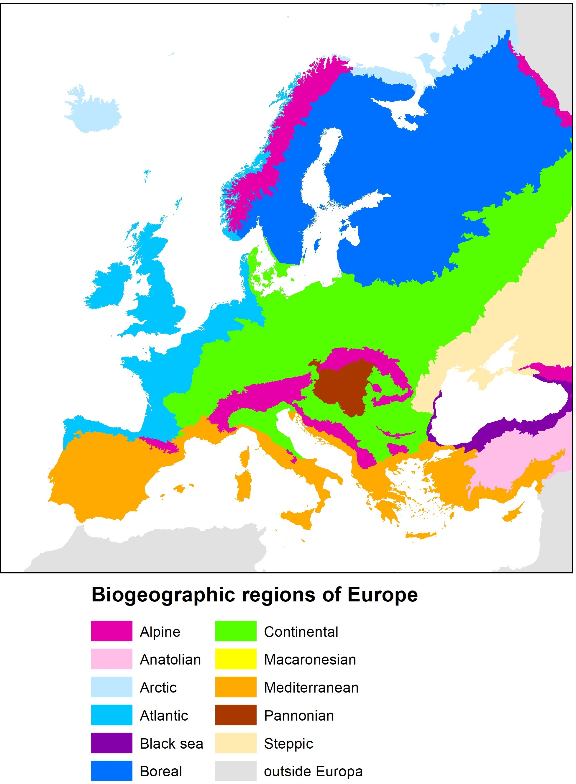
Annex 3a. Biogeographical regions in Europe.

Annex 3b. Biogeographical regions in Europe.
Distribution of Stonecrop within Europe. xxx: widespread; xx: localised spread; x: few isolated stands; ?: species may be able to establish in (parts of) the country in future. The area (%) of a specific region has been listed for each country.
Europe EU |  | Alpine | Anatolian | Arctic | Atlantic | BlackSea | Boreal | Continental | Macaronesia | Mediterranean | Pannonian | Steppic | Outside
Belgium | xxx |  |  |  | 61 |  |  | 39
Bulgaria | ? | 16 |  |  |  | 7 |  | 78 |  | 0 |  | 0
Cyprus |  |  |  |  |  |  |  |  |  | 100
Denmark | x |  |  |  | 31 |  |  | 69
Germany | xx | 1 |  |  | 20 |  |  | 79
Estonia |  |  |  |  |  |  | 100
Finland |  | 5 |  |  |  |  | 95
France | xx | 6 |  |  | 49 |  |  | 34 |  | 12
Greece |  | 0 |  |  |  |  |  | 0 |  | 100
Hungary |  | 0 |  |  |  |  |  | 0 |  |  | 100
Ireland | xx |  |  |  | 100
Italy | ? | 17 |  |  |  |  |  | 29 |  | 54
Croatia |  | 15 |  |  |  |  |  | 55 |  | 30 | 0
Latvia |  |  |  |  |  |  | 100
Lithuania |  |  |  |  |  |  | 100 | 0
Luxembourg | x |  |  |  |  |  |  | 100
Malta |  |  |  |  |  |  |  |  |  | 100
Netherlands | xxx |  |  |  | 100 |  |  | 0
Austria | x | 63 |  |  |  |  |  | 37 |  |  | 0
Poland |  | 3 |  |  |  |  | 0 | 97
Portugal | ? |  |  |  | 5 |  |  |  | 3 | 91
Romania |  | 21 |  |  |  | 2 |  | 56 |  |  | 6 | 16
Slovenia | ? | 38 |  |  |  |  |  | 62 |  | 0 | 0
Slovakia |  | 71 |  |  |  |  |  | 0 |  |  | 29
Spain | x | 2 |  |  | 11 |  |  |  | 1 | 86 |  |  | 0
Czech Republic |  | 0 |  |  |  |  |  | 96 |  |  | 4
Sweden | ? | 19 |  |  |  |  | 77 | 4
Europe non-EU
Norway | ? | 59 |  | 1 | 23 |  | 17
Russia |  | 2 |  | 4 |  | 0 | 18 | 7 |  |  |  | 8 | 62
Serbia | ? | 5 |  |  |  |  |  | 70 |  |  | 25
Switzerland |  | 59 |  |  |  |  |  | 41
North Macedonia |  | 47 |  |  |  |  |  | 53 |  | 0
Ukraine |  | 4 |  |  |  | 0 |  | 54 |  |  | 0 | 41
United Kingdom | xxx |  |  |  | 100
Liechtenstein |  | 100

Annex 4: Natura 2000 sites in the Netherlands in which Stonecrop has been found, with the number of infections, based upon data in the National Database Flora and Fauna (NDFF).
Province | Natura 2000 area | Number of sites in NDFF
Drenthe | Dwingelderveld | 1
Friesland | Duinen Ameland | 1
Friesland | Duinen Terschelling | 6
Friesland | IJsselmeer | 26
Gelderland | De Bruuk | 1
Gelderland | Korenburgerveen | 180
Gelderland | Landgoederen Brummen | 256
Gelderland | Veluwe | 51
Groningen | Leekstermeergebied | 1
Limburg | Geuldal | 6
Limburg | Groote Peel | 1
Limburg | Maasduinen | 26
Limburg | Sarsven en De Banen | 3
Limburg | Weerter- en Budelerbergen & Ringselven | 1
North Brabant | Brabantse Wal | 63
North Brabant | Kampina & Oisterwijkse Vennen | 3
North Brabant | Kempenland-West | 192
North Brabant | Krammer-Volkerak | 76
North Brabant | Langstraat | 19
North Brabant | Leenderbos, Groote Heide & De Plateaux | 407
North Brabant | Loonse en Drunense Duinen & Leemkuilen | 64
North Brabant | Regte Heide & Riels Laag | 1
North Brabant | Vlijmens Ven, Moerputten & Bossche Broek | 10
North Holland | IJsselmeer | 5
North Holland | Kennemerland-Zuid | 1
North Holland | Naardermeer | 6
North Holland | Noordhollands Duinreservaat | 7
Overijssel | Aamsveen | 1
Overijssel | Achter de Voort, Agelerbroek & Voltherbroek | 6
Overijssel | Landgoederen Oldenzaal | 6
Overijssel | Rijntakken | 4
Utrecht | Oostelijke Vechtplassen | 2
Zeeland | Grevelingen | 2
Zeeland | Groote Gat | 1
Zeeland | Kop van Schouwen | 175
Zeeland | Krammer-Volkerak | 27
Zeeland | Manteling van Walcheren | 11
Zeeland | Oosterschelde | 2
South Holland | Duinen Goeree & Kwade Hoek | 7
South Holland | Krammer-Volkerak | 74
South Holland | Meijendel & Berkheide | 4
South Holland | Nieuwkoopse Plassen & De Haeck | 1
South Holland | Voornes Duin | 17
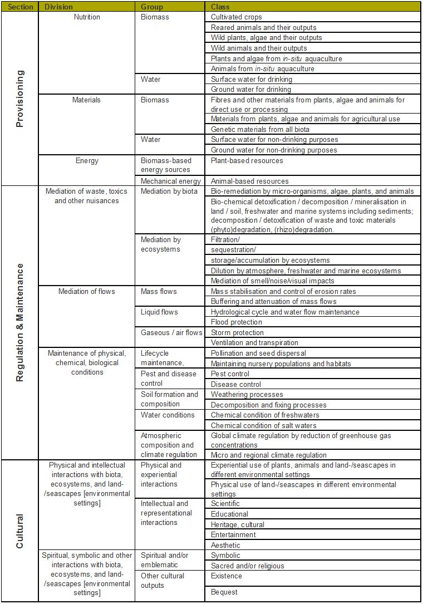
Annex 5. Overview of Ecosystem Services (BISE 2020).


FLORON

Natuurplaza
Toernooiveld 1 - 6525 ED Nijmegen
PO Box 9010 - 6500 GL Nijmegen

T: +31 (0)24 - 7 410 660 (gen.)
www.floron.nl

