**Risk assessment template developed under the "Study on Invasive Alien Species – Development of risk assessments to tackle priority species and enhance prevention"   
Contract No 07.0202/2020/834529/ETU/ENV.D.2[1]**

**Name of organism:** *Delairea odorata* Lem.

**Author(s) of the assessment:**

Helmut Kudrnovsky, Umweltbundesamt/Environment Agency Austria, Vienna, Austria

Richard Shaw, CABI - Centre for Agriculture and Bioscience International, Centre United Kingdom

Rob Tanner, European and Mediterranean Plant Protection Organization, Paris, France

Björn Beckmann, UK Centre for Ecology & Hydrology, Edinburgh, United Kingdom

**Risk Assessment Area:** The risk assessment area is the territory of the European Union 27 and UK, excluding the outermost regions.

**Peer review 1:** *Johan van Valkenburg, National Reference Centre for Plant Healths, NVWA, Wageningen, the Netherlands*

**Peer review 2:** *Giuseppe Brundu, Department of Agricultural Sciences, University of Sassari, Viale Italia 39, 07100 Sassari, Italy*

**Date of completion:** 15/10/2021

**Date of revision: 30 September 2022**

**Contents**

SECTION A – Organism Information and Screening 4

SECTION B – Detailed assessment 37

1 PROBABILITY OF INTRODUCTION AND ENTRY 37

2 PROBABILITY OF ESTABLISHMENT 53

3 PROBABILITY OF SPREAD 60

4 MAGNITUDE OF IMPACT 75

Biodiversity and ecosystem impacts 75

Ecosystem Services impacts 79

Economic impacts 81

Social and human health impacts 84

Other impacts 85

RISK SUMMARIES 88

REFERENCES 90

Distribution Summary 98

ANNEX I Scoring of Likelihoods of Events 100

ANNEX II Scoring of Magnitude of Impacts 101

ANNEX III Scoring of Confidence Levels 102

ANNEX IV CBD pathway categorisation scheme 103

ANNEX V Ecosystem services classification (CICES V5.1, simplified) and examples 104

ANNEX VI EU Biogeographic Regions and MSFD Subregions 108

ANNEX VII Delegated Regulation (EU) 2018/968 of 30 April 2018 109

ANNEX VIII Projection of environmental suitability for *Delairea odorata* establishment in Europe 110

# SECTION A – Organism Information and Screening

|  |
| --- |
| **A1. Identify the organism. Is it clearly a single taxonomic entity and can it be adequately distinguished from other entities of the same rank?**  including the following elements:   * the taxonomic family, order and class to which the species belongs; * the scientific name and author of the species, as well as a list of the most common synonym names; * names used in commerce (if any) * a list of the most common subspecies, lower taxa, varieties, breeds or hybrids   As a general rule, one risk assessment should be developed for a single species. However, there may be cases where it may be justified to develop one risk assessment covering more than one species (e.g. species belonging to the same genus with comparable or identical features and impact). It shall be clearly stated if the risk assessment covers more than one species, or if it excludes or only includes certain subspecies, lower taxa, hybrids, varieties or breeds (and if so, which subspecies, lower taxa, hybrids, varieties or breeds). Any such choice must be properly justified. |

Response: This risk assessment covers one species, the Cape ivy *Delairea odorata* Lem.

**Taxonomy**

|  |  |
| --- | --- |
| **Kingdom** | *Plantae* |
| **Phylum** | *Tracheophyta* |
| **Class** | *Magnoliopsida* |
| **Order** | *Asterales* |
| **Family** | *Asteraceae* Dumort. |
| **Subfamily** | *Asteroideae* (Cass.) Lindl. |
| **Genus** | *Delairea* Lem. |
| **Species** | *Delairea odorata* Lem. |

*Delairea odorata* Lem., in Ann. Sci. Nat., Bot. 1: 379 (1844), is the valid name of the species with an origin in the Cape region of South Africa in the genus *Delairea* (family *Asteraceae*) (Euro+Med 2006-; IPNI 2021; Plants of the World Online 2021; Roskov et al. 2021; The Plant List 2013). This vine was first described by Lemaire (1844) as *Delairea odorata*, but transferred to *Senecio* (as *S. mikanioides*) by Harvey (1865) and returned to the original *D. odorata* by Jeffrey (1986). For a long period, the genus *Delairea* was considered monospecific. Recently, Funez et al. (2021) newly described *Delairea aparadensis*, an endemic species in the highlands of southern Brazil.

**Synonyms**

After cross-checking the information available at IPNI (2021), Plants of the World Online (2021), Euro+Med (2006-), Roskov et al. (2021), Iamonico (2017), and the African Plant Database (2021) it can be concluded that main synonyms for the species are:

* ***Delairea scandens***(DC.) Lem.;
* ***Mikania scandens***Lem. [*non* (L.) W.];
* ***Senecio mikanioides*** Otto ex Walp., *in* C.F.Otto & A.Dietrich, Allg. Gartenzeitung 13: 42. 1845;
* ***Senecio scandens*** Juss. ex DC. *non* Buch.-Ham. ex D.Don , *nom. illeg., p.p.*];
* ***Breonia palmata*** Hort. [*non* A.Rich.];

**Common names**

According to CABI (2021), EPPO (2021), Euro+Med (2006-), FinBIF (2021) and Roskov et al. (2021) common names in the European region are:

* Croatian: mirisavi staračac
* Danish: jernbanevedbend
* English: Cape ivy, German ivy, climbing senecio, parlor-ivy
* Finnish: murattivillakko
* French: lierre d’Allemagne
* German: Kap-Efeu, Efeugreiskraut, Salonefeu
* Italian: Senecione profumato, Senecione mikanioide
* Portuguese: erva-de-são-tiago
* Russian: крестовник миканиевидный
* Spanish: yedra alemana
* Swedish: sommarmurgröna
* Welsh: Creulys Dail Eiddew

According to Cal-IPC (2021a), Italian ivy, ivy groundsel, parlor ivy and water ivy are additional common names in the USA.

**Most common subspecies, lower taxa, varieties, breeds or hybrids**

Subspecies, lower taxa, breeds or hybrids are not known. Two morphological varieties (stipulate and exstipulate) of Cape-ivy exist in the native region in South Africa as well in the invaded regions of California and Oregon (Reddy & Mehelis 2015). The stipulate variety has ear-like, flattened auricles at the base of the leaf petioles, whereas the exstipulate variety lacks auricles. The stipulate variety is the most common variety reported in all collections of Cape-ivy in South Africa (Robison & DiTomaso, 2010). In contrast, the exstipulate variety is the most common variety in California (Robison & DiTomaso, 2010).

**Assumptions made by the authors on the reproductive mechanisms of *D. odorata* in the risk assessment area**

*Delairea odorata* is an obligate outcrossing species that can reproduce sexually by seed which are wind dispersed and spreads vegetatively from stem fragments that readily root at nodes (Robison, 2006) and by the extension of the plant through stolons (Alvarez 1998). Viable seed has only been reported from the plants’ native range (South Africa) and from Australia (Rolando 2000) and the USA (Hawaii, California and Oregon) (Robison 2006, Alvarez, 1998, Rolando, 2000).

It is interesting to note that viable seed was not reported in the USA before 2000, despite relevant studies. Bossard (2000) and Bossard et al. (2000) tested thousands of seeds from 26 populations in the USA and did not find any viable seeds. Additionally, Young (2000) tested 100 seeds at temperatures between 5 and 40 oC using various treatments and only one seed germinated. However, Robison (2006) showed that *D. odorata* was self-incompatible and able to produce viable seed throughout California. Over a three-year period, seed from a wide geographic range of populations was sampled and 66% of 104 locations produced viable seed. In addition, viable seed is reported from Oregon (Robison 2006).

Robison (2006) suggests that this indicates, at least in California, viable seed was not produced in populations in the natural environment prior to 2001. The author suggests that this could be due to two reasons:

1. Because the flowers of *D. odorata* are self-incompatible, only a few genetic lines have been introduced, which inhibits viable seed production. But potentially, additional genetic lines have been introduced.
2. A factor inhibiting viable seed production occurs in the risk assessment area.

Robison (2006) does however highlight that it is not known whether sexual or asexual reproduction contributes more to the spread of *D. odorata* in North America. Robison (2006) notes that although viable seed is produced in some populations in the USA, most populations are sterile and clonal expansions.

Another consideration could be the lack of pollinators. CABI (2022) states 'the vast majority of seeds produced by *D. odorata* in North America and perhaps elsewhere are not viable, possibly indicating the lack of effective pollinators’.

In the risk assessment area, vegetative reproduction is considered the main, if not the only reproductive mechanism. Vegetative reproduction can occur at any time when the nodes of the stem, stolon, or leaf petiole are in contact with the soil. Small fragments of 1.3 cm can root easily and quickly.

Seed production has been observed in the risk assessment area (for example, pers. obs. E. Marchante, Portugal), but scientific studies are lacking to confirm seed viability.

The authors of this risk assessment have assumed that at the current time in the risk assessment area, *D. odorata* does not produce:

(1) viable seed, or

(2) Seedlings are not produced in the natural environment, or

(3) Seedlings do not persist to grow into mature plants.

The authors base these assumptions on two main arguments. Firstly, there is no scientific evidence to suggest one or more of the above occur in the risk assessment area. Secondly, although the species is established in the risk assessment area, evidence of high spread rates and establishment of satellite populations, as would be expected from a wind dispersed species, is lacking.

Therefore, throughout the risk assessment, only vegetative reproduction is considered when answering and scoring the questions (with the exception of some questions on entry when potentially viable seed could be imported). However, when providing the overall score for the risk assessment and the associated confidence, the uncertainty of viable seeds has been taken into consideration.

If point 1, 2 and 3 occur in the future this may increase the scores in the spread sections. This may require a revision of the spread scores. The authors do not consider that the lack of seed production in itself is a limitation to invasiveness.

|  |
| --- |
| **A2. Provide information on the existence of other species that look very similar [that may be detected in the risk assessment area, either in the environment, in confinement or associated with a pathway of introduction]**  Include both native and non-native species that could be confused with the species being assessed, including the following elements:   * other alien species with similar invasive characteristics, to be avoided as substitute species (in this case preparing a risk assessment for more than one species together may be considered); * other alien species without similar invasive characteristics, potential substitute species; * native species, potential misidentification and mis-targeting |

Response: *Delairea odorata* is a fleshy, perennial, evergreen vine with a woody base. Roots arise from the nodes of stolons and rhizomes, and are simple and shallow, frequently scarcely penetrating the loose surface layer of organic material. Stolons and rhizomes are shiny, with thick cuticles, and the latter frequently have dark purple blotches, or are entirely purple. Stems are twining and can ascend to 8 m. Leaves are green, glabrous, alternate, broadly deltate to “ivy-shaped”, 3-10 cm long, 3.6 cm wide with 3 to 10 lobes. Both leaves and stems store water. Capitula with yellow florets, grouped on terminal and axillary cymes, disk florets 4-5 mm long arranged in clusters, ray flowers absent. Fruits are cypselas about 2 mm long, pappus 5–6 mm long, readily falling or fragile, white; bristles minutely scabrid-barbellate (CABI 2021a; EPPO 2012; Manning, & Goldblatt 2012).

**Existence of other non-native species that look very similar**

*Senecio angulatus* L.f. (*Asteraceae*; creeping groundsel, climbing groundsel) is a vigorous fast-growing climber with semi-succulent stems and leaves native to South Africa. Its form is a dense tangled shrub 2 meters tall or a climber that can reach 6 meters high. The leaves are rhombic to ovate, 3.7 to 22 centimeters long and 1 to 14 centimeters wide and occur in 1-4 pairs. They are thick, glossy, fleshy and coarsely toothed (but not entirely), with one to three teeth each side and bluntly lobed, with upper leaves becoming smaller with fewer teeth or none at all. Flower heads radiate, in branched corymbs or panicles, yellow, involucres calycled (Manning, & Goldblatt 2012). According to Euro+Med (2006- b) and CABI (2021b), the species is present in the following European countries: Albania, Croatia, France, Italy, Malta, Portugal and Spain.

*Senecio tamoides* DC. (*Asteraceae*; Canary creeper, parlor ivy) is a climbing *Asteraceae* species native to Southern Africa. It is a fast-growing, scrambling, mostly evergreen perennial climber with semi-succulent stems and leaves that creeps along the ground or climbs several meters into the trees. It grows up to a height of 4 metres. The light green, shiny, fleshy leaves resemble those of ivy in that they are roughly triangle-shaped with unequal lobes. According to CABI (2021c), the species is present in Portugal.

*Roldana petasitis* (Sims) H.Rob. & Brettell (*Asteraceae*; Velvet groundsel) is an erect perennial *Asteraceae* shrub native to Southern Africa. Leaves with lamina are ± circular to broad-ovate, 10–20 cm long and wide, margins palmately lobed with 9–13 lobes, softly hairy,; petiole at least half as long as lamina, except on leaves near heads. According to Euro+Med (2006- c) and CABI (2021d), the species is present in France, Italy, Portugal and Spain.

**Existence of other native species that look very similar**

No information about native species looking very similar are found.

|  |
| --- |
| **A3. Does a relevant earlier risk assessment exist? Give details of any previous risk assessment, including the final scores and its validity in relation to the risk assessment area.** |

Response: No.

*Delairea odorata* was added to the EPPO Alert List in 2009 and transferred to the List of Invasive Alien Plants in 2012 (EPPO 2012).

Inside of the risk assessment area

**Cyprus**

In 2019, a workshop of experts on invasive alien species, prioritised species that may cause a threat to Cyprus. Experts were asked to score each potential IAS within their thematic group for their separate likelihoods of: (i) arrival, (ii) establishment, (iii) magnitude of the potential negative impact on human health or economies. *Delairea odorata* was considered a high threat as this species can negatively impact on both human health and economies. The plant species has a high likelihood of arrival, establishment and human health impacts within Cyprus (Peyton et al. 2020).

Outside of the risk assessment area

**United States of America (USA)**

USDA (2013) used a PPQ weed risk assessment model (Koop et al. 2012) to evaluate the risk potential of *Delairea odorata*. The species was first introduced into the USA in the 1850s as an ornamental houseplant (Robison et al. 2011). It was first collected from California in 1892 (Robison & DiTomaso, 2010) and naturalized there by the 1960s (Bossard et al. 2000). Since then, this species has become naturalized in all coastal counties in California, one coastal county in Oregon, and much of Hawaii (Kartesz 2021; Robison & DiTomaso 2010). In Hawaii, it was first collected in 1910 and is now considered naturalized (Wagner et al. 1999). In California, it occurs in riparian forest, coastal scrub, salt marsh, oak woodland, conifer forest, agricultural, and non-native forests (Robison & DiTomaso 2010). In California, it readily establishes in riparian areas and then spreads into drier sites (CABI 2021). In Hawaii, it encompasses an elevation range of 1600 to 8200 feet (487 m – 2500 m) (Jacobi & Warschauer 1992). *Delairea odorata* is managed in California and Hawaii (Bossard et al. 2000; Elliott 1994; Motooka et al. 2003). It is commercially grown and sold in the USA, but it does not appear to be sold by any of the major distributors (e.g., Monrovia, Green Leaf, Bailey). It is sold as both Cape ivy and German ivy (CABI 2021). It primarily impacts natural systems. As with other vine species, *D.* *odorata* forms dense mats that blanket and smother vegetation (Elliott 1994), including small trees (Bossard et al. 2000), and reduces native species diversity (Alvarez & Cushman 2002). It prefers shady disturbed sites with ample year-round moisture (Bossard et al. 2000). In habitats without year-round moisture, it dies back during dry seasons and then regrows during wet seasons (Bossard et al. 2000). *Delairea odorata* is particularly troublesome because of its ability to root at stem nodes (Bossard et al. 2000; Elliott 1994). This species reproduces and spreads vegetatively from stem fragments that readily root at nodes (Robison 2006) and by the extension of the plant through stolons (Alvarez 1998). In summary, the result of the weed risk assessment for *Delairea odorata* is scored as **High Risk**.

Parts of the USA West coast may have similar climatic conditions as well as habitat conditions like some regions in the EU (Western Europe covered by the Atlantic and Mediterranean biogeographic region), basic information of e.g. biology, habitat preferences, invasiveness given in this risk assessment can be taken into account.

**USA - Hawaii**

According to the Hawaiian Ecosystems at Risk project (HEAR 2021) *Delairea odorata* is assessed as **High Risk** by a score of **14**. The relevant scores are:

| **Question** | **Score** |
| --- | --- |
| Has the species become naturalized where grown? |  |
| Species suited to tropical or subtropical climate(s) (0-low; 1-intermediate; 2-high) | 2 |
| Quality of climate match data (0-low; 1-intermediate; 2-high) |  |
| Broad climate suitability (environmental versatility) | Yes |
| Native or naturalized in regions with tropical or subtropical climates | Yes |
| Does the species have a history of repeated introductions outside its natural range? | Yes |
| Naturalized beyond native range | Yes |
| Environmental weed | Yes |
| Toxic to animals | Yes |
| Causes allergies or is otherwise toxic to humans | Yes |
| Climbing or smothering growth habit | Yes |
| Geophyte (herbaceous with underground storage organs -- bulbs, corms, or tubers) | Yes |
| Produces viable seed | yes |
| Reproduction by vegetative fragmentation | Yes |
| Propagules likely to be dispersed unintentionally (plants growing in heavily trafficked areas) | Yes |
| Propagules dispersed intentionally by people | Yes |
| Propagules adapted to wind dispersal | Yes |
| Tolerates, or benefits from, mutilation, cultivation, or fire | Yes |

Hawaii has different climatic conditions than regions in the EU, though basic information on e.g. biology, habitat preferences, given in this risk assessment can be taken into account, though the assessment of e.g. invasiveness has to be reviewed accordingly to different climate conditions.

**USA - Oregon**

*Delairea odorata* meets the criteria of an “A” listed noxious weed as defined by the Oregon Department of Agriculture Noxious Weed Policy and Classification System (ODA 2014). *Delairea odorata* scored **58** out of a potential score of 90 using an adapted USDA-APHIS PPQ rating system. Using the ODA Noxious Weed Rating system, the species scored **19**, indicating an “A” listing. Noxious weeds are non-native plants with scores of 11 points or higher. The determination is based on two independent risk assessments.

|  |  |
| --- | --- |
| **Issue** | **Answer and score** |
| Invasive in other areas. | Known to be invasive in geographically similar areas (California Coastal Riparian Areas) - 6 |
| Habitat availability: Are there susceptible habitats for this species and how common or widespread are they? | **High** - 6 |
| Environmental factors: Do abiotic (non-living) factors in the environment effect establishment and spread of the species? (e.g., precipitation, drought, temperature, nutrient availability, soil type, slope, aspect, soil moisture, standing or moving water). | **Medium** – Moderately confined by environmental factors (Needs moisture year round to become established, can survive drought once established) - 2 |
| Reproductive traits: How does this species reproduce? Traits that may allow rapid population increase both on and off site. | **Medium** – Reproduction is vegetative (e.g., by root fragments, rhizomes, bulbs, stolons) - 3 |
| Biological factors: Do biotic (living) factors restrict or aid establishment and spread of the species? | **High** – Few biotic interactions restrict growth and reproduction. Species expresses full growth and reproductive potential (No evidence indicating biotic factors limiting spread on the west coast.) - 4 |
| Reproductive potential and spread after establishment - Non-human Factors. | **Medium** - Moderate potential for natural spread with either high reproductive potential or highly mobile propagules (Can be moved in waterways during flood events, seeds can be wind blown via wispy pappus on achenes) - 3 |
| Economic Impact: What impact does/can the species have on Oregon’s agriculture and economy? | **Medium** – Potential to, or causes moderate impacts to urban areas, right-of-way maintenance, property values, recreational activities, reduces rangeland productivity (Similar impacts to that of English Ivy, which include additional right of way maintenance costs, forest regeneration costs, and control costs to public and private landowners. These impacts are most likely to occur in the coastal zones. Leaves are toxic to livestock, animals) - 5 |
| Environmental Impact: What risks or harm to the environment does this species pose? Plant may cause negative impacts on ecosystem function, structure, and biodiversity of plant or fish and wildlife habitat; may put desired species at risk. | **High** - Species can or does cause significant impacts in several of the above categories. Plant causes severe impacts to limited or priority habitats (Significant impacts to riparian and some inland habitats, alters entire canopy and understory diversity.) - 6 |

Parts of Oregon may have similar climatic conditions as well as habitat conditions like some regions in the EU (Western Europe covered by the Atlantic biogeographic region), basic information of e.g. biology, habitat preferences, invasiveness given in this risk assessment can be taken into account.

**USA - California**

Cal-IPC (2021a) assesses *D. odorata* as a perennial vine found along the coast of California and in the San Gabriel Mountains. *Delairea odorata* is especially problematic in coastal riparian areas, though it may also invade inland riparian areas, moist forests, and oak woodlands. Vines are known to form dense mats of vegetation over trees and shrubs, killing plants underneath. It is toxic to animals and fish can be killed when plant materials are soaking in waterways. Stem, rhizome and stolon fragments resprout if left in the ground after treatment. Can occasionally reproduce by seeds in some areas. The Cal-IPC rating is **high**. These species have severe ecological impacts on physical processes, plant and animal communities, and vegetation structure. Their reproductive biology and other attributes are conducive to moderate to high rates of dispersal and establishment. The California Department of Food and Agriculture (CDFA)Rating is **B\***. A pest with rating B is of known economic or environmental detriment and, if present in California, it is of limited distribution and is included in the CCR Section 4500 list of California State Noxious Weeds Cal-IPC (2021a). The impact on abiotic ecosystem processes, plant communities and on higher trophic levels are assessed as severe. Role of anthropogenic and natural disturbance in establishment is assessed as severe as well. *Delairea odorata* takes over habitats regardless of anthropogenic or natural disturbance. *Delairea odorata* on the US west coast grows vigorously in physically challenging environments such as streamside thickets, willows and poison oak *(Toxicodendron diversilobum)*. Severe invasive potential. This species can establish independently of natural or anthropogenic disturbance. The distribution of *D. odorata* ranges along the entire Californian coast and some mesic areas of the Central Valley. Over 500,000 acres (202342 ha) are infested in California, and on Catalina Island, 13 populations were detected with six in riparian habitats and one in island scrub oak chaparral near a riparian area. *Delairea odorata* spreads primarily by vegetative means, breaks apart easily and both stem nodes and leaf petioles are capable of rooting. Seeds disperse with wind, water, and soil movement. If there is a *D. odorata* source upstream, high water flows in the winter can be expected to transport pieces of plants down-stream, which can begin new colonies (Cal-IPC 2021b).

Parts of California may have similar climatic conditions as well as habitat conditions like some regions in the EU (Western Europe covered by the Atlantic and Mediterranean biogeographic region), basic information of e.g. biology, habitat preferences, invasiveness given in this risk assessment can be taken into account.

**Australia - Victoria**

The Weed Risk Assessment (WRA) developed by the Biosciences Research Division of the Department of Primary Industries, Victoria, is a prioritisation process or risk assessment, based on the Analytic Hierarchy Process (AHP), which ranks weeds by (1) assessing the plant’s invasiveness, (2) comparing the plant’s present and potential distribution and (3) determining the impacts of the plant on social, economic, and environmental values. Accordingly Agriculture Victoria (Agriculture Victoria 2021a) conducted an invasiveness (Agriculture Victoria 2021b) and impact (Agriculture Victoria 2021c) assessment of *Delairea odorata* and modelled the species’ distribution (Agriculture Victoria 2021d). During the assessment of biological data, criteria are assigned intensity ratings (criteria ratings) of high (H), medium-high (MH), medium (M), medium-low (ML), and low (L), to score each species.

Relevant high respectively medium-high rated criterions regarding biological characteristics of *D. odorata* in the invasiveness assessment (Agriculture Victoria 2021b) are:

|  |  |
| --- | --- |
| Establishment | |
| Germination requirements | Germination is reported to be rare, occurring in autumn. However vegetative propagules (pieces of stem and stolons) which is the main form of reproduction can root and grow when conditions are suitable (Blood 2001) - **High** |
| Establishment requirements | Reported to invade rainforest (Carr et al. 1992). Therefore, it can establish under low light conditions. Cut stems can survive months, then set roots and grow when exposed to suitable conditions (Blood 2001). Therefore, it has some requirements for establishment. – **Medium-High** |
| How much disturbance is required? | Establishes in undisturbed /minor disturbed natural ecosystems: heath land: sclerophyll forest and woodland: riparian vegetation: rainforest (Carr et al. 1992). - **High** |
| Growth/Competitive | |
| Tolerates herb pressure? | Contains pyrrolizidine alkaloids and xanthones that make it unsuitable forage for most fauna and if slashed to ground level, plants can regrow from rootstock (Bossard et al. 2000). Bio-Control agents have been researched in South Africa and a program has been developed in California, however no such efforts are reported in Australia (Bossard et al. 2000). - **High** |
| Normal growth rate? | Reported to be a fast growing vine (Weber 2003). In California it has been reported as spreading more rapidly than any other weed species. Average growth rates of plants around San Francisco have been calculated to one foot of growth per month. (Alvarez 1998). - **High** |
| Stress tolerance to frost, drought, w/logg, sal. etc? | Tolerates some salinity (recorded on salt exposed bluffs) (Alvarez 1998). Drought tolerant (Blood 2001). Reported in seasonal wetlands, therefore tolerant of waterlogging (Bossard et al. 2000). Frost tender (Blood 2001), however hard frosts appear to stimulate seed set, therefore while frost may damage the plant, it may not kill it. Foliage has high moisture content and therefore resistant to burning also plants can regrow from rootstock (Bossard et al. 2000). - **High** |
| Reproduction | |
| Reproductive system | Produces seed, however primary mode of reproduction is vegetative, through stolons and stem fragments (Bossard et al. 2000 and Muyt 2001). - **High** |
| Number of propagules produced? | Large plants can produce more than 40,000 seeds annually (Muyt 2001). - **High** |
| Reproductive period? | Long lived, can form monocultures (Bossard et al. 2000). - **High** |
| Time to reproductive maturity? | Reach sexual maturity within two years (Muyt 2001) – **Medium-High** |
| Dispersal | |
| Number of mechanisms? | Seeds are 2 mm with hairs attached, spread by wind and water (Muyt 2001). Vegetative propagules spread by water and deliberate human actions (Alvarez 1998). - **High** |
| How far do they disperse? | Wind dispersed seed can travel distances of more than 1 km. - **High** |

Relevant high or medium-high rated criterions regarding recreation, abiotic characteristics, habitat and fauna in the impact assessment (Agriculture Victoria 2021c) are:

|  |  |
| --- | --- |
| Recreation | |
| Restrict human access? | Can from dense tangled curtains of vegetation, including in riparian areas (Muyt 2001). Access would be difficult and would require significant work to control the species to maintain access due to the species rapid growth. – **Medium-High** |
| Injurious to people? | Toxic to people. Toxins include pyrrolizidine alkaloids and xanthones, which are contained in the leaves and present all year (Bossard et al. 2000). No reported fatalities. – **Medium-High** |
| Abiotic | |
| Increase soil erosion? | Can contribute to soil erosion on hillsides (Bossard et al. 2000). – **Medium-High** |
| Reduce biomass? | The weight of the ivy can cause trees to fall, and dense canopy of the vine can smother species of the lower strata and reduce growth (Bossard et al. 2000). – **Medium-High** |
| Community Habitat | |
| Impact on composition   1. high value Ecological Vegetation Class (EVC): Riparian Forest 2. medium value EVC: Lowland Forest 3. low value EVC: Wet Forest | The weight of the ivy can cause trees to fall, the dense canopy of the vine can smother species of the lower strata and reduce growth and regeneration of species and can form monocultures (Bossard et al. 2000). All EVCs - **High** |
| Impact on structure? | The weight of the ivy can cause trees to fall, and the dense canopy of the vine can smother species of the lower strata and reduce growth and regeneration of species (Bossard et al. 2000). – **Medium-High** |
| Effect on threatened flora? | Can significantly reduce the species richness and diversity of an area, and render habitat in protected reserves for plant species worthless (Bossard et al. 2000). – **Medium-High** |
| Fauna | |
| Effect on threatened fauna? | Can render habitat in protected reserves for animal species worthless (Bossard et al. 2000). – **Medium-High** |
| Effect on non-threatened fauna? | Significant alteration of habitat; reducing plant species richness and diversity and therefore diversity of food and shelter available. Invasion by cape ivy can render habitat in protected reserves for animal species worthless (Bossard et al. 2000). – **Medium-High** |
| Benefits fauna? | Nothing reported. Insects may visit flowers, dense foliage may provide some shelter. - **High** |
| Injurious to fauna? | Foliage contains compounds toxic to mammals, spiders and fish (Bossard et al. 2000). Compounds toxic but not necessarily lethal to rats. - **High** |

In summary, *Delairea odorata* is assessed as **Highly Invasive** (Score 0.6-0.79) by its invasiveness index of 0.72 and a **risk rating V - very serious threat to one or more vegetation formation in Victoria**.

Parts of Victoria may have similar climatic conditions as well as habitat conditions like some regions in the risk assessment (Western Europe covered by the Mediterranean biogeographic region), basic information of e.g. biology, habitat preferences, invasiveness given in this risk assessment can be taken into account.

|  |
| --- |
| **A4. Where is the organism native?**  including the following elements:   * an indication of the continent or part of a continent, climatic zone and habitat where the species is naturally occurring * if applicable, indicate whether the species could naturally spread into the risk assessment area |

Response: *Delairea odorata* is native to southern Africa from Uitenhage to KwaZulu-Natal (CABI 2021; Manning & Goldblatt 2012; Red List of South African Plants 2021), i.e. Lesotho and (Eastern and Western) Cape Province and KwaZulu-Natal in South Africa (GRIN-Global 2021; Grobbelaar et al. 1999; Queensland Government 2021; Roskov et al. 2021; USDA 2013).

Hilliard (1977) describes the native distribution as: “*Widespread, but not much collected, from the Cape peninsula through the southern and eastern Cape to Natal as far north as Nkandia, Nhlazatsche Mt. and the Biggarsberg north of Ladysmith; also recorded from Mohaleshoek in Lesotho. Grows on forest margins or in the forest, in Natal between ca. 800 and 1900 m above sea level.*” In its native region, *D. odorata* appears to have originally been confined to 'mist-veldt' regions, such as those in the Drakensberg Mountains, where it is found along forest edges and as an opportunistic vine exploiting openings in the native forest. Its occurrence at more coastal sites in South Africa may be more recent (Balciunas et al. 2004). Some of the coastal sites are quite arid, to less than 100 mm/yr (CABI 2021). According to EPPO (2012), Cape ivy grows in moist mountain forests.

Since the native distribution center in southern Africa and the European continent are separated by a large distance, natural spread into the risk assessment area is very unlikely.

|  |
| --- |
| **A5. What is the global non-native distribution of the organism outside the risk assessment area?** |

Response: Table 1 and Figure 1 give an overview about global non-native distribution outside the risk assessment area. Considering the native range in the Cape region of Southern Africa, available spatial and non-spatial data describe the non-native distribution of *Delairea odorata* covering parts of North, Middle and South America, Northern Africa, Asia and Oceania. Occurrence information provided in literature without coordinates are listed in the table, but are not shown in the map.

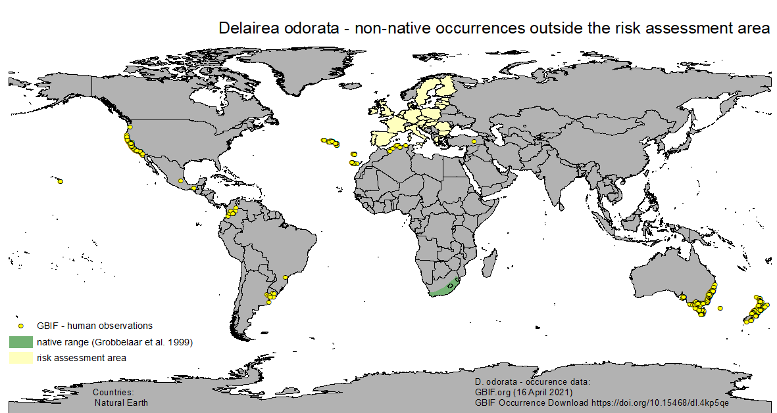

Figure 1 Global non-native occurrence records of Delairea odorata based upon GBIF human observations outside the risk assessment area (yellow) – green: native range according to Grobbelaar et al. 1999 (map designed by Umweltbundesamt/Environment Agency Austria - 2022/08/10)

Table 1 countries with *Delairea odorata* occurrences mentioned in references and databases (* references without coordinates not shown in map)

| **Continent/ region** | **country** | **general remarks** | **source** |
| --- | --- | --- | --- |
| Africa | Algeria | Present; naturalized | Chatelain (2011), GBIF (2021), GRIN-Global (2021), Euro+Med (2006- a), Quézel & Santa (1963), Roskov et al. 2021 |
| Asia | India* | invasive | Prabu et al. (2012) |
| Atlantic Islands | Azores, Madeira | Present / localized; naturalized; invasive | Brunel et al. (2010), CABI (2021a), Euro+Med (2006- a), GBIF (2021), GISD (2021), EPPO (2021); Sampaio (1947), Plants of the World online (2021), Roskov et al. 2021, Royal Botanic Garden Edinburgh (2003) |
| Canary Islands | Present /localized; naturalized | Brunel et al. (2010), CABI (2021a), GBIF (2021), EPPO (2012), EPPO (2021), EXOS (2021), GISD (2021), GRIN-Global (2021), Plants of the World online (2021), Roskov et al. 2021, Royal Botanic Garden Edinburgh (2003) |
| Saint Helena* | Present | CABI (2021a), Hilliard (1977) |
| North and Middle America (incl. Caribbean) | United States (California, Hawaii, Oregon) | Present / widespread / localized; naturalized; invasive; first reported: 1892 (California), 1909 (Hawaii) | Balciunas et al. (2004), CABI, (2021), EPPO (2012), GBIF (2021), GRIN-Global (2021), Munz (1959), Roskov et al. 2021, Starr et al. (2003), Wagner et al. (1990) |
| Costa Rica* |  | Roskov et al. 2021 |
| Guatemala* |  | Roskov et al. 2021 |
| South America | Argentina | Present / localized | CABI (2021a), GBIF (2021), Hilliard (1977), Roskov et al. 2021 |
| Bolivia* |  | Plants of the World online (2021), Roskov et al. 2021 |
| Chile* | Present | CABI (2021a), Rodríguez et al. (2018), Roskov et al. 2021 |
| Colombia |  | GBIF (2021), Plants of the World online (2021), Roskov et al. 2021 |
| Uruguay | Present / naturalized | GBIF (2021), GRIN-Global (2021), Plants of the World online (2021), Roskov et al. 2021 |
| Venezuela* |  | Plants of the World online (2021) |
| Oceania | Australia | Present / widespread / localized; naturalized; invasive | CABI (2021a), Fagg (1989), EPPO (2012), GISD (2021), GRIN-Global (2021), Hnatiuk (1990), Roskov et al. 2021 |
| Federal States of Micronesia* | Present | EPPO (2012), GISD (2021), GRIN-Global (2021) |
| New Zealand | Present / widespread; naturalized; invasive | CABI (2021a), EPPO (2012), GISD (2021), GRIN-Global (2021), Webb et al. (1988), Plants of the World online (2021), Roskov et al. 2021 |

|  |
| --- |
| **A6. In which biogeographic region(s) or marine subregion(s) in the risk assessment area has the species been recorded and where is it established? The information needs be given separately for recorded (including casual or transient occurrences) and established occurrences. “Established” means the process of an alien species successfully producing viable offspring with the likelihood of continued survival[2].**  **A6a. Recorded: List regions**  **A6b. Established: List regions**  Freshwater / terrestrial biogeographic regions:   * Alpine, Atlantic, Black Sea, Boreal, Continental, Mediterranean, Pannonian, Steppic   Marine regions:   * Baltic Sea, North-east Atlantic Ocean, Mediterranean Sea, Black Sea   Marine subregions:   * Greater North Sea, incl. the Kattegat and the English Channel, Celtic Seas, Bay of Biscay and the Iberian Coast, Western Mediterranean Sea, Adriatic Sea, Ionian Sea, Central Mediterranean Sea, Aegean-Levantine Sea.   Comment on the sources of information on which the response is based and discuss any uncertainty in the response.  For delimitation of EU biogeographical regions please refer to <https://www.eea.europa.eu/data-and-maps/figures/biogeographical-regions-in-europe-2> (see also Annex VI).  For delimitation of EU marine regions and subregions consider the Marine Strategy Framework Directive areas; please refer to <https://www.eea.europa.eu/data-and-maps/data/msfd-regions-and-subregions/technical-document/pdf> (see also Annex VI). |

Response: The Arctic, Anatolian and Macaronesian biogeographical regions are not part of the risk assessment area, but included for completeness. Table 2 and Figure 2 give an overview about occurrences of the species in the biogeographical regions. In the Steppic region, no occurrence information is available.

Source of human observation data is GBIF (2021), European wide overviews like Euro+Med PlantBase (providing an on-line database and information system for the vascular plants of Europe and the Mediterranean region, against an up-to-date and critically evaluated consensus taxonomic core of the species concerned) as well as national floristic or invasive species references.

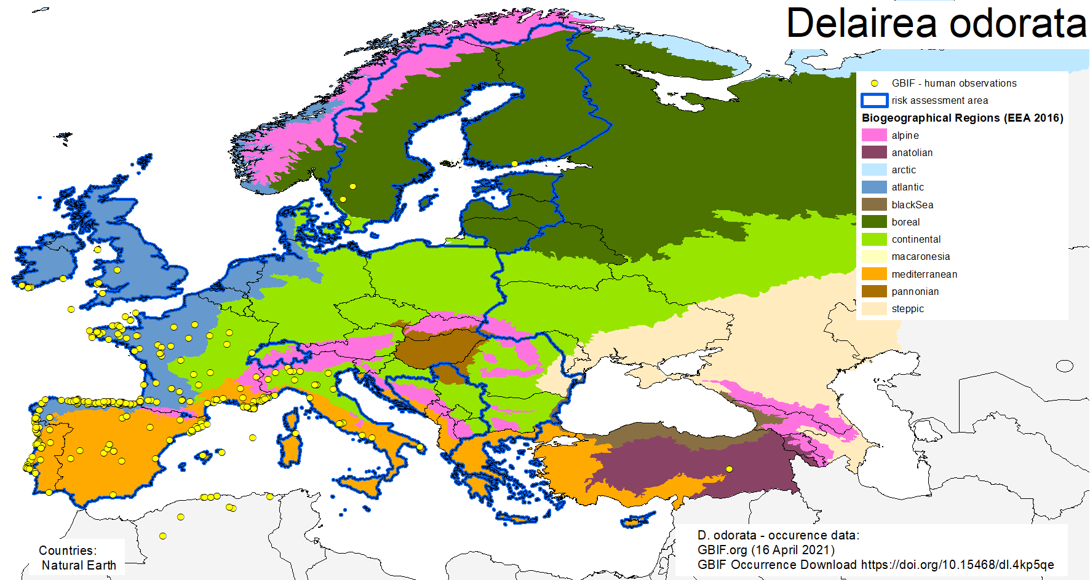

Figure 2 Occurrence records of Delairea odorata in the biogeographical regions of the risk assessment area based upon GBIF human observations (map designed by Umweltbundesamt/Environment Agency Austria – 2021/04/19)

Table 2 biogeographical regions with recorded/established *Delairea odorata* occurrences (grey cell – biogeographical region not covered by the risk assessment area)

| **biogeographical region** | **recorded** | **established** | **source of recorded occurrences** | **source of established occurrences** |
| --- | --- | --- | --- | --- |
| Alpine | Yes | No | GBIF (2021) |  |
| Anatolian | Yes | No | GBIF (2021) |  |
| Arctic |  |  |  |  |
| Atlantic | Yes | Yes | GBIF (2021) | CABI (2021a), EPPO (2012), EPPO (2021), Euro+Med (2006- a), GISD (2021), GRIN-Global (2021), Hilliard (1977), NBN Atlas (2021), Plants of the World online (2021), Reynolds (2002), Roskov et al. 2021, Sell & Murrell (1963), Tutin et al. (1976 |
| Black Sea | No | No |  |  |
| Boreal | Yes | No | Euro+Med (2006- a), FinBIF (2021), GBIF (2021), |  |
| Continental | Yes | Yes | Brunel et al. (2010), CABI (2021a), EPPO (2012), EPPO (2021), Euro+Med (2006- a), GBIF (2021), GRIN-Global (2021), Plants of the World online (2021), Roskov et al. 2021 | Euro+Med (2006- a), Tutin et al. (1976) |
| Macaronesian | Yes | Yes | GBIF (2021) | Brunel et al. (2010), CABI (2021a), Euro+Med (2006- a), GISD (2021), EPPO (2021); Sampaio (1947), Plants of the World online (2021), Roskov et al. 2021, Royal Botanic Garden Edinburgh (2003) |
| Mediterranean | Yes | Yes | GBIF (2021) | Brunel et al. (2010), CABI (2021a), Catalano et al. (1996), Celesti-Grapow et al. (2009), Conti et al. (2005), EPPO (2012), EPPO (2021), Euro+Med (2006- a), GISD (2021), GRIN-Global (2021), Nikolić (2005 onwards), Plants of the World online (2021), Roskov et al. 2021, Royal Botanic Garden Edinburgh (2003), Sampaio (1947), Tutin et al. (1976 |
| Pannonian | No | No |  |  |
| Steppic | No | No |  |  |

Response (6a): *Delairea odorata* is recorded in the Alpine, Atlantic, Boreal, Continental and Mediterranean biogeographical regions. No recorded occurrence data is available for the Black Sea, Pannonian and Steppic biogeographical regions.

Response (6b): According to the available information, *D. odorata* can be considered as “established” in the Atlantic, Continental and Mediterranean biogeographical regions.

“Established” means the process of an alien species successfully producing viable offspring with the likelihood of continued survival. In the available references (mainly Euro+Med PlantBase), the term “naturalized” is used. In order to answer question 6b, “naturalized” is used as a synonym for “established”. The assessment of established occurrences in biogeographical regions is mainly deduced from the data available on national level (compare Table 3).

|  |
| --- |
| **A7. In which biogeographic region(s) or marine subregion(s) in the risk assessment area could the species establish in the future under current climate and under foreseeable climate change? The information needs be given separately for current climate and under foreseeable climate change conditions.**  **A7a. Current climate: List regions**  **A7b. Future climate: List regions**  With regard to EU biogeographic and marine (sub)regions, see above.  With regard to climate change, provide information on   * the applied timeframe (e.g. 2050/2070) * the applied scenario (e.g. RCP 4.5) * what aspects of climate change are most likely to affect the risk assessment (e.g. increase in average winter temperature, increase in drought periods)   The assessment does not have to include a full range of simulations on the basis of different climate change scenarios, as long as an assessment with a clear explanation of the assumptions is provided. However, if new, original models are executed for this risk assessment, the following RCP pathways shall be applied: RCP 2.6 (likely range of 0.4-1.6°C global warming increase by 2065) and RCP 4.5 (likely range of 0.9-2.0°C global warming increase by 2065). Otherwise, the choice of the assessed scenario has to be explained. |

According to SDM results (see also Annex VIII) the biogeographical regions *D. odorata* could establish in are as follows:

Response (7a):

|  |  |  |
| --- | --- | --- |
| **Biogeographic region** | **likeliness** | **confidence** |
| Alpine | unlikely | high |
| Anatolian | unlikely | high |
| Arctic | unlikely | high |
| Atlantic | likely | high |
| Black Sea | likely | high |
| Boreal | unlikely | high |
| Continental | likely | medium |
| Macaronesia | likely | high |
| Mediterranean | likely | high |
| Pannonian | unlikely | high |
| Steppic | unlikely | high |

Response (7b):

|  |  |  |  |  |
| --- | --- | --- | --- | --- |
| **Biogeographic region** | **Scenario RCP 2.6** | | **Scenario RCP 4.5** | |
| **likeliness** | **confidence** | **likeliness** | **confidence** |
| Alpine | unlikely | medium | likely | medium |
| Anatolian | unlikely | high | unlikely | high |
| Arctic | unlikely | high | unlikely | high |
| Atlantic | likely | high | likely | high |
| Black Sea | likely | high | likely | high |
| Boreal | unlikely | high | unlikely | high |
| Continental | likely | medium | likely | medium |
| Macaronesia | likely | high | likely | high |
| Mediterranean | likely | high | likely | high |
| Pannonian | likely | medium | likely | medium |
| Steppic | unlikely | high | unlikely | high |

|  |
| --- |
| **A8. In which EU Member States has the species been recorded and in which EU Member States has it established? List them with an indication of the timeline of observations. The information needs be given separately for recorded and established occurrences.**  **A8a. Recorded: List Member States**  **A8b. Established: List Member States**  Austria, Belgium, Bulgaria, Croatia, Cyprus, Czech Republic, Denmark, Estonia, Finland, France, Germany, Greece, Hungary, Ireland, Italy, Latvia, Lithuania, Luxembourg, Malta, Netherlands, Poland, Portugal, Romania, Slovakia, Slovenia, Spain, Sweden  The description of the invasion history of the species shall include information on countries invaded and an indication of the timeline of the first observations, establishment and spread. |

Response: Figure 3 and Table 3 give an overview about occurrences of the species in the EU Member States and the United Kingdom. Sources of information are observational data (GBIF 2021), European wide overviews like Euro+Med PlantBase as well as national floristic or invasive species references. An indication of the first observation is not possible for every member state but given if possible.

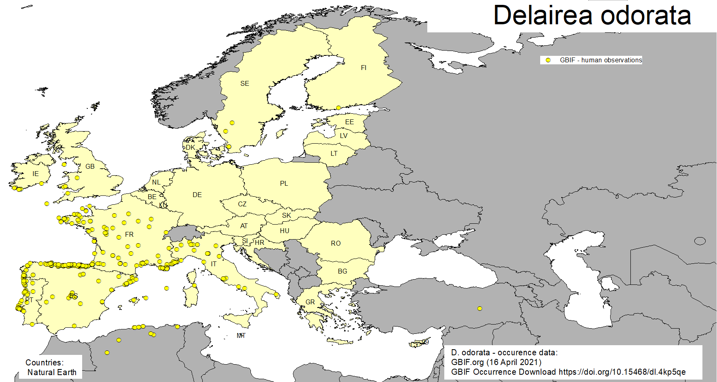

Figure 3 occurrence data records of Delairea odorata based upon GBIF human observations in the EU member states (including United Kingdom) (map designed by Umweltbundesamt/Environment Agency Austria – 2021/04/19)

Table 3 EU member states and United Kingdom with recorded/established *Delairea odorata* occurrences

| **country** | **recorded** | **established** | **source recorded** | **source established** | **general remarks** | **timeline of observations** |
| --- | --- | --- | --- | --- | --- | --- |
| Austria | No | No |  |  |  |  |
| Belgium | No | No |  |  |  |  |
| Bulgaria | No | No |  |  |  |  |
| Croatia | Yes | Yes | Brunel et al. (2010), CABI (2021a), EPPO (2021),Milović et al. 2010, Milović et al. 2014 Nikolić, 2005 onwards, Roskov et al. 2021, Wallnöfer 2007 | |  |  |
| Cyprus | No | No |  |  |  |  |
| Czech Republic | No | No |  |  |  |  |
| Denmark | No | No |  |  |  |  |
| Estonia | No | No |  |  |  |  |
| Finland | Yes | No | FinBIF (2021), GBIF (2021) |  | alien, new, ephemeral - at most a soil immigrant, perhaps slightly spreading vegetatively; 2 observations: 1983, 2012 | 1983 - 2012 |
| France | Yes | Yes | Brunel et al. (2010), CABI (2021a), EPPO (2012), EPPO (2021), Euro+Med (2006- a), GBIF (2021), GRIN-Global (2021), Plants of the World online (2021), Roskov et al. 2021 | | Present / localized; naturalized |  |
| Germany | No | No |  |  |  |  |
| Greece | No | No |  |  |  |  |
| Hungary | No | No |  |  |  |  |
| Ireland | Yes | Yes | CABI (2021a), EPPO (2012), EPPO (2021), Euro+Med (2006- a), GBIF (2021), GRIN-Global (2021), NBN Atlas (2021), Plants of the World online (2021), Reynolds (2002), Roskov et al. 2021 | | Present; naturalized |  |
| Italy | Yes | Yes | Brunel et al. (2010), CABI (2021a), Catalano et al. (1996), Celesti-Grapow et al. (2009), Conti et al. (2005), EPPO (2012), EPPO (2021), Euro+Med (2006- a), GBIF (2021), GRIN-Global (2021), Plants of the World online (2021), Roskov et al. 2021 | | Present / localized; naturalized; invasive |  |
| Latvia | No | No |  |  |  |  |
| Lithuania | No | No |  |  |  |  |
| Luxembourg | No | No |  |  |  |  |
| Malta | No | No |  |  |  |  |
| Netherlands | No | No |  |  |  |  |
| Poland | No | No |  |  |  |  |
| Portugal | Yes | Yes | Brunel et al. (2010), CABI (2021a), Euro+Med (2006- a), GISD (2021), EPPO (2021), GBIF (2021)Sampaio (1947), Plantas invasoras em Portugal (2020), Plants of the World online (2021), Roskov et al. 2021, Royal Botanic Garden Edinburgh (2003) | | Present / localized; naturalized; invasive |  |
| Romania | No | No |  |  |  |  |
| Slovakia | No | No |  |  |  |  |
| Slovenia | No | No |  |  |  |  |
| Spain | Yes | Yes | Brunel et al. (2010), CABI (2021a), EPPO (2012), EPPO (2021), GBIF (2021), GISD (2021), GRIN-Global (2021), Plants of the World online (2021), Roskov et al. 2021, Royal Botanic Garden Edinburgh (2003) | | Present / localized; naturalized |  |
| Sweden | Yes | No | Euro+Med (2006- a), GRIN-Global (2021), Karlsson (1998), Plants of the World online (2021), Roskov et al. 2021 |  | Cultivated |  |
| United Kingdom | Yes | Yes | CABI (2021a), Ecoflora (2021), EPPO (2012), Euro+Med (2006- a), GBIF (2021), GISD (2021), GRIN-Global (2021), Hilliard (1977), NBN Atlas (2021), Plants of the World online (2021), Roskov et al. 2021, Sell & Murrell (1963) | | Present / localized; naturalized; invasive | Introduced: 1855; appearance in the wild: 1923 |

Response (8a): *Delairea odorata* is recorded in 8 out of 27 Member States (Croatia, Finland, France, Ireland, Italy, Portugal, Spain, Sweden) and in the United Kingdom.

Response (8b): Based upon the available data, *Delairea odorata* can be assessed as established in 6 Member States (Croatia, France, Ireland, Italy, Portugal, Spain) and in the United Kingdom.

By using a subset of GBIF records with a spatial accuracy <= 250 m, the EUNIS habitat classes at Level 2 (EEA 2019) can be spatially retrieved from the Ecosystem types of Europe 2012 raster data set. *Delairea odorata* in its native distribution seems to underlie some oceanic climate conditions. Therefore, the parameter “distance to sea” is used in the species distribution model (SDM; see Annex VIII). In its non-native range in the Western USA (California, Oregon), the species is described with most occurrences in coastal areas. In order to get some impressions whether there may be differences in EUNIS ecosystems at actual European occurrences, these are roughly classified as directly along the coast-line (coastal occurrences) respectively as inland occurrences in a distance of more than 10 km from the coast (Figure 4).

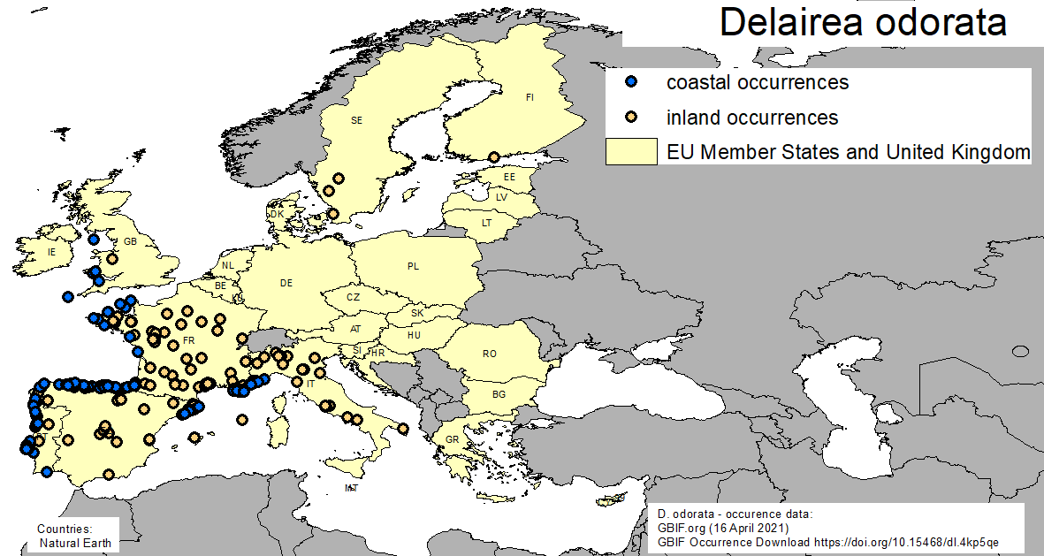

Figure 4 along coastline (coastal) and in a distance >10 km from the coastline (inland) classified occurrences of Delairea odorata based upon GBIF human observations (map designed by Umweltbundesamt/Environment Agency Austria – 2022/08/10)

Based upon the available data, there is enough evidence that the used data covers several ecosystem categories from anthropogenic/urban to more natural types (Table 4) in coastal as well as in countryside classified occurrences.

Anthropogenic types are for example *Buildings of cities, towns and villages* or *Low density buildings*; more natural types are woodland (*Broadleaved deciduous woodland* or *Mixed deciduous and coniferous woodland*) and grassland (*Mesic grassland*).

Table 4 *Delairea odorata* GBIF occurrences with coordinate accuracy < 250 m classified as coastal or countryside, and related EUNIS habitat classes at level 2 (EEA 2019)

| **EUNIS ecosystem level 2** | **coastal occurrences** | **inland occurrences** |
| --- | --- | --- |
| E2 - Mesic grasslands | 18 | 10 |
| F3 - Temperate and Mediterranean-montane scrub | 3 |  |
| F5 - Maquis, arborescent matorral and thermo-Mediterranean brushes | 1 |  |
| FB - Shrub plantations |  | 1 |
| G1 - Broadleaved deciduous woodland | 8 | 8 |
| G2 - Broadleaved evergreen woodland | 1 |  |
| G3 - Coniferous woodland | 4 |  |
| G4 - Mixed deciduous and coniferous woodland | 5 |  |
| G5 - Lines of trees, small anthropogenic woodlands, recently felled woodland, early-stage woodland and coppice | 1 |  |
| I1 - Arable land and market gardens | 15 | 6 |
| I2 - Cultivated areas of gardens and parks | 5 | 4 |
| J1 - Buildings of cities, towns and villages | 28 | 50 |
| J2 - Low density buildings | 13 | 24 |
| J3 - Extractive industrial sites |  | 1 |
| J4 - Transport networks and other constructed hard-surfaced areas | 3 | 2 |

|  |
| --- |
| **A9. In which EU Member States could the species establish in the future under current climate and under foreseeable climate change? The information needs be given separately for current climate and under foreseeable climate change conditions.**  **A9a. Current climate: List Member States**  **A9b. Future climate: List Member States**  With regard to EU Member States, see above.  With regard to climate change, provide information on   * the applied timeframe (e.g. 2050/2070) * the applied scenario (e.g. RCP 4.5) * what aspects of climate change are most likely to affect the risk assessment (e.g. increase in average winter temperature, increase in drought periods)   The assessment does not have to include a full range of simulations on the basis of different climate change scenarios, as long as an assessment with a clear explanation of the assumptions is provided. However, if new, original models are executed for this risk assessment, the following RCP pathways shall be applied: RCP 2.6 (likely range of 0.4-1.6°C global warming increase by 2065) and RCP 4.5 (likely range of 0.9-2.0°C global warming increase by 2065). Otherwise, the choice of the assessed scenario has to be explained. |

The ensemble model (see Annex VIII) suggested that suitability for *D. odorata* was most strongly determined by Minimum temperature of the coldest month (Bio6), accounting for 50.2% of variation explained, followed by Human influence index (HII) (24.8%), Mean temperature of the warmest quarter (Bio10) (10.4%), Distance to the sea (dist_to_sea) (8.6%), Climatic moisture index (CMI) (5.6%) and Global tree cover (Tree) (0.4%)

Response (9a): EU Members States and the United Kingdom with suitability under current conditions

|  |  |  |
| --- | --- | --- |
| **country** | **likeliness** | **confidence** |
| Austria | unlikely | high |
| Belgium | likely | high |
| Bulgaria | unlikely | high |
| Croatia | likely | high |
| Cyprus | likely | high |
| Czech Republic | unlikely | high |
| Denmark | likely | high |
| Estonia | unlikely | high |
| Finland | unlikely | high |
| France | likely | high |
| Germany | likely | medium |
| Greece | likely | high |
| Hungary | unlikely | high |
| Ireland | likely | high |
| Italy | likely | high |
| Latvia | unlikely | high |
| Lithuania | unlikely | high |
| Luxembourg | likely | medium |
| Malta | likely | high |
| Netherlands | likely | high |
| Poland | unlikely | high |
| Portugal | likely | high |
| Romania | unlikely | high |
| Slovakia | unlikely | high |
| Slovenia | likely | medium |
| Spain | likely | high |
| Sweden | unlikely | high |
| United Kingdom | likely | high |

Response (9b): EU Members States and the United Kingdom with suitability under projected conditions

|  |  |  |  |  |
| --- | --- | --- | --- | --- |
| **country** | **Scenario RCP 2.6** | | **Scenario RCP 4.5** | |
| **likeliness** | **confidence** | **likeliness** | **confidence** |
| Austria | unlikely | medium | unlikely | high |
| Belgium | likely | high | likely | high |
| Bulgaria | likely | high | likely | high |
| Croatia | likely | high | likely | high |
| Cyprus | likely | high | likely | high |
| Czech Republic | unlikely | medium | likely | medium |
| Denmark | likely | high | likely | high |
| Estonia | unlikely | high | unlikely | high |
| Finland | unlikely | high | unlikely | high |
| France | likely | high | likely | high |
| Germany | likely | high | likely | high |
| Greece | likely | high | likely | high |
| Hungary | likely | medium | likely | medium |
| Ireland | unlikely | high | unlikely | high |
| Italy | likely | high | likely | high |
| Latvia | unlikely | medium | likely | medium |
| Lithuania | unlikely | medium | likely | medium |
| Luxembourg | likely | high | likely | high |
| Malta | likely | high | likely | high |
| Netherlands | likely | high | likely | high |
| Poland | unlikely | medium | likely | medium |
| Portugal | likely | high | likely | high |
| Romania | unlikely | high | unlikely | high |
| Slovakia | unlikely | high | unlikely | high |
| Slovenia | likely | high | likely | high |
| Spain | likely | high | likely | high |
| Sweden | unlikely | high | unlikely | high |
| United Kingdom | likely | high | likely | high |

|  |
| --- |
| **A10. Is the organism known to be invasive (i.e. to threaten or adversely impact upon biodiversity and related ecosystem services) anywhere outside the risk assessment area?** |

Response: *Delairea odorata* is invasive in North America (California, Hawaii and Oregon), Australia (New South Wales, Northern Territory, South Australia, Tasmania, Victoria) and New Zealand.

Table 1 gives an overview about invasiveness outside of the risk assessment area. Well-documented invasive behavior of *Delairea odorata* is reported for Australia, New Zealand, and the United States.

In California, it occurs in riparian forest, coastal scrub, salt marsh, oak woodland, conifer forest, agricultural, and non-native forests (Robison & DiTomaso 2010). *Delairea* *odorata* forms dense mats that blanket and smother vegetation (Elliott 1994), including small trees (Bossard et al. 2000), and reduces native plant species diversity (Alvarez & Cushman 2002). Cape ivy can invade different habitat types ranging from disturbed to native ecosystems and occurs in both dry to moist conditions. Due to a shallow root system, Cape ivy can contribute to soil erosion problems on hillsides and impact flood control functions along streams (Bossard 2000).

In southern Australia, Cape Ivy is a highly invasive environmental weed. It invades waterways, moist gullies, closed forests and margins, open woodlands, roadsides, waste areas and coastal areas and is also commonly found in gardens and along fences and urban areas parks (Weeds Australia 2021).

In New Zealand, Cape Ivy can be found in coastal and lowland regions. The plant occurs in coastal ecosystems as well as in scrub and forest margin communities, shrublands, rocklands, roadsides, quarries, farm hedges, wasteland and house gardens (New Zealand Plant Conservation Network 2021).

|  |
| --- |
| **A11. In which biogeographic region(s) or marine subregion(s) in the risk assessment area has the species shown signs of invasiveness? Indicate the area endangered by the organism as detailed as possible.**  Freshwater / terrestrial biogeographic regions:   * Alpine, Atlantic, Black Sea, Boreal, Continental, Mediterranean, Pannonian, Steppic   Marine regions:   * Baltic Sea, North-east Atlantic Ocean, Mediterranean Sea, Black Sea   Marine subregions:  Greater North Sea, incl. the Kattegat and the English Channel, Celtic Seas, Bay of Biscay and the Iberian Coast, Western Mediterranean Sea, Adriatic Sea, Ionian Sea, Central Mediterranean Sea, Aegean-Levantine Sea |

Response: *Delairea odorata* exhibits a widespread distribution in parts of the Atlantic and Mediterranean biogeographical regions (compare Figure 2). There are documented signs of invasiveness in these regions, especially along the coastlines. In Portugal, Cape Ivy frequently invades banks of watercourses, hedgerows and slopes, ruderal environments and communities of thorny shrubs (Plantas invasoras em Portugal 2020). *Delairea odorata* is reported as established in Tuscany (including the Tuscan Archipelago, see Lazzaro et al., 2014) and in Sardinia (Italy) (Iamonico 2017), where it occurs in ruderal habitats only, and in few localities with low density, so that at the time being no significant ecological impacts have been recorded (Bacchetta et al. 2009, Camarda et al. 2016, Portale della Flora d’Italia 2021).

|  |
| --- |
| **A12. In which EU Member States has the species shown signs of invasiveness? Indicate the area endangered by the organism as detailed as possible.**  Austria, Belgium, Bulgaria, Croatia, Cyprus, Czech Republic, Denmark, Estonia, Finland, France, Germany, Greece, Hungary, Ireland, Italy, Latvia, Lithuania, Luxembourg, Malta, Netherlands, Poland, Portugal, Romania, Slovakia, Slovenia, Spain, Sweden |

Response: There are documented signs of invasiveness in Portugal and Italy. In Portugal, Cape Ivy frequently invades banks of watercourses, hedgerows and slopes, ruderal environments and communities of thorny shrubs (Plantas invasoras em Portugal 2020). *Delairea odorata* is reported as established in Tuscany and in Sardinia (Italy) (Iamonico 2017), where it occurs in ruderal habitats only, and in few localities with low density, so that at the time being no significant ecological impacts have been recorded (Bacchetta et al. 2009, Camarda et al. 2016, Portale della Flora d’Italia 2021).

Fried (2010) reported for France that *D. odorata* is cultivated and sometimes escapes from gardens in Bretagne, locally in the Finistère department. It can form dense stands several meters high, smothering trees and shrubs. It is also established on the coastal areas of Provence. The plant spreads by vegetative growth, the stolons fragment easily and can quickly produce new plants. Though GT IBMA (2016) details that its impact on vegetation remains to be determined in France.

No references regarding (potential) invasiveness of *D. odorata* in Spain, where it is abundant can be found.

For the United Kingdom, invasiveness is mentioned in a few references (e.g. CABI 2021a), though no further and detailed information could be found.

|  |
| --- |
| **A13. Describe any known socio-economic benefits of the organism.**  including the following elements:   * Description of known uses for the species, including a list and description of known uses in the risk assessment area and third countries, if relevant. * Description of social and economic benefits deriving from those uses, including a description of the environmental, social and economic relevance of each of those uses and an indication of associated beneficiaries, quantitatively and/or qualitatively depending on what information is available.   If the information available is not sufficient to provide a description of those benefits for the entire risk assessment area, qualitative data or different case studies from across the risk assessment area or third countries shall be used, if available. |

Response: *Delairea odorata* is a popular ornamental climbing vine used in landscaping and gardening (Cal-IPC 2021a, EPPO 2012, ISSG 2021). *Delairea odorata* is traded and used as an ornamental species in the RA area. However, there is no quantitative data on its value to the horticulture trade and it is not considered to be a popular species in horticulture. This may also be due to the fact that the species can easily be propagated by its ramets. Ornamental use includes the use as a ground cover and also for covering structures; additionally, the species is used as an indoor ornamental.

# SECTION B – Detailed assessment

|  |
| --- |
| **Important instructions:**   * In the case of lack of information the assessors are requested to use a standardized answer: “No information has been found.” In this case, no score and confidence should be given and the standardized “score” is N/A (not applicable). * With regard to the scoring of the likelihood of events or the magnitude of impacts see Annexes I and II. * With regard to the confidence levels, see Annex III. * Highlight the selected response score and confidence level in **bold** but keep the other scores in normal text (so that the selected score is evident in the final document). |

## 1 PROBABILITY OF INTRODUCTION AND ENTRY

|  |
| --- |
| **Important instructions:**   * **Introduction** is the movement of the species into the risk assessment area (it may be either in captive conditions and/or in the environment, depending on the relevant pathways). * **Entry** is the release/escape/arrival in the environment, i.e. occurrence in the wild * Introduction and entry may coincide for species entering through pathways such as “corridor” or “unaided”, but it also may differ. If different, please consider all relevant pathways, both for the introduction into the risk assessment area and the entry in the environment. * The classification of pathways developed by the Convention of Biological Diversity (CBD) should be used (see Annex IV). For detailed explanations of the CBD pathway classification scheme consult the IUCN/CEH guidance document[3] and the provided key to pathways[4]. * For organisms which are already present (recorded or established) in the risk assessment area, the likelihood of introduction and entry should be scored as “very likely” by default. * Repeated (independent) introductions and entries at separate locations in the risk assessment area should be considered here (see Qu. 1.7). |

|  |
| --- |
| **Qu. 1.1. List relevant pathways through which the organism could be introduced into the risk assessment area and/or enter into the environment. Where possible give details about the specific origins and end points of the pathways as well as a description of any associated commodities.**  For each pathway answer questions 1.2 to 1.8 (copy and paste additional rows at the end of this section as necessary). Please attribute unique identifiers to each question if you consider more than one pathway, e.g. 1.2a, 1.3a, etc. and then 1.2b, 1.3b etc. for the next pathway.  In this context a pathway is the route or mechanism of introduction and/or entry of the species.  The description of commodities with which the introduction of the species is generally associated shall include a list and description of commodities with an indication of associated risks (e.g. the volume of trade; the likelihood of a commodity being contaminated or acting as vector).  If there are no active pathways or potential future pathways this should be stated explicitly here, and there is no need to answer the questions 1.2-1.9. |

**(1): Horticulture (escape from confinement)**

**(2): Ornamental purpose other than horticulture (escape from confinement)**

**(3):** **Transport of habitat material (soil, vegetation) (transport – contaminant)**

Pathways considered but excluded from the risk assessment.

The pathway people and their luggage/equipment in particular tourism (transport - stowaway) was considered when writing this risk assessment. However, the authors consider it is very unlikely that *D. odorata* will enter along this pathway. There is no evidence in the literature that tourism is an active pathway, and it is unlikely that the seeds will be moved by this pathway. Seeds do not have barbs or spines which can attach to clothes or recreation equipment.

The authors considered the pathway Landscape / flora / fauna improvement in the wild and concluded that this pathway did not warrant a detailed analysis as the species is generally described as growing poorly in full sunlight (Robison et al., 2011). There may be some potential situations where the species may be used for such purposes, however, there is no evidence that landscape /flora/fauna improvements in the wild is an active pathway. The pathway is not considered further in the risk assessment.

Pathway name: **Horticulture (escape from confinement)**

|  |
| --- |
| **Qu. 1.2a. Is introduction and/or entry along this pathway intentional (e.g. the organism is imported for trade) or unintentional (e.g. the organism is a contaminant of imported goods)?** |

|  |  |  |  |
| --- | --- | --- | --- |
| **RESPONSE** | **intentional**  unintentional | **CONFIDENCE** | low  medium  **high** |

Response: Horticulture is the intentional introduction of the species into the risk assessment area for commercial culturing. *Delairea odorata* has been utilized as a garden ornamental species in the risk assessment area since the early 1900s (Bollettino 1902).

The pathway includes the movement of plant material via e-commerce.

The Horticulture pathway should be applied to plants escaping from commercial culturing facilities (nurseries, greenhouses) (including the deliberate dumping of plant material) or during transport to/from the nursery trade. Therefore, this pathway includes the bulk shipment of live plants for nurseries and gardens centres, and the intentional introduction of seeds for planting.

García Gallo et al. (2008) detail that *D. odorata* has been intentionally introduced as an ornamental species into the Azores, Madeira and the Canary Islands, most likely from stock in Portugal.

|  |
| --- |
| **Qu. 1.3a. How likely is it that large numbers of the organism will be introduced and/or enter into the environment through this pathway from the point(s) of origin over the course of one year?**  including the following elements:   * discuss how likely the organism is to get onto the pathway in the first place. Also comment on the volume of movement along this pathway. * an indication of the propagule pressure (e.g. estimated volume or number of individuals / propagules, or frequency of passage through pathway), including the likelihood of reinvasion after eradication * if relevant, comment on the likelihood of introduction and/or entry based on propagule pressure (i.e. for some species low propagule pressure (1-2 individuals) could result in subsequent establishment whereas for others high propagule pressure (many thousands of individuals) may not. |

|  |  |  |  |
| --- | --- | --- | --- |
| **RESPONSE** | very unlikely  unlikely  **moderately likely**  likely  very likely | **CONFIDENCE** | low  **medium**  high |

Response: The species is an ornamental species and grown in the risk assessment area. There are a number of suppliers listed throughout EU Member states.

The pathway ‘Horticulture’ is the deliberate movement of the plant into the risk assessment area for use as an ornamental species. However, it should be noted that the frequency and volume of individuals entering the risk assessment area is potentially low as much of the material sold in nurseries and garden centers is likely to be propagated within the risk assessment area.

The species is available for sale via a limited number of e-commerce sites (often under the name *Senecio mikanioides)* such as: eBayand others, e.g. https://www.araflora.nl/p4042/senecio_mikanioides.

It is moderately likely that the species will enter the natural environment via this pathway. Potentially, if planted in nurseries and garden centers, plant material may escape from confined areas into the natural environment. Additionally, dumping of material into the natural environment may occur though unlikely with good horticulture industry practice. Dumped waste, containing seeds (though not relevant for the risk assessment area) and stem pieces, has been reported as contributing to its spread in Australia (Northcote City Council & Duggan 1994).

If eradication measures are taken following dumping, there is the potential that the species can re-establish if it is dumped again or if some small shoot or root material is left behind. Plants can regenerate from a small piece of stem, stolon or rhizome as long as a node is included (DiTomaso and Healy 2004).

|  |
| --- |
| **Qu. 1.4a. How likely is the organism to survive, reproduce, or increase during transport and storage along the pathway (excluding management practices that would kill the organism)?** |

|  |  |  |  |
| --- | --- | --- | --- |
| **RESPONSE** | very unlikely  unlikely  moderately likely  likely  **very likely** | **CONFIDENCE** | low  **medium**  high |

Response: The pathway ‘Horticulture’ is the deliberate movement of plant material into the risk assessment area and as such plant material would be maintained and moved to ensure survival.

*Delairea odorata* is utilized as an ornamental plant (Cal-IPC 2021a, EPPO 2012, ISSG 2021) and also as a houseplant (Robison & DiTomaso2010).

Three types of material can potentially enter the risk assessment area via this pathway (1) seed, (2) live plants and (3) cuttings (including rhizomes and stems).

**Seed**

Although seed import cannot be ruled out, it is very unlikely seeds of this species will be part of the horticulture pathway for the commercial production of the species.

Seed may survive along the pathway but there is no period of dormancy of the seed. It would not be possible for the species to reproduce or increase during transport and storage along this pathway. There is no detailed analysis on the viability of seed when stored or transported.

**Live plants**

Live plants will be moved along the pathway and packaged to promote their survival. It is unlikely the plants will reproduce or increase during their transport along this pathway. The end result of the pathway is the planting of the species in a suitable area (garden) to promote its growth.

**Shoot or root material**

Shoot or root material may be moved along the pathway and packaged to promote survival. There is no data on the survival of this material, but it is likely that it will survive during transportation as industry will ensure they are packaged appropriately to ensure survival. Roots are robust and if placed near the soil surface, this can increase the changes of growth after they are dumped. If plant material is placed in areas where there is disturbance, there may be a greater chance that the species can survive in these habitats. Often dumping of plant material takes place in ruderal habitats.

|  |
| --- |
| **Qu. 1.5a. How likely is the organism to survive existing management practices before and during transport and storage along the pathway?** |

|  |  |  |  |
| --- | --- | --- | --- |
| **RESPONSE** | very unlikely  unlikely  moderately likely  likely  **very likely** | **CONFIDENCE** | **low**  medium  high |

Response: Plant material (most likely live plants or cuttings) is the commodity itself and it is deliberately moved for sale within the risk assessment area. Therefore, management practices before and during transport are not considered in this question. Management practices during storage at the end point (nursery and garden centre) may affect the survival of the species for example cleaning, temperature storage etc. However, the species is likely to survive.

|  |
| --- |
| **Qu. 1.6a. How likely is the organism to be introduced into the risk assessment area or entry into the environment undetected?** |

|  |  |  |  |
| --- | --- | --- | --- |
| **RESPONSE** | very unlikely  unlikely  **moderately likely**  likely  very likely | **CONFIDENCE** | low  **medium**  high |

Response: It is moderately likely that the organism will enter the risk assessment area undetected via this pathway as this concerns the intentional movement of plant material into the risk assessment area. USDA (2013) found no evidence that propagules are likely to be dispersed in trade as contaminants or hitchhikers.

The species could enter the environment undetected as the species may escape from garden centers and nurseries via seed or the dumping of plant material. Robison & DiTomaso (2010) highlight that the species may have been established in California from discarded houseplants. A moderate score has been given with a medium confidence due to potential dumping of the species.

|  |
| --- |
| **Qu. 1.7a. How isolated or widespread are possible points of introduction and/or entry into the environment in the risk assessment area?** |

|  |  |  |  |
| --- | --- | --- | --- |
| **RESPONSE** | isolated  **widespread**  ubiquitous | **CONFIDENCE** | low  medium  **high** |

Response: For live plant imports in the risk assessment area (introduction), each EU Member country has official entry points where plant material can be imported into. Therefore, these introduction points are widespread in the risk assessment area.

For the introduction of plant material via e-commerce, the entry points are widespread as anyone with an internet connection and a postal address can obtain seeds of the species from outside the risk assessment area. Therefore, introduction points are widespread within the risk assessment area.

*Delaria odorata* can enter the environment from nurseries and garden centers (the end point of this pathway) which are widespread within the risk assessment area. This does not mean the species is widely propagated but implies these possible points of introduction are widespread.

|  |
| --- |
| **Qu. 1.8a. Estimate the overall likelihood of introduction into the risk assessment area and/or entry into the environment based on this pathway?** |

|  |  |  |  |
| --- | --- | --- | --- |
| **RESPONSE** | very unlikely  unlikely  **moderately likely**  likely  very likely | **CONFIDENCE** | low  medium  **high** |

Response: The pathway ‘Horticulture’ involves the movement of plant material for planting from outside of the risk assessment area via nurseries and garden centres.

This pathway is active though it is unlikely that the species is being moved along the pathway from outside the risk assessment area into the risk assessment area. However, the species is sold within the risk assessment area and nurseries will propagate the species and it is moderately likely for the species to enter the natural environment from these types of facilities.

Live plant material may be imported into the risk assessment area for sale in the horticulture industry. However, it should be noted that this is probably more of a historic pathway as the species is likely to be propagated within the risk assessment area as the species can be easily grown from root fragments.

**Pathway name: (2) Ornamental purposes other than horticulture (escape from confinement)**

|  |
| --- |
| **Qu. 1.2b. Is introduction and/or entry along this pathway intentional (e.g. the organism is imported for trade) or unintentional (e.g. the organism is a contaminant of imported goods)?** |

|  |  |  |  |
| --- | --- | --- | --- |
| **RESPONSE** | Unintentional  **intentional** | **CONFIDENCE** | low  medium  **high** |

Response: This pathway involves the intentional introduction of the species for ornamental purposes, though entry into the natural environment would be unintentional. This pathway includes the movement of all potential plant parts (live plants, seed and rhizomes) into the risk assessment area. However, it should be noted that there is only evidence of live plants being moved along this pathway.

In Spain, *D. odorata* is an ornamental escape in waste places, abandoned gardens and along paths (Perez 2002).

For escape/entry into the environment, this pathway includes the dumping of plant material into the natural environment. Dumping of garden waste, containing seed, shoots or roots, has been reported as contributing to its spread in Australia (Northcote City Council & Duggan 1994).

*Delairea odorata* has been utilized as a garden ornamental species for a number of decades in the risk assessment area since the early 1900s (Bollettino SBI 1902, p. 141).

|  |
| --- |
| **Qu. 1.3b. How likely is it that large numbers of the organism will be introduced and/or enter into the environment through this pathway from the point(s) of origin over the course of one year?**  including the following elements:   * discuss how likely the organism is to get onto the pathway in the first place. Also comment on the volume of movement along this pathway. * an indication of the propagule pressure (e.g. estimated volume or number of individuals / propagules, or frequency of passage through pathway), including the likelihood of reinvasion after eradication * if relevant, comment on the likelihood of introduction and/or entry based on propagule pressure (i.e. for some species low propagule pressure (1-2 individuals) could result in subsequent establishment whereas for others high propagule pressure (many thousands of individuals) may not. |

|  |  |  |  |
| --- | --- | --- | --- |
| **RESPONSE** | very unlikely  unlikely  **moderately likely**  likely  very likely | **CONFIDENCE** | **low**  medium  high |

Response: Entry into the natural environment is likely as the species will be planted in gardens, sometimes in close proximity to the natural environment. Shoots can spread into the natural environment from planting in gardens. The species has been shown to escape gardens and along paths (Perez 2002; Northcote City Council & Duggan 1994). However, *D. odorata* is not a popular ornamental species and therefore it is only consideredmoderately likely that large numbers of the organism will be introduced and/or enter into the environment through this pathway.

If eradication measures are taken following planting, there is the potential that the species can re-establish if replanted. The number of potential areas where the species can escape from increases the difficulty of eradication at a large scale.

|  |
| --- |
| **Qu. 1.4b. How likely is the organism to survive, reproduce, or increase during transport and storage along the pathway (excluding management practices that would kill the organism)?** |

|  |  |  |  |
| --- | --- | --- | --- |
| **RESPONSE** | very unlikely  unlikely  moderately likely  **likely**  very likely | **CONFIDENCE** | low  **medium**  high |

Response: Plant material is the commodity itself and it is deliberately moved for sale within the risk assessment area. Therefore, plant parts or whole parts are likely to survive along the pathway to the end point where it is planted in a garden.

The following section lists the plant parts of concern:

**Seed (low concern)**

There are no reports of seed in the Risk assessment area.

**Live plants (high concern)**

Live plants may be dumped into the natural environment and it is likely that these can survive during transport. *D. odorata* can grow in a range of habitats from disturbed to natural areas and occurs in both dry to moist conditions. It also can tolerate a wide range of soil conditions. Robison & DiTomaso (2010) highlight that the species may have been established in California from discarded houseplants.

**Shoot and root material (high concern)**

Shoot material and to a lesser extent, root material may spread outside the confines of a garden where it is deliberately planted. Additionally, if garden waste is placed on a suitable substrate, it will be able to survive.

|  |
| --- |
| **Qu. 1.5b. How likely is the organism to survive existing management practices before and during transport and storage along the pathway?** |

|  |  |  |  |
| --- | --- | --- | --- |
| **RESPONSE** | very unlikely  unlikely  moderately likely  likely  **very likely** | **CONFIDENCE** | low  medium  **high** |

Response: Management practices before and during transport are very likely to facilitate the survival of the species as it is the commodity itself..

Management practices, i.e. removal and waste disposal may increase the propagule pressure of the species in the environment and facilitate the reproduction of the species. Therefore, management practices such as physical removal or cutting above and below ground material may lead to fragmentation of plant material.

Other management practices (e.g. chemical control of weeds in gardens), may have an impact on the survival and reproduction of the species.

|  |
| --- |
| **Qu. 1.6b. How likely is the organism to be introduced into the risk assessment area or entry into the environment undetected?** |

|  |  |  |  |
| --- | --- | --- | --- |
| **RESPONSE** | very unlikely  unlikely  **moderately likely**  likely  very likely | **CONFIDENCE** | low  **medium**  high |

Response. It is moderately likely the species can enter the environment via the dumping of garden waste. Dumping of garden waste, containing shoots or roots, has been reported as contributing to its spread in Australia (Northcote City Council & Duggan 1994). These plant parts may be hidden within other foliage and therefore can enter the environment undetected. The score is based on the worst-case scenario. A moderately likely overall score has been given based on the potential of it entering the natural environment.

|  |
| --- |
| **Qu. 1.7b. How isolated or widespread are possible points of introduction and/or entry into the environment in the risk assessment area?** |

|  |  |  |  |
| --- | --- | --- | --- |
| **RESPONSE** | isolated  **widespread**  ubiquitous | **CONFIDENCE** | low  medium  **high** |

Response: Private gardens associated with households are high. For example, data from 2014 shows that 58% of houses have a garden or outside space in France, 81% in the United Kingdom, 80.3% in Poland and 27% in Spain (Statista 2020).

|  |
| --- |
| **Qu. 1.8b. Estimate the overall likelihood of introduction into the risk assessment area and/or entry into the environment based on this pathway?** |

|  |  |  |  |
| --- | --- | --- | --- |
| **RESPONSE** | very unlikely  unlikely  moderately likely  **likely**  very likely | **CONFIDENCE** | low  **medium**  high |

Response: Through management practices or dumping of plant material, plant material can enter into the natural environment.

This introduction pathway is active and there is evidence that the species is being moved along the pathway into the risk assessment area. Based on this, a score of likely with medium confidence has been given.

**Pathway name (3): Transport – Contaminant (transport of habitat material (soil, vegetation))**

|  |
| --- |
| **Qu. 1.2c. Is introduction and/or entry along this pathway intentional (e.g. the organism is imported for trade) or unintentional (e.g. the organism is a contaminant of imported goods)?** |

|  |  |  |  |
| --- | --- | --- | --- |
| **RESPONSE** | intentional  **unintentional** | **CONFIDENCE** | low  medium  **high** |

Response: Entry via this pathway is unintentional movement of the species via the contamination of habitat material (soil and vegetation).

|  |
| --- |
| **Qu. 1.3c. How likely is it that large numbers of the organism will be introduced and/or enter into the environment through this pathway from the point(s) of origin over the course of one year?**  including the following elements:    ● discuss how likely the organism is to get onto the pathway in the first place. Also comment on the volume of movement along this pathway.  ● an indication of the propagule pressure (e.g. estimated volume or number of individuals / propagules, or frequency of passage through pathway), including the likelihood of reinvasion after eradication  ● if relevant, comment on the likelihood of introduction and/or entry based on propagule pressure (i.e. for some species low propagule pressure (1-2 individuals) could result in subsequent establishment whereas for others high propagule pressure (many thousands of individuals) may not. |

|  |  |  |  |
| --- | --- | --- | --- |
| **RESPONSE** | very unlikely  unlikely  **moderately likely**  likely  very likely | **CONFIDENCE** | **low**  medium  high |

Response: There is no information available on the volumes of movement along this pathway. The transport of topsoil, sand or other contaminated habitat material with shoot or root material could facilitate entry into the RA area. However, the pathway is mainly closed within the RA as there are prohibitions of the movement of soil into the EU from many countries.

Such material is likely to be placed in suitable habitats in the risk assessment area for the establishment of the species.

*Delairea odorata* can produce a large biomass of shoot material which may regenerate into viable plants if broken from the parent plant. Shoot material can become incorporated into soil and included in habitat material which is then transported both into the risk assessment area and within the risk assessment area.

|  |
| --- |
| **Qu. 1.4c. How likely is the organism to survive, reproduce, or increase during transport and storage along the pathway (excluding management practices that would kill the organism)?** |

|  |  |  |  |
| --- | --- | --- | --- |
| **RESPONSE** | very unlikely  unlikely  moderately likely  **likely**  very likely | **CONFIDENCE** | low  **medium**  high |

Response: Weeds of Australia (2022) detail that seeds and stem fragments are spread in contaminated soil indicating that it is likely the species can survive along this pathway. Both shoot and root material are likely to survive transport along the pathway, especially as it would be moved with habitat material that is likely to retain moisture. It is unlikely that plant material will reproduce or increase along the pathway.

|  |
| --- |
| **Qu. 1.5c. How likely is the organism to survive existing management practices before and during transport and storage along the pathway?** |

|  |  |  |  |
| --- | --- | --- | --- |
| **RESPONSE** | very unlikely  unlikely  **moderately likely**  likely  very likely | **CONFIDENCE** | **low**  medium  high |

Response: The species is moderately likely to survive existing management practices along this pathway. However, there is no information available for this pathway.

|  |
| --- |
| **Qu. 1.6c. How likely is the organism to be introduced into the risk assessment area or entry into the environment undetected?** |

|  |  |  |  |
| --- | --- | --- | --- |
| **RESPONSE** | very unlikely  unlikely  moderately likely  **likely**  very likely | **CONFIDENCE** | **low**  medium  high |

Response: The species is known to move as a contaminant of soil (Weeds of Australia, 2022) and plants can regenerate from a small piece of stem, stolon or rhizome as long as a node is included (DiTomaso and Healy 2004). Shoots and root material can be buried in soil and other material, making them difficult to detect. Therefore, it is likely that the species could be introduced into the risk assessment area undetected.

|  |
| --- |
| **Qu. 1.7c. How isolated or widespread are possible points of introduction and/or entry into the environment in the risk assessment area?** |

|  |  |  |  |
| --- | --- | --- | --- |
| **RESPONSE** | isolated  **widespread**  ubiquitous | **CONFIDENCE** | **low**  medium  high |

Response: There are no specific data on the points of introduction or entry.

Points of introduction can include road routes which join countries and other international transportation hubs. These are widespread throughout the risk assessment area. Urbanization and the management of land is increasing through the risk assessment area.

|  |
| --- |
| **Qu. 1.8c. Estimate the overall likelihood of introduction into the risk assessment area and/or entry into the environment based on this pathway?** |

|  |  |  |  |
| --- | --- | --- | --- |
| **RESPONSE** | very unlikely  unlikely  **moderately likely**  likely  very likely | **CONFIDENCE** | low  **medium**  high |

Response: Root and shoot material may be able to move along this pathway, and the commodity is placed within the environment where the propagules have the opportunity to establish. However, there is no direct evidence that the species has moved along this pathway and therefore it is scored moderately likely with medium confidence.

|  |
| --- |
| **Qu. 1.9. Estimate the overall likelihood of introduction into the risk assessment area or entry into the environment based on all pathways and specify if different in relevant biogeographical regions in current conditions.**  Provide a thorough assessment of the risk of introduction in relevant biogeographical regions in current conditions: providing insight in to the risk of introduction into the risk assessment area. |

|  |  |  |  |
| --- | --- | --- | --- |
| **RESPONSE** | very unlikely  unlikely  moderately likely  likely  **very likely** | **CONFIDENCE** | low  medium  **high** |

Response: The overall likelihood of *D. odorata* being introduced into the risk assessment area is very likely with a high confidence especially because the species is already present (recorded or established) in the risk assessment area, hence the likelihood of introduction and entry should be scored as “very likely” by default. The species has been known to be introduced into the risk assessment area by ‘Horticulture’ (escape from confinement), and ‘Ornamental purpose other than horticulture’ (e.g. planting by private gardeners). *Delairea odorata* has the potential of being dumped in the environment as the species produces a lot of above ground biomass which can be difficult to dispose of in the proper means.

As the highest occurrences of the species in the environment are in the Atlantic and Mediterranean biogeographical regions, it is these regions that would potentially see a higher likelihood of entry into the environment. The species distribution modelling shows that the Alpine, Boreal, Pannonian and Steppic biogeographical regions are currently largely unsuitable for the establishment of the species (compare SDM in Annex VIII) and therefore the likelihood of the species traded for horticultural purposes in these regions is low.

|  |
| --- |
| **Qu. 1.10. Estimate the overall likelihood of introduction into the risk assessment area or entry into the environment based on all pathways in foreseeable climate change conditions?**  Thorough assessment of the risk of introduction in relevant biogeographical regions in foreseeable climate change conditions: explaining how foreseeable climate change conditions will influence this risk.  With regard to climate change, provide information on   * the applied timeframe (e.g. 2050/2070) * the applied scenario (e.g. RCP 4.5) * what aspects of climate change are most likely to affect the likelihood of introduction (e.g. change in trade or user preferences)   The thorough assessment does not have to include a full range of simulations on the basis of different climate change scenarios, as long as an assessment of likely introduction within a medium timeframe scenario (e.g. 30-50 years) with a clear explanation of the assumptions is provided. However, if new, original models are executed for this risk assessment, the following RCP pathways shall be applied: RCP 2.6 (likely range of 0.4-1.6 °C global warming increase by 2065) and RCP 4.5 (likely range of 0.9-2.0 °C global warming increase by 2065). Otherwise, the choice of the assessed scenario has to be explained. |

|  |  |  |  |
| --- | --- | --- | --- |
| **RESPONSE** | very unlikely  unlikely  moderately likely  likely  **very likely** | **CONFIDENCE** | low  **medium**  high |

Response: The main aspects of climatic change which will influence the entry of *D. odorata* into the risk assessment area include increased minimum temperature of winter months, increased spring and summer temperatures (compare SDM in Annex IX).

Climate change (RCP 2.6 2070) will expand the potential distribution the species can establish in, making the species more available to gardeners. For example, more inland areas in the Atlantic and Continental biogeographical regions may become more suitable for growing the species and the horticulture pathway may expand in this area to meet further demand. Ornamental plants traded for private gardens and landscape improvements may also see a higher volume and frequency. A high rating has been given with a medium confidence (due to the fact that this is a projection).

## 2 PROBABILITY OF ESTABLISHMENT

|  |
| --- |
| **Important instructions:**   * For organisms which are already established in parts of the risk assessment area or have previously been eradicated, the likelihood of establishment should be scored as “very likely” by default. * Discuss the risk also for those parts of the risk assessment area, where the species is not yet established. |

|  |
| --- |
| **Qu. 2.1. How likely is it that the organism will be able to establish in the risk assessment area based on similarity of climatic and abiotic conditions in its distribution elsewhere in the world?** |

|  |  |  |  |
| --- | --- | --- | --- |
| **RESPONSE** | very unlikely  unlikely  moderately likely  likely  **very likely** | **CONFIDENCE** | low  medium  **high** |

Response: *Delairea odorata* is already established in the natural environment in the risk assessment area (Croatia, France, Ireland, Italy, Portugal, Spain, United Kingdom) (see Qu. A8b). It is likely that further countries where the species could potentially establish are present within the RA area (see Qu. A9a).

The SDM (Annex VIII) shows the potential distribution of the species based on the current occurrences of the species both in the risk assessment area and elsewhere in the world. The model shows that there is a large area of the EU that is suitable for the establishment of *D. odorata*.

In the native and introduced ranges (outside of the EU), *D. odorata* occurs predominantly in the Köppen-Geiger climate classifications of Cfb (Temperate [oceanic climate](https://en.wikipedia.org/wiki/Oceanic_climate)), Csb ([Warm-summer Mediterranean climate](https://en.wikipedia.org/wiki/Warm-summer_Mediterranean_climate)), Csa ([Hot-summer Mediterranean climate](https://en.wikipedia.org/wiki/Mediterranean_climate#Hot-summer_mediterranean_climate)) and (BSk ([Cold semi-arid climate](https://en.wikipedia.org/wiki/Cold_semi-arid_climate)). MacLeod and Korycinska (2019) estimate that the percentage of 5-minute grid cells for each aforementioned climate category occurring in the EU are as follows: Cfb 48.62 %, Csb 3.8% Csa 10.13 and BSk 1.46. Based on this almost 60% of the EU plus the United Kingdom is currently climatically suitable.

|  |
| --- |
| **Qu. 2.2. How widespread are habitats or species necessary for the survival, development and multiplication of the organism in the risk assessment area? Consider if the organism specifically requires another species to complete its life cycle.** |

|  |  |  |  |
| --- | --- | --- | --- |
| **RESPONSE** | very isolated  isolated  moderately widespread  **widespread**  ubiquitous | **CONFIDENCE** | low  medium  **high** |

Response: *Delairea odorata* can invade different habitats ranging from disturbed to natural and occurs in both dry to moist conditions. It can form dense vegetative ground cover mats that can prevent seeding of native plants.

In South Africa, *D. odorata* grows in moist mountain forests. Where it naturalized, it extended its habitat range and is found in coastal areas, riparian zones and wetlands, dry forests and moist forests, shrublands and ruderal habitats, and grows very well in early successional forests. Typically found below 200 m elevation, it prefers shady, disturbed sites with year-round moisture.

According to the CORINE Land Cover nomenclature, these habitats correspond to: natural grassland, mixed forests, broad-leaved forests, sclerophyllous vegetation (e.g. garrigue, maquis), inland wetlands (marshes, EPPO, 2012 peat bogs), continental waters (water courses, water bodies), banks of continental water, riverbanks/canal sides (dry river beds), road and rail networks and associated land, and other artificial surfaces (wastelands).

CABI (2021) lists potential habitats as managed forests, plantations and orchards, managed grasslands, disturbed areas, rail/roadsides, urban/per-urban areas, natural forests, natural grasslands, riverbanks, wetlands and coastal areas.

García Gallo et al. (2008) detail habitats for *D. odorata* in Azores, Madeira and the Canary Islands to be: Waste places, hedgerows, walls, ravines, *Pittosporum* and *Morella* scrubland, Cliffs, heath substituting *Apollonias* laurel forest, heath substituting *Ocotea* laurel forest, *Apollonias* laurel forest (Mediterranean laurel forest), *Ocotea* laurel forest (temperate laurel forest), riparian laurel forest (*Sambucus* woodland, *Persea* laurel forest, *Salix* woodland), cultivated land, anthropogenic vegetation, mountain humid woodlands and urban areas.

According to Iamonico (2017), *D. odorata* is recorded in Sardinia (Italy) in ruderal habitats only. According to Viciani et al. (2020), *D. odorata* communities can be included in the vegetation class *Artemisietea vulgaris* Lohmeyer, Preising & Tüxen ex Von Rochow 1951.

When taking into consideration all of the habitats detailed above, within the EU, habitats that can facilitate the survival, development and multiplication of the *D. odorata* are widespread. However, it should be noted that many of the areas where the species is currently clustered in the risk assessment area are close to the coast and/or at lower altitudes.

*Delairea odorata* is commonly found in high pH soils characterized by high fertility (Baars et al. 1998) and the species has some tolerance to salt as in the US it has been known to establish on salt exposed bluffs (Starr et al. 2003)

|  |
| --- |
| **Qu. 2.3. How likely is it that establishment will occur despite competition from existing species in the risk assessment area?** |

|  |  |  |  |
| --- | --- | --- | --- |
| **RESPONSE** | very unlikely  unlikely  moderately likely  likely  **very likely** | **CONFIDENCE** | low  **medium**  high |

Response: Competition with native vegetation is unlikely to limit the establishment of *D. odorata* in the risk assessment area. Although there is no scientific information on competition with native species, Brunel et al. (2010) highlights: “*D. odorata* can invade different habitats ranging from disturbed to natural and occurs in both dry to moist conditions. It can form dense vegetative ground-cover mats that can prevent seeding of native plants. It can also smother native vegetation and affect regeneration, forming stands of over 75% cover and competing with other plants for water and nutrients.. It can use ground cover vegetation as a support to grow up into the canopy and climb over other species.

Competition may occur with native lianas in managed forests in the risk assessment area; other liana species in Europe, with the exception of *Hedera helix* and *Clematis vitalba,* are limited, but a higher diversity of lianas is present in Mediterranean shrublands and forests.

|  |
| --- |
| **Qu. 2.4. How likely is it that establishment will occur despite predators, parasites or pathogens already present in the risk assessment area?** |

|  |  |  |  |
| --- | --- | --- | --- |
| **RESPONSE** | very unlikely  unlikely  moderately likely  likely  **very likely** | **CONFIDENCE** | low  **medium**  high |

Response: CABI (2021) detail a number of biological control agents including two insect species, the Cape ivy gall fly (*Parafreutreta regalis* Munro) and the Cape ivy stem moth (*Digitivalva delaireae* Gaedike & Kruger). However, these species are not present in the EU. It is very likely that establishment will occur despite predators, parasites or pathogens already present in the risk assessment area. *D. odorata* does not have any host specific natural enemies in the risk assessment area and there is no evidence that native organisms feed or infect the species in substantial levels to inflict any damage on the species.

|  |
| --- |
| **Qu. 2.5. How likely is the organism to establish despite existing management practices in the risk assessment area? Explain if existing management practices could facilitate establishment.** |

|  |  |  |  |
| --- | --- | --- | --- |
| **RESPONSE** | very unlikely  unlikely  **moderately likely**  likely  very likely | **CONFIDENCE** | low  **medium**  high |

Response: As detailed in section (2.2), the establishment of *D. odorata* is suited to a number of different habitat types, including disturbed habitats. Management of urban and semi-urban habitats is likely to increase disturbance of the habitat, which can act to break the shoots of the plant and resprouting of these parts can occur if they have contact with the ground (Starr et al. 2003).

|  |
| --- |
| **Qu. 2.6. How likely is it that biological properties of the organism would allow it to survive eradication campaigns in the risk assessment area?** |

|  |  |  |  |
| --- | --- | --- | --- |
| **RESPONSE** | very unlikely  unlikely  moderately likely  **likely**  very likely | **CONFIDENCE** | **low**  medium  high |

Response: In the risk assessment area, vegetative reproduction is currently considered the main, if not the only reproductive mechanism. Vegetative reproduction can occur at any time when the nodes of the stem, stolon, or leaf petiole are in contact with the soil. Small fragments of 1.3 cm can root easily and quickly. Seed production has been observed in the risk assessment area (for example, pers. obs. E. Marchante, Portugal), but scientific studies are lacking to confirm seed viability. These biological properties do not allow survival from eradication campaigns, but the fact that small pieces of shoot and root material can form viable plants increases the likelihood. In addition, the stems are brittle and easily broken, thus this can further complicate eradication. *D. odorata* uses other plants to support its growth and can climb over structures.

Therefore, unless eradication campaigns are thorough and remove all reproductive material, it is likely that the species can survive during eradication campaigns. A medium confidence is given as there is no published information for the risk assessment area on eradication campaigns.

|  |
| --- |
| **Qu. 2.7. How likely are the biological characteristics of the organism to facilitate its establishment in the risk assessment area?**  including the following elements:   * a list and description of the reproduction mechanisms of the species in relation to the environmental conditions in the risk assessment area * an indication of the propagule pressure of the species (e.g. number of gametes, seeds, eggs or propagules, number of reproductive cycles per year) of each of those reproduction mechanisms in relation to the environmental conditions in the risk assessment area. * If relevant, comment on the likelihood of establishment based on propagule pressure (i.e. for some species low propagule pressure (1-2 individuals) could result in establishment whereas for others high propagule pressure (many thousands of individuals) may not. * If relevant, comment on the adaptability of the organism to facilitate its establishment and if low genetic diversity in the founder population would have an influence on establishment. |

|  |  |  |  |
| --- | --- | --- | --- |
| **RESPONSE** | very unlikely  unlikely  **moderately likely**  likely  very likely | **CONFIDENCE** | **low**  medium  high |

In the risk assessment area, vegetative reproduction is considered the main, if not the only reproductive mechanism. Vegetative reproduction can occur at any time when the nodes of the stem, stolon, or leaf petiole are in contact with the soil. Small fragmented pieces of 1.3 cm can root easily and quickly. Parts of the plant can also disperse along water courses. Nelson (1999) reports that pieces of *D. odorata* are transported via flooding along the coast of Big Sur river in California.

The growth habit of *D. odorata* can facilitate its establishment, the species climbs over most other vegetation, forming a solid cover that blocks light and smothers other vegetation.

The authors consider the biological properties of the species are moderately likely to facilitate the establishment of the species. The small pieces of viable material required to produce a viable plant coupled with the ability of the plant to grow in a variety of soil types will promote establishment. However, as the species reproduces mostly through vegetative propagules, it is likely that it has a low genetic diversity in the founder population which might have an influence on establishment.

|  |
| --- |
| **Qu. 2.8. If the organism does not establish, then how likely is it that casual populations will continue to occur?**  Consider, for example, a species which cannot reproduce in the risk assessment area, because of unsuitable climatic conditions or host plants, but is present because of recurring introduction, entry and release events. This may also apply for long-living organisms. |

|  |  |  |  |
| --- | --- | --- | --- |
| **RESPONSE** | very unlikely  unlikely  moderately likely  **likely**  very likely | **CONFIDENCE** | low  **medium**  high |

Response: In areas, where *D. odorata* is not present, casual populations may occur in urban habitats or semi-urban habitats. Casual populations may occur in surrounding habitats. Casual populations are likely to occur in areas outside the optimum climatic conditions. For example, this may include areas in Figure 5 of Annex VIII. at the margin of suitable and unsuitable areas. Countries where casual populations may occur include those in central and eastern Europe (see Qu. A8a).

|  |
| --- |
| **Qu. 2.9. Estimate the overall likelihood of establishment in the risk assessment area under current climatic conditions. In addition, details of the likelihood of establishment in relevant biogeographical regions under current climatic conditions should be provided.**  Thorough assessment of the risk of establishment in relevant biogeographical regions in current conditions: providing insight in the risk of establishment in (new areas in) the risk assessment area. |

|  |  |  |  |
| --- | --- | --- | --- |
| **RESPONSE** | very unlikely  unlikely  moderately likely  likely  **very likely** | **CONFIDENCE** | low  medium  **high** |

Response: The overall likelihood of *D. odorata* establishing in the risk assessment area is very likely with high confidence. The species is already established in the Mediterranean and Atlantic biogeographical regions. Countries where the species is established include: Croatia, France, Ireland, Italy, Portugal, Spain, and the United Kingdom. The Mediterranean and Atlantic biogeographical regions have a high proportion of area suitable for the establishment of the species and thus further establishment is likely in these areas under the current climatic conditions.

|  |
| --- |
| **Qu. 2.10. Estimate the overall likelihood of establishment in the risk assessment area under foreseeable climate change conditions. In addition, details of the likelihood of establishment in relevant biogeographical regions under foreseeable climate change conditions should be provided.**  Thorough assessment of the risk of establishment in relevant biogeographical regions in foreseeable climate change conditions: explaining how foreseeable climate change conditions will influence this risk.  With regard to climate change, provide information on   * the applied timeframe (e.g. 2050/2070) * the applied scenario (e.g. RCP 4.5) * what aspects of climate change are most likely to affect the likelihood of establishment (e.g. increase in average winter temperature, increase in drought periods)   The thorough assessment does not have to include a full range of simulations on the basis of different climate change scenarios, as long as an assessment of likely establishment within a medium timeframe scenario (e.g. 30-50 years) with a clear explanation of the assumptions is provided. However, if new, original models are executed for this risk assessment, the following RCP pathways shall be applied: RCP 2.6 (likely range of 0.4-1.6°C global warming increase by 2065) and RCP 4.5 (likely range of 0.9-2.0°C global warming increase by 2065). Otherwise, the choice of the assessed scenario has to be explained. |

|  |  |  |  |
| --- | --- | --- | --- |
| **RESPONSE** | very unlikely  unlikely  moderately likely  likely  **very likely** | **CONFIDENCE** | low  **medium**  high |

Response: The overall likelihood of establishing in the risk assessment area under future climatic conditions (2070 RCP. 2.6) is very likely with medium confidence. The species is already established in the Mediterranean, Continental and Atlantic biogeographical regions. The Continental and Atlantic biogeographical regions see a slight increase in establishment potential with future climate change whereas the Mediterranean region shows a slight decrease. The Pannonian region shows a steep increase in suitability. Southern areas of the Boreal biogeographical region show potential for establishment and small coastal areas of Norway (Alpine biogeographical region) under future climatic conditions (see Annex VIII).

## 3 PROBABILITY OF SPREAD

|  |
| --- |
| **Important instructions:**   * Spread is defined as the expansion of the geographical distribution of an alien species within the risk assessment area. * Repeated releases at separate locations do not represent continuous spread and should be considered in the probability of introduction and entry section (Qu. 1.7). |

|  |
| --- |
| **Qu. 3.1. How important is the expected spread of this organism within the risk assessment area by natural means? (List and comment on each of the mechanisms for natural spread.)**  including the following elements:   * a list and description of the natural spread mechanisms of the species in relation to the environmental conditions in the risk assessment area. * an indication of the rate of spread discussed in relation to the species biology and the environmental conditions in the risk assessment area.   The description of spread patterns here refers to the CBD pathway category “Unaided (Natural Spread)”. It should include elements of the species life history and behavioural traits able to explain its ability to spread, including: reproduction or growth strategy, dispersal capacity, longevity, dietary requirements, environmental and climatic requirements, specialist or generalist characteristics. |

|  |  |  |  |
| --- | --- | --- | --- |
| **RESPONSE** | minimal  minor  **moderate**  major  massive | **CONFIDENCE** | **low**  medium  high |

Response: In the USA, *D. odorata* reproduces vegetatively from stem fragments that readily root at nodes (Robison 2006) and by the extension of the plant through stolons (Alvarez 1998). There is no scientific information on the spread rates of this species for the risk assessment area.

In California, *D. odorata* has readily established in riparian areas and then subsequently spread into drier sites (CABI 2013). One California infestation expanded from 9 acres (3.6 ha) to 67 acres (27.1 ha) in nine years (Alvarez 1998). Alvarez & Cushman (2002) stated that rapid growth (0.35 to 1.35 m per month), clonal reproduction, and pronounced tolerance to environmental conditions have contributed to its invasiveness.

Vegetative reproduction can occur at any time when the nodes of the stem, stolon, or leaf petiole are in contact with the soil. Small fragmented pieces of 1.3 cm can root easily and quickly. Parts of the plant can also disperse along water courses. Nelson (1999) reports that pieces of *D. odorata* are transported via flooding along the coast of Big Sur river in California.

|  |
| --- |
| **Qu. 3.2a. List and describe relevant pathways of spread other than "unaided". For each pathway answer questions 3.3 to 3.9 (copy and paste additional rows at the end of this section as necessary). Please attribute unique identifiers to each question if you consider more than one pathway, e.g. 3.3a, 3.4a, etc. and then 3.3b, 3.4b etc. for the next pathway.**  including the following elements:   * a list and description of pathways of spread with an indication of their importance and associated risks (e.g. the likelihood of spread in the risk assessment area, based on these pathways; likelihood of survival, or reproduction, or increase during transport and storage; ability and likelihood of transfer from the pathway to a suitable habitat or host) in relation to the environmental conditions in the risk assessment area. * an indication of the rate of spread for each pathway discussed in relation to the species biology and the environmental conditions in the risk assessment area. * All relevant pathways of spread (except “Unaided (Natural Spread)”, which is assessed in Qu. 3.1) should be considered. The classification of pathways developed by the Convention of Biological Diversity shall be used (see Annex IV). |

Starr et al. (2003) state: ‘Long distance dispersal is currently mostly by humans spreading the plant in landscaping.

**Spread pathways are detailed in order of importance**

**Ornamental purposes other than horticulture (Escape from confinement)**

This spread pathway is the intentional spread of the species from private gardening and urban and semi-urban plantings (roadsides and roundabouts for example). This pathway would be the most relevant for spread and include the highest movement of plant propagules.

**Transport – Contaminant (transport of habitat material (soil, vegetation))**

This spread pathway deals with the potential spread of contaminated habitat material. There is no quantitative evidence/ interceptions to support the movement of the species along this spread pathway but where urbanization has occurred in the Mediterranean region the species has shown significant spread.

**Transport – stowaway: Machinery/ equipment**

This pathway details the potential spread of contaminated machinery and equipment. There is no quantitative evidence/ interceptions to support the movement of the species along this spread pathway but the potential for the pathway is highlighted in the USA (Alvarez 1997; USDA 2013).

**Pathway name: (1) Ornamental purposes other than horticulture (Escape from confinement)**

|  |
| --- |
| **Qu. 3.3a. Is spread along this pathway intentional (e.g. the organism is deliberately transported from one place to another) or unintentional (e.g. the organism is a contaminant of translocated goods within the risk assessment area)?** |

|  |  |  |  |
| --- | --- | --- | --- |
| **RESPONSE** | Unintentional  **intentional** | **CONFIDENCE** | low  medium  **high** |

Response: *Delairea odorata* is present in the risk assessment area as an ornamental species. Additionally, the species may be planted in urban and semi-urban habitats (for example on roundabouts).

In Spain, *D. odorata* is an ornamental escape in waste places, abandoned gardens and along paths (Perez 2002).

|  |
| --- |
| **Qu. 3.4a. How likely is it that a number of individuals sufficient to originate a viable population will spread along this pathway from the point(s) of origin over the course of one year?**  including the following elements:  ● an indication of the propagule pressure (e.g. estimated volume or number of specimens, or frequency of passage through pathway), including the likelihood of reinvasion after eradication  ● if appropriate, indicate the rate of spread along this pathway  ● if appropriate, include an explanation of the relevance of the number of individuals for spread with regard to the biology of species (e.g. some species may not necessarily rely on large numbers of individuals). |

|  |  |  |  |
| --- | --- | --- | --- |
| **RESPONSE** | very unlikely  unlikely  moderately likely  **likely**  very likely | **CONFIDENCE** | **low**  medium  high |

Response: There is no quantitative information on the number of sales of the species in the risk assessment area or the numbers of sites where the species has been planted. Sales of the species within the risk assessment area will be mainly whole plants as seeds have variable viability in non-optimal conditions. However, plants that can be very easily propagated vegetatively are so interesting for professional breeders and garden centers, as everyone can very easily propagate the species (by ramets) and plant it in his/her garden, without buying it and paying for it.

Plants can be purchased from garden centers within the risk assessment area and moved to gardens where they are planted. However, *D. odorata* is not a popular ornamental species. The species may also be dumped from waste garden material into the natural environment, though again, there are no details and the volume of movement or frequency.

|  |
| --- |
| **Qu. 3.5a. How likely is the organism to survive, reproduce, or increase during transport and storage along the pathway (excluding management practices that would kill the organism)?** |

|  |  |  |  |
| --- | --- | --- | --- |
| **RESPONSE** | very unlikely  unlikely  moderately likely  likely  **very likely** | **CONFIDENCE** | **low**  medium  high |

Response: It is very likely that *D. odorata* plant material will survive during transport and storage along this pathway. Plants can regenerate from a small piece of stem, stolon or rhizome as long as a node is included (DiTomaso and Healy 2004).

Live plants will be moved along the pathway and packaged to promote their survival. It is unlikely the plants will reproduce during their transport along this pathway.

|  |
| --- |
| **Qu. 3.6a. How likely is the organism to survive existing management practices during spread?** |

|  |  |  |  |
| --- | --- | --- | --- |
| **RESPONSE** | very unlikely  unlikely  moderately likely  **likely**  very likely | **CONFIDENCE** | low  **medium**  high |

Response: *Delairea odorata* is likely to survive existing management practises during spread. Management of urban and semi-urban habitats is likely to increase disturbance of the habitat, which can act to break the shoots of the plant and resprouting of these parts can occur if they have contact with the ground (Starr et al. 2003).

Although there is no data on the effect of urbanisation on the spread of the species, small fragments of the plant may be moved which can facilitate spread. If dumped, the species is likely to be deposited in ruderal habitats and potentially on waste ground where management practices may be minimal and the native vegetation sparse, this may make the survival of the species in these areas more likely.

|  |
| --- |
| **Qu. 3.7a. How likely is the organism to spread in the risk assessment area undetected?** |

|  |  |  |  |
| --- | --- | --- | --- |
| **RESPONSE** | very unlikely  unlikely  moderately likely  **likely**  very likely | **CONFIDENCE** | **low**  medium  high |

Response: Small root fragments (e.g. 2-3 cm in length with a node) can produce a viable plant (DiTomaso and Healy 2004)..These fragments may be spread via dumping of garden waste and therefore may be spread in the risk assessment area undetected. Dumped waste, containing stem pieces, has been reported as contributing to its spread in Australia (Northcote City Council & Duggan 1994)..

|  |
| --- |
| **Qu. 3.8a. How likely is the organism to be able to transfer from the pathway to a suitable habitat or host during spread?** |

|  |  |  |  |
| --- | --- | --- | --- |
| **RESPONSE** | very unlikely  unlikely  moderately likely  **likely**  very likely | **CONFIDENCE** | low  **medium**  high |

Response: The species has been shown to spread to ruderal habitats and natural habitats within the risk assessment area. The presence of the species in urban and semi-urban habitats in the risk assessment area, including waste/abandoned lands highlights the species spread. In Spain, *D. odorata* is an ornamental escape in waste places, abandoned gardens and along paths (Perez 2002). In other areas, such as Portugal occurrence along hedgerows, water banks, slopes and ruderal environments (Invasoras.pt, 2021) suggests spread from planted populations.

|  |
| --- |
| **Qu. 3.9a. Estimate the overall potential rate of spread based on this pathway in relation to the environmental conditions in the risk assessment area. (please provide quantitative data where possible).** |

|  |  |  |  |
| --- | --- | --- | --- |
| **RESPONSE** | very slowly  slowly  **moderately**  rapidly  very rapidly | **CONFIDENCE** | **low**  medium  high |

Response: *Delairea odorata* is a garden ornamental species which is sold in the risk assessment area. It has also been planted in urban and semi-urban habitats. There is no quantitative analysis on the spread of the species in the risk assessment area. Expert opinion, (authors of the risk assessment) suggests that the spread of this species will be moderately rapid, but a low confidence is given. Spread from planted populations has been shown, though the lack of seed will limit the rate of spread in the risk assessment area.

**Pathway name: (2) Transport of habitat material (soil, vegetation) (Transport – Contaminant)**

|  |
| --- |
| **Qu. 3.3b. Is spread along this pathway intentional (e.g. the organism is deliberately transported from one place to another) or unintentional (e.g. the organism is a contaminant of translocated goods within the risk assessment area)?** |

|  |  |  |  |
| --- | --- | --- | --- |
| **RESPONSE** | intentional  **unintentional** | **CONFIDENCE** | low  medium  **high** |

Response: The spread of *D. odorata* via transport of habitat material (soil, vegetation) is the unintentional spread of the species within the risk assessment area. Both seed material and plant fragments can be spread via this pathway, though seed is unlikely to be viable in the risk assessment area.

|  |
| --- |
| **Qu. 3.4b. How likely is it that a number of individuals sufficient to originate a viable population will spread along this pathway from the point(s) of origin over the course of one year?**  including the following elements:  ● an indication of the propagule pressure (e.g. estimated volume or number of specimens, or frequency of passage through pathway), including the likelihood of reinvasion after eradication  ● if appropriate, indicate the rate of spread along this pathway  ● if appropriate, include an explanation of the relevance of the number of individuals for spread with regard to the biology of species (e.g. some species may not necessarily rely on large numbers of individuals). |

|  |  |  |  |
| --- | --- | --- | --- |
| **RESPONSE** | very unlikely  unlikely  moderately likely  **likely**  very likely | **CONFIDENCE** | **low**  medium  high |

Response: There is no information available on the volumes of movement along this pathway. Shoot and root material can be present on/in the soil, in potentially large amounts if such material is taken from an area where the species is present.

|  |
| --- |
| **Qu. 3.5b. How likely is the organism to survive, reproduce, or increase during transport and storage along the pathway (excluding management practices that would kill the organism)?** |

|  |  |  |  |
| --- | --- | --- | --- |
| **RESPONSE** | very unlikely  unlikely  **moderately likely**  likely  very likely | **CONFIDENCE** | **low**  medium  high |

Response: There is no quantitative evidence for *D. odorata*, for the survival, reproduction or increase as a contaminant of habitat material. Viable shoot and root material can be small and therefore it could survive during transport along this spread pathway. Habitat material would be suitable for the survival of the species over short periods. Shoot and root material can remain viable within soil material.

|  |
| --- |
| **Qu. 3.6b. How likely is the organism to survive existing management practices during spread?** |

|  |  |  |  |
| --- | --- | --- | --- |
| **RESPONSE** | very unlikely  unlikely  **moderately likely**  likely  very likely | **CONFIDENCE** | **low**  medium  high |

Response: Careful methodical management practices coupled with inspection would be needed to ensure that the species did not spread with contaminated soil and vegetation. This is often not feasible with such small shoot or root fragments.

|  |
| --- |
| **Qu. 3.7b. How likely is the organism to spread in the risk assessment area undetected?** |

|  |  |  |  |
| --- | --- | --- | --- |
| **RESPONSE** | very unlikely  unlikely  moderately likely  likely  **very likely** | **CONFIDENCE** | low  **medium**  high |

Response: Soil and other habitat material can be moved throughout the RA area and can be spread within such material. Shoot and root material may be small and buried in soil and other material, making them difficult to detect. Plants can regenerate from a small piece of stem, stolon or rhizome as long as a node is included which will aid spread along this pathway (DiTomaso and Healy 2004).

|  |
| --- |
| **Qu. 3.8b. How likely is the organism to be able to transfer from the pathway to a suitable habitat or host during spread?** |

|  |  |  |  |
| --- | --- | --- | --- |
| **RESPONSE** | very unlikely  unlikely  moderately likely  likely  **very likely** | **CONFIDENCE** | low  **medium**  high |

Response: It would be very likely that *D. odorata* can transfer to a suitable habitat if shoot and root material of the species is incorporated in soil. Topsoil and habitat material is often physically transferred and deposited in suitable habitats. This fact that the species is recorded in urban development areas further supports the hypothesis that the species can be moved by soil and habitat material.

|  |
| --- |
| **Qu. 3.9b. Estimate the overall potential rate of spread based on this pathway in relation to the environmental conditions in the risk assessment area. (provide quantitative data where possible).** |

|  |  |  |  |
| --- | --- | --- | --- |
| **RESPONSE** | very slowly  slowly  **moderately**  rapidly  very rapidly | **CONFIDENCE** | low  **medium**  high |

Response: There is no quantitative data on the spread of the species in relation to habitat material.

Habitat material can move freely within the single market in the EU enabling contaminated material to spread over long distances. Shoot or root material may be included as a contaminant. Because of the lack of quantitative data, confidence is medium.

**Pathway name: (3) Machinery / Equipment (Transport – stowaway)**

|  |
| --- |
| **Qu. 3.3c. Is spread along this pathway intentional (e.g. the organism is deliberately transported from one place to another) or unintentional (e.g. the organism is a contaminant of translocated goods within the risk assessment area)?** |

|  |  |  |  |
| --- | --- | --- | --- |
| **RESPONSE** | intentional  **unintentional** | **CONFIDENCE** | low  medium  **high** |

Response: This pathway details the potential spread of the species with contaminated machinery and equipment. There is no quantitative evidence / interceptions to support the movement of the species along this spread pathway but the potential for the pathway is highlighted in the USA (Alvarez 1997; USDA 2013).

|  |
| --- |
| **Qu. 3.4c. How likely is it that a number of individuals sufficient to originate a viable population will spread along this pathway from the point(s) of origin over the course of one year?**  including the following elements:  ● an indication of the propagule pressure (e.g. estimated volume or number of specimens, or frequency of passage through pathway), including the likelihood of reinvasion after eradication  ● if appropriate, indicate the rate of spread along this pathway  ● if appropriate, include an explanation of the relevance of the number of individuals for spread with regard to the biology of species (e.g. some species may not necessarily rely on large numbers of individuals). |

|  |  |  |  |
| --- | --- | --- | --- |
| **RESPONSE** | very unlikely  unlikely  **moderately likely**  likely  very likely | **CONFIDENCE** | low  **medium**  high |

Response: There is no information available on the volumes of movement along this pathway. However, any mechanisms involving equipment and vehicles could act to break shoot or root material into smaller fragments. This may aid spread as plants can regenerate from a small piece of stem, stolon or rhizome as long as a node is included which will aid spread along this pathway (DiTomaso and Healy 2004).

|  |
| --- |
| **Qu. 3.5c. How likely is the organism to survive, reproduce, or increase during transport and storage along the pathway (excluding management practices that would kill the organism)?** |

|  |  |  |  |
| --- | --- | --- | --- |
| **RESPONSE** | very unlikely  unlikely  **moderately likely**  likely  very likely | **CONFIDENCE** | low  **medium**  high |

Response: Root and shoot material could survive during transport along this spread pathway. The species is unlikely to increase along the pathway until it finds a suitable habitat.

|  |
| --- |
| **Qu. 3.6c. How likely is the organism to survive existing management practices during spread?** |

|  |  |  |  |
| --- | --- | --- | --- |
| **RESPONSE** | very unlikely  unlikely  moderately likely  likely  **very likely** | **CONFIDENCE** | low  **medium**  high |

Response: Root and shoot material can also remain hidden within crevices of machinery and equipment. ISPM 41 (IPPC 2017) ‘Intentional movement of machinery and equipment’ provides international measures for cleaning, which can be applied to local level movement also.

|  |
| --- |
| **Qu. 3.7c. How likely is the organism to spread in the risk assessment area undetected?** |

|  |  |  |  |
| --- | --- | --- | --- |
| **RESPONSE** | very unlikely  unlikely  **moderately likely**  likely  very likely | **CONFIDENCE** | low  **medium**  high |

Response: Shoot and root fragments are relatively small, are easily broken from the main stem or root and potentially can remain hidden in soil in cracks and crevices in machinery and equipment. Such machinery can be moved within the RA area transporting the seed to new areas.

|  |
| --- |
| **Qu. 3.8c. How likely is the organism to be able to transfer from the pathway to a suitable habitat or host during spread?** |

|  |  |  |  |
| --- | --- | --- | --- |
| **RESPONSE** | very unlikely  unlikely  **moderately likely**  likely  very likely | **CONFIDENCE** | **low**  medium  high |

Response: It would be moderately likely that *D. odorata* can transfer to a suitable habitat if the species is a stowaway on machinery/ equipment. Landscaping machinery and construction machinery is used in suitable habitats of the species.

|  |
| --- |
| **Qu. 3.9c. Estimate the overall potential rate of spread based on this pathway in relation to the environmental conditions in the risk assessment area. (provide quantitative data where possible).** |

|  |  |  |  |
| --- | --- | --- | --- |
| **RESPONSE** | very slowly  slowly  **moderately**  rapidly  very rapidly | **CONFIDENCE** | **low**  medium  high |

Response: Used machinery and equipment can be moved within the RA area at a local and long distances scale. Any seed and root/shoot material attached could be spread at a fast rate. However, it is scored moderately as a number of measures can be adopted against this spread pathway to reduce the spread of the species. Inspections of used machinery and equipment coupled with cleaning will reduce the potential of spread of the species. A low confidence has been given as there is no quantitative data.

|  |
| --- |
| **Qu. 3.10. Within the risk assessment area, how difficult would it be to contain the organism in relation to these pathways of spread?** |

|  |  |  |  |
| --- | --- | --- | --- |
| **RESPONSE** | very easy  easy  **with some difficulty**  difficult  very difficult | **CONFIDENCE** | **low**  medium  high |

Response: Natural spread would be relatively easy to control within the risk assessment area. Though some habitats where the species grows may present more difficulties - e.g. coastal habitats.

As the species can spread as a contaminant of soil and habitat material, machinery and equipment and recreational equipment, biosecurity measures and inspections would need to be adopted where these spread pathways are active, and the species is present. This would involve multiple stakeholders and communication and awareness raising to reduce the spread pathways. A ban on sale could act to prevent further spread of the species within the risk assessment area.

Preventing the spread from already established populations, including those in private gardens will be difficult.

|  |
| --- |
| **Qu. 3.11. Estimate the overall potential rate of spread in relevant biogeographical regions under current conditions for this organism in the risk assessment area (indicate any key issues and provide quantitative data where possible).**  Thorough assessment of the risk of spread in relevant biogeographical regions in current conditions, providing insight in the risk of spread into (new areas in) the risk assessment area. |

|  |  |  |  |
| --- | --- | --- | --- |
| **RESPONSE** | very slowly  slowly  **moderately**  rapidly  very rapidly | **CONFIDENCE** | **low**  medium  high |

Response: In the risk assessment area, *D. odorata* reproduces and spreads by vegetative reproduction. Therefore, spread by natural means can be assessed as moderately.

Human mediated spread includes intentional movement of the species through horticulture and unintentional movement through contamination of habitat material and used machinery and equipment). For human mediated spread, the rate of spread can be estimated as moderately. Spread would be highest in biogeographical regions where the species is already present, such as Alpine, Atlantic, Boreal, Continental and Mediterranean biogeographical regions. A higher rate of spread may be seen in biogeographical regions where *D. odorata* can be considered as established, e.g. Atlantic, Continental and Mediterranean biogeographical regions.

|  |
| --- |
| **Qu. 3.12. Estimate the overall potential rate of spread in relevant biogeographical regions in foreseeable climate change conditions (provide quantitative data where possible).**  Thorough assessment of the risk of spread in relevant biogeographical regions in foreseeable climate change conditions: explaining how foreseeable climate change conditions will influence this risk, specifically if rates of spread are likely slowed down or accelerated. |

|  |  |  |  |
| --- | --- | --- | --- |
| **RESPONSE** | very slowly  slowly  **moderately**  rapidly  very rapidly | **CONFIDENCE** | **low**  medium  high |

Response: The overall potential rate of spread in the risk assessment area under future climatic conditions (2070 RCP. 2.6) is moderately with a low confidence. Spread would maintain in the areas where the species is already established: Mediterranean, Continental and Atlantic biogeographical regions. The Continental and Atlantic biogeographical regions see a slight increase in establishment potential with future climate change whereas the Mediterranean region shows a slight decrease. The Pannonian region shows a steep increase in suitability. Southern areas of the Boreal biogeographical region show potential for establishment and small coastal areas of Norway (Alpine biogeographical region) under future climatic conditions (see Annex VIII). All this might also increase the likelihood of human-mediated spread in these regions.

## 4 MAGNITUDE OF IMPACT

|  |
| --- |
| Important instructions:   * Questions 4.1-4.5 relate to biodiversity and ecosystem impacts, 4.6-4.8 to impacts on ecosystem services, 4.9-4.13 to economic impact, 4.14-4.15 to social and human health impact, and 4.16-4.18 to other impacts. These impacts can be interlinked, for example, a disease may cause impacts on biodiversity and/or ecosystem functioning that leads to impacts on ecosystem services and finally economic impacts. In such cases the assessor should try to note the different impacts where most appropriate, cross-referencing between questions when needed. * Each set of questions starts with the impact elsewhere in the world, then considers impacts in the risk assessment area (=EU excluding outermost regions) separating known impacts to date (i.e. past and current impacts) from potential future impacts (including foreseeable climate change). * Only negative impacts are considered in this section (socio-economic benefits are considered in Qu. A.7) * In absence of specific studies or other direct evidence this should be clearly stated by using the standard answer “No information has been found on the issue”. This is necessary to avoid confusion between “no information found” and “no impact found”. In this case, no score and confidence should be given and the standardized “score” is N/A (not applicable). |

### Biodiversity and ecosystem impacts

|  |
| --- |
| **Qu. 4.1. How important is the impact of the organism on biodiversity at all levels of organisation caused by the organism in its non-native range excluding the risk assessment area?**  including the following elements:   * Biodiversity means the variability among living organisms from all sources, including terrestrial, marine and other aquatic ecosystems and the ecological complexes of which they are part; this includes diversity within species, between species and of ecosystems * impacted chemical, physical or structural characteristics and functioning of ecosystems |

|  |  |  |  |
| --- | --- | --- | --- |
| **RESPONSE** | minimal  minor  moderate  **major**  massive | **CONFIDENCE** | low  **medium**  high |

Response: *Delairea odorata* has caused considerable biodiversity and ecosystem impacts in its invasive range particularly on the west coast of the USA. The California Invasive Plant Council (Cal-IPC) lists Cape ivy on its High List as a "Species with severe ecological impacts on ecosystems, plant and animal communities, and vegetational structure" (Cal-IPC 2005). Its impacts are broad and Brunel et al. (2010) summed it up as follows: “*D. odorata* can invade different habitats ranging from disturbed to natural and occurs in both dry to moist conditions. It can form dense vegetative ground-cover mats that can prevent seeding of native plants. It can also smother native vegetation and affect regeneration, forming stands of over 75% cover and competing with other plants for water and nutrients. Native plant species richness can be reduced by about 50 percent, with greater impact on annual than on woody perennial species. The weight of large masses of climbing vines can bring down trees. Higher trophic levels can also be affected, such as several sensitive species of insects and predators.”

In the Golden Gate National Recreation Area, California, USA, Alvarez (1998) found that native plant species richness was significantly lower with increasing cover of Cape ivy, but this was not the case for non-native species. In addition, invasion by Cape ivy was associated with a 31% decrease in species diversity as well as an 88% decrease in the abundance of native seedlings and a 92% decrease in non-native seedlings compared to uninvaded areas. This impact was found to be somewhat reversible in that a 2-year Cape-ivy reduction experiment (Alvarez & Cushman, 2002) resulted in a 10% increase in the richness of native species compared to control plots, but also a 43% increase in the richness of nonnative taxa. Forb species richness increased significantly when Cape-ivy cover was reduced, whereas shrub richness decreased slightly and no effects were detected for ferns and grasses. They also found that Cape-ivy reduction led to a 32% increase in plant species diversity, and importantly an 86% increase in the abundance of native seedlings, and an 85% increase for nonnative seedlings. This research was carried out by hand weeding 1.5m x 1.5m quadrats within 15m x 30m blocks in different habitats but this would be prohibitive to replicate on a very large scale.

Lab studies also show the production of biotoxic and bioactive compounds which can inhibit seed germination and root growth as well as having significant impacts on copepod populations (Kozsiz 2013).

According to the US Fish and Wildlife Service (2009a; 2009b) *D. odorata* contributes to the threat posed to two threatened and endangered plant species namely *Thysanocarpus conchuliferus* and *Zanthoxylum dipetalum* var. *tomentosum*.

In Macaronesian islands, which is not included in the risk assessment area, *D. odorata* exhibit impact in areas with high conservation value (ARCOS 2021).

*Delairea odorata* has been shown to change soil mycobiota to its benefit by increasing functional diversity (Oclaman & Case 2017). There is also some preliminary evidence that there is less microbial metabolic diversity in native coastal scrub soil than in soil under *D. odorata* (Khalil & Case 2013).

Though not a direct impact on species at risk, Robison & DiTomaso (2010) observed that in California three animals vulnerable to Cape Ivy invasion and five vulnerable plants were expected to have 40% reduction of their occurrences within a 500 m buffer to Cape ivy infestations.

In the Mediterranean islands *D. odorata* is present and of concern and highlighted as a species that should be “put on an observation list, as available information does not allow them to be included among the worst threats” (Brundu, 2013). According to Vieira (2002) in Madeira “It is now perfectly naturalized in landfills, rubble areas, uncultivated, abandoned land, earth retaining walls, watercourses and paths and roadsides and on the slopes of low and medium altitude areas (up to about 800 m), especially in the south coast but also in coastal areas of the north coast”. Vieira (2002) goes on to quote Lowe (1868) referring to it “forming, at various sites, thick matted beds 100 yards long and 20 broad or more and notes that it was unknown before 1845 but was soon scarcely less remarkable and useless than *Eupatorium adenophorum*,” a famous invader then.

*D odorata* is also invasive in the Canary Islands where it is noted in protected areas (Gallo et al, 2008).

Given the wide range of impacts from pulling down trees and shrubs to competing for space and water as well as altering the soil to its benefit across quite a large area, the impact is scored as major with medium confidence.

|  |
| --- |
| **Qu. 4.2. How important is the current known impact of the organism on biodiversity at all levels of organisation (e.g. decline in native species, changes in native species communities, hybridisation) in the risk assessment area (include any past impact in your response)?**  Discuss impacts that are currently occurring or are likely occurring or have occurred in the past in the risk assessment area. Where there is no direct evidence of impact in the risk assessment area (for example no studies have been conducted), evidence from outside of the risk assessment area can be used to infer impacts within the risk assessment area. |

|  |  |  |  |
| --- | --- | --- | --- |
| **RESPONSE** | minimal  **minor**  moderate  major  massive | **CONFIDENCE** | **low**  medium  high |

Response: *Delairea odorata* is reported as established in Tuscany and in Sardinia (Italy) (Iamonico 2017), where it occurs in ruderal habitats only, and in few localities with low density, so that at the time being no significant ecological impacts have been recorded (Bacchetta et al. 2009, Camarda et al. 2016). However, in Portugal, Cape Ivy frequently invades banks of watercourses, hedgerows and slopes, ruderal environments and communities of thorny shrubs (Plantas invasoras em Portugal 2020). There is a lack of published information so the score is minor with a low confidence.

|  |
| --- |
| **Qu. 4.3. How important is the potential future impact of the organism on biodiversity at all levels of organisation likely to be in the risk assessment area?**  See comment above. The potential future impact shall be assessed only for the risk assessment area. A potential increase in the distribution range due to climate change does not *per se* justify a higher impact score. |

|  |  |  |  |
| --- | --- | --- | --- |
| **RESPONSE** | minimal  minor  **moderate**  major  massive | **CONFIDENCE** | **low**  medium  high |

Response: If its behaviour in other invaded regions (Cal-IPC 2005; Alvarez, 1997; Alvarez & Cushman, 2002) is replicated then the impacts on biodiversity could be major but without any evidence of impact at this stage it is hard to place a high potential impact estimate in the medium term. It is expected that the impacts will increase so a moderate score with low confidence is given.

|  |
| --- |
| **Qu. 4.4. How important is decline in conservation value with regard to European and national nature conservation legislation caused by the organism currently in the risk assessment area?**  including the following elements:   * native species impacted, including red list species, endemic species and species listed in the Birds and Habitats directives * protected sites impacted, in particular Natura 2000 * habitats impacted, in particular habitats listed in the Habitats Directive, or red list habitats * the ecological status of water bodies according to the Water Framework Directive and environmental status of the marine environment according to the Marine Strategy Framework Directive |

|  |  |  |  |
| --- | --- | --- | --- |
| **RESPONSE** | minimal  minor  **moderate**  major  massive | **CONFIDENCE** | **low**  medium  high |

Response: *D. odorata* is certainly found in areas with high conservation value and there is some evidence of impact in Macaronesian islands (Vieira, 2007; Gallo et al, 2008) which is not included in the risk assessment area. Its recorded presence is likely to devalue status and require management as was the case in the Natura 2000 site Cabo Busto-Luanco; where removal of the species was carried out under the LIFE+ project ([ARCOS](https://www.arcoslife.eu/arcosweb/wp-content/uploads/2020/09/final_report-ARCOS-21092020-def.pdf) 2021).

By overlaying Natura 2000 sites with human observations (GBIF coordinate accuracy <250m), 18 Natura 2000 sites are recorded namely

FR2601012 Gîtes et habitats à chauves-souris en Bourgogne;

ES7020073 Los Acantilados de la Culata;

ES0000143 Marismas de Santoña, Victoria y Joyel y Ría de Ajo;

ES1300007 Marismas de Santoña, Victoria y Joyel; confirmed in Laiseca (2017)

PTCON0061 Ria de Aveiro;

PTZPE0004 Ria de Aveiro;

PTCON0055 Dunas de Mira, Gândara e Gafanhas;

PTZPE0011 Estuário do Sado;

PTCON0011 Estuário do Sado;

ES0000106 Teno;

ES7020096 Teno;

ES1200009 Ponga-Amieva;

ES1200016 Ría del Eo;

ES1200055 Cabo Busto-Luanco;

ES0000318 Cabo Busto-Luanco; where removal of the species was carried out under the LIFE+ project [ARCOS](https://www.arcoslife.eu/arcosweb/wp-content/uploads/2020/09/final_report-ARCOS-21092020-def.pdf)

PTCON0008 Sintra / Cascais;

PTCON0017 Litoral Norte

*D. odorata* is also recorded as present in the Urdaibai Biosphere Reserve of Biscay, Basque Country, Spain (world species reserve [dataset](https://worldspecies.org/indices/advanced?page=4&direction=asc&GT=W&GO=2936)) [accessed 28.04.2021]

There is some inferred evidence of impact in the risk assessment area and given the multiple sites harbouring the plant and evidence of control measures implemented in at least one Natura 2000 site a score of moderate is given but with a low confidence due to the lack of peer reviewed evidence.

|  |
| --- |
| **Qu. 4.5. How important is decline in conservation value with regard to European and national nature conservation legislation caused by the organism likely to be in the future in the risk assessment area?**   * See guidance to Qu. 4.3. and 4.4. |

|  |  |  |  |
| --- | --- | --- | --- |
| **RESPONSE** | minimal  minor  **moderate**  major  massive | **CONFIDENCE** | **low**  medium  high |

Response: as above the score is kept the same as it is unlikely that major impacts would occur in the time frame considered but confidence remains low.

### Ecosystem Services impacts

|  |
| --- |
| **Qu. 4.6. How important is the impact of the organism on provisioning, regulating, and cultural services in its non-native range excluding the risk assessment area?**   * For a list of services use the CICES classification V5.1 provided in Annex V. * Impacts on ecosystem services build on the observed impacts on biodiversity (habitat, species, genetic, functional) but focus exclusively on reflecting these changes in relation to their links with socio-economic well-being. * Quantitative data should be provided whenever available and references duly reported. |

|  |  |  |  |
| --- | --- | --- | --- |
| **RESPONSE** | minimal  minor  **moderate**  major  massive | **CONFIDENCE** | low  medium  **high** |

Response: Various ecosystem service impacts are associated with *D. odorata* invasions outside of the risk assessment area and much evidence comes from the USA.

Regulation & Maintenance - Regulation of physical, chemical, biological conditions - Baseline flows and extreme event regulation: In riparian communities, *D. odorata* can increase soil erosion along watercourses due to its shallow root system not capable of holding soil (Brunel et al 2010). It can also contribute to soil erosion on hillsides (Bossard et al. 2000).

Regulation & Maintenance - Regulation of physical, chemical, biological conditions - Water conditions: *Delairea odorata* contains pyrrolizidine alkaloids (liver toxins) and xanthone (Catalano et al, 1996) and can be toxic to animals when ingested; fish can be killed when plant materials are soaking in waterways. It is possible that chemicals could enter the food chain through honey and milk derivatives in the same way as is reported with *Senecio* spp. (see Gottschalk et al, 2020; de Nijs et al, 2017) but no evidence was found of this for *D odorata*. Flood control function along streams is impacted by *D. odorata* (Bossard et al. 2000).

Regulation & Maintenance - Regulation of physical, chemical, biological conditions - Soil quality regulation: Biotoxicity and bioactive compounds shown to inhibit seed germination and root growth using EPA bioassays as well as having significant impacts on copepod populations (Kozsiz and Case, 2013).

Cultural - Direct, in-situ and outdoor interactions with living systems that depend on presence in the environmental setting - natural environment: Can significantly reduce the species richness and diversity of an area, and render habitat in protected reserves for plant species worthless (Bossard et al. 2000). *Delairea odorata* dominates plant communities altering vegetation structure and topples oaks (Knapp 2010). The weight of the ivy can cause trees to fall, and dense canopy of the vine can smother species of the lower strata and reduce growth (Bossard et al. 2000).

|  |
| --- |
| **Qu. 4.7. How important is the impact of the organism on provisioning, regulating, and cultural services currently in the different biogeographic regions or marine sub-regions where the species has established in the risk assessment area (include any past impact in your response)?**   * See guidance to Qu. 4.6. |

|  |  |  |  |
| --- | --- | --- | --- |
| **RESPONSE** | minimal  **minor**  moderate  major  massive | **CONFIDENCE** | **low**  medium  high |

Response: The presence of *D. odorata* in vulnerable and/or protected sites and areas of eco-tourism interest across the risk assessment area, coupled with its known behaviour allows us to conclude that it is likely to be having an effect on multiple ecosystem services but with no direct evidence of ecosystem service impacts in the RA area, a minor score is given with low confidence.

|  |
| --- |
| **Qu. 4.8. How important is the impact of the organism on provisioning, regulating, and cultural services likely to be in the different biogeographic regions or marine sub-regions where the species can establish in the risk assessment area in the future?**   * See guidance to Qu. 4.6. |

|  |  |  |  |
| --- | --- | --- | --- |
| **RESPONSE** | minimal  **minor**  moderate  major  massive | **CONFIDENCE** | **low**  medium  high |

Response: No information has been found on the issue but as above an expert judgment suggests that a minor score with low confidence would remain in the timescale considered and the precautionary principle dictates that the score should not reduce. The confidence remains low in the absence of published evidence.

### Economic impacts

|  |
| --- |
| **Qu. 4.9. How great is the overall economic cost caused by the organism within its current area of distribution (excluding the risk assessment area), including both costs of / loss due to damage and the cost of current management.**   * Where economic costs of / loss due to the organism have been quantified for a species anywhere in the world these should be reported here. The assessment of the potential costs of / loss due to damage shall describe those costs quantitatively and/or qualitatively depending on what information is available. Cost of / loss due to damage within different economic sectors can be a direct or indirect consequence of the earlier-noted impacts on ecosystem services. In such case, please provide an indication of the interlinkage. As far as possible, it would be useful to separate costs of / loss due to the organism from costs of current management. |

|  |  |  |  |
| --- | --- | --- | --- |
| **RESPONSE** | minimal  minor  **moderate**  major  massive | **CONFIDENCE** | low  **medium**  high |

Response: There are references to economic impacts such as reducing forage quality when present in pastures (Weber 2003; GISD 2007) and cattle poisoning in New Zealand (Verdcourt &Trump 1969). However, there are no estimates of financial cost.

In the case of management costs there is reference to Golden Gate National Recreation Area, California, USA which spent over US$600,000 over three years trying to eradicate this vine (CABI 2021a) This figure justifies the moderate score but it is quite probable that higher costs are incurred by other land owners.

|  |
| --- |
| **Qu. 4.10. How great is the economic cost of / loss due to damage (excluding costs of management) of the organism currently in the risk assessment area (include any past costs in your response)?**   * Where economic costs of / loss due to the organism have been quantified for a species anywhere in the EU these should be reported here. Assessment of the potential costs of damage on human health, safety, and the economy, including the cost of non-action. A full economic assessment at EU scale might not be possible, but qualitative data or different case studies from across the EU (or third countries if relevant) may provide useful information to inform decision making. In absence of specific studies or other direct evidences this should be clearly stated by using the standard answer “No information has been found on the issue”. This is necessary to avoid confusion between “no information found” and “no impact found”. In this case, no score and confidence should be given and the standardized “score” is N/A (not applicable). Cost of / loss due to damage within different economic sectors can be a direct or indirect consequence of the earlier-noted impacts on ecosystem services. In such case, please provide an indication of the interlinkage. |

|  |  |  |  |
| --- | --- | --- | --- |
| **RESPONSE** | **N/A**  minimal  minor  moderate  major  massive | **CONFIDENCE** | low  medium  high |

Response: No information has been found on the issue. The question has not been scored.

|  |
| --- |
| **Qu. 4.11. How great is the economic cost of / loss due to damage (excluding costs of management) of the organism likely to be in the future in the risk assessment area?**   * See guidance to Qu. 4.10. |

|  |  |  |  |
| --- | --- | --- | --- |
| **RESPONSE** | **N/A**  minimal  minor  moderate  major  massive | **CONFIDENCE** | low  medium  high |

Response: No information has been found on the issue. The question has not been scored.

|  |
| --- |
| **Qu. 4.12. How great are the economic costs / losses associated with managing this organism currently in the risk assessment area (include any past costs in your response)?**   * In absence of specific studies or other direct evidences this should be clearly stated by using the standard answer “No information has been found on the issue”. This is necessary to avoid confusion between “no information found” and “no impact found”. In this case, no score and confidence should be given and the standardized “score” is N/A (not applicable). |

|  |  |  |  |
| --- | --- | --- | --- |
| **RESPONSE** | **minimal**  minor  moderate  major  massive | **CONFIDENCE** | **low**  medium  high |

Response: The control measures referred to in the ARCOS Life+ project (<https://www.arcoslife.eu/arcosweb/>) are not costed in the report and the control was also applied to species other than *D. odorata* so it is not possible to estimate costs beyond minimal with low confidence because multiple small scale management efforts would soon exceed the threshold for a minor or even moderate score. Other examples include:

<https://www.gavarres.cat/uploads/imagenes/22-url-1575553537.pdf>

<https://www.miteco.gob.es/es/ceneam/grupos-de-trabajo-y-seminarios/red-parques-nacionales/Plan%20de%20control%20y%20eliminaci%C3%B3n%20de%20especies%20vegetales%20invasoras%20dunas_tcm30-169318.pdf>

|  |
| --- |
| **Qu. 4.13. How great are the economic costs / losses associated with managing this organism likely to be in the future in the risk assessment area?**   * See guidance to Qu. 4.12. |

|  |  |  |  |
| --- | --- | --- | --- |
| **RESPONSE** | minimal  minor  **moderate**  major  massive | **CONFIDENCE** | **low**  medium  high |

Response: In the absence of evidence for current annual costs associated with the management of the species it is difficult to estimate future costs but it is highly likely that across the risk assessment area the costs would exceed 10,000 Euros per year in the near future if not already, so a minor score is given with a low confidence. In the 10-year window used this could easily exceed 100,000 Euros per year so a moderate score is given but the confidence remains very low.

### Social and human health impacts

|  |
| --- |
| **Qu. 4.14. How important is social, human health or other impact (not directly included in any earlier categories) caused by the organism for the risk assessment area and for third countries, if relevant (e.g. with similar eco-climatic conditions).**  The description of the known impact and the assessment of potential future impact on human health, safety and the economy, shall, if relevant, include information on   * illnesses, allergies or other affections to humans that may derive directly or indirectly from a species; * damages provoked directly or indirectly by a species with consequences for the safety of people, property or infrastructure; * direct or indirect disruption of, or other consequences for, an economic or social activity due to the presence of a species.   Social and human health impacts can be a direct or indirect consequence of the earlier-noted impacts on ecosystem services. In such case, please provide an indication of the interlinkage. |

|  |  |  |  |
| --- | --- | --- | --- |
| **RESPONSE** | minimal  **minor**  moderate  major  massive | **CONFIDENCE** | **low**  medium  high |

Response: *Delairea odorata* contains pyrrolizidine alkaloids (liver toxins) and xanthone (Catalano et al, 1996) and can be toxic to animals when ingested (Bossard 2000). Balciunas (2004) reports that *D. odorata* is considered to be poisonous to pets that consume it with the Dog’s Trust citing gastrointestinal tract and dermatitis as potential areas of concern (<https://www.dogstrust.org.uk/help-advice/factsheets-downloads/factsheetpoisonoussubstances09.pdf>) No evidence of such impacts were found in the risk assessment area and it is assumed that the impacts are potential rather than common. The fact that park managers in Western USA spend their limited resources managing the plant suggests that the visitor experience would be reduced if such management were not carried out but this is difficult to quantify.

|  |
| --- |
| **Qu. 4.15. How important is social, human health or other impact (not directly included in any earlier categories) caused by the organism in the future for the risk assessment area.**   * In absence of specific studies or other direct evidences this should be clearly stated by using the standard answer “No information has been found on the issue”. This is necessary to avoid confusion between “no information found” and “no impact found”. In this case, no score and confidence should be given and the standardized “score” is N/A (not applicable). |

|  |  |  |  |
| --- | --- | --- | --- |
| **RESPONSE** | minimal  **minor**  moderate  major  massive | **CONFIDENCE** | **low**  medium  high |

Response: It is not anticipated that any significant change in the importance is caused in the future.

### Other impacts

|  |
| --- |
| **Qu. 4.16. How important is the organism in facilitating other damaging organisms (e.g. diseases) as food source, a host, a symbiont or a vector etc.?** |

|  |  |  |  |
| --- | --- | --- | --- |
| **RESPONSE** | **N/A**  minimal  minor  moderate  major  massive | **CONFIDENCE** | low  medium  high |

Response: No information has been found on the issue.

|  |
| --- |
| **Qu. 4.17. How important might other impacts not already covered by previous questions be resulting from introduction of the organism?** |

|  |  |  |  |
| --- | --- | --- | --- |
| **RESPONSE** | **N/A**  minimal  minor  moderate  major  massive | **CONFIDENCE** | low  medium  high |

Response: No information has been found on the issue.

|  |
| --- |
| **Qu. 4.18. How important are the expected impacts of the organism despite any natural control by other organisms, such as predators, parasites or pathogens that may already be present in the risk assessment area?** |

|  |  |  |  |
| --- | --- | --- | --- |
| **RESPONSE** | minimal  minor  **moderate**  major  massive | **CONFIDENCE** | **low**  medium  high |

Response: *Delairea odorata* does not have any host specific natural enemies in the risk assessment area and there is no evidence that native organisms feed or infect the species in substantial levels to inflict any damage on the species. Given the impacts seen elsewhere in its alien range, *D. odorata* can be expected to have at least a moderate impact should it replicate its behaviour in California, for example, where it is considered a “species with severe ecological impacts on ecosystems, plant and animal communities, and vegetational structure" (Cal-IPC 2005). However, confidence remains low due to lack of current evidence of impact in the risk assessment area.

|  |
| --- |
| **Qu. 4.19. Estimate the overall impact in the risk assessment area under current climate conditions. In addition, details of overall impact in relevant biogeographical regions should be provided.**  Thorough assessment of the overall impact on biodiversity and ecosystem services, with impacts on economy as well as social and human health as aggravating factors, in current conditions. |

|  |  |  |  |
| --- | --- | --- | --- |
| **RESPONSE** | **minimal**  minor  moderate  major  massive | **CONFIDENCE** | **low**  medium  high |

Response: The overall current impact in the risk assessment area can only be scored as minimal due to the limited amount of reliable evidence but confidence in this score is low. In other, more thoroughly researched and reported regions such as California the overall impact of the species is major on various levels of community structure and ecosystem services and it could be considered an ecosystem engineer given the transformations it can achieve through smothering competing vegetation permanently.

|  |
| --- |
| **Qu. 4.20. Estimate the overall impact in the risk assessment area in foreseeable climate change conditions. In addition, details of overall impact in relevant biogeographical regions should be provided.**  Thorough assessment of the overall impact on biodiversity and ecosystem services, with impacts on economy as well as social and human health as aggravating factors, under future conditions.   * See also guidance to Qu. 4.3. |

|  |  |  |  |
| --- | --- | --- | --- |
| **RESPONSE** | minimal  minor  **moderate**  major  massive | **CONFIDENCE** | **low**  medium  high |

Response: Under future climate conditions *D. odorata* is likely to exert more impact on habitats and ecosystem services in the risk assessment area but the speed at which this will happen is unclear given the doubts over current and future spread by seed so a slightly elevated score of minor with low confidence is given.

|  |  |  |  |
| --- | --- | --- | --- |
| RISK SUMMARIES | | | |
|  | **RESPONSE** | **CONFIDENCE** | **COMMENT** |
| **Summarise Introduction and Entry\*** | very unlikely  unlikely  moderately likely  likely  **very likely** | low  medium  **high** | The species has been introduced and entered the risk assessment area in the past. A number of active pathways exist (e.g. horticulture, ornamental purposes other than horticulture and contaminant of habitat material). The plant is not a very popular ornamental species in the risk assessment area. The very likely score is given by default as the species is already established in the risk assessment area. |
| **Summarise Establishment**\* | very unlikely  unlikely  moderately likely  likely  **very likely** | low  **medium**  high | The species is established in the risk assessment area and further establishment is likely in both current and future climatic conditions. The species has a wide tolerance of habitats and other abiotic parameters which promotes its establishment. |
| **Summarise Spread**\* | very slowly  slowly  **moderately**  rapidly  very rapidly | **low**  medium  high | Natural spread by vegetative reproduction. There is no scientific evidence to suggest the species spreads by seed in the risk assessment area. Human assisted spread can act to move the species within the RA area. |
| **Summarise Impact**\* | minimal  minor  **moderate**  major  massive | **low**  medium  high | The species has shown significant and extensive impact on biodiversity and ecosystem services in its invaded range outside of the risk assessment area but this has not yet been realised in the risk assessment area. However, the significant number of control projects in the risk assessment area means this moderate score could be higher so a low confidence is given |
| **Conclusion of the risk assessment  (overall risk)** | low  **moderate**  high | **low**  medium  high | Overall, *D. odorata* has a moderate risk to the EU with a low confidence. This score takes into account the moderate impact score but also the high likelihood of entry and establishment, coupled with a moderate spread. The low confidence score incorporates uncertainty in seed reproduction in the risk assessment area and the potential implications of seed reproduction in the future. |

*in current climate conditions and in foreseeable future climate conditions

# REFERENCES

African Plant Database (2021). *Delairea odorata* Lem. Conservatoire et Jardin botaniques de la Ville de Genève and South African National Biodiversity Institute, Pretoria. Version 3.4.0. http://www.ville-ge.ch/musinfo/bd/cjb/africa/details.php?langue=an&id=97574 [accessed 2021/08/17]

Agriculture Victoria (2021a). Cape ivy (*Delairea odorata).* http://vro.agriculture.vic.gov.au/dpi/vro/vrosite.nsf/pages/weeds_climbing_cape_ivy[accessed 2021/02/19]

Agriculture Victoria (2021b). Invasiveness Assessment - Cape ivy (*Delairea odorata*) in Victoria. http://vro.agriculture.vic.gov.au/dpi/vro/vrosite.nsf/pages/invasive_cape_ivy [accessed 2021/02/19]

Agriculture Victoria (2021c). Impact Assessment - Cape ivy (*Delairea odorata*) in Victoria. http://vro.agriculture.vic.gov.au/dpi/vro/vrosite.nsf/pages/impact_cape_ivy [accessed 2021/02/19]

Agriculture Victoria (2021c). Cape ivy (*Delairea odorata).* Potential Distribution of Cape ivy (*Delairea odorata*)in Victoria. http://vro.agriculture.vic.gov.au/dpi/vro/vrosite.nsf/pages/lwm_pest_plants_cape_ivy [accessed 2021/02/19]

Alvarez, M. E. (1998). Management of Cape-ivy (*Delairea odorata*) in the Golden Gate National Recreation Area. Pages 91-95 in M. Kelly, E. Wagner, and P. Warner, (eds.). Proceedings of the California Exotic Pest Plant Council Symposium Vol. 3. California Exotic Pest Plant Council, Concord, California.

Alvarez, M. E. & Cushman, J. H. (2002). Community-level consequences of a plant invasion: Effects on three habitats in coastal California. Ecological Applications 12(5):1434-1444.

ARCOS (2021). Final Report. In situ and Ex situ innovative combined techniques for coastal dune habitats restoration in SCIs of northern Spain - LIFE+ ARCOS. <https://www.arcoslife.eu/arcosweb/wp-content/uploads/2020/09/final_report-ARCOS-21092020-def.pdf> [accessed 2021/02/19]

Baars, R., Kelly, D., & Sparrow, A.D., (1998) Liane Distribution Within Native Forest Remnants in Two Regions of the South Island, New Zealand, New Zealand Journal of Ecology, 22, 71-85.

Bacchetta, G., Mayoral Garcia Berlanga, O. & Podda, L. (2009) Catálogo de la flora exótica de la isla de Cerdeña (Italia). Flora Montiberica 41: 35–61.

Balciunas, J., Grobbelaar, E., Robison, R., & Neser, S. (2004). Distribution of Cape ivy (*Delairea odorata* Lem.), a growing threat to western riparian ecosystems. Weed Technology.

Blood, K. (2001). Environmental weeds – a field guide for SE Australia. CRC Weed Management Systems. CH Jerram & Associates, Melbourne.

Bollettino (1920) <https://gallica.bnf.fr/ark:/12148/bpt6k5406613h/f556.item.r=%22Senecio%20mikanioides%22>).

Bossard, C. (2000). *Delairea odorata*. In: Bossard, C., Randall, J. M. & Hoshovsky, M. C. (eds.) (2000). Invasive Plants of California's Wildlands. University of California Press, Berkeley, CA, U.S.A.

Bossard, C., Randall, J. M. & Hoshovsky, M. C. (eds.) (2000). Invasive Plants of California's Wildlands. University of California Press, Berkeley, CA, U.S.A. 360 pp.

Brunel, S., Schrader, G., Brundu, G. & Fried, G. (2010). Emerging invasive alien plants for the Mediterranean Basin. Bulletin OEPP/EPPO Bulletin 40(2), 219-238.

CABI (2021a). *Delairea odorata*. Datasheet. Invasive Species Compendium. Wallingford, UK. https://www.cabi.org/isc/datasheet/18265 [accessed 2021/02/19]

CABI (2021b). *Senecio angulatus*. Datasheet. Invasive Species Compendium. Wallingford, UK.<https://www.cabi.org/isc/datasheet/117058> [accessed 2021/04/15]

CABI (2021c). *Senecio tamoides*. Datasheet. Invasive Species Compendium. Wallingford, UK.<https://www.cabi.org/isc/datasheet/117088> [accessed 2021/04/15]

CABI (2021d). *Roldana petasitis*. Datasheet. Invasive Species Compendium. Wallingford, UK. https://www.cabi.org/isc/datasheet/117078 [accessed 2021/04/15]

Cal-IPC California Invasive Plant Council. 2005. Proceedings California Invasive Plant Council Symposium Volume 9: 2005 Prevention Reinvention: Protocols, Information, and Partnerships to Stop the Spread of lnvasive Plants. http://www.cal­ ipc.org/symposia/archive/

Cal-IPC (2021a). *Delairea odorata*. Plant profile. California Invasive Plant Council. https://www.cal-ipc.org/plants/profile/delairea-odorata-profile/ [accessed 2021/02/19]

Cal-IPC (2021b). *Delairea odorata*. Plant Assessment Form. Evaluated on: 12/29/04. California Invasive Plant Council. https://www.cal-ipc.org/plants/paf/delairea-odorata-plant-assessment-form/ [accessed 2021/02/19]

Camarda, I., Cossu, T.A., Carta, L., Brunu, A. & Brundu, G. (2016). An updated inventory of the non-native flora of Sardinia (Italy). Plant Biosystematics 150(5): 1106–1118

Carr, G.W., Yugovic, J.V. & Robison, K.E. (1992), Environmental weed invasions in Victoria: Conservation and management implications, Department of Conservation and Natural Resources and Ecological Horticulture, Victoria.

Catalano, S., Luschi, S., Flamini, G., Cioni, P. L., Nieri, E. M. & Morelli, I. (1996). A xanthone from *Senecio mikanioides* leaves. Phytochemistry. 42 (6), 1605-1607. DOI:10.1016/0031-9422(96)00154-9

Celesti-Grapow, L., Alessandrini, A., Arrigoni, P.V., Banfi, E., Bernardo, L., Bovio, M., Brundu, G., Cagiotti, M.R., Camarda, I., Carli, E., Conti, F., Fascetti, S., Galasso, G., Gubellini, L., La Valva, V,. Lucchese, F., Marchiori, S., Mazzola, P., Peccenini, S., Poldini , L., Pretto, F., Prosser, F., Siniscal, C., Villani, M.C., Viegi, L., Wilhalm, T. & Blasi, C. (2009). Inventory of the non-native flora of Italy. Plant Biosystems 143(2), 386-430.

Chatelain, C. (2011).Index synonymique de la flore d’Afrique du Nord 2. *Dicotyledoneae*: *Acanthaceae* - *Asteraceae*.

Conti, F., Abbbate, G. & Alessandrini, A. (eds.) (2005). An annotated checklist of the Italian vascular flora.

de Nijs, M., Mulder, P. P., Klijnstra, M. D., Driehuis, F., & Hoogenboom, R. L. (2017). Fate of pyrrolizidine alkaloids during processing of milk of cows treated with ragwort. Food Additives & Contaminants: Part A, 34(12), 2212-2219.

Ecoflora (2021). *Delairea odorata*. Ecological Flora of the British Isles. EN Alien Audit Data.<http://www.ecoflora.org.uk/search_aliens05.php?plant_no=920004362> [accessed 2021/04/20]

EEA (2019). Ecosystem types of Europe 2012 - Full map (marine and terrestrial habitats) - version 3 revision 1, Feb. 2019 – spatial resolution 100 x 100 m. https://sdi.eea.europa.eu/catalogue/biodiversity/api/records/faff2281-1fca-4548-89d8-c8ec0c507bc7 [accessed 2021/04/16]

Elliott, W. (1994). German ivy engulfing riparian forests and heading for the uplands. CalEPPC News 2(1):9-9.

EPPO (2012). Mini data sheet on *Delairea odorata*. http://gd.eppo.int/download/doc/1137_minids_SENMI.pdf [accessed 2021/02/19]

EPPO (2021). *Delairea odorata* (SENMI). https://gd.eppo.int/taxon/SENMI [accessed 2021/02/19]

Euro+Med (2006- a). *Delairea odorata*. Euro+Med PlantBase - the information resource for Euro-Mediterranean plant diversity. Published on the Internet http://europlusmed.org/cdm_dataportal/taxon/9b554494-700c-4089-865f-d5396b0efe12 [accessed 2021/02/19]

Euro+Med (2006- b). *Senecio angulatus*. Euro+Med PlantBase - the information resource for Euro-Mediterranean plant diversity. Published on the Internet<http://europlusmed.org/cdm_dataportal/taxon/7e056cee-f7c4-4388-9434-636caed39f50> [accessed 2021/04/15]

Euro+Med (2006- c). *Roldana petasitis*. Euro+Med PlantBase - the information resource for Euro-Mediterranean plant diversity. Published on the Internet<http://europlusmed.org/cdm_dataportal/taxon/c02cbe49-ddb1-4f1f-8f5a-e2c41f180617> [accessed 2021/04/15]

EXOS (2021). *Delairea odorata* Lem. Especies introducidas en Canarias.<https://www.biodiversidadcanarias.es/exos/especie/F01663> [accessed 2021/04/20]

Fagg, P. C. (1989). Control of *Delairea odorata* (cape ivy) in native forest with the herbicide clopyralid. Plant Protection Quarterly. 4 (3), 107-110.

FinBIF (2021). *Delairea odorata*. Observations in Finland. Finnish Biodiversity Information Facility.

Fried, G. (2010). Prioritization of Potential Invasive Alien Plants in France.

Funez, L.A., Hassemer, G., Peroni, N. & Drechsler-Santos, E.R. (2021). *Delairea aparadensis* (Asteraceae, Senecioneae), the first native species of the genus in the Americas. Phytotaxa 494 (1): 122–128.<https://doi.org/10.11646/phytotaxa.494.1.8>

Garcia-Gallo A, Wildpret W, Rodriguez M (2008) Especies vegales consideradas de habitats, en la historia natural de Canarias Lazaroa 10.

GBIF (2021). *Delairea odorata*. GBIF Occurrence Download.<https://doi.org/10.15468/dl.4kp5qe> [accessed 2021/04/16]

Global Invasive Species Database (GISD) 2021. Species profile *Delairea odorata*. http://www.iucngisd.org/gisd/species.php?sc=1187 [accessed 2021/02/19]

Gottschalk, C., Kaltner, F., Zimmermann, M., Korten, R., Morris, O., Schwaiger, K., & Gareis, M. (2020). Spread of *Jacobaea vulgaris* and occurrence of pyrrolizidine alkaloids in regionally produced honeys from Northern Germany: inter-and intra-site variations and risk assessment for special consumer groups. Toxins, 12(7), 441.

GRIN-Global (2021). Taxon: *Delairea odorata* Lem. GR Database of The National Genebank of Tunisia. Banque Nationale de Gènes. Ministère des Affaires Locales et de L'Environnement Banque Nationale de Gènes. http://tn-grin.nat.tn/gringlobal/taxon/taxonomydetail?id=410179 [accessed 2021/02/19]

Grobbelaar, E., Neser, O. C. & Neser, S. (1999). A survey of the potential insect biological control agents of Delairea odorata Lemaire in South Africa. Plant Protection Research Institute, Agricultural Research Council, Pretoria, South Africa.

GT IBMA (2016). *Delairea odorata*. Base d’information sur les invasions biologiques en milieux aquatiques. Groupe de travail national Invasions biologiques en milieux aquatiques. UICN France et Onema.

Harvey, W.H. (1865). *Compositae* Juss. In: Harvey, W.H., Sonder, O.W. (eds). Flora Capensis: being a systematic description of the plants of the Cape Colony, Caffraria, & Port Natal. Vol. III. *Rubiaceae* to *Campanulaceae*. London, UK: Lovell Reeve & Co. Ltd, 44-530.

HEAR (2021). Delairea odorata. RISK ASSESSMENT RESULTS. Pacific Island Ecosystems at Risk (PIER). http://www.hear.org/pier/wra/pacific/delairea_odorata_htmlwra.htm [accessed 2021/02/19]

Hilliard, O,M,. (1977). *Compositae* in Natal., Pietermaritzburg, South Africa. University of Natal Press.

Hnatiuk, R. J. (1990). Census of Australian vascular plants. In: Census of Australian vascular plants. Canberra, Australia: Australian Government Publishing Service (AGPS). xvi + 650 pp.

Iamonico, D. (2017). Alien taxa of the tribe Senecioneae (Asteraceae) in Italy: a nomenclatural synopsis. Hacquetia, 16/2, 281–292. DOI: 10.1515/hacq-2017-0005

IPNI (2021). *Delairea odorata* Lem., Ann. Sci. Nat., Bot. sér. 3, 1: 380 (1844). International Plant Names Index. https://www.ipni.org/n/201136-1 [accessed 2021/02/19]

ISSG (2021). *Delairea odorata.* Global invasive species database.<http://www.iucngisd.org/gisd/species.php?sc=1187> [accessed 2021/04/16]

Jacobi, J. D. & Warschauer, F. R. (1992). Distribution of six alien plant species in upland habitats on the island of Hawaii. Pages 155-188 in C. P. Stone, C. W. Smith, and J. T. Tunison, (eds.). Alien Plant Invasions in Native Ecosystems of Hawai'i: Management and Research. University of Hawaii Cooperative National Park Resources Studies Unit, Honolulu, Hawaii, USA.

Jeffrey, C. (1986). Notes on *Compositae* IV: The *Senecioneae* in East Tropical Africa. Kew Bulletin, 41:873-943.

Khalil, K., & Case, C. (2013) The Effects of Cape Ivy on Soil Microbial Populations. [https://skylinecollege.edu/booarchive/HIA2013/kee.pdf [accessed](https://skylinecollege.edu/booarchive/HIA2013/kee.pdf%5Baccessed) 2021/04/21]

Karlsson, T. (1998). Förteckning över svenska kärlväxter in Svensk botanisk tidskrift utgifven af svenska botaniska föreningen 91(5): 241-560.

Kartesz, J. (2021). The Biota of North America Program (BONAP). North American Plant Atlas. http://bonap.net/Napa/TaxonMaps/Genus/County/Delairea [accessed 2021/02/19]

Knapp, J. (2010). Catalina Island’s invasive plant management program, with an emphasis on invasion and protection of oak ecosystems. Oak ecosystem restoration on Catalina Island, California. Catalina Island Conservancy, Avalon, CA, 35-46.

Koop, A., Fowler, L., Newton, L. & Caton, B. (2012). Development and validation of a weed screening tool for the United States. Biological Invasions 14(2):273-294.

Kozsiz, A. Allelopathy and Biotoxicity of Cape Ivy *Delairea odorata*. In 2013 SACNAS Conference Abstract. <http://accounts.smccd.edu/case/cape_ivy_project/AK.pdf>

Laiseca, G.G. (2017). Flora alóctona invasora en el Parque Natural Marismas de Santoña, Victoria y Joyel. <https://docplayer.es/96817441-Flora-aloctona-invasora-en-el-parque-natural-marismas-de-santona-victoria-y-joyel.html> [accessed 2021/05/27]

Lazzaro, L., Ferretti, G., Giuliani, C. & Foggi, B. (2014). A checklist of the alien flora of the Tuscan Archipelago (Italy). Webbia, 69:1, 157-176. DOI: 10.1080/00837792.2014.907981

Lemaire, C. (1844). *Delairea*, ad synantheras genus novum spectans. In: Milne-Edwards, M., Brongniart, M.M.A.D., Decaisne, J. Annales des Sciences Naturelles. Paris, France: Fortin, Masson et Cie), Libraires-Éditeurs, 379-381.

Manning, J. & Goldblatt, P. 2012. Plants of the Greater Cape Floristic Region 1: the Core Cape flora. Strelitzia 29. South African National Biodiversity Institute, Pretoria.

MacLeod A, Korycinska A (2019) Detailing Köppen–Geiger climate zones at sub-national to continental scale: a resource for pest risk analysis *EPPO Bulletin*, **49**, 73-82.

Milović, M., Mitić , A. & Alegro, A. (2010). New neophytes in the flora of Croatia. Nat. Croat., Vol. 19, No 2, 407–431.

Milović, M. & Pandža, M. (2014). New localities of *Senecio inaequidens* DC. in Croatia. Nat. Croat., Vol. 23, No. 1, 219–227.

Motooka, P., Castro, L., Nelson, D., Nagai, G. & Ching, L. (2003). Weeds of Hawai'i's Pastures and Natural Areas: An Identification and Management Guide. College of Tropical Agriculture and Human Resources, University of Hawai'i at Manoa, Honolulu, HI. 184 pp.

Munz, P.A. (1959). A California flora. Berkeley, USA: University of California Press.

Muyt, A. (2001). Bush invaders of south-east Australia. a guide to the identification and control of environmental weeds found in south-east Australia, R.G. & F.J. Richardson Victoria.

NBN Atlas (2021). *Delairea odorata* Lem. National Biodiversity Network.<https://species.nbnatlas.org/species/NHMSYS0000458028> [accessed 2021/04/20]

Nelson, D. 1999. Cape Ivy, Another Problem Plant for the Ventana Wilderness. The Double Cone Quarterly, Vol. 2, number 1. Available: http://www.ventanawild.org/- news/se99/capeivy.html. (Accessed: November 27, 2001).

New Zealand Plant Conservation Network (2021). *Delairea odorata*.<https://www.nzpcn.org.nz/flora/species/delairea-odorata/> [accessed 2021/04/19]

Northcote City Council & Duggan, D. (1994). Weeds of Urban Waterways. Northcote City Council Parks and Gardens, & Yarra Bend Trust, Melbourne.

Oclaman, J. M., & Case, C (2017). Comparison and Characterization of the Soil Microbiomes of Delairea odorata and California Native Plants. http://accounts.smccd.edu/case/cape_ivy_project/JMO2017.pdf[Accessed 19.04.2021]

ODA (2014). *Delairea odorata*, Asteraceae. Plant Pest Risk Assessment. Oregon Department of Agriculture, Noxious Weed Control Program.

Perez, H. B. 2002. Status of *Senecio angulatus* and *Senecio mikanioides* (Asteraceae) in the Spanish Mediterranean. But. Inst. Catalana Hist. Nat. 70:45-46.

Peyton, J. M., Martinou A. F., Adriaens, T. et al. (2020). Horizon Scanning to Predict and Prioritize Invasive Alien Species With the Potential to Threaten Human Health and Economies on Cyprus. Frontiers in Ecology and Evolution, 8. DOI=10.3389/fevo.2020.566281

Plantas invasoras em Portugal (2020). *Delairea odorata*.<https://invasoras.pt/en/plantas-invasoras/delairea-odorata> [accessed 2021/04/19]

Plants of the World online (2021). *Delairea odorata* Lem. http://www.plantsoftheworldonline.org/taxon/urn:lsid:ipni.org:names:201136-1 [accessed 2021/02/19]

Portale della Flora d’Italia (2021). Delairea odorata Lem. http://dryades.units.it/floritaly/index.php?procedure=taxon_page&tipo=all&id=5754 [accessed 2021/08/18]

Prabu, R. & Das, A., Stalin, N. & Swamy, P. (2012). A REPORT ON THE ADDITION OF NEW TAXON TO INDIAN FLORA, DELAIREA ODORATA LEM. - AN INVASIVE WEED FROM NIL GIRlS IN THE WESTERN GHATS OF INDIA. Journal of Economic and Taxonomic Botany, 36, 2050-9768.

Queensland Government (2021). *Delairea odorata* Lem. Weeds of Australia. Biosecurity Queensland Edition. https://keyserver.lucidcentral.org/weeds/data/media/Html/delairea_odorata.htm [accessed 2021/02/19]

Quézel, P. & Santa, S. (1963). Nouvelle flore de l’Algérie et des régions désertiques méridionales 2.

Reddy, A. M & Mehelis, C. N. (2015). Pre-release efficacy assessment of the leaf-mining moth *Digitivalva delaireae* (Lepidoptera: Glyphipterigidae), a potential biological control agent for Cape-ivy, *Delairea odorata* (Asteraceae), in western North America. Biological Control, 90, 67–74.

Red List of South African Plants (2021). *Delairea odorata* Lem. http://redlist.sanbi.org/species.php?species=3125-1 [accessed 2021/08/17]

Reynolds, S. C. P. (2002). A catalogue of alien plants in Ireland.

Robison, R. A. (2006). Distribution, growth analysis and reproductive biology of Cape ivy (*Delairea odorata* Lem. syn *Senecio mikanioides* Walp.) in California. Dissertation, University of California - Davis, Davis.

Robison, R. & DiTomaso, J. M. (2010). Distribution and community associations of cape ivy (*Delairea odorata*) in California. Madrono 57(2):85-94.

Robison, R. A., Kyser, K. J. Rice, G. B., & DiTomaso, J. M. (2011). Light intensity is a limiting factor to the inland expansion of Cape ivy (*Delairea odorata*). Biological Invasions 13(1):35-44.

Rodríguez, R., Marticorena, C., Alarcón, D., Baeza, C., Lohengrin, C., Finot, V.L., Fuentes, N., Kiessling, A., Mihoc, M., Pauchard, A., Ruíz, E., Sanchez. P. & Marticorena, A. (2018). Catalogue of the vascular plants of Chile. (Catálogo de las plantas vasculares de Chile). In: Gayana Botánica, 75 (1) 430 pp.

Roskov, Y., Ower, G., Orrell, T., Nicolson, D., Bailly, N., Kirk, P.M., Bourgoin, T., DeWalt, R.E., Decock, W., Nieukerken, E. van, Zarucchi, J., Penev, L., eds. (2021). Species 2000 & ITIS Catalogue of Life, COL Version 2020-12-01. Digital resource at www.catalogueoflife.org/col. Species 2000: Naturalis, Leiden, the Netherlands. ISSN 2405-8858. https://www.catalogueoflife.org/data/taxon/34FHY [accessed 2021/02/19]

Royal Botanic Garden Edinburgh (2003). Flora Europaea, Database of European Plants (ESFEDS)., Edinburgh, UK: Royal Botanic Garden.

Sampaio, G. (1947). Flora portuguesa, ed. 2.

Sell, P. & Murrell, G. (2006). Flora of Great Britain and Ireland 4.

Silva L, E Ojeda Land & JL Rodríguez Luengo (eds.) (2008) Invasive Terrestrial Flora & Fauna of Macaronesia. TOP 100 in Azores, Madeira and Canaries. ARENA, Ponta Delgada, 546 pp <https://www.researchgate.net/profile/Elizabeth-Ojeda-Land/publication/271074658_Invasive_Terrestial_Flora_Fauna_of_Macaronesia_TOP_100_in_Azores_Madeira_y_Canarias/links/54bd219e0cf27c8f28149649/Invasive-Terrestial-Flora-Fauna-of-Macaronesia-TOP-100-in-Azores-Madeira-y-Canarias.pdf> [accessed 2021/05/27]

Starr, F., Starr, K., & Loope, L. (2003). *Delairea odorata* Cape ivy, United States Geological Survey, Biological Resources Division, Haleakala Field Station, Maui, Hawai’i.

Statista (2020) https://www.statista.com/

The Plant List (2013). *Delairea odorata* Lem. Version 1.1. Published on the Internet http://www.theplantlist.org/tpl1.1/record/gcc-26037 [accessed 2021/02/19]

Tutin, T.G., Heywood, V.H., Burges, N.A., Moore, D.M., Valentine, D.H., Walters, S.M., & Webb, D.A. (1976). Flora Europaea. Volume 4. Plantaginaceae to Compositae (and Rubiaceae) (p. 505). Cambridge University Press.

US Fish and Wildlife Service, 2009 (a). 5-Year Review, Short Form Summary: *Zanthoxylum dipetalum* var*. tomentosum*. In: 5-Year Review, Short Form Summary: *Zanthoxylum dipetalum* var*. tomentosum* : US Fish and Wildlife Service.7 pp.

US Fish and Wildlife Service, 2009(b). *Thysanocarpus conchuliferus* (Santa Cruz Island Fringepod). 5-Year Review: Summary and Evaluation. In: Thysanocarpus conchuliferus (Santa Cruz Island Fringepod). 5-Year Review: Summary and Evaluation : US Fish and Wildlife Service.18 pp.

USDA (2013). Weed Risk Assessment for *Delairea odorata* Lem. (*Asteraceae*) – Cape ivy. Version 1, September 24, 2013. United States Departement of Agriculture. Animal and Plant Health Inspection Service. https://www.aphis.usda.gov/plant_health/plant_pest_info/weeds/downloads/wra/Delairea_odorata_WRA.pdf [accessed 2021/02/19]

Viciani D, Vidali M, Gigante D, Bolpagni R, Villani M, Acosta ATR, Adorni M, Aleffi M, Allegrezza M, Angiolini C, Assini S, Bagella S, Bonari G, Bovio M, Bracco F, Brundu G, Buffa G, Caccianiga M, Carnevali L, Ceschin S, Ciaschetti G, Cogoni A, Di Cecco V, Foggi B, Frattaroli AR, Genovesi P, Gentili R, Lazzaro L, Lonati M, Lucchese F, Mainetti A, Mariotti M, Minissale P, Paura B, Pellizzari M, Perrino EV, Pirone G, Poggio L, Poldini L, Poponessi S, Prisco I, Prosser F, Puglisi M, Rosati L, Selvaggi A, Sottovia L, Spampinato G, Stanisci A, Stinca A, Venanzoni R, Lastrucci L (2020) A first checklist of the alien-dominated vegetation in Italy. Plant Sociology 57(1): 29-54.

Wallnöfer, B. (2007). An annotated checklist of the vascular plants of the Cres-Lošinj (Cherso-Lussino) archipelago (NE-Adriatic Sea, Croatia). Annalen des Naturhistorischen Museums in Wien. Serie B Für Botanik Und Zoologie, 109, 207-318.

Wagner, W.L., Herbst, D.R. & Sohmer & S.H. (1990). Manual of Flowering Plants of Hawaii. In: Bernice Pauahi Bishop Museum Special Publication 83, Honolulu, Hawaii, USA: University of Hawaii.

Wagner, W. L., Herbst, D. R.& Sohmer, S. H. (1999). Manual of the Flowering Plants of Hawai'i (Revised ed., vols 1 & 2). University of Hawaii Press & Bishop Museum Press, Hawaii, U.S.A. 1919 pp.

Webb, C. J., Sykes, W. R. & Garnock-Jones, P. J. (1988). Flora of New Zealand Volume IV: Naturalized *Pteridophytes*, *Gymnosperms*, *Dicotyledons*. Christchurch, New Zealand: Department of Scientific and Industrial Research. 1365 pp.

Weber, E. (2003). Invasive plant species of the world: A reference guide to environmental weeds, CABI Publishing, Wallingford.

Weeds Australia (2021). *Delairea odorata* Lem. Centre for Invasive Species Solutions, Canberra.<https://profiles.ala.org.au/opus/weeds-australia/profile/Delairea%20odorata> [accessed 2021/04/19]

Young, J. L. 2000. Letter sent to Ramona Robison regarding Cape ivy seed germination trials. Quoted in Robison, R. A. (2006). Distribution, growth analysis and reproductive biology of Cape ivy (*Delairea odorata* Lem. syn *Senecio mikanioides* Walp.) in California. Dissertation, University of California - Davis, Davis.

# Distribution Summary

Please answer as follows:

Yes if recorded, established or invasive

– if not recorded, established or invasive

? Unknown; data deficient

The columns refer to the answers to Questions A5 to A12 under Section A.

For data on marine species at the Member State level, delete Member States that have no marine borders. In all other cases, provide answers for all columns.

Member States, and the United Kingdom

|  |  |  |  |  |  |
| --- | --- | --- | --- | --- | --- |
|  | Recorded | Established (currently) | Possible establishment (under current climate) | Possible establishment (under foreseeable climate) | Invasive (currently) |
| Austria | NO | NO | YES | YES | NO |
| Belgium | NO | NO | YES | YES | NO |
| Bulgaria | NO | NO | YES | YES | NO |
| Croatia | YES | YES | YES | YES | NO |
| Cyprus | NO | NO | YES | YES | NO |
| Czech Republic | NO | NO | NO | YES | NO |
| Denmark | NO | NO | YES | YES | NO |
| Estonia | NO | NO | NO | YES | NO |
| Finland | YES | NO | NO | NO | NO |
| France | YES | YES | YES | YES | NO |
| Germany | NO | NO | YES | YES | NO |
| Greece | NO | NO | YES | YES | NO |
| Hungary | NO | NO | YES | YES | NO |
| Ireland | YES | YES | YES | YES | NO |
| Italy | YES | YES | YES | YES | YES |
| Latvia | NO | NO | NO | YES | NO |
| Lithuania | NO | NO | YES | YES | NO |
| Luxembourg | NO | NO | YES | YES | NO |
| Malta | NO | NO | YES | YES | NO |
| Netherlands | NO | NO | YES | YES | NO |
| Poland | NO | NO | YES | YES | NO |
| Portugal | YES | YES | YES | YES | YES |
| Romania | NO | NO | YES | YES | NO |
| Slovakia | NO | NO | NO | YES | NO |
| Slovenia | NO | NO | YES | YES | NO |
| Spain | NO | NO | YES | YES | NO |
| Sweden | YES | NO | YES | YES | NO |
| United Kingdom | YES | YES | YES | YES | YES |

Biogeographical regions of the risk assessment area

|  |  |  |  |  |  |
| --- | --- | --- | --- | --- | --- |
|  | Recorded | Established (currently) | Possible establishment (under current climate) | Possible establishment (under foreseeable climate) | Invasive (currently) |
| Alpine | YES | NO | YES | YES | NO |
| Atlantic | YES | YES | YES | YES | YES |
| Black Sea | NO | NO | YES | YES | NO |
| Boreal | YES | NO | YES | YES | NO |
| Continental | YES | YES | YES | YES | YES |
| Mediterranean | YES | YES | YES | YES | YES |
| Pannonian | NO | NO | YES | YES | NO |
| Steppic | NO | NO | YES | YES | NO |

# ANNEX I Scoring of Likelihoods of Events

(taken from UK Non-native Organism Risk Assessment Scheme User Manual, Version 3.3, 28.02.2005)

|  |  |  |
| --- | --- | --- |
| **Score** | **Description** | **Frequency** |
| Very unlikely | This sort of event is theoretically possible, but is never known to have occurred and is not expected to occur | 1 in 10,000 years |
| Unlikely | This sort of event has occurred somewhere at least once in the last millenium | 1 in 1,000 years |
| Moderately likely | This sort of event has occurred somewhere at least once in the last century | 1 in 100 years |
| Likely | This sort of event has happened on several occasions elsewhere, or on at least once in the last decade | 1 in 10 years |
| Very likely | This sort of event happens continually and would be expected to occur | Once a year |

# ANNEX II Scoring of Magnitude of Impacts

(modified from UK Non-native Organism Risk Assessment Scheme User Manual, Version 3.3, 28.02.2005)

|  |  |  |  |  |
| --- | --- | --- | --- | --- |
| **Score** | **Biodiversity and ecosystem impact** | **Ecosystem Services impact** | **Economic impact (Monetary loss and response costs per year)** | **Social and human health impact, and other impacts** |
|  | *Question 5.1-5* | *Question 5.6-8* | *Question 5.9-13* | *Question 5.14-18* |
| Minimal | Local, short-term population loss, no significant ecosystem effect | No services affected[5] | Up to 10,000 Euro | No social disruption. Local, mild, short-term reversible effects to individuals. |
| Minor | Some ecosystem impact, reversible changes, localised | Local and temporary, reversible effects to one or few services | 10,000-100,000 Euro | Significant concern expressed at local level. Mild short-term reversible effects to identifiable groups, localised. |
| Moderate | Measureable long-term damage to populations and ecosystem, but reversible; little spread, no extinction | Measureable, temporary, local and reversible effects on one or several services | 100,000-1,000,000 Euro | Temporary changes to normal activities at local level. Minor irreversible effects and/or larger numbers covered by reversible effects, localised. |
| Major | Long-term irreversible ecosystem change, spreading beyond local area | Local and irreversible or widespread and reversible effects on one / several services | 1,000,000-10,000,000 Euro | Some permanent change of activity locally, concern expressed over wider area. Significant irreversible effects locally or reversible effects over large area. |
| Massive | Widespread, long-term population loss or extinction, affecting several species with serious ecosystem effects | Widespread and irreversible effects on one / several services | Above 10,000,000 Euro | Long-term social change, significant loss of employment, migration from affected area. Widespread, severe, long-term, irreversible health effects. |

# ANNEX III Scoring of Confidence Levels

(modified from Bacher et al. 2017)

Each answer provided in the risk assessment must include an assessment of the level of confidence attached to that answer, reflecting the possibility that information needed for the answer is not available or is insufficient or available but conflicting.

The responses in the risk assessment should clearly support the choice of the confidence level.

|  |  |
| --- | --- |
| **Confidence level** | **Description** |
| Low | There is no direct observational evidence to support the assessment, e.g. only inferred data have been used as supporting evidence *and/or* Impacts are recorded at a spatial scale which is unlikely to be relevant to the assessment area *and/or* Evidence is poor and difficult to interpret, e.g. because it is strongly ambiguous *and/or* The information sources are considered to be of low quality or contain information that is unreliable. |
| Medium | There is some direct observational evidence to support the assessment, but some information is inferred *and/or* Impacts are recorded at a small spatial scale, but rescaling of the data to relevant scales of the assessment area is considered reliable, or to embrace little uncertainty *and/or* The interpretation of the data is to some extent ambiguous or contradictory. |
| High | There is direct relevant observational evidence to support the assessment (including causality) *and* Impacts are recorded at a comparable scale *and/or* There are reliable/good quality data sources on impacts of the taxa *and* The interpretation of data/information is straightforward *and/or* Data/information are not controversial or contradictory. |

# ANNEX IV CBD pathway categorisation scheme

Overview of CBD pathway categorisation scheme showing how the 44 pathways relate to the six main pathway categories. All of the pathways can be broadly classified into 1) those that involve intentional transport (blue), 2) those in which the taxa are unintentionally transported (green) and 3) those where taxa moved between regions without direct transportation by humans and/or via artificial corridors (orange and yellow). **Note that the pathways in the category “Escape from confinement” can be considered intentional for the introduction into the risk assessment area and unintentional for the entry into the environment.** 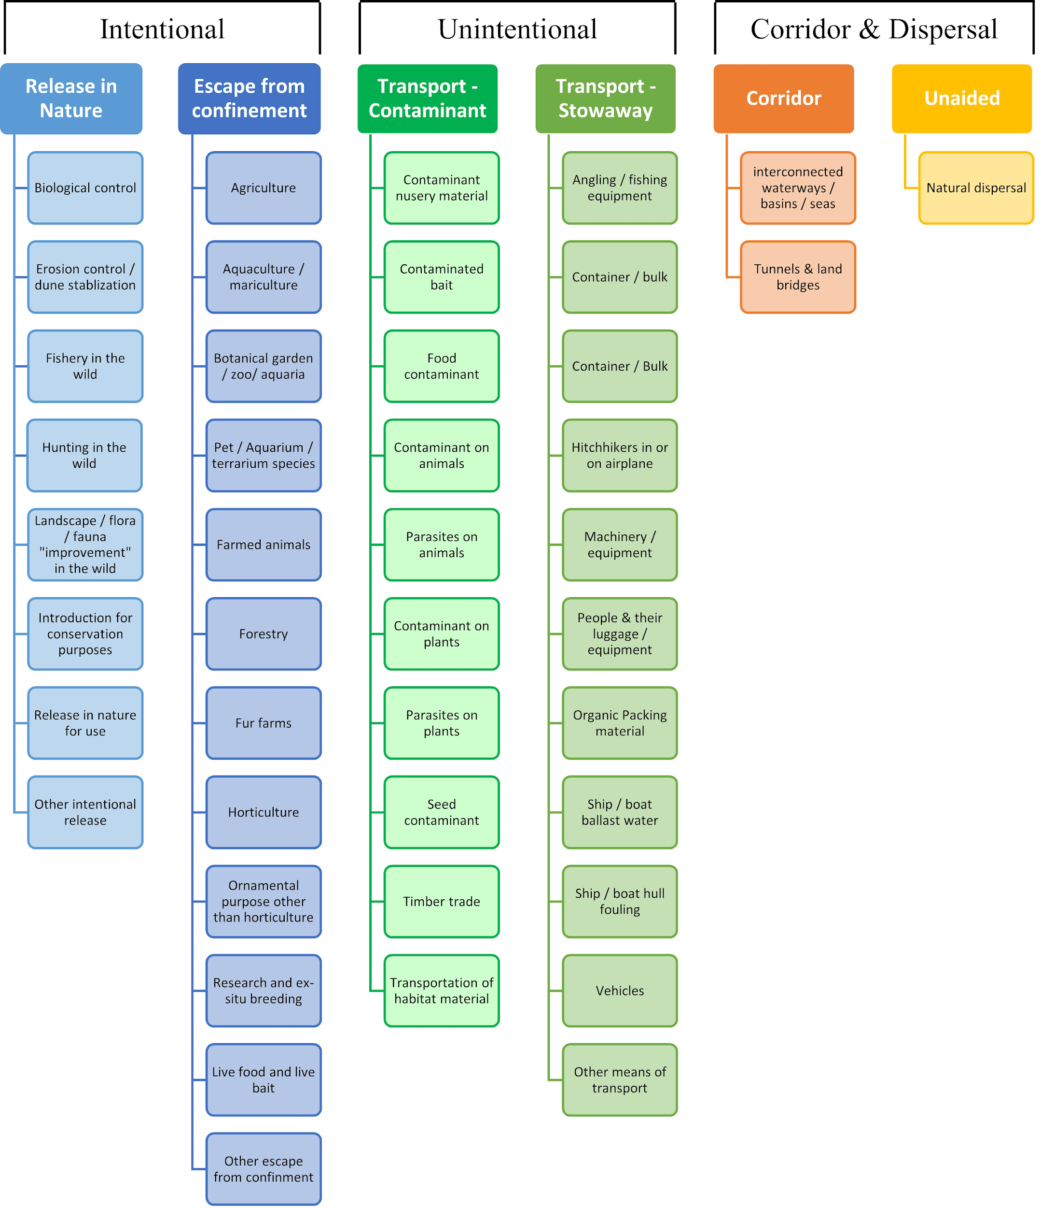

# ANNEX V Ecosystem services classification (CICES V5.1, simplified) and examples

For the purposes of this risk assessment, please feel free to use what seems as the most appropriate category / level / combination of impact (Section – Division – Group), reflecting information available.

|  |  |  |  |
| --- | --- | --- | --- |
| **Section** | **Division** | **Group** | **Examples (i.e. relevant CICES “classes”)** |
| **Provisioning** | **Biomass** | **Cultivated *terrestrial* plants** | Cultivated terrestrial plants (including fungi, algae) grown for nutritional purposes;  Fibres and other materials from cultivated plants, fungi, algae and bacteria for direct use or processing (excluding genetic materials);  Cultivated plants (including fungi, algae) grown as a source of energy  *Example: negative impacts of non-native organisms to crops, orchards, timber etc.* |
|  |  | **Cultivated *aquatic* plants** | Plants cultivated by in- situ aquaculture grown for nutritional purposes;  Fibres and other materials from in-situ aquaculture for direct use or processing (excluding genetic materials);  Plants cultivated by in- situ aquaculture grown as an energy source.  *Example: negative impacts of non-native organisms to aquatic plants cultivated for nutrition, gardening etc. purposes.* |
|  |  | **Reared animals** | Animals reared for nutritional purposes;  Fibres and other materials from reared animals for direct use or processing (excluding genetic materials);  Animals reared to provide energy (including mechanical)  *Example: negative impacts of non-native organisms to livestock* |
|  |  | **Reared *aquatic* animals** | Animals reared by in-situ aquaculture for nutritional purposes;  Fibres and other materials from animals grown by in-situ aquaculture for direct use or processing (excluding genetic materials);  Animals reared by in-situ aquaculture as an energy source  *Example: negative impacts of non-native organisms to fish farming* |
|  |  | **Wild plants** (terrestrial and aquatic) | Wild plants (terrestrial and aquatic, including fungi, algae) used for nutrition;  Fibres and other materials from wild plants for direct use or processing (excluding genetic materials);  Wild plants (terrestrial and aquatic, including fungi, algae) used as a source of energy  *Example: reduction in the availability of wild plants (e.g. wild berries, ornamentals) due to non-native organisms (competition, spread of disease etc.)* |
|  |  | **Wild animals** (terrestrial and aquatic) | Wild animals (terrestrial and aquatic) used for nutritional purposes;  Fibres and other materials from wild animals for direct use or processing (excluding genetic materials);  Wild animals (terrestrial and aquatic) used as a source of energy  *Example: reduction in the availability of wild animals (e.g. fish stocks, game) due to non-native organisms (competition, predations, spread of disease etc.)* |
|  | **Genetic material** from all biota | **Genetic material** from plants, algae or fungi | Seeds, spores and other plant materials collected for maintaining or establishing a population;  Higher and lower plants (whole organisms) used to breed new strains or varieties;  Individual genes extracted from higher and lower plants for the design and construction of new biological entities  *Example: negative impacts of non-native organisms due to interbreeding* |
|  |  | **Genetic material** from animals | Animal material collected for the purposes of maintaining or establishing a population;  Wild animals (whole organisms) used to breed new strains or varieties;  Individual genes extracted from organisms for the design and construction of new biological entities  *Example: negative impacts of non-native organisms due to interbreeding* |
|  | **Water[6]** | **Surface water** used for nutrition, materials or energy | Surface water for drinking;  Surface water used as a material (non-drinking purposes);  Freshwater surface water, coastal and marine water used as an energy source  *Example: loss of access to surface water due to spread of non-native organisms* |
|  |  | **Ground water** for used for nutrition, materials or energy | Ground (and subsurface) water for drinking;  Ground water (and subsurface) used as a material (non-drinking purposes);  Ground water (and subsurface) used as an energy source  *Example: reduced availability of ground water due to spread of non-native organisms and associated increase of ground water consumption by vegetation.* |
| **Regulation & Maintenance** | **Transformation** of biochemical or physical inputs to ecosystems | **Mediation of wastes or toxic substances** of anthropogenic origin by living processes | Bio-remediation by micro-organisms, algae, plants, and animals; Filtration/sequestration/storage/accumulation by micro-organisms, algae, plants, and animals  *Example: changes caused by non-native organisms to ecosystem functioning and ability to filtrate etc. waste or toxics* |
|  |  | **Mediation of nuisances** of anthropogenic origin | Smell reduction; noise attenuation; visual screening (e.g. by means of green infrastructure)  *Example: changes caused by non-native organisms to ecosystem structure, leading to reduced ability to mediate nuisances.* |
|  | **Regulation** of physical, chemical, biological conditions | **Baseline flows and extreme event** regulation | Control of erosion rates;  Buffering and attenuation of mass movement;  Hydrological cycle and water flow regulation (Including flood control, and coastal protection);  Wind protection;  Fire protection  *Example: changes caused by non-native organisms to ecosystem functioning or structure leading to, for example, destabilisation of soil, increased risk or intensity of wild fires etc.* |
|  |  | **Lifecycle maintenance**, habitat and gene pool protection | Pollination (or 'gamete' dispersal in a marine context);  Seed dispersal;  Maintaining nursery populations and habitats (Including gene pool protection)  *Example: changes caused by non-native organisms to the abundance and/or distribution of wild pollinators; changes to the availability / quality of nursery habitats for fisheries* |
|  |  | **Pest and disease control** | Pest control;  Disease control  *Example: changes caused by non-native organisms to the abundance and/or distribution of pests* |
|  |  | **Soil quality** regulation | Weathering processes and their effect on soil quality;  Decomposition and fixing processes and their effect on soil quality  *Example: changes caused by non-native organisms to vegetation structure and/or soil fauna leading to reduced soil quality* |
|  |  | **Water** conditions | Regulation of the chemical condition of freshwaters by living processes;  Regulation of the chemical condition of salt waters by living processes  *Example: changes caused by non-native organisms to buffer strips along water courses that remove nutrients in runoff and/or fish communities that regulate the resilience and resistance of water bodies to eutrophication* |
|  |  | **Atmospheric** composition and conditions | Regulation of chemical composition of atmosphere and oceans;  Regulation of temperature and humidity, including ventilation and transpiration  *Example: changes caused by non-native organisms to ecosystems’ ability to sequester carbon and/or evaporative cooling (e.g. by urban trees)* |
| **Cultural** | **Direct, in-situ and outdoor interactions** with living systems that depend on presence in the environmental setting | **Physical and experiential** interactions with natural environment | Characteristics of living systems that that enable activities promoting health, recuperation or enjoyment through active or immersive interactions;  Characteristics of living systems that enable activities promoting health, recuperation or enjoyment through passive or observational interactions  *Example: changes caused by non-native organisms to the qualities of ecosystems (structure, species composition etc.) that make it attractive for recreation, wild life watching etc.* |
|  |  | **Intellectual and representative** interactions with natural environment | Characteristics of living systems that enable scientific investigation or the creation of traditional ecological knowledge;  Characteristics of living systems that enable education and training;  Characteristics of living systems that are resonant in terms of culture or heritage;  Characteristics of living systems that enable aesthetic experiences  *Example: changes caused by non-native organisms to the qualities of ecosystems (structure, species composition etc.) that have cultural importance* |
|  | **Indirect, remote, often indoor interactions** with living systems that do not require presence in the environmental setting | **Spiritual, symbolic** and other interactions with natural environment | Elements of living systems that have symbolic meaning;  Elements of living systems that have sacred or religious meaning;  Elements of living systems used for entertainment or representation  *Example: changes caused by non-native organisms to the qualities of ecosystems (structure, species composition etc.) that have sacred or religious meaning* |
|  |  | Other biotic characteristics that have a **non-use value** | Characteristics or features of living systems that have an existence value;  Characteristics or features of living systems that have an option or bequest value  *Example: changes caused by non-native organisms to ecosystems designated as wilderness areas, habitats of endangered species etc.* |

# ANNEX VI EU Biogeographic Regions and MSFD Subregions

See <https://www.eea.europa.eu/data-and-maps/figures/biogeographical-regions-in-europe-2> ,

<http://ec.europa.eu/environment/nature/natura2000/biogeog_regions/>

and

https://www.eea.europa.eu/data-and-maps/data/msfd-regions-and-subregions-1/technical-document/pdf

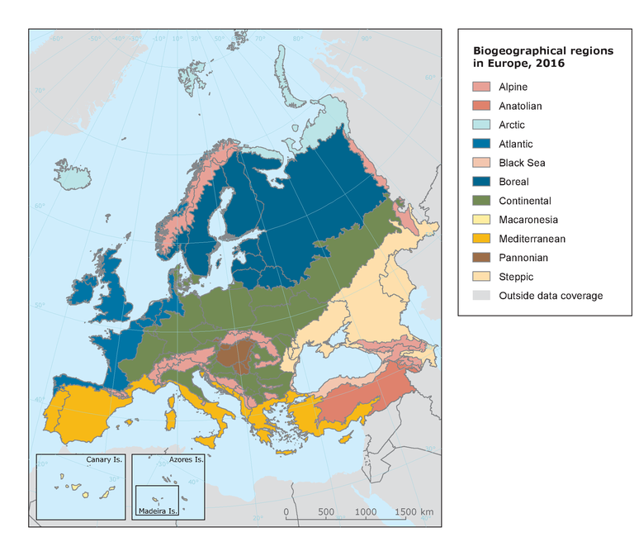 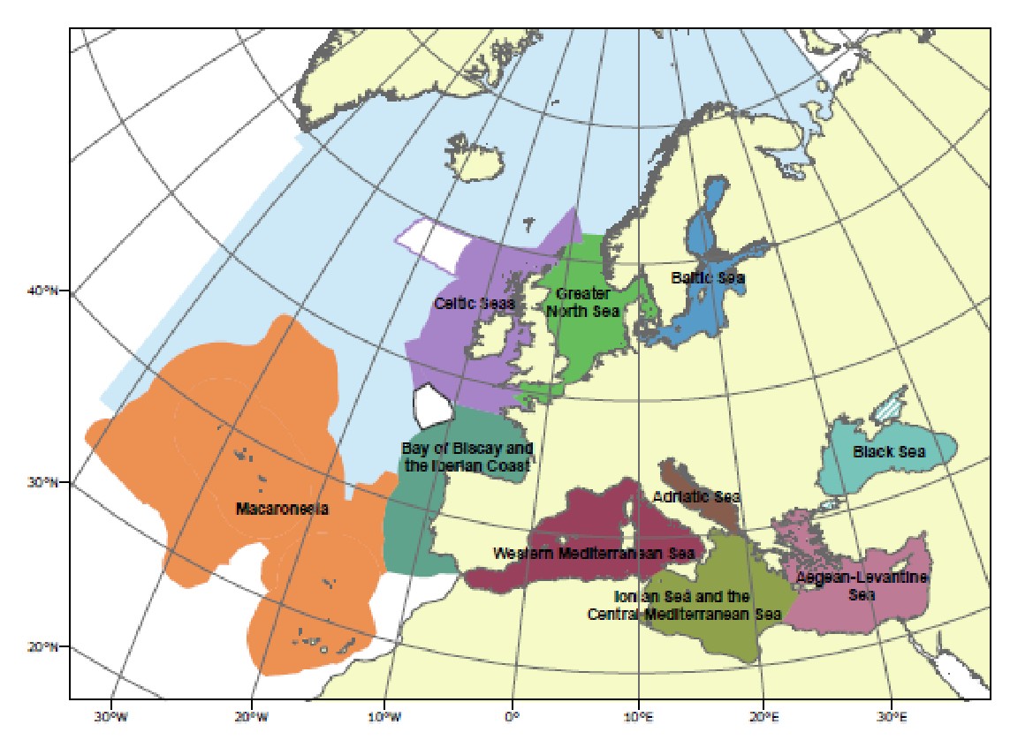

# ANNEX VII Delegated Regulation (EU) 2018/968 of 30 April 2018

see <https://eur-lex.europa.eu/legal-content/en/TXT/?uri=CELEX%3A32018R0968>

# ANNEX VIII Projection of environmental suitability for *Delairea odorata* establishment in Europe

Björn Beckmann, Helmut Kudrnovsky, Rob Tanner, Richard Shaw and Dan Chapman

15 June 2021

## Aim

To project the suitability for potential establishment of *Delairea odorata* in Europe, under current and predicted future climatic conditions.

## Data for modelling

Species occurrence data were obtained from the Global Biodiversity Information Facility (GBIF) (4253 records), iNaturalist (2214 records), the Atlas of Living Australia (1356 records), the Biodiversity Information Serving Our Nation database (BISON) (400 records), and additional records from the risk assessment team. We scrutinised occurrence records from regions where the species is not known to be established and removed any dubious records or where the georeferencing was too imprecise (e.g. records referenced to a country or island centroid) or outside of the coverage of the predictor layers (e.g. small island or coastal occurrences). We removed records dated pre-1950, as these might refer to populations no longer in existence. The remaining records were gridded at a 0.25 x 0.25 degree resolution for modelling, yielding 535 grid cells with occurrences (Figure 1a). As a proxy for recording effort, the density of Tracheophyta records held by GBIF was also compiled on the same grid (Figure 1b).

**Figure 1.** (a) Occurrence records obtained for *Delairea odorata* and used in the modelling, showing native and invaded distributions. (b) The recording density of Tracheophyta on GBIF, which was used as a proxy for recording effort.

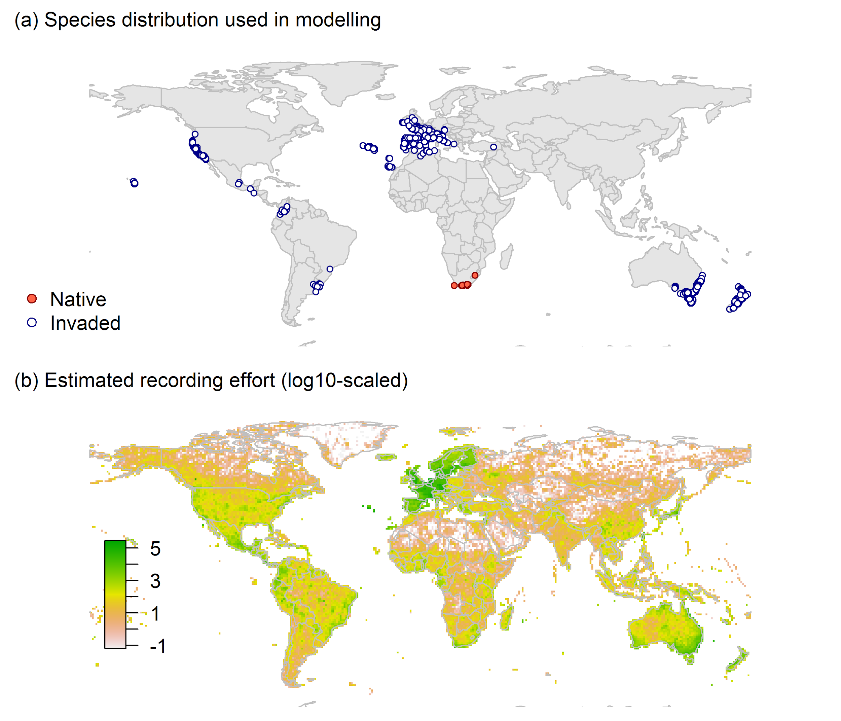

Climate data were selected from the ‘Bioclim’ variables contained within the WorldClim database (Hijmans et al., 2005), originally at 5 arcminute resolution (0.083 x 0.083 degrees of longitude/latitude) and aggregated to a 0.25 x 0.25 degree grid for use in the model.

Based on the biology of *Delairea odorata*, the following climate variables were used in the modelling:

* Minimum temperature of the coldest month (Bio6)
* Mean temperature of the warmest quarter (Bio10)
* Climatic moisture index (CMI): ratio of mean annual precipitation to potential evapotranspiration, log+1 transformed. For its calculation, monthly potential evapotranspirations were estimated from the WorldClim monthly temperature data and solar radiation using the simple method of Zomer et al. (2008) which is based on the Hargreaves evapotranspiration equation (Hargreaves, 1994).

To estimate the effect of climate change on the potential distribution, equivalent modelled future climate conditions for the 2070s under the Representative Concentration Pathways (RCP) 2.6 and 4.5 were also obtained. These represent low and medium emissions scenarios, respectively. The above variables were obtained as averages of outputs of eight Global Climate Models (BCC-CSM1-1, CCSM4, GISS-E2-R, HadGEM2-AO, IPSL-CM5A-LR, MIROC-ESM, MRI-CGCM3, NorESM1-M), downscaled and calibrated against the WorldClim baseline (see <http://www.worldclim.org/cmip5_5m> ).

The following habitat layers were also used:

* Tree cover (Tree): This was estimated from the MODerate-resolution Imaging Spectroradiometer (MODIS) satellite continuous tree cover raster product, produced by the Global Land Cover Facility (<http://glcf.umd.edu/data/vcf/>). The raw product contains the percentage cover by trees in each 0.002083 x 0.002083 degree grid cell. We aggregated this to the mean cover in our 0.25 x 0.25 degree grid cells.
* Human influence index (HII): As many non-native invasive species associate with anthropogenically disturbed habitats. We used the Global Human Influence Index Dataset of the Last of the Wild Project (Wildlife Conservation Society - WCS & Center for International Earth Science Information Network - CIESIN - Columbia University, 2005), which is developed from nine global data layers covering human population pressure (population density), human land use and infrastructure (built-up areas, nighttime lights, land use/land cover) and human access (coastlines, roads, railroads, navigable rivers). The index ranges between 0 and 1 and was ln+1 transformed for the modelling to improve normality.
* Distance to the sea (dist_to_sea): As some species require oceanic climates, we calculated distance to the sea as a proxy. Distances are in meters and were ln+1 transformed for modelling to improve normality.

## Species distribution model

A presence-background (presence-only) ensemble modelling strategy was employed using the BIOMOD2 R package version 3.4.6 (Thuiller et al., 2020, Thuiller et al., 2009). These models contrast the environment at the species’ occurrence locations against a random sample of the global background environmental conditions (often termed ‘pseudo-absences’) in order to characterise and project suitability for occurrence. This approach has been developed for distributions that are in equilibrium with the environment. Because invasive species’ distributions are not at equilibrium and subject to dispersal constraints at a global scale, we took care to minimise the inclusion of locations suitable for the species but where it has not been able to disperse to (Chapman et al. 2019). Therefore the background sampling region included:

* The area accessible by native *Delairea odorata* populations, in which the species is likely to have had sufficient time to disperse to all locations. Based on presumed maximum dispersal distances, the accessible region was defined as a 400km buffer around the native range occurrences; AND
* A 30km buffer around the non-native occurrences, encompassing regions likely to have had high propagule pressure for introduction by humans and/or dispersal of the species; AND
* Regions where we have an *a priori* expectation of high unsuitability for the species so that absence is assumed irrespective of dispersal constraints (see Figure 2). The following rules were applied to define a region expected to be highly unsuitable for *Delairea odorata* at the spatial scale of the model:
  + Minimum temperature of the coldest month (Bio6) < -7.5°C
  + Mean temperature of the warmest quarter (Bio10) < 11°C
  + Climatic moisture index (CMI) < 0.20

Altogether, only 0.9% of occurrence grid cells were located in the unsuitable background region.

Within the unsuitable background region, 10 samples of 5000 randomly sampled grid cells were obtained. In the accessible background (comprising the accessible areas around native and non-native occurrences as detailed above), the same number of pseudo-absence samples were drawn as there were presence records (535), weighting the sampling by a proxy for recording effort (Figure 2).

**Figure 2.** The background from which pseudo-absence samples were taken in the modelling of *Delairea odorata*. Samples were taken from a 400km buffer around the native range and a 30km buffer around non-native occurrences (together forming the accessible background), and from areas expected to be highly unsuitable for the species (the unsuitable background region). Samples from the accessible background were weighted by a proxy for recording effort (Figure 1(b)).

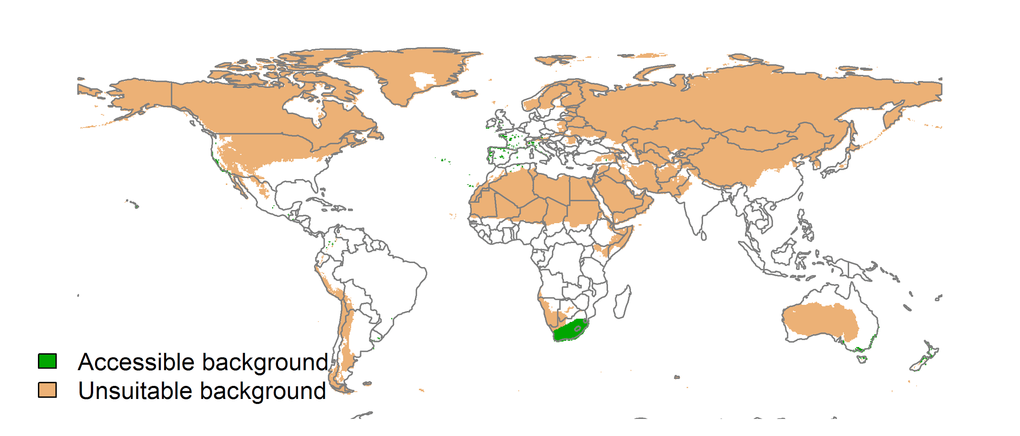

Each dataset (i.e. combination of the presences and the individual background samples) was randomly split into 80% for model training and 20% for model evaluation. With each training dataset, seven statistical algorithms were fitted with the default BIOMOD2 settings and rescaled using logistic regression, except where specified below:

* Generalised linear model (GLM)
* Generalised boosting model (GBM)
* Generalised additive model (GAM) with a maximum of four degrees of freedom per smoothing spline
* Artificial neural network (ANN)
* Multivariate adaptive regression splines (MARS)
* Random forest (RF)
* Maxent

Since the total background sample was larger than the number of occurrences, prevalence fitting weights were applied to give equal overall importance to the occurrences and the background. Normalised variable importance was assessed and variable response functions were produced using BIOMOD2’s default procedure.

Model predictive performance was assessed by the following three measures:

* AUC, the area under the receiver operating characteristic curve (Fielding & Bell 1997). Predictions of presence-absence models can be compared with a subset of records set aside for model evaluation (here 20%) by constructing a confusion matrix with the number of true positive, false positive, false negative and true negative cases. For models generating non-dichotomous scores (as here) a threshold can be applied to transform the scores into a dichotomous set of presence-absence predictions. Two measures that can be derived from the confusion matrix are sensitivity (the proportion of observed presences that are predicted as such, quantifying omission errors), and specificity (the proportion of observed absences that are predicted as such, quantifying commission errors). A receiver operating characteristic (ROC) curve can be constructed by using all possible thresholds to classify the scores into confusion matrices, obtaining sensitivity and specificity for each matrix, and plotting sensitivity against the corresponding proportion of false positives (equal to 1 - specificity). The use of all possible thresholds avoids the need for a selection of a single threshold, which is often arbitrary, and allows appreciation of the trade-off between sensitivity and specificity. The area under the ROC curve (AUC) is often used as a single threshold-independent measure for model performance (Manel, Williams & Ormerod 2001). AUC is the probability that a randomly selected presence has a higher model-predicted suitability than a randomly selected absence (Allouche et al. 2006).
* Cohen’s Kappa (Cohen 1960). This measure corrects the overall accuracy of model predictions (ratio of the sum of true presences plus true absences to the total number of records) by the accuracy expected to occur by chance. The kappa statistic ranges from -1 to +1, where +1 indicates perfect agreement and values of zero or less indicate a performance no better than random. Advantages of kappa are its simplicity, the fact that both commission and omission errors are accounted for in one parameter, and its relative tolerance to zero values in the confusion matrix (Manel, Williams & Ormerod 2001). However, Kappa has been criticised for being sensitive to prevalence (the proportion of sites in which the species was recorded as present) and may therefore be inappropriate for comparisons of model accuracy between species or regions (McPherson, Jetz & Rogers 2004, Allouche et al. 2006).
* TSS, the true skill statistic (Allouche et al. 2006). TSS is defined as sensitivity + specificity - 1, and corrects for Kappa’s dependency on prevalence. TSS compares the number of correct forecasts, minus those attributable to random guessing, to that of a hypothetical set of perfect forecasts. Like kappa, TSS takes into account both omission and commission errors, and success as a result of random guessing, and ranges from -1 to +1, where +1 indicates perfect agreement and values of zero or less indicate a performance no better than random (Allouche et al. 2006).

An ensemble model was created by first rejecting poorly performing algorithms with relatively extreme low AUC values and then averaging the predictions of the remaining algorithms, weighted by their AUC. To identify poorly performing algorithms, AUC values were converted into modified z-scores based on their difference to the median and the median absolute deviation across all algorithms (Iglewicz & Hoaglin 1993). Algorithms with z < -2 were rejected. In this way, ensemble projections were made for each dataset and then averaged to give an overall suitability, as well as its standard deviation.

Projections were classified into suitable and unsuitable regions using a “lowest presence threshold” (Pearson et al. 2007), setting the cut-off as the lowest value at which 98% of all presence records are classified correctly under the current climate (here 0.61). In order to express the sensitivity of classifications to the choice of this threshold, thresholds at which 95% and 99% of records are classified correctly (here 0.77 and 0.36 respectively) were used in the calculation of error bars in Figs. 9 and 10 below in addition to taking account of uncertainty in the projections themselves.

We also produced a limiting factor map for Europe following Elith et al. (2010). For this, projections were made separately with each individual variable fixed at a near-optimal value. These were chosen as the median values at the occurrence grid cells. Then, the most strongly limiting factors were identified as the ones resulting in the highest increase in suitability in each grid cell.

##### Page Break

## Results

The ensemble model suggested that suitability for *Delairea odorata* was most strongly determined by Minimum temperature of the coldest month (Bio6), accounting for 50.9% of variation explained, followed by Human influence index (HII) (24.1%), Mean temperature of the warmest quarter (Bio10) (9.9%), Distance to the sea (dist_to_sea) (8.6%), Climatic moisture index (CMI) (6%) and Global tree cover (Tree) (0.5%) (Table 1, Figure 3).

**Table 1.** Summary of the cross-validation predictive performance (AUC, Kappa, TSS) and variable importance of the fitted model algorithms and the ensemble (AUC-weighted average of the best performing algorithms). Results are the average from models fitted to 10 different background samples of the data.

|  |  |  |  |  |  |  |  |  |  |  |
| --- | --- | --- | --- | --- | --- | --- | --- | --- | --- | --- |
|  |  |  |  |  | **Variable importance (%)** | | | | | |
| **Algorithm** | **AUC** | **Kappa** | **TSS** | **Used in the ensemble** | **Minimum temperature of the coldest month (Bio6)** | **Human influence index (HII)** | **Mean temperature of the warmest quarter (Bio10)** | **Distance to the sea (dist_to_sea)** | **Climatic moisture index (CMI)** | **Global tree cover (Tree)** |
| GLM | 0.962 | 0.644 | 0.895 | yes | 56 | 22 | 15 | 3 | 4 | 0 |
| GAM | 0.962 | 0.640 | 0.895 | yes | 47 | 27 | 9 | 15 | 2 | 0 |
| GBM | 0.959 | 0.643 | 0.893 | no | 51 | 3 | 13 | 12 | 21 | 0 |
| ANN | 0.963 | 0.651 | 0.897 | yes | 53 | 24 | 11 | 4 | 7 | 2 |
| MARS | 0.963 | 0.653 | 0.896 | yes | 48 | 23 | 5 | 12 | 11 | 0 |
| RF | 0.942 | 0.611 | 0.882 | no | 61 | 7 | 4 | 8 | 16 | 3 |
| Maxent | 0.954 | 0.638 | 0.885 | no | 36 | 13 | 13 | 11 | 23 | 4 |
| **Ensemble** | **0.963** | **0.652** | **0.897** |  | **51** | **24** | **10** | **9** | **6** | **1** |

**Figure 3.** Partial response plots from the fitted models. Thin coloured lines show responses from the algorithms in the ensemble, while the thick black line is their ensemble. In each plot, other model variables are held at their median value in the training data. Some of the divergence among algorithms is because of their different treatment of interactions among variables.

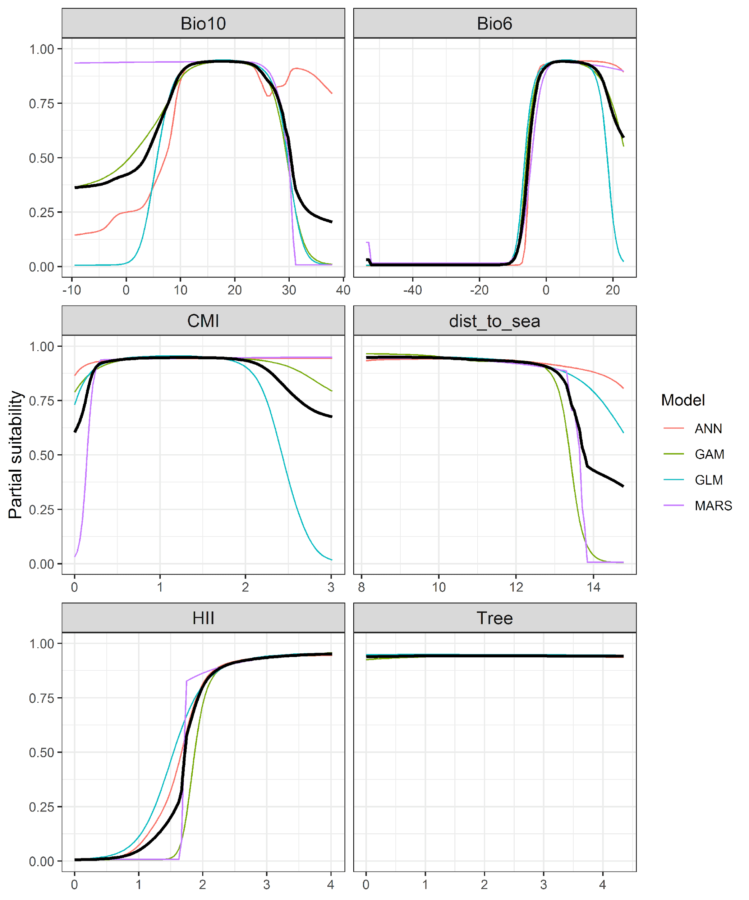

**Figure 4.** (a) Projected global suitability for *Delairea odorata* establishment in the current climate. For visualisation, the projection has been aggregated to a 0.5 x 0.5 degree resolution, by taking the maximum suitability of constituent higher resolution grid cells. Values > 0.61 are suitable for the species, with 98% of global presence records above this threshold. Values below 0.61 indicate lower relative suitability. (b) Uncertainty in the ensemble projections, expressed as the among-algorithm standard deviation in predicted suitability, averaged across the 10 datasets.

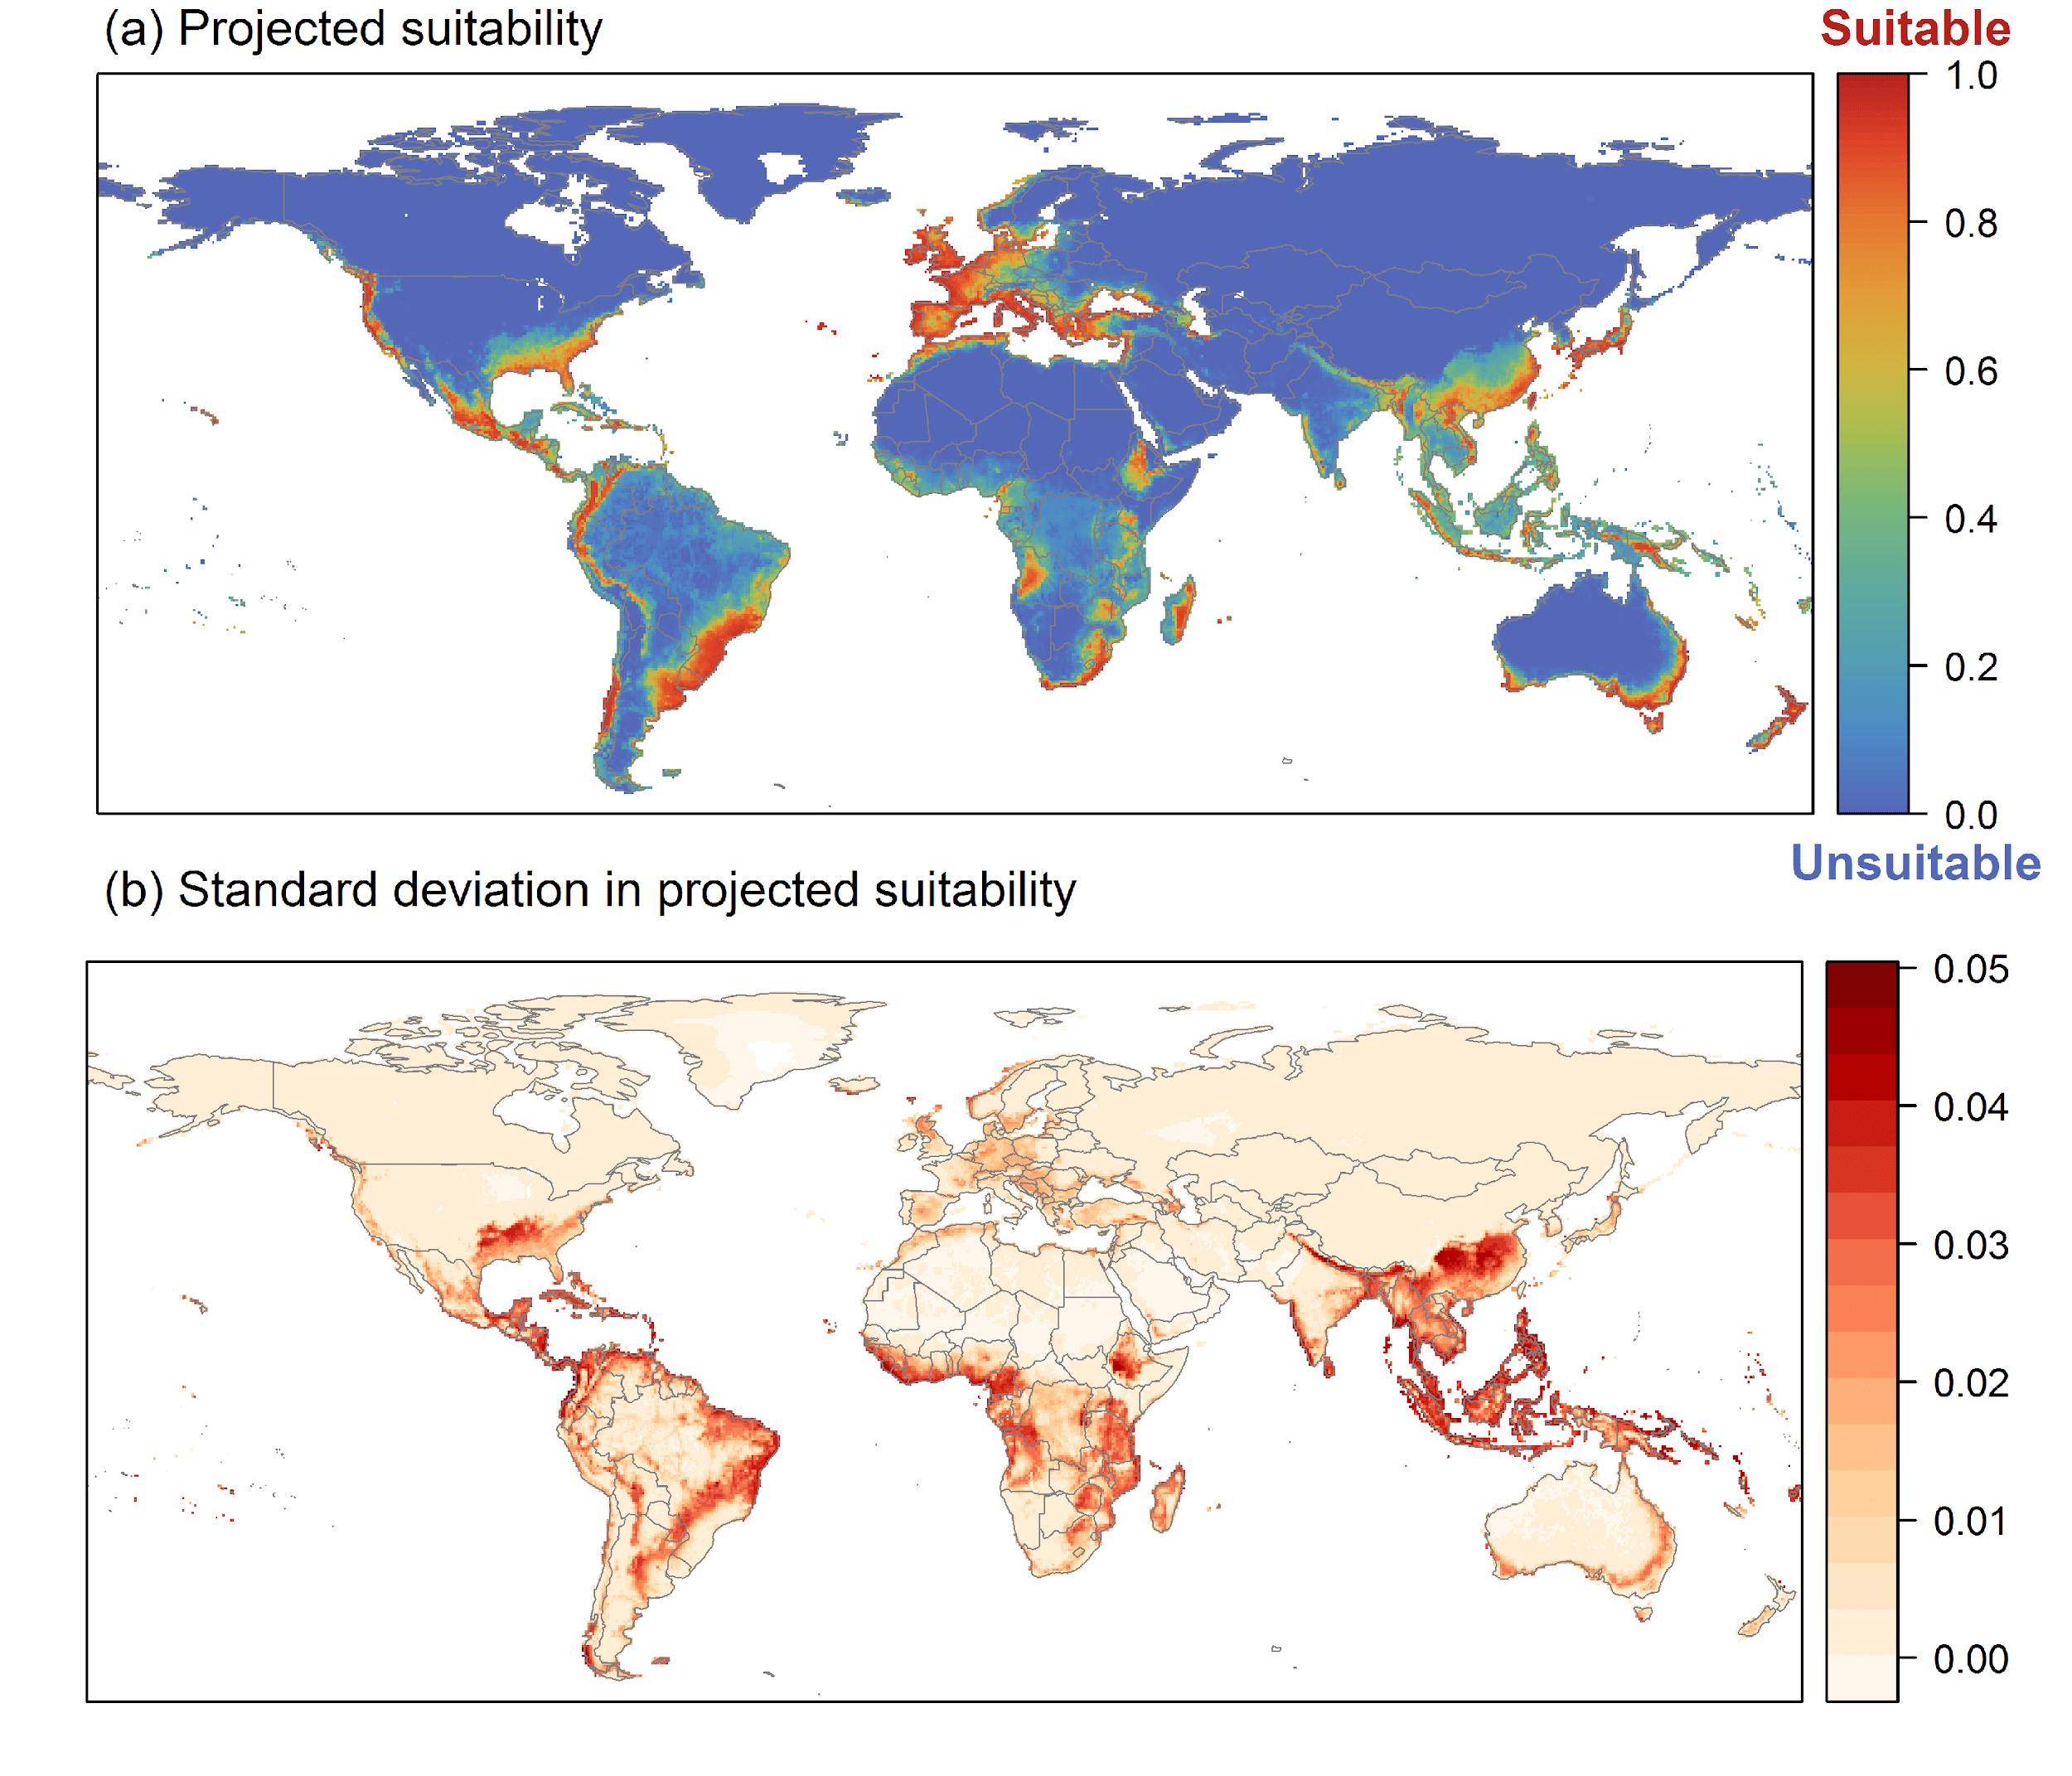

**Figure 5.** (a) Projected current suitability for *Delairea odorata* establishment in Europe and the Mediterranean region. Values > 0.61 are suitable for the species, with 98% of global presence records above this threshold. Values below 0.61 indicate lower relative suitability. (b) Uncertainty in the ensemble projections, expressed as the among-algorithm standard deviation in predicted suitability, averaged across the 10 datasets.

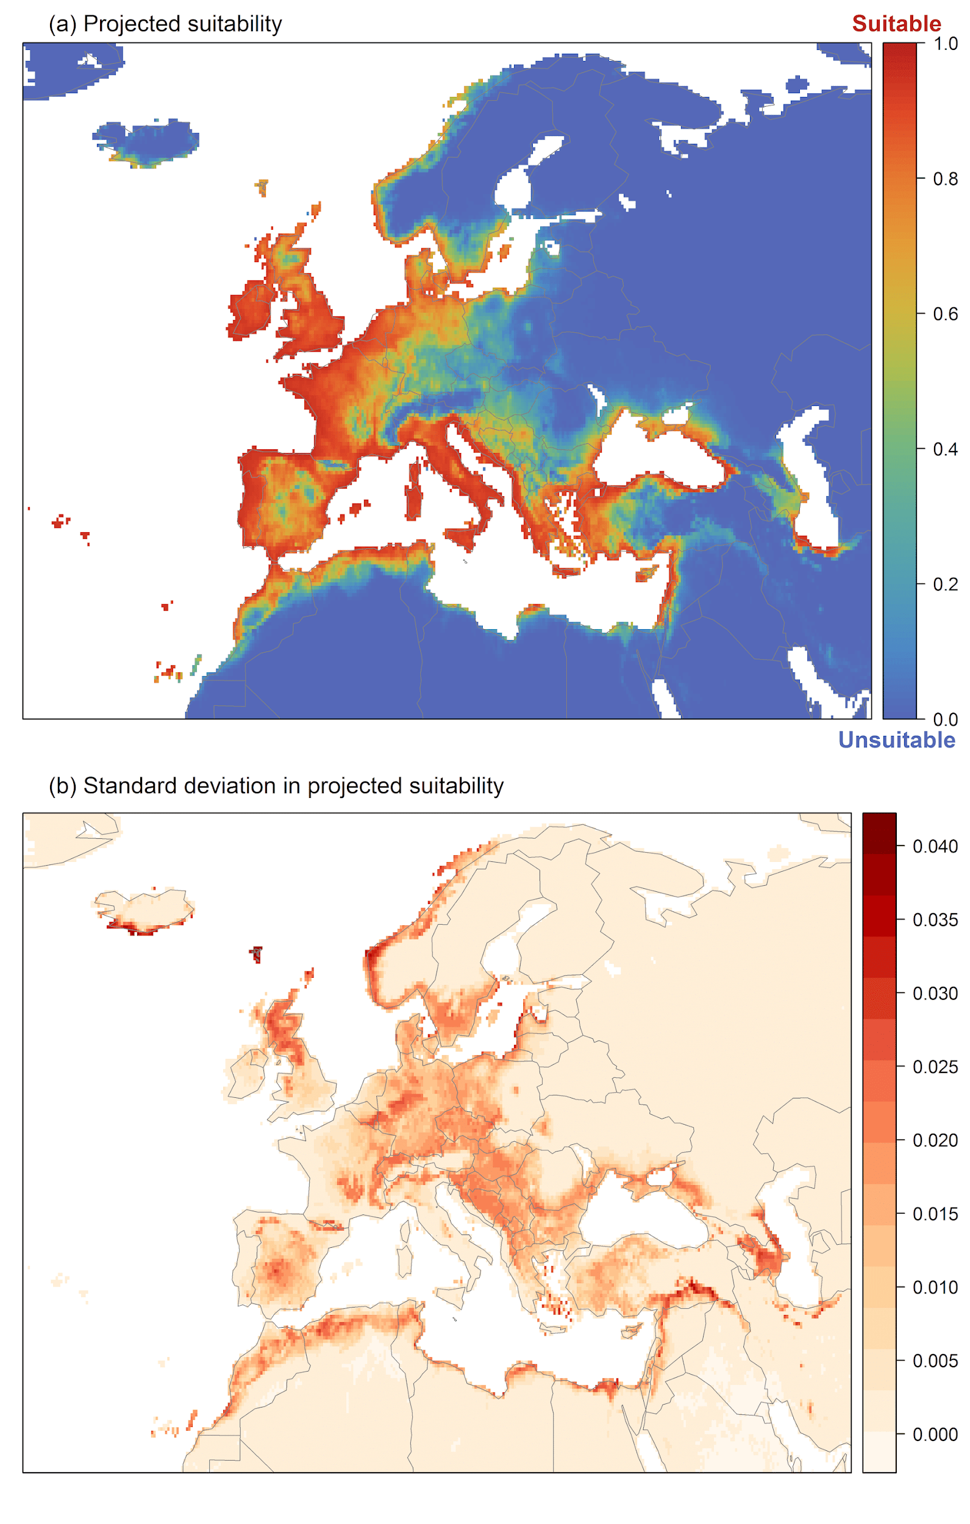

**Figure 6.** The most strongly limiting factors for *Delairea odorata* establishment estimated by the model in Europe and the Mediterranean region in current climatic conditions.

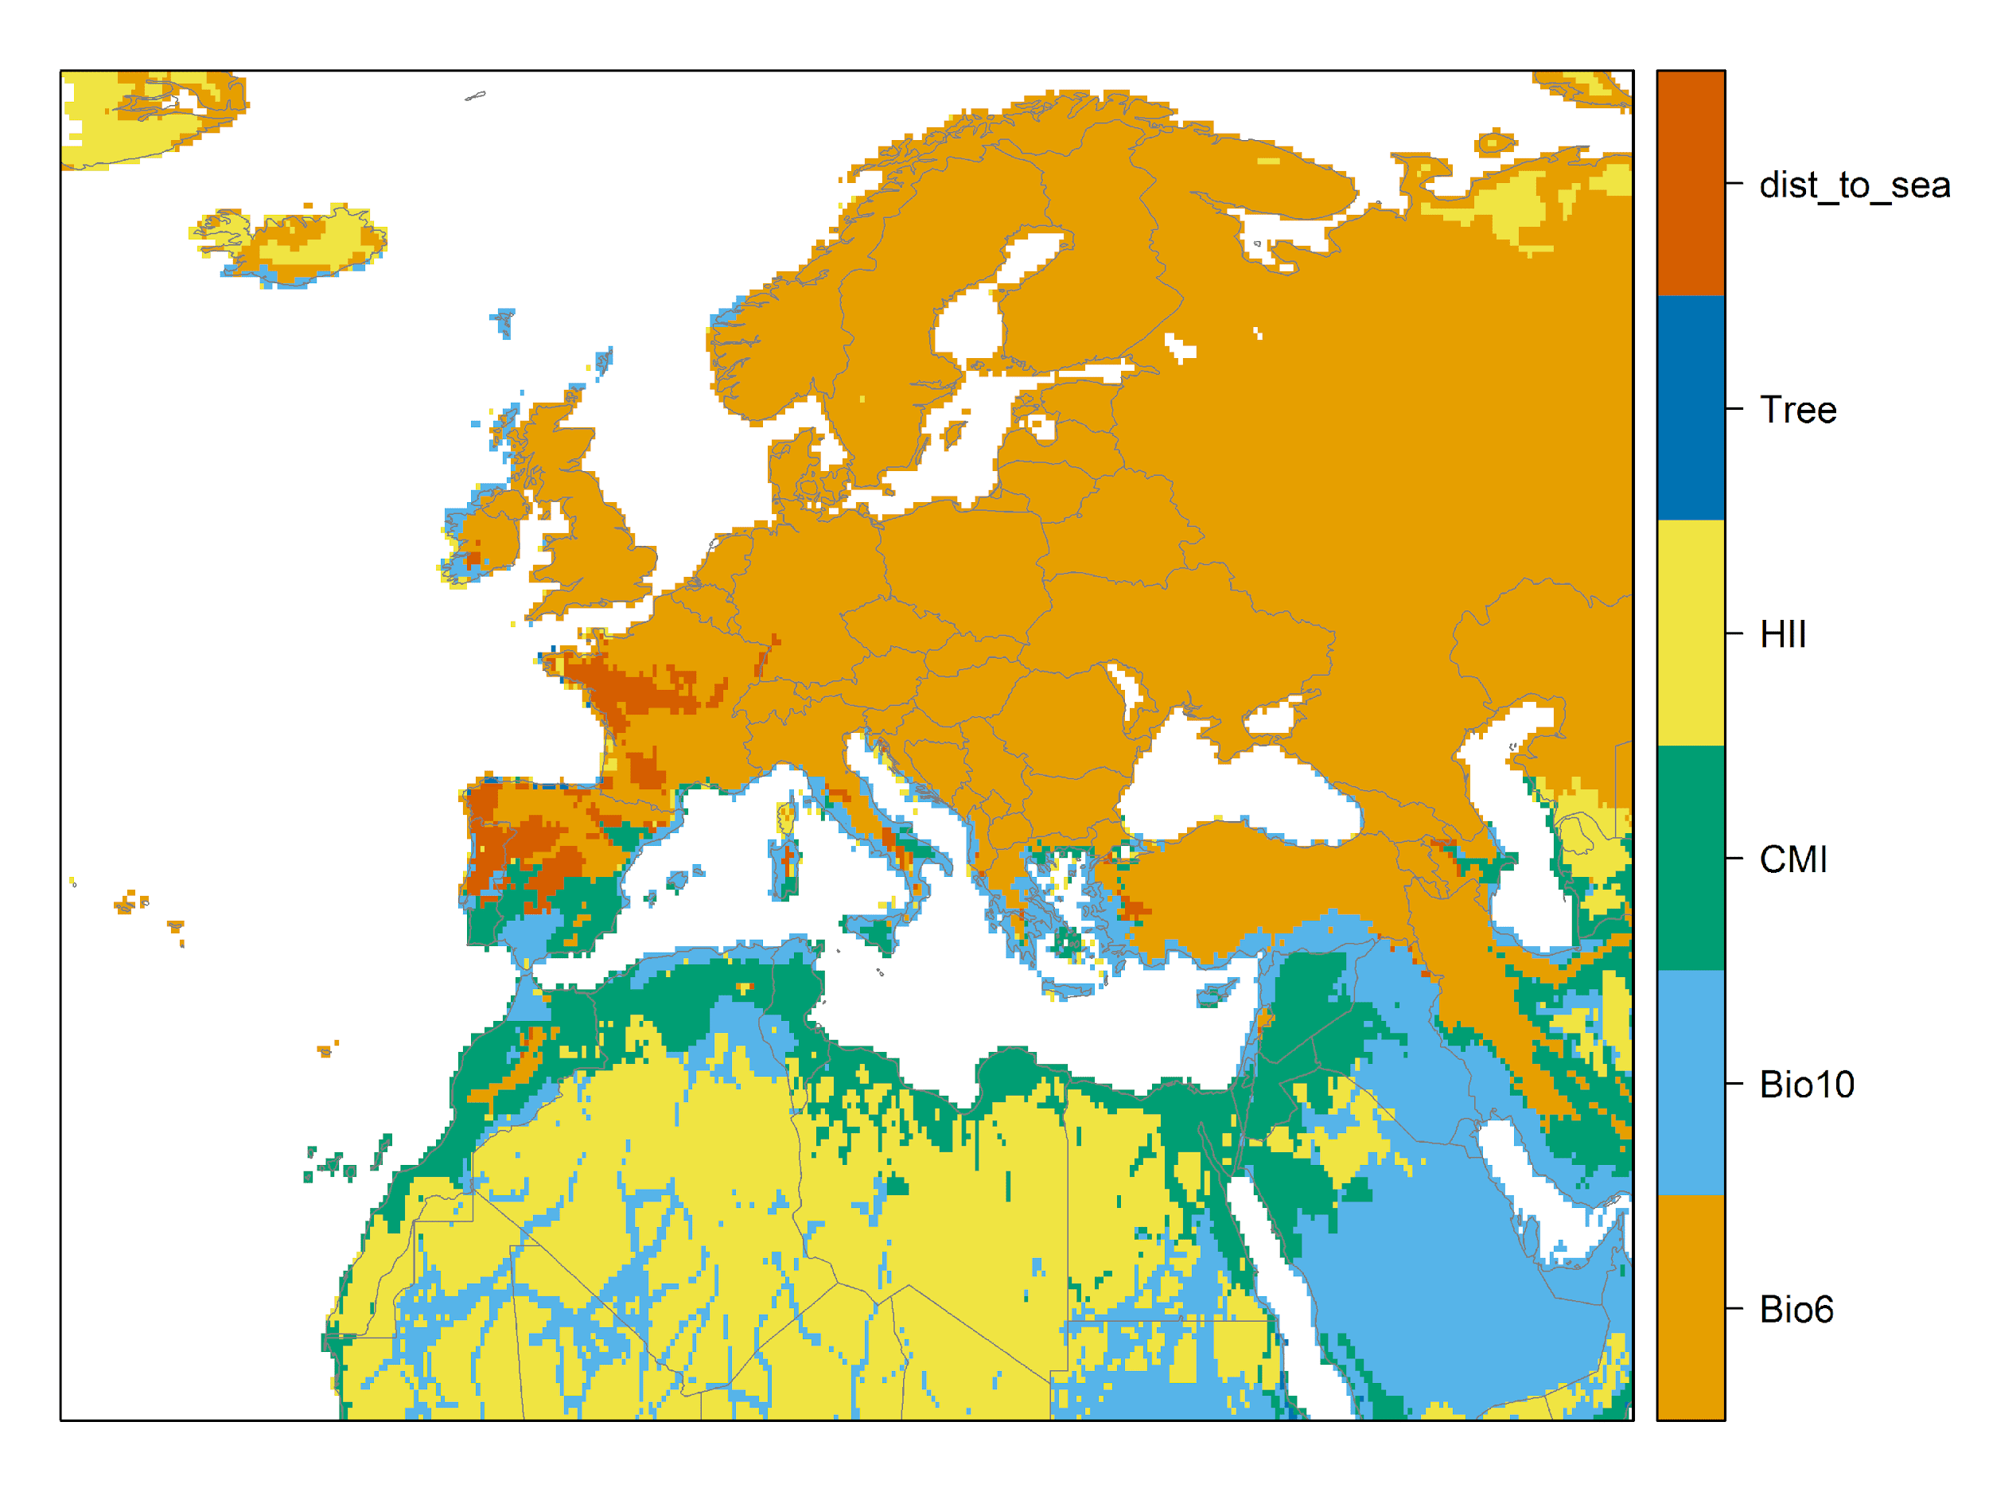

**Figure 7.** (a) Projected suitability for *Delairea odorata* establishment in Europe and the Mediterranean region in the 2070s under climate change scenario RCP2.6. Values > 0.61 are suitable for the species, with 98% of global presence records above this threshold under current climate. Values below 0.61 indicate lower relative suitability. (b) Uncertainty in the ensemble projections, expressed as the among-algorithm standard deviation in predicted suitability, averaged across the 10 datasets.

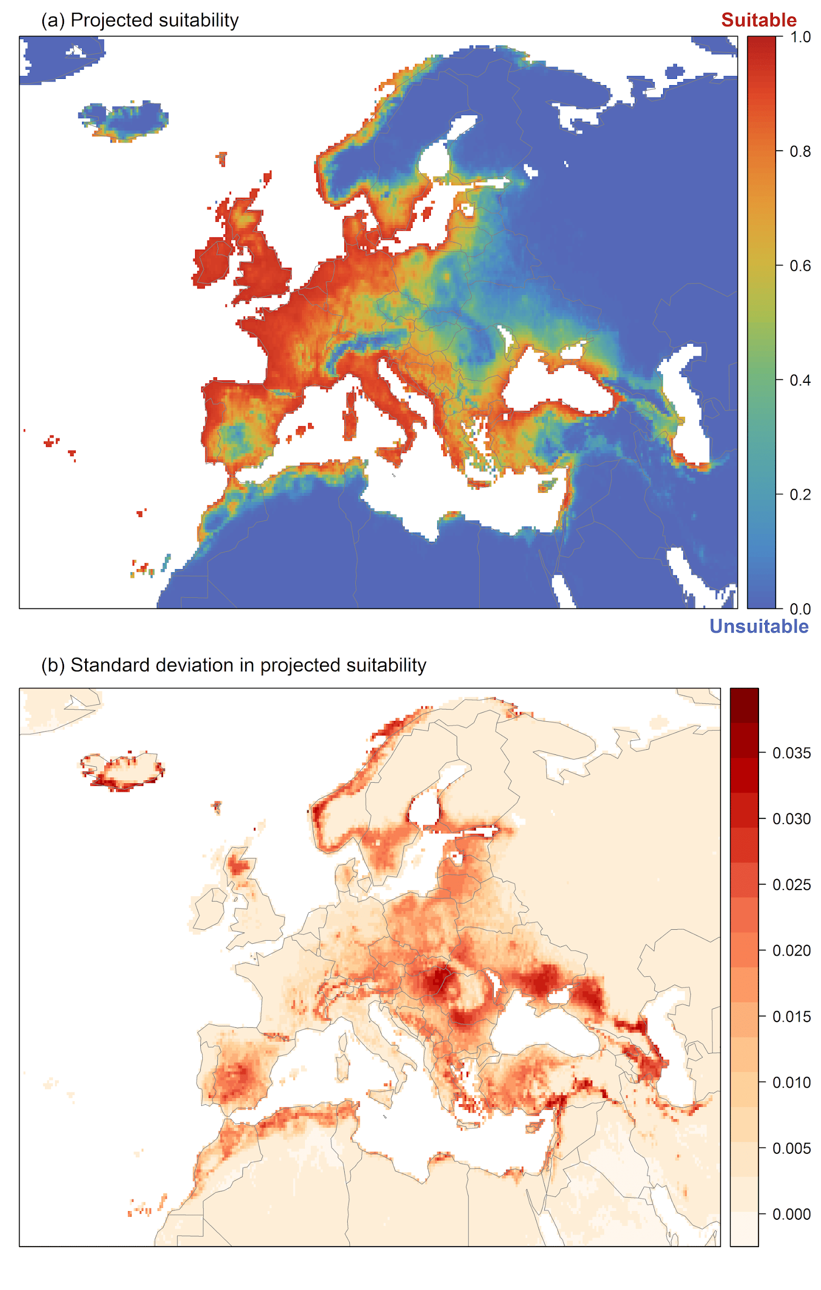

**Figure 8.** (a) Projected suitability for *Delairea odorata* establishment in Europe and the Mediterranean region in the 2070s under climate change scenario RCP4.5. Values > 0.61 are suitable for the species, with 98% of global presence records above this threshold under current climate. Values below 0.61 indicate lower relative suitability. (b) Uncertainty in the ensemble projections, expressed as the among-algorithm standard deviation in predicted suitability, averaged across the 10 datasets.

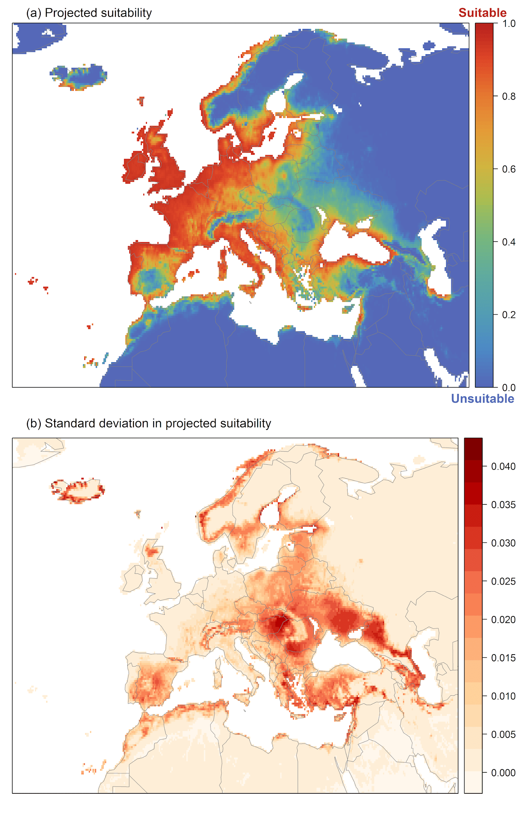

**Figure 9.** Variation in projected suitability for *Delairea odorata* establishment among Biogeographical Regions of Europe (<https://www.eea.europa.eu/data-and-maps/data/biogeographical-regions-europe-3>). The bar plots show the proportion of grid cells in each region classified as suitable (with values > 0.61) in the current climate and projected climate for the 2070s under two RCP emissions scenarios. Error bars indicate uncertainty due to both the choice of classification threshold (cf. p.5/6) and uncertainty in the projections themselves (cf. part (b) of Figs. 5,7,8). The location of each region is also shown. The Arctic and Macaronesian regions are not part of the study area, but are included for completeness.

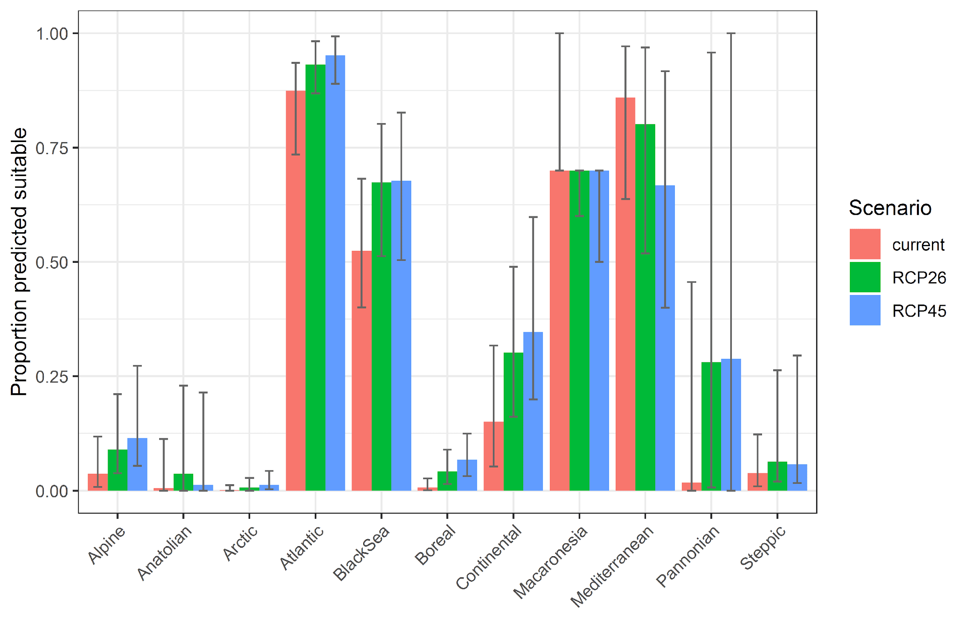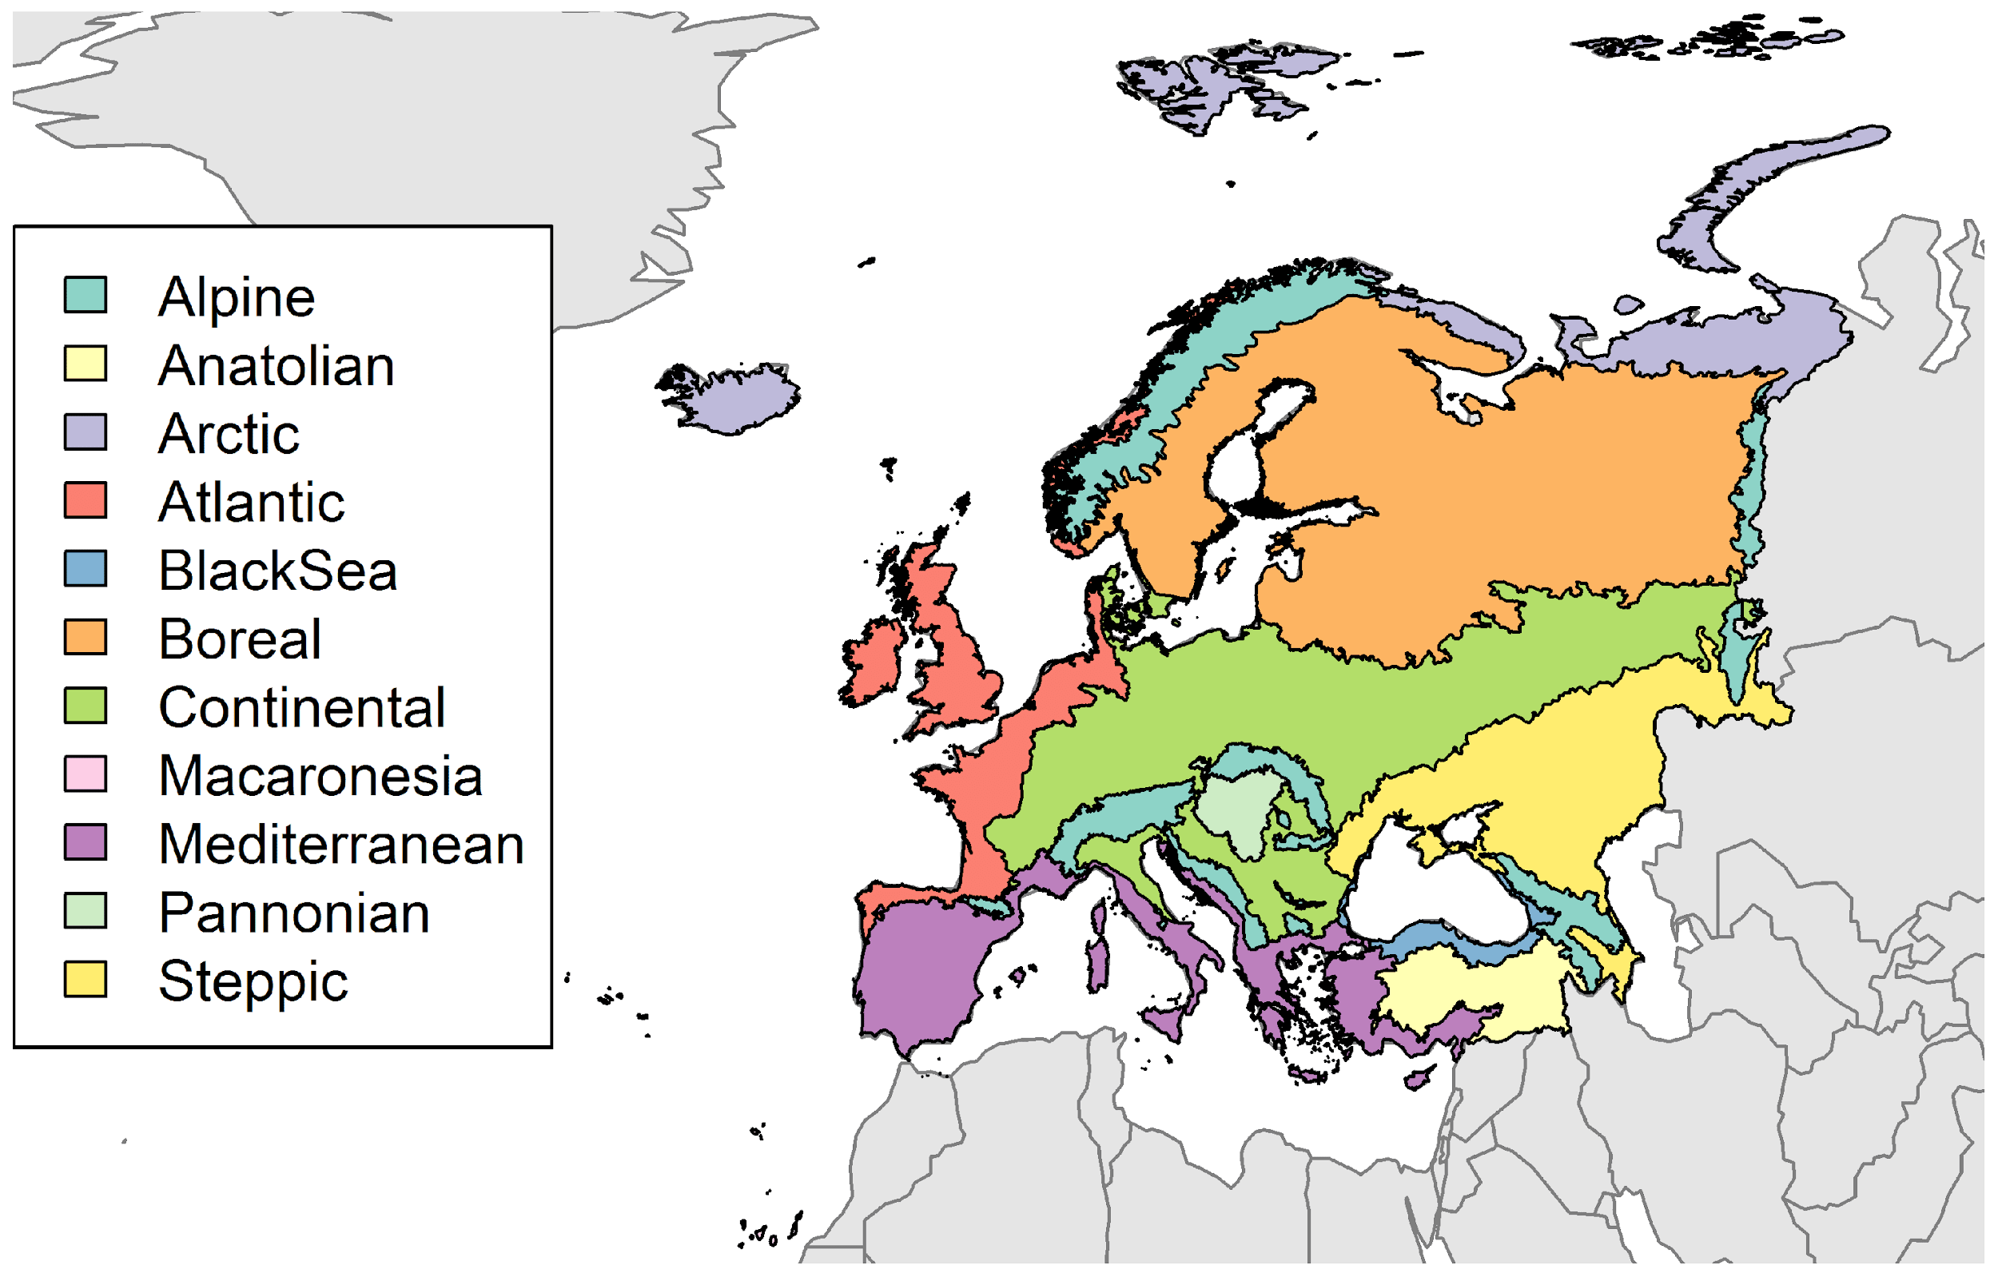

**Table 2.** Variation in projected suitability for *Delairea odorata* establishment among Biogeographical regions of Europe (numerical values of Figure 9 above). The numbers are the proportion of grid cells in each region classified as suitable in the current climate and projected climate for the 2070s under two RCP emissions scenarios. The Arctic and Macaronesian biogeographical regions are not part of the study area, but are included for completeness.

|  |  |  |  |  |  |  |  |  |  |
| --- | --- | --- | --- | --- | --- | --- | --- | --- | --- |
|  | **current climate** | | | **2070s RCP2.6** | | | **2070s RCP4.5** | | |
|  | lower | **central estimate** | upper | lower | **central estimate** | upper | lower | **central estimate** | upper |
| Alpine | 0.01 | 0.04 | 0.12 | 0.04 | 0.09 | 0.21 | 0.05 | 0.12 | 0.27 |
| Anatolian | 0.00 | 0.01 | 0.11 | 0.00 | 0.04 | 0.23 | 0.00 | 0.01 | 0.21 |
| Arctic | 0.00 | 0.00 | 0.01 | 0.00 | 0.01 | 0.03 | 0.00 | 0.01 | 0.04 |
| Atlantic | 0.73 | 0.87 | 0.94 | 0.87 | 0.93 | 0.98 | 0.89 | 0.95 | 0.99 |
| Black Sea | 0.40 | 0.52 | 0.68 | 0.51 | 0.67 | 0.80 | 0.50 | 0.68 | 0.83 |
| Boreal | 0.00 | 0.01 | 0.03 | 0.01 | 0.04 | 0.09 | 0.03 | 0.07 | 0.12 |
| Continental | 0.05 | 0.15 | 0.32 | 0.16 | 0.30 | 0.49 | 0.20 | 0.35 | 0.60 |
| Macaronesia | 0.70 | 0.70 | 1.00 | 0.60 | 0.70 | 0.70 | 0.50 | 0.70 | 0.70 |
| Mediterranean | 0.64 | 0.86 | 0.97 | 0.52 | 0.80 | 0.97 | 0.40 | 0.67 | 0.92 |
| Pannonian | 0.00 | 0.02 | 0.46 | 0.01 | 0.28 | 0.96 | 0.00 | 0.29 | 1.00 |
| Steppic | 0.01 | 0.04 | 0.12 | 0.02 | 0.06 | 0.26 | 0.02 | 0.06 | 0.30 |

**Figure 10.** Variation in projected suitability for *Delairea odorata* establishment among European Union countries and the UK. The bar plots show the proportion of grid cells in each country classified as suitable (with values > 0.61) in the current climate and projected climate for the 2070s under two RCP emissions scenarios. Error bars indicate uncertainty due to both the choice of classification threshold (cf. p.5/6) and uncertainty in the projections themselves (cf. part (b) of Figs. 5,7,8). Malta has been excluded because the Human Influence Index dataset lacks coverage for Malta.

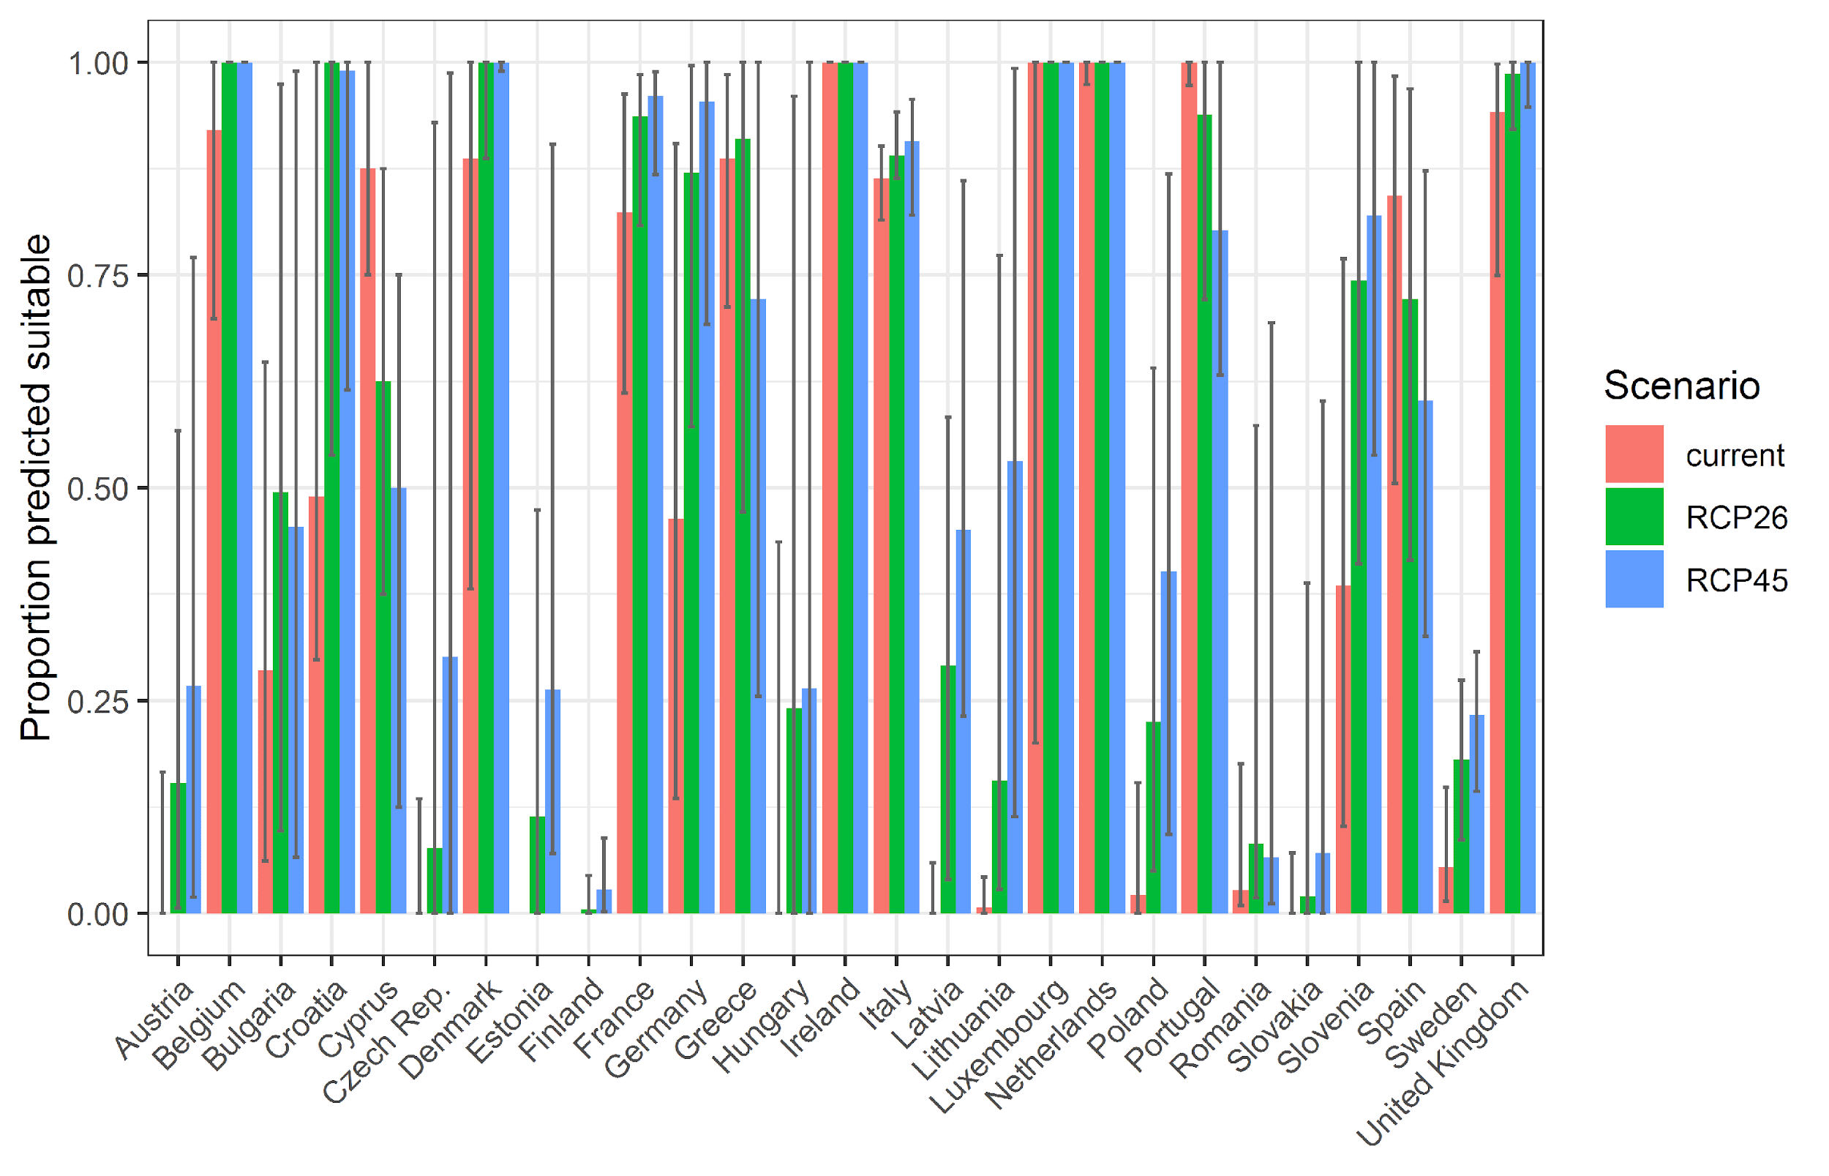

**Table 3.** Variation in projected suitability for *Delairea odorata* establishment among European Union countries and the UK (numerical values of Figure 10 above). The numbers are the proportion of grid cells in each country classified as suitable in the current climate and projected climate for the 2070s under two RCP emissions scenarios.

|  |  |  |  |  |  |  |  |  |  |
| --- | --- | --- | --- | --- | --- | --- | --- | --- | --- |
|  | **current climate** | | | **2070s RCP2.6** | | | **2070s RCP4.5** | | |
|  | lower | **central estimate** | upper | lower | **central estimate** | upper | lower | **central estimate** | upper |
| Austria | 0.00 | 0.00 | 0.17 | 0.01 | 0.15 | 0.57 | 0.02 | 0.27 | 0.77 |
| Belgium | 0.70 | 0.92 | 1.00 | 1.00 | 1.00 | 1.00 | 1.00 | 1.00 | 1.00 |
| Bulgaria | 0.06 | 0.29 | 0.65 | 0.10 | 0.49 | 0.97 | 0.07 | 0.45 | 0.99 |
| Croatia | 0.30 | 0.49 | 1.00 | 0.54 | 1.00 | 1.00 | 0.62 | 0.99 | 1.00 |
| Cyprus | 0.75 | 0.88 | 1.00 | 0.38 | 0.62 | 0.88 | 0.12 | 0.50 | 0.75 |
| Czech Rep. | 0.00 | 0.00 | 0.13 | 0.00 | 0.08 | 0.93 | 0.00 | 0.30 | 0.99 |
| Denmark | 0.38 | 0.89 | 1.00 | 0.89 | 1.00 | 1.00 | 0.99 | 1.00 | 1.00 |
| Estonia | 0.00 | 0.00 | 0.00 | 0.00 | 0.11 | 0.47 | 0.07 | 0.26 | 0.90 |
| Finland | 0.00 | 0.00 | 0.00 | 0.00 | 0.01 | 0.04 | 0.00 | 0.03 | 0.09 |
| France | 0.61 | 0.82 | 0.96 | 0.81 | 0.94 | 0.99 | 0.87 | 0.96 | 0.99 |
| Germany | 0.14 | 0.46 | 0.90 | 0.57 | 0.87 | 1.00 | 0.69 | 0.95 | 1.00 |
| Greece | 0.71 | 0.89 | 0.99 | 0.47 | 0.91 | 1.00 | 0.25 | 0.72 | 1.00 |
| Hungary | 0.00 | 0.00 | 0.44 | 0.00 | 0.24 | 0.96 | 0.00 | 0.26 | 1.00 |
| Ireland | 1.00 | 1.00 | 1.00 | 1.00 | 1.00 | 1.00 | 1.00 | 1.00 | 1.00 |
| Italy | 0.81 | 0.86 | 0.90 | 0.86 | 0.89 | 0.94 | 0.82 | 0.91 | 0.96 |
| Latvia | 0.00 | 0.00 | 0.06 | 0.04 | 0.29 | 0.58 | 0.23 | 0.45 | 0.86 |
| Lithuania | 0.00 | 0.01 | 0.04 | 0.03 | 0.16 | 0.77 | 0.11 | 0.53 | 0.99 |
| Luxembourg | 0.20 | 1.00 | 1.00 | 1.00 | 1.00 | 1.00 | 1.00 | 1.00 | 1.00 |
| Netherlands | 0.97 | 1.00 | 1.00 | 1.00 | 1.00 | 1.00 | 1.00 | 1.00 | 1.00 |
| Poland | 0.00 | 0.02 | 0.15 | 0.05 | 0.23 | 0.64 | 0.09 | 0.40 | 0.87 |
| Portugal | 0.97 | 1.00 | 1.00 | 0.72 | 0.94 | 1.00 | 0.63 | 0.80 | 1.00 |
| Romania | 0.01 | 0.03 | 0.18 | 0.02 | 0.08 | 0.57 | 0.01 | 0.07 | 0.69 |
| Slovakia | 0.00 | 0.00 | 0.07 | 0.00 | 0.02 | 0.39 | 0.00 | 0.07 | 0.60 |
| Slovenia | 0.10 | 0.38 | 0.77 | 0.41 | 0.74 | 1.00 | 0.54 | 0.82 | 1.00 |
| Spain | 0.51 | 0.84 | 0.98 | 0.41 | 0.72 | 0.97 | 0.33 | 0.60 | 0.87 |
| Sweden | 0.01 | 0.05 | 0.15 | 0.09 | 0.18 | 0.27 | 0.14 | 0.23 | 0.31 |
| UK | 0.75 | 0.94 | 1.00 | 0.92 | 0.99 | 1.00 | 0.95 | 1.00 | 1.00 |

## Caveats to the modelling

To remove spatial recording biases, the selection of the background sample from the accessible background was weighted by the density of Tracheophyta records on the Global Biodiversity Information Facility (GBIF). While this is preferable to not accounting for recording bias at all, it may not provide the perfect measure of recording bias.

There was substantial variation among modelling algorithms in the partial response plots (Figure 3). In part this will reflect their different treatment of interactions among variables. Since partial plots are made with other variables held at their median, there may be values of a particular variable at which this does not provide a realistic combination of variables to predict from.

Other variables potentially affecting the distribution of the species, such as types of land cover other than trees were not included in the model.

##### Page Break

## References

* Allouche O, Tsoar A, Kadmon R (2006) Assessing the accuracy of species distribution models: prevalence, kappa and the true skill statistic (TSS), Journal of Applied Ecology, 43, 1223-1232.
* Chapman D, Pescott OL, Roy HE, Tanner R (2019) Improving species distribution models for invasive non-native species with biologically informed pseudo-absence selection. Journal of Biogeography, <https://doi.org/10.1111/jbi.13555>.
* Cohen J (1960) A coefficient of agreement of nominal scales. Educational and Psychological Measurement, 20, 37-46.
* Elith J, Kearney M, Phillips S (2010) The art of modelling range-shifting species. Methods in Ecology and Evolution, 1, 330-342.
* Fielding AH, Bell JF (1997) A review of methods for the assessment of prediction errors in conservation presence/absence models. Environmental Conservation, 24, 38-49.
* Hargreaves GH (1994) Defining and Using Reference Evapotranspiration. Journal of Irrigation and Drainage Engineering, 120.
* Hijmans RJ, Cameron SE, Parra JL, Jones PG, Jarvis A (2005) Very high resolution interpolated climate surfaces for global land areas. International Journal of Climatology, 25, 1965-1978.
* Iglewicz B, Hoaglin DC (1993) How to detect and handle outliers, Asq Press.
* Manel S, Williams HC, Ormerod SJ (2001) Evaluating presence-absence models in ecology: the need to account for prevalence. Journal of Applied Ecology, 38, 921-931.
* McPherson JM, Jetz W, Rogers DJ (2004) The effects of species’ range sizes on the accuracy of distribution models: ecological phenomenon or statistical artefact? Journal of Applied Ecology, 41, 811-823.
* Pearson RG, Raxworthy CJ, Nakamura M, Townsend Peterson A (2007), Predicting species distributions from small numbers of occurrence records: a test case using cryptic geckos in Madagascar. Journal of Biogeography, 34: 102-117. <https://doi.org/10.1111/j.1365-2699.2006.01594.x>
* Thuiller W, Lafourcade B, Engler R, Araújo MB (2009) BIOMOD-a platform for ensemble forecasting of species distributions. Ecography, 32, 369-373.
* Thuiller W, Georges D, Engler R and Breiner F (2020). biomod2: Ensemble Platform for Species Distribution Modeling. R package version 3.4.6. [https://CRAN.R-project.org/package=biomod2](https://cran.r-project.org/package=biomod2)
* Zomer RJ, Trabucco A, Bossio DA, Verchot LV (2008) Climate change mitigation: A spatial analysis of global land suitability for clean development mechanism afforestation and reforestation. Agriculture, Ecosystems & Environment, 126, 67-80.

1. This template is based on the Great Britain non-native species risk assessment scheme (GBNNRA). A number of amendments have been introduced to ensure compliance with Regulation (EU) 1143/2014 on IAS and relevant legislation, including the Delegated Regulation (EU) 2018/968 of 30 April 2018, supplementing Regulation (EU) No 1143/2014 of the European Parliament and of the Council with regard to risk assessments in relation to invasive alien species (see <https://eur-lex.europa.eu/legal-content/en/TXT/?uri=CELEX%3A32018R0968>).
2. Convention on Biological Diversity, Decision VI/23
3. <https://circabc.europa.eu/sd/a/7e5f0bd4-34e8-4719-a2f7-c0cd7ec6a86e/2020-CBD-pathways-interpretation.pdf>
4. <https://circabc.europa.eu/sd/a/0aeba7f1-c8c2-45a1-9ba3-bcb91a9f039d/TSSR-2016-010%20CBD%20pathways%20key%20full%20only.pdf>
5. Not to be confused with “no impact”.
6. Note: in the CICES classification provisioning of water is considered as an abiotic service whereas the rest of ecosystem services listed here are considered biotic.