Risk assessment of four Asian knotweeds in Europe

R. Beringen, R.S.E.W. Leuven, B. Odé,
M. Verhofstad & J.L.C.H. van Valkenburg

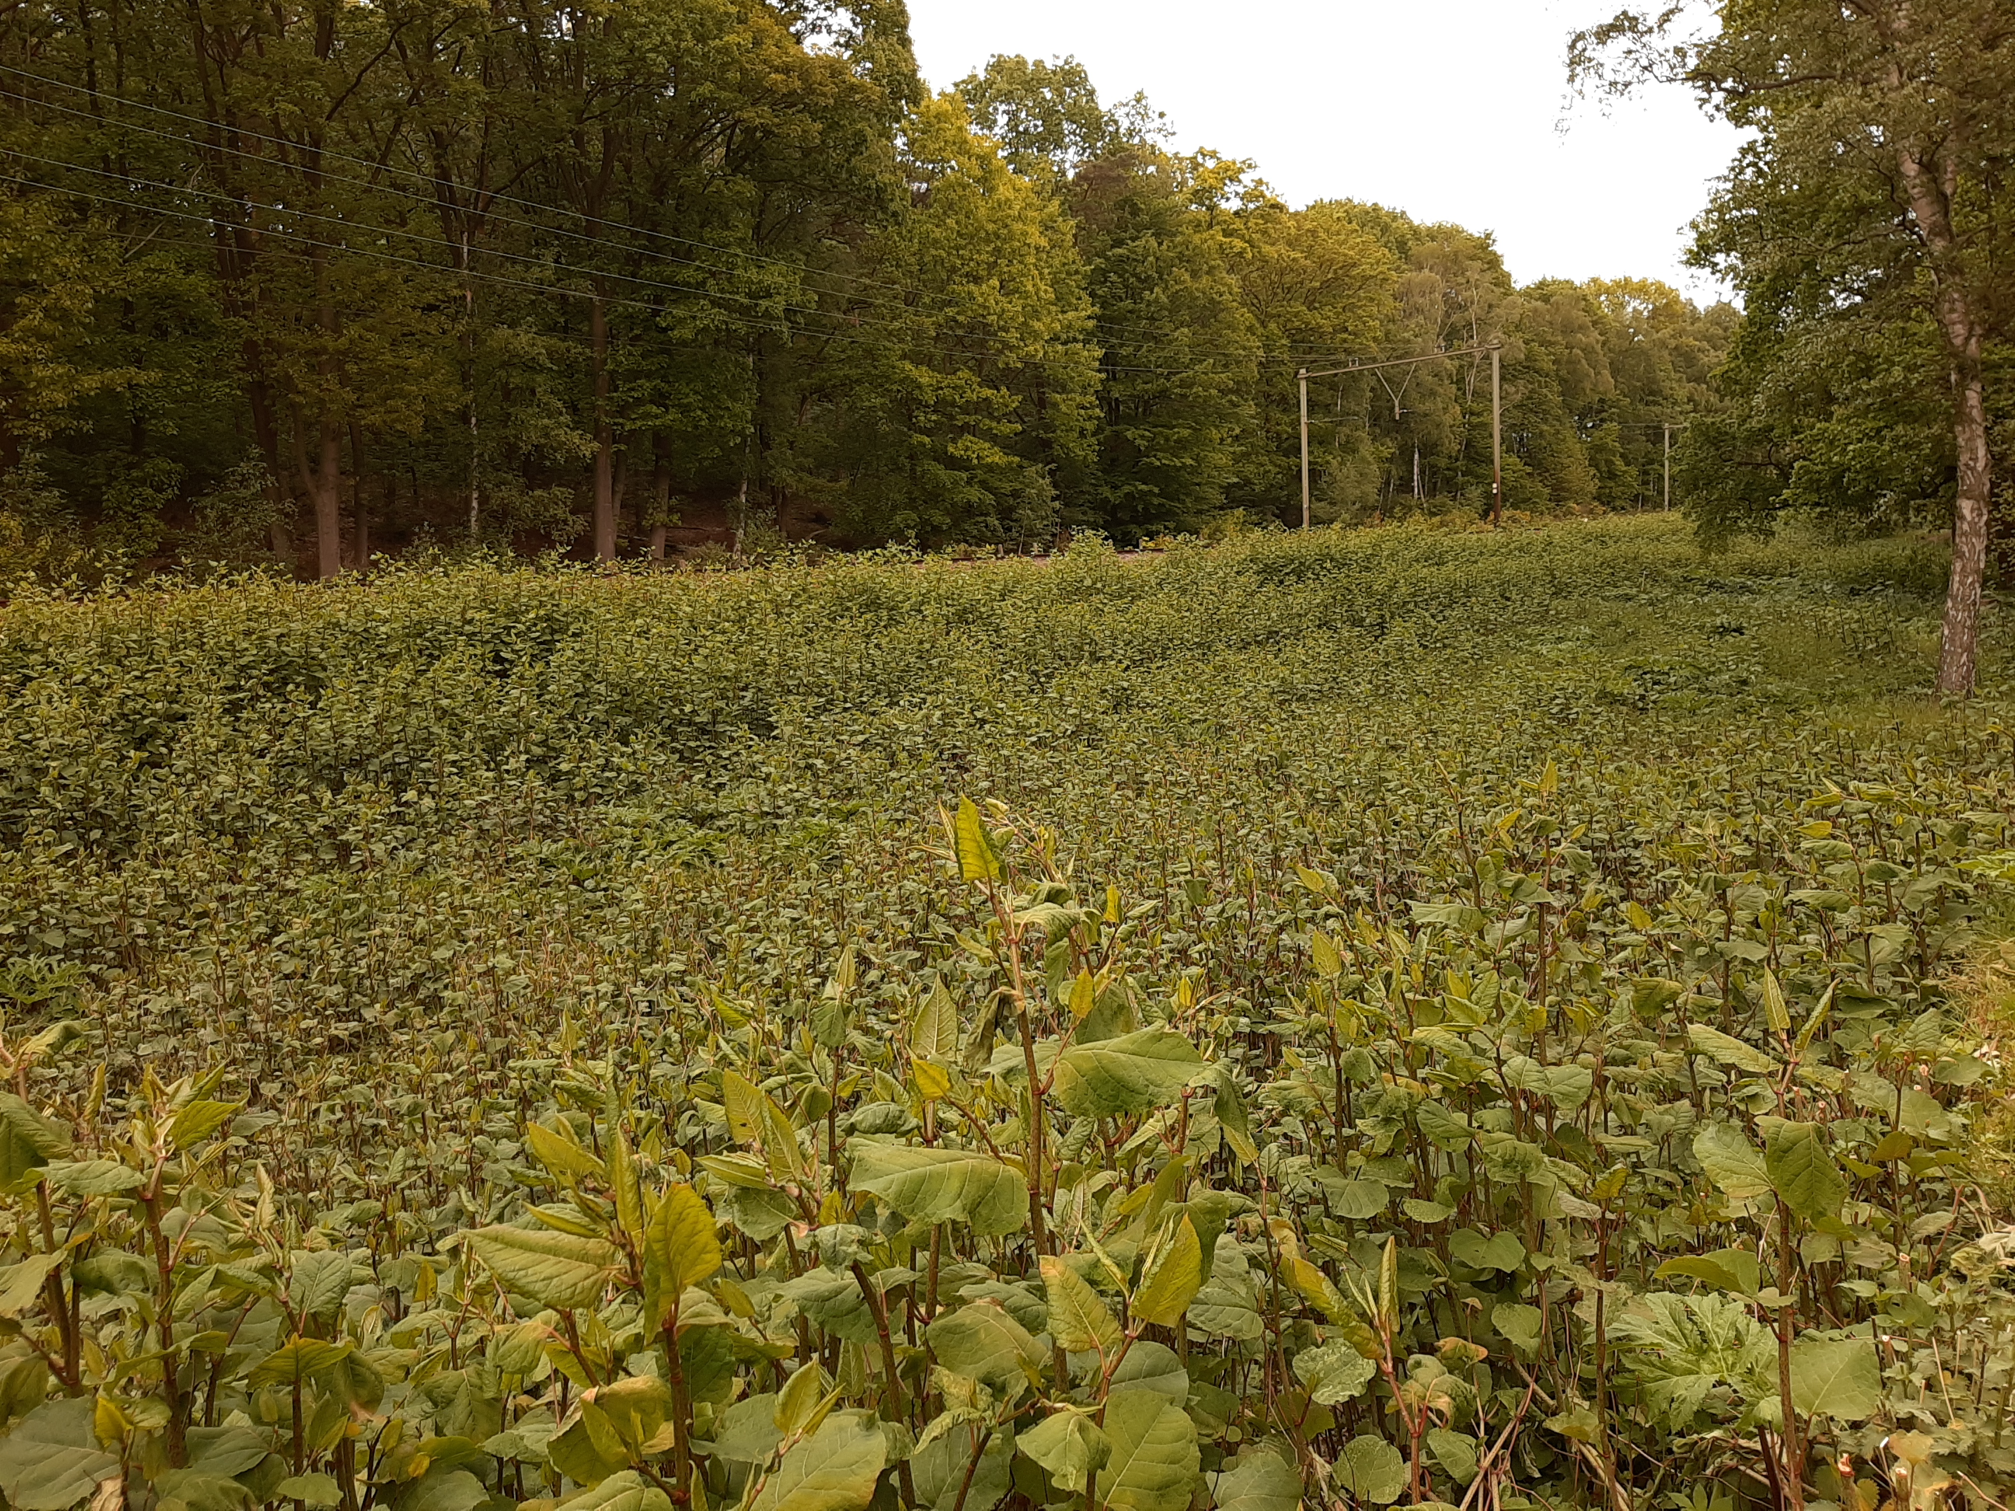



FLORON report 2018.049.e2

Publication details

Publication status: Final, after review of scientific forum

Report number: FL2018.049.e2

Date of publication: August 2022

Title: Risk assessment of four Asian knotweeds in Europe

Citation method: R. Beringen, R.S.E.W. Leuven, B. Odé, M. Verhofstad & J.L.C.H. van Valkenburg (2022). Risk assessment of four Asian knotweeds in Europe FLORON report: 2018.049.e2

Cover photograph: Overgrowth of Bohemian knotweed (Reynoutria × bohemica) near Oosterbeek (Photo: Ruud Beringen).

Project number: FL2018.049

Project leader: Baudewijn Odé
Implementation: FLORON and Radboud University Nijmegen
Project team: Ruud Beringen, Rob Leuven, Baudewijn Odé, Michiel Verhofstad and Johan van Valkenburg

Review: Chris van Dijk, Wageningen University

Commissioned by: Ministry of Agriculture, Nature and Food Quality
Netherlands Food and Consumer Product Safety Authority (NVWA)
J. Leferink
Postbus 43006
3540 AA Utrecht

Publication approval: B. Odé (FLORON project leader)

Initials:

© 2019/2022 FLORON, Nijmegen. FLORON studies and protects wild plants.
FLORON is a brand name of the RAVON Foundation.

Contents
Summary 7
Samenvatting 9
1 Introduction 11
1.1 Background 11
1.2 Research request 12
1.3 Document structure 12
2 Materials and method 14
2.1 Literature review 14
2.2 Taxonomy and nomenclature of the species being assessed 14
2.3 Delineation of species being assessed 14
2.4 Distribution in the Netherlands 15
2.5 Distribution in Europe 15
2.6 Risk assessment and classification using Harmonia⁺ 16
2.7 Comparison with other risk assessments 18
3 Reynoutria japonica – Japanese knotweed 19
3.1 Species description 19
3.1.1 Taxonomy 19
3.1.2 Nomenclature 19
3.1.3 Range 20
3.1.4 Characteristics 21
3.1.5 Reproduction and dispersal 21
3.1.6 Habitat and ecology 24
3.2. Distribution 25
3.2.1 Invasion history of potential distribution area 25
3.2.2 Pathways of introduction 25
3.2.3 Climate and biogeography 28
3.2.4 Occurrence within the EU 29
3.3 Impacts 31
3.3.1 Biodiversity and ecosystems 31
3.3.2 Red List species and protected species 33
3.3.3 EU habitats 33
3.3.4 Physicochemical properties and structure of ecosystems 34
3.3.5 Ecosystem services 35
3.3.6 Public health & the economy 37
4 Reynoutria × bohemica 39
4.1 Species description 39
4.1.1 Taxonomy 39
4.1.2 Nomenclature 39
4.1.3 Range 40
4.1.4 Characteristics 40
4.1.5 Reproduction and dispersal 40
4.1.6 Habitat and ecology 42
4.2. Distribution 42
4.2.1 Invasion history of potential distribution area 42
4.2.2 Pathways of introduction (UNEP pathways and vectors) 43
4.2.3 Climate and biogeography 43
4.2.4 Occurrence within the EU 44
4.3 Impacts 47
4.3.1. Biodiversity and ecosystems 47
4.3.2 Red List species and protected species 47
4.3.3 EU habitats 47
4.3.4 Physicochemical properties and structure of ecosystems 48
4.3.5 Ecosystem services 48
4.3.6 Public health & the economy 48
5 Reynoutria sachalinensis 50
5.1 Species description 50
5.1.1 Taxonomy 50
5.1.2 Nomenclature 50
5.1.3 Range 51
5.1.4 Characteristics 51
5.1.5. Reproduction and dispersal 51
5.1.6. Habitat and ecology 52
5.2. Distribution 53
5.2.1 Invasion history of potential distribution area 53
5.2.2 Pathways of introduction (UNEP pathways and vectors) 54
5.2.3 Climate and biogeography 54
5.2.4 Occurrence within the EU 56
5.3 Impacts 57
5.3.1 Biodiversity and ecosystems 57
5.3.2 Red List species and protected species 58
5.3.3 EU habitats 58
5.3.4 Physicochemical properties and structure of ecosystems 58
5.3.5 Ecosystem services 58
5.3.6 Public health & the economy 59
6 Koenigia polystachya 60
6.1 Species description 60
6.1.1 Taxonomy 60
6.1.2 Nomenclature 60
6.1.3 Range 61
6.1.4 Characteristics 61
6.1.5 Reproduction and dispersal 62
6.1.6. Habitat and ecology 62
6.2 Distribution 63
6.2.1 Invasion history of potential distribution area 63
6.2.2 Pathways of introduction (UNEP pathways and vectors) 63
6.2.3 Climate and biogeography 64
6.2.4 Occurrence within the EU 65
6.3 Impacts 68
6.3.1 Biodiversity and ecosystems 68
6.3.2 Red List species and protected species 69
6.3.3 EU habitats 69
6.3.4 Physicochemical properties and structure of ecosystems 69
6.3.5 Ecosystem services 69
6.3.6 Public health & the economy 69
7 Results of the risk analysis 71
7.1 Risk classifications 71
7.2 Risk and confidence scores 76
7.3 Comparison with other risk assessments 77
8 Control and eradication of Asian knotweed 81
8.1 Prevention of spread 81
8.2 Control and eradication 82
8.2.1 Mechanical control 82
8.2.2 Chemical control 84
8.2.3 Biological control 85
8.2.4 Thermal control 88
8.3 Risks of improper management 88
9 Potential costs of damage and control 91
9.1 Damage to biodiversity and ecosystem services 91
9.2 Damage to health, safety and the economy 92
9.3. Costs of control efforts 92
10 Discussion, conclusions and recommendations 95
10.1 Discussion 95
10.2 Conclusion 95
10.3 Recommendations for control 96
10.4 Recommendations for further research 96
Acknowledgements 97
Bibliography 98
Appendix 1 Countries in which Reynoutria species and Koenigia polystachya occur in the wild 111
Appendix 2 Biogeographic regions in Europe 113
Appendix 3 Chromosome numbers in a few Asian knotweeds 114
Appendix 4 Diagnostic characters for Reynoutria species 115
Appendix 5 Asian knotweeds in Natura 2000 areas in the Netherlands 116
Appendix 6a Area (ha) of EU habitat type 6430 in EU countries (and Great Britain). 120
Appendix 6b Area (ha) of EU habitat type 91E0 in EU countries (and Great Britain). 121
Appendix 7 Crosses and backcrosses within the Reynoutria genus 122
Appendix 8: Risk assessment of four Asian knotweeds using the Harmonia+ protocol. 123

Summary

This report describes a risk assessment of the alien species of Asian knotweeds in Europe. This species group comprises four species: Japanese knotweed (Reynoutria japonica), Bohemian knotweed (R. x bohemica), Giant knotweed (R. sachalinensis) and Himalayan knotweed (Koenigia polystachya). The species are native to Asia, but have been imported in many places in the world as ornamental species. The hybrid R. x bohemica at first originated outside Asia in Europe. They are all giant rhizomatous herbs, growing up to some meters high. The species are not only present in many European countries, but are often considered invasive as well. In Europe, in many cases these species have been introduced as vegetatively propagated ornamental plants.

The present risk assessment is based on a detailed risk inventory and supports national and international decision making on the management of Asian knotweeds. The available information and data on the four species were analysed and the risks were classified by a team of experts using the Harmonia+ protocol.

Especially Japanese, Bohemian and giant knotweed are already being distributed widely throughout Europe, both invading a wide variety of artificial and natural habitats. Vegetative means of dispersal by stems or root fragments being able to sprout and grow to a new plant enhances the invasion potential of these three species. The fourth species, Himalayan knotweed, is rarer and localized, but has comparable capacities.

Dispersion is both human-induced and natural. Main dispersion pathways are active dump of plant material from gardens in nature, transportation of stem fragments during vegetation management (mowing), and transport of soils infested with root fragments. Natural dispersion may especially occur along waterways, with high flow rates in the winter season, when root fragments are being dispersed as a result of erosion. In Europe, seed production seems rare, but may especially in Reynoutria-species become more important. It may yield both in other ways of dispersion (floating seeds) and in more diversification of the gene pool. K. polystachya under present climatic conditions seems not capable of producing seeds in European countries.

Asian knotweeds grow in dense monospecific stands and can out-compete native plants, thus changing natural ecosystems fundamentally, but stands may also influence traffic safety or damage infrastructure. Banks of watercourses become more vulnerable to erosion when they are overgrown with knotweeds.

The future climate change is expected to have little effect on the risk of establishment, although high-elevation sites and northern regions may become increasingly vulnerable to Asian knotweeds invasions, as extreme cold temperatures might become less frequent.

The risk assessment with Harmonia+ shows the final score of risk is high in all Reynoutria-species and medium in K. polystachya. In all species, especially the risks of establishment and dispersion due to human activities are high, and negatively impacting biodiversity. Thus far, effects on human health, crops and cultivation systems are absent or less prominent.

Being all species with a rhizomatous growth form, with roots growing up to 1 meter deep in the soil and the capability of small root or stem fragments to easily grow into a new plant, eradication is not a simple task. Not only need measures to be thorough to be effective, but also it may easily take some years of follow-up management to get rid of the species. In most cases a combination of two or even more measures, applied over several years will be required to achieve total extermination. In some instances, it may be better not to manage sites at all, to avoid dispersion of fragments. However, if seed production is becoming more important such a measure may need re-evaluation to be able to prevent seed dispersion and establishment.

Some knowledge gaps exist, in Reynoutria-species especially in the effect of seed production in dispersion and genetic diversification. In K. polystachya, the status of potential different taxa or cultivars traded and naturalized in Europe needs to be elucidated. Attention should be paid to upcoming potentially invasive species like Reynoutria multiflora.

Samenvatting

Dit rapport beschrijft een risicobeoordeling van de exotische Aziatische duizendknopen in Europa. Deze groep soorten omvat 4 soorten: Japanse duizendknoop (Reynoutria japonica), Basterdduizendknoop (R. x bohemica), Sachalinse duizendknoop (R. sachalinensis) en Afghaanse duizendknoop (Koenigia polystachya). Ze zijn allen inheems in Azië, maar zijn op veel plaatsen wereldwijd geïntroduceerd als sierplant. De hybride R. x bohemica is aanvankelijk buiten Azië in Europa ontstaan. Het zijn tot enige meters hoge kruidachtige planten met een kruipende wortelstok. Deze soorten zijn niet alleen aanwezig en verwilderd in veel Europese landen, maar worden op veel plaatsen ook als invasieve soort beschouwd. In Europa zijn deze soorten veelal geïntroduceerd als vegetatief vermeerderde sierplant.

Deze risicobeoordeling is gebaseerd op een gedetailleerde risico-inventarisatie en kan worden gebruikt om nationaal en internationaal beleid te formuleren met betrekking tot bestrijding en beheer van Aziatische duizendknopen. De beschikbare informatie van de vier soorten zijn beoordeeld en geclassificeerd door deskundigen met gebruikmaking van het Harmonia+ protocol.

Vooral Japanse duizendknoop, Basterdduizendknoop en Sachalinse duizendknoop zijn al wijd verspreid in grote delen van Europa. Ze zijn invasief in allerlei natuurlijke en niet-natuurlijke habitats. Deze soorten kunnen zich op nieuwe plaatsen vestigen dankzij vegetatieve verspreiding, doordat stengel- en wortelfragmenten weer kunnen uitgroeien tot een nieuwe plant zijn. Deze eigenschap vergroot het invasiepotentieel van deze drie soorten. De vierde soort, Afghaanse duizendknoop, is weliswaar zeldzamer en bezet vaak kleinere oppervlakken, maar heeft vergelijkbare eigenschappen.

De soorten verspreiden zich zowel door de mens als via natuurlijke weg. De belangrijkste manieren waarop de soorten zicht verspreiden zijn actieve dumping van tuinafval in de natuur, verspreiding van stengelfragmenten bij vegetatiebeheer (maaien) en transport van met wortelstokken besmette grond. Natuurlijke verspreiding kan plaatsvinden langs wateren, vooral als door stroming en erosie wortelfragmenten losraken en benedenstroom aanspoelen. Zaadproductie is zover bekend in Europa zeldzaam, maar lijkt bij de Reynoutria-soorten belangrijker te worden. Dit kan zowel leiden tot andere manieren van dispersie (o.a. via drijvende zaden), maar ook tot een diversificatie van de genenpool, waardoor duizendknopen zich nog gemakkelijker kunnen aanpassen. Afghaanse duizendknoop lijkt in de huidige klimaatomstandigheden in Europa niet in staat om zaad te produceren.

Aziatische duizendknopen groeien in dichte monotone begroeiingen die geen ruimte laten voor andere soorten; ze kunnen inheemse soorten daarbij geheel verdringen en ecosystemen fundamenteel veranderen. Daarnaast kunnen de begroeiingen ook de verkeersveiligheid beïnvloeden of beschadigingen aan infrastructuur veroorzaken. Ook oevers van watergangen kunnen gevoeliger worden voor erosie als ze begroeid zijn met Aziatische duizendknopen.

Naar verwachting hebben veranderingen in het klimaat weinig effect op nieuwvestiging, hoewel hoger gelegen en noordelijker streken gevoeliger kunnen worden voor invasies van Aziatische duizendknopen als gevolg van het afnemen van lage temperatuurextremen.

De risicobeoordeling met Harmonia+ laat voor alle Reynoutria-soorten een hoog risico als eindscore zien, voor K. polystachya een matig risico. Bij alle soorten is met name het risico op vestiging en verdere verspreiding door menselijke activiteiten hoog en van negatieve invloed op biodiversiteit. Op dit moment zijn de effecten op menselijke gezondheid, agrarische en bosbouwkundige teelten beperkt of afwezig.

Omdat alle Aziatische duizendknopen tot 1 meter diepe kruipende wortelstokken hebben en omdat kleine wortel- en stengelfragmenten gemakkelijk tot een nieuwe plant kunnen uitgroeien, is het uitroeien op een groeiplaats niet gemakkelijk. Bestrijdingsmaatregelen moeten niet alleen grondig zijn om effectief te zijn, maar vervolgbeheer neemt ook vaak enkele jaren in beslag voordat de plant echt weg is. In veel gevallen is voor uitroeiing een combinatie nodig van twee of meer bestrijdingswijzen, die bovendien enkele jaren wordt toegepast. In sommige gevallen is het zelfs beter om helemaal geen beheer toe te passen, ter voorkoming van verspreiding van fragmenten. Echter, mocht duidelijk worden dat zaadproductie een grotere rol gaat spelen in de dispersie van de soort, dan zou een beheer van niets-doen mogelijk minder gunstig zijn, omdat daardoor zaadzetting en dispersie door zaden kan toenemen.

Er zijn nog een aantal kennishiaten. Bij Reynoutria-soorten gaat het vooral om het belang van zaadproductie met betrekking tot verspreiding en genetische diversificatie. Bij K. polystachya moet vooral de status van de in Europa verhandelde en verwilderde taxa of cultivars worden opgehelderd. Tenslotte moet er aandacht zijn voor mogelijke nieuwe invasieve soorten in Europa, zoals Reynoutria multiflora.

1 Introduction

1.1 Background

In various EU Member States, including the Netherlands, there are four taxa of Asian knotweeds: Japanese knotweed (Reynoutria japonica), Bohemian knotweed (Reynoutria × bohemica), Giant knotweed (Reynoutria sachalinensis) and Himalayan knotweed (Koenigia polystachya). These Asian knotweeds are alien plant species that are very difficult to control. They are increasingly common in nature reserves, gardens, public parks, in between paved surfaces and alongside roads and water courses. They out-compete the original vegetation and cause economic damage by, for instance, reducing the stability of dikes, banks and slopes.

The scientific names used in the Dutch version of this risk assessment differ from those that are still used in the Netherlands. Insofar as possible, the scientific names used in this report are in line with recent, internationally accepted views and correspond to those used in various international online databases, such as: Global Biodiversity Information Facility (GBIF), The PlantList, Catalogue of Life and Germplasm Resources Information Network (GRIN). These names also happen to be used in the European policy frameworks. Two important Dutch sources of taxonomic names - Heukels’ flora and Het Soortenregister - still use the old scientific names (Table 1.1).

Table 1.1 Names used in this report and names used in Heukels’ Flora van Nederland and on Soortenregister.nl.
Name used in Heukels’ flora & Soortenregister.nl | Name used in this report
Fallopia japonica (Houtt.) Ronse Decr. | Reynoutria japonica Houtt.
Fallopia x bohemica (Chrtek & Chrtková) J.P. Bailey | Reynoutria × bohemica Chrtek & Chrtková
Fallopia sachalinensis (Maxim.) Ronse Decr. | Reynoutria sachalinensis (F. Schmidt) Nakai
Persicaria wallichii Greuter & Burdet | Koenigia polystachya (Wall. ex Meisn.) T.M. Schust & Reveal

Asian knotweeds are a source of growing concern among land management organisations such as nature conservationists, municipalities, provinces, water boards and the Directorate-General for Public Works and Water Management (Rijkswaterstaat), as well as private citizens. This has come to light in part due to the large amount of media attention the plants have garnered over the past year. Nevertheless, Reynoutria japonica var. compacta is still being sold, usually under the name Fallopia japonica var. compacta, and knotweed stems were recently for sale at a garden centre as decorative material.

Attempts were made in 2015 and 2016 to put Japanese and Giant knotweed on the European Union’s List of Invasive Alien Species, but this met with too much resistance in many member states. The main arguments were that the species are already very widely distributed and are difficult and thus also expensive to control. There was also an assumption that there was no longer any trade in the species. Another important reason for not placing the two species on the list was that the risk assessment had not yet satisfied all the criteria of EU Regulation 1143/2014 on Invasive Alien Species. Key omissions pertained to their potential socioeconomic benefits, effects on ecosystem services, effects on protected species and areas and potential effects of climate change on their establishment, spread and impact.
Municipalities and land managers recognise that the plants are extremely harmful and there is a will among wider sections of society to take joint action to eradicate them. There is also a call to ban the sale of these species or to place the species on the EU’s List of Invasive Alien Species. In the Netherlands from 01-01-2022 on a trade ban on living plant parts has come into effect for R. japonica (including var. compacta), R. × bohemica and R. sachalinensis.

Note: This risk analysis has been performed initially before the scientific forum reviewed an earlier risk analysis of Koenigia polystachya and before this species was subsequently added to the list of species under the European legislation on invasive alien species (2018-968). Therefore, the treatment of this species in this publication seems somewhat superfluous. Nevertheless we regard the presented information on K.polystachya still valuable for this publication.

1.2 Research request
Placement on the EU’s List of Invasive Alien Species is contingent on there being a risk assessment that satisfies all criteria contained in the regulation, as stated in Commission Delegated Regulation (EU) 2018-968. To this end, the Netherlands Food and Consumer Product Safety Authority has asked FLORON and Radboud University to scientifically substantiate the harmfulness of these species. They have been asked to do so in the form a risk assessment for Japanese knotweed, Bohemian knotweed, Giant knotweed and Himalayan knotweed, based on already existing EU draft risk assessments for Fallopia japonica (= Reynoutria japonica) and Fallopia sachalinensis (= Reynoutria sachalinensis) and any other available risk assessments. The final product must satisfy, as much as possible, the EU criteria for inclusion on the EU’s List of Invasive Alien Species and address, among other things, the following elements:
- cultivation and trade;
- ground transportation and other possible pathways of dispersal;
- risks of sexual propagation;
- risks of improper management;
- knowledge gaps;
- recommendations for research.

1.3 Document structure

This report is both a background document containing information on Asian knotweeds and a risk assessment.
Chapter 2 outlines the methodological aspects of both parts.
In Chapters 3 through 6, the knotweeds are discussed as individual taxa based on an extensive literature review. In light of the significant overlap found between the species in terms of characteristics and the fact that most of the literature available pertained to Reynoutria japonica, we frequently refer back to this species when discussing the other species. These sections in these chapters are based on those used in Commission Delegated Regulation (EU) 2018/968.
Chapter 7 discusses the results of the risk analysis. Even though various foreign risk assessments have treated species of the Reynoutria genus as one group, we have assessed these three taxa separately as much as possible.
Chapter 8 discusses the possibilities of control and eradication and Chapter 9 examines the potential costs related to both damage and eradication efforts. The species are treated primarily as one group in these two chapters.
Lastly, Chapter 10 contains a discussion, followed by a number of conclusions and recommendations.

2 Materials and method

2.1 Literature review

The review began by creating a format for the knowledge documents that are necessary for the risk assessments (a risk inventory). A literature search was then conducted. The search strategy and related search terms were designed to obtain the information needed for the risk assessments.
The literature search focused on those topics that had received little to no attention in the available risk analyses, the European context and scale of risks and the scientific substantiation that is necessary for assessing the relevant risk criteria. Insofar as relevant, the species’ potential dispersal and the risks they pose to the European Union are described both for the member states (including the Netherlands) and biogeographic regions.
An online search was conducted for information about knotweeds. The Web of Science was searched using the most common scientific species names as search terms (see 2.2). A Quick scan of the title or summary of all articles was made to estimate their relevance. Google and Google Scholar were consulted in order to find references that are not accessible to the Web of Science.
While no web search was conducted to investigate which taxa are on the market in which countries, we do state which taxa appear on the List of Names of Perennials and the List of Names of Woody Plants (Hoffman 2016a, 2016b). These lists contain the names of most of the plants that are on the market in Europe (and also in the United States to a large extent).
Other available risk assessments and classifications of the species were tracked down using all possible combinations of their scientific names and the search terms risk assessment, risk analysis and risk classification (in several languages).

2.2 Taxonomy and nomenclature of the species being assessed

The taxonomic classification of the knotweed family (Polygonaceae) has undergone changes over the course of time. The classification and nomenclature used for the species in this report correspond to those found in recent literature (Galasso et al. 2009, Sanchez et al. 2009, Schuster et al. 2011, Schuster et al. 2015). In recently published European floras, such as the fourth edition of New Flora of the British Isles (Stace 2019), the same nomenclature is used.

The following names will be used for the species discussed in this report:

Scientific name | Common name
Reynoutria japonica Houtt. | Japanese knotweed
Reynoutria × bohemica Chrtek & Chrtková | Bohemian knotweed
Reynoutria sachalinensis (F. Schmidt) Nakai | Giant knotweed
Koenigia polystachya (Wall. ex Meisn.) T.M. Schust & Reveal | Himalayan knotweed

The common names used in the Dutch version of this report correspond to those used in Heukels’ flora (Van der Meijden 2005) and Het Nederlands Soortenregister (https://www.nederlandsesoorten.nl/).

2.3 Delineation of species being assessed

Only the risks associated with the four species specified in Section 2.2 will be assessed in this report. Various other species from the knotweed family that originally come from Asia occur in the wild in Europe. Most species are closely related and some are able to hybridise with the species discussed in this report. Brief descriptions of the latter appear below.

Reynoutria multiflora (Chinese knotweed, Chinesischer Flügelknöterich). A perennial, dioecious vine native to eastern China. Commercially available (Hoffman 2016a). In Italy, regionally established in Lombardy and locally occurring in the wild in Trentino and Veneto (Galasso et al. 2006). Occurs locally in the wild in Hungary (Lajos et al. 2004) and Slovenia (Balant 2015). An important traditional Chinese medicinal herb: “He Shou Wu”.

Fallopia baldschuanica (Chinese bruidssluier, Russian vine, Schling-Flügelknöterich). A perennial vine native to China and Tibet. Commercially available as various cultivars (Hoffman 2016b). Invasive in Spain (Anonymous 2013a) and southwest Slovenia (Strgulc Krajšek & Dolenc Koce 2015), among other places. Capable of hybridising with Reynoutria japonica. Likely the main pollinator of seed-producing ♀Reynoutria japonica var. japonica. The resulting hybrid ×Reylopia conollyana (=Fallopia × conollyana J.P. Bailey) has established itself at a few sites in various countries, but has not yet been found to be invasive (Bailey 2001, Bailey et al. 2013). Hybridisations with Reynoutria japonica var. compacta, Reynoutria × bohemica and Reynoutria sachalinensis are also possible (Hoste et al. 2017).

Persicaria orientalis (Oosterse duizendknoop, Princess-feather, Renouée orientale, Östlicher Knöterich). An annual species native to Asia and eastern Australia. Also commercially available under the names “Japanese knotweed”. Has established itself in many southern European countries, but is not known to be invasive.

Muehlenbeckia species (Wireplant, Drahtstrauch/Teppich-Scheinknöterich). Muehlenbeckia complexa is a perennial groundcover native to New Zealand. Occurs in the wild in southwest England, Wales and Ireland (Stace 2019), Belgium, Portugal and Spain (Verloove 2019). Commercially available as cultivar “Spotlight” (Hoffman 2016a) and, in 2017, found in the wild for the first time in the Netherlands(“whole carpets, taking root in the joints of the pavement”) (waarneming.nl).
Muehlenbeckia axillaris is also native to New Zealand and commercially available. In New Zealand hybrids with Reynoutria japonica were found (Bailey 2013).

2.4 Distribution in the Netherlands

Data regarding the distribution within the Netherlands has been taken from the National Flora & Fauna Database (NDFF) (https://www.ndff.nl/). The NDFF contains distribution data that has been contributed by volunteers, provinces, municipalities, water boards, research institutes and land managers. In addition to data regarding the site at which species are found, some observations also include data regarding abundance and biotope.

2.5 Distribution in Europe
Data regarding distribution outside the Netherlands has been taken from the Catalogue of Life (http://www.catalogueoflife.org), unless otherwise indicated. For the ‘climate match’ (Sections 3.2.3, 5.2.3 and 6.2.3), the location data in the original range was obtained from the GBIF website (https://www.gbif.org). Given that the Bohemian knotweed originated in Europe, no ‘climate match’ analysis has been performed for this hybrid.
The distribution and invasiveness shown in Appendix 1 has been taken from the CABI website (https://www.cabi.org), supplemented with distribution data from recent literature and national lists of invasive species.It should be noted that distribution records probably are affected by misidentifications in distinguishing hybrids from parental species. As R. x bohemica often is identified as R. japonica it is probably underrecorded and more frequent than reported (Mandák et al. 2004, Medvecká et al. 2012, Vuković et al. 2019). .

2.6 Risk assessment and classification using Harmonia⁺

The risk assessments and classifications of the four Asian knotweeds have been carried out by a team of five experts (in this case the authors) using the Harmonia⁺ protocol. Each expert reviewed the knowledge document on the particular species in advance and then completed the online version of the assessment protocol (D’hondt et al. 2014) for the risk classification of each species. In doing so, they devoted attention to both the current situation and the future situation (involving a time horizon of approximately 50 years), assessing the impact of climate change on the risks associated with the Asian knotweeds.
After completing their individual risk assessments, the team of experts (all five authors) came together for a workshop. During the workshop, they explained their arguments for all risk scores and their level of confidence in these. Differences in risk and confidence scores were discussed. This discussion led to a consensus on these scores and the scientific argument in support of them for all criteria of the Harmonia⁺ protocol.

All risk and confidence scores were then calculated (Box 2.1). The version of the Harmonia⁺ protocol used contains a total of 41 questions grouped into the following seven categories:
- Context (questions A1-A5);
- Introduction of the species (questions A6-A8);
- Establishment of the species (questions A9-A10);
- Spread of the species (questions A11-A12);
- Potential environmental effects (questions A13-A30);
- Potential effects of the species on ecosystem services (questions A31-A33);
- Effects of climate change on the risks posed by a species (questions A34-A41).

The ‘Potential environmental effects of the species’ category has been divided into the following five subcategories:
- Effects on biodiversity and ecosystems (questions A13-A18);
- Effects on plant cultivation (questions A19-A23);
- Effects on animal production and animal well-being (questions A24-A26);
- Effects on human health (questions A27-A28);
- Other effects, such as damage to infrastructure (question A29).
Each (sub)category contains several risk assessment questions; for each question, a risk score and confidence level can be given. There are three to five risk score options: none/very low, low, medium, high and very high. ‘Inapplicable’ is also possible. Three scores are possible for level of confidence: low, medium and high. All questions in the risk assessment protocol are accompanied by an explanatory note and examples that serve as a reference for determining the risk scores.

The Harmonia⁺ protocol is a procedure for risk screening. This method was expressly developed for assessing the negative effects of potentially invasive species and does not take any positive effects into consideration. However, the knowledge overview contains information on the positive effects of the species being assessed and this is assessed in section on the effects on ecosystem services.

Box 2.1: Concept and definitions for risk assessment and classification of potentially invasive species using the Harmonia⁺ protocol (D’hondt et al. 2014).

Concept
Invasion = f(Introduction; Establishment; Spread; Impacts_{a-e})
Risk = Exposure x Likelihood x Consequence

Invasion = risk?
Exposure ≡ f₁(Introduction;Establishment;Spread) = Invasion score
Likelihood x Consequence ≡ f₂(Impact_{a}; Impact_{b}; Impact_{c};Impact_{d}; Impact_{e}) = Impact score
with a: environment (biodiversity and ecosystems); b: plant cultivation; c. animal production; d. human health; e: other

Risk = Exposure x Likelihood x Consequence ≡ f₃(Invasion score; Impact score) = Invasion

Calculation methods
f₁ : (weighted) geometric mean or product
f₂ : (weighted) arithmetic mean or maximum
f₃ : product

Box 2.1 shows the methods used for calculating the different risk scores. In the Harmonia⁺ protocol, a biological invasion is described as a function (f) of the introduction, establishment, spread and various types of (a-e) impacts exhibited by a species (D’hondt et al. 2014). The ‘risk’ of an invasion is defined as the chance that a particular hazard associated with a species may actually cause damage. The risk increases (1) with exposure to the hazardous event, (2) with the likelihood that hazardous event will actually occur, and (3) with possible consequences of that event happening. As such, risk is defined as a product of these three factors: exposure x likelihood x consequence.

The protocol can be used to calculate three scores: the invasion score, the impact score and the risk. The invasion score is a measure of exposure and in the protocol it is calculated as a function (f1) of the introduction, establishment and spread. The impact score is a measure of likelihood x consequence and in the protocol it is calculated as a function (f2) of the chance of different types of impacts (a-e, i.e. impacts on biodiversity and ecosystems, plant cultivation, animal production and animal well-being, human health and other impacts). Following on from this, risk is calculated as a function (f3) of the invasion and impact score.

Different functions can be used to calculate the invasion score, impact score and the risk (see f1, f2 and f3 in Box 2.1). The protocol also allows for weighting within and between different risk categories. In the risk assessment of the four Asian knotweeds, all weights were assigned the default value (= 1). In calculating the risk scores, the different types of impact within a particular risk category were always weighted equally. To calculate an impact score for a specific risk category, the maximum value was always used in order to avoid averaging out impacts. To calculate the invasion score, the product of the introduction, establishment and spread score was used. To calculate the aggregated impact score, the maximum of the various impact scores was always used. Table 2.1 provides an overview of the cut-off values and colour schemes used for the ‘low’, ‘medium’ and ‘high’ risk classifications.

All assessment questions provide the opportunity to indicate the level of confidence in the response. Following the framework of Mastrandrea et al. (2010; 2011), the level of confidence is reported consistently, with a ‘low’, ‘medium’ or ‘high’ likelihood corresponding to a 0-33%, 33-66% or 66-100% probability, respectively. In Harmonia⁺ , the scores of 0, 0.5 and 1 correspond to ‘low’, ‘medium’ and ‘high’, respectively. For each risk category, the arithmetic mean of all confidence scores is calculated for the related criteria and then the risk classifications of ‘low’, ‘medium’ or ‘high’ are assigned based on the cut-off values (Table 2.1). Colour codes (blue hues) are used to indicate the level of confidence.

Table 2.1: Cut-off values and colour schemes of risk and confidence classification.

2.7 Comparison with other risk assessments

As part of the literature review, a compilation was made of risk assessments of the four Asian knotweeds that have been drawn up by other assessors (Section 2.1). The available risk assessments were often carried out using different protocols. They range from compact or quick assessments on behalf of prioritisation or invasive species advisory lists to detailed risk assessments regarding these species for individual countries in Europe, Europe as a whole or the United States (Table 7.5). In order to properly compare their outcomes with the current assessment, all risk scores have been harmonised into three risk categories, i.e. low, medium and high.

The risk classifications using the Invasive Species Environmental Impact Assessment (ISEIA) protocol (Belgian Forum on Invasive Species 2019a) have been left as is because this protocol also distinguishes between three risk levels, i.e. low risk (Score 4-8; Code C), medium risk (Score 9-10; Code B; watch list) and high risk (Score 11-12; Code A; black list).

The scores 2, 3 and 4 from the Generic Impact Scoring System (GISS) have been harmonised as low, medium and high risk, respectively. The five risk classes of the GISS derived from the classification system of Blackburn et al. (2011) have been harmonised into three categories: low risk (for ‘minimal risk’ and ‘minor risk’), medium risk (moderate risk) and high risk (for ‘major risk’ and ‘massive risk’).

Scores for the invasiveness of non-native plant species using the Australian Weed Risk Assessment (WRA) system (Pheloung et al. 1999) have been harmonised as low risk for WRA scores <11, medium risk for scores 11-20 and high risk for scores >20. Scores derived from the WG system developed by Weber & Gut (2004), the combined WG-WRA system (Andreu & Vila 2009) and the combined WG-European and Mediterranean Plant Protection Organisation Pest Risk Assessment Scheme (EPPO) have been harmonised as low risk for WG scores <21, medium risk for scores 21-27 and high risk for scores >28. The scores from the Risk Assessment Methodology Invasive Species Ireland (RAMISI; version 2007; Kelly et al. 2013) have been harmonised as low risk for scores <14, medium risk for scores 14-18 and high risk for scores >18.

The Great Britain Non-Native species Risk Assessment (GBNNRA) protocol, Methodik der naturschutzfachlichen Invasivitätsbewertung für gebietsfremde Arten (MNIGA; version 1.2) and Naturschutzfachliche Beurteilung (NFB) all use three risk categories and have therefore been left unaltered. In a few cases no explicit risk categories were stated, but the species in question had been placed on a national or regional list for invasive alien plants (e.g. black list, invasive species list, list of potentially invasive species or list of banned species). Such cases have been harmonised as high risk.

3 Reynoutria japonica – Japanese knotweed

3.1 Species description

3.1.1 Taxonomy
Scientific classification
Kingdom: Plantae
Phylum: Tracheophyta
Class: Magnoliopsida
Order: Caryophyllales
Family: Polygonaceae
Sub-Family: Polygonoideae
Tribe: Polygoneae
Genus: Reynoutria

3.1.2 Nomenclature
Scientific name
Reynoutria japonica Houtt.

Synonyms
Fallopia japonica (Houtt.) Ronse Decraene (including var. japonica)
Fallopia japonica var. uzenensis (Honda) K. Yonekura & Hiroyoshi Ohashi
Pleuropterus cuspidatus (Sieb. & Zucc.) H. Gross
Pleuropterus zuccarinii Small
Pleuropterus cuspidatus (Siebold & Zucc.) H. Gross
Polygonum cuspidatum Sieb. & Zucc.
Polygonum Reynoutria (Houtt.) Makino
Polygonum Reynoutria f. colorans Makino
Polygonum Reynoutria var. humilis Nakai
Polygonum sieboldii de Vriese ex L.H. Bailey
Polygonum zuccarinii Small
Reynoutria elata Nakai
Reynoutria hastata Nakai ex Ui
Reynoutria henryi Nakai
Reynoutria japonica var. humilis (Nakai) Nakai
Reynoutria japonica var. uzenensis Honda
Reynoutria uzenensis (Honda) Honda
Reynoutria yabeana Honda
Tiniaria japonica (Houtt.) Hedberg

Fallopia compacta (Hook. fil.) G.H. Loos & P. Keil
Fallopia japonica var. compacta (Hook. fil.) J.P. Bailey
Polygonum compactum Hook. fil.
Polygonum cuspidatum f. compactum (Hook. fil.) Nakai
Polygonum cuspidatum f. rosea (Satomi) N. Satomi
Polygonum cuspidatum var. compactum (Hook. fil.) L.H. Bailey
Polygonum Reynoutria var. compactum (Hook. fil.) Nakai
Polygonum sieboldii var. compactum (Hook. fil.) L.H. Bailey
Reynoutria compacta (Hook. fil.) Nakai
Reynoutria japonica f. rosea Satomi
Reynoutria japonica var. compacta (Hook. fil.) Moldenke

Trade names
The following cultivars appear on the List of Names of Perennials (Hoffman 2016a):
‘Rosea’ (=Reynoutria japonica var. compacta)
‘Crimson Beauty’
‘Freckles’
‘Rebou’
‘Rema’
‘Remus’
‘Spectabilis’
‘Variegata’

Some cultivars, such as ‘Freckles’ and ‘Variegata’, have variegated leaves and are thought to be less invasive. For many cultivars, there are no longer any outlets where they are sold. The cultivars ‘Rosea’ and ‘Variegata’(= ‘Milkboy’?) are cultivars of var. compacta and are commercially available in Europe.

Vernacular names
Bulgarian: Японска фалопия
Czech: Kridlatka japonska
Danish: Japan-pileurt
Dutch: Japanse duizendknoop
Estonian: Vooljas pargitatar
Finnish: Japanintatar
French: Renouée à feuilles pointues, Renouée du Japon
German: Japanischer Staudenknöterich
Irish: Glúineach bhiorach
Italian: Poligono del Giappone
Latvian: Japānas dižsūrene
Lithuanian: Japoninė reinutrė, Japoninis pelėvirkštis
Norwegian: Parkslirekne
Polish: Rdestowiec ostrokończysty
Portuguese: Sanguinária-Do-Japão
Romanian: Troscotul japonez
Russian: гречишка японская
Spanish: Hierba nudosa japonesa
Swedish: Vanligt parkslide

Note: despite having a clear taxonomy, this taxon exhibits great variation outside its original territory and hybrids exist with R. × bohemica, in particular.

3.1.3 Range
The original range of R. japonica encompasses Japan (Hokkaido, Honshu, Shikoku, Kyushu), Korea, China and Taiwan. The species is highly variable within this original range (Meyer & Walker 1965). Its most common form within the original range is R. japonica var. japonica, which can be found throughout Japan. The compacta variety is a dwarf form that is found in Japan (and Korea) in the alpine zone. Galasso et al. (2009) argue for granting species status to this taxon under the name Reynoutria compacta (Hook. fil.) Nakai. This variety is planted as an ornamental in Europe and North America. While most Japanese authors do not treat this form as a separate taxon, a few do make a distinction between two varieties that are endemic to Japan: var. hachidyoensis (=var. terminalis) and var. uzenensis. These varieties are native to the Izu islands and the island of Honshu (Yonekura & Ohashi 1997), respectively, and have never been spread outside of Japan (Galasso et al. 2009). According to Galasso et al., (2009), these varieties should also be granted species status. Nowadays, var. hachidyoensis is considered to be a separate species under the name Reynoutria hachidyoensis (Makino) Nakai apud Jotani.

R. japonica has been introduced to most European countries (Appendix 1). Its secondary range also encompasses North America (Canada, United States), South America (Chili), Russia (with the exception of Sachalin), Australia (Queensland, Tasmania) and New Zealand (CABI 2019).

R. japonica occurs in different chromosome numbers (ploidy levels). The base number within Reynoutria is 11 (Appendix 3). R. japonica var. japonica occurs in tetraploid, hexaploid and octoploid forms in its original range. In its secondary range, the variety is predominantly octoploid (2n=88). Var. compacta is tetraploid (2n=44) (Mandak et al. 2003, Kim & Park 2000, Bailey et al. 2009). In the Netherlands, hexaploid (2n=66) cytotypes of R. japonica have also been found (Duistermaat et al. 2012). With respect to morphology, plants of different ploidy levels are indistinguishable, though tetraploids seem to have thicker leaves (Kim & Park 2000).

3.1.4 Characteristics
Strong herbaceous perennials with thick, belowground, creeping rhizomes. Established plants form woody rootstock with vertical tap roots that can burrow up to three metres deep under favourable conditions. Stems: erect, 50-150(-300) cm high, hollow, usually with reddish spots, branched at the top. Leaves: from broadly ovate to broadly elliptic, 6-12(-15) cm long and 5-8 cm wide, cuspidate at the apex and truncate at the base, pale green, underside usually covered in papillae. Petioles: 1-3 cm long; extrafloral nectaries under the base of the petiole. Sheaths (ochreae): thinly membranous. Inflorescence: some plants with only bisexual flowers and other plants with only female (male-sterile) flowers (gynodioecy); flowers occur in terminal or axillary panicles of branched ears (Figures 3.1, 3.2). Flowers: (creamy) white, 2.5-3 mm in diameter; 5 tepals, the outer 3 of which are keeled; 8 stamens, filaments 0.3-0.4(-0.8) mm long; 3 styles. Fruit: the outermost tepals are winged on the back and are 6-10 mm long, completely enclosing the achene. Seeds: a sharply triangular, glossy, dark brown achene; 2-2.5(-4) mm long and 2 mm wide. (Meyer & Walker 1965, Beerling et al. 1994).

Similar species
R. japonica is very similar to R. × bohemica and, to a lesser extent, R. sachalinensis (see Appendix 4).
R. japonica is also very similar to Reynoutria forbesii (Hance) T. Yamaz. (=Fallopia forbesii (Hance) Yonekura & H. Ohashi, = Polygonum forbesii Hance) (Galasso et al. 2009). Some authors do not regard the latter as a separate species, but rather as the Chinese and Korean form of R. japonica. According to Kim & Park (2000), however, R. forbesii is easy to distinguish from R. japonica based on leaf and fruit characteristics, among other things, and both species occur alongside each other in Korea. Its leaves are orbicular with rounded bases (while R. japonica has ovate leaves that are truncate at the base) and its apex is more abruptly acuminate. Plants with intermediate characteristics have been found in Korea and China, and these are likely hybrids between R. japonica and R. forbesii. Insofar as known, R. forbesii has never been found outside its original range (China and Korea) (Kim & Park 2000).

3.1.5 Reproduction and dispersal
Life cycle
The shoots sprout in early April. In Northern Europe, the shoots sprout later in April-May. Mainly the aboveground portions of the plant grow in the spring. Between mid-April and June, the plant can grow up to 40 cm in four days under favourable conditions. The plants achieve their maximum height around mid-June and flower from late August into October. In northern Europe (Finland) they flower from September into October (https://vieraslajit.fi). Between August and November, the assimilates are primarily invested in the rhizomes. The supply of assimilates to belowground organs is the highest in August (in the United Kingdom). The biomass of the rhizomes can be up to 18 times higher in September compared to May. The aboveground portions of the plants die back with the first frost. The brown stems persist throughout the winter and part of the subsequent growing season (Beerling et al. 1994, Seiger & Merchant 1997, Price et al. 2001, Jones et al. 2018). The seed bank of Japanese knotweed is transient; the seeds have a short-lived germinative capacity and germinate in the spring or the ensuing autumn (Tiébré et al. 2007a). However, the seeds of some Slovenian specimens of R. japonica and R. sachalinensis germinated during the second year (Strgulc Krajšek & Dolenc Koce 2015).

Reproduction
Reynoutria is characterised by gynodioecy, featuring inflorescence with either only hermaphroditic flowers or only female flowers and sterile stamens (Bailey 2013). As an exception, plants with only male flowers producing viable pollen have been found on the east coast of the United States (Forman & Kesseli 2003, Barney et al. 2006). Plants (clones) are thus either hermaphroditic or female. Hermaphroditic plants of Reynoutria species are self-incompatible (Beerling et al. 1994., Bailey 2013).
Pollen-producing plants of R. japonica var. japonica are probably rare in the United Kingdom and Europe (Bailey 2013, Mandak et al. 2003, Tiébré et al. 2007a). As such, fructification mainly occurs through pollination with hermaphroditic plants of related species such as R. japonica var. compacta, R. × bohemica, R. sachalinensis and Fallopia baldschuanica. In the United Kingdom, Fallopia baldschuanica (Chinese fleecevine) is the primary pollen donor. However, cases in which the hybrid has established itself are extremely rare (Bailey et al. 2009). In Belgium and Canada, the majority of the seeds of R. japonica were found to have resulted from backcrossing with R. × bohemica (Tiébré et al. 2007a, Groeneveld et al. 2014). Variegated varieties of var. compacta sold by nurseries as “non-invasive” species have been found to have viable pollen and can serve as a pollen donor to wild R. japonica, and thereby contribute to its spread (Forman & Kesseli 2003). Pollination experiments conducted between ♀ plants (probably R. japonica var. japonica) and ♂plants (probably R. japonica var. compacta) gathered in the Netherlands were found to produce seeds capable of germinating (Duistermaat 2012).
The single female clone of R. japonica that occurs throughout Europe (see Section 3.2.1.) also occurs in the United States. At the same time, however, several genetically different clones are present in the United States and the genetic diversity there is higher (Forman & Kesseli 2003, Grimsby et al. 2007, VanWallendael et al. 2021). This higher genetic diversity can be attributed in part to the fact that several clones from Asia have been imported into the United States (Gammon & Kesseli 2009). In the northeastern United States and neighbouring regions, R. japonica sets copious seed and spreads by means of seed, meaning that several genetically different clones are often present at one site. The germinability of harvested seeds was found to be higher (up to 90%) later in the season (October) rather than earlier in the season (mid-September) (Forman & Kesseli 2003, Grimsby et al. 2007, Bram & Mc Nair 2004, Groeneveld et al. 2014).
In Belgium, R. japonica sets minimal seed, and field observations found no germination or establishment in existing vegetation. Nevertheless, hybrids are likely established by means of seeds due to the great genetic diversity among them (Tiébré et al. 2007a).
Field observations conducted in Germany also yielded few seedlings, yet the seeds collected were found to be viable under laboratory conditions. Many seeds were found that bore signs of predation, indicating that they are fed on by birds, probably sparrows (Engler et al. 2017). In laboratory experiments conducted on seeds of R. × bohemica and R. japonica gathered in the wild, germination percentages ranged from 88% to 98%. Seedling survival is hampered by summertime drought and late frost (Funkenberg et al. 2012).
According to recent germination research conducted in the Netherlands, up to 80-90% of the seeds of R. japonica produced in the wild are viable under greenhouse conditions, while at the same time the number of seedlings found in the wild is very low (oral communication with Chris van Dijk, WUR; Martijn Boosten, Probos) (Leferink et al. 2020).
In Slovenia, researchers observed that R. japonica sets seed better than R. × bohemica and R. sachalinensis. The primary pollen donor to R. japonica is R. × bohemica. R. × bohemica itself is pollinated by both other R. × bohemica plants and R. sachalinensis. In field tests, seeds of R. japonica are more successful than those of R. × bohemica and R. sachalinensis in terms of seed germination and seedling survival. Few seedlings were still alive after three years, i.e. no more than 12% of R. japonica, no more than 2% of R. × bohemica and 0% of R. sachalinensis (Strgulc Krajšek & Dolenc Koce 2015).

Pollinators
The flowers of Reynoutria species produce a lot of nectar and are visited and pollinated by a wide range of insects. In the United Kingdom, a change in the composition of the pollinators has come to the attention of researchers. Whereas Diptera (flies) were initially the primary pollinators of the flowers of R. japonica in the late 1970s and early 1980s, they were later supplanted by honeybees. It presumably took some time for the honeybees to discover this new source of nectar (Beerling et al. 1994, Bailey et al. 2009).

Hybrids
R. japonica var. japonica can hybridise with R. sachalinensis. Nowadays, the hybrid R. × bohemica is more common than R. japonica var. japonica in many countries. Given the existence of male-fertile specimens of R. × bohemica, backcrosses with the parental species also occur (Bailey et al. 2009, Bailey 2013).
R. japonica is relatively frequently pollinated by Fallopia baldschuanica (Chinese fleecevine). Many seeds of R. japonica contain embryos of this hybrid. However, established specimens of this hybrid, ×Reyllopia conollyana (=Fallopia × conollyana), are rare and known to exist at only a few localities in the United Kingdom, Ireland, Belgium and Germany (Bailey 2001, Stace 2015, Hoste et al. 2017).
R. japonica var. japonica can also hybridise with R. japonica var. compacta. This hybrid is hexaploidy (2n=66). In the Netherlands, hexaploidy plants that highly resemble R. japonica var. japonica and produce viable pollen have been found (Duistermaat et al. 2012). These plants are possibly hybrids between var. japonica (2n=88) and var. compacta (2n=44).

Dispersal
The seeds, which are enclosed by the winged perianth, fall off in the course of the winter. The wind is the most likely means of dispersal (Beerling et al. 1994). A single stem can produce 127,000 seeds if all flowers are pollinated and set seed (Bram & McNair 2004). Most seeds fall onto the ground near their mother clone. A small portion of them may be dispersed beyond a distance of 16 metres (Tiébré et al. 2007a). In North America, dispersal occurs by means of (viable) seeds being carried off by flowing water (Barney et al. 2006). While specimens in Canada do produce seeds, the spread is primarily vegetative, by means of rhizome and stem fragments (Duquette et al. 2016). Seeds that germinate underneath dense stands of R. japonica have little chance of surviving due to the growth of foliage in the early spring, which blocks light from reaching the soil surface (Forman & Kesseli 2003).

Vegetative spread
In Europe, the majority of plants probably belong to a single octoploid female clone of R. japonica var. japonica (Hollingsworth & Bailey 2000a, 2000b, Mandak 2003). As such, reproduction in the region is primarily vegetative. Zhang et al. (2017) found only very little genetic variation among 83 R. japonica var. japonica clones, sampled across Central Europe, indicating they all belonged to the same genetic clone. They found however significant epigenetic variation, indicating that environmental differences in the source populations probably induced epigenetic changes that had persisted through several years of vegetative propagation. Grown in the same common garden these 83 identical clones showed significant phenotypic plasticity related to habitat adaptations, indicating that R. japonica has adapted to different habitats through epigenetic or other nongenetic means (Zhang et al. 2017).
In North America clonal spread is undoubtedly important to the invasive success of R. japonica, but sexual reproduction has also occurred during its rapid spread (VanWallendael et al. 2021). Rhizome fragments as small as 0.7 g in weight and 1 cm in length can grow into new plants (Bailey et al. 2009). Even in heavy shade rhizome fragments with a length of 12-13 cm manage to establish (Martin et al. 2020).Garden experiments have shown that stem and rhizome fragments from different species of Reynoutria can become new plants (Bimova et al. 2003). This regeneration is possible on the condition that the stem fragment contains at least one bud. Regeneration from rhizomes is more efficient than regeneration from stem fragments in both R. japonica (var. japonica and var. compacta) and R. × bohemica. Only when stem fragments are suspended in water are they more successful than rhizomes. Regeneration capacity was generally the highest in R. × bohemica and R. japonica var. compacta and the lowest in R. sachalinensis. Buried stem fragments of R. japonica var. japonica were not found to regenerate. In contrast, buried rhizome fragments of R. japonica var. japonica regenerated relatively well in sandy soil with relatively poor nutrient levels (Bimova et al. 2003). In a semi-rural study area in Belgium the total surface area occupied by R. japonica increased over two years by 34.9%. The colonization rate was low. Only a few new stands formed by clonal reproduction were recorded every year. The minimal distance between existing stand and newly formed ones was 10 m and the maximum distance was 105 m. (Tiébré et al. 2008).
Within monospecific Reynoutria stands in riparian habitats erosive winter flows can create rhizomatous propagules that get washed away to establish new plants on downstream streambanks (Colleran et al. 2020). In experiments conducted in riparian forest plots in the United States, rhizome fragments were found to have a much higher chance of establishing themselves (85%) than seeds (3%) and stem fragments (16%) (Gowton et al. 2016). Fragments remain viable for only one spring after they are dispersed through stream bank erosion (Colleran & Goodall 2015).

3.1.6 Habitat and ecology
Habitat
R. japonica grows in unmanaged or extensively managed habitats that are relatively rich in nutrients and provide a lot of light. The species is often found in linear stands along the banks of streams or rivers, the edges of fields or forests, roadways or railways, hedges and wooded embankments. Planar stands can establish themselves in vacant lots or well-lit deciduous forests of poplar and willow trees (Sukopp & Sukopp 1988, Beerling et al. 1994, , Tiébré et al. 2008, Dassonville et al. 2011, Rouifed et al. 2014, NDFF 2019).
R. japonica can grow in a variety of soils, ranging from acidic and oligotrophic to nutrient-rich and calcareous. The average pH of ten sites in Belgium and France was 6.6 (5.3-7.4) (Dassonville et al. 2007, 2011). In the United Kingdom, an average pH value of 5.9 (3.7-7.9) was measured at eight sites (Table 3.1) (Beerling et al. 1994). In Polish river valleys, R. japonica grows better than R. × bohemica and R. sachalinensis at sites with relatively little available nitrogen in the form of NH₄⁺ and NO₃⁻ ions (Chmura et al. 2015).
In Japan, R. japonica var. compacta is a pioneer species on lava and ash fields (Beerling et al. 1994). Then, over the course of the succession, other species establish themselves in the midst of the old Reynoutria clones, in a phenomenon known as “central die-back”. This central die-back has not yet been observed in the species’ secondary range (Dassonville et al. 2007).
Experiments (pot tests) with plant specimens taken from the banks of the Loire river in France have demonstrated that Reynoutria species have a considerably high salt tolerance (Rouifed et al. 2012). This explains the occurrence of Reynoutria stands in the central reservations of salted motorways. In Central Europe, the species grows on some river banks that have been shored up with rockfill (Sukopp & Sukopp 1988).

Table 3.1. Average values of a few soil parameters measured inside and outside clumps of R. japonica found in the United Kingdom (Beerling et al. 1994). Note: the differences between the average values are not very large.
 | Inside clump of R. japonica |  |  | Outside clump of R. japonica
 | Avg. | Min. | Max. | Avg. | Min. | Max.
pH | 5.9 | 3.7 | 7.9 | 5.9 | 4.1 | 7.4
Moisture (%) | 21.7 | 13.8 | 39.9 | 21.7 | 12.2 | 34.2
NH₄⁺-N (μg/g) | 1.8 | 0.0 | 6.0 | 1.2 | 0.0 | 2.3
NO₃⁻-N (μg/g) | 6.1 | 0.4 | 38.3 | 2.0 | 0.0 | 11.4
PO₄-P (μg/g) | 13.8 | 1.3 | 59.7 | 9.9 | 3.3 | 32.5
K (μg/g) | 108.1 | 30.9 | 257.1 | 122.5 | 30.4 | 240.0
Ca (μg/g) | 2,192.4 | 261.0 | 5,330.0 | 1,797.9 | 89.0 | 4,873.0
Na (μg/g) | 48.5 | 11.7 | 108.5 | 42.4 | 14.4 | 88.4

Vegetation types
In the Netherlands and Germany, the vegetation dominated by R. japonica is classified as Nitrophilous perennial vegetation of wet to mesic habitats (Galio-Urticetea). Characteristic species of nitrophilous vegetation include common nettle (Urtica dioica), cleavers (Galium aparine), ground-ivy (Glechoma hederacea) and garlic mustard (Alliaria petiolata) (Stortelder et al. 1999, Böhmer et al. 2006).
In southern Poland, R. japonica grows in riparian vegetation containing, among other species, reed canary grass (Phalaris arundinacea), butterbur (Petasites hybridus), hedge bindweed (Calystegia sepium), ground elder (Aegopodium podagraria) and common nettle (Urtica dioica). In drier habitats, the species grows alongside bushgrass (Calamagrostis epigejos), false oat-grass (Arrhenatherum elatius), creeping thistle (Cirsium arvense), dewberry (Rubus caesius) and field horsetail (Equisetum arvense) (Zubek et al. 2016).

3.2. Distribution

3.2.1 Invasion history of potential distribution area
R. japonica was imported from Japan to the Netherlands by Philipp von Siebold between 1829 and 1841. His nursery in Leiden is likely the source of most, if not all, Japanese knotweed in Europe. The plant first appears in the “Von Siebold & Company” catalogue in 1848. In the previous year, 1847, the Dutch society for agriculture and horticulture (“Maatschappij voor Land- en Tuinbouw”, based in Utrecht) named the species the year’s most important new ornamental plant. In 1850, Von Siebold sent R. japonica to Kew, though other specimens had possibly already arrived in England in 1825 (Bailey & Conolly 2000).
R. japonica var. compacta was probably introduced by Von Siebold in 1841, with the plant first appearing in the company catalogue as Polygonum pictum in 1844. The plants of this variety that occur in the United Kingdom probably came from Mount Fuji (Pashley 2003).

3.2.2 Pathways of introduction
The pathways of introduction are summarised in Table 3.2.

Table 3.2. Pathways of introduction for R. japonica based on the UNEP classification of pathways of introduction and vectors (UNEP 2014)).
Category | Subcategory | Primary | Secondary
Release in Nature | Release in nature for erosion control | x
Release in Nature | Release in nature for landscape improvement | x
Escape from confinement | Agriculture (including biofuel) | x
Escape from confinement | Botanical garden/zoo | x
Escape from confinement | Horticulture | x
Transport contaminant | Transportation of habitat material (soil, vegetation, wood) |  | x
Corridor | Interconnected waterways |  | x

Intentional introduction
R. japonica was originally marketed as an ornamental plant and was imported to Europe from Asia. Some cultivars (var. compacta) are still sold as garden plants. Stems are still sold (sometimes as ‘Dutch bamboo’) as ornamental bouquets or garden equipment, among other things. In Central Europe, the plant was also once farmed as a fodder crop and planted in grazing areas (Sukopp & Sukopp 1988).
Its occurrence at new sites outside gardens is usually the result of the dumping of garden waste or soil containing rhizome fragments.

Unintentional introduction
The improper management of existing sites of establishment (e.g. through excavation and mowing activities) can lead to the dispersal of viable rhizome and stem fragments. Rhizome and stem fragments, as well as seeds, can end up in surface water and come to rest elsewhere along river banks. Stem fragments can be dispersed by mowing equipment (Oldenburger et al. 2017).
The species has expanded its range in Central Europe primarily via creeks and rivers. Rhizome fragments can come to the surface as a result of bank erosion or excavation work and be dispersed by flowing water (Sukopp & Sukopp 1988, Böhmer et al. 2006).
The plant can be spread over long distances when soil containing rhizomes is transported on behalf of housing and road construction. Stands in the central reservation of motorways are likely due to the use of fill sand contaminated with rhizomes or the scattering of stem fragments by mowing machines.

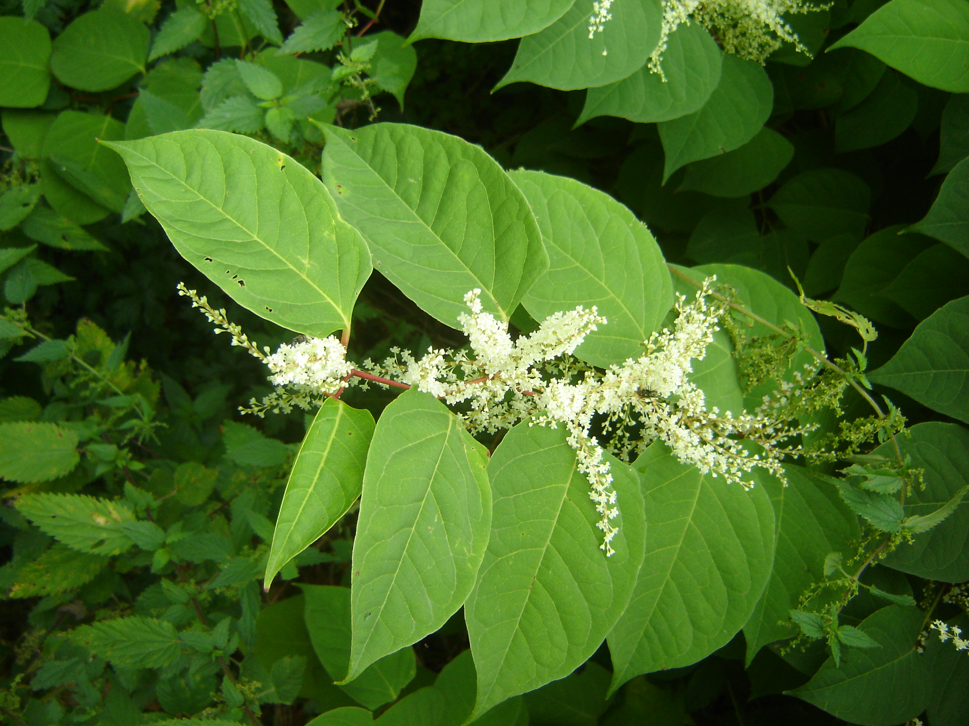
Figure 3.1 Flowering female specimen of Japanese knotweed (Ruud Beringen).

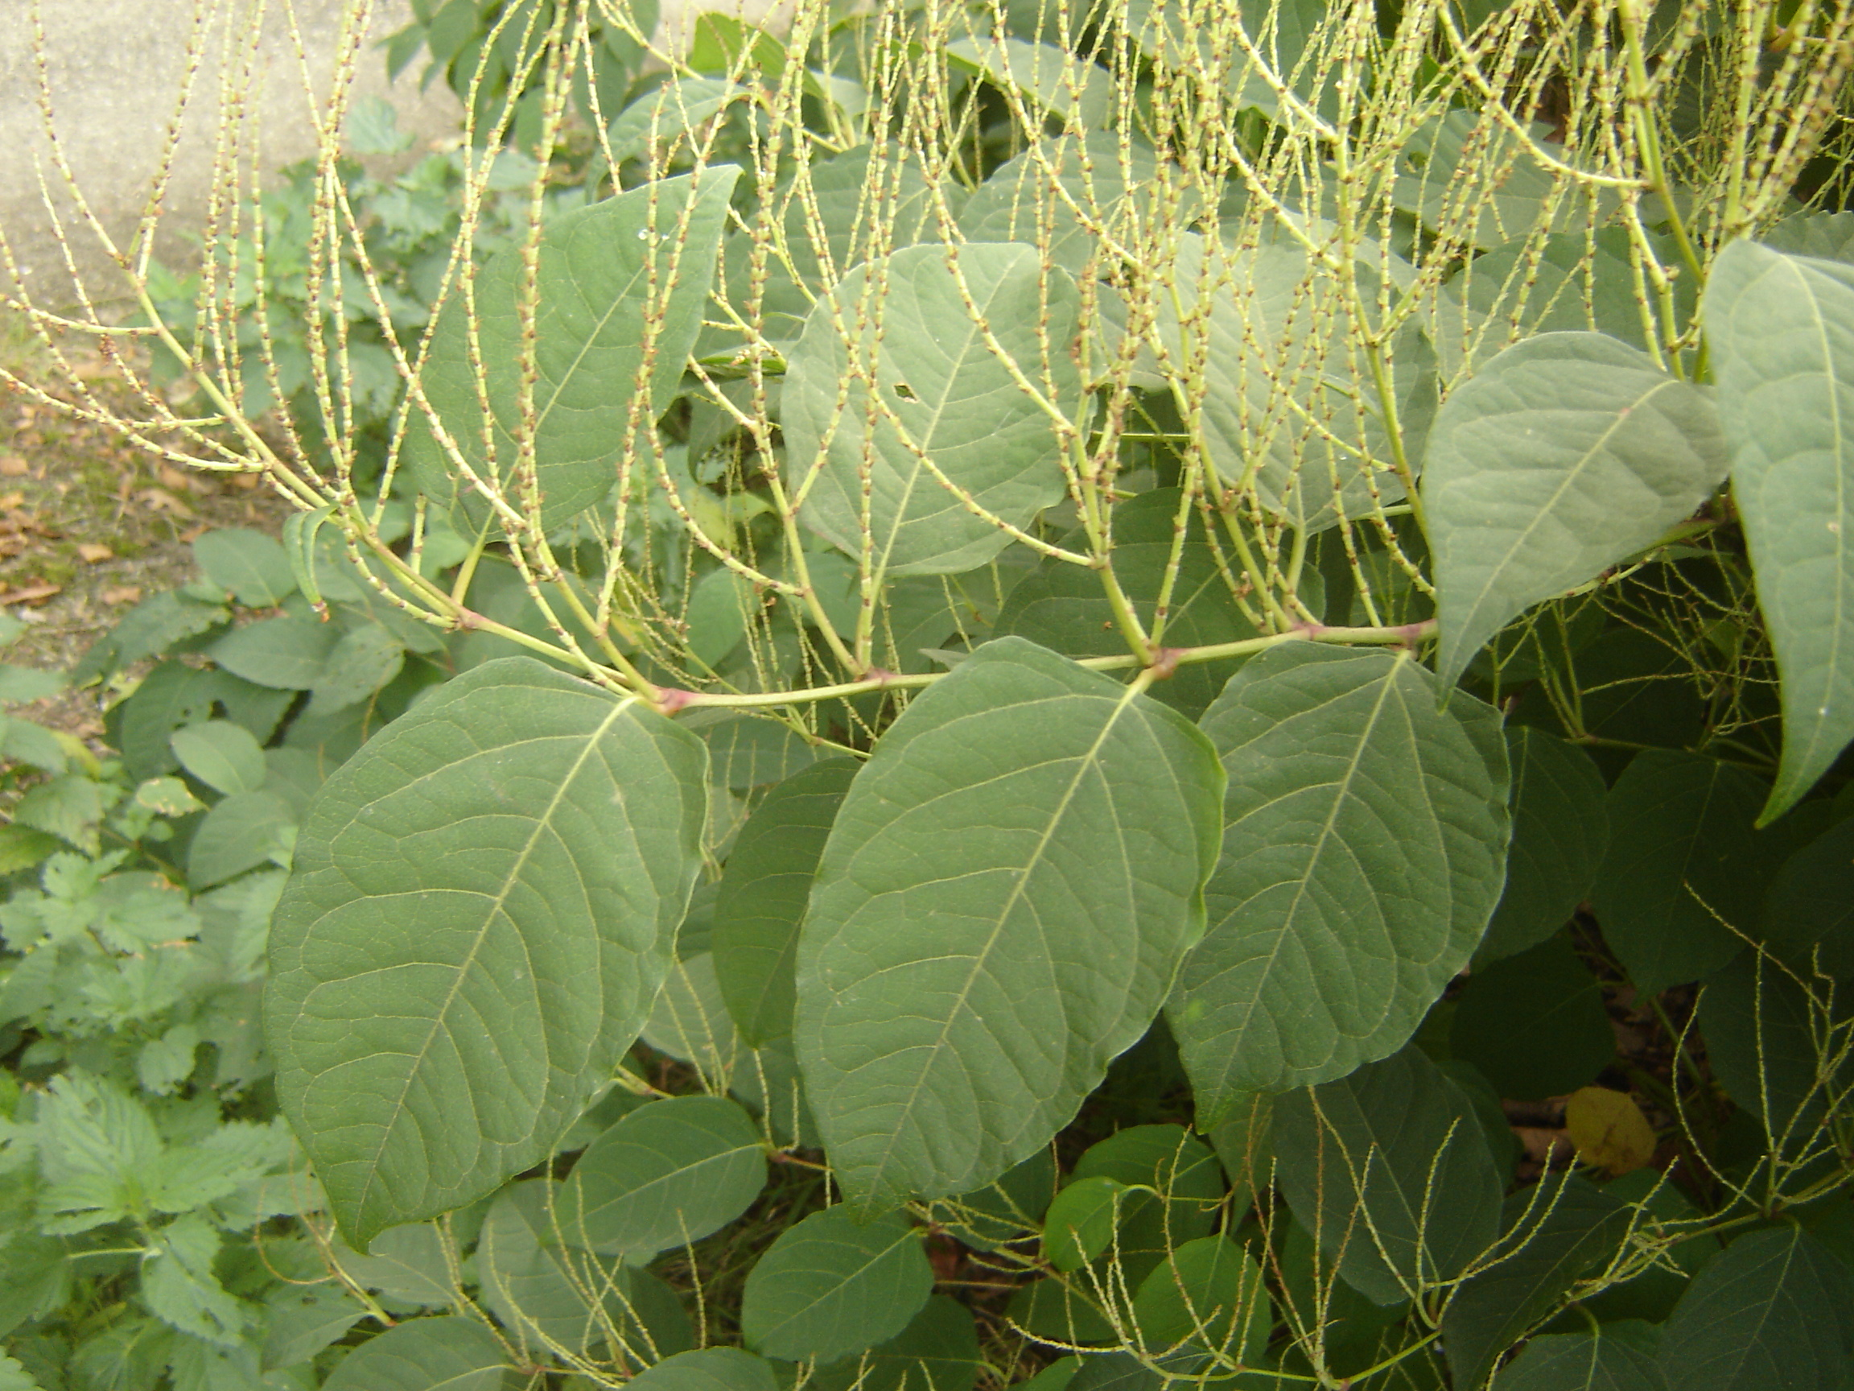
Figure 3.2 Male specimen of Japanese knotweed after flowering in Grijsoord, the Netherlands (Ruud Beringen).

3.2.3 Climate and biogeography

Climate match
The original range of R. japonica encompasses the Köppen-Geiger climate regions listed in Table 3.3 (http://koeppen-geiger.vu-wien.ac.at/present.htm). The regions in Europe with similar climates are shown in Figure 3.3.

Table 3.3 Köppen-Geiger climate regions within the original range of R. japonica.
Code |  | Köppen-Geiger classification | Original range in
Cwa |  | Temperate-Dry Winter-Hot Summer | Southeastern China, Northern Vietnam
Cfa |  | Temperate-No Dry Season-Hot Summer | Southeastern China, Taiwan, Japan (Kyushu, Shikoku, Honshu)
Dwa |  | Cold-Dry Winter-Hot Summer | North Korea, Eastern Rusland
Dfa |  | Cold-No Dry Season-Hot Summer | South Korea, Japan (Honshu)
Dfb |  | Cold-No Dry Season-Warm Summer | Japan (Hokkaido)

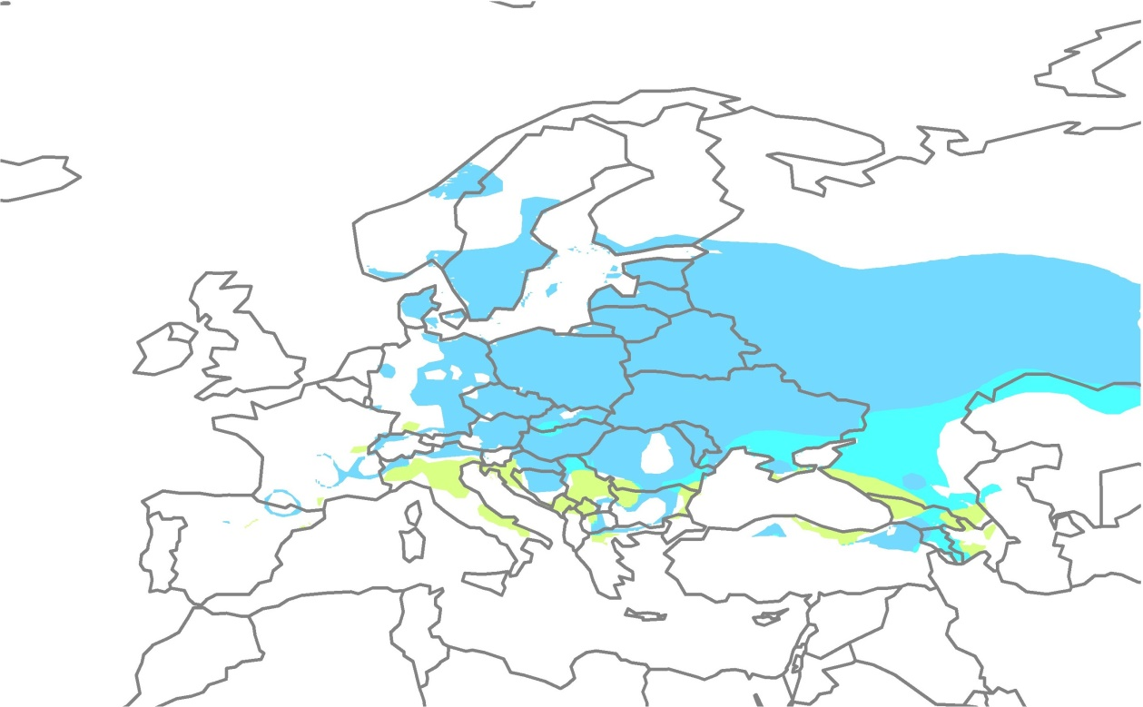
Figure 3.3. The location of climate regions Cfa, Dfa and Dfb in Europa.

Within Europa, climate regions Dfb, Cfa and Dfa are those where the climate corresponds to that of the species’ original range. These regions are mainly in Central and Eastern Europe (Figure 3.3). The climate zone to which Western Europe belongs (Cfb: Temperate-No Dry Season-Warm Summer) does not occur within the original range.

Biogeographic occurrence in Europe
R. japonica occurs in the following biogeographic regions in Europe (this is a simplified summary; for greater detail, see Appendix 1 and Appendix 2):
Atlantic region: Ireland, United Kingdom, the Netherlands, Belgium, France.
Continental region: Luxembourg, Poland, Czech Republic, Germany, Bulgaria, Serbia.
Boreal region: Estonia, Latvia, Lithuania, Finland, Sweden, Russia.
Mediterranean region: Cyprus, Portugal, Spain, Italy.
Pannonian region: Hungary.

Note: In the French department Isère R. japonica occurs in the montane zone at elevations between 900-1665 meter a.s.l. (Rouifed et al 2014). In the French Alps elevation had no effect on the expansion of stand of R. japonica along a gradient ranging from 787 to 1666 meter above sea level (Martin 2019). In other countries e.g. Slovakia, Austria, Switzerland and Norway, the species also possibly may occur up to in the Alpine biogeographic region.

Climate scenarios
Climate models are predicting higher winter temperatures at higher latitudes and drier summers. Based on these future climate scenarios, R. japonica will spread to higher elevations of the Central European mountains and the northern limit of the range will shift considerably northwards in western Norway, Sweden and Finland. The eastern limit of the range will shift eastwards and end up somewhere between the Baltic states and the Urals. Parts of Iceland will likely become suitable should the species ever be introduced there. At the same time, lower precipitation levels will make conditions less suitable for the species in large parts of central Northern Europe and Southern and Southeastern Europe (Beerling 1993, Beerling et al. 1995, Jovanović et al. 2018).
According to model calculations the number of 35 km² quadrants in Germany and Austria with suitable biotope for R. japonica will increase by 33% in the period 2051-2060, as a consequence of temperature rise (Kleinbauer et al. 2010).
According to the future climate analysis R. japonica could expand her range in riparian habitats in Southeastern Europe up to 31% (Jovanović et al. 2018).

At its northern distribution limit, R. japonica does not produce viable seed due to later flowering. Frost occurs before the plants can finish setting seed. The northern limit at which R. japonica is capable of viable seed production has shifted 500 km northwards in recent decades, likely as a result of climate change (Groeneveld et al. 2014).

3.2.4 Occurrence within the EU
The countries within the European Union in which R. japonica occurs in the wild are shown in Figure 3.4 and Appendix 1. In Finland, the distribution of R. japonica until now is limited to the vicinity of settelements in the utmost south of the country (https://vieraslajit.fi/lajit). In Sweden R. japonica is also distributed mainly in the southern provinces (Skäne, Väster Götland and Smäland) (https://Artfakta.se). In Italy, R. japonica seems to occur mainly in the northern regions and in Tuscany (Padula et al. 2008).
The distribution within the Netherlands is shown in Figure 3.5. With respect to this figure, it should be noted that in some cases R. × bohemica may have been mistakenly identified as R. japonica. Nevertheless, this does not change the general picture with respect to the distribution and occurrence of R. japonica in the Netherlands.

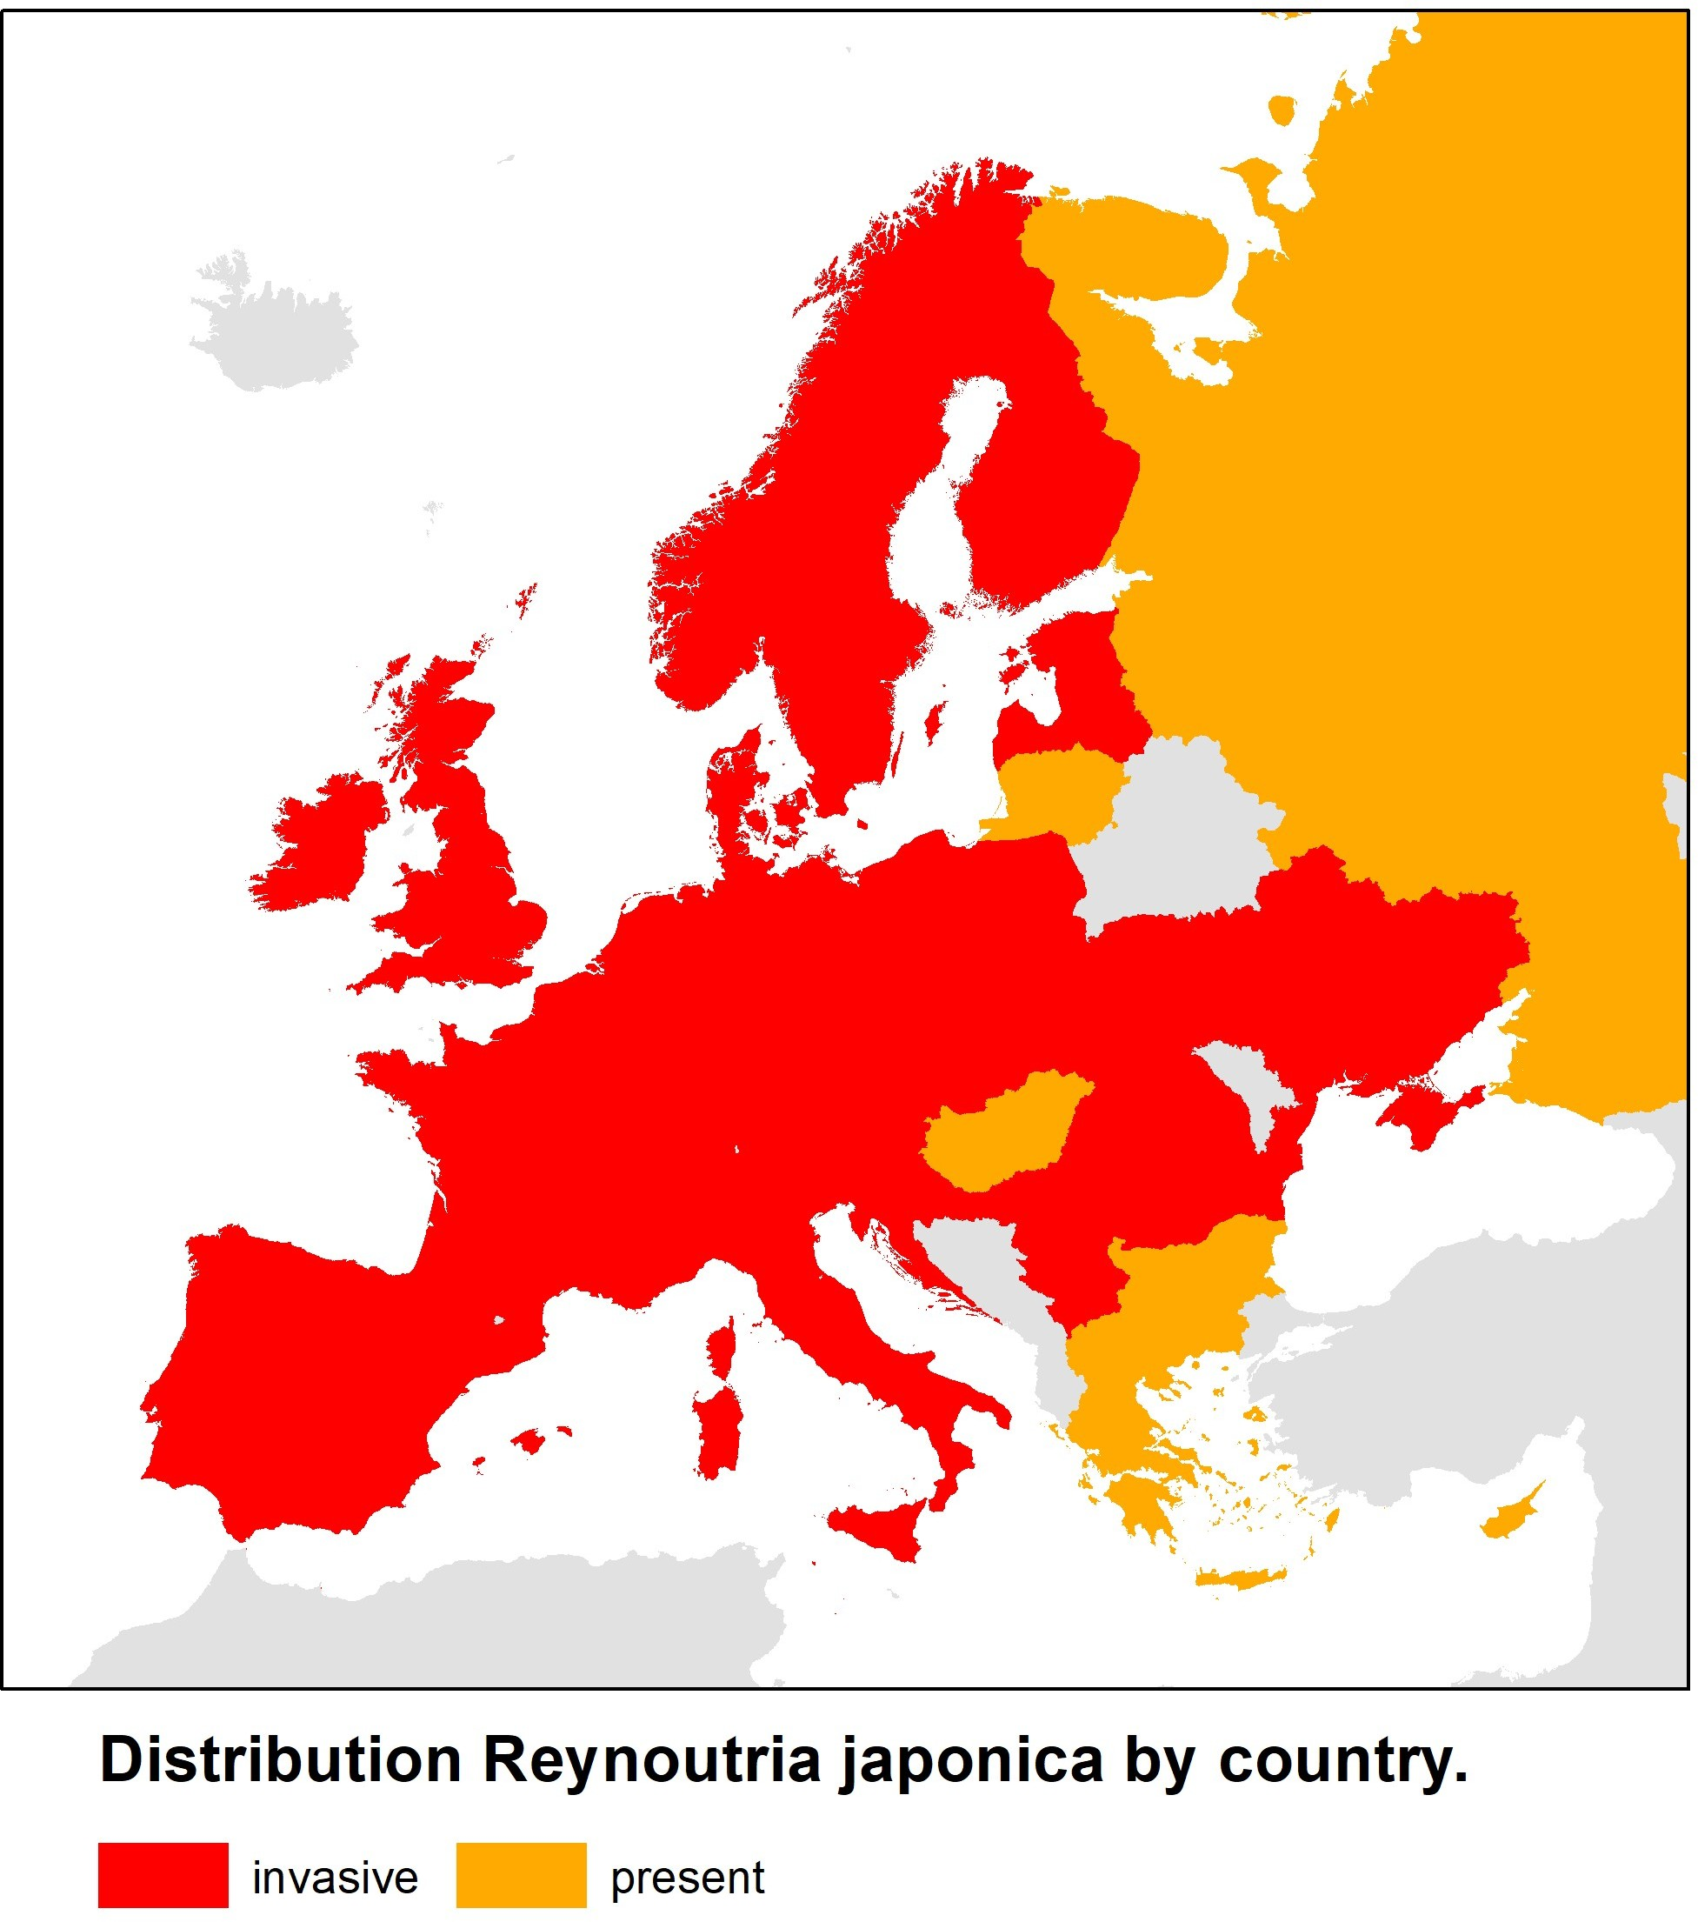
Figure 3.4 Distribution and extent of invasiveness of Reynoutria japonica in Europe (Source: https://www.cabi.org/isc/ supplemented/updated with data from sources in Appendix 1a).

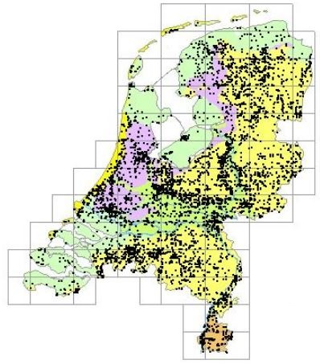
Figure 3.5 The distribution of Reynoutria japonica in the Netherlands based on observations entered in the NDFF (2022).

3.3 Impacts

3.3.1 Biodiversity and ecosystems
Soil microflora
In laboratory experiments, the addition of rhizome extracts of R. japonica was found to affect soil microbiology. While no effect on fungal biomass was observed, the total microbial biomass was sometimes negatively impacted. Compared to blank controls, the rhizome extracts changed the composition of the soil food web, which exhibited a proportionally greater abundance of bacterivorous nematodes, springtails (Collembola) and mites (Acari) (Abgrall et al. 2018).
The litter of Reynoutria species has a high C/N ratio and contains a lot of tannins and polyphenols, which are difficult to break down. This slowly decomposing litter favours fungi over bacteria. In soils under R. japonica stands, fungi are 2 to 8 times as abundant as in soils adjacent to the same stands (Suseela et al. 2016, Lavoie 2017, Brousseau et al. 2021).
Bardon et al. (2014) demonstrated that secondary metabolites in rhizome extracts and roots of Reynoutria species had an inhibiting effect on numerous strains of denitrifying soil bacteria. This reduced nitrogen losses due to the anaerobic respiration of N₂O or N₂.
Zubek et al. (2016) found both a lower abundance and a lower species richness of arbuscular mycorrhizal fungi (AMF) in patches of R. japonica in comparison to patches of native vegetation in southern Poland.

Vascular plants
Starting in the spring, Reynoutria species quickly gain height and form a closed canopy. Leaves and stems accumulate under Reynoutria species, forming litters with low decomposition rates. These factors contribute to the displacement of native species (Chmura et al. 2015).
In the northeastern United States, 1.6-10 times more species were found in areas adjacent to R. japonica stands than in the stands themselves. At the end of the growing season, the R. japonica stands contained 1.8-5.2 times more total aboveground biomass (kg/m²) and 2-6 times more Carbon and Nitrogen than the vegetation in adjacent areas. Little to no tree seedlings establish themselves in R. japonica stands are found in the undergrowth of forests (Aguilera et al. 2010). Model studies predict a decline in native species cover due to competition and the creation of unfavorable native colonization sites (van Oorschot et al. 2017).
In six R. japonica stands in Belgium, fewer species were found in Reynoutria stands than in adjacent uninvaded plots. The number of species found within the Reynoutria stands and the uninvaded plots ranged from 1 to 6, and 4 to 24, respectively. At 3 of the 6 sites, no plants other than Reynoutria were observed (Dassonville et al. 2007). In a similar study conducted in Switzerland, Stoll et al. (2012) found 50% fewer species in plots with Reynoutria. Only the number of early flowering annuals was not significantly affected. During a three year study in urban areas of Tatra National Park (Slovakia) Renčo et al. (2021) found that invasion of R. japonica had a negative impact on the native plant communities and reduced the number and coverage of plant species.. In assessing the impact of 13 invasive species Hejda et al. (2009) sampled for each species 10 pairs of adjacent, invaded and uninvaded, 4×4 meter vegetation plots. Reynoutria species showed the highest reduction in species number; R. sachalinensis 87%, R. japonica 73% and R. xbohemica 65%. Reynoutria species, and Heracleum mantegazzianum, also had the highest impact on species composition (Sørensen similarity index) (Hejda et al. 2009).
When the allelopathic effect of constituents of the roots of R. japonica plants from China was compared with that of the same species collected in Switzerland, the constituents of the latter had a stronger inhibitive effect on the seed germination of Lepidium sativum (Fan et al. 2010).
In laboratory experiments conducted by Moravcová et al. (2011), extracts from the dried leaves of R. japonica were found to have an inhibitory (phytotoxic) effect on the seed germination of Urtica dioica, Calamogrostis epigejos and Lepidium sativum, though the inhibitory effect was less than that of R. × bohemica and R. sachalinensis.
Another laboratory experiment found that leachates of soil in which R. japonica grew inhibited the growth of cuttings of Populus nigra and Salix viminalis. The growth of cuttings of Salix atrocinerea was not inhibited. This suggests that, through the emission of polyphenols, R. japonica has a direct or indirect allelopathic effect on the growth of some Salicaceae species (Dommanget et al. 2014).
In Germany, R. japonica was found to be capable of penetrating nearly all scrub and ruderal vegetation (Convolvulion, Aegopodion, Arction and Dauco-Melilotion) and becoming dominant (Böhmer et al. 2006).

Invertebrates
In the cold climate of Tatra National Park (Slovakia) nematode abundance of all trophic groups and the mean number of nematode species were significantly lower in the soil of plots invaded with R. japonica than in uninvaded control plots (Renčo et al. 2021).
In a comparison of grassland-dominated and bush-dominated riparian habitats, it was found that in those habitats that had been invaded by knotweed (R. japonica, R. sachalinensis, R. × bohemica), there were not only fewer plant species, but also fewer invertebrates. The biomass of invertebrates (Mollusca, Annelida, Arachnida, Crustacea, Myriopoda, Insecta) in undisturbed habitats was twice as high as that in habitats invaded by knotweed (Gerber et al. 2008).
In riparian sites in Normandy (France) functional diversity of detrivorous and predatory macro-invertebrates was less correlated in Knotweed invaded plots than in uninvaded plots. This suggests that Reynoutria species simplify the soil food-web structure (Brousseau et al. 2021).
Stoll et al. (2012) found fewer snail species on average in stands of R. japonica when comparing vegetation plots situated on the bank of a Swiss river. The reduction had a greater impact on large and long-lived snails (≥5 mm shell size and >2 years), such as the Roman snail (Helix pomatia), than on slugs or small and short-lived snails. The small snail Vertigo pusilla occurred in higher abundances in the R. japonica plots.
Riparian vegetation in Ireland and Northern Ireland with a high cover of R. japonica (with a mean 53% cover) had more flowers during the flowering season than sites with primarily native species (with a mean 1.7% cover of R. japonica ). Both the total diversity of insects and the abundance of bumblebees and hoverflies were higher in the sites dominated by R. japonica than in sites with predominantly native vegetation, despite the plants being male-sterile in Ireland and producing no pollen. During the flowering period of R. japonica (from late August to September), there are relatively few flowering native plants (Davis et al. 2018).
In comparing the leaf area consumed by four herbivores - the Portuguese slug (Arion lusitanicus), the large yellow underwing (Noctua pronuba), Roesel’s bush-cricket (Metrioptera roeselii) and the green dock beetle (Gastrophysa viridula) - of the native plant species bitter dock (Rumex obtusifolius) and dandelion (Taraxacum officinale) with that of R. japonica, R. × bohemica, R. sachalinensis and Fallopia baldschuanica, it was found that the Reynoutria and Fallopia species were consumed less than both native species. R. japonica was the least preferred food source of all four herbivores (Krebs et al. 2011).

Vertebrates
In a study of slowly flowing streams in Scotland, bankside cover provided by R. japonica and Himalayan balsam (Impatiens glandulifera) had no effect on the total biomass and density of brown trout (Salmo trutta) and Atlantic salmon (Salmo salar) when taken as a whole. However, in terms of fish density per species, a positive correlation was found between salmon density and cover provided by both plant species, while a negative correlation was found between trout density and cover. The ratio of aquatic to terrestrial invertebrates in the stomach contents of the fish was also not influenced by high coverage of these species (Seeney 2016).
Along 50 m transects of vegetation, including 25 m of R. japonica and 25 m of original native vegetation, Maerz et al. (2005) observed an increase in the mass of most green frogs Lithobates clamitans (synonym: Rana clamitans) in the original vegetation and no increase in frog mass in the R. japonica stands. This suggests that the habitat quality for green frogs has deteriorated due to the decreased abundance of invertebrates following the appearance of R. japonica.

3.3.2 Red List species and protected species
Very few publications were found that examine the impact of Japanese knotweed on Red List species or protected species in Europe. Two experts on invasive species in Dutch nature reserves were also unable to produce any examples of a decrease in policy-relevant species when queried (oral communication with Henk Siebel and Max Simmelink). In the Netherlands, Japanese knotweed grows mainly at sites where garden waste is dumped. These sites are generally located at nutrient-rich forest edges and scrub vegetation where few rare or protected species grow. In Finland Reynoutria species have been recorded within the boundaries of 42 protected areas (7% of the observation sites). Reynoutria species have been reported growing in the vicinity of 40 endangered species; mainly endangered forest species, but also near meadow species and several lichen species of limestone cliffs, e.g. Lemmopsis arnoldiana (extremely endangered), Bagliettoa calciseda (notable) and Scytinium biatorinum (endangered) (Huusela-Veistola et al. 2020).

3.3.3 EU habitats
R. japonica usually grows in habitats that have been disturbed by humans, such as vacant lots, ruderal areas and along unmaintained or extensively maintained roads or railway tracks. Most stands are found close to urban areas and are the result of garden overspill or the dumping of garden waste. As such, the species occurs in a wide range of biotopes. River and stream valleys are the primary type of natural habitat in which the species can establish itself, survive and spread, as these areas provide an ample supply of water and nutrients. In the spring, the plants’ rhizomes are capable of growing through layers of sediment that have been deposited in the winter. Open areas created by erosion or sedimentation provide opportunities for seeds and rhizome fragments transported downstream by the current to establish themselves. In Baden-Württemberg, Reynoutria species already began to overrun long stretches of stream and river banks in the early 1990s (Kretz & Vogtsburg 1994).

In Central Europe, bank vegetation comprised of species such as butterbur (Petasites hybridus) and hedge bindweed (Convolvulus sepium) has also been completely displaced by R. japonica (Sukopp & Sukopp 1988). This vegetation can be classified as habitat type 6430: Hydrophilous tall herb fringe communities of plains and of the montane to alpine levels (Anonymous 2013b). The surface covered by this habitat type in the Natura 2000 network of natural protection areas in EU countries is shown in Appendix 6a.

In Central Europe, R. japonica mainly grows in stands of Stellario-Alnetum glutinosae and Stellario-Petasitetum. Common native species such as butterbur (Petasites hybridus) and stitchwort (Stellaria nemorum) can eventually be displaced by R. japonica. R. japonica prevents forest regeneration because it blocks sunlight from reaching saplings (Sukopp & Sukopp 1988). In the United Kingdom, R. japonica occurs mainly among stands of W6 Alnus glutinosa - Urtica dioica woodland plant communities and Salicion albae alluvial willow forests (Beerling et al. 1994). These forest communities can be classified under habitat type 91E0: Alluvial forests with Alnus glutinosa and Fraxinus excelsior (Alno-Padion, Alnion incanae, Salicion albae) (Anonymous 2013b). The surface covered by this habitat type in the Natura 2000 network of natural protection areas in EU countries is shown in Appendix 6b.

The Natura 2000 areas in the Netherlands where R. japonica is found are shown in Appendix 5. In some cases R. × bohemica may have been mistakenly identified as R. japonica.R. japonica has been observed in 91 (and possibly 116) Natura 2000 areas in the Netherlands. Its occurrence in a Natura 2000 area does not necessarily mean that it is also growing in a protected EU habitat type.

In summary, R. japonica appears to already pose a threat to habitat types in river and stream valleys, particularly in Central Europe. In the Netherlands, it currently only occurs to a modest extent in the wild in similar biotopes, but in light of the situation in Central Europe this could change in the future.

Potential distribution modelling showed that in the South East European countries Bulgaria, Croatia, Romania, Serbia and Slovenia, a large area of suitable riparian habitat in National Parks and Nature reserves, including the Natura 2000 area’s Vitosha, Žumberak-Samoborsko gorje, Medvednica, Cheile Bicazului-Hăşmaş, Călimani, Defileul Mureşului, Julijske Alpe (Triglav), could yet be occupied by Reynoutria taxa (Jovanović et al. 2018).

3.3.4 Physicochemical properties and structure of ecosystems
Higher concentrations of the minerals K, Mg and Mn are found in the top 10 cm of soil underneath R. japonica stands than in similar soils in which native vegetation grows. The total biomass of R. japonica was found to be 4.2 (3-13) times greater than that of native vegetation. The aboveground mineral concentrations underneath R. japonica were also higher than underneath native vegetation: Cu (+45%), K (+34%), Mg (+49%), Mn (+61%), P (+44%) and Zn (+75%). This is an indication of a net transfer of minerals from deep soil layers to the topsoil underneath Reynoutria stands (Vanderhoeven et al. 2005, Dassonville et al. 2007).
While soil parameters such as the availability of cations and phosphate are impacted by Reynoutria, the direction of this impact depends greatly on the site. At sites with low concentrations, the values increase following the appearance of Reynoutria, while at sites with high concentrations, the values decrease following the appearance of Reynoutria. In other words, the appearance of Reynoutria leads to a site-specific homogenisation or levelling out of soil parameters (Dassonville et al. 2007).
R. japonica and R. × bohemica inhibit the conversion of nitrate into nitrogen (denitrification) in the soil, in part due to the reduced density of denitrifying bacteria. Shifts in the composition of soil microflora underneath Reynoutria species reduce the activity of ammonia and nitrifying bacteria. The large leaf surface of Reynoutria species leads to the evaporation of a lot of moisture. Soil moisture levels underneath Reynoutria stands are on average lower than in the direct vicinity. These lower moisture levels increase the oxygen content of the soil, which in turn likely serves to inhibit the denitrification by anaerobic bacteria. The loss of nitrogen due to leaching or volatilisation is expected to be less (Dassonville et al. 2011). Beerling et al. (2009) also found significantly higher concentrations of NO₃⁻-N under Reynoutria stands than in adjacent plots (Table 3.1).
The litter under Reynoutria species has a high C/N ratio because 60% of the nitrogen present in the leaves in the autumn (prior to falling) is stored in the root system. The litter decomposes slowly. The mean pH of Reynoutria stands was somewhat lower than that of native vegetation under similar conditions (Aguilera et al. 2010, Dassonville et al. 2011).
On Mount Fuji in Japan, R. japonica is a pioneer species on lava fields. Here, the species grows in circular stands, in nutrient-poor soil (low in nitrogen). According to research, it is plausible that 1) nitrogen taken up in the centre of a clone is transported to the periphery of the clone, enabling it to expand outwards, and 2) young shoots on the periphery utilise this transported nitrogen in the spring and begin to take up nitrogen with their own roots later in the year (Adachi et al. 1996).
In the northeastern United States, R. japonica was found to remove 10.4 mm of water per m² (2.1 litres per m² of leaf area) through transpiration. This means that R. japonica situated on the banks of a stream is capable of lowering stream levels significantly (Vanderklein et al. 2014).

3.3.5 Ecosystem services
Provisioning services
The young shoots can be eaten in the spring, much like asparagus. They can also be used as a replacement for rhubarb cakes, juices, chutneys, compotes and jam. Seeds ground into powder can be used as seasoning or as a binding agent in soups, or mixed with flour to make cake or bread. The roots are also sometimes eaten (pfaf.org, eattheweeds.com). The plant can also be used to make wine or beer (Hamilton 2011). However, the fact that knotweed is used in many Asian countries does not automatically mean the same applies to Europe. Food that was not consumed in the EU to a significant degree before 15 May 1997 is considered as ‘Novel Food’ and cannot be marketed before authorisation has been granted by the European Food and Safety Authority (EFSA). To obtain that authorisation requires scientific and technical proof that the new food can be consumed safely and has no harmful effects on those who consume it. In addition, it must be shown that the ‘new’ crop or product can be produced safely. This means that the cultivation has to be performed under controlled and hygienic conditions.

By definition wild growing Asian knotweed does not meet this EFSA condition for cultivation. This makes the option of using Asian knotweed for human nutrition, medicinal applications or for the supplement market in Europe unlikely.(Van Dijk et al. 2020).

Under fantasy names as “Dutch bamboo” or “Polygonum sticks” living stems of Reynoutria species were sold as ornamentals in Dutch floristry (Iersel 2019b). Disposal of these stems in nature could have caused new infestations. From 1-1-2022 on there is a trade ban on living Asian knotweeds parts in the Netherlands (https://zoek.officielebekendmakingen.nl/stb-2021-381.html).

Reynoutria species contain a lot of biologically active constituents, especially polyphenols. In traditional Eastern medicine, the rhizomes of R. japonica (known of as Hu zhang in China and Itadori in Japan) are used to treat inflammation, infections, influenza, skin diseases, burns, snake bites and high cholesterol, among other conditions. The rhizomes contain higher amounts of the active constituents resveratrol, piceid, catechin and epicatechin than the young shoots. The rhizomes of R. japonica harvested in the autumn are richer in resveratrol than those of other Reynoutria species and likewise contain more resveratrol than vegetables, fruit, grapes or wine (Vrchotova et al. 2007, Frantik et al. 2013, Nhiem et al. 2014, Nawrot-Hadzik et al. 2019, PFAF 2019).
Crushed leaves can be applied externally as a poultice to abscesses and cuts. Plants extracts have been shown to have an inhibitory effect on tumours (PFAF 2019).
In vitro extracts of R. japonica (Minimum Inhibitory Concentration of 0.25–0.5%) showed strong activity against both the growing and the non-growing stationary phase of Borrelia burgdorferi, the causative agent of Lyme disease (Feng et al. 2020).
Some phytochemicals extracted from the rhizomes of R. japonica and R. sachalinensis (vanicoside A and vanicoside B) showed moderate inhibition of SARSCoV-2 main protease by docking into the binding site of this COVID-19 virus protein (Nawrot-Hadzik et al. 2021).

Fabrics made of cotton and bamboo rayon can be dyed using an extract from the rhizomes of R. japonica. Thanks to bioactive constituents in the rhizome extract, the fabrics also have antibacterial properties that protect against Staphylococcus aureus (Gorjanc et al. 2016).

Paper can be made from the pulp of the dried stems. This paper is suitable for making bags, newspapers and writing paper (https://www.vokasnaga.si/en/circular-economy, https://www.whiteleafpaper.com/shop)

R. japonica is a good honey plant and is heavily visited by honeybees in the autumn, when few native plants flower. Beekeepers are also said to have once planted the species (Beerling et al. 1994, Böhmer et al. 2006, Davis et al. 2018, http://www.iucngisd.org). The honey appears to be a good source of minerals, especially K and Na, at levels of 1187-6196 mg kg⁻¹ and 58.8-68.8 mg kg⁻¹, respectively. In addition, the honey contains high levels of calcium (Bobis et al., 2019).

Regulating services
In Japan, both R. japonica and R. sachalinensis are planted with a view to stabilising road verges against the threat of erosion (Pashley 2003).
Outside its native range, however, R. japonica has the reputation of making the river banks on which it grows more susceptible to erosion. The root systems of Reynoutria species contain little to no finely branched roots in the topsoil. Given that practically no other species grow in Reynoutria stands, the topsoil is poorly rooted and susceptible to erosion. As such, the soil is easily washed away when the water runoff is high in the winter (Kretz & Vogtsburg 1994, Colleran et al. 2020). At the same time, there are reports that R. japonica promotes sedimentation: “Its rigid, wider than a thumb-sized aboveground stems reduce the flow rate during high water, promote sedimentation and contribute to the heightening of banks, which can be detrimental to water drainage” (Original text in German: “Seine wenig elastischen, Uberdaumendicken, oberirdischen Sprosse vermindern die Fliessgeschwindigkeit des Hochwassers, fangen das Getreibsel, fördern die Sedimentation und tragen zur Aufhöhung des Ufers bei, was für den Abfluss von Nachteil sein kann“) (Lohmeyer 1969, 1971, in Sukopp and Sukopp 1988). In summary, it can be concluded that in waterways with periodically high winter runoff, Reynoutria contributes to bank erosion, while in slowly flowing (downstream) waterways it has a more inhibitory effect on erosion and could perhaps promote sedimentation.

3.3.6 Public health & the economy

Public health
Reynoutria species contain relatively high levels of oxalic acid. While oxalic acid is not toxic, it can bind to minerals such as calcium and magnesium and prevent them from being absorbed by the body, which could in turn lead to deficiencies. Individuals predisposed to rheumatism, arthritis, gout and kidney stones should exercise caution if they decide to eat Japanese knotweed. In traditional dishes that include knotweed, the oxalic acid is removed by rinsing it with water or adding salt (PFAF 2019).

Safety of people and infrastructure
When Reynoutria species become established on dams and dikes, they supplant the grass cover. This makes these structures more susceptible to erosion when there is high water runoff. The upward growth of rhizomes can displace individual stones in the pavement or stone pitching. (Kretz & Vogtsburg 1994).
In some places where Reynoutria species grow close to the road and obstruct vision, extra mowing is carried out, in part to prevent unsafe traffic situations (personal observation, Baudewijn Odé).

Socioeconomic impact
In the United Kingdom, the presence of R. japonica within seven metres of a building is considered to pose a risk to the building’s structural integrity. The soil on which R. japonica grows is classified as “controlled waste”. Accordingly, the decontamination and/or removal of the soil is expensive, with total nationwide costs for such work estimated at 166 million pounds per year. Meanwhile, the presence of R. japonica on a residential property can serve as a reason for denying a mortgage to potential buyers. However, based on a survey of contractors and property managers and a field study of structurally damaged buildings with and without R. japonica nearby, no evidence was found to support the assumption that R. japonica can cause significant damage to buildings. Woody plants are the species that cause the most damage to buildings. The rhizomes of R. japonica rarely grow more than 4 metres away from the aboveground stems and usually no more than 2-2.5 metres. There is no evidence whatsoever to support the claim that R. japonica is capable of “growing through concrete”. The rhizome tips are remarkably soft and flexible and capable of growing around obstacles and through existing cracks and seams (Fennel et al. 2018, Figure 3.6).
Natural forest regeneration in cleared areas can be impeded if stands of Reynoutria are present (Kretz & Vogtsburg 1994). Little to no saplings can establish themselves in Reynoutria stands (Aguilera et al. 2010, van Oorschot et al. 2017).
In the state of Missouri in the United States, R. japonica occurs as an agricultural weed (Fishel 1999, in Barney et al. 2006). At a local level in Europe, the species also occurs at the edges of agricultural plots (oral communication with J. Leferink).
In the Netherlands, there has been a clear increase in the attention paid to the economic damage caused by Asian knotweeds in recent years. Road authorities and water managers are frequently called to account when adjacent private land is colonised from areas they oversee. More and more homeowners are looking for ways to control infestations in their gardens (personal observation, FLORON & Radboud University).
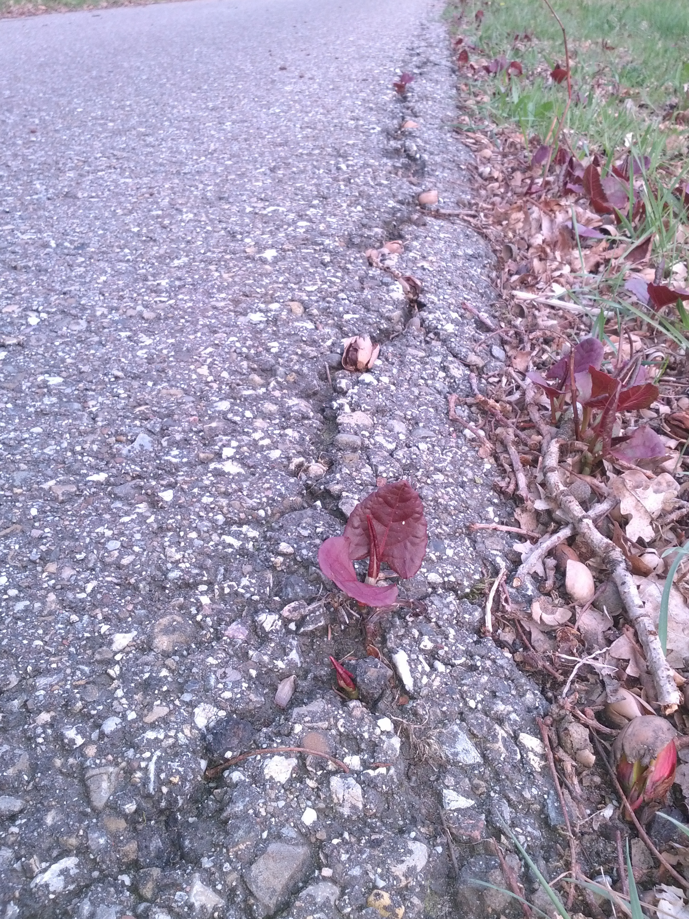
Figure 3.6 Bohemian knotweed penetrating a crack in the asphalt (Ruud Beringen).

4 Reynoutria × bohemica

4.1 Species description

4.1.1 Taxonomy
Scientific classification
Kingdom: Plantae
Phylum: Tracheophyta
Class: Magnoliopsida
Order: Caryophyllales
Family: Polygonaceae
Sub-Family: Polygonoideae
Tribe: Polygoneae
Genus: Reynoutria

4.1.2 Nomenclature
Scientific name
Reynoutria × bohemica J. Chrtek & A. Chrtková

Synonyms
Fallopia x bohemica (Chrtek & Chrtková) J.P. Bailey
Fallopia sachalinensis var. intermedia (Tatew.) K.Yonekura & Hiroyoshi Ohashi
Polygonum x bohemicum (Chrtek & Chrtková) Zika & Jacobson
Polygonum sachalinense var. intermedium Tatew.
Reynoutria x vivax J. Schmitz & K.J. Strank
Reynoutria x mizushimae Yokouchi ex T. Shimizu
Reynoutria sachalinensis var. intermedia (Tatew.) Miyabe & Kudô

Common name
Bohemian knotweed

Trade name
No prevailing trade name known (the Dutch name ‘Bastaard-duizendknoop’ is used occasionally)

Vernacular namesBulgarian: Бохемска фалопия
Czech: Křídlatka česká
Danish: Hybrid-pileurt
Dutch: Basterdduizendknoop, Bastaardduizendknoop, Boheemse duizendknoop
Estonian: voolja ja sahhalini pargitatra hübriid
Finnish: Tarhatatar
French: Renouée de Bohême
German: Bastard Staudenknöterich
Irish: Glúineach
Italian: Poligono di Boemia, Reynoutria ibrida
Norwegian: Hybridslirekne
Polish: Rdestowiec posredni, Rdestowiec czeski
Swedish: Hybridslide

Note: despite having a clear taxonomy, this taxon exhibits great variation and hybrids exist with both parental species, R. japonica and R. sachalinensis

4.1.3 Range
Reynoutria × bohemica is a hybrid between R. japonica and R. sachalinensis. It first emerged outside the original range of its parental species. In the original range, the parental species are geographically and ecologically separated.
Tetraploid, hexaploid and octoploid forms of R. × bohemica occur in Europe. The most common form in Europe is hexaploid (Table 4.1) (Bailey & Wisskirchen 2006, Tiébré et al. 2007b, Krebs et al. 2010, Mandak et al. 2003/2004).
Of all the sampled knotweed plants in Europe, the percentage of R. × bohemica varies by region, between 3% and 55% on average (Table 4.1). In the Czech Republic, for instance, R. × bohemica is more invasive than each of its parental species and spreads faster (Mandak et al. 2004). The current representation of R. × bohemica in the total knotweed population is probably higher than the percentages shown in Table 4.1.

In western North America, R. × bohemica is now the most common knotweed (Gaskin et al. 2014). R. × bohemica was not found in Japan until 1997, when it was given the name Reynoutria × mizushimae Yokouchi ex T. Shimizu. In Japan, it is the hybrid between R. japonica var. uzenensis and R. sachalinensis (Galasso et al. 2009). Though R. japonica and R. sachalinensis both occur in northern Honshu, they grow in undisturbed areas far removed from each other. Both species are planted in road verges to protect against erosion. As a result, more and more hybrids have been found in disturbed areas in the vicinity of cities (Pashley 2003).
In North America and Europe, the genetic variation within R. × bohemica is far greater than it is within R. japonica (Gaskin et al. 2014, Krebs et al. 2010).

Table 4.1. Relative occurrences of R. japonica, R. sachalinensis and R. × bohemica and relative occurrences of the different chromosome numbers (ploidy) in R. × bohemica, both shown as a % the total number of sites sampled.

 | Occurrences of Reynoutria taxa (%) |  |  | Occurrences of ploidy R. x bohemica (%)
Region | jap. | sach. | x boh. | aneuploidy | 2n=44 | 2n=66 | 2n=88 | Source
Czech Republic | 67.6 | 13.2 | 19.2 | 0 | 2.1 | 92.5 | 5.3 | Mandak et al. 2003/2004
U.K. | 87 | 10 | 3 | 0 | 21 | 75 | 4 | Bailey & Wisskirchen 2006
Belgium | 49 | 8 | 43 | 3 | 3 | 84 | 10 | Tiébré et al. 2007b
Germany & Switzerland | 68 | 8 | 24 | 0 | 0 | 100 | 0 | Krebs et al. 2010
Western North America | 15.2 | 13.5 | 71.3 | - | - | - | - | Gaskin et al. 2014
Germany (Rhineland) | ? | ? | 55 | - | - | - | - | Buhk & Thielsch 2015
Denmark | 77.5 | 25.5 | 3.9 | - | - | - | - | Hartvig & Vestergaard 2015

4.1.4 Characteristics
R. × bohemica is very similar to R. japonica and, to a lesser extent, R. sachalinensis (see Appendix 4). In particular, its hexaploid form is very similar to R. japonica var. japonica (Tiébré et al. 2007b).

4.1.5 Reproduction and dispersal
Life cycle
The life cycle of R. × bohemica is very similar to that of R. japonica, and as such the following is a repeat of the description of the life cycle of the latter species. The shoots sprout in early April. In Northern Europe, the shoots sprout later in April-May. Mainly the aboveground portions of the plant grow in the spring. Between mid-April and June, the plant can grow up to 40 cm in four days under favourable conditions. The plants achieve their maximum height around mid-June and flower from late August into October. In northern Europe (Finland) they flower from August into September (https://vieraslajit.fi). Between August and November, the assimilates are primarily invested in the rhizomes. The supply of assimilates to belowground organs is the highest in August (in the United Kingdom). The biomass of the rhizomes can be up to 18 times higher in September compared to May. The aboveground portions of the plants die back with the first frost. The brown stems persist throughout the winter and part of the subsequent growing season (Beerling et al. 1994, Seiger & Merchant 1997, Price et al. 2001, Jones et al. 2018). The seed bank of Japanese knotweed is transient; the seeds have a short-lived germinative capacity and germinate in the spring or the ensuing autumn (Tiébré et al. 2007a). However, the seeds of some Slovenian specimens of R. japonica and R. sachalinensis germinated during the second year (Strgulc Krajšek & Dolenc Koce 2015).

Reproduction
R. × bohemica probably arose independently in several locations as a result of hybridisation between R. japonica and R. sachalinensis. Both in North America (Groeneveld et al. 2014, Gaskin et al. 2014) and Europe (Hollingsworth & Bailey 2000a), it exhibits greater genetic diversity than R. japonica. It also has both male-fertile and male-sterile clones, while the R. japonica found in Europe is usually male-sterile. So male-fertile clones of R. × bohemica can pollinate male-sterile clones. In many areas, R. × bohemica is the main pollinator of R. japonica (Groeneveld et al. 2014, Tiébré et al. 2007a, Krebs et al. 2010). In contrast with R. japonica, R. × bohemica can spread by means of both seeds and vegetative propagation, at least in North America (Groeneveld et al. 2014, Gaskin et al. 2014).

Pollinators
The flowers of Reynoutria species produce a lot of nectar and are visited and - where the gender distribution allows it - pollinated by a wide range of insects.

Hybrids
R. × bohemica can backcross with R. japonica and R. sachalinensis (Bailey et al. 2007). Many publications refer to the “Japanese knotweed complex”, which includes R. japonica sensu lato and hybrids and backcrosses.
Testing regeneration ability of rhizome fragments of Reynoutria species in the Czech Republic, Pyšek et al. (2003) found 9 genotypes of R. xbohemica, 5 genotypes of R. sachalinensis and only one genotype of R. japonica. The high genotype variability within R. xbohemica suggests that hybridization between R. japonica and R. sachalinensis does occur in the introduced range. Hybrids can originate by hybridization between R. japonica and R. sachalinensis and by reciprocal hybridization between R. xbohemica genotypes or backcrosses of R. x bohemica with parental species. Some hybrids with novel genotypes appear to have a higher fitness (as to regeneration capacity and growth rate) than their parental taxa, supporting the hypothesis that hybridization increases the invasion potential of Reynoutria taxa (Pyšek et al. 2003).

Dispersal
When stored at room temperature, seeds of R. × bohemica remained viable for four years (Beerling et al. 1994). In seed flotation experiments, 50% of the achenes of R. × bohemica were still floating after two days. After three days, the seeds began to germinate and these seedlings continued to float. Compared to sowing seeds in the ground, exposure to water significantly improved seedling germination and survival. Both seeds and seedlings can be spread by means of flowing water (Rouifed et al. 2011). Their buoyancy is positively correlated to the wing area of the achene. Rounded achenes have a higher buoyancy than elongated achenes. There are clear differences between the various populations of R. × bohemica with respect to achene shape (Lamberti-Raverot et al. 2017).

Vegetative spread
Garden experiments have shown that stem and rhizome fragments from different species of Reynoutria species can become new plants (Bimova et al. 2003). This regeneration is possible on the condition that the stem fragment contains at least one bud. Regeneration from rhizomes is more efficient than regeneration from stem fragments in both R. japonica (var. japonica and var. compacta) and R. × bohemica. Only when stem fragments are suspended in water are they more successful than rhizomes. Regeneration capacity is generally the highest in R. × bohemica and R. japonica var. compacta and the lowest in R. sachalinensis. Buried stem fragments of R. japonica var. japonica were not found to regenerate. In contrast, buried rhizome fragments of R. japonica var. japonica regenerated relatively well in sandy soil with relatively poor nutrient levels. With respect to regeneration from fragments, clear differences have been observed between the various genotypes of R. × bohemica (Pysek et al. 2003). In a semi-rural study area in Belgium the total surface area occupied by R. x bohemica increased over two years by 34.7%. The colonization rate was low. Only a few new stands formed by clonal reproduction were recorded every year. The minimal distance between existing stand and newly formed ones was 10 m and the maximum distance was 105 m. (Tiébré et al. 2008). While specimens in eastern Canada do produce seeds, the spread along rivers there is primarily vegetative, by means of rhizome and stem fragments. The colonisation of river banks begins in cities and villages, from which they then further spread (Duquette et al. 2016).

4.1.6 Habitat and ecology
R. x bohemica grows in unmanaged or extensively managed habitats that are relatively rich in nutrients and provide a lot of light. The species is often found in linear stands along the banks of waterways, the edges of fields or forests, along roadways or railways, hedges and wooded embankments. Flat stands can establish themselves in vacant lots or well-lit deciduous forests of poplar and willow trees (NDFF 2019, Tiébré et al. 2008, Dassonville et al. 2011). In Canada and the United States, R. × bohemica mainly grows in riparian contexts (e.g. Duquette et al. 2014). In a semi-rural study area in Belgium, compared to R. japonica, the presence of R. × bohemica was higher in edges of exotic tree plantations and banks of running waters (Tiébré et al. 2008). In Belgium and France, the mean soil pH of R. × bohemica plots is 6.8 (5.8-7.6) (Dassonville et al. 2011). In Polish river valleys, R. × bohemica grows at sites with relatively high levels of available nitrogen in the form of NH₄⁺ and NO₃⁻ ions (Chmura et al. 2015). Compared with R. japonica and R. sachalinensis, R. × bohemica occurs more outside built-up areas in the Czech Republic (Mandak et al. 2004).
On the east coast of the United States, hybrids (F1 and backcrosses) have recently established themselves in coastal salt marshes (Richards et al. 2008, Walls 2010). Rhizomes of R. × bohemica can survive exposure to saline concentrations of up to 120 mg/l (Rouifed et al. 2012).

4.2. Distribution

4.2.1 Invasion history of potential distribution area
Reynoutria × bohemica was first reported in the former Czechoslovakia in 1983. Later, it was determined that the plant must have been present in Europe for a lot longer than that. In the United Kingdom, herbarium material was found of plants that had been collected in 1872. These plants had originally come from a nursery. It is assumed that R. × bohemica arose independently multiple times in Europe - in nurseries, parks, botanical gardens or in the wild - as a result of hybridisation between R. japonica and R. sachalinensis (see Appendix 7). The spread of R. × bohemica was probably also facilitated by the exchange of seeds between botanical gardens, as seeds from R. japonica in Europe can actually only be formed as a result of being pollinated with the pollen of ♂ R. sachalinensis and are thus mostly of hybrid origin. (Bailey & Conolly 2000, Bailey & Wisskirchen 2006, Krebs et al. 2010).
In the Czech Republic, R. × bohemica is spreading faster than each of its parental species (Mandak et al. 2004). In western North America, this taxon is now more common than R. japonica and R. sachalinensis and also spreading faster than each of its parental species (Gaskin et al. 2014).

4.2.2 Pathways of introduction (UNEP pathways and vectors)

R. × bohemica arose multiple times in nurseries, and later also in the wild as a result of hybridisation between planted or naturalized parental species. The pathways of introduction of the parental species are listed in Table 3.2 and 5.1).

Intentional introduction
The parental species were originally marketed as ornamental plants and were imported to Europe from Asia. Although not imported as an ornamental plant, R. x bohemica was already supplied from a nursery in the United Kingdom around 1911. Spontaneous establishments in nurseries are likely origins of this hybrid (Bailey & Conolly 2000). The plants were possibly bred in nurseries later on. R. × bohemica is sold via at least one Dutch website under the name ‘Bastaard-duizendknoop’.
The dumping of both parental species as garden waste or their emergence from soil contaminated with rhizome fragments increases the chances of hybridisation occurring in the wild. In turn, the dumping of the hybrid increases the chances of backcrossing with the parental species.

Unintentional introduction
The improper management of existing sites of establishment (e.g. through excavation and mowing activities) can lead to the dispersal of viable rhizome and stem fragments. Rhizome and stem fragments, as well as seeds, can end up in surface water and come to rest elsewhere along river banks. Stem fragments can be dispersed by mowing equipment (Oldenburger et al. 2017).
The species has expanded its range in Central Europe primarily via creeks and rivers. Rhizome fragments can come to the surface as a result of bank erosion or excavation work and be dispersed by flowing water (Sukopp & Sukopp 1988, Böhmer et al. 2006).
The plant can be spread over long distances when soil contaminated with rhizomes is transported on behalf of housing and road construction. Stands in the central reservation of motorways are likely due to the use of fill sand contaminated with rhizomes or the scattering of stem fragments by mowing machines (i.e. poor mowing practices).

4.2.3 Climate and biogeography

Climate match
This hybrid has no original range, and as such no link has been made with Köppen-Geiger climate regions within the original range.

R. × bohemica occurs in the following biogeographic regions in Europe (this is a simplified summary; for greater detail, see Appendix 1 and Appendix 2):
Atlantic region: Ireland, United Kingdom, The Netherlands, France, Belgium, Denmark.
Continental region: Poland, Czech Republic, Germany, Danmark.
Boreal region: Finland, Sweden.
Mediterranean region: Cyprus, Spain, Italy.
Pannonian region: Hungary.

In Croatia where the distribution of all Reynoutria species was thoroughly investigated, unlike R. japonica and R. sachalinensis, R. ×bohemica was recorded in the Mediterranean region (Vukovic et al. 2019). Bailey and Wisskirchen (2006) also mention the presence of R. ×bohemica and the absence of R. japonica in the French Mediterranean. Potential distribution modelling revealed R.×bohemica tolerates higher temperatures in different seasons than both parental species and also endures 50–60 mm less precipitation throughout the year (Jovanović et al. 2018).
Note: In Slovakia, Austria, Switzerland, France and Norway, the species possibly occurs in to the Alpine biogeographic region.

Climate scenarios
Climate models are predicting higher winter temperatures at higher latitudes and drier summers. There is no reason to assume that R. × bohemica will respond any differently to these changes than R. japonica. Based on these future climate scenarios, R. × bohemica will spread to higher elevations of the Central European mountains and the northern limit of the range will shift considerably northwards in western Norway, Sweden and Finland. The eastern limit of the range will shift eastwards and end up somewhere between the Baltic states and the Urals. Parts of Iceland will likely become suitable should the species ever be introduced there. At the same time, lower precipitation levels will make conditions less suitable for the species in large parts of central Northern Europe and Southern and Southeastern Europe (Beerling 1993, Beerling et al. 1995, ). According to the future climate analysis R.×bohemica could expand her range in riparian habitats in Southeastern Europe up to 40% (Jovanović et al. 2018).
At its northern distribution limit, R. japonica does not produce viable seed due to later flowering (Groeneveld et al. 2014). It is not clear whether this also applies to R. ×bohemica.

4.2.4 Occurrence within the EU
The countries within the European Union in which R. × bohemica occurs in the wild are shown in Figure 4.1 and Appendix 1. In Finland, the distribution of R. ×bohemica until now is limited to the vicinity of settelements in the utmost south of the country (https://vieraslajit.fi/lajit). In Sweden R. ×bohemica is rare and mainly distributed in the southern provinces (Smäland, Väster Götland and Skäne) (https://Artfakta.se).In Italy, R. ×bohemica seems to occur mainly in the northern regions and in Tuscany (Padula et al. 2008).
The distribution within the Netherlands is shown in Figure 4.2. Due to its late discovery and similarity to R. japonica and R. sachalinensis, R. × bohemica is until recently in many countries probably often overlooked and much more frequent than reported (see e.g. Vuković et al. 2019). In Belgium, R. × bohemica is more common than R. japonica (Tiébré et al. 2007b).
In parts of the Netherlands where the hybrid has been closely monitored, such as the area north of the Nederrijn between Veenendaal and Oosterbeek, the species occurs in virtually every square kilometre (Figure 4.2). In general, the stands of R. × bohemica in the Netherlands are also much more massive than those of R. japonica (observation by R. Beringen).

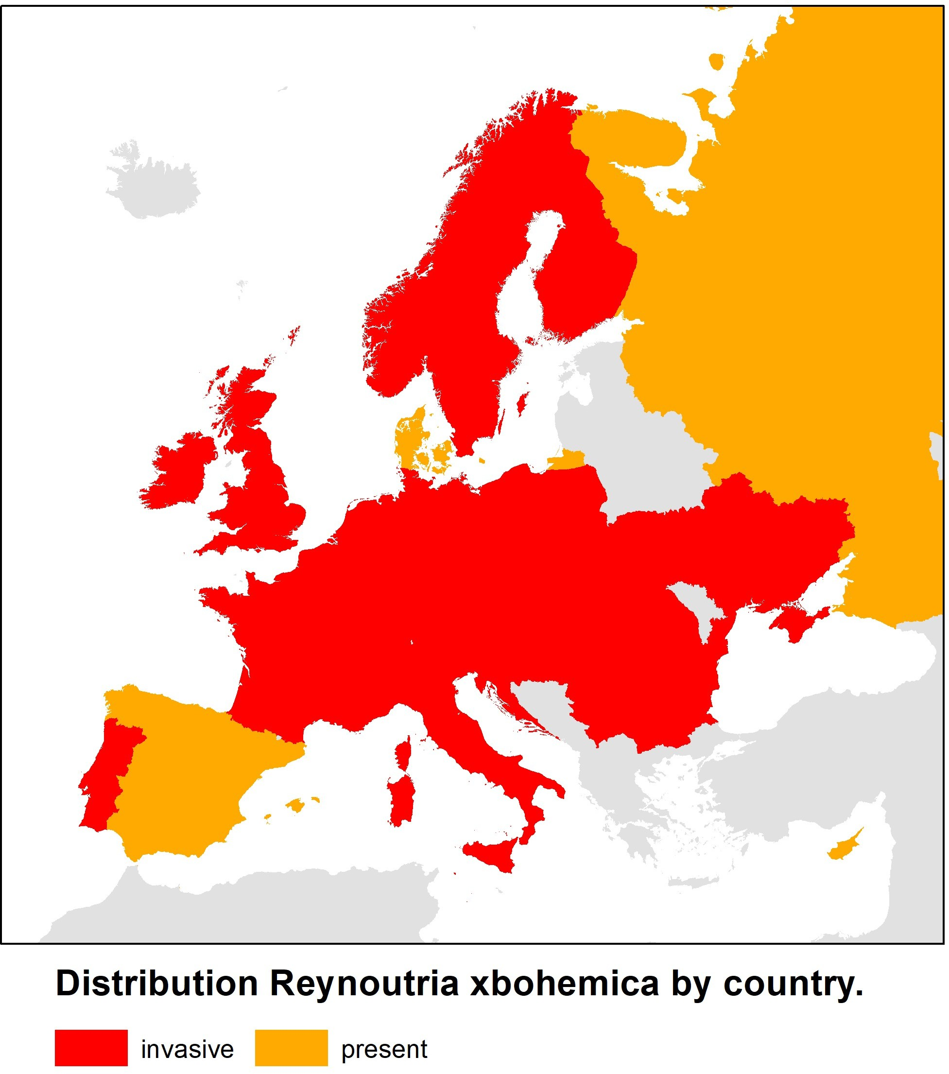
Figure 4.1 Distribution and extent of invasiveness of Reynoutria × bohemica in Europe ((Source: https://www.cabi.org/isc/ supplemented/updated with data from sources in Appendix 1a).
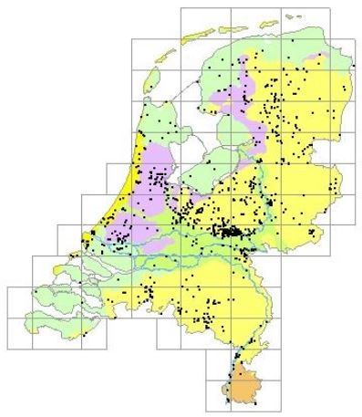
Figure 4.2. The distribution of R. × bohemica in the Netherlands based on observations entered in the NDFF (2022).

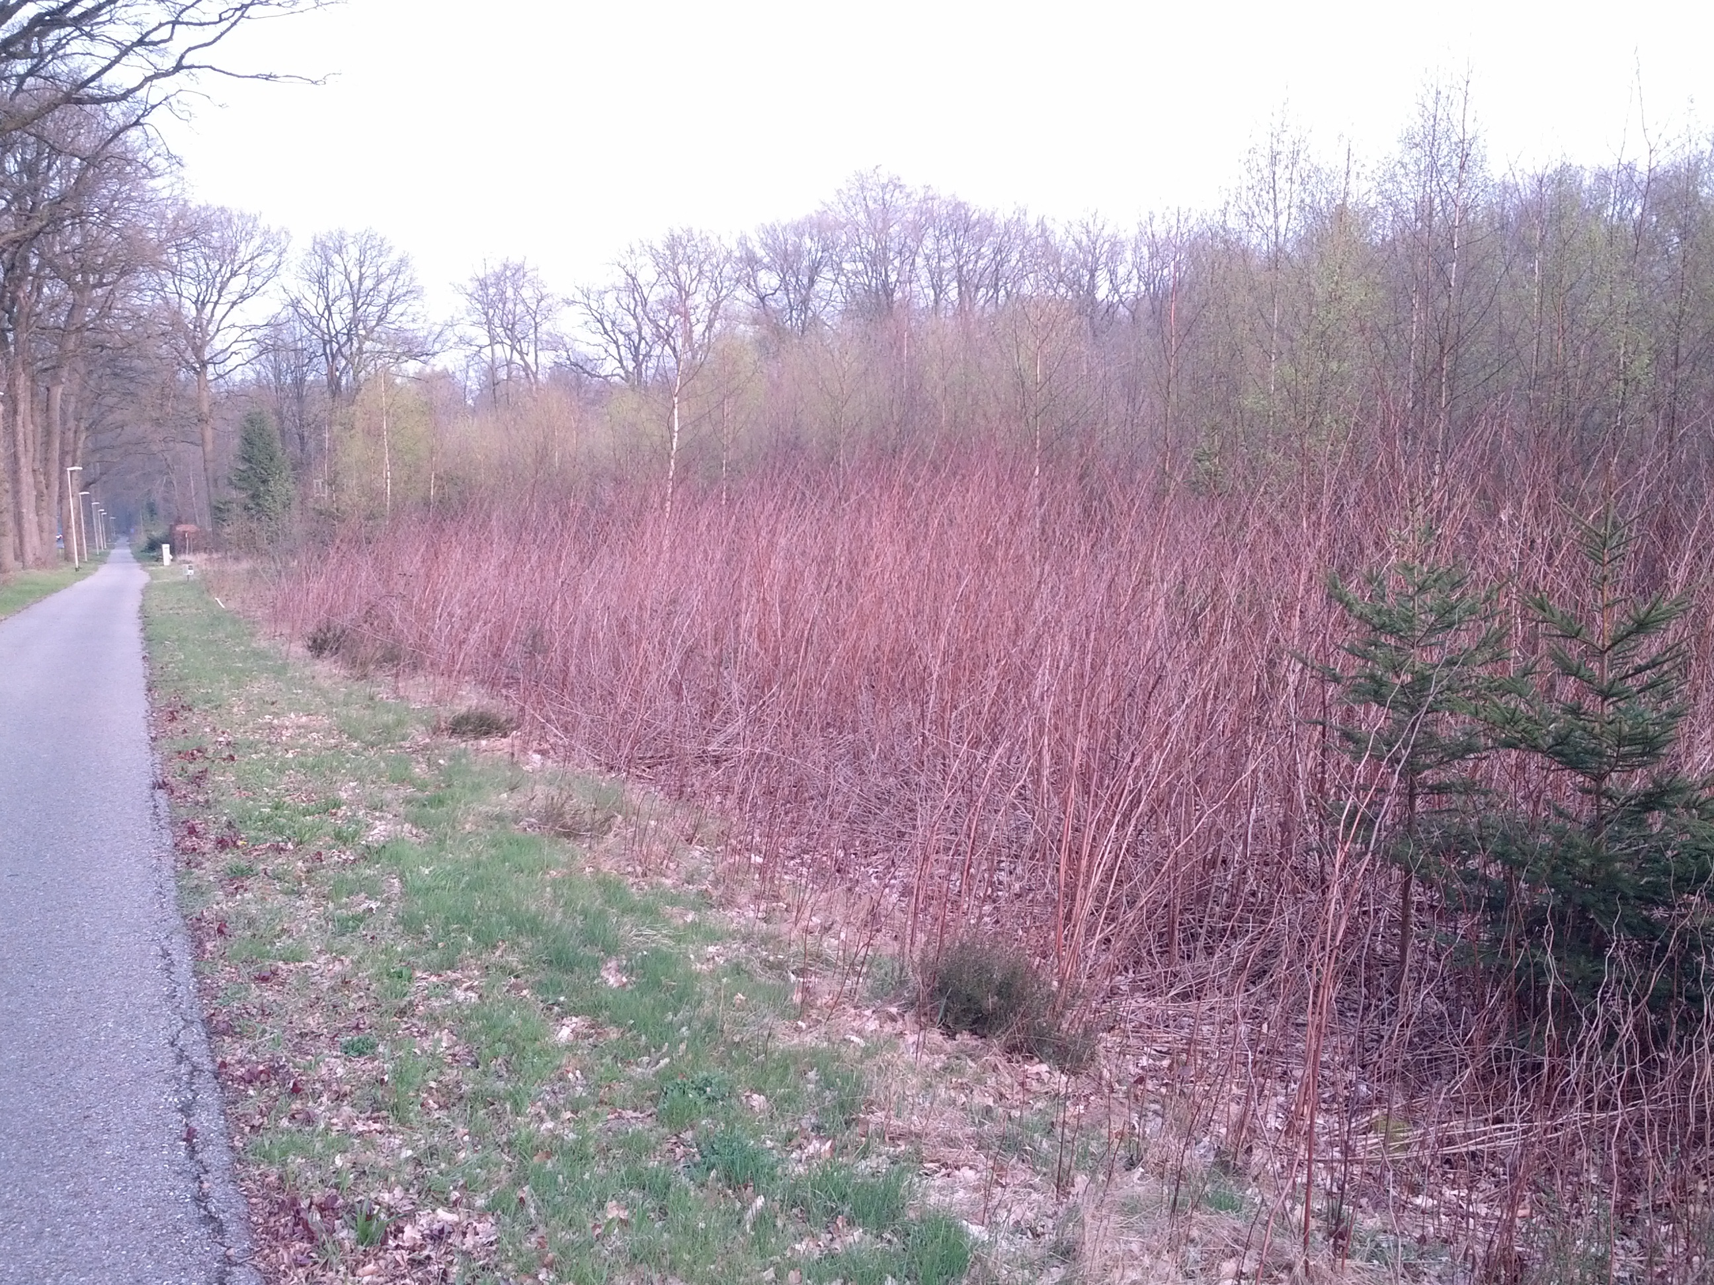

Figure 4.3 Large stand of Bohemian knotweed in early spring (Ruud Beringen)

4.3 Impacts

4.3.1. Biodiversity and ecosystems

Vascular plants
In germination tests conducted in a greenhouse, leachates of litter from R. × bohemica and soil in which R. × bohemica had previously grown did not have a significant negative effect on the seed germination or seedling biomass of nine native herbs. In fact, soil in which R. × bohemica had previously grown had a positive effect on the germination of most species. In an outdoor experiment, the total biomass of native species was not negatively impacted by the leachates, the rhizomes of R. × bohemica nor the soil in which R. × bohemica had previously grown. However, the separate biomass of ground-ivy (Glechoma hederacea) was negatively affected by the presence of R. × bohemica rhizomes or leachates. It also invested more energy in horizontal runners than flowering shoots when in the presence of rhizomes and leachates. R. × bohemica (leachates, rhizomes, soil in which R. × bohemica had previously grown) also significantly delayed the flowering time of Silene dioica (Parepa et al. 2012).
In laboratory experiments conducted by Moravcová et al. (2011), extracts from the dried leaves of R. × bohemica were found to have an inhibitory (phytotoxic) effect on the seed germination of Urtica dioica, Calamogrostis epigejos and Lepidium sativum. The germination of the seeds of Calamagrostis epigejos, in particular, was inhibited.
Within non-invaded plots, Padula et al. (2008) recorded 7-19 plant species; within R. × bohemica invaded plots they recorded significantly less (1-9) species. In competition experiments with native plants, R. × bohemica was found to be significantly more competitive and more strongly suppressed the growth of native species than both parental species (Parepa et al. 2014). In assessing the impact of 13 invasive species Hejda et al. (2009) sampled for each species 10 pairs of adjacent, invaded and uninvaded, 4×4 meter vegetation plots. Reynoutria species showed the highest reduction in species number; R. sachalinensis 87%, R. japonica 73% and R. xbohemica 65%. Reynoutria species, and Heracleum mantegazzianum, also had the highest impact on species composition (Sørensen similarity index) (Hejda et al. 2009).

4.3.2 Red List species and protected species
No publications were found that examine the impact of Asian knotweeds on Red List species or protected species in Europe. Two experts on invasive species in nature reserves were also unable to produce any examples of a decrease in policy-relevant species when queried (oral communication with Henk Siebel and Max Simmelink). In the Netherlands, Asian knotweeds grow mainly at sites where garden waste is dumped. These sites are generally located at nutrient-rich forest edges and scrub vegetation where few rare or protected species grow.

4.3.3 EU habitats
The Natura 2000 areas in the Netherlands where R. × bohemica is found are shown in Appendix 5. Given that the hybrid has possibly been mistaken for R. japonica, it likely occurs in many more Natura 2000 areas than this. In any case, R. × bohemica has been observed in 15 (and possibly many more) Natura 2000 areas in the Netherlands. Its occurrence in a Natura 2000 area does not necessarily mean that it is also growing in a protected EU habitat type.

Potential distribution modelling showed that in the South East European countries Bulgaria, Croatia, Romania, Serbia and Slovenia, a large area of suitable riparian habitat in National Parks and Nature reserves, including the Natura 2000 area’s Vitosha, Žumberak-Samoborsko gorje, Medvednica, Cheile Bicazului-Hăşmaş, Călimani, Defileul Mureşului, Julijske Alpe (Triglav), could yet be occupied by Reynoutria taxa (Jovanović et al. 2018).

As with the Japanese knotweed, it can be said that R. × bohemica already poses a threat to habitat types in river and stream valleys, particularly in Central Europe. In the Netherlands, it currently only occurs to a modest extent in the wild in similar biotopes, but in light of the situation in Central Europe this could change in the future. So far, R. × bohemica has escaped from gardens to establish itself and spread at various sites in the country, such as along the lower reaches of the Heelsumse Beek brook, where efforts are being made to control it.

4.3.4 Physicochemical properties and structure of ecosystems
In Belgium and France, the mean soil pH of R. × bohemica plots is 6.8 (5.8-7.6). The mean pH of Reynoutria stands was somewhat lower than that of native vegetation under similar conditions (Aguilera et al. 2011).
Compared to the leaves of red alder trees (Alnus rubra), the fallen leaves of R. × bohemica had lower levels of nitrogen and phosphorous and higher levels of cellulose, fibre and lignin. The values were comparable to those of poplar (Populus trichocarpa). “Shredders” (macrofauna such as amphipods and stone fly larvae that consume and reduce coarse organic material in water) that were collected from leaf packs that had soaked in water for 31 days were more abundant on red alder leaves than R. × bohemica and poplar leaves. Changes to the quality and amount of litter that ends up in the aquatic environment as a result of the appearance of R. × bohemica can have an impact on the functioning of stream ecosystems (Claeson et al. 2014).

4.3.5 Ecosystem services
Provisioning services
R. × bohemica is edible like R. japonica (see 3.3.5).
Reynoutria species contain a lot of biologically active constituents, especially polyphenols. Their rhizomes and young shoots are used in traditional Asian medicine. The rhizomes contain higher amounts of the active constituents resveratrol, piceid, catechin and epicatechin than the young shoots. (Vrchotova et al. 2007, Frantik et al. 2013).
In field experiments conducted in the Czech Republic, the aboveground biomass of R. × bohemica was found to be higher than that of R. japonica or R. sachalinensis. Some clones of R. × bohemica appear to be suitable as biomass crops (Frantik et al. 2013).

Regulating services
Banks that are overgrown with R. × bohemica are susceptible to erosion because the banks become bare in the winter after the plant dies off. The dead stems are said to obstruct drainage and the plant purportedly causes damage to flood defences, yet no corroboration can be found for these harmful effects in the scientific literature (Lavoie 2017). At the same time, there are reports that R. japonica (and thus also presumably R. × bohemica) promotes sedimentation: “Seine wenig elastischen, überdaumendicken, oberirdischen Sprosse vermindern die Fliessgeschwindigkeit des Hochwassers, fangen das Getreibsel, fördern die Sedimentation und tragen zur Aufhöhung des Ufers bei, was für den Abfluss von Nachteil sein kann“ (Lohmeyer 1969, 1971 in Sukopp & Sukopp 1988).
In Japan, both R. japonica and R. sachalinensis are in fact planted with a view to stabilising road verges against the threat of erosion (Pashley 2003).

4.3.6 Public health & the economy

Public health
Reynoutria species contain relatively high levels of oxalic acid. While oxalic acid is not toxic, it can bind to minerals such as calcium and magnesium and prevent them from being absorbed by the body, which could in turn lead to deficiencies. Individuals predisposed to rheumatism, arthritis, gout and kidney stones should exercise caution if they decide to eat Japanese knotweed. In traditional dishes that include knotweed, the oxalic acid is removed by rinsing it with water or adding salt (PFAF 2019).

Safety of people and infrastructure
Dams and dikes that are covered with Reynoutria species are more susceptible to erosion when there is high water runoff. The upward growth of rhizomes can displace individual stones in the pavement or stone pitching. (Kretz & Vogtsburg 1994).

Socioeconomic impact
The damage that is reported in the United Kingdom for the presence of R. japonica in the vicinity of buildings and infrastructure also applies to R. × bohemica (see Section 3.3.6).
In the Netherlands, there has been a clear increase in the attention paid to the economic damage caused by Asian knotweeds in recent years. Road authorities and water managers are frequently called to account when adjacent private land is colonised from areas they oversee. Homeowners are looking for ways to control infestations in their gardens (personal observation, FLORON & Radboud University).

5 Reynoutria sachalinensis

5.1 Species description

5.1.1 Taxonomy
Scientific classification
Kingdom: Plantae
Phylum: Tracheophyta
Class: Magnoliopsida
Order: Caryophyllales
Family: Polygonaceae
Sub-Family: Polygonoideae
Tribe: Polygoneae
Genus: Reynoutria

5.1.2 Nomenclature
Scientific name
Reynoutria sachalinensis (Friedrich Schmidt Petrop.) Nakai

Synonyms
Fallopia sachalinensis (Friedrich Schmidt Petrop.) Ronse Decraene
Pleuropterus sachalinensis (F. Schmidt) Moldenke
Polygonum sachalinense Friedrich Schmidt Petrop.
Reynoutria brachyphylla (Honda) Nakai
Reynoutria sachalinensis var. brachyphylla Honda
Tiniaria sachalinensis (Fr. Schmidt) Janch.

Common name
Giant knotweed

Trade name
The following cultivars appear on the List of Names of Perennials (Hoffman 2016a):
‘Candy’®
‘Igniscum’®
Both cultivars have been developed to serve as biomass crops. As biomass crops, they are known under the names Fallopia sachalinensis var. igniscum Candy® and Fallopia sachalinensis var. igniscum Basic®. (Veste et al. 2011). In the Netherlands, as far as it is known, Reynoutria sachalinensis is not sold by nurseries as a garden plant (https://plantago.nl). These cultivars are described as mutants or varieties of Reynoutria sachalinensis and they would have lost their invasiveness, due to the fact that they have no running roots, and no seeds or only very few seeds are formed.( US Plant Patent Application Publication 2008). The photos in this publication however suggest that it is probably Reynoutria x bohemica. It is stated that “it sends out runners (stolons) easily, and its rootstock reaches down to a depth of 2 m.”.In the Netherlands spreading rhizomes and flowers with stamens have been observed (Matthews et al. 2015). Therefore these plants probably spread vegetatively and pollinate female Reynoutria clones. The assumption that this crop is not invasive is poorly substantiated.
Vernacular names
Bulgarian: гигантска фалопия
Czech: Křídlatka sachalinská
Danish: Kæmpe-pileurt
Dutch: Sachalinse duizendknoop
Estonian: Sahhalini pargitatar
Finnish: Sahalinintatar
French: Renouée de Sakhaline
German: Sachalin Staudenknöterich
Irish: Glúineach chapaill
Italian: Poligono di Sachalin
Latvian: Sahalīnas dižsūrene
Lithuanian: Sachalininė reinutrė, Sachalininis pelėvirkštis
Norwegian: Kjempeslirekne
Polish: Rdestowiec sachalinski
Spanish: Musaraña de Sajalín
Swedish: Jätteslide

5.1.3 Range
The original range of R. sachalinensis encompasses Russia (Sakhalin island and the southern Kuril islands), Japan (Hokkaido, northern Honshu) (Komarov 1970) and Korea (only on the island of Ulleungdo) (Kim & Park 2000).

5.1.4 Characteristics
Robust, rhizome-forming herbaceous perennials with 2-3(-4) m long erect, hollow stems. Leaves: thin, 10-30 cm long and 4-25 cm wide; from oblong ovate to oblong, cuspidate with a cordate base (Figure 5.1, sometimes truncate in the uppermost leaves), glabrous or with sporadic long, flexible hairs on the underside, somewhat wavy edges. Petioles: 3-4 cm long. Ochreae: oblong, membranous, with prominent nerves, not ciliate, weather quickly. Inflorescence: axillary panicles, singular or in bundles, primary axis inflorescence shorter than the leaves (<15 cm) with short, thick hair; bracts small, ovate, point-tipped, downy. Flowers: pedicels longer than perianth, perianth funnel-shaped, greenish white, the inner 3 tepals have strongly developed wings in flowering time, 8 stamens, 3 styles, stigma shield-shaped. Achenes: trigonous, oblong, dark brown, glossy, pointed (Komarov 1970).

Similar species
R. sachalinensis resembles R. japonica and R. × bohemica (see Appendix 4 for their differences), but is more robust in all aspects. Its inflorescence is shorter and more compact than that of R. japonica.

5.1.5. Reproduction and dispersal
Life cycle
The life cycle of R. sachalinensis is very similar to that of R. japonica, and as such the following is a repeat of the description of the life cycle of the latter species. The shoots sprout in early April. In Northern Europe, the shoots sprout later in: April-May. Mainly the aboveground portions of the plant grow in the spring. Between mid-April and June, the plant can grow up to 40 cm in four days under favourable conditions. The plants achieve their maximum height around mid-June and flower from late August into October. In northern Europe (Finland) they flower from August into September (https://vieraslajit.fi). Between August and November, the assimilates are primarily invested in the rhizomes. The supply of assimilates to belowground organs is the highest in August (in the United Kingdom). The biomass of the rhizomes can be up to 18 times higher in September compared to May. The aboveground portions of the plants die back with the first frost. The brown stems persist throughout the winter and part of the subsequent growing season (Beerling et al. 1994, Seiger & Merchant 1997, Price et al. 2001, Jones et al. 2018). The seed bank of Japanese knotweed is transient; the seeds have a short-lived germinative capacity and germinate in the spring or the ensuing autumn (Tiébré et al. 2007a). However, the seeds of some Slovenian specimens of R. japonica and R. sachalinensis germinated during the second year (Strgulc Krajšek & Dolenc Koce 2015).

Reproduction
In Europe, both hermaphroditic and male-sterile clones occur. The minimal genetic diversity in the United Kingdom and Belgium is an indication that the population is descended from a few imported clones that reproduced mainly by vegetative means (Pashley et al. 2007, Tiébré et al. 2007b). Hermaphroditic clones are rare in Belgium (Tiébré et al. 2007a).

Pollinators
The flowers of Reynoutria species produce a lot of nectar and are visited and - where the gender distribution allows it - pollinated by a wide range of insects.

Hybrids
R. sachalinensis can cross with R. japonica and backcross with R. × bohemica (Bailey et al. 2007).

Dispersal
Little is known about the spread of R. sachalinensis by means of seeds. In Europe, the plant appears to spread to new areas mainly by vegetative means (Pashley 2007, Tiébré et al. 2007b).

Vegetative spread
Garden experiments have shown that stem and rhizome fragments from different species of Reynoutria species can become new plants (Bimova et al. 2003). This regeneration is possible on the condition that the stem fragment contains at least one bud. Regeneration from rhizomes in R. sachalinensis is generally less efficient than in both R. japonica and R. × bohemica. Only when its stem fragments are suspended in water does the regeneration in R. sachalinensis compare favourably with the other taxa (80% regeneration). Nevertheless, the overall regenerative capacity of R. sachalinensis is the lowest of the Reynoutria species. Rhizomes placed upright, with the node at the soil surface level, exhibited no regeneration. In contrast, buried rhizome fragments of R. sachalinensis regenerated relatively well in sandy soil with relatively rich nutrient levels (Bimova et al. 2003)..
In a field experiment in the Czech Republic planted rhizome fragments of R. sachalinensis showed significantly less succesfull establishment compared with R. japonica and R. × bohemica (Brabec & Pyšek 2000).

5.1.6. Habitat and ecology
R. sachalinensis grows in unmanaged or extensively managed habitats that are relatively rich in nutrients and provide a lot of light. Outside of parks or gardens, the species is found along the banks of streams or rivers, the edges of fields or forests, along roadways or railways, hedges and wooded embankments. While the species is grown in Europe as a feed crop, it is not known whether it also occurs in neglected fields as a result of this cultivation.
Compared to the other two Reynoutria species, R. sachalinensis seems to have a greater preference for more humid sites.
In Polish river valleys, R. sachalinensis grows at sites with relatively high levels of available nitrogen in the form of NH₄⁺ and NO₃⁻ ions (Chmura et al. 2015).

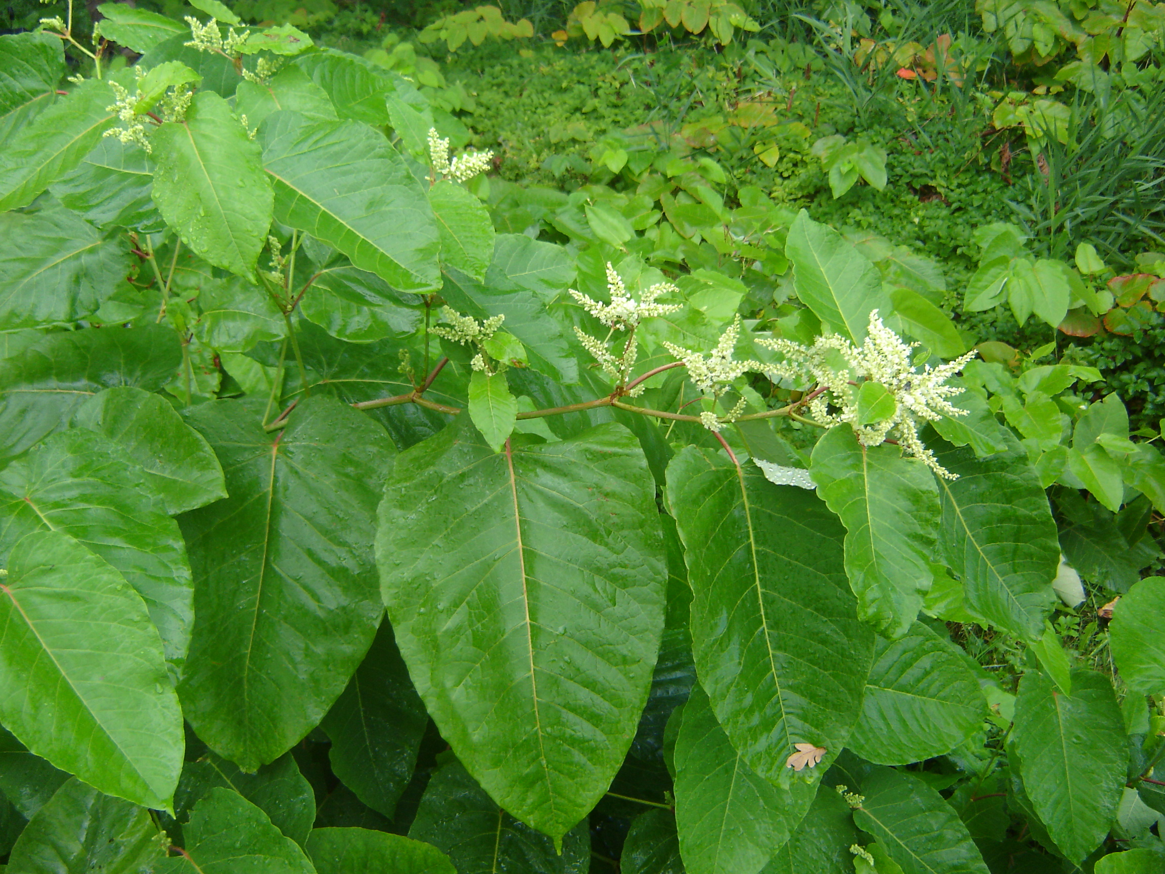
Figure 5.1 Flowering R. sachalinensis (Ruud Beringen).

5.2. Distribution

5.2.1 Invasion history of potential distribution area
During Russian expeditions to Sakhalin in 1853 and 1861, material from R. sachalinensis was collected and sent to St. Petersburg. The type material, i.e. the plants based upon which the species was described (=holotype), was collected from a river bank on the west coast of Sakhalin in 1853. When this material arrived in St. Petersburg in 1855, it was planted in the botanical garden. During another expedition in 1861, material was also collected in Japan. It is possible that other living material (seeds or plants) found its way from Asia to the United Kingdom (Kew Gardens) around the years 1860 and 1879. In the United Kingdom, the plant appeared on the market for the first time in 1869/1870. Genetic research has shown that plants originally from Hokkaido (Japan) occur in Europe, and were spread via St. Petersburg. Plants also occur in the United Kingdom that descend from material that was imported directly from Honshu (Pashley et al. 2007). St. Petersburg and Kew Gardens botanical garden in the United Kingdom are the centres from which R. sachalinensis spread to its current secondary range. By virtue of these different provenances and given that not only rhizomes but also seeds were probably imported, R. sachalinensis exhibits greater genetic diversity than R. japonica in Europe. In contrast to R. japonica, there are not only male-sterile genotypes but also male-fertile genotypes of R. sachalinensis in Europe (Bailey & Conolly 2000, Pashley et al. 2007).
Compared to R. japonica and R. × bohemica, R. sachalinensis is less invasive and spreads more slowly (Herpigny et al. 2014, Mandak et al. 2004).

5.2.2 Pathways of introduction (UNEP pathways and vectors)
The pathways of introduction are summarised in Table 5.1.

Table 5.1. Pathways of introduction for R. sachalinensis based on the UNEP classification of pathways of introduction and vectors (UNEP 2014).
Category | Subcategory | Primary | Secondary
Release in Nature | Release in nature for landscape improvement | x
Escape from confinement | Agriculture (including biofuel) | x
Escape from confinement | Botanical garden/zoo | x
Escape from confinement | Horticulture | x
Transport contaminant | Transportation of habitat material (soil, vegetation, wood) |  | x
Corridor | Interconnected waterways |  | x

Intentional introduction
R. sachalinensis was imported to Europe from Asia and was used as a feeder crop and ornamental plant (Conolly 1977). It is not known to have been grown as a feeder crop in the Netherlands, though the Dutch have conducted experiments involving the cultivation of R. sachalinensis as a biomass crop (Matthews et al. 2015). Its occurrence at new sites outside gardens is usually the result of the dumping of garden waste or soil contaminated with rhizome fragments.

Unintentional introduction
The improper management of existing sites of establishment (e.g. through excavation and mowing activities) can lead to the dispersal of viable rhizome and stem fragments, just as it can for other Reynoutria species.

5.2.3 Climate and biogeography

Climate match
The original range of R. sachalinensis encompasses the Köppen-Geiger climate regions listed in Table 5.2 (http://koeppen-geiger.vu-wien.ac.at/present.htm). The regions in Europe with similar climates are shown in Figure 5.2.

Table 5.2. Köppen-Geiger climate regions within the original range of R. sachalinensis.
Code |  | Köppen-Geiger classification | Original range in
Dfa |  | Cold-No Dry Season-Hot Summer | Japan (Honshu)
Dfb |  | Cold-No Dry Season-Warm Summer | Japan (Hokkaido)
Dfc |  | Cold-No Dry Season-Cold Summer | Sakhalin, Kuril Islands, Eastern Russia
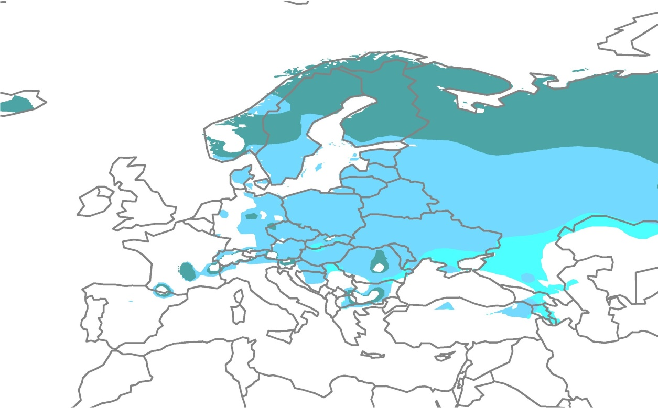
Figure 5.2. The location of climate regions Dfa, Dfb and Dfc in Europe.

Within Europa, climate regions Dfb, Dfc and Dfa are those regions where the climate corresponds to that of the species’ original range. These regions are located mainly in Central, Eastern and Northern Europe (Figure 5.2). The climate zone to which Western Europe belongs (Cfb: Temperate-No Dry Season-Warm Summer) does not occur within the original range.

Biogeographic occurrence in Europe
R. sachalinensis occurs in the following biogeographic regions in Europe (this is a simplified summary; for greater detail, see Appendix 1 and Appendix 2):
Atlantic region: Ireland, United Kingdom, The Netherlands, Belgium, Denmark.
Continental region: Luxembourg, Poland, Czech Republic, Germany, Bulgaria, Serbia, Danmark, Slovenia, Romania, Croatia, Ukraine.
Boreal region: Estonia, Lithuania, Finland, Sweden.
Mediterranean region: Cyprus, Greece, Spain, Italy.
Pannonian region: Hungary
Note: In Slovakia, Austria, Switzerland and Norway, the species possibly occurs up to the Alpine region.

Climate scenarios
Climate models are predicting higher winter temperatures at higher latitudes and drier summers. There is no reason to assume that R. sachalinensis will respond any differently to these changes than R. japonica. Based on these future climate scenarios, R. sachalinensis will spread to higher elevations of the Central European mountains and the northern limit of the range will shift considerably northwards in western Norway, Sweden and Finland. The eastern limit of the range will shift eastwards and end up somewhere between the Baltic states and the Urals. Parts of Iceland will likely become suitable should the species ever be introduced there. At the same time, lower precipitation levels will make conditions less suitable for the species in large parts of central Northern Europe and Southern and Southeastern Europe (Beerling 1993, Beerling et al. 1995).
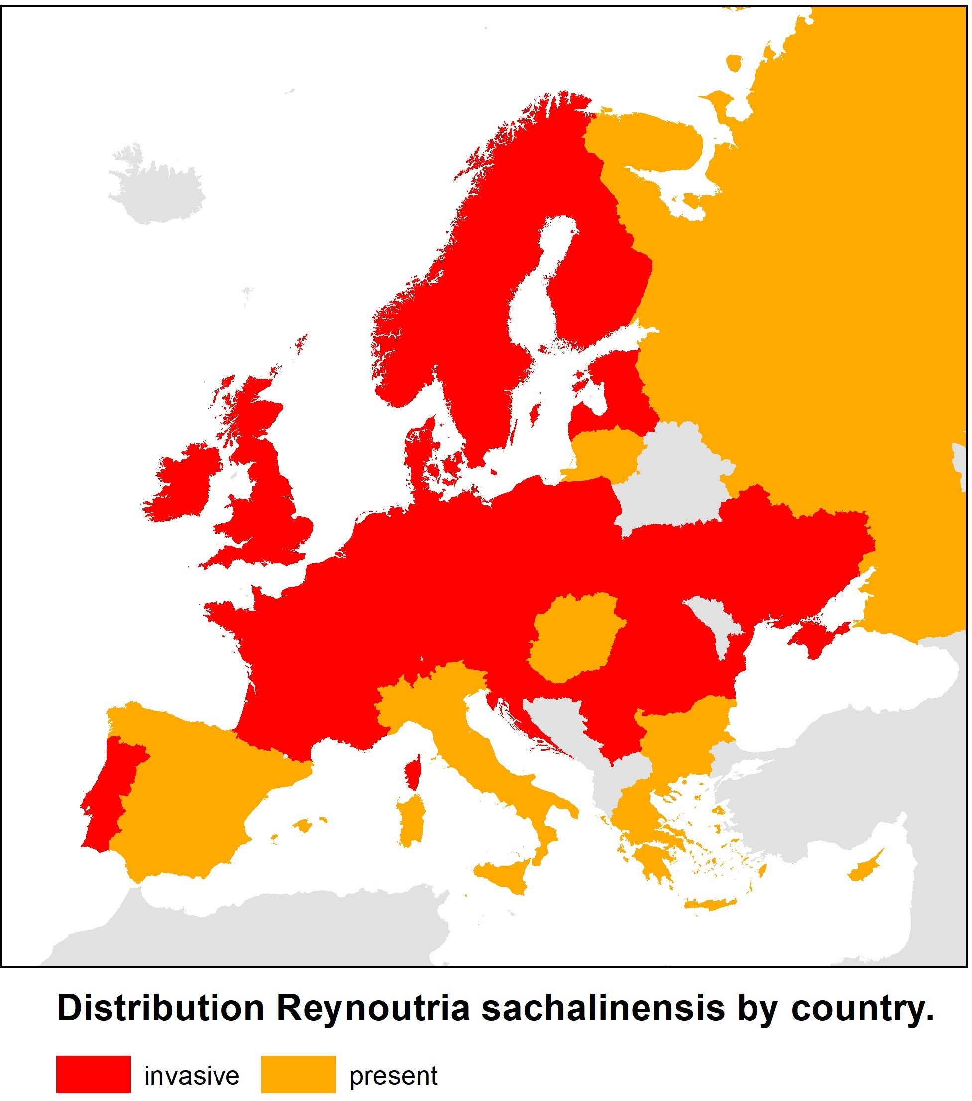
According to model calculations the number of 35 km² quadrants in Germany and Austria with suitable biotope for R. sachalinensis will increase by 33% in the period 2051-2060, as a consequence of temperature rise (Kleinbauer et al. 2010).
At its northern distribution limit, R. japonica does not produce viable seed due to later flowering (Groeneveld et al. 2014). It is not clear whether this also applies to R. sachalinensis.

5.2.4 Occurrence within the EU
The countries within the European Union in which R. sachalinensis occurs in the wild are shown in Figure 5.3 and Appendix 1. In Finland, the distribution of R. sachalinensis until now is limited to the vicinity of settelements in the utmost south of the country (https://vieraslajit.fi/lajit). In Sweden R. sachalinensis is also distributed mainly in the southern provinces (Skäne, Uppland, Smäland and Väster Götland) (https://Artfakta.se). In Italy, R. sachalinensis seems to occur mainly in the northern regions and in Tuscany (Padula et al. 2008).
The distribution within the Netherlands is shown in Figure 5.4. Within Europe, it is more common in Northern and Eastern Europe than in the south (Krebs et al. 2010).

Figure 5.3 Distribution and extent of invasiveness of Reynoutria sachalinensis in Europe (Source: https://www.cabi.org/isc/ supplemented/updated with data from sources in Appendix 1a)..
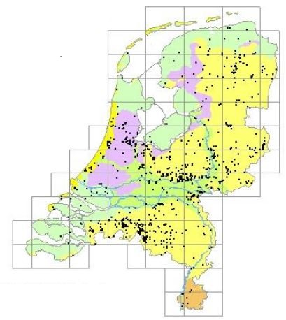
Figure 5.4. The distribution of R. sachalinensis in the Netherlands based on observations entered in the NDFF (2022).

5.3 Impacts

5.3.1 Biodiversity and ecosystems
Soil microflora
In field experiments conducted in the Czech Republic, Hedenec et al. (2014a) found a lower abundance and diversity of the soil fauna under R. sachalinensis and a few other introduced biofuel crops than under native biofuel crops such as Phalaris arundinacea and Salix viminalis.
Leachates from R. sachalinensis inhibit the growth and development of white worms Enchytraeus crypticus (Annelida) and springtails Folsomia candida (Collembola) (Hedenec et al. 2014b).

Vascular plants
In riparian forests in the western United States, Urgenson et al. (2009) found a negative correlation between the density of R. sachalinensis and the species richness and abundance of native herbs, shrubs and juvenile trees (< 3m).
Leachates from the withered leaves of Reynoutria sachalinensis have a negative effect on the seed germination of wheat and mustard (Hedenec et al. 2014b).
In laboratory experiments conducted by Moravcová et al. (2011), extracts from the dried leaves of R. sachalinensis were found to have an inhibitory (phytotoxic) effect on the seed germination of Urtica dioica, Calamogrostis epigejos and Lepidium sativum. The germination of the seeds of Urtica dioica, in particular, was inhibited by the extracts of R. sachalinensis.
In assessing the impact of 13 invasive species Hejda et al. (2009) sampled for each species 10 pairs of adjacent, invaded and uninvaded, 4×4 meter vegetation plots. Reynoutria species showed the highest reduction in species number; R. sachalinensis 87%, R. japonica 73% and R. xbohemica 65%. Reynoutria species, and Heracleum mantegazzianum, also had the highest impact on species composition (Sørensen similarity index) (Hejda et al. 2009).

5.3.2 Red List species and protected species
No publications were found that examine the impact of Asian knotweeds on Red List species or protected species in Europe. Two experts on invasive species in nature reserves were also unable to produce any examples of a decrease in policy-relevant species when queried (oral communication with Henk Siebel and Max Simmelink). In the Netherlands, R. sachalinensis grows in nutrient-rich areas where few rare or protected species grow.

5.3.3 EU habitats
The Natura 2000 areas in the Netherlands where R. sachalinensis is found are shown in Appendix 5. R. sachalinensis has been observed in 23 (and possibly 49) Natura 2000 areas in the Netherlands. Its occurrence in a Natura 2000 area does not necessarily mean that it is also growing in a protected EU habitat type.
As with the Japanese knotweed, R. sachalinensis is a potential threat to habitat types in river and stream valleys, particularly in Central Europe. In the Netherlands, it currently only occurs to a modest extent in the wild in similar biotopes, but in light of the situation in Central Europe this could change in the future. Currently, R. sachalinensis can be found growing in massive stands in some places, such as along upstream portions of the Reusel river. It is not in conceivable that R. sachalinensis could stifle the development of the Floating water-plantain (Luronium natans) here due to sunlight obstruction.

5.3.4 Physicochemical properties and structure of ecosystems
The litter of R. sachalinensis has a higher C/N ratio (52:1) (38-58% higher) than Alnus and Salix species. A high percentage (76%) of the nitrogen present in the leaves in the autumn (prior to falling) is stored in the root system. The displacement of native species in riparian biotopes by R. sachalinensis can lead to changes in the structure and functioning of these and adjacent aquatic ecosystems (Urgenson et al. 2009). The resorption of nitrogen from senescing leaves appears to be less efficient in R. sachalinensis when compared with R. japonica and R. × bohemica. One possible explanation for the higher competitive ability of the latter two species is their comparatively larger belowground reserves of nitrogen (Herpigny et al. 2012).

5.3.5 Ecosystem services
Provisioning services
In Europe, R. sachalinensis was cultivated as a feed crop, with the young shoots being eaten by cattle and horses. The plants were also stored as silage (Komarov 1970, Bailey & Conolly 2000).
Reynoutria sachalinensis var. Igniscum is cultivated as a biofuel. The plants also thrive in nitrogen-poor soil and can be harvested 2-3 times per growing season. The harvested material can be burned directly or used in the production of biogas (Veste et al. 2011, Matthews et al. 2015).
Reynoutria species contain a lot of biologically active constituents, especially polyphenols. Their rhizomes and young shoots are used in traditional Asian medicine. The rhizomes contain higher amounts of the active constituents resveratrol, piceid, catechin and epicatechin than the young shoots. The rhizomes of R. sachalinensis are less suitable for the production of resveratrol than those of R. japonica and R. × bohemica (Vrchotova et al. 2007, Frantik et al. 2013).
Some phytochemicals extracted from the rhizomes of R. japonica and R. sachalinensis (vanicoside A and vanicoside B) showed moderate inhibition of SARSCoV-2 main protease by docking into the binding site of this COVID-19 virus protein (Nawrot-Hadzik et al. 2021).

Extracts of R. sachalinensis, sold under the names Milsana® VP 1999 & 2001, are effective against powdery mildew (Uncinula necator) in grapes, if applied at the early stages of disease development (Konstantinidou-Doltsinis et al. 2007).

Regulating services
In Europe, R. sachalinensis was planted as a riverbank stabiliser (Bailey & Conolly 2000). In Japan, both R. japonica and R. sachalinensis are planted with a view to stabilising road verges against the threat of erosion (Pashley 2003).
An extract from R. sachalinensis can be sprayed on the leaves of grape, wheat, tomato, cucumber and strawberry plants to increase the resistance of these crops to fungal pathogens (Lalancette et al. 2013, EFSA 2015).
In addition to being used as a biofuel, R. sachalinensis can also be used to decontaminate sewage sludge of heavy metals and other hazardous elements (Pb, Cr, Co, As, Hg, Mn) (Ust'ak & Vana 1998).

5.3.6 Public health & the economy

Public health
Reynoutria species contain relatively high levels of oxalic acid. While oxalic acid is not toxic, it can bind to minerals such as calcium and magnesium and prevent them from being absorbed by the body, which could in turn lead to deficiencies. Individuals predisposed to rheumatism, arthritis, gout and kidney stones should exercise caution if they decide to eat Japanese knotweed. In traditional dishes that include knotweed, the oxalic acid is removed by rinsing it with water or adding salt (PFAF 2019).

Safety of people and infrastructure
Dams and dikes that are covered with Reynoutria species are more susceptible to erosion when there is high water runoff. The upward growth of rhizomes can displace individual stones in the pavement or stone pitching (Kretz & Vogtsburg 1994).

Socioeconomic impact
The damage that is reported in the United Kingdom for the presence of R. japonica in the vicinity of buildings and infrastructure also applies to R. sachalinensis (see 3.3.6).
In the Netherlands, there has been a clear increase in the attention paid to the economic damage caused by Asian knotweeds in recent years. Road authorities and water managers are frequently called to account when adjacent private land is colonised from areas they oversee. Homeowners are looking for ways to control infestations in their gardens (personal observation, FLORON & Radboud University).

6 Koenigia polystachya

6.1 Species description

6.1.1 Taxonomy
Scientific classification
Kingdom: Plantae
Phylum: Tracheophyta
Class: Magnoliopsida
Order: Caryophyllales
Family: Polygonaceae
Sub-Family: Polygonoideae
Tribe: Persicarieae
Genus: Koenigia

6.1.2 Nomenclature

Scientific name
Koenigia polystachya (Wall. ex Meisn.) T.M. Schust. & Reveal

Synonyms
Aconogonon polystachyum (Wall. ex Meisn.) K. Haraldson
Aconogonon polystachyum (Wall. ex Meisn.) Kral
Persicaria polystachya (Meisn.) H. Gross
Persicaria wallichii W. Greuter & Burdet
Persicaria wallichii var. tomentosa S.P. Hong
Peutalis polystachya Raf.
Pleuropteropyrum hagei (Royle ex Bab.) A.H. Munshi & G.N. Javeid
Pleuropteropyrum polystachyum (Wallich ex Meisn.) A.H. Munshi & G.N. Javeid
Polygonum hagei Royle ex Bab.
Polygonum molle Wight
Polygonum polystachyum Meisn.
Polygonum polystachyum var. longifolia J. D. Hooker
Reynoutria polystachya (Wall.) Moldenke
Rubrivena polystachya (Wall.) M. Král

Common name: Himalayan knotweed

Trade name
This species appears as Persicaria polystachya on the List of Names of Perennials (Hoffman 2016a) and is sold by only a few Dutch nurseries (https://plantago.nl).

Vernacular names
Czech: Křídlatka himálajská
Danish: Syren-pileurt
Dutch: Afghaanse duizendknoop
French: Renouée à épis nombreux
German: Stutzblättriger Bergknöterich
Irish: Glúineach spíceach
Norwegian: Syrinslirekne
Polish: Rdest wielokłosowy
Swedish: Syrenslide

6.1.3 Range
The original range of K. polystachya encompasses the alpine and subalpine zones between 2,400 and 4,400 m of elevation of the Himalayan mountain range in China (Sichuan, Yunnan), Tibet, Bhutan, Jammu and Kashmir (Kashmir), Pakistan (Kurram, Hazara), Sikkim, Nepal, India (Assam, Arunachal Pradesh, Himachal Pradesh) and possibly Afghanistan. The species’ optimal habitat lies between 3,000 and 3,800 m of elevation (Kala 2004, Catalogue of Life 2019). While its Dutch name (Afghaanse duizendknoop) would suggest that the species also occurs in Afghanistan, no herbarium material from this country is known (Hong 1993).
K. polystachya occurs in the wild in Europe, the United States, the south coast of Alaska (Klein 2011), Canada and New Zealand (https://www.gbif.org/species/8848208). While there is a record of the species being collected in 1932 in the Pusan district of southeastern South Korea (Hong & Moon 2003), it is unknown whether the species is still present in the country.

6.1.4 Characteristics
Erect, 30-100(-150) cm high perennials with creeping rhizomes. Outside its original range, the species can grow to a height of 2.5 m under favourable conditions (Diekjobst 1992). Stems: glabrous to pubescent with short internodes, usually reddish brown. Leaves: (7.5-)9-22(-27) cm long and 2.8-8.0 cm wide, oblong to oblong-ovate, acuminate at the apex, cordate/truncate at the base, hairy on the veins, glabrous above, almost glabrous to densely hairy below, subsessile or petiolate, approx. 1 cm long. Rosette leaves absent. Ochreae: tubular, dark brown, 1-2 cm long, membranous, densely pubescent, not ciliate. Inflorescence: terminal, paniculate, spreading, pubescent, with reddish axes. Perianth: (2.5-)3-4(-5) mm, fragrant, pedicels 2-3.5 mm long, usually 5 tepals, white-cream coloured, inner 3 obtuse, broadly ovate 3-3.5(-4) mm long, outer 2 acute, ovate, smaller than the inner ones. Stamens: (7-)8 unequal in length. Ovaries: Trigonous with 3 free styles. Achenes: trigonous 3(-3.5) x 1.5 mm, brown, shining. (Flora of Pakistan on http://www.tropicos.org/ Rubrivena polystachya (Wall. ex Meisn.) M. Král, Hong 1993, Stace 2019).
Interestingly, Flora of Pakistan and Flora of China differ with European flora in that they report smaller leaf sizes, among other things, and characterise the plant as “shrubby”.

Similar species
The following similar species are on the market in Europe (in bold) and/or can establish themselves in the wild (Jonsell 1999, Hoffman 2016a, Stace 2019, names according to Schuster et al. 2015):
- Koenigia alpina (Aconogonon alpinum, Persicaria alpina, Polygonum alpinum, Pleuropteropyrum alpinum, Polygonum polymorphum, Aconogonon polymorphum).
- Koenigia alaskana (Polygonum alpinum var. lapathifolium, Polygonum polymorphum var. lapathifolium, Polygonum alpinum var. alaskanum, Polygonum alpinum subsp. alaskanum, Polygonum alaskanum, Aconogonon alaskanum, Aconogonon hultenianum var. lapathifolium).
- Koenigia × fennica (=Koenigia alpina x Koenigia weyrichii), (Aconogonon × fennicum, Persicaria × fennica, Polygonum × fennicum).
- Koenigia weyrichii (Aconogonon weyrichii, Persicaria weyrichii, Polygonum weyrichii)
- Koenigia mollis (Aconogonon molle, Polygonum molle, Ampelygonum molle).
- Koenigia campanulata (Polygonum campanulatum, Reynoutria campanulata, Aconogonon campanulatum, Persicaria campanulata).
- Koenigia lichiangensis (Polygonum lichiangense, Aconogonon lichiangense).

On the website Plantago.nl, more sales outlets are listed for Polygonum polymorphum (Alpenknöterich) Koenigia alpina than for K. polystachya (under the name Persicaria polystachya). Koenigia alpina has been found in the wild in the Netherlands many times in the past.
During flowering, the longest (outer) tepals of K. polystachya, K. alpina and K. x fennica are longer than 2.5 mm, while those of K. weyrichii and K. mollis are shorter than 2.5 mm. The style (+stigma) of K. polystachya is longer than 0.5 mm and the base of its basal leaves is cordate or truncate; the style (+stigma) of K. alpina and K. x fennica is shorter than 0.5 mm and the base of their basal leaves is cuneate (Stace 2019). Specimens of K. polystachya var. pubescens and K. campanulata found in the wild in the United Kingdom in the past have been mistaken for K. lichiangensis (Conolly 1991).

6.1.5 Reproduction and dispersal
Life cycle
K. polystachya flowers later than the three Reynoutria species, i.e. from September-October until well into November (Floraweb.de, Diekjobst 1992, De Visser 1973).

Reproduction
Due to its late flowering, the species probably does not form ripe achenes and instead propagates vegetatively by means of rhizome fragments (Kaplan et al. 2017, Diekjobst 1992, Bartoszek et al. 2006). In California, the species rarely forms achenes; farther north, in British Columbia, the plants are sterile (DiTomaso & Healy 2007 in Klein 2011). In the Netherlands, fruit formation is apparently a rare phenomenon (Weeda et al. 1985). The plants are in full bloom in mid-October, which makes it unlikely that they will produce ripe seeds before the first frost.

Pollinators
No information was found regarding specific pollinators. Just as with Reynoutria species, the fragrant flowers of K. polystachya are attractive to a wide range of insects. In the Netherlands, the flowers are mainly visited in October by various kinds of large and small flies (Diptera) (observation by R. Beringen).

Hybrids
While no hybrids have been described, there appears to be variation within the species referred to as K. polystachya. It is possible that more hybrids than just Koenigia x fennica have arisen between the closely related taxa.

Dispersal
Little is known about the spread of K. polystachya by means of seeds. In Europe, the plant appears to spread to new areas mainly by vegetative means (Tanner & Branquart, 2019).

Vegetative spread
In the United Kingdom, K. polystachya rarely establishes itself at new sites. Most stands in the United Kingdom are abandoned gardens or places where garden waste is dumped (Conolly 1977). The plant is capable of significant vegetative expansion; stands can range in size from a few dozen to a few hundred square metres (Diekjobst 1992, De Visser 1973, Bacieczko et al. 2015). The size of a population in Poland increased by over 30 times in 17 years. However, long-distance expansion does not appear to occur in Poland either, and no new stands are found in the wider surroundings of this population (Bacieczko et al. 2015).

6.1.6. Habitat and ecology
K. polystachya grows mainly at unmanaged sites, such as stream sides, road and railway embankments, the edges of forests, hedges and at ruderal areas (Kaplan et al. 2017, Conolly 1977, infoflora.ch, Follak et al. 2018). On river banks, the species can grow to a height of 2.5 m under favourable conditions (Diekjobst 1992).
Within its original range, K. polystachya is a pioneer species that establishes itself at disturbed sites such as rock fields and avalanche pathways (Kala 2004).

In Germany, vegetation found with K. polystachya is classified as Aegopodion podagrariae within Nitrophilous perennial vegetation of wet to mesic habitats (Galio-Urticetea dioicae) (Floraweb.de). In Poland, the species also grows together with nitrophilous species such as Aegopodium podagraria, Urtica dioica, Cirsium oleraceum, Epilobium hirsutum, Rumex obtusifolius, Rubus caesius, Galium aparine and Geum urbanum and invasive species such as Impatiens glandulifera, Solidago gigantea, Reynoutria japonica and Robinia pseudoacacia (Bartoszek et al. 2006, Bacieczko et al. 2015).
At one site in the Netherlands (Soesterberg), the species grows on dry, gravelly sand. The vegetation in the direct surroundings consists of blackberry (Rubus fruticosus), bentgrass (Agrostis spec.), broad buckler-fern (Dryopteris dilatata) and basal shoots of silver birch (Betula pendula, Scots pine (Pinus sylvestris) and black cherry (Prunus serotina) (personal observation by R. Beringen).

The soil pH at a site in Poland was 7.1. The organic carbon content and total nitrogen content were relatively low, at 2.8% and 0.26%, respectively. The bioavailable potassium content and bioavailable phosphorus content were relatively high (Bacieczko et al. 2015).

6.2 Distribution

6.2.1 Invasion history of potential distribution area
K. polystachya was introduced to Europe from Asia (the Himalayas) as a horticultural plant. It was imported to the United Kingdom around 1900 and was planted in botanic gardens. The first report of it growing in the wild in the United Kingdom was in 1917 (Conolly 1977). The first recordings in Austria and Belgium date from 1885 and 1898 respectively (https://www.nobanis.org). In Poland, the species is frequently found as a relict in the parks of neglected mansions (Bartoszek et al. 2006). In the Netherlands, while the species was collected for the first time in 1920, it was not until 1944 that the herbarium material was recognised. Occurrences in the wild were initially in and around rural estates and on roadsides in the middle of the country (Van der Ham 1985). Londo & Leys (1979) considered the species to be a ‘stinsenplant’: “a species whose distribution within a certain area is (almost) exclusively limited to ‘stinsen’ (Dutch mediaeval strongholds), country estates, old farmsteads, parsonage gardens and similar environs such as cemeteries and old town ramparts”.

6.2.2 Pathways of introduction (UNEP pathways and vectors)
The pathways of introduction are summarised in Table 6.1.

Table 6.1. Pathways of introduction for K. polystachya
Category | Subcategory | primary | secondary
Escape from confinement | Botanical garden/zoo | X
Escape from confinement | Horticulture | X
Transport contaminant | Transportation of habitat material (soil, vegetation, wood) |  | X
Corridor | Interconnected waterways |  | X

Intentional introduction
K. polystachya was imported to Europe from Asia and was primarily used as an ornamental plant. Its occurrence at new sites outside gardens is usually the result of the dumping of garden waste or soil contaminated with rhizome fragments.

Unintentional introduction
The improper management of existing sites of establishment (e.g. through excavation and mowing activities) can lead to the dispersal of viable rhizome fragments (and probably also stem fragments), just as it can for other Asian knotweed species. The plant is capable of regenerating from rhizome fragments as small as 1 cm in length. It is possible that rhizome fragments could be spread via water (Tanner & Branquart 2019).

6.2.3 Climate and biogeography
Climate match
The original range of K. polystachya encompasses the Köppen-Geiger climate regions listed in Table 6.2 (http://koeppen-geiger.vu-wien.ac.at/present.htm). The regions in Europe with similar climates are shown in Figure 6.1.

Table 6.2. Köppen-Geiger climate regions within the original range of K. polystachya.
Code |  | Köppen-Geiger classification | Original range in
Cfb |  | Temperate-No Dry Season-Warm Summer | China (Yunnan)
Cwa |  | Temperate-Dry Winter-Hot Summer | Nepal, Bhutan, Assam, Arunachal Pradesh, Himachal Pradesh
Cwb |  | Temperate-Dry Winter-Warm Summer | Nepal, Bhutan, Assam, Sikkim, Arunachal Pradesh, Himachal Pradesh, China (Yunnan, Sichuan)

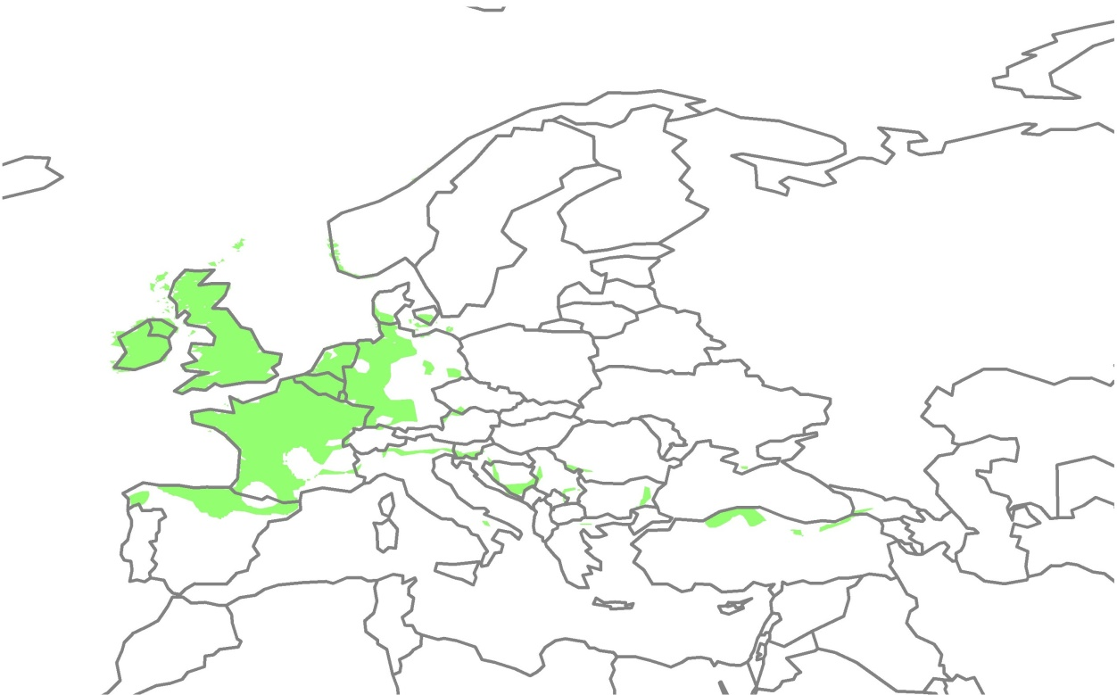
Figure 6.1. The location of climate region Cfb in Europe.

Within Europa, climate region Cfb is the only region where the climate corresponds to that of part of the species’ original range. Only a relatively small portion of the original range is located in this climate region. In Europe, it is mainly the regions with an Atlantic climate that lie within this climate region (Figure 6.1). This preference for Atlantic climates, which lack harsh winters, is confirmed by the fact that K. polystachya has spread primarily west in the British Isles (Conolly 1977) and Brittany is the only region in France where the species is considered to be invasive (Quere & Geslin 2016).

Biogeographic occurrence in Europe
K. polystachya occurs in the following biogeographic regions in Europe (this is a simplified summary; for greater detail, see Appendix 1 and Appendix 2):
Atlantic region: Ireland, United Kingdom, The Netherlands, Belgium.
Continental region: Poland, Czech Republic, Germany, Denmark.
Boreal region: Sweden
Mediterranean region: Spain, Italy.

Possibly also in the Alpine region:
Alpine regio: Liechtenstein, Austria, Switzerland, Norway.

Climate scenarios
Climate models are predicting higher winter temperatures at higher latitudes and drier summers. Based on climate models, the species is expected to expand further into the north of the Iberian Peninsula, the British Isles, Scandinavia, the Alps and the mountains of Southeastern Europe (Chapman 2018 in Tanner & Branquart 2019). The main hindrances to its expansion are the cold winters of northern Scandinavia and the dryness in parts of Southern Europe.

6.2.4 Occurrence within the EU
The countries within the European Union in which K. polystachya occurs in the wild are shown in Figure 6.2 and Appendix 1. The distribution within the Netherlands is shown in Figure 6.3. In the EU Belgium, Ireland and France (Brittany) are the only countries in which the species is considered to be invasive. In Belgium, the species is considered as a locally naturalized garden escape. First recorded in Ostend in 1898, it was subsequently collected in numerous locations throughout Belgium and well established in several places (Groom 2011). In Brittany, the species is classified as an IA1i species, meaning that the species has established itself or is in the process of establishing itself, can be invasive within natural or semi-natural plant communities and, furthermore, competes with native species and changes ecosystems (Quere & Geslin 2016). In Ireland it is classified as an invasive species with a risk of Medium Impact (https://species.biodiversityireland.ie/). Until now no recordings are known from within Bulgaria, Croatia, Estonia, Finland, Latvia, Lithuania, Luxembourg, Portugal, Romania, Slovakia and Slovenia, but current climate conditions in these EU-countries are suitable for establishment of K. polystachya (Tanner & Branquart 2019).
Outside the EU, the species is reported as invasive in Switzerland (Buholzer et al. 2014) and some western states of the United States (including Alaska) (https://www.cabi.org/isc/datasheet/120210), among other places.
Compared to the Reynoutria species, K. polystachya is less widespread in Europe, and fewer countries consider it to be invasive.

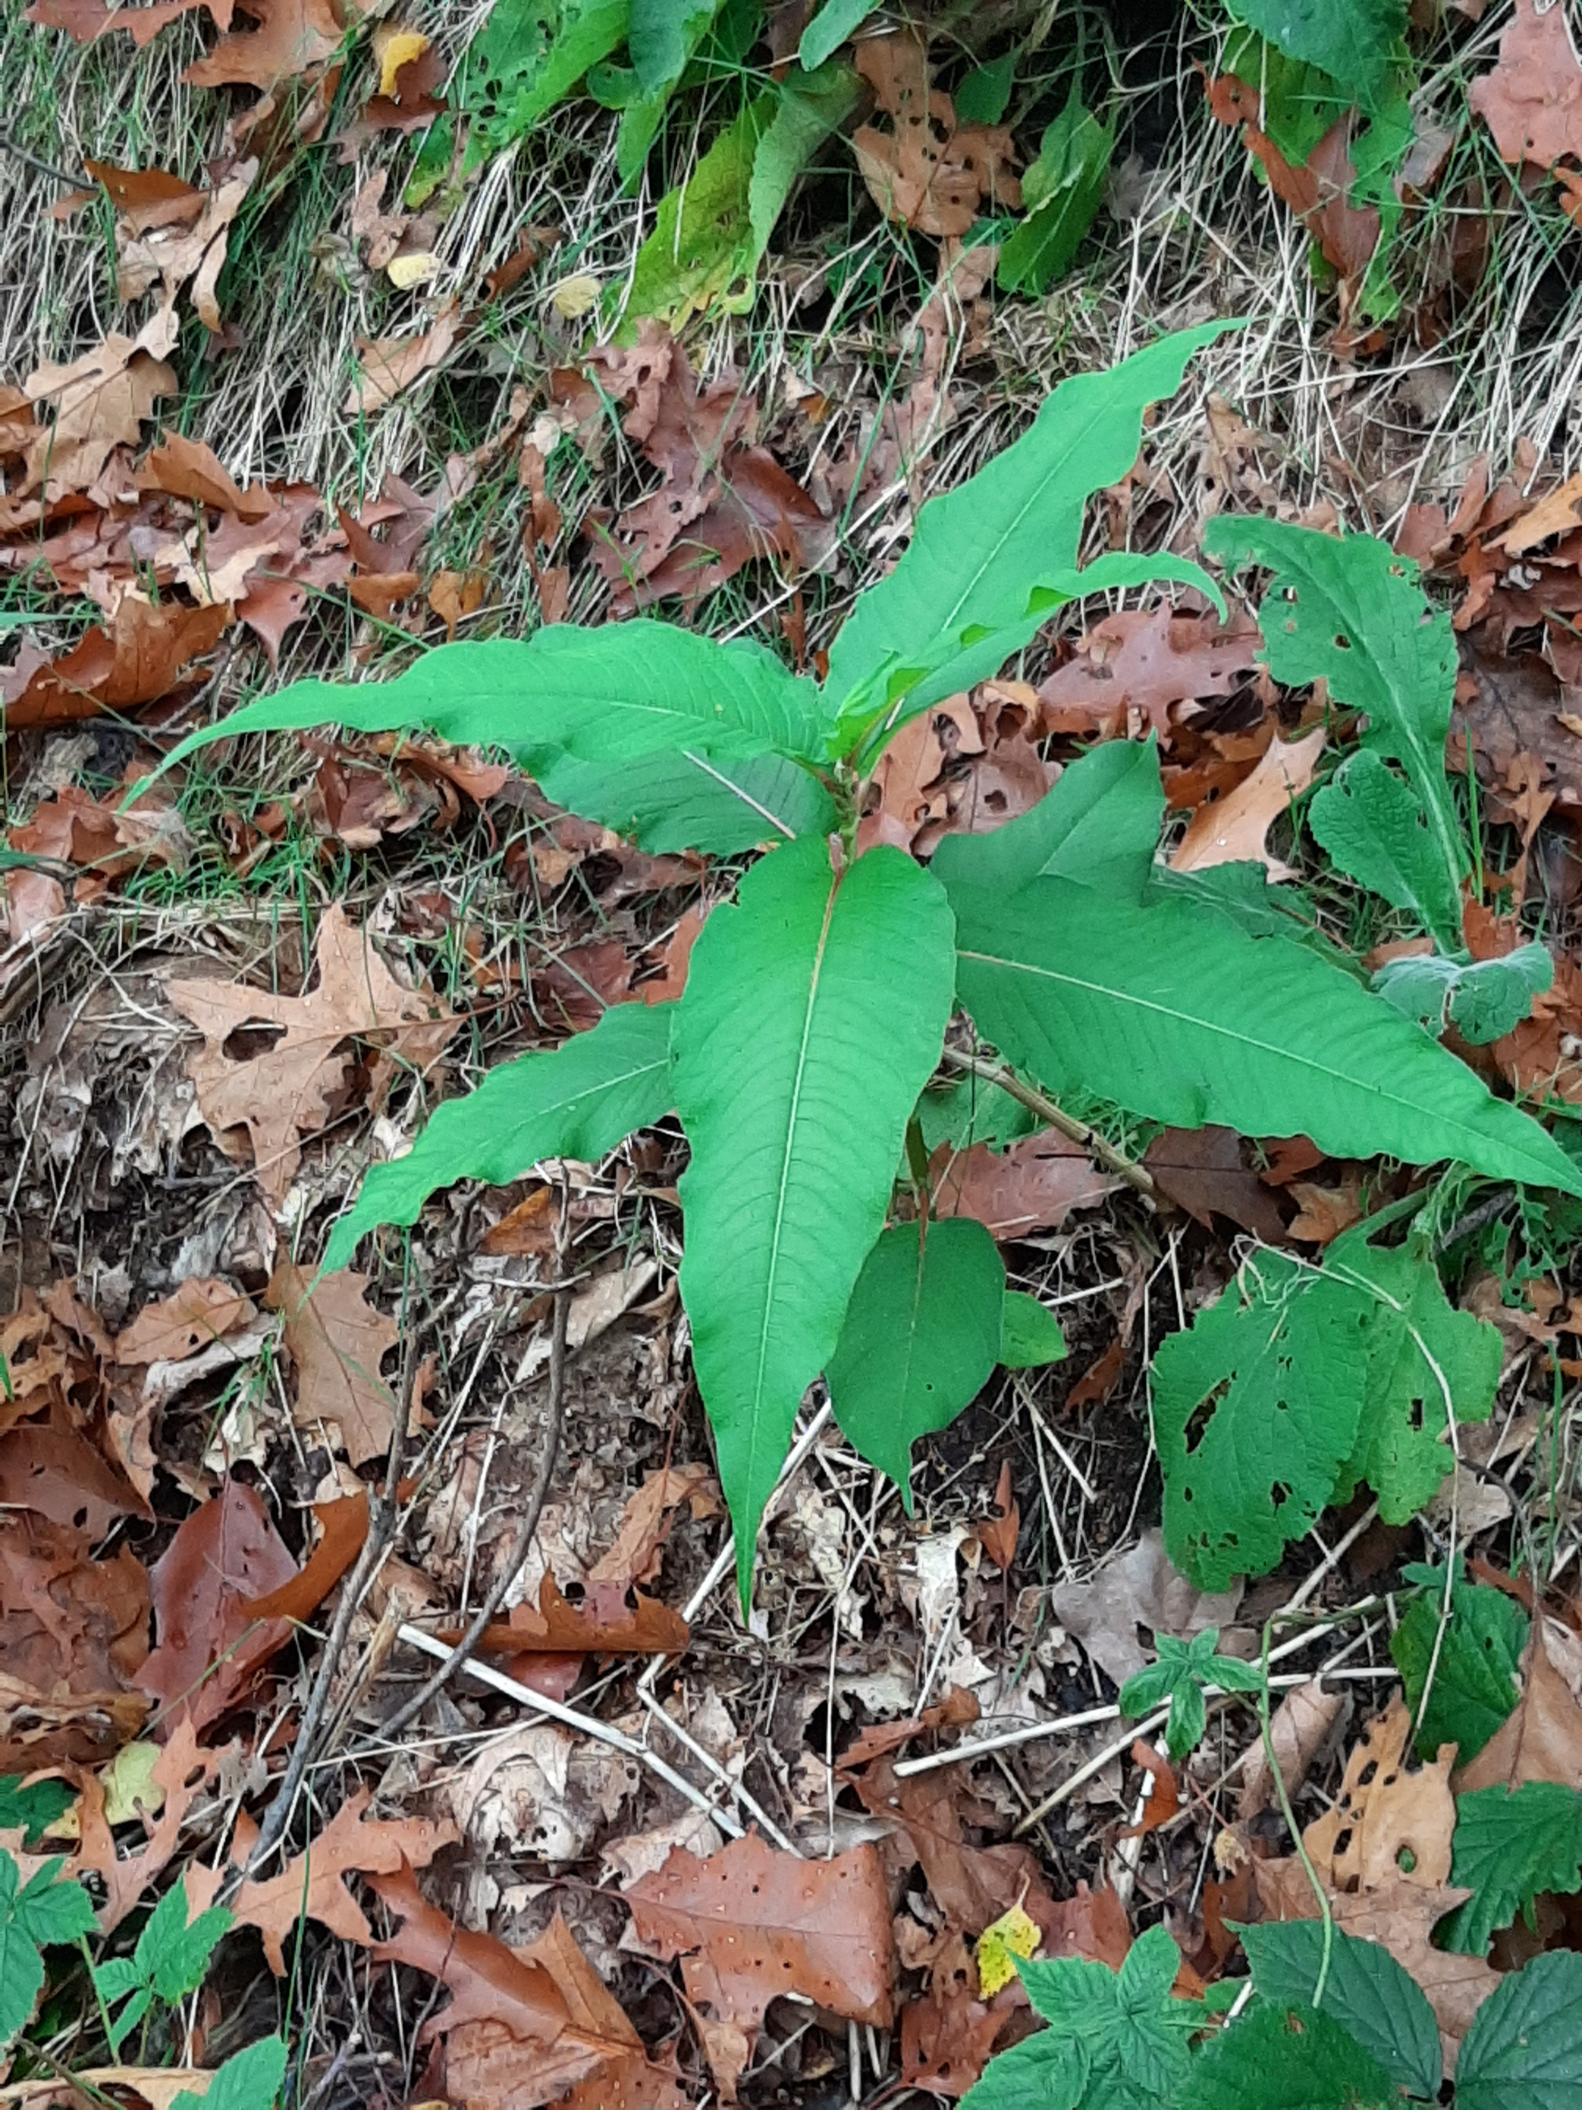

Figure 6.1 Himalayan knotweed (Ruud Beringen)

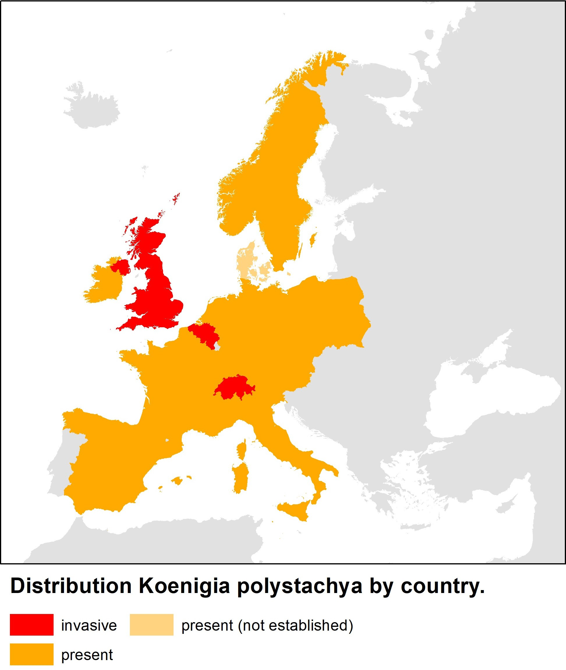
Figure 6.2 Distribution and extent of invasiveness of Koenigia polystachya in Europe (Source: https://www.cabi.org/isc/ supplemented/updated with data from sources in Appendix 1a)

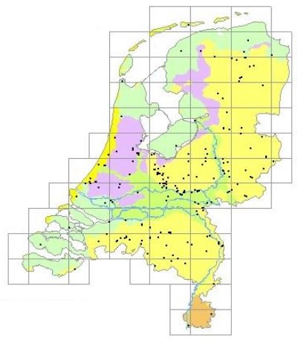
Figure 6.3 The distribution of Koenigia polystachya in the Netherlands based on observations entered in the NDFF (2022).

6.3 Impacts

6.3.1 Biodiversity and ecosystems
In its original range in the Himalayas, K. polystachya has become a problematic species in a few national parks in India in recent decades. While it initially only grew at disturbed sites such as rock fields and avalanche paths, it is now expanding elsewhere. This expansion began after shepherds and their flocks were prohibited from using national park lands. The species is now found in dense stands and is pushing out many endangered species from the alpine and subalpine zones above the tree line. The recent establishment of K. polystachya around the tree line and in the forests could potentially hinder forest regeneration (Kala 2004, Negi et al. 2017).
The dense stands can thus overshadow and displace native species and hinder forest regeneration. In riparian biotopes, they can reduce the habitat quality for fish and other fauna. Infestations along waterways can also negative impact insect populations, an important food source for salmon (Di Tomaso & Healy 2007, Wilson 2007 and WSDA 2008 in Nawrocki et al. 2011 & Klein 2011).
In Brittany, the species is also establishing itself in natural or semi-natural plant communities, competing with native species and changing ecosystems (Quere & Geslin 2016).
Compared to the Reynoutria species, K. polystachya is less widespread in Europe, and fewer countries consider it to be invasive. It is also likely that K. polystachya is less dominant in the vegetation than the Reynoutria species, although hard data on this is lacking.

6.3.2 Red List species and protected species
No publications were found that examine the impact of Himalayan knotweed on Red List species or protected species in Europe. Two experts on invasive species in nature reserves were also unable to produce any examples of a decrease in policy-relevant species when queried (oral communication with Henk Siebel and Max Simmelink).

6.3.3 EU habitats
The Natura 2000 areas in the Netherlands where K. polystachya is found are shown in Appendix 4. K. polystachya has been observed in 9 (and possibly 14) Natura 2000 areas in the Netherlands. Its occurrence in a Natura 2000 area does not necessarily mean that it is also growing in a protected EU habitat type.
No information was found regarding its occurrence in EU habitats in the Netherlands or other EU countries.

6.3.4 Physicochemical properties and structure of ecosystems
In comparison to other species in its original range, K. polystachya produces a lot of biomass and removes a lot of moisture from the soil through transpiration, which prevents the leaching of nutrients. The organic matter content under stands of K. polystachya is relatively high due to the accumulation of organic matter (Kala 2004).
K. polystachya reduces the bioavailability of nutrients in the soil. Its dense covering and litter can hinder the seed germination of native species. It can also lead to a reduction in the shading of rivers and streams, as it prevents the growth (or regrowth) of trees (Wilson 2007 and WSDA 2008 in Nawrocki et al. 2011 & Klein 2011²).

6.3.5 Ecosystem services
Provisioning services
In its original range, animals such as horses and mules often graze on the plant’s tender young shoots and leaves (Hong 1993).

Regulating services
Thanks to its long, thick rhizomes, K. polystachya serves to prevent erosion and stabilise slopes in its original range (Kala 2004).

6.3.6 Public health & the economy

Public health
No harmful effects are described with respect to eating K. polystachya as a vegetable. It is not known whether its levels of oxalic acid are comparable to those of the Reynoutria species. If so, the same caution should be exercised with respect to its consumption.

Safety of people and infrastructure
It is not known whether dams or dikes that are covered with K. polystachya are more or less susceptible to erosion.

Socioeconomic impact
It is not known whether it poses a potential threat to buildings and infrastructure. Its alleged harmfulness is based on the assumption that it can cause just as much damage as R. japonica.
In its original range, it has been reported that pastureland decreases in value if K. polystachya becomes established on it; no similar findings have been reported in Europe.
In the Netherlands, there has been a clear increase in the attention paid to the economic damage caused by Asian knotweeds in recent years. Road authorities and water managers are frequently called to account when adjacent private land is colonised from areas they oversee. Homeowners are looking for ways to cotrol infestations in their gardens (personal observation, FLORON & Radboud University). This very likely does not pertain to a relatively rare species like K. polystachya.
Compared to the Reynoutria species, fewer countries consider this species to be invasive. As such, its socioeconomic impact is estimated to be lower than that of the Reynoutria species.

7 Results of the risk analysis
The risk classifications of the four Asian knotweeds (consensus scores) and the levels of confidence in these are shown in Appendix 8. These scores are explained briefly in Section 7.1. In this section, the numbers that appear in the parentheses (A1-A41) correspond to the criteria found on the online version of the Harmonia+ protocol. The calculated risk and confidence scores appear in Tables 7.2-7.4 and are explained in Section 7.2.

7.1 Risk classifications

Context
The risk scores have been calculated by the five authors of this report (A1) for Japanese knotweed (Reynoutria japonica), Giant knotweed (Reynoutria sachalinensis), Bohemian knotweed (Reynoutria × bohemica) and Himalayan knotweed (Koenigia polystachya) (A2). These risk scores have been calculated for both the Netherlands and the EU (A3). The four Asian knotweeds are already present in the EU and have established populations in several member states, including the Netherlands (A4). The risk domains of the scores are ‘the environmental domain’ and ‘the human (health) domain’ (A5). The risk scores have been calculated based on all of the information available on the four Asian knotweeds (Chapters 3-6). During the workshop, full agreement was reached with respect to all risk scores and the levels of confidence in them. The risk scores for the EU are explained briefly below. The risk scores for the Netherlands correspond entirely with these scores for the EU.

Introduction
The probability of the four Asian knotweeds being introduced into the EU by natural means (dispersal) from their regions of origin has been scored as low (A6). The level of confidence in this is high due to the large distance between the EU and the species’ original ranges and the numerous natural barriers between the two. In addition, no information was found on natural vectors capable of dispersing these knotweeds over large distances. It is therefore highly likely that their natural frequency of introduction is less than once in 30 years.
However, the probability of the four Asian knotweeds being introduced by unintentional (A7) or intentional (A8) human actions is high. The level of confidence in these scores is high. After all, the four Asian knotweeds were recently introduced into many EU member states and other parts of the world as ornamental crops and biofuels (Appendix 1). These plants propagate mainly vegetatively by means of small stem and rhizome fragments that can be dispersed through excavation, mowing or the dumping of garden waste, among other things. Given the species’ wide distribution, the combined probability of introduction and subsequent unintentional or intentional spread in the wild (in the EU) is expected to be greater than once per year.

Establishment
All Asian knotweeds assessed already have established populations in several member states and are widely distributed (Appendix 1). The available distribution data confirm that both the climate (A9) and the habitat (A10) are optimal for establishment in large parts of the EU, including the Netherlands. The level of confidence in the suitability of climate and habitat conditions is high, given the wealth of distribution data and scientific publications available regarding the successful establishment of the four Asian knotweeds in the EU.

Spread
The capacity of the three Reynoutria species to disperse from established populations within the EU has been deemed to be high, with a moderate level of confidence (A11). This assumes that the natural spread currently not only takes place by means of vegetative propagation, but also increasingly by means of seed dispersal. Stem and rhizome fragments can be spread by means of the current when river banks erode due to high water runoff (Van Oorschot et al. 2017). Flowing water can also spread viable seeds. The seeds can potentially spread over large distances, certainly in stream and river systems with fast-moving currents. In making this assessment, it was not possible to adequately differentiate between the three Reynoutria species due to the lack of sufficient field data on successful vegetative and generative propagation (seed setting, germination and establishment). The natural dispersal capacity of K. polystachya is low. The species flowers late in the year and sets little to no seed. The natural establishment of K. polystachya at new sites is rarely observed (see Section 6.1.5). Given that few publications are available on this subject, the risk score has been assigned a low level of confidence.
The four Asian knotweeds are already widely distributed within the EU. Their spread is primarily attributable to human activities (e.g. ground excavation, mowing, ornamental plant cultivation). Spread due to human actions in the entire EU definitely occurs more frequently than once per year. Various primary and secondary pathways of introduction are known for R. japonica, R. × bohemica and R. sachalinensis (see Sections 3.2.2, 4.2.2 and 5.2.2). K. polystachya is sold by a few nurseries in the EU (see Section 6.1.2). For these reasons, the frequency of secondary spread due to human actions has been scored as high for the four Asian knotweeds, with a high level of confidence (A12).

Environmental risk
The effects of Asian knotweeds on native species due to predation, parasitism or herbivory (A13) are not applicable. This answer can be assigned a high level of confidence. Knotweeds are autotrophic plants that are non-parasitic and have not developed any mechanisms for preying on animal species (as in the case of carnivorous plants). Herbivory is not a characteristic of plants and pertains to the grazing of vegetation by plant-eating animals.
The effects of the three Reynoutria species on native species through competition (A14) have been scored as high (see Sections 3.3, 4.3 and 5.3). The level of confidence in this is high because a relatively large number of scientific publications are available on the subject of competition with native species. Based on the information available, it was found that R. × bohemica is generally more competitive than both of its parental species (R. japonica and R. sachalinensis) and that K. polystachya is probably less competitive than the three Reynoutria species assessed. With respect to the effects of K. polystachya on biodiversity, however, too little information is available with respect to the EU and as such this risk has been scored with a low level of confidence.
The effects on native species through hybridisation (A15) has been scored as none/very low with a high level of confidence. Within the EU, there are no closely related native species with which hybridisation is possible (see Sections 3.1.5, 4.1.5, 5.1.5 and 6.1.5).
The effect of the four Asian knotweeds on native species by hosting pathogens or parasites that are harmful to them (A16) has been scored as very low with a medium level of confidence. As far as known, such effects have not been observed in the EU despite the relatively long presence and numerous introductions of the species. However, relatively little explicit documentation of this is available with respect to the EU.
The three Reynoutria species have significant effects on ecosystem integrity by affecting its abiotic (A17) and biotic (A18) properties; a lot of scientific literature is available on this subject. This risk has therefore been assessed as high, with a high level of confidence. K. polystachya is likely less dominant over other vegetation. Given that hardly any documentation is available regarding the effects of this species on the abiotic and biotic properties of ecosystems in the EU, this risk score has been assigned a low level of confidence.

Risk to cultivated plants
The effects of Asian knotweeds on cultivated plant species through herbivory or parasitism (A19) are not applicable. This answer can be assigned a high level of confidence. Knotweeds are autotrophic plants that are non-parasitic and have not developed any mechanisms for preying on other species. Herbivory, or grazing, is a characteristic of plant-eating animals.
The probability of the four Asian knotweeds having undesirable effects on plant cultivation through competition has been scored as low (A20). In the extensive literature on the environmental impact of the three Reynoutria species, virtually no report or evidence of this has yet been found with respect to Europe. For this reason, their risk scores were assigned a medium level of confidence. It is not inconceivable that Reynoutria species could become problematic root weeds at some sites in the future. Due to the lack of scientific documentation on the environmental impact of K. polystachya, the level of confidence in the risk score for this species is low.
The probability of effects on cultivated plants through hybridisation (A21) has been scored as medium when R. sachalinensis and R. × bohemica are cultivated together on a large scale as biofuels (Matthews et al. 2015). This is not the case for R. japonica because this species does not produce any pollen in the Netherlands. Virtually only male-sterile specimens currently occur in Europe. As such, this effect has been scored as low for R. japonica. If this changes in the future, the score for the species will have to be changed accordingly. Given that a relatively large amount of knowledge and information is available regarding hybridisation and the three Reynoutria species, these risk scores have been assigned a high level of confidence. With respect to K. polystachya, no evidence has been found in the limited literature on this species regarding its potential for hybridising with other cultivated plants in the EU. As such, it has been given a none/very low risk score, but with a low level of confidence due to the lack of scientific documentation.
The probabilities of effects on the cultivation system’s integrity (A22) has been scored as very low for all four Asian knotweeds. In the extensive literature on the environmental impact of the three Reynoutria species, virtually no report or evidence of this has yet been found with respect to Europe. For this reason, their risk scores were assigned a medium level of confidence. It is not inconceivable that Reynoutria species could negatively impact natural forest regeneration or agriculture at some sites in the future. While K. polystachya is reported to colonise pastureland in the Himalayas according to the literature, there is no evidence of this in Europe, nor is there any evidence that this species is capable of having a greater effect on cultivation system integrity than the other knotweeds assessed. This risk score has been assigned a low level of confidence because far less scientific documentation is available for K. polystachya than for the other species.
For the EU, no evidence has been found in the literature for effects on cultivated plants by hosting pathogens or parasites that are harmful to them (A23). As such, the probability of this has been scored as very low for the four Asian knotweeds. Given the lack of explicit statements to this effect, a medium level of confidence has been assigned to the risk scores for the three Reynoutria species. ForK. polystachya, the level of confidence is low because very few studies on the environmental impact of this species have been conducted.

Risk to domesticated animals
Effects on animal health or animal production through predation or parasitism (A24) do not apply to non-native plants and therefore this score is assigned a high level of confidence.
The probability of effects on animal health or animal production by having properties that are hazardous upon contact (A25) is low for the four Asian knotweeds. This score is provided with a high level of confidence because no evidence of this has been found in the literature, even though quite a lot of research has been conducted around the world into the toxicity of plants.
As far as known, Asian knotweeds in the EU have no effect on animal health or animal production by hosting pathogens or parasites (A26). As such, this criterion has been scored as not applicable and assigned a high level of confidence. A medium level of confidence has been assigned to the risk score of K. polystachya given the relatively limited amount of research that has been done on this species.

Risk to human health
The risk category ‘Effects on human health through parasitism’ (A27) does not apply to the four Asian knotweeds, and this can be assigned a high level of confidence. While there is ample literature on the effects of the Reynoutria species, no documentation has been found regarding them having any effects on human health by having properties that are hazardous upon contact (A28). The level of confidence in this score is high. Effects on human health through the transmission of pathogens or parasites can be scored as inapplicable (A29). A medium level of confidence can be assigned to the risk scores of K. polystachya for criteria A28 and A29, given the relatively limited scientific literature available on the effects of this species.

Risk of other effects
This criterion is used to assess the probability of the species causing damage to infrastructure or the way it is used (A30). The score is determined by using the likelihood-consequence matrix found in the protocol. Based on available knowledge, it is not possible to differentiate between the risks posed by the three Reynoutria species. While the risk of damage to pavement, buildings, foundations and other structural works (e.g. dikes and embankments) is large, this risk is reversible. The risk classification for this criterion is high, and can be provided with a high level of confidence given the sufficient amount of scientific documentation available on the subject. For K. polystachya, the risk has been assessed as low because no reports were found in the literature regarding (potential) damage to infrastructure. Given the lack of documentation, however, this classification has been given with a low level of confidence.

Effects on ecosystem services
For the three Reynoutria species, the effects on provisioning services (A31) were assessed as neutral and the effects on regulating services (A32) and cultural services (A33) were assessed as moderately negative. A medium level of confidence has been assigned to these risk classifications because, although sufficient knowledge is available regarding the impact of the three Reynoutria species on the functioning of ecosystems, the effects on ecosystem services have not been quantified and no methods exist for weighing positive and negative services.
The effects of K. polystachya on ecosystem services (A31-A33) have been assessed as neutral, but with a low level of confidence due to a lack of (scientific) information.

Effect of climate change on risks
The four Asian knotweeds have been introduced into various climate regions in Europe and have successfully established themselves. Climate change is not expected to effect the natural and unintentional or intentional introduction of these knotweeds into the EU (A34), their establishment (A35) or their spread within the EU (A36). This is based on a time horizon of 50 to 100 years. The primary pathways of introduction and mechanisms of dispersal are well known, and the risks of introduction and spread would not be impacted by climate factors within the expected range of temperature and precipitation change. This score has been assigned a high level of confidence, as large parts of the EU will remain suitable for the species in the near future.
Enough is known regarding the ecology of the three Reynoutria species and, as such, the authors do not expect climate change to change the probability of undesirable effects on the environment (A37), plant cultivation (A38), animal production (A39), human health (A40) or infrastructure (A41).
Climate change is also not expected to impact the risk scores for K. polystachya with respect to criteria A34-A41, but these scores have been provided with a low level confidence in light of the lack of documentation and the fact that relatively little is known about the ecology of this species. Only the score for the impact of climate change on the risk of introduction (A34) can be provided with a high level of confidence, as large parts of the EU will remain suitable for establishment and the introduction pressure in these areas is determined by other factors.

7.2 Risk and confidence scores
Based of the risk classifications made using the Harmonia⁺ protocol, all risk and confidence scores have been calculated for the four Asian knotweeds (Table 7.2 – 7.4). The three Reynoutria species score high on the risks of introduction, establishment, spread and environmental impacts. They score low on the risks of undesirable effects on animal production and human health. The risk of effects on plant cultivation is medium for R. sachalinensis and R. × bohemica and low for R. japonica. All of these risk scores have a high level of confidence. The aggregated invasion, impact and risk scores are high for all three Reynoutria species.

Table 7.2: Risk and confidence scores for Japanese knotweed (Reynoutria japonica) based on the Harmonia+ protocol.
Table 7.3: Risk and confidence scores for Giant knotweed (Reynoutria sachalinensis) and Bohemian knotweed (Reynoutria × bohemica) based on the Harmonia+ protocol. N.B. scores for both taxa were assessed separately.
The risks of introduction, establishment and spread of Koenigia polystachya are high, and these scores result in a high invasion score. The environmental risk posed by this species is medium. The risks of effects on plant cultivation, animal production, human health and infrastructure are low. The aggregated impact score is determined by the category with the highest score, which is the environment, and its score is medium. The aggregated risk score is medium.

Table 7.4: Risk and confidence scores for Himalayan knotweed (Koenigia polystachya) based on the Harmonia+ protocol.

Comparison with other risk assessments

Risk assessments of the environmental effects of the Asian knotweeds have been conducted for many countries and areas in Europe Table 7.5 provides an overview of the protocols used, effects examined, risk scores and sources of these risk assessments. The table also includes the harmonised risk classification and the list status of the Asian knotweeds in the particular country or region. This list status indicates whether the species has been placed on an advisory list or prohibited list for invasive species. The authors of this report have harmonised the quantitative risk scores and qualitative descriptions of the risks of the Asian knotweeds from the different countries and regions into three risk classes: low, medium and high risk (see Section 2.7). Harmonising risk scores is difficult due to the large differences in risk assessment methods and the lack of protocols for doing so (Verbrugge et al. 2012; Matthews et al. 2017). The results of risk assessments are also always context-dependent, and as such it is sometimes difficult to compare different regions and levels of scale. After all, the environmental impact of non-native species depends on the environmental conditions in the particular risk area (e.g. climate, environmental quality and habitat suitability).
The harmonised risk classifications provide a more or less consistent picture of the risks of the knotweed species assessed and correspond well to these risk classifications for Europe obtained using the Harmonia⁺ protocol (Sections 7.1 and 7.2). All available risk classifications for K. polystachya indicate a low or medium risk, depending on the effects and region considered. The risk of this species having undesirable effects on native biodiversity and the functioning of ecosystems has been assessed as medium in all countries and for Europe as a whole, except in Austria, where the risk has been assessed as low. The risk of phytosanitary effects has been assessed as medium, and the risk of other environmental effects, socioeconomic effects and human health effects has always been assessed as low.
The risk of R. japonica having undesirable effects on native biodiversity and the functioning of ecosystems has always been assessed as high in all countries and for Europe as a whole. The risks of other effects ranges from low to high, depending on the country. The risk of this species having undesirable effects on human health and animal health has been assessed as low. A similar risk picture emerged in a review by Lavoie (2017), which assessed the R. japonica species complex, including R. sachalinensis and R. × bohemica, based on 44 peer-reviewed studies in Europe and the United States.
There is a strong correspondence between the risks of undesirable effects arising from the establishment of R. sachalinensis and R. × bohemica in various European countries and the classifications with respect to R. japonica. The risk posed by R. sachalinensis and R. × bohemica to biodiversity and ecosystems is assessed as high in nearly all studies, except the one for Spain, in which the risk is assessed as medium. The harmonised assessments of Rumlerova et al. (2016) also differ greatly and are mostly lower, but this is likely due to the fact that these risk scores are based on a comparison of a large number of invasive species and it is likely that the risk classifications were underestimated when harmonising their scores.

Table 7.5: Available risk assessments of the four Asian knotweeds in Europe, in Europe and the United States or in individual European countries.

8 Control and eradication of Asian knotweed
This chapter will discuss how to manage and control all four species of Asian knotweed. This is possible due to the higher degree of similarities between the species with respect to ecology, manner of growth and mechanisms of dispersal. As such, the following is a description of generic measures, unless otherwise stated.
A good recent source for systematically addressing and formulating specifications for managing or controling Asian knotweed is the Dutch “National protocol for dealing with Asian knotweed” (in Dutch, https://bestrijdingduizendknoop.nl/protocol/).

8.1 Prevention of spread
Steps must be taken to prevent the transportation of soil contaminated with rhizomes. In building specifications and for the construction of infrastructure, it would be possible to include the requirement that the soil supplied is knotweed-free. Rhizomes and stem fragments (and seeds) can also be dispersed by equipment like mowing machines. Equipment that is used at locations with knotweed stands must be cleaned before it is used at knotweed-free locations (Oldenburger et al. 2017).
Stem fragments can be dispersed via clippings left along roads and waterways. When stem fragments containing nodes wind up in the water, they can be swept away by the current and establish new stands elsewhere. It is preferable that mowing be done using a mower-suction combination (Oldenburger et al. 2017). Knotweed clippings must be transported away to a certified composting facility. The Dutch Branch Organisation for Organic Residues (BVOR) created the ’Recognised processor of invasive aliens’ certificate in September 2015. Only processors that can guarantee that plant remains and seeds from invasive alien species are rendered harmless are certified.

A potentially important preventive measure is to prevent Reynoutria species from setting viable seed. Should K. polystachya begin producing viable seeds in the future, this would also apply to this species. Given the spread of various clones, especially R. x bohemica, it can be deduced that only a small portion of established knotweed stands came about due to seed propagation (see, for example, Section 4.1.5). Seed propagation not only increases the chance of more hybridisation between clones, but it also increases genetic variation, with potentially even better adapted, more invasive genotypes as a result. Mowing should thus not only be hygienic, but also focus on preventing plants from setting seed and even preventing the flowering of clones with male-fertile flowers.

Reynoutria species are still commercially available. In most cases, this pertains to varieties R. japonica var. compacta. While this variety is not so invasive itself, it can give rise to invasive plants if other knotweed plants are pollinated with its pollen. A ban on the import, trade, cultivation and dispersal in the wild is essential for preventing further spread.
Koenigia polystachya and a few related Koenigia species are also commercially available.

The Environment Agency in the United Kingdom has drawn up the following regulations for the removal of Japanese knotweed (GOV.UK 2019):
- the plants must be removed by a certified contractor.

Bury the plant material (including ash and soils containing potential Japanese knotweed):
- on the site it came from;
- at a depth of at least 5 metres if you have not sealed it with a geotextile membrane;
- at a depth of at least 2 metres if you have sealed it with a geotextile membrane.

The geotextile used must satisfy the following requirements:
- it must be undamaged;
- it must be large enough to minimise the number of seams;
- its seams must be carefully sealed;
- it must be able to remain intact for at least 50 years;
- it must be UV resistant.

Rhizomes and stems of R. japonica are no longer viable after they have been kept at 40 °C or higher for 14 days (Figure 8.1) (Macfarlane, 2011). Professional composting or fermentation plants at temperatures above 37 °C for a few weeks also resulted in non-viable plant parts. When it comes to smaller, open-air compost piles, the temperature is generally too low around the edges for the rhizomes to be rendered entirely harmless (Fuchs 2017).
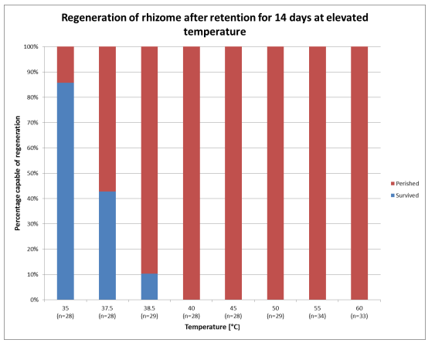

Figure 8.1. Required temperatures, sustained for 14 days, to die off rhizomes (from Macfarlane 2011).

8.2 Control and eradication

8.2.1 Mechanical control

Manual removal/uprooting
Manual removal is primarily effective as part of Early detection and rapid response. Small new stands, such as stands that have established themselves on banks from flood-dispersed fragments, are best addressed by manually removing them at the earliest stage possible. Uprooting is especially effective in light, sandy soils, as this minimises the chance of roots remaining in the soil (Colleran & Goodall 2015, ). Manual uprooting is an effective method of controlling Japanese knotweed. Given that the method is labour intensive and thus relatively expensive, it can be cost-effective to have volunteers perform the task (Oldenburger et al. 2017).

Mowing
A field experiment in the Czech Republic with planted rhizome fragments showed, that mowing twice a year in an early stage of invasion is an effective measure to prevent invasion of Reynoutria species in grasslands. Mowing should be carried out continuously (every year). Once stopped or interrupted, the invasion progresses and more drastic elimination measures are required. (Brabec & Pyšek 2000).
Mowing and transporting away R. japonica three times a year weakens it to such an extent that it is replaced by other species after several years. In Central Europe the first mow must take place around mid-May to prevent the translocation of assimilates to the rhizomes. The shoots must be at least 40 cm high, as this will ensure that the belowground reserves of R. japonica are exhausted. Still, this process requires a lot of time and patience: all of the Reynoutria is often not gone after seven years (Böhmer et al. 2006).

In a one-year greenhouse experiment in which R. japonica was mowed once, twice or three times a year, the belowground biomasses that remained at the end of the growing season were 65%, 31% and 13%, respectively, compared to the uncut controls. Based on these results, it is recommended that the knotweed be mowed at least four times per growing season to achieve a net decrease in belowground biomass. The last mow must take place at least seven weeks prior to senescence, as any mowing later in the season is less effective. While mowing alone is probably not sufficient for eradicating R. japonica, a combination of mowing and herbicides can reduce the amount of herbicides needed (Seiger & Merchant 1997).
In two other experiments in the Netherlands which Japanese knotweed was mowed once a month or once every two weeks, there was a reduction in the number of stems per m² and stem height, but even with this intensive mowing regime the knotweed was still present after four years. It is possible that it would be eradicated in the very long term. Mowing every two weeks is relatively expensive, and the reduction in stem density was not significantly higher than when the knotweed was mowed once a month. Mowing is more of a control method than an eradication method. What’s more, if the mowing is not done with the proper care it can serve as the source of dispersal itself (Oldenburger et al. 2017).
Mowing of R. japonica clones should be applied over their whole cover in order to reduce their growth, for unmowed clone parts manage to compensate for the loss in biomass production of their mowed counterparts (Martin et al. 2020).
The mowing regime should also aim to prevent plants from setting seed or releasing pollen.

In summary, it would seem advisable to mow and transport away knotweed at least four times a year, starting in mid-May until early September. This would go a long way to prevent flowering. Hygienic measures should be taken and materials carefully processed to prevent contamination from stem fragments (see Section 8.1).

Excavation
Removing the root system along with the soil can be an effective method in poor, sandy soils where there are few tree roots or shallow cables or pipes. These sites would have to be monitored for regrowth and any stems that come up would have to be pulled out or treated with chemical agents. The dug up soil has to be sieved in order to remove root fragments (Oldenburger et al. 2017).
Most knotweed roots (80%) are in the top 20 cm of the soil. The roots constitute 90% of the plant’s total biomass. The plant’s belowground reserves can be exhausted by means of a combination of 1) removing the roots from the topsoil, 2) seeding native plants immediately after removing the roots and 3) manually removing or mowing any stems that come up after this. The seeded native plants will block the sunlight of and compete with the weakened knotweed stems, which have been found to be susceptible to snails under these conditions (Portegijs 2019).

Covering
Covering Japanese knotweed is labour intensive, but it can be an effective method of controlling the plant if done properly. Prior to the growing season, the stands must be well covered with a heavy, high-quality geotextile (no anti-root fabric or agricultural plastic). There needs to be a lot of overlap between the strips of geotextile. After this, the geotextile must be covered by a layer of soil 30 to 50 cm deep. Covering is only possible at sites where there are no obstacles such as trees, stumps and fences. The knotweed roots will be smothered after four growing seasons (Oldenburger et al. 2017). A water permeable geotextile that prevents issues with standing water is now available on the market. This enables the covering layer of soil to drain better, making it more suitable for plant growth (Raats 2019).

No mowing or flail mowing
In some countries, they employ the strategy of leaving large populations (>200 m²) of knotweed untouched, as mowing or flail mowing can disperse stem fragments and lead to vegetative propagation. While such stands would be able to gradually expand via their rhizomes, the idea is that this will occur more slowly than via the dispersal of stem fragments (ISC 2016). This strategy only works if there is no generative propagation and if “by doing nothing” no natural values are damaged in the direct vicinity of the sites in question.

8.2.2 Chemical control

Herbicides
Pursuant to the first paragraph of article 27b of the Dutch Plant Protection Products and Biocides Decree (Besluit gewasbeschermingsmiddelen en biociden), the professional use of pesticides outside the agricultural sector has been banned as of 1 November 2017. This ban does not apply to the targeted eradication of a number of organisms. R. japonica, R. × bohemica, R. sachalinensis and K. polystachya are all exempt from the ban and may be controlled using pesticides (Government Gazette no. 55089, 3 October 2017).

By either injecting the stems with glyphosate (late July/August), mowing twice per growing season (mid-June and mid-August) and then spraying the leaves with glyphosate or applying glyphosate to fresh cuts after mowing (late June and late August), it is possible to greatly reduce regrowth and the number of stems and also reduce the height and thickness of growth. Injecting stems with glyphosate or applying glyphosate to fresh cuts is very labour intensive and relatively expensive. Chemical treatment with glyphosate must be administered for several years in a row, as knotweed stems were still found to be present after four years of treatment. There was a 85-95% decrease in the number of stems following the above treatments (injecting glyphosate, mowing twice and spraying or applying glyphosate to cuts after mowing twice) (Oldenburger et al. 2017).
Chemical treatment is particularly suitable for small to medium-sized stands and, due to the harmful side effects of the agents, is only possible at sites where other, non-chemical methods are impracticable (Oldenburger et al. 2017).
The combined method of mowing in June and injecting the newly grown shoots once they reached approx. 20 cm in length was found to be successful, as the plants were eradicated after three years of treatment (Böhmer et al. 2006).
In a comparison of 19 different treatments involving different doses of different herbicides at different times and combinations of herbicides with mowing or excavation, the following three treatments were found to be the most effective (Jones et al. 2018):
- spraying the leaves with glyphosate (2.6 kg ae/ha) in the summer and the autumn
- injecting the stems once with glyphosate (65 kg ae/ha)
- spraying the leaves with glyphosate (3.6 kg ae/ha) in the autumn

Additional safety measures must be taken if there is a possibility that the knotweed treated could be harvested for consumption.

8.2.3 Biological control

Insects
In Japan, the leaf-feeding psyllid Aphalara itadori is specialised in knotweed. The psyllid can only complete its life cycle on R. japonica, R. japonica var. compacta and R. sachalinensis. Additional research in Europe has shown that its eggs can be deposited on and its nymphs can develop on R. × bohemica and x Reyllopia conollyana, as well. Little to no eggs were deposited on other plant species and none of the eggs that were deposited on other species developed into adult psyllids (Clements et al. 2016, Shaw et al. 2009, CABI 2015, Jones et al. 2013). In comparison to a control, the biomass of both R. × bohemica and R. sachalinensis decreased by 50% after 50 days of exposure to A. itadori (Grevstad et al. 2013). The use of A. itadori to control R. japonica in Northwestern Europe is deemed to pose little risk (CABI 2015).
Since 2010, A. itadori has been released each year at various sites in the United Kingdom. Monitoring has shown that the adults overwinter and prefer to deposit eggs on stands that have previously been cut. Eggs and nymphs of A. itadori were preyed upon by native assassin bugs, such as Orius laevigatus (Anthocoridae) (Ellison & Pratt 2018).
In British Columbia, A. itadori was released in 2016. Just as in the United Kingdom, the variety that was released here is native to the island of Kyushu, Japan, and is primarily specialised in R. japonica and R. × bohemica. A different variety from the island of Hokkaido is more specialised in R. sachalinensis. The impact of this northern variety and the hybrid between both varieties is still being investigated (CABI 2019, Grevstad et al. 2013, Andersen et al. 2016).
In the Netherlands Aphalara is released at 3 locations in October 2020 and June/July 2021. They survived the winter of 2020-2021 and at one location reproduction was assessed. Reynoutria plants showed reduced growth rate and underdeveloped leaves. Aphalara was predated by native predatory mites (https://bestrijdingduizendknoop.nl/overige-onderzoeken/biologische-bestrijding/#toggle-id-19).
In Asia, the beetle Gallerucida bifasciata (Coleoptera: Chrysomelidae) is important herbivore of R. japonica. In field and laboratory tests, 87 plant species from different families were tested for suitability as a food source for this beetle’s larvae. The larvae could only complete their development on seven of the 87 tested species. Of these seven species, larval survival rates on R. japonica, Persicaria perfoliata and Reynoutria multiflorum were significantly higher than on Polygonum runcinatum, Rumex acetosa, Fagopyrum acutatum and Fagopyrum esculentum. With respect to feeding and depositing eggs, adults also had a clear preference for the three species R. japonica, Persicaria perfoliata and Reynoutria multiflorum (Wang et al. 2008).

Fungi
In Japan, the leaf-spot fungus Mycosphaerella polygoni-cuspidati (Ascomyceten) commonly occurs on R. japonica and causes leaf necrosis (Kurose et al. 2006). Tests conducted in Europe found that R. japonica and R. bohemica had a low level of susceptibility to this fungus and R. sachalinensis was even immune to it. This low susceptibility could be attributed to the fact that the tests were conducted in the autumn, when the epidermis of the leaves are thicker than in the spring (Jones et al. 2013).
In Japan, a total of 1,581 endophytic fungi were found on R. japonica. A few of these increase the virulence of a rust pathogen Puccinia polygoni-amphibii var. tovariae. In Japan, this rust fungus damages R. japonica and can potentially be used as a biological control agent (Kurose et al. 2012).
The leaf-feeding psyllid A. itadori could serve as a vector that could contribute to the spread of fungi Puccinia polygoni-amphibii var. tovariae and Mycosphaerella polygoni-cuspidati (CABI 2015).

Bacteria
The bacteria Candidatus Phytoplasma aurantifolia was found to be able to weaken R. japonica to such an extent that it can be overgrown by stinging nettles (Urtica dioica) (Reeder et al. 2010).

Bacteria can also be used to smother the plants. This method involves a number of steps. After mowing down the knotweed, protein-rich pellets are worked into the soil to a depth of 25 cm. The soil is then watered and covered with an air-tight sheet. The protein will enable the bacteria to grow and consume the oxygen present in the soil, which will no longer be replenished due to the sheet covering. Anaerobic bacteria will consume and break down the carbohydrates in the roots of the plant, causing it to die. A practical trial recently conducted should demonstrate whether knotweed can be completely eradicated within one season. The results are promising, but had not yet been published at the time this report was compiled (see https://bestrijdingduizendknoop.nl/overige-onderzoeken/wortels/).

Grazing
A field experiment in the Czech Republic with planted rhizome fragments showed, that sheep- or goat grazing in an early stage of invasion are effective measures to prevent invasion of Reynoutria species in grasslands. It is important grazing is applied continuously (every year). Once stopped or interrupted, the invasion progresses and more drastic elimination measures are required (Brabec & Pyšek 2000).
Sheep, cows and horses are particularly fond of the young shoots of R. japonica. At a site in the Black Forest, R. japonica was able to be completely suppressed by the combined grazing of Galloway cattle, moorland sheep and goats (3-4 grazing moments with >20 animals/ha). However, the resulting short grass is low in natural values. For large areas located outside natural areas, land managers in Germany see sheep grazing as the most effective and cost-effective control measure against knotweed (Böhmer et al. 2006).
The Probos foundation conducted a trial involving grazing by fenced-in Kempen heath sheep (three times a year for 2-3 days). This grazing method did not result in a reduction of knotweed because the sheep only ate the leaves and not the stems. However, a reduction was seen at a different site where Schoonbeker heath sheep were allowed to graze for the entire growing season. In this case, the sheep ate primarily the young shoots. The use of sheep grazing is relatively expensive and does not always lead to a significant reduction of knotweed (Oldenburger et al. 2017).
Since April 2015, the Municipality of Renkum (Netherlands) has been conducting a trial with fenced-in Bentheim Black Pied pigs. These pigs eat not only leaves and stems, but also the roots and rhizomes near the surface. The Bohemian knotweed was almost entirely eradicated near the pigs’ night-quarters and feeding trough and under the trees in the shade. The knotweed is decreasing elsewhere at the site, but it is still present (Oldenburger et al. 2017). Except for the trees, the knotweed and giant hogweed (Heracleum mantegazzianum), all other plant species at the grazing site disappeared (Fig. 8.1) (personal observation by R. Beringen). As it was thought that pigs would exhaust the knotweed more quickly because they also eat the belowground parts of the plant, the expectation was that grazing with pigs would be more effective than grazing with sheep. However, this did not prove to be in the case in practice (personal observation by J. Leferink). In terms of animal welfare, it would also be best if knotweed were not the only item on the menu, regardless of whether sheep or pigs are used (Oldenburger 2017).

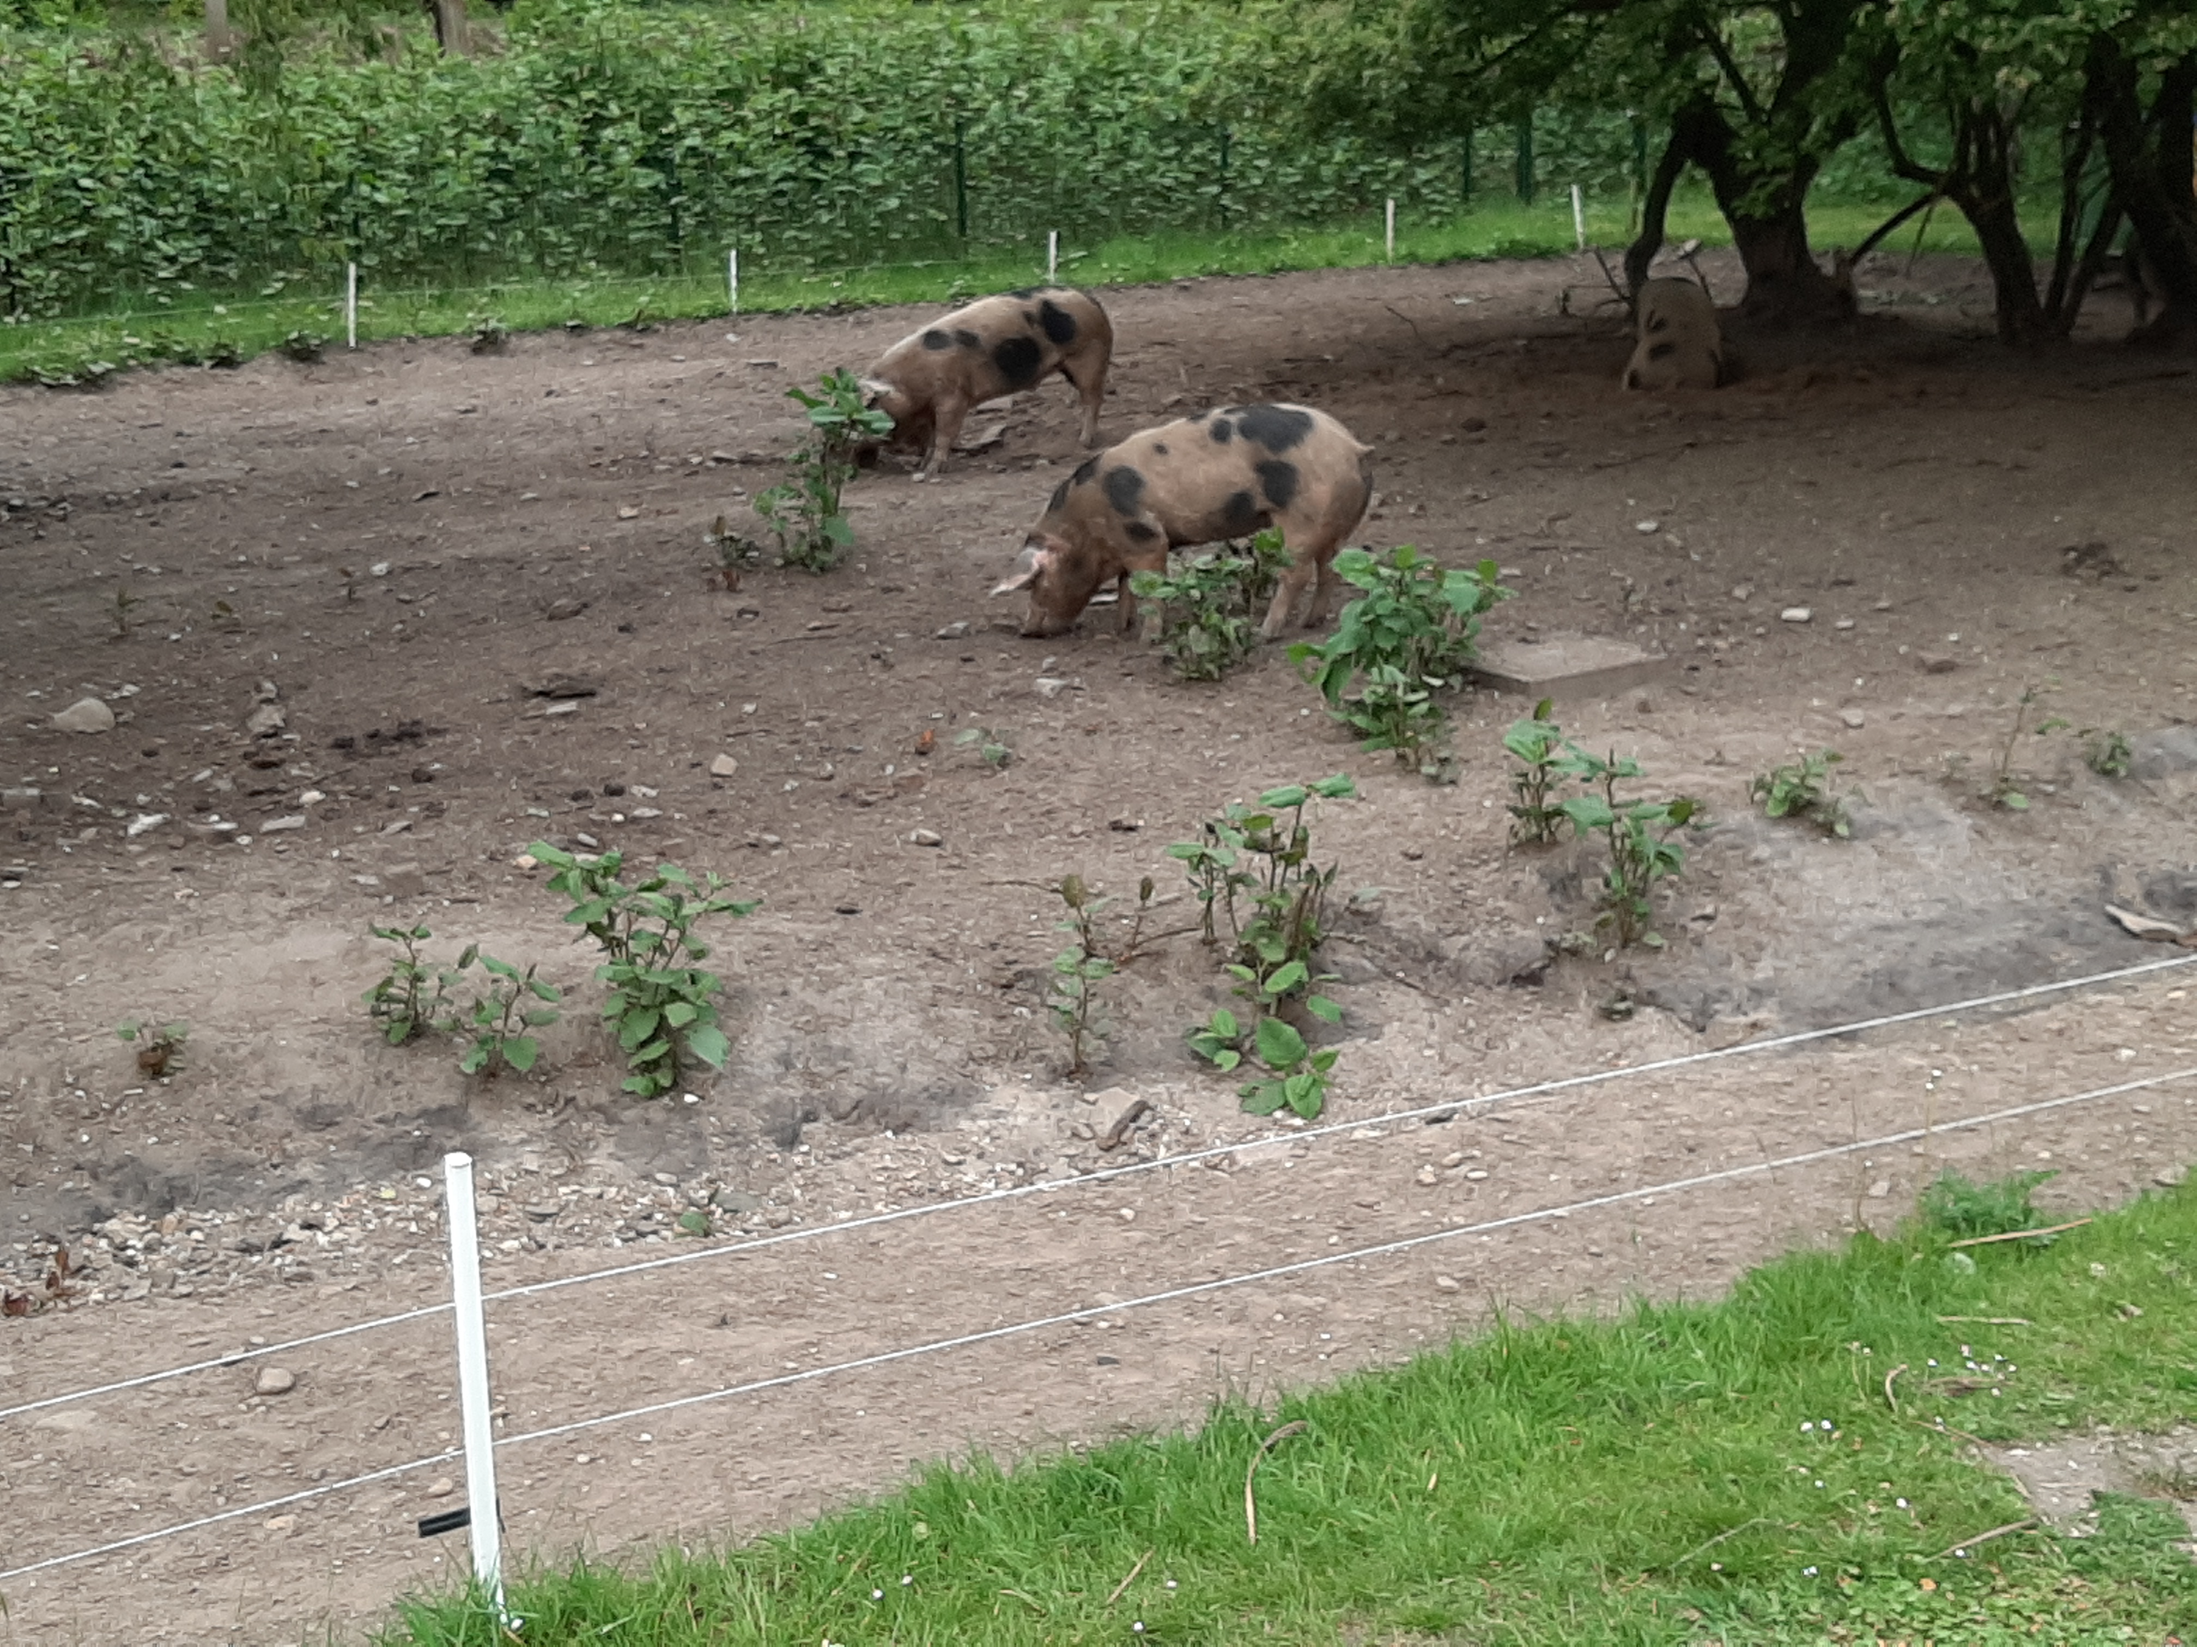
Figuur 8.2 The use of pig grazing to control Asian knotweed in Renkum (Netherlands) (Ruud Beringen).

Competing plants
The planting of tall or shady native species such as reed canary grass (Phalaris arundinacea), common reed (Phragmites australis), butterbur (Petasites hybridus) and common alder (Alnus glutinosa) can help cotrol the establishment and expansion of Japanese knotweed along river banks, as long as the planted areas are sufficiently wide (Böhmer et al. 2006).
The planting of cuttings of competitive (long-living and shady) native species such as willows and/or poplars could also be a way of suppressing stands of R. japonica (Dommanget at al. 2014, 2019). When growing under heavy shade R. japonica only forms few ramets separated by long rhizome spacers (“guerrilla” growth form); homogeneously illuminated many aggregated ramets separated by short rhizome spacers (“phalanx” growth form) are produced (Martin et al. 2020).

To limit the growth of knotweed as much as possible, the so-called 'ecosystem approach' is being tested at various locations in Europe. The basic principle here is that the dominance of an invasive exotic species is broken (by removing knotweed plants and rhizomes as much as possible) and that the resilience of the native ecosystem is strengthened (by planting endeginous trees and shrubs). The aim is that the ecosystem itself is able to keep the exotic under control. This approach is relatively new and It remains to be seen whether this approach is successful (LIFE Resilias project).

8.2.4 Thermal control
Thermal control methods are designed to damage and ultimately kill plants at high (>70°C) or extremely low, freezing temperatures.

Electricity
The Rootwave Pro is a relatively new device consisting of a metal lance and a metal earthing rod that carries a charge of 5,000 volts. Touching the lance to a plant sends a current through the plant to the earthing rod, essentially boiling it from the inside out, from the roots upwards. This method is both selective and labour intensive, and thus less suitable for large stands (Van Iersel 2019a).

Hot water or steam
Various devices are available on the market for controlling knotweed by means of hot or boiling water. These methods are generally not very selective in that they tend to kill all plants in the vicinity, though this is not necessarily a problem when it comes to species-poor, uniform knotweed stands. Another disadvantage is that the heat does not penetrate very deeply into the soil, which allows part of the root system to survive (https://bestrijdingduizendknoop.nl/). To address these belowground parts of the plant, experiments are being conducted in which hot water is injected into the soil after mowing. This treatment needs to be repeated several times per season, for a few seasons in a row (https://www.ranox.nl/)

Hot air
Tests have shown that it is technically possible to heat larger soil volumes in and ex situ to temperatures of at least 40 °C by means of hot air. No vital rhizome fragments were found in the soil samples collected after each thermal treatment. No regrowth of knotweed was also observed during the monitoring period after the treatments (Van Dijk et al., 2021).

Microwaves and UV
Research is also being conducted into whether technologies like microwaves and UV light that are already being used in the agricultural and horticultural sectors to decontaminate the soil or eradicate weeds can also be used to control Japanese knotweed (Vermeulen et al. 2002, Cuperus et al. 2013, https://bestrijdingduizendknoop.nl/).

Freezing
Liquid nitrogen can be used to freeze the roots of knotweed to death. In practice, however, it is difficult to keep the soil below zero degrees long enough to kill them (https://bestrijdingduizendknoop.nl/).
An in situ cold treatment for larger soil volumes was developed and tested at a 45 m² knotweed site in Gendringen (NL). It involved a growth core with thick ‘knots’ from which closely knitted stems with a 2-3 cm diameter and a height of 3-4 metres were growing. The freezing lances and insulated covering were placed in such a way that the core of the growth site fell inside the treatment area. It was technically feasible to cool larger soil volumes on site down to a temperature of around -10 °C at 1 m below ground level. Freezing the soil was shown to be an effective control measure for Asian knotweed Van Dijk & de Visser 2021)

8.3 Risks of improper management
The manual removal of K. polystachya in the Indian Himalayas has been found to be counterproductive and has led to erosion and the domination of Impatiens sulcata (Kala 2004). This is a general ecological principle. In the mountainous areas of Europe, any large-scale control efforts must also take into account the risk of erosion and domination by annual species.
In Europe, the risks of improper management pertain more to the further spread of the knotweed species due to, among other things, poor mowing hygiene (e.g. flail mowing) and the failure to prevent flowering or seed setting when the possibility of viable seed production exists. What’s more, despite existing protocols, there is no guarantee that contaminated clippings will be disposed of properly. They could end up in compost piles, or rhizomes could survive in soil depots. There continue to be incidents in which construction sites, road verges and even private gardens are contaminated with soil or compost brought in from elsewhere. In 2019, for example, in a story that received extensive coverage in the Netherlands, large areas along a motorway (the A27 near Bilthoven) became overgrown with Asian knotweed after contaminated soil was used in a road widening project.

9 Potential costs of damage and control

9.1 Damage to biodiversity and ecosystem services
Asian knotweed species are quite similar when it comes to their harmfulness to biodiversity and ecosystem services - so similar, in fact, that they are often intentionally lumped together under one heading in not only the scientific literature, but also in risk assessments. A lot of relatively recent literature does not appear to draw a distinction between R. japonica and R. x bohemica, and the assumption is that many of these studies pertain to both taxa.
With respect to K. polystachya, less specific literature is available and the uncertainties are somewhat greater than for the Reynoutria species.

Total costs
The total costs (damage, losses and management costs) of invasive alien species in Europe between 1960 and 2020 are calculated at € 116.610 000 000. After Ragweed species (Ambrosia artemisiifolia and Ambrosia polystachya), R. japonica is the most costliest invasive plant species in Europe. The aggregated reliable observed costs for 2 countries (UK and Spain) amounted to $540 000 000 (± €480 000 000) (Haubrock et al. 2021).
In France, the total cost of Reynoutria species over the period 1993-2018, is estimated at $2 090 356. (±€1 851 839). Among the invasive plants, only the costs for Ambrosia artemisiifolia (€488 million), Ambrosia polystachya (€62 million) and the both Ludwigia species (€31 million) are higher (Renault et al. 2021).
Invasive alien species have cost the UK economy since 1976 between $ 6.900 000 000 (±€ 6.110 000 000) and $ 17.600 000 000 (±€ 15.591 000 000) in reported losses and expenses. The total costs of invasive plants amounted $ 1.300 000 000 (±€ 1.150 000 000). With European rabbit and Rock pigeon, R. japonica is the most costliest invasive species in the UK. Among plants it ranks as the most costliest species, followed by Floating pennyworth (Hydrocotyle ranunculoides) and Canadian pondweed (Elodea canadensis) respectively. Especially managements costs are high and amount to 62% of the total management costs (Cuthbert et al. 2021). In 2010 annual costs in the UK (England, Wales and Scotland) for Japanese knotweed on development sites were estimated at £150 510 000. Costs for householder control were estimated at £447 660, devaluation of housings at £1 115 652, control in riparian habitats at £5 636 698 and control costs across the road network at £5 095 894 (Williams et al. 2010).
The overall annual costs for the German economy of Reynoutria species were estimated by Reinhard et al. (2003) at almost €30 million; divided over the following cost items: bank restoration €7.0 million, control €6.2 million and bank reinforcement €16.7 million (Reinhard et al. 2003).

Damage to biodiversity
Based on the literature review that was performed for this report, Asian knotweeds have a significant impact on the biotic and abiotic environment (see Section 3.3). It has effects on the chemical soil composition, soil moisture, soil microflora, soil fungi, vascular plants, aboveground insect fauna and sometimes even vertebrates.
While these are also effects that native species can sometimes have under certain circumstances, the latter effects are generally easy to keep in check by adjusting management measures.
Though little to no examples were found in the consulted literature regarding specific effects on rare or Red List species, there are definitely examples from other EU countries in which the quality of protected EU habitats has been damaged due to knotweed infestations (see Section 3.3.3.).

Based on the size of the knotweed populations in the Netherlands, R. japonica and R. x bohemica (which are often mistaken for each other) are more harmful to biodiversity than R. sachalinensis and K. polystachya.

No publications are known of that express the damage to biodiversity in financial terms.

Damage to ecosystem services
Asian knotweed can damage or hamper ecosystem services. This mainly occurs through encroachment on land used for agriculture or forestry. The extent to which this is an issue and the associated costs are unknown.

9.2 Damage to health, safety and the economy
Asian knotweed does not impact human health, unless it is consumed as a foodstuff in large quantities. The risks to safety and the economy are far greater.

There are all kinds of situations in which it negatively affects traffic and water safety. Knotweed infestations can make dams and dikes more susceptible to erosion. The upward growth of rhizomes can displace the pavement or stone pitching. At some spots along roadways, knotweed stands require more frequent mowing in order to prevent unsafe traffic situations.

In Europe, knotweed infestations are reported to have an economic impact on the price of real estate, the processing of soil and compost and natural forest regeneration. Evidence also suggests that the management of agricultural land is affected. Lastly, a lot of money is spent to control or eradicate existing knotweed stands. In various European countries, including the United Kingdom and the Netherlands, a growing number of horticulturalists and other entrepreneurs are participating in knotweed control efforts initiated by private citizens or the government.

The species also present potential societal benefits, mainly as medicine or food. In Europe, however, the economic importance of these benefits is likely small because the medicine made from knotweed is mostly imported from outside Europe and only a limited number of individuals consume knotweed as a food. Furthermore, Asian knotweed that grows in the wild by definition does not meet with the EFSA regulations for ‘novel foods’. This makes the use of Asian knotweed for human nutrition, medicinal applications or for the supplement market in Europe unlikely. There are a few cases in which catering establishments feature knotweed on the menu in response to the growing interest in eating “foraged food”.

9.3. Costs of control efforts
Many different methods for controlling Asian knotweed have been tested, taking into account the cost aspects, both in Dutch and international literature. The studies focus primarily on the most common taxa, R. japonica and R. x bohemica. The costs associated with efforts to control both other knotweed species can likely be determined in a similar way.
With a view to finding a cost-effective method for controlling knotweed, the Dutch independent knowledge institute Probos conducted a practical trial involving seven different methods. The costs of these methods range from a few euros to approx. € 80 per square metre per year, generally based on a timeframe of four years. The best methods were found to be manual uprooting for smaller stands and monthly mowing for larger, easily accessible stands. However, almost none of the methods achieved 100% eradication in a 4-8 year period, and even after eradication follow-up monitoring is recommended for the subsequent five years. In general, a combination of measures is recommended (Oldenburger et al. 2017). Comparable studies into the costs of knotweed control have also been conducted in the United Kingdom (Table 9.1).

For various species on the list of invasive alien species of Union concern (the Union list), rough estimates have recently been made of the costs of control in the Netherlands (van der Meer et al. 2019). For the widely distributed species, these estimates pertained to the portion of the population that poses a risk to Natura 2000 goals or public health, for example. Based on a number of assumptions, the same system was used to obtain an estimate of the expenses associated with the eradication of all existing populations of Asian knotweeds within a period of three years. Assuming there to be approximately 10,000 populations (counted in square kilometres) of knotweed species ranging in size between 1 and 1,000 m² and in cost between € 30 and € 90 per m², the annual costs are projected to be € 1 million - € 11 million - € 300 million (minimum-average-maximum). This exceeds the annual costs associated with controlling a portion of the population of Himalayan balsam (Impatiens glandulifera: maximum costs estimated at € 114 million) or giant hogweed (Heracleum mantegazzianum: maximum costs estimated at € 250 million).
Additional costs related to excavation work, more frequent mowing or the use of glyphosate, among other things, are already being made in various places to limit the growth and expansion of Asian knotweeds. The Municipality of Amersfoort has earmarked an amount of € 307,000 for city-wide efforts to control Japanese knotweed over the 2017-2020 period (Tijhuis 2017). In the same municipality, the costs of eradicating the knotweed by excavating all of its roots have been estimated at over € 500 million. This amount is so high due to the destruction of capital necessary, as bridges and houses would have to be demolished in order to remove all of the roots. The price tag for excavating the roots of Japanese knotweed at one urban expansion site in the Municipality of Harderwijk was € 400,000 (van der Sneppen 2018). The Municipality of Amsterdam set aside an amount of € 8.2 million for eradication efforts in 2019. It cost the municipality € 300,000 to rid just one listed building of a Japanese knotweed infestation (Municipality of Amsterdam 2019).
Within the framework of this study, no estimate was made of costs associated with the control and eradication of Asian knotweeds at the European level.

Table 9.1. Average costs for one-time treatment/removal of Japanese knotweed in the United Kingdom in 2017; conversion rate ₤ 1.00= € 1.1413. (Source: https://environetuk.com/beacon/Japanese-knotweed-removal-costs-uk)

Area (m²) | Spraying with herbicide | Excavation and disposal
50 | € 4,005 | € 32,537
500 | € 16,018 | € 201,229

10 Discussion, conclusions and recommendations

10.1 Discussion
Asian knotweed species are quite similar in manner of growth, biology and harmfulness - so similar, in fact, that they are often intentionally lumped together under one heading in not only the scientific literature, but also in some risk assessments. A lot of relatively recent literature does not appear to draw a distinction between R. japonica and R. x bohemica, and the assumption is that many of these studies pertain to both taxa. With respect to K. polystachya, less specific literature is available and the uncertainties are somewhat greater than for the Reynoutria species.
There is an enormous amount of literature on the Reynoutria species, especially R. japonica. Given the latter’s close relationship with the other Reynoutria taxa, this literature was a good aid in assessing the risks associated with these taxa, for which far less literature is available. However, publications are known to borrow a lot from one another and in that sense can rehash the same general message. In part because of this, the comprehensive literature review may not provide unambiguous answers to all questions.

The Harmonia⁺ protocol was not necessarily developed for species that have already been established and widely distributed for a long time. While the risk assessment scores for the three Reynoutria species are more or less the same, according to this protocol R. × bohemica is the most invasive, followed by R. japonica and R. sachalinensis. R. × bohemica is not only the most prone to expansion (via vegetative and probably also generative propagation), but also exhibits the most vigorous growth and is therefore more competitive (Parepa et al. 2014).
The primary danger lies in the potential emergence of a larger and more genetically diverse hybrid swarm, to which all three Reynoutria species could contribute. For this reason, it is recommended that the three be dealt with jointly. Preventing generative propagation (via seeds) is an important part of this. An increase in the generative propagation of Reynoutria has been observed in the United States (Forman & Kesseli 2003, Grimsby et al. 2007). At the same time, preventing generative propagation can be at odds with measures designed to prevent vegetative spread on roadsides or dikes (e.g. not mowing or flail mowing as opposed to mowing or flail mowing).

10.2 Conclusion
The invasion, impact and risk scores for the Japanese knotweed (Reynoutria japonica) are high. The risk of significant effects on biodiversity, ecosystems and infrastructure has also been assessed as high, while the risk posed to plant cultivation, animal production and human health is seen as low. There is a high level of confidence in the risk scores for all assessment categories.
The risk scores for Giant knotweed (Reynoutria sachalinensis) and Bohemian knotweed (Reynoutria × bohemica) are exactly the same. Their invasion, impact and risk scores are high. They pose a medium risk to plant cultivation and a low risk to animal production and human health. There is a high level of confidence in the risk scores for all assessment categories.
The invasion score for the Himalayan knotweed (Koenigia polystachya) is high, while its impact and risk scores are medium. Its risk scores for introduction, establishment and spread are high, its environmental impact risk score is medium and its scores for effects on plant cultivation, animal production, human health and other aspects are low. The level of confidence in these scores ranges from low to high for the different assessment categories; only the risk of other effects has been given a low level of confidence.

10.3 Recommendations for control
The primary methods for preventing the spread of Asian knotweed are:
1) banning its import, trade, cultivation and dispersal in the wild;
2) preventing contamination due to earthmoving or contaminated compost;
3) practising good hygiene in vegetation control or not mowing or flail mowing populations;
4) ensuring that garden waste is disposed of properly.

There has been a lot of discussion between managers (water boards, municipalities and land managers), private citizens and green entrepreneurs regarding control methods, with new methods being frequently tested or promoted. In short, there is no simple, fixed recipe for controlling knotweed. The best method can differ for each situation, and it is usually necessary to implement a combination of measures, several years in a row. A decision tree can be a useful aid in this process (see, for example, https://bestrijdingduizendknoop.nl/beslisboom/).
A major obstacle when it comes to control efforts is that parties need to work together to achieve real results. Far too often we see a manager on one side of the fence doing his or her best, while the manager on the other side is not. Cooperation is essential, especially if preventing generative propagation proves to be important.
Preventing the generative propagation of the Reynoutria species is an important strategy for preventing the emergence of an increasingly larger and more genetically diverse hybrid swarm. If generative propagation does indeed play a significant role, it is key to prevent female plants from setting seed and male plants from flowering. Not managing knotweed stands would then be a less appropriate strategy.

10.4 Recommendations for further research
In light of the genetic and morphological variation of the Reynoutria species, in particular, it is evident that generative propagation is taking place in many European countries. There is sufficient proof that plants are often producing viable seed. That which is much less clear is under what field conditions germination and establishment occur. One of the main research questions that remains is to what extent and at what kind of sites are seedlings able to establish themselves. If this process has already taken place, it should reveal itself in the genetic diversity of populations. Studying the genetic makeup of existing populations would shed light on this.
Based on the life strategy of Asian knotweed and the distribution of the species in Central Europe, it appears that the more dynamic the stream or river, the more potentially susceptible they are to knotweed establishment, with the possibility of much more invasive behaviour in these natural ecosystems.
There is still a lack of knowledge regarding the environmental impact of the Himalayan knotweed (Koenigia polystachya) in the EU. Our current knowledge relies too heavily on the known effects of the other knotweed species. More research into the effects of this species would increase the level of confidence in the risk assessment. It is also important to perform a taxonomic study to clear up its origin, relationship to other species in the genus, genetic variation and possible hybridisation.

Acknowledgements

We would like to thank Jenneke Leferink (NVWA) for her active role on behalf of the commissioning party and her insightful thoughts regarding the content, always keeping in mind this risk assessment’s target audience. Chris van Dijk (WUR) and Martijn Boosten (PROBOS) provided us with valuable information regarding the germination and establishment of knotweed in the Netherlands. Henk Siebel and Max Simmelink from the Society for the Preservation of Nature in the Netherlands (Vereniging Natuurmonumenten) drew on their experience to share insights into the potential impact of Asian knotweed on rare or protected species in the Netherlands.

Bibliography
Abgrall, C., E. Forey, L. Mignot & M. Chauvat, 2018. Invasion by Fallopia japonica alters soil food webs through secondary metabolites. Soil Biology and Biochemistry 127: 100-109.
Adachi, N., I. Terashima & M. Takahashi, 1996. Nitrogen translocation via rhizome systems in monoclonal stands of Reynoutria japonica in an oligotrophic desert on Mt Fuji: Field experiments. Ecological Research 11(2): 175-186.
Aguilera, A.G., P. Alpert, J.S. Dukes & R. Harrington, 2010. Impacts of the invasive plant Fallopia japonica (Houtt.) on plant communities and ecosystem processes. Biological Invasions 12(5): 1243–1252.
Alberternst, B.& H.J. Böhmer, 2011. NOBANIS – Invasive Alien Species Fact Sheet – Fallopia japonica. (https://www.nobanis.org/globalassets/speciesinfo/r/reynoutria-japonica/reynoutria_japonica4.pdf).
Andersen, J.C., R. S. Bourchier, F.S. Grevstad, R. Van Driesche & N.J. Mills, 2016. Development and verification of SNP arrays to monitor hybridization between two host-associated strains of knotweed psyllid, Aphalara itadori. Biological Control 93: 49-55.
Andreu, J. & Vila, M., 2009. Risk analysis of potential invasive plants in Spain. Journal for Nature Conservation 18 (1): 34-44.
Anonymous, 2013a. Fallopia baldschuanica. Catálogo Español de Especies Exóticas Invasoras. download van: https://www.miteco.gob.es/es/biodiversidad/temas/conservacion-de-especies/especies-exoticas-invasoras/.
Anonymous, 2013b. Interpretation Manual of European Union Habitats - EUR28. European Commission DG Environment.
Anonymous, 2011. GB Non-native Species Risk Assessment Fallopia japonica - Japanese Knotweed. GB Non-native species secretariat.
Anonymous, 2011. GB Non-native Species Risk Assessment Fallopia sachalinensis - Giant Knotweed. GB Non-native species secretariat.
Anonymous, 2019. Unknotting Canada's knotweed problem. CABI (https://www.cabi.org/projects/project/33000).
Anonymous, 2020. Management plan to prevent invasive alien species of national concern. Ministry of Agriculture and Forestry, Finland.(https://vieras-cms.laji.fi/wp-content/uploads/2020/12/Managementplan_III_kansallisesti_haitallisten_vieraslajien_torjumiseksi.pdf).
Bacieczko, W., A. Borcz & E. Kaszycka, 2015. Ecological characteristics of Polygonum polystachyum population in North western Poland (West Pomerania: Niepołcko). Polish Journal of Natural Sciences 30(1): 35-46.
Bailey, J.P., 2013. The Japanese knotweed invasion viewed as a vast unintentional hybridisation experiment. Heredity 110(2): 105-110.
Bailey, J.P., 2001. Fallopia × conollyana The Railway-yard Knotweed. Watsonia 23: 539-541.
Bailey, J.P. & R. Wisskirchen, 2006. The distribution and origins of Fallopia x bohemica (Polygonaceae) in Europe. Nordic Journal of Botany 24(2): 173 - 199.
Bailey, J.P. & A.P. Conolly, 2000. Prize-winners to pariahs: A history of Japanese knotweed s.l. (Polygonaceae) in the British Isles. Watsonia 23: 93–110.
Bailey, J.P., K. Bímová & B. Mandák, 2007. The potential role of polyploidy and hybridisation in the further evolution of the highly invasive Fallopia taxa in Europe. Ecological Research 22(6): 920–928.
Bailey, J.P., K. Bímová & B. Mandák, 2009. Asexual spread versus sexual reproduction and evolution in Japanese Knotweed s.l. sets the stage for the "Battle of the Clones". Biological Invasions 11(5): 1189-1203.
Balant, M., 2015. Potentially invasive species Fallopia baldschuanica and Fallopia multiflora in Slovenia. Thesis University of Ljubljana, Biotechnical faculty, Ecology and biodiversity studies, 82 pag.
Bardon, C., F. Piola, F. Bellvert, F. el Zahar Haichar, G. Comte, G. Meiffren, T. Pommier, S. Puijalon, N. Tsafack & F. Poly, 2014. Evidence for biological denitrification inhibition (BDI) by plant secondary metabolites. New Phytologist 204(3): 620-630.
Barney, J.N., N. Tharayil, A. Di Tommaso & P.C. Bhowmik, 2006. The Biology of Invasive Alien Plants in Canada. 5. Polygonum cuspidatum Sieb. & Zucc. [= Fallopia japonica (Houtt.) Ronse Decr.]. Canadian Journal of Plant Science 86(3): 887–906.
Bartoszek, W., A. Urbisz & B. Tokarska-Guzik, 2006. Polygonum polystachyum Wall. ex Meissner in Poland: status, distribution, habitats. Biodiversity Research and Conservation 1-2: 86-88.
Beerling, D.J., 1993. The Impact of Temperature on the Northern Distribution Limits of the Introduced Species Fallopia japonica and Impatiens glandulifera in North-West Europe. Journal of Biogeography 20(1): 45-53.
Beerling, D.J., B. Huntley & J.P. Bailey, 1995. Climate and the distribution of Fallopia japonica: use of an introduced species to test the predictive capacity of response surfaces. Journal of Vegetation Science 6(2): 269-282.
Beerling, D.J., J.P. Bailey & A.P. Conolly, 1994. Biological Flora of the British Isles; Fallopia japonica (Houtt.) Ronse Decraene. Journal of Ecology 82(4): 959-979.
Belgian Forum on Invasive Species (BFIS), 2019a. Invasive Species in Belgium: Koenigia polystachya - Himalayan knotweed. BFIS, Brussels. http://ias.biodiversity.be/species/show/85.
Belgian Forum on Invasive Species (BFIS), 2019b. Invasive Species in Belgium: Fallopia japonica - Japanese knotweed. BFIS, Brussels. http://ias.biodiversity.be/species/show/9.
Belgian Forum on Invasive Species (BFIS), 2019c. Invasive Species in Belgium: Fallopia x bohemica - Hybrid knotweed. BFIS, Brussels. http://ias.biodiversity.be/species/show/145.
Belgian Forum on Invasive Species (BFIS), 2019d. Invasive Species in Belgium: Fallopia sachalinensis - Giant knotweed. BFIS, Brussels. http://ias.biodiversity.be/species/show/144.
Bímová, K., B. Mandák & P. Pyšek, 2003. Experimental study of vegetative regeneration in four invasive Reynoutria taxa (Polygonaceae). Plant Ecology 166(1): 1-11.
Blackburn, T., Pyšek, P., Bacher, S., Carlton, J.T., Duncan, R.P., Jarošík, V., Wilson, J.R.U. & Richardson, D.M., 2011. A proposed unified framework for biological invasions. Trends in Ecology & Evolution 26 (7): 333-339.
Bobis, O., D.S. Dezmirean, V. Bonta, A. Moise, C. Pasca, T.E. Domokos & A.C. Urcan, 2019. Japanese Knotweed (Fallopia Japonica): Landscape Invasive Plant Versus High Quality Honey Source. Scientific Papers. Series D. Animal Science. Vol. LXII, No. 1: 231-235.
Böhmer, H.J., T. Heger, B. Alberternst & B. Walser, 2006. Ökologie, Ausbreitung und Bekämpfung des Japanischen Staudenknöterichs (Fallopia japonica) in Deutschland. Anliegen Natur 30: 29-34.
Brabec, J. & P. Pyšek, 2000. Establishment and survival of three invasive taxa of the Genus Reynoutria (Polygonaceae) in mesic mown meadows: A field experimental study. Folia Geobotanica 35(1): 27-42.
Bram, M.R. & J.N. McNair, 2004. Seed germinability and its seasonal onset of Japanese knotweed (Polygonum cuspidatum). Weed Science 52(5): 759-767.
Branquart E., G. Brundu, S. Buholzer, D. Chapman, P. Ehret, G. Fried, U. Starfinger, J. van Valkenburg & R. Tanner, 2016. A prioritization process for invasive alien plant species incorporating the requirements of EU Regulation no. 1143/2014. EPPO Bulletin 46 (3): 603–617.
Brousseau, P-M., M. Chauvat, T. De Almeida & E. Forey, 2021. Invasive knotweed modifies predator–prey interactions in the soil food web. Biological Invasions 23(6): 1987-2002. (doi.org/10.17632/rf7wdssr9t.1).
Buhk, C. & A. Thielsch, 2015. Hybridisation boosts the invasion of an alien species complex: Insights into future invasiveness. Perspectives in Plant Ecology, Evolution and Systematics 17(4): 274–283.
Buholzer, S., M. Nobis, N. Schoenenberger & S. Rometsch, 2014. Liste der gebietsfremden invasiven Pflanzen der Schweiz. Info Flora.
CABI, 2015. A Pest Risk Analysis for Aphalara itadori for the European Union (EU) Member States in North Western Europe. CABI, Egham (Surrey), 160 pag.
Caillon, A. & Lavoué, M., 2016. Liste hiérarchisée des plantes exotiques envahissantes d’Aquitaine. Version 1.0. Conservatoire Botanique National Sud-Atlantique, Audenge. 33 pp. https://ofsa.fr/ofsa/ressources/5_ref_eee/liste_des_eee_aquitaine.pdf.
CBNMC, 2017. Liste hiérarchisée des plantes exotiques envahissantes D’Auvergne. Conservatoire botanique national du Massif central (CBNMC), Chavaniac-Lafayette. http://eee-auvergnerhonealpes.fr/wordpress/wp-content/uploads/2017/10/liste-EEE-v20170913.pdf
Chmura, D., B. Tokarska-Guzik, T. Nowak, G. Woźniak, K. Bzdęga, K. Koszela & M. Gancarek, 2015. The influence of invasive Fallopia taxa on resident plant species in two river valleys (southern Poland). Acta Societatis Botanicorum Poloniae 84(1): 23-33.
Claeson, S.M., C.J. LeRoy, J.R. Barry & K.A. Kuehn, 2014. Impacts of invasive riparian knotweed on litter decomposition, aquatic fungi, and macroinvertebrates. Biological Invasions 16(7): 1531–1544.
Clements, D.R., T. Larsen & J. Grenz, 2016. Knotweed management strategies in North America with the advent of widespread hybrid Bohemian Knotweed, regional differences, and the potential for biocontrol via the Psyllid Aphalara itadori Shinji. Invasive Plant Science and Management 9(1): 60-70.
Colleran, B.P. & K.E. Goodall, 2015. Extending the Timeframe for Rapid Response and Best Management Practices of Flood-Dispersed Japanese Knotweed (Fallopia japonica). Invasive Plant Science and Management 8(2): 250-253.
Colleran, B., S. N. Lacy & M. R. Retamal, 2020. Invasive Japanese knotweed (Reynoutria japonica Houtt.) and related knotweeds as catalysts for streambank erosion. River Research and Applications 36(9): 1962-1969. (https://doi.org/10.1002/rra.3725).
Conolly, A.P., 1991. Polygonum lichiangense W. Smith rejected as a naturalized British species. Watsonia 18: 351-358.
Conolly, A.P., 1977. The distribution and history in the British Isles of some alien species of Polygonum and Reynoutria. Watsonia 11(4): 291-311.
Cuperus, G., P. van Welsem & J. Ooms, 2013. Inventarisatie onkruidbestrijding op verhardingen. Tauw, Deventer, 72 p.
Cuthbert, R.N., A.C. Bartlett, A.J. Turbelin, P.J. Haubrock, C. Diagne, Z. Pattison, F. Courchamp & J.A. Catford, 2021. Economic costs of biological invasions in the United Kingdom In: R.D. Zenni, S. McDermott, E. García-Berthou & Franz Essl (Eds.): The economic costs of biological invasions around the world. Neobiota 67: 299–328. (doi: 10.3897/neobiota.67.59743).
D’hondt, B., S. Vanderhoeven, S. Roelandt, F. Mayer, V. Versteirt, E. Ducheyne, G. San Martin, J-C. Grégoire, I. Stiers, S. Quoilin & E. Branquart, 2014. Harmonia+ and Pandora+: risk screening tools for potentially invasive organisms. Belgian Biodiversity Platform, Brussels. 63 pag.
Dassonville, N., N. Guillaumaud, F. Piola, P. Meerts & F. Poly, 2011. Niche construction by the invasive Asian knotweeds (species complex Fallopia): impact on activity, abundance and community structure of denitrifiers and nitrifiers. Biological Invasions 13: 115-1133.
Dassonville, N., S. Vanderhoeven, W. Gruber & P. Meerts, 2007. Invasion by Fallopia japonica increases topsoil mineral nutrient concentrations. Ecoscience 14(2): 230-240.
Davis, E.S., R. Kelly, C.A. Maggs & J.C. Stout, 2018. Contrasting impacts of highly invasive plant species on flower‑visiting insect communities. Biodiversity and Conservation 27(8): 2069-2085.
Desmoulins, F. & Emeriau T., 2017. Liste des espèces végétales invasives du Centre-Val de Loire Version 3.0. Conservatoire botanique national du Bassin parisien, délégation Centre-Val de Loire, Orléans. 43 p.
Diekjobst, H., 1992. Der Vielährige Knöterich (Polygonum polystachyum) im Iserlohner Stadtwald (Sauerland). Natur und Heimat 52(2): 49-54.
Dommanget, F., A. Evette, T. Spiegelberger, C. Gallet, M. Pacé, M. Imbert & M-L. Navas, 2014. Differential allelopathic effects of Japanese knotweed on willow and cottonwood cuttings used in riverbank restoration techniques. Journal of Environmental Management 132: 71-78.
Dommanget, F., A. Evette, V. Breton, N. Daumergue, O. Forestier, Ph. Poupart, F-M. Martin, M.-L. Navas, 2019. Fast-growing willows significantly reduce invasive knotweed spread. Journal of Environmental Management 231: 1-9. (https://doi.org/10.1016/j.jenvman.2018.10.004).
Duistermaat, H., D.M. Soes, J. van Valkenburg, B.J. van Heuven, B. Zonneveld & P.J.A. Kessler, 2012. Actuele verspreiding en risico’s van mannelijk fertiele Fallopia japonica (Polygonaceae) planten. NCB Naturalis Leiden, Bureau Waardenburg Culemborg, NVWA Wageningen, Hortus Botanicus Leiden.
Duquette, M.‐C., A. Compérot, L.F. Hayes, C. Pagola, F. Belzile, J. Dubé & C. Lavoie, 2016. From the source to the outlet: Understanding the distribution of invasive knotweeds along a North American river. River Research and Applications 32(5): 958-966.
eattheweeds.com, website Eat the Weeds: http://www.eattheweeds.com/japanese-knotweed-dreadable-edible/, accessed June 2019
EFSA (European Food Safety Authority), 2015. Conclusion on the peer review of the pesticide risk assessment of the active substance Reynoutria sachalinensis extract. EFSA Journal 13(9):4221, 73 pp. doi:10.2903/j.efsa.2015.4221.
Ellison, C. & C. Pratt, 2018. Update on the CABI UK invasive weeds biocontrol programme. CABI powerpoint (http://www.nonnativespecies.org/downloadDocument.cfm?id=1817).
Engler, J., K. Abt & C. Buhk, 2011. Seed characteristics and germination limitations in the highly invasive Fallopia japonica s.l. (Polygonaceae). Ecological Research 26(3): 555-562.
Environment Agency, 2019. Treatment and disposal of invasive non-native plants: RPS 178. Website Environment Agency, geraadpleegd maart 2019.
Essl, F. & Rabitsch, W., 2002. Neobiota in Österreich. Umweltbundesamt, Wien. 432 p.
Fan, P., K. Hostettmann & H. Lou, 2010. Allelochemicals of the invasive neophyte Polygonum cuspidatum Sieb. & Zucc. (Polygonaceae). Chemoecology 20(3): 223-227.
Feng J., J. Leone, S. Schweig & Y. Zhang, 2020. Evaluation of Natural and Botanical Medicines for Activity Against Growing and Non-growing Forms of B. burgdorferi. Frontiers in Medicine 7:6. doi: 10.3389/fmed.2020.00006.
Fennell, M., M. Wade & K.L. Bacon, 2018. Japanese knotweed (Fallopia japonica): an analysis of capacity to cause structural damage (compared to other plants) and typical rhizome extension. PeerJ 6:e5246; DOI 10.7717/peerj.5246.
Follak, S., M. Eberius, F. Essl, A. Fürdös, N. Sedlacek & F. Trognitz, 2018. Invasive alien plants along roadsides in Europe. EPPO Bulletin 48(2): 256–265.
Forman J. & R.V. Kesseli, 2003. Sexual reproduction in the invasive species Fallopia japonica (Polygonaceae). American Journal of Botany 90(4): 586-592.
Frantík, T., M. Kovárová, H. Koblihová, K. Bartunková, Z. Nyvltová & M. Vosátka, 2013. Production of medically valuable stilbenes and emodin in knotweed. Industrial Crops and Products 50: 237–243.
Fuchs, J.G., 2017. Studie zur Persistenz von Erdmandelgras (Cyperus esculentus) und Japanknöterich (Reynoutria japonica) in Kompostierungs- und Vergärungsprozessen. Forschungsinstitut für Biologischen Landbau (FiBL, Schweiz).
Funkenberg, T., D. Roderus & C. Buhk, 2012. Effects of climatic factors on Fallopia japonica s.l. seedling establishment: evidence from laboratory experiments. Plant Species Biology 27(3): 218–225.
Gemeente Amsterdam, 2019. Voorjaarsnota 2019 pagina 46. (https://assets.amsterdam.nl/publish/pages/96325/voorjaarsnota_2019_1.pdf)
Galasso, G., E. Banfi, F. De Mattia, F. Grassi, S. Sgorbati & M. Labra, 2009. Molecular phylogeny of Polygonum L. s.l. (Polygonoideae, Polygonaceae), focusing on European taxa: preliminary results and systematic considerations based on rbcL plastidial sequence data. Atti Soc. It. Sci. Nat. Museo Civ. Stor. Nat. Milano 150(1): 113-148.
Galasso, G., G. Ceffali & A. Colatore, 2006. In: Scoppola, A. (red.): Notulae alla checklist della flora vascolare Italiana: 2 (1192-1266); Notula_1249. Informatore Botanico Italiano 38(1): 208.
Gammon, M.A. & R. Kesseli, 2009. Haplotypes of Fallopia introduced into the US. Biological Invasions 12(3): 421-427.
Gaskin, J.F., M. Schwarzländer, F.S. Grevstad, M.A. Haverhals, R.S. Bourchier & T.W. Miller, 2014. Extreme differences in population structure and genetic diversity for three invasive congeners: knotweeds in western North America. Biological Invasions 16(10): 2127-2136.
GB Non-native Species Secretariat (GBNNSS), 2015. Rapid risk assessment summary sheet Himalayan knotweed (Persicaria wallichii). GB Non-native Species Secretariat, York. https://secure.fera.defra.gov.uk/nonnativespecies/downloadDocument.cfm?id=1413.
GB Non-native Species Secretariat (GBNNSS), 2019. Risk assessment. GB Non-native Species Secretariat, York. http://www.nonnativespecies.org/index.cfm?pageid=143.
Gerber, E., C. Krebs, C. Murrell, M. Moretti, R. Rocklin & U. Schaffner, 2008. Exotic invasive knotweeds (Fallopia spp.) negatively affect native plant and invertebrate assemblages in European riparian habitats. Biological Conservation 141(3): 646-654.
Gorjanc, M., A. Savić, L. Topalić-Trivunović, M. Mozetič, R. Zaplotnik, A. Vesel & D. Grujić, 2016. Dyeing of plasma treated cotton and bamboo rayon with Fallopia japonica extract. Cellulose 23(3): 2221-2228.
GOV.UK 2019. Guidance Treatment and disposal of invasive non-native plants: RPS 178. Environment Agency (https://www.gov.uk/government/publications/treatment-and-disposal-of-invasive-non-native-plants-rps-178/treatment-and-disposal-of-invasive-non-native-plants-rps-178, Updated 9 April 2019).
Gowton, C., A. Budsock & D. Matlaga, 2016. Influence of Disturbance on Japanese Knotweed (Fallopia japonica) Stem and Rhizome Fragment Recruitment Success within Riparian Forest Understory. Natural Areas Journal 36(3): 259-267.
Grevstad, F., R. Shaw, R. Bourchier, P. Sanguankeo, G. Cortat & R.C. Reardon, 2013. Efficacy and host specificity compared between two populations of the psyllid Aphalara itadori, candidates for biological control of invasive knotweeds in North America. Biological Control 65(1): 53-62.
Grimsby J.L., D. Tsirelson, M.A. Gammon & R. Kesseli, 2007. Genetic diversity and clonal vs. sexual reproduction in Fallopia spp. (Polygonaceae). American Journal of Botany 94(6): 957-964.
Groeneveld E., F. Belzile & C. Lavoie, 2014. Sexual reproduction of Japanese knotweed (Fallopia japonica s.l.) at its northern distribution limit: new evidence of the effect of climate warming on an invasive species. American Journal of Botany 101(3): 459-466.
Groom, Q., 2011. Rubrivena polystachya. On: Manual of the Alien Plants of Belgium. Botanic Garden Meise, Belgium. (https://alienplantsbelgium.myspecies.info/content/rubrivena-polystachya).
Ham, R.W.J.M., 1985. Afghaanse duizendknoop. In: Mennema, J., A.J. Quené-Boterenbrood & C.L. Plate: Atlas van de Nederlandse Flora deel 2, Zeldzame en vrij zeldzame planten. Bohn, Scheltema & Holkema, Utrecht.
Hamilton, A., 2011. Booze for Free. Penguin Books, 399p.
Hartvig, P. & P. Vestergaard (Eds), 2015. Atlas Flora Danica 1-3. Gyldendal København, 1230 pp.
Haubrock, P.J., A.J. Turbelin, R.N. Cuthbert, A. Novoa, N.G. Taylor, E. Angulo, L. Ballesteros-Mejia, T.W. Bodey, C. Capinha, C. Diagne, F. Essl, M. Golivets, N. Kirichenko, M. Kourantidou, B. Leroy, D. Renault, L. Verbrugge & F. Courchamp, 2021. Economic costs of invasive alien species across Europe. In: R.D. Zenni, S. McDermott, E. García-Berthou & Franz Essl (Eds.): The economic costs of biological invasions around the world. Neobiota 67: 153-190. (doi: 10.3897/neobiota.67.58196).
Hedenec P., D. Novotný, S. Ustak, R. Honzík, M Kovarova, H. Simackova & J. Frouz, 2014b. Allelopathic effect of new introduced biofuel crops on the soil biota: A comparative study. European Journal of Soil Biology 63:14-20.
Hedenec, P., D. Novotny, S. Ustak, T. Cajthaml, A. Slejska, H. Simackova, R. Honzık, M. Kovarova & J. Frouz, 2014a. The effect of native and introduced biofuel crops on the composition of soil biota communities. Biomass and Bioenergy 60: 137-146.
Hejda M., P. Pyšek & V. Jarošík, 2009. Impact of invasive plants on the species richness, diversity and composition of invaded communities. Journal of Ecology 97(3): 393–403.
Herpigny, B., N. Dassonville, P. Ghysels, G. Mahy & P. Meerts, 2012. Variation of growth and functional traits of invasive knotweeds (Fallopia spp.) in Belgium. Plant Ecology 213(3): 419-430.
Hoffman, M.H.A., 2016a. List of names of perennials: Naamlijst van Vaste Planten. Naktuinbouw, Roelofarendsveen. 632 pp.
Hoffman, M.H.A., 2016b. List of names of perennials: Naamlijst van Houtige gewassen. Naktuinbouw, Roelofarendsveen. 1080 pp.
Hollingsworth, M.L. & J.P. Bailey, 2000a. Hybridisation and clonal diversity in some introduced Fallopia species (Polygonaceae). Watsonia 23(1): 111-121.
Hong, S-P., 1993. Reconsideration of the generic status of Rubrivena (Polygonaceae, Persicarieae). Plant Systematics and Evolution 186(1-2): 95-122.
Hong, S-P. & H.K. Moon, 2003. Unrecorded and introduced taxon in Korea: Persicaria wallichii Greuter & Burdet (Persicaria, Polygonaceae). Korean Journal of Plant Taxonomy 33(2): 219-223.
Hoste, I., F. Verloove & J.P. Bailey, 2017. Two recent records from Belgium of established plants of Fallopia × conollyana: A low profile alien steps into the open. Dumortiera 112: 8-13.
Huusela-Veistola, E., S. Hellsten, K, Holmala, T. Hyvönen, K. Kauhala, B. Lindqvist, U.-Maija Liukko, M. Kuoppala, T. Seimola, J. Teeriaho, T. Ryttäri, E.-M. Tuhkanen & L. Urho, 2020. Ehdotus kansallisesti haitallisten vieraslajien hallintasuunnitelmaksi. Valtioneuvoston selvitys- ja tutkimustoiminnan julkaisusarja 2020:32, ISSN 2342-6799, ISBN PDF 978-952-287-939-4. Valtioneuvoston kanslia, Helsinki. 134 p. (https://julkaisut.valtioneuvosto.fi/handle/10024/162285).
Iersel, W. van, 2019a. Zap! En je onkruid is weg. Stad + Groen 7(1): 111-113.
Iersel, W. van, 2019b. Levende stokken Japanse duizendknoop gewoon te koop bij bloemist: Bestrijding invasieve exoot lijkt op dweilen met de kraan open. Stad+Groen 7(5): 26-27. (https://www.stad-en-groen.nl/article/30655/levende-stokken-japanse-duizendknoop-gewoon-te-koop-bij-bloemist).
Info Flora, 2018. Die Asiatischen Knöteriche (Polygonaceae, Knöterichgewächse). www.infoflora.ch.
ISC 2016. Knotweeds Tips. Invasive Species Council of British Columbia (https://bcinvasives.ca/documents/Knotweeds_TIPS_Final_07_22_2016.pdf).
Jones, D., G. Bruce, M.S. Fowler, R. Law-Cooper, I. Graham, A. Abel, F.A. Street-Perrott & D. Eastwood, 2018. Optimising physiochemical control of invasive Japanese knotweed. Biological Invasions 20(8): 2091–2105.
Jones, K., D. Shaw, S. Wood, M. Seier, S. Thomas, K. Pollard & A. Brook, 2013. Japanese knotweed biological control testing for The Netherlands. NVWA-CABI.
Jonsell B., 1999. Additional nomenclatural notes to Flora Nordica (Lycopodiaceae to Polygonaceae). Nordic Journal of Botany 19(4): 385-387.
Jovanović, S., V. Hlavati-Širka, D. Lakušić, N. Jogan, T. Nikolić, P. Anastasiu, V. Vladimirov & J. Šinžar-Sekulić, 2018. Reynoutria niche modelling and protected area prioritization for restoration and protection from invasion: A Southeastern Europe case study. Journal for Nature Conservation 41: 1-15. (https://doi.org/10.1016/j.jnc.2017.10.011).
Kala, C.P., 2004. Pastoralism, plant conservation, and conflicts on proliferation of Himalayan knotweed in high altitude protected areas of the Western Himalaya, India. Biodiversity and Conservation 13(5): 985-995.
Kaplan, Z., J. Danihelka, P. Koutecký, K. Šumberová, L. Ekrt, V. Grulich, R. Řepka, Z. Hroudová, J. Štěpánková, V. Dvořák, M. Dančák, P. Dřevojan & J. Wild, 2017. Distributions of vascular plants in the Czech Republic. Part 4. Preslia 89(2): 180.
Kelly, J., O’Flynn, C., and Maguire, C. 2013. Risk analysis and prioritization for invasive and non-native species in Ireland and Northern Ireland. Environment Agency and National Parks and Wildlife Service as part of Invasive Species, Dublin. http://invasivespeciesireland.com/wp-content/uploads/2013/03/Risk-analysis-andprioritization-29032012-FINAL.pdf.
Kim, J.Y. & C-W. Park, 2000. Morphological and chromosomal variation in Fallopia section Reynoutria (Polygonaceae) in Korea. Brittonia 52(1): 34–48.
Klein, H.I., 2011. Species biography for Himalayan knotweed Persicaria wallichii Greuter & Burdet (Polygonum polystachyum Meisner). Alaska Center for Conservation Science.
Kleinbauer, I., S. Dullinger, F. Klingenstein, R. May, S. Nehring & F. Essl, 2010. Ausbreitungspotenzial ausgewählter neophytischer Gefäßpflanzen unter Klimawandel in Deutschland und Österreich. BfN-Skripten 275: 76 pag.
Komarov, V.L. (red.), 1970. Flora of the USSR, Volume V. Botanicheskii institut (Akademiia nauk SSSR), Translated and published as part of the translations program of the Smithsonian Institution Libraries.
Konstantinidou-Doltsinis, S., E. Markellou, A.-M. Kasselaki, E. Siranidou, A. Kalamarakis, K. Tzembelikou, A. Schmitt, C. Koumakis & N. Malathrakis, 2007. Control of powdery mildew of grape in Greece using Sporodex® L and Milsana®. Journal of Plant Diseases and Protection 114(6): 256-262.(doi: 10.1007/BF03356226).
Korakaki, E., A. Legakis, S. Katsanevakis, P.P. Kouleli, E.V. Avramidou, N. Souliot & P.V. Petrakis, 2021. Invasive Alien Species of Greece. In: Invasive Alien Species: Observations and Issues from Around the World, Volume 3: Issues and Invasions in Europe, chapter 4 page 124-189. Edited by T. Pullaiah and Michael R. Ielmini. John Wiley & Sons Ltd. Published 2021 (DOI:10.1002/9781119607045.ch29).
Krebs, C., E. Gerber, D. Matthies & U. Schaffner, 2011. Herbivore resistance of invasive Fallopia species and their hybrids. Oecologia 167(4): 1041–1052.
Krebs, C., G. Mahy, D. Matthies, U. Schaffner, M‐S. Tiébré & J‐P. Bizoux, 2010. Taxa distribution and RAPD markers indicate different origin and regional differentiation of hybrids in the invasive Fallopia complex in central‐western Europe. Plant Biology 12(1): 215-223.
Kretz, M. & I.K. Vogtsburg, 1994. Kontrolle des Japan-Knöterichs an Fließgewässern: 1., Erprobung ausgewählter Methoden. Landesanstalt für Umweltschutz Baden-Württemberg, Karlsruhe, 60 pag.
Kurose, D., T. Renals, R. Shaw, N. Furuya, M. Takagi & H. Evans, 2006. Fallopia japonica, an increasingly intractable weed problem in the UK: Can fungi help cut through this Gordian knot? Mycologist 20(2): 126–129.
Kurose, D., N. Furuya, K. Tsuchiya, S. Tsushima & H.C. Evans, 2012. Endophytic fungi associated with Fallopia japonica (Polygonaceae) in Japan and their interactions with Puccinia polygoni-amphibii var. tovariae, a candidate for classical biological control. Fungal Biology 116(7): 785-791.
Lajos, B. D. István & K. Gergely, 2004. A magyarországi neofitonok idôszerû jegyzéke és besorolásuk inváziós zempontból. In: Botond, M. & Z. Botta-Dukát: Biológiai Inváziók Magyarországon: Özönnövények, pag. 61-92. TermészetBÚVÁR Alapítvány Kiadó, Budapest.
Lalancette, N., L.A. Furman & J.F. White, 2013. Management of peach rusty spot epidemics with biorational fungicides. Crop Protection 43: 7-13.
Lamberti-Raverot, B., F. Piola, M. Thiébaut, L. Guillard, F. Vallier & S. Puijalon, 2017. Water dispersal of the invasive complex Fallopia: The role of achene morphology. Flora 234: 150-157.
Lavoie, C., 2017. The impact of invasive knotweed species (Reynoutria spp.) on the environment: review and research perspectives. Biological Invasions 19(8): 2319-2337.
Leferink, J., J. van Valkenburg, J. Penninkhof & C. van Dijk, 2020. Zaden bij Japanse duizendknoop! Kunnen ze kiemen en zich vestigen? Nature Today, 2 juli 2020. (https://www.naturetoday.com/intl/nl/nature-reports/message/?msg=26400)
Londo, G. & H.N. Leys, 1979. Stinseplanten en de Nederlandse flora. Gorteria 9(7/8): 247-257.
Macfarlane J.S., 2011. Development of strategies for the control and eradication of Japanese knotweed. PhD Thesis, University of Exeter, Exeter (UK).( http://hdl.handle.net/10871/11862)
Maerz, J.C., B. Blossey & V. Nuzzo, 2005. Green frogs show reduced foraging success in habitats invaded by Japanese knotweed. Biodiversity and Conservation 14(12): 2901–2911.
Májeková, J. & M. Zaliberová, 2008. Invasive and expansive plant species in Slovakian agrocoenoses. Biodiversity Research & Conservation 9-10: 51-56.
Mandák, B., P. Pysek & K. Bimova, 2004. History of the invasion and distribution of Reynoutria taxa in the Czech Republic: a hybrid spreading faster than its parents. Preslia 76: 15-64.
Mandák, B., P. Pysek, M. Lysak J. Suda, A. Krahulcova & K. Bimova, 2003. Variation in DNA-ploidy Levels of Reynoutria Taxa in the Czech Republic. Annals of Botany 92(2):265-272.
Martin, F-M., 2019. The study of the spatial dynamics of Asian knotweeds (Reynoutria spp.) across scales and its contribution for management improvement. Thesis Universite Grenoble Alps, 138 pag.
Martin, F-M., F. Dommanget, F. Lavallée & A. Evette, 2020. Clonal growth strategies of Reynoutria japonica in response to light, shade, and mowing, and perspectives for management. Neobiota 56: 89-110. (https://doi.org/10.3897/neobiota.56.47511).
Mastrandrea, M.D., C.B. Field, T.F. Stocker, O. Edenhofer, K.L. Ebi. D.J. Frame, H. Held, E. Kriegler, K.J. Mach, P.R. Matschoss, G-K. Plattner, G.W. Yohe & F.W. Zwiers, 2010. Guidance note for lead authors of the IPCC Fifth Assessment Report on consistent treatment of uncertainties. Intergovernmental Panel on Climate Change, Geneva. Beschikbaar op IPPC-website. Laatst bezocht 23 juli 2019.
Mastrandrea, M.D., K.J. Mach, G-K. Plattner, O. Edenhofer, T.F. Stocker, C.B. Field, K.L. Ebi & P.R. Matschoss, 2011. The IPCC AR5 guidance note on consistent treatment of uncertainties: a common approach across the working groups. Climatic Change 108: 675-691.
Matthews, J., R. Beringen, M.A.J. Huijbregts, H.J. van der Mheen, B. Odé, L. Trindade, J.L.C.H. van Valkenburg, G. van der Velde & R.S.E.W. Leuven, 2015. Horizon scanning and environmental risk analyses of non-native biomass crops in the Netherlands. Institute for Water and Wetland Research, Radboud University, Nijmegen, 253 pag.
Matthews, J., G. van der Velde, F.P.L. Collas, L. de Hoop, K.R. Koopman, A.J. Hendriks & R.S.E.W. Leuven, 2017. Inconsistencies in the risk classification of alien species and implications for risk assessment in the European Union. Ecosphere 8 (6): e01832. 10.1002/ecs2.1832.
Medvecká, J., J. Kliment, J. Májeková, Ľ. Halada, M. Zaliberová, E. Gojdičová, V. Feráková & I. Jarolímek, 2012. Inventory of the alien flora of Slovakia. Preslia 84: 257–309.
Meijden, R. van der, 2005. Heukels' Flora van Nederland. Wolters-Noordhoff, Groningen.
Meyer, F.G. & E.H. Walker (red.), 1965. Polygonum. In: Flora of Japan (A combined, much revised, and extended translation of the Flora of Japan by Jisaburo Ohwi 1953) pag. 405-413. Smithsonian Institution, Washington DC. (download van https://www.biodiversitylibrary.org).
MMARM (Ministerio de Medio Ambiente, Rural & Marino), 2011. 19398 - Real Decreto 1628/2011, de 14 de noviembre, por el que se regula el listado y catálogo español de especies exóticas invasoras. Boletín Oficial del Estado 298: 132711.
Moravcová, L., P. Pyšek, V. Jarošík & P. Zákravský, 2011. Potential phytotoxic and shading effects of invasive Fallopia (Polygonaceae) taxa on the germination of dominant native species. Neobiota 9: 31-47.
Nawrocki, T., H.I. Klein, L.A. Flagstad & M.L. Carlson, 2011. Alaska non-native plant invasiveness Ranking Form for Persicaria wallichii Greuter & Burdet. Alaska Center for Conservation Science.
Nawrot-Hadzik, I., S. Slusarczyk, S. Granica, J. Hadzik & A. Matkowski, 2019. Phytochemical Diversity in Rhizomes of Three Reynoutria Species and their Antioxidant Activity Correlations Elucidated by LC-ESI-MS/MS Analysis. Molecules 24, 1136: 1-38; doi:10.3390/molecules24061136.
Nawrot-Hadzik, I.,M. Zmudzinski, A. Matkowski, R. Preissner, M. Kęsik-Brodacka, J. Hadzik, M. Drag & R. Abel, 2021. Reynoutria Rhizomes as a Natural Source of SARS-CoV-2 Mpro Inhibitors–Molecular Docking and In Vitro Study. Pharmaceuticals 14(8), 742 (doi.org/10.3390/ph14080742).
Negi, V.S., R.K. Maikhuri, A. Maletha, 2017. Polygonum polystachyum: Peril to biodiversity of the alpine ecosystem, Western Himalaya, India. Current Science 113(12): 2249-2251.
Nehring, S., Kowarik, I., Rabitsch, W. & Essl, F., 2013. Naturschutzfachliche Invasivitätsbewertungen für in Deutschland wildlebende gebietsfremde Gefäßpflanzen unter Verwendung von Ergebnissen aus den F+E-Vorhaben FKZ 806 82 330, FKZ 3510 86 0500 und FKZ 3511 86 0300. Bundesamt für Naturschutz, Bonn. 204 p.
Nhiem, N.X., P. Van Kiem, C. Van Minh, N.T. Hoai, H.V. Duc, B.H. Tai, T.H. Quang, B.L.T. Anh, S-G. Yeo, J-H. Song, D-S. Cheon, M.H. Park, H-J. Ko & S.H. Kim, 2014. Anti-influenza Sesquiterpene from the roots of Reynoutria japonica. Natural Product Communications 9(3): 315-318.
Nishizono, H., K. Kubota, S. Suzuki & F. Ishii, 1989. Accumulation of heavy metals in cell walls of Polygonum cuspidatum roots from metalliferous habitats. Plant and Cell Physiology 30(4): 595-598.
O’Flynn, C., Kelly, J.& Lysaght, L., 2014. Ireland’s invasive and non-native species – trends in introductions. National Biodiversity Data Centre Series 2 (Series editor L. Lysaght). National Biodiversity Data Centre, Waterford. 50 p.
Oldenburger, J., J. Penninkhof, C. de Groot & F. Voncken, 2017. Praktijkproef bestrijding duizendknoop. Probos, Wageningen.
Oldenburger, J.F. & J. Penninkhof, 2017. Bestrijding van Aziatische Duizendknopen. De Levende Natuur 118(4): 136-138.
Padula, M., L. Lastrucci, G. Fiorini, G. Galasso, A. Zoccola & G. Quilghini, 2008. Prime segnalazioni di Reynoutria × bohemica Chrtek & Chrtková (Polygonaceae) per l’Italia e analisi della distribuzione del genere Reynoutria Houtt. Atti della Società italiana di scienze naturali e del Museo civico di storia naturale di Milano 149(1): 77-108.
Parepa, M., M. Fischer, C. Krebs & O. Bossdorf, 2014. Hybridization increases invasive knotweed success. Evolutionary Applications 7(3): 413-420.
Parepa, M., U. Schaffner & O. Bossdorf, 2012. Sources and modes of action of invasive knotweed allelopathy: the effects of leaf litter and trained soil on the germination and growth of native plants. Neobiota 13: 15-30.
Pashley, C.H., 2003. The use of molecular markers in the study of the origin and evolution of Japanese Knotweed sensu lato. Thesis University of Leicester.
Pashley, C.H., J.P. Bailey & C. Ferris, 2007. Clonal diversity in British populations of the alien invasive Giant Knotweed, Fallopia sachalinensis (F. Schmidt) Ronse Decraene, in the context of European and Japanese plants. Watsonia 26: 359-371.
Pauková, Ž., 2013. Invasive plant species in the three microregions of Nitra region South-West Slovakia. Ekologia Bratislava 32(2): 262–266.
Pergl, J., J. Sádlo, A. Petrusek, Z. Laštůvka, J. Musil, I. Perglová, R. Šanda, H. Šefrová, J. Šíma, V. Vohralík & P. Pyšek, 2016. Black, Grey and Watch Lists of alien species in the Czech Republic based on environmental impacts and management strategy. NeoBiota 28: 1-37.
Petrova, P., V. Vladimirov & V. Georgiev, 2012. Инвазивни чужди видове растения в България (Invasive alien plant species in Bulgaria). Institute of Biodiversity and Ecosystem Research (IBEI). https://drive.google.com/file/d/1v7AOsm2gNXO6S2xLicFEum0_4SXn05Yb/.
pfaf.org, website Plants For A Future: https://pfaf.org/user/Plant.aspx?LatinName=Reynoutria+japonica, accessed June 2019.
Pheloung, P.C., Williams, P.A. & Halloy, S.R., 1999. A weed risk assessment model for use as a biosecurity tool evaluating plant introductions. Journal of Environmental Management 57: 239-251.
Portegijs, T., 2019. Experiment zorgt voor aanzienlijke afname woekerende duizendknopen. Nature Today 26 2-2019: https://www.naturetoday.com/intl/nl/nature-reports/message/?msg=24962.
Pyšek P., J.H. Brock, K. Bímová B. Mandák V. Jarošík, I. Koukolíková, J. Pergl & J. Štìpánek, 2003. Vegetative regeneration in invasive Reynoutria (Polygonaceae) taxa: the determinant of invasibility at the genotype level. American Journal of Botany 90: 1487–1495.
Quere E. & J. Geslin, 2016. Liste des plantes vasculaires invasives de Bretagne. DREAL Bretagne, Région Bretagne. Conservatoire botanique national de Brest, 27 p. + annexes.
Raats, S, 2019. Japanse duizendknoop? Naadloos afdekken en zand erover! Stad + Groen 7(1): 88-91.
Reeder, R., P. Kelly & Y. Arocha, 2010. First identification of ‘Candidatus Phytoplasma aurantifolia’ infecting Fallopia japonica in the United Kingdom. Plant Pathology 59(2): 396-396.
Reinhard, F., M. Herle, F. Bastiansen & B. Streit, 2003. Ökonomische Folgen der Ausbreitung von Neobiota. Umweltforschungsplan des Bundesministerium für Umwelt, Naturschutz und Reaktorsicherheit, Forschungsbericht 201 86 211, UBA-FB 000441, 248 pp. (https://www.umweltbundesamt.de/sites/default/files/medien/publikation/long/2433.pdf).
Renault, D., E. Manfrini, B. Leroy, C. Diagne, L. Ballesteros-Mejia, E. Angulo & F. Courchamp, 2021. Biological invasions in France: Alarming costs and even more alarming knowledge gaps. In: R.D. Zenni, S. McDermott, E. García-Berthou & Franz Essl (Eds.): The economic costs of biological invasions around the world. Neobiota 67: 191-224. (doi: 10.3897/neobiota.67.59134).
Renčo, M., A. Čerevková & Z. Homolová, 2021. Nematode communities indicate the negative impact of Reynoutria japonica invasion on soil fauna in ruderal habitats of tatra national park in Slovakia. Global Ecology and Conservation 26. (https://doi.org/10.1016/j.gecco.2021.e01470).
Richards, C.L., R.L. Walls, J.P. Bailey, R. Parameswaran, T. George & M. Pigliucci, 2008. Plasticity in salt tolerance traits allows for invasion of novel habitat by Japanese knotweed s. l. (Fallopia japonica and F. × bohemica, Polygonaceae). American Journal of Botany 95(8): 931–942.
Rouifed, S., C. Byczek, D, Laffray & F. Piola, 2012. Invasive Knotweeds are highly tolerant to salt stress. Environmental Management 50(6): 1027–1034.
Rouifed, S., F. Piola & T. Spiegelberger, 2014. Invasion by Fallopia spp. in a French upland region is related to anthropogenic disturbances. Basic and Applied Ecology 15(5): 435-443.
Rouifed, S., M-R. Viricel, S. Puijalon & F. Piola, 2011. Achene Buoyancy and Germinability of the Terrestrial Invasive Fallopia × bohemica in Aquatic Environment: A New Vector of Dispersion? Ecoscience 18(1): 79-84.
Rumlerová, Z., M. Vilà, J. Pergl, W. Nentwig & P. Pyšek, 2016. Scoring environmental and socioeconomic impacts of alien plants invasive in Europe. Biological Invasions 18: 3697-3711.
Sanchez, A., T.M. Schuster & K.A. Kron, 2009. A Large‐Scale Phylogeny of Polygonaceae Based on Molecular Data. International Journal of Plant Sciences 170(8): 1044-1055.
Schuster, T.M., J.L. Reveal, M.J. Bayly & K.A. Kron, 2015. An updated molecular phylogeny of Polygonoideae (Polygonaceae): Relationships of Oxygonum, Pteroxygonum, and Rumex, and a new circumscription of Koenigia. Taxon 64 (6): 1188-1208.
Schuster, T.M., K.L. Wilson & K.A. Kron, 2011. Phylogenetic Relationships of Muehlenbeckia, Fallopia, and Reynoutria (Polygonaceae) Investigated with Chloroplast and Nuclear Sequence Data. International Journal of Plant Sciences 172(8): 1053-1066.
Seeney, A., 2016. The riparian invasion: salmonid friend or foe? FBA News 70(3): 5-7.
Seiger, L.A. & H.C. Merchant, 1997. Mechanical control of Japanese knotweed (Fallopia japonica [Houtt.] Ronse Decraene): effects of cutting regime on rhizomatous reserves. Natural Areas Journal 17(4): 341-345.
Shaw, R.H., S. Bryner & R. Tanner, 2009. The life history and host range of the Japanese knotweed psyllid, Aphalara itadori Shinji: Potentially the first classical biological weed control agent for the European Union. Biological Control 49(2): 105–113.
Sîrbu, C., V. Vîntu, C. Samuil & M. Stavarache, 2016. Invasive neophytes in natural grasslands of Romania. Romanian Journal of Grassland and Forage Crops 13: 57-71.
Sneppen, P. van der, 2018. Harderwijk verdrinkt Japanse duizendknoop. Stad en Groen 4 34-37 (https://www.stad-en-groen.nl/upload/artikelen/sg418harderwijkjapanseduizendknoop.pdf)
Stace, C.A., 2019. New Flora of the British Isles, Fourth Edition. C & M Floristics, Middlewood Green, Suffolk.
Stoll, P., K. Gatzsch, H-P. Rusterholz & B. Baur, 2012. Response of plant and gastropod species to knotweed invasion. Basic and Applied Ecology 13(3): 232-240.
Stortelder, A.H.F., J.H.J. Schaminée & P.W.F.M. Hommel, 1999. De vegetatie van Nederland. Deel 5 plantengemeenschappen van ruigten, struwelen en bossen. Opulus Press, Uppsala-Leiden, 376 p.
Strgulc Krajšek, S. & J. Dolenc Koce, 2015. Sexual reproduction of knotweed (Fallopia sect. Reynoutria) in Slovenia. Preslia 87(1): 17-30.
Sukopp, H. & U. Sukopp, 1988. "Reynoutria japonica" Houtt. in Japan und in Europa. Veröffentlichungen des Geobotanischen Institutes der Eidg. Tech. Hochschule, Stiftung Rübel, in Zürich 98: 354-372.
Suseela, V., P. Alpert, C.H. Nakatsu, A. Armstrong & N. Tharayil, 2016. Plant–soil interactions regulate the identity of soil carbon in invaded ecosystems: implication for legacy effects. Functional Ecology 30(7): 1227-1238.
Tanner, R. & Branquart, E., 2019. Koenigia polystachya (Wall. ex Meisn.) T.M. Schust. & Reveal. Study on Invasive Alien Species – Development of Risk Assessments: Final Report. European Commission, Brussels (in prep.)
Tiébré, M-S., S. Vanderhoeven, L. Saad & G. Mahy, 2007a. Hybridization and sexual reproduction in the invasive alien Fallopia (Polygonaceae) complex in Belgium. Annals of Botany 99(1): 193-203.
Tiébré, M-S., J.P. Bizoux, O.J. Hardy, J.P. Bailey & G. Mahy, 2007b. Hybridization and morphogenetic variation in the invasive alien Fallopia (Polygonaceae) complex in Belgium. American Journal of Botany 94(11): 1900–1910.
Tiébré, M-S., L. Saad & G. Mahy, 2008. Landscape dynamics and habitat selection by the alien invasive Fallopia (Polygonaceae) in Belgium. Biodiversity and Conservation 17(10): 2357-2370. (doi: 10.1007/s10531-008-9386-4)
Tijhuis, C.I.M., 2017. Collegevoorstel Stadsbrede bestrijding Japanse Duizendknoop 2017-2019 (https://www.amersfoort.nl/web/file?uuid=71da1303-adb2-426a-b8d1-a9cdaba631ad&owner=a46adc0b-3fdf-46de-afba-c11e346680c1&contentid=4508).
UNEP, 2014. Pathways of Introduction of Invasive Species, their prioritization and management. Convention on Biological Diversity UNEP/CBD/SBSTTA/18/9/Add.1, Montreal, 18 pag.
Urgenson, L.S., S.H. Reichard & C.B. Halpern, 2009. Community and ecosystem consequences of giant knotweed (Polygonum sachalinense) invasion into riparian forests of western Washington, USA. Biological Conservation 142(7): 1536-1541.
US Plant Patent Application Publication, 2008. Fallopia plant named 'Igniscum' US 2008/0201811 P1. (https://patentimages.storage.googleapis.com/31/50/15/2c192217e1a40c/US20080201811P1.pdf).
Ust'ak, S. & J. Vana, 1998. Hazardous element transfer from contaminated soils to selected energy plants. Rostlinna Vyroba 44(10): 477-485.
Van der Meer, S., B. Odé & M. Verhofstad (2019). Ruwe inschatting kosten van uitvoering maatregelen uit de strategie voor exoten die in 2017 aan de EU-Unielijst zijn toegevoegd. FLORON-rapport: 2019.039.e1
Van Dijk, C. J., van de Meer, I. M., de Vos, R. C. H., & van der Werf, A. K. (2020). Exploratory study into possible applications of Asian knotweed. (Report / Stichting Wageningen Research, Wageningen Plant Researchs; No. WPR-1004). (https://doi.org/10.18174/534063).
Van Dijk, C.J. & W. de Visser, 2021. Bestrijding Aziatische duizendknoop door bevriezing van de bodem. Effectiviteit van een in situ behandeling. Wageningen Research, Rapport WPR-1130.
Van Dijk, C.J., W.D. Neutel, W. de Visser & T.J. Vendrig, 2021. Pilot thermisch reinigen van grond met Aziatische duizendknoop. Effectiviteit behandeling van een gronddepot met hete lucht (proof of principle). Wageningen Research, Rapport WPR 1064. (https://doi.org/10.18174/550843).
Van Oorschot, M., M.G. Kleinhans, G.W. Geerling, G. Egger, R.S.E.W. Leuven & H. Middelkoop, 2017. Modeling invasive alien plant species in river systems: Interaction with native ecosystem engineers and effects on hydro‐morphodynamic processes. Water Resources Research 53(8): 6945-6969.
Vanderhoeven, S., N. Dassonville & P. Meerts, 2005. Increased Topsoil Mineral Nutrient Concentrations Under exotic invasive plants in Belgium. Plant and Soil 275(1–2): 169–179.
Vanderklein, D.W., J. Galster & R. Scherr, 2014. The impact of Japanese knotweed on stream baseflow. Ecohydrology 7(2): 881-886.
VanWallendael, A., M. Alvarez & S. J. Franks, 2021. Patterns of population genomic diversity in the invasive Japanese knotweed species complex. American Journal of Botany 108(5): 857-868. (https://doi.org/10.1002/ajb2.1653).
Verbrugge, L.N.H., G.van der Velde, A.J., Hendriks, H. Verreycken & R.S.E.W. Leuven, 2012. Risk classifications of aquatic non-native species: application of contemporary European assessment protocols in different biogeographical settings. Aquatic Invasions 7 (1): 49-58.Verloove, F., 2017. Muehlenbeckia. On: Manual of the Alien Plants of Belgium. Botanic Garden Meise, Belgium. At: http://alienplantsbelgium.be/content/muehlenbeckia, accessed March 2019.
Vermeulen, G.D., R.P. van Zuydam, D.A.G. Kurstjens, 2002. Toepassingsmogelijkheden van niet-chemische technieken voor onkruidbestrijding op verhardingen. Nota P 2002-91, Instituut voor Milieu- en Agritechniek (IMAG), Wageningen, 79 pag.
Veste M., D. Mantovani, L. Koning, S. Lebzien & D. Freese, 2011. Improving nutrient and water use efficiency of IGNISCUM®–a new biomass crop. Berichte der Deutschen Bodenkundlichen DBG, p. 4.
Visser, A. de, 1973. Polygonum polystachyum Wall. ex Meissn. op Walcheren. Gorteria 6 (12): 203-204.
Vrchotova, N., B. Sera & J. Triska, 2007. The stilbene and catechin content of the spring sprouts of Reynoutria species. Acta Chromatographica 19: 21-28.
Vuković, N., V. Šegota, A. Alegro, N. Koletić, A. Rimac & S. Dekanić, 2019. “Flying under the radar” – how misleading distributional data led to wrong appreciation of knotweeds invasion (Reynoutria spp.) in Croatia. BioInvasions Records 8(1): 175–189.
Walls, R.L., 2010. Hybridization and plasticity contribute to divergence among coastal and wetland populations of invasive hybrid Japanese Knotweed s.l. (Fallopia spp.). Estuaries and Coasts 33(4): 902–918.
Wang, Y, J. Ding & G. Zhang, 2008. Gallerucida bifasciata (Coloeptera: Chrysomelidae), a potential biological control agent for Japanese knotweed (Fallopia japonica). Biocontrol Science and Technology 18: 59-74.
Weber, E. & D. Gut, D., 2004. Assessing the risk of potentially invasive plant species in central Europe. Journal for Nature Conservation 12: 171-179.
Weeda, E.J., R. Westra, Ch. Westra & T. Westra, 1985. Nederlandse oecologische flora, wilde planten en hun relaties, deel 1. IVN / Vara / VEWIN.
Wegnez, J., 2018. Liste hiérarchisée des plantes exotiques envahissantes (PEE) d’Île-de-France. Version 2.0. Conservatoire botanique national du Bassin Parisien (CBNBP), délégation Ile-de-France, Paris. 45 p.
Williams, F., R. Eschen, A. Harris, D. Djeddour, C. Pratt, R.S. Shaw, S. Varia, J. Lamontagne-Godwin, S.E. Thomas & S.T. Murphy, 2010. The Economic Cost of Invasive Non-Native Species on Great Britain. CABI Egham UK, 198 pp..
Wittenberg, R. (red.), 2006. Invasive aliens’ species in Switzerland, factsheets. Federal Office for the Environment (FOEN).
Yonekura, K. & H. Ohashi, 1997. New Combinations of East Asian Species of Polygonum s. l. Journal of Japanese Botany 72(3): 154-161.
Zhang Y-Y., M. Parepa, M. Fischer & O. Bossdorf, 2017. Epigenetics of colonizing species? A study of Japanese knotweed in Central Europe. In: Invasion Genetics: The Baker and Stebbins Legacy, First Edition. Edited by S.C.H. Barrett, R.I. Colautti, K.M. Dlugosch & L.H. Rieseberg. John Wiley & Sons, Hoboken, Chapter 19: page 328-340. (https://doi.org/10.1002/9781119072799.ch19).
Zubek, S., M.L. Majewska, J. Błaszkowski, A.M. Stefanowicz, M. Nobis & P. Kapusta, 2016. Invasive plants affect arbuscular mycorrhizal fungi abundance and species richness as well as the performance of native plants grown in invaded soils. Biology and Fertility of Soils 52(6): 879-893.

Appendix 1 Countries in which Reynoutria species and Koenigia polystachya occur in the wild
I : Considered invasive, x: Present (established in nature and/or rural and urban areas), (x): Present (not established).Source: https://www.cabi.org/isc/ supplemented/updated with data from sources in Appendix 1a. For the sake of completeness, the table includes Reynoutria multiflora, which occurs in the wild in some European countries. The surface area of a country that is covered by a particular biogeographic region is shown in percentages that are colour-coded from yellow to red. Note: Due to erroneous identification in the pastother sources can provide different or additional information about distribution and invasiveness than which is shown in this table.
Appendix 1a Supplementary references

Appendix 2 Biogeographic regions in Europe
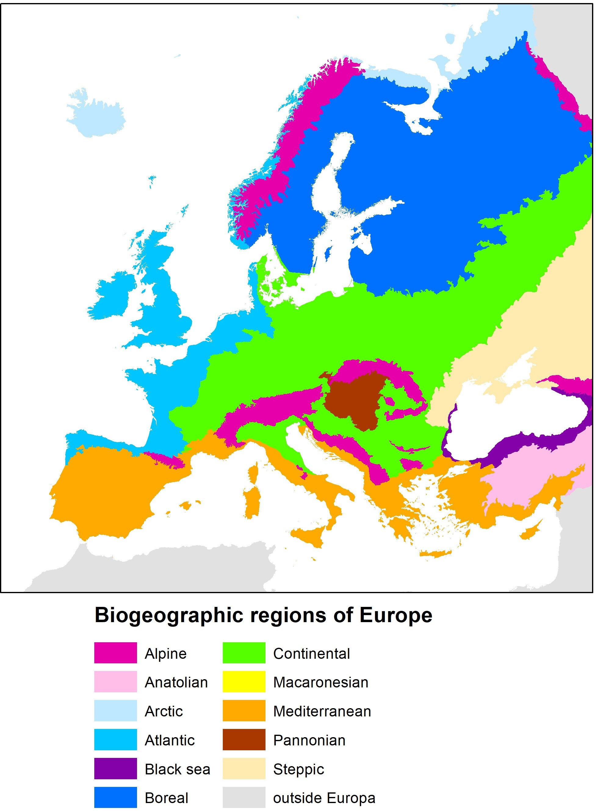

Appendix 3 Chromosome numbers in a few Asian knotweeds

Genus  (n=base number) |  | Species | Original range | Secondary  range | The Netherlands
Reynoutria (n=11) | R. japonica var. japonica |  | 44, 66, 88, 110 | 88 | 66, 88
Reynoutria (n=11) | R. japonica var. compacta |  | 44 | 44
Reynoutria (n=11) | R. × bohemica |  | 66 | 66, 44, 77, 88, 105, 110 | 66
Reynoutria (n=11) | R. sachalinensis |  | 44, 102, 132 | 44, 66, 88 | 88
Koenigia  (n=11) | K. polystachya |  | 22 | 22
Fallopia  (n=10) | F. baldschuanica |  | 20 | 20
×Reylopia | × Reylopia conollyana |  |  | 54

The most common ploidy in the secondary range is shown in bold. Source: Bímová et al. (2003), Padula et al. (2008), Bailey et al. (2009), Mandak et al. (2003), Duistermaat et al. (2012) and Stace (2019).

Appendix 4 Diagnostic characters for Reynoutria species
Characters | Reynoutria japonica | Reynoutria xbohemica | Reynoutria sachalinensis
Spots on the shoots | densely redbrown spotted | ± redbrown spotted | without spots
Main leaf vain (abaxial) | sharply square in diameter | square to slightly rounded | clearly rounded
Leaf base | truncate | truncate or ± cordate | distinct cordate
Leaf apex | cuspidate | cuspidate to acute | acute
Leaf form | broadly ovate | broadly to narrow ovate | narrow ovate to elliptic oblong
Leaf size | 10-18 cm | 20-35 cm | 30-45 cm
1: var. japonica (2n=88)  2: var. japonica (2n=66)  3: var. compacta (2n=44) | 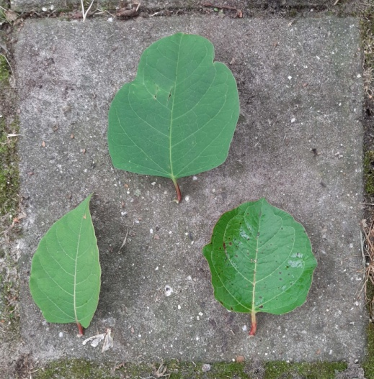  2  3  1  30 cm | 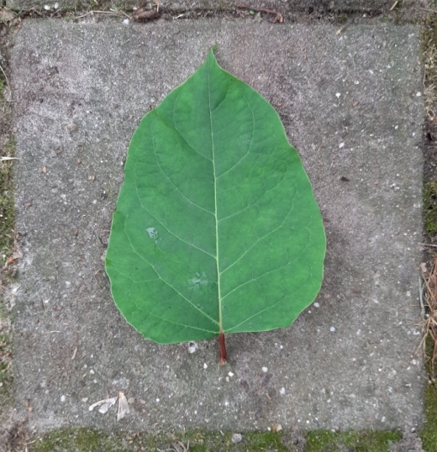 | 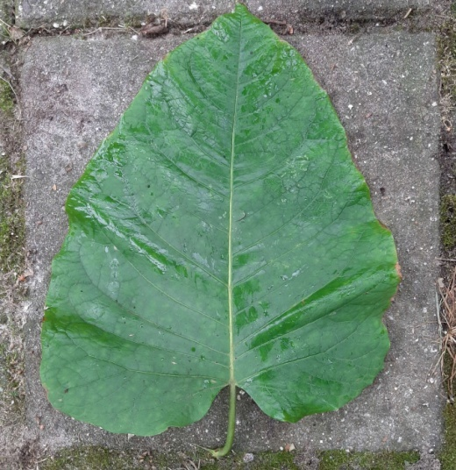
Leaf structure | thick leathery | strong but not leathery | thin, soft
Leaf hairs (abaxial) | without true hairs, but with rough papillae | short, up to 0.5 mm long hairs (5-10x as long as wide | long flexuous up to 1 mm long hairs
 | 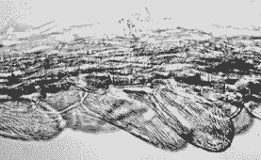 | 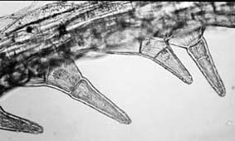 | 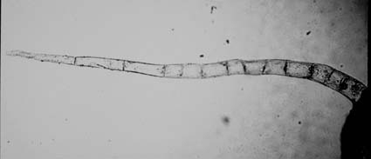
Extrafloral nectaries | only 1 underneath the attachment site of the leaf petiole (pulvinus) | only 1 abaxial underneath the attachment site of the leaf petiole or + 1-4 pairs additional smaller ones on both sides of the stem at the node position | 1 abaxial underneath the attachment site of the leaf petiole + 1-4 pairs of smaller ones on both sides of the stem at the node position
Height | (1-) 1.5-2.5 (-3) m | 2.5-3.5 (-4) m | 3.0-4.5 m
Inflorescence (♂ sterile) | branches medium-sized, spreading stout in different directions | branches medium-sized, spreading stout, arching in different directions | branches rather short, nodding, spreading in different directions
Inflorescence (♂ fertile) | branches very long, strictly upright | branches long, strictly upright | branches medium-sized, upright
Source: Bailey & Wisskirchen 2006, https://www2.le.ac.uk/departments/genetics/people/bailey/res/ident, Duistermaat et al. 2012

Appendix 5 Asian knotweeds in Natura 2000 areas in the Netherlands

Number of unique observations of Asian knotweeds (period 1990-2018) in Natura 2000 areas. The observations highlighted in yellow are imprecise observations, as it is uncertain as to whether the observation took place in the Natura 2000 area (Source: NDFF 2019).
Natura 2000 area | R. japonica | R. × bohemica | R. sachalinensis | K. polystachya
Aamsveen | 2
Abtskolk & De Putten | 2
Achter de Voort, Agelerbroek & Voltherbroek | 1
Alde Feanen | 14 |  | 1
Arkemheen | 5
Bargerveen | 31
Bekendelle | 1 |  | 5
Bemelerberg & Schiepersberg | 4
Bergvennen & Brecklenkampse Veld | 1
Biesbosch | 18 | 2 |  | 1
Binnenveld | 1
Boetelerveld |  |  | 1
Borkeld | 1
Brabantse Wal | 30 |  | 3
Bunder- en Elsloërbos | 12
Buurserzand & Haaksbergerveen | 4 |  | 2
Canisvliet | 2
Coepelduynen | 2
De Wieden | 5
Deurnsche Peel & Mariapeel | 43
Dinkelland | 14 |  | 1
Donkse Laagten | 2
Drentsche Aa-gebied | 26 |  | 7
Drents-Friese Wold & Leggelderveld | 33 | 3 | 2
Drouwenerzand | 3
Duinen Den Helder-Callantsoog | 3
Duinen en Lage Land Texel | 4 |  | 1
Duinen Schiermonnikoog | 1
Duinen Terschelling | 12
Dwingelderveld | 17 | 1 | 3
Eems-Dollard | 1
Eilandspolder | 1
Engbertsdijksvenen | 4
Fochteloërveen | 21 |  | 2
Gelderse Poort | 144 | 13 | 84 | 2
Geleenbeekdal | 4 |  | 3 | 1
Geuldal | 47
Grensmaas | 6
Grevelingen | 1
Groote Peel | 5
Groote Wielen | 2
Haringvliet | 5
Havelte-Oost | 18 |  |  | 9
Hollands Diep | 13 |  | 1 | 1
IJsselmeer | 4 |  | 1
Ilperveld, Varkensland, Oostzanerveld & Twiske | 3 |  | 1
Kampina & Oisterwijkse Vennen | 31 | 1 | 6 | 4
Kempenland-West | 33 | 2 | 40
Kennemerland-Zuid | 30 |  | 7
Ketelmeer & Vossemeer |  |  |  | 1
Kolland & Overlangbroek | 6 |  | 1
Kop van Schouwen | 28 |  | 2
Krammer-Volkerak | 1
Landgoederen Brummen | 16 | 8 | 1
Landgoederen Oldenzaal | 7
Langstraat | 2
Lauwersmeer | 2
Leekstermeergebied | 7
Leenderbos, Groote Heide & De Plateaux | 117 | 4 | 5
Lemselermaten | 1
Leudal | 12
Lingegebied & Diefdijk | 1
Loevestein, Pompveld & Kornsche Boezem | 2
Lonnekermeer | 1 |  | 7 | 1
Loonse en Drunense Duinen & Leemkuilen | 23 | 1 | 1 | 1
Maasduinen | 21
Manteling van Walcheren | 11
Mantingerzand | 5
Markermeer & IJmeer | 5 |  | 2
Meijendel & Berkheide | 10
Meinweg | 4
Nieuwkoopse Plassen & De Haeck | 1 |  | 2
Noordhollands Duinreservaat | 10 |  | 3
Noordzeekustzone |  |  | 1
Olde Maten & Veerslootslanden | 2
Oostelijke Vechtplassen | 24 | 3 | 6
Oosterschelde | 2
Oude Maas | 2
Oudegaasterbrekken, Fluessen en omgeving | 2
Polder Westzaan |  |  | 1
Polder Zeevang | 2
Regte Heide & Riels Laag | 4 |  | 2 | 1
Roerdal | 32
Rottige Meenthe & Brandemeer | 2 | 1
Sallandse Heuvelrug | 2
Schoorlse Duinen | 7 | 5 | 1
Sint Jansberg | 1
Sint Pietersberg & Jekerdal | 3
Sneekermeergebied | 4
Solleveld & Kapittelduinen | 21 | 4 | 2
Springendal & Dal van de Mosbeek | 7 |  | 1
Strabrechtse Heide & Beuven | 2 |  | 1
Swalmdal | 3
Uiterwaarden IJssel | 45 | 8 | 2
Uiterwaarden Lek | 3
Uiterwaarden Neder-Rijn | 56 | 1 | 9 | 8
Uiterwaarden Waal | 60 | 1 | 8
Uiterwaarden Zwarte Water en Vecht | 1 |  | 2
Ulvenhoutse Bos | 12 |  |  | 1
Vecht- en Beneden-Reggegebied | 12 | 9 | 17 | 1
Veerse Meer | 1
Veluwe | 733 | 193 | 124 | 5
Veluwerandmeren | 5
Vlijmens Ven, Moerputten & Bossche Broek | 12 | 1
Voordelta | 1
Voornes Duin | 48 | 3 | 1
Waddenzee | 1
Weerribben | 2 |  | 2
Weerter- en Budelerbergen & Ringselven | 4 |  | 1
Westduinpark & Wapendal | 31 | 1 | 1
Westerschelde & Saeftinghe | 5
Wierdense Veld | 2
Wijnjeterper Schar | 1
Witte Veen | 4
Witterveld | 2
Wormer- en Jisperveld & Kalverpolder | 6 |  | 1
Yerseke en Kapelse Moer | 1
Zuidlaardermeergebied | 4 |  | 1
Zwanenwater & Pettemerduinen | 3 |  | 16
Zwarte Meer | 1
Number of Natura 2000 areas: | 91(-116) | 15(-21) | 23(-49) | 9(-14)

Appendix 6a Area (ha) of EU habitat type 6430 in EU countries (and Great Britain).

Hydrophilous tall herb fringe communities of the plains and of the montane to alpine levels (Source: https://www.eea.europa.eu/data-and-maps/data/natura-10).

Country | Atlantic | Boreal | Continental | Mediterranean | Pannonian | Alpine | Black Sea | Atlantic Marine | Baltic Marine | Black Sea Marine | Mediterr. Marine | Steppe
Bulgaria |  |  | 8,758 |  |  | 4,048 | 829 |  |  | 13 |  |  | 13,648
Denmark | 5 |  | 27 |  |  |  |  | 6 | 5 |  |  |  | 43
Germany | 1,650 |  | 8,780 |  |  | 4,192 |  |  |  |  |  |  | 14,622
Estonia |  | 1,872 |  |  |  |  |  |  | 868 |  |  |  | 2,740
Finland |  | 306 |  |  |  | 44 |  |  |  |  |  |  | 350
France | 18,363 |  | 5,371 | 1,980 |  | 8,090 |  |  |  |  |  |  | 33,804
Greece |  |  |  | 305 |  |  |  |  |  |  |  |  | 305
Great Britain | 369 |  |  |  |  |  |  |  |  |  |  |  | 369
Hungary |  |  |  |  | 3,804 |  |  |  |  |  |  |  | 3,804
Ireland | 207 |  |  |  |  |  |  |  |  |  |  |  | 207
Italy |  |  | 5,882 | 7,403 |  | 21,000 |  |  |  |  | 8 |  | 34,292
Croatia |  |  | 71 |  |  | 57 |  |  |  |  |  |  | 128
Latvia |  | 745 |  |  |  |  |  |  |  |  |  |  | 745
Lithuania |  | 1,194 |  |  |  |  |  |  |  |  |  |  | 1,194
Luxembourg |  |  | 13 |  |  |  |  |  |  |  |  |  | 13
The Netherlands | 1,347 |  |  |  |  |  |  | 44 |  |  |  |  | 1,391
Austria |  |  | 138 |  |  | 1,426 |  |  |  |  |  |  | 1,564
Poland |  |  | 6,264 |  |  | 554 |  |  |  |  |  |  | 6,818
Portugal | 0 |  |  | 0 |  |  |  | 0 |  |  |  |  | 0
Romania |  |  | 175 |  | 2,570 | 537 | 0 |  |  |  |  | 39 | 3,321
Slovenia |  |  | 20,821 |  |  | 24,192 |  |  |  |  |  |  | 45,013
Slovakia |  |  |  |  | 825 | 3,234 |  |  |  |  |  |  | 4,060
Spain | 3,757 |  |  | 39,191 |  | 185 |  | 157 |  |  | 348 |  | 43,639
Czech Republic |  |  | 3,516 |  | 4 |  |  |  |  |  |  |  | 3,521
Sweden |  | 2,309 | 135 |  |  | 7,138 |  | 165 | 14 |  |  |  | 9,760

Appendix 6b Area (ha) of EU habitat type 91E0 in EU countries (and Great Britain).

Alluvial forests with Alnus glutinosa and Fraxinus excelsior (Alno-Padion, Alnion incanae, Salicion albae) (Source: https://www.eea.europa.eu/data-and-maps/data/natura-10).

Country | Atlantic | Boreal | Continental | Mediterranean | Pannonian | Alpine | Black Sea | Atlantic Marine | Baltic Marine | Black Sea Marine | Mediterr. Marine | Steppe
Bulgaria |  |  | 8,002 |  |  | 1,298 | 567 |  |  | 312 |  |  | 10,179
Denmark | 112 |  | 1,169 |  |  |  |  | 131 | 179 |  |  |  | 1,591
Germany | 5,371 |  | 48,112 |  |  | 889 |  |  |  |  |  |  | 54,372
Estonia |  | 3,279 |  |  |  |  |  |  | 71 |  |  |  | 3,350
Finland |  | 1,330 |  |  |  | 314 |  |  |  |  |  |  | 1,645
France | 36,934 |  | 23,552 | 7,041 |  | 12,100 |  |  |  |  |  |  | 79,627
Greece |  |  |  | 844 |  |  |  |  |  |  |  |  | 844
Great Britain | 3,318 |  |  |  |  |  |  |  |  |  |  |  | 3,318
Hungary |  |  |  |  | 50,915 |  |  |  |  |  |  |  | 50,915
Ireland | 2,353 |  |  |  |  |  |  |  |  |  |  |  | 2,353
Italy |  |  | 19,397 | 6,050 |  | 3,629 |  |  |  |  | 47 |  | 29,123
Croatia |  |  | 19,155 |  |  | 498 |  |  |  |  |  |  | 19,653
Latvia |  | 2,688 |  |  |  |  |  |  |  |  |  |  | 2,688
Lithuania |  | 2,661 |  |  |  |  |  |  |  |  |  |  | 2,661
Luxembourg |  |  | 265 |  |  |  |  |  |  |  |  |  | 265
The Netherlands | 4,294 |  |  |  |  |  |  |  |  |  |  |  | 4,294
Austria |  |  | 9,642 |  |  | 3,157 |  |  |  |  |  |  | 12,799
Poland |  |  | 80,382 |  |  | 6,811 |  |  |  |  |  |  | 87,193
Portugal | 0 |  |  | 3,124 |  |  |  | 2,042 |  |  |  |  | 5,166
Romania |  |  | 2,260 |  | 274 | 659 |  |  |  |  |  | 107 | 3,300
Slovenia |  |  | 3,955 |  |  | 660 |  |  |  |  |  |  | 4,616
Slovakia |  |  |  |  | 8,130 | 5,845 |  |  |  |  |  |  | 13,975
Spain | 17,809 |  |  | 30,160 |  | 646 |  | 2,575 |  |  | 161 |  | 51,351
Czech Republic |  |  | 5,889 |  | 587 |  |  |  |  |  |  |  | 6,476
Sweden |  | 2,414 | 629 |  |  | 1,659 |  | 73 | 290 |  |  |  | 5,065
Appendix 7 Crosses and backcrosses within the Reynoutria genus

The diagram below showing crosses and backcrosses within the genus Reynoutria has been taken from Bailey (2013). Note: with the exception of F. baldschuanica, all Fallopia species have now been included in the genus Reynoutria.
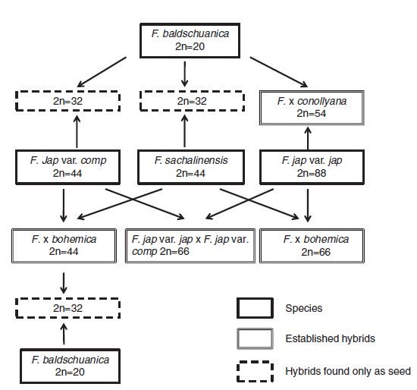

Appendix 8: Risk assessment of four Asian knotweeds using the Harmonia+ protocol.

FLORON

Natuurplaza
Toernooiveld 1 - 6525 ED Nijmegen
Postbus 9010 - 6500 GL Nijmegen

T: +31 (0)24 - 7 410 573 (general)
E: infor@floron.nl
www.floron.nl

“Taxon naturalisé ou en voie de naturalisation présentant un caractère envahissant à l’intérieur de communautés végétales naturelles ou semi-naturelles, Concurrence les espèces indigènes et modifie les écosystèmes.“
Note:The impacts discussed by Nawrocki et al. 2011 and Klein 2011 relate to knotweeds as a whole and make no distinction between the different species.
On November 24, 2020, the Court of Appeal of The Hague declared the ban on use non-binding. The consequence of the judgment of the Court of Appeal is that the professional use of authorized plant protection products outside agriculture is allowed again in accordance with the label regulations. https://www.nefyto.nl/dev.nefyto.nl/media/Documenten/Diversen/EUO3-2002308483-v1-ARREST-24-november-2020.pdf

